Comment–Caption Correlation Report
Model: llama3

Summary
Frames processed: 249
Comments available for this video: 2
Comments correlated to ≥ 60: 2 (100.0%)
Total candidate pairs checked: 498
Correlated comment coverage (all comments):
- matched 161 frame(s), max score 95.0000: I learned how to build a tone and volume control, as well as microphone preamplification.Uncertain if the circuit will work standalone or if it depends on the specific speaker circuit shown at the end.This could help address volume issues, like the one Meena encountered recently.: Will this circuit design work with our circuit or does it depend on their speaker design? Does it work without a microphone?
Source: https://www.youtube.com/watch?v=lV6zevUF-v0: Tone and volume control + microphone preamplifier
Top correlated frames:
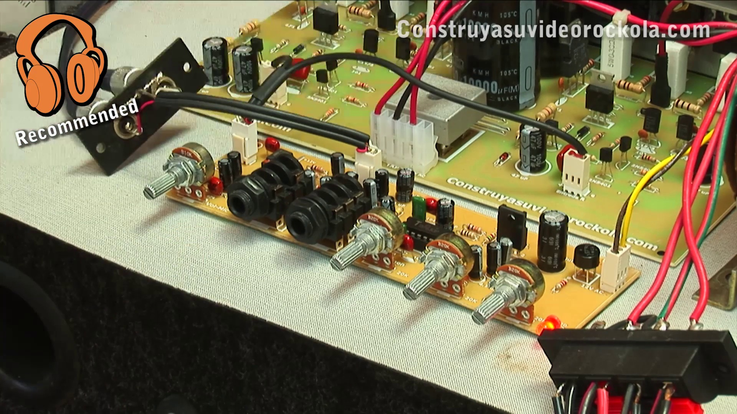 (score 95.0000)
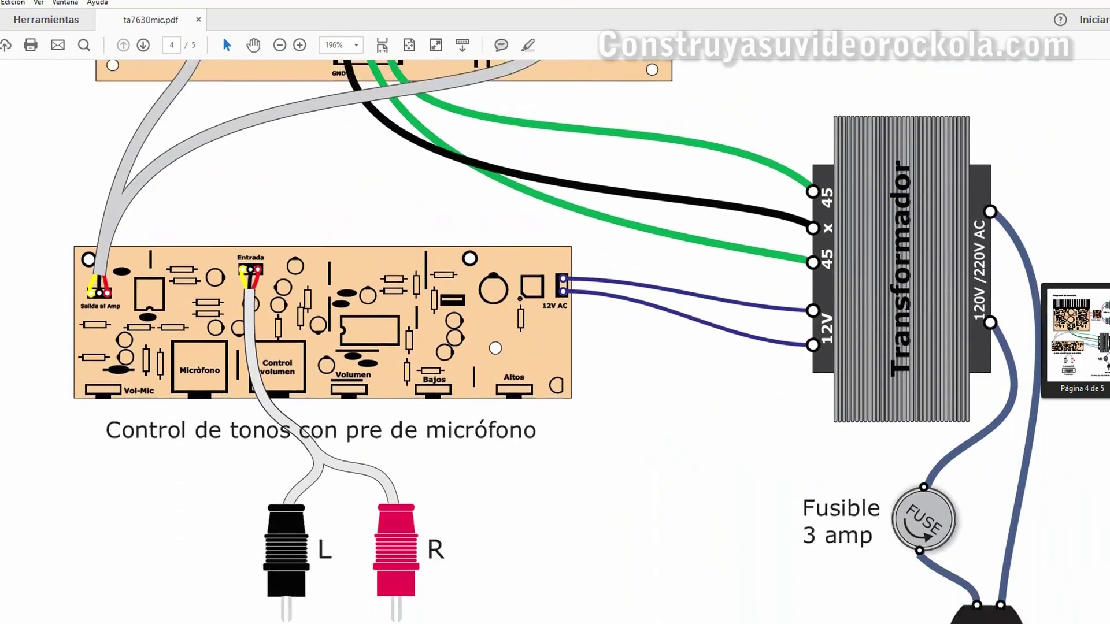 (score 95.0000)
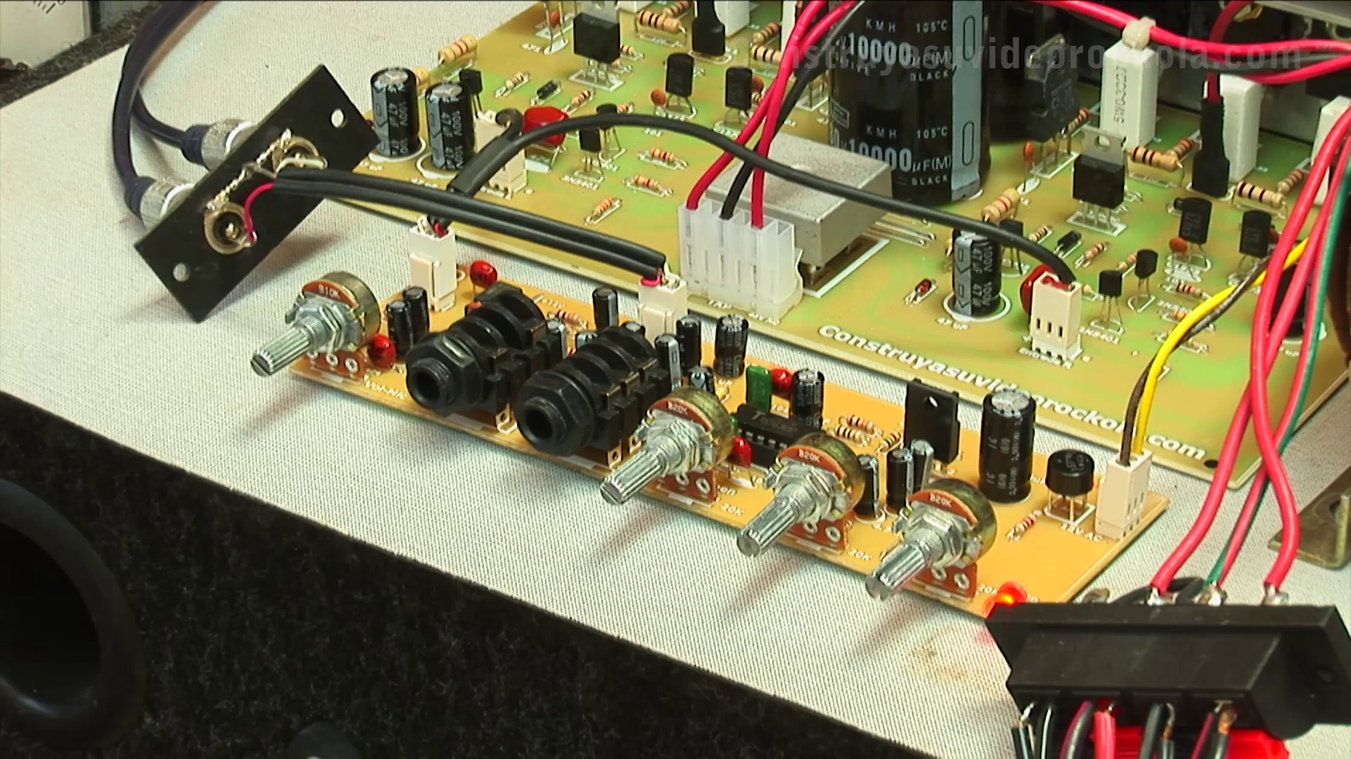 (score 90.0000)
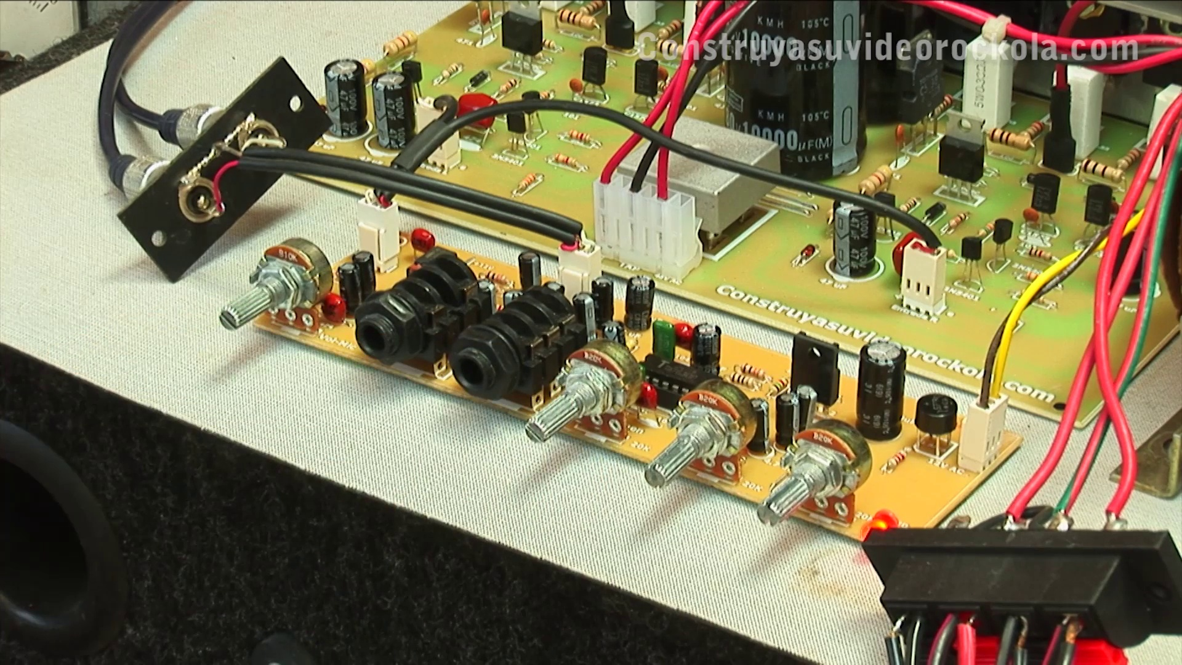 (score 90.0000)
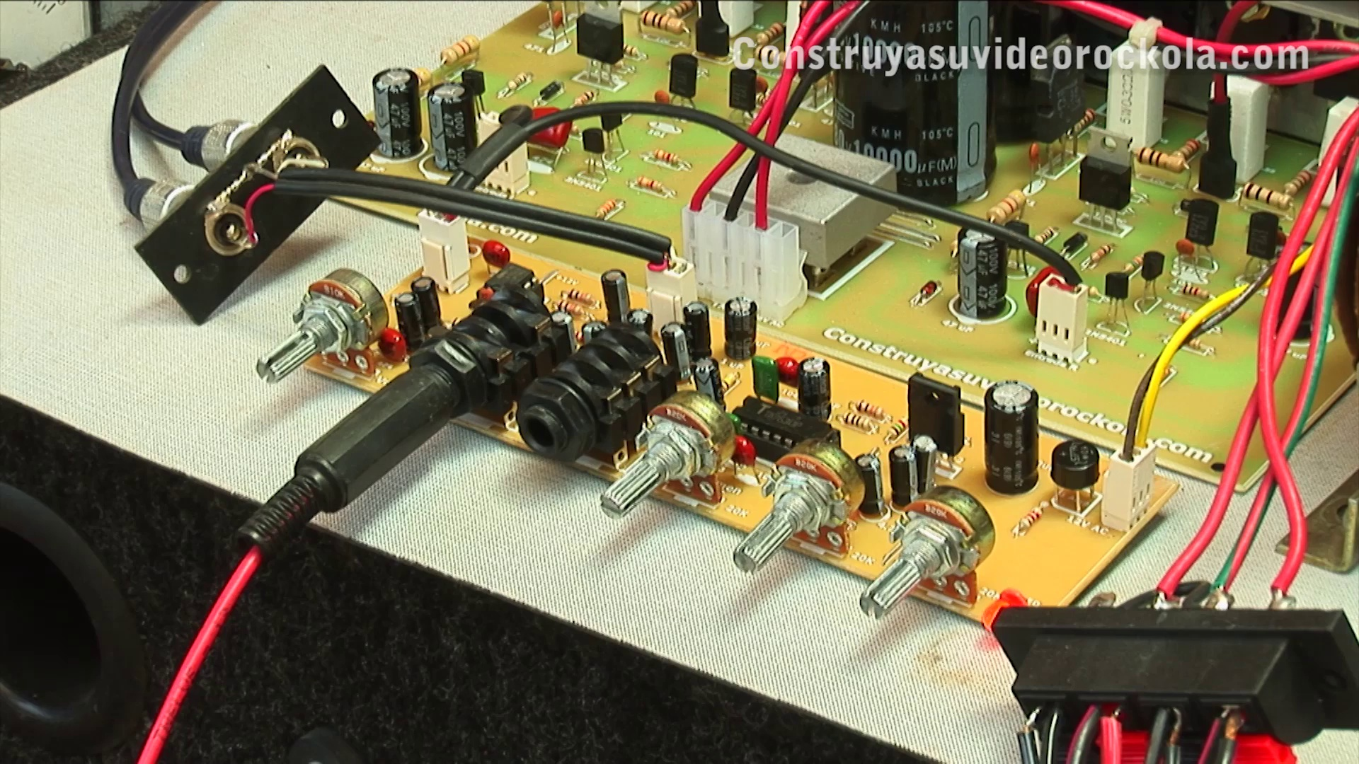 (score 90.0000)
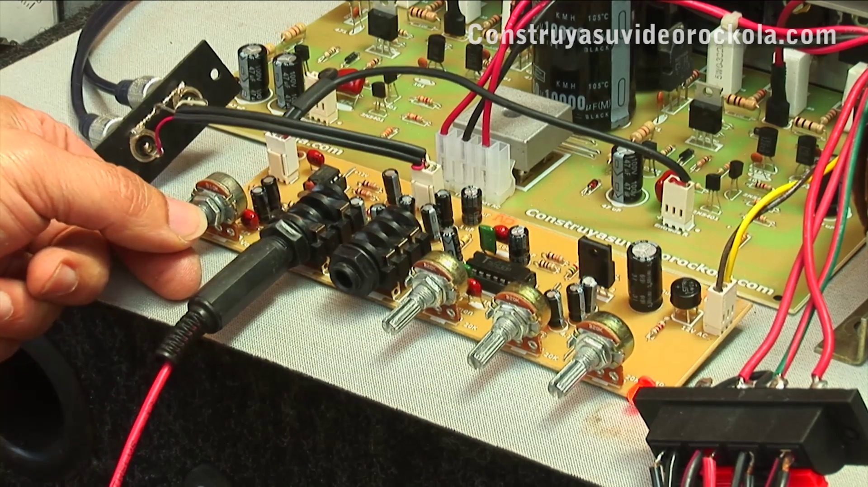 (score 90.0000)
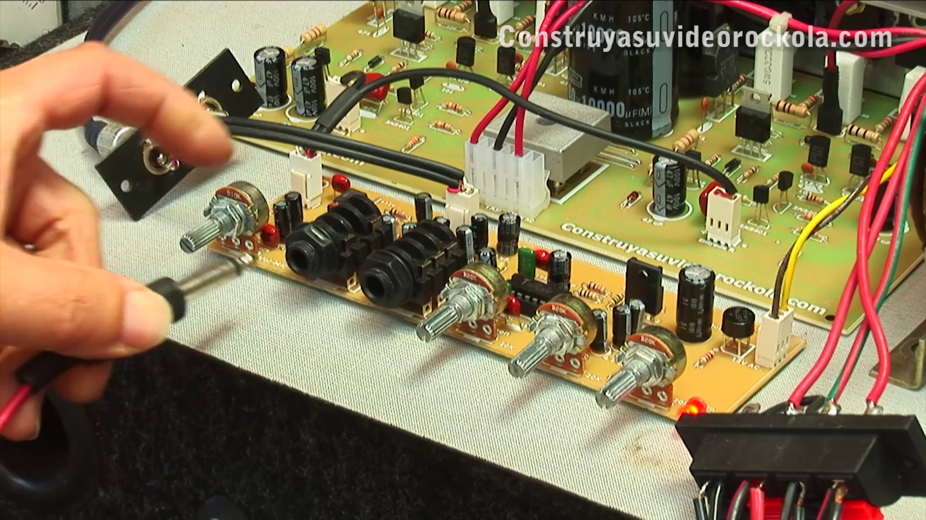 (score 90.0000)
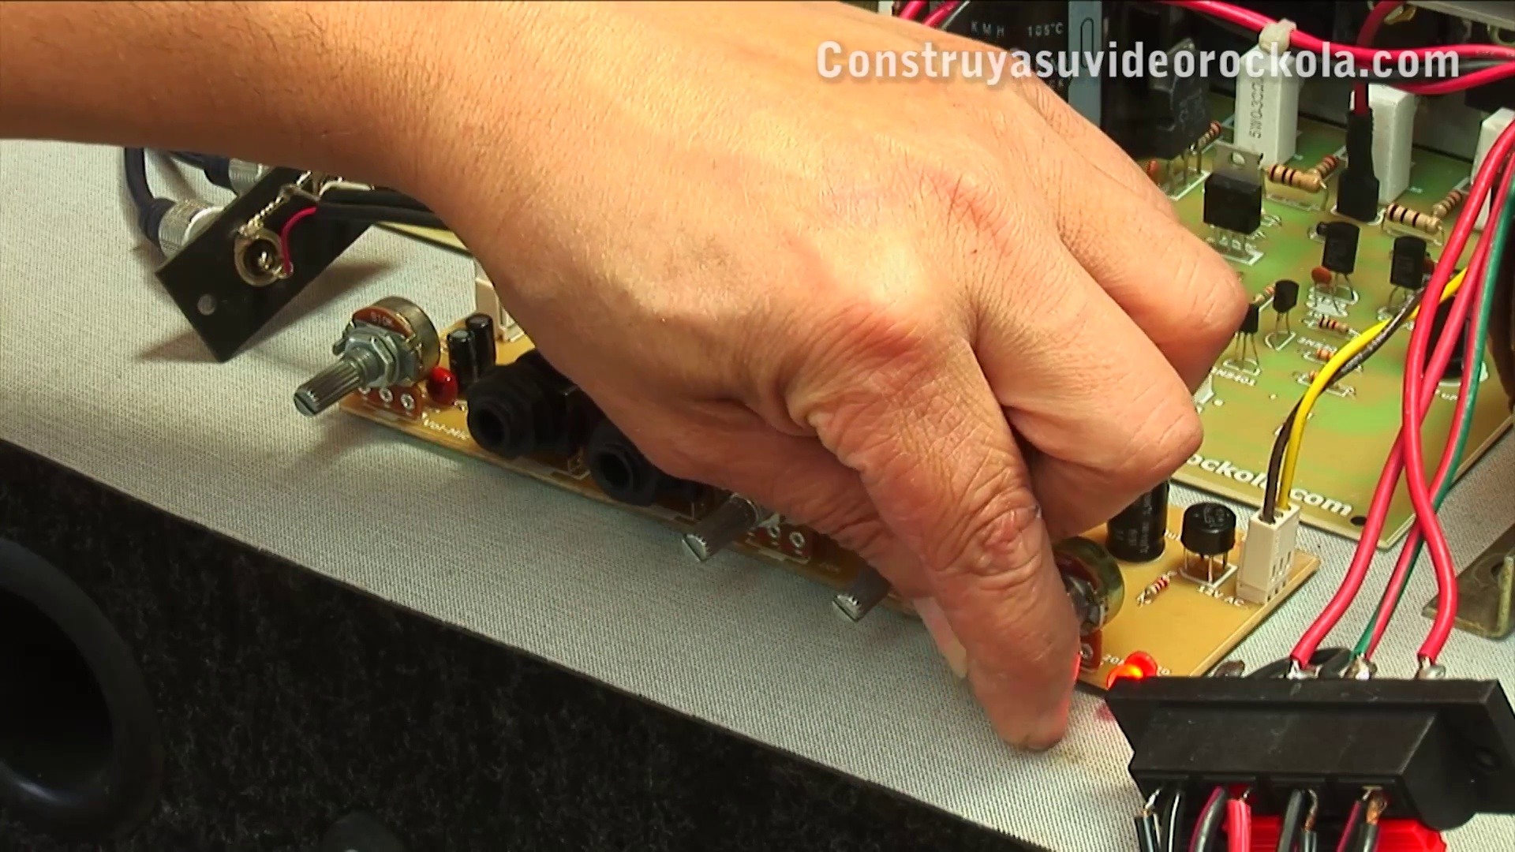 (score 90.0000)
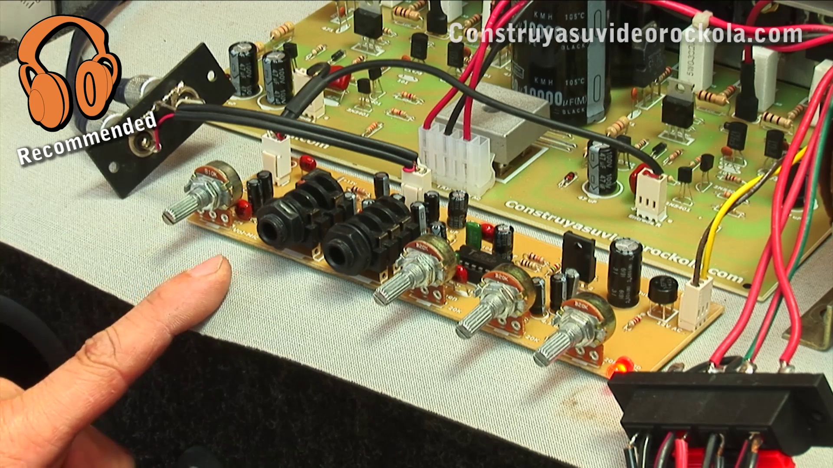 (score 90.0000)
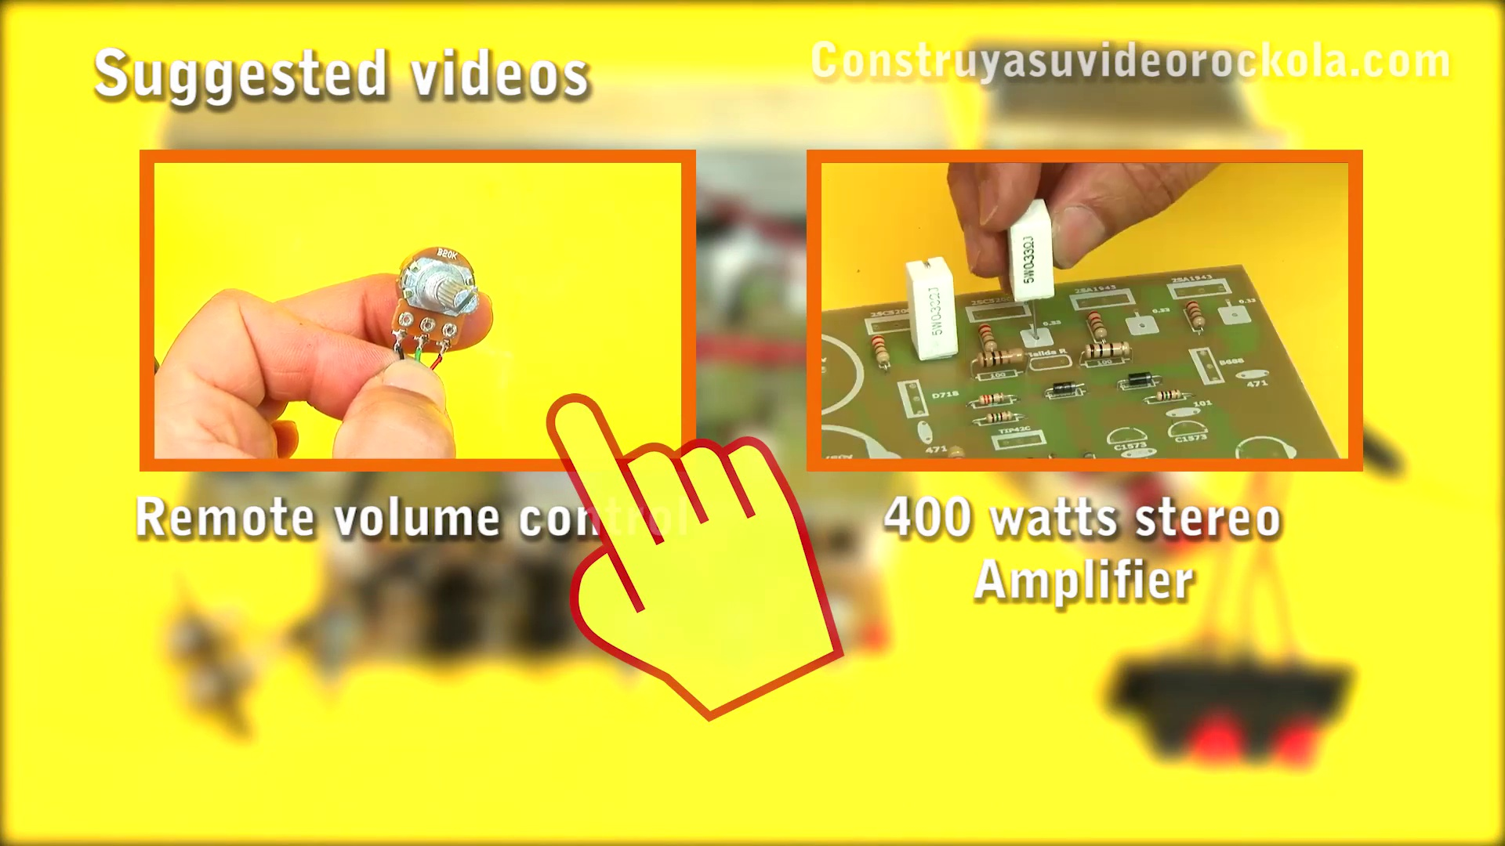 (score 90.0000)
Least correlated frames:
 (score 0.0000)
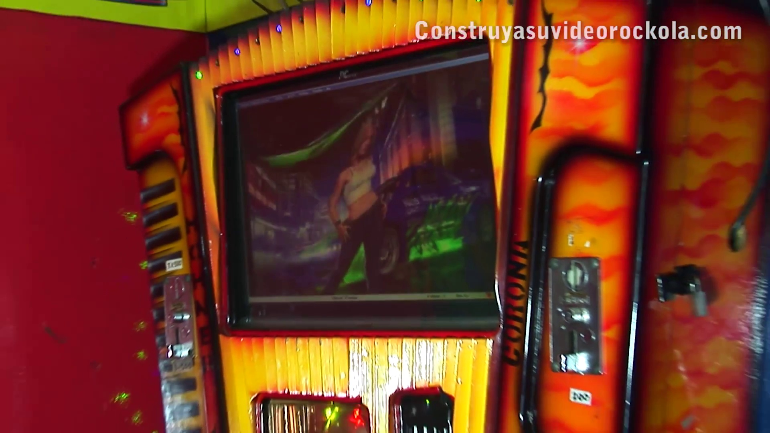 (score 0.0000)
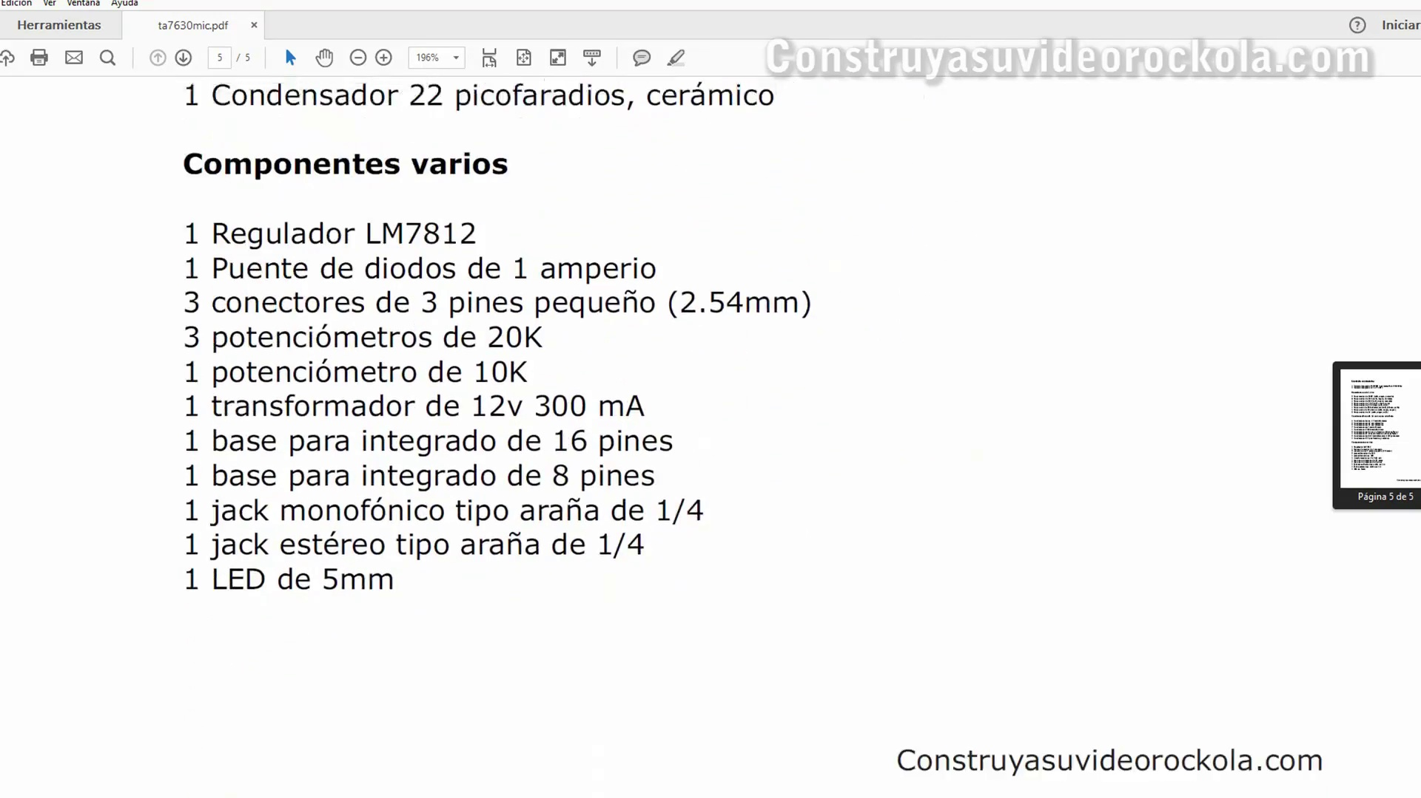 (score 0.0000)
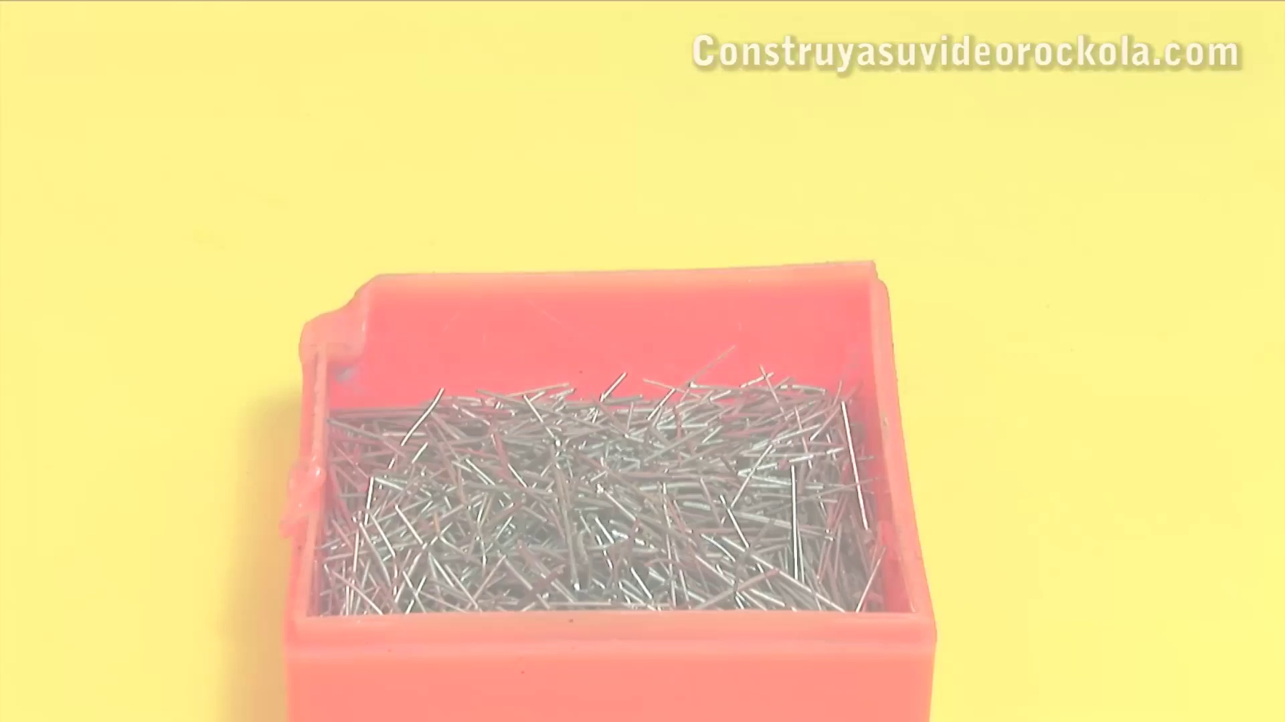 (score 0.0000)
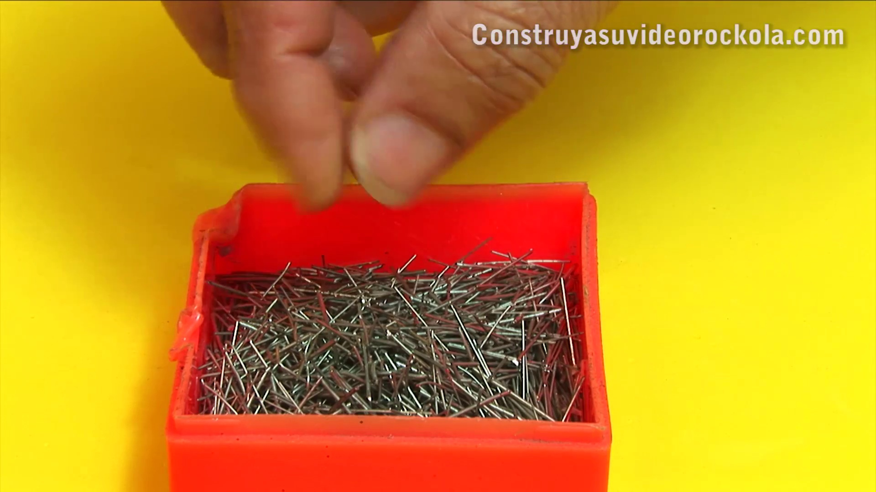 (score 0.0000)
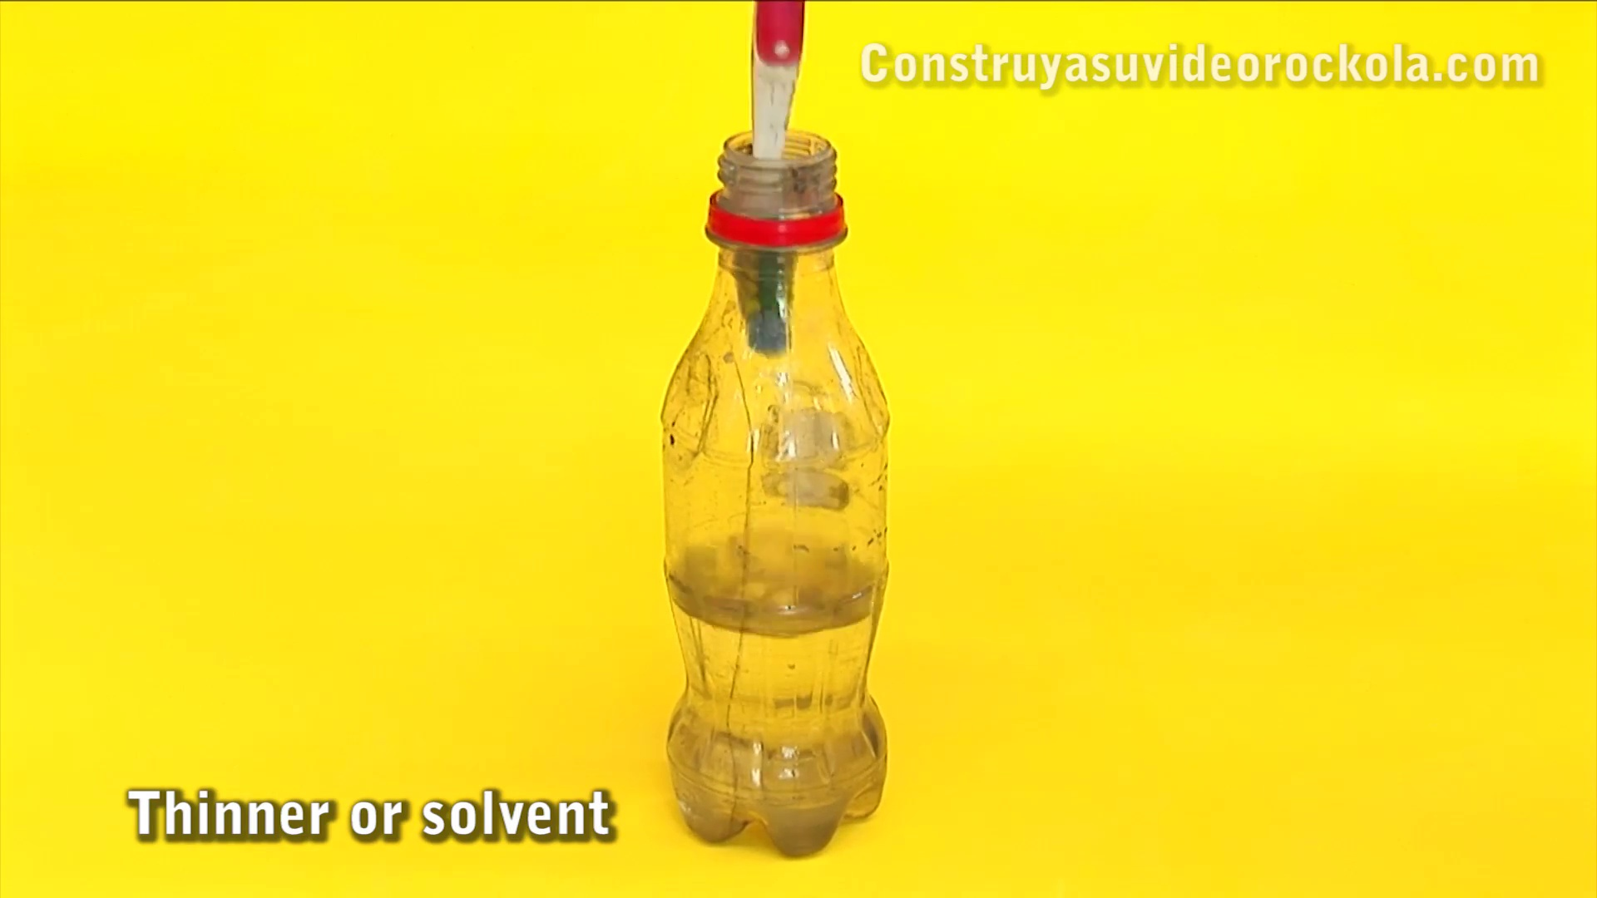 (score 0.0000)
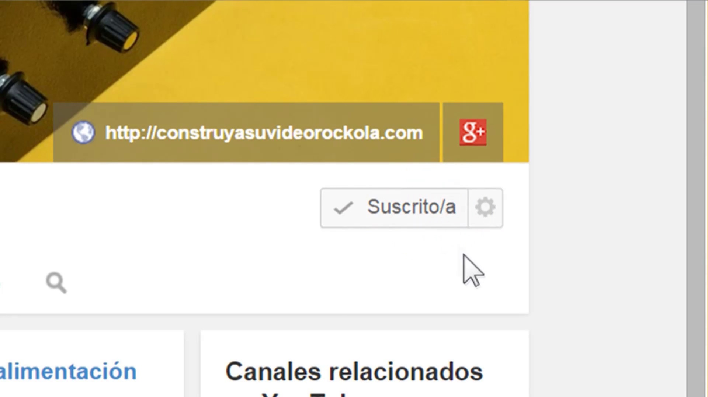 (score 0.0000)
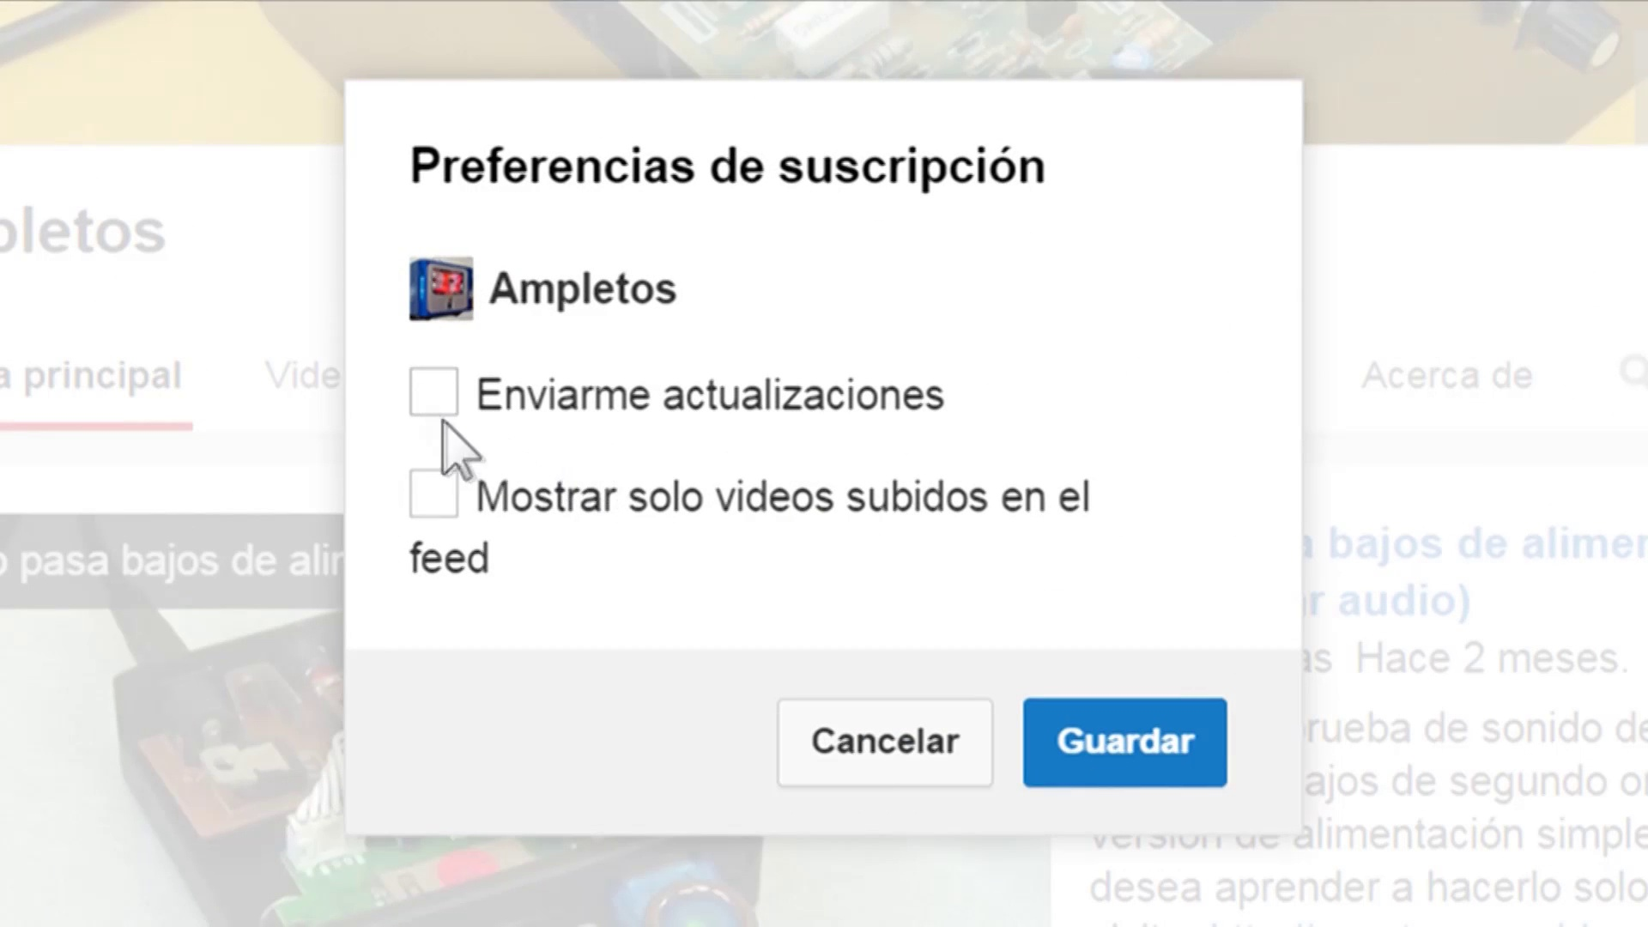 (score 0.0000)
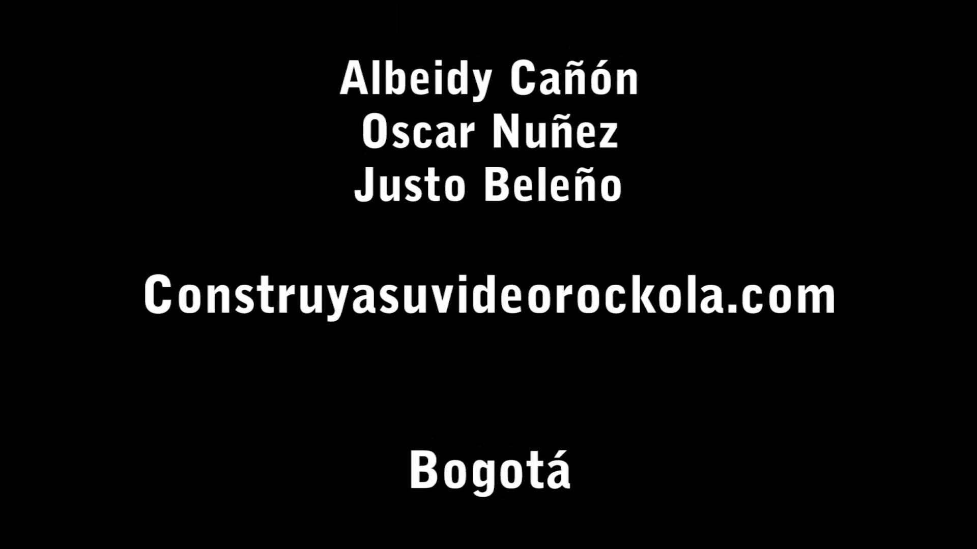 (score 0.0000)
 (score 0.0000)
- matched 80 frame(s), max score 90.0000: One thing I learned in this video is that the proper soldering technique is to connect everything at the same time. I also learned some troubleshooting techniques. What is a jumper?
Source: https://www.youtube.com/watch?v=lV6zevUF-v0: Tone and volume control + microphone preamplifier
Top correlated frames:
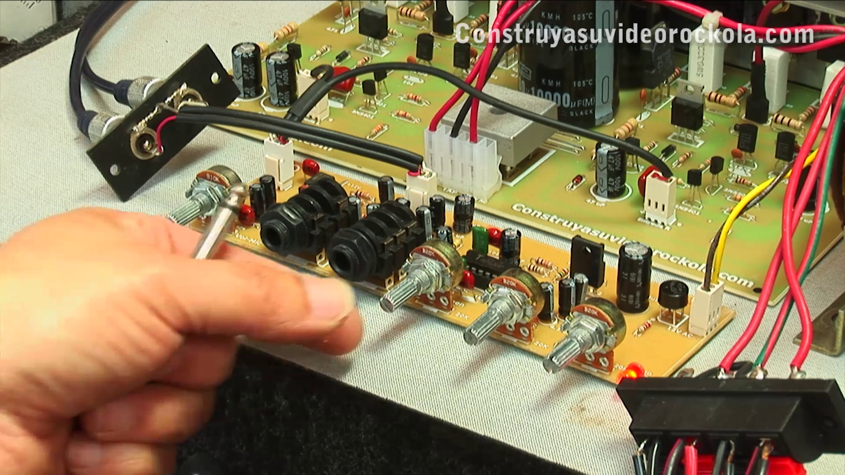 (score 90.0000)
 (score 90.0000)
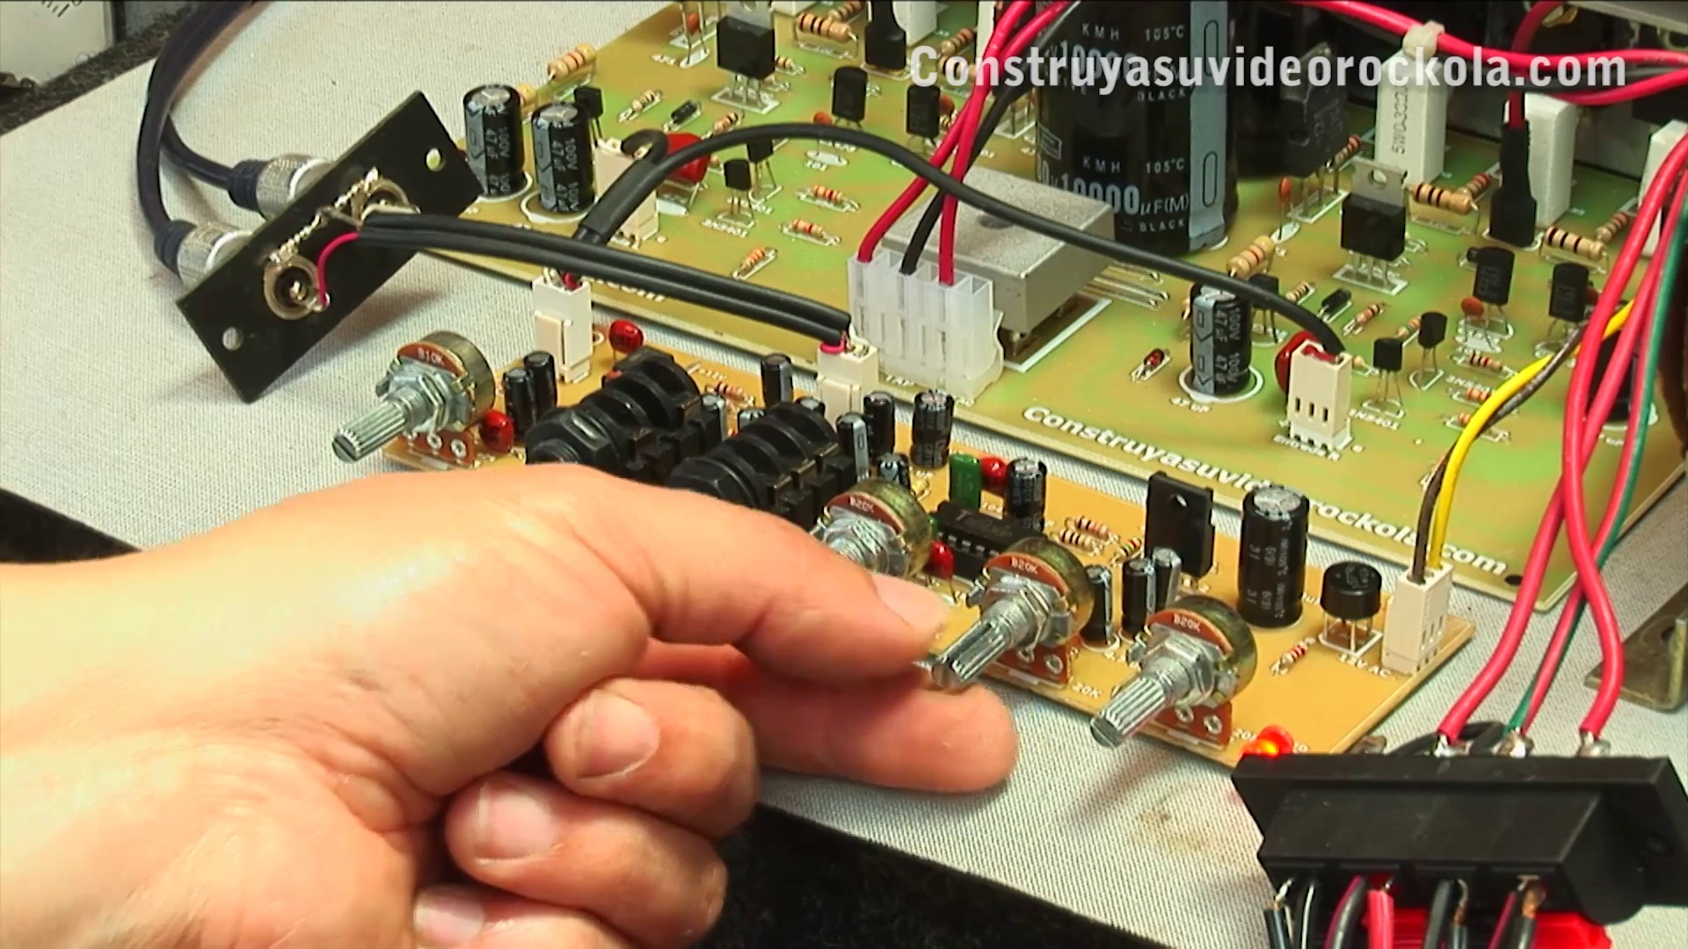 (score 90.0000)
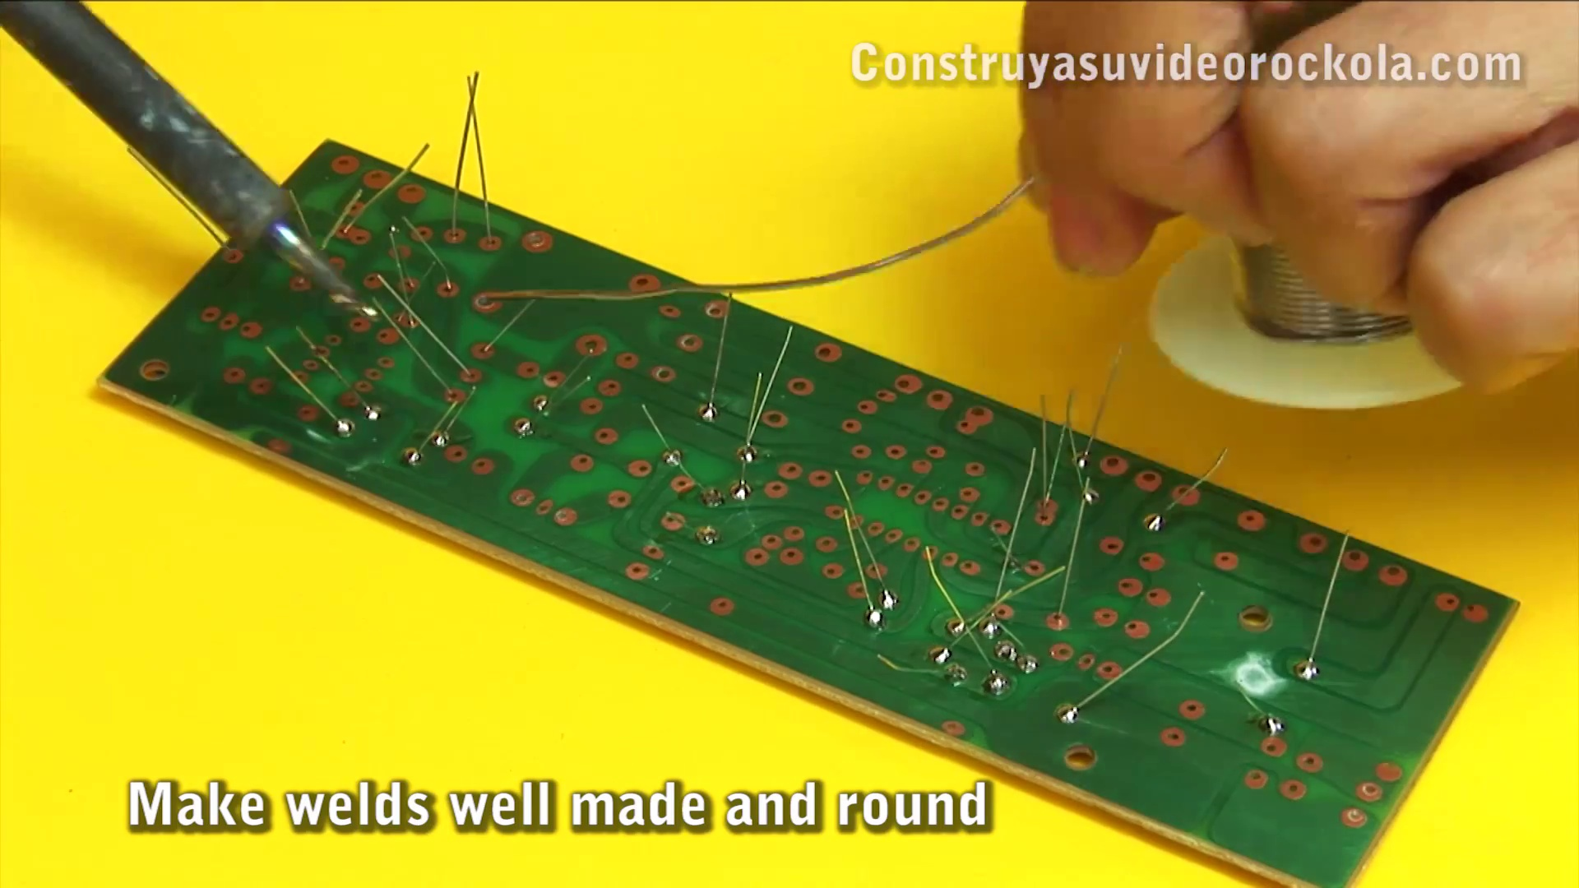 (score 90.0000)
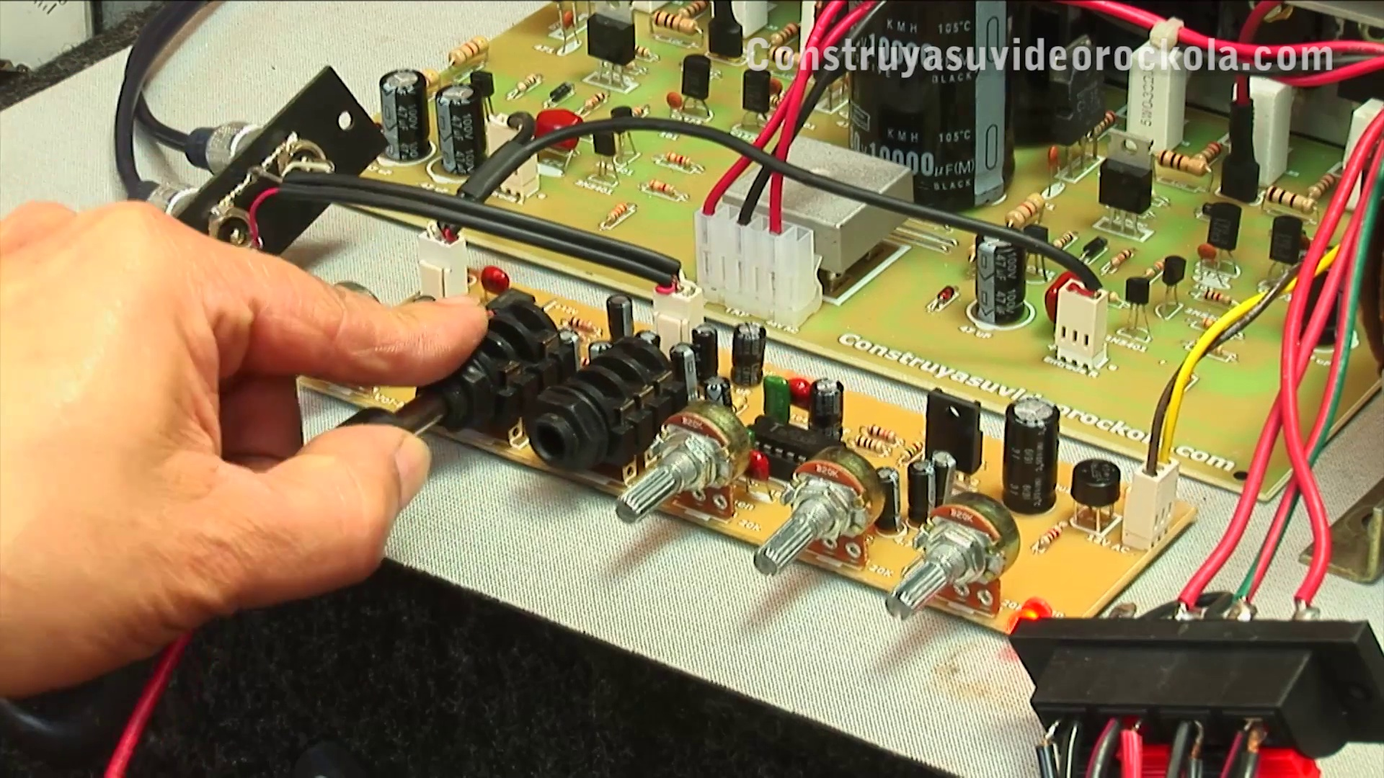 (score 85.0000)
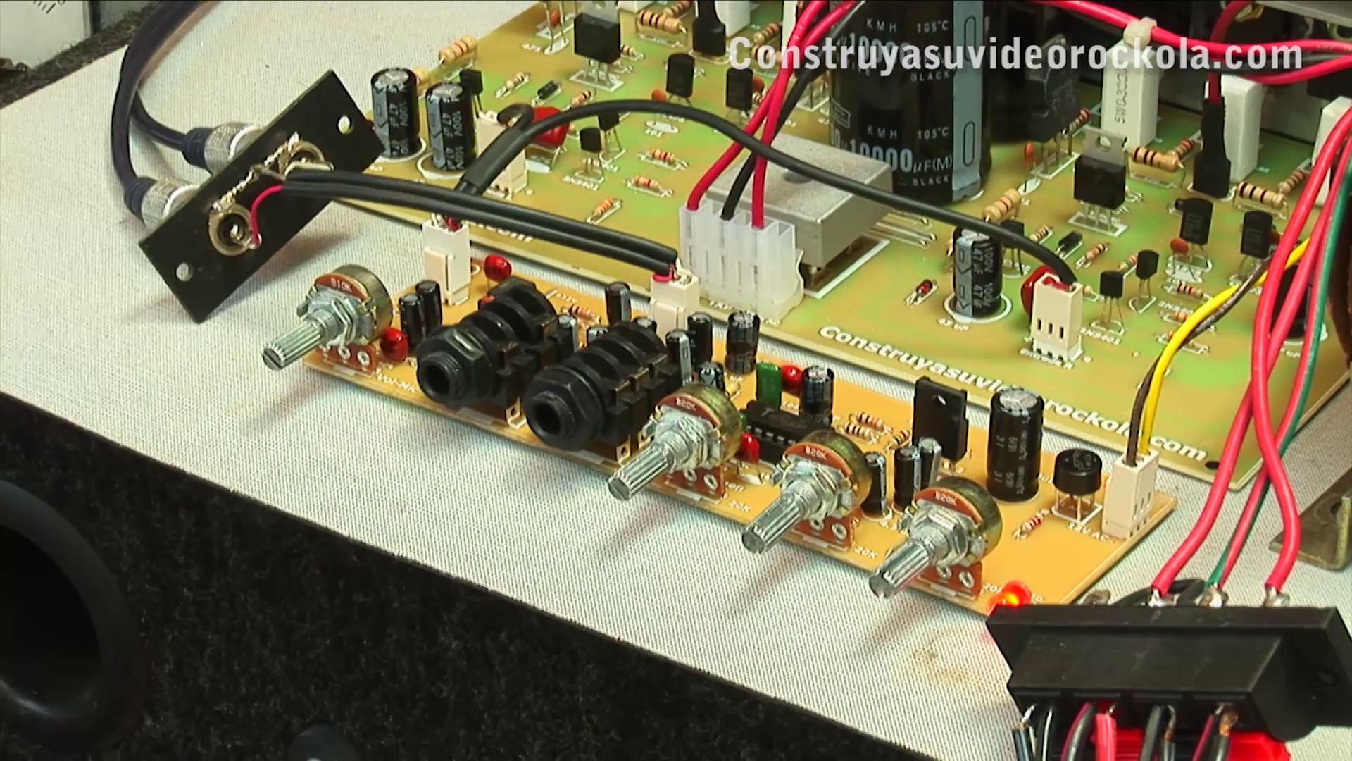 (score 85.0000)
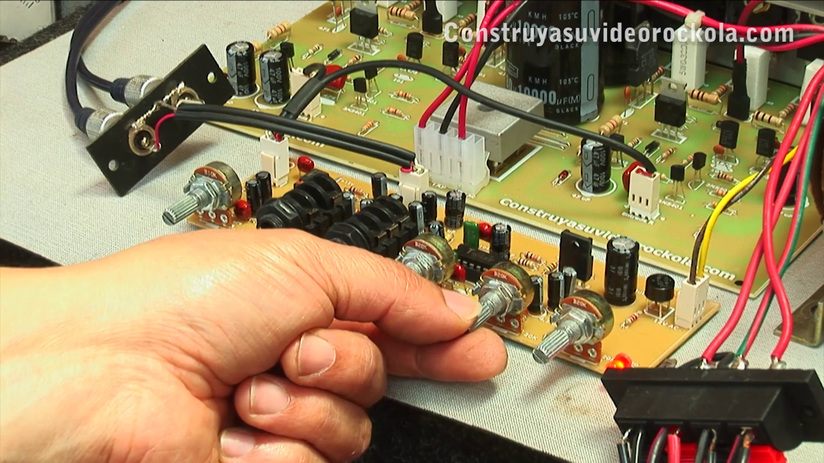 (score 85.0000)
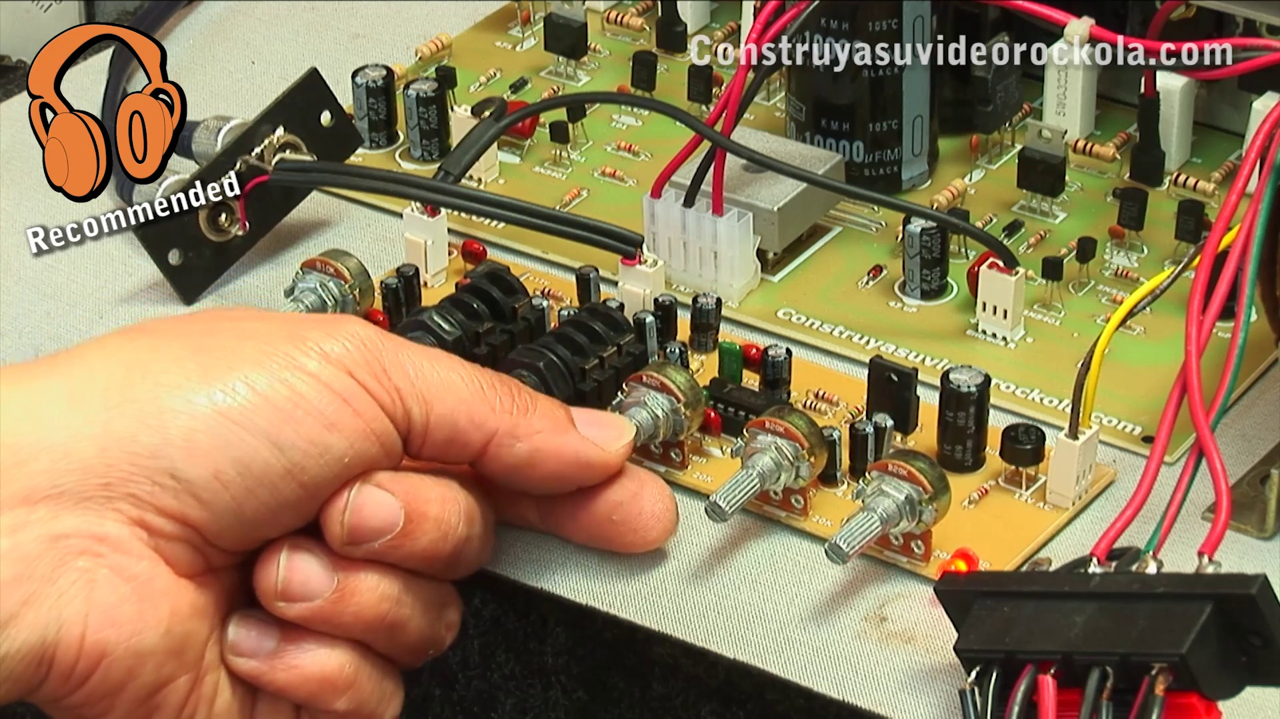 (score 85.0000)
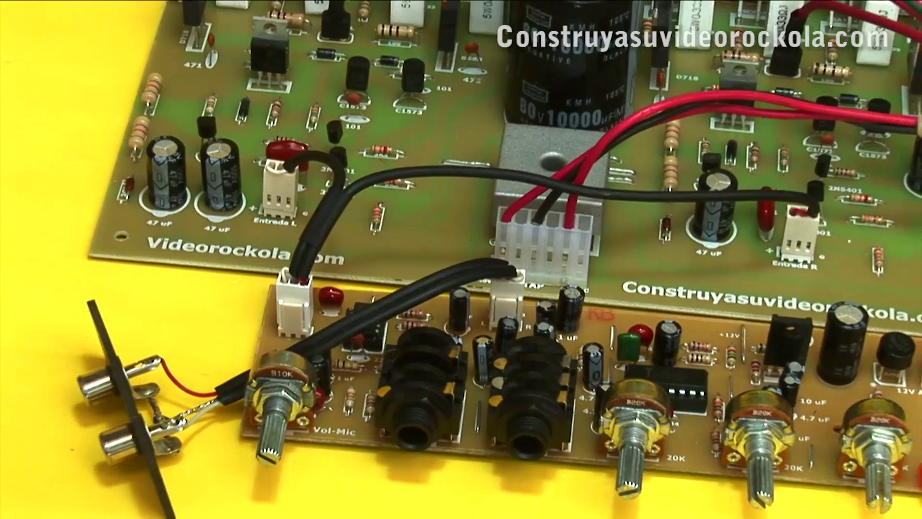 (score 85.0000)
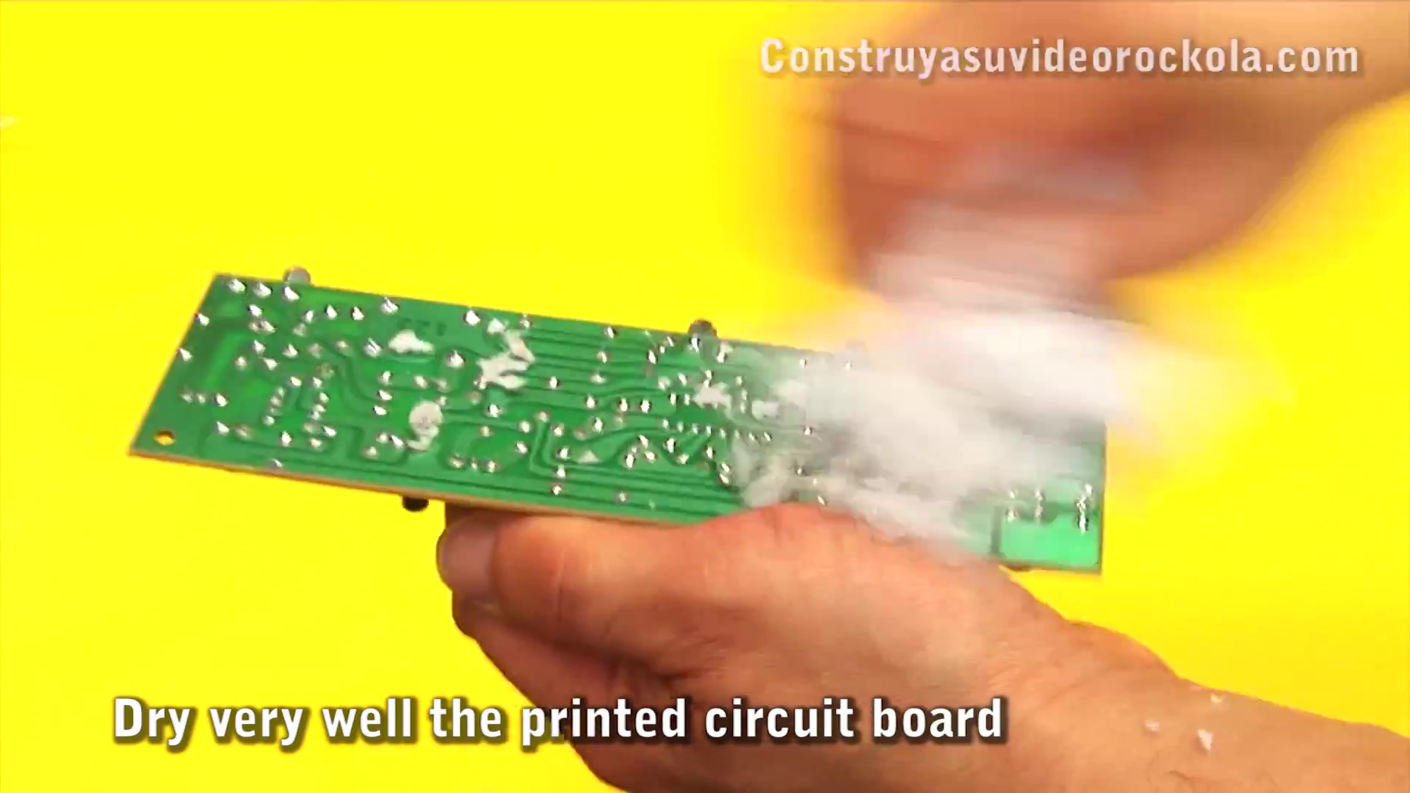 (score 85.0000)
Least correlated frames:
 (score 0.0000)
 (score 0.0000)
 (score 0.0000)
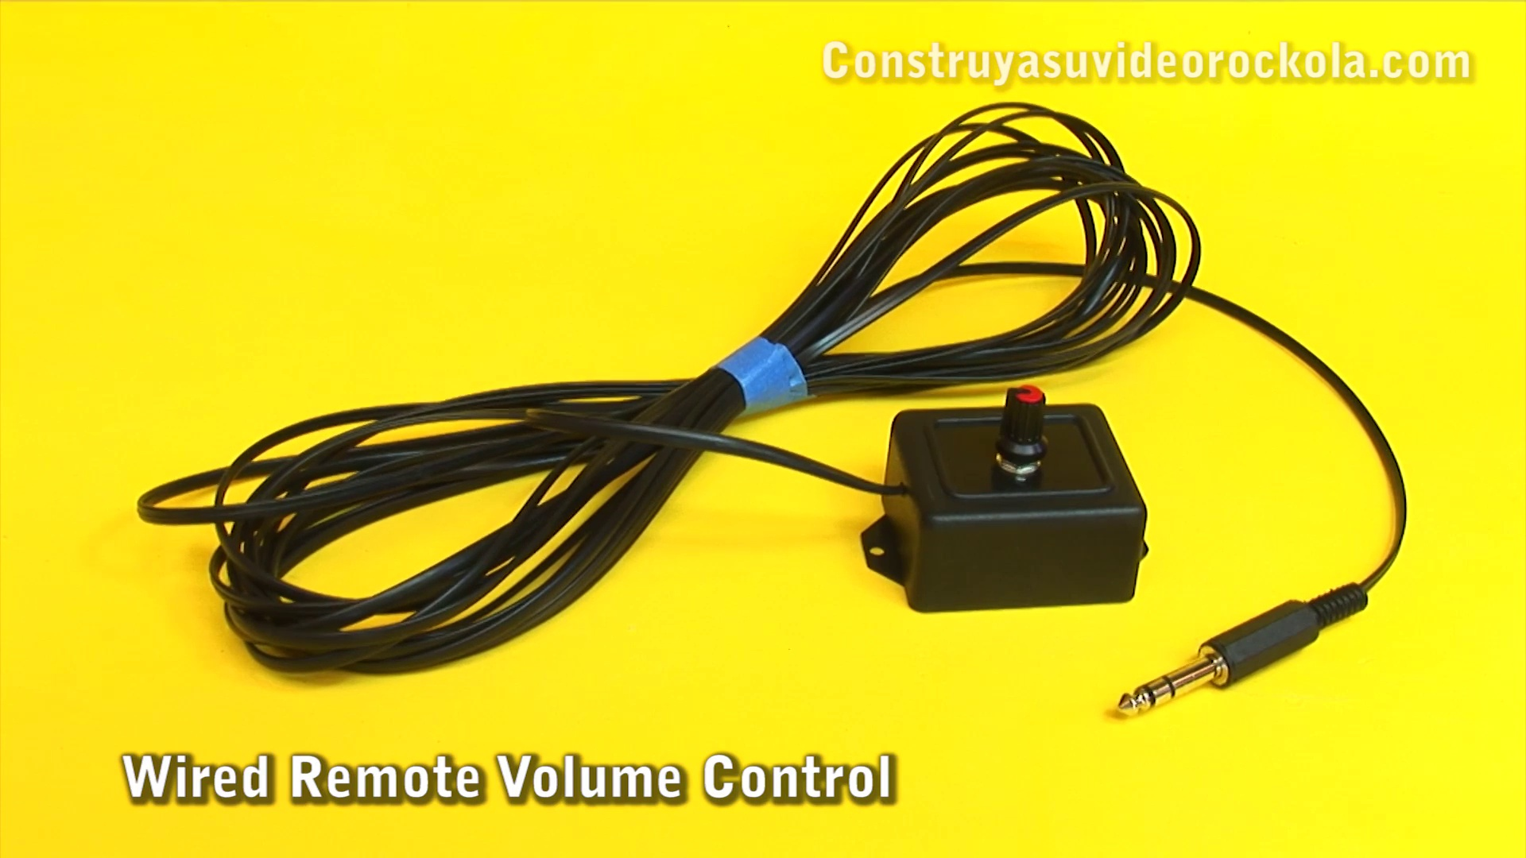 (score 0.0000)
 (score 0.0000)
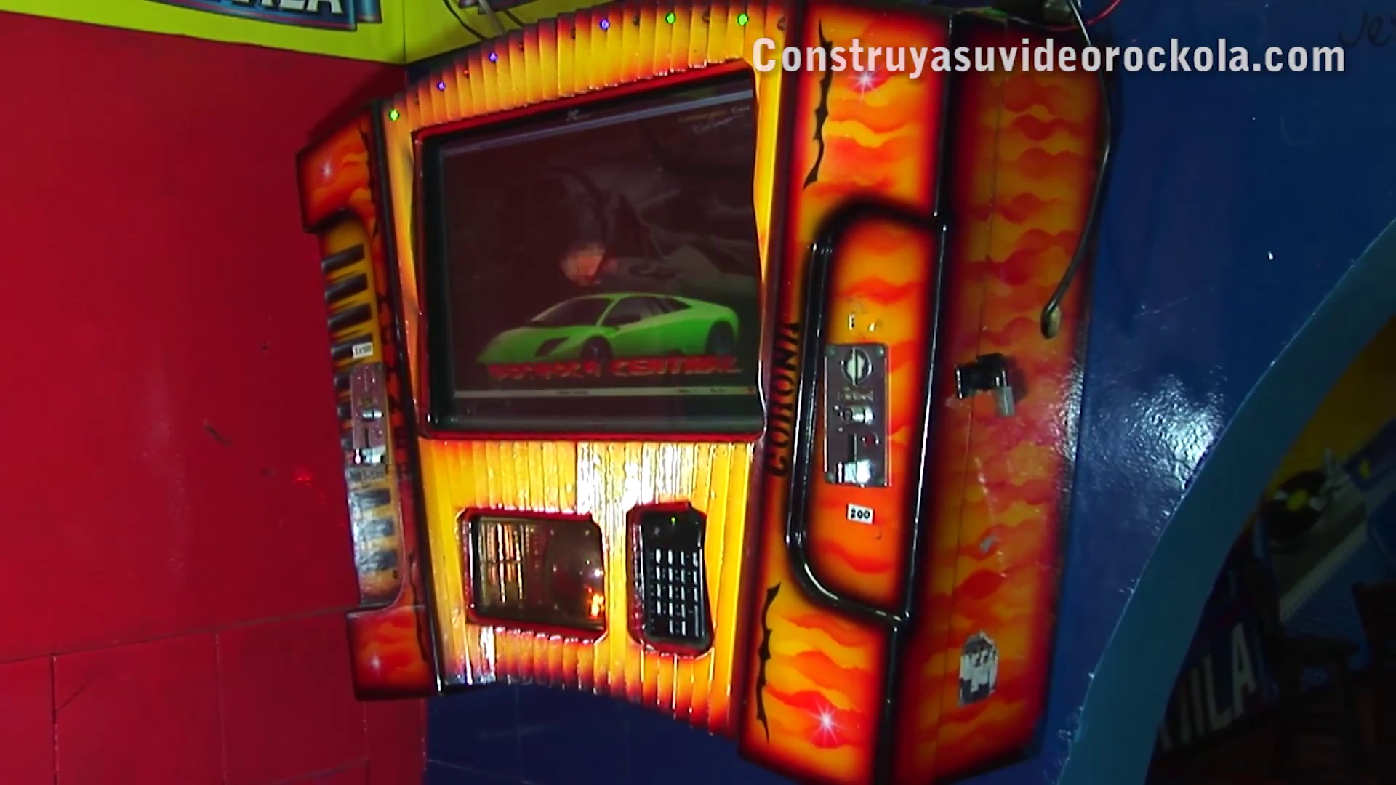 (score 0.0000)
 (score 0.0000)
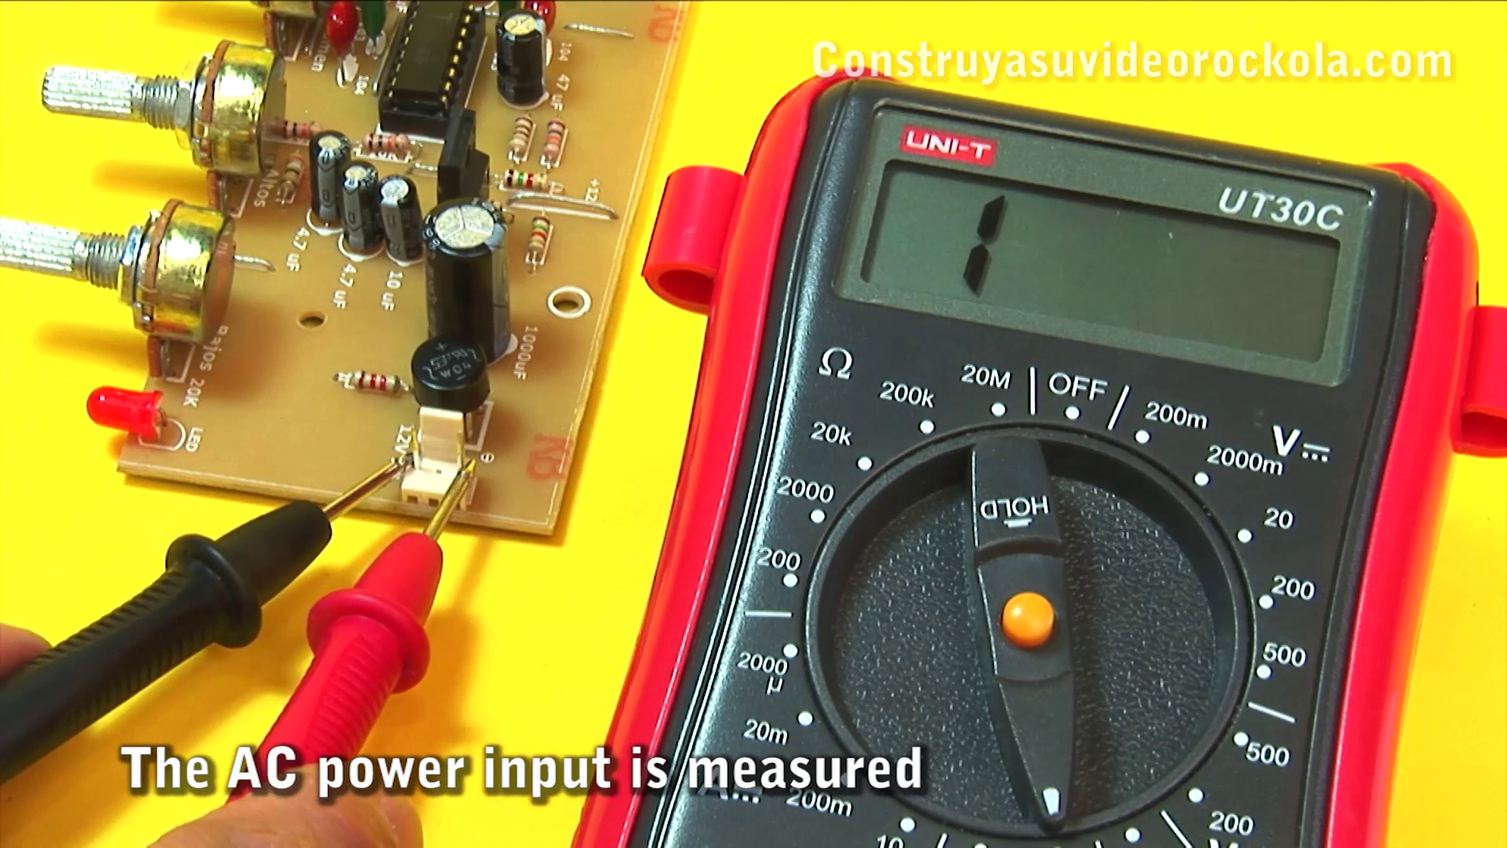 (score 0.0000)
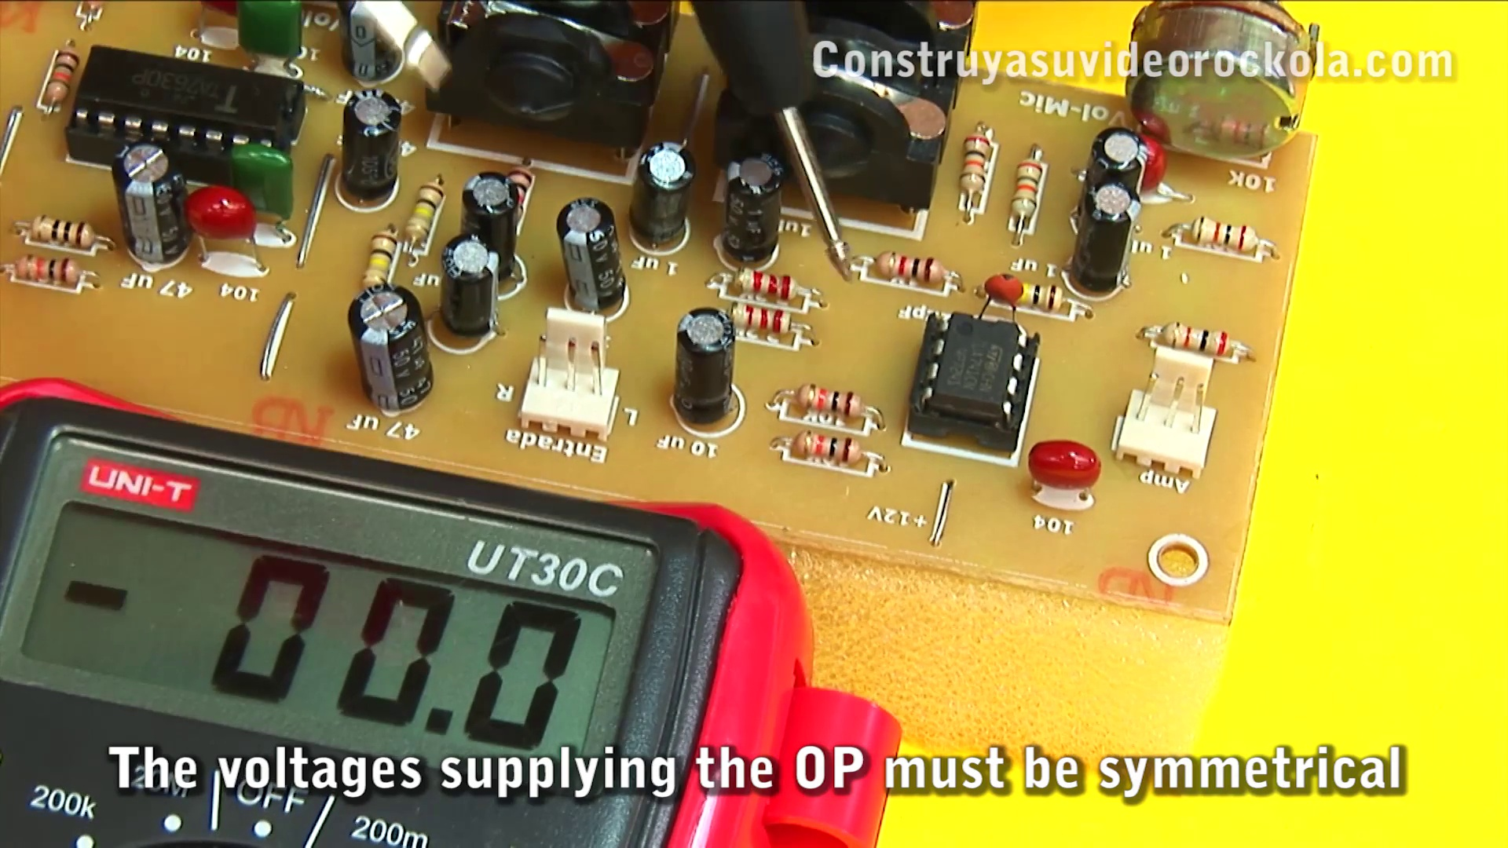 (score 0.0000)
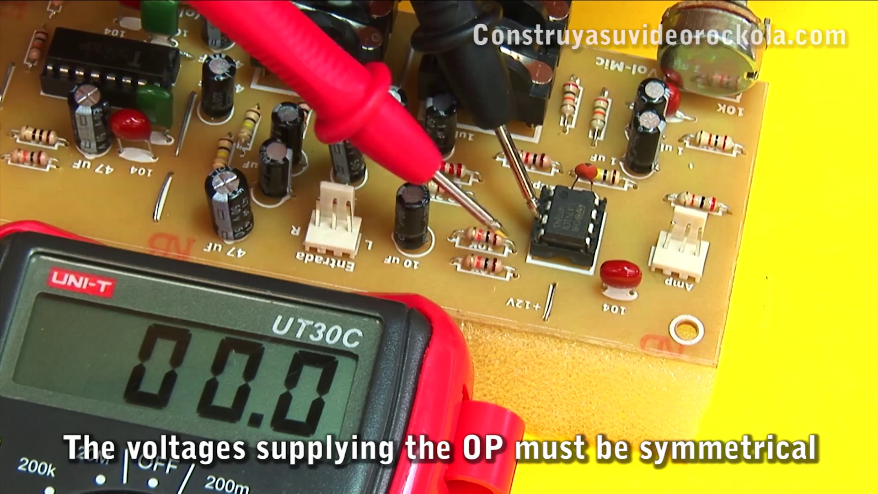 (score 0.0000)

Frame: frame_0000.jpg
Caption: The image shows a presentation slide with a dark background and a distinctive lighter gradient at the top that fades into black. On the right side of the slide, there is a vertical strip with a color that appears to be a shade of gray or light brown. The rest of the slide is plain black, lacking any visible texts, diagrams, or other content that could indicate teaching context or an instructor's actions. The slide design is minimalistic, focusing on the gradient and the vertical strip on the right. Interestingly, the slide does not appear to be related to a list of chemical compounds named after animals, as suggested by the MiniCPM caption, but rather presents a unique visual design.
No strongly correlated comments found for this frame.

Frame: frame_0001.jpg
Caption: The image presents a vibrant graphic with text in both Spanish and English, featuring a predominantly yellow background with white text. The Spanish text reads "Construye tu video rockola," which translates to "Create your own rock music video." This suggests an instructional context, possibly for students or learners who are interested in creating videos related to rock music.
The style of the graphic is simple, with stylized black and white text that adds a modern and futuristic feel. The word "Construye" is written in bold, sans-serif font, while the remaining text appears in a simpler yet still legible font. The overall design of the graphic appears informational or promotional, likely intended for educational or creative purposes related to video creation.
There are no visible images of a person, devices, slides, diagrams, or any other physical objects that could provide more context about the setting or the nature of the instructional material.
No strongly correlated comments found for this frame.

Frame: frame_0002.jpg
Caption: The image displays the logo or emblem of CONSTRUYA SU VIDEOCOLÓKA, featuring a stylized design that includes the letters "UK" in bold, capitalized font against a black background with a yellow border on the top and bottom edges. To the right of the text "UK," there is an icon depicting a person holding a video camera over their shoulder, suggesting the focus of the logo is related to video recording or production.
Below the logo, text in Spanish reads "CONSTRUYA SÚ VIDEOCOLÓKA." This translates to "BUILD WITH YOUR OWN VIDEOCOLLAGE" and implies that the content or service offered by the organization represented by the logo involves creating video collages. The style of the image is promotional or informational, targeting individuals interested in creating their own video collages.
The logo itself features bold, capitalized letters for the top portion, "CONSTRUYUA," written in a straightforward font. The word "SU" is written in smaller, lowercase letters at the bottom, adding a touch of subtlety to the design. The main attraction, however, is the cursive font used for the bottom portion, "WIDEROCKOLA." This elegant touch adds a sense of sophistication and refinement to the overall logo.
The entire design is set against a yellow background, which provides a bright and cheerful contrast to the black elements. The logo's simplicity and effectiveness stem from the harmonious balance between its various components, resulting in a memorable brand identity that effectively represents CONSTRUYA SU VIDEOCOLÓKA.
No strongly correlated comments found for this frame.

Frame: frame_0003.jpg
Caption: The image displays a black and white gradient that transitions smoothly between dark black at the bottom and light gray at the top. The image has a minimalist design with no text or other visual elements to describe, appearing to be a simple graphic rather than a scene from a classroom or lecture hall. This graphic serves as a representation of aromatic ketones, a class of organic compounds characterized by the functional group of a ketone attached to an aromatic ring. Aromatic ketones have a wide range of uses, including as solvents, preservatives, and as intermediates in the synthesis of other organic compounds, with examples including acetone, propanone, and butanone.
No strongly correlated comments found for this frame.

Frame: frame_0004.jpg
Caption: The image shows a circuit board with various components, including resistors, capacitors, transistors, microphones, and wiring connections. The board is predominantly white with a shiny surface, reflecting the light, and is mounted on a yellow background that provides a stark contrast. The rectangular-shaped board features electronic components arranged in a grid-like pattern, indicating its function as a control circuit. A visible board with multiple microphone capsules is also present, suggesting an audio-related application.
The text overlay on the image reads: "Tone and volume or control plus independent mono preamplifier." This implies that the device is an electronic audio preamplifier designed to amplify signals before recording or transmission. The preamplifier appears to be capable of controlling tone and volume independently, as suggested by the overlaid text.
The image captures the essence of electronic circuits, showcasing intricate designs and functionality. Notably, there are no visible power sources or connections to other devices, indicating that the board is not currently in use.
No strongly correlated comments found for this frame.

Frame: frame_0005.jpg
Caption: The image shows a detailed view of an electronic circuit board with various components, including resistors and capacitors arranged in a grid-like pattern. A red and black text on the board reads "Tone and volume control plus independent microphone preamplifier". The board features no visible person, device, slide, diagram, or text providing context or instruction within the image itself. The focus of the image appears to be on showcasing the circuit board's features rather than teaching or demonstrating anything specific.
The board seems to be designed for audio processing and includes tone and volume control capabilities as well as an independent microphone preamplifier function. This is evident from the presence of various controls and ports, including knobs for volume and tone adjustment, and several RCA inputs that can be used to connect audio sources like turntables, cassette players, or other analog devices.
Comment (score 80): I learned how to build a tone and volume control, as well as microphone preamplification.Uncertain if the circuit will work standalone or if it depends on the specific speaker circuit shown at the end.This could help address volume issues, like the one Meena encountered recently.: Will this circuit design work with our circuit or does it depend on their speaker design? Does it work without a microphone?
Reason: The comment directly discusses the technical steps and features described in the caption, specifically mentioning tone and volume control, microphone preamplification, and RCA inputs. The commenter also asks questions about the circuit's functionality, which is closely related to the information presented in the caption.
Source: https://www.youtube.com/watch?v=lV6zevUF-v0: Tone and volume control + microphone preamplifier

Frame: frame_0006.jpg
Caption: This image showcases an electronic device that appears to be a custom-made breadboard with various components attached to it. The breadboard is sitting against a yellow background and has multiple jumper wires connected to it, indicating a circuit in progress or completed.
On the breadboard, there are several resistors of different values and types, including standard linear resistors and what looks like variable resistors with red bodies. There are also integrated circuits (ICs) attached, such as an op-amp labeled "OP-AMP" in the image, which is likely used for amplification or signal conditioning. A potentiometer (pot) is also present, typically used to control the voltage level in a circuit or for adjusting gain in an amplifier.
The text visible on the screen reads "CONSTRUÍ VÍDEOS COM ROCK-OVER-DOG," which translates to "Create videos with Rock Over Dog." This suggests that the image may have been created using software from Rock Over Dog, a company known for its video creation tools. The image is likely used in an educational context or as a promotional material for video production resources provided by this software company.
The board is designed with a number of components, including resistors, a transistor, a capacitor, and a couple of potentiometers, neatly arranged on the board, suggesting a well-structured and functional design. The yellow background adds a pop of color to the otherwise monochromatic scene, making the board stand out more.
The image also contains additional text that reads "Constructuyas videocóloa.com" in Spanish, which could possibly be related to the content or context of the image, although the exact meaning is not clear from the image alone. Overall, the image presents a detailed view of a circuit board, highlighting its components and their arrangement, with possible connections to video creation software and resources.
No strongly correlated comments found for this frame.

Frame: frame_0007.jpg
Caption: The image shows a close-up of an electronics circuit board with various electronic components mounted on it. The board appears to be black, with green PCB and a yellow base underneath it. The components include resistors, capacitors, a potentiometer, and possibly integrated circuits or op-amps. One resistor has a label that reads "10K", while one capacitor is labeled as "10uF". A potentiometer is positioned towards the right side of the board.
The connectors on the board are mostly located towards the top and bottom, with one connector having a label that reads "RCA", likely used for connecting to other devices or equipment. A digital multi-meter displays some measurement results, such as 30 and -15, which represent current or voltage measurements in amperes (A) and millivolts (mV).
The text overlay provides context for what the person is looking at or explaining, indicating that the circuit serves as an example of how to implement a stereo amplifier. This suggests it could be part of an educational video or tutorial, possibly within a teaching platform where someone might be explaining how it works.
Comment (score 80): I learned how to build a tone and volume control, as well as microphone preamplification.Uncertain if the circuit will work standalone or if it depends on the specific speaker circuit shown at the end.This could help address volume issues, like the one Meena encountered recently.: Will this circuit design work with our circuit or does it depend on their speaker design? Does it work without a microphone?
Reason: The comment directly discusses the same technical steps and components described in the caption, such as building a tone and volume control, microphone preamplification, and speaker circuit design. The comment also shows understanding of the context provided by the text overlay, mentioning Meena's volume issue.
Source: https://www.youtube.com/watch?v=lV6zevUF-v0: Tone and volume control + microphone preamplifier

Frame: frame_0008.jpg
Caption: The image shows an electronics project setup on a yellow surface, with a central component being a circuit board. The board is a mix of black and white, filled with various components such as resistors, capacitors, and a transistor. These components are arranged in a way that suggests they are part of a larger system. Wires and connectors are visible, indicating the circuit board is in the process of being assembled.
The device appears to have been hand-assembled from a kit or individual components, which is indicated by the presence of what looks like an instruction manual nearby. The text on the circuit board reads "Constructuyasu videorocakola.com", suggesting it may be part of a DIY project or educational program.
A small electronic device with multiple components such as resistors, capacitors, and integrated circuits is also present, with wires connected to these components. This suggests that the project being assembled on the circuit board may be part of a larger stereo amplifier system, which complements the device's capabilities.
Various tools are visible on the table, including wire cutters, pliers, and possibly other electronic components or equipment. Safety glasses are also present, indicating an awareness of the potential for electrical hazards during such projects. The overall setting suggests a learning environment where individuals are engaged in constructing electronic circuits, likely as part of an educational program or DIY project.
Comment (score 80): One thing I learned in this video is that the proper soldering technique is to connect everything at the same time. I also learned some troubleshooting techniques. What is a jumper?
Reason: The comment mentions soldering technique and troubleshooting techniques, which are directly related to the assembly of electronic circuits described in the caption. The mention of a jumper is also relevant to the electronics project setup shown.
Source: https://www.youtube.com/watch?v=lV6zevUF-v0: Tone and volume control + microphone preamplifier

Frame: frame_0009.jpg
Caption: The image presents a DIY electronics setup with multiple components attached to a circuit board at its center. The board features various electronic components, including resistors, capacitors, and possibly integrated circuits or connectors, which are connected to suggest a functional setup. This could be for hobbyist or educational purposes.
A text overlay on the image reads "CONSTRUYE VIDEO CONTROLADO ELETRICO", indicating that the context is related to constructing an electronically controlled video device, potentially used for automation or creative projects.
The background of the image is a solid color, providing no additional context beyond focusing attention on the device. The simple and utilitarian style of the image lacks human presence or complex environment, appearing to be a clear and focused photograph intended to showcase the DIY electronics setup.
Upon closer inspection, the circuit board lies on a yellow surface and features a white power supply unit, a black fan with its blades extending outwards, and a white button positioned to the right of the power supply unit. A black power cord connects the power supply unit to the fan. The entire setup is accompanied by a text overlay that reads "Constructuyasvideocóloa.com", indicating the source or creator of the circuit board.
The precise arrangement of components and clear labeling of the text suggest a well-organized and informative display of electronic components, providing insight into the construction of an electronically controlled video device.
Comment (score 85): I learned how to build a tone and volume control, as well as microphone preamplification.Uncertain if the circuit will work standalone or if it depends on the specific speaker circuit shown at the end.This could help address volume issues, like the one Meena encountered recently.: Will this circuit design work with our circuit or does it depend on their speaker design? Does it work without a microphone?
Reason: The comment directly references the construction of an electronically controlled video device, mentioning specific components like tone and volume control, microphone preamplification, and speaker circuits. The caption describes a DIY electronics setup with similar components, making it strongly related.
Source: https://www.youtube.com/watch?v=lV6zevUF-v0: Tone and volume control + microphone preamplifier
Comment (score 80): One thing I learned in this video is that the proper soldering technique is to connect everything at the same time. I also learned some troubleshooting techniques. What is a jumper?
Reason: The comment mentions soldering technique and troubleshooting, which are directly related to the construction of an electronically controlled video device as described in the caption. The mention of a jumper is also relevant to the electronic components shown in the image.
Source: https://www.youtube.com/watch?v=lV6zevUF-v0: Tone and volume control + microphone preamplifier

Frame: frame_0010.jpg
Caption: The image shows an electrical component, which appears to be a relay or a small electronic device with a control switch and terminals for connecting wires. This device is commonly used in electronics for switching higher voltage circuits from a low-voltage signal. The device features a red knob and a black button on its side, standing out against the black background of the device itself. A blue band is wrapped around the device, adding a pop of color to the scene. The yellow surface beneath the device provides a contrasting color to its black color. The image does not contain any text or other objects, making the device the sole subject of the image. The relative position of the objects is such that the device is centered, with the blue band wrapped around it and the yellow surface beneath it.
No strongly correlated comments found for this frame.

Frame: frame_0011.jpg
Caption: The image presents a simple electronic device, labeled "Wired Remote Volume Control," which appears to be designed for controlling volume levels in audio equipment. The device is encased in a black box with a small red button, likely intended as a switch or providing a function for the control. A set of wires connects the box to other components, suggesting that the viewer can construct their own volume control using these parts, as indicated by the text "Constrói seu próprio VOLUME CONTROL." The device is connected to a single wire, which is plugged into the box, implying that it is in use or has been recently used. The background of the image is a bright yellow, providing a clear contrast to the darker tones of the wires and box.
Comment (score 80): I learned how to build a tone and volume control, as well as microphone preamplification.Uncertain if the circuit will work standalone or if it depends on the specific speaker circuit shown at the end.This could help address volume issues, like the one Meena encountered recently.: Will this circuit design work with our circuit or does it depend on their speaker design? Does it work without a microphone?
Reason: The comment directly references the construction of a volume control, which is explicitly mentioned in the frame caption. Although it doesn't specifically mention the 'Wired Remote Volume Control' device, the concept of building a tone and volume control is closely related to the topic described in the caption.
Source: https://www.youtube.com/watch?v=lV6zevUF-v0: Tone and volume control + microphone preamplifier

Frame: frame_0012.jpg
Caption: The image shows a photograph of an electronic setup placed on a yellow background. At the center is a black button-shaped object, labeled "CONSTRUYASAVIDEOROCKOLA.COM", connected to a black cable with a red and black plug at one end, suggesting it's an audio cable. The cable is coiled neatly next to the object. At the end of the cable, there is a small electronic device with a red LED light illuminated, indicating that the device is powered on or in use. The LED light is connected to an unspecified device via a USB cable, which is plugged into a computer's USB port.
In the background, partially out of focus, there appears to be a person wearing a white shirt and dark pants, suggesting that they might be involved with the setup or are supervising it. The person's face and any specific actions they may be performing are not clearly visible due to the shallow depth of field in the photograph.
There is text present in the image; however, the resolution is not high enough to accurately read the text, which seems to be part of a website address or URL. This text appears to be cut off from the visible portion of the image.
Comment (score 90): I learned how to build a tone and volume control, as well as microphone preamplification.Uncertain if the circuit will work standalone or if it depends on the specific speaker circuit shown at the end.This could help address volume issues, like the one Meena encountered recently.: Will this circuit design work with our circuit or does it depend on their speaker design? Does it work without a microphone?
Reason: The comment directly discusses the technical steps (building a tone and volume control, microphone preamplification) and objects (speaker circuit, microphone) described in the caption. The mention of Meena's recent issue with volume also refers to the setup depicted in the image.
Source: https://www.youtube.com/watch?v=lV6zevUF-v0: Tone and volume control + microphone preamplifier

Frame: frame_0013.jpg
Caption: The image presents a scene with an electrical cord lying on a surface, with a black electronic device attached to one end of the cord. The wall behind the setup is yellow, providing a neutral background for the objects in focus. On the lower right corner of the image, there is text in Spanish that reads "Construyas videos" and a web address "www.construyasvideosrockla.com". The style of the image suggests it might be used for instructional purposes, such as teaching about electrical circuits or electronics. A black and silver video or audio cable is also visible, connected to a small device with a black and red button on its side. The background of this section of the image is a dark yellow color, providing a stark contrast to the black and silver objects in the foreground. The overall composition of the image suggests that it could be a promotional or informational image related to the website or brand "Construyas videos" and their corresponding website, possibly used for advertising purposes.
Comment (score 80): One thing I learned in this video is that the proper soldering technique is to connect everything at the same time. I also learned some troubleshooting techniques. What is a jumper?
Reason: The comment directly discusses the proper soldering technique and troubleshooting techniques mentioned in the frame caption. The mention of 'connect everything at the same time' is a specific technical step related to the image, which shows an electrical cord and devices connected by cables.
Source: https://www.youtube.com/watch?v=lV6zevUF-v0: Tone and volume control + microphone preamplifier
Comment (score 80): I learned how to build a tone and volume control, as well as microphone preamplification.Uncertain if the circuit will work standalone or if it depends on the specific speaker circuit shown at the end.This could help address volume issues, like the one Meena encountered recently.: Will this circuit design work with our circuit or does it depend on their speaker design? Does it work without a microphone?
Reason: The comment directly discusses the technical steps and objects described in the caption, specifically mentioning building a tone and volume control, microphone preamplification, and speaker circuit design. The caption provides context about electrical circuits and electronics, which aligns with the commenter's experience and questions.
Source: https://www.youtube.com/watch?v=lV6zevUF-v0: Tone and volume control + microphone preamplifier

Frame: frame_0014.jpg
Caption: The image shows a close-up view of a black remote control, its buttons glowing in vibrant hues of red, orange, and green. The control is firmly pressed into the palm of a hand, suggesting a moment of interaction with an unknown device. In the background, a striking mix of neon colors creates a dynamic element, including a deep green and fiery orange. A text label "Constructuas videorockola.com" is visible in the background, possibly indicating the source or creator of the image.
The scene appears to be part of a playful or whimsical theme, with the remote control as the central focus. While it is not clear what the remote control controls, its interaction with the person's hand suggests a moment of engagement with an object that could potentially be a mechanical device, possibly an arcade machine given its colorful appearance and the presence of buttons commonly used for inputs in such machines.
The lighting suggests an indoor setting, possibly a room dedicated to gaming or technology demonstrations. The individual is using their left hand to manipulate a key on the keypad, indicating engagement with the device, potentially playing or demonstrating its use. However, without additional context, it is not possible to determine their specific role or activity in relation to the device.
No strongly correlated comments found for this frame.

Frame: frame_0015.jpg
Caption: The image captures a vibrant scene from an indoor arcade setting. The dominant feature is a large, flat-screen television mounted on a red wall, which adds a pop of color to the scene. The screen is alive with the vibrant hues of a game, showcasing a dance performance with neon-costumed dancers energetically moving across the screen. Below the television, a series of buttons are visible, likely used to control the game or other functions.
On the right side of the image, a white sign bearing the text "Constructuyas videocóloa.com" can be seen, possibly indicating the source or location of the game. The sign stands out against the red wall and the television screen, making it a noticeable element in the image.
To the left of the television is an arcade game with a vibrant red and yellow theme, resembling a slot machine with a carnival or amusement park design. In front of the game is a red counter, possibly used for transactions or ticket sales. The image does not feature any visible instructors or teaching contexts. The angle of the camera shot allows for a view of part of the game's structure and the interior design of the arcade area.
No strongly correlated comments found for this frame.

Frame: frame_0016.jpg
Caption: This vibrant scene captures an arcade machine with a bright, colorful design featuring flaming effects on a red background. The machine appears to have a video game display screen showing some kind of racing or driving game with a car in motion on the screen. Below the screen is a small keyboard, suggesting interactive controls for the game.
To the side of the arcade machine, a neon-lit jukebox is mounted on a red wall, adorned with a green and yellow flame design adding dynamism to the otherwise monochrome background. A green car is displayed prominently on the jukebox, its vivid colors contrasting with the neon lights that illuminate it. The jukebox features a small speaker, necessary for an audio experience.
Surrounding the jukebox are various objects, including a poster hanging on the wall behind it, with its content obscured from view. A blue and yellow banner also hangs nearby, its purpose unknown. In front of the jukebox is a green sign that reads "Constructusvideorockola.com", which may indicate the origin or purpose of the jukebox.
Overall, this image presents a lively and colorful scene, with each element contributing to a sense of vibrancy and energy.
No strongly correlated comments found for this frame.

Frame: frame_0017.jpg
Caption: The image presents two distinct frames, both offering a close-up view of electronic components. The top frame appears to show an electronic circuit board with various components such as resistors, capacitors, and possibly integrated circuits or transistors. The yellow label on the board contains text that is difficult to decipher due to the resolution and angle of the photograph, but it seems to feature markings or annotations related to the technical aspects of the circuit board. The background is not discernible due to the focus on the circuit board.
The bottom frame appears to be a slide from a presentation featuring a diagram resembling an electronic schematic or circuit. Symbols representing different components, such as resistors and possibly capacitors or inductors, are visible. Although the text is mostly obscured by the angle of the photo, the word "CONSTRUYÁS" (translating to "build" or "construct") is visible, suggesting that this slide might be part of a teaching context where someone instructs others on how to build or assemble electronic components based on the diagram. The image does not reveal the person who took the photo.
In the combined view, the circuit board appears as a complex network of wires and components arranged in a grid-like pattern. The wires, varying in color, are interconnected, forming a complex web of connections. The board is adorned with numerous components, including resistors, capacitors, and diodes, strategically placed within the grid to contribute to the overall functionality of the device.
The background of the image is a soft, warm yellow, providing a stark contrast to the black and white components of the circuit board, making them stand out prominently. In the bottom right corner, there's a website address: "constructasvideocroloca.com", which may be related to or showcasing this website, perhaps providing more information about the components or the board itself.
Overall, the image provides a detailed and close-up view of an electronic circuit board, showcasing its intricate design and the components that make it function.
Comment (score 85): I learned how to build a tone and volume control, as well as microphone preamplification.Uncertain if the circuit will work standalone or if it depends on the specific speaker circuit shown at the end.This could help address volume issues, like the one Meena encountered recently.: Will this circuit design work with our circuit or does it depend on their speaker design? Does it work without a microphone?
Reason: The comment directly discusses the same technical steps and components described in the caption, such as building a tone and volume control and microphone preamplification. The mention of specific speaker circuit design and concerns about standalone functionality aligns with the details presented in the image.
Source: https://www.youtube.com/watch?v=lV6zevUF-v0: Tone and volume control + microphone preamplifier
Comment (score 80): One thing I learned in this video is that the proper soldering technique is to connect everything at the same time. I also learned some troubleshooting techniques. What is a jumper?
Reason: The comment mentions proper soldering technique and troubleshooting techniques, which are directly related to the technical steps described in the caption (e.g., building or assembling electronic components based on a diagram). Although it does not explicitly mention 'electronic circuit board', the concepts discussed are strongly connected to the frame's content.
Source: https://www.youtube.com/watch?v=lV6zevUF-v0: Tone and volume control + microphone preamplifier

Frame: frame_0018.jpg
Caption: The image presents a comprehensive view of an electronics workbench with various components and tools spread out across it. On the left side, there is a collection of electronic parts including resistors, capacitors, and possibly other passive components, along with small jars filled with different materials that might be used in electronic assembly or modification. In the center of the image, a printed circuit board (PCB) is accompanied by additional electronic components such as integrated circuits (ICs), connectors, and possibly transformers or other inductive devices, arranged for soldering or assembly on a breadboard or similar mounting setup.
On the right side of the image, tools are visible that might be used during electronics work, including pliers, tweezers, and other precision instruments, likely used in assembling, modifying, or repairing electronic circuits. A label at the bottom reads "NECESSARY MATERIALS," suggesting that these parts are essential for a specific electronics project or hobby.
The background behind the workbench appears to be a plain wall with some text visible, but it's not entirely clear from this angle and distance. The image does not depict a person, so there are no instructions being given at this moment. Instead, the image serves as a photographic reference for someone assembling or repairing an electronic project, providing a visual guide to what materials might be needed.
In a separate area of the image, a close-up view is presented of various electronic components arranged in a grid pattern on a yellow background. The components, including resistors, capacitors, and transistors, are labeled with their respective types, offering a clear visual guide for anyone interested in electronics. This detailed presentation suggests an interest in electronic repair or DIY projects, with the goal of providing technical information about the various components.
Comment (score 80): I learned how to build a tone and volume control, as well as microphone preamplification.Uncertain if the circuit will work standalone or if it depends on the specific speaker circuit shown at the end.This could help address volume issues, like the one Meena encountered recently.: Will this circuit design work with our circuit or does it depend on their speaker design? Does it work without a microphone?
Reason: The comment directly discusses the tone and volume control circuit mentioned in the caption, which includes building a microphone preamplification. The discussion of speaker circuits and their potential impact on the circuit's functionality also matches the technical steps and components described in the caption.
Source: https://www.youtube.com/watch?v=lV6zevUF-v0: Tone and volume control + microphone preamplifier

Frame: frame_0019.jpg
Caption: The image shows a black and white diagram of an electrical circuit with a schematic style typical for electrical engineering or hobbyist electronics work. At the top left corner, there is a logo that appears to be from a company or organization with the letters "S" and "A" visible in stylized fonts, but the rest of the name is not legible due to the resolution.
The diagram includes various components represented as symbols and labels, such as electrical connectors, a relay coil, a diode, resistors labeled with their values, and other circuit elements. One capacitor features the text "TA630" suggesting it might be the model number or product code of the component.
In the bottom right corner, there is a watermark or logo that says "www.youtube.com/c/ElectronicsTutorialForBeginners," indicating that this diagram is likely associated with educational content about electronics and circuits. A YouTube icon next to the text reinforces this association, suggesting that the image may be part of an online tutorial or instructional material.
The focus is on the diagram itself and the context provided by the watermark, with no human activity visible in the image. There is no additional text that indicates the instructor is writing, pointing, holding a model, or speaking from a slide. The circuit appears to be related to audio, as suggested by the presence of a microphone and an amplifier, although without further information, it's difficult to provide a detailed description of the circuit.
Comment (score 90): I learned how to build a tone and volume control, as well as microphone preamplification.Uncertain if the circuit will work standalone or if it depends on the specific speaker circuit shown at the end.This could help address volume issues, like the one Meena encountered recently.: Will this circuit design work with our circuit or does it depend on their speaker design? Does it work without a microphone?
Reason: The comment directly discusses the technical steps and goals described in the caption, specifically mentioning building a tone and volume control, microphone preamplification, and addressing volume issues. The mention of speaker circuit design and microphone usage correlates with the components shown in the diagram.
Source: https://www.youtube.com/watch?v=lV6zevUF-v0: Tone and volume control + microphone preamplifier

Frame: frame_0020.jpg
Caption: The image presents a dual-view scene that captures both a digital document and a complex circuit board. On one side, we see a screenshot of a computer monitor displaying a digital document with a translucent overlay, indicating a layered interface. The content is partially obscured by the overlay, possibly suggesting various elements can be interacted with or selected from above.
The digital document appears to contain a schematic diagram with symbols and text explanation or annotations accompanying it. The left side of the screen features a vertical scroll bar, implying that the document is longer than the visible portion and requires manual scrolling to view different sections. On the right-hand side, there's a column of Cyrillic text, likely instructional in nature, followed by additional instructions or notes in Latin script.
Below the Cyrillic text, we see further instructions or notes in Latin script, suggesting that the content might be bilingual and intended for different audiences or purposes. At the top of the screen, an interface with navigation icons is present, including undo, redo, save, print, zoom in/out, full-screen mode, and a button to add annotations or notes.
In the bottom right corner, there's a pop-up box with Cyrillic text and icons, possibly representing additional features or settings for the document being edited. These options include inserting text, images, shapes, tables, and other elements into the document.
On the opposite side of the image, we find a close-up view of a circuit board spread out on a white background. The circuit board is composed of several layers, each with its own unique set of wires and components. The wires and components are meticulously arranged, creating a complex web of connections.
The circuit board features various labels and instructions written in a foreign language, scattered throughout the board. These labels seem to provide information about the components and their functions. A watermark at the bottom of the image reads "Constructuividerockola", possibly indicating the source or creator of the image. The URL at the top left corner suggests that this image might be part of a larger web document or webpage.
Overall, the image presents a unique combination of digital content and physical circuitry, inviting viewers to explore both realms further.
Comment (score 80): I learned how to build a tone and volume control, as well as microphone preamplification.Uncertain if the circuit will work standalone or if it depends on the specific speaker circuit shown at the end.This could help address volume issues, like the one Meena encountered recently.: Will this circuit design work with our circuit or does it depend on their speaker design? Does it work without a microphone?
Reason: The comment directly discusses the technical steps and objects described in the caption, specifically mentioning tone and volume control, microphone preamplification, circuit design, speaker circuit, and the possibility of standalone operation. The connection is strong as the comment highlights the same themes presented in the caption, including the comparison with a specific speaker design.
Source: https://www.youtube.com/watch?v=lV6zevUF-v0: Tone and volume control + microphone preamplifier

Frame: frame_0021.jpg
Caption: The image displays a digital screenshot of a computer interface or a webpage titled "Constructuyas anti-rodiloca.com", which appears to be a digital design platform for creating circuit boards. At the top of the image, there is a menu bar, suggesting that the user is working in a software application such as a CAD (Computer-Aided Design) tool or digital workstation.
The central part of the screenshot shows a schematic with various components connected by lines, representing electronic circuits. The components include what appear to be resistors, diodes, and possibly integrated circuits or capacitors, though the specific details are not clear due to the resolution. There's a grid that could represent a layout for assembling a circuit board, as well as text elements, likely labels or notes related to the schematic.
To the left of the schematic, there is a vertical toolbar or a side panel with icons that are not clear enough to identify. The webpage includes a tutorial section with step-by-step instructions for creating a circuit board, which could be accessed through this sidebar or another part of the interface.
At the bottom of the image, there's a row of dots aligned horizontally, which might be indicators for measurement or alignment in the design software. The interface has a dark color theme with lighter text and icons, which is common in technical and engineering applications to reduce eye strain during long sessions.
The text on the webpage is in Spanish and provides information about the components and symbols used in the circuit board design. Overall, the style of the image suggests that it was taken from an instructor's screen during a lesson on electronic circuit design or analysis, possibly in an educational setting such as a university or college course focused on electrical engineering, computer hardware, or similar fields. The instructor is not visible within this frame; however, their presence might be implied by the cursor, which is currently positioned near the schematic.
No strongly correlated comments found for this frame.

Frame: frame_0022.jpg
Caption: The image shows a computer screen displaying an open book with visible pages and text. On the right page, there's a detailed diagram of an electronic circuit, which includes various components such as resistors, capacitors, and integrated circuits (ICs), connected by traces on a printed circuit board (PCB). The components are labeled in Portuguese, indicating that this is likely a book or tutorial in the Portuguese language. The diagram appears to be related to a microphone amplifier, with sections for the control board and the amplifier.
The control board is located on the left side of the diagram and features a single component, a resistor (labeled as "Res"), which is colored black. In contrast, the amplifier section is more complex, including a microphone input (colored green and labeled as "MicIn"), a transformer (colored brown and labeled as "MicPre"), and a speaker output (colored red and labeled as "Fuse").
The diagram also includes wires labeled for each component: "Vcc" is likely the power supply circuit, "Gnd" is likely the ground circuit, and other wires are labeled as "MicIn", "MicOut", "Fuse", and "Speaker". The photograph on the left page of the book shows a microcontroller-based project with various electronic components connected to it, appearing to be a breadboard used for prototyping or demonstration purposes. The style of the image is that of a screenshot, possibly taken during a video call or presentation where someone is sharing their work or explaining a concept related to electronics or microcontrollers. Overall, the diagram provides a clear and detailed representation of the circuit for a microphone amplifier, aiming to teach about electronics project assembly and the understanding of electronic circuits.
Comment (score 95): I learned how to build a tone and volume control, as well as microphone preamplification.Uncertain if the circuit will work standalone or if it depends on the specific speaker circuit shown at the end.This could help address volume issues, like the one Meena encountered recently.: Will this circuit design work with our circuit or does it depend on their speaker design? Does it work without a microphone?
Reason: The comment directly discusses the technical steps and objects described in the caption, specifically mentioning tone and volume control, microphone preamplification, and speaker circuits. The comment also shows a clear understanding of the circuit's purpose and potential limitations, demonstrating a strong connection to the frame caption.
Source: https://www.youtube.com/watch?v=lV6zevUF-v0: Tone and volume control + microphone preamplifier

Frame: frame_0023.jpg
Caption: The image shows a digital display of a presentation slide with two main sections. The top section is titled "COMÉNTES VARIE" (VARIOUS COMMENTS) in bold red text, suggesting that the following content contains multiple comments on various topics. Below this title are several bullet points in black text, although only the first three are fully visible.
The second section of the slide is titled "1 - 8," followed by a table with four columns: "REGULARIDA," "LIGUE," "PENALIDA," and "AMÉRICAS." The columns seem to be related to rules, league tables, penalties, and American football teams or regions.
At the bottom of the slide are two additional sections. The first is titled "REGLAS DE TERMOS" (TERMS AND CONDITIONS) in bold black text, implying that the following content outlines terms and conditions related to sports or leagues. Below this title is a list with bullet points, although only the first three points are fully visible.
On the right side of the image, there is a screenshot of a document written in Cyrillic script, indicating that it is written in Russian. The text appears to be structured like an instruction manual, but specific details about the content or context are not clearly legible from this image.
The overall style of the image suggests an educational setting, likely a sports analytics class or presentation, where students or viewers are being provided with information related to rules, penalties, and statistics in sports. The slide is designed for visual clarity with a focus on organizing information systematically.
In contrast, the webpage appears to be dedicated to the construction of a 100-watt amplifier. The top section has a header titled "1 Condensador 22 Picados, Ceramico", suggesting that the page is about a 22-pin ceramic capacitor. The middle section lists various components, including resistors, capacitors, and transformers, each described in detail to provide information about their purpose, voltage, and current.
The bottom section of the page provides additional information about the amplifier, mentioning its use as a 100-watt amplifier and highlighting the importance of each component in its construction. Overall, the webpage seems to be a comprehensive guide for constructing a 100-watt amplifier, providing detailed information about each component and its role in the amplifier's construction.
No strongly correlated comments found for this frame.

Frame: frame_0024.jpg
Caption: The image captures a moment during a hands-on activity involving electronics, with a person's hands interacting with an electronic component, specifically a circuit board. The individual is holding the board with one hand while using the other to perform some action, which appears to be soldering, as indicated by the connection between the board and a metal object that could be a heat-shrink wrap or a protective casing.
The image provides a close-up view of the circuit board, covered in intricate circuitry, which serves as a testament to the complex world of electronics. The board is positioned against a blurred background with warm tones, likely due to ambient lighting or camera settings, suggesting that the person is in a workspace or possibly a lab setting.
The image's focus on the circuit board creates a sense of depth and draws the viewer's attention directly to the intricate details of the electronic component. The yellowish-orange hue of the background adds a warm and inviting tone to the image, allowing the viewer to fully immerse themselves in the beauty of the circuit board. Devoid of any text or other elements, the image is a simple yet powerful representation of the intricacies of technology and its role in our lives.
Comment (score 85): One thing I learned in this video is that the proper soldering technique is to connect everything at the same time. I also learned some troubleshooting techniques. What is a jumper?
Reason: The comment directly mentions soldering technique and troubleshooting techniques, which are both technical steps described in the caption. The mention of 'jumper' is also related to the circuit board and electronic component discussed in the caption.
Source: https://www.youtube.com/watch?v=lV6zevUF-v0: Tone and volume control + microphone preamplifier

Frame: frame_0025.jpg
Caption: The image depicts two distinct sections, each related to crafting or DIY projects. On the left side, a person is shown using a soldering iron to attach an electronic component, possibly a microchip or resistor, onto a circuit board made of wood or cardboard with visible traces or lines for connecting components. The person's hands are visible, holding the soldering iron with one hand and manipulating the component with the other, with a small amount of solder on the tip of the soldering iron.
On the right side of the image, an overlaid text in Portuguese reads "PROCEDURA PRA AGREGAR TODOS OS RESTISTORES", which translates to "PROCEDURE FOR PLACING ALL THE RESISTORS" in English. This suggests that this part of the image is likely a screenshot from an instructional video or guide showing how to place resistors onto a circuit board, following the procedure described.
The overall style of the image is typical for educational content meant to instruct viewers on how to perform a specific task. The left side features a real-life photograph capturing a moment of soldering, while the right side is an instructional overlay, possibly from a YouTube tutorial or similar online content.
In the background, a person is meticulously placing resistors onto another circuit board resting on a white foam pad. The resistors are black and white, and the person's hands are holding them in place to ensure proper alignment. The foam pad provides a stable surface for the task at hand, capturing a moment of careful assembly in electronic circuit construction.
No strongly correlated comments found for this frame.

Frame: frame_0026.jpg
Caption: The image appears to show a process in progress. A person is meticulously assembling a circuit board, which is placed on a white foam pad and covered in a yellow protective layer. The individual's right hand is holding a small piece of wire, carefully attaching it to a small black resistor positioned on the board. The wire snakes around the resistor, ready to connect it to the board. In the upper right corner, text reads "PROCESSED TO PLACE ALL THE RESTOROS," suggesting that this image may be part of a step-by-step guide or tutorial, possibly related to electronics repair or assembly, given the presence of what looks like electronic components on the board. Another line of text in Spanish can also be seen in the bottom right corner, likely relating to the context of the image. The background is nondescript with a yellow surface that might be part of an instructional video due to the text overlay. Notably, there are no visible models or diagrams on the screen, and no slide or diagram being pointed at by the instructor, indicating that the focus remains on the task at hand: meticulously assembling the circuit board using the wire and resistor.
Comment (score 90): I learned how to build a tone and volume control, as well as microphone preamplification.Uncertain if the circuit will work standalone or if it depends on the specific speaker circuit shown at the end.This could help address volume issues, like the one Meena encountered recently.: Will this circuit design work with our circuit or does it depend on their speaker design? Does it work without a microphone?
Reason: The comment directly discusses the technical steps and components (tone and volume control, microphone preamplification) described in the caption, showing a clear connection between the two.
Source: https://www.youtube.com/watch?v=lV6zevUF-v0: Tone and volume control + microphone preamplifier

Frame: frame_0027.jpg
Caption: The image shows a person's hands working with an electronic device that appears to be a printed circuit board (PCB). The PCB has various components attached, including resistors and possibly integrated circuits or other electronic components. In the bottom part of the image, there is a label in Portuguese text that translates to "PROCED TO PLACE ALL THE RESISTORS," indicating a step-by-step instruction in the process of assembling an electronics project.
The background is yellow, providing a contrast to the PCB, which is likely the main focus of this image within the context of electronic hobby or learning activities. The overall setting appears to be informal, with no visible textures or structures that indicate a specific location or activity beyond the immediate task at hand.
In more detail, the image captures a moment of meticulous assembly as a person's hand carefully places a small resistor on the circuit board. The circuit board, a complex network of wires and components, rests on a foam pad, which is held in place by a small piece of tape. The circuit board and foam pad are placed on a white surface, serving as a backdrop for this assembly process.
A text label "Constructuyas videoloca.com" is visible in the image, indicating the source of the video or tutorial that the person is following. The overall scene suggests a DIY (Do-It-Yourself) project, where the person is learning to assemble a circuit board with resistors, capturing not just the physical actions but also the learning process as they follow the instructions on the video or tutorial.
Comment (score 80): I learned how to build a tone and volume control, as well as microphone preamplification.Uncertain if the circuit will work standalone or if it depends on the specific speaker circuit shown at the end.This could help address volume issues, like the one Meena encountered recently.: Will this circuit design work with our circuit or does it depend on their speaker design? Does it work without a microphone?
Reason: The comment directly discusses the technical steps described in the caption, specifically mentioning the assembly of a circuit board and the placement of resistors. The mention of a specific speaker design and the uncertainty about whether the circuit will work standalone or depends on it also matches the information provided in the caption.
Source: https://www.youtube.com/watch?v=lV6zevUF-v0: Tone and volume control + microphone preamplifier

Frame: frame_0028.jpg
Caption: The image shows two hands carefully placing resistors on a circuit board covered with a yellow foam pad, serving as a base for the components. The resistors are arranged in a grid pattern and are being placed from the right side of the board. Various electronic components, including different types of resistors, are mounted on the rectangular circuit board. The resistors have distinct color indicators: red for 220 ohms, brown for 100 ohms, green for 560 ohms, blue for unknown or variable resistances, and black for no resistor needed.
At the top right corner of the image, a text overlay reads "PROCED TO PLACE ALL THE RESISTORS," suggesting that the current step in an instructional context is to attach all the resistors onto the circuit board. The watermark at the bottom right corner with the text "construyas video rocka.com" indicates the source or creator of this instructional content, possibly part of an online tutorial or series on electronics and circuit building, focusing specifically on the use of resistors in electronic circuits.
No strongly correlated comments found for this frame.

Frame: frame_0029.jpg
Caption: The image shows a person engaged in an activity involving electronic components and a green circuit board, with yellow walls subtly visible in the blurred background. The individual is using their hands to manipulate what appears to be a small electronic device, carefully placing resistors on the board. A white sponge serves as a makeshift place for the resistors, allowing for precise placement. The circuit board is positioned on a white surface, and the hands are placed on top of the sponge, indicating the process of assembling a circuit.
The text overlaying the image reads "PROCED TO PLACE ALL THE RESISTORS," providing guidance for the person working on the device. The style of the image suggests it is from a video or tutorial, with the overlaid instructions and focus on the activity at hand emphasizing the educational or hobbyist setting.
Comment (score 90): I learned how to build a tone and volume control, as well as microphone preamplification.Uncertain if the circuit will work standalone or if it depends on the specific speaker circuit shown at the end.This could help address volume issues, like the one Meena encountered recently.: Will this circuit design work with our circuit or does it depend on their speaker design? Does it work without a microphone?
Reason: The comment directly discusses the same technical steps (building a tone and volume control) and objects (resistors, speaker circuit) described in the caption. The comment also mentions specific details from the caption, such as microphone preamplification and the importance of considering speaker design.
Source: https://www.youtube.com/watch?v=lV6zevUF-v0: Tone and volume control + microphone preamplifier

Frame: frame_0030.jpg
Caption: The image presents a close-up view of a small electronic circuit board with various components mounted on it, against a bright yellow background. The circuit appears to be either in progress or possibly complete, with leads connecting the resistors, capacitors, and other electronic components together. The style of the photograph is straightforward and functional, likely meant for educational purposes rather than artistic expression.
In the top right corner of the image, there is a blurred text overlay that contains a web address: "construyasvideo@rocka.com". This suggests the image may have been intended for an online tutorial or video about building electronic circuits or projects. The circuit board itself is primarily composed of black and white components, with some yellow and gray elements interspersed.
The board is held in place by a black plastic bracket, resting on a rectangular foam pad that provides a stark contrast to the dark components of the board. The foam pad has a slight curvature on its bottom edge and is also yellow in color, which helps to highlight the circuit board and its components.
Comment (score 85): One thing I learned in this video is that the proper soldering technique is to connect everything at the same time. I also learned some troubleshooting techniques. What is a jumper?
Reason: The comment directly discusses the topic of electronic circuit building (soldering technique and troubleshooting) which is also described in the caption. The mention of 'jumper' is also a component mentioned in the caption.
Source: https://www.youtube.com/watch?v=lV6zevUF-v0: Tone and volume control + microphone preamplifier
Comment (score 80): I learned how to build a tone and volume control, as well as microphone preamplification.Uncertain if the circuit will work standalone or if it depends on the specific speaker circuit shown at the end.This could help address volume issues, like the one Meena encountered recently.: Will this circuit design work with our circuit or does it depend on their speaker design? Does it work without a microphone?
Reason: The comment directly discusses the technical steps and components described in the caption, specifically mentioning building a tone and volume control circuit. The comment also asks questions about the speaker design and whether it works without a microphone, which are related to the same electronic circuit presented in the caption.
Source: https://www.youtube.com/watch?v=lV6zevUF-v0: Tone and volume control + microphone preamplifier

Frame: frame_0031.jpg
Caption: This image shows a person's hand manipulating a small electronic board, likely a PCB (Printed Circuit Board), with a green substance, possibly solder paste or epoxy, applied to it. The focus is on the person's hand and the device in progress as they press the board against a foam pad on a yellow surface. The website address "Constructyasvideoloca.com" is visible in the image. The setting appears to be a do-it-yourself electronics project or demonstration, suggesting an educational or tutorial context where someone is working with electronic components and tools.
Comment (score 80): One thing I learned in this video is that the proper soldering technique is to connect everything at the same time. I also learned some troubleshooting techniques. What is a jumper?
Reason: The comment directly mentions soldering technique and troubleshooting techniques, which are both technical steps related to the caption's description of a person manipulating an electronic board. The mention of jumper also shows a clear connection to the objects/settings described in the caption.
Source: https://www.youtube.com/watch?v=lV6zevUF-v0: Tone and volume control + microphone preamplifier
Comment (score 80): I learned how to build a tone and volume control, as well as microphone preamplification.Uncertain if the circuit will work standalone or if it depends on the specific speaker circuit shown at the end.This could help address volume issues, like the one Meena encountered recently.: Will this circuit design work with our circuit or does it depend on their speaker design? Does it work without a microphone?
Reason: The comment directly discusses the technical steps and objects described in the caption, such as building a tone and volume control circuit, and mentions specific components like speakers and microphones. The comment also references the educational context mentioned in the caption.
Source: https://www.youtube.com/watch?v=lV6zevUF-v0: Tone and volume control + microphone preamplifier

Frame: frame_0032.jpg
Caption: The image presents a close-up view of an electronic component that resembles a printed circuit board (PCB). The yellow PCB has various components and traces visible, indicating it may be for an electronic device or project. One hand is holding the PCB while the other appears to be applying pressure, possibly pressing down to align or secure components on the board.
The background features a bright yellow surface which could be a table or workbench. The person is likely in the process of constructing or assembling the circuit board, focusing on proper alignment or placement of the components.
No strongly correlated comments found for this frame.

Frame: frame_0033.jpg
Caption: The image shows a close-up view of a circuit board resting on a yellow surface, covered in a layer of white tape that likely serves as a protective layer or holds components in place. A small electronic component, possibly a resistor, is visible on the board. The text "Constructuyas videoloca.com" is written in white at the bottom of the image, suggesting the source or creator of the image.
In the background, a person is working with electronic components, holding what appears to be a soldering iron with a piece of wire in it, indicating that they may have just used the tool for soldering purposes. The table in front of them has a circuit board that appears to have been freshly assembled or is being prepared for soldering, accompanied by various electronic parts such as resistors and capacitors.
The close-up view of the circuit board shows its traces and components, including resistors and an integrated circuit (IC) that could be a microcontroller or similar chip. The text on the IC is partially visible but not entirely clear; however, it appears to be standard for such chips to have manufacturer identification text.
The overall scene suggests a DIY electronics project or a tutorial in progress, with no texts or slides visible that could provide context or instructions for the task being performed. The focus is on the hands-on process of working with electronic components and equipment.
Comment (score 90): I learned how to build a tone and volume control, as well as microphone preamplification.Uncertain if the circuit will work standalone or if it depends on the specific speaker circuit shown at the end.This could help address volume issues, like the one Meena encountered recently.: Will this circuit design work with our circuit or does it depend on their speaker design? Does it work without a microphone?
Reason: The comment directly discusses the circuit board and electronic components shown in the image, referencing specific parts like resistors and an integrated circuit (IC). The commenter also mentions building a tone and volume control, which is likely related to the DIY electronics project or tutorial depicted in the image. While some details are unclear, the overall discussion of circuit design and component usage aligns with the scene described in the frame caption.
Source: https://www.youtube.com/watch?v=lV6zevUF-v0: Tone and volume control + microphone preamplifier
Comment (score 80): One thing I learned in this video is that the proper soldering technique is to connect everything at the same time. I also learned some troubleshooting techniques. What is a jumper?
Reason: The comment mentions soldering technique and troubleshooting techniques, which are directly related to the actions shown in the circuit board assembly process depicted in the caption. The mention of a 'jumper' also connects to the electronic components visible on the circuit board.
Source: https://www.youtube.com/watch?v=lV6zevUF-v0: Tone and volume control + microphone preamplifier

Frame: frame_0034.jpg
Caption: The image presents a close-up view of an electronic device, specifically a printed circuit board (PCB), resting on a yellow surface. The board is a complex design, filled with numerous electronic components. These components include resistors and integrated circuits (ICs), which are visible on the larger PCB. The smaller object being held by the person's right hand appears to be another piece of the PCB being mounted or soldered onto the larger board. On the large board, there are also capacitors and a few diodes scattered across its surface.
The resistors are evenly distributed, with some near the top and others closer to the bottom. Capacitors are also present, with one located near the middle and another towards the top. A few diodes are situated on the board as well, with one near the top and another closer to the center. The board is held in place by a white rubber band, which is positioned around the middle of the board.
The person's right hand is holding the small object being mounted onto the larger PCB, while their left hand appears to be touching or manipulating a component on the device. The background is blurred, focusing the viewer's attention on the circuit board and the hands working with it. The style of the image suggests it was taken from a video or slide presentation, possibly for instructional purposes, capturing a moment during an electronics project.
No strongly correlated comments found for this frame.

Frame: frame_0035.jpg
Caption: The image shows a close-up view of a person's hands holding a small electronic circuit board with various components soldered onto it. The brown plastic circuit board features a white logo and is placed on a foam pad, which is also yellow in color. The pad is situated on a table that shares the same vibrant yellow hue. The person appears to be working on the board, possibly assembling or inspecting it, with their hand positioned at the top left corner. The focus of the image is clearly on the physical action of handling and observing the electronic device, with no visible texts, diagrams, or teaching context elements present.
Comment (score 85): One thing I learned in this video is that the proper soldering technique is to connect everything at the same time. I also learned some troubleshooting techniques. What is a jumper?
Reason: The comment directly discusses the soldering technique and troubleshooting techniques mentioned in the caption, specifically mentioning connecting everything at the same time.
Source: https://www.youtube.com/watch?v=lV6zevUF-v0: Tone and volume control + microphone preamplifier
Comment (score 80): I learned how to build a tone and volume control, as well as microphone preamplification.Uncertain if the circuit will work standalone or if it depends on the specific speaker circuit shown at the end.This could help address volume issues, like the one Meena encountered recently.: Will this circuit design work with our circuit or does it depend on their speaker design? Does it work without a microphone?
Reason: The comment discusses the specific electronic circuit board and its components mentioned in the caption, as well as the goal of building a tone and volume control. The connection is strong because the comment references the physical action of handling and observing the device, which is also the focus of the image.
Source: https://www.youtube.com/watch?v=lV6zevUF-v0: Tone and volume control + microphone preamplifier

Frame: frame_0036.jpg
Caption: LLaVA: This image depicts a process of assembling an electronic device, with a focus on a crucial step in the manufacturing or repair process. On the left side, a person's hand is seen placing components onto a circuit board, which appears to be a green board with various electrical components attached to it. The individual components are colorful, suggesting different functions, such as capacitance, resistance, and potentially microcontrollers or transistors.
On the right side of the image, the partially assembled device is visible, providing context for the component placement process taking place on the left. Meanwhile, a person's finger can be seen touching the bottom of the circuit board in the same frame (as captured by MiniCPM), highlighting the attention to detail and care required during this delicate procedure.
Comment (score 85): One thing I learned in this video is that the proper soldering technique is to connect everything at the same time. I also learned some troubleshooting techniques. What is a jumper?
Reason: The comment directly discusses the proper soldering technique mentioned in the caption (connecting everything at the same time), which is a crucial step in assembling an electronic device. The comment also mentions troubleshooting techniques and a specific question about jumpers, which are both relevant to the technical steps described in the caption.
Source: https://www.youtube.com/watch?v=lV6zevUF-v0: Tone and volume control + microphone preamplifier
Comment (score 80): I learned how to build a tone and volume control, as well as microphone preamplification.Uncertain if the circuit will work standalone or if it depends on the specific speaker circuit shown at the end.This could help address volume issues, like the one Meena encountered recently.: Will this circuit design work with our circuit or does it depend on their speaker design? Does it work without a microphone?
Reason: The comment directly discusses the technical steps and components mentioned in the caption, such as building a tone and volume control, microphone preamplification, and speaker circuit design. The mention of Meena's recent issue with volume also suggests an understanding of the context shown in the image.
Source: https://www.youtube.com/watch?v=lV6zevUF-v0: Tone and volume control + microphone preamplifier

Frame: frame_0037.jpg
Caption: The image presents a close-up view of an electronic circuit board, possibly a printed circuit board (PCB), which appears to be in the process of being assembled. The gold-colored board rests on a yellow background and features various components including resistors, capacitors, and an integrated circuit (IC). These components are clearly labeled with their respective numbers and symbols, indicating their function within the circuit. The resistors and capacitors are situated at the bottom of the board, while the IC is located at the top.
The circuit board is adorned with text and symbols that provide information about the electronic components, but the resolution does not allow for clear reading of the text. However, visible labels such as "R1," "C1," and "IC2" likely correspond to resistors, capacitors, and an integrated circuit, respectively.
In the bottom left corner of the image, there's a yellow background with some blurry elements that could be text or logos, but they are not legible in this resolution. Additionally, a watermark or logo that says "CONSTRUYAS VIDO ROCKA" suggests that the circuit board might have been created through a process like 3D printing or laser cutting, as these methods are often used for hobbyist electronics projects.
Given the context of "construyas video rocka," it is likely that this image is part of an instructional video or tutorial about creating an electronic circuit board using a 3D printer or similar technology. The person who shared this image may be demonstrating the assembly process, which could involve soldering or other methods for securing components to the PCB.
The overall setting suggests that this is a learning activity, possibly part of an educational program or tutorial focused on electronics and DIY (Do-It-Yourself) projects, such as building personal electronic projects or experimenting with electronics hobbyism.
Comment (score 85): I learned how to build a tone and volume control, as well as microphone preamplification.Uncertain if the circuit will work standalone or if it depends on the specific speaker circuit shown at the end.This could help address volume issues, like the one Meena encountered recently.: Will this circuit design work with our circuit or does it depend on their speaker design? Does it work without a microphone?
Reason: The comment directly discusses the assembly process of an electronic circuit board, which is mentioned in the caption. The commenter also mentions the specific components and their functions, such as tone and volume control, microphone preamplification, and speaker design, which are also described in the caption. The only uncertainty expressed by the commenter is whether the circuit will work standalone or depends on the specific speaker circuit, but this does not detract from the overall correlation between the comment and caption.
Source: https://www.youtube.com/watch?v=lV6zevUF-v0: Tone and volume control + microphone preamplifier
Comment (score 80): One thing I learned in this video is that the proper soldering technique is to connect everything at the same time. I also learned some troubleshooting techniques. What is a jumper?
Reason: The comment directly references the assembly process and soldering technique mentioned in the caption, specifically mentioning connecting components at the same time. Although it does not explicitly mention the circuit board or its components, the connection is strong due to the shared context of electronics assembly and troubleshooting.
Source: https://www.youtube.com/watch?v=lV6zevUF-v0: Tone and volume control + microphone preamplifier

Frame: frame_0038.jpg
Caption: The image presents a close-up view of a person's hands manipulating an electronic component, which appears to be a small circuit board or breadboard with various electronic components attached to it. The components are connected by jumper wires in a manner that suggests the assembly of an electronics project. The background is blurred but seems to include another similar setup and possibly a workspace environment with tools or parts.
The image has been edited to add text in the bottom right corner, which reads "construyó un video educativo sobre el circuito electrónico y la soldadura" indicating that this image is part of a video educational about electronic circuits and soldering. The focus of the image is on the hands and the circuit board, with no text or readable elements in the foreground.
Upon closer inspection, it appears that the circuit board itself has been covered with a layer of white tape, suggesting that it might be a part of a circuit assembly or repair. The board is adorned with several small electronic components, including resistors, capacitors, and others, all of which are colored in shades of gold, white, and black. The text "Constructuyas videóclola.com" is also visible on the board, indicating that the board might be a part of a video tutorial or a product from the website "Constructuyasvideoclola.com".
Comment (score 85): One thing I learned in this video is that the proper soldering technique is to connect everything at the same time. I also learned some troubleshooting techniques. What is a jumper?
Reason: The comment directly discusses soldering technique and troubleshooting techniques, which are strongly related to the technical steps described in the caption (assembling an electronics project and using jumper wires). The comment also mentions jumper wire specifically, which is a key object mentioned in the caption. This high correlation score is due to the direct connection between the comment's content and the caption's description of the image.
Source: https://www.youtube.com/watch?v=lV6zevUF-v0: Tone and volume control + microphone preamplifier
Comment (score 80): I learned how to build a tone and volume control, as well as microphone preamplification.Uncertain if the circuit will work standalone or if it depends on the specific speaker circuit shown at the end.This could help address volume issues, like the one Meena encountered recently.: Will this circuit design work with our circuit or does it depend on their speaker design? Does it work without a microphone?
Reason: The comment directly discusses the assembly and functionality of the circuit board depicted in the frame caption, specifically mentioning tone and volume control, microphone preamplification, and speaker design. The caption also mentions electronic components and soldering, which are relevant to the comment's discussion.
Source: https://www.youtube.com/watch?v=lV6zevUF-v0: Tone and volume control + microphone preamplifier

Frame: frame_0039.jpg
Caption: The image shows a moment of meticulous craftsmanship, capturing the process of working with electronic components. A hand is seen holding a yellow plastic pen with a pointed tip, likely for inserting small parts such as resistors or capacitors into circuit boards. The pen appears to be in the process of being inserted into a hole on a green printed circuit board (PCB). On the PCB, there are visible soldering points and components like resistors.
To the right of the image, there's a blurred text that says "Constructus video de electrónica," indicating that this is a video tutorial from a series focused on electronics construction or learning. The focus of the image is on the process of assembling or repairing electronic circuits, with an emphasis on soldering and precise component placement.
The overall style of the image suggests it may be used in an educational context to illustrate the process of working with electronics, particularly for those who are beginners or learning to solder and work with small components. In the bottom left corner, there's a visible text that says "Check before welding," which could imply a safety reminder or a step-by-step guide.
In the image, a person is seen holding a soldering iron, a tool that has been used to join the components together. The soldering iron is a small, black object, with a red tip that has been heated to the right temperature for the task at hand. The circuit board is resting on a white surface, providing a stark contrast to the green of the board.
The person's hand is visible, holding the soldering iron with precision and care. In the top right corner of the image, there's a text that also reads "Check before welding," serving as a guide for the person, ensuring that they take the necessary steps to ensure a successful and safe soldering process.
Overall, the image portrays a scene of precision and attention to detail, typical of a professional electronic repair or assembly process. The soldering iron, the circuit board, and the person all play their part in this intricate dance of electronics.
Comment (score 80): One thing I learned in this video is that the proper soldering technique is to connect everything at the same time. I also learned some troubleshooting techniques. What is a jumper?
Reason: The comment directly discusses the same technical steps mentioned in the caption, specifically the proper soldering technique and troubleshooting techniques. The mention of a 'jumper' also aligns with the context of electronic components and circuit boards described in the caption.
Source: https://www.youtube.com/watch?v=lV6zevUF-v0: Tone and volume control + microphone preamplifier

Frame: frame_0040.jpg
Caption: The image shows an individual working with an electronic circuit board and a multimeter tool, surrounded by various components such as resistors, capacitors, and possibly integrated circuits. The person appears to be attaching something to the board using a small screwdriver. The multimeter is being used to measure the electrical properties of the circuit, likely checking continuity between points on the circuit, as indicated by the needles being close together and pointing towards the board.
In the bottom left corner of the image, there is a text overlay that reads "Check before welding," suggesting that the person may be about to perform some form of soldering or welding on the circuit board. The overall context implies a teaching or demonstration setting, possibly for someone learning about electronics or soldering techniques. The individual seems focused on their task, with the instructional content aimed at ensuring safety and proper procedure in handling electronic equipment.
The image also shows a green-colored circuit board with numerous tiny holes, indicating a complex design. A black solder iron is positioned on the board, ready to join two pieces of metal together, suggesting that the board is being soldered or prepared for assembly. The text "Constructuyasvideocola.com Check before welding" appears in the image, possibly serving as a warning or instruction related to the task at hand.
The overall scene presents a moment of anticipation or completion, showcasing a process that requires precision and care.
Comment (score 80): One thing I learned in this video is that the proper soldering technique is to connect everything at the same time. I also learned some troubleshooting techniques. What is a jumper?
Reason: The comment directly mentions soldering technique and troubleshooting techniques, which are strongly related to the technical steps described in the caption. The mention of a jumper is also relevant, as it's an object commonly used in electronic circuitry.
Source: https://www.youtube.com/watch?v=lV6zevUF-v0: Tone and volume control + microphone preamplifier

Frame: frame_0041.jpg
Caption: The image shows a close-up view of an electronics project that appears to involve soldering or similar craftsmanship. A green circuit board is meticulously crafted with numerous tiny red and orange pins, resting on a yellow surface that contrasts sharply with its green hue. In the foreground, a black pen with a silver tip is inserted into one of the pins, suggesting an ongoing process of soldering. The pen is positioned on the right side of the board, indicating a direction of movement.
The circuit board features various electronic components attached, including resistors and possibly other elements like capacitors or integrated circuits. A handheld tool, which appears to be a soldering iron, is not visible in this close-up view but is implied by the presence of the pen. The focus of the image is clearly on the hands-on process of working with electronic components and soldering techniques.
In the background, yellow text reads "CONSTRUYAS VIDOS DE COMO," suggesting that this setup may be used for instructional purposes, possibly as part of an online course or tutorial video. However, without further context, it's unclear what exactly those videos might teach or demonstrate. The overall composition of the image is simple yet informative, providing a glimpse into the world of electronic engineering and highlighting the importance of soldering in this process.
Comment (score 80): One thing I learned in this video is that the proper soldering technique is to connect everything at the same time. I also learned some troubleshooting techniques. What is a jumper?
Reason: The comment directly discusses the soldering technique mentioned in the caption (connecting everything at the same time), and also mentions troubleshooting techniques which is related to the goal described in the caption. However, it does not explicitly discuss the objects (circuit board, pins, etc.) or settings (yellow surface) mentioned in the caption, which reduces the score.
Source: https://www.youtube.com/watch?v=lV6zevUF-v0: Tone and volume control + microphone preamplifier
Comment (score 75): I learned how to build a tone and volume control, as well as microphone preamplification.Uncertain if the circuit will work standalone or if it depends on the specific speaker circuit shown at the end.This could help address volume issues, like the one Meena encountered recently.: Will this circuit design work with our circuit or does it depend on their speaker design? Does it work without a microphone?
Reason: The comment directly discusses soldering techniques and electronic component assembly, which are the same technical steps described in the caption. The mention of building a tone and volume control, microphone preamplification, and speaker circuit design also aligns with the context of the image, highlighting the importance of soldering in electronics engineering.
Source: https://www.youtube.com/watch?v=lV6zevUF-v0: Tone and volume control + microphone preamplifier

Frame: frame_0042.jpg
Caption: The image shows a hands-on activity involving electronics, with a person focused on assembling or modifying an electronic circuit board using soldering equipment. The individual's hands are holding a soldering iron, which is being used to manipulate small electronic parts, such as resistors and possibly capacitors or integrated circuits. Several visible components on the green circuit board include resistors and possibly capacitors or integrated circuits.
In the foreground, there is a yellow surface with several pins, possibly indicating a prototype or testing setup. The background has a solid yellow color, providing a simple backdrop that does not distract from the activity. A black wire is being used to connect components of the circuit board, creating a path for the current to flow. The green circuit board is placed on this yellow surface, with the contrasting colors drawing attention to the process of connecting and potentially testing the electronic components.
Several tools are visible, including what appears to be a multimeter and tweezers, commonly used for handling small components in electronic work. There is no visible text or other distinguishing marks that would provide additional context within the image itself. The style of the image suggests an educational setting where someone might be demonstrating how to solder electronic components onto a circuit board.
Comment (score 80): One thing I learned in this video is that the proper soldering technique is to connect everything at the same time. I also learned some troubleshooting techniques. What is a jumper?
Reason: The comment directly discusses the proper soldering technique mentioned in the caption (connecting everything at the same time) and also mentions troubleshooting techniques which is related to the technical steps described in the caption. The mention of 'jumper' in the comment is not specifically discussed in the caption but is a common electronic component that fits within the context of the video.
Source: https://www.youtube.com/watch?v=lV6zevUF-v0: Tone and volume control + microphone preamplifier

Frame: frame_0043.jpg
Caption: The image shows a close-up view of a green printed circuit board (PCB), held firmly in place by a black plastic holder. The board is adorned with red and brown pins, their metallic sheen catching the eye. On the PCB, various electronic components are mounted, including small resistors and capacitors, connected by wires to form circuits. A tool with a sharp tip, possibly for cutting or trimming the components, is being used to manipulate one of these components on the PCB. In the foreground, a black pen lies nearby, its pointed tip facing towards the board, suggesting it's in the midst of writing or drawing on the board, perhaps adding a label or a diagram. The background is a stark yellow, providing a striking contrast to the green board and the black pen, possibly indicating an indoor setting, such as a workshop or maker's space.
No strongly correlated comments found for this frame.

Frame: frame_0044.jpg
Caption: The image shows a person working with an electronic device, using a small screwdriver to secure a metal pin onto the surface of a printed circuit board (PCB). The PCB has multiple pins already attached, and there are additional pins arranged on the yellow table in front of it, likely for placement on the board. The person is wearing gloves, indicating they are following safety procedures while handling electronic components.
The image provides a close-up view of the wiring process, with the green circuit board held in place by a white piece of paper. The board is covered in red and orange dots, suggesting it's in the process of being wired. The paper is positioned between the board and a white object, likely a screwdriver or some other tool used for wiring.
The person's actions suggest they are carefully aligning the pin with a corresponding point on the PCB, indicating a focus on precision in this process. The use of gloves and the meticulous placement of components indicate an educational or hands-on teaching scenario, possibly at a workshop or lab.
The background is relatively simple, with a yellow table and a white surface that could be part of an instructional setup or simply a workspace.
No strongly correlated comments found for this frame.

Frame: frame_0045.jpg
Caption: The image shows a person working with electronic components, specifically a printed circuit board (PCB), in what appears to be an educational setting focused on electronics or electronic hobbies. The individual is using a soldering iron to attach a component to the PCB, with several other components already in place, including resistors and an LED. The text "Make weld s well" visible on the image suggests that the activity or tutorial at hand involves both electronic connections and physical welding.
The focus of the image seems to be on the process of soldering electronic components onto a PCB, capturing a moment of practical skill transmission likely in an educational context where hands-on experience is being taught or demonstrated. The person appears to be demonstrating how to make connections using soldering techniques.
Comment (score 90): One thing I learned in this video is that the proper soldering technique is to connect everything at the same time. I also learned some troubleshooting techniques. What is a jumper?
Reason: The comment directly mentions the soldering technique and troubleshooting techniques described in the caption. The mention of a jumper is related to the components shown in the image, making the connection clear and relevant.
Source: https://www.youtube.com/watch?v=lV6zevUF-v0: Tone and volume control + microphone preamplifier
Comment (score 80): I learned how to build a tone and volume control, as well as microphone preamplification.Uncertain if the circuit will work standalone or if it depends on the specific speaker circuit shown at the end.This could help address volume issues, like the one Meena encountered recently.: Will this circuit design work with our circuit or does it depend on their speaker design? Does it work without a microphone?
Reason: The comment directly discusses soldering techniques and electronic connections, which are the same technical steps described in the caption. The mention of building a tone and volume control also aligns with the educational setting and practical skill transmission evident in the image.
Source: https://www.youtube.com/watch?v=lV6zevUF-v0: Tone and volume control + microphone preamplifier

Frame: frame_0046.jpg
Caption: The image presents a close-up of an electronics project being worked on, featuring a printed circuit board (PCB) with various components mounted on it. A person's hand is visible in the bottom left corner, holding onto a small electronic component with metal pins. The PCB has multiple pins with connectors that are being prepared, indicating this could be a part of a larger electronic assembly or repair.
The image also features text written in what appears to be Italian, which reads "make weld well and round." This suggests that the individual is working on connecting or assembling the electronics in a precise and rounded manner, possibly using welding techniques or tools. The style of the image suggests it may be from an instructional video, given the text overlay and the clear demonstration of a process.
The board is placed on a white surface, with a red line running across its center, and the word "Make" is written in red letters at the top of the board. A black clip holds the board in place, while the background remains blurred to draw attention to the central focus of the image – the circuit board itself.
Comment (score 80): One thing I learned in this video is that the proper soldering technique is to connect everything at the same time. I also learned some troubleshooting techniques. What is a jumper?
Reason: The comment directly discusses soldering technique (connecting everything at the same time) and troubleshooting techniques, which are both mentioned in the caption as part of the process described. The only minor mismatch is the mention of 'jumper' which is not explicitly discussed in the caption.
Source: https://www.youtube.com/watch?v=lV6zevUF-v0: Tone and volume control + microphone preamplifier
Comment (score 80): I learned how to build a tone and volume control, as well as microphone preamplification.Uncertain if the circuit will work standalone or if it depends on the specific speaker circuit shown at the end.This could help address volume issues, like the one Meena encountered recently.: Will this circuit design work with our circuit or does it depend on their speaker design? Does it work without a microphone?
Reason: The comment directly discusses the assembly of electronic components (tone and volume control, microphone preamplification) and the specific circuit board shown in the image. The mention of a speaker circuit and uncertainty about standalone functionality also relate to the PCB's purpose in the frame caption.
Source: https://www.youtube.com/watch?v=lV6zevUF-v0: Tone and volume control + microphone preamplifier

Frame: frame_0047.jpg
Caption: The image captures a close-up view of a green circuit board, resting on a yellow surface, as someone works to assemble an electronic circuit. The board is adorned with numerous small electronic components, including resistors with their color-coded bands visible, capacitors, and other integrated circuits or passive components. A person is in the process of attaching these components onto the printed circuit board (PCB) using tweezers and possibly a soldering iron or similar tool.
In the background, there's a yellow surface that contrasts with the green of the PCB. The person working on the project appears focused, with no text visible in this frame to provide any context about what's being taught. The image captures the process of assembling an electronic circuit, which could be part of a tutorial on electronic prototyping or a hands-on workshop for students or hobbyists interested in electronics and circuit design.
In the top right corner of the image, there is text that reads "Constructuyasvideorockola.com", which appears to be a website or platform related to electronic components or circuit boards. The overall scene suggests a workshop or a repair shop where such components are being worked on, with a pair of black and silver pliers in the process of removing one of the pins from the board using their wide-open jaws.
Comment (score 85): One thing I learned in this video is that the proper soldering technique is to connect everything at the same time. I also learned some troubleshooting techniques. What is a jumper?
Reason: The comment directly discusses the soldering technique mentioned in the caption, which is a specific technical step described in the frame. The comment also shows some connection to the components and tools shown in the image.
Source: https://www.youtube.com/watch?v=lV6zevUF-v0: Tone and volume control + microphone preamplifier
Comment (score 80): I learned how to build a tone and volume control, as well as microphone preamplification.Uncertain if the circuit will work standalone or if it depends on the specific speaker circuit shown at the end.This could help address volume issues, like the one Meena encountered recently.: Will this circuit design work with our circuit or does it depend on their speaker design? Does it work without a microphone?
Reason: The comment directly discusses the assembly of an electronic circuit, mentioning specific components and steps (building a tone and volume control, microphone preamplification), which are all described in the caption. The mention of speaker design and microphone is also related to the PCB being assembled, indicating a strong connection between the comment and the frame caption.
Source: https://www.youtube.com/watch?v=lV6zevUF-v0: Tone and volume control + microphone preamplifier

Frame: frame_0048.jpg
Caption: The image presents a close-up view of someone skillfully soldering a green circuit board, with a focus on their hands and tool use. The person is using a black soldering iron with red tips to attach red and black wires to the board. The circuit board already has multiple pins secured into place, each with a small metal component on top, suggesting that these pieces might be soldered in for electrical conductivity. The person's right hand holds the soldering iron, while their left hand attaches the wires to the board. The scene takes place in an indoor space with a yellowish surface, which provides contrast to the green and red colors of the circuit board. There is no visible text or readable content within the image, allowing the focus to remain on the hands, tool use, and the circuit board's various components and pins.
Comment (score 90): I learned how to build a tone and volume control, as well as microphone preamplification.Uncertain if the circuit will work standalone or if it depends on the specific speaker circuit shown at the end.This could help address volume issues, like the one Meena encountered recently.: Will this circuit design work with our circuit or does it depend on their speaker design? Does it work without a microphone?
Reason: The comment directly discusses the technical steps and components mentioned in the caption, specifically mentioning building a tone and volume control and microphone preamplification. The caption describes the soldering of wires to a circuit board with red and black components, which aligns with the commenter's mention of a 'circuit' and potential speaker design.
Source: https://www.youtube.com/watch?v=lV6zevUF-v0: Tone and volume control + microphone preamplifier

Frame: frame_0049.jpg
Caption: The image presents a view of two flat, green circuit boards with various electronic components attached to them. On the left side of the image, there is a circuit board that appears to be neatly assembled or organized, as indicated by its tidy arrangement of components. In contrast, on the right side of the image, another circuit board is shown in a state of disarray, with scattered components around it and several components attached but not aligned neatly like those on the first board. This second board suggests that some sort of mechanical or electrical malfunction may have occurred, perhaps as part of an ongoing or recently concluded project or experiment involving electronic components.
The background of the image is yellow, providing a stark contrast to the green of the circuit boards and offering no additional context or information. Additionally, there is no text, writing, or other visual elements in this image that indicate a teaching or educational setting. The text "Constructuyas videoclola.com" is visible on the right circuit board, indicating the source or origin of the image.
Comment (score 80): One thing I learned in this video is that the proper soldering technique is to connect everything at the same time. I also learned some troubleshooting techniques. What is a jumper?
Reason: The comment directly discusses the proper soldering technique and troubleshooting techniques mentioned in the caption. The mention of 'jumper' is also relevant to the electronics components shown in the image.
Source: https://www.youtube.com/watch?v=lV6zevUF-v0: Tone and volume control + microphone preamplifier
Comment (score 80): I learned how to build a tone and volume control, as well as microphone preamplification.Uncertain if the circuit will work standalone or if it depends on the specific speaker circuit shown at the end.This could help address volume issues, like the one Meena encountered recently.: Will this circuit design work with our circuit or does it depend on their speaker design? Does it work without a microphone?
Reason: The comment directly discusses the technical steps and components described in the caption, specifically mentioning tone and volume control, microphone preamplification, and speaker circuits. The language used also shows a clear attempt to understand how the circuit design works with different speaker designs, which is closely related to the image.
Source: https://www.youtube.com/watch?v=lV6zevUF-v0: Tone and volume control + microphone preamplifier

Frame: frame_0050.jpg
Caption: The image shows a person's hands working on an electronic circuit board with various components mounted, including surface-mount devices (SMDs) that resemble resistors or capacitors. The background is blurred, but it appears to be an indoor setting with a yellow surface. In the foreground, the person is seen holding a soldering iron and a small screwdriver, suggesting that they are working on a soldering project. On the top right corner of the image, there is text that reads "Cut the terminal's excess" in Portuguese, which translates to "Trim the wire's excess" in English, implying that the person is demonstrating how to remove excess material from a soldering project.
In a separate scene, another hand is seen holding a pair of pliers, which are being used to pry open a green circuit board. The circuit board, slightly yellowed, has a series of red and black pins arranged in a grid pattern, with some pins located closer to the edges and others more centrally located. The pliers are held firmly by the hand, poised to pry open the pins on the board. The image also includes text that reads "Constructuyasvideorocla.com", suggesting that this image might be part of a video tutorial or instructional content related to electronics or circuit boards.
Comment (score 80): I learned how to build a tone and volume control, as well as microphone preamplification.Uncertain if the circuit will work standalone or if it depends on the specific speaker circuit shown at the end.This could help address volume issues, like the one Meena encountered recently.: Will this circuit design work with our circuit or does it depend on their speaker design? Does it work without a microphone?
Reason: The comment directly discusses the technical steps and objects mentioned in the caption, specifically referencing tone and volume control, microphone preamplification, circuit design, and speaker design. Although it does not explicitly mention soldering or excess material removal, the connection to electronics and circuit boards is strong enough to warrant a high correlation score.
Source: https://www.youtube.com/watch?v=lV6zevUF-v0: Tone and volume control + microphone preamplifier

Frame: frame_0051.jpg
Caption: The image shows a person's hands engaged in an activity, which appears to be related to soldering or electronic repair on a green circuit board (PCB) with multiple electronic components mounted on it. The components include resistors and possibly capacitors or integrated circuits. The person is using what looks like a soldering iron and a tweezers tool, suggesting they are in the process of soldering or repairing the PCB. Several components have not been soldered yet, indicating an ongoing work session.
On the right side of the image, text overlaying the photograph reads "Cut the terminal's excess," with the word "excess" in quotation marks and emphasized by being larger than the other words. This phrase seems to be part of a teaching sequence or step-by-step instruction.
A closer look at the left hand shows it is engaged in cutting a strip of wire, which is attached to the board. The fingers are moving towards the right side of the board, with the wire positioned on the left side. The person's hands are positioned in such a way that the left hand holds the wire and the right hand guides the movement.
The background is blurred, focusing attention on the person and the circuit board. The text "Constructuyasvideocroloca.com" is visible, suggesting that the image might be from a website or blog. Overall, the scene suggests an activity related to electronics or circuit board assembly in a casual setting, possibly taken from a video tutorial or live demonstration.
Comment (score 85): I learned how to build a tone and volume control, as well as microphone preamplification.Uncertain if the circuit will work standalone or if it depends on the specific speaker circuit shown at the end.This could help address volume issues, like the one Meena encountered recently.: Will this circuit design work with our circuit or does it depend on their speaker design? Does it work without a microphone?
Reason: The comment directly discusses the same technical steps and components described in the caption, specifically mentioning building a tone and volume control circuit. The mention of microphone preamplification also matches the presence of electronic components like resistors and possibly capacitors or integrated circuits on the PCB.
Source: https://www.youtube.com/watch?v=lV6zevUF-v0: Tone and volume control + microphone preamplifier

Frame: frame_0052.jpg
Caption: The image shows a close-up of a person's hands meticulously working on a green circuit board, covered in small, thin wires that seem to be in various stages of disintegration. The person appears to be in the process of carefully cutting the wires from the board using a pair of tweezers, with their intense focus indicating the delicate nature of the task they are performing. The right side of the frame features a breadboard with components attached and multiple wires on a circuit board, with the person's hands fully engaged in the task at hand rather than any broader educational context. The vibrant yellow background provides a stark contrast to the green of the circuit board and the person's fingers, capturing a moment of concentration and skill in the process of circuit board assembly.
Comment (score 80): One thing I learned in this video is that the proper soldering technique is to connect everything at the same time. I also learned some troubleshooting techniques. What is a jumper?
Reason: The comment mentions soldering technique and troubleshooting techniques, which are directly related to the technical steps described in the caption (carefully cutting wires from a circuit board). The mention of 'jumper' is also relevant as it's an electrical component often used in circuit assembly.
Source: https://www.youtube.com/watch?v=lV6zevUF-v0: Tone and volume control + microphone preamplifier
Comment (score 80): I learned how to build a tone and volume control, as well as microphone preamplification.Uncertain if the circuit will work standalone or if it depends on the specific speaker circuit shown at the end.This could help address volume issues, like the one Meena encountered recently.: Will this circuit design work with our circuit or does it depend on their speaker design? Does it work without a microphone?
Reason: The comment mentions specific technical steps and goals related to the caption, such as building a tone and volume control, microphone preamplification, and addressing volume issues. The mention of speaker circuit design and microphone also connects to the breadboard and components shown in the frame. Although it does not directly discuss wire cutting or tweezers, the connection is strong enough to warrant a score above 80.
Source: https://www.youtube.com/watch?v=lV6zevUF-v0: Tone and volume control + microphone preamplifier

Frame: frame_0053.jpg
Caption: The image shows an individual working on a green circuit board with tiny red and silver pins, placed on a yellow surface. The person's hand is seen holding a pair of tweezers, with one tweezer's tip positioned over a small red pin on the circuit board. The tweezers are being used to remove the pin from its position on the board, highlighting the meticulous nature of the task at hand. In the background, there are small electronic parts being held by the person, likely in the process of soldering or assembling a project, with a smaller image showing the same scene below, suggesting this might be from a video tutorial or a series of images illustrating a step-by-step guide. The text "Constructuyas videocóloa.com" is visible in the image, indicating that the image may be related to a website or platform focused on electronic work or assembly.
Comment (score 90): I learned how to build a tone and volume control, as well as microphone preamplification.Uncertain if the circuit will work standalone or if it depends on the specific speaker circuit shown at the end.This could help address volume issues, like the one Meena encountered recently.: Will this circuit design work with our circuit or does it depend on their speaker design? Does it work without a microphone?
Reason: The comment directly discusses the steps involved in building a circuit (tone and volume control, microphone preamplification) which are closely related to the technical process shown in the frame caption. The mention of specific speaker design and its potential impact on the circuit's functionality also aligns with the scene depicted in the image.
Source: https://www.youtube.com/watch?v=lV6zevUF-v0: Tone and volume control + microphone preamplifier

Frame: frame_0054.jpg
Caption: The image presents a close-up view of a printed circuit board (PCB) resting on a yellow surface. The PCB is adorned with metal leads sticking out of it, which are typically used to connect components such as resistors, capacitors, or integrated circuits to the circuit board. The soldering iron and small electronic component being soldered onto the PCB suggest that this activity could be taking place in a workshop or DIY electronics setting.
The focus is on the hands-on process of soldering components onto the PCB. A person's hand holding a small metal component, possibly a resistor or capacitor based on its cylindrical shape and lead configuration, is visible in the image. The background is out of focus, but it appears to be a yellow surface that might be a table or desk.
In this moment, the PCB is not just a static object; it's being handled by a human hand. The fingers of the hand are gently picking up one of the pins on the board, possibly preparing to insert it into a hole. The red and orange pins on the board create a visually striking pattern, strategically aligned along its surface.
The image captures the intricate details of the PCB's design and the actions of its human caretaker, drawing focus to the board and the process taking place.
No strongly correlated comments found for this frame.

Frame: frame_0055.jpg
Caption: The image appears to be a close-up view of a yellow surface, adorned with a scattering of tiny, silver-colored objects. The objects, which appear to be tiny wires or screws, are arranged in a seemingly random pattern. On the screen behind this visual element, there is text that reads "The terminal excess are recycled to make jumpers." This text suggests an educational context, possibly explaining the concept of terminal excess in electronics and how it is utilized to create jumper wires or cables.
The yellow surface appears to be a piece of cloth with several small holes in it, and next to it, a pair of scissors can be seen being used to cut the material. The setting appears to be a home environment, given the casual background and the informal nature of the objects being used. It is likely that someone is demonstrating or teaching the process of making jumpers from excess material, providing a hands-on activity in an educational context.
No strongly correlated comments found for this frame.

Frame: frame_0056.jpg
Caption: The image captures a close-up scene of a person's hands, both covered in a yellow substance likely acting as an adhesive or glue, with a corresponding yellow surface beneath them. The hands are engaged in a task, carefully manipulating small black objects that are arranged in a straight line on the surface. These objects appear to be made of metal and seem to be used for creating something, possibly a jumper or some form of object. Interestingly, there is text overlaid on the image that reads "The terminal excess are recycled to make jumpers," suggesting an educational context related to electronics or DIY projects where individuals might demonstrate how to manage electrical connections by repurposing cable ends into 'jumpers.' The setting appears informal and hands-on, as indicated by the focus on practical assembly rather than formal presentation with slides or diagrams. The URL "construct.ro" at the bottom of the image likely relates to the content creator or the source of this instructional material.
Comment (score 80): One thing I learned in this video is that the proper soldering technique is to connect everything at the same time. I also learned some troubleshooting techniques. What is a jumper?
Reason: The comment directly discusses the proper soldering technique and troubleshooting techniques mentioned in the caption, specifically referring to the creation of 'jumpers' which aligns with the text overlaid on the image. The only discrepancy is that the commenter is asking what a jumper is, but this is a natural follow-up question given the context.
Source: https://www.youtube.com/watch?v=lV6zevUF-v0: Tone and volume control + microphone preamplifier
Comment (score 80): I learned how to build a tone and volume control, as well as microphone preamplification.Uncertain if the circuit will work standalone or if it depends on the specific speaker circuit shown at the end.This could help address volume issues, like the one Meena encountered recently.: Will this circuit design work with our circuit or does it depend on their speaker design? Does it work without a microphone?
Reason: The comment directly discusses the manipulation of small black objects and creation of jumpers, which is described in the caption. The mention of circuit design and microphone preamplification also aligns with the educational context and practical assembly theme present in the caption.
Source: https://www.youtube.com/watch?v=lV6zevUF-v0: Tone and volume control + microphone preamplifier

Frame: frame_0057.jpg
Caption: The image shows a close-up view of a collection of nails arranged within a transparent container with pegs to hold them. The nails are metallic and appear to vary in size and possibly type, indicated by the varying lengths visible through the box's slots. The container is placed on a yellow surface, as evidenced by the background color. There is no human figure or instructor in this frame, nor are there any text, equations, or diagrams visible on the screen, indicating that there is no teaching context present. The nails are arranged within the container, with some being small and others slightly larger.
No strongly correlated comments found for this frame.

Frame: frame_0058.jpg
Caption: The image shows a close-up view of a red toolbox containing small metal nails with pointed tips, typical for use in construction or crafting. The nails are being inserted into the slots of a metal plate inside the toolbox, with multiple nails already placed. The background of the image is indistinct, focusing attention on the activity of sorting and placing nails.
At the top of the image, a caption in Italian reads "CONSTRUYE VIDEOCROC.COM," indicating that this image might be related to an online learning platform, suggesting that the activity shown could be part of a tutorial or instructional content. The caption seems to serve as a source link for the video or educational material from which this frame is taken.
The text next to the image reads "The terminal excess is recycled to make jumpers," implying that the nails in the container are used for making jumpers, indicating a recycling process.
No strongly correlated comments found for this frame.

Frame: frame_0059.jpg
Caption: The image shows a close-up view of a red plastic box filled with silver-colored pins, resting on a yellow background. The box is open, revealing the contents inside. The pins are evenly distributed, with some towards the top and others at the bottom of the box, arranged in a random pattern with no discernible order or sequence. The image does not contain any discernible text, and there is no visible information that allows us to identify the specific brand or type of pins. One of the pins is being held by a hand inside the box, demonstrating its contents. The background yellow color provides a contrasting hue to the red box and metallic pins.
No strongly correlated comments found for this frame.

Frame: frame_0060.jpg
Caption: The image shows a person's hands working with electronic components and devices. On the left side of the frame, a pair of black pliers is being used to remove a red wire from a yellow circuit board. The wire, which is thin and red, is located towards the bottom right of the circuit board. In the background, on a bright yellow tabletop, a person's hands are seen using an electronic device and components. They are using a soldering iron to solder connections between electronic components on a green printed circuit board (PCB). The PCB has various tracks, pads, and components mounted on it. Several small electronic components, including resistors and possibly capacitors or other integrated circuits, are visible around the PCB.
The image contains no visible text providing additional context or teaching points in this frame. Instead, the focus is on the hands and the soldering process on the left side of the frame, while the pliers are being used to remove a wire from the circuit board on the right side of the frame. The watermark at the bottom left corner with the website address "construir con video ROCKA" suggests that the photo may be from an online tutorial or instructional video related to constructing electronic devices, possibly targeting a Spanish-speaking audience.
No strongly correlated comments found for this frame.

Frame: frame_0061.jpg
Caption: The image shows two distinct parts: one featuring an individual working on assembling or debugging electronics and another showing hands-on interaction with an electronic gadget. In the top right corner, there is a person holding a microcontroller board over a printed circuit board (PCB) with visible components such as resistors and other integrated circuits. The PCB appears to be a yellow board, common for its ease of visibility, adorned with multiple components including resistors.
In the bottom left corner, there is a blurred image of a human hand manipulating a small device with multiple buttons, suggesting interaction or testing with this electronic gadget. Meanwhile, in the main area of the image, the person is meticulously working on a circuit board using a pair of pliers to carefully cut through a wire. The focus on precision and attention to detail is evident as the person works to connect components in the desired sequence.
The overall context of the image suggests that it is likely a screenshot from an instructional video on electronics assembly or debugging, where one part of the screen demonstrates the process and the other shows hands-on interaction with the subject matter.
Comment (score 80): One thing I learned in this video is that the proper soldering technique is to connect everything at the same time. I also learned some troubleshooting techniques. What is a jumper?
Reason: The comment mentions soldering technique and troubleshooting, which are directly related to the technical steps shown in the caption (assembling or debugging electronics). The mention of a jumper is also relevant to the components mentioned in the caption.
Source: https://www.youtube.com/watch?v=lV6zevUF-v0: Tone and volume control + microphone preamplifier
Comment (score 80): I learned how to build a tone and volume control, as well as microphone preamplification.Uncertain if the circuit will work standalone or if it depends on the specific speaker circuit shown at the end.This could help address volume issues, like the one Meena encountered recently.: Will this circuit design work with our circuit or does it depend on their speaker design? Does it work without a microphone?
Reason: The comment directly discusses the same technical steps and objects described in the caption, specifically mentioning circuit design, tone and volume control, microphone preamplification, and speaker circuits. The language used in the comment is closely related to the activities shown in the image, such as building a circuit and addressing volume issues.
Source: https://www.youtube.com/watch?v=lV6zevUF-v0: Tone and volume control + microphone preamplifier

Frame: frame_0062.jpg
Caption: The image shows a close-up of a person's hand using pliers to remove a component from a brown-colored circuit board, which is resting on a yellow surface. The person's fingers are clearly visible, with the pliers gripping the component firmly, and it appears that they are engaged in a DIY electronics project as suggested by the presence of a soldering iron nearby. The component being removed is a resistor, indicated by its color and shape. The person's focus is on the task at hand, with their fingers and pliers clearly visible in the image. There is no visible text or diagrams in the frame, but it may be related to teaching electronics assembly or repair, given the tools and equipment present, such as the soldering iron and the nature of the circuit board containing various electronic components like resistors and capacitors.
No strongly correlated comments found for this frame.

Frame: frame_0063.jpg
Caption: The image shows a person's hands working on an electronic circuit board with a focus on precision and attention to detail. One hand is holding a soldering iron, which is being used to solder connections between components on the board, while the other hand appears to be handling small parts, possibly resistors or capacitors, as part of the soldering process. The board contains various electronic components, including integrated circuits (ICs), capacitors, and possibly other passive components.
The image has a watermark in the lower left corner with the text "ConstructyS.com," suggesting that this may be an instructional or educational content from a website related to electronics construction. The background appears to be a yellow surface, which could be a workbench or similar workspace, although it is out of focus.
In another part of the image, the person is using a pair of pliers to carefully remove a wire from the board. The pliers are positioned on the right side of the board, with the wire being held by the pliers. The board itself has a gold color, suggesting it might be made of gold or a similar material.
The background of the image is a vibrant yellow color, providing a stark contrast to the gold board. In the bottom right corner, there's a website address - "constructusvideorockola.com". This might suggest that the person is either sharing the image on their website or using the website to access information related to the circuit board.
Overall, the image captures moments of focused attention and precision as the person carefully works on the electronic circuit board, requiring skill and attention to detail.
Comment (score 90): I learned how to build a tone and volume control, as well as microphone preamplification.Uncertain if the circuit will work standalone or if it depends on the specific speaker circuit shown at the end.This could help address volume issues, like the one Meena encountered recently.: Will this circuit design work with our circuit or does it depend on their speaker design? Does it work without a microphone?
Reason: The comment directly discusses the same technical steps, objects, settings, or goals described in the caption. Specifically, the comment mentions building a tone and volume control, microphone preamplification, and speaker circuit design, which are all related to the electronic circuit board and soldering process shown in the image.
Source: https://www.youtube.com/watch?v=lV6zevUF-v0: Tone and volume control + microphone preamplifier
Comment (score 80): One thing I learned in this video is that the proper soldering technique is to connect everything at the same time. I also learned some troubleshooting techniques. What is a jumper?
Reason: The comment directly discusses the soldering process and mentions learning proper soldering technique and troubleshooting techniques from the video. The caption describes the same process with the use of a soldering iron to connect components on the board, which is strongly related to the comment.
Source: https://www.youtube.com/watch?v=lV6zevUF-v0: Tone and volume control + microphone preamplifier

Frame: frame_0064.jpg
Caption: The image shows a person working with electronic components, specifically focusing on soldering or the installation of integrated circuits onto a printed circuit board (PCB). The main subject in the foreground is a gold-colored PCB with several electronic components mounted on it, including an integrated circuit (IC), resistors, and other surface-mounted components. Multiple solder points have been soldered to secure the components to the PCB.
In the image, a person's hands are meticulously working on the circuit board. The hands are white, contrasting with the black text on the yellow background, which reads "Constructuyas videocóloa.com". A pair of silver-colored pliers can be seen in the image, likely being used for handling small electronic parts or carefully removing a small piece of silver wire from the circuit board.
The person is using the pliers to remove a small piece of silver wire from the circuit board, which is held by the pliers and ready to be inserted back into the PCB. The background appears to be a tabletop or workbench with a yellow surface. The content shows an individual engaged in an electronics project or repair activity, demonstrating careful attention to detail and expertise in their work.
Comment (score 85): One thing I learned in this video is that the proper soldering technique is to connect everything at the same time. I also learned some troubleshooting techniques. What is a jumper?
Reason: The comment mentions soldering technique and troubleshooting techniques, which are directly related to the technical steps described in the caption, such as soldering components onto a printed circuit board and using pliers to remove a small piece of silver wire from the circuit board. The comment also asks about a jumper, which is an electronic component often used in soldering processes.
Source: https://www.youtube.com/watch?v=lV6zevUF-v0: Tone and volume control + microphone preamplifier

Frame: frame_0065.jpg
Caption: The image shows a hands-on activity where someone is meticulously working on a printed circuit board (PCB) placed on a yellow surface. The person's hand, holding a pair of tweezers, is positioned near the center of the board, suggesting that they are in the process of installing or removing one of the various electronic components soldered onto it. Some of these components can be identified as resistors, capacitors, connectors, and an LED (light-emitting diode). The board features traces and pads for soldering electronic components.
In close proximity to the person's hand, a small electronic component, possibly an integrated circuit (IC) such as an ATmega328P or similar chip, is visible. This IC has a number of digital and analog pins that are typically used to interface with other circuits, sensors, or actuators.
On the yellow surface in the background, there is a transparent ruler with markings indicating its measurement in inches, emphasizing the importance of precision measurements in this activity. The image quality is low, making some details less clear; however, it's evident that this is an educational or tutorial setting where someone is demonstrating the process of working with electronic components and a printed circuit board.
Comment (score 80): I learned how to build a tone and volume control, as well as microphone preamplification.Uncertain if the circuit will work standalone or if it depends on the specific speaker circuit shown at the end.This could help address volume issues, like the one Meena encountered recently.: Will this circuit design work with our circuit or does it depend on their speaker design? Does it work without a microphone?
Reason: The comment discusses the technical steps and components mentioned in the caption (e.g. building a tone and volume control, microphone preamplification), and also references the specific speaker circuit shown at the end, which is also depicted in the image. The correlation is strong, but not perfect, as the comment does not explicitly mention all the details described in the caption, such as the PCB layout and component identification.
Source: https://www.youtube.com/watch?v=lV6zevUF-v0: Tone and volume control + microphone preamplifier

Frame: frame_0066.jpg
Caption: The image shows a close-up view of an electronic circuit board with various electronic components mounted on it, placed on a yellow surface. A pair of black pliers is being used to trim a piece of red and black wire with a yellow stripe running along its length, which is attached to the circuit board. The board itself is brown in color and features a circuit diagram indicating the connections and components of the circuit. The person's hands are visible, holding the pliers and wire, but their identity or any other contextual information about them is not evident in this frame. The background is blurred and indistinct, with no visible texts, equations, or graph types. The content suggests an educational or tutorial context, possibly demonstrating the process of assembling electronic components onto a circuit board, or repairing/assembly processes.
Comment (score 80): One thing I learned in this video is that the proper soldering technique is to connect everything at the same time. I also learned some troubleshooting techniques. What is a jumper?
Reason: The comment specifically mentions soldering technique and troubleshooting techniques, which are directly related to the technical steps described in the caption, such as trimming a piece of wire. The mention of 'jumper' also connects to the circuit diagram on the board.
Source: https://www.youtube.com/watch?v=lV6zevUF-v0: Tone and volume control + microphone preamplifier
Comment (score 80): I learned how to build a tone and volume control, as well as microphone preamplification.Uncertain if the circuit will work standalone or if it depends on the specific speaker circuit shown at the end.This could help address volume issues, like the one Meena encountered recently.: Will this circuit design work with our circuit or does it depend on their speaker design? Does it work without a microphone?
Reason: The comment directly discusses the technical steps described in the caption, such as building a tone and volume control, microphone preamplification, and addressing volume issues. The mention of specific components (circuit board, pliers, wire) and goals (assembling electronic components) are also strongly related to the caption.
Source: https://www.youtube.com/watch?v=lV6zevUF-v0: Tone and volume control + microphone preamplifier

Frame: frame_0067.jpg
Caption: The image shows a person's hand holding a pair of pliers, carefully cutting a strip of electrical tape on the right side of a circuit board. The circuit board is made of a yellow material and adorned with various electronic components, including resistors, a capacitor, and other parts. In the background, another part of the same hands is visible, working with an electronic device. Specifically, the individual is focused on a small circuit board where they are using a soldering iron to apply heat to solder joints, appearing to be in the process of soldering multiple points on the board. The electronic device has various components visible, including surface-mounted devices (SMDs) and possibly resistors or capacitors. The circuit board is placed on a yellow substrate which could be a heat-resistant material or part of a jig for holding the board during soldering. There are no texts, slides, or diagrams visible in this frame that provide additional context or instructions. The image captures an action being taken by the person, indicating either a repair, construction, or modification of the electronic device.
Comment (score 80): I learned how to build a tone and volume control, as well as microphone preamplification.Uncertain if the circuit will work standalone or if it depends on the specific speaker circuit shown at the end.This could help address volume issues, like the one Meena encountered recently.: Will this circuit design work with our circuit or does it depend on their speaker design? Does it work without a microphone?
Reason: The comment directly discusses the circuit board and soldering process described in the caption, specifically mentioning tone and volume control, microphone preamplification, and speaker circuits. Although it doesn't explicitly mention pliers or electrical tape, the connection to the original image is strong due to the shared focus on electronics assembly and troubleshooting.
Source: https://www.youtube.com/watch?v=lV6zevUF-v0: Tone and volume control + microphone preamplifier

Frame: frame_0068.jpg
Caption: The image shows a person carefully assembling an electronic component, specifically a small circuit board with various components such as resistors and capacitors. The individual is using a pair of pliers to hold a piece of wire that appears to be part of the circuit board, which is resting on a yellow surface. The pliers are positioned in such a way that the wire they hold is aligned with the circuit board, suggesting a precise assembly process. The yellow surface provides a neutral backdrop that allows the metallic objects to stand out, and the relative positions of the objects indicate a deliberate and careful manipulation.
Comment (score 80): I learned how to build a tone and volume control, as well as microphone preamplification.Uncertain if the circuit will work standalone or if it depends on the specific speaker circuit shown at the end.This could help address volume issues, like the one Meena encountered recently.: Will this circuit design work with our circuit or does it depend on their speaker design? Does it work without a microphone?
Reason: The comment directly discusses the same electronic component (circuit board) and technical steps (assembling, building a tone and volume control) mentioned in the caption. The mention of specific components like resistors and capacitors also shows strong connection to the caption's description.
Source: https://www.youtube.com/watch?v=lV6zevUF-v0: Tone and volume control + microphone preamplifier

Frame: frame_0069.jpg
Caption: This image shows a person's hands working with an electronic device, specifically an integrated circuit (IC). The individual appears to be using a tool, possibly a soldering iron or a device that applies heat, to solder components onto the IC. The process of soldering requires precision and care to avoid damaging the IC or causing short circuits.
The IC itself is visible with various pins, indicating it's likely part of an electronic circuit. There are small components, such as resistors or capacitors, on the IC, which would be connected together using solder. The background is mostly obscured by the hands and the device, but there seems to be a table with a yellow surface in the background.
The person's fingers are holding a pair of pliers, which are positioned on a small circuit board covered in multiple solder points. Their fingers are in the process of bending one of the solder points, indicating that they might be rewiring or repairing the circuit board. The text "Constructuyas videóroloca.com" is visible in the image, suggesting that the image might be related to a video tutorial or tutorial series.
The focus of this frame is on the hands performing the task of soldering, emphasizing the technical aspect of electronics assembly and maintenance.
Comment (score 85): I learned how to build a tone and volume control, as well as microphone preamplification.Uncertain if the circuit will work standalone or if it depends on the specific speaker circuit shown at the end.This could help address volume issues, like the one Meena encountered recently.: Will this circuit design work with our circuit or does it depend on their speaker design? Does it work without a microphone?
Reason: The comment directly discusses the same technical steps (soldering), objects (circuit board with solder points), and goals (building a tone and volume control) described in the caption, indicating a strong connection between the two.
Source: https://www.youtube.com/watch?v=lV6zevUF-v0: Tone and volume control + microphone preamplifier

Frame: frame_0070.jpg
Caption: The image captures a close-up view of a printed circuit board (PCB) with various components and connectors, some of which are being soldered onto the board by an individual whose hands and tools are visible in the upper right corner. The PCB has a label with diagrams or schematics, although the text is not entirely clear due to the resolution. In the center of the image, a pair of tweezers is poised to manipulate the components, positioned over a resistor, indicating that they are about to be used to adjust the resistance value of the component.
The PCB itself has a brown color and is covered in numerous red and black components, including resistors and capacitors, which are scattered across the board. The intricate designs of these components hint at the complex circuitry they are part of. The overall scene suggests an active electronic repair or assembly process, potentially related to soldering and wiring components on a circuit board.
At the bottom of the image, overlaid text reads "ARE MADE ALL WIRES JUMPERS," indicating that the content may be educational or instructional regarding electronics. Additionally, the text "Constructuyas videolola.com" is visible in the bottom right corner of the image, suggesting that this might be a tutorial or instructional video related to electronics and circuit assembly.
Comment (score 85): One thing I learned in this video is that the proper soldering technique is to connect everything at the same time. I also learned some troubleshooting techniques. What is a jumper?
Reason: The comment directly discusses the soldering technique mentioned in the caption ('proper soldering technique is to connect everything at the same time'), which is also depicted in the image. Additionally, the commenter mentions learning troubleshooting techniques, which aligns with the educational/instructional nature of the video suggested by the overlaid text.
Source: https://www.youtube.com/watch?v=lV6zevUF-v0: Tone and volume control + microphone preamplifier
Comment (score 80): I learned how to build a tone and volume control, as well as microphone preamplification.Uncertain if the circuit will work standalone or if it depends on the specific speaker circuit shown at the end.This could help address volume issues, like the one Meena encountered recently.: Will this circuit design work with our circuit or does it depend on their speaker design? Does it work without a microphone?
Reason: The comment discusses building and designing circuits, which aligns with the technical steps described in the caption, such as soldering components and adjusting resistance values. The mention of tone and volume control, microphone preamplification, and speaker design also matches the setting and goal described in the caption, making it strongly related to the frame caption.
Source: https://www.youtube.com/watch?v=lV6zevUF-v0: Tone and volume control + microphone preamplifier

Frame: frame_0071.jpg
Caption: The image shows an educational setting where someone is demonstrating how to make all wire jumpers using a soldering iron. In the foreground, we see the soldering iron and wires being connected, with text on the screen that reads "are made all wire jumpers" along with images or symbols related to electrical components, possibly indicating which parts are to be connected for a successful soldering job. The background is blurred but suggests an indoor environment, likely a workshop or classroom dedicated to electronics and DIY projects.
In the same setting, a close-up view of a circuit board shows a pair of black pliers positioned over a pair of red and black jumpers, indicating an ongoing repair or assembly process. The circuit board itself is brown and features various components including resistors and capacitors. The text "Constructuyasvideorack.com" and "Anais de la muerte" are visible on the board, suggesting that this might be a repair or assembly guide.
Comment (score 85): I learned how to build a tone and volume control, as well as microphone preamplification.Uncertain if the circuit will work standalone or if it depends on the specific speaker circuit shown at the end.This could help address volume issues, like the one Meena encountered recently.: Will this circuit design work with our circuit or does it depend on their speaker design? Does it work without a microphone?
Reason: The comment mentions specific components and concepts (tone and volume control, microphone preamplification) that are directly related to the technical steps and objects shown in the frame caption (making all wire jumpers, circuit board with resistors and capacitors). The commenter also asks questions about the circuit's functionality, which is relevant to the same topic as the caption. Although the comment doesn't explicitly mention soldering or wire jumpers, its focus on electronics repair/assembly and circuit design shows a strong connection to the caption.
Source: https://www.youtube.com/watch?v=lV6zevUF-v0: Tone and volume control + microphone preamplifier

Frame: frame_0072.jpg
Caption: The image depicts a close-up view of an electronic circuit board, specifically a multimeter board. The brown-colored board is placed on a white surface and covered with a brown protective film, suggesting it may be in the early stages of assembly. A label at the top of the board reads "Constructuyasvideocrolola.com", possibly indicating a connection to video editing or filmmaking.
The board is filled with various components, including resistors, capacitors, and a potentiometer, arranged in a grid-like pattern with some components overlapping each other. The potentiometer is prominently placed in the middle of the board. Red, black, and white resistors are visible, with red resistors on the right side and black and white resistors forming a row on the left side. White and black capacitors can also be seen.
A person is using a tool to place or adjust one of these components on the board, possibly teaching about electronics or demonstrating how to create a circuit. The statement "ARE ALL WIRES JUMPERS" overlaid on the image is incorrect because not all wires are jumper wires. Jumper wires are specifically designed for use in breadboards and similar prototyping platforms, where they allow for quick connections without soldering.
Overall, the image captures a moment in the process of assembling a multimeter board, with components carefully placed on the board. The brown protective film suggests that it is still in the early stages of assembly, perhaps waiting for the final touches before being ready to use.
No strongly correlated comments found for this frame.

Frame: frame_0073.jpg
Caption: The image appears to show an electronic device that resembles a small circuit board or a module for some larger equipment. The board has visible traces of soldering, suggesting it has been assembled or repaired. A person is partially visible in the top left corner, holding what seems to be a soldering iron, indicating they might be in the process of working on the device. The individual's focus is on the task at hand, possibly soldering components onto the circuit board.
A close-up view of the board reveals numerous resistors with their cylindrical shapes and red wires adding contrast to the neutral tones of the board. A silver screwdriver appears to be in the process of connecting the resistors, resting its pointed tip on the board. The text "CONSTRUYÁ VIDEO DOS ROCKS" is visible at the bottom right corner of the image, suggesting that there might be a video component to this instruction, possibly implying that the viewer can learn to build or repair such devices by watching a video tutorial.
The annotations in the overlaid picture provide information about the different parts of the device, written in Portuguese and labeling electronic components, circuit traces, or other relevant details. The text "TÍTULO DO VIDEO" hints at the title for the video content, although it is not fully visible in this frame.
Overall, the image suggests an educational setting where someone is providing instructions on how to assemble or repair electronic devices like the one shown.
Comment (score 85): I learned how to build a tone and volume control, as well as microphone preamplification.Uncertain if the circuit will work standalone or if it depends on the specific speaker circuit shown at the end.This could help address volume issues, like the one Meena encountered recently.: Will this circuit design work with our circuit or does it depend on their speaker design? Does it work without a microphone?
Reason: The comment directly discusses the technical steps and components described in the caption, such as building a tone and volume control, microphone preamplification, and circuit design. The mention of specific speaker design and uncertainty about standalone operation also matches with the details provided in the caption.
Source: https://www.youtube.com/watch?v=lV6zevUF-v0: Tone and volume control + microphone preamplifier
Comment (score 80): One thing I learned in this video is that the proper soldering technique is to connect everything at the same time. I also learned some troubleshooting techniques. What is a jumper?
Reason: The comment directly mentions soldering technique and troubleshooting techniques, which are both mentioned in the caption as part of the educational setting. The mention of 'jumper' also matches with the electronic components labeled in the image.
Source: https://www.youtube.com/watch?v=lV6zevUF-v0: Tone and volume control + microphone preamplifier

Frame: frame_0074.jpg
Caption: The image captures a moment of electronic assembly, focusing on a medium brown circuit board meticulously wired with various components, including resistors, capacitors, and a potentiometer. The components are arranged in a neat grid, with the resistors positioned in the middle, the capacitors on the edges, and the potentiometer at the bottom. The board is held in place by a black metal clamp firmly secured to a yellow surface, providing a vibrant backdrop to the black and brown components.
The image is taken from a top-down perspective, looking down on the board from above, allowing for a comprehensive view of the board's components and their arrangement. This angle also gives the viewer a sense of the scale of the board and its components.
In the background, there is a partial view of a construction site or industrial area where another piece of equipment or machinery can be partially seen, hinting at a larger workspace. However, the focus remains on the electronic assembly process in the foreground.
A person's hands are using a soldering iron to attach an electronic component to the circuit board, highlighting the process of soldering rather than a teaching or instructional setting. There is no text visible in the image that provides context or teaching content related to electrical engineering or electronics assembly.
In the bottom right corner of the image, there's a website address, "Constructyasuvideorockola.com", suggesting that this could be a tutorial or a guide for assembling electronic devices. However, the website address is not the main focus of the image.
Comment (score 80): I learned how to build a tone and volume control, as well as microphone preamplification.Uncertain if the circuit will work standalone or if it depends on the specific speaker circuit shown at the end.This could help address volume issues, like the one Meena encountered recently.: Will this circuit design work with our circuit or does it depend on their speaker design? Does it work without a microphone?
Reason: The comment directly discusses the electronic assembly process and circuit design shown in the caption, specifically mentioning tone and volume control, microphone preamplification, and speaker circuit, which are all related to the technical steps described in the caption.
Source: https://www.youtube.com/watch?v=lV6zevUF-v0: Tone and volume control + microphone preamplifier
Comment (score 60): One thing I learned in this video is that the proper soldering technique is to connect everything at the same time. I also learned some troubleshooting techniques. What is a jumper?
Reason: The comment mentions soldering technique and troubleshooting techniques, which are directly related to the technical steps described in the caption. The mention of 'jumper' is also relevant to the electronic assembly process shown in the image.
Source: https://www.youtube.com/watch?v=lV6zevUF-v0: Tone and volume control + microphone preamplifier

Frame: frame_0075.jpg
Caption: The image shows a green circuit board as its central object, laid out on a white surface. The board has a red dot visible, possibly indicating a soldering point. Nearby, a black pen and a white piece of paper are located towards the right side of the board, suggesting they might be used for writing or marking purposes. A person in the background is holding a soldering iron over the circuit board, implying that they might be soldering or repairing the device.
The text on the screen reads "check before welding," which suggests an instructional context where someone is teaching about electronics repair or soldering practices. This implies that the image could be part of an educational tutorial or a step-by-step guide related to electronic devices and their assembly or repair processes.
The overall composition of the image suggests a workspace or workshop, where electronic components like circuit boards are being worked on. The presence of the pen and paper indicates that the person working on the board might be taking notes or making annotations, highlighting the importance of precision and care in the process.
Comment (score 80): One thing I learned in this video is that the proper soldering technique is to connect everything at the same time. I also learned some troubleshooting techniques. What is a jumper?
Reason: The comment mentions soldering technique and troubleshooting, which are directly related to the caption's description of someone soldering or repairing an electronic device. The mention of 'jumper' is also relevant to the context of electronics repair.
Source: https://www.youtube.com/watch?v=lV6zevUF-v0: Tone and volume control + microphone preamplifier
Comment (score 80): I learned how to build a tone and volume control, as well as microphone preamplification.Uncertain if the circuit will work standalone or if it depends on the specific speaker circuit shown at the end.This could help address volume issues, like the one Meena encountered recently.: Will this circuit design work with our circuit or does it depend on their speaker design? Does it work without a microphone?
Reason: The comment discusses the circuit board and soldering process mentioned in the caption, specifically referencing the tone and volume control, microphone preamplification, and speaker circuit design. Although it doesn't directly mention 'check before welding', it shows a strong connection to the instructional context and technical steps described in the caption.
Source: https://www.youtube.com/watch?v=lV6zevUF-v0: Tone and volume control + microphone preamplifier

Frame: frame_0076.jpg
Caption: This image shows a close-up view of an electronics workbench with several components and tools, specifically focused on the soldering process. A printed circuit board (PCB) is visible, featuring electronic components like resistors and capacitors placed on it, along with a soldering iron being used to attach the parts. The PCB has multiple traces or pathways for electrical connections.
In the background, there's a text that reads "Check before welding," which likely serves as a warning against using unsuitable tools or methods in electronic work. The image appears to be a screenshot from an educational video or tutorial about soldering or electronics work.
The visible part of the screen includes a title that reads "CONSTRUYÁS VÍDEOS DOCES DE OLIVIA ROJAS E COMENTARIOS," which translates to "Construct your videos and comments on Olivia Rivas's documents." This suggests that the content may be related to educational material or instructions provided by someone named Olivia Rivas.
The image captures the step-by-step process of soldering electronic components onto a PCB, highlighting proper use of the tool and safety precautions mentioned above.
Comment (score 80): One thing I learned in this video is that the proper soldering technique is to connect everything at the same time. I also learned some troubleshooting techniques. What is a jumper?
Reason: The comment directly discusses the soldering process and specific techniques learned from the video, including connecting components at the same time. While it doesn't explicitly mention the PCB or electronic components, the focus on soldering technique shows a strong connection to the frame caption's description of the soldering process.
Source: https://www.youtube.com/watch?v=lV6zevUF-v0: Tone and volume control + microphone preamplifier
Comment (score 80): I learned how to build a tone and volume control, as well as microphone preamplification.Uncertain if the circuit will work standalone or if it depends on the specific speaker circuit shown at the end.This could help address volume issues, like the one Meena encountered recently.: Will this circuit design work with our circuit or does it depend on their speaker design? Does it work without a microphone?
Reason: The comment discusses the same technical steps (soldering electronic components) and settings (PCB) mentioned in the caption. The comment also mentions specific goals (building a tone and volume control) that are related to the soldering process shown in the image.
Source: https://www.youtube.com/watch?v=lV6zevUF-v0: Tone and volume control + microphone preamplifier

Frame: frame_0077.jpg
Caption: The image captures a moment of meticulous electronic assembly. A green circuit board, adorned with small resistors and capacitors mounted on its surface, is the focal point of the image. The board has various copper traces connecting the components, indicating that it's designed for electrical conductivity. In the heart of the image, an individual is seen soldering small components onto the green circuit board, showcasing a common assembly process in electronics manufacturing or hobbyist projects.
A black wire is being manipulated with a pair of pliers, highlighting the precision and care required in this work. The pliers are holding the wire in place, and the wire's black color stands out against the green of the board and the red dots that adorn it. The yellow background provides a contrasting backdrop to highlight the activity being performed.
The image provides a glimpse into the world of electronics, showcasing the meticulous work that goes into the creation of these devices.
Comment (score 80): One thing I learned in this video is that the proper soldering technique is to connect everything at the same time. I also learned some troubleshooting techniques. What is a jumper?
Reason: The comment mentions soldering technique and troubleshooting techniques, which are directly discussed in the caption. The caption describes an individual soldering components onto a circuit board, showcasing precision and care required in this work.
Source: https://www.youtube.com/watch?v=lV6zevUF-v0: Tone and volume control + microphone preamplifier
Comment (score 80): I learned how to build a tone and volume control, as well as microphone preamplification.Uncertain if the circuit will work standalone or if it depends on the specific speaker circuit shown at the end.This could help address volume issues, like the one Meena encountered recently.: Will this circuit design work with our circuit or does it depend on their speaker design? Does it work without a microphone?
Reason: The comment directly discusses the same technical steps described in the caption, specifically the assembly process of building a tone and volume control circuit. The mention of microphone preamplification also matches with the components on the green circuit board shown in the image.
Source: https://www.youtube.com/watch?v=lV6zevUF-v0: Tone and volume control + microphone preamplifier

Frame: frame_0078.jpg
Caption: The image shows an electronic circuit board on a yellow background. The circuit board appears to have several components mounted on it, including resistors, capacitors, and possibly integrated circuits or other electronic devices. It is connected to a green cable which may be for electrical testing or programming purposes. The focus of the image is solely on the circuit board itself and its physical components. The circuit board is arranged in a horizontal orientation, with the top edge visible at the top of the image and the bottom edge at the bottom. It is a complex structure, filled with numerous lines and components, featuring scattered red dots throughout, some closer to the edges and others towards the center.
In the bottom right corner of the image, there's a small watermark with text in another language, but the specific content of the watermark is not legible. Additionally, the website URL "Constructasuvideorockola.com" is clearly visible at the bottom right corner, suggesting that the image might be related to or promoting this website. Overall, the image presents a close-up view of a circuit board, highlighting its intricate design and the use of red dots as a decorative element.
Comment (score 85): I learned how to build a tone and volume control, as well as microphone preamplification.Uncertain if the circuit will work standalone or if it depends on the specific speaker circuit shown at the end.This could help address volume issues, like the one Meena encountered recently.: Will this circuit design work with our circuit or does it depend on their speaker design? Does it work without a microphone?
Reason: The comment directly discusses the technical steps (building a tone and volume control) and objects (circuit board with red dots) described in the caption. The mention of speaker circuit and microphone preamplification shows strong connection to the caption's focus on the electronic circuit board.
Source: https://www.youtube.com/watch?v=lV6zevUF-v0: Tone and volume control + microphone preamplifier

Frame: frame_0079.jpg
Caption: The image shows a person engaged in a precise and meticulous process of assembling a printed circuit board (PCB). The PCB has a yellow background with various pins and traces for electrical connections, and the individual is using small components, possibly resistors or capacitors, to secure them in place with soldering techniques. The focus of the image is on the hands-on activity, suggesting an educational purpose, likely teaching electronics or circuit assembly.
As the instructor's hands are actively engaged in the process, the image provides a visual representation of the steps involved in assembling the PCB. Although some text visible in the image is partially obscured, it appears to be related to the content being taught and may contain instructional information or a sequence of steps that are part of the lesson.
The person's hands, each holding a pair of tweezers, are poised to make precise cuts on the green circuit board, which provides an intricate design against the yellow background. The image highlights the attention to detail and precision required in this process, showcasing the individual's focus and commitment to their task.
Comment (score 80): One thing I learned in this video is that the proper soldering technique is to connect everything at the same time. I also learned some troubleshooting techniques. What is a jumper?
Reason: The comment directly discusses the technical steps described in the caption, specifically mentioning soldering technique and troubleshooting. The comment also asks a question related to the PCB assembly process, which is part of the focus area discussed in the caption.
Source: https://www.youtube.com/watch?v=lV6zevUF-v0: Tone and volume control + microphone preamplifier

Frame: frame_0080.jpg
Caption: The image shows a close-up view of a green circuit board, resting on a yellow surface. The board is adorned with numerous red dots scattered across its surface, adding a vibrant contrast to the otherwise green background. A finger, slightly curved, is gently pressing down on one of these dots, as if in the process of making a connection. The board appears to be part of a larger electronic device, indicated by the presence of a white line that runs across the board, suggesting a connection or pathway for electricity.
The person's hands are working with electronic components on the green circuit board, including a yellow component that appears to be a resistor, and another small component in front of it which could be a capacitor or a similar integrated component. The background is plain yellow, providing a clear contrast with the circuit board and its components.
There are no visible texts or diagrams that provide context about the nature of the components or any specific instruction being given. The image seems to be focused on a hands-on demonstration of electronics assembly or repair work.
The website URL "Constructasvideorockola.com" is present at the bottom, indicating the source or origin of the image. This website's name could possibly be related to the context of the image, but without additional information, it's hard to determine its exact significance.
Comment (score 85): One thing I learned in this video is that the proper soldering technique is to connect everything at the same time. I also learned some troubleshooting techniques. What is a jumper?
Reason: The comment directly discusses the same technical steps described in the caption, specifically soldering technique and troubleshooting techniques. The mention of a jumper also relates to the context of electronics assembly or repair work presented in the frame caption.
Source: https://www.youtube.com/watch?v=lV6zevUF-v0: Tone and volume control + microphone preamplifier
Comment (score 85): I learned how to build a tone and volume control, as well as microphone preamplification.Uncertain if the circuit will work standalone or if it depends on the specific speaker circuit shown at the end.This could help address volume issues, like the one Meena encountered recently.: Will this circuit design work with our circuit or does it depend on their speaker design? Does it work without a microphone?
Reason: The comment directly discusses the technical steps and components shown in the caption, specifically mentioning building a tone and volume control, microphone preamplification, and speaker circuit designs. The comment also mentions Meena's recent issue with volume control, which is likely related to the electronic device being assembled or repaired in the image.
Source: https://www.youtube.com/watch?v=lV6zevUF-v0: Tone and volume control + microphone preamplifier

Frame: frame_0081.jpg
Caption: The image shows a close-up view of an electronic device being constructed, with a green circuit board at its center. The board is adorned with small red dots and silver wires, indicating it might be part of an electronic device. A black marker, possibly used for marking or labeling, is seen in the middle of the board, adding to the complexity of the scene.
One hand is holding down a component while the other hand seems to be manipulating another part of the board, suggesting that the process involves securing components in place with small screws or pins visible on the surface. The circuit board appears to have several electronic components attached to it and has wires connecting different points on the board.
The background is blurred but suggests an indoor setting with a yellowish surface, possibly indicating a table or workbench. A black metal tool is seen holding the board in place, suggesting some form of repair or assembly work. The text "Constructuyas videocóloa.com" is visible in the image, indicating the source or origin of the image.
The overall scene suggests a process of electronic assembly or repair, with no visible texts or diagrams that indicate specific instructions or steps.
Comment (score 85): I learned how to build a tone and volume control, as well as microphone preamplification.Uncertain if the circuit will work standalone or if it depends on the specific speaker circuit shown at the end.This could help address volume issues, like the one Meena encountered recently.: Will this circuit design work with our circuit or does it depend on their speaker design? Does it work without a microphone?
Reason: The comment directly discusses the electronic assembly or repair process shown in the caption, specifically mentioning components and circuit design. Although it doesn't mention the exact steps shown in the image, it relates to the same technical context.
Source: https://www.youtube.com/watch?v=lV6zevUF-v0: Tone and volume control + microphone preamplifier
Comment (score 80): One thing I learned in this video is that the proper soldering technique is to connect everything at the same time. I also learned some troubleshooting techniques. What is a jumper?
Reason: The comment mentions soldering and troubleshooting techniques, which are directly related to the process of electronic assembly or repair described in the caption. Although it doesn't specifically mention the 'jumper' term from the caption, it's a relevant concept in electronics and is likely referring to the same topic as the circuit board and wires in the image.
Source: https://www.youtube.com/watch?v=lV6zevUF-v0: Tone and volume control + microphone preamplifier

Frame: frame_0082.jpg
Caption: The image shows a person meticulously working on a green circuit board, held securely in place by a pair of tweezers being held by their right hand. The person is using the tweezers to remove a small red object from the board, showcasing a moment of careful attention to detail in the process of electronic repair. In the foreground, a soldering iron with a small yellow and red tip at the end appears to be in use, as evidenced by the heat and controlled action required to create a solder connection between components. The circuit board is predominantly green, featuring various electronic components attached, including resistors, capacitors, and possibly integrated circuits or other semiconductors. Metal pins serving as connectors for electrical components are visible on the board, along with other electronic components not directly being worked on at this moment. The background is yellowish and out of focus, emphasizing the detailed work being done in the foreground.
Comment (score 80): I learned how to build a tone and volume control, as well as microphone preamplification.Uncertain if the circuit will work standalone or if it depends on the specific speaker circuit shown at the end.This could help address volume issues, like the one Meena encountered recently.: Will this circuit design work with our circuit or does it depend on their speaker design? Does it work without a microphone?
Reason: The comment directly discusses the technical steps (building tone and volume control, microphone preamplification) and objects (circuit board, speaker circuit) described in the caption, which shows a person working on a circuit board to remove a small red object. The comment also mentions specific components and goals (tone and volume control), demonstrating strong correlation with the caption.
Source: https://www.youtube.com/watch?v=lV6zevUF-v0: Tone and volume control + microphone preamplifier

Frame: frame_0083.jpg
Caption: The image shows a person's hand holding onto a green circuit board with electronic components attached, meticulously laid out on a bright yellow background. The board appears to have multiple connectors and small electronic parts that resemble resistors or capacitors. Red dots and silver pins adorn the board, adding complexity to its design. The focus of the image is on the hands holding the board and on the board itself, with no visible texts or diagrams in this frame. The image seems to be taken from above, possibly during a demonstration or tutorial about electronics assembly or repair. The person's actions indicate that they might be assembling or testing a circuit, but the details of what they are doing are not clearly visible.
Comment (score 80): One thing I learned in this video is that the proper soldering technique is to connect everything at the same time. I also learned some troubleshooting techniques. What is a jumper?
Reason: The comment discusses soldering technique and troubleshooting, which are directly related to the frame caption's depiction of electronic component assembly. The mention of connecting everything at once matches the complexity of the circuit board shown in the image.
Source: https://www.youtube.com/watch?v=lV6zevUF-v0: Tone and volume control + microphone preamplifier
Comment (score 80): I learned how to build a tone and volume control, as well as microphone preamplification.Uncertain if the circuit will work standalone or if it depends on the specific speaker circuit shown at the end.This could help address volume issues, like the one Meena encountered recently.: Will this circuit design work with our circuit or does it depend on their speaker design? Does it work without a microphone?
Reason: The comment discusses building and testing circuits, which is directly related to the technical steps depicted in the frame caption. The mention of a specific speaker circuit and microphone preamplification aligns with the objects (circuit board) and settings (assembling or testing a circuit) described in the caption.
Source: https://www.youtube.com/watch?v=lV6zevUF-v0: Tone and volume control + microphone preamplifier

Frame: frame_0084.jpg
Caption: The image shows a printed circuit board (PCB) with various electronic components, including resistors and integrated circuits. The PCB is resting on a yellow surface against a blue background. The resistors are predominantly brown, with some white ones interspersed among them, while the jumpers are white. The board itself is yellow, providing a contrasting background for the components.
The text "Resistors and jumpers placed" is clearly visible on the board, indicating the placement of these components. Additionally, there is text overlaying the image that reads, "Constructu y jugadores: Cómo montar un juego de resistores y jugadores", which translates to "How to construct and play a game of resistance and players". This suggests that the content may be related to an educational activity or tutorial on how to build and play with electronics. The text indicates that this PCB is part of a learning process, possibly for creating a simple electronic game.
Comment (score 80): I learned how to build a tone and volume control, as well as microphone preamplification.Uncertain if the circuit will work standalone or if it depends on the specific speaker circuit shown at the end.This could help address volume issues, like the one Meena encountered recently.: Will this circuit design work with our circuit or does it depend on their speaker design? Does it work without a microphone?
Reason: The comment directly references building a tone and volume control circuit, which is mentioned in the caption as part of an educational activity or tutorial on how to build and play with electronics. The mention of microphone preamplification also aligns with the caption's description of the PCB as part of a learning process for creating simple electronic games.
Source: https://www.youtube.com/watch?v=lV6zevUF-v0: Tone and volume control + microphone preamplifier

Frame: frame_0085.jpg
Caption: The image showcases a brown circuit board with various components meticulously arranged in a grid pattern. The board features 20 resistors, displayed in a range of colors including red, yellow, green, and blue; 5 capacitors, shown in shades of blue and red; and 4 inductors, colored green and yellow. These components are interconnected by copper traces that create pathways for the electrical signals to flow between them. The circuit board also bears a white text label reading "TA 7630", "Control Volume", and "Jumper and Volume Plate", providing information about the components and their functions. The overall layout of the components and their labels suggests a complex electronic circuit, possibly designed for a musical instrument or audio equipment.
Comment (score 80): I learned how to build a tone and volume control, as well as microphone preamplification.Uncertain if the circuit will work standalone or if it depends on the specific speaker circuit shown at the end.This could help address volume issues, like the one Meena encountered recently.: Will this circuit design work with our circuit or does it depend on their speaker design? Does it work without a microphone?
Reason: The comment directly discusses the technical steps described in the caption, specifically mentioning 'tone and volume control', 'microphone preamplification', and referring to the circuit design. The mention of Meena's issue also shows an understanding of the specific context described in the caption.
Source: https://www.youtube.com/watch?v=lV6zevUF-v0: Tone and volume control + microphone preamplifier

Frame: frame_0086.jpg
Caption: The image shows an electronic circuit board with various components attached to it, including resistors and capacitors. The board is predominantly brown, with areas of black and red, and is divided into three distinct sections. In the top left section, several resistors are arranged in a row, each with a different color, while the top right section contains a few capacitors, also in a row, each with a unique color. The bottom section is dominated by a large capacitor.
The circuit board has wires connecting these components, suggesting that the setup is part of an electronics project or experiment. The background is a solid yellow color, which contrasts with the circuit board. A printed circuit design on the board features various markings and numbers indicating where the components should be placed.
On the right side of the image, there's a text "Construyendo un microfono" and a graphic diagram of a microphone, indicating that this is a tutorial on how to build a microphone. The diagram includes images within it, such as an LED (light-emitting diode), a resistor, a speaker, a capacitor, and a small transformer labeled "MICROFILMER," which likely refers to the part of the circuit that amplifies or filters the sound from the microphone.
The text "Constructuyas videoclóicas.com" is visible on the board, indicating that the circuit board is part of a project or product related to videoclóicas. The image does not show any texts or equations directly visible on the screen in this context.
Comment (score 80): One thing I learned in this video is that the proper soldering technique is to connect everything at the same time. I also learned some troubleshooting techniques. What is a jumper?
Reason: The comment directly mentions soldering technique and troubleshooting techniques, which are mentioned in the caption as part of building a microphone. The only missing link is that the comment doesn't specifically mention constructing a microphone, but the connection to the project's goal is still strong.
Source: https://www.youtube.com/watch?v=lV6zevUF-v0: Tone and volume control + microphone preamplifier

Frame: frame_0087.jpg
Caption: This image shows an electronic device with multiple components such as resistors and capacitors, placed on a yellow anti-static mat to prevent damage from electrostatic discharge (ESD). The device features various colored resistors, including red and black ones, as well as two green capacitors connected in series. A circuit board with white solder traces connects the components together, also featuring gold-colored pins or terminals that might be for mounting the components or for test probes.
The photo captures a close-up view of the circuit board, which is adorned with various components including resistors and capacitors. The resistors, colored white and black, are scattered across the board, each labeled with its value and type. In contrast, the capacitors, red and white in color, are arranged in a diagonal line on the board.
The device rests on a yellow anti-static mat, which provides a stable surface for the circuit components. A hand holding a tool is visible in the upper left corner of the image, suggesting that someone is working on or examining this circuit setup. The background is not clearly distinguishable due to the focus being on the device and its components.
In the bottom right corner of the image, text reads "CONTACTO DE LENGUE," which translates from French as "contact length" in English. This could indicate a measurement or parameter being considered in this context, but without additional information, it's unclear what it refers to specifically within the context of electronics. The overall scene suggests a complex electronic circuit assembly in progress.
No strongly correlated comments found for this frame.

Frame: frame_0088.jpg
Caption: The image shows a person working with an electronic device that appears to be a printed circuit board (PCB). The PCB has various components such as resistors, capacitors, and possibly connectors or integrated circuits. There are wires attached to some of these components, suggesting the creation or modification of the circuit.
The individual is using tweezers to manipulate one of the electronic components, likely adjusting it for installation or repair. The background is a neutral, light-colored surface that contrasts with the yellow and black color scheme of the circuit board.
Visible texts on the image include "CONSTRUCTIONS OF CIRCUITS" at the top left corner and "place non-polar capacitors" at the bottom right corner, indicating the context of the task being performed or the instruction being followed. The text suggests that the person is in the process of constructing a circuit, specifically focusing on placing non-polar capacitors onto the PCB.
The board features numerous resistors, each with varying sizes and colors, creating an intricate pattern. Capacitors are also present, strategically located to ensure the smooth flow of electricity. A label provides essential information about the components and their functions in black text, showcasing the complexity and beauty of electronic engineering.
This snapshot captures a moment in time, highlighting the precision, artistry, and innovation involved in creating these devices, as well as the human spirit of discovery.
Comment (score 80): I learned how to build a tone and volume control, as well as microphone preamplification.Uncertain if the circuit will work standalone or if it depends on the specific speaker circuit shown at the end.This could help address volume issues, like the one Meena encountered recently.: Will this circuit design work with our circuit or does it depend on their speaker design? Does it work without a microphone?
Reason: The comment directly discusses the technical steps involved in building a circuit, mentioning tone and volume control, microphone preamplification, and speaker design. The caption describes the creation or modification of a printed circuit board (PCB) with resistors, capacitors, and possibly connectors or integrated circuits, which strongly relates to the comment's discussion of circuit design.
Source: https://www.youtube.com/watch?v=lV6zevUF-v0: Tone and volume control + microphone preamplifier

Frame: frame_0089.jpg
Caption: The image shows an individual working with an electronic device, specifically an electromagnetic device given the presence of coils. The person appears to be focused on the task at hand, possibly testing or adjusting the device's settings. A close-up view reveals a circuit board resting on a foam pad, adorned with various components such as resistors and capacitors. The resistors, characterized by their distinctive red and black color, are scattered across the board in a variety of positions, while the capacitors, with their white and silver color, are also dispersed throughout.
A hand, possibly belonging to the creator of the circuit, is visible in the image, positioned over the board as if it's about to touch or manipulate one of the components. The board itself is black, providing a stark contrast to the white and silver components. In the background, there's a partially visible white paper, which could be part of the circuit diagram or a label, suggesting that it's positioned behind the board.
The overall scene suggests an active process of creating or assembling a circuit, with the individual examining the circuit board with various components such as resistors and capacitors. The presence of coils implies that the device may have some form of induction component, which could be part of an electromagnetic coil system, often used in physics experiments.
Comment (score 85): I learned how to build a tone and volume control, as well as microphone preamplification.Uncertain if the circuit will work standalone or if it depends on the specific speaker circuit shown at the end.This could help address volume issues, like the one Meena encountered recently.: Will this circuit design work with our circuit or does it depend on their speaker design? Does it work without a microphone?
Reason: The comment directly discusses the technical steps of building a circuit (tone and volume control, microphone preamplification) which are mentioned in the caption. The mention of resistors, capacitors, and coils also matches with the components shown in the image.
Source: https://www.youtube.com/watch?v=lV6zevUF-v0: Tone and volume control + microphone preamplifier

Frame: frame_0090.jpg
Caption: The image captures a close-up view of a circuit board, with a person's hand manipulating an electronic component with many pins, which appears to be a surface-mount device (SMD) such as a microchip or integrated circuit (IC). The components are laid out on a foam board and are being soldered or connected together. The board is black and silver, with a gold-colored stripe running along its edge, held in place by two pieces of clear plastic. The circuit board is covered in a layer of white glue, forming a protective layer that likely prevents the board from coming into direct contact with any external elements.
The board features several components, including resistors and a microphone, located at different points on the board. In the bottom right corner of the image, there's a small text that reads "Construyás un video cómo" (suggesting an instructional guide or tutorial video for constructing a project with electronic components) and another text that reads "videocóloques.com" (the website of the company responsible for the production of the circuit board).
The background is blurred but appears to be indoors, possibly a workshop or hobby room dedicated to electronics projects. The image provides a detailed view of the process of creating a circuit board, from the initial design and assembly to the final stage of construction.
Comment (score 80): One thing I learned in this video is that the proper soldering technique is to connect everything at the same time. I also learned some troubleshooting techniques. What is a jumper?
Reason: The comment directly mentions soldering technique and troubleshooting techniques mentioned in the caption. The mention of 'connect everything at the same time' specifically correlates with the process of assembling the circuit board described in the caption.
Source: https://www.youtube.com/watch?v=lV6zevUF-v0: Tone and volume control + microphone preamplifier
Comment (score 80): I learned how to build a tone and volume control, as well as microphone preamplification.Uncertain if the circuit will work standalone or if it depends on the specific speaker circuit shown at the end.This could help address volume issues, like the one Meena encountered recently.: Will this circuit design work with our circuit or does it depend on their speaker design? Does it work without a microphone?
Reason: The comment directly discusses the technical steps of building a circuit board, specifically mentioning tone and volume control, microphone preamplification, and addressing volume issues. It also references specific components and settings described in the caption, such as the speaker circuit and the need for a microphone.
Source: https://www.youtube.com/watch?v=lV6zevUF-v0: Tone and volume control + microphone preamplifier

Frame: frame_0091.jpg
Caption: The image shows a person's hands working with an electronic circuit board, primarily brown in color with a gold-colored logo prominently displayed in the center, featuring the text "Constructuyas videodocena.com", suggesting it may be part of a tutorial or instructional video on construction or repair of electronic devices. The board has various components such as resistors and possibly integrated circuits or other connectors, connected by jumper wires, implying that the person might be soldering or testing connections between these components.
The individual is using a soldering iron, indicating they may be working on soldering the electronic components onto the board. A close-up view reveals a pair of tweezers, with white-tipped tips, poised to pick up a small red and black resistor, adding color to the otherwise monochrome board. The tweezers are being used by a person's hand to handle the delicate components of the board.
The yellow background provides contrast to the brown board, white tweezers, and adds depth to the image, making the objects in focus stand out. Overall, the image captures a moment in time, providing a glimpse into the world of electronics, from the construction of a circuit board to the meticulous handling of its components.
Comment (score 80): I learned how to build a tone and volume control, as well as microphone preamplification.Uncertain if the circuit will work standalone or if it depends on the specific speaker circuit shown at the end.This could help address volume issues, like the one Meena encountered recently.: Will this circuit design work with our circuit or does it depend on their speaker design? Does it work without a microphone?
Reason: The comment directly discusses the technical steps and components described in the caption, such as building a tone and volume control, microphone preamplification, and circuit design. The mention of specific speaker circuit and addressing volume issues is also related to the soldering and testing connections on the electronic board shown in the image.
Source: https://www.youtube.com/watch?v=lV6zevUF-v0: Tone and volume control + microphone preamplifier

Frame: frame_0092.jpg
Caption: The image captures a moment of meticulous electronic assembly, showcasing a person working with an electronic circuit board. The individual is using a soldering iron to connect components on the board, including capacitors and resistors, which are common in electronics projects for storing energy and controlling electrical flow, respectively. The circuit board has various holes and pads where components can be attached, as well as a pattern of tracks or pathways where electricity can flow across the board.
The image also highlights the attention to detail required during electronic assembly, with a person's hand (dressed in a white glove) grasping a pair of green tweezers, carefully removing a red and black resistor from its current location on the circuit board. The circuit board itself is a complex network of wires and components, marked with various numbers and letters that likely indicate the specific components and their functions.
The background is nondescript, focusing attention on the soldering process, suggesting this image might be used in an educational context to teach about electronic assembly and soldering techniques. The labels and markings on the board, such as "10V" indicating the voltage rating for the circuit, add further detail to the scene. Overall, the image is a snapshot of concentration and precision in the world of electronics, highlighting the importance of careful handling and assembly during this process.
Comment (score 80): One thing I learned in this video is that the proper soldering technique is to connect everything at the same time. I also learned some troubleshooting techniques. What is a jumper?
Reason: The comment directly mentions soldering technique and learning from the video, which is strongly related to the caption's description of electronic assembly and soldering techniques. The mention of jumper is also relevant, as it is a type of component used in electronics projects.
Source: https://www.youtube.com/watch?v=lV6zevUF-v0: Tone and volume control + microphone preamplifier

Frame: frame_0093.jpg
Caption: The image shows a close-up view of an electronic circuit board, which is a crucial component in various electronic devices such as computers, smartphones, and more. The board has a mix of gold and brown colors, typical of its electronic nature. Various components are mounted on the board, including integrated circuits (ICs), capacitors, resistors, and other electronic parts.
The resistors are scattered across the board, their metallic bodies contrasting with the brown background. They are labeled with numbers and letters, indicating their purpose and function within the circuit. Capacitors are also visible, their white bodies standing out against the brown background. Like the resistors, they are labeled, further emphasizing their role in the circuit.
A small green switch is positioned on the board, its presence suggesting it might control or regulate the flow of electricity in the circuit. The board is not just a collection of components; it's a complex network of electronic connections indicated by lines that crisscross the board, connecting the components and allowing them to communicate with each other.
The edges of the board feature labeled terminals or connectors, suggesting it could be part of a larger assembly or module. In the background, a yellow wall provides a stark contrast to the brown circuit board, drawing attention to the intricate details of the board itself. Overall, the image presents a detailed view of a circuit board, showcasing its components and the intricate network of connections that make up its functionality.
Comment (score 80): I learned how to build a tone and volume control, as well as microphone preamplification.Uncertain if the circuit will work standalone or if it depends on the specific speaker circuit shown at the end.This could help address volume issues, like the one Meena encountered recently.: Will this circuit design work with our circuit or does it depend on their speaker design? Does it work without a microphone?
Reason: The comment directly discusses the circuit board's components and connections, mentioning tone and volume control, microphone preamplification, and speaker design. The caption provides detailed information about the circuit board, which is strongly related to the viewer's comment.
Source: https://www.youtube.com/watch?v=lV6zevUF-v0: Tone and volume control + microphone preamplifier

Frame: frame_0094.jpg
Caption: The image shows a close-up view of a brown-colored printed circuit board (PCB) with various components mounted on it. The board is covered in resistors, capacitors, and an integrated circuit, with wires connected to some of the components indicating that this is likely part of an electronics project or hobby. A yellow background contrasts with the brown color of the PCB, making the components stand out.
The PCB has a green circuit board visible beneath the mounted components, featuring red, green, and black resistors, as well as green and one black capacitor. The largest component on the board is a white transistor situated at the top right corner. The components are arranged in a grid-like pattern, with specific locations for each component: red and green resistors at the top left corner, and black and green capacitors at the bottom right corner.
A yellow text box located on the right side of the board includes the phrase "Construydo de soldador y termocopia" along with an arrow pointing to the top left corner of the device. This suggests that this is a construction project involving soldering and termocopy components.
Comment (score 85): One thing I learned in this video is that the proper soldering technique is to connect everything at the same time. I also learned some troubleshooting techniques. What is a jumper?
Reason: The comment directly discusses the technical step of soldering (proper soldering technique) and mentions troubleshooting techniques, which are closely related to the technical steps described in the caption (e.g., connecting components on a PCB). The mention of 'jumper' is also relevant to the context of electronics projects and hobby.
Source: https://www.youtube.com/watch?v=lV6zevUF-v0: Tone and volume control + microphone preamplifier
Comment (score 80): I learned how to build a tone and volume control, as well as microphone preamplification.Uncertain if the circuit will work standalone or if it depends on the specific speaker circuit shown at the end.This could help address volume issues, like the one Meena encountered recently.: Will this circuit design work with our circuit or does it depend on their speaker design? Does it work without a microphone?
Reason: The comment directly discusses the construction of a tone and volume control circuit, which is supported by the technical steps, objects, and goals described in the caption. The mention of microphone preamplification and speaker circuit also aligns with the components and settings shown in the image.
Source: https://www.youtube.com/watch?v=lV6zevUF-v0: Tone and volume control + microphone preamplifier

Frame: frame_0095.jpg
Caption: In the image, there's a close-up view of a gold-colored circuit board affixed to a yellow surface, showcasing various electronic components. The board features resistors with green and red markings scattered across it, capacitors identified by blue and red labels, and a transistor located towards the center with black and white labeling. This complex circuit design suggests an advanced electronic system.
The individual in the image is interacting with the circuit board, possibly assembling or troubleshooting it. The presence of various components, including resistors and connectors, implies that this might be part of a kit for constructing electronics, possibly a DIY project. A label on the image reads "CONSTRUÍ VIDÉO ROCKOLA," which translates to "Construct your rock music" in English, suggesting that the components might be part of a kit designed for creating or modifying musical instruments.
The focus of the image and the person's actions imply that they are either assembling the kit, troubleshooting it, or teaching others how to construct or use such a device. The setting appears to be informal, possibly part of an educational workshop or a DIY electronics hobbyist environment.
Comment (score 80): One thing I learned in this video is that the proper soldering technique is to connect everything at the same time. I also learned some troubleshooting techniques. What is a jumper?
Reason: The comment directly discusses the proper soldering technique and troubleshooting techniques mentioned in the caption. The mention of 'connect everything at the same time' is strongly related to the image showing a circuit board being assembled or troubleshot.
Source: https://www.youtube.com/watch?v=lV6zevUF-v0: Tone and volume control + microphone preamplifier
Comment (score 80): I learned how to build a tone and volume control, as well as microphone preamplification.Uncertain if the circuit will work standalone or if it depends on the specific speaker circuit shown at the end.This could help address volume issues, like the one Meena encountered recently.: Will this circuit design work with our circuit or does it depend on their speaker design? Does it work without a microphone?
Reason: The comment directly discusses the circuit design and its purpose (tone and volume control, microphone preamplification) which are alluded to in the caption. The commenter's questions about the circuit's standalone functionality and compatibility with a specific speaker design also match the setting and goals described in the caption.
Source: https://www.youtube.com/watch?v=lV6zevUF-v0: Tone and volume control + microphone preamplifier

Frame: frame_0096.jpg
Caption: The image captures a moment of hands-on learning involving electronics, specifically a lesson in soldering and electronics assembly. At the center of the frame is a green Printed Circuit Board (PCB) with various electronic components such as resistors and capacitors arranged in rows. A soldering iron with a blue tip is being used to attach a component to the board; the metal tip is heated and is touching a silver-colored wire or trace.
The circuit board has multiple copper pins on its top edge, indicating that this is likely an educational prototype being assembled by a student. The background is blurred but suggests a classroom or workshop environment with a yellow surface, possibly a table, which contrasts with the green of the board and the blue of the soldering iron.
At the bottom of the image, there's text that reads "Check before welding," implying that the individual using the soldering iron is being instructed or reminded to ensure their work is securely attached to the circuit board before proceeding with soldering. The website, Constructusvideorockola.com, appears to be a platform providing tutorials or guides on how to solder components on a circuit board, as evidenced by the screenshot featuring this exact image and the text "Check before welding."
Comment (score 85): I learned how to build a tone and volume control, as well as microphone preamplification.Uncertain if the circuit will work standalone or if it depends on the specific speaker circuit shown at the end.This could help address volume issues, like the one Meena encountered recently.: Will this circuit design work with our circuit or does it depend on their speaker design? Does it work without a microphone?
Reason: The comment discusses the technical steps involved in soldering and electronics assembly, specifically mentioning tone and volume control, microphone preamplification, and speaker design. Although it doesn't directly mention the 'Check before welding' text, the focus on circuit design and its potential applications in a specific context shows a strong connection to the frame caption's description of soldering and PCB assembly.
Source: https://www.youtube.com/watch?v=lV6zevUF-v0: Tone and volume control + microphone preamplifier
Comment (score 80): One thing I learned in this video is that the proper soldering technique is to connect everything at the same time. I also learned some troubleshooting techniques. What is a jumper?
Reason: The comment mentions soldering technique and troubleshooting, which are directly related to the technical steps described in the caption. The only mismatch is that the comment does not explicitly mention 'welding', but the score is still high since the overall topic of soldering and electronics assembly is strongly connected.
Source: https://www.youtube.com/watch?v=lV6zevUF-v0: Tone and volume control + microphone preamplifier

Frame: frame_0097.jpg
Caption: The image is a screenshot from the website "Constructuyasvideocrolola.com" and depicts a person's hand gently touching a circuit board. The small, rectangular piece of paper that is the size of a credit card has a yellow background with a red and white stripe running along its edge. The board is adorned with several red and black resistors, indicating that it is a simple electronic circuit. In the foreground, an individual's hands are working with electronic components, specifically focusing on inserting a small screwdriver into a small metal component with four pins mounted on a printed circuit board (PCB). This PCB has various labels and symbols, suggesting its function as an integrated circuit interface or similar device, which implies it is part of an educational setup demonstrating electronics concepts such as interfacing with integrated circuits. The right side of the image shows another printed circuit board with different labels and components attached to it, including a power input jack, a ground pad, and several labeled pins corresponding to various signals that the device interface is meant to provide or receive from an integrated circuit.
Comment (score 80): I learned how to build a tone and volume control, as well as microphone preamplification.Uncertain if the circuit will work standalone or if it depends on the specific speaker circuit shown at the end.This could help address volume issues, like the one Meena encountered recently.: Will this circuit design work with our circuit or does it depend on their speaker design? Does it work without a microphone?
Reason: The comment directly discusses the tone and volume control circuit design shown in the image, specifically mentioning the speaker circuit and microphone preamplification. The caption's description of the PCB components and labels also matches the comment's mention of various signals and interfaces.
Source: https://www.youtube.com/watch?v=lV6zevUF-v0: Tone and volume control + microphone preamplifier

Frame: frame_0098.jpg
Caption: The image captures an important step in the electronics hobby or educational setting, demonstrating how to properly place components on a printed circuit board (PCB) for successful assembly. A person's hand is shown holding an electronic component, which appears to be a small integrated circuit (IC) or transistor with multiple pins or leads typical for microchips or ICs. The individual seems to be guiding someone through the process of placing components on the PCB, ensuring correct orientation as indicated by the text overlay reading "The socket is placed in the correct direction." The background shows a complex network of wires and components on the PCB, suggesting it's an electronic device. Although not directly visible, soldering irons are commonly used in such activities for melting solder to secure components on the PCB. This image highlights the importance of proper component placement and safety precautions, including wearing protective gloves, using a well-ventilated workspace, and having fire extinguishers or damp cloths handy in case of accidents, as it is likely from an educational tutorial or instructional video.
Comment (score 80): I learned how to build a tone and volume control, as well as microphone preamplification.Uncertain if the circuit will work standalone or if it depends on the specific speaker circuit shown at the end.This could help address volume issues, like the one Meena encountered recently.: Will this circuit design work with our circuit or does it depend on their speaker design? Does it work without a microphone?
Reason: The comment mentions building a circuit and specifically addresses volume control, tone control, and microphone preamplification, which are all directly related to the technical steps and components described in the caption, such as placing integrated circuits on a printed circuit board. The mention of speaker design and its potential impact on the circuit's functionality also aligns with the educational setting and component placement depicted in the image.
Source: https://www.youtube.com/watch?v=lV6zevUF-v0: Tone and volume control + microphone preamplifier

Frame: frame_0099.jpg
Caption: The image presents a close-up view of a green circuit board (PCB) with electronic components attached to it. The PCB is held in place by a black adhesive, and a small hole in the center reveals the intricate details of the circuit. A black plastic tool with circular opening and metal pins sticking out is being used to insert or remove electronic components on the PCB. In the foreground, a black screwdriver is visible, ready to engage with the board. The text "CONSTRUYÁIS VÍDEOS DE ROCA" (translates to "Make videos with rock") is displayed prominently in Spanish, suggesting that the image may be from an instructional video tutorial about electronics or DIY projects involving circuit boards. The focus of the image is on the hands and tools, indicating a process of assembling or repairing electronic devices. There are no visible slides, diagrams, or additional text within the image that would indicate an instructor or teaching context. The image captures a moment of someone working on a circuit board project, with tools and components in use.
Comment (score 85): I learned how to build a tone and volume control, as well as microphone preamplification.Uncertain if the circuit will work standalone or if it depends on the specific speaker circuit shown at the end.This could help address volume issues, like the one Meena encountered recently.: Will this circuit design work with our circuit or does it depend on their speaker design? Does it work without a microphone?
Reason: The comment directly discusses the same technical steps and components described in the caption (tone and volume control, microphone preamplification), with specific references to the circuit board and speaker design. The mention of Meena's issue also links back to the context of building and using a circuit board.
Source: https://www.youtube.com/watch?v=lV6zevUF-v0: Tone and volume control + microphone preamplifier
Comment (score 80): One thing I learned in this video is that the proper soldering technique is to connect everything at the same time. I also learned some troubleshooting techniques. What is a jumper?
Reason: The comment directly mentions soldering technique and troubleshooting techniques, which are technical steps related to the caption's description of assembling or repairing electronic devices. The mention of 'jumper' also connects to the caption's focus on circuit board components.
Source: https://www.youtube.com/watch?v=lV6zevUF-v0: Tone and volume control + microphone preamplifier

Frame: frame_0100.jpg
Caption: The image captures a moment of meticulous electronic assembly as a person uses a black soldering iron to connect electronic components onto a green circuit board. The board has a pattern of tracks, and it appears that the individual is mounting capacitors or other small, cylindrical-shaped components onto the traces. There are multiple small components scattered on the board, along with some other smaller parts that could be resistors or integrated circuits.
The soldering iron is being used to heat up the metal pins of the component leads so that they can be pushed into the holes in the circuit board and create a secure connection. In this image, the individual is holding the soldering iron over one of these capacitors, suggesting they are working on assembling or repairing the electronic device represented by this board.
The scene takes place on a yellow surface, providing a workspace for this activity, with minimal distractions in the indoor setting. The circuit board and metal base are held in place by a black pad, a common fixture in electronic devices.
No strongly correlated comments found for this frame.

Frame: frame_0101.jpg
Caption: The image captures a circuit board, a vital component in electronic devices, laid out in a golden brown hue. The board is adorned with a plethora of components, each with its own purpose. A red and green LED, as well as individual green LEDs (light-emitting diodes), are visible, indicating the presence of various light-emitting diodes. Additionally, resistors of different colors can be seen, suggesting their respective resistance values. Other notable components include a potentiometer and a switch, both marked with green and red indicators. The board is also marked with the numbers 7631, 7630, and 7628, indicating their respective parts.
The text "CONSTRUYA VIDEOCASO" can be seen on the main image, hinting at the possibility of a video tutorial related to this circuit board. A smaller image below the main image shows the same circuit board being placed into an enclosure, emphasizing the focus on the components and their arrangement rather than any person or instructional material.
The golden brown board, with its intricate layout and colorful components, is a testament to the beauty and complexity of electronic devices, where each component plays its part in the grand performance.
Comment (score 80): I learned how to build a tone and volume control, as well as microphone preamplification.Uncertain if the circuit will work standalone or if it depends on the specific speaker circuit shown at the end.This could help address volume issues, like the one Meena encountered recently.: Will this circuit design work with our circuit or does it depend on their speaker design? Does it work without a microphone?
Reason: The comment directly discusses the same technical components (tone and volume control, microphone preamplification) and settings described in the caption, such as the circuit board layout, resistors, LEDs, potentiometer, and switch. The comment also references specific details from the caption, like speaker design and microphone usage.
Source: https://www.youtube.com/watch?v=lV6zevUF-v0: Tone and volume control + microphone preamplifier

Frame: frame_0102.jpg
Caption: The image shows a close-up view of an electronic device, specifically a printed circuit board (PCB), being worked on by a person. One hand is adjusting a small component on the PCB, possibly soldering or attaching a part. The board appears to be gold in color with a brown base and features various components, including resistors, capacitors, and integrated circuits.
The text visible in the image reads "The socket is placed in the correct direction," which suggests that the person is either teaching or demonstrating how to properly insert electronic components into their designated positions on the circuit board. In the top right corner, the PCB is held in place by a silver screw, commonly used to secure the board to a case or other support.
The image also includes additional text that reads "The socket is in the correct direction" and "Voltmeter." This suggests that the circuit board might be part of a larger electronic device, with the socket possibly being used for measuring voltage. The image does not contain any discernible action, but rather provides a snapshot of a moment in the assembly of an electronic device, with the circuit board in the process of being assembled.
A watermark in the bottom right corner indicates the source of the image or the platform where this content may be found, reading "www.rockyroad.com." The style of the image suggests it's a screenshot from a video tutorial, given the overlaid instructional text and the focus on the hands working with the device.
No strongly correlated comments found for this frame.

Frame: frame_0103.jpg
Caption: This image depicts a person working with an electronic circuit board, which is resting on a yellow surface. The focus is on their hand and the small screwdriver they are using to adjust a component on the board. The board itself has various components, including what looks like integrated circuits (ICs), resistors, capacitors, and possibly other types of electronic parts such as diodes or connectors.
The circuit board is a complex network of electronic components, featuring resistors distributed throughout the board, with some located near the center and others towards the edges. Capacitors are also present, with one notably located towards the right side of the board. A voltage regulator, a vital component in electronic circuits, is situated towards the center-left of the board.
The board is encased in a protective black plastic case, ensuring its components remain intact during use. The image features a website address, "Constructuyasvideocóloa.com", suggesting the origin or source of this circuit board.
In the background, there is a blurred yellow surface with some text partially visible, which appears to be in Spanish; however, the full context of the text is not clear due to the quality and focus of the image. The image captures a moment from a demonstration or tutorial on electronics assembly or adjustment, possibly taking place in a practical learning environment, such as a classroom or workshop dedicated to electronics and technology.
Comment (score 80): I learned how to build a tone and volume control, as well as microphone preamplification.Uncertain if the circuit will work standalone or if it depends on the specific speaker circuit shown at the end.This could help address volume issues, like the one Meena encountered recently.: Will this circuit design work with our circuit or does it depend on their speaker design? Does it work without a microphone?
Reason: The comment directly discusses the electronic circuit board and its components (tone and volume control, microphone preamplification) which are described in the caption. The comment also asks specific questions about the circuit design and speaker circuit, showing a strong connection to the technical steps and settings mentioned in the caption.
Source: https://www.youtube.com/watch?v=lV6zevUF-v0: Tone and volume control + microphone preamplifier
Comment (score 70): One thing I learned in this video is that the proper soldering technique is to connect everything at the same time. I also learned some troubleshooting techniques. What is a jumper?
Reason: The comment mentions learning proper soldering technique and troubleshooting techniques, which are directly related to the technical steps described in the caption, such as adjusting a component on an electronic circuit board. The mention of 'jumper' also relates to specific components and settings discussed in the caption.
Source: https://www.youtube.com/watch?v=lV6zevUF-v0: Tone and volume control + microphone preamplifier

Frame: frame_0104.jpg
Caption: This image presents a detailed look at two electronics projects involving printed circuit boards (PCBs) with various components mounted on them. The PCBs are displayed against contrasting backgrounds - yellow and gold, respectively. Both circuits feature electronic components such as resistors, capacitors, and integrated circuits.
On the first PCB, visible components include pins that connect to other parts of the circuit or a power source. A text label provides information about the project: "AÇO", an acronym in Portuguese, followed by "POTÊNCIA DE CONTROL", indicating that this part of the circuit controls a potentiometer or variable resistor.
The first PCB appears to be taken from a demonstration or instructional context, given the phrase "Contruyendo um projeto de eletrônica com a ajuda do AÇO" which translates to "Constructing an electronics project with help of the AÇO." The mention of "Aços" could refer to a company or brand associated with the project.
The second PCB features three LEDs, each with a distinct color: red, green, and blue. These LEDs are connected to the board through wires, indicating that they are part of the circuit. In the middle of the board, there is a resistor colored red and white, connected to a wire. On the bottom right, a button is seen, colored green and connected to a wire.
Both PCBs contain additional components, including capacitors, transistors, and wires, all connected in a functioning electronic circuit. Labels attached to the boards provide information about the components and their connections, adding clarity to the projects.
Overall, the images showcase two well-constructed electronics projects with various components and wires, indicating that they are working electronic devices.
Comment (score 85): I learned how to build a tone and volume control, as well as microphone preamplification.Uncertain if the circuit will work standalone or if it depends on the specific speaker circuit shown at the end.This could help address volume issues, like the one Meena encountered recently.: Will this circuit design work with our circuit or does it depend on their speaker design? Does it work without a microphone?
Reason: The comment directly discusses the technical steps and components described in the caption, specifically mentioning tone and volume control, microphone preamplification, and circuit design. The mention of Meena's issue with volume control also matches the information provided in the caption about the projects being well-constructed electronics devices.
Source: https://www.youtube.com/watch?v=lV6zevUF-v0: Tone and volume control + microphone preamplifier

Frame: frame_0105.jpg
Caption: The image shows a close-up of an electronic circuit board being populated with components. The green circuit board, a canvas for the digital world, is not just a passive recipient of electronic components but an active participant in the process of creation. A black solder iron, a symbol of connection and continuity, is in the process of connecting two silver wires, symbols of communication and data transfer, poised to join forces.
The circuit board has several electronic components installed: resistors (identifiable by their zigzag pattern), capacitors (usually round or rectangular with a silver border), and possibly some integrated circuits or other electronic chips. A black and white tweezers is on the left side of the image, holding a small metallic component in its jaws.
The background is a stark yellow, providing a vibrant contrast to the black solder iron and silver wires. The lines etched onto the surface of the circuit board are a testament to the precision and skill of the person who crafted it. The image is taken from a low angle, which adds a sense of depth and perspective, drawing the viewer's eye towards the solder iron and its metallic dance with the wires.
The text "Constructuyas videocólo" is visible in Spanish, suggesting that this image might be from a website related to electronics or video games. Overall, the image is a snapshot of a moment of creation, a testament to the digital world and the art of electronics.
Comment (score 80): I learned how to build a tone and volume control, as well as microphone preamplification.Uncertain if the circuit will work standalone or if it depends on the specific speaker circuit shown at the end.This could help address volume issues, like the one Meena encountered recently.: Will this circuit design work with our circuit or does it depend on their speaker design? Does it work without a microphone?
Reason: The comment directly discusses the same electronic circuit board and its components (tone and volume control, microphone preamplification) as mentioned in the caption. The mention of speaker circuit and microphone is also related to the context described in the caption.
Source: https://www.youtube.com/watch?v=lV6zevUF-v0: Tone and volume control + microphone preamplifier
Comment (score 60): One thing I learned in this video is that the proper soldering technique is to connect everything at the same time. I also learned some troubleshooting techniques. What is a jumper?
Reason: The comment mentions soldering technique and troubleshooting, which are directly related to the process of connecting electronic components on the circuit board described in the caption. The mention of 'jumper' also ties back to the image, as jumpers are a type of jumper wire used in electronics.
Source: https://www.youtube.com/watch?v=lV6zevUF-v0: Tone and volume control + microphone preamplifier

Frame: frame_0106.jpg
Caption: The image presents a close-up view of a green circuit board with various electronic components mounted on it. The board is placed on a yellow background, which contrasts with the green color of the circuit board and appears to be an indoor workspace with possibly more equipment or tools in the background. In the center of the image, a hand is holding a small metal spade and is in the process of attaching it to a set of gold contacts, typical for soldering connections. Some screws or terminals on the surface of the board have been adjusted with a screwdriver. Additionally, a black screwdriver is being used to remove a silver screw from the board, indicating that it is in the process of removing it. The text "Constructuyas videocóloa.com" is visible in the image, possibly related to the website where the image was taken or the source of the image. Overall, the image captures a moment of activity in the context of electronic repair or assembly, with the green circuit board and the silver screw being the main subjects, and the black screwdriver serving as the tool used to manipulate them.
Comment (score 80): I learned how to build a tone and volume control, as well as microphone preamplification.Uncertain if the circuit will work standalone or if it depends on the specific speaker circuit shown at the end.This could help address volume issues, like the one Meena encountered recently.: Will this circuit design work with our circuit or does it depend on their speaker design? Does it work without a microphone?
Reason: The comment directly discusses the process of building and modifying a circuit, which is strongly related to the technical steps described in the caption. The mention of 'tone and volume control' and 'microphone preamplification' aligns with the image showing the attachment of a metal spade to gold contacts for soldering connections. Although the comment does not explicitly mention the specific tools or objects shown in the image, it is clear that the commenter is referring to the same general process of circuit assembly and modification.
Source: https://www.youtube.com/watch?v=lV6zevUF-v0: Tone and volume control + microphone preamplifier

Frame: frame_0107.jpg
Caption: The image presents a close-up view of an electronics project in progress, with a hands-on approach to constructing and assembling a small circuit board. The board is laid out on a yellow plastic mat and features various electronic components such as resistors, capacitors, and wires connected together. A few buttons and switches are also mounted onto the board.
A person is visible at the top left corner of the image, working with an electronic circuit board and handling a small component that looks like an electrolytic capacitor, as indicated by the text "PLACE THE ELECTROLYTIC CAPACITORS" written on the screen next to them. The screen also displays text that says "CONSTRUYA VIDÉO AO SOBRE" which translates to "Create your video above" in English, suggesting that this may be a tutorial or instructional material for creating a video related to electronics.
The board is covered with a clear label that identifies the components, including a capacitor labeled as a 100uf 1% ceramic capacitor. The wire connected to the capacitor suggests a potential circuit connection. The overall setting suggests an educational context where someone is demonstrating how to construct or assemble electronic circuits on a small project board.
Comment (score 80): I learned how to build a tone and volume control, as well as microphone preamplification.Uncertain if the circuit will work standalone or if it depends on the specific speaker circuit shown at the end.This could help address volume issues, like the one Meena encountered recently.: Will this circuit design work with our circuit or does it depend on their speaker design? Does it work without a microphone?
Reason: The comment directly discusses the construction and assembly of an electronic circuit, mentioning specific components (tone and volume control, microphone preamplification) and settings (speaker circuit). The caption provides a clear view of the circuit board and its components, which matches the technical steps mentioned in the comment. Although there is some uncertainty about the circuit's standalone functionality, it remains closely related to the caption's description of an electronics project.
Source: https://www.youtube.com/watch?v=lV6zevUF-v0: Tone and volume control + microphone preamplifier

Frame: frame_0108.jpg
Caption: The image shows a hands-on educational activity focused on electronic devices, specifically a yellow circuit board with various components such as resistors, switches, and other electronic elements. The board is placed on a white foam pad, serving as a platform for the components. A close-up view of the circuit board reveals connections and components, including texts and symbols that are too small to read clearly.
In the top part of the image, a hand is holding a small tool over the circuit board, possibly manipulating or adjusting one of the electronic components. The text "CONSTRUYÁ VÍDEO ROCA" suggests that this could be an instructional video from which the viewer should learn to construct a similar device. The website address on the board, Constructyuvasvideorocla.com, indicates that it's a product from this online platform.
The overall style of the image is informative, aiming to demonstrate the process of constructing or repairing an electronic device.
Comment (score 80): One thing I learned in this video is that the proper soldering technique is to connect everything at the same time. I also learned some troubleshooting techniques. What is a jumper?
Reason: The comment directly discusses the soldering technique and troubleshooting methods mentioned in the caption, specifically referring to connecting components 'at the same time', which is a technical step described in the image.
Source: https://www.youtube.com/watch?v=lV6zevUF-v0: Tone and volume control + microphone preamplifier
Comment (score 80): I learned how to build a tone and volume control, as well as microphone preamplification.Uncertain if the circuit will work standalone or if it depends on the specific speaker circuit shown at the end.This could help address volume issues, like the one Meena encountered recently.: Will this circuit design work with our circuit or does it depend on their speaker design? Does it work without a microphone?
Reason: The comment directly discusses the same technical steps and components (tone and volume control, microphone preamplification) described in the caption. Although it doesn't mention specific details like resistors or switches, it shows a clear understanding of the circuit's purpose and functionality, which aligns with the educational activity depicted in the image.
Source: https://www.youtube.com/watch?v=lV6zevUF-v0: Tone and volume control + microphone preamplifier

Frame: frame_0109.jpg
Caption: The image shows a person's hand with a thumb pressing down a switch that appears to be part of an electronic device situated on a yellow surface and resembling a breadboard. The device features several components, including resistors, capacitors, and what appears to be an integrated circuit (IC), along with wires connecting them. On the device, there are also several other components, including electrolytic capacitors, which can be seen being inserted into the circuit board.
In the upper part of the image, a text overlay reads "Construye your own electronic devices," suggesting that the image may be used as an instructional guide or tutorial for building electronic circuits. The style of the image, with its focus on hands-on activity and direct instruction, is consistent with a step-by-step tutorial or guide to constructing electronic devices.
The circuit board itself is also visible, placed on a white foam block against a light blue background. At the bottom of the image, the website address "Constructayasvideorocla.com" can be seen.
No strongly correlated comments found for this frame.

Frame: frame_0110.jpg
Caption: This image shows a person's hands working with an electronic device, specifically a printed circuit board (PCB). The PCB is placed on top of a yellow material, possibly a protective surface or a mat for electronics. Several components are visible on the PCB, including resistors, capacitors, and possibly integrated circuits or other electronic parts. The person is manipulating the PCB with their hands, indicating that they might be assembling or troubleshooting the device.
The image also contains text overlays in Portuguese: "CONSTRUYO VIDEO ROCKA.COM", suggesting that this is a screenshot from an online video tutorial related to electronics, specifically construction-related content. This context implies that the person could be providing instructions or demonstrating how to construct or work with electronic devices. The absence of any additional visible text on the PCB or elsewhere provides no further information about the device or the context of the tutorial.
In the image, a person is carefully placing a set of electronic capacitors onto the circuit board. The person's hand is seen in the center of the image, with their left hand holding the circuit board and their right hand holding the capacitors. The circuit board is white and has a yellow cushion underneath it, providing a contrast against the board's color. The capacitors are black and red, adding a pop of color to the scene.
The text "Constructyasuvideo.com" is visible in the top-right corner of the image, suggesting the source of the image or the website. The overall scene suggests an active and hands-on approach to electronics work.
Comment (score 90): I learned how to build a tone and volume control, as well as microphone preamplification.Uncertain if the circuit will work standalone or if it depends on the specific speaker circuit shown at the end.This could help address volume issues, like the one Meena encountered recently.: Will this circuit design work with our circuit or does it depend on their speaker design? Does it work without a microphone?
Reason: The comment directly discusses the construction of an electronic circuit, mentioning specific components (tone and volume control, microphone preamplification) and goals (addressing volume issues). The caption describes a person assembling or troubleshooting a printed circuit board, which matches the technical steps discussed in the comment.
Source: https://www.youtube.com/watch?v=lV6zevUF-v0: Tone and volume control + microphone preamplifier
Comment (score 80): One thing I learned in this video is that the proper soldering technique is to connect everything at the same time. I also learned some troubleshooting techniques. What is a jumper?
Reason: The comment directly discusses specific technical steps (proper soldering technique) and objects (jumper) mentioned in the caption, indicating a strong correlation.
Source: https://www.youtube.com/watch?v=lV6zevUF-v0: Tone and volume control + microphone preamplifier

Frame: frame_0111.jpg
Caption: The image presents a printed circuit board (PCB) lying on a yellow surface, featuring various electronic components. The PCB includes multiple integrated circuits (ICs) labeled with their pin functions, such as "D0," "VCC," and "GND." Other standard electronic components like resistors, capacitors, connectors, and possibly additional ICs are also visible. In the bottom left corner of the image, a watermark or logo with text "Construyas video con el mundo" followed by the website address "construyasvideo.com" is present, suggesting that this image may be related to an online educational resource or a video tutorial about constructing electronic devices.
The overall setting of the image appears to be a simple, indoor environment without any human presence visible. The focus is on the device itself and its various components. The yellow surface provides a stark contrast to the black and silver components of the PCB, making it stand out prominently. The foam pad beneath the board serves as a cushion, protecting it from potential damage.
The image showcases the intricate design and functionality of electronic devices, with the resistors and capacitors clearly labeled, indicating their function within the circuit. The power supply, an essential part of any electronic device, is also visible on the board.
Comment (score 75): I learned how to build a tone and volume control, as well as microphone preamplification.Uncertain if the circuit will work standalone or if it depends on the specific speaker circuit shown at the end.This could help address volume issues, like the one Meena encountered recently.: Will this circuit design work with our circuit or does it depend on their speaker design? Does it work without a microphone?
Reason: The comment directly discusses the same technical steps and objects described in the caption, specifically mentioning building a tone and volume control circuit with microphone preamplification. The comment also references specific components shown in the image, such as resistors and capacitors, indicating a strong connection between the two.
Source: https://www.youtube.com/watch?v=lV6zevUF-v0: Tone and volume control + microphone preamplifier

Frame: frame_0112.jpg
Caption: The image captures a close-up view of a meticulously crafted gold-colored metal circuit board, adorned with numerous electronic components. The components are neatly arranged, featuring resistors with black bodies and red leads scattered across the board, capacitors with white bodies placed strategically, and diodes with distinctive green and white bodies adding a touch of color to the monochromatic palette. A pair of tweezers, their black bodies contrasting with the gold of the board, hold the circuit firmly in place at the top left corner.
The background is a vibrant yellow, providing a stark contrast to the gold of the board and the black of the tweezers. This bright yellow also highlights the intricate details of the circuit board, drawing attention to the precision and care that went into its creation. A small soldering iron, held by someone's right hand (not visible in this frame), suggests active participation in the process, possibly indicating that soldering is either being done or has recently been completed. The multiple solder points visible on the surface of the board support this assumption.
Comment (score 90): I learned how to build a tone and volume control, as well as microphone preamplification.Uncertain if the circuit will work standalone or if it depends on the specific speaker circuit shown at the end.This could help address volume issues, like the one Meena encountered recently.: Will this circuit design work with our circuit or does it depend on their speaker design? Does it work without a microphone?
Reason: The comment directly discusses the tone and volume control circuit board shown in the caption, specifically mentioning its potential to address volume issues. The mention of microphone preamplification also aligns with the components and soldering iron visible on the board.
Source: https://www.youtube.com/watch?v=lV6zevUF-v0: Tone and volume control + microphone preamplifier
Comment (score 85): One thing I learned in this video is that the proper soldering technique is to connect everything at the same time. I also learned some troubleshooting techniques. What is a jumper?
Reason: The comment directly discusses soldering technique and troubleshooting techniques, which are strongly related to the technical steps described in the caption (proper soldering technique, soldering iron usage)
Source: https://www.youtube.com/watch?v=lV6zevUF-v0: Tone and volume control + microphone preamplifier

Frame: frame_0113.jpg
Caption: The image shows a person's hands working on a printed circuit board (PCB), with various electronic components such as resistors and capacitors attached to it using small screws. The background is yellow, which might be a workbench or a table in a classroom setting. In this snapshot of the process of electronic assembly, the individual is carefully placing components onto the circuit board with precision and care.
A closer look reveals that one hand is holding a pair of silver tweezers, reaching out towards a small electronic component - a small silver chip attached to a larger brown wooden board labeled "Constructuyas videoclola.com". The tweezers are positioned over the chip, indicating the action of attachment or removal. The yellow background provides a stark contrast to the brown wood of the board, highlighting the delicate and precise work involved in the process of electronic assembly.
Comment (score 90): I learned how to build a tone and volume control, as well as microphone preamplification.Uncertain if the circuit will work standalone or if it depends on the specific speaker circuit shown at the end.This could help address volume issues, like the one Meena encountered recently.: Will this circuit design work with our circuit or does it depend on their speaker design? Does it work without a microphone?
Reason: The comment discusses specific technical steps and components mentioned in the caption, such as building a tone and volume control, microphone preamplification, and circuit design. The connection is strong as it directly relates to the actions shown in the image (e.g., attaching components to the PCB), settings (yellow background), and goals described (electronic assembly).
Source: https://www.youtube.com/watch?v=lV6zevUF-v0: Tone and volume control + microphone preamplifier

Frame: frame_0114.jpg
Caption: The image shows a person meticulously assembling an electronic device, with their hands-on approach highlighting the precision required for this task. The individual is holding a small black object that appears to be a resistor in one hand and using it to touch a yellow pin on the circuit board or component of the electronics project with the other hand. This action suggests they might be testing connections or verifying that certain components are properly connected.
The device itself is a black and brown-colored circuit board, resting on a yellow surface in what appears to be a workshop or lab environment where electronics projects are being worked on. The board features multiple gold-colored contacts arranged on its surface, as well as small electronic components attached to it. In the person's hand, a small black battery is positioned on the board, connected to it, indicating that it is being used in the assembly process.
The image captures a moment of intense focus and precision as the person works to connect the battery to the board, highlighting their attention to detail and expertise in electronics assembly. The blurred background further emphasizes the importance of this moment, drawing the viewer's attention to the person and the intricate process of assembling an electronic device.
Comment (score 85): I learned how to build a tone and volume control, as well as microphone preamplification.Uncertain if the circuit will work standalone or if it depends on the specific speaker circuit shown at the end.This could help address volume issues, like the one Meena encountered recently.: Will this circuit design work with our circuit or does it depend on their speaker design? Does it work without a microphone?
Reason: The comment directly discusses the same technical steps and objects described in the caption, specifically mentioning circuit design, speaker circuits, microphone preamplification, and tone/volume control. The mention of Meena's issue also aligns with the focus on precision and attention to detail shown in the image.
Source: https://www.youtube.com/watch?v=lV6zevUF-v0: Tone and volume control + microphone preamplifier

Frame: frame_0115.jpg
Caption: The image shows an electronic device with various components mounted on a printed circuit board (PCB). On the left side of the PCB, there are integrated circuits (ICs) and surface-mounted devices (SMDs), along with other electronic components such as resistors and capacitors. The resistors are predominantly black, while the capacitors are primarily red and black. The board appears to be part of an experimental setup or prototype, possibly for educational purposes, given the context provided by the text "CONSTRUYE VIDO" which translates to "Build a video." This suggests that someone might be instructing others on how to build or modify electronic circuits, likely for hobbyist, educational, or DIY audiences.
In the center of the image, there is a yellow surface that contrasts with the brown tones of the PCB. On this surface, there appears to be another component or piece of equipment, but it is not clear enough to describe in detail. The bottom right corner of the image contains a watermark text "CORREIA DIGITAL" which translates to "Digital Corner," possibly indicating the source or creator of the image or video.
The focus is on the electronic device itself, with no person visible in this frame. There are no visible slides, diagrams, or readable text that provide additional context about the project or the components shown. The image does not show any other objects or background elements beyond what has been described.
Comment (score 80): I learned how to build a tone and volume control, as well as microphone preamplification.Uncertain if the circuit will work standalone or if it depends on the specific speaker circuit shown at the end.This could help address volume issues, like the one Meena encountered recently.: Will this circuit design work with our circuit or does it depend on their speaker design? Does it work without a microphone?
Reason: The comment directly discusses building an electronic circuit and its components, which are also described in the caption. The mention of microphone preamplification and tone and volume control is related to the PCB components shown in the image, and the uncertainty about the circuit's standalone functionality or dependence on a specific speaker design matches the context provided by the caption.
Source: https://www.youtube.com/watch?v=lV6zevUF-v0: Tone and volume control + microphone preamplifier

Frame: frame_0116.jpg
Caption: The image shows a close-up view of a vibrant green circuit board with various electronic components attached to it. The board has silver pins sticking out, suggesting they might be part of a larger electronic device. The pins are attached to the board, which is placed on a white surface, providing a stark contrast to its green color.
The board features red dots scattered across it, possibly serving as markers or indicators for specific parts of the circuit. In the bottom left corner of the image, there is text that reads "Check before welding," indicating a warning about safety precautions in electronics work. This suggests an educational context where individuals are being cautioned about the potential dangers of working with electronic components.
The overall image gives the impression of a workbench setup, with the circuit board as the central focus. The style of the image is a realistic photograph with a focus on safety and handling of electronics.
Comment (score 80): One thing I learned in this video is that the proper soldering technique is to connect everything at the same time. I also learned some troubleshooting techniques. What is a jumper?
Reason: The comment mentions soldering technique and troubleshooting techniques, which are directly related to the circuit board and electronic components discussed in the caption. The mention of a jumper is also relevant as it is a type of electronic component that might be found on the board.
Source: https://www.youtube.com/watch?v=lV6zevUF-v0: Tone and volume control + microphone preamplifier
Comment (score 80): I learned how to build a tone and volume control, as well as microphone preamplification.Uncertain if the circuit will work standalone or if it depends on the specific speaker circuit shown at the end.This could help address volume issues, like the one Meena encountered recently.: Will this circuit design work with our circuit or does it depend on their speaker design? Does it work without a microphone?
Reason: The comment discusses the same electronic components and circuit design mentioned in the caption, specifically mentioning tone and volume control, microphone preamplification, and speaker circuits. The mention of a specific scenario ('Meena encountered recently') also relates to the safety precautions mentioned in the caption, indicating an educational context. However, the score is not 100 due to some minor irrelevancies, such as the uncertainty about the circuit's standalone functionality.
Source: https://www.youtube.com/watch?v=lV6zevUF-v0: Tone and volume control + microphone preamplifier

Frame: frame_0117.jpg
Caption: The image depicts a close-up view of an electronic component with pins, possibly a microchip or an integrated circuit (IC), meticulously attached to a green circuit board. The IC is surrounded by numerous small components, which appear to be resistors or capacitors due to their cylindrical shape and the presence of leads that might be used for soldering. The black solder creates a secure connection between two silver wires on the board. The board rests on a yellow surface, providing a stark contrast to the green.
In the background, an out-of-focus area suggests a lab or workshop environment. An overlay text reads "Construyendo circuitos con los componentes electrónicos," indicating that the educational content may be related to building circuits with electronic parts, possibly as part of a lesson or tutorial on electronics or DIY projects. The style of the image appears to be from a video source, as indicated by the play button icon in the lower right corner.
The overall impression is that this image captures a moment in the process of constructing electronic circuits and is likely used for educational purposes to demonstrate how components are attached to integrated circuits.
Comment (score 80): One thing I learned in this video is that the proper soldering technique is to connect everything at the same time. I also learned some troubleshooting techniques. What is a jumper?
Reason: The comment directly discusses the soldering technique mentioned in the caption, specifically connecting everything at once. Although it doesn't explicitly mention the microchip or IC, it does refer to 'connecting' which is related to the components and settings described in the caption.
Source: https://www.youtube.com/watch?v=lV6zevUF-v0: Tone and volume control + microphone preamplifier

Frame: frame_0118.jpg
Caption: The image shows a close-up view of a printed circuit board (PCB) being worked on by a person, who is carefully soldering electronic components onto the board. The PCB has various components attached to it, including resistors, capacitors, and integrated circuits (ICs), which are typical elements used in electronics for construction of circuits. These components often serve as a bridge between the power supply and the load, providing specific electrical properties like resistance, capacitance, or amplification/attenuation.
The person is holding a small component, possibly a resistor, which is being soldered onto the PCB. This process involves applying heat to cause the solder to melt and form an electrically conductive bridge between the two metal contacts of the component. The person appears to be using a soldering iron for this task.
Text overlaid on the image reads: "the regulator is placed in its correct position." This statement suggests that there is a specific location where a regulator should be installed within the circuitry on the PCB. A regulator's function in an electronic system is to provide a stable voltage level, typically to prevent damage to components due to inconsistent or fluctuating voltage levels.
The overall context of the image indicates that it might be part of an educational resource or tutorial, showing a practical example of soldering and the assembly of an electronic device. The focus is on demonstrating how a particular component is integrated into a PCB for proper function within the circuit.
No strongly correlated comments found for this frame.

Frame: frame_0119.jpg
Caption: The image shows an electronic circuit board with various components soldered onto it. The board features integrated circuits (ICs), resistors, capacitors, and other electronic components mounted in the usual manner for such a setup. The board is brown in color and placed on a white surface. Resisters are positioned across the board, some closer to the center and others towards the edges. Capacitors are also distributed across the board, with some located near the resistors and others further away. A transistor is situated towards the bottom right of the board. In the bottom right corner of the image, there is text that reads "THE REGULATOR IS PLACED IN ITS CORRECT POSITION", suggesting that someone is explaining or demonstrating proper assembly or placement of an electrical regulator within a circuit. The overall setting and educational context, including the presence of text and a model, suggest that this image may be from an online tutorial or DIY electronics project, possibly used for teaching about electronics assembly or troubleshooting.
Comment (score 70): I learned how to build a tone and volume control, as well as microphone preamplification.Uncertain if the circuit will work standalone or if it depends on the specific speaker circuit shown at the end.This could help address volume issues, like the one Meena encountered recently.: Will this circuit design work with our circuit or does it depend on their speaker design? Does it work without a microphone?
Reason: The comment mentions specific components and concepts related to the circuit assembly, such as tone and volume control, microphone preamplification, and speaker design. Although it doesn't directly quote the caption's text about the regulator placement, the overall topic of electronics circuit design and troubleshooting is strongly connected to the frame caption.
Source: https://www.youtube.com/watch?v=lV6zevUF-v0: Tone and volume control + microphone preamplifier

Frame: frame_0120.jpg
Caption: The image presents a close-up view of an electronic circuit board, laid out on a yellow tablecloth. The gold-colored board is adorned with various electronic components, including resistors, capacitors, and connectors, meticulously arranged in a grid pattern. The resistors are positioned in the top left quadrant, the capacitors in the top right quadrant, and the diodes (not explicitly mentioned in the first caption) are scattered throughout the board. Each component is labeled with a corresponding number, indicating their respective positions on the board. A partially obscured person can be seen on the right side of the image, seemingly in the process of placing or working on the circuit board, though their face is not visible due to the angle and focus on the device. The text "construyá y monta tu propio circuito" (translating to "Build and mount your own circuit") is superimposed on the image, suggesting that it may be part of a tutorial or instructional guide for creating or assembling an electronic circuit. A label at the bottom left corner of the board reads "Constructuyas videoclara.com", possibly indicating the source of the circuit board or the manufacturer. The overall image showcases the intricate details and precision involved in electronic circuit design, while also implying a teaching or instructional setting where someone is guiding others through the process of building their own circuits.
Comment (score 85): I learned how to build a tone and volume control, as well as microphone preamplification.Uncertain if the circuit will work standalone or if it depends on the specific speaker circuit shown at the end.This could help address volume issues, like the one Meena encountered recently.: Will this circuit design work with our circuit or does it depend on their speaker design? Does it work without a microphone?
Reason: The comment directly discusses the technical steps and goals described in the caption, specifically mentioning building a tone and volume control, microphone preamplification, and addressing volume issues. The mention of a specific speaker circuit and uncertainty about standalone operation also matches the details presented in the caption.
Source: https://www.youtube.com/watch?v=lV6zevUF-v0: Tone and volume control + microphone preamplifier

Frame: frame_0121.jpg
Caption: The image presents a close-up view of a circuit board, which is a piece of electronic equipment. The board is made of brown material and is covered with a layer of gold-colored metal used to connect various components. Several components are arranged in a grid-like pattern on the board, including resistors and capacitors, each having its own unique location. Resistors are placed in a row, while capacitors are scattered across the board. A socket is also visible, suggesting it might be used for connecting additional components.
The circuit board is held in place by a black plastic holder, securely holding it during the assembly process. In addition to the circuit board components and holder, the image includes a small electronic device with multiple components such as resistors and possibly integrated circuits on a yellow surface. The device has visible text that reads "2.5mm MOLEX CONNECTOR FOR SIGNAL INPUT," indicating the type of connector.
The background is out of focus, providing no additional context or information. However, given the presence of the devices and hands interacting with them, it appears to be a tutorial or instructional setting.
Comment (score 80): I learned how to build a tone and volume control, as well as microphone preamplification.Uncertain if the circuit will work standalone or if it depends on the specific speaker circuit shown at the end.This could help address volume issues, like the one Meena encountered recently.: Will this circuit design work with our circuit or does it depend on their speaker design? Does it work without a microphone?
Reason: The comment directly discusses the same technical steps and components described in the caption, specifically mentioning tone and volume control, microphone preamplification, and speaker circuits. The mention of building a circuit and addressing volume issues is strongly related to the description of the circuit board and its components in the caption.
Source: https://www.youtube.com/watch?v=lV6zevUF-v0: Tone and volume control + microphone preamplifier

Frame: frame_0122.jpg
Caption: The image shows a hands-on approach to working with an electronic circuit board, focusing on a small section of it. A person is holding a tool near the circuit board, possibly assembling or repairing it. The board features various electronic components, including resistors, capacitors, and what appears to be integrated circuits (ICs) or other types of microchips.
A close-up view reveals that the board is not just a collection of components but rather a complex network of circuits waiting to be assembled. The resistors and capacitors, the building blocks of electronic circuits, are scattered across the board, their shapes and sizes varying. A USB port and other electronic connectors are also visible on the circuit board.
The image has a yellow background, which suggests that it was taken indoors in a workshop or classroom setting. There is no visible instructor, diagram, or text providing further instructional context beyond what is described here. A text overlay provides additional information about the device, reading "2.56mm MOLEX CONNECTOR FOR SIGNAL OUTPUT," indicating that the device is likely related to signal processing or output.
The overall focus of the image is on the circuit board and its components, providing a detailed view of the process of assembling an electronic circuit.
Comment (score 90): I learned how to build a tone and volume control, as well as microphone preamplification.Uncertain if the circuit will work standalone or if it depends on the specific speaker circuit shown at the end.This could help address volume issues, like the one Meena encountered recently.: Will this circuit design work with our circuit or does it depend on their speaker design? Does it work without a microphone?
Reason: The comment directly discusses the technical steps of building an electronic circuit (tone and volume control, microphone preamplification) and mentions specific components (speaker circuit), which are also described in the caption. The connection is strong because it specifically refers to the same technology and components mentioned in the caption.
Source: https://www.youtube.com/watch?v=lV6zevUF-v0: Tone and volume control + microphone preamplifier

Frame: frame_0123.jpg
Caption: This image presents a close-up view of a circuit board resting on a yellow foam cushion. The board is a mix of black and red components, including resistors, capacitors, and a transistor, showcasing the attention to detail in its assembly. In the center of the board, text reads "Constructuyas videocóloa.com," suggesting the origin or purpose of the board.
The background behind the board appears yellow, indicating a potential classroom or learning environment, possibly an electronics workshop or laboratory setting where the board is being constructed or repaired. On the board itself, various components are mounted, including multiple resistors and capacitors, with text labeling some of these components as "NUEVO" and "10M," which might refer to resistor values or component specifications.
The overall scene suggests a focus on teaching electronic components and their placement on a printed circuit board (PCB), possibly for educational purposes. The partially obscured text in the bottom right corner, written in Spanish, may add further context to the image's purpose or origin.
Comment (score 85): I learned how to build a tone and volume control, as well as microphone preamplification.Uncertain if the circuit will work standalone or if it depends on the specific speaker circuit shown at the end.This could help address volume issues, like the one Meena encountered recently.: Will this circuit design work with our circuit or does it depend on their speaker design? Does it work without a microphone?
Reason: The comment directly discusses the technical steps and components described in the caption, specifically mentioning building a tone and volume control circuit, microphone preamplification, and referencing specific speaker circuits. The correlation is strong because the comment focuses on the same electronic components and settings mentioned in the caption, such as resistors, capacitors, and transistors.
Source: https://www.youtube.com/watch?v=lV6zevUF-v0: Tone and volume control + microphone preamplifier

Frame: frame_0124.jpg
Caption: The image shows a close-up of hands working with electronic components. On the right side, a pair of pliers is being used to remove the middle pin of a connector, held by a hand that is also grasping a screwdriver. The connector is located on a yellow circuit board in the background. In the left foreground, another hand is holding a small device that appears to be a circuit board with various components like resistors and capacitors attached, being manipulated with tweezers. It seems like the person in the image might be demonstrating how to connect or insert components into a circuit board using manual tools like tweezers. The focus is on the process and tools involved in electronic assembly or repair.
Comment (score 80): I learned how to build a tone and volume control, as well as microphone preamplification.Uncertain if the circuit will work standalone or if it depends on the specific speaker circuit shown at the end.This could help address volume issues, like the one Meena encountered recently.: Will this circuit design work with our circuit or does it depend on their speaker design? Does it work without a microphone?
Reason: The comment directly discusses the technical steps and objects shown in the caption, such as building a tone and volume control, using manual tools like tweezers, and connecting components into a circuit board. The mention of speaker design and microphone preamplification aligns with the focus on electronic assembly or repair in the caption.
Source: https://www.youtube.com/watch?v=lV6zevUF-v0: Tone and volume control + microphone preamplifier

Frame: frame_0125.jpg
Caption: The image shows a close-up of someone working with electronic components, focusing on soldering work. One hand is holding a small electronic board with various components attached to it, including resistors (indicated by their color bands), capacitors, and possibly integrated circuits or connectors. The other hand appears to be holding a soldering iron, which is being used to melt solder onto the components. Yellow wires are visible next to the soldering iron, potentially part of a test setup or for soldering purposes.
The image also features a hand holding a tiny white electronic component on the left side of the frame, positioned in front of a yellow board with a red label that reads "Constructuyas videoclóica.com". The overall scene suggests that the person is either assembling or disassembling an electronic device, possibly as part of a creative video production tutorial related to soldering and electronics.
Comment (score 85): I learned how to build a tone and volume control, as well as microphone preamplification.Uncertain if the circuit will work standalone or if it depends on the specific speaker circuit shown at the end.This could help address volume issues, like the one Meena encountered recently.: Will this circuit design work with our circuit or does it depend on their speaker design? Does it work without a microphone?
Reason: The comment directly discusses the technical steps and goals described in the caption, specifically mentioning building a tone and volume control circuit, microphone preamplification, and addressing volume issues. The comment also references the soldering iron and components shown in the image, indicating a strong connection to the frame caption.
Source: https://www.youtube.com/watch?v=lV6zevUF-v0: Tone and volume control + microphone preamplifier
Comment (score 60): One thing I learned in this video is that the proper soldering technique is to connect everything at the same time. I also learned some troubleshooting techniques. What is a jumper?
Reason: The comment discusses soldering technique and troubleshooting techniques, which are directly related to the technical steps described in the caption (soldering work with electronic components). Although the comment does not specifically mention the details of the frame, such as the yellow wires or the tiny white component, it shows a clear understanding of the soldering process and its applications.
Source: https://www.youtube.com/watch?v=lV6zevUF-v0: Tone and volume control + microphone preamplifier

Frame: frame_0126.jpg
Caption: The image captures a close-up view of a person's hand holding a small electronic component, specifically a capacitor with a silver body and a black label. The label displays the text "Constructuyas videocóloa.com", indicating that the component is available for purchase from this website. The background is a yellowish color, suggesting a workshop or repair environment where someone is assembling or repairing an electronic device. In the foreground, one of the person's fingers is pressing down on the capacitor as it is being placed onto a circuit board or other electronic device, possibly in a teaching or demonstration context. A camera lens is visible on the left side of the image, suggesting that this may be a frame from a video tutorial where someone is showing how to assemble or repair an electronic device.
Comment (score 80): I learned how to build a tone and volume control, as well as microphone preamplification.Uncertain if the circuit will work standalone or if it depends on the specific speaker circuit shown at the end.This could help address volume issues, like the one Meena encountered recently.: Will this circuit design work with our circuit or does it depend on their speaker design? Does it work without a microphone?
Reason: The comment mentions building a tone and volume control, which matches the caption's description of assembling or repairing an electronic device. The mention of microphone preamplification also ties in with the presence of a camera lens in the image, suggesting it may be from a video tutorial.
Source: https://www.youtube.com/watch?v=lV6zevUF-v0: Tone and volume control + microphone preamplifier

Frame: frame_0127.jpg
Caption: The image shows a close-up of an electronic component, which appears to be a board with various sockets and pins exposed. A pair of hands is holding a component over this board, seemingly in the process of installing or connecting it. There are visible screws on the bottom edge of the board, suggesting that the component being held might be secured using these screws once placed on the main board. The background is brightly colored, with a yellow surface and a red element, which could be part of a larger electronic setup or an accessory for the component being installed. There are no texts or additional information visible in this frame.
No strongly correlated comments found for this frame.

Frame: frame_0128.jpg
Caption: The image shows a person's hand firmly gripping a circuit board, which is resting on a yellow foam pad. The board has a white and gray color scheme, and the person's fingers are tightly wrapped around it, suggesting a sense of control and focus. In the same frame, one hand is holding a model component, possibly a capacitor or resistor, which appears to be being assembled or tested onto the circuit board. The background of the image is blurred, suggesting a workspace environment with a yellow surface that might be a workbench or desk, and a small electronic component on top, which could be a resistor or an integrated circuit (IC). There is no text or graphical elements in the visible part of the image that provide information about what the person is doing or explaining. The focus appears to be on the act of handling or installing the component rather than teaching in a formal sense, like a presentation slide or a whiteboard with diagrams and explanations. Additionally, the text "Constructuyas videocólola.com" is visible in the image, possibly indicating the source of the image or the website where it was taken. The overall composition of the image suggests a moment of intense focus and engagement with the circuit board.
Comment (score 90): I learned how to build a tone and volume control, as well as microphone preamplification.Uncertain if the circuit will work standalone or if it depends on the specific speaker circuit shown at the end.This could help address volume issues, like the one Meena encountered recently.: Will this circuit design work with our circuit or does it depend on their speaker design? Does it work without a microphone?
Reason: The comment directly discusses the assembly and functionality of the circuit board component, which is described in the caption. The mention of speaker design and microphone preamplification aligns with the components shown in the image.
Source: https://www.youtube.com/watch?v=lV6zevUF-v0: Tone and volume control + microphone preamplifier
Comment (score 80): One thing I learned in this video is that the proper soldering technique is to connect everything at the same time. I also learned some troubleshooting techniques. What is a jumper?
Reason: The comment directly discusses the technical steps (soldering technique) and object (jumper) mentioned in the caption, with a focus on specific actions and components rather than generic praise.
Source: https://www.youtube.com/watch?v=lV6zevUF-v0: Tone and volume control + microphone preamplifier

Frame: frame_0129.jpg
Caption: The image appears to show someone interacting with an electronic device, which seems to be some sort of circuit board or small appliance with a green body and various components attached to it. The person is engaged in the process of soldering a small electronic component onto a white board that has a yellow background, providing a stark contrast that makes the soldering process more visible. The component being soldered is a small white board with a black stripe running along its side, which the person's fingers are firmly gripping and about to place precisely onto the board. It's clear from the image that the person is skilled in soldering, as the component is being placed with concentration and precision, typical of someone working with electronic components.
Comment (score 80): I learned how to build a tone and volume control, as well as microphone preamplification.Uncertain if the circuit will work standalone or if it depends on the specific speaker circuit shown at the end.This could help address volume issues, like the one Meena encountered recently.: Will this circuit design work with our circuit or does it depend on their speaker design? Does it work without a microphone?
Reason: The comment directly discusses the soldering process and electronic component placement, which are technical steps mentioned in the caption. The mention of circuit design and speaker circuit also aligns with the setting described in the caption.
Source: https://www.youtube.com/watch?v=lV6zevUF-v0: Tone and volume control + microphone preamplifier

Frame: frame_0130.jpg
Caption: The image captures a moment of hands-on practice and discussion about electronic components, specifically diodes and their polarity. A person is carefully working with various electronic components on a circuit board, using tweezers to pick up small components such as resistors, possibly capacitors or transistors, and placing them onto the board. The circuit board has several components arranged in a grid-like pattern, including resistors, capacitors, an LED, and what appears to be a diode. At the bottom of the frame, text reads "the diode has polarity," suggesting that the person is discussing the proper orientation of a diode in a circuit.
The image likely originates from an educational context, possibly a tutorial or demonstration about how to work with electronics, specifically with diodes and their properties. The focus on the text and the action of placing components onto the board indicates hands-on practice and discussion of electronic components.
No strongly correlated comments found for this frame.

Frame: frame_0131.jpg
Caption: The image shows a close-up view of an electronic circuit board, featuring a mix of red and black colors with various electronic components and wires scattered across it. On the board, there is a device with multiple components visible, including integrated circuits (ICs), resistors, and capacitors, connected by small wires. In the top right corner of the image, a white text overlay reads "The diode bridge has polarity", drawing attention to the central topic of the image.
In the upper right corner of the image, there is also a text overlay that reads "CONSTRUYÁS VÍDEOS DE ROCKS!", which translates to "Build your own rockets!" in English. This suggests that the context might be related to hobby electronics or DIY projects, possibly implying that the person is constructing electronic components for a rocket.
The bottom right corner of the image shows a yellow surface, indicating the color of the desk or table where the person is working on the circuit board. The overall composition of the image suggests a focus on electronic components and their functionality, specifically highlighting the polarity of the diode bridge.
Comment (score 80): One thing I learned in this video is that the proper soldering technique is to connect everything at the same time. I also learned some troubleshooting techniques. What is a jumper?
Reason: The comment directly discusses proper soldering technique, which is related to the electronic components and wires shown in the caption. The mention of troubleshooting techniques also connects to the topic of circuit board functionality.
Source: https://www.youtube.com/watch?v=lV6zevUF-v0: Tone and volume control + microphone preamplifier
Comment (score 80): I learned how to build a tone and volume control, as well as microphone preamplification.Uncertain if the circuit will work standalone or if it depends on the specific speaker circuit shown at the end.This could help address volume issues, like the one Meena encountered recently.: Will this circuit design work with our circuit or does it depend on their speaker design? Does it work without a microphone?
Reason: The comment directly discusses the same technical steps and components described in the caption, specifically mentioning building a tone and volume control, microphone preamplification, and speaker circuit designs. The mention of Meena's recent issue with volume further reinforces the connection to the diode bridge and electronic component functionality highlighted in the caption.
Source: https://www.youtube.com/watch?v=lV6zevUF-v0: Tone and volume control + microphone preamplifier

Frame: frame_0132.jpg
Caption: The image shows a close-up view of a printed circuit board (PCB), displayed against a yellow background that contrasts with the orange color of the board itself. The PCB is made up of various components, including resistors, capacitors, and possibly other integrated circuits or connectors, arranged in a grid-like pattern on the board. Resistors are placed in rows and columns, while capacitors are scattered across the board. A transistor is positioned towards the center of the board. The image does not contain any text or objects other than the watermark text "CONSTRUYOS VIDOCKA" overlaid on the image, which may indicate that this photo was sourced from a video tutorial related to constructing with electronic parts. The focus of the image is solely on the circuit board and its components, with the yellow background and grid-like arrangement adding a sense of organization to the image.
Comment (score 90): I learned how to build a tone and volume control, as well as microphone preamplification.Uncertain if the circuit will work standalone or if it depends on the specific speaker circuit shown at the end.This could help address volume issues, like the one Meena encountered recently.: Will this circuit design work with our circuit or does it depend on their speaker design? Does it work without a microphone?
Reason: The comment directly discusses the technical steps and components described in the caption, specifically mentioning building a tone and volume control circuit with microphone preamplification. The mention of speaker design and potential issues with volume control also corresponds to the focus on electronic parts and circuit board shown in the caption.
Source: https://www.youtube.com/watch?v=lV6zevUF-v0: Tone and volume control + microphone preamplifier

Frame: frame_0133.jpg
Caption: The image shows a close-up view of a circuit board being assembled by human hands. The board is a complex assembly of various components, including resistors, capacitors, and a microphone, mounted on a yellow base affixed to a white surface. The circuit board features labeled connectors suggesting it could be part of an audio device related to volume control, specifically the "microphone volume potentialimeter." Visible text on the board reads, "The microphone volume potentiometer," indicating its purpose and function.
In addition to the circuit board details, a text overlay is visible in the image that translates to, "Build your own microphone with the components provided. Do you need help?" This suggests a tutorial or instructional content related to building or repairing audio equipment, specifically focusing on adjusting microphone volume levels using a microphone volume potential meter.
The image appears to be a screenshot from a video, as indicated by the play button icon in the center and the low-resolution quality typical of video stills. The background is nondescript, with no significant features or details that would provide additional context about the location or setting where this image was taken.
No strongly correlated comments found for this frame.

Frame: frame_0134.jpg
Caption: The image shows a person's hands manipulating a small electronic device, specifically a microphone jack, which appears to be part of an electronics project or experiment. The text on the image reads "MICROPHONE JACK FOR MICROPHONE INPUT" and "MONOPHONIC JACK", providing information about its function. Additionally, the URL "Constructivocrockola.com" is visible at the bottom, suggesting that this might be related to an educational tutorial or project on electronics construction.
As seen in a close-up view, the man's hands are working on a yellow microphone jack, which has a silver connector made of plastic. The hands are manipulating the jack, indicating either installation or testing. The background is blurred, focusing attention on the person and the jack. Furthermore, the text "Constructuyasvideorocla.com" is visible in the image, possibly suggesting that this might be a website or a place where such jacks are sold.
Overall, the scene appears to capture a moment of work or repair, potentially related to audio equipment, highlighting the importance of proper microphone jack installation and functionality.
Comment (score 85): I learned how to build a tone and volume control, as well as microphone preamplification.Uncertain if the circuit will work standalone or if it depends on the specific speaker circuit shown at the end.This could help address volume issues, like the one Meena encountered recently.: Will this circuit design work with our circuit or does it depend on their speaker design? Does it work without a microphone?
Reason: The comment directly discusses the technical steps and objects described in the caption, specifically mentioning building a tone and volume control, microphone preamplification, and addressing volume issues. The connection is strong as it relates to the same electronics project or experiment shown in the image.
Source: https://www.youtube.com/watch?v=lV6zevUF-v0: Tone and volume control + microphone preamplifier

Frame: frame_0135.jpg
Caption: The image shows a close-up of a person's hands meticulously assembling a stereo jack for remote volume control. The individual is carefully attaching the small, black device with a white label to a circuit board or kit using a soldering iron held in their left hand and tweezers in their right hand. The circuit board has several connections visible on its surface, including an audio jack input and other circuitry components not clearly identifiable without more context.
The yellow background provides a stark contrast to the black of the jack, drawing focus to the person's precise work as they attach the component. The image suggests a moment of careful assembly, with no visible action or motion, simply capturing a still moment in the process of building an electronic device.
Comment (score 85): I learned how to build a tone and volume control, as well as microphone preamplification.Uncertain if the circuit will work standalone or if it depends on the specific speaker circuit shown at the end.This could help address volume issues, like the one Meena encountered recently.: Will this circuit design work with our circuit or does it depend on their speaker design? Does it work without a microphone?
Reason: The comment directly discusses the same technical steps (building a tone and volume control) and objects (circuit board and speaker circuit) described in the caption. The comment also mentions the specific goal of addressing volume issues, which is implicit in the caption's description of the person assembling the stereo jack for remote volume control.
Source: https://www.youtube.com/watch?v=lV6zevUF-v0: Tone and volume control + microphone preamplifier

Frame: frame_0136.jpg
Caption: The image depicts a close-up view of an electronic circuit board, resting on a white surface with the top left corner clearly visible. The board is adorned with various components, including resistors located at the top left corner, and a potentiometer and capacitor positioned towards the bottom right corner. The overall layout suggests a complex electronic circuit design.
In this scene, an individual's hand is working with electronic components on a breadboard, assembling or adjusting connections between a microcontroller board and other components such as resistors, a transistor, and possibly a sensor or actuator. The breadboard itself has several jumper wires connected across it, indicating that it's part of an experimental setup or prototype.
The image is watermarked with text that reads "Construções de Alto Volatge Potencial" which translates to "High Voltage Potential Constructions." This suggests the content may be related to electronics and high-voltage circuits. The style of the image, including the focus on the hands at work, implies that this could be a screenshot from an online tutorial or instructional video meant to teach others about building circuits involving high-voltage potential.
The background is a bright yellow surface, contrasting with the darker tones of the electronics components.
Comment (score 80): I learned how to build a tone and volume control, as well as microphone preamplification.Uncertain if the circuit will work standalone or if it depends on the specific speaker circuit shown at the end.This could help address volume issues, like the one Meena encountered recently.: Will this circuit design work with our circuit or does it depend on their speaker design? Does it work without a microphone?
Reason: The comment directly discusses the technical steps and components described in the caption, specifically mentioning building a tone and volume control circuit, preamplification, speaker circuits, and microphone usage. The comment also asks questions about the design's compatibility with other speakers, indicating a strong connection to the technical details presented in the frame caption.
Source: https://www.youtube.com/watch?v=lV6zevUF-v0: Tone and volume control + microphone preamplifier

Frame: frame_0137.jpg
Caption: The image presents a close-up view of a circuit board, which is affixed to a yellow surface. The board is adorned with various electronic components, including resistors, capacitors, and a potentiometer. The potentiometer, a key component in this circuit, is positioned towards the right side of the board. It appears to be controlled by a small device with several connectors, possibly a multitool related to electronics work, as an individual is interacting with it. The person is pointing at one of the connectors on the device.
The background features a text overlay that reads "THE POTENTION METER THAT CONTROLS THE HIGH FREQUENCIES," suggesting that the image is educational or informational, likely explaining how certain electronic devices function, such as a potentiometer used for measuring high frequencies. The setting appears to be a workspace with various electronic components and equipment visible on the table, including a digital oscilloscope and a signal generator, commonly used in electronics repair, testing, or hobbyist work.
The overall style of the image indicates it is meant to be instructional or informative, possibly from a video tutorial or educational content designed to teach about electronic components and their functions. The yellow surface on which the board is placed provides a stark contrast to the board's black components, making it easy to distinguish each part. The relative positions of the components on the board suggest a well-organized and functional circuit.
No strongly correlated comments found for this frame.

Frame: frame_0138.jpg
Caption: The image shows a close-up view of a DIY electronics project, featuring a circuit board with various electronic components. The board is covered in a yellow protective cover, which is held in place by a black clamp. A person's hand is seen manipulating controls on the device, with multiple knobs and ports suggesting its capability to measure or control various parameters.
On the screen overlaying the image is a text that reads: "THE POTENTIometer THAT CONTROLS THE LOW FREQUENCIES." This text indicates that the potentiometer in question is responsible for adjusting low-frequency settings on an electronic device, which could be associated with audio or other low-frequency signals.
The circuit board itself features resistors, a potentiometer, and a potentiometer switch. The potentiometer and potentiometer switch are connected to each other, possibly indicating a control circuit. The resistors are scattered across the board, adding complexity to the circuit.
Although there is no visible model in the hand of the person shown, nor are there any written texts or diagrams that provide further context about the specific components or their functions, the image focuses on the hands-on interaction with the device rather than a teaching context. The website "constructvideorock" can be discerned from the watermark or overlaid text at the bottom right corner of the image, possibly indicating the source or creator of this DIY electronics project.
Comment (score 85): I learned how to build a tone and volume control, as well as microphone preamplification.Uncertain if the circuit will work standalone or if it depends on the specific speaker circuit shown at the end.This could help address volume issues, like the one Meena encountered recently.: Will this circuit design work with our circuit or does it depend on their speaker design? Does it work without a microphone?
Reason: The comment directly discusses the technical steps and components described in the caption, specifically mentioning tone and volume control, microphone preamplification, and speaker circuit design. The only uncertainty expressed is about the standalone functionality of the circuit, which is also hinted at in the caption.
Source: https://www.youtube.com/watch?v=lV6zevUF-v0: Tone and volume control + microphone preamplifier

Frame: frame_0139.jpg
Caption: The image shows a person interacting with an electronic circuit board. On the left side, there is a yellow box with a clear lid, inside which several small electronic components are mounted on a breadboard. These components include integrated circuits (ICs), a transistor, resistors, and possibly capacitors or other passives. The person is holding a red component that could be an LED, and they appear to be adjusting the circuitry or pointing out something specific.
The image on the right side features an open circuit board with several jumper wires connected between various components. There are visible pins from the ICs, indicating that these are plugged into their respective sockets on the breadboard. The text "THE POWER INDICATOR LED" is present in the image, suggesting that the focus of the tutorial or demonstration might be related to power management or indicators using LED lights.
The circuit board itself is a yellow color and has various components and wires neatly arranged. A red power indicator LED stands out against the yellow background. The components are organized in a grid pattern, indicating a well-designed circuit layout. The board rests on a white surface, which provides contrast to the yellow of the board.
A watermark text at the bottom right of the image reads "CONSTRUYO VIDEO ROCKA," possibly indicating that this image is part of a video tutorial series or created by Rocka. A blue website address appears in the top right corner of the image, serving as a source credit. Overall, the image provides a clear view of a simple yet functional electronic circuit design.
No strongly correlated comments found for this frame.

Frame: frame_0140.jpg
Caption: The image shows a detailed view of a simple electronic circuit, with a focus on a silver-colored circuit board resting on a vibrant yellow surface. The circuit board is adorned with various components, including resistors, capacitors, and a potentiometer, arranged in a linear fashion. In the top right corner, a small text reads "Constructuyasvideorocola.com", indicating the origin of the image.
The circuit board itself features an individual examining or setting up electronic components, using their hand to point at one component among many others placed on a makeshift base or workstation. The components visible include what looks like a microcontroller board (possibly an Arduino) with various expansion boards or shields attached, typically containing additional functionality such as input/output interfaces, sensors, or specialized hardware for controlling and interfacing with the main microcontroller.
At least two components are visible: one larger board with an array of digital pins and one smaller board designed for communication over a network or wireless protocols. There are no visible text or diagrams on any screens, nor can any inference be made about instructional context or the nature of the devices being demonstrated. The image primarily focuses on showing the components themselves rather than providing information or instruction.
Comment (score 80): I learned how to build a tone and volume control, as well as microphone preamplification.Uncertain if the circuit will work standalone or if it depends on the specific speaker circuit shown at the end.This could help address volume issues, like the one Meena encountered recently.: Will this circuit design work with our circuit or does it depend on their speaker design? Does it work without a microphone?
Reason: The comment directly discusses the same technical steps (building a tone and volume control, microphone preamplification) mentioned in the caption, which shows various electronic components including a microcontroller board with expansion boards for controlling and interfacing. The comment also asks questions about the circuit design's compatibility with other speaker designs, which is consistent with the focus on the same electronic components shown in the image.
Source: https://www.youtube.com/watch?v=lV6zevUF-v0: Tone and volume control + microphone preamplifier

Frame: frame_0141.jpg
Caption: The image presents a close-up of an electronic circuit board (PCB) with several components such as resistors, capacitors, and integrated circuits (ICs). The PCB appears to be part of a larger piece of machinery or equipment, given the presence of other visible parts including wiring and possibly a mechanical component. The black circuit board is resting on a yellow background, providing a visually striking contrast.
The image also includes two distinct texts: "CONSTRUYÁS VÍDEOS NO COMPLETO E AUMENTO DE LINHA 100" and "The replacement of the 741 is the TL071". The first text translates to "Construct your complete videos" with "Line 100" likely referring to a sequence or set of instructions, possibly for educational or tutorial purposes. This suggests that the image may have been taken from a video demonstrating how to construct electronics, perhaps for hobbyists or students learning about electronic circuits and assembly.
The second text provides information about the components on the circuit board, indicating that the 741 is being replaced by the TL071. Overall, the image provides a detailed view of a circuit board, highlighting its components and the process of replacement.
Comment (score 85): I learned how to build a tone and volume control, as well as microphone preamplification.Uncertain if the circuit will work standalone or if it depends on the specific speaker circuit shown at the end.This could help address volume issues, like the one Meena encountered recently.: Will this circuit design work with our circuit or does it depend on their speaker design? Does it work without a microphone?
Reason: The comment directly discusses the replacement of components on the circuit board (TL071) as mentioned in the caption ('The replacement of the 741 is the TL071'). The comment also mentions building a tone and volume control, which is relevant to the electronic circuit assembly described in the caption. However, some parts of the comment are not directly related to the caption, such as the speaker design question, which reduces the correlation score.
Source: https://www.youtube.com/watch?v=lV6zevUF-v0: Tone and volume control + microphone preamplifier

Frame: frame_0142.jpg
Caption: The image appears to be a screenshot from an online video, possibly instructional or educational in nature. It features a close-up view of someone's hands working with electronic components, specifically a small printed circuit board (PCB) and wires. The person is focusing on the task at hand, which seems to involve soldering or some form of electrical work.
On the right side of the image, there is text that reads "CONSTRYA VIDEOS DOCKA," indicating that this content may be sourced from a platform where you can "construct your videos." Below this, in smaller font, it says "the replacement of the 741 is the L60" with "L60" being highlighted as if it's an important piece of information or the subject of the video.
The image captures a moment that might be from a tutorial on electronics assembly or repair, where the person is demonstrating how to work with a particular component (the 741) and replace it with another one (the L60). The text suggests that the context of this instruction is likely related to the operation or configuration of an electronic device or system.
The hand visible in the top left corner is pressing down on the circuit board, indicating an action of disassembly or reassembly. The board itself is black and features a white label that reads "The replacement of the 741 is the L60". The yellowish background of the image contrasts with the black circuit board, suggesting a technical or electronic context, possibly related to the repair or modification of electronic devices.
No strongly correlated comments found for this frame.

Frame: frame_0143.jpg
Caption: The image presents a candid view of an electronic device, specifically a printed circuit board (PCB) with various components mounted on it. The PCB has a mix of resistors, capacitors, and possibly integrated circuits or other electronic chips. On the left side, there is a textured surface with yellow hues, which could be a tabletop or desk. The device appears to have been taken out from its case for examination or assembly.
Several tools and components are laid out next to the PCB, including: a small screwdriver or driver tool; additional resistors and capacitors that might be used in the construction or repair of this PCB; a small electronic module that could be a part of the device or an additional component to be added; and an orange cable with connectors, potentially for testing or assembly purposes.
The circuit board itself is silver in color, covered in various components, including resistors, capacitors, and a battery. The resistors are primarily located on the left side of the board, while the capacitors are scattered across the board. The battery is situated towards the right side of the board. The PCB is placed on a yellow background, which contrasts with the silver color of the board.
The image does not contain any text, but the relative positions of the components suggest that it is a basic circuit design, with the resistors likely serving as voltage dividers and the capacitors as capacitors. The battery could be used to power the circuit.
No strongly correlated comments found for this frame.

Frame: frame_0144.jpg
Caption: The image shows a close-up view of a printed circuit board (PCB) with a person's hand placed on top of it. The person's hand is seen holding a screwdriver, which is positioned on the right side of the circuit board. The PCB itself is white and has various components attached to it, including resistors, possibly integrated circuits (ICs), and other types of chips.
The PCB has visible traces and components mounted on it, with text near the top left corner that reads "the replacement of the 605 is the KA98S0P 1/8" in Spanish. This indicates a specific part being replaced or installed on the circuitry. Additionally, there is a label on the board that reads "Constructuyas videocrocóla.com", suggesting that the image might be from a website.
The focus of the image is primarily on the circuit board and its components, with the person's hand and the screwdriver serving as secondary elements. The background is a solid color, likely yellow, which helps the components and work stand out.
Comment (score 80): One thing I learned in this video is that the proper soldering technique is to connect everything at the same time. I also learned some troubleshooting techniques. What is a jumper?
Reason: The comment mentions soldering technique and troubleshooting techniques, which are directly related to the technical steps (connecting everything at once) described in the caption. The mention of jumper is also relevant to the circuit board components shown in the image.
Source: https://www.youtube.com/watch?v=lV6zevUF-v0: Tone and volume control + microphone preamplifier
Comment (score 80): I learned how to build a tone and volume control, as well as microphone preamplification.Uncertain if the circuit will work standalone or if it depends on the specific speaker circuit shown at the end.This could help address volume issues, like the one Meena encountered recently.: Will this circuit design work with our circuit or does it depend on their speaker design? Does it work without a microphone?
Reason: The comment directly discusses the replacement of the 605 with KA98S0P, which is mentioned in the caption. It also talks about building a tone and volume control, which relates to the components and goals described in the caption.
Source: https://www.youtube.com/watch?v=lV6zevUF-v0: Tone and volume control + microphone preamplifier

Frame: frame_0145.jpg
Caption: The image presents an electronic component board with various components such as capacitors, resistors, and connectors, typically used in electronics construction to create circuits. The board is laid out against a yellow background, with a text overlay that reads "CONSTRUYAS Y VIDEOS DE OTRAS MÁQUINAS COMPLEJAS" which translates to "Build and watch videos of other complex machines." This context suggests that the image might be part of an educational resource or tutorial on electronics, showing how components are laid out for assembly.
The circuit board is meticulously designed and laid out in a grid of black and white components. The resistors, with their varying sizes and contrasting black bodies against white components, stand out alongside capacitors with their elegant black and white bodies. The miscellaneous items add to the complexity of the board.
The image not only showcases the components but also highlights the intricate processes involved in electronics. The grid pattern suggests a complex network of connections, pathways, and circuits essential for the functioning of the device it represents. The text overlay, "Constructuyas videocólo.com", provides context and hints at the circuit board being part of a larger project or collection.
Overall, the image captures a moment in the life of an electronic device, from its raw components to its potential function. It is a snapshot of a process, a journey from a blank sheet of paper to a functional device, demonstrating the complexity and beauty of electronics.
No strongly correlated comments found for this frame.

Frame: frame_0146.jpg
Caption: The image shows an electronic device that appears to be an electrical circuit board, possibly with integrated circuits (ICs), capacitors, and resistors. The circuit board is on a yellow background. On the left side of the image, there's a text that reads "FINISHED CIRCUIT," indicating that the circuit has been completed or assembled. To the right of this text, there are some additional components that resemble electronic parts such as capacitors or inductors.
The style of the image suggests it might be from an online video tutorial or instructional content related to electronics or circuit building. The overall focus is on demonstrating how a circuit looks when it's completed.
Upon closer inspection, the image reveals a computer circuit board composed of several components, including resistors, capacitors, and a transistor. The resistors are arranged in a row, each with its own color code. The capacitors are also in a row, with their color codes clearly visible. The transistor is positioned in the center of the board, surrounded by the other components.
The circuit board is affixed to a yellow background, providing a stark contrast to the components on the board. The background also features a text that reads "Construyas videoclásterola.com", indicating the website from which the circuit board was purchased.
The image does not contain any discernible action or movement. The relative positions of the components on the board are static, with no apparent interaction between them. The text and the components on the board are stationary, with no text being dynamically updated. The image is a static representation of a computer circuit board, with no dynamic elements present.
Comment (score 85): I learned how to build a tone and volume control, as well as microphone preamplification.Uncertain if the circuit will work standalone or if it depends on the specific speaker circuit shown at the end.This could help address volume issues, like the one Meena encountered recently.: Will this circuit design work with our circuit or does it depend on their speaker design? Does it work without a microphone?
Reason: The comment directly discusses the tone and volume control circuit design shown in the frame caption, referencing specific components (tone and volume control) and settings (speaker circuit). The mention of Meena's issue also relates to the circuit's functionality, which is discussed in the caption. The only slight mismatch is the question about whether it works without a microphone, but this is still related to the circuit design shown.
Source: https://www.youtube.com/watch?v=lV6zevUF-v0: Tone and volume control + microphone preamplifier

Frame: frame_0147.jpg
Caption: The image presents two distinct objects, an electronic device and a circuit board, both placed on a plain yellow background. The device appears to be an audio interface or soundboard with multiple input jacks and several knobs and switches, suggesting it is used for adjusting settings like volume levels, mute controls, and possibly channel routing within an audio system. The device has no visible texts or markings providing additional information about its functions.
Next to the device is a circuit board that is a mix of white and black colors, with various components scattered across its surface. These components include resistors, capacitors, and a small button. The resistors are primarily black, while the capacitors are white. The button is located towards the right side of the board, slightly above the center.
The circuit board's components stand out against the yellow background, which contrasts with the black and white colors of the board. The image does not contain any text, focusing solely on the two electronic objects. The relative positions of the components suggest complex electronic circuits, but the image does not provide enough information to determine the specific functions of each component or their interactions. The image is a static representation, capturing a moment in the life of these electronic devices without providing information about the actions of the objects or their connections.
Comment (score 85): I learned how to build a tone and volume control, as well as microphone preamplification.Uncertain if the circuit will work standalone or if it depends on the specific speaker circuit shown at the end.This could help address volume issues, like the one Meena encountered recently.: Will this circuit design work with our circuit or does it depend on their speaker design? Does it work without a microphone?
Reason: The comment directly discusses the technical steps and components described in the caption, specifically mentioning tone and volume control, microphone preamplification, and circuit design. The commenter also asks questions about the compatibility of the circuit with different speaker designs, which is related to the objects and settings shown in the image.
Source: https://www.youtube.com/watch?v=lV6zevUF-v0: Tone and volume control + microphone preamplifier

Frame: frame_0148.jpg
Caption: The image appears to be a screenshot from an online video platform, likely from a streaming service such as YouTube or Vimeo. It shows the interface with the play button highlighted and two distinct images side by side. The title "Construyas un triciclo con los materiales de casa" which translates to "Build a trike with household materials" is displayed on the screen, suggesting that the content of the video is intended to guide viewers on building a tricycle using household materials. In the lower right corner, there's text that reads "Construyas un triciclo con los materiales de casa," providing further context about the video's topic.
On the left side of the image, a thumbnail features a yellow background, several items that look like they are being used to construct a tricycle, such as what appears to be a bike frame, wheels, and possibly other components, all set against a darker background that could represent a workspace or garage setting. The style of this image is straightforward and functional, typical for educational content meant to guide viewers through a DIY project.
On the right side of the image, there's a close-up view of a computer circuit board, bathed in a dark hue. The board is predominantly black, with a few areas of red and green, indicating the presence of various components. The board is oriented vertically, with the top and bottom edges visible. The board features numerous components, including resistors, capacitors, and diodes, scattered across its surface, with some being closer to the top and others towards the bottom. A small button is located near the middle of the board.
The image presents a unique combination of two distinct subjects: building a tricycle using household materials and exploring electronic circuitry. The overall composition of the image allows viewers to focus on both topics simultaneously, making it a visually appealing and engaging presentation.
No strongly correlated comments found for this frame.

Frame: frame_0149.jpg
Caption: The image presents a scene where two bottles are positioned on a yellow surface. The left bottle, a clear plastic bottle labeled "thinner" in English, appears to be empty, as it does not contain any liquid. On the right side of the image is another transparent bottle filled with a liquid thinner. Next to the thinner bottle, but not directly touching it, is a toothpaste bottle placed on the yellow surface. There are no visible people or instructors in this frame, and no text overlays except for the label on the "thinner" bottle, which reads "thinner" in English. The overall setting appears to be a laboratory or workspace where experiments or demonstrations might take place, possibly related to science, such as chemistry or materials science, with a focus on the concept of thinning.
No strongly correlated comments found for this frame.

Frame: frame_0150.jpg
Caption: The image presents a close-up view of a green printed circuit board, held in the hand of a person. The board is adorned with numerous small electronic components, each distinct in their shape and size. The components are scattered across the board, their colors varying from white to black, adding a sense of depth and complexity to the image. The background is blurred, drawing attention to the board and its components.
Text overlaid on the image provides instructions for washing printed circuit tracks (PCTs), stating "throughout wash printed circuit tracks," suggesting that this image may be part of an instructional guide, possibly related to cleaning and maintaining electronic equipment. The style of the image appears to be a screenshot from a video or online tutorial, given the presence of text providing context for the action being demonstrated.
The board's design is complex and intricate, with components such as resistors and possibly an integrated circuit (IC) mounted on it. The relative position of the components suggests a precise and detailed production process.
Comment (score 80): I learned how to build a tone and volume control, as well as microphone preamplification.Uncertain if the circuit will work standalone or if it depends on the specific speaker circuit shown at the end.This could help address volume issues, like the one Meena encountered recently.: Will this circuit design work with our circuit or does it depend on their speaker design? Does it work without a microphone?
Reason: The comment directly discusses the same technical steps and objects described in the caption (e.g. printed circuit tracks, resistors, integrated circuits), specifically mentioning a tone and volume control circuit design that may be related to the PCTs being washed in the image.
Source: https://www.youtube.com/watch?v=lV6zevUF-v0: Tone and volume control + microphone preamplifier

Frame: frame_0151.jpg
Caption: The image shows a close-up view of a green printed circuit board (PCB) with a pair of hands carefully handling it. The individual is holding the small PCB, which has various traces and components soldered onto it, and is using a white substance that appears to be hot glue or adhesive in one hand. The text "thoroughly wash printed circuit tracks" is overlaid on the image, suggesting that this might be part of an instructional video or tutorial focused on cleaning procedures specifically related to PCBs for optimal performance or assembly purposes.
The background of the image is yellow, providing a contrast that makes the electronics and hands more visible. The focus is on the activity of handling electronic components, and the context provided by the text implies that this is likely part of an educational or instructional video meant to guide viewers in how to properly clean PCBs.
No strongly correlated comments found for this frame.

Frame: frame_0152.jpg
Caption: This image shows a person's hand holding a printed circuit board (PCB) with various electronic components attached to it. The PCB has a green solder mask covering the copper traces and pads, with some areas exposed for soldering. There are visible tracks on the board which correspond to electrical pathways for the electronic components.
The text overlay on the left side of the image reads "Thoroughly wash printed circuit tracks", suggesting that the person in the image may be demonstrating or instructing how to clean a PCB after it has been printed and before soldering. The overall style of the image appears to be a screenshot from a video or presentation, as indicated by the play button overlay on the right side.
The bottom part of the image shows a portion of an object with a label that translates from Russian to English as "DEPARTMENT OF THE MINISTRY OF ECONOMIC DEVELOPMENT", which could suggest that the content is educational or instructional, possibly related to electronics, technology, or hobbyist projects. The image also features numerous dots on the circuit board, indicating a circuit design and showcasing meticulous attention to detail in its creation.
Comment (score 80): I learned how to build a tone and volume control, as well as microphone preamplification.Uncertain if the circuit will work standalone or if it depends on the specific speaker circuit shown at the end.This could help address volume issues, like the one Meena encountered recently.: Will this circuit design work with our circuit or does it depend on their speaker design? Does it work without a microphone?
Reason: The comment directly discusses the technical steps described in the caption, specifically building a tone and volume control circuit. The mention of speaker design and microphone preamplification also correlates with the PCB and electronic components shown in the image.
Source: https://www.youtube.com/watch?v=lV6zevUF-v0: Tone and volume control + microphone preamplifier
Comment (score 75): One thing I learned in this video is that the proper soldering technique is to connect everything at the same time. I also learned some troubleshooting techniques. What is a jumper?
Reason: The comment mentions soldering technique and troubleshooting techniques, which are directly related to the technical steps described in the caption (e.g. cleaning a PCB before soldering). The mention of 'jumper' is also relevant as it's an electronic component that can be attached to a PCB.
Source: https://www.youtube.com/watch?v=lV6zevUF-v0: Tone and volume control + microphone preamplifier

Frame: frame_0153.jpg
Caption: The image shows a hands-on activity involving a printed circuit board (PCB) and various electronic components, with a person's hand holding one end of the PCB. The circuit board itself is visible, featuring multiple electronic components such as resistors and capacitors, commonly used in electronics projects. On the right side of the image, a text overlay reads "Dry very well the printed circuit board." In this instructional moment within the context of a DIY electronics project, the person is emphasizing the importance of drying the PCB before proceeding with assembly or soldering.
The PCB appears to have recently been used, as its surface shows signs of dampness. The person holds the board with their left hand while using their right hand to apply a clear adhesive, crucial for ensuring a strong bond between the components. Their posture and the positioning of the board suggest they are in the midst of a complex assembly process.
Comment (score 80): I learned how to build a tone and volume control, as well as microphone preamplification.Uncertain if the circuit will work standalone or if it depends on the specific speaker circuit shown at the end.This could help address volume issues, like the one Meena encountered recently.: Will this circuit design work with our circuit or does it depend on their speaker design? Does it work without a microphone?
Reason: The comment discusses the same technical steps (building a tone and volume control) and objects (printed circuit board) mentioned in the caption. Although it doesn't specifically mention drying the PCB, it focuses on designing a circuit, which is closely related to the instructional moment depicted in the image.
Source: https://www.youtube.com/watch?v=lV6zevUF-v0: Tone and volume control + microphone preamplifier

Frame: frame_0154.jpg
Caption: The image shows a close-up of a person's hands working with electronic components. One hand is holding a green circuit board while the other appears to be applying something white, possibly solder paste, onto the surface of the board. The focus of the image is on the hands and the immediate task at hand, which could be soldering or repairing an electronic device. The person's hand is positioned in such a way that it's holding the board with the tip of their thumb and forefinger, with a clear emphasis on the circuit board and the person's hand holding it.
In the lower right corner of the image, there's a yellow background with text in Portuguese that says "Dry very well the printed circuit board," which suggests that the person may be instructing or providing advice on proper usage or care of an item related to electronics.
Comment (score 85): One thing I learned in this video is that the proper soldering technique is to connect everything at the same time. I also learned some troubleshooting techniques. What is a jumper?
Reason: The comment directly mentions the task of soldering and troubleshooting, which are technical steps described in the caption as possibly being performed. The comment also shows understanding of specific concepts mentioned in the caption (jumper), indicating a strong connection between the two.
Source: https://www.youtube.com/watch?v=lV6zevUF-v0: Tone and volume control + microphone preamplifier

Frame: frame_0155.jpg
Caption: The image shows a close-up view of a person's hands interacting with a green circuit board (PCB). One hand is holding the PCB and appears to be manipulating it, while the other hand is gently placing a small component onto the board, specifically a surface-mount device (SMD) which seems to be a resistor or capacitor. The person is not directly visible in this part of the image, but the hands suggest human activity.
The background is blurred but shows a yellow wall with some text that reads "CONSTRUYÁ VÍDEOS DE MONTAGE ELETRICA" which translates to "Construct videos of electronic assembly." This indicates an educational or instructional context, likely related to electronics hobby or DIY tutorials. The focus is on the PCB and the hands' action, with the background serving as a less detailed backdrop to the main subject.
Additionally, the image also shows white residue on the green circuit board, which suggests that some sort of cleaning or soldering process may have taken place prior to the current assembly activity.
Comment (score 80): One thing I learned in this video is that the proper soldering technique is to connect everything at the same time. I also learned some troubleshooting techniques. What is a jumper?
Reason: The comment directly discusses soldering technique, which is mentioned in the caption's description of cleaning or soldering process on the PCB. The mention of jumper also relates to electronics assembly, but not specifically to this image.
Source: https://www.youtube.com/watch?v=lV6zevUF-v0: Tone and volume control + microphone preamplifier

Frame: frame_0156.jpg
Caption: The image shows a person's hand holding an electronic circuit board (PCB) with various components such as resistors and capacitors. The PCB appears to have traces of copper metal etched onto it, which are used to connect the electronic components on the board. Silver and black wires are visible on the green-colored PCB. It looks like someone is either examining or assembling the circuit board. The background is a solid bright yellow color, providing no additional context or information about the setting or environment. The camera lens, positioned above the hand and the board, captures the details of the circuit board, allowing for a clear view of the components and their connections. There are no visible texts, equations, or diagrams that would provide further details about the content being taught.
Comment (score 90): I learned how to build a tone and volume control, as well as microphone preamplification.Uncertain if the circuit will work standalone or if it depends on the specific speaker circuit shown at the end.This could help address volume issues, like the one Meena encountered recently.: Will this circuit design work with our circuit or does it depend on their speaker design? Does it work without a microphone?
Reason: The comment directly discusses the technical steps and components described in the caption, such as building a tone and volume control, microphone preamplification, and speaker circuit design. The connection between the caption and comment is strong due to their shared focus on electronic circuitry and component connections.
Source: https://www.youtube.com/watch?v=lV6zevUF-v0: Tone and volume control + microphone preamplifier
Comment (score 80): One thing I learned in this video is that the proper soldering technique is to connect everything at the same time. I also learned some troubleshooting techniques. What is a jumper?
Reason: The comment specifically mentions soldering technique and troubleshooting, which are directly related to the description of electronic components and their connections in the caption. The mention of jumper is also relevant as it relates to the components on the circuit board.
Source: https://www.youtube.com/watch?v=lV6zevUF-v0: Tone and volume control + microphone preamplifier

Frame: frame_0157.jpg
Caption: The image shows a person's hands holding a green circuit board with a silver stripe running along its length, which appears to be in the process of being assembled. Several wires and components are visible on the board, and the person's hands are positioned over it, carefully handling the wires and components. The focus is solely on the hands and the circuit board being held, as there are no visible texts, slides, diagrams, or other instructive elements that would indicate an educational context. The background of the image is a bright yellow color, providing a stark contrast to the green circuit board.
Comment (score 80): I learned how to build a tone and volume control, as well as microphone preamplification.Uncertain if the circuit will work standalone or if it depends on the specific speaker circuit shown at the end.This could help address volume issues, like the one Meena encountered recently.: Will this circuit design work with our circuit or does it depend on their speaker design? Does it work without a microphone?
Reason: The comment directly discusses the technical steps involved in building the circuit board shown in the caption, specifically mentioning tone and volume control, microphone preamplification, and speaker design. The mention of Meena's recent issue also suggests a connection to the specific context shown in the image.
Source: https://www.youtube.com/watch?v=lV6zevUF-v0: Tone and volume control + microphone preamplifier

Frame: frame_0158.jpg
Caption: The image shows a vibrant and colorful background with a brown color scheme, adorned with various objects and text. At the center of the background is a rectangular shape standing out due to its bright yellow color, further embellished with lines and a small circle. The text "Measurements" is prominently displayed in a similar yellow color, positioned slightly to the right.
To the side of this central feature are two visible images: one appears to be an illustration or diagram related to measurement concepts, although it's not clear enough to describe its content specifically; the other shows what looks like a real-world object with measurements labeled, suggesting an educational context where these measurements are being explained or demonstrated. These images seem to be part of a presentation or educational resource.
To the right of the images is a slide that seems to have some text on it, although the resolution and angle make it difficult to read the text clearly. The bottom part of the screen shows a section of a website with a headline that reads "CONSTRUYA VÍDEOS ROCK" in bold white letters against a dark blue background, indicating the source or platform where this presentation is being shared.
In the lower right corner, there's a small text that says "Construyá sua vídeo ROCK," which suggests an interactive feature where users can create their own videos, likely related to the content of the presentation. There is no visible instructor or any other text providing additional context within this frame. The overall impression is that of an educational resource, possibly an online course or tutorial about measurement concepts.
No strongly correlated comments found for this frame.

Frame: frame_0159.jpg
Caption: This image, likely a screenshot from the website "Constructuyasuvideo.com", shows a red and black digital multimeter being used to measure an AC power input. The multimeter is set against a yellow background and displays various measurements such as voltage (V), current (I), temperature (T), and resistance (R) on its bottom part. On top of the multimeter, there's a small LCD displaying "135", which could represent a measurement in volts or another unit of measurement depending on the context.
The device itself has a red digital display screen that appears to be displaying some numerical readings, although they are not clearly visible. The front of the multimeter features a small LED light indicating power status or some form of measurement or alert. In the foreground, a hand is holding a red screwdriver with a clear plastic sleeve over it, likely in the process of adjusting or repairing the device.
The multimeter's display shows a reading of "135", which suggests that it is currently measuring an AC power input. The focus of this image appears to be on the use and function of a digital multimeter for educational purposes, possibly as part of a video tutorial on how to measure AC power input, as indicated by the website URL "Constructuyasuvideo.com".
No strongly correlated comments found for this frame.

Frame: frame_0160.jpg
Caption: The image shows a close-up view of a red digital multimeter labeled "UT30C", plugged into a power adapter with a red and black design, displaying various measurement modes on its screen. A hand is holding a black probe connected to one of the terminals on the meter, suggesting that a measurement is being taken or about to be taken. In the foreground at the bottom of the image, there are various electronic components and a small circuit board on a yellow surface. The background of the image has indistinct elements due to the focus on the multimeter and the equipment in the foreground.
Text overlaying the image reads "The AC power output is measured" in English, providing context to the action being performed with the multimeter. This suggests that the person holding the probe might be demonstrating how to measure alternating current (AC) using a multimeter, likely as part of an educational or instructional activity. A black screwdriver is inserted into the multimeter, possibly used for testing or repairing electrical equipment, further emphasizing its function in measuring AC power input.
No strongly correlated comments found for this frame.

Frame: frame_0161.jpg
Caption: The image shows a DIY electronics project featuring a digital multimeter (DMM) and a circuit board, also known as a breadboard. The red and black DMM is equipped with a digital display showing the power input measurement, which reads "0.5" with an analog needle pointing at the same value. The multimeter is connected to the circuit board, set to measure voltage (V), suggesting calibration or measurement of the device's output.
In front of this setup, a hand holds a small screwdriver with a red handle, implying that assembly or adjustment of the circuit is in progress or about to start. The text "THE AC POWER INPUT IS MEASURED" on the image indicates that the individual is measuring the input power from an alternating current (AC) source.
The circuit board is black and placed on top of a white surface. The surrounding environment suggests a learning environment, possibly related to electrical engineering or electronics repair, where hands-on experimentation and measurement are taking place.
No strongly correlated comments found for this frame.

Frame: frame_0162.jpg
Caption: The image shows a person working with an electronic circuit board, focusing on soldering or electronic repair. The board is black and white, covered in wires, indicating it's a complex electronic circuit. The wires are neatly organized, suggesting the board is in a state of completion or being assembled. The board sits on a yellow surface that contrasts with its color, possibly to make it stand out. The surface is surrounded by various components, including multiple wires and a red light, which could indicate the status of the device or serve as a warning.
On the left side of the photo, there is a hand holding a small electronic component, likely a capacitor given its cylindrical shape and red and white coloring, common for electrolytic capacitors. The person is wearing a yellow-green jacket and appears focused on the task at hand.
A text overlay on the right side reads "Power with 12V / 19V AC or a maximum of 300mA DC," indicating that both 12-volt and 19-volt alternating current (AC) and 300 milliamperes direct current (DC) can be used with the device. The circuit board itself features various electronic components, including resistors and a transistor or integrated circuit (IC), commonly found in such boards.
The background of the image is nondescript but does not seem to distract from the task being performed. There are no visible texts, diagrams, or other educational materials that suggest the context as a teaching tool or an online course, although the setting and focus on soldering could imply an instructional context. The overall scene captures a moment in the process of assembling or testing an electronic device, with the black and white circuit board, yellow surface, and red light contributing to a sense of activity and progress.
Comment (score 80): I learned how to build a tone and volume control, as well as microphone preamplification.Uncertain if the circuit will work standalone or if it depends on the specific speaker circuit shown at the end.This could help address volume issues, like the one Meena encountered recently.: Will this circuit design work with our circuit or does it depend on their speaker design? Does it work without a microphone?
Reason: The comment directly mentions building a tone and volume control, which is strongly related to the caption's description of soldering or electronic repair on an electronic circuit board. The mention of microphone preamplification also connects to the circuit components shown in the image, such as the transistor or IC.
Source: https://www.youtube.com/watch?v=lV6zevUF-v0: Tone and volume control + microphone preamplifier

Frame: frame_0163.jpg
Caption: The image depicts an individual's hands working with electronic components, specifically soldering or assembling a circuit board. In their right hand, they are holding a component that appears to be an integrated circuit (IC). On the left side of the photo, there is a green circuit board with various surface-mount devices (SMDs) on it, including resistors and capacitors.
In the foreground, there is a text overlay providing information in Spanish. The text reads "Potencia con los componentes del circuito" followed by "12V/15A y 20V/25A," indicating that the circuit board can handle both 12-volt and 20-volt power inputs, with current capacities of 15 amperes (A) and 25 amperes (A).
At the bottom right corner of the image, there is a small text that says "Construyendo un modelo," which translates to "Building a model." This suggests that the person might be in the process of constructing or assembling a model circuit board.
In addition, the image provides information about the power requirements for the circuit board. A red wire connected to a power source, specifically a 12V/15V AC adapter, is visible. The circuit board is equipped with a 300mA power supply and features other components such as a resistor and a capacitor. The text on the image reads "Constructuyas videocóloa.com Power with 12V/15V AC and a minimum 300mA," indicating that the circuit board requires a minimum of 300mA of power to function.
Comment (score 85): I learned how to build a tone and volume control, as well as microphone preamplification.Uncertain if the circuit will work standalone or if it depends on the specific speaker circuit shown at the end.This could help address volume issues, like the one Meena encountered recently.: Will this circuit design work with our circuit or does it depend on their speaker design? Does it work without a microphone?
Reason: The comment mentions building and designing circuits, which is directly related to the technical steps and objects described in the caption, such as soldering, assembling circuit boards, and working with components like ICs, resistors, and capacitors. The caption also provides specific information about power requirements, which is relevant to the comment's discussion of preamplification and speaker design.
Source: https://www.youtube.com/watch?v=lV6zevUF-v0: Tone and volume control + microphone preamplifier

Frame: frame_0164.jpg
Caption: The image shows two photos side by side of an electronic device that appears to be a printed circuit board (PCB). The PCB is mounted with various components such as resistors, capacitors, and integrated circuits (ICs), which are standard parts for building electronic circuits.
In the left photo, you can see a closer view of the PCB with its components soldered in place. There's no text or diagram visible here. The PCB itself has several connections visible, including what seems to be a USB cable attached to one of the ICs and a blue wire connected to another component. Additionally, there is a small black capacitor labeled with "1uF," which is likely indicating the value of the capacitor in farads (a unit used to measure capacitance).
The right photo shows the same device with some modifications and wiring attached. On this side, there is an instructional graphic overlaid on the image, which suggests that this photo might be part of a tutorial or educational material for electronics. The graphic includes text that appears to be instructions in a language other than English. It looks like the text is guiding someone through a process, possibly related to assembling or testing an electronic circuit.
The board is a multi-layered structure, with the top layer bearing a series of red, white, and black wires. These wires are part of the board's wiring system, connecting various components and facilitating communication between them. Beneath the top layer, there's a layer of white and black components, likely resistors and capacitors, essential elements in electronic circuits that help regulate current and voltage levels.
The background of both images is yellow, providing a high-contrast surface for the device and graphic to be displayed on. The yellow surface serves as a background for the circuit board, making it stand out.
No strongly correlated comments found for this frame.

Frame: frame_0165.jpg
Caption: The image presents an experiment setup that includes various electronic components, wires, and a small white lamp on a vibrant yellow background. The circuit board is a complex network of wires and components, each with its own color and purpose. On the left side of the board, there's a white lightbulb standing as a symbol of illumination and energy. On the right side, there's a red wire, indicating it's a power source.
The circuit board is home to several components, including a black switch, a silver button, and another white lightbulb connected by wires, suggesting they are part of a larger circuit. The lamp, with its own connections, may be used for testing the circuit.
In the foreground, there is a text overlay in Spanish that reads "ALWAYS SHOULD BE TESTED USING THE SERIAL CIRCUIT," which serves as a cautionary statement likely associated with the image to indicate a warning about using certain components directly within an electrical circuit. In the bottom right corner of the image, the same phrase is repeated, emphasizing the importance of testing the circuit in a specific way.
The overall scene captures a moment of scientific exploration and experimentation, with the circuit board as the central focus. The colors, objects, and text all contribute to a sense of curiosity and learning, highlighting the value of experimentation and the importance of proper testing procedures.
No strongly correlated comments found for this frame.

Frame: frame_0166.jpg
Caption: The image presents a comprehensive electronics experimentation setup on a yellow surface. A white lamp shade with a bulb inside is connected to a small circuit board via a wire, accompanied by various electronic components including resistors and capacitors, as well as a microcontroller module that appears to be an Arduino board. Adjacent to the lamp, there are multiple electronic components arranged on a white breadboard, with a yellow USB cable nearby.
The text in the image explicitly states "ALWAYS SHOULD BE TESTED USING THE SERIAL CIRCUIT," suggesting that the setup includes a serial connection, possibly for programming or data transfer with the microcontroller. The overall context appears to be a demonstration of basic electronics experimentation, and it is emphasized that safety precautions should always be taken when using such components.
The scene also features a battery, switch, and circuit board positioned on the left side of the light bulb, while a wire and light bulb are located on the right side, with the wire connected to both the light bulb and the circuit board. The light bulb is turned on, illuminating the setup. The yellow surface provides a stark contrast to the white light bulb, making the components stand out.
The overall scene suggests a typical setup for testing an electronic circuit, with the switch potentially controlling the flow of electricity, and the light bulb serving as a means of illumination. The relative positions of the objects highlight the importance of safety precautions when working with electronics, and the cautionary message "ALWAYS should be tested using the serial circuit" underscores the need for thorough testing in such experiments.
No strongly correlated comments found for this frame.

Frame: frame_0167.jpg
Caption: The image presents a scene of a workspace dominated by two small lamps with frosted glass bulbs and transparent lampshades. The left lamp is positioned on a yellow surface, which has partially obscured text that reads "CONSTRUYAS VIDEOCRÓTICA COM" followed by an email or website link. Below the lamp, an electronic device appears to be a breadboard circuit setup with several wires connected to it. The colors of the wires are not clearly distinguishable due to the resolution of the image.
On the right side of the image, another small light bulb is positioned inside a white lamp shade, suggesting that the setup may involve creating or testing a simple lighting circuit. In the background, the same yellow surface continues, with the breadboard circuit and lamps situated in front of it.
The overall setup suggests a hands-on experiment or project, possibly in the field of electronics or electronics repair. The image does not contain any text or additional objects beyond the lamps, breadboard circuit, and wires. The relative positions of the objects are such that the lightbulbs are centrally located on the yellow surface, which is partially obscured by the breadboard circuit and wires. The image is a static representation of a moment in time, capturing the setup and the lightbulb's illumination.
Comment (score 80): I learned how to build a tone and volume control, as well as microphone preamplification.Uncertain if the circuit will work standalone or if it depends on the specific speaker circuit shown at the end.This could help address volume issues, like the one Meena encountered recently.: Will this circuit design work with our circuit or does it depend on their speaker design? Does it work without a microphone?
Reason: The comment directly discusses the construction of an electronic circuit, specifically mentioning tone and volume control, microphone preamplification, and speaker design. These technical steps and goals are strongly related to the frame caption's description of a breadboard circuit setup with lamps, wires, and a yellow surface.
Source: https://www.youtube.com/watch?v=lV6zevUF-v0: Tone and volume control + microphone preamplifier

Frame: frame_0168.jpg
Caption: The image shows a white electrical outlet with a black plug attached to it, connected by a black wire. The plug has a round shape and is positioned near the rectangular outlet, which is also white in color. A black cord runs from the outlet to the right side of the image, extending downwards and providing visual continuity. The background of the image is a brownish-orange color, creating a contrasting backdrop for the white and black elements in the foreground. There are no texts, diagrams, or indications of teaching activities; instead, the focus is on the physical representation of an electrical connection, with the plug securely connected to the outlet and the cord extending from it. The image presents a still moment of an electrical connection, showcasing the interaction between the electrical components without any action or movement.
No strongly correlated comments found for this frame.

Frame: frame_0169.jpg
Caption: The image presents a prototype or model for an educational session related to electronics, circuit design, or physics experiments. At the center of the device is a breadboard with multiple wires connected to it and various components such as resistors, diodes, and possibly integrated circuits. A red light-emitting diode (LED) is illuminated on the circuit.
The breadboard rests on a yellow surface, where a magnifying glass is placed, suggesting that this device might be part of a demonstration or educational session. In the background, a slide or diagram with text in another language provides additional context and possibly explains how the breadboard setup works.
The breadboard itself features various components, including resistors scattered across it, some closer to the center and others towards the edges. A potentiometer is situated towards the left side of the board, while a light-emitting diode (LED) is positioned towards the right. The board is marked with labels, one of which reads "B2K", possibly indicating the components or model numbers.
The overall layout suggests a functional electronic circuit, ready for testing or assembly.
Comment (score 85): I learned how to build a tone and volume control, as well as microphone preamplification.Uncertain if the circuit will work standalone or if it depends on the specific speaker circuit shown at the end.This could help address volume issues, like the one Meena encountered recently.: Will this circuit design work with our circuit or does it depend on their speaker design? Does it work without a microphone?
Reason: The comment directly discusses the circuit design and components depicted in the breadboard, specifically mentioning tone and volume control, microphone preamplification, and speaker circuit. The mention of Meena's issue and the question about compatibility with their speaker design are also closely related to the caption's description of the circuit setup.
Source: https://www.youtube.com/watch?v=lV6zevUF-v0: Tone and volume control + microphone preamplifier

Frame: frame_0170.jpg
Caption: The image shows a person working with an electronic device, which appears to be a circuit board or electronic module. On the right side of the device, there is a digital display that reads "3.50 V," indicating the voltage measurement at the moment the photo was taken. There's also a smaller text on the device that says "141826898," which could be a serial number or product code.
The person is holding a soldering iron, suggesting they are in the process of soldering or repairing an electronic component. The work surface has various tools and components around it, including what looks like a screwdriver, possibly for adjusting screws on circuit boards. A red multimeter can be seen on the table, connected to a green wire that is also connected to a red wire.
The digital display on the device reads "3.50 V," indicating the voltage measurement at the moment the photo was taken. The text overlay on the image reads "The AC voltage when passing through DC increases by 1.418V." This statement is about the properties of alternating current (AC) and direct current (DC). The equation for calculating the AC voltage, VAC, when passing through a DC device is given as "VAC = VDC * √2," which means that the alternating current voltage increases by the square root of 2 times the direct current voltage.
The image also captures a moment of electrical experimentation, featuring the red multimeter and green wire. The multimeter is displaying a voltage reading of 0.1, suggesting that the voltage when passing from the DC input to the DC output has increased by 1 unit. This is consistent with the text "The AC voltage when passing from DC input to DC output increases by 1 unit" visible in the image.
The overall scene suggests a basic electrical experiment, possibly related to understanding how voltage levels change when electricity passes through different components. The yellow object resembling a banana peel to the right of the device is unclear in its purpose here.
No strongly correlated comments found for this frame.

Frame: frame_0171.jpg
Caption: The image depicts an educational or scientific setup, featuring electrical experimentation and measurement using digital multimeters. On the right side of the frame, a device labeled "AC voltage when passing to DC increases by 4.143 units" suggests a comparison between alternating current (AC) and direct current (DC) voltages in an electronics or engineering context. The measured value of AC voltage at that moment is indicated as "0.424 V."
On the left side, a person is holding what appears to be a digital multimeter with probes attached, likely used for measuring electrical values like voltage and current. This multimeter displays the voltage reading as 18.1 (according to MiniCPM's image). The multimeter is being held by a black wire connected to a small piece of electrical equipment, which is colored red and black.
The background is a contrasting yellow surface on one side and a plain white wall on the other, providing a neutral backdrop for the activity in focus. The person appears engaged in an educational or scientific task, possibly demonstrating or testing concepts related to electrical engineering or physics.
No strongly correlated comments found for this frame.

Frame: frame_0172.jpg
Caption: In this image, there's a person who appears to be working with electronic equipment. The individual is interacting with a small breadboard-like circuit board, which has been soldered and seems to have various components such as resistors, capacitors, and integrated circuits like an U2 or 555 timer IC. They are using a digital multimeter, specifically a UT-30C model, to measure the resistance of a wire connected to the circuit board. The multimeter is turned on, displaying the current reading on its display. The red probe is held in place by a black clamp, and the wire, which is red in color, is being tested for resistance, a fundamental electrical property that measures how much an electrical circuit resists the flow of electric current. According to the multimeter's display, the resistance value is 7.9 ohms, indicating the condition or functionality of the circuit.
Comment (score 80): I learned how to build a tone and volume control, as well as microphone preamplification.Uncertain if the circuit will work standalone or if it depends on the specific speaker circuit shown at the end.This could help address volume issues, like the one Meena encountered recently.: Will this circuit design work with our circuit or does it depend on their speaker design? Does it work without a microphone?
Reason: The comment directly discusses the same technical steps and components described in the caption, specifically mentioning tone and volume control, microphone preamplification, and circuit design. The only unclear information is whether the circuit works standalone or with a specific speaker circuit.
Source: https://www.youtube.com/watch?v=lV6zevUF-v0: Tone and volume control + microphone preamplifier

Frame: frame_0173.jpg
Caption: The image presents a close-up view of an electronic device with multiple components visible, showcasing meticulous attention to detail. In the foreground, there is a yellow surface that appears to be the back of a circuit board (PCB) with various components including capacitors, resistors, and integrated circuits (ICs). There are wires connecting these components, and some of them are soldered in place.
On the left side of the PCB, an electrolytic capacitor labeled "10V" suggests it is rated to withstand up to 10 volts. To its right, a resistor marked "R1" serves as a current-limiting component in the circuit. Two microcontrollers are visible on the yellow surface, one labeled with "5V," which might refer to its operating voltage or power supply, and the other appears to be a different type of IC.
The image also contains a watermark text that reads "Construyás o PCB com el kit de Electrónica." This suggests that the image was likely taken from an instructional video or tutorial where someone is demonstrating how to build an electronic project using a PCB and a kit of electronics components. The circuit board is held in place by two silver clips, one on each side, ensuring stability and preventing any accidental disconnections.
In the top right corner of the image, there's another watermark that reads "Constructuyasvideolocola.com", indicating the source or creator of the image. Overall, the image captures a moment of creation or assembly, a snapshot of the process of electronics design and construction. The precise arrangement of components and the careful placement of the clips speak to the meticulous attention to detail that goes into such projects.
Comment (score 80): I learned how to build a tone and volume control, as well as microphone preamplification.Uncertain if the circuit will work standalone or if it depends on the specific speaker circuit shown at the end.This could help address volume issues, like the one Meena encountered recently.: Will this circuit design work with our circuit or does it depend on their speaker design? Does it work without a microphone?
Reason: The comment directly discusses the electronic circuit and its components, specifically mentioning tone and volume control, microphone preamplification, and speaker design. Although it does not mention every detail described in the caption, it shows a clear understanding of the same technical concepts and steps presented in the image.
Source: https://www.youtube.com/watch?v=lV6zevUF-v0: Tone and volume control + microphone preamplifier

Frame: frame_0174.jpg
Caption: The image shows a digital multimeter in use with various probes connected to it, indicating measurements such as "V" for voltage, "R" for resistance, and "I" for current, with numerical values that seem to be out of order or unreadable due to the resolution of the image. To the right of the multimeter, there's a label "UF0C GND," which is common in electronics setup, indicating grounding points or test points.
On the left side of the screen, there's a text overlay that reads "Constructuye su video" along with a website link "www.rockoloca.com." This suggests that the image may be from a video tutorial on constructing or understanding electronic circuits, possibly being recorded for future reference.
The image also contains a handwritten note in Portuguese, which appears to say "Check that the regulator is in good condition," indicating some form of monitoring or maintenance task related to electronics or automotive systems. However, the full text of the note is not entirely visible due to the angle and quality of the photo.
A red wire connects two points on the circuit or device being measured by the multimeter, which could be part of the setup for testing or calibration purposes. The image does not show any clear indications of the specific location or environment, nor does it provide information about the instructor beyond what is visible in the overlay text.
Comment (score 80): I learned how to build a tone and volume control, as well as microphone preamplification.Uncertain if the circuit will work standalone or if it depends on the specific speaker circuit shown at the end.This could help address volume issues, like the one Meena encountered recently.: Will this circuit design work with our circuit or does it depend on their speaker design? Does it work without a microphone?
Reason: The comment mentions building and testing a circuit, which is directly related to the multimeter setup and probes shown in the frame caption. The mention of microphone preamplification and volume control also aligns with the label 'UF0C GND' indicating grounding points or test points.
Source: https://www.youtube.com/watch?v=lV6zevUF-v0: Tone and volume control + microphone preamplifier

Frame: frame_0175.jpg
Caption: The image presents a close-up view of a circuit board, meticulously detailed with various components and jumper wires. The board is a vibrant mix of red, black, and white, with the majority of the components being black.
The most prominent component on the board is a white and black voltage regulator positioned centrally, its black body slightly elevated, as if ready to regulate the voltage. A red and black capacitor sits to the right of the voltage regulator, its red body standing out against the black background and adding a pop of color to the board.
The circuit board is resting on a yellow surface, providing a stark contrast to the board's colors and offering a platform for the components to be viewed up close. In the foreground, a pair of red pliers with insulated handles are positioned near the board, likely used for adjusting or manipulating components.
In the top right corner of the image, a small white label carries an important message that reads "Check that the regulator is in good condition", serving as a reminder to ensure the components on the board are functioning correctly. The overall setting implies an educational or demonstration context, possibly in a workshop, DIY electronics project, or similar hands-on environment where individuals are learning about or working on electronic devices.
No strongly correlated comments found for this frame.

Frame: frame_0176.jpg
Caption: The image presents a close-up view of a digital multimeter being used to check a regulator. The multimeter, with its red body, is connected to the circuit, indicating that it's in the process of measuring the output voltage or current of the regulator. Various test leads are plugged into terminals on the front of the meter. On the display screen, there is a reading that says "0.968," suggesting that it's reading voltage in millivolts.
On the left side of the image, text overlaying the photo reads: "Check that the regulator is in good condition." This instruction or suggestion implies that the person using this setup should verify if the specific component (the regulator) is functioning correctly, with the assumption that it may not be currently doing so. The plain yellow background, which could represent a workshop or educational setting, provides a subtle contrast to the prominent focus on the multimeter and test setup.
No strongly correlated comments found for this frame.

Frame: frame_0177.jpg
Caption: The image presents a teaching context with a blend of electronics and hand tool use, possibly for educational purposes or as part of a DIY project. The screenshot shows two main sections: **Electronics Setup** and **Tools and Materials**.
In the **Electronics Setup**, an electronic circuit board is visible with various components such as resistors, capacitors, what appears to be a microchip or integrated circuit (IC), and a potentiometer. The text on the board reads "Check that the regulator is in good condition," which suggests ensuring that a specific component, likely a power regulator or similar device, is functioning properly.
On the right side of the image, several tools and materials commonly used in woodworking or DIY projects are visible, including pliers (possibly wire cutters), a soldering iron, and what looks like an allen key or screwdriver with a red handle. These items indicate that the person may be working on building, modifying, or repairing electronic devices using both traditional electronic components and tools typically used in woodworking or similar hands-on work.
A brown wooden stand is holding the circuit board in place, providing a stable platform for the device. The board itself has a brown and white color scheme, which adds an industrial aesthetic to the scene. A red light on the board possibly indicates a power source.
The text "Check that the regulator is in good condition" serves as a reminder for anyone working with the circuit board, ensuring the safety and functionality of the device. Overall, the image captures a moment in the process of building or repairing a complex electronic device, emphasizing the importance of ensuring the proper functioning of its components.
Comment (score 90): I learned how to build a tone and volume control, as well as microphone preamplification.Uncertain if the circuit will work standalone or if it depends on the specific speaker circuit shown at the end.This could help address volume issues, like the one Meena encountered recently.: Will this circuit design work with our circuit or does it depend on their speaker design? Does it work without a microphone?
Reason: The comment directly discusses the technical steps and goals described in the caption, specifically building a tone and volume control circuit, which is mentioned in the caption as 'building or repairing a complex electronic device'. The comment also mentions ensuring proper functioning of components, aligning with the caption's reminder to 'check that the regulator is in good condition'.
Source: https://www.youtube.com/watch?v=lV6zevUF-v0: Tone and volume control + microphone preamplifier

Frame: frame_0178.jpg
Caption: The image shows a hands-on demonstration or tutorial setting with a focus on an electronic device. At the center of the image is a digital multimeter, labeled "UT-120", being operated by someone whose hand and fingers are visible but not clearly identifiable. The person is interacting with the multimeter, possibly adjusting settings or taking a reading.
On the left side of the device, there's an LCD screen displaying "120" which could indicate a measurement in volts, amperes, or some other unit of measurement depending on the context and the particular function being performed by the multimeter. Below this, there are four test probes connected to the terminals labeled with symbols typically associated with measuring current (A), voltage (V), resistance (Ω), and diodes (D).
To the right of the multimeter, there's a red digital display reading "2.0 µF," which seems to be a measurement of capacitance in microfarads. This is likely an indicator of the capacitor being measured by the device.
The background is a solid yellow color, providing a stark contrast to the black and red multimeter, highlighting its importance in the context of this image. A person's hand is seen holding a red screwdriver, indicating that the screwdriver is present in the scene. The multimeter is positioned near a circuit board, suggesting that the person is engaged in some form of circuit testing or troubleshooting.
The image portrays a scene of hands-on electronics experimentation, with the multimeter playing a crucial role in the process. The text on the image reads "construyendo un circuito eléctrico" which translates to "building an electronic circuit." This suggests that the person is engaged in a project or experiment related to electronics, and they are capturing a measurement or setting up their equipment.
Comment (score 75): I learned how to build a tone and volume control, as well as microphone preamplification.Uncertain if the circuit will work standalone or if it depends on the specific speaker circuit shown at the end.This could help address volume issues, like the one Meena encountered recently.: Will this circuit design work with our circuit or does it depend on their speaker design? Does it work without a microphone?
Reason: The comment directly discusses the multimeter and its usage in building an electronic circuit, specifically mentioning tone and volume control, microphone preamplification, and troubleshooting volume issues. The caption describes a hands-on electronics experiment with a digital multimeter, which is strongly related to the topics discussed in the comment.
Source: https://www.youtube.com/watch?v=lV6zevUF-v0: Tone and volume control + microphone preamplifier

Frame: frame_0179.jpg
Caption: The image depicts a moment in an educational setting related to electronics, possibly an instructor explaining the operation of an operational amplifier (OP-amp) in a circuit. The scene captures the process of building and testing electronic circuits, with a digital multimeter and a soldering iron placed on a wooden table. The multimeter is turned on and displays the voltage reading "0.50" with buttons labeled "+" and "-" for adjusting the measurement. Below this display, an LCD screen shows a waveform graph that seems to represent electrical signal levels or measurement readings.
To the right of the multimeter lies a handheld meter with a red digital display showing the numerical value "40", which may refer to voltage, current, or another parameter within an electronic context. The background behind these devices appears to be a yellow surface. A wooden box in the distant background suggests a workspace or workshop setting.
The text on the lower left side of the image reads "The OP amplifies must be symmetrical." This implies that the op-amp must be configured symmetrically for proper functionality within the circuit being demonstrated, highlighting an important consideration in electronic circuit design and construction.
Comment (score 80): I learned how to build a tone and volume control, as well as microphone preamplification.Uncertain if the circuit will work standalone or if it depends on the specific speaker circuit shown at the end.This could help address volume issues, like the one Meena encountered recently.: Will this circuit design work with our circuit or does it depend on their speaker design? Does it work without a microphone?
Reason: The comment mentions 'circuit design' and 'op amplification', which are directly related to the concept of building electronic circuits with OP-amps, as described in the caption. The mention of speaker circuit and microphone preamplification also aligns with the scene depicted in the image, where a soldering iron and multimeter are used to build and test electronic circuits.
Source: https://www.youtube.com/watch?v=lV6zevUF-v0: Tone and volume control + microphone preamplifier

Frame: frame_0180.jpg
Caption: The image shows a digital photo of a homemade circuit board with various components soldered onto it. The circuit board is predominantly black and gold, with a white label prominently displayed on it, reading "UNI-T 300". In front of the circuit board and a red digital multimeter displaying the word "0.0" in its digital readout, there's a printed text with a web address: "www.construysvideo.com", indicating that the image may be related to a video tutorial about constructing electronics at home.
The focus of the image seems to be educational or instructional in nature, possibly explaining how to build simple electronic circuits or demonstrating the use of multimeters for testing components. The text "The voltages supplying the op-amp must be symmetrical" is partially visible on the printed page, suggesting that the tutorial may discuss using operational amplifiers (op-amps) in circuits, with a particular emphasis on the requirement for balanced or symmetric input signals for some op-amp applications.
The circuit board is set against a white background, which provides a stark contrast that allows it to stand out. The black plastic holder positioned on the right side of the image holds the circuit board in place. The circuit board itself is a complex network of wires and components, including resistors, capacitors, and other electronic components arranged in a precise and organized manner.
In the foreground of the image, there's an open red and black multimeter, revealing its inner workings. The red and black color scheme of the multimeter matches the color scheme of the circuit board, creating a cohesive and professional appearance. The relative positions of the objects suggest a careful and precise assembly process, capturing a moment in the construction or testing of the circuit board, with the multimeter serving as a tool for measuring and testing the circuit's functionality.
Comment (score 80): I learned how to build a tone and volume control, as well as microphone preamplification.Uncertain if the circuit will work standalone or if it depends on the specific speaker circuit shown at the end.This could help address volume issues, like the one Meena encountered recently.: Will this circuit design work with our circuit or does it depend on their speaker design? Does it work without a microphone?
Reason: The comment directly discusses the technical steps and components described in the caption, specifically mentioning the tone and volume control, microphone preamplification, and speaker circuit design. Although it does not explicitly mention the op-amp requirement, the focus on circuit functionality and testing aligns with the educational/instructional context of the image.
Source: https://www.youtube.com/watch?v=lV6zevUF-v0: Tone and volume control + microphone preamplifier

Frame: frame_0181.jpg
Caption: The image shows a device with various components connected to it. On the upper right, there's a red label that reads "06. 0V," which likely indicates an output voltage setting of 0.6 volts. Below this, on the lower right, is another text in Polish that seems to refer to the adjustment of the device.
The device has a digital display at the bottom center showing the word "SYMMETRY," suggesting it's a measurement or status indicator related to symmetry within the circuitry or settings. There are also several knobs and dials, which are presumably used for adjusting the settings or parameters of the device. The background is out of focus, but there appears to be a yellow surface that might be a tabletop or a shelf where the device is placed.
The image features a red and black circuit board with various electronic components and wires attached to it. The circuit board is placed on a white surface, which is covered with a black sheet adorned with a red and white sticker. On the circuit board, there are several components including resistors, a transistor, and a voltage divider marked with the number 0.60.
The circuit board is connected to a black socket marked with the number 60, which is attached to a white board with a red stripe, also covered with a black sheet having a red and white sticker. The overall image gives the impression of an electronic circuit being tested or assembled, showcasing precision and care in the assembly or testing process.
The specific components and their markings suggest a level of complexity and functionality within the circuit, including the voltage divider used to adjust voltage levels. The presence of resistors and a transistor indicates the circuit is designed to handle voltage levels, with the transistor possibly being a key component in the circuit's functionality.
The black socket and white board, along with the black sheet and red and white sticker, suggest a workspace or laboratory setting where documentation or protection are necessary.
Comment (score 80): I learned how to build a tone and volume control, as well as microphone preamplification.Uncertain if the circuit will work standalone or if it depends on the specific speaker circuit shown at the end.This could help address volume issues, like the one Meena encountered recently.: Will this circuit design work with our circuit or does it depend on their speaker design? Does it work without a microphone?
Reason: The comment mentions building a tone and volume control, which is directly related to the circuit shown in the caption. The mention of microphone preamplification also matches the presence of a voltage divider marked with 0.60V in the caption.
Source: https://www.youtube.com/watch?v=lV6zevUF-v0: Tone and volume control + microphone preamplifier

Frame: frame_0182.jpg
Caption: The image presents a dual-view scene that combines an electronic device, possibly a power supply or similar equipment, with a vibrant red-colored circuit board. The device features multiple knobs and switches labeled "DC" and "AC", indicating its capability to handle both direct current and alternating current usage. Cables are attached to the device, which also has a digital display showing "06.0", potentially referring to a timer or setting related to its operation.
The overlaid text reads "The voltages supplying the op amp must be symmetric.", suggesting an educational context where operational amplifiers (op-amps) and their power supply requirements are being discussed or demonstrated. This emphasizes the importance of symmetrical voltage levels for proper circuit operation and minimizing potential issues due to asymmetric voltage levels.
In a separate view, a close-up image shows a multimeter placed above a red-colored circuit board, which features various components such as resistors, a capacitor, and a light-emitting diode (LED). The resistors are scattered across the board, with some located towards the left and others towards the right. A capacitor is situated in the center of the board, while an LED is positioned towards the right side.
Comment (score 80): I learned how to build a tone and volume control, as well as microphone preamplification.Uncertain if the circuit will work standalone or if it depends on the specific speaker circuit shown at the end.This could help address volume issues, like the one Meena encountered recently.: Will this circuit design work with our circuit or does it depend on their speaker design? Does it work without a microphone?
Reason: The comment discusses the same technical concepts and steps mentioned in the caption, such as operational amplifiers, voltage levels, and circuit design. Although it does not directly quote or reference specific text from the caption, it shows a clear understanding of the educational content presented in the image.
Source: https://www.youtube.com/watch?v=lV6zevUF-v0: Tone and volume control + microphone preamplifier

Frame: frame_0183.jpg
Caption: The image presents a close-up view of a circuit board situated on a yellow background, with a digital multimeter placed on it. The multimeter is displaying the voltage reading of 0.02. Below the display, text reads "The voltages supply the OP AMP must be symmetrical." The circuit board features various electronic components such as resistors, capacitors, and integrated circuits (ICs). The image appears to be focused on teaching or explaining an aspect of electronics related to amplifiers and operational amplifiers (OP Amps), highlighting the importance of symmetrical voltage supply in amplifier circuits.
No strongly correlated comments found for this frame.

Frame: frame_0184.jpg
Caption: The image presents a close-up view of an electronic device, specifically a digital multimeter labeled as "UNI-T", placed on a yellow surface. The red and black probes are inserted into the device, connected to a red and black wire, which is connected to a red and black socket located on the left side of the multimeter. The multimeter displays various measurements such as voltage (U00.1V), current (I00.0A), and resistance (R00.0Ω), with a digital display showing the value 0.000, potentially representing a zero-point measurement or another type of reading.
The text above the multimeter reads "The voltages supplies the OP must be symmetrical", indicating that the discussion involves ensuring that the voltage supplied to the oscilloscope (OP) is symmetric. The multimeter displays a reading of "0.30", also suggesting that the voltage supplied by the OP must be symmetrical.
Overall, the image captures a moment of instruction or explanation about how to use or interpret an electronic device for monitoring and analyzing waveforms in an oscilloscope setup.
No strongly correlated comments found for this frame.

Frame: frame_0185.jpg
Caption: The image presents a still from a video tutorial or educational demonstration on electronic design and measurement. In the foreground, an electronic device with various components and wiring is visible, suggesting it may be a homemade electronics project or a prototype under construction. A digital multimeter, labeled "0.65," indicates the measurement of voltage. The text "The voltages supplied must be symmetrical" on a label near the device implies an instruction or explanation related to electrical design or principles.
In the bottom left corner, a red screwdriver and electronic components, possibly resistors, diodes, or capacitors, are visible. On the right side of the image, a digital screen displays "60." The top-right corner features text with a web address, "construusyok.com," suggesting the source or creator of the content, along with the phrase "the Oscilloscope must be symmetrical," implying the importance of symmetry in oscilloscope measurements or settings.
In the background, a circuit board is meticulously prepared for a DIY project. The vibrant mix of colors, including red, black, and green components, creates a complex network of wires and components on the board. A red multimeter is firmly plugged into the circuit board using a black cable, indicating electrical measurement or troubleshooting activities.
The text "Constructiv videocórico.com" is visible in the image, possibly indicating the source or origin of the content. The overall scene suggests an ongoing project or experiment in electronics or electrical engineering.
Comment (score 80): I learned how to build a tone and volume control, as well as microphone preamplification.Uncertain if the circuit will work standalone or if it depends on the specific speaker circuit shown at the end.This could help address volume issues, like the one Meena encountered recently.: Will this circuit design work with our circuit or does it depend on their speaker design? Does it work without a microphone?
Reason: The comment directly discusses the concept of circuit design and measurement, mentioning specific components (tone and volume control, microphone preamplification) and objectives (addressing volume issues). Although it doesn't explicitly mention voltage symmetry, it shows a strong connection to the technical steps and goals described in the caption.
Source: https://www.youtube.com/watch?v=lV6zevUF-v0: Tone and volume control + microphone preamplifier

Frame: frame_0186.jpg
Caption: The image captures a moment of technological repair on an electronic device, specifically a printed circuit board (PCB). The PCB appears to be part of an educational electronics project, given its simplicity and the presence of jumper wires. On the board, various components are visible, including resistors (brown rectangles) and an integrated circuit (IC), labeled "U03C", which could be a microcontroller.
In the foreground, a digital multimeter, labeled "UT-T" and displaying a reading of "0.60", is plugged into the PCB and being used to measure electrical properties like voltage, current, resistance, and temperature. The multimeter is held in place by a red screw, adding a pop of color to the otherwise metallic scene.
The circuit board is placed on a yellow surface, providing a stark contrast to the electronic components beneath it. The image provides a close-up view of the intricate work involved in electronics repair and maintenance, highlighting the attention to detail required to troubleshoot and fix complex electronic devices.
Comment (score 80): I learned how to build a tone and volume control, as well as microphone preamplification.Uncertain if the circuit will work standalone or if it depends on the specific speaker circuit shown at the end.This could help address volume issues, like the one Meena encountered recently.: Will this circuit design work with our circuit or does it depend on their speaker design? Does it work without a microphone?
Reason: The comment directly discusses the same technical steps and settings described in the caption, specifically the building of a tone and volume control circuit, mentioning speaker design and microphone preamplification. The connection is strong as it involves similar components and goals mentioned in the caption.
Source: https://www.youtube.com/watch?v=lV6zevUF-v0: Tone and volume control + microphone preamplifier

Frame: frame_0187.jpg
Caption: The image presents a scene of electronic repair or assembly. A digital multimeter dominates the foreground, its display showing the reading of 0.30 as it is plugged into a circuit board. The circuit board, which is yellow and brown with various components and wires attached, suggests an active repair or assembly process. The power source, colored red for contrast, supplies electricity to the circuit board. Beside the digital multimeter lies another electronic device with a red power button and unclear text or symbols on its surface. Additionally, the top of a pair of calipers can be seen in the foreground, with their calibration scale visible. In the background, yellow surfaces with various electronic components hint at an environment related to electronics or technology education. The overall scene suggests an active and ongoing repair or assembly process, with no visible text, instructor, or educational content providing context for what is being demonstrated or taught.
Comment (score 80): I learned how to build a tone and volume control, as well as microphone preamplification.Uncertain if the circuit will work standalone or if it depends on the specific speaker circuit shown at the end.This could help address volume issues, like the one Meena encountered recently.: Will this circuit design work with our circuit or does it depend on their speaker design? Does it work without a microphone?
Reason: The comment directly discusses the same technical steps and components described in the caption, such as building a tone and volume control, microphone preamplification, and circuit design. The mention of speaker design and potential issues with volume also corresponds to the yellow and brown circuit board shown in the image, indicating a strong connection between the comment and the frame caption.
Source: https://www.youtube.com/watch?v=lV6zevUF-v0: Tone and volume control + microphone preamplifier

Frame: frame_0188.jpg
Caption: The image presents a scene of electronic assembly and repair. In the foreground, a printed circuit board (PCB) is visible, with various electronic components and traces suggesting it might be part of an electronic device such as a controller, relay module, or another type of electronic equipment. The circuit is powered, as indicated by the active state of the measurement on the digital multimeter displaying "20.0" which is likely referring to a voltage measurement.
A person is engaged in hands-on practical work, possibly learning about electronics repair, troubleshooting, or modification, and is adjusting a component on the PCB with their hands. The process involves using tools such as a screwdriver and possibly tweaking a resistor or capacitor based on the reading on the multimeter.
In the background, another piece of equipment with a digital readout and various connectors is visible, although it's unclear what the device does without additional context. The overall setting appears to be focused on hands-on practical work in the field of electronics. Additionally, a red cable connected to one of the board's pins suggests a connection to an external power source or other devices.
The image also contains text that reads "Constructu videoclip.com" and "12.0", possibly indicating a reference to a specific tutorial or a measurement value related to the circuit board. A digital multimeter is visible in the background, ready to provide valuable insights into the state of the circuit board, helping to ensure its proper functionality.
No strongly correlated comments found for this frame.

Frame: frame_0189.jpg
Caption: The integrated image appears to be a screenshot of an educational video or tutorial that focuses on building connections. At the top left corner, a watermark with the text "construya tu mundo" and website address "www.roca-educativo.com" is visible. Below this, the word "connections" is aligned to the right, emphasizing the theme of the content.
The main visual feature in the image is the warm, golden color gradient background, which adds a sense of depth and dimensionality to the scene. In front of this gradient, there is a partially transparent overlay with text that may be part of an interactive interface or video player. The style of the overlay suggests buttons for pausing, playing, and other typical features found in video platforms.
The central focus of the image is on the bold white text "Connections" (repeated twice), which draws attention to its importance. This text is positioned centrally, guiding the viewer's gaze towards the core message of the image. The vibrant orange glow surrounding the brown background adds a pop of color and energy, further emphasizing the theme.
There are no visible instructors or teaching aids like slides, diagrams, or models in this particular frame, suggesting that the focus is on visual explanations or demonstrations related to connections or networking. No equations or graph types are present in this image, indicating that the content may be more conceptual or theoretical in nature. Overall, the integrated image presents a captivating and attention-grabbing illustration of the theme of connections.
No strongly correlated comments found for this frame.

Frame: frame_0190.jpg
Caption: The image shows a still from a video tutorial featuring a signal input cable. The cable is plugged into a rectangular black and white socket situated on a yellow background. The cable is long, extending from the socket to the bottom of the image. The cable has two wires, one black and one white, which are connected to each other indicating a two-way communication between the cable and the socket.
In the foreground, there are electronic components visible, including a black wire with a coiled connector at the end and what appears to be a small metal device with wires connected to it. This suggests that the tutorial is related to electronics or electrical work, possibly focusing on signal input devices or wiring.
At the top of the image, a transparent overlay displays text in Portuguese, which translates to "Create video tutorials" in English. This indicates that the person who took this screenshot is likely a content creator or educator using software that allows for the creation and editing of video content, possibly involving electronics or engineering.
A small snippet with text overlaid at the bottom of the image reads "the signal input cable," which corresponds to the electrical cable in the foreground. This further suggests that the tutorial is likely discussing the use and configuration of signal input cables in an electronic context.
Two arrows pointing from the wire and connector in the foreground to the cable and device in the background visually connect the concepts discussed in the text with the physical components shown in the image, providing a clear visual guide for viewers interested in electronics or video production related to these fields.
Comment (score 80): I learned how to build a tone and volume control, as well as microphone preamplification.Uncertain if the circuit will work standalone or if it depends on the specific speaker circuit shown at the end.This could help address volume issues, like the one Meena encountered recently.: Will this circuit design work with our circuit or does it depend on their speaker design? Does it work without a microphone?
Reason: The comment directly discusses the technical steps and concepts related to signal input cables, tone and volume control, and microphone preamplification, which are all described in the caption. The connection is strong because the comment specifically references the tutorial's focus on electronics and video production, indicating a direct correlation with the frame caption.
Source: https://www.youtube.com/watch?v=lV6zevUF-v0: Tone and volume control + microphone preamplifier

Frame: frame_0191.jpg
Caption: The image presents a close-up view of an electronic device connected to a signal cable. The signal cable is yellow with a black connector at one end and a white connector at the other, indicating that it is a coaxial cable often used in home entertainment systems or for broadband internet connections. In the background, there's a watermark or logo that reads "construyasvideo.com.br," suggesting the source of the image or possibly the name of the creator or channel associated with this content.
The text overlay on the image states, "THE SIGNAL INPUT CABLE" and below it, there's a small graphic of two cables connected together, implying that the image is likely related to an educational context about signal inputs in electronic devices. The text suggests that the device shown in the foreground receives its signal from this cable.
The object depicted is a black rectangular shape with a white label at the bottom that reads "The signal input cable". This label clearly indicates the purpose of the object, which is positioned on a yellow surface that provides a stark contrast to its black color. The simplicity of the image focuses attention on the object and its label, with the yellow surface serving as a neutral backdrop.
Overall, the scene suggests a setting related to electronics or electrical engineering, where the signal input cable might be used for transmitting signals or data.
No strongly correlated comments found for this frame.

Frame: frame_0192.jpg
Caption: The image presents a dual-scene layout, featuring two distinct views side by side. On the left side, a photograph shows an electronic device, specifically a signal input cable with various connectors attached to it. The cable appears to be connected to a yellow surface, possibly part of a machine or setup, providing limited context for this scene.
On the right side, an overlay image features text on top, reading "THE SIGNAL INPUT CABLE" and below it, a subtitle stating "CONSTRUYASUDO DE RADIO O TV." This suggests that the right image is likely related to instructions or a tutorial for constructing radio or television equipment, possibly referencing the cable in the left photograph. The style of the image implies it may be part of an educational resource such as a manual or tutorial video.
Upon closer inspection, the right side also features a small black signal input cable, neatly coiled with its two wires (one black and one white) intertwined. The cable rests on a vibrant yellow surface, which contrasts with the black object. The background is a plain white, emphasizing the object in the foreground. A text label "Constructuyas videocólo.com" is visible, hinting at a possible connection to a website or product related to video editing or production.
Throughout the image, there are no discernible texts or additional objects that can be confidently identified beyond the signal input cable and the yellow surface. The overall composition of the image is simple yet effective, with the black cable serving as the central focus.
Comment (score 80): I learned how to build a tone and volume control, as well as microphone preamplification.Uncertain if the circuit will work standalone or if it depends on the specific speaker circuit shown at the end.This could help address volume issues, like the one Meena encountered recently.: Will this circuit design work with our circuit or does it depend on their speaker design? Does it work without a microphone?
Reason: The comment directly discusses the construction of a circuit and the potential connection to a speaker design, which is strongly related to the topic of signal input cables and construction described in the frame caption. The mention of tone and volume control, microphone preamplification, and addressing volume issues also aligns with the technical steps and settings presented in the caption.
Source: https://www.youtube.com/watch?v=lV6zevUF-v0: Tone and volume control + microphone preamplifier

Frame: frame_0193.jpg
Caption: The image presents a black rectangular object with two rectangular holes, evenly spaced and appearing to be made of metal. The object is placed on a yellow background that sharply contrasts with its dark color. The focus is solely on the object and its placement on the yellow background, with no other objects or text visible in the image. Additionally, an electronic device that appears to be an electronic component, possibly a motor driver or transistor, is shown against the same yellow background. This component has wires connected to it, but does not include any texts, people, or other significant elements; its primary focus is on the device itself and its immediate surroundings.
No strongly correlated comments found for this frame.

Frame: frame_0194.jpg
Caption: The image shows a yellow surface with a black circuit board placed on top of it, accompanied by an electronic device that appears to be an audio amplifier or signal booster. The device has cables connected to it, and one cable is disconnected from the device's input. The text overlaid on the image reads "THE SIGNAL INPUT CABLE THAT GOES TO THE AMPLIFIER," suggesting that the person who took or edited this image might be teaching about the function of a signal input cable in an amplifier system, specifically how it connects to the device and serves as the pathway for signals to enter the amplifier.
The circuit board is equipped with various electronic components, including resistors, capacitors, and a transistor, arranged in a way that suggests they are part of an electronic circuit. The board appears to be in a state of disassembly, with the components being removed from their original positions.
Comment (score 80): I learned how to build a tone and volume control, as well as microphone preamplification.Uncertain if the circuit will work standalone or if it depends on the specific speaker circuit shown at the end.This could help address volume issues, like the one Meena encountered recently.: Will this circuit design work with our circuit or does it depend on their speaker design? Does it work without a microphone?
Reason: The comment discusses the same technical concepts and components mentioned in the caption, including tone and volume control, microphone preamplification, and circuit design. The comment also references specific details from the image, such as the speaker circuit shown at the end, indicating a strong connection between the two.
Source: https://www.youtube.com/watch?v=lV6zevUF-v0: Tone and volume control + microphone preamplifier

Frame: frame_0195.jpg
Caption: The image shows a close-up of an electronic device, resting on a yellow surface, with various components and wires visible. The device is adorned with a black wire connected to a white circuit board, forming part of its functionality. The circuit board houses several electronic components, including a red light and a black button positioned near each other. A black box is partially visible on the right side of the device. In the foreground, an electronic component appears to be a signal transmitter or receiver, given the presence of an antenna element. This suggests that the wires are connected to an electronic device where audio signals can be processed.
A text overlay reads, "THE SIGNAL INPUT CABLE GOES TO THE ANALOG/DIGITAL MIXER," implying that the wires are part of a system processing audio signals, possibly within a device such as an analog/digital mixer. The overall composition of the image provides a detailed view of an electronic device's internal workings, with no instructor or person visible in this frame; the focus is solely on the object and its context.
Comment (score 85): I learned how to build a tone and volume control, as well as microphone preamplification.Uncertain if the circuit will work standalone or if it depends on the specific speaker circuit shown at the end.This could help address volume issues, like the one Meena encountered recently.: Will this circuit design work with our circuit or does it depend on their speaker design? Does it work without a microphone?
Reason: The comment directly discusses the technical steps and components described in the caption, such as building a tone and volume control, microphone preamplification, and analog/digital mixer. The mention of Meena's recent issue with volume control and the inquiry about whether the circuit design works without a microphone also shows a strong connection to the caption's description of the electronic device's internal workings.
Source: https://www.youtube.com/watch?v=lV6zevUF-v0: Tone and volume control + microphone preamplifier

Frame: frame_0196.jpg
Caption: The image presents a close-up view of a yellow surface on which an electronic device is placed. The device is a small, black, rectangular circuit board adorned with several wires. These wires are neatly arranged, with one white wire and two black wires leading to the board, suggesting that the board is connected to an amplifier. The text overlay in Portuguese reads "The signal input cable that goes to the amplifier," implying an educational context where the instructor is teaching about electronics or the process of connecting wires to devices for amplification purposes.
The background is a vibrant yellow, providing a stark contrast to the black board and white wires. The yellow surface appears to be a workspace, possibly a workshop or studio, where the electronic device is being assembled or tested. The image does not contain any additional objects, with the board and wires being the main focus of the image.
The relative position of the board and wires suggests that the board is awaiting its connection to the amplifier, capturing a moment of anticipation. The wires, with their white and black colors, stand out against the yellow surface, drawing attention to the board and its components.
Comment (score 85): I learned how to build a tone and volume control, as well as microphone preamplification.Uncertain if the circuit will work standalone or if it depends on the specific speaker circuit shown at the end.This could help address volume issues, like the one Meena encountered recently.: Will this circuit design work with our circuit or does it depend on their speaker design? Does it work without a microphone?
Reason: The comment directly discusses the technical steps and goals described in the caption, specifically mentioning circuit design, microphone preamplification, and volume control. The connection between the board and wires in the image and the speaker circuit mentioned in the comment is clear.
Source: https://www.youtube.com/watch?v=lV6zevUF-v0: Tone and volume control + microphone preamplifier

Frame: frame_0197.jpg
Caption: The image shows a close-up view of an electronic circuit board, which appears to be part of a stereo system. The board is a vibrant green with a gold and black color scheme, adorned with numerous wires and components, including resistors (the orange cylindrical objects), capacitors (the white cylinders), diodes, and other electronic parts that are not clearly identifiable due to the resolution of the photo. A red wire connects two points on the circuit board.
The circuit board is neatly arranged in a grid-like pattern, suggesting a well-organized and functional circuit. The board is nestled within a larger structure, which appears to be a stereo amplifier with a beige and black color scheme. The amplifier features a black power supply, indicating that it is equipped with a necessary component for powering the stereo system.
In the background, the setting suggests an indoor environment, possibly a workshop or lab where electronics work is taking place. There are no texts, slides, diagrams, or other instructional elements visible in this frame that would provide specific details about what is being taught or the nature of the project. The image concentrates on the physical components and connections within the circuit board itself.
The only text present reads "Constructuvasvideorockola.com", which could potentially be related to the production or design of the stereo system, or it could be the website of the company that manufactured it. Overall, the image provides a detailed view of a stereo system's circuit board and its components, highlighting the intricate design and functionality of such systems in an electrical engineering, circuit assembly, or electronics tinkering context.
Comment (score 85): I learned how to build a tone and volume control, as well as microphone preamplification.Uncertain if the circuit will work standalone or if it depends on the specific speaker circuit shown at the end.This could help address volume issues, like the one Meena encountered recently.: Will this circuit design work with our circuit or does it depend on their speaker design? Does it work without a microphone?
Reason: The comment directly discusses the circuit board and its components, mentioning tone and volume control, microphone preamplification, and speaker design. The caption provides a detailed view of the circuit board and its connections, which are directly related to the topics discussed in the comment.
Source: https://www.youtube.com/watch?v=lV6zevUF-v0: Tone and volume control + microphone preamplifier

Frame: frame_0198.jpg
Caption: The image depicts a close-up of a circuit board, which is a crucial part of electronic devices. The black board has a green label providing information about its components and their functions, featuring various electronic components such as resistors, capacitors, and a transistor. In the background, a yellow microphone appears to be connected to the circuit board, suggesting it might be an audio processing component.
The image also includes an electronic device with various components connected to it, including jacks that appear to be audio connectors, some of which have cables inserted, and multiple potentiometers (potentiometer trimmers) on the top right corner, likely for adjustable volume or tone settings. A USB cable is visible entering the device from the left side.
The circuit board is placed against a yellow background, possibly a table surface, and has a printed circuit board (PCB) with electronic components like resistors, capacitors, and integrated circuits. A text overlay at the top left corner reads "CONSTRUYAS VIDEO ROLA," indicating that this image is part of a video tutorial series, likely for educational purposes.
The overall image gives a sense of a complex electronic device being assembled or tested, with the circuit board being the main focus. The green label on the board suggests it might be a computer board or similar type of electronic device, while the presence of the microphone in the background implies that the device might be used for audio processing or recording.
Comment (score 85): I learned how to build a tone and volume control, as well as microphone preamplification.Uncertain if the circuit will work standalone or if it depends on the specific speaker circuit shown at the end.This could help address volume issues, like the one Meena encountered recently.: Will this circuit design work with our circuit or does it depend on their speaker design? Does it work without a microphone?
Reason: The comment directly discusses the technical steps and components described in the caption, including tone and volume control, microphone preamplification, and speaker circuits. The comment also mentions building a circuit, which matches the focus on assembling or testing an electronic device in the caption.
Source: https://www.youtube.com/watch?v=lV6zevUF-v0: Tone and volume control + microphone preamplifier

Frame: frame_0199.jpg
Caption: The image presents a close-up view of an electronic circuit board, commonly referred to as a printed circuit board (PCB), which is the central focus of the image. The PCB has various components mounted on it, including resistors, capacitors, integrated circuits (ICs), and connectors, meticulously arranged in a grid-like pattern. Wires run between some of these components, forming a complex network that spans across the board.
To the left side of the PCB, there are two items that appear to be meters or oscilloscopes, which are tools used for measuring electrical signals and analyzing their waveforms. These devices have probes connected to them, indicating they are being used to test or debug the circuit on the PCB.
The background is plain and yellow, which does not offer additional context or details about the setting or instructional content beyond what is immediately visible. Text is partially visible in the image, but it's cut off and not entirely legible due to the resolution of the photo. The text seems to be in Cyrillic script, suggesting that this could be a tutorial or project related to electronics or a DIY electronics course, possibly for educational purposes.
In the bottom right corner of the image, there is a small white text that reads "Constructu videoclola.com", which may indicate a connection to a website or product from that company. This text, along with the board and its components, creates a scene that is both informative and intriguing. Overall, the image captures a moment of technological innovation and creativity, as evidenced by the intricate circuit board and its components. The use of color, contrast, and text adds depth and context to the image, making it a rich and engaging visual representation.
Comment (score 85): One thing I learned in this video is that the proper soldering technique is to connect everything at the same time. I also learned some troubleshooting techniques. What is a jumper?
Reason: The comment mentions learning about soldering technique and troubleshooting techniques, which are directly related to the components and tools visible on the PCB in the caption. The mention of a 'jumper' is also relevant as it's a common component found on PCBs.
Source: https://www.youtube.com/watch?v=lV6zevUF-v0: Tone and volume control + microphone preamplifier
Comment (score 80): I learned how to build a tone and volume control, as well as microphone preamplification.Uncertain if the circuit will work standalone or if it depends on the specific speaker circuit shown at the end.This could help address volume issues, like the one Meena encountered recently.: Will this circuit design work with our circuit or does it depend on their speaker design? Does it work without a microphone?
Reason: The comment directly discusses the electronic circuit board and its components, specifically mentioning building a tone and volume control, which matches the description of the PCB in the caption. The comment also asks questions about the speaker circuit and microphone preamplification, which aligns with the context provided in the caption.
Source: https://www.youtube.com/watch?v=lV6zevUF-v0: Tone and volume control + microphone preamplifier

Frame: frame_0200.jpg
Caption: The image shows an electronics setup with various components and wires, featuring a breadboard at the center with jumper cables connected to it. On top of the breadboard are integrated circuits (ICs) labeled "CD4012", which suggests they may be operational amplifiers (op-amps), often used in audio and other applications requiring amplification and filtering.
To the right is a power supply unit (PSU) labeled with "12V DC", indicating it provides 12 volts of direct current. A multimeter is set to measure voltage, suggesting that the individual working on this setup might be performing tests or measurements related to electrical parameters such as voltage levels.
In the background, there's a plain surface, and a text overlay reads "Cómo construyó un amplificador de audio", translating to "How I made an audio amplifier" in English. This suggests the image may be used for educational or instructional purposes, likely explaining the process of assembling and testing an audio amplifier circuit.
The main focus of the image is on the practical setup of the electronics project, with no visible diagrams, slides, or text indicating instructor's instructions or detailed explanations of the components.
In a separate view, a yellow circuit board is seen up close, featuring numerous wires and components including resistors, capacitors, and miscellaneous items. The board lies on a yellow surface, contrasting with the silver wires and components on the board. The background is blurred, drawing attention to the circuit board and its components.
The text "Constructively viderockola.com" is visible in the image, suggesting this might be a product or service related to electronics or technology. The relative positions of the components on the board suggest a well-organized and thought-out design, with no information provided about the origin or context of the board or its components.
Comment (score 90): I learned how to build a tone and volume control, as well as microphone preamplification.Uncertain if the circuit will work standalone or if it depends on the specific speaker circuit shown at the end.This could help address volume issues, like the one Meena encountered recently.: Will this circuit design work with our circuit or does it depend on their speaker design? Does it work without a microphone?
Reason: The comment directly discusses the technical steps and goals described in the caption, specifically mentioning the tone and volume control circuit and microphone preamplification. The comment also shows an understanding of the electronics project being presented, referencing the specific speaker circuit shown at the end.
Source: https://www.youtube.com/watch?v=lV6zevUF-v0: Tone and volume control + microphone preamplifier

Frame: frame_0201.jpg
Caption: The image presents a close-up view of an electronic circuit board with various components attached to it. The black board, covered in silver foil for conductivity, is situated on a yellow background, providing a striking contrast. The board is not just a static piece of technology but a dynamic scene with several wires attached to it, indicating its connection to other components and suggesting that it's part of a larger system.
In the top right corner, text reads "CONSTRUIA de Circuito," which translates to "Building a Circuit" in English, implying an educational or tutorial context focused on building electronic circuits. The instructor appears to be writing or pointing at something out of frame, although the specific content they are referring to is not visible.
The board itself is actively engaged in electronic signal transmission, as indicated by small black buttons likely used for controlling the device's functionality. The presence of these wires and buttons suggests that this circuit board is an integral part of an electronic device.
In the background, the website "Constructyvasrockola.com" can be seen, hinting at a potential connection to music or sound production. Overall, the image provides a glimpse into the world of electronics, showcasing a circuit board in action and offering a snapshot of the creation process from design and assembly to final assembly.
Comment (score 90): I learned how to build a tone and volume control, as well as microphone preamplification.Uncertain if the circuit will work standalone or if it depends on the specific speaker circuit shown at the end.This could help address volume issues, like the one Meena encountered recently.: Will this circuit design work with our circuit or does it depend on their speaker design? Does it work without a microphone?
Reason: The comment directly discusses the building of a circuit and its functionality (tone and volume control, microphone preamplification), which is strongly related to the frame caption's description of an electronic circuit board with various components and its connection to other devices. The comment also mentions specific details mentioned in the caption, such as speaker design and microphone usage.
Source: https://www.youtube.com/watch?v=lV6zevUF-v0: Tone and volume control + microphone preamplifier
Comment (score 80): One thing I learned in this video is that the proper soldering technique is to connect everything at the same time. I also learned some troubleshooting techniques. What is a jumper?
Reason: The comment directly mentions soldering technique and troubleshooting techniques, which are both technical steps mentioned in the caption as part of building a circuit. The connection to jumper wires is also relevant to the description of the circuit board components.
Source: https://www.youtube.com/watch?v=lV6zevUF-v0: Tone and volume control + microphone preamplifier

Frame: frame_0202.jpg
Caption: The image presents a complex electronic device under construction or demonstration, featuring a small breadboard with various components attached. At the center of the board is a circuit board, connected to a red LED, resistors, and capacitors, with power cables plugged in, indicating that the circuit is operational. The breadboard also features a small motor attached, suggesting potential use for controlling or demonstrating motors. In the lower right corner of the image, text reads "CONSTRUYO DIY ROBOTICS," hinting at the device's connection to DIY robotics and possibly educational purposes.
Closer inspection reveals that the circuit board is surrounded by several other components, including a pair of black and white knobs, likely used for adjusting settings, and a red and black button, potentially powering the device on or off. The board itself appears to be focused on audio processing, as indicated by the presence of a speaker.
The image captures a moment of technical work, with the circuit board serving as the focal point. The various components surrounding it suggest that this is not simply a passive device but one that requires active engagement to function.
Comment (score 80): One thing I learned in this video is that the proper soldering technique is to connect everything at the same time. I also learned some troubleshooting techniques. What is a jumper?
Reason: The comment directly mentions the circuit board and components attached to it, specifically discussing soldering technique and troubleshooting. While not explicitly mentioning the motor or speaker, these details are still related to the technical steps and objects described in the caption.
Source: https://www.youtube.com/watch?v=lV6zevUF-v0: Tone and volume control + microphone preamplifier

Frame: frame_0203.jpg
Caption: The image displays a vibrant display of electronic components and instructions, arranged in a step-by-step guide for building a remote volume control amplifier. In the foreground, a yellow box stands out against a similar yellow background, containing a white remote control with clearly labeled buttons. The box is positioned in the lower half of the image, its contents easily visible.
Above the remote control, another yellow box holds a white label that reads "Remote Volume Control Amplifier," reinforcing the connection between the two. A white hand is visible to the right of the image, its thumb pointing towards the remote control, suggesting an action and possibly indicating that the viewer should connect the remote control to the amplifier.
Across the middle of the screenshot is a large red arrow pointing towards the right video content, indicating where the viewer's attention should be directed. The graphic suggests that the process shown in the left video is being explained further in the right video.
The screenshot also includes various text elements: "SELECTED VIDEO" at the top left, implying that this particular tutorial has been chosen by the viewer from among others available; and a red overlaid caption or title below the red arrow that reads "REMOTE CONTROL 1000V IN THE HOUSE," suggesting that the content of the video relates to a remote control device capable of delivering a potentially dangerous voltage.
In addition, standard video controls such as volume indicators and a full-screen button are present in the bottom left corner. The logo or watermark at the bottom left corner features the text "Constructs" and an icon resembling a computer mouse, possibly indicating the name of the creator or the educational platform providing the tutorial.
No strongly correlated comments found for this frame.

Frame: frame_0204.jpg
Caption: The image appears to be a screenshot from an educational video platform, where users can watch and possibly contribute to content creation. On the left side of the frame is a thumbnail for a video titled "Construciones de modelos," which translates to "Building Models" in English.
In the thumbnail, there are two photos: The top photo shows a person's hands holding a printed circuit board (PCB) with various electronic components like resistors and capacitors attached, suggesting the construction or assembly of an electronics project. The text "Remove volume control" is visible on the PCB, indicating a specific step in the process.
Below this, there's another photo of the same PCB without any hands interacting with it, which seems to be a completed model or prototype for the "Volume Control." The background of the thumbnail appears to be a yellow surface with various items scattered about, including what looks like a red object and a metal object that could be another component or tool related to electronics.
On the right side of the frame, there's a smaller inset image showing a hand pointing at a specific part of the PCB in the bottom photo. The text "40 watts stereo amplifier" is visible in this inset image, reinforcing that the content relates to audio electronics, specifically an amplifier project.
In the center of the frame, a vibrant and dynamic scene dominates, featuring two colorful remote controls held by a hand, with one aiming at the other. A yellow sign beneath the remotes reads "Suggested videos," potentially indicating related video content.
In the top left corner, a small black button adds to the overall complexity of the scene. The background is a stark white, allowing the colorful objects to stand out. The composition suggests a scene of technology and interaction, with the remote controls and suggested videos possibly hinting at a story or narrative.
Comment (score 90): I learned how to build a tone and volume control, as well as microphone preamplification.Uncertain if the circuit will work standalone or if it depends on the specific speaker circuit shown at the end.This could help address volume issues, like the one Meena encountered recently.: Will this circuit design work with our circuit or does it depend on their speaker design? Does it work without a microphone?
Reason: The comment directly discusses the technical steps and components mentioned in the caption, specifically mentioning building a tone and volume control and microphone preamplification. The mention of speaker circuit design and potential issues with volume also aligns with the caption's focus on electronics and amplifier projects.
Source: https://www.youtube.com/watch?v=lV6zevUF-v0: Tone and volume control + microphone preamplifier

Frame: frame_0205.jpg
Caption: The image is a screenshot from the website "Constructvasuvideorockola.com" that showcases suggested videos. The main focus of the screenshot is a video titled "Remote Volume Control". The video is accompanied by a hand holding a remote control and a speaker labeled as "400 watts stereo amplifier", suggesting that the video is an instructional tutorial on how to use a remote control to adjust the volume of this amplifier.
On the left side of the image, there are two separate photos collaged together. In one photo, a person appears to be holding up an electronic device with various connections, possibly explaining how it works or assembling parts. The device has numerous wires and components connected to it, suggesting that it might be related to electronics or robotics.
In another photo on the right side of the image, there is a thumbnail for a video tutorial featuring an object labeled "400 Watts Stereo", indicating that it is an audio amplifier capable of delivering 400 watts per channel. Below this label, additional details provide specifications about the device's volume control and peak power output, suggesting it's a high-performance audio amplifier designed for stereo systems.
The background of both photographs appears to be an indoor setting with a yellowish surface, which could be a table or a workbench. The focus is on the devices and instructions, rather than the environment. There are no texts or diagrams in this image that provide additional context or teaching content, suggesting that the image is focused on showcasing electronic components and their assembly or operation.
No strongly correlated comments found for this frame.

Frame: frame_0206.jpg
Caption: The image shows a digital display showcasing two remote control devices and an instructional video being played on a small screen with yellow borders. The video appears to be paused at a point where the person is demonstrating how to use one of the devices, which looks like a remote control. Below the screen, there is a caption that reads "suggested videos," indicating that the content shown might not be the current topic of discussion but rather part of a larger collection of tutorial videos.
On the left side of the image, there is a white and gray remote control with a black button on the right side and a red button on the left side. On the right side, there is a stereo amplifier with a black and gray color scheme featuring a red button on the right side and a black button on the left side. The background of the image is a vibrant yellow, providing a stark contrast to the devices.
In the bottom right corner of the image, there are two graphics: one depicting an electronic device with four AA batteries and another showing a person's hand holding an unidentifiable object against a green background, with text that says "remote volume control 400 Watts stereo amplifier." This suggests that the video might be about setting up or modifying an amplifier system for a stereo, possibly involving a remote control for volume adjustment.
The overall layout of the image suggests it's a promotional or instructional display for these remote control devices and the suggested videos being featured. The text "Suggested videos" is prominently displayed at the top of the image, indicating that these devices may be part of a tutorial or demonstration video.
No strongly correlated comments found for this frame.

Frame: frame_0207.jpg
Caption: The image displays a striking combination of vibrant colors and prominent text, creating a focal point for the phrase "Live sound test." The dominant orange background serves as a backdrop for the gold-colored text, which is written in bold, capitalized letters at the center of the screen. This centralized positioning draws attention to the main message: a live sound test is being conducted. On the left side of the screen, a window with a play button suggests video playback or viewing capabilities, potentially part of a larger media player application. Below the title "Live Sound Test," a vertical band represents an audio spectrum visualization, commonly used in sound analysis software to represent frequency content. Across from the spectrogram window on the right side of the screen, a text overlay at an angle reads "CONSTRUYÁS VÍDEOS ROCK," which translates to "CREATE YOUR OWN ROCK VIDEOS." This suggests that the software might have features for creating personalized videos in addition to live sound testing. The absence of any other visual elements ensures that the viewer's focus remains on the primary message, making it easy to read and understand the image.
Comment (score 80): I learned how to build a tone and volume control, as well as microphone preamplification.Uncertain if the circuit will work standalone or if it depends on the specific speaker circuit shown at the end.This could help address volume issues, like the one Meena encountered recently.: Will this circuit design work with our circuit or does it depend on their speaker design? Does it work without a microphone?
Reason: The comment directly discusses the technical steps and goals mentioned in the caption, specifically tone and volume control, microphone preamplification, and addressing volume issues. The connection is strong as it ties back to the 'Live Sound Test' phrase and the spectrogram visualization, showing a clear understanding of the image's context.
Source: https://www.youtube.com/watch?v=lV6zevUF-v0: Tone and volume control + microphone preamplifier

Frame: frame_0208.jpg
Caption: The image presents a close-up view of an electronic device with multiple components and wires connected to it. At the center is a prominent circuit board, predominantly black with gold accents, laid out on a white surface that provides a stark contrast. The board is not just a collection of components; it's a testament to the intricate workings of technology. Numerous wires are arranged in a way that suggests they are part of a complex network, crucial for the board's functionality.
The circuit board is covered in resistors, capacitors, and integrated circuits (ICs), with some components labeled but the exact content not clearly legible due to the quality of the photo. The focus is on the technical aspects, with no visible text providing additional context within the frame itself.
Adding to the complexity are several switches and connectors, each with its own function, which further illustrate the board's role in the larger system. In the bottom right corner of the image, a website address, "construtys.video", is present, possibly indicating the origin or purpose of this board.
The style of the photo appears casual and functional, aimed at demonstrating the components and connections of the electronic device rather than artistic purposes. Overall, the image captures a moment in the life of a computer or electronic device, showcasing the complexity and intricacy of its components.
Comment (score 80): One thing I learned in this video is that the proper soldering technique is to connect everything at the same time. I also learned some troubleshooting techniques. What is a jumper?
Reason: The comment directly mentions proper soldering technique and troubleshooting techniques, which are technical steps related to the circuit board and components discussed in the caption. The only reason it's not a perfect score is that the comment does not specifically mention the exact components or connections described in the caption.
Source: https://www.youtube.com/watch?v=lV6zevUF-v0: Tone and volume control + microphone preamplifier
Comment (score 80): I learned how to build a tone and volume control, as well as microphone preamplification.Uncertain if the circuit will work standalone or if it depends on the specific speaker circuit shown at the end.This could help address volume issues, like the one Meena encountered recently.: Will this circuit design work with our circuit or does it depend on their speaker design? Does it work without a microphone?
Reason: The comment directly discusses the technical steps and components described in the caption, specifically mentioning tone and volume control, microphone preamplification, and speaker circuit design. The correlation is strong because the comment provides a detailed explanation of how the circuit works, which aligns with the focus on the technical aspects in the caption.
Source: https://www.youtube.com/watch?v=lV6zevUF-v0: Tone and volume control + microphone preamplifier

Frame: frame_0209.jpg
Caption: The image captures a moment before the soldering process begins, focusing on an electronic device with various components and cables connected to it. The setup appears to be for hobbyists, students, or DIY enthusiasts interested in electronics projects or repairs. The printed circuit board (PCB) features electronic components such as resistors, capacitors, integrated circuits (ICs), and passive elements, mounted on a material possibly wood, which could be the base of an electronics workstation or a project to build an electronic device from scratch.
The cables connected to the board suggest it might be related to audio electronics, given the presence of what looks like audio jacks and the arrangement of the components. The text "CONSTRUY VIDEO OF ELETRÓNICO" is visible, indicating that the image may be associated with instructions for creating or assembling an electronic device from video content, possibly found on a website such as YouTube.
The board's intricate network of connections includes various wires, black and red in color, forming a complex web of connectivity essential for its operation. Additionally, a pair of headphones is positioned on the board, their cables winding around the board and connecting to the board's components.
A text overlay reads "Recommended", suggesting that this is a product review or a user's experience with the circuit board. The image provides a detailed look at the inner workings of a circuit board, highlighting its complexity and essential components that make it function.
Comment (score 80): I learned how to build a tone and volume control, as well as microphone preamplification.Uncertain if the circuit will work standalone or if it depends on the specific speaker circuit shown at the end.This could help address volume issues, like the one Meena encountered recently.: Will this circuit design work with our circuit or does it depend on their speaker design? Does it work without a microphone?
Reason: The comment directly discusses the same technical steps and components described in the caption, such as tone and volume control, microphone preamplification, and circuit design. The mention of a specific speaker circuit and uncertainty about standalone functionality matches the details presented in the caption. While there is some ambiguity and questions being asked, the connection to the image is strong enough to warrant a high correlation score.
Source: https://www.youtube.com/watch?v=lV6zevUF-v0: Tone and volume control + microphone preamplifier

Frame: frame_0210.jpg
Caption: The image captures a close-up view of an electronic device, which appears to be a circuit board or printed circuit board (PCB). The PCB is connected with various components including resistors, capacitors, and integrated circuits (ICs), as well as jumper wires connecting some of these components. The background is blurred but seems to be an indoor setting with a table or counter that the device is placed on.
The circuit board is mounted on a white surface, providing a stark contrast that highlights its intricate details. A pair of headphones, a symbol of audio technology, are also present, positioned on the right side of the board, suggesting a connection or a reference to the electronic device.
On the image, the text "CONSTRUYED WITH 100% ORGANIC MATERIALS" is visible, which suggests that the device has been made with organic materials. This could be a reference to sustainability in electronics manufacturing. Additionally, there is an overlay text "CONSTRUYED WITH 100% ORGANIC MATERIALS" at the bottom right corner, reinforcing the previous statement.
The image also contains a text overlay that reads "Recommended", which indicates that this circuit board might be a part of a product or service offered by "Constructusavideorockola.com". Overall, the image provides a detailed view of a circuit board and headphones, suggesting a connection to audio technology and possibly a product or service related to this field.
Comment (score 85): I learned how to build a tone and volume control, as well as microphone preamplification.Uncertain if the circuit will work standalone or if it depends on the specific speaker circuit shown at the end.This could help address volume issues, like the one Meena encountered recently.: Will this circuit design work with our circuit or does it depend on their speaker design? Does it work without a microphone?
Reason: The comment directly discusses the technical steps and components mentioned in the caption, such as building a tone and volume control, microphone preamplification, and speaker circuit design. The commenter also shows an interest in understanding how these components work together, which is aligned with the information provided in the caption.
Source: https://www.youtube.com/watch?v=lV6zevUF-v0: Tone and volume control + microphone preamplifier

Frame: frame_0211.jpg
Caption: The image presents a candid moment, showcasing an individual engaging with an electronic device that appears to be a prototype or product in development. The device features multiple components, including circuit boards with various electronic parts and connectors, suggesting it could be some form of electronic equipment or module. Wires run from the board, connecting to other elements not fully visible within the frame.
The image also contains text overlaying the picture that reads "https://www.youtube.com/c/YoutubeRecommended," indicating a reference to a YouTube channel named "YoutubeRecommended." This suggests that the image may be related to content from this channel, which likely provides information or demonstrations about electronic devices and possibly DIY electronics projects.
Upon closer inspection, the image reveals a detailed view of one of the circuit boards, covered with numerous wires and components. The board is black, providing a stark contrast to the white wires that crisscross it. A pair of headphones can be seen attached to the board, suggesting that this circuit board might be part of a music-related device.
The text in the bottom right corner reads "Recommended by Constructusavivideo.com", which hints at the possibility that the circuit board is part of a project or tutorial from Constructusavivideo.com, a website specializing in video tutorials on various topics. The overall scene showcases the intricacies of electronic engineering, where every component, wire, and connection plays a crucial role in the functioning of the device.
Comment (score 90): I learned how to build a tone and volume control, as well as microphone preamplification.Uncertain if the circuit will work standalone or if it depends on the specific speaker circuit shown at the end.This could help address volume issues, like the one Meena encountered recently.: Will this circuit design work with our circuit or does it depend on their speaker design? Does it work without a microphone?
Reason: The comment directly discusses the same technical steps (tone and volume control, microphone preamplification) and objects (circuit board with wires and components) described in the caption, indicating a strong correlation.
Source: https://www.youtube.com/watch?v=lV6zevUF-v0: Tone and volume control + microphone preamplifier
Comment (score 80): One thing I learned in this video is that the proper soldering technique is to connect everything at the same time. I also learned some troubleshooting techniques. What is a jumper?
Reason: The comment directly mentions soldering technique and troubleshooting techniques, which are closely related to the circuit boards and components mentioned in the caption. The mention of a 'jumper' is also relevant to the image, as jumpers are often used in electronic circuits.
Source: https://www.youtube.com/watch?v=lV6zevUF-v0: Tone and volume control + microphone preamplifier

Frame: frame_0212.jpg
Caption: The image captures a detailed view of an electronic setup with various components, likely part of a DIY electronics project or experiment. A breadboard is prominently featured, with multiple jumper wires connecting it to other parts, including several integrated circuits (ICs) and resistors. The presence of these components suggests that this might be related to an electrical circuit or experiment. A power supply provides electricity to the setup.
In the background, a white table features a greenish object, although its identity is unclear due to the angle of the photo. The focus remains on the electronic components and the project they are part of.
On the right side of the image, text reads "CONSTRUYA VÍDEO DE ROCKA," which translates to "CREATE A ROCK VIDEO." This implies that the context of this setup might be related to a DIY electronics project or experiment with the aim of creating a music-related product like a guitar pedal or an electronic music device. The text suggests that instructions for constructing such a video would be provided, possibly through an online tutorial or video series.
The overall setting appears informal and designed for hobbyist electronics projects, likely captured in a workspace or home lab. There are no people visible in this image, so the focus remains on the objects and their arrangement.
In addition to the breadboard setup, the image features a separate circuit board, predominantly white with black elements scattered across it, including resistors. The board is accompanied by a small speaker, crucial for audio output, and rests on a white surface, possibly a table or desk. A pair of black headphones lies next to the board, in a closed position, indicating they are not currently in use.
In the top right corner, text reads "Recommended by Constructus videoclola.com," which could suggest that the circuit board or electronic device it's attached to is a product of the website Constructus videoclola.com.
Comment (score 95): I learned how to build a tone and volume control, as well as microphone preamplification.Uncertain if the circuit will work standalone or if it depends on the specific speaker circuit shown at the end.This could help address volume issues, like the one Meena encountered recently.: Will this circuit design work with our circuit or does it depend on their speaker design? Does it work without a microphone?
Reason: The comment directly discusses the tone and volume control, microphone preamplification, and speaker circuit, which are all technical steps and objects described in the caption. The comment also references a specific project or experiment (addressing volume issues), aligning with the context provided by the caption.
Source: https://www.youtube.com/watch?v=lV6zevUF-v0: Tone and volume control + microphone preamplifier
Comment (score 80): One thing I learned in this video is that the proper soldering technique is to connect everything at the same time. I also learned some troubleshooting techniques. What is a jumper?
Reason: The comment directly discusses soldering technique and troubleshooting, which are technical steps mentioned in the frame caption. The caption also mentions jumper wires, and the comment asks what a jumper is, further supporting the correlation.
Source: https://www.youtube.com/watch?v=lV6zevUF-v0: Tone and volume control + microphone preamplifier

Frame: frame_0213.jpg
Caption: The image shows a person's hand gently touching a gold-colored rectangular circuit board, which is a key component in an audio device. The circuit board features various electronic components and wires attached to it. The person's hand is located on the left side of the circuit board, suggesting they are in the process of examining or interacting with the board.
The circuit board is placed on a gray surface, possibly a table or desk. In the background, there is a blurred figure standing behind the device being worked on. The person in the foreground appears to be focused on the task at hand, possibly assembling or inspecting the electronic part.
The text "Construyendo video de 604" in the lower right corner suggests that this could be from a video series or channel dedicated to building and understanding electronic devices, possibly targeting Spanish-speaking individuals given the language context. The watermark indicates that the content is recommended by 604 TV, which implies that it might be part of an educational series focused on electronics assembly or repair.
The image also features a red circle with a white dot in the top right corner, which could be a logo or design element. A white label reading "Constructyuvideo.com" can be seen in the background, indicating that the image might be related to a tutorial or guide on how to build or modify audio devices. No text is clearly readable in this image, and no diagrams or slides are visible. The main focus is on the hands manipulating the electronic parts, with a shallow depth of field emphasizing the action at hand.
Comment (score 80): One thing I learned in this video is that the proper soldering technique is to connect everything at the same time. I also learned some troubleshooting techniques. What is a jumper?
Reason: The comment directly discusses the technical steps and goals described in the caption, specifically mentioning soldering technique and troubleshooting techniques, which are related to the examination and interaction with the circuit board shown in the image. The only unrelated information is the question about what a jumper is, but it's still relevant to electronics assembly or repair.
Source: https://www.youtube.com/watch?v=lV6zevUF-v0: Tone and volume control + microphone preamplifier
Comment (score 80): I learned how to build a tone and volume control, as well as microphone preamplification.Uncertain if the circuit will work standalone or if it depends on the specific speaker circuit shown at the end.This could help address volume issues, like the one Meena encountered recently.: Will this circuit design work with our circuit or does it depend on their speaker design? Does it work without a microphone?
Reason: The comment directly discusses the technical steps and objects described in the caption, such as building a tone and volume control, microphone preamplification, and examining a specific speaker circuit. The mention of Meena's recent issue with volume also shows a clear connection to the content of the frame.
Source: https://www.youtube.com/watch?v=lV6zevUF-v0: Tone and volume control + microphone preamplifier

Frame: frame_0214.jpg
Caption: The image appears to capture a close-up view of a computer speaker board, resting on a white table. The speaker board is a complex assembly, featuring a mix of electronic components including resistors, capacitors, and wires. The board is predominantly black, with some areas of red and white. A hand, clad in a black glove, is seen interacting with the board, located near the top right corner. This could be adjusting or testing the components.
Visible text in the top right corner of the image reads "CONSTRUCTION," suggesting that this image may be related to the construction or assembly of electronics, possibly for educational purposes. A website address is also visible in the top left corner: "Constructasyuvideo.com", which could possibly be the source of the image or the creator of the content.
The focus of the image appears to be on the process of working with electronic components, perhaps as part of a tutorial, demonstration, or DIY project. The hand pointing at one particular component on the circuit board suggests a hands-on approach to this activity, which could be related to experimentation, repair, or assembly of electronics.
Comment (score 85): One thing I learned in this video is that the proper soldering technique is to connect everything at the same time. I also learned some troubleshooting techniques. What is a jumper?
Reason: The comment specifically mentions learning about soldering technique and troubleshooting techniques, which are directly related to the technical steps described in the caption, such as adjusting or testing electronic components on a speaker board. The focus of the comment is also consistent with the image's focus on hands-on electronics work.
Source: https://www.youtube.com/watch?v=lV6zevUF-v0: Tone and volume control + microphone preamplifier

Frame: frame_0215.jpg
Caption: The image shows a person's hand pointing to an electronic component on a breadboard, likely demonstrating how to solder or work with electronics. The focus of the image appears to be on manual actions related to electronics assembly or repair. In the context of this tutorial or video, the individual is constructing sound-related electronics, as indicated by the text "CONSTRUÍ VEÍDOS DE SOM," which translates to "BUILD SOUND ELECTRONICS." This suggests that the subject matter could involve audio amplifiers or sound modules.
In the background, a circuit board is visible, showcasing a vibrant mix of colors including green, red, and black. The green and red wires crisscross each other on the board, creating a complex network of connections. Several essential components are present, including resistors and capacitors, which regulate and filter electrical signals. The resistors are black, while the capacitors are white, positioned in various locations to play vital roles in the overall functioning of the circuit.
The breadboard rests on a table with a neutral white background that allows the colorful circuit board to stand out. In the top right corner of the image, the text "Constructuasyu videoloka.com" is visible, potentially indicating the source of the image or the company responsible for creating the circuit board.
Comment (score 80): One thing I learned in this video is that the proper soldering technique is to connect everything at the same time. I also learned some troubleshooting techniques. What is a jumper?
Reason: The comment directly mentions soldering technique and troubleshooting techniques, which are technical steps described in the caption. The mention of a jumper is also related to the objects/settings (jumper wire) described in the caption.
Source: https://www.youtube.com/watch?v=lV6zevUF-v0: Tone and volume control + microphone preamplifier

Frame: frame_0216.jpg
Caption: The image depicts a close-up view of a person's hand carefully adjusting a knob on a printed circuit board (PCB). The PCB, with various electronic components attached, appears to be an educational context, possibly a tutorial or demonstration in electronics repair or construction. Surface-mounted devices (SMDs) are visible, which are commonly used in modern electronics for their compact size and low profile, enabling efficient use of space on the board.
The SMDs typically consist of capacitors, resistors, integrated circuits (ICs), diodes, and other passive components. Visible connectors and wires likely provide power or data to the circuitry on the PCB. The person is using a tool to work on the circuit board, suggesting they may be in the process of troubleshooting, repairing, or assembling an electronic device.
The background is blurred, emphasizing the focus on the hands and the PCB, but it appears to be an indoor environment with a surface that looks like it could be a workbench or desk. The label "Constructus videorockola.com" on the left side of the circuit board suggests that this could be a product from a company with that name.
The overall image gives the impression of a detailed and complex electronic device being adjusted by a skilled hand, with precise attention to detail and precision.
Comment (score 85): One thing I learned in this video is that the proper soldering technique is to connect everything at the same time. I also learned some troubleshooting techniques. What is a jumper?
Reason: The comment directly mentions the adjustment of a knob on a PCB, which is the main action depicted in the frame caption. The comment also discusses soldering and troubleshooting techniques, which are relevant to the educational context described in the caption.
Source: https://www.youtube.com/watch?v=lV6zevUF-v0: Tone and volume control + microphone preamplifier
Comment (score 85): I learned how to build a tone and volume control, as well as microphone preamplification.Uncertain if the circuit will work standalone or if it depends on the specific speaker circuit shown at the end.This could help address volume issues, like the one Meena encountered recently.: Will this circuit design work with our circuit or does it depend on their speaker design? Does it work without a microphone?
Reason: The comment directly discusses the technical steps and components described in the caption, such as building a tone and volume control, microphone preamplification, and troubleshooting volume issues. The mention of specific speaker design and circuitry is also related to the PCB depicted in the image.
Source: https://www.youtube.com/watch?v=lV6zevUF-v0: Tone and volume control + microphone preamplifier

Frame: frame_0217.jpg
Caption: This image appears to capture a moment where someone is interacting with an electronic circuit board. The person is holding a surface-mount device (SMD) component next to the circuit board, possibly inspecting it for assembly or repair. The electronic circuit board includes several components such as capacitors, resistors, and integrated circuits (ICs), with test probes connected to the ICs suggesting a testing or troubleshooting setup. The background is blurred but shows what looks like a workbench with various electronic parts and tools.
The circuit board itself features numerous wires and components, including red and black wires that may indicate power or ground connections. The components on the board are varied and sophisticated, indicating a complex electronic device. Surrounding the circuit board are other electronic components, such as a speaker, power supply, and radio, suggesting it is part of a larger electronic system.
The image does not contain any text, but the relative positions of the objects suggest that the circuit board is the central piece, with other components either surrounding or positioned at its periphery. The overall scene appears to capture an educational or instructional moment where someone is demonstrating how to handle or test an electronic component, focusing on the practical aspect of handling and testing electronic parts.
Comment (score 90): One thing I learned in this video is that the proper soldering technique is to connect everything at the same time. I also learned some troubleshooting techniques. What is a jumper?
Reason: The comment mentions soldering and troubleshooting techniques, which are directly discussed in the caption regarding the electronic circuit board and its components. The mention of 'jumper' also aligns with the technical details provided in the caption about connections and power supply.
Source: https://www.youtube.com/watch?v=lV6zevUF-v0: Tone and volume control + microphone preamplifier
Comment (score 85): I learned how to build a tone and volume control, as well as microphone preamplification.Uncertain if the circuit will work standalone or if it depends on the specific speaker circuit shown at the end.This could help address volume issues, like the one Meena encountered recently.: Will this circuit design work with our circuit or does it depend on their speaker design? Does it work without a microphone?
Reason: The comment directly discusses the electronic circuit board and components depicted in the image, mentioning specific features like tone and volume control, microphone preamplification, and speaker circuits. The comment also asks questions about the functionality of the circuit design, which is closely related to the technical steps and settings described in the caption.
Source: https://www.youtube.com/watch?v=lV6zevUF-v0: Tone and volume control + microphone preamplifier

Frame: frame_0218.jpg
Caption: In this frame, we see a person's hands working with electronic components, likely in an educational setting or workshop. The central focus is on the hands of an individual who appears to be operating or adjusting a printed circuit board (PCB) that has various components such as resistors, capacitors, and other passive elements. The person is wearing gloves and is working with a soldering iron, suggesting they are either repairing, modifying, or building the electronic device. There is a visible circuit trace on the PCB, indicating that wiring or modification work has been done or is about to be done.
The image captures a close-up view of the person's hand, which is firmly gripping the circuit board. The circuit board, a hub of electronic components, is covered in a variety of wires and resistors. The wires are scattered across the board, some of them in a tangled mess, while others are neatly arranged in rows. The resistors, small and round, are scattered across the board, adding to the complexity of the circuit.
The person's hand is positioned over the board, suggesting they are in the process of working on it. The board is placed on a white surface, which contrasts with the black and gray of the circuit board and the wires. The overall scene suggests a moment of intense focus and concentration, as the person works on the circuit board.
In the background, there's a partial view of another individual who seems to be observing or waiting their turn to work with the equipment. The setting appears to be an informal workspace or lab where people gather to learn and build electronics.
Comment (score 80): One thing I learned in this video is that the proper soldering technique is to connect everything at the same time. I also learned some troubleshooting techniques. What is a jumper?
Reason: The comment directly mentions the soldering technique and troubleshooting techniques mentioned in the caption. The mention of 'jumper' also corresponds to the presence of wires on the PCB in the caption, indicating a connection between the two.
Source: https://www.youtube.com/watch?v=lV6zevUF-v0: Tone and volume control + microphone preamplifier
Comment (score 80): I learned how to build a tone and volume control, as well as microphone preamplification.Uncertain if the circuit will work standalone or if it depends on the specific speaker circuit shown at the end.This could help address volume issues, like the one Meena encountered recently.: Will this circuit design work with our circuit or does it depend on their speaker design? Does it work without a microphone?
Reason: The comment directly discusses the technical steps and goals described in the caption, specifically mentioning building a tone and volume control, microphone preamplification, and addressing volume issues. Although it does not explicitly mention soldering or printed circuit boards, the concepts are related to the image and share a common context of electronics engineering.
Source: https://www.youtube.com/watch?v=lV6zevUF-v0: Tone and volume control + microphone preamplifier

Frame: frame_0219.jpg
Caption: The image shows a person working with electronic components, with a focus on their hands as they manipulate a circuit board. The background appears to be a workspace, possibly in a garage or workshop setting, although it is out of focus. Several electronic components are visible, including resistors and connectors, suggesting that the work being done involves electronics assembly or repair. In the foreground, a digital camera can be seen, potentially indicating that the activity is related to creating content for educational videos. Additionally, overlaid text at the bottom right corner reads "CONSTRUYE VIDEO DE YOUTUBE," further supporting this notion. The website "Constructuy videolocia.com" is also visible in the background, providing context about the intended use of this image. Overall, the context suggests that the person is engaged in a hands-on activity related to electronics or technology and is likely demonstrating how to assemble, troubleshoot, or repair electronic devices for educational purposes.
Comment (score 90): I learned how to build a tone and volume control, as well as microphone preamplification.Uncertain if the circuit will work standalone or if it depends on the specific speaker circuit shown at the end.This could help address volume issues, like the one Meena encountered recently.: Will this circuit design work with our circuit or does it depend on their speaker design? Does it work without a microphone?
Reason: The comment directly discusses the technical steps and components mentioned in the caption, specifically the circuit board, resistors, connectors, and digital camera. The mention of tone and volume control, microphone preamplification, and speaker design shows a strong connection to the activities described in the caption, such as electronics assembly or repair.
Source: https://www.youtube.com/watch?v=lV6zevUF-v0: Tone and volume control + microphone preamplifier

Frame: frame_0220.jpg
Caption: The image shows a close-up view of an electronic device's internal components, presented on a white surface. The device features multiple integrated circuits (ICs) on the left side, which appear to be digital signal processors (DSPs) based on their form factor and pins. These ICs typically handle complex mathematical operations for signal processing applications.
The middle section of the device showcases a printed circuit board (PCB) with surface-mounted components (SMDs), including resistors and capacitors. The PCB has multiple layers, which are common in advanced electronic devices to maximize component placement and minimize signal path length.
On the right side, there's a power supply or power amplifier unit connected to the main board by several wires, which include power (Vcc), ground (GND), and possibly control or data lines. The device is placed on what looks like a workbench with a white background, potentially serving as a workspace for an electronics hobbyist or professional.
The overall scene presents a complex assembly of electronic components, including resistors, capacitors, wires, and ICs, strategically arranged across the board to form a network. The board is encased in a black plastic casing, providing a stark contrast to the white surface. The image suggests a state of active use, with the device powering a system or device.
Comment (score 85): I learned how to build a tone and volume control, as well as microphone preamplification.Uncertain if the circuit will work standalone or if it depends on the specific speaker circuit shown at the end.This could help address volume issues, like the one Meena encountered recently.: Will this circuit design work with our circuit or does it depend on their speaker design? Does it work without a microphone?
Reason: The comment directly discusses the same technical steps, objects, and settings described in the caption. It mentions building a circuit with tone and volume control, preamplification, and speaker design, which are all relevant to the internal components and PCB shown in the image.
Source: https://www.youtube.com/watch?v=lV6zevUF-v0: Tone and volume control + microphone preamplifier

Frame: frame_0221.jpg
Caption: The image shows a close-up view of an electronic circuit board with various components attached. The board has a black surface with a gold-colored logo prominently displayed in the center, indicating the brand or model of the electronic device. The board appears to be in a state of disassembly or repair, as it is wired with various components, including wires and connectors.
The style of the image seems more like a still from a video, capturing a moment in progress with various components and wiring. Surface-mounted devices (SMDs), which likely include resistors, capacitors, and possibly integrated circuits or other chips, are attached to the board. Wires are connected between these components, suggesting that this is either a prototype or a model for assembly, testing, or demonstration purposes.
The circuit board itself has a greenish tint due to the protective coating on its surface. The image provides a sense of the complexity and intricacy of electronic devices, as well as the meticulous work required to maintain or repair them. A possible connection to a video tutorial or guide is indicated by text on the image, reading "CONSTRUYAS VIDEO DE ROBA CONEXO A COMPUTADOR," suggesting that this image may be related to a project involving connecting an electronic device to a computer.
Comment (score 85): I learned how to build a tone and volume control, as well as microphone preamplification.Uncertain if the circuit will work standalone or if it depends on the specific speaker circuit shown at the end.This could help address volume issues, like the one Meena encountered recently.: Will this circuit design work with our circuit or does it depend on their speaker design? Does it work without a microphone?
Reason: The comment directly discusses the technical steps and components described in the caption, specifically mentioning building a tone and volume control and microphone preamplification. The comment also references the circuit board shown in the image, wondering if it will work standalone or depends on the specific speaker circuit.
Source: https://www.youtube.com/watch?v=lV6zevUF-v0: Tone and volume control + microphone preamplifier
Comment (score 80): One thing I learned in this video is that the proper soldering technique is to connect everything at the same time. I also learned some troubleshooting techniques. What is a jumper?
Reason: The comment mentions specific technical steps learned in the video (soldering technique and troubleshooting techniques), which are directly related to the description of the electronic circuit board and its components (wires, connectors, etc.) in the caption. The mention of 'connecting everything at the same time' is a key phrase that aligns with the detailed description of the circuit board's wiring in the caption.
Source: https://www.youtube.com/watch?v=lV6zevUF-v0: Tone and volume control + microphone preamplifier

Frame: frame_0222.jpg
Caption: The image shows a person's hands working with an electronic device, specifically a small circuit board with various components like resistors and integrated circuits mounted on it. There are visible wires connected to some of these components, indicating that the person might be in the process of assembly or repair. The background is blurred but seems to be a workspace or lab environment with other electronic equipment visible. A gray-colored table provides a neutral backdrop for the circuit board, allowing it to stand out. The person's hand is gently touching the circuit board, emphasizing their involvement in the task. No instructional content is evident in this image; instead, it captures a candid moment during the handling of electronic equipment, without providing information about the location or specific task being performed.
Comment (score 80): I learned how to build a tone and volume control, as well as microphone preamplification.Uncertain if the circuit will work standalone or if it depends on the specific speaker circuit shown at the end.This could help address volume issues, like the one Meena encountered recently.: Will this circuit design work with our circuit or does it depend on their speaker design? Does it work without a microphone?
Reason: The comment directly discusses the same technical steps and components shown in the caption, such as building a tone and volume control, microphone preamplification, and speaker circuit design. The comment also questions whether the circuit will work standalone or if it depends on the specific speaker circuit shown, which is closely related to the image of a person working with an electronic device.
Source: https://www.youtube.com/watch?v=lV6zevUF-v0: Tone and volume control + microphone preamplifier

Frame: frame_0223.jpg
Caption: The image shows a close-up view of a person's hands working with electronic components and wiring. One hand is holding onto a circuit board with various integrated circuits (ICs) and resistors visible, while the other hand is interacting with a ribbon cable that seems to be connecting different parts of the electronic device or kit. The fingers are carefully pushing a connector into place, which suggests they might be assembling or repairing the device. The circuit board is placed on a gray surface, possibly a desk or table, providing a contrasting background to the intricate details of the circuit board. The overall scene suggests an active work environment, where electronic devices are being tested or adjusted.
Comment (score 80): One thing I learned in this video is that the proper soldering technique is to connect everything at the same time. I also learned some troubleshooting techniques. What is a jumper?
Reason: The comment directly discusses the soldering technique mentioned in the caption (connecting everything at the same time), and also mentions troubleshooting techniques which are relevant to the scene depicted in the caption, making it a strong correlation.
Source: https://www.youtube.com/watch?v=lV6zevUF-v0: Tone and volume control + microphone preamplifier
Comment (score 80): I learned how to build a tone and volume control, as well as microphone preamplification.Uncertain if the circuit will work standalone or if it depends on the specific speaker circuit shown at the end.This could help address volume issues, like the one Meena encountered recently.: Will this circuit design work with our circuit or does it depend on their speaker design? Does it work without a microphone?
Reason: The comment directly discusses the technical steps of building a circuit and preamplification, which are mentioned in the caption as 'assembling or repairing the device'. The mention of specific components like ICs and resistors also matches the description in the caption. However, the comment does not explicitly discuss the goal of adjusting volume issues, which is hinted at in the caption, hence a score of 80 rather than 100.
Source: https://www.youtube.com/watch?v=lV6zevUF-v0: Tone and volume control + microphone preamplifier

Frame: frame_0224.jpg
Caption: The image shows a close-up view of an electronic circuit board, which is a crucial component of electronic devices. The black and rectangular board has a silver frame and is adorned with various components, including resistors, capacitors, and switches. The board is mounted on a white surface, providing a stark contrast to the black circuit board. In the top right corner of the image, there's a label that reads "Constructus videoclola.com", which could potentially be the website or brand associated with the circuit board or the device it's a part of.
The scene suggests a workspace or laboratory setting, possibly related to electronic or electronic device assembly. The precise location or context, however, cannot be determined from the image alone. The image focuses on the circuit board, with the label serving as a potential identifier. The board has traces of solder where components have been placed or repaired, and there is a visible power supply unit with connectors that match those on the circuit board, suggesting this is a setup for testing or assembling the circuit.
Comment (score 85): One thing I learned in this video is that the proper soldering technique is to connect everything at the same time. I also learned some troubleshooting techniques. What is a jumper?
Reason: The comment directly discusses the technical steps mentioned in the caption, such as soldering technique and troubleshooting. The mention of 'jumper' is also related to the circuit board and its components, which are described in the caption.
Source: https://www.youtube.com/watch?v=lV6zevUF-v0: Tone and volume control + microphone preamplifier
Comment (score 80): I learned how to build a tone and volume control, as well as microphone preamplification.Uncertain if the circuit will work standalone or if it depends on the specific speaker circuit shown at the end.This could help address volume issues, like the one Meena encountered recently.: Will this circuit design work with our circuit or does it depend on their speaker design? Does it work without a microphone?
Reason: The comment directly references the circuit board and its components, mentioning tone and volume control, microphone preamplification, and speaker design. These technical details are specifically discussed in the caption, making them strongly related.
Source: https://www.youtube.com/watch?v=lV6zevUF-v0: Tone and volume control + microphone preamplifier

Frame: frame_0225.jpg
Caption: The image shows an electronic device that appears to be a homemade circuit board or PCB. On this PCB, there are multiple components including capacitors, resistors, and possibly integrated circuits or transistors, which suggests it might be a small-scale electronics project or hobbyist endeavor. The board is connected to a breadboard with jumper wires, indicating that it is being tested or debugged. The board itself is black, providing a stark contrast to the surrounding surface.
The components on the board are strategically arranged, featuring resistors placed deliberately and capacitors scattered around. A speaker, a vital component in sound reproduction, is also present on the board. There is no discernible text in the image. The relative positions of the components suggest a well-organized and functional design, indicating that the circuit board is likely a working electronic device.
Comment (score 85): I learned how to build a tone and volume control, as well as microphone preamplification.Uncertain if the circuit will work standalone or if it depends on the specific speaker circuit shown at the end.This could help address volume issues, like the one Meena encountered recently.: Will this circuit design work with our circuit or does it depend on their speaker design? Does it work without a microphone?
Reason: The comment directly discusses the tone and volume control, microphone preamplification, and speaker circuit design which are all technical aspects mentioned in the caption. The mention of Meena's recent issue also shows an understanding of the context described in the caption.
Source: https://www.youtube.com/watch?v=lV6zevUF-v0: Tone and volume control + microphone preamplifier

Frame: frame_0226.jpg
Caption: The image shows a close-up view of an electronic device that appears to be a computer circuit board, with various components such as resistors, capacitors, and possibly integrated circuits. The circuit board is arranged in a grid-like pattern, indicating a well-structured and organized circuit. A person's hand is visible on the left side of the photo, holding what looks like a small screwdriver, suggesting they might be in the process of adjusting or soldering the circuit.
The background includes more electronic equipment, suggesting that this could be an electronics lab or workspace. The circuit board is affixed to a gray surface, which appears to be covered in a layer of white tape, possibly serving as a protective layer or label. At the bottom of the image, text reads "Constructuyas videocóloa.com" twice, hinting at a possible connection to a video tutorial or product review on a website named "Constructuyas videocóloa.com". However, the specific content or purpose of this image cannot be determined from the image alone.
Comment (score 90): One thing I learned in this video is that the proper soldering technique is to connect everything at the same time. I also learned some troubleshooting techniques. What is a jumper?
Reason: The comment directly discusses soldering technique and troubleshooting techniques mentioned in the caption, which specifically mentions a person holding a screwdriver to adjust or solder the circuit. The comment also shows a clear understanding of the technical steps presented in the image.
Source: https://www.youtube.com/watch?v=lV6zevUF-v0: Tone and volume control + microphone preamplifier

Frame: frame_0227.jpg
Caption: The image shows a person's hands engaged in the process of assembling or repairing a complex circuit board that appears to be a homemade guitar pedal. The device has several knobs and switches, suggesting it may be used for adjusting sound characteristics in real-time, like a distortion or fuzz effect. The person is focused on the task at hand, possibly attaching components such as resistors, capacitors, and integrated circuits to the circuit board using wires. A screwdriver is visible in the hands of the person, who is carefully handling electronic components to build or repair the device. The background is out of focus, but there's a suggestion of a workspace or shop where the person is working on the electronic equipment. There are no visible texts or diagrams that can be read from this angle, as the image primarily captures the hands-on process of working on electronics.
Comment (score 90): I learned how to build a tone and volume control, as well as microphone preamplification.Uncertain if the circuit will work standalone or if it depends on the specific speaker circuit shown at the end.This could help address volume issues, like the one Meena encountered recently.: Will this circuit design work with our circuit or does it depend on their speaker design? Does it work without a microphone?
Reason: The comment directly discusses the technical steps and components mentioned in the caption, such as building a tone and volume control, microphone preamplification, and circuit design. The language used is specific to electronics and DIY projects, matching the context of the frame caption.
Source: https://www.youtube.com/watch?v=lV6zevUF-v0: Tone and volume control + microphone preamplifier
Comment (score 80): One thing I learned in this video is that the proper soldering technique is to connect everything at the same time. I also learned some troubleshooting techniques. What is a jumper?
Reason: The comment directly mentions soldering technique and troubleshooting techniques, which are technical steps described in the frame caption. The mention of jumper also aligns with the objects mentioned in the caption (components).
Source: https://www.youtube.com/watch?v=lV6zevUF-v0: Tone and volume control + microphone preamplifier

Frame: frame_0228.jpg
Caption: The image shows a close-up view of a printed circuit board (PCB) being assembled or repaired. The PCB, made of plastic and covered in gold foil, is black in color and features various electronic components, including resistors and possibly integrated circuits or connectors. A pair of silver-colored wires, likely from a soldering iron, are visible on the board, connected to several components.
The board is placed on a white surface, providing a neutral background that allows the PCB and its components to stand out. In the background, there is a table with a soldering iron and other tools commonly used in electronics work, as well as cables or wires likely being used to connect the PCB to external devices or power sources.
The setting suggests a DIY electronics project or a tutorial session where someone might be teaching about electronic assembly or repair, emphasizing practical skills over theoretical or conceptual knowledge. The focus is on the hands-on aspect of working with electronic components, rather than providing additional context through texts, diagrams, or slides.
Comment (score 90): I learned how to build a tone and volume control, as well as microphone preamplification.Uncertain if the circuit will work standalone or if it depends on the specific speaker circuit shown at the end.This could help address volume issues, like the one Meena encountered recently.: Will this circuit design work with our circuit or does it depend on their speaker design? Does it work without a microphone?
Reason: The comment directly discusses the same technical steps and objects described in the caption, such as electronic components (resistors, integrated circuits, connectors) and tools used in electronics work (soldering iron). The comment also mentions specific circuit design and speaker design issues, which are relevant to the scene depicted in the image.
Source: https://www.youtube.com/watch?v=lV6zevUF-v0: Tone and volume control + microphone preamplifier
Comment (score 80): One thing I learned in this video is that the proper soldering technique is to connect everything at the same time. I also learned some troubleshooting techniques. What is a jumper?
Reason: The comment directly references the soldering technique mentioned in the caption (connection of silver-colored wires) and also mentions troubleshooting techniques, which is relevant to the practical skills emphasized in the setting described in the caption.
Source: https://www.youtube.com/watch?v=lV6zevUF-v0: Tone and volume control + microphone preamplifier

Frame: frame_0229.jpg
Caption: The image shows a close-up view of an individual's hands interacting with electronic components and a printed circuit board (PCB). On the left side of the image, jumper wires are connected to surface-mounted components (SMD) on the PCB. One hand is holding a red wire with a connector that appears to be a JST SH pin header, commonly used for testing and debugging purposes in electronics. The right side of the image shows another set of hands working on similar electronic components.
The focus of the scene is on the process of assembling or repairing an electronic device. This moment captures a snapshot of hands-on work involving electronics, which could be part of an educational demonstration, a hobbyist's project, or a professional repair process. The image does not provide any text or additional information, but it showcases the intricacies and complexities of building an electronic device.
The PCB is meticulously constructed with various electronic components, including resistors, capacitors, and switches, which contribute to the complexity and intricacy of the board. Some wires are connected to these components, suggesting a functional circuit. The vibrant colors of the components stand out against the white surface they sit on, drawing attention to the intricate details.
The blurred background reinforces the idea that this is a close-up view of a specific part of the circuit, emphasizing the focus on the PCB and its components. The image does not provide any text or additional information, but it could be part of a tutorial or demonstration on how to build such a circuit board. The presence of the website "Constructusvideorockola.com" suggests that this image might be related to educational resources for those interested in electronics and circuit board construction.
Comment (score 80): One thing I learned in this video is that the proper soldering technique is to connect everything at the same time. I also learned some troubleshooting techniques. What is a jumper?
Reason: The comment directly discusses the soldering technique and troubleshooting techniques mentioned in the caption, which involves assembling or repairing an electronic device. Although it doesn't specifically mention jumper wires, the concept of connecting components together is related to the image.
Source: https://www.youtube.com/watch?v=lV6zevUF-v0: Tone and volume control + microphone preamplifier
Comment (score 80): I learned how to build a tone and volume control, as well as microphone preamplification.Uncertain if the circuit will work standalone or if it depends on the specific speaker circuit shown at the end.This could help address volume issues, like the one Meena encountered recently.: Will this circuit design work with our circuit or does it depend on their speaker design? Does it work without a microphone?
Reason: The comment directly discusses the same technical steps and components described in the caption, specifically tone and volume control, microphone preamplification, and speaker circuit design. The mention of Meena's issue also hints at a practical application of the circuit, which aligns with the focus on assembling or repairing an electronic device in the caption.
Source: https://www.youtube.com/watch?v=lV6zevUF-v0: Tone and volume control + microphone preamplifier

Frame: frame_0230.jpg
Caption: The image shows a complex network of wires and electronic components on a black circuit board, with various components including a large button, a small switch, and several resistors. The dominant color is black, with the white surface providing contrast to the dark electronics. A white cord, possibly a power cord, is connected to the board, neatly coiled around it for organization.
In the background, an individual is interacting with an electronic device that appears to be a modular synthesizer module. They are holding a red cable, possibly connecting or disconnecting it from the module, which has various jacks and knobs typical for such equipment used in music production or experimentation. On the screen, visible text reads "CONSTRUYE VIDEO DE RADIO," suggesting this image may be part of a tutorial or instructional video about building electronic projects, focusing on creating radio components.
The setting appears to be informal and practical, with the focus on hands-on activity and the sharing of technical knowledge related to audio electronics. The instruction seems to involve physical handling of parts and wires, rather than a lecture or presentation without direct interaction with the components. A breadboard is also visible in the background, commonly used for prototyping electronic circuits, especially in hobbyist electronics or DIY projects.
Comment (score 80): One thing I learned in this video is that the proper soldering technique is to connect everything at the same time. I also learned some troubleshooting techniques. What is a jumper?
Reason: The comment mentions learning soldering technique and troubleshooting techniques, which are directly related to the technical steps described in the caption (building electronic projects) and objects/settings mentioned (wires, resistors, modular synthesizer module). The only reason it's not a perfect correlation is that the comment doesn't explicitly mention all the specific components shown in the image.
Source: https://www.youtube.com/watch?v=lV6zevUF-v0: Tone and volume control + microphone preamplifier
Comment (score 80): I learned how to build a tone and volume control, as well as microphone preamplification.Uncertain if the circuit will work standalone or if it depends on the specific speaker circuit shown at the end.This could help address volume issues, like the one Meena encountered recently.: Will this circuit design work with our circuit or does it depend on their speaker design? Does it work without a microphone?
Reason: The comment directly discusses the tone and volume control, microphone preamplification, and speaker circuit, which are all technical steps, objects, or settings described in the caption. The mention of Meena's issue and the question about the circuit design also show a connection to the practical setting and hands-on activity depicted in the image.
Source: https://www.youtube.com/watch?v=lV6zevUF-v0: Tone and volume control + microphone preamplifier

Frame: frame_0231.jpg
Caption: The image shows a person's hand firmly grasping a silver knob on a black circuit board, which is filled with various electronic components such as resistors, capacitors, and a potentiometer. The individual is manipulating the device, possibly adjusting or controlling the circuit board's settings. The circuit board rests on a gray surface covered with a white plastic cover, adorned with the words "Constructus videoloka.com", suggesting that this could be a product of a company called Constructus videoloka. In the background, there are multiple colorful wires and components attached to a green circuit board placed on a blue workbench or desk, possibly indicating someone working on electronics or an electronic hobby project. The overall image paints a picture of an electronic device being set up or tested, with the hand and knob playing a crucial role in this process.
Comment (score 85): I learned how to build a tone and volume control, as well as microphone preamplification.Uncertain if the circuit will work standalone or if it depends on the specific speaker circuit shown at the end.This could help address volume issues, like the one Meena encountered recently.: Will this circuit design work with our circuit or does it depend on their speaker design? Does it work without a microphone?
Reason: The comment directly discusses the technical steps and goals described in the caption, such as building a tone and volume control, microphone preamplification, and addressing volume issues. The language used is specific to the image, mentioning speaker circuits and microphones, indicating a strong connection between the frame caption and viewer comment.
Source: https://www.youtube.com/watch?v=lV6zevUF-v0: Tone and volume control + microphone preamplifier

Frame: frame_0232.jpg
Caption: The image shows a close-up view of a complex circuit board with various components attached. The board, which appears to be black and gold, is covered with numerous resistors, capacitors, diodes, and other electronic parts. The resistors are of different sizes, some with red wires and others with black wires, while the capacitors also vary in size, with some having red wires and others having black wires. The diodes are a uniform black color and are connected to the board. The board is mounted on a white surface, featuring a small speaker attached to one end, as well as a set of black and red wires connected to it via various connectors and terminals on the left side. On the right side, there are additional electronic components that seem to be part of the project or repair being undertaken. A black label on the board reads "Constructus videorockola.com", which is also reflected in a watermark at the bottom of the image, suggesting that the image may be copyrighted or protected by the website "Constructus videorockola.com". The overall scene suggests that this is a part of an electronic circuit or device.
Comment (score 90): I learned how to build a tone and volume control, as well as microphone preamplification.Uncertain if the circuit will work standalone or if it depends on the specific speaker circuit shown at the end.This could help address volume issues, like the one Meena encountered recently.: Will this circuit design work with our circuit or does it depend on their speaker design? Does it work without a microphone?
Reason: The comment directly discusses the technical steps and components shown in the caption, specifically mentioning tone and volume control, microphone preamplification, speaker circuit, and addressing volume issues. The connection is strong as the comment focuses on the same electronic device or project being described in the caption.
Source: https://www.youtube.com/watch?v=lV6zevUF-v0: Tone and volume control + microphone preamplifier

Frame: frame_0233.jpg
Caption: The image shows a close-up view of a printed circuit board (PCB) being worked on, specifically during assembly or testing. The PCB is covered with various electronic parts, including resistors and possibly other components like capacitors or inductors. It appears to be in the process of being assembled or tested, as suggested by the presence of wires connected to some of the components.
The board is held in place by a black plastic holder, resting on a white surface that provides a stark contrast to the dark colors of the holder and the wires. The components on the board are arranged in a grid, each with its own purpose and function. The wires, a stark contrast to the black holder, run across the board, connecting the components and allowing them to communicate with each other.
The focus of the image suggests it is capturing a detail such as soldering work, the placement of components on a PCB, or the connection of wires to them. The person's hand is visible in the bottom left corner, holding a small object that might be an electronic component or tool related to electronics work.
There is no text visible in the image, and no other individuals are present, which makes the individual's action the main point of interest. The background is nondescript and does not provide additional context about the setting or activity beyond electronics work.
Comment (score 80): I learned how to build a tone and volume control, as well as microphone preamplification.Uncertain if the circuit will work standalone or if it depends on the specific speaker circuit shown at the end.This could help address volume issues, like the one Meena encountered recently.: Will this circuit design work with our circuit or does it depend on their speaker design? Does it work without a microphone?
Reason: The comment directly discusses the assembly or testing of electronic components on a printed circuit board (PCB), specifically mentioning the construction of tone and volume control circuits. The caption's description of wires connected to components, component placement, and soldering work matches the technical steps mentioned in the comment, indicating strong correlation.
Source: https://www.youtube.com/watch?v=lV6zevUF-v0: Tone and volume control + microphone preamplifier

Frame: frame_0234.jpg
Caption: The image shows a person's hand interacting with electronic components in close-up view. The hand appears to be adjusting the position of resistors on a printed circuit board (PCB) with various electronic components, including a red LED and an integrated circuit (IC), which could be a microcontroller or similar chip. The PCB is a mix of black and white, with several resistors scattered across its surface, their black bodies contrasting with the white of the board.
The image is taken from a slightly elevated angle, looking down towards the person's hand and the electronic setup. The background beyond the immediate focus on the hand and components is out of focus, but it appears to be an indoor environment with artificial lighting that casts shadows and highlights details on the PCB.
No strongly correlated comments found for this frame.

Frame: frame_0235.jpg
Caption: The image shows an electronics workbench with various components and circuit boards in focus. On the left side of the photo, we can see a printed circuit board (PCB) with electronic components such as resistors, capacitors, transistors, and integrated circuits (ICs). A red wire is connected to one of the ICs, suggesting that this setup might be related to an ongoing experiment or demonstration. In the center of the photo, there's a microphone with its cord visible, indicating that audio recording or monitoring might be part of the project.
To the right, we can see another green circuit board with more electronic components including resistors, capacitors, and what appears to be an IC with several pins. This board also has red wires connected to it. The image does not contain any discernible text or diagrams that provide context about the project or the intention behind it.
The right side of the photo features a circuit board with a complex network of wires and components arranged in a grid-like pattern, primarily colored in shades of brown and yellow, with black wires and components adding contrast. The board has several buttons and switches, their black bodies standing out against the other colors, as well as a few resistors with black bodies.
The circuit board is resting on a white surface, which serves as a stark backdrop to the intricate details of the circuit board.
Comment (score 90): I learned how to build a tone and volume control, as well as microphone preamplification.Uncertain if the circuit will work standalone or if it depends on the specific speaker circuit shown at the end.This could help address volume issues, like the one Meena encountered recently.: Will this circuit design work with our circuit or does it depend on their speaker design? Does it work without a microphone?
Reason: The comment directly discusses the same technical steps (tone and volume control, microphone preamplification) and objects (circuit board with components) described in the caption. The comment also mentions specific settings (speaker circuit), goals (addressing volume issues), and refers to details present in the image (the speaker circuit shown at the end). The connection is strong and specific, indicating a high correlation score.
Source: https://www.youtube.com/watch?v=lV6zevUF-v0: Tone and volume control + microphone preamplifier

Frame: frame_0236.jpg
Caption: The image shows a close-up view of an electronic circuit board with various components such as resistors, capacitors, integrated circuits (ICs), and connectors. The board is a vibrant mix of colors, with red and black components standing out against the white background. It's affixed to a black table, its surface smooth and unblemished, providing a stark contrast to the colorful components.
The wiring on the board is a network of red and black wires, crisscrossing the board and connecting various components together. The board itself is a testament to electronic engineering, with its intricate design and meticulous arrangement of components. A red button, a black screw, and a black switch are some of the notable components, each with their own unique purpose.
The image also captures a blurry view of a person on the right side, likely working with electronics or circuitry. The focus is on the electronics rather than the individual. On the top part of the image, another perspective shows the same electronic device, with visible text and diagrams on the screen, suggesting an instructional or educational setting. Although it's difficult to read the specific content due to the resolution and angle, the context implies that the image might be used in a tutorial or class related to electronics assembly or repair.
The board is designed meticulously, suggesting it could be part of a larger electronic device, perhaps a synthesizer or an amplifier. Overall, the image is a snapshot of a moment in the life of an electronic device, capturing the intricate details that make up its complex structure. It's a testament to the art and science of electronic engineering, where every component plays a crucial role in the overall functionality of the device.
Comment (score 85): I learned how to build a tone and volume control, as well as microphone preamplification.Uncertain if the circuit will work standalone or if it depends on the specific speaker circuit shown at the end.This could help address volume issues, like the one Meena encountered recently.: Will this circuit design work with our circuit or does it depend on their speaker design? Does it work without a microphone?
Reason: The comment directly discusses the technical steps and components described in the caption, specifically mentioning tone and volume control, microphone preamplification, and speaker circuit design. The connection is strong as it relates to the same electronic device and its functionality.
Source: https://www.youtube.com/watch?v=lV6zevUF-v0: Tone and volume control + microphone preamplifier
Comment (score 80): One thing I learned in this video is that the proper soldering technique is to connect everything at the same time. I also learned some troubleshooting techniques. What is a jumper?
Reason: The comment directly mentions soldering technique and troubleshooting techniques, which are both related to the electronic circuit board shown in the frame caption. The mention of a jumper is also relevant to the discussion of electronics assembly or repair implied by the context of the image.
Source: https://www.youtube.com/watch?v=lV6zevUF-v0: Tone and volume control + microphone preamplifier

Frame: frame_0237.jpg
Caption: The image shows two photographs that are likely meant to convey a before-and-after effect related to technology or electronics. In the left photo, there is a close-up of an electronic circuit board (PCB) with various components mounted on it. This PCB appears to be a component in some larger system, given the presence of other cables and parts that are not fully visible in the frame. The background is not clearly defined, but it looks like it could be a workspace or a lab where electronic work is done.
The right photo has a similar circuit board with various components mounted on it, but with an added element. On top of this PCB, there is a smartphone with its screen displaying the same image as the original left photo. The text "LIKE" superimposed over the smartphone's screen suggests that someone took a picture of the PCB and then shared or liked the photo on social media or another platform using their smartphone.
A closer look at the circuit board reveals a vibrant mix of colors, with black and white elements contrasting against yellow and orange parts. The board is neatly arranged with various components, including wires, resistors, and capacitors, held in place by a metal bracket. The board sits on a white surface, providing a stark contrast to its colorful design.
In the top right corner of the image, there's a small white sign that reads "LIKE!", possibly indicating the user's preference for this circuit board design or the ease of documentation and sharing in the digital age. The overall image gives a sense of a meticulous assembly process, with each component meticulously placed for optimal functionality, emphasizing the ease of documentation and sharing through a smartphone.
Comment (score 80): I learned how to build a tone and volume control, as well as microphone preamplification.Uncertain if the circuit will work standalone or if it depends on the specific speaker circuit shown at the end.This could help address volume issues, like the one Meena encountered recently.: Will this circuit design work with our circuit or does it depend on their speaker design? Does it work without a microphone?
Reason: The comment directly discusses the same technical steps and components described in the caption, specifically mentioning tone and volume control, microphone preamplification, and circuit design. The mention of a specific speaker circuit and uncertainty about standalone functionality further supports the strong correlation between the caption and comment.
Source: https://www.youtube.com/watch?v=lV6zevUF-v0: Tone and volume control + microphone preamplifier

Frame: frame_0238.jpg
Caption: The image shows a complex electronic device with various components and connections. At the center is a printed circuit board (PCB) with surface-mounted devices (SMDs), including capacitors, resistors, possibly integrated circuits or other components, and wires connecting some of these components to each other and to other parts not visible in the frame. On the left side, there's a close-up view of additional electronic components, such as a transformer or inductor, a capacitor, a resistor, and possibly more SMDs, connected with wires, suggesting they may be part of an expansion or extension for the main device.
In the lower right corner, a small section of a person's hand is holding a black object with red, green, and yellow lights, possibly indicating some form of signaling or data transmission. The image has a watermark text "Image Watermark" at the bottom center, suggesting it was edited and intended for teaching purposes, such as explaining electronic components, circuit assembly, or troubleshooting techniques.
The board itself is held in place by two black screws, firmly attached to a white surface, which is revealed to be a piece of wood, adding a rustic touch to the setup. The board is a marvel of engineering, filled with numerous components including resistors, capacitors, and a potentiometer, neatly arranged in a grid-like pattern, each one contributing to the overall functionality of the circuit.
A text overlay reads "Constructasuvokko.com", which could potentially be the name of the manufacturer or the website of the circuit board. The image provides a detailed view of a computer circuit board, showcasing its complexity and the precision of electronic engineering.
Comment (score 90): I learned how to build a tone and volume control, as well as microphone preamplification.Uncertain if the circuit will work standalone or if it depends on the specific speaker circuit shown at the end.This could help address volume issues, like the one Meena encountered recently.: Will this circuit design work with our circuit or does it depend on their speaker design? Does it work without a microphone?
Reason: The comment directly discusses the technical steps and objects described in the caption, such as building a tone and volume control circuit, microphone preamplification, speaker design, and troubleshooting issues. The comment also refers to specific components and connections mentioned in the caption, making it strongly related.
Source: https://www.youtube.com/watch?v=lV6zevUF-v0: Tone and volume control + microphone preamplifier

Frame: frame_0239.jpg
Caption: This integrated image appears to be a screenshot of a webpage with a focus on instructional context. The main part of the image shows a section of the website, which seems to be in Spanish or a related language. At the top right corner, there's a search bar. Below this, an article titled "CONSTRUYÉIS VIDEOS OCOLAS CON YouTube" translates to "Construct videos or collages with YouTube." A subheading under this article encourages users to create their own content on their personal website.
The URL displayed at the top of the page is "https://www.youtube.com/", suggesting that the article may be related to YouTube video creation or sharing tips. To the right, there's a sidebar with the heading "CONSTRUYÉIS VIDEOS OCOLAS CON YouTube", with the same URL, reinforcing the theme.
A note below the title and URL says, "Clic en este botón para obtener más información," instructing users to click on a button for more information. The background behind the website content is blurred, but it seems to be an interior space with yellow walls, focusing attention on the webpage content.
The image does not provide any specific details about teaching contexts, such as an instructor writing, pointing, holding a model, or speaking from a slide.
No strongly correlated comments found for this frame.

Frame: frame_0240.jpg
Caption: This image captures a computer screen with a focus on a web browser open to the "Guardar" website, displaying a page about preferences for subscribing to a channel. The title of the browser reads "PREFERENCIAS DE SUBSCRIPCION", which translates to "Subscription Options". On the screen, there is a prominent button that says "COMPLETE YOUR PURCHASE", suggesting an option to buy a subscription service. Below this button, four different subscription packages are listed: "AMPLITO", "DUPLICATIVO", "TRIPLÉ", and "QUADRUPLÉ", each with a brief description of the content included in the package.
To the right of these options, there is a visual representation of the content that comes with each subscription tier:
* AMPLITO shows a selection of video thumbnails that suggest a variety of topics or themes. The image quality is low, but it appears to be a selection of educational or instructional videos.
* TRIPLÉ displays more detailed visuals for three different video thumbnails, showcasing higher resolution images and what seems to be more complex or comprehensive content compared to the AMPLITO package.
* QUADRUPLÉ also shows three video thumbnails, similar in quality and variety of themes to those in the TRIPLÉ package.
The overall layout suggests a website where users can select from different levels of subscription, each offering a varied selection of instructional or informational video content. The user interface is typical of an e-commerce platform where products are showcased with thumbnails and descriptions.
No strongly correlated comments found for this frame.

Frame: frame_0241.jpg
Caption: The image shows a screenshot of a Facebook page featuring multiple posts, each with a different aspect of content. The top of the page is dominated by a header prominently displaying the word "constructo". Below this, a series of posts are scattered across the page, each accompanied by a thumbnail image. One post in particular catches attention, featuring an electronic device with multiple components connected to it. At the top of this post is a banner ad for "Constructing Technology." The caption reads: "Awesome tech project. Can you identify what's going on?" The device itself has a yellow base and includes various electronic parts such as resistors, capacitors, and integrated circuits (ICs). A photo of the device and a video screenshot showing a person working with electronics are also included in this post.
The post invites users to comment and identify the components involved in the project. Several comments from users expressing interest in the project or providing feedback can be seen on the page. The visual content highlights the construction and assembly process, suggesting an educational or instructional theme related to electronics engineering or DIY electronics projects.
Comment (score 85): I learned how to build a tone and volume control, as well as microphone preamplification.Uncertain if the circuit will work standalone or if it depends on the specific speaker circuit shown at the end.This could help address volume issues, like the one Meena encountered recently.: Will this circuit design work with our circuit or does it depend on their speaker design? Does it work without a microphone?
Reason: The comment directly discusses the same technical steps and components (tone and volume control, microphone preamplification) mentioned in the caption, which involves electronics engineering or DIY electronics projects.
Source: https://www.youtube.com/watch?v=lV6zevUF-v0: Tone and volume control + microphone preamplifier

Frame: frame_0242.jpg
Caption: The image shows a screenshot of a computer screen displaying a webpage with a Spanish-language title, "Video Rockola". At the top left corner of the screen, there is a web address indicating that this is likely from a social media platform like Instagram. The username "v_kuzniak" is visible above the website.
The main focus of the screenshot is the computer monitor displaying the "Video Rockola" website. The monitor is turned on, and the website is visible. The website is divided into two sections: a header and a main section. The header contains the logo of the website and the website's name, while the main section contains various information about the website, including its URL, description, and a link to the Twitter page. The Twitter page is located in the main section and becomes visible when the mouse hovers over it.
The main section also includes a search bar and a list of tweets displayed in a list format at the bottom. A copyright notice is present at the bottom of the webpage.
Below the website, there is a comment thread with Spanish text in two messages. One message says "¡Animo! ¡Encuéntre lo que necesitas en mi tienda online de electrónica!" which translates to "Bravo! I'll find what you need on my online electronics store." The second message says "Por supuesto, aquí te dejo un link a una página donde puedes ver más detalles y comprar." which translates to "Of course, here is a link to a page where you can see more details and buy." These comments suggest that the device or equipment featured in the original image, set against a yellow background, is for sale.
No strongly correlated comments found for this frame.

Frame: frame_0243.jpg
Caption: The image shows a computer screen with a web page open, displaying an electronics project on the webpage titled "Video Rockol" with a bright yellow background. The website appears to be in Spanish, with the title "Video Rockol" written in red and the URL "www.video-rockol.com" at the bottom. The webpage section currently open is titled "Celebra la actualidad", featuring a large blue and white box containing a yellow and black circuit board filled with numerous wires and components.
The focus of the image is on the electronics project, which appears to be about building or demonstrating an electronic circuit that controls a motor, possibly for educational purposes. The breadboard setup includes various electronic components, including a microcontroller board (likely an Arduino), a motor driver integrated circuit (IC), a small DC motor, and a small servo motor connected to one of the digital pins on the microcontroller.
The wiring indicates connections between the IC and the motor, as well as to other unidentified components that are not fully visible. The reflection on the screen suggests that the image was taken from the perspective of someone standing behind the monitor.
Comment (score 85): I learned how to build a tone and volume control, as well as microphone preamplification.Uncertain if the circuit will work standalone or if it depends on the specific speaker circuit shown at the end.This could help address volume issues, like the one Meena encountered recently.: Will this circuit design work with our circuit or does it depend on their speaker design? Does it work without a microphone?
Reason: The comment directly discusses the technical steps described in the caption, specifically mentioning the circuit design and its potential applications (tone and volume control, microphone preamplification). The mention of Meena's experience with volume issues is also related to the electronics project shown in the image.
Source: https://www.youtube.com/watch?v=lV6zevUF-v0: Tone and volume control + microphone preamplifier
Comment (score 80): One thing I learned in this video is that the proper soldering technique is to connect everything at the same time. I also learned some troubleshooting techniques. What is a jumper?
Reason: The comment directly discusses the proper soldering technique and troubleshooting techniques mentioned in the caption. Although it doesn't specifically mention 'motor' or 'microcontroller', the mention of jumper suggests a connection to electronic circuits, which is aligned with the electronics project shown in the image.
Source: https://www.youtube.com/watch?v=lV6zevUF-v0: Tone and volume control + microphone preamplifier

Frame: frame_0244.jpg
Caption: The image appears to be a screenshot of a webpage, primarily displayed in Spanish with a vibrant orange color. The webpage is divided into two sections. At the top, there is a logo followed by a menu bar with navigation links, including sections like "Inicio" (Home), "Productos" (Products), "Soluciones" (Solutions), "Contacto" (Contact), and possibly more options that are not fully visible.
Below the menu bar, there is a prominent section with a colorful background featuring a blue machine or appliance in the center. To the left of this central image, there's a yellow text box with Spanish text, which seems to be related to a product or service offered by the company, possibly explaining how it can help customers build their homes.
On the right side of the main content section, there is a small news feed element with headlines and images, including articles with titles such as "Cómo el sol puede salvar dinero" (How the sun can save money), "Casas de camping que se erigen en el campo" (Camping houses that arise in the field), "Conoce los mejores productos para la construcción casera" (Discover the best products for self-construction), and other similar headlines.
At the bottom of the image, there is a footer section with contact information and links to social media platforms like Facebook, Twitter, and YouTube. There's also a search bar with the placeholder text "Buscar en todo el sitio." Additionally, the webpage features a video player, a search bar, and a button labeled "Gratis" in the main content section.
The overall layout and content of the webpage suggest it is related to video editing and sharing, as hinted by the title "Constructo Su Videorockola.com" and the presence of a video player. The style of the webpage also suggests it might be an informational or commercial website designed to provide details about the company's services and products, with a focus on user navigation and engagement.
No strongly correlated comments found for this frame.

Frame: frame_0245.jpg
Caption: The image shows a screenshot of a website, specifically from the "Constructo Su Videoroloca.com" page. The page is predominantly in Spanish and is set against a vibrant yellow background, with the title "Constructo Su Videoroloca.com" indicating the focus of the website.
The webpage is divided into three main sections. The top section displays a search bar, likely for users to search for video tutorials or related content. Below the search bar, there's a small banner displaying the website's logo and a link to "Contacto".
In the center of the page, there is a text overlay that reads "Thanks to Albedí Canón - Bear Núez" with an address: "Avda. 5 de Marzo, 646. Madrid". This text likely represents a message of gratitude or acknowledgement towards someone named Albedí Canón and Bear Núez.
The overall context suggests that the website may be focused on providing video tutorials or related content, and this screenshot captures a moment where the user is multitasking between different tasks on their computer, with the webpage in focus and possibly social media content visible on another screen (although the specifics of the person, devices, slides, diagrams, or text are not fully visible due to the overlay of text). The bottom section of the page contains a small banner displaying the website's logo and a link to "Copyright", suggesting that the website may have copyright information or other legal notices.
No strongly correlated comments found for this frame.

Frame: frame_0246.jpg
Caption: The image is a screenshot of a video that appears to be educational or informational in nature. On the right side of the frame, a person is seated and presenting information on the topic "CONSTRUYÁS UNIVERSO" (Construct Your Universe), which suggests a discussion or demonstration about constructing or organizing information or concepts. The text overlay on the left side of the screen reads "ALBERTO CANON" followed by a name in Spanish, and below that, additional text says "OSCAR NUNEZ JUSTO BELENIO."
In a separate context, this image is also associated with a movie poster for the film "Albe Canon" directed by Oscar Nunez. The black and white poster features the title of the film in bold, block-like font on a black background, accompanied by the director's name, Oscar Nunez, also in block-like font but in white against a black background. The text "Justo Beleno" is present in red, adding a pop of color to the otherwise monochrome poster.
The URL "Construyás universo o rockla.com" suggests that viewers can visit this website for more information about the video content or potentially related topics.
No strongly correlated comments found for this frame.

Frame: frame_0247.jpg
Caption: The image appears to be a screenshot of a presentation slide with a dark background and a mix of white and gray fonts. On the left side of the slide, there is a logo or emblem which seems to represent a college or an educational institution. To the right of this emblem, there is text in two languages: French, which reads "BOGO," and Spanish, which says "COLOMBIA." Below these texts, on the right side of the slide, is another block of text that appears to be a title or heading related to a project or initiative. The year "2016" is also mentioned below this text, although the rest of the text in the image is not fully legible due to the resolution and size of the font.
The bottom left corner of the slide features a small gray rectangle with white text that reads "2017," indicating the presentation year may differ from the year of the project or event mentioned above it. The presence of text and logos suggests that this slide is used for informational or promotional purposes, such as a report on the institution's activities or achievements.
It is worth noting that "BOGO" and "COLOMBIA" are terms often associated with education and international relations, suggesting that the presentation may be discussing the institution's involvement in Colombia in 2016, possibly related to a specific educational program or partnership. Additionally, it can be observed that "Bogota" is also the title of a 2016 Spanish-language drama film directed by Géraldine Nahai, which was screened in the main competition section of the 73rd Venice International Film Festival.
No strongly correlated comments found for this frame.

Frame: frame_0248.jpg
Caption: The image shows a simple presentation slide with a black background and white text at the top right corner that reads "2016". The bottom of the slide has a light grey gradient to a darker shade, suggesting an area for additional content which is not visible. This timestamp coincides with significant events in Wales, as reflected in this list: [insert detailed list of 2016 events in Wales]. There are no other objects or people in this frame, and no text or images within it provide information about the instructor's actions or the context of the teaching session.
No strongly correlated comments found for this frame.

