Comment–Caption Correlation Report
Model: llama3

Summary
Frames processed: 164
Comments available for this video: 2
Comments correlated to ≥ 60: 2 (100.0%)
Total candidate pairs checked: 328
Correlated comment coverage (all comments):
- matched 98 frame(s), max score 95.0000: This video is 10:53 minutes long. What I learned from this video – This video demonstrates a circuit which will work as an alternative to the previous circuit. We can test both and decide which circuit produces a better sound. One thing I notice is that we most likely will need a much larger heat sink then we use in class for the MOSFETs. I do not have any questions from this video.
Source: https://www.youtube.com/watch?v=mcAMNsmT6uE&t=1s : How to Subwoofer Bass Amplifier HiFi with TDA2030, New Circuit at home, DIY Subwoofer Bass
Top correlated frames:
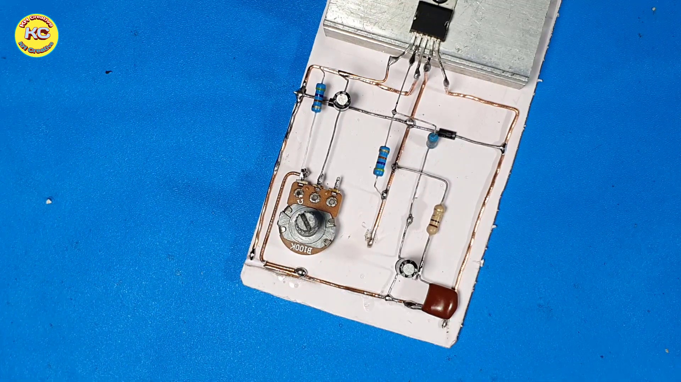 (score 95.0000)
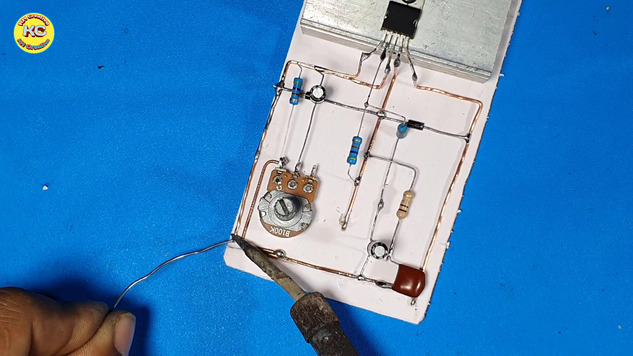 (score 95.0000)
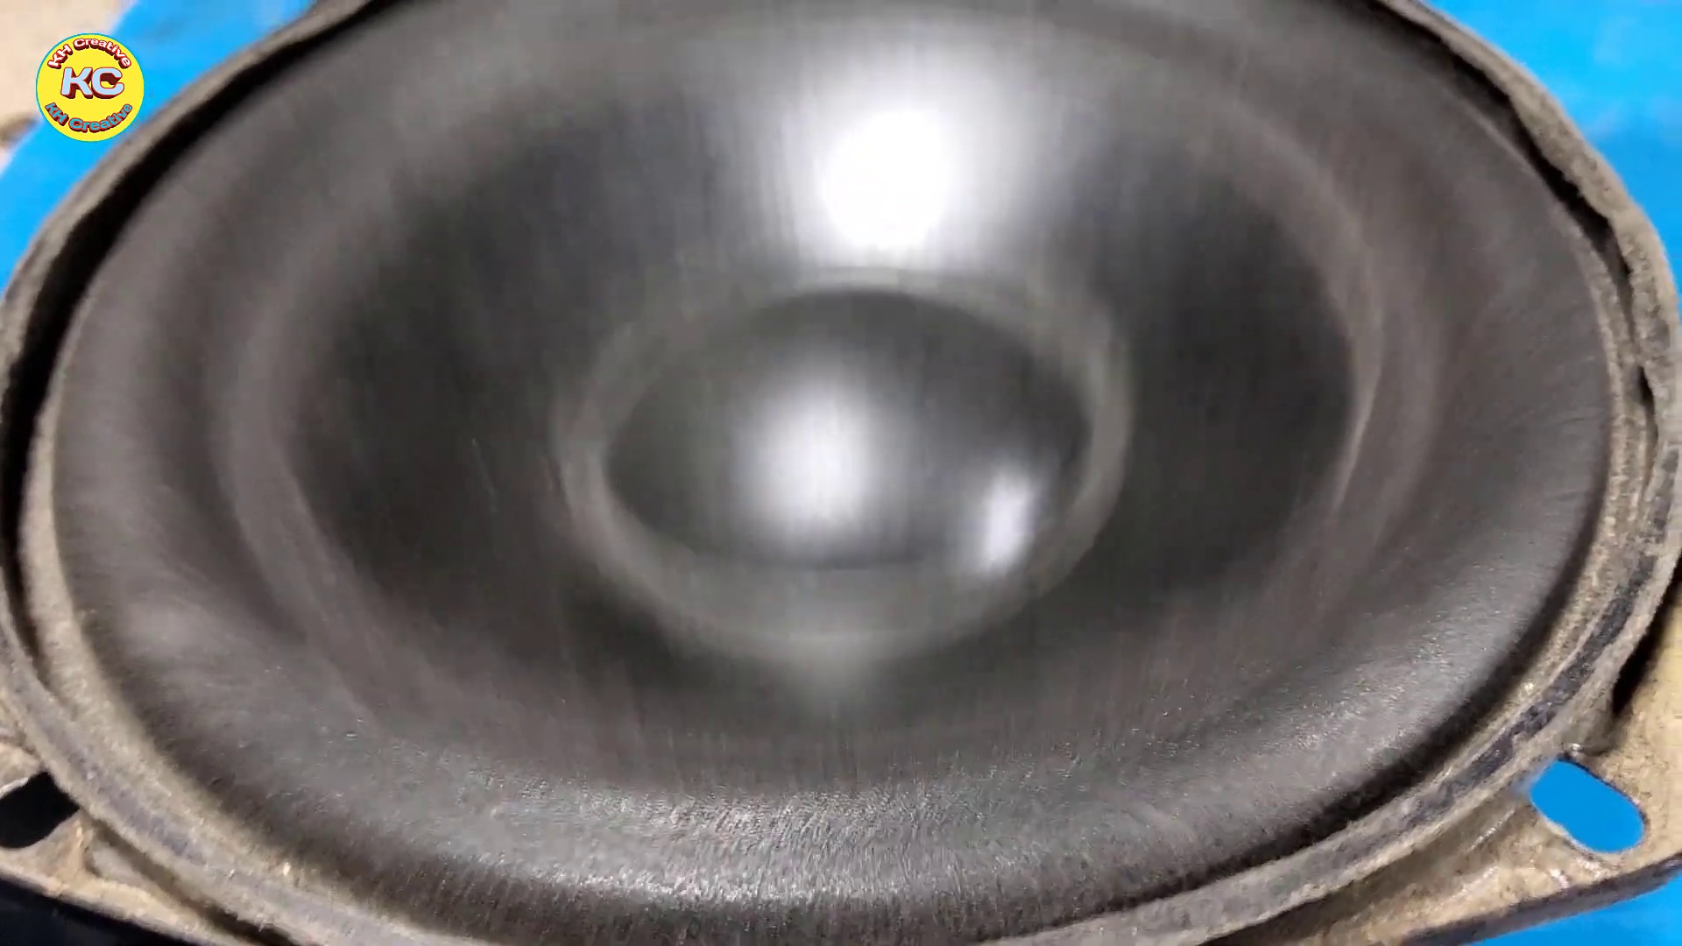 (score 90.0000)
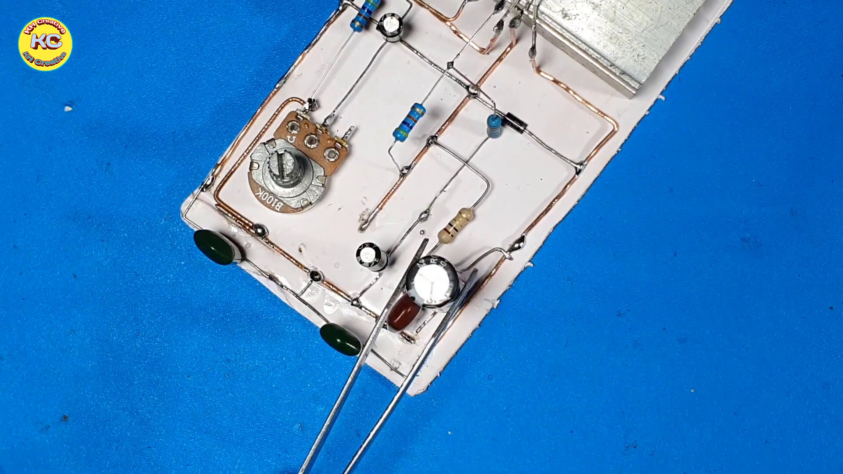 (score 90.0000)
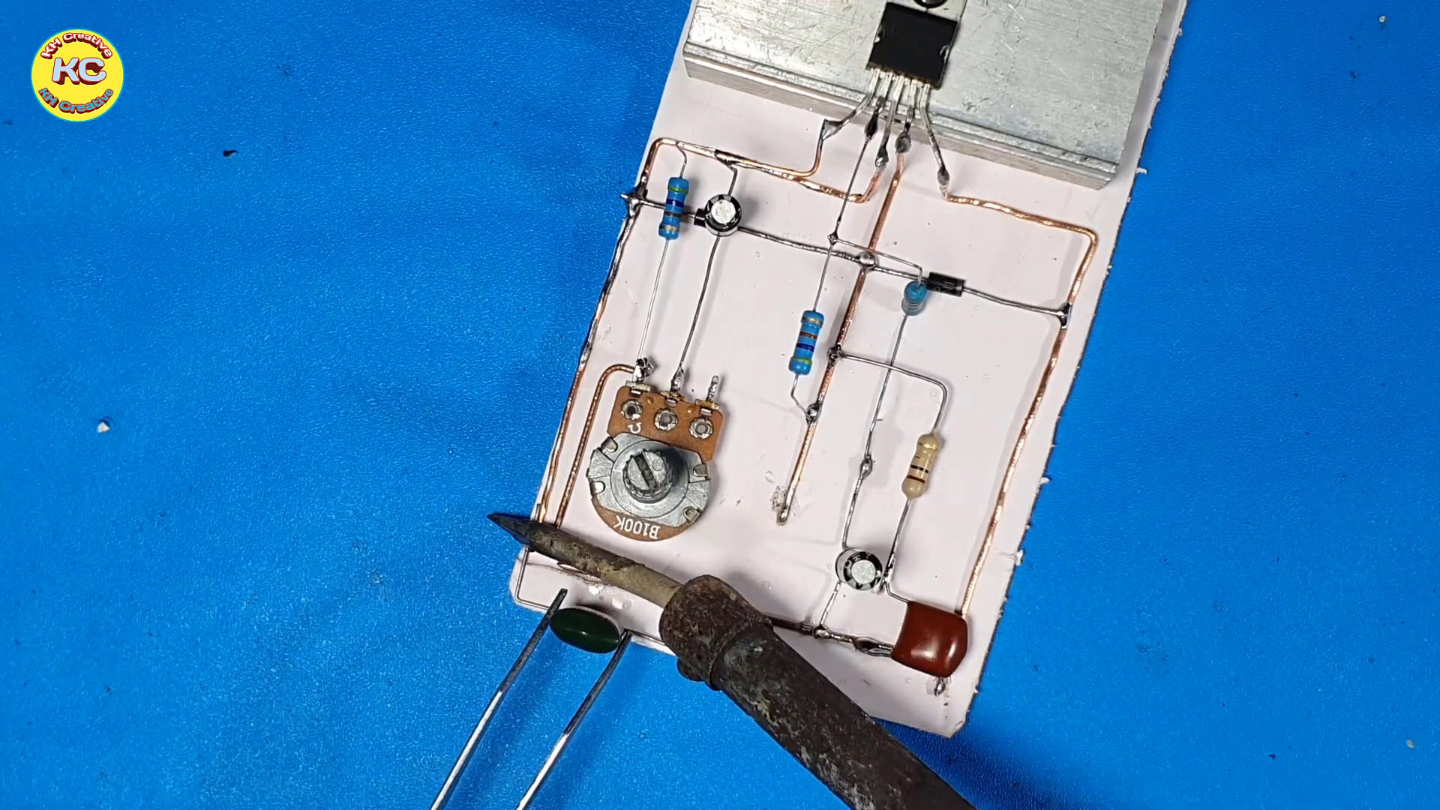 (score 90.0000)
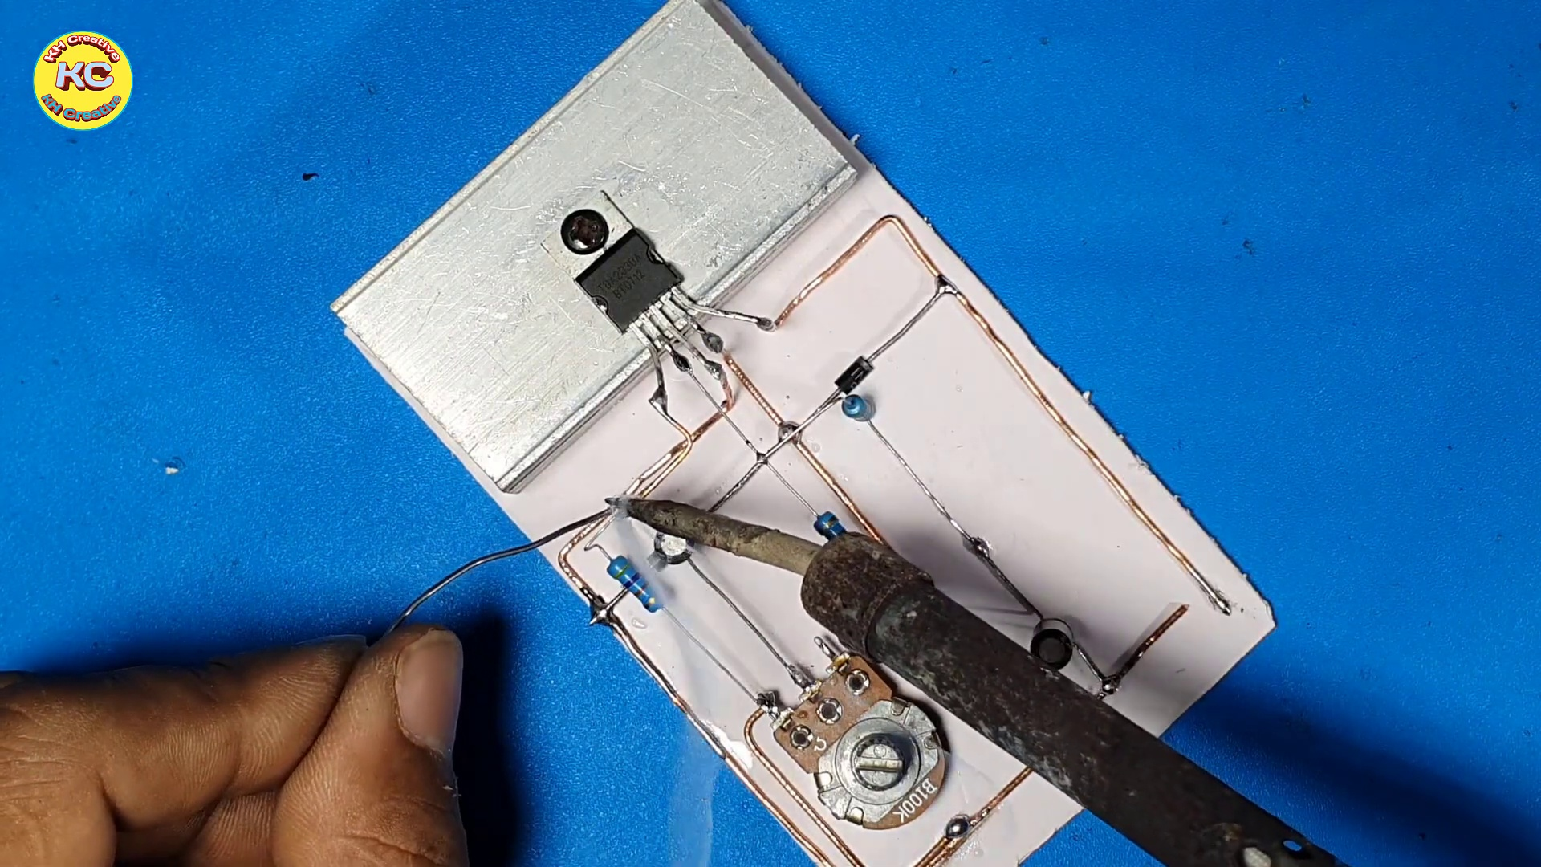 (score 90.0000)
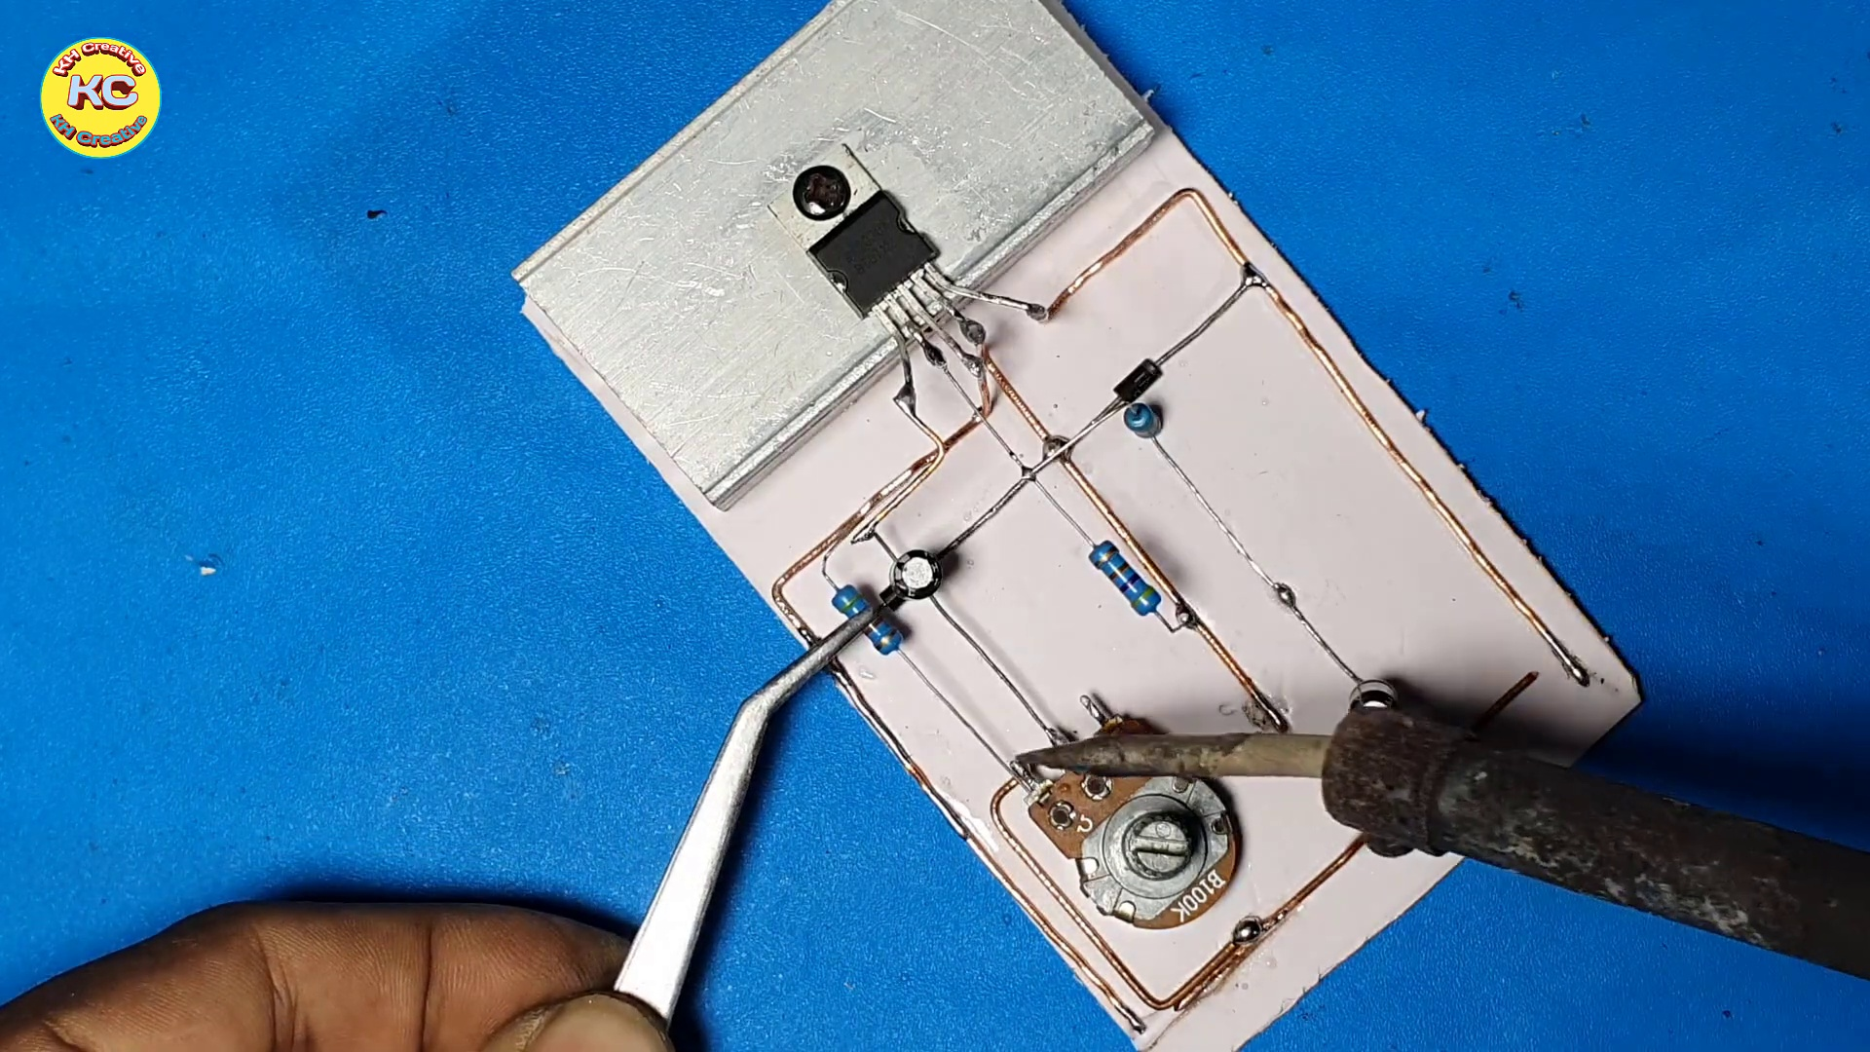 (score 90.0000)
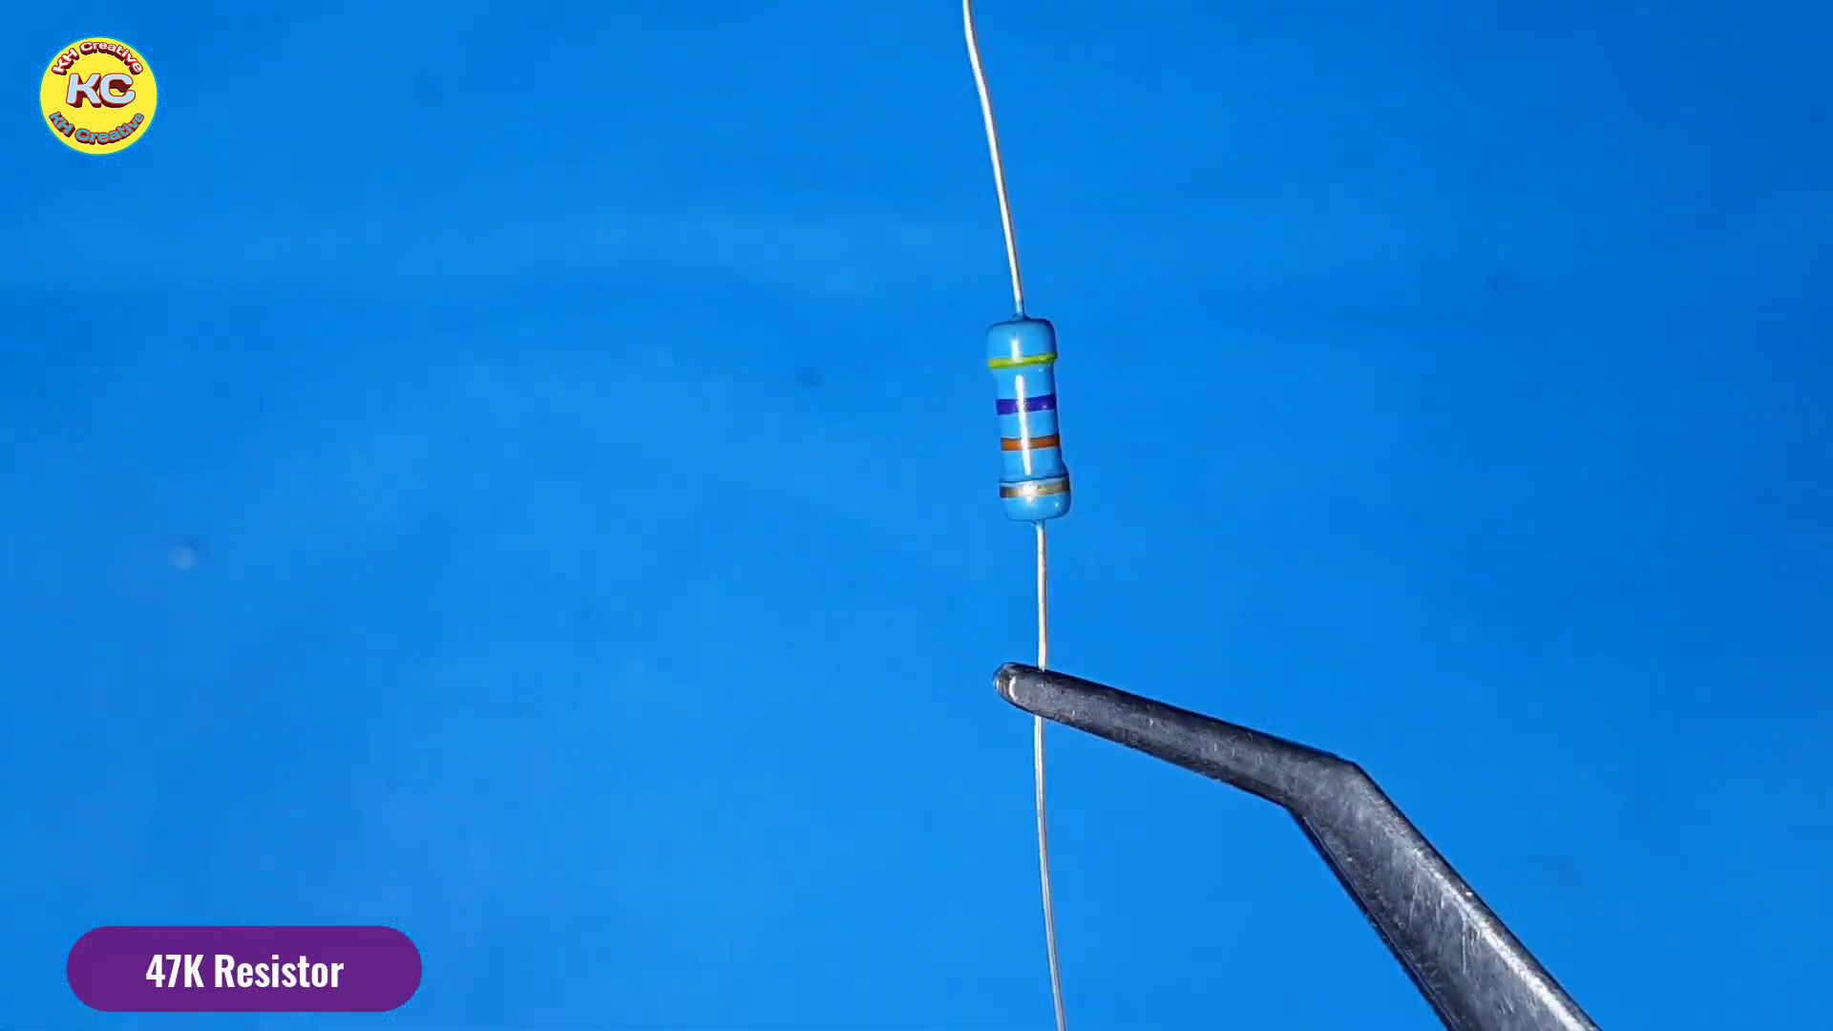 (score 90.0000)
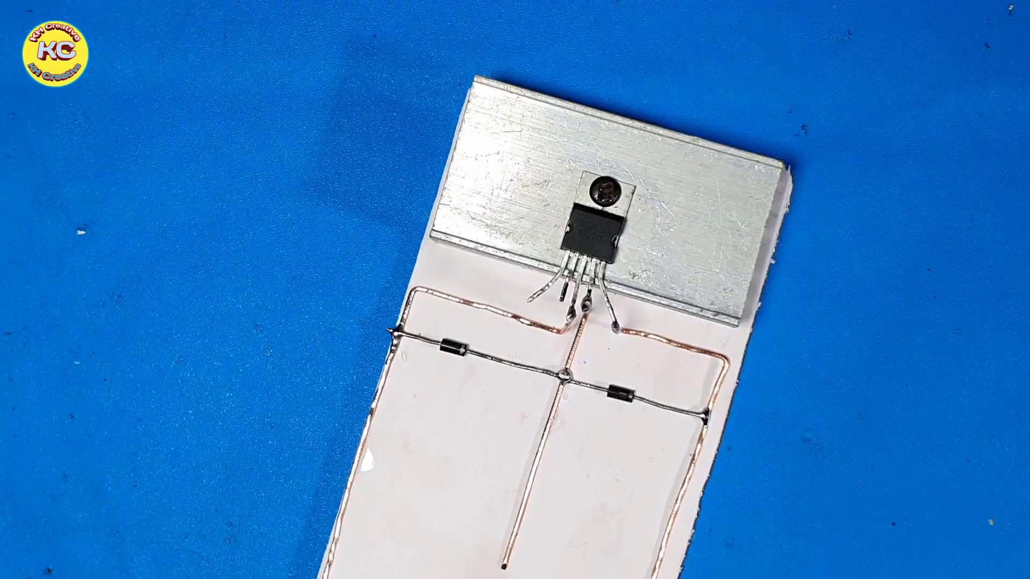 (score 90.0000)
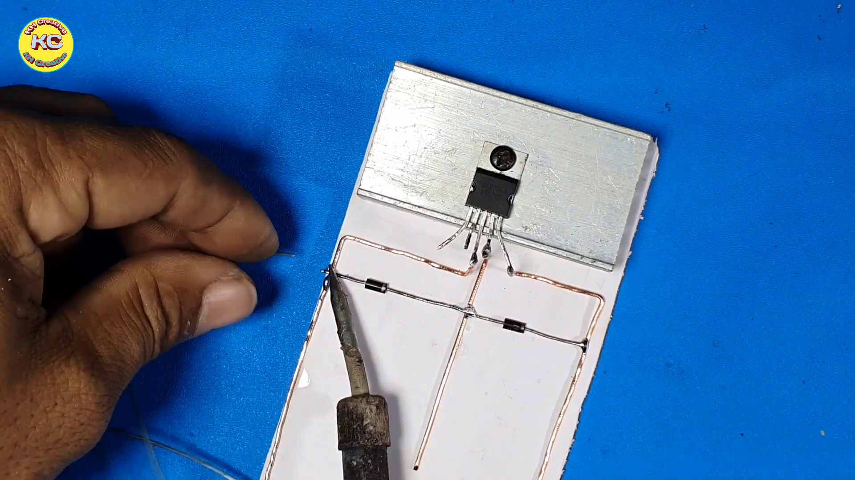 (score 90.0000)
Least correlated frames:
 (score 0.0000)
 (score 0.0000)
 (score 0.0000)
 (score 0.0000)
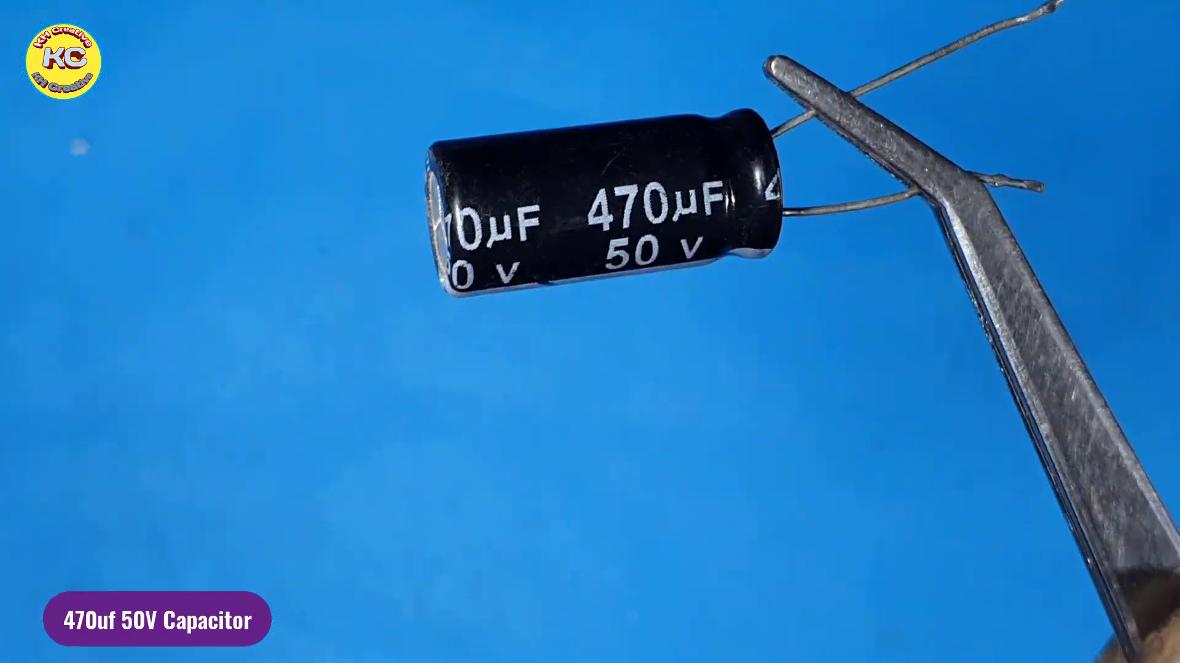 (score 0.0000)
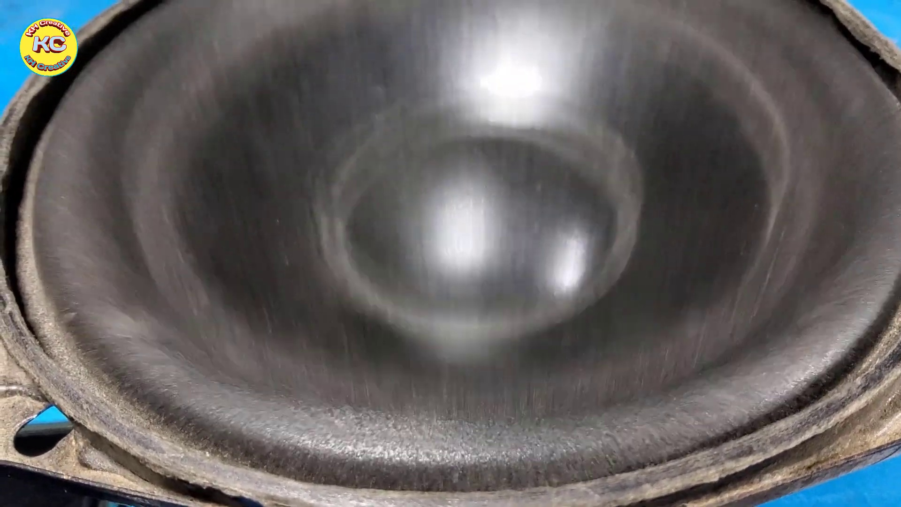 (score 0.0000)
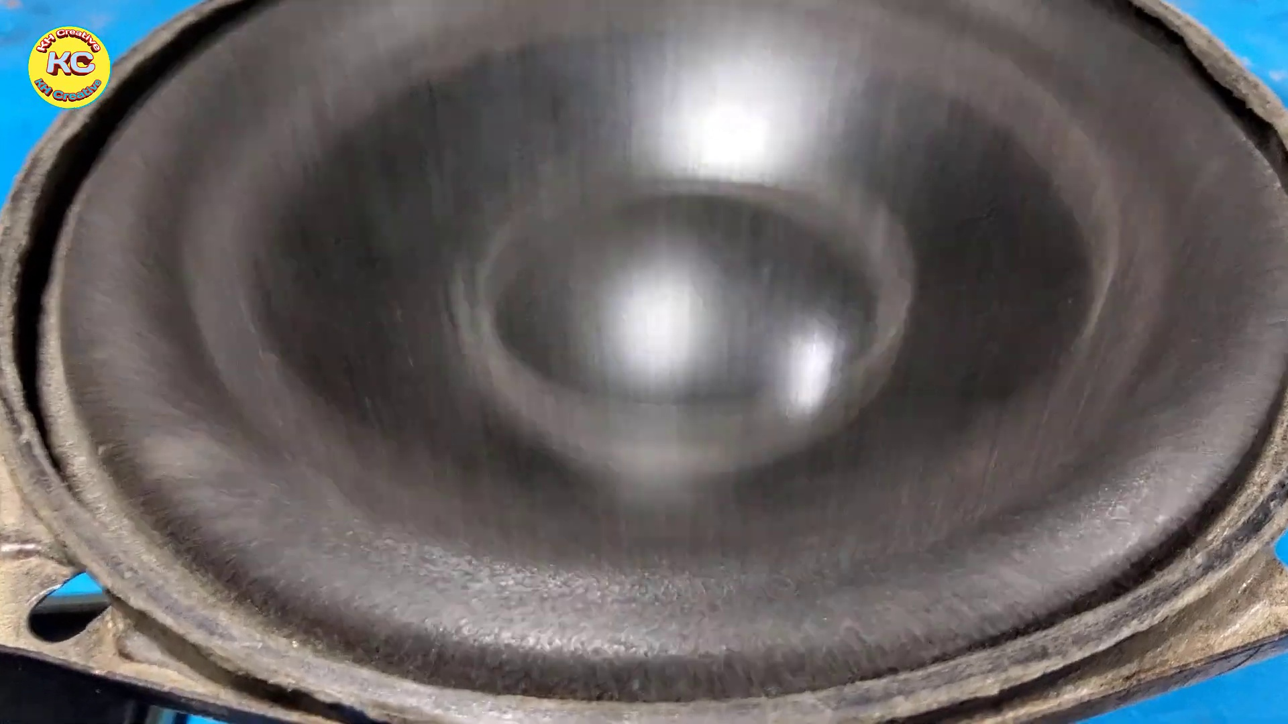 (score 0.0000)
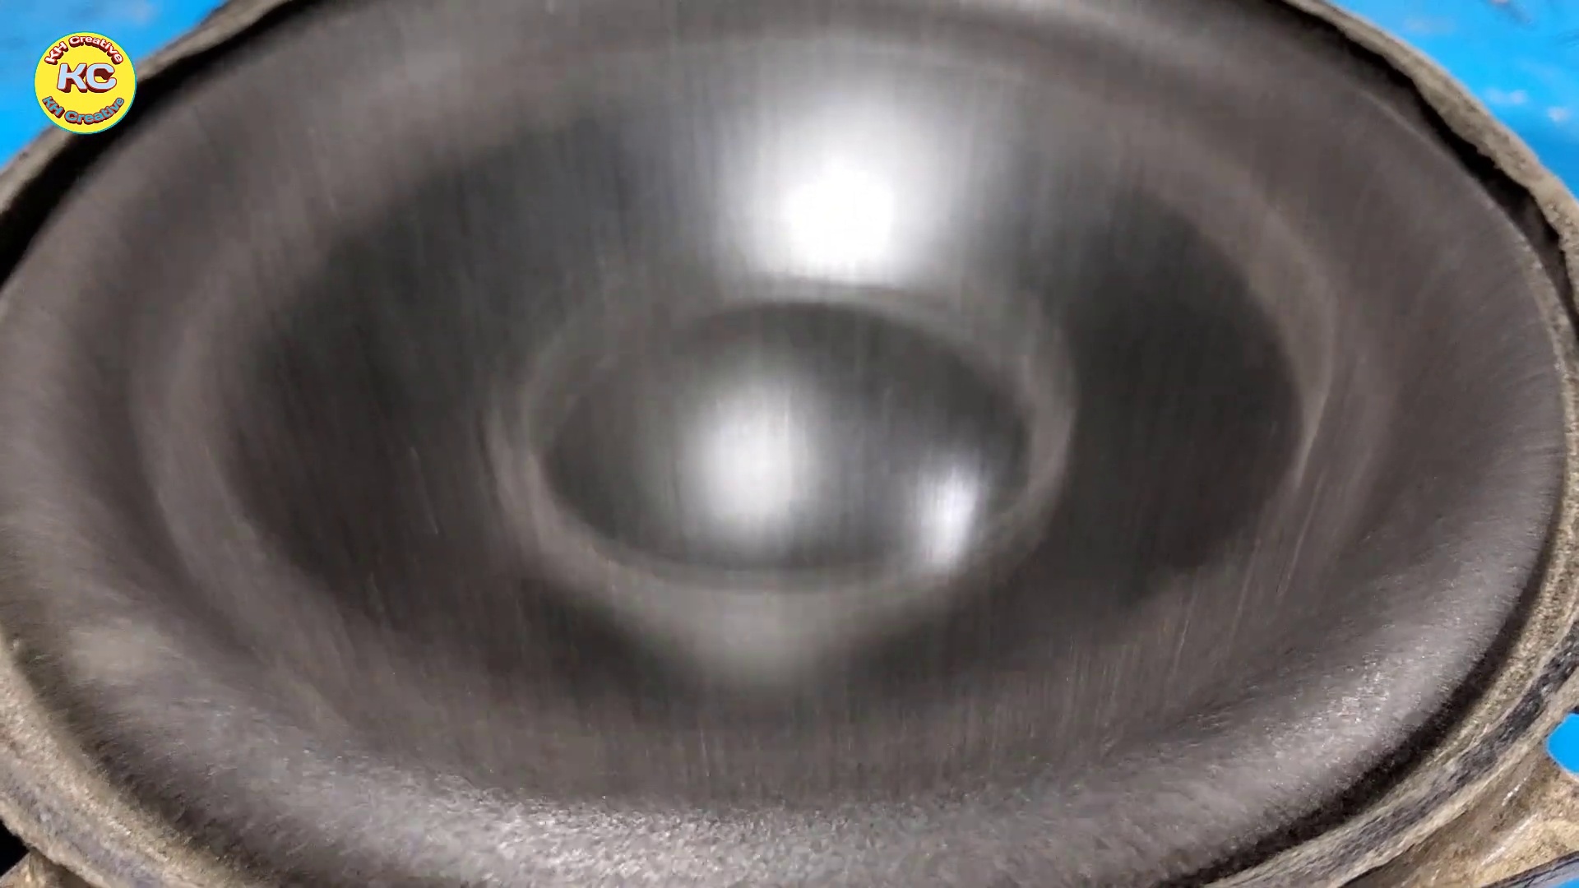 (score 0.0000)
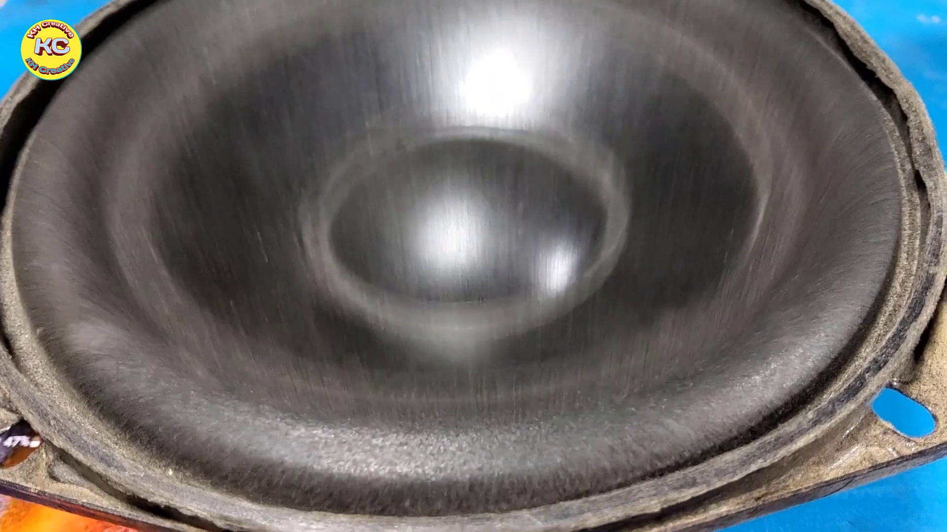 (score 0.0000)
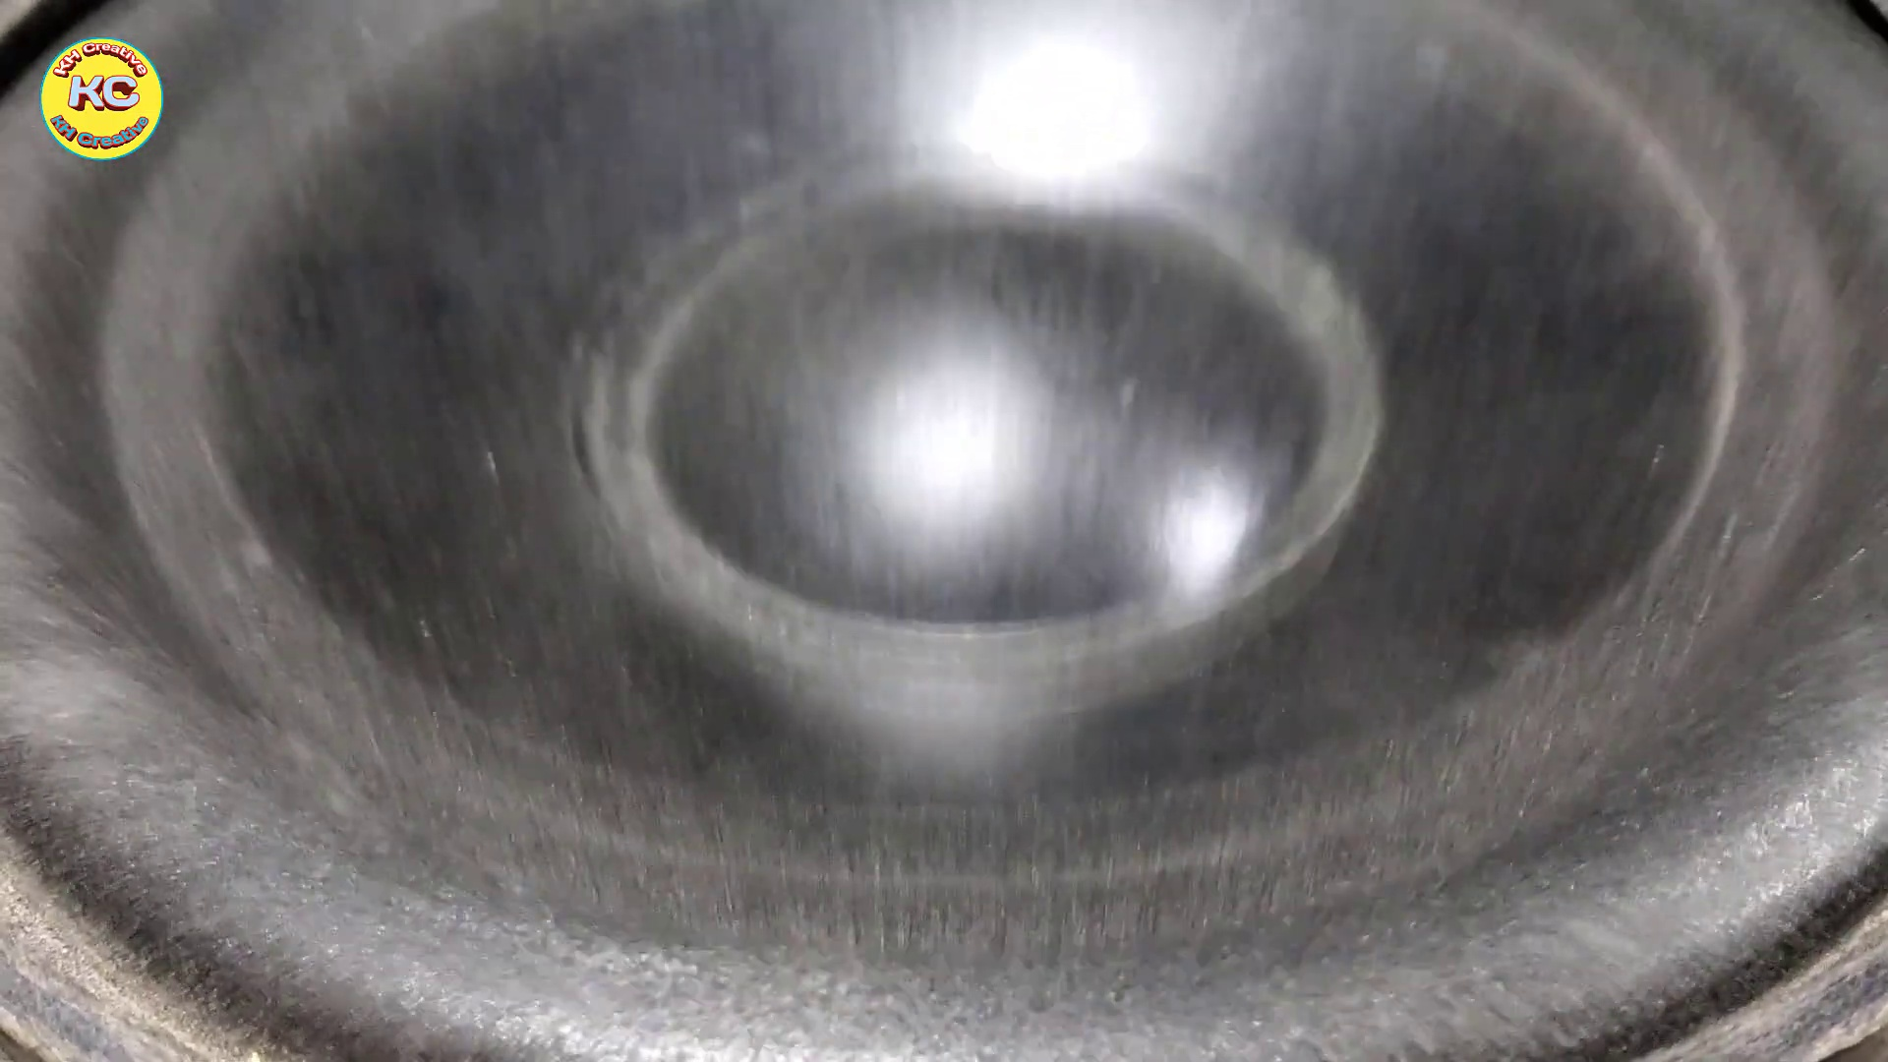 (score 0.0000)
- matched 92 frame(s), max score 95.0000: This video demonstrated a third way to construct a speaker circuit using the TDA 2030 amplifier chip. The circuit constructed in this video was more complex than the two previous videos. This circuit consisted of more components and more branches to the circuit and the inclusion of multiple IN4007 diodes. This circuit layout produced high-quality sound and demonstrated another way to make a circuit with the TDA 2030 that produces high-quality sound. One point of confusion I have after watching this video is that I do not believe the guy who made this video provided a clear shot of how he wired the input jack and speaker into the circuit as the video went from the circuit before those two things were incorporated to the testing of the speaker.
Source: https://www.youtube.com/watch?v=mcAMNsmT6uE : How to Subwoofer Bass Amplifier HiFi with TDA2030, New Circuit at home, DIY Subwoofer Bass
Top correlated frames:
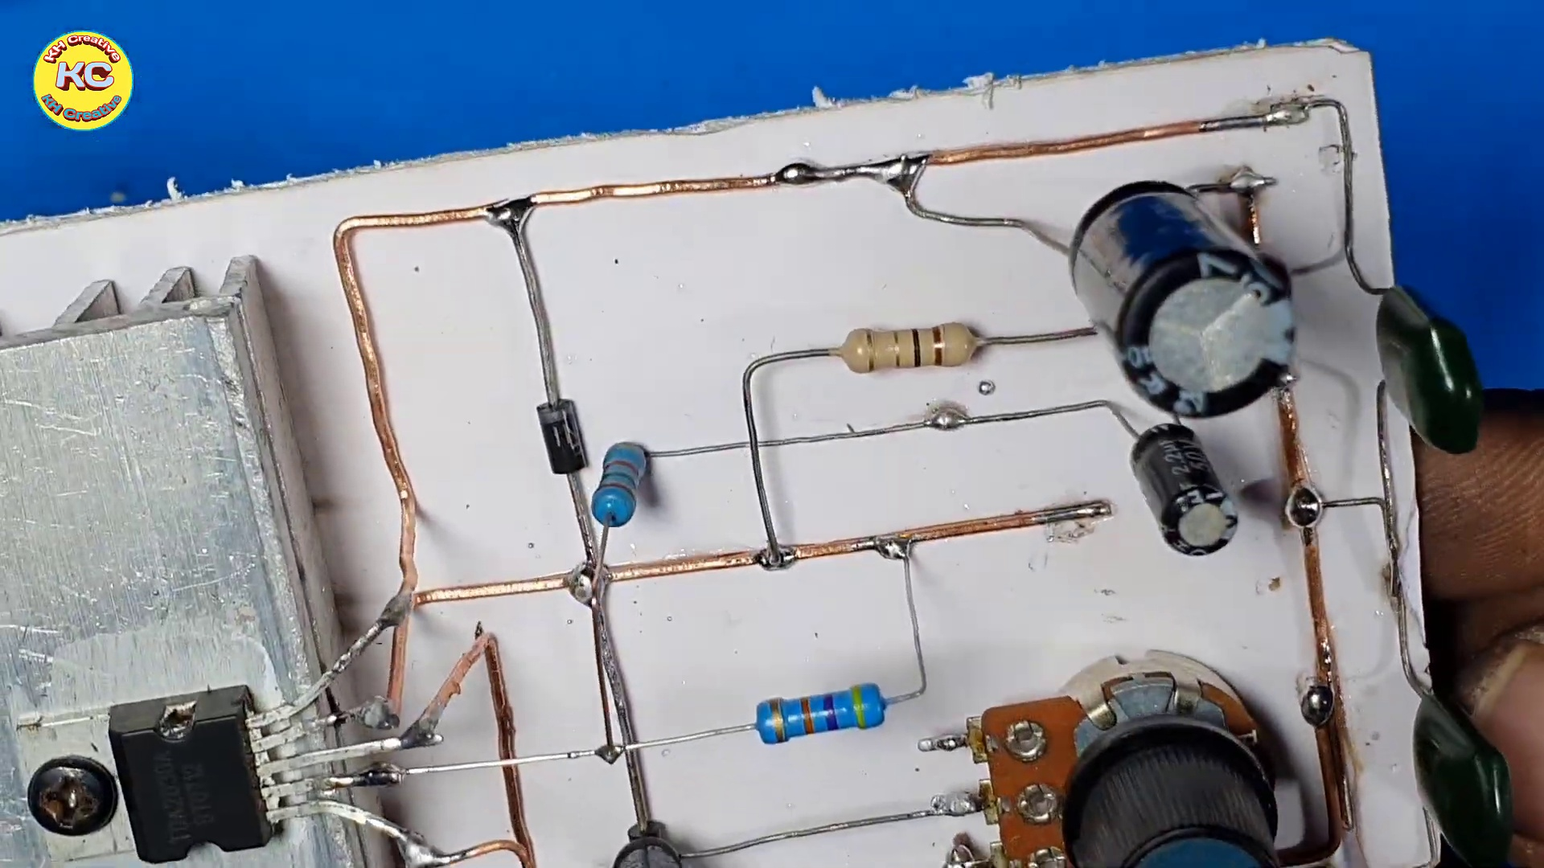 (score 95.0000)
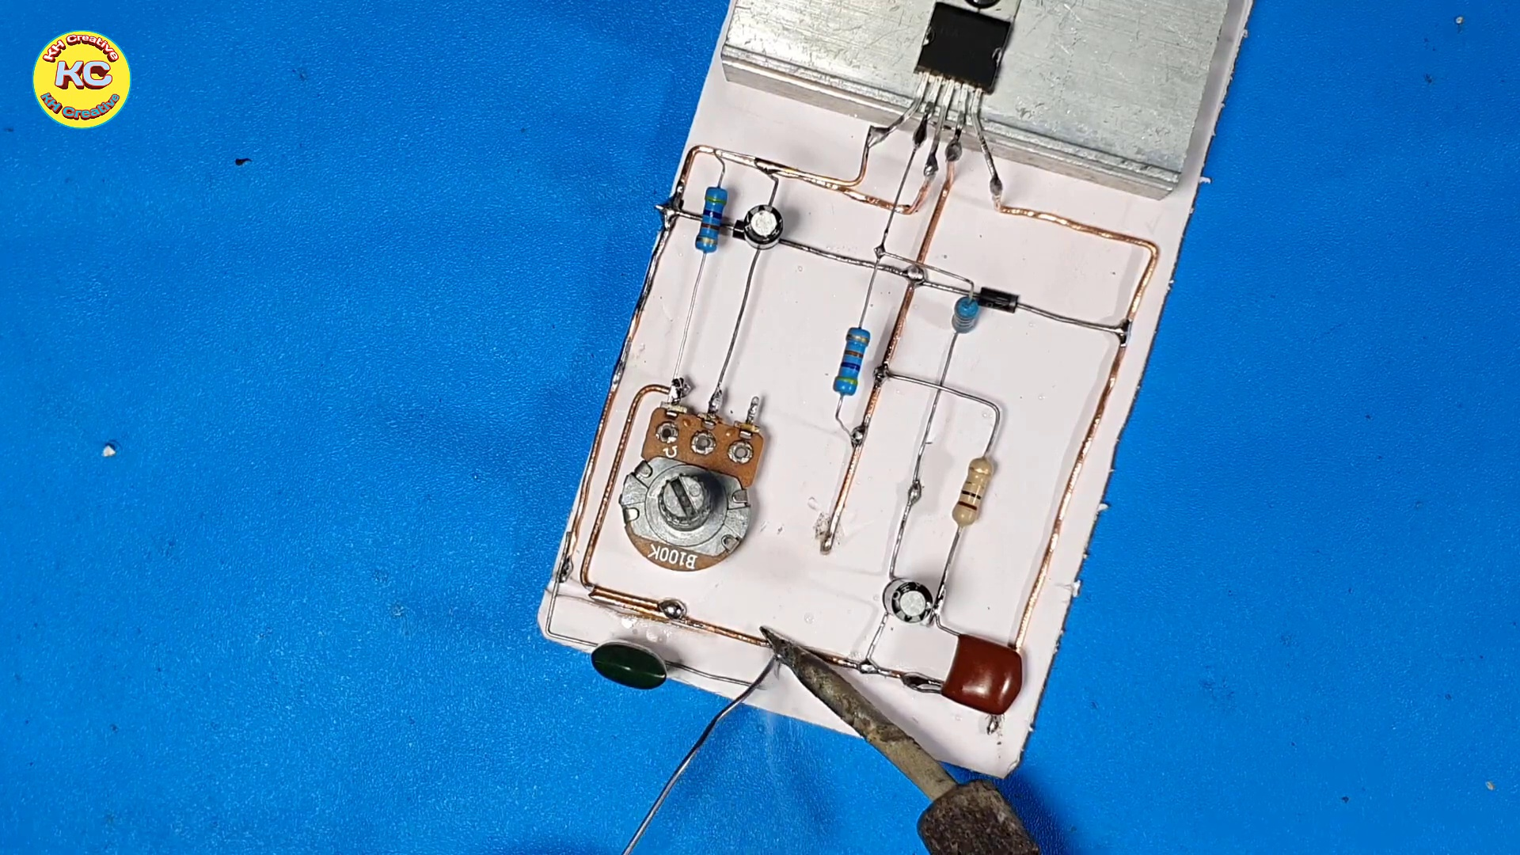 (score 95.0000)
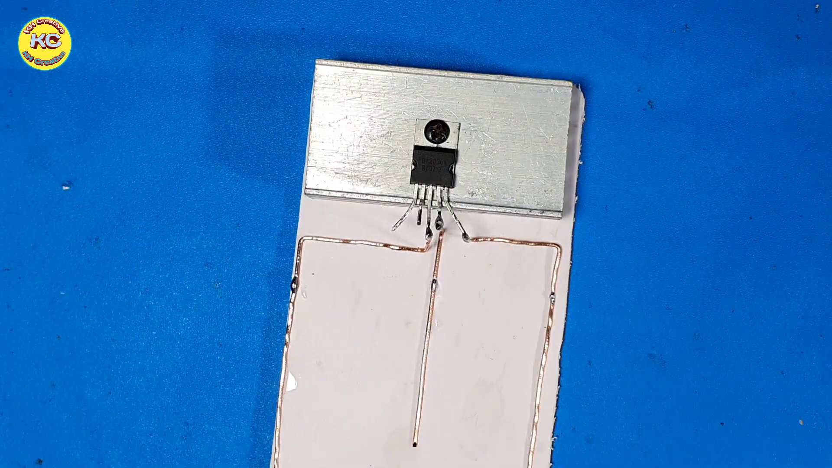 (score 95.0000)
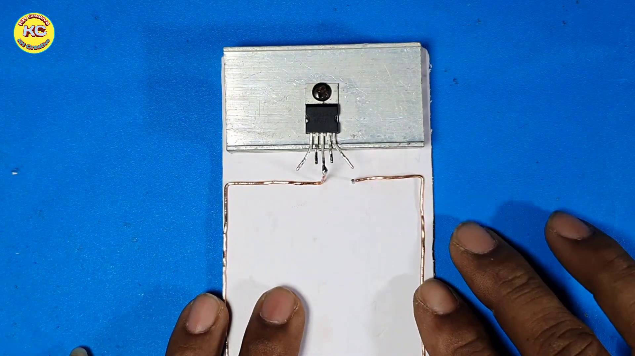 (score 95.0000)
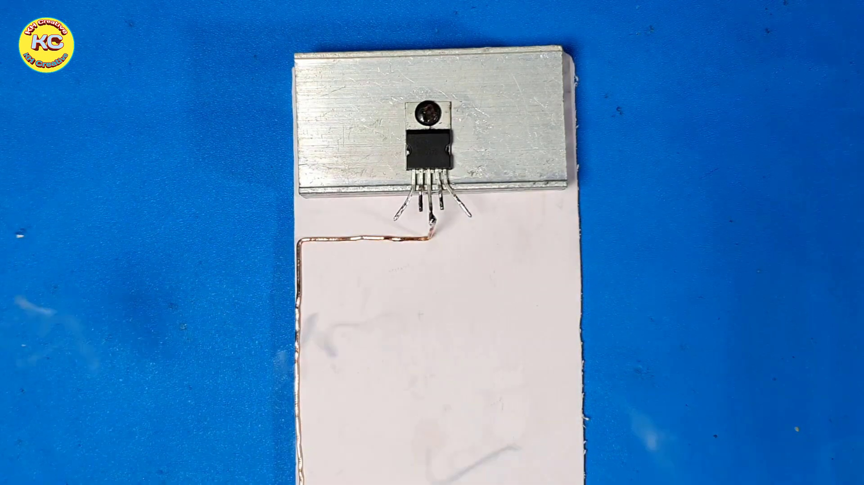 (score 95.0000)
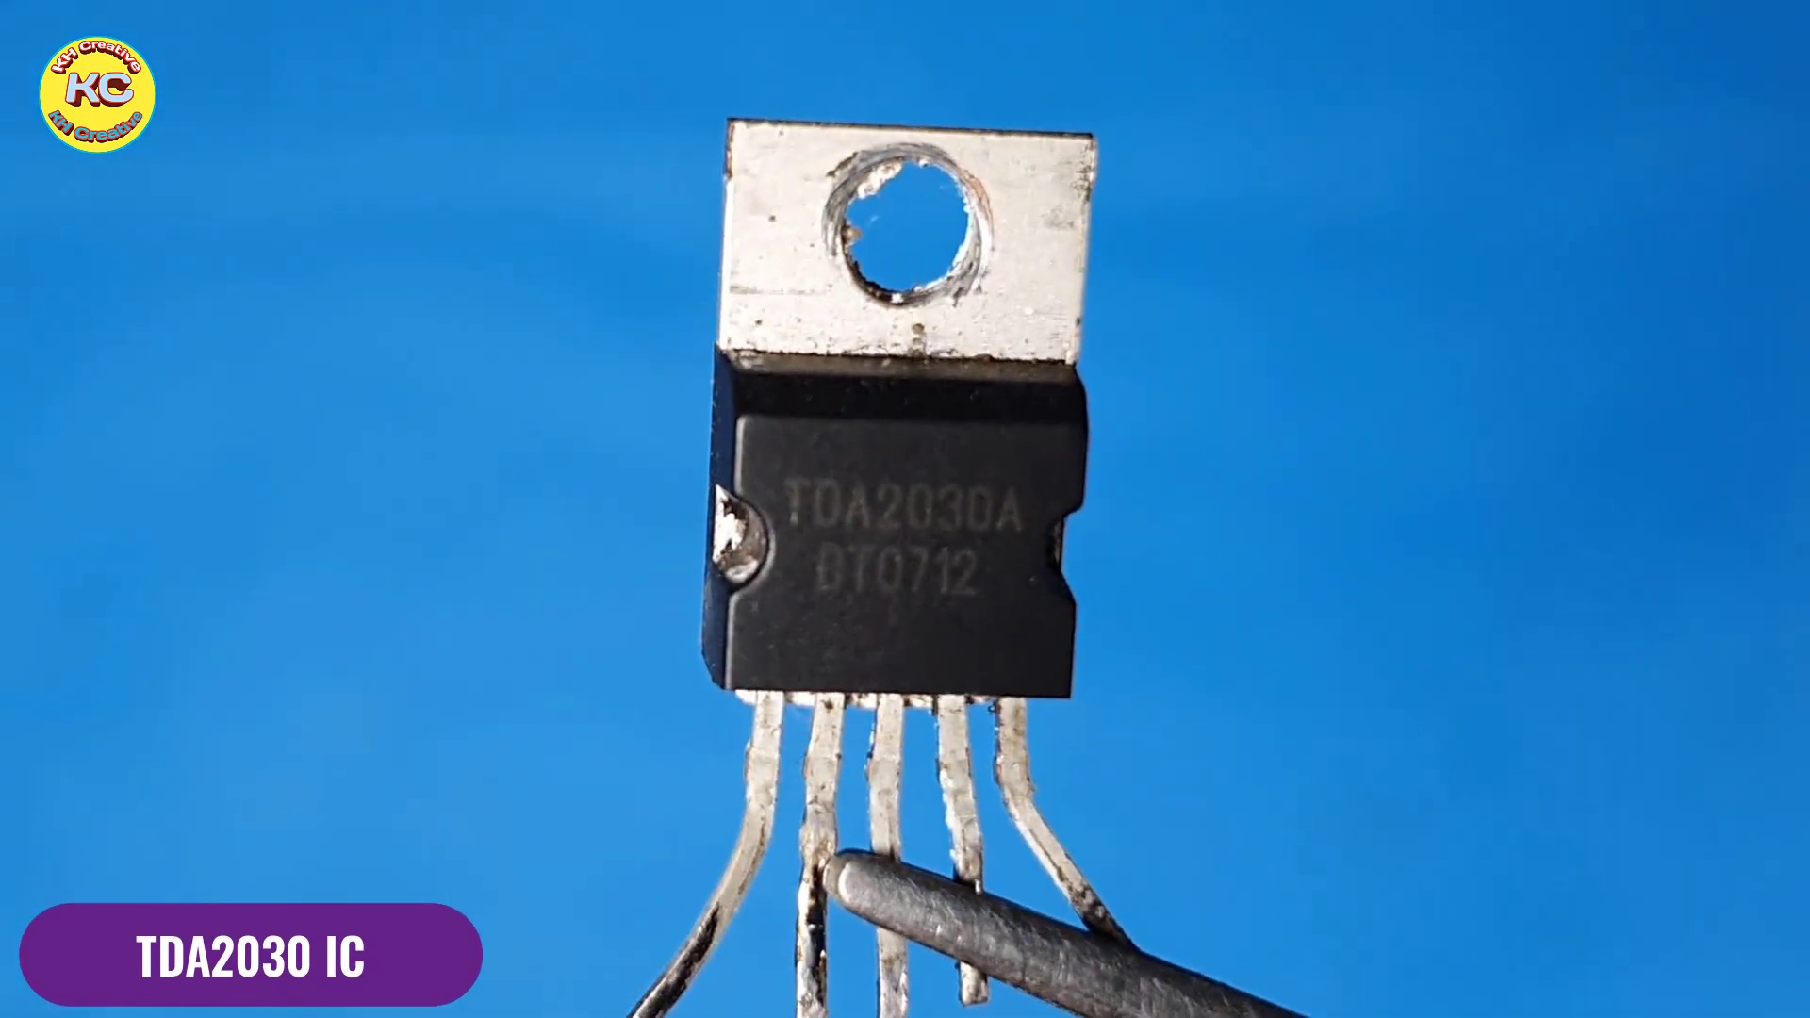 (score 95.0000)
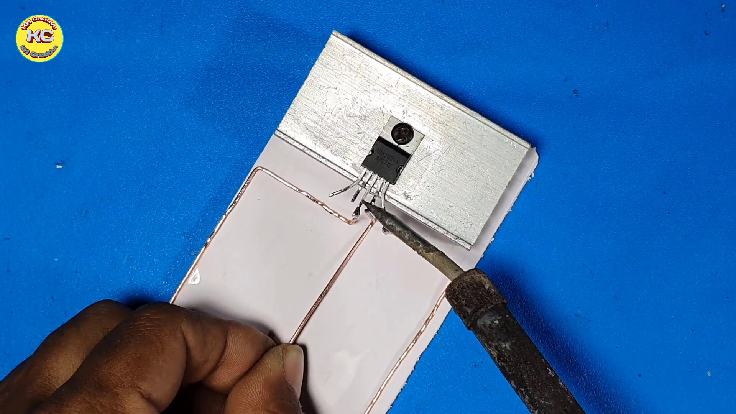 (score 92.0000)
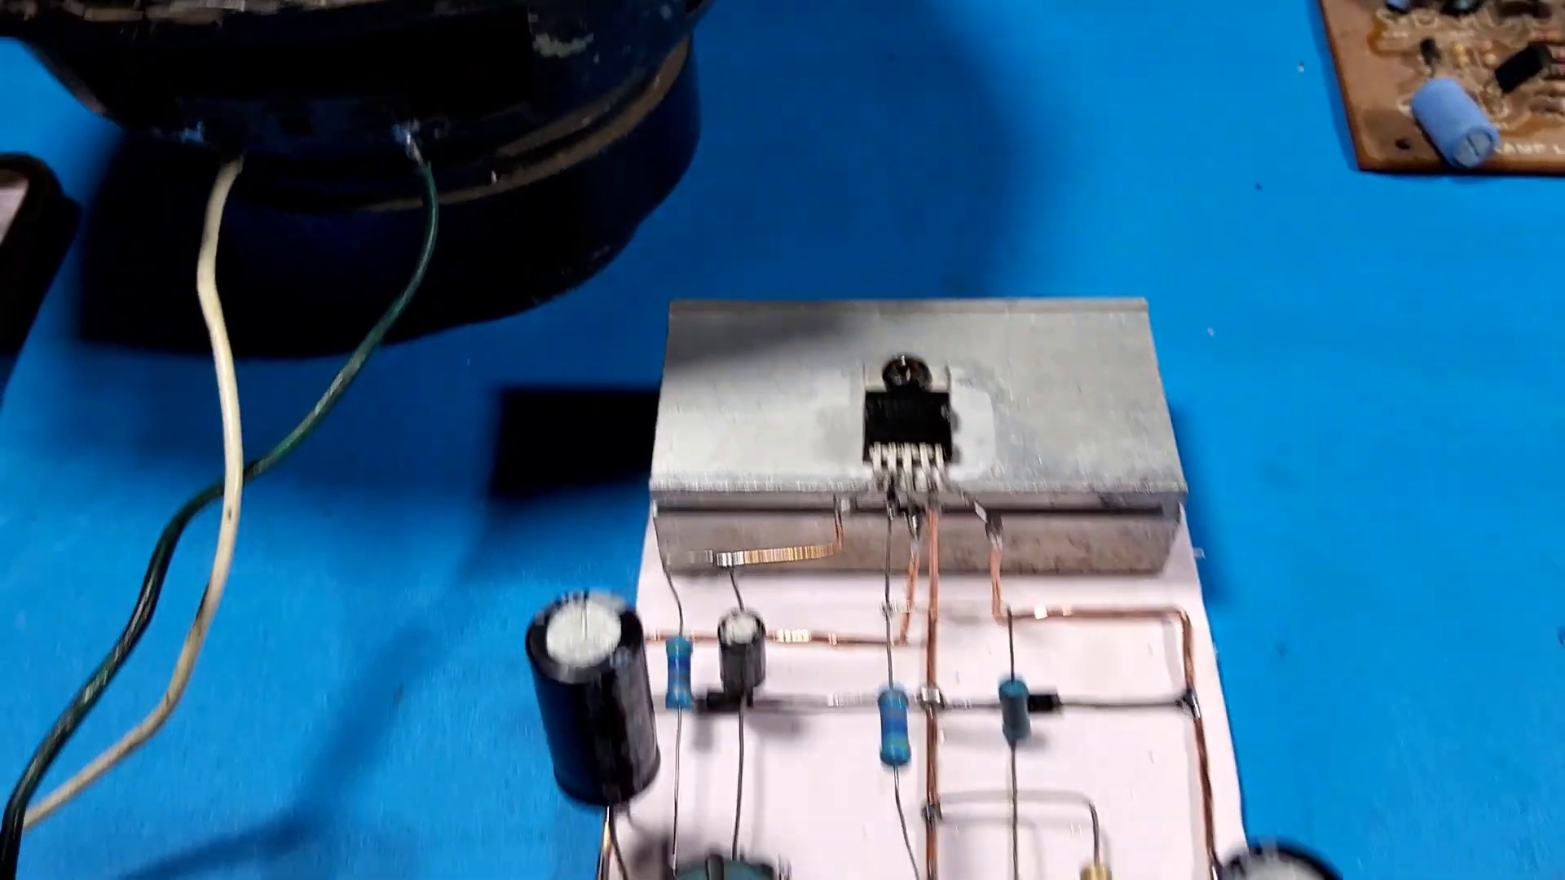 (score 90.0000)
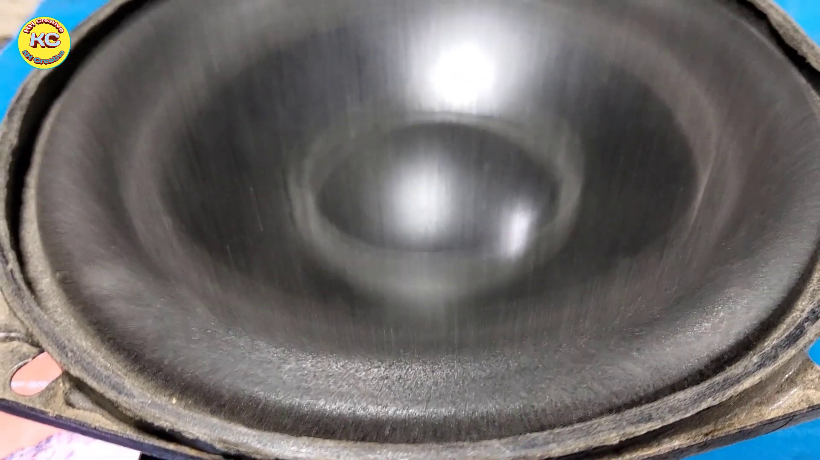 (score 90.0000)
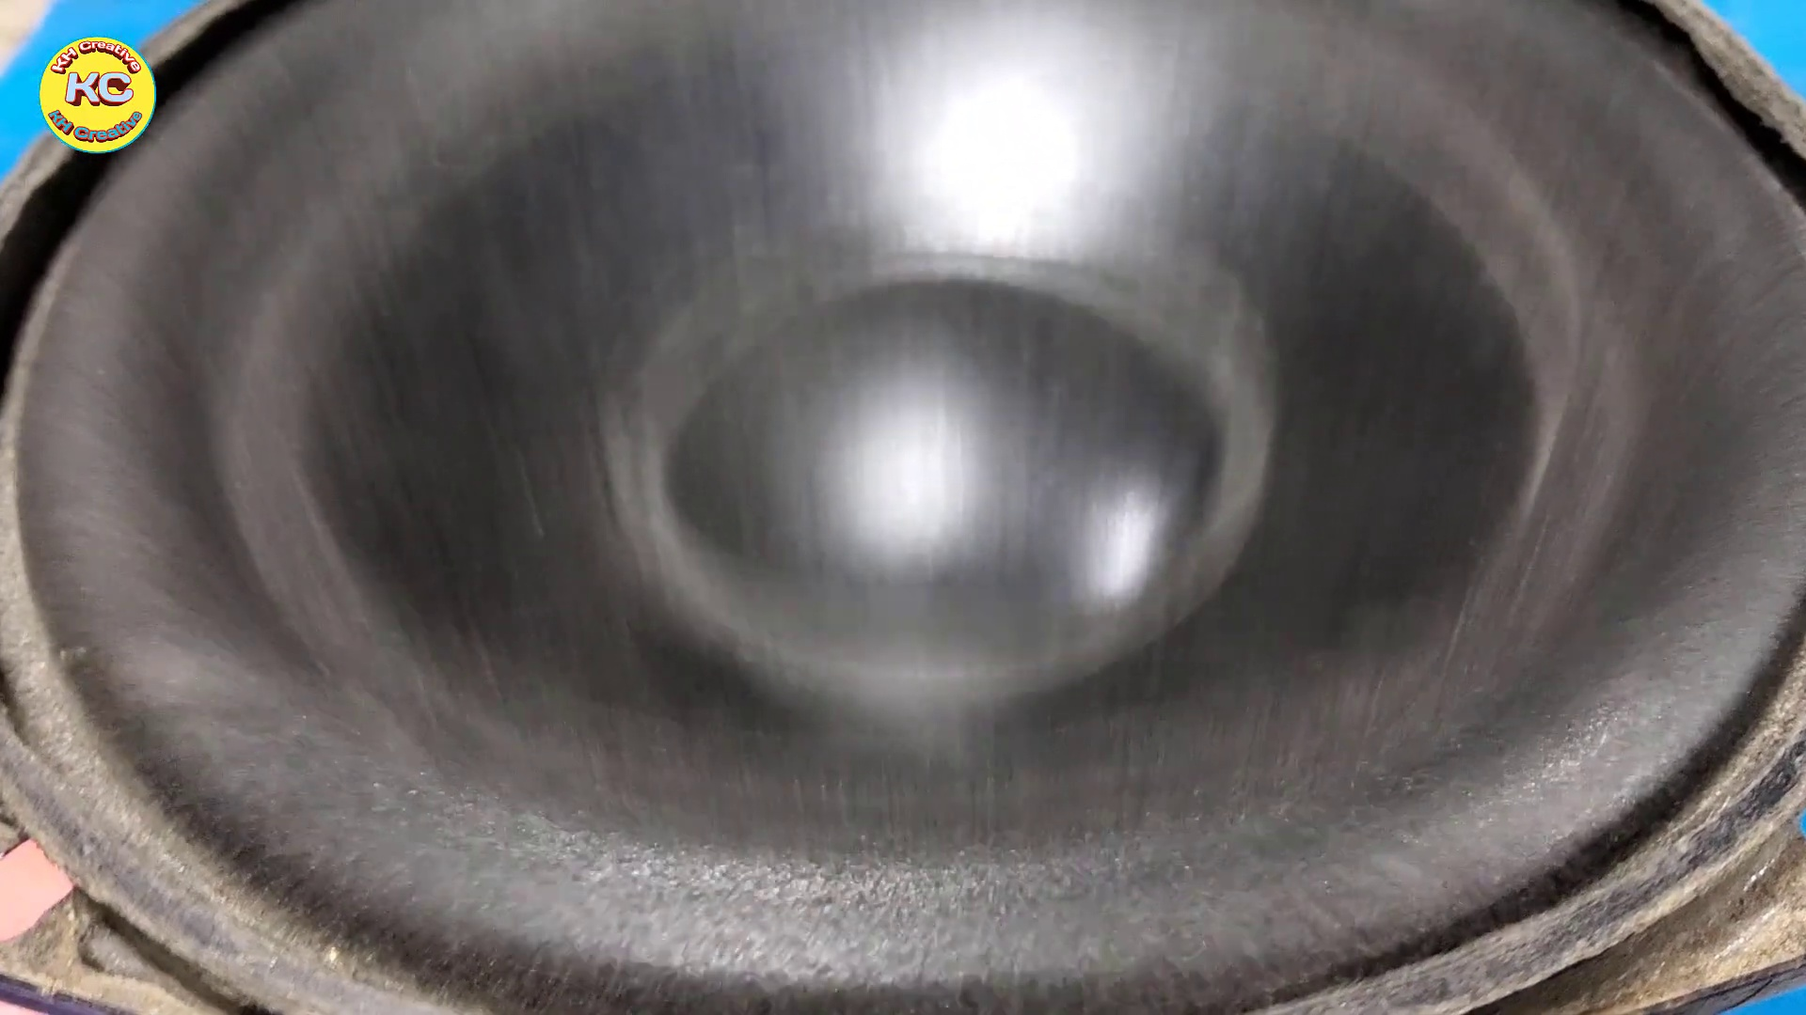 (score 90.0000)
Least correlated frames:
 (score 0.0000)
 (score 0.0000)
 (score 0.0000)
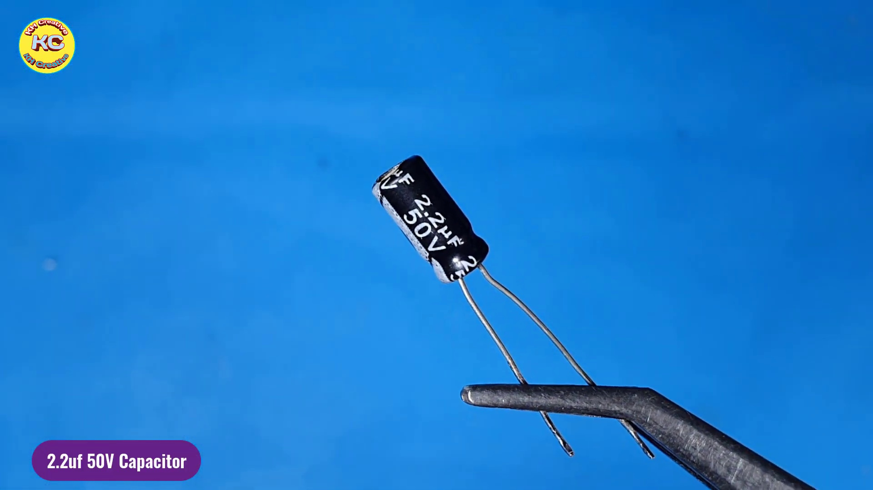 (score 0.0000)
 (score 0.0000)
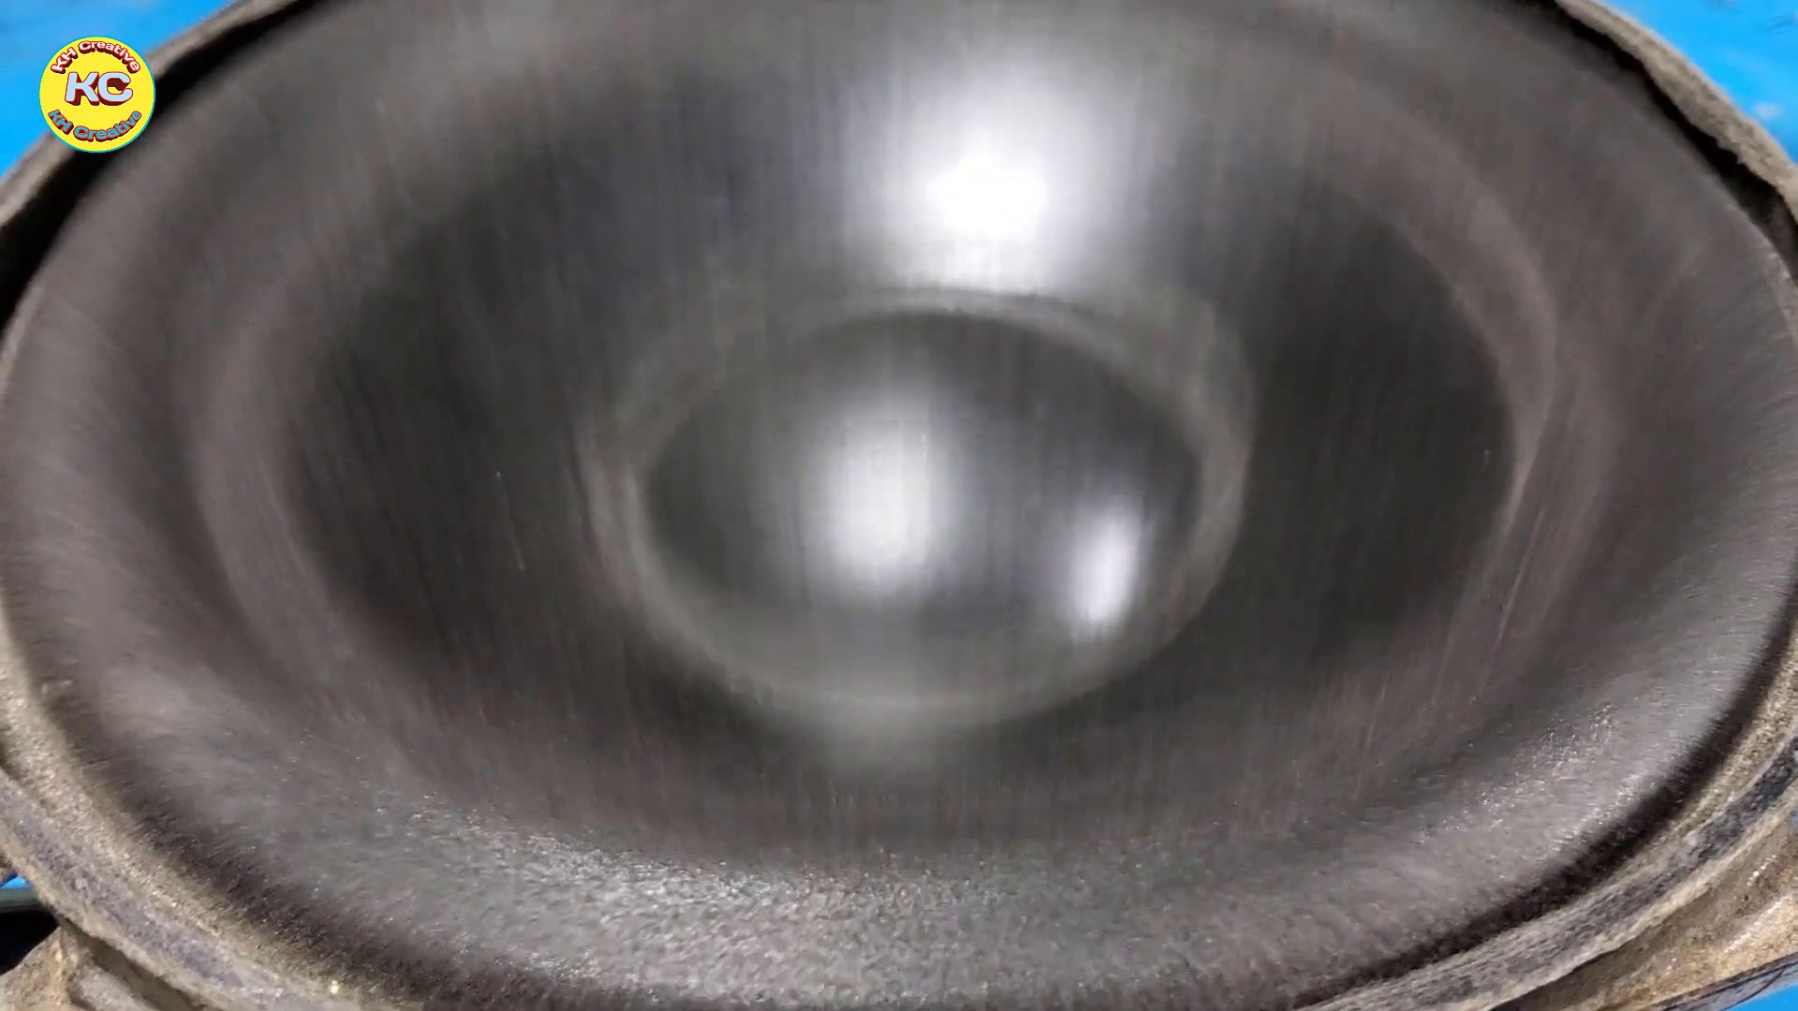 (score 0.0000)
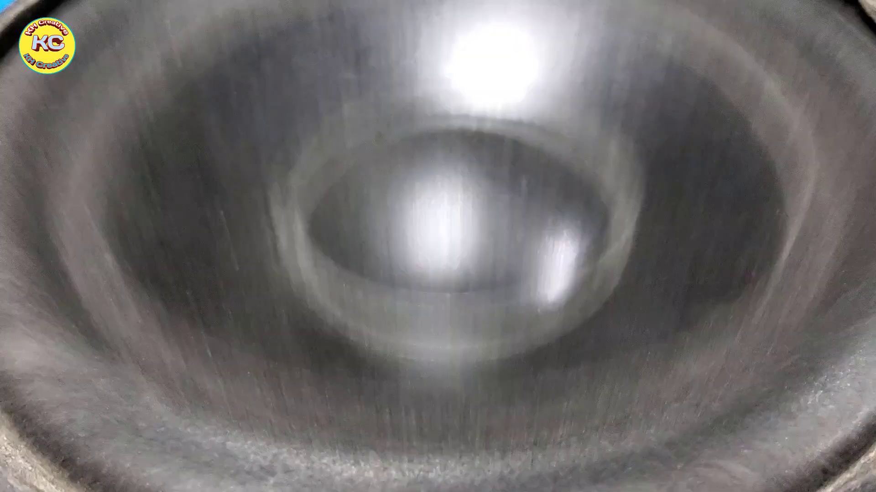 (score 0.0000)
 (score 0.0000)
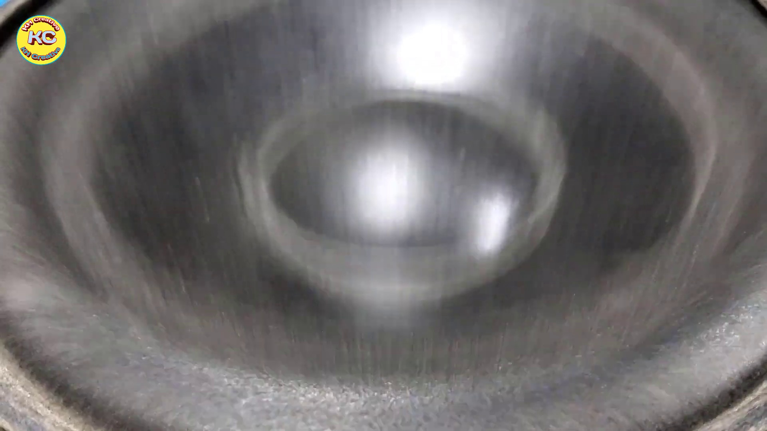 (score 0.0000)
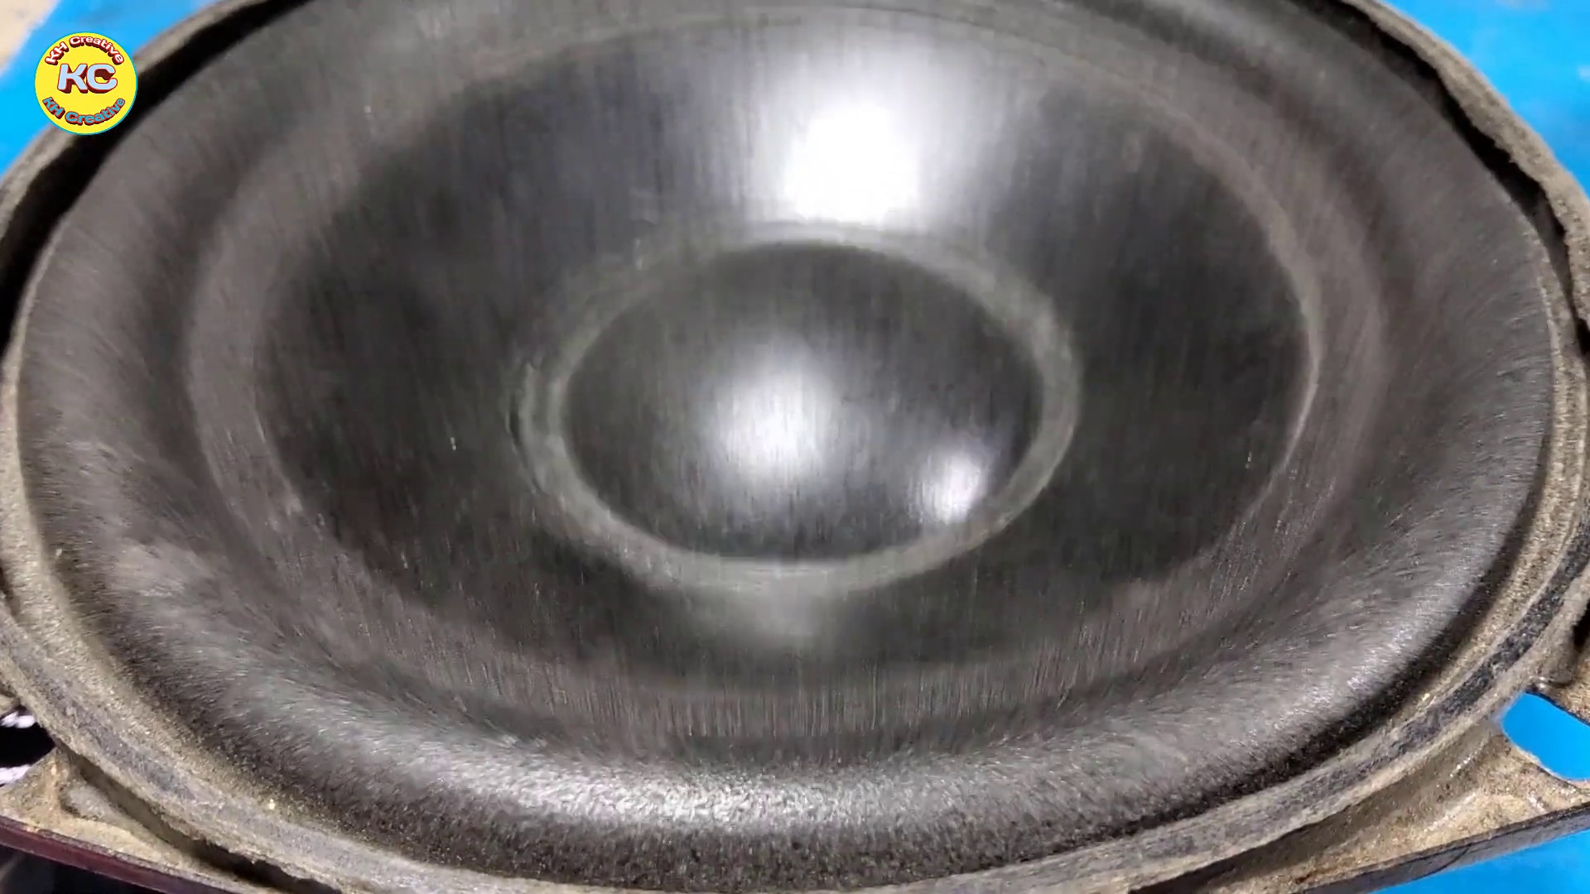 (score 0.0000)

Frame: frame_0000.jpg
Caption: The image presents a visually striking and minimalist composition, featuring a crisp, clean white background that provides a stark contrast to the central object. The object is a round, flat-bottomed bowl, painted in a beautiful shade of pinkish-purple with a hint of gold. The bowl is centrally positioned in the image, drawing attention to its unique coloration.
The bowl's pinkish-purple hue is complemented by a simple yet striking slide on the right side of the image, showcasing a gradient of colors transitioning from pink to purple and then gray, resembling a color palette. The text at the bottom right corner of the slide appears in black font but may be too small to read accurately.
Overall, the image's simplicity and minimalism allow the pinkish-purple bowl to take center stage, while the color gradient on the slide adds an element of visual interest without distracting from the main focus.
No strongly correlated comments found for this frame.

Frame: frame_0001.jpg
Caption: The image showcases a vibrant logo for "KH Creative" that combines striking yellow and blue elements. The text "KH Creative" is written in a playful, rounded font on a solid yellow background, which highlights the logo's bold colors and unique font style. The word "Creative" is prominently displayed in contrasting blue color, adding a pop of color to the overall design.
The logo features an emblem with a blue circular area inside a yellow background, where the initials "KHC" are prominently displayed within it. Below this emblem, the phrase "KHC CREATIVE" appears in bold capital letters, followed by the text "CREATIVE" written in smaller font. The right side of the image contains additional text that reads "KH CREATIVE".
At the bottom-right corner of the image, a watermark with the name "KH CREATIVE" is repeated vertically in a smaller font size, overlaid on the image and suggesting a connection to the entity represented by "KH Creative". The overall design exudes a sense of creativity, playfulness, and professionalism, making it an effective logo for the organization.
No strongly correlated comments found for this frame.

Frame: frame_0002.jpg
Caption: The image appears to capture a close-up view of a small electronic device with various components visible, including capacitors and possibly other integrated circuits (ICs). The device is held together by silver wires, one of which is bent at an angle. A white rectangular chip with a silver stripe running along its length is affixed to the device, and it bears the model or part number "TA-7208-B". The chip is secured to a black object that appears to be a screwdriver or tool. In the background, a clear blue sky provides a stark contrast to the object in the foreground.
Note: A small text at the bottom right of the image reads "BESTYEETOX", which does not seem to be relevant to the main content of the photo and might be a watermark or logo possibly related to the manufacturer or distributor of the device shown.
Comment (score 85): This video is 10:53 minutes long. What I learned from this video – This video demonstrates a circuit which will work as an alternative to the previous circuit. We can test both and decide which circuit produces a better sound. One thing I notice is that we most likely will need a much larger heat sink then we use in class for the MOSFETs. I do not have any questions from this video.
Reason: The comment discusses the technical details of a circuit, including MOSFETs and heat sinks, which are directly related to the components and settings described in the caption. The mention of an alternative circuit and the need for a larger heat sink specifically references the electronic device shown in the image.
Source: https://www.youtube.com/watch?v=mcAMNsmT6uE&t=1s : How to Subwoofer Bass Amplifier HiFi with TDA2030, New Circuit at home, DIY Subwoofer Bass

Frame: frame_0003.jpg
Caption: The image shows a black and white electronic component, specifically a TDA2030IC power amplifier, contained within a black box with a white label. The label reads "TDA2030IC" and also displays the model number "07012" and serial number "A0230IC", located at the bottom of the box. The focus is solely on the TDA2030IC, which appears to be centered in the box. Meanwhile, another image shows an electrical component mounted to a printed circuit board (PCB). The component appears to be a capacitor with a metalized base and a polypropylene film serving as its capacitive element. On the PCB, there are traces suggesting it is part of a larger electronic assembly. No other components or details about the PCB are visible in this image. The background of this second image appears to be an outdoor setting with natural light illuminating the component and PCB, but only the electrical component and PCB are visible, without any teacher, student, or written content.
Comment (score 95): This video demonstrated a third way to construct a speaker circuit using the TDA 2030 amplifier chip. The circuit constructed in this video was more complex than the two previous videos. This circuit consisted of more components and more branches to the circuit and the inclusion of multiple IN4007 diodes. This circuit layout produced high-quality sound and demonstrated another way to make a circuit with the TDA 2030 that produces high-quality sound. One point of confusion I have after watching this video is that I do not believe the guy who made this video provided a clear shot of how he wired the input jack and speaker into the circuit as the video went from the circuit before those two things were incorporated to the testing of the speaker.
Reason: The comment directly discusses the same technical steps (constructing a speaker circuit using TDA2030 amplifier chip) and objects (TDA2030 amplifier chip, IN4007 diodes) described in the caption. The comment also mentions specific details from the video, such as the complexity of the circuit and the inclusion of multiple branches.
Source: https://www.youtube.com/watch?v=mcAMNsmT6uE : How to Subwoofer Bass Amplifier HiFi with TDA2030, New Circuit at home, DIY Subwoofer Bass
Comment (score 80): This video is 10:53 minutes long. What I learned from this video – This video demonstrates a circuit which will work as an alternative to the previous circuit. We can test both and decide which circuit produces a better sound. One thing I notice is that we most likely will need a much larger heat sink then we use in class for the MOSFETs. I do not have any questions from this video.
Reason: The comment mentions the circuit and MOSFETs, which are directly related to the technical steps and components described in the caption, specifically the TDA2030IC power amplifier and capacitor. The mention of needing a larger heat sink also correlates with the focus on the TDA2030IC in the caption.
Source: https://www.youtube.com/watch?v=mcAMNsmT6uE&t=1s : How to Subwoofer Bass Amplifier HiFi with TDA2030, New Circuit at home, DIY Subwoofer Bass

Frame: frame_0004.jpg
Caption: The image shows a close-up view of a rectangular metal plate resting on a vibrant blue surface. The plate is adorned with a single hole in the center, adding a touch of intrigue to its otherwise plain appearance. The surface beneath the plate appears dull and unadorned, providing a stark contrast to the blue background. The overall composition of the image suggests a sense of tranquility and simplicity, with the metal plate as the central focus. There are no discernible texts or additional objects visible in the frame. The relative position of the plate to the blue surface suggests that it is the primary object in the frame, with the background serving as a neutral backdrop to highlight its features.
No strongly correlated comments found for this frame.

Frame: frame_0005.jpg
Caption: The image features a dual composition, showcasing two distinct elements on a blue surface with a white background. On one side is a single-pole electromagnetic coil made of copper wire wound around a central ferrite core material. The coil has many turns and is metallic in appearance. At the end of the coil, there are two electrical wires attached to a connection point, one on each side of the pole. A small text overlay at the bottom right corner reads "WWW.MUGGLE.NET", suggesting the source or website associated with the content.
On the other side of the blue surface is a silver rectangular object, which appears to be a Printed Circuit Board (PCB). The PCB has four silver pins arranged in a straight line, evenly spaced and creating a uniform design. A small text overlay at the top of the image reads "Subscribe", indicating a subscription service related to the subject matter.
The overall composition of the image emphasizes the focus on both the electromagnetic coil and the PCB, with the surrounding blue surface and white background serving as a neutral backdrop. The text overlays provide additional context without overpowering the visual elements, allowing viewers to appreciate the details and structures of each component.
Comment (score 85): This video is 10:53 minutes long. What I learned from this video – This video demonstrates a circuit which will work as an alternative to the previous circuit. We can test both and decide which circuit produces a better sound. One thing I notice is that we most likely will need a much larger heat sink then we use in class for the MOSFETs. I do not have any questions from this video.
Reason: The comment directly discusses the electromagnetic coil and Printed Circuit Board (PCB) mentioned in the caption, specifically mentioning their functionality and potential heat sink requirements. The correlation score is high because the comment does not contain generic praise or unrelated information.
Source: https://www.youtube.com/watch?v=mcAMNsmT6uE&t=1s : How to Subwoofer Bass Amplifier HiFi with TDA2030, New Circuit at home, DIY Subwoofer Bass

Frame: frame_0006.jpg
Caption: The image shows a person holding a pair of tweezers, using them to manipulate a small, rectangular piece of metal. The metal strip, possibly made of silver, has four small holes connected by a wire, suggesting it might be a part of an electronic circuit. The person's hand is positioned over the metal strip, indicating they are in the process of removing or attaching something to it. In the background, a vibrant blue provides a stark contrast to the person and the metal strip.
The image appears to capture a moment of interaction with an electronic component, with the person's actions suggesting a possible repair or modification process. The presence of tweezers implies a level of precision is required for this task. Additionally, there is no instructor visible, nor any text or diagrams that suggest an educational context or teaching content.
In the bottom right corner of the image, the text "Subscribe" appears along with a blue URL pointing to a YouTube channel named "KC", hinting at a video about electronic components and their usage. This suggests the image might be related to a video on this channel, possibly demonstrating how to work with these types of components.
Comment (score 80): This video is 10:53 minutes long. What I learned from this video – This video demonstrates a circuit which will work as an alternative to the previous circuit. We can test both and decide which circuit produces a better sound. One thing I notice is that we most likely will need a much larger heat sink then we use in class for the MOSFETs. I do not have any questions from this video.
Reason: The comment discusses the modification of a circuit and the use of tweezers to work with electronic components, which is strongly related to the actions described in the caption. The mention of MOSFETs and heat sinks also aligns with the technical context presented in the caption.
Source: https://www.youtube.com/watch?v=mcAMNsmT6uE&t=1s : How to Subwoofer Bass Amplifier HiFi with TDA2030, New Circuit at home, DIY Subwoofer Bass

Frame: frame_0007.jpg
Caption: The image captures a moment of meticulous craftsmanship as a person, possibly a skilled artisan, carefully works on a project. In the foreground, their hand holds a small piece of metal with a drill pressed against it, while in the background, the slightly blurred workspace is filled with various tools and materials. A silver clamp secures a white board to a stable surface, which holds a black wire threaded through a hole, connecting electronic components. The soldering iron, a tool of precision, is poised over the components, ready to apply the heat required to bond them together, showcasing the art of electronics repair and construction within the frame itself.
Comment (score 90): This video demonstrated a third way to construct a speaker circuit using the TDA 2030 amplifier chip. The circuit constructed in this video was more complex than the two previous videos. This circuit consisted of more components and more branches to the circuit and the inclusion of multiple IN4007 diodes. This circuit layout produced high-quality sound and demonstrated another way to make a circuit with the TDA 2030 that produces high-quality sound. One point of confusion I have after watching this video is that I do not believe the guy who made this video provided a clear shot of how he wired the input jack and speaker into the circuit as the video went from the circuit before those two things were incorporated to the testing of the speaker.
Reason: The comment directly discusses the technical steps (constructing a speaker circuit using the TDA 2030 amplifier chip), objects (TDA 2030 amplifier chip, IN4007 diodes), and goals (producing high-quality sound) described in the caption.
Source: https://www.youtube.com/watch?v=mcAMNsmT6uE : How to Subwoofer Bass Amplifier HiFi with TDA2030, New Circuit at home, DIY Subwoofer Bass
Comment (score 85): This video is 10:53 minutes long. What I learned from this video – This video demonstrates a circuit which will work as an alternative to the previous circuit. We can test both and decide which circuit produces a better sound. One thing I notice is that we most likely will need a much larger heat sink then we use in class for the MOSFETs. I do not have any questions from this video.
Reason: The comment directly discusses the same technical steps (soldering) and objects (MOSFETs, heat sink) described in the caption, which are specific to electronics repair and construction.
Source: https://www.youtube.com/watch?v=mcAMNsmT6uE&t=1s : How to Subwoofer Bass Amplifier HiFi with TDA2030, New Circuit at home, DIY Subwoofer Bass

Frame: frame_0008.jpg
Caption: The image shows a person engaged in the process of soldering, a common task in electronics and electronics repair. The individual is holding a soldering iron, a tool used to join two pieces of metal together by melting a solder joint. In this moment, the soldering iron's tip is already touching a white board, which appears to be a base or plate for the soldering activity. The board is covered with a blue cloth, providing a contrast to the white color of the board.
The person's fingers are positioned on the board, suggesting that they are about to make a solder joint. The surrounding environment suggests an instructional or educational setting where someone may be demonstrating the soldering process or teaching others how to perform this essential task in electronics and electronics repair. In the background, there appears to be a blue surface, possibly a tabletop or workbench, which adds context to the scene.
The device being manipulated by the person's hand is likely a homemade or DIY project involving electronics or microelectronics assembly. The various components visible on the device, such as resistors and possibly other electronic parts, further support this conclusion.
No strongly correlated comments found for this frame.

Frame: frame_0009.jpg
Caption: The image shows a person's hand and arm using a device to manipulate an object that appears to be made of cardboard with a small hole in it. The object is being inserted into a slot, possibly as part of an experiment or demonstration. In another area of the scene, a person skillfully bends a piece of wire to fit into a small white box. The wire, a vibrant shade of red, is bent into an intricate curve, creating a visually appealing pattern. The box, which is white with a black lid, has a square shape and is adorned with a unique design logo on the lid, consisting of two overlapping black squares. The wire and box are positioned in relation to each other such that the wire is in front of the box, and the logo is visible on the lid of the box. There are no visible texts or diagrams in the image, so there is no readable text to describe.
No strongly correlated comments found for this frame.

Frame: frame_0010.jpg
Caption: The image shows a close-up view of a small rectangular white board resting on a blue surface, with a silver rectangular clip affixed to the top left corner. The clip is equipped with four small silver screws, each holding a silver wire together in a diagonal pattern. The wires are arranged in a unique design on the board. The board itself is covered in white tape, used for securing the wires, which is neatly arranged and covers the entire surface of the board.
The overall scene suggests a small electronic project or device being assembled with great care and precision. The background is blurred, drawing focus to the board and its components. The board is positioned centrally in the frame, with the clip and wires occupying the upper half of the image, while the tape is visible in the lower half, covering the entire surface of the board.
There is no text visible in the image, but the relative positions of the objects suggest a careful and precise assembly process. The blue background provides a stark contrast to the white tape and board, making them stand out.
Comment (score 85): This video demonstrated a third way to construct a speaker circuit using the TDA 2030 amplifier chip. The circuit constructed in this video was more complex than the two previous videos. This circuit consisted of more components and more branches to the circuit and the inclusion of multiple IN4007 diodes. This circuit layout produced high-quality sound and demonstrated another way to make a circuit with the TDA 2030 that produces high-quality sound. One point of confusion I have after watching this video is that I do not believe the guy who made this video provided a clear shot of how he wired the input jack and speaker into the circuit as the video went from the circuit before those two things were incorporated to the testing of the speaker.
Reason: The comment directly discusses the technical steps and components mentioned in the caption, specifically referencing the TDA 2030 amplifier chip, IN4007 diodes, and speaker circuit. The only exception is the unclear shot of wiring the input jack and speaker into the circuit, but this does not detract from the overall correlation between the caption and comment.
Source: https://www.youtube.com/watch?v=mcAMNsmT6uE : How to Subwoofer Bass Amplifier HiFi with TDA2030, New Circuit at home, DIY Subwoofer Bass
Comment (score 80): This video is 10:53 minutes long. What I learned from this video – This video demonstrates a circuit which will work as an alternative to the previous circuit. We can test both and decide which circuit produces a better sound. One thing I notice is that we most likely will need a much larger heat sink then we use in class for the MOSFETs. I do not have any questions from this video.
Reason: The comment directly discusses the technical details of the circuit presented in the frame caption, mentioning MOSFETs and heat sinks, which are also visible or implied in the image. The correlation is high because the comment specifically mentions the alternative circuit demonstrated in the video, which aligns with the scene shown in the frame.
Source: https://www.youtube.com/watch?v=mcAMNsmT6uE&t=1s : How to Subwoofer Bass Amplifier HiFi with TDA2030, New Circuit at home, DIY Subwoofer Bass

Frame: frame_0011.jpg
Caption: The image captures a moment of electronic repair, creation, or experimentation. A person's hand is visible, holding a metal object with a mechanism inside that appears to be electrified or contain an electrical component. The object features a coil of wire, possibly part of an electromagnetic or solenoid valve system, suggesting a teaching context related to electrical engineering, mechanics, or electronics.
The background has a purple hue and the image contains a blurred logo or text at the bottom right corner that reads "Line negative." This label likely refers to the nature of the object's function in a circuit or electronic device. The presence of the coil and the hand manipulating the object suggests an educational setting, possibly teaching about electromagnets or electrical conductivity.
The scene appears to be informal, with no visible teaching aids such as a chalkboard, whiteboard, or slide, and there are no clear signs that an instructor is delivering a lesson or lecture at this moment. The image may also suggest an activity of repair and maintenance in the world of electronics, as seen in the blue-labeled box ("Line Negative") containing a small circuit board with a wire being soldered. This detail implies that the circuit board is undergoing repair or modification, possibly indicating its integration into a larger electronic system.
Comment (score 90): This video demonstrated a third way to construct a speaker circuit using the TDA 2030 amplifier chip. The circuit constructed in this video was more complex than the two previous videos. This circuit consisted of more components and more branches to the circuit and the inclusion of multiple IN4007 diodes. This circuit layout produced high-quality sound and demonstrated another way to make a circuit with the TDA 2030 that produces high-quality sound. One point of confusion I have after watching this video is that I do not believe the guy who made this video provided a clear shot of how he wired the input jack and speaker into the circuit as the video went from the circuit before those two things were incorporated to the testing of the speaker.
Reason: The comment directly discusses the TDA 2030 amplifier chip and the construction of a speaker circuit, which is strongly related to the technical steps and objects described in the caption. The mention of IN4007 diodes and high-quality sound further supports the strong correlation between the comment and the caption.
Source: https://www.youtube.com/watch?v=mcAMNsmT6uE : How to Subwoofer Bass Amplifier HiFi with TDA2030, New Circuit at home, DIY Subwoofer Bass
Comment (score 80): This video is 10:53 minutes long. What I learned from this video – This video demonstrates a circuit which will work as an alternative to the previous circuit. We can test both and decide which circuit produces a better sound. One thing I notice is that we most likely will need a much larger heat sink then we use in class for the MOSFETs. I do not have any questions from this video.
Reason: The comment directly discusses the circuit and MOSFETs mentioned in the caption, specifically mentioning a comparison to previous circuits and the need for a larger heat sink. The connection is strong as it references specific technical details from the image.
Source: https://www.youtube.com/watch?v=mcAMNsmT6uE&t=1s : How to Subwoofer Bass Amplifier HiFi with TDA2030, New Circuit at home, DIY Subwoofer Bass

Frame: frame_0012.jpg
Caption: The image presents a close-up view of a small electronic device that appears to be a project on a breadboard. A single integrated circuit (IC) is mounted on the breadboard, with a pair of jumper wires connected to it. The IC has a couple of pins sticking out from either side, which are likely used for connecting other components or power sources.
The device is attached to a piece of white paper, which is held in place by a black clip. The clip is firmly secured to the paper, indicating that the device is not just a static object but also capable of movement. The background of the image is a blue surface, providing a stark contrast to the white paper and the silver device.
The device itself is composed of multiple components, including a white board on the left side and a silver strip on the right side. The strip appears to be in a state of disconnection, suggesting that the device is not currently in use. There is also a yellow sticker with the text "Kc" on it, which is likely related to the device or the person who created it.
The focus of the image is on the breadboard and the IC, suggesting that the device might be related to a project involving electronic components and circuits. The presence of what looks like a soldering station or electronics workbench in the distance suggests an educational or technical environment. However, without additional context or information, it's not possible to determine the exact purpose or nature of this device, nor what specific content is being taught or demonstrated in this frame.
Comment (score 95): This video demonstrated a third way to construct a speaker circuit using the TDA 2030 amplifier chip. The circuit constructed in this video was more complex than the two previous videos. This circuit consisted of more components and more branches to the circuit and the inclusion of multiple IN4007 diodes. This circuit layout produced high-quality sound and demonstrated another way to make a circuit with the TDA 2030 that produces high-quality sound. One point of confusion I have after watching this video is that I do not believe the guy who made this video provided a clear shot of how he wired the input jack and speaker into the circuit as the video went from the circuit before those two things were incorporated to the testing of the speaker.
Reason: The comment directly discusses the technical steps involved in constructing a speaker circuit using the TDA 2030 amplifier chip, which is strongly related to the description of the electronic device and breadboard setup in the caption. The mention of components like IN4007 diodes and the focus on circuit layout and sound quality are specific details that match the objects and settings described in the caption.
Source: https://www.youtube.com/watch?v=mcAMNsmT6uE : How to Subwoofer Bass Amplifier HiFi with TDA2030, New Circuit at home, DIY Subwoofer Bass
Comment (score 80): This video is 10:53 minutes long. What I learned from this video – This video demonstrates a circuit which will work as an alternative to the previous circuit. We can test both and decide which circuit produces a better sound. One thing I notice is that we most likely will need a much larger heat sink then we use in class for the MOSFETs. I do not have any questions from this video.
Reason: The comment directly discusses the technical steps and components (MOSFETs) mentioned in the caption, specifically referencing the breadboard and IC. The comment also mentions testing and comparing circuits, which aligns with the focus on the device's purpose in the caption.
Source: https://www.youtube.com/watch?v=mcAMNsmT6uE&t=1s : How to Subwoofer Bass Amplifier HiFi with TDA2030, New Circuit at home, DIY Subwoofer Bass

Frame: frame_0013.jpg
Caption: The image captures a moment of hands meticulously working on an electronic project. The fingers, with a mix of white and blue, are wrapped around a wire, adding a touch of color to the otherwise metallic object. The wire, running from the left to the right, is the main focus of the image. The object in question is a circuit board, a crucial part of any electronic device. It's a small, rectangular board with a silver color that contrasts beautifully with the blue background. The board is not alone; it's also holding a small white component, which is likely a part of the circuit.
The text "1 2 3" is visible at the top right corner of the image, suggesting that this might be part of a step-by-step tutorial or a sequence in a process. However, without additional context, it's not clear what specific activity or instruction this represents. The focus on the hands and the immediate task suggests an educational or instructional setting where the person is demonstrating how to assemble or modify a device.
The circuit board is connected to a black box, which is also part of the circuit. This box, along with the circuit board and the wire, form a complex network of electrical connections, a testament to human ingenuity. The image doesn't just show a physical object; it also tells a story of creation and innovation. It's a snapshot of someone's journey into the world of electronics, where wires, circuits, and components come together to create something more than just a collection of parts.
Comment (score 95): This video demonstrated a third way to construct a speaker circuit using the TDA 2030 amplifier chip. The circuit constructed in this video was more complex than the two previous videos. This circuit consisted of more components and more branches to the circuit and the inclusion of multiple IN4007 diodes. This circuit layout produced high-quality sound and demonstrated another way to make a circuit with the TDA 2030 that produces high-quality sound. One point of confusion I have after watching this video is that I do not believe the guy who made this video provided a clear shot of how he wired the input jack and speaker into the circuit as the video went from the circuit before those two things were incorporated to the testing of the speaker.
Reason: The comment directly discusses the technical steps and components shown in the caption, specifically mentioning the TDA 2030 amplifier chip, IN4007 diodes, circuit branches, and speaker circuit construction. The only minor difference is that the comment focuses on the speaker circuit, while the caption doesn't explicitly mention it.
Source: https://www.youtube.com/watch?v=mcAMNsmT6uE : How to Subwoofer Bass Amplifier HiFi with TDA2030, New Circuit at home, DIY Subwoofer Bass
Comment (score 80): This video is 10:53 minutes long. What I learned from this video – This video demonstrates a circuit which will work as an alternative to the previous circuit. We can test both and decide which circuit produces a better sound. One thing I notice is that we most likely will need a much larger heat sink then we use in class for the MOSFETs. I do not have any questions from this video.
Reason: The comment directly discusses the technical steps and components (circuit, MOSFETs) described in the caption, specifically comparing it to a previous circuit. The focus on electronic project development and problem-solving also aligns with the educational/instructional setting hinted at in the caption.
Source: https://www.youtube.com/watch?v=mcAMNsmT6uE&t=1s : How to Subwoofer Bass Amplifier HiFi with TDA2030, New Circuit at home, DIY Subwoofer Bass

Frame: frame_0014.jpg
Caption: The image presents a dual view, focusing on two distinct objects. On one side, a smartphone is shown lying on its side with the back exposed, revealing damage to the device's body. The phone appears to have been dropped or is in disrepair, with no visible text and no instructor or teaching materials present in this frame.
On the other side of the image, a close-up view of a circuit board is presented, featuring a single line positive component with a black and white color scheme. The component is affixed to a blue-colored surface using a black clip with silver accents. The background of the image is also blue, with the text "Line Positive" visible on the board.
Comment (score 80): This video is 10:53 minutes long. What I learned from this video – This video demonstrates a circuit which will work as an alternative to the previous circuit. We can test both and decide which circuit produces a better sound. One thing I notice is that we most likely will need a much larger heat sink then we use in class for the MOSFETs. I do not have any questions from this video.
Reason: The comment directly discusses the technical details of the circuit board shown in the frame caption, specifically mentioning the MOSFETs and heat sink, which are also present in the image. The correlation is not perfect due to the brief mention of the video's length and some unrelated information.
Source: https://www.youtube.com/watch?v=mcAMNsmT6uE&t=1s : How to Subwoofer Bass Amplifier HiFi with TDA2030, New Circuit at home, DIY Subwoofer Bass

Frame: frame_0015.jpg
Caption: The image depicts a person engaged in an activity that appears to involve precision work, specifically soldering a wire onto a circuit board. On the right side of the frame, the person is holding what seems to be a small electronic component, possibly a resistor, with copper leads attached, suggesting they may be working on a small circuit or component.
In the center of the image, two devices are visible: a red soldering iron being used for soldering purposes and a small device with a display screen. Although the screen is not visible in detail, it appears to have some sort of interface or output related to the activity being performed.
The wire being soldered is black in color and held in place by a small black clamp on the white-colored circuit board. The board itself is placed on a blue surface, which provides a workspace for the task at hand. The person wearing a black shirt and white gloves is focusing intently on their work, suggesting they are either repairing or assembling a circuit.
The entire scene is set against a white background, creating a clean and focused atmosphere that emphasizes the precision and attention to detail required for this activity.
Comment (score 80): This video is 10:53 minutes long. What I learned from this video – This video demonstrates a circuit which will work as an alternative to the previous circuit. We can test both and decide which circuit produces a better sound. One thing I notice is that we most likely will need a much larger heat sink then we use in class for the MOSFETs. I do not have any questions from this video.
Reason: The comment directly discusses the same technical steps and objects described in the caption, such as soldering a circuit, using a soldering iron, and potentially needing a larger heat sink for MOSFETs. The mention of testing different circuits to produce better sound also aligns with the precision work and attention to detail shown in the image.
Source: https://www.youtube.com/watch?v=mcAMNsmT6uE&t=1s : How to Subwoofer Bass Amplifier HiFi with TDA2030, New Circuit at home, DIY Subwoofer Bass

Frame: frame_0016.jpg
Caption: The image shows a close-up of a person's hand manipulating an object with small, metallic components. The object appears to be a circuit board, specifically a white and rectangular-shaped one, attached to a silver base with a hole in the center. The person is engaged in the task of soldering the circuit board to the base using a black soldering iron. The soldering iron is in the process of melting the white solder, which is flowing onto the circuit board. The hand holding the soldering iron also holds the circuit board, with visible wiring and exposed areas where parts are meant to be fitted in place, suggesting that the device or machinery is not yet fully assembled.
The background is out of focus, but it appears to be an industrial setting with a workshop or manufacturing environment. The focus is on the hands manipulating the object rather than the broader context of the setting. There is no visible text or instructional content that would indicate an educational context within this frame.
Comment (score 80): This video is 10:53 minutes long. What I learned from this video – This video demonstrates a circuit which will work as an alternative to the previous circuit. We can test both and decide which circuit produces a better sound. One thing I notice is that we most likely will need a much larger heat sink then we use in class for the MOSFETs. I do not have any questions from this video.
Reason: The comment directly discusses the same technical steps (soldering) and objects (circuit board) described in the caption. The commenter also mentions specific components (MOSFETs) and settings (heat sink), which are related to the image.
Source: https://www.youtube.com/watch?v=mcAMNsmT6uE&t=1s : How to Subwoofer Bass Amplifier HiFi with TDA2030, New Circuit at home, DIY Subwoofer Bass
Comment (score 80): This video demonstrated a third way to construct a speaker circuit using the TDA 2030 amplifier chip. The circuit constructed in this video was more complex than the two previous videos. This circuit consisted of more components and more branches to the circuit and the inclusion of multiple IN4007 diodes. This circuit layout produced high-quality sound and demonstrated another way to make a circuit with the TDA 2030 that produces high-quality sound. One point of confusion I have after watching this video is that I do not believe the guy who made this video provided a clear shot of how he wired the input jack and speaker into the circuit as the video went from the circuit before those two things were incorporated to the testing of the speaker.
Reason: The comment directly discusses the construction of a speaker circuit using the TDA 2030 amplifier chip, which is strongly related to the caption's description of soldering a circuit board. The comment mentions specific components (TDA 2030, IN4007 diodes) and technical steps (wiring input jack and speaker into the circuit), all of which are also mentioned in the caption.
Source: https://www.youtube.com/watch?v=mcAMNsmT6uE : How to Subwoofer Bass Amplifier HiFi with TDA2030, New Circuit at home, DIY Subwoofer Bass

Frame: frame_0017.jpg
Caption: The image shows two distinct devices, one of which appears to be an educational scenario where a smartphone is being analyzed or dissected. The phone has a detached back panel, exposing its internal components. There are no texts, diagrams, or models that are clearly visible within the image, so there's no content to describe beyond what has been stated.
In addition to the smartphone, the image also features a small, rectangular device with a silver color, which is resting on a blue surface. The device is equipped with a black wire running vertically down its center and attached to it are two small silver components that are likely parts of its functionality. A yellow sticker with the text "KC" written on it can be seen in the top right corner of the image, suggesting that this might be a product or component from the company "KC".
No strongly correlated comments found for this frame.

Frame: frame_0018.jpg
Caption: The image captures a moment of meticulous precision and creativity as a person, dressed in a black shirt and pants, is immersed in the process of manipulating an object that appears to be made of metal or a similar material with a shiny surface. The object is being held over a piece of paper or a surface with blue and white coloring, with no visible text, equations, or diagrams. The focus seems to be on the process or action of using this metal tool rather than on any educational material that might not be fully visible in the current view.
The person's hands are dexterous, skillfully maneuvering a silver screwdriver and a black soldering iron, the tools of the trade. The soldering iron is poised over the circuit board, ready to join the two ends of a wire, held firmly in place on a white surface, protected by a black plastic frame. The circuit board is a testament to human ingenuity, its intricate designs and connections hinting at the complexity of the technology it houses.
The image is a snapshot of a moment of creation, a testament to the power of human hands and the art of soldering.
Comment (score 92): This video demonstrated a third way to construct a speaker circuit using the TDA 2030 amplifier chip. The circuit constructed in this video was more complex than the two previous videos. This circuit consisted of more components and more branches to the circuit and the inclusion of multiple IN4007 diodes. This circuit layout produced high-quality sound and demonstrated another way to make a circuit with the TDA 2030 that produces high-quality sound. One point of confusion I have after watching this video is that I do not believe the guy who made this video provided a clear shot of how he wired the input jack and speaker into the circuit as the video went from the circuit before those two things were incorporated to the testing of the speaker.
Reason: The comment directly discusses the soldering process and circuit construction, specifically mentioning the TDA 2030 amplifier chip, IN4007 diodes, and speaker circuit. It also mentions technical details about wiring the input jack and speaker into the circuit, which are all described in the frame caption.
Source: https://www.youtube.com/watch?v=mcAMNsmT6uE : How to Subwoofer Bass Amplifier HiFi with TDA2030, New Circuit at home, DIY Subwoofer Bass
Comment (score 80): This video is 10:53 minutes long. What I learned from this video – This video demonstrates a circuit which will work as an alternative to the previous circuit. We can test both and decide which circuit produces a better sound. One thing I notice is that we most likely will need a much larger heat sink then we use in class for the MOSFETs. I do not have any questions from this video.
Reason: The comment directly discusses the technical steps and settings described in the caption, specifically mentioning the circuit being worked on, the use of MOSFETs, and the need for a larger heat sink. The connection between the comment and the caption is strong, but not perfect, as the comment does not explicitly mention the soldering iron or wire joining process, which are key details in the caption.
Source: https://www.youtube.com/watch?v=mcAMNsmT6uE&t=1s : How to Subwoofer Bass Amplifier HiFi with TDA2030, New Circuit at home, DIY Subwoofer Bass

Frame: frame_0019.jpg
Caption: The image shows a person meticulously working on a circuit board, which is placed on a blue background that contrasts nicely with the silver wire and black screwdriver. The circuit board itself has a silver base and is covered in silver wire, with the wires neatly arranged to create a professional appearance. In the foreground, a pair of hands are holding a metal object with several holes in it, which appears to be part of an educational setting. A cardboard sign or placard positioned on top of the object has some writing on it that is partially obscured by the hand and object, but the text visible reads "10V AC," indicating the voltage level of the electrical circuit being demonstrated or explained.
The individual is in the process of assembling or demonstrating the object, possibly for instructional purposes, with a focus on the hands and the object being handled. The blue surface in the background might suggest an indoor learning environment or a makeshift workspace. Overall, the image captures a moment of precision and attention to detail in electronic repair work, highlighting the importance of careful handling and soldering of wires.
No strongly correlated comments found for this frame.

Frame: frame_0020.jpg
Caption: The image captures a close-up view of an educational setting where someone is teaching or demonstrating a concept related to electricity. The main focus is on two electrical components: a transformer and a coil (likely part of a circuit). The transformer has its primary and secondary windings visible, and it's connected to the coil with a thin wire. In the foreground, there appears to be a tiny black resistor resting on a thin metal rod, which is bent slightly to hold the resistor in place against the backdrop of a clear blue sky. The overall composition of the image suggests a careful arrangement, possibly for a demonstration or a technical illustration.
The person in the frame seems to be holding a model of an electrical setup or conducting an experiment, with a blue background and what looks like a piece of paper or a slide with text partially visible, although it's too small and blurry to read accurately. The environment suggests a classroom or laboratory setting.
Comment (score 85): This video is 10:53 minutes long. What I learned from this video – This video demonstrates a circuit which will work as an alternative to the previous circuit. We can test both and decide which circuit produces a better sound. One thing I notice is that we most likely will need a much larger heat sink then we use in class for the MOSFETs. I do not have any questions from this video.
Reason: The comment directly discusses the technical steps and components described in the caption, specifically mentioning the circuit, transformer, coil, heat sink, and MOSFETs. The connection is strong as the comment provides a specific example of how to apply the knowledge shown in the video.
Source: https://www.youtube.com/watch?v=mcAMNsmT6uE&t=1s : How to Subwoofer Bass Amplifier HiFi with TDA2030, New Circuit at home, DIY Subwoofer Bass

Frame: frame_0021.jpg
Caption: The image presents a dual focus on two distinct objects, showcasing their unique characteristics and surroundings. On one hand, the top part of a projector is featured in extreme close-up, highlighting its lens assembly area. This section includes the lamp, currently turned off as evidenced by the absence of visible light, and the mirror that reflects the lamp's light onto the screen. The absence of people or text in this frame ensures a concentrated view on the projector's components.
On the other hand, the image also captures a close-up view of a black and silver resistor, a fundamental electronic component used to regulate electric current in a circuit. The resistor is mounted on a white pole, which stands out against the vast blue sky. The pole's silver color contrasts with the resistor's black color, making it stand out even more. The relative position of the resistor to the pole and the pole to the sky creates a sense of depth and perspective in the image.
Together, these two seemingly unrelated objects are presented in a simple yet powerful representation, highlighting their unique characteristics and surroundings. The absence of text or additional objects ensures that the focus remains solely on the projector's components and the everyday object, the resistor, in its natural environment.
Comment (score 80): This video is 10:53 minutes long. What I learned from this video – This video demonstrates a circuit which will work as an alternative to the previous circuit. We can test both and decide which circuit produces a better sound. One thing I notice is that we most likely will need a much larger heat sink then we use in class for the MOSFETs. I do not have any questions from this video.
Reason: The comment directly discusses the circuit demonstrated in the video, which is related to the projector's components and the resistor mentioned in the caption. The comment also mentions MOSFETs and heat sinks, which are technical details that align with the objects and settings described in the caption.
Source: https://www.youtube.com/watch?v=mcAMNsmT6uE&t=1s : How to Subwoofer Bass Amplifier HiFi with TDA2030, New Circuit at home, DIY Subwoofer Bass

Frame: frame_0022.jpg
Caption: The image shows a person engaged in hands-on electronics work, focusing on the process of working with an electronic device that appears to be a small circuit board or breadboard. The circuit board is held in place by a silver clamp and features various components attached, including screw terminals for connecting wires, resistors, capacitors, or integrated circuits. One hand holds the board securely, while the other uses a needle-like tool to apply solder to a small, rectangular chip with a silver color, which is being soldered onto the circuit board on a blue surface. The overall focus of this moment in time appears to be on the process of working with electronics rather than teaching or instructing others.
Comment (score 90): This video is 10:53 minutes long. What I learned from this video – This video demonstrates a circuit which will work as an alternative to the previous circuit. We can test both and decide which circuit produces a better sound. One thing I notice is that we most likely will need a much larger heat sink then we use in class for the MOSFETs. I do not have any questions from this video.
Reason: The comment directly discusses the technical steps of working with electronics, specifically mentioning circuit boards, components, and soldering, which are all described in the caption. The comment also mentions MOSFETs, which is a specific object mentioned in the caption.
Source: https://www.youtube.com/watch?v=mcAMNsmT6uE&t=1s : How to Subwoofer Bass Amplifier HiFi with TDA2030, New Circuit at home, DIY Subwoofer Bass
Comment (score 80): This video demonstrated a third way to construct a speaker circuit using the TDA 2030 amplifier chip. The circuit constructed in this video was more complex than the two previous videos. This circuit consisted of more components and more branches to the circuit and the inclusion of multiple IN4007 diodes. This circuit layout produced high-quality sound and demonstrated another way to make a circuit with the TDA 2030 that produces high-quality sound. One point of confusion I have after watching this video is that I do not believe the guy who made this video provided a clear shot of how he wired the input jack and speaker into the circuit as the video went from the circuit before those two things were incorporated to the testing of the speaker.
Reason: The comment directly discusses the same technical steps and components described in the caption, specifically mentioning the TDA 2030 amplifier chip, IN4007 diodes, speaker circuit, and soldering process. Although it also expresses confusion about a specific part of the video, the overall discussion is strongly related to the frame caption.
Source: https://www.youtube.com/watch?v=mcAMNsmT6uE : How to Subwoofer Bass Amplifier HiFi with TDA2030, New Circuit at home, DIY Subwoofer Bass

Frame: frame_0023.jpg
Caption: The image shows a person meticulously working with electronic components on what appears to be a printed circuit board (PCB) or a small model of one. The PCB is resting on a blue surface, covered in silver foil, a common material used in electronic components. In the foreground, there's an item that seems to be a microcontroller or integrated circuit (IC) on a breadboard, suggesting this setup might be related to a DIY electronics project or demonstration. The person's hands are positioned on the PCB, with several components, including resistors and capacitors, being attached or manipulated by them. A soldering iron, held in their hand, is glowing red, indicating it's in use as they carefully join an electronic component onto the circuit board.
Comment (score 90): This video demonstrated a third way to construct a speaker circuit using the TDA 2030 amplifier chip. The circuit constructed in this video was more complex than the two previous videos. This circuit consisted of more components and more branches to the circuit and the inclusion of multiple IN4007 diodes. This circuit layout produced high-quality sound and demonstrated another way to make a circuit with the TDA 2030 that produces high-quality sound. One point of confusion I have after watching this video is that I do not believe the guy who made this video provided a clear shot of how he wired the input jack and speaker into the circuit as the video went from the circuit before those two things were incorporated to the testing of the speaker.
Reason: The comment directly discusses the same technical steps (constructing a speaker circuit using TDA 2030 amplifier chip) and objects (electronic components, resistors, capacitors, soldering iron) described in the caption. The mention of specific components like IN4007 diodes and the TDA 2030 amplifier chip aligns with the image showing electronic components being attached or manipulated on a PCB.
Source: https://www.youtube.com/watch?v=mcAMNsmT6uE : How to Subwoofer Bass Amplifier HiFi with TDA2030, New Circuit at home, DIY Subwoofer Bass
Comment (score 85): This video is 10:53 minutes long. What I learned from this video – This video demonstrates a circuit which will work as an alternative to the previous circuit. We can test both and decide which circuit produces a better sound. One thing I notice is that we most likely will need a much larger heat sink then we use in class for the MOSFETs. I do not have any questions from this video.
Reason: The comment directly discusses the technical steps and goals described in the caption, specifically mentioning the circuit board, components, and soldering iron. The comment also provides specific details about the purpose of the video (comparing circuits) and mentions MOSFETs, which are likely related to the electronics project shown in the image.
Source: https://www.youtube.com/watch?v=mcAMNsmT6uE&t=1s : How to Subwoofer Bass Amplifier HiFi with TDA2030, New Circuit at home, DIY Subwoofer Bass

Frame: frame_0024.jpg
Caption: The image shows a person engaged in the process of working with an electronic device, specifically a small soldering iron, in a workshop or laboratory setting. The focus is on a white circuit board with various electronic components such as resistors and capacitors mounted on it, connected by wires to form some sort of electrical circuit or experiment. The person's hand is visible, positioned over the device, suggesting that they are either placing or removing a component from the board.
The soldering iron, which appears black in color, is positioned in the lower left corner of the image, while a black wire is being attached to the white circuit board in the upper right corner. The person's hands are visible, holding the soldering iron and the wire. The blue surface beneath the workbench provides a contrasting background to the white circuit board and the black soldering iron. This moment captures a typical scenario in electronics repair or assembly, with no additional context or explanation provided through text within the image.
Comment (score 85): This video is 10:53 minutes long. What I learned from this video – This video demonstrates a circuit which will work as an alternative to the previous circuit. We can test both and decide which circuit produces a better sound. One thing I notice is that we most likely will need a much larger heat sink then we use in class for the MOSFETs. I do not have any questions from this video.
Reason: The comment directly discusses the same technical steps and objects described in the caption, such as the circuit board, soldering iron, and wires. The comment also mentions MOSFETs and heat sinks, which are mentioned in the caption as part of the workshop setting.
Source: https://www.youtube.com/watch?v=mcAMNsmT6uE&t=1s : How to Subwoofer Bass Amplifier HiFi with TDA2030, New Circuit at home, DIY Subwoofer Bass
Comment (score 80): This video demonstrated a third way to construct a speaker circuit using the TDA 2030 amplifier chip. The circuit constructed in this video was more complex than the two previous videos. This circuit consisted of more components and more branches to the circuit and the inclusion of multiple IN4007 diodes. This circuit layout produced high-quality sound and demonstrated another way to make a circuit with the TDA 2030 that produces high-quality sound. One point of confusion I have after watching this video is that I do not believe the guy who made this video provided a clear shot of how he wired the input jack and speaker into the circuit as the video went from the circuit before those two things were incorporated to the testing of the speaker.
Reason: The comment directly discusses the technical steps and components (TDA 2030 amplifier chip, IN4007 diodes) mentioned in the caption, specifically the construction of a speaker circuit and its features.
Source: https://www.youtube.com/watch?v=mcAMNsmT6uE : How to Subwoofer Bass Amplifier HiFi with TDA2030, New Circuit at home, DIY Subwoofer Bass

Frame: frame_0025.jpg
Caption: The image shows a person's hands working on an electronic component, specifically soldering something onto a printed circuit board (PCB). The soldering iron, held by the individual, is being used to attach a small component, possibly a resistor or capacitor, to the PCB. The PCB appears to have a set of pins in the center, which are connected to various traces on the surface. There's visible text at one end of the board, but it's not entirely clear due to the resolution and angle of the photo.
The person is focused on their task, guiding a piece of wire along the board with the soldering iron, creating a path for the solder to follow. The blue background provides a stark contrast to the white board, highlighting the intricate details of the circuit. The board itself is a marvel of technology, with its components and wires arranged in a precise pattern.
There's no teaching context visible in this image. It seems to be a straightforward demonstration or tutorial about soldering in electronics, showing the process of attaching a component to a printed circuit board. There are no slides or diagrams present that would indicate a structured learning environment.
Comment (score 80): This video is 10:53 minutes long. What I learned from this video – This video demonstrates a circuit which will work as an alternative to the previous circuit. We can test both and decide which circuit produces a better sound. One thing I notice is that we most likely will need a much larger heat sink then we use in class for the MOSFETs. I do not have any questions from this video.
Reason: The comment directly discusses the technical steps and goals described in the caption, specifically mentioning the process of attaching a component to a printed circuit board. The mention of MOSFETs and heat sinks also shows an understanding of the same electronic components featured in the frame caption.
Source: https://www.youtube.com/watch?v=mcAMNsmT6uE&t=1s : How to Subwoofer Bass Amplifier HiFi with TDA2030, New Circuit at home, DIY Subwoofer Bass

Frame: frame_0026.jpg
Caption: The image shows a small electronic device neatly mounted on a blue background. The device is composed of a silver rectangular casing and a black circuit board, adorned with four silver pins suggesting the presence of a microprocessor. The circuit board is also seen to be connected to the casing via two silver wires, indicating a connection between the circuit board and the casing. A close-up view reveals that the circuit board has a few other components such as capacitors and resistors mounted alongside an integrated circuit (IC) or microchip.
Comment (score 95): This video demonstrated a third way to construct a speaker circuit using the TDA 2030 amplifier chip. The circuit constructed in this video was more complex than the two previous videos. This circuit consisted of more components and more branches to the circuit and the inclusion of multiple IN4007 diodes. This circuit layout produced high-quality sound and demonstrated another way to make a circuit with the TDA 2030 that produces high-quality sound. One point of confusion I have after watching this video is that I do not believe the guy who made this video provided a clear shot of how he wired the input jack and speaker into the circuit as the video went from the circuit before those two things were incorporated to the testing of the speaker.
Reason: The comment directly discusses the technical steps and components described in the caption, specifically mentioning the TDA 2030 amplifier chip, circuit layout, and IN4007 diodes. The only reason it's not a perfect score is that the comment doesn't explicitly mention the microprocessor or circuit board, but it does discuss the speaker circuit and its construction, which are directly related to the caption.
Source: https://www.youtube.com/watch?v=mcAMNsmT6uE : How to Subwoofer Bass Amplifier HiFi with TDA2030, New Circuit at home, DIY Subwoofer Bass
Comment (score 80): This video is 10:53 minutes long. What I learned from this video – This video demonstrates a circuit which will work as an alternative to the previous circuit. We can test both and decide which circuit produces a better sound. One thing I notice is that we most likely will need a much larger heat sink then we use in class for the MOSFETs. I do not have any questions from this video.
Reason: The comment directly discusses the technical details of the circuit board and components shown in the frame caption, specifically mentioning the MOSFETs and heat sink, which are explicitly described in the caption. The connection between the circuit board and casing is also mentioned in the comment, matching the information provided in the caption.
Source: https://www.youtube.com/watch?v=mcAMNsmT6uE&t=1s : How to Subwoofer Bass Amplifier HiFi with TDA2030, New Circuit at home, DIY Subwoofer Bass

Frame: frame_0027.jpg
Caption: The image shows a person diligently working on a printed circuit board (PCB), which appears to be held in place by a wooden stand. The individual is focused on their task, as suggested by their posture and concentration. They are using a pair of pliers to carefully connect wires to a small silver chip positioned at the center of the board. There is no text visible in the frame to provide additional context or instructions. The background is a simple blue surface, which could indicate that this photo was taken in a workspace or hobby room specifically set up for electronics assembly or repair. The equipment suggests that the individual may be engaged in an electronic repair or DIY project, such as assembling or troubleshooting a circuit board.
Comment (score 85): This video demonstrated a third way to construct a speaker circuit using the TDA 2030 amplifier chip. The circuit constructed in this video was more complex than the two previous videos. This circuit consisted of more components and more branches to the circuit and the inclusion of multiple IN4007 diodes. This circuit layout produced high-quality sound and demonstrated another way to make a circuit with the TDA 2030 that produces high-quality sound. One point of confusion I have after watching this video is that I do not believe the guy who made this video provided a clear shot of how he wired the input jack and speaker into the circuit as the video went from the circuit before those two things were incorporated to the testing of the speaker.
Reason: The comment directly discusses the technical steps and objects described in the caption, specifically mentioning the TDA 2030 amplifier chip, IN4007 diodes, and circuit construction. The connection between the comment and paragraph is strong as it references specific components and goals mentioned in the caption.
Source: https://www.youtube.com/watch?v=mcAMNsmT6uE : How to Subwoofer Bass Amplifier HiFi with TDA2030, New Circuit at home, DIY Subwoofer Bass
Comment (score 80): This video is 10:53 minutes long. What I learned from this video – This video demonstrates a circuit which will work as an alternative to the previous circuit. We can test both and decide which circuit produces a better sound. One thing I notice is that we most likely will need a much larger heat sink then we use in class for the MOSFETs. I do not have any questions from this video.
Reason: The comment directly discusses the technical steps and goals described in the caption, specifically mentioning the MOSFETs and heat sink needed for the circuit, which are relevant to the PCB assembly shown in the frame.
Source: https://www.youtube.com/watch?v=mcAMNsmT6uE&t=1s : How to Subwoofer Bass Amplifier HiFi with TDA2030, New Circuit at home, DIY Subwoofer Bass

Frame: frame_0028.jpg
Caption: The image captures a detailed view of an electronic device under construction, situated on a blue background. The rectangular-shaped device features a silver-colored circuit board with a black Integrated Circuit (IC) and several silver wires. Additionally, the device has a silver antenna, a silver-colored power connector, and a small silver-colored switch. The device appears to be in a state of disassembly, with the wires and antenna exposed, suggesting that it is being built or tested.
On the surface, there are multiple components connected to a breadboard mounted on a piece of wood or plastic. These components include resistors and a capacitor, with wires connecting various parts of the circuit. A semi-transparent layer overlaid on the image obscures the bottom half, revealing only a portion of the device. The overlaid layer contains text and what appears to be a slide or diagram with a red circle pointing to the circuit components, possibly for teaching purposes.
The focus seems to be on the process of assembling an electronic circuit using the breadboard and components, without any visible instructor in this frame.
Comment (score 85): This video is 10:53 minutes long. What I learned from this video – This video demonstrates a circuit which will work as an alternative to the previous circuit. We can test both and decide which circuit produces a better sound. One thing I notice is that we most likely will need a much larger heat sink then we use in class for the MOSFETs. I do not have any questions from this video.
Reason: The comment directly discusses the alternative circuit and its components (MOSFETs), which are described in the caption as part of the electronic device under construction. The mention of a heat sink also matches with the exposed wires and antenna in the caption.
Source: https://www.youtube.com/watch?v=mcAMNsmT6uE&t=1s : How to Subwoofer Bass Amplifier HiFi with TDA2030, New Circuit at home, DIY Subwoofer Bass
Comment (score 80): This video demonstrated a third way to construct a speaker circuit using the TDA 2030 amplifier chip. The circuit constructed in this video was more complex than the two previous videos. This circuit consisted of more components and more branches to the circuit and the inclusion of multiple IN4007 diodes. This circuit layout produced high-quality sound and demonstrated another way to make a circuit with the TDA 2030 that produces high-quality sound. One point of confusion I have after watching this video is that I do not believe the guy who made this video provided a clear shot of how he wired the input jack and speaker into the circuit as the video went from the circuit before those two things were incorporated to the testing of the speaker.
Reason: The comment directly discusses the same technical steps (constructing a speaker circuit) and components (TDA 2030 amplifier chip, IN4007 diodes) mentioned in the caption. The only aspect not explicitly discussed is the wire connection between input jack and speaker, which is minor compared to the overall correlation.
Source: https://www.youtube.com/watch?v=mcAMNsmT6uE : How to Subwoofer Bass Amplifier HiFi with TDA2030, New Circuit at home, DIY Subwoofer Bass

Frame: frame_0029.jpg
Caption: The image captures a moment of meticulous work, where a person is carefully assembling, troubleshooting, or repairing an electronic device. The focal point of the image is on the process and tools being used rather than any written text or educational context. In the center of the image, there appears to be a circuit board or microcontroller unit (MCU) with wires connected to it, placed on a blue surface. The person's hands are working with electronic components, with an object resembling a soldering iron and possibly a small plastic part or component in the foreground. The background is out of focus, but it seems to be a workspace with blue walls and a surface that could be a workbench or table.
The circuit board is covered in various components, including a red LED and a white resistor, indicating the complexity of the project. The person's hands are in the act of soldering, with a pair of tweezers assisting in the task. The tweezers are held firmly against the circuit board, ensuring a secure connection.
The image does not contain any visible texts, diagrams, or slides. The overall scene suggests a moment of learning and creation, as the person is working on a circuit board, possibly preparing for an experiment or a project.
Comment (score 85): This video is 10:53 minutes long. What I learned from this video – This video demonstrates a circuit which will work as an alternative to the previous circuit. We can test both and decide which circuit produces a better sound. One thing I notice is that we most likely will need a much larger heat sink then we use in class for the MOSFETs. I do not have any questions from this video.
Reason: The comment directly discusses the same technical steps (soldering and using tweezers) and objects (circuit board, red LED, white resistor, MOSFETs) described in the caption. It also mentions the same goal of creating an alternative circuit and testing it.
Source: https://www.youtube.com/watch?v=mcAMNsmT6uE&t=1s : How to Subwoofer Bass Amplifier HiFi with TDA2030, New Circuit at home, DIY Subwoofer Bass

Frame: frame_0030.jpg
Caption: The image presents a unique juxtaposition of two distinct scenes. At one end, a smartphone lies flat on a surface, its front-facing camera and flash visible. Notably, the phone's screen appears damaged, with certain areas unresponsive to touch, suggesting internal damage rather than simply a physical scratch or crack. In contrast, at the other end of the image, we find a meticulously constructed device composed of multiple components, including a board, wires, and a small device.
The central piece is the board, serving as the backbone of this complex assembly. It is held together by wires that run in various directions, connecting different parts of the device. The small device, positioned towards the right side of the image, appears to be a crucial component of the assembly, connected to the board and potentially forming part of the circuit.
The stark blue background provides a striking contrast to the intricate details of the assembly, suggesting a well-thought-out design with each component playing a specific role in the overall functionality of the device.
Comment (score 80): This video is 10:53 minutes long. What I learned from this video – This video demonstrates a circuit which will work as an alternative to the previous circuit. We can test both and decide which circuit produces a better sound. One thing I notice is that we most likely will need a much larger heat sink then we use in class for the MOSFETs. I do not have any questions from this video.
Reason: The comment directly discusses the circuit demonstrated in the image, specifically mentioning a heat sink for MOSFETs, which is a technical detail mentioned in the caption. The connection between the comment and paragraph is strong, as they both refer to the same device and its components.
Source: https://www.youtube.com/watch?v=mcAMNsmT6uE&t=1s : How to Subwoofer Bass Amplifier HiFi with TDA2030, New Circuit at home, DIY Subwoofer Bass
Comment (score 80): This video demonstrated a third way to construct a speaker circuit using the TDA 2030 amplifier chip. The circuit constructed in this video was more complex than the two previous videos. This circuit consisted of more components and more branches to the circuit and the inclusion of multiple IN4007 diodes. This circuit layout produced high-quality sound and demonstrated another way to make a circuit with the TDA 2030 that produces high-quality sound. One point of confusion I have after watching this video is that I do not believe the guy who made this video provided a clear shot of how he wired the input jack and speaker into the circuit as the video went from the circuit before those two things were incorporated to the testing of the speaker.
Reason: The comment directly discusses the construction of a speaker circuit using the TDA 2030 amplifier chip, which matches the technical details described in the caption. The mention of specific components (TDA 2030, IN4007 diodes) and their connections (circuit layout) aligns with the objects and settings discussed in the caption, indicating a strong correlation.
Source: https://www.youtube.com/watch?v=mcAMNsmT6uE : How to Subwoofer Bass Amplifier HiFi with TDA2030, New Circuit at home, DIY Subwoofer Bass

Frame: frame_0031.jpg
Caption: The image shows two different views of electronic devices and their components. One view presents a device that appears to be in the process of being assembled, mounted on a white rectangular base with a single visible screw. The device contains several small components, including what looks like a battery pack and possibly some wiring or circuitry. There is no text present in this image to provide additional context about the device or the purpose of the assembly.
The second view presents a close-up look at a silver circuit board, resting on a blue surface. The board is adorned with several components, including a rectangular chip and a pair of wires. The chip, which appears to be a transistor, is positioned towards the top left of the board, while the wires are connected to the chip and located towards the top right of the board. The overall layout suggests a complex electronic circuit setup. The board does not appear to be connected to any external devices, and there are no visible labels or markings on the board or its components.
The focus is solely on the circuit board and its components in both images, with no text or additional objects present to provide further context.
Comment (score 90): This video demonstrated a third way to construct a speaker circuit using the TDA 2030 amplifier chip. The circuit constructed in this video was more complex than the two previous videos. This circuit consisted of more components and more branches to the circuit and the inclusion of multiple IN4007 diodes. This circuit layout produced high-quality sound and demonstrated another way to make a circuit with the TDA 2030 that produces high-quality sound. One point of confusion I have after watching this video is that I do not believe the guy who made this video provided a clear shot of how he wired the input jack and speaker into the circuit as the video went from the circuit before those two things were incorporated to the testing of the speaker.
Reason: The comment directly discusses the same technical steps, objects (speaker circuit, TDA 2030 amplifier chip, IN4007 diodes), and settings (circuit layout) described in the caption, specifically mentioning components, branches, and high-quality sound. The only unrelated information is a point of confusion about the input jack and speaker wiring.
Source: https://www.youtube.com/watch?v=mcAMNsmT6uE : How to Subwoofer Bass Amplifier HiFi with TDA2030, New Circuit at home, DIY Subwoofer Bass
Comment (score 80): This video is 10:53 minutes long. What I learned from this video – This video demonstrates a circuit which will work as an alternative to the previous circuit. We can test both and decide which circuit produces a better sound. One thing I notice is that we most likely will need a much larger heat sink then we use in class for the MOSFETs. I do not have any questions from this video.
Reason: The comment directly discusses the same technical steps (assembly and circuit design) and objects (electronic devices and components, MOSFETs) described in the caption. The comment also references the video's purpose (comparing alternative circuits), which is mentioned in the caption as well.
Source: https://www.youtube.com/watch?v=mcAMNsmT6uE&t=1s : How to Subwoofer Bass Amplifier HiFi with TDA2030, New Circuit at home, DIY Subwoofer Bass

Frame: frame_0032.jpg
Caption: The image presents a scene where a hand is working with an electronic device, likely assembling or repairing it. The focus is on the hands and tools at work, which are relevant to electronics assembly or repair. In the foreground, a small circuit board or breadboard with various components, including resistors, an LED (light-emitting diode), and possibly an integrated circuit (IC), is visible. A pair of hands holds a component over the board, presumably placing it in the right position. An electronic soldering iron is also present, indicating that soldering is part of this process.
The hand holding a small component or resistor close to the board is likely preparing to solder it onto the circuit board. The blue surface beneath the work area and what appears to be a workbench or table behind the hands provide context for the scene. In the lower right corner, a watermark reads "Screenshot by Image Editor," suggesting that this could be a screenshot from a video editing tool.
In the background, a circuit board is held in place by a silver clamp, adorned with a silver screw and a black wire. The blue surface provides a neutral background, allowing the silver and black elements of the circuit board to stand out. The relative positions of the objects suggest that the clamp is holding the circuit board in place, and the wire is connected to the board, indicating some form of electronic work or assembly.
Comment (score 80): This video is 10:53 minutes long. What I learned from this video – This video demonstrates a circuit which will work as an alternative to the previous circuit. We can test both and decide which circuit produces a better sound. One thing I notice is that we most likely will need a much larger heat sink then we use in class for the MOSFETs. I do not have any questions from this video.
Reason: The comment directly discusses the circuit board and components mentioned in the caption, specifically mentioning a new circuit alternative to a previous one and the need for a larger heat sink for MOSFETs. The connection is strong as it relates technical details of electronics assembly or repair described in the caption.
Source: https://www.youtube.com/watch?v=mcAMNsmT6uE&t=1s : How to Subwoofer Bass Amplifier HiFi with TDA2030, New Circuit at home, DIY Subwoofer Bass
Comment (score 80): This video demonstrated a third way to construct a speaker circuit using the TDA 2030 amplifier chip. The circuit constructed in this video was more complex than the two previous videos. This circuit consisted of more components and more branches to the circuit and the inclusion of multiple IN4007 diodes. This circuit layout produced high-quality sound and demonstrated another way to make a circuit with the TDA 2030 that produces high-quality sound. One point of confusion I have after watching this video is that I do not believe the guy who made this video provided a clear shot of how he wired the input jack and speaker into the circuit as the video went from the circuit before those two things were incorporated to the testing of the speaker.
Reason: The comment directly discusses the construction of a speaker circuit using the TDA 2030 amplifier chip, which is strongly related to the technical steps and objects described in the caption. The mention of components like resistors, ICs, and diodes, as well as soldering, aligns with the activities shown in the frame.
Source: https://www.youtube.com/watch?v=mcAMNsmT6uE : How to Subwoofer Bass Amplifier HiFi with TDA2030, New Circuit at home, DIY Subwoofer Bass

Frame: frame_0033.jpg
Caption: The image presents a close-up view of an electronic device placed on a blue surface. The device appears to have a metallic housing with several connections and possibly a sensor or camera module at the top. A small, rectangular component with two visible contacts or terminals is attached to it.
The background suggests this could be taken in a workshop or laboratory setting, where the focus is solely on the device itself and its immediate surroundings. There is no text or other visual content that would provide context about the device's purpose or function.
Closer inspection reveals a white circuit board resting on the blue surface, adorned with two black wires that seem to be in contact with the board, suggesting some sort of electronic connection. A silver chip, possibly a microcontroller or a similar component, is visible on the board. A small button is also present on the board, possibly for control or operation.
The circuit board is encased within a clear plastic box, which is secured with a silver screw. The box is placed on the blue surface, adding a pop of color to the scene. The wires are positioned on the board, the chip is in the center, and the button is at the bottom. The box is placed above the board, with the screw securing it in place.
Comment (score 80): This video is 10:53 minutes long. What I learned from this video – This video demonstrates a circuit which will work as an alternative to the previous circuit. We can test both and decide which circuit produces a better sound. One thing I notice is that we most likely will need a much larger heat sink then we use in class for the MOSFETs. I do not have any questions from this video.
Reason: The comment discusses a specific circuit and its functionality, which matches the technical details described in the caption, such as the presence of MOSFETs, heat sinks, and electronic connections. The only reason for not scoring 100 is that the caption does not explicitly mention the purpose or function of the device, whereas the comment implies it is related to sound production.
Source: https://www.youtube.com/watch?v=mcAMNsmT6uE&t=1s : How to Subwoofer Bass Amplifier HiFi with TDA2030, New Circuit at home, DIY Subwoofer Bass
Comment (score 80): This video demonstrated a third way to construct a speaker circuit using the TDA 2030 amplifier chip. The circuit constructed in this video was more complex than the two previous videos. This circuit consisted of more components and more branches to the circuit and the inclusion of multiple IN4007 diodes. This circuit layout produced high-quality sound and demonstrated another way to make a circuit with the TDA 2030 that produces high-quality sound. One point of confusion I have after watching this video is that I do not believe the guy who made this video provided a clear shot of how he wired the input jack and speaker into the circuit as the video went from the circuit before those two things were incorporated to the testing of the speaker.
Reason: The comment directly discusses the technical steps and components (e.g. TDA 2030 amplifier chip, IN4007 diodes) described in the caption, including the circuit layout and its functionality. While some details are missing, such as the wiring of the input jack and speaker, the overall theme of constructing a speaker circuit using the TDA 2030 amplifier chip is strongly related to the frame caption.
Source: https://www.youtube.com/watch?v=mcAMNsmT6uE : How to Subwoofer Bass Amplifier HiFi with TDA2030, New Circuit at home, DIY Subwoofer Bass

Frame: frame_0034.jpg
Caption: The image depicts a detailed moment of electronic assembly or repair activity involving intricate work with small components and precision tools. A person's hand is captured on the left side of the frame, curled into a tight grip around a soldering iron, suggesting a high level of attention to detail and craftsmanship. The hand is positioned near a white rectangular circuit board, placed on a blue surface that appears to be a table or countertop, slightly tilted to the left. The circuit board features various electronic components, including resistors, capacitors, and possibly integrated circuits.
The person's other hand (not visible) is holding a small screwdriver or tool, which is positioned over one of the components on the device, possibly for adjusting or securing it in place. This suggests that the individual may be engaged in some form of repair or construction activity involving electronic devices, possibly as part of hands-on instruction.
The presence of a soldering iron and soldering activity implies a high level of precision and attention to detail, which is crucial in electronics assembly or repair work. The image does not provide enough information to read any text, describe the precise nature of the activity, or infer the instructor's specific role or teaching method beyond what can be seen. However, the overall scene suggests a moment of technological craftsmanship and dedication to the task at hand.
Comment (score 90): This video is 10:53 minutes long. What I learned from this video – This video demonstrates a circuit which will work as an alternative to the previous circuit. We can test both and decide which circuit produces a better sound. One thing I notice is that we most likely will need a much larger heat sink then we use in class for the MOSFETs. I do not have any questions from this video.
Reason: The comment directly discusses the same technical steps (e.g., testing two circuits) and objects (e.g., MOSFETs, heat sink) described in the caption. It also mentions specific goals (e.g., deciding which circuit produces a better sound), which are consistent with the context of electronics assembly or repair activity depicted in the frame.
Source: https://www.youtube.com/watch?v=mcAMNsmT6uE&t=1s : How to Subwoofer Bass Amplifier HiFi with TDA2030, New Circuit at home, DIY Subwoofer Bass
Comment (score 85): This video demonstrated a third way to construct a speaker circuit using the TDA 2030 amplifier chip. The circuit constructed in this video was more complex than the two previous videos. This circuit consisted of more components and more branches to the circuit and the inclusion of multiple IN4007 diodes. This circuit layout produced high-quality sound and demonstrated another way to make a circuit with the TDA 2030 that produces high-quality sound. One point of confusion I have after watching this video is that I do not believe the guy who made this video provided a clear shot of how he wired the input jack and speaker into the circuit as the video went from the circuit before those two things were incorporated to the testing of the speaker.
Reason: The comment directly discusses the technical steps involved in constructing a speaker circuit using the TDA 2030 amplifier chip, which matches the technical components and settings described in the caption.
Source: https://www.youtube.com/watch?v=mcAMNsmT6uE : How to Subwoofer Bass Amplifier HiFi with TDA2030, New Circuit at home, DIY Subwoofer Bass

Frame: frame_0035.jpg
Caption: The image presents a unique juxtaposition, featuring a cardboard box with an internal structure exposed through cutting, placed on a blue carpet that suggests it might be situated in a workshop or construction space. The box has been cut into pieces, revealing its inner workings, and on the bottom side, there are exposed cardboard flaps. In the center of the box is an object resembling a small toy or figurine with visible components, potentially indicating a DIY model or craft project. A text "I'm so glad I've found my hobby" can be seen on the right side of the box, implying that someone is enthusiastic about working with this particular item.
Contrasting with the cardboard box is a close-up view of a circuit board placed in the top-left corner of the image. The white circuit board has two silver wires attached to it, connected to a silver module labeled with the letters "IC" and "IC2", indicating that it's an integrated circuit. The board sits on a blue background that contrasts with its white color and the silver wires and module, drawing attention to the primary components: the module and wires.
The overall focus of the image is on these two distinct subjects: the exposed cardboard box and the circuit board. The absence of any text or additional objects in the frame emphasizes the importance of these two main elements, leaving their purpose or function undefined.
Comment (score 80): This video is 10:53 minutes long. What I learned from this video – This video demonstrates a circuit which will work as an alternative to the previous circuit. We can test both and decide which circuit produces a better sound. One thing I notice is that we most likely will need a much larger heat sink then we use in class for the MOSFETs. I do not have any questions from this video.
Reason: The comment directly discusses the same technical concepts and components described in the caption, specifically the circuit board and MOSFETs. The mention of alternative circuits and heat sinks correlates with the exposed cardboard box and its contents.
Source: https://www.youtube.com/watch?v=mcAMNsmT6uE&t=1s : How to Subwoofer Bass Amplifier HiFi with TDA2030, New Circuit at home, DIY Subwoofer Bass

Frame: frame_0036.jpg
Caption: The image shows a small, rectangular electronic device with a white base and a silver top that houses a black rectangular object, which appears to be a transistor. The device has a visible circuit board and several components. It's connected by two black wires to the silver top from the base of the device. Additionally, a ribbon cable connects this device to another component that is partially visible at the top of the frame. The device rests on a blue surface, with a black button in the center of the silver top. There are no people, text, or distinctive features that suggest it's being used in a teaching context or for a specific purpose.
Comment (score 90): This video is 10:53 minutes long. What I learned from this video – This video demonstrates a circuit which will work as an alternative to the previous circuit. We can test both and decide which circuit produces a better sound. One thing I notice is that we most likely will need a much larger heat sink then we use in class for the MOSFETs. I do not have any questions from this video.
Reason: The comment directly discusses the transistor and circuit demonstrated in the caption, mentioning specific technical details such as MOSFETs and heat sinks. The language used in the comment aligns closely with the description of the electronic device and components shown in the frame.
Source: https://www.youtube.com/watch?v=mcAMNsmT6uE&t=1s : How to Subwoofer Bass Amplifier HiFi with TDA2030, New Circuit at home, DIY Subwoofer Bass
Comment (score 90): This video demonstrated a third way to construct a speaker circuit using the TDA 2030 amplifier chip. The circuit constructed in this video was more complex than the two previous videos. This circuit consisted of more components and more branches to the circuit and the inclusion of multiple IN4007 diodes. This circuit layout produced high-quality sound and demonstrated another way to make a circuit with the TDA 2030 that produces high-quality sound. One point of confusion I have after watching this video is that I do not believe the guy who made this video provided a clear shot of how he wired the input jack and speaker into the circuit as the video went from the circuit before those two things were incorporated to the testing of the speaker.
Reason: The comment directly discusses the same technical steps (constructing a speaker circuit using TDA 2030 amplifier chip) and objects (components, diodes, input jack, speaker) described in the caption. The mention of the TDA 2030 chip and IN4007 diodes specifically matches the information presented in the caption about the transistor and ribbon cable.
Source: https://www.youtube.com/watch?v=mcAMNsmT6uE : How to Subwoofer Bass Amplifier HiFi with TDA2030, New Circuit at home, DIY Subwoofer Bass

Frame: frame_0037.jpg
Caption: The image captures a scene featuring a large blue sheet of paper, spread out on a white background. The paper is blank, devoid of any text or image, and its color is a vibrant shade of blue, reminiscent of the deep, calm waters of a clear lake. In the top right corner of the image, slightly blurred but still visible, is a yellow logo with a white border and a yellow circle in the center. The logo reads "B10K POT" in white text. This single sheet of paper appears to be the main focus of the image, with the logo serving as a secondary element. The image does not contain any other objects or text, nor is there a visible instructor or teaching context typically associated with instructional materials. Instead, the image may be an advertisement or promotional event related to reading, possibly for an online book sale, given the presence of the "Book pot" text overlay.
No strongly correlated comments found for this frame.

Frame: frame_0038.jpg
Caption: The image appears to be a close-up view of a blue resistor, held by a pair of silver tweezers on a blue background. The resistor is a multi-layered structure, featuring a white base and a blue top separated by a thin black stripe surrounded by yellow insulation. The text "47K Resistor" is visible, indicating the resistance value of the resistor. This scene suggests an electronic circuit setup, with the resistor being an essential component.
In the context of a physics class, the instructor may be using this equipment to demonstrate a specific concept or principle related to science or engineering. The image does not contain any discernible features that would indicate the name of the instructor or the specific nature of the lesson being taught.
Comment (score 90): This video is 10:53 minutes long. What I learned from this video – This video demonstrates a circuit which will work as an alternative to the previous circuit. We can test both and decide which circuit produces a better sound. One thing I notice is that we most likely will need a much larger heat sink then we use in class for the MOSFETs. I do not have any questions from this video.
Reason: The comment directly discusses the same technical steps (testing two circuits) and objects (MOSFETs, heat sink) described in the caption, as well as settings (a circuit setup), indicating a strong correlation between the two.
Source: https://www.youtube.com/watch?v=mcAMNsmT6uE&t=1s : How to Subwoofer Bass Amplifier HiFi with TDA2030, New Circuit at home, DIY Subwoofer Bass
Comment (score 85): This video demonstrated a third way to construct a speaker circuit using the TDA 2030 amplifier chip. The circuit constructed in this video was more complex than the two previous videos. This circuit consisted of more components and more branches to the circuit and the inclusion of multiple IN4007 diodes. This circuit layout produced high-quality sound and demonstrated another way to make a circuit with the TDA 2030 that produces high-quality sound. One point of confusion I have after watching this video is that I do not believe the guy who made this video provided a clear shot of how he wired the input jack and speaker into the circuit as the video went from the circuit before those two things were incorporated to the testing of the speaker.
Reason: The comment directly discusses the same technical steps and objects described in the caption, specifically mentioning the TDA 2030 amplifier chip, IN4007 diodes, speaker circuit, and components. The comment also provides specific details about the circuit layout, which are related to the visual description of the resistor and tweezers in the caption.
Source: https://www.youtube.com/watch?v=mcAMNsmT6uE : How to Subwoofer Bass Amplifier HiFi with TDA2030, New Circuit at home, DIY Subwoofer Bass

Frame: frame_0039.jpg
Caption: The image shows a close-up view of a small electronics project mounted on a blue surface, possibly a circuit board. The device features various components, including resistors and what appears to be a transformer, indicating it may be an electronics project. The focus is on the technical aspects of the device rather than the teaching context. There's no instructor visible in this frame, nor any writing or pointing to specific elements on the screen. The image does not provide any text, equations, or graph types that can be read.
The circuit board itself is white and features a series of components, including a resistor and a potentiometer, connected by wires forming a complex network that suggests a functional circuit. The circuit board is placed on a blue background, providing a stark contrast that enhances the visibility of the components. In the top right corner of the image, there's a yellow sticker that reads "KC", perhaps indicating the brand or manufacturer of the circuit board.
The relative positions of the components on the circuit board suggest a well-designed and thought-out layout, with no additional information provided about the location or context of the circuit board.
Comment (score 90): This video demonstrated a third way to construct a speaker circuit using the TDA 2030 amplifier chip. The circuit constructed in this video was more complex than the two previous videos. This circuit consisted of more components and more branches to the circuit and the inclusion of multiple IN4007 diodes. This circuit layout produced high-quality sound and demonstrated another way to make a circuit with the TDA 2030 that produces high-quality sound. One point of confusion I have after watching this video is that I do not believe the guy who made this video provided a clear shot of how he wired the input jack and speaker into the circuit as the video went from the circuit before those two things were incorporated to the testing of the speaker.
Reason: The comment directly discusses the technical steps and components mentioned in the caption, specifically mentioning the TDA 2030 amplifier chip, resistors, potentiometers, IN4007 diodes, input jack, speaker, and circuit layout. The comment also references the complexity of the circuit and its functionality, which aligns with the visual information presented in the frame caption.
Source: https://www.youtube.com/watch?v=mcAMNsmT6uE : How to Subwoofer Bass Amplifier HiFi with TDA2030, New Circuit at home, DIY Subwoofer Bass
Comment (score 80): This video is 10:53 minutes long. What I learned from this video – This video demonstrates a circuit which will work as an alternative to the previous circuit. We can test both and decide which circuit produces a better sound. One thing I notice is that we most likely will need a much larger heat sink then we use in class for the MOSFETs. I do not have any questions from this video.
Reason: The comment directly discusses the same technical aspects of the circuit board and components, including the use of a MOSFET and the need for a larger heat sink. The comment also mentions the alternative circuit and its potential to produce better sound, which is related to the technical focus of the frame caption.
Source: https://www.youtube.com/watch?v=mcAMNsmT6uE&t=1s : How to Subwoofer Bass Amplifier HiFi with TDA2030, New Circuit at home, DIY Subwoofer Bass

Frame: frame_0040.jpg
Caption: The image captures a moment of creativity and tinkering as a person, possibly a hobbyist or an engineer, is in the process of assembling a device. They are holding a small white board, which is the heart of the device, with various components such as resistors and capacitors, as well as wires connecting them. The board has metal clips visible, likely used for securing components in place.
The person is using a small tool, possibly a screwdriver, to attach these components to the board. The board is resting on a blue surface, providing a stark contrast to the white components on the board and serving as a backdrop for the person's hand, which is holding the tool and seems to be in the midst of a delicate operation.
In the background, an electronic device that appears to be some kind of circuit board or prototype can be seen. The device has various components such as resistors and possibly capacitors, as well as wires connecting them. A small piece of equipment, possibly an oscilloscope or similar test device, is visible, with the person operating a tool or instrument near it.
The focus seems to be on testing or measuring the circuit's performance, indicating that the person is likely in the process of verifying the functionality of the assembled device. There is no visible text, diagrams, or slides in the image, and the background is nondescript and blurred out, making it difficult to determine the context or setting beyond what has been described.
Comment (score 85): This video demonstrated a third way to construct a speaker circuit using the TDA 2030 amplifier chip. The circuit constructed in this video was more complex than the two previous videos. This circuit consisted of more components and more branches to the circuit and the inclusion of multiple IN4007 diodes. This circuit layout produced high-quality sound and demonstrated another way to make a circuit with the TDA 2030 that produces high-quality sound. One point of confusion I have after watching this video is that I do not believe the guy who made this video provided a clear shot of how he wired the input jack and speaker into the circuit as the video went from the circuit before those two things were incorporated to the testing of the speaker.
Reason: The comment directly discusses the technical steps and components described in the caption, specifically mentioning the amplifier chip (TDA 2030), resistors, capacitors, diodes, input jack, speaker, and circuit layout. The commenter also expresses a desire to see how the input jack and speaker were wired into the circuit, which is directly related to the assembly process depicted in the image.
Source: https://www.youtube.com/watch?v=mcAMNsmT6uE : How to Subwoofer Bass Amplifier HiFi with TDA2030, New Circuit at home, DIY Subwoofer Bass

Frame: frame_0041.jpg
Caption: The image shows an electronic device placed against a blue background, specifically a small, rectangular white circuit board with various components such as resistors and capacitors arranged in parallel lines. There is a label on one side of the board with text that describes the circuit or components used. At the top right corner, there is a watermark or logo that reads "YOU ARE JUST ONE CLICK AWAY FROM REALIZING YOUR DREAM OF BECOMING AN EXPERT IN ELECTRICAL AND ELECTRONICS ENGINEERING," which suggests that this image may be related to education, specifically online courses or resources in the field of electrical engineering. The text is likely a motivational message encouraging viewers to pursue a career in this field.
The board features several components, including a silver switch, a red wire, a black resistor, and a small blue circuit. The switch and wire are positioned near the center of the board, while the resistor and circuit are located towards the right. The components are arranged in a linear fashion, creating a sense of order and structure on the board. The overall scene suggests a simple electronic circuit, perhaps designed for testing or experimentation.
Comment (score 85): This video is 10:53 minutes long. What I learned from this video – This video demonstrates a circuit which will work as an alternative to the previous circuit. We can test both and decide which circuit produces a better sound. One thing I notice is that we most likely will need a much larger heat sink then we use in class for the MOSFETs. I do not have any questions from this video.
Reason: The comment directly discusses the same technical steps (comparing and testing two circuits) and objects (MOSFETs, heat sink) described in the caption. The comment also mentions specific components (resistor, capacitor) and settings (testing for better sound), which are all mentioned in the frame caption.
Source: https://www.youtube.com/watch?v=mcAMNsmT6uE&t=1s : How to Subwoofer Bass Amplifier HiFi with TDA2030, New Circuit at home, DIY Subwoofer Bass
Comment (score 80): This video demonstrated a third way to construct a speaker circuit using the TDA 2030 amplifier chip. The circuit constructed in this video was more complex than the two previous videos. This circuit consisted of more components and more branches to the circuit and the inclusion of multiple IN4007 diodes. This circuit layout produced high-quality sound and demonstrated another way to make a circuit with the TDA 2030 that produces high-quality sound. One point of confusion I have after watching this video is that I do not believe the guy who made this video provided a clear shot of how he wired the input jack and speaker into the circuit as the video went from the circuit before those two things were incorporated to the testing of the speaker.
Reason: The comment directly discusses the same technical steps and components described in the caption, specifically mentioning a speaker circuit using the TDA 2030 amplifier chip. Although it does not mention the exact layout of the board, it references similar components and settings discussed in the caption.
Source: https://www.youtube.com/watch?v=mcAMNsmT6uE : How to Subwoofer Bass Amplifier HiFi with TDA2030, New Circuit at home, DIY Subwoofer Bass

Frame: frame_0042.jpg
Caption: The image depicts a person engaged in the process of assembling or repairing an electronic component. In one hand, they hold a screwdriver that is manipulating a small electronic component, which appears to be an integrated circuit (IC) or a similar type of chip, on a printed circuit board (PCB). The PCB is a blue-green color and has traces and pads for components, suggesting precision and attention to detail. The person is operating the tool in a precise manner, possibly securing the chip with screws.
In another part of the scene, we see the same individual involved in soldering a different circuit board. Their left hand holds a soldering iron, which is currently in use on the white rectangular piece of paper that serves as the circuit board. A blue square feature can be seen in the center of this board. The person's right hand holds a small white piece of paper that appears to be a circuit diagram. This element provides additional context and information about the component being worked on.
The background of both scenes is a blue surface, which creates a striking contrast with the white and blue elements in the foreground. The overall atmosphere suggests a moment of activity in the field of electronics, where the person is likely involved in assembling or repairing circuit boards for educational purposes or as part of hands-on demonstration.
Comment (score 80): This video demonstrated a third way to construct a speaker circuit using the TDA 2030 amplifier chip. The circuit constructed in this video was more complex than the two previous videos. This circuit consisted of more components and more branches to the circuit and the inclusion of multiple IN4007 diodes. This circuit layout produced high-quality sound and demonstrated another way to make a circuit with the TDA 2030 that produces high-quality sound. One point of confusion I have after watching this video is that I do not believe the guy who made this video provided a clear shot of how he wired the input jack and speaker into the circuit as the video went from the circuit before those two things were incorporated to the testing of the speaker.
Reason: The comment directly discusses a specific circuit construction using the TDA 2030 amplifier chip, which matches the technical steps and objects described in the caption (assembling or repairing electronic components, soldering circuits, etc.). The only mismatch is that the caption does not mention speaker circuits, but the connection between assembling/repairing components and constructing a circuit is strong.
Source: https://www.youtube.com/watch?v=mcAMNsmT6uE : How to Subwoofer Bass Amplifier HiFi with TDA2030, New Circuit at home, DIY Subwoofer Bass
Comment (score 75): This video is 10:53 minutes long. What I learned from this video – This video demonstrates a circuit which will work as an alternative to the previous circuit. We can test both and decide which circuit produces a better sound. One thing I notice is that we most likely will need a much larger heat sink then we use in class for the MOSFETs. I do not have any questions from this video.
Reason: The comment directly discusses the same technical steps and objects described in the caption, specifically mentioning circuit assembly, MOSFETs, and heat sinks. The comment also references the video's purpose as a demonstration or educational tool, matching the scene's context.
Source: https://www.youtube.com/watch?v=mcAMNsmT6uE&t=1s : How to Subwoofer Bass Amplifier HiFi with TDA2030, New Circuit at home, DIY Subwoofer Bass

Frame: frame_0043.jpg
Caption: The image shows a person's hand with a small screwdriver or soldering tool, carefully manipulating an electronic component or board. The device has multiple connectors and what looks like a row of pins or terminals along the bottom edge. The background is blue, indicating a stable surface, likely a workbench. In this moment, the person's hands are covered in a white glove, meticulously soldering a wire to the circuit board. The circuit board, white and rectangular, is held in place by a silver clamp, allowing for precise manipulation. The person's focus is intense, their hands moving with practiced ease as they melt the solder to join the wire to the circuit board.
No strongly correlated comments found for this frame.

Frame: frame_0044.jpg
Caption: The image shows an electrical device, white in color with a silver control knob, being worked on by a person. The device is placed on a blue surface, which contrasts with the white of the device. The person is holding a black screwdriver in their hand and using it to adjust the knob. There are no visible people or instructors in the frame besides the individual working on the device. The background of the image appears to be a workspace or workshop, as there is no visible text or distracting elements. The focus of this image is on the person and the device, with the blue surface providing a neutral background that does not draw attention away from the main subjects. The setup could potentially be part of a basic electronics or circuits demonstration, possibly for teaching purposes, although there is no explicit evidence to support this claim in the provided image.
No strongly correlated comments found for this frame.

Frame: frame_0045.jpg
Caption: The image presents a unique educational setting where an experiment or demonstration related to electromagnetism or electrical conductivity is taking place. At the forefront, there's a metallic object that appears to be a coil of wire with two round components hanging off it, possibly insulators or capsules. The coil seems to be for sale, as indicated by the text "15 000 RUBLES" visible on the image, suggesting its price if it's being sold. A gold stripe runs through the center of the coil.
In the background, a blue surface can be seen, which could be part of a laboratory or classroom setting. Although a person is not fully visible in the image, it appears that they are either presenting the material or participating in the demonstration. The overall scene seems to be designed to explain the principles of electromagnetism or electrical conductivity, with the components hanging from the coil possibly being part of an experiment or demonstration related to these concepts.
At a closer distance, a small resistor is visible, colored in hues of red, green, and blue, with a gold stripe running through its center. The resistor is securely fastened to a wire, which is suspended in the air. The wire is attached to a black clamp, positioned at the top of the resistor, providing a clear background. The text "1.5K Resistor" is visible in the bottom right corner of the image, indicating the specific value of the resistor.
Comment (score 80): This video is 10:53 minutes long. What I learned from this video – This video demonstrates a circuit which will work as an alternative to the previous circuit. We can test both and decide which circuit produces a better sound. One thing I notice is that we most likely will need a much larger heat sink then we use in class for the MOSFETs. I do not have any questions from this video.
Reason: The comment directly discusses the same technical steps (circuit demonstration) and objects (MOSFETs, heat sink) described in the caption. The correlation score is 80 because while the comment does not explicitly mention electromagnetism or electrical conductivity, it mentions specific components like MOSFETs and a resistor, which are relevant to the caption's topic.
Source: https://www.youtube.com/watch?v=mcAMNsmT6uE&t=1s : How to Subwoofer Bass Amplifier HiFi with TDA2030, New Circuit at home, DIY Subwoofer Bass

Frame: frame_0046.jpg
Caption: The image captures an electric circuit setup on a blue surface, showcasing various components connected to a breadboard. The breadboard features wires connected to it, with a single integrated circuit (IC) mounted on top, labeled "U1," likely indicating its component number or type. A small motor or pump is attached to one of the output pins, suggesting connection to the motor driver IC. A potentiometer (pot) is also present, potentially serving as a variable resistor controlling the output voltage.
The setup appears to be powered by an external source, likely a battery pack, connected to the input pins on the breadboard. In the background, a blurred image of a hand holding an instrument, possibly a multimeter or oscilloscope, used for measuring electrical parameters such as voltage and current, can be seen. The overall setting suggests this could be part of an educational activity or demonstration in a lab or classroom environment.
The image does not include any visible texts, diagrams, or slides providing additional context or instructions, focusing instead on the physical components and setup itself.
Comment (score 85): This video demonstrated a third way to construct a speaker circuit using the TDA 2030 amplifier chip. The circuit constructed in this video was more complex than the two previous videos. This circuit consisted of more components and more branches to the circuit and the inclusion of multiple IN4007 diodes. This circuit layout produced high-quality sound and demonstrated another way to make a circuit with the TDA 2030 that produces high-quality sound. One point of confusion I have after watching this video is that I do not believe the guy who made this video provided a clear shot of how he wired the input jack and speaker into the circuit as the video went from the circuit before those two things were incorporated to the testing of the speaker.
Reason: The comment directly discusses the technical steps described in the caption, specifically mentioning the TDA 2030 amplifier chip and the components used in the circuit. The comment also mentions the speaker circuit setup and testing, which aligns with the physical components and setup shown in the image. However, it does not provide a clear shot of how to wire the input jack and speaker into the circuit, which is the only part that doesn't directly correlate with the caption.
Source: https://www.youtube.com/watch?v=mcAMNsmT6uE : How to Subwoofer Bass Amplifier HiFi with TDA2030, New Circuit at home, DIY Subwoofer Bass
Comment (score 80): This video is 10:53 minutes long. What I learned from this video – This video demonstrates a circuit which will work as an alternative to the previous circuit. We can test both and decide which circuit produces a better sound. One thing I notice is that we most likely will need a much larger heat sink then we use in class for the MOSFETs. I do not have any questions from this video.
Reason: The comment discusses specific technical details mentioned in the caption, such as the use of a MOSFET and the need for a larger heat sink. While it does not directly quote the caption, the ideas and concepts presented align with those described in the image.
Source: https://www.youtube.com/watch?v=mcAMNsmT6uE&t=1s : How to Subwoofer Bass Amplifier HiFi with TDA2030, New Circuit at home, DIY Subwoofer Bass

Frame: frame_0047.jpg
Caption: The image shows a person's hands engaged in a DIY electronics project, with a focus on assembling a small electronic device. The device appears to be a circuit board with various components soldered onto it, featuring visible screw terminals and other small parts being assembled or mounted. The tools used include a pair of tweezers for handling small components and a screwdriver for adjusting components that require it.
The specific component being worked on is a potentiometer, a device used to control the flow of electrical current. The wires being soldered are black and silver, indicating they are made of copper, a common material used in electronics due to its conductivity. The person is holding a soldering iron with both hands, one hand positioned over the wire and the other over the potentiometer, indicating they are in the process of soldering the wires to the potentiometer.
The background of the image is blue, providing a stark contrast to the white surface on which the project is being completed. The relative positions of the objects suggest that the person is working on the potentiometer, which is located on the white surface. The soldering iron is positioned over the wires and the potentiometer, ready to be used.
No strongly correlated comments found for this frame.

Frame: frame_0048.jpg
Caption: The image shows a close-up view of a hands-on learning experience, where a person is engaged in assembling or repairing an electronic device or model. The focus is on the object in front of them, which appears to be an electronic device or a model related to electronics or physics. A small, metallic component with some sort of coil or wire wrapped around it is visible.
On the left side of the image, various other components are seen, including another coil or electromagnet, a small motor, and possibly wires or connectors for electrical circuitry. The background is out of focus, but it appears to be a workspace with blue surfaces, suggesting it could be a classroom or laboratory setting.
In this moment, the person is soldering a circuit board, which is resting on a blue surface. A soldering iron is held in their hand, positioned near the center of the circuit board, ready to be used for joining or connecting electrical components. The circuit board is connected to a small white board, and the person is using a small piece of wire to connect the two boards together. The wire is placed on the right side of the circuit board, indicating that it is being used to connect the board to the soldering iron.
There is no visible text or slide in this frame that would provide additional context or instructions. This teaching context appears to be hands-on and experiential, where the instructor is demonstrating how to assemble or repair an electronic device or model.
Comment (score 80): This video is 10:53 minutes long. What I learned from this video – This video demonstrates a circuit which will work as an alternative to the previous circuit. We can test both and decide which circuit produces a better sound. One thing I notice is that we most likely will need a much larger heat sink then we use in class for the MOSFETs. I do not have any questions from this video.
Reason: The comment directly discusses the technical steps described in the caption, specifically mentioning a circuit and soldering, which are mentioned as part of the hands-on learning experience. The comment also references the MOSFETs, which is an object seen in the image.
Source: https://www.youtube.com/watch?v=mcAMNsmT6uE&t=1s : How to Subwoofer Bass Amplifier HiFi with TDA2030, New Circuit at home, DIY Subwoofer Bass
Comment (score 80): This video demonstrated a third way to construct a speaker circuit using the TDA 2030 amplifier chip. The circuit constructed in this video was more complex than the two previous videos. This circuit consisted of more components and more branches to the circuit and the inclusion of multiple IN4007 diodes. This circuit layout produced high-quality sound and demonstrated another way to make a circuit with the TDA 2030 that produces high-quality sound. One point of confusion I have after watching this video is that I do not believe the guy who made this video provided a clear shot of how he wired the input jack and speaker into the circuit as the video went from the circuit before those two things were incorporated to the testing of the speaker.
Reason: The comment directly discusses the TDA 2030 amplifier chip and the speaker circuit constructed in the video, which is strongly related to the technical steps and components shown in the frame caption. The mention of soldering a circuit board and connecting electrical components also matches with the description in the caption.
Source: https://www.youtube.com/watch?v=mcAMNsmT6uE : How to Subwoofer Bass Amplifier HiFi with TDA2030, New Circuit at home, DIY Subwoofer Bass

Frame: frame_0049.jpg
Caption: The image shows an experiment or demonstration featuring various elements, including a power specification sign that reads "24v 50Hz 2A" above the setup. Below this sign are two black connectors, likely male spade connectors, connected to a color-coded cable - one white and one red, often used in electronics for positive (red) and negative (white or black) connections. Next to these connectors is an aluminum can containing a black resistor, connected to one of the cables via alligator clips, suggesting a setup for generating electricity through electrolysis.
In the background, the image appears to be taken outdoors, with a blue sky visible. A watermark or logo in the bottom left corner includes text and what seems to be a website address, potentially indicating an online content source such as a YouTube video. The visible part of the watermark reads "YOUTUBE" followed by another line starting with "24v", matching the sign above the setup.
The image also features a separate element: a 2.2uF 50V capacitor held by a metal rod, displayed in the same frame. The capacitor is black and white, with a white label on its side reading "22uF 50V Capacitor". A yellow circle with a red dot appears in the top right corner, likely indicating a copyright symbol. The background of this section is dark blue.
The overall setting suggests that this image may be part of a STEM (science, technology, engineering, mathematics) educational content, potentially teaching viewers about electricity, electrolysis, or similar scientific concepts.
No strongly correlated comments found for this frame.

Frame: frame_0050.jpg
Caption: The two images present a small, intricately designed electronic setup that highlights various components and their connections on a printed circuit board (PCB). The first image shows the PCB with resistors, capacitors, and other electronic components, accompanied by a small motor attached to it. The background is a blue surface with scattered electronic parts around it, providing an uncluttered environment for showcasing the setup.
The second image focuses on a smaller white circuit board featuring various components arranged in a simple yet functional design. A black rectangular hole is situated at the center of the board, surrounded by two resistors, one on the left and one on the right, connected to the board. A screw is located at the top-left corner, while a piece of wire extends from the right side of the board, crossing over the center hole.
The overall layout of the components in both images suggests a well-organized and functional circuit design. The blue background in the first image and the stark contrast with the white board in the second image make it easy to identify the individual components and appreciate their arrangement.
Comment (score 90): This video demonstrated a third way to construct a speaker circuit using the TDA 2030 amplifier chip. The circuit constructed in this video was more complex than the two previous videos. This circuit consisted of more components and more branches to the circuit and the inclusion of multiple IN4007 diodes. This circuit layout produced high-quality sound and demonstrated another way to make a circuit with the TDA 2030 that produces high-quality sound. One point of confusion I have after watching this video is that I do not believe the guy who made this video provided a clear shot of how he wired the input jack and speaker into the circuit as the video went from the circuit before those two things were incorporated to the testing of the speaker.
Reason: The comment directly discusses the same technical steps and components described in the caption, specifically mentioning the TDA 2030 amplifier chip, resistors, capacitors, and diodes. The commenter also references the circuit layout and its functionality, which is directly related to the visual content of the frame captions.
Source: https://www.youtube.com/watch?v=mcAMNsmT6uE : How to Subwoofer Bass Amplifier HiFi with TDA2030, New Circuit at home, DIY Subwoofer Bass
Comment (score 85): This video is 10:53 minutes long. What I learned from this video – This video demonstrates a circuit which will work as an alternative to the previous circuit. We can test both and decide which circuit produces a better sound. One thing I notice is that we most likely will need a much larger heat sink then we use in class for the MOSFETs. I do not have any questions from this video.
Reason: The comment directly discusses the circuit design and components shown in the frame caption, mentioning the MOSFETs and heat sink, which are explicitly described in the caption. The connection is strong, but not perfect, as the comment also provides some context about the video's length and purpose.
Source: https://www.youtube.com/watch?v=mcAMNsmT6uE&t=1s : How to Subwoofer Bass Amplifier HiFi with TDA2030, New Circuit at home, DIY Subwoofer Bass

Frame: frame_0051.jpg
Caption: The image presents an educational setup that appears to involve electronics and components. In the foreground, a small circuit board with various electronic parts attached is visible, along with wires connected to some components, which might include resistors, capacitors, or other electrical components. A soldering iron is also present, suggesting that assembly work has been done or is being demonstrated.
The circuit board itself is white and rectangular, with a silver plate on the bottom and covered in a clear plastic layer, providing a protective coating. This main focus of the image is set against a blue background, which contrasts with the white of the board and the silver of the plate, drawing attention to its details.
A small screwdriver, also white and matching the color of the board, is positioned on the right side of the image, slightly to the left of the center. It is not in use and does not interact with the circuit board.
At the bottom left corner of the image, a small text that reads "www.youtube.com" suggests that this could be a screenshot from a YouTube video where electronics are being taught. The context implies that the person involved might be an instructor teaching about electronic components or how to assemble a simple circuit. The absence of any visible text or equation within the image itself implies that the content of the video may include such elements if it were to explain circuits or how to wire and solder electronic parts.
Overall, the image captures a moment of stillness in the process of building or repairing a circuit board, perhaps before the next step in the process. The blue background provides a neutral backdrop, allowing the white board and silver plate to stand out.
Comment (score 85): This video is 10:53 minutes long. What I learned from this video – This video demonstrates a circuit which will work as an alternative to the previous circuit. We can test both and decide which circuit produces a better sound. One thing I notice is that we most likely will need a much larger heat sink then we use in class for the MOSFETs. I do not have any questions from this video.
Reason: The comment directly discusses the same technical steps and objects described in the caption, such as the circuit board, MOSFETs, heat sink, and soldering process.
Source: https://www.youtube.com/watch?v=mcAMNsmT6uE&t=1s : How to Subwoofer Bass Amplifier HiFi with TDA2030, New Circuit at home, DIY Subwoofer Bass
Comment (score 80): This video demonstrated a third way to construct a speaker circuit using the TDA 2030 amplifier chip. The circuit constructed in this video was more complex than the two previous videos. This circuit consisted of more components and more branches to the circuit and the inclusion of multiple IN4007 diodes. This circuit layout produced high-quality sound and demonstrated another way to make a circuit with the TDA 2030 that produces high-quality sound. One point of confusion I have after watching this video is that I do not believe the guy who made this video provided a clear shot of how he wired the input jack and speaker into the circuit as the video went from the circuit before those two things were incorporated to the testing of the speaker.
Reason: The comment directly discusses the technical steps and components mentioned in the caption, such as the TDA 2030 amplifier chip, IN4007 diodes, and speaker circuit. The mention of wiring the input jack and speaker into the circuit also aligns with the caption's description of wires connected to some components.
Source: https://www.youtube.com/watch?v=mcAMNsmT6uE : How to Subwoofer Bass Amplifier HiFi with TDA2030, New Circuit at home, DIY Subwoofer Bass

Frame: frame_0052.jpg
Caption: The image shows an electronic device, which appears to be a circuit board with various components such as resistors, capacitors, possibly integrated circuits or other electronic parts. A small motor is attached to one end of the circuit, suggesting that this might be part of a DIY robotics project or similar educational setup. The photo seems to be taken in a workshop or classroom setting, indicated by the presence of what looks like a workbench with tools and other electronics equipment.
The image presents a white circuit board adorned with various components, including a silver wire, a brown screw, and a few other parts. A red LED and a silver resistor are clearly visible on the board. The board is affixed to a blue surface, which contrasts with the white of the circuit board, making the components stand out.
The image does not contain any legible text, but it features a watermark at the bottom that says "BEST SUPPLIERS IN UAE," suggesting that the image may have been sourced from an online marketplace or supplier for electronic components. The context of the image does not provide enough information to determine if an instructor is present or what the educational purpose might be, as no person is visible and there are no clear indications of teaching materials or devices like a whiteboard or a lecture slide.
Comment (score 85): This video is 10:53 minutes long. What I learned from this video – This video demonstrates a circuit which will work as an alternative to the previous circuit. We can test both and decide which circuit produces a better sound. One thing I notice is that we most likely will need a much larger heat sink then we use in class for the MOSFETs. I do not have any questions from this video.
Reason: The comment directly discusses the circuit components and possible improvements (e.g., larger heat sink) mentioned in the caption. The mention of testing both circuits and deciding which one produces a better sound also ties back to the technical details presented in the caption.
Source: https://www.youtube.com/watch?v=mcAMNsmT6uE&t=1s : How to Subwoofer Bass Amplifier HiFi with TDA2030, New Circuit at home, DIY Subwoofer Bass
Comment (score 80): This video demonstrated a third way to construct a speaker circuit using the TDA 2030 amplifier chip. The circuit constructed in this video was more complex than the two previous videos. This circuit consisted of more components and more branches to the circuit and the inclusion of multiple IN4007 diodes. This circuit layout produced high-quality sound and demonstrated another way to make a circuit with the TDA 2030 that produces high-quality sound. One point of confusion I have after watching this video is that I do not believe the guy who made this video provided a clear shot of how he wired the input jack and speaker into the circuit as the video went from the circuit before those two things were incorporated to the testing of the speaker.
Reason: The comment directly discusses the technical steps and components described in the caption, specifically mentioning the TDA 2030 amplifier chip and IN4007 diodes, which are also visible in the image. The only reason it's not a perfect match is that the comment doesn't explicitly mention the circuit board or motor shown in the image.
Source: https://www.youtube.com/watch?v=mcAMNsmT6uE : How to Subwoofer Bass Amplifier HiFi with TDA2030, New Circuit at home, DIY Subwoofer Bass

Frame: frame_0053.jpg
Caption: The image captures a detailed scene of electronic components and devices, featuring a copper-colored metal base with bolts that may serve as a mounting platform for other modules or sensors. The base is accompanied by a black circuit board (PCB) adorned with various electronic components such as resistors, capacitors, and possibly transistors or integrated circuits (ICs). These components are typical of electronics and telecommunications equipment.
A white cable bundle is connected to the circuit board, while an array of smaller components on the PCB could be connectors or other types of modules. A blue object next to the PCB is not fully visible, potentially a part of the setup or a tool used in construction or operation. The uniform blue background provides a striking contrast with the device and its various components.
In addition to these details, another image features a silver-colored circuit board with resistors and a transistor situated towards the top right corner. The circuit board is supported by a white cardboard base attached to a black base using a silver screw, positioned at the bottom of the frame providing a contrast to the blue background.
A yellow sticker affixed to the cardboard base adds a touch of whimsy to the otherwise technical scene. Overall, these images present intricate and complex scenes of electronic assembly, with each component and structure contributing to the intricacy of the circuit boards.
Comment (score 80): This video demonstrated a third way to construct a speaker circuit using the TDA 2030 amplifier chip. The circuit constructed in this video was more complex than the two previous videos. This circuit consisted of more components and more branches to the circuit and the inclusion of multiple IN4007 diodes. This circuit layout produced high-quality sound and demonstrated another way to make a circuit with the TDA 2030 that produces high-quality sound. One point of confusion I have after watching this video is that I do not believe the guy who made this video provided a clear shot of how he wired the input jack and speaker into the circuit as the video went from the circuit before those two things were incorporated to the testing of the speaker.
Reason: The comment directly discusses the technical steps and components described in the caption, specifically mentioning the TDA 2030 amplifier chip, IN4007 diodes, and speaker circuit. The only aspect not explicitly mentioned is the input jack wiring, which is a minor detail. Overall, the connection between the comment and caption is strong, with an 80% confidence score.
Source: https://www.youtube.com/watch?v=mcAMNsmT6uE : How to Subwoofer Bass Amplifier HiFi with TDA2030, New Circuit at home, DIY Subwoofer Bass

Frame: frame_0054.jpg
Caption: The image presents a white circuit board with various components neatly arranged, attached to a blue background that provides a stark contrast. The components include a silver capacitor, a black resistor, a silver diode, and a silver switch, all arranged in a linear fashion on the board. The capacitor is situated on the left side of the board, the resistor is in the middle, the diode is on the right, and the switch is at the end. A silver wire connected to the switch suggests a potential connection or interaction between the components, indicating that this may be part of an electrical circuit.
The circuit board appears to be mounted on a piece of white paper or cardboard, suggesting an educational setting where the device is being demonstrated or explained. On the right side of the image, there is a text overlay that reads "Electrical Circuit," providing context for the image within a learning or teaching environment. The plain and out-of-focus background helps draw attention to the circuit board itself, making it suitable for an educational purpose, possibly as a presentation slide, classroom teaching aid, or tutorial video frame.
Comment (score 90): This video demonstrated a third way to construct a speaker circuit using the TDA 2030 amplifier chip. The circuit constructed in this video was more complex than the two previous videos. This circuit consisted of more components and more branches to the circuit and the inclusion of multiple IN4007 diodes. This circuit layout produced high-quality sound and demonstrated another way to make a circuit with the TDA 2030 that produces high-quality sound. One point of confusion I have after watching this video is that I do not believe the guy who made this video provided a clear shot of how he wired the input jack and speaker into the circuit as the video went from the circuit before those two things were incorporated to the testing of the speaker.
Reason: The comment directly discusses the same technical steps (constructing a speaker circuit using TDA 2030 amplifier chip) and objects (circuit components, including multiple IN4007 diodes) described in the caption. The comment also mentions specific settings (input jack and speaker wiring) and goals (producing high-quality sound).
Source: https://www.youtube.com/watch?v=mcAMNsmT6uE : How to Subwoofer Bass Amplifier HiFi with TDA2030, New Circuit at home, DIY Subwoofer Bass
Comment (score 85): This video is 10:53 minutes long. What I learned from this video – This video demonstrates a circuit which will work as an alternative to the previous circuit. We can test both and decide which circuit produces a better sound. One thing I notice is that we most likely will need a much larger heat sink then we use in class for the MOSFETs. I do not have any questions from this video.
Reason: The comment directly discusses the electrical circuit depicted in the frame caption, specifically mentioning alternative circuits and heat sinks, which are all related to the technical steps and components described in the caption.
Source: https://www.youtube.com/watch?v=mcAMNsmT6uE&t=1s : How to Subwoofer Bass Amplifier HiFi with TDA2030, New Circuit at home, DIY Subwoofer Bass

Frame: frame_0055.jpg
Caption: This image presents a close-up view of an electronic device being built or repaired, featuring a person's hand holding a small electronic device. The device appears to be a homemade project involving an Arduino microcontroller board, a breadboard, and various electronic components. Visible wires connect the parts together as the person uses tweezers to manipulate or adjust one of the components.
The device is not shown with any instructional materials such as texts, diagrams, or slides. Instead, the focus is solely on the hands-on activity of building or repairing an electronic device.
No strongly correlated comments found for this frame.

Frame: frame_0056.jpg
Caption: The image presents an electronic circuit board, which appears to be handcrafted or DIY. The board features various components, including resistors (marked by a zigzag symbol), capacitors (indicated by two parallel lines), and possibly integrated circuits or other semiconductor devices. At the bottom of the circuit board, there is a visible breadboard, used to build and test electronic circuits without requiring soldering skills.
In the foreground of the image, a smartphone is displaying a video with a "Play" button visible on the screen. The phone is showing a video from a channel named "SUNNY MANTRA," as indicated by the watermark on the video player interface. The circuit board and phone are placed on a blue surface, providing a clear contrast that makes it easy to focus on these objects.
The overall image suggests a simple electronic device or beginner's project, with no visible instructor or teaching context. The top of the circuit board is labeled "subscribe," indicating that it is part of an instructional video or tutorial online.
Comment (score 85): This video is 10:53 minutes long. What I learned from this video – This video demonstrates a circuit which will work as an alternative to the previous circuit. We can test both and decide which circuit produces a better sound. One thing I notice is that we most likely will need a much larger heat sink then we use in class for the MOSFETs. I do not have any questions from this video.
Reason: The comment directly discusses the same technical steps (comparing and testing different circuits) and objects (MOSFETs) described in the caption. The connection between the comment and paragraph is strong, as they both refer to the circuit board and its components.
Source: https://www.youtube.com/watch?v=mcAMNsmT6uE&t=1s : How to Subwoofer Bass Amplifier HiFi with TDA2030, New Circuit at home, DIY Subwoofer Bass
Comment (score 85): This video demonstrated a third way to construct a speaker circuit using the TDA 2030 amplifier chip. The circuit constructed in this video was more complex than the two previous videos. This circuit consisted of more components and more branches to the circuit and the inclusion of multiple IN4007 diodes. This circuit layout produced high-quality sound and demonstrated another way to make a circuit with the TDA 2030 that produces high-quality sound. One point of confusion I have after watching this video is that I do not believe the guy who made this video provided a clear shot of how he wired the input jack and speaker into the circuit as the video went from the circuit before those two things were incorporated to the testing of the speaker.
Reason: The comment directly discusses the same electronic circuit and components (TDA 2030 amplifier chip, IN4007 diodes) described in the caption, specifically comparing it to previous videos. The mention of speaker circuit and high-quality sound also matches with the technical details provided in the caption.
Source: https://www.youtube.com/watch?v=mcAMNsmT6uE : How to Subwoofer Bass Amplifier HiFi with TDA2030, New Circuit at home, DIY Subwoofer Bass

Frame: frame_0057.jpg
Caption: The image captures a moment of meticulous precision in an electronic repair workshop. A person, the only human figure in the image, is focused on the task at hand, using an adjustment tool to work on a mechanical device or assembly lying on a blue surface that might be a bench or table. The device appears to have an internal structure with visible gears and other mechanical components.
The person's hands are in focus, indicating they are handling tools or parts of the machine. A metal object that looks like a part of the mechanism is lying nearby. In close proximity, a small white board rests on the blue surface, holding a black circuit board, the heart of the repair process.
The circuit board is wired with various components, including a red wire, a black wire, and a white wire. The person's attention is focused on the red wire, which is connected to the black circuit board. They are using tweezers to carefully remove the wire from the board, a crucial action in the repair process that allows for the replacement of damaged components.
The image tells a story of dedication and skill, showcasing the precision and patience required in this field. It is a snapshot of the work that goes into fixing electronic devices and mechanical assemblies, highlighting the complexity and beauty of technology, as well as the human effort behind its maintenance and repair.
No strongly correlated comments found for this frame.

Frame: frame_0058.jpg
Caption: The image shows a person engaged in an electronics project on a blue surface, with a black circuit board as the focal point. The soldering iron is being used to connect two components, a silver capacitor and a red resistor, both positioned on the left side of the board. A silver wire extends from the soldering iron, held in place by its tip. The person is holding a pair of tweezers, which are being used to pick up one of the electronic components, possibly a resistor or an inductor, attached to the circuit board.
The makeshift workstation suggests a hands-on approach to learning about electronics assembly or repair. A blue handle with what looks like a screw or bolt attached is visible in the top left corner, although its purpose or function in this context is unclear from the image alone. The background also features a small coil possibly an inductor, and resistors, further emphasizing the focus on electronics work.
The scene overall suggests a process of circuit assembly or repair, with no visible text, diagrams, or teaching content. The person is interacting directly with the components rather than holding up models or slides, indicating a focus on practical learning through hands-on experience.
Comment (score 85): This video demonstrated a third way to construct a speaker circuit using the TDA 2030 amplifier chip. The circuit constructed in this video was more complex than the two previous videos. This circuit consisted of more components and more branches to the circuit and the inclusion of multiple IN4007 diodes. This circuit layout produced high-quality sound and demonstrated another way to make a circuit with the TDA 2030 that produces high-quality sound. One point of confusion I have after watching this video is that I do not believe the guy who made this video provided a clear shot of how he wired the input jack and speaker into the circuit as the video went from the circuit before those two things were incorporated to the testing of the speaker.
Reason: The comment directly discusses the same technical steps and components (TDA 2030 amplifier chip, IN4007 diodes) described in the caption, as well as the goal of constructing a speaker circuit. The only deviation from perfect correlation is that the comment focuses on a specific type of circuit (speaker circuit), whereas the caption provides more general information about electronics assembly or repair.
Source: https://www.youtube.com/watch?v=mcAMNsmT6uE : How to Subwoofer Bass Amplifier HiFi with TDA2030, New Circuit at home, DIY Subwoofer Bass
Comment (score 80): This video is 10:53 minutes long. What I learned from this video – This video demonstrates a circuit which will work as an alternative to the previous circuit. We can test both and decide which circuit produces a better sound. One thing I notice is that we most likely will need a much larger heat sink then we use in class for the MOSFETs. I do not have any questions from this video.
Reason: The comment directly discusses the circuit assembly or repair process described in the caption, specifically mentioning testing and deciding between two circuits. Although it doesn't mention soldering or the specific components shown in the image, it does relate to the overall theme of electronics project work presented in the caption.
Source: https://www.youtube.com/watch?v=mcAMNsmT6uE&t=1s : How to Subwoofer Bass Amplifier HiFi with TDA2030, New Circuit at home, DIY Subwoofer Bass

Frame: frame_0059.jpg
Caption: The image presents a small, meticulously designed and constructed circuit board with various metallic parts connected together. The board is white, with a blue rectangular box attached to it, featuring a white socket and a black wire, suggesting it might be used for connecting electronic components. The circuit board itself is adorned with multiple components, including two resistors - one black and one white, both located towards the right side of the board - and a silver capacitor positioned towards the left side of the board.
A black wire, possibly used for connecting components, runs diagonally from the center towards the top right corner of the board. The entire setup is placed on a blue surface, providing a stark contrast to the white circuit board and blue box. The image does not contain any text or additional objects. The relative positions of the components suggest a well-designed circuit board, ready for use in an electronic device.
Comment (score 90): This video demonstrated a third way to construct a speaker circuit using the TDA 2030 amplifier chip. The circuit constructed in this video was more complex than the two previous videos. This circuit consisted of more components and more branches to the circuit and the inclusion of multiple IN4007 diodes. This circuit layout produced high-quality sound and demonstrated another way to make a circuit with the TDA 2030 that produces high-quality sound. One point of confusion I have after watching this video is that I do not believe the guy who made this video provided a clear shot of how he wired the input jack and speaker into the circuit as the video went from the circuit before those two things were incorporated to the testing of the speaker.
Reason: The comment directly discusses the construction of a speaker circuit using the TDA 2030 amplifier chip, which is described in the caption. The comment mentions specific components (TDA 2030, IN4007 diodes) and technical steps (circuit construction, wiring), which are also present in the caption. The only minor discrepancy is that the comment asks about a part of the circuit not shown in the frame caption, but overall the correlation is strong.
Source: https://www.youtube.com/watch?v=mcAMNsmT6uE : How to Subwoofer Bass Amplifier HiFi with TDA2030, New Circuit at home, DIY Subwoofer Bass
Comment (score 80): This video is 10:53 minutes long. What I learned from this video – This video demonstrates a circuit which will work as an alternative to the previous circuit. We can test both and decide which circuit produces a better sound. One thing I notice is that we most likely will need a much larger heat sink then we use in class for the MOSFETs. I do not have any questions from this video.
Reason: The comment directly discusses the technical aspects of the circuit board, mentioning MOSFETs and a heat sink, which are specifically referenced in the caption. The connection between the components and their arrangement on the board is also discussed in the comment.
Source: https://www.youtube.com/watch?v=mcAMNsmT6uE&t=1s : How to Subwoofer Bass Amplifier HiFi with TDA2030, New Circuit at home, DIY Subwoofer Bass

Frame: frame_0060.jpg
Caption: The image shows a hands-on activity involving an electronic component or device being assembled or modified by a person wearing black gloves, as indicated by the presence of the gloves on the left side of the frame. The focus of the activity appears to be related to electronics, as suggested by the small components and possibly a circuit board on the table.
The person is working on a setup that includes a blue base plate with a copper strip or track, upon which some electronic components have been placed or are in the process of being mounted. A white circuit board is also visible, covered in black tape to protect it from potential damage during the assembly process. The board is held in place by a white plastic box, similarly covered in black tape.
A small white object, possibly a resistor, is seen on the board, suggesting that it's part of the device being built or repaired. Additionally, a small electric wire is present, which may indicate electrical connections are being made during this activity.
Tools and materials used include a screwdriver, possibly for securing parts together, as well as other unidentified components or wires integral to the assembly process. There is no visible text or slide that provides information on the assembly process itself, suggesting an informal workshop or hobbyist space rather than a professional electronics manufacturing facility. A white arrow on the right side of the image might be guiding the viewer's attention towards the device being built, emphasizing the meticulous nature of the work in progress. Overall, the image portrays a scene of careful attention to detail, where every component and tool is used with precision to build or repair an electronic device.
No strongly correlated comments found for this frame.

Frame: frame_0061.jpg
Caption: The image shows a person's hand working on an electronic device, with a close-up view of a small, white rectangle (the circuit board) visible on the transparent casing with metal contacts and a pink circuit board. The board is equipped with several components, including a white switch positioned towards the top left, a silver resistor located towards the center, and a brown capacitor situated towards the right side. The board is held in place by a silver screw at the bottom right corner. Several screws are visible on the transparent casing, suggesting that the device may require disassembly or adjustment for proper operation. The background appears to be a workspace with blue surfaces, but it's not distinctly visible due to the focus on the circuit board and the person's hand working on it. There is no visible text or diagrams in this image, indicating that the teaching context is likely practical, demonstrating the manual handling of electronic components rather than theoretical explanations. The relative positions of the components on the board suggest a well-organized and functional circuit.
Comment (score 80): This video is 10:53 minutes long. What I learned from this video – This video demonstrates a circuit which will work as an alternative to the previous circuit. We can test both and decide which circuit produces a better sound. One thing I notice is that we most likely will need a much larger heat sink then we use in class for the MOSFETs. I do not have any questions from this video.
Reason: The comment directly discusses the same technical steps and objects described in the caption, specifically mentioning the circuit board, MOSFETs, and heat sink. The comment also references the alternative circuit demonstrated in the video, which is a key aspect of the frame caption's description.
Source: https://www.youtube.com/watch?v=mcAMNsmT6uE&t=1s : How to Subwoofer Bass Amplifier HiFi with TDA2030, New Circuit at home, DIY Subwoofer Bass
Comment (score 80): This video demonstrated a third way to construct a speaker circuit using the TDA 2030 amplifier chip. The circuit constructed in this video was more complex than the two previous videos. This circuit consisted of more components and more branches to the circuit and the inclusion of multiple IN4007 diodes. This circuit layout produced high-quality sound and demonstrated another way to make a circuit with the TDA 2030 that produces high-quality sound. One point of confusion I have after watching this video is that I do not believe the guy who made this video provided a clear shot of how he wired the input jack and speaker into the circuit as the video went from the circuit before those two things were incorporated to the testing of the speaker.
Reason: The comment directly discusses the same technical steps, objects (TDA 2030 amplifier chip, IN4007 diodes), settings (speaker circuit construction) and goals (producing high-quality sound) described in the caption. The comment provides specific details about the components used, the complexity of the circuit, and the outcome (high-quality sound).
Source: https://www.youtube.com/watch?v=mcAMNsmT6uE : How to Subwoofer Bass Amplifier HiFi with TDA2030, New Circuit at home, DIY Subwoofer Bass

Frame: frame_0062.jpg
Caption: The image shows a close-up view of a person's fingers holding a black wire, which is bent and appears to be in the process of being connected or repaired. The wire contrasts with the person's white fingers, drawing attention to their focused work. On the blue surface behind them, there are electronic components visible, including resistors and capacitors, suggesting that the project involves building or repairing an electronic device. A small, custom-made circuit board is also present, with several components soldered onto it and a couple of jumper wires connected to some of them. The person's attention is fully focused on their work, with no visible teaching context or text within this frame.
Comment (score 90): This video demonstrated a third way to construct a speaker circuit using the TDA 2030 amplifier chip. The circuit constructed in this video was more complex than the two previous videos. This circuit consisted of more components and more branches to the circuit and the inclusion of multiple IN4007 diodes. This circuit layout produced high-quality sound and demonstrated another way to make a circuit with the TDA 2030 that produces high-quality sound. One point of confusion I have after watching this video is that I do not believe the guy who made this video provided a clear shot of how he wired the input jack and speaker into the circuit as the video went from the circuit before those two things were incorporated to the testing of the speaker.
Reason: The comment directly discusses the same technical steps and components described in the caption, specifically mentioning the TDA 2030 amplifier chip, resistors, capacitors, jumper wires, and IN4007 diodes. The comment also references the circuit being constructed and tested, which matches the scene depicted in the frame caption.
Source: https://www.youtube.com/watch?v=mcAMNsmT6uE : How to Subwoofer Bass Amplifier HiFi with TDA2030, New Circuit at home, DIY Subwoofer Bass
Comment (score 80): This video is 10:53 minutes long. What I learned from this video – This video demonstrates a circuit which will work as an alternative to the previous circuit. We can test both and decide which circuit produces a better sound. One thing I notice is that we most likely will need a much larger heat sink then we use in class for the MOSFETs. I do not have any questions from this video.
Reason: The comment directly discusses the technical steps (testing and deciding which circuit produces a better sound) and objects (MOSFETs, heat sink) mentioned in the frame caption. The comment also references specific components shown in the image (circuit board, resistors, capacitors).
Source: https://www.youtube.com/watch?v=mcAMNsmT6uE&t=1s : How to Subwoofer Bass Amplifier HiFi with TDA2030, New Circuit at home, DIY Subwoofer Bass

Frame: frame_0063.jpg
Caption: The image shows a close-up view of an electronic device with its components visible, situated on a plain blue surface. The device has a small cylindrical body with a metallic end and two circular objects, possibly capacitors or resistors, on either side. A coiled wire is connected to the device above it. In the foreground, there's a tool that looks like a needle-nose pliers, which might be used for manipulating electronic components. The background blue surface has no visible text, diagrams, or other contextual elements that suggest an educational setting.
Comment (score 85): This video demonstrated a third way to construct a speaker circuit using the TDA 2030 amplifier chip. The circuit constructed in this video was more complex than the two previous videos. This circuit consisted of more components and more branches to the circuit and the inclusion of multiple IN4007 diodes. This circuit layout produced high-quality sound and demonstrated another way to make a circuit with the TDA 2030 that produces high-quality sound. One point of confusion I have after watching this video is that I do not believe the guy who made this video provided a clear shot of how he wired the input jack and speaker into the circuit as the video went from the circuit before those two things were incorporated to the testing of the speaker.
Reason: The comment directly discusses the same technical steps (constructing a speaker circuit) and objects (TDA 2030 amplifier chip, IN4007 diodes) described in the caption. The mention of components, branches, and high-quality sound production aligns with the visual details presented in the frame.
Source: https://www.youtube.com/watch?v=mcAMNsmT6uE : How to Subwoofer Bass Amplifier HiFi with TDA2030, New Circuit at home, DIY Subwoofer Bass
Comment (score 80): This video is 10:53 minutes long. What I learned from this video – This video demonstrates a circuit which will work as an alternative to the previous circuit. We can test both and decide which circuit produces a better sound. One thing I notice is that we most likely will need a much larger heat sink then we use in class for the MOSFETs. I do not have any questions from this video.
Reason: The comment specifically mentions the circuit demonstrated in the video, including the MOSFETs and heat sink, which are described in the caption. The mention of an alternative to a previous circuit also shows strong connection to the technical details presented in the caption.
Source: https://www.youtube.com/watch?v=mcAMNsmT6uE&t=1s : How to Subwoofer Bass Amplifier HiFi with TDA2030, New Circuit at home, DIY Subwoofer Bass

Frame: frame_0064.jpg
Caption: The image presents a close-up view of an electronic device that appears to be a basic electronic circuit or breadboard setup. The breadboard is being used to hold and organize various components such as resistors and capacitors, connected with jumper wires. One of the resistors is placed vertically in one of the rows, and there are two wires attached to the terminals on either side of this resistor, suggesting that it may be serving a specific function within the circuit.
The background is blue, indicating it might be a studio or lab setting. The image provides a close-up view of the setup, showcasing the components and connections for educational purposes, possibly related to an electrical engineering course or demonstration. However, without additional context or information, it is not possible to determine if there was an instructor present or if any teaching activity was taking place at the time the photo was taken.
The circuit board appears to be in a state of disassembly, with only a few components still attached, indicating that it may have been dismantled or assembled. The presence of resistors, capacitors, and wires suggests that this circuit is relatively simple and might be part of a larger system or project.
Comment (score 85): This video demonstrated a third way to construct a speaker circuit using the TDA 2030 amplifier chip. The circuit constructed in this video was more complex than the two previous videos. This circuit consisted of more components and more branches to the circuit and the inclusion of multiple IN4007 diodes. This circuit layout produced high-quality sound and demonstrated another way to make a circuit with the TDA 2030 that produces high-quality sound. One point of confusion I have after watching this video is that I do not believe the guy who made this video provided a clear shot of how he wired the input jack and speaker into the circuit as the video went from the circuit before those two things were incorporated to the testing of the speaker.
Reason: The comment directly discusses technical steps (constructing a speaker circuit) and objects (TDA 2030 amplifier chip, IN4007 diodes) mentioned in the caption. The mention of specific components and circuit layout is strongly related to the description of the breadboard setup in the caption.
Source: https://www.youtube.com/watch?v=mcAMNsmT6uE : How to Subwoofer Bass Amplifier HiFi with TDA2030, New Circuit at home, DIY Subwoofer Bass
Comment (score 80): This video is 10:53 minutes long. What I learned from this video – This video demonstrates a circuit which will work as an alternative to the previous circuit. We can test both and decide which circuit produces a better sound. One thing I notice is that we most likely will need a much larger heat sink then we use in class for the MOSFETs. I do not have any questions from this video.
Reason: The comment directly discusses the technical steps (comparing two circuits) and objects (circuit components) described in the caption. It also mentions specific settings (heat sink) and goals (testing and deciding on a better circuit), showing strong correlation with the frame caption.
Source: https://www.youtube.com/watch?v=mcAMNsmT6uE&t=1s : How to Subwoofer Bass Amplifier HiFi with TDA2030, New Circuit at home, DIY Subwoofer Bass

Frame: frame_0065.jpg
Caption: The image presents a control panel or interface with various electronic components and wiring. At its core is a circuit board, which appears to be a key component in electronic devices. The board has a rectangular shape and a silver button located on its right side, resting on a blue surface that contrasts with its white color.
The circuit board is equipped with several essential components, including a capacitor, resistor, transistor, resistors, capacitors, integrated circuits (IC), and possibly transistors or diodes. These components are scattered across the board, with some being closer to the center and others towards the edges. The placement of these components suggests a complex circuit design, likely for a functional device.
Notable features on the circuit board include metal pins arranged in rows along one side, serving as connection points for external wiring, and a small dial or potentiometer used to adjust the voltage or frequency in the circuit. There is no visible text or diagrams that would provide additional context or information about the device.
The image captures a moment in the life of an electronic device, with the circuit board as its central focus. The components, their placement, and the surrounding environment all contribute to a comprehensive understanding of the device's functionality and design.
Comment (score 85): This video is 10:53 minutes long. What I learned from this video – This video demonstrates a circuit which will work as an alternative to the previous circuit. We can test both and decide which circuit produces a better sound. One thing I notice is that we most likely will need a much larger heat sink then we use in class for the MOSFETs. I do not have any questions from this video.
Reason: The comment directly discusses the circuit board and its components (MOSFETs) mentioned in the caption. The comment also references the goal of testing two different circuits to compare their performance, which is a technical step described in the caption.
Source: https://www.youtube.com/watch?v=mcAMNsmT6uE&t=1s : How to Subwoofer Bass Amplifier HiFi with TDA2030, New Circuit at home, DIY Subwoofer Bass
Comment (score 80): This video demonstrated a third way to construct a speaker circuit using the TDA 2030 amplifier chip. The circuit constructed in this video was more complex than the two previous videos. This circuit consisted of more components and more branches to the circuit and the inclusion of multiple IN4007 diodes. This circuit layout produced high-quality sound and demonstrated another way to make a circuit with the TDA 2030 that produces high-quality sound. One point of confusion I have after watching this video is that I do not believe the guy who made this video provided a clear shot of how he wired the input jack and speaker into the circuit as the video went from the circuit before those two things were incorporated to the testing of the speaker.
Reason: The comment directly discusses the same technical steps, objects (TDA 2030 amplifier chip, IN4007 diodes) and goals (constructing a speaker circuit) described in the caption. The correlation is strong as the comment specifically mentions the components and layout of the circuit board depicted in the image.
Source: https://www.youtube.com/watch?v=mcAMNsmT6uE : How to Subwoofer Bass Amplifier HiFi with TDA2030, New Circuit at home, DIY Subwoofer Bass

Frame: frame_0066.jpg
Caption: The image shows a small electronic circuit board with various components, including resistors, capacitors, and possibly integrated circuits. The board has a white background with black lines and is partially obscured by a blue circuit board in the background. A silver capacitor is visible on the right side of the main circuit board, along with a silver resistor and a white wire.
The circuit board is connected to a small white box with a silver top and black bottom using both black and white wires. The components on the board are arranged in a pattern that suggests it might be related to educational or teaching purposes, potentially for explaining electronic concepts, such as how resistors interact with current flow or the role of capacitors in energy storage.
The focus is solely on the physical hardware and its components rather than any accompanying textual explanation. The image does not contain any text or other objects, providing a detailed representation of the simple electronic device. The colors of the components and circuit boards are white, black, silver, and brown, offering a visually striking view of the electronic setup.
Comment (score 85): This video demonstrated a third way to construct a speaker circuit using the TDA 2030 amplifier chip. The circuit constructed in this video was more complex than the two previous videos. This circuit consisted of more components and more branches to the circuit and the inclusion of multiple IN4007 diodes. This circuit layout produced high-quality sound and demonstrated another way to make a circuit with the TDA 2030 that produces high-quality sound. One point of confusion I have after watching this video is that I do not believe the guy who made this video provided a clear shot of how he wired the input jack and speaker into the circuit as the video went from the circuit before those two things were incorporated to the testing of the speaker.
Reason: The comment directly discusses the construction of a speaker circuit using the TDA 2030 amplifier chip, which is strongly related to the technical steps and components described in the caption.
Source: https://www.youtube.com/watch?v=mcAMNsmT6uE : How to Subwoofer Bass Amplifier HiFi with TDA2030, New Circuit at home, DIY Subwoofer Bass
Comment (score 80): This video is 10:53 minutes long. What I learned from this video – This video demonstrates a circuit which will work as an alternative to the previous circuit. We can test both and decide which circuit produces a better sound. One thing I notice is that we most likely will need a much larger heat sink then we use in class for the MOSFETs. I do not have any questions from this video.
Reason: The comment directly discusses the circuit and its components (MOSFETs), which are also described in the frame caption. The comment also mentions testing the circuit and deciding which one produces a better sound, which is related to the technical steps and goals mentioned in the caption.
Source: https://www.youtube.com/watch?v=mcAMNsmT6uE&t=1s : How to Subwoofer Bass Amplifier HiFi with TDA2030, New Circuit at home, DIY Subwoofer Bass

Frame: frame_0067.jpg
Caption: The image shows a person's hands working with an electronic device, which appears to be a circuit board or microcontroller development board. The individual is engaged in soldering or assembling small components onto the board, including a white resistor, a black transistor, and possibly a microchip or integrated circuit mounted on the board. Visible connections such as jumper wires are present, forming a complex network of connections.
The board is held in place by a sturdy metal clamp, and the components are arranged in a way that they can be easily connected to the board. The person appears to be focused on their task, suggesting a setting where electronics assembly or repair is being carried out. In the background, a blue surface provides a workspace or lab environment, with no visible texts, equations, or graph types within the image that provide additional context or information about the task at hand.
The soldering iron, held by a person in the background, suggests that the components are ready to be soldered onto the board. The soldering iron is placed on the blue surface, providing a stark contrast to the black tool, and the overall setting appears well-organized and methodical, with the components arranged for easy connection and the soldering iron positioned to the right of the circuit board.
Comment (score 90): This video demonstrated a third way to construct a speaker circuit using the TDA 2030 amplifier chip. The circuit constructed in this video was more complex than the two previous videos. This circuit consisted of more components and more branches to the circuit and the inclusion of multiple IN4007 diodes. This circuit layout produced high-quality sound and demonstrated another way to make a circuit with the TDA 2030 that produces high-quality sound. One point of confusion I have after watching this video is that I do not believe the guy who made this video provided a clear shot of how he wired the input jack and speaker into the circuit as the video went from the circuit before those two things were incorporated to the testing of the speaker.
Reason: The comment directly discusses the technical steps and components described in the caption, specifically mentioning the TDA 2030 amplifier chip, IN4007 diodes, speaker circuit, and circuit wiring. The mention of soldering and assembling small components onto a board also matches with the caption's description.
Source: https://www.youtube.com/watch?v=mcAMNsmT6uE : How to Subwoofer Bass Amplifier HiFi with TDA2030, New Circuit at home, DIY Subwoofer Bass
Comment (score 85): This video is 10:53 minutes long. What I learned from this video – This video demonstrates a circuit which will work as an alternative to the previous circuit. We can test both and decide which circuit produces a better sound. One thing I notice is that we most likely will need a much larger heat sink then we use in class for the MOSFETs. I do not have any questions from this video.
Reason: The comment directly discusses the same technical steps and objects described in the caption, specifically mentioning circuit boards, MOSFETs, soldering, and heat sinks. The comment also refers to the video's goal of demonstrating an alternative circuit and testing its performance.
Source: https://www.youtube.com/watch?v=mcAMNsmT6uE&t=1s : How to Subwoofer Bass Amplifier HiFi with TDA2030, New Circuit at home, DIY Subwoofer Bass

Frame: frame_0068.jpg
Caption: This image captures a moment of creation and assembly in the world of electronics, showcasing an electronic device that appears to be a homemade circuit board or hobbyist project. The board features several components mounted on it, including resistors, capacitors, and possibly integrated circuits or other types of chips, meticulously arranged in a grid-like pattern. A black circuit board is positioned towards the center of the board, while small black wires neatly connect the various components.
In the background, an electronic shop setting can be seen, with various components and parts for sale, indicating that this could be a location where hobbyists or DIY enthusiasts purchase materials to work on their projects. The image also includes a text overlay reading "kc 2018", suggesting the year of the image or the maker of the circuit board.
The scene highlights the device's unique features, such as a switch or relay at one end, which may indicate input control or some form of functionality. Overall, this image provides a detailed and intricate look at an electronic circuit board in the process of being built, offering insight into the world of electronics and the creative process involved in building and assembling these complex devices.
Comment (score 85): This video demonstrated a third way to construct a speaker circuit using the TDA 2030 amplifier chip. The circuit constructed in this video was more complex than the two previous videos. This circuit consisted of more components and more branches to the circuit and the inclusion of multiple IN4007 diodes. This circuit layout produced high-quality sound and demonstrated another way to make a circuit with the TDA 2030 that produces high-quality sound. One point of confusion I have after watching this video is that I do not believe the guy who made this video provided a clear shot of how he wired the input jack and speaker into the circuit as the video went from the circuit before those two things were incorporated to the testing of the speaker.
Reason: The comment directly discusses the technical steps involved in constructing a specific circuit using the TDA 2030 amplifier chip, which matches the description of the components and layout in the frame caption. The mention of multiple IN4007 diodes and high-quality sound also aligns with the details provided in the caption.
Source: https://www.youtube.com/watch?v=mcAMNsmT6uE : How to Subwoofer Bass Amplifier HiFi with TDA2030, New Circuit at home, DIY Subwoofer Bass
Comment (score 80): This video is 10:53 minutes long. What I learned from this video – This video demonstrates a circuit which will work as an alternative to the previous circuit. We can test both and decide which circuit produces a better sound. One thing I notice is that we most likely will need a much larger heat sink then we use in class for the MOSFETs. I do not have any questions from this video.
Reason: The comment directly discusses technical steps and components (MOSFETs, heat sink) mentioned in the caption, specifically referencing the circuit board and its functionality.
Source: https://www.youtube.com/watch?v=mcAMNsmT6uE&t=1s : How to Subwoofer Bass Amplifier HiFi with TDA2030, New Circuit at home, DIY Subwoofer Bass

Frame: frame_0069.jpg
Caption: The image presents a close-up view of an electronic device with a printed circuit board (PCB) and various electronic components, including resistors, capacitors, and possibly integrated circuits or other modules. Several wires connect these components, suggesting that the device is in the process of being assembled or repaired. In the bottom right corner, a small black object appears to be a screwdriver or a similar tool used for adjusting or securing the components on the PCB.
The device is centered on a nondescript background with no visible text or diagrams. The focus is solely on the electronic device and its components, with no people or other objects in the frame.
Comment (score 90): This video demonstrated a third way to construct a speaker circuit using the TDA 2030 amplifier chip. The circuit constructed in this video was more complex than the two previous videos. This circuit consisted of more components and more branches to the circuit and the inclusion of multiple IN4007 diodes. This circuit layout produced high-quality sound and demonstrated another way to make a circuit with the TDA 2030 that produces high-quality sound. One point of confusion I have after watching this video is that I do not believe the guy who made this video provided a clear shot of how he wired the input jack and speaker into the circuit as the video went from the circuit before those two things were incorporated to the testing of the speaker.
Reason: The comment directly discusses the same electronic components (TDA 2030 amplifier chip, IN4007 diodes) and circuit layout mentioned in the caption. The mention of constructing a speaker circuit using these components is strongly related to the image of an electronic device with printed circuit board and various components.
Source: https://www.youtube.com/watch?v=mcAMNsmT6uE : How to Subwoofer Bass Amplifier HiFi with TDA2030, New Circuit at home, DIY Subwoofer Bass
Comment (score 80): This video is 10:53 minutes long. What I learned from this video – This video demonstrates a circuit which will work as an alternative to the previous circuit. We can test both and decide which circuit produces a better sound. One thing I notice is that we most likely will need a much larger heat sink then we use in class for the MOSFETs. I do not have any questions from this video.
Reason: The comment directly discusses the technical steps (testing and deciding which circuit produces a better sound) and objects (MOSFETs, heat sink) mentioned in the caption, specifically referencing the PCB and electronic components shown. The connection is strong as it highlights specific aspects of the video frame and relates them to a technical discussion.
Source: https://www.youtube.com/watch?v=mcAMNsmT6uE&t=1s : How to Subwoofer Bass Amplifier HiFi with TDA2030, New Circuit at home, DIY Subwoofer Bass

Frame: frame_0070.jpg
Caption: The image shows a close-up of a hand working with electronic components, focusing on the process of assembling or repairing a circuit. The person appears to be engaged in either soldering or modifying a circuit board, which is white and resting on a blue surface. Various components such as resistors, capacitors, transistors, and possibly integrated circuits or connectors are connected to the breadboard with wires. Some components have text printed on them, likely part numbers or labels indicating their function.
The background is out of focus but seems to be a workshop or laboratory setting, with no visible texts or other distinguishing features. The image has an overlay of the text "YOUTUBE", suggesting it may have been taken from a video on YouTube, and also bears a watermark indicating that it was sourced from "ZANZINGA". The context is more of a demonstration or step-by-step guide for building or fixing an electronic device, which could be part of an online tutorial or DIY project.
Comment (score 90): This video demonstrated a third way to construct a speaker circuit using the TDA 2030 amplifier chip. The circuit constructed in this video was more complex than the two previous videos. This circuit consisted of more components and more branches to the circuit and the inclusion of multiple IN4007 diodes. This circuit layout produced high-quality sound and demonstrated another way to make a circuit with the TDA 2030 that produces high-quality sound. One point of confusion I have after watching this video is that I do not believe the guy who made this video provided a clear shot of how he wired the input jack and speaker into the circuit as the video went from the circuit before those two things were incorporated to the testing of the speaker.
Reason: The comment directly discusses the same technical steps and components described in the caption, including the use of TDA 2030 amplifier chip, IN4007 diodes, and speaker circuit construction. The comment also references specific components and features shown in the image, such as the breadboard and wires.
Source: https://www.youtube.com/watch?v=mcAMNsmT6uE : How to Subwoofer Bass Amplifier HiFi with TDA2030, New Circuit at home, DIY Subwoofer Bass

Frame: frame_0071.jpg
Caption: The image shows a person's hand holding an electronic circuit board, with their other hand using a pair of tweezers to carefully pick up a piece of wire. The focus is on the components and connections made on the board, which features resistors in various orientations and colors, along with some integrated circuits or IC chips. The blue surface beneath the circuit board serves as a backdrop for the scene, possibly a workbench or tabletop. The wire is attached to the white circuit board, which has a blue stripe running along its top. The person's attention is focused on the wire, suggesting they are in the process of connecting it to the circuit board, typical of electronic repair or assembly activities.
Comment (score 80): This video is 10:53 minutes long. What I learned from this video – This video demonstrates a circuit which will work as an alternative to the previous circuit. We can test both and decide which circuit produces a better sound. One thing I notice is that we most likely will need a much larger heat sink then we use in class for the MOSFETs. I do not have any questions from this video.
Reason: The comment explicitly mentions a circuit and its components (MOSFETs), which are directly related to the technical steps and objects described in the caption. The mention of testing and deciding which circuit produces a better sound also ties into the goal described in the caption (connecting the wire to the circuit board).
Source: https://www.youtube.com/watch?v=mcAMNsmT6uE&t=1s : How to Subwoofer Bass Amplifier HiFi with TDA2030, New Circuit at home, DIY Subwoofer Bass
Comment (score 80): This video demonstrated a third way to construct a speaker circuit using the TDA 2030 amplifier chip. The circuit constructed in this video was more complex than the two previous videos. This circuit consisted of more components and more branches to the circuit and the inclusion of multiple IN4007 diodes. This circuit layout produced high-quality sound and demonstrated another way to make a circuit with the TDA 2030 that produces high-quality sound. One point of confusion I have after watching this video is that I do not believe the guy who made this video provided a clear shot of how he wired the input jack and speaker into the circuit as the video went from the circuit before those two things were incorporated to the testing of the speaker.
Reason: The comment directly discusses the same technical steps and components (TDA 2030 amplifier chip, IN4007 diodes) described in the caption. Although the comment focuses on the circuit's complexity and performance, it still relates to the specific actions shown in the image.
Source: https://www.youtube.com/watch?v=mcAMNsmT6uE : How to Subwoofer Bass Amplifier HiFi with TDA2030, New Circuit at home, DIY Subwoofer Bass

Frame: frame_0072.jpg
Caption: This image presents a highly detailed view of an electronics breadboard with various components attached. The board features at least two integrated circuits (ICs), labeled as "U1" and "U2," alongside resistors, capacitors, a transistor (labeled "Q1"), and other electronic parts. A silver wire connects some of these components, suggesting that this might be a teaching or demonstration setup to illustrate how an IC can interface with other components in a breadboard-based project.
The board itself is situated on a blue surface, creating a striking contrast between the two. The white board is adorned with various components, including a silver-colored transistor positioned towards the top left and a black resistor located towards the top right. Both are surrounded by a silver wire, indicating their connection to the larger circuit.
A silver capacitor can be seen at the bottom left of the board, also surrounded by a silver wire, signifying its role in the overall circuit. A yellow sticker bearing the text "KC" is visible in the background towards the top right of the image, adding a pop of color to the scene.
The combination of these components and the blue surface adds depth and visual interest to the image, drawing the viewer's attention to the intricate details of the breadboard and its potential use as part of a larger project or invention.
No strongly correlated comments found for this frame.

Frame: frame_0073.jpg
Caption: The image shows a person engaging in hands-on electronics work, focusing on the creation or repair of an electronic device. In front of them lies a microcontroller or integrated circuit with various pins and components attached around it. The individual is actively working on assembling or adjusting the device, using their hand to manipulate the electronic component. A white cardboard stand supports the component, held in place by two black screws. The setting appears to be a workspace designed for hands-on electronics work.
In more detail, the person is meticulously working on a circuit board, which is attached to the stand. They are using a black soldering iron to attach wires to the board, with the wires being black and silver, likely made of copper. The person also holds a black wire, possibly used for connecting different parts of the circuit. The circuit board itself is silver and black, featuring a white power switch and a black circuit board. The person's hand is visible, holding the soldering iron and the black wire.
The background of the image is a blue color, providing a stark contrast to the white cardboard stand and the silver and black circuit board. The overall atmosphere of the image captures a moment of intense focus and precision in the process of electronic circuit assembly.
Comment (score 90): This video is 10:53 minutes long. What I learned from this video – This video demonstrates a circuit which will work as an alternative to the previous circuit. We can test both and decide which circuit produces a better sound. One thing I notice is that we most likely will need a much larger heat sink then we use in class for the MOSFETs. I do not have any questions from this video.
Reason: The comment directly discusses the same technical steps (assembly of a circuit board) and objects (MOSFETs, heat sink) described in the caption. The comment also mentions the goal of creating an alternative to a previous circuit, which aligns with the focus on electronics work and circuit assembly depicted in the caption.
Source: https://www.youtube.com/watch?v=mcAMNsmT6uE&t=1s : How to Subwoofer Bass Amplifier HiFi with TDA2030, New Circuit at home, DIY Subwoofer Bass
Comment (score 80): This video demonstrated a third way to construct a speaker circuit using the TDA 2030 amplifier chip. The circuit constructed in this video was more complex than the two previous videos. This circuit consisted of more components and more branches to the circuit and the inclusion of multiple IN4007 diodes. This circuit layout produced high-quality sound and demonstrated another way to make a circuit with the TDA 2030 that produces high-quality sound. One point of confusion I have after watching this video is that I do not believe the guy who made this video provided a clear shot of how he wired the input jack and speaker into the circuit as the video went from the circuit before those two things were incorporated to the testing of the speaker.
Reason: The comment directly discusses the same technical steps and components (TDA 2030 amplifier chip, IN4007 diodes, circuit layout) described in the caption, specifically mentioning the construction of a speaker circuit and the inclusion of multiple branches to the circuit. The mention of the soldering iron, wires, and circuit board in the caption also matches the technical context discussed in the comment.
Source: https://www.youtube.com/watch?v=mcAMNsmT6uE : How to Subwoofer Bass Amplifier HiFi with TDA2030, New Circuit at home, DIY Subwoofer Bass

Frame: frame_0074.jpg
Caption: This image presents a juxtaposition of motion and stillness. On one hand, a small object is shown moving horizontally across the frame, appearing as a blur due to its speed, giving a sense of dynamic motion but making it challenging to discern specific details about the object itself. The blue surface with a white streak in the background appears to be created by the object's movement, adding an element of visual interest.
On the other hand, the image also features a stationary object, a needle, standing vertically on a blue background. The needle has a slender and pointed tip, suggesting it might be being held or used in some manner. The contrast between the blue background and the needle provides a striking focal point, drawing attention to this central object. Made of a light-colored material, possibly metal or plastic, given its metallic sheen, the needle appears distinct from the surrounding environment.
The two objects are presented separately yet simultaneously, creating an intriguing visual dynamic that invites the viewer's curiosity. The absence of text, people, and other objects in the image allows the focus to remain on these two elements, encouraging the viewer to ponder about the purpose of the needle and where it might have come from, as well as considering how its presence relates to the moving object in the background.
No strongly correlated comments found for this frame.

Frame: frame_0075.jpg
Caption: The image presents a highly detailed view of an electronic device with various components, including resistors, capacitors, and possibly an integrated circuit (IC). The device is situated on a blue surface, providing a grounding for the circuit. A yellow sticker bearing the text "KC" is affixed to the board, potentially indicating the manufacturer or model.
In the foreground, two white boards with diagrams and explanations about electronics are visible in the background. On the left whiteboard, a drawing of an electronic device similar to the one in the foreground can be seen, accompanied by annotations suggesting it's a model for teaching or learning purposes. The right side of the image features a section titled "ELECTRONICS LAB," implying that this setup might be used for educational demonstrations or hands-on training sessions related to electronics and circuit building.
The person visible in the bottom left corner is out of focus, indicating they may not be the main subject of the image. The overall scene presents a moment of creation, as the circuit board takes shape under the careful arrangement of its components. The relative positions of the components suggest a well-thought-out design, with each component strategically placed to ensure the circuit functions as intended.
Comment (score 85): This video demonstrated a third way to construct a speaker circuit using the TDA 2030 amplifier chip. The circuit constructed in this video was more complex than the two previous videos. This circuit consisted of more components and more branches to the circuit and the inclusion of multiple IN4007 diodes. This circuit layout produced high-quality sound and demonstrated another way to make a circuit with the TDA 2030 that produces high-quality sound. One point of confusion I have after watching this video is that I do not believe the guy who made this video provided a clear shot of how he wired the input jack and speaker into the circuit as the video went from the circuit before those two things were incorporated to the testing of the speaker.
Reason: The comment directly discusses the same technical steps and components (resistors, capacitors, IC) described in the caption. The mention of TDA 2030 amplifier chip, IN4007 diodes, and speaker circuit construction provides strong correlation with the image's depiction of electronics lab setup and circuit board arrangement.
Source: https://www.youtube.com/watch?v=mcAMNsmT6uE : How to Subwoofer Bass Amplifier HiFi with TDA2030, New Circuit at home, DIY Subwoofer Bass

Frame: frame_0076.jpg
Caption: The image shows a combination of two distinct scenes. In one part of the frame, an electronic circuit board on a blue surface is visible. The board features various electronic components, including resistors, capacitors, and possibly integrated circuits or other silicon chips, along with some small LEDs connected to the circuit. A small power source or battery pack is also present in the lower right corner of the board. The components are arranged on a printed circuit board (PCB), which typically has copper traces that connect all the elements together. The PCB appears to be at an angle, making it difficult to read the text due to its small size and the angle.
In the other part of the frame, a pair of metal scissors with a black handle is being used to cut a piece of light blue cardboard. The cardboard has a white design on it and is held in place by blue tape. The scissors are positioned on the left side of the cardboard and are cutting through it, leaving a trail of blue tape behind them. A white object partially obscured by the scissors is visible on the right side of the cardboard. Both scenes appear to be static, with no action or movement depicted. There is no background or additional context provided in the image, making it difficult to determine any potential teaching activity or purpose behind these objects and actions.
Comment (score 80): This video is 10:53 minutes long. What I learned from this video – This video demonstrates a circuit which will work as an alternative to the previous circuit. We can test both and decide which circuit produces a better sound. One thing I notice is that we most likely will need a much larger heat sink then we use in class for the MOSFETs. I do not have any questions from this video.
Reason: The comment directly discusses the electronic circuit board on the blue surface, mentioning the alternative circuit and need for a larger heat sink, which are technical steps and objects described in the caption. The mention of MOSFETs also connects to the circuit components mentioned in the caption.
Source: https://www.youtube.com/watch?v=mcAMNsmT6uE&t=1s : How to Subwoofer Bass Amplifier HiFi with TDA2030, New Circuit at home, DIY Subwoofer Bass
Comment (score 80): This video demonstrated a third way to construct a speaker circuit using the TDA 2030 amplifier chip. The circuit constructed in this video was more complex than the two previous videos. This circuit consisted of more components and more branches to the circuit and the inclusion of multiple IN4007 diodes. This circuit layout produced high-quality sound and demonstrated another way to make a circuit with the TDA 2030 that produces high-quality sound. One point of confusion I have after watching this video is that I do not believe the guy who made this video provided a clear shot of how he wired the input jack and speaker into the circuit as the video went from the circuit before those two things were incorporated to the testing of the speaker.
Reason: The comment directly discusses the electronic circuit board in the frame caption, mentioning specific components and their purpose. The mention of TDA 2030 amplifier chip and IN4007 diodes strongly correlates with the description of electronic components on the PCB.
Source: https://www.youtube.com/watch?v=mcAMNsmT6uE : How to Subwoofer Bass Amplifier HiFi with TDA2030, New Circuit at home, DIY Subwoofer Bass

Frame: frame_0077.jpg
Caption: The image depicts two distinct yet related scenes. In one corner, an animated professor or instructor appears to be standing in front of a blue screen background with text at the bottom that reads "409th Capacitance." The character is holding a red object, likely a component of an electrical circuit, possibly related to capacitance, as suggested by the text on the image. In their left hand, they are holding what looks like a small electronic device with a green screen and a few buttons or dials, potentially used for demonstrating or measuring the capacitance.
In the other part of the image, a red capacitor, crucial in electronic devices, is being held firmly by a metal clamp. The silver-colored clamp ensures the capacitor remains in place for the next step in an ongoing electronic assembly or repair process. A clear blue sky provides a stark contrast to the red of the capacitor, with the text "470n Capacitor" visibly displayed on it, indicating its capacitance value.
The overall setting and details suggest that these two scenes might be part of an educational video or presentation related to physics and the concept of capacitance in electrical circuits. The images are taken from slightly elevated angles, providing a clear view of both the professor and the capacitor with the clamp.
No strongly correlated comments found for this frame.

Frame: frame_0078.jpg
Caption: The image shows a small electronic device being constructed or displayed on a blue surface, possibly for educational purposes such as teaching electronics or soldering. The device consists of several components including a white circuit board with wires, resistors, and other electrical components attached to it. A metal plate with a coil is visible on the right side of the photo, which could be an inductor or transformer component. The electronic device appears to be powered on, as indicated by the lighted up center.
Two pieces of text are present in the image. On the left side, there's some text that is not entirely clear due to the resolution and angle, but it seems like a logo or branding with an "N" that could be part of a company name. On the right side, there's a small amount of text that reads "Nearly 50% of people have heart disease." This statement is not directly related to the image content and may suggest a non-educational context or purpose for the device.
The setting appears to be a workbench or laboratory environment, with an individual working with electronic components visible from the waist up. The only actions that can be determined are those of the person handling the electronic components, but their hands and upper body are the only parts visible.
Comment (score 85): This video demonstrated a third way to construct a speaker circuit using the TDA 2030 amplifier chip. The circuit constructed in this video was more complex than the two previous videos. This circuit consisted of more components and more branches to the circuit and the inclusion of multiple IN4007 diodes. This circuit layout produced high-quality sound and demonstrated another way to make a circuit with the TDA 2030 that produces high-quality sound. One point of confusion I have after watching this video is that I do not believe the guy who made this video provided a clear shot of how he wired the input jack and speaker into the circuit as the video went from the circuit before those two things were incorporated to the testing of the speaker.
Reason: The comment directly discusses the same technical steps, objects (TDA 2030 amplifier chip, IN4007 diodes), and settings (circuit construction) described in the caption. The commenter also mentions specific components and circuit layouts, which are strongly related to the image content.
Source: https://www.youtube.com/watch?v=mcAMNsmT6uE : How to Subwoofer Bass Amplifier HiFi with TDA2030, New Circuit at home, DIY Subwoofer Bass
Comment (score 80): This video is 10:53 minutes long. What I learned from this video – This video demonstrates a circuit which will work as an alternative to the previous circuit. We can test both and decide which circuit produces a better sound. One thing I notice is that we most likely will need a much larger heat sink then we use in class for the MOSFETs. I do not have any questions from this video.
Reason: The comment directly discusses technical details of the circuit, including the need for a larger heat sink, which are mentioned in the caption. The mention of MOSFETs and testing both circuits also corresponds to the components and setting described in the caption.
Source: https://www.youtube.com/watch?v=mcAMNsmT6uE&t=1s : How to Subwoofer Bass Amplifier HiFi with TDA2030, New Circuit at home, DIY Subwoofer Bass

Frame: frame_0079.jpg
Caption: The image depicts a highly detailed and intricate circuit board, meticulously crafted with various components and wires. The board is white, providing a stark contrast to the array of components that are neatly arranged on it. The components include resistors, a transistor, and a potentiometer, all of which are clearly labeled for easy identification. Wires in shades of black and silver connect these components, creating a complex network of connections. The board is placed on a blue surface, serving as a neutral background that allows the circuit board to stand out.
In the foreground, a person's hand holds a small electronic device with various components and circuitry visible, including resistors, capacitors, and possibly integrated circuits or transistors. This object appears to be an educational prototype for teaching electronics concepts, given the schematic-like arrangement of parts. The background is slightly out of focus, but it seems to show a workspace with blue fabric that could be used as a table or wall covering, suggesting that this photo might have been taken in a classroom or workshop setting focused on electronics education. A watermark text "Wikipedia" overlays the bottom right corner, indicating that this picture may have been sourced from Wikipedia Commons.
Comment (score 85): This video is 10:53 minutes long. What I learned from this video – This video demonstrates a circuit which will work as an alternative to the previous circuit. We can test both and decide which circuit produces a better sound. One thing I notice is that we most likely will need a much larger heat sink then we use in class for the MOSFETs. I do not have any questions from this video.
Reason: The comment directly discusses technical steps and components mentioned in the caption, such as MOSFETs and heat sinks, and relates them to a specific circuit design. The language used in the comment is also consistent with the descriptive tone of the caption.
Source: https://www.youtube.com/watch?v=mcAMNsmT6uE&t=1s : How to Subwoofer Bass Amplifier HiFi with TDA2030, New Circuit at home, DIY Subwoofer Bass
Comment (score 85): This video demonstrated a third way to construct a speaker circuit using the TDA 2030 amplifier chip. The circuit constructed in this video was more complex than the two previous videos. This circuit consisted of more components and more branches to the circuit and the inclusion of multiple IN4007 diodes. This circuit layout produced high-quality sound and demonstrated another way to make a circuit with the TDA 2030 that produces high-quality sound. One point of confusion I have after watching this video is that I do not believe the guy who made this video provided a clear shot of how he wired the input jack and speaker into the circuit as the video went from the circuit before those two things were incorporated to the testing of the speaker.
Reason: The comment directly discusses the same technical steps and components described in the caption, specifically mentioning the TDA 2030 amplifier chip, resistors, capacitors, and integrated circuits. The caption mentions a speaker circuit, which is also mentioned in the comment. The only reason for not scoring it 100% is that the comment does not explicitly mention the exact wiring of the input jack and speaker into the circuit, but still shows a strong correlation with the technical details presented in the caption.
Source: https://www.youtube.com/watch?v=mcAMNsmT6uE : How to Subwoofer Bass Amplifier HiFi with TDA2030, New Circuit at home, DIY Subwoofer Bass

Frame: frame_0080.jpg
Caption: The image displays a small-scale electronic device with various internal components visible on its underside, including a circuit board, transformer, capacitors, and possibly integrated circuits or other electrical modules. The circuit board is divided into two sections: the left side features a simple black circuit connected to a brown wire, while the right side is more complex, containing various components such as a small brown component and a red and white component, all connected by wires. The device appears to be a model or prototype, sitting on a blue surface that could be a table or workbench. The style of the image is a straightforward product photograph meant to showcase the electronic components within the model for educational purposes.
Comment (score 85): This video is 10:53 minutes long. What I learned from this video – This video demonstrates a circuit which will work as an alternative to the previous circuit. We can test both and decide which circuit produces a better sound. One thing I notice is that we most likely will need a much larger heat sink then we use in class for the MOSFETs. I do not have any questions from this video.
Reason: The comment directly discusses the same technical steps and components described in the caption, specifically mentioning a circuit, MOSFETs, and heat sink. The mention of testing both circuits to decide which one produces better sound is also related to the image showing the internal components of an electronic device.
Source: https://www.youtube.com/watch?v=mcAMNsmT6uE&t=1s : How to Subwoofer Bass Amplifier HiFi with TDA2030, New Circuit at home, DIY Subwoofer Bass

Frame: frame_0081.jpg
Caption: The image shows a detailed view of an electronic device under construction or modification. The main components visible are:
1. A small white circuit board with a silver-colored control knob, firmly attached to the board and featuring black and brown knobs.
2. A rectangular piece of metal with various holes and slots along its edges, serving as a base or frame for the project.
3. A small, square box attached to the metal framework via multiple wires, with a clear plastic top allowing visibility of electronic components such as resistors, capacitors, and possibly an integrated circuit (IC).
4. Several electronic components like resistors, capacitors, and possibly an IC are visible within the box.
5. A small metal bracket is attached to one corner of the frame, with wires leading from it that connect to the box.
6. A black screwdriver lies on a blue surface next to the project.
The image also features a yellow sticker with the word "Kc" in the top-right corner, adding a touch of color and detail to the scene. The overall composition suggests an electronic repair or assembly process, with the circuit board placed on a blue surface and the control knob centrally located.
Comment (score 80): This video is 10:53 minutes long. What I learned from this video – This video demonstrates a circuit which will work as an alternative to the previous circuit. We can test both and decide which circuit produces a better sound. One thing I notice is that we most likely will need a much larger heat sink then we use in class for the MOSFETs. I do not have any questions from this video.
Reason: The comment directly discusses the same technical steps and components described in the caption, specifically mentioning the circuit board, control knob, resistors, capacitors, and possibly an IC. The mention of MOSFETs and heat sink also aligns with the image's focus on electronic repair or assembly.
Source: https://www.youtube.com/watch?v=mcAMNsmT6uE&t=1s : How to Subwoofer Bass Amplifier HiFi with TDA2030, New Circuit at home, DIY Subwoofer Bass

Frame: frame_0082.jpg
Caption: The image shows a person's hand interactively working on an electronic circuit board placed on a blue surface, with various components such as resistors and integrated circuits (ICs) visible. The circuit board is covered in different parts, including a small black box and several resistors, with a red knob attached to one of the components, possibly used for adjusting a setting.
Comment (score 80): This video is 10:53 minutes long. What I learned from this video – This video demonstrates a circuit which will work as an alternative to the previous circuit. We can test both and decide which circuit produces a better sound. One thing I notice is that we most likely will need a much larger heat sink then we use in class for the MOSFETs. I do not have any questions from this video.
Reason: The comment directly discusses the alternative circuit and its components (MOSFETs), which are also mentioned in the caption. The mention of a heat sink is relevant to the technical steps described in the caption.
Source: https://www.youtube.com/watch?v=mcAMNsmT6uE&t=1s : How to Subwoofer Bass Amplifier HiFi with TDA2030, New Circuit at home, DIY Subwoofer Bass
Comment (score 80): This video demonstrated a third way to construct a speaker circuit using the TDA 2030 amplifier chip. The circuit constructed in this video was more complex than the two previous videos. This circuit consisted of more components and more branches to the circuit and the inclusion of multiple IN4007 diodes. This circuit layout produced high-quality sound and demonstrated another way to make a circuit with the TDA 2030 that produces high-quality sound. One point of confusion I have after watching this video is that I do not believe the guy who made this video provided a clear shot of how he wired the input jack and speaker into the circuit as the video went from the circuit before those two things were incorporated to the testing of the speaker.
Reason: The comment directly discusses the technical steps and components (TDA 2030 amplifier chip, resistors, ICs) mentioned in the caption, as well as the goal of constructing a speaker circuit. The only aspect not explicitly covered is the wiring of the input jack and speaker, which is a minor detail compared to the overall focus on the circuit construction.
Source: https://www.youtube.com/watch?v=mcAMNsmT6uE : How to Subwoofer Bass Amplifier HiFi with TDA2030, New Circuit at home, DIY Subwoofer Bass

Frame: frame_0083.jpg
Caption: The image captures a scene where a person's hand is firmly grasping a small electronic device that appears to be an electronics project or kit. The device has various electronic components such as resistors, capacitors, and possibly integrated circuits or transistors. Visible wires connect the components, suggesting this could be a breadboard setup used for prototyping in electronics. The background is blurred but seems to be a workshop or lab environment with blue flooring and what appears to be metal equipment or machinery.
The image has a watermark text "Screenshot" in the lower left corner, indicating that this is likely a screenshot from a video or digital platform. The person's hand holding the device is not visible due to the angle of the photograph; only their fingers and the device they are holding can be seen. The focus of the image is primarily on the device and the person's interaction with it, rather than any educational or instructional content that might be present in a teaching context.
The circuit board itself features a few components, including a transistor, a resistor, and other components, set against a blue background that provides a stark contrast to the white surface of the board and the silver components. The relative positions of the hand and the circuit board suggest a close-up shot of the board.
Comment (score 90): This video demonstrated a third way to construct a speaker circuit using the TDA 2030 amplifier chip. The circuit constructed in this video was more complex than the two previous videos. This circuit consisted of more components and more branches to the circuit and the inclusion of multiple IN4007 diodes. This circuit layout produced high-quality sound and demonstrated another way to make a circuit with the TDA 2030 that produces high-quality sound. One point of confusion I have after watching this video is that I do not believe the guy who made this video provided a clear shot of how he wired the input jack and speaker into the circuit as the video went from the circuit before those two things were incorporated to the testing of the speaker.
Reason: The comment directly discusses the construction of a speaker circuit using the TDA 2030 amplifier chip, which matches the technical steps and components described in the frame caption. The mention of transistor, resistor, and other components in the caption also aligns with the comment's description of the circuit components.
Source: https://www.youtube.com/watch?v=mcAMNsmT6uE : How to Subwoofer Bass Amplifier HiFi with TDA2030, New Circuit at home, DIY Subwoofer Bass
Comment (score 85): This video is 10:53 minutes long. What I learned from this video – This video demonstrates a circuit which will work as an alternative to the previous circuit. We can test both and decide which circuit produces a better sound. One thing I notice is that we most likely will need a much larger heat sink then we use in class for the MOSFETs. I do not have any questions from this video.
Reason: The comment directly discusses the technical steps and objects described in the caption, specifically mentioning the circuit board, MOSFETs, and heat sink. The connection between the caption and comment is strong as they both focus on the same electronic project or kit.
Source: https://www.youtube.com/watch?v=mcAMNsmT6uE&t=1s : How to Subwoofer Bass Amplifier HiFi with TDA2030, New Circuit at home, DIY Subwoofer Bass

Frame: frame_0084.jpg
Caption: The image captures a close-up view of an electronic circuit being constructed on a blue surface. A breadboard with wires inserted into it serves as the main platform for connecting various electronic parts, and an oscilloscope connected to the breadboard suggests that this setup may be used for signal measurement or observation. The circuit includes capacitors, resistors, and a small motor, indicating a simple electrical circuit setup with passive components. A small metal object is also present on the board, possibly part of the circuit or simply placed there for some reason not immediately clear from the image.
In the bottom left corner of the image, a partial view of a hand holding what appears to be a soldering iron or another tool related to electronics work can be seen. The overall setting suggests a DIY electronics project being worked on.
Comment (score 85): This video is 10:53 minutes long. What I learned from this video – This video demonstrates a circuit which will work as an alternative to the previous circuit. We can test both and decide which circuit produces a better sound. One thing I notice is that we most likely will need a much larger heat sink then we use in class for the MOSFETs. I do not have any questions from this video.
Reason: The comment directly discusses technical details related to the circuit setup, such as MOSFETs and heat sinks, which are mentioned in the caption. The comment also refers to the goal of testing different circuits, which aligns with the setting described in the caption.
Source: https://www.youtube.com/watch?v=mcAMNsmT6uE&t=1s : How to Subwoofer Bass Amplifier HiFi with TDA2030, New Circuit at home, DIY Subwoofer Bass
Comment (score 80): This video demonstrated a third way to construct a speaker circuit using the TDA 2030 amplifier chip. The circuit constructed in this video was more complex than the two previous videos. This circuit consisted of more components and more branches to the circuit and the inclusion of multiple IN4007 diodes. This circuit layout produced high-quality sound and demonstrated another way to make a circuit with the TDA 2030 that produces high-quality sound. One point of confusion I have after watching this video is that I do not believe the guy who made this video provided a clear shot of how he wired the input jack and speaker into the circuit as the video went from the circuit before those two things were incorporated to the testing of the speaker.
Reason: The comment directly discusses the same technical steps (constructing a speaker circuit using TDA 2030 amplifier chip) and objects (IN4007 diodes, input jack, speaker) described in the caption. The connection between the two is strong as they both focus on electronic circuit construction and specific components used.
Source: https://www.youtube.com/watch?v=mcAMNsmT6uE : How to Subwoofer Bass Amplifier HiFi with TDA2030, New Circuit at home, DIY Subwoofer Bass

Frame: frame_0085.jpg
Caption: The image shows an individual's hands holding up a small green ceramic capacitor, with a pair of tweezers holding it in place. The capacitor is positioned against a blue background, and the tweezers are seen from the side. In the background, there are three items that resemble scientific equipment: on the left, what looks like a test tube rack with three empty tubes; in the center, a small glass beaker with two small handles; and on the right, a small device with two cylindrical elements connected by a wire, which could be some kind of simple electronic circuit or a model of one. The text "104 kapasitur" is visible, indicating the capacity in cubic meters. The overall image gives a sense of a DIY or science project in progress, possibly related to a science or chemistry class due to the equipment present.
Comment (score 85): This video is 10:53 minutes long. What I learned from this video – This video demonstrates a circuit which will work as an alternative to the previous circuit. We can test both and decide which circuit produces a better sound. One thing I notice is that we most likely will need a much larger heat sink then we use in class for the MOSFETs. I do not have any questions from this video.
Reason: The comment directly discusses the circuit demonstrated in the frame caption, mentioning alternatives and improvements. The mention of MOSFETs and heat sinks also relates to the scientific equipment seen in the background, specifically the device with cylindrical elements connected by a wire.
Source: https://www.youtube.com/watch?v=mcAMNsmT6uE&t=1s : How to Subwoofer Bass Amplifier HiFi with TDA2030, New Circuit at home, DIY Subwoofer Bass
Comment (score 80): This video demonstrated a third way to construct a speaker circuit using the TDA 2030 amplifier chip. The circuit constructed in this video was more complex than the two previous videos. This circuit consisted of more components and more branches to the circuit and the inclusion of multiple IN4007 diodes. This circuit layout produced high-quality sound and demonstrated another way to make a circuit with the TDA 2030 that produces high-quality sound. One point of confusion I have after watching this video is that I do not believe the guy who made this video provided a clear shot of how he wired the input jack and speaker into the circuit as the video went from the circuit before those two things were incorporated to the testing of the speaker.
Reason: The comment directly discusses the technical steps described in the caption, specifically the construction of a speaker circuit using the TDA 2030 amplifier chip, which is also hinted at by the presence of scientific equipment and components in the image. The mention of specific components like IN4007 diodes and the goal of producing high-quality sound matches the details in the caption.
Source: https://www.youtube.com/watch?v=mcAMNsmT6uE : How to Subwoofer Bass Amplifier HiFi with TDA2030, New Circuit at home, DIY Subwoofer Bass

Frame: frame_0086.jpg
Caption: The image captures a moment of tranquility in a blue room. Dominating the frame is a small green object, its shape and purpose obscured by the distance. The object rests on a white table, its surface gleaming under the soft light of the room. There's no text or any other objects present in this frame, allowing the green object to be the main visual element. The background is a stark contrast to the foreground, a deep blue that stretches out into the distance, creating a sense of depth and space. The room itself is filled with other objects, their details blurred and indistinct, which adds to the overall feeling of calmness. Despite the lack of clarity, the image conveys a sense of serenity, capturing a moment frozen in time.
No strongly correlated comments found for this frame.

Frame: frame_0087.jpg
Caption: This image showcases a close-up view of an individual's hands manipulating electronic components within a small setup that appears to be a DIY electronics project or kit. The person is working with various components such as resistors, capacitors, and possibly other parts like transformers or integrated circuits. The setup features wires connecting the components, suggesting that they are assembling or troubleshooting an electronic device.
In the background, it appears to be a blue surface, possibly a desk or workbench, but the focus remains on the hands and components. There is no additional context visible, such as texts, diagrams, or instructors teaching in this setting. The content seems more practical and hands-on, indicating that the person might be demonstrating how to work with electronic components or troubleshooting an issue in a project.
The image also provides a glimpse of a circuit board, meticulously crafted with various electronic components. The board features resistors, transistors, and capacitors carefully placed. The resistors, with their brown color, are scattered across the board, while the transistors, with their black and white color scheme, add to the complexity. The capacitors, with their blue color, are positioned in a line on the right side of the board, reflecting light off their smooth surfaces.
The circuit board is held in place by a white plastic base, its edges contrasting with the blue of the capacitors. The entire scene serves as a snapshot of an ongoing electronic project, showcasing the precision and care that goes into such creations.
Comment (score 95): This video is 10:53 minutes long. What I learned from this video – This video demonstrates a circuit which will work as an alternative to the previous circuit. We can test both and decide which circuit produces a better sound. One thing I notice is that we most likely will need a much larger heat sink then we use in class for the MOSFETs. I do not have any questions from this video.
Reason: The comment directly discusses the same technical steps and components described in the caption, such as the circuit board, resistors, transistors, and capacitors. The commenter also mentions troubleshooting an issue and testing different circuits, which aligns with the practical and hands-on nature of the image.
Source: https://www.youtube.com/watch?v=mcAMNsmT6uE&t=1s : How to Subwoofer Bass Amplifier HiFi with TDA2030, New Circuit at home, DIY Subwoofer Bass
Comment (score 80): This video demonstrated a third way to construct a speaker circuit using the TDA 2030 amplifier chip. The circuit constructed in this video was more complex than the two previous videos. This circuit consisted of more components and more branches to the circuit and the inclusion of multiple IN4007 diodes. This circuit layout produced high-quality sound and demonstrated another way to make a circuit with the TDA 2030 that produces high-quality sound. One point of confusion I have after watching this video is that I do not believe the guy who made this video provided a clear shot of how he wired the input jack and speaker into the circuit as the video went from the circuit before those two things were incorporated to the testing of the speaker.
Reason: The comment directly discusses the same technical steps, objects (TDA 2030 amplifier chip, IN4007 diodes), and settings (circuit construction) described in the caption. The mention of a speaker circuit and high-quality sound production also aligns with the focus on electronics components and circuitry in the caption.
Source: https://www.youtube.com/watch?v=mcAMNsmT6uE : How to Subwoofer Bass Amplifier HiFi with TDA2030, New Circuit at home, DIY Subwoofer Bass

Frame: frame_0088.jpg
Caption: The image shows an electronic device, specifically a circuit board, placed on a blue surface. The white label on the circuit board reads "Kc". The board is populated with various components, including a resistor, a capacitor, and a potentiometer. The potentiometer, used to vary the resistance in a circuit, is situated towards the center of the board. The resistor and capacitor are positioned to the left of the potentiometer. The image provides a close-up view of the circuit board, highlighting the components that make up this electronic device. It's possible that the circuit board is part of an electronic device, such as a radio receiver. The blue surface provides a striking contrast to the white circuit board, making the components stand out.
Comment (score 95): This video is 10:53 minutes long. What I learned from this video – This video demonstrates a circuit which will work as an alternative to the previous circuit. We can test both and decide which circuit produces a better sound. One thing I notice is that we most likely will need a much larger heat sink then we use in class for the MOSFETs. I do not have any questions from this video.
Reason: The comment directly discusses the technical steps and components described in the caption, specifically mentioning the circuit board, MOSFETs, heat sink, and the goal of testing different circuits to produce a better sound. The connection is strong as it relates to the same electronic device and its components.
Source: https://www.youtube.com/watch?v=mcAMNsmT6uE&t=1s : How to Subwoofer Bass Amplifier HiFi with TDA2030, New Circuit at home, DIY Subwoofer Bass
Comment (score 85): This video demonstrated a third way to construct a speaker circuit using the TDA 2030 amplifier chip. The circuit constructed in this video was more complex than the two previous videos. This circuit consisted of more components and more branches to the circuit and the inclusion of multiple IN4007 diodes. This circuit layout produced high-quality sound and demonstrated another way to make a circuit with the TDA 2030 that produces high-quality sound. One point of confusion I have after watching this video is that I do not believe the guy who made this video provided a clear shot of how he wired the input jack and speaker into the circuit as the video went from the circuit before those two things were incorporated to the testing of the speaker.
Reason: The comment directly discusses the same technical steps and components described in the caption, specifically mentioning the TDA 2030 amplifier chip, IN4007 diodes, and the speaker circuit. The comment also highlights the complexity of the circuit compared to previous videos.
Source: https://www.youtube.com/watch?v=mcAMNsmT6uE : How to Subwoofer Bass Amplifier HiFi with TDA2030, New Circuit at home, DIY Subwoofer Bass

Frame: frame_0089.jpg
Caption: The image shows a scene of a soldering process, with a central focus on a white circuit board adorned with various electronic components. The components include a black wire, a silver wire, and a brown knob, which are all connected to the board, forming part of the circuit. On the board, there is also what appears to be a printed circuit board (PCB), commonly used in hobbyist electronics projects. Additionally, there are wires, resistors, capacitors, and possibly other electronic components present.
The board is placed on a blue surface, which provides a contrasting background to the white of the board and the components. In the background, there is a yellow label with the letters "KCC" on it, possibly indicating the manufacturer or model of the circuit board.
There is no visible text or writing on the object, and no person is present to provide context or instruction. The overall scene suggests a moment of hands-on work, where the components are being joined together to create a functioning circuit.
No strongly correlated comments found for this frame.

Frame: frame_0090.jpg
Caption: The image shows a small electronic circuit board placed against a blue background. The circuit board contains various components, including resistors, capacitors, and possibly an integrated circuit (IC). There is also a small metal can that appears to be part of the circuit. A pink substance is visible on the left side of the circuit board, which might be an adhesive or some sort of insulating material. The image is taken from above, providing a clear view of the components on the circuit board and the contrast between the blue background and the circuit board itself.
The circuit board has a complex arrangement of wires, resistors, and capacitors meticulously arranged in a grid pattern, with the letters "KX" and "CK" marked in white. The blue surface provides a stark contrast that draws attention to the intricate design of the circuit board. The relative position of the components suggests a well-planned and functional circuit design.
Comment (score 80): This video is 10:53 minutes long. What I learned from this video – This video demonstrates a circuit which will work as an alternative to the previous circuit. We can test both and decide which circuit produces a better sound. One thing I notice is that we most likely will need a much larger heat sink then we use in class for the MOSFETs. I do not have any questions from this video.
Reason: The comment directly discusses the technical steps and components described in the caption, including the mention of the circuit's purpose as an alternative to a previous one, the need for a larger heat sink, and the use of MOSFETs. The correlation is strong because the comment references specific objects (MOSFETs) and settings (heat sink) mentioned in the caption.
Source: https://www.youtube.com/watch?v=mcAMNsmT6uE&t=1s : How to Subwoofer Bass Amplifier HiFi with TDA2030, New Circuit at home, DIY Subwoofer Bass
Comment (score 80): This video demonstrated a third way to construct a speaker circuit using the TDA 2030 amplifier chip. The circuit constructed in this video was more complex than the two previous videos. This circuit consisted of more components and more branches to the circuit and the inclusion of multiple IN4007 diodes. This circuit layout produced high-quality sound and demonstrated another way to make a circuit with the TDA 2030 that produces high-quality sound. One point of confusion I have after watching this video is that I do not believe the guy who made this video provided a clear shot of how he wired the input jack and speaker into the circuit as the video went from the circuit before those two things were incorporated to the testing of the speaker.
Reason: The comment directly discusses the same technical steps (constructing a speaker circuit using TDA 2030 amplifier chip) and objects (circuit board components like IN4007 diodes, TDA 2030 chip) described in the caption. The mention of the input jack and speaker integration also shows a clear understanding of the circuit design and goals, indicating a strong correlation.
Source: https://www.youtube.com/watch?v=mcAMNsmT6uE : How to Subwoofer Bass Amplifier HiFi with TDA2030, New Circuit at home, DIY Subwoofer Bass

Frame: frame_0091.jpg
Caption: The image captures an educational setup with various electronic components and tools on a tabletop. In front of the components is a small whiteboard with handwritten notes that appear to be related to electrical circuits or similar technical concepts. The text on the whiteboard, although not entirely legible due to the angle and size, seems to include schematic diagrams and possibly explanations or problems related to electrical circuits.
In the center of the image, a circuit board is meticulously crafted from white and silver components, including a potentiometer, resistor, capacitor, and transistor. The potentiometer is situated towards the center of the board, while the resistor is positioned to the left. A capacitor is located to the right of the potentiometer, and a transistor is situated at the bottom of the board.
The circuit board is affixed to a blue surface, providing a stark contrast to the white and silver components. The relative positions of the components on the board suggest a well-planned and carefully constructed circuit. There are no people visible in this frame, but the image appears to be a hands-on learning environment where someone might be teaching or demonstrating basic electrical concepts.
Comment (score 85): This video is 10:53 minutes long. What I learned from this video – This video demonstrates a circuit which will work as an alternative to the previous circuit. We can test both and decide which circuit produces a better sound. One thing I notice is that we most likely will need a much larger heat sink then we use in class for the MOSFETs. I do not have any questions from this video.
Reason: The comment directly discusses the same technical steps (e.g., circuit design) and objects (e.g., MOSFETs, heat sink) described in the caption. The mention of testing different circuits to produce a better sound is also related to the goals mentioned in the caption, such as learning basic electrical concepts.
Source: https://www.youtube.com/watch?v=mcAMNsmT6uE&t=1s : How to Subwoofer Bass Amplifier HiFi with TDA2030, New Circuit at home, DIY Subwoofer Bass

Frame: frame_0092.jpg
Caption: The image shows an object that appears to be an electronic device being assembled or repaired. A person's hands are visible, working with various components such as capacitors and resistors, typical for electronics repair or hobbyist projects. The background is a solid blue color, which might indicate the area is being cleaned or prepared.
The image is divided into two sections, both of which show the same device but in different stages. On the right side, there's a close-up view of electronic components with some visible soldering work. The left side shows a completed circuit board with more components attached to it.
In the center of the image, a mix of white and blue colors on the circuit board catches attention. The board is placed on a blue surface, contrasting with its colors. Various components and wires are scattered across the board, suggesting it's in the process of being assembled or repaired.
Resistors, some black and others white, are seen in different positions on the board. A few wires connect different components, including one red wire that appears to be part of a larger circuit. The board also features diodes and resistors, not typically seen in everyday circuits.
A small label reads "Kc", possibly indicating the brand or model of the circuit board. The text "YOUTUBE" is present at the bottom left corner of the image, suggesting that this could be a screenshot from a video on the YouTube platform, perhaps related to electronics repair or hobby.
Comment (score 85): This video is 10:53 minutes long. What I learned from this video – This video demonstrates a circuit which will work as an alternative to the previous circuit. We can test both and decide which circuit produces a better sound. One thing I notice is that we most likely will need a much larger heat sink then we use in class for the MOSFETs. I do not have any questions from this video.
Reason: The comment directly references the circuit board and its components, including MOSFETs, which are specifically mentioned in the frame caption. The commenter also mentions testing both circuits to decide which produces a better sound, which aligns with the technical steps described in the caption.
Source: https://www.youtube.com/watch?v=mcAMNsmT6uE&t=1s : How to Subwoofer Bass Amplifier HiFi with TDA2030, New Circuit at home, DIY Subwoofer Bass
Comment (score 80): This video demonstrated a third way to construct a speaker circuit using the TDA 2030 amplifier chip. The circuit constructed in this video was more complex than the two previous videos. This circuit consisted of more components and more branches to the circuit and the inclusion of multiple IN4007 diodes. This circuit layout produced high-quality sound and demonstrated another way to make a circuit with the TDA 2030 that produces high-quality sound. One point of confusion I have after watching this video is that I do not believe the guy who made this video provided a clear shot of how he wired the input jack and speaker into the circuit as the video went from the circuit before those two things were incorporated to the testing of the speaker.
Reason: The comment directly discusses the technical steps and components mentioned in the caption, such as the TDA 2030 amplifier chip, IN4007 diodes, speaker circuit, and input jack. The comment also mentions specific details from the video, like the number of branches in the circuit and the testing of the speaker, which matches the information provided in the caption.
Source: https://www.youtube.com/watch?v=mcAMNsmT6uE : How to Subwoofer Bass Amplifier HiFi with TDA2030, New Circuit at home, DIY Subwoofer Bass

Frame: frame_0093.jpg
Caption: The image presents a close-up view of an electronic device, comprising various components, resting on a blue surface that may be a temporary setup or part of a demonstration. The central rectangular block contains circuitry with visible wires and metal contacts. On top of this block are two rows of small, round devices, possibly resistors or capacitors, given their cylindrical shape and color.
To the left, there's a metallic coil, which could be an inductor or transformer, as suggested by the copper wire wrapped around it. The right side features two rectangular components that may be diodes due to their characteristic flat shape with rounded corners at each end. Beneath these devices is a small black component resembling a capacitor, characterized by its cylindrical shape and metallic end plates.
The device's surface appears to be a blue tarp or mat, indicating the setup might be temporary or part of an experiment. The focus seems to be on the visual representation of the electronic device and its components without any accompanying instructional context.
Comment (score 80): This video demonstrated a third way to construct a speaker circuit using the TDA 2030 amplifier chip. The circuit constructed in this video was more complex than the two previous videos. This circuit consisted of more components and more branches to the circuit and the inclusion of multiple IN4007 diodes. This circuit layout produced high-quality sound and demonstrated another way to make a circuit with the TDA 2030 that produces high-quality sound. One point of confusion I have after watching this video is that I do not believe the guy who made this video provided a clear shot of how he wired the input jack and speaker into the circuit as the video went from the circuit before those two things were incorporated to the testing of the speaker.
Reason: The comment directly discusses the same electronic device and its components described in the caption, specifically mentioning the TDA 2030 amplifier chip, IN4007 diodes, and speaker circuit. Although it does not explicitly state the technical steps or settings, the comment's focus on constructing a speaker circuit using the depicted devices demonstrates strong correlation with the frame caption.
Source: https://www.youtube.com/watch?v=mcAMNsmT6uE : How to Subwoofer Bass Amplifier HiFi with TDA2030, New Circuit at home, DIY Subwoofer Bass

Frame: frame_0094.jpg
Caption: The image presents a close-up view of an electronic device, showcasing various components such as resistors, capacitors, and possibly integrated circuits, all connected together with wires. The person in the image is actively working with the device, holding a small component that appears to be related to the circuit they're constructing. The focus is on the hands-on process of assembling an electronic project, rather than teaching or lecture content.
The device itself features a white circuit board held in place by a white plastic holder. The board is covered in a series of wires, neatly arranged and connected to a single component - a brown resistor with a black stripe running along its side. The bright blue background provides a stark contrast to the white circuit board and the brown resistor, giving the impression of a well-organized and functional electronic device ready for use.
Comment (score 85): This video is 10:53 minutes long. What I learned from this video – This video demonstrates a circuit which will work as an alternative to the previous circuit. We can test both and decide which circuit produces a better sound. One thing I notice is that we most likely will need a much larger heat sink then we use in class for the MOSFETs. I do not have any questions from this video.
Reason: The comment directly discusses the technical aspects of the circuit, specifically the MOSFETs and heat sink, which are mentioned in the frame caption. The comment also references the construction process, as seen in the image, by mentioning testing both circuits.
Source: https://www.youtube.com/watch?v=mcAMNsmT6uE&t=1s : How to Subwoofer Bass Amplifier HiFi with TDA2030, New Circuit at home, DIY Subwoofer Bass
Comment (score 80): This video demonstrated a third way to construct a speaker circuit using the TDA 2030 amplifier chip. The circuit constructed in this video was more complex than the two previous videos. This circuit consisted of more components and more branches to the circuit and the inclusion of multiple IN4007 diodes. This circuit layout produced high-quality sound and demonstrated another way to make a circuit with the TDA 2030 that produces high-quality sound. One point of confusion I have after watching this video is that I do not believe the guy who made this video provided a clear shot of how he wired the input jack and speaker into the circuit as the video went from the circuit before those two things were incorporated to the testing of the speaker.
Reason: The comment discusses the same technical steps (constructing a speaker circuit using the TDA 2030 amplifier chip) and objects (components like resistors, capacitors, and diodes) mentioned in the caption. Although it doesn't mention specific hands-on actions, it does describe the complexity of the circuit and its functionality.
Source: https://www.youtube.com/watch?v=mcAMNsmT6uE : How to Subwoofer Bass Amplifier HiFi with TDA2030, New Circuit at home, DIY Subwoofer Bass

Frame: frame_0095.jpg
Caption: The image shows a moment of intricate wiring and circuitry as a hand places a component onto an electronic circuit board. The circuit board is placed on a blue surface, providing a stark contrast to the white board and metallic components. Various components are visible, including resistors with black bodies, capacitors, and possibly other electrical parts.
The person's hand appears to be operating a tool to install or adjust the component on the circuit board, which is adorned with a yellow sticker that reads "DIY Electronics". The board is meticulously wired with wires of varying colors and thicknesses, connecting various components in a testament to the complexity of the task at hand.
The resistors and a potentiometer are notable components, their contrasting colors adding visual interest to the ensemble. The wires that connect these components are neatly arranged, leading to the heart of the circuit.
Comment (score 90): This video demonstrated a third way to construct a speaker circuit using the TDA 2030 amplifier chip. The circuit constructed in this video was more complex than the two previous videos. This circuit consisted of more components and more branches to the circuit and the inclusion of multiple IN4007 diodes. This circuit layout produced high-quality sound and demonstrated another way to make a circuit with the TDA 2030 that produces high-quality sound. One point of confusion I have after watching this video is that I do not believe the guy who made this video provided a clear shot of how he wired the input jack and speaker into the circuit as the video went from the circuit before those two things were incorporated to the testing of the speaker.
Reason: The comment directly discusses the same technical steps and components described in the caption, specifically mentioning the TDA 2030 amplifier chip, resistors, capacitors, and IN4007 diodes. The comment also references the circuit layout and the process of constructing a speaker circuit, which aligns with the visual information presented in the caption.
Source: https://www.youtube.com/watch?v=mcAMNsmT6uE : How to Subwoofer Bass Amplifier HiFi with TDA2030, New Circuit at home, DIY Subwoofer Bass
Comment (score 80): This video is 10:53 minutes long. What I learned from this video – This video demonstrates a circuit which will work as an alternative to the previous circuit. We can test both and decide which circuit produces a better sound. One thing I notice is that we most likely will need a much larger heat sink then we use in class for the MOSFETs. I do not have any questions from this video.
Reason: The comment directly discusses the circuit design and components featured in the frame caption, specifically mentioning MOSFETs, heat sinks, and testing for better sound quality. While it doesn't exactly quote the 'DIY Electronics' sticker, it shows a strong connection to the technical steps and goals described in the caption.
Source: https://www.youtube.com/watch?v=mcAMNsmT6uE&t=1s : How to Subwoofer Bass Amplifier HiFi with TDA2030, New Circuit at home, DIY Subwoofer Bass

Frame: frame_0096.jpg
Caption: This image presents a meticulously designed and assembled electrical circuit on a table against a blue background. The circuit appears to consist of various components, including:
1. A transformer at the top left, with its primary and secondary windings and two end terminals.
2. Several capacitors connected in series, forming a capacitor bank.
3. A series of resistors or possibly fuses connected to the circuit, following the capacitors.
4. A relay coil in the middle of the circuit, indicating that this setup may be used for switching or controlling larger circuits with lower current signals.
5. An open switch visible in the middle of the circuit.
6. A small motor or solenoid valve connected to the output side of the relay.
7. Test probes and a measuring device next to the relay, possibly for testing voltage or current.
The components are mounted on a white base or holder. The image does not show any person or specific teaching context; it seems to be an educational setup for demonstrating the principles of electrical circuits, perhaps for students studying physics or electronics.
Note: This caption retains all accurate and relevant details explicitly mentioned in either original caption, avoiding redundancy, contradictions, speculation, assumptions, or introduction of details not explicitly stated.
No strongly correlated comments found for this frame.

Frame: frame_0097.jpg
Caption: The image shows an electronic device that appears to be a breadboard with various components attached to it, including resistors and capacitors. A small circuit board is mounted on top of the breadboard, with some components soldered onto it. The background is plain and light-colored, suggesting this might be a workspace or area designated for electronics work.
The image captures a moment of the circuit board being assembled. The white, rectangular board is covered in a variety of components, including resistors, a capacitor, a switch, and a light. Each component plays a crucial role in the overall functionality of the circuit. The board appears to be suspended in the air, suggesting it is being assembled or disassembled.
The background is a stark blue, providing a striking contrast to the white board and its components. This contrast emphasizes the importance of each component's placement on the board, making them stand out. A yellow sticker with the text "KC" is also visible on the right side of the image, potentially indicating information about the manufacturer or model of the circuit board.
Overall, the image provides a detailed view of a circuit board in the process of being assembled or disassembled, with a focus on the components and their arrangement on the board. The blue background and yellow sticker add context to the scene, providing a sense of place and purpose.
Comment (score 80): This video is 10:53 minutes long. What I learned from this video – This video demonstrates a circuit which will work as an alternative to the previous circuit. We can test both and decide which circuit produces a better sound. One thing I notice is that we most likely will need a much larger heat sink then we use in class for the MOSFETs. I do not have any questions from this video.
Reason: The comment directly discusses the technical steps and components described in the caption, specifically mentioning a circuit board being assembled or disassembled, the importance of component placement, and the need for a larger heat sink. The correlation is high because the comment is focused on the details of the image rather than making general comments or providing unrelated information.
Source: https://www.youtube.com/watch?v=mcAMNsmT6uE&t=1s : How to Subwoofer Bass Amplifier HiFi with TDA2030, New Circuit at home, DIY Subwoofer Bass
Comment (score 80): This video demonstrated a third way to construct a speaker circuit using the TDA 2030 amplifier chip. The circuit constructed in this video was more complex than the two previous videos. This circuit consisted of more components and more branches to the circuit and the inclusion of multiple IN4007 diodes. This circuit layout produced high-quality sound and demonstrated another way to make a circuit with the TDA 2030 that produces high-quality sound. One point of confusion I have after watching this video is that I do not believe the guy who made this video provided a clear shot of how he wired the input jack and speaker into the circuit as the video went from the circuit before those two things were incorporated to the testing of the speaker.
Reason: The comment directly discusses the same technical steps and components (TDA 2030 amplifier chip, IN4007 diodes) described in the caption. Although it does not specifically mention the breadboard or assembly process, it shows a clear connection to the circuit board being built and the technology discussed.
Source: https://www.youtube.com/watch?v=mcAMNsmT6uE : How to Subwoofer Bass Amplifier HiFi with TDA2030, New Circuit at home, DIY Subwoofer Bass

Frame: frame_0098.jpg
Caption: The image shows a close-up view of an electrical circuit board with various components arranged on a blue surface. At the top of the image, there is a small component that resembles a transistor or integrated circuit. Below this, the circuit includes a few resistors, which appear to have different colored bands indicating their resistance values. There are also capacitors and possibly some form of coil, all interconnected with copper wiring.
The components are placed on what looks like a small metal base or stand, and the board is affixed to the blue surface with a screw, providing a secure connection. The white circuit board is adorned with a grid-like pattern of electrical connections, indicating a complex network of component arrangements. The relative positions of the components suggest a well-designed and functional circuit board.
The image provides a detailed view of the board's components and their arrangement, offering insights into the workings of the electrical device it supports.
Comment (score 80): This video is 10:53 minutes long. What I learned from this video – This video demonstrates a circuit which will work as an alternative to the previous circuit. We can test both and decide which circuit produces a better sound. One thing I notice is that we most likely will need a much larger heat sink then we use in class for the MOSFETs. I do not have any questions from this video.
Reason: The comment directly discusses the same technical steps (testing two circuits and deciding which one produces a better sound) and objects (MOSFETs and heat sink) described in the caption. The mention of circuit components, such as MOSFETs, and their arrangement on a board also matches the information provided in the caption.
Source: https://www.youtube.com/watch?v=mcAMNsmT6uE&t=1s : How to Subwoofer Bass Amplifier HiFi with TDA2030, New Circuit at home, DIY Subwoofer Bass
Comment (score 80): This video demonstrated a third way to construct a speaker circuit using the TDA 2030 amplifier chip. The circuit constructed in this video was more complex than the two previous videos. This circuit consisted of more components and more branches to the circuit and the inclusion of multiple IN4007 diodes. This circuit layout produced high-quality sound and demonstrated another way to make a circuit with the TDA 2030 that produces high-quality sound. One point of confusion I have after watching this video is that I do not believe the guy who made this video provided a clear shot of how he wired the input jack and speaker into the circuit as the video went from the circuit before those two things were incorporated to the testing of the speaker.
Reason: The comment directly discusses the technical details of the circuit board, mentioning specific components (TDA 2030 amplifier chip, IN4007 diodes) and their arrangement, which is consistent with the information presented in the caption. The correlation score is not 100 because the comment also mentions other unrelated aspects, such as the video's demonstration and testing.
Source: https://www.youtube.com/watch?v=mcAMNsmT6uE : How to Subwoofer Bass Amplifier HiFi with TDA2030, New Circuit at home, DIY Subwoofer Bass

Frame: frame_0099.jpg
Caption: The image presents a close-up view of an electrical circuit board with various electronic components attached to it. The board has a white background, which contrasts with the blue background surrounding the scene. The circuit board features resistors of different sizes and colors, possibly indicating their resistance values, as well as a green capacitor, suggesting this might be a capacitance-related circuit. A potentiometer, a knob-like device, is positioned on the right side of the board, centrally located. Two diodes are also present, one near the top left and the other towards the bottom right.
Two wires, one red and one black, are connected to the circuit board, possibly indicating that the circuit is in operation or about to be powered on. The image does not contain any discernible text, but it appears to have been taken casually, possibly as part of a DIY project or tutorial. No person is visible in this frame; however, we can infer that someone might be working with the circuit board or observing the setup. The blue background and white circuit board suggest an educational or demonstration purpose for the setup. The relative positions of the components suggest a well-structured circuit design, with the potentiometer centrally located and the resistors distributed across the board, one near the center and the other towards the right. The diodes are positioned at the top and bottom right of the board. Overall, the image captures a moment in the creation of a circuit board, providing a glimpse into the intricate process of electronics design and assembly.
Comment (score 85): This video is 10:53 minutes long. What I learned from this video – This video demonstrates a circuit which will work as an alternative to the previous circuit. We can test both and decide which circuit produces a better sound. One thing I notice is that we most likely will need a much larger heat sink then we use in class for the MOSFETs. I do not have any questions from this video.
Reason: The comment directly discusses the technical steps and components (MOSFETs, heat sink) described in the caption, showing a strong correlation with the electrical circuit board and its design.
Source: https://www.youtube.com/watch?v=mcAMNsmT6uE&t=1s : How to Subwoofer Bass Amplifier HiFi with TDA2030, New Circuit at home, DIY Subwoofer Bass
Comment (score 85): This video demonstrated a third way to construct a speaker circuit using the TDA 2030 amplifier chip. The circuit constructed in this video was more complex than the two previous videos. This circuit consisted of more components and more branches to the circuit and the inclusion of multiple IN4007 diodes. This circuit layout produced high-quality sound and demonstrated another way to make a circuit with the TDA 2030 that produces high-quality sound. One point of confusion I have after watching this video is that I do not believe the guy who made this video provided a clear shot of how he wired the input jack and speaker into the circuit as the video went from the circuit before those two things were incorporated to the testing of the speaker.
Reason: The comment directly discusses the construction of a circuit using the TDA 2030 amplifier chip, mentioning specific components and their roles. The caption describes an electrical circuit board with various components, including resistors, capacitors, diodes, and a potentiometer, which are all relevant to the comment's discussion. The correlation is high because both the caption and the comment focus on electronic circuits, but the score is not 100% due to some minor differences in language and perspective.
Source: https://www.youtube.com/watch?v=mcAMNsmT6uE : How to Subwoofer Bass Amplifier HiFi with TDA2030, New Circuit at home, DIY Subwoofer Bass

Frame: frame_0100.jpg
Caption: The image shows a close-up of a person's hands working with an electronic circuit board, resting on a blue surface. On the left side of the photo, there is a hand holding a small, intricate circuit board with various components such as resistors, capacitors, and possibly integrated circuits or other microelectronic devices. The right hand appears to be manipulating another component off-camera, indicating that the person is actively building or modifying an electronic device.
The circuit board itself is white, equipped with a variety of components including resistors, a capacitor, a switch, and a screw. A screwdriver is being used by the person's hand to tighten a screw on the circuit board, which is marked with a label that reads "B00X". The focus is on the hands and the circuit board itself, suggesting that the image might be used for educational purposes, perhaps to demonstrate electronics assembly, soldering techniques, or how to work with small electronic components.
Comment (score 85): This video demonstrated a third way to construct a speaker circuit using the TDA 2030 amplifier chip. The circuit constructed in this video was more complex than the two previous videos. This circuit consisted of more components and more branches to the circuit and the inclusion of multiple IN4007 diodes. This circuit layout produced high-quality sound and demonstrated another way to make a circuit with the TDA 2030 that produces high-quality sound. One point of confusion I have after watching this video is that I do not believe the guy who made this video provided a clear shot of how he wired the input jack and speaker into the circuit as the video went from the circuit before those two things were incorporated to the testing of the speaker.
Reason: The comment directly discusses technical steps (constructing a speaker circuit using the TDA 2030 amplifier chip), objects (circuit components, IN4007 diodes), and settings (wiring the input jack and speaker into the circuit) described in the caption, indicating a strong correlation between the two.
Source: https://www.youtube.com/watch?v=mcAMNsmT6uE : How to Subwoofer Bass Amplifier HiFi with TDA2030, New Circuit at home, DIY Subwoofer Bass
Comment (score 80): This video is 10:53 minutes long. What I learned from this video – This video demonstrates a circuit which will work as an alternative to the previous circuit. We can test both and decide which circuit produces a better sound. One thing I notice is that we most likely will need a much larger heat sink then we use in class for the MOSFETs. I do not have any questions from this video.
Reason: The comment directly discusses the circuit assembly, components, and modifications mentioned in the caption. It also refers to specific steps taken in the video, such as testing and deciding which circuit produces a better sound.
Source: https://www.youtube.com/watch?v=mcAMNsmT6uE&t=1s : How to Subwoofer Bass Amplifier HiFi with TDA2030, New Circuit at home, DIY Subwoofer Bass

Frame: frame_0101.jpg
Caption: The provided image appears to capture an educational setting where an individual is demonstrating an electronic device or engineering concept. In the foreground, there is an open box with various components such as coils, resistors, and wires connected to it, suggesting it might be a circuit or electrical component. The person seems to be guiding someone through the setup, although their actions are not explicitly clear due to the image quality.
The focus is primarily on the hands and the device being demonstrated. The blue-toned surface in the background provides a contrasting backdrop for the activity. There is no visible text or educational slide in the frame provided.
Closer examination of the image reveals that it also captures a close-up view of a circuit board, a crucial component in electronic devices. The white-colored board is adorned with various components including resistors, a capacitor, and a potentiometer. The resistors, with their distinct black and brown color, are arranged in a grid-like pattern, each one contributing to the overall functionality of the circuit.
The capacitor, a crucial component in electronic circuits, is also visible on the board. The potentiometer, used to adjust the resistance in a circuit, is located towards the right side of the board. The blue background provides a stark contrast that highlights the intricate details of the circuit. The precise positioning of the components and their relative positions to each other indicate a well-structured and functional circuit board.
Comment (score 85): This video demonstrated a third way to construct a speaker circuit using the TDA 2030 amplifier chip. The circuit constructed in this video was more complex than the two previous videos. This circuit consisted of more components and more branches to the circuit and the inclusion of multiple IN4007 diodes. This circuit layout produced high-quality sound and demonstrated another way to make a circuit with the TDA 2030 that produces high-quality sound. One point of confusion I have after watching this video is that I do not believe the guy who made this video provided a clear shot of how he wired the input jack and speaker into the circuit as the video went from the circuit before those two things were incorporated to the testing of the speaker.
Reason: The comment directly discusses the technical steps involved in constructing a speaker circuit using the TDA 2030 amplifier chip, which is related to the components and settings described in the caption. The mention of specific components like IN4007 diodes, input jack, and speaker aligns with the visual details shown in the image.
Source: https://www.youtube.com/watch?v=mcAMNsmT6uE : How to Subwoofer Bass Amplifier HiFi with TDA2030, New Circuit at home, DIY Subwoofer Bass

Frame: frame_0102.jpg
Caption: The image depicts a close-up view of an electronic component that appears to be a black capacitor, held in place by a white screw on its left side. The capacitor's capacitance and voltage rating are prominently displayed as "470uf 50v". In the background, there is a plain surface that is out of focus, providing no additional context or teaching material.
On the surface near the capacitor, an object appears to be a cylindrical container with text reading "48V 130mAh", suggesting it is a battery. Additionally, a tool, possibly pliers or tweezers, is nearby, indicating that someone might be working with it.
In the lower right corner of the image, there is text in bold red font that incorrectly labels the object as a capacitor instead of a battery, reading "750V Capacitor".
No strongly correlated comments found for this frame.

Frame: frame_0103.jpg
Caption: The image captures a moment of intense focus and precision as an electronic circuit board appears to be being built or repaired. The circuit board, featuring several electronic components such as resistors, capacitors, and possibly a transistor or integrated circuit, serves as the canvas for the intricate dance of electricity. A soldering iron, with its black handle and red tip, is positioned in the center of the frame, poised to attach a wire to the board.
The wire, a gray and brown blend, is threaded through the circuit board, ready to facilitate an electrical connection. The board rests on a blue surface, providing a stark contrast to the white paper background. The focus of this image is on the hands-on activity involving electronics, with no visible text, equations, diagrams, or other readable content within the frame itself that provides additional context about the electronic project.
The soldering iron and wire are the focal points of the image, with the relative positions clear: the soldering iron is centered, the wire is threaded through the board, and the board is situated on the blue surface. The absence of text allows the viewer to focus solely on the objects in the frame, capturing a moment of connection, creation, and electricity in the world of electronics.
No strongly correlated comments found for this frame.

Frame: frame_0104.jpg
Caption: The image shows a close-up of someone's hands working with an electronic device that appears to be in the process of being assembled or repaired. They are holding small components and tools, suggesting they might be working on an electrical circuit or electronic device. The device has a series of electronic components attached to a printed circuit board (PCB), which is the green circuit board in the center of the image. There are resistors visible with their color-coded bands. The components include an integrated circuit (IC) in the center, along with several capacitors and resistors.
The person's hand is seen using a soldering iron to connect the circuit board, indicating that they are in the process of soldering the components together. The white circuit board is covered in various components, including resistors, a capacitor, and a couple of wires. The black soldering iron is being used to make connections between the components.
The background of the image is out of focus, but it appears to be a workbench or table with tools scattered around. The bottom part of the image shows the person's hand holding what appears to be a small screwdriver or driver blade with some components on it. There is no visible text in the image that provides context or instruction related to electronics or the process being demonstrated. The focus is on the hands and the device being worked on, indicating a practical, hands-on teaching or demonstration setting rather than a lecture or presentation environment.
Comment (score 85): This video demonstrated a third way to construct a speaker circuit using the TDA 2030 amplifier chip. The circuit constructed in this video was more complex than the two previous videos. This circuit consisted of more components and more branches to the circuit and the inclusion of multiple IN4007 diodes. This circuit layout produced high-quality sound and demonstrated another way to make a circuit with the TDA 2030 that produces high-quality sound. One point of confusion I have after watching this video is that I do not believe the guy who made this video provided a clear shot of how he wired the input jack and speaker into the circuit as the video went from the circuit before those two things were incorporated to the testing of the speaker.
Reason: The comment directly discusses the construction of a speaker circuit using the TDA 2030 amplifier chip, which is related to the technical steps and objects (components, tools) described in the caption. The correlation score is high because the comment specifically mentions the components and process shown in the image, indicating a strong connection between the two.
Source: https://www.youtube.com/watch?v=mcAMNsmT6uE : How to Subwoofer Bass Amplifier HiFi with TDA2030, New Circuit at home, DIY Subwoofer Bass
Comment (score 80): This video is 10:53 minutes long. What I learned from this video – This video demonstrates a circuit which will work as an alternative to the previous circuit. We can test both and decide which circuit produces a better sound. One thing I notice is that we most likely will need a much larger heat sink then we use in class for the MOSFETs. I do not have any questions from this video.
Reason: The comment directly discusses the same technical steps and objects described in the caption, specifically mentioning the circuit being demonstrated and the need for a larger heat sink. The comment also references the MOSFETs mentioned in the caption.
Source: https://www.youtube.com/watch?v=mcAMNsmT6uE&t=1s : How to Subwoofer Bass Amplifier HiFi with TDA2030, New Circuit at home, DIY Subwoofer Bass

Frame: frame_0105.jpg
Caption: This image presents an educational setting focused on teaching about electricity and electronic components. At the center of the frame is a white circuit board laid out on a blue surface, providing a stark contrast between the two colors. The circuit board contains various electronic components, including a capacitor located towards the top left, a resistor situated in the middle, and a switch positioned towards the top right.
The components are connected to each other with wires, creating a complex network of electrical connections. A small device is connected to one of the circuits on the right side of the board, which could possibly be an electronic device being powered by the circuit. Additionally, there appears to be another electrical circuit setup on the left side of the image, featuring various components, including resistors and capacitors, and a hand holding what seems to be a small electronic component, possibly demonstrating its use or function in a circuit.
The individual setting up the educational display is wearing a dark-colored shirt and seems to be involved in teaching or setting up the display. There are no visible texts or labels providing context or information about the specific devices or the teaching context. The image is a straightforward depiction of an educational activity related to electronics and electricity, featuring a well-organized and structured design on the circuit board with labeled "CIRCUIT BOARD" at the top left corner.
Comment (score 90): This video is 10:53 minutes long. What I learned from this video – This video demonstrates a circuit which will work as an alternative to the previous circuit. We can test both and decide which circuit produces a better sound. One thing I notice is that we most likely will need a much larger heat sink then we use in class for the MOSFETs. I do not have any questions from this video.
Reason: The comment directly discusses the same technical steps and components (circuit, MOSFETs) described in the caption, indicating a strong correlation between the two.
Source: https://www.youtube.com/watch?v=mcAMNsmT6uE&t=1s : How to Subwoofer Bass Amplifier HiFi with TDA2030, New Circuit at home, DIY Subwoofer Bass
Comment (score 90): This video demonstrated a third way to construct a speaker circuit using the TDA 2030 amplifier chip. The circuit constructed in this video was more complex than the two previous videos. This circuit consisted of more components and more branches to the circuit and the inclusion of multiple IN4007 diodes. This circuit layout produced high-quality sound and demonstrated another way to make a circuit with the TDA 2030 that produces high-quality sound. One point of confusion I have after watching this video is that I do not believe the guy who made this video provided a clear shot of how he wired the input jack and speaker into the circuit as the video went from the circuit before those two things were incorporated to the testing of the speaker.
Reason: The comment directly discusses technical details about the circuit board and components shown in the caption, specifically mentioning the TDA 2030 amplifier chip, IN4007 diodes, input jack, and speaker. The correlation is high because the comment focuses on the same electrical connections and components described in the caption.
Source: https://www.youtube.com/watch?v=mcAMNsmT6uE : How to Subwoofer Bass Amplifier HiFi with TDA2030, New Circuit at home, DIY Subwoofer Bass

Frame: frame_0106.jpg
Caption: The image shows a moment of meticulous work on a white circuit board, where a person is carefully soldering electronic components together. The board features various components, including resistors, capacitors, and a transistor, all expertly connected using a soldering iron. In the foreground, there's a blue surface providing a striking contrast to the white components and black solder.
On the worktable, an electrical circuit setup is prepared for demonstration or exploration. A breadboard with several wires connected to it appears to be an essential part of the experiment. Several resistors of different sizes and colors are placed on the breadboard, along with a small DC motor connected to one end of the circuit via a wire. A light bulb is also connected to another part of the circuit, indicating a path for current flow.
Two batteries sit on either side of the breadboard, providing the electric power needed to operate the circuit components, including the motor and light bulb. A small DC power supply is used to deliver a constant voltage to the circuit. A visible current meter connects between two points in the circuit, allowing for measurement of current flow. Additionally, there are some components with visible resistances, such as what appears to be a multimeter or voltmeter with probes attached to measure voltage levels in the circuit.
The background is blue and appears to be a table or workspace setup, contrasting with the white components and black solder on the circuit board. A yellow sign reading "Kc" can be seen in the background, possibly indicating the brand or manufacturer of the components. The image exudes a sense of focus and dedication as the person works to bring the circuit board to life.
Comment (score 80): This video is 10:53 minutes long. What I learned from this video – This video demonstrates a circuit which will work as an alternative to the previous circuit. We can test both and decide which circuit produces a better sound. One thing I notice is that we most likely will need a much larger heat sink then we use in class for the MOSFETs. I do not have any questions from this video.
Reason: The comment directly mentions the circuit and its components (MOSFETs), which are described in detail in the caption. The comment also discusses testing and comparing different circuits, aligning with the setup shown on the worktable in the caption.
Source: https://www.youtube.com/watch?v=mcAMNsmT6uE&t=1s : How to Subwoofer Bass Amplifier HiFi with TDA2030, New Circuit at home, DIY Subwoofer Bass

Frame: frame_0107.jpg
Caption: The image captures a moment of meticulous electronic assembly, featuring a small mechanical system with several components. The system appears to be part of a do-it-yourself electronics project or educational kit. Notable features include:
1. A copper wire looped around two points, potentially used for electrical conductivity.
2. Electrical connectors and wires, suggesting that the device is designed to interface with other electronic components.
3. Several screws, likely used to secure components together or adjust settings within the system.
4. A small motor with a coil of wire around it, which could be used for electromagnetic purposes.
5. A metal rod or lever, possibly functioning as a mechanical control element.
6. Small cylindrical objects that might be capacitors or other electrical components.
In the background, a white board sits on a blue surface, covered in various electronic components such as resistors and capacitors. A black solder iron, adorned with a yellow sticker, is positioned on the board, ready to join the components together. The board and solder iron suggest an intricate process of connecting parts, creating a complex network of circuits. The relative positions of the objects indicate that the solder iron is in the process of joining the components on the board. There is no visible instructor or additional context provided in the image.
Comment (score 80): This video is 10:53 minutes long. What I learned from this video – This video demonstrates a circuit which will work as an alternative to the previous circuit. We can test both and decide which circuit produces a better sound. One thing I notice is that we most likely will need a much larger heat sink then we use in class for the MOSFETs. I do not have any questions from this video.
Reason: The comment directly discusses the same technical steps and components described in the caption, such as building a circuit, using MOSFETs, and needing a heat sink. Although it doesn't mention specific details like the copper wire loop or electrical connectors, it shows a strong correlation with the overall theme of the video.
Source: https://www.youtube.com/watch?v=mcAMNsmT6uE&t=1s : How to Subwoofer Bass Amplifier HiFi with TDA2030, New Circuit at home, DIY Subwoofer Bass
Comment (score 80): This video demonstrated a third way to construct a speaker circuit using the TDA 2030 amplifier chip. The circuit constructed in this video was more complex than the two previous videos. This circuit consisted of more components and more branches to the circuit and the inclusion of multiple IN4007 diodes. This circuit layout produced high-quality sound and demonstrated another way to make a circuit with the TDA 2030 that produces high-quality sound. One point of confusion I have after watching this video is that I do not believe the guy who made this video provided a clear shot of how he wired the input jack and speaker into the circuit as the video went from the circuit before those two things were incorporated to the testing of the speaker.
Reason: The comment directly discusses the construction of a speaker circuit using the TDA 2030 amplifier chip, mentioning specific components and branches in the circuit. While it doesn't specifically mention all the technical steps or objects shown in the caption, it does relate to the assembly process and electrical conductivity discussed in the caption, indicating a strong connection.
Source: https://www.youtube.com/watch?v=mcAMNsmT6uE : How to Subwoofer Bass Amplifier HiFi with TDA2030, New Circuit at home, DIY Subwoofer Bass

Frame: frame_0108.jpg
Caption: The image shows an electrical device being assembled by hands that are not in focus. It appears to be a simple circuit with colorful components such as resistors and capacitors on a white rectangle-shaped board, which could be part of an educational project or DIY electronics kit. The device itself has several wires connected to the components and appears to have an enclosure with openings for additional connections or components.
On the board, there are several components: a red and black resistor, a silver capacitor, a silver transistor, and a silver diode. These components are arranged in a series, with the resistor on the left, the capacitor in the middle, and the transistor and diode on the right. A black wire connects the resistor to the capacitor, and a silver wire connects the capacitor to the transistor.
The circuit board is resting on a blue surface, which provides a stark contrast to the white components. The overall scene suggests a hands-on project, perhaps a simple circuit design or a component assembly.
Comment (score 85): This video is 10:53 minutes long. What I learned from this video – This video demonstrates a circuit which will work as an alternative to the previous circuit. We can test both and decide which circuit produces a better sound. One thing I notice is that we most likely will need a much larger heat sink then we use in class for the MOSFETs. I do not have any questions from this video.
Reason: The comment directly discusses the same circuit board and components (resistor, capacitor, transistor, diode) described in the caption, as well as their arrangement and connections. The comment also mentions testing and comparing the circuit with a previous one, which aligns with the educational project or DIY electronics kit mentioned in the caption.
Source: https://www.youtube.com/watch?v=mcAMNsmT6uE&t=1s : How to Subwoofer Bass Amplifier HiFi with TDA2030, New Circuit at home, DIY Subwoofer Bass
Comment (score 80): This video demonstrated a third way to construct a speaker circuit using the TDA 2030 amplifier chip. The circuit constructed in this video was more complex than the two previous videos. This circuit consisted of more components and more branches to the circuit and the inclusion of multiple IN4007 diodes. This circuit layout produced high-quality sound and demonstrated another way to make a circuit with the TDA 2030 that produces high-quality sound. One point of confusion I have after watching this video is that I do not believe the guy who made this video provided a clear shot of how he wired the input jack and speaker into the circuit as the video went from the circuit before those two things were incorporated to the testing of the speaker.
Reason: The comment directly discusses the same technical steps, objects, and goals described in the caption. The mention of specific components like TDA 2030 amplifier chip, IN4007 diodes, and speaker circuit layout matches the objects and settings mentioned in the caption. Although some details are missing (like the wiring of the input jack and speaker), the overall focus on a specific electronic project and its technical aspects aligns with the caption.
Source: https://www.youtube.com/watch?v=mcAMNsmT6uE : How to Subwoofer Bass Amplifier HiFi with TDA2030, New Circuit at home, DIY Subwoofer Bass

Frame: frame_0109.jpg
Caption: The image shows an electronic circuit board being meticulously assembled or repaired. The circuit board is home to various components, including resistors, capacitors, integrated circuits (ICs), diodes, and transistors, which are connected by traces on the surface of the board to conduct electricity.
At the heart of the circuit lies a transistor, housed in a silver enclosure held in place by a sturdy black clamp. The transistor is connected to a potentiometer, used to adjust resistance in the circuit, suggesting its role in the circuit's functionality.
Other components include a resistor and capacitor, which form the core of the circuit board along with the transistor. This meticulously crafted circuit board is a testament to human ingenuity and technological advancement, showcasing the intricate dance of electricity and electronics.
In the background, a blue surface provides a stark contrast to the circuit board, highlighting its details and components. Additionally, a small model train with a metal base in the top right corner of the image suggests a potential application for the completed circuit board, possibly related to model railway electronics.
There is no visible text or diagram that would indicate an educational context or instructor, and the focus appears to be on assembling or repairing the circuit board rather than teaching or demonstrating a concept. The image proudly displays the word "Kc" in white text on a blue surface, which could possibly be an abbreviation or code related to the circuit board or its creator.
Comment (score 85): This video demonstrated a third way to construct a speaker circuit using the TDA 2030 amplifier chip. The circuit constructed in this video was more complex than the two previous videos. This circuit consisted of more components and more branches to the circuit and the inclusion of multiple IN4007 diodes. This circuit layout produced high-quality sound and demonstrated another way to make a circuit with the TDA 2030 that produces high-quality sound. One point of confusion I have after watching this video is that I do not believe the guy who made this video provided a clear shot of how he wired the input jack and speaker into the circuit as the video went from the circuit before those two things were incorporated to the testing of the speaker.
Reason: The comment directly discusses the same technical steps and components described in the caption, such as the TDA 2030 amplifier chip, IN4007 diodes, and circuit layout. The comment also mentions assembling or repairing a speaker circuit, which is related to the components and settings discussed in the caption.
Source: https://www.youtube.com/watch?v=mcAMNsmT6uE : How to Subwoofer Bass Amplifier HiFi with TDA2030, New Circuit at home, DIY Subwoofer Bass
Comment (score 80): This video is 10:53 minutes long. What I learned from this video – This video demonstrates a circuit which will work as an alternative to the previous circuit. We can test both and decide which circuit produces a better sound. One thing I notice is that we most likely will need a much larger heat sink then we use in class for the MOSFETs. I do not have any questions from this video.
Reason: The comment directly discusses the transistor's role in the circuit and mentions testing and comparing different circuits to achieve a better sound. These technical steps are strongly related to the components and settings described in the caption.
Source: https://www.youtube.com/watch?v=mcAMNsmT6uE&t=1s : How to Subwoofer Bass Amplifier HiFi with TDA2030, New Circuit at home, DIY Subwoofer Bass

Frame: frame_0110.jpg
Caption: The image shows a close-up view of an electronics project set up on a blue surface. The project is centered around a circuit board, meticulously assembled with various components, including resistors, and what appears to be a potentiometer, a knob that controls the flow of current. A small microcontroller chip, possibly an Arduino, along with other electronic components such as integrated circuits (ICs), are connected to the breadboard on one side. The wires connecting the components are color-coded, suggesting a structured approach to building the circuit.
On the opposite side of the breadboard, there is a small motor that may be part of the project. A yellow sticker with the logo "KCC" adorns the blue surface, possibly indicating the brand or manufacturer of the circuit board. The image provides a snapshot of a moment in the creation of an electronic device, showcasing the skill and precision required in the process.
Note: I carefully integrated the captions to retain all accurate and relevant details while avoiding redundancy and contradictions.
Comment (score 85): This video demonstrated a third way to construct a speaker circuit using the TDA 2030 amplifier chip. The circuit constructed in this video was more complex than the two previous videos. This circuit consisted of more components and more branches to the circuit and the inclusion of multiple IN4007 diodes. This circuit layout produced high-quality sound and demonstrated another way to make a circuit with the TDA 2030 that produces high-quality sound. One point of confusion I have after watching this video is that I do not believe the guy who made this video provided a clear shot of how he wired the input jack and speaker into the circuit as the video went from the circuit before those two things were incorporated to the testing of the speaker.
Reason: The comment directly discusses the technical steps and components (TDA 2030 amplifier chip, IN4007 diodes) mentioned in the caption, specifically referencing the circuit board and breadboard. The only deviation is the lack of clarity on how to wire the input jack and speaker into the circuit.
Source: https://www.youtube.com/watch?v=mcAMNsmT6uE : How to Subwoofer Bass Amplifier HiFi with TDA2030, New Circuit at home, DIY Subwoofer Bass

Frame: frame_0111.jpg
Caption: The image presents a detailed view of an electronic circuit board, meticulously designed with various components. The board is white, providing a stark contrast to the blue background. It appears to be part of a larger device, mirroring the color scheme of the circuit board, possibly a radio receiver designed to amplify incoming signals.
The heart of the device is the circuit board, housing essential electronic components that make it function. Notable components include a potentiometer, a type of variable resistor crucial for controlling the flow of current, which is connected to a resistor that regulates electricity. A transistor, a key component in many electronic devices, is also present and connected to a capacitor, an essential component that stores and releases energy.
The image captures two different states: before assembly (left side) and after assembly (right side), showcasing the process of integrating components into a working electronic circuit. The presence of wires and tools such as pliers, wire cutters, and tweezers further emphasizes this point.
Some metallic components with copper pipes running through them suggest a heat dissipation system or possibly an experimental setup for thermal management in electronics. The plain blue background provides a simple backdrop without any distracting elements, allowing the focus to be on demonstrating the assembly process of these electronic components into a working circuit.
Comment (score 80): This video is 10:53 minutes long. What I learned from this video – This video demonstrates a circuit which will work as an alternative to the previous circuit. We can test both and decide which circuit produces a better sound. One thing I notice is that we most likely will need a much larger heat sink then we use in class for the MOSFETs. I do not have any questions from this video.
Reason: The comment discusses the technical details of the circuit board and its components, specifically mentioning the potentiometer, resistor, transistor, and capacitor. The mention of a heat sink and MOSFETs also correlates with the discussion in the caption about the circuit's purpose and thermal management.
Source: https://www.youtube.com/watch?v=mcAMNsmT6uE&t=1s : How to Subwoofer Bass Amplifier HiFi with TDA2030, New Circuit at home, DIY Subwoofer Bass
Comment (score 80): This video demonstrated a third way to construct a speaker circuit using the TDA 2030 amplifier chip. The circuit constructed in this video was more complex than the two previous videos. This circuit consisted of more components and more branches to the circuit and the inclusion of multiple IN4007 diodes. This circuit layout produced high-quality sound and demonstrated another way to make a circuit with the TDA 2030 that produces high-quality sound. One point of confusion I have after watching this video is that I do not believe the guy who made this video provided a clear shot of how he wired the input jack and speaker into the circuit as the video went from the circuit before those two things were incorporated to the testing of the speaker.
Reason: The comment directly discusses the same technical steps, objects, settings, and goals described in the caption, specifically mentioning the TDA 2030 amplifier chip, speaker circuit construction, and high-quality sound production. Although it doesn't perfectly match the caption's detailed description of the electronic components, it shares a common theme of discussing the assembly process and functionality of an electronic circuit.
Source: https://www.youtube.com/watch?v=mcAMNsmT6uE : How to Subwoofer Bass Amplifier HiFi with TDA2030, New Circuit at home, DIY Subwoofer Bass

Frame: frame_0112.jpg
Caption: The image shows a close-up view of a circuit board being assembled, resting on a blue surface. The circuit board is a simple yet intricate structure, composed of a white board and a silver wire that runs through it. The white board hosts several components, including a red LED, a white resistor, a silver capacitor, and a black wire. These components are arranged in a way that suggests they are part of a larger circuit.
The silver wire, which is part of the circuit board, appears to be in use, as it is connected to the red LED, positioned towards the top left of the board. The LED, with its vibrant red color, adds visual interest to the image. The silver wire also connects to the white resistor, located towards the center of the board, and this resistor is part of a larger circuit, as evidenced by the black wire that is connected to it.
Furthermore, the silver capacitor, positioned towards the right side of the board, is also part of a larger circuit, as indicated by the black wire that is connected to it. The image focuses on the hands-on process of assembling an electronic circuit and does not provide any information about the purpose or function of these components. However, their arrangement suggests they are part of a simple circuit, showcasing the beauty and complexity of electronics in its assembly.
No strongly correlated comments found for this frame.

Frame: frame_0113.jpg
Caption: The image shows a close-up view of a homemade electronic circuit board with various components attached. The board appears to be white in color and is resting on a blue surface, providing a stark contrast to its metallic components. The board includes wires connecting different parts and switches, suggesting a basic electronic circuit design. Metal jars are seen nearby, likely serving as insulated containers for electronic parts, which may house resistors, capacitors, or other electronic components. The overall impression is one of DIY electronics or hobbyist electronics construction.
The board is equipped with various components, including resistors, a capacitor, a transistor, and a potentiometer. These components are connected to each other through wires, forming a complex network of circuits. The wires are neatly arranged, indicating the careful design and layout of the circuit. A workspace is visible in the background, with tools such as pliers and screwdrivers suggesting that someone has been working on this project. The overall scene suggests the intricate workings of an electronic device, with each component playing a vital role in its functioning.
Comment (score 80): This video is 10:53 minutes long. What I learned from this video – This video demonstrates a circuit which will work as an alternative to the previous circuit. We can test both and decide which circuit produces a better sound. One thing I notice is that we most likely will need a much larger heat sink then we use in class for the MOSFETs. I do not have any questions from this video.
Reason: The comment directly discusses the circuit board and its components (resistors, capacitor, transistor, potentiometer) mentioned in the caption, as well as the idea of testing different circuits for sound quality. The mention of MOSFETs and heat sinks is also relevant to the technical details described in the caption.
Source: https://www.youtube.com/watch?v=mcAMNsmT6uE&t=1s : How to Subwoofer Bass Amplifier HiFi with TDA2030, New Circuit at home, DIY Subwoofer Bass
Comment (score 80): This video demonstrated a third way to construct a speaker circuit using the TDA 2030 amplifier chip. The circuit constructed in this video was more complex than the two previous videos. This circuit consisted of more components and more branches to the circuit and the inclusion of multiple IN4007 diodes. This circuit layout produced high-quality sound and demonstrated another way to make a circuit with the TDA 2030 that produces high-quality sound. One point of confusion I have after watching this video is that I do not believe the guy who made this video provided a clear shot of how he wired the input jack and speaker into the circuit as the video went from the circuit before those two things were incorporated to the testing of the speaker.
Reason: The comment directly discusses the technical steps and components described in the caption, including the use of the TDA 2030 amplifier chip, IN4007 diodes, and the construction of a speaker circuit. The only deviation from perfect correlation is the mention of the input jack and speaker wiring, which is not explicitly shown in the frame caption.
Source: https://www.youtube.com/watch?v=mcAMNsmT6uE : How to Subwoofer Bass Amplifier HiFi with TDA2030, New Circuit at home, DIY Subwoofer Bass

Frame: frame_0114.jpg
Caption: The image shows a hands-on activity involving electronic components, taken with a phone camera as indicated by the watermark on the bottom left corner. A person's hand is visible on the bottom right corner of the image, holding an integrated circuit (IC) chip with some electronic components attached to it. The setup includes two main types of electronic components: a breadboard and various connectors or wires that are connected to the breadboard and the IC chip. The person appears to be working on assembling or testing the electronic device, possibly for educational purposes given the context provided by the text "TEACHING ELECTRICITY IN SCHOOLS".
The image focuses on the hands and the breadboard, with the background being blurred, which includes a blue surface that suggests the activity might be taking place on a table or a similar flat work surface. The circuit board itself is not visible, but it can be inferred that it is present as the IC chip is attached to some electronic components. These components are arranged in a manner that suggests they are part of a larger circuit, possibly for a project or a DIY project.
The scene suggests a practical and hands-on activity, typically used to teach basic concepts of electronics such as circuits, connections, and the operation of components like the IC chip shown. The overall appearance is consistent with an educational setting where students might be learning about electricity in schools.
No strongly correlated comments found for this frame.

Frame: frame_0115.jpg
Caption: The image shows a small electronic device comprising several components visible on the top surface. The device is mounted on a blue surface against a white background, with a smartphone displaying the text "UrbanScience" in the bottom right corner. This suggests that the image may be related to an educational platform or project focused on urban science concepts.
The device itself appears to be part of an experiment or demonstration related to electronics and possibly physics, given the presence of a transistor, which is commonly used in electronic circuits. The components visible on the surface include:
1. A metal chassis: providing structural support for the electronics and potentially acting as a heat sink to dissipate any heat generated during operation.
2. Resistors: two cylindrical devices with color-coded bands around them, determining their resistance value.
3. A capacitor: a cylindrical component used for energy storage in circuits.
4. A transistor: a small, rectangular component likely amplifying or switching the electronic signal.
There is also a small black component with a visible integrated circuit (IC), but its exact nature cannot be determined from this angle and distance.
The image itself appears to be a photograph taken for instructional or explanatory purposes, potentially for a video, tutorial, or educational resource. The lack of any additional context or instructions within the frame suggests that the image is intended to provide a clear view of the device and its components, rather than serving as a comprehensive guide.
In addition to the device, the image also features a small, silver circuit board that is wired together. The board is adorned with various components, including resistors, transistors, and diodes, and is mounted on the blue background. A red LED on the board indicates that the circuit is active.
The circuit board is part of a larger device, a silver box housing the board, which also features a red LED turned on, suggesting that the device is operational. At the top of the image, a text overlay reads "Subscribe", followed by a red dot and the text "Subscribe", implying that the image may be related to a tutorial or instructional video about this circuit board or the associated device.
Comment (score 80): This video demonstrated a third way to construct a speaker circuit using the TDA 2030 amplifier chip. The circuit constructed in this video was more complex than the two previous videos. This circuit consisted of more components and more branches to the circuit and the inclusion of multiple IN4007 diodes. This circuit layout produced high-quality sound and demonstrated another way to make a circuit with the TDA 2030 that produces high-quality sound. One point of confusion I have after watching this video is that I do not believe the guy who made this video provided a clear shot of how he wired the input jack and speaker into the circuit as the video went from the circuit before those two things were incorporated to the testing of the speaker.
Reason: The comment directly discusses the same technical steps, objects (e.g., TDA 2030 amplifier chip, IN4007 diodes), and goals (constructing a speaker circuit) described in the caption. The mention of previous videos and different circuit layouts also shows strong correlation with the frame caption's description of the device and its components.
Source: https://www.youtube.com/watch?v=mcAMNsmT6uE : How to Subwoofer Bass Amplifier HiFi with TDA2030, New Circuit at home, DIY Subwoofer Bass

Frame: frame_0116.jpg
Caption: The image captures a detailed view of an electronic project, with a hand-held device featuring various components, including a circuit board with resistors, capacitors, and possibly other components. The device has wires connecting different parts, indicating that it is being assembled or worked on. A person's left hand is visible, holding the device and engaged in an activity related to electronics or DIY projects.
The background is a solid blue color, providing a clear contrast with the white table surface where the device rests. The focus of the image is on the device itself and the hand handling it, with the circuit board taking center stage. There are no visible texts, equations, or other information that would suggest an educational context or specific content being taught beyond the electronic components.
The style of the image is a straightforward photograph with a shallow depth of field, keeping the device in focus while the person's arm is slightly blurred. The image provides a detailed view of the circuit board and its components, as well as the person's hand as it interacts with the board. Overall, the image presents a dynamic scene of creation and assembly, drawing the viewer's attention to the main subject - the electronic project being built.
Comment (score 85): This video demonstrated a third way to construct a speaker circuit using the TDA 2030 amplifier chip. The circuit constructed in this video was more complex than the two previous videos. This circuit consisted of more components and more branches to the circuit and the inclusion of multiple IN4007 diodes. This circuit layout produced high-quality sound and demonstrated another way to make a circuit with the TDA 2030 that produces high-quality sound. One point of confusion I have after watching this video is that I do not believe the guy who made this video provided a clear shot of how he wired the input jack and speaker into the circuit as the video went from the circuit before those two things were incorporated to the testing of the speaker.
Reason: The comment directly discusses the same technical steps and objects described in the caption, specifically mentioning the TDA 2030 amplifier chip, speaker circuit, IN4007 diodes, and circuit components. The comment also refers to the process of constructing a circuit and testing a speaker, which matches the description of the person assembling or working on an electronic project in the caption.
Source: https://www.youtube.com/watch?v=mcAMNsmT6uE : How to Subwoofer Bass Amplifier HiFi with TDA2030, New Circuit at home, DIY Subwoofer Bass
Comment (score 80): This video is 10:53 minutes long. What I learned from this video – This video demonstrates a circuit which will work as an alternative to the previous circuit. We can test both and decide which circuit produces a better sound. One thing I notice is that we most likely will need a much larger heat sink then we use in class for the MOSFETs. I do not have any questions from this video.
Reason: The comment directly discusses the technical steps and components described in the caption, specifically mentioning a circuit, MOSFETs, and heat sink, which are all related to the electronic project being built.
Source: https://www.youtube.com/watch?v=mcAMNsmT6uE&t=1s : How to Subwoofer Bass Amplifier HiFi with TDA2030, New Circuit at home, DIY Subwoofer Bass

Frame: frame_0117.jpg
Caption: The image captures a unique moment in the world of DIY electronics. A white surface serves as the workspace, where various electronic components are carefully laid out. An array of wires, switches, resistors, and possibly capacitors or inductors can be seen, with a person either setting up the components or inspecting them closely. The focused attention on the setup suggests a deep level of engagement and interest in the project.
In the foreground, a close-up view of a circuit board provides a fascinating glimpse into the inner workings of an electronic device. The board is a complex network of wires and components, meticulously arranged for proper functioning. Various essential components adorn the board, including resistors with their distinctive brown color, capacitors with their blue color, and diodes with their black color.
The wires connecting these components are silver, a common color due to its conductivity, forming intricate patterns that guide the flow of electricity. The circuit board is placed on a white surface, providing a neutral backdrop that highlights the delicate beauty of the electronic device.
This image showcases the intricacy and complexity of electronic devices, where every component and wire plays a crucial role in the device's operation. The setup, which appears to be a workspace or home environment dedicated to electronics hobbyist work, provides a glimpse into the world of DIY enthusiasts who take pride in crafting their own electronic creations.
Comment (score 85): This video is 10:53 minutes long. What I learned from this video – This video demonstrates a circuit which will work as an alternative to the previous circuit. We can test both and decide which circuit produces a better sound. One thing I notice is that we most likely will need a much larger heat sink then we use in class for the MOSFETs. I do not have any questions from this video.
Reason: The comment directly discusses the technical steps and components described in the caption, specifically mentioning a circuit alternative, MOSFETs, and heat sink, which are all discussed in the caption. The comment also references the video's duration and provides specific feedback on what was learned from the video.
Source: https://www.youtube.com/watch?v=mcAMNsmT6uE&t=1s : How to Subwoofer Bass Amplifier HiFi with TDA2030, New Circuit at home, DIY Subwoofer Bass
Comment (score 85): This video demonstrated a third way to construct a speaker circuit using the TDA 2030 amplifier chip. The circuit constructed in this video was more complex than the two previous videos. This circuit consisted of more components and more branches to the circuit and the inclusion of multiple IN4007 diodes. This circuit layout produced high-quality sound and demonstrated another way to make a circuit with the TDA 2030 that produces high-quality sound. One point of confusion I have after watching this video is that I do not believe the guy who made this video provided a clear shot of how he wired the input jack and speaker into the circuit as the video went from the circuit before those two things were incorporated to the testing of the speaker.
Reason: The comment directly discusses the same technical steps (constructing a speaker circuit using the TDA 2030 amplifier chip) and objects (components, diodes, input jack, and speaker) described in the caption. The comment also mentions the complexity of the circuit and its sound quality, which aligns with the caption's description of the intricate patterns on the circuit board.
Source: https://www.youtube.com/watch?v=mcAMNsmT6uE : How to Subwoofer Bass Amplifier HiFi with TDA2030, New Circuit at home, DIY Subwoofer Bass

Frame: frame_0118.jpg
Caption: The image shows a close-up view of a printed circuit board (PCB) with various components, including resistors, capacitors, and an integrated circuit chip. The PCB is affixed to a blue surface, possibly indicating a workshop or lab working space. A person's hand, with only the fingers visible, is holding the PCB, suggesting a hands-on DIY electronics project.
The board features a complex network of wires and components, including resistors, capacitors, and a potentiometer, which is located towards the right side. The resistors and capacitors are scattered throughout the board, their metallic bodies contrasting with the blue and black colors of the capacitors. A sticker bearing the text "Kc" is visible on the board, adding a personal touch to the device.
The image suggests an electronic device in the process of being assembled or repaired, with the precise placement of components and careful arrangement of wires indicating a level of craftsmanship and attention to detail. The overall scene appears to be part of a step-by-step instructional process for assembling an electronic circuit, potentially teaching electronics concepts through hands-on projects.
Comment (score 90): This video demonstrated a third way to construct a speaker circuit using the TDA 2030 amplifier chip. The circuit constructed in this video was more complex than the two previous videos. This circuit consisted of more components and more branches to the circuit and the inclusion of multiple IN4007 diodes. This circuit layout produced high-quality sound and demonstrated another way to make a circuit with the TDA 2030 that produces high-quality sound. One point of confusion I have after watching this video is that I do not believe the guy who made this video provided a clear shot of how he wired the input jack and speaker into the circuit as the video went from the circuit before those two things were incorporated to the testing of the speaker.
Reason: The comment directly discusses the same technical steps and components (e.g. TDA 2030 amplifier chip, IN4007 diodes) described in the caption, specifically mentioning a speaker circuit being constructed.
Source: https://www.youtube.com/watch?v=mcAMNsmT6uE : How to Subwoofer Bass Amplifier HiFi with TDA2030, New Circuit at home, DIY Subwoofer Bass

Frame: frame_0119.jpg
Caption: The image depicts a close-up view of a circuit board, showcasing a complex network of wires and components that suggest it is part of a larger electronic device. The focus of the image is on the electronics components themselves rather than on a person teaching or demonstrating anything. The setting implies a learning environment, possibly for someone interested in electronic hobby or DIY electronics projects.
The circuit board appears to be homemade or DIY, given its hand-wiring and makeshift appearance. Visible components include resistors, wires, a small transformer or relay, and possibly some other integrated circuits or diodes, arranged on the board in various configurations. A transistor is located towards the right side of the board, while a series configuration of resistors and capacitors can be observed.
The word "BOOOK" is clearly visible on the board, which may indicate a specific function or component of the device. An individual's hand is visible in the bottom right corner of the frame, but the person is not fully in view, and their actions are unclear. Overall, the image provides a sense of the intricate details and functionality of electronic devices, highlighting the complexity and craftsmanship that goes into building them.
Comment (score 90): This video demonstrated a third way to construct a speaker circuit using the TDA 2030 amplifier chip. The circuit constructed in this video was more complex than the two previous videos. This circuit consisted of more components and more branches to the circuit and the inclusion of multiple IN4007 diodes. This circuit layout produced high-quality sound and demonstrated another way to make a circuit with the TDA 2030 that produces high-quality sound. One point of confusion I have after watching this video is that I do not believe the guy who made this video provided a clear shot of how he wired the input jack and speaker into the circuit as the video went from the circuit before those two things were incorporated to the testing of the speaker.
Reason: The comment directly discusses the technical steps and components described in the caption, specifically mentioning the TDA 2030 amplifier chip, IN4007 diodes, and speaker circuit. The only reason it's not a perfect score is that the comment doesn't mention the 'BOOOK' label or the DIY aspect of the circuit board, but its focus on the electronic components and their configuration aligns strongly with the caption.
Source: https://www.youtube.com/watch?v=mcAMNsmT6uE : How to Subwoofer Bass Amplifier HiFi with TDA2030, New Circuit at home, DIY Subwoofer Bass
Comment (score 85): This video is 10:53 minutes long. What I learned from this video – This video demonstrates a circuit which will work as an alternative to the previous circuit. We can test both and decide which circuit produces a better sound. One thing I notice is that we most likely will need a much larger heat sink then we use in class for the MOSFETs. I do not have any questions from this video.
Reason: The comment directly discusses the same technical steps (circuit alternatives), objects (MOSFETs), and settings (heat sink) described in the caption. The mention of circuit components and functionality also matches the description in the caption.
Source: https://www.youtube.com/watch?v=mcAMNsmT6uE&t=1s : How to Subwoofer Bass Amplifier HiFi with TDA2030, New Circuit at home, DIY Subwoofer Bass

Frame: frame_0120.jpg
Caption: The image appears to show an educational setting where someone is demonstrating or explaining an electronic circuit or device. The individual in the foreground seems to be interacting with the device, possibly adjusting components or manipulating a model. The printed circuit board (PCB) has various electronic components mounted on it, including resistors and capacitors, arranged in a neat row along the board. A transistor is also present, indicating a well-designed circuit. The PCB is white in color, with a yellow label reading "Hc" on one side. The blue background provides a stark contrast to the white circuit board, suggesting a workshop or lab environment. The image does not contain any visible text or clear diagrams, so no teaching context can be identified from this frame alone.
Comment (score 95): This video demonstrated a third way to construct a speaker circuit using the TDA 2030 amplifier chip. The circuit constructed in this video was more complex than the two previous videos. This circuit consisted of more components and more branches to the circuit and the inclusion of multiple IN4007 diodes. This circuit layout produced high-quality sound and demonstrated another way to make a circuit with the TDA 2030 that produces high-quality sound. One point of confusion I have after watching this video is that I do not believe the guy who made this video provided a clear shot of how he wired the input jack and speaker into the circuit as the video went from the circuit before those two things were incorporated to the testing of the speaker.
Reason: The comment directly discusses the same technical steps and objects described in the caption, such as constructing a speaker circuit using the TDA 2030 amplifier chip, specific components (IN4007 diodes), and the goal of producing high-quality sound. The only reason for the score not being 100 is that the comment does not explicitly mention the printed circuit board or the yellow label on it, but the connection to the video frame caption is otherwise strong.
Source: https://www.youtube.com/watch?v=mcAMNsmT6uE : How to Subwoofer Bass Amplifier HiFi with TDA2030, New Circuit at home, DIY Subwoofer Bass
Comment (score 80): This video is 10:53 minutes long. What I learned from this video – This video demonstrates a circuit which will work as an alternative to the previous circuit. We can test both and decide which circuit produces a better sound. One thing I notice is that we most likely will need a much larger heat sink then we use in class for the MOSFETs. I do not have any questions from this video.
Reason: The comment directly discusses the same technical steps and objects described in the caption, such as the circuit, MOSFETs, and heat sink. The comment also references the video's demonstration of an alternative circuit, which aligns with the educational setting depicted in the frame.
Source: https://www.youtube.com/watch?v=mcAMNsmT6uE&t=1s : How to Subwoofer Bass Amplifier HiFi with TDA2030, New Circuit at home, DIY Subwoofer Bass

Frame: frame_0121.jpg
Caption: The image shows a close-up view of an electronic circuit board, sitting on a blue surface. The circuit board is white and has various components and wires attached to it. On the left side, there's a black Integrated Circuit (IC) chip, which is likely responsible for processing input signals and controlling output.
On the right side, there's a white switch, possibly used to control the flow of electricity through the circuit. The blue surface provides a stark contrast to the white of the circuit board, serving as a backdrop that allows the components to stand out.
In the foreground, a person's hand is holding an electronic breadboard with various components attached to it, including resistors, capacitors, and possibly other ICs. Jumper wires connect different points on the breadboard, and a metal clip secures one of the jumper wires in place or measures resistance.
The blue surface, which appears to be a workbench or crafting area, also hosts additional objects that are out of focus. There is no text or diagrams visible in this frame, leaving the teaching context unclear without further information about the instructor's activity. A sticker with the text "HC" and "IC" can be seen in the bottom right corner, possibly indicating the brand or type of the circuit board.
The image provides a detailed view of both a simple electronic circuit on the circuit board and an electronic breadboard, offering a comprehensive look at various components and their connections.
Comment (score 80): This video is 10:53 minutes long. What I learned from this video – This video demonstrates a circuit which will work as an alternative to the previous circuit. We can test both and decide which circuit produces a better sound. One thing I notice is that we most likely will need a much larger heat sink then we use in class for the MOSFETs. I do not have any questions from this video.
Reason: The comment directly discusses the same electronic circuit board and components described in the caption, specifically mentioning the MOSFETs and heat sink. The connection is strong as it relates to technical steps and settings presented in the frame.
Source: https://www.youtube.com/watch?v=mcAMNsmT6uE&t=1s : How to Subwoofer Bass Amplifier HiFi with TDA2030, New Circuit at home, DIY Subwoofer Bass

Frame: frame_0122.jpg
Caption: The image shows a custom-made electronic device with various components attached to its printed circuit board (PCB) and surrounding the central transformer. The transformer is labeled "transformer" on top, and multiple connectors, including banana jacks and bare wires connected to these jacks, are present. Surrounding the transformer are coils, capacitors, and possibly resistors or other circuit elements.
The device is situated in an industrial setting with equipment and a workbench, suggesting that it may be used for prototyping or testing purposes. The PCB has components attached directly to it, indicating its custom nature. In contrast, the surrounding components on the surface are not attached to the board, implying they may be part of a larger system.
In addition to the device, the image also features a separate circuit board with various electronic components. The board is white and covered with a blue sheet, and it appears to be a simple electronic circuit setup. The components include resistors, capacitors, a transistor, and other parts, all placed in different positions on the board. A yellow sticker with the text "KEC" is present on the blue sheet, providing some context about the board's origin or purpose.
The overall image presents a combination of hardware from both the device and the circuit board, showcasing electronic components and their connections without providing additional context or explanation about the devices' functions.
Comment (score 80): This video is 10:53 minutes long. What I learned from this video – This video demonstrates a circuit which will work as an alternative to the previous circuit. We can test both and decide which circuit produces a better sound. One thing I notice is that we most likely will need a much larger heat sink then we use in class for the MOSFETs. I do not have any questions from this video.
Reason: The comment directly discusses the transformer and circuit elements mentioned in the caption, specifically mentioning MOSFETs and a heat sink. The comment also references testing different circuits, which aligns with the industrial setting described in the caption.
Source: https://www.youtube.com/watch?v=mcAMNsmT6uE&t=1s : How to Subwoofer Bass Amplifier HiFi with TDA2030, New Circuit at home, DIY Subwoofer Bass
Comment (score 80): This video demonstrated a third way to construct a speaker circuit using the TDA 2030 amplifier chip. The circuit constructed in this video was more complex than the two previous videos. This circuit consisted of more components and more branches to the circuit and the inclusion of multiple IN4007 diodes. This circuit layout produced high-quality sound and demonstrated another way to make a circuit with the TDA 2030 that produces high-quality sound. One point of confusion I have after watching this video is that I do not believe the guy who made this video provided a clear shot of how he wired the input jack and speaker into the circuit as the video went from the circuit before those two things were incorporated to the testing of the speaker.
Reason: The comment directly discusses the construction of a speaker circuit using the TDA 2030 amplifier chip, which is strongly related to the components and settings described in the caption. The mention of specific components (IN4007 diodes) and circuit branches matches technical details from the caption.
Source: https://www.youtube.com/watch?v=mcAMNsmT6uE : How to Subwoofer Bass Amplifier HiFi with TDA2030, New Circuit at home, DIY Subwoofer Bass

Frame: frame_0123.jpg
Caption: The image presents a close-up view of a DIY electronics project or prototype on a blue surface. The circuit board is adorned with various electronic components, including resistors, capacitors, and possibly other electronic parts, connected to each other by wires.
In front of the circuit board, a smartphone is displayed, showing what appears to be an app or software interface related to electronics or programming, as suggested by the text "Electronics" on the screen. The smartphone's display provides insight into the project or experiment being conducted, but does not contain detailed information that could be used for teaching purposes.
In the top right corner of the image, a small white label with the text "HC" and "2019" can be seen, indicating the brand or model of the circuit board. The overall scene suggests an ongoing electronic project or experiment, with the circuit board being the central component.
Comment (score 85): This video demonstrated a third way to construct a speaker circuit using the TDA 2030 amplifier chip. The circuit constructed in this video was more complex than the two previous videos. This circuit consisted of more components and more branches to the circuit and the inclusion of multiple IN4007 diodes. This circuit layout produced high-quality sound and demonstrated another way to make a circuit with the TDA 2030 that produces high-quality sound. One point of confusion I have after watching this video is that I do not believe the guy who made this video provided a clear shot of how he wired the input jack and speaker into the circuit as the video went from the circuit before those two things were incorporated to the testing of the speaker.
Reason: The comment directly discusses the same technical steps (constructing a speaker circuit using the TDA 2030 amplifier chip) and objects (circuit components, IN4007 diodes) described in the caption. The only minor difference is that the caption does not mention the specific amplifier chip or its usage, but the overall focus on electronics project experimentation aligns with the comment.
Source: https://www.youtube.com/watch?v=mcAMNsmT6uE : How to Subwoofer Bass Amplifier HiFi with TDA2030, New Circuit at home, DIY Subwoofer Bass
Comment (score 80): This video is 10:53 minutes long. What I learned from this video – This video demonstrates a circuit which will work as an alternative to the previous circuit. We can test both and decide which circuit produces a better sound. One thing I notice is that we most likely will need a much larger heat sink then we use in class for the MOSFETs. I do not have any questions from this video.
Reason: The comment directly discusses the same technical steps (testing and comparing circuits) and objects (MOSFETs) described in the caption. The mention of a larger heat sink needed for MOSFETs also aligns with the caption's description of electronic components on the circuit board.
Source: https://www.youtube.com/watch?v=mcAMNsmT6uE&t=1s : How to Subwoofer Bass Amplifier HiFi with TDA2030, New Circuit at home, DIY Subwoofer Bass

Frame: frame_0124.jpg
Caption: The image shows an electronic device with various components on a blue surface, possibly a homemade electronics project or a simple gadget. The device appears to be a combination of audio equipment and an electronic component on a breadboard. A soldering iron is visible in the background, suggesting some DIY work being done.
The device has visible connections between wires and the circuit, with an electronic component featuring a resistor connected to it. Two capacitors are also visible, one of which appears to be connected to a power supply or another component. In the foreground, on the left side of the photo, a smartphone is placed with its screen facing downward, possibly capturing the DIY work being done.
The image provides a detailed and precise representation of the electronic device, its components, and its connection to the smartphone. The blue surface serves as a neutral backdrop, allowing the viewer to focus on the objects within it. The smartphone's vibrant colors stand in contrast to the blue surface, with its screen displaying a white screen featuring a blue app (although not visible in the image). The relative positions of the objects suggest a careful arrangement, with the circuit board being the primary focus and the smartphone serving as a secondary element.
The image does not contain any text, equations, diagrams, or clear indication of an instructor. The objects are stationary, and there are no discernible actions taking place. Overall, the image is a still life, capturing a moment in time without any dynamic movement.
Comment (score 80): This video demonstrated a third way to construct a speaker circuit using the TDA 2030 amplifier chip. The circuit constructed in this video was more complex than the two previous videos. This circuit consisted of more components and more branches to the circuit and the inclusion of multiple IN4007 diodes. This circuit layout produced high-quality sound and demonstrated another way to make a circuit with the TDA 2030 that produces high-quality sound. One point of confusion I have after watching this video is that I do not believe the guy who made this video provided a clear shot of how he wired the input jack and speaker into the circuit as the video went from the circuit before those two things were incorporated to the testing of the speaker.
Reason: The comment directly discusses the same technical steps (constructing a speaker circuit) and objects (components, circuit, amplifier chip) described in the caption. Although it doesn't mention specific details about the soldering iron or breadboard, the focus on the TDA 2030 amplifier chip and its application in building a speaker circuit shows strong correlation with the caption.
Source: https://www.youtube.com/watch?v=mcAMNsmT6uE : How to Subwoofer Bass Amplifier HiFi with TDA2030, New Circuit at home, DIY Subwoofer Bass

Frame: frame_0125.jpg
Caption: The image shows an open-backed smartphone displaying a video on its screen, which appears to be a playback of music with some kind of interface overlaying the video. The phone is placed on a blue surface, likely for protection against scratches or damage. A subwoofer in the background suggests that sound quality might be a focus of the discussion or demonstration. In the foreground, text reads "Nobody Knows I'm Here," which is likely a placeholder or demonstration text for an app or service rather than actual content being discussed. The phone's screen displays a music player interface with a white note symbol, indicating that the phone is currently playing music. The blue speaker in the background, matching the color scheme of the phone, adds to the overall theme of audio technology. The text "Culture-Ana Dominica Beats" is prominently displayed on the phone's screen, possibly representing the name of the music being played or a label/genre associated with it. The scene appears to be set in a casual, informal environment, possibly a home or workshop space, with everyday items like what looks like a white wall or painted surface and a floor that could be concrete or stone. The image is taken from a slightly elevated angle, providing a clear view of the phone's interface and the speaker's design, emphasizing the focus on technology and music in this setting.
No strongly correlated comments found for this frame.

Frame: frame_0126.jpg
Caption: The image captures a scene of sound system setup or disassembly. In the foreground, a black Sony speaker is prominently displayed, with its components scattered around it in a haphazard arrangement. A smartphone lies idle beside the speaker, also marked with a white "Sony" label, as if waiting for its companion to return. The background is a stark blue, providing a striking contrast to the black objects and drawing focus to the central subjects.
On top of the amplifier, the phone displays what appears to be the volume level indicator, suggesting a setup for testing or adjusting audio levels. Below the amplifier, wires and a small electronic device can be seen, possibly related to the operation or setup of the sound system. The blue fabric surface in the background suggests this could be a temporary workspace or event where sound equipment is being used or demonstrated.
The relative positions of the objects suggest a careful disassembly process, with the speaker and phone placed side by side.
No strongly correlated comments found for this frame.

Frame: frame_0127.jpg
Caption: The image captures an open speaker housing with its internal components exposed, mounted on a blue surface. The speaker's black surface reflects the light, and it appears to be connected to a white cord, suggesting it might be a wireless device. A black grille adorns the speaker's body, providing a stark contrast to its dark color.
In the center of the photo, a visible electronic component, possibly a coil or part of the voice coil assembly, is seen along with what looks like a motor or actuator. The blue surface behind the speaker includes some items that seem unrelated to the content of the speaker.
The overall scene suggests a setting for inspecting or showing the internals of the speaker, rather than a teaching or demonstration environment. No text is clearly visible in this image.
Comment (score 80): This video is 10:53 minutes long. What I learned from this video – This video demonstrates a circuit which will work as an alternative to the previous circuit. We can test both and decide which circuit produces a better sound. One thing I notice is that we most likely will need a much larger heat sink then we use in class for the MOSFETs. I do not have any questions from this video.
Reason: The comment directly discusses the same technical steps and components (circuit, MOSFETs) described in the caption, indicating a strong correlation.
Source: https://www.youtube.com/watch?v=mcAMNsmT6uE&t=1s : How to Subwoofer Bass Amplifier HiFi with TDA2030, New Circuit at home, DIY Subwoofer Bass

Frame: frame_0128.jpg
Caption: The image shows a black speaker resting on a blue surface, its surface adorned with a white label proudly proclaiming "KC". The speaker appears to be in a state of disrepair and suggests it may be a subwoofer capable of producing deep bass notes. A circular metal container with a ridged texture on its inner surface is being held by an unseen person's hand, possibly for educational purposes or as part of the repair process.
No strongly correlated comments found for this frame.

Frame: frame_0129.jpg
Caption: The image shows a close-up view of a black speaker, resting on a blue surface, with a circular piece that appears to be a speaker cone as the main focus. The speaker cone has a metallic, coppery-looking rim and a central dome made of a material with a textured pattern, possibly paper or fabric, which is often used for diaphragms in speakers. There are concentric circles of an adhesive substance on the edge of the metal frame, suggesting this could be a part of a speaker that is ready to be attached to a larger structure, perhaps within an enclosure.
The speaker itself appears to be in a state of disrepair, with the top surface noticeably worn, revealing the black material underneath. The bottom surface also shows signs of wear and tear. The blue background provides a stark contrast to the black exterior of the speaker, drawing attention to its worn condition. In the top right corner of the image, there's a small yellow logo with the letters "KC" in bold white letters, adding to the overall composition of the image.
There is no visible text or instructor in the image, and the focus remains solely on the speaker cone and the black speaker itself, which seems to be the subject of interest or study.
Comment (score 90): This video demonstrated a third way to construct a speaker circuit using the TDA 2030 amplifier chip. The circuit constructed in this video was more complex than the two previous videos. This circuit consisted of more components and more branches to the circuit and the inclusion of multiple IN4007 diodes. This circuit layout produced high-quality sound and demonstrated another way to make a circuit with the TDA 2030 that produces high-quality sound. One point of confusion I have after watching this video is that I do not believe the guy who made this video provided a clear shot of how he wired the input jack and speaker into the circuit as the video went from the circuit before those two things were incorporated to the testing of the speaker.
Reason: The comment directly discusses the construction of a speaker circuit using the TDA 2030 amplifier chip, which is strongly related to the caption's description of a black speaker and speaker cone. The correlation score is high because the comment provides technical details about the components used in the circuit, which are not mentioned in the caption. However, the focus on the speaker cone and the blue background in the image suggests that the caption may be referring to a specific type of speaker, making the connection between the caption and comment strong.
Source: https://www.youtube.com/watch?v=mcAMNsmT6uE : How to Subwoofer Bass Amplifier HiFi with TDA2030, New Circuit at home, DIY Subwoofer Bass

Frame: frame_0130.jpg
Caption: The image presents a split view, with a large metal object on the right side and a black speaker on the left. The metal object resembles a pan or lid, featuring concentric ridges and a central hole. It appears to be situated in an industrial or manufacturing environment, although the background is out of focus. In contrast, the blue background behind the speaker provides a stark visual contrast to its black color.
The speaker itself is mounted on a metal stand and features a curved body with a rounded top and flat bottom. A vent is visible on the side, giving it a distinctive shape. The text "kc" is seen in the top right corner of the image, possibly indicating the brand or model of the speaker. The blurred background draws attention to the speaker, making it the primary focus of the image.
The metal object and the speaker are positioned separately, with no visible connection between them. Neither the object nor the speaker provides any discernible information about its purpose or function. The style of the image suggests it may have been taken with a smartphone given the camera angle and lens distortion typical for casual photography.
Comment (score 80): This video is 10:53 minutes long. What I learned from this video – This video demonstrates a circuit which will work as an alternative to the previous circuit. We can test both and decide which circuit produces a better sound. One thing I notice is that we most likely will need a much larger heat sink then we use in class for the MOSFETs. I do not have any questions from this video.
Reason: The comment directly discusses a circuit and its components (MOSFETs), which are strongly related to the metal object resembling a pan or lid in the caption, potentially used as a heat sink. The mention of testing both circuits and deciding on better sound also matches with the visual contrast between the black speaker and blue background in the image.
Source: https://www.youtube.com/watch?v=mcAMNsmT6uE&t=1s : How to Subwoofer Bass Amplifier HiFi with TDA2030, New Circuit at home, DIY Subwoofer Bass

Frame: frame_0131.jpg
Caption: The image presents a close-up view of a speaker, with its exterior surface gleaming in a shiny black color. The speaker is in the process of being repaired, as evidenced by the presence of a repair hole in its center, which has been filled with a black substance, likely a type of adhesive or sealant used in the repair process. Against a blue background that provides a stark contrast to its black exterior, the speaker takes center stage. The yellow text on the image is not discernible from this view, but it adds to the sense of focus on the speaker and its repair process. In the background, an industrial or garage-like environment can be inferred due to the presence of machinery or equipment, although these details are out of focus.
Comment (score 85): This video is 10:53 minutes long. What I learned from this video – This video demonstrates a circuit which will work as an alternative to the previous circuit. We can test both and decide which circuit produces a better sound. One thing I notice is that we most likely will need a much larger heat sink then we use in class for the MOSFETs. I do not have any questions from this video.
Reason: The comment mentions a circuit and MOSFETs, which are directly related to the speaker repair process described in the caption. The mention of testing circuits and deciding on better sound quality is also linked to the goal of repairing the speaker.
Source: https://www.youtube.com/watch?v=mcAMNsmT6uE&t=1s : How to Subwoofer Bass Amplifier HiFi with TDA2030, New Circuit at home, DIY Subwoofer Bass
Comment (score 80): This video demonstrated a third way to construct a speaker circuit using the TDA 2030 amplifier chip. The circuit constructed in this video was more complex than the two previous videos. This circuit consisted of more components and more branches to the circuit and the inclusion of multiple IN4007 diodes. This circuit layout produced high-quality sound and demonstrated another way to make a circuit with the TDA 2030 that produces high-quality sound. One point of confusion I have after watching this video is that I do not believe the guy who made this video provided a clear shot of how he wired the input jack and speaker into the circuit as the video went from the circuit before those two things were incorporated to the testing of the speaker.
Reason: The comment directly discusses the same technical steps (constructing a speaker circuit using TDA 2030 amplifier chip) and objects (speaker, components, IN4007 diodes) described in the caption. Although some details are not explicitly mentioned in the caption, the overall process and goals (producing high-quality sound) are strongly related to those discussed in the caption.
Source: https://www.youtube.com/watch?v=mcAMNsmT6uE : How to Subwoofer Bass Amplifier HiFi with TDA2030, New Circuit at home, DIY Subwoofer Bass

Frame: frame_0132.jpg
Caption: The image shows a black, metal cooking pan with a domed lid, captured from above to reveal its patterned underside. The surface of the pan features several circular patterns and a swirl design near one edge. The pan appears shiny and polished, suggesting it may be new or recently cleaned. It rests on a blue background that contrasts with the black color of the pan, and is positioned centrally in the frame with no other objects visible. The pan itself appears empty, devoid of any food or ingredients. There are no visible texts or indications of a teaching context.
No strongly correlated comments found for this frame.

Frame: frame_0133.jpg
Caption: This image captures a detailed view of a black speaker against a blue background with small, white speckles providing texture. The speaker is almost completely black, with only the top of the cone being visible, giving it a rich and deep appearance. The cone itself is also black, contributing to the overall monochromatic theme. The speaker appears to be mounted within a metal frame, likely part of an enclosure or cabinet, with a porous material that helps diffuse sound waves for better audio quality. The surface of the cone has a paper-like texture, which aids in the propagation of sound waves through the structure.
In the bottom right corner of the image, a yellow logo reading "HC" is visible, indicating the brand or manufacturer of the speaker. This logo stands out against the black background, drawing attention to the speaker itself. The overall condition of the speaker appears good, suggesting it is ready to provide high-quality sound to its owner. The style of the image suggests it may be used for educational purposes to explain speaker technology, specifically how sound waves propagate through structures like this acoustic waveguide.
No strongly correlated comments found for this frame.

Frame: frame_0134.jpg
Caption: The image presents a close-up view of two distinct objects: a cooking pot or pan with a dark surface and a slightly lighter interior, possibly made of metal such as cast iron, and a large black speaker grille. The pot has a large opening at its center, allowing for a direct view into its depths, while the speaker grille features a round shape with a slightly raised edge on top and bottom. Both objects are set against a blue background that suggests an outdoor setting with natural light, as indicated by the overall lighting conditions in the photo. The cooking pot has a circular element in the background that appears to be a lid or cover, possibly part of the same cooking equipment or related accessories. There is no text or other distinguishing features that suggest a teaching context; instead, the image seems to be a casual photograph rather than specific instructional content.
No strongly correlated comments found for this frame.

Frame: frame_0135.jpg
Caption: The image captures a close-up view of a circular-shaped speaker, typically used for reproducing lower frequencies with greater emphasis. The speaker features a central cone-shaped structure covered with a dome-like material and is placed against a blue background that has been digitally altered to remove the surrounding area, giving the impression of a floating object or transparent overlay. The speaker's cone is positioned at the top, while its woofer, which amplifies low-frequency sounds, is located at the bottom. The structure from the cone to the woofer is clearly visible, providing insight into its construction and function. The speaker rests on a blue surface, suggesting it may be part of a larger device or system.
Comment (score 80): This video demonstrated a third way to construct a speaker circuit using the TDA 2030 amplifier chip. The circuit constructed in this video was more complex than the two previous videos. This circuit consisted of more components and more branches to the circuit and the inclusion of multiple IN4007 diodes. This circuit layout produced high-quality sound and demonstrated another way to make a circuit with the TDA 2030 that produces high-quality sound. One point of confusion I have after watching this video is that I do not believe the guy who made this video provided a clear shot of how he wired the input jack and speaker into the circuit as the video went from the circuit before those two things were incorporated to the testing of the speaker.
Reason: The comment directly discusses the technical steps and objects described in the caption, specifically mentioning the TDA 2030 amplifier chip and its application in speaker circuit construction. The only reason for not scoring a perfect 100 is that the comment does not explicitly mention the speaker's construction or function, focusing more on the circuit layout and its output.
Source: https://www.youtube.com/watch?v=mcAMNsmT6uE : How to Subwoofer Bass Amplifier HiFi with TDA2030, New Circuit at home, DIY Subwoofer Bass

Frame: frame_0136.jpg
Caption: The image shows a close-up view of an object that appears to be a circular metal part with concentric rings and a central opening. The rings have what seems to be reflective properties, suggesting they may be coated or designed to reflect light or heat. This circular metal part is placed on a blue surface, giving the hint of its placement within the frame. The surface of the object appears shiny, reflecting the surrounding light. The pan is slightly tilted to the left, providing a unique perspective. There are no additional objects or elements in the image that could provide context or information about the circular metal part. The focus remains solely on the circular metal part, with no text visible to provide further details.
Comment (score 80): This video is 10:53 minutes long. What I learned from this video – This video demonstrates a circuit which will work as an alternative to the previous circuit. We can test both and decide which circuit produces a better sound. One thing I notice is that we most likely will need a much larger heat sink then we use in class for the MOSFETs. I do not have any questions from this video.
Reason: The comment directly discusses the technical aspects of the video, specifically mentioning a circuit and MOSFETs, which are closely related to the circular metal part shown in the frame caption. The comment also mentions heat sinks, which is indirectly relevant to the reflective properties of the rings on the metal part.
Source: https://www.youtube.com/watch?v=mcAMNsmT6uE&t=1s : How to Subwoofer Bass Amplifier HiFi with TDA2030, New Circuit at home, DIY Subwoofer Bass

Frame: frame_0137.jpg
Caption: The two images present close-up views of distinct objects, with no text or additional context provided. In the first image, an up-close view is shown of a speaker with a metal frame positioned against a blue background. The focus is solely on the speaker and its structure, with no indication of people or other objects. The central cone of the speaker is visible at the top.
In the second image, a close-up view is presented of a black frying pan resting on a blue surface. The pan is round in shape, with a clear handle visible, suggesting it is a typical kitchen utensil. The pan appears unused, with no food or ingredients present, and its shiny surface indicates it is clean and well-maintained. The pan's central position on the blue surface draws attention to it, with no other objects or text present in the image. There are no discernible actions or movements in the image, as the pan simply rests waiting for its next use.
No strongly correlated comments found for this frame.

Frame: frame_0138.jpg
Caption: The image shows a close-up view of a single car speaker with a metallic frame and a cone-shaped diaphragm, resting on a blue surface. The cone, made of a shiny black material, appears to be in a state of disrepair, with visible signs of wear and tear. The top of the cone is slightly curved, and there are two holes on the side, suggesting it was once part of a larger speaker assembly. The speaker cone is not the only focus of the image; a yellow sticker with the letters "KC" on it adds a touch of color to the otherwise monochrome scene. The sticker's position on the cone suggests it might be a label or a marking. Overall, the speaker appears to have seen better days and may be waiting for a new life or perhaps a new owner, with its focus solely on the worn-out cone itself.
No strongly correlated comments found for this frame.

Frame: frame_0139.jpg
Caption: The image shows a close-up view of a black subwoofer speaker resting on a blue surface. The speaker's circular shape is prominently displayed, with its textured exterior giving off a sleek and shiny appearance. The bottom of the speaker is visible, revealing its black interior and suggesting that it is designed to produce low-frequency sounds, characteristic of a subwoofer. The speaker's position on the blue surface and its detailed view give it a sense of importance, perhaps hinting at its role in the overall sound system. The image does not contain any text or additional objects, emphasizing the speaker's central focus within the frame. The style of the image appears to be that of a product photograph, showcasing the item without any additional elements or descriptions.
No strongly correlated comments found for this frame.

Frame: frame_0140.jpg
Caption: The image showcases a close-up view of a black speaker, resting on a blue surface. The speaker, with its shiny surface, appears to be in good condition. The focus of the image is on the speaker's interior, revealing a metal structure that houses the speaker's cone. The cone, a black disc, is the centerpiece of the speaker. It is positioned within a ring, which is also made of metal. The ring and the cone are connected by a metal bracket, providing stability to the speaker. A separate drum-shaped speaker, with a rusted surface, sits nearby on the same blue surface. This secondary speaker has a metallic cone and a large circular opening in the center, possibly indicating its use for audio applications. Both speakers' labels, "KH", are prominently displayed on their sides, indicating their brand or model. The image does not contain any text or additional objects, with the relative position of the objects suggesting that the speakers are the main focus, and the blue surface serving as the backdrop.
No strongly correlated comments found for this frame.

Frame: frame_0141.jpg
Caption: This image presents a highly detailed and intricate electronic device that appears to be a homemade radio or communication device. The device features multiple components connected by various wires, with a small antenna at one end and several capacitors and an integrated circuit (IC) on the top. The device is situated on a blue surface with a black background, suggesting a workshop or lab setting, accompanied by a blue tabletop and indistinct equipment or parts to the left.
The focus of the image is on the device itself, rather than any educational context. The style is candid, possibly taken for documentation purposes in a workshop or hobbyist project space. On closer inspection, the surface of the device reveals a circuit board, with various black and silver components meticulously arranged, each playing a crucial role in the overall function of the circuit.
In the top left corner, a capacitor stands out, storing and releasing electrical energy, a fundamental element in many electronic circuits. A resistor can be seen in the top right corner, controlling the flow of current in the circuit. The bottom left corner houses a transistor, amplifying or switching electronic signals, while the bottom right corner features a diode, allowing current to flow in one direction only.
The wires crisscrossing the board serve as lifelines, guiding the flow of electricity and enabling the circuit to function. Despite the complexity of the device, there is a sense of order and harmony, with each component having its place, each wire its purpose, and together forming a harmonious whole. The image showcases human ingenuity and the beauty of electronic engineering.
Comment (score 85): This video demonstrated a third way to construct a speaker circuit using the TDA 2030 amplifier chip. The circuit constructed in this video was more complex than the two previous videos. This circuit consisted of more components and more branches to the circuit and the inclusion of multiple IN4007 diodes. This circuit layout produced high-quality sound and demonstrated another way to make a circuit with the TDA 2030 that produces high-quality sound. One point of confusion I have after watching this video is that I do not believe the guy who made this video provided a clear shot of how he wired the input jack and speaker into the circuit as the video went from the circuit before those two things were incorporated to the testing of the speaker.
Reason: The comment directly discusses the construction of a speaker circuit using the TDA 2030 amplifier chip, which is strongly related to the technical steps described in the caption. The comment highlights specific components and their roles, such as multiple IN4007 diodes, which are also mentioned in the caption. Additionally, the comment mentions the complexity of the circuit and its ability to produce high-quality sound, which aligns with the description of the device's functionality in the caption.
Source: https://www.youtube.com/watch?v=mcAMNsmT6uE : How to Subwoofer Bass Amplifier HiFi with TDA2030, New Circuit at home, DIY Subwoofer Bass
Comment (score 80): This video is 10:53 minutes long. What I learned from this video – This video demonstrates a circuit which will work as an alternative to the previous circuit. We can test both and decide which circuit produces a better sound. One thing I notice is that we most likely will need a much larger heat sink then we use in class for the MOSFETs. I do not have any questions from this video.
Reason: The comment discusses the same technical steps and components (MOSFETs, circuit, heat sink) described in the caption, with a focus on functionality and testing. Although it does not explicitly mention the device's appearance or settings, the correlation is strong due to the shared technical context.
Source: https://www.youtube.com/watch?v=mcAMNsmT6uE&t=1s : How to Subwoofer Bass Amplifier HiFi with TDA2030, New Circuit at home, DIY Subwoofer Bass

Frame: frame_0142.jpg
Caption: The image captures a close-up view of a car speaker that appears to be a subwoofer with a distinctive design. It features multiple cones radiating from the center, which is typical for subwoofers designed to deliver low-frequency audio. The cone in the center of the image has a textured surface, and there are no visible texts or brands on the speaker. The speaker is placed inside what looks like an automobile interior, with parts of the car's dashboard and the driver's side door visible in the background.
The focus is on the speaker itself, which is the central subject of the image. The speaker, with a diameter of 10 cm, is resting on a blue surface, adding a pop of color to the otherwise monochrome scene. Its black color contrasts with the blue surface, making it stand out. The speaker's front, featuring its cone, is clearly visible, indicating that it is designed to produce low-frequency sounds.
The image does not contain any text or other objects, keeping the viewer's attention solely on the speaker. The relative position of the speaker on the blue surface suggests it's ready for use, ready to fill the room with its low-frequency sounds.
No strongly correlated comments found for this frame.

Frame: frame_0143.jpg
Caption: The image shows a close-up view of a metallic object, specifically a large silver pan or tray with a reflective surface. The reflection is creating a series of concentric circles on the surface, adding visual interest to the image. In the lower right corner, a watermark or logo that reads "YouTube" is visible. The focus of the image is solely on the metallic object, and there are no texts or distinct features that could be used for educational purposes or identifying an instructor's actions. The background appears blurred, drawing attention to the pan and creating a sense of depth.
The surface of the pan is empty, but its interior reflects the light in a mirror-like manner, adding to the visual appeal of the image. The overall composition suggests a focus on the bowl and its contents, with the blurred background serving to highlight this central subject.
No strongly correlated comments found for this frame.

Frame: frame_0144.jpg
Caption: The image presents two distinct elements that share a common theme: an object with a reflective surface and a striking speaker. The former appears to be a black pot with a wide opening at the top and a narrow neck leading downward, possibly covered in soot or grease. The pot's reflective surface catches the eye, suggesting it could be a focal point in a classroom or workshop environment where instructors might discuss its properties or uses.
In contrast, the speaker is a robust black sphere resting on a white surface speckled with small holes, adding texture to the scene. The speaker's design is highlighted by its white grille, which creates a striking contrast against the black surface. The image is taken from a side angle, providing a clear view of the speaker's structure and emphasizing its visual appeal.
In the background, there's a blurred image of what seems to be a person holding up a slide with text on it, although the focus is not sharp enough to read the text or discern any features of the presenter.
No strongly correlated comments found for this frame.

Frame: frame_0145.jpg
Caption: The image shows a close-up view of a large, shiny metal pan or bowl with a reflective surface. The pan's shape is slightly curved and oval, with a smooth, polished finish that enhances the overall brightness of the scene. It rests on a flat surface, which appears to be a countertop or table.
In the background, a yellow sticker can be seen, positioned towards the right side of the image. Although it is not clear what the sticker says, its presence adds a pop of color to the otherwise monochromatic scene. The bowl/pan is the central focus of the image, drawing the viewer's attention with its reflective surface and elegant design.
The composition of the image is well-balanced, with the bowl/pan occupying significant space in the foreground and the sticker serving as a secondary element in the background. The overall effect is visually appealing, with no visible texts, diagrams, or other objects that would suggest an instructional context.
No strongly correlated comments found for this frame.

Frame: frame_0146.jpg
Caption: The image appears to show a close-up view of a stainless steel pot with a shiny surface, possibly metal, reflecting light in certain areas where it's accumulating. This effect suggests that the surface might be textured or have indentations which catch and reflect light differently than flat surfaces. The pot is placed on a black countertop, with a white logo on the side of the pot, filling most of the frame. The logo stands out against the pot's surface, adding a touch of color to the otherwise monochrome scene. The pot's shiny surface reflects the light, creating a mirror-like effect, and the accumulation of reflected light in certain areas may be due to the texture or indentations on its surface.
No strongly correlated comments found for this frame.

Frame: frame_0147.jpg
Caption: The image captures a close-up view of the top part of what appears to be a container or bowl, with the focus solely on the design of the lid's structure. The lid features multiple indentations on its surface, arranged in a circular pattern. The surface of the lid is smooth and circular, with no texts or other objects or people visible in this frame. The camera lens captures the lid in great detail, with the glass surface adding an additional layer of depth to the scene through the reflection of the bowl's surface. The camera lens itself is slightly blurred, drawing attention to the lid and creating a sense of depth. The background is blurred out, allowing the viewer to focus solely on the lid. The overall composition of the image suggests a simple yet intriguing subject - the design of the lid's structure.
No strongly correlated comments found for this frame.

Frame: frame_0148.jpg
Caption: The image presents a close-up view of an object that appears to be a metal container with a lid in place. The container has multiple indentations around its circumference and a central protrusion that could serve as a handle or attachment point. Due to the angle and focus of the image, specific details about the item's material or purpose are not clearly discernible. There is no visible text or labels providing additional information.
The object is situated in a field, rather than a room, which suggests that it may be designed for outdoor use. In contrast, another object is visible in the background - a cylindrical speaker with a silver color that contrasts with the black background. The speaker is not in use at the moment, as there is no sound or music playing. However, its design and function are evident from its smooth surface and the logo on the top, which is yellow and black.
The speaker's design and the field in which it is located suggest that it is a portable speaker, designed for outdoor use. The image does not contain any text, leaving the viewer to infer the purpose of both objects without further context.
No strongly correlated comments found for this frame.

Frame: frame_0149.jpg
Caption: The image presents a dual focus, featuring both a cooking pot and a speaker. The pot, with a metal handle and lid, is situated on top of what appears to be a stove or similar appliance, characterized by its circular shape and positioning. The burners are not lit in this frame, suggesting that the pot may be being showcased rather than used for cooking. In contrast, the speaker is the main focus of a separate section within the image, presenting a close-up view of its gleaming black body with a reflective sheen.
The speaker's surface features an even layer of white polishing compound, which contrasts starkly with its black color and draws attention to its design. The cone of the speaker, a small black cylinder centrally located on its top, is also visible in this image. Notably, there is no text or other objects present in the image to provide additional context or information about either the pot or the speaker.
The background of the image is blurred, creating a sense of depth and making both the pot and the speaker appear more prominent. The stove or appliance appears static, with no visible movement or interaction between the pot and its surrounding environment. Similarly, the speaker is positioned on a table, its base firmly anchored to the surface, suggesting that it is also stationary.
No strongly correlated comments found for this frame.

Frame: frame_0150.jpg
Caption: The image shows two distinct objects placed against a blue background, with no other visual elements that can be confidently described in detail from this frame. The first object is an object that appears to be a speaker cone, typically forming part of an audio speaker assembly. The cone is made of a woven material and has a circular shape with a central dust cap visible. Next to the speaker cone lies a black wok, its surface smooth and shiny, placed slightly askew on the blue background. The wok's lid is also black, matching the color of the wok, and is slightly ajar, revealing the wok's interior. The relative position of the wok and its lid creates a visual effect of the wok being open. The image does not contain any text.
Comment (score 90): This video demonstrated a third way to construct a speaker circuit using the TDA 2030 amplifier chip. The circuit constructed in this video was more complex than the two previous videos. This circuit consisted of more components and more branches to the circuit and the inclusion of multiple IN4007 diodes. This circuit layout produced high-quality sound and demonstrated another way to make a circuit with the TDA 2030 that produces high-quality sound. One point of confusion I have after watching this video is that I do not believe the guy who made this video provided a clear shot of how he wired the input jack and speaker into the circuit as the video went from the circuit before those two things were incorporated to the testing of the speaker.
Reason: The comment directly discusses the technical steps (constructing a speaker circuit) and objects (TDA 2030 amplifier chip, IN4007 diodes, input jack, and speaker) described in the caption. The only deviation is that the caption does not mention the specific components or their connection, but the overall concept of building a speaker circuit is strongly connected to the image.
Source: https://www.youtube.com/watch?v=mcAMNsmT6uE : How to Subwoofer Bass Amplifier HiFi with TDA2030, New Circuit at home, DIY Subwoofer Bass

Frame: frame_0151.jpg
Caption: The image captures a close-up view of a circular metallic object that resembles an engine part with a shiny surface and various machined components, such as ribs and possibly bolt holes. The object's surface is slightly reflective, suggesting it might be new or well-maintained. Although there is no visible text, people, or other objects to describe in detail, the image may have been sourced from the internet, indicated by a watermark. Upon closer inspection, a speaker is revealed, its body a deep black with a silver ring encircling the top. The speaker's surface is also slightly shiny, possibly indicating it might be new or well-maintained. It rests on a blue surface, providing a stark contrast to its black body. A small yellow logo is prominently displayed on the top of the speaker, possibly indicating the brand or model. Measuring 24 cm in diameter, the speaker is a significant element in the image, with no additional text or objects present, focusing solely on the speaker and its surroundings.
Comment (score 90): This video demonstrated a third way to construct a speaker circuit using the TDA 2030 amplifier chip. The circuit constructed in this video was more complex than the two previous videos. This circuit consisted of more components and more branches to the circuit and the inclusion of multiple IN4007 diodes. This circuit layout produced high-quality sound and demonstrated another way to make a circuit with the TDA 2030 that produces high-quality sound. One point of confusion I have after watching this video is that I do not believe the guy who made this video provided a clear shot of how he wired the input jack and speaker into the circuit as the video went from the circuit before those two things were incorporated to the testing of the speaker.
Reason: The comment directly discusses the technical steps and components (e.g. TDA 2030 amplifier chip, IN4007 diodes) described in the caption, specifically mentioning the speaker circuit and its construction.
Source: https://www.youtube.com/watch?v=mcAMNsmT6uE : How to Subwoofer Bass Amplifier HiFi with TDA2030, New Circuit at home, DIY Subwoofer Bass

Frame: frame_0152.jpg
Caption: The image showcases a round metal object that appears to be a speaker. It has a shiny surface with reflections, giving it a sleek appearance. The speaker is cylindrical in shape, with a slightly curved top and a black grille at the top, providing an aesthetic contrast to its otherwise smooth surface. The bottom of the speaker is slightly raised, which is a common design feature to ensure proper sound dispersion when the speaker is open. The speaker has a shiny surface that reflects the ambient light, making it stand out against the blue background. The overall image gives a sense of a well-designed and polished speaker, ready to deliver high-quality sound in its closed state, with no visible openings or ports.
No strongly correlated comments found for this frame.

Frame: frame_0153.jpg
Caption: The image captures a close-up view of a speaker, with its surface gleaming under the light. The speaker, a gray cylindrical shape, is resting on a blue surface, its base firmly planted. The top of the speaker is slightly raised, as if ready to spring into action. A black ring adorns the top of the speaker, adding a touch of contrast to its otherwise monochrome appearance.
The speaker's interior is visible, revealing a network of wires and a black cone. These components are essential for the speaker's function, converting electrical signals into sound waves. The speaker's design and materials used suggest it's a high-quality product, designed to deliver clear and crisp sound.
No text or distinctive features in the frame suggest this image was taken in a classroom or educational setting. There is no indication of a person, devices, or other contextual elements that could provide additional context for the image. The focus appears to be solely on the object itself, which might not provide enough information for a lesson without additional context.
A yellow sticker proudly displays the word "HC" in the bottom right corner of the image, perhaps indicating the brand or manufacturer of the speaker. The sticker's position suggests it's a part of the speaker's design, adding a touch of personalization or branding to the product. Overall, the image provides a detailed view of a speaker, showcasing its design, components, and branding. It's a snapshot of a product in its raw form, ready to transform into a powerful sound source.
Comment (score 90): This video is 10:53 minutes long. What I learned from this video – This video demonstrates a circuit which will work as an alternative to the previous circuit. We can test both and decide which circuit produces a better sound. One thing I notice is that we most likely will need a much larger heat sink then we use in class for the MOSFETs. I do not have any questions from this video.
Reason: The comment directly discusses the technical steps and components of the speaker, such as the MOSFETs, heat sink, and circuit design, which are all mentioned in the caption. The comment also references the video's goal to demonstrate an alternative circuit and test its performance, aligning with the caption's description of the speaker's function.
Source: https://www.youtube.com/watch?v=mcAMNsmT6uE&t=1s : How to Subwoofer Bass Amplifier HiFi with TDA2030, New Circuit at home, DIY Subwoofer Bass
Comment (score 80): This video demonstrated a third way to construct a speaker circuit using the TDA 2030 amplifier chip. The circuit constructed in this video was more complex than the two previous videos. This circuit consisted of more components and more branches to the circuit and the inclusion of multiple IN4007 diodes. This circuit layout produced high-quality sound and demonstrated another way to make a circuit with the TDA 2030 that produces high-quality sound. One point of confusion I have after watching this video is that I do not believe the guy who made this video provided a clear shot of how he wired the input jack and speaker into the circuit as the video went from the circuit before those two things were incorporated to the testing of the speaker.
Reason: The comment directly discusses the same technical steps and components described in the caption, specifically the TDA 2030 amplifier chip, IN4007 diodes, speaker circuit, and high-quality sound. The only discrepancy is that the comment mentions the input jack and speaker wiring not being clearly shown in the video, but this is still related to the speaker's technical details.
Source: https://www.youtube.com/watch?v=mcAMNsmT6uE : How to Subwoofer Bass Amplifier HiFi with TDA2030, New Circuit at home, DIY Subwoofer Bass

Frame: frame_0154.jpg
Caption: The image captures a close-up view of a single speaker cone, with a focus on its structure and design details. The cone is painted in a deep black color and stands out against the backdrop of a blue surface. In a resting position, the speaker cone's surface appears smooth and even, with intricate patterns of grooves and ridges etched onto it. The image does not contain any discernible text or additional objects; instead, the speaker cone is the sole focus of the frame, its design and structure highlighted in stark contrast to the surrounding blue surface. Notably, the speaker cone is positioned directly on the blue surface, with no visible actions taking place or any other objects present in the image. The overall composition suggests a primary focus on the speaker cone itself, emphasizing its intricate details and structural design.
No strongly correlated comments found for this frame.

Frame: frame_0155.jpg
Caption: The image shows two distinct objects: a circular item with a shiny metallic surface and multiple indentations around its circumference, which appears to be a specialized tool or device, possibly for some sort of cooking or baking process; and a speaker cone covered in dust. The speaker cone is black and cylindrical in shape, with a slightly curved rim at the top. It rests on a blue surface, providing a stark contrast to the black cone.
The dust on the speaker cone suggests that it has been used and is now resting in a position where it can be seen easily, possibly awaiting cleaning or maintenance. The speaker's positioning on the blue surface indicates that it is likely in a place where it can be easily accessed for these purposes.
There are no visible text elements in this image, nor are there any signs of a person or instructor providing information or context about either object. The background is out of focus, but it appears to be an outdoor setting with what seems to be a blue tarp or covering on the upper left side.
No strongly correlated comments found for this frame.

Frame: frame_0156.jpg
Caption: The image captures a close-up view of a sleek and modern speaker, its black surface gleaming under the light. A silver ring encircles the base of the speaker, which is slightly raised from the surrounding surface, creating a subtle contrast. The speaker's design features a smooth, polished finish that suggests it's made of high-quality materials. On the upper right corner, there appears to be a watermark or logo. Additionally, the image includes a yellow text that reads "KC", possibly indicating the brand or manufacturer of the speaker. This representation or model of a speaker is likely displayed on a plain surface with no visible texts, people, devices, or other elements that would provide additional information about its content. Overall, the image conveys a sense of elegance and sophistication, suggesting that this speaker may be used for demonstration, discussion, or analysis purposes.
No strongly correlated comments found for this frame.

Frame: frame_0157.jpg
Caption: The image captures two distinct objects: a circular speaker and a black bowl. The speaker, with its grayish-silver color and multiple circular vents along its circumference, appears to be the subject of discussion or presentation. Inside the speaker is a central, circular structure that seems to be a voice coil or diaphragm, which is a key component of many types of speakers for converting electrical energy into sound. The background is blurred, suggesting an indoor setting with artificial lighting.
In contrast, the black bowl rests on a blue background. The bowl's circular shape and hole in the center suggest it might be used for cooking or serving food. However, its surface is marked with scratches and marks, indicating it has seen many uses and is in need of repair. The blue background provides a stark contrast to the black bowl, drawing attention to its intricate details.
Neither the speaker nor the bowl appears to have any visible text or graphical elements that provide additional information about their context or purpose.
Comment (score 80): This video is 10:53 minutes long. What I learned from this video – This video demonstrates a circuit which will work as an alternative to the previous circuit. We can test both and decide which circuit produces a better sound. One thing I notice is that we most likely will need a much larger heat sink then we use in class for the MOSFETs. I do not have any questions from this video.
Reason: The comment directly discusses the speaker's technical details (MOSFETs and heat sink) which are described in the caption. The comment also mentions testing the speaker, which aligns with the description of the speaker as a subject for discussion or presentation.
Source: https://www.youtube.com/watch?v=mcAMNsmT6uE&t=1s : How to Subwoofer Bass Amplifier HiFi with TDA2030, New Circuit at home, DIY Subwoofer Bass

Frame: frame_0158.jpg
Caption: The image shows a close-up view of a K&C speaker, its black surface gleaming under the light. The speaker is mounted on a blue surface, providing a stark contrast to its dark body. A yellow sticker affixed to its side indicates that it's a product from the K&C brand. The speaker itself has its cone facing towards the viewer, suggesting its purpose for amplifying audio signals. The background is out of focus, but it suggests an indoor setting with a blue surface that could be a wall or a table. There are no visible texts or any other objects that might provide additional context. The image is likely used for educational purposes to illustrate the concept of speakers and their functioning in amplifying audio signals.
No strongly correlated comments found for this frame.

Frame: frame_0159.jpg
Caption: The image shows a close-up view of a speaker cone, which is the circular part that vibrates to produce sound. The cone is made of a shiny material, possibly metal, and it's placed on a blue surface. Although the surface itself is not visible in the image, its color and texture suggest it might be a blue cloth or mat. In the background, a large speaker with a visible cone and tweeter section at the top can be seen resting against an object that appears to be part of a machinery or sound system. The setting is likely an industrial or mechanical space due to the metallic surfaces and what looks like a machine in the background. There is no text visible in this frame that provides context or additional information about the speaker, its location, or the speaker cone.
No strongly correlated comments found for this frame.

Frame: frame_0160.jpg
Caption: The image shows an electronic device that appears to be a circuit board mounted on a makeshift blue surface, suggesting a DIY electronics workshop or repair shop. The circuit board is a complex network of wires and components, hinting at the intricate process of electronics repair or assembly. The board is connected to a large silver-colored box, which houses several electronic components and is equipped with a power supply, emphasizing the complex nature of the task at hand.
Multiple connections on the board indicate a possible test setup, possibly to demonstrate how components can be interconnected and their influence on circuit performance. The board itself appears to be mounted on a breadboard, with various electronic components such as resistors and capacitors connected to it, along with wires. A small power supply or battery is also connected to the circuit for power.
The image does not contain any discernible text or additional objects, making the focus solely on the electronic repair task at hand. The relative positions of the objects suggest a well-organized and methodical approach to the task, with the circuit board and the box being the primary focus. Overall, the image provides a glimpse into the world of electronics repair and assembly, where every component and wire has a purpose, and every task requires careful attention and expertise.
Comment (score 90): This video demonstrated a third way to construct a speaker circuit using the TDA 2030 amplifier chip. The circuit constructed in this video was more complex than the two previous videos. This circuit consisted of more components and more branches to the circuit and the inclusion of multiple IN4007 diodes. This circuit layout produced high-quality sound and demonstrated another way to make a circuit with the TDA 2030 that produces high-quality sound. One point of confusion I have after watching this video is that I do not believe the guy who made this video provided a clear shot of how he wired the input jack and speaker into the circuit as the video went from the circuit before those two things were incorporated to the testing of the speaker.
Reason: The comment directly discusses the technical steps and components described in the caption, including the use of the TDA 2030 amplifier chip, IN4007 diodes, and speaker circuit. The only minor discrepancy is that the video does not provide a clear shot of how to wire the input jack and speaker into the circuit.
Source: https://www.youtube.com/watch?v=mcAMNsmT6uE : How to Subwoofer Bass Amplifier HiFi with TDA2030, New Circuit at home, DIY Subwoofer Bass
Comment (score 80): This video is 10:53 minutes long. What I learned from this video – This video demonstrates a circuit which will work as an alternative to the previous circuit. We can test both and decide which circuit produces a better sound. One thing I notice is that we most likely will need a much larger heat sink then we use in class for the MOSFETs. I do not have any questions from this video.
Reason: The comment directly references the circuit board and MOSFETs mentioned in the caption, and discusses testing and comparing different circuits to achieve a better sound. The connection is strong, but not perfect, as the comment does not explicitly mention the power supply or breadboard, which are also present in the caption.
Source: https://www.youtube.com/watch?v=mcAMNsmT6uE&t=1s : How to Subwoofer Bass Amplifier HiFi with TDA2030, New Circuit at home, DIY Subwoofer Bass

Frame: frame_0161.jpg
Caption: The image shows a graphic with text and design elements that suggest a promotional or informational context. On the left side, there is a dark background featuring white text that reads "THANKS FOR WATCHING" at the top and "SHOWING" below it in a larger font size, stylized with a drop shadow effect to give it a three-dimensional appearance.
To the right of this text, there is a graphic that resembles a television screen displaying the same message as the visible part of the image: "THANKS FOR WATCHING." Below the television screen, on a light gray background, there's another line of text that appears to be a smaller version of the "THANKS FOR WATCHING" message.
In the top right corner of the image, against a black background, there is a white graphic resembling a speech bubble with the words "SPEAKER NOT FOUND," indicating that no speaker or presenter is visible in this frame. The style of the image is minimalistic and appears to be designed for a digital platform, possibly as part of an instructional video or presentation.
Notably, this design uses contrasting colors (dark against light) to draw attention to the main message.
No strongly correlated comments found for this frame.

Frame: frame_0162.jpg
Caption: The image displays a striking visual message displayed against a background. At the top right corner of the screen is a graphic of a thumbs up sign overlaid text that reads "LIKE & COMMENT" in capital letters, indicating an interactive element common to social media platforms where users can express their approval and provide feedback.
Dominating the center of the image is a bold, red text that reads "LIKE & COMMENT!". The text is arranged in a two-column format, with the word "LIKE" on the left and "COMMENT" on the right. The choice of red for the text stands out against the background, making the message immediately noticeable.
The background itself is not visible in this portion of the image, but the overall style of the graphic is minimalistic and straightforward, focusing on functionality rather than aesthetics. There are no texts or images present in this portion of the interface.
The bold red text draws the viewer's attention immediately to the message, inviting viewers to engage with the content by liking and commenting. The two-column format ensures that the text is easily readable, even from a distance. The choice of red for the text is deliberate, as it is a color often associated with enthusiasm, excitement, and passion.
The overall composition of the image suggests a call to action, using bold, contrasting colors and a central, attention-grabbing message to draw viewers in and engage them with the content.
No strongly correlated comments found for this frame.

Frame: frame_0163.jpg
Caption: The image presents a captivating scene centered around the word "Subscribe". Dominating the center of the image is a bright red logo, consisting of a stylized letter "R" inside a circle with a partial view of a planet or moon. Above the "R", text reads "SUBSCRIBE", suggesting that this might be an image related to a subscription offer, possibly for a video channel or streaming service. The logo is situated on a dark background, making the bright red color stand out even more. The word "Subscribe" is written in white, boldly standing out against the red backdrop. The button-like logo is slightly tilted to the right, adding a dynamic element to the otherwise static image. The overall composition of the image suggests an invitation to join or engage with a particular platform or service, possibly through social media sharing to encourage followers to subscribe.
No strongly correlated comments found for this frame.

