Comment–Caption Correlation Report
Model: llama3

Summary
Frames processed: 152
Comments available for this video: 1
Comments correlated to ≥ 60: 1 (100.0%)
Total candidate pairs checked: 152
Correlated comment coverage (all comments):
- matched 11 frame(s), max score 90.0000: This video was helpful because I did not know that transistors can be used to increase the bass of a speaker. Also, it was not hard to build it, I hope I watched the video before finalizing our speaker project to implement transistors to get a better bass.
Source: https://www.youtube.com/watch?v=muGlauyfOGsT: How to make Ultra Bass Powerful Amplifier with Transistor, DIY Simple Amplifier at home
Top correlated frames:
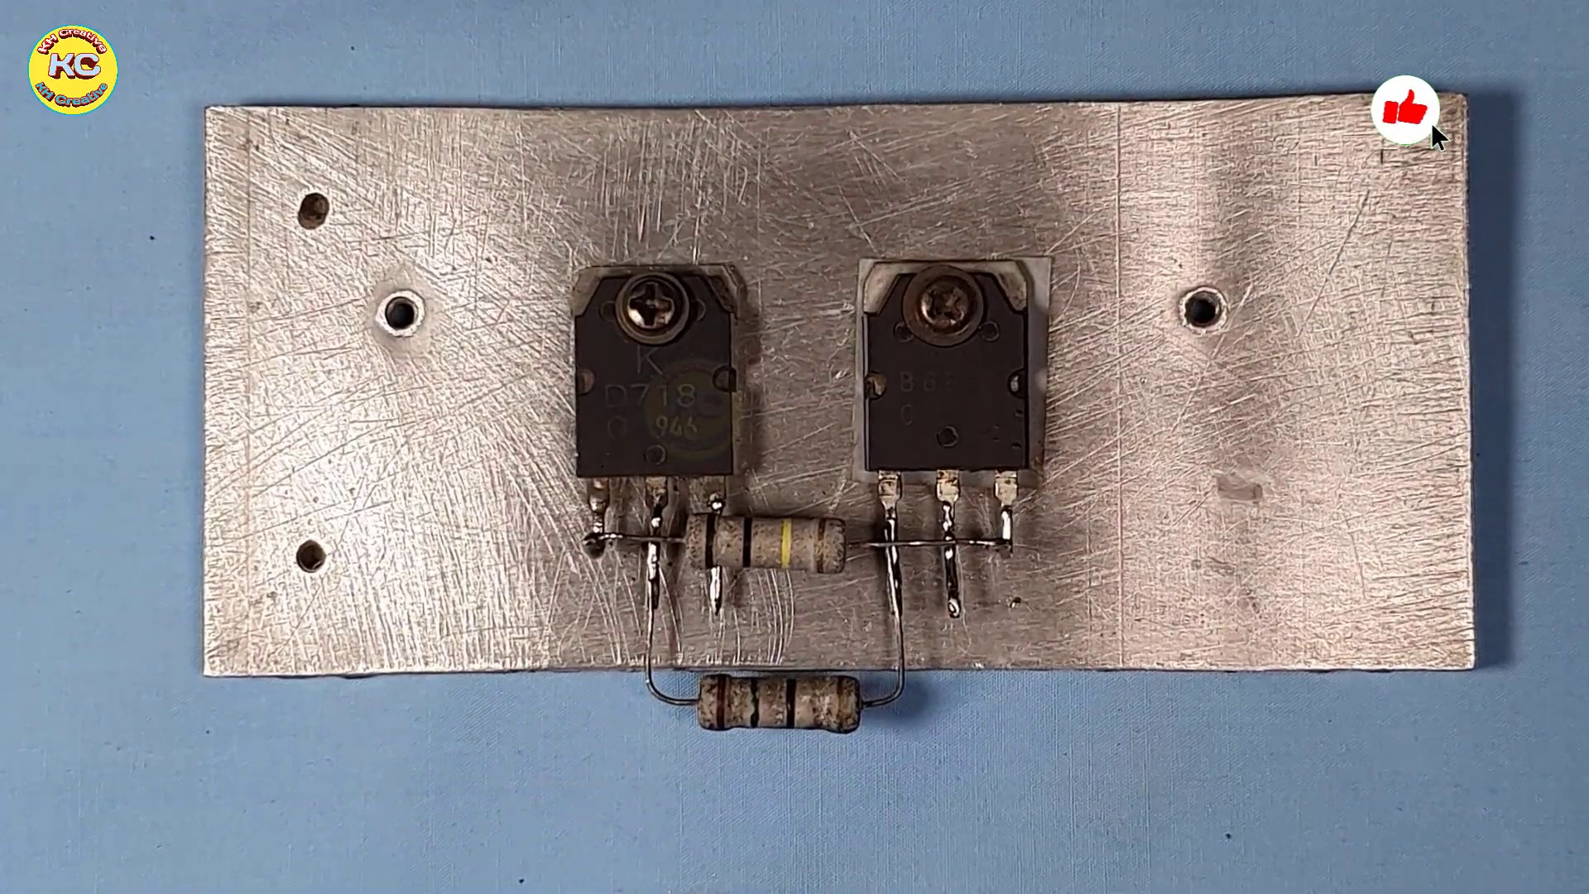 (score 90.0000)
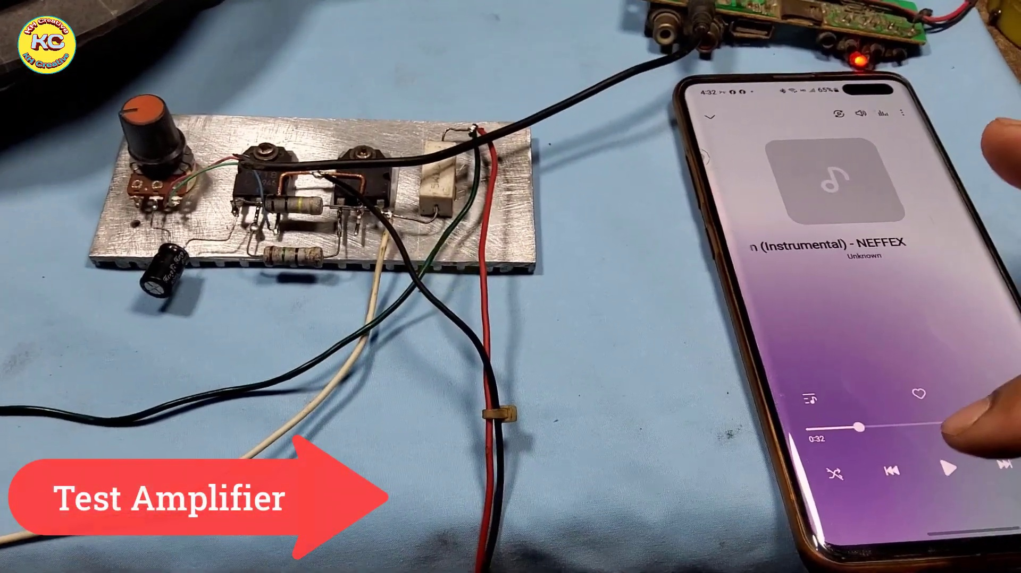 (score 85.0000)
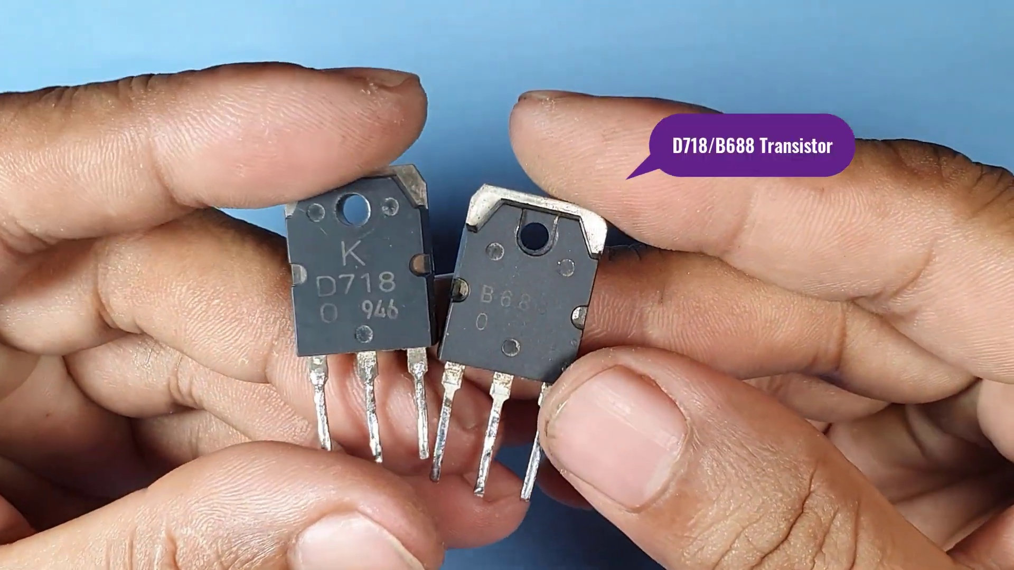 (score 85.0000)
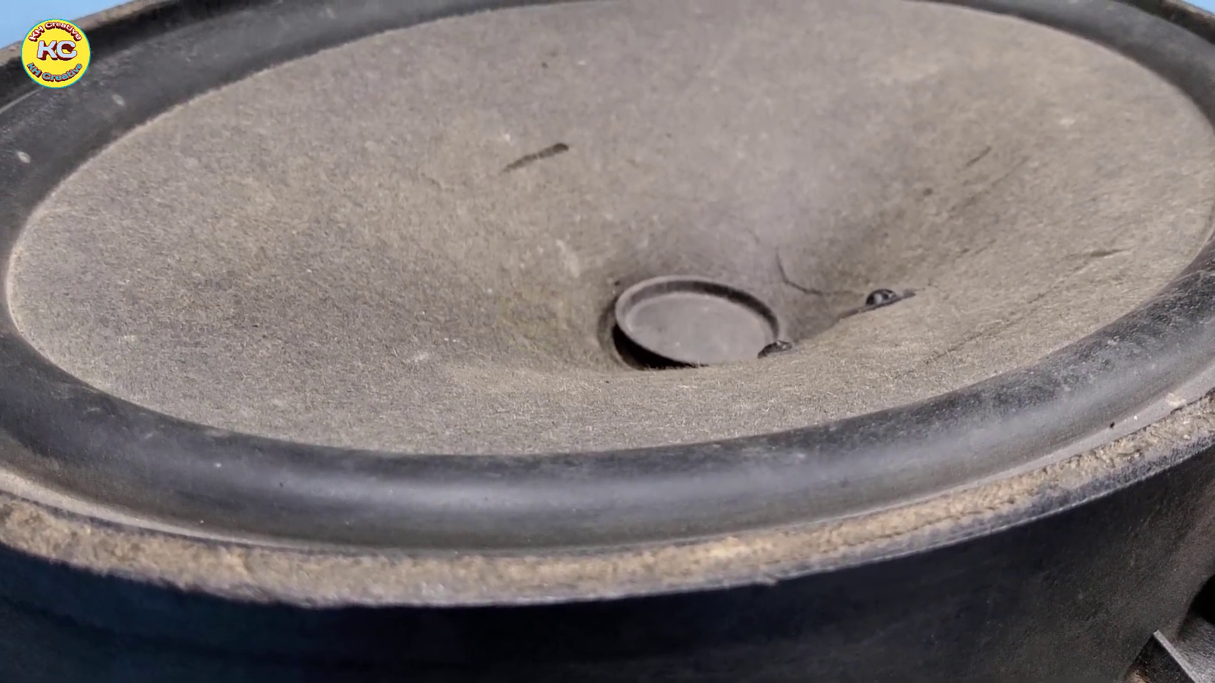 (score 80.0000)
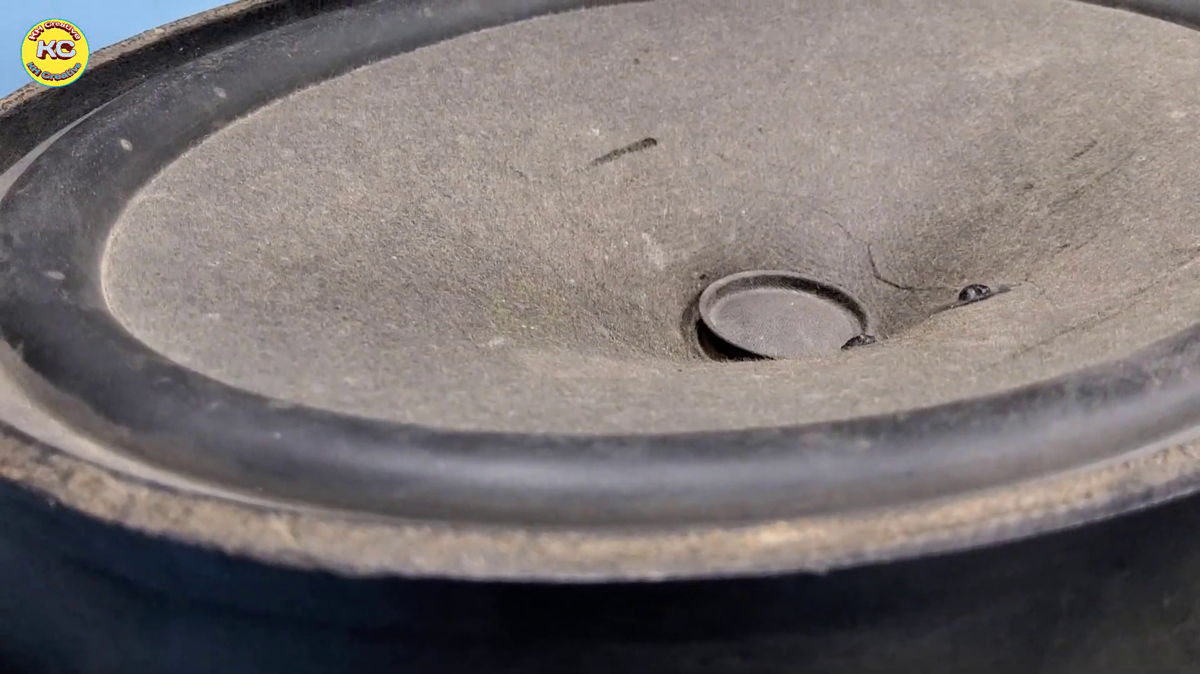 (score 80.0000)
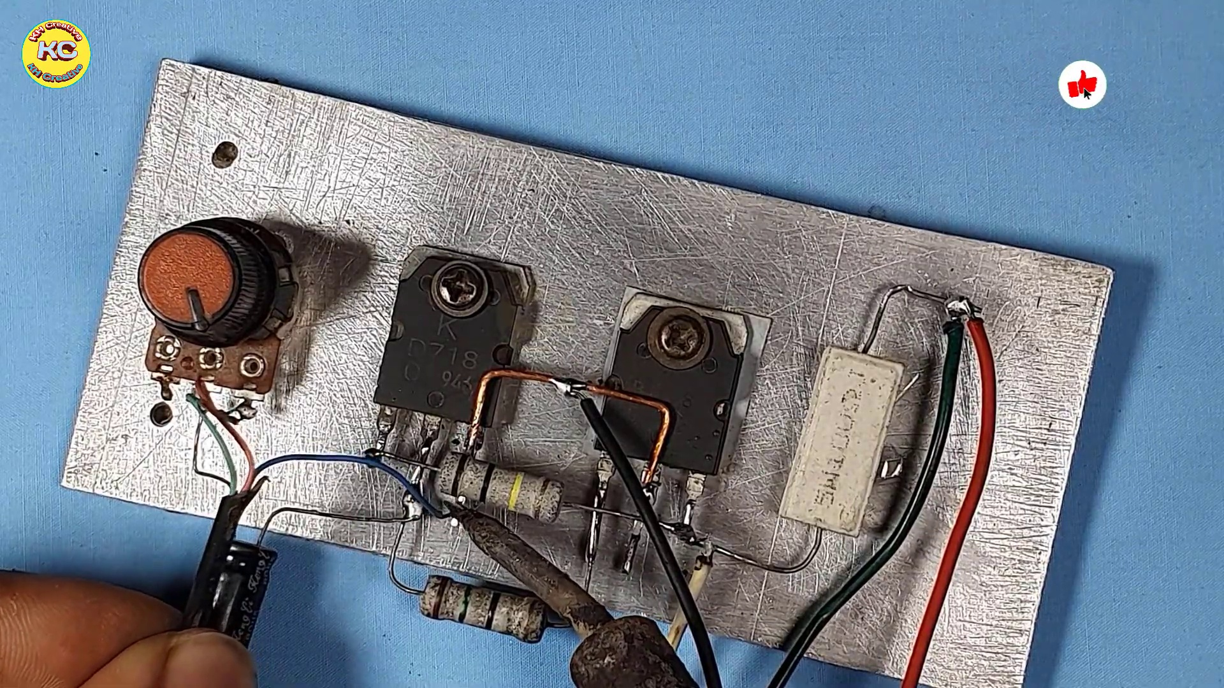 (score 80.0000)
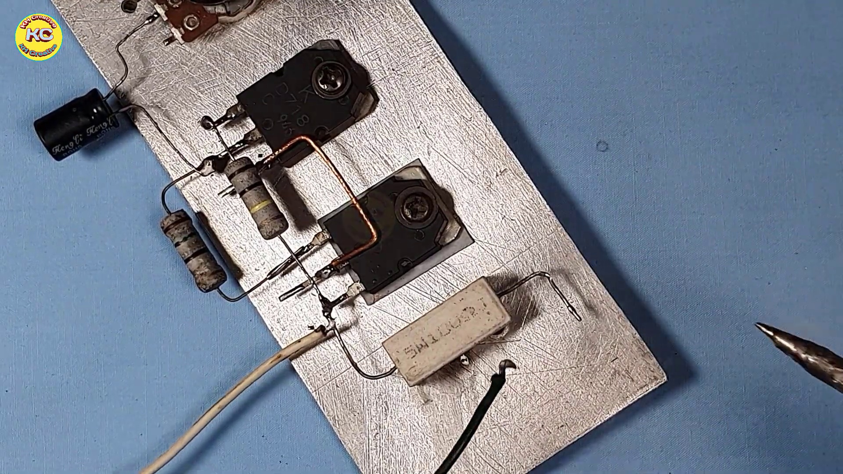 (score 80.0000)
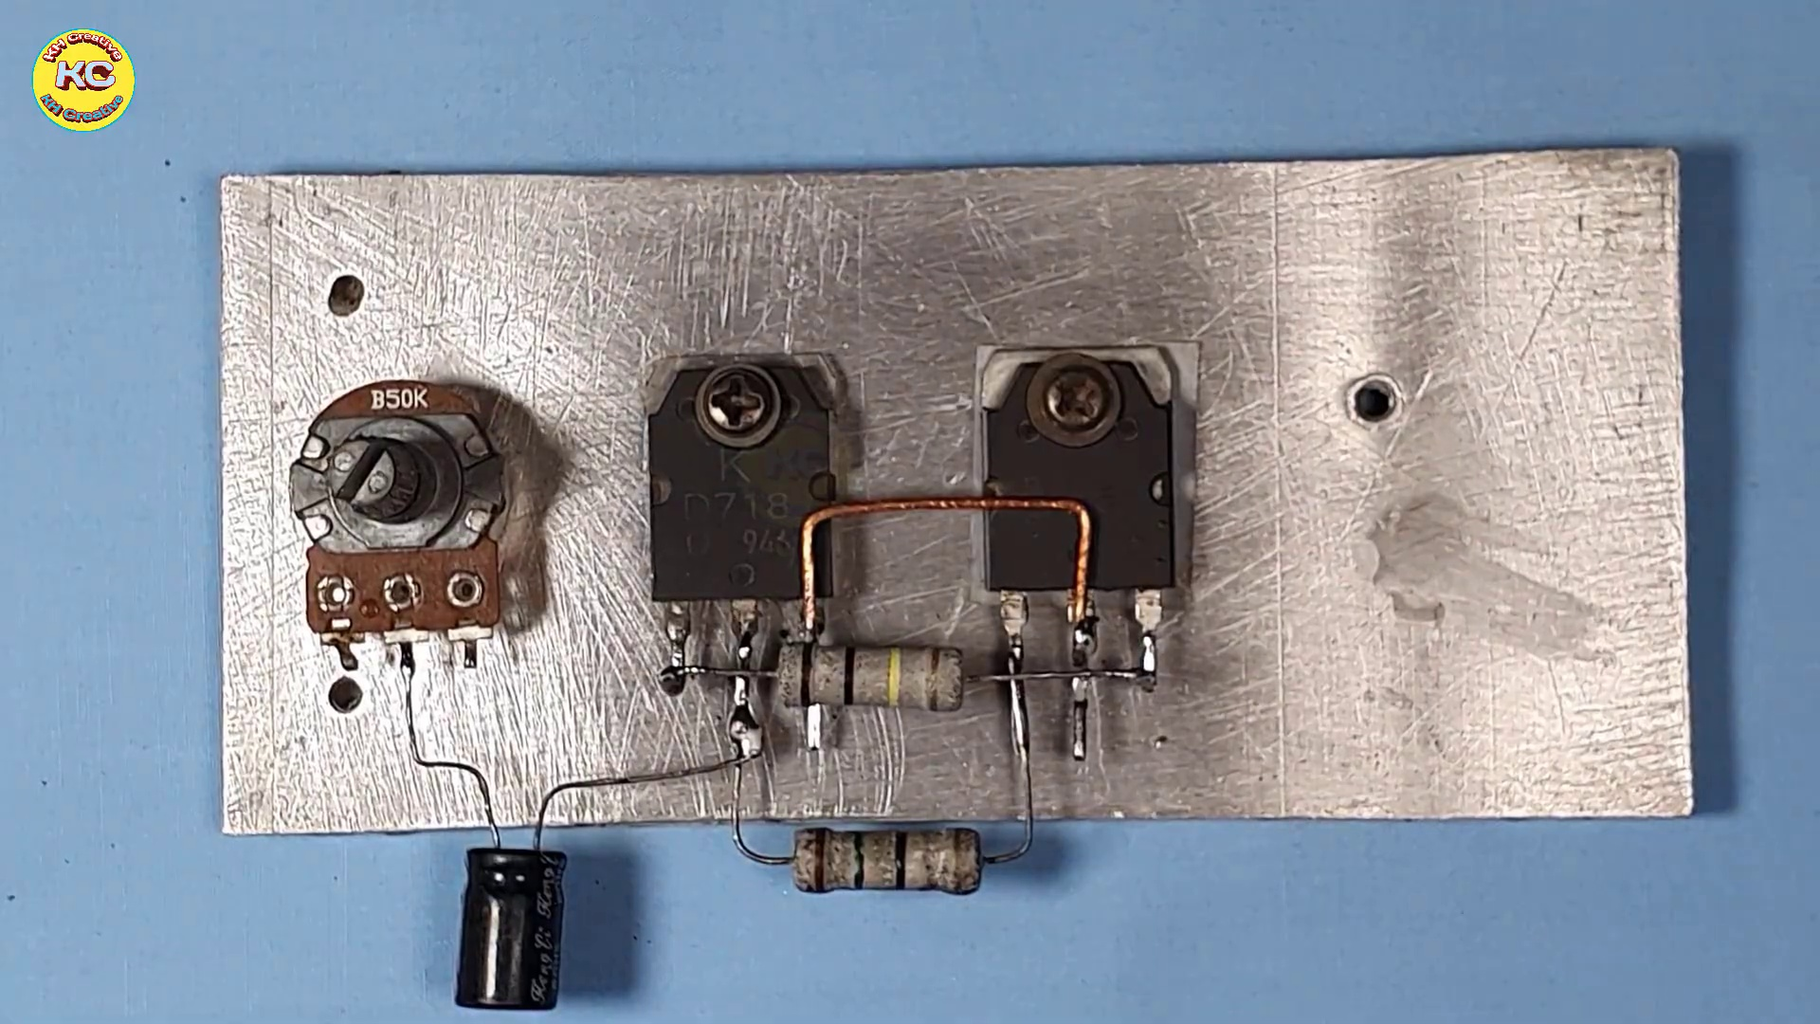 (score 80.0000)
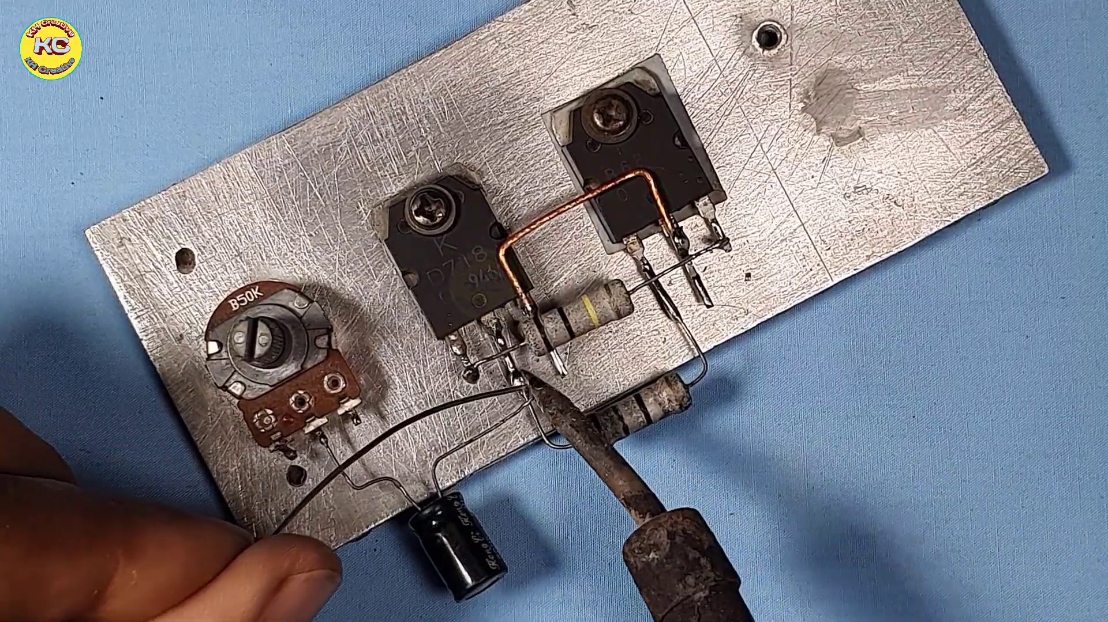 (score 80.0000)
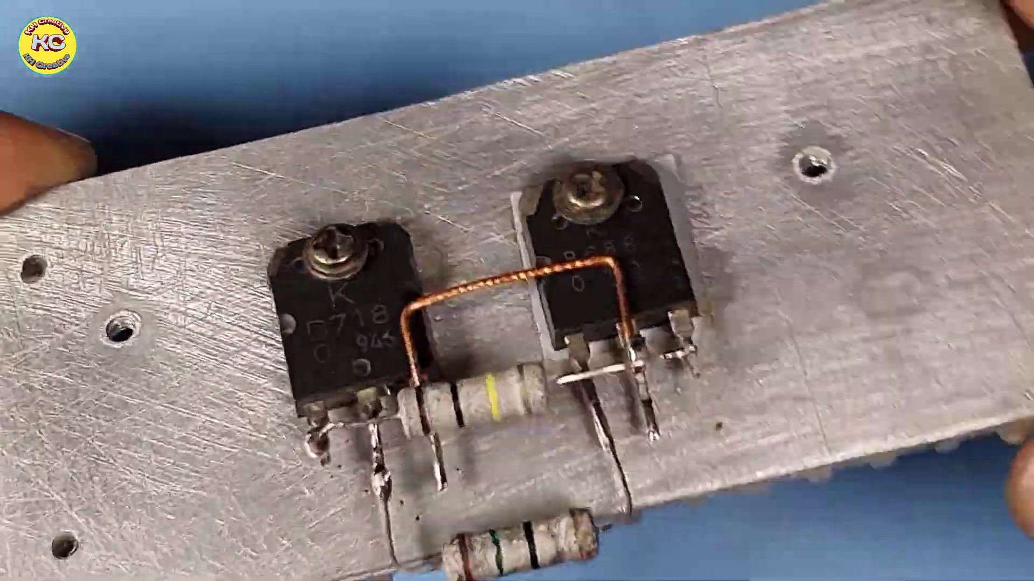 (score 80.0000)
Least correlated frames:
 (score 0.0000)
 (score 0.0000)
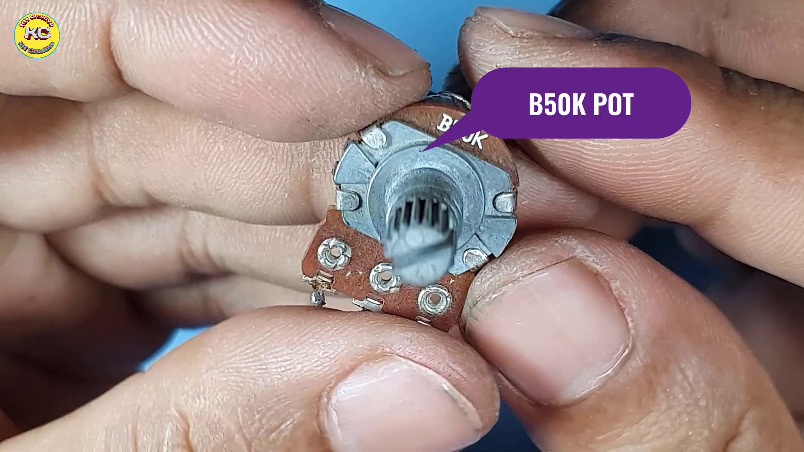 (score 0.0000)
 (score 0.0000)
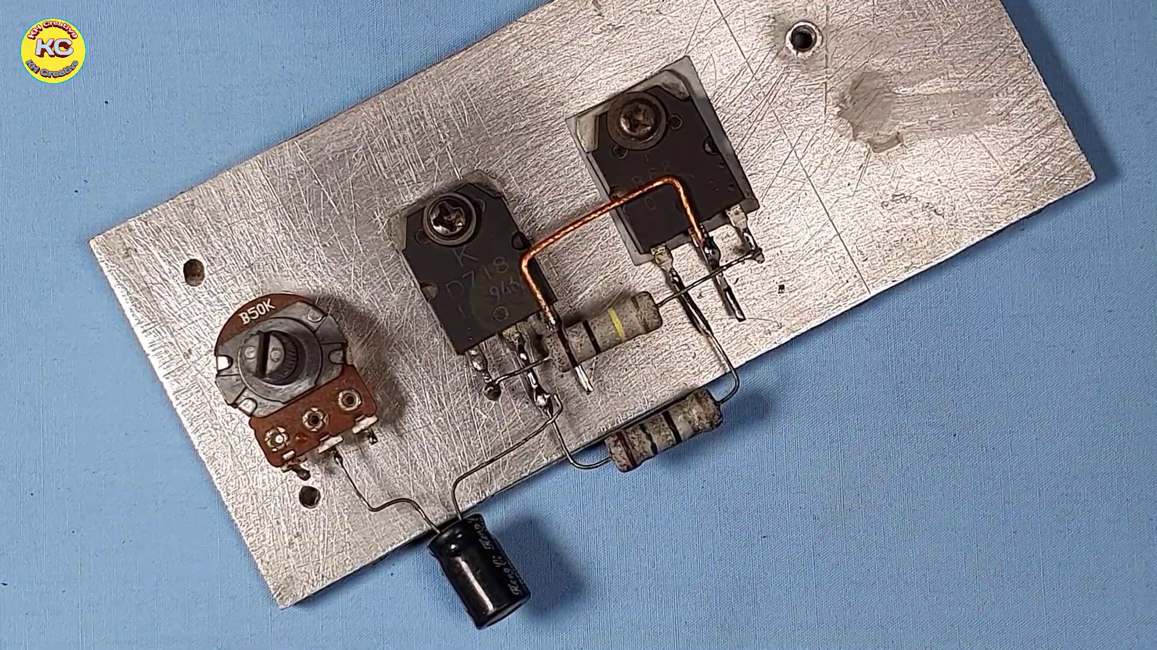 (score 0.0000)
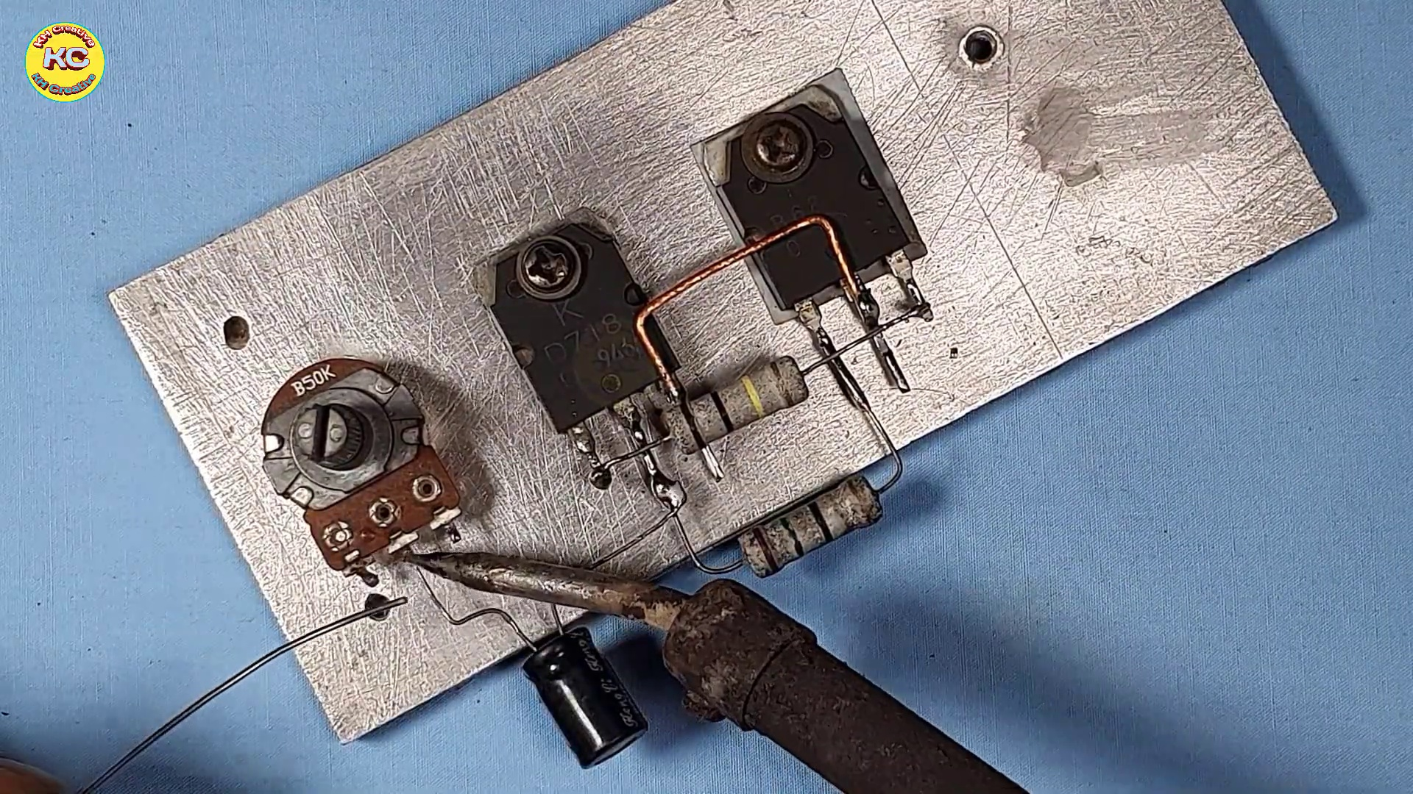 (score 0.0000)
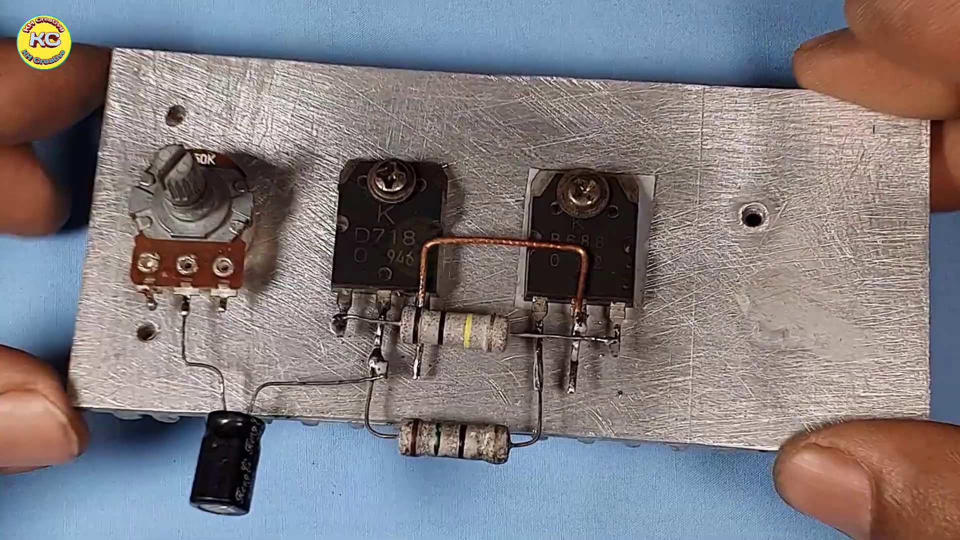 (score 0.0000)
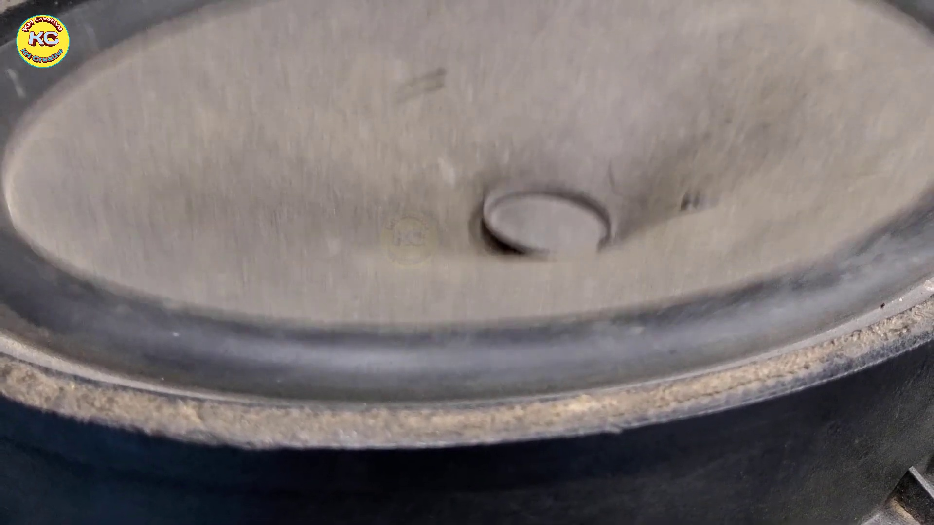 (score 0.0000)
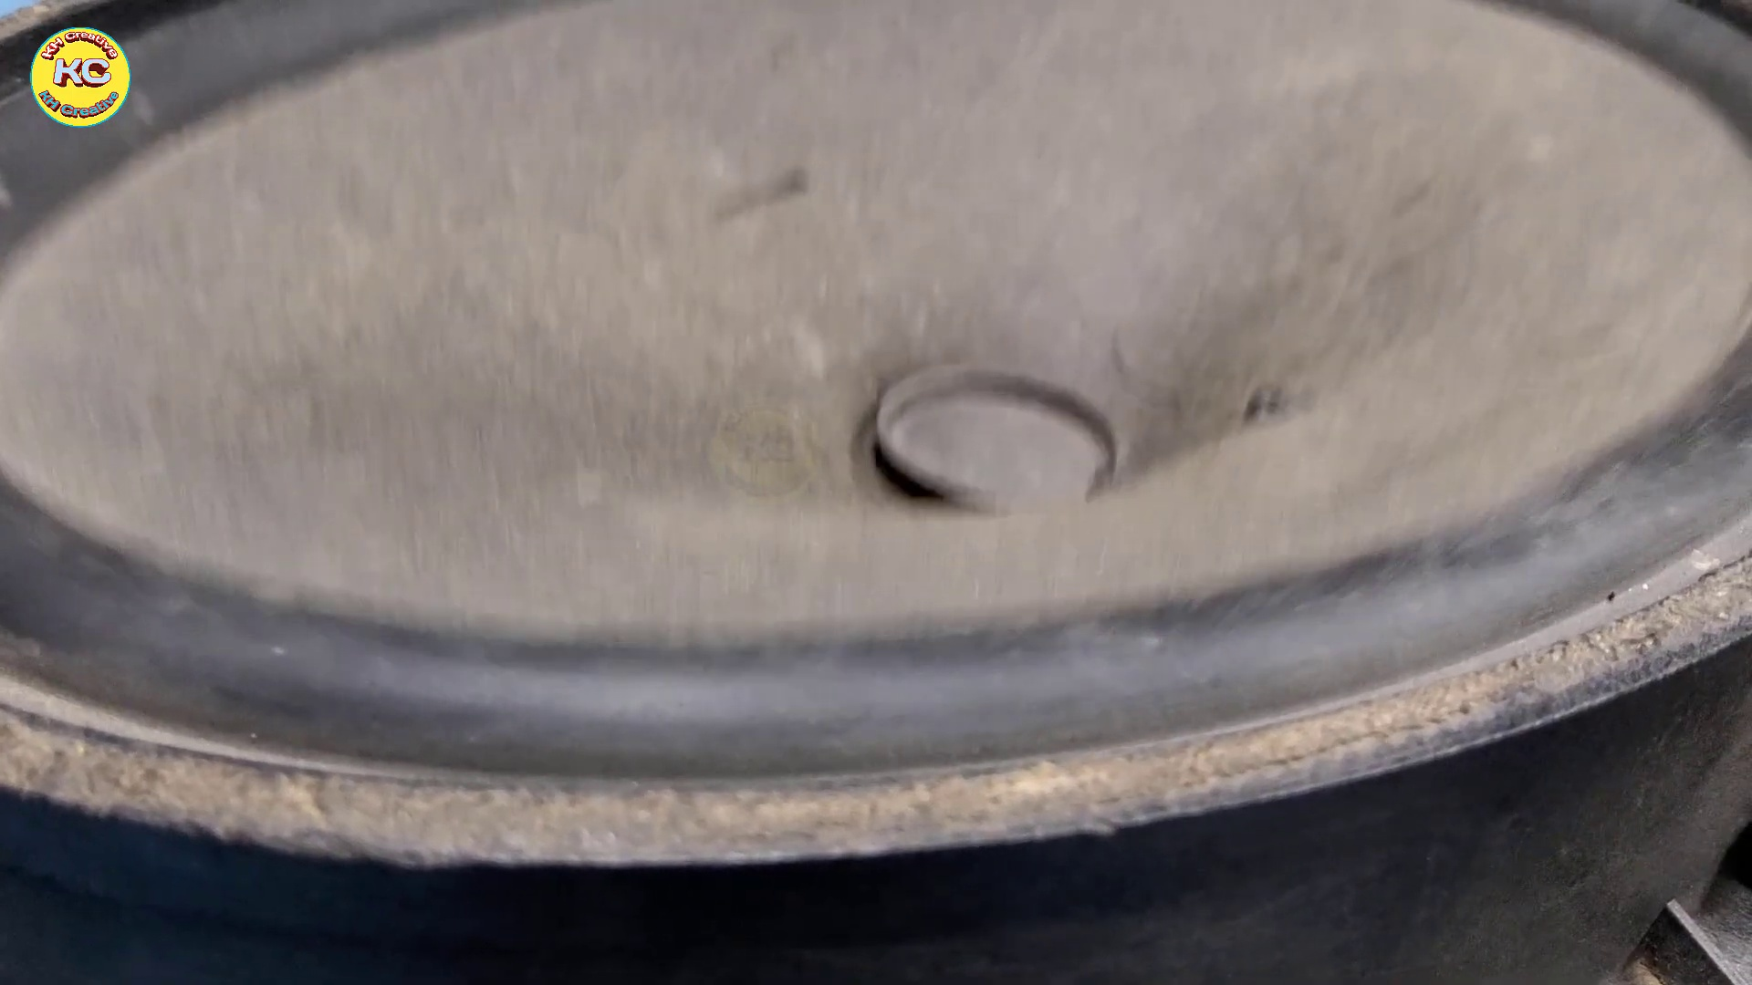 (score 0.0000)
 (score 0.0000)

Frame: frame_0000.jpg
Caption: The image presents a captivating dual-scene, with one section displaying a black screen featuring white text at the bottom, while the other section showcases a celestial landscape. The black screen appears to contain visual presentation or instructional material, including both written text and images, possibly illustrating a concept related to science or technology. The text is difficult to read due to the resolution and angle of the photo.
In the celestial landscape, two vibrant bodies stand out against the backdrop of a dark sky: a red planet in the foreground and a white star in the background. The planet's fiery glow contrasts sharply with the dark expanse, creating a dynamic composition that adds depth to the image. The relative positions of the planet and the star create a sense of distance, with the planet appearing closer to the viewer than the star.
The absence of any other objects or text in the celestial landscape further emphasizes the two celestial bodies as the sole focus of this captivating scene, allowing the viewer's attention to be drawn to their striking contrast and relative positions.
No strongly correlated comments found for this frame.

Frame: frame_0001.jpg
Caption: The image appears to be a screenshot of a digital display with graphical elements, featuring a striking design that draws immediate attention. On the left side of the display is a large circle with various smaller graphics, including what seems to be a combination of geometric shapes and abstract figures. Above this graphic, there's text that reads "KHcreative," which could imply the name or title associated with the content displayed. The style of the image is reminiscent of a video game interface or a digital artistic creation, as indicated by the pixelated quality and colorful graphics.
The background of the display is dark, which contrasts with the brightly colored elements in the circle. There are no visible texts or any actions that can be discerned from this still frame. The image has a grainy texture, suggesting it might be an actual photograph of a screen or a digital artwork designed to mimic such a screen effect.
The primary focus of the design is the word "KhCreative," which is prominently displayed on a black background in bold, red and white colors. The text is centered and features larger-sized letters for the "K" and "h," while the rest of the letters are slightly smaller, creating a balanced composition. The overall design is simple yet effective, with the bold text and vibrant colors drawing attention to the focal point, which is the word "KhCreative."
No strongly correlated comments found for this frame.

Frame: frame_0002.jpg
Caption: The image shows a person's hands holding two small electronic components, which appear to be transistors, labeled "D710/B686 Transistor" on the top of the blue speech bubble. The transistors are positioned side by side, with their pins facing outward. The hand holding the left transistor is slightly in front of the hand holding the right one. A black glove covers the person's left hand. The background is a solid blue color, providing a stark contrast to the black transistors. The bottom of the image features the text "086" written in white.
Comment (score 85): This video was helpful because I did not know that transistors can be used to increase the bass of a speaker. Also, it was not hard to build it, I hope I watched the video before finalizing our speaker project to implement transistors to get a better bass.
Reason: The comment directly mentions 'transistors' and references building a speaker project to increase bass, which is specifically discussed in the caption about using transistors. Although not identical, the connection between the two is strong and relevant.
Source: https://www.youtube.com/watch?v=muGlauyfOGsT: How to make Ultra Bass Powerful Amplifier with Transistor, DIY Simple Amplifier at home

Frame: frame_0003.jpg
Caption: The image appears to show a person holding two electronic components against a blue background. The individual is demonstrating or inspecting these parts, possibly for assembly or repair work. One component has a series of pins and holes on its underside, typical for connectors used in electronics, resembling a header pin type that interfaces with breadboards or other electronic circuits. The second component appears to be a small cylindrical part with a series of teeth around the circumference, which might be a locking mechanism or a connector that interfaces with another system.
The circuit board held by the person features two transistors marked with the numbers 0666 and 0666, indicating their model and type. The board is held against a blue background, contrasting with the black of the board and the white of the hands.
No strongly correlated comments found for this frame.

Frame: frame_0004.jpg
Caption: The image showcases a complex composition that juxtaposes two distinct elements. The dominant blue fabric with a slightly wrinkled texture appears to be the central focus, taking up most of the frame. However, upon closer inspection, attention is drawn to the vibrant yellow sticker situated centrally on the blue background. The sticker features a simple yet effective design, consisting of a circle with the letters "AC" inscribed in it, positioned in the top left corner.
The sticker not only bears the logo but also conveys movement and direction through the presence of a black arrow pointing towards the right. This dynamic element adds depth to the image, suggesting that the sticker is in motion. The blue background provides a calm and serene atmosphere, which contrasts with the energy conveyed by the moving sticker.
Despite its simplicity, the image effectively communicates a message of motion and direction, thanks to the harmonious blend of color, shape, and text. The yellow sticker stands out against the pale blue backdrop, drawing attention to its logo and arrow, while the black arrow adds an element of dynamism. The overall composition is a masterful balance of visual elements that work together to create a cohesive and thought-provoking image.
No strongly correlated comments found for this frame.

Frame: frame_0005.jpg
Caption: The image shows a close-up view of a silver metal plate with six evenly spaced holes drilled into it. The plate is resting on a blue surface, and upon closer inspection, one side appears to have multiple rectangular cutouts and possibly some textures or patterns on its surface, although the details are not clear due to the angle. The plate appears to be made of a shiny metal, suggesting it could be a piece of jewelry or an accessory. In addition, the image includes yellow text that reads "AK" and "500", which might be a reference to a product or a brand. However, without additional context, it's difficult to determine the exact meaning of these texts. The focus of the image is solely on the plate and its details, with no instructor teaching, text, equations, diagrams, or other objects present.
No strongly correlated comments found for this frame.

Frame: frame_0006.jpg
Caption: The image presents a metallic object, possibly a piece of electronics or a device, resting on a blue surface. The object has a shiny metallic surface with a thin layer of silver paint, giving it a reflective appearance. Two holes are aligned in a straight line on the plate, and there are four additional holes scattered across the object, some of which are larger and more prominent than others. These holes are evenly spaced, suggesting a precise and intentional placement.
The object is not alone on the surface; a small brown object, possibly a piece of paper or a label, is located near the bottom right corner of the image. The positioning of these objects creates a sense of depth and perspective in the image.
The image does not contain any text or additional visual content that suggests an educational or instructional context. The blue background provides a contrasting surface, making the metallic object stand out. The overall composition of the image is simple yet intriguing, drawing attention to the metallic object and its unique features.
No strongly correlated comments found for this frame.

Frame: frame_0007.jpg
Caption: The image shows a close-up of a person's hand holding a silver rectangular object, which appears to be a piece of electronic equipment, possibly a circuit board. The object is affixed to a blue surface using a series of holes and screws, indicating precise placement. The blue surface suggests it might be a test or prototyping surface where electronic components are being tested or assembled.
Notably, the focus is on the object and its placement rather than on any person who might be operating the equipment. There are no visible texts or diagrams that suggest a teaching context. The image provides no information about the operation of the equipment or specific teaching points, instead offering a practical demonstration of electronic components being tested or assembled.
No strongly correlated comments found for this frame.

Frame: frame_0008.jpg
Caption: The image captures a close-up view of a person's hands holding a small metal component with four holes, possibly demonstrating its use or construction. The piece appears to be an electrical connector or part of some electronic circuitry, made of metal with four holes that could accommodate nuts or screws for secure attachment to other components. In the background, a light blue color provides a stark contrast to the silver rectangular metal plate being held firmly in place by the hands. The plate is adorned with three rectangular holes, each equipped with a black screw strategically placed on the plate - one on each corner and one in the center. The scene suggests an assembly or installation process, possibly related to electronics or technology, as the person's hands are positioning this small electronic component into the plate. There is no text or visible writing on the component itself or in the image, emphasizing the object being held up.
No strongly correlated comments found for this frame.

Frame: frame_0009.jpg
Caption: The image displays a silver-colored metal plate with a rectangular shape, affixed to a blue background. The plate is adorned with a yellow sticker on its top left corner and features four holes. Two silver rectangular components are embedded within the plate, aligned with the holes. The overall arrangement gives a sense of a circuit board that could be used for electronic devices. The plate's shiny surface suggests it might be made of a material that is good for conducting electricity, such as copper or silver. The placement of the components and holes, along with the plate's material, suggest a design that allows for easy wiring and connection. The yellow sticker on the plate could potentially provide information about the components or the design of the plate. The image does not contain any text or other objects that can be confidently identified. The relative positions of the components and the holes suggest a well-planned and organized design. Notably, the metal mounting bracket with two black plugs attached at one end is present in the same blue fabric surface as the silver-colored metal plate. This type of bracket is commonly used for securing electrical components in a framework, such as in a vehicle's wiring system. The image does not provide any information about the purpose or function of the plate, components, or mounting bracket.
No strongly correlated comments found for this frame.

Frame: frame_0010.jpg
Caption: The image shows a hand placing an electronic component onto a circuit board. The person is holding the component with their fingertips, and their index finger is visibly pushing down on the component to align it properly with the pins on the surface of the circuit board. The object being manipulated appears to be a small electronic device, possibly an integrated circuit (IC), given its rectangular shape with multiple legs for connection. The circuit board has several holes aligned to accept various types of electronic components.
In the lower part of the image, there is a blurred background that suggests this could be a photograph taken indoors, possibly in an educational setting given the focus on the process of assembling or modifying an electronic device. The lighting is even, which indicates it might be an indoor environment with adequate illumination.
The component being placed onto the circuit board is a silver rectangular plate adorned with four silver pins, each with a black tip. The pins are arranged in a vertical line on the plate. The plate is gently held by the hand, which appears to be concentrated on ensuring proper alignment and placement of the device.
No strongly correlated comments found for this frame.

Frame: frame_0011.jpg
Caption: This image appears to show a hands-on demonstration of manual labor and craftsmanship, with two distinct scenes unfolding simultaneously. The central figure is using a drill press to work on a piece of metal, focused intently on the task at hand as they guide the movement of the drill bit into the material. The background suggests this might be taking place in a workshop or garage, with no visible text or diagrams providing context or instructions within the frame.
The second scene shows a person engaged in a separate task involving a small, round object with a hole in the center. The person is using a yellow screwdriver to grip the object and apply pressure, held firmly in their right hand. The object is placed on a white sheet of paper, which is resting on a blue surface, while the blurred background focuses attention on the person and the object in the foreground.
The drill press appears to be an essential piece of equipment for metalworking, allowing precise drilling into metals to create holes or modify the material in a specific way. The person's hands are on the machine's lever, controlling the movement of the table where the workpiece is mounted. Meanwhile, the screwdriver seems to be being used to grip and manipulate the small object, with the relative position suggesting that the person is working on it.
The image captures two moments of manual labor, emphasizing the skill involved in operating equipment like drill presses safely and effectively, as well as the importance of precision and control when handling smaller objects.
No strongly correlated comments found for this frame.

Frame: frame_0012.jpg
Caption: The image shows a person working on an electronic component or metal object, with their hands skillfully maneuvering a yellow and black screwdriver. The individual is concentrating on the task at hand, using the screwdriver to pry open a small metal plate that rests on a blue surface. In the background, there may be a workbench or other indoor workspace, although the low resolution of the image makes it difficult to discern. The person appears focused on their work, with no visible text providing additional context or instructions.
The style of the image suggests a still from a video tutorial or demonstration, given the hands-on nature of the activity and the setting that implies someone teaching or showing how to work with electronics components or metal objects like the one being handled by the person in the photo. The image provides a testament to the precision and care that goes into such tasks, highlighting the importance of attention to detail and manual dexterity.
No strongly correlated comments found for this frame.

Frame: frame_0013.jpg
Caption: The image shows a person engaged in meticulous assembly work, using tools to manipulate electronic components on a silver board with a yellow label. The individual appears to be using a screwdriver to securely fasten multiple components, including a red and black IC and a black and yellow capacitor, onto the board. One of the components is a piece of metal with multiple holes, which is part of an electronic circuit board likely used for prototyping electronics. This board features a series of copper traces connecting pads, suggesting that it may be used in creating electronic prototypes at home or in a DIY environment.
On the right side of the image, there's a text overlay that reads "DOWNLOAD INSTRUCTION," indicating that the image is likely part of an online tutorial or educational content where viewers can download instructions for creating similar electronic circuit boards. The presence of this text suggests that the image may be related to an instructional video or guide, teaching others how to create their own electronic prototypes at home or in a DIY environment.
No strongly correlated comments found for this frame.

Frame: frame_0014.jpg
Caption: The image shows a person's hands engaged in a precise and focused task. The person is holding a screwdriver in their right hand, which they are using to tighten or adjust components on a small circuit board with several attached components, including resistors and possibly integrated circuits. The circuit board appears to be held firmly in place by a black metal clamp, allowing the person to work on it comfortably.
In the background, there is a blue tabletop that provides a contrasting surface against which the device is placed. On the left side of the image, there seems to be a tool or component holder with various tools and electronic parts. The focus of the image is on the hands manipulating the small circuit board, suggesting an educational or instructional context, possibly teaching how to assemble or repair electronic devices at a DIY level.
Note: I have carefully integrated the two captions while avoiding redundancy and contradictions, retaining all accurate and relevant details explicitly mentioned in either original caption.
No strongly correlated comments found for this frame.

Frame: frame_0015.jpg
Caption: The image shows a close-up view of a small metal circuit board resting on a white surface, with a silver color providing a stark contrast to the light blue background. On the board, there are two black components - a transistor and a resistor - positioned next to each other, with the transistor slightly to the left and the resistor to the right. The board is held in place by a small black screw located towards the top of the board, just above the center, and slightly to the right.
One component is being held up by the person's thumb, allowing for closer inspection of the part. The focus of this image appears to be educational or instructional, likely meant to teach about electronics or circuit assembly, with the text overlay in the upper right corner reading "Download circuit in description." This suggests that there might be instructions for downloading a circuit diagram or plan from the description area on the platform where this image was shared. The image provides a detailed view of a simple electronic circuit, highlighting the components and their positions, making it potentially a step-by-step guide or tutorial for someone learning about electronics.
No strongly correlated comments found for this frame.

Frame: frame_0016.jpg
Caption: The image shows a close-up view of a person meticulously assembling a small electronic device on a metal plate. The individual's right hand is holding a small metal piece against a larger part, while their left hand is using a tool to manipulate the smaller component. It appears that the person is carefully inserting a tiny screw into the circuit using a small metal screwdriver held in their left hand. The circuit itself consists of a few components being connected together, and the image captures a moment of focus and precision in the process of creating a functional electronic device. The background is out of focus but appears to be an indoor environment with a blue surface that could be part of a workbench or table. The style of the image suggests it might be used in an online learning platform or instructional content, possibly teaching electronics, DIY projects, or similar hands-on skills.
No strongly correlated comments found for this frame.

Frame: frame_0017.jpg
Caption: The image shows a person's hands meticulously assembling a circuit using a soldering iron on an electronics project. The hands are focused on the task at hand, which appears to involve attaching or connecting something using the soldering iron and wires. The soldering iron is active with a bright tip, indicating it has been heated for use. A small silver piece of metal is being handled by the person's fingers, which are visible as they manipulate the components, showcasing their level of expertise in the task. This piece of metal is affixed to a larger silver piece of metal and connected to a black component attached to a yellow board resting on a blue surface. The contrast between the yellow and blue surfaces creates a visually striking image that captures a moment of precision and attention to detail in the process of circuit assembly, likely taking place within a hands-on learning environment where someone is demonstrating soldering techniques as part of an online tutorial or class.
No strongly correlated comments found for this frame.

Frame: frame_0018.jpg
Caption: In this close-up view, a person's right hand holds a small metal object, specifically a small electronic circuit board with two small metal pins sticking out from the top. The person is holding the object with their thumb and index finger, while their other fingers are curled around it. Their thumb rests on the bottom of the object, and their index finger curls around the top. This focused grip suggests careful handling of the electronics.
To the left, one hand appears to be engaged in working with electronic components, holding a small circuit board with their dominant hand, while the other hand inspects or manipulates a component on the board. Both hands are steady and focused, indicating precise handling of the electronics.
In the background, there is a light blue color with a faint pattern that might be related to the work at hand or serves as a plain backdrop for clarity. Superimposed over the image is text that reads "Download Crook in description" (later corrected to "Download Circuit in Description"), suggesting an educational context, possibly from a tutorial video teaching electronics repair or creation.
The style of the image and the presence of the circuit board with pins indicate that this image may be from a video platform like YouTube, where viewers can download additional information or resources related to the content of the video. There are no other visible people or objects in the image that would provide additional context about the location or environment.
No strongly correlated comments found for this frame.

Frame: frame_0019.jpg
Caption: The image shows an electronic device demonstration setup that combines hands-on activity with precision and dedication. A relay module, resembling a small metallic box with two terminals on one side and four relays on the other, is being used for educational purposes. Each relay has a switch, indicating manual control over turning them on or off.
In front of the relay module, a screwdriver with a yellow handle lies atop it, suggesting that someone is using it to adjust or manipulate the relays. The blue fabric surface behind the setup and the indistinct objects likely represent tools or materials related to electronics or DIY projects. This informal setting could be a workshop or hobbyist's workspace where someone is teaching how to use a relay module, potentially for an educational tutorial on YouTube or similar platforms.
On a separate table, a man is meticulously soldering a circuit board placed on a gray metal plate, which is affixed to a silver metal stand. The stand is anchored to the table, providing stability to the setup. The circuit board, shining with a silver hue, reflects the light in the room. The soldering iron, with its red tip, is poised to join two pieces of metal on the board.
The man's focused expression and the intricate process of soldering demonstrate his dedication and precision in his work. The entire scene unfolds against a blue background, creating a calming contrast to the action taking place.
No strongly correlated comments found for this frame.

Frame: frame_0020.jpg
Caption: The image shows a close-up view of a person's hands manipulating an electronic device or circuit board. The board features several components, including two connectors with pins that could be used for securing wires or other connections. The individual's hands are working with a tool or part of the equipment, although their face is not visible in the frame. In the top right corner of the image, there is text that reads "Download in description," suggesting that additional instructions or information can be found in the description section, likely on a platform like YouTube, where this image might have been shared.
Upon closer inspection, the board appears to be home to two small black transistors, each with a wire attached to it. These wires are being manipulated by a black screwdriver, implying some form of repair or modification is taking place. The text "Download Circuit Description" is clearly visible, indicating that the image might be part of a larger context, possibly related to electronic repair or design.
Comment (score 80): This video was helpful because I did not know that transistors can be used to increase the bass of a speaker. Also, it was not hard to build it, I hope I watched the video before finalizing our speaker project to implement transistors to get a better bass.
Reason: The comment directly references the transistors on the circuit board mentioned in the caption, indicating a strong connection between the two. Although it doesn't mention specific technical steps or settings, the comment does discuss how the video's content was applied to a real-world project (building a speaker) and provides context for the use of transistors.
Source: https://www.youtube.com/watch?v=muGlauyfOGsT: How to make Ultra Bass Powerful Amplifier with Transistor, DIY Simple Amplifier at home

Frame: frame_0021.jpg
Caption: The image shows a close-up view of a metallic circuit board with several electronic components mounted on it, including two black connectors that could be terminals or connectors for wiring. The components may include resistors or capacitors, and are attached to the board with wires. The circuit board is placed on a blue surface, suggesting it might be a workbench or table in an educational or technical setting. In the background, there is a hint of a person's hand, indicating that someone is either assembling or examining the device.
The image also features two main components: a red and a silver one, which are attached to the board with wires. The red component is located towards the left side of the board, while the silver one is situated towards the right. The board itself is mounted on a silver plate, which is affixed to a gray metal surface, held in place by a black screw visible on the right side of the board.
At the bottom-right corner of the image, there is text that reads "DOWNLOAD CIRCUI [CIRCUIT] IN DEPICTION" and "Download Circuit Description in description", indicating that the circuit board is part of a larger project or study. The style of the image suggests it might be used for educational purposes, possibly as part of a tutorial or a classroom activity where students are learning about electronics and circuit assembly.
No strongly correlated comments found for this frame.

Frame: frame_0022.jpg
Caption: The image shows a piece of hardware with two metallic components attached to it, which appears to be an electronic circuit board or module. There are multiple screw terminals on the board, and one terminal is connected to a small metal component that has two wires attached to it. The background suggests this might be a DIY electronics project or tutorial. A silver board with two black components is affixed to a gray metal base, with a pair of black wires connected to the components. The words "Download Circuit in Description" are clearly visible on the board, indicating the steps for assembling or repairing the circuit. This scene appears to capture an electronic repair process, with the black components and wires suggesting the need for precise assembly and connection.
No strongly correlated comments found for this frame.

Frame: frame_0023.jpg
Caption: The image shows a person's hands working with an electronic device on a blue background. The device appears to be a small circuit board or integrated circuit (IC) with several components that resemble resistors, capacitors, and integrated circuits mounted directly onto the board. One of the person's hands is holding a tool, which could be used for installing or adjusting components on the circuit board. On the board, two electronic components are positioned, ready to be connected, and are being carefully manipulated by the other hand using tweezers. The board itself is silver, reflecting the light in the room, and stands out against the black components. The background of the image is a bit blurry, focusing on the hands and the board. In the distance, the text "Download Circuit Description" is visible, suggesting that the image may be part of a larger document or project related to electronics or circuit design.
No strongly correlated comments found for this frame.

Frame: frame_0024.jpg
Caption: The image shows a person's hands working with an electronic component, showcasing two devices that appear to be printed circuit boards (PCBs). One hand holds a soldering iron while the other manipulates an electronic component, likely attaching it to the PCB using the soldering iron. The background is blurred, featuring what seems to be a blue fabric surface, suggesting this might be taking place in a workshop or lab environment.
The focus of the image is on the hands working with the electronic components and the soldering process. One hand holds a piece of metal, specifically a silver-colored rectangular board with two silver-colored connectors attached to two silver-colored electronic components. The board is positioned on a silver-colored metal surface, which bears the text "Download Circuit Description in Description" written in dark blue color.
The image also includes a logo that reads "KA" in light blue color, situated towards the top right corner. This entire scene gives the impression of someone working on a circuit board with electronic components, possibly indicating a lesson or demonstration related to electronics assembly or soldering techniques.
No strongly correlated comments found for this frame.

Frame: frame_0025.jpg
Caption: The image shows a close-up view of a person's hands, specifically the thumb and index finger, as they work with an electronic component on a breadboard. The person is facing away from the camera, with a blue fabric background providing a neutral backdrop for the activity. The breadboard itself has several rows of metal pins arranged vertically with spaces between them, used to make electrical connections with jumper wires.
In this hands-on moment, the person appears to be in the process of installing or adjusting a device that looks like a small motor or solenoid valve into the breadboard. The text on the image reads "DOWNLOAD INSTRUCTIONS," suggesting that the image might be part of an online tutorial or step-by-step guide where one can learn to work with electronics by following instructions provided in digital format.
The object held by the person's hands is a small rectangular piece of metal, labeled with the text "Download Circuit Description." This suggests a setting related to electronics or engineering, where the person is engaged in the process of downloading a circuit description. The overall style of the image, focusing on the activity and lacking other elements like textbooks or teaching aids, implies that it is intended for instructional purposes, possibly as part of an online learning platform or community.
No strongly correlated comments found for this frame.

Frame: frame_0026.jpg
Caption: The image shows a close-up view of a silver plate with a black square in the center, held together by a silver screw on the right side. The plate is adorned with two black wires, one of which is connected to the square. Against a white background that contrasts with the silver plate, the text "Download Circuit Description" is clearly visible, suggesting that the image might be related to a circuit diagram or a similar electronic device.
The plate itself appears to be part of an educational demonstration or presentation related to electronics, as indicated by the label "ELECTRIC COMPONENT" on the other side. The background of the image is out of focus but seems to be a workshop or laboratory setting, indicating a practical learning environment where hands-on activities are taking place.
The main focus is on the electronic component itself and the demonstration of its functionality or assembly process, with no visible text, diagrams, or other educational materials in the image that would provide additional context about the content being taught.
No strongly correlated comments found for this frame.

Frame: frame_0027.jpg
Caption: The image captures a close-up view of a silver metal plate, which serves as a circuit board. The plate is affixed to a larger metal plate, both of which are resting on a black surface. The plate features two rectangular holes, presumably for the placement of components. A red sticker prominently displays the text "Download Circuit Description" on the plate. In addition, an electrical wall plate with two terminals installed and secured in the metal housing is shown. There is no instructor or teaching context visible in this frame, as the focus remains solely on the electrical component itself. The overall scene suggests a workspace or laboratory setting, where electronic components are being assembled or tested.
No strongly correlated comments found for this frame.

Frame: frame_0028.jpg
Caption: The image presents a close-up view of two fingers working with small electronic components. A hand is holding a small circuit board and a pair of tweezers, with a component on it being lifted by one of the tweezers. Below the tweezers, text reads "Download Circuit in Descriptions." Additionally, a 100K/2W resistor, gray in color with a yellow stripe on its side, is placed on a white background, contrasting sharply with its gray color. The image also contains text overlays that read "Download Circuit in Description," suggesting a possible connection to a circuit diagram or tutorial on how to use this resistor. The hands holding the resistor and the text are the main focus of the image, drawing attention to the object being held and the instructions provided. The relative position of the hands and the text overlay indicates that the image is centered around the 100K/2W resistor and its accompanying instructions.
No strongly correlated comments found for this frame.

Frame: frame_0029.jpg
Caption: The image presents a silver rectangular plate resting on a black background, adorned with two black rectangular holes each housing a silver screw. The plate is affixed to a black metal surface with the holes and screws securely fastened. Measuring 77 pixels in width and 128 pixels in height, the plate has a rectangular shape.
Notably, there is no visible text, person, or other objects that provide context or indicate any instructor's actions. The focus of this image remains solely on the wall plate and its connectors, with two RJ45 connectors attached to each outlet on the metallic wall plate.
In the top left corner of the plate, a white sticker carries the text "Download Circuit Description in Description", serving as a reminder for potential users of the plate, suggesting that circuit details can be found elsewhere. The overall layout of the image suggests a practical application, possibly in the realm of electronics or circuit design, with a well-designed and functional object displayed on the black surface.
No strongly correlated comments found for this frame.

Frame: frame_0030.jpg
Caption: The image shows a close-up of an individual carefully assembling electronic components in a workshop setting. A person's hand, wearing a dark glove, holds tweezers that are being used to handle small components. The right hand is holding the tweezers firmly, with the fingers carefully manipulating them to place or remove components.
In the foreground, a pair of silver-colored components are being assembled together, with a tiny black component being held in place by the tweezers. The tweezers are lifting off the gray metal surface, revealing the small components in detail. The soldering iron, with its black handle and multiple buttons, is positioned nearby on the same metal surface.
The background of the image features a blue surface, which could be a workbench or table, providing contrast to the gray metal surface where the assembly is taking place. A thermocouple or temperature monitoring component, connected by wires to the main body of the soldering iron, adds further detail to the scene. The overall atmosphere suggests a moment of precision and care in the process of electronic assembly.
The image contains overlaid text that reads "DOWNLOAD CROSS IN DESCRIPTION," indicating that additional information about this item is available in the description section of an online platform. This suggests that the image may be part of an instructional tutorial or educational resource, possibly from a video or guide, demonstrating how to use or set up the soldering iron and assemble electronic components.
No strongly correlated comments found for this frame.

Frame: frame_0031.jpg
Caption: The image captures a close-up view of a silver circuit board, resting on a gray surface. On the board, several components are visible, including resistors, capacitors, and possibly integrated circuits or connectors. Two rectangular metal brackets hold silver wires that connect to a small electronic device housed within a plastic enclosure. The enclosure is marked with the text "Download Circuit Description". In the lower right corner of the image, the text "DOWNLOAD INSTRUCTION" suggests that accompanying instructions or explanations may be available for download. However, no text or diagrams are directly visible within the frame, which focuses solely on the physical components of the device without any external context or teaching materials.
No strongly correlated comments found for this frame.

Frame: frame_0032.jpg
Caption: The image depicts a moment of electronic assembly, where an individual is engaged in hands-on activity to modify or assemble an electronic device. In the foreground, a small metal fixture with two black connectors is being worked on, with a pair of pliers used to strip wires from an insulated cable and connect them to one of these connectors. A silver circuit board, marked "Download Circuit Description", is visible in the background, affixed to a silver metal plate on a black surface. The wire, presumably from the circuit board, is being soldered to a metal component located towards the right side of the image. The overall scene suggests a process of electronic assembly or repair. The background is plain black, providing a stark contrast to the silver and black elements in the foreground.
No strongly correlated comments found for this frame.

Frame: frame_0033.jpg
Caption: This image presents a close-up view of a person working with electronic components, using a black screwdriver to solder two black wires onto a silver circuit board. The circuit board features white text that reads "Download Circuit Description in Description", suggesting that the device is part of a larger electronic assembly and that a detailed description of the circuit can be found in a separate document. The individual appears to be using the screwdriver to secure the wires onto two solder points, with two connectors also attached to the metal plate, which has small indentations for each connector. One side of the metal plate is visible, revealing the wires and solder points. The overall scene suggests a workspace or workshop where electronic components are assembled and tested, with a focus on the technical work of soldering wires onto the circuit board.
No strongly correlated comments found for this frame.

Frame: frame_0034.jpg
Caption: The image presents a metal plate affixed to a wooden surface. The plate features two rectangular holes, each containing a black screw. At the top of the plate is a label with bold black letters reading "Download" and smaller black letters reading "Description", positioned below. The word "Circuit" is written in black letters above the label. The metal plate appears to be made of a lightweight material, possibly aluminum, given its silvery color and the visible bolt holding it together. The plate is centered on the image, with the rectangular holes located in the center of the plate. The wooden surface it's affixed to has a gray color and is situated at the bottom of the image.
No strongly correlated comments found for this frame.

Frame: frame_0035.jpg
Caption: The image shows a close-up of an electronic device being worked on by a person using a pair of tweezers. The person, focused on the task at hand, is possibly soldering or working with small electronic components. A silver circuit board is visible, attached to a gray metal plate with a silver screw. The plate has a white label that reads "Download Circuit Description", suggesting that more information about the process being demonstrated could be accessed by following the instruction link provided.
The tweezers are holding a red wire, which is connected to a black screw on the circuit board. The person appears to be in the process of soldering the wire onto the board, with no visible text or diagrams indicating a specific topic or course. Instead, it seems to be a real-life demonstration of soldering or working with small electronic parts.
No strongly correlated comments found for this frame.

Frame: frame_0036.jpg
Caption: This image captures a moment of electronic repair, featuring a small silver board with a blue label sitting on a metal surface. The board is adorned with two screws: one silver and one red, both connected to the board by a silver wire. The board itself is affixed to the metal surface by two additional silver screws. A white text label on the board reads "Download Circuit Description", suggesting that this may be a circuit board requiring detailed information for repair or troubleshooting. In the foreground, a screwdriver is being used to interact with the electronic component, possibly a printed circuit board (PCB), given its presence of traces and components on its surface.
No strongly correlated comments found for this frame.

Frame: frame_0037.jpg
Caption: This image showcases two separate subjects, one an electrical socket with four terminals: three standard (neutral) terminals and one grounding terminal, and the other a circuit board. The electrical socket appears to be mounted on a blue fabric surface, often used in photography studios for its uniform color that does not distract from the subject being photographed. There is no visible text or person present in this frame, with the focus solely on the socket's configuration and potential installation into a wall.
In contrast, the circuit board is a silver-colored board with a black square in the center, attached to a blue surface creating a stark visual contrast between the two colors. The board features small black dots, likely representing holes where circuit components are placed. Two black components on the left side of the board, possibly resistors, have yellow labels attached to them, which may contain information about the components. Similarly, two more black components on the right side of the board, potentially transistors, have white labels attached to them.
The overall scene suggests that this is a circuit board, possibly part of a larger electronic device, with the components ready for installation. The careful placement and labeling of the components imply professional or semi-professional planning and organization, indicating that this might be an expertly crafted project.
No strongly correlated comments found for this frame.

Frame: frame_0038.jpg
Caption: The image captures a close-up view of an electronic device's components, including several resistors and possibly integrated circuits or microcontrollers, connected to a printed circuit board (PCB). The resistors, with silver bodies and brown wicks, are resting on the PCB. Each resistor is labeled with numbers and letters, indicating their specific characteristics. In the background, a person's hand can be seen holding what appears to be a soldering iron or similar tool, suggesting that this might be a step in the assembly or repair process. The setting seems to be a lab or workshop focused on electronics and possibly DIY projects.
No strongly correlated comments found for this frame.

Frame: frame_0039.jpg
Caption: The image depicts an intricate scene featuring two silver-colored transistors, each encased in a rectangular case, affixed to a metal surface using black electrical tape. The tape forms a neat pattern on the surface, ensuring the transistors remain firmly in place. One transistor's case is slightly larger than the other, adding subtle asymmetry to the composition.
The transistors are centrally located on the metal surface, with the tape running vertically from top to bottom. The background of the image is blurred, creating a sense of depth and drawing focus to the transistors and their metallic surroundings. The overall composition suggests a simple yet detailed examination of electronic components.
In a separate scene, an industrial environment provides the backdrop for another image featuring an electronic device with four gold-colored connectors, two with screw terminals. The focus is on the device itself, without any visible text or diagrams indicating educational content or context.
Comment (score 80): This video was helpful because I did not know that transistors can be used to increase the bass of a speaker. Also, it was not hard to build it, I hope I watched the video before finalizing our speaker project to implement transistors to get a better bass.
Reason: The comment directly references the technical steps and components described in the caption (transistors, speaker project), demonstrating a strong connection between the two.
Source: https://www.youtube.com/watch?v=muGlauyfOGsT: How to make Ultra Bass Powerful Amplifier with Transistor, DIY Simple Amplifier at home

Frame: frame_0040.jpg
Caption: The image shows two hands firmly gripping a 15R/1W resistor, with fingers curled around it. The resistor is black in color and features a white stripe running across its surface, indicating its resistance value. The text "15R/1W Resistor" is clearly visible on the component, specifying its characteristics. In the background, a light blue color provides a neutral backdrop that allows the resistor to stand out. The hands are working with the electronic component, which appears to be a 160-ohm resistor labeled "157 W", likely indicating its resistance value.
No strongly correlated comments found for this frame.

Frame: frame_0041.jpg
Caption: The image shows an electronic device consisting of a metal plate with two black-colored components mounted on it. A transistor and a resistor are positioned on the left and right sides, respectively, with the resistor slightly overlapping the transistor. The plate is rectangular in shape and situated in the middle of a blue background. There are no visible text or additional objects in the image.
The device appears to be a small circuit board with various components mounted on it, including at least three integrated circuits (ICs) with their pins exposed. The ICs could indicate operational or test conditions. The board has a metal frame and several screws securing the components in place. Two small screws are present at each corner of the frame, suggesting it may be designed for mounting onto a larger assembly or easy disassembly.
The image does not provide any information about the purpose or function of the device or its components. The plate and its components appear to be in a state of rest, with no visible movement or interaction between them.
Comment (score 80): This video was helpful because I did not know that transistors can be used to increase the bass of a speaker. Also, it was not hard to build it, I hope I watched the video before finalizing our speaker project to implement transistors to get a better bass.
Reason: The comment directly mentions transistors and their use to increase bass, which is specifically discussed in the caption about the device's components. The mention of building a speaker project also relates to the device's purpose, despite not being explicitly stated.
Source: https://www.youtube.com/watch?v=muGlauyfOGsT: How to make Ultra Bass Powerful Amplifier with Transistor, DIY Simple Amplifier at home

Frame: frame_0042.jpg
Caption: This image depicts a close-up view of a circuit board, affixed to a silver metal plate. On the top left corner, there is a small metal component with two gold-colored pins or contacts, which could suggest it's part of a larger assembly or is connected to other components. The circuit board itself is adorned with two black transistors, each labeled with a number and a symbol. One transistor bears the number '715' clearly visible, while the other displays the symbol 'N'. The circuit board is not alone; it's being held by two pairs of tweezers, one pair on the left and the other on the right, in the process of handling a small piece of wire, which appears to be part of the circuit. The background is indistinct, but there are tools and parts that seem related to the object being focused on, suggesting an ongoing electrical work or repair.
No strongly correlated comments found for this frame.

Frame: frame_0043.jpg
Caption: The image captures a moment of precise electronic assembly, showcasing the attention to detail required for such delicate work. A pair of tweezers is being used to manipulate a small piece of metal, which appears to be part of a larger circuit board marked with the letters "K" and "C". The circuit board is situated on a silver surface, suggesting that the assembly process involves attaching the board to this surface. The tweezers are positioned in close proximity to the circuit board and the silver surface, indicating that they are being used to carefully attach the board to its new location. In addition to the precise manipulation of the metal piece with the tweezers, another tool, possibly a soldering iron or precision device, is nearby, further emphasizing the level of care and attention required for this delicate process.
No strongly correlated comments found for this frame.

Frame: frame_0044.jpg
Caption: The image presents a unique combination of mechanical and electronic elements. In the foreground, a metal plate with several holes and two small protrusions at its ends appears to be a part of a mechanical assembly or a prototype for a product or project. The plate has no visible texts, equations, or graph types that can provide context about its purpose or function.
In the background, a silver circuit board is resting against a blue surface, awaiting further assembly. The circuit board features two black transistors, labeled "T718" and "T718", and two red resistors, identified as "R18" and "R18". These components are affixed to the board with silver screws, suggesting that they are ready to be connected.
The overall scene has an air of anticipation, implying that the circuit board is on the verge of coming to life. The mechanical plate in the foreground adds a layer of complexity, potentially indicating a connection between mechanical and electronic systems.
No strongly correlated comments found for this frame.

Frame: frame_0045.jpg
Caption: This image shows an object that appears to be a close-up view of a silver rectangular plate with a black circuit board affixed to it. The circuit board, which is made up of black and silver components, is adorned with three yellow resistors and two black transistors. These components are arranged in a grid-like pattern, with the resistors positioned vertically and the transistors horizontally on the plate. The plate is mounted on a blue background, providing a stark contrast to the silver and black components.
The panel itself is made of a metallic material, with various components attached, such as switches and terminals. There are no visible texts or diagrams on the panel itself, nor in the immediate foreground. The artificial lighting casts shadows behind the panel, suggesting that it may be an industrial control panel, possibly a power distribution or circuit breaker panel.
The background of the image is out of focus, but it seems to be a room with a blue surface that could be a wall or a tabletop. There are no visible texts, diagrams, or any indication of an instructor providing information about this object. Therefore, no detailed description of any teaching context can be made based on the image alone.
Comment (score 90): This video was helpful because I did not know that transistors can be used to increase the bass of a speaker. Also, it was not hard to build it, I hope I watched the video before finalizing our speaker project to implement transistors to get a better bass.
Reason: The comment directly discusses the same technical steps (building a speaker project) and objects (transistors) described in the caption. The comment also mentions specific goals (getting better bass), which are related to the settings (speaker panel) depicted in the image.
Source: https://www.youtube.com/watch?v=muGlauyfOGsT: How to make Ultra Bass Powerful Amplifier with Transistor, DIY Simple Amplifier at home

Frame: frame_0046.jpg
Caption: The image shows a close-up view of an electronic device, possibly a circuit board or panel, with two connectors having wires inserted into them. One connector has two wires connected to it, while the other has three. The device is covered in a white plastic sleeve, bearing the words "Subscribe" and "Kc". A small screwdriver can be seen in the top left corner of the image, suggesting that the person might be working on or adjusting the device. The background appears to be a blue cloth surface, commonly used as a backdrop in photography studios for its neutral color and ability to reduce glare on reflective surfaces. There are no visible texts or labels providing additional information or context about the device or the person's actions, indicating that the focus is solely on the object being worked with.
No strongly correlated comments found for this frame.

Frame: frame_0047.jpg
Caption: The image captures a moment of careful repair on a silver metal plate with a black arrow etched onto it. The stage is set for a delicate operation, as two black wires, each adorned with a small red LED, are being manipulated with precision. The wires are being bent and twisted, forming a complex network of connections that are crucial for the functionality of the circuit. In the background, a drill press appears to be in use, with someone focused on their task, drilling two holes in the top left corner of the metal plate. The rotating bit of the machine tool is currently in contact with the metal. The silver plate stands out against the blue backdrop, creating a stark contrast that draws attention to the wires and their intricate dance.
No strongly correlated comments found for this frame.

Frame: frame_0048.jpg
Caption: The image shows a close-up view of an electrical component mounted on a blue wall, with a silver screw visible at the base of the component. The component is a rectangular, metallic board that appears to be a terminal block for wiring connections to control electric circuits. It has multiple screw terminals around its perimeter, with two main components visible:
1. A black capacitor located on the left side of the board.
2. A black resistor positioned on the right side of the board.
A smaller mechanism or part of a switch or relay system is also present within the terminal block, indicated by the presence of what appears to be a coil and some mechanical components. The background is plain white, highlighting the object, and there are no texts or additional objects that can be identified. The focus is solely on the electrical component and its structure.
No strongly correlated comments found for this frame.

Frame: frame_0049.jpg
Caption: The image shows a close-up of a person's hand meticulously soldering two small resistors on a silver metal surface with several small holes. The person is holding a small needle with a pair of tweezers, carefully applying solder to the components. A soldering iron can be inferred from the scene, suggesting that the person may be in the process of repairing or assembling an electronic device. The metal surface appears to have small holes, possibly for ventilation or other purposes.
The image captures a moment of careful work in an electronic assembly process, demonstrating the person's level of skill and precision. There is no visible background text, diagrams, or other objects that would suggest this is part of an educational setting. However, it is possible that this could be a teaching moment focused on demonstrating soldering techniques as part of a broader lesson in electronics repair or assembly.
No strongly correlated comments found for this frame.

Frame: frame_0050.jpg
Caption: The image captures a close-up view of an intricate mechanical device or assembly, with a person's hand manipulating its components. The device features several metallic surfaces and small metal parts that resemble gears or linkages, including a visible spring at one end. The mechanism appears to be part of a larger system that could be an automaton, toy, or machinery.
The background is out of focus, but the focus remains on the object in the foreground. There is no visible text or diagrams providing additional context about the device's function or construction. The image style suggests a candid moment of use rather than a structured educational presentation.
In contrast to the mechanical device, the image also showcases a silver plate resting on a blue surface, featuring a complex electrical circuit with two wires connected to a small metal box adorned with a red sticker. The wires, one black and the other white, are intricately woven around the box, suggesting a delicate dance of electricity. The wires likely conduct power or data, and the silver plate serves as a grounding point for the circuit.
The precise arrangement of objects in this image suggests order and precision. The relative positions of the devices and wires imply a direct connection between them, with no visible text or additional objects distracting from the main subjects: the mechanical device and electrical circuit.
No strongly correlated comments found for this frame.

Frame: frame_0051.jpg
Caption: The image shows a person's hands working with an electronic device, which appears to be a small circuit board or breadboard. The board is held in place by a black screw, visible in the center of the board. The person is adjusting or soldering one of the components onto the circuit board, which seems to be a mechanical or robotics project given the presence of gears or sprockets. A few components are visible: a capacitor (round), resistors (striped cylinders), and possibly some integrated circuits (ICs) or connectors.
The background is not entirely clear due to the focus on the hands and the device being worked on. However, there appears to be a blue surface that could be a table or workbench, providing a neutral background for the circuit board and its components. The image is taken in natural light, and the person's attire suggests a casual setting, possibly a workshop or DIY project space.
A close-up shot of one of the hands is captured in the top left corner, showing a curled finger indicating a grip or hold on something. This provides context for the scene without drawing attention away from the main subject: the circuit board and its components. The image does not contain any text that provides additional context or information about the device or the task being performed.
No strongly correlated comments found for this frame.

Frame: frame_0052.jpg
Caption: The image shows a person's hands working with an object that appears to be part of an electronic device. The object has a metallic frame and several components attached, including a printed circuit board (PCB) with various electronic components such as resistors, capacitors, and possibly other integrated circuits or connectors. In the background, there is no additional context that provides information about the object or the process being performed.
At the center of the image, a silver metal plate is prominently displayed against a blue background. The plate has two holes, one on each side, suggesting it might be a part of a larger device or assembly. A small piece of wire is inserted into one of these holes, indicating some form of connection or connection point. The plate is held in place by a black screw located on the right side, which appears to be in the process of being tightened, implying some form of assembly or repair work.
In addition to the wire and screw, there are a few other components visible on the plate: a small metal piece and a small electrical component, both attached to the plate. The presence of these components suggests that the plate might be part of a larger electronic device or circuit. Overall, the image captures a moment of activity in an electronic repair or assembly process, with the silver metal plate as the central object. The wire, screw, and components on the plate all contribute to this narrative, hinting at the complex process of creating or repairing electronic devices.
No strongly correlated comments found for this frame.

Frame: frame_0053.jpg
Caption: The image shows a silver board with two metallic components attached to it, forming a circuit connected by a wire. The board is affixed to a blue background with a yellow label that reads "KA", standing out due to its contrasting color. To the left of the board, an electronic device features a metallic plate and multiple components, with screws and wires connecting various parts. On the right side of the device, there is a metal box with two terminals labeled with numbers and symbols, possibly indicating electrical connections or codes. A label on the device appears to have instructions or information related to it, although its text is too small to read in detail.
The style of the image is straightforward, focusing solely on the objects without any surrounding elements or additional context that would suggest an educational setting or instructor explanation. The overall impression is one of precision and care in the assembly process, with no distractions or text. The image presents a close-up view of the devices and components, drawing attention to their placement and arrangement, suggesting a moment in the creation or testing of electronic devices.
No strongly correlated comments found for this frame.

Frame: frame_0054.jpg
Caption: The image shows a silver metal plate affixed to a blue surface, featuring two black electronic components. One of these components is a resistor, and the other is a capacitor, which are connected by a wire, suggesting a connection or connection point on the plate. The plate itself is marked with the letters "KC", possibly indicating the manufacturer or model of the components.
The metal fixture, attached to the plate, has an array of electronic components mounted on it. On the left side of the fixture, there appears to be a small LED or light source connected to a small circuit board or printed circuit board (PCB), which is populated with various resistors and capacitors. A connector on the right side of the fixture carries an electrical signal, possibly from a power supply or another electronic device.
The PCB includes several surface-mounted components, including what looks like a microchip or integrated circuit (IC) with multiple pins. The plate's connection to a cable has two connectors, one of which appears to be a JST connector, commonly used in electronics for its small size and ease of use.
The background is blurred but suggests a laboratory or workshop setting with equipment typically used for electronics assembly or testing. The focus of the image is on the metal fixture and plate itself, making it difficult to discern any additional context or details about the surroundings. There are no visible texts or other distinguishing features in this image that would provide additional information.
No strongly correlated comments found for this frame.

Frame: frame_0055.jpg
Caption: The image shows a person's hands engaged in hands-on electronics work, interacting with an object that appears to be a board, possibly an electronic device or circuit board. The person is working on the board, possibly testing its functionality or assembling it. The board has several components, including what looks like a microcontroller or integrated circuit (IC), connectors, and potentially capacitors or resistors.
In this moment, the person is holding a soldering iron, which is glowing red hot, indicating that the soldering process is underway. Two small screws are holding in place a resistor and a transistor, which will be soldered onto the board. The board itself has a silver color and appears to be made of metal. The background of the image is a blue color, providing contrast to the objects in the foreground.
The person's hand is visible, guiding the process as they hold the soldering iron. The image captures a moment in the circuit assembly process, with the soldering iron and components ready for the next step.
No strongly correlated comments found for this frame.

Frame: frame_0056.jpg
Caption: The image captures a moment of meticulous repair work as an engineer is carefully using a piece of wire to connect components on a silver rectangular-shaped circuit board. The board, covered in various components including resistors and capacitors, appears to have had previous soldering work done or is currently being performed, with visible traces of solder evident. In the background, there is a blue surface providing a stark contrast to the silver of the board, suggesting it could be part of a workbench or desk setup. The engineer's hands are visible, holding the wire and connecting the components with great care, highlighting their expertise in electronic repair. The focus and attention to detail in the image suggest a teaching context related to electronics or engineering, where someone is demonstrating or practicing soldering for electronic projects.
No strongly correlated comments found for this frame.

Frame: frame_0057.jpg
Caption: The image captures a moment of meticulous craftsmanship as hands work with electronic components. A hand skillfully holding a soldering iron is in the process of attaching components to a circuit board with solder. The circuit board has various traces, which are pathways for electrical current, and several surface-mounted devices (SMDs), such as resistors and capacitors, already attached. In the foreground, another hand carefully holds a pair of tweezers, meticulously placing a small, silver-colored piece of metal onto a white metal board covered in tiny holes. The background appears to be a workspace or lab with a blue fabric on the wall, providing a contrasting hue to the scene. The overall scene suggests a process of soldering or assembly, with both hands and tools playing crucial roles in this intricate task.
No strongly correlated comments found for this frame.

Frame: frame_0058.jpg
Caption: The image shows a person meticulously assembling a circuit board using a soldering iron. The board consists of two rectangular metal plates, each housing two silver wires, which are held in place by two small black screws. In the process of assembly, one wire is being carefully attached to one screw, while the other wire is hovering over another screw, ready to be connected. The person's hands are holding a tool and adjusting the circuit board component with precision. The image captures the meticulous nature of the task, with the person's hand poised above the board as they complete the assembly process.
No strongly correlated comments found for this frame.

Frame: frame_0059.jpg
Caption: The image shows a close-up view of someone working with electronic components. In the center of the frame, the person's hand is visible, holding a tool that appears to be a soldering iron. The hand is curled around the wire, indicating the delicate nature of the task at hand. Two wires are being meticulously soldered onto a silver board, which is held in place by a small metal bracket. The wires are held securely by a small clamp, and a small piece of metal, possibly a screw, is being used to secure them to the board. The background is a simple blue wall, providing a stark contrast to the silver board and the person's hands. The workspace environment surrounding the subject is blurred, suggesting a room filled with tools and equipment.
No strongly correlated comments found for this frame.

Frame: frame_0060.jpg
Caption: The image presents a close-up view of an electronic device or circuit board, with a central focus on the components and wiring. A small metal plate with two connectors, which could be electronic components such as wires or terminals, is visible along with visible wiring or connections. The background appears to be a workshop or lab setting, indicated by the presence of what appears to be a workbench and tools. The circuit board itself is silver in color and is affixed to a blue surface, featuring a series of electronic components including resistors, capacitors, and a transistor. The resistors are placed in a series configuration, indicating a direct current flow, while the capacitors are also in series, suggesting an AC circuit. The transistor is positioned between the resistors, indicating its role in the circuit. The circuit board is held in place by two screws, one on each side, securing it firmly to the blue surface. There is no visible text or instructional elements that suggest teaching context; however, the image could be part of an educational resource if paired with text explaining the operation or purpose of the device shown. The relative positions of the components on the circuit board suggest a well-designed and functional circuit, offering a glimpse into the intricate workings of modern technology.
Comment (score 80): This video was helpful because I did not know that transistors can be used to increase the bass of a speaker. Also, it was not hard to build it, I hope I watched the video before finalizing our speaker project to implement transistors to get a better bass.
Reason: The comment directly discusses the use of transistors in a circuit to achieve a specific goal (increasing bass), which is mentioned in the caption as one of the electronic components on the circuit board. The connection is strong because the comment explicitly mentions using transistors for a particular application, matching the technical context described in the caption.
Source: https://www.youtube.com/watch?v=muGlauyfOGsT: How to make Ultra Bass Powerful Amplifier with Transistor, DIY Simple Amplifier at home

Frame: frame_0061.jpg
Caption: The image presents a close-up view of an electronic device, featuring various components mounted on a metallic structure. The casing appears to be part of the device, with wiring and components attached to it. At least one visible connection point is present, and a manual or instruction sheet is attached to the device. A label above the device reads "K 1548," which could indicate a model number or part of a serial number.
In the background, a person is partially cropped out on the left side of the image, seemingly handling or inspecting the device without direct interaction. This suggests they may be responsible for assembling, testing, or maintaining the device in a workshop or laboratory setting, where technical work is conducted. The presence of other equipment and documentation further reinforces this assumption.
The image also shows a pair of resistors attached to a metal surface, connected by a silver wire that attaches to a white metal surface, possibly part of a larger circuit board. The black and white resistors feature small red dots on the black parts, indicating a well-organized and systematic approach to assembling or repairing an electronic device.
No strongly correlated comments found for this frame.

Frame: frame_0062.jpg
Caption: The image shows a close-up view of a person's hand interacting with an electronic component, specifically a printed circuit board (PCB). The PCB has visible components such as resistors, capacitors, and possibly an integrated circuit (IC), indicated by the presence of pins. The hand is holding a small adjustment tool or test meter near these components, suggesting some form of calibration or measurement being performed.
The PCB is resting on a surface, with a few electronic components attached to it. A pair of black resistors and a gray transistor are visible, secured to the board by a silver screw located towards the top left. The overall scene suggests an electronic circuit setup.
No strongly correlated comments found for this frame.

Frame: frame_0063.jpg
Caption: The image presents a dual-focus composition, featuring a person's hand holding a small object that appears to be a plastic toy against a plain blue fabric backdrop. The object is the primary subject of attention, with the hand and its surroundings minimized in a minimalist environment. In contrast, another part of the image showcases a piece of paper nestled against a gradient blue background. The paper is blank, devoid of any text or images, with only a few scattered dots adding visual interest to its otherwise plain surface.
The blue background transitions from a lighter shade at the top to a darker shade at the bottom, creating depth and making the paper stand out even more. The paper and the blue background are the sole elements in the frame, creating a simple yet powerful composition that focuses exclusively on these two components. There is no discernible text or other objects in the image, nor are there any actions or movements depicted. The paper remains stationary, as does the background, ensuring that the viewer's attention is solely focused on the presented scene.
The overall simplicity of the image allows for a strong visual focus on the hand holding the object and the paper against the blue background, making it a unique and thought-provoking composition.
No strongly correlated comments found for this frame.

Frame: frame_0064.jpg
Caption: The image shows a close-up of someone's hands working with a mechanical device, specifically a 50 kilohm potentiometer (B50K Pot). The person appears to be adjusting or repairing the potentiometer, which has a gray color and a silver screw. The main focus of the image is on the potentiometer, with the person's hands holding it in place. The brown body of the potentiometer is marked "6K ohm" and features a silver spindle being adjusted by the person's hand. A small white object near the center may be an electronic part.
In the top right corner of the image, there is a graphic with text "50K pot" accompanied by an arrow pointing down to the potentiometer, indicating that the device being worked on is a 50 kilohm potentiometer. The purple text "B50K Pot" is clearly visible on the pot, providing context for what is being demonstrated in the image.
The image does not contain any other objects or text beyond these details, with the person's hands positioned to highlight the B50K Pot as the main subject. The blurred background adds depth and helps focus attention on the potentiometer and the person's hands working with it.
No strongly correlated comments found for this frame.

Frame: frame_0065.jpg
Caption: The image presents a visually striking scene with a harmonious blend of colors and shapes. On a light blue background, a vibrant red circle dominates the center of the frame, its dynamic presence emphasized by a scattered pattern of red dots surrounding it. The contrast between the bright red and pale blue creates a captivating visual effect.
In the top left corner, a small white square adds a touch of subtle contrast to the composition. On the right side of the image, a bold yellow sticker stands out against the blue background, suggesting it may be part of a larger object or structure that provides direction or purpose.
In the bottom right corner, a single red figure appears on a blue screen with a watermark or logo featuring a red checkmark and white background. The rest of the frame remains blank, devoid of any text, images, or other visible content.
No strongly correlated comments found for this frame.

Frame: frame_0066.jpg
Caption: The image depicts a moment of creativity and craftsmanship, as a person wearing a black shirt is diligently working on a project. In the foreground, the individual is seen applying glue to a silver metal plate using a small screwdriver, with their hand firmly gripping the tool. The plate features two black rectangular components, one of which has two black wires attached. The person's fingers are visible, wrapping around the handle of the screwdriver, indicating active engagement in the process.
In the background, a blue surface provides a neutral color backdrop for the activity. The image does not contain any discernible text. The plate's components and the person's actions suggest a process of assembly or repair, possibly related to electronics or technology. The relative position of the objects implies that the person is in the midst of attaching the components to the plate.
Additionally, another individual is seen working with an electronic device, likely engaged in DIY electronics or soldering work. They are holding a soldering iron, which has a visible coil and electrically powered heating element at its tip, and appear to be actively soldering electronic parts onto a small, possibly custom-built circuit board featuring various components such as resistors, capacitors, and integrated circuits (ICs). The setting is informal, with no text or distinctive branding visible, suggesting a focus on practical electronics work rather than a specific educational context. Overall, the impression is one of someone demonstrating soldering techniques or actively engaged in building or repairing electronic devices.
No strongly correlated comments found for this frame.

Frame: frame_0067.jpg
Caption: The image showcases a silver board with two black and red resistors and a small wire firmly attached to it. The resistors are positioned on the board, one located near the top and the other near the bottom, with the wire connected to one of them, suggesting an electrical connection. In addition, two electronic components, which appear to be integrated circuits (ICs), are mounted on a metal plate with a row of pins on one side for connection purposes. The background is a plain, light blue color, providing no additional context or distractions from the central objects.
No strongly correlated comments found for this frame.

Frame: frame_0068.jpg
Caption: In this close-up view, we see a silver metal plate resting on a blue background, adorned with several electronic components. On the left side of the plate are two resistors, characterized by their distinct black and brown bands. In the center of the plate is a capacitor, distinguished by its white body. On the right side is a potentiometer, featuring a black and silver body. The image also captures the interaction between two fingers, presumably belonging to a person, as they work on assembling or modifying an electronic device, possibly involving components such as printed circuit boards (PCBs), resistors, capacitors, or integrated circuits (ICs).
No strongly correlated comments found for this frame.

Frame: frame_0069.jpg
Caption: This image shows a silver metal plate resting on a blue background, adorned with multiple electronic components. The plate features a large silver rotary knob labeled as "50K" positioned on the left side, accompanied by a small black screw to its right. Two silver resistors are also visible: one larger than the other, situated towards the center and right sides of the plate respectively. In addition to these components, there is visible copper wire interconnecting them, with some labeled to indicate their functions or values within a circuit. The focus is on the hardware components rather than any educational or teaching context, suggesting an electrical or electronic device assembly without human presence or text.
No strongly correlated comments found for this frame.

Frame: frame_0070.jpg
Caption: The image captures a meticulous moment as a person carefully works on a tiny black capacitor encased in a plastic case. The person's hands are delicately handling the capacitor, with one hand gently prying the cap off the case and the other hand working on the wire that connects it to the circuit. The background is a stark blue, providing a striking contrast to the black capacitor and the person's hands. There is no visible text in the image, but the focus and concentration of the person as they work on this small yet crucial component are palpable. The image is a snapshot of a moment in the life of a circuit, where every component has its unique role to play.
No strongly correlated comments found for this frame.

Frame: frame_0071.jpg
Caption: The image appears to show a hands-on activity involving an electronic component with various specifications, including "100V DC 6.3W 1A" which likely refers to the voltage, current, and power rating of the component. A diagram with a label that reads "HP 100V 50/60Hz" on the left indicates the high-pass filter frequency range. On the right side of the image, there is a text box containing "HF 2000 VOLTS DC" which could be related to the component's high-frequency voltage rating.
In the center, a pair of hands is holding a coil or inductor, possibly part of an electronic device, given its shape and the context of the activity. The environment appears to be a workbench or a DIY electronics setup. The overall impression is that someone is working on or demonstrating an electronic component, possibly in an educational setting to teach about specifications or functions of such components.
A closer look at the scene reveals a small, rectangular capacitor being held by the person's hands. The capacitor is black and white, with the number 100uf prominently displayed on it. The text "100uf 50V Capacitor" is also visible on the capacitor, indicating its specifications. The person's fingers are firmly gripping the capacitor, suggesting they are either testing or assembling it.
No strongly correlated comments found for this frame.

Frame: frame_0072.jpg
Caption: The image presents a close-up view of a printed circuit board (PCB) resting on a blue background, showcasing various components. The PCB is adorned with integrated circuits (ICs), resistors, and an inductor or transformer component labeled "T1". A single-chip microcontroller appears to be part of the device, suggesting it could be part of a microcontroller or sensor board. The circuit board features a red resistor situated on the left side of the center potentiometer, with a black switch located on the right side. The potentiometer is positioned at the center of the board. A small silver screw affixes the circuit board to the blue background, located towards the bottom right corner of the image.
No strongly correlated comments found for this frame.

Frame: frame_0073.jpg
Caption: The image captures a moment of meticulous craftsmanship, showcasing both mechanical and electronic assembly. A metal rectangular object with various mechanical parts attached to its surface is visible, likely used for some form of manufacturing process. On top of this device, a person's hand holds a small tool or component, possibly adjusting or manipulating one of the parts.
In the foreground, a silver circuit board rests on a blue background, held firmly in place by a black clamp. Two resistors, their red and black bodies standing out against the white surface, are connected to the board by thin wires. These wires, in turn, are connected to a silver screwdriver with a black handle and silver tip.
The screwdriver appears to be in the process of attaching or detaching one of the resistors, demonstrating intricate electronic assembly. The precise placement of components, careful manipulation of the screwdriver, and intricate wiring all contribute to a scene of meticulous craftsmanship.
The background is out of focus, but it seems to be an indoor setting with a blue floor, suggesting that the photo might have been taken in a workshop or lab.
No strongly correlated comments found for this frame.

Frame: frame_0074.jpg
Caption: The image presents a close-up view of an electronic device, showcasing its intricate components. At the center, a printed circuit board (PCB) is prominently featured, with multiple surface-mounted devices (SMDs), resistors, and wires connecting various points on the board. A small motor is attached to the PCB on the left side. The background, although blurred, suggests an indoor setting, possibly a workshop or lab.
The device appears to be some sort of electronic controller or interface, given the presence of multiple connectors and what looks like inputs for various signals or data. On one side of the image, a potentiometer is visible, its knobs poised for adjustment, which is reminiscent of the craftsmanship and attention to detail exhibited in the precise arrangement of components on the PCB.
The overall image exudes a sense of anticipation, as if the circuit is waiting to be activated or tested. The silver frame encasing the board adds an industrial aesthetic touch to the scene.
No strongly correlated comments found for this frame.

Frame: frame_0075.jpg
Caption: The image shows a meticulous electronic assembly setup featuring a silver-colored circuit board resting on a blue surface. The board is adorned with various components, including resistors and a potentiometer, which are meticulously soldered to the board, forming a complex network of connections. A wire connects some of these components, and at least one terminal is visible, suggesting a place for connection to other hardware.
The device appears to be connected to a power source, as indicated by the presence of a live wire and what appears to be an electrical socket. The circuit board is also accompanied by a black soldering iron, poised to complete the assembly process. Its slightly bent tip suggests it has been used before, adding to the sense of precision and attention to detail in the setup.
The blue surface beneath the board provides a striking contrast to the metallic components, while the surrounding blue wall serves as a backdrop for the intricate electronics work. The image is devoid of any text, allowing the viewer to focus solely on the physical elements of the scene. The relative positions of the objects suggest a well-planned and executed assembly process, with the potentiometer positioned on the board and its wire extending outwards, while the resistors are scattered around it, their connections clearly visible.
Overall, the image presents a snapshot of a moment in an electronics workshop, where the art of soldering and the precision of circuit board assembly come together.
No strongly correlated comments found for this frame.

Frame: frame_0076.jpg
Caption: The image captures a unique scene that showcases both an electronic device and a printed circuit board (PCB). The device, which appears to be a soldering iron or heated tool, has a silver body with a black handle featuring a trigger-style switch and a brass tip. It is mounted on a base with various components connected, including a small metal part that serves as a heat sink or support structure to protect it from the heating element.
The PCB, affixed to a blue background, takes center stage in the image. At its heart lies a red and black potentiometer, a variable resistor capable of changing resistance in the circuit. This key component is used to control the flow of current in electronic circuits.
To the right of the potentiometer, a silver-colored capacitor is mounted, which plays a crucial role in storing and releasing electrical energy in many electronic devices. The PCB also features several other components, including resistors, a silver-colored screw, and a small black button, all essential to the overall functioning of the circuit.
The precise arrangement of these components on the PCB suggests a well-designed and thoughtfully arranged electronic circuit. The image does not contain any text or additional objects, focusing solely on the circuit board and its components. This detailed snapshot provides a glimpse into the intricate world of electronics, highlighting the complexity and beauty of its design.
No strongly correlated comments found for this frame.

Frame: frame_0077.jpg
Caption: The image shows a close-up view of a silver printed circuit board (PCB) with various components connected to it. A black clamp holds the board in place, affixed to a blue surface. The components on the board include resistors, capacitors, and transistors, all of which are black. Specifically, one resistor and one capacitor are connected to a transistor, forming a circuit. Additionally, a yellow sticker is visible on the board, although its content is not discernible. In the top left corner, a person's hand holding a soldering iron is partially visible, suggesting that they are working on or modifying the device. The focus of the image is on the electronics work rather than any educational context. There is no text or visible teaching aids like slides or diagrams. The image appears to capture a moment during a hands-on electronic project or repair activity.
Comment (score 80): This video was helpful because I did not know that transistors can be used to increase the bass of a speaker. Also, it was not hard to build it, I hope I watched the video before finalizing our speaker project to implement transistors to get a better bass.
Reason: The comment specifically mentions the use of transistors to increase bass in a speaker, which is directly discussed in the frame caption as being connected to other components on the PCB. The mention of building and implementing transistors for a project also matches the hands-on electronic work described in the caption.
Source: https://www.youtube.com/watch?v=muGlauyfOGsT: How to make Ultra Bass Powerful Amplifier with Transistor, DIY Simple Amplifier at home

Frame: frame_0078.jpg
Caption: The image captures a precise and ongoing moment of electronic assembly, where a silver circuit board rests on a blue surface. The board is home to several components, including integrated circuits (ICs), resistors, and metal contacts that are part of the PCB's electrical connections. A soldering iron in the top left corner suggests that the board is being constructed or modified, with no people visible in the frame. Various wires, such as a black wire and a brown wire, are connected to a silver component on the board, indicating an ongoing electrical connection. The board itself is affixed to the surface with a silver screw, reinforcing its position. The overall scene is one of static, with no movement or action taking place. The image does not contain any discernible text, and the relative positions of the objects suggest a careful and precise assembly process. The silver component on the board serves as the focal point, with the wires and screws serving as conduits for its electrical connections. The blue surface provides a neutral backdrop, allowing the silver components to stand out.
No strongly correlated comments found for this frame.

Frame: frame_0079.jpg
Caption: The image presents an electronic device with a metallic housing, which appears to be an amplifier module or power supply unit given its cylindrical shape and the presence of what seems to be a transformer, likely for step-up (boosting voltage) or step-down (reducing voltage). On the left side of the device, there is an electrical connection point with some wires attached. In the background, blurred but suggesting an indoor environment possibly a workshop or laboratory where electronics are worked on, a silver circuit board rests against a blue background. The circuit board is adorned with several components, including a black screw, a silver wire, a silver screw, and a black wire. The components are neatly arranged in a grid pattern on the board, creating a sense of order and precision. The screw, wire, and screw are all located in the center of the board, while the wire is positioned at the top right corner. The black wire is situated at the bottom left corner, and the black screw is located at the bottom center. The silver wire is positioned at the top left corner. There is no visible text or brand names that provide additional context about the device or its purpose.
No strongly correlated comments found for this frame.

Frame: frame_0080.jpg
Caption: In the image, a person's hands are seen holding a small, black and grey circuit board with various components attached. The board appears to be a breadboard or similar electronic device, with two resistors visible - one with a black and brown color scheme and another with a black and red color scheme. These resistors are connected to a black wire, which is attached to the circuit board. Additionally, a black and white capacitor is present on the board. The person's hands are placed firmly on the circuit board, holding it in place. The background of the image is blue, providing a stark contrast to the dark colors of the circuit board. There are no visible texts, equations, diagrams, or slides that would indicate an educational context in this frame. The image does not provide any information about the person's actions or the purpose of the circuit board, instead focusing on the circuit board and the person holding it.
No strongly correlated comments found for this frame.

Frame: frame_0081.jpg
Caption: The image depicts a close-up view of a circuit board resting on a blue surface. The board is adorned with various components, including resistors and capacitors, as well as integrated circuits and connectors. A pair of tweezers is being used by the person to manipulate one of these components in the foreground. In the background, there appears to be a laboratory setting or workshop where electronics are being demonstrated or created. The board itself features a potentiometer with a red knob located towards its center, surrounded by two resistors with distinct color coding - one brown and the other black - arranged in a linear fashion, suggesting a simple circuit design. The board is held in place by two silver screws, adding a metallic touch to the scene. There is no visible text or additional objects within this frame that could provide further context.
No strongly correlated comments found for this frame.

Frame: frame_0082.jpg
Caption: The image shows a silver metal surface with various electronic components arranged in a row on it. The components include a resistor, followed by a capacitor, a potentiometer positioned in the middle, and finally, a transistor. The metal surface has a blue color. Below this arrangement, there is an object that appears to be a metal fixture with several components attached to it. The fixture has at least two cylindrical objects that could be motors or other mechanical parts, with visible wiring and terminals for connection. There is also a small rectangular box with various connections on it, which might be a circuit board or some form of electronics device. Additionally, there are three smaller components that resemble cylindrical devices, possibly additional motors or parts of a mechanical system, located below the main fixture. The background is blue and nondescript, providing no additional information about the context or location of the setup.
Comment (score 80): This video was helpful because I did not know that transistors can be used to increase the bass of a speaker. Also, it was not hard to build it, I hope I watched the video before finalizing our speaker project to implement transistors to get a better bass.
Reason: The comment directly discusses the use of transistors in a speaker project, which is mentioned in the caption as one of the components. The mention of increasing bass and implementing transistors in a project shows strong correlation with the technical steps described in the caption.
Source: https://www.youtube.com/watch?v=muGlauyfOGsT: How to make Ultra Bass Powerful Amplifier with Transistor, DIY Simple Amplifier at home

Frame: frame_0083.jpg
Caption: The image shows two hands carefully manipulating a silver circuit board adorned with various electronic components. The potentiometer is positioned on the left side, while the transistor is located on the right. One of the hands appears to be in the process of working on the device, possibly installing or adjusting parts, as there are capacitors and resistors mounted on a small board nearby. The setting suggests a workshop or lab where electronics are being worked on. The focus is on the hands and the circuit board, indicating a demonstration or tutorial related to electronics assembly or repair. The hands, with their fingers delicately touching the components, suggest an act of care and precision.
No strongly correlated comments found for this frame.

Frame: frame_0084.jpg
Caption: The image shows an electronic circuit board mounted on a metallic backing plate with bolts, against a blue fabric background that might be part of a wall covering. The circuit board has several components, including a small black device with buttons and possibly LEDs, which could be a control module or interface, as well as an electrolytic capacitor recognizable by its cylindrical shape and markings indicating its voltage rating, and a resistor identified by its color-coded bands representing resistance values.
The components are connected to each other through connectors and wires leading from a breadboard or similar assembly point, suggesting this setup is for testing or prototyping purposes. The breadboard itself is commonly used in electronics projects to easily connect components without soldering them together permanently. A metal bracket or mount with holes where screws are likely inserted to secure the circuit board to the backing plate completes the hardware.
In the background, a silver board features a black and white circuit diagram that is neatly organized, with various components clearly labeled. The components include a black and white knob, a red and black button, and a silver and black screw, as well as a black and white resistor and capacitor, all connected to each other in a specific sequence. The overall layout suggests a simple yet functional electrical circuit.
The relative positions of the components indicate a well-designed circuit, with the knob and button positioned at the top, while the resistor and capacitor are located towards the bottom. The silver and black screw is positioned between the resistor and capacitor, suggesting a connection point. The overall layout is organized and logical, reflecting a well-thought-out design with no visible text or instructional context that would provide additional information about the components or their purpose in this setup.
No strongly correlated comments found for this frame.

Frame: frame_0085.jpg
Caption: The image shows a close-up of someone's hands working with a small object that appears to be a 100R/5W resistor. The person is engaged with the component; one hand seems to be holding or manipulating the device, while the other is either pointing at it or picking up another part of it. The background is blurred but appears to be an indoor setting with a blue surface, possibly a table or workspace. A watermark on the image says "INDIA," indicating the location where the photo was taken.
The object is being held in the palm of one hand, while the other hand is holding a piece of wire, suggesting that it's being tested or assembled. The wire is coiled around the resistor, indicating an active, hands-on interaction with electronic components. A small purple text bubble with the number "100R/5W" is visible, providing a clear identification of the resistor's specifications.
A piece of paper with text that reads "100 SW DIVIDER" is also present in the image, suggesting a possible connection to 100 SMD (Surface Mount Device) divider, which could be used in electronic manufacturing for precision assembly of small components onto circuit boards. The overall scene focuses on the object and the hands interacting with it, rather than providing a broader view of the classroom or laboratory environment.
No strongly correlated comments found for this frame.

Frame: frame_0086.jpg
Caption: The image appears to show an educational setting, possibly a classroom or home learning environment. The dominant feature of the frame is the predominantly blue background, which creates a sense of calmness and tranquility. However, due to the resolution and angle of the photo, it is difficult to provide more detailed information about the context or subject matter being taught.
A person is present in the frame, but their face and most of their body are obscured by the corner of the desk and the blue cardboard poster or board that appears to be used for teaching. On the desk, there is a whiteboard or chalkboard with some text on it, although the resolution is not high enough to read the writing clearly.
The blue cardboard poster or board has a watermark with some text that includes "YouTube" and "Subscribe," suggesting that this image may have been taken from a video hosted on YouTube. A red rectangle shape is visible at the bottom right corner of the poster or board, but its content is not clearly visible due to the angle and resolution of the photo.
The background behind the instructor is also predominantly blue, which could indicate a teaching theme or resource for learning, such as flashcards. However, there is no visible text in this frame that would provide context about the subject matter being taught. No models, devices, or diagrams are discernible from this angle and distance from the instructional setting.
The instructor's actions are not clearly visible due to the angle and the partial view provided by the desk edge and blue object. Overall, the image captures a moment during an educational session, but due to the limitations of the photo's quality and perspective, it is difficult to provide more detailed information about the context or subject matter being taught.
No strongly correlated comments found for this frame.

Frame: frame_0087.jpg
Caption: The image shows a hands-on project involving an electronics component, likely a small mechanical part with wires and possibly a motor or solenoid valve attached. The person in the photo appears to be working on the assembly of this component; they are holding a piece that seems to be either a switch or some other type of control mechanism. The device is placed on a blue surface, which could be a mat or a board specifically designed for electronics work. In the background, there's an additional object that looks like a small electronic circuit board with various components and traces.
On closer inspection, the focus shifts to the process of repair work being carried out on the right side of the circuit board. A black screwdriver is being used to apply clear glue to a small silver piece of metal, which is also being held by the screwdriver. The entire scene is a testament to the meticulous nature of the repair work.
No strongly correlated comments found for this frame.

Frame: frame_0088.jpg
Caption: The image presents a dual-view perspective, comprising two distinct components. At the top, a photograph taken from above showcases an electromechanical device against a contrasting blue fabric background. The device consists of two main sections: one appears to be an electronic component with wires and connectors, while the other seems to be a mechanical part with a metal frame and what looks like gears or pulleys. A visible mechanism suggests the device may have a motor or rotational function.
At the bottom, a close-up view of a circuit board is presented, made of silver. The board features various components, including resistors and capacitors, arranged in a linear fashion. Resistors are positioned on the left, while capacitors are situated on the right. The board rests on a blue surface, providing a stark contrast to the silver of the board. Overall, this image appears to capture both the electronic circuitry and mechanical aspects of an electromechanical device, potentially highlighting its assembly or functional state.
No strongly correlated comments found for this frame.

Frame: frame_0089.jpg
Caption: This image shows a person's hand actively engaged in handling an electronic device, which appears to be some sort of electronic board or assembly with various components such as a small motor, wires, and possibly a microchip or integrated circuit. The individual is carefully placing a component onto the board using tweezers, which suggests precision and attention to detail.
In the background, there's another device that looks like a soldering iron or similar tool, indicating that this might be a workshop or lab setting where electronics are being assembled or repaired. On the board itself, we see a complex circuit design featuring several electronic components, including resistors, capacitors, and a light-emitting diode (LED). The resistors are scattered across the board, with some placed close to the LED, while others are positioned further away. The capacitors too are spread across the board, some near the resistors and others further away. The LED is positioned towards the right side of the board.
The overall layout of the components suggests a complex circuit design. The image does not contain any discernible text, but the relative positions of the components and their colors add to the complexity of the circuit board design.
No strongly correlated comments found for this frame.

Frame: frame_0090.jpg
Caption: The image presents a unique combination of electromagnetic coil setup and circuit board, showcasing a high level of mechanical precision and electronic innovation. At the center of the frame is a copper coil wound tightly, with terminals connected to it on either side. The left terminal appears to be attached to a small electronic component or resistor, while the right terminal is connected to a larger device that might be a transformer or an induction motor.
The setup is situated on a wooden base, with visible screws indicating a custom-made or modified piece of equipment. A plain blue surface in the background suggests a workshop or laboratory setting where electrical experiments are conducted. To one side of the coil and components lies a circuit board, bathed in soft blue light, adorned with various electronic components arranged in a grid pattern. A black screwdriver rests on the board, its pointed end suggesting it might be used to attach or detach components.
The overall scene conveys a sense of meticulous arrangement and precision engineering, possibly indicating an experimental setup or a custom-built device for testing electrical properties.
No strongly correlated comments found for this frame.

Frame: frame_0091.jpg
Caption: The image shows a close-up view of a silver metal circuit board, resting on a blue surface. The circuit board is adorned with a series of electronic components, including resistors, capacitors, and a transistor, neatly arranged in a grid-like pattern, suggesting a well-planned and executed design. A pair of black pliers is prominently positioned on the circuit board, appearing to be in use as they grip one of the components, indicating that the circuit board is undergoing some form of repair or assembly.
The object in question has several components, including what seems to be an electrical component with two wires connected to it, likely representing a switch or relay. Other mechanical parts, such as springs and metal plates, are also present, suggesting it might be from an electronic device or a mechanism with a triggering action when the switch is thrown.
The image contains no visible texts or diagrams that would provide additional context or information about the object or its function. The background is minimalistic, focusing attention on the circuit board itself without any surrounding details. A white text overlay reading "1000" can be seen in the top right corner of the circuit board, adding a subtle yet noticeable detail to the scene. Overall, the image suggests an environment where electronic devices are being built or repaired, possibly in a workshop or a similar setting.
No strongly correlated comments found for this frame.

Frame: frame_0092.jpg
Caption: The image shows a close-up view of an individual working on electronic devices, with two main components visible on the table: a printed circuit board (PCB) and a breadboard. The PCB appears to have various components soldered onto it, including resistors, capacitors, and possibly integrated circuits or transistors, which are not fully visible. A small electronic device with a visible battery pack is connected to the breadboard.
The person's hands are focused on one of the components on the PCB, suggesting they might be in the process of soldering or adjusting a connection. The background is out of focus, but it appears to be an indoor setting with a blue surface which could be a tablecloth or a cloth covering the workbench.
On the blue surface, a silver metal plate is affixed, adorned with several electronic components, including a black capacitor and a red resistor. The components are neatly arranged, with the capacitor positioned in the center and the resistor flanking it on either side. A black screw, possibly used to secure the components, is visible.
The overall scene suggests an ongoing electronic repair or assembly process, potentially for educational purposes, given the focus on the hands working at the device and the presence of a logo and watermark from a social media platform in the bottom right corner and lower left side of the image, respectively.
No strongly correlated comments found for this frame.

Frame: frame_0093.jpg
Caption: The image presents a close-up view of an electrical device, which appears to be an electronic circuit board or small electronic appliance with various components such as resistors and capacitors mounted on it. The device is placed against a blue background that suggests a teaching context. It does not contain any visible text, focusing entirely on the physical characteristics of the device without any teaching content or instructor present.
A closer examination reveals that the circuit board is silver in color and affixed to the blue surface. The board is adorned with a variety of components, including resistors, capacitors, and diodes. The resistors are arranged in a series, with the largest one located towards the bottom left of the board. The capacitors are dispersed throughout the board, with one notably situated towards the center-right. The diodes are also distributed across the board, with one prominently placed at the top right.
The overall layout of the components suggests a complex electronic circuit, possibly for testing or repair. The relative positions of the components and their arrangement on the board indicate a well-planned and organized design.
No strongly correlated comments found for this frame.

Frame: frame_0094.jpg
Caption: The image shows a close-up view of a silver circuit board, adorned with various electronic components, set against a blue background. The board is a canvas of gray and black, with the components adding splashes of red and black. The components are arranged in a grid-like pattern, with some of them overlapping each other.
The most prominent components include a resistor, a capacitor, and a transformer, each labeled with its corresponding part number. This provides a glimpse into the intricate details of the circuit.
On the right side of the image, there appears to be another electronic device, which looks like a circuit board with several electronic components mounted on its surface. This device also includes wires and appears to be more complex than the component on the left. The complexity suggests that it could be a microcontroller or an integrated circuit of some kind.
The devices are arranged in a way that implies they might be related, perhaps as part of a DIY electronics project or for educational purposes to demonstrate different types of electronic circuits. There is no text visible in the image that provides additional context or information about the devices or their purpose. The focus here is on the visual content of the devices themselves and their arrangement, without any explicit teaching or instructional context provided within the image itself.
No strongly correlated comments found for this frame.

Frame: frame_0095.jpg
Caption: This image shows a person's hands meticulously working on a small electronic circuit board, placed on a blue surface that could be a table or desk. The board itself is a vibrant blue and is covered in various components, including a large capacitor, a tiny resistor, and a small wire connected to a component. The person's left hand is holding a wire, which is coiled and appears to be in the process of being soldered to one of these components, while their right hand is holding a black screwdriver.
The board is surrounded by metallic and silvery components, contrasting with the blue background. There are no specific instructions, equations, or graph types visible in the image, as the focus is on the physical activity of working with electronics rather than a teaching context. The person's white shirt provides a striking contrast to the blue tones of the board and surrounding surface.
In the process of being worked on, the circuit board appears to be receiving additional components, including a small speaker that is plugged into the board using a white wire. Overall, the image captures a moment of hands-on learning and experimentation in electronics, with the person deeply focused on their task at hand in an electronics workshop setting.
No strongly correlated comments found for this frame.

Frame: frame_0096.jpg
Caption: The image shows a close-up view of an electronic device being worked on by a person wearing a white shirt. The central object is a black metal circuit board, which appears to be in the process of being assembled or repaired. Various electronic components, including resistors and capacitors in black and silver colors, are attached to the board. A red wire is connected to the board, suggesting it may be part of the circuit. A person's hand, likely belonging to an electronics technician, engineer, or hobbyist, is holding a pair of black pliers, which are being used to attach a black wire to the board. The process of soldering the wire to the board is underway.
The background appears to be a light blue-colored workshop or lab setting, indicated by the presence of blue insulation material and possibly other electronic components or tools. There is also a printed circuit board (PCB) with an array of capacitors, resistors, and possibly integrated circuits or other electronic components, which has been soldered and shows visible traces such as copper wiring. A multimeter probe can be seen in the person's hand, likely being used to measure some aspect of the circuit on the board.
The image does not contain any textual information that can be directly interpreted for educational purposes, such as equations or diagrams. It appears to be a practical demonstration of electronics work, possibly for educational or instructional purposes, where someone is showing how to work with electronic circuits and devices.
No strongly correlated comments found for this frame.

Frame: frame_0097.jpg
Caption: The image captures a close-up view of an electronics workbench with various items. On the left side, a person's hand is holding an electronic component, which appears to be an integrated circuit (IC), possibly for soldering or adjustment purposes. The IC has two legs attached and one leg connected to an external wire, suggesting that it may have been modified or is in the process of being modified.
To the right, there is a large rectangular IC resting on some metallic or conductive material. This IC is larger and appears to be a central component for this project. Two smaller electronic components are next to it, which could be capacitors or resistors, given their cylindrical shape with colored bands around them. The image has a blue cloth covering what seems to be a wooden surface in the background, which might be used as a workbench.
In addition to these details, the image also features a close-up view of a silver circuit board meticulously crafted with various electronic components on the transparent overlay. The board is affixed to a blue background, providing a stark contrast that accentuates the intricate details of the circuit. Each component is clearly labeled, indicating their specific functions within the circuit.
The circuit board is not just a static display of components; it's a dynamic representation of a working electronic device. The presence of wires and connectors suggests that this is a piece of electronic equipment that can be powered and used for its intended purpose.
No strongly correlated comments found for this frame.

Frame: frame_0098.jpg
Caption: The image captures a scene of electronic assembly, showcasing a silver circuit board as its main component. The board is affixed to a blue background, creating a stark contrast that highlights the intricate details of the circuit. The circuit board features a complex web of wires, each connected to various components, including resistors, capacitors, and transistors, all clearly labeled in black text.
The resistors are scattered across the board, while the capacitor and transistor are positioned more centrally. A soldering iron, used for joining components together, is also present on the board, situated near the center and ready to make the final connection. The soldering iron, the resistors, and the components appear to be in a state of readiness, as if waiting for the next step in the assembly process.
Two integrated circuits (ICs) with visible pins are mounted on the circuit board, commonly used in digital electronics for processing and interfacing purposes. To the right of the ICs, there is a transformer with a primary winding and a secondary winding, which is an electrical device that transfers energy between two or more circuits through electromagnetic induction.
In the foreground, a soldering iron suggests that someone may have been working on this setup, possibly assembling or repairing it. The background is indistinct, providing no context about the environment or the person who took the photo.
No strongly correlated comments found for this frame.

Frame: frame_0099.jpg
Caption: The image shows an electrical setup consisting of various components that are part of an electronic circuit or device. A small circuit board with soldered connections and some components such as resistors, possibly a capacitor, and a Sallen-Key label is featured prominently. On top of the circuit board, there appears to be a power source or a component used to transfer power, like a transistor, diode, or integrated circuit (IC).
The image has been split into two panels, with the left side showing a close-up view of the electronic components and the right side providing a more distanced perspective that includes additional context. On the right panel, there is a tool with a drill bit, suggesting someone may be in the process of assembling or modifying the device. A small part from the circuit board is placed on the desk next to the tools.
The background has a blue surface, which could indicate a workbench or a workspace designed for electronics hobbyists or professionals. The presence of the power source and the tools implies that the setting is for working on or modifying electronic devices, possibly for educational purposes or a demonstration.
Upon closer inspection, the circuit board itself appears to be a complex network of wires and components, each serving a specific purpose in the overall function of the circuit. A metal capacitor is prominently displayed on the board, positioned in the center of the circuit. The board is silver, providing a contrast to the black wires that crisscross it, forming an intricate network.
A small motor is attached to the board, suggesting that the circuit board is capable of moving. The motor is positioned towards the bottom of the board, ready to turn on and start the circuit. The overall scene suggests a complex, yet intriguing, electronic device in the making.
No strongly correlated comments found for this frame.

Frame: frame_0100.jpg
Caption: This image presents a close-up view of a complex electronic device, featuring a silver-colored circuit board affixed to a blue background. The board is a intricate network of wires and components, including resistors and capacitors, arranged in a manner that suggests it is in the process of being assembled or repaired. A metal plate with multiple wires attached to it, possibly a circuit board or similar device, is visible at the center of the image. Other components are also present, such as what appears to be a soldering iron, which may have been used in the assembly or modification of the electronic device.
The blue background could be a backdrop for photography or a piece of protective covering, and it's not clear if any instructions or diagrams are visible that would provide context for the work being done. The overall scene suggests a moment of activity in an electronics workshop or repair shop, with no text or instructor present in this image.
No strongly correlated comments found for this frame.

Frame: frame_0101.jpg
Caption: The image captures a fascinating scene that combines electronic components with a hint of activity. In the foreground, a small box appears to be a homemade amplifier or preamplifier, adorned with resistors, capacitors, and possibly integrated circuits on its surface. The device is connected by wires, suggesting it may be powered or in use. This setup is part of a larger environment that hints at someone working with electronics, as a person is partially visible, holding what appears to be a circuit board or another electronic component.
In the close-up view of the circuit board, we see a meticulous assembly of various components on a silver surface with a blue background. The board features three resistors with distinct colors - red, black, and white - adding a touch of color to the otherwise monochrome board. A red wire is connected to one of the resistors, indicating a connection between the components. Additionally, a black wire is also connected to another resistor, showcasing the complex wiring that makes up this circuit board.
The precise arrangement of the components and their connections on the circuit board suggests a well-thought-out design, testifying to the skill of its creator. The image does not contain any text or additional objects, focusing solely on the intricate details of the circuit board and the surrounding electronic setup.
No strongly correlated comments found for this frame.

Frame: frame_0102.jpg
Caption: The image captures a close-up view of a silver circuit board, showcasing an intricate arrangement of wires and components. On the left side of the board, a capacitor is nestled amidst other electronic elements, suggesting its potential for storing and releasing energy in a controlled manner. On the right side, a resistor stands out, serving to limit the flow of current and prevent it from reaching dangerously high levels.
The circuit board itself appears to be resting on a blue surface, providing a striking contrast with the silver tones of the board. The background is blurred, drawing focus to the board's components and their intricate relationships. A coil or transformer is also visible, indicating the presence of an inductor or transformer in the circuit.
At the bottom right corner of the image, the text "SALLER" is visible, potentially identifying the brand or manufacturer of the circuit board. The overall image presents a complex yet fascinating world of electronics, with various components such as resistors, capacitors, transistors, and connectors working together in harmony.
No strongly correlated comments found for this frame.

Frame: frame_0103.jpg
Caption: The image shows a close-up view of a silver circuit board, resting on a blue surface. The board is a complex network of wires and components, with three visible resistors located in the middle, each with a color-coded band indicating its resistance value. A capacitor is positioned towards the top of the board. Several small electronic components such as resistors and capacitors are attached to a stripboard, which is typically used for mounting and prototyping electronics.
Additional components on the circuit board include a silver metal base plate with several holes and connections to it, two small cylindrical capacitors each with a color-coded band at one end, a small transformer or inductor with a coil of wire, a red and white LED (light-emitting diode) which is illuminated, three transistors each with two pins visible on the circuit board, and two integrated circuits (ICs) with multiple pins, possibly serving as integrated circuits or microcontrollers.
The board is labeled "SALLER" in black text, indicating its function or purpose. The relative positions of the components suggest a well-organized circuit design. There are no visible texts or diagrams that provide additional context or instructions about the circuit's purpose or operation, with the focus being on the physical components themselves rather than teaching content.
No strongly correlated comments found for this frame.

Frame: frame_0104.jpg
Caption: The image shows an electronic circuit board placed on a light blue background, dominated by various components including resistors, capacitors, and an integrated circuit (IC), which could potentially be an op-amp or a similar type of integrated chip. The IC is accompanied by connectors, wires, and possibly a small motor or solenoid valve. The circuitry is on top of the board, with traces connecting different components.
The image appears to have been taken in a classroom or lab setting, given the presence of what looks like a whiteboard with some markings, although the writing is not fully visible. A person's hand is visible at the bottom left corner of the image, but only a portion of their arm is shown, making it difficult to determine if they are a student or an instructor and whether they are engaged in teaching or learning activity related to electronics.
The text "Ampere" is partially visible on one side of the circuit board, suggesting that the discussion may involve electrical currents measured in amperes (Amps). The style of the image is a photograph with a focus on the electronic device, and it seems to be part of an educational setting meant for teaching or learning about electronics and possibly control systems.
The scene captures a moment of meticulous assembly, with each component precisely placed and connected. Resistors, with their distinct black and white color schemes, are neatly arranged in rows on the board, while wires in a contrasting white crisscross the board, connecting different components. A black wire, the color of the solder, is visible, indicating that it's in the process of joining two components. The blue background serves as a stark contrast to the silver board, showcasing the attention to detail and care taken during the assembly process.
No strongly correlated comments found for this frame.

Frame: frame_0105.jpg
Caption: The image shows an electrical circuit on a breadboard, which is a type of prototyping board used for building electronic circuits. The breadboard features several electronic components attached to it, including resistors with unique colors such as black, red, and blue, a capacitor with a silver color, and two integrated circuits (ICs), one of which appears to be a microcontroller or similar semiconductor device.
The circuit is powered by a 9-volt battery connected via two jumper wires. Another jumper wire is connected from the output pin of the IC to a power supply, indicating that the circuit is in operation and providing an electrical path for current to flow through the components. The components are arranged on the breadboard in a complex network, with each part working together in harmony.
The scene is set against a blue wall, providing a stark contrast to the silver and black of the circuit board. This backdrop adds depth and context to the image, showcasing the intricate dance of electricity within the circuit. The overall effect is a testament to human ingenuity and innovation, highlighting the beauty and complexity of electronic devices.
No strongly correlated comments found for this frame.

Frame: frame_0106.jpg
Caption: The image shows a close-up view of an electronic device with various components visible, such as resistors, capacitors, and integrated circuits. A pair of hands is seen holding a piece of equipment that appears to be part of the circuit being worked on. The background is slightly blurred but suggests an indoor setting, possibly a workshop or lab environment. In the foreground, a soldering iron with its black tip and red handle is being used to join two wires together. The wires, which are black and gray in color, are held together by the tip of the soldering iron, which is glowing red, indicating that the iron is in the process of melting the solder. The silver surface on which the soldering iron rests is located to the left of the wires being joined. The image does not contain any discernible text and provides a stark contrast between the dark red of the soldering iron and the black wires against the light blue background. The focus of the image is on the device, the action of the hands, and the soldering process, indicating some form of repair, assembly, or maintenance process involving electronics.
No strongly correlated comments found for this frame.

Frame: frame_0107.jpg
Caption: In this captivating image, a person's hand is carefully poised over a piece of silver wire, in the midst of soldering it to another wire. The focus is on the delicate process, with the soldering iron's black body and white handle standing out against the pale blue background. This moment of meticulous craftsmanship suggests that the person is working on an electronic project, possibly related to robotics or hobby electronics.
The image reveals a close-up view of the hands-on work, showcasing the various components attached to a microcontroller board, which appears to be held by the same hand. A small motor or stepper motor connected to the board is visible, along with solder and possible conductive material, hinting at the project's complexity. The indoor setting, likely a workshop or lab, is blurred in the background, but the blue surface could be a workbench or table.
The image does not contain any text, diagrams, or other contextual elements that provide information about the content or instructions being given. Instead, it serves as a testament to the skill and precision required in electronic work, where the subtle manipulation of wires and components is essential for creating functional circuits.
No strongly correlated comments found for this frame.

Frame: frame_0108.jpg
Caption: The image presents a detailed view of a customized electronics project featuring a silver-colored metal base plate that resembles a circuit board. The plate has various components connected to it, including wires and possibly resistors on the left side. Two small black objects with metal leads are also present, which could be integrated circuits (ICs) or other electronic components.
The surface of the circuit board is predominantly covered in various components, such as resistors, capacitors, and wires. The resistors are scattered throughout the board, with some located near the center and others towards the edges. Capacitors are also present, with some situated near the center and others near the periphery. Wires, both black and silver, connect these components, forming a complex network of electrical connections.
The circuit board is resting on a blue background, creating a striking contrast between the silver components and the surrounding environment. The overall design suggests a complex electronic circuit, possibly intended for use in a computer or other electronic device.
No strongly correlated comments found for this frame.

Frame: frame_0109.jpg
Caption: The image captures a moment of meticulous repair work, with a person's hand holding a small black object that appears to be a soldering iron. The soldering iron is in the process of heating up, its tip glowing a vibrant red. The person's fingers are carefully positioned over the soldering iron, indicating a level of expertise in the task at hand.
The background is a stark blue, providing a stark contrast to the red of the soldering iron and the black of the person's hand. This contrast makes the soldering iron and the person's hand stand out prominently in the image.
As the person works on repairing or assembling an electronic device, their hands are visible manipulating components such as resistors, diodes, and possibly integrated circuits or connectors. The device itself appears to have several components, with wires connecting or disconnecting from these parts.
There is no additional context or text present in the image, but it seems intended for educational purposes, possibly as part of an instructional material or tutorial related to electronics repair or assembly.
No strongly correlated comments found for this frame.

Frame: frame_0110.jpg
Caption: The image shows a close-up view of an electronic device with various components attached to a metal base, situated on a plain blue fabric backdrop. The device features three wires: two that appear to be connecting components within the device and one that extends outwards. On the left side of the device, there is a small metallic object that could be an electromagnetic coil or transformer, commonly used in electronic devices for energy transfer. To the right, there's another component that looks like a switch or relay, which is often used to control an electrical circuit. The board itself is silver and features various electronic components, including resistors, capacitors, and a battery, arranged in a linear fashion with the battery located at the top and the resistors and capacitors in between. The arrangement suggests a functional electronic circuit.
No strongly correlated comments found for this frame.

Frame: frame_0111.jpg
Caption: The image shows a close-up view of a circuit board, which is affixed to a blue surface, adding a pop of color to the scene. The board is a mix of white and grey, with various components and wires interspersed throughout, showcasing a level of precision and attention to detail in its design. A red and black wire, connected to a white component, stands out against the board's grey background.
In the center of the circuit board, there is a text label that reads "Audio Input," suggesting that the board is involved in some form of audio processing or input. The overall layout of the components and wires indicates a well-organized and functional design.
The person's hand appears to be manipulating electronic components, connecting wires to the circuit board, which includes various components such as resistors, capacitors, and integrated circuits. The wrist is visible in the bottom left corner of the image, indicating that they are operating the circuit board.
No strongly correlated comments found for this frame.

Frame: frame_0112.jpg
Caption: The image presents a homemade electronic device, possibly a simple electronic circuit board with various components mounted on it. The components include resistors, capacitors, and an integrated circuit (IC), arranged in a manner consistent with typical electronic prototypes or educational demonstrations. Wires connecting some of the parts suggest this might be a prototype or educational setup for learning about electronics or DIY projects. The device is meticulously crafted from silver and gray, resting on a blue background that provides no additional context or information. A potentiometer, with its knobs and dials, stands out among the other components, hinting at its potential role in controlling the flow of electricity. Overall, the image gives a sense of a well-designed and functional electronic device, showcasing a complex electronic circuit with various components working together.
No strongly correlated comments found for this frame.

Frame: frame_0113.jpg
Caption: The image shows an electronic device with various components, featuring two silver metal boxes connected by cables. Each box has its own set of terminals and wiring, including a red connector on one side and a black connector on the other. Inside each box, there are visible integrated circuits (ICs) and resistors, suggesting this is some sort of electronic interface or controller, possibly for a robot or a piece of machinery that requires control inputs.
In addition to the boxes, the image captures a close-up view of one of the circuit boards inside the silver frame. The board is meticulously assembled with various components, including a potentiometer, resistors, and capacitors. The potentiometer, with its black color blending harmoniously with the board, is connected to a series of resistors and capacitors, contributing to an intricate web of circuits.
The resistors are arranged in a series, their black bodies standing out against the silver background, while the capacitors, with their green bodies, add a splash of color to the otherwise monochrome scene. They are connected to the potentiometer and resistors, their purpose unclear but their presence undeniable.
A wire, its brown color standing out against the silver frame, appears to be part of the circuit, its purpose unknown but its presence undeniable. The board is perched on a blue background, its silver frame contrasting with the blue backdrop, allowing the viewer to focus solely on the board and its components.
The precise arrangement of the components and the careful attention to detail suggest a level of expertise and precision in the circuit's design.
No strongly correlated comments found for this frame.

Frame: frame_0114.jpg
Caption: The image shows a close-up view of a silver board with various components and wires, affixed to a blue background that provides a stark contrast. The components on the board include a resistor, a capacitor, a battery, and a switch, with wires neatly arranged around these elements, suggesting the board's functionality. A small metal box with electronic components mounted on its surface is also visible in the image, featuring a rotary switch with three positions and black connectors attached. On the left side of the box, wires are connected to one of the components, which could be a transformer or relay given its appearance. The blue background provides a neutral backdrop for both the board and the metal box, without any visible texts, people, or clear indications of a teaching context in this frame. The overall scene suggests that the board is in the midst of a repair or modification process, with the metal box potentially playing a role in this technical or electronic procedure.
No strongly correlated comments found for this frame.

Frame: frame_0115.jpg
Caption: The image presents an intricate electronic device with various components, which appears to be part of a larger circuit or project. Two knobs, one at each end of the device, suggest control functions for adjusting settings or parameters within the device. Between these knobs is a small circular display that may indicate some sort of readout or status information. The surrounding area is filled with wires and cables, which are likely to be part of the device's circuitry.
The background appears to be a blue fabric surface, providing a neutral backdrop for the device. A hand is visible on the right side of the image, seemingly holding or adjusting one of the knobs. The absence of any text or person directly interacting with the device adds mystery to the scene.
Upon closer inspection, the device can be seen to consist of several components, including resistors and a potentiometer. The potentiometer is positioned in the middle of the circuit, near which some resistors are scattered. Other resistors are placed closer to a small black box situated towards the right side of the circuit.
The overall scene suggests an intricate electronic project in progress, with the device being part of a larger complex system.
No strongly correlated comments found for this frame.

Frame: frame_0116.jpg
Caption: The image shows two close-up views, one of a metal electrical box and another of a silver-colored circuit board. The box contains various components, including wires possibly connected to terminals or switches, and two control knobs mounted on the front panel. A copper-colored terminal block labeled "POWER IN" is visible, suggesting that this might be part of an electrical installation or project. In contrast, the circuit board features several electronic components, including a transistor, a resistor, and a capacitor, all arranged in a well-organized manner. The transistor is prominently positioned towards the center of the board, while the resistor and capacitor are located towards the right side. The board is affixed to a metal surface, possibly a panel, and held in place by two bolts. A blue background provides a striking contrast to the silver of the board. There are no people visible in either frame, and neither appears to be a teaching scenario where someone is explaining how something works.
No strongly correlated comments found for this frame.

Frame: frame_0117.jpg
Caption: The image captures a unique moment where a person is intensely engaged with an electronic device or circuit board. The focus of the scene is on their hands-on interaction, showcasing their practical use and manipulation of various components such as resistors, capacitors, an integrated circuit (IC), wires, and a potentiometer. The potentiometer, specifically, is a knob-like device currently set to the position labeled "716". The person holding the board is visible from the side, with their hand manipulating the components. In the background, there is a plain blue wall, providing a stark contrast to the colorful circuit board. Additionally, the text "Subscribe" and "KC" can be seen on the wall, possibly indicating a subscription service or a brand name. The overall image exudes a sense of intrigue and curiosity, highlighting the intricate workings of electronic circuits.
No strongly correlated comments found for this frame.

Frame: frame_0118.jpg
Caption: The image shows a close-up view of an electric box with various components, situated against a blue background. The box features multiple wires running through it, some connected to terminals, while others appear disconnected. A black switch is located in the top right corner, accompanied by what appears to be a light fixture above it. To the left, a fuse box with several fuses can be seen, adding complexity to the electric box's design. In the bottom right corner, a red circuit breaker adds another layer of functionality. Meanwhile, on the metal surface of the silver-colored circuit board, which occupies most of the frame, various electronic components are arranged in an intricate pattern. These components include resistors, capacitors, and a potentiometer, all situated against the blue background. The resistors form a grid-like pattern, while the capacitors are scattered throughout the board. The potentiometer is positioned towards the top left corner of the circuit board, suggesting a complex electronic circuit possibly used for controlling or amplifying signals.
No strongly correlated comments found for this frame.

Frame: frame_0119.jpg
Caption: The image depicts an individual working with a smartphone and a test amplifier setup. The smartphone, resting on a tablecloth or cloth of some kind, is displaying audio output through its speaker (not visible in this frame). The amplifier, with an electronic circuit and wires connected to the smartphone, appears next to it. A red arrow points from the smartphone to the amplifier, indicating a connection or process involved in the testing.
The background of the image is somewhat blurred, suggesting an indoor environment where the testing is taking place. The focus of the image is on the testing process itself, rather than any additional context or visual elements that might be present.
On the screen of the smartphone, a black app icon labeled "Test Amplifier" is visible, implying that this device is being used as a tool for testing and experimentation. A small button on the screen also suggests a touch-sensitive interface.
To the left of the phone, a white circuit board with black wires and components can be seen, hinting at the intricate work involved in electronic engineering. The circuit board rests on another cloth or cloth-like surface, providing a striking visual contrast to the blue background.
Finally, the phrase "Instrumental" and "HEFFEI" are visible on the screen of the phone, possibly indicating the brand or model of the device being used for testing. Overall, the image presents a blend of technology and creativity, with the smartphone serving as a tool for innovation and experimentation.
Comment (score 85): This video was helpful because I did not know that transistors can be used to increase the bass of a speaker. Also, it was not hard to build it, I hope I watched the video before finalizing our speaker project to implement transistors to get a better bass.
Reason: The comment directly discusses the use of transistors to increase bass, which is technically relevant to the smartphone and amplifier setup shown in the frame caption. The mention of building a speaker project and implementing transistors for better bass also aligns with the technical steps described in the caption.
Source: https://www.youtube.com/watch?v=muGlauyfOGsT: How to make Ultra Bass Powerful Amplifier with Transistor, DIY Simple Amplifier at home

Frame: frame_0120.jpg
Caption: The image captures a moment of technological demonstration, featuring an electronic device with various wires and components. A person's hand is visible in the foreground, pointing at the device, suggesting they are explaining or illustrating its functionality. On the right side of the frame, a mobile phone is capturing the scene, indicating that this might be a screenshot from an online tutorial or video recording.
The device itself includes a small motor or actuator connected to a circuit board or breadboard with various electronic components such as resistors, capacitors, and possibly transistors or integrated circuits. Wires connect these components together, with at least one red wire suggesting it might be a power supply or signal line. The background is nondescript and does not provide additional context or setting for the activity being captured in the image.
In the background, a phone can be seen, its screen lit up and showing a black screen. This adds a touch of modernity to the scene, which also features a vintage aesthetic, as evident from the blue surface on which the circuit board rests. The white button prominently displayed on the board suggests it might be a key control or switch.
No strongly correlated comments found for this frame.

Frame: frame_0121.jpg
Caption: The image captures a dual perspective, showcasing two distinct objects that appear to be an old-fashioned mechanical component with a circular shape and a flange on its side, suggesting it might be from a machinery or equipment part, as well as a close-up view of a car speaker, specifically a 100-watt subwoofer. The mechanical component is prominently displayed without any immediate indication of a teaching or learning scenario.
The subwoofer, meanwhile, features a black speaker with a gray base that includes a metal ring around it, adding to the overall durability and strength of the speaker. The speaker's design consists of a speaker cone and a vent, which are crucial components for efficient sound production. Notably, the speaker's position on the base is such that the cone faces upwards, suggesting that it is ready to produce sound.
The image does not contain any discernible text, but the relative position of the speaker to the base suggests that it is securely mounted, ready for use. The focus is solely on the two objects and their components, highlighting their design and functionality without providing any additional context or information about their purpose.
No strongly correlated comments found for this frame.

Frame: frame_0122.jpg
Caption: The image presents a dual focus, showcasing two distinct objects: an agricultural equipment or machinery wheel and a speaker grille. The wheel's center and edge are prominently featured, with the hub meeting the tire tread. The background is out of focus, suggesting an outdoor setting with natural light. No text or human is visible in this frame.
The second object, a black speaker grille, is captured in close-up view. Its surface features a circular hole at its center, standing out against the grille's metallic grayish hue. The grille itself is made of metal and exhibits a subtle sheen. In the background, a dark gray surface provides context to the image, creating a stark contrast with the speaker grille's black color.
A notable detail in this image is the presence of a logo, identifiable as the "AC" logo, situated in the top left corner. This subtle yet significant element adds complexity to the overall composition. The detailed view of the speaker grille, its features, and surroundings meticulously captured, creates an intriguing visual representation.
No strongly correlated comments found for this frame.

Frame: frame_0123.jpg
Caption: The image presents a dual-focus close-up view featuring a textured circular object, likely an industrial machine or equipment cover on the left side of the frame, and a speaker on the right. The speaker, displayed in black and white, rests on a gray surface with its rim visible, adding to its aesthetic appeal. The speaker's design is classic oval-shaped, characteristic of audio equipment, producing sound evenly across the frequency spectrum.
The compact size suggests indoor use, while the rim serves a functional purpose by preventing the speaker from falling over when placed on a surface, ensuring stability and longevity. The black grille not only adds to the speaker's aesthetic appeal but also reduces unwanted light reflections, enhancing its sound quality.
On the left side of the frame, the circular object has no visible branding or distinguishing marks indicating its function or manufacturer. There are no people, devices, slides, diagrams, or other textual elements directly related to teaching or instruction in this frame. A watermark with text reading "Download Circuit in description" is present, suggesting that this image may have been taken from a video tutorial or educational content where downloading information about circuits is suggested within the description section.
The absence of additional objects and text allows the viewer to focus on the speaker's design, materials, and functionality, as well as the industrial machine cover, without any distractions.
No strongly correlated comments found for this frame.

Frame: frame_0124.jpg
Caption: The image shows a mechanical device with a circular top that appears to have a missing piece, possibly a cover or a seal. The device has a cylindrical shape and is attached to a larger assembly or machine. In the background, an industrial setting is suggested by other equipment visible.
On the right side of the frame, there's a separate scene featuring a close-up view of a black speaker grille resting on a black surface. The speaker grille, circular in shape, is made of a durable material, possibly metal or plastic, and features a circular hole in the center that sets it apart from other speakers.
The speaker grille is slightly tilted, giving it an interesting appearance against its black backdrop. A small text at the bottom right corner reads "Download Circuit in Description", hinting that the speaker grille may have a specific design or function that requires a detailed understanding of its internal components, which could be available in a description file.
This image presents two distinct scenes: one showing a mechanical device and another featuring a black speaker grille. The circular shapes, industrial background, and the mention of technical details add layers of complexity to the images, making them visually interesting and potentially requiring further exploration.
No strongly correlated comments found for this frame.

Frame: frame_0125.jpg
Caption: The image shows two distinct objects, a wheel and a speaker. The wheel has a hubcap and a tire sitting on top of a round metal object that appears to be a circular flange or base. The background is nondescript with no distinguishable features, suggesting it could be an outdoor or industrial setting. There is a text overlay in the bottom right corner that reads "Download Crack," indicating there may be instructions for downloading a crack or solution related to the wheel or its assembly.
In contrast, the speaker is shown in a close-up view, positioned on a black surface. The speaker itself is cylindrical in shape with a hole in the center, which appears to be a vent. The top of the speaker is slightly raised, giving it a distinctive shape. The speaker's design is simple and functional, with no visible text or additional features.
The overall style of both images seems informative and serves as an instructional guide, likely for technical or repair-oriented purposes given the focus on the wheel and the presence of the overlay text.
No strongly correlated comments found for this frame.

Frame: frame_0126.jpg
Caption: The image shows two distinct objects with different purposes: a mechanical part and a black speaker grille. The mechanical part appears to be related to a construction or manufacturing process, featuring a circular piece with ridges and a center hole, possibly part of a larger assembly or machinery. This object is presented in an industrial setting, evident from the visible industrial tools and background.
In contrast, the black speaker grille is showcased in a close-up view, slightly tilted to the right. The grille is worn out, revealing its inner structure, indicating that it has been used extensively. The speaker grille is made of durable material and features a simple yet effective design. It takes up a significant portion of the frame, surrounded by a gray background that contrasts with the black color of the grille.
The image does not contain any text or additional objects, making the speaker grille the main focus. Its details are clearly visible, providing a detailed view of its design and material. The absence of brand or model information suggests that the image is intended to showcase the speaker grille's features rather than identify it specifically.
A notice on the mechanical part object reads "DOWNLOAD CROSS IN DESCRIPTION," indicating that there should be information about a cross available for downloading from the description area.
No strongly correlated comments found for this frame.

Frame: frame_0127.jpg
Caption: The image shows a close-up view of a mechanical component, possibly part of a larger assembly given its size and structure. The object appears to be made of metal or metallic materials, with a worn and rusty base. A central cavity or opening is visible, designed for something to fit into it, such as a bolt, screw, or another type of fastener.
The background is out of focus but suggests an outdoor setting with natural light, indicating that the photo was likely taken during daytime hours. Text overlay on the image reads "Download Cork in description," which may refer to a downloadable resource or file related to the object's material or function.
Additional small texts and numbers are visible at the bottom of the image, although they are too small and blurry to read with certainty. The object's purpose or function is unclear without further context, as there are no clear indicators of its intended use or the system it belongs to.
The image does not contain any visible people or instructors, nor does it show any devices, slides, diagrams, or other teaching materials that might suggest an educational setting.
No strongly correlated comments found for this frame.

Frame: frame_0128.jpg
Caption: The image presents a dual focus, featuring both an old-fashioned mechanical device and a gray speaker cone. The mechanical device, possibly a piece of machinery or a historical artifact, appears to be displayed outdoors against a blurred background. Its circular shape features concentric rings and a central cylindrical component, suggesting it may have been used for a specific function.
The main object in the image is the speaker cone, which dominates the frame with its smooth surface and slight tilt to the right. The absence of any other objects or text in the image draws attention solely to the speaker cone's design and texture. The gray color of the cone serves as the sole focus of the scene.
The mechanical device appears to have overlaid text that reads "DOWNLOAD CHECKLIST IN DECOUPLATION," which might indicate a connection to some sort of checklist or inspection process, potentially in an industrial setting. However, the text also includes the words "IN COUPON," suggesting there may be additional information or context not visible in this portion of the image.
The overall composition of the image is simple yet effective, with both objects serving as focal points. The use of color and contrast enhances the viewer's attention towards these two distinct elements, providing no additional information about their contexts or relationships.
No strongly correlated comments found for this frame.

Frame: frame_0129.jpg
Caption: The image presents a close-up view of an object that appears to be a metal can with a textured surface and a circular opening in its top. The background is blurred but seems to be an outdoor setting with natural lighting. At the bottom left corner of the image, there is a watermark with the text "Download Crock in description," suggesting that there might be a video related to this image on a platform such as YouTube, where viewers can download resources described in the video's description section.
Upon closer inspection, it appears that the object is actually a speaker cone, captured from a side angle. The cone is made of a dark grey material, giving it a matte finish and occupying a significant portion of the frame. Notably, the cone features a hole in the center, which is likely a vent for the speaker, surrounded by a ring of ridges for additional support and stability.
At the bottom of the cone, there is a black label that adds a touch of color to the otherwise monochromatic design. The label reads "Download Circuit in Description," suggesting that the cone may be part of a larger speaker system or device, and providing instructions or information about the speaker's components and functions.
No strongly correlated comments found for this frame.

Frame: frame_0130.jpg
Caption: The provided image appears to be a scene related to mechanics or technology, featuring multiple objects and elements. In the foreground, there is a piece of equipment with various components, including a fan, wiring, and electronic parts. Behind this equipment, a motor or pump seems to be present. To the right, an open manual or booklet sits on a desk or table, displaying text that reads "DOWNLOAD CROSS IN DETAIL." This suggests the image might be connected to an instructional guide or tutorial for assembling or using a device called "Cross."
Above the equipment, a circular object with teeth along its edge is visible, possibly a wheel or pulley. The specific context and purpose of these objects are unclear from the image alone due to low focus and resolution. However, the presence of the booklet implies an educational setting or step in a DIY project.
In a separate section of the image, a close-up view captures a car part, specifically a brown metal bracket, resting on a blue surface. The bracket is adorned with evenly spaced bolts in different colors - black, silver, and gold. These bolts appear well-maintained, indicating good condition. A white sticker in the top-right corner displays text that reads "Download Circuit in Description," implying the bracket might be part of a larger assembly or system.
The blurred background draws attention to the bracket, making it the focal point of the image. Overall, the provided image offers a detailed view of a car part and its components, possibly hinting at the intricate workings of a larger system.
No strongly correlated comments found for this frame.

Frame: frame_0131.jpg
Caption: The image presents a detailed view of an electronic device setup, showcasing various components and wires. At the center of the image is a silver-colored circuit board with several resistors, capacitors, integrated circuits (ICs), and other electronic components connected together with jumper wires. The circuit board is affixed to a white surface, providing a stark contrast that makes it stand out. The surrounding area features wiring harnesses and connectors that are part of the device's setup.
In the top right corner of the image, there is a watermark or logo with the text "BEST ELECTRONICS TUTORIAL" followed by a series of bullet points and what appears to be a web address. This suggests that the image is intended for educational purposes to demonstrate an electronics project or DIY setup.
The devices visible in the image include a DC motor on the left side, its armature wound with copper wire, as well as a black box with a red button and various electronic components around it. This box appears to be some kind of controller or interface unit. The purpose of these components together is not entirely clear from this angle; however, it suggests that this setup could be related to an educational electronics project, possibly involving motor control or robotics.
A yellow sticker is present at the top left corner of the image, reading "Download Circuit in Description". This suggests that the image is intended as a guide or reference for someone who might be building or working with the circuit. Overall, the image provides a clear and detailed view of electronic components and their connections, making it suitable for educational purposes.
No strongly correlated comments found for this frame.

Frame: frame_0132.jpg
Caption: The image presents a dual-scene instructional setup focused on teaching about creating credit card transactions using a DIY approach. On the left side of the screen, a person is shown in the middle of explaining or demonstrating something, with their hand and forearm visible as they hold what appears to be a modified device or tool related to the instructional content.
On the right side of the image, text reads "DOWNLOAD CREDIT IN PROCESION," suggesting that the context is related to creating or generating credit card transactions, potentially in a DIY or hacking context. The text indicates that more information can be found by downloading something, hinting at educational content warning about the risks associated with creating such transactions outside of proper security protocols.
The background of the image shows a makeshift lab or workspace with various items scattered around, including what appears to be some electronic components and tools, suggesting an informal and hands-on learning environment. In contrast, the right side of the image focuses on a speaker grille made of gray metal, circular in shape with a diameter of approximately 10 centimeters. The surface is smooth and polished, giving it a reflective quality.
The speaker grille features three small holes, evenly spaced and located towards its center. Below these details, text reads "Download Circuit in Description," hinting at technical or engineering context where the speaker grille and its components are described in detail.
Overall, the image presents two distinct scenes: one focused on instructional content about credit card transactions and another showcasing a detailed view of a speaker grille, highlighting its design and features.
No strongly correlated comments found for this frame.

Frame: frame_0133.jpg
Caption: The image presents a dual focus, featuring both an outdoor setting with a metallic object or tool and a close-up view of a silver-colored speaker grille. In the outdoor scene, a wheel or disc with a central hole is visible, appearing to be part of machinery or equipment due to its robust construction and metal ring around the hole. The image does not contain any text or instructional content, and the focus remains solely on the object shown.
In contrast, the other half of the image showcases a speaker grille centrally located on a gray surface. This intricately designed grille features multiple circular patterns, adding an air of elegance to its appearance. While serving as both decorative and functional, the speaker grille is positioned to protect internal components and provide aesthetic appeal in a larger structure, possibly part of a speaker or stereo equipment setup.
The absence of text and additional objects ensures that the speaker grille remains the primary subject of the image, with its central position on the gray surface drawing attention to it. Overall, the image provides detailed views of both the outdoor setting with the metallic object and the speaker grille, highlighting their designs and purposes in their respective contexts.
No strongly correlated comments found for this frame.

Frame: frame_0134.jpg
Caption: The image presents a close-up view of an object with a gray speaker cone having a slightly raised rim at the top, affixed to a larger black speaker housing with a silver ring. The speaker cone itself is somewhat dirty, featuring spots of rust on its surface. The surrounding speaker housing has a gray surface that contrasts with the black color of the cone.
In the bottom right corner of the image, a small text reads "Download Circuit Description," suggesting that the speaker cone may be part of a larger circuit or assembly, and the description provides information about its components and functions.
The focus of the image seems to be on the texture or composition of the material surrounding the hole in the object. In fact, the circular rubber bumper or gasket with a hole in it appears to share attention in this particular frame, alongside the speaker cone.
No strongly correlated comments found for this frame.

Frame: frame_0135.jpg
Caption: This image presents a close-up view of an object with several notable features. At its center lies a cylindrical metal core, which appears to be a magnet of some sort due to its central position and metallic canister-like encasement. The object also boasts a metallic ring surrounding the core, suggesting it could be part of an electromagnetic device or system.
On top of the cylindrical part, there is a black disc that seems to be either a rubber seal or a protective covering for the top end of the object. The background is nondescript and does not provide context about the environment or setting. Notably, there are no texts, people, or additional objects in the image; it focuses solely on this cylindrical apparatus.
In fact, upon closer inspection, the black disc atop the cylinder bears a striking resemblance to the small black object seen on top of a speaker cone, which is also featured prominently in the same frame. The speaker cone itself is made of gray material and displays a unique, slightly bent shape. A small screw sits atop the cone, while a small black hole occupies the bottom of the cone.
The entire assembly is situated on a gray surface, with the cylindrical apparatus and speaker cone drawing attention to their distinct features. The image does not contain any text or other objects, with both components serving as the main focus of the photograph.
No strongly correlated comments found for this frame.

Frame: frame_0136.jpg
Caption: The image shows an overturned circular object resting on its concave side at an angle to the viewer's perspective. This object appears to be a cylindrical structure with some sort of opening, possibly a container for liquids or solids given its shape and the presence of what seems like a cap or plug in place of the opening. The surrounding area suggests this might be a mechanical or technical environment, as indicated by the presence of what looks like a mechanical part with gears or pulleys in the background. There is also a circular metal disc lying flat on a surface to the right, which might be a lid or another piece related to the object.
In the foreground, a speaker is captured from the bottom, made of a gray material and designed with a black rubber grille. A black wire, likely a speaker wire, winds around the speaker, adding to its functionality. The speaker is located in a room, as indicated by the white wall in the background, which appears to be a bit cluttered with a black object and a white object visible. The speaker, with its black wire, stands out against the white wall, drawing attention to its design and purpose.
The image does not contain any discernible text except for a text overlay at the bottom left corner that reads "DOWNLOAD CHECKLIST IN DECOMPOSITION." This indicates that the image is likely meant for instructional purposes, possibly as part of a tutorial or guide, and that users can download additional materials related to the checklist mentioned. The overall style of the image seems to be that of a thumbnail for a video or a screenshot from a presentation, designed to convey information about the object in question, possibly within an educational or instructional context.
No strongly correlated comments found for this frame.

Frame: frame_0137.jpg
Caption: The image shows two different views of a circular device with various holes around its edge, likely part of a mechanical assembly. The top view includes some components which are partially obscured by the outer ring. One of the device's features is that it appears to be a speaker, with a black exterior contrasting with a white interior. The speaker rests on a surface, showcasing its intricate design and curved shape, hinting at the power it holds within. A black wire extends from the speaker, perhaps connecting it to another device. The yellow sticker in the background adds a pop of color to the scene, but its meaning or purpose is left to the viewer's imagination. The overall composition of the image focuses on the speaker, drawing attention to its design and function, rather than the background or other objects. There is no visible text, diagrams, or any indication of a teaching context in this frame. It seems to be a simple photograph without an instructor, with no slides or diagrams that can be discerned from the current image. The focus is solely on the physical object presented in two different angles.
No strongly correlated comments found for this frame.

Frame: frame_0138.jpg
Caption: This image presents a close-up view of a speaker cone, showcasing its fabric material against a black background. The cone is attached to a circular frame with a central hole for the voice coil. The speaker cone's surface appears in a shade of gray, nestled within a cylindrical speaker encased in a black rubber ring. The speaker's interior is filled with a dark substance, creating a striking contrast between the gray exterior and the black interior. The design of the speaker suggests it is a high-quality product, potentially used for audio equipment. There are no visible text or diagrams that imply an instructional context or teaching activity. Instead, the image focuses on the speaker cone and its surroundings, with the black rubber ring serving as a protective barrier. Overall, the composition of the image is simple yet detailed, allowing for a clear view of the speaker cone and its design features.
No strongly correlated comments found for this frame.

Frame: frame_0139.jpg
Caption: The image shows a close-up view of a black speaker resting on a gray surface. The speaker is a large, round object with a cylindrical opening at the top, featuring a black rubber grommet inside, adding to its functionality. The surface beneath the speaker provides a stark contrast to the black speaker and appears smooth, possibly indicating that it's being examined or tested on this equipment, which has a circular pattern suggesting some type of examination or testing setup. There are no visible texts or distinguishing marks on the speaker itself. The context of this image does not provide any information about an instructor or teaching environment, as there is nothing in the frame that suggests a classroom setting or a person guiding viewers through the subject at hand.
No strongly correlated comments found for this frame.

Frame: frame_0140.jpg
Caption: The image presents a close-up view of a speaker cone, with a focus on its intricate design and unique features. The speaker appears to be outdoors, resting directly on the ground, with a noticeable hole at the bottom suggesting it might have been removed from a speaker casing or is part of an impromptu setup. A metal ring in the center of the speaker cone is characteristic of many types of speakers.
The surrounding area looks like a parking lot or similar outdoor space with pavement and a metal container in the background, creating an ordinary environment without any distinctive features or landmarks visible. The image does not contain any discernible text or additional objects, with the speaker taking up most of the frame and the blue sky serving as a neutral background.
The quality of the image is not very high due to the angle and focus, making some finer details hard to distinguish. A watermark at the bottom right of the image contains text, but it's unclear enough to read accurately. Additionally, there's a logo at the top left corner, but again, the details are too small and blurry to discern any specific information about it.
The style of the photograph is candid and unprofessional, lacking any form of artistic expression or intentional aesthetic, focusing more on the subject at hand, which appears to be audio equipment or perhaps sound science education.
Comment (score 80): This video was helpful because I did not know that transistors can be used to increase the bass of a speaker. Also, it was not hard to build it, I hope I watched the video before finalizing our speaker project to implement transistors to get a better bass.
Reason: The comment directly references the speaker cone and its use in increasing bass, which is a technical aspect described in the caption. Although it doesn't mention the exact design or setting, it shows a clear connection to the visual information provided.
Source: https://www.youtube.com/watch?v=muGlauyfOGsT: How to make Ultra Bass Powerful Amplifier with Transistor, DIY Simple Amplifier at home

Frame: frame_0141.jpg
Caption: The image presents a multi-faceted composition, featuring a round object with a circular hole in its center, which appears to be made of rubber or a similar material. This object is situated on what looks like a concrete surface. In the lower part of the image, there's a text overlay that seems to be a watermark or logo, but it's too small and blurry to read. The upper part of the image shows a close-up view of a circular object with a hole in its center, which is similar in appearance to what is visible in the lower part.
To the left of this composition, there's an adjacent view that captures a detailed, close-up perspective of a speaker cone. This cylindrical structure is made of a black material and is adorned with a silver ring around its circumference. The ring, with its smooth surface, adds a touch of elegance to the otherwise industrial design.
The speaker cone is nestled within a larger speaker, which is also black in color and resembles sand, giving it a rugged and earthy appearance. This speaker system appears to be part of a larger setup, potentially a stereo or audio equipment. The surrounding environment provides a stark contrast with its blue hue, suggesting that the speaker is located within a room or space.
The image does not contain any additional text or objects; instead, it focuses on showcasing the intricate design and materials used in the speaker cone, making it the main subject of the composition.
No strongly correlated comments found for this frame.

Frame: frame_0142.jpg
Caption: The image presents a close-up view of a black speaker with a silver mesh grille located at its top. The speaker is tilted slightly to the left, offering a glimpse into its inner workings. The bottom of the speaker is black, creating a striking contrast with the silver mesh. The speaker rests on a black stand situated on the right side of the frame. A light blue background provides a neutral setting that allows the speaker to take center stage.
In the foreground, a mechanical object with a metal rim and a central black circular component comes into view. This appears to be a part of machinery or equipment associated with music, possibly linked to sound speakers given the context. The object's surface bears visible signs of dirt, suggesting it may have been used or stored in an environment prone to dust accumulation.
The background is blurred, but elements hint at an industrial or workshop setting. No person is visible in this frame, and there is no text or diagrams apparent from this angle.
No strongly correlated comments found for this frame.

Frame: frame_0143.jpg
Caption: The image you've shared shows a close-up of a speaker cone with its paper surround partially removed, revealing the interior structure that includes a magnet and voice coil components. This is an example of the type of component used in loudspeakers to convert electrical signals into audible sound waves. There is no visible text or instructor in this frame, as it is focused solely on the speaker cone itself. The image does not provide any context for teaching, as it is a still image and lacks a broader context or setting that would suggest an educational scenario.
No strongly correlated comments found for this frame.

Frame: frame_0144.jpg
Caption: The image shows a close-up view of an open lid from a circular metal container or drum, with a layer of brown dirt and indistinct objects inside. In the foreground, part of a black speaker cone is visible, resting on a flat surface. The speaker cone has a smooth, slightly darker than surrounding area, circular shape with a slight curvature at the bottom due to its raised design. There are no visible texts or logos on the speaker cone. The background of the image is a light blue color, providing a stark contrast to the black speaker cone. The speaker cone is positioned slightly to the left of the center of the image, adding depth to the composition. The rest of the image remains empty, with no other objects or text present. The speaker cone appears to be in good condition, showing no signs of wear or damage.
No strongly correlated comments found for this frame.

Frame: frame_0145.jpg
Caption: The image is a close-up view that captures two distinct scenes: a black, oval-shaped bowl and a tire tread. The bowl, situated on a black surface, contains a gray substance, possibly sand or gravel, scattered across its surface. A yellow sticker with the letter "C" in the background adds a pop of color to the scene, giving an impression of an industrial setting, potentially related to a construction or excavation site.
The second part of the image shows a tire tread with visible wear, captured from a slightly distorted angle due to the camera lens. The focus is solely on the tire condition, suggesting that the purpose of this section is for inspecting vehicle tires for safety or determining if they require maintenance, without any indication of a teaching context or instructor.
These two seemingly unrelated scenes coexist in this image, inviting observation and analysis of their respective characteristics and potential connections to industrial settings.
No strongly correlated comments found for this frame.

Frame: frame_0146.jpg
Caption: The image shows a close-up view of a black ceramic pot, its surface adorned with a series of grooves that lead to a small hole located towards the center of the pot. The pot appears to be in use, with its mouth slightly open, suggesting it might be in the process of being filled or emptied. It is placed on a black surface, where it stands out against the dark background.
The pot is not alone; it shares its environment with a white object that remains partially obscured by the angle of the shot. The overall scene presents a sense of action, possibly capturing a moment in a cooking process.
A yellow sticker bearing the text "AC" can be seen in the background, adding a touch of color to the otherwise monochrome scene and hinting at a possible brand or label associated with the pot or its contents. Meanwhile, a circular metal ring with a hole in the center is placed over what appears to be a drum or cylindrical object in the blurred background, providing no additional context or details about the location or setting where this photo was taken.
No strongly correlated comments found for this frame.

Frame: frame_0147.jpg
Caption: The image displays an object with an opening at its center, which appears to be made of metal. The cylindrical shape and ring-like structure around the middle section suggest that it may be part of machinery or an appliance. The material looks weathered, indicating that it has possibly been outdoors for some time. The speaker's surface is adorned with a distinct black rim, centrally located on its surface. The rim adds a touch of contrast to the otherwise monochromatic scene against a stark white background. The speaker's cone, a darker shade of gray, is slightly tilted as if ready to respond to the music it's about to emit. The image is taken from a side angle, providing a unique perspective that allows the viewer to appreciate the speaker's intricate design and structure.
Comment (score 80): This video was helpful because I did not know that transistors can be used to increase the bass of a speaker. Also, it was not hard to build it, I hope I watched the video before finalizing our speaker project to implement transistors to get a better bass.
Reason: The comment directly discusses the technical aspect of using transistors to increase bass in a speaker, which is closely related to the description of the speaker's design and structure in the caption.
Source: https://www.youtube.com/watch?v=muGlauyfOGsT: How to make Ultra Bass Powerful Amplifier with Transistor, DIY Simple Amplifier at home

Frame: frame_0148.jpg
Caption: This image shows a DIY electronics project setup on a blue surface with a silver circuit board as its main component. The board is covered with black tape, likely for insulation or protection, and features various electronic components such as resistors, capacitors, and a potentiometer near the center. The potentiometer has a black knob and a white dial, suggesting it might be used for adjusting or controlling the board's functionality.
The components are connected to the board through wires, which are neatly organized and run across the surface of the board. A small green circuit board with integrated circuits (ICs) and discrete components is also visible, connected to the main circuit board by color-coded wires representing different voltage levels or signal types. In the foreground, a small black box with multiple connectors is present, possibly serving as an interface or power supply unit for the project.
The setup appears to be in the midst of development, with wires scattered across the surface, indicating that the individual working on this project is engaged in assembling and testing the electronics. The background features a blue wall with no significant content visible apart from the activity at the table. Overall, the image portrays a workspace where an individual is creating an electronic device, requiring careful attention to detail and a deep understanding of electronics.
No strongly correlated comments found for this frame.

Frame: frame_0149.jpg
Caption: The image features a computer screen with a presentation slideshow in progress. At the center of the slide, the title "THANKS FOR WATCHING" is displayed prominently, accompanied by an animated character that appears to be a stylized cartoon dog or fox, winking and smiling at the camera, represented by a simple white outline on a black background. The bottom right corner of the slide contains additional text that reads "YOUR NAME HERE" in capital letters, suggesting a place for personalization.
The overall color scheme of the slide is muted, with gray and beige tones dominating the visual, giving it an educational or instructional feel, possibly from a thank you or conclusion message at the end of such a video. Alternatively, the image could be a promotional or informational message, as indicated by the clear legibility of the text.
In this version, the text "Thanks for Watching" is displayed on a black background with the word "Watching" written in red, adding a pop of color to the monochrome design. The slightly tilted layout gives the message a dynamic feel, emphasizing its brief and to-the-point nature, possibly from a video or advertisement.
No strongly correlated comments found for this frame.

Frame: frame_0150.jpg
Caption: The image presents a striking graphic design set against a neutral background, allowing the focus to remain on the call-to-action provided by the text and icons. A large graphic of a thumbs-up gesture, commonly associated with "like" on social media platforms, is featured prominently in the top-left corner of the image, next to which is the text "LIKE & COMMENT." This suggests an interactive element where users can like and comment on some content or action.
Below this main heading, there is a placeholder image of a comment box with an exclamation mark inside it, indicating a place for additional interaction, such as adding comments to the post or page being referred to. The background remains neutral, keeping the focus on the call-to-action provided by the text and icons.
In addition to these elements, a red arrow dominates the center of the image, extending from the top left corner to the bottom right corner. This bold and contrasting color serves as a focal point, drawing the viewer's attention. Above the arrow, a white text box displays the phrase "LIKE & COMMENT!" written in a bold, sans-serif font, which contrasts with the softer, more rounded font used for the arrow.
The use of white for the text ensures that it stands out against the background, emphasizing its importance. Below the arrow, the word "LIKE" is written in a similar bold font, while "COMMENT!" is written in a smaller, more rounded font. This arrangement of text creates a sense of hierarchy, with the phrase "LIKE & COMMENT!" taking precedence over the individual words.
Overall, the image communicates a sense of action and engagement, inviting the viewer to interact with the content by liking and commenting. The use of contrasting colors and bold fonts further emphasizes this message, making it clear that users are encouraged to engage with the content through these means.
No strongly correlated comments found for this frame.

Frame: frame_0151.jpg
Caption: The image displays two distinct elements: a computer monitor with a video playing on it and a red and white striped banner against a dark blue background. The video on the monitor is displayed at low resolution, making it difficult to discern its content. However, several details are visible within the video frame.
On the monitor screen, there's a user interface or webpage with an error message or loading symbol at the center. The text "SUBSCRIBE" is prominently displayed, suggesting that this interface may be related to subscription or account creation. In the corner of the screen, the label "USER ACCOUNT" appears, indicating a possible connection to account management or authentication.
To the right of the "SUBSCRIBE" message, there's a red icon with an exclamation mark, commonly used to indicate errors or notifications. The bottom of the screen features text, but it is too small and blurry to read clearly.
Meanwhile, the banner against the dark blue background dominates the foreground, drawing attention with its bold colors. The banner bears the text "SUBURBAN" in a bold, sans-serif font, with white letters standing out against red and white stripes. The text is arranged symmetrically along a straight line, adding to its visual appeal.
The overall context suggests that this image might be part of a presentation or tutorial about navigating or using a specific software application or website feature, possibly related to subscription or account creation.
No strongly correlated comments found for this frame.

