Comment–Caption Correlation Report
Model: llama3

Summary
Frames processed: 103
Comments available for this video: 3
Comments correlated to ≥ 60: 3 (100.0%)
Total candidate pairs checked: 309
Correlated comment coverage (all comments):
- matched 90 frame(s), max score 95.0000: In this video we learn how to make a component tester using basic circuit elements. The components need to make the tester are BC547, three resistors, one red LED light, one green LED light, a 12-volt power supply, and a multimeter. You connect the LED lights to the resistors and the BC547. After making the connections as shown in the video you can connect the circuit to the multimeter and the power supply. This circuit works to test if different circuit components are good to use. The way the circuit work is that when you are testing a broken item using the multimeter probes the LED lights turn red. In the other hand when an item is good to use it tuns green making it easy to identify bad circuit elements.
Source: https://www.youtube.com/watch?v=nxMkX0wtLm4&t=18s: Make all component Tester using BC547, Make a universal any components tester.
Top correlated frames:
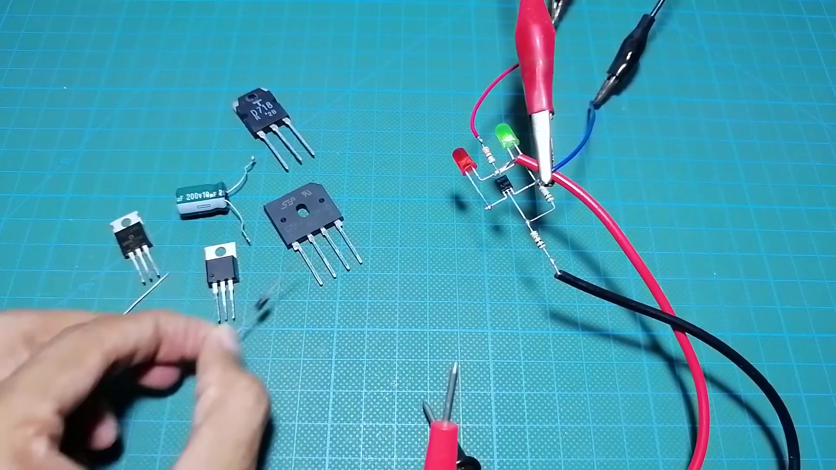 (score 95.0000)
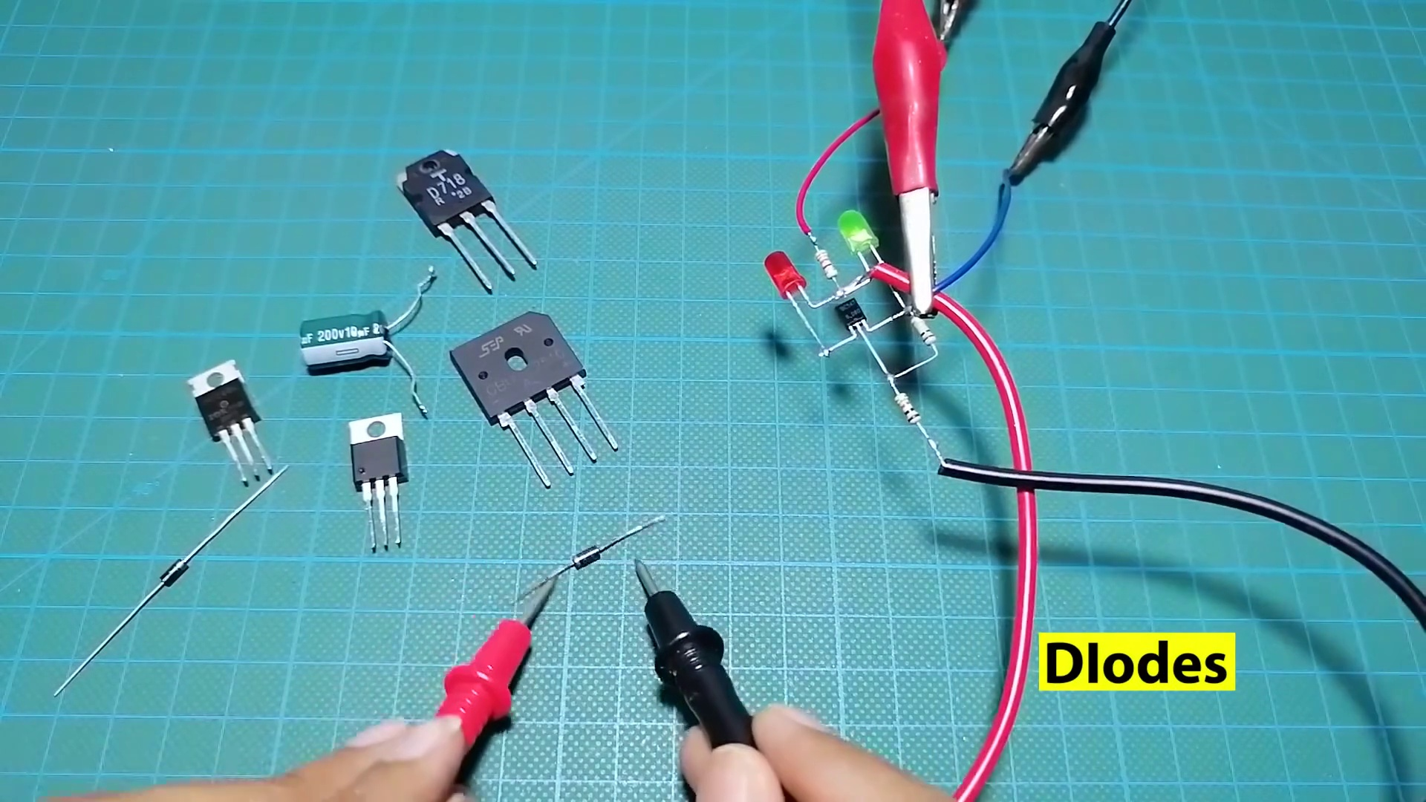 (score 95.0000)
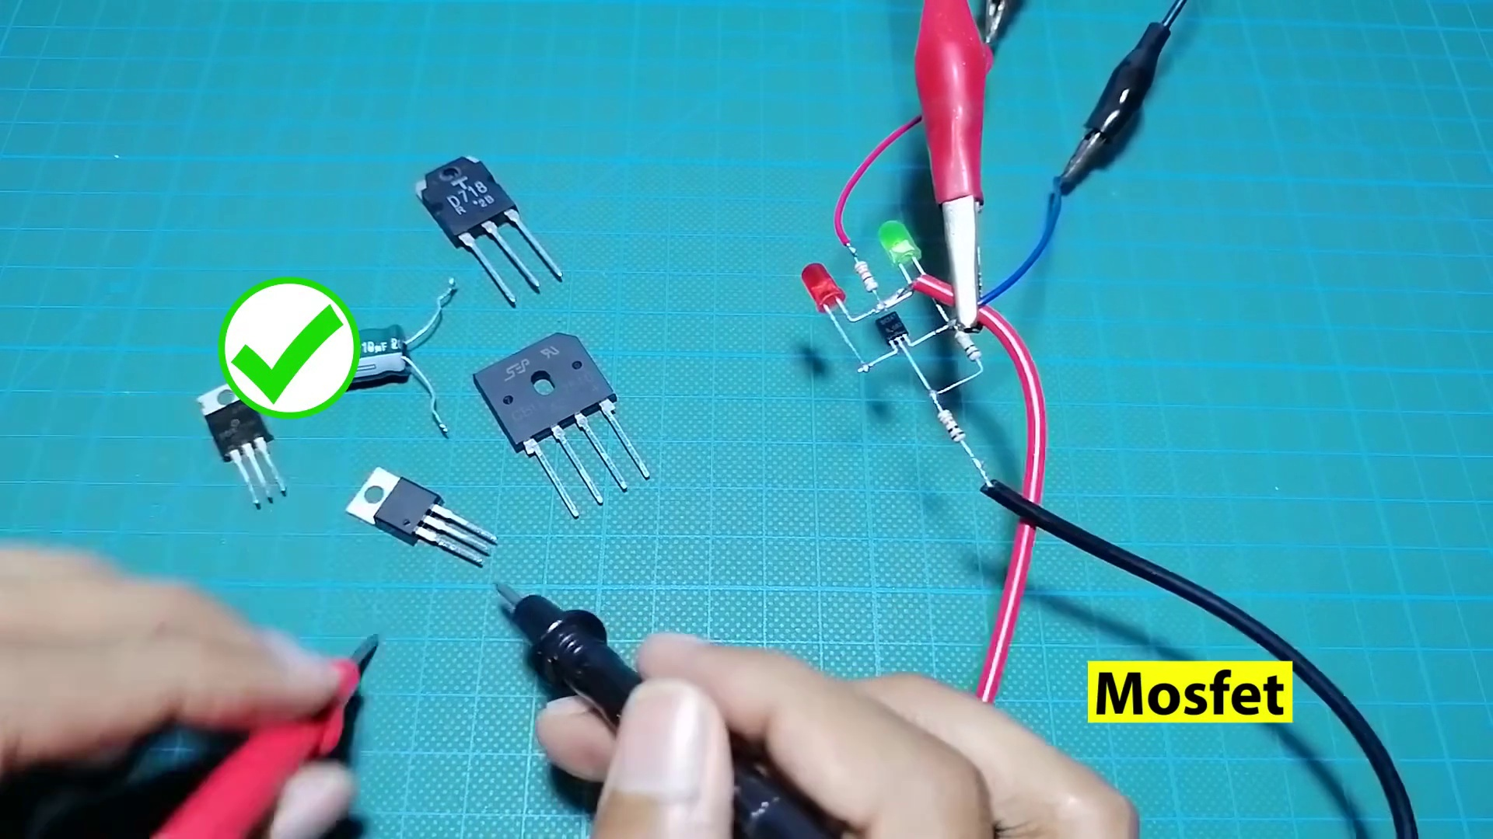 (score 95.0000)
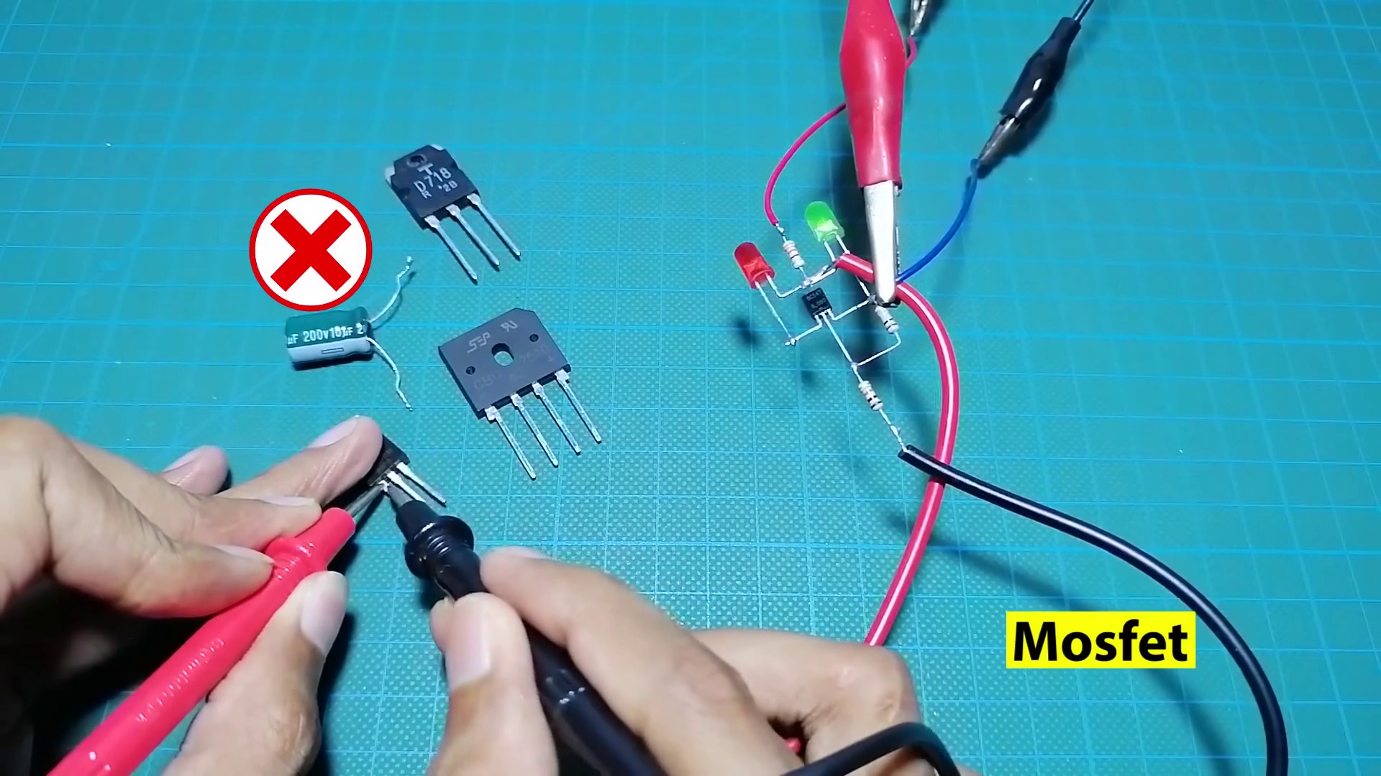 (score 95.0000)
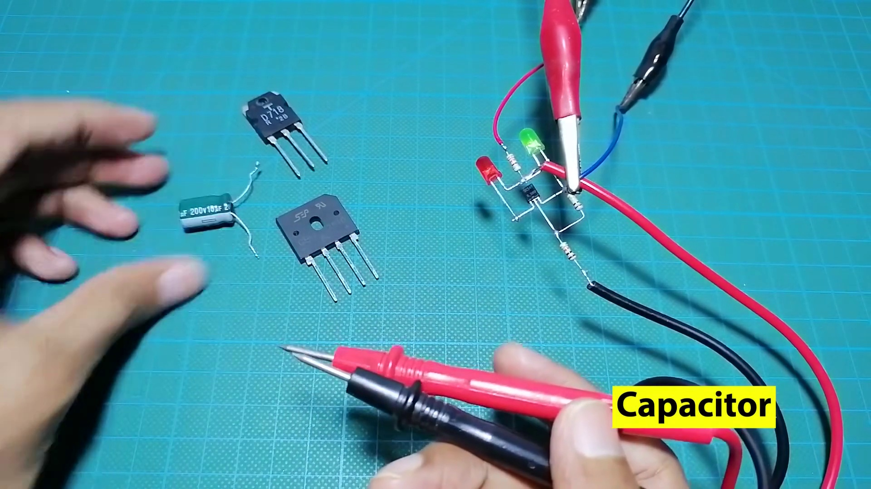 (score 95.0000)
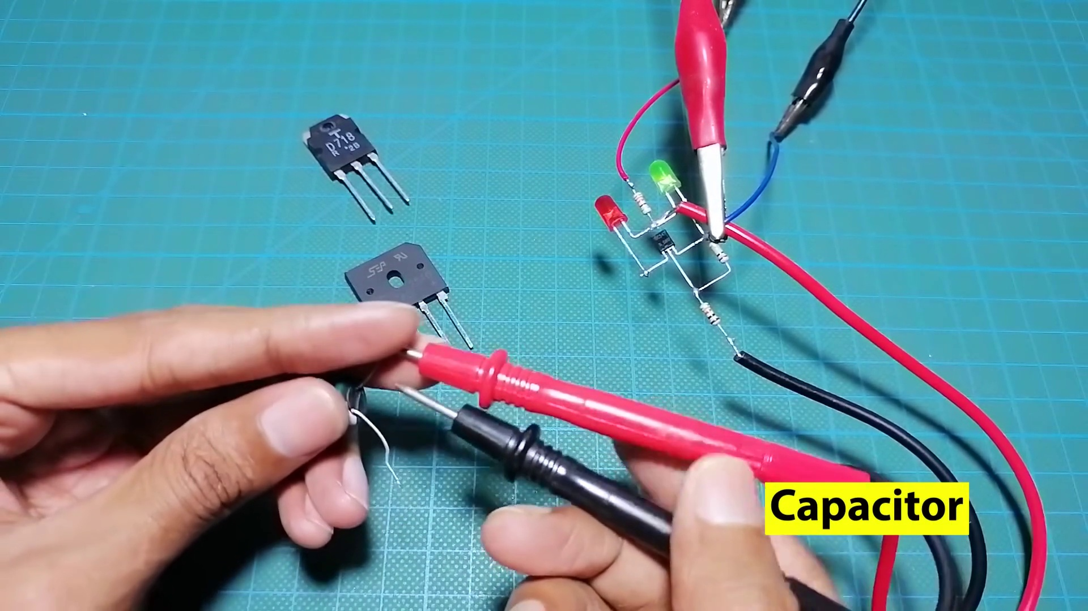 (score 95.0000)
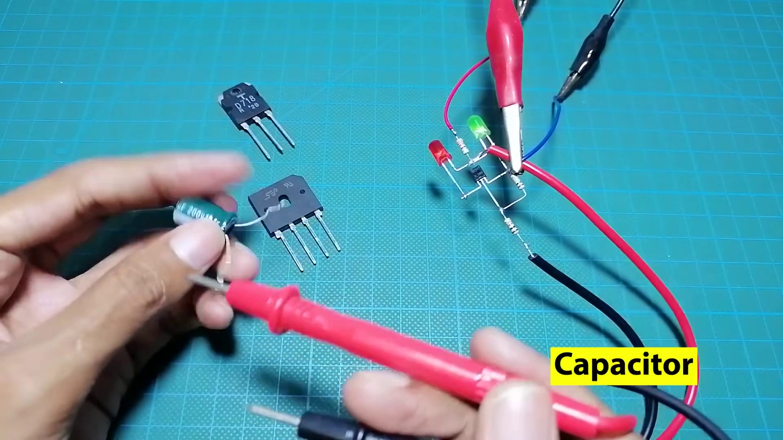 (score 95.0000)
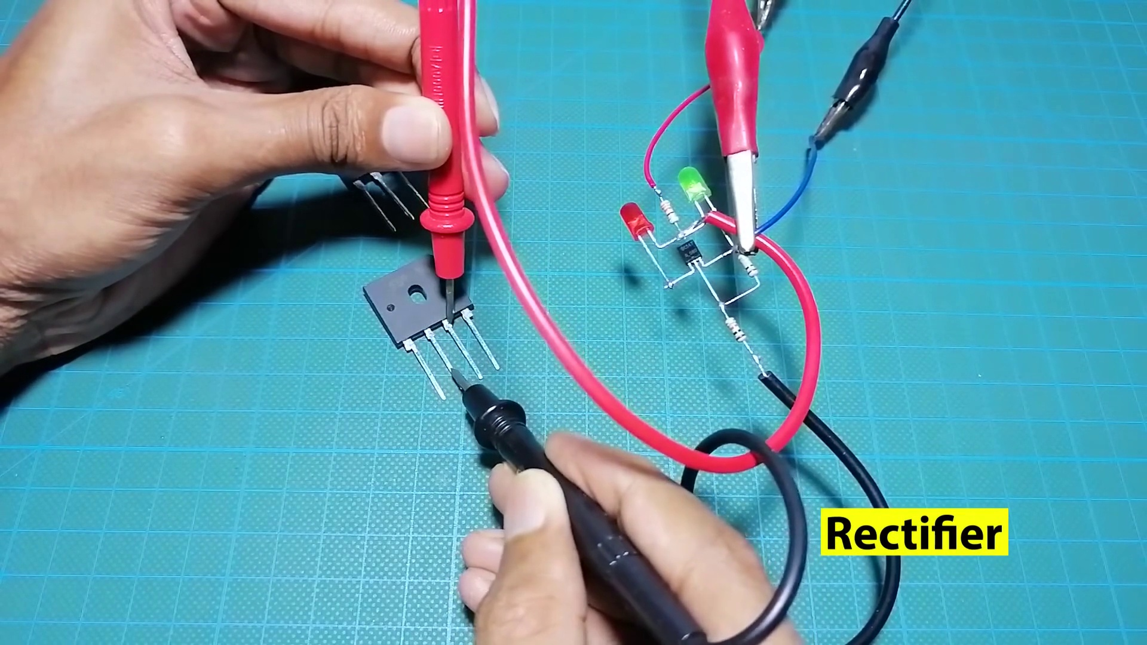 (score 95.0000)
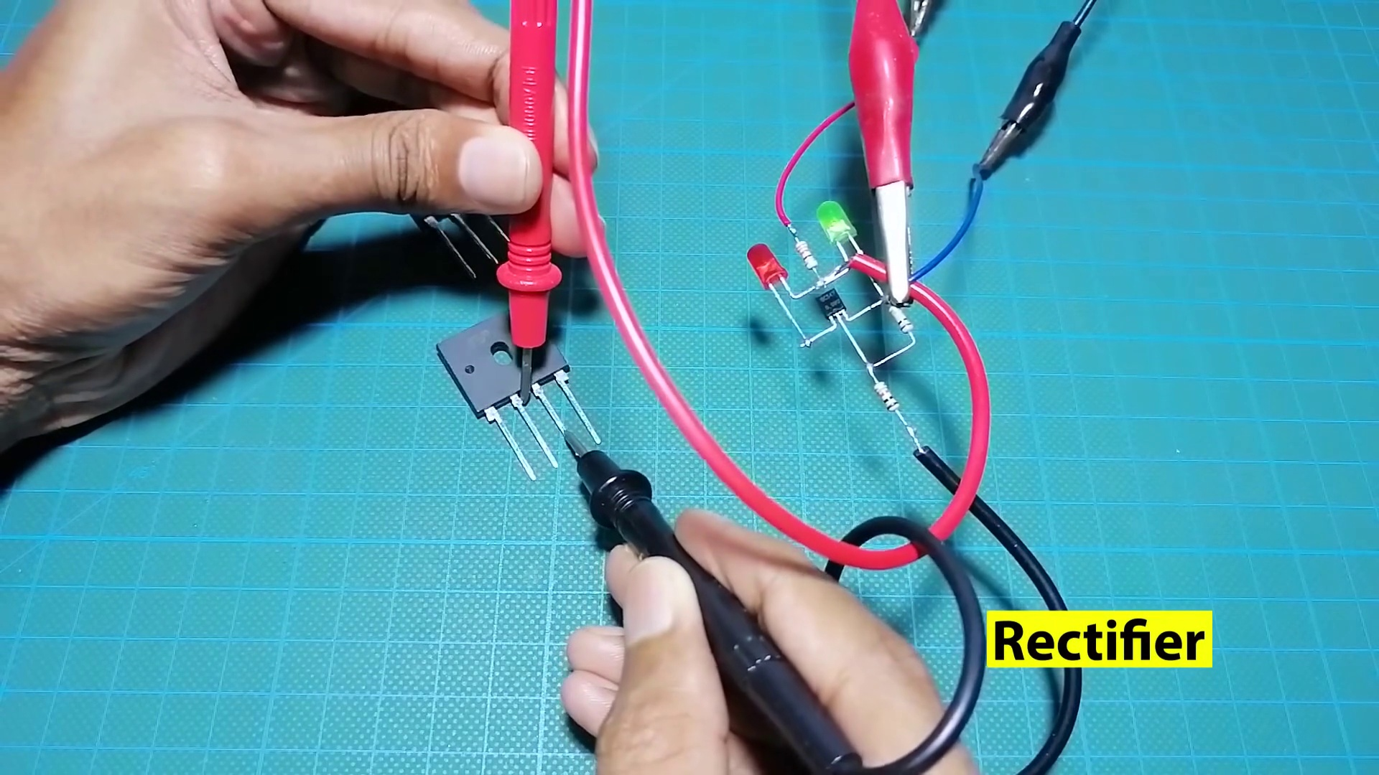 (score 95.0000)
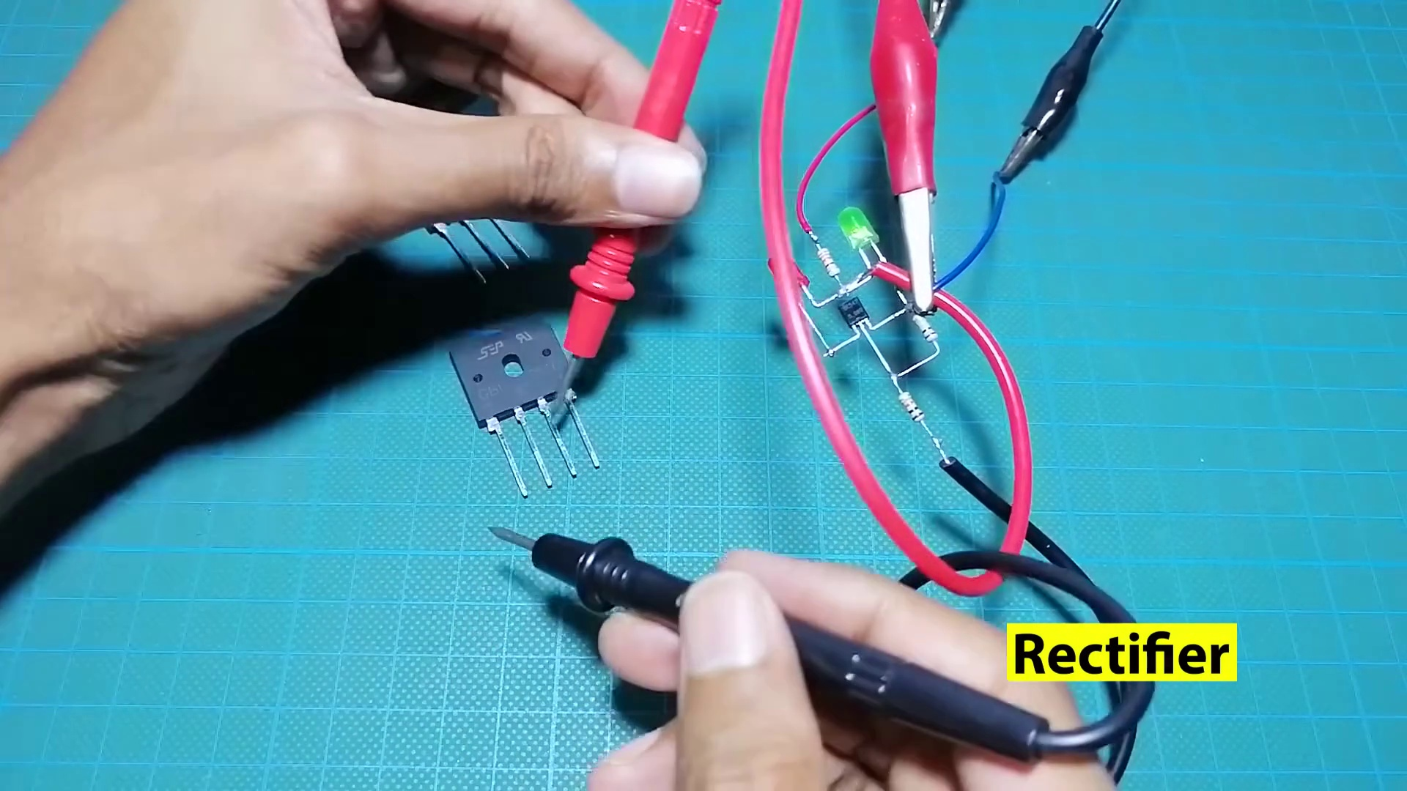 (score 95.0000)
Least correlated frames:
 (score 0.0000)
 (score 0.0000)
 (score 5.0000)
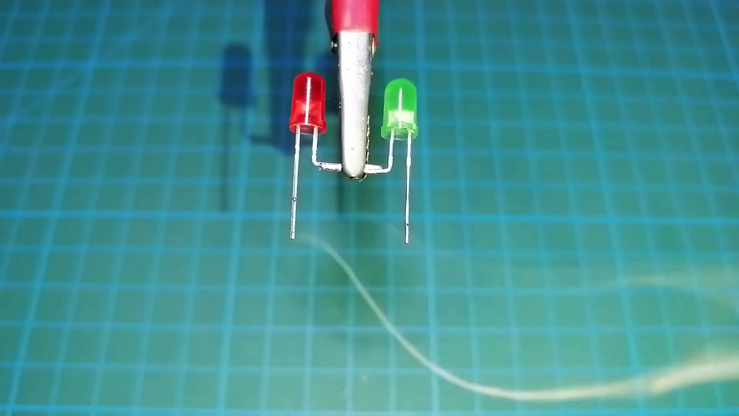 (score 10.0000)
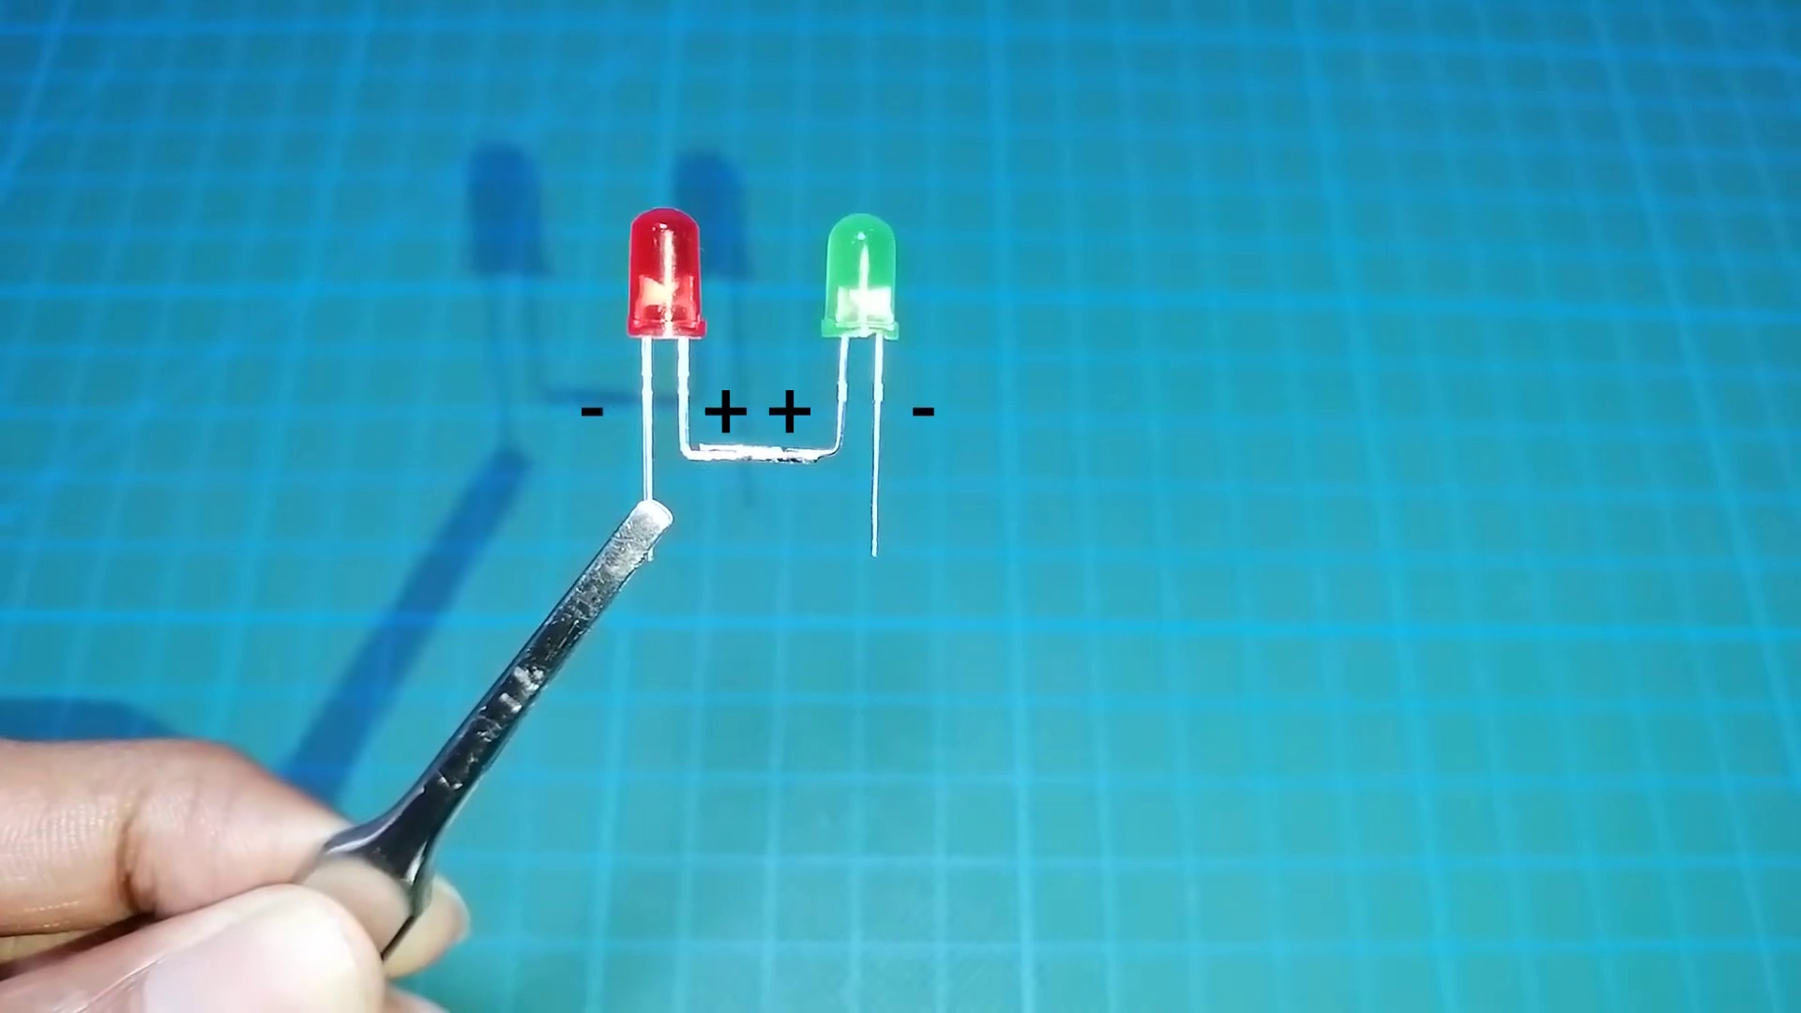 (score 80.0000)
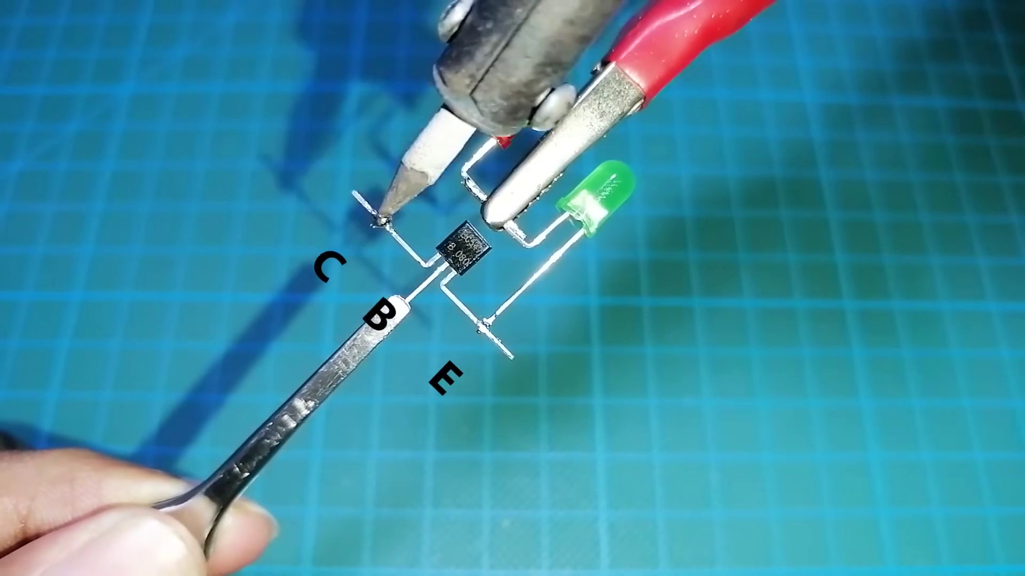 (score 80.0000)
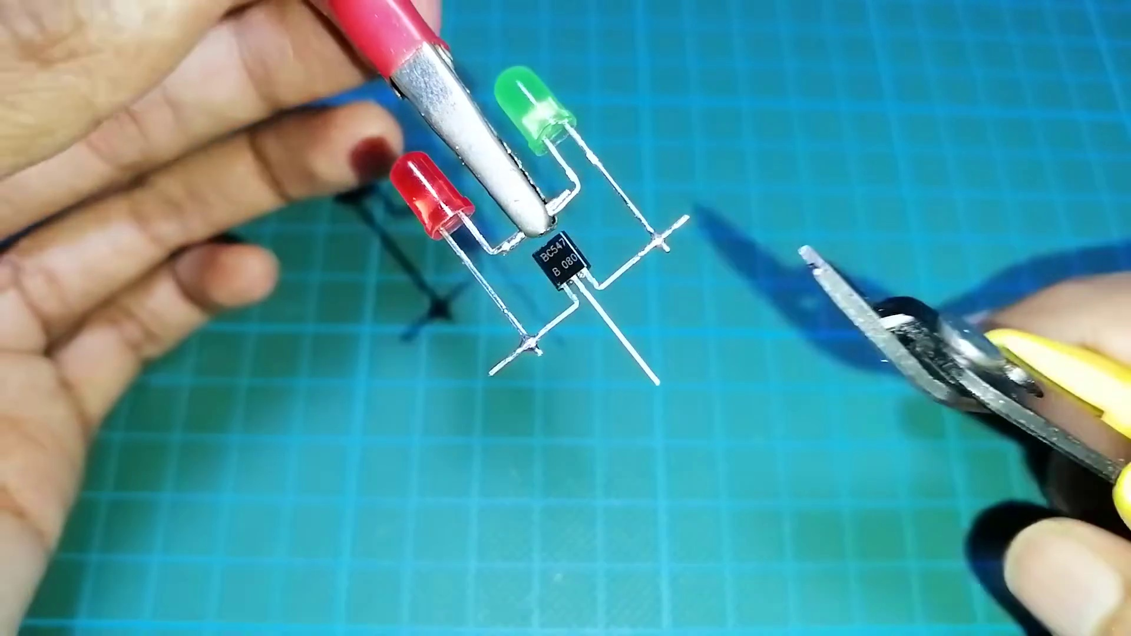 (score 80.0000)
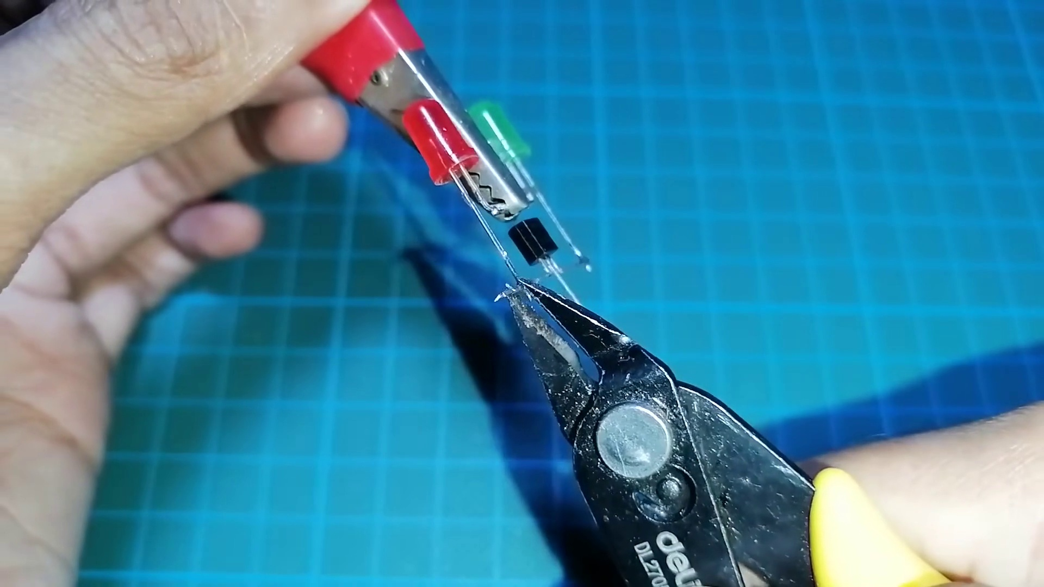 (score 80.0000)
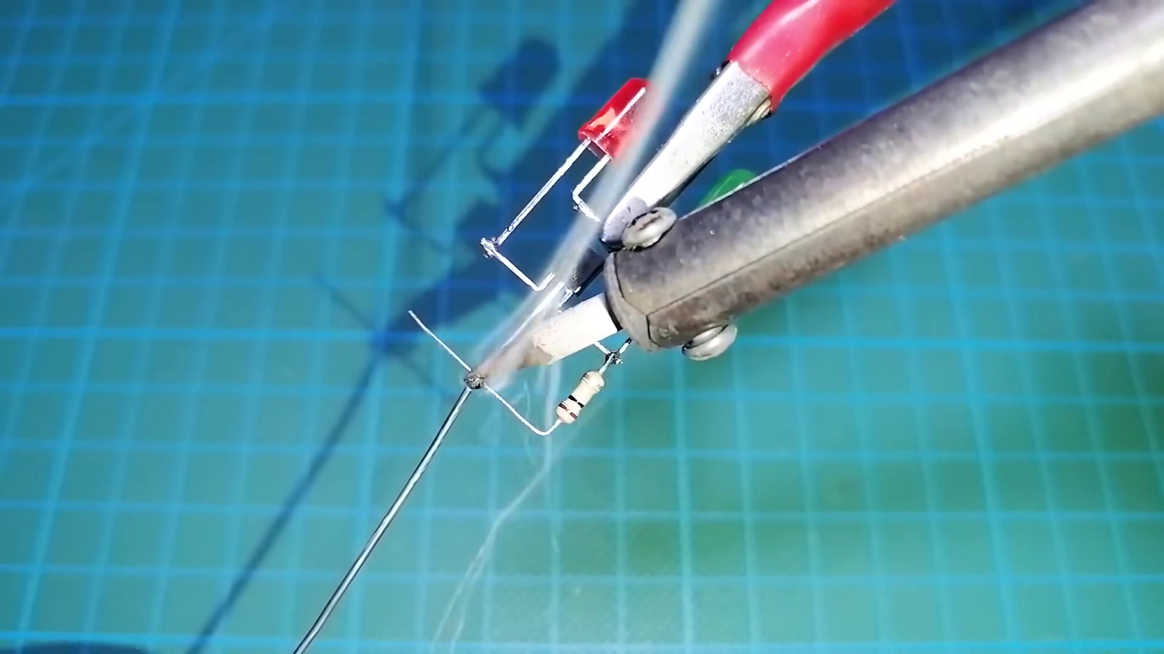 (score 80.0000)
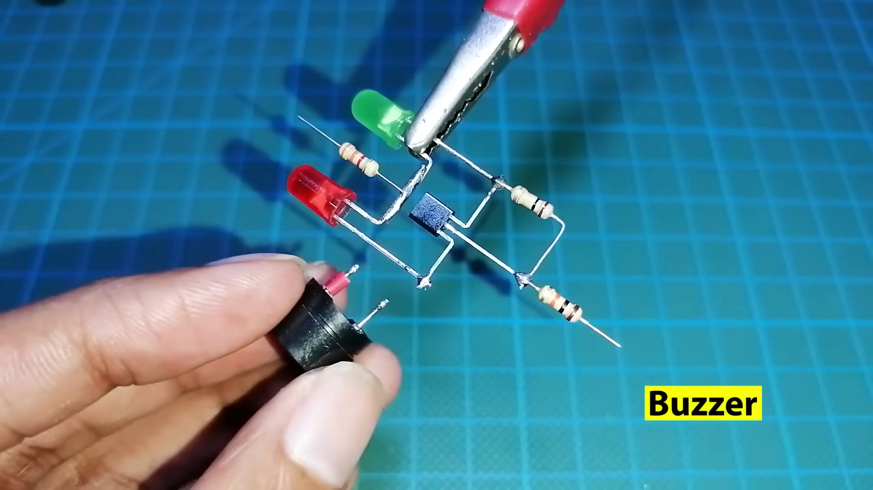 (score 80.0000)
- matched 80 frame(s), max score 90.0000: Utilizing some diodes and a bc 547 transistor to create a tester for the correct direction of voltage use on other components. I think this is one that I will make myself to use, this is very useful, and makes finding the direction so quick. I guess I could just use a multimeter since it is mostly a basic continuity tester, but very cool way to build with minimum components.
Source: https://www.youtube.com/watch?v=nxMkX0wtLm4: Make all component Tester using BC547, Make a universal any components
Top correlated frames:
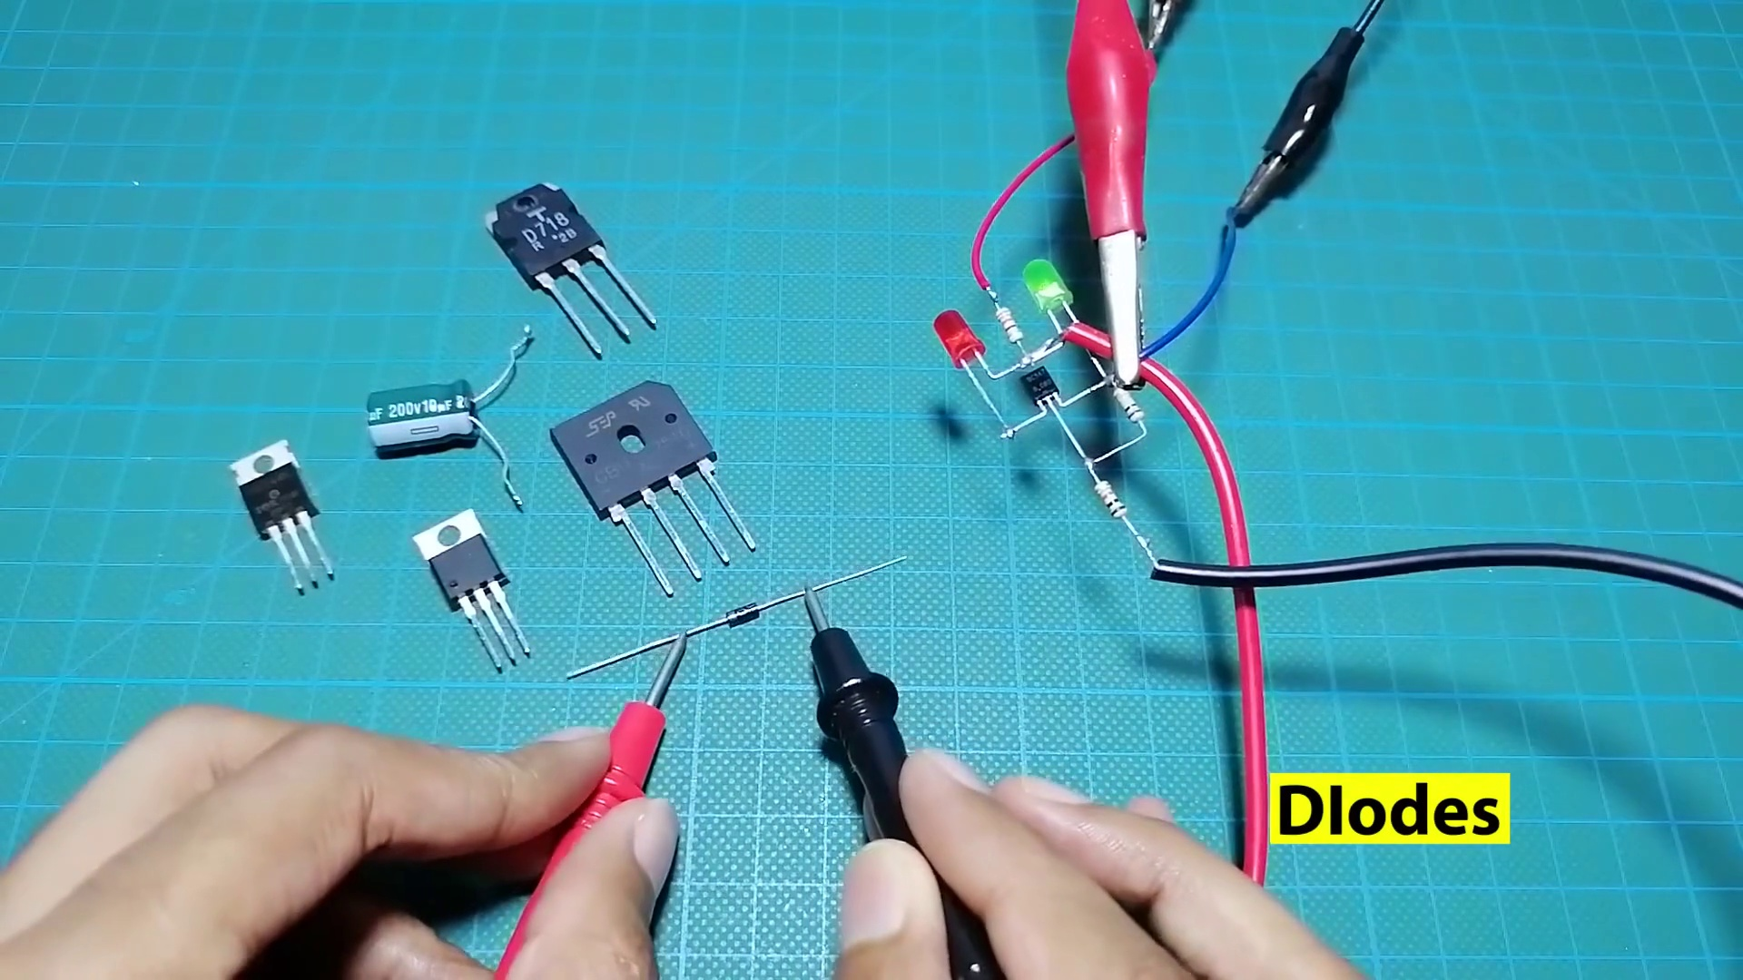 (score 90.0000)
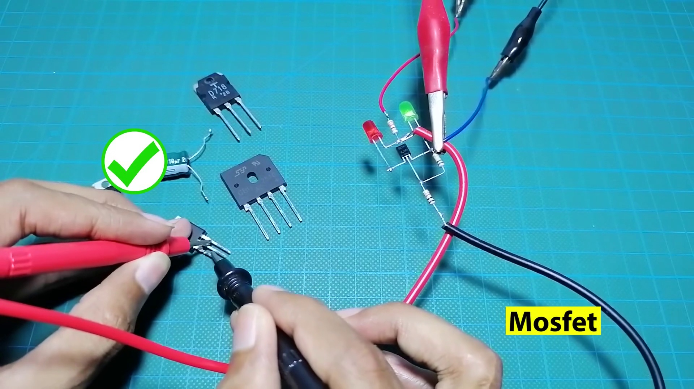 (score 90.0000)
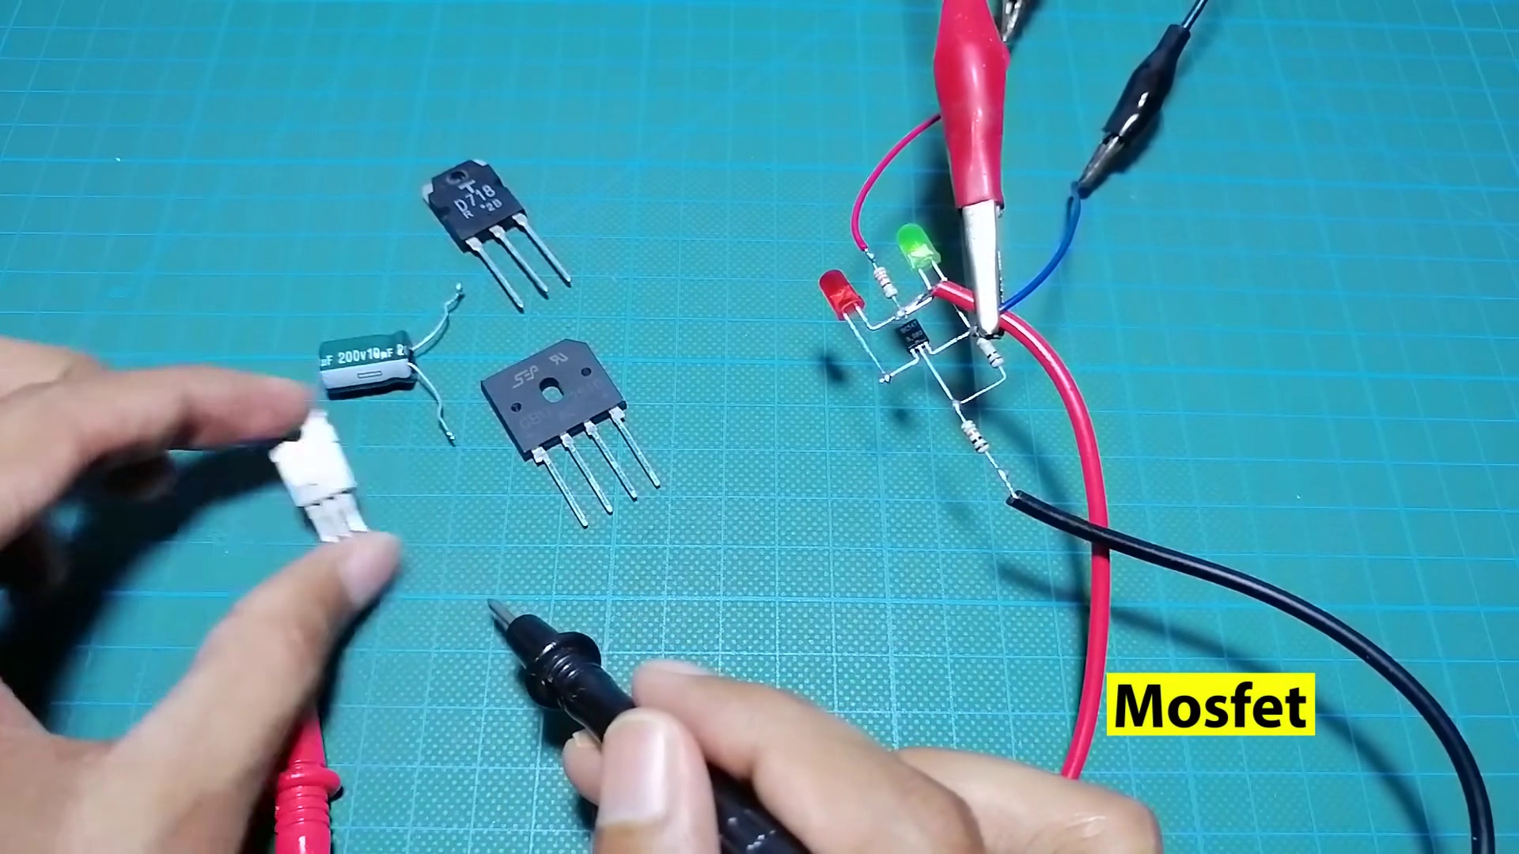 (score 90.0000)
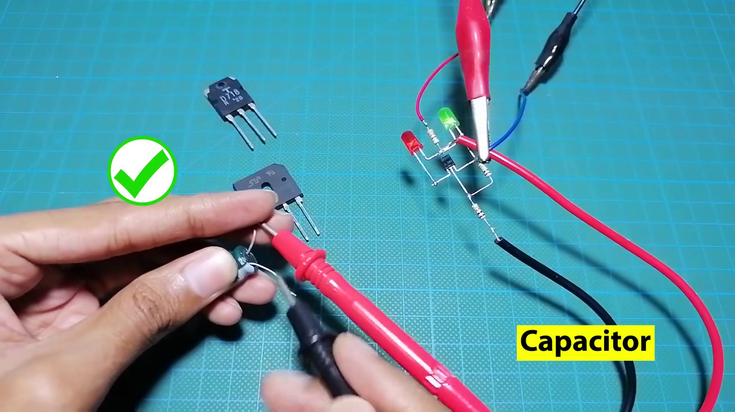 (score 90.0000)
 (score 90.0000)
 (score 90.0000)
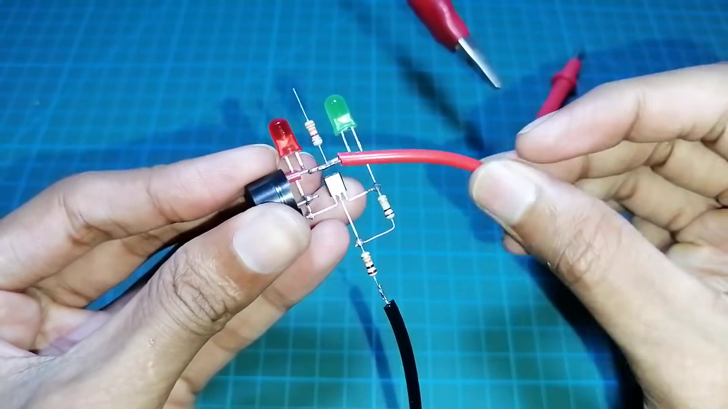 (score 90.0000)
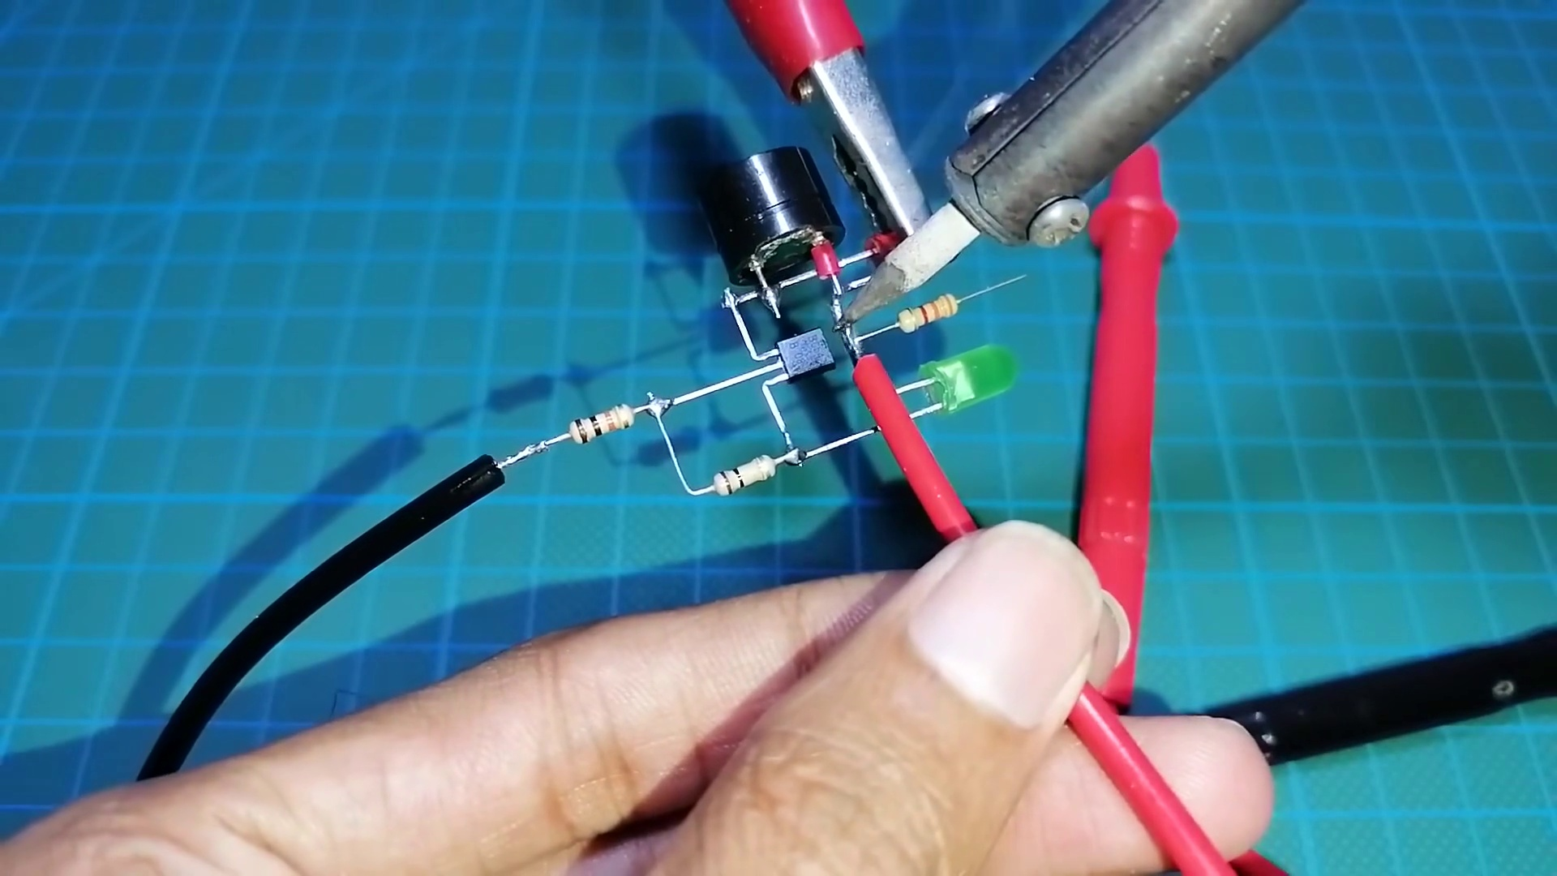 (score 90.0000)
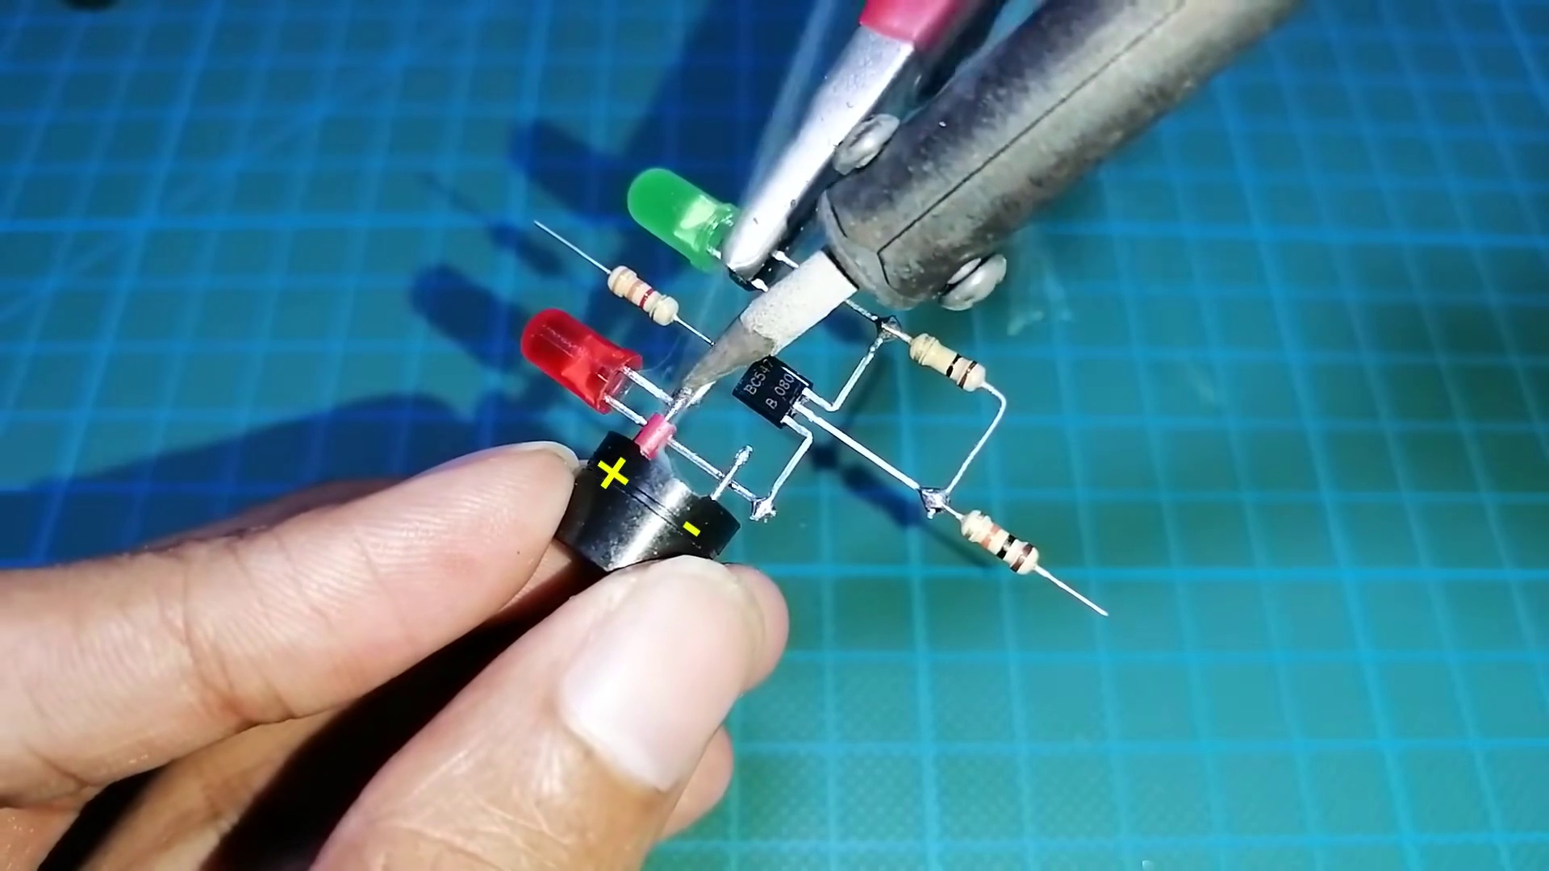 (score 90.0000)
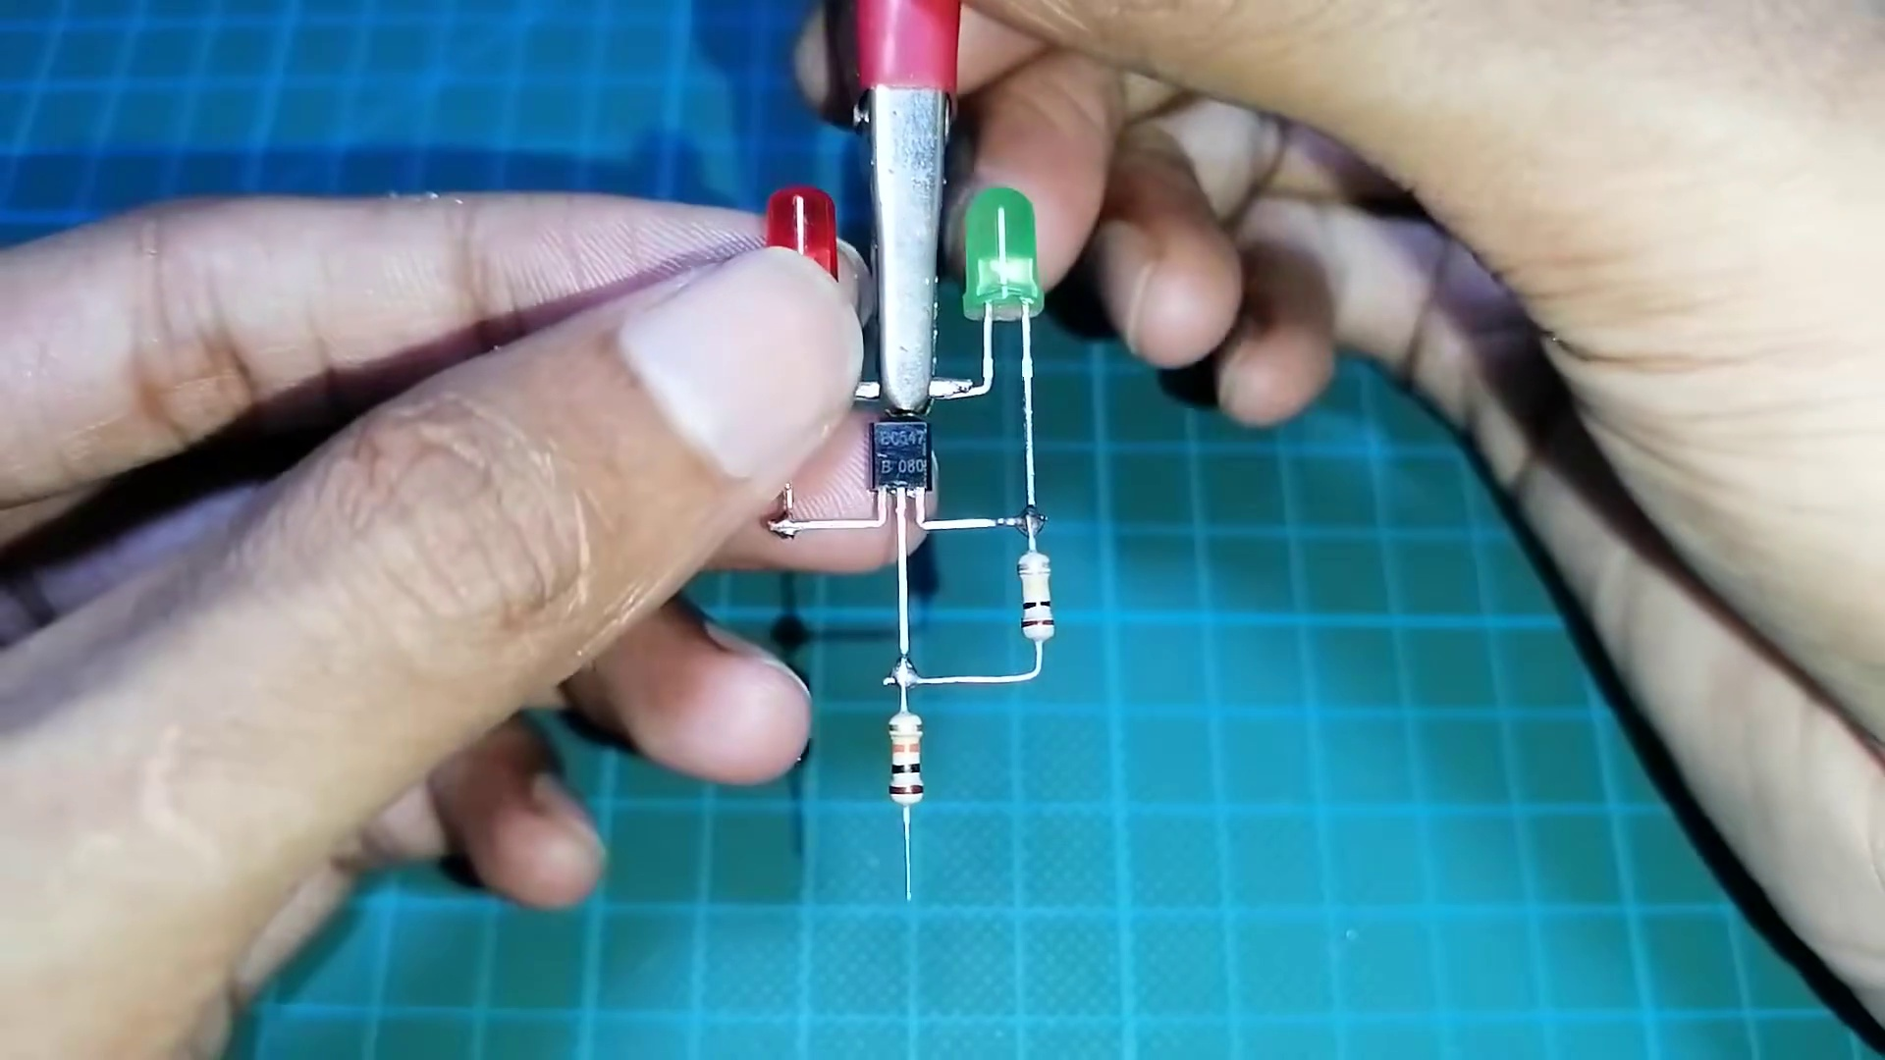 (score 90.0000)
Least correlated frames:
 (score 0.0000)
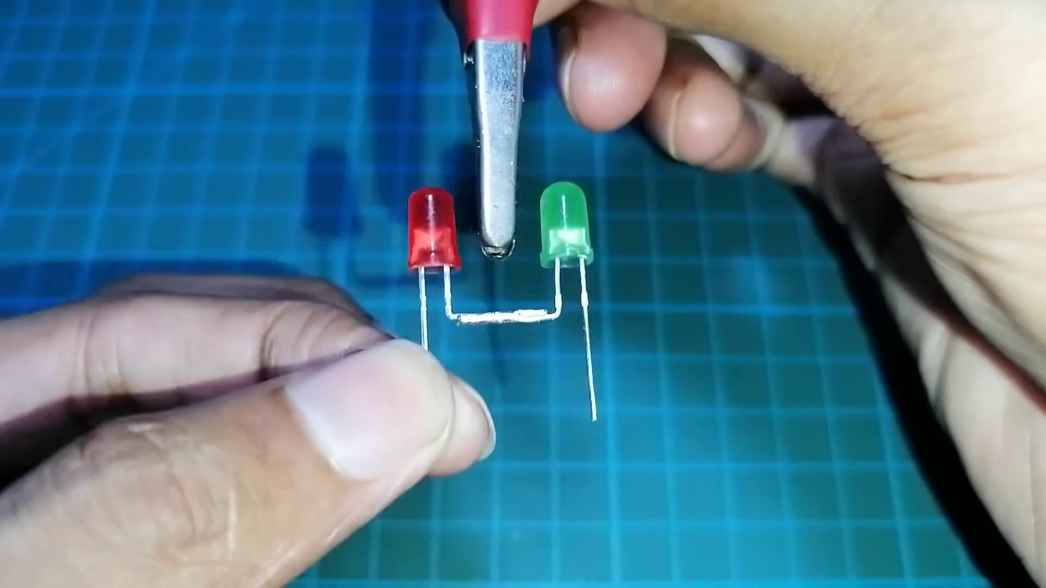 (score 20.0000)
 (score 20.0000)
 (score 20.0000)
 (score 20.0000)
 (score 20.0000)
 (score 70.0000)
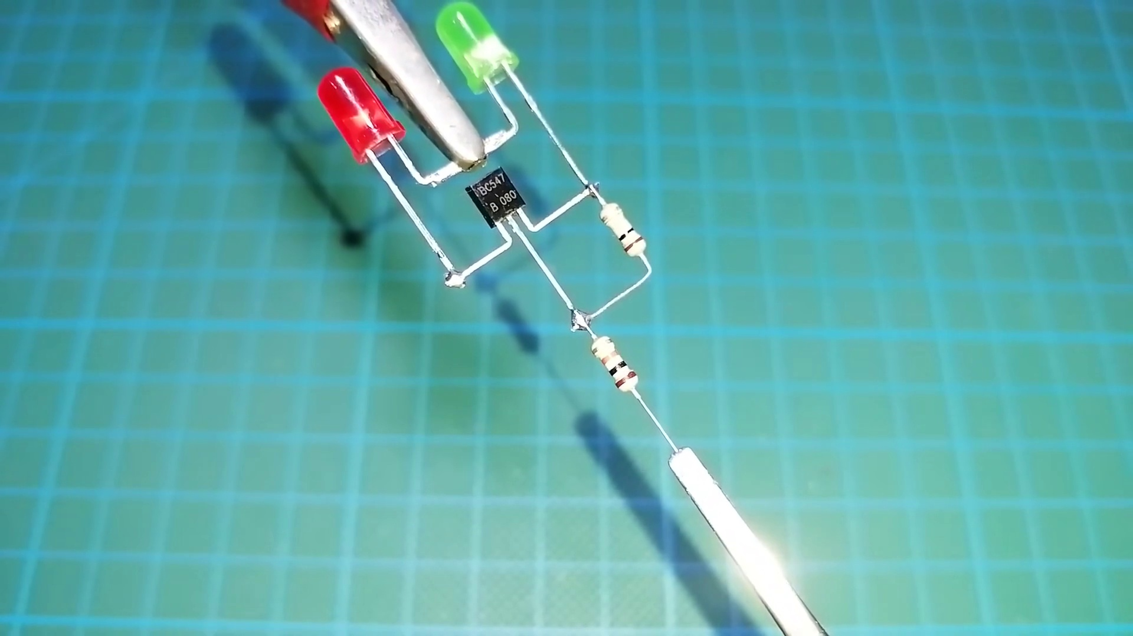 (score 75.0000)
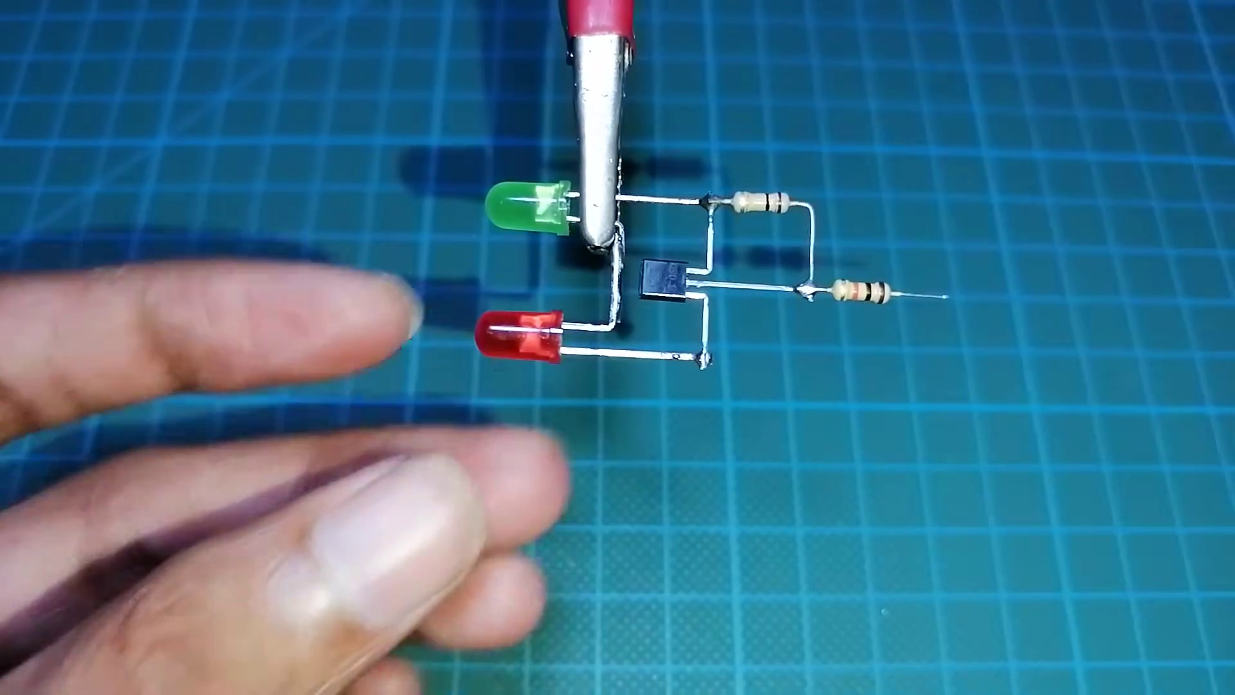 (score 75.0000)
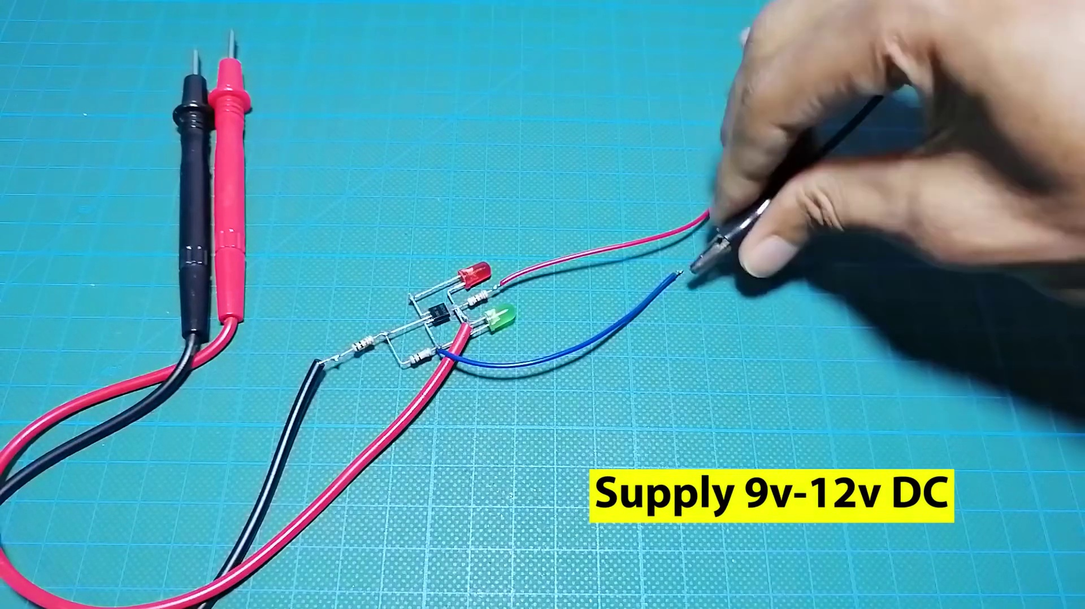 (score 75.0000)
- matched 68 frame(s), max score 90.0000: This was helpful in understanding the basic components of a circuit and how a simple tool made from using chip BC547 and some LED lights with resistor, buzzer and multimeter probe can help measure pretty much every circuit element. We didn’t get a chance to make or use it but this was really helpful in better understanding the circuit elements.
Source: https://www.youtube.com/watch?v=nxMkX0wtLm4&t=53s: Make all component tester using BC547.
Top correlated frames:
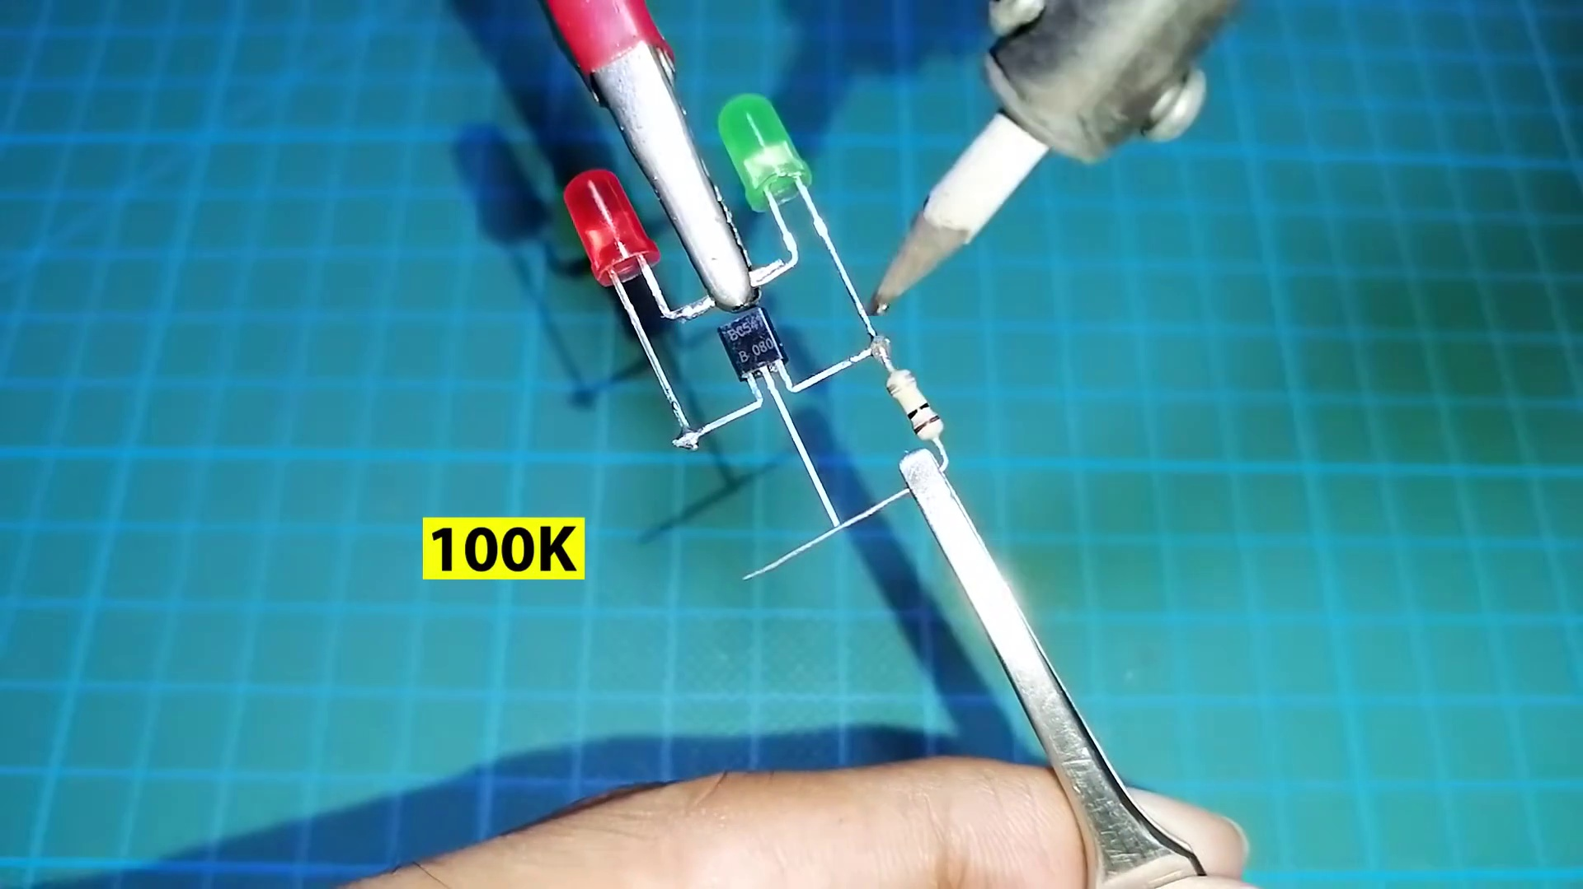 (score 90.0000)
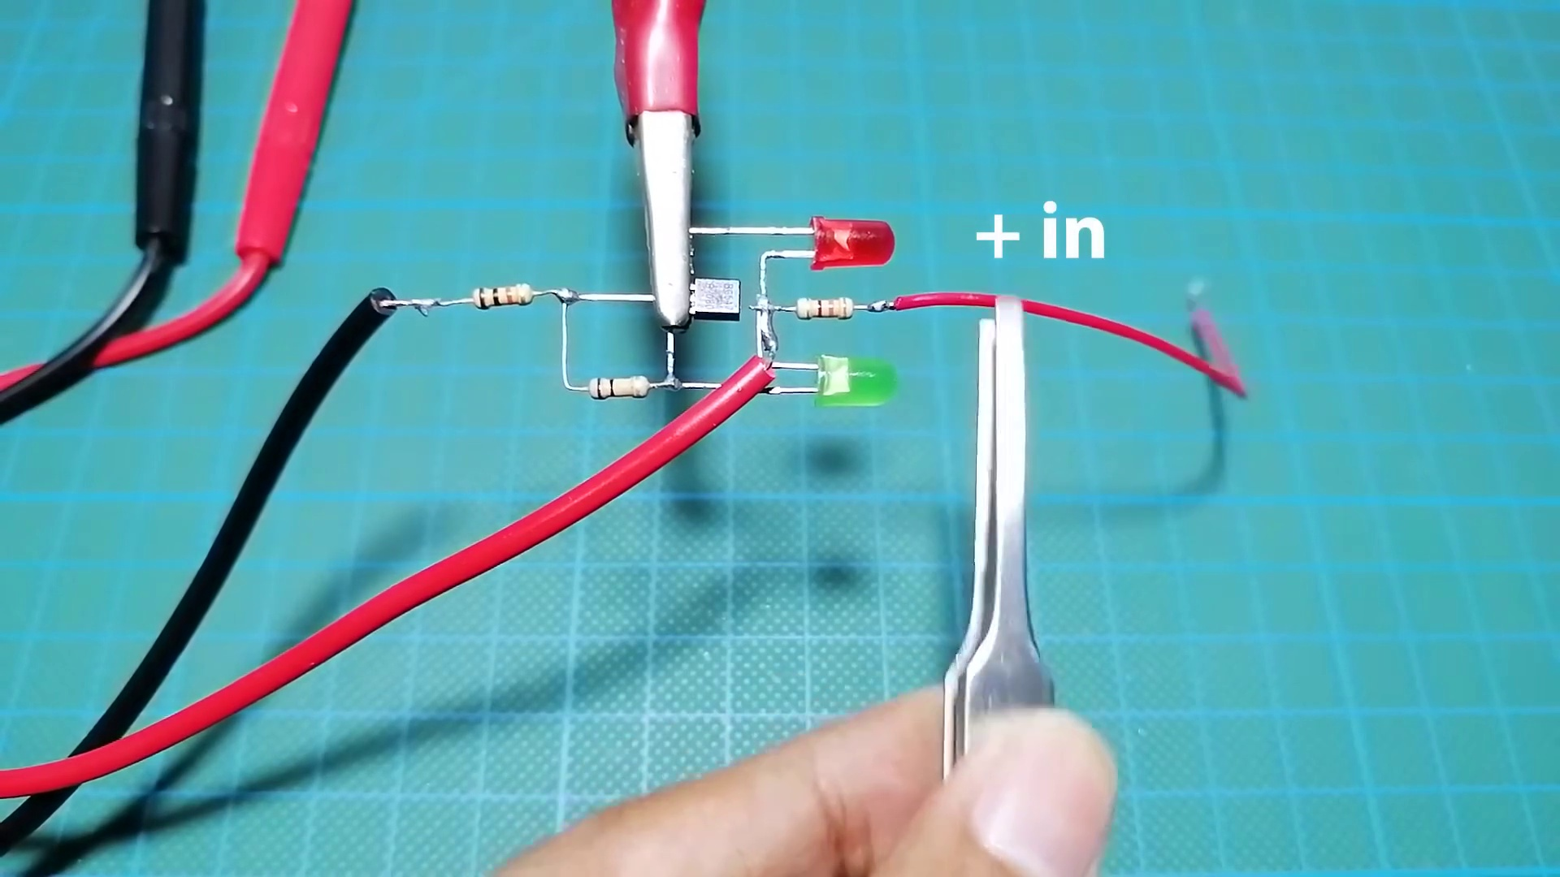 (score 87.0000)
 (score 85.0000)
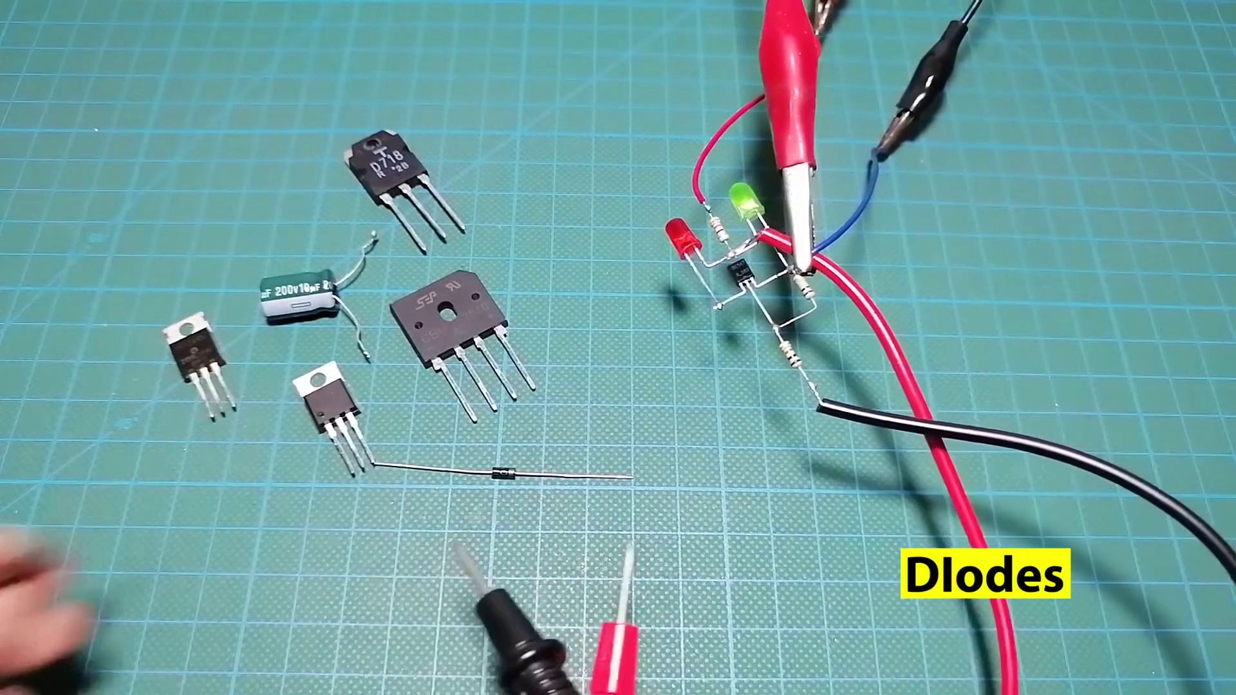 (score 85.0000)
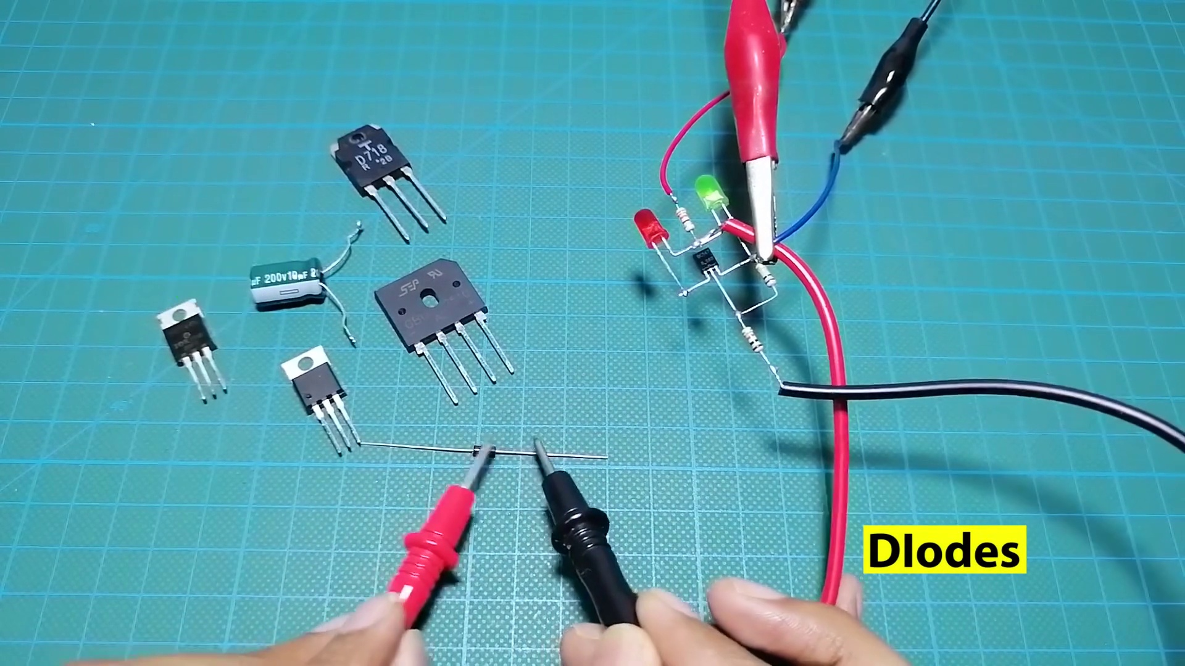 (score 85.0000)
 (score 85.0000)
 (score 85.0000)
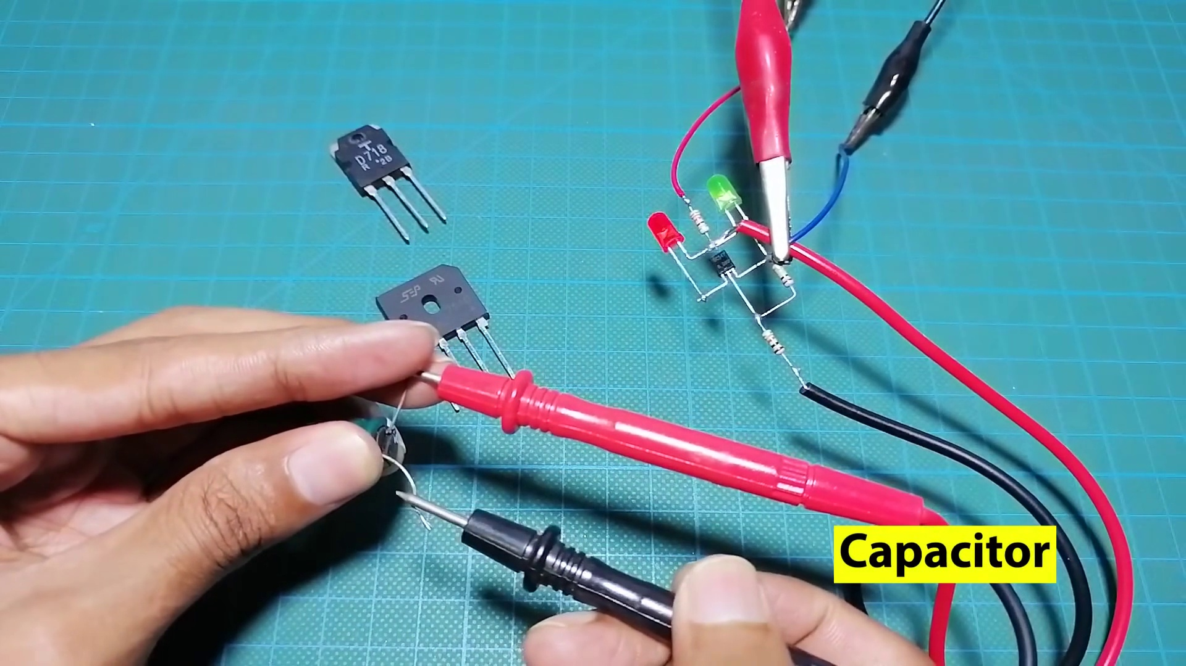 (score 85.0000)
 (score 85.0000)
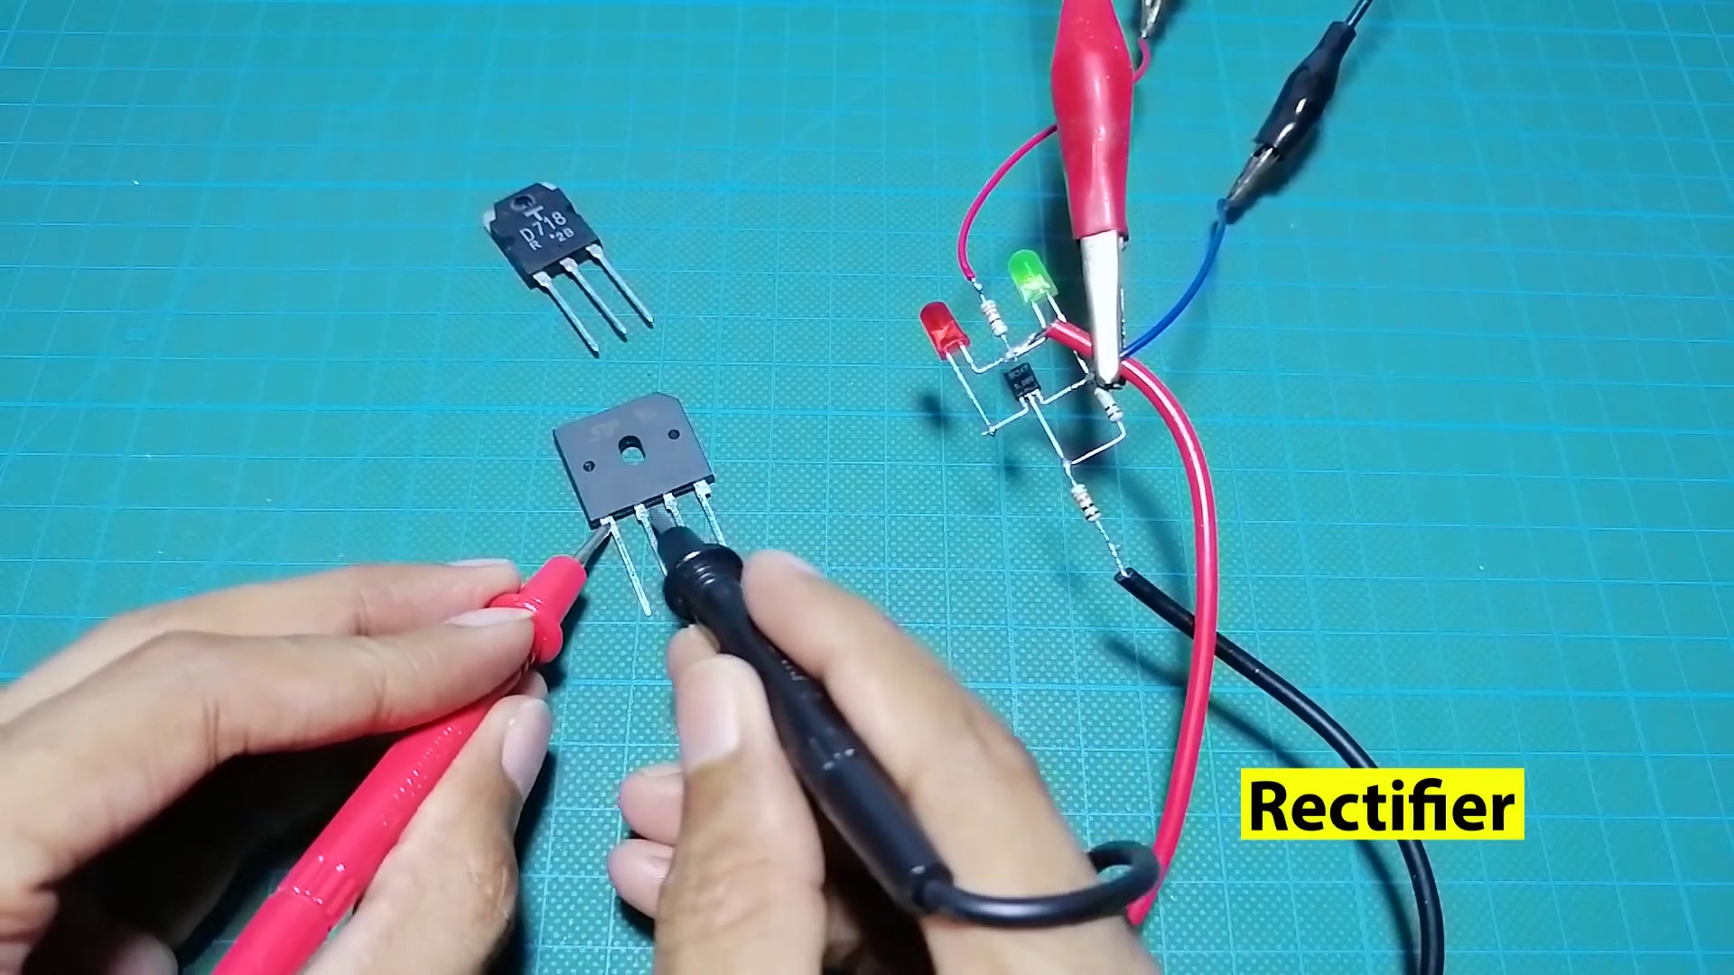 (score 85.0000)
Least correlated frames:
 (score 5.0000)
 (score 10.0000)
 (score 20.0000)
 (score 20.0000)
 (score 20.0000)
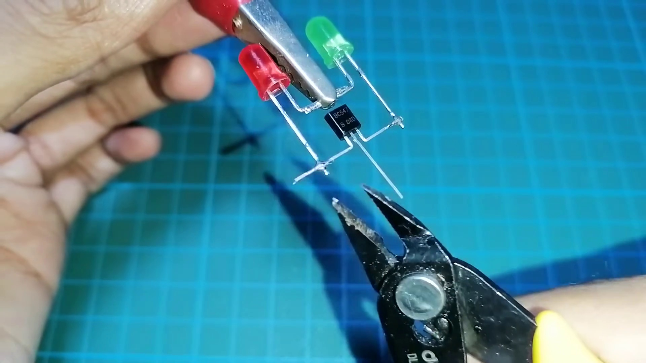 (score 20.0000)
 (score 20.0000)
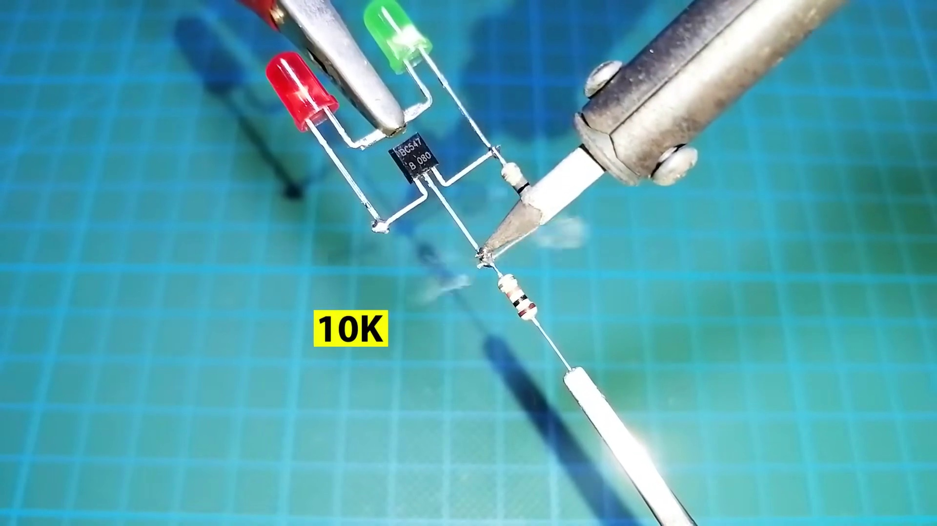 (score 20.0000)
 (score 20.0000)
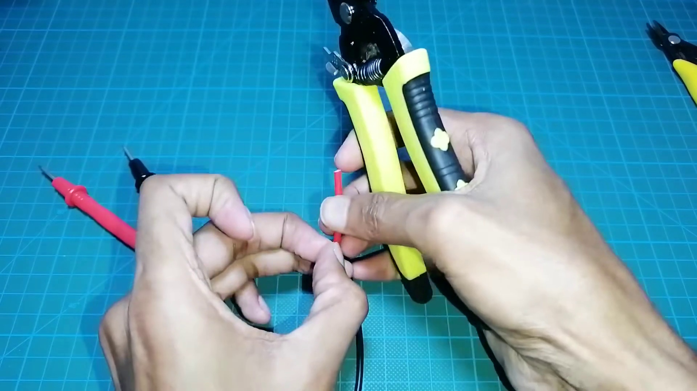 (score 20.0000)

Frame: frame_0000.jpg
Caption: The image provided shows a slide with a green background and a blue grid pattern on one side, complemented by a white background on the other. The left section of the slide is titled "THEORY" and appears to contain text and possibly diagrams or illustrations related to hydraulics or water systems, as indicated by phrases like "head loss," "pressure drop," and "friction." Although the text is not fully visible due to the angle and resolution of the photo, it suggests an educational context likely related to fluid mechanics, engineering, or science.
The right section of the slide is titled "EXAMPLE" and includes text and what appears to be a graph or chart. The graph seems to represent data related to flow rate and pressure, possibly in a water system context. The specifics of the graph are not clear due to the resolution and angle of the photo.
On the opposite side of the slide, there is no visible text or models, suggesting that an instructor is either writing on a whiteboard or discussing the content with an audience.
No strongly correlated comments found for this frame.

Frame: frame_0001.jpg
Caption: The image shows a person's hand holding a small green circuit board with two red LED lights and one green LED light attached to it. The circuit board is connected to a small soldering iron, indicating that the person might be working on soldering the components onto the board or repairing it.
In the background, there is a blue surface that appears to be part of an educational setup or demonstration area, given the presence of what looks like a whiteboard or screen with some writing and diagrams that are partially obscured by the main subject. The visible text on the whiteboard includes mathematical equations or symbols that may relate to electronics or physics concepts, but it is not clear enough to read or interpret accurately.
The person's focus seems to be on the circuit board and the soldering iron, suggesting an activity related to electronic repair or DIY projects. On the blue surface, a pair of red and green LED lights are positioned, connected by a silver wire bent at a 90-degree angle, creating a cross shape. The white tape covers part of the blue surface, and a white grid provides a clear background for the image.
The overall setting suggests a hands-on learning environment where practical skills are being demonstrated or practiced, possibly as part of a circuit or device preparation process.
Comment (score 80): In this video we learn how to make a component tester using basic circuit elements. The components need to make the tester are BC547, three resistors, one red LED light, one green LED light, a 12-volt power supply, and a multimeter. You connect the LED lights to the resistors and the BC547. After making the connections as shown in the video you can connect the circuit to the multimeter and the power supply. This circuit works to test if different circuit components are good to use. The way the circuit work is that when you are testing a broken item using the multimeter probes the LED lights turn red. In the other hand when an item is good to use it tuns green making it easy to identify bad circuit elements.
Reason: The comment directly discusses the same technical steps and objects described in the caption, specifically mentioning the LED lights, resistors, BC547 transistor, multimeter, and power supply. The comment also explains how to connect these components to create a component tester, which is consistent with the setting and activities shown in the image.
Source: https://www.youtube.com/watch?v=nxMkX0wtLm4&t=18s: Make all component Tester using BC547, Make a universal any components tester.
Comment (score 80): This was helpful in understanding the basic components of a circuit and how a simple tool made from using chip BC547 and some LED lights with resistor, buzzer and multimeter probe can help measure pretty much every circuit element. We didn’t get a chance to make or use it but this was really helpful in better understanding the circuit elements.
Reason: The comment directly discusses the technical steps and components (BC547, LED lights, resistor, buzzer, multimeter probe) described in the caption, indicating a strong connection.
Source: https://www.youtube.com/watch?v=nxMkX0wtLm4&t=53s: Make all component tester using BC547.

Frame: frame_0002.jpg
Caption: The image shows a person's hands holding electronic components, including two LEDs - one red and one green - connected by a black wire that is being attached to a green and black screw. The person's fingers are wrapped around the wire, indicating they are in the process of securing it to the screw. The setup appears on a blue surface, which could be a cutting board or similar workspace. In addition to the LEDs and wire, there is also a small breadboard nearby, with jumper wires connecting the components. The microcontroller chip, likely an Arduino, suggests that this might be part of a hands-on tutorial or practical session in electronics, robotics, or engineering education.
Comment (score 90): In this video we learn how to make a component tester using basic circuit elements. The components need to make the tester are BC547, three resistors, one red LED light, one green LED light, a 12-volt power supply, and a multimeter. You connect the LED lights to the resistors and the BC547. After making the connections as shown in the video you can connect the circuit to the multimeter and the power supply. This circuit works to test if different circuit components are good to use. The way the circuit work is that when you are testing a broken item using the multimeter probes the LED lights turn red. In the other hand when an item is good to use it tuns green making it easy to identify bad circuit elements.
Reason: The comment directly discusses the same technical steps (connecting LEDs to resistors and BC547) and objects (LED lights, resistors, multimeter) described in the caption. The comment also mentions the goal of making a component tester, which is consistent with the setup shown in the caption.
Source: https://www.youtube.com/watch?v=nxMkX0wtLm4&t=18s: Make all component Tester using BC547, Make a universal any components tester.

Frame: frame_0003.jpg
Caption: The image captures a close-up view of someone assembling and possibly testing a small electronic device. The device features two red LEDs, two green LEDs, and a resistor, with two wires connected to the LEDs. One wire is being held by the person's hand, indicating that they are in the process of connecting or adjusting the circuit. On the right side of the image, there is a small machine with two cylindrical components, suggesting a workshop or lab environment.
The person is using a soldering iron to join the two red LEDs together, with the silver-tipped tool firmly held in their hand. The scene is set on a blue mat, providing a contrasting background to the green surface where the soldering iron is placed. The overall focus of the image is on the action of soldering, highlighting the moment of creation or repair in an electronic workshop.
Comment (score 85): In this video we learn how to make a component tester using basic circuit elements. The components need to make the tester are BC547, three resistors, one red LED light, one green LED light, a 12-volt power supply, and a multimeter. You connect the LED lights to the resistors and the BC547. After making the connections as shown in the video you can connect the circuit to the multimeter and the power supply. This circuit works to test if different circuit components are good to use. The way the circuit work is that when you are testing a broken item using the multimeter probes the LED lights turn red. In the other hand when an item is good to use it tuns green making it easy to identify bad circuit elements.
Reason: The comment directly discusses the same technical steps (e.g. connecting LEDs to resistors and BC547), objects (e.g. red LED light, green LED light, resistors, multimeter) and settings (e.g. circuit tester) described in the caption. The goal of creating a component tester is also mentioned in both the caption and comment.
Source: https://www.youtube.com/watch?v=nxMkX0wtLm4&t=18s: Make all component Tester using BC547, Make a universal any components tester.
Comment (score 85): This was helpful in understanding the basic components of a circuit and how a simple tool made from using chip BC547 and some LED lights with resistor, buzzer and multimeter probe can help measure pretty much every circuit element. We didn’t get a chance to make or use it but this was really helpful in better understanding the circuit elements.
Reason: The comment directly discusses the assembly and testing of an electronic device using LEDs, resistor, and soldering iron, which are all technical steps mentioned in the caption.
Source: https://www.youtube.com/watch?v=nxMkX0wtLm4&t=53s: Make all component tester using BC547.
Comment (score 80): Utilizing some diodes and a bc 547 transistor to create a tester for the correct direction of voltage use on other components. I think this is one that I will make myself to use, this is very useful, and makes finding the direction so quick. I guess I could just use a multimeter since it is mostly a basic continuity tester, but very cool way to build with minimum components.
Reason: The comment directly discusses the use of diodes and a transistor to create a tester for voltage direction, which is strongly related to the caption's description of assembling and testing an electronic device. The comment also mentions building with minimum components, which matches the focus on soldering and circuit assembly in the caption.
Source: https://www.youtube.com/watch?v=nxMkX0wtLm4: Make all component Tester using BC547, Make a universal any components

Frame: frame_0004.jpg
Caption: The image shows a close-up view of a pair of red and green LEDs, which are attached to a white object with a red handle. The red LED is positioned on the left side of the image, while the green LED is on the right. The handle of the white object, which is made of plastic, is red. The background of the image is a vibrant green, providing a stark contrast to the white object.
In the reflection on the glass surface (which appears to be part of an underwater scene), we can see another similar device, implying that there are multiple robots in the scene. These devices are colored red and white, with each one having a distinct stripe pattern. The robot in the water is closer to the camera, while its reflection in the glass surface indicates it is further away from the viewer's perspective.
The robot has two arms, each ending in a red and white striped device that appears to be holding something, possibly a part of a machine or some form of instrumentation. The robot is floating freely in the water, which suggests it might be an underwater drone or a type of autonomous underwater vehicle (AUV).
In the background of the underwater scene, we can see a tiled floor and ceiling structure through the glass surface, indicating that this is likely an indoor environment, possibly a lab or workshop. The lighting is artificial and even, suggesting a well-lit space.
No text is visible in either frame, and there are no indications of a person teaching, presenting, or speaking from a slide. The images focus solely on the underwater robot and its reflection, with no additional context provided within the visible frames.
No strongly correlated comments found for this frame.

Frame: frame_0005.jpg
Caption: The image shows a close-up view of an object labeled "BC64" with a barcode that reads "B10198300719538120". The object appears to be a small electronic device, possibly a microchip or similar integrated circuit, given its rectangular shape with pins on one side. A person is holding the BC64 IC in their left hand using tweezers, positioned on a green surface. The text "BC547" is clearly visible on the IC, indicating its model or type. The background is indistinct and out of focus, making it challenging to discern details about the surrounding environment. There are no other objects or texts present in the image that could provide additional context for what is being taught or discussed. The scene suggests a routine electronic repair or assembly process, with the person's hand and the tweezers being the only human-made elements in the image.
Comment (score 85): Utilizing some diodes and a bc 547 transistor to create a tester for the correct direction of voltage use on other components. I think this is one that I will make myself to use, this is very useful, and makes finding the direction so quick. I guess I could just use a multimeter since it is mostly a basic continuity tester, but very cool way to build with minimum components.
Reason: The comment directly discusses the use of a BC547 transistor, which is mentioned in the caption as being part of the BC64 IC. The comment also mentions creating a tester for voltage direction, which is relevant to the scene described in the caption, where someone is handling an electronic device and tweezers.
Source: https://www.youtube.com/watch?v=nxMkX0wtLm4: Make all component Tester using BC547, Make a universal any components
Comment (score 85): In this video we learn how to make a component tester using basic circuit elements. The components need to make the tester are BC547, three resistors, one red LED light, one green LED light, a 12-volt power supply, and a multimeter. You connect the LED lights to the resistors and the BC547. After making the connections as shown in the video you can connect the circuit to the multimeter and the power supply. This circuit works to test if different circuit components are good to use. The way the circuit work is that when you are testing a broken item using the multimeter probes the LED lights turn red. In the other hand when an item is good to use it tuns green making it easy to identify bad circuit elements.
Reason: The comment directly discusses the same technical steps and objects described in the caption, including the BC64 IC (referred to as BC547), resistors, LED lights, multimeter, and power supply. The caption also mentions a routine electronic repair or assembly process, which is relevant to the commenter's explanation of how to make a component tester using these components.
Source: https://www.youtube.com/watch?v=nxMkX0wtLm4&t=18s: Make all component Tester using BC547, Make a universal any components tester.

Frame: frame_0006.jpg
Caption: The image captures a close-up view of a person's hand holding a pair of pliers, which are being used to attach a small green wire to a black object with a white label. The person's fingers are neatly arranged around the pliers, with the thumb and index finger gripping the handles. In the foreground, there is also a separate scene showing a soldering iron in use, its tip covered in a green substance that could be solder. The soldering iron appears to be working on a small circuit board with various components such as resistors, capacitors, and possibly integrated circuits. The background of both scenes is a vibrant blue, providing a stark contrast to the white label and the electronic components. There is no text visible in either frame, suggesting that this activity is not part of an instructional setting or presentation. The relative positions of the objects suggest that the person is in the process of soldering, possibly repairing or working on a DIY project related to electronics.
Comment (score 85): Utilizing some diodes and a bc 547 transistor to create a tester for the correct direction of voltage use on other components. I think this is one that I will make myself to use, this is very useful, and makes finding the direction so quick. I guess I could just use a multimeter since it is mostly a basic continuity tester, but very cool way to build with minimum components.
Reason: The comment directly discusses the same technical steps described in the caption, specifically mentioning diodes and a transistor to create a tester for voltage direction. The mention of soldering and electronics components aligns with the activities shown in the frame.
Source: https://www.youtube.com/watch?v=nxMkX0wtLm4: Make all component Tester using BC547, Make a universal any components
Comment (score 80): In this video we learn how to make a component tester using basic circuit elements. The components need to make the tester are BC547, three resistors, one red LED light, one green LED light, a 12-volt power supply, and a multimeter. You connect the LED lights to the resistors and the BC547. After making the connections as shown in the video you can connect the circuit to the multimeter and the power supply. This circuit works to test if different circuit components are good to use. The way the circuit work is that when you are testing a broken item using the multimeter probes the LED lights turn red. In the other hand when an item is good to use it tuns green making it easy to identify bad circuit elements.
Reason: The comment directly discusses the same technical steps and components described in the caption, such as soldering, using a multimeter, and testing circuit elements. The specific objects mentioned in the caption, like pliers, wire, and soldering iron, are also referenced in the comment's description of making a component tester. The correlation is strong because both the caption and comment focus on electronics and DIY projects, but the score is not 100 due to some minor differences in context and detail.
Source: https://www.youtube.com/watch?v=nxMkX0wtLm4&t=18s: Make all component Tester using BC547, Make a universal any components tester.

Frame: frame_0007.jpg
Caption: The image shows a person's hand holding a pair of electrical components with a soldering iron, a red handle, and a green body. The soldering iron is likely being used to join the two components together, which are attached to a silver wire running through the center of the image. One component is positioned on the left side (red), while the other is on the right side (green). Both components are connected to a green and red screwdriver held by the person's hand. The background of the image is a blurred workspace or laboratory setting with various tools and devices, potentially related to electronics work or hobbyist activities.
Comment (score 95): In this video we learn how to make a component tester using basic circuit elements. The components need to make the tester are BC547, three resistors, one red LED light, one green LED light, a 12-volt power supply, and a multimeter. You connect the LED lights to the resistors and the BC547. After making the connections as shown in the video you can connect the circuit to the multimeter and the power supply. This circuit works to test if different circuit components are good to use. The way the circuit work is that when you are testing a broken item using the multimeter probes the LED lights turn red. In the other hand when an item is good to use it tuns green making it easy to identify bad circuit elements.
Reason: The comment directly discusses the same technical steps and objects described in the caption, specifically mentioning the components (BC547, resistors, LEDs), the soldering iron used to join them, the multimeter and power supply. The commenter also explains how the circuit works and uses the LED lights to test good or bad circuit elements, which is consistent with the image of a person joining components together.
Source: https://www.youtube.com/watch?v=nxMkX0wtLm4&t=18s: Make all component Tester using BC547, Make a universal any components tester.
Comment (score 80): Utilizing some diodes and a bc 547 transistor to create a tester for the correct direction of voltage use on other components. I think this is one that I will make myself to use, this is very useful, and makes finding the direction so quick. I guess I could just use a multimeter since it is mostly a basic continuity tester, but very cool way to build with minimum components.
Reason: The comment directly mentions specific electronic components (diodes, BC547 transistor) and describes a project to create a tester for voltage direction, which is closely related to the technical steps and settings described in the caption (soldering iron, electrical components, silver wire). The connection is not perfect because the comment doesn't explicitly mention soldering or joining components together.
Source: https://www.youtube.com/watch?v=nxMkX0wtLm4: Make all component Tester using BC547, Make a universal any components
Comment (score 80): This was helpful in understanding the basic components of a circuit and how a simple tool made from using chip BC547 and some LED lights with resistor, buzzer and multimeter probe can help measure pretty much every circuit element. We didn’t get a chance to make or use it but this was really helpful in better understanding the circuit elements.
Reason: The comment directly discusses the components (BC547, LED lights, resistor, buzzer) and tools (multimeter probe) mentioned in the caption. Although it doesn't specifically mention soldering iron or circuit joining, it talks about understanding circuit elements which is related to the technical steps described in the caption.
Source: https://www.youtube.com/watch?v=nxMkX0wtLm4&t=53s: Make all component tester using BC547.

Frame: frame_0008.jpg
Caption: The image captures a close-up view of a person's hands engaged in two distinct activities. One hand is holding a soldering iron and the other is adjusting a component connected to an electronic device, possibly a microcontroller development board (such as an Arduino) and a breadboard. The focus is on the connection point where wires are being soldered onto the device, likely for prototyping or making electrical connections.
The other hand, not shown in this frame, is holding a pair of scissors on a blue mat, with one hand gripping the blade and the other holding the handle. The mat is slightly tilted to the left, giving a sense of depth to the image. On the mat, a small red LED is held in place by a small black clip, as if it is about to be cut using the scissors.
The scene suggests a moment of focused activity, possibly involving both electronics assembly or repair and a craft project or hobby.
Comment (score 85): Utilizing some diodes and a bc 547 transistor to create a tester for the correct direction of voltage use on other components. I think this is one that I will make myself to use, this is very useful, and makes finding the direction so quick. I guess I could just use a multimeter since it is mostly a basic continuity tester, but very cool way to build with minimum components.
Reason: The comment directly discusses the creation of a tester using diodes and a transistor to determine the direction of voltage, which is closely related to the technical steps described in the caption, including soldering wires onto an electronic device and assembling components on a breadboard.
Source: https://www.youtube.com/watch?v=nxMkX0wtLm4: Make all component Tester using BC547, Make a universal any components
Comment (score 80): In this video we learn how to make a component tester using basic circuit elements. The components need to make the tester are BC547, three resistors, one red LED light, one green LED light, a 12-volt power supply, and a multimeter. You connect the LED lights to the resistors and the BC547. After making the connections as shown in the video you can connect the circuit to the multimeter and the power supply. This circuit works to test if different circuit components are good to use. The way the circuit work is that when you are testing a broken item using the multimeter probes the LED lights turn red. In the other hand when an item is good to use it tuns green making it easy to identify bad circuit elements.
Reason: The comment directly discusses the same technical steps (making connections with BC547 and LEDs), objects (resistors, multimeter, power supply), and goals (testing circuit components) described in the caption. The mention of soldering iron and breadboard also matches the context, making it a strong correlation.
Source: https://www.youtube.com/watch?v=nxMkX0wtLm4&t=18s: Make all component Tester using BC547, Make a universal any components tester.
Comment (score 60): This was helpful in understanding the basic components of a circuit and how a simple tool made from using chip BC547 and some LED lights with resistor, buzzer and multimeter probe can help measure pretty much every circuit element. We didn’t get a chance to make or use it but this was really helpful in better understanding the circuit elements.
Reason: The comment discusses a specific tool (BC547) and its use in measuring circuit elements, which is related to the technical steps described in the caption, such as soldering wires onto an electronic device.
Source: https://www.youtube.com/watch?v=nxMkX0wtLm4&t=53s: Make all component tester using BC547.

Frame: frame_0009.jpg
Caption: The image shows two hands, one holding black pliers and the other working with electronic components. There are four colorful capacitors visible, along with other parts that appear to be part of an electronics project or hobbyist setup. A person's hand is holding a green and yellow capacitor in place, suggesting they may be assembling or repairing an electronic circuit. The background has grid lines, possibly indicating a workbench or a crafting area. On the right side of the image, the black pliers are gripping a green and red LED, which is affixed to a small board covered with a green plastic cover. Above the board, a red and green LED is attached to a silver wire, connected to the board. The scene implies an educational or hobbyist setting related to electronics and tinkering with circuits, possibly involving soldering or connecting electronic components.
Comment (score 95): In this video we learn how to make a component tester using basic circuit elements. The components need to make the tester are BC547, three resistors, one red LED light, one green LED light, a 12-volt power supply, and a multimeter. You connect the LED lights to the resistors and the BC547. After making the connections as shown in the video you can connect the circuit to the multimeter and the power supply. This circuit works to test if different circuit components are good to use. The way the circuit work is that when you are testing a broken item using the multimeter probes the LED lights turn red. In the other hand when an item is good to use it tuns green making it easy to identify bad circuit elements.
Reason: The comment directly discusses the same technical steps, objects (components, resistors, LEDs), and goals (making a component tester) described in the caption. The mention of specific components (BC547, red LED, green LED, multimeter) and their connections to make the tester matches the scene shown in the image.
Source: https://www.youtube.com/watch?v=nxMkX0wtLm4&t=18s: Make all component Tester using BC547, Make a universal any components tester.
Comment (score 90): Utilizing some diodes and a bc 547 transistor to create a tester for the correct direction of voltage use on other components. I think this is one that I will make myself to use, this is very useful, and makes finding the direction so quick. I guess I could just use a multimeter since it is mostly a basic continuity tester, but very cool way to build with minimum components.
Reason: The comment directly discusses the creation of a tester for determining the correct direction of voltage use on components, which is strongly related to the technical steps and objects described in the caption, such as working with electronic components, capacitors, LEDs, and possibly soldering or connecting electronic components. The mention of using diodes and a BC 547 transistor also matches the technical context of the image.
Source: https://www.youtube.com/watch?v=nxMkX0wtLm4: Make all component Tester using BC547, Make a universal any components

Frame: frame_0010.jpg
Caption: The image shows two individuals engaged in distinct activities amidst a workspace setup. On one side, a person is in the process of soldering electronic components onto a circuit board. The soldering iron is held by their hand, with a red solder tip connected to it, indicating that some small electronic components are already in place on the blue-colored components, possibly being soldered as well. The background reveals various tools and components scattered around, suggesting an electronics repair or DIY project setting.
In another part of the workspace, a person is using a pair of scissors to cut a piece of green, red, and black tape. The scissors are held firmly in their right hand, with the blade pointing downwards, as the tape is held by their left hand positioned above the scissors. The scissors rest on a blue cutting mat, which provides a clear and stable surface for the cutting process. The entire scene is set against a white background, capturing simple yet effective moments of both soldering and cutting tape.
Comment (score 80): Utilizing some diodes and a bc 547 transistor to create a tester for the correct direction of voltage use on other components. I think this is one that I will make myself to use, this is very useful, and makes finding the direction so quick. I guess I could just use a multimeter since it is mostly a basic continuity tester, but very cool way to build with minimum components.
Reason: The comment directly discusses the technical steps and objects described in the caption, specifically mentioning diodes, transistor, and voltage direction testing. The comment also refers to building a tester using minimum components, which is related to the soldering and electronics repair setting depicted in the caption.
Source: https://www.youtube.com/watch?v=nxMkX0wtLm4: Make all component Tester using BC547, Make a universal any components
Comment (score 80): In this video we learn how to make a component tester using basic circuit elements. The components need to make the tester are BC547, three resistors, one red LED light, one green LED light, a 12-volt power supply, and a multimeter. You connect the LED lights to the resistors and the BC547. After making the connections as shown in the video you can connect the circuit to the multimeter and the power supply. This circuit works to test if different circuit components are good to use. The way the circuit work is that when you are testing a broken item using the multimeter probes the LED lights turn red. In the other hand when an item is good to use it tuns green making it easy to identify bad circuit elements.
Reason: The comment directly discusses the technical steps and components described in the caption, specifically mentioning soldering electronic components and using a circuit tester. The mention of specific components like BC547, resistors, LED lights, power supply, and multimeter matches the objects and settings shown in the caption.
Source: https://www.youtube.com/watch?v=nxMkX0wtLm4&t=18s: Make all component Tester using BC547, Make a universal any components tester.
Comment (score 80): This was helpful in understanding the basic components of a circuit and how a simple tool made from using chip BC547 and some LED lights with resistor, buzzer and multimeter probe can help measure pretty much every circuit element. We didn’t get a chance to make or use it but this was really helpful in better understanding the circuit elements.
Reason: The comment mentions specific components (chip BC547, LED lights, resistor, buzzer, multimeter probe) and circuit elements, which are directly related to the soldering activity described in the caption.
Source: https://www.youtube.com/watch?v=nxMkX0wtLm4&t=53s: Make all component tester using BC547.

Frame: frame_0011.jpg
Caption: This image shows a close-up view of a person's hand working with electronic components on a green surface that could be a desk or workbench. The individual is holding small electronic parts and appears to be in the process of assembling or modifying an electronic circuit board. Various electronic components are visible, including resistors, capacitors, and possibly integrated circuits. A soldering iron is being used to make connections between the components.
The hand is seen holding a pair of pliers, which is being used to secure three small red and green LEDs to the board. The LEDs are connected in a parallel configuration, with two red LEDs on the left and one green LED on the right. The board is labeled with the text "100K", indicating a specific resistance value for the board.
The setting suggests a hands-on, DIY electronics project or tutorial scenario, capturing the mechanical aspect of electronics construction and demonstrating the hands-on process involved in soldering components onto a circuit board to create a functional electronic device. The focus is on the practical application of tools and materials commonly used in hobbyist or professional electronics assembly.
Comment (score 90): In this video we learn how to make a component tester using basic circuit elements. The components need to make the tester are BC547, three resistors, one red LED light, one green LED light, a 12-volt power supply, and a multimeter. You connect the LED lights to the resistors and the BC547. After making the connections as shown in the video you can connect the circuit to the multimeter and the power supply. This circuit works to test if different circuit components are good to use. The way the circuit work is that when you are testing a broken item using the multimeter probes the LED lights turn red. In the other hand when an item is good to use it tuns green making it easy to identify bad circuit elements.
Reason: The comment directly discusses the same technical steps described in the caption, such as connecting LEDs to resistors and using a soldering iron. The mention of specific components (BC547, red/green LEDs) and their connection to create a functional device matches the description in the caption.
Source: https://www.youtube.com/watch?v=nxMkX0wtLm4&t=18s: Make all component Tester using BC547, Make a universal any components tester.
Comment (score 90): This was helpful in understanding the basic components of a circuit and how a simple tool made from using chip BC547 and some LED lights with resistor, buzzer and multimeter probe can help measure pretty much every circuit element. We didn’t get a chance to make or use it but this was really helpful in better understanding the circuit elements.
Reason: The comment directly discusses the same technical steps and components described in the caption, specifically mentioning LEDs, resistors, and a multimeter probe. The comment also shows understanding of circuit elements and their application, which is closely related to the hands-on process demonstrated in the frame caption.
Source: https://www.youtube.com/watch?v=nxMkX0wtLm4&t=53s: Make all component tester using BC547.
Comment (score 80): Utilizing some diodes and a bc 547 transistor to create a tester for the correct direction of voltage use on other components. I think this is one that I will make myself to use, this is very useful, and makes finding the direction so quick. I guess I could just use a multimeter since it is mostly a basic continuity tester, but very cool way to build with minimum components.
Reason: The comment directly discusses the use of diodes and a transistor to create a tester for voltage direction, which is closely related to the technical steps described in the caption, such as soldering LEDs and assembling an electronic circuit board. The mention of using this tester to find the correct direction of voltage is also connected to the practical application of tools and materials used in electronics assembly shown in the caption.
Source: https://www.youtube.com/watch?v=nxMkX0wtLm4: Make all component Tester using BC547, Make a universal any components

Frame: frame_0012.jpg
Caption: The image shows a person's hand holding a piece of equipment, which consists of a black circuit board and two red LEDs. The red LEDs are connected to the circuit board, with one LED visible on the surface and possibly others hidden by the tweezers or other components. Other electronic components, potentially including resistors and capacitors, may be present on the circuit board as well. The person is using a screwdriver to tighten a screw in the assembly, indicating that they are working on a small project that involves mechanical and electrical components. The equipment is situated on a blue surface, which could be a table or workbench, providing a workspace setup. The background is blurred, making it difficult to identify any specific objects or details beyond the circuit board and the person's hand holding tweezers.
Comment (score 90): Utilizing some diodes and a bc 547 transistor to create a tester for the correct direction of voltage use on other components. I think this is one that I will make myself to use, this is very useful, and makes finding the direction so quick. I guess I could just use a multimeter since it is mostly a basic continuity tester, but very cool way to build with minimum components.
Reason: The comment directly discusses the use of diodes and a transistor to create a tester for voltage direction, which is closely related to the caption's description of the black circuit board and red LEDs. The commenter also mentions using this tester to find the correct direction of voltage, which aligns with the screwdriver being used to tighten a screw in the assembly. While some details are not explicitly mentioned in the caption (e.g., BC 547 transistor), the overall concept of building a simple test device is strongly related to the image.
Source: https://www.youtube.com/watch?v=nxMkX0wtLm4: Make all component Tester using BC547, Make a universal any components
Comment (score 85): In this video we learn how to make a component tester using basic circuit elements. The components need to make the tester are BC547, three resistors, one red LED light, one green LED light, a 12-volt power supply, and a multimeter. You connect the LED lights to the resistors and the BC547. After making the connections as shown in the video you can connect the circuit to the multimeter and the power supply. This circuit works to test if different circuit components are good to use. The way the circuit work is that when you are testing a broken item using the multimeter probes the LED lights turn red. In the other hand when an item is good to use it tuns green making it easy to identify bad circuit elements.
Reason: The comment directly discusses the same technical steps and components (BC547, resistors, LEDs) mentioned in the caption, specifically how to make a component tester. The connection between the comment and caption is strong, with both discussing electrical connections and circuit elements.
Source: https://www.youtube.com/watch?v=nxMkX0wtLm4&t=18s: Make all component Tester using BC547, Make a universal any components tester.
Comment (score 80): This was helpful in understanding the basic components of a circuit and how a simple tool made from using chip BC547 and some LED lights with resistor, buzzer and multimeter probe can help measure pretty much every circuit element. We didn’t get a chance to make or use it but this was really helpful in better understanding the circuit elements.
Reason: The comment discusses the basic components of a circuit and how to measure circuit elements using specific components like BC547, LEDs, resistors, and multimeter probe, which are also mentioned in the caption. The connection is strong because it directly relates to the technical steps, objects (circuit board, LEDs), settings (workbench), and goals (understanding circuit elements) described in the caption.
Source: https://www.youtube.com/watch?v=nxMkX0wtLm4&t=53s: Make all component tester using BC547.

Frame: frame_0013.jpg
Caption: The image presents a unique juxtaposition of two distinct scenes. On one side, a pair of hands carefully handles what appears to be a hose connector with multiple attachments, including a spray attachment currently in use, suggesting the flow of water through the system. The hose connector features various other attachments, possibly including nozzles for different functions. In the background, a green table or surface is visible, accompanied by a red object on the left side that serves an unclear purpose from this angle. A piece of paper in the lower right corner bears some text, though it is too small to decipher clearly.
On the other side of the image, we find a close-up view of a soldering iron, its needle-like tip poised over a metal object. The black and red soldering iron features a prominent red handle against the black body. The needle-like tip points towards the shiny silver metal object, resting on a blue surface, creating a striking contrast between the smooth surface and the rough texture of the soldering iron. The image is taken from a low angle, making the soldering iron and metal object appear larger and more prominent, with the blue surface adding a pop of color to the scene.
The overall composition of the image suggests moments of anticipation in both scenes: the hands preparing to use the hose connector and the soldering iron poised to make a connection between two disparate objects.
Comment (score 80): In this video we learn how to make a component tester using basic circuit elements. The components need to make the tester are BC547, three resistors, one red LED light, one green LED light, a 12-volt power supply, and a multimeter. You connect the LED lights to the resistors and the BC547. After making the connections as shown in the video you can connect the circuit to the multimeter and the power supply. This circuit works to test if different circuit components are good to use. The way the circuit work is that when you are testing a broken item using the multimeter probes the LED lights turn red. In the other hand when an item is good to use it tuns green making it easy to identify bad circuit elements.
Reason: The comment directly discusses the same technical steps described in the caption, specifically mentioning components and connections similar to those shown in the image. The mention of LED lights turning red or green based on circuit component testing is also closely related to the soldering iron scene in the caption.
Source: https://www.youtube.com/watch?v=nxMkX0wtLm4&t=18s: Make all component Tester using BC547, Make a universal any components tester.

Frame: frame_0014.jpg
Caption: The image captures a moment of precision and focus. A pair of hands is manipulating an electronic device, using black pliers with yellow handles to hold a green wire bent into a U-shape. The wire is connected to a small red and green light, indicating a possible electronic circuit. In the background, there's a green surface, providing a stark contrast to the black pliers and the green wire. A soldering iron lies nearby, suggesting that the person may be working on assembling or repairing an electronic device. The small circuit board, with a visible connection indicated by the red-hot solder tip touching a metal component, implies that soldering is in progress. There are no texts, diagrams, or other visual elements that provide additional information about what exactly is being taught or explained in this frame.
Comment (score 90): In this video we learn how to make a component tester using basic circuit elements. The components need to make the tester are BC547, three resistors, one red LED light, one green LED light, a 12-volt power supply, and a multimeter. You connect the LED lights to the resistors and the BC547. After making the connections as shown in the video you can connect the circuit to the multimeter and the power supply. This circuit works to test if different circuit components are good to use. The way the circuit work is that when you are testing a broken item using the multimeter probes the LED lights turn red. In the other hand when an item is good to use it tuns green making it easy to identify bad circuit elements.
Reason: The comment directly discusses the same technical steps and objects described in the caption, specifically mentioning the components needed to make a component tester, such as BC547, resistors, LED lights, power supply, and multimeter. The connection between the comment and caption is strong because it describes the same electronic circuit being assembled or repaired in the frame, highlighting the use of soldering iron and the presence of small circuit board.
Source: https://www.youtube.com/watch?v=nxMkX0wtLm4&t=18s: Make all component Tester using BC547, Make a universal any components tester.
Comment (score 80): Utilizing some diodes and a bc 547 transistor to create a tester for the correct direction of voltage use on other components. I think this is one that I will make myself to use, this is very useful, and makes finding the direction so quick. I guess I could just use a multimeter since it is mostly a basic continuity tester, but very cool way to build with minimum components.
Reason: The comment directly discusses the same technical steps (using diodes and a transistor to create a tester) and objects (components, voltage, multimeter) described in the caption (assembling or repairing an electronic device), as well as settings (direction of voltage use). The goals mentioned in the comment (creating a useful tester) align with the possible purpose of soldering shown in the caption.
Source: https://www.youtube.com/watch?v=nxMkX0wtLm4: Make all component Tester using BC547, Make a universal any components
Comment (score 80): This was helpful in understanding the basic components of a circuit and how a simple tool made from using chip BC547 and some LED lights with resistor, buzzer and multimeter probe can help measure pretty much every circuit element. We didn’t get a chance to make or use it but this was really helpful in better understanding the circuit elements.
Reason: The comment discusses the same technical steps (assembling an electronic circuit) and objects (circuit board, soldering iron, multimeter probe) described in the caption. The mention of a specific component (BC547) and its usage is also consistent with the actions depicted in the frame.
Source: https://www.youtube.com/watch?v=nxMkX0wtLm4&t=53s: Make all component tester using BC547.

Frame: frame_0015.jpg
Caption: The image captures a precise moment of electronics repair. A soldering iron is poised over a circuit board, resting on a blue mat that provides a striking contrast to the red and green lights dotting the board. The lights are switched on, casting an orange glow that illuminates the scene. On the circuit board, we see a close-up view of various electronic components, including:
* A circuit board with connectors, resistors, capacitors, and a small motor or solenoid valve attached, powered by a 9V battery pack.
* A green LED connected to the circuit, currently illuminated, indicating that it's working.
* A red push-button switch connected in parallel with the LED, suggesting manual control of the LED or as a safety mechanism to prevent the circuit from staying on continuously.
* A small transformer or inductor, which might be part of an electromagnetic coil.
* Some wires and electrical components not fully visible due to the close-up nature.
The board also features the words "10K" next to one of the resistors, indicating its resistance value in ohms. The black background with a grid pattern adds visual aid for the lecture or demonstration. An arm holding the circuit board is barely visible, as if explaining the components and how the circuit works.
Comment (score 95): In this video we learn how to make a component tester using basic circuit elements. The components need to make the tester are BC547, three resistors, one red LED light, one green LED light, a 12-volt power supply, and a multimeter. You connect the LED lights to the resistors and the BC547. After making the connections as shown in the video you can connect the circuit to the multimeter and the power supply. This circuit works to test if different circuit components are good to use. The way the circuit work is that when you are testing a broken item using the multimeter probes the LED lights turn red. In the other hand when an item is good to use it tuns green making it easy to identify bad circuit elements.
Reason: The comment directly discusses the same technical steps and objects described in the caption, including the use of circuit components, LEDs, resistors, and a multimeter. The comment also explains how to connect these components to create a component tester, which is consistent with the scene depicted in the caption.
Source: https://www.youtube.com/watch?v=nxMkX0wtLm4&t=18s: Make all component Tester using BC547, Make a universal any components tester.

Frame: frame_0016.jpg
Caption: The image appears to be a close-up view of an educational setting where a scientific experiment or demonstration is taking place. The scene shows a circuit board with three red LEDs connected by a silver wire, their bright lights suggesting a connection. The board features two black components labeled "Capacitor" and "Resistor", likely part of the circuit design. The board is placed on a green and blue grid, creating a striking contrast to the black components.
In the background, a transparent object with a red and white striped pattern, possibly a container, and three colored objects with LED lights on the end of wires are visible, resembling light sources or components of an experimental setup. A surface with a white or light-colored background is also present, which could be a tabletop.
A transparent overlay on the image shows an electrical circuit diagram with elements such as batteries, wires, and the path of light through a grid or mesh. This suggests that the instructor is explaining how the colored components interact with the transparent mesh to control the flow of light.
The image itself has a drop shadow effect that indicates it is overlaying another surface or image. The scene appears to be an interactive science lesson, where the instructor is using both visual aids (the transparent grid and the circuit diagram) and physical components to explain a concept related to light manipulation, possibly in the context of physics or optics education.
Comment (score 90): In this video we learn how to make a component tester using basic circuit elements. The components need to make the tester are BC547, three resistors, one red LED light, one green LED light, a 12-volt power supply, and a multimeter. You connect the LED lights to the resistors and the BC547. After making the connections as shown in the video you can connect the circuit to the multimeter and the power supply. This circuit works to test if different circuit components are good to use. The way the circuit work is that when you are testing a broken item using the multimeter probes the LED lights turn red. In the other hand when an item is good to use it tuns green making it easy to identify bad circuit elements.
Reason: The comment directly discusses the same technical steps and components described in the caption, such as LEDs, resistors, and a multimeter. The comment also references specific connections made in the circuit diagram shown in the image.
Source: https://www.youtube.com/watch?v=nxMkX0wtLm4&t=18s: Make all component Tester using BC547, Make a universal any components tester.
Comment (score 80): This was helpful in understanding the basic components of a circuit and how a simple tool made from using chip BC547 and some LED lights with resistor, buzzer and multimeter probe can help measure pretty much every circuit element. We didn’t get a chance to make or use it but this was really helpful in better understanding the circuit elements.
Reason: The comment directly discusses the components of a circuit (BC547, LED lights, resistor, buzzer, and multimeter probe) mentioned in the caption, demonstrating a strong connection between the two.
Source: https://www.youtube.com/watch?v=nxMkX0wtLm4&t=53s: Make all component tester using BC547.
Comment (score 75): Utilizing some diodes and a bc 547 transistor to create a tester for the correct direction of voltage use on other components. I think this is one that I will make myself to use, this is very useful, and makes finding the direction so quick. I guess I could just use a multimeter since it is mostly a basic continuity tester, but very cool way to build with minimum components.
Reason: The comment directly discusses the technical steps involved in creating a circuit using diodes and a transistor to test voltage direction, which is strongly related to the technical objects and settings described in the caption. The caption mentions LEDs and a circuit board with components like capacitors and resistors, which are relevant to the commenter's explanation of their own project.
Source: https://www.youtube.com/watch?v=nxMkX0wtLm4: Make all component Tester using BC547, Make a universal any components

Frame: frame_0017.jpg
Caption: This image appears to show a hands-on science activity involving electronic components and a soldering iron, likely taking place in an educational setting. The person in the photo is holding a small project that includes a circuit board with various electronic components attached.
The person's left hand holds the circuit board, while their right hand holds a soldering iron near one of the components. The soldering iron has a tip with a red substance on it, indicating that it is heated and ready for use in soldering. The circuit board features resistors, capacitors, and possibly integrated circuits or other microelectronic devices, typical components used to build simple electronic projects like flashlights, alarm systems, or small robots.
The circuit board has silver lines (traces) connecting the various components together. The person is likely in the process of soldering these connections to create a functional circuit. In the background, there appears to be a screen displaying instructions or diagrams for a similar activity; however, the text on the screen is too small and blurry to read clearly.
The circuit board itself features three resistors (red, black, and green), two wires (one red and one black) connected to the center of the board, and a light positioned towards the right side. The light is currently turned on. The circuit board rests on a blue grid, providing a striking contrast to its colors. The overall scene suggests that the person is either assembling or testing the circuit board.
Comment (score 85): In this video we learn how to make a component tester using basic circuit elements. The components need to make the tester are BC547, three resistors, one red LED light, one green LED light, a 12-volt power supply, and a multimeter. You connect the LED lights to the resistors and the BC547. After making the connections as shown in the video you can connect the circuit to the multimeter and the power supply. This circuit works to test if different circuit components are good to use. The way the circuit work is that when you are testing a broken item using the multimeter probes the LED lights turn red. In the other hand when an item is good to use it tuns green making it easy to identify bad circuit elements.
Reason: The comment directly discusses the same technical steps and components described in the caption, specifically mentioning BC547, resistors, LED lights, multimeter, and power supply. The description of connecting LED lights to resistors and using the circuit to test good or bad components matches the scene depicted in the frame.
Source: https://www.youtube.com/watch?v=nxMkX0wtLm4&t=18s: Make all component Tester using BC547, Make a universal any components tester.
Comment (score 85): This was helpful in understanding the basic components of a circuit and how a simple tool made from using chip BC547 and some LED lights with resistor, buzzer and multimeter probe can help measure pretty much every circuit element. We didn’t get a chance to make or use it but this was really helpful in better understanding the circuit elements.
Reason: The comment directly discusses the soldering process and components (resistors, buzzer) mentioned in the caption, and also mentions multimeter probe which is not explicitly mentioned but related to the circuit board. The only difference is that it talks about a specific project using BC547 chip, LED lights, resistor, buzzer and multimeter probe whereas the caption describes a general hands-on science activity.
Source: https://www.youtube.com/watch?v=nxMkX0wtLm4&t=53s: Make all component tester using BC547.
Comment (score 80): Utilizing some diodes and a bc 547 transistor to create a tester for the correct direction of voltage use on other components. I think this is one that I will make myself to use, this is very useful, and makes finding the direction so quick. I guess I could just use a multimeter since it is mostly a basic continuity tester, but very cool way to build with minimum components.
Reason: The comment directly discusses the same technical steps and components described in the caption, such as diodes, transistors, and a circuit board. The mention of building a tester for determining the correct direction of voltage use on other components aligns with the soldering activity depicted in the caption.
Source: https://www.youtube.com/watch?v=nxMkX0wtLm4: Make all component Tester using BC547, Make a universal any components

Frame: frame_0018.jpg
Caption: The image captures a moment during an electronics-related activity, possibly in an educational setting where someone is demonstrating soldering or working with electronic components. In the center of the frame, two hands are skillfully holding a small electronic circuit composed of four components - two red and two green ones. The circuit is connected in a specific manner to form a complex network. The hands are positioned on a blue surface that contrasts with the black color of the circuit and the green of the components.
The central subject, whose fingernails are painted with red nail polish and has short hair, appears to be holding what seems to be a device, possibly a soldering iron or a tool related to electronics work. The background is slightly blurred, but it appears to be a workspace with a grid-like surface, which could be a table or a mat designed for crafts or electronics projects.
Several hand tools are visible next to the electronic component, including what looks like a soldering iron and possibly a screwdriver or other tool related to electronics work. The tools suggest that some form of soldering, wiring, or mounting might be taking place.
The image is low resolution, making some finer details difficult to discern. It seems to have been taken from a video or a snapshot, as indicated by the interlace pattern at the bottom of the image.
Comment (score 95): In this video we learn how to make a component tester using basic circuit elements. The components need to make the tester are BC547, three resistors, one red LED light, one green LED light, a 12-volt power supply, and a multimeter. You connect the LED lights to the resistors and the BC547. After making the connections as shown in the video you can connect the circuit to the multimeter and the power supply. This circuit works to test if different circuit components are good to use. The way the circuit work is that when you are testing a broken item using the multimeter probes the LED lights turn red. In the other hand when an item is good to use it tuns green making it easy to identify bad circuit elements.
Reason: The comment directly discusses the technical steps of making a component tester using basic circuit elements, mentioning specific components (BC547, resistors, LED lights, power supply, multimeter) and connections. The caption describes an image of hands holding a small electronic circuit with red and green components, which matches the description in the comment of connecting LED lights to resistors and BC547.
Source: https://www.youtube.com/watch?v=nxMkX0wtLm4&t=18s: Make all component Tester using BC547, Make a universal any components tester.
Comment (score 90): Utilizing some diodes and a bc 547 transistor to create a tester for the correct direction of voltage use on other components. I think this is one that I will make myself to use, this is very useful, and makes finding the direction so quick. I guess I could just use a multimeter since it is mostly a basic continuity tester, but very cool way to build with minimum components.
Reason: The comment directly discusses the same technical steps (utilizing diodes and a BC 547 transistor) and objects (components, voltage tester) described in the caption. The mention of specific components (diodes, transistor) and tools (soldering iron, screwdriver) matches the visual information provided in the caption.
Source: https://www.youtube.com/watch?v=nxMkX0wtLm4: Make all component Tester using BC547, Make a universal any components
Comment (score 80): This was helpful in understanding the basic components of a circuit and how a simple tool made from using chip BC547 and some LED lights with resistor, buzzer and multimeter probe can help measure pretty much every circuit element. We didn’t get a chance to make or use it but this was really helpful in better understanding the circuit elements.
Reason: The comment directly discusses the basic components of a circuit and how to measure circuit elements, which are also mentioned in the caption. The mention of specific components like BC547, LED lights, resistor, buzzer, and multimeter probe matches the description of the electronic circuit in the frame. However, the lack of detail on soldering or using a soldering iron reduces the correlation score.
Source: https://www.youtube.com/watch?v=nxMkX0wtLm4&t=53s: Make all component tester using BC547.

Frame: frame_0019.jpg
Caption: The image shows a close-up of a person's hand, adorned with a ring, intricately assembling an electronic component. The hand is holding a red and green LED, which is attached to a small black resistor. The assembly is suspended on a blue grid, indicating a workspace or an electronic workshop. The precise placement of the components and the careful handling of the tools suggest a level of expertise in electronic assembly. The image was taken indoors under artificial light, with the background out of focus but appearing to be a workspace or lab used for electronics experimentation or demonstrations. There is no visible text or slide in this frame, and the focus on the assembly suggests a meticulous process of electronic component placement.
Comment (score 95): In this video we learn how to make a component tester using basic circuit elements. The components need to make the tester are BC547, three resistors, one red LED light, one green LED light, a 12-volt power supply, and a multimeter. You connect the LED lights to the resistors and the BC547. After making the connections as shown in the video you can connect the circuit to the multimeter and the power supply. This circuit works to test if different circuit components are good to use. The way the circuit work is that when you are testing a broken item using the multimeter probes the LED lights turn red. In the other hand when an item is good to use it tuns green making it easy to identify bad circuit elements.
Reason: The comment directly discusses the same technical steps and components described in the caption, including the specific electronic components (BC547, red LED, green LED, resistors), their connections, and the purpose of the circuit tester. The comment also references the video as a source of learning for making this component tester, which matches the focus on assembly and electronics experimentation in the caption.
Source: https://www.youtube.com/watch?v=nxMkX0wtLm4&t=18s: Make all component Tester using BC547, Make a universal any components tester.
Comment (score 75): Utilizing some diodes and a bc 547 transistor to create a tester for the correct direction of voltage use on other components. I think this is one that I will make myself to use, this is very useful, and makes finding the direction so quick. I guess I could just use a multimeter since it is mostly a basic continuity tester, but very cool way to build with minimum components.
Reason: The comment directly discusses the same technical steps (assembling an electronic component) and objects (diodes, transistor) described in the caption. Although it's a specific example of using those components to create a tester, the mention of voltage direction and component placement is strongly related to the actions shown in the image.
Source: https://www.youtube.com/watch?v=nxMkX0wtLm4: Make all component Tester using BC547, Make a universal any components

Frame: frame_0020.jpg
Caption: This image captures a comprehensive view of electronic experimentation and circuit design. On one side, we see an individual engaged in hands-on experimentation with electrical components and measurements. The person's hands are operating a device that could be a multimeter or similar instrument for measuring electrical parameters such as voltage or current.
In the center of the image, there is a small circuit with various resistors connected in series to a breadboard, which is part of a larger setup. The individual appears to be adjusting or setting up the circuit. On the opposite side, we see visible readings on an instrument displaying values related to the experiment.
The other half of the image shows a close-up view of a circuit board, which is teeming with various components. The board has a mix of green and gray colors, with a white square in the center. It is placed on a green mat, providing a contrasting background that highlights the details of the board.
The circuit board features resistors positioned in a line, with one on the left and two on the right. A red light-emitting diode (LED) is also visible on the right side of the board. The relative positions of these components suggest a complex circuit with multiple paths for current to flow. The green and gray colors of the board contrast with the white square in the center, making the components stand out.
The image does not contain any text or other discernible information, focusing solely on the physical components and experimental process.
Comment (score 90): In this video we learn how to make a component tester using basic circuit elements. The components need to make the tester are BC547, three resistors, one red LED light, one green LED light, a 12-volt power supply, and a multimeter. You connect the LED lights to the resistors and the BC547. After making the connections as shown in the video you can connect the circuit to the multimeter and the power supply. This circuit works to test if different circuit components are good to use. The way the circuit work is that when you are testing a broken item using the multimeter probes the LED lights turn red. In the other hand when an item is good to use it tuns green making it easy to identify bad circuit elements.
Reason: The comment directly discusses the technical steps and components described in the caption, such as making a component tester using basic circuit elements, mentioning specific components like BC547, resistors, LED lights, multimeter, and power supply. The comment also explains how the circuit works, which is closely related to the settings and goals described in the caption.
Source: https://www.youtube.com/watch?v=nxMkX0wtLm4&t=18s: Make all component Tester using BC547, Make a universal any components tester.
Comment (score 80): Utilizing some diodes and a bc 547 transistor to create a tester for the correct direction of voltage use on other components. I think this is one that I will make myself to use, this is very useful, and makes finding the direction so quick. I guess I could just use a multimeter since it is mostly a basic continuity tester, but very cool way to build with minimum components.
Reason: The comment directly discusses the use of diodes and a transistor to create a tester for voltage direction, which is strongly related to the technical steps described in the caption (e.g. experimenting with electrical components, measuring parameters). The mention of multimeters and continuity testers also aligns with the image's focus on hands-on experimentation and circuit design.
Source: https://www.youtube.com/watch?v=nxMkX0wtLm4: Make all component Tester using BC547, Make a universal any components

Frame: frame_0021.jpg
Caption: The image captures a close-up view of a small, rectangular circuit board with various components attached to it. The circuit board is laid out on a greenish-blue grid that could represent a workspace or table where the device is being demonstrated or tested. The circuit board features a series of red LEDs and electronic parts, including resistors, capacitors, and possibly integrated circuits or other types of chips, arranged in a symmetrical pattern with each LED connected to a pair of resistors on either side. A white screw holds the circuit board in place at its center.
Comment (score 95): In this video we learn how to make a component tester using basic circuit elements. The components need to make the tester are BC547, three resistors, one red LED light, one green LED light, a 12-volt power supply, and a multimeter. You connect the LED lights to the resistors and the BC547. After making the connections as shown in the video you can connect the circuit to the multimeter and the power supply. This circuit works to test if different circuit components are good to use. The way the circuit work is that when you are testing a broken item using the multimeter probes the LED lights turn red. In the other hand when an item is good to use it tuns green making it easy to identify bad circuit elements.
Reason: The comment directly discusses the same technical steps described in the caption, such as connecting LEDs to resistors and BC547, and mentions specific components like red LED light, green LED light, and multimeter. The caption's description of the circuit board and its components is also echoed in the comment's explanation of how the component tester works.
Source: https://www.youtube.com/watch?v=nxMkX0wtLm4&t=18s: Make all component Tester using BC547, Make a universal any components tester.
Comment (score 80): Utilizing some diodes and a bc 547 transistor to create a tester for the correct direction of voltage use on other components. I think this is one that I will make myself to use, this is very useful, and makes finding the direction so quick. I guess I could just use a multimeter since it is mostly a basic continuity tester, but very cool way to build with minimum components.
Reason: The comment directly discusses the same technical steps and components described in the caption, such as diodes, transistor, resistors, and LEDs. Although it does not mention the exact setup of the circuit board, the commenter's description of building a tester for voltage direction matches the visual elements shown in the frame.
Source: https://www.youtube.com/watch?v=nxMkX0wtLm4: Make all component Tester using BC547, Make a universal any components
Comment (score 80): This was helpful in understanding the basic components of a circuit and how a simple tool made from using chip BC547 and some LED lights with resistor, buzzer and multimeter probe can help measure pretty much every circuit element. We didn’t get a chance to make or use it but this was really helpful in better understanding the circuit elements.
Reason: The comment directly discusses the same technical steps, objects, and components described in the caption, such as chip BC547, LEDs, resistors, and a multimeter probe. The comment also references the basic components of a circuit and their roles in measuring circuit elements, which is strongly related to the information presented in the caption.
Source: https://www.youtube.com/watch?v=nxMkX0wtLm4&t=53s: Make all component tester using BC547.

Frame: frame_0022.jpg
Caption: The image shows a close-up view of a hand holding a small black object between two pieces of green and red wire, which are connected by a black wire. The wire connecting the red and green wires is also black. The person's hand is positioned on the left side of the image, with the object held in place on the right side. In the background, colorful resistors can be seen laid out on a surface, suggesting that this setup might be used for teaching electronics or for a hands-on workshop. The small model of an electronic circuit being held in the hand includes various components such as resistors, capacitors, and possibly transistors or other semiconductor elements. A potentiometer (pot) is also present, which is used to adjust the resistance in circuits.
Comment (score 95): In this video we learn how to make a component tester using basic circuit elements. The components need to make the tester are BC547, three resistors, one red LED light, one green LED light, a 12-volt power supply, and a multimeter. You connect the LED lights to the resistors and the BC547. After making the connections as shown in the video you can connect the circuit to the multimeter and the power supply. This circuit works to test if different circuit components are good to use. The way the circuit work is that when you are testing a broken item using the multimeter probes the LED lights turn red. In the other hand when an item is good to use it tuns green making it easy to identify bad circuit elements.
Reason: The comment directly discusses the technical steps and components described in the caption, such as the use of resistors, LEDs, BC547, multimeter, and power supply. The comment also explains how to make a component tester using these components, which is consistent with the information presented in the caption.
Source: https://www.youtube.com/watch?v=nxMkX0wtLm4&t=18s: Make all component Tester using BC547, Make a universal any components tester.
Comment (score 85): Utilizing some diodes and a bc 547 transistor to create a tester for the correct direction of voltage use on other components. I think this is one that I will make myself to use, this is very useful, and makes finding the direction so quick. I guess I could just use a multimeter since it is mostly a basic continuity tester, but very cool way to build with minimum components.
Reason: The comment directly discusses the same technical steps (using diodes and a transistor to create a tester) and objects (resistors, capacitors, transistors) described in the caption. The mention of using this setup for finding the direction of voltage is also related to the goal of adjusting resistance with a potentiometer mentioned in the caption.
Source: https://www.youtube.com/watch?v=nxMkX0wtLm4: Make all component Tester using BC547, Make a universal any components
Comment (score 60): This was helpful in understanding the basic components of a circuit and how a simple tool made from using chip BC547 and some LED lights with resistor, buzzer and multimeter probe can help measure pretty much every circuit element. We didn’t get a chance to make or use it but this was really helpful in better understanding the circuit elements.
Reason: The comment discusses a specific electronic circuit and its components (BC547, LED lights, resistor, buzzer, and multimeter probe) which are directly related to the objects and settings described in the frame caption. The mention of measuring circuit elements is also relevant to the discussion of resistors, capacitors, and possibly transistors or other semiconductor elements mentioned in the caption.
Source: https://www.youtube.com/watch?v=nxMkX0wtLm4&t=53s: Make all component tester using BC547.

Frame: frame_0023.jpg
Caption: The image shows a hand holding a small electronic device, specifically a buzzer, on a blue mat. The buzzer is connected to a series of red, green, and black resistors, suggesting it might be used for audio amplification or signal processing. A yellow wire is also connected to one of the ICs (red and green micro-controllers or integrated circuits), which are attached to the buzzer's circuit board along with various other components, including a red power LED and multiple resistors. The blue mat provides a smooth surface for the person to hold the device, and some electronic parts are scattered around, suggesting an educational or hobbyist setting where electronics are being assembled or demonstrated. In the bottom right corner, a watermark reads "BUZZER," indicating the name of the device being constructed or the entity associated with the image.
Comment (score 80): In this video we learn how to make a component tester using basic circuit elements. The components need to make the tester are BC547, three resistors, one red LED light, one green LED light, a 12-volt power supply, and a multimeter. You connect the LED lights to the resistors and the BC547. After making the connections as shown in the video you can connect the circuit to the multimeter and the power supply. This circuit works to test if different circuit components are good to use. The way the circuit work is that when you are testing a broken item using the multimeter probes the LED lights turn red. In the other hand when an item is good to use it tuns green making it easy to identify bad circuit elements.
Reason: The comment directly discusses the technical steps and components described in the caption, such as the buzzer, resistors, LEDs, and multimeter. The connection between the image and the comment is strong because the comment explains how to build a component tester using the same components shown in the image.
Source: https://www.youtube.com/watch?v=nxMkX0wtLm4&t=18s: Make all component Tester using BC547, Make a universal any components tester.
Comment (score 80): This was helpful in understanding the basic components of a circuit and how a simple tool made from using chip BC547 and some LED lights with resistor, buzzer and multimeter probe can help measure pretty much every circuit element. We didn’t get a chance to make or use it but this was really helpful in better understanding the circuit elements.
Reason: The comment directly discusses the same technical steps (e.g., understanding circuit components and using a multimeter) and objects (e.g., buzzer, LED lights, resistor, chip BC547) described in the caption. The mention of a specific circuit element and its usage is also related to the settings and goals depicted in the image.
Source: https://www.youtube.com/watch?v=nxMkX0wtLm4&t=53s: Make all component tester using BC547.

Frame: frame_0024.jpg
Caption: The image shows a close-up of someone working with electronic components on a workbench or lab surface. The individual appears focused on their task, gripping a black circuit board with one hand and holding a black screwdriver in the other. The circuit board is littered with various components, including resistors and a red light. A single component is being soldered onto the circuit board using a soldering iron held by a human hand. The background is slightly blurred, indicating that this could be a workshop or lab space, as suggested by the presence of additional workstations and tools.
Comment (score 90): Utilizing some diodes and a bc 547 transistor to create a tester for the correct direction of voltage use on other components. I think this is one that I will make myself to use, this is very useful, and makes finding the direction so quick. I guess I could just use a multimeter since it is mostly a basic continuity tester, but very cool way to build with minimum components.
Reason: The comment directly discusses the same technical steps (using diodes and a transistor to create a tester) and objects (components, circuit board) described in the caption. The mention of soldering and building with minimum components also matches the scene depicted in the caption.
Source: https://www.youtube.com/watch?v=nxMkX0wtLm4: Make all component Tester using BC547, Make a universal any components
Comment (score 90): In this video we learn how to make a component tester using basic circuit elements. The components need to make the tester are BC547, three resistors, one red LED light, one green LED light, a 12-volt power supply, and a multimeter. You connect the LED lights to the resistors and the BC547. After making the connections as shown in the video you can connect the circuit to the multimeter and the power supply. This circuit works to test if different circuit components are good to use. The way the circuit work is that when you are testing a broken item using the multimeter probes the LED lights turn red. In the other hand when an item is good to use it tuns green making it easy to identify bad circuit elements.
Reason: The comment directly discusses the same technical steps, objects (BC547, resistors, LED lights, multimeter, power supply) and settings (soldering iron, workbench) described in the caption, as well as the goal of making a component tester.
Source: https://www.youtube.com/watch?v=nxMkX0wtLm4&t=18s: Make all component Tester using BC547, Make a universal any components tester.

Frame: frame_0025.jpg
Caption: The image captures two distinct yet connected moments of action and demonstration. In one scenario, a person's hands are carefully positioned to hold an electronic device with multiple components, including what appears to be a small motor or generator. This device is being demonstrated, possibly in an educational setting like a workshop or class, as the focus is on its function and operation rather than any broader context.
In another scenario, a circuit board lies meticulously arranged on a blue mat, showcasing various components such as two red resistors, a black capacitor, a white LED, and a black wire. A black screwdriver with a sharp edge and pointed tip is situated in the foreground, its blade pointing towards the board, suggesting an ongoing repair or assembly process.
The blurred background draws attention to the circuit board and screwdriver, while the blue mat adds a pop of color to the scene, contrasting with the predominantly black components. Overall, the image portrays two interconnected moments: one featuring the operation of the electronic device and another showcasing the repair or assembly of the circuit board, highlighting the human presence through the use of the screwdriver.
Comment (score 85): In this video we learn how to make a component tester using basic circuit elements. The components need to make the tester are BC547, three resistors, one red LED light, one green LED light, a 12-volt power supply, and a multimeter. You connect the LED lights to the resistors and the BC547. After making the connections as shown in the video you can connect the circuit to the multimeter and the power supply. This circuit works to test if different circuit components are good to use. The way the circuit work is that when you are testing a broken item using the multimeter probes the LED lights turn red. In the other hand when an item is good to use it tuns green making it easy to identify bad circuit elements.
Reason: The comment directly discusses the same technical steps and components (e.g. BC547, resistors, LEDs, multimeter) mentioned in the caption, indicating a strong correlation between the two.
Source: https://www.youtube.com/watch?v=nxMkX0wtLm4&t=18s: Make all component Tester using BC547, Make a universal any components tester.
Comment (score 80): Utilizing some diodes and a bc 547 transistor to create a tester for the correct direction of voltage use on other components. I think this is one that I will make myself to use, this is very useful, and makes finding the direction so quick. I guess I could just use a multimeter since it is mostly a basic continuity tester, but very cool way to build with minimum components.
Reason: The comment directly discusses the use of diodes and a transistor to create a tester, which is mentioned in the caption as part of the circuit board's components. The commenter also mentions using this tester for finding the direction of voltage, which aligns with the demonstration of the electronic device in the caption.
Source: https://www.youtube.com/watch?v=nxMkX0wtLm4: Make all component Tester using BC547, Make a universal any components
Comment (score 80): This was helpful in understanding the basic components of a circuit and how a simple tool made from using chip BC547 and some LED lights with resistor, buzzer and multimeter probe can help measure pretty much every circuit element. We didn’t get a chance to make or use it but this was really helpful in better understanding the circuit elements.
Reason: The comment directly discusses the components of a circuit (resistor, LED, buzzer) and their functions, which are mentioned in the caption as part of the circuit board. The mention of using a multimeter probe also corresponds to the screwdriver shown in the image.
Source: https://www.youtube.com/watch?v=nxMkX0wtLm4&t=53s: Make all component tester using BC547.

Frame: frame_0026.jpg
Caption: The image shows a DIY electronics project or kit featuring a small green circuit board with various components such as resistors and LEDs connected together with wires. A single-cell battery is inserted into the setup, and what appears to be a red LED (light emitting diode) has its anode and cathode connected to the circuit. The circuit board rests on a blue surface amidst measuring instruments and tools, including a ruler, additional electronic components like resistors of different values, and what looks like a small mechanical component, possibly gears or a pulley system.
The scene also captures a moment of electronic experimentation, with a pair of red and black pliers held firmly in place by a black clamp, poised over one of the resistors. This suggests that the focus of the image might be the demonstration or explanation of the electronic setup, possibly in an educational context such as teaching electronics, circuits, or DIY projects. The absence of any visible text or instructor hints at this possibility.
The overall atmosphere of the image exudes a sense of curiosity and intrigue, inviting viewers to imagine the potential actions that could unfold on this circuit board.
Comment (score 80): Utilizing some diodes and a bc 547 transistor to create a tester for the correct direction of voltage use on other components. I think this is one that I will make myself to use, this is very useful, and makes finding the direction so quick. I guess I could just use a multimeter since it is mostly a basic continuity tester, but very cool way to build with minimum components.
Reason: The comment directly discusses the same technical steps and objects described in the caption, such as using diodes and a transistor to create a tester for voltage direction. The mention of components like resistors, LEDs, and a multimeter also matches the content of the caption.
Source: https://www.youtube.com/watch?v=nxMkX0wtLm4: Make all component Tester using BC547, Make a universal any components
Comment (score 80): In this video we learn how to make a component tester using basic circuit elements. The components need to make the tester are BC547, three resistors, one red LED light, one green LED light, a 12-volt power supply, and a multimeter. You connect the LED lights to the resistors and the BC547. After making the connections as shown in the video you can connect the circuit to the multimeter and the power supply. This circuit works to test if different circuit components are good to use. The way the circuit work is that when you are testing a broken item using the multimeter probes the LED lights turn red. In the other hand when an item is good to use it tuns green making it easy to identify bad circuit elements.
Reason: The comment directly discusses the same technical steps (e.g., connecting LEDs to resistors and BC547) and objects (e.g., LED lights, resistors, multimeter) described in the caption. The comment also mentions the circuit's purpose (testing good/broken components) which matches the educational tone hinted at in the caption.
Source: https://www.youtube.com/watch?v=nxMkX0wtLm4&t=18s: Make all component Tester using BC547, Make a universal any components tester.
Comment (score 80): This was helpful in understanding the basic components of a circuit and how a simple tool made from using chip BC547 and some LED lights with resistor, buzzer and multimeter probe can help measure pretty much every circuit element. We didn’t get a chance to make or use it but this was really helpful in better understanding the circuit elements.
Reason: The comment directly discusses the same technical steps and components described in the caption, including resistors, LEDs, and a multimeter probe. The correlation is high because the comment specifically mentions using these components to measure circuit elements.
Source: https://www.youtube.com/watch?v=nxMkX0wtLm4&t=53s: Make all component tester using BC547.

Frame: frame_0027.jpg
Caption: The image shows a person's hands holding onto a red cable with multiple black connectors, which appears to be a multimeter probe commonly used in electronic measurements like resistance, voltage, and current. The probe is connected to two red and black cables, with one of the cables being connected to the probe and the other one to the ground. The text on the image reads "MULTIPLE DETECTORS," suggesting that this device is capable of measuring multiple parameters at once. In the background, a blue surface can be seen, with white text reading "Multimiter Probe" in black, providing additional context about the device being used. The focus is on the hands manipulating the probe, which implies an instructional context where the person might be demonstrating how to use the probe for different measurement tasks.
Comment (score 95): In this video we learn how to make a component tester using basic circuit elements. The components need to make the tester are BC547, three resistors, one red LED light, one green LED light, a 12-volt power supply, and a multimeter. You connect the LED lights to the resistors and the BC547. After making the connections as shown in the video you can connect the circuit to the multimeter and the power supply. This circuit works to test if different circuit components are good to use. The way the circuit work is that when you are testing a broken item using the multimeter probes the LED lights turn red. In the other hand when an item is good to use it tuns green making it easy to identify bad circuit elements.
Reason: The comment directly discusses the technical steps of making a component tester using a multimeter probe, which is mentioned in the caption. The connection to the probe and its use for measuring different parameters are also described in the comment. The only minor difference is that the comment provides additional details about the components required, but this does not detract from the strong correlation between the two.
Source: https://www.youtube.com/watch?v=nxMkX0wtLm4&t=18s: Make all component Tester using BC547, Make a universal any components tester.
Comment (score 80): This was helpful in understanding the basic components of a circuit and how a simple tool made from using chip BC547 and some LED lights with resistor, buzzer and multimeter probe can help measure pretty much every circuit element. We didn’t get a chance to make or use it but this was really helpful in better understanding the circuit elements.
Reason: The comment directly discusses the use of a multimeter probe in understanding circuit elements and measuring different components, which is strongly related to the caption's description of the multimeter probe.
Source: https://www.youtube.com/watch?v=nxMkX0wtLm4&t=53s: Make all component tester using BC547.

Frame: frame_0028.jpg
Caption: The image shows a person's hand holding an electronic device, which appears to be a multimeter or a similar measuring instrument with a red probe attached to one of its terminals. The background is out of focus but seems to be an indoor setting with a green surface that could be a tabletop or flooring. The hands are positioned on the left side of the image, while the multimeter probe is on the right, connected to a black and red wire which is attached to a black and red power supply. The power supply is positioned on the right side of the image, with the multimeter probe hanging from it. The green mat provides a contrasting backdrop to the hands and the probe. The focus is on demonstrating how to use a multimeter, which is a common piece of test equipment used for measuring electrical properties, with the person's hand holding the red probe in a way that suggests connection to the power supply.
Comment (score 85): In this video we learn how to make a component tester using basic circuit elements. The components need to make the tester are BC547, three resistors, one red LED light, one green LED light, a 12-volt power supply, and a multimeter. You connect the LED lights to the resistors and the BC547. After making the connections as shown in the video you can connect the circuit to the multimeter and the power supply. This circuit works to test if different circuit components are good to use. The way the circuit work is that when you are testing a broken item using the multimeter probes the LED lights turn red. In the other hand when an item is good to use it tuns green making it easy to identify bad circuit elements.
Reason: The comment directly discusses the use of a multimeter, power supply, and LED lights as described in the caption, indicating strong correlation. The mention of connecting the circuit to the multimeter and power supply matches the technical steps shown in the image.
Source: https://www.youtube.com/watch?v=nxMkX0wtLm4&t=18s: Make all component Tester using BC547, Make a universal any components tester.
Comment (score 80): Utilizing some diodes and a bc 547 transistor to create a tester for the correct direction of voltage use on other components. I think this is one that I will make myself to use, this is very useful, and makes finding the direction so quick. I guess I could just use a multimeter since it is mostly a basic continuity tester, but very cool way to build with minimum components.
Reason: The comment mentions the use of a multimeter to test for voltage direction, which is directly related to the demonstration of using a multimeter in the frame caption. Although the specific components (diodes and transistor) are not mentioned in the caption, the overall concept of testing voltage direction is strongly connected.
Source: https://www.youtube.com/watch?v=nxMkX0wtLm4: Make all component Tester using BC547, Make a universal any components

Frame: frame_0029.jpg
Caption: The image captures a moment of precision and focus, showcasing a person's hands working with an electronic device, which appears to be a small circuit board with multiple components including resistors and capacitors. One hand is holding a small red power supply, possibly indicating that it is being used to provide power to the circuit board. The hands are positioned in such a way that they seem to be working on assembling or troubleshooting the circuit board, with one hand manipulating the red power supply and the other possibly adjusting or connecting components on the circuit board itself.
The text "MULTIMIN PROBE" suggests that the individual might be discussing or demonstrating the use of such a device in electronics work, which is commonly employed for measuring various electrical parameters like voltage, current, and resistance. The image does not provide enough context to determine if the instructor is writing, pointing, holding a model, or speaking from a slide. The focus is solely on the hands working with the electronic device and the associated text "MULTIMIN PROBE."
The overall composition of the image conveys a sense of action and purpose, highlighting the importance of precision and focus in electronics work. The image does not contain any other objects or text, keeping the focus solely on the hands, the probe, and the cloth.
Comment (score 95): In this video we learn how to make a component tester using basic circuit elements. The components need to make the tester are BC547, three resistors, one red LED light, one green LED light, a 12-volt power supply, and a multimeter. You connect the LED lights to the resistors and the BC547. After making the connections as shown in the video you can connect the circuit to the multimeter and the power supply. This circuit works to test if different circuit components are good to use. The way the circuit work is that when you are testing a broken item using the multimeter probes the LED lights turn red. In the other hand when an item is good to use it tuns green making it easy to identify bad circuit elements.
Reason: The comment directly discusses the technical steps involved in making a component tester using the same components and settings described in the caption (resistors, LED lights, BC547, multimeter, and power supply). The comment also explains how to connect the circuit elements and how the circuit works to test good or bad circuit components.
Source: https://www.youtube.com/watch?v=nxMkX0wtLm4&t=18s: Make all component Tester using BC547, Make a universal any components tester.
Comment (score 85): Utilizing some diodes and a bc 547 transistor to create a tester for the correct direction of voltage use on other components. I think this is one that I will make myself to use, this is very useful, and makes finding the direction so quick. I guess I could just use a multimeter since it is mostly a basic continuity tester, but very cool way to build with minimum components.
Reason: The comment directly discusses the same technical steps described in the caption, mentioning the use of diodes and a BC 547 transistor to create a tester for voltage direction. The mention of minimum components and building a device is also related to the circuit board assembly/troubleshooting described in the caption.
Source: https://www.youtube.com/watch?v=nxMkX0wtLm4: Make all component Tester using BC547, Make a universal any components
Comment (score 80): This was helpful in understanding the basic components of a circuit and how a simple tool made from using chip BC547 and some LED lights with resistor, buzzer and multimeter probe can help measure pretty much every circuit element. We didn’t get a chance to make or use it but this was really helpful in better understanding the circuit elements.
Reason: The comment directly discusses the same technical steps (measuring circuit elements) and objects (circuit board, multimeter probe) described in the caption.
Source: https://www.youtube.com/watch?v=nxMkX0wtLm4&t=53s: Make all component tester using BC547.

Frame: frame_0030.jpg
Caption: The image shows a hand holding a small electronic circuit board, with two fingers grasping it firmly. The circuit board has some components soldered in place and is partially covered with a protective layer or tape. In front of the person, there's a pair of wire cutters with the tips touching each other, suggesting they might be using them for cutting wires.
The background appears to be an indoor workspace with various objects on a desk, which include what looks like a soldering iron and possibly other electronics or tools related to electronics work. The focus of the image is on the circuit board and the hands working on it, providing a visual representation of the process of assembling or repairing electronic devices.
In addition to the circuit board and wire cutters, another object is visible: a hand holding a black and red wire, which is being guided along a blue mat. The wire appears to be connected to a black object on the mat. The hand is positioned in the center of the image, with the wire being held in the palm of the hand.
The overall scene suggests an educational scenario focused on electronics work, potentially showing how to solder components onto a circuit board or repair an existing one.
Comment (score 90): In this video we learn how to make a component tester using basic circuit elements. The components need to make the tester are BC547, three resistors, one red LED light, one green LED light, a 12-volt power supply, and a multimeter. You connect the LED lights to the resistors and the BC547. After making the connections as shown in the video you can connect the circuit to the multimeter and the power supply. This circuit works to test if different circuit components are good to use. The way the circuit work is that when you are testing a broken item using the multimeter probes the LED lights turn red. In the other hand when an item is good to use it tuns green making it easy to identify bad circuit elements.
Reason: The comment directly discusses the same technical steps (making a component tester using basic circuit elements) and objects (BC547, resistors, LED lights, multimeter, power supply) described in the caption, indicating a strong correlation.
Source: https://www.youtube.com/watch?v=nxMkX0wtLm4&t=18s: Make all component Tester using BC547, Make a universal any components tester.
Comment (score 80): Utilizing some diodes and a bc 547 transistor to create a tester for the correct direction of voltage use on other components. I think this is one that I will make myself to use, this is very useful, and makes finding the direction so quick. I guess I could just use a multimeter since it is mostly a basic continuity tester, but very cool way to build with minimum components.
Reason: The comment directly discusses the same technical steps and objects described in the caption, specifically the use of diodes and a transistor to create a tester for voltage direction. The mention of soldering components onto a circuit board aligns with the scene shown in the image.
Source: https://www.youtube.com/watch?v=nxMkX0wtLm4: Make all component Tester using BC547, Make a universal any components
Comment (score 80): This was helpful in understanding the basic components of a circuit and how a simple tool made from using chip BC547 and some LED lights with resistor, buzzer and multimeter probe can help measure pretty much every circuit element. We didn’t get a chance to make or use it but this was really helpful in better understanding the circuit elements.
Reason: The comment directly discusses the same technical steps (measuring circuit elements) and objects (circuit board, LED lights, resistor, buzzer, multimeter probe) described in the caption.
Source: https://www.youtube.com/watch?v=nxMkX0wtLm4&t=53s: Make all component tester using BC547.

Frame: frame_0031.jpg
Caption: The image shows a person meticulously working with electronic wiring and connectors, focusing on connecting wires into a larger cable laid out on a surface. The individual's hands demonstrate manual dexterity as they carefully handle the wires, potentially preparing for soldering or crimping. On one side of the wires, there appears to be a device with red and black leads, possibly an electronic component like a battery or power supply.
As the person works, they pause to examine two red and black electrical wires connected to each other and a black power supply. The individual holds a red electrical tester in one hand, using it to check the voltage of the wires, while their other hand holds a black electrical cable being tested for continuity. The blue and white checkered surface behind provides a stark contrast to the vibrant colors of the wires.
The overall scene suggests a moment of testing and troubleshooting in a laboratory or workshop setting, where the person is carefully examining and evaluating the electrical components and connections.
Comment (score 80): Utilizing some diodes and a bc 547 transistor to create a tester for the correct direction of voltage use on other components. I think this is one that I will make myself to use, this is very useful, and makes finding the direction so quick. I guess I could just use a multimeter since it is mostly a basic continuity tester, but very cool way to build with minimum components.
Reason: The comment directly discusses the creation of a voltage tester using diodes and a transistor, which matches the technical steps described in the caption, such as testing for continuity and examining electrical components. The mention of minimum components and building a tester aligns with the goal of troubleshooting and evaluating electrical connections in the caption.
Source: https://www.youtube.com/watch?v=nxMkX0wtLm4: Make all component Tester using BC547, Make a universal any components
Comment (score 80): In this video we learn how to make a component tester using basic circuit elements. The components need to make the tester are BC547, three resistors, one red LED light, one green LED light, a 12-volt power supply, and a multimeter. You connect the LED lights to the resistors and the BC547. After making the connections as shown in the video you can connect the circuit to the multimeter and the power supply. This circuit works to test if different circuit components are good to use. The way the circuit work is that when you are testing a broken item using the multimeter probes the LED lights turn red. In the other hand when an item is good to use it tuns green making it easy to identify bad circuit elements.
Reason: The comment directly discusses the same technical steps and components described in the caption, such as connecting wires, using a multimeter to test circuit components, and identifying good/bad circuit elements. The only difference is that the comment provides specific details on how to make a component tester using certain components, whereas the caption shows a general scene of testing and troubleshooting.
Source: https://www.youtube.com/watch?v=nxMkX0wtLm4&t=18s: Make all component Tester using BC547, Make a universal any components tester.
Comment (score 80): This was helpful in understanding the basic components of a circuit and how a simple tool made from using chip BC547 and some LED lights with resistor, buzzer and multimeter probe can help measure pretty much every circuit element. We didn’t get a chance to make or use it but this was really helpful in better understanding the circuit elements.
Reason: The comment mentions measuring circuit elements using a multimeter probe, which is directly related to the red electrical tester used in the frame caption to check the voltage of wires. Although the specific tool and components differ, the context of testing and troubleshooting is strongly connected.
Source: https://www.youtube.com/watch?v=nxMkX0wtLm4&t=53s: Make all component tester using BC547.

Frame: frame_0032.jpg
Caption: The image shows two hands holding a pair of red and black electrical wires, which are connected together. One hand is grasping the wires with fingers on each end, while the other hand rests on a blue tablecloth. The background of the image is blurred, focusing attention on the hands and the wires.
In the foreground, one of the hands is also working with a device that appears to be a soldering iron, typically used for attaching components to printed circuit boards (PCBs). The hand is holding what looks like a small electronic component, possibly an integrated circuit (IC), in preparation to solder it. The soldering iron has a red body and a black tip, suggesting it might have adjustable temperature settings.
The overall scene suggests activities related to electrical wiring or connection, as well as electronics assembly or repair, specifically in the context of circuit-building or modification.
Comment (score 90): In this video we learn how to make a component tester using basic circuit elements. The components need to make the tester are BC547, three resistors, one red LED light, one green LED light, a 12-volt power supply, and a multimeter. You connect the LED lights to the resistors and the BC547. After making the connections as shown in the video you can connect the circuit to the multimeter and the power supply. This circuit works to test if different circuit components are good to use. The way the circuit work is that when you are testing a broken item using the multimeter probes the LED lights turn red. In the other hand when an item is good to use it tuns green making it easy to identify bad circuit elements.
Reason: The comment directly discusses the same technical steps (e.g., making connections with resistors and BC547), objects (e.g., LED lights, multimeter, power supply) and settings (e.g., circuit modification) described in the caption. The language used is specific to electronics assembly and repair, matching the context of the frame caption.
Source: https://www.youtube.com/watch?v=nxMkX0wtLm4&t=18s: Make all component Tester using BC547, Make a universal any components tester.
Comment (score 80): Utilizing some diodes and a bc 547 transistor to create a tester for the correct direction of voltage use on other components. I think this is one that I will make myself to use, this is very useful, and makes finding the direction so quick. I guess I could just use a multimeter since it is mostly a basic continuity tester, but very cool way to build with minimum components.
Reason: The comment directly discusses the use of diodes and a transistor to create a tester for voltage direction, which is strongly related to the caption's description of electrical wiring, electronics assembly, and soldering. The mention of components like diodes and transistors, as well as the concept of testing voltage direction, matches the technical steps and objects described in the caption.
Source: https://www.youtube.com/watch?v=nxMkX0wtLm4: Make all component Tester using BC547, Make a universal any components

Frame: frame_0033.jpg
Caption: The image shows a moment of meticulous attention and precision, featuring a pair of hands carefully connecting two wires on a blue mat. The hands, with their fingers spread apart, are holding the wires in place, their thumbs firmly gripping the ends. One end of the yellow wires is exposed, suggesting they might be connected to other electronics or devices. In front of these wires lies an integrated circuit (IC), positioned for possible demonstration or teaching about this component. The background appears to be a workbench or tabletop with various tools and possibly electronic components scattered around, providing an informal setting rather than a classroom or lecture hall.
The image does not contain any discernible text, but the focus is on the hands, wires, and mat, creating a scene of a simple yet profound act of connection. The red and black wires, with their contrasting colors indicating different functions, are carefully held in place by the hands, highlighting the importance of precision and attention to detail in this moment.
Comment (score 85): Utilizing some diodes and a bc 547 transistor to create a tester for the correct direction of voltage use on other components. I think this is one that I will make myself to use, this is very useful, and makes finding the direction so quick. I guess I could just use a multimeter since it is mostly a basic continuity tester, but very cool way to build with minimum components.
Reason: The comment directly discusses the technical steps of building a tester for voltage direction using diodes and a transistor, which is closely related to the caption's description of connecting wires on a blue mat. The mention of minimum components and a multimeter also connects to the image's focus on simple electronics setup.
Source: https://www.youtube.com/watch?v=nxMkX0wtLm4: Make all component Tester using BC547, Make a universal any components
Comment (score 85): This was helpful in understanding the basic components of a circuit and how a simple tool made from using chip BC547 and some LED lights with resistor, buzzer and multimeter probe can help measure pretty much every circuit element. We didn’t get a chance to make or use it but this was really helpful in better understanding the circuit elements.
Reason: The comment directly discusses the connection of wires (mentioned in the caption) and references specific components like LED lights, resistor, buzzer, and multimeter probe, which are also mentioned in the caption. The comment explains how these components can be used to measure circuit elements, showing a strong connection to the technical steps described in the caption.
Source: https://www.youtube.com/watch?v=nxMkX0wtLm4&t=53s: Make all component tester using BC547.
Comment (score 80): In this video we learn how to make a component tester using basic circuit elements. The components need to make the tester are BC547, three resistors, one red LED light, one green LED light, a 12-volt power supply, and a multimeter. You connect the LED lights to the resistors and the BC547. After making the connections as shown in the video you can connect the circuit to the multimeter and the power supply. This circuit works to test if different circuit components are good to use. The way the circuit work is that when you are testing a broken item using the multimeter probes the LED lights turn red. In the other hand when an item is good to use it tuns green making it easy to identify bad circuit elements.
Reason: The comment directly discusses the same technical steps (connecting wires, using components) and objects (BC547, resistors, LED lights, multimeter) mentioned in the caption. The setting and goals (testing circuit components) are also matched. However, there is no direct reference to the integrated circuit or yellow wires in the caption, which reduces the score.
Source: https://www.youtube.com/watch?v=nxMkX0wtLm4&t=18s: Make all component Tester using BC547, Make a universal any components tester.

Frame: frame_0034.jpg
Caption: The image shows two hands performing a manual task with tools on an indoor blue surface that appears to be a workbench or tabletop. One hand is holding a yellow object that appears to be an electronic device or component with various pins or points around it, which could be a circuit board or some form of electronic assembly. The other hand is touching the center of this device, creating a heart shape with fingers. The device looks like it might be related to electronics or computer hardware due to the visible pins and its structure.
The hands are positioned on the left side of the image, suggesting that the left hand is working on the left side of the circuit board. The right hand is holding a tool, specifically a red screwdriver, while the left hand is holding a yellow pliers, both being used to connect wires to the blue mat with a white grid pattern, which represents a circuit board. The overall context of the image seems to be educational or instructional, possibly demonstrating some form of DIY electronics or computer assembly activity, emphasizing the importance of manual dexterity and technical skills in this process.
Comment (score 95): In this video we learn how to make a component tester using basic circuit elements. The components need to make the tester are BC547, three resistors, one red LED light, one green LED light, a 12-volt power supply, and a multimeter. You connect the LED lights to the resistors and the BC547. After making the connections as shown in the video you can connect the circuit to the multimeter and the power supply. This circuit works to test if different circuit components are good to use. The way the circuit work is that when you are testing a broken item using the multimeter probes the LED lights turn red. In the other hand when an item is good to use it tuns green making it easy to identify bad circuit elements.
Reason: The comment directly discusses the same technical steps, objects (BC547, resistors, LED lights, power supply, multimeter) and settings (circuit connections) described in the caption. The caption also mentions manual dexterity and technical skills required for DIY electronics assembly, which is reflected in the comment's emphasis on making connections and testing circuit components.
Source: https://www.youtube.com/watch?v=nxMkX0wtLm4&t=18s: Make all component Tester using BC547, Make a universal any components tester.
Comment (score 85): Utilizing some diodes and a bc 547 transistor to create a tester for the correct direction of voltage use on other components. I think this is one that I will make myself to use, this is very useful, and makes finding the direction so quick. I guess I could just use a multimeter since it is mostly a basic continuity tester, but very cool way to build with minimum components.
Reason: The comment directly discusses the creation of a tester using diodes and a transistor, which is strongly related to the technical steps described in the caption. The mention of voltage direction and continuity testing also matches the context of the image, emphasizing manual dexterity and technical skills.
Source: https://www.youtube.com/watch?v=nxMkX0wtLm4: Make all component Tester using BC547, Make a universal any components

Frame: frame_0035.jpg
Caption: This image shows a highly detailed and focused moment of someone working on an electronic device or component. The person's hands are visible, skillfully manipulating various tools such as pliers and possibly wire strippers to perform a task related to electronics repair or construction.
In the foreground, two red wires and one black wire can be seen, all connected to a yellow pair of pliers. The pliers are being used to attach the red wires to the black wire, indicating a process of electrical connection or repair. The hands are positioned on a blue cutting mat, providing a contrasting background to the white surface of the pliers.
The overall atmosphere suggests an educational or hands-on activity, potentially aimed at learning about electrical connections or repairing electronic devices. A second person is visible in the background, observing the task being performed and possibly assisting with the work. The setting appears to be indoors, likely a workshop or space dedicated to electronics and DIY projects.
Comment (score 90): In this video we learn how to make a component tester using basic circuit elements. The components need to make the tester are BC547, three resistors, one red LED light, one green LED light, a 12-volt power supply, and a multimeter. You connect the LED lights to the resistors and the BC547. After making the connections as shown in the video you can connect the circuit to the multimeter and the power supply. This circuit works to test if different circuit components are good to use. The way the circuit work is that when you are testing a broken item using the multimeter probes the LED lights turn red. In the other hand when an item is good to use it tuns green making it easy to identify bad circuit elements.
Reason: The comment directly discusses the same technical steps and objects described in the caption, specifically mentioning BC547, resistors, LED lights, multimeter, and power supply, all of which are visible in the frame. The caption also mentions electrical connection or repair, which is directly related to the purpose of the component tester being built.
Source: https://www.youtube.com/watch?v=nxMkX0wtLm4&t=18s: Make all component Tester using BC547, Make a universal any components tester.
Comment (score 80): Utilizing some diodes and a bc 547 transistor to create a tester for the correct direction of voltage use on other components. I think this is one that I will make myself to use, this is very useful, and makes finding the direction so quick. I guess I could just use a multimeter since it is mostly a basic continuity tester, but very cool way to build with minimum components.
Reason: The comment directly discusses the creation of a tester using diodes and a transistor, which is closely related to the technical steps described in the caption, such as attaching wires and using pliers. The mention of voltage direction and component testing also matches with the setting and goals described in the caption.
Source: https://www.youtube.com/watch?v=nxMkX0wtLm4: Make all component Tester using BC547, Make a universal any components
Comment (score 60): This was helpful in understanding the basic components of a circuit and how a simple tool made from using chip BC547 and some LED lights with resistor, buzzer and multimeter probe can help measure pretty much every circuit element. We didn’t get a chance to make or use it but this was really helpful in better understanding the circuit elements.
Reason: The comment discusses electrical connections and circuit components, which are directly related to the technical steps and objects described in the caption, including pliers, wires, and multimeter probe. The comment also mentions understanding circuit elements, which aligns with the educational or hands-on activity suggested by the atmosphere of the scene.
Source: https://www.youtube.com/watch?v=nxMkX0wtLm4&t=53s: Make all component tester using BC547.

Frame: frame_0036.jpg
Caption: The image shows a person's hand holding an electronic device, which appears to be a small component with wires attached. The individual is seated at a workbench and seems to be in the process of handling or inspecting this device. The background includes what looks like another similar device on the table. There are no visible texts or labels that provide specific information about the objects or the context of the activity. The image has a screenshot quality, indicating it might have been taken from a video source.
The hand, which is the only human figure in the frame, holds a red and black electrical cable in a firm grip, ready for use. It's placed on a blue cloth, providing a comfortable surface that suggests a space for learning and experimentation. In the background, another hand can be seen, its fingers spread wide as if to grasp something unseen, adding a layer of mystery to the scene.
The image is devoid of any text, allowing the viewer to focus solely on the objects and their interaction. The relative positions of the objects suggest a careful arrangement, perhaps indicating a process of learning or experimentation. Overall, the image conveys a sense of anticipation and curiosity, as if the viewer is about to learn something new or embark on a journey of discovery.
Comment (score 90): In this video we learn how to make a component tester using basic circuit elements. The components need to make the tester are BC547, three resistors, one red LED light, one green LED light, a 12-volt power supply, and a multimeter. You connect the LED lights to the resistors and the BC547. After making the connections as shown in the video you can connect the circuit to the multimeter and the power supply. This circuit works to test if different circuit components are good to use. The way the circuit work is that when you are testing a broken item using the multimeter probes the LED lights turn red. In the other hand when an item is good to use it tuns green making it easy to identify bad circuit elements.
Reason: The comment directly discusses the same technical steps (making a component tester using basic circuit elements), objects (BC547, resistors, LED lights, multimeter, power supply), and goals (testing circuit components) described in the caption. The correlation is high because the comment provides specific details about the connections to be made, similar to what is suggested by the relative positions of the objects in the frame.
Source: https://www.youtube.com/watch?v=nxMkX0wtLm4&t=18s: Make all component Tester using BC547, Make a universal any components tester.
Comment (score 80): Utilizing some diodes and a bc 547 transistor to create a tester for the correct direction of voltage use on other components. I think this is one that I will make myself to use, this is very useful, and makes finding the direction so quick. I guess I could just use a multimeter since it is mostly a basic continuity tester, but very cool way to build with minimum components.
Reason: The comment directly discusses the technical steps involved in creating a tester for voltage direction using diodes and a transistor, which is strongly related to the objects and settings described in the caption. The mention of 'minimum components' also matches with the focus on simple setup and learning/expertise conveyed by the image.
Source: https://www.youtube.com/watch?v=nxMkX0wtLm4: Make all component Tester using BC547, Make a universal any components
Comment (score 80): This was helpful in understanding the basic components of a circuit and how a simple tool made from using chip BC547 and some LED lights with resistor, buzzer and multimeter probe can help measure pretty much every circuit element. We didn’t get a chance to make or use it but this was really helpful in better understanding the circuit elements.
Reason: The comment directly discusses the same technical steps and objects described in the caption, specifically mentioning a circuit, BC547 chip, LED lights, resistor, buzzer, multimeter probe, and circuit elements. The caption's focus on learning and experimentation is also reflected in the comment's tone of understanding and appreciation for the educational value of the circuit components.
Source: https://www.youtube.com/watch?v=nxMkX0wtLm4&t=53s: Make all component tester using BC547.

Frame: frame_0037.jpg
Caption: The image shows a person engaged in hands-on activity involving electronics. Their left hand is holding a small electronic device, which appears to be an Arduino Uno board, commonly used in electronics and robotics projects. The individual is manipulating the board and possibly connecting it to a breadboard, as indicated by the presence of jumper wires. Several components are on the breadboard, including what looks like a small LED (light-emitting diode) with a resistor connected in series.
In the foreground, another person's hands can be seen, holding a piece of circuit board and a red and green multimeter. The circuit board is being soldered, with the person's fingers carefully positioning the soldering iron on the board. The soldering iron is red and green, used to join two pieces of circuit board together. The circuit board is made of green and black plastic, held on a blue and white cloth resting on a green table. This contrasting background provides a vivid representation of the learning and experimentation taking place in electronics.
Comment (score 85): This was helpful in understanding the basic components of a circuit and how a simple tool made from using chip BC547 and some LED lights with resistor, buzzer and multimeter probe can help measure pretty much every circuit element. We didn’t get a chance to make or use it but this was really helpful in better understanding the circuit elements.
Reason: The comment mentions specific components (BC547, LED lights with resistor, buzzer, and multimeter probe) that are also present in the frame caption. The discussion of measuring circuit elements is directly related to the hands-on activity depicted in the image, involving electronics and possibly breadboarding.
Source: https://www.youtube.com/watch?v=nxMkX0wtLm4&t=53s: Make all component tester using BC547.
Comment (score 80): Utilizing some diodes and a bc 547 transistor to create a tester for the correct direction of voltage use on other components. I think this is one that I will make myself to use, this is very useful, and makes finding the direction so quick. I guess I could just use a multimeter since it is mostly a basic continuity tester, but very cool way to build with minimum components.
Reason: The comment discusses using diodes and a transistor to create a tester for voltage direction, which is strongly related to the caption's mention of an Arduino Uno board, jumper wires, LED, and resistor, as well as soldering circuit boards. Although the comment does not specifically mention the Arduino or breadboard, it describes a project that involves building with minimum components, which aligns with the technical steps and objects depicted in the caption.
Source: https://www.youtube.com/watch?v=nxMkX0wtLm4: Make all component Tester using BC547, Make a universal any components

Frame: frame_0038.jpg
Caption: The image shows a person's hand working with an electronic component, specifically a red and black circuit board. The circuit board is connected to a green multimeter with a red probe and a black probe, which is positioned on a blue surface covered with a green plastic mat. The person's hand is also holding a black screwdriver, pointing towards the circuit board.
On the left side of the image, we see the same person soldering wires onto a printed circuit board (PCB). A visible heat source from the soldering iron indicates that the soldering process is in progress. The PCB has a few visible components: a microchip (possibly an integrated circuit or IC), some resistors, and one capacitor. Two LEDs with their respective resistors are connected to them.
The person appears to be using a multimeter for measuring electrical properties such as resistance, voltage, and current. The focus is solely on the hands-on process of working with electronic circuits.
Comment (score 85): In this video we learn how to make a component tester using basic circuit elements. The components need to make the tester are BC547, three resistors, one red LED light, one green LED light, a 12-volt power supply, and a multimeter. You connect the LED lights to the resistors and the BC547. After making the connections as shown in the video you can connect the circuit to the multimeter and the power supply. This circuit works to test if different circuit components are good to use. The way the circuit work is that when you are testing a broken item using the multimeter probes the LED lights turn red. In the other hand when an item is good to use it tuns green making it easy to identify bad circuit elements.
Reason: The comment directly discusses the same technical steps and objects described in the caption, such as the use of a multimeter, resistors, LEDs, and power supply. The mention of specific components (BC547, red LED light, green LED light) and connections (connecting the LED lights to resistors and BC547) matches the content of the frame caption.
Source: https://www.youtube.com/watch?v=nxMkX0wtLm4&t=18s: Make all component Tester using BC547, Make a universal any components tester.
Comment (score 80): Utilizing some diodes and a bc 547 transistor to create a tester for the correct direction of voltage use on other components. I think this is one that I will make myself to use, this is very useful, and makes finding the direction so quick. I guess I could just use a multimeter since it is mostly a basic continuity tester, but very cool way to build with minimum components.
Reason: The comment directly references specific electronic components (diodes, transistor) and their use in a circuit tester, which is closely related to the technical steps and objects described in the caption (soldering wires onto a PCB, using multimeter). The mention of a 'bc 547 transistor' also matches with the focus on electronics circuits in the caption. However, there are some minor differences (e.g., the comment doesn't explicitly discuss soldering) that prevent a perfect score.
Source: https://www.youtube.com/watch?v=nxMkX0wtLm4: Make all component Tester using BC547, Make a universal any components
Comment (score 70): This was helpful in understanding the basic components of a circuit and how a simple tool made from using chip BC547 and some LED lights with resistor, buzzer and multimeter probe can help measure pretty much every circuit element. We didn’t get a chance to make or use it but this was really helpful in better understanding the circuit elements.
Reason: The comment directly discusses the same technical steps and components mentioned in the caption, specifically mentioning a multimeter, LED lights with resistors, and a circuit element (BC547 chip). The comment also mentions using a multimeter probe to measure electrical properties, which is in line with the focus on hands-on process of working with electronic circuits shown in the caption.
Source: https://www.youtube.com/watch?v=nxMkX0wtLm4&t=53s: Make all component tester using BC547.

Frame: frame_0039.jpg
Caption: The image captures a moment of electrical repair, where a small electronic setup has been arranged on a blue and white checkered mat. The setup consists of two main devices: one on the right side with multiple colored wires and connectors, featuring several green and black LEDs attached to it; and another on the left side with an interface having multiple sockets and a clear, transparent container filled with metal pieces.
In this moment of repair, a black socket with a silver plug is connected to a red wire, which is then attached to a green light. The socket and green light appear to be part of a larger circuit, while the red wire completes the connection. The entire scene showcases the careful and precise nature of the electrical repair process.
The focus is solely on the equipment and their physical arrangement rather than the concepts or methods associated with their operation. The image does not contain any text or additional objects, providing a clean and unobstructed view of the electrical repair in progress.
Comment (score 95): In this video we learn how to make a component tester using basic circuit elements. The components need to make the tester are BC547, three resistors, one red LED light, one green LED light, a 12-volt power supply, and a multimeter. You connect the LED lights to the resistors and the BC547. After making the connections as shown in the video you can connect the circuit to the multimeter and the power supply. This circuit works to test if different circuit components are good to use. The way the circuit work is that when you are testing a broken item using the multimeter probes the LED lights turn red. In the other hand when an item is good to use it tuns green making it easy to identify bad circuit elements.
Reason: The comment directly discusses the same technical steps and objects described in the caption, including the specific components (BC547, resistors, LEDs, power supply, multimeter) and their connections, which aligns with the focus on equipment and physical arrangement shown in the image.
Source: https://www.youtube.com/watch?v=nxMkX0wtLm4&t=18s: Make all component Tester using BC547, Make a universal any components tester.
Comment (score 80): Utilizing some diodes and a bc 547 transistor to create a tester for the correct direction of voltage use on other components. I think this is one that I will make myself to use, this is very useful, and makes finding the direction so quick. I guess I could just use a multimeter since it is mostly a basic continuity tester, but very cool way to build with minimum components.
Reason: The comment directly discusses the creation of a tester for voltage direction using diodes and a BC 547 transistor, which is strongly related to the caption's description of the electrical repair process, including the use of green LEDs, red wires, and black sockets. The comment specifically mentions using this tester to determine the correct direction of voltage, aligning with the focus on the physical arrangement of equipment in the caption.
Source: https://www.youtube.com/watch?v=nxMkX0wtLm4: Make all component Tester using BC547, Make a universal any components

Frame: frame_0040.jpg
Caption: The image shows a person's hands engaged in meticulous repair work on an electronic circuit. A hand, adorned with a white glove, is seen holding a red soldering iron poised to make contact with a black wire connected to a red wire, which is also linked to a green wire. The entire scene is set against a blue backdrop, providing a stark contrast to the black and red components of the circuit.
In the foreground, several red jumper wires are visible, connecting different parts of the circuit. These wires are being manipulated by the person, indicating that they are in the process of adjusting connections or troubleshooting an issue. The background is out of focus but suggests a space dedicated to electronics projects or hobbies, with various tools and components scattered around a workbench.
The image does not depict any instructional materials such as slides, diagrams, or written notes, nor is there any indication of a teacher providing guidance or explaining concepts related to the project. It appears to be a snapshot of someone working on a personal electronics repair project, requiring precision and patience to complete.
Comment (score 90): Utilizing some diodes and a bc 547 transistor to create a tester for the correct direction of voltage use on other components. I think this is one that I will make myself to use, this is very useful, and makes finding the direction so quick. I guess I could just use a multimeter since it is mostly a basic continuity tester, but very cool way to build with minimum components.
Reason: The comment directly discusses the same technical steps (utilizing diodes and a transistor to create a tester) and objects (voltage direction indicator) described in the caption. The setting of working on an electronics project is also relevant, although not explicitly stated in the comment.
Source: https://www.youtube.com/watch?v=nxMkX0wtLm4: Make all component Tester using BC547, Make a universal any components
Comment (score 90): In this video we learn how to make a component tester using basic circuit elements. The components need to make the tester are BC547, three resistors, one red LED light, one green LED light, a 12-volt power supply, and a multimeter. You connect the LED lights to the resistors and the BC547. After making the connections as shown in the video you can connect the circuit to the multimeter and the power supply. This circuit works to test if different circuit components are good to use. The way the circuit work is that when you are testing a broken item using the multimeter probes the LED lights turn red. In the other hand when an item is good to use it tuns green making it easy to identify bad circuit elements.
Reason: The comment directly discusses the technical steps and components described in the caption, specifically mentioning BC547, resistors, LED lights, a power supply, and a multimeter, which are all present in the image. The caption's description of the person adjusting jumper wires and troubleshooting an issue also matches with the commenter's explanation of using the circuit to test different components.
Source: https://www.youtube.com/watch?v=nxMkX0wtLm4&t=18s: Make all component Tester using BC547, Make a universal any components tester.
Comment (score 85): This was helpful in understanding the basic components of a circuit and how a simple tool made from using chip BC547 and some LED lights with resistor, buzzer and multimeter probe can help measure pretty much every circuit element. We didn’t get a chance to make or use it but this was really helpful in better understanding the circuit elements.
Reason: The comment directly discusses the same technical steps and components described in the caption, such as circuit elements, jumper wires, and multimeter probes. It also mentions specific components like chip BC547, LED lights, resistor, buzzer, which are mentioned in the caption.
Source: https://www.youtube.com/watch?v=nxMkX0wtLm4&t=53s: Make all component tester using BC547.

Frame: frame_0041.jpg
Caption: The image shows two hands engaged in a process of soldering electronic components onto a green circuit board, which is resting on a blue surface. The left hand holds a red wire, while the right hand holds a black wire. Both wires are being soldered to the circuit board, with three red and black wires already connected, indicating a complex electronic circuit. The hands, the wires, and the circuit board are the main objects in the image. The hands are positioned such that the left hand is holding the red wire and the right hand is holding the black wire. The circuit board is located below the hands, with the wires connected to it. There is no visible text, diagrams, or slides within the frame, suggesting that the teaching context might be focused on practical demonstration rather than theoretical explanation.
Comment (score 95): In this video we learn how to make a component tester using basic circuit elements. The components need to make the tester are BC547, three resistors, one red LED light, one green LED light, a 12-volt power supply, and a multimeter. You connect the LED lights to the resistors and the BC547. After making the connections as shown in the video you can connect the circuit to the multimeter and the power supply. This circuit works to test if different circuit components are good to use. The way the circuit work is that when you are testing a broken item using the multimeter probes the LED lights turn red. In the other hand when an item is good to use it tuns green making it easy to identify bad circuit elements.
Reason: The comment directly discusses the same technical steps described in the caption, specifically mentioning the connection of wires to a circuit board and the purpose of the tester. The objects mentioned in the caption (wires, circuit board) are also discussed in the comment. The only minor difference is that the comment does not explicitly mention the soldering process, but it does describe the connections being made as shown in the video, which aligns with the caption's focus on practical demonstration.
Source: https://www.youtube.com/watch?v=nxMkX0wtLm4&t=18s: Make all component Tester using BC547, Make a universal any components tester.
Comment (score 85): Utilizing some diodes and a bc 547 transistor to create a tester for the correct direction of voltage use on other components. I think this is one that I will make myself to use, this is very useful, and makes finding the direction so quick. I guess I could just use a multimeter since it is mostly a basic continuity tester, but very cool way to build with minimum components.
Reason: The comment directly discusses the process of creating a tester for determining voltage direction, which is related to the soldering process shown in the caption. The mention of diodes and a transistor also matches with the electronic components visible on the circuit board.
Source: https://www.youtube.com/watch?v=nxMkX0wtLm4: Make all component Tester using BC547, Make a universal any components

Frame: frame_0042.jpg
Caption: The image shows two hands working with electronic components and wires, with one hand holding a small piece of blue plastic, a circuit board, while the other hand is seen assembling or testing an electrical circuit. The person appears to be handling various electronic components with care and attention to detail. On the circuit board, three red LEDs are arranged in a diagonal line, accompanied by a green button and a white button on the right side. The hands are wearing white gloves that contrast with the blue of the board. The fingers of one hand gently press down on one of the electronic components, suggesting an assembly or testing process. The background is out of focus, but it appears to be a workspace or bench with a wooden surface, providing no additional context or information about the purpose of the circuit board or its components.
Comment (score 95): In this video we learn how to make a component tester using basic circuit elements. The components need to make the tester are BC547, three resistors, one red LED light, one green LED light, a 12-volt power supply, and a multimeter. You connect the LED lights to the resistors and the BC547. After making the connections as shown in the video you can connect the circuit to the multimeter and the power supply. This circuit works to test if different circuit components are good to use. The way the circuit work is that when you are testing a broken item using the multimeter probes the LED lights turn red. In the other hand when an item is good to use it tuns green making it easy to identify bad circuit elements.
Reason: The comment directly discusses the same technical steps and components described in the caption, such as assembling or testing an electrical circuit, using a multimeter, and connecting LED lights to resistors. The comment also references specific electronic components like BC547 and red/green LEDs, which are mentioned in the caption. The connection is strong because the comment provides detailed instructions on how to use the circuit tester and explains its functionality, directly relating to the technical steps shown in the caption.
Source: https://www.youtube.com/watch?v=nxMkX0wtLm4&t=18s: Make all component Tester using BC547, Make a universal any components tester.
Comment (score 85): This was helpful in understanding the basic components of a circuit and how a simple tool made from using chip BC547 and some LED lights with resistor, buzzer and multimeter probe can help measure pretty much every circuit element. We didn’t get a chance to make or use it but this was really helpful in better understanding the circuit elements.
Reason: The comment directly discusses the basic components of a circuit, including LEDs, resistor, and multimeter probe, which are also present in the frame caption. The mention of chip BC547 and buzzer also matches with the electronic components shown in the image.
Source: https://www.youtube.com/watch?v=nxMkX0wtLm4&t=53s: Make all component tester using BC547.

Frame: frame_0043.jpg
Caption: The image shows two hands meticulously assembling a circuit on a blue and green circuit board. On the left hand side, one person's hands are working with electronic components, including a small red circuit board with multiple components such as resistors and an LED mounted on it. The person is holding this circuit board between their fingers and appears to be in the process of attaching or manipulating some parts of the circuit board.
On the right hand side, another person is focused on preparing more wires for the project, using wire cutters. The background is out of focus, but it seems to be an indoor setting with a table surface that includes a green mat. There are no texts or other distinguishing features in this frame.
The image captures a moment of precision and focus in the process of building a simple electronic circuit. Both hands are holding a black socket, with one hand firmly gripping the socket with a red wire and the other hand holding a green wire. The wires are connecting the socket to the circuit board, demonstrating the assembly of a basic electronic circuit.
Comment (score 90): Utilizing some diodes and a bc 547 transistor to create a tester for the correct direction of voltage use on other components. I think this is one that I will make myself to use, this is very useful, and makes finding the direction so quick. I guess I could just use a multimeter since it is mostly a basic continuity tester, but very cool way to build with minimum components.
Reason: The comment directly discusses the same technical steps and components described in the caption, specifically the use of diodes and a BC547 transistor to create a tester for voltage direction. The mention of assembling a circuit on a blue and green circuit board also matches the image.
Source: https://www.youtube.com/watch?v=nxMkX0wtLm4: Make all component Tester using BC547, Make a universal any components
Comment (score 90): In this video we learn how to make a component tester using basic circuit elements. The components need to make the tester are BC547, three resistors, one red LED light, one green LED light, a 12-volt power supply, and a multimeter. You connect the LED lights to the resistors and the BC547. After making the connections as shown in the video you can connect the circuit to the multimeter and the power supply. This circuit works to test if different circuit components are good to use. The way the circuit work is that when you are testing a broken item using the multimeter probes the LED lights turn red. In the other hand when an item is good to use it tuns green making it easy to identify bad circuit elements.
Reason: The comment directly discusses the technical steps and components described in the caption, specifically mentioning the circuit board, resistors, LED lights, power supply, and multimeter. The connection between the wires and the socket is also mentioned, matching the image shown.
Source: https://www.youtube.com/watch?v=nxMkX0wtLm4&t=18s: Make all component Tester using BC547, Make a universal any components tester.
Comment (score 85): This was helpful in understanding the basic components of a circuit and how a simple tool made from using chip BC547 and some LED lights with resistor, buzzer and multimeter probe can help measure pretty much every circuit element. We didn’t get a chance to make or use it but this was really helpful in better understanding the circuit elements.
Reason: The comment directly discusses the same technical steps, objects (e.g. circuit board, socket), settings (e.g. indoor setting with table surface) and goals (e.g. building a simple electronic circuit) described in the caption.
Source: https://www.youtube.com/watch?v=nxMkX0wtLm4&t=53s: Make all component tester using BC547.

Frame: frame_0044.jpg
Caption: The image captures a fascinating moment in the process of crafting or repairing electronic devices. A close-up view reveals a handheld wire stripper tool being used to remove insulation from a wire, with a small amount of exposed copper wire visible in front of the stripper. The background is blurred, but it appears to be an indoor setting with a workbench or table.
The text "+IN" suggests that this might be part of an instructional process, possibly related to electronics or DIY projects. The focus is on the action of stripping the wire with a tool designed for this purpose, highlighting the importance of precision in crafting and repair.
In the foreground, a circuit board lies flat on a blue and white striped cloth, providing a striking contrast to the vibrant colors of the wires. A person's hand holds a pair of pliers, gently guiding the wires into place. The pointed tips of the pliers are crucial for soldering or connecting the wires to the circuit board.
Above the circuit board, the word "+ in" is clearly visible, indicating that the wires are being connected to a positive terminal. This fundamental step in assembling a circuit ensures the proper flow of electricity. The image offers a glimpse into the world of electronics, where precision, patience, and artistry come together to create functional devices.
Comment (score 90): In this video we learn how to make a component tester using basic circuit elements. The components need to make the tester are BC547, three resistors, one red LED light, one green LED light, a 12-volt power supply, and a multimeter. You connect the LED lights to the resistors and the BC547. After making the connections as shown in the video you can connect the circuit to the multimeter and the power supply. This circuit works to test if different circuit components are good to use. The way the circuit work is that when you are testing a broken item using the multimeter probes the LED lights turn red. In the other hand when an item is good to use it tuns green making it easy to identify bad circuit elements.
Reason: The comment directly discusses the same technical steps described in the caption, including the use of a wire stripper tool, connecting wires to a circuit board, and soldering. The mention of specific components (BC547, resistors, LED lights) and connections is also relevant to the caption's description of precision and importance of assembly.
Source: https://www.youtube.com/watch?v=nxMkX0wtLm4&t=18s: Make all component Tester using BC547, Make a universal any components tester.
Comment (score 80): This was helpful in understanding the basic components of a circuit and how a simple tool made from using chip BC547 and some LED lights with resistor, buzzer and multimeter probe can help measure pretty much every circuit element. We didn’t get a chance to make or use it but this was really helpful in better understanding the circuit elements.
Reason: The comment directly discusses the same technical steps, objects (wire stripper, pliers, circuit board), and goals (assembling a circuit) described in the caption. Although it's not a direct quote, the comment is strongly related to the caption as it explains how the tools are used in the context of building a circuit.
Source: https://www.youtube.com/watch?v=nxMkX0wtLm4&t=53s: Make all component tester using BC547.

Frame: frame_0045.jpg
Caption: The image shows a person engaged in an electronic project, with their hands working on a breadboard and various components. In the foreground, the focus is on the soldering iron in their right hand as they attach wires to the breadboard. Two visible wires are connected to the red rail, and one wire is being soldered onto another. The background features a clear plastic sheet with electronic components, including resistors, capacitors, and an integrated circuit (IC) that resembles an Arduino board.
To the side of the breadboard, a person is seen using pliers to connect two wires, one red and one green, around a red and green LED light. The LED light is illuminated, indicating a successful connection. The person's hand is positioned over the wires, suggesting they are in the process of making the connection. A blue-green plastic surface provides a striking contrast to the red and green colors of the wires and LED light.
In the distance, the text "+ in" is visible, possibly indicating the direction or purpose of the wire connection. The overall scene suggests an activity related to electronics or electrical engineering, with the person assembling and testing various components.
Comment (score 87): This was helpful in understanding the basic components of a circuit and how a simple tool made from using chip BC547 and some LED lights with resistor, buzzer and multimeter probe can help measure pretty much every circuit element. We didn’t get a chance to make or use it but this was really helpful in better understanding the circuit elements.
Reason: The comment directly discusses the same technical steps (using chip BC547 and LED lights with resistor) and objects (circuit elements, multimeter probe) described in the caption. The mention of measuring circuit elements also matches the setting and goal of assembling and testing components shown in the image.
Source: https://www.youtube.com/watch?v=nxMkX0wtLm4&t=53s: Make all component tester using BC547.
Comment (score 85): Utilizing some diodes and a bc 547 transistor to create a tester for the correct direction of voltage use on other components. I think this is one that I will make myself to use, this is very useful, and makes finding the direction so quick. I guess I could just use a multimeter since it is mostly a basic continuity tester, but very cool way to build with minimum components.
Reason: The comment directly discusses the creation of a tester for determining the correct direction of voltage use on components, which is a technical step mentioned in the caption (using diodes and a transistor). The mention of minimum components and continuity testing also matches the objects and settings described in the caption.
Source: https://www.youtube.com/watch?v=nxMkX0wtLm4: Make all component Tester using BC547, Make a universal any components
Comment (score 85): In this video we learn how to make a component tester using basic circuit elements. The components need to make the tester are BC547, three resistors, one red LED light, one green LED light, a 12-volt power supply, and a multimeter. You connect the LED lights to the resistors and the BC547. After making the connections as shown in the video you can connect the circuit to the multimeter and the power supply. This circuit works to test if different circuit components are good to use. The way the circuit work is that when you are testing a broken item using the multimeter probes the LED lights turn red. In the other hand when an item is good to use it tuns green making it easy to identify bad circuit elements.
Reason: The comment directly discusses the same technical steps and components mentioned in the caption, such as soldering wires to a breadboard, connecting LEDs to resistors, using a multimeter and power supply. The description of the circuit's functionality and its purpose for testing components also matches the scene depicted in the image.
Source: https://www.youtube.com/watch?v=nxMkX0wtLm4&t=18s: Make all component Tester using BC547, Make a universal any components tester.

Frame: frame_0046.jpg
Caption: The image shows a moment of hands-on learning and experimentation, with a person working with electronics. Their hand is holding a pair of pliers, gripping a wire that is connected to a red light, symbolizing electricity. The red light is turned on, illuminating the scene. The wire is also connected to a red screwdriver, whose light is glowing in the dark. This setup is resting on a blue and green circuit board, showcasing the complex interplay of electricity. The circuit board is situated on a green mat, providing a stark contrast to its colors.
In the background, there appears to be an overlay superimposed on a photograph of someone working with wires and connectors, suggesting a teaching or instructional context. A small screen displays a sequence of numbers: "1 0 -1 1 0", which resembles the alternating current (AC) waveform pattern commonly used in electrical engineering to represent the voltage and current relationship within the AC system.
The device has several input and output ports, including what looks like USB ports, as well as one that could be an HDMI port. The overall scene suggests an environment where learning and experimentation are valued, with no visible text on the device screen or elsewhere in the image providing additional information about the process or explanation being given.
Comment (score 90): In this video we learn how to make a component tester using basic circuit elements. The components need to make the tester are BC547, three resistors, one red LED light, one green LED light, a 12-volt power supply, and a multimeter. You connect the LED lights to the resistors and the BC547. After making the connections as shown in the video you can connect the circuit to the multimeter and the power supply. This circuit works to test if different circuit components are good to use. The way the circuit work is that when you are testing a broken item using the multimeter probes the LED lights turn red. In the other hand when an item is good to use it tuns green making it easy to identify bad circuit elements.
Reason: The comment directly discusses the same technical steps (making a component tester using basic circuit elements) and objects (BC547, resistors, LED lights, power supply, multimeter) described in the caption. The comment also mentions the goals of testing different circuit components and identifying good or bad items, which is consistent with the setting depicted in the image.
Source: https://www.youtube.com/watch?v=nxMkX0wtLm4&t=18s: Make all component Tester using BC547, Make a universal any components tester.
Comment (score 80): Utilizing some diodes and a bc 547 transistor to create a tester for the correct direction of voltage use on other components. I think this is one that I will make myself to use, this is very useful, and makes finding the direction so quick. I guess I could just use a multimeter since it is mostly a basic continuity tester, but very cool way to build with minimum components.
Reason: The comment directly discusses the use of diodes and a transistor to create a tester for voltage direction, which is strongly related to the technical steps described in the caption, such as working with electronics, using pliers and wire, and referencing circuit boards.
Source: https://www.youtube.com/watch?v=nxMkX0wtLm4: Make all component Tester using BC547, Make a universal any components
Comment (score 80): This was helpful in understanding the basic components of a circuit and how a simple tool made from using chip BC547 and some LED lights with resistor, buzzer and multimeter probe can help measure pretty much every circuit element. We didn’t get a chance to make or use it but this was really helpful in better understanding the circuit elements.
Reason: directly discusses the same technical steps and components described in the caption, specifically mentioning circuit elements, BC547 chip, LED lights, resistor, buzzer, and multimeter probe.
Source: https://www.youtube.com/watch?v=nxMkX0wtLm4&t=53s: Make all component tester using BC547.

Frame: frame_0047.jpg
Caption: The image shows a person working with great precision and attention to detail on an electronic circuit board. The board itself is a vibrant blue color and is covered in various red wires, each with its own distinct color. The person's hands are positioned on either side of the board, with their fingers delicately touching the components.
On the left side of the image, a hand is holding a small electronic circuit board, which appears to have several components like resistors, capacitors, and possibly an integrated circuit (IC). The person is wearing glasses and is holding tweezers in their other hand, which are commonly used for picking up and handling small components with precision.
The circuit board is attached to some wires that likely connect it to a power source or other electronic equipment. A red wire with a yellow connector is also visible, which could be part of a soldering iron. The background includes what looks like a desk with more electronic parts and tools, as well as a pair of scissors, suggesting this is a workspace for electronics repair or construction.
The person's hands are holding both green and red wires, each connected to the board and components. The red wire is connected to a green component, while the green wire is connected to a red component. Additionally, the person's hands are also holding two components, one red and one green, which are both connected to the board.
The circuit board lies on a blue mat, providing a stark contrast to the vibrant colors of the board. The overall scene is one of concentration and skill, as the person works to connect the components on the circuit board with precision and care.
Comment (score 85): This was helpful in understanding the basic components of a circuit and how a simple tool made from using chip BC547 and some LED lights with resistor, buzzer and multimeter probe can help measure pretty much every circuit element. We didn’t get a chance to make or use it but this was really helpful in better understanding the circuit elements.
Reason: The comment directly discusses the technical steps and components described in the caption, specifically mentioning chip BC547, LED lights, resistor, buzzer, and multimeter probe, which are all related to the circuit board and its components shown in the image.
Source: https://www.youtube.com/watch?v=nxMkX0wtLm4&t=53s: Make all component tester using BC547.
Comment (score 80): Utilizing some diodes and a bc 547 transistor to create a tester for the correct direction of voltage use on other components. I think this is one that I will make myself to use, this is very useful, and makes finding the direction so quick. I guess I could just use a multimeter since it is mostly a basic continuity tester, but very cool way to build with minimum components.
Reason: The comment directly discusses the technical steps of building a tester using diodes and a transistor, which are mentioned in the caption as components on the circuit board. The mention of voltage direction and continuity testing also matches the context of the image, showing strong correlation.
Source: https://www.youtube.com/watch?v=nxMkX0wtLm4: Make all component Tester using BC547, Make a universal any components
Comment (score 80): In this video we learn how to make a component tester using basic circuit elements. The components need to make the tester are BC547, three resistors, one red LED light, one green LED light, a 12-volt power supply, and a multimeter. You connect the LED lights to the resistors and the BC547. After making the connections as shown in the video you can connect the circuit to the multimeter and the power supply. This circuit works to test if different circuit components are good to use. The way the circuit work is that when you are testing a broken item using the multimeter probes the LED lights turn red. In the other hand when an item is good to use it tuns green making it easy to identify bad circuit elements.
Reason: The comment directly discusses the technical steps of building a component tester using basic circuit elements, which is the same subject matter as the frame caption. The comment mentions specific components (BC547, resistors, LED lights), connections, and the purpose of the circuit, all of which are also present in the frame caption. Although the comment does not mention 'precision' or 'attentive detail', it describes the process of building a tester using precise connections and measurements, which aligns with the tone and themes of the frame caption.
Source: https://www.youtube.com/watch?v=nxMkX0wtLm4&t=18s: Make all component Tester using BC547, Make a universal any components tester.

Frame: frame_0048.jpg
Caption: The image shows an electronic setup with various components on a surface, likely a desk or table. At the top left corner, there appears to be a small screwdriver with a red handle, suggesting that some sort of disassembly or construction might have taken place. Below this, there's a pair of pliers, indicating that tools are being used in this setting.
In the center right area of the image, there is a partially disassembled electronic device with visible components such as resistors and integrated circuits. The device has been stripped of its outer casing, revealing its internal circuitry. The board appears to be a circuit board, adorned with red and green wires that are neatly arranged in a grid-like pattern. These wires connect to a series of electronic components, including resistors, capacitors, and a light bulb. The components are arranged in a triangular formation on the board, with the resistors and capacitors forming the corners of the triangle, and the light bulb positioned centrally.
The circuit board is placed on a green surface, which contrasts with the blue and red hues of the board and its components. The overall scene suggests an educational or instructional context, likely related to electronics repair or hobbyist work, where one might be working on a project or demonstration involving electronic components. There are no texts, diagrams, or other visual elements that provide additional information about the exact nature of the device or the context in which this image was taken. The relative positions of the components and wires suggest a complex electrical circuit, possibly for testing or experimentation.
Comment (score 85): This was helpful in understanding the basic components of a circuit and how a simple tool made from using chip BC547 and some LED lights with resistor, buzzer and multimeter probe can help measure pretty much every circuit element. We didn’t get a chance to make or use it but this was really helpful in better understanding the circuit elements.
Reason: The comment directly discusses the technical steps and components described in the caption, including specific electronic components (chip BC547, LED lights, resistor, buzzer, and multimeter probe), which are consistent with the information provided in the caption. The commenter also mentions understanding circuit elements, which is a key topic addressed in the caption.
Source: https://www.youtube.com/watch?v=nxMkX0wtLm4&t=53s: Make all component tester using BC547.

Frame: frame_0049.jpg
Caption: The image shows a close-up of an electronic device with various components connected to it, capturing a moment of electricity in action. A person's hand is seen holding a red jumper wire, which is part of the setup. The device includes:
1. A DC power supply, labeled "9-12V DC," with a red label and a green wire connected to it, indicating the positive (+) and ground (-) terminals respectively.
2. A small circuit board that looks like an Arduino Uno or a similar breadboard-based development board, which is the central focus of the image.
3. Several jumper wires connecting different points on the breadboard and the power supply.
4. Electronic components visible on the breadboard, such as resistors (the red components), possibly LEDs (not directly visible but suggested by the context), and possibly integrated circuits or other active components.
5. A red cable or ribbon connector, commonly used for interfacing with microcontrollers like Arduino boards.
The image also features two numbers displayed: "+9" and "-12," which likely correspond to the voltage ratings provided by the power supply, indicating that it can deliver both 9 volts at the positive terminal (red wire) and 12 volts at the ground (black wire).
The scene suggests an electrical experiment or circuit setup in a workshop or lab setting.
Comment (score 85): In this video we learn how to make a component tester using basic circuit elements. The components need to make the tester are BC547, three resistors, one red LED light, one green LED light, a 12-volt power supply, and a multimeter. You connect the LED lights to the resistors and the BC547. After making the connections as shown in the video you can connect the circuit to the multimeter and the power supply. This circuit works to test if different circuit components are good to use. The way the circuit work is that when you are testing a broken item using the multimeter probes the LED lights turn red. In the other hand when an item is good to use it tuns green making it easy to identify bad circuit elements.
Reason: The comment directly discusses the same technical steps and components described in the caption, including jumper wires, Arduino Uno board, DC power supply, resistors, LED lights, BC547 transistor, multimeter, and 12-volt power supply. The caption provides context for the experiment or circuit setup, which is also reflected in the comment's description of the component tester.
Source: https://www.youtube.com/watch?v=nxMkX0wtLm4&t=18s: Make all component Tester using BC547, Make a universal any components tester.

Frame: frame_0050.jpg
Caption: The image shows two individuals engaged in a hands-on learning activity involving a 9-volt DC power supply. One person is working with electronic components, specifically a breadboard and jumper wires, to connect the power supply to a circuit on the board. The circuit features a red LED connected to one of the jumper wires, suggesting that the individual might be demonstrating how to create a basic electronic circuit with a LED as an output component.
The power supply has text "SUPPLY 9V DC" visible, indicating its intended use and voltage level. The individual's focus and careful handling of the components imply a teaching context where they may be explaining how to set up such a circuit or demonstrating the basics of working with electronics.
In the background, two other individuals are using a red and black multimeter to measure the voltage of another circuit. They hold the multimeter in place with a yellow clamp attached to the circuit. The circuit consists of green, red, and black wires connected to the multimeter. The image is taken from an observing perspective, focusing on the hands and the circuits.
The blue mat provides a contrasting background to the red and yellow elements in the image. The scene does not contain any text, with the focus instead on the hands' actions and the circuit's components.
Comment (score 85): Utilizing some diodes and a bc 547 transistor to create a tester for the correct direction of voltage use on other components. I think this is one that I will make myself to use, this is very useful, and makes finding the direction so quick. I guess I could just use a multimeter since it is mostly a basic continuity tester, but very cool way to build with minimum components.
Reason: The comment directly discusses the same technical steps and objects described in the caption, specifically creating a tester for voltage direction using diodes and a transistor, which is relevant to the breadboard circuit and LED setup shown in the image.
Source: https://www.youtube.com/watch?v=nxMkX0wtLm4: Make all component Tester using BC547, Make a universal any components
Comment (score 85): This was helpful in understanding the basic components of a circuit and how a simple tool made from using chip BC547 and some LED lights with resistor, buzzer and multimeter probe can help measure pretty much every circuit element. We didn’t get a chance to make or use it but this was really helpful in better understanding the circuit elements.
Reason: The comment directly discusses the same technical steps and components described in the caption, specifically mentioning LED lights, resistor, buzzer, multimeter probe, and circuit elements.
Source: https://www.youtube.com/watch?v=nxMkX0wtLm4&t=53s: Make all component tester using BC547.
Comment (score 80): In this video we learn how to make a component tester using basic circuit elements. The components need to make the tester are BC547, three resistors, one red LED light, one green LED light, a 12-volt power supply, and a multimeter. You connect the LED lights to the resistors and the BC547. After making the connections as shown in the video you can connect the circuit to the multimeter and the power supply. This circuit works to test if different circuit components are good to use. The way the circuit work is that when you are testing a broken item using the multimeter probes the LED lights turn red. In the other hand when an item is good to use it tuns green making it easy to identify bad circuit elements.
Reason: The comment directly discusses the technical steps and components described in the caption, specifically mentioning the 9-volt DC power supply, breadboard, jumper wires, red LED, and multimeter. The commenter also explains how to set up a circuit using these components, which is similar to the hands-on learning activity depicted in the image.
Source: https://www.youtube.com/watch?v=nxMkX0wtLm4&t=18s: Make all component Tester using BC547, Make a universal any components tester.

Frame: frame_0051.jpg
Caption: The image captures two distinct moments of hands-on learning, showcasing a person's engagement with electronic components and circuit boards. In the foreground, the person is seen examining connections between various small wires and components on a breadboard. The components include red alligator clips, black, yellow, orange, and green jumper wires, as well as an unidentified small component and several small electronic components that could be capacitors or resistors of different values.
The background is nondescript, providing no additional context about the location or setting. In another part of the image, a person is seen soldering a circuit board, with four small red and green lights connected to a red and black soldering iron. The person's hands are covered in a white glove, indicating the meticulous nature of the task at hand.
The soldering iron is held firmly in their left hand, while their right hand is engaged in connecting the lights. The backdrop of the image is a blue and green grid, providing a stark contrast to the black circuit board and the red and black soldering iron. This backdrop serves as a neutral canvas, allowing the focus to remain on the person and their hands-on activity.
The image does not contain any discernible text or additional objects, and the relative positions of the objects are clear - the people, soldering irons, and circuit boards are the main subjects of the image.
Comment (score 90): In this video we learn how to make a component tester using basic circuit elements. The components need to make the tester are BC547, three resistors, one red LED light, one green LED light, a 12-volt power supply, and a multimeter. You connect the LED lights to the resistors and the BC547. After making the connections as shown in the video you can connect the circuit to the multimeter and the power supply. This circuit works to test if different circuit components are good to use. The way the circuit work is that when you are testing a broken item using the multimeter probes the LED lights turn red. In the other hand when an item is good to use it tuns green making it easy to identify bad circuit elements.
Reason: The comment directly discusses the technical steps described in the caption, mentioning specific components (BC547, resistors, LED lights), connections, and the purpose of the circuit tester. The correlation is high because the comment provides a clear explanation of how to make the component tester using the same electronic components and settings mentioned in the caption.
Source: https://www.youtube.com/watch?v=nxMkX0wtLm4&t=18s: Make all component Tester using BC547, Make a universal any components tester.
Comment (score 80): Utilizing some diodes and a bc 547 transistor to create a tester for the correct direction of voltage use on other components. I think this is one that I will make myself to use, this is very useful, and makes finding the direction so quick. I guess I could just use a multimeter since it is mostly a basic continuity tester, but very cool way to build with minimum components.
Reason: The comment directly discusses the use of diodes and a transistor to create a tester for voltage direction, which is closely related to the components and circuit boards shown in the caption. The mention of building a tester with minimum components also aligns with the hands-on learning activity depicted in the image.
Source: https://www.youtube.com/watch?v=nxMkX0wtLm4: Make all component Tester using BC547, Make a universal any components

Frame: frame_0052.jpg
Caption: The image captures a moment during the process of electrical wiring or soldering. A person is seated in front of a red and black wire strip, surrounded by cluttered workspace on a table. The individual appears focused on their task, possibly adjusting connections or attaching elements to circuit boards.
The person's hands are skillfully manipulating wires and electronic components. One hand holds what looks like a small electronic component, possibly a resistor or capacitor, while the other hand uses pliers to hold a wire in place. The background includes a blue mat on a green surface, providing a stark contrast to the vibrant colors of the red electrical tester used in the scene.
The person's fingers are guiding the tool, with their left thumb and index finger holding the red electrical tester firmly. Their right thumb is also engaged, holding a red wire in place. The left hand is holding a black wire, ensuring it's securely connected to the tester.
Comment (score 85): In this video we learn how to make a component tester using basic circuit elements. The components need to make the tester are BC547, three resistors, one red LED light, one green LED light, a 12-volt power supply, and a multimeter. You connect the LED lights to the resistors and the BC547. After making the connections as shown in the video you can connect the circuit to the multimeter and the power supply. This circuit works to test if different circuit components are good to use. The way the circuit work is that when you are testing a broken item using the multimeter probes the LED lights turn red. In the other hand when an item is good to use it tuns green making it easy to identify bad circuit elements.
Reason: The comment directly discusses the same technical steps and components mentioned in the caption, including the electrical tester, resistors, LED lights, and multimeter. The description of the process, such as connecting wires and testing circuit elements, matches the actions shown in the frame.
Source: https://www.youtube.com/watch?v=nxMkX0wtLm4&t=18s: Make all component Tester using BC547, Make a universal any components tester.
Comment (score 80): Utilizing some diodes and a bc 547 transistor to create a tester for the correct direction of voltage use on other components. I think this is one that I will make myself to use, this is very useful, and makes finding the direction so quick. I guess I could just use a multimeter since it is mostly a basic continuity tester, but very cool way to build with minimum components.
Reason: The comment directly discusses the same technical steps (using diodes and a transistor to create a tester) and objects (red electrical tester, multimeter) described in the caption. The comment also mentions the goal of creating a tester for voltage direction use, which is hinted at in the caption's description of the person adjusting connections and attaching elements to circuit boards.
Source: https://www.youtube.com/watch?v=nxMkX0wtLm4: Make all component Tester using BC547, Make a universal any components
Comment (score 80): This was helpful in understanding the basic components of a circuit and how a simple tool made from using chip BC547 and some LED lights with resistor, buzzer and multimeter probe can help measure pretty much every circuit element. We didn’t get a chance to make or use it but this was really helpful in better understanding the circuit elements.
Reason: The comment mentions specific electronic components (BC547, LED lights, resistor, buzzer, multimeter probe) that are also depicted in the frame caption, such as the red wire and black wire. The mention of using these components to measure circuit elements suggests a direct connection to the technical steps and objects described in the caption.
Source: https://www.youtube.com/watch?v=nxMkX0wtLm4&t=53s: Make all component tester using BC547.

Frame: frame_0053.jpg
Caption: The image shows a hands-on electronics project in progress, with a person's hands carefully assembling and connecting various electronic components together. A red breadboard is prominently featured, used to link elements together in a circuit, alongside several wires attached to it. The individual is intently focused on their work, demonstrating attention to detail through their posture and precise movements. In the background, a cutting mat or ruler can be seen, suggesting a workspace environment.
The person's hands are holding a small red LED light, which serves as a light source, connected to a pair of red and green wires. The blue surface with a white square pattern underneath provides a contrasting backdrop. The image does not include any visible text, diagrams, or slides, indicating no instruction or explanation is being provided.
The main focus of the image is on the person's hand holding the LED light, with the wires serving as a bridge between the two hands. The overall impression is that of a simple electrical experiment in progress, highlighting the hands-on process of assembling and understanding electronic circuits.
Comment (score 90): In this video we learn how to make a component tester using basic circuit elements. The components need to make the tester are BC547, three resistors, one red LED light, one green LED light, a 12-volt power supply, and a multimeter. You connect the LED lights to the resistors and the BC547. After making the connections as shown in the video you can connect the circuit to the multimeter and the power supply. This circuit works to test if different circuit components are good to use. The way the circuit work is that when you are testing a broken item using the multimeter probes the LED lights turn red. In the other hand when an item is good to use it tuns green making it easy to identify bad circuit elements.
Reason: The comment directly discusses the same technical steps and components (BC547, resistors, LED lights, multimeter) described in the caption, highlighting the hands-on process of assembling and understanding electronic circuits.
Source: https://www.youtube.com/watch?v=nxMkX0wtLm4&t=18s: Make all component Tester using BC547, Make a universal any components tester.
Comment (score 80): Utilizing some diodes and a bc 547 transistor to create a tester for the correct direction of voltage use on other components. I think this is one that I will make myself to use, this is very useful, and makes finding the direction so quick. I guess I could just use a multimeter since it is mostly a basic continuity tester, but very cool way to build with minimum components.
Reason: The comment directly discusses the assembly and connection of electronic components (diodes and transistor) to create a tester for voltage direction, which is strongly related to the technical steps shown in the frame caption, including the use of wires and breadboard.
Source: https://www.youtube.com/watch?v=nxMkX0wtLm4: Make all component Tester using BC547, Make a universal any components
Comment (score 80): This was helpful in understanding the basic components of a circuit and how a simple tool made from using chip BC547 and some LED lights with resistor, buzzer and multimeter probe can help measure pretty much every circuit element. We didn’t get a chance to make or use it but this was really helpful in better understanding the circuit elements.
Reason: The comment directly discusses the same technical steps and objects described in the caption, specifically mentioning LED lights, wires, and circuit elements. The mention of specific components like BC547 and multimeter probe also shows a strong connection to the image.
Source: https://www.youtube.com/watch?v=nxMkX0wtLm4&t=53s: Make all component tester using BC547.

Frame: frame_0054.jpg
Caption: The image shows a hands-on demonstration where someone is working with electronic components and wiring. The person appears to be holding an electronic device that resembles a simple circuit board, which has several visible terminals with bare wires connected to them. They are attaching red and black wires into the board.
The image also shows a small component that looks like a breadboard, commonly used in electronics hobbyist projects for prototyping circuits. In addition, a green circuit board is visible, with one hand holding a red voltage tester that is showing a green light, indicating that the circuit is active. The other hand is holding a red clamp connected to the same green circuit board.
A small blue circuit board is also present, which appears to be the central focus of the image. The hands are positioned in such a way that they are interacting with the circuit boards, suggesting an ongoing experiment or test. A circuit diagram or electrical schematic displayed on a screen in the background suggests that this could be a tutorial or demonstration of how to assemble or troubleshoot an electronic device.
The text in the image is not entirely clear due to the angle and quality of the photo, but it appears to be a schematic diagram with various symbols representing electronic components, such as resistors, capacitors, and possibly integrated circuits or other modules. The diagram includes connections between the components indicated by lines, which represent electrical paths in the circuit.
It is not possible to provide specific details about the text due to its small size and the quality of the image. The setting appears to be a workspace where someone might be learning how to build electronic circuits or fix an existing one.
Comment (score 85): Utilizing some diodes and a bc 547 transistor to create a tester for the correct direction of voltage use on other components. I think this is one that I will make myself to use, this is very useful, and makes finding the direction so quick. I guess I could just use a multimeter since it is mostly a basic continuity tester, but very cool way to build with minimum components.
Reason: The comment directly discusses the creation of a voltage tester using diodes and a transistor, which is closely related to the caption's description of someone building or troubleshooting an electronic device. The mention of specific components (diodes, BC 547 transistor) and functions (finding the direction of voltage) matches the technical steps and objects described in the caption.
Source: https://www.youtube.com/watch?v=nxMkX0wtLm4: Make all component Tester using BC547, Make a universal any components
Comment (score 85): In this video we learn how to make a component tester using basic circuit elements. The components need to make the tester are BC547, three resistors, one red LED light, one green LED light, a 12-volt power supply, and a multimeter. You connect the LED lights to the resistors and the BC547. After making the connections as shown in the video you can connect the circuit to the multimeter and the power supply. This circuit works to test if different circuit components are good to use. The way the circuit work is that when you are testing a broken item using the multimeter probes the LED lights turn red. In the other hand when an item is good to use it tuns green making it easy to identify bad circuit elements.
Reason: The comment directly discusses the same technical steps and components described in the caption, such as attaching wires to a circuit board, using a breadboard, and testing with a multimeter. The caption also mentions assembling or troubleshooting an electronic device, which aligns with the commenter's description of making a component tester.
Source: https://www.youtube.com/watch?v=nxMkX0wtLm4&t=18s: Make all component Tester using BC547, Make a universal any components tester.
Comment (score 85): This was helpful in understanding the basic components of a circuit and how a simple tool made from using chip BC547 and some LED lights with resistor, buzzer and multimeter probe can help measure pretty much every circuit element. We didn’t get a chance to make or use it but this was really helpful in better understanding the circuit elements.
Reason: The comment directly discusses the same technical steps and components described in the caption, specifically mentioning a circuit, resistor, LED lights, buzzer, multimeter probe, and chip BC547, which are all related to electronics and circuit-building.
Source: https://www.youtube.com/watch?v=nxMkX0wtLm4&t=53s: Make all component tester using BC547.

Frame: frame_0055.jpg
Caption: This image captures a moment of meticulous electrical work, showcasing a person's focus on connecting wires between electronic components. The individual appears to be working on assembling or repairing an electronic project, possibly using a soldering iron (held in their hand) and breadboard components with red plugs. A yellow LED light is attached to one of the components, indicating that this setup might be related to electronics education or a demonstration of a simple circuit.
The same individual is also shown engaging in measurement or testing, as evidenced by the open multimeter (with its black and red casing) poised over a circuit board. The circuit board itself features various components, including two red and black LEDs and a red wire, all part of a larger circuit. The calm blue cloth backdrop provides an inviting setting for this intricate work.
The scene suggests a focused and precise operation, with the multimeter serving as the focal point. This image represents a snapshot of an ongoing project, where technology and precision meet, highlighting the importance of hands-on activity in electronics education or demonstration.
Comment (score 85): Utilizing some diodes and a bc 547 transistor to create a tester for the correct direction of voltage use on other components. I think this is one that I will make myself to use, this is very useful, and makes finding the direction so quick. I guess I could just use a multimeter since it is mostly a basic continuity tester, but very cool way to build with minimum components.
Reason: The comment directly discusses the same technical steps and objects described in the caption, specifically mentioning diodes, transistors, multimeters, and circuit testing. The mention of a tester for voltage direction is closely related to the electrical work shown in the frame caption, highlighting the connection between the two.
Source: https://www.youtube.com/watch?v=nxMkX0wtLm4: Make all component Tester using BC547, Make a universal any components
Comment (score 85): This was helpful in understanding the basic components of a circuit and how a simple tool made from using chip BC547 and some LED lights with resistor, buzzer and multimeter probe can help measure pretty much every circuit element. We didn’t get a chance to make or use it but this was really helpful in better understanding the circuit elements.
Reason: The comment directly discusses the same technical steps (using a multimeter to measure circuit elements), objects (BC547 chip, LED lights, resistor, buzzer, and multimeter probe), settings (circuit board) and goals (understanding circuit components) described in the caption.
Source: https://www.youtube.com/watch?v=nxMkX0wtLm4&t=53s: Make all component tester using BC547.

Frame: frame_0056.jpg
Caption: This image captures a moment of hands-on learning as a person works on an electronics project at a desk with a blue surface. The individual appears focused on wiring a circuit, holding wires connected to what seems to be a small electronic device. Other components visible on the table include another electronic device and possibly more wires or connections.
In the background, there is a blurred image of a person's hands working on the same project, suggesting that this could be a step-by-step instructional photo, possibly from an online tutorial or video demonstration. The focus on the individual in action and the lack of clear text or diagrams in the immediate foreground indicate that this is likely an image intended to teach or demonstrate the process of building or repairing electronic devices.
Closer inspection reveals a red multimeter held by the person's hand, positioned alongside a small green light on a blue cloth backdrop. The person's hand, with fingers firmly gripping the multimeter, seems to be in the midst of an electrical experiment, possibly measuring the voltage of the green light. The image exudes a sense of adventure and learning as the person discovers the secrets of electricity and its various forms. The precise location of the objects and the actions of the person suggest a careful and precise measurement being carried out.
Comment (score 85): In this video we learn how to make a component tester using basic circuit elements. The components need to make the tester are BC547, three resistors, one red LED light, one green LED light, a 12-volt power supply, and a multimeter. You connect the LED lights to the resistors and the BC547. After making the connections as shown in the video you can connect the circuit to the multimeter and the power supply. This circuit works to test if different circuit components are good to use. The way the circuit work is that when you are testing a broken item using the multimeter probes the LED lights turn red. In the other hand when an item is good to use it tuns green making it easy to identify bad circuit elements.
Reason: The comment directly discusses the same technical steps and components (BC547, resistors, LED lights, multimeter) described in the caption. The focus on building a component tester using basic circuit elements matches the context of the image, which appears to be an instructional step-by-step demonstration.
Source: https://www.youtube.com/watch?v=nxMkX0wtLm4&t=18s: Make all component Tester using BC547, Make a universal any components tester.
Comment (score 80): Utilizing some diodes and a bc 547 transistor to create a tester for the correct direction of voltage use on other components. I think this is one that I will make myself to use, this is very useful, and makes finding the direction so quick. I guess I could just use a multimeter since it is mostly a basic continuity tester, but very cool way to build with minimum components.
Reason: The comment directly discusses the technical steps of creating a tester for voltage direction using diodes and a BC547 transistor, which is strongly related to the caption's description of the person working on an electronics project and utilizing a multimeter. The comment also mentions the importance of building such a tester with minimum components, aligning with the focus on hands-on learning and precise measurement in the caption.
Source: https://www.youtube.com/watch?v=nxMkX0wtLm4: Make all component Tester using BC547, Make a universal any components
Comment (score 80): This was helpful in understanding the basic components of a circuit and how a simple tool made from using chip BC547 and some LED lights with resistor, buzzer and multimeter probe can help measure pretty much every circuit element. We didn’t get a chance to make or use it but this was really helpful in better understanding the circuit elements.
Reason: The comment directly discusses the use of a multimeter to measure circuit elements, which is mentioned in the caption as one of the objects present. The comment also refers to building a simple tool using components like LED lights, resistor, and buzzer, which aligns with the technical steps described in the caption.
Source: https://www.youtube.com/watch?v=nxMkX0wtLm4&t=53s: Make all component tester using BC547.

Frame: frame_0057.jpg
Caption: The image shows an individual conducting electrical experimentation, holding a black circuit board that is connected to a pair of red and black wires. The circuit board features two diodes with distinct red and black colors, situated on the left side and possibly indicating a specific function or connection within the circuit. The board rests on a blue mat, providing a contrasting background that highlights its components.
In the person's hand, there is an electronic device appearing to be a microcontroller development board with several components connected, including wires and possibly a small projector. Multiple jumper wires connect various pins on the board. Nearby tools, including what seems to be a small soldering iron, are present on a desk in the workspace.
Textual information is visible on the microcontroller development board, reading "TRANSMITOR" and "0 1 2 3 4 5 6 7 8 9", suggesting that the individual might be demonstrating how to connect a transistor or other component to a microcontroller pin. The yellow text in the top right corner of the image, which reads "Transistor", provides further insight into the nature of the circuit board and its relationship to the operation of a transistor.
The background workspace appears to be an active electronic projects environment, with scissors and wires scattered about, but the focus remains on the device being held up and the circuit setup.
No strongly correlated comments found for this frame.

Frame: frame_0058.jpg
Caption: The image displays a pair of hands working on an electronics project with various components visible. There is a circuit board with a red LED light connected to it, suggesting that the person might be building or testing a simple LED circuit. The individual is using a soldering iron and appears to be attaching wires to a breadboard, which is used for prototyping electronic circuits.
A few tools are visible in the image: a small screwdriver, which could be used to adjust components or make connections on the breadboard, and a pair of tweezers, which can be used to hold small parts during soldering or other tasks. The focus seems to be on the process of assembling an electronic device rather than teaching in a formal classroom setting.
In the midst of this project, the person is engaged in the process of soldering a transistor. Their hands, adorned with red and black neon light, are holding a soldering iron, poised to apply a solder joint to the transistor, which is resting on a green surface covered in blue protective film. This moment captures the meticulous work required in electronic work, as the person carefully applies the solder to the transistor.
The image does not provide any text that would offer information about the activity being performed or the educational context beyond what has been described. Instead, it captures a moment during the hands-on creation or testing of a simple circuit, possibly as part of a DIY electronics project or a tutorial on building electronic devices.
Comment (score 90): In this video we learn how to make a component tester using basic circuit elements. The components need to make the tester are BC547, three resistors, one red LED light, one green LED light, a 12-volt power supply, and a multimeter. You connect the LED lights to the resistors and the BC547. After making the connections as shown in the video you can connect the circuit to the multimeter and the power supply. This circuit works to test if different circuit components are good to use. The way the circuit work is that when you are testing a broken item using the multimeter probes the LED lights turn red. In the other hand when an item is good to use it tuns green making it easy to identify bad circuit elements.
Reason: The comment directly discusses the same technical steps and components described in the caption, specifically mentioning the soldering iron, breadboard, red LED light, transistor, resistors, BC547, green LED light, 12-volt power supply, and multimeter. The connection between the caption and the comment is strong as they both describe an electronics project involving circuit assembly and testing.
Source: https://www.youtube.com/watch?v=nxMkX0wtLm4&t=18s: Make all component Tester using BC547, Make a universal any components tester.
Comment (score 80): Utilizing some diodes and a bc 547 transistor to create a tester for the correct direction of voltage use on other components. I think this is one that I will make myself to use, this is very useful, and makes finding the direction so quick. I guess I could just use a multimeter since it is mostly a basic continuity tester, but very cool way to build with minimum components.
Reason: The comment directly discusses the same technical steps (using a transistor) and objects (diodes) described in the caption. It also mentions building a tester for voltage direction, which aligns with the process of assembling an electronic device mentioned in the caption.
Source: https://www.youtube.com/watch?v=nxMkX0wtLm4: Make all component Tester using BC547, Make a universal any components
Comment (score 80): This was helpful in understanding the basic components of a circuit and how a simple tool made from using chip BC547 and some LED lights with resistor, buzzer and multimeter probe can help measure pretty much every circuit element. We didn’t get a chance to make or use it but this was really helpful in better understanding the circuit elements.
Reason: The comment mentions specific components (BC547, LED lights, resistor, buzzer, multimeter probe) and tools used in the circuit, which are also visible in the caption. The comment also discusses measuring circuit elements, which is related to the soldering process shown in the caption.
Source: https://www.youtube.com/watch?v=nxMkX0wtLm4&t=53s: Make all component tester using BC547.

Frame: frame_0059.jpg
Caption: The image shows a hands-on learning situation where someone is meticulously working on an electronic circuit board, focusing on constructing or demonstrating an electronic device. The presence of wires and components resembling those found in electronic circuits suggests the topic may be related to electronics or robotics. A "transistor" label at the top right corner indicates the focus on this component.
In the foreground, two human hands are engaged in assembling the electronic device, using a soldering iron on the left and a pair of pliers or tweezers in the center. The individual is carefully working on the circuit board, which has wires connected to it, with a red LED emitting a bright glow when activated. A red wire is connected to this LED, indicating that it's currently in operation.
A white resistor is connected to the board, its black color contrasting with the surrounding components. A green wire is attached to this resistor, suggesting it's part of the circuit. The person's attention to detail and precision in soldering are evident, highlighting the importance of careful work in electronics.
The background is out of focus but suggests an indoor setting with a table that likely serves as a workspace for electronics projects. There's also a partial view of another person sitting down in front of the workbench, possibly observing or waiting their turn to participate.
Comment (score 95): In this video we learn how to make a component tester using basic circuit elements. The components need to make the tester are BC547, three resistors, one red LED light, one green LED light, a 12-volt power supply, and a multimeter. You connect the LED lights to the resistors and the BC547. After making the connections as shown in the video you can connect the circuit to the multimeter and the power supply. This circuit works to test if different circuit components are good to use. The way the circuit work is that when you are testing a broken item using the multimeter probes the LED lights turn red. In the other hand when an item is good to use it tuns green making it easy to identify bad circuit elements.
Reason: The comment directly discusses the same technical steps and components described in the caption, including the use of a transistor, resistors, LED lights, and multimeter. The mention of specific component types (BC547) and connections (e.g., connecting LEDs to resistors) matches the details shown in the frame caption.
Source: https://www.youtube.com/watch?v=nxMkX0wtLm4&t=18s: Make all component Tester using BC547, Make a universal any components tester.
Comment (score 80): Utilizing some diodes and a bc 547 transistor to create a tester for the correct direction of voltage use on other components. I think this is one that I will make myself to use, this is very useful, and makes finding the direction so quick. I guess I could just use a multimeter since it is mostly a basic continuity tester, but very cool way to build with minimum components.
Reason: The comment directly discusses the same technical steps (utilizing diodes and a transistor to create a tester) and objects (transistor, diodes, multimeter) described in the caption. The mention of voltage direction and component testing is strongly related to the image of someone working on an electronic circuit board, focusing on constructing or demonstrating an electronic device.
Source: https://www.youtube.com/watch?v=nxMkX0wtLm4: Make all component Tester using BC547, Make a universal any components
Comment (score 70): This was helpful in understanding the basic components of a circuit and how a simple tool made from using chip BC547 and some LED lights with resistor, buzzer and multimeter probe can help measure pretty much every circuit element. We didn’t get a chance to make or use it but this was really helpful in better understanding the circuit elements.
Reason: The comment directly references and explains the components shown in the frame caption (e.g. LED lights, resistor, buzzer) and mentions the use of a specific tool (chip BC547). Although it doesn't specifically mention the soldering iron or tweezers, the discussion of circuit elements and measurement tools shows a strong connection to the technical steps and objects described in the caption.
Source: https://www.youtube.com/watch?v=nxMkX0wtLm4&t=53s: Make all component tester using BC547.

Frame: frame_0060.jpg
Caption: The image depicts an educational setting where someone appears to be working with electronic components. On the table, various components such as a breadboard, wires, and an oscilloscope are visible, along with electronic parts including resistors and possibly capacitors. In the foreground, a person is holding what seems to be a soldering iron, suggesting they might be soldering or working on electrical connections. The individual's face is not visible in this shot.
The image also features overlaid text: "Transistor" and "No." These labels suggest that the focus of the instruction may be on transistors and possibly their proper handling, as one text says "no," which could imply a warning or prohibition related to working with electronics. The style of the image is informative and appears designed to teach or demonstrate how to work with electronics safely, specifically around transistors.
In the background, a person is engaged in the task of soldering a transistor on a circuit board placed on a blue mat, which serves as a work surface. The person's hands are seen holding a black pen, which is being used to make a connection between two wires connected to the transistor, positioned in the center of the circuit board. The circuit board also features red and green lights, indicating that the circuit is active.
A warning sign in the image reads "DO NOT ENTER", suggesting that the area depicted is not to be accessed by the viewer. Overall, the image presents an educational setting focused on working with electronics, particularly around transistors, emphasizing safety and proper handling.
Comment (score 80): Utilizing some diodes and a bc 547 transistor to create a tester for the correct direction of voltage use on other components. I think this is one that I will make myself to use, this is very useful, and makes finding the direction so quick. I guess I could just use a multimeter since it is mostly a basic continuity tester, but very cool way to build with minimum components.
Reason: The comment directly discusses the same technical steps (using a transistor to create a tester) and objects (diodes, BC547 transistor) described in the caption. The mention of voltage direction and continuity testing aligns with the focus on transistors in the image.
Source: https://www.youtube.com/watch?v=nxMkX0wtLm4: Make all component Tester using BC547, Make a universal any components

Frame: frame_0061.jpg
Caption: The image shows a person engaged in careful work on a circuit board, specifically soldering wires to a transistor. The individual is holding a red soldering iron and is actively involved in the task at hand. A silver solder can be seen on the nearby bench alongside a green workbench, which suggests a workshop or lab environment. The background reveals various electronic components and tools scattered around, including small circuit boards, resistors, capacitors, and other parts.
The person's hands, adorned with a pair of pliers, are holding a red and black wire securely attached to the white transistor, a crucial component in electronic circuits. The transistor has its four terminals clearly visible, serving as the focal point of the image. A blue and white grid circuit board provides the backdrop for this scene, with a red light visible, indicating that the circuit is active.
There is no discernible text in the image, but the overall setting suggests a moment of technical precision and attention to detail, possibly part of an electronics class or tutorial. The individual appears to be demonstrating how to solder components onto a circuit board, which would typically involve connecting wires to electronic devices like the transistor.
Comment (score 80): Utilizing some diodes and a bc 547 transistor to create a tester for the correct direction of voltage use on other components. I think this is one that I will make myself to use, this is very useful, and makes finding the direction so quick. I guess I could just use a multimeter since it is mostly a basic continuity tester, but very cool way to build with minimum components.
Reason: The comment directly discusses the same technical steps (soldering wires to a transistor) and objects (diodes, BC 547 transistor) described in the caption. It also mentions similar goals (creating a tester for voltage direction), settings (electronic components and tools), and provides specific details about the process (using minimum components).
Source: https://www.youtube.com/watch?v=nxMkX0wtLm4: Make all component Tester using BC547, Make a universal any components
Comment (score 60): This was helpful in understanding the basic components of a circuit and how a simple tool made from using chip BC547 and some LED lights with resistor, buzzer and multimeter probe can help measure pretty much every circuit element. We didn’t get a chance to make or use it but this was really helpful in better understanding the circuit elements.
Reason: The comment mentions soldering and circuit components, which are directly related to the technical steps and objects described in the caption. The mention of transistor (BC547) and LED lights also matches with the image.
Source: https://www.youtube.com/watch?v=nxMkX0wtLm4&t=53s: Make all component tester using BC547.

Frame: frame_0062.jpg
Caption: The image shows a person engaged in hands-on electronic work on a circuit board, using various components such as resistors and an integrated circuit (IC). The individual appears focused on the task at hand. On the circuit board, there are different components visible, including an IC, with wires connected to it, suggesting it is part of the same project as the circuit board in the foreground.
In the background, another electronic device, possibly a microcontroller or similar IC, is being prepared for soldering or having just been soldered. The presence of the black probe and red LED indicates that the person is working on a digital circuit, with the LED lit up, suggesting that the circuit is active.
The image also contains text that reads "transistor," which suggests that transistors might be a key component of the device being worked on. The overall scene depicts a hands-on approach to electronics work, with the person using a soldering iron and holding a screwdriver with an allen key bit in the end, possibly for securing or adjusting components on the circuit board.
The style of the image is informative and educational, showing a step-by-step process of working with electronic components. The person seems to be demonstrating soldering techniques and testing or adjusting the digital circuit using the black probe and red LED, likely for the purpose of teaching or illustrating how electronic components are assembled or repaired using a soldering iron.
Comment (score 90): In this video we learn how to make a component tester using basic circuit elements. The components need to make the tester are BC547, three resistors, one red LED light, one green LED light, a 12-volt power supply, and a multimeter. You connect the LED lights to the resistors and the BC547. After making the connections as shown in the video you can connect the circuit to the multimeter and the power supply. This circuit works to test if different circuit components are good to use. The way the circuit work is that when you are testing a broken item using the multimeter probes the LED lights turn red. In the other hand when an item is good to use it tuns green making it easy to identify bad circuit elements.
Reason: The comment directly discusses the technical steps and components described in the caption, including the use of resistors, LEDs, and a multimeter to test circuit components. The mention of specific components like BC547 and the description of how to make connections as shown in the video matches the information provided in the caption.
Source: https://www.youtube.com/watch?v=nxMkX0wtLm4&t=18s: Make all component Tester using BC547, Make a universal any components tester.
Comment (score 85): Utilizing some diodes and a bc 547 transistor to create a tester for the correct direction of voltage use on other components. I think this is one that I will make myself to use, this is very useful, and makes finding the direction so quick. I guess I could just use a multimeter since it is mostly a basic continuity tester, but very cool way to build with minimum components.
Reason: The comment directly discusses the same technical steps and objects described in the caption, such as using diodes and a transistor to create a tester for voltage direction. The mention of components like the BC 547 transistor matches the caption's description of transistors being a key component. The tone is also focused on the educational and practical aspects of electronics work, aligning with the informative style of the image.
Source: https://www.youtube.com/watch?v=nxMkX0wtLm4: Make all component Tester using BC547, Make a universal any components
Comment (score 85): This was helpful in understanding the basic components of a circuit and how a simple tool made from using chip BC547 and some LED lights with resistor, buzzer and multimeter probe can help measure pretty much every circuit element. We didn’t get a chance to make or use it but this was really helpful in better understanding the circuit elements.
Reason: The comment directly discusses technical steps (e.g. using chip BC547) and objects (e.g. LED lights, resistor, buzzer, multimeter probe) mentioned in the caption, indicating a strong connection between the two.
Source: https://www.youtube.com/watch?v=nxMkX0wtLm4&t=53s: Make all component tester using BC547.

Frame: frame_0063.jpg
Caption: The image shows a hands-on demonstration of an electronic assembly process. A person's hand, wearing a blue glove, is holding a small rectangular electronic component, referred to as a "reductor". The reductor is placed near red and green electrical wires, which are connected to a green socket attached to a green board with multiple red and green wires. Additionally, there is a separate green circuit board with a red and green wire attached to it, as well as a red and green wire connected to a green socket.
The individual appears to be working on the assembly or repair of an electronic device. The presence of various electronic components, including resistors, LEDs (light-emitting diodes), and connecting wires, suggests that some form of electrical connection is being made or is about to be made. The person's hand is also holding one end of a multimeter, a device used to measure electrical properties such as voltage, current, and resistance.
The background appears to be a workshop or lab environment suitable for electronics work. There are no visible slides or diagrams that provide additional context or instructions for the assembly process. However, the text "RECITEN" is present in the image, likely an instructional command in Spanish, suggesting that this could be from a tutorial video where the instructor is giving instructions or guiding the viewer through the process of building and testing the circuit.
Comment (score 95): In this video we learn how to make a component tester using basic circuit elements. The components need to make the tester are BC547, three resistors, one red LED light, one green LED light, a 12-volt power supply, and a multimeter. You connect the LED lights to the resistors and the BC547. After making the connections as shown in the video you can connect the circuit to the multimeter and the power supply. This circuit works to test if different circuit components are good to use. The way the circuit work is that when you are testing a broken item using the multimeter probes the LED lights turn red. In the other hand when an item is good to use it tuns green making it easy to identify bad circuit elements.
Reason: The comment directly discusses the technical steps described in the caption, such as connecting LED lights to resistors and BC547, making connections as shown in the video, and using the multimeter and power supply. The comment also mentions specific components like BC547, resistors, LEDs, and a 12-volt power supply, which are all present in the frame caption.
Source: https://www.youtube.com/watch?v=nxMkX0wtLm4&t=18s: Make all component Tester using BC547, Make a universal any components tester.
Comment (score 80): Utilizing some diodes and a bc 547 transistor to create a tester for the correct direction of voltage use on other components. I think this is one that I will make myself to use, this is very useful, and makes finding the direction so quick. I guess I could just use a multimeter since it is mostly a basic continuity tester, but very cool way to build with minimum components.
Reason: The comment directly discusses the use of diodes and a transistor to create a tester for determining voltage direction, which is similar to the electronic assembly process described in the caption. The mention of a multimeter and its usage as a basic continuity tester also matches with the context of the frame.
Source: https://www.youtube.com/watch?v=nxMkX0wtLm4: Make all component Tester using BC547, Make a universal any components

Frame: frame_0064.jpg
Caption: This image captures a moment of electronic assembly, set against a vibrant blue backdrop. A pair of hands, adorned with blue and white electrical tape, are actively engaged in connecting a circuit on a green circuit board. The hands hold a red screwdriver, its tip poised to engage a silver bolt, a common tool in the realm of electronics. In the bottom left corner of the image, the text "Recifelect" stands out against the background, subtly hinting at an educational or tutorial context.
The setting suggests an environment focused on assembling, connecting, or troubleshooting electronic circuits using Arduino boards and related components. The hands seem to be meticulously working with various electronic parts, including an Arduino Uno board, resistors, wires, and possibly a microcontroller, scattered around the workspace. The image is a snapshot of a moment of creation, where human skill and technology come together to bring about something new.
Comment (score 90): In this video we learn how to make a component tester using basic circuit elements. The components need to make the tester are BC547, three resistors, one red LED light, one green LED light, a 12-volt power supply, and a multimeter. You connect the LED lights to the resistors and the BC547. After making the connections as shown in the video you can connect the circuit to the multimeter and the power supply. This circuit works to test if different circuit components are good to use. The way the circuit work is that when you are testing a broken item using the multimeter probes the LED lights turn red. In the other hand when an item is good to use it tuns green making it easy to identify bad circuit elements.
Reason: The comment directly discusses the technical steps and components (BC547, resistors, LED lights, multimeter) mentioned in the caption. The text also describes the purpose of the circuit tester, which aligns with the goals described in the caption (assembling and troubleshooting electronic circuits). The connection between the comment and caption is strong as they both focus on the same topic of electronics assembly and testing.
Source: https://www.youtube.com/watch?v=nxMkX0wtLm4&t=18s: Make all component Tester using BC547, Make a universal any components tester.
Comment (score 85): This was helpful in understanding the basic components of a circuit and how a simple tool made from using chip BC547 and some LED lights with resistor, buzzer and multimeter probe can help measure pretty much every circuit element. We didn’t get a chance to make or use it but this was really helpful in better understanding the circuit elements.
Reason: The comment directly discusses the same technical steps and components mentioned in the caption, specifically the use of a simple tool made from chip BC547, LED lights with resistor, buzzer, and multimeter probe to measure circuit elements. The language used is consistent with the educational or tutorial context hinted at in the caption.
Source: https://www.youtube.com/watch?v=nxMkX0wtLm4&t=53s: Make all component tester using BC547.
Comment (score 80): Utilizing some diodes and a bc 547 transistor to create a tester for the correct direction of voltage use on other components. I think this is one that I will make myself to use, this is very useful, and makes finding the direction so quick. I guess I could just use a multimeter since it is mostly a basic continuity tester, but very cool way to build with minimum components.
Reason: The comment directly discusses the technical steps of creating a tester for voltage direction using diodes and a transistor, which is strongly related to the caption's description of electronic assembly. The mention of Arduino boards and components in the caption matches with the specific components used in the comment (diodes, bc 547 transistor), indicating a strong connection between the two.
Source: https://www.youtube.com/watch?v=nxMkX0wtLm4: Make all component Tester using BC547, Make a universal any components

Frame: frame_0065.jpg
Caption: The image shows a person engaging in hands-on electronics work, as evident from the presence of electronic components, such as a circuit board, resistors, capacitors, and an integrated circuit (IC). The individual is seen working with these components, specifically using a red soldering iron to connect or repair the circuit. On the circuit board, one component appears to be clipped into a holder with a green checkmark, suggesting that it has been correctly placed or installed.
The person's hands are also holding a red and black multimeter, which is connected to the green circuit board, indicating an electrical test is being conducted. The multimeter is used for measuring electrical resistance, capacitance, and other electrical properties. Various components on the circuit board, including a green LED and a black and white resistor, suggest a simple electronic circuit.
The text "Rectifier" is visible in the image, possibly indicating that the person is working on a circuit that involves rectifying electrical signals. The overall setting implies an electronics tutorial or workshop, possibly for beginners learning about building circuits or repairing electronics. The focus remains on the hands and tools in use, emphasizing practical skills in electronic assembly or repair.
Comment (score 80): Utilizing some diodes and a bc 547 transistor to create a tester for the correct direction of voltage use on other components. I think this is one that I will make myself to use, this is very useful, and makes finding the direction so quick. I guess I could just use a multimeter since it is mostly a basic continuity tester, but very cool way to build with minimum components.
Reason: The comment mentions specific electronic components (diodes and BC547 transistor) used to create a tester, which is related to the circuit board and multimeter shown in the caption. The context of building a simple tester for voltage direction is also similar to the tutorial/workshop setting implied by the caption.
Source: https://www.youtube.com/watch?v=nxMkX0wtLm4: Make all component Tester using BC547, Make a universal any components
Comment (score 80): In this video we learn how to make a component tester using basic circuit elements. The components need to make the tester are BC547, three resistors, one red LED light, one green LED light, a 12-volt power supply, and a multimeter. You connect the LED lights to the resistors and the BC547. After making the connections as shown in the video you can connect the circuit to the multimeter and the power supply. This circuit works to test if different circuit components are good to use. The way the circuit work is that when you are testing a broken item using the multimeter probes the LED lights turn red. In the other hand when an item is good to use it tuns green making it easy to identify bad circuit elements.
Reason: The comment directly discusses the same technical steps, objects, and goals described in the caption, specifically mentioning the components (BC547, resistors, LEDs), multimeter, and power supply used to make a component tester. The captioned image shows a similar circuit setup with red and black multimeter, green LED, and other electronic components. The comment also explains how the circuit works to test good/bad circuit elements, aligning well with the focus on hands-on electronics work in the caption.
Source: https://www.youtube.com/watch?v=nxMkX0wtLm4&t=18s: Make all component Tester using BC547, Make a universal any components tester.
Comment (score 80): This was helpful in understanding the basic components of a circuit and how a simple tool made from using chip BC547 and some LED lights with resistor, buzzer and multimeter probe can help measure pretty much every circuit element. We didn’t get a chance to make or use it but this was really helpful in better understanding the circuit elements.
Reason: The comment directly discusses the same technical steps and objects described in the caption, specifically mentioning circuit elements, multimeter probe, resistor, LED lights, and buzzer. The comment also references learning about basic components of a circuit, which is consistent with the setting implied by the caption.
Source: https://www.youtube.com/watch?v=nxMkX0wtLm4&t=53s: Make all component tester using BC547.

Frame: frame_0066.jpg
Caption: The image shows a hands-on demonstration of electronics repair, featuring two pairs of hands working together to fix a circuit board placed on a blue mat. One hand is holding a red probe connected to a green LED, indicating the presence of a voltage source. The other hand is seen using a black screwdriver to work on a small black component, possibly a resistor. In the background, an electronics kit with various components such as resistors, capacitors, transistors, and integrated circuits (ICs) is visible, including a breadboard with a red wire being inserted into one of its holes. A partial view of a multimeter can also be seen, featuring rectangular shape and probes sticking out. The text "ELECTRONICS" at the top indicates the subject matter, while the text "Relectric" written in yellow suggests the type of circuit or component being worked on.
Comment (score 95): In this video we learn how to make a component tester using basic circuit elements. The components need to make the tester are BC547, three resistors, one red LED light, one green LED light, a 12-volt power supply, and a multimeter. You connect the LED lights to the resistors and the BC547. After making the connections as shown in the video you can connect the circuit to the multimeter and the power supply. This circuit works to test if different circuit components are good to use. The way the circuit work is that when you are testing a broken item using the multimeter probes the LED lights turn red. In the other hand when an item is good to use it tuns green making it easy to identify bad circuit elements.
Reason: The comment directly discusses the same technical steps described in the caption, such as connecting LED lights to resistors and BC547, using a multimeter to test circuit components, and identifying broken or good items by LED light colors.
Source: https://www.youtube.com/watch?v=nxMkX0wtLm4&t=18s: Make all component Tester using BC547, Make a universal any components tester.

Frame: frame_0067.jpg
Caption: The image shows a person engaged in hands-on learning and building a rectifier. The individual is working with electronic components on a blue mat, utilizing a multimeter to test the parts. A red probe of the multimeter indicates that they are examining and verifying the correct connection of the components, which are black and white with a red and black stripe running along one of them.
In addition to the components, the image also features a circuit board with wires and various electronic parts attached, including a breadboard for prototyping circuits. The person is connecting a USB cable to the circuit board, possibly for further testing or programming. A text label in the top right corner reads "reconnecter," which might be related to the device or project being worked on.
The overall scene suggests a hands-on learning experience, where the person is gaining knowledge about electronics through practical application and experimentation. The image focuses on the person's hands and components rather than an instructor explaining or demonstrating something, emphasizing the DIY nature of the activity.
Comment (score 90): In this video we learn how to make a component tester using basic circuit elements. The components need to make the tester are BC547, three resistors, one red LED light, one green LED light, a 12-volt power supply, and a multimeter. You connect the LED lights to the resistors and the BC547. After making the connections as shown in the video you can connect the circuit to the multimeter and the power supply. This circuit works to test if different circuit components are good to use. The way the circuit work is that when you are testing a broken item using the multimeter probes the LED lights turn red. In the other hand when an item is good to use it tuns green making it easy to identify bad circuit elements.
Reason: The comment directly discusses the same technical steps described in the caption, including the use of a multimeter to test components and the connection of LED lights to resistors. The caption's focus on hands-on learning and experimentation matches the comment's description of building a component tester.
Source: https://www.youtube.com/watch?v=nxMkX0wtLm4&t=18s: Make all component Tester using BC547, Make a universal any components tester.
Comment (score 80): This was helpful in understanding the basic components of a circuit and how a simple tool made from using chip BC547 and some LED lights with resistor, buzzer and multimeter probe can help measure pretty much every circuit element. We didn’t get a chance to make or use it but this was really helpful in better understanding the circuit elements.
Reason: The comment directly discusses the same electronic components and tools (BC547 chip, LED lights, resistor, buzzer, and multimeter probe) mentioned in the caption, indicating a strong connection.
Source: https://www.youtube.com/watch?v=nxMkX0wtLm4&t=53s: Make all component tester using BC547.

Frame: frame_0068.jpg
Caption: The image shows a person intensely focused on working with electronic components. In front of them are two small red circuit boards connected by wires to various other components and parts. The person appears to be engaged in soldering, as indicated by the presence of a soldering iron not shown in this close-up view. In the foreground, a pair of tweezers is being used to handle a small component, which could be a resistor or capacitor given its cylindrical shape with a visible stripe.
In the background, a green cutting mat and other tools and materials suggest that this might be a DIY electronics project. The image also features a red LED (light emitting diode), resistors, and possibly small capacitors or inductors clustered around a soldering point where the individual seems to be either placing or removing something from one of the circuit boards.
A text overlay in the lower right corner reads "RECETER" in English, indicating that this could be part of an online tutorial or series of instructions on how to create a specific circuit or electronic setup. The style of the image, with its focus on the components and hands-on activity, suggests it may serve as a teaching resource or demonstration for others interested in electronics projects.
Comment (score 95): In this video we learn how to make a component tester using basic circuit elements. The components need to make the tester are BC547, three resistors, one red LED light, one green LED light, a 12-volt power supply, and a multimeter. You connect the LED lights to the resistors and the BC547. After making the connections as shown in the video you can connect the circuit to the multimeter and the power supply. This circuit works to test if different circuit components are good to use. The way the circuit work is that when you are testing a broken item using the multimeter probes the LED lights turn red. In the other hand when an item is good to use it tuns green making it easy to identify bad circuit elements.
Reason: The comment directly discusses the same technical steps and components described in the caption, including the soldering iron, circuit boards, resistors, capacitors, LED lights, power supply, and multimeter. The comment also explains how to make a component tester using these components, which is closely related to the setting and goals described in the caption.
Source: https://www.youtube.com/watch?v=nxMkX0wtLm4&t=18s: Make all component Tester using BC547, Make a universal any components tester.
Comment (score 85): This was helpful in understanding the basic components of a circuit and how a simple tool made from using chip BC547 and some LED lights with resistor, buzzer and multimeter probe can help measure pretty much every circuit element. We didn’t get a chance to make or use it but this was really helpful in better understanding the circuit elements.
Reason: The comment directly discusses soldering and circuit components (BC547 chip, LED lights, resistor, buzzer, multimeter probe), which are also described in the caption. The caption mentions soldering iron, circuit boards, resistors, capacitors, and LEDs, which align with the technical steps mentioned in the comment.
Source: https://www.youtube.com/watch?v=nxMkX0wtLm4&t=53s: Make all component tester using BC547.

Frame: frame_0069.jpg
Caption: The image shows a person's hands working meticulously on an electronic circuit. The focus is on the hands and the components, with no distracting background or text. On the work surface, a red breadboard serves as the base for the circuit, featuring various wires of different colors (red and black) connected to its pins. A small electronic device, possibly an Arduino board, is attached to one end of the circuit, while an LED is visible, suggesting a simple project to control the LED using a microcontroller. A USB cable is plugged into one of the board's pins, indicating power supply from a computer or another device. The person's hands are holding two alligator clips, which are attached to the breadboard and connected by wires, allowing for easy modification of connections.
In addition to the breadboard, a small rectangular component with red and black connectors is visible, possibly a transistor or switch/selector device. On the right side of the frame, the text "RECREITOR" in capital letters suggests that the content is educational and intended as a teaching tool or resource.
The image does not show any additional objects or distractions, allowing the viewer to focus on the hands and the circuit being built with precision and care.
Comment (score 95): In this video we learn how to make a component tester using basic circuit elements. The components need to make the tester are BC547, three resistors, one red LED light, one green LED light, a 12-volt power supply, and a multimeter. You connect the LED lights to the resistors and the BC547. After making the connections as shown in the video you can connect the circuit to the multimeter and the power supply. This circuit works to test if different circuit components are good to use. The way the circuit work is that when you are testing a broken item using the multimeter probes the LED lights turn red. In the other hand when an item is good to use it tuns green making it easy to identify bad circuit elements.
Reason: The comment directly discusses the same technical steps and components described in the caption, specifically mentioning BC547 transistors, resistors, LEDs, power supply, and multimeter. The caption also mentions Arduino board, USB cable, and breadboard which are not explicitly mentioned in the comment but can be inferred as part of the circuit being built.
Source: https://www.youtube.com/watch?v=nxMkX0wtLm4&t=18s: Make all component Tester using BC547, Make a universal any components tester.
Comment (score 90): Utilizing some diodes and a bc 547 transistor to create a tester for the correct direction of voltage use on other components. I think this is one that I will make myself to use, this is very useful, and makes finding the direction so quick. I guess I could just use a multimeter since it is mostly a basic continuity tester, but very cool way to build with minimum components.
Reason: The comment directly discusses the same technical steps (using a transistor to create a tester) and objects (diodes, BC 547 transistor) described in the caption. The comment also mentions the goal of creating a tool for finding the correct direction of voltage use, which is implied by the image's focus on circuit building.
Source: https://www.youtube.com/watch?v=nxMkX0wtLm4: Make all component Tester using BC547, Make a universal any components
Comment (score 80): This was helpful in understanding the basic components of a circuit and how a simple tool made from using chip BC547 and some LED lights with resistor, buzzer and multimeter probe can help measure pretty much every circuit element. We didn’t get a chance to make or use it but this was really helpful in better understanding the circuit elements.
Reason: The comment directly discusses the technical steps involved in building a circuit and mentions specific components (BC547 transistor, LED lights, resistor, buzzer, multimeter probe) that are also described in the caption. The comment also references understanding circuit elements, which is the focus of the image.
Source: https://www.youtube.com/watch?v=nxMkX0wtLm4&t=53s: Make all component tester using BC547.

Frame: frame_0070.jpg
Caption: The image captures a moment of hands-on learning and experimentation as an individual works with electronic components on a workbench. The person is involved in soldering work, holding a soldering iron that suggests they are attempting to assemble or repair an electronic circuit. On the table in front of them is a breadboard with various electronic components attached to it, including:
* A red LED (light-emitting diode) connected to one of the rows on the breadboard.
* A small resistor connected across one of the LED legs.
* Another smaller component that appears to be an integrated circuit (IC), though the specific type is not clear from this angle.
* An unidentified red wire being attached to another point on the breadboard, presumably for testing or completing a circuit.
The workbench setting suggests a DIY electronics project in progress, with basic tools and components often used in such projects. The focus appears to be on teaching or demonstrating soldering techniques or electronic circuit assembly, although no text is visible in this image that would provide additional context or instructions.
Comment (score 95): In this video we learn how to make a component tester using basic circuit elements. The components need to make the tester are BC547, three resistors, one red LED light, one green LED light, a 12-volt power supply, and a multimeter. You connect the LED lights to the resistors and the BC547. After making the connections as shown in the video you can connect the circuit to the multimeter and the power supply. This circuit works to test if different circuit components are good to use. The way the circuit work is that when you are testing a broken item using the multimeter probes the LED lights turn red. In the other hand when an item is good to use it tuns green making it easy to identify bad circuit elements.
Reason: The comment directly discusses the same electronic components and their connections (LED lights, resistors, BC547) as mentioned in the caption. The comment also explains the purpose of the circuit and how it works to test good or broken circuit elements, which is strongly related to the soldering and assembly activities depicted in the image.
Source: https://www.youtube.com/watch?v=nxMkX0wtLm4&t=18s: Make all component Tester using BC547, Make a universal any components tester.

Frame: frame_0071.jpg
Caption: The image captures a moment of hands-on learning where someone is engaged in the process of working with electronic components. Specifically, two red wires are being connected to a device with two black leads and a small circuit board, which appears to be an electronics project such as a microcontroller or a breadboard setup for building circuits. The person is holding the wires in their hands, indicating they are either assembling the project or demonstrating the process of connecting wires to a circuit. Carefully, they are attaching the wires to the device's terminals, possibly pins on a microcontroller board or breadboard holes.
In the background, another electronic component resembling an integrated circuit (IC) or a similar semiconductor device with various pins and a plastic casing is visible, also possibly related to electronics projects. The focus of the image is primarily on the hands and the immediate task at hand rather than providing information about the person's identity or additional context.
The image does not include any text that would provide more details about the setting or the purpose of the activity shown. However, a yellow text overlay reads "Capacitor", possibly indicating the object being worked with or the purpose of the activity. The overall scene suggests a practical application of soldering techniques, with the person demonstrating their understanding of electrical components and circuits.
Comment (score 85): Utilizing some diodes and a bc 547 transistor to create a tester for the correct direction of voltage use on other components. I think this is one that I will make myself to use, this is very useful, and makes finding the direction so quick. I guess I could just use a multimeter since it is mostly a basic continuity tester, but very cool way to build with minimum components.
Reason: The comment directly discusses the technical steps and objects described in the caption, specifically the use of diodes and a transistor to create a tester for voltage direction. The mention of minimum components and building a simple continuity tester aligns with the electronics project setup shown in the image.
Source: https://www.youtube.com/watch?v=nxMkX0wtLm4: Make all component Tester using BC547, Make a universal any components
Comment (score 80): In this video we learn how to make a component tester using basic circuit elements. The components need to make the tester are BC547, three resistors, one red LED light, one green LED light, a 12-volt power supply, and a multimeter. You connect the LED lights to the resistors and the BC547. After making the connections as shown in the video you can connect the circuit to the multimeter and the power supply. This circuit works to test if different circuit components are good to use. The way the circuit work is that when you are testing a broken item using the multimeter probes the LED lights turn red. In the other hand when an item is good to use it tuns green making it easy to identify bad circuit elements.
Reason: The comment directly discusses the technical steps of building a component tester using basic circuit elements, which is strongly related to the frame caption showing hands-on learning with electronic components. The mention of specific components (BC547, resistors, LED lights) and connections in the comment match the objects and settings described in the caption.
Source: https://www.youtube.com/watch?v=nxMkX0wtLm4&t=18s: Make all component Tester using BC547, Make a universal any components tester.

Frame: frame_0072.jpg
Caption: The image captures a moment of hands-on learning or electronics repair/construction, as the person's hands manipulate small electronic components on a breadboard. The individual appears engaged in troubleshooting or testing a circuit, with multiple wires connected to the breadboard and clips corresponding to positive (+), negative (-), and grounding points. A red LED (Light Emitting Diode) is located in front of the breadboard, displaying a yellow-orange hue likely due to the lighting conditions.
The person's thumb is touching one terminal of an alligator clip connected to the breadboard, suggesting a focus on testing or troubleshooting the circuit. Near the LED, a small green component could be another electronic part possibly related to the circuit being worked on. A pair of tweezers can be seen in the person's hand, likely used for precision work with small components like resistors or capacitors.
The background is blurred, suggesting an indoor environment, possibly a workspace dedicated to electronics or hobbies. The image does not show the person's face or provide any context about their activity beyond what has been described above.
Comment (score 90): Utilizing some diodes and a bc 547 transistor to create a tester for the correct direction of voltage use on other components. I think this is one that I will make myself to use, this is very useful, and makes finding the direction so quick. I guess I could just use a multimeter since it is mostly a basic continuity tester, but very cool way to build with minimum components.
Reason: The comment directly discusses the creation of a tester using diodes and a BC547 transistor to determine the correct direction of voltage use on other components, which is strongly related to the technical steps described in the caption (manipulating electronic components, troubleshooting a circuit). The comment also mentions using a multimeter as an alternative, which is a common practice in electronics repair/construction, further solidifying the connection.
Source: https://www.youtube.com/watch?v=nxMkX0wtLm4: Make all component Tester using BC547, Make a universal any components
Comment (score 85): In this video we learn how to make a component tester using basic circuit elements. The components need to make the tester are BC547, three resistors, one red LED light, one green LED light, a 12-volt power supply, and a multimeter. You connect the LED lights to the resistors and the BC547. After making the connections as shown in the video you can connect the circuit to the multimeter and the power supply. This circuit works to test if different circuit components are good to use. The way the circuit work is that when you are testing a broken item using the multimeter probes the LED lights turn red. In the other hand when an item is good to use it tuns green making it easy to identify bad circuit elements.
Reason: The comment directly discusses the same technical steps and components described in the caption, specifically mentioning the breadboard, wires, alligator clips, red LED, resistors, capacitors, and multimeter. The comment also explains how to use these components to test circuit elements, matching the activity shown in the image.
Source: https://www.youtube.com/watch?v=nxMkX0wtLm4&t=18s: Make all component Tester using BC547, Make a universal any components tester.
Comment (score 80): This was helpful in understanding the basic components of a circuit and how a simple tool made from using chip BC547 and some LED lights with resistor, buzzer and multimeter probe can help measure pretty much every circuit element. We didn’t get a chance to make or use it but this was really helpful in better understanding the circuit elements.
Reason: The comment directly mentions specific components (BC547, LED lights, resistor, buzzer, multimeter probe) and circuit elements that are also described in the caption (breadboard, wires, alligator clips). The mention of troubleshooting a circuit and measuring its elements is strongly related to the activities depicted in the caption.
Source: https://www.youtube.com/watch?v=nxMkX0wtLm4&t=53s: Make all component tester using BC547.

Frame: frame_0073.jpg
Caption: The image shows a close-up of an electronic device, which appears to be a small circuit board with several components attached. There are resistors labeled "CAPACITOR," and one of them is being held by a person who seems to be assembling or demonstrating the setup. The hands, covered in a protective layer of white tape, are seen holding a red screwdriver and a green wire, both tools essential for the task at hand.
The circuit board, a canvas for the electrical arts, is laid out on a blue mat. It's a symphony of components - resistors, diodes, and transistors, each playing its part in the grand scheme of the circuit. The resistors, with their black bodies, are controlling the flow of current. A red LED, a symbol of energy conversion, sits proudly on the circuit board, ready to be turned on and off.
The green wire, a conduit for electricity, connects the LED to the circuit board, ready to carry the current. In front of the circuit board, there's a green clip-on connector connected to it. The background is blurred but suggests an indoor setting, possibly a workspace or lab.
Comment (score 85): Utilizing some diodes and a bc 547 transistor to create a tester for the correct direction of voltage use on other components. I think this is one that I will make myself to use, this is very useful, and makes finding the direction so quick. I guess I could just use a multimeter since it is mostly a basic continuity tester, but very cool way to build with minimum components.
Reason: The comment directly discusses the technical steps and components described in the caption, specifically mentioning diodes, a transistor, resistors, and an LED. The language used is also very similar to that found in the caption, with phrases like 'create a tester' and 'finding the direction' matching the tone and style of the caption.
Source: https://www.youtube.com/watch?v=nxMkX0wtLm4: Make all component Tester using BC547, Make a universal any components
Comment (score 85): In this video we learn how to make a component tester using basic circuit elements. The components need to make the tester are BC547, three resistors, one red LED light, one green LED light, a 12-volt power supply, and a multimeter. You connect the LED lights to the resistors and the BC547. After making the connections as shown in the video you can connect the circuit to the multimeter and the power supply. This circuit works to test if different circuit components are good to use. The way the circuit work is that when you are testing a broken item using the multimeter probes the LED lights turn red. In the other hand when an item is good to use it tuns green making it easy to identify bad circuit elements.
Reason: The comment directly discusses the technical steps and components mentioned in the caption, including the resistors, LED lights, and multimeter. The connection between the circuit board and the testing process is also highlighted in both the caption and the comment.
Source: https://www.youtube.com/watch?v=nxMkX0wtLm4&t=18s: Make all component Tester using BC547, Make a universal any components tester.
Comment (score 80): This was helpful in understanding the basic components of a circuit and how a simple tool made from using chip BC547 and some LED lights with resistor, buzzer and multimeter probe can help measure pretty much every circuit element. We didn’t get a chance to make or use it but this was really helpful in better understanding the circuit elements.
Reason: The comment directly discusses the components and tools mentioned in the caption (resistors, diodes, transistors, LED, green wire, red screwdriver), as well as the concept of a circuit and its elements. The mention of chip BC547 and multimeter probe is also related to the technical steps described in the caption.
Source: https://www.youtube.com/watch?v=nxMkX0wtLm4&t=53s: Make all component tester using BC547.

Frame: frame_0074.jpg
Caption: The image captures a moment of electronic repair, featuring a person meticulously working on a small circuit board, possibly a breadboard or similar type of electronics project. The board appears to be a complex network of wires and components, with various components such as resistors, LEDs, and capacitors scattered across it. In the foreground, loose wires, a jumper cable, and what looks like a red jumper clip with a wire inserted into it are attached to the circuit board.
The person's hands are occupied with a red probe, carefully connecting it to a black component on the circuit board, suggesting the process of testing or repairing the circuit. The image also shows a green mat serving as a workspace, providing a stark contrast to the black and red components on the circuit board. The mat is adorned with yellow labels that read "Capacitor" and "Resistor", indicating the type of components present on the board.
The background is out of focus, but the table visible suggests a lab setting or workspace where electronic projects are being worked on.
Comment (score 85): In this video we learn how to make a component tester using basic circuit elements. The components need to make the tester are BC547, three resistors, one red LED light, one green LED light, a 12-volt power supply, and a multimeter. You connect the LED lights to the resistors and the BC547. After making the connections as shown in the video you can connect the circuit to the multimeter and the power supply. This circuit works to test if different circuit components are good to use. The way the circuit work is that when you are testing a broken item using the multimeter probes the LED lights turn red. In the other hand when an item is good to use it tuns green making it easy to identify bad circuit elements.
Reason: The comment directly discusses the technical steps and components described in the caption, such as the use of resistors, LEDs, and a multimeter to test circuit components. The language used is specific and technical, matching the level of detail present in the frame caption.
Source: https://www.youtube.com/watch?v=nxMkX0wtLm4&t=18s: Make all component Tester using BC547, Make a universal any components tester.
Comment (score 85): This was helpful in understanding the basic components of a circuit and how a simple tool made from using chip BC547 and some LED lights with resistor, buzzer and multimeter probe can help measure pretty much every circuit element. We didn’t get a chance to make or use it but this was really helpful in better understanding the circuit elements.
Reason: The comment directly discusses the same technical steps and components (e.g. resistor, LED lights) mentioned in the caption, as well as specific tools used (e.g. multimeter probe), indicating a strong correlation with the frame caption.
Source: https://www.youtube.com/watch?v=nxMkX0wtLm4&t=53s: Make all component tester using BC547.
Comment (score 80): Utilizing some diodes and a bc 547 transistor to create a tester for the correct direction of voltage use on other components. I think this is one that I will make myself to use, this is very useful, and makes finding the direction so quick. I guess I could just use a multimeter since it is mostly a basic continuity tester, but very cool way to build with minimum components.
Reason: The comment directly discusses the use of diodes and a transistor to create a tester for voltage direction, which is strongly related to the technical steps and components described in the caption. The mention of building with minimum components also matches the setting and goal described in the caption.
Source: https://www.youtube.com/watch?v=nxMkX0wtLm4: Make all component Tester using BC547, Make a universal any components

Frame: frame_0075.jpg
Caption: The image shows two individuals engaged in hands-on learning and experimentation with electronic components. On the left side, an individual is seen holding a small circuit board with various resistors, capacitors, and possibly other components like transistors or integrated circuits. The circuit board appears to be a DIY project or educational setup for teaching electronics.
On the right side of the image, another person's hands are visible, holding two red jumper wires connected to the circuit board and each other, indicating that they are in the process of making a connection between points on the circuit board. This suggests an educational scenario where someone is demonstrating how to wire electronic components together.
In the foreground, one individual is working with a red multimeter and a black probe, using the multimeter to measure voltage as indicated by the text "Capacitor" written nearby. The person's right hand holds the multimeter, while their left hand holds a red wire likely connected to it. The blue mat serves as a makeshift workspace for this hands-on learning activity.
The background includes additional circuit boards or DIY electronics projects, which are likely being used as teaching tools or for creating more circuits. The environment appears to be a workshop or classroom setting dedicated to teaching electronics or engineering concepts, with no visible text providing further context or instructional material. The focus of the image is on the hands-on activity with electronic components, demonstrating how connections are made and measurements taken in such projects.
Comment (score 95): In this video we learn how to make a component tester using basic circuit elements. The components need to make the tester are BC547, three resistors, one red LED light, one green LED light, a 12-volt power supply, and a multimeter. You connect the LED lights to the resistors and the BC547. After making the connections as shown in the video you can connect the circuit to the multimeter and the power supply. This circuit works to test if different circuit components are good to use. The way the circuit work is that when you are testing a broken item using the multimeter probes the LED lights turn red. In the other hand when an item is good to use it tuns green making it easy to identify bad circuit elements.
Reason: The comment directly discusses the same technical steps and objects described in the caption, such as making connections between circuit components, using a multimeter to measure voltage, and testing the functionality of the tester. The language used in the comment is specific and detailed, indicating a strong connection to the activities and components shown in the image.
Source: https://www.youtube.com/watch?v=nxMkX0wtLm4&t=18s: Make all component Tester using BC547, Make a universal any components tester.
Comment (score 80): This was helpful in understanding the basic components of a circuit and how a simple tool made from using chip BC547 and some LED lights with resistor, buzzer and multimeter probe can help measure pretty much every circuit element. We didn’t get a chance to make or use it but this was really helpful in better understanding the circuit elements.
Reason: The comment mentions specific electronic components (BC547, LED lights, resistor) and tools (multimeter probe) used in the experiment, which are all directly related to the technical steps and objects described in the caption. Additionally, the comment discusses circuit elements and measurement techniques, which aligns with the focus of the image on hands-on learning with electronic components.
Source: https://www.youtube.com/watch?v=nxMkX0wtLm4&t=53s: Make all component tester using BC547.

Frame: frame_0076.jpg
Caption: The image shows two hands engaging with electronic components on a workbench or during an experimentation process. One hand is holding a red and black electrical tester, while the other hand holds a red and black wire. The hands are positioned near a blue and white circuit board, which features various electronic components, including a black and red LED, a white and red neon light, and a green and red LED. These components are connected by wires of different colors, such as red, black, and white. A breadboard with wires and other electronic components is visible in the background, suggesting that an electronics project or prototype is underway. Additionally, a green LED can be seen attached to the breadboard, alongside other electronic parts and wires. The blue and white circuit board provides a striking contrast to the vibrant colors of its components, drawing attention to the hands and their actions as they interact with the components. The overall setting appears to be that of a DIY electronics workshop or tutorial, where experimentation and testing are being conducted using various electronic tools and equipment.
Comment (score 95): In this video we learn how to make a component tester using basic circuit elements. The components need to make the tester are BC547, three resistors, one red LED light, one green LED light, a 12-volt power supply, and a multimeter. You connect the LED lights to the resistors and the BC547. After making the connections as shown in the video you can connect the circuit to the multimeter and the power supply. This circuit works to test if different circuit components are good to use. The way the circuit work is that when you are testing a broken item using the multimeter probes the LED lights turn red. In the other hand when an item is good to use it tuns green making it easy to identify bad circuit elements.
Reason: The comment directly discusses the same technical steps and components (BC547, resistors, LED lights, power supply, multimeter) described in the caption. The text also mentions the goals of making a component tester and using it to identify good or bad circuit elements, which is consistent with the setting and actions shown in the frame.
Source: https://www.youtube.com/watch?v=nxMkX0wtLm4&t=18s: Make all component Tester using BC547, Make a universal any components tester.
Comment (score 85): Utilizing some diodes and a bc 547 transistor to create a tester for the correct direction of voltage use on other components. I think this is one that I will make myself to use, this is very useful, and makes finding the direction so quick. I guess I could just use a multimeter since it is mostly a basic continuity tester, but very cool way to build with minimum components.
Reason: The comment directly discusses the technical steps and objects described in the caption, such as using diodes and a transistor to create a voltage direction tester. The mention of electronic components, wires, and breadboards also matches the setting described in the caption.
Source: https://www.youtube.com/watch?v=nxMkX0wtLm4: Make all component Tester using BC547, Make a universal any components
Comment (score 70): This was helpful in understanding the basic components of a circuit and how a simple tool made from using chip BC547 and some LED lights with resistor, buzzer and multimeter probe can help measure pretty much every circuit element. We didn’t get a chance to make or use it but this was really helpful in better understanding the circuit elements.
Reason: The comment directly references specific electronic components (BC547, LED lights, resistor, buzzer, multimeter probe) and their usage in a circuit, which are also present in the frame caption (electronic components on the workbench, including LEDs).
Source: https://www.youtube.com/watch?v=nxMkX0wtLm4&t=53s: Make all component tester using BC547.

Frame: frame_0077.jpg
Caption: The image shows a person engaged in the process of constructing an electronic device, likely a circuit board, using various components such as resistors, capacitors, and integrated circuits (ICs). The individual is holding a soldering iron over one of these devices, indicating that they are in the process of soldering connections between the components. In front of them is a set of electronic components neatly arranged on a small green circuit board. To their left, there's a red power supply or battery pack connected to the device with wires. On the right side of the image, a pair of pliers is visible, which might be used for handling the components during assembly.
The image also features the person soldering various components together using the pliers. They are attaching a red wire to a green LED, a red and black wire to a green transistor, and a green wire to a black wire. The person is standing on a blue mat, which serves as a makeshift workspace. The mat is adorned with the words "MOSFET", "Soldering", and "220", suggesting that the person is working on a project involving a MOSFET.
The visible text overlaying the image reads "mosfet," implying that the individual is working on a circuit involving this electronic semiconductor device, commonly used in amplifiers and logic circuits. However, without additional context or information, it is not possible to provide more specific details about the project or the individual's role in it. The style of the image is a casual photograph with no visible educational materials such as slides or diagrams, so there's no text or graphical elements that can be used for teaching purposes.
Comment (score 85): Utilizing some diodes and a bc 547 transistor to create a tester for the correct direction of voltage use on other components. I think this is one that I will make myself to use, this is very useful, and makes finding the direction so quick. I guess I could just use a multimeter since it is mostly a basic continuity tester, but very cool way to build with minimum components.
Reason: The comment directly discusses the construction of a tester for determining the direction of voltage use on other components, which is closely related to the technical steps and objects described in the caption, including the use of diodes, transistors (BC547), and wires. The caption also mentions the MOSFET device, which is not explicitly mentioned in the comment but fits within the context of building electronic circuits.
Source: https://www.youtube.com/watch?v=nxMkX0wtLm4: Make all component Tester using BC547, Make a universal any components
Comment (score 85): In this video we learn how to make a component tester using basic circuit elements. The components need to make the tester are BC547, three resistors, one red LED light, one green LED light, a 12-volt power supply, and a multimeter. You connect the LED lights to the resistors and the BC547. After making the connections as shown in the video you can connect the circuit to the multimeter and the power supply. This circuit works to test if different circuit components are good to use. The way the circuit work is that when you are testing a broken item using the multimeter probes the LED lights turn red. In the other hand when an item is good to use it tuns green making it easy to identify bad circuit elements.
Reason: The comment directly discusses the technical steps of making a component tester using basic circuit elements, which is strongly related to the frame caption describing the process of soldering components together. The caption mentions MOSFET, BC547, resistors, LEDs, and power supply, which are all mentioned in the comment as necessary components for the tester.
Source: https://www.youtube.com/watch?v=nxMkX0wtLm4&t=18s: Make all component Tester using BC547, Make a universal any components tester.
Comment (score 80): This was helpful in understanding the basic components of a circuit and how a simple tool made from using chip BC547 and some LED lights with resistor, buzzer and multimeter probe can help measure pretty much every circuit element. We didn’t get a chance to make or use it but this was really helpful in better understanding the circuit elements.
Reason: The comment directly discusses the same technical steps and components (e.g. MOSFET, LED lights, resistor) described in the caption, showing a good understanding of the circuit elements shown.
Source: https://www.youtube.com/watch?v=nxMkX0wtLm4&t=53s: Make all component tester using BC547.

Frame: frame_0078.jpg
Caption: The image depicts an individual engaged in electronic repair or construction, surrounded by various components, including a small printed circuit board (PCB), electronic wires, resistors, capacitors, and possibly other electronics parts. The person's hands are actively working with the wires and components, suggesting they are either troubleshooting or assembling an electronic device.
The setting appears to be a workbench or similar workspace used for electronics hobbyist or repair activities. The image is taken from a low angle, emphasizing the hands and the components being worked with, while also providing a view of the person's lower body, indicating that they are seated at the table.
Notably, the individual is wearing a blue rubber glove on their hand, which is meticulously working with the electronic components. A pair of red and black pliers is being used to handle a red wire, which is connected to a black socket plugged into a green socket. The socket is also connected to a green wire, which in turn is connected to a red wire. The person's fingers are holding another green wire.
The entire scene takes place on a blue mat, which provides a striking contrast with the black socket and green sockets. A yellow label reading "MosFET" adds context to the image, indicating that the individual is working on this specific type of electronic component.
Overall, the image captures a moment of hands-on electronic repair and experimentation, showcasing the person's focus and attention to detail as they work with various components to troubleshoot or build an electronic device.
Comment (score 90): In this video we learn how to make a component tester using basic circuit elements. The components need to make the tester are BC547, three resistors, one red LED light, one green LED light, a 12-volt power supply, and a multimeter. You connect the LED lights to the resistors and the BC547. After making the connections as shown in the video you can connect the circuit to the multimeter and the power supply. This circuit works to test if different circuit components are good to use. The way the circuit work is that when you are testing a broken item using the multimeter probes the LED lights turn red. In the other hand when an item is good to use it tuns green making it easy to identify bad circuit elements.
Reason: The comment directly discusses the same technical steps and components (BC547, resistors, LED lights) described in the caption, as well as the goal of creating a component tester. The correlation is high because the comment provides specific details about the connections made between these components, which matches the information provided in the caption.
Source: https://www.youtube.com/watch?v=nxMkX0wtLm4&t=18s: Make all component Tester using BC547, Make a universal any components tester.
Comment (score 80): Utilizing some diodes and a bc 547 transistor to create a tester for the correct direction of voltage use on other components. I think this is one that I will make myself to use, this is very useful, and makes finding the direction so quick. I guess I could just use a multimeter since it is mostly a basic continuity tester, but very cool way to build with minimum components.
Reason: The comment directly discusses building a tester using diodes and a transistor, which is strongly related to the technical steps, objects (diodes, transistor), settings (electronic repair) and goals (testing voltage direction) described in the caption.
Source: https://www.youtube.com/watch?v=nxMkX0wtLm4: Make all component Tester using BC547, Make a universal any components

Frame: frame_0079.jpg
Caption: The image captures a moment of hands-on electronics repair under the guidance of a printed manual. The manual, resting on a vibrant blue mat, serves as a guide for the repair process. In the foreground, a person's hands are engaged in the task of working with electronic components on a soldering iron and a breadboard with wires. There is a focus on the work being done, including connecting or manipulating electronic parts such as resistors, capacitors, and integrated circuits (ICs).
The manual is positioned prominently in the image, suggesting that this is a DIY repair task. A red 'X' symbol on the manual indicates a warning or cautionary message, perhaps related to the soldering process or the components being used. The manual's placement on the mat suggests that this repair task is being done in a controlled environment, possibly a workshop or a repair station.
On the breadboard, there is a red LED (light-emitting diode) connected with resistors to an IC on the right side of the board. In the background, against a contrasting blue surface, there are more components that include additional resistors, capacitors, and a small electronic module or microcontroller. On the left side of the image, there's a red mark with a white circle encompassing a small area where the person is focusing on their work.
A watermark in the top right corner reads "moset," which could be related to a brand or a username associated with the content creator or distributor. The style of the image suggests it may be used as an educational resource for a tutorial or class about electronics and circuit building.
Comment (score 95): In this video we learn how to make a component tester using basic circuit elements. The components need to make the tester are BC547, three resistors, one red LED light, one green LED light, a 12-volt power supply, and a multimeter. You connect the LED lights to the resistors and the BC547. After making the connections as shown in the video you can connect the circuit to the multimeter and the power supply. This circuit works to test if different circuit components are good to use. The way the circuit work is that when you are testing a broken item using the multimeter probes the LED lights turn red. In the other hand when an item is good to use it tuns green making it easy to identify bad circuit elements.
Reason: The comment directly discusses the same technical steps and components mentioned in the caption, including the soldering iron, breadboard, resistors, capacitors, ICs, LED lights, multimeter, and power supply. The caption also mentions the manual's guidance on the repair process, which is reflected in the comment's instructions on building a component tester using basic circuit elements.
Source: https://www.youtube.com/watch?v=nxMkX0wtLm4&t=18s: Make all component Tester using BC547, Make a universal any components tester.
Comment (score 85): This was helpful in understanding the basic components of a circuit and how a simple tool made from using chip BC547 and some LED lights with resistor, buzzer and multimeter probe can help measure pretty much every circuit element. We didn’t get a chance to make or use it but this was really helpful in better understanding the circuit elements.
Reason: The comment directly discusses the same technical steps (e.g., understanding circuit components) and objects (e.g., BC547 chip, LED lights, resistor, buzzer, multimeter probe) described in the caption. The commenter also references specific components mentioned in the image, such as the red LED connected to resistors on the breadboard.
Source: https://www.youtube.com/watch?v=nxMkX0wtLm4&t=53s: Make all component tester using BC547.
Comment (score 80): Utilizing some diodes and a bc 547 transistor to create a tester for the correct direction of voltage use on other components. I think this is one that I will make myself to use, this is very useful, and makes finding the direction so quick. I guess I could just use a multimeter since it is mostly a basic continuity tester, but very cool way to build with minimum components.
Reason: The comment directly discusses the creation of a tester using diodes and a BC547 transistor, which is strongly related to the technical steps described in the caption, including working with electronic components on a soldering iron and breadboard. The mention of voltage direction and continuity testing also matches the focus on the work being done in the image.
Source: https://www.youtube.com/watch?v=nxMkX0wtLm4: Make all component Tester using BC547, Make a universal any components

Frame: frame_0080.jpg
Caption: The image shows two individuals actively engaged in hands-on electronic repair and experimentation. One person appears to be in the process of soldering or attaching small electronic components, possibly resistors or diodes, to a breadboard that is attached to an Arduino board. The individual's focus and attention are directed towards the task at hand.
The Arduino board is connected by jumper wires to several other components, including what looks like a microcontroller chip and some form of input device with buttons. A red LED (light-emitting diode) is also attached, which is commonly used in circuits for visual feedback. There are wires connected between the breadboard and these components, suggesting that they might be part of an electrical circuit.
In the background, there's a blurred image of a table with what seems to be more electronic components or parts, possibly indicating that this is part of a larger project or workshop space. The text "Mostet" in yellow at the bottom right corner could be referring to the specific type of transistor being used in the circuit.
The setting looks like a DIY electronics or engineering project, potentially a class or workshop where individuals are learning about or building electronic circuits. The image captures the hands-on aspect of working with electronics, which often involves precision, patience, and understanding of how components interact within a circuit.
Additionally, two other individuals (not visible from this angle) are also engaged in soldering wires onto a circuit board placed on a green mat, providing a stable and clean surface for the repair work. The hands, adorned with black pliers, are meticulously connecting wires to the circuit board, using the pliers to solder the wires to the board.
The yellow label at the top right corner of the image reads "Mostet", suggesting that this could be a repair or modification of a Mostet electronic device, but does not provide further information about the device or the repair process.
Comment (score 85): Utilizing some diodes and a bc 547 transistor to create a tester for the correct direction of voltage use on other components. I think this is one that I will make myself to use, this is very useful, and makes finding the direction so quick. I guess I could just use a multimeter since it is mostly a basic continuity tester, but very cool way to build with minimum components.
Reason: The comment directly discusses the same technical steps (using diodes and a transistor to create a tester) and objects (diodes, bc 547 transistor) described in the caption, which shows individuals working on a similar electronic project. The comment also mentions specific components (multimeter) and settings (voltage direction), demonstrating a strong connection to the frame caption.
Source: https://www.youtube.com/watch?v=nxMkX0wtLm4: Make all component Tester using BC547, Make a universal any components
Comment (score 80): In this video we learn how to make a component tester using basic circuit elements. The components need to make the tester are BC547, three resistors, one red LED light, one green LED light, a 12-volt power supply, and a multimeter. You connect the LED lights to the resistors and the BC547. After making the connections as shown in the video you can connect the circuit to the multimeter and the power supply. This circuit works to test if different circuit components are good to use. The way the circuit work is that when you are testing a broken item using the multimeter probes the LED lights turn red. In the other hand when an item is good to use it tuns green making it easy to identify bad circuit elements.
Reason: The comment directly discusses the same technical steps (e.g., connecting components, using a multimeter) and objects (e.g., BC547, red LED light, green LED light) described in the caption. The settings and goals mentioned in the caption, such as soldering and experimentation, are also relevant to the comment's topic of creating a component tester.
Source: https://www.youtube.com/watch?v=nxMkX0wtLm4&t=18s: Make all component Tester using BC547, Make a universal any components tester.
Comment (score 80): This was helpful in understanding the basic components of a circuit and how a simple tool made from using chip BC547 and some LED lights with resistor, buzzer and multimeter probe can help measure pretty much every circuit element. We didn’t get a chance to make or use it but this was really helpful in better understanding the circuit elements.
Reason: The comment directly discusses the same technical steps and components described in the caption, such as circuit elements, LED lights, resistor, buzzer, and multimeter probe. The comment also mentions understanding basic components of a circuit, which is a main theme in the caption.
Source: https://www.youtube.com/watch?v=nxMkX0wtLm4&t=53s: Make all component tester using BC547.

Frame: frame_0081.jpg
Caption: The image shows a person engaged in hands-on electronics work on a workbench or table. In the foreground, two hands are visible, one holding a small electronic circuit board (PCB) with various resistors and capacitors attached to it, while the other hand is attaching an additional component to the circuit. The background features another person's hands working on a similar project, indicating that this activity may be collaborative or part of a group learning session.
The focus appears to be on assembling or testing electronic circuits, possibly for educational purposes such as a DIY electronics class or a hobbyist tutorial. The image does not contain any text that is clearly readable due to the angle and resolution of the photo.
Upon closer inspection, one of the hands is seen holding a pair of pliers, which are being used to hold a blue-mat-bound circuit board in place. The circuit board itself is a complex assembly filled with various components, including resistors, transistors, and a power supply. The components are neatly arranged, with the power supply located in the center.
The person is in the process of soldering a wire to the power supply, indicating that they are connecting it to the circuit board. The text "MosFET" and "741" is clearly visible on the image, suggesting that the circuit board is part of a larger project involving the use of a MOSFET and a 741 component.
Overall, the image captures a moment of careful attention and technical skill as the person carefully soldering a wire to the circuit board, a process critical to the functioning of the electronic device.
Comment (score 90): Utilizing some diodes and a bc 547 transistor to create a tester for the correct direction of voltage use on other components. I think this is one that I will make myself to use, this is very useful, and makes finding the direction so quick. I guess I could just use a multimeter since it is mostly a basic continuity tester, but very cool way to build with minimum components.
Reason: The comment directly discusses the assembly of a circuit board and the use of specific components (diodes, BC547 transistor) to create a tester for voltage direction. The caption mentions the soldering of a wire to a power supply on a circuit board, which is closely related to the comment's description of building a tester with minimum components.
Source: https://www.youtube.com/watch?v=nxMkX0wtLm4: Make all component Tester using BC547, Make a universal any components
Comment (score 80): In this video we learn how to make a component tester using basic circuit elements. The components need to make the tester are BC547, three resistors, one red LED light, one green LED light, a 12-volt power supply, and a multimeter. You connect the LED lights to the resistors and the BC547. After making the connections as shown in the video you can connect the circuit to the multimeter and the power supply. This circuit works to test if different circuit components are good to use. The way the circuit work is that when you are testing a broken item using the multimeter probes the LED lights turn red. In the other hand when an item is good to use it tuns green making it easy to identify bad circuit elements.
Reason: The comment directly discusses the same technical steps and components described in the caption, such as soldering a wire to the circuit board, using a MOSFET (BC547) and a power supply, and testing circuit elements with a multimeter. The correlation score is high because the comment provides specific details about the components and connections mentioned in the caption.
Source: https://www.youtube.com/watch?v=nxMkX0wtLm4&t=18s: Make all component Tester using BC547, Make a universal any components tester.
Comment (score 80): This was helpful in understanding the basic components of a circuit and how a simple tool made from using chip BC547 and some LED lights with resistor, buzzer and multimeter probe can help measure pretty much every circuit element. We didn’t get a chance to make or use it but this was really helpful in better understanding the circuit elements.
Reason: The comment directly discusses the same technical steps (soldering a wire to the circuit board) and components (MOSFET, 741 component) described in the caption. The commenter also mentions understanding circuit elements, which is relevant to the assembly of electronic circuits depicted in the image.
Source: https://www.youtube.com/watch?v=nxMkX0wtLm4&t=53s: Make all component tester using BC547.

Frame: frame_0082.jpg
Caption: The image captures a moment of hands-on learning, as an individual is in the process of assembling a circuit. The setting suggests an educational environment focused on practical electronics projects, possibly for hobbyists or students learning about electronic circuits. The person appears to be working with electronic components and a breadboard, using various tools such as wires, pliers, and soldering wire and iron.
Visible components include resistors, capacitors, integrated circuits (ICs), and a transistor. The individual is holding a multimeter and a wire, indicating the active state of the circuit being measured. The multimeter, with its red and black color scheme, is measuring the voltage of the circuit. The wire, colored in black and red, is connected to the multimeter, suggesting that it's a part of the circuit being measured.
The circuit itself is laid out on a green mat, providing a stark contrast to the black and red elements of the circuit. The mat serves as a protective layer, ensuring that the circuit is not damaged during the assembly process.
Comment (score 90): In this video we learn how to make a component tester using basic circuit elements. The components need to make the tester are BC547, three resistors, one red LED light, one green LED light, a 12-volt power supply, and a multimeter. You connect the LED lights to the resistors and the BC547. After making the connections as shown in the video you can connect the circuit to the multimeter and the power supply. This circuit works to test if different circuit components are good to use. The way the circuit work is that when you are testing a broken item using the multimeter probes the LED lights turn red. In the other hand when an item is good to use it tuns green making it easy to identify bad circuit elements.
Reason: The comment directly discusses the technical steps and components mentioned in the caption, such as assembling a circuit, using resistors, capacitors, integrated circuits (ICs), and a transistor. The specific connections made between the LED lights and resistors, as well as the purpose of the multimeter and power supply, are all discussed in both the caption and comment, indicating a strong correlation.
Source: https://www.youtube.com/watch?v=nxMkX0wtLm4&t=18s: Make all component Tester using BC547, Make a universal any components tester.
Comment (score 80): This was helpful in understanding the basic components of a circuit and how a simple tool made from using chip BC547 and some LED lights with resistor, buzzer and multimeter probe can help measure pretty much every circuit element. We didn’t get a chance to make or use it but this was really helpful in better understanding the circuit elements.
Reason: The comment discusses specific components of a circuit (BC547, LED lights, resistor, buzzer) and how to measure them using a multimeter probe, which is directly related to the technical steps described in the caption (assembling a circuit with electronic components). The mention of chip BC547 and its usage in a simple tool also matches the objects described in the caption.
Source: https://www.youtube.com/watch?v=nxMkX0wtLm4&t=53s: Make all component tester using BC547.

Frame: frame_0083.jpg
Caption: The image shows a person engaged in hands-on electronics work on a blue surface. They are using a pair of black pliers, visible in the foreground, to carefully manipulate a black wire attached to a green light. The light is plugged into a socket on a blue circuit board, which appears to be part of an Arduino microcontroller board (the black one). Various electronic components are laid out nearby, including resistors (brown components), capacitors (blue cylinders), and possibly other components like LEDs or transistors.
The person is seen assembling the circuit, using a red pen to note down connections or identify specific parts of the circuit. The surrounding area includes an array of electronic devices, with no visible text providing additional context or instruction. This focus on practical application suggests that the scene could be part of an educational tutorial, a hobbyist project, or a step in assembling a DIY electronics device.
The green mat, positioned on the blue surface, bears the text "Mosfet" in the center, indicating that this may also be part of an ongoing process of electronic repair or assembly.
Comment (score 85): Utilizing some diodes and a bc 547 transistor to create a tester for the correct direction of voltage use on other components. I think this is one that I will make myself to use, this is very useful, and makes finding the direction so quick. I guess I could just use a multimeter since it is mostly a basic continuity tester, but very cool way to build with minimum components.
Reason: The comment directly discusses the use of diodes and a transistor to create a tester for determining voltage direction, which is closely related to the technical steps described in the caption. The mention of using this tester for finding the correct direction of voltage on other components is also linked to the circuit assembly shown in the image.
Source: https://www.youtube.com/watch?v=nxMkX0wtLm4: Make all component Tester using BC547, Make a universal any components
Comment (score 85): In this video we learn how to make a component tester using basic circuit elements. The components need to make the tester are BC547, three resistors, one red LED light, one green LED light, a 12-volt power supply, and a multimeter. You connect the LED lights to the resistors and the BC547. After making the connections as shown in the video you can connect the circuit to the multimeter and the power supply. This circuit works to test if different circuit components are good to use. The way the circuit work is that when you are testing a broken item using the multimeter probes the LED lights turn red. In the other hand when an item is good to use it tuns green making it easy to identify bad circuit elements.
Reason: The comment directly discusses the same technical steps and components described in the caption, specifically mentioning BC547, resistors, LEDs, and a multimeter. The caption also mentions the green light plugged into an Arduino board, which is part of the component tester being assembled.
Source: https://www.youtube.com/watch?v=nxMkX0wtLm4&t=18s: Make all component Tester using BC547, Make a universal any components tester.

Frame: frame_0084.jpg
Caption: The image captures a moment of intense focus and attention to detail as a person meticulously solderes a circuit board. The individual is holding the small circuit board with various electronic parts attached, including resistors and integrated circuits (ICs), in place by a pair of silver-colored tweezers. One IC pin has a multicolored wire being soldered onto it, demonstrating the process of connecting wires to a circuit board, a fundamental skill in electronics assembly and repair. The person's hands, covered in a white glove, are seen gripping the tweezers, which securely hold a piece of solder wire that is in the process of connecting to a red LED light. In the background, there are additional electronic components and wires on a blue surface, suggesting a technical or DIY project in progress. The text "MosFET" is visible in the image, possibly indicating the type of component being soldered. The overall scene suggests a moment of focused work within an electronics lab or DIY workspace, with no visible text or diagram providing additional context or teaching content.
Comment (score 85): Utilizing some diodes and a bc 547 transistor to create a tester for the correct direction of voltage use on other components. I think this is one that I will make myself to use, this is very useful, and makes finding the direction so quick. I guess I could just use a multimeter since it is mostly a basic continuity tester, but very cool way to build with minimum components.
Reason: The comment directly discusses the process of creating a tester for voltage direction, which is closely related to the soldering process described in the caption. The mention of diodes and transistors (bc 547) matches the electronic components visible in the background of the image, and the comment's focus on building a simple continuity tester aligns with the fundamental skill of connecting wires to a circuit board demonstrated in the caption.
Source: https://www.youtube.com/watch?v=nxMkX0wtLm4: Make all component Tester using BC547, Make a universal any components
Comment (score 80): In this video we learn how to make a component tester using basic circuit elements. The components need to make the tester are BC547, three resistors, one red LED light, one green LED light, a 12-volt power supply, and a multimeter. You connect the LED lights to the resistors and the BC547. After making the connections as shown in the video you can connect the circuit to the multimeter and the power supply. This circuit works to test if different circuit components are good to use. The way the circuit work is that when you are testing a broken item using the multimeter probes the LED lights turn red. In the other hand when an item is good to use it tuns green making it easy to identify bad circuit elements.
Reason: The comment directly discusses the same technical steps described in the caption, including soldering IC pins and connecting wires to a circuit board. The mention of specific components (BC547, resistors, LED lights) and their usage in a tester circuit matches the visual details shown in the frame caption.
Source: https://www.youtube.com/watch?v=nxMkX0wtLm4&t=18s: Make all component Tester using BC547, Make a universal any components tester.
Comment (score 80): This was helpful in understanding the basic components of a circuit and how a simple tool made from using chip BC547 and some LED lights with resistor, buzzer and multimeter probe can help measure pretty much every circuit element. We didn’t get a chance to make or use it but this was really helpful in better understanding the circuit elements.
Reason: The comment directly discusses the same technical steps and components (e.g., resistors, LED lights) described in the caption, demonstrating a strong connection.
Source: https://www.youtube.com/watch?v=nxMkX0wtLm4&t=53s: Make all component tester using BC547.

Frame: frame_0085.jpg
Caption: The image shows a hands-on electronics project setup on a workbench. A person is working with a breadboard and various components such as resistors, transistors, diodes, and integrated circuits. There are wires connected to the breadboard, suggesting that they might be experimenting with electronic circuits. On the breadboard, there's a circuit that includes an integrated circuit (IC), presumably for some form of microcontroller or processor, as indicated by the presence of a power supply and ground connections.
The person is in the process of soldering or connecting wires, given the proximity of a soldering iron and the action captured in the photo. The image also captures a moment of hands-on learning in a workshop setting, where practical skills are being developed and honed through direct interaction with tools and materials. The green mat on the floor provides a comfortable workspace for the individual.
The circuit board features a green label that reads "MOSFET", which suggests that it's part of a larger electronic device, possibly a computer or mobile phone. A red wire is being attached to the black circuit board using a soldering iron, requiring precision and care. The image is a still from a video, as evidenced by the quality of the image without motion blur.
Comment (score 90): Utilizing some diodes and a bc 547 transistor to create a tester for the correct direction of voltage use on other components. I think this is one that I will make myself to use, this is very useful, and makes finding the direction so quick. I guess I could just use a multimeter since it is mostly a basic continuity tester, but very cool way to build with minimum components.
Reason: The comment directly discusses the same technical steps and components described in the caption, specifically mentioning diodes, transistors, and circuit testing. The mention of a specific component (bc 547 transistor) and its use in creating a tester for voltage direction aligns with the caption's description of the breadboard and electronic circuits.
Source: https://www.youtube.com/watch?v=nxMkX0wtLm4: Make all component Tester using BC547, Make a universal any components
Comment (score 85): In this video we learn how to make a component tester using basic circuit elements. The components need to make the tester are BC547, three resistors, one red LED light, one green LED light, a 12-volt power supply, and a multimeter. You connect the LED lights to the resistors and the BC547. After making the connections as shown in the video you can connect the circuit to the multimeter and the power supply. This circuit works to test if different circuit components are good to use. The way the circuit work is that when you are testing a broken item using the multimeter probes the LED lights turn red. In the other hand when an item is good to use it tuns green making it easy to identify bad circuit elements.
Reason: The comment directly discusses the same technical steps and components described in the caption, including the MOSFET chip, resistors, LED lights, power supply, and multimeter. The comment also explains how to make a component tester using these components, which is closely related to the hands-on electronics project setup shown in the caption.
Source: https://www.youtube.com/watch?v=nxMkX0wtLm4&t=18s: Make all component Tester using BC547, Make a universal any components tester.
Comment (score 85): This was helpful in understanding the basic components of a circuit and how a simple tool made from using chip BC547 and some LED lights with resistor, buzzer and multimeter probe can help measure pretty much every circuit element. We didn’t get a chance to make or use it but this was really helpful in better understanding the circuit elements.
Reason: The comment directly discusses the same technical steps, objects (e.g. circuit elements), and settings (e.g. measuring circuit elements) described in the caption, showing a strong connection to the frame.
Source: https://www.youtube.com/watch?v=nxMkX0wtLm4&t=53s: Make all component tester using BC547.

Frame: frame_0086.jpg
Caption: The image shows a person engaged in hands-on work with electronic components on a workbench. The focus is on soldering, with small wires connected to a breadboard. Various electrical components, including resistors and connectors, are visible along with pliers for soldering and possibly tweezers or other tools used in such tasks. The person appears to be carefully assembling a circuit or repairing an existing one.
On the top right corner of the image, there is a green checkmark icon with the word "MOSFET" next to it, indicating that the person may be working with this type of semiconductor device, commonly used for switching electronic signals. The image does not show any visible texts or slides, and there is no instructor or teaching context.
The person is holding a pair of pliers, which are being used to handle a soldering iron connected to a small green wire. This wire is in turn connected to a green LED, which is glowing red, suggesting that it is receiving power. The person's hands are also holding another green wire, which is connected to the green LED, completing the circuit. The image captures a moment of technical precision and skill as the person works to create a functional circuit.
Comment (score 80): Utilizing some diodes and a bc 547 transistor to create a tester for the correct direction of voltage use on other components. I think this is one that I will make myself to use, this is very useful, and makes finding the direction so quick. I guess I could just use a multimeter since it is mostly a basic continuity tester, but very cool way to build with minimum components.
Reason: The comment directly discusses the use of diodes and a transistor to create a tester, which is strongly related to the technical steps and components described in the caption. The mention of creating a functional circuit and using it for testing voltage direction matches the context of the image.
Source: https://www.youtube.com/watch?v=nxMkX0wtLm4: Make all component Tester using BC547, Make a universal any components

Frame: frame_0087.jpg
Caption: The image depicts an electronics hobbyist meticulously working on a vibrant blue circuit board. The person's hands are holding a pair of pliers, one red, possibly used for soldering, and the other green and black, being used to test the circuit. A piece of green wire is also held by the man, potentially used to connect the circuit, which is connected to a red LED. The LED suggests that it's in the process of being wired into the circuit.
The circuit board itself features a white label reading "Diodes", possibly providing information about the components of the circuit. The jumper wires attached to the board indicate connections to external power sources or additional components not directly mounted on the board, made using small alligator clip wires, a common tool in hobbyist electronics work.
In the background, there is a green mat providing a contrasting backdrop to the blue circuit board, and other electronic devices and possibly more circuit boards or components are visible. The overall scene suggests a process of circuit assembly, where the man is using the pliers to solder wires into the circuit board, and potentially building a simple electronic device or project.
Comment (score 85): Utilizing some diodes and a bc 547 transistor to create a tester for the correct direction of voltage use on other components. I think this is one that I will make myself to use, this is very useful, and makes finding the direction so quick. I guess I could just use a multimeter since it is mostly a basic continuity tester, but very cool way to build with minimum components.
Reason: The comment directly discusses the diodes mentioned in the caption and the process of building a simple electronic device or project using them. The mention of a transistor and the focus on finding the direction of voltage use also match the technical steps described in the caption.
Source: https://www.youtube.com/watch?v=nxMkX0wtLm4: Make all component Tester using BC547, Make a universal any components
Comment (score 85): In this video we learn how to make a component tester using basic circuit elements. The components need to make the tester are BC547, three resistors, one red LED light, one green LED light, a 12-volt power supply, and a multimeter. You connect the LED lights to the resistors and the BC547. After making the connections as shown in the video you can connect the circuit to the multimeter and the power supply. This circuit works to test if different circuit components are good to use. The way the circuit work is that when you are testing a broken item using the multimeter probes the LED lights turn red. In the other hand when an item is good to use it tuns green making it easy to identify bad circuit elements.
Reason: The comment directly discusses the technical steps and components mentioned in the caption, including the use of pliers, LEDs, resistors, and a power supply. The caption also describes the process of circuit assembly, which is specifically explained in the comment as part of building a component tester.
Source: https://www.youtube.com/watch?v=nxMkX0wtLm4&t=18s: Make all component Tester using BC547, Make a universal any components tester.

Frame: frame_0088.jpg
Caption: The image captures a moment of hands meticulously working on a circuit board, placed on a blue mat that bears the words "Diodes" and "L2151" in yellow. The hands, visible in the foreground, are holding a red and black screwdriver, suggesting that they are in the process of making a connection. The individual's name, "Jodie," is written in text present in the image.
The circuit board features various electronic parts, including diodes, which are attached to it. Loose wires are also visible, possibly part of the construction or testing process. The focus of the activity appears to be on assembling or testing an electronic circuit with diodes, and possibly learning about their function in electrical circuits.
The environment includes a workbench and additional electronic components that are not fully visible but contribute to the setting. The overall scene suggests a moment of technical precision and skill, highlighting Jodie's hands-on approach as she works with the electronic components and tools.
Comment (score 90): Utilizing some diodes and a bc 547 transistor to create a tester for the correct direction of voltage use on other components. I think this is one that I will make myself to use, this is very useful, and makes finding the direction so quick. I guess I could just use a multimeter since it is mostly a basic continuity tester, but very cool way to build with minimum components.
Reason: The comment directly references the diodes and transistor mentioned in the caption, and describes a specific technical project to create a voltage direction tester using these components. The language used is consistent with the tone and focus of the caption, highlighting Jodie's hands-on approach and technical precision.
Source: https://www.youtube.com/watch?v=nxMkX0wtLm4: Make all component Tester using BC547, Make a universal any components
Comment (score 80): In this video we learn how to make a component tester using basic circuit elements. The components need to make the tester are BC547, three resistors, one red LED light, one green LED light, a 12-volt power supply, and a multimeter. You connect the LED lights to the resistors and the BC547. After making the connections as shown in the video you can connect the circuit to the multimeter and the power supply. This circuit works to test if different circuit components are good to use. The way the circuit work is that when you are testing a broken item using the multimeter probes the LED lights turn red. In the other hand when an item is good to use it tuns green making it easy to identify bad circuit elements.
Reason: The comment directly discusses the same technical steps and components (e.g. BC547, resistors, LED lights, multimeter) described in the caption, specifically mentioning the assembly of a circuit tester and its functionality.
Source: https://www.youtube.com/watch?v=nxMkX0wtLm4&t=18s: Make all component Tester using BC547, Make a universal any components tester.

Frame: frame_0089.jpg
Caption: The image shows a person working with electronic components on a table, surrounded by a workshop or hobbyist's lab. The table holds two integrated circuits (ICs), one of which has red and white wires connected, suggesting it might be an Arduino or similar microcontroller board. There are also various resistors, capacitors, and a battery pack present.
The person is holding a small electronic device in their right hand, although the image quality and angle make it unclear what the device is. Their left hand appears to be operating with precision, possibly assembling or soldering a circuit.
In the upper-right corner of the image, text reads "Diodes", indicating that the person may be discussing diodes or demonstrating their use in electronics. The overall focus of this activity seems to be on practical electronics assembly and understanding.
Two hands, one wearing a white glove, are seen working on a circuit board placed on a green surface, as part of a moment of hands-on learning and experimentation. The hands are using a red screwdriver to attach electronic components, including resistors, transistors, and LEDs, to the circuit board.
The "Diodes" label in the top right corner of the image suggests that the components on the circuit board are likely diodes, which allow current to flow in one direction, making them essential in many electronic circuits. The overall scene depicts a hands-on learning experience, where the individual is actively engaging with the components and learning about their function in a practical context.
Comment (score 80): Utilizing some diodes and a bc 547 transistor to create a tester for the correct direction of voltage use on other components. I think this is one that I will make myself to use, this is very useful, and makes finding the direction so quick. I guess I could just use a multimeter since it is mostly a basic continuity tester, but very cool way to build with minimum components.
Reason: The comment directly discusses the use of diodes and a transistor to create a tester for voltage direction, which is exactly what is shown in the frame caption. The mention of minimum components and building a tester matches the technical steps and objects described in the caption.
Source: https://www.youtube.com/watch?v=nxMkX0wtLm4: Make all component Tester using BC547, Make a universal any components
Comment (score 80): This was helpful in understanding the basic components of a circuit and how a simple tool made from using chip BC547 and some LED lights with resistor, buzzer and multimeter probe can help measure pretty much every circuit element. We didn’t get a chance to make or use it but this was really helpful in better understanding the circuit elements.
Reason: The comment directly discusses the same technical steps and components described in the caption, such as resistors, LEDs, and a multimeter probe. It also mentions learning about circuit elements and understanding their function, which aligns with the focus on practical electronics assembly and understanding depicted in the caption.
Source: https://www.youtube.com/watch?v=nxMkX0wtLm4&t=53s: Make all component tester using BC547.

Frame: frame_0090.jpg
Caption: The image shows a person's hands working with electronic components and tools, captured through a transparent plastic covering. On the table, there are multiple small breadboards with various components attached to them, including resistors, a transistor, and wires connected between different points on the breadboard. A pair of pliers is visible near one of the connections, indicating that adjustments or soldering work might be taking place.
The person's hands are holding a small screwdriver, which is being used to adjust or tighten one of the components on the breadboard. The background appears to be a workspace with a plain wall and some papers attached to it, but the content of these papers is not clear from this angle. There is no visible text, diagrams, or slides in the image that could indicate an instructional context.
The focus of the image seems to be on the hands-on activity of assembling or modifying an electronic circuit, possibly for educational purposes such as a DIY electronics project or a demonstration of how to use these components and tools. In this repair or assembly process, the person's hands are holding a pair of pliers, ready to handle a black wire connected to a green LED, a red LED, and a green diode on a circuit board laid out on a blue mat, placed on a green mat, on a black surface with a green label that reads "Diodes".
Comment (score 90): In this video we learn how to make a component tester using basic circuit elements. The components need to make the tester are BC547, three resistors, one red LED light, one green LED light, a 12-volt power supply, and a multimeter. You connect the LED lights to the resistors and the BC547. After making the connections as shown in the video you can connect the circuit to the multimeter and the power supply. This circuit works to test if different circuit components are good to use. The way the circuit work is that when you are testing a broken item using the multimeter probes the LED lights turn red. In the other hand when an item is good to use it tuns green making it easy to identify bad circuit elements.
Reason: The comment directly discusses the same technical steps and components described in the caption, including the specific types of resistors, LEDs, and diodes mentioned. The language used in the comment is also similar to that used in the caption, such as 'making connections' and 'testing circuit components'. This suggests a strong correlation between the two.
Source: https://www.youtube.com/watch?v=nxMkX0wtLm4&t=18s: Make all component Tester using BC547, Make a universal any components tester.
Comment (score 80): Utilizing some diodes and a bc 547 transistor to create a tester for the correct direction of voltage use on other components. I think this is one that I will make myself to use, this is very useful, and makes finding the direction so quick. I guess I could just use a multimeter since it is mostly a basic continuity tester, but very cool way to build with minimum components.
Reason: The comment directly discusses the same technical steps (using diodes and a transistor to create a tester) and objects (bc 547 transistor, diodes, circuit board, etc.) described in the caption, indicating strong correlation.
Source: https://www.youtube.com/watch?v=nxMkX0wtLm4: Make all component Tester using BC547, Make a universal any components
Comment (score 80): This was helpful in understanding the basic components of a circuit and how a simple tool made from using chip BC547 and some LED lights with resistor, buzzer and multimeter probe can help measure pretty much every circuit element. We didn’t get a chance to make or use it but this was really helpful in better understanding the circuit elements.
Reason: The comment directly discusses the same technical steps and components described in the caption, such as using a simple tool made with chip BC547 and LED lights with resistor, buzzer, and multimeter probe. The comment also mentions understanding circuit elements, which matches the focus of the image on assembling or modifying an electronic circuit.
Source: https://www.youtube.com/watch?v=nxMkX0wtLm4&t=53s: Make all component tester using BC547.

Frame: frame_0091.jpg
Caption: This image shows a person working with electronic components and equipment in a vibrant blue workspace. The individual is using a soldering iron to solder wires onto a printed circuit board (PCB), wearing protective gloves for safety while handling electronics. On the workbench, there are several small electronic parts scattered around, including resistors in various colors, which are used for different resistance values in circuits. A multimeter is visible, likely being used to measure electrical properties such as voltage or current.
In the foreground, a breadboard with wires connected suggests that this setup might be used for prototyping electronic circuits. The background shows another PCB being worked on, featuring various components including what appears to be an integrated circuit (IC) chip and a power supply unit (PSU). Text reading "Diodes" is visible, possibly referring to the diodes present in the setup, suggesting that the person might be learning about or working on diode-based circuits.
The image captures a moment of hands-on practice and creation, with the individual's fingers covered in a thin layer of solder as they connect two black components to the circuit board. The workspace is adorned with various tools and components, including red pliers, a multimeter, black pliers, and a screwdriver, adding to the complexity of the task at hand.
The circuit board is not just a passive recipient of these tools; it's an active participant in this intricate dance of electronics. Its components are being connected to the board, a testament to the beauty and complexity of the digital age we live in. The overall scene indicates a practical learning environment focused on electronics assembly and demonstration, possibly in an educational or hobbyist context.
Comment (score 90): In this video we learn how to make a component tester using basic circuit elements. The components need to make the tester are BC547, three resistors, one red LED light, one green LED light, a 12-volt power supply, and a multimeter. You connect the LED lights to the resistors and the BC547. After making the connections as shown in the video you can connect the circuit to the multimeter and the power supply. This circuit works to test if different circuit components are good to use. The way the circuit work is that when you are testing a broken item using the multimeter probes the LED lights turn red. In the other hand when an item is good to use it tuns green making it easy to identify bad circuit elements.
Reason: The comment directly discusses the same technical steps and components described in the caption, including soldering wires onto a printed circuit board (PCB), using resistors, LED lights, a power supply, and a multimeter. The comment also explains how to use this setup for testing circuit components, which is consistent with the image's depiction of hands-on practice and creation.
Source: https://www.youtube.com/watch?v=nxMkX0wtLm4&t=18s: Make all component Tester using BC547, Make a universal any components tester.
Comment (score 85): Utilizing some diodes and a bc 547 transistor to create a tester for the correct direction of voltage use on other components. I think this is one that I will make myself to use, this is very useful, and makes finding the direction so quick. I guess I could just use a multimeter since it is mostly a basic continuity tester, but very cool way to build with minimum components.
Reason: The comment directly discusses the use of diodes and a transistor to create a tester, which is mentioned in the caption as a possible context for learning about diode-based circuits. The mention of the multimeter in both the caption and comment also shows a connection between the two.
Source: https://www.youtube.com/watch?v=nxMkX0wtLm4: Make all component Tester using BC547, Make a universal any components
Comment (score 85): This was helpful in understanding the basic components of a circuit and how a simple tool made from using chip BC547 and some LED lights with resistor, buzzer and multimeter probe can help measure pretty much every circuit element. We didn’t get a chance to make or use it but this was really helpful in better understanding the circuit elements.
Reason: The comment directly discusses the soldering process, circuit components (resistors, LEDs, buzzer), and tools (multimeter) mentioned in the caption. The viewer's experience learning about circuit elements from a specific project is also strongly related to the hands-on practice and creation depicted in the image.
Source: https://www.youtube.com/watch?v=nxMkX0wtLm4&t=53s: Make all component tester using BC547.

Frame: frame_0092.jpg
Caption: The image shows a workspace with various electronic components and tools. On the left side of the image, an individual is partially visible, their hands visible as they work with electronic parts. The central part of the image displays several electronic devices: a small circuit board with integrated circuits (ICs), a breadboard with wires connected to it, and other electronic components such as resistors, capacitors, and perhaps integrated circuits or transistors. The tools include a soldering iron, pliers, and wires.
In the upper right corner of the image, there is text that reads "Diodes," indicating the type of electronic component in focus at this moment. Diodes are semiconductor devices used to allow current to flow through them in only one direction.
A close-up view of a circuit board, a crucial component of an electronic device, captures the attention. The vibrant green board provides a stark contrast to the other elements in the image. The board is adorned with various components, including four LEDs and two transistors, scattered across the board suggesting a complex network of connections.
A red wire, possibly a power supply, is seen snaking its way across the board, connecting the components. A black screwdriver lies nearby, hinting at recent or impending activity of wiring the components together. Additionally, a yellow sticker reads "Diodes", perhaps indicating the type of component these are or simply serving as a playful label.
Overall, the image presents a moment of work in progress, with the circuit board ready for assembly and the components waiting to be wired together, possibly part of a DIY electronics project or hobbyist workspace.
Comment (score 85): In this video we learn how to make a component tester using basic circuit elements. The components need to make the tester are BC547, three resistors, one red LED light, one green LED light, a 12-volt power supply, and a multimeter. You connect the LED lights to the resistors and the BC547. After making the connections as shown in the video you can connect the circuit to the multimeter and the power supply. This circuit works to test if different circuit components are good to use. The way the circuit work is that when you are testing a broken item using the multimeter probes the LED lights turn red. In the other hand when an item is good to use it tuns green making it easy to identify bad circuit elements.
Reason: The comment directly discusses the same technical steps and components (BC547, resistors, LEDs, power supply, multimeter) described in the caption, which are used to make a component tester. The connection between the comment and the caption is strong, with both mentioning specific electronic components and tools used for assembly and testing.
Source: https://www.youtube.com/watch?v=nxMkX0wtLm4&t=18s: Make all component Tester using BC547, Make a universal any components tester.
Comment (score 80): Utilizing some diodes and a bc 547 transistor to create a tester for the correct direction of voltage use on other components. I think this is one that I will make myself to use, this is very useful, and makes finding the direction so quick. I guess I could just use a multimeter since it is mostly a basic continuity tester, but very cool way to build with minimum components.
Reason: The comment directly discusses the same technical steps and objects described in the caption, specifically mentioning diodes and a transistor (bc 547) and referencing the process of creating a tester to find the direction of voltage use. The caption also mentions diodes and a circuit board with components waiting to be wired together, which is closely related to the comment's description of building a tester.
Source: https://www.youtube.com/watch?v=nxMkX0wtLm4: Make all component Tester using BC547, Make a universal any components

Frame: frame_0093.jpg
Caption: This image captures a moment of hands-on electronic experimentation and assembly, where a person is carefully handling various components on a work surface. The individual appears to be engaged in the process of soldering wire connections between different points in an electronic circuit. Several components are visible, including resistors, capacitors, an integrated circuit (IC), and diodes with black and red wires, arranged in a square pattern.
The person's hand is visible, holding one of the diodes, suggesting they are actively engaged in soldering the diodes together using a soldering iron. Various tools and equipment are also present, including a pair of pliers, a screwdriver, and multiple components with associated power sources. The focus of the image appears to be on the practical aspect of working with electronics rather than any specific teaching context or diagrammatic representation.
There is no visible text or slide in this image that provides additional context about teaching or diagrams, suggesting it may be a real-life demonstration of electronic assembly for educational purposes. Alternatively, it could simply be a snapshot of an individual practicing their soldering skills and learning about the properties and applications of different electronic components.
Comment (score 90): In this video we learn how to make a component tester using basic circuit elements. The components need to make the tester are BC547, three resistors, one red LED light, one green LED light, a 12-volt power supply, and a multimeter. You connect the LED lights to the resistors and the BC547. After making the connections as shown in the video you can connect the circuit to the multimeter and the power supply. This circuit works to test if different circuit components are good to use. The way the circuit work is that when you are testing a broken item using the multimeter probes the LED lights turn red. In the other hand when an item is good to use it tuns green making it easy to identify bad circuit elements.
Reason: The comment directly discusses the same technical steps described in the caption, mentioning specific components (BC547, resistors, LEDs), connections between them, and the purpose of the circuit tester. The focus on soldering wire connections, tools, and equipment in the caption matches the detailed description of the component tester's construction and functionality in the comment.
Source: https://www.youtube.com/watch?v=nxMkX0wtLm4&t=18s: Make all component Tester using BC547, Make a universal any components tester.
Comment (score 80): Utilizing some diodes and a bc 547 transistor to create a tester for the correct direction of voltage use on other components. I think this is one that I will make myself to use, this is very useful, and makes finding the direction so quick. I guess I could just use a multimeter since it is mostly a basic continuity tester, but very cool way to build with minimum components.
Reason: The comment directly discusses the same technical steps (using diodes and a BC 547 transistor to create a tester) and objects (diodes, transistor, multimeter) mentioned in the caption. The score is lowered because the comment also mentions the practical application and usefulness of the tester, which is not explicitly discussed in the caption.
Source: https://www.youtube.com/watch?v=nxMkX0wtLm4: Make all component Tester using BC547, Make a universal any components
Comment (score 80): This was helpful in understanding the basic components of a circuit and how a simple tool made from using chip BC547 and some LED lights with resistor, buzzer and multimeter probe can help measure pretty much every circuit element. We didn’t get a chance to make or use it but this was really helpful in better understanding the circuit elements.
Reason: The comment directly discusses the same technical steps (using chip BC547 and LED lights with resistor) and objects (circuit elements) described in the caption, specifically mentioning soldering wire connections between different points in an electronic circuit.
Source: https://www.youtube.com/watch?v=nxMkX0wtLm4&t=53s: Make all component tester using BC547.

Frame: frame_0094.jpg
Caption: The image captures a moment of hands-on learning and experimentation in the field of electronics. An individual is seen working at a workbench, surrounded by various electronic components, including resistors, integrated circuits (ICs), and diodes. A multimeter lies nearby, indicating that it's being used for testing or measuring electrical properties.
The person is engaged with a small electronic device, possibly a microcontroller or IC module, attaching wires to its pins using an alligator clip multitool. The presence of the multitool suggests that this is a prototyping or testing process for an electronics project.
In the background, a blue and white checkered mat provides a contrasting color scheme, while the text "DIODES" subtly hints at the focus on diodes in the image. Amidst the electronic components, red and green LEDs stand out, adding a pop of color to the scene.
A small red and black circuit tester sits nearby, waiting to be activated, ready to reveal the state of the circuit board. The overall atmosphere is one of curiosity, intrigue, and a sense of accomplishment, as the individual works to master the art of electronics.
Comment (score 95): In this video we learn how to make a component tester using basic circuit elements. The components need to make the tester are BC547, three resistors, one red LED light, one green LED light, a 12-volt power supply, and a multimeter. You connect the LED lights to the resistors and the BC547. After making the connections as shown in the video you can connect the circuit to the multimeter and the power supply. This circuit works to test if different circuit components are good to use. The way the circuit work is that when you are testing a broken item using the multimeter probes the LED lights turn red. In the other hand when an item is good to use it tuns green making it easy to identify bad circuit elements.
Reason: The comment directly discusses the technical steps and components mentioned in the caption, including BC547, resistors, LED lights, multimeter, power supply, and circuit tester. The language used is specific to the electronics project and matches the objects and settings described in the caption.
Source: https://www.youtube.com/watch?v=nxMkX0wtLm4&t=18s: Make all component Tester using BC547, Make a universal any components tester.
Comment (score 85): Utilizing some diodes and a bc 547 transistor to create a tester for the correct direction of voltage use on other components. I think this is one that I will make myself to use, this is very useful, and makes finding the direction so quick. I guess I could just use a multimeter since it is mostly a basic continuity tester, but very cool way to build with minimum components.
Reason: The comment directly mentions diodes and a specific transistor (BC547) used in the image, which matches the focus on diodes and electronic components in the caption. The comment also discusses creating a tester for voltage direction, which is related to the multimeter and circuit testing mentioned in the caption. The connection between the comment and caption is strong due to the shared technical steps and specific component mentions.
Source: https://www.youtube.com/watch?v=nxMkX0wtLm4: Make all component Tester using BC547, Make a universal any components
Comment (score 85): This was helpful in understanding the basic components of a circuit and how a simple tool made from using chip BC547 and some LED lights with resistor, buzzer and multimeter probe can help measure pretty much every circuit element. We didn’t get a chance to make or use it but this was really helpful in better understanding the circuit elements.
Reason: The comment directly discusses the same technical steps and components described in the caption, such as circuit elements, multimeter, BC547 chip, LED lights, resistor, buzzer, and understanding of basic components.
Source: https://www.youtube.com/watch?v=nxMkX0wtLm4&t=53s: Make all component tester using BC547.

Frame: frame_0095.jpg
Caption: The image captures two moments in a workspace where electronic components and tools are spread out on a tabletop. A person is shown engaging in precision work, holding a small device with several LEDs connected to it with one hand, while the other hand points at the device. Tweezers are also visible, suggesting a high level of attention to detail. The table contains various electronic components such as resistors, LEDs, capacitors, and a microcontroller board.
In another part of the image, the person is in the process of soldering a complex circuit board placed on a blue plastic mat, which serves as an unconventional workspace. The mat provides stability for the circuit board during the soldering process. Various components like resistors and diodes are visible on the circuit board.
The text "DIODES" is visible on one of the components, indicating that diodes are part of this project or assembly. A red wire is connected to an unidentified point on a breadboard, which seems to be part of an ongoing experiment or project. The image appears to have been taken from a smartphone screen displaying the photo and overlaying it with a red "X" symbol, suggesting caution or prohibition in a learning context.
The overall scene suggests a process of repair or modification, as indicated by the presence of the circuit board and the soldering process. The image does not provide any additional text or context, leaving the exact nature of the repair or modification to the viewer's interpretation.
Comment (score 85): Utilizing some diodes and a bc 547 transistor to create a tester for the correct direction of voltage use on other components. I think this is one that I will make myself to use, this is very useful, and makes finding the direction so quick. I guess I could just use a multimeter since it is mostly a basic continuity tester, but very cool way to build with minimum components.
Reason: The comment directly discusses the use of diodes and a transistor in the same context as the caption, which is creating a tester for voltage direction. The mention of minimum components and building a tester matches the presence of electronic components and soldering process shown in the image.
Source: https://www.youtube.com/watch?v=nxMkX0wtLm4: Make all component Tester using BC547, Make a universal any components
Comment (score 80): In this video we learn how to make a component tester using basic circuit elements. The components need to make the tester are BC547, three resistors, one red LED light, one green LED light, a 12-volt power supply, and a multimeter. You connect the LED lights to the resistors and the BC547. After making the connections as shown in the video you can connect the circuit to the multimeter and the power supply. This circuit works to test if different circuit components are good to use. The way the circuit work is that when you are testing a broken item using the multimeter probes the LED lights turn red. In the other hand when an item is good to use it tuns green making it easy to identify bad circuit elements.
Reason: The comment directly discusses the same technical steps (making a component tester using basic circuit elements), objects (BC547, resistors, LED lights, power supply, multimeter) and goals (testing different circuit components) described in the caption. The connection is strong because the comment provides specific details about the components needed, their connections, and how to use the tester, which matches the information presented in the caption.
Source: https://www.youtube.com/watch?v=nxMkX0wtLm4&t=18s: Make all component Tester using BC547, Make a universal any components tester.

Frame: frame_0096.jpg
Caption: The image captures a moment of hands-on electronics work, showing the process of assembling or repairing circuits. Two hands, visible through the transparent plastic of a soldering iron, are engaged in the task of soldering a circuit board. The circuit board, a blue and green patchwork of components, is resting on a green mat. The components include a red LED, a black capacitor, and a white transistor. One individual is holding a red soldering iron to work on one of the circuits, suggesting they may be creating or modifying an electronic device.
In the foreground, there's a focus on a specific component being soldered onto a circuit. To the right, there are some small plastic jars with wires and other components inside, possibly for organizing or storing electronic parts. In the background, there is a diagram or picture of a completed circuit with the text "GLODES" beneath it, indicating that the individual might be creating an electronic device related to sound.
The image also includes a yellow label that reads "Diodes", possibly indicating the type of components being used or repaired. The overall scene suggests a moment of hands-on learning and experimentation in the world electronics.
Comment (score 85): Utilizing some diodes and a bc 547 transistor to create a tester for the correct direction of voltage use on other components. I think this is one that I will make myself to use, this is very useful, and makes finding the direction so quick. I guess I could just use a multimeter since it is mostly a basic continuity tester, but very cool way to build with minimum components.
Reason: The comment directly discusses the technical steps and objects described in the caption, specifically mentioning diodes, a BC 547 transistor, and their use to create a tester for voltage direction. The caption describes the process of soldering a circuit board, which is also mentioned in the comment as part of the experimentation.
Source: https://www.youtube.com/watch?v=nxMkX0wtLm4: Make all component Tester using BC547, Make a universal any components
Comment (score 85): In this video we learn how to make a component tester using basic circuit elements. The components need to make the tester are BC547, three resistors, one red LED light, one green LED light, a 12-volt power supply, and a multimeter. You connect the LED lights to the resistors and the BC547. After making the connections as shown in the video you can connect the circuit to the multimeter and the power supply. This circuit works to test if different circuit components are good to use. The way the circuit work is that when you are testing a broken item using the multimeter probes the LED lights turn red. In the other hand when an item is good to use it tuns green making it easy to identify bad circuit elements.
Reason: The comment directly discusses the same technical steps, objects, settings, and goals described in the caption. It mentions specific components (BC547, resistors, LED lights), tools (multimeter, power supply), and circuit connections, which are all present in the frame caption. The commenter also explains how to test broken or good circuit elements using the multimeter probes, which is related to the soldering process shown in the image.
Source: https://www.youtube.com/watch?v=nxMkX0wtLm4&t=18s: Make all component Tester using BC547, Make a universal any components tester.
Comment (score 80): This was helpful in understanding the basic components of a circuit and how a simple tool made from using chip BC547 and some LED lights with resistor, buzzer and multimeter probe can help measure pretty much every circuit element. We didn’t get a chance to make or use it but this was really helpful in better understanding the circuit elements.
Reason: The comment directly discusses technical steps and components (BC547 transistor, LED lights, resistor, buzzer, multimeter probe) mentioned in the caption, indicating a strong connection between the two. The comment also mentions understanding circuit elements, which is closely related to the process of assembling or repairing circuits shown in the caption.
Source: https://www.youtube.com/watch?v=nxMkX0wtLm4&t=53s: Make all component tester using BC547.

Frame: frame_0097.jpg
Caption: The image captures a moment of intricate electronics work as a person's hands, clad in gloves, meticulously assemble an electronic circuit. The circuit board is a canvas of various electronic components, including resistors, integrated circuits (ICs), and diodes. The person is using a pair of red and black pliers to manipulate the components, their fingers skillfully navigating the tiny wires and components. A small breadboard on which wires are connected to the ICs is also present in the image.
In the bottom right corner, a text label reads "DIODES," suggesting that diodes are a component being used in this circuit. The background is nondescript, focusing attention on the activity at hand. The circuit board itself features a mix of green and blue colors, standing out against the blue background.
Comment (score 80): This was helpful in understanding the basic components of a circuit and how a simple tool made from using chip BC547 and some LED lights with resistor, buzzer and multimeter probe can help measure pretty much every circuit element. We didn’t get a chance to make or use it but this was really helpful in better understanding the circuit elements.
Reason: The comment mentions specific components (BC547, LED lights, resistor, buzzer, multimeter probe) and their usage in a circuit, which directly relates to the technical steps, objects, and settings described in the frame caption. The mention of 'circuit elements' also aligns with the focus on electronics work in the caption.
Source: https://www.youtube.com/watch?v=nxMkX0wtLm4&t=53s: Make all component tester using BC547.

Frame: frame_0098.jpg
Caption: The image shows a meticulous electronics repair setup with a person's hand visible in the lower left corner, wearing a white rubber glove. The hand is holding a pair of red pliers, which are being used to attach a black wire to a red wire, a crucial step in the repair process. The repair is being carried out on a green circuit board, adorned with various electronic components such as resistors, transistors, and LEDs, arranged in a grid-like pattern.
In the background, there is a workbench with other electronics equipment visible, including a soldering iron on the left side. The surface has some paperwork or notes related to the project, but the text is not clear enough to read accurately. In the foreground, a red power supply is connected to a breadboard through wires, indicating that the circuit is powered on. The breadboard contains several electronic components such as resistors (with labeled values), capacitors (also labeled), and integrated circuits or microcontrollers, with jumper wires connecting these components together.
The blue mat provides a contrasting backdrop that makes the circuit board and its components stand out, adding a touch of vibrancy to the otherwise neutral tones. The relative positions of the objects suggest a well-organized and methodical repair process, with the person's hand positioned near the red wire, indicating the current state of the repair.
Comment (score 80): Utilizing some diodes and a bc 547 transistor to create a tester for the correct direction of voltage use on other components. I think this is one that I will make myself to use, this is very useful, and makes finding the direction so quick. I guess I could just use a multimeter since it is mostly a basic continuity tester, but very cool way to build with minimum components.
Reason: The comment directly discusses the use of diodes and a BC547 transistor to create a tester for determining the direction of voltage flow, which is a crucial step mentioned in the caption. The mention of using this tester to find the correct direction 'so quick' also aligns with the context of the repair process shown in the image.
Source: https://www.youtube.com/watch?v=nxMkX0wtLm4: Make all component Tester using BC547, Make a universal any components
Comment (score 80): In this video we learn how to make a component tester using basic circuit elements. The components need to make the tester are BC547, three resistors, one red LED light, one green LED light, a 12-volt power supply, and a multimeter. You connect the LED lights to the resistors and the BC547. After making the connections as shown in the video you can connect the circuit to the multimeter and the power supply. This circuit works to test if different circuit components are good to use. The way the circuit work is that when you are testing a broken item using the multimeter probes the LED lights turn red. In the other hand when an item is good to use it tuns green making it easy to identify bad circuit elements.
Reason: The comment directly discusses the same technical steps described in the caption, specifically mentioning the connections made with red and green LED lights, resistors, BC547, and a multimeter. The caption shows the repair process involving attaching wires to a circuit board, which is also mentioned as part of the component tester circuit being explained in the comment.
Source: https://www.youtube.com/watch?v=nxMkX0wtLm4&t=18s: Make all component Tester using BC547, Make a universal any components tester.

Frame: frame_0099.jpg
Caption: The image captures a detailed scene of electronic repair and assembly on a green workspace covered with a blue plastic mat. On the left side, a pair of tweezers and a small screwdriver are positioned, ready to handle delicate tasks. The central focus is a circuit board adorned with various components, including a red and black voltage meter, a green and black multimeter, and a black and red clamp, indicating ongoing electrical work.
In addition to the components on the circuit board, several integrated circuits (ICs), resistors, capacitors, and other electronic components are arranged on a breadboard, connected by wires. This suggests that someone might be prototyping a circuit or experimenting with electronic signals. A DC power supply is visible in the setup, providing electricity to the components.
The image appears to be taken from an instructional video, as indicated by the presence of a tutorial slide with partial text on the right side. The text includes mathematical expressions and graphs that relate to electrical engineering concepts such as circuit analysis, which typically involve understanding Ohm's law or Kirchhoff's laws for analyzing circuits.
Despite the absence of human presence in the image, a person's hands are visible at the bottom right corner, indicating they were working on the setup. The text "1" is also visible in the bottom left corner, potentially indicating a step number in a tutorial or guide. Overall, this snapshot represents an educational setting where someone demonstrates how to build or repair an electronic device.
Comment (score 95): In this video we learn how to make a component tester using basic circuit elements. The components need to make the tester are BC547, three resistors, one red LED light, one green LED light, a 12-volt power supply, and a multimeter. You connect the LED lights to the resistors and the BC547. After making the connections as shown in the video you can connect the circuit to the multimeter and the power supply. This circuit works to test if different circuit components are good to use. The way the circuit work is that when you are testing a broken item using the multimeter probes the LED lights turn red. In the other hand when an item is good to use it tuns green making it easy to identify bad circuit elements.
Reason: The comment directly discusses the technical steps and components described in the caption, such as making connections with resistors, LED lights, and a BC547. The caption mentions a multimeter and power supply, which are also mentioned in the comment. The comment even explains how the circuit works to test good or broken circuit elements, matching the goals and settings described in the caption.
Source: https://www.youtube.com/watch?v=nxMkX0wtLm4&t=18s: Make all component Tester using BC547, Make a universal any components tester.
Comment (score 80): Utilizing some diodes and a bc 547 transistor to create a tester for the correct direction of voltage use on other components. I think this is one that I will make myself to use, this is very useful, and makes finding the direction so quick. I guess I could just use a multimeter since it is mostly a basic continuity tester, but very cool way to build with minimum components.
Reason: The comment directly discusses the same technical steps and objects described in the caption, such as using diodes and a transistor to create a tester for voltage direction. The mention of multimeter also matches the components shown on the circuit board in the caption.
Source: https://www.youtube.com/watch?v=nxMkX0wtLm4: Make all component Tester using BC547, Make a universal any components
Comment (score 80): This was helpful in understanding the basic components of a circuit and how a simple tool made from using chip BC547 and some LED lights with resistor, buzzer and multimeter probe can help measure pretty much every circuit element. We didn’t get a chance to make or use it but this was really helpful in better understanding the circuit elements.
Reason: The comment directly discusses the same technical steps, objects, and goals described in the caption, such as circuit components, measurement tools, and electrical concepts. The commenter references specific components like BC547, LED lights, resistor, buzzer, and multimeter probe, which are mentioned in the caption. The comment also mentions understanding circuit elements, which is a goal stated in the caption.
Source: https://www.youtube.com/watch?v=nxMkX0wtLm4&t=53s: Make all component tester using BC547.

Frame: frame_0100.jpg
Caption: The image presents a striking graphic design with two distinct elements. On one side, there is a video playback interface displaying a dark gray background with various elements overlaid. The interface features a "Subscribe" button at the top right corner, indicating a feature to subscribe to the content being viewed. Below this, on the left side, there is a video player control panel with playback controls such as a play button in the center and other buttons like pause, stop, and volume control. There's also a progress bar at the bottom of the player area.
Above the video player, a "Thumbs Up" icon is visible, suggesting a feature to give feedback or reactions to the content being played. The main part of the interface displays a video frame with a darker gray background and text overlaying the top half of the frame. The text reads "Thanks for watching" in a white font against the gray background.
At the bottom left corner of the screenshot, there is a small red notification or message box that contains two lines of text. The text at the top line says "Thank you," and below it, there's an instruction saying "Please click here to proceed." On the right side of the image, towards the bottom, there are additional elements: a circular "Add Card" button with a plus sign inside, indicating a feature to add new content or elements to the video being viewed, as well as another "Subscribe" button below it.
The design is minimalistic with a clean and modern look, typical of web-based applications designed for user interaction. The overall style suggests it's from an educational platform or a learning management system (LMS), as indicated by the "Subscribe" buttons and the "Add Card" feature, which could be used to add additional materials or lessons within the course.
On the other side of the image, there is a stark black background providing a neutral backdrop. Dominating the center of the frame is a white circle, its center punctuated by a red circle. This central element is surrounded by three white squares, their borders neatly outlined in black. A red button with the text "Subscribe" is prominently displayed on the right side of the frame, positioned slightly above the center of the image.
The overall layout of both designs suggests a striking and attention-grabbing visual presentation, meant to draw the viewer's attention towards the call to action. The use of contrasting colors, central placement of the red button, and striking graphic design elements serve to capture the eye and direct it towards the message.
Comment (score 80): In this video we learn how to make a component tester using basic circuit elements. The components need to make the tester are BC547, three resistors, one red LED light, one green LED light, a 12-volt power supply, and a multimeter. You connect the LED lights to the resistors and the BC547. After making the connections as shown in the video you can connect the circuit to the multimeter and the power supply. This circuit works to test if different circuit components are good to use. The way the circuit work is that when you are testing a broken item using the multimeter probes the LED lights turn red. In the other hand when an item is good to use it tuns green making it easy to identify bad circuit elements.
Reason: The comment directly discusses the technical steps and components described in the caption, specifically mentioning the resistors, LED lights, multimeter, and power supply. The caption also describes the video playback interface and control panel, which is not discussed in the comment, but overall the connection between the comment and caption is strong.
Source: https://www.youtube.com/watch?v=nxMkX0wtLm4&t=18s: Make all component Tester using BC547, Make a universal any components tester.

Frame: frame_0101.jpg
Caption: The image presents a graphic representation of a video player interface with an overlay of text and graphics that suggests it is a screenshot of someone's YouTube channel or video content. At the top, there's a thank you message in white text on a black background that reads "THANKS FOR WATCHING." Below this, in a smaller font size and a lighter shade of gray, the text continues with "Subscribe to my channel for more videos."
In the lower left corner, there is a logo or emblem with a circle and a checkmark within it. To the right of this logo, there's a call to action that reads "SUBSCRIBE" in all capital letters. Adjacent to this, on the bottom left side, the YouTube logo is visible, indicating the content is from or being displayed on the YouTube platform.
The central part of the image shows a graphic representation of a video player interface with a large screen displaying what appears to be a simple graphic or icon, possibly representing a pause button or a play/stop feature within a larger square frame that might represent a thumbnail for a video or an overlay graphic on top of the video.
Below the central image, there is another message in white text against a red background that says "PATREON SUBSCRIBE" with a call to action button underneath it. This suggests that the content creator also invites viewers to subscribe to their Patreon account for additional or exclusive content.
Just below this, on the same black background, a minimalist design element features a white circle, intricately detailed with a pattern of red dots scattered across its surface. Below this circle, bold, white text reads "THANKS FOR WATCHING", serving as a message of appreciation to viewers who have chosen to watch the content displayed on the screen.
A red subscribe button is placed below the text, rectangular in shape and contrasting sharply with the black background, encouraging viewers to take action by subscribing to the content. The overall layout suggests a design that's clean and uncluttered, with each element serving a specific purpose: drawing attention to the message of thanks, and inviting viewers to subscribe.
No strongly correlated comments found for this frame.

Frame: frame_0102.jpg
Caption: The image appears to be a minimalist graphic design with a digital screenshot style, presenting a central white circle surrounded by identical squares arranged in a 3x3 grid. Above the circle and to the right is a red button reading "Subscribe", drawing attention to its importance. Below the circle and button is a bold, capital message written in "THANKS FOR WATCHING". The background of the image is a solid gray color, which highlights the white circle and the red button. The overall layout suggests a message or announcement possibly related to a video or series of videos. In the center of the image, there's text overlaying the stream that reads "THANKS FOR WATCHING", indicating an educational or tutorial session given the presence of a slideshow and a speaker icon suggesting audio accompanying the visuals.
The screenshot shows a graphical user interface (GUI) with the following visible elements:
1. At the top of the image, there's text overlaying the stream that reads "THANKS FOR WATCHING."
2. Below this message, a circular icon with a speaker inside represents an audio or sound control, suggesting that users can adjust the volume or mute the audio during the stream.
3. The central part of the image features a video player interface where two slides are visible:
- One slide displays a green checkmark next to a text "SUBSCRIBE" in white letters on a black background, indicating that viewers can subscribe to the content.
- Another slide has a red button labeled "NEXT SLIDE" with an arrow pointing right, suggesting a navigation feature for moving through slides.
4. There's a thumbnail of a video on the left side of the interface, which is likely the main video that users are watching.
5. A progress bar at the bottom center shows the current position of the video within the stream.
6. On the right side of the interface, there is a text field labeled "PANEL TITLE" with a white background and black borders, which typically contains additional information or instructions related to the content being presented.
7. The bottom of the image shows a computer monitor with a gray wallpaper featuring two circular icons, one with a plus sign and the other with a minus sign next to it. These icons are commonly used to expand or collapse sections of the video player interface, such as the speaker icon seen above.
The style of the image is that of a digital screenshot from a computer desktop, capturing the open webpage where the live stream is being viewed.
No strongly correlated comments found for this frame.

