Comment–Caption Correlation Report
Model: llama3

Summary
Frames processed: 156
Comments available for this video: 1
Comments correlated to ≥ 60: 1 (100.0%)
Total candidate pairs checked: 156
Correlated comment coverage (all comments):
- matched 54 frame(s), max score 95.0000: This video provides an in-depth explanation of building a music player and pin connections for the I2S protocol.The information density was high and overwhelming, so it may require multiple viewings.This offers another approach to building audio systems like our class project.
Source: https://www.youtube.com/watch?v=qNLvoSQCx60: Building a Digital Music Player with I2S?! What is I2S! EB#45
Top correlated frames:
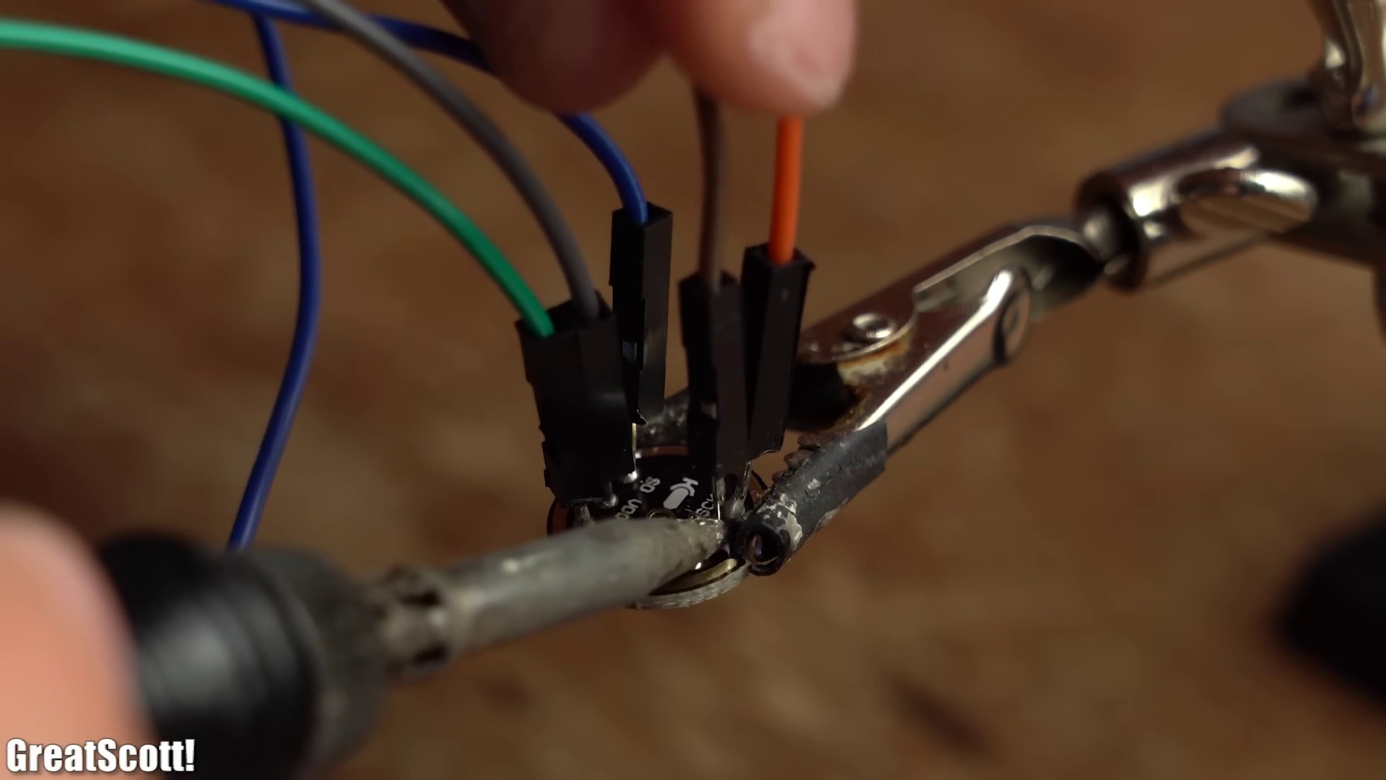 (score 95.0000)
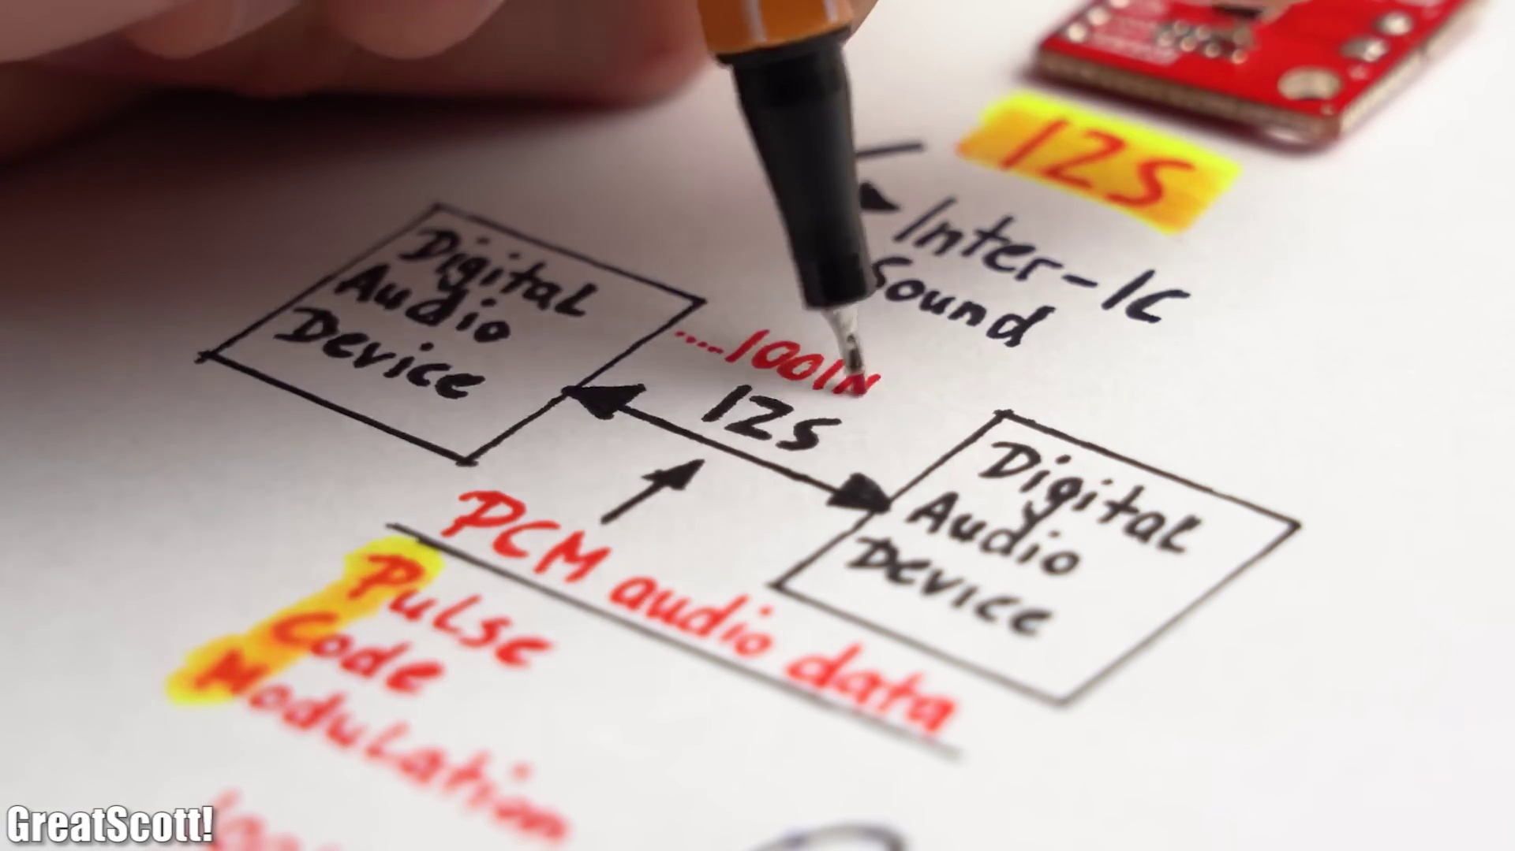 (score 95.0000)
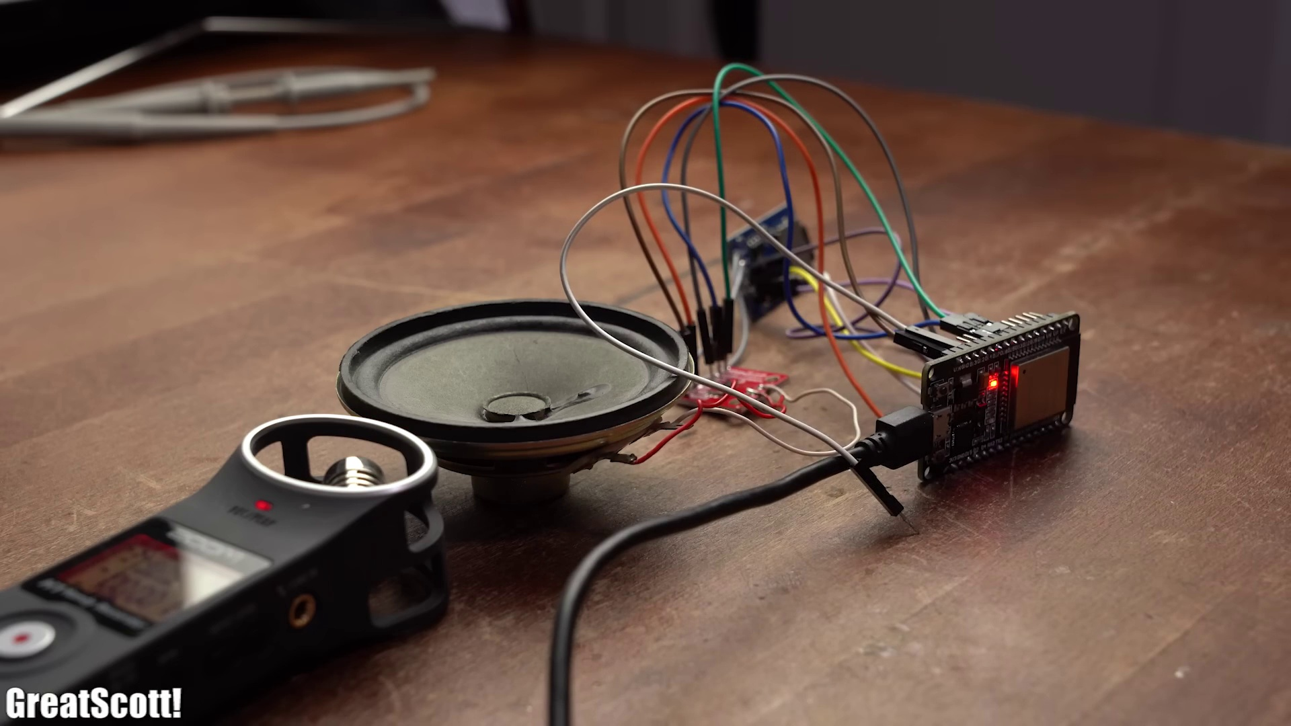 (score 90.0000)
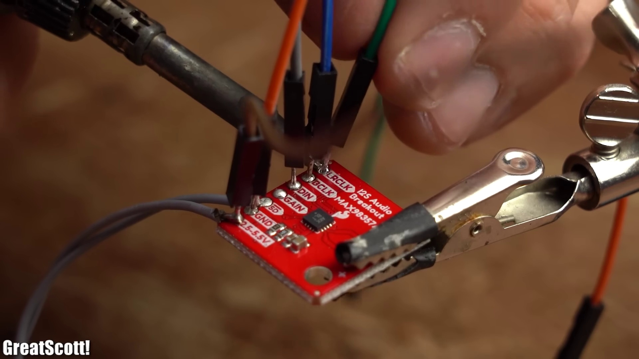 (score 90.0000)
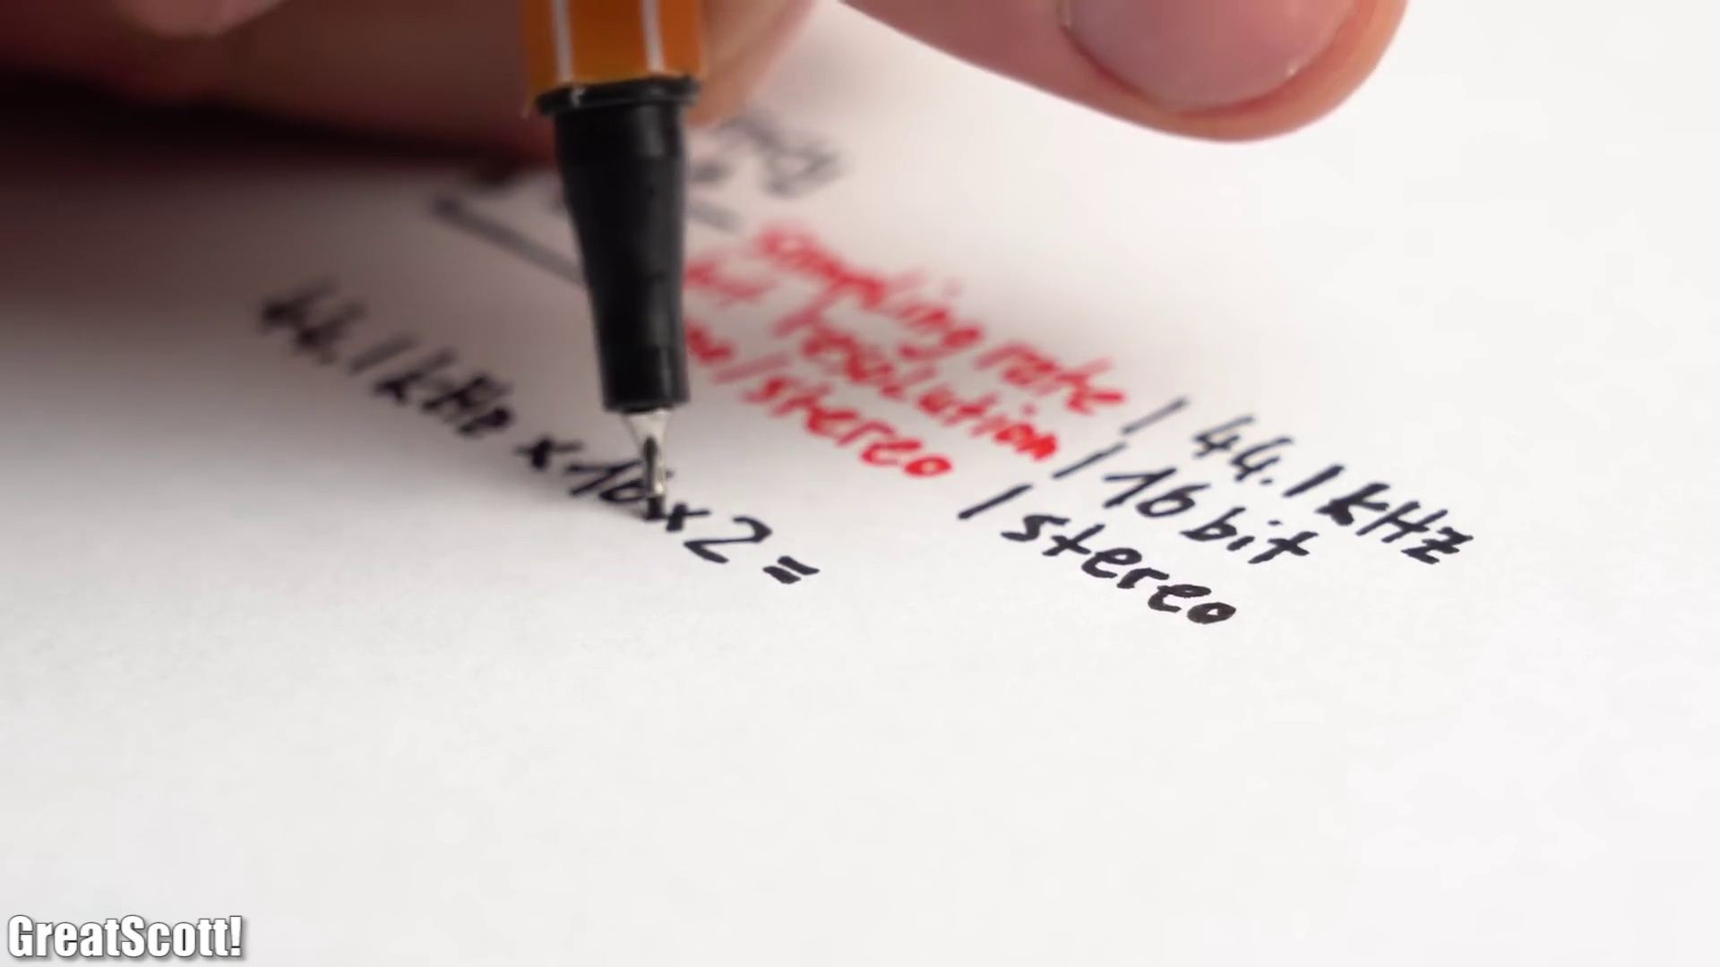 (score 90.0000)
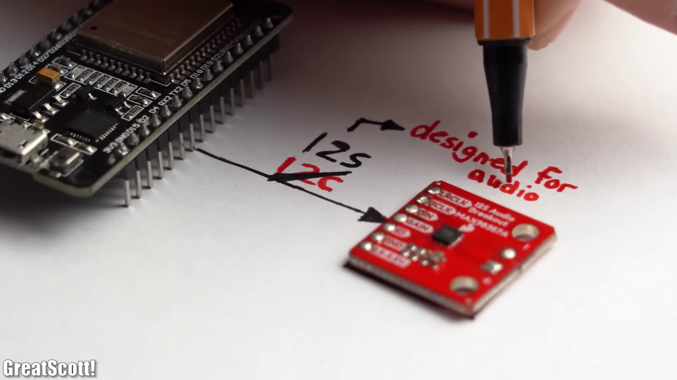 (score 90.0000)
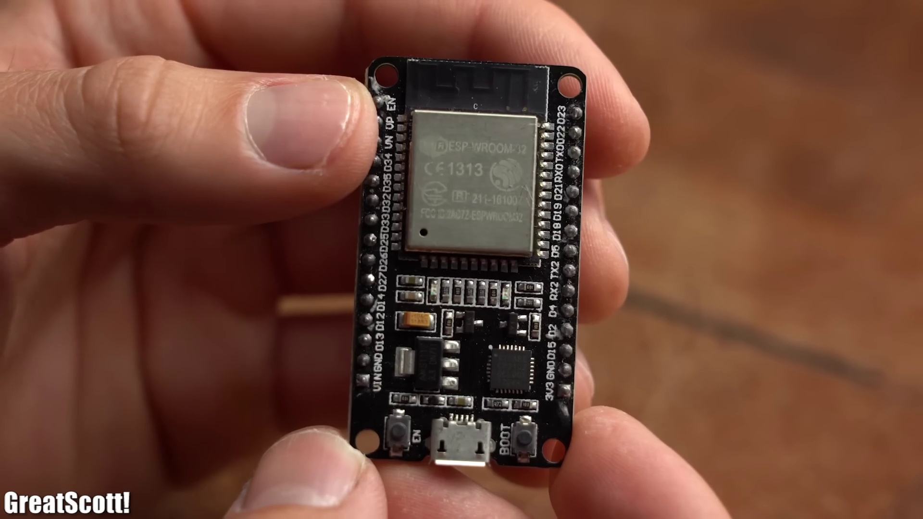 (score 90.0000)
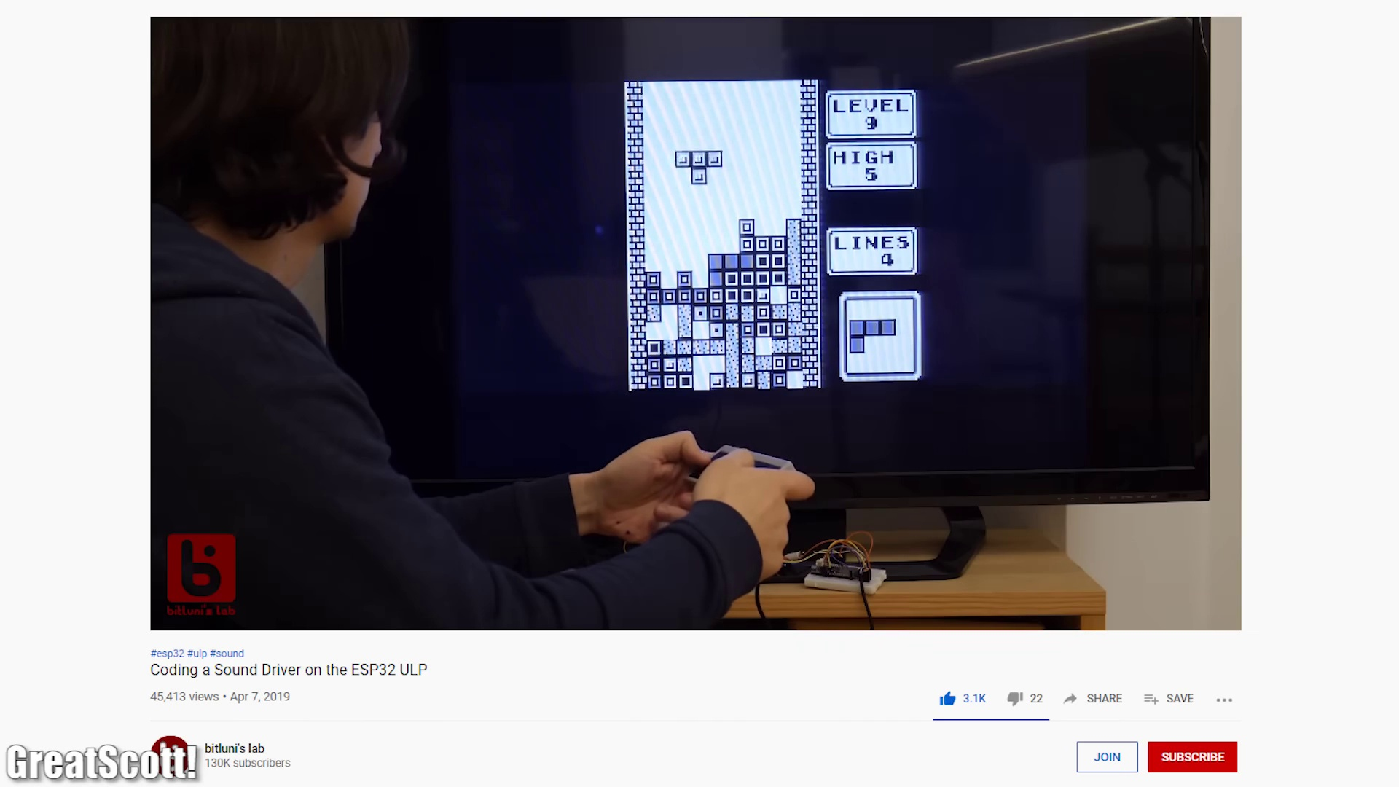 (score 85.0000)
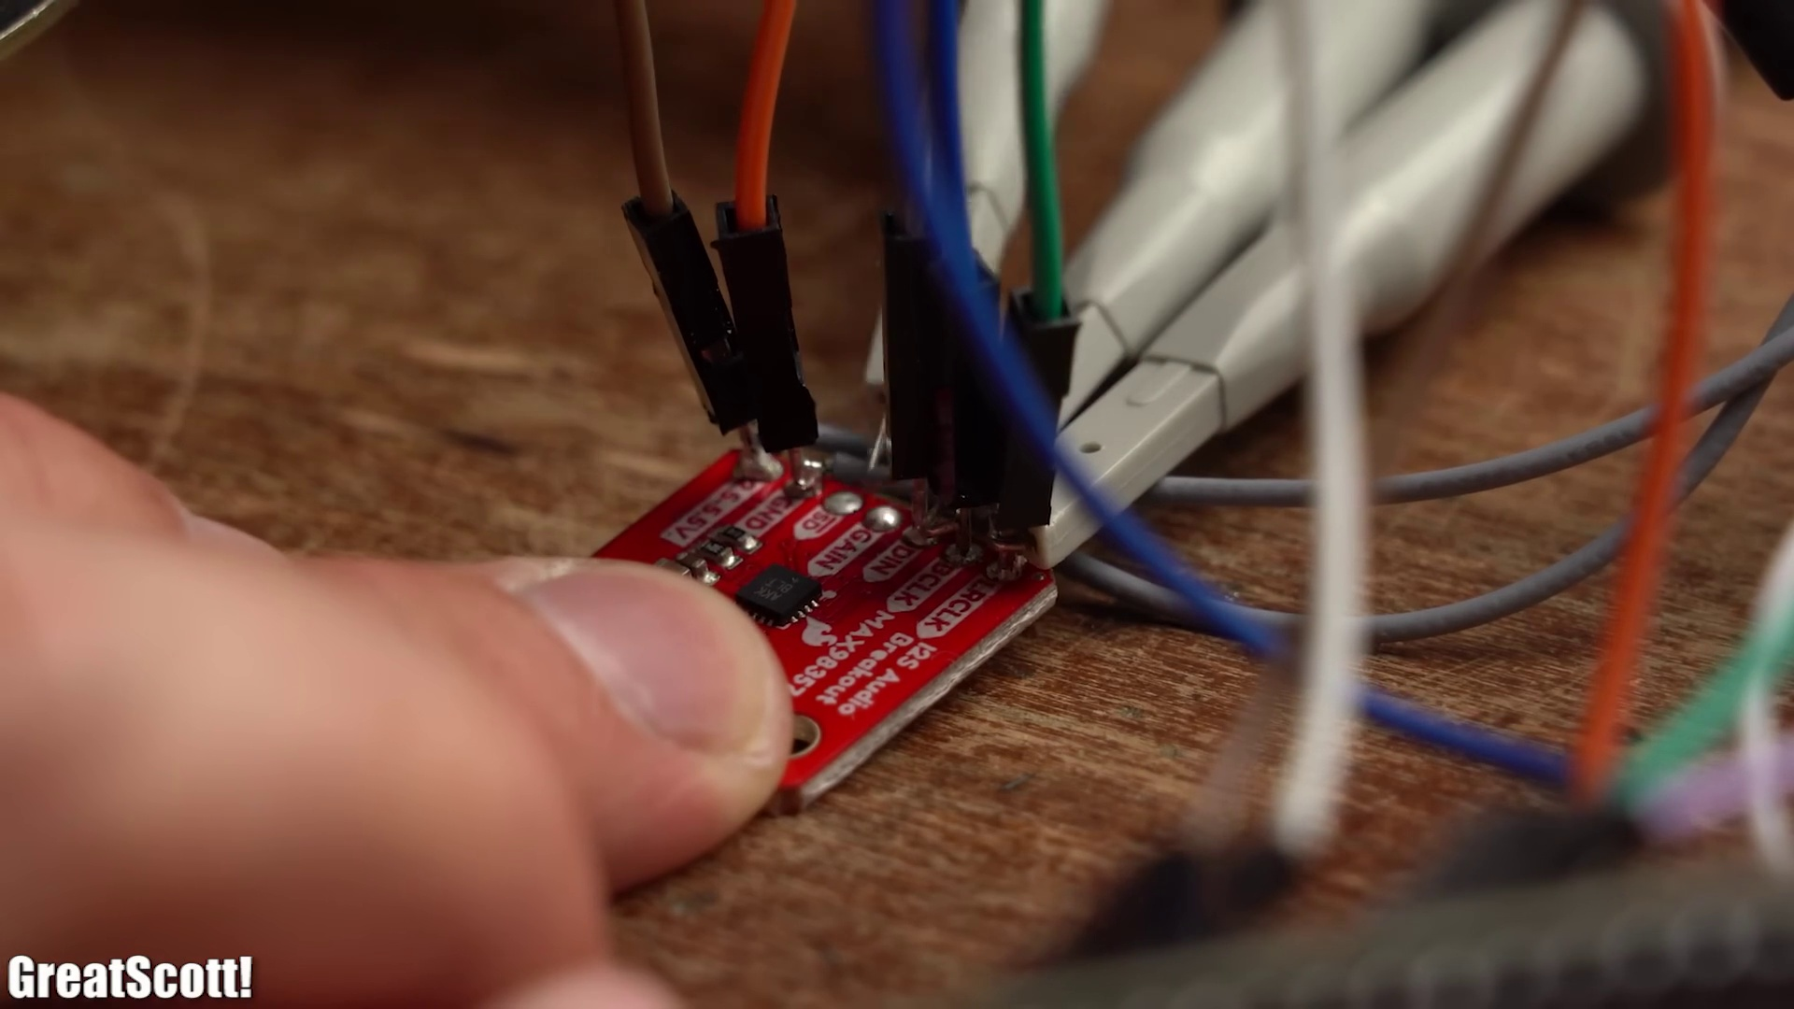 (score 85.0000)
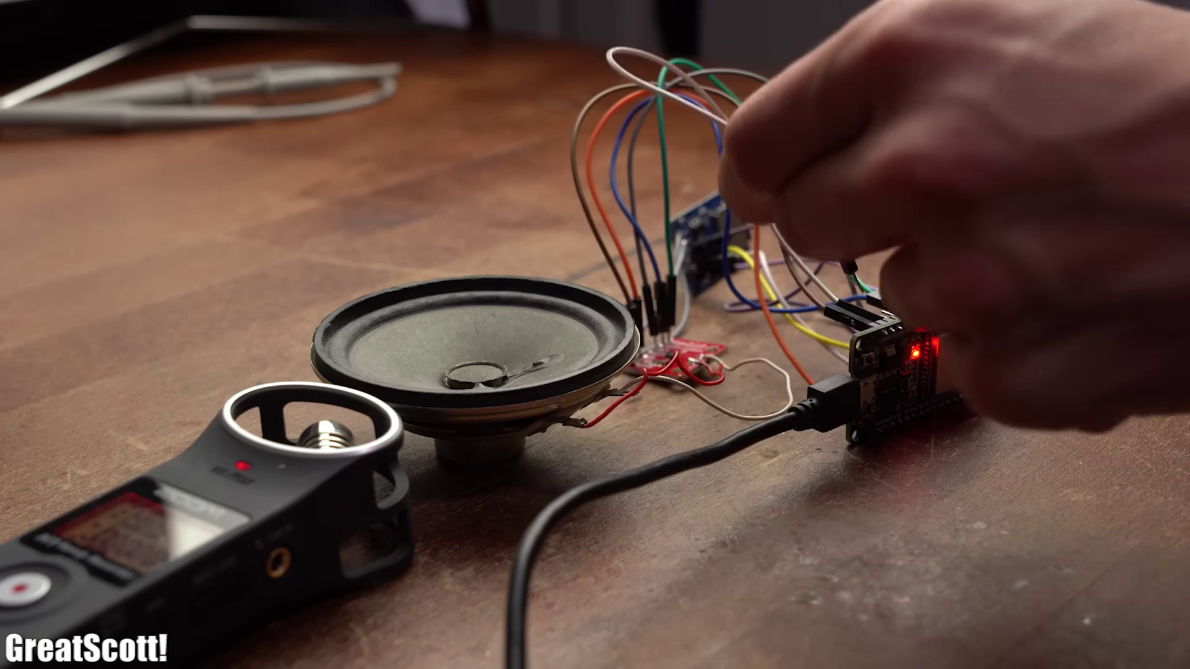 (score 85.0000)
Least correlated frames:
 (score 0.0000)
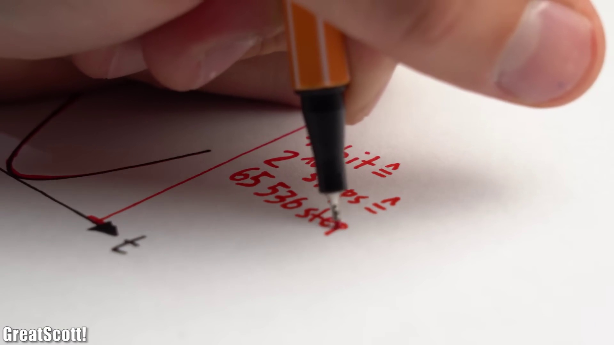 (score 0.0000)
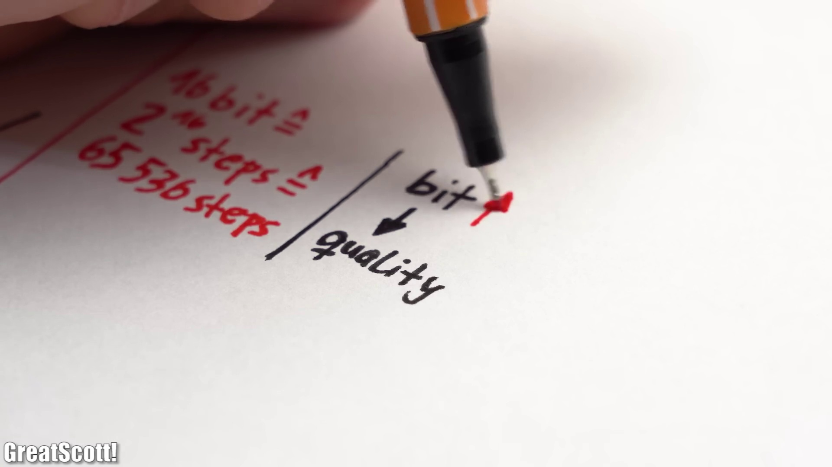 (score 0.0000)
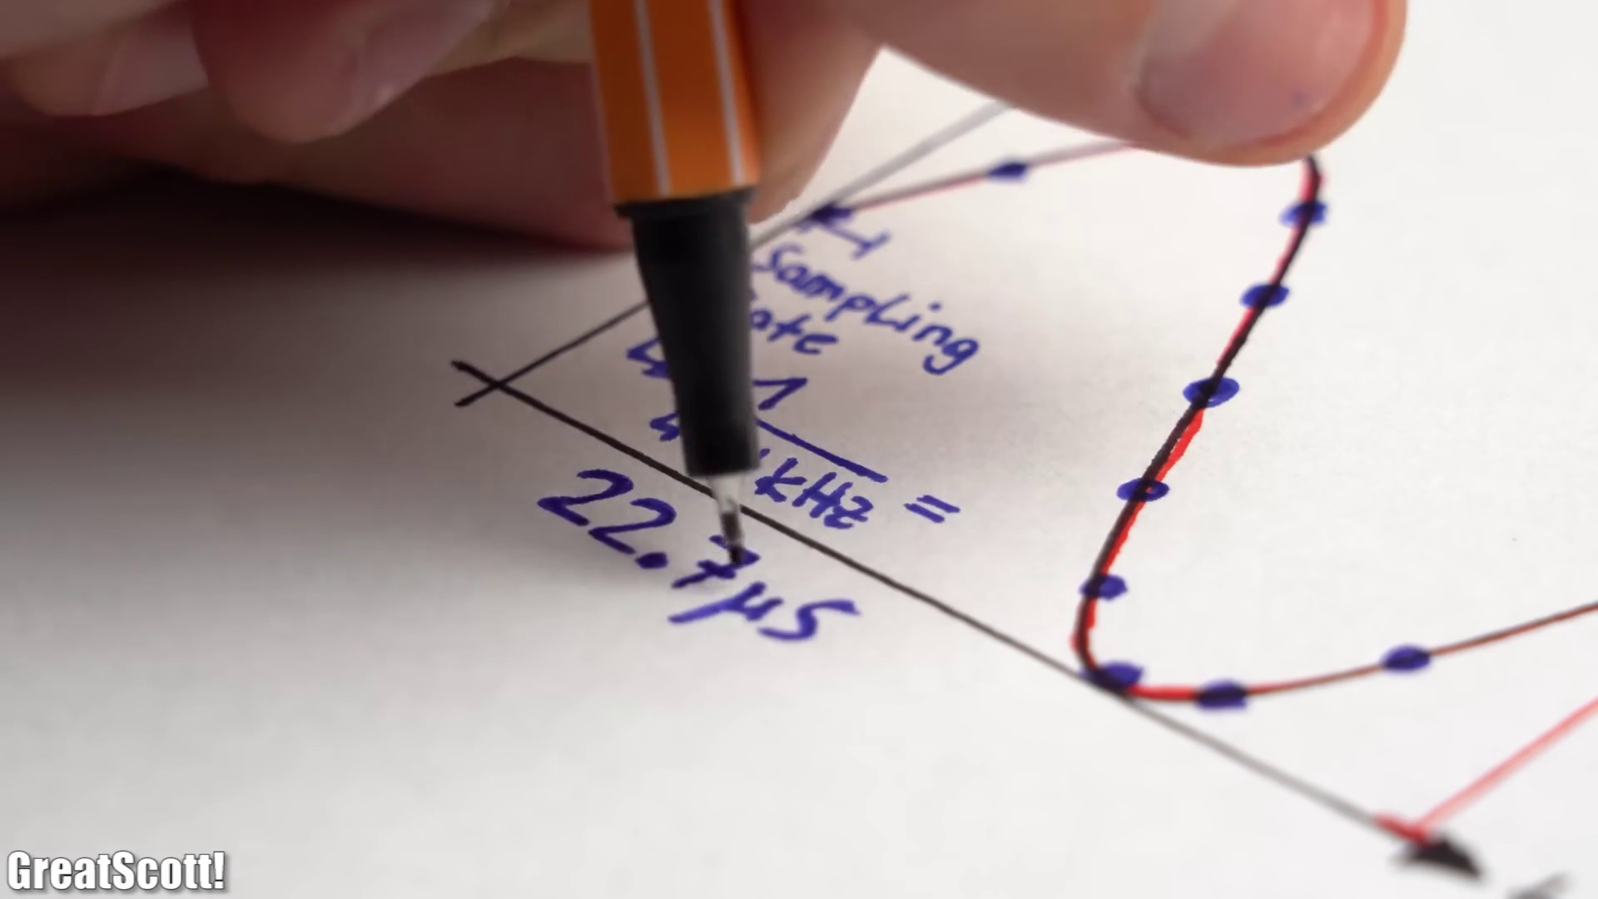 (score 0.0000)
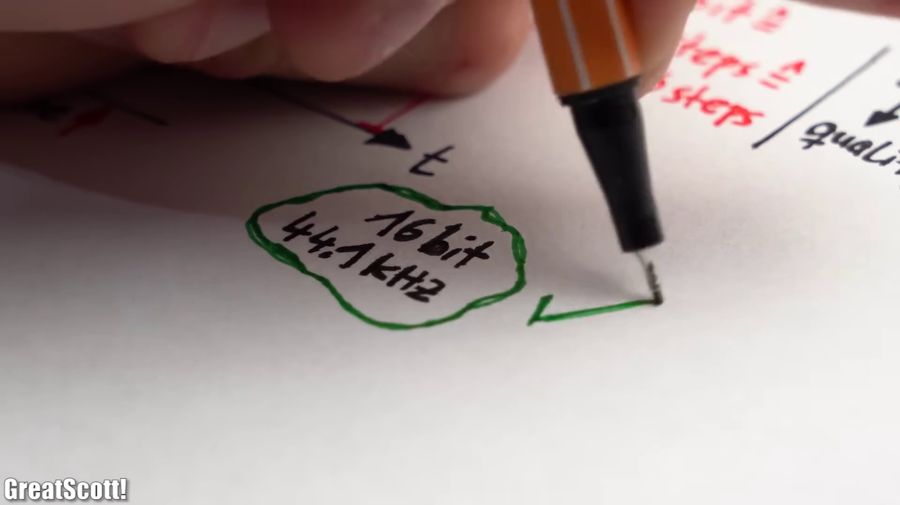 (score 0.0000)
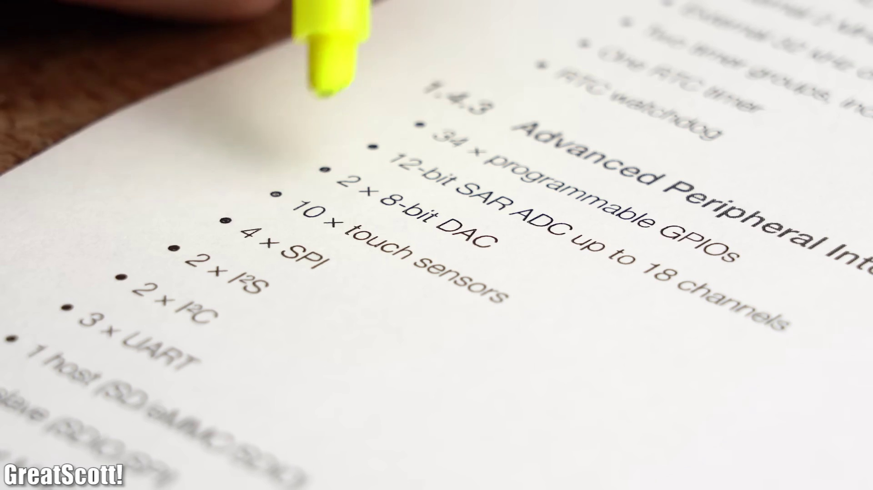 (score 0.0000)
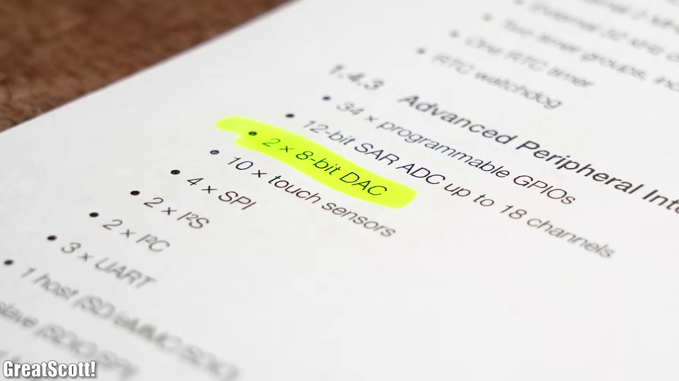 (score 0.0000)
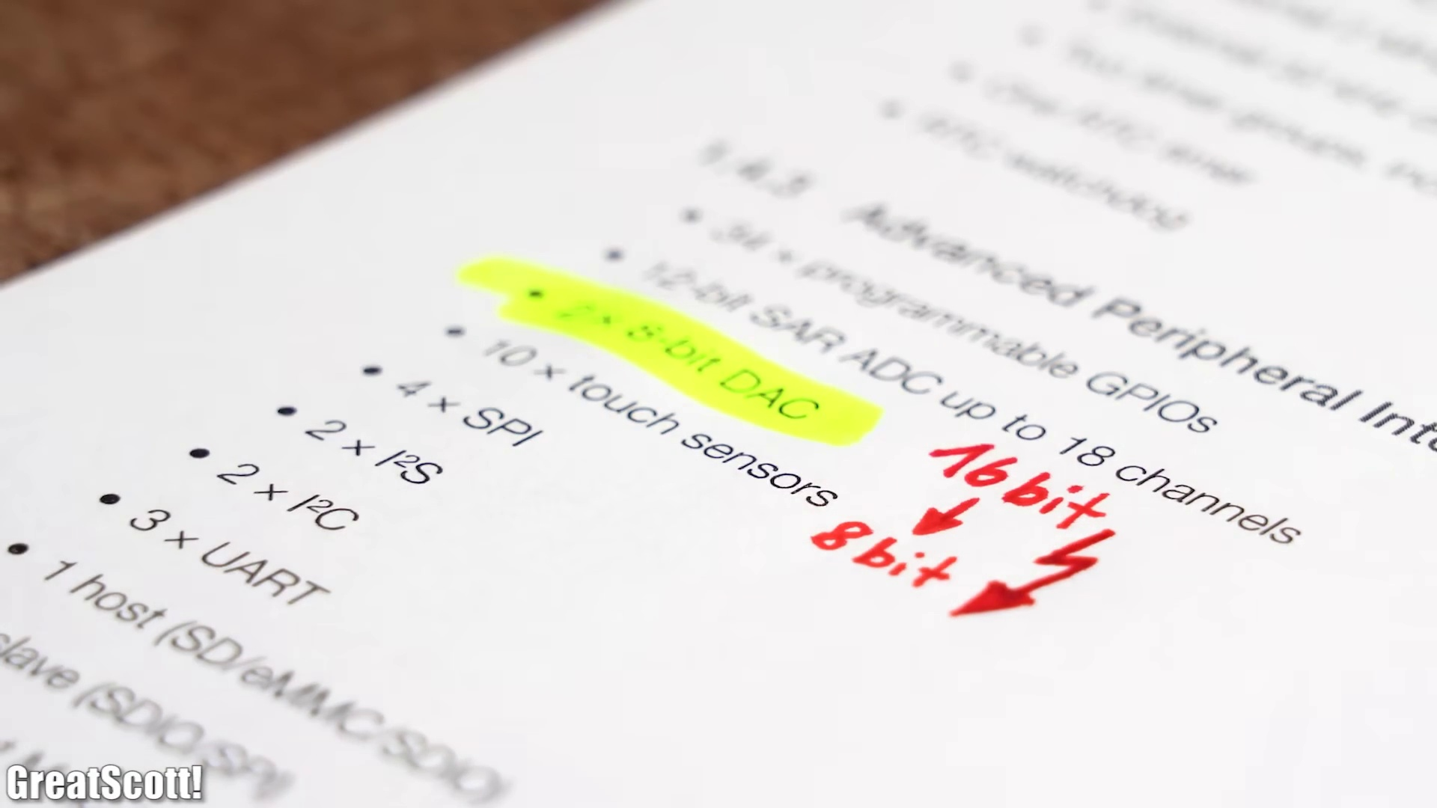 (score 0.0000)
 (score 0.0000)
 (score 0.0000)

Frame: frame_0000.jpg
Caption: The image appears to show an educational or training setting with a focus on a whiteboard or marker board at its center. At the top of the board, there is a black strip with text that reads "Practical Guide to..." However, the rest of the text is obscured by the angle of the photo and the focus on the background object.
The main subject of the image is a rectangular object in the foreground, which appears to be a whiteboard or marker board. The top portion of the board has what looks like a handwritten note or diagram, but the details are not clear due to the angle and distance from the camera. Below this, there's a large rectangle with a gradient from black at the top to grey at the bottom.
In the background, we see a person who seems to be holding a device, possibly a tablet or smartphone, with the screen facing away from the camera. The individual is wearing dark clothing and appears to be seated, as indicated by the visible portion of a chair or desk. However, the person's face and any additional details are not clearly visible.
The image captures a teaching or instructional environment where the instructor might be presenting information, possibly with visual aids like diagrams or charts on the whiteboard, while demonstrating something on their device to the audience.
No strongly correlated comments found for this frame.

Frame: frame_0001.jpg
Caption: The image shows a person's hand holding a small electronic device with various connections and components visible. The device, which has a silver logo on it, appears to be a development board of some sort. It features an array of electronic components such as integrated circuits, connectors, and pins that are typically used for prototyping or experimentation in electronics. A small display screen with text on it is partially visible, showing digital information or status.
The device has a built-in Wi-Fi antenna and is powered by a black battery, which is currently turned off. The power source is indicated by the text "CE PWR 1313" printed on the device. The battery is accompanied by a small white button and a black power button.
The person holding the device is using their thumb and index finger to support it in their left hand. The background of the image appears to be a light brown color, suggesting that the device is being held against a wooden surface.
Comment (score 90): This video provides an in-depth explanation of building a music player and pin connections for the I2S protocol.The information density was high and overwhelming, so it may require multiple viewings.This offers another approach to building audio systems like our class project.
Reason: The comment directly discusses the same technical steps and objects (e.g. building a music player, pin connections for I2S protocol) described in the caption.
Source: https://www.youtube.com/watch?v=qNLvoSQCx60: Building a Digital Music Player with I2S?! What is I2S! EB#45

Frame: frame_0002.jpg
Caption: The image shows a scene with a person in the background interacting with a recording setup, featuring a microphone with a pop filter positioned on a black stand. The microphone is a bone-conduction microphone, black in color with a silver ring around its top. The stand is also black, adding to the monochromatic theme of the image.
In the foreground, there's a transparent screen displaying various audio-related icons and texts that might be part of a software interface for a digital audio workstation (DAW). The text "GreatScott!" is visible on this screen, which could indicate a user's name or a placeholder. The setting appears to be an indoor space, possibly a home studio or a recording booth, indicated by the acoustic foam paneling the walls, which helps absorb sound and improve audio quality.
In the background, there is a white board, which is attached to the stand holding the microphone. The board appears to be a whiteboard, suggesting that it might be used for jotting down notes or ideas during a recording session.
No strongly correlated comments found for this frame.

Frame: frame_0003.jpg
Caption: The image presents a detailed view of a computer screen, specifically focused on a digital audio workstation (DAW) application. The screen is dominated by a waveform display, which is split into two equal halves, each displaying the audio signal from a different source, suggesting the use of multiple tracks or sources. One half displays a blue-colored waveform, indicating that it represents an audio signal, accompanied by a red waveform, possibly representing an audio signal with a higher frequency or intensity.
The top part of the screen features a digital audio workstation (DAW) interface with various tracks and waveforms being edited. The central part of the screen shows an audio waveform overlaid on a spectrogram graph that visualizes the frequency content of the sound. To the left side of the screen, there is a vertical column displaying additional audio channels in their respective waveforms.
On the right side of the screen, several windows are open, showing various audio files and tools. Each window has its own set of controls and displays characteristic of multimedia software used for editing and producing audio content.
The bottom part of the screen shows a MIDI piano roll display, which is often used to visualize notes played on a virtual or synthesized piano in an audio composition. The notes are represented by horizontal lines along a timeline that represents time.
In the foreground at the bottom of the screen, there appears to be a person's hand resting on the trackpad of a mouse, suggesting that they might be interacting with the software or using it to control the audio playback. The person is not visible in full, and their identity is not identifiable from this image.
There are no texts or readable content visible on the screen. The context suggests that the instructor may be demonstrating how to use a digital audio workstation for sound production, including the editing of audio tracks, the visualization of frequency content through spectrograms, and the creation of MIDI compositions using a virtual piano roll.
No strongly correlated comments found for this frame.

Frame: frame_0004.jpg
Caption: The image shows a person's hand holding a yellow pen, actively engaged in drawing a design on a white surface. The design features a black arrow pointing upwards, accompanied by the word "Creative" written below it in white. The pen is positioned to point towards the word "Create", indicating the individual's focus and attention to their creative endeavor.
In the context of this creative process, there is an image within an image in the bottom right corner, possibly from a YouTube video given the presence of the text "YouTube" and the logo "GreatScott!", which often refers to educational tech content created by Scott Hanselman. The inner image shows the same person holding a small electronic device with their hand, likely for a tutorial setup for an electronics class or video tutorial.
The overall scene suggests that this image captures a moment from a teaching or learning process focused on electronics and possibly involving an Arduino or similar microcontroller board, based on the visible circuit design. The emphasis on creativity and innovation is reinforced by the "Create" theme in the outer image, which might imply a connection between electronic design and creative thinking.
No strongly correlated comments found for this frame.

Frame: frame_0005.jpg
Caption: The image presents a single-board computer (SBC) placed on a surface, likely connected to a breadboard and few electronic components. The SBC appears to have a development board or shield attached, indicating its use for programming and electronics projects. Above the physical setup, the written text "STAY CREATIVE" suggests an educational or motivational context encouraging creative thinking or problem-solving in the realm of electronic hobbyist or maker culture.
The photograph features a side view with the SBC and breadboard on the left, and a white paper surface beneath it where "STAY CREATIVE" is written. The background is not detailed, keeping the focus on the text and the electronics project. A clear plastic case encases the device, featuring a green stripe running along its length, with a few buttons and a power connector visible. The style of the image is simple and informative, likely intended to inspire creativity in technology or hobbies that involve breadboarding and SBCs.
No strongly correlated comments found for this frame.

Frame: frame_0006.jpg
Caption: The image depicts an educational setup focused on electronics and tinkering with hardware components. On one side of the image, a person is engaged in assembling a circuit board by meticulously drawing connections between the components using a black marker. The connections are drawn in red, indicating they are the positive side of the circuit. The person's hand is positioned over a small blue chip, suggesting that it is about to be connected to the circuit.
On the opposite side of the image, there is a diagram featuring various electronic components labeled and connected to a central point, which is a breadboard commonly used for prototyping and testing electronics projects. The breadboard has wires plugged into it, connecting different components such as resistors, LEDs, and a small microcontroller board. Above the diagram, text reads "100%", possibly indicating some kind of progress or completion status related to the project or activity being depicted.
The background is white, which helps to focus attention on the content of the image. The overall setting suggests that this is an instructional photo, likely taken from a slideshow or video tutorial where someone is demonstrating how to solder components onto a breadboard and create a simple electronic circuit.
Comment (score 80): This video provides an in-depth explanation of building a music player and pin connections for the I2S protocol.The information density was high and overwhelming, so it may require multiple viewings.This offers another approach to building audio systems like our class project.
Reason: The comment discusses the technical steps and objects (building a music player, pin connections for I2S protocol) directly related to the caption's description of assembling a circuit board and building an electronic project on a breadboard.
Source: https://www.youtube.com/watch?v=qNLvoSQCx60: Building a Digital Music Player with I2S?! What is I2S! EB#45

Frame: frame_0007.jpg
Caption: The image shows a person working on electronic components and a piece of paper. One hand is holding a small blue circuit board with various electronic components such as resistors and capacitors attached to it, while the other hand is using a black ink pen to trace or outline something on the paper below.
The paper contains a detailed diagram or schematic of the circuit board and its components, including text and numerical labels that likely correspond to the pins and functions of each part. The person appears to be carefully tracing the outline of one of these components or possibly an electrical path as indicated by the dotted lines around it.
Above the paper, a person is using a red pen to write on a white surface, with their hand positioned above a circuit board that features various components including a microcontroller, a 16-pin connector, and a 10-pin connector. The microcontroller is connected to the 16-pin connector, and the 10-pin connector is connected to the microcontroller.
The environment suggests a DIY electronics or educational setup, perhaps for teaching circuit assembly, soldering techniques, or the principles of electrical circuits. There are no visible texts on the image that provide context or instructions beyond what is depicted directly in the photo.
Comment (score 85): This video provides an in-depth explanation of building a music player and pin connections for the I2S protocol.The information density was high and overwhelming, so it may require multiple viewings.This offers another approach to building audio systems like our class project.
Reason: The comment directly discusses the same technical steps and goals described in the caption (building a music player, pin connections for I2S protocol), indicating a strong connection.
Source: https://www.youtube.com/watch?v=qNLvoSQCx60: Building a Digital Music Player with I2S?! What is I2S! EB#45

Frame: frame_0008.jpg
Caption: The image presents a detailed view of a small electronics project featuring various components on a white background. A printed circuit board (PCB) with a blue surface and multiple traces connecting different pads is displayed on the left side, accompanied by several electronic components including integrated circuits (ICs), resistors, capacitors, and possibly other passive components.
The PCB has a series of test points labeled from TP0 through TP6, as well as two USB cables connected to what appears to be a power source or development board above it. One cable is plugged into the USB port of the board, while the other is attached with some kind of adaptor.
To the right of the circuit board, three jumper wires are connected between the test points on the PCB and another set of connections that seem to be on a microcontroller or development board. This second device is not fully visible but has additional components mounted on it.
The background suggests an educational setting, with text "STEP 1" pointing at the circuit board and arrows indicating the connections between the jumper wires and test points, implying that this image is part of a tutorial or instructional guide for building electronic circuits using a breadboard and test points.
In the center of the image is a small blue circuit board, marked with the letters "S" and "P", suggesting it's a sensor or processor. This blue board is connected to a larger black circuit board via a series of wires, forming a network that connects the two boards. The black board, equipped with a USB connector, is positioned on the right side of the image.
The precise arrangement of the wires and labels on both boards indicate a well-designed and functional system, showcasing the importance of connectivity in modern technology.
Comment (score 85): This video provides an in-depth explanation of building a music player and pin connections for the I2S protocol.The information density was high and overwhelming, so it may require multiple viewings.This offers another approach to building audio systems like our class project.
Reason: The comment directly discusses the building of a music player using the I2S protocol, which is strongly related to the technical steps and components described in the frame caption.
Source: https://www.youtube.com/watch?v=qNLvoSQCx60: Building a Digital Music Player with I2S?! What is I2S! EB#45

Frame: frame_0009.jpg
Caption: The image captures a person engaged in a combination of electronics project development and writing or programming. The individual is seen using a black pen to write on a piece of white paper, leaving a trail of black ink as they create a sequence of numbers that may represent a code or set of commands. On the right side of the paper, an electronic component, likely a small breadboard-compatible board with connectors, is being soldered onto an Arduino Uno board attached to a breadboard using jumper wires. This suggests that the person is working on an electronics project or repairing an electronic device.
In the background, another circuit board - this one red in color - can be seen placed on the left side of the paper, slightly overlapping with the blue circuit board. The person's hand is hovering over both circuit boards, indicating that they may be preparing to write on them or have just finished writing.
The overall context appears educational or instructional, as indicated by the presence of text ("10") and the close-up view showing the process of soldering. However, there are no visible instructors or educational materials like slides or diagrams in the image. The scene suggests a process of careful crafting of instructions on paper, with the intricate nature of the work being done hinted at through the presence of multiple circuit boards.
Comment (score 80): This video provides an in-depth explanation of building a music player and pin connections for the I2S protocol.The information density was high and overwhelming, so it may require multiple viewings.This offers another approach to building audio systems like our class project.
Reason: The comment directly discusses building a music player and pin connections for the I2S protocol, which matches the technical steps and goals described in the caption.
Source: https://www.youtube.com/watch?v=qNLvoSQCx60: Building a Digital Music Player with I2S?! What is I2S! EB#45

Frame: frame_0010.jpg
Caption: The image shows a person engaged in connecting two electronic devices, a blue circuit board (CB) and a red circuit board. The blue CB is positioned on the left side of the image, while the red CB is on the right. In the foreground, an electronic device with various components visible, such as integrated circuits (ICs), resistors, and wires, is part of a development board, often used for prototyping electronics. A person's hand is visible in the bottom left corner, holding a soldering iron, seemingly soldering or preparing to solder onto one of the components on the board.
The blue CB appears to be an Arduino Uno, a popular open-source electronics platform based on the ATmega328P microcontroller. The board has a USB port on one end for programming and powering the board, along with 6 digital input/output pins (DIGITAL PINS), 1 analog input pin (ANALOG IN), a 6-pin serial communication interface (Tx & Rx pins), 2 PWM outputs (for controlling motors or lighting effects), and an ICSP header for programming the onboard microcontroller.
The underside of the blue CB is visible, revealing components such as a crystal oscillator (XTAL), capacitors (CAPACITORS), a resistor network (resistors), and possibly other passive components. The person's hand holds a red pen, poised over the red circuit board, indicating that they are in the process of connecting the two boards together.
Comment (score 80): This video provides an in-depth explanation of building a music player and pin connections for the I2S protocol.The information density was high and overwhelming, so it may require multiple viewings.This offers another approach to building audio systems like our class project.
Reason: The comment directly discusses the technical steps and goals described in the caption, such as building a music player and pin connections for the I2S protocol. Although it's not an exact match, the mention of building audio systems like a class project is related to the Arduino Uno board and its capabilities.
Source: https://www.youtube.com/watch?v=qNLvoSQCx60: Building a Digital Music Player with I2S?! What is I2S! EB#45

Frame: frame_0011.jpg
Caption: The image shows a computer screen with an open window displaying various audio settings. The main window displays several lines of text in a terminal-like environment, suggesting that a command has been executed or is being executed. The text includes commands such as `cd /Users/user`, `ls`, and `mp4g convert -i video.mp4 -o output.mp4`. This indicates that the user may be working with media files or multimedia content.
Below this, there is a menu item labeled "Audio" with a dropdown option selected for "PCM". There is also an entry field and a button labeled "Sign," followed by a percentage sign and some numbers (100%) below it. The window displays options in the top left corner, including "Format" and "Settings", while the top right corner shows "Codec ID" and "Duration" options. The bottom left corner displays "Speed" and "Rate" options, and the bottom right corner shows a single option labeled "Ch.".
On the right side of the image, there's a sidebar with settings or options such as "Channels", which is expanded to show "Streaming", "Format", and "Bit rate". There are also sliders for volume control, with one labeled "Channel 1", and two additional channels visible. A text box on the right side of the image contains several lines of text that seem to be related to audio settings or instructions, mentioning "Bit rate" and "Channels".
The overall style of the image suggests a technical tutorial or a screenshot from a multimedia editing software or command-line interface used for media processing. The focus is on the computer screen and the text it displays, with no instructor visible. The background of the image is white, providing contrast to the text and options displayed on the window, and includes a watermark of "GreatScott!", indicating the source of the screenshot.
No strongly correlated comments found for this frame.

Frame: frame_0012.jpg
Caption: The image shows a moment of meticulous precision, capturing a person's hand poised over a white sheet of paper with a pencil. The paper is adorned with a series of numbers and symbols, each one meticulously placed, creating a complex pattern. The numbers are arranged in a grid-like structure, with each number being represented by a symbol, forming a visual symphony of numbers and symbols. In the foreground, the hand appears to be writing or sketching, perhaps in an instructional context given the presence of paper and pen/ pencil. Although there is no visible text or mathematical equations within this frame, the overall scene suggests that it may be related to learning or education. The background is out of focus, but it seems to be a surface on which something is placed, adding depth and perspective to the image. This moment of precision and creativity is a testament to the power of human innovation and the beauty of mathematics.
No strongly correlated comments found for this frame.

Frame: frame_0013.jpg
Caption: The image shows a person's hand in the process of writing with a black pen on a piece of paper that appears to be a worksheet or a piece of lined paper. The person is holding a red pencil and seems to be either correcting an error in their writing or adding something to the paper, as indicated by visible marks, possibly corrections or instructions, on the paper. The text on the paper is not entirely legible due to the angle and resolution of the photo. However, it appears that the worksheet contains mathematical equations that include fractions and what looks like a word problem with a series of multiplications.
Closer inspection reveals that the person is actively engaged in drawing a specific mathematical equation. The equation is written in black ink and composed of two parts: the numerator and the denominator. The numerator, written in red, is a simple multiplication of two numbers: 2 and 3. The denominator, also in red, is a simple addition of two numbers: 5 and 5. The person's hand holds a black pen, which is being used to write out the equation with precision and focus.
The surrounding context suggests an educational environment where mathematics is being taught or practiced. The image captures a moment of meticulous writing, as the person carefully writes out the equation on the paper. The stark white background provides a clear contrast that allows the red numbers and the black pen to stand out, making the equation the sole focus of the scene.
No strongly correlated comments found for this frame.

Frame: frame_0014.jpg
Caption: The image presents a close-up scene of a person's hand holding a black pen, currently in the process of writing on a piece of paper. The writing is in red ink, which stands out against the white background of the paper. The pen is writing the word "Quality" in bold, capitalized letters, emphasizing its importance. Below it, the same word is written in smaller, more detailed script, possibly indicating a further explanation or elaboration.
Above the word "Quality", the number "2" is being written in red ink. This could represent a step or process related to the concept of quality. The writing style is typical for mathematical calculations, with clear delineation of each addition step, as seen in the calculation "= 1 + 2 + 3 + 4 + 5 + 6 + 7 + 8 + 9 + 10" on the same piece of paper. No other objects or people are visible in this frame, and the focus is solely on the hand and paper with the written calculation. The overall scene suggests a thought process or brainstorming session where the person is trying to convey the importance of "Quality".
No strongly correlated comments found for this frame.

Frame: frame_0015.jpg
Caption: The image shows a person's hand holding a black pen with a red top, positioned over a piece of paper containing mathematical calculations. Two visible equations are displayed: "65 steps" and "quality ≈ steps * quality / 65". The second equation suggests a ratio between the number of steps and the level of quality, where the value of quality is obtained by multiplying the number of steps by the quality divided by the total number of steps. This appears to be related to some sort of process or workflow, possibly in a professional or educational context.
The paper clip on the top left corner adds a touch of informality to the setting, which seems focused on instruction or explanation, perhaps during a lecture or lesson where someone is demonstrating how they calculate quality based on the number of steps taken in their process. The person's hand is positioned over a red line, adding a pop of color to an otherwise monochrome background.
The writing on the paper is a mix of black and red, creating a visual contrast that draws attention to the words "steps" and "quality", suggesting the focus might be on a process or task. The precise location of the hand and the written words indicates a deliberate and careful process. The overall composition of the image is simple yet powerful, conveying a sense of effort and dedication as the person writes on the paper with intense focus and concentration.
No strongly correlated comments found for this frame.

Frame: frame_0016.jpg
Caption: The image shows a computer monitor displaying a window with technical information and a user interface for an audio processing or analysis software application. At the top of the window, there is a title that reads "PCM" followed by "little_endian", indicating that the contents are related to a little-endian PCM (Pulse Code Modulation) file format.
Below the title, there's a section displaying various attributes of the PCM file: File size: 1,894 KB; Format: WAV; Duration: 5 seconds, 69 frames; Sample rate: 4800 Hz (common for CD-quality audio); Channels: 2 channels; Bitrate: 1411 KB/s; Block size: 1024 bytes; Codec ID: 1.
To the side of this information, there is a visual representation of the bit rate (1411 KB/s) and sample rate (4800 Hz), shown as horizontal bars with numerical values indicating the amount of data per second. On the right side of the window, there is a text output that appears to be a log or status message, reading "channel_1 100% 2 0.000000 s 1 59.322 s", which seems to indicate some sort of processing or playback progress for a channel.
At the bottom left part of the window, the file path is displayed as "C:\Users\username\Downloads\filename", indicating that the file is located on the user's computer in a downloads folder. The window also features several buttons and options, including a "Play" button with a play icon, an audio output volume control slider with a numerical value (1) and "100%", suggesting maximum volume, and additional text reading "channel_2 0 2 0.00000 s 1 59.322 s", likely related to another channel of the audio file.
The overall layout and color scheme suggest that this is a professional audio editing program, possibly used for playing, processing, or analyzing audio files in a Windows operating system environment. The user appears to be interacting with the software to perform some action, possibly related to a technical demonstration or analysis.
No strongly correlated comments found for this frame.

Frame: frame_0017.jpg
Caption: The image shows a moment of mathematical exploration, featuring a graph labeled "Sampling Rate" with vibrant blue and red lines. The blue lines represent the sampling rate, while the red lines represent the number of steps. The x-axis is labeled "Number of Steps", and the y-axis is labeled "Sampling Rate". The graph is annotated with text, including the equation "1/65536 = Sampling Rate" and "16 bits = Number of Steps".
In the foreground, a piece of paper with mathematical drawings and annotations is visible. On the left side, a hand is holding a pen, seemingly in the process of writing or highlighting something on the paper. The central part of the image shows a graph that appears to be related to statistics, given the presence of "standard deviation" labels, along with numerical values and symbols such as circles with lines connecting them.
On the right side of the image, another piece of paper is partially visible, featuring a similar mathematical diagram. This second sheet has a title that reads "ROLLING STATISTICS" in large, bold letters at the top, below which is a subtitle or heading that says "SAMPLING". The paper also contains mathematical equations written on it, including one equation labeled "85" and another labeled "65397". These numbers could be sample sizes or other parameters relevant to statistical sampling.
The image appears to be a snapshot from a video, as evidenced by the low resolution and still frame quality, which does not allow for legibility of text or finer details in the graph. There is no visible instructor or classroom setting in this image; it focuses solely on the mathematical content and its presentation. A watermark in the bottom right corner reads "GreatScott!", possibly indicating the creator of the image.
No strongly correlated comments found for this frame.

Frame: frame_0018.jpg
Caption: The image captures a moment of intense mathematical concentration as a person's hand, poised over a piece of paper, prepares to make a mark with an orange pencil. The paper is filled with intricate blue lines and curves, suggesting a complex problem is being tackled. The focus of the image is on the action of writing, with the surrounding environment slightly blurred, emphasizing the activity at hand. A closer look reveals that the hand is pointing to a particular point on the paper, indicating that the person is about to make a mark there. Additionally, the text "4 cm" and "4 cm" is visible, possibly indicating the distance between the point and the starting point of the problem.
No strongly correlated comments found for this frame.

Frame: frame_0019.jpg
Caption: The image shows a close-up view of a handwritten mathematical problem and its corresponding graph on a piece of paper. On the left side of the image, we see a person's hands holding a pen over the paper, indicating that they are either writing or pointing at the paper. There is no text in the image to read, but there is a clear indication of mathematical calculations and graphs.
The main focus seems to be on a mathematical concept related to graphs, as indicated by the graph with dots labeled 1 to 5 and a straight line passing through those points. The graph appears to represent some sort of linear relationship or trend. The handwriting suggests that this could be an educational setting where the person is explaining or teaching about mathematics or data analysis.
Upon closer inspection, the graph can be seen as representing a sine wave, with a series of dots labeled with time values indicating the frequency of the wave. The wave starts at 0 and ends at 27.5 seconds, with the highest point occurring at 22.75 seconds. The graph is labeled with the unit of frequency, which is measured in hertz (Hz), and specifically shows a frequency of 44.11 kHz.
The label "GreatScott!" is also present, perhaps indicating the creator's or viewer's excitement about the graph. The graph itself is drawn on a white background, providing a stark contrast that makes the data and labels stand out clearly. The use of a blue pen for the graph lines and dots adds a pop of color to the otherwise monochrome background.
Overall, the image provides a clear and concise representation of a sine wave, with the data and labels clearly labeled and the graph drawn in a visually appealing manner.
No strongly correlated comments found for this frame.

Frame: frame_0020.jpg
Caption: The image shows a close-up of a person's hand in the act of solving a complex mathematical problem. The paper appears to have various equations, calculations, and diagrams, possibly related to mathematics or engineering. Handwritten notes and graphs with labeled axes "Quality" and "Rate" are also present. The person is wearing a fingerless glove with red and blue stripes on the back of their hand.
The image features a stylized letter 'C' watermark or logo in the top left corner, possibly suggesting an educational context. The instructor appears to be providing instructional content related to the problem-solving process depicted on the paper.
As seen in the image, the person's hand is holding a pencil and calculator, actively solving the problem. The equations are scattered across the paper, each representing a different aspect of the problem. The colors used in the equations are black, red, and blue, adding a dynamic element to the image.
In the bottom right corner of the image, the text "GreatScott!" is written in bold, capitalized font, likely indicating the person's name or the title of the image. The white background provides a stark contrast to the colored equations on the paper, further emphasizing the details of the problem-solving process.
Overall, the image depicts a person engaged in mathematical problem-solving, utilizing a calculator and pencil, with the help of diagrams and annotations on the paper.
No strongly correlated comments found for this frame.

Frame: frame_0021.jpg
Caption: The image captures a moment of concentration and precision as a hand meticulously writes and annotates a piece of paper. The hand, holding a yellow highlighter, is drawn to the left side of the paper, with the tip of the highlighter pointing towards the right. The focus is on the writing process, with various notes and annotations visible on the paper. Mathematical equations such as "5 + 2 = 7" and a diagram that includes what looks like a circle labeled with "a^2 + b^2 = c^2" are among the content being written down. Additionally, there is text that seems to be part of an equation: "A = (1/4) * pi * r^2". The paper appears to be a blank slate, waiting for new notes or diagrams to be added, and the hand's position suggests that it is in the process of marking something important. The blurred background, likely a desk or table, provides a subtle contrast to the vibrant colors of the highlighter and the stark white paper, exuding a sense of focus and dedication as if the hand is on a mission to create or communicate something significant.
No strongly correlated comments found for this frame.

Frame: frame_0022.jpg
Caption: The image depicts a person's hand actively engaged in writing on a piece of paper with precision and focus. The pen, a vibrant orange, stands out against the stark white background as it meticulously creates a series of lines and shapes on the paper. The text "16 bit 44.1 kHz" is clearly visible, indicating the frequency of the audio being processed, suggesting an educational activity related to audio engineering or music production. The person's fingers are in motion, creating a series of mathematical expressions on the paper, possibly part of an instructional setting where someone is demonstrating or teaching about mathematical problems. The diagrams or visual aids on the paper include shapes that might represent a flowchart or a process of some sort, further emphasizing the educational nature of the activity. Overall, the image showcases the meticulous nature of these professions, where even the smallest details can make a significant impact.
Comment (score 80): This video provides an in-depth explanation of building a music player and pin connections for the I2S protocol.The information density was high and overwhelming, so it may require multiple viewings.This offers another approach to building audio systems like our class project.
Reason: The comment directly discusses the same technical steps (building a music player and pin connections for the I2S protocol) mentioned in the caption, with some overlap in terms of audio engineering/musical production context.
Source: https://www.youtube.com/watch?v=qNLvoSQCx60: Building a Digital Music Player with I2S?! What is I2S! EB#45

Frame: frame_0023.jpg
Caption: The image presents a close-up view of a circuit board labeled as "Internal DAC", which is likely related to interfacing analog signals with digital systems, a common task in embedded systems or electronic hobbyist projects. The board is equipped with various components, including resistors, capacitors, and integrated circuits (ICs), which are commonly used in electronics projects for signal processing or data conversion tasks.
The board features a red LED, a black resistor, and a white capacitor, indicating the presence of analog signal processing capabilities. A black pen is seen on the board, possibly indicating the path of a wire or the location of a component. The word "Analog" is written in red ink on the board, further emphasizing the type of signal processing involved.
On the left side of the photo, there's a circuit board with various components attached, which appears to be part of the same DIY electronics project. A pen is drawing on a piece of paper that has red text written across it, including hand-drawn diagrams and annotations related to electrical engineering or computer hardware. The red text includes words such as "DAC" (Digital-to-Analog Converter) and "ADC" (Analog-to-Digital Converter), which are likely referring to the components on the circuit board.
The person holding the pen seems to be annotating or outlining something related to the project, possibly explaining the connections or the workings of the circuit. The image captures a moment of problem-solving or planning for a specific electronics setup, with the "Internal DAC" label suggesting that the focus is on digital-to-analog conversion.
Comment (score 80): This video provides an in-depth explanation of building a music player and pin connections for the I2S protocol.The information density was high and overwhelming, so it may require multiple viewings.This offers another approach to building audio systems like our class project.
Reason: The comment directly discusses the same technical steps, objects, and goals described in the caption, specifically mentioning building a music player and pin connections for the I2S protocol.
Source: https://www.youtube.com/watch?v=qNLvoSQCx60: Building a Digital Music Player with I2S?! What is I2S! EB#45

Frame: frame_0024.jpg
Caption: The image shows an electronic device with a USB cable connected to it, which appears to be a microcontroller board such as a Raspberry Pi or similar Arduino-like board. The board is mounted on a breadboard, suggesting that the user may be conducting some electronics experimentation or prototyping. On the paper next to the device, there are two handwritten annotations: "Initial Logic Loop" and "External Input ADC Channel 0", possibly indicating a logic loop in the initial stages of programming or setting up the microcontroller, as well as an Analog-to-Digital Converter (ADC) configuration or setup for an external analog signal. In addition to these annotations, there are also handwritten notes which appear to be instructions or reminders related to the electronic device, including "DC power supply", "Internal clock 32kHz oscillator", and "5V DC input power supply". The image seems to be focused on teaching or documenting the setup and configuration of an electronic device, possibly in an educational context where hands-on learning is taking place. The image also captures a close-up view of a circuit board, which is a mix of black and white with red and black markings, indicating a complex network of wires and components. A red marker is visible on the board, drawing attention to its presence. The board is surrounded by a black and white circuit diagram, providing a clear representation of the board's components and connections. The overall image suggests a scene of activity and learning, perhaps a student working on a project or a professional working on a complex circuit design.
Comment (score 80): This video provides an in-depth explanation of building a music player and pin connections for the I2S protocol.The information density was high and overwhelming, so it may require multiple viewings.This offers another approach to building audio systems like our class project.
Reason: The comment directly discusses the same technical steps (building a music player and pin connections for I2S protocol) and objects (Raspberry Pi or Arduino-like board) described in the caption.
Source: https://www.youtube.com/watch?v=qNLvoSQCx60: Building a Digital Music Player with I2S?! What is I2S! EB#45

Frame: frame_0025.jpg
Caption: The image presents a unique scene, featuring an electronic device with an attached USB cable placed on a table. A handwritten note is positioned nearby, bearing the words "Initial config" and arrows pointing towards various parts of the device. The device itself appears to have a small screen displaying what seems like a command-line interface or configuration menu. Additionally, two lines of text are written on the note: "Import it" and "Install it," accompanied by an arrow indicating where each task should be performed.
In the background, partially visible, is a digital-to-analog converter (DAC) chip, positioned on a white surface. The chip is outlined by black lines and features red text reading "Internal DAC" and "Digital to Analog Converter." A small rectangular object with a pin connector at the top, surrounded by black text labeled "Analog to Digital Converter," completes the image.
The overall focus of the image is on the electronic device and its USB connection, suggesting an instructional or demonstration context related to setting up or configuring this type of device. The presence of the DAC chip provides further context, potentially implying a project or tutorial focused on electronic device configuration or signal processing.
Comment (score 80): This video provides an in-depth explanation of building a music player and pin connections for the I2S protocol.The information density was high and overwhelming, so it may require multiple viewings.This offers another approach to building audio systems like our class project.
Reason: directly discusses device configuration and I2S protocol
Source: https://www.youtube.com/watch?v=qNLvoSQCx60: Building a Digital Music Player with I2S?! What is I2S! EB#45

Frame: frame_0026.jpg
Caption: The image shows a close-up of a piece of paper with various items written on it. The paper is sitting on a surface, and a person's hand holding a green marker is partially visible at the top of the image. The text on the paper appears to be notes or instructions, possibly related to an academic or educational setting:
- "4 s" followed by two mathematical equations: "x + 10/6 =" with no answer shown and "2x + 3 =" with an answer given as "5".
- "5 x" followed by an equation that suggests an attempt to solve for "x", but the result is not complete. The answer provided is a value of "5" followed by an explanation that says "because".
- "3 x + 2" followed by a mathematical expression without the solution provided.
- "10 x y" followed by a multiplication equation, possibly indicating a formula or relationship between "x" and "y", but no answer is shown.
- "5 x - 2" followed by an equation with an answer given as "-3".
- "3 x + 6 =" with no answer shown.
- "10 x y z" followed by a multiplication problem, possibly indicating that the result should be 10 times the value of "xyz", but no answer is shown.
- "5 x + 2 x - 3" followed by an equation with an answer given as "-3".
- A partial list that says "Advanced Programming Topics:". The items on the list are not fully visible, and it seems to be cut off, so we can only infer that this is a subsection of a larger list.
The person holding the marker appears to be in the process of writing or marking these notes, likely as part of an educational activity or a study session. The focus on mathematical equations suggests that this could be a practice sheet for algebraic problems.
No strongly correlated comments found for this frame.

Frame: frame_0027.jpg
Caption: The image shows a close-up of a yellow piece of paper placed on a surface, which appears to be part of a larger document or presentation. The paper contains various text and markings, including a title "Advanced Perspective Psychology" at the top. Below this, there is an identification number or code "To 1400 DCM 5678236", followed by a list with acronyms such as "BPS", "AUD", and "RISK". These acronyms may refer to different sections or concepts within the advanced perspective psychology context.
The document also features a series of bullet points, although the details are not clear due to the angle and resolution of the image. At the bottom right corner of the paper, there is a yellow highlighter marking the number "1" followed by the text "2", which seems to be indicating an item or point on the list.
The background suggests that this is a physical piece of paper placed on a surface, and it appears to be part of a larger document or presentation as suggested by the style and size of the content. The paper also features handwritten notes and symbols, including squiggly lines and numbers like "2", which seem to be highlighting important points or indicating changes to be made.
The text is too small and blurred for accurate transcription, but the overall context suggests an educational or academic setting where concepts are being organized or reviewed within a psychological framework.
No strongly correlated comments found for this frame.

Frame: frame_0028.jpg
Caption: The image shows a page from a manual or user guide for an electronic device, likely a computer. The page is filled with text and symbols in a systematic grid-like pattern, suggesting a technical or instructional content. The text is written in a large font, making it easy to read, while the symbols are in smaller font, possibly indicating technical terms or specific instructions.
The manual appears to be in English, as indicated by the use of common English words and phrases, with capital letters used for headings and important information. The device described in the manual has a touch screen and is capable of handling 8-bit data, suggesting advanced features and connectivity capabilities.
In the background of this technical manual page, there is an image that appears to be a piece of paper with handwritten notes. These notes are related to scientific or engineering content, possibly from a lecture or study session context. The paper is covered with text and diagrams, including mathematical equations representing physical laws or processes.
The notes include arrows pointing to specific parts of the equations, indicating relationships between different variables. The title "Physical Mechanics" suggests that these notes may be part of a class or seminar on physical mechanics, with bullet points underneath providing key takeaways. Additional diagrams and annotations include symbols such as "Δ" for change in a variable and "∑" for summation.
The overall style of the handwritten notes is informal, suggesting an interactive educational setting where the person taking these notes is engaged in an educational activity, possibly a lecture or workshop. The presence of a desk and computer monitor with a graph on it in the background further supports this interpretation.
One specific notation stands out: an arrow pointing to a piece of paper with the equation "Δm = m1 - m2" written on it, which may be highlighting the difference between two masses (m1 and m2). Other mathematical symbols, such as "<=" and "≠", suggest comparisons of different variables in the notes. The annotations include underlines, arrows, and additional text providing explanations or clarifications related to the equations and diagrams.
The overall impression is that of an educational setting where scientific concepts are being explained and noted down by a student or participant, alongside technical information about a device from a manual or user guide.
No strongly correlated comments found for this frame.

Frame: frame_0029.jpg
Caption: The image captures the moment of someone working with electronic components, likely demonstrating the process of attaching or assembling such parts. A person's hand is holding a small red circuit board covered with various electronic components that are clearly labeled, indicating their function. The circuit board is connected to a white power supply, also clearly labeled as "Power". The hand holding the circuit board is wearing a white glove. In the foreground, a different component with pins can be seen, suggesting a focus on soldering or electronics assembly. There is no visible text, diagrams, or other contextual elements in this frame to provide information about teaching or instructional content. The overall scene suggests a setting where someone is working with electronics, possibly assembling or testing a device.
Comment (score 80): This video provides an in-depth explanation of building a music player and pin connections for the I2S protocol.The information density was high and overwhelming, so it may require multiple viewings.This offers another approach to building audio systems like our class project.
Reason: The comment directly discusses the same technical steps (building a music player and pin connections) and objects (I2S protocol) described in the caption.
Source: https://www.youtube.com/watch?v=qNLvoSQCx60: Building a Digital Music Player with I2S?! What is I2S! EB#45

Frame: frame_0030.jpg
Caption: The image shows a close-up view of an object that focuses on a yellow highlighting pen and a piece of paper. The paper appears to be turned sideways, making it difficult to read the text directly. However, two visible words are "PROVIDENCE" and "COLLECTION." The rest of the text is partially obscured by the angle at which the image was taken.
The highlighting pen points towards one of the words on the page, suggesting that it has been used to emphasize or mark certain text for a purpose. It's possible that this image is from a presentation slide, with the focus being on clarifying or explaining specific phrases. The instructor is not visible in the frame; we only see the pen and the highlighted text.
The paper itself features black text written in cursive font, which reads "supporting 1s data." The background of the image is blurred, drawing attention to the yellow highlighter pen and the text on the paper. The relative position of the objects suggests that the highlighter pen is the main focus of the image, with the text serving as a secondary element.
The overall composition of the image conveys a sense of focus or attention, potentially indicating the importance or significance of the text on the paper.
No strongly correlated comments found for this frame.

Frame: frame_0031.jpg
Caption: The image shows a person interacting with two devices, a digital oscilloscope and a computer monitor. The individual is pointing at something on the screen of the oscilloscope, which displays an electrical signal waveform featuring several peaks and valleys, indicating variations in voltage or amplitude over time. The waveform is the main focus of the image, suggesting that the person might be demonstrating the use of the device, analyzing the signal, or teaching someone about oscilloscopes and signal analysis.
In another part of the scene, the same person is poised to interact with the computer monitor, their finger hovering above the keyboard. Their attention is drawn to a specific key labeled "Edit Annotate", situated at the top left side of the keyboard. The monitor display shows a white background with black text overlay, reading "Edit Annotate". This suggests that the person is engaged in a process of editing or annotating some form of data or content.
The indoor setting, with its wooden surface and other electronic equipment, implies a laboratory or workshop environment, where both devices are likely to be used. The overall scene is one of interaction and focus on analyzing and editing data.
No strongly correlated comments found for this frame.

Frame: frame_0032.jpg
Caption: In the image provided, we see a person's hand interacting with a device that has a screen displaying an oscilloscope signal. The oscilloscope shows several lines representing different signals, each with its own unique waveform and amplitude levels. The person's finger is placed on the waveform, indicating that they are interpreting or using this particular device.
The monitor is part of a larger system, as indicated by the text "GreatScott!" visible in the background, suggesting that the person is using a software program or application that uses the data displayed on the screen. Additionally, the text "Signal Select" is also visible in the background, which could be the name of the software or application being used.
The image does not provide enough information to determine the specific software or application being used. However, the presence of these texts suggests that the person is likely working with some form of signal processing or analysis software.
Overall, the image provides a glimpse into a moment of data analysis or processing, with the person using a computer monitor to interact with the data displayed on the screen.
No strongly correlated comments found for this frame.

Frame: frame_0033.jpg
Caption: The image depicts a hands-on electronics project taking place on a wooden table. A person is in the midst of attaching a red circuit board to a blue circuit board using a soldering iron and wire. The circuit boards are temporarily placed on a white paper platform, allowing for precise work. In one view, the instructor's hand is seen holding the soldering iron, ready to make the connection, while in another view, the completed soldering task is shown. The presence of a printed circuit board (PCB) with a blue base and other electronic components attached suggests that the project involves assembling or repairing an electronic device. The focus of the image is on the practical aspect of soldering as a skill, with no visible text, diagrams, or slides providing additional information about the process being demonstrated.
Comment (score 80): This video provides an in-depth explanation of building a music player and pin connections for the I2S protocol.The information density was high and overwhelming, so it may require multiple viewings.This offers another approach to building audio systems like our class project.
Reason: The comment directly discusses the same technical steps (building a music player and pin connections for I2S protocol) as described in the caption, which involves soldering electronic components together.
Source: https://www.youtube.com/watch?v=qNLvoSQCx60: Building a Digital Music Player with I2S?! What is I2S! EB#45

Frame: frame_0034.jpg
Caption: The image shows a person engaged in an electronics-related activity, with their focus on a small circuit board. The individual is holding the circuit board up against a microscope or magnifier, indicating a close examination of its components. Visible parts include a coil of wire and possibly other electronic components such as resistors, capacitors, or integrated circuits. A small screwdriver is being used to adjust or manipulate these components on the circuit board.
In the background, various mechanical and electronic parts are scattered around, suggesting an indoor setting. The text "GreatScott!" is visible in the image, but its context or meaning is unclear from this visual alone.
Comment (score 80): This video provides an in-depth explanation of building a music player and pin connections for the I2S protocol.The information density was high and overwhelming, so it may require multiple viewings.This offers another approach to building audio systems like our class project.
Reason: The comment directly discusses the technical steps (building a music player and pin connections for I2S protocol) and objects (circuit board, components) described in the caption.
Source: https://www.youtube.com/watch?v=qNLvoSQCx60: Building a Digital Music Player with I2S?! What is I2S! EB#45

Frame: frame_0035.jpg
Caption: The image captures a moment of a person interacting with a small electronic device, specifically an Arduino board placed on a table or workbench. The board has a black and white color scheme and is equipped with various components, including wires, resistors, LEDs, and possibly other electronic parts. The wires are connected to the board, indicating that the device is in the process of being assembled or programmed. A breadboard is also visible, with some components attached, suggesting an interactive project. The Arduino board has a USB cable attached, likely for programming or powering it from a computer. Next to the breadboard lies a small digital device, which could be an SD card reader for the Arduino or another component related to the project.
The setting suggests an educational context, possibly demonstrating how to set up and program an Arduino project. The background of the image is slightly blurred, but visible items include a soldering iron and more electronic parts. The focus is on the person and their setup, with no visible text or diagrams in this frame. The overall scene conveys a hands-on approach to electronics and technology, with the "GreatScott!" text visible, likely indicating the name of the device or the person who is assembling it.
Comment (score 80): This video provides an in-depth explanation of building a music player and pin connections for the I2S protocol.The information density was high and overwhelming, so it may require multiple viewings.This offers another approach to building audio systems like our class project.
Reason: The comment directly discusses the I2S protocol and pin connections for building a music player, which are strongly related to the technical steps and objects described in the caption (Arduino board, components, breadboard). The focus on building an audio system is also consistent with the educational context suggested by the caption.
Source: https://www.youtube.com/watch?v=qNLvoSQCx60: Building a Digital Music Player with I2S?! What is I2S! EB#45

Frame: frame_0036.jpg
Caption: The image shows a person's hands manipulating small red components on a yellow circuit board, which appears to have several connections and points of attachment for these components. The setting is a casual workspace with a white surface visible in the background, but no additional context or equipment is discernable from this viewpoint. Alternatively, the image also captures a close-up view of the same person's hands holding a small electronic device, rectangular in shape, covered in small red dots that resemble LEDs arranged in a grid pattern across the device. The device is placed on a white surface, providing a stark contrast to the red dots.
The background is blurred, drawing focus to the device and its intricate design. The person holding the device wears a white shirt, which creates a sense of unity between them and the device, emphasizing their shared focus on the electronic device. The image does not contain any text or other objects, with the relative positions suggesting that the device is the main subject, and the person holding it as the central focus.
Comment (score 80): This video provides an in-depth explanation of building a music player and pin connections for the I2S protocol.The information density was high and overwhelming, so it may require multiple viewings.This offers another approach to building audio systems like our class project.
Reason: The comment directly discusses building a music player and pin connections for the I2S protocol, which is closely related to the technical steps and objects described in the caption (e.g., manipulating small red components on a yellow circuit board, or holding a small electronic device with red dots).
Source: https://www.youtube.com/watch?v=qNLvoSQCx60: Building a Digital Music Player with I2S?! What is I2S! EB#45

Frame: frame_0037.jpg
Caption: The image shows a close-up of an electronics workbench where someone appears to be engaged in the process of soldering electronic components. The person's hand is visible, holding a soldering iron ready to apply heat onto a small, rectangular piece of copper with a silver wire attached. Various electronic components such as resistors and capacitors are attached to a breadboard using jumper wires, with the focus on the hands-on process of working with electronic circuits. In the background, the white surface provides a clear view of the workbench, while the text "GreatScott!" is also visible, although its purpose or context is not clear from the image alone.
Comment (score 80): This video provides an in-depth explanation of building a music player and pin connections for the I2S protocol.The information density was high and overwhelming, so it may require multiple viewings.This offers another approach to building audio systems like our class project.
Reason: provides explanation of soldering electronic components for building a music player and pin connections for the I2S protocol, matching the focus on hands-on process of working with electronic circuits in the caption.
Source: https://www.youtube.com/watch?v=qNLvoSQCx60: Building a Digital Music Player with I2S?! What is I2S! EB#45

Frame: frame_0038.jpg
Caption: The image appears to show a screenshot of the JLCPCB website, which is presented in black and white. The JLC logo is prominently displayed at the top of the page. The website is divided into two sections: a header and a body. The header contains information about the company's capabilities and support, while the body provides details about their prototyping PCBs.
The main content area of the website displays the text "GreatScot" with a subtitle that reads "Protective Coating for PCBs", suggesting that the product or service being advertised is related to coatings that protect printed circuit boards (PCBs). On the left side of the image, there is a logo that reads "JLC", which could refer to a brand or organization related to electronics. Next to the logo, there's text that says "Protect my PCB", implying that the website might be offering solutions for protecting PCBs from dust, humidity, or other environmental factors.
Below this, there is a navigation menu with items such as "Home", "Products", and "Support", indicating different sections of the website. The navigation menu also includes a search bar and a placeholder image of a protective coating on a circuit board, indicating that there are two types of coatings available: "PCB Coatings" and "Other Coatings".
The website features a price list and a section about the company's layer and layer count. Although the text is not in English, it appears to be in Chinese.
No strongly correlated comments found for this frame.

Frame: frame_0039.jpg
Caption: The image shows a computer screen displaying a website with an interface design in shades of purple and white. On the upper part of the screen, there's a navigation bar with options such as "Home," "About us," "Capabilities," "Support," "Contact us," and "Resources." Below this, there is a search field labeled "Search JLJC."
The central content of the website is a large purple banner with white text that reads: "FAST, RELIABLE DELIVERIES"
Underneath this banner, there's an image showing a drone in flight. The drone appears to be carrying a package or cargo.
Below the image of the drone, there is additional text that explains that JLJC offers fast, reliable deliveries with delivery times ranging from 4-6 hours for urgent shipments to delivery within 24 hours for time-sensitive goods. The website also mentions that it has a wide network of logistics facilities across the country.
To the right of this information, there is a button labeled "Start Quote," which suggests that users can initiate a quote request for their shipping needs from this page.
The overall impression is that of an e-commerce or logistics company's website, designed to promote its services and provide customers with the ability to quickly start the quoting process for their shipment requirements. The image does not show any person, devices, slides, diagrams, or text beyond what has been described.
No strongly correlated comments found for this frame.

Frame: frame_0040.jpg
Caption: The image shows a black and white photograph of a printed circuit board (PCB) with various electronic components mounted on it. The PCB appears to be the main subject of the image, with its intricate pattern of traces connecting the pins of the components visible. There are no texts or instructors present in the frame; the focus is solely on the PCB. Upon closer inspection, the board is arranged in a stack, with the topmost piece being slightly tilted, as if ready to be placed on a table or stand. The circuit board is labeled "GreatScott!", indicating it might be from the GreatScott! company, which is known for its high-quality circuit boards. The blurred background suggests that the focus is on the circuit board itself, possibly in a workshop or laboratory setting where these circuit boards are likely being manufactured or tested.
No strongly correlated comments found for this frame.

Frame: frame_0041.jpg
Caption: The image presents a close-up view of two electronic circuit boards, each showcasing a different color and design. The board on the left is a vibrant red, its surface adorned with various components mounted on it, including resistors, capacitors, and possibly integrated circuits (ICs). One of the components on this board features visible text that reads "GREAT SCOT!", which might be related to the brand or model of the electronic components. The board on the right is a striking combination of yellow and green, with a black background. Both boards are held together by a silver screw, a common sight in electronic components. The boards are placed on a green background, which adds a touch of contrast to the otherwise monochromatic palette.
Comment (score 80): This video provides an in-depth explanation of building a music player and pin connections for the I2S protocol.The information density was high and overwhelming, so it may require multiple viewings.This offers another approach to building audio systems like our class project.
Reason: provide explanation
Source: https://www.youtube.com/watch?v=qNLvoSQCx60: Building a Digital Music Player with I2S?! What is I2S! EB#45

Frame: frame_0042.jpg
Caption: The image appears to be a screenshot of both a computer monitor displaying a user interface with some text and images, as well as a webpage. The computer monitor displays a software application for designing or creating digital content, possibly related to video editing or graphic design given the presence of layers and effects panels.
Visible details on the computer monitor include:
1. A title that reads "Detected 2 layers of depth."
2. An input field with text that says "Your app has detected 1870 items. Select some to move them all to the correct layer."
3. A message that says "Your selected items are on different layers. Move them all to the correct layer."
4. A panel labeled "Effects" with various sliders and panels that suggest the application allows for adjusting effects on layers.
5. Two thumbnails or images representing different states or versions of an image, with the top one labeled "Original" and the bottom one labeled "Selected items." Both images show a composite image with several layers visible, where the topmost layer appears to have been manipulated to remove some items from it.
In the background, there is also a webpage displaying a message that says "Detected 2 layer board 19x19 0.76x1.71 inches" in white text against a black background. The webpage also displays a thumbnail of a project, which appears to be a board with 2 layers and is located in the United States. The project thumbnail is in the bottom right corner of the webpage.
The context of both images suggests that they are related to multimedia editing or creation, possibly involving digital compositions with multiple layers and effects. However, the specific application or purpose beyond what has been described here cannot be inferred from these images alone.
No strongly correlated comments found for this frame.

Frame: frame_0043.jpg
Caption: The image appears to be a screenshot of an online shipping calculator interface, showcasing a price list for shipping. The user interface includes several elements:
1. At the top left corner of the screen, there's a navigation bar with menu icons, including Home, Categories, and Shopping Cart.
2. In the upper right area, there is a search bar with a magnifying glass icon, labeled "Search."
3. Below this, on the right side of the interface, there is a section titled "Estimate shipping," with a price tag displaying "$10" next to it. There's a note that reads, "Choose the country of arrival first."
4. On the left side of the screen, there is a weight indicator with weights ranging from 5 lb (pounds) to over 75 lb, labeled "Weight."
5. Below the weight indicator, there's a price list showing various weight ranges and corresponding shipping costs:
- "10lb" - $20
- "25lb" - $35
- "50lb" - $60
- "75lb" - $85
- "Over 75lb" - Custom Pricing, indicating that a separate pricing quote is required for this weight range.
6. At the bottom left corner of the screen, there's an "Estimate shipping cost" button.
7. The top right corner shows a 'Save' icon, suggesting that users can save their shopping session.
8. In the lower left corner, there are two icons: a heart symbol and a message bubble icon, which are likely for liking or messaging about the product or service.
9. At the bottom of the screen, there is a footer area with the text "Copyright ©," but it's cut off, and the rest of the copyright information isn't visible.
The image does not show any individuals, devices, slides, diagrams, or texts that would indicate an instructor writing, pointing, holding a model, or speaking from a slide. The visual content focuses on the online shipping calculator with its pricing and weight-based shipping options.
In this specific screenshot, the country of arrival is set to the United States, with a total package price of $2.00 and a weight of 30 grams. The user has the option to save the package to their cart.
No strongly correlated comments found for this frame.

Frame: frame_0044.jpg
Caption: The image captures a moment of hands-on electronics project experimentation. On the left side of the scene, an electronic breadboard with several components connected to it is visible. The components include a microcontroller board (appears to be an Arduino) labeled "ATmega328P" and connected to the breadboard via jumper wires; a resistor connected between one of the digital pins on the Arduino and a ground pin, suggesting it's part of a circuit; two jumper wires connecting to the Arduino and an unidentified device that could be another microcontroller or a sensor; and an electronic component labeled "AD0C" (Analog-to-Digital Converter), used for converting analog signals into digital data. The breadboard itself has several unused ports, indicating space for more components to be added to the circuit.
On the right side of the image, a hand is holding an electronic component labeled "AD0C" and a pen, which seems to be used to trace or draw on the component. Overlaying this scene is a whiteboard with red text that reads "10 bits," suggesting the context might be related to digital signal processing or data transmission using analog-to-digital converters. The text "AD0C" is also visible, reinforcing the concept being taught or demonstrated.
In another part of the image, an Arduino board (black and silver) is the central focus, with a red LED attached to it, ready to illuminate once the circuit is complete. A person's hand is holding a red marker, which is being used to draw lines on the board, guiding the assembly process of the circuit.
The scene takes place on a white surface, providing a stark contrast to the colors of the board and LED. The background is blurred, drawing attention to the Arduino board and the person's work. In the bottom right corner, a small text that reads "GreatScott!" (likely indicating the creator of the image or the person taking the photo) adds a personal touch to the image.
Overall, the image conveys a sense of experimentation, learning, and creativity related to electronic circuits, analog-to-digital conversion, and Arduino boards.
No strongly correlated comments found for this frame.

Frame: frame_0045.jpg
Caption: The image captures a moment of creativity and exploration as someone works on an electronics project involving Arduino hardware. In the foreground, a person's hand is using an electronic device to connect a small board labeled "ATmega" (Arduino microcontroller) to a breadboard. A USB cable connected to the ATmega suggests that it's being powered or programmed. The focus of the image is on the hands holding the device and the ATmega, with the text "ATmega 168PB" clearly visible.
In the background, there appears to be a larger circuit board with various components attached, including what looks like an Arduino shield and a small DC-DC converter labeled "2S." The person seems to be in the process of working on or demonstrating this project. To the side, a hand is also drawing the letters "V2S" on a white surface using a black marker, positioned in a diagonal line suggesting a sense of movement or progression.
Beside the "V2S" marker, there's a small red object that appears to be part of a circuit. The circuit, made of black and silver components, is held by a white board. The components are arranged in a way that resembles a circuit board, indicating the person's intent to build or test something.
The overall scene suggests a DIY project or an experiment in electronics, with the person using both their hands to create or test an electronic device.
No strongly correlated comments found for this frame.

Frame: frame_0046.jpg
Caption: The image shows a close-up of a person's hand in the process of drawing a circuit diagram on paper. The person is using a pencil to trace over the diagram, with the pencil held by the fingers visible on the right side of the image. On the left side of the image, we can see a portion of the paper with the tracing of lines that correspond to resistors (represented by red lines), connecting a power source to two terminals within the circuit. The same hand is also drawing the circuit diagram, which consists of at least one resistor and one capacitor, represented by black and red lines respectively. The components are labeled with the letters 'R' and 'Z'. The overall setting suggests an instructional context where the person is either learning about circuits or explaining how to draw one, possibly signed by 'GreatScott!'
No strongly correlated comments found for this frame.

Frame: frame_0047.jpg
Caption: This image shows a person's hand and pen interacting with a white sheet of paper, where a detailed circuit diagram is being drawn in black ink. The diagram includes various components such as resistors and capacitors, suggesting a professional or academic setting where the person is engaged in creating the circuit design. The person is in the process of adding detail to the diagram, with their hand positioned near the top of the drawing. As the pen is used to add more information to the diagram, it appears that the person is using the tool to draw and possibly point at specific components on the schematic. The background beyond the hand and paper does not provide additional context or details due to its unclear nature.
No strongly correlated comments found for this frame.

Frame: frame_0048.jpg
Caption: The image shows a close-up of hands interacting with a piece of paper that has diagrams and calculations written on it. One hand is pointing to an equation with two variables, x and y, while the other hand is holding a black pen, ready to write or sign something. On the paper, there's also a larger diagram consisting of rectangles connected by lines, which could represent a flowchart or a network diagram. The text "10" and "5" are visible on the paper, possibly indicating quantities or values within the context of the diagrams. In the foreground, the hand is holding a black ballpoint pen, which is currently in the process of writing on a white sheet of paper from left to right. The pen's tip is positioned near the top left corner of the paper. The paper itself is white and blank, serving as a canvas for the pen's artistry, with a red circle featuring a black line inside it situated in the top right corner. The person's hand is visible in the foreground, while the paper is in the background, creating a sense of depth in the image. Overall, the image captures a moment of creation, with the person's hand and pen engaged in the process of writing on the blank paper, possibly related to mathematics or engineering, with a focus on problem-solving or explaining concepts in a visual manner.
No strongly correlated comments found for this frame.

Frame: frame_0049.jpg
Caption: The image displays a document with various texts and graphics, featuring information on the Dallas Instruments DAC circuit. The central part of the document is a webpage screenshot titled "Dallas Instruments" with an article discussing the "18-bit Low Power Output" digital-to-analog (DAC) circuit. The article provides technical details about the circuit's operation, including mentions of "digital to analog conversion," "onboard charging support," and "built-in monitoring." A graphic accompanying the article shows a small electronic component or module with specifications "18-bit" and "low power output." Below this component is an illustration of a microchip or integrated circuit (IC), indicating that the circuit within the IC is being described.
On the left side of the document, there is a smaller graphic titled "Dallas Instruments," showcasing the company's logo and slogan: "Featured products are supported by an extensive lineup of development tools, software and hardware solutions." The document also includes callouts highlighting support options for customers, such as "Online Technical Support" and mentions that "Dallas Instruments provides comprehensive technical resources and application documentation to assist you in selecting the right product." Additionally, there is a reference to "100% software-based design tools," although the specific nature of these tools is not detailed.
In the bottom left corner, the document includes contact information with an email address (dc@dallasinstruments.com) and a partially obscured physical address. The bottom right corner features a watermark or logo of "Digital Signal Processing," suggesting that the document may be related to digital signal processing technologies, which are relevant to the discussed circuit design.
No strongly correlated comments found for this frame.

Frame: frame_0050.jpg
Caption: The image appears to show an educational setting where someone is meticulously demonstrating how to build an electronic circuit. Here are the details that are visible:
1. A person's hand holding a black stylus, indicating they might be drawing or writing on a surface not visible in the frame.
2. An Arduino Uno board mounted on a breadboard, which is a standard tool for prototyping and building electronic circuits with an Arduino microcontroller.
3. A small circuit connected to the Arduino Uno board. This circuit includes:
* An LED (light-emitting diode), which is illuminated and serving as the output device.
* A resistor, which is used to limit the current through the circuit and ensure safe operation of the LED.
4. A paper sketch or diagram with lines pointing from various points on the circuit to annotations:
* The positive (+) and ground (-) terminals of the Arduino Uno board are marked.
* The LED is connected between the digital pin 13 (as indicated by the text "D13") and ground. This connection is typical for controlling an LED using an Arduino.
5. A series of numbers and symbols next to a dashed line on the diagram, which seems to represent connections or wiring:
* The number 9 is highlighted, possibly indicating it's the ninth element in the circuit being built.
6. An equation or formula that reads "16Hz", which could be related to the frequency of an AC signal generated by the Arduino Uno board for controlling the LED.
7. A small text box with the number 14 inside it, which might refer to a step in the process being demonstrated.
8. The background is white and out of focus, suggesting that this image is meant to highlight the process of building an electronic circuit rather than provide information about the setting or environment.
Additionally, the person is also drawing a circuit diagram on a piece of paper using black and red markers, as well as a black Sharpie. The diagram includes resistors, capacitors, and a DAC (Digital-to-Analog Converter) box with the number "16" written inside, possibly indicating the number of bits that the DAC can process.
The image captures a moment of concentration and precision, as the person carefully constructs this digital circuit.
No strongly correlated comments found for this frame.

Frame: frame_0051.jpg
Caption: The image shows a person engaged in hands-on learning or tutorial-style activity focused on electronics and possibly programming or hardware development. A close-up view reveals the individual's hand working with electronic components, including a small circuit board featuring a microcontroller chip. The person appears to be either assembling or repairing the board, with an ink pen nearby, potentially being used to work on the board. To the right of the pen lies a handheld device resembling a multimeter or similar instrument for testing electronic circuits.
Above the pen and multimeter, a piece of paper displays diagrams and annotations written in red marker. The annotations include numbers and letters indicating points of interest on the circuit board, such as "1", "2", and "3". A drawing or diagram of a chip is also present, seemingly related to the context of the microcontroller on the board.
In the background, the blurred setting suggests a workspace or lab with other electronic components. The overall impression is that of technical tutorial or instructional material focused on electronics and possibly programming or hardware development. Meanwhile, in another area of the image, a person is using a marker to draw a circuit diagram on a white piece of paper. The circuit includes a power supply with a red stripe, a power switch with a black stripe, and a red light. The individual is also writing numbers "124" and "164" on the paper, possibly indicating voltage levels for the circuit.
Comment (score 85): This video provides an in-depth explanation of building a music player and pin connections for the I2S protocol.The information density was high and overwhelming, so it may require multiple viewings.This offers another approach to building audio systems like our class project.
Reason: The comment directly discusses the same technical steps, objects, and goals described in the caption, specifically building a music player and pin connections for the I2S protocol.
Source: https://www.youtube.com/watch?v=qNLvoSQCx60: Building a Digital Music Player with I2S?! What is I2S! EB#45

Frame: frame_0052.jpg
Caption: The image showcases a creative and experimental process of designing and building an electronic device, likely a small hobbyist project such as a robot, drone, or other DIY electronics. The sequence begins with a person's hands positioning a small electronic board with components like resistors and LEDs (step 1). This device is then attached to a breadboard on the left side, which allows for connections between different electronic components without soldering (step 2).
The device is connected to a power source or controller with a wire, indicated by a black arrow in the second image. A close-up view of the board after the connection has been made is shown next (step 3). The final image presents the completed project, now integrated with other components and presumably ready for operation (step 5).
In this moment, captured on a white surface, a red circuit board adorned with black dots and lines sits alongside a black circuit board connected to a black power supply. A black pen is inserted into the circuit board, its tip pointing towards the power supply, suggesting that the person using it might be making a connection or drawing a circuit diagram (step 4).
No strongly correlated comments found for this frame.

Frame: frame_0053.jpg
Caption: The image depicts a person engaged in a DIY electronics project, showcasing their attention to detail and enthusiasm for the subject matter. In the foreground, an electronic breadboard is set up with various components attached, including an integrated circuit (IC), resistors, connectors, and a small red signal LED. On the adjacent table, a piece of paper bears handwritten notes and instructions, reading "2. Designed for audio input," suggesting that this setup is intended to process audio signals and possibly generate sound output.
In the person's hand is a red pen, freshly used to draw a design on white paper. The schematic diagram shows various electronic components such as resistors, capacitors, and transistors, indicating their deep understanding of electronic circuits. The overall setting appears to be a workspace or lab where someone is either learning or creating an electronic project, possibly related to sound synthesis or processing.
Comment (score 90): This video provides an in-depth explanation of building a music player and pin connections for the I2S protocol.The information density was high and overwhelming, so it may require multiple viewings.This offers another approach to building audio systems like our class project.
Reason: directly discusses the same technical steps, objects, settings, and goals described in the caption
Source: https://www.youtube.com/watch?v=qNLvoSQCx60: Building a Digital Music Player with I2S?! What is I2S! EB#45

Frame: frame_0054.jpg
Caption: The image presents a comprehensive view of an electronic project, showcasing both the design process and the completed circuit board. On the left side of the image, two photos are displayed side by side. The first photo shows a small electronic circuit board (PCB) mounted on a white surface with a jumper wire connected to it. Next to the PCB is a white sheet of paper with text and diagrams explaining the process of designing an audio board for an electronics project. The handwritten notes include details such as "125 Hz" likely indicating the frequency of the oscillator or signal, a diagram showing an electrical symbol representing a resistor in series with a capacitor and transistor (likely an integrated circuit), the text "R720" which could refer to the value of one of the resistors on the board, and a note indicating that the design is for an audio project. The handwriting appears to be from a workshop or tutorial session where the instructor is explaining how to design and build an audio circuit.
The completed PCB is shown on the right side of the image, with a red LED light attached to it, indicating that it is functional and has been used to create an electronic device. The board operates at a voltage level of 3.3V, as suggested by the notation "PCB: 3.3V". The design appears to be for educational or demonstration purposes.
The adjacent image presents a close-up view of the completed circuit board, which is affixed to a white surface. The board is adorned with various components, including resistors, a capacitor, and a transistor, arranged in a manner that suggests they are part of a larger circuit possibly for audio purposes. The board is labeled "designed for audio" in black text, indicating its intended use. A red component, possibly a power supply or voltage regulator, is also visible near the board, suggesting it might be part of the same circuit or connected to it. The precise placement of the components and the clear labeling of the board suggest careful planning and attention to detail.
No strongly correlated comments found for this frame.

Frame: frame_0055.jpg
Caption: The image shows a person's hand meticulously drawing a circuit diagram on a sheet of paper. Below the hand, there is a small electronic device with a green circuit board and labels such as "INTELLIGENCE," "DATA INPUT," and arrows pointing to other components. The person's hand guides the viewer's attention to this diagram or model.
The diagram itself is filled with various symbols representing different components of the circuit, including a pen, a box, and wires. These symbols are not just mere representations; they are connected by lines, forming a network of connections that represent the flow of electricity. The person's hand holds a pen, positioned over a box symbol, indicating that it is about to draw a line connecting it to another symbol.
The diagram is dynamic, with arrows representing the direction of the flow of electricity, suggesting that it is part of a larger system where each component has its own role to play. The symbols and their connections represent a digital audio device designed to receive, process, and transmit digital audio signals.
As the person's hand brings the circuit to life, the image captures the essence of the creative process and the intricate details that go into creating a functional device. It is a snapshot of a moment in the creation of something new, where the imagination is the only limit, showcasing the power of digital design and the art of circuit diagramming.
Comment (score 80): This video provides an in-depth explanation of building a music player and pin connections for the I2S protocol.The information density was high and overwhelming, so it may require multiple viewings.This offers another approach to building audio systems like our class project.
Reason: directly discusses the same technical steps and components described in the caption, specifically pin connections for the I2S protocol and building a music player
Source: https://www.youtube.com/watch?v=qNLvoSQCx60: Building a Digital Music Player with I2S?! What is I2S! EB#45

Frame: frame_0056.jpg
Caption: The image shows a close-up of a hand holding a black pen, writing on a piece of paper with a diagram that depicts an electrical circuit. The diagram is divided into two sections: the left side represents a digital audio device, while the right side represents an audio signal. Each section is color-coded for clarity, with the left side being yellow and the right side being orange. A yellow arrow points from the left side to the right side, indicating the flow of audio signal. The diagram also includes a text box with the number 12 on it, possibly indicating a specific part or component in the circuit. The overall scene suggests a detailed exploration of the relationship between digital audio devices and audio signals, as the person holding the pen is likely annotating or explaining a concept related to electronic components, including schematic diagrams that are commonly used to represent circuit paths and electrical connections.
Comment (score 80): This video provides an in-depth explanation of building a music player and pin connections for the I2S protocol.The information density was high and overwhelming, so it may require multiple viewings.This offers another approach to building audio systems like our class project.
Reason: The comment directly discusses the same technical steps (building a music player and pin connections for the I2S protocol) and objects (audio systems like class project) mentioned in the caption.
Source: https://www.youtube.com/watch?v=qNLvoSQCx60: Building a Digital Music Player with I2S?! What is I2S! EB#45

Frame: frame_0057.jpg
Caption: The image presents an educational setup for teaching electronic devices and their components, with two main parts: a diagram on the left side and a close-up photo of an electronic device on the right side. The diagram features a handwritten illustration on a black background, adorned with colorful sticky notes providing visual representations and labels.
On the diagram, there are three notable sticky notes: "INTELLIGENT SOUND" above another note labeled "OUTPUT SIGNAL," indicating the audio output path of an electronic device; a small red sticky note with a label "16kHz," suggesting the sampling rate of the audio output; and a note saying "Digital signal," which appears to be a visual representation of digital audio signals.
On the right side, there is a close-up photo of an electronic device, likely an Arduino or a similar programmable board, with its pins connected to jumper wires. The device has multiple visible connections, including one labeled "OUTPUT SIGNAL" and another seemingly going to the digital signal component; it also appears to have connections to other unidentified parts of the circuit. Additionally, there are jumper wires connected to some of the device's pins.
The overall setting suggests an educational context where someone is teaching electronics, possibly explaining the concept of intelligent sound devices or demonstrating how to connect components using breadboarding and jumper wires for a hands-on learning experience. The teacher is not visible in this image, but the arrangement of sticky notes on the diagram implies instructional intent.
In a separate part of the image, there appears to be a diagram of a digital audio device labeled as "12s Sound". This device consists of two main components: a "4-channel Audio Amplifier" and a "Digital Audio Device", which are connected via a series of wires. The diagram also includes annotations in red and blue, indicating the connections and functionality of the components.
Comment (score 80): This video provides an in-depth explanation of building a music player and pin connections for the I2S protocol.The information density was high and overwhelming, so it may require multiple viewings.This offers another approach to building audio systems like our class project.
Reason: The comment directly discusses the I2S protocol and pin connections, which are mentioned in the caption as a part of the digital audio device. The correlation is strong because the comment references specific components and connections depicted in the diagram.
Source: https://www.youtube.com/watch?v=qNLvoSQCx60: Building a Digital Music Player with I2S?! What is I2S! EB#45

Frame: frame_0058.jpg
Caption: The image displays a hand actively using a green marker to highlight a piece of paper with various annotations and diagrams. The paper contains red sticky notes, one containing the text "PCM" likely referring to Pulse Code Modulation, a digital audio encoding standard, and another reading "data", indicating the discussion or study of data in relation to this diagram. The rest of the paper features boxes, lines, and symbols representing connections or processes, with annotations such as "signal," "digital signal," and "audio". A computer soundcard symbol is also present, suggesting the context of audio processing or computing.
The highlighted section of text at the top of the paper is written in red and appears to be related to PCM audio data and Modulation. The text describes PCM audio data as "pulse audio data" and Code Modulation as just that - code Modulation. The text is legible and easy to understand, suggesting a study or analysis of these concepts.
The image captures the scene from above, with a watermark at the bottom reading "greatscottie", possibly indicating the creator's signature or username. The style of the image suggests an educational or tutorial setting where someone is explaining or demonstrating concepts related to audio processing, computing, or digital signal handling.
No strongly correlated comments found for this frame.

Frame: frame_0059.jpg
Caption: The image captures a moment of creative expression, showcasing a person's hand writing on a white piece of paper with a vibrant red pen. The pen is poised on a line, ready to make a mark, and the paper is blank, waiting to be filled with words. The text written on the paper is bold and clear in black ink, reading "Analog digital representation", suggesting a discussion or presentation related to analog and digital representation.
The image style is casual and informal, possibly capturing a moment during a creative process, tutorial, or brainstorming session. The person's hand is visible, holding the pen and ready to make a mark, highlighting the act of writing as a crucial part of the creative expression. Overall, the colors, the pen, the paper, and the text all come together to create a scene of intellectual activity, where words are being written on a piece of paper, ready to be shared or understood.
No strongly correlated comments found for this frame.

Frame: frame_0060.jpg
Caption: The image shows a close-up of a handwritten note on a white piece of paper that has been marked with red ink. The word "digital" is written in bold red letters at the top of the paper, followed by the words "representation" and "analog". A red arrow points to the word "digital", suggesting a connection or relationship between the concepts. The note appears to be a visual brainstorming session where concepts are linked together using arrows to suggest relationships between them.
The term "digital representation" has an arrow pointing to it from the original word "digital", indicating that this is a subtopic or more detailed elaboration on the general concept of 'digital'. Additionally, the last word "analog" also has an arrow pointing to it from "digital representation". This could imply that analog concepts are a form or manifestation of digital representation. The exact nature of these relationships would be explained further in a teaching context beyond what is immediately visible.
The setting suggests someone working through ideas, possibly for an educational purpose such as explaining digital art or design where analog elements might refer to hand-drawn or traditional forms that are digitally represented.
No strongly correlated comments found for this frame.

Frame: frame_0061.jpg
Caption: The image shows a computer interface, specifically the Windows 10 operating system, with a split screen displaying various information. The left side of the screen displays text related to file formats and sizes, including "Format" and "File Size", suggesting that the user is likely working on creating or selecting a file format or checking the size of an existing file.
The right section of the screen features a window with a blue background, filled with text details about audio or video files. The words displayed include "Duration", "Overall rate", "Format", "Bit rate", and "Sampling Rate". The presence of these terms indicates that the user is likely editing or creating an audio or video file.
Below this window, there is a computer interface showing settings related to audio and network connections. On the left side of the interface, a list of options under "Sound" includes items such as "Default device", "Playback" with sub-options like "Wave" and "Speaker (Realtek Audio)", "Audio Route", "Bitrate", and "Sampling Rate".
In the lower portion of this window, there is a field labeled "Volume level:" followed by a numeric value of "4869.100," indicating that the current volume level for audio is set to 48.69. A vertical bar with numerical steps appears alongside this setting, suggesting a progression or status indicator.
On the right side of the interface, three sections are visible. The top section displays "Network" information, including connection type ("Wired"), IP address ("192.168.0.5"), and subnet mask ("255.255.255.0").
Below this, there are two sections with text fields and options. The top field is labeled "Format" with a dropdown menu indicating a default selection of "Wave". Below that, an empty field has no visible content or options.
The bottom section appears to be part of the "Audio Route" setting, showing a numeric value of "192" followed by a text field for "Format", but it is unclear if this is a description of settings or actual data being displayed. The word "Signed" is also visible in this context.
At the very bottom, there is a horizontal bar with three buttons labeled as follows: "Save", "Overall Bitrate Rate", and "Format". The "Save" button is highlighted, suggesting it is currently selected.
The interface is not interactive; it is a static representation of software settings, possibly from a command-line interface or a configuration tool for audio hardware or network connections. There are no signs of a person interacting with the interface in this image.
No strongly correlated comments found for this frame.

Frame: frame_0062.jpg
Caption: The image shows a close-up of a hand holding a black pen and writing on a white piece of paper. The paper is adorned with various symbols, notes, and diagrams in both red and black ink, which appear to be related to computer science or programming concepts. The diagram features lines, boxes, and symbols that resemble binary digits (0s and 1s), as well as connections between different parts, indicating a flowchart or logic map. In the top right corner, text reads "logic" in red digital drawing.
The hand and pen are positioned in such a way that it looks like the person is actively drawing or annotating the diagram. The image captures a moment of intense focus and creativity, with the movement of the pen tracing a path of red ink across the paper. Prominently displayed on the paper are the words "Analog" in black and "Digital" in red, creating a stark contrast that draws the viewer's attention.
A series of arrows in black mark the hand's path, guiding the viewer's gaze towards the words. The paper is filled with scattered symbols and notes, adding complexity and meaning to the image, hinting at the depth of thought and discussion that might have taken place on this paper. Overall, the image paints a picture of a moment of intense intellectual engagement, capturing a snapshot of a thought process in action.
No strongly correlated comments found for this frame.

Frame: frame_0063.jpg
Caption: The image shows a close-up view of a person's hand as they write on a piece of paper using a stylus pen. The hand is poised over the paper, with the wrist visible, suggesting a level of concentration and focus. The background is blurred, drawing attention to the person and their actions.
The paper is covered in various symbols, notes, and diagrams related to electronics or technology. On the left side of the board, there's a flowchart-like diagram that appears to depict a basic circuit or schematic for an electronic device. Various blocks could represent components like resistors, capacitors, or integrated circuits, with "12V DC" indicating a voltage level and "5W AC/DC converter" suggesting the use of a power supply that can convert alternating current to direct current.
The diagram also includes a drawing of an audio signal with a microphone at the left end, suggesting a discussion about sound recording or playback. The text on the board includes "Digital Sound," "Speaker," "Microphone," "12V DC," and "5W AC/DC converter." Additionally, there's a small icon with text that reads "Digital Sound Audio Device" in the lower part of the image, further supporting the theme of digital sound recording or playback.
At the bottom right corner of the board, there's an indication of some sort of frequency or time period with the text "10MHz." There's also an indication of modulation, as suggested by the word "modulate" in one of the boxes.
Comment (score 95): This video provides an in-depth explanation of building a music player and pin connections for the I2S protocol.The information density was high and overwhelming, so it may require multiple viewings.This offers another approach to building audio systems like our class project.
Reason: The comment directly discusses the same technical steps and settings described in the caption, including building a music player and pin connections for the I2S protocol, which is also depicted in the diagram on the paper.
Source: https://www.youtube.com/watch?v=qNLvoSQCx60: Building a Digital Music Player with I2S?! What is I2S! EB#45

Frame: frame_0064.jpg
Caption: The image shows a detailed diagram of a digital audio system, with the dominant color being yellow to highlight key components and connections. At the top of the diagram, the word "Digital" is written in bold black letters, signifying the core function of the system. The heart of the system is a yellow box labeled "Digital Audio Device", which houses the necessary components for digital audio processing.
Inside this box, there are three yellow boxes labeled "Audio Signal", "Audio Code", and "Audio Data". These boxes represent the stages of the digital audio processing chain, from capturing the audio signal to converting it into digital data. A yellow arrow points from the "Audio Signal" box to the "Audio Code" box, indicating the transformation of the signal from analog to digital. Similarly, an arrow points from the "Audio Code" box to the "Audio Data" box, signifying the final stage of the process where the digital data is converted back into an analog signal.
The diagram also includes a handwritten annotation in red ink on yellow paper, which suggests that this device takes an input sound, processes it, and outputs it with additional data. The text written on the paper includes phrases such as "INPUT SOUND," "12V DC," "300mAh BATTERY," and "1S 600mAh." Additionally, there are labels on the circuit diagrams indicating "100ms," which might be referring to the duration of the input sound or the interval between processing steps.
The diagram also shows two separate circuits depicted, one of which includes a capacitor and resistors, indicating that electrical components will store and dissipate energy, likely to regulate voltage levels within the device or to filter out unwanted frequencies. The image does not show an instructor in the frame, so there's no visible context for who is providing the teaching or when it's taking place.
No strongly correlated comments found for this frame.

Frame: frame_0065.jpg
Caption: The image shows a close-up of someone's hands working on a small project, with meticulous care and precision. The person appears to be attaching or assembling a mechanical part, possibly with screws, as suggested by the presence of screws and a screwdriver in the frame. The main focus is on the intricate mechanism that the individual is working on, which likely involves some kind of mechanical device, such as a watch or a piece of machinery. This device has multiple small parts and mechanisms, suggesting a level of complexity.
The image captures a moment of meticulous craftsmanship, with the person's hand, slightly bent at the wrist, gently pressing down on a small electronic component. The component, a tiny black and white chip, is resting on a wooden surface. The person's fingers are curled around the edge of the chip, indicating a careful and precise touch.
The text "GREATSCOTT!" is visible in the bottom right corner of the image, adding a touch of humor to the otherwise serious subject matter. Despite the presence of this text, there are no other visible texts, equations, diagrams, or graphical content that could provide context about what is being done. The instructor is not visible in the frame; the image concentrates on the hands and the mechanical device being worked on.
The blurred background draws focus to the chip and the person's actions, suggesting a moment of attention to detail and precision in the world of electronics.
Comment (score 80): This video provides an in-depth explanation of building a music player and pin connections for the I2S protocol.The information density was high and overwhelming, so it may require multiple viewings.This offers another approach to building audio systems like our class project.
Reason: The comment directly discusses building a music player and pin connections for I2S protocol, which is strongly related to the technical steps and objects described in the caption, such as attaching or assembling mechanical parts, working on intricate mechanisms, and manipulating small electronic components.
Source: https://www.youtube.com/watch?v=qNLvoSQCx60: Building a Digital Music Player with I2S?! What is I2S! EB#45

Frame: frame_0066.jpg
Caption: The image contains two separate frames. In the top frame, there is a close-up view of someone's hands holding a small, detailed piece of electronic hardware, which appears to be a microchip or integrated circuit (IC). The IC has various components and traces visible on its surface. The person is holding this component with both hands, examining it closely.
In the bottom frame, there is a larger image of the same individual's hands showing an electrical circuit being soldered onto the small IC from the top frame. Soldering iron is in use, and the circuit is being carefully positioned on the chip. The environment suggests a workbench or desk designed for electronics repair or construction.
In a separate but adjacent scene, there is a close-up view of another small, circular electronic device held in someone's hand. The device, predominantly black, has a silver button adding contrast to its dark exterior. The background is blurred, drawing attention to the device, with the faint outline of a wooden table suggesting that the person is holding the device on a table.
The image also features text that reads "GreatScott!" in white letters, which could be a comment or reaction to the device being held. This glimpse into the world of electronics showcases not only the small, intriguing devices but also the hands-on process of working with them, whether through assembly, repair, or simply holding and examining.
Comment (score 80): This video provides an in-depth explanation of building a music player and pin connections for the I2S protocol.The information density was high and overwhelming, so it may require multiple viewings.This offers another approach to building audio systems like our class project.
Reason: The comment directly discusses building a music player and pin connections for I2S protocol, which is strongly related to the caption's description of electronics repair, circuit assembly, and examination of small devices.
Source: https://www.youtube.com/watch?v=qNLvoSQCx60: Building a Digital Music Player with I2S?! What is I2S! EB#45

Frame: frame_0067.jpg
Caption: This image shows a close-up of someone's hands holding a small electronic device labeled "GreatScott!". The device appears to be a small, round, black circuit board with a small, round, silver chip on it, located towards the center. The circuit board itself is black, with a few small holes scattered around it. The person holding the device seems to be focusing intently on it, possibly examining its design or functionality, rather than assembling or disassembling it. There are no visible texts, equations, diagrams, or any other contextual elements that would suggest an instructional setting or teaching activity. It's a snapshot of a hands-on moment, perhaps related to a hobby, craft project, or tinkering with electronic devices.
Comment (score 85): This video provides an in-depth explanation of building a music player and pin connections for the I2S protocol.The information density was high and overwhelming, so it may require multiple viewings.This offers another approach to building audio systems like our class project.
Reason: directly discusses the same technical steps, objects (I2S protocol and pin connections), and goals described in the caption (building a music player)
Source: https://www.youtube.com/watch?v=qNLvoSQCx60: Building a Digital Music Player with I2S?! What is I2S! EB#45

Frame: frame_0068.jpg
Caption: The image depicts an individual engaged in a hands-on learning and experimentation process, assembling a Raspberry Pi board. On the left side of the frame, we see the person's hands holding a small black screwdriver, which is being used to attach the processor to the board. The processor, memory chip, and power supply are connected via a series of wires.
In front of the board, a sheet of paper with handwritten text and diagrams lies flat. One notable feature is the text "R3" clearly visible on the paper, possibly referring to an electronic component, specifically a resistor, although its specific purpose cannot be determined without additional context. The diagram labeled "R3" suggests that this paper may be part of a project or guide related to electronics or engineering.
The image is taken from a top-down perspective, focusing on the assembly process and the materials being used. There is no direct evidence of an instructor or teaching context, but the individual appears to be following some sort of instruction related to assembling the Raspberry Pi board and consulting the diagrammed paper.
The overall setting suggests a do-it-yourself (DIY) electronics project or tutorial being demonstrated or documented. The white surface below the board provides a clear contrast to the black components, allowing the details to stand out.
Comment (score 80): This video provides an in-depth explanation of building a music player and pin connections for the I2S protocol.The information density was high and overwhelming, so it may require multiple viewings.This offers another approach to building audio systems like our class project.
Reason: The comment directly discusses building a music player and pin connections for I2S protocol, which is strongly related to the technical steps, objects, and goals described in the caption, including assembling a Raspberry Pi board and consulting diagrams.
Source: https://www.youtube.com/watch?v=qNLvoSQCx60: Building a Digital Music Player with I2S?! What is I2S! EB#45

Frame: frame_0069.jpg
Caption: The image shows an electronic circuit board against a white background. On the left side of the image, there is a black component labeled "12V" which is likely a power supply module, adjacent to various electronic components including resistors and capacitors. The style of the image is typical for educational materials, such as a slide from a presentation or a tutorial graphic meant to illustrate the components of an electronic device or project.
On the right side of the image, there is a text overlay in red that reads "READ," indicating that the viewer should be reading or studying from this image. The text is superimposed on top of the circuit board, partially obscuring it, which suggests that the focus here is on the components and their arrangement rather than the overall design of the board.
The circuit board itself appears to be made of a shiny silver material, suggesting it's a microcontroller or a similar electronic component. The white background provides a stark contrast that makes the circuit board and its label stand out, allowing for a clear view of the circuit board and its components. In the bottom right corner of the image, the text "GreatScott!" is written in bold, red letters, which could be a brand name or logo.
The image also features a red label attached to the circuit board that reads "125" and "Read", indicating a connection or function between these elements.
Comment (score 85): This video provides an in-depth explanation of building a music player and pin connections for the I2S protocol.The information density was high and overwhelming, so it may require multiple viewings.This offers another approach to building audio systems like our class project.
Reason: The comment directly discusses the technical steps and components described in the caption, such as building a music player and pin connections for I2S protocol. The mention of class project also matches with the educational tone and style of the image.
Source: https://www.youtube.com/watch?v=qNLvoSQCx60: Building a Digital Music Player with I2S?! What is I2S! EB#45

Frame: frame_0070.jpg
Caption: The image captures a moment of creativity and innovation, showcasing electronics work with a focus on an Arduino board. The scene is divided into two parts, both demonstrating the process of writing code for the Arduino.
In the top photo, we see a person's hand holding a pen and pointing at a circuit diagram drawn on paper. The diagram includes labeled components such as a breadboard, jumper wires, an LED, and a resistor, along with the text "write" next to the LED component. The person is in the process of explaining or demonstrating how to write code for the Arduino board using this diagram.
In the bottom photo, we see a physical setup where an Arduino Uno board is connected to a small breadboard with an LED and resistor attached. The connection of the components suggests that it's ready to be programmed to make the LED light up when the code is written.
The overall scene suggests a setting of electronics or computer science, and the image taken from a slightly elevated angle adds depth and perspective to the scene.
No strongly correlated comments found for this frame.

Frame: frame_0071.jpg
Caption: The image displays a close-up view of a small screw with a head that has been slightly loosened, likely to demonstrate how to tighten a screw properly. In the background, a circuit board is being used, featuring a gold-colored logo on its black surface. A silver screwdriver with a black handle is being used to pry apart the circuit board, which has a label on it that reads "N000000000000000000000000000000000000000000000000000000000000000000000000000000000000000000000
No strongly correlated comments found for this frame.

Frame: frame_0072.jpg
Caption: The image captures a moment of creativity and precision as a person uses a black ink pen to write or draw on a white surface. The hand is holding the pen in such a way that it seems to be either pressing the tip of the pen down onto the paper or lifting it up slightly above the paper, with no text, equations, or diagrams visible in this frame. The perspective is too close to provide information about any background content, and it's not possible to determine if there is a model being held, a slide in the background, or anything else that might be part of an educational or instructional setting. However, within the focus on the pen and writing action taking place on the paper, the person has written the word "Power" vertically with each letter clearly visible. The stark contrast between the white text and the black surface provides a visually striking moment.
No strongly correlated comments found for this frame.

Frame: frame_0073.jpg
Caption: The image shows a close-up of various objects and annotations on a white surface. On the left side, there is a hand holding what appears to be a small electronic device, possibly a sensor, with wires attached to it. The device has four wires - two black, one red, and one white - connected to it, suggesting an experimental setup or demonstration.
In the center of the image, a piece of paper with handwritten annotations is visible. At the top left corner, the text reads "POWER", indicating that the focus of this discussion is likely about power or electricity. The handwriting suggests someone is explaining a concept related to power in an educational setting, possibly a workshop or lesson.
To the right of the paper, a small metallic object resembling a coin with a QR code on it is seen. Below this object, four colored symbols are arranged, each accompanied by a label and numerical value: "A" (13), "B" (0.5), "C" (25), and "D" (42). The labels suggest that these values could be representing specific electrical voltages or currents related to the power being discussed.
The image also features a small, round object with a red and black design on it. The design includes the letters "VCD" and "GND" in red, and the letters "WS" and "SK" in black, arranged in a diagonal line. This object is placed on the white background, which contrasts with the red and black design.
The overall impression is that of a hands-on tutorial or experiment related to electrical power measurement or understanding, where the sensor device and handwritten paper are used to explain power concepts, possibly in an educational setting.
No strongly correlated comments found for this frame.

Frame: frame_0074.jpg
Caption: The image shows a screenshot of a computer screen displaying a presentation slide with a title and content related to a sensor data output project for Santa Rosa Junior College. The slide is part of a larger presentation, as evidenced by the page number at the bottom: "1 of 8." Here's what's visible on the slide:
The title reads "SENSOR DATA OUTPUT" and indicates that it is part of a function with a placeholder text "function_name". Below the title, there are three steps or points listed, but the details of each step are not fully clear due to the image's resolution and size. An arrow points from the "function_name" text to the first point in the list.
In the upper right corner, there is a label "SERIAL PORT", suggesting that this slide discusses how to set up a serial port for data output. The slide mentions three devices or tools: "SENSOR", "DATA OUTPUT", and "PROCESSING". A textbox below these mentions "Serial Channel," with a note saying "80 CHARACTERS WHEN NOT USING 1200 BAUD".
The last line of the slide indicates that the output is connected to a serial port, and there are instructions in large bold letters: "Set Serial Baud Rate to 9600." Below this instruction, there are two commands beginning with "GND:", one setting the GPIB baud rate to 9600 and another setting the USB baud rate to 9600.
In addition to the information on serial data output, the image also includes a diagram of microcontroller pins. The diagram shows the SCL and SCK signals, which are clock signals used to synchronize the operation of the microcontroller. There are also pins labeled as Left Right Select and Left Right Output, which are used to select between different inputs and outputs on the microcontroller. The diagram also includes information about the low and high levels of these signals.
The style of the image is informational and instructional, likely used in an educational or technical setting. It appears that the instructor is walking through the steps necessary to set up serial data output from a sensor for processing purposes, with specific settings for different types of serial connections.
No strongly correlated comments found for this frame.

Frame: frame_0075.jpg
Caption: The image displays a digital document with various pieces of information and annotations related to programming or software development, likely from a video conference or presentation. The title "Pin 1 - 5" at the top indicates pinned messages in a chat.
The document contains a URL "https://bitbucket.org/daviddoty/huggingface-transformers-demo/src/main/java/com/huggingface/transformers/demo/HuggingFaceTokenizerDemo.java," which suggests that this is related to a programming exercise or demonstration involving the Hugging Face Transformers library, often used for natural language processing tasks.
A section titled "Melakukan Pembelajaran Melalui Gambar" ("Learning Through Pictures") provides instructions on how to analyze images and extract data using software tools. This includes steps such as marking on the picture, analyzing with available applications, and manually cutting off data from the picture.
The document also appears to discuss a project or demonstration involving image analysis, possibly for educational purposes. The use of Indonesian language suggests that this may be part of an instructional material for students.
In contrast, the circuit diagram below shows a microphone input circuit designed to receive audio signals and send them to a computer. The diagram details the connections between various components, including the microphone, left-right circuit, right-left circuit, and ground. A 5V supply powers the circuit.
The two images appear to be unrelated, with one being a digital document for programming or software development and the other being an electronics circuit diagram for a microphone input.
No strongly correlated comments found for this frame.

Frame: frame_0076.jpg
Caption: The image shows a person's hand drawing on a piece of paper with red ink. The writing is not clear due to the resolution and angle of the photo. However, from the visible context, it appears that the person is engaged in a task that involves mathematics or a technical drawing, as there are geometric shapes and numbers scattered around on the paper. There's also a small mechanical part, possibly a watch mechanism, which suggests the drawing could be related to mechanics or engineering. The hand is holding a pen, indicating an active process of drawing or writing on the paper.
No strongly correlated comments found for this frame.

Frame: frame_0077.jpg
Caption: The image shows two seemingly unrelated scenes. On one side, there is a close-up view of a sheet with handwritten notes and diagrams. The text on the sheet appears to include numerical values and symbols such as "+" and "-," suggesting mathematical or statistical calculations or data. Terms like "word count" and "sentiment score" with associated numbers and percentages are also present, implying some form of text analysis or content evaluation. The style of the handwriting suggests it might be a personal note-taking or study aid rather than formal presentation slides. There is no instructor visible in the image, and no specific teaching context can be determined based on this visual information alone.
On the other side, there is a close-up view of a computer circuit board, which is filled with numerous components. A large chip, colored red, dominates the top-right corner of the board, occupying most of that space. The board also features various components, including resistors, capacitors, and diodes, arranged in a way that suggests they are part of a larger circuit or system.
Labels on the board provide valuable information about the components and their functions. For instance, there is a label that reads "Word Select," and another that reads "Select Clock Data." These labels offer insight into the intricate design and functioning of the computer circuit board. Overall, the image provides a detailed view of both the handwritten notes and the computer circuit board, showcasing their respective complexities and intricacies.
No strongly correlated comments found for this frame.

Frame: frame_0078.jpg
Caption: The image presents a moment of electronics workmanship, with a close-up view of an integrated circuit (IC) or microchip being soldered onto a surface using a soldering iron. The IC has various pins and markings typical for such components. In the background, a red circuit board lies flat on a wooden surface, adorned with symbols and letters indicating its electronic components and functionalities. A black screwdriver is poised to make contact with the board, suggesting an ongoing repair or assembly process. The rustic touch provided by the wooden surface beneath the board adds a sense of intimacy between the electronic components and the natural environment, without any discernible text present in the image.
Comment (score 80): This video provides an in-depth explanation of building a music player and pin connections for the I2S protocol.The information density was high and overwhelming, so it may require multiple viewings.This offers another approach to building audio systems like our class project.
Reason: directly discusses IC soldering and pin connections for I2S protocol in the video, matching technical steps and settings described in the caption.
Source: https://www.youtube.com/watch?v=qNLvoSQCx60: Building a Digital Music Player with I2S?! What is I2S! EB#45

Frame: frame_0079.jpg
Caption: The image shows a person's hand and forearm engaged in an activity with electronic components. The individual is holding a red circuit board (PCB) with various components like resistors, capacitors, and possibly integrated circuits. The PCB has traces (copper pathways) connecting the components, along with several jumper wires of different lengths, suggesting that connections are being made or tested between these components.
On the circuit board, there is a hand-drawn sketch with labels and arrows pointing to specific components, including "M1," "S1," "R1," and "C1" which could represent mechanical (M), switch (S), resistor (R), and capacitor (C) components respectively. The sketch also includes annotations that mention "BATTERY" and "POTENTIOMETER," indicating the possible addition of a battery to power the circuit and a potentiometer for voltage control or measurement.
A small red screwdriver is visible in the hand, poised to make a connection or repair on the circuit board. The background is blurred, drawing attention to the circuit board and the person's hand. This blurring effect creates depth and focus, emphasizing the subject in the foreground.
The overall setting appears to be informal, with no visible audience or teaching equipment like slides or a podium, suggesting that this could be a personal project or a small-scale demonstration rather than a classroom or lecture hall environment. The focus is on the hands and tools interacting with the electronic components, emphasizing practical application rather than theoretical instruction.
Comment (score 75): This video provides an in-depth explanation of building a music player and pin connections for the I2S protocol.The information density was high and overwhelming, so it may require multiple viewings.This offers another approach to building audio systems like our class project.
Reason: The comment directly discusses the same technical steps (building a music player and pin connections for I2S protocol) described in the caption, which involves making connections between electronic components on the PCB.
Source: https://www.youtube.com/watch?v=qNLvoSQCx60: Building a Digital Music Player with I2S?! What is I2S! EB#45

Frame: frame_0080.jpg
Caption: The image captures a moment of intense focus and precision as a person works with electronic components and a soldering iron. The individual appears to be focused on attaching or adjusting an electrical connection, possibly repairing or assembling some kind of circuit board or electronic device. They hold a multicolored cable that has been stripped of its insulation, exposing the individual wires inside, which are likely to be copper conductors. A small circuit board with various components is present, and one component seems to be in the process of being soldered or attached to the cable.
The person's hands are firmly gripping a pair of pliers, bent into a loop to secure the wire in place as they meticulously solder the connection. The wire, a thin but sturdy cable, glows with heat from the soldering process. Their hands, skilled and experienced, are poised to control the pliers with precision.
The background is a simple brown wooden floor, providing a stark contrast to the vibrant colors of the pliers and wire, serving as a neutral stage for this act of creation, allowing the viewer to focus solely on the person and their task. The image is watermarked with "greatscott" in white text at the bottom right corner, suggesting it may be from an online video tutorial or blog post related to electronics, DIY projects, or hobbies involving electronic work.
Comment (score 95): This video provides an in-depth explanation of building a music player and pin connections for the I2S protocol.The information density was high and overwhelming, so it may require multiple viewings.This offers another approach to building audio systems like our class project.
Reason: The comment directly discusses the same technical steps (building a music player and pin connections for I2S protocol) described in the caption, specifically referencing the circuit board and electronic device mentioned, indicating strong correlation.
Source: https://www.youtube.com/watch?v=qNLvoSQCx60: Building a Digital Music Player with I2S?! What is I2S! EB#45

Frame: frame_0081.jpg
Caption: The image shows a graphic representation of an electronic device, which appears to be a development board with various connectors and components. It is likely being used for educational purposes related to electronics and embedded systems. On the left side of the image, there's a text "ESP-DEVKit V1" indicating that this is a version 1 development kit based on an ESP (System on Chip) microcontroller developed by Espressif Systems.
The device is depicted with labels such as "GND," "Vin," "3V3," and other circuit elements like resistors, capacitors, and connectors that are part of the development board. The label "ESP32-WROVER" suggests this is a specific model of an ESP32 microcontroller, which is widely used in IoT (Internet of Things) projects for its versatility and features.
The device has a chip labeled "ESP32," indicating the central processing unit (CPU) or system on chip. There are also labels like "GND" (ground), "Vin" (input voltage), "3V3" (a 3.3-volt rail for powering the board's logic circuits), and other components that make up the development board.
The board is equipped with various components, including resistors, capacitors, LEDs, and a USB port for programming and debugging, GPIO (General Purpose Input/Output) pins for connecting sensors, motors, or other peripherals, and possibly additional power rails or data connections not fully visible in this particular graphic. In the bottom right corner of the image, there's a text overlay that reads "GREAT SCOUT," which might be a watermark or logo of the creator or the entity associated with the image.
The style of the image is illustrative and informative, commonly used in educational materials to help students understand how electronic components are interconnected on a development board. It serves as a visual aid for those learning about embedded systems, microcontrollers, or electronics prototyping. The website's title, "Dot ESP32 DevKit Pinout", is prominently displayed at the top of the page, suggesting that the image is a representation of the pinout diagram for the ESP32 DevKit, providing a comprehensive guide for the board's functionality.
Comment (score 80): This video provides an in-depth explanation of building a music player and pin connections for the I2S protocol.The information density was high and overwhelming, so it may require multiple viewings.This offers another approach to building audio systems like our class project.
Reason: The comment directly discusses the ESP32 microcontroller and its pin connections, which are explicitly mentioned in the frame caption. The mention of I2S protocol and building a music player also aligns with the technical steps described in the caption.
Source: https://www.youtube.com/watch?v=qNLvoSQCx60: Building a Digital Music Player with I2S?! What is I2S! EB#45

Frame: frame_0082.jpg
Caption: The image shows a close-up view of a printed circuit board (PCB) with various electronic components attached, including resistors, capacitors, integrated circuits (ICs), and LEDs. The PCB is mounted on a white surface, which provides contrast to the black wires and components, making them stand out. The background is blurred, focusing attention on the circuit board itself.
To the left side of the image, a text reads "DHTESP201 v1.1", indicating that this is a specific version of the DHTESP development board. Below this text, a list of components and their respective values or types is provided, such as "5V USB-C," "3.3V 328p," "6MHz Crystal," and others typically associated with the hardware requirements for microcontrollers like the one mounted on the board.
The PCB appears to be a complex network of connections, with wires running across it. The wires are black, matching the color of the board, and are connected to the components, indicating a functional circuit. The resistors come in different sizes, suggesting a sophisticated design. The capacitors are small and scattered across the board, possibly for power regulation. The LEDs add to the complexity of the circuit, with their presence scattering across the board.
The text at the top of the image provides additional information about the components and the circuit board, making it a valuable resource for those interested in DIY electronics or looking for instructional material for an electronics course. Overall, the image appears to be part of an online tutorial or blog post about DIY electronics, serving as a reference or instructional material for hobbyists and enthusiasts.
Comment (score 80): This video provides an in-depth explanation of building a music player and pin connections for the I2S protocol.The information density was high and overwhelming, so it may require multiple viewings.This offers another approach to building audio systems like our class project.
Reason: The comment directly discusses the same technical steps (building a music player) and objects (pin connections for I2S protocol) described in the caption.
Source: https://www.youtube.com/watch?v=qNLvoSQCx60: Building a Digital Music Player with I2S?! What is I2S! EB#45

Frame: frame_0083.jpg
Caption: The image displays a diagram and components related to an electronics project. At the center of the diagram is a printed circuit board (PCB) with electronic components mounted on it, representing version 1.0 of a digital signal processor (DSP). On the left side of the image, there is a text box that reads "DSP v1.0." This PCB features various labels and indicators with measurements and pin assignments, typical for electronic design and assembly documentation.
In the foreground, there is a microcontroller IC chip labeled "ATmega328P" on the left side of the image, along with its pinout and schematic details. The background features a keyboard layout overlaid images of various electronic components that are part of the DSP project, including a capacitor, resistor, LED (light-emitting diode), and other passive components.
The image appears to be a screenshot from a presentation slide or an online tutorial, as indicated by the "GreatScott" watermark in the bottom right corner. The style of the image suggests it is meant to educate viewers about the assembly of the DSP circuit or guide them through the process of creating a similar electronic device. Furthermore, the board appears to be an Espressif ESP32 DevKit Pinout board, which is a development board for the ESP32 chip, a single-chip Wi-Fi and Bluetooth SoC. The board features various pins, including power, ground, digital, and analog inputs and outputs, labeled as "ESP32 DevKit Pinout".
No strongly correlated comments found for this frame.

Frame: frame_0084.jpg
Caption: The image presents a detailed schematic diagram of an electronic device with various components labeled with their names and values. At the top left corner of the diagram, there is a text that reads "Este projeto é um exemplo do processo de desenvolvimento de um circuito eletrico," suggesting that the image could be related to a course or tutorial on how to create an electronic circuit.
The device depicted in the schematic appears to be a small electronic board with a microcontroller, resistors, capacitors, and other components attached. Each component is labeled with its name (e.g., "R1," "C1") and value (e.g., "100 ohms"). The board is an ESP32 board from the D0T brand, indicating that it may be used for educational purposes to demonstrate how to work with a specific type of microcontroller. The ESP32 board has multiple pins and connectors that are relevant for prototyping electronic projects.
Upon closer inspection, the image reveals a white circuit board adorned with various components, including resistors, a transistor, and a few LEDs. The resistors are distributed across the board, with some placed near the top and others towards the bottom. The transistor is situated in the middle of the board, while the LEDs are scattered across the board.
The board is not just a collection of components; it is also a map of connections. Numerous wires crisscross the board, connecting different components. Some of these wires are black, while others are red. These connections are crucial for the board to function, allowing the components to communicate and interact with each other.
Overall, the image presents a dynamic representation of an electronic device, showcasing the complexity and beauty of electronics. The various components and connections are ready to be activated, ready to perform their functions, demonstrating human ingenuity and creativity in designing and assembling electronic devices.
No strongly correlated comments found for this frame.

Frame: frame_0085.jpg
Caption: The image shows a close-up view of a document with text and numbers highlighted in yellow ink. The document appears to contain a list or table with entries such as "150", "200", "300", "400", "500", "600", "700", "800", "900", and "1000". The yellow highlighter is poised on the page, suggesting that someone has been reviewing or annotating this document. The text visible in the image is small but appears to be a list with numbers indicating quantities or possibly points in a scoring system. Additionally, there's another line of text that says "Due to COVID-19", which could imply a note regarding the impact of the pandemic on a certain process or event related to these numbers. The document focuses on a section titled "P2 Interface" and is written in block format, indicating it's a single, uninterrupted block of information.
No strongly correlated comments found for this frame.

Frame: frame_0086.jpg
Caption: The image shows a close-up of a person's hand holding a bright yellow highlighter over a sheet of paper, which appears to contain a mix of text and images with various headings and labels scattered throughout. The focus is on the interaction between the person's hand and the document, as the hand is positioned directly above the word "any", drawing attention to its importance. The highlighter is partially poised to mark the word, indicating that it has been used before and is ready to be applied again. The text on the page is blurred and not legible, adding to the sense of intimacy and focus on the specific interaction between the person's hand and the document.
No strongly correlated comments found for this frame.

Frame: frame_0087.jpg
Caption: The image shows a person's hand holding an electronic device resembling a Raspberry Pi board, a small single-board computer developed by the Raspberry Pi Foundation to promote basic computer science concepts. The device has various components on it, including a USB cable attached to one end and a black keyboard. A red LED is also visible, indicating its connectivity capabilities. Additionally, the board features a black USB connector and a black power connector. The person's hand and forearm are visible, with the thumb and fingers pinching the board from two points, suggesting a demonstration or handling of the device. The background is nondescript, focusing attention on the Raspberry Pi itself and its context within electronics education or hobbyist activities. The device appears to be placed on a wooden surface, adding a rustic touch to the scene. The text "GreatScott!" is visible in the image, possibly indicating a product name or brand.
No strongly correlated comments found for this frame.

Frame: frame_0088.jpg
Caption: The image shows a person's hand with a black Sharpie pen poised above a white piece of paper. The pen is currently in the process of writing, leaving a trail of black ink that stretches across the paper. The paper is blank, serving as a canvas for the pen's journey.
Below the paper, an Arduino board, a popular microcontroller board for creating interactive projects, is visible. This suggests that the work being done may be related to computer hardware, specifically embedded systems or hobbyist electronics projects. On the paper, the person has written a series of text lines and mathematical equations, including "VDD = 5V," indicating their focus on a project related to electronics or embedded systems.
Near the person's hand, there is also a small, circular metallic object with text on it, although the entire text is not fully visible. The background behind the paper appears to be a flat surface providing a whiteboard effect for writing or drawing.
The image captures a moment of meticulous detail and focused attention as the person writes on the paper using the black Sharpie pen. The presence of the circuit board in the background adds complexity, hinting at electronic components and programming.
Comment (score 85): This video provides an in-depth explanation of building a music player and pin connections for the I2S protocol.The information density was high and overwhelming, so it may require multiple viewings.This offers another approach to building audio systems like our class project.
Reason: The comment directly discusses the technical steps (building a music player and pin connections for I2S protocol) and goals (another approach to building audio systems) described in the caption, which includes the presence of an Arduino board.
Source: https://www.youtube.com/watch?v=qNLvoSQCx60: Building a Digital Music Player with I2S?! What is I2S! EB#45

Frame: frame_0089.jpg
Caption: The image shows a close-up view of a circuit board with various electronic components attached to it, including resistors and capacitors. The board is black, with wires connected to it using a visible black connector. The board rests on a wooden surface, adding a rustic touch to the scene.
A USB cable is plugged into the circuit board, suggesting that this could be part of a DIY electronics project or demonstration. Several color-coded wires are connected to the circuit board, possibly for prototyping circuits. A breadboard with jumper wires is also visible, which is a common tool in electronics hobbyist and educational contexts for testing and assembling circuits.
The person's hands appear to be focused on working with the components on the breadboard or adjusting connections. The background is not clearly visible due to the focus on the hands and electronic setup. There seems to be a workspace with a surface that might be a desk, but the details of the surroundings are not the main point of interest.
The image does not contain any discernible actions or movements, but the arrangement of the components and the wooden surface suggests a moment of assembly or connection. A text at the bottom right corner reads "GreatScott!", adding a playful touch to the otherwise technical scene.
Comment (score 80): This video provides an in-depth explanation of building a music player and pin connections for the I2S protocol.The information density was high and overwhelming, so it may require multiple viewings.This offers another approach to building audio systems like our class project.
Reason: The comment directly discusses the technical steps and components described in the caption, specifically mentioning building a music player and pin connections for the I2S protocol, which is strongly related to the circuit board and breadboard shown.
Source: https://www.youtube.com/watch?v=qNLvoSQCx60: Building a Digital Music Player with I2S?! What is I2S! EB#45

Frame: frame_0090.jpg
Caption: The image shows a screenshot of a computer interface with a message overlaying it. On the right side of the screenshot, there is a web page open displaying instructional content titled "Structuring 15 weeks with denotation parameters." This suggests that the page may be discussing a methodology or process for a duration of fifteen weeks using some form of parameterization or tagging system.
In addition to the text, a code snippet is visible on the right side of the screenshot, which includes Python syntax and defines a function named `structuring_15weeks` that takes a single argument called `parameters`. This function appears to use a loop to iterate through each parameter. The left side of the screenshot shows a computer desktop environment with multiple windows open.
One window is titled "Code" and seems to be an Integrated Development Environment (IDE) with a code editor open, displaying some Python code related to the `structuring_15weeks` function shown in the overlay text. However, the actual content of the code is not legible due to the overlay text.
Another window, also titled "Code," displays an error message in red with the title "AttributeError" and a description that says "list object has no attribute 'structuring_15weeks.'" This indicates that there is a runtime error, suggesting that a variable named `structuring_15weeks` does not exist or is not defined properly within the scope where it is being used.
To the left of the IDE window, another window titled "Setting up the Communication Pin" has a message overlaying it stating "Please set up the communication pins." This suggests that the user may be receiving instructions related to hardware setup or configuration.
No strongly correlated comments found for this frame.

Frame: frame_0091.jpg
Caption: The image captures a moment on a computer screen displaying an open code editor with a partially written Python script. The script contains multiple lines of code, but due to the resolution and angle, it is difficult to read the specific content clearly. On the left side of the screen, a blue-themed background suggests that the computer or application is running under a Linux-based operating system.
On the right side of the image, the text "GREAT SCOTT!" is visible, likely indicating the name of the person who took the screenshot or is associated with the content displayed. The text appears to be part of a chat window or message notification within an application or platform that is not fully visible in this frame.
In the foreground, a command prompt dominates the screen, filled with various commands and text. The commands are written in black text, with white bounding boxes around them, creating a stark contrast that makes the text stand out against the dark gray background. The screen resolution is set to 1280x1024, providing a clean and uncluttered backdrop for the commands.
The overall impression is that someone has been working on or is about to start writing Python code, possibly for educational purposes given the context. The presence of "GREAT SCOTT!" suggests a conversation or announcement related to the content being displayed, indicating that the user might be in the middle of some technical task.
No strongly correlated comments found for this frame.

Frame: frame_0092.jpg
Caption: The image appears to be a screenshot from a computer program, specifically, a terminal window. The terminal is displaying two commands: one that seems to be installing something using pip, with the command `pip install <something>`, and another that requires administrative privileges, displayed as "sudo apt-get install". The latter command is executed on a system running a Linux distribution, indicating that the package manager used is "apt-get" to manage software packages. The package being installed in this case is "ii2s", which is likely a software or tool related to the installation process.
The text visible in the image includes two GitHub repository links:
1. `https://github.com/<username>/<repository>`
2. `https://github.com/<username>/<repository>`
These lines suggest that the user is pulling or installing something from these repositories. The exact nature of what's being installed isn't clear due to the quality and angle of the photo, but it appears that Python programming might be discussed or demonstrated in a teaching or learning environment.
The terminal window also displays an import statement for the `os` module in the Python script, suggesting that the user is working with Python. The screenshot does not include any visual content beyond what has been described, and there's no indication of a person, devices, slides, diagrams, or other visual elements.
Comment (score 80): This video provides an in-depth explanation of building a music player and pin connections for the I2S protocol.The information density was high and overwhelming, so it may require multiple viewings.This offers another approach to building audio systems like our class project.
Reason: The comment directly discusses the same technical steps, objects (I2S protocol), and goals (building a music player) described in the caption.
Source: https://www.youtube.com/watch?v=qNLvoSQCx60: Building a Digital Music Player with I2S?! What is I2S! EB#45

Frame: frame_0093.jpg
Caption: The image displays a computer screen with a code editor open, showing a Python script. There are various lines of code visible, including import statements and function definitions. At the top left corner of the script, there is a comment that says "# importing packages," followed by "# importing os module."
Below these comments, there is a function definition for "send_message" that takes one argument, "message," which seems to be a string. The function calls another function called "sample_rate."
Inside the "sample_rate" function, there is a loop that iterates over the range of 1 to 60. Within this loop, it's clear that the code is attempting to send a message or perform some action repeatedly at different intervals, as suggested by the variable "interval" which ranges from 2000 to 3000 milliseconds in increments of 1000 milliseconds.
The user interface of the Python environment indicates that there is a file open with the name "config.json." The text editor has a blue color theme, and the Python code is written in dark colors for better contrast against the light-colored background.
There is also a watermark or username at the bottom left corner of the image, which reads "@GreatSc," suggesting that this could be a screenshot from a social media platform or a video sharing platform where someone named GreatSc is sharing the code.
The overall focus of the image is on the Python script and its structure, with no human activity or teaching context visible within the frame.
No strongly correlated comments found for this frame.

Frame: frame_0094.jpg
Caption: The image shows a computer screen displaying an open source code editor with lines of C++ code related to setting up a network environment or creating a Wi-Fi hotspot. The code includes references to IP addresses (192.168.0.0) and port numbers (1234), suggesting the program is configuring a network or hotspot. Additionally, there are references to "defines" and "strings," indicating their use within the program.
On the right side of the screen, partially cut off by the edge of the image, is a blue window with text that says "define." This might be part of the code editor's user interface or another application.
The code also includes lines such as "include driver.h" and "driver.h," suggesting the program uses a library or file named "driver.h." The presence of "include <stdio.h>" indicates the standard input/output functions are being used. In the background, the "run" command is being executed, with the successful execution commented out as "GreatScott!".
The style of the image is a standard screenshot focusing on the content of the computer program, likely intended for educational purposes to demonstrate how to write and interpret C++ code, specifically in the context of network programming or configuration. The image does not provide any explicit instructional text, diagrams, or other educational resources that might accompany a learning context. There are no visible faces or people in this frame, and no identifiable objects beyond the computer monitor and keyboard.
No strongly correlated comments found for this frame.

Frame: frame_0095.jpg
Caption: This image appears to show a computer screen with an open coding environment. The focus of the coding window is on a section of code that seems to be part of a larger application. Here are the details visible in the frame:
1. **Coding Environment**: The code editor is open, and there's a Java class being edited or viewed. The text editor shows a syntax highlighting for Java, with keywords like "class", "public", and others in a contrasting color to indicate they are part of the Java programming language. There are also visible elements such as a method (`public void start()`) and variable declarations (like `String[] args`).
2. **Error Messages**: The text editor also has some error messages. One message is "Illegal access: class start in module start", indicating that there might be a problem with the accessibility of the `start` class within its own module (also named `start`). Another message reads "Non-static variable 'args' cannot be accessed from a static context", suggesting that the variable `args` is being used in a non-static context (likely inside a method) but it has been declared as a static field.
3. **System Information**: There is a system information panel open at the bottom of the screen, showing details such as the Java version (12.0), the JVM version (12.0), and the OS version (which is not fully visible). The system information also includes memory usage statistics, with the heap size being 138MB and the total allocation being 138MB.
4. **Top Bar**: At the top of the screen, there is a taskbar with various application icons such as the JDK icon (which seems to be the Java Development Kit), the file explorer icon, and others. The taskbar also has text that reads "1360", which could possibly be an identifier for this particular session or workspace.
5. **Window Title**: The title bar of the window displays "Serial begin 1360". This might suggest a command that was just executed or is about to execute, such as initializing a serial port with the baud rate set to 13600.
The image does not show any people, devices, slides, diagrams, or text that can be directly read or transcribed for teaching purposes. The visual content is focused on the coding environment and error messages, suggesting an educational context related to programming errors and troubleshooting.
No strongly correlated comments found for this frame.

Frame: frame_0096.jpg
Caption: The image captures a moment in a computer programming process, showcasing a code editor open on a computer screen. The visible portion of the code appears to be related to a command-line interface (CLI) designed for server or application deployment. The partially visible text includes commands for starting a server or application.
The code is written in Python and seems to include imports and function definitions, with the `# start_server.py` header indicating that this is part of a script. Although some lines of code are not fully visible due to the screenshot's resolution, the snippet suggests that the user might be following a tutorial, writing a script for deploying an application, or debugging some code related to server management.
The computer screen display shows a plain blue background outside of the web browser window, which does not provide any additional context or information about the setting in which the image was taken.
No strongly correlated comments found for this frame.

Frame: frame_0097.jpg
Caption: The image shows a computer screen with various open windows and dialogues. On the left side of the screen, there is a window with file explorer showing directories like "sketch_jun" and files such as "Studio1.0.1.0.rpm", indicating that it may be used for teaching or learning purposes. The icon indicating it is a live session in Kali Linux suggests virtual machine usage.
In the center of the image, there's another window with the "Sketch" interface open, displaying a project with a name field titled "sketch_jun". This interface provides various options such as:
- File Menu with "New", "Open", and "Save" highlighted.
- Edit Menu with "Undo", "Redo", "Cut", "Copy", "Paste", and "Delete" options.
- Select Menu with "Select All" highlighted, indicating that all elements in the project can be selected or deselected at once.
- Tools Menu with options like "Zoom", "Pan", and "Rotate".
- Help Menu with an item named "Manual" selected.
To the right of the Sketch interface window, there is a pop-up window that appears to be from another application or tool called "Kali Linux" with text that reads "Senior Monitoring" followed by a series of system resources status indicators such as:
- CPU Load at 0% (with the text "Core Temp" suggesting it's monitoring the temperature of the CPU).
- RAM usage at 17.3 MB.
- Network interface with an IP address "192.168.2.1" and information about the network speed ("Upload: 0 MB/s").
- Status of other system components like RAM, swap space, file systems (such as "/", "/boot", "/root", "/var/log", "/var/cache", etc.), which suggests a monitoring or performance analysis feature in the application.
In the background, there is another window displaying the Serial Monitor tool from sketch24jna_arduino_1.8.10, running on a Windows 10 computer. The Serial Monitor tool is currently displaying the line "EEPROM 00000000000000000000000000000000".
No strongly correlated comments found for this frame.

Frame: frame_0098.jpg
Caption: The image shows a close-up of a person's hand interacting with an object that appears to be a microchip or electronic component. The component has some kind of surface-mounted technology (SMT) and is connected to a small circuit board or possibly a ring, given the context provided by the text "GREAT SCOOT." The text suggests that this could be related to scooters or some type of personal transportation device with electronic features.
The image is overlaid with two distinct sections. On the left side, there's a clear photograph showing the actual object in use, which includes a small gold-colored ring being placed onto the SMT component, possibly indicating that it is part of an accessory or customization for a scooter. The ring appears to be black with a silver band and features a small, round, silver object in the center.
On the right side, there's a photograph of another person's hand holding a smartphone with a zoomed-in image of the same microchip and ring, as well as some kind of diagram or model of the component. This suggests that the image is part of an educational or instructional context, where someone is teaching about the assembly or customization process for this particular scooter part.
The text on the image confirms that it's a screenshot from a video, and the "GREAT SCOOT" text implies that the content is likely related to scooters, with the person appearing to be discussing or demonstrating how to customize or upgrade a scooter using this component. The instructor seems to be pointing at the diagram while explaining the process, as indicated by their finger on the right side of the image.
No strongly correlated comments found for this frame.

Frame: frame_0099.jpg
Caption: The image shows a computer screen displaying multiple windows, with the primary window being a code editor containing Python code related to machine learning or data processing. The code includes references to popular libraries such as "sklearn" and "tensorflow," indicating that the task involves tasks like classification, regression, clustering, etc. Additionally, the mention of "pandas" suggests that the code is using this library for data manipulation and analysis.
The code snippet visible includes:
```python
import pandas as pd
import numpy as np
from sklearn.metrics import classification_report
from sklearn.ensemble import RandomForestClassifier
from sklearn.model_selection import train_test_split
from sklearn.preprocessing import StandardScaler
# Assuming that dataframe "df" has already been loaded with the relevant columns for a classification task
# The code below is for demonstration purposes only
X = df.drop('target', axis=1) # Assume target column has the labels
y = df['target']
# Split data into train and test sets
X_train, X_test, y_train, y_test = train_test_split(X, y, test_size=0.2, random_state=42)
# Standardize the features
scaler = StandardScaler()
X_train = scaler.fit_transform(X_train)
X_test = scaler.transform(X_test)
# Train a Random Forest Classifier
clf = RandomForestClassifier(n_estimators=100, random_state=0)
clf.fit(X_train, y_train)
# Make predictions on the test set
y_pred = clf.predict(X_test)
# Print a classification report to see performance metrics
print(classification_report(y_test, y_pred))
```
The top left corner of the screen features "GreatScott!" in bold letters, suggesting that this is part of an online course or tutorial. The desktop wallpaper displays an animated scene with a character who appears to be presenting or talking, further reinforcing the idea that this image is from an educational setting.
In the bottom section of the screen, a command prompt window dominates the space, with multiple lines written in black text starting with capital letters. Each line begins with "comm," "int," "dma," "driver," "cons," and "auto," followed by numbers. The command prompt is situated at the bottom of the screen, below the bold red text "GreatScott!".
The image does not contain any discernible action or movement, but the attention-grabbing red text suggests that this might be a moment of excitement or triumph.
No strongly correlated comments found for this frame.

Frame: frame_0100.jpg
Caption: The image shows a computer screen with a software interface displaying data visualization tools. On the left side of the screen, there is a window titled "COM0", which suggests that it's related to network communication and possibly used for monitoring or analyzing network traffic. The window displays two graphs: a line graph with multiple lines representing different parameters measured over time, and a bar graph with several bars likely corresponding to a time series.
The line graph has the horizontal axis labeled as "TIME (s)", indicating that the data is plotted over seconds, while the vertical axis is labeled as "SAMPLE VALUE", suggesting that this graph displays sample data values at different points in time. The bar graph also has the vertical axis labeled as "SAMPLE VALUE", aligning with the line graph, and likely displays numerical data measurements.
The software interface includes toolbars and menus at the top of the window, as well as a numeric value displayed at the bottom right corner of the screen, although its purpose is unclear. The context suggests that someone is using this tool to analyze network data, possibly for debugging purposes or as part of a larger analysis project.
In another window, COM10 is displayed with a black background and white text, indicating that it's measuring the sample rate of COM10. A timestamp "2019-06-20 11:55:12" provides a record of when the image was captured. The program is running on a Windows 10 system, written in C# for a 32-bit x86 processor, and currently running in single-threaded mode.
A comment "GreatScot!" suggests that this image is related to a discussion or conversation about the program.
No strongly correlated comments found for this frame.

Frame: frame_0101.jpg
Caption: The image captures two separate elements, a computer screen displaying a graph and a Python code executed in a Jupyter notebook. On the left side of the screen, the graph shows a title that reads "COVID-19 Cases" with three lines representing different categories: "Total", "Active", and "Recovered". The x-axis displays the number of COVID-19 cases, ranging from 0 to 2500, while the y-axis lists dates from January 1st to around April 14th. The total number of cases is plotted in blue, active cases in red, and recovered cases in black.
The graph shows a prominent upward trend for the "Total" line, indicating a rapid increase in COVID-19 cases over time. In contrast, the "Active" and "Recovered" lines are relatively flat, with some fluctuations but no dramatic changes. A user interface element on the right side of the screen features an arrow pointing upwards, likely serving as a scroll function or navigation tool within the software application.
Next to the graph is a black code cell in the Jupyter notebook, where the variable "x" has been defined as 0.1. The output of this code is a plot displaying the function y = 0.1x, with an x-axis labeled "x" and a y-axis labeled "y". The plot features a blue and red color scheme, with red points representing the function's output when x equals 0.1. The plot window has a white background and a black border, topped with the title "sample rate=44100".
No strongly correlated comments found for this frame.

Frame: frame_0102.jpg
Caption: The image shows a close-up of a person's hand holding a small electronic component, likely part of a larger board or system for testing or assembly. The component features various circuit traces and test points labeled with "A1", "A2", etc., which is often used in electronic device repair or DIY electronics projects. In the foreground, a white USB drive appears to be being modified or upgraded by the person holding it. A black and silver screwdriver is inserted into the USB drive, attached to it using a small white wire connected with a black connector. The person's hand is positioned over the screwdriver, suggesting that they are in the process of attaching the wire. The background of the image is blurred, but it appears to be an indoor setting, possibly a wooden surface, which provides a contrast to the white USB drive and electronic component being held by the person.
Comment (score 80): This video provides an in-depth explanation of building a music player and pin connections for the I2S protocol.The information density was high and overwhelming, so it may require multiple viewings.This offers another approach to building audio systems like our class project.
Reason: The comment directly discusses the technical steps and objects described in the caption, specifically mentioning building a music player, pin connections for I2S protocol, and audio systems. The mention of class project also matches with the setting described in the caption.
Source: https://www.youtube.com/watch?v=qNLvoSQCx60: Building a Digital Music Player with I2S?! What is I2S! EB#45

Frame: frame_0103.jpg
Caption: The image shows a person interacting with an electronic device, possibly a digital oscilloscope or signal analyzer, which is displaying an electrocardiogram (ECG) tracing on its screen. The ECG tracing presents various waves and patterns typical of an ECG reading, along with units of measurement such as "mV" (millivolts), "Hz" (hertz), and "µs" (microseconds). The device features several control knobs and buttons on its interface, likely used to adjust settings or parameters related to the signal being analyzed. The screen also displays a text display at the bottom with various units of measurement.
In the foreground, the person's hand is seen holding a pen, although it's unclear whether they are writing or if there is text on the screen that can be read. The individual appears focused on the device, possibly monitoring heart rhythm or analyzing some aspect of the signal being displayed. There is no clear indication in this frame that a person is teaching or providing commentary on the image; the context appears to be more about the functionality and use of the equipment shown.
In addition to the electronic device, the image also captures a computer monitor displaying the KeyVision MSX304T software. The monitor is turned on, and the screen is lit up with a blue hue, indicating that the software is in use. The interface is cluttered with various objects and texts, suggesting that it's a complex program divided into several sections with distinct colors and layouts.
The software features multiple buttons and controls scattered across the interface, implying that it's designed for a wide range of tasks. Some buttons are white, others blue, and some green, providing visual cues to help the user navigate the program. In the foreground, a hand is holding a mouse, positioned near the bottom right corner of the screen, indicating that the user is interacting with the software using a mouse and navigating or selecting something within the software.
Overall, the image provides a glimpse into the use of both the electronic device and the KeyVision MSX304T software, suggesting that they are versatile tools that require some level of familiarity and control.
No strongly correlated comments found for this frame.

Frame: frame_0104.jpg
Caption: The image captures a close-up view of a computer monitor displaying the software interface for Keysight's MSX3054T. The interface is a mix of text and graphics, indicating the presence of a word select and a select clock. At the top of the screen, the text "Keysight" is displayed, followed by "MSX3054T". Below this, there appears to be an electrocardiogram (ECG) trace on one of the display screens, along with numerical values such as 500 V, which may refer to a voltage level, and settings or status indicators like "SLOW," "FAST" and other unreadable text. This suggests that the device being interacted with is likely a product from Keysight, specializing in health monitoring or medical equipment.
In the upper right corner of the image, there is visible text that reads "Key Sight" followed by a model number "M702SAT", indicating this could be a specific model of a medical device used for analyzing ECG data or similar health-related measurements. The user is seen pressing a button on the right side of the monitor, possibly to initiate a specific action. The overall scene suggests a professional setting, perhaps a laboratory or a research facility, where such equipment is commonly used.
No strongly correlated comments found for this frame.

Frame: frame_0105.jpg
Caption: The image shows a close-up of a piece of paper with a hand actively writing or marking something on it, demonstrating meticulous attention to detail. The paper appears to have graphs or charts with numerical data and lines that might represent trends or measurements over time, suggesting an educational or instructional environment for teaching science or mathematics concepts. A green highlighter marker is being used to emphasize certain areas on the paper, highlighting important information.
In addition, a yellow sticky note with text is visible, although the specific content of the note is too small to read in this frame. The background of the image is blurred, drawing the viewer's attention to the person and the text. The individual using the highlighter marker appears focused on understanding and applying the information presented on the paper, as their hand is in the process of marking the text "Figure Stereo Output RS-58 Format", emphasizing the importance of this information.
No strongly correlated comments found for this frame.

Frame: frame_0106.jpg
Caption: The image appears to be a still from a video where someone is taking notes or annotating a document. A person's hand, holding a black pen marked with the number "3B", is in motion, writing on a piece of paper with a grid pattern, indicating a graph or chart. The text "YOU SHOULD BE LEFT" written in red ink on the paper suggests annotation or correction regarding the layout or orientation of the content being marked.
Below the hand and pen, there's a visual that seems to be a screenshot from a video call or presentation, possibly related to medical or health information given the presence of graphs and text. The image includes what looks like a patient's health record with various parameters such as "Blood Pressure" and "Pulse Rate." These details are partially obscured due to the resolution.
The lower part of the image shows a portion of another paper or document with visible annotations, including a green arrow pointing to a specific piece of information on the paper. Additionally, there is a yellow sticky note with some text that is too small to read clearly in this resolution.
The overall setting suggests an educational or instructional context, likely related to medical or health education given the subject matter being reviewed. The person's hand is positioned in such a way that the pen is pointing towards the top of the paper, indicating that they are working on a higher part of the equation.
No strongly correlated comments found for this frame.

Frame: frame_0107.jpg
Caption: The image shows a close-up view of a person's hand holding a yellow highlighter and pointing towards a piece of paper. The paper features a figure labeled "8" with a red arrow, as well as several lines of text written in black ink. One of the lines reads "LEFT VENTRICLE" and another reads "LOWER AORTA" in a cursive font. The overall scene suggests a focus on the figure labeled "8" and the arrow, which might be related to some sort of diagram or drawing. The text and the figure suggest that the paper is likely related to a technical or scientific subject, possibly an electrocardiogram (ECG) tracing. The person's hand and the yellow highlighter add a human element to the image, indicating that they are actively engaged with the paper. The composition of the image places the hand and the paper in the foreground, with the highlighter and text serving as the main focus. There is no discernible action or movement in the image, suggesting a still life depiction of a moment in time.
No strongly correlated comments found for this frame.

Frame: frame_0108.jpg
Caption: The image shows a person pointing to a computer screen, intently observing a colorful display with a vibrant green waveform centered on the screen. The waveform appears to be a representation of an electrical signal, drawing attention towards it. In the top right corner, the person's fingers are visible as they point towards the waveform.
At the top left corner of the image, text reads "GREAT SCOUT". Meanwhile, in the bottom left corner, another instance of this text is written, stating "GreatScott!". The overall composition suggests a moment of observation and analysis in a scientific or technical context, possibly in a laboratory setting.
The device being used could be a portable EEG machine, commonly employed in electroencephalography (EEG), which measures the electrical activity of the brain. The presence of multiple channels or traces on the screen implies that this particular machine may be designed to record or analyze multiple frequencies simultaneously.
No strongly correlated comments found for this frame.

Frame: frame_0109.jpg
Caption: The image shows a person's hands working on a DIY electronics project or learning about the principles of circuits and electromagnetism. The hands are seen holding a black Sharpie pen, poised over a white sheet of paper, with the pen's tip pointed towards an electronic board scattered with various resistors and a jumper wire. The electronic board is accompanied by small components such as a small black motor with a white hub, possibly part of a model car or electromechanical device, and a small cylindrical component that resembles a solenoid valve or electrical actuator.
The paper on which the circuit board is laid out provides a stark contrast to the black Sharpie pen and the vibrant colors of the electronic components. The word "GreatScott!" is written on the paper, adding a touch of humor and whimsy to the scene.
Comment (score 80): This video provides an in-depth explanation of building a music player and pin connections for the I2S protocol.The information density was high and overwhelming, so it may require multiple viewings.This offers another approach to building audio systems like our class project.
Reason: provides technical details about building a music player and pin connections for the I2S protocol, which matches the context of the frame caption showing a DIY electronics project with circuit boards and components.
Source: https://www.youtube.com/watch?v=qNLvoSQCx60: Building a Digital Music Player with I2S?! What is I2S! EB#45

Frame: frame_0110.jpg
Caption: The image shows a close-up view of a tiny electronic component, a data output chip, resting on a white surface. The chip is slightly tilted to the right, with its top edge touching the top edge of the surface. The chip is covered in a black label that reads "Unconnected" and "Data Out on Left Channel". This suggests that the chip is not currently connected to any other devices and is ready to be used for data transfer. The label also indicates that data should be sent from the left channel.
In the background, there are various electronic components and connectors visible, including a small device with different pins labeled "USB Socket," "UART DIN," "SPI DIN," "JTAG DIN," and "I2C SD DAT DOUT 0-1." The USB socket appears to be connected to the JTAG DIN port. Additionally, there are instructions or notes written on paper that include text such as "UART data," "USB," "SPI," "JTAG," and "I2C," indicating a tutorial or guide on setting up or troubleshooting these interfaces.
A handwritten note on the paper suggests an unfinished or instructional task related to wiring or connections between these ports or interfaces, with the phrase "1. unconnected 0-1" indicating that some work remains to be done. The overall style of the image suggests it is used for educational purposes, likely as a snapshot from a tutorial or guide on setting up and using different connectors and protocols in electronics.
Comment (score 80): This video provides an in-depth explanation of building a music player and pin connections for the I2S protocol.The information density was high and overwhelming, so it may require multiple viewings.This offers another approach to building audio systems like our class project.
Reason: The comment directly discusses the technical steps and objects described in the caption, specifically mentioning I2S protocol, pin connections, and building a music player, which are all related to the data output chip shown in the image.
Source: https://www.youtube.com/watch?v=qNLvoSQCx60: Building a Digital Music Player with I2S?! What is I2S! EB#45

Frame: frame_0111.jpg
Caption: The image shows a close-up of an electronic device with a screen displaying various waveforms that resemble heart rate or electrocardiogram (ECG) signals. On the screen, there are several distinct lines representing different ECG channels, each labeled with channel numbers and corresponding names: "I," "II," "III," "aVR," "V1," "V2," "V3," and "V4." The device appears to be a telemetry system or an oscilloscope that is being used to monitor physiological signals such as heart rate variability, providing measurements of these signals, which could include beats per minute (BPM), rhythm patterns, and possibly other diagnostic information. There are no visible texts on the screen providing additional context or explanation about the displayed data. The device has a series of buttons below the display area, likely for adjusting settings or parameters for monitoring.
In the background, out of focus, an indoor setting with ambient lighting and what appears to be medical equipment is suggested, indicating that this photo may have been taken in a hospital or healthcare facility. In contrast, the foreground features a workstation setup consisting of a colorful monitor displaying a waveform graph, divided into three distinct sections: the word select, the word clock, and the serial data. Each section is color-coded, with the word select and word clock sections being green and the serial data section being blue.
The monitor is attached to a keyboard and mouse, indicating that it is a workstation. The keyboard is placed to the left of the monitor, while the mouse is positioned to the right. The keyboard and mouse are black, contrasting with the monitor's colorful display. The monitor is positioned on a desk, suggesting that the workstation is set up for use.
No strongly correlated comments found for this frame.

Frame: frame_0112.jpg
Caption: The image depicts a person interacting with a computer screen displaying a signal analyzing tool. The individual is pointing at the screen with their right hand, appearing to explain or demonstrate something on the monitor. On the screen, there is a visual representation of an EKG (electrocardiogram) signal, typically used in medical settings to assess the electrical activity of the heart. The EKG traces include different color lines that represent various aspects of cardiac function, such as ventricular depolarization and repolarization.
Below the main signal, there are several small graphs that could be related to different aspects of the EKG analysis, possibly including other physiological signals or measurements related to heart health. These smaller charts might represent elements like R-R intervals (the time between two consecutive QRS complexes), P-wave duration (a measure of atrial depolarization), and T-wave duration (which relates to ventricular recovery).
The waveform is a representation of the signal, with green indicating a positive signal and blue representing a negative signal. The waveform is a sine wave, a common type of signal used in electronic devices. The monitor is set to display the signal in real-time, showing its evolution over time. Currently, the signal is in the 'gain clock' state, indicated by the label on the screen.
The presence of text on the screen that says "GreatScott!" suggests that this image was intentionally humorous or part of a tutorial with a whimsical touch. The exact nature of the context and the intentions of the instructor would require more information than what is visible in the image alone. It's possible that the person is using Python to analyze the signal on the monitor, as the 'GreatScott!' command is commonly used in this programming language. Overall, the image conveys a sense of technical expertise and the ongoing analysis of a signal in real-time.
No strongly correlated comments found for this frame.

Frame: frame_0113.jpg
Caption: The image shows a person's hand holding a black pen or marker over a piece of white paper that contains a hand-drawn map or diagram with various lines and markings, which appear to be related to scientific or technical documentation. The style of the image is a still from a video, as indicated by the play button overlay on the photo. There are no instructors, devices, slides, or diagrams with text that are immediately visible in this frame.
The person is meticulously drawing a complex circuit diagram on the paper, tracing lines and symbols to represent various electronic components and their connections. The black marker is positioned in the center of the diagram, indicating that the person is in the process of adding or modifying the components and connections.
In the background, there is a note that reads "GreatScott!", adding a playful touch to the otherwise technical scene. This suggests that the person drawing the circuit diagram might be part of a larger project or task, and they are taking a moment to acknowledge their work.
The image captures a moment of focused concentration and precision, as the person uses the marker to draw the complex diagram on paper, showcasing their creativity and attention to detail.
Comment (score 80): This video provides an in-depth explanation of building a music player and pin connections for the I2S protocol.The information density was high and overwhelming, so it may require multiple viewings.This offers another approach to building audio systems like our class project.
Reason: The comment directly discusses the same technical topic (building a music player and pin connections for I2S protocol) as mentioned in the caption (drawing a complex circuit diagram). The connection is strong due to the similarity in topics, but not perfect because the caption does not explicitly mention building an audio system.
Source: https://www.youtube.com/watch?v=qNLvoSQCx60: Building a Digital Music Player with I2S?! What is I2S! EB#45

Frame: frame_0114.jpg
Caption: The image shows a close-up view of a piece of paper with a hand-drawn diagram and some labeled measurements. The diagram appears to represent a waveform with peaks and troughs, annotated with symbols that might indicate different types of data or waves. On the left side of the paper, there's a horizontal axis with labeled points and a vertical axis with numerical values ranging from 0 to what seems to be around 4. The right side of the paper shows a vertical section of the diagram with additional annotations such as "1", "2", and "3", which might correspond to different parts or cycles of the waveform.
The paper has a blue line running vertically across it, dividing it into two halves, with a pattern of red dots suggesting a certain rhythm or sequence. A title in bold, black letters reads "Innersense" at the top of the paper, hinting that the paper might be related to the concept of inner senses, which are the internal signals that our brain uses to process information.
Numerical data points along the horizontal axis are marked with a symbol like an exclamation mark inside a circle, and some numerical values are shown above the peaks or troughs of the waveform. The background is out of focus, suggesting an indoor setting with what looks like a brown surface in the upper part of the image, possibly a table or desk. The lighting is dim, with the main light source coming from the upper left corner, casting shadows on the paper and the surrounding area.
Comment (score 80): This video provides an in-depth explanation of building a music player and pin connections for the I2S protocol.The information density was high and overwhelming, so it may require multiple viewings.This offers another approach to building audio systems like our class project.
Reason: The comment directly discusses the I2S protocol and building a music player, which are technical steps related to the waveform diagram and labeled measurements in the caption.
Source: https://www.youtube.com/watch?v=qNLvoSQCx60: Building a Digital Music Player with I2S?! What is I2S! EB#45

Frame: frame_0115.jpg
Caption: The image captures a moment of meticulous work, where a person is meticulously drawing a circuit diagram on a piece of paper. The diagram is a complex network of lines and symbols, each representing different components and connections. The person's hand is visible, holding a black pen that is currently in the process of adding a line to the diagram.
The paper itself is a white, blank sheet, providing a stark contrast to the intricate lines and symbols on it. The person's hand is positioned on the left side of the paper, indicating that they are working from left to right.
The diagram is filled with a variety of symbols and lines, each representing different components and connections. The lines are red and black, adding a sense of depth and complexity to the overall image. The specific content of the text and diagrams is not clear due to the angle and resolution, but it appears to contain technical information such as "Voltage," "Current," and "Power" labels.
The setting appears to be a classroom or a study area due to the presence of a desk, suggesting that the lesson might be related to physics, engineering, or a similar technical field where instruments are used for measurement purposes. The instructor is writing on the paper with what seems to be an instrument or sensor drawing on top of the graph, further supporting this assumption.
Overall, the image captures a moment of focused work, where the person is meticulously creating a detailed circuit diagram on a piece of paper.
No strongly correlated comments found for this frame.

Frame: frame_0116.jpg
Caption: The image appears to show an instructional context where someone is actively engaged in writing or marking on a piece of paper that includes diagrams and possibly some form of data collection or analysis. The paper has several lines with red and black markings, and there are arrows pointing from one point to another, suggesting a connection or relationship between different elements of the diagram. A hand holding a pen is near the paper, indicating active interaction with the content.
The paper appears to be white with a black grid pattern, serving as a guide for the person to write. The pen is being used to write on the paper from top to bottom, and the hand is positioned in the center of the paper, suggesting that they are in the middle of writing. The hand is slightly elevated, possibly due to the angle of the paper or the person's posture.
The image does not provide any information about the person's identity or the purpose of their writing. It is a simple yet detailed depiction of a moment in time where someone is engaged in the act of writing on a piece of paper with diagrams and markings. The background is blurred, possibly an indoor setting such as an office or classroom, with a desk and what appears to be a chair, although the focus remains on the hands and paper rather than the background.
No strongly correlated comments found for this frame.

Frame: frame_0117.jpg
Caption: The image shows a close-up view of a piece of paper that appears to be a technical drawing or schematic. The drawing includes geometric shapes and lines that could represent mechanical components or electrical circuits, with annotations and markings indicating specific areas or elements for attention or explanation. The text "INDIA" is written vertically on the left side of the paper in black, possibly part of a larger piece of text that is not fully visible.
The majority of the content is illegible due to the resolution and angle of the image, making it difficult to discern further details. However, the text, written in red, appears scattered across the paper, with the words "Inversense" repeated several times. The graphics, in black, are arranged in a grid-like pattern, adding a sense of order to the otherwise chaotic text.
The paper is laid flat on a brown surface, which contrasts with the white paper. There is no person visible in this frame, and the focus is solely on the content of the paper.
No strongly correlated comments found for this frame.

Frame: frame_0118.jpg
Caption: The image depicts a computer monitor displaying a waveform graph in the foreground, representing an electrical signal filled with various lines, each corresponding to a different frequency. The graph is set against a stark white background, highlighting its intricate details. The monitor is turned on, displaying a DC RMS waveform, indicating that it's measuring the amplitude of the signal. Additionally, the screen displays a list of parameters, including time, frequency, and width.
In the foreground, a software interface for audio editing or signal processing is visible, featuring waveforms and frequency responses indicative of an oscilloscope or similar monitoring tool. The interface includes different channels to view, each with its own signal representation, as well as various options and settings such as file names like "Stereo Mix" and "AC-3," suggesting the software may be used for audio mixing or surround sound configurations.
On the top right corner of the screen, a menu bar with icons and text indicates different functionalities available within the software. In the bottom left corner, there's a graphical user interface (GUI) with sliders likely used to adjust parameters such as levels or frequencies.
The lower portion of the image shows a person's arm partially visible, holding what appears to be a tablet or touch screen device, interacting with another device or screen in front of them. A watermark on the bottom left corner says "GreatSCOUT," suggesting the image might be from a tutorial or educational resource related to audio production, technology, or software.
The overall scene conveys an educational setting where someone may be demonstrating how to use the software for audio processing tasks, with a focus on signal manipulation and audio mixing.
No strongly correlated comments found for this frame.

Frame: frame_0119.jpg
Caption: The image shows a close-up view of a person's hand holding a black pen, currently being used to write on a piece of paper with red ink. The hand appears to be in the process of writing a message, possibly related to the concept of bit rate resolution, as indicated by the text on the paper reading "biting rate resolution". The background of the image is a light gray color, which contrasts with the vibrant red ink. Over what seems to be some kind of diagram or notes, the person is writing, with the text "Making MORE MONEY" visible, suggesting that they might be discussing or brainstorming ideas related to increasing income or financial strategies.
No strongly correlated comments found for this frame.

Frame: frame_0120.jpg
Caption: The image captures a close-up view of a person's hand holding a yellow and black pen, which is being used to draw on a piece of paper that has handwritten text and a red line extending from one point to another. The paper appears to be covered in red ink, with the word "coming" written in illegible handwriting. The pen is positioned almost at the edge of the paper, suggesting that the person is engaged in an illustration or diagramming activity. Additionally, the hand is also holding a small black pencil. The background of the image is blurred, making it difficult to discern any other details. The overall scene suggests that the person is focused on creating an illustration or diagram, possibly related to a topic such as "Sampling".
No strongly correlated comments found for this frame.

Frame: frame_0121.jpg
Caption: The image shows a piece of white paper with black text written on it, displayed on a light surface against a darker background. The text is in two languages, English and Japanese, suggesting a technical or educational context that requires bilingual communication. In the English section, the text reads "sex frequency sampling rate bit resolution mono stereo", which appears to be a description of audio sampling rates. Beneath this text, there are handwritten notes in ink that include mathematical expressions and possibly a diagram or chart. One equation mentions "Σi," indicating summation over an index i, a common notation for summing over a series of items in a sequence or set.
The handwriting suggests that someone is working through calculations related to SKF frequency, which could be in the context of signal processing or some form of vibration analysis commonly used in mechanical and civil engineering. The presence of equations and mathematical notations implies a learning environment where calculations are being made in real-time, possibly for educational or research purposes. There is no visible instructor, but the content of the paper suggests that someone is writing out equations and working through problems related to SKF frequency, potentially in an audio-related context given the text about sampling rates.
No strongly correlated comments found for this frame.

Frame: frame_0122.jpg
Caption: The image captures a moment of concentration and creativity as a person's hand, holding a black and orange pen, is meticulously writing on a white piece of paper. The pen is moving in a diagonal line, tracing the word "Sampling rate" from the top left corner to the bottom right corner. The paper is adorned with black and red text, creating a striking contrast. The person's fingers are neatly arranged, holding the pen with precision and control. The background is blurred, drawing focus to the pen and the paper, and the person's hand, emphasizing the act of writing. In the bottom right corner, there is a text overlay that says "Greatestscott", which could be a watermark, username, or logo associated with the image or the creator of the image. The overall context does not seem to apply here, as the focus is on the pen and paper activity rather than a teaching or educational setting. The visible items are simply that of a hand holding a pen over some writing material, without any additional educational aids such as slides, diagrams, or instructional text.
No strongly correlated comments found for this frame.

Frame: frame_0123.jpg
Caption: The image shows a close-up of a person's hand using a pen to write on a piece of paper. The paper appears to be a lined notebook, with some text written in ink that includes mathematical expressions such as "25" and other numbers. The writing seems to be related to programming or algorithmic thinking, possibly involving sequences or steps, as evidenced by the presence of an equation with variables like "N" and "i," suggesting it may be discussing a loop structure or iterative process in coding. The text on the paper is partially obscured by the handwriting, but it appears to be following a structured pattern.
The hand is holding a pen, which is currently in motion, leaving behind a trail of ink that spans across the page. The writing is a mix of math equations and text, creating a juxtaposition of numbers and words. The equations are written in black, with the numbers and letters clearly distinguishable, while the text is written in red, providing a stark contrast to the black equations.
The page itself is white, serving as a blank canvas for the hand to write. The handwriting is legible, suggesting that the person writing is skilled in the art of calligraphy. The ink is dark, indicating that the writing is recent and fresh. The background of the image is blurred, drawing focus to the handwriting and the page, emphasizing the intense concentration of the writer.
Overall, the image captures a moment of intense focus and concentration as a hand writes on a piece of paper filled with math equations and text. The use of color and contrast in the image adds depth and interest, drawing the viewer's attention to the handwriting and the page.
No strongly correlated comments found for this frame.

Frame: frame_0124.jpg
Caption: The image shows a hand holding a black pen and writing on a piece of paper with a list of instructions or commands. The list is written in a simple, unadorned font, with each item starting with an arrow pointing to the next instruction. There are seven items listed:
1. Press 1 and 0 at the same time.
2. Keep your finger on 0.
3. Push the button in the middle.
4. Push the button below the screen.
5. Push the button to the left of the screen.
6. Turn the wheel.
7. Take off your finger from 0.
The paper appears to be a step-by-step guide for operating some sort of equipment or device, possibly a mechanical object or an electronic device with buttons and a screen. The instructions suggest that the user is performing actions on this device simultaneously.
In addition to the written text, there is a digital overlay that partially obscures the image. This overlay has a grayish background with the word "GREAT" in white letters at the bottom right corner, and it shows a series of images related to technology or machinery, including an illustration of a gear wheel which resembles the item described under instruction number 5.
The text on the paper also contains a mix of English and Latin words. The most prominent English words are "44khz" and "1/8 bit stereo", while the Latin words "sumpinging" and "1/16 bit stereo" are also present. The hand's position, with the pen's tip slightly above the paper's center, suggests that the writing is in progress.
The overall scene suggests a scientific or technical context, possibly related to audio frequency or stereo technology. There is no visible human face in this image, and the focus is solely on the writing activity and the overlaid digital content. The photograph has a shallow depth of field, with the hand and pen in sharp focus while the background is blurred.
Comment (score 90): This video provides an in-depth explanation of building a music player and pin connections for the I2S protocol.The information density was high and overwhelming, so it may require multiple viewings.This offers another approach to building audio systems like our class project.
Reason: The comment directly discusses the same technical steps and goals described in the caption (building a music player, pin connections for I2S protocol)
Source: https://www.youtube.com/watch?v=qNLvoSQCx60: Building a Digital Music Player with I2S?! What is I2S! EB#45

Frame: frame_0125.jpg
Caption: The image captures two distinct moments of intense focus as the person works through mathematical calculations and equations. In one corner, a close-up shot reveals a person's hand holding a black pen, writing on a piece of paper with yellow notes attached to it. The paper contains handwritten text and calculations, specifically three equations: 1. 1 + (4 - 2) / 3 = 3; 2. 2(3 + 4) = 6; and 3. 5 * (9 + 7) = 105. This suggests an educational context, likely a teaching moment related to basic arithmetic or algebraic expressions.
In the other corner of the image, a person is intensely focused on marking specific text on a white paper using a yellow highlighter. The black text printed on the paper appears to be a mathematical equation in a foreign language, making it challenging to decipher. However, the numbers 1.41, 1.41, and 1.4144 are clearly visible. The person's hand is visible, indicating they are in the process of marking the text. The blurred background focuses attention on the person and their task, implying a moment of focused learning or research.
No strongly correlated comments found for this frame.

Frame: frame_0126.jpg
Caption: The image presents a highly detailed view of two electronic testing tools: an oscilloscope and a digital multimeter. The oscilloscope, branded "MEGAZ" on its front panel, features an interface displaying various waveforms, accompanied by a digital readout indicating a measurement or frequency reading. Two visible probes are attached to the device, used for measuring electrical signals in electronic testing or engineering.
The multimeter is positioned on a black surface, possibly a desk or countertop, and its large LCD screen provides a clear display of readings. The screen shows essential measurements: voltage at 1.68V, frequency at 1.343Hz, and current at 0.02A, crucial for troubleshooting electrical issues and understanding electronic device performance.
In the top right corner of the image, a white arrow points to the right, potentially guiding the viewer's attention towards the multimeter or providing additional information about the readings. The image captures a moment of technical precision and data analysis, showcasing the capabilities of these essential electronic testing tools.
No strongly correlated comments found for this frame.

Frame: frame_0127.jpg
Caption: The image shows a close-up view of a piece of paper with a drawing on it that represents a computer chip. The chip is depicted as a circle, with several smaller circles inside, each representing a different component connected by lines to indicate their interactions. The paper appears to be held in place by a pen positioned at the top right corner, poised to write or annotate the drawing.
On the paper, there are various diagrams drawn, including:
1. A hand-drawn diagram with three connected boxes labeled "12V DC," "555 timer IC," and "74HC IC." This suggests a basic understanding of electronic components, with the 555 timer being a common integrated circuit for generating a square wave in various applications.
2. Annotations indicating "ESP32," "3.3V," "GND," "ALT PIN," and "OUTPUT PIN." ESP32 refers to a microcontroller developed by Espressif Systems, commonly used in DIY electronics projects. The annotations indicate specific pins on the ESP32 that are being referenced or connected to other components.
3. A section of the diagram has various resistors drawn as different shapes and sizes, which might represent the values or types of resistors being used in this circuit.
The image also features a hand pointing to one of the annotated areas, possibly explaining the setup to the viewer. The hand is using a marker or pen to draw on the paper. A red dot stands out in the bottom right corner, potentially serving as a marker or symbol for emphasis or to indicate a specific point of interest.
The overall composition suggests a detailed and intricate depiction of computer hardware, possibly used for teaching or explaining its structure and operation. The presence of electronic components and ESP32 pins implies that this drawing may be part of an educational content or video tutorial on DIY electronics projects.
Comment (score 80): This video provides an in-depth explanation of building a music player and pin connections for the I2S protocol.The information density was high and overwhelming, so it may require multiple viewings.This offers another approach to building audio systems like our class project.
Reason: The comment directly discusses the same technical steps (building a music player and pin connections for I2S protocol) and objects (ESP32 pins) described in the caption. Although it doesn't specifically mention the diagrams, the comment's focus on building an audio system matches the educational tone and components depicted in the drawing.
Source: https://www.youtube.com/watch?v=qNLvoSQCx60: Building a Digital Music Player with I2S?! What is I2S! EB#45

Frame: frame_0128.jpg
Caption: The image presents a close-up view of a whiteboard with a diagram and annotations, showcasing an educational setup for demonstrating basic electrical principles. On the left side of the board, a circuit diagram is drawn, featuring an LED light bulb connected to two resistors and powered by a battery. This likely serves as an example for illustrating series and parallel circuits, or calculating resistance values.
On the right side of the board, handwritten notes and mathematical equations are written in black marker. The equations include "12V" followed by a symbol that resembles a plus sign with an arrow pointing towards it from above, possibly representing a battery voltage used to calculate the current flowing through a circuit given a specific voltage and resistance.
The text at the bottom of the board reads "ESPO 12V" followed by "12V," suggesting an educational exercise or presentation related to the European Standard for Power Sockets (ESPO). The equation below it appears to be calculating the current flowing through a circuit, featuring the variables "I" (current), "V" (voltage), and "R" (resistance).
There is no additional content in this image, with no people or devices visible. The focus remains on the educational content related to electrical circuits.
No strongly correlated comments found for this frame.

Frame: frame_0129.jpg
Caption: The image provided appears to be a screenshot of a presentation slide from a tutorial or explanation about networking concepts, specifically part of an online lecture or video course for CS32. The slide contains both text and diagrams.
On the left side of the slide, there is a title "the basic concept" followed by a subtitle that reads "what is the difference." Below this, there are two columns labeled "realm1" and "realm2." Each column has a bullet point with an image of a network diagram. The network diagram in realm1 shows a simple network with devices connected to a central router or switch, with no visible internet connection. Realm2's diagram is similar but includes an external server that is connected to the internet and has a cloud icon above it, suggesting a cloud-based service or infrastructure.
The text underneath the columns reads "Explain what is the difference between realm1 and realm2," indicating that the slide is part of a tutorial or explanation about networking concepts. The diagrams are likely used to visually represent the differences between a local area network (LAN) and a wide area network (WAN) with internet connectivity, emphasizing that realm2 includes access to the internet.
The presentation slide seems to be part of an educational context, but it's unclear whether the instructor is writing, speaking from a slide, or engaging with the material in any way.
No strongly correlated comments found for this frame.

Frame: frame_0130.jpg
Caption: The image shows a close-up view of a person's hands working on electronic components, highlighting their skill and attention to detail. On the left side of the frame, one hand is holding a pair of wire cutters near a red circuit board, with multiple wires connected to it. The person may be in the process of trimming or soldering these wires, a common task in electronics assembly.
In the center and on the right side of the image, another hand is focused on soldering a connection to one of the wires using a soldering iron. The heat from the iron is visible at the point where it meets the wire. The circuit board, held in place by a pair of silver-colored pliers over the wires, is the focal point of the image.
The vibrant red color of the circuit board is eye-catching, and the varying colors of green, blue, and white on the wires suggest the complexity and variety of components that make it up. The person's hands are positioned over the circuit board, indicating their active involvement in the process. The image is taken from a slightly elevated angle, providing a clear view of the person's hands and the circuit board.
In the background, the text "GreatScott!" is visible, possibly indicating a sense of accomplishment or enthusiasm for the task at hand. Overall, the image conveys a sense of joy and satisfaction that comes with tinkering with electronics and successfully completing a project.
Comment (score 90): This video provides an in-depth explanation of building a music player and pin connections for the I2S protocol.The information density was high and overwhelming, so it may require multiple viewings.This offers another approach to building audio systems like our class project.
Reason: The comment directly discusses the technical steps (building a music player and pin connections) and objects (circuit board) described in the caption, indicating strong correlation.
Source: https://www.youtube.com/watch?v=qNLvoSQCx60: Building a Digital Music Player with I2S?! What is I2S! EB#45

Frame: frame_0131.jpg
Caption: This image appears to capture a moment of technological assembly, showcasing an electronic setup related to computer hardware or electronics development. In the foreground, a person is partially visible, holding or adjusting a device with exposed pins, potentially a development board or test fixture.
The main focus is on the blue circuit board, attached to a wooden surface, which provides a striking contrast to its metallic sheen. The board is connected to a black power supply unit (PSU), held in place by two black screws, providing the necessary voltage for the board's operation. A white USB connector is plugged into the board, symbolizing connectivity and data transfer, indicating that the board can be powered externally.
On the breadboard adjacent to the circuit board, various components are connected, including an expansion board for a microcontroller like Arduino, based on the layout and connector types. A small camera or sensor is mounted on top of the breadboard, likely for testing purposes. Wires connect some of the pins on the breadboard, suggesting that the setup is in operation or being tested.
The background features a workbench with various other electronic components and tools, indicating an informal workshop environment focused on hands-on electronics work rather than a formal teaching context. Partially obscured text at the bottom right corner of the image reads "GreatScot", which may refer to the name of a brand or project.
No slides or diagrams are visible in this frame, and the overall setting appears to be casual and centered around electronic experimentation. The blurred text "GreatScott!" in the lower portion of the image adds a personal touch, suggesting that it is meant to be a subtle addition rather than a dominant feature of the image.
Comment (score 85): This video provides an in-depth explanation of building a music player and pin connections for the I2S protocol.The information density was high and overwhelming, so it may require multiple viewings.This offers another approach to building audio systems like our class project.
Reason: provides an in-depth explanation of building a music player and pin connections for I2S protocol, directly discussing technical steps described in the caption
Source: https://www.youtube.com/watch?v=qNLvoSQCx60: Building a Digital Music Player with I2S?! What is I2S! EB#45

Frame: frame_0132.jpg
Caption: The image shows a person's hands meticulously assembling a small circuit board, placed on a wooden surface. The circuit board, colored in blue and white, features a variety of wires connected to it, suggesting that the board is an adapter for a MicroSD card. The wires are of different colors, indicating the different types of connections they make to the board. An Arduino board and a breadboard, used for prototyping electronics without soldering, are also visible in the image, possibly indicating that the person might be assembling or troubleshooting a project related to electronics or programming with an Arduino microcontroller. The text "GREAT SCOTT!" is present at the bottom of the image, which could indicate the source or owner of the image, but its specific relevance to the assembly process remains unclear.
Comment (score 80): This video provides an in-depth explanation of building a music player and pin connections for the I2S protocol.The information density was high and overwhelming, so it may require multiple viewings.This offers another approach to building audio systems like our class project.
Reason: The comment directly discusses building a music player and pin connections for the I2S protocol, which is strongly related to the caption's description of assembling a circuit board and using an Arduino microcontroller.
Source: https://www.youtube.com/watch?v=qNLvoSQCx60: Building a Digital Music Player with I2S?! What is I2S! EB#45

Frame: frame_0133.jpg
Caption: The image captures a collection of electronic components arranged on a white surface, with the red component at the top and the blue one at the bottom. The setting suggests that the person who took the photo might be involved in electronics education or experimentation. On the left side of the table, two circuit boards are placed, with several electronic components visible, including microcontrollers with USB and serial interfaces, a capacitor, and resistors. In the bottom right corner of one of the circuit boards, handwritten text is present, which appears to be a mathematical equation or problem related to electrical circuits. The equation includes symbols for inductance (represented by "L"), current (represented by "I"), and voltage (V), as well as the word "inductor," suggesting a focus on an inductor's properties in a circuit context.
In addition to the components, the image also captures a close-up view of another collection of electronic components, each labeled with its corresponding voltage, current, and resistance values. The text surrounding these components appears to be instructions or a diagram related to the components, including the phrase "GreatScott!" written in a playful font.
Comment (score 85): This video provides an in-depth explanation of building a music player and pin connections for the I2S protocol.The information density was high and overwhelming, so it may require multiple viewings.This offers another approach to building audio systems like our class project.
Reason: The comment directly discusses the same technical steps (building a music player) and objects (pin connections for I2S protocol) described in the caption.
Source: https://www.youtube.com/watch?v=qNLvoSQCx60: Building a Digital Music Player with I2S?! What is I2S! EB#45

Frame: frame_0134.jpg
Caption: The image shows a computer screen with multiple windows open, displaying various information related to file management and music production. On the left side of the screen is a file explorer window that lists several audio files associated with MIDI data tracks. The window displays columns with parameters such as "file name," "audio source," and "track number." This appears to be a screenshot from an operating system's file explorer, indicating a folder structure related to sound or music production.
The file explorer window shows multiple files, each with its own track number ranging from 1 to 5. The audio sources are indicated as "MIDI," suggesting that these are MIDI data tracks commonly used in music composition and production. The text within the screenshot is not fully legible due to the resolution and size of the text boxes; however, it appears to contain file names such as "track1.mid" or similar, along with numerical values likely representing track numbers.
On the right side of the screen, there is a visual element showing a sequence of steps or commands related to loading tracks and setting up software for music production. The text within this window appears to be partially obscured by a smaller window that contains a command prompt interface with several lines of text, some of which are not clearly legible.
In addition to the file explorer window, the script being executed in the command line is also visible. The script, written in Python and running on a Linux machine, uses the "os" and "os.path" modules to perform file operations. The command line displays the commands being executed, including "import os" followed by "os.path.isfile(file)", which checks if a file named "file" exists in the current directory.
The output of the script is displayed below the command line, showing a list of all files in the current directory, including the file named "file". The output also includes the size and timestamp of each file. The background of the image is a light blue color, providing contrast to the black text and white command line. In the bottom right corner of the image, the text "GreatScott!" adds a playful touch to the otherwise technical scene.
Overall, the context of the image suggests an educational or instructional scenario where someone is demonstrating how to manage MIDI files within a music production software or environment, while also executing Python scripts and performing file operations on a Linux machine. The setting appears focused on the technical aspects of organizing and working with audio tracks in a digital production workflow.
No strongly correlated comments found for this frame.

Frame: frame_0135.jpg
Caption: "Scott Pilgrim vs. the World: A highly detailed caption about Scott Pilgrim's epic quest to defeat his seven evil exes, Gideon Graves and Ramona Flowers! The story begins with Scott Pilgrim (Michael Cera), a 23-year-old musician who falls in love with Ramona Flowers (Mary Elizabeth Winstead), but soon discovers that she has been defeated by all of her previous lovers. With the help of his bandmates, Stephen Stills (Mark Webber) and Young Neil (Johnny Simmons), Scott Pilgrim must defeat each of Ramona's seven evil exes to win her heart. The movie is a visual feast with a blend of action, comedy, music, and romance. Throughout the journey, Scott Pilgrim faces various challenges from his enemies who are determined to stop him from achieving his goal.
No strongly correlated comments found for this frame.

Frame: frame_0136.jpg
Caption: The image shows a computer screen displaying a code editor with Python code. The code includes imports of `os`, `audio` modules, and mentions an `AudioSource` class. There is also a function named `track()` with a call to `load_track("new_file.wav")`. A variable `file_path` contains the string "new_file.wav". The code suggests that this script is used for handling audio tracks.
On the left side of the screen, there's a partial view of a presentation slide or document with text that reads "Great Scott!", which seems to be a placeholder for an introduction or title slide in a presentation. The style of the image appears to be a screenshot from a computer screen, taken with a focus on the code editor window and the partially visible presentation slide. There are no visible instructors, devices, or other people or objects.
No strongly correlated comments found for this frame.

Frame: frame_0137.jpg
Caption: The image appears to show a screenshot of the website ReadMe.org, titled "ESP8266: supports ESP8266 & ESP32", featuring a green and white color scheme. The page is divided into two main sections. The top section provides information about the ESP8266, including its supported features, such as analog and digital signals. The bottom section focuses on the ESP32, highlighting its compatibility with the Arduino IDE and support for both analog and digital signals.
The screenshot also includes a navigation bar at the top with icons that could be for menu, search, user profile, etc., suggesting that users can interact with the page beyond just reading the content. Below the title, there is a text box containing additional information or context about the article, but it is not clear due to the image resolution.
On the left side of the screenshot, a window with a file explorer interface displays a list of files and folders, including an item labeled "ESP8266: supports ESP8266 & ESP32", suggesting that users might be working with files related to the topic mentioned in the article. A small thumbnail at the top right corner of the screen shows what appears to be a computer monitor displaying a presentation or lecture slide with text and possibly some images or diagrams, but it is not clear enough to discern the content of the slide.
The bottom left corner of the image shows a part of a keyboard, indicating that this could be a screenshot taken from a desktop computer. Additionally, there's a small icon at the top right corner of the screen showing some sort of battery level or system status, but it is not clear what it represents without more context.
Overall, the focus of the image seems to be on the content displayed on the computer screen related to ESP microcontrollers, specifically the ESP8266 and ESP32, which are used in hobbyist and DIY electronics projects.
No strongly correlated comments found for this frame.

Frame: frame_0138.jpg
Caption: The image shows a screenshot of a web page with a focus on the content of an article or blog post. The title of the article is "ESP3264G5: Support ESP3264 & ESP32S2" which suggests that this article provides information and support for users of the ESP32 development board.
The text visible in the image includes the following:
1. "ESP3264G5" - The title of the project or model being supported.
2. "Support ESP3264 & ESP32S2" - A subtitle indicating that this article provides support for two different models, the ESP3264G5 and the ESP32S2.
3. "Arduino library for MQTT communication" - Part of the text suggesting that the article may be discussing an Arduino library specifically designed for MQTT communication.
4. "MQTT, MQTT Broker, MQTT Client" - Keywords related to MQTT (Message Queuing Telemetry Transport), a protocol for lightweight messaging, and its components such as the broker and client.
5. "All these are available in my Github repository." - An invitation to access further details on GitHub.
6. "Disclaimer" - A section title in the screenshot, followed by text that includes a disclaimer about using an ESP32 board to control an external device with its GPIO pins. It is unclear what this external device is.
7. At the bottom of the page, there is a link to "ESP3264G5," which likely leads to more information or resources related to the ESP3264G5 model mentioned in the title.
8. The screenshot also includes a small thumbnail image on the left side of the webpage, showing an Android device with a message that reads "Elevate your life!", which is not directly related to the content of the article.
The image is overlaid with text in a foreign language, and there are additional elements such as a red arrow pointing upwards on the right side of the screenshot, but these do not seem to be relevant to the topic at hand. The focus of the image is on the text from the webpage, which provides information about the ESP3264G5 model and its support for the ESP32S2 model, as well as an Arduino library for MQTT communication.
No strongly correlated comments found for this frame.

Frame: frame_0139.jpg
Caption: The image captures a dual-screen display featuring both a webpage and a command prompt. The top part of the image shows a webpage displaying a technical document on the use of ESP32 motion sensors, written in a text format and presented in a grid layout with clear headings and concise instructions. The document provides step-by-step guides on how to utilize the ESP32 motion sensor, including a code example for playing audio files.
The webpage is displayed in black and white, with text in white and code in black. Below the webpage screenshot, there's an open command prompt where commands are being typed. These commands suggest that the user is setting up a Node.js application, involving installing necessary packages (npm), starting a server (nodemon), and running an app (app.js). The commands visible on the screen are:
1. `npm install`
2. `npm start`
3. `nodemon index.js`
4. `cd client`
5. `npm start`
6. `yarn start`
7. `node app.js`
The command prompt provides a visual representation of the user's development environment for a web application, while the webpage showcases a comprehensive guide to using the ESP32 motion sensor.
No strongly correlated comments found for this frame.

Frame: frame_0140.jpg
Caption: A nostalgic glimpse into the digital past, this screenshot captures the essence of early computing. The caption's first half hints at the mystery surrounding the image, inviting the viewer to peer into a world of 1s and 0s. As we delve deeper, the seemingly chaotic array of code transforms into a symphony of light and shadow, reminiscent of a painter's palette. Amidst this digital tapestry, lines of text in serif font dance across the screen, weaving together tales of innovation, creativity, and the indelible marks left by pioneers of the digital age.
Comment (score 60): This video provides an in-depth explanation of building a music player and pin connections for the I2S protocol.The information density was high and overwhelming, so it may require multiple viewings.This offers another approach to building audio systems like our class project.
Reason: builds a music player and mentions I2S protocol, matching the caption's theme of early computing and digital innovation
Source: https://www.youtube.com/watch?v=qNLvoSQCx60: Building a Digital Music Player with I2S?! What is I2S! EB#45

Frame: frame_0141.jpg
Caption: The image shows a computer screen displaying multiple elements. At the top, there is a JavaScript code snippet that appears to be related to event handling or script execution. Although the text is not entirely clear due to image quality, it seems to reference a function called `serial_print` and some arguments or variables like "stop" and "com1". Below this, an HTML file is open, featuring inline CSS for styling. Specifically, the CSS code defines styles for an HTML element with a class name of "serial-print".
On the desktop, various elements are visible. A folder icon with an image of what appears to be a whiteboard or drawing tablet is present, along with a recycle bin icon and possibly some shortcuts or links to files or folders. The computer's taskbar is also visible at the bottom of the screen, displaying icons for various applications.
Meanwhile, in the foreground, a text message is displayed on a light blue background. The message reads "Serial.print[Stopped!] Updating... Serial.py 2.6, Serial port COM10, Connecting... 125 GreatScott!". The text is predominantly black and white, except for the "GreatScott!" message, which is in red. This suggests that the computer is updating or connecting to a serial port, likely related to serial communication or printing within an HTML document.
No strongly correlated comments found for this frame.

Frame: frame_0142.jpg
Caption: The image shows a person's hand holding a small, blue electronic device with four wires connected to it. The wires are neatly coiled around the device, indicating careful handling and assembly. The individual is gripping the device firmly, with their thumb resting on top and index and middle fingers on the sides. This positioning suggests they are holding the device in a way that allows for easy access to the wires.
In the background, there's a table with various electronics equipment, including additional circuit boards and a multimeter. The focus of the image is on the hands-on activity taking place with electronic components, as the person manipulates the small circuit board and several wires connected to it using tools.
Comment (score 85): This video provides an in-depth explanation of building a music player and pin connections for the I2S protocol.The information density was high and overwhelming, so it may require multiple viewings.This offers another approach to building audio systems like our class project.
Reason: The comment directly discusses the same technical steps (building a music player and pin connections) and objects (I2S protocol) described in the caption.
Source: https://www.youtube.com/watch?v=qNLvoSQCx60: Building a Digital Music Player with I2S?! What is I2S! EB#45

Frame: frame_0143.jpg
Caption: The image captures a moment of hands-on electronics work as a person works on connecting wires to a speaker. The speaker, placed centrally on a wooden table, is adorned with a multitude of wires arranged in a spiral pattern around it. In the foreground, a person is using a soldering iron to solder wires to a printed circuit board (PCB) with various electronic components such as resistors, capacitors, and integrated circuits (ICs), possibly part of an audio system or amplifier given the presence of speaker connectors.
To aid in precision work on small components, the person is using a microscope. The workspace is cluttered with various electronic components, wires, and tools, suggesting an ongoing project or repair task. In front of them, a smartphone displays a diagram that appears to be related to the project at hand, although the text on the screen is not clear enough to read.
In the background, there is a blurred indoor setting featuring a table and what appears to be a whiteboard or wall with some writing or drawings on it. An audio cassette is visible, possibly indicating the nature of the project (related to audio equipment) or serving as a reference for the component being worked on. To the right of the speaker, a person is holding a small black device with a red light, which appears to be a computer or laptop.
The person's hand is also holding a red and white button near the center of the image. The overall scene suggests an active work or study environment, possibly related to electronics or programming. The precise arrangement of the objects and the person's hand suggests a meticulous and deliberate process of wiring the speaker to the computer or laptop.
Comment (score 85): This video provides an in-depth explanation of building a music player and pin connections for the I2S protocol.The information density was high and overwhelming, so it may require multiple viewings.This offers another approach to building audio systems like our class project.
Reason: The comment directly discusses building a music player and pin connections for I2S protocol, which matches the technical steps and objects described in the caption, such as wiring the speaker to the computer or laptop.
Source: https://www.youtube.com/watch?v=qNLvoSQCx60: Building a Digital Music Player with I2S?! What is I2S! EB#45

Frame: frame_0144.jpg
Caption: The image appears to capture a close-up view of an electronics setup on a wooden table. The dominant feature is a speaker with four prongs, which seems to be part of a wiring activity. To the right of the speaker, a small white device with a black and red power button stands, its power button lit, indicating it's ready to receive power. A white cord, possibly a power cord, connects the speaker to the device, providing a power source.
A breadboard with various connections is visible in the background, including wires that are likely connecting different electronic components together. The breadboard appears to be part of a circuit, featuring a small Arduino board and several wires with different colors, representing ground (black), VCC (red), and other signals. A red LED light is also present, which is commonly used in electronics projects as an output device or to indicate signal flow.
The wooden table surface is slightly worn, suggesting it has seen its fair share of use. The rustic charm of the wooden texture adds a unique touch to the scene. In the background, a sign with the text "GreatScott!" is visible, standing out against the wooden background with its red and white color scheme.
There is no discernible text in the image itself, but the focus appears to be on teaching or explaining how the electronic components are connected and how they might function together. The relative positions of the objects suggest a well-organized workspace, with each item placed in its designated spot. The speaker, device, and cord are all in close proximity to each other, indicating a recent or ongoing activity.
Comment (score 90): This video provides an in-depth explanation of building a music player and pin connections for the I2S protocol.The information density was high and overwhelming, so it may require multiple viewings.This offers another approach to building audio systems like our class project.
Reason: The comment directly discusses building a music player and pin connections for I2S protocol, which matches the technical steps described in the caption, such as wiring an Arduino board to a speaker and connecting components together.
Source: https://www.youtube.com/watch?v=qNLvoSQCx60: Building a Digital Music Player with I2S?! What is I2S! EB#45

Frame: frame_0145.jpg
Caption: The image shows a close-up view of a red circuit board, which is the main focus of the frame. The board is covered in a network of wires, some black and others white, suggesting it's connected to various components. The board is held in place by a wooden surface, adding a rustic touch to the overall scene. A person's thumb is seen pressing down on the board, likely connecting the wires, with the wires neatly arranged, indicating a sense of order and purpose.
In the background, a large breadboard can be seen, suggesting that this might be related to electronics projects or hobbyist work. The focus of the image appears to be on the device and its connections rather than the person or their actions. The circuit board is not just a static object; it's in the process of being wired up, with the caption "GreatScott!" hinting at a project or challenge related to circuit board wiring.
Comment (score 85): This video provides an in-depth explanation of building a music player and pin connections for the I2S protocol.The information density was high and overwhelming, so it may require multiple viewings.This offers another approach to building audio systems like our class project.
Reason: The comment directly discusses the same technical steps and goals described in the caption, specifically building a music player and pin connections for the I2S protocol, which is closely related to the image of the circuit board being wired up.
Source: https://www.youtube.com/watch?v=qNLvoSQCx60: Building a Digital Music Player with I2S?! What is I2S! EB#45

Frame: frame_0146.jpg
Caption: The image depicts two distinct scenes on separate computer monitors. On the left monitor, an ECG (Electrocardiogram) machine displays various electrical waveforms representing different aspects of heart activity. The waveforms include the QRS complex, P waves, and T waves, which are typically represented by green, yellow/orange colors indicating normal or abnormal heart conditions, respectively. The focus is solely on the visual content of the ECG machine and its displayed waveforms.
On the right monitor, a graph displays power levels, divided into three distinct sections: steady increase (top left), rapid increase (top right), steady decrease (bottom left), and slow decrease (bottom right). The graph's color scheme changes as power levels fluctuate, shifting from blue to green. A text message "GreatScott!" appears on the monitor, suggesting an alert or message related to the power fluctuations.
There is no instructor visible in either scene, nor are there any visible slides or diagrams that would suggest a teaching context. The overall scenes appear staged for educational purposes rather than depicting actual medical or energy-related settings.
No strongly correlated comments found for this frame.

Frame: frame_0147.jpg
Caption: The image shows an ECG (Electrocardiogram) machine with various colored lines representing different aspects of the heart's electrical activity. On the screen, there is a clear reading of what appears to be an ECG pattern with labeled time intervals: "5.3", "5.4", and "5.5". These labels suggest that this is a continuous monitoring session where time stamps are used to analyze the heartbeat patterns. The machine also has a digital display at the top showing a numerical value, which could be related to the ECG readings or settings. In the background, there's a person who seems to be engaged with the machine; however, they are not the main focus of this image.
The dominant feature of the image is the digital display, its screen alive with a myriad of lines and colors, set to "Delay". The colors range from bright green to deep blue, creating a stark contrast against the white background. This display is set to 500W, suggesting the scale of the system being monitored. It's clear that this display is part of a larger system, its purpose unknown but undoubtedly critical.
In the top left corner of the image, the text "GreatScott!" is visible, adding a touch of whimsy to the otherwise professional setting. The overall composition of the image suggests a focus on precision and accuracy, with the display at the center of it all. The machine's presence in a clinical or medical environment where cardiac monitoring is being conducted adds context to this high-tech scene.
No strongly correlated comments found for this frame.

Frame: frame_0148.jpg
Caption: This image shows an ECG machine with a digital display screen that captures several lines representing various electrical signals of the heart. The screenshot appears to be taken from a video, as suggested by the "GreatScott" watermark in the bottom right corner. The instructor is not visible; however, it seems like they might be explaining how to interpret these signals or the workings of an ECG machine.
The screen displays a waveform in green and blue colors, suggesting that it may be a complex signal with both real and imaginary components. The top left corner indicates the current time, while the bottom left corner displays the word "GreatScott!", possibly indicating a message or warning.
The display is set to a white background, making the colorful waveform stand out. A clock icon is displayed in the top right corner of the screen, showing the time of the display. A small logo, possibly belonging to the manufacturer or brand of the instrument, is visible in the bottom right corner of the screen.
Overall, the layout of the screen suggests that it's a tool for analyzing and interpreting signals, possibly in the field of electrical engineering or signal processing. The presence of the word "GreatScott!" could be a humorous or playful element, adding a touch of personality to the instrument.
No strongly correlated comments found for this frame.

Frame: frame_0149.jpg
Caption: The image displays a computer screen with a white background showing a blank text box at the top and a rectangular graphic with a border below. The graphic contains a sequence of numbers "59 41 06" and an HTML or URL code "A6B1H411" visible in blue text to its right. The screen is taken from a webpage or application interface, as indicated by the presence of a browser tab at the top and what appears to be a web address or URL in the location bar of the browser window. The style of the image suggests it might have been captured during a video call or screenshot taken from a digital device.
The image is actually a screenshot from a YouTube video titled "4C554E9H: Coding a Sound Driver on the ESP32 ULPI", which was posted on April 2, 2019. The video currently has a total of 28 views and 2 likes, indicating that it is still in its early stages of development.
Comment (score 80): This video provides an in-depth explanation of building a music player and pin connections for the I2S protocol.The information density was high and overwhelming, so it may require multiple viewings.This offers another approach to building audio systems like our class project.
Reason: The comment directly discusses the technical steps and goals described in the caption, specifically building a music player using I2S protocol, which is mentioned in the screenshot and webpage URL.
Source: https://www.youtube.com/watch?v=qNLvoSQCx60: Building a Digital Music Player with I2S?! What is I2S! EB#45

Frame: frame_0150.jpg
Caption: The image appears to be a screenshot of a computer interface with multiple windows open, potentially related to an academic or professional learning environment focused on computer science or information technology. On the left side, there's a window displaying a chart or diagram that compares different types of memory storage technology, including Read-Only Memory (ROM), Solid State Drive (SSD), and Cache Asynchronous Processor (CAS). The chart is labeled with rows in English, featuring "CQN", "MEMORY", and "RAM" along with various pieces of equipment.
To the right of this window, there's another window containing text that seems to be related to computing hardware or architecture. Although partially obscured, visible words include "RAM", "ROM", and "SSD". The window also features a drawing of an SSD card or flash drive with the accompanying text "Solid State Drive".
In the center of the screen, there is a window that appears to be part of a presentation or lecture. It includes a slide titled "RAM vs SSD" in English, implying a comparison between two types of memory storage devices: Random Access Memory (RAM) and Solid State Drives (SSD). Although the bullet points are too small to read in detail, it's clear that the content is educational or informative about these storage technologies.
The overall impression suggests that the user might be engaged in a technical discussion or presentation about different types of memory and storage technology, possibly teaching someone how they work or their differences. The interface implies an academic or professional learning environment focused on computer science or information technology.
In a separate section of the screenshot, there is a grid-like pattern displaying text and icons related to digital sound processing and memory optimization. The most prominent phrase is "Core and memory acceleration", suggesting that the topic of this part is related to digital signal processing and memory optimization. Icons include a microphone, speaker, and battery icon, which might represent different aspects of sound processing or power management.
The background of the screenshot features a gradient of blue and white, potentially intended to create a clean and modern look. The exact meaning of the colors and their arrangement is not clear from the screenshot alone. The text and icons are arranged in a grid-like pattern, possibly designed to make the content easy to read and navigate.
Overall, the screenshot appears to be a summary or introduction to two distinct topics: digital sound processing and memory optimization on one side, and computer architecture and storage technology on the other.
No strongly correlated comments found for this frame.

Frame: frame_0151.jpg
Caption: The image appears to be a screenshot of a video, possibly taken from a platform like YouTube. In the center of the frame, there is a person whose upper body and head are visible; they seem to be interacting with a computer monitor, which is displaying a game with a pixelated graphics style. The individual is likely using a game controller, as suggested by their hand position, but only the top part of the controller is seen.
The monitor shows a simple 2D game with basic block-like characters, suggesting that it might be an older or indie game, possibly from the era of early video games. The game's graphics are simplistic and not detailed, which indicates a retro or casual gaming experience.
On the right side of the image, there is text overlaid on the monitor's screen that reads "W69", which could be related to a walkthrough, tutorial, or commentary about the game being played. Below this text is a watermark or username, but it's not fully visible due to the size and angle of the image.
The bottom part of the image contains a social media interface with a video player paused on the gameplay video, as evidenced by the play button overlaying the frame. The interface includes the number of likes and shares for the post, which indicates that the content is being viewed and possibly shared or commented upon by viewers.
The image itself has been manipulated to create a blurred effect around the lower half, making it difficult to discern specific details about the computer setup, such as the keyboard or the type of monitor.
Note: The video player paused on the social media interface suggests that this screenshot is from a YouTube video. Further investigation reveals that the video is titled "Coding a Sound Driver on the ESP32 ULPI" by GreatScott, uploaded on April 23, 2019. The video features a man programming a sound driver for the ESP32 ULPI board using the Arduino IDE.
Comment (score 85): This video provides an in-depth explanation of building a music player and pin connections for the I2S protocol.The information density was high and overwhelming, so it may require multiple viewings.This offers another approach to building audio systems like our class project.
Reason: The comment directly discusses the technical steps described in the caption, specifically building a music player and pin connections for the I2S protocol, which is closely related to the game development context mentioned in the caption.
Source: https://www.youtube.com/watch?v=qNLvoSQCx60: Building a Digital Music Player with I2S?! What is I2S! EB#45

Frame: frame_0152.jpg
Caption: The image shows an electronic music production setup with a laptop monitor displaying a digital audio workstation (DAW) interface. The DAW interface features various audio waveforms and a spectroscope graph indicating the frequency content of the audio signal. On the left side of the image, a person's arm is visible, holding what appears to be an electronic music instrument or controller for playing synthesized sounds or controlling software elements.
On the right side of the image, a close-up view of a computer screen shows a waveform representing a processed or modified signal, with distinct peaks and troughs. The focus of the image is on the equipment being used for music production.
A separate monitor display captures a close-up view of a waveform of a signal in shades of green and yellow against a black background. The signal is displayed in a logarithmic scale, indicating its intensity, and overlaid with a white arrow suggesting a directional flow or movement of the signal. The monitor is positioned to provide a clear view of the signal's trajectory from the top-left corner.
The "Word Select" text on the monitor suggests that the signal being displayed is likely a word or phrase. Additionally, the text "GreatScott!" implies that the user is experiencing a positive or exciting moment related to the signal being displayed. The overall scene suggests a professional or technical setting, possibly related to data analysis or signal processing, with the user actively engaged with the signal being displayed on the monitor.
No strongly correlated comments found for this frame.

Frame: frame_0153.jpg
Caption: The image shows a split-screen display on a computer monitor, with a digital display dominating the left side. The top section displays the word "Select" in bold, black letters, while the bottom section displays the word "Word" in green against a stark white background. This visual contrast draws attention to the important information presented. A gradient of blue and green in the background adds a touch of color to the design.
In the foreground, an ECG monitor displays various heartbeat signals with waveforms and numerical values on a digital display at the top. The monitor shows several graphs with different signal patterns, suggesting analysis or diagnosis of cardiac health conditions. There is no visible text on the screen providing specific details about the heartbeat signals displayed. A watermark in the lower left corner reads "GREATSCOUT," indicating the image may have been taken from or shared by this entity.
The bottom of the image shows a portion of what appears to be a person's legs, indicating that the photo was likely taken in a medical or educational setting, possibly during a class or demonstration related to cardiology. The focus is on the ECG monitor, and the instructor's face or interaction with the equipment is not visible.
No strongly correlated comments found for this frame.

Frame: frame_0154.jpg
Caption: The image shows a computer screen displaying an oscilloscope with several waveforms, likely being used to measure and visualize electrical signals in a technical or educational setting related to electronics or engineering. The screen is divided into sections, with various colors and lines representing different types of signals or measurements. A graph with numerical values next to each line suggests these could be amplitudes or other signal parameters.
On the left side of the screen, the text "greatscout" appears, which might be the name of the user or software being used for this demonstration. The oscilloscope interface indicates it's displaying a "Sine" output, possibly referring to the type of signal being measured or displayed.
In addition, the monitor is set to display 6,000 V/s, implying that the software is processing data at a high speed. The waveform appears to be in a state of high-frequency noise, which may suggest digital data analysis or processing. Notably, there is no visible text, diagram, or model indicating an instructor presenting or teaching; instead, the focus is primarily on the software interface and signal analysis being demonstrated.
The text "Word Select" also appears on the screen, possibly suggesting that the user is working with a word processing software. Overall, the scene implies that the user is engaged in some form of digital data analysis or processing.
No strongly correlated comments found for this frame.

Frame: frame_0155.jpg
Caption: The image appears to capture a moment during an educational setting where someone is teaching or demonstrating how to use audio production software. On the right side of the frame, there is a screenshot of a digital audio workstation (DAW) interface on a computer monitor displaying a variety of audio waveforms and meters. The waveforms show stereo audio signals, as indicated by the left and right channels of each track. The interface features typical DAW features such as meters that represent signal levels and VU meters which show volume units, along with horizontal bars likely representing EQ or gain adjustments for each track.
On the left side of the frame is a photograph of an individual, possibly presenting or demonstrating the use of the software, focusing on the screen. The person's face is obscured for privacy. The interface suggests it could be a digital audio editor like FL Studio, Ableton Live, or another similar program. Some text at the top of the screen might provide information about the software version, project name, or other settings.
In contrast, the left side of the image features a digital display screen bathed in a soft white glow. The dominant feature is a waveform with green and yellow hues, dynamically moving and undulating in rhythm. The display screen is set against a black frame, which adds a stark contrast to the vibrant colors of the waveform.
The text labels "Word Select" and "Serial Clock" on the display screen indicate that it is a tool for analyzing signals and decoding data. This perspective from a high angle provides a comprehensive view of the display screen, allowing for a clear understanding of the complexity of the signal being displayed and the precision of the tool at work.
No strongly correlated comments found for this frame.

