Comment–Caption Correlation Report
Model: llama3

Summary
Frames processed: 220
Comments available for this video: 2
Comments correlated to ≥ 60: 2 (100.0%)
Total candidate pairs checked: 440
Correlated comment coverage (all comments):
- matched 42 frame(s), max score 95.0000: Small glass fuses are used to interrupt current flow, but resettable fuses offer an alternative.
Source: https://www.youtube.com/watch?v=sF0KOVWj9p8: The Best Protection for your circuit is NOT a fuse… but a resettable fuse?
Top correlated frames:
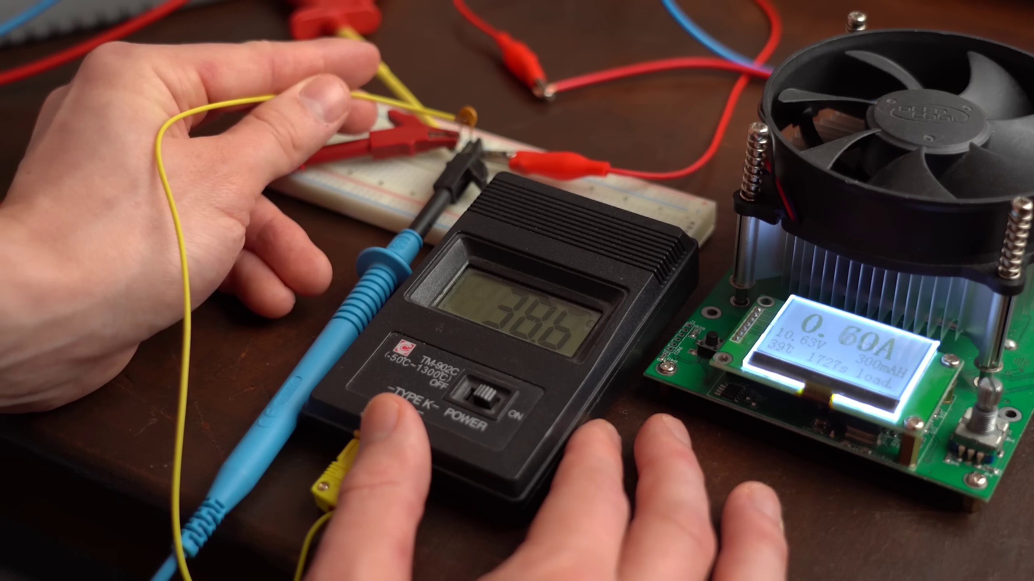 (score 95.0000)
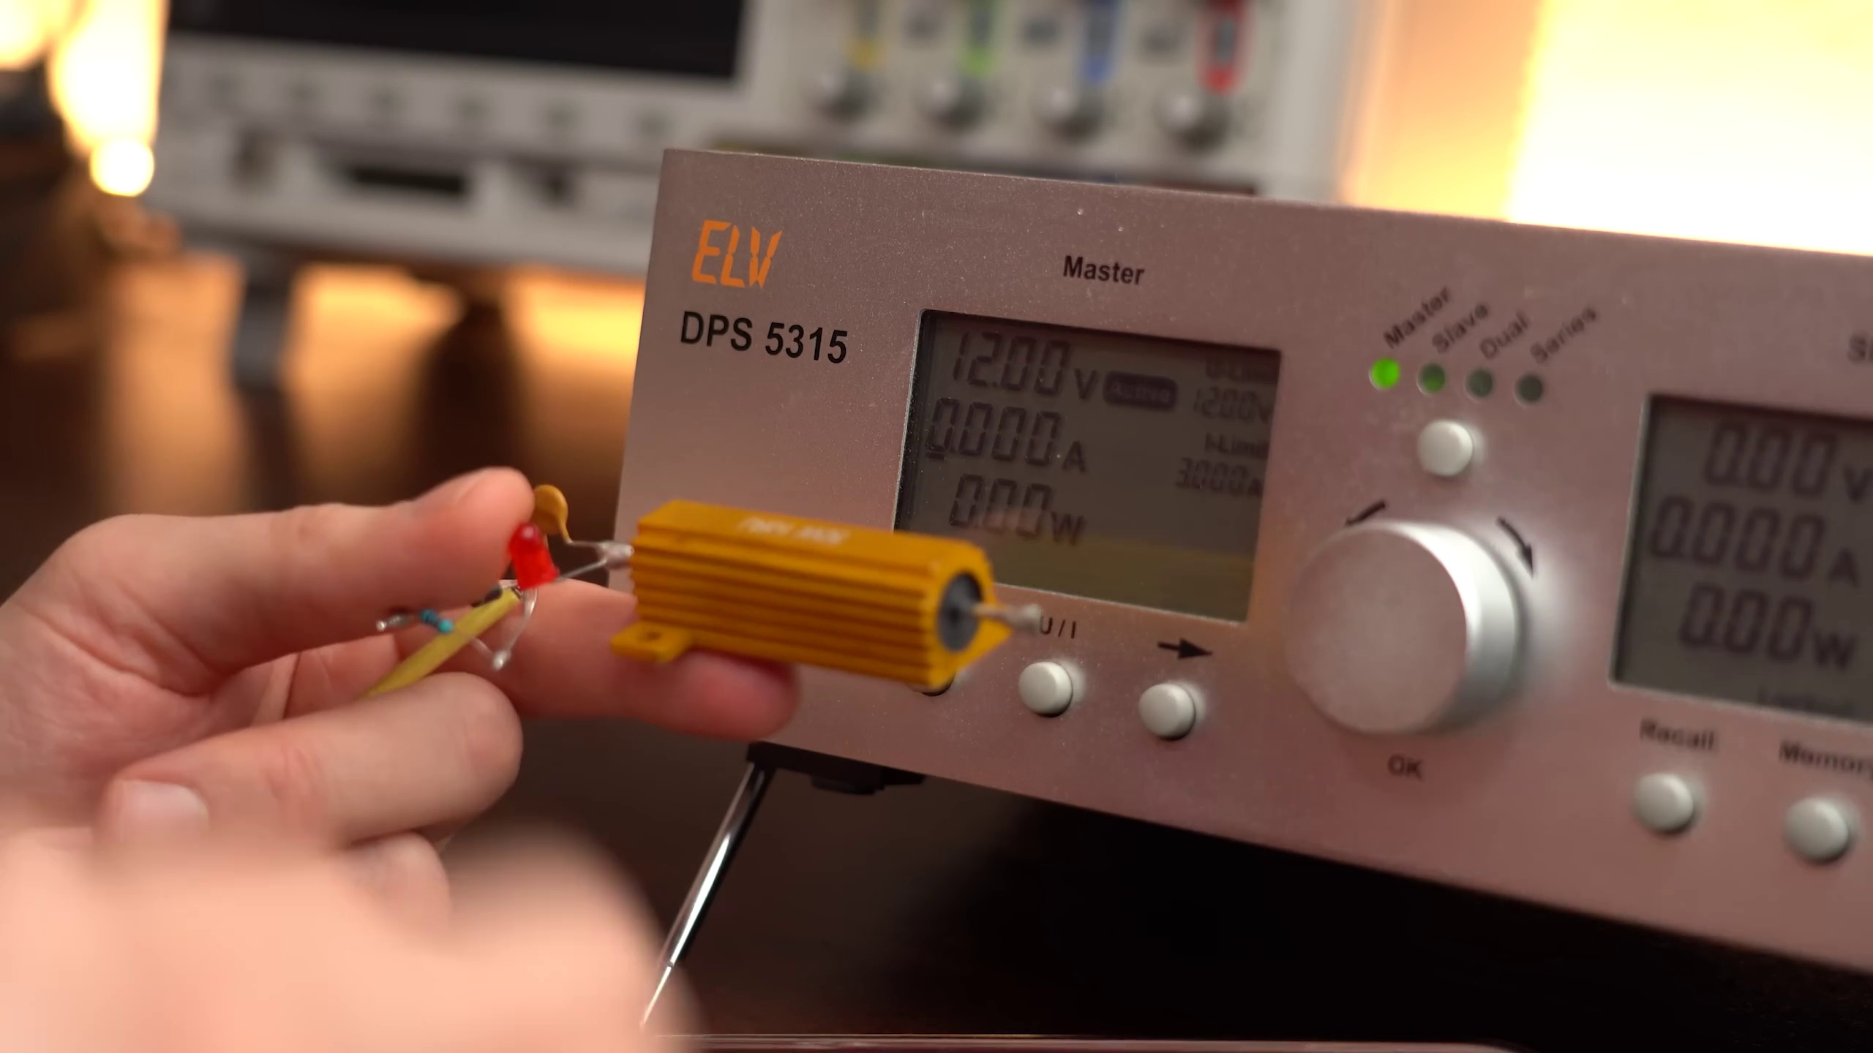 (score 90.0000)
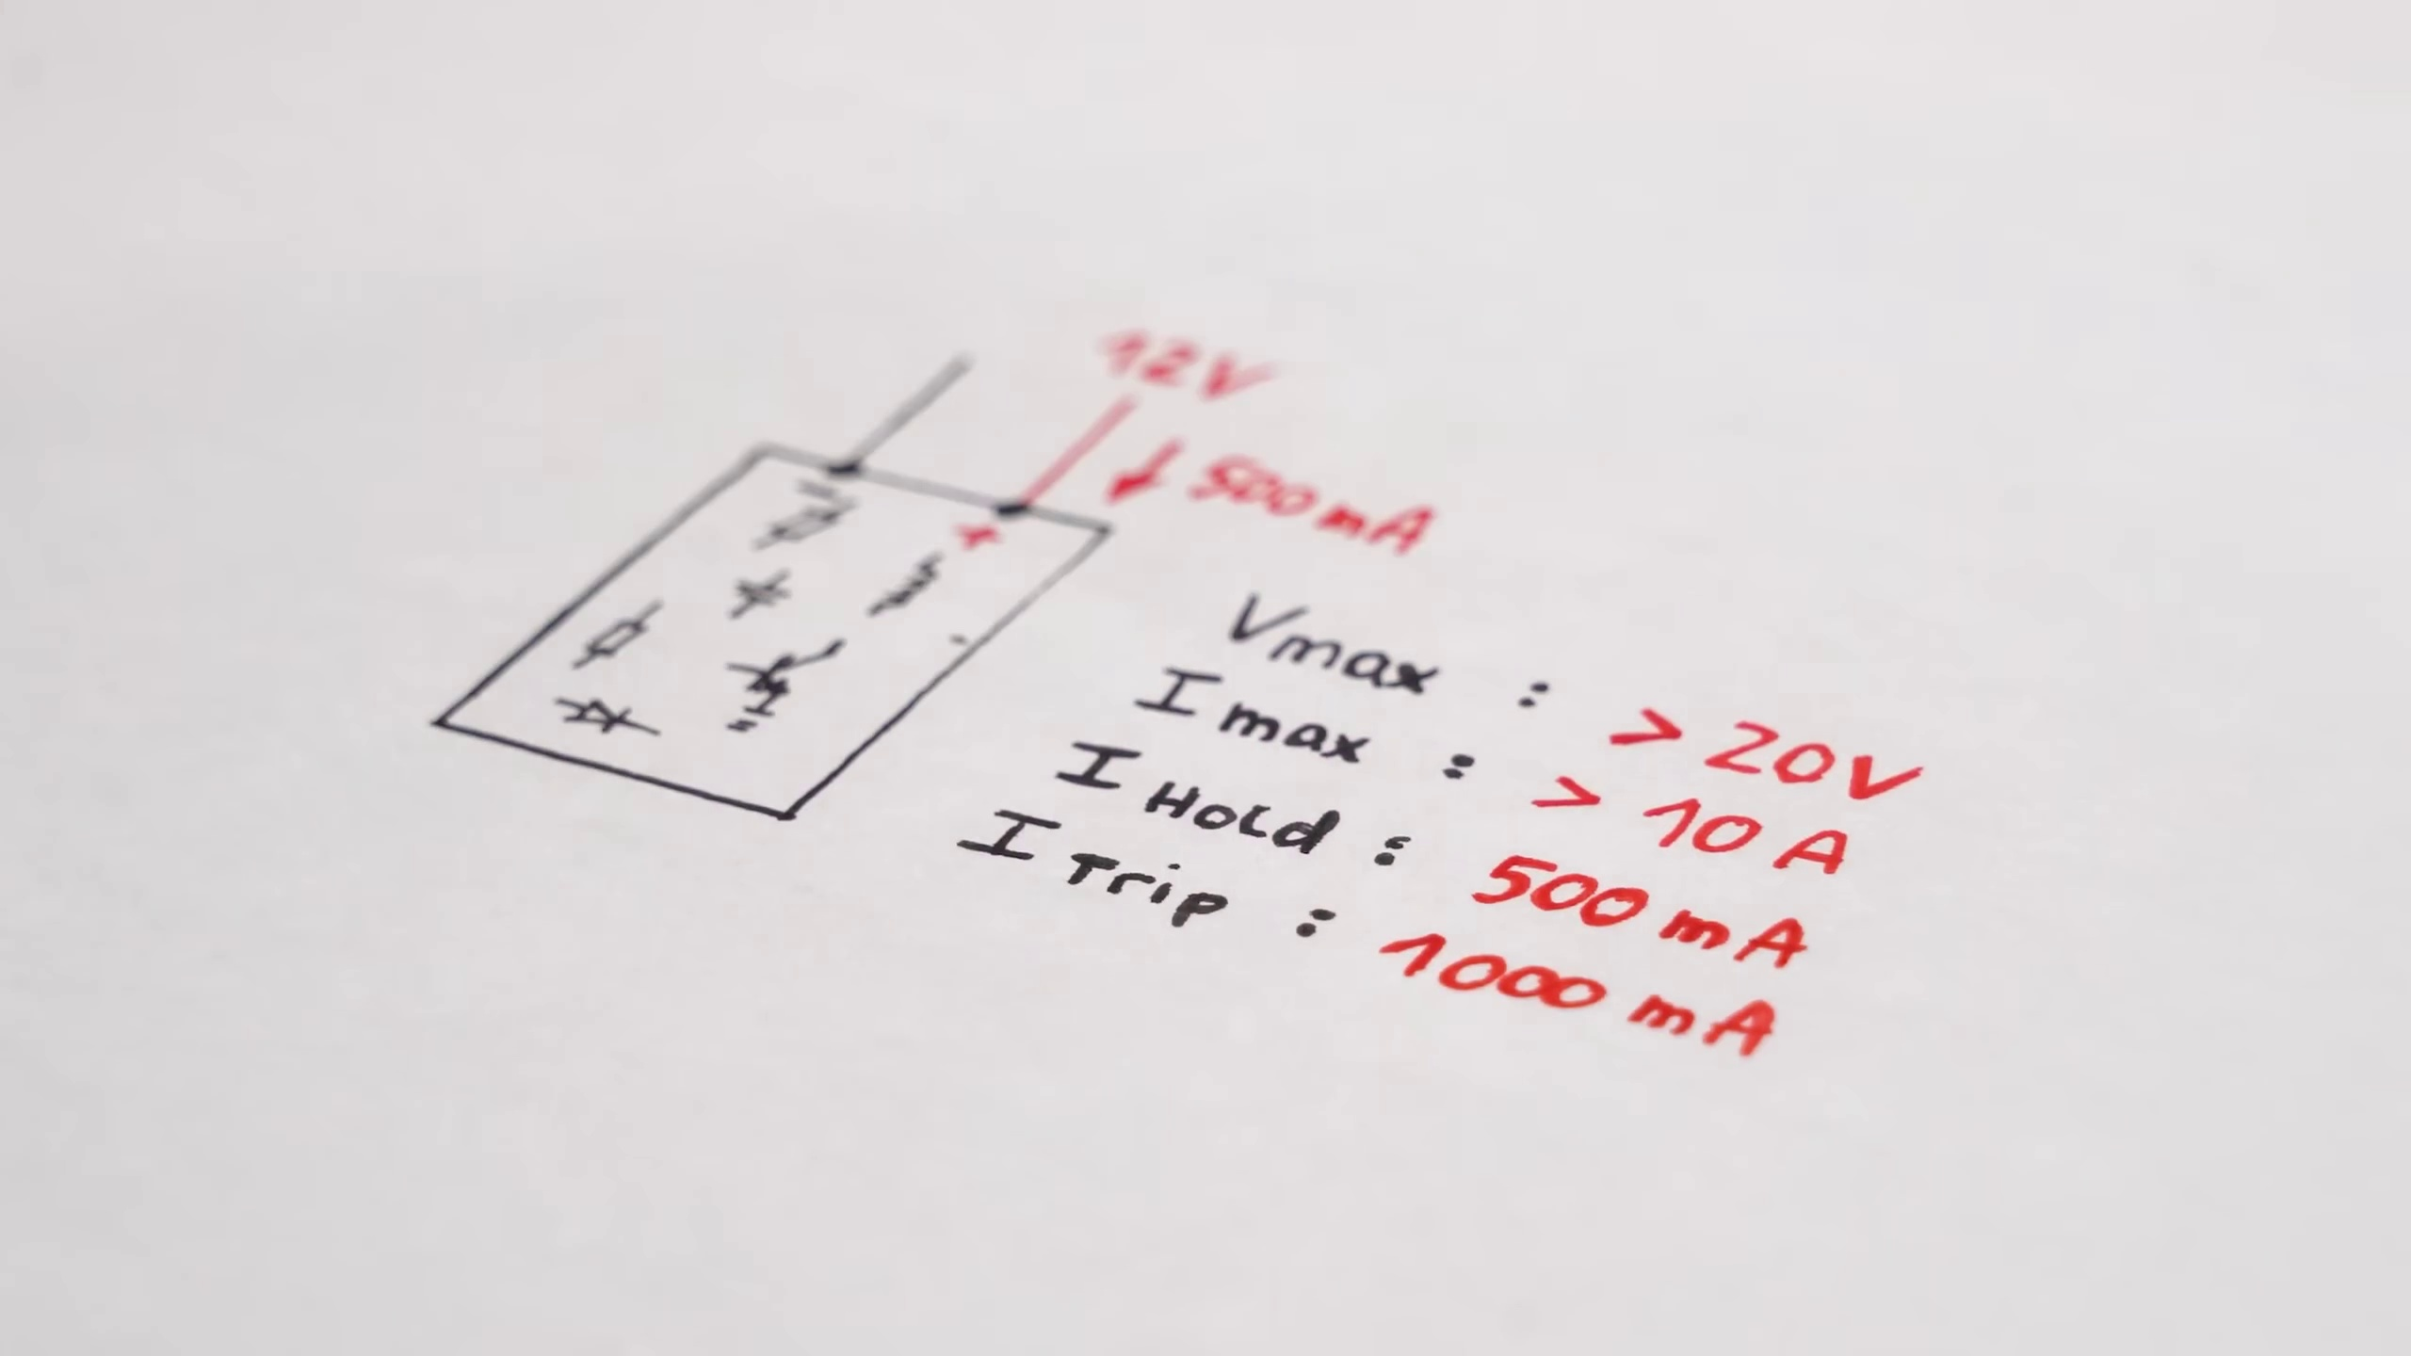 (score 87.0000)
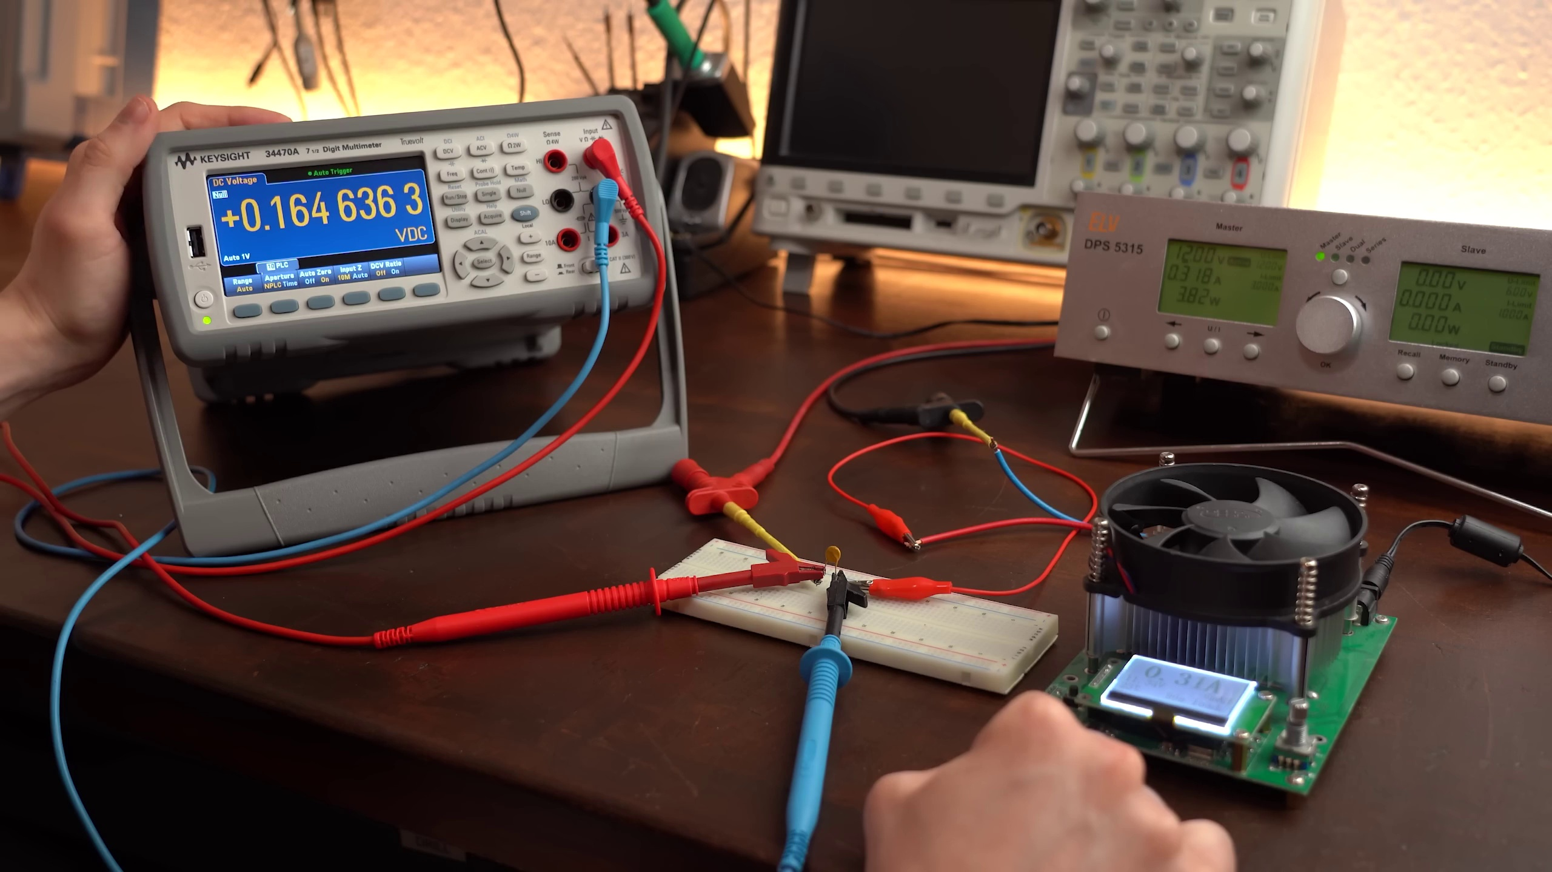 (score 85.0000)
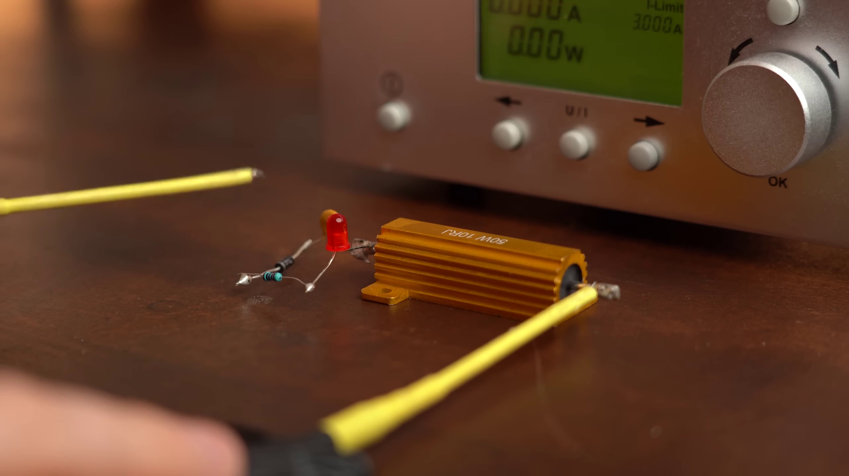 (score 85.0000)
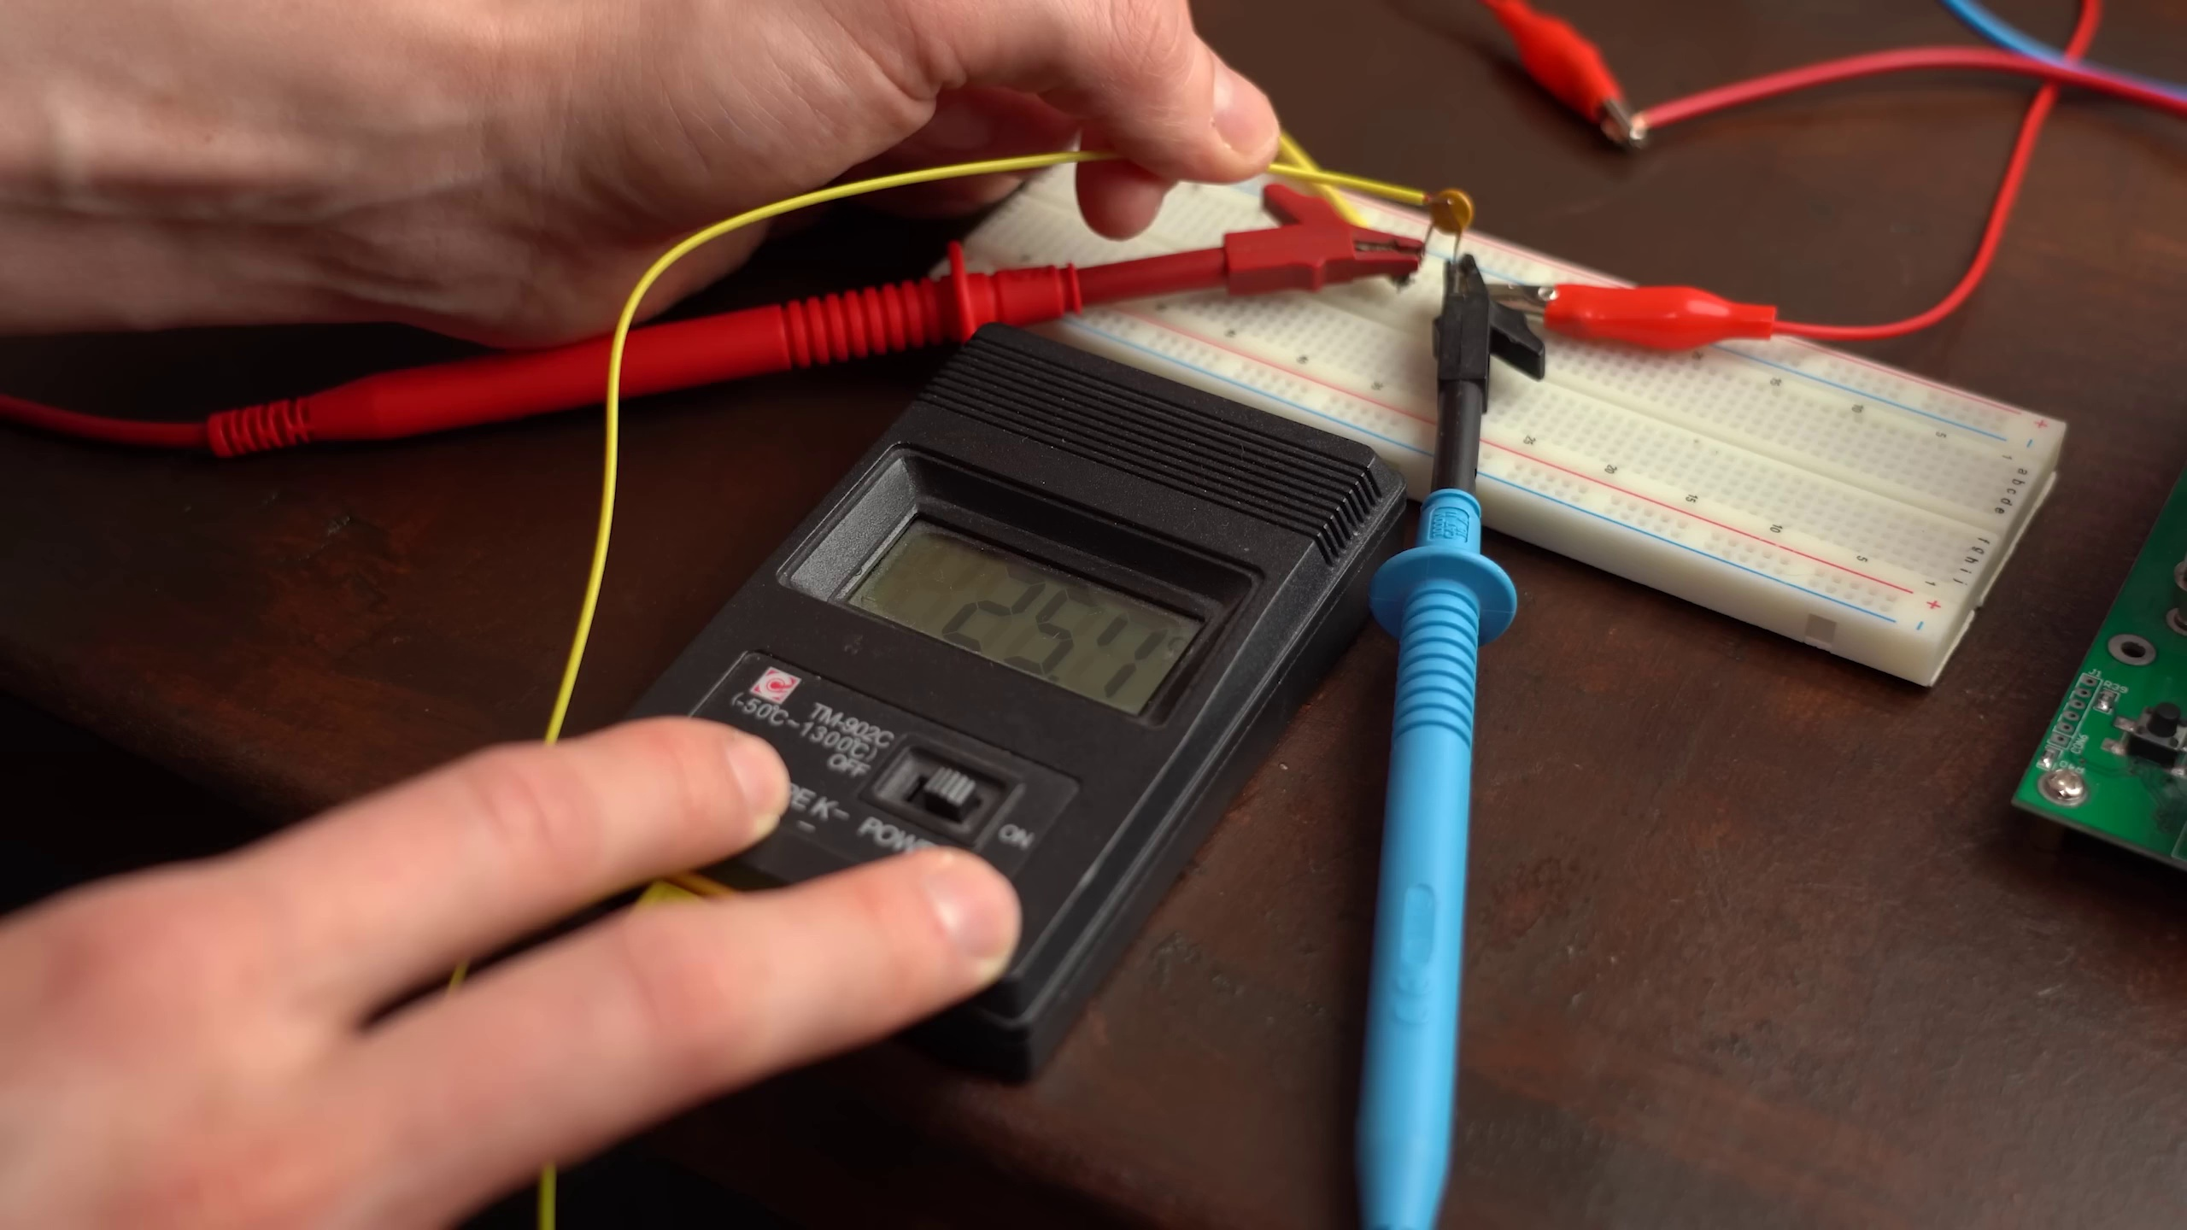 (score 85.0000)
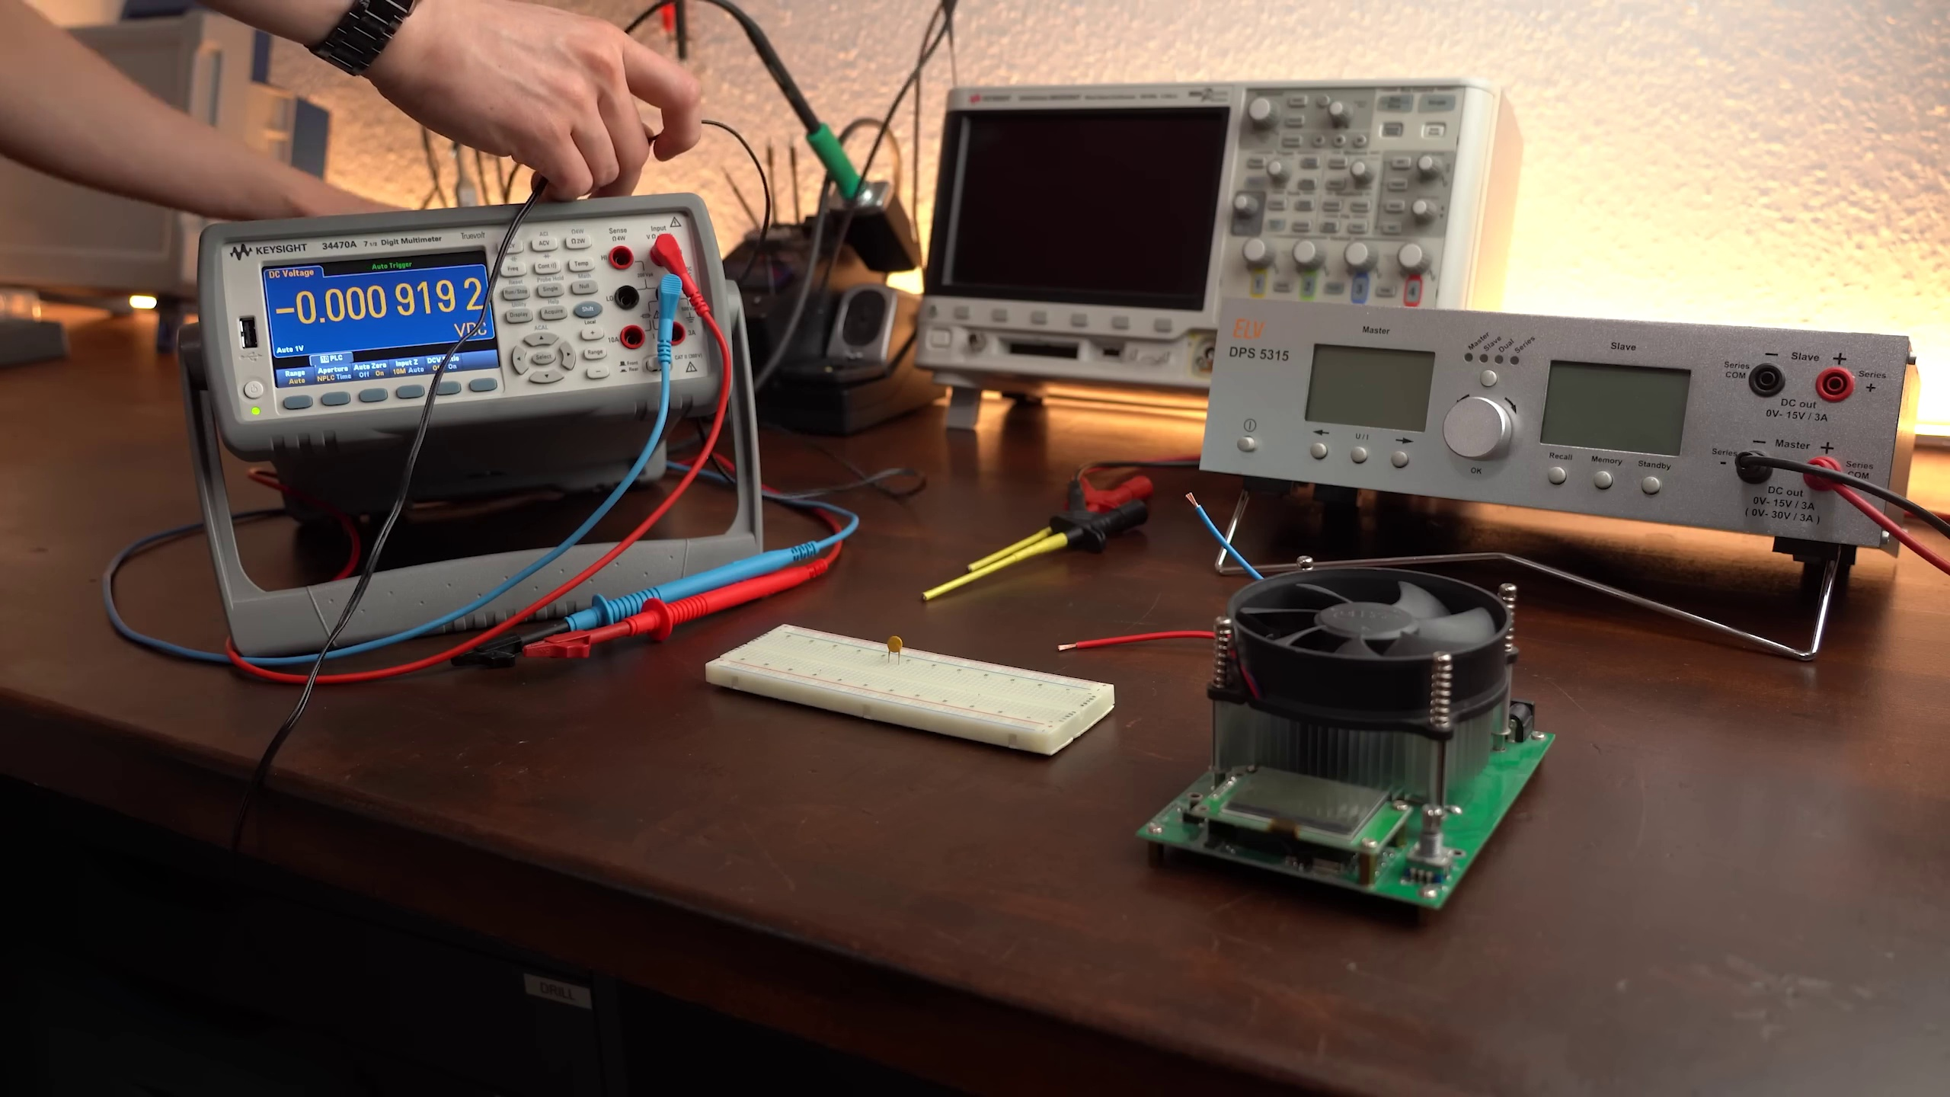 (score 85.0000)
 (score 85.0000)
 (score 85.0000)
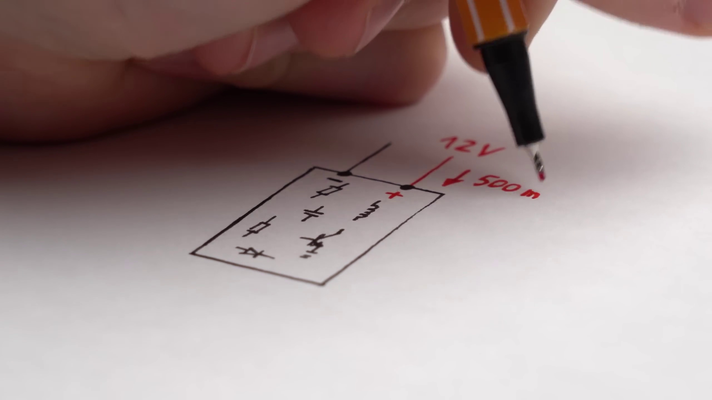 (score 85.0000)
Least correlated frames:
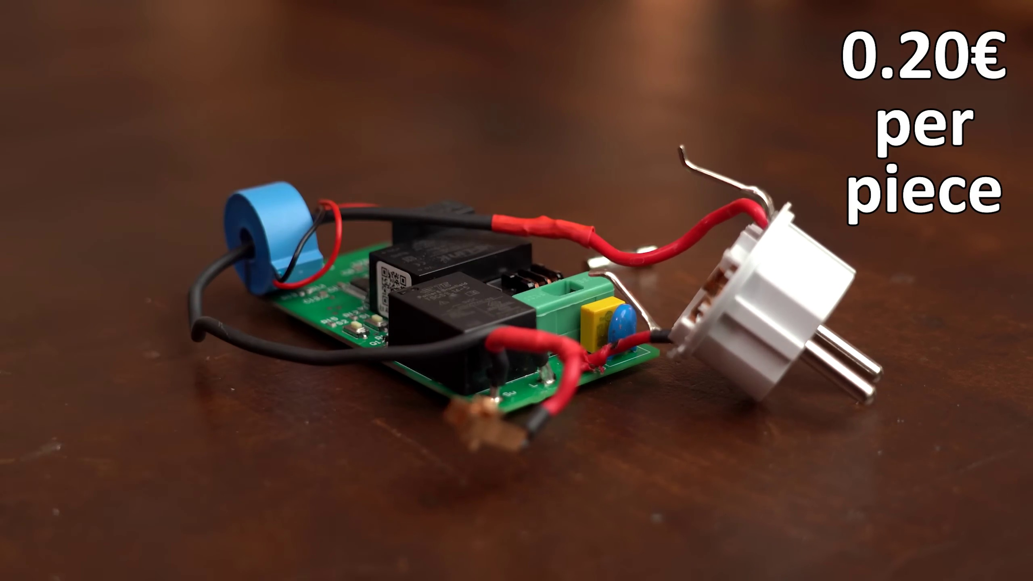 (score 0.0000)
 (score 0.0000)
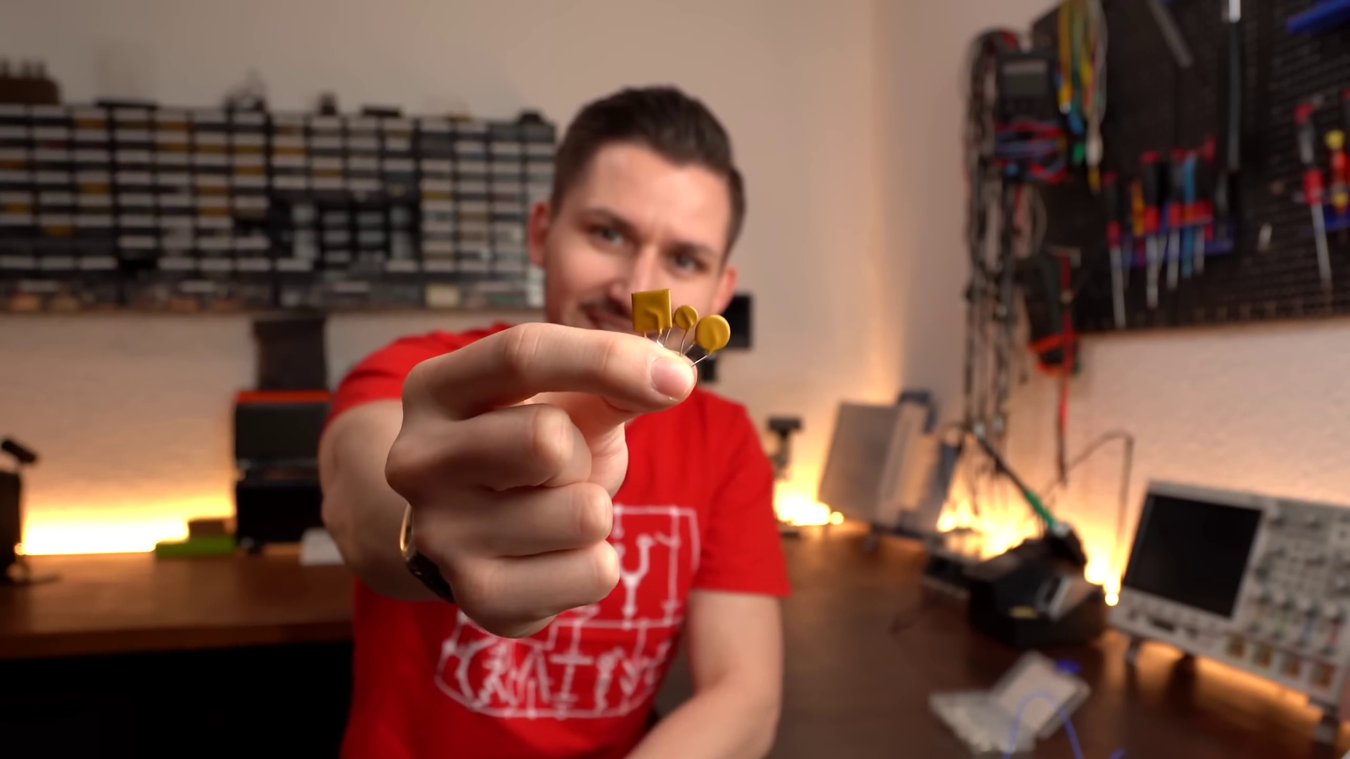 (score 0.0000)
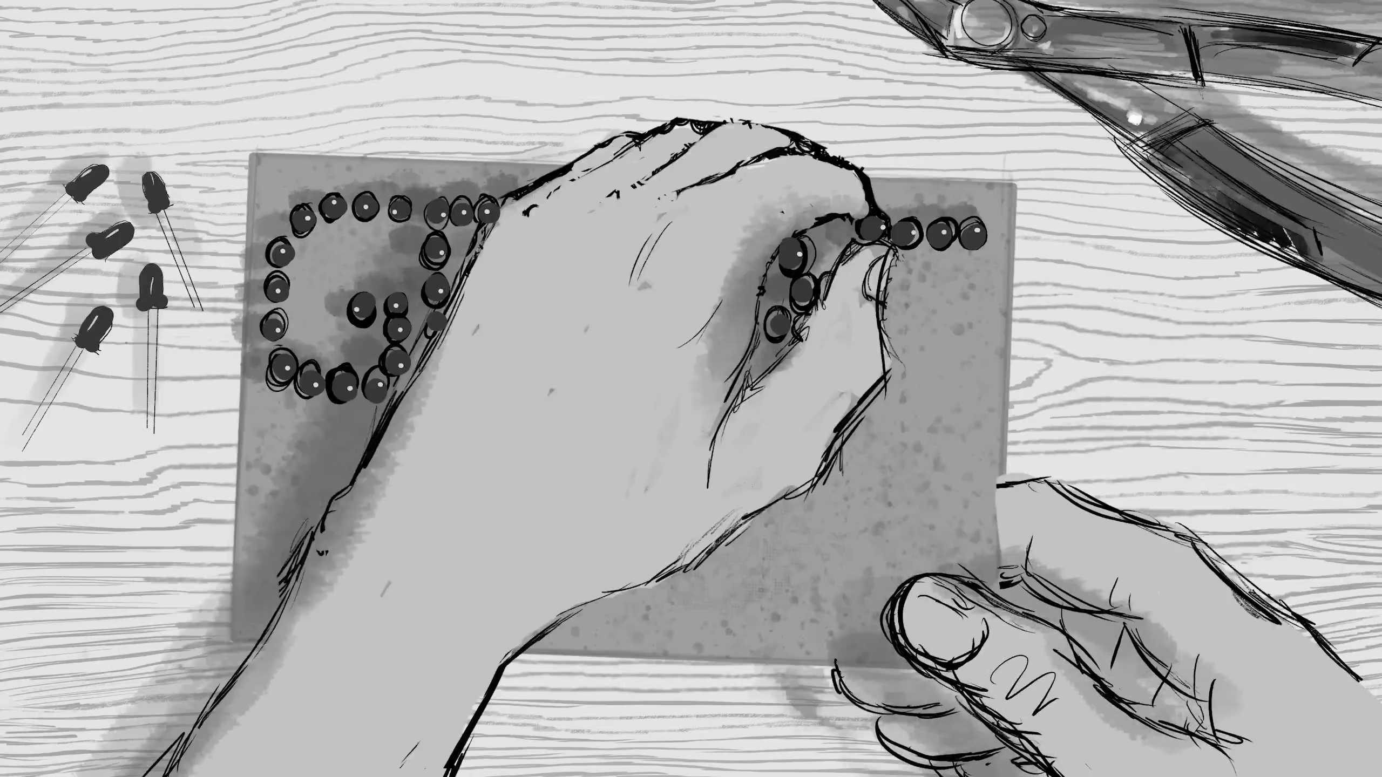 (score 0.0000)
 (score 0.0000)
 (score 0.0000)
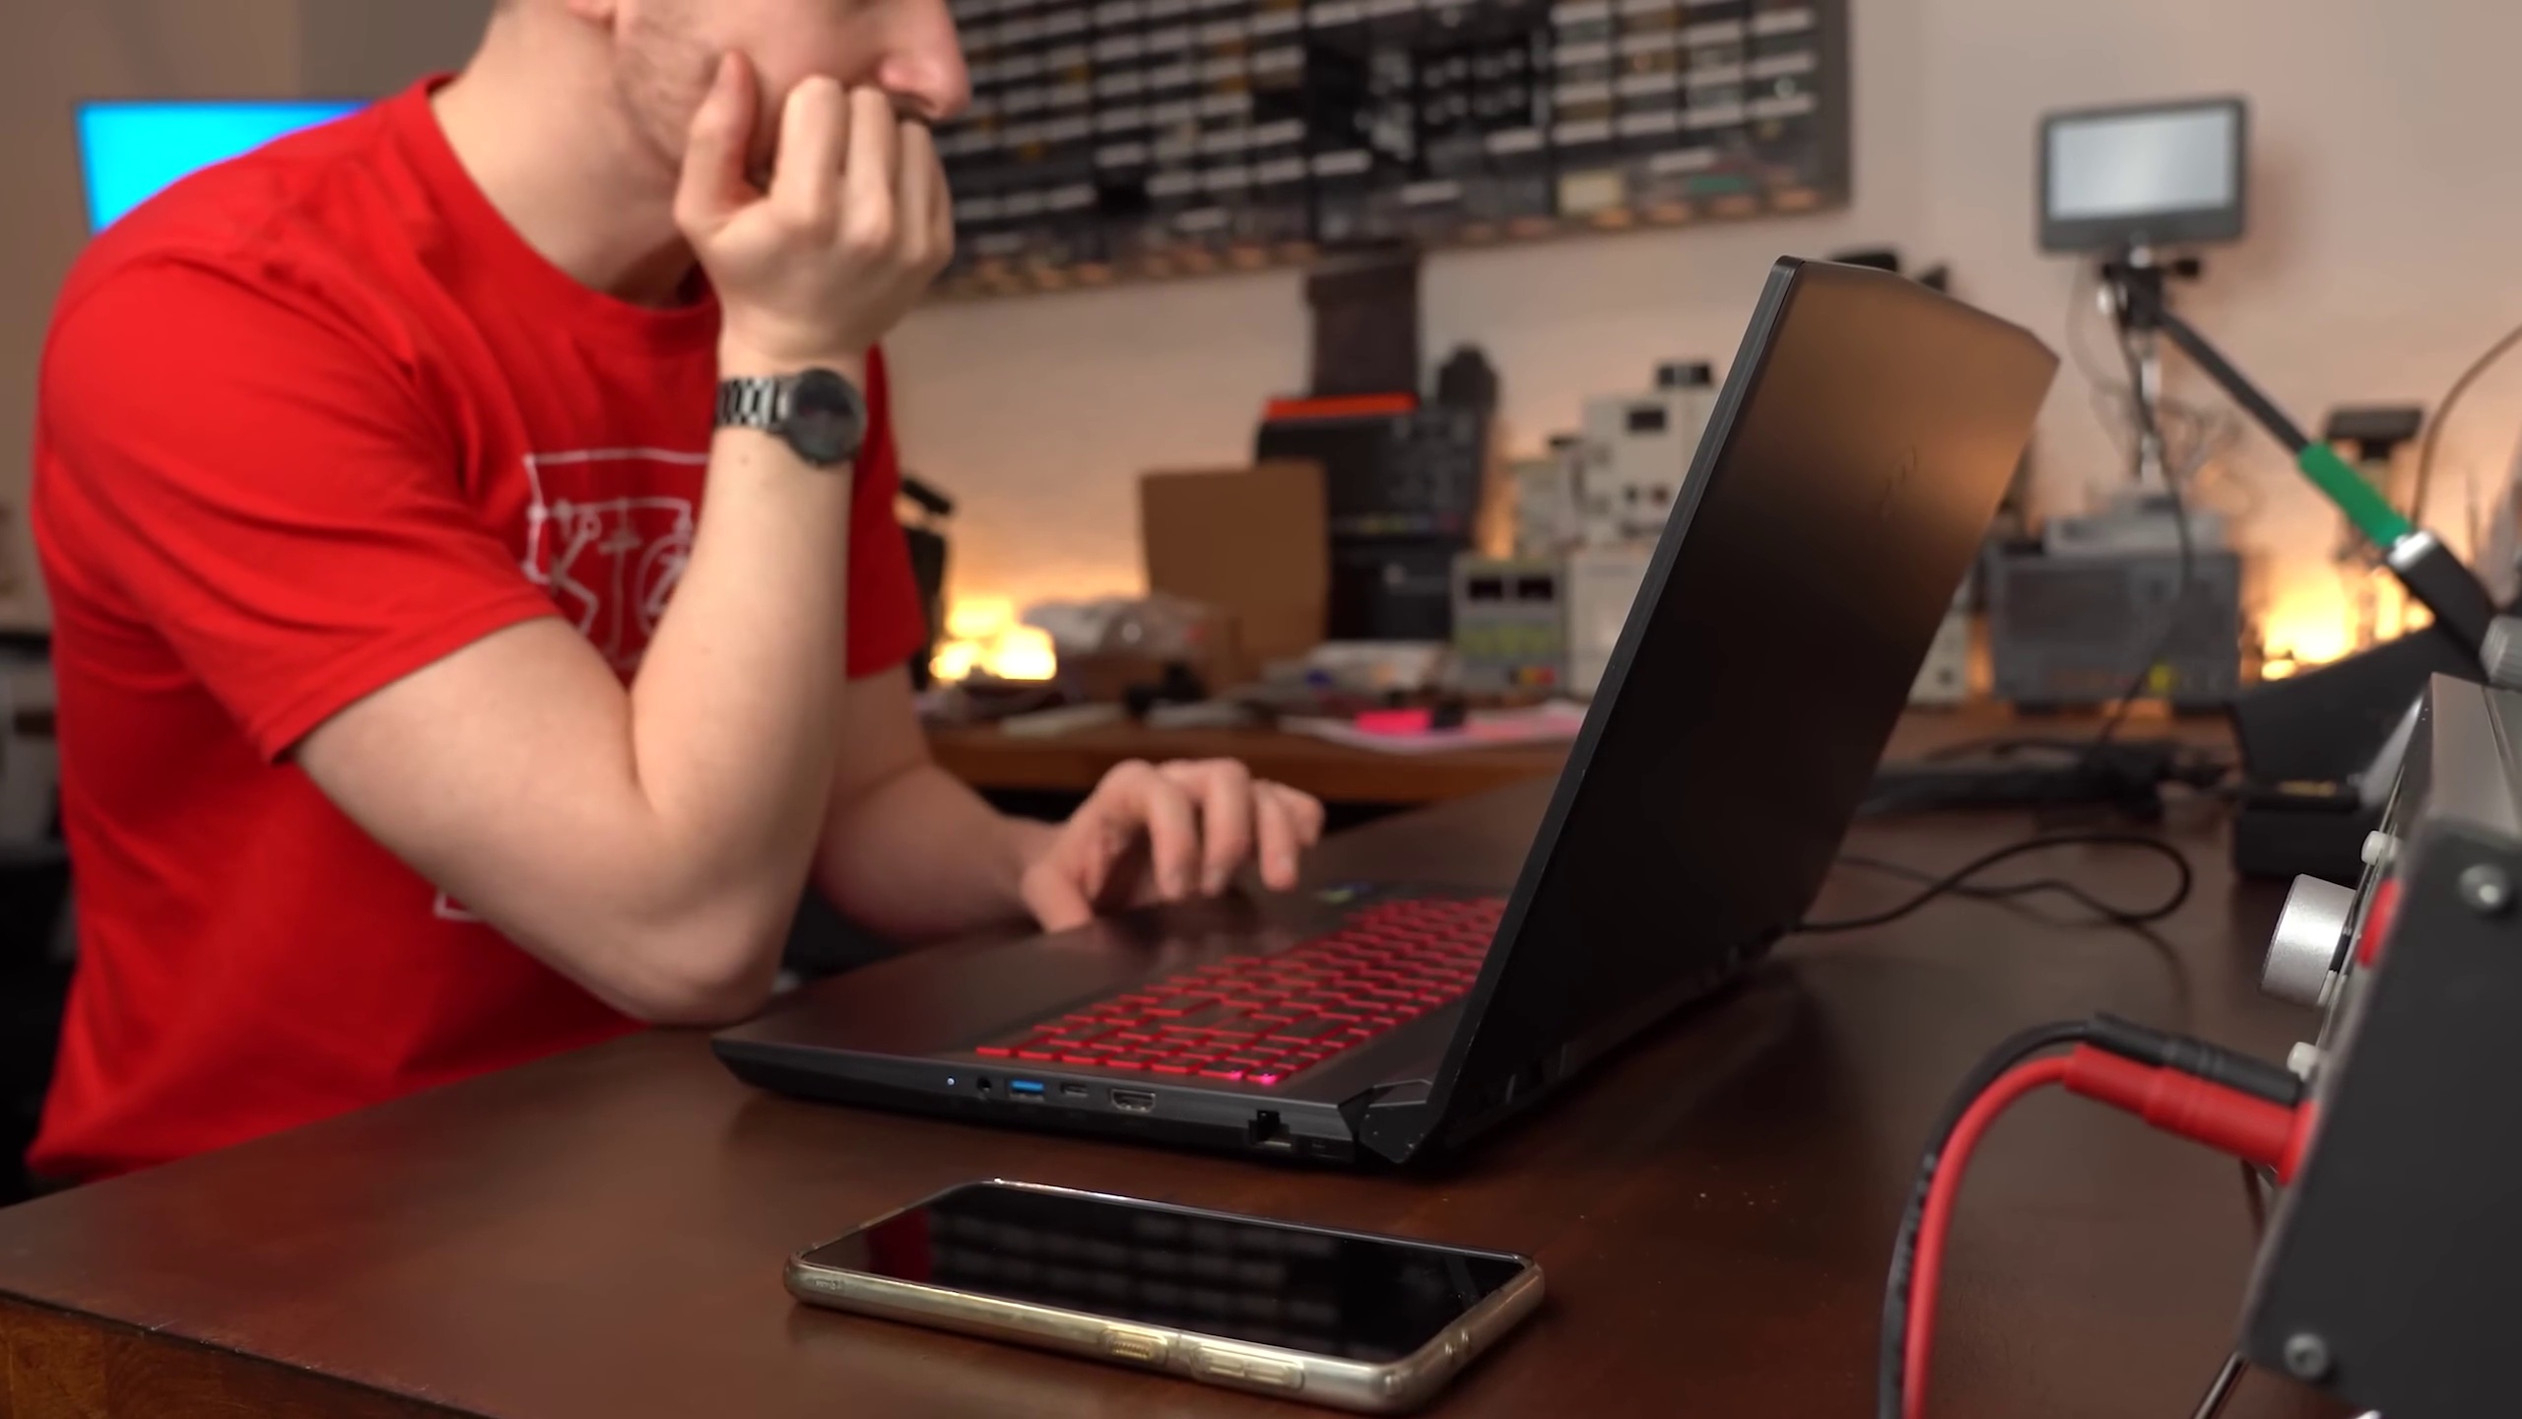 (score 0.0000)
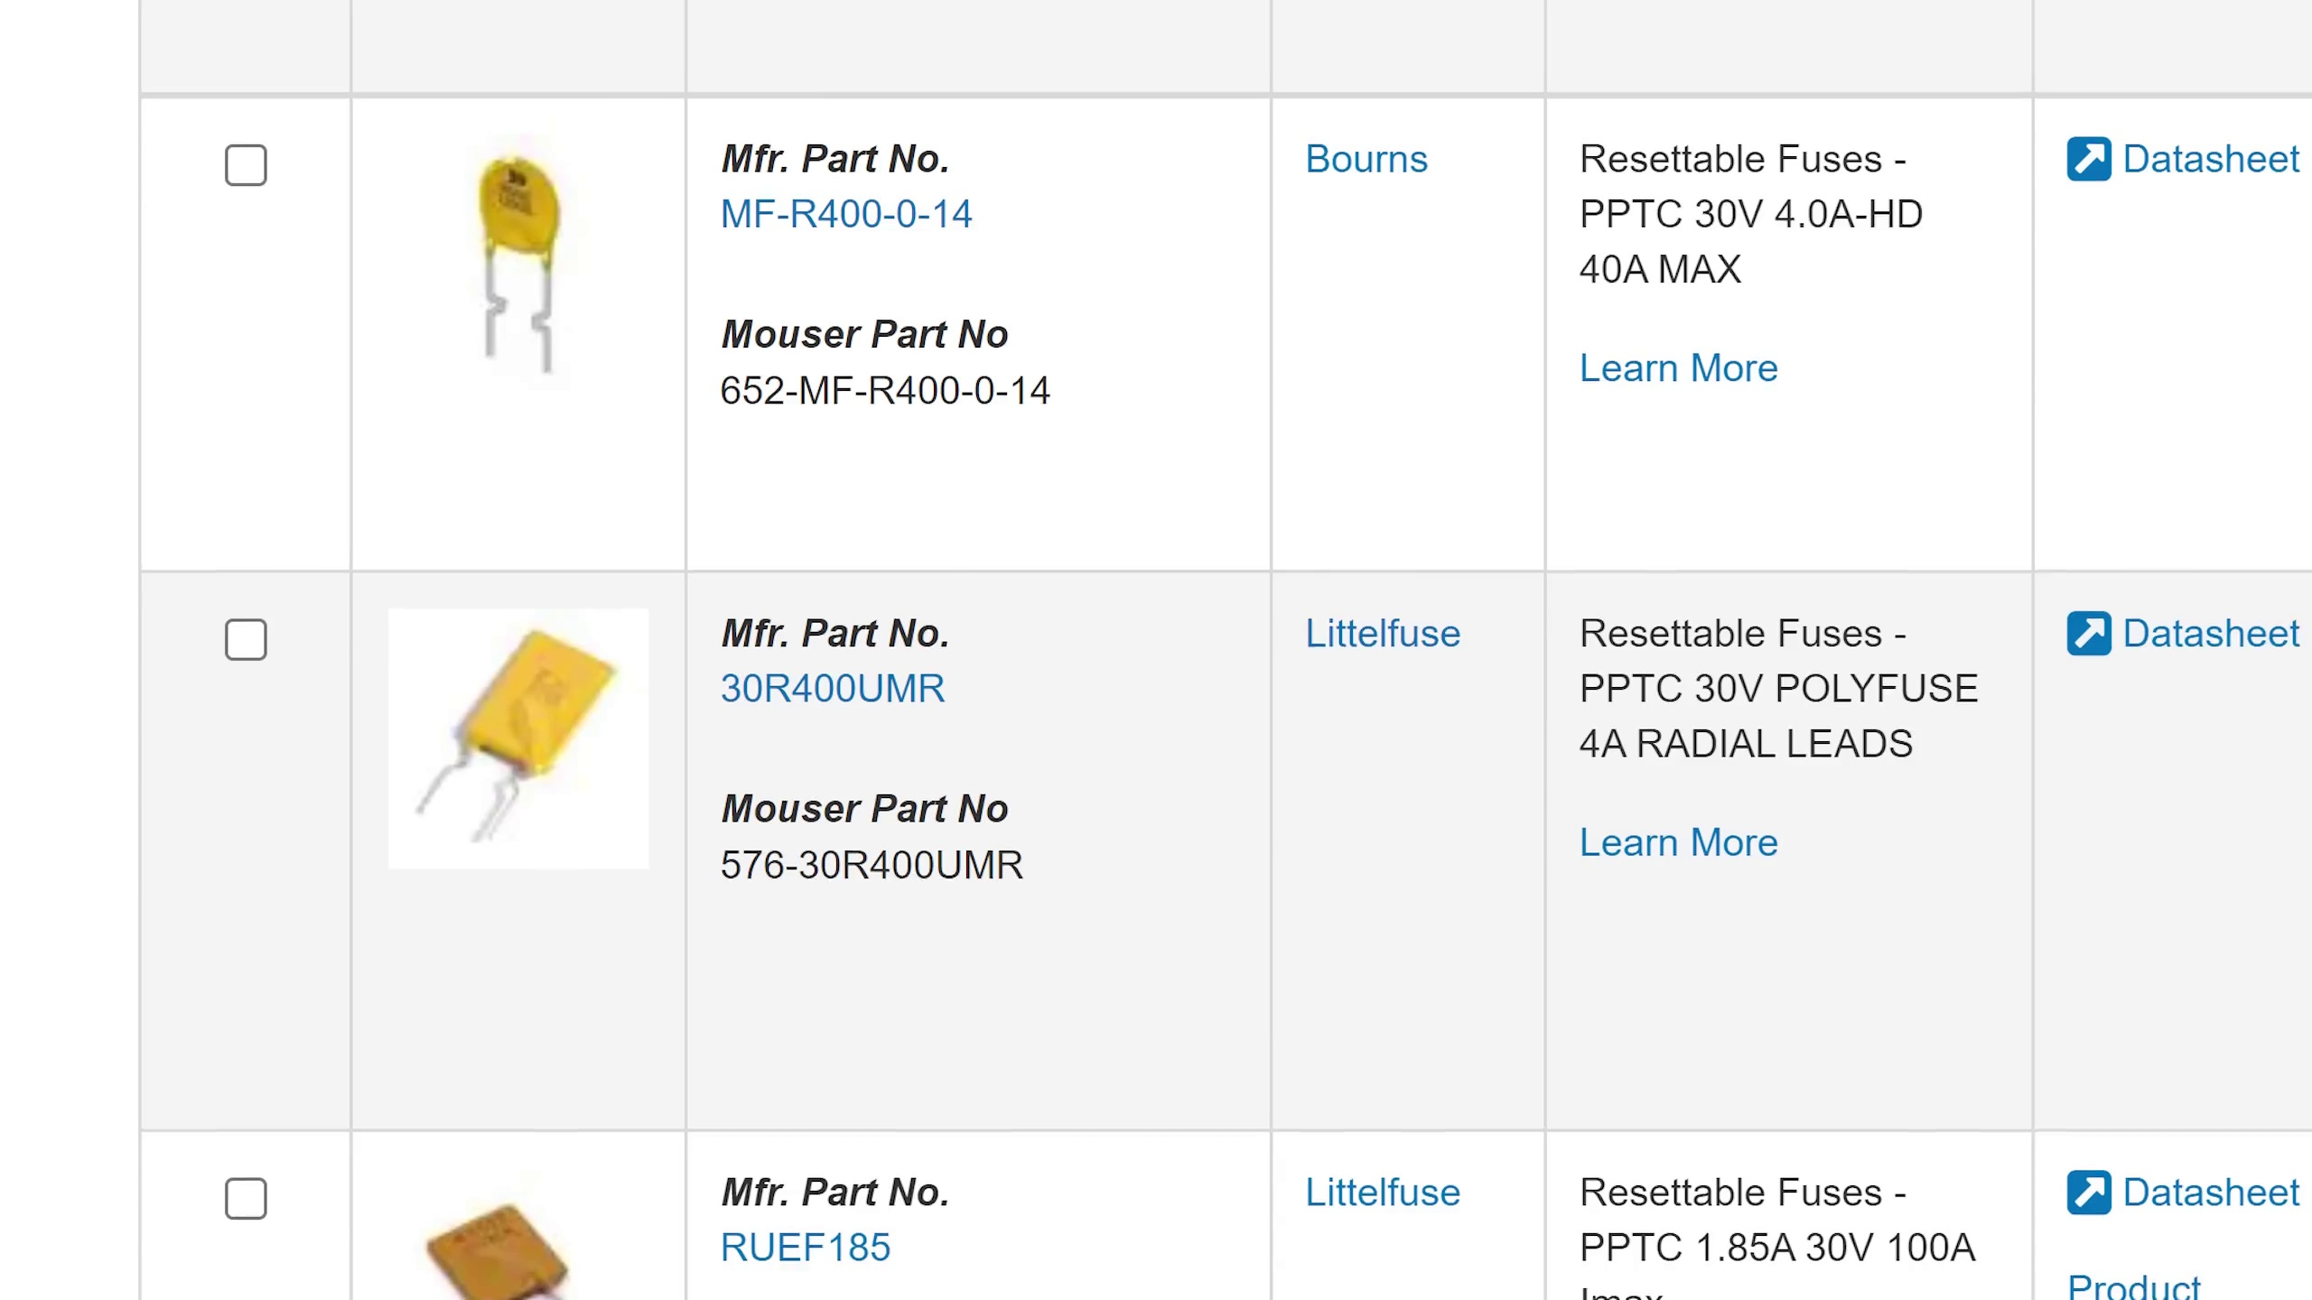 (score 0.0000)
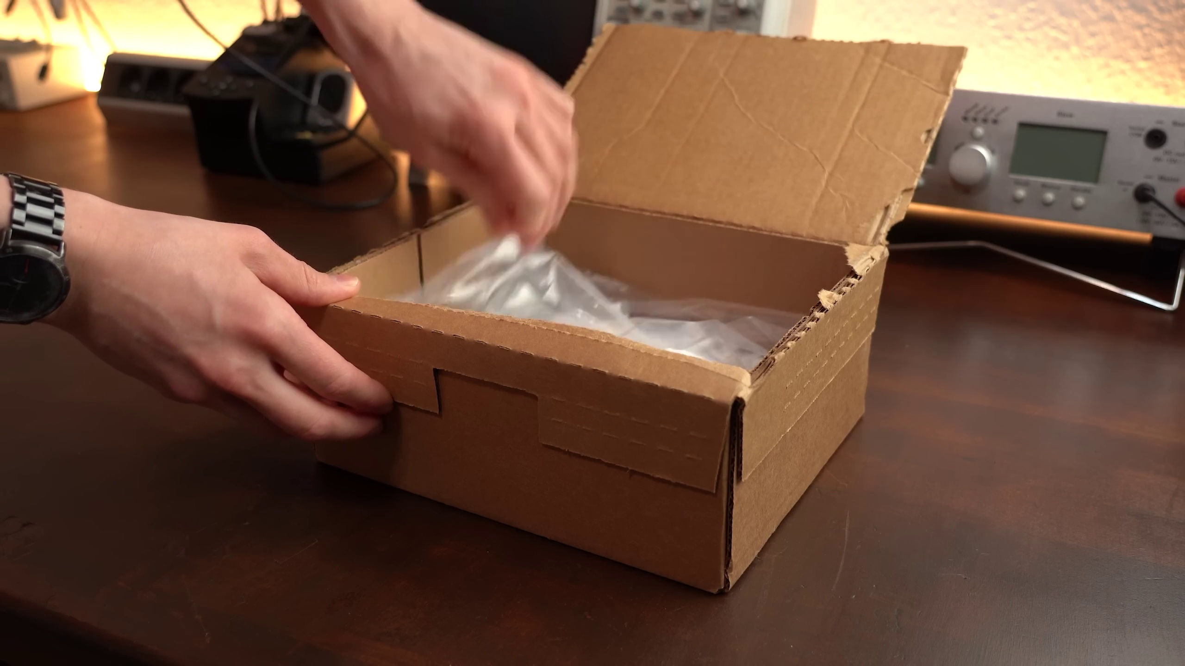 (score 0.0000)
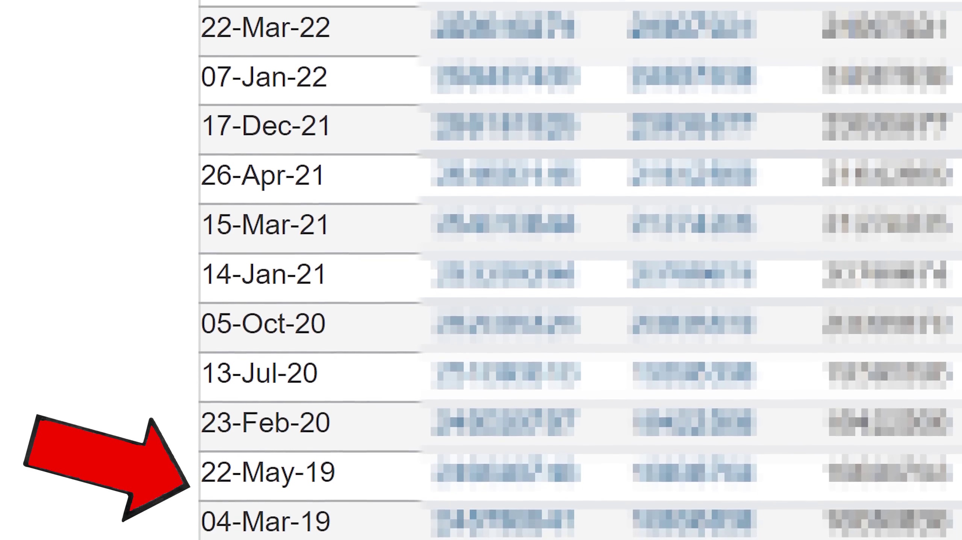 (score 0.0000)
- matched 2 frame(s), max score 80.0000: From this video I learned there is such thing as resettable fuses. This was very interesting I’ve never heard of this. No questions.
Source: https://www.youtube.com/watch?v=sF0KOVWj9p8: The Best Protection for your Circuit is NOT a Fuse!.....but a Resettable Fuse? EB#54
Top correlated frames:
 (score 80.0000)
 (score 80.0000)
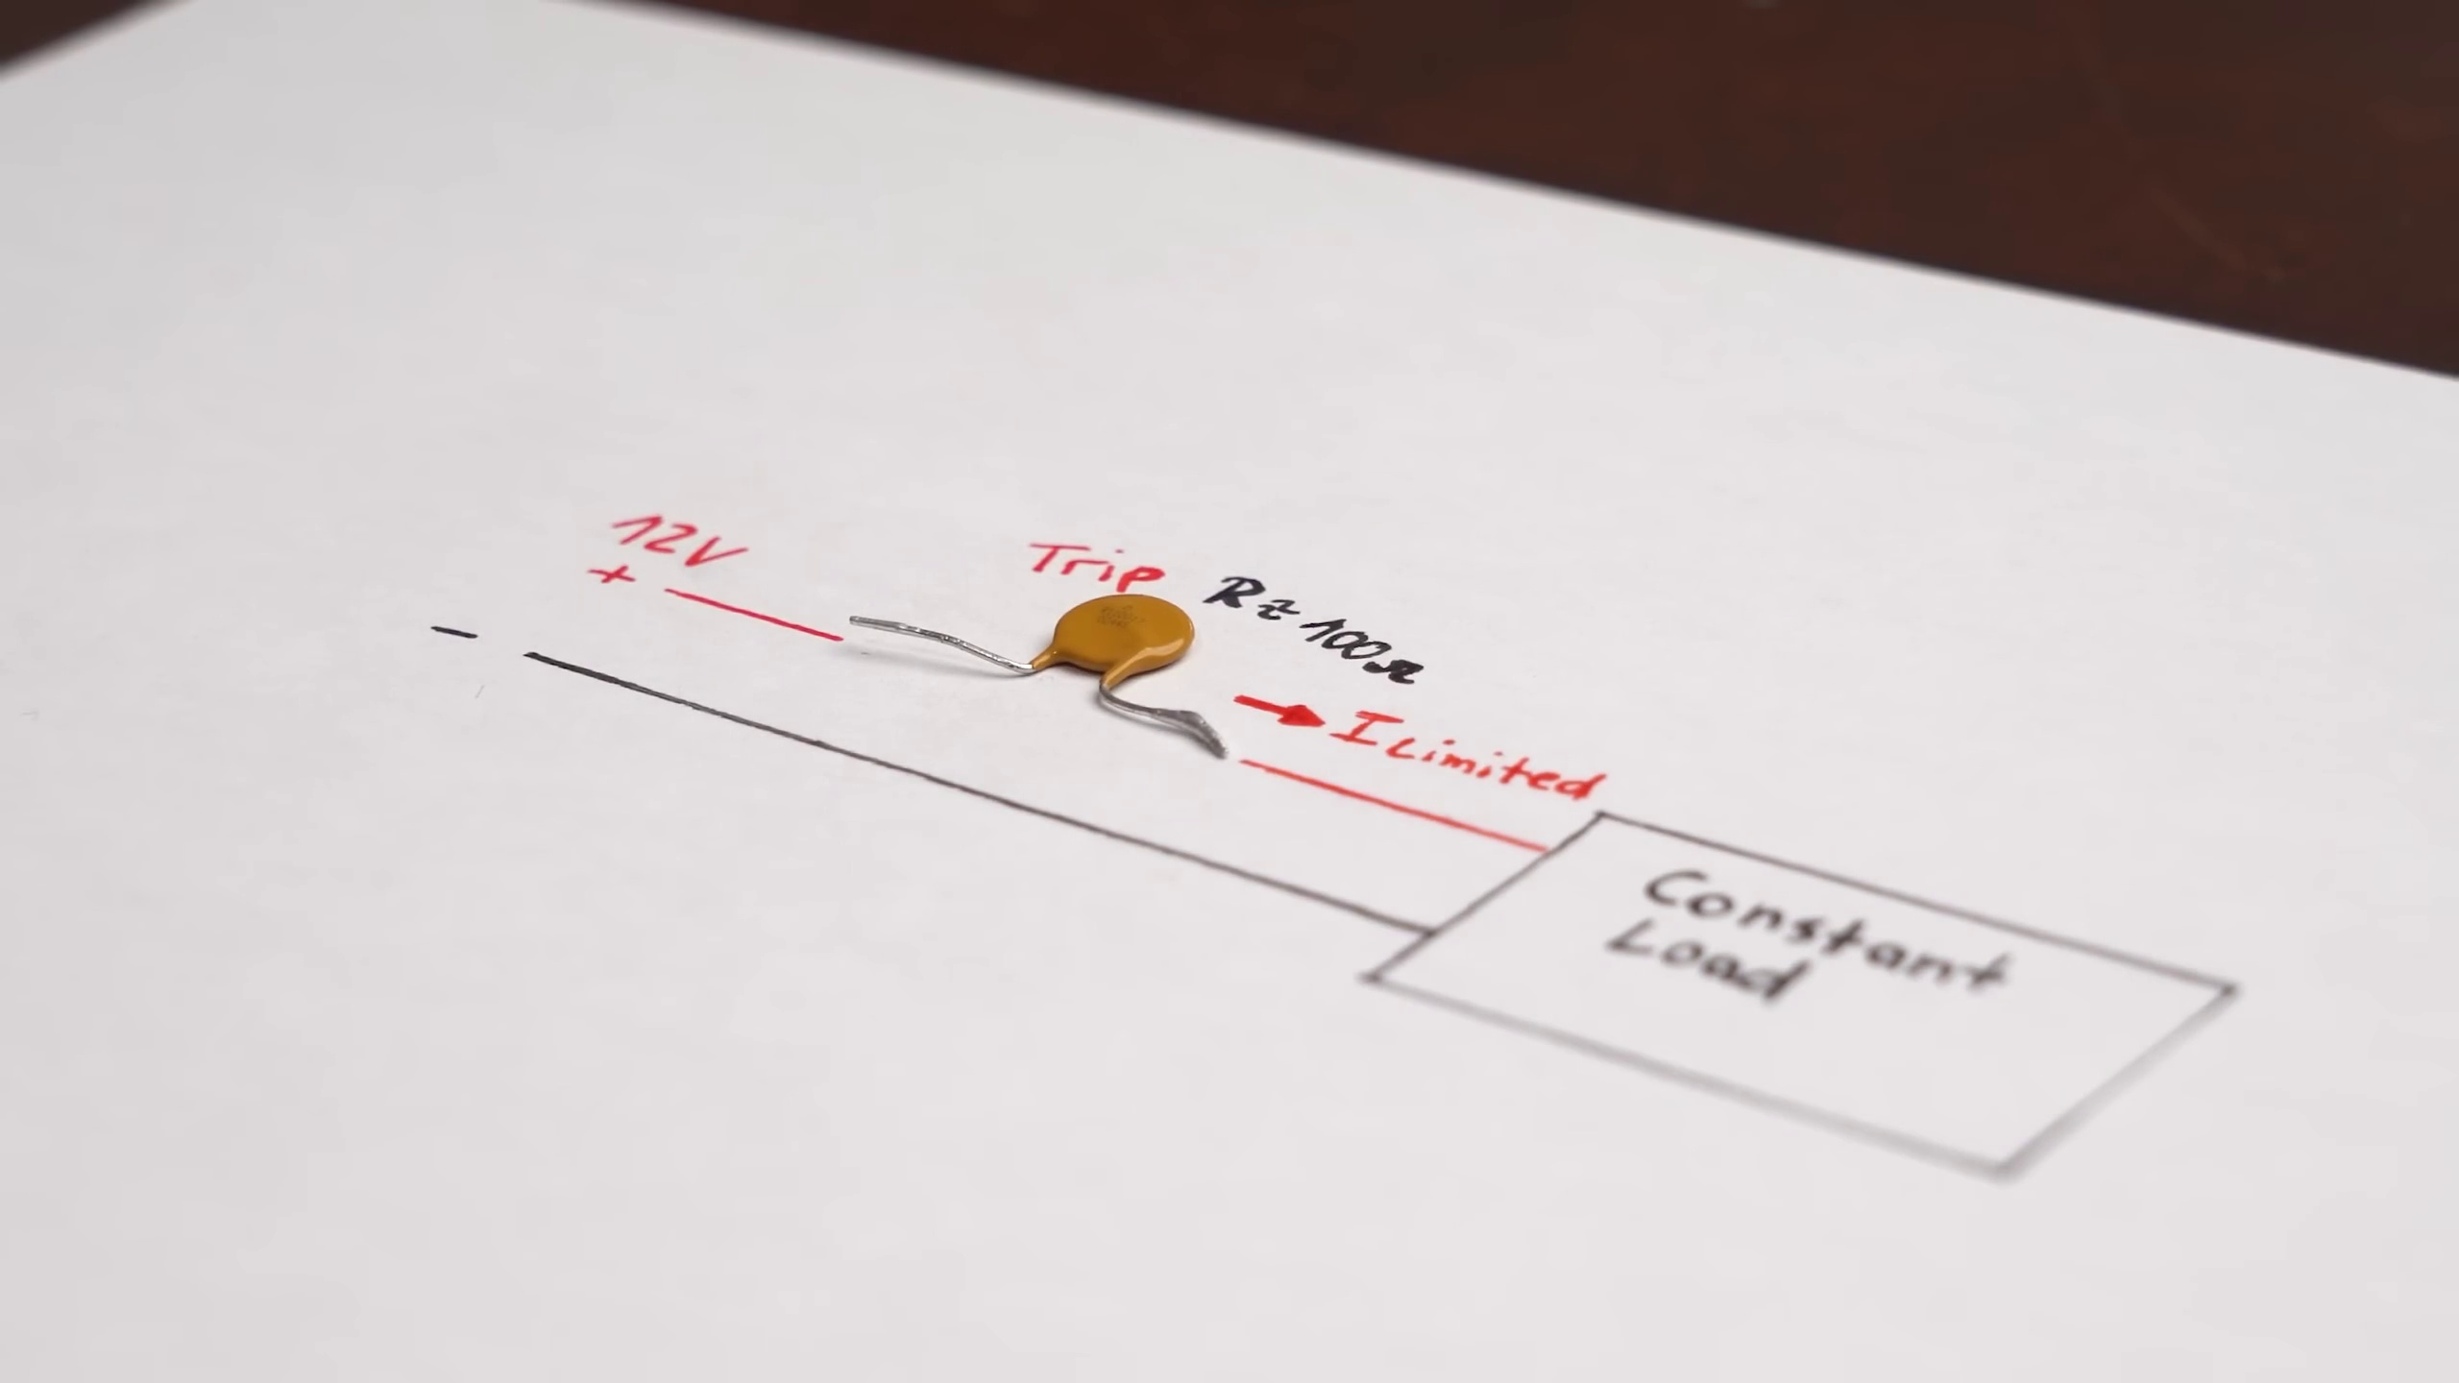 (score 30.0000)
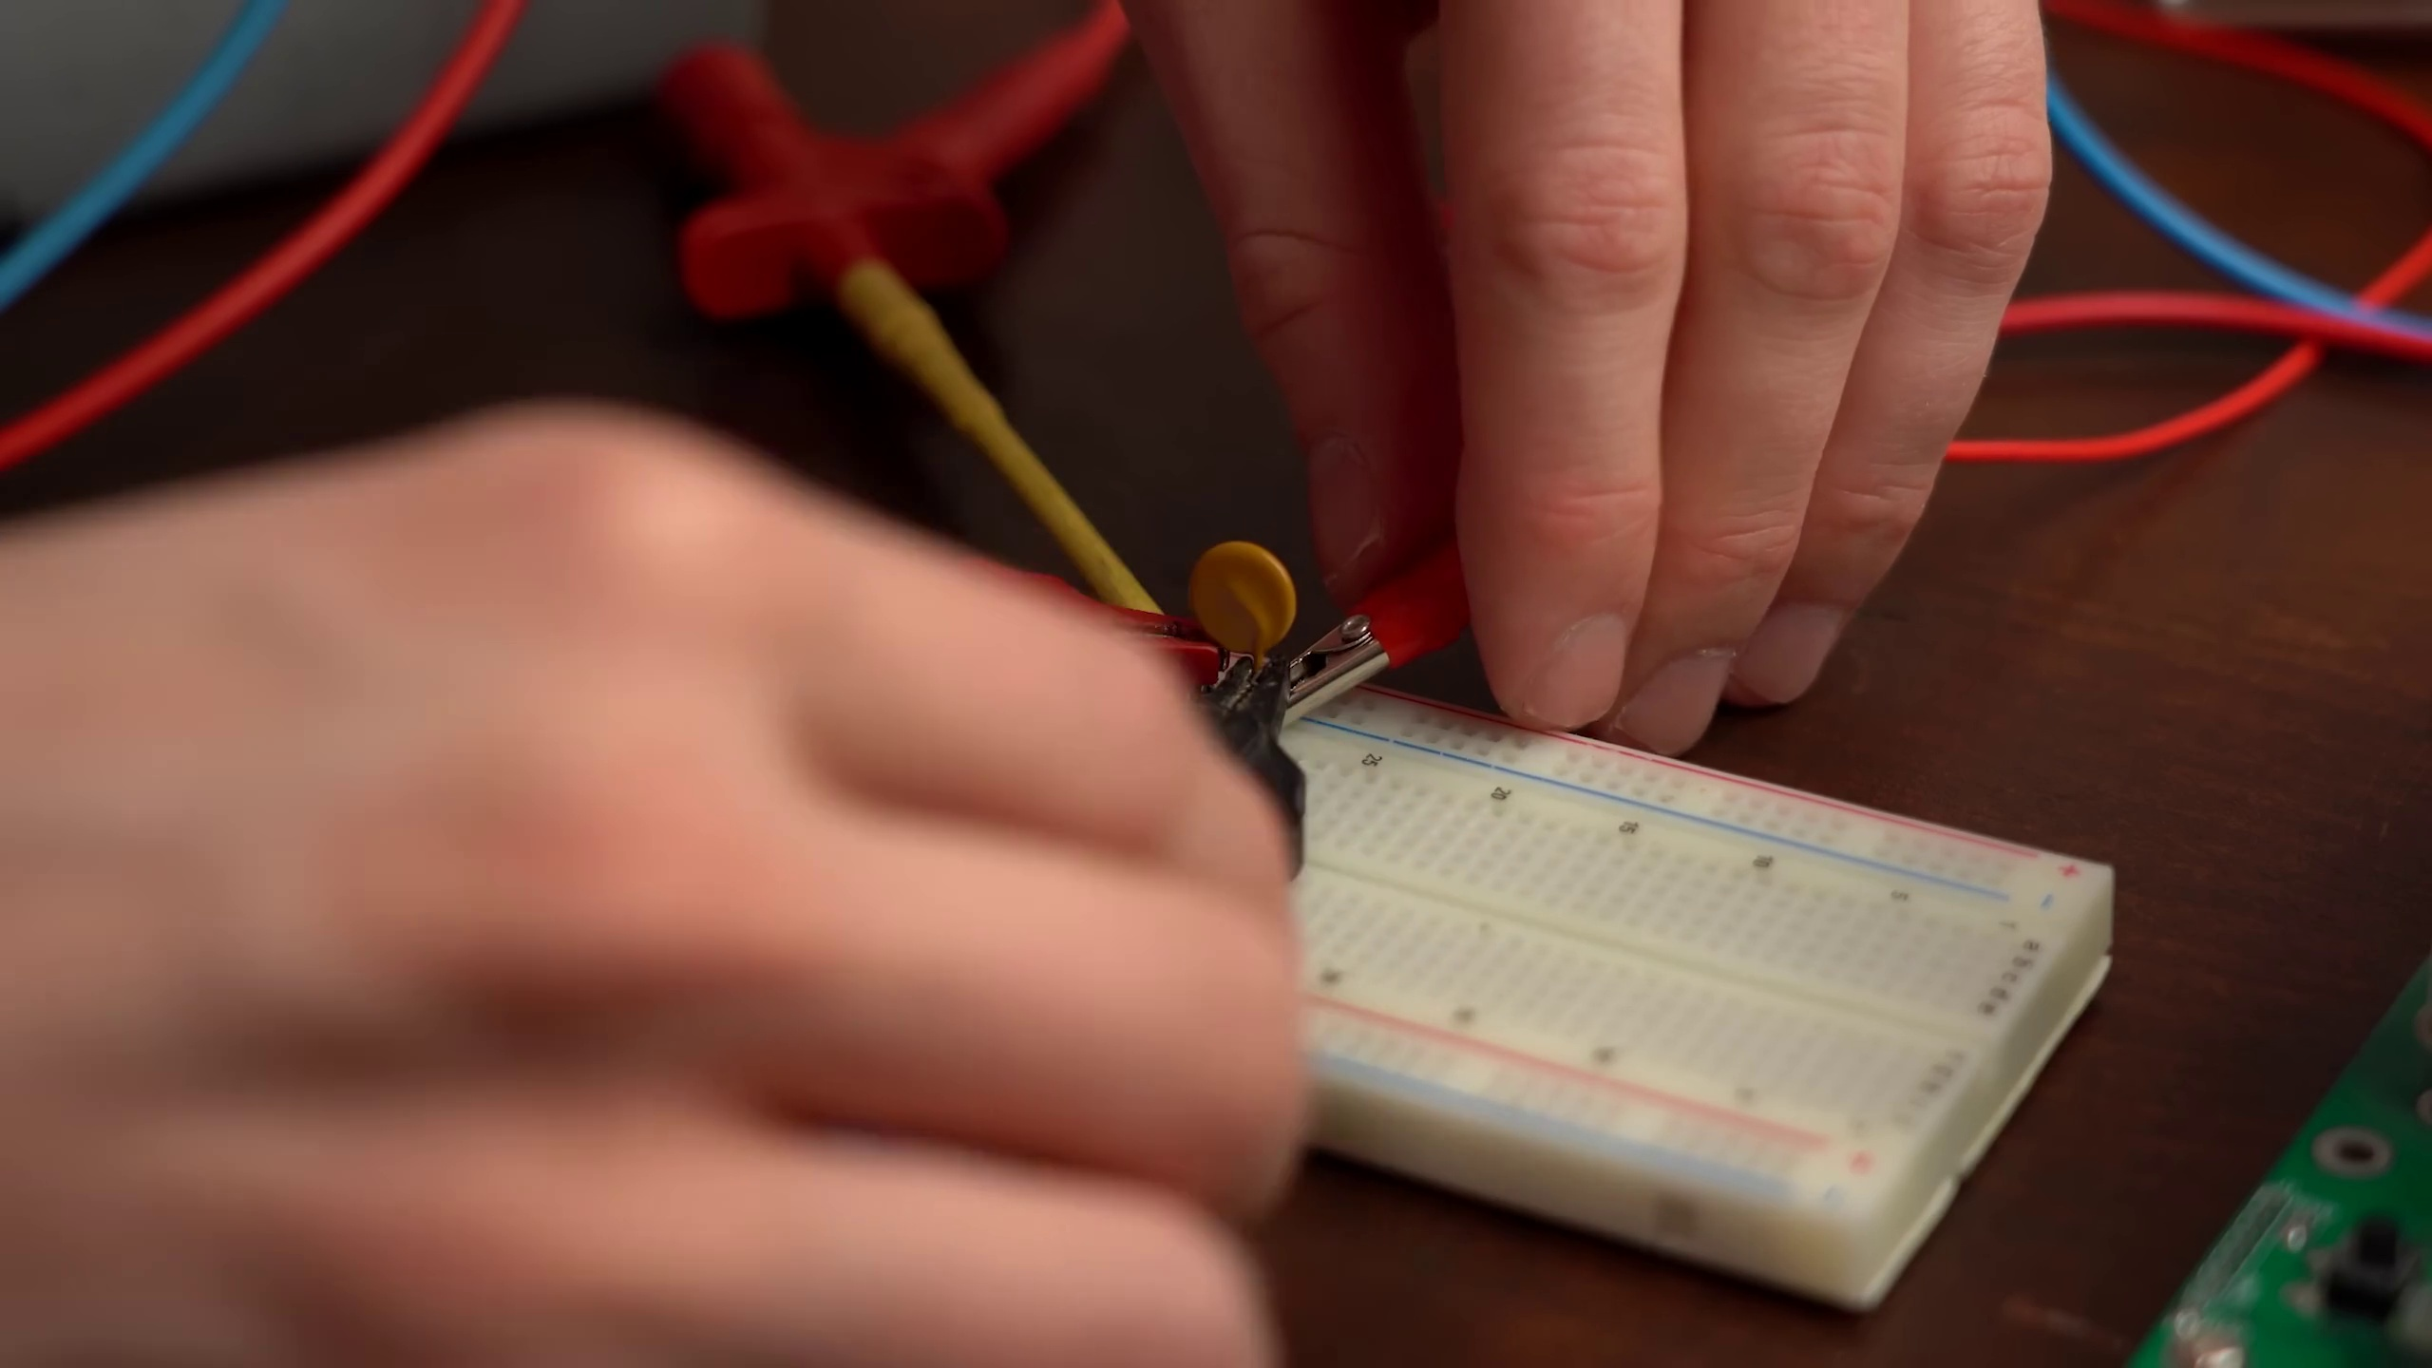 (score 30.0000)
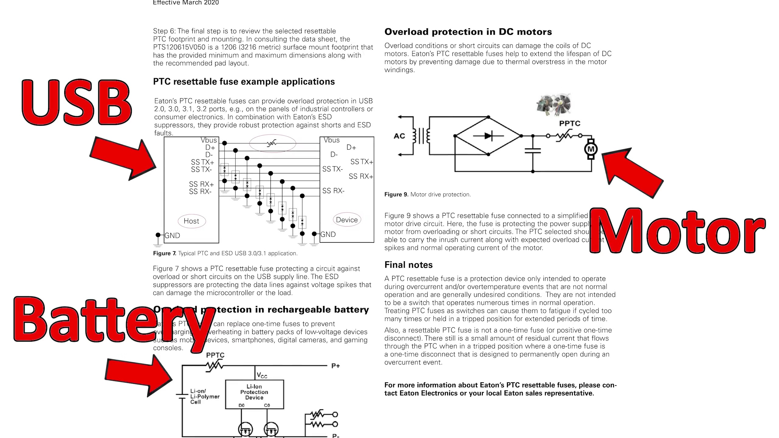 (score 25.0000)
 (score 25.0000)
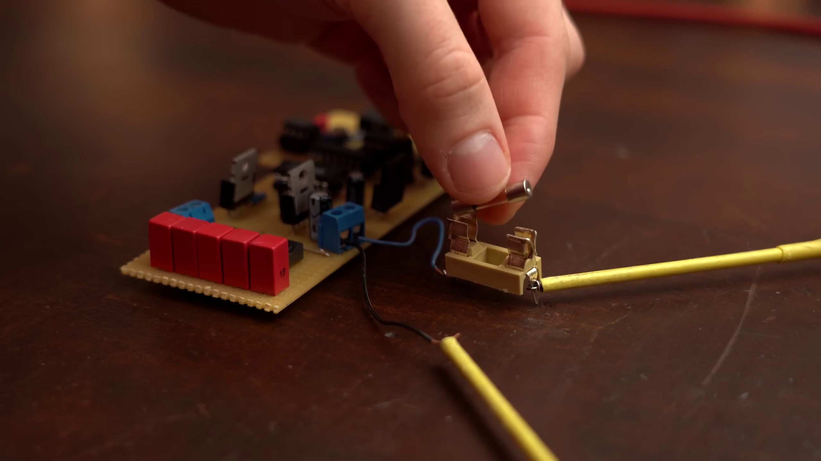 (score 25.0000)
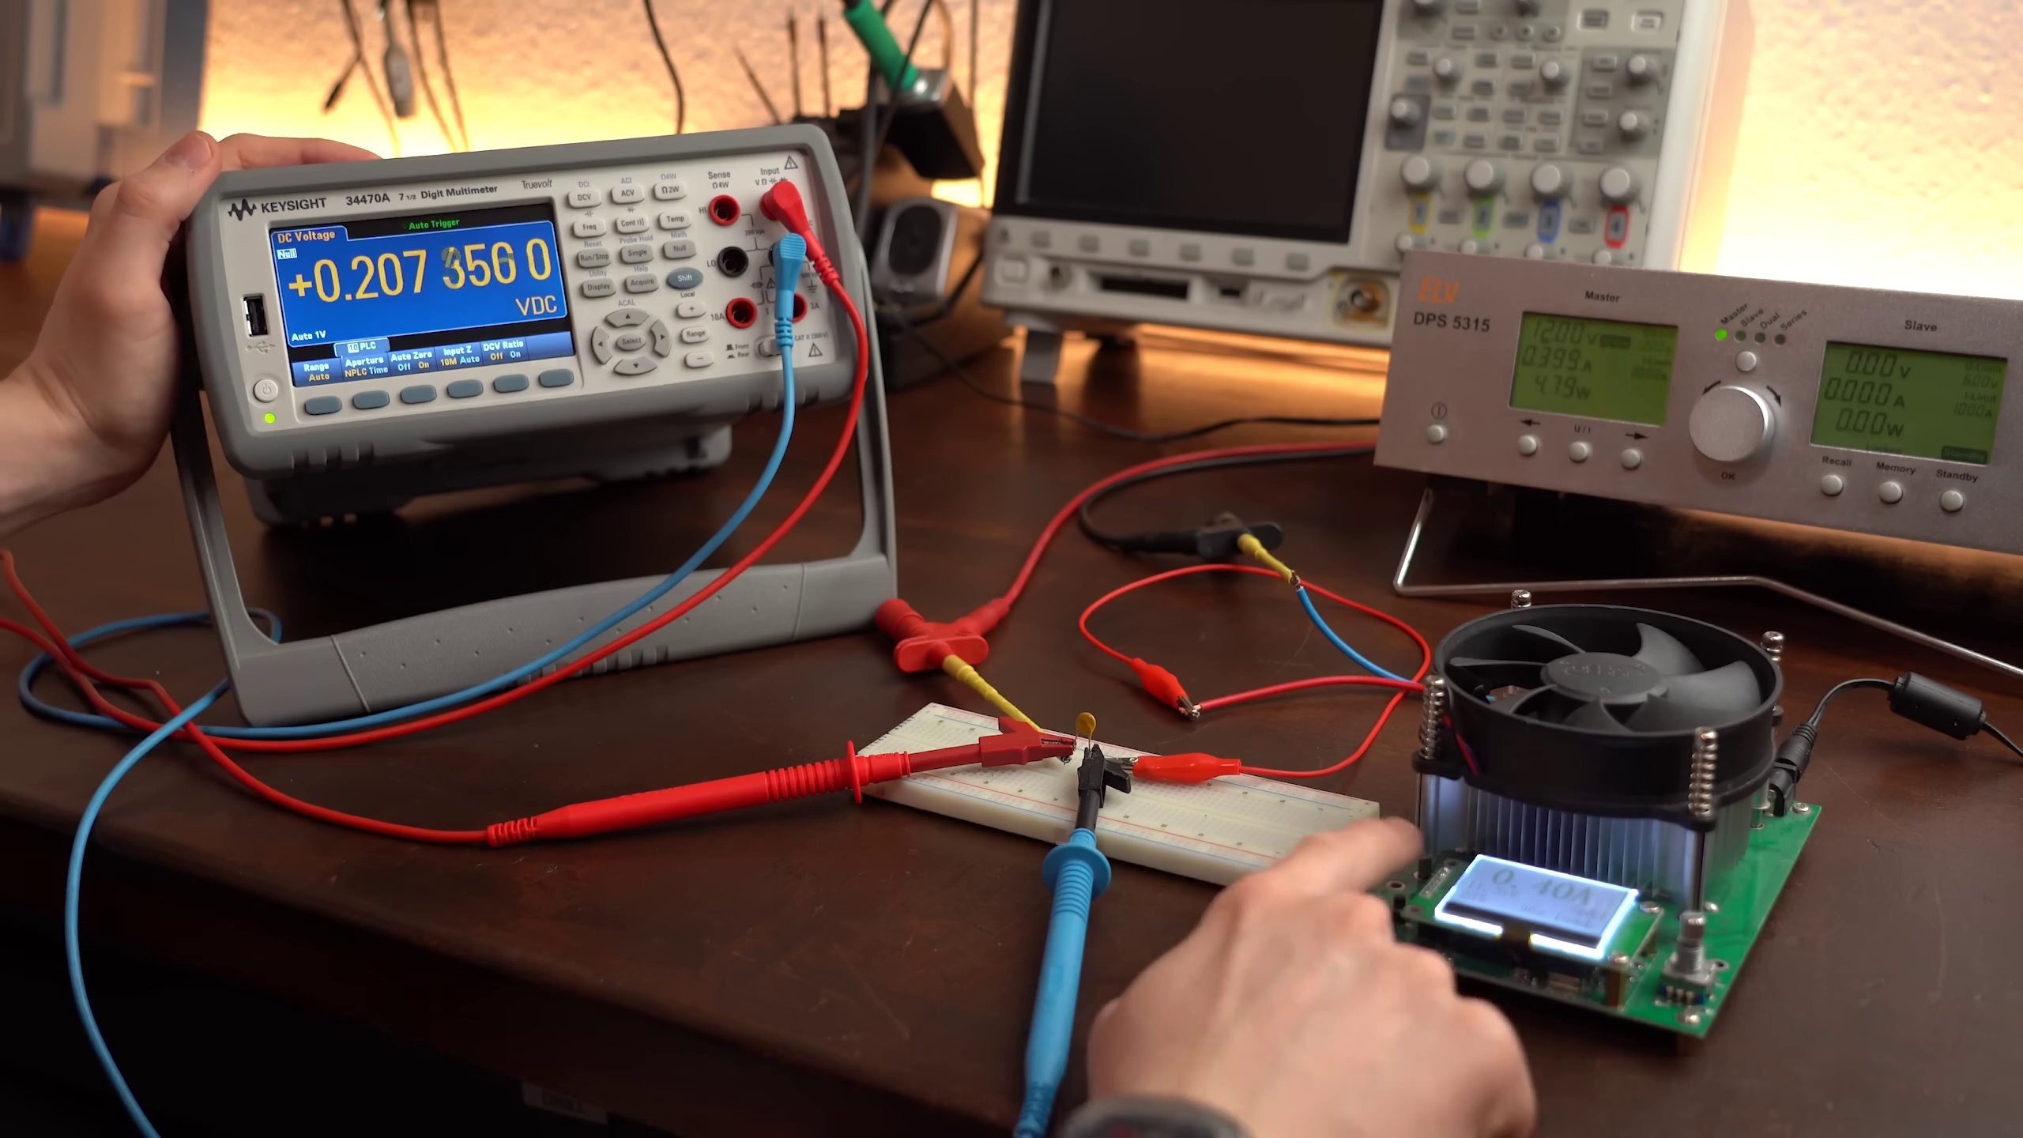 (score 20.0000)
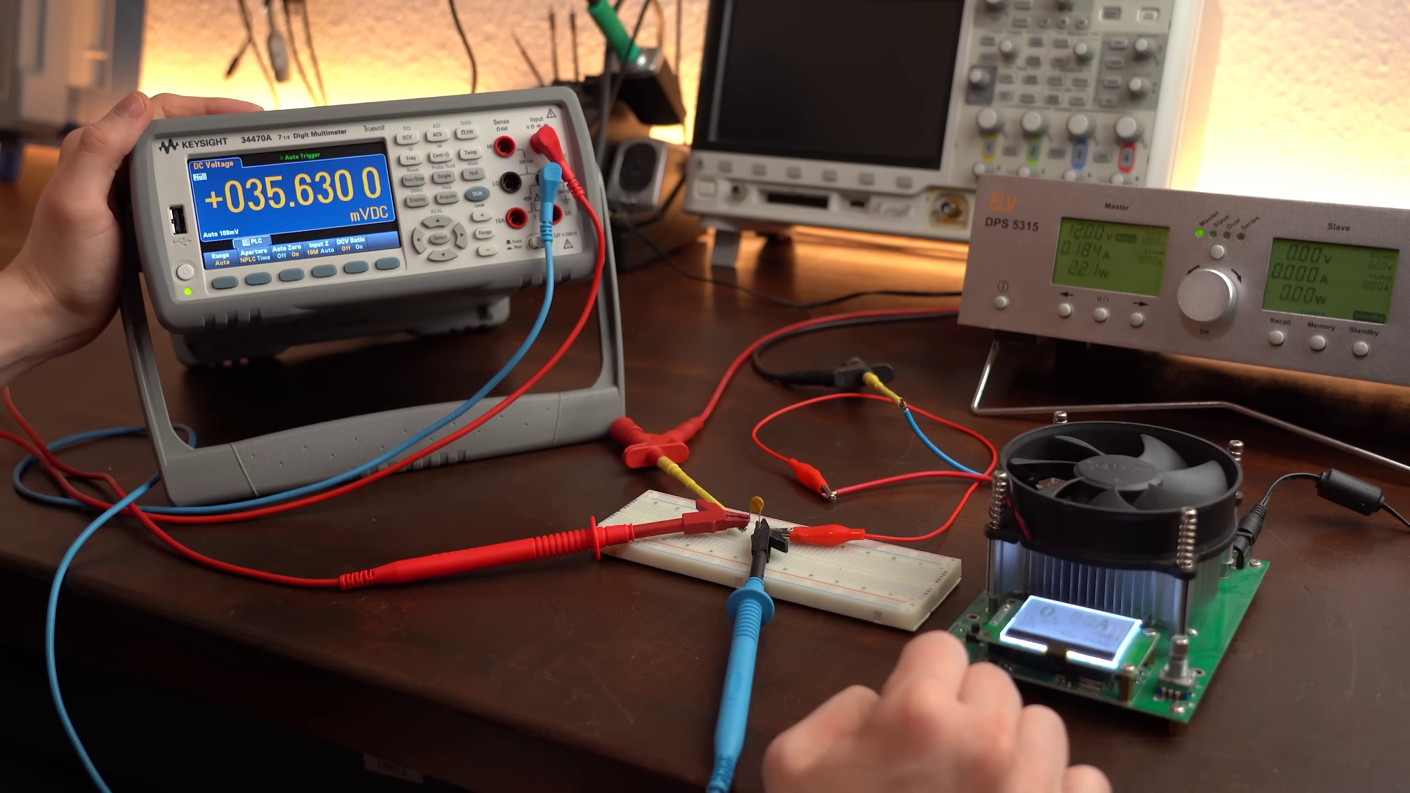 (score 20.0000)
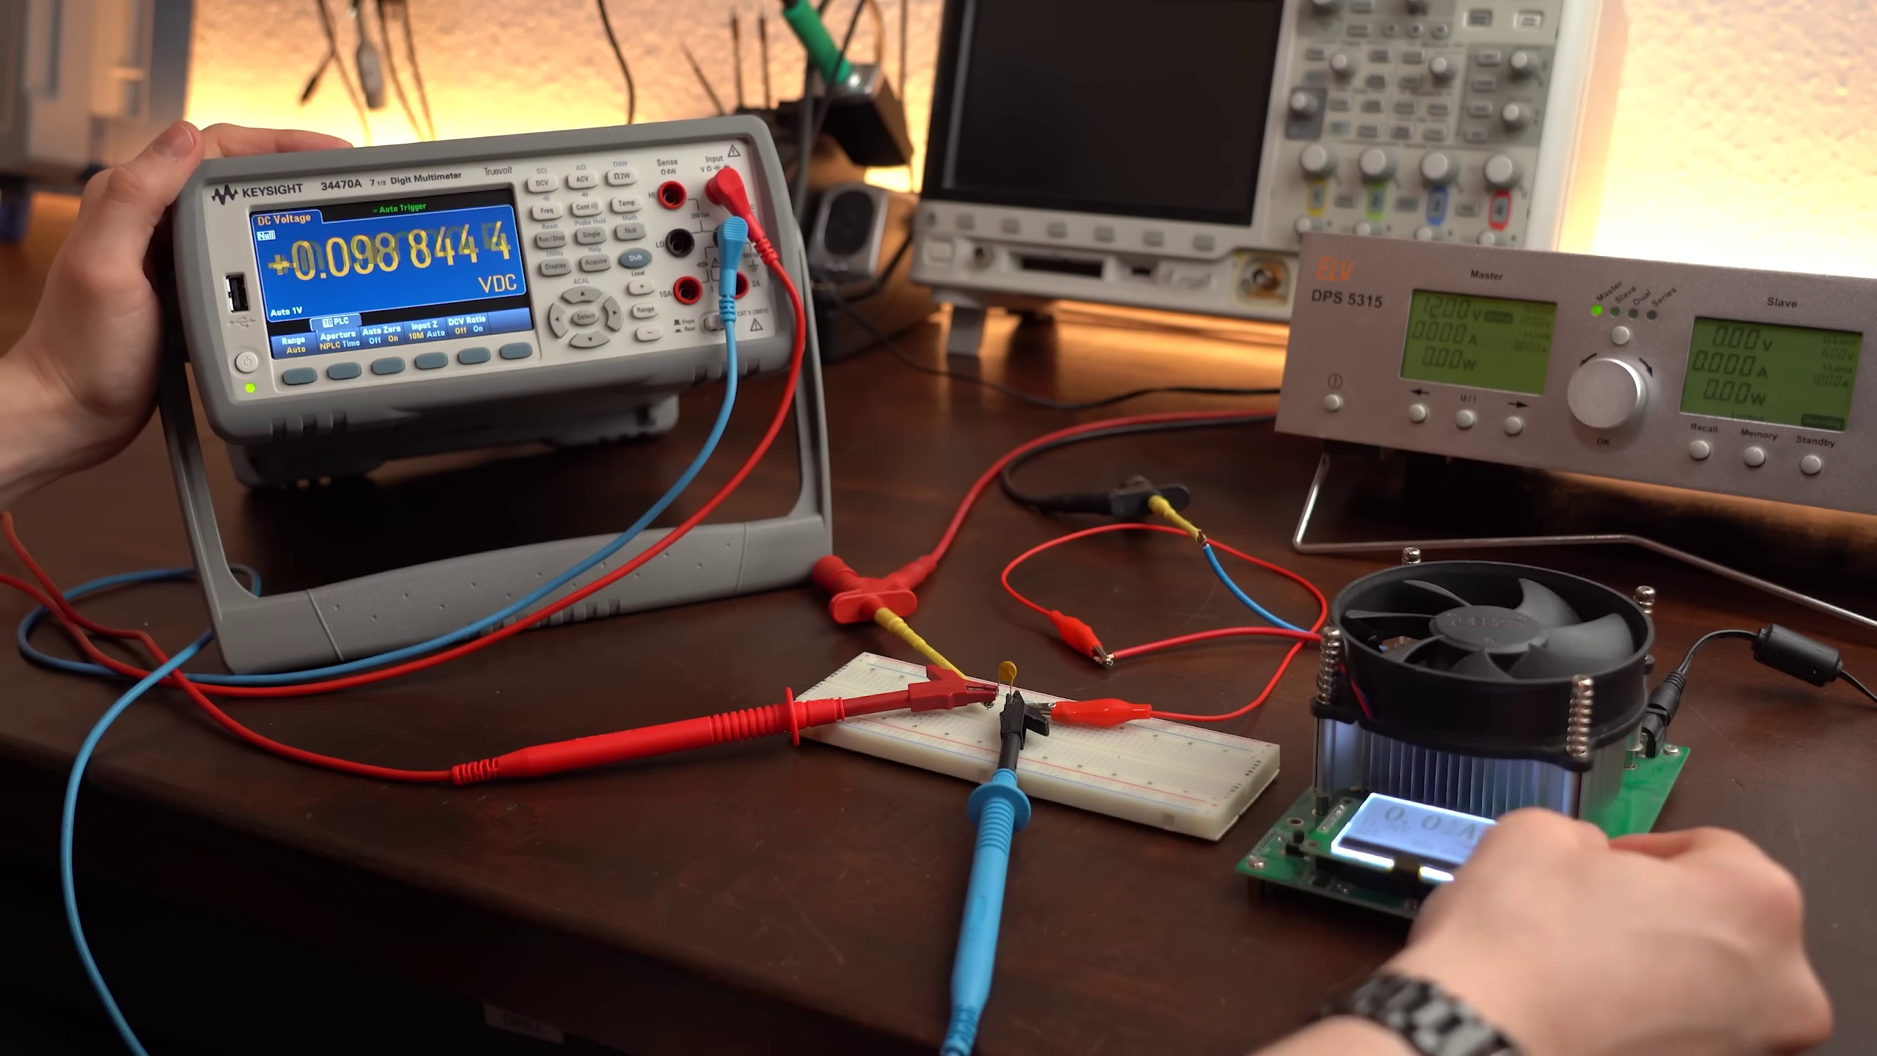 (score 20.0000)
Least correlated frames:
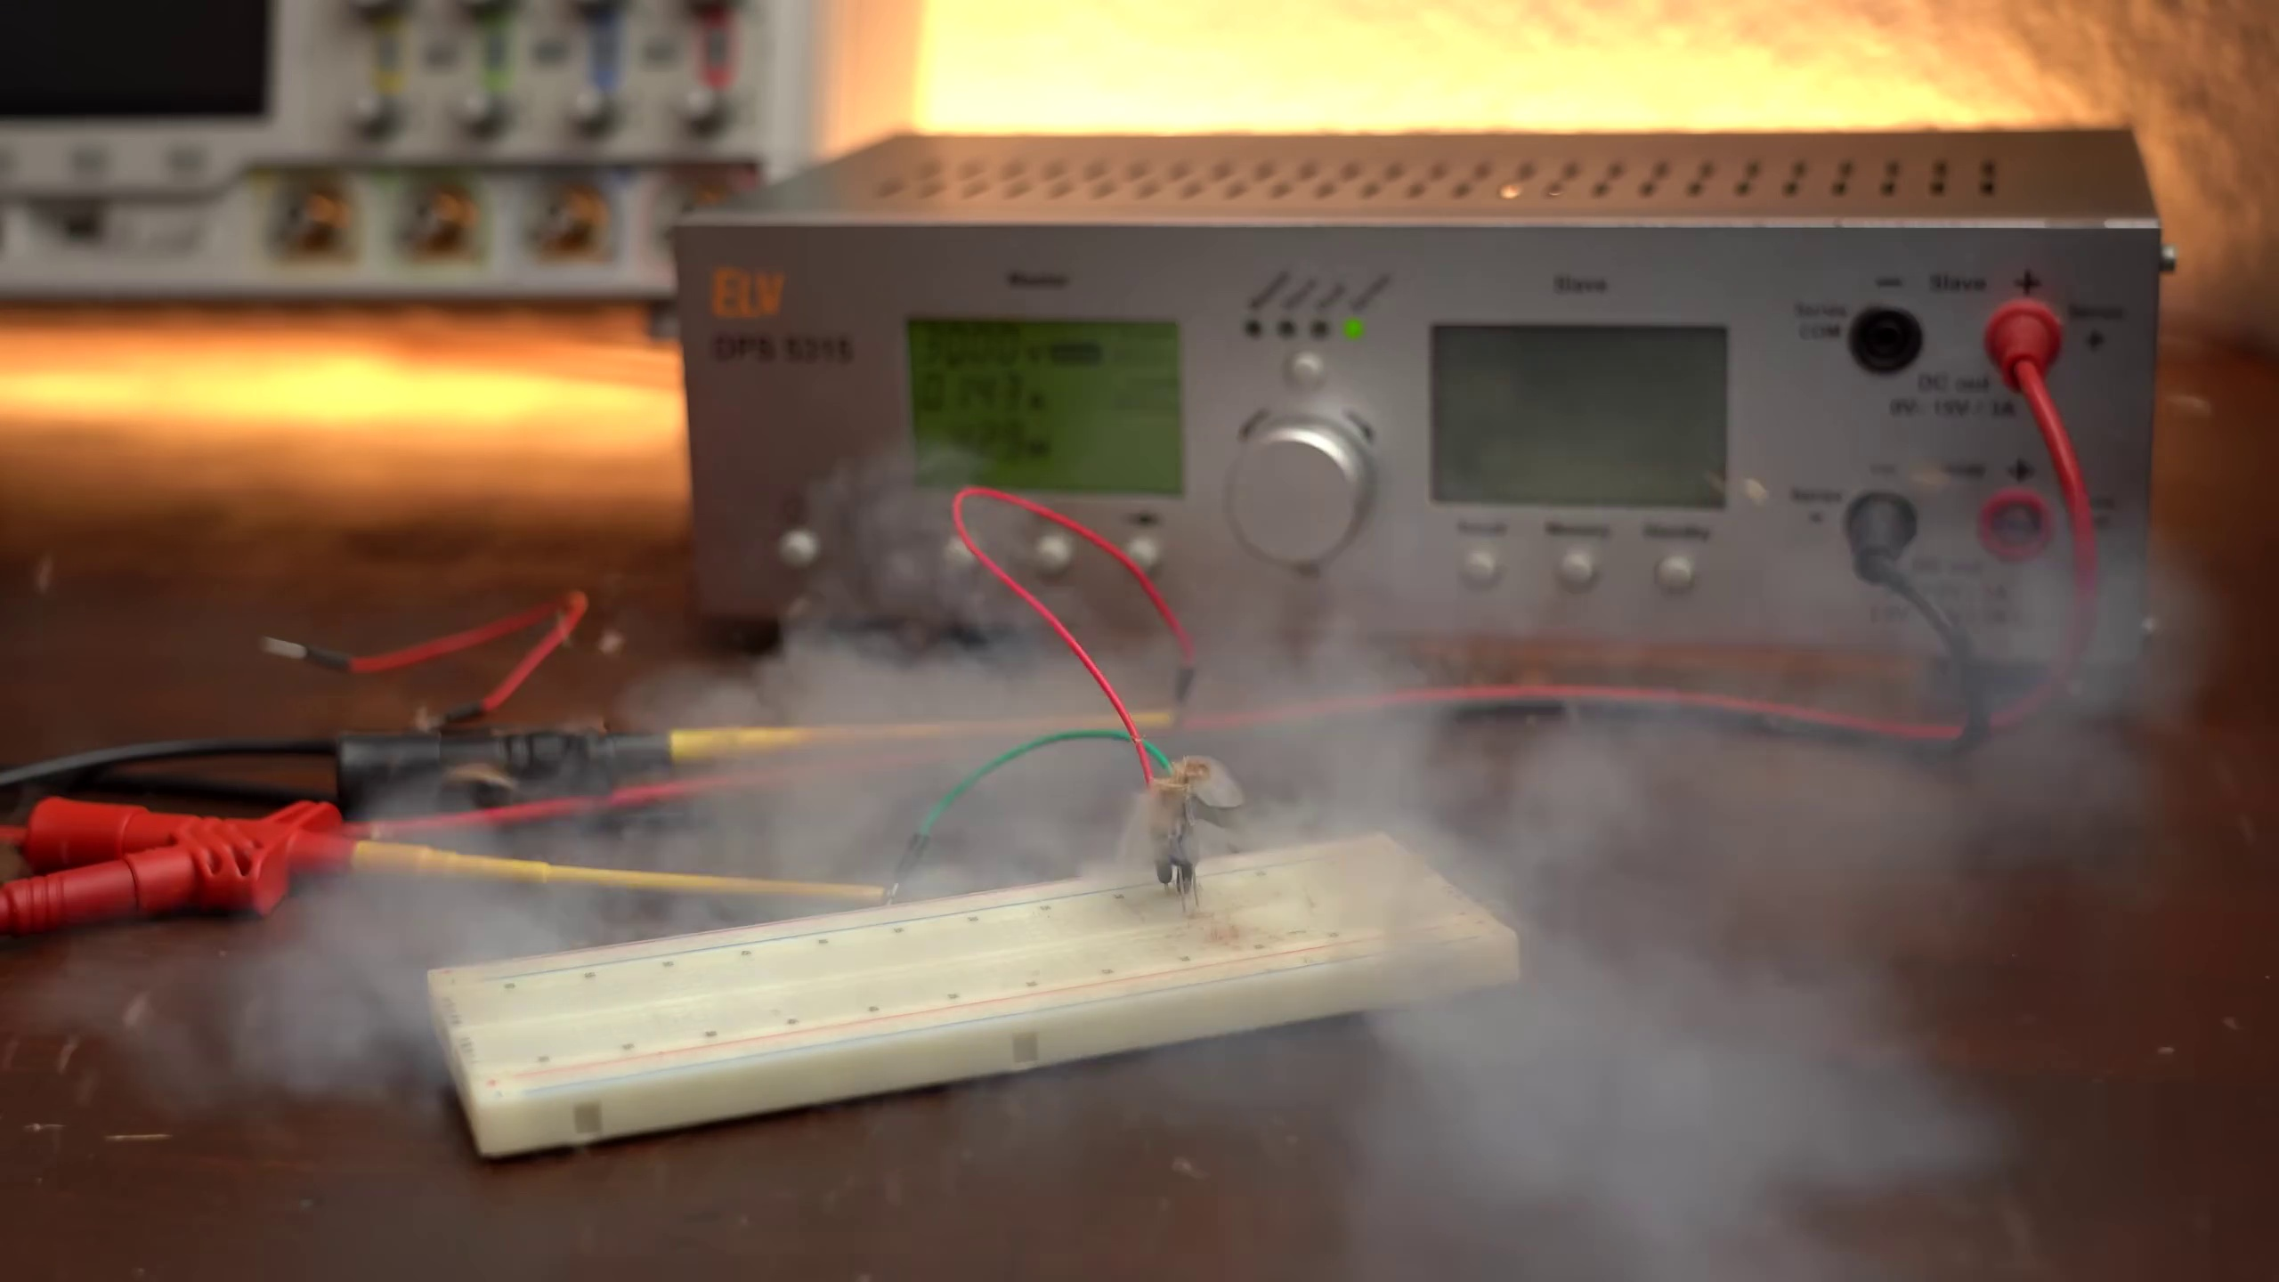 (score 0.0000)
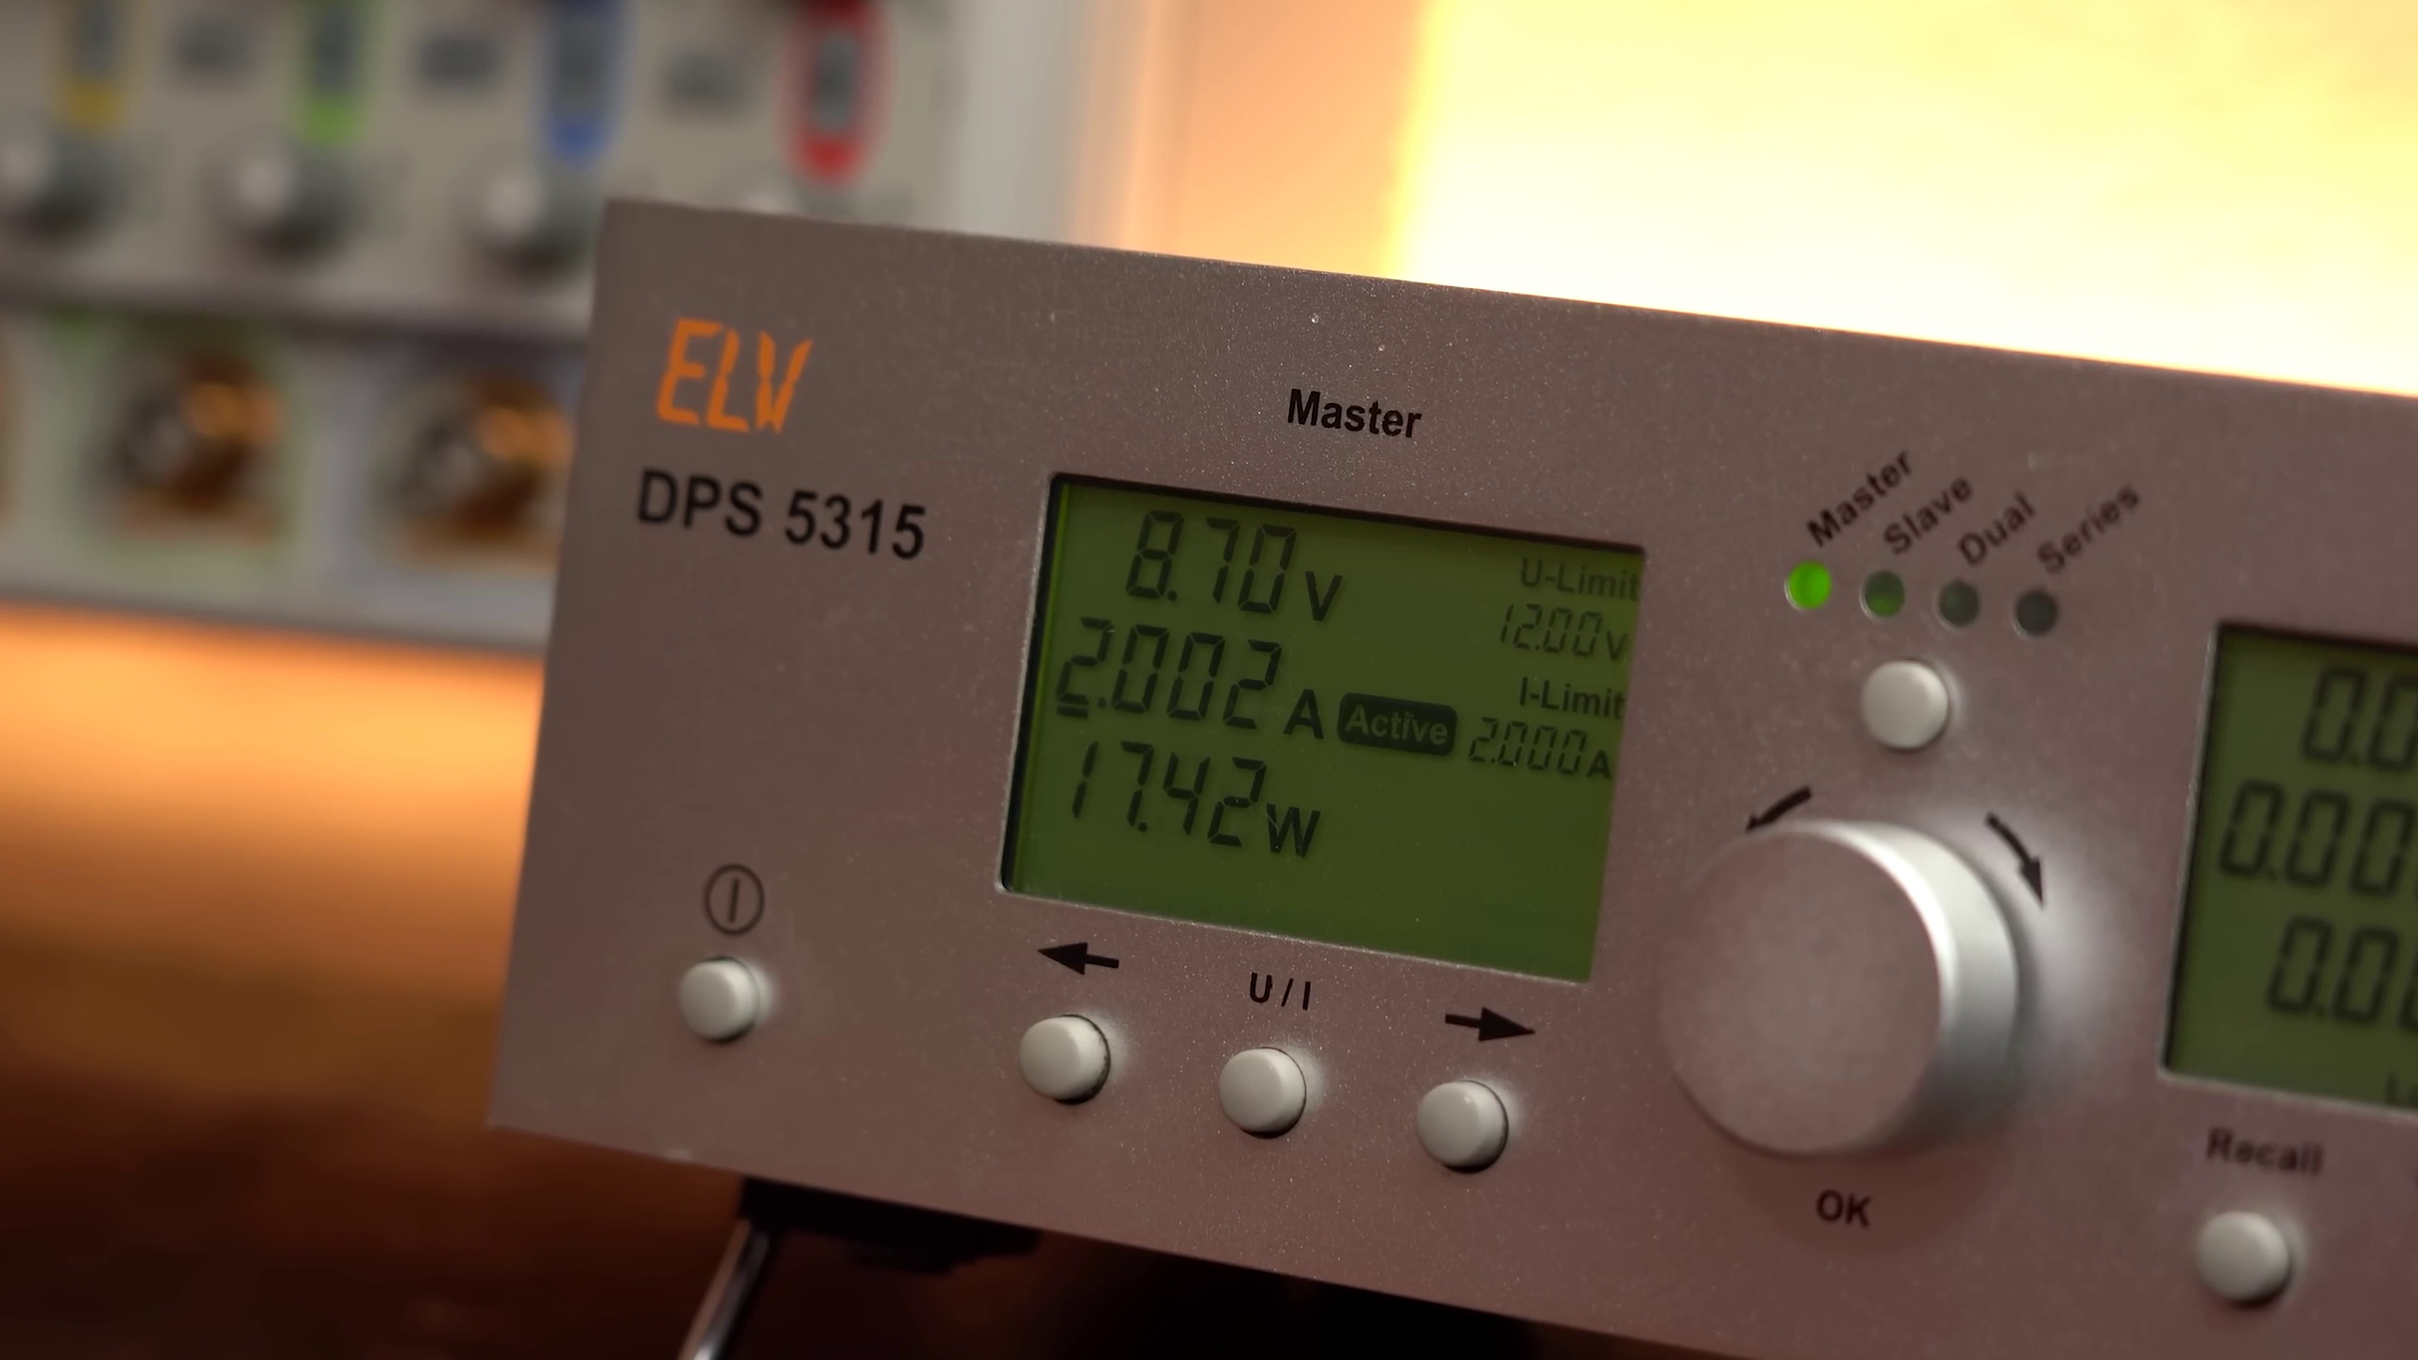 (score 0.0000)
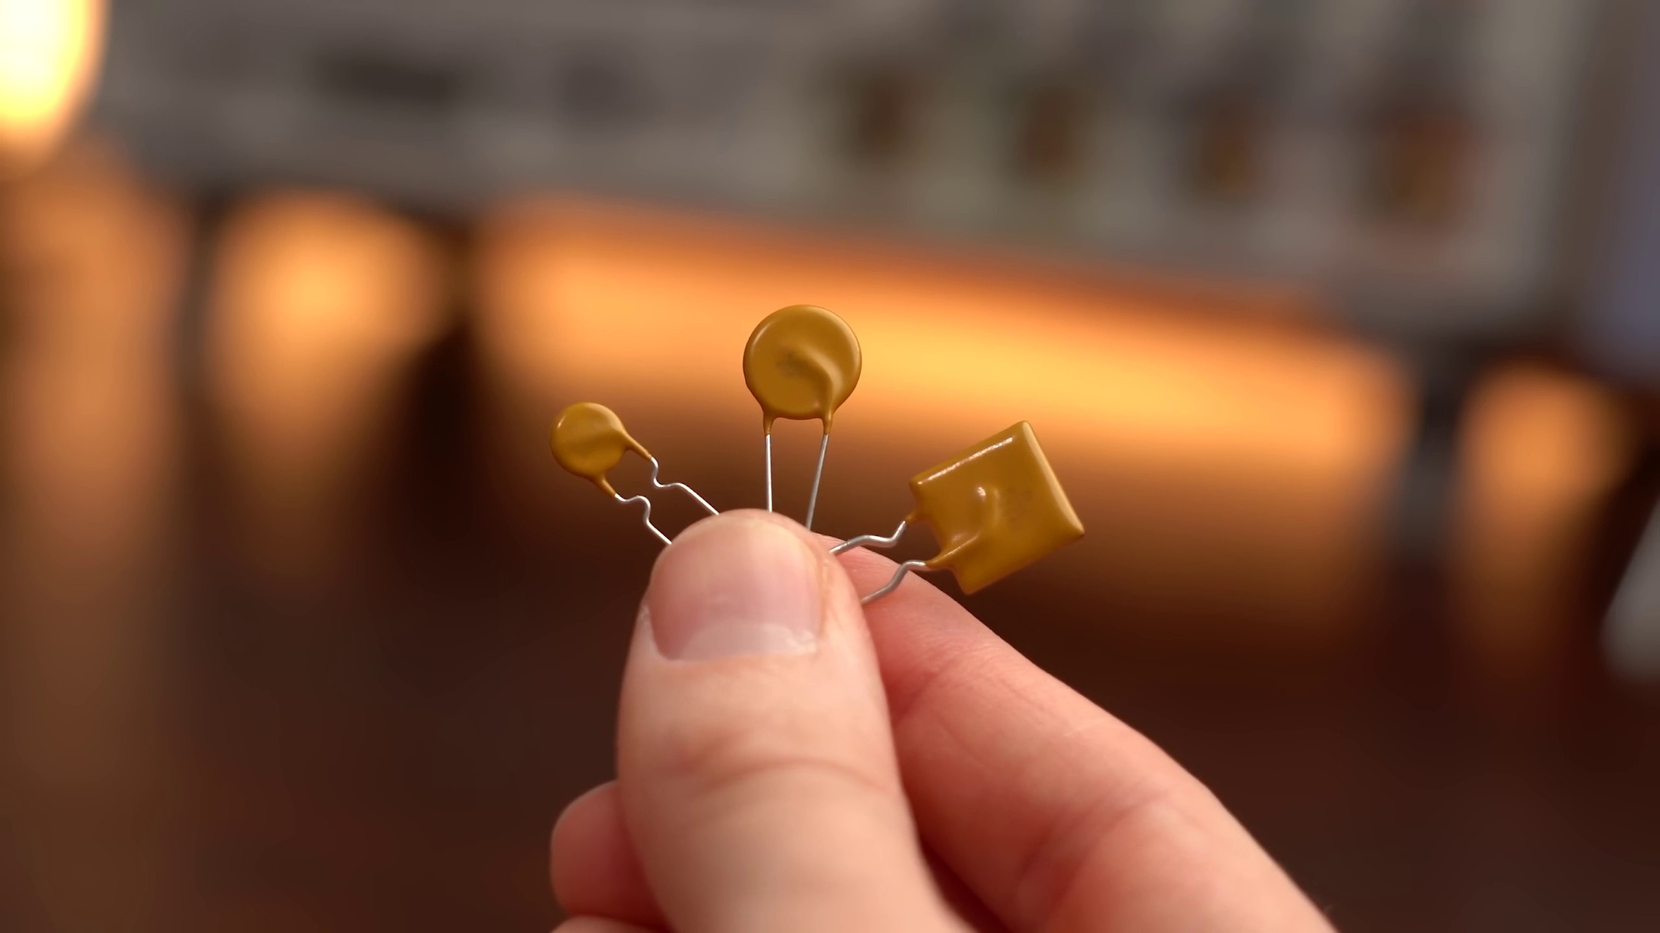 (score 0.0000)
 (score 0.0000)
 (score 0.0000)
 (score 0.0000)
 (score 0.0000)
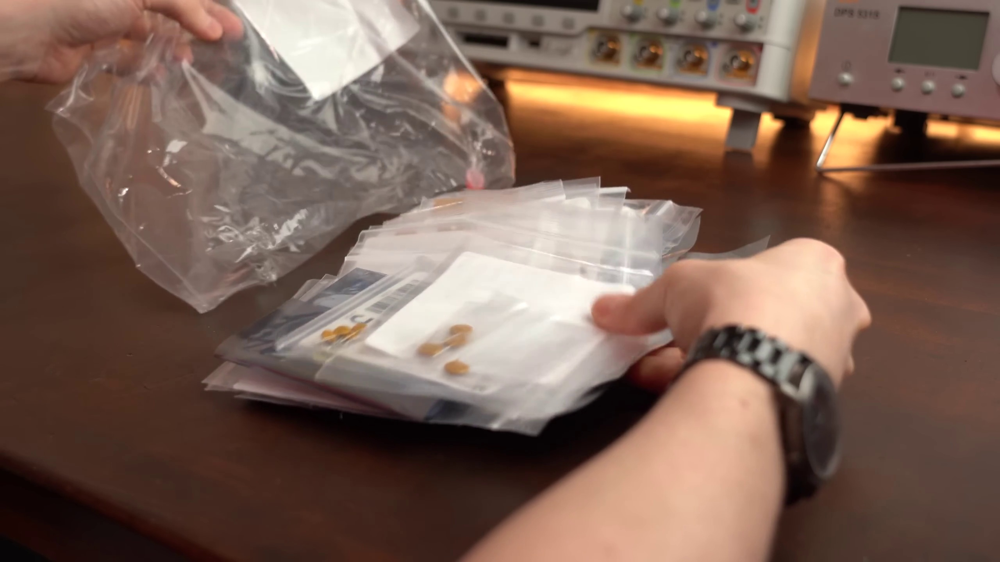 (score 0.0000)
 (score 0.0000)
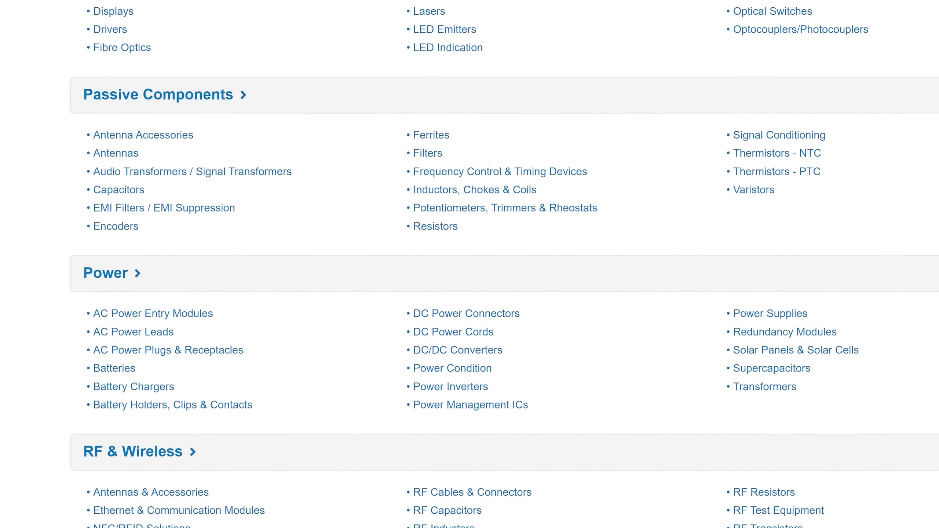 (score 0.0000)

Frame: frame_0000.jpg
Caption: The image shows a close-up view of an electronic setup involving a breadboard, wires, and a USB cable connected to the small circuit. The breadboard is white with a grid of small black squares on its surface, creating a network of connections for making connections between different components without soldering them. A small red wire is inserted into one of these connections, suggesting that some form of electronic circuit is being assembled or tested.
The USB cable indicates that the circuit is powered by a computer or another USB-compatible device. On the breadboard, there appears to be a resistor and possibly other electronic components, but their specific types or values cannot be determined from this angle. The background is out of focus, but it seems to be an indoor setting with a table and some other items that are not the main focus of the image.
The scene suggests a meticulous assembly or testing process, with no discernible text present in the image. Given the visual content, it could be part of a tutorial or demonstration about basic electronics concepts such as wiring, creating simple circuits, or using a breadboard for prototyping electronic projects.
Comment (score 80): Small glass fuses are used to interrupt current flow, but resettable fuses offer an alternative.
Reason: The comment specifically mentions 'interrupting current flow' and 'resettable fuses', which are directly related to the technical steps and components described in the caption, such as the breadboard and wires. The mention of fuses is a specific detail that aligns with the image's focus on electronic circuit assembly or testing.
Source: https://www.youtube.com/watch?v=sF0KOVWj9p8: The Best Protection for your circuit is NOT a fuse… but a resettable fuse?

Frame: frame_0001.jpg
Caption: The image shows an electronics breadboard with several components attached to it. On the left side of the breadboard, there is a red wire connected to the +5V rail, suggesting that this setup might be powered by a 5-volt DC source. A black wire connects to another rail on the right, but it's not clear whether it's connected to the ground rail or another voltage rail; we would need to see a complete connection path to know for sure.
Attached to the breadboard are two small components that look like integrated circuits (ICs), often used in electronics as processors or other types of logic. One IC is on the left side and the other is on the right, both connected to the breadboard by a few jumper wires. The precise nature or purpose of these ICs is not immediately clear from this image alone.
The background is out of focus, but it appears to be an indoor setting with some decorative items that could be part of a holiday display. There's no visible text or diagrams in the image that provide additional information about the components or their function.
No strongly correlated comments found for this frame.

Frame: frame_0002.jpg
Caption: The image shows an individual, a man wearing a red t-shirt with a graphic design on it (although the text on the shirt is not legible), standing in a room filled with various electronic equipment. He is holding up a white object with a black strap adorned with the words "Stay Creative" written in white letters. The room features a mix of white and black, creating a stark contrast with the man and his object.
Behind him, on the wall, there are several items that resemble electronics components or parts of a project, such as a breadboard, jumper wires, and what might be a small electronic device or module. A whiteboard in the background has some text on it, although the content is not entirely clear due to the angle and distance from which the photo was taken.
The individual appears to be in the middle of a presentation or demonstration, perhaps discussing the importance of creativity in the field of electronics. He is surrounded by a workspace with electronic equipment and various wires, indicating a hobbyist or maker space setting.
No strongly correlated comments found for this frame.

Frame: frame_0003.jpg
Caption: The image captures a moment in an electronic setup or experiment. At the center, there's a digital clock with a red LED display showing "12:00". Surrounding this central device are several other items. On the left, a small electronic device with a screen and buttons appears to show some sort of data or settings menu. To the right of the clock, an electronic breadboard with various wires connected is visible, featuring two small screw terminals with a metal clip attached and a red LED connected to one. The bottom right corner shows smoke rising from the connections on the breadboard, indicating an electrical short has occurred.
In the background, a gray control panel dominates the scene, its surface gleaming with a silver sheen. Two black wires are attached to it, one plugged into a black socket and the other hanging loose, ready to be connected. These wires are connected to a green and white device, its components clearly visible. The control panel is centrally located, with the wires and device in close proximity.
A white board lies on the floor next to the control panel, seemingly untouched. A few feet away, a wooden table stands tall, its surface also untouched. The scene is devoid of any human presence, suggesting that the equipment is left unattended for the moment.
Comment (score 70): Small glass fuses are used to interrupt current flow, but resettable fuses offer an alternative.
Reason: The comment directly mentions specific components and concepts related to the setup or experiment captured in the frame caption, such as interrupting current flow and using fuses. While it doesn't exactly match the exact sequence of events depicted in the caption, the technical context is strongly connected.
Source: https://www.youtube.com/watch?v=sF0KOVWj9p8: The Best Protection for your circuit is NOT a fuse… but a resettable fuse?

Frame: frame_0004.jpg
Caption: The image appears to be a split-screen photo that shows two different scenes related to electronics or hobbyist work. In the top half, a person is seen working with electronic components on a breadboard. The person seems to be in the process of connecting wires and possibly troubleshooting or setting up an electronic circuit, as indicated by the tools in their hands. There are visible electronic components such as resistors (brown cylinders) and capacitors (blue cylinders). The breadboard is situated on a surface with various electronic devices around it, including what looks like an electronic module or a small amplifier.
In the bottom half of the image, a person's hand is seen working on a circuit board, which is part of an electronic device. The circuit board is black and has various wires attached to it, indicating it's in the process of being wired up. The person is holding a red and black wire, which is connected to one of the wires on the circuit board.
The electronic device itself is a white radio with a silver control panel. A green light on the radio is currently off, suggesting it's not in use at the moment. The background of the image is blurred, making it difficult to discern any additional details. However, the focus of the image is clearly on the person and the circuit board, indicating that the image was likely taken from a distance, possibly capturing a moment in the process of assembling or testing the electronic device.
No strongly correlated comments found for this frame.

Frame: frame_0005.jpg
Caption: The image presents a scene set on a wooden table, showcasing an educational context where electronics and technology intersect. In the foreground, a small electronic device, possibly a Raspberry Pi or similar single-board computer (SBC), is being demonstrated or used for an educational purpose. The text overlay "Definitely Wong Useage" suggests that the device is being used in an unusual way, which might be meant to illustrate how not to use such technology.
The device appears to be connected to a breadboard or similar type of prototyping electronics setup, featuring various components such as resistors and possibly LEDs. The green circuit board with its intricate wiring and components, including wires, resistors, and a red LED, dominates the center of the frame, reflecting the ambient light on its silver surface.
The scene is surrounded by various objects that contribute to the overall composition. A green cord dangles to the left of the board, stretching towards the edge of the image. To the right of the board, a red lightbulb sits, contrasting with the cooler tones of the circuitry.
In the background, a speaker can be seen, suggesting an environment where audio equipment is present, perhaps indicating a space where music or sound is produced or experienced. The overall composition of the image captures a moment in time, a snapshot of a space where technology and creativity intersect, representing the intersection of science and art.
No strongly correlated comments found for this frame.

Frame: frame_0006.jpg
Caption: The image shows a close-up view of a person's hand holding a small electronic device, likely an educational kit designed to teach electronics and robotics principles. The device itself is red, with visible connections between its components, indicating that the person is either wiring or assembling them in a specific configuration. One hand holds a component that appears to be a sensor, while the other manipulates what could be a circuit board or mounting hardware for the sensor.
The hand is firmly gripping the device, suggesting a sense of focus and concentration as the person works on building or assembling it. The background is blurred, drawing attention to the device and the person's hand. The image does not contain any discernible text, equations, or graph types, with the focus instead on the hands-on activity of building an electronic device.
No strongly correlated comments found for this frame.

Frame: frame_0007.jpg
Caption: The image shows an electronic device with various knobs and screens on its front panel, situated on a table surface surrounded by electronic components, suggesting a laboratory or workshop environment. The device appears to be a piece of test equipment, possibly used for measuring electrical characteristics such as voltage, current, or frequency.
The display screen features multiple gauges and scales, with numerical values and needle indicators indicating measurement results for different parameters. The topmost gauge has a scale marked from 0 to 8, set at around 5.4 units. Below this, there are two more gauges; one labeled "Amplitude" with a scale ranging from 0 to 32, and another labeled "Phase" with a scale that goes up to 16 units. The bottommost gauge is marked "Frequency," indicating that it measures the frequency of an input signal.
In addition to these measurement gauges, the device's display also shows text that reads "DSP 3165," suggesting this might be a model number or a specific function of the device. The overall appearance and precision of the measurements indicate that the device is designed for scientific or industrial use.
On the table nearby, a digital display panel catches attention, with its black background providing a stark contrast to the white display. This display panel is currently set to a temperature of 20 degrees Celsius, indicating that it might be used for precise temperature control. The panel features various buttons, including one labeled "ELV" and another labeled "Master", likely used for adjusting settings or controlling the device. A power button also appears on the panel, indicating its operational status.
No strongly correlated comments found for this frame.

Frame: frame_0008.jpg
Caption: The image shows a close-up view of an electronics workstation with a white breadboard at its center. The breadboard has multiple jumper wires connected to it, suggesting that some form of electrical circuit is being assembled or demonstrated. A small black electronic device, possibly a microcontroller or integrated circuit, is mounted on the breadboard.
The background reveals more details: a person's hand and forearm are visible in the top left corner, indicating that someone might be working with the setup. Red cables run from the breadboard to an external power source or electronic device, which could be a power supply or another piece of equipment. The overall scene suggests an educational setting where someone might be teaching or demonstrating how to build and test electronic circuits.
The breadboard is positioned on a brown table, with a red and green cord running across it, adding a pop of color to the scene. It is adorned with several components, including two red wires, a black wire, and a black resistor. The wires and resistor are neatly arranged in the sockets, ready for connection. The red wires are connected to the black wire, suggesting a potential electrical connection. The black resistor stands out against the white background of the breadboard.
The image does not contain any discernible text or additional objects. The relative positions of the objects are clear - the breadboard is in the foreground, the cords are in the middle ground, and the table and background are in the background. The image is a snapshot of a moment in an electronics workshop, capturing the moment just before a connection is made.
No strongly correlated comments found for this frame.

Frame: frame_0009.jpg
Caption: The image shows an electronic breadboard with several wires connected to it, featuring a small insect sitting atop one row where two wires meet. The background is blurred but appears to be a dark surface that could be a tabletop or workbench. On the right side of the photo, there's a speech bubble with the text "help!" suggesting that the user may need assistance or guidance in working with this breadboard setup.
The board is not just a static display of technology, but a dynamic one as well. A small white chip, possibly an integrated circuit, sits on the board, its red, green, and black wires connecting it to the rest of the circuit. The wires, vibrant and contrasting against the white of the board, are a testament to the power of electricity.
The background of the image is a dark brown, providing a stark contrast to the white board and the colorful wires. The wooden table on which the board sits adds an element of rustic charm to the scene.
No strongly correlated comments found for this frame.

Frame: frame_0010.jpg
Caption: The image shows a person standing in front of a cluttered workspace. The individual is dressed in a vibrant red t-shirt with the word "SALAD" in bold white letters, and their gaze is directed towards the camera. Their hand is resting on their chin in a contemplative gesture.
Behind them, a black desk is cluttered with various tools and equipment, hinting at an ongoing project or repair process. The tools range from small screwdrivers to larger circuit boards, suggesting a focus on electronics projects. Some of the items visible on the desk include soldering irons, wires, electronic components, circuit boards, capacitors, resistors, and possibly development boards or Raspberry Pi.
In the background, a window is partially visible, showing a blurred view of the outside world. However, the person's attention remains focused on the camera, rather than the external surroundings. Despite the chaotic workspace, the individual exudes an air of calm and focus, with their red t-shirt standing out against the backdrop of tools and equipment.
The image appears to capture a moment in time, showcasing a person immersed in their work surrounded by the tangible signs of their project or repair process.
No strongly correlated comments found for this frame.

Frame: frame_0011.jpg
Caption: The image captures a moment of meticulous assembly as an individual works with electronics or performs a small electrical project. The person is handling components such as resistors and wires, typical materials used in basic electrical experiments or hobbyist projects. A small circuit board is visible, suggesting the person might be building or repairing an electronic device. The focus of the image is on the activity being performed rather than a teaching context.
The individual's hand, the only human presence in the scene, is seen holding a small electronic component with care and precision. The component is held by a white screw, partially visible through the object it's holding. The object being held is a tiny electronic circuit board, which is held together by a series of wires. These wires are yellow, providing a stark contrast to the brown surface of the table they're resting on.
The wires are arranged in a neat line, suggesting a well-planned and organized assembly process. Overall, the scene paints a picture of careful and precise work, indicative of a hobbyist or a professional working on their craft. The individual's attention to detail is evident as they handle the components with precision, implying concentration and care in the work being done.
Comment (score 80): Small glass fuses are used to interrupt current flow, but resettable fuses offer an alternative.
Reason: The comment directly discusses the use of fuses, which is related to the technical steps and objects described in the caption. The mention of resettable fuses as an alternative also shows a connection to the electrical project being worked on in the image.
Source: https://www.youtube.com/watch?v=sF0KOVWj9p8: The Best Protection for your circuit is NOT a fuse… but a resettable fuse?

Frame: frame_0012.jpg
Caption: This high-resolution image captures a detailed view of an electronic project underway on a wooden table. The central focus is a complex circuit board, comprising a network of wires - some red, blue, and black - leading to various electronic components, including resistors, capacitors, and a light-up button. These components are neatly arranged on the circuit board, suggesting a well-organized and functional electronic device. A yellow wire connects one of the input jacks on a microcontroller or integrated circuit (IC) mounted on a breadboard, implying that this project may be related to Arduino microcontrollers or electronics projects.
The background of an indoor setting, possibly a workshop or laboratory, suggests an environment conducive to hands-on learning and experimentation. The image does not contain any discernible text or additional objects, apart from the overlaid text "An Introduction to Arduino and Electronics," which implies that this is likely the first slide in a presentation or educational material focused on teaching about Arduino microcontrollers and electronics projects.
The overall composition of the image presents an active electronic work scene, with the circuit board and its components ready for testing and experimentation. The wooden table provides a sturdy base for these components, ensuring they remain stable and intact.
Comment (score 80): Small glass fuses are used to interrupt current flow, but resettable fuses offer an alternative.
Reason: The comment directly discusses the use of fuses (specifically resettable fuses) in an electronic project, which is related to the technical steps and components described in the caption (such as circuit board, wires, resistors, capacitors, and a light-up button). The connection between the comment and paragraph is strong, but not perfect, as the comment does not explicitly mention Arduino microcontrollers or electronics projects, but it still shares common themes with the caption.
Source: https://www.youtube.com/watch?v=sF0KOVWj9p8: The Best Protection for your circuit is NOT a fuse… but a resettable fuse?

Frame: frame_0013.jpg
Caption: The image shows a close-up view of a small, rectangular circuit board made of wood, with a wooden frame. The board is covered in various electronic components, including wires, resistors, capacitors, and an integrated circuit (IC) chip, arranged in a grid-like pattern to create a complex network of connections. A yellow wire coils around the board, which may serve as a connection or grounding lead, connected to one of the components on the board, indicating that it is part of the electrical system. In the background, a speaker is positioned in the upper left corner, providing a sense of scale and perspective. The setting suggests that this could be a learning setup, possibly for teaching electronics, as indicated by the presence of what looks like a breadboard and other electronic components in the background.
No strongly correlated comments found for this frame.

Frame: frame_0014.jpg
Caption: The image shows an electronic device, specifically a DPS 5315 Master digital display device, which appears to be used for signal analysis or measurement. The device is labeled "EV" and features several knobs, a digital display with numerical values, and a red power button on the front. Additionally, there's a socket that resembles a headphone jack.
On the right side of the device, a dial with numbers from 1 to 100 suggests that this might be used to adjust parameters such as gain or amplitude for signal analysis. The background is blurred but indicates an indoor setting with artificial lighting, possibly a laboratory or workshop space.
The digital display shows a voltage reading of 120V and an amperage reading of 0A, illuminated by a green light. The device is set to "0000" and appears to be currently in use for measuring electrical parameters. It is placed on a desk with a black cord connected to it, indicating that the device is operational and ready for use.
No strongly correlated comments found for this frame.

Frame: frame_0015.jpg
Caption: The image shows a close-up of someone's hands working with electronic equipment. On the left side of the frame, there is a person's hand holding a small black device that appears to be a modem or router, with an Ethernet cable connected to it. On the right, another set of hands is attaching what looks like a network cable into a port on the bottom of the device being held. In the background, a brown wooden surface can be seen, providing a simple and unobtrusive context for the activity. There are no visible texts, diagrams, or slides that suggest an instructional or teaching context in this image. Meanwhile, next to the device, a silver rectangular object - a battery - is positioned, waiting to be inserted into another electronic device. The battery's label and barcode are clearly visible, indicating its brand and model. The image captures two moments of everyday technology use: one involving network connectivity and the other preparing to power up a device.
No strongly correlated comments found for this frame.

Frame: frame_0016.jpg
Caption: The image shows a person's hand meticulously working on a green circuit board through a transparent plastic window. The focus of the repair work appears to be on the circuitry and connections between various components, including small resistors and possibly an integrated circuit (IC). A piece of paper with text that reads "0.20 per piece" is visible in the image, indicating the cost or pricing model for these components.
The circuit board, surrounded by red and black wires, suggests an ongoing repair process. The person's hand is holding a green plug attached to the board, further emphasizing the repair work. The background of the image is a dark brown wooden table, providing a stark contrast to the vibrant colors of the circuit board and its components.
The overall scene suggests a professional or technical repair work, possibly in a workshop or a repair shop, where students or professionals are learning about electrical components and their assembly, or conducting hands-on repairs.
Comment (score 85): Small glass fuses are used to interrupt current flow, but resettable fuses offer an alternative.
Reason: The comment directly discusses the same technical aspect mentioned in the caption, specifically the use of fuses to interrupt current flow, which is relevant to the repair work on the circuit board.
Source: https://www.youtube.com/watch?v=sF0KOVWj9p8: The Best Protection for your circuit is NOT a fuse… but a resettable fuse?

Frame: frame_0017.jpg
Caption: The image shows a disassembled electronic device with internal components exposed on a work surface. A small circuit board, various electronic parts such as resistors or capacitors, a plug-in power connector with a blue cable, and an external antenna or sensor module are clearly visible. In the background, a table holds a piece of paper or cardboard with text overlay reading "2€ per piece", suggesting that the device may be for sale at a craft fair or similar event.
The device itself is resting on top of a brown wooden surface, with a white circuit board featuring a blue plastic casing. The board appears to be incomplete, missing a black connector and red wire, which are listed alongside their price: 0.20 Euros. The scene presents a simple yet informative snapshot of the device's internal workings and pricing information, without any visible instructor or teaching context.
No strongly correlated comments found for this frame.

Frame: frame_0018.jpg
Caption: The image shows an individual sitting at a desk surrounded by various electronic equipment and tools. He is dressed in casual attire, wearing a vibrant red t-shirt, suggesting an informal setting. The desk is filled with a range of components, including circuit boards, resistors, capacitors, and more, indicating that he might be involved in repairing or building electronics.
The individual's hands are occupied with manipulating his smartphone, likely for reference, communication, or documentation purposes while working on the electronic components. A white circuit board sits prominently in the foreground, showcasing intricate design details hinting at the complexity of the work being done.
In the background, black cabinets line a white wall, filled with various electronic components that add to the professional and scientific atmosphere of the workspace. The man's focused expression suggests his involvement in some form of electronic work or study.
Overall, the image captures a moment in time, freezing a snapshot of his work and the intricate world of electronics, highlighting the individual's hands-on activity with electronic components rather than any formal instructional setting.
Comment (score 80): Small glass fuses are used to interrupt current flow, but resettable fuses offer an alternative.
Reason: The comment directly discusses the use of fuses in electronics, which is a technical detail mentioned in the caption. The mention of 'interrupting current flow' and 'resettable fuses' is specifically related to the components seen on the desk and the hands-on activity described in the caption.
Source: https://www.youtube.com/watch?v=sF0KOVWj9p8: The Best Protection for your circuit is NOT a fuse… but a resettable fuse?

Frame: frame_0019.jpg
Caption: The image depicts a person's hands disassembling an iPhone, with one part of the device held, revealing the internal components. Specifically, the battery assembly with the battery and various components exposed is shown, including the camera module, wiring, electronic parts, and a charging circuit board. A small amount of electronic equipment, possibly related to electronics repair or diagnostics, is also present.
In the background, a desk with papers or documents is visible, which may contain schematics, notes, or other technical information related to the repair process or phone parts. The overall setting suggests that someone is working on their iPhone and could be demonstrating how to remove or replace parts within the device.
No strongly correlated comments found for this frame.

Frame: frame_0020.jpg
Caption: The image shows a person standing in front of a desk with computer equipment, including a monitor and what appears to be a keyboard. On the desk, there is a small white object that resembles a sticky note or post-it note with text written on it. The text on the note reads: "PROBLEMS: NUMBERS TO REPLACE 1 can get expensive". The person is holding up the note and pointing to it, suggesting that they are presenting this as a problem or issue related to numbers that need to be replaced.
In the background, there appears to be a blurred image of a room, which adds depth and context to the scene. On the wall behind the desk, there is a black and white poster framed and hung, which is divided into three sections containing different text.
The top section of the poster begins with the phrase "Problems", while the middle section introduces "cumbersome" followed by "one time usage". The bottom section ends with "can get expensive". The overall design of the poster suggests it might be related to a discussion or debate on the topic of efficiency and cost, possibly in the context of financial planning or budgeting.
The text on both the note and the poster is clearly legible, and the combination of these elements effectively communicates a message about the potential issues with replacing numbers. The person's action of holding up the note and pointing to it reinforces this idea, implying that they are presenting this as a problem or issue related to financial planning or budgeting.
No strongly correlated comments found for this frame.

Frame: frame_0021.jpg
Caption: The image shows a person, dressed in a red shirt with the word "KARL" on the front, standing behind a desk cluttered with various tools and equipment. The individual is holding up a small device that appears to be a key fob or similar type of remote control, pointing it at something out of frame. The desk is set up for electronics work, featuring electronic components, wires, possibly a breadboard or prototyping board, and other items commonly used in hobby or education settings.
In the background, a computer monitor is visible on the left side of the desk, though its screen appears to be blank. A lightbulb hangs from the ceiling, casting a warm glow over the scene. The person's focused expression suggests a professional setting, possibly a workshop or laboratory. It is unclear what the device being held up represents or what it is intended for, as there is no visible text on any of the objects in the image providing additional context about its purpose.
No strongly correlated comments found for this frame.

Frame: frame_0022.jpg
Caption: The image shows a close-up view of a person's hand holding four small, yellow components arranged in a triangle formation on the palm. Two of the components are located on the left side of the triangle and one is on the right. The hand is positioned in the center of the image, with the components resting on it. A small model with several paper clips attached to it is also being held by the hand, composed of sticks and possibly used for educational purposes or an arts and crafts activity. The background is blurred, drawing attention to the components, the hand, and the model. There are no visible texts, equations, or diagrams on the screen. The focus of the image is clearly on the objects being held by the person's hand.
No strongly correlated comments found for this frame.

Frame: frame_0023.jpg
Caption: This image depicts an indoor setting where a person is seated at a desk with various electronic equipment. The individual appears to be in the middle of explaining or working on something related to electronics or technology, as suggested by their gestures and facial expression, which conveys focus and excitement. They are wearing a red t-shirt with the word "CREATIVE" prominently displayed.
The desk is equipped with multiple devices such as a desktop computer monitor, an electrical component rack or organizer possibly containing resistors or other electronic parts, and various tools that might be used in electronics work, including pliers, wire strippers, or clamps. There are also cables visible on the desk, including those connected to the computer monitor.
On the left side of the screen, there appears to be a whiteboard with some red and black marks on it, but the text is too small to read clearly. Two diagrams are visible on the whiteboard, one with a circuit symbol and another with a more complex electrical or electronic circuit diagram. The person's left hand is pointing towards these diagrams while they gesture with their right hand.
On the right side of the desk, a white circuit board with various electronic components is visible. The individual is holding a small, yellow object, possibly a piece of paper or a piece of paper with some markings, suggesting they might be discussing or analyzing something related to the circuit board.
The overall scene suggests a blend of creativity and technology, with the person's red t-shirt adding a splash of color to the otherwise professional setting. The environment appears to be an educational or work setting where technical knowledge is being shared, possibly within the context of teaching electronics or computer hardware assembly.
No strongly correlated comments found for this frame.

Frame: frame_0024.jpg
Caption: The image shows a person's hands, holding a red and yellow wire, meticulously assembling a circuit board on a wooden desk. The circuit board is a grid of red and black wires, with the red and yellow wire suggesting the completion of a circuit. In the foreground, the person's index finger presses one of the buttons on a small electronic device connected to two wires via jumper wires, attached to a breadboard or similar prototyping platform. The device itself features visible red LED lights. The background features an electronic circuit on the table with various components such as resistors, LEDs, and possibly a microcontroller or transistor.
No strongly correlated comments found for this frame.

Frame: frame_0025.jpg
Caption: The image shows a hands-on approach to electronics experimentation, featuring a wooden table with a circuit board resting on it. The board is a hub of activity, adorned with various electronic components, including a red light, a black and white keyboard, and a few other devices. A yellow wire connects the red light to the board, suggesting that it may be used for prototyping or experimentation. Additionally, jumper wires connect different electronic parts on a breadboard in the background, indicating a focus on circuit design and functionality. In the blurred view of the background, a human hand is holding a smartphone with a camera app open, capturing this setup. The absence of any visible texts, diagrams, or slides implies that the primary focus is on the physical arrangement of the electronics, rather than providing additional context about the experiment or components used.
No strongly correlated comments found for this frame.

Frame: frame_0026.jpg
Caption: The image shows a person engaged in a moment of careful measurement and experimentation. Their hands hold a yellow and black test lead, poised to touch an electrical device, likely a digital multimeter, situated on a brown wooden desk. The multimeter's display is lit up, showing the current reading as 0.00 A. In addition to the multimeter, several other items are present on the table. To the side of the multimeter lies an electronic device with a screen and buttons, which appears to be a signal generator or oscilloscope due to the waveform displayed. The person seems to be adjusting or manipulating its settings. On the device's display, a sine wave is shown, suggesting it may be used for generating audio signals of specific frequencies, often used in radio communication or audio production for testing purposes.
Nearby, a pair of headphones and various tools and cables are scattered about, possibly used for adjusting or repairing the equipment. A smartphone, possibly an iPhone, with its recognizable logo on the backside, is also present. Cables and connectors, including what appears to be a USB cable and a 3.5mm audio jack, suggest connections to the device being used. An object with a yellow label, though the text is not legible in this image, and a small speaker or amplifier are also visible.
The setting appears to be a workspace or home laboratory, given the presence of technical equipment and wires. The overall impression is that of an educational or experimental activity related to electronics or signal processing, with the person engaging in scientific inquiry or experimentation to understand the electrical properties of the devices they are working with.
No strongly correlated comments found for this frame.

Frame: frame_0027.jpg
Caption: This image appears to be a screenshot from an educational or instructional video, likely featuring a workspace with various equipment and the person sitting in front of it. The individual seems to be engaged in a task related to electronics or technology, as suggested by the presence of electronic components, wires, and possibly soldering or hobbyist tools.
The person is wearing a red t-shirt with the phrase "Solder like" visible on it, although the rest of the text is partially obscured. The individual has short hair and is smiling at the camera, but their face is mostly cropped out of the image, leaving only the head and shoulders in view.
In front of the person, there are several electronic components, including a small circuit board with resistors, capacitors, and other parts typically used in hobbyist electronics projects. A soldering iron is also visible on the desk, suggesting they may be working on or demonstrating soldering techniques.
Behind the person, an array of equipment is visible: computer monitors displaying various interfaces or applications, and further back, there are more electronic devices possibly related to data acquisition or control systems. The presence of multiple keyboards in different orientations hints at a tech-heavy environment, possibly a workshop or lab for electronics hobbyists or professionals.
The overall setting appears to be a well-lit room with a wooden desk and a variety of equipment that suggests expertise in electronic engineering or a related field. The person seems to be presenting or demonstrating something, potentially explaining a concept or showing how to use specific components or tools, but the exact content of their explanation is not clear from this image alone.
Note: The caption also mentions the man's shirt prominently displays the word "Stay Creative", which was mentioned in MiniCPM caption. However, due to the cropping issue in LLaVA caption, it is unclear if the entire phrase "Stay Creative" is visible on the shirt or only part of it.
No strongly correlated comments found for this frame.

Frame: frame_0028.jpg
Caption: The image appears to be a detailed illustration or photograph showing a human hand, meticulously arranging small black beads on a light-colored wooden surface. The beads are arranged in a seemingly random pattern, with the main focus being on the intricate arrangement. The hand is positioned in the foreground, seen from the side, allowing for a clear view of the bead arrangement.
In the background, a pair of scissors can be seen, hinting at the possibility of a crafting or design activity taking place. Below the feet, there is a blurred area that seems to contain small spheres or objects, which are not clearly defined due to the focus on the hand and beads above.
On the lower part of the image, a pair of scissors lies next to a craft item, suggesting an environment where some form of art, design, or craft project might be taking place. The overall composition of the image suggests a moment of concentration and creativity, as the person meticulously arranges the beads.
The image is in black and white, adding a timeless quality to the scene, and does not contain any text or additional objects that provide context for the nature of the activity or setting. The focus on the hand with the painted nails, each decorated with dots possibly representing a keyboard layout for typing, suggests that this image may have been digitally manipulated to include this element.
No strongly correlated comments found for this frame.

Frame: frame_0029.jpg
Caption: The image presents a vibrant scene featuring a cartoon character, Scott, prominently displayed in the center. Scott is characterized by his yellow hair and orange shirt, with his face being the most detailed, showcasing a playful and cheerful demeanor. The text "Great Scott!" is written in a bold, white font, positioned directly above the character, emphasizing his name and adding a playful touch to the overall image.
The background of the image features a dynamic burst of color, with a mix of red and orange hues that create a visually striking contrast with the character's design. This burst of color follows the path of the character, creating a sense of movement and dynamism, without containing any discernible actions or movements.
The bold, colorful design of the sign, which includes the words "GREAT SCOTT" in capital letters, suggests that it might be related to an event, campaign, or product called "GREAT SCOTT." The image appears to be a promotional or informational message due to its design, potentially for advertising or event branding purposes.
Overall, the image is a lively and colorful representation of the character Scott, with the text "Great Scott!" adding a playful and upbeat tone to the scene.
No strongly correlated comments found for this frame.

Frame: frame_0030.jpg
Caption: The image shows the logo of MEC Electronics, also known as Mouser, prominently displayed on a white background. The logo features a blue square with a white 'M' inside it, representing the company's initials "MEC", which stands for Molded Electronic Components. Below the blue square, the name "Mouser" is written in white, clearly legible and positioned below the 'M'. A small illustration of a mouse is situated next to the text "MEC", adding visual interest to the design. To the right of this text, a smaller graphic of a mouse cursor highlights a section of the larger mouse illustration, possibly hinting at the company's connection to electronics or computer hardware due to the use of the word "mouse". The overall style and design of the logo are simple and straightforward, with the 'Mouser' name clearly visible against the stark white background.
No strongly correlated comments found for this frame.

Frame: frame_0031.jpg
Caption: In this image, an individual is seated at a wooden desk working on a black laptop with a red keyboard and trackpad. The laptop screen is partially visible, showing a workspace environment with electronic components or parts spread out on the desk, including a soldering iron and what appears to be an electronic circuit board or breadboard.
The person is wearing a red t-shirt with white text and graphics on it, adding a pop of color to the scene. Their attention is focused on the laptop screen, as their hands are resting on their chin and looking down at the display. The desk itself is adorned with various objects, including a black phone that suggests potential use for communication or research.
The room has an industrial feel, with artificial lighting casting a soft glow. A black lamp hangs from the white wall in the background, illuminating the space. A black table stands next to the wall, likely used for storage or as a separate workspace. The overall scene presents a busy work environment where technology and creativity intersect, suggesting a maker space or electronics hobbyist's area.
Comment (score 85): Small glass fuses are used to interrupt current flow, but resettable fuses offer an alternative.
Reason: The comment directly discusses the use of fuses in electronics, which is also mentioned in the caption ("electronic circuit board or breadboard"). The mention of current flow and interrupting it also matches with the technical context of the scene, making a strong connection between the comment and the frame caption.
Source: https://www.youtube.com/watch?v=sF0KOVWj9p8: The Best Protection for your circuit is NOT a fuse… but a resettable fuse?

Frame: frame_0032.jpg
Caption: The image shows a person sitting at a wooden desk with an open black laptop in front of them. They appear to be focused on something on the computer screen, perhaps reading, writing, or interacting with the device. To the right of the laptop, there is a keyboard and a mouse, suggesting that this is a typical workspace setup for a computer.
The desk also features various gadgets, including a camera and a lamp, adding an eclectic touch to the scene. The person is wearing a vibrant red t-shirt and a black watch, which adds a pop of color to the image. On the desk, there is also a small model train, indicating an interest in model railways or trains as a hobby.
The background behind the person is somewhat blurred but shows what looks like a room with various items on shelves, including what appears to be electronic equipment and boxes that could contain components for electronics or models. The overall scene has a tech-oriented environment, hinted at by the blur of lights and wires in the background.
No strongly correlated comments found for this frame.

Frame: frame_0033.jpg
Caption: The image displays a screenshot of a computer interface that showcases detailed information about various products. The spreadsheet or inventory list appears on the screen, containing product details such as part numbers, descriptions, and quantities. The visible text includes items like "Moser Farm," "Horse Paddock," "Watering Can," "Pipe," "Fence Posts," and other agricultural supplies.
The interface shows several rows with different products, each row consisting of a number (possibly a part number or inventory code), a description of the item, a quantity, and additional information such as price or status. The quantities range from 1 to a few hundred for each product.
Within the screenshot is an image showing three items: "Moser Farm," "Horse Paddock," and "Watering Can." These images appear to be actual products, with the "Watering Can" displaying a yellow container with a spout at the top. Notably absent are visible people or devices, as well as any indication that someone is writing, pointing, holding a model, or speaking from a slide.
In contrast, this image presents detailed information about electronic components, specifically resistors. The list is categorized into various parts, each with its own unique identifier, prominently displaying the name "Mr. Part" at the top. The list is organized into two columns: the first column shows the part number, and the second column provides additional information such as the part's value and type.
The list also includes the part's color and material, as well as its shape and size. This clear and organized presentation makes it easy to identify and locate the desired component among the detailed information.
No strongly correlated comments found for this frame.

Frame: frame_0034.jpg
Caption: The image appears to be a screenshot of a computer screen displaying information from a spreadsheet, possibly representing an inventory system or shopping cart used in retail or e-commerce contexts. The title "Datasheet" is prominently displayed at the top.
The page includes two columns labeled "In Stock", with different values: one column displays 4.5318 units available for purchase, while the other shows 45,318 units currently in stock. Below this information, a list of items with their respective prices in Euros (€) is displayed, titled "Fuses". The list includes two entries: "40272.1 HD 8325 €" and "Polyflex Injectors 100 6,96 €", each with a price tag indicating the cost of each item.
The prices vary from 8325€ to 6,96€, and some items have a quantity listed in the third column ("In Stock" with a number next to it). The overall layout suggests a simple and straightforward presentation of product details for potential buyers or inventory managers. Additionally, there is a reference to a product with the code "9.131", which is presumably part of the product being sold.
No strongly correlated comments found for this frame.

Frame: frame_0035.jpg
Caption: The image shows a computer screen displaying a comprehensive spreadsheet with various columns and rows, organized into two main sections. The top section focuses on "Protection" styles, including "Maximum Volume", with numerical values listed below each heading. To the left of the screen, a vertical menu labels different types of protection, such as "Rugged," "Electric," and "Trip." On the right side, the text reads "Maximum Current" followed by numerical values.
The bottom section of the spreadsheet lists important parameters for electrical circuit analysis: "Minimum Voltage", "Time", and corresponding numerical data. The overall theme suggests a setting related to protection or component safety, where multiple factors are being considered and quantified. The image is taken from a slightly elevated angle looking down at the screen, displaying the spreadsheet in an application such as Excel.
The table also includes details on terminal styles, including "Hold Current", "Terminate Current", "Max Current", "Max Voltage", "Max Power", and "Max Temperature". Additionally, there is a separate section for current values, listed in milliamperes (mA), volts (V), and degrees Celsius (°C). The inclusion of a "Hold Current" column allows for the analysis and understanding of electrical circuits and their components.
Comment (score 80): Small glass fuses are used to interrupt current flow, but resettable fuses offer an alternative.
Reason: The comment directly discusses the concept of current flow interruption and resettable fuses, which is closely related to the 'Maximum Current' and 'Hold Current' concepts presented in the caption. The mention of glass fuses and their alternative provides a technical connection to the spreadsheet's parameters for electrical circuit analysis.
Source: https://www.youtube.com/watch?v=sF0KOVWj9p8: The Best Protection for your circuit is NOT a fuse… but a resettable fuse?

Frame: frame_0036.jpg
Caption: The image shows a person interacting with a brown cardboard box that appears to have been partially opened hastily. The person's hand is seen in the act of opening the box, with their thumb visible on the left side of the image. Inside the box, a layer of plastic wrap is revealed. The individual is reaching into the box, which contains several items, including what looks like a small bag or pouch, although the contents are not clearly visible due to the open state of the box.
The setting appears to be an indoor space with a wooden surface that could be a desk or table. In the background, there is a glimpse of electronic equipment and what appears to be a speaker or microphone stand, suggesting a home office or recording studio environment. The focus is on the act of removing something from the box rather than on any specific item within it. There are no visible texts, graphs, or diagrams in this frame that would provide additional context or information about the contents of the box or the purpose of the activity being shown.
No strongly correlated comments found for this frame.

Frame: frame_0037.jpg
Caption: In the center of the image, an individual's hand is seen holding a plastic bag filled with small, round objects. The bag is secured with a zipper, and the objects inside appear to be in a pile, suggesting they might be in the process of being sorted or organized. The person's wrist is adorned with a black watch, adding a touch of style to the scene.
On the table in front of them are several small packets or envelopes, which appear to contain what looks like seeds or capsules based on their size and shape. The individual is holding one such packet while another group is on the table. There's a clear plastic bag containing more of these items, with visible contents that resemble seedlings or small plants.
In the background, audio equipment components are visible, including what seems to be a professional microphone or sound system and some other electronics. The setting suggests someone might be preparing for a seed-related activity, perhaps a podcast, radio show, or some form of broadcasting related to gardening, agriculture, or environmental topics.
No strongly correlated comments found for this frame.

Frame: frame_0038.jpg
Caption: The image shows a screenshot of a digital calendar displayed on a computer screen. The calendar is for the month of March, with the days from 1 to 31 laid out in rows and columns. Each day has a label indicating its position within the week: Sunday through Saturday.
The visible dates are:
- The top row shows Sunday through Saturday as usual.
- The second row starts with Monday (20th) and continues through to Sunday (26th).
- Following rows show the days of the week, with the names abbreviated in common style (M for Monday, T for Tuesday, etc.).
The calendar appears to be a standard digital calendar interface, likely from a productivity software or web application. It's a clear and functional representation of the month, intended to help users keep track of their schedule.
Although not explicitly shown, it is possible that this image is part of a larger spreadsheet that contains dates ranging from February 22 to April 19, 2019, as hinted by the text "22-May-19" present in the image.
No strongly correlated comments found for this frame.

Frame: frame_0039.jpg
Caption: The image shows a digital display of educational content with a focus on computer programming and possibly data science or software engineering given the terms "Object Orientation," "Control Flow," and "Array." At the top, there's a title that says "Learning Objectives." Below this, there are bullet points listed as follows:
- Control structures (conditions, loops)
- Working with arrays and collections
- Writing code to analyze and interpret data
Each point is accompanied by a small graphic or icon relevant to the content of the objective. For example, the icon for "Control structures" depicts a flowchart with decision points and arrows indicating the flow of control based on conditions. The icon for "Working with arrays and collections" shows two arrays side by side, one labeled with "Arrays" and the other "Collections."
The slide is part of an online course or tutorial, as indicated by the navigation tabs at the bottom: "Previous," "Next," "Learning Objectives," and "Content." Additionally, there are interactive elements such as a search bar and what appears to be a list of content types like "Text," "Audio," "Video," and "Interactive," suggesting that this platform provides various multimedia resources for learning.
The image is taken from a phone screen, as evidenced by the reflection on the surface of the device displaying the slide. The screen captures a moment where the content was being displayed, possibly in an educational setting like a classroom or online course.
In the background, there's a secondary digital display that appears to be related to electronic components. The page is divided into several categories, each representing a different type of electronic component. These categories include LED Bulbs, LED Emitters, LED Motors, and others. Each category is further divided into subcategories, providing a detailed list of available products. For instance, under the LED Emitters category, there are subcategories such as LED Lighting, LED Drivers, and LED Sensors. The page also includes a list of passive components, which are not directly related to electronic devices but are still essential in the design and operation of electronic systems.
No strongly correlated comments found for this frame.

Frame: frame_0040.jpg
Caption: The image appears to show a computer screen with a webpage open. The page is displaying some sort of course information, possibly for an educational institution or platform. It seems to be a structured list of modules or components, each labeled with a title and possibly additional details such as the duration of the module (e.g., "6 Weeks") or what's included in the course ("Education").
The text on the screen is partially visible, and it includes items like "Welcome to Your Course," "Your Dashboard," "Course Components," "Module 1 - Lessons," "Lesson Plan," "Module 2 - Lessons," "Module 3 - Lessons," and "Module 4 - Lessons."
At the top of the page, there is a navigation bar with menu items such as "Home," "Courses," "Dashboard," "Support," "Logout," and possibly other administrative functions. The bottom part of the screen shows a footer that includes links or buttons, which might lead to additional pages or functionalities.
The design suggests an educational platform where students can manage their course progress, view lessons, and navigate between modules. There is no visible interaction with the instructor or students, such as writing on a whiteboard or speaking from a slide, as the focus of this image is on the digital interface itself.
No strongly correlated comments found for this frame.

Frame: frame_0041.jpg
Caption: In the image, there is a person whose hands are occupied with small packets of what appears to be brown seeds or capsules. The person seems to be in the process of sorting or organizing these items, which are scattered on a table that has various clear packages and bags containing similar items. On the table, there is also a clear plastic bag labeled "Cannabis," suggesting that these items might be related to cannabis.
In the background, there is a piece of equipment that resembles a small computer or electronics device with a monitor displaying what looks like a signal or chart. The environment suggests a casual and personal setting, possibly a home laboratory or workspace dedicated to the handling of these items. There are no visible texts, diagrams, or other distinguishing features in this frame that would indicate a teaching context.
No strongly correlated comments found for this frame.

Frame: frame_0042.jpg
Caption: The image captures a moment where a person is carefully handling electronic components on a wooden desk. The individual, wearing a glove, gently holds a white envelope containing several small yellow components. The envelope is sealed with a clear plastic bag, secured by a string, and the components inside are arranged in a neat row.
In front of the person, there are various packets of what appears to be nuts or similar edible products, possibly spread across the surface of the table; some are already sealed, while others remain open. A clear plastic bag containing more items is visible in front of the individual.
The background suggests an indoor setting with a desk and chair visible, indicating this activity might take place in a home or office environment. The presence of a white computer monitor and black computer keyboard behind the person implies an electronic workspace, where the warning label on the monitor cautions about the hazardous contents of the envelope.
No strongly correlated comments found for this frame.

Frame: frame_0043.jpg
Caption: The image captures a scene of a person engaged in an activity related to small quantities of materials, possibly seeds or herbs. The individual is sitting at a table with several transparent bags containing what appears to be seeds or dried plants, as well as yellow envelopes that may be part of the sorting or packing process. One of these bags is being held up, possibly for discussion with another person off-camera, as suggested by the motion blur on their hand.
To the left side of the image, a close-up view shows another person's hand reaching out towards one of the transparent bags, suggesting an interaction but without revealing the content of the discussion or activity. The overall setting appears to be an indoor environment focused on organizing and possibly packaging small quantities of herbs or seeds for a purpose that might be related to gardening, cooking, or a specific type of craft or project.
In the foreground, a person is meticulously unpacking a large number of small, yellow, square-shaped objects from plastic bags. The bags, labeled with "WARNING" and the number "20", are scattered on a wooden table. The person's hands, visible in the image, are carefully separating the yellow objects from the plastic bags. The blurred background draws attention to the person and their task, providing no additional information about the context or purpose of their actions.
No strongly correlated comments found for this frame.

Frame: frame_0044.jpg
Caption: The image shows a close-up view of a wooden table, covered with a variety of small electronic components. The components, including integrated circuits (ICs) and resistors, are arranged randomly across the table, with no apparent order or sequence. The dark brown table provides a stark contrast to the bright yellow color of the components. In the background, partially obscured by the components, is a white paper, suggesting that it may contain information or instructions related to the components on the table.
The person working with the components is not visible in the image, but their hands are shown carefully aligning and placing the components onto a printed circuit board (PCB). Several ICs and resistors are spread out on the table in front of them, indicating a process of assembly or repair. The setting appears to be a workspace with electronic equipment or devices visible in the background, suggesting that this might be an electronics hobbyist or DIY project.
No strongly correlated comments found for this frame.

Frame: frame_0045.jpg
Caption: The image presents a close-up view of a tabletop workspace, covered with small electronic components. The components, primarily square-shaped with yellow caps, are arranged in rows, forming a pattern of rectangles on the surface. The table itself is brown, providing a neutral background that allows the components to stand out.
In the foreground, a person's hands are engaged with some of these components, which appear to be electronic components or models. One of them is being held in their hand, while others are scattered across the tabletop. Below the components, a printed circuit board (PCB) with multiple pins on it can be seen, suggesting an association with electrical projects or electronics work.
The components seem to be in a state of rest, with no signs of movement or activity, and their exact purpose or function is not clear from the image alone. However, their presence implies a workspace or workshop where they might be used in the production or repair of electronic devices.
No strongly correlated comments found for this frame.

Frame: frame_0046.jpg
Caption: The image captures a moment of hands-on creativity and discovery, showcasing someone's fingers delicately manipulating an electronic device with a soldering iron. The focus is on the act of soldering, as evidenced by the molten solder being applied to the circuit board, which appears to be a small electronic board potentially similar to an Arduino or a microcontroller-based platform. Visible traces of solder on the board indicate that this activity has been ongoing.
In the background, a blurred figure, possibly a person, is visible against a wall with decorations, but there are no other objects or text that stand out in this context, suggesting the image's primary focus is on demonstrating the soldering process rather than providing additional information. The scene presents an opportunity for teaching, explaining the steps of soldering, the components involved, and how to safely and correctly use a soldering iron.
Note: I've carefully integrated the captions while avoiding redundancy and contradictions, strictly adhering to the original details without introducing any speculation or assumptions.
No strongly correlated comments found for this frame.

Frame: frame_0047.jpg
Caption: The image shows a close-up view of someone's hand holding an electronic component, specifically a small integrated circuit (IC) with its pins exposed and ready for soldering or insertion into a device. The person is likely preparing or demonstrating the process of using an IC in an electronics project or repair. In the foreground, a clear plastic container holds the component, possibly for protection or to keep it from rolling away. A transparent plastic bag with a white label is partially visible on the right side of the image, suggesting that this might be part of a product package or a temporary storage solution.
The IC appears as a tiny, black-colored object with a gold-colored line running across its surface. The chip is held in the palm of the hand, with the thumb and index finger gently resting on it. The background is out of focus but seems to include some office or lab equipment, indicating that this activity is likely taking place in an electronic workshop, classroom, or hobbyist space where electronics work is done.
No strongly correlated comments found for this frame.

Frame: frame_0048.jpg
Caption: The image shows a close-up view of a green circuit board with numerous components, including resistors and capacitors, all meticulously placed in a grid-like pattern. The board is affixed to a black base, which is marked with white text reading "408040A", potentially indicating the board's identification or specifications. On top of the board, there are multiple gold-plated pins arranged in rows on a microchip (printed circuit board) that appears to be mounted on the green circuit board with several traces connecting different pads.
The focus of the image is on the microchip and its components, which include "RAM" printed on the chip, standing for Random Access Memory, a type of memory used in computers. The background of the image is blurred, suggesting it was taken indoors, possibly near a computer or desk, with what appears to be a monitor or screen visible.
The overall composition of the image presents a moment of discovery or investigation, as if someone is peering into the inner workings of a device. There are no instructors or educational materials visible in the image; instead, it seems to be a straightforward photograph intended to demonstrate the structure or layout of such electronic components.
No strongly correlated comments found for this frame.

Frame: frame_0049.jpg
Caption: The image provided shows a close-up view of a person's hand interacting with small electronic components. The focus is on the hand, which is gently pressing down on multiple small yellow capacitors, each with two silver metal pins protruding from its top. The positioning of these capacitors suggests they are part of a circuit or a small electronic device.
In the center of the image, the person's thumb is firmly holding one capacitor in place, while adjacent capacitors sit nearby. The surface appears to be a whiteboard or paper, possibly indicating a teaching or demonstration context where the components are being used to explain an electrical circuit or concept.
The component that catches attention amidst the capacitors is a transistor, which can be seen in the top-right corner of the image. It consists of three terminals: the emitter, base, and collector, allowing it to control current flow within electronic circuits. The hand is holding what appears to be this transistor in place on the surface, further emphasizing its use as an educational tool.
The blurred background gives a sense of an indoor setting with a desk or table in front of which there are other objects that are not clearly distinguishable. The overall image suggests a hands-on learning environment where electronic components and circuits are being explored and demonstrated.
No strongly correlated comments found for this frame.

Frame: frame_0050.jpg
Caption: The image presents a split-screen composition that combines a real-world scenario with an educational context. On the left side, an individual is depicted in a teaching setting, holding an object that resembles a mechanical component, possibly related to a physical process or object. This portion of the image does not feature any visible texts, equations, or graph types.
On the right side, there is a presentation slide with the title "Restorable Fuse" at the top. The slide contains a diagram labeled "Representable Fuse" and three mathematical equations:
1. "Multifuse" followed by the equation: "MultiFuse = ∑(P_i * T_i)"
2. "PolyFuse" followed by the equation: "PolyFuse = ∫(V * I) dt"
3. "Fuse" followed by the equation: "Fuse = ∫(R * I^2) dt"
The presentation slide appears to be part of a lecture or tutorial related to electrical engineering, specifically discussing different types of fuses and their mathematical definitions. The individual on the left may be providing a practical example to illustrate the concept being discussed on the right. Alternatively, the demonstration could be unrelated to the mathematical concepts presented on the slide.
In contrast, the black and white image on the bottom-right corner features a Resettable Fuse, an electrical component used to protect electronic devices from overheating. The Resettable Fuse is composed of two metal contacts, one of which is red, and it's positioned on a white background. The text "Resettable Fuse" is clearly visible, indicating the type of component depicted. This image provides a clear view of the Resettable Fuse and its essential components.
Comment (score 80): From this video I learned there is such thing as resettable fuses. This was very interesting I’ve never heard of this. No questions.
Reason: The comment directly references the technical topic discussed in the caption (Resettable Fuse), and its description matches with the image provided in the caption. Although the comment does not explicitly discuss the mathematical equations presented, it shows a clear understanding of the concept being taught in the video.
Source: https://www.youtube.com/watch?v=sF0KOVWj9p8: The Best Protection for your Circuit is NOT a Fuse!.....but a Resettable Fuse? EB#54

Frame: frame_0051.jpg
Caption: The image captures a close-up view of what appears to be a white surface, seemingly a piece of paper or a board. Dominating the foreground is a trio of small, round objects, their colors blending together in a subtle yet striking contrast. They are positioned at the center of the image, their placement suggesting a sense of balance and symmetry. The background, also a simple white, serves to highlight the objects and draw attention to their unique features. Amidst these objects, one notices that they have small heart-shaped markings or stains on them, which appear to be the main subject of the photo. Despite the simplicity of the composition, the image conveys a sense of depth and intrigue, as if inviting the viewer to explore the details of the objects further.
No strongly correlated comments found for this frame.

Frame: frame_0052.jpg
Caption: The image presents a split-screen layout, showcasing two distinct subjects. On the left side of the image, there is a close-up photograph of a textured fabric item that appears to be an educational material or possibly a piece of clothing. The item has the letters "PPV" printed on it in bold red font against a black background. The focus is tight on this item, and the surrounding area is out of focus, making the details of the rest of the object or its context indistinct.
On the right side of the image, there's a slide from an online presentation, featuring text "PPV" in a large font size at the top left corner of the slide. The slide has a white background with text content that is not fully legible due to the resolution. However, it appears likely related to the educational material on the left side.
In stark contrast, the right half of the image presents a simple yet striking composition featuring red letters "PPTC" in bold and clear style, arranged horizontally from the top left corner to the bottom right corner of the image. These prominent letters serve as the main focus against the white background, drawing attention to themselves. The overall style of the image suggests that it is possibly a screenshot from an online video or presentation, where the instructor uses visuals to explain educational concepts.
No strongly correlated comments found for this frame.

Frame: frame_0053.jpg
Caption: The image presents a minimalist yet informative visual representation, featuring a black and white arrangement of the acronym PPT. The letters are neatly aligned in a vertical line, with P at the top, followed by T, and then repeated twice as the last letter. The symmetrical layout emphasizes the importance of the acronym. In contrast, another part of the image shows a person's hand holding a pen over a white surface, positioned to write or point at text that reads "PCP positive coefficient device temperature efficiency" with each word starting with a capital letter except for "device." This text suggests a discussion about the attributes of a specific type of device in relation to its ability to perform efficiently under various conditions, such as temperature and coefficient of performance. The overall context implies an educational setting where the instructor is explaining the properties or features of a particular kind of device during a lecture or presentation.
No strongly correlated comments found for this frame.

Frame: frame_0054.jpg
Caption: The image shows a person reaching out towards a plastic storage box filled with various components, which appear to be electronic hardware. The individual is wearing a white shirt and has their hand extended as if they are either picking up or placing something in the box. The contents of the box include small parts that could be screws, nuts, or washers, as well as what looks like a white label with some text on it. The box itself is labeled with the letters "M2" and "IC Sockets", and the interior features compartments with labels such as "Audio Jack FPC Spacer", "2mm", "20mm", "1.25mm", and "2.5mm". Each compartment contains its own set of small parts, suggesting a moment of organization and categorization as the person sorts through the contents.
On the wall behind the person, there is a pegboard with shelves attached to it. Although the items on these shelves are not clearly distinguishable, they appear to be tools or components used for repairing or constructing electronic devices or other mechanical objects, adding to the organized workspace environment.
No strongly correlated comments found for this frame.

Frame: frame_0055.jpg
Caption: This image captures a close-up view of a hand holding up two small objects: a blue robot figurine and a blue ceramic capacitor. The robot has a round head, two arms, and an abstract appearance due to its lack of facial features. It is positioned on the palm of the hand, which appears warm and well-lit from the soft glow in the blurred background. The indoor environment is suggested by the absence of any outdoor distinguishing features.
The ceramic capacitor is held in place by a metal wire and secured with a small metal screw, drawing attention to its detailed construction. This type of capacitor is crucial in electronic circuits for storing and releasing electrical energy, and its blue color is commonly used due to its high dielectric strength and stability. The use of ceramic material provides low resistance to electricity, making it an efficient choice for various electronic applications.
The image does not provide any additional information about the specific context or location of the scene, leaving the viewer to simply appreciate the detailed depictions of these two small objects.
No strongly correlated comments found for this frame.

Frame: frame_0056.jpg
Caption: This image depicts a person engaging with electronic equipment, partially visible in the bottom left corner of the frame. In front of them is a digital multimeter, specifically a KeySight 3470A, displaying a reading of "0.135 Ohms". The multimeter appears to be showing the resistance of the wire held by the individual, which is being held up against one of its ports or probes. A small red light on the multimeter indicates that it is in test mode.
On the right side of the frame, there is a digital display showing a numerical value of "1356789", which may indicate a serial number or code related to the device or experiment being conducted. Next to this display is a small electronic device with a screen showing a measurement or reading of "1.64". This device appears to be an oscilloscope, given its shape and display.
The individual seems to be interacting with these devices, as suggested by their hand holding the wire near one of the multimeter's ports or buttons, which could imply connecting or disconnecting it from a power source or another component. The overall setting appears to be a lab or workspace with a focus on electrical measurements or tests, but without clear instructions or additional information, it's difficult to determine the exact nature of the activity.
No strongly correlated comments found for this frame.

Frame: frame_0057.jpg
Caption: The image depicts a person engaged in an experiment or demonstration involving fire and electronic devices. The individual appears to be using a small soldering iron or miniature torch with a blue tip, as well as a lighter, to ignite a small piece of material within a device that displays the word "FIRE" and a numerical value "1657". This device has a digital display showing what could be interpreted as a temperature or heat reading in degrees Celsius.
The person is carefully controlling the flame using the lighter, with their hands visible holding the tool. The setup includes various electronic components in the background, including what looks like a multimeter or oscilloscope, suggesting that this activity involves measuring and monitoring some form of electrical signal or parameter.
In the foreground, a separate experiment is being conducted where the person is testing the resistance of a wire using a pair of black pliers. The wire, which is black and red, is connected to the pliers and being measured by a digital multimeter displaying a reading of 0.188 Ohms. The person's actions suggest they are in the process of determining the wire's resistance.
The image quality is low, making it difficult to discern finer details, but it appears to be an informal setting where someone might be teaching or demonstrating the concepts of fire and its measurement, as well as electrical properties like resistance.
No strongly correlated comments found for this frame.

Frame: frame_0058.jpg
Caption: The image shows an indoor setting that appears to be a workshop or lab with machinery and electronics. In the foreground, the upper part of a 3D printer is visible, with its extrusion head in motion, indicating it's either printing or preparing to print something. Two red plastic containers are located on the left side of the image, one smaller than the other, which could be part of the printer setup or contain parts for assembly.
In the background, a large 3D printer is seen with an attached build platform and what appears to be a partially printed model or object. On the right side of the image, there is a smaller electronic device with a display showing a red box with the letters "NCT" written in white. The device has a small digital screen and various ports and connectors, suggesting it may be for control or monitoring during the 3D printing process.
A pair of red-rimmed glasses are visible on the left side of the image, which could belong to someone working with the equipment. In the upper right corner, there is a blurred figure holding what appears to be an electronic component or part, but it's not clear enough to identify.
The scene is dominated by an NTC 3D printer, its vibrant red letters spelling out the name. The printer is equipped with a black nozzle and a green nozzle, suggesting it's ready to print. It's placed on a gray desk, a common workspace in many modern homes or offices.
In front of the printer, there's a small green object, perhaps a piece of art or a design. It's positioned in such a way that it appears to be waiting to be printed, possibly a testament to the power of 3D printing technology.
No strongly correlated comments found for this frame.

Frame: frame_0059.jpg
Caption: The image presents a scene from an educational or laboratory setting, showcasing a 3D printer with a print bed and nozzle visible. The printer is situated against a backdrop featuring a whiteboard with various pieces of text related to its operation or settings. At the center of the whiteboard, a phrase stands out: "Negative temperature coefficient device." This refers to an electronic device that has a negative temperature coefficient (NTC), meaning its resistance decreases with an increase in temperature.
On the left side of the image, a screen displaying a control panel or interface is visible, featuring various buttons and possibly some sort of digital readout or display. However, due to the angle and resolution, it's difficult to discern specific details on the screen. The overall context suggests that someone is explaining how a negative temperature coefficient device can be used in a 3D printer context.
In the background, a computer monitor is positioned on a black desk, cluttered with various objects. The monitor's screen displays a blue message reading "Negative Temperature Coefficient Device." To the right of the monitor, a red box stands out, contrasting with the monochrome surroundings. Nearby, a green thermometer appears upright, suggesting its use for temperature readings.
A white printer is situated to the left of the monitor, hinting at potential printing or scanning activities. The overall scene suggests a workspace where scientific or technical tasks are being carried out, possibly involving 3D printing and temperature compensation with NTC devices.
No strongly correlated comments found for this frame.

Frame: frame_0060.jpg
Caption: The image shows a person working on a DIY electronics project. They are holding a small component, possibly a resistor or capacitor, and an open circuit board in front of them. The circuit board has visible soldering points and various components, suggesting it's part of a hobbyist electronics project.
To the right of the circuit board, there is a digital multimeter displaying several measurements related to the component being held: "9.81V," which likely refers to the voltage in volts (V), and "0.42A" for amperes (A). The measurement for current suggests it's measuring the current flow through the component at a given point. There is also a digital display showing "99.610V," which might indicate an overall voltage measurement or possibly the supply voltage being used in the project.
On the circuit board, there are visible texts and numbers that include "8.1kΩ" and "0.42A," indicating resistances and currents respectively, within the context of electrical engineering or electronics hobbyism. Additionally, there is a red light on the circuit board, which could be an indicator for some function of the circuit (such as power status).
The multimeter used in the project appears to be a Keysight 400 Series Multimeter, currently displaying the reading of 0.604018 ohms, indicating that it's measuring resistance. The device is turned on and the power button is illuminated, suggesting it's ready for use. The display screen of the multimeter shows the reading with the numbers 069 and 418 displayed.
The person using the multimeter is actively interacting with the device, holding it with their right hand and a piece of paper in their left hand. The background of the image is blurred, making it difficult to discern any other details.
No strongly correlated comments found for this frame.

Frame: frame_0061.jpg
Caption: The image shows a person's hand and arm engaged in the act of writing or drawing. The individual is using a yellow highlighter to add something to a blank piece of paper, with the tip pointing towards the center of the paper. The setting suggests an active learning or experimentation process, possibly related to electronics or another field where diagrams or notes are necessary.
In the background, there are two other objects that provide context to the scene: a red wire, which hints at some electrical work or experimentation, and a red light, which could be part of the same setup or a separate object entirely. The paper appears to have a diagram or drawing with text, possibly indicating a sequence or steps in a process. However, the text is too small to read clearly, and it seems to be part of an instructional context.
The overall scene captures a moment where the person is focused on writing or drawing something, with the yellow highlighter being the central point of attention. The absence of any other objects or text beyond the paper and the two red objects in the background reinforces this focus.
No strongly correlated comments found for this frame.

Frame: frame_0062.jpg
Caption: The image shows two closely related moments of scientific inquiry, focusing on the thermal aspects of electronics. In the top part of the image, a close-up of a white piece of paper displays several small blue objects, which appear to be electronic components such as resistors and LEDs, connected by red lines representing electrical connections or paths. A white temperature symbol labeled "TEMP" in red text is also present, suggesting a focus on thermal aspects within the context of electronics.
Below this image is another picture that seems to be related, but its meaning is unclear without more context. The style of the images suggests they might have been taken from a presentation or educational material related to electronics, possibly for teaching purposes.
In the second part of the image, two wires are connected to a red and black circuit board. A blue wire labeled "PTC" connects to a red wire, indicating it's a positive temperature coefficient (PTC) resistor designed to increase its resistance as its temperature increases, providing a safety feature in electronic devices. The PTC resistor is designed to provide thermal protection in various electronic systems.
The second wire, labeled "NTC", represents a negative temperature coefficient resistor that decreases its resistance as its temperature increases, aiding in temperature control in various electronic devices. The circuit board serves as a platform for these components, with white lines indicating the connections between the resistors and the wires. The overall image suggests an experiment or study related to the properties of these thermally responsive resistors.
No strongly correlated comments found for this frame.

Frame: frame_0063.jpg
Caption: The image appears to show a close-up of someone handling electronic equipment in a laboratory setting. The person has their back turned towards the camera, suggesting they are focused on the equipment rather than the camera. There is no visible text that provides information about the content of the lesson or the intentions of the instructor.
The main devices shown in the image are a Digital Thermometer, displaying a temperature reading with a red background and white text, which includes numbers and possibly additional information that is not entirely clear due to the angle and focus of the photograph. The device is connected to a handheld unit via a cable, which seems to be a portable device such as a power bank or battery pack.
In the foreground, a person is seen holding a red match up to a digital display, which is displaying the time 00:13:47. The display is a Keysight 34470A, a device used for testing and measurement. It appears that the person is in the process of testing the device, as they are holding the match up to the display. The background of the image is dark, with no visible text or additional context about the person or the devices.
No strongly correlated comments found for this frame.

Frame: frame_0064.jpg
Caption: This image captures a moment of creative exploration, featuring a hand wearing a white glove holding a black marker, currently engaged in drawing a circuit diagram. The gloved hand is carefully crafting a complex web of lines and symbols on the paper, each representing different components of a circuit.
The diagram is not just a static representation but is alive with activity. A red arrow, symbolizing current, points towards a blue symbol representing a resistor, indicating that the current is flowing from the resistor to the rest of the circuit. The diagram also features a yellow symbol representing a transistor, connected to a black symbol representing a capacitor, suggesting that these components are part of the same circuit.
The hand holding the marker is using a pencil on the paper's left side to draw something that includes mathematical symbols, possibly representing an equation or set of instructions related to electronics or physics. The paper contains various components depicted in a simplified, schematic style, including lines that could represent electrical connections or pathways, circles indicating the boundary of a particular component, and arrows indicating directions or flows.
There is also text present on the paper, but it's not entirely clear due to the angle and close-up nature of the image. The background appears to be a typical indoor setting, suggesting that this could be an educational or instructional activity, possibly for someone learning about electronics, physics, or related fields. The exact content and context of what is being taught are not entirely clear from this image alone.
Comment (score 85): Small glass fuses are used to interrupt current flow, but resettable fuses offer an alternative.
Reason: The comment directly discusses the concept of current flow and fuses, which are closely related to the technical steps and objects described in the caption (e.g. red arrow symbolizing current, resistor, transistor, capacitor). The mention of resettable fuses is particularly relevant to the diagram shown in the caption.
Source: https://www.youtube.com/watch?v=sF0KOVWj9p8: The Best Protection for your circuit is NOT a fuse… but a resettable fuse?

Frame: frame_0065.jpg
Caption: The image shows a close-up of a person's hand drawing a circuit diagram on white paper. The hand is positioned amidst various components of an electrical circuit, including two resistors represented by red and blue lines, a capacitor indicated by a yellow line, and a wire possibly representing the connection between the components. A black pen is poised to draw lines connecting these components, indicating the flow of electricity within the circuit.
The text surrounding the diagram includes words and numbers such as "PF", "V", "R", "C", "D", and "N", which appear to be related to electronic components or symbols, possibly referring to resistors (R), capacitors (C), diodes (D), and inductors or transformers (L). The handwriting suggests that the person is engaged in teaching or explaining the diagram, likely providing information about each component and their function within a circuit or electrical system.
The hand's action of drawing lines connects the components in a specific pattern, representing the flow of electricity within the circuit. This circuit diagram is a representation of efficient and correct electricity flow, created for educational or technical purposes. The overall image captures a moment of learning and understanding in the field of electronics and electrical engineering.
Comment (score 80): Small glass fuses are used to interrupt current flow, but resettable fuses offer an alternative.
Reason: The comment directly discusses the use of fuses in interrupting current flow, which is closely related to the circuit diagram shown in the caption. The mention of resettable fuses as an alternative also ties in with the technical context of the diagram, making the connection strong and relevant.
Source: https://www.youtube.com/watch?v=sF0KOVWj9p8: The Best Protection for your circuit is NOT a fuse… but a resettable fuse?

Frame: frame_0066.jpg
Caption: The image depicts a hand in the act of drawing or tracing a pattern on a piece of paper, with meticulous attention to detail. The hand, clad in a white shirt, holds a black and yellow pencil poised over the paper, ready to etch a small design onto it. The design itself is composed of two lines, one black and one red, with a white space between them.
The drawing surface has some red marks on it, suggesting corrections or additions are being made. On one side of the image, there's a clear and legible text that reads "2+1=3", potentially indicating an educational context, such as teaching basic arithmetic or problem-solving skills.
The background is plain white, emphasizing the activity happening in the foreground. The focus is solely on the hand, pen (a black pen lies nearby), and paper, with no other objects or people visible. The overall scene suggests a moment of creative expression or artistic endeavor, with the hand's position conveying a sense of focus and precision as if crafting this design is an act of careful craftsmanship.
No strongly correlated comments found for this frame.

Frame: frame_0067.jpg
Caption: The image captures a moment of intense focus and precision, showcasing a person's hand delicately holding a black ballpoint pen poised over a blank white paper. The pen is about to make contact with a red and black pencil lying flat on the paper, ready to add a splash of color to the scene. The diagram or technical schematic in the background appears to be a complex electrical circuit, with lines and dots representing electrical connections and possibly indicating the flow of electricity through a circuit. Numbers next to the diagram suggest it may be part of a problem set or key for reading the diagram.
The hand is holding the pen, implying that the person is in the process of drawing or adding annotations to the schematic. The focus on the task at hand implies a serious or academic setting, possibly related to electrical engineering, circuit design, or physics education. The moment is one of anticipation, as the artist prepares to make their mark on the paper, blurring the background to draw attention to the person's hand and the pencil poised to create something new.
Comment (score 85): Small glass fuses are used to interrupt current flow, but resettable fuses offer an alternative.
Reason: The comment directly discusses the same technical concept mentioned in the caption (electrical current flow and fuses) and is related to the diagram in the background, which appears to be a complex electrical circuit.
Source: https://www.youtube.com/watch?v=sF0KOVWj9p8: The Best Protection for your circuit is NOT a fuse… but a resettable fuse?

Frame: frame_0068.jpg
Caption: The image appears to be a still frame from a video, likely an educational tutorial or demonstration related to electronics or computer technology. The central focus is on a pair of hands adjusting settings on a sleek black computer monitor, which is situated on a simple wooden desk.
The monitor itself has various buttons and dials, indicating its multi-functional nature, possibly used for tasks requiring precise adjustments such as programming or data analysis. One of the hands is working on the monitor's controls, while the other hand is not visible in the frame, suggesting that this moment captures focused work with technology.
In the background, the setting appears to be an indoor space with a dark ambiance, which might imply that the focus is on the equipment and activity rather than the surrounding environment. The image suggests a workspace where technology and human activity intersect, with no visible texts or visual aids like slides or diagrams. The style of the image implies that it might be part of an educational video intended to teach users how to operate electronic devices or provide guidance on specific settings or functions.
Comment (score 80): Small glass fuses are used to interrupt current flow, but resettable fuses offer an alternative.
Reason: The comment directly discusses the setting on a computer monitor (interrupting current flow and resettable fuses) which is mentioned in the caption. The language used is technical and specific to electronics, matching the tone of the caption.
Source: https://www.youtube.com/watch?v=sF0KOVWj9p8: The Best Protection for your circuit is NOT a fuse… but a resettable fuse?

Frame: frame_0069.jpg
Caption: This image appears to capture a moment during an electronics-related activity, with the central focus being a person's hands interacting with a device. The individual is meticulously working on a DPS 5315 device, which features a screen and a control panel. Their hands are positioned on the control panel, with one hand holding a white piece of paper and the other adjusting a knob.
In the foreground, a digital multimeter is being hooked up to a circuit board labeled "ELV DPS85 928-4U," suggesting it's an Elv brand device with the model number DPS85 and serial number 928-4U. The multimeter displays a measurement reading of 0.617 A (ampere), indicating the current flow through the circuit being tested or set up by the individual.
A USB cable is being connected to the circuit board in the bottom right corner, and the person is wearing a protective glove as they focus on attaching the cable. The setting appears to be an electronics workshop or home hobbyist setup, with other electronic equipment visible in the background, including additional meters and control interfaces.
No strongly correlated comments found for this frame.

Frame: frame_0070.jpg
Caption: The image shows a person at a desk with various electronic equipment around them, surrounded by a casual and personal setting that suggests a workspace dedicated to audio production or electronic hobbies. The individual is holding a tool, possibly a soldering iron, and is working on an audio interface or soundboard device, which has cables connected to it. On top of this device is a small electronic component that appears to be a microphone capsule or preamplifier module.
Next to the soundboard, a black charger with a USB port is being plugged into a wall socket. The charger is connected to a black box adorned with white buttons and dials, which seems to be a device for controlling the charger. A red and white LED strip is also visible, connected to a black wire that is connected to both the charger and the black box.
The wooden desk provides a stable surface for these electronic devices to rest on, giving a sense of organization and functionality to this tech enthusiast's setup. The close proximity of the charger and the box suggests a direct connection between them, while the LED strip and the wire indicate that they are part of the same system.
No strongly correlated comments found for this frame.

Frame: frame_0071.jpg
Caption: The image captures a moment of hands-on learning in the field of electronics. A person is seated at a table, surrounded by small devices resembling electronic components or modules, such as resistors or capacitors. The individual is using their hands to pick up and arrange these components, possibly assembling an electronics project. In front of them on the table are the small components, neatly arranged in a line and likely part of a kit or set of parts for a DIY electronics project.
On the screen behind the person, there's an image of an educational resource, possibly a slide from a presentation or tutorial that includes diagrams with multiple resistors connected to a single device. Although the text on the screen is partially obscured due to the angle and resolution of the photo, it appears to be related to electronics engineering or a similar technical field.
The setting suggests an educational or hands-on workshop environment where participants are learning about or building with electronic components under instruction. The slide visible on the screen appears to be part of a larger presentation or guide that is explaining a concept related to resistors, such as a series or parallel connection. The overall image conveys a sense of learning and practical experimentation in the field of electronics.
In the foreground, a close-up view of the person's hand reveals their fingers pressing down on a white circuit board with various yellow-colored components arranged in a grid-like pattern. This intimate moment showcases the person's focused attention and engagement with the electronic components, highlighting the hands-on nature of the learning experience. The blurred background focuses the viewer's attention on the person and the circuit board, emphasizing the importance of tactile interaction in the learning process.
No strongly correlated comments found for this frame.

Frame: frame_0072.jpg
Caption: The image shows a close-up view of an electronic setup on a white circuit board. The board is adorned with a variety of yellow capacitors, each varying in shape and size, neatly arranged in a row. In the foreground, a breadboard with several jumper wires attached to it sits atop the capacitors. On top of the breadboard, three small, yellow-like components that could be electronic resistors or other types of electronic components are visible. The background, blurred to focus on the board and its contents, adds depth to the image.
The circuit board appears to be the central focus of the image, with the capacitors serving as its focal point. The relative positions of the capacitors on the board suggest a precise arrangement, perhaps indicating their function or importance within the circuit. There is no visible text or labels in the image that provide additional context about the activity or purpose of the setup.
The setting suggests a lab or workspace for electronics or circuit building, with the breadboard and jumper wires implying an active construction or experimentation process. The overall composition of the image suggests a technical or scientific setting, possibly related to electronics or engineering.
Comment (score 80): Small glass fuses are used to interrupt current flow, but resettable fuses offer an alternative.
Reason: The comment directly discusses the use of fuses, which is not mentioned in the caption. However, the setup shown in the image appears to be related to circuit building or electronics experimentation, which aligns with the general topic of fuses and their application.
Source: https://www.youtube.com/watch?v=sF0KOVWj9p8: The Best Protection for your circuit is NOT a fuse… but a resettable fuse?

Frame: frame_0073.jpg
Caption: The image appears to be a screenshot of a video or a photo with an overlaid text, presenting a white object with a black logo and text in the center. The object is labeled "RESESTABLE FUSE" with text that includes "VMAX" and "MAX" written in capital letters, suggesting a relationship to voltage or maximum value of voltage, possibly indicating a voltage level above which the fuse should be resettable. The text "VMAX" and "MAX" indicates that there is a maximum voltage level that the fuse can handle before it is triggered to interrupt the circuit.
The blurred background on the left side of the image appears to feature a person, although their face and specific details are not clear due to the focus being on the object in the foreground. The overall composition suggests a product related to electronics or technology, possibly used as part of an instructional video, demonstration, or tutorial on electrical systems.
The label "RESESTABLE FUSE" emphasizes its function in managing voltage levels and preventing overloads or short circuits within an electrical circuit. This information is crucial for anyone working with electrical systems, as exceeding the maximum voltage limit could lead to damage or failure of the equipment.
Comment (score 85): Small glass fuses are used to interrupt current flow, but resettable fuses offer an alternative.
Reason: The comment directly discusses the concept of resettable fuses and their purpose in interrupting current flow, which is also described in the caption. The mention of voltage levels and maximum limits is also related to the caption's explanation of the fuse's function.
Source: https://www.youtube.com/watch?v=sF0KOVWj9p8: The Best Protection for your circuit is NOT a fuse… but a resettable fuse?

Frame: frame_0074.jpg
Caption: The image shows a close-up of an object that resembles a fuse box with terminals labeled "A", "B", "C", and "F". Above the object, there is text that reads "Repetable Fuse", suggesting that this could be a 3D model or a representation of a component designed to be duplicated. Below the text is a slider control with the following parameters:
* "Maximum" set to 150
* "Voltage" set to 48V
* "Current" set to 5A
* "Temperature" set to 70°C
* "Time" set to a default value of 3 minutes and 27 seconds
The slider control indicates that these parameters can be adjusted or are part of the fuse design process. On the adjacent white surface, a white paper with black text reads "Resettable Fuse V max, hold, trip" in bold and clear font. The overall composition of the image suggests a technical or scientific context, possibly related to electronics or computer engineering.
Comment (score 85): Small glass fuses are used to interrupt current flow, but resettable fuses offer an alternative.
Reason: The comment directly discusses the same concept of fuses and their functionality (resettable vs. small glass fuses), which is also mentioned in the caption ('Repetable Fuse'). The technical terms used, such as 'interrupt current flow', align with the settings displayed on the slider control (Maximum, Voltage, Current).
Source: https://www.youtube.com/watch?v=sF0KOVWj9p8: The Best Protection for your circuit is NOT a fuse… but a resettable fuse?
Comment (score 80): From this video I learned there is such thing as resettable fuses. This was very interesting I’ve never heard of this. No questions.
Reason: The comment directly discusses the concept of resettable fuses, which is specifically mentioned in the caption as 'Resettable Fuse V max, hold, trip'. The comment shows a clear understanding of the topic and does not contain unrelated information or generic praise.
Source: https://www.youtube.com/watch?v=sF0KOVWj9p8: The Best Protection for your Circuit is NOT a Fuse!.....but a Resettable Fuse? EB#54

Frame: frame_0075.jpg
Caption: The image captures a moment of focused work or study, featuring a person's hand poised over a printed document. The hand is using a blue pen to mark on the document, with the thumb firmly gripping the pen as it interacts with the paper. The document itself appears to contain a grid of numbers with various columns and rows labeled, possibly representing financial data such as expenses, income, or budget categories. Some handwritten notes are also visible, indicating specific items or figures, although the text is not entirely legible due to the angle and resolution of the image.
The wrist, adorned with a blue watch, is visible in the frame, providing a glimpse into the person's attire. The background is a blend of white and blue, providing a stark contrast to the main subject - the person's hand and the paper. The paper itself is covered in a variety of markings, including red, blue, and black colors, suggesting a complex task or project being undertaken.
The overall composition of the image emphasizes the moment of focused work, with the person's hand poised over the paper, ready to make a mark or draw a line.
No strongly correlated comments found for this frame.

Frame: frame_0076.jpg
Caption: The image shows a digital device with various interfaces, likely used for measurement or control purposes, featuring a digital display reading "3057164," which may be a serial number or code related to the device's operation. In the foreground, there is a small yellow label with a QR code and some numbers beneath it, although its details are unclear due to the angle and resolution of the photo.
On the right side of the device, an electronic component resembling a semiconductor or integrated circuit (IC) has been removed from its socket, and a pair of tweezers with metal ends is holding it in place. This suggests that someone might be repairing, testing, or replacing parts within the device.
In the background, a yellow and black digital multimeter is being used to measure some parameter of the device, possibly electrical resistance given the context of the electronic component being measured. The screen of the multimeter reads "30.972" and "27.150," providing additional information about the measurement being taken.
The overall scene suggests a moment of data collection or analysis, possibly occurring in a laboratory or workshop setting.
No strongly correlated comments found for this frame.

Frame: frame_0077.jpg
Caption: The image shows an electronic device with a digital display that reads "50.095" and various knobs and buttons around it. The device is a black digital multimeter, plugged into a black electrical outlet, with a red wire securely connected to it. A yellow and black electrical lead is also connected to the device, indicating a test or measurement being conducted. In front of the multimeter, there's a microprocessor unit (MPU) connected to some sort of breadboard or hobby electronics setup, along with other electronic components such as resistors, capacitors, and possibly integrated circuits or other parts, including a heat sink that suggests the need for cooling.
On the top right corner, a person is holding a soldering iron over a component with a yellowish hue, which might be a type of resin or plastic material. The individual appears to be working on or repairing the device, perhaps as part of an educational setting where electronics work is being demonstrated, teaching about electronic components, circuit building, soldering, or similar technical topics.
The overall scene suggests a controlled environment, possibly in a laboratory or workshop, with the multimeter as the centerpiece. The red wire and yellow lead suggest an ongoing electrical test or measurement, without any visible texts, slides, diagrams, or readable elements providing additional information about the content of the lesson or specific instructions being given by the instructor.
Comment (score 80): Small glass fuses are used to interrupt current flow, but resettable fuses offer an alternative.
Reason: The comment directly discusses the use of fuses, which is related to the electrical test or measurement being conducted in the frame caption. The mention of resettable fuses specifically connects to the presence of a multimeter and electrical leads in the caption.
Source: https://www.youtube.com/watch?v=sF0KOVWj9p8: The Best Protection for your circuit is NOT a fuse… but a resettable fuse?

Frame: frame_0078.jpg
Caption: The image shows a close-up view of a black pen with blue ink being used to mark or reference a page in a technical manual, likely containing detailed information about the MF-R series of PTC resistors. The page is filled with text and graphs, providing specifications and characteristics of the resistors, as indicated by the blue and red coloring. On top of the manual, there appears to be a printed piece of paper with a grid that could possibly be a spreadsheet or data table, featuring the word "MJ" and some numerical values. The individual is engaged in an activity involving this document, possibly writing on it or pointing at specific values. The setting suggests an environment where technical information is being analyzed or documented, but the context of this specific activity remains unclear.
No strongly correlated comments found for this frame.

Frame: frame_0079.jpg
Caption: The image captures a moment of precision and focus as a person, clad in a black shirt and gray pants, is meticulously working on a document. They are using a blue ink pen to mark or write on the paper, which appears to be a table or spreadsheet with various columns and rows labeled with numbers, letters, and possibly symbols or codes. The columns and rows suggest financial or payment information, with column headers including labels such as "PMT," "PT," "GST," "TOTAL," and others.
Numerical entries within the cells of the table indicate quantities or amounts related to the categories suggested by the column headings. Symbols or codes that could represent currencies or accounting entries are also present in the cells. The background is blurred but seems to be an indoor setting with a table and possibly some other items on it, suggesting a workspace environment.
The focus of the image is on the interaction between the person's hand and the paper, emphasizing the action of marking or writing on the document. The person's attention is focused on the table, which is labeled as "PTC Rec" and lists the maximum allowable temperature rise for the PTC resistor, a crucial specification for a product manual (visible in the background). The blue ink pen held by the person's hand is poised over the table, ready to make their mark.
No strongly correlated comments found for this frame.

Frame: frame_0080.jpg
Caption: The image shows a close-up view of a hand holding a mechanical pencil with an attached yellow eraser. The pencil is poised to draw or write on a piece of white paper placed on a flat surface, which appears to be a sheet. In the background, slightly blurred due to the focus on the pencil and paper in the foreground, there is a hand holding a small toy car, suggesting that someone might be playing with it. The overall setting seems casual and possibly creative or educational, as indicated by the pencil being used for writing or drawing. The pencil tip is poised to create a precise mark, pointing towards a small, red object - a resistor - positioned on the white surface, slightly to the right of the pencil.
No strongly correlated comments found for this frame.

Frame: frame_0081.jpg
Caption: The image shows a person's hand holding a small, yellow marker, which is being used to draw a small, yellow arrow on a white piece of paper. The arrow is pointing towards the word "I hold" written in black ink. In the background, there appears to be a pen lying on top of sketches, including what looks like a stick figure and some geometric shapes, on a piece of paper that suggests financial planning or investment related content ("INVEST" is visible). The individual is sitting at a table, as indicated by the presence of what looks like a piece of furniture.
No strongly correlated comments found for this frame.

Frame: frame_0082.jpg
Caption: The image presents a whimsical scene featuring a small, seemingly informal setting. On a white surface, there is a red line drawn, accompanied by the written text "I hold" in black. Next to this drawing, a small brown ceramic object sits, with a red and black arrow pointing towards it. The arrow's direction suggests a playful or humorous tone.
In addition to these visual elements, a sketch on a piece of paper or cardboard placed between two toys (a toy train and a toy traffic light) displays an intersecting line with text reading "India" on one end. A small arrow points towards India, accompanied by the text "will never visit you" above it. The overall style of the image, including the presence of toys and the sketch, suggests a casual setting rather than a formal educational environment.
No strongly correlated comments found for this frame.

Frame: frame_0083.jpg
Caption: The image captures two distinct moments of creative expression and technical precision. On one end, a person's hand is carefully holding a digital caliper, using it to measure the size of a small plastic toy, resembling a yellowish robot or figurine. The caliper's clear display screen shows two measurements in millimeters, highlighting its accuracy and precision. This scene appears to be an educational demonstration, perhaps teaching about dimensions or precision instruments.
On the other side of the image, the same person's hand is holding a red and orange marker, drawing a small red arrow on white paper. The arrow is pointing towards the word "trip" written in black on the paper, suggesting a creative moment of writing and illustration.
No strongly correlated comments found for this frame.

Frame: frame_0084.jpg
Caption: The image presents a complex scene of digital interaction, with two distinct frames that work together to convey the concept of activation. The upper frame features a close-up view of a small paper clip with a tiny yellow piece of paper attached to it, accompanied by the superimposed text "Activate." Below this frame is an illustration of a switch being turned on and off, emphasizing the idea that something needs to be taken or has been taken.
The lower frame shows a diagram or schematic with a label reading "Activate," which appears to feature a paperclip-like object possibly indicating a mechanism for activating something. While the rest of the image is not fully visible due to the resolution and angle, the combination of the paper clip and switch illustration suggests that activation is the central theme.
In the main frame of the image, a small rectangular object in shades of orange and brown is attached to a white surface, appearing to be in the process of activating. A bold black red arrow pointing upwards is drawn beside the object, suggesting movement or direction. The stark white background serves to highlight the objects and the arrow, creating a dynamic composition that implies a digital interface or gaming scenario.
The precise positioning of the objects and the arrow, combined with the text on the arrow ("Activate"), creates a sense of direction and purpose, emphasizing the idea that activation is the central action being taken. Overall, the image effectively conveys the concept of activation through a combination of visual elements, text, and composition.
No strongly correlated comments found for this frame.

Frame: frame_0085.jpg
Caption: The image appears to capture an instructional moment, possibly in a classroom setting. A person's hand is actively engaged with a pencil and paper, holding a small piece of paper and placing it on a larger sheet of paper. On this larger sheet, there is text that reads "ACTIVATE" with an arrow pointing towards the piece of paper being placed. The text suggests an action or instruction associated with the piece of paper being added.
On the smaller piece of paper, the word "activate" is printed, aligning with the instruction given by the text on the larger sheet. In the background, a whiteboard or presentation board seems to be present, but the details are not clear enough to describe them accurately.
The person's body language suggests focus and attention to the task at hand, as they carefully place the small paper onto the larger one. The scene is playful, with the vibrant orange pencil and red dot adding a pop of color to the otherwise blank white paper.
A small red arrow on the paper points to the red dot, creating a sense of direction or action, as if guiding the creation process. In the bottom right corner, a small red text reads "Activate!", emphasizing the importance and urgency of the moment.
Overall, the image captures a snapshot of a moment of creativity, inspiration, and possibly instruction, showcasing the power of playfulness and imagination in this simple yet powerful scene.
No strongly correlated comments found for this frame.

Frame: frame_0086.jpg
Caption: The image shows two related diagrams placed side by side. On the left, there's a close-up of a piece of paper with red and black ink marking diagrams related to electrical components. The diagrams include schematics for switches (with "SV" indicating "Single Pole Single Throw"), a relay coil (labeled with "V" and "A" suggesting voltage and current), and another component labeled as "T." Measurements are provided, such as "100 Volts," "5 amps," and numerical values that likely represent other electrical characteristics. This diagram appears to be a practical representation of electrical components and their schematics, suggesting an educational context related to teaching electrical engineering or electronics.
On the right side of the image, there is a blurred photograph that seems to be taken in an educational setting, possibly a classroom or lecture hall. Although the focus is too low to discern specific details, this blurred image conveys a sense of a learning environment where students or instructors might engage with diagrams and schematics as part of their studies or discussions about electricity and electromagnetism.
The two diagrams appear to be connected in purpose, as they both deal with electrical components and circuits. On the right side, there is a diagram of a circuit with several components, including a voltage source labeled "24V" and a current source labeled "50mA." The components are connected with wires, each labeled to indicate its purpose. The diagram also includes labels for various components such as "Imax", "I10", and "I50," presumably representing the maximum current, current at 10A, and current at 50mA, respectively. This circuit diagram is written on white paper with black ink, providing a clear and structured representation of the electrical circuit.
Comment (score 87): Small glass fuses are used to interrupt current flow, but resettable fuses offer an alternative.
Reason: The comment directly discusses the electrical components and circuits mentioned in the caption, specifically mentioning 'current flow' and 'resettable fuses', which are also featured in the diagram on the right side of the image.
Source: https://www.youtube.com/watch?v=sF0KOVWj9p8: The Best Protection for your circuit is NOT a fuse… but a resettable fuse?

Frame: frame_0087.jpg
Caption: The image appears to be a computer screen with multiple windows open, related to data analysis or data mining. The main window has a dark theme, displaying a list of items on the left side and some sort of data table or results section on the right. The list includes columns such as "Node", "Edge", "Result", "Current", and "Status", with numerical values associated with each entry in the table.
In the background, another window is visible with a lighter theme, showing a graphical user interface (GUI) with data visualization options. This window has sections for "Graph", "Data", "Settings", and "Help", with the "Graph" section currently selected, suggesting that some kind of graph or chart is being created or selected from the menu.
A smaller pop-up window in the top right corner displays a message saying "Result 8156 remained on protection", followed by a button labeled "Retry" and three numbers (0, 2, 9). The context of this pop-up is unclear from the image alone. Various options and settings are visible in the interface, including numerical sliders or inputs for different parameters related to data analysis.
The overall style of the image is a standard computer screenshot, capturing the state of an open application with multiple windows active. In the bottom left corner, there is a small text that reads '3.11.18', indicating the date of the screenshot.
In addition to these details, the screenshot also shows a table containing various data points, organized into rows and columns. The top row displays the product name, followed by the type of measurement, and finally the measurement itself. Each column represents a different type of measurement or characteristic. The text in the table is black on a white background, making it easy to read.
The screenshot provides a clear and organized view of both the data and the software interface, allowing for easy understanding and interpretation of the information presented.
No strongly correlated comments found for this frame.

Frame: frame_0088.jpg
Caption: The image appears to show a computer screen with a web browser open displaying an electronic component selection tool. The tool currently shows a list of components with their respective prices and quantities. A highlighted resistor is displayed, with a quantity of 1 and a price of $0.10. The tool includes several buttons, including "Buy Selected," which allows users to purchase the selected components; "Previous Purchase," which enables users to view their previous purchases; and "Compare Selected," which facilitates comparison of the selected components with others.
The visible portion of the text on the screen includes terms such as "CONTACT US," likely part of the website's contact information section, along with a phone number or link that says "CONTACT US" beside it, suggesting there is a mechanism to contact the seller or service provider. Additionally, icons and links are present but too small to discern their content in this image.
The rest of the text is partially obscured by a red arrow pointing to a specific product or item on the page, with a label that reads "FRESH," which might indicate that the product is new or newly available for purchase. The overall context of the image suggests it could be used as an example in discussions about electronic component selection tools, e-commerce platforms, online retail, customer contact methods, and consumer behavior when shopping online.
No strongly correlated comments found for this frame.

Frame: frame_0089.jpg
Caption: The image appears to be a screenshot from a product specification document, titled "ROHS" and focused on a PCB Mount. The document provides information about the product's electrical specifications, including voltage (500 VDC), current (1 A), and power (600 W). Additionally, the document includes tables detailing the product's physical characteristics, such as its dimensions (70 x 70 x 5.1 mm) and weight (5.1 g), as well as its tolerance (0.1 mm).
In a separate section, there is also a screenshot of a computer interface displaying user settings or preferences in a table format. The table includes columns with headers such as "User," "Device," and "Status." Under the "User" header, there is only one entry ("user@example.com"), while under the "Device" header, there are three entries: "M&R," "Max V/C," "Termination Style," "Hotel Room," and "Current Location," which are presumably types of devices or equipment that can be selected from. The "Status" field shows four entries, with three indicating they are currently in operation ("Operating").
The image quality is blurry, making it difficult to read any specific details about the items listed in the tables. However, the overall focus is on the text within these tables, which provides information about the product's specifications and user settings.
No strongly correlated comments found for this frame.

Frame: frame_0090.jpg
Caption: The image appears to be a screenshot of a computer interface showing a table with various columns related to vehicle information or inventory, given the headers "Make," "Model," "VIN (Serial Number)," "Horsepower," "Max Towing Capacity," "Mpg (City/Highway)," "Max MPG," and other technical specifications for vehicles. At the top of the image, there is a small text that reads "Hotspot Shield," suggesting that the image may be taken from a device using this software to browse the internet securely.
On the left side of the screen, there is a vertical list with the following items: "Sedan," "SUV/Crossover," and "Pickup." These terms likely refer to different vehicle types within the context of the table. The text in the image is small and partially obscured; however, one can make out phrases such as "Horsepower," "Max Towing Capacity," "Mpg (City/Highway)," "Max MPG," and possibly other automotive-related terms.
In the center of the table, there are checkboxes next to each vehicle entry. The topmost line of text is cut off, but it appears to be a heading or title for the table. The bottom part of the image shows that this is a spreadsheet application with a user interface typical of Microsoft Excel or Google Sheets.
There's also a small icon indicating a battery charging status, with text such as "100%," which could refer to the charge level of an electric vehicle or some other kind of energy storage. Notably absent from the image are any instructors or students engaging in a teaching activity; instead, the focus is on presenting data from a spreadsheet in a clear and organized manner.
In contrast to this spreadsheet, at the bottom of the sheet, there is a table with various values related to a PCB mount component. This section includes specifications such as the part number (MF-R), material (PCBA), and voltage (500 mA). The temperature range (-50 to +125 degrees Celsius) and lead-free requirement are also noted.
No strongly correlated comments found for this frame.

Frame: frame_0091.jpg
Caption: The image shows a computer screen with a window open that contains a table with rows and columns. Each row appears to represent an item or event with a timestamp, a title, and some text that is partially obscured. The table includes details such as "Series" with "K2S" underlined, which could refer to a specific model or type; "Holding current" with "6 A" next to it, suggesting this is about electrical currents; and "Maximum speed," with "40 mph" visible, which might relate to vehicle speeds. Below the title "MAXIMUM VOLTAGE," there is a numerical value of "10," indicating it might be related to voltage levels.
The timestamp for the item "MAXIMUM VOLTAGE" indicates it was set at "1:53." The text under "Series" seems to mention a term related to electrical circuits or components, but it is cut off and not fully legible in this image. At the bottom of the window, there are checkboxes next to each item, which could suggest that this is a form for data entry or approval.
In addition to these details, the table appears to be connected to a manufacturing process, as suggested by the similarity with the sheet from RF M-R, labeled "MiniCPM". The sheet provides a comprehensive overview of the manufacturing process, including sections dedicated to "Mounting", where the information about the mounting method is provided; "Metal", where the material used for the metal components is listed; and "Rohs", indicating compliance with the RoHS directive. There's also a section labeled "Cable" where the type of cable used in the manufacturing process is listed, which could be relevant for understanding the electrical connections within the components.
Overall, the focus on this area of the screen suggests that someone might be reviewing or setting the maximum voltage in a context such as safety regulations, maintenance records, or settings for an electrical device or system.
No strongly correlated comments found for this frame.

Frame: frame_0092.jpg
Caption: The image displays a comprehensive system interface with multiple components. At the top, it reads "Temperature Control," indicating that the interface is designed for configuring parameters related to temperature monitoring and control.
On the left sidebar, there are two main sections labeled "Temperature Settings" and "Temperature Alarms." The latter has a sub-section titled "Alarm Configuration." The right side of the interface shows a series of alarm configuration settings: "High temperature alarm," "Low temperature alarm," "Current temperature," "Setpoint," "Upper limit," "Lower limit," and "Percentage over setpoint."
Each section contains numerical values, suggesting that these are adjustable parameters for setting and monitoring temperatures. The current temperature is displayed as 25.0°C, with a setpoint of 23.0°C, upper and lower limits of ±10°C, and a percentage over setpoint indicator showing 0%.
Below the interface, there are two images side by side: on the left, a graph or chart is partially visible, and on the right, there's a photograph of an actual device with temperature settings and indicators. The image appears to be capturing a tutorial or demonstration process, possibly in a technical or educational setting where someone is guiding users on how to configure the temperature control system for their equipment.
The image does not contain any information about protection functions or current values.
No strongly correlated comments found for this frame.

Frame: frame_0093.jpg
Caption: The image shows a computer screen with an open spreadsheet program. The spreadsheet appears to have several columns, each titled in a way that suggests data related to electronic components or specifications. There are numerical values, some of which are in scientific notation (e.g., 10^6). In the lower right corner, there is a graph with three lines representing what looks like voltage, current, and power curves, possibly for a battery or similar device. The graph includes labels such as "Voltage," "Current," and "Power."
The user interface of the spreadsheet program has tabs open at the bottom, including "Sheet1," which is currently active. The window shows various buttons and options typical to a spreadsheet application, such as "File," "Edit," "View," "Insert," "Layout," "Menus," "Tools," and "Window." There's also a "Protection" tab that seems to be related to data protection or security settings within the spreadsheet.
The screen does not explicitly show an instructor or teaching context, and there are no visible texts, diagrams, or other content that could indicate a specific topic or intention beyond what has been described above.
No strongly correlated comments found for this frame.

Frame: frame_0094.jpg
Caption: The image shows an individual in the process of using a green soldering iron to work on two golden-colored resistors placed on a brown wooden surface. The person's hand is visible, holding the soldering iron, with their fingers wrapped around the tip of the iron. The focus is on the soldering process rather than the finished product, capturing a moment of repair or assembly as the individual attends to the task at hand. In the background, it appears that the resistors are being connected to a larger mechanical structure or device, featuring various components attached, although the finished product is not the primary subject of the image.
No strongly correlated comments found for this frame.

Frame: frame_0095.jpg
Caption: The image shows a person's hands engaged in the process of peeling a plastic bag, which appears to be a clear or transparent bag with a label on it. The label features "Royal Mail" branding and text that reads "Tracked," suggesting the use of a trackable shipping method by Royal Mail in the UK. The person is gently separating the plastic layers to reveal the contents inside.
The scene takes place in a home environment, with a wooden table serving as the backdrop. A smartphone can be seen on the edge of the table, but its screen does not display any visible text that would provide additional context.
In the foreground, the person's hands are focused on peeling the plastic bag, while the bag and table form the background. The image is taken from a slightly elevated angle, giving it a sense of depth. The wooden table has a dark brown surface, providing a contrasting backdrop to the white and blue bag.
No strongly correlated comments found for this frame.

Frame: frame_0096.jpg
Caption: The image captures a scene of a laboratory setup where a person is engaged in a DIY electronics project or experiment. The individual's hand is seen holding a white object, possibly a device or tool, as they wrap their fingers around it, suggesting adjustment or manipulation.
On the wooden desk with a brown color, various electronic devices and tools are scattered around, indicating a busy work environment. A black and silver digital multimeter stands out against the background, while a power supply with its silver and black color scheme is prominently displayed on the left side of the image. A computer monitor, also black and silver, is positioned on the right side.
Next to the power supply lies an electronic setup featuring various components, including a Raspberry Pi with its logo and model number visible. The Raspberry Pi is connected to an oscilloscope, which appears to be being adjusted by the person in the image. A small electronic module with a blue LED nearby might be a development board for embedded electronics. Additionally, there's a breadboard, jumper wires, and a DC power supply with cables connected to one of the probes or terminals.
A small digital display shows some numbers on it, possibly part of the setup for monitoring the signal or data being processed by the Raspberry Pi. The rest of the equipment is not clearly identifiable due to the angle and distance from the camera. There are no visible texts or diagrams in this image. The scene suggests a DIY electronics project or experiment, possibly related to hobbyist or educational electronics work, with the person engaged in the process of setting up or adjusting parameters for their project.
Comment (score 85): Small glass fuses are used to interrupt current flow, but resettable fuses offer an alternative.
Reason: The comment directly discusses the use of fuses in electronics, which is a technical step related to the DIY electronics project or experiment described in the caption. The mention of resettable fuses as an alternative is also relevant to the setup and components seen in the image.
Source: https://www.youtube.com/watch?v=sF0KOVWj9p8: The Best Protection for your circuit is NOT a fuse… but a resettable fuse?

Frame: frame_0097.jpg
Caption: In this image, there appears to be an educational setup with a focus on electronics and possibly radio communication equipment. The scene captures a moment of active learning, where practical electronic components are being demonstrated, possibly as part of an educational class or workshop.
A person's hand is visible in the foreground, holding a small component labeled "50 Ohms Resistor" and pointing towards it, likely explaining its use or function. This individual seems to be engaged in an activity related to electronics or radio equipment, given the context of the surrounding objects.
In the middle of the frame, there is a green circuit board mounted on a breadboard. It has several electronic components attached to it, including resistors and what appears to be a speaker or other audio component. Two wires connected to this board suggest that it might be part of an experiment or demonstration.
The background features a workbench with various electronics equipment. To the right, there is a soldering iron on a stand, which indicates the possibility of electronic repair or construction activities. There's also what looks like a small electronic device with a screen and buttons, possibly a remote control or a radio transmitter.
On the left side of the workbench, there are additional components such as resistors and capacitors. These items are typical in electronics projects and suggest that the individual might be working on a DIY electronics project or repairing equipment.
The circuit board is perched on a wooden desk, which adds a touch of warmth and practicality to the scene. The desk is adorned with various electronics, each with its own unique purpose: a white and blue digital multimeter for measuring electrical quantities, a black and red thermometer for measuring temperature, and a silver and black power supply as a source of electrical power.
The CPU, housed on the circuit board, serves as the brain of the project, controlling the flow of electricity. The resistor and capacitor are essential components, controlling the flow of electricity and maintaining stability.
This image is a snapshot of a moment of discovery and learning, a testament to the power of hands-on experimentation in understanding the world around us.
Comment (score 80): Small glass fuses are used to interrupt current flow, but resettable fuses offer an alternative.
Reason: The comment directly discusses the use of a fuse to interrupt current flow, which is related to the description of the circuit board and its components in the caption. The mention of resettable fuses as an alternative also matches with the context of the image, where various electronic components are being demonstrated or used in an experiment.
Source: https://www.youtube.com/watch?v=sF0KOVWj9p8: The Best Protection for your circuit is NOT a fuse… but a resettable fuse?

Frame: frame_0098.jpg
Caption: The image depicts an electronic setup on a wooden desk, dominated by a black computer monitor with a blank screen. On the desk, a green circuit board (PCB) sits, displaying various components and wires, suggesting ongoing work or experimentation. The PCB is labeled "Motor Driver" and appears to be a custom or DIY project.
In front of the circuit board, a black box with a white panel stands, featuring a red button and a green LED, possibly used for control or monitoring purposes. A small heat sink above a transistor (Q1) on the PCB dissipates excess heat from electronic components.
The desk also holds various tools, including a red and black screwdriver, likely used for adjusting the circuit board or box. A white paper clip is present, adding to the overall cluttered nature of the workspace.
In the background, a black speaker adds an industrial feel to the workspace, suggesting a professional or technical environment where work is being done. The speaker's placement implies it might be used for audio output, possibly for testing or monitoring the circuit board.
Above the circuit board and behind it are red wires leading to a device with a screen displaying analog signals, possibly from a measurement device like an oscilloscope. This suggests that the setup may involve electronics testing, measuring, and observing electrical waveforms.
The overall setting appears to be a home laboratory or hobbyist's workbench, with personal items like a keyboard and mouse indicating that the user is actively involved in working on this electronic project.
Comment (score 80): Small glass fuses are used to interrupt current flow, but resettable fuses offer an alternative.
Reason: The comment discusses the same technical aspect (interrupting current flow) mentioned in the caption (small glass fuses), and also refers to a specific component (resettable fuses) that is visible on the PCB.
Source: https://www.youtube.com/watch?v=sF0KOVWj9p8: The Best Protection for your circuit is NOT a fuse… but a resettable fuse?

Frame: frame_0099.jpg
Caption: The image shows two distinct pieces of electronic equipment: an ELEV-250 HF Communications Receiver and Transmitter on the left, and a digital multimeter model ELV DPS 5315 on the right. The communications receiver has multiple knobs and controls on its front panel, suggesting it is used for tuning frequencies and adjusting various settings related to radio communication. A display screen in the center of the panel shows some sort of readout or measurement, possibly indicating signal strength, frequency, or other parameters relevant to radio communication. The bottom part of the device has additional controls and a power LED indicator, along with a red button labeled "PWR". On the wooden table beside the receiver, the digital multimeter is turned on, displaying a reading of 1200V 0.00A 0.00V, indicating that it is currently measuring voltage. The overall scene suggests a professional setting where both devices are being used for testing or measuring electrical parameters in radio communication and electronics experimentation.
No strongly correlated comments found for this frame.

Frame: frame_0100.jpg
Caption: This image shows a hands-on activity involving an electronics project. A person is seen working on the project, possibly adjusting components or connecting wires, with their hands visible holding a red jumper wire and pointing towards the circuit board with precision. The central focus of the image is a small green circuit board with various components, including resistors, a heat sink with a fan attached to it, and a microcontroller module with a green LED on its pin header. The LED may be connected or programmed to illuminate in response to an input signal from the microcontroller.
Behind the circuit board is a small white clipboard with what appears to be a ruler attached, suggesting that measurements or dimensions might be involved in the project. In front of the circuit board is a breadboard with additional components attached, hinting at a more complex setup for testing or demonstrating the project's functionality. A small white LED module is also connected to it.
The background is blurred but shows an office-like environment with a desk and various items on it, such as a mouse and other electronics equipment. The overall setting suggests that this image was taken in a workspace where electronic projects are being undertaken.
No strongly correlated comments found for this frame.

Frame: frame_0101.jpg
Caption: The image shows a digital device, specifically a Spectrum Analyzer (with label) placed on a white surface against a blurred background that suggests a laboratory or testing environment. The device has a digital display screen showing numerical values, likely corresponding to the measurement of frequency or time. The display reads "0.75614" in the upper right corner and "0.075 V" in the lower left area. Additionally, there is a red horizontal line with a label "V 0.075" beneath it, indicating a voltage measurement.
Below the display screen, there is a keypad and various buttons that are typically used for navigating through the device's settings or to perform measurements. The device has a black keypad and display screen, similar to a digital multimeter. In fact, another device in the same image appears to be a white digital multimeter with a black keypad and display screen, displaying the reading 0.01 Volts and showing the unit as VDC. This multimeter is connected to a black wire, which is plugged into it.
The overall setting suggests a laboratory or testing environment where electronic measurements or experiments are being conducted or demonstrated. The device's capabilities, including analyzing signals across a range of frequencies, suggest that it may be used in fields such as radio communications, engineering, physics, or other disciplines where the analysis of frequency and time domain signals is important.
No strongly correlated comments found for this frame.

Frame: frame_0102.jpg
Caption: The image captures a close-up view of someone's hand in the process of writing something down on a piece of paper, with a blurry photograph of a whiteboard below. The whiteboard appears to display mathematical equations and calculations, including an addition problem that reads "5 + 3 = ______," followed by another equation showing the result: "8 ÷ 2 = 4." The handwritten text includes a series of numbers and letters arranged in a grid-like pattern, ranging from 0 to 526, with a mix of uppercase and lowercase letters. The handwriting style is cursive, adding a personal and artistic touch to the piece.
The focus of the image is on the hand writing and the immediate context of mathematical addition and division, suggesting an educational or instructional setting where basic math operations are being demonstrated or taught. The precise location of the numbers and letters is difficult to determine from the image alone, but they appear to be evenly spaced, creating a sense of symmetry and balance.
The blue and black color scheme adds a striking contrast to the white background of the paper, drawing attention to the intricate details of the handwriting. There is no discernible text or other objects in the image, with the focus solely on the handwriting and its arrangement on the paper. The relative positions of the numbers and letters are not specified, but they appear to be organized in a logical and coherent manner.
No strongly correlated comments found for this frame.

Frame: frame_0103.jpg
Caption: The image shows a person's hand interacting with electronic components and equipment on a wooden desk. Specifically, one hand is operating a digital multimeter, which is displaying the reading of 25.4 on its display. The other hand is holding what appears to be a soldering iron, indicating that some form of repair or modification of an electronic circuit is being demonstrated or attempted.
The components visible include a breadboard with jumper wires connecting it to a small electronic device that could be a microcontroller board, and there are cables running from this board to other devices. A strip of LED lights is attached to the breadboard, suggesting that the person might be testing or setting up an LED display. Multiple wires are connected to the multimeter, indicating that the person is in the process of measuring or testing the electrical properties of the object.
The environment suggests a workspace or a hobbyist's area, as evidenced by the presence of additional electronics and tools in the background, including what seems to be a small amplifier. The focus of the image is on the hands manipulating the equipment, which implies that the context of the image could be related to teaching or demonstrating electronic troubleshooting, repair, or DIY electronics projects.
Comment (score 85): Small glass fuses are used to interrupt current flow, but resettable fuses offer an alternative.
Reason: The comment directly discusses the use of fuses, which is related to the electronic components and equipment being demonstrated or attempted in the caption. The mention of resettable fuses as an alternative suggests that the commenter is referring to the same technical steps and goals described in the caption.
Source: https://www.youtube.com/watch?v=sF0KOVWj9p8: The Best Protection for your circuit is NOT a fuse… but a resettable fuse?

Frame: frame_0104.jpg
Caption: The image shows a person's hand holding a writing instrument, either a pen (as suggested by LLaVA) or a pencil (as explicitly stated by MiniCPM), and seemingly in the process of writing on a piece of white paper. The content being written is not fully clear due to the angle and focus of the photograph, but it appears to be a mathematical problem or equation involving basic arithmetic operations, such as addition or multiplication. Some numbers are visible, including the correct sum 1 + 1 = 2, which suggests that this might be an educational context where the person is demonstrating fundamental mathematical concepts.
The surrounding background is mostly out of focus and doesn't provide any additional context or details. However, it's clear that the person is engaged in a moment of intellectual activity, with the hand positioned in the center of the paper, indicating a focused effort on calculations or problem-solving. The writing itself appears to be mathematical in nature, featuring units and symbols indicative of resistance, voltage, and power, as described by MiniCPM.
No strongly correlated comments found for this frame.

Frame: frame_0105.jpg
Caption: The image shows two separate photographs of a white piece of paper with handwritten text on it, placed side by side against a dark background that makes the writing more legible. In the left photo, the handwriting is focused and precise, suggesting careful consideration or a methodical approach to whatever task is being documented. The list of items or concepts includes "energy," "velocity," "force," "work," and what appears to be a mathematical term related to physics or engineering, written in blue ink. This writing style suggests it could be notes for a lecture, study notes, or a brainstorming session related to physics or a similar field of study, with the presence of mathematical symbols such as ∑ (summation) and fractions indicating an application of mathematics in the context of physics or engineering.
The same handwritten text is visible on a piece of paper that is slightly rotated compared to the paper in the left photo. The mathematical content continues with what appears to be a series of equations or expressions related to physics, which could be part of an educational resource such as a lecture slide, homework assignment, or study material. The writing suggests an academic or educational setting where scientific concepts and mathematical formulations are being explained or discussed. There is no text visible in the right photo due to rotation, but the context remains consistent with the left photo's content.
The image does not contain any discernible instructor or additional objects; instead, it focuses on the paper with handwritten notes and equations that suggest a focus on physics or engineering principles. The dominant color of the paper is white, providing a neutral backdrop for the black text and numbers written in a cursive font, giving the equations a flowing and dynamic appearance.
The equations are scattered across the paper, some appearing more prominently than others, with topics including power, voltage, current, and resistance, indicating that the paper might be related to electrical or electronic engineering. The paper is also marked with a watermark, reading "Power V=I*R", which is a fundamental equation in electrical engineering.
No strongly correlated comments found for this frame.

Frame: frame_0106.jpg
Caption: The image shows a person's hand interacting with a small, green electronic device with various components attached, including resistors and possibly integrated circuits. The device appears to be being manipulated by the person's fingers, which are spread out in a focused manner. A black cooling fan is seen nearby, suggesting that the activity may involve electronics or electrical engineering applications related to cooling or power supply components.
In the foreground, the device displays a current reading of "0.49A" on its screen, indicating its functionality. The background features a wooden table and a visible circuit board, hinting at electronic work or repair taking place. The focus of the image is on the hands and the device being interacted with, rather than the person or the surrounding area.
Comment (score 80): Small glass fuses are used to interrupt current flow, but resettable fuses offer an alternative.
Reason: The comment directly discusses the technical aspect of current flow and interrupting devices mentioned in the caption, specifically mentioning fuses as an alternative. While it's not a direct description of the same device shown in the image, it's strongly related to the electronics context depicted.
Source: https://www.youtube.com/watch?v=sF0KOVWj9p8: The Best Protection for your circuit is NOT a fuse… but a resettable fuse?

Frame: frame_0107.jpg
Caption: The image features an oscilloscope displaying a signal with two sets of data: one set labeled "Voc" and another labeled "Vc." Both sets have numerical values displayed along their axes, indicating voltage levels at different points in time. The horizontal axis is marked with numbers from 0 to 260, suggesting that it represents time in some unit (not specified), while the vertical axis shows a non-linear range of voltage levels, possibly representing microamps.
The device has a digital display at the top showing "260," indicating that it is set to a maximum measurement frequency or channel of 260, which could be in microamps per second (microA/s) given the scale on the vertical axis. The brand name "KEYSIGHT" is visible above the display screen, revealing the manufacturer of the oscilloscope.
Red and white probes are connected to the oscilloscope, typically used for measuring voltages at specific points in a circuit or signal path. Additionally, the oscilloscope features an SD card slot on its right side, possibly for saving data or software settings.
In the foreground, a separate digital display is visible, showing voltage values, including 0.26693V and 0.26699V. The device also displays the voltage in volts, indicating a value of 0.26693V. This display is set to DC voltage mode (VDC) and appears to be in use, displaying voltage values and settings.
The overall setting suggests that someone is using this equipment for electrical measurements, possibly in a laboratory or educational setting.
No strongly correlated comments found for this frame.

Frame: frame_0108.jpg
Caption: The image depicts two electronic devices situated in an indoor environment with artificial lighting casting shadows on the background. To the left, a device that appears to be an oscilloscope is displayed, featuring various settings and measurements on its screen. The screen shows a reading of 2650 Hz and another measurement labeled "VOUT." Additionally, there are indicators showing a value of "199 mV" and a graph or waveform representation. The oscilloscope has multiple control knobs and dials for adjusting settings such as frequency, voltage, and timing.
On the right side of the oscilloscope, a cable is connected to one of its inputs, suggesting that it is being used to measure or display a signal from another device. A white digital multimeter with a black and gray keyboard is situated nearby, displaying the voltage in volts (V) and the current in amperes (A). The multimeter is currently set to the DC voltage function, which is indicated by the symbol 'V' on the screen. The multimeter's LED screen is glowing, indicating that it is in use.
No strongly correlated comments found for this frame.

Frame: frame_0109.jpg
Caption: The image shows a person engaged in scientific exploration and measurement, with their hands holding a digital multimeter displaying a reading of either "120" or "218", indicating the current state of the circuit being tested. The multimeter's interface suggests it is set to measure AC current in amperes (A). The individual is also seen holding a pair of blue and yellow test leads, crucial components in the process of electrical testing.
In the background, there is a table with electronic components and equipment, including a breadboard and jumper wires, which are typically used for prototyping or testing circuits. A small speaker with an audio signal connected to it can be seen among the electronic parts on the table. Additionally, a yellow circuit board (PCB) with various traces connecting different pins is present.
The scene appears to be set in a laboratory or workspace setting, as evidenced by the brown wooden desk and the overall atmosphere of scientific inquiry. The setup could be part of a DIY electronics project, demonstration related to electrical engineering, circuit analysis, or learning about electronic components and measurement techniques.
Comment (score 80): Small glass fuses are used to interrupt current flow, but resettable fuses offer an alternative.
Reason: The comment directly discusses the concept of current flow and interrupting it with fuses, which is closely related to the measurement and testing process described in the caption. The mention of resettable fuses specifically ties back to the multimeter reading and AC current measurement in the image.
Source: https://www.youtube.com/watch?v=sF0KOVWj9p8: The Best Protection for your circuit is NOT a fuse… but a resettable fuse?

Frame: frame_0110.jpg
Caption: The image shows a person interacting with electronic equipment, specifically working with electronics. On the table in front of the person, there is a digital multimeter displaying "0.542" on its LCD screen, which indicates it's measuring the voltage across two points, likely in an educational or hobbyist context to demonstrate how to use a multimeter. The device is connected with various cables and components, suggesting that the person may be conducting a hands-on experiment or demonstration.
In the background, there are other electronic devices and cables visible, including what appears to be a soldering iron and additional wires and components, which supports the idea of an electronics workbench. The setting suggests a classroom, home lab, or workshop environment where electronics education is taking place. A close-up view of the digital multimeter reveals it to be black in color with a digital display showing the reading as "278". The multimeter is placed on a wooden surface, with a red wire and a yellow wire nearby, suggesting that it might be in the process of measuring these wires. The image also includes a person's hand, which is seen holding the multimeter, indicating that the person is actively using it to measure electrical quantities. The overall scene suggests an active work environment, possibly in a laboratory or workshop, where hands-on learning and experimentation with electronics are taking place.
No strongly correlated comments found for this frame.

Frame: frame_0111.jpg
Caption: The image captures a close-up view of a small electronic device that appears to be an Arduino Uno board, based on Atmel's AVR microcontroller (ATmega328P). The board is resting on a wooden surface and features a red LED and two black components, likely resistors. A green circuit board is also visible, but its connection or purpose is unclear.
On the board itself, there's an LCD screen displaying "147 0:19" with a digital temperature reading on the right side of the display. The text and numbers are too small to read in detail, but they seem to be related to the temperature or status monitoring of the device.
In the background, a white object that resembles a component or part of an electronic setup is visible, possibly a fan or heat sink given its cylindrical shape with fins for cooling purposes. The focus is on the board itself, and no people or additional context are provided in this image.
The circuit boards are arranged in a way that hints at a complex network of connections and circuits. A small, white LED is attached to one of the boards, its glowing red and white color adding a dynamic element to the scene. The device itself appears to be a multi-board assembly with the green board beneath and the white board on top.
The image doesn't provide a clear view of the device's purpose or function, but its components and arrangement suggest it's a complex electronic device, possibly used for monitoring or control purposes.
No strongly correlated comments found for this frame.

Frame: frame_0112.jpg
Caption: The image shows a digital multimeter from Keysight Technologies, model 44707A, sitting on a white surface with a blurred background. The device is positioned centrally and stands out against the neutral white backdrop. The display screen is a vibrant blue, contrasting with the black keys and buttons.
To the left of the device, there is an instrument labeled "Rigoloskeys" at the top, indicating it's a product from Rigoloskey, which is a company known for its oscilloscopes and signal analyzers. The instrument features a digital display showing a graph with a time axis and two lines representing signals or measurements over time.
The labels on the axes are "Time (s)" and "Frequency (Hz)," indicating that the measurement being taken involves frequency analysis over time. A numerical value "0.7493657" is displayed, which could represent a specific measurement or result.
Below the digital display, there is a knob with the label "Time/Division," suggesting that the user can adjust the scale of the time axis for better resolution or to view different sections of the signal or data being analyzed.
On the right side of the instrument, there are additional controls and connectors, likely for inputting signals or configuring the settings of the device. The overall setting suggests a science, engineering, or technical demonstration, possibly related to electronics, signal processing, or similar fields.
No strongly correlated comments found for this frame.

Frame: frame_0113.jpg
Caption: The image depicts a scientific instrument, featuring a Keysight oscilloscope and a Keysight 44707A Multimultiplier device. The oscilloscope appears to be actively measuring an electrical signal, as indicated by the green channel waveform displayed on its screen. The device has multiple controls and settings for adjusting parameters such as time base, voltage range, and channels, along with a digital display showing numerical data and values related to the signal being measured or analyzed.
In the foreground, a cable connected to the oscilloscope's input connector is visible, suggesting that the instrument is measuring something. The background is out of focus and does not provide any additional context or setting for the activity being performed. There are no visible texts or diagrams in this image that would indicate a teaching context or specific scientific concepts.
The Multimultiplier device, also made by Keysight, appears to be amplifying and combining signals. Its digital display shows a voltage reading of +0.14545064 VDC, indicating its functionality as an amplifier. The device is plugged into a power supply, indicated by the presence of a red and white power connector, and sits on a white surface against a dark background, providing high contrast.
The image does not contain any text, focusing solely on the two scientific instruments, with no other objects or actions depicted. The relative position of the devices to each other and their surroundings is not discernible from the image.
No strongly correlated comments found for this frame.

Frame: frame_0114.jpg
Caption: The image captures a moment of creativity and problem-solving as a person's hand, poised over a piece of paper, holds a pencil and a marker. The pencil, poised on the left side of the paper, is about to make contact with a black circuit board adorned with a red resistor and a black capacitor, both symbols of electronic components. The hand's fingers are spread out, indicating a careful and precise movement, suggesting a moment of intellectual engagement where the hand is in the process of creating a circuit diagram.
As the hand begins to draw on the paper filled with a black marker, the focus is on the act of drawing out a system's components rather than on instruction or explanation. The content being drawn appears to be an outline of a basic computer or software architecture, with different boxes connected by lines, likely representing the components and relationships within a system. Text visible on the drawing reads "load data" and "load model," suggesting the process of loading data and a model in a workflow or system.
The background is blurred but seems to be an indoor setting, possibly an office or study room, given the presence of what looks like an ergonomic chair. The overall scene conveys a sense of intellectual engagement and creativity as the person works through a problem or designs a system, with no visible slides or diagrams outside of the hand-drawn outline, and no text that is fully legible due to the angle and quality of the image.
No strongly correlated comments found for this frame.

Frame: frame_0115.jpg
Caption: This image contains a combination of visual content and text. It appears to be a screenshot from a video, as indicated by the aspect ratio and the pause button overlaying the image. In the foreground, there is a piece of paper with handwritten notes, diagrams, and symbols that include a power symbol (a lightning bolt with an "E" inside) and other technical-looking representations. The content on the paper suggests some form of electrical engineering or computer science, possibly related to hardware or software development.
The top part of the image shows a person's hand holding a small model that resembles a circuit board or a piece of electronic equipment. It is not clear whether the instructor is visible in this frame, but the presence of an unseen person's hand suggests that they are likely there, possibly speaking, pointing at the paper, or explaining the diagrams.
On the paper, a simple circuit diagram is drawn, composed of two components: a 4.7V trip re-energizer and a constant load. The trip re-energizer, with a yellow body and black cap, is located on the left side of the diagram and connected to the leftmost point of the circuit, indicating it is the starting point of the circuit.
The constant load, represented by a red body and black cap, is situated on the right side of the diagram and connected to the rightmost point of the circuit, suggesting it is the endpoint of the circuit. The connection between these components is indicated by a thin black line.
The circuit diagram is accompanied by written text that reads "Trip Re-energizer, Constant Load", providing a clear indication of the components present in the circuit and their function. Overall, the image presents a basic circuit diagram, providing a clear visual representation of a simple electrical circuit.
No strongly correlated comments found for this frame.

Frame: frame_0116.jpg
Caption: The image shows an experimental setup with various electronic devices and components. At the center of the image is a smartphone displaying a digital interface that appears to simulate speed measurement, showing a reading of "174628 km/h." This could suggest a device or app designed for measuring speed, possibly in a scientific context.
To the right of the phone, there is a KeySight 3440A digital multimeter connected to the phone via its USB port. The multimeter has a large display screen showing various information: voltage (1.117 volts), current (73 milliamperes), and frequency (22.02 Hz). A small device with a digital display, possibly used for measuring speed in kilometers per hour and current in millivolts, is placed in front of the oscilloscope. This device shows "174628 km/h" and "1.00 mV," suggesting it is synchronized with the phone's measurement for comparison or data logging purposes.
The oscilloscope to the right of the multimeter is connected to a breadboard and wires, indicating that it's being used for some sort of signal analysis or measurement. The oscilloscope shows a waveform with a peak-to-peak amplitude of approximately 1V. An ink pen rests on the edge of the table in the top left corner of the image, possibly used for taking notes or making adjustments.
The background suggests a casual and informal setting, perhaps a workshop or an experiment conducted by an individual interested in electronics or science projects.
No strongly correlated comments found for this frame.

Frame: frame_0117.jpg
Caption: The image captures a moment in a laboratory setting where a digital multimeter, model 3440A, is being used to measure the voltage of a phone. The multimeter, displaying the current reading as 1.006 with units that are not fully visible, is connected to the phone via a USB cable. The phone is placed on a white surface, indicating a controlled environment for testing. Below the main display of the multimeter, there is a smaller digital readout showing "0.29487." A smartphone propped up against a stand with a charging cable plugged in can be seen on the left side of the image. Although the content of the phone's screen is not clear from this angle and distance, it appears to be in use. The multimeter's screen is lit up with various numbers and symbols, providing detailed information about the current measurement. Overall, the scene suggests a routine test or measurement being conducted in a professional setting, possibly for scientific or engineering purposes.
No strongly correlated comments found for this frame.

Frame: frame_0118.jpg
Caption: In this image, there's a close-up view of someone meticulously working with electronics. The individual is holding a small, clear plastic box filled with various sizes of fuses. The box has labels on each side, indicating the different sizes of fuses it contains. On top of the case, there is a piece of paper with printed labels that seem to indicate the type or function of each component inside the box—for example, "LED," "Resistor," and "Capacitor." The person's hands are visible, suggesting they are in the process of placing the fuses into the labeled categories. The box is placed on a brown wooden table, which contrasts with the clear plastic of the box and the silver of the fuses. This image captures a moment of organization and efficiency in the work of electrical maintenance or repair, highlighting both the physical components and their organization, as well as the visible text that provides information about each part.
No strongly correlated comments found for this frame.

Frame: frame_0119.jpg
Caption: The image shows two individuals working together to assemble or repair an electronic device. One person is holding a black cable and connecting it to other cables and components, including circuit boards, red cables, and possibly more electronic parts on a table or desk surface. The second individual's hand can be seen pointing at one of the circuit boards with a green component on it, appearing to instruct or demonstrate the process of wiring and connecting electronic circuits.
The focus is on the hands and equipment being used, suggesting an educational setting related to electronics, possibly a workshop or class where participants are learning how to assemble or repair electronic circuits. The person working on the device is meticulously holding a green screwdriver, using it to attach the circuit board to the small, black box. The box is adorned with red and blue wires that connect to the circuit board, showcasing the intricate details of the electronic assembly.
The blurred background indicates that the focus is on the individuals' hands and their work, capturing a moment of concentration and skill as they assemble the device.
No strongly correlated comments found for this frame.

Frame: frame_0120.jpg
Caption: The image captures a close-up view of a small electronic device with a green module and a red circuit board connected to it. The device's digital display reads "101" on its small screen. A yellow cable is attached to one of the modules, and a small black motor with red wires sits nearby. The background, although blurred, suggests a workspace or lab setting, potentially a classroom or an electronics enthusiast's area.
The focus of the image is on the electronic components themselves, rather than a teaching context. The green module and circuit board are meticulously arranged, showcasing the intricate workings of electronics. A yellow display located at the top right corner of the board indicates voltage and current readings, displaying the values 10.56V and 394mA.
No strongly correlated comments found for this frame.

Frame: frame_0121.jpg
Caption: The image presents a close-up view of an electronic device with visible components, which appears to be a prototype or homemade electronic circuit board. The board is a mix of green and black, with the green elements dominating the left side and the black ones on the right. On the board, there are several components including a microcontroller chip, resistors, and possibly other semiconductors or integrated circuits. A small green LED is illuminated at the top-right corner of the board, suggesting that power has been supplied to the circuit.
In front of the circuit board, a digital voltmeter displays the voltage measurement, though it's not clear whether this meter is connected to the circuit or simply measuring something else. The text on the screen reads "0.5V," which indicates that the measurement is 0.5 volts. A red wire appears to be connected to the display chip, possibly indicating a power supply or a signal line.
The board features a prominent display chip, specifically a digital display, with the word "0.99A" emblazoned on it in white letters. This indicates that the chip is capable of displaying a maximum current of 0.99 amperes. The board rests on a wooden surface, providing a stark contrast to the green and black of the circuit board. The blurred background draws attention to the board and its components.
Overall, the image captures a moment in the development of an electronic circuit, showcasing its components and their potential functions. It's a snapshot of the intricate world of electronics, where every component has its own purpose, and the board is a testament to human ingenuity.
Comment (score 80): Small glass fuses are used to interrupt current flow, but resettable fuses offer an alternative.
Reason: The comment discusses the use of fuses in electronic circuits, which is directly related to the components and settings described in the caption. The mention of resettable fuses specifically connects to the display chip displaying a maximum current of 0.99 amperes.
Source: https://www.youtube.com/watch?v=sF0KOVWj9p8: The Best Protection for your circuit is NOT a fuse… but a resettable fuse?

Frame: frame_0122.jpg
Caption: The image captures a moment of meticulous repair work on a circuit board, with a vibrant green board housing a small electronic display featuring a red and yellow color scheme, labeled "2.00A" and "ON/OFF", indicating its function. The circuit board has various components attached to it, including an integrated circuit chip (IC) and a red LED illuminated, suggesting some sort of measurement or testing is being conducted. A small black probe is connected to one of the pins on the IC.
The background shows a hand holding a small electronic component, possibly an integrated circuit (IC) chip with labels like "Q2" and "U2", which are common designations for specific IC parts on a schematic or circuit diagram, suggesting that the person may be in the process of assembling or repairing the device shown. The hands, both left and right, are visible in the image, indicating the hands of a skilled technician or a curious individual.
The left hand is seen touching the board, possibly testing or adjusting something, while the right hand is engaged in the repair process, with a screwdriver and a wire visible in the image. The blurred background creates a sense of depth and draws the viewer's eye towards the central objects, emphasizing the focus on the hands-on operation of electronic equipment rather than an instructional context.
The labels on the circuit board include "2000mAh", indicating the capacity of the battery, "0V", which might refer to the current voltage level, and "1A", which could be related to the amperage (current flow) in the circuit.
No strongly correlated comments found for this frame.

Frame: frame_0123.jpg
Caption: The image presents a process that involves electronics work or experimentation, as evident from two photographs arranged side by side. In the left photo, a person's hand is holding a multimeter with various probes connected to it, while a small device with a green circuit board (PCB) is visible on a breadboard. The PCB has electronic components such as resistors and capacitors mounted on it, along with an integrated circuit chip. A white label attached to the device reads "2000A," indicating the current measurement at the time of the photo. Additional electronic components and a power supply unit are present in the background, suggesting an environment for electrical experiments or repairs.
In the right photo, the same small device is powered on, with its display glowing, and two handwritten labels attached to it read "0.1A" and "2000A," possibly indicating different current measurements or error messages. The person appears to be using the multimeter to measure the current being drawn by the device, which is placed on a wooden surface along with additional electronic components.
The image seems to document an educational process related to electronics work, possibly teaching how to build or test a circuit, as suggested by the text "2000A" and "0.1A." The setting suggests hands-on learning or experimentation in the field of electronics.
No strongly correlated comments found for this frame.

Frame: frame_0124.jpg
Caption: The image presents a close-up view of a green circuit board (PCB), which is the central focus. The board features a small fan, a red and white power supply, and a silver grounding wire, all clearly visible on its surface. Two screws, also silver in color, hold the board in place on either side, ensuring its stability.
On the left side of the board, there's a small white label that reads "2.000". This label is likely part of the circuit's design, providing important information about the board's specifications or components. The PCB has several electronic components, including resistors, capacitors, an inductor, and possibly integrated circuits.
The image also shows the same motor with its attached electronics connected to a larger control module on the right side. The digital display on the smaller module reads "200 10", suggesting that the value being monitored has increased, possibly indicating some form of accumulation or counting process.
A fan is mounted on the PCB for cooling purposes, implying that this setup might be related to an experiment or project in electronics or robotics. A small screwdriver lies nearby, commonly used for adjusting components on PCBs, suggesting that this might be an active workspace where adjustments are being made to the electronics setup.
No strongly correlated comments found for this frame.

Frame: frame_0125.jpg
Caption: The image shows a close-up view of a person's hand interacting with a piece of paper. The person is holding a red and yellow marker, with the tip pointing towards the paper, poised to write on it. On the paper, there is text written by the person that says "SLOW," along with a simple drawing or sketch next to the word. The person's hand, positioned in the lower right corner of the image, is curled around the marker, ready to make a mark. Two additional pieces of paper are visible in the background, but due to the perspective and resolution, it is unclear what text they contain. The environment suggests an informal setting, possibly related to handwriting or writing speed exercises, as indicated by the "SLOW" text and drawing.
No strongly correlated comments found for this frame.

Frame: frame_0126.jpg
Caption: The image presents a scene of simplicity, featuring a small, round, silver-colored capacitor as the main subject. The capacitor is surrounded by bold black letters reading "SLOW!" and "SLOWER!", suggesting a warning or instruction. Against a stark white background, the red markings provide a striking contrast, drawing attention to the details of the capacitor and its warning.
In the foreground, two screws are attached to a paper surface. One screw is labeled "SLOW" with an arrow pointing to it, indicating that it is the slow one. The other screw is labeled "FAST", and there's no label on the second one because it appears to be the fast one by default. Additionally, two small metal pieces labeled "SLOW" and "FAST" might represent washers or nuts that would accompany the screws in a real-world scenario.
The context suggests an educational setting, possibly teaching about mechanical parts such as screws, washers, and the concept of adjusting for speed by identifying different types of fasteners. The image does not contain any other objects or text, with the relative positions of the objects straightforward - the capacitor is centered, surrounded by the red markings, while the screws are attached to the paper surface in the foreground.
No strongly correlated comments found for this frame.

Frame: frame_0127.jpg
Caption: The image shows a close-up of a person's hands working on an electronic device, which appears to be a small, plastic model or kit. One hand is holding a soldering iron with the tip touching the device, indicating that soldering work might be underway. The other hand is manipulating what looks like a tiny component, possibly a resistor or capacitor. Specifically, one hand is engaged in the task of soldering a yellow resistor, which is securely placed on a black surface.
The person's hands are adorned with a black glove, and the soldering iron used is green. The soldering process involves applying yellow solder to the resistor using the soldering iron, creating a bond between the two components. The device itself has visible electronics with traces of solder and an array of electronic components including resistors.
The setting appears to be a workbench, as there are what appear to be a soldering iron on the left side and a clamp partially visible on the right, suggesting that it might be used to hold components in place during assembly. The focus is on the hands and the work being done, with no additional context or background provided.
No strongly correlated comments found for this frame.

Frame: frame_0128.jpg
Caption: The image shows a person working with an electronic device that appears to be some kind of circuit board or breadboard. The individual is using a green soldering iron to attach a red wire to the yellow circuit board, indicating a process of assembling or repairing electronics. The tool being used is a green soldering iron, which can be seen in the person's hand, along with the red wire they are attaching to the circuit. The scene is set on a wooden table and suggests a workspace or hobbyist environment.
No strongly correlated comments found for this frame.

Frame: frame_0129.jpg
Caption: The image shows a close-up view of an electronic device, specifically a digital multimeter, with a prominent label that reads "ELS" and "DPS 5315", indicating its make and model. The instrument has a green display lit up, displaying the voltage in yellow. Below the display, there are several controls and indicators, including what appears to be a pressure gauge needle pointing to just above 70 psi. The digital display shows a value of "91.8," which could represent a value in units such as pounds per square inch (psi) if it's a pressure gauge.
In the lower left corner of the image, there is a hand with a yellow cable connected to one of the device's ports, possibly adjusting or connecting the cable. The person's face and any text on the screen are not visible in this shot. The device has an "ELV" logo or emblem next to the digital display, which could indicate the brand or model of the instrument.
The image is taken from a low angle, focusing on the bottom and front of the multimeter, providing a clear view of the controls and indicators. The background behind the device appears to be indoors, possibly a room with equipment and cables visible in the top left corner.
No strongly correlated comments found for this frame.

Frame: frame_0130.jpg
Caption: The image captures a scene of an electronics workshop, with a focus on a person's hands working on an electronic circuit board with various components such as resistors and capacitors. The circuit board is placed on a surface next to a microphone, surrounded by a wooden table with a digital display panel housing an array of buttons and a small screen. A yellow knob adds a pop of color to the otherwise monochrome setting.
To the left of the panel, a red LED light stands out against the wooden backdrop, adding a sense of dynamism to the image. The person appears to be soldering or attaching parts to the circuit board with precision using a tool, possibly tweezers or pliers, given their focus on a particular component of the circuit.
The background is not clearly visible due to the close-up nature of the shot, but it seems to be an indoor setting, as suggested by the domestic furniture and household items in the frame. The panel, LED, and knob all seem to be in close proximity, suggesting a working environment where these components are being used or tested.
In the background, a small box can be seen, its contents not visible but adding depth to the image and hinting at the various tools and equipment that might be used in this workshop. The relative positions of the objects suggest a well-organized workspace, with the LED light to the left of the panel, and the knob on the right.
The overall atmosphere is one of calm and order, as if the viewer has entered a moment of focused attention and precision in the midst of an electronics workshop.
Comment (score 85): Small glass fuses are used to interrupt current flow, but resettable fuses offer an alternative.
Reason: The comment directly discusses the use of fuses in electronics, which is closely related to the technical steps and components shown in the caption (e.g., circuit board, resistors, capacitors). The mention of resettable fuses specifically matches the focus on precise work with electronic components presented in the caption.
Source: https://www.youtube.com/watch?v=sF0KOVWj9p8: The Best Protection for your circuit is NOT a fuse… but a resettable fuse?

Frame: frame_0131.jpg
Caption: The image shows an electronic device on a brown wooden table, with a focus on its components and connections. The device is labeled "10uA 128W" and features a white knob, a red light, and a black button, all of which are illuminated. The device is connected to a silver wire, which is in turn connected to a red wire that is attached to a small black object labeled "500 Ohm", likely a resistor.
In the background, there appears to be a shelf with a small radio displaying a time of 10:54. On the table, nearby the electronic device, there are yellow wires connected to what appears to be a microchip or integrated circuit (IC), accompanied by a red LED light and two connectors, one seemingly connected to a circuit board or breadboard.
The overall scene suggests an experiment or testing process, with the electronic device and the resistor being connected to a power source, as indicated by the red light on the device and the red wire. The image does not contain any text or additional objects, but the relative positions of the components suggest a setup for testing or experimentation, with the device, wires, and resistor all connected to the power source, possibly serving as test objects.
Comment (score 60): Small glass fuses are used to interrupt current flow, but resettable fuses offer an alternative.
Reason: The comment directly mentions 'interrupt current flow', which is related to the electronic device and resistor shown in the image. Although it doesn't specifically mention the device's components or settings, the concept of current flow is discussed, indicating a moderate level of correlation.
Source: https://www.youtube.com/watch?v=sF0KOVWj9p8: The Best Protection for your circuit is NOT a fuse… but a resettable fuse?

Frame: frame_0132.jpg
Caption: The image depicts a tabletop scene with various electronic components, featuring a golden-colored power supply unit to its right. The power supply's digital display reads "0.510A 1.000W" and is accompanied by a knob in the "OK" position. To the left of the power supply, a red lightbulb stands out against the wooden table surface.
In the background, various items are arranged on the table, including a small, yellowish electronic device (labeled as "transistor") with wires connected to it and a red LED attached to one of the leads, indicating that the transistor is in operation. Two additional LEDs are visible: one is unlit and appears to be disconnected or waiting for connection, while the other has a yellow wire connected to it.
A green circuit board with various electronic components, including a capacitor and resistors, is part of an electronics project or experiment. A small digital display on the circuit board shows some sort of reading or measurement, although the content is not clear enough to read. An analog signal meter beside the circuit board suggests that someone might be measuring the performance of the electronic setup.
In the upper left corner, a portion of what appears to be a digital display with numbers and symbols is visible, but the resolution doesn't allow for legible reading. The image is framed by a border that includes some text, although it's not clear enough to provide details about the content displayed.
Comment (score 80): Small glass fuses are used to interrupt current flow, but resettable fuses offer an alternative.
Reason: The comment directly discusses the use of fuses, which is related to the electronics project or experiment depicted in the image. The mention of 'interrupting current flow' and 'resettable fuses' specifically connects to the various electronic components and wires shown in the image.
Source: https://www.youtube.com/watch?v=sF0KOVWj9p8: The Best Protection for your circuit is NOT a fuse… but a resettable fuse?

Frame: frame_0133.jpg
Caption: The image captures a tabletop scene with various objects on it, dominated by an electronic device that appears to be an instrumentation unit or a piece of radio equipment. The device features knobs and dials, including a knob located on the left side and turned to the right, indicating a setting change. A button, also white in color, is situated on the right side and is in the "OK" position.
Next to the device is a small yellow and black structure that could be a model or representation of the same type of equipment. Additionally, there are two electronic components: a red LED indicator light (light-emitting diode), which is illuminated, and a small brown circuit board. The LED is connected to the circuit board with a single wire.
A device with a display screen shows some sort of numerical or digital data; however, the details on the screen are not clear due to the angle and distance of the photograph. A small piece of equipment that looks like a soldering iron suggests that someone might be involved in repairing or constructing electronics.
The overall scene appears to be related to hobbyist electronics or radio communication equipment, with no visible instructor or teaching context within this image. The desk itself is brown, providing a warm contrast to the electronic device, and the background is blurred, keeping the focus solely on the device.
Comment (score 80): Small glass fuses are used to interrupt current flow, but resettable fuses offer an alternative.
Reason: The comment directly discusses the use of fuses in electronic circuits, which is strongly related to the instrumentation unit or radio equipment depicted in the frame caption. The mention of resettable fuses as an alternative also matches with the presence of a circuit board and LED indicator light in the caption.
Source: https://www.youtube.com/watch?v=sF0KOVWj9p8: The Best Protection for your circuit is NOT a fuse… but a resettable fuse?

Frame: frame_0134.jpg
Caption: The image shows a scene of experimentation with electronic equipment, likely for hobbyist radio communication purposes. In the foreground, an electronic device appears to be an amateur radio transceiver, such as an Elecraft K3S, on a table with various components and wires attached to it. A small antenna is visible near the device, along with a power supply unit with two green indicator lights to its right. The background suggests a workspace or home lab setting with a computer monitor displaying waveforms or signal analysis software.
In the distance, there is a person wearing a black shirt and apron, suggesting they may be working on the equipment or have been present in the scene for some time. This adds a human element to the image, making it more dynamic and real. In contrast, the electronic device dominates the foreground, with its "ELEV" label and two knobs labeled "Master" and "Slave", indicating that it is a powerful instrument used for measuring voltage and current.
The wooden desk provides a neutral backdrop for the electronic equipment, allowing the device to stand out prominently. The overall setting appears well-organized, with the electronic device as the centerpiece. The image does not contain any text, but the focus is on the electronic device and its surroundings, suggesting a professional workspace where the device is the main focus, and the person in the background supports this work.
Comment (score 80): Small glass fuses are used to interrupt current flow, but resettable fuses offer an alternative.
Reason: The comment directly mentions a technical aspect of the scene (small glass fuses and resettable fuses) and discusses their use in interrupting current flow, which is related to the electronic device's purpose mentioned in the caption (measuring voltage and current). The connection is strong, but not perfect, as the comment does not explicitly mention the Elecraft K3S or the specific settings described in the caption.
Source: https://www.youtube.com/watch?v=sF0KOVWj9p8: The Best Protection for your circuit is NOT a fuse… but a resettable fuse?

Frame: frame_0135.jpg
Caption: The image presents a scene from a laboratory setting or educational context related to electronic measurements and signal processing. In the foreground, a silver electronic device, labeled "ELS DPS 5315", dominates the frame. This device is equipped with two analog meters, each displaying different readings: the left meter reads 1290 V, while the right meter displays 0.00 A.
The device is placed on a wooden table, which serves as a makeshift workspace. The table is adorned with various items, including a black laptop and a white power supply. The laptop is open, its screen glowing with unknown content. The power supply, with its yellow and black color scheme, is positioned on the right side of the table.
In front of the device, there appears to be a small wooden table with some additional electronic components, including a voltage meter, an oscilloscope, and a radio transmitter with several components. The transmitter has a display panel with digital information, including a time counter and signal strength meter, along with various controls and meters around it. To the right of the transmitter is a power amplifier with an indicator showing "0dB", suggesting that the output signal level is at its maximum capability. Below this amplifier, there are two yellow probes connected to a device which could be a spectrum analyzer or another type of test equipment.
In the background, slightly out of focus, there are parts of two other pieces of equipment: one looks like a signal generator or oscillator, and the other could be some type of radio receiver or scanner. The image is a digital photograph with a watermark that includes text "MERCHYNT" in the corner, indicating the image may be from a website or company associated with electronic equipment.
Comment (score 80): Small glass fuses are used to interrupt current flow, but resettable fuses offer an alternative.
Reason: The comment directly discusses the use of fuses (specifically resettable ones) which is related to the technical step described in the caption, i.e., current flow and signal processing.
Source: https://www.youtube.com/watch?v=sF0KOVWj9p8: The Best Protection for your circuit is NOT a fuse… but a resettable fuse?

Frame: frame_0136.jpg
Caption: The image shows an electronic device, identified as the ELY DPS 5315, that appears to be a signal generator or test signal source. The device features various dials and knobs, which suggest adjustable parameters for output signals. Numerical readouts and displays are present, including digital and analog values that could represent frequency, amplitude, or other waveform properties. The brand "ELV" is visible on the front of the device, indicating the manufacturer.
The device is equipped with multiple knobs and buttons, each with its own specific function. One knob is labeled as "Master", indicating its importance in the device's operation. Another knob is marked as "0.130", possibly representing a specific setting or parameter. The buttons on the device are labeled as "123A", "103A", and "240W", suggesting they may control power output or current.
The display currently shows a voltage reading of 1200V, indicating the device's capability to monitor and control electrical systems. The overall layout of the device and its components suggests it is a sophisticated piece of equipment, likely used for monitoring and controlling electrical systems, as well as producing test signals commonly used in radio frequency (RF) applications such as calibrating antennas or testing communication systems.
No strongly correlated comments found for this frame.

Frame: frame_0137.jpg
Caption: A person is engaged in a hands-on activity involving electronic equipment. On the left side of the image, there is a close-up view of an electronic device with various controls and indicators, including buttons, dials, and screens with digital readouts. The device has two labels that read "FLY DPS 8651" and "MICROCOUPLE", which suggests it could be a piece of audio or broadcast equipment, possibly an oscilloscope.
The person is shown in silhouette, working on the device using a small handheld tool. They are not directly interacting with the camera but are adjusting the settings of the device. The right side of the image shows another view of the same electronic equipment, which appears to be an oscilloscope given its display characteristics and labels.
In the foreground, there is a yellow and white electrical cable with insulators connected to it, indicating that it might be used for testing or measuring purposes. The background is out of focus but seems to be an indoor setting with a table and other electronic equipment. A digital multimeter, which is white in color and features a large screen displaying various readings, is also present in the image.
The person is seen using a small handheld tool to adjust the device, and there is another object nearby that appears to be a yellow screwdriver. The background is blurred, but it appears to be a workspace with a table and a computer monitor. There are no visible texts or diagrams in the image that provide additional context or information about the task being performed.
No strongly correlated comments found for this frame.

Frame: frame_0138.jpg
Caption: The image captures two hands-on educational activities involving electronics and electronic test or measurement equipment. On the left side of the image, a person's hand is holding an oscilloscope probe with a green plug attached to it, connected to a device that could be a signal source or generator (model number DP685, serial number CJ01). The device has various knobs and switches on its control panel or switches, suggesting that it is a piece of electronic test or measurement equipment.
On the right side of the image, another person's hand is manipulating this device using a yellow-handled tool to adjust or modify its settings. In the background, there is an indoor setting with blurred elements, emphasizing that the focus is on the action involving the oscilloscope and the adjustment of the device.
Simultaneously, in another part of the image, a person clad in a white lab coat is meticulously working on a digital display screen. The screen, a vibrant display of various readings and settings, is set against a backdrop of a wooden desk, adding a touch of warmth and simplicity to the scene. This digital display screen belongs to an ELV DPS 5315 Master device, as indicated by the text "ELV DPS 5315 Master" on the screen.
The person in the lab coat is busy adjusting knobs and buttons on the digital display screen, their focus unwavering. The image paints a picture of two professional settings where technical knowledge, precision, and expertise come together to achieve common goals.
No strongly correlated comments found for this frame.

Frame: frame_0139.jpg
Caption: The image shows an electronic device, likely part of a home theater system or audio-visual setup, given its connection setup. The device has various knobs and buttons, some labeled with numerical values like "1.5" and "4.0". A person's hand is interacting with the device in the lower right corner of the image. The equipment includes cables connected to it, suggesting a larger audio-visual setup.
The device's interface displays small text, although it's too small to read clearly. In the background, there appears to be a domestic environment, possibly a countertop or table. However, there are no texts or educational materials indicating an instructional setting.
Closer inspection reveals that the device is labeled "ELV DPS 5315", suggesting its model and purpose. The display shows a voltage reading of 1000V on a digital screen surrounded by a gray frame, adding contrast to the scene. A person's hand can be seen in the background, indicating that the device is being used or inspected. The focus remains solely on the digital display and the person's hand, creating a sense of depth and focus.
No strongly correlated comments found for this frame.

Frame: frame_0140.jpg
Caption: The image shows a close-up view of a person's hands engaged with a piece of paper and a pencil. The person appears to be drawing or writing on the paper, with red text written on it. Although the resolution and angle of the photo make it unclear what the text says, the main focus of the image is on the content being created.
The background is not fully visible, but it seems like a typical indoor setting with a table or desk surface, suggesting this could be a classroom or study space. The paper itself features a red arrow pointing down, which appears to be part of the drawing or writing process. Additionally, the person's hand is holding a marker, with the tip pointing down and the handle pointing up, as if it is being used to draw a line on the paper.
No strongly correlated comments found for this frame.

Frame: frame_0141.jpg
Caption: The image shows a close-up of a person's hands using a yellow and black marker to write on a blank piece of paper placed on a flat surface. The hand, which is the main subject of the image, is holding the marker poised over the paper in a way that suggests a relaxed posture. The fingers are spread apart, with the thumb on the left side, the index finger on the right side, and the other fingers positioned in between. The fingers are slightly curled, possibly due to the pressure exerted by the marker or the natural shape of the hand.
The marker is pointing towards the paper, indicating that the hand is about to write. The background is blurred and indistinct, focusing attention on the hands and the writing activity. The style of the image suggests a casual setting, perhaps a home office or study environment.
No strongly correlated comments found for this frame.

Frame: frame_0142.jpg
Caption: The image presents two seemingly unrelated diagrams that, upon closer inspection, reveal connections between the depicted components. The first diagram appears to be a hand-drawn illustration in a classroom teaching context, focusing on a simple line chart with three axes labeled as "Temperature," "Speed," and "RPM" (Revolutions Per Minute). The graph features two horizontal lines, one at the top labeled "Maximum Temperature" and another at the bottom marked "Minimum Speed." A red arrow pointing to the temperature axis is annotated with "Temperature is ..." suggesting where the teacher might write or point during explanation. Two arrows on the right side of the graph, both labeled "Speed," suggest changes in speed.
The second diagram features a small, rectangular capacitor with text labels "Trip" and "Temperature." The capacitor sits atop a white surface alongside a red arrow pointing upwards, labeled "RI." This arrangement creates a sense of movement from left to right. There are no other objects or text visible in the image, but the relative position of the capacitor and the arrow implies a direct connection between them.
The overall layout of both diagrams suggests a complex relationship between the depicted components. The arrow, labeled "RI," might represent a reaction or process involving the capacitor. The capacitor, labeled "Trip," could initiate this reaction or process.
No strongly correlated comments found for this frame.

Frame: frame_0143.jpg
Caption: The image shows a person's hands engaged in a moment of meticulous craftsmanship. The individual is carefully holding a small electronic component against an oscilloscope display, with the oscilloscope appearing to show a signal that is being measured or analyzed. The focus seems to be on the act of measuring the component with the oscilloscope, suggesting that the person may be teaching or demonstrating how to use this tool to analyze electronic components such as capacitors.
In another corner of the scene, the same person's hand holds a green soldering iron, skillfully used to meticulously solder a tiny black component onto a larger black capacitor. The wooden table beneath adds a touch of rustic charm to the setting, highlighting the attention to detail and precision required for electronic assembly. The tiny black component being soldered is actually a crucial part of the circuit, alongside the larger black capacitor.
Through this dual activity, the image beautifully encapsulates the process of electronic assembly, from the initial selection of components to the final soldering and connection, showcasing the importance of both measurement and construction in bringing electronic circuits to life.
No strongly correlated comments found for this frame.

Frame: frame_0144.jpg
Caption: The image showcases a radio transmitter with various components visible around it. On the left side of the transmitter, there's a power supply with cords plugged into the back, and on the right side, there are antenna elements connected to the unit. In front of the transmitter, there is a small device that appears to be a digital display or interface panel, showing numerical values which could be settings or information related to the operation of the transmitter.
To the left of the radio transmitter, a table with a desktop computer monitor on it provides additional context. A microphone attached to an arm stand with various electronic components around it is set up for recording or broadcasting purposes, but not currently in use. The focus of the image remains on the radio transmitter and its immediate surroundings, suggesting a setting where radio equipment maintenance or operation might be taking place.
In the foreground, a digital multimeter is placed on a wooden table, with a label that reads "ELW DPS 5315", possibly indicating the model or type of the multimeter. The multimeter's large LCD screen displays various readings, currently showing a voltage reading of 293.6V, suggesting it has been recently used to measure electrical parameters. The blurred background allows the attention to remain on the radio transmitter and the digital multimeter, highlighting their importance in the scene.
Comment (score 60): Small glass fuses are used to interrupt current flow, but resettable fuses offer an alternative.
Reason: The comment discusses a specific component used in the radio transmitter (small glass fuses) and provides technical information about their functionality. The correlation is not perfect as it does not directly discuss the same setting or goal described in the caption, but still shares a technical aspect related to the equipment.
Source: https://www.youtube.com/watch?v=sF0KOVWj9p8: The Best Protection for your circuit is NOT a fuse… but a resettable fuse?

Frame: frame_0145.jpg
Caption: The image presents a digital multimeter, labeled as "DPS 5315", which is currently displaying a reading of 0.00 V. The multimeter is placed on a brown wooden table and connected to a wire, colored blue and orange. In the background, there are common household items visible, including a keyboard and what looks like the corner of a dining table with papers on it, suggesting a home setting or workshop.
In contrast, in the foreground, an electronic device labeled "K3" is showcased, which appears to be some sort of oscilloscope or signal analyzer. The device displays various parameters and measurements on its digital interface, including a frequency measurement that reads "0.476 MHz," indicating it might be used for measuring high-frequency signals, likely in the context of electronics or radio communication.
The interface also shows what seems to be a test signal with a square wave pattern at the top left corner, suggesting the device is generating or analyzing test signals for calibration or to analyze signal characteristics. The settings and controls suggest that the user can interact with the device to configure the measurement parameters such as frequency, amplitude, and other technical specifications.
The image is likely intended for educational purposes, demonstrating real-world applications of both the multimeter and oscilloscope. The focus on the devices and their interfaces suggests that the viewer should concentrate on the technical aspects rather than the surroundings, with no visible human activity in the image, implying someone was recently working with this equipment.
No strongly correlated comments found for this frame.

Frame: frame_0146.jpg
Caption: The image shows an individual's hands operating with a small electronic device, which appears to be a soldering iron or similar handheld tool. The person is wearing a ring and has a tattoo on their left forearm, but the rest of their body is not visible within the frame. Two white gloves cover each hand, meticulously assembling a circuit board on a wooden table. The circuit board is a marvel of electronic engineering, with red, yellow, and green components scattered across it.
The device being used by the person seems to have a heating element for soldering purposes, as indicated by the visible red hot wire at the end of the tool. They are placing what looks like a small electronic component, possibly a resistor or capacitor, onto the circuit board with metal traces (likely used in hobby electronics). In the background, a black box labeled "18V 6.0" stands out against the backdrop, perhaps holding the power source for the circuit board.
The image captures a moment of intense focus and creativity, with the hands and tool at the center of attention. The style of the photograph is realistic, capturing the moment during an actual activity rather than a staged or artistic composition. There is no visible text within the image that provides information about the device or the process being demonstrated, allowing the viewer to focus solely on the hands, the circuit board, and the black box.
No strongly correlated comments found for this frame.

Frame: frame_0147.jpg
Caption: The image shows an individual's hand holding a black radio receiver with a white label featuring the model number "1014" and the brand name "JRC". The receiver is being held by the hand, suggesting a moment of interaction or inspection. In front of the hand, there is a small electronic device, which appears to be a remote control, operated with fingers. A black box with writing and symbols is visible next to the device, although due to the angle and distance in the photo, the text is not legible. The background consists of a blurred image that seems to be a room or space where the device might be used.
No strongly correlated comments found for this frame.

Frame: frame_0148.jpg
Caption: The image shows a person's hand holding a black battery box, which is equipped with various electronic components. The front side of the box faces the viewer, and it features a yellow circuit board, a black power supply, and a green LED light. The box is secured with a black strap, and the handle on its right side is visible. In the background, there are hints of a partially disassembled mechanical object with visible components and wires, suggesting a DIY project or robotics setup. This scene appears to take place in a workspace or hobby room where electronic tinkering occurs. The focus is on the hands-on activity involving the battery box and its components, rather than any specific educational context.
No strongly correlated comments found for this frame.

Frame: frame_0149.jpg
Caption: The image shows a close-up view of an electronic circuit board with various components, including resistors and capacitors, on a wooden surface. A yellow jumper wire is connected to one of the components, which appears to be a transistor due to its three legs, and there's also a small red component nearby that could possibly be a diode. The centerpiece of the circuit is a bright red LED, its light illuminating the scene as it is connected to a yellow wire, which in turn connects to a black wire. The black wire is connected to a silver chip, a small component that could be part of a larger circuit. The wooden table provides a natural backdrop for the circuit, with a yellow sheet covering it, creating a contrasting color scheme. The image captures the moment of creation and learning, with an emphasis on the towering presence of the LED, suggesting an experiment or DIY project in progress.
No strongly correlated comments found for this frame.

Frame: frame_0150.jpg
Caption: The image shows a hand holding a small smartphone, displaying an infrared image of a person sitting down. The phone's screen is visible and displays a thermal heat map with various colors indicating different levels of warmth. The highest concentration of red, which likely represents the warmest areas, is located on the upper body of the individual. On the device itself, there are visible controls including buttons and a joystick, suggesting it might be a gaming controller or a specialized remote control for a smartphone or other electronic device.
In the background, there's a portion of a computer monitor displaying a graphical user interface, but the content is not fully visible. Additionally, the hand holding the phone indicates that either the person is operating the device themselves or demonstrating its use to someone else. The focus is on the interaction between the person and the smartphone in relation to the infrared image displayed on the device's screen.
Notably, the scene appears to be taking place near a black thermographic camera, model TG267, which is pointed towards a laptop computer. According to the temperature reading on the camera, the surface is relatively warm at 32.6°C. The background of the image is blurred, suggesting that the camera is being used in a controlled environment with minimal distractions. The hand holding the camera is positioned in front of the laptop, with the camera pointing towards it. The temperature reading on the camera is visible in the center of the image, providing an additional layer of context to the overall scene.
No strongly correlated comments found for this frame.

Frame: frame_0151.jpg
Caption: The image captures a close-up view of an electronic device, specifically a digital multimeter model DPS 5315, resting on a wooden desk. The multimeter is positioned in the center of the frame and features a black and green color scheme, typical for devices used to measure electrical parameters. The meter's display is lit up, displaying the current reading of 120V, 2.7A, with no visible text providing additional context or information about the device or its purpose. A human hand is visible in the bottom right corner, interacting with one of the controls on the device. On the screen, there appears to be numerical data, likely representing voltage or current values, typical for electronic equipment used for measuring, generating, or manipulating electrical signals. The background is blurred but suggests an indoor setting with a dark surface, possibly a countertop or table where the device is placed. The device is powered by a 9V battery, as indicated by the label on the back of the meter.
No strongly correlated comments found for this frame.

Frame: frame_0152.jpg
Caption: The image shows an electronic device, resembling a synthesizer or modular sound system, sitting on a table in what appears to be a workshop or laboratory. The device features various control knobs and buttons, as well as an LCD display showing numerical values indicating levels or settings. Below the device, a text overlay indicates "leakage current" with an arrow pointing to a specific part where leakage might occur or be measured.
In close proximity to the device, a digital multimeter, specifically an ELV DPS 5315, is situated on the table. The multimeter is in the "Leakage Current" mode, as indicated by its display showing a value of 0.00. The meter's face is black with white digits and features a red power button. Upon inspection, it can be seen that the device is powered on and displaying voltage and current readings. Specifically, the voltage reading is 120V, and the current reading is 0.00A.
Notably, the multimeter is equipped with a 2-wire connection and digital display. A label attached to the device reads "Master", suggesting that this is the master unit.
No strongly correlated comments found for this frame.

Frame: frame_0153.jpg
Caption: The image captures a hands-on educational setting where someone is engaged in a scientific exploration. A partial view of their hand and forearm can be seen, with the fingers wrapped around an electronic device that appears to be an oscilloscope. The oscilloscope display shows a waveform with timestamps, suggesting it's being used to measure or analyze some type of electrical signal. Cables are attached to the device, indicating it's in use or being prepared for demonstration purposes.
In the foreground, another individual is seen holding a digital multimeter, a device used for measuring electrical quantities such as voltage, current, and resistance. The multimeter has a black casing and a digital display reading 9.18, suggesting it's currently taking a measurement. It's connected to a yellow and black wire, which is being probed by the red clamp attached to the multimeter. This setup implies that the person is using the multimeter to measure the electrical properties of this particular wire.
The scene is set against a backdrop of various electronic components and equipment, hinting at a workshop or laboratory setting. A clock in the background adds a sense of time and context to the moment, perhaps indicating when the measurement was taken. The wooden surface beneath the multimeter provides a rustic touch, grounding the scientific exploration in a practical and tactile environment.
No strongly correlated comments found for this frame.

Frame: frame_0154.jpg
Caption: This image depicts an individual engaging with electronic equipment, showcasing a moment of scientific experimentation and DIY electronics project. The person's hands are interacting with two devices: on the left, they hold a black device with various buttons and ports, which appears to be some kind of multitool or adaptor with cables connected to it; on the right, they manipulate what looks like a digital audio interface or sound card, as indicated by the green light illuminated under the word "USB." The environment suggests an at-home setup, possibly for recording or producing audio. A wooden surface with various cables visible, including both yellow and black wires connected to the devices, is present. In front of this equipment, there is a wooden board with different types of electronic parts and components, indicating a DIY electronics project.
As one of the hands carefully examines a thermometer, displaying a reading of 95.3 degrees Celsius, the scene highlights the importance of precision and accuracy in scientific research. The thermometer is held against a wooden surface, providing a neutral backdrop for the precise measurement. In the background, a digital audio recorder can be seen, possibly capturing experimental data for future analysis. This combination of scientific experimentation and recording suggests that this moment in time is not just about observing and measuring but also about meticulously documenting data to contribute to a larger body of knowledge.
No strongly correlated comments found for this frame.

Frame: frame_0155.jpg
Caption: The image depicts an educational setting where electronics and physics concepts are being explored or demonstrated. On the left side of the table, there is an oscilloscope displaying a waveform with the timebase label "01:28:34" at the top, next to a boxed device that appears to be a signal generator or similar equipment. The signal generator shows a digital readout and various control knobs. In front of these devices, several colorful wires with alligator clips are connected to the signal generator and possibly other components on the table.
On the right side of the table, a microphone is set up on a boom arm, suggesting that this setup might be used for recording audio or capturing video. The boom arm is typically used to position microphones at an optimal height above the subject being recorded. In the background, a person's hands are visible, possibly operating or adjusting settings.
On the wooden table, a digital multimeter is turned on and displays a number "014.15315". The multimeter has a red and blue digital display showing the current reading as "0.560V", accompanied by a pair of red and yellow test leads to the right. The person's hand is placed on top of the multimeter, indicating that it's being used or about to be used.
No strongly correlated comments found for this frame.

Frame: frame_0156.jpg
Caption: The image captures a scene of scientific experimentation and electronic testing. On the left side of the frame, a hand is holding a device that appears to be a GPS receiver, as indicated by the presence of antennas and a display showing coordinates or position data. The device has cables connected to it, suggesting it might be in use or under testing.
In front of the GPS receiver, there are other electronic devices: on the right, an analog signal oscilloscope with a display that shows what appears to be a square wave, and next to it, several cables connected to jacks, some of which have small connectors like banana plugs or spade terminals attached. To the right of these items, a digital device with a digital readout showing "800175" is visible, which could be a channel number, frequency, or other form of identification. Below this display, there's a set of dials and buttons, likely used to control the operation of the device.
On the table in front of the electronic devices, a person's arm, clad in a blue shirt and black gloves, is poised over a silver digital multimeter. The multimeter displays the voltage of a test point, with a vibrant blue display featuring white numbers and letters providing clear readings. A black wire is coiled to the side of the multimeter, perhaps indicating a connection to another device.
In the background, a black and silver computer monitor stands, its screen off, suggesting that the person might be taking a break or pausing their work. The table beneath the multimeter is a dark wood color, providing a stark contrast to the silver of the multimeter and the black of the wire.
Overall, the image paints a picture of a scientific experiment in progress, with the person's arm as the conductor of the electrical journey, surrounded by various electronic devices and equipment.
No strongly correlated comments found for this frame.

Frame: frame_0157.jpg
Caption: This image depicts a close-up view of someone's hands interacting with a piece of paper. The left hand holds a pen, with the tip touching the paper and the fingers poised over the pen, suggesting that writing is in progress. On the paper, there are some numbers written out: "6 7 8". The right hand holds a black pen with an orange grip, but it is not actively interacting with the paper at this moment.
In the image, the person's hand holding a yellow and black pencil is poised over a white sheet of paper. The pencil tip is slightly above the paper, indicating that the person is about to make a mark or draw a line. The paper itself is blank, without any other objects or text. The background of the image is blurred, focusing attention on the hand and the pencil.
No strongly correlated comments found for this frame.

Frame: frame_0158.jpg
Caption: The image shows a person's hand engaged in an activity that involves mathematical problem-solving. The hand is holding a pen, which is used to write down numbers and symbols on a piece of paper. The paper contains handwritten text that includes the numbers 2 and 3, along with the symbol "x", suggesting a multiplication calculation is being performed. The person appears to be using the pen to write down an equation based on these numbers.
In addition to the handwritten text, the background of the image is a blurred photograph of a whiteboard with additional handwritten text, which includes mathematical expressions and symbols such as an equal sign (=). This suggests that the activity is related to math education or practice. The overall scene implies that someone is in the process of teaching or practicing basic multiplication skills, possibly for educational purposes.
The focus remains on the hands and the immediate task at hand, which involves solving a multiplication problem using the numbers provided.
No strongly correlated comments found for this frame.

Frame: frame_0159.jpg
Caption: The image displays a spreadsheet with data points that seem to relate to performance metrics of some sort. At the top left corner of the spreadsheet is text that reads "MF-R Series PTC Resistors," which suggests that this might be a table related to resistors produced by a company or series, possibly for industrial or technical use.
The spreadsheet columns are labeled with headers such as "Item," "Time (hours)," "Current (Amps)," "Voltage (Volts)," and "Temperature." There is also a column titled "JES," which could be referring to initials, job numbers, or some other identifier used for organizational purposes. The data points in the spreadsheet include numerical values under each heading, representing measurements or results related to the resistors.
One row in the spreadsheet has been highlighted with a red box, indicating that this particular row may be of special interest or importance. This cell contains the number "5," which could be part of an indexing system within the spreadsheet or another type of reference number. In the lower right corner of the spreadsheet, there is a note that reads "Note: Current measurements are in Amps, Volts are measured and recorded as needed," which serves to clarify the units of measurement for the data presented.
The image appears to be captured from a computer or tablet screen, as evidenced by the user interface elements such as the taskbar at the bottom of the image, which includes icons for web browsing, a virtual clipboard, and various system utilities. The resolution of the image is low, making it difficult to read specific text details within the spreadsheet itself.
The style of the image is informational and functional, with an emphasis on data management and organization. This table likely serves as a reference guide or product manual, providing information on the performance characteristics of MF-R Series PTC Resistors. The data presented includes maximum and minimum current ratings for different types of resistors, as well as information on time required for reset, temperature at which resetting starts, and maximum and minimum voltage ratings.
Comment (score 80): Small glass fuses are used to interrupt current flow, but resettable fuses offer an alternative.
Reason: The comment directly discusses the technical steps related to current flow and interrupting it, which is a specific topic discussed in the caption. The mention of resettable fuses as an alternative to small glass fuses also connects to the data points in the spreadsheet about maximum and minimum current ratings.
Source: https://www.youtube.com/watch?v=sF0KOVWj9p8: The Best Protection for your circuit is NOT a fuse… but a resettable fuse?

Frame: frame_0160.jpg
Caption: The image appears to be a screenshot of a computer screen displaying a dual-purpose spreadsheet with both sports betting data and electrical characteristics information. The spreadsheet is divided into columns and rows, each containing different pieces of information.
From top to bottom, the visible columns include what seems to be date headers, followed by columns labeled "League", "Game ID", "Home Team", "Away Team", "Spread", "Total", "Money Line", and "Over/Under". Each row in the spreadsheet contains data for a specific sports event. For example, there is a line that indicates a date of "2017-03-25", followed by a league name, game ID, home team, away team, point spreads, total points or goals scored, money line odds (indicating the favorite and underdog teams), and over/under bet totals.
The numbers in the cells represent the data for each category for that particular event. Additionally, there appear to be some calculations visible on the screen; for instance, there is a summation function applied to certain cells, which indicates that numerical totals have been calculated based on the data in the spreadsheet. Furthermore, there is also a "Score" column with values indicating the scores at various times during the events.
On the bottom of the screenshot, another application or window is partially visible, but it's not clear what it is due to the angle and cropping of the image. The image quality is low, making some text difficult to read.
In contrast to the sports betting data, there are also two rows that display the electrical characteristics of a specific component, specifically a voltage source. The table is divided into two columns and three rows. The first column lists the component's name, the second column gives the maximum voltage, the third column displays the maximum current, and the fourth column provides the frequency response.
The table also includes a row for temperature and another for power dissipation. The values in the table are expressed in various units including degrees Celsius, ohms, and watts. This table serves as a comprehensive guide to the electrical characteristics of the voltage source, providing essential information on its operating conditions.
No strongly correlated comments found for this frame.

Frame: frame_0161.jpg
Caption: The image displays a table with numerical data related to some kind of performance metrics or tracking, possibly from an educational or professional environment. The table is divided into columns labeled "Date," "Time," "Frequency," "Percentage Change," and "Sales." Each row includes the date and time, along with corresponding figures for frequency, percentage change, and sales.
At the top of the image, a partially obscured title or heading appears to be in English. Additionally, numbers are visible at the top right corner of the table: 25% at the top of the "Frequency" column and a smaller number below it, which is difficult to read clearly due to the resolution.
The bottom part of the image features a digital clock showing the time as 09:48. The rest of the image does not contain any visible text or objects providing additional context about the setting or nature of the data presented in the table. The image primarily shows a screenshot of a spreadsheet or database interface on a computer screen.
Contrary to this data, another table exists that displays information about resistors, showing their resistance in ohms, temperature in degrees Celsius, and power in watts. This table is divided into columns for the resistor type, resistance, power, temperature, time, and maximum time, indicating the maximum time each resistor can withstand the specified power. The table is organized by resistance, with the highest resistance at the top and the lowest at the bottom.
No strongly correlated comments found for this frame.

Frame: frame_0162.jpg
Caption: As you gaze at this intriguing image, notice the subtle details that make it stand out. In the foreground, a person is seated in front of a computer, with a look of intense focus on their face. The room behind them is dimly lit, with only a few faint lights illuminating the space. The camera angle is slightly above eye level, giving a sense of height and grandeur to the scene.
No strongly correlated comments found for this frame.

Frame: frame_0163.jpg
Caption: The image appears to show a spreadsheet with numerical data displayed in rows and columns. There are numbers in each cell, which represent some form of quantitative data. At the top of the spreadsheet, there is text that likely describes the column headings or perhaps indicates the names of the entities being measured. The visible text on the screen suggests that it is a screenshot from a presentation or document being shared.
The table includes units such as mm, m, and kg, indicating that the measurements could be related to dimensions or weights. The numbers are written in a consistent format, with each value starting with a decimal point and followed by a number. The table also includes a reference number, possibly used for identification purposes.
In the bottom right corner of the image, there's a red arrow pointing towards one particular cell within the spreadsheet, which could indicate the focus of attention or possibly refer to the number or data point within that cell. Overall, the layout of the table suggests it is a data table, likely used for calculations or comparisons in a field like engineering or science.
No strongly correlated comments found for this frame.

Frame: frame_0164.jpg
Caption: The image shows a person sitting at a desk with various electronic equipment, suggesting a laboratory or workspace dedicated to electronic experimentation or repair. On the left side of the desk is an oscilloscope displaying a waveform with numerical values at the top right corner, indicating amplitude and frequency information. Next to this oscilloscope is a box with cables connected to it, which could be an electronic device or project under development. Power supplies or batteries are also present on the desk.
On the right side of the image, a person is seated at the desk, although only their upper body and arm are visible as they work with the equipment. They appear focused on the task at hand, possibly involving electronics or computer hardware.
The same individual can be seen using a digital multimeter (DMM) placed on a wooden desk, which is covered in various electronic components and wires, suggesting that they are in the middle of an electronics project. The DMM's large display shows real-time readings, indicating that it is being used to measure electrical quantities such as voltage, current, and resistance.
The person's wrist is adorned with a watch, possibly signifying their commitment to their work and the passage of time. Their hands firmly grip the DMM, demonstrating their concentration on the task at hand. Overall, the scene suggests a dynamic and hands-on approach to electronics work.
Comment (score 80): Small glass fuses are used to interrupt current flow, but resettable fuses offer an alternative.
Reason: The comment directly discusses the use of fuses to interrupt current flow, which is mentioned in the caption as one of the components present on the desk. The mention of resettable fuses also matches the focus on electronics and electrical quantities in the caption.
Source: https://www.youtube.com/watch?v=sF0KOVWj9p8: The Best Protection for your circuit is NOT a fuse… but a resettable fuse?

Frame: frame_0165.jpg
Caption: The image shows an electronics workbench with various components and devices. A digital multimeter is prominently displayed, its black and silver body gleaming under the light. The multimeter is in use, its display lit up with a reading of "0.866", indicating some form of measurement related to electrical properties such as current, voltage, or resistance. Next to it, there are cables connected to a circuit board and possibly an electric motor with red and black wires attached.
On the right side of the desk, a digital signal analyzer or oscilloscope is visible, showing what appears to be a waveform on its screen, which might represent electrical signals such as pulses or sine waves. In the foreground, two DC motors are connected to small electronic devices, possibly control boards or integrated circuits (ICs), which are often used to interface with motors for controlling speed and direction. These devices seem to be connected to a breadboard, commonly used in electronics prototyping to create connections between various components using jumper wires.
The background shows other electronic equipment, including what appears to be an older desktop computer tower and a large screen with some text that's not entirely clear due to the angle and distance of the image, but it might refer to digital signal processing or electronics control systems. The overall setting suggests an educational environment focused on electronics experimentation or teaching, possibly at a university or hobbyist's workshop.
Comment (score 80): Small glass fuses are used to interrupt current flow, but resettable fuses offer an alternative.
Reason: The comment mentions 'interrupt current flow' which directly refers to the electrical properties measured by the digital multimeter (current) and the waveform on the oscilloscope (electrical signals). The mention of fuses also relates to the components on the workbench, specifically the circuit board and possibly the electric motor.
Source: https://www.youtube.com/watch?v=sF0KOVWj9p8: The Best Protection for your circuit is NOT a fuse… but a resettable fuse?

Frame: frame_0166.jpg
Caption: The image shows a digital display of a line graph against a light background with a partial view of a table at the bottom. On the left side of the image, there is a blurred photograph of a room interior with a desk holding various electronic devices and a computer monitor showing what appears to be a spreadsheet or financial data. The right side of the image contains a graph that shows two lines: one line represents "Revenue in USD" with values ranging from approximately 500 at the beginning to over 6500 towards the end of the graph, while the other line's label is not fully visible.
At the bottom of the image, there's a text that reads "Soda Ppt," which might suggest this is a slide from a presentation or a document related to a project or case study named "Soda." However, without more context, it's unclear what "Soda" refers to.
In addition to the graph showing revenue, another image captures a separate graph that depicts the current loss of a 100A PPTC over time. This graph is filled with a spectrum of colors, indicating different stages of current loss, which starts at 100A and progressively decreases as time progresses. The graph also includes a series of arrows indicating the different stages of current loss, with each arrow representing a different stage. The units of current loss are labeled in amperes.
The overall style of the image suggests that it may be a screenshot from an online meeting or webinar, as indicated by the digital format and the presentation-like slide with the graph on it. The quality of the non-graphical elements is somewhat low due to the blurring effect applied to them.
No strongly correlated comments found for this frame.

Frame: frame_0167.jpg
Caption: The image displays a screenshot of a digital presentation with an overlaid photo and text. The overlaid text and background photo are superimposed over the presentation slide, suggesting they were added later rather than being part of the original slide content.
On the screenshot of the presentation slide, there is a graph titled "Cumulative number of users by week." It shows two lines: one in blue labeled "Total," and another in black labeled "Social Media." Both lines increase over time, with the total line surpassing the social media line after the fifth week. The graph has numerical values along both axes, with weeks marked from 1 to 8 on the horizontal axis (x-axis) and "Cumulative number of users" labeled on the vertical axis (y-axis), although specific numbers are not visible due to the overlaid photo.
In the bottom right corner of the image, there is a photo of a person's hands holding what appears to be an electronic device with buttons and switches, possibly suggesting a discussion about electronics or technology in relation to the presentation slide. The photo of the hands obscures part of the graph.
Overlaying the photo is a text box that contains the following message: "This is not my content. I just added it for illustration purposes." This statement clarifies that the image does not represent original content, but rather an example or demonstration related to a presentation slide. The overall style of the image suggests it may be used in an educational context to demonstrate how data visualization can be incorporated into presentations.
In contrast, the graph also represents technological progress, as depicted by two lines on a white background. The red line shows power loss, indicating a decrease in efficiency, while the blue line represents power output, showing an increase in efficiency. The two lines intersect at 588, signifying a critical point in the system's efficiency.
No strongly correlated comments found for this frame.

Frame: frame_0168.jpg
Caption: The image presents a close-up view of a white surface featuring a printed content, three small objects resembling pins or clips, and two red ceramic capacitors. The small objects are each attached to a piece of paper and connected to lines with numerical values next to them: 2, 4, and 6. These values may represent forces, weights, or measurements in the context of this image.
The capacitors are labeled as "C1" and "C2", positioned on the surface with "C1" slightly above "C2". The labels indicate different power ratings for each capacitor: "1.25W" and "1.7W", respectively. Additionally, "P" and "L" labels are visible, likely indicating specific parts of the device.
The background behind these items suggests an educational setting, possibly a classroom or study area, where a teacher or student might be explaining concepts related to physics, such as the principle of Archimedes' screw. However, without additional context, it's not possible to determine the exact nature of the content or the intentions of the person responsible for setting this up. The image does not provide any text that can be read with certainty, nor are there any visible models or slides.
No strongly correlated comments found for this frame.

Frame: frame_0169.jpg
Caption: The image shows a close-up of a person's hand working on a piece of paper in a laboratory setting. The hand is holding an orange pen, poised to make a mark on the paper, which is adorned with various symbols and calculations related to complex mathematical problem-solving. Specifically, there are equations that include variables like "length," "angle," and "width" along with arrows pointing to specific parts of the diagram, suggesting trigonometry or geometry concepts.
The text on the paper reads "Less Ploss While", which likely refers to a specific equation or concept being applied in the problem-solving process. The symbols and text are arranged in a way that suggests a progression of thought or calculation, with the pen's current position indicating a pause in the process.
In the background, there is a surface with some out-of-focus text visible, possibly from a book or notebook related to the activity at hand. The overall scene conveys a moment of concentrated effort and intellectual engagement as someone works through a technical problem-solving exercise, possibly for educational purposes such as learning engineering, trigonometry, or physics concepts.
No strongly correlated comments found for this frame.

Frame: frame_0170.jpg
Caption: The image shows a person sitting at a desk and interacting with a piece of paper that has diagrams and labels written on it. The individual appears to be writing with a pen, pointing to specific parts of the diagram with their other hand, and is poised to make another mark on the paper.
The diagram consists of three main sections:
1. **Thermal Energy**: At the bottom, there's a depiction of two blocks labeled "Insulator" and "Conductor," with a pathway marked with the word "Heat" indicating that heat would move from the hot side to the cooler one through this conductor.
2. **Electrical Energy**: Above the insulator block, there's an electrical circuit represented by two bulbs connected by wires, suggesting a flow of electricity. There are arrows pointing from one bulb to the other, implying the current is flowing between them.
3. **Radiant Energy**: The uppermost part of the diagram shows a symbol representing radiant energy, with an arrow labeled "Light" pointing toward the electrical circuit, suggesting that light is passing through the insulator block and affecting the electricity flow.
The paper also features several other symbols and labels, including representations of temperature with arrows pointing up for hotter and down for cooler, as well as text annotations like "Insulation" next to the insulator material and "Conduction" next to the conductor. The words "Heat," "Electrical Circuit," and "Radiant Energy" are present, indicating the different types of energy being discussed or depicted.
The person appears to be providing instructions or explanations related to these diagrams, possibly in an educational setting such as a classroom or tutorial video.
No strongly correlated comments found for this frame.

Frame: frame_0171.jpg
Caption: The image shows a combination of diagrams and annotations on a whiteboard, primarily focused on the concepts of temperature, heat transfer, and insulation. The diagram on the left side of the board illustrates two sets of data represented by graphs and arrows pointing between them: one labeled "temperature" and the other "Heat." Between these is an arrow labeled "Heat Transfer," indicating the concept of heat flowing from a source to a sink or vice versa. Above this arrow, three terms are written in red ink: "Conduction," "Convection," and "Radiation," which represent the three primary modes of heat transfer.
On the right side of the board, there is a list of materials or processes written in black ink: "Insulation," "Infiltration," and "Exfiltration." These terms are likely related to heat transfer and insulation, suggesting that they represent different ways heat can enter (infiltration) or exit (exfiltration) an object.
At the top of the board, a title or heading is written in red ink, although it's not fully visible in the image. The overall context suggests that this whiteboard is used for teaching or explaining concepts related to heat transfer and insulation. The diagrams and text appear to be used by an instructor to convey how materials interact with each other to facilitate or inhibit heat flow.
The diagram on the top-right corner of the board presents a clear and concise representation of the relationship between "Temperature" and "I Hold Trip." A graph is displayed, featuring two distinct lines: one representing temperature in red and the other representing I Hold Trip in black. The text and lines are neatly arranged, with clear labels and positions. This diagram appears to be part of the larger context discussing heat transfer and insulation.
No strongly correlated comments found for this frame.

Frame: frame_0172.jpg
Caption: The image shows two individuals engaged in creative activities, likely in an educational setting where scientific principles are being explored. On the left side of the image, a person is drawing on paper with a pencil to illustrate temperature variation over time. The drawing includes several key elements:
1. A series of numbers along the x-axis indicates a time scale or progression, ranging from 0 to 40 and so on.
2. A sine wave is plotted over the numbered axis, representing the temperature variation over time, with values ranging from -10 to 10 degrees Celsius.
3. Annotated points indicate specific instances of the sine wave's peak and trough.
4. Two sets of data are plotted: one with a solid line representing the actual data, and another with a dashed line likely indicating a fitted or idealized curve.
5. The drawing includes annotations "REP" with a downward arrow pointing at it from the dashed line, suggesting that this part of the wave is being replicated by the dashed line.
6. A label "INC" with an upward arrow points to a part of the sine wave indicating that this section is increasing in value.
7. The word "Temperature" is written alongside the y-axis.
On the right side of the image, another person is drawing a circuit diagram using a pen and black ink for components and red ink for wires. The circuit is composed of various components such as resistors, a capacitor, and a diode, connected by wires to represent the flow of electricity. The person's hand is seen holding the pen, pointing towards the top right corner of the diagram, suggesting that they are in the process of adding more components or adjusting connections.
Two equations written on the paper on the left side appear to be related to temperature variation over time: 20t and 10sin(t).
No strongly correlated comments found for this frame.

Frame: frame_0173.jpg
Caption: This image shows a hand-drawn diagram on a white piece of paper propped up on a stand or table, with a red wire nearby. The diagram includes various elements labeled and appears to be an educational resource related to heat transfer processes and concepts.
The diagram features axes labeled "Y - Temperature" and "X - Time," suggesting a graphical representation of temperature over time. A series of vertical dashed lines, possibly representing data points or time intervals, are also present. Several curves with labels such as "T_s" and "T_e" may indicate different types of temperature conditions or variables.
Notably, there are two main curves labeled "Solar energy" (in red) and "Radiant energy" (in blue), both showing an increase in temperature over time. The curve for radiant energy appears to have a steeper slope than the one for solar energy. Annotations and labels such as "Initial temperature," "Heat capacity," "Final temperature," "Thermal conductivity," and "Thermal diffusivity" are present, highlighting their relevance to heat transfer processes.
A small figure labeled "Thermal conductivity" is also included, emphasizing its importance in heat transfer. An arrow pointing from "Radiant energy" to "Thermal conductivity" suggests a cause-and-effect relationship between radiant energy and thermal conductivity.
In the top-left corner of the diagram, there is a key with a red cross on it, accompanied by an explanation that reads: "Thermal energy in a system is the internal energy present when the molecules of a substance are in motion." This educational context reinforces the theme of heat transfer and energy in systems.
The overall setting suggests that this image was taken in an educational environment, possibly during a lecture or presentation, with the diagram serving as a visual aid for understanding heat transfer concepts.
No strongly correlated comments found for this frame.

Frame: frame_0174.jpg
Caption: The image shows two devices from Keysight: an oscilloscope labeled "KEYSIGHT 3615A" and a digital multimeter. The oscilloscope display shows two sets of data. A numerical value with a percentage sign reads "+465.75%," likely related to power measurement, while a line graph plots voltage or another electrical parameter over time, ranging from 0 to approximately 1400, with the top left corner reading just above "1395.75V." The oscilloscope also displays digital indicators, including "+663.25%," "866.09V," and "466.10V" (with a percentage sign), but some readings are not fully visible.
The multimeter has a white body with a black display showing a sequence of numbers: 0.4663463, 0.4663464, 0.4663465, and 0.4663466. Additionally, it displays a VDC value of 5. The control panel is black and features a keypad.
Both devices have distinct user interfaces with buttons and dials (oscilloscope) or a keypad (multimeter), typical for adjusting settings such as measurement units, channels, time scales, and more. The oscilloscope has an HDMI output, suggesting it can be connected to a display or monitored through a computer for advanced data analysis.
No strongly correlated comments found for this frame.

Frame: frame_0175.jpg
Caption: The image shows an oscilloscope with a digital display and several analog dials from Keysight Technologies, accompanied by a digital multimeter model 34470A also from Keysight. The screen of the oscilloscope is displaying a signal that appears to be a voltage measurement, as indicated by the scale on the y-axis (0 - 1.5) and the numbers above the horizontal lines representing the time axis (X). The signal has peaks at around 0.8 and 0.9 volts, with values fluctuating between these two points, suggesting DC measurements. Below the digital display, there's an analog section of the oscilloscope with additional dials and switches, possibly for configuring measurements or adjusting settings such as gain, offset, or timebase.
The digital multimeter model 34470A is placed on a wooden surface, displaying its capabilities. The device shows the power supply voltage at 7.0 Volts at the top and the current reading at 0.466 Amps at the bottom. The device also features a VDC button, indicating it can measure voltage in Volts Direct Current.
The image itself appears to be a screenshot from a video or an online presentation, as indicated by the presence of a camera icon and possibly a video player interface in the background, along with some overlaid text such as "0.8" which could be the instructor's notes or points they are discussing during a lecture or demonstration. The instructor is not visible within the frame; only their actions and tools used for teaching are implied.
The setup suggests that it may be related to an engineering or physics lesson, where these devices are used as teaching aids to demonstrate how they are used for measuring and analyzing electrical signals. The instructor might be explaining concepts such as DC measurements, signal amplitude, or time domain analysis of waveforms.
No strongly correlated comments found for this frame.

Frame: frame_0176.jpg
Caption: The image captures a moment of precision and experimentation in an electronics workshop. A person is working with electronic equipment, using a soldering iron to assemble or repair a small electronic device on a workbench surrounded by various components and tools. The device being worked on appears to be connected to an oscilloscope probe, indicating that the person is testing electrical signals in the circuit.
The digital display on the device shows "0.100", suggesting it may be measuring voltage or signal strength at 1-second intervals. A black digital multimeter with a white display sits nearby, equipped with a red and black probe ready for use. The multimeter is placed on a wooden table, contrasting with the warm tones of the wood.
The table also hosts other objects, including a red and black power strip that may be housing the multimeter's power source, as well as a black and white computer monitor that suggests the person might be working on a computer-related task. In the background, a blue and red power strip is visible, adding complexity to the scene without providing clear context.
The overall image presents a snapshot of a moment in a workspace where tools and technology come together to perform tasks requiring precision and accuracy.
Comment (score 95): Small glass fuses are used to interrupt current flow, but resettable fuses offer an alternative.
Reason: The comment directly discusses the use of fuses in electronics, which is closely related to the caption's description of the person working with electronic equipment and testing electrical signals. The mention of 'interrupting current flow' and 'resettable fuses' specifically ties into the technical steps and objects described in the caption, indicating a strong correlation.
Source: https://www.youtube.com/watch?v=sF0KOVWj9p8: The Best Protection for your circuit is NOT a fuse… but a resettable fuse?

Frame: frame_0177.jpg
Caption: The image shows a hands-on electronics project in progress. On the left side of the frame, there is a person's right hand holding a small electronic device with a digital display and various connectors, likely related to microcontrollers or development boards. This device appears to have been taken apart for maintenance or repair, as suggested by its disassembled state.
The same right hand is working on a project that includes an Arduino board, which is a popular open-source electronics platform based on ATmega microcontrollers. The Arduino is connected to a small electronic device with a digital display and additional components such as resistors and capacitors. A USB cable is attached to the Arduino, indicating that it is being powered or programmed via a computer.
In front of the person, there are several other electronic components including a DC motor, a fan with its power circuit visible, and additional electronics components like resistors and capacitors. The presence of these components suggests that the person might be involved in building a small robot or some sort of automaton.
The background is not fully visible due to the close-up nature of the photograph, but it appears to be a cluttered workspace with more electronic components scattered around. There is no text or clear readable content in this image, and the focus is on the hands-on activity related to electronics and Arduino programming.
In addition to the electronics project, another aspect of the scene shows a moment of hands-on learning in progress. On the brown table in front of the person, there is a digital multimeter displaying a resistance reading of 36.8 ohms as they measure the resistance of a wire using this tool. This highlights the importance of practical application and measurement in the scientific process.
No strongly correlated comments found for this frame.

Frame: frame_0178.jpg
Caption: The image shows a person's hands interacting with an electronic device, which appears to be a small circuit board. One hand is holding a digital multimeter that has various probes attached to it and is displaying the measurement "749" on its screen. A yellow probe wire is extending from one of the terminals to a point not visible in the image. The background features another device with a red power light, which seems to be connected to the circuit board. The person is meticulously examining the digital multimeter, which is black in color, held in their hand and connected to the brown-colored circuit board laid out on a wooden desk. Their fingers are seen on the multimeter, indicating active involvement in the repair process, likely a scene of troubleshooting or maintenance.
No strongly correlated comments found for this frame.

Frame: frame_0179.jpg
Caption: The image appears to capture a moment of scientific precision, showcasing an experimental setup related to electronics or physics. At the center is a device labeled "Keithley" with a digital display showing numbers and graphs, which are common interfaces for oscilloscopes or similar equipment used to measure and observe signals in science and engineering applications.
In front of the Keithley instrument, a smartphone is connected to an external battery pack, suggesting that the phone is being powered by this auxiliary power source, possibly to prevent drain on its own battery during the experiment. The device is also connected to a digital multimeter, specifically a Keysight 34470A model, which displays a graph of voltage and current measurements.
The background shows another screen displaying oscilloscope readings, with various traces and measurements that include a voltage or current measurement of 1.230 kV and a temperature reading of 68 degrees Celsius, which is quite high for electronic equipment. The blurred background suggests a laboratory setting, where scientific equipment is commonplace.
Overall, the image conveys a sense of scientific inquiry and technological advancement, highlighting the intersection of technology and science in this experimental setup.
Comment (score 80): Small glass fuses are used to interrupt current flow, but resettable fuses offer an alternative.
Reason: The comment mentions specific technical details ('Small glass fuses are used to interrupt current flow') that match the caption's description of an experimental setup with a Keithley instrument and digital multimeter. The mention of resettable fuses as an alternative is also related to the discussion of electronic equipment and measurement tools in the caption.
Source: https://www.youtube.com/watch?v=sF0KOVWj9p8: The Best Protection for your circuit is NOT a fuse… but a resettable fuse?

Frame: frame_0180.jpg
Caption: The image captures a setup featuring a device that appears to be an oscilloscope or signal measurement instrument, labeled "V/M" on its screen. The display shows several traces and readings, including numerical values like "0.63" and "0.58," which could indicate signal strength or frequency. Additionally, the screen displays a label for "V/M", suggesting that the measurement is related to voltage in relation to the maximum value (commonly referred to as V-max). A smartphone lies below the screen, displaying the time "1:29" and a numerical reading of "4.7384," which could be a timestamp or a digital reading from the instrument.
The device has a digital interface with various buttons and displays, indicating it's likely used for calibration or setup, as well as data measurement and display. Cables are plugged into jacks on the device, suggesting that it may be connected to other equipment or sensors not visible in the image. The setup is placed on a surface with a dark background, but there are no people or instructors visible in this frame.
In the foreground, a smartphone is positioned on the same table as the device, its screen turned off and displaying a black background. A red charging symbol on its screen indicates that it is charging. In contrast, the digital multimeter, labeled "KEYSIGHT 3470A", has an active display with blue text reading "+0.00821," indicating a measurement.
No strongly correlated comments found for this frame.

Frame: frame_0181.jpg
Caption: The image shows a screenshot of a presentation slide with a graph on it, displaying a comparison between two timeframes: Typical Time and Current Time. The title at the top of the slide reads "Typical Time vs Current Time." The x-axis represents time, marked in increments starting from 0 and going up to 16 hours, with 8-hour intervals indicated by dashed lines between the tick marks. The y-axis shows a scale from 0 to 24, which could represent a measurement or count.
Two curves are plotted on the graph: one labeled "Typical Time" and the other "Current Time." These curves appear to be overlaid on each other and have peaks that cross at around 16 hours on the x-axis, indicating a convergence of the two timeframes. The text below the graphs says "Difference is increasing over time," suggesting an interpretation of the data or trends shown in the graph.
The graph also displays a second comparison, showing the typical time to trip at 23 degrees Celsius. The x-axis represents time in seconds, and the y-axis represents the current in amps. The graph is divided into ten distinct segments, each representing a different phase of the trip. The segments are labeled with the phase number, which is the number of seconds from the start of the trip. The graph shows that the trip begins at approximately 1 second and continues for a total of 100 seconds.
The current remains constant for the first few seconds before gradually decreasing, indicating the onset of the trip. This information appears to be part of a larger presentation or lecture on temperature-related phenomena.
No strongly correlated comments found for this frame.

Frame: frame_0182.jpg
Caption: The image appears to show a slide from a presentation or lecture that combines scientific data with experimental setup. The diagram consists of three main sections: on the left, there's a vertical column with two sections at different heights, each containing a measurement or numerical value (e.g., 0.4 and 0.7) next to a unit of measure (V/cm), which could be interpreted as volume per centimeter; in the center, there's a horizontal line with three sections, each corresponding to a different time point (16s, 32s, and 64s); and on the right side, there's a graph with axes labeled "time (t0)" and "V/cm," which corresponds to the vertical column on the left.
The graph shows a non-linear relationship between time and a measurement or volume per centimeter. There are two lines on the graph, one in red and one in black, representing different sets of data or variables. The curve for 23 degrees Celsius is prominent, indicating the time current for this temperature.
Additionally, there are arrows pointing from the left column to the central horizontal line, suggesting a timeline for the data points shown in the diagram. A legend or explanation box at the bottom right corner might contain information related to the graph's interpretation or the significance of the various shapes and lines in the diagram. The slide itself has a plain white background with a simple layout designed for educational purposes.
No strongly correlated comments found for this frame.

Frame: frame_0183.jpg
Caption: The image is a graph that appears to be part of an educational presentation or technical illustration, combining a diagram with a legend. The diagram is a scatter plot displaying time on the horizontal axis, labeled as "Time" at the bottom. Multiple lines with different colors and symbols suggest each line represents a distinct variable or dataset over time.
The legend next to the diagram outlines three datasets:
* "actual_time 2015"
* "simulated_time 2016"
* "experiment 2017"
Each dataset is associated with a color and symbol, indicating how they are plotted on the graph. The colors and symbols lack specific meanings without additional context or labels.
Below the diagram, there is text that reads "Typical Time to 2015 100%". This statement implies that the actual time has been completed by 2015. Additionally, the text "67.9%" is visible below this statement, likely representing the percentage of completion or progress toward the actual time by 2015.
The graph also displays a visual representation of the typical time to trip at 23°C, with the x-axis representing time and the y-axis representing current in amperes. The points on the graph are plotted in a diagonal line, indicating that the typical time to trip increases as time goes up. The graph is colored in shades of blue and orange, with blue points representing the lower end of the typical time to trip and orange points representing the upper end.
The legend includes scales for both the x and y axes, providing a comprehensive visual representation of the data.
No strongly correlated comments found for this frame.

Frame: frame_0184.jpg
Caption: The image shows a person's hand holding a soldering iron with a red tip towards a small electronic device labeled "EVE 51130". The device appears to have several knobs and displays, including what seems to be an LCD screen showing numerical values and a digital readout. In the background, there is a circuit board placed on a white table, adorned with numerous electronic components, including resistors and diodes. The person's hand is firmly gripping a screwdriver, which they are using to carefully remove a screw from one of the components. The screwdriver is black and has a silver tip, adding a contrasting element to the scene.
The surrounding environment suggests a workshop or lab setting with other electronics and equipment visible in the background. A window with a brown frame offers a glimpse of the outside world, creating a visually harmonious composition by contrasting with the white table and the black and silver components of the circuit board.
The image captures moments of technical precision and attention to detail as the person carefully removes a screw from the circuit board and conducts soldering techniques on the "EVE 51130" device. The precise location of the objects and their relative positions to each other contribute to the overall narrative of the image, which could relate to electronics repair, DIY electronics building, or demonstrating soldering techniques.
Comment (score 80): Small glass fuses are used to interrupt current flow, but resettable fuses offer an alternative.
Reason: The comment mentions soldering techniques and refers to specific components (fuses) which are also present in the frame caption. Although it doesn't directly discuss the exact steps shown in the image, the technical context is closely related.
Source: https://www.youtube.com/watch?v=sF0KOVWj9p8: The Best Protection for your circuit is NOT a fuse… but a resettable fuse?

Frame: frame_0185.jpg
Caption: The image appears to be a close-up view of a silver electronic device, labeled "ELV DPS 5315". The device is being carefully manipulated by a person, who is adjusting a knob on the top right side. The person's hand is visible on the left side of the device, holding the knob firmly as it appears to be in the middle of a turn.
The main focus of the image is a piece of equipment labeled "ELV 02", which suggests it might be a model or version number of an electronic device or component. The label also includes "OPS-153", indicating this may be a type of oscillator or signal processor. There are several dials and buttons on the front panel, along with a display screen showing various numerical readouts and graphical elements that resemble waveforms or oscilloscope outputs.
The equipment has an old-fashioned appearance with analog dials, and the overall setting suggests a home environment due to the presence of domestic items in the background. The style of the image seems to be casual and informative, likely intended for instructional or review purposes regarding electronic equipment.
Comment (score 90): Small glass fuses are used to interrupt current flow, but resettable fuses offer an alternative.
Reason: The comment directly discusses the use of fuses to interrupt current flow, which is related to the equipment shown in the frame caption ('ELV DPS 5315' and 'ELV 02') as it mentions analog dials and an oscilloscope-like display. The mention of resettable fuses also implies a discussion on electronic components or signal processing, aligning with the technical settings described in the caption.
Source: https://www.youtube.com/watch?v=sF0KOVWj9p8: The Best Protection for your circuit is NOT a fuse… but a resettable fuse?

Frame: frame_0186.jpg
Caption: The image shows a close-up of a person's hand interacting with electronic devices, specifically a small audio interface or signal processor with various knobs and displays. The person appears to be adjusting settings or connections on the device using a yellow cable and a small red connector, which is being inserted into one of the ports on the device. In the foreground, there is a blurred image of another person's hand holding a small device with a digital display showing numbers and percentages, suggesting some form of measurement or processing data related to the equipment being used.
The background is out of focus but includes what seems to be an electronic appliance and possibly other electronic equipment, indicating that this scene might be taking place in a recording studio or a space dedicated to electronics or audio production. The overall style of the image appears to be a composite photograph taken from different angles and merged into one frame to show the interaction between the person and the device.
Note: There is no visible text, slide, diagram, or readable text in the image, suggesting that this might be an educational or instructional context, where the instructor is demonstrating how to use the equipment for audio recording or processing.
No strongly correlated comments found for this frame.

Frame: frame_0187.jpg
Caption: The image shows a hands-on demonstration of an electronic device, specifically a digital multimeter. There is a person on the left side of the image who appears to be adjusting the probes connected to the multimeter. On the right side of the screen, there is a close-up view of the multimeter displaying numerical values and graphs, which suggests it is measuring or testing electronic components. The device displays various readings such as "0.79" and "765."
No strongly correlated comments found for this frame.

Frame: frame_0188.jpg
Caption: The image captures two different scenes with a focus on electronic instruments and measurements. On the left side of the image, a person holds a digital multimeter in their hand, displaying a measurement reading "703.6," which could be a voltage or current reading. The device is being used for electrical testing, as indicated by cables connected to the multimeter probes.
On the right side of the image, there is another scene with different electronic equipment and devices. A digital oscilloscope displays a waveform, typically showing changes in voltage or current over time. One of the channels on the oscilloscope has a multimeter probe connected, suggesting that the measurement from the left side of the image might be related to this setup.
In both scenes, the devices and settings suggest that someone is conducting electrical tests or measurements, possibly for educational or demonstration purposes. The foreground scene shows a person actively engaged in testing, holding a digital multimeter with results displayed on its screen: "000.0336", indicating the resistance of a wire (0.0336 ohms). The multimeter is connected to a circuit in the background, which allows it to measure the resistance.
The image primarily focuses on the devices and their usage rather than a teaching context, providing a detailed snapshot of scientific investigation where electronic instruments are used for measurements and testing.
No strongly correlated comments found for this frame.

Frame: frame_0189.jpg
Caption: The image appears to be a screenshot of a computer displaying a presentation slide about PTC, possibly referring to Parametric Technology Corporation, a software company known for its CAD (Computer-Aided Design) and PLM (Product Lifecycle Management) software products. The slide has a black background with a white text box containing the title "PTC Basics." Below this, there are three main sections, each containing a bullet point.
The first section, titled "V max", features a bullet point that reads "I max > Damage! Hold - trip - when? How fast?" The second section, also titled "I max", has a bullet point that explains "Resistance (Heat) Resistance change." The third and final section is again labeled "I max" and includes a bullet point asking "Hold - trip - when? How fast?"
The text on the slide is clear and legible, with no visible people, devices, slides, or diagrams in the image. The focus remains solely on the textual content and its teaching context related to the software basics of Parametric Technology Corporation.
No strongly correlated comments found for this frame.

Frame: frame_0190.jpg
Caption: The image shows a computer monitor displaying a presentation slide with the title "PPT Basics" in white text against a black background at the top. Below the title, there is a screenshot of a Python code editor window that includes the following lines:
```python
def calculate_age(years_since_1900):
current_year = 2023
age = current_year - years_since_1900
return age
```
The text in the code editor reads "calculate_age" followed by a function definition that takes an argument `years_since_1900`. The function calculates the age by subtracting the current year from the input year. Below this block of code, there is a list of bullet points with the following text:
- VMax = Maximum heart rate (bpm) when not exercising
- Resting HR = Normal resting heart rate
- Trip = Heart rate in trip mode (bpm)
The slide also includes two sections titled "PPT Basics" that provide additional information on programming and health or fitness concepts. The first section, which is further divided into "V max, I max, Damage!", explains the relationship between voltage, current, and damage, stating that when V max increases, I max also increases, and damage occurs when I max + trip > time. The second section, titled "Hold, I trip, when fast?", provides guidance on how to hold and trip a circuit when the trip is fast, suggesting to hold the circuit as long as possible and to trip the circuit as soon as possible.
No strongly correlated comments found for this frame.

Frame: frame_0191.jpg
Caption: The image shows a person engaged in a hands-on project involving electronic components, wires, and LED lights. The individual appears to be seated at a desk with a computer monitor in front of them, suggesting a home setting or DIY project. The focus is on the hands and components, implying a teaching context where one might be demonstrating how to work with electronics.
The person's hands are seen holding a soldering iron in one hand, possibly assembling or repairing something. In front of them lies a printed circuit board (PCB) with various electronic components, including capacitors and resistors. An electronic device that resembles a charging station or power bank is also present, which might be the object being repaired or disassembled.
On the table, a strip of LED lights is being wired by the person holding a piece of wire. The LED lights are connected to a black cable running from the strip to a black power supply unit on the right side of the image. This power supply has two plugs: one for a USB cable and another for a standard electrical outlet.
The table, made of dark wood with a shiny surface, is situated in a room with a brown wall and a partially open window, allowing natural light to enter. The overall scene depicts a workspace where someone is engaged in a project involving LED lights, power supplies, and electronic components.
Comment (score 80): Small glass fuses are used to interrupt current flow, but resettable fuses offer an alternative.
Reason: The comment directly discusses the use of fuses in a project involving electronic components, which is strongly related to the hands-on project described in the caption. The mention of resettable fuses offers an alternative to traditional glass fuses and specifically relates to the soldering iron and PCB shown in the image.
Source: https://www.youtube.com/watch?v=sF0KOVWj9p8: The Best Protection for your circuit is NOT a fuse… but a resettable fuse?

Frame: frame_0192.jpg
Caption: This image appears to show a diagram illustrating the components and their functions in a DC motor circuit. The main visual content includes various symbols and text that describes the different parts of the system. At the top, there is text that reads "DESKTOP COMPUTER SPECS." The main components include a battery, represented by the symbol "Battery", located at the bottom of the diagram; a USB, represented by the symbol "USB", connected to the battery; a motor, represented by the symbol "Motor", located at the top of the diagram and connected to a fuse, represented by the symbol "Fuse".
The annotations next to each component emphasize their function in the circuit:
* Next to the USB, it says "USB" in bold text.
* Next to the motor, it reads "MOTOR" with an arrow pointing from the motor to the USB.
* Next to the battery, there is a red exclamation mark followed by "BATTERY" in bold text, and below it, another exclamation mark pointing to the USB.
The diagram also includes arrows pointing from the USB to the battery, and from the motor to the fuse, indicating the flow of power in the circuit. The text "Overload protection in DC motor" is present, suggesting that there is some form of overload protection in place for the DC motor. Additionally, the text "PTC battery" indicates that the battery is a type of positive temperature coefficient (PTC) battery.
The overall style of the image suggests a humorous take on computer components, possibly implying that all these parts are necessary for a desktop computer setup. The text "DESKTOP COMPUTER SPECS" could indicate that this is part of a list or article explaining the various specifications required for a desktop computer system.
No strongly correlated comments found for this frame.

Frame: frame_0193.jpg
Caption: The image appears to be a combination of visual aids used to explain electrical engineering principles and demonstrate the use of batteries in simple electronic circuits. The collage includes various elements related to an educational context, possibly a workshop or class setting.
In the top-left corner, a whiteboard features red text and hand-drawn diagrams that represent a schematic for electronic circuits or components. The diagram includes labels such as "USB," "MOTOR," and wires connecting these elements, along with mathematical equations involving variables like "V1" and "V2." The equation appears to be calculating a voltage or current value based on a resistance value (R). Additionally, the text mentions "RMS," which could refer to Root Mean Square or a similar concept in electrical engineering.
The top-right corner features a photograph of an electronic device, likely a microcontroller board such as an Arduino, connected to various components and wires. The device has a USB cable plugged into it, indicating that it is powered by a USB connection.
In the middle part of the image, a page with text provides further explanations on electrical circuits. The text includes terms like "battery," "motor," and "USB." This section appears to be calculating a voltage or current value based on resistance, using equations similar to those found on the whiteboard.
The bottom part of the image shows a smaller photograph of what looks like a printed circuit board (PCB) with various components mounted on it. The PCB includes labels such as "USB," "MOTOR," and "BATTERY" pointing to these elements, which are connected by wires and a green component that might be a capacitor or inductor.
The image also features overlays highlighting the term "battery" in red text over the electronic device and PCB images, suggesting that batteries are being discussed or demonstrated. Annotations with red arrows and text boxes likely explain the concepts or components shown in the photographs.
In addition to these visual aids, the diagram from MiniCPM provides a clear representation of the USB battery and motor circuit. The diagram is divided into three main sections: the USB battery, the motor, and the circuit. The USB battery is represented by a white rectangle with a red dot in the center, signifying the positive terminal. The motor is depicted as a black rectangle with a red dot in the center, also representing the positive terminal.
The diagram shows the connections between the USB battery and the motor, with red arrows indicating the flow of electricity in the circuit. This visual representation provides further insight into how these components work together in simple electronic circuits.
Overall, the image appears to be an educational tool, possibly used as a teaching aid to explain electrical engineering principles or demonstrate the use of batteries in combination with motors and microcontrollers.
No strongly correlated comments found for this frame.

Frame: frame_0194.jpg
Caption: The image shows a person working with electronic equipment on a wooden desk. The individual appears to be using a gray and white digital multimeter, a device used for measuring electrical quantities such as voltage, current, and resistance. The display is lit up, displaying the number 0.00019, suggesting that they are currently taking a measurement. The person's hand is wearing a blue and white watch, indicating a professional setting.
To the right of the multimeter, a white computer keyboard is visible, with a hand pressing a key. The desk is cluttered with various devices and components, including another multimeter in the background, an oscilloscope, and a laptop on the right side. Wires and a breadboard near the laptop are often used for prototyping electronics circuits.
The setting appears to be a home lab or workspace dedicated to electronics hobbyism or education. The presence of multiple electronic devices suggests that this is an environment where hands-on work with electronics is common. There are no visible texts or diagrams that provide specific context about the activity being performed, but it seems that someone is actively working or testing the multimeter.
Comment (score 80): Small glass fuses are used to interrupt current flow, but resettable fuses offer an alternative.
Reason: The comment directly discusses the use of fuses, which is related to the electronic equipment and multimeter seen in the caption. The mention of resettable fuses as an alternative provides a specific technical step or concept relevant to the scene.
Source: https://www.youtube.com/watch?v=sF0KOVWj9p8: The Best Protection for your circuit is NOT a fuse… but a resettable fuse?

Frame: frame_0195.jpg
Caption: The image shows a computer screen displaying a line chart with time on the x-axis and data points that represent power loss in watts on the y-axis. The chart has various lines, each color-coded differently, which suggests multiple sets of data being plotted against the same variable over time. A horizontal axis at the bottom of the chart is labeled "Time (s)" indicating that the timeline is measured in seconds.
The graph depicts the loss of power in a circuit over time, with several sections labeled with different colors. The y-axis represents the loss of power in watts, while the x-axis represents the time in seconds. The graph starts with a line labeled '558', indicating the initial power loss of 558 watts. As the time progresses, the power loss increases sharply, reaching a peak at around 100 seconds. The graph then shows a gradual decline in power loss, indicating that the circuit is slowly recovering.
In addition to the main graph, there is a separate line labeled '558' in blue, which may represent a different circuit or a different phase of the same circuit. The graph also includes several other lines labeled with numbers, such as '134', '44', '97', '100', '90', and '900', representing the power loss in watts at different points in time.
The image provides a clear visual representation of the power loss in a circuit over time, allowing for a better understanding of the circuit's performance and recovery. The presence of what looks like a mouse cursor at the bottom of the screen suggests that this is a screenshot taken from a computer or mobile device. The resolution is low enough that no text or additional details can be read on the screen, with the focus being solely on the chart displayed on the screen.
No strongly correlated comments found for this frame.

Frame: frame_0196.jpg
Caption: This image shows a close-up view of a green printed circuit board (PCB) with various components, including resistors and unidentified parts. A yellow strip of tape runs across the top of the board, likely used to secure components in place. The PCB is sitting on a black surface, providing contrast to its green color.
In the center of the image, a microchip or integrated circuit (IC) appears mounted on the PCB, labeled with "64" and other markings that may indicate part numbers or specifications. The IC has numerous pins connecting to various components or power sources via several traces running across the surface of the PCB.
The overall scene suggests a workspace where electronic components are being assembled or tested, showcasing a level of organization and precision in the arrangement of components and the careful placement of tape. Additionally, the text "259920" appears on the board, which may be a part number or identifier for one of the components.
The image provides a glimpse into the world of electronics, capturing the meticulous process of component assembly and testing.
No strongly correlated comments found for this frame.

Frame: frame_0197.jpg
Caption: This image shows a person engaged with content on a laptop screen, which appears to be a screenshot from the YouTube video "Save Your Dreams" by Drew Scissors. The video is about a man named Drew Scissors who is making a robot. The laptop screen displays a live-action shot of someone using electronic equipment, specifically a soldering iron to work on an electronic component. A visible circuit board with various connections and components attached can be seen in the video.
The individual at the desk appears to be interacting with the content on the computer, possibly controlling a slide or managing a presentation related to electronics or DIY projects. The laptop is playing a YouTube video with a thumbnail showing a soldering iron in use with electronic components around it. There are no clearly legible texts, equations, or diagrams on the screen.
The setting appears to be a home environment, with a desk holding the laptop and possibly other related materials or equipment. The focus is on the content displayed on the screen and the interaction between the person and that content.
No strongly correlated comments found for this frame.

Frame: frame_0198.jpg
Caption: The image shows a computer monitor displaying a comprehensive analysis of a circuit's power loss. The graph is divided into five sections, each representing a different stage of the circuit. The top left section initially shows high power loss, which decreases as the circuit progresses to reach a low point in the middle section. However, the graph then reveals a sudden increase in power loss, indicating a potential issue. The bottom section displays the circuit's power loss after a certain time, showing a gradual decrease. The graph also includes a bar chart that compares the power loss at different power supply voltages, providing valuable insights into the circuit's behavior. The data points on the graph appear to be plotted in a line graph format, suggesting some kind of trend or growth over the period depicted. On the left side of the chart, there is an x-axis labeled "time," and on the right side, vertical axes show percentages ranging from 20 to 100, indicating measurement or progress over time. The graphic overlay of a microscope on the chart suggests scientific research or analysis in this context.
No strongly correlated comments found for this frame.

Frame: frame_0199.jpg
Caption: The image captures a scene from a laboratory setting or workshop, where electronic testing and measurement are carried out. At the center of the image is a silver and black digital multimeter with its two knobs and display screen. The display screen shows a reading of 1200V, indicating that the multimeter is functioning correctly.
To the right of the multimeter, an electronic setup with various components is visible. A device labeled "EVL" is present, with a digital display indicating that it is set to 1300A. Below this device, two black cables are connected to red terminals, which appear to be alligator clips. One of these clips has a green cable attached.
In front of the electronic setup, there is a white piece of paper or sticker with the text "1300A" written in red marker, indicating that the current measurement or setting on the device is 1300 amperes.
On the wooden table surface, additional equipment and components can be seen, including a microcontroller board with an integrated circuit (IC) visible on its top side. The IC has multiple pins and looks like it could be part of a development board used for programming embedded systems.
In the background, there's a white label attached to the multimeter, which reads "ELV DPS F246 Master", providing information about the multimeter and suggesting that it is a part of a larger system or equipment. The overall scene suggests a professional setting, possibly a laboratory or workshop, where electronic testing and measurement are carried out.
No strongly correlated comments found for this frame.

Frame: frame_0200.jpg
Caption: This image presents a scene of scientific equipment, with a focus on a large electronic device, labeled as "ELV DPS F246", which is the main subject of the image. The device is powered on, indicated by its green light, suggesting it's in use for testing or analysis. Placed on a brown wooden table, this complex piece of equipment occupies a significant portion of the frame.
The ELV DPS F246 device is accompanied by various components and tools used in an electronics setup. In the foreground, an electronic device labeled "ELY" appears to be a microprocessor board or development board, possibly an Arduino or similar type of circuit board. The oscilloscope nearby displays a signal labeled "100Vpp," indicating it's measuring a voltage level of 100 volts peak-to-peak, with a square wave amplitude of approximately 5 volts.
To the side, a digital multimeter (DMM) displays various measurements: "0.994V," which is the current measurement, "100mA," indicating the current flow as milliamperes, and "72°," which could refer to a phase angle in an electrical circuit or some other form of measurement that is not immediately clear from the image.
A power supply or transformer with red cables connected to it is visible, likely powering the devices shown. An external hard drive with its interface visible is plugged into one of the USB ports on the microprocessor board. Several jumper wires and electronic components, such as resistors, are used to create connections between different parts of an electronics circuit.
The image is taken from a high angle, appearing to be captured in a classroom or lab setting, as there's a book or manual visible in the background that includes text and diagrams related to electronics. The presence of these components suggests someone may be conducting an electronics experiment or demonstration, possibly teaching others how to use such equipment.
The overall narrative presented by this image is one of scientific or technical inquiry, with the ELV DPS F246 device at its center, surrounded by various tools and instruments used in the field of electronics.
Comment (score 80): Small glass fuses are used to interrupt current flow, but resettable fuses offer an alternative.
Reason: The comment directly discusses the use of fuses to interrupt current flow, which is related to the caption's mention of a digital multimeter displaying '100mA' and the power supply/transformer visible in the image. The comment also mentions resettable fuses, which can be compared to the oscilloscope displaying a signal labeled '100Vpp', indicating its ability to measure voltage levels.
Source: https://www.youtube.com/watch?v=sF0KOVWj9p8: The Best Protection for your circuit is NOT a fuse… but a resettable fuse?

Frame: frame_0201.jpg
Caption: The image shows a close-up view of an object that appears to be a scientific or electronic device against a yellow polka dot background. The device is predominantly green and blue, with the background providing a contrasting color scheme. The device has several features:
* A cylindrical body with metallic ends, which may be connectors or terminals.
* A series of holes along one side, suggesting it might have functionalities related to its use.
* A circular piece at the top that seems to be a mounting point or part of the device's structure.
* An elongated component with a metallic finish, possibly a coil or inductor, which is a common element in electrical devices.
* Two small protrusions on one end, which could be switches, buttons, or other controls for the operation of the device.
The device is held in place by a silver screw and has a transparent front that reveals a connected silver wire. The wire appears to be in motion, suggesting that it is currently in use. The overall composition of the image suggests a focus on the details of the device and its connection to the wire, rather than the larger context of the polka dot background. There are no texts, diagrams, or additional objects in the frame that provide further information about the function or purpose of the device.
No strongly correlated comments found for this frame.

Frame: frame_0202.jpg
Caption: The image captures a moment of an individual using electronic equipment, specifically an oscilloscope and a Keysight 2470A multimeter. The oscilloscope displays waveforms at different frequencies and amplitudes, with two channels visible, one labeled "0" and the other "1," suggesting that they might represent different signals or data streams. Below the oscilloscope, there is a digital readout indicating numbers like "253" and "0.796," which could relate to the frequency or amplitude being displayed.
The person's right hand is holding an instrument with a probe attached to its tip, connected to a small cable plugged into the oscilloscope. The probe seems to be used for measuring or monitoring some sort of signal or electrical activity. Red and black wires are visible, typical for such equipment, suggesting a connection to external circuits or components.
In the background, there is a computer monitor displaying what looks like a software interface with various menus and panels that might be related to the oscilloscope's operation. The text "MICROWAVE" on the screen could indicate that this oscilloscope is designed for measuring microwave signals or frequencies, a common use in electronic engineering and physics.
The person is also seen using the Keysight 2470A multimeter, displaying a reading of 0.2858817 on its digital display. The multimeter is set to the M01 mode, suggesting that the person is making a measurement in this specific mode.
No strongly correlated comments found for this frame.

Frame: frame_0203.jpg
Caption: This image depicts an educational setting where someone is engaging with an electronic breadboard. The breadboard has several jumper wires connected to it, and there's a small device attached to one end of the board with jumper wires. On the right side of the frame, a hand is holding a red wire in front of the breadboard, which appears to be part of an experiment or demonstration. A close-up view shows that the hand is actually holding a small electronic circuit on the breadboard, consisting of a small chip and a few wires connected to it, suggesting that the circuit is being tested or assembled. The breadboard itself is white, with a black line running down the middle, providing a stark contrast to the white surface. The background is blurred, drawing focus to the person's hand and the circuit. The overall scene suggests a workshop or laboratory setting, where electronic circuits are being designed, tested, or assembled.
No strongly correlated comments found for this frame.

Frame: frame_0204.jpg
Caption: This image appears to capture a moment in an electronics project setup on a desk with various components and tools. On the left side, there's a breadboard with electronic components connected to it, including resistors, capacitors, and integrated circuits (ICs). A small electric motor is also visible, along with what looks like a DC power supply or battery pack, and a small electronic device or gadget.
On the right side of the image, there's a digital multimeter connected to the breadboard, indicating that some form of testing or measuring is being conducted. The display on the multimeter reads "0.51 V," which suggests it might be measuring voltage at this point in time. Additionally, there's a small image of what appears to be a computer chip or IC with pins, accompanied by the text "0.51 V," which may refer to the operating voltage of the chip in question.
On the right side of the image (not shown in the MiniCPM caption), there's a digital multimeter connected to the breadboard, indicating that some form of testing or measuring is being conducted. The display on the multimeter reads "0.51 V," which suggests it might be measuring voltage at this point in time.
In the bottom right corner, there's a text overlay that includes a price tag reading "€2.66." This could imply that the components are available for purchase from an online store or marketplace for this amount. The currency symbol indicates that it is likely within Europe, where the Euro (€) is commonly used.
The image also presents a close-up view of a circuit board with three distinct components. The topmost component is a yellow resistor, its wire snaking across the board. Just below it, there's a green LED, its tiny body standing out against the black background of the board. The bottommost component is a red and white capacitor, its vibrant colors contrasting with the other two.
The numbers "0.2", "0.5", and "1" are prominently displayed on the circuit board, perhaps indicating the values of these components. The board itself is a green circuit board, its surface adorned with various components. The board is neatly arranged, each component placed at a specific location, creating a sense of order and precision.
In the bottom right corner of the image, there's also a red and white power cord, its color standing out against the black background of the board. It's not clear what this cord is used for or how it's connected to the circuit board, but its presence adds an element of functionality to the image.
Overall, the image captures a moment in the world of electronics, where components come together to create something more than the sum of their parts, possibly within an educational context where someone is demonstrating how to assemble a simple electronics circuit using readily available components and tools. The focus on the multimeter and the price tag might indicate that the viewer is being encouraged to build their own circuits at home with minimal investment in equipment.
No strongly correlated comments found for this frame.

Frame: frame_0205.jpg
Caption: The image shows a hands-on electronics project, specifically focusing on the assembly of a circuit board. The circuit board serves as the foundation for the project, with visible electronic components such as a resistor and an integrated circuit (IC), which appears to be an Arduino microcontroller board given its recognizable shape and markings. Wires are being soldered onto these components to connect them together.
On the left side of the image, there is a person's hand holding a soldering iron with the tip touching the wire, indicating that they are in the process of soldering. The individual seems to be working meticulously on the circuit board.
In the foreground, three components are visible: a red LED, a yellow wire, and a black resistor. The red LED stands out against the white background of the board, while the yellow wire is bent and placed to connect the LED to the resistor.
The person's hands, which are engaged in the task at hand, are holding the yellow wire and the black resistor. A part of the person's face is also visible, suggesting that they are deeply involved in the project. The background of the image is blurred, drawing focus to the hands and the circuit board.
Overall, the image depicts a scene of active experimentation and learning, with the person using the circuit board to connect the components and possibly create a functional circuit. The image suggests a moment of learning and exploration in an educational setting where someone might be teaching or learning about electronics assembly, focusing on the practical steps of creating a circuit with the provided components.
No strongly correlated comments found for this frame.

Frame: frame_0206.jpg
Caption: The image shows a person's hands working with electronic components, focusing on assembling or adjusting an electronic circuit board that includes a battery pack labeled "6V 1A". The circuit board features visible text reading "6V 1A" and "G052A", indicating specifications for the voltage and current of the battery pack. This could be a model or prototype setup for testing or demonstration purposes.
In the top right corner, a small green LED is connected to two resistors labeled "R1" and "R2". The resistors are used in electronics to control current flow in circuits. Overlaid text reads "6V 1A 60V 15A", which could be a typo or an incorrect representation of the battery pack's specifications, as the voltage and current do not add up.
The bottom part of the image shows a close-up view of what appears to be a mechanical switch or toggle, labeled with "G052A" again, suggesting that it is part of the circuit board's configuration or used as a switch for the battery pack's output. The focus of the image is on hands-on work with electronic components rather than instructional content.
The image also captures a close-up view of the circuit board itself, which is black in color and features a green LED positioned towards the upper right corner, a white resistor located towards the center, and a yellow cap situated towards the left side. The text on the board reads "60V 15A", representing the voltage and current rating of the circuit board. This information is crucial for ensuring safe operation and compatibility with connected components.
The overall composition of the image emphasizes the importance of the circuit board and its components in electronic devices, highlighting their positions and relative sizes.
No strongly correlated comments found for this frame.

Frame: frame_0207.jpg
Caption: The image presents a close-up view of a circuit board, which is the central object in the image. The circuit board is black in color and is labeled with the numbers 250V, 100A, and 15A, indicating the voltage, current, and amperage of the circuit board. Surrounding the circuit board are various electronic components, including resistors, capacitors, and a small plastic clip. The resistors are colored yellow, and the capacitors are colored red. The plastic clip is white.
In the lower left corner of the image, a person's hand is visible, holding the circuit board in a way that it appears to be oriented vertically. On the top right corner of the image, there are four distinct texts: "100v", "250V", "500V", and "1000V", which likely indicate the voltage ratings for a specific component or setup.
Below the circuit board is another electronic component with a red outline, but it's not clear enough to identify or describe accurately. Additionally, a small electronic component appears to be a microchip integrated circuit (IC), as indicated by the "205/60" text on its packaging, which usually refers to specific pinouts and functionalities of an IC.
The background is indistinct and out of focus, making it difficult to determine its context or setting. The overall style of the image suggests an educational or instructional purpose, possibly in the field of electronics repair or assembly. On the digital scale at the bottom right corner of the image, the weight of the components is displayed as "250g" and "15g", suggesting that these are small or lightweight parts.
Note: I've carefully integrated the two captions to retain all accurate and relevant details explicitly mentioned in either original caption while avoiding redundancy and contradictions.
No strongly correlated comments found for this frame.

Frame: frame_0208.jpg
Caption: The image shows a close-up view of a workbench with a focus on electronics. On the left side of the image, there are two electronic devices: one is a breadboard with several wires connected to it, and the other appears to be an Arduino board or similar development board, connected to the breadboard. The breadboard itself has jumper wires plugged into its terminals, suggesting that the person might be working on a project related to electronics, possibly involving the Arduino board for programming and interfacing with other electronic components.
On the right side of the image, there is a label with text and icons representing electronic components: "500 V" indicates the voltage range, "200 mA" signifies the maximum current capacity, and "1A" shows the actual current through the circuit or component. The icon of a battery with a label reading "6V 1A" suggests that the battery is capable of delivering 6 volts and 1 ampere of current.
In the foreground, a close-up view reveals three distinct components on a circuit board: a 5000V capacitor (top), a 250V resistor (middle), and a 100mA transistor (bottom). The labels on these components indicate their respective voltage and current ratings, providing important information for the design and operation of the circuit.
No strongly correlated comments found for this frame.

Frame: frame_0209.jpg
Caption: The image shows a person's hands interacting with two distinct objects. On the left side of the image, there is an object that resembles a model radio transmitter or receiver, given its shape and size. The person appears to be attaching something to this object using wires, which suggests some kind of modification, repair, or assembly activity related to electronics.
On the right side of the image, there's a blurred view of a room with what seems like a monitor or television screen displaying some sort of interface or data. Although the details on the screen are not clear due to the blurriness and low resolution, it appears to be part of a larger technical or scientific setting.
In addition to these electronics-related activities, the image also shows the person's hands holding a small model airplane in one hand and a plastic knife in the other. This suggests that the activity is not directly related to electronics but could be part of a different project or hobby.
The object on the right side of the image, with the digital display and labeled buttons ("Master", "Slave", "000000", etc.), provides a contrast to the wooden background, making the display stand out. The person's hands are positioned over the "Master" button, indicating that they are controlling or monitoring some process. The overall scene suggests a technical or scientific setting, possibly related to electronics or programming.
No strongly correlated comments found for this frame.

Frame: frame_0210.jpg
Caption: The image captures a moment of precision and focus as two individuals are engaged in technical work. On the left side of the frame, one person's hands are seen operating an amateur radio transceiver, with one hand holding small tools and the other adjusting parts of the device. The transceiver has several controls and meters, indicating its sophisticated nature for radio communication.
In the center of the image, an oscilloscope displays a waveform, suggesting that the individual is monitoring or testing the transceiver. The oscilloscope screen shows signal patterns, which could be related to the performance of the device or the type of signal it transmits and receives.
On the right side of the frame, there's a small yellow object with a pair of black antennas on top, attached to some kind of stand or mounting bracket. This object appears to be connected to the transceiver as an external component.
In the foreground, there is a wooden surface, and in the background, another person is seated at a table, possibly observing the process or waiting for their turn to work on the equipment. The overall setting appears to be a personal workspace or lab, with a casual yet focused atmosphere. There are no visible texts, diagrams, or slides that provide information about radio transceivers or any specific learning context.
In contrast, another individual is seen operating a digital multimeter in the same frame. The multimeter, placed on a brown wooden desk, is the central object in this part of the image. It's switched on, indicating it's ready for use, and displays a voltage reading of 0.000, suggesting that the device is currently in standby mode.
The hands of the person operating the multimeter are seen in the frame, emphasizing their active role. The white wall and black computer keyboard in the background add depth to the image and provide context to the scene, conveying a sense of technical work and precision.
No strongly correlated comments found for this frame.

Frame: frame_0211.jpg
Caption: The image depicts a scene dominated by a gray electronic device labeled "ELEX" and "DPS5315". The device features a silver panel displaying a blue LED display, which appears to show some sort of monitoring or measurement information. On the device itself, there are several knobs and buttons that likely control its functionality, as well as a small LED screen providing additional details about the current state of the equipment.
In the foreground, two pairs of headphones with microphone extensions are visible, suggesting that this device is related to audio or communication tasks. The background features a cluttered table with various electronic devices and cables, indicating a workspace dedicated to electronics or sound technology. A blurred figure of a person sitting at the table can be seen in the distance, although their face is not visible due to the focus on the foreground item.
The bottom right corner of the image contains a small text that reads "EVL," which may be an abbreviation for the brand or model of the equipment, or it could be part of the device's labeling system. The overall scene suggests an environment where scientific or technical work is being performed.
No strongly correlated comments found for this frame.

Frame: frame_0212.jpg
Caption: The image appears to show a comparison or demonstration of various electronic components and their characteristics. In the center, three components with distinct electrical values are displayed:
1. A green chip labeled "FAST," which is likely a capacitor with high voltage capabilities.
2. A pink component labeled "SLOW," which might be a resistor given its color and context.
3. A yellow component labeled "CHEAP," which could be another type of resistor or a variable capacitor, often used in timers for timekeeping purposes.
To the left of these components is a digital meter displaying non-numerical values with descriptive labels:
- Speed (FAST): "+ fast" with an arrow pointing to the green capacitor, implying that the component provides high speed or faster operation.
- Cost (CHEAP): "- cheap" with an arrow pointing to the yellow variable capacitor, suggesting it's a less expensive option compared to the other two components.
- Time (SLOW): "High V" which indicates it's not a numerical value but rather "high voltage," a non-numeric term.
Above these values are terms with their corresponding symbols:
- Speed (FAST): "+ fast" with an arrow pointing to the green capacitor.
- Cost (CHEAP): "- cheap" with an arrow pointing to the yellow variable capacitor.
- Time (SLOW): "Not specified," which means the time value isn't given and is open for interpretation or discussion.
The background shows a person sitting at a desk with a computer monitor displaying this information. There's also a red arrow pointing from the digital meter to the text, indicating that these are not numerical values but rather descriptors for the respective components.
On the circuit board in the foreground, a multitude of components, including resistors, capacitors, and diodes, are arranged in a grid pattern with different values and colors. The resistors are red, yellow, and black, while the capacitors are blue, and the diodes are orange. Some components overlap or sit near each other. Text on the board reads "slow + cheap + high + medium + low + fast + reset + not reset," indicating the values of the components and possibly their functions in the circuit.
The image also includes a picture of a person, suggesting that these electronic components are part of a larger electronic device or an educational demonstration comparing different electronic components in terms of their speed, cost, time characteristics.
No strongly correlated comments found for this frame.

Frame: frame_0213.jpg
Caption: The image shows a table with various items that appear to be electronic components and a graphic of a component layout. On the left side of the table, there are three items: 1) A small bottle labeled "slow" with a yellow liquid inside it, suggesting that the contents could be a chemical or material that affects the speed at which something operates; 2) A blue label with red and white text, partially obscured, but one can discern the words "+ cheap," indicating that the item is meant to be cost-effective; and 3) A green circuit board (PCB) with various electronic components mounted on it, featuring a label containing more text and symbols that are not entirely clear due to the image resolution.
On the right side of the table, there is a digital display showing the mathematical expression "1 + (high V1) + (medium V2) + {low V3} ≈ {not responsible}," which seems to be an equation or formula related to voltage levels and their effects on component operation or response times. The curly braces around "not responsive" imply that the value of V3 is being held constant in this calculation.
The background behind the table includes a computer monitor with more text, which appears to be part of an educational presentation or lecture notes, discussing concepts of electronics, such as electrical circuits or engineering principles. In the foreground, a circuit board dominates the frame, its surface featuring various components and markings. The board is a testament to the intricate interplay of wires, resistors, and capacitors, each element playing a crucial role in the functioning of the circuit.
Resistors are visible on the left side of the board, arranged in a neat row, and a capacitor stands tall on the right, its silver body gleaming under the light. Scattered across the board are several components, their purpose unclear from the image alone, but they contribute to the complexity of the circuit, hinting at the myriad of functions it could perform.
No strongly correlated comments found for this frame.

Frame: frame_0214.jpg
Caption: The image captures a hands-on approach to electronics and signal processing as a person works with electronic equipment. At the center of the table is an oscilloscope displaying a signal with amplitude peaks and valleys, likely used for testing signal quality, frequency response, or other aspects of the signal being measured. The device has a digital interface showing parameters such as "Frequency," "Amplitude," and "Time/Division" with a value of 20ms.
To the left of the oscilloscope, a breadboard holds electronic components connected to it, including resistors marked by their color, capacitors, and an integrated circuit chip labeled "U1." The wires are connected to a small DC power supply. A multimeter measures voltage levels at different points on the circuit, reading approximately 0.32V across a specific component.
In front of the breadboard, another device or digital camera is visible with cables and components surrounding it, suggesting experimentation related to electronics or signal processing. The image does not contain any text, providing no equations or diagrams that can be described.
Additionally, an engineer or technician is seen holding a device with a green and white digital display showing a reading of 0.0008, indicating calibration mode. They are also holding a red and black multimeter connected to the device, with its needle pointing towards the red end, suggesting a reading process.
The scene unfolds on a desk covered with a black tablecloth, adorned with another green and white digital display possibly representing a computer monitor or another device being tested. The overall setting implies a laboratory or workshop where electronic devices are regularly tested and calibrated.
No strongly correlated comments found for this frame.

Frame: frame_0215.jpg
Caption: The image captures a moment of intense focus in a laboratory setting, showcasing an individual's hands-on involvement with electronic components and testing equipment. The dominant presence is a white computer monitor displaying the number 0421.726, surrounded by various electronic components and cables.
To the left of the monitor, a person's hand is seen holding a piece of blue wire, indicating active participation in the task at hand. Several components are visible, including a device labeled "Multimeter" with its probes attached to red and black wires, likely measuring electrical parameters such as voltage and current; a green circuit board with various electronic components, possibly undergoing testing or debugging using the multimeter; and a small DC motor connected to a red wire, which is presumably part of the circuit being tested.
The desk on which the monitor and components are placed is cluttered with various electronic devices, emphasizing the complexity and intricacy of the task at hand. The precise positioning of the objects suggests a well-organized and systematic approach to the task. Other notable features include two batteries, one labeled "3V" and the other "6V," suggesting that the setup is powered by these sources; a digital caliper with its display showing "0.118"; a soldering iron on the desk, indicating recent or ongoing work involving electronic assembly or repair; and a microscope with a clear stage and some small objects that could be components or parts of the circuit being observed or prepared for assembly.
The overall impression is one of a hands-on electronics enthusiast or technician working with electronic components and testing equipment. The "471" on the computer monitor might refer to a resistor value (common values for resistors), or it could be part of an instructional guide or code related to the setup, further highlighting the individual's focus on precision and accuracy in their work.
No strongly correlated comments found for this frame.

Frame: frame_0216.jpg
Caption: This image captures an individual engaged in focused work with electronic equipment on a table. The person appears to be concentrated on connecting cables and possibly setting up or troubleshooting some form of electronic device or experiment. On the table, there is a digital oscilloscope displaying an analog signal that has been digitally recorded. To the right of the oscilloscope, there's a breadboard with various wires connected to it. The individual is wearing a white lab coat and is looking at the oscilloscope screen.
In front of the person, there are multiple electronic components including what appears to be a small circuit board, possibly from an Arduino or similar microcontroller platform, with jumper cables connecting it to other components. Additionally, there are other items like a small DC motor and a small green LED light.
On the desk nearby, a calculator is displaying a reading of 0.1643633. The calculator, with its red and blue keys, is surrounded by various other electronic components, including a computer monitor, a CPU, and a CPU cooler, all connected to the calculator via wires. The background includes a wall-mounted clock and a shelf with various items, suggesting it could be a home or personal lab space.
The room has a casual setting, with no visible text on the devices or any slides or diagrams. The overall scene suggests a technical or scientific environment, possibly related to electronics or computing.
Comment (score 85): Small glass fuses are used to interrupt current flow, but resettable fuses offer an alternative.
Reason: The comment mentions specific components and concepts (small glass fuses, resettable fuses) that are directly related to the electronic equipment and settings described in the caption. The connection is strong, but not perfect, as the caption provides more context about the overall environment and setup.
Source: https://www.youtube.com/watch?v=sF0KOVWj9p8: The Best Protection for your circuit is NOT a fuse… but a resettable fuse?

Frame: frame_0217.jpg
Caption: The image shows a person standing at a wooden desk with a workspace setup, surrounded by various electronics and tools. They are holding a black and white analog multimeter firmly in their hands, with the digital display showing 0.099844. The multimeter is positioned in front of a computer monitor displaying a blue screen, alongside a black keyboard. The desk also features a blue and red power supply, a white circuit board, and a black and red fan.
In addition to these devices, there are various electronic equipment and devices on the table, including an oscilloscope that appears to be in use for signal analysis or measurement. The oscilloscope has cables attached to it and displays waveforms on its screen. A microchip or integrated circuit is also visible on the table, connected to some of the equipment.
The overall setting suggests a laboratory or workshop environment where electrical engineering or electronics hobby activities are taking place, with the person engaged in hands-on experimentation and testing.
No strongly correlated comments found for this frame.

Frame: frame_0218.jpg
Caption: The image captures a moment of hands-on experimentation on a desk, where a person clad in a white lab coat is meticulously working on a circuit board. The board, a canvas of electronic components, showcases the intricate dance of electricity and electronics. The individual is using an oscilloscope to measure a signal, with the displayed value labeled as "90.60°" on its screen, which is connected to a breadboard or electronics prototyping tool.
To the right of the oscilloscope, a digital multimeter displays a voltage measurement of "0.518V," also connected to the breadboard with wires and probes attached. In front of the oscilloscope, several small electronic components resembling integrated circuits or microcontrollers are visible, including what appears to be a microcontroller development board.
In the foreground, the person is holding a green circuit board and looking at it, possibly in the process of assembling or debugging an electronic project. The background includes equipment such as a soldering station and other electronic devices, as well as a laptop open with its screen visible but contents not clear.
The image also showcases the use of a multimeter to inspect the circuit board, displaying a reading of 0.35V on its screen. A computer monitor in the background displays a webpage, suggesting that the person may be working on a project requiring internet access. The entire scene is set on a cluttered desk, indicating a dedicated workspace for experimentation and discovery.
No strongly correlated comments found for this frame.

Frame: frame_0219.jpg
Caption: The image shows a tabletop setup with various electronic devices and a person engaged with the equipment. In the foreground, an oscilloscope displays a signal, with multiple cables connected to other components beside it. The lower half of the person's body is visible, suggesting they may be sitting or squatting behind the table, possibly working on a project or conducting an experiment.
The table also features a laptop screen open, displaying what appears to be a data graph or waveform pattern related to the signal being measured on the oscilloscope. However, the details of the graph are not legible in the image. Additionally, a small electronic device with an LCD screen shows numbers and possibly other parameters, although the specific values cannot be read.
In the background, a person wearing a blue shirt is working on a computer with a monitor and keyboard. The computer screen displays "0.02753560" in white text on a blue background. The person uses a computer mouse and holds a red and black digital multimeter open, displaying the same reading ("0.02753560") on its display.
The workspace features a small blue fan placed on the desk and a red and black circuit board on the floor. The overall scene suggests an educational or experimental setting focused on electronics, possibly in a laboratory or workshop environment. The person's actions and the objects around them hint at a process of measurement or testing.
No strongly correlated comments found for this frame.

