Comment–Caption Correlation Report
Model: llama3

Summary
Frames processed: 126
Comments available for this video: 1
Comments correlated to ≥ 60: 1 (100.0%)
Total candidate pairs checked: 126
Correlated comment coverage (all comments):
- matched 81 frame(s), max score 95.0000: From this video I have learned how to hook up multiple speakers to one amplifier. In the first video I watched it was a video using the TPA3110 amplifier and eight speakers. The video started with two speakers being hooked up and the sound tested. The TPA3110 allows for a left and right speaker. This would definitely be helpful for the set up that Erik and I are trying to do because we have a total of five speakers, two tweeters, two woofers, and a subwoofer. If we could split the two tweeters and two woofers to be a left and a right set for each then it would allow sound to play in stereo instead of mono. The subwoofer would be in mono but that should not be an issue because very rarely is bass recorded in stereo. As the video progresses, he continues to add more speakers. He wired his in parallel I believe but at one point it appeared that he was wiring some of them in series. It was really interesting to see eight speakers hooked up to the same amplifier. It makes me curious if the same could be said of the TDA2030A. I know if we used the headphone jack, we can still do the speakers in stereo because there is a left input and a write input. So, we will just need to put one tweeter and one woofer to the right input and one tweeter and on woofer to the left input, the subwoofer will need to go to both inputs to make it mono. After doing more research on the subwoofer I found out that both sides of the subwoofer needs to be wired in series to itself so this video helped me figure that out. The only confusion I have was whether the speakers were hooked up in series or parallel.
Source: https://www.youtube.com/watch?v=sHwSIcIdeDI : Class d amplifier sound test | TPA 3110 bass test
Top correlated frames:
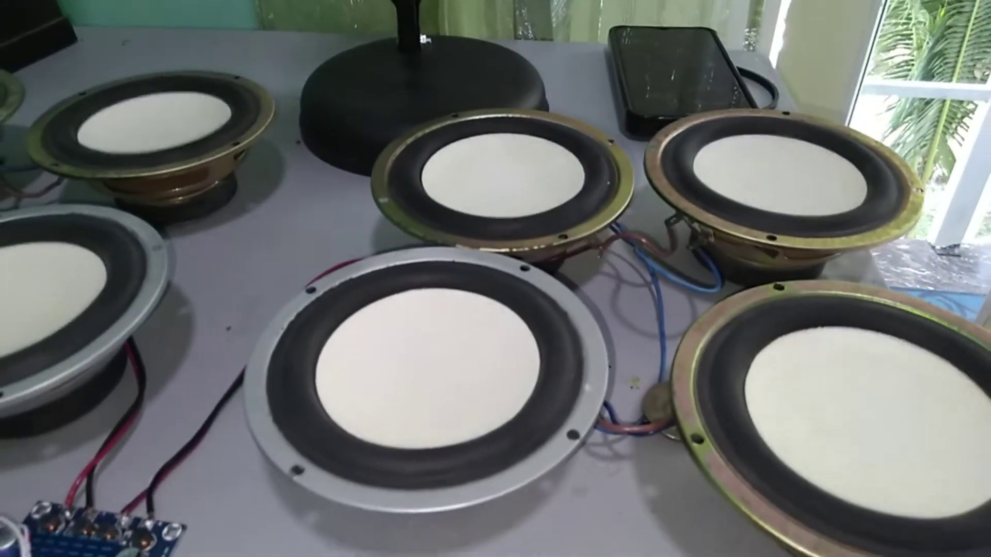 (score 95.0000)
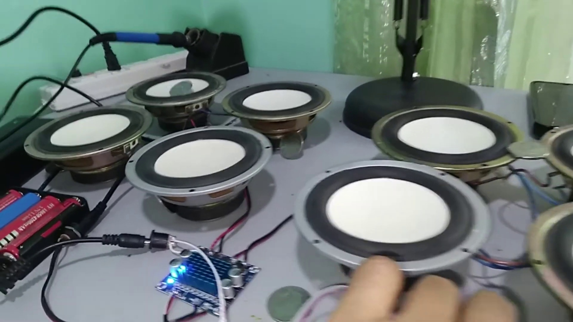 (score 95.0000)
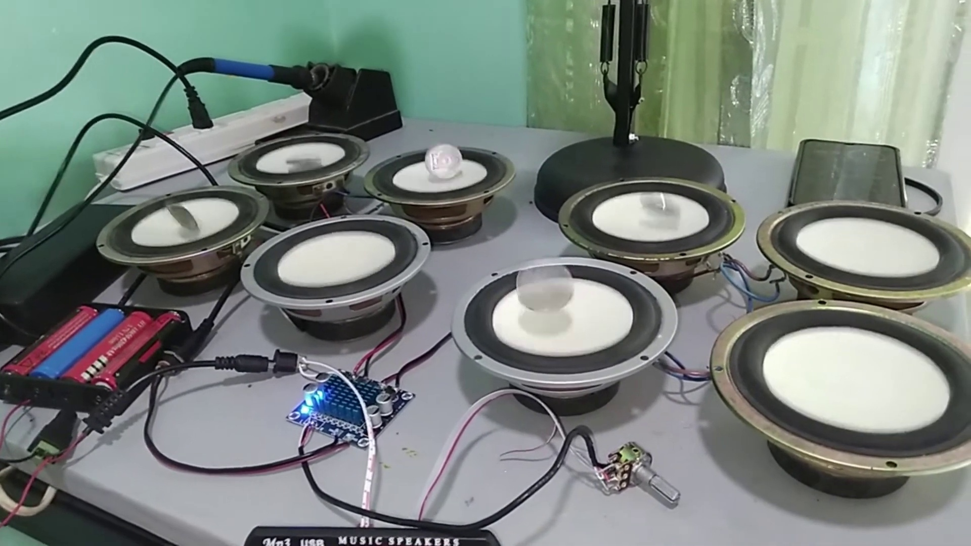 (score 95.0000)
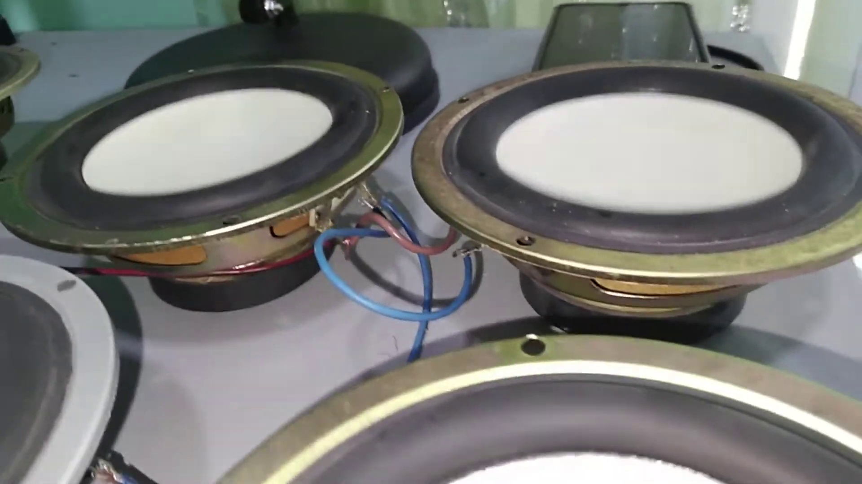 (score 95.0000)
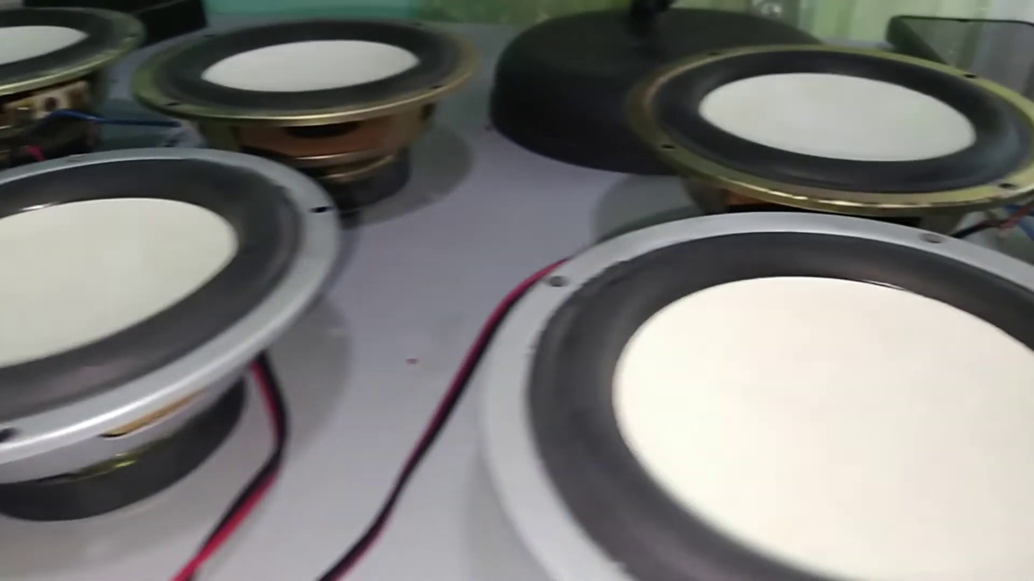 (score 95.0000)
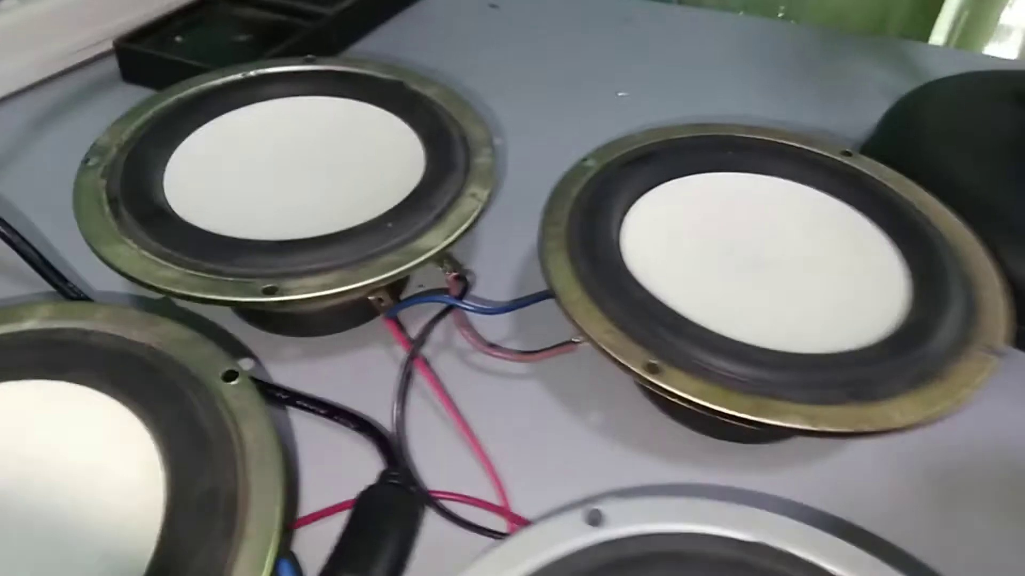 (score 95.0000)
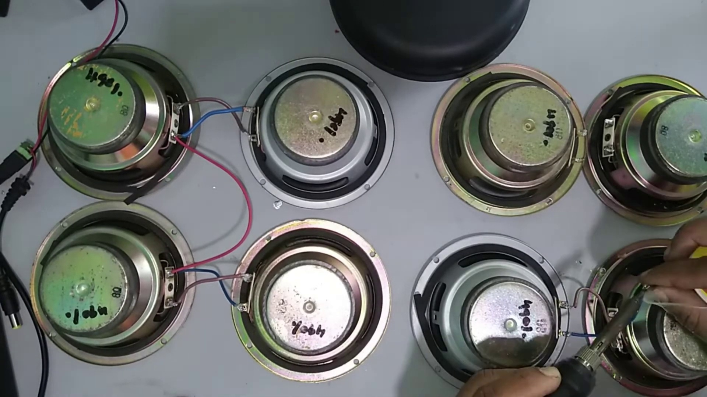 (score 95.0000)
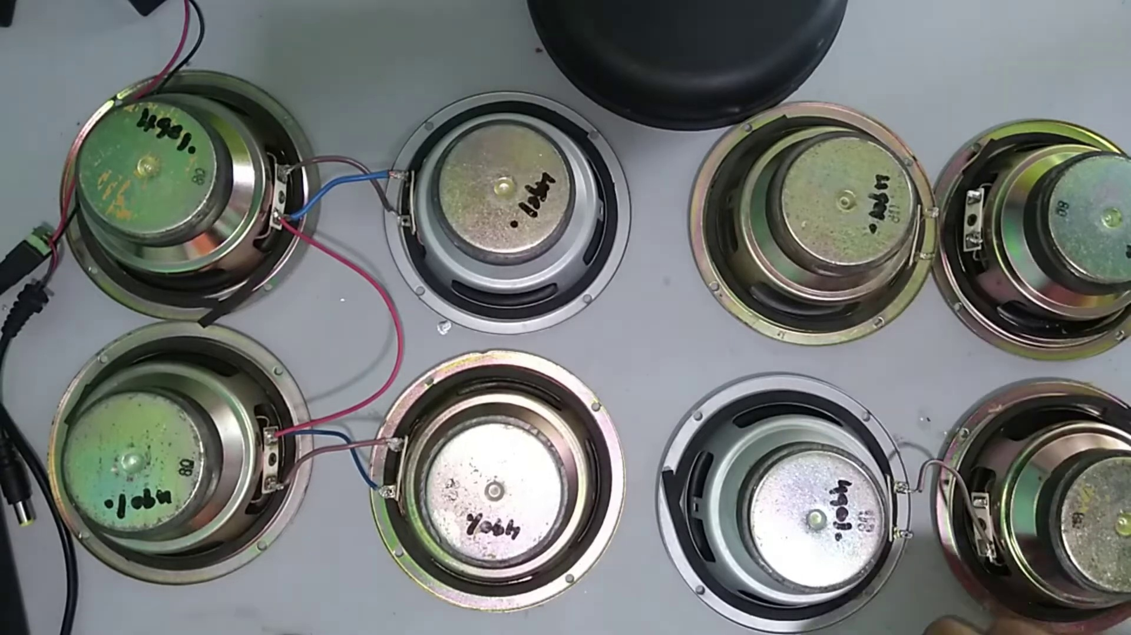 (score 95.0000)
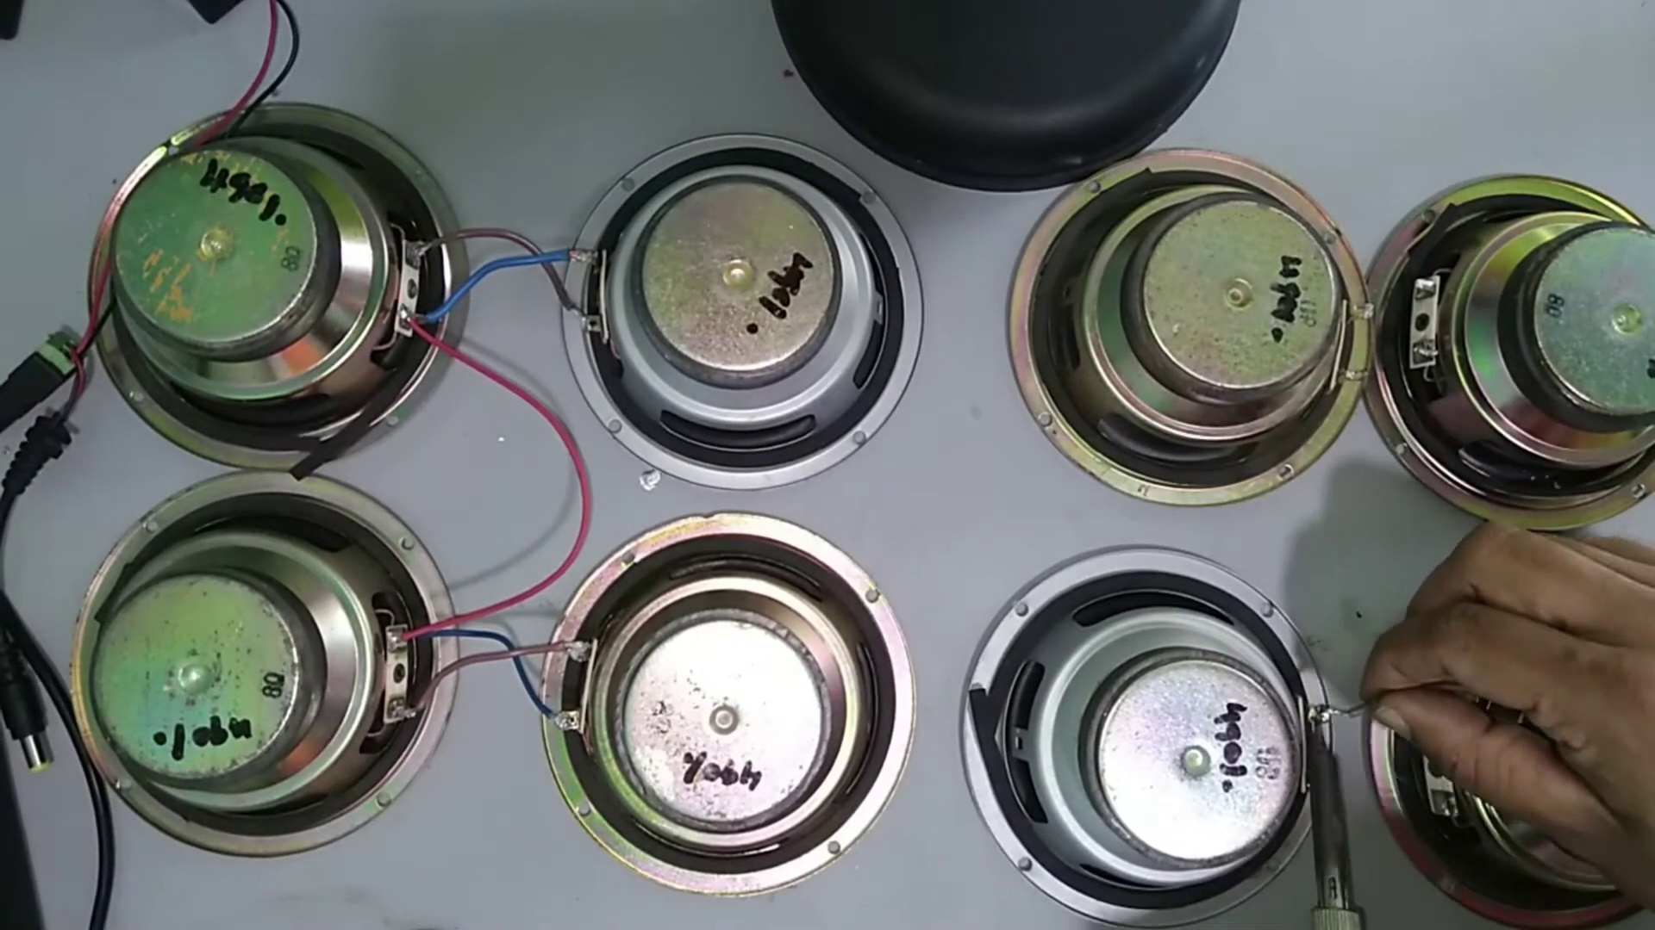 (score 95.0000)
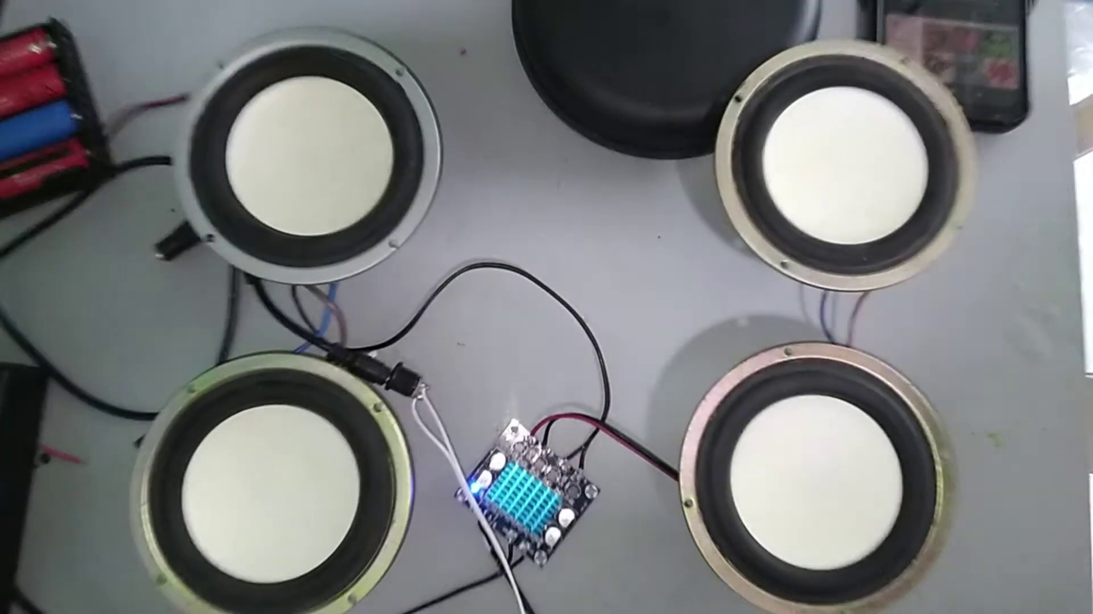 (score 95.0000)
Least correlated frames:
 (score 0.0000)
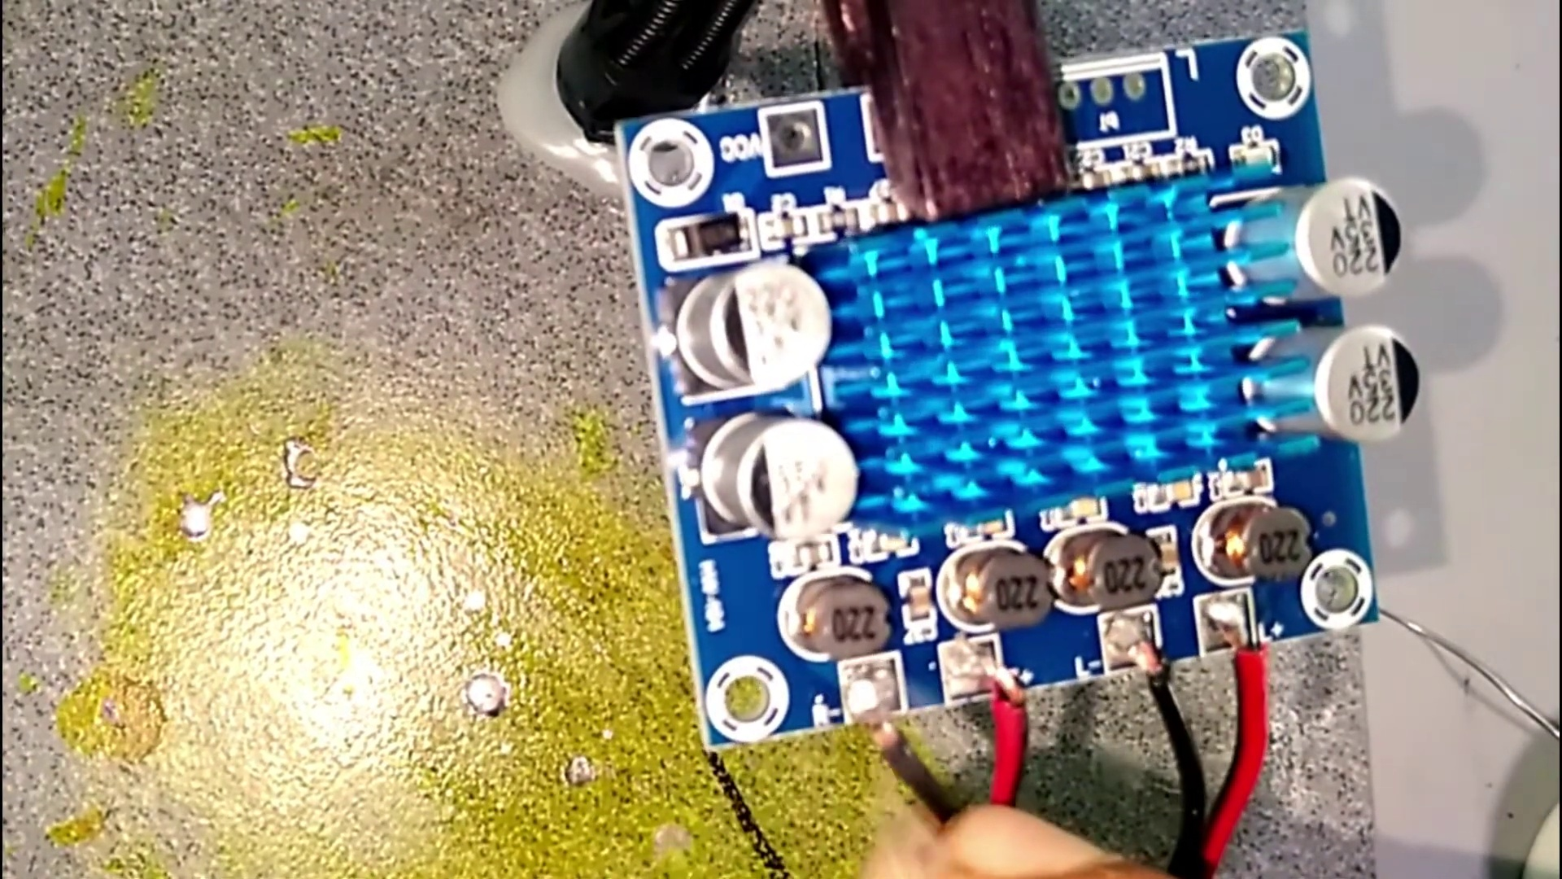 (score 5.0000)
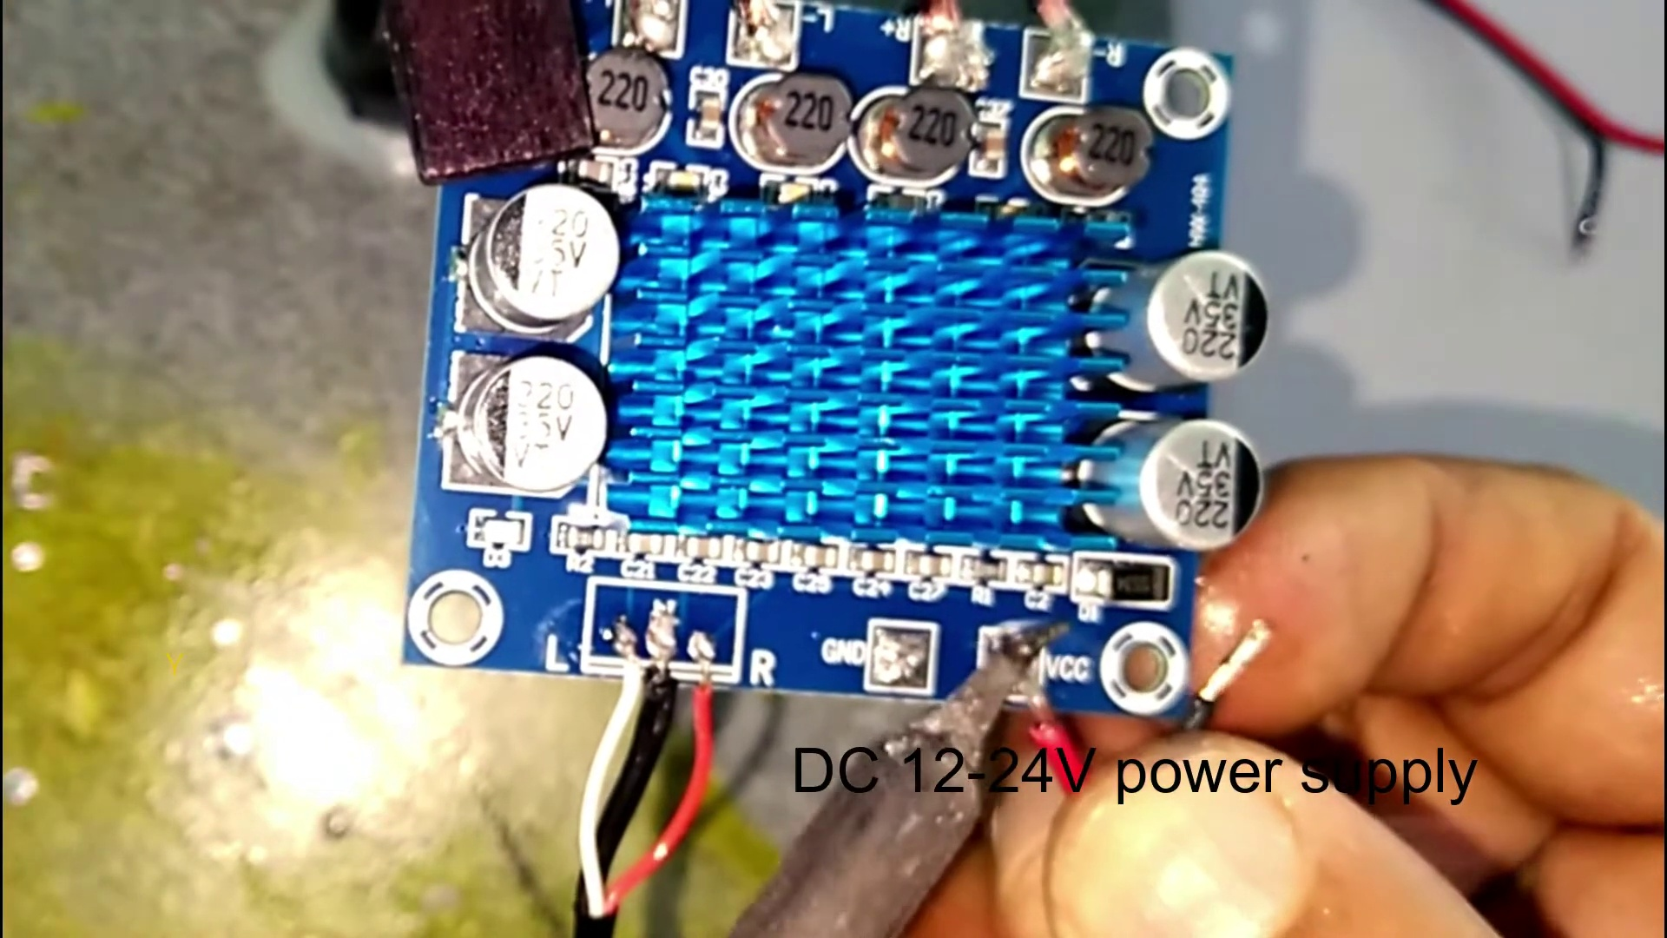 (score 5.0000)
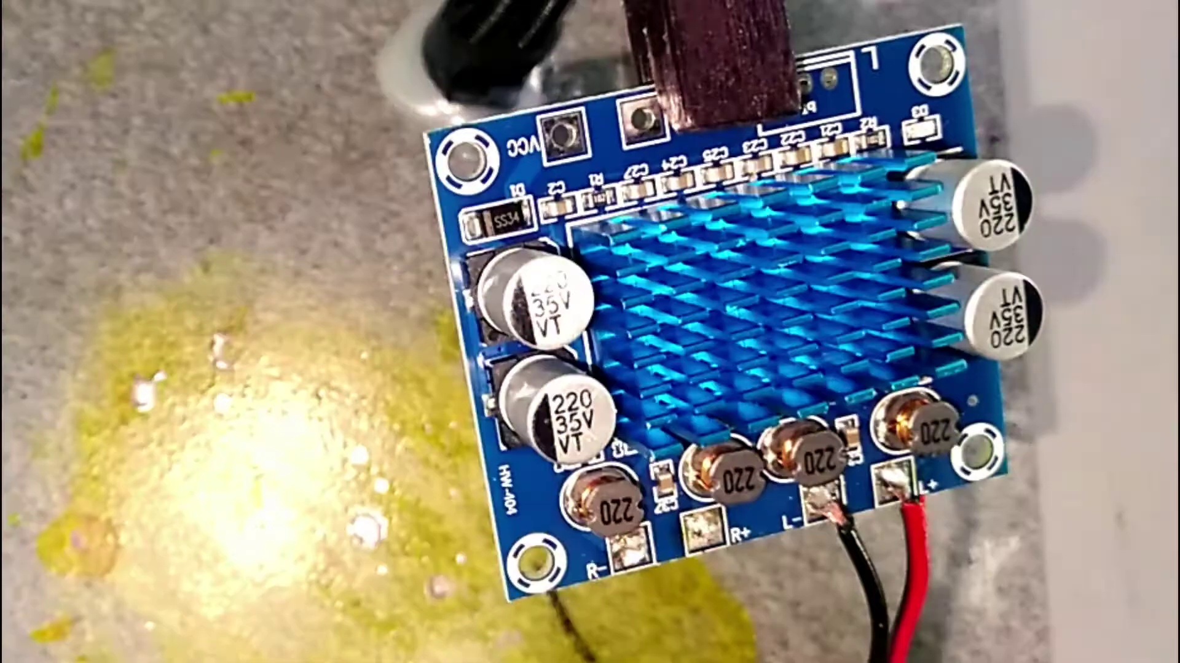 (score 10.0000)
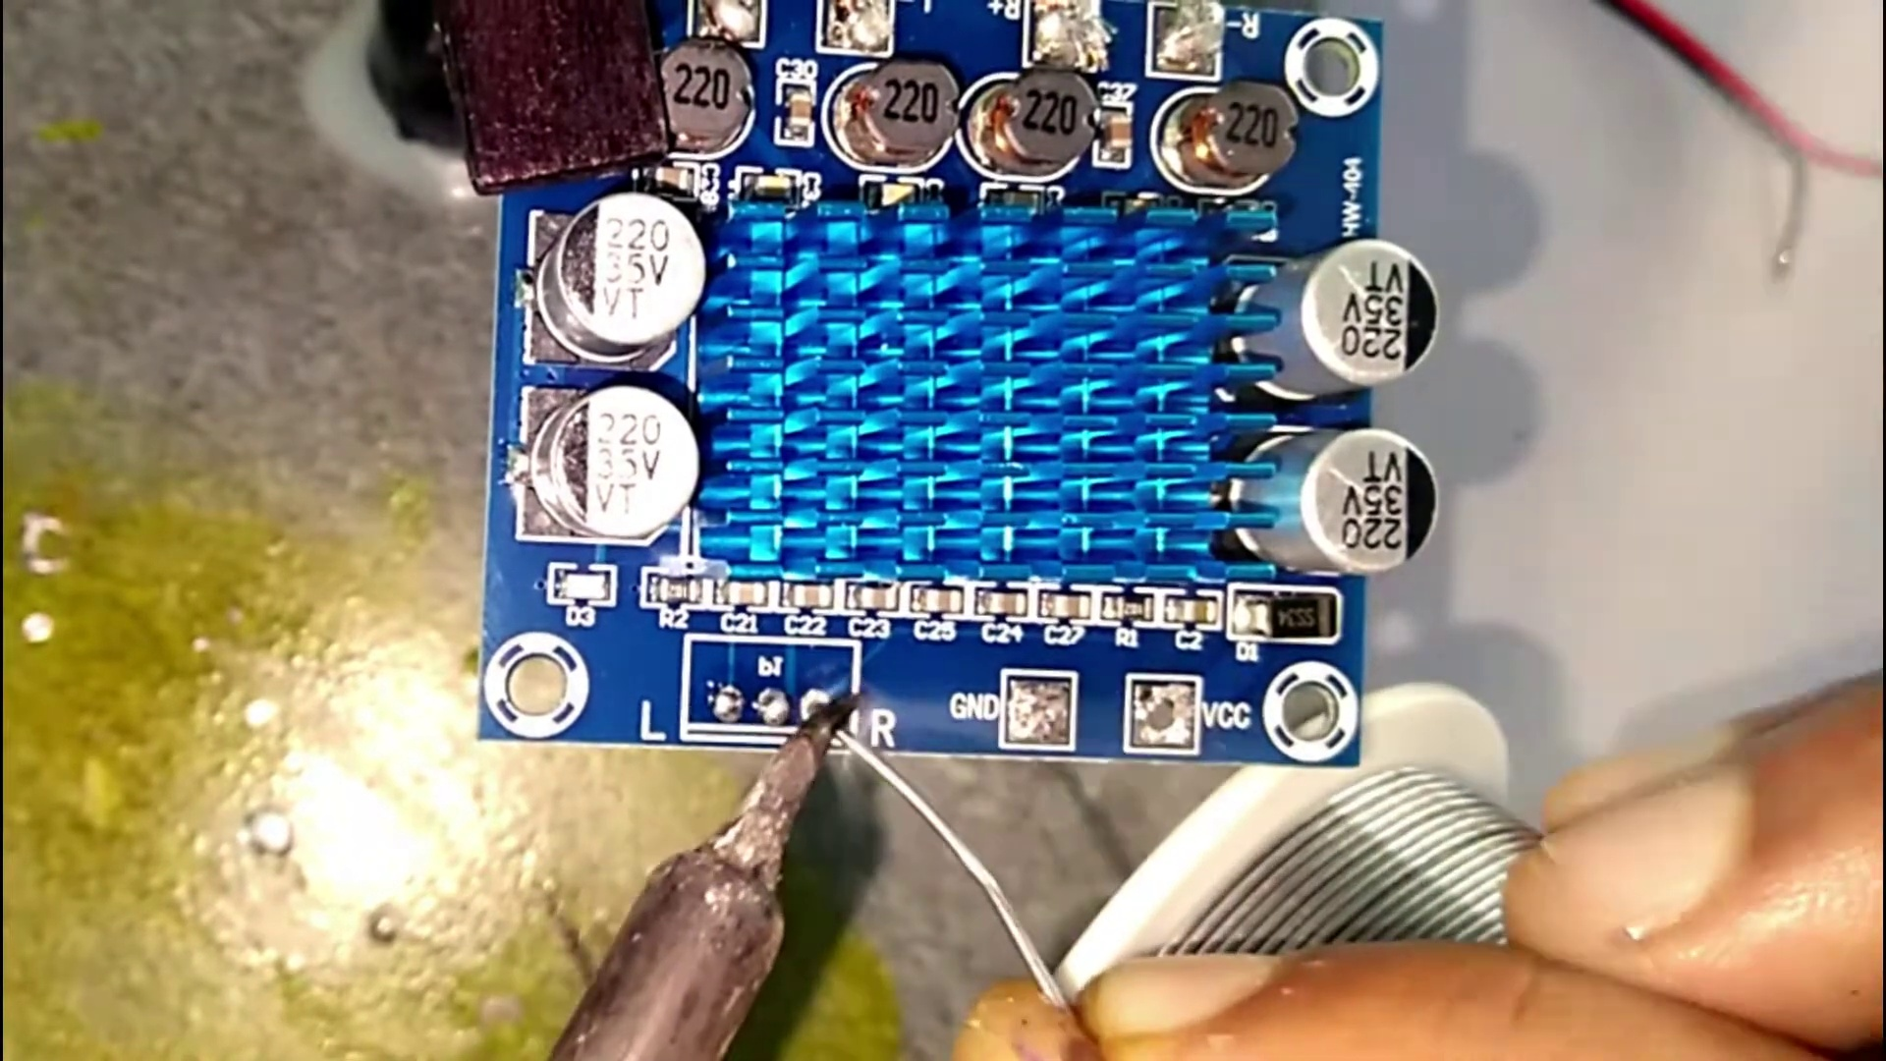 (score 10.0000)
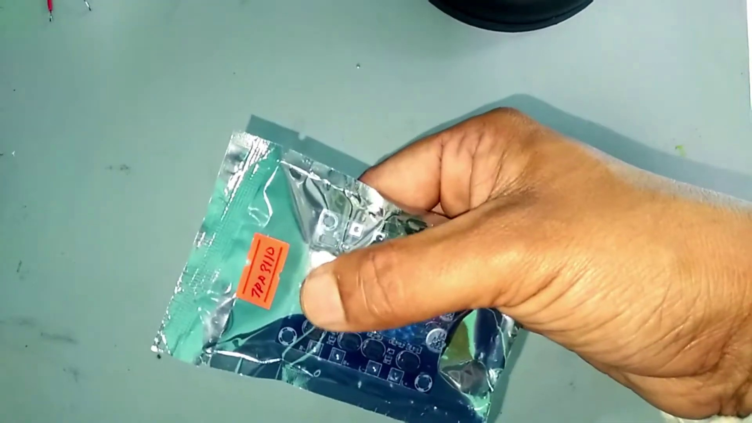 (score 20.0000)
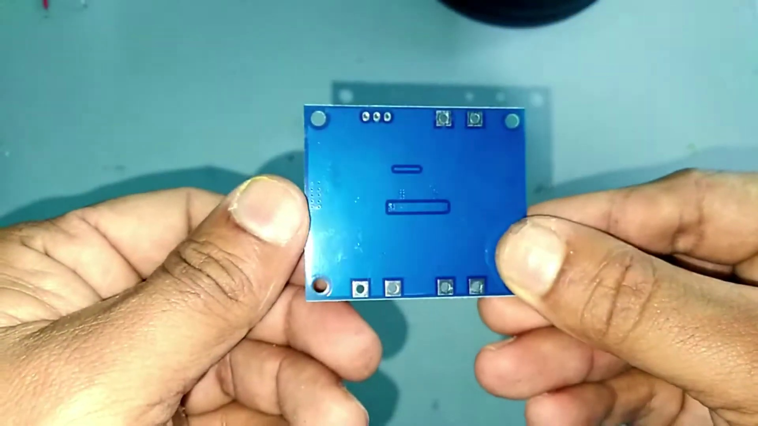 (score 20.0000)
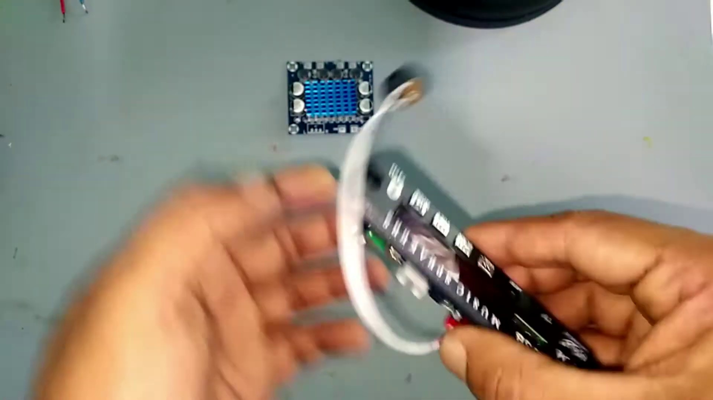 (score 20.0000)
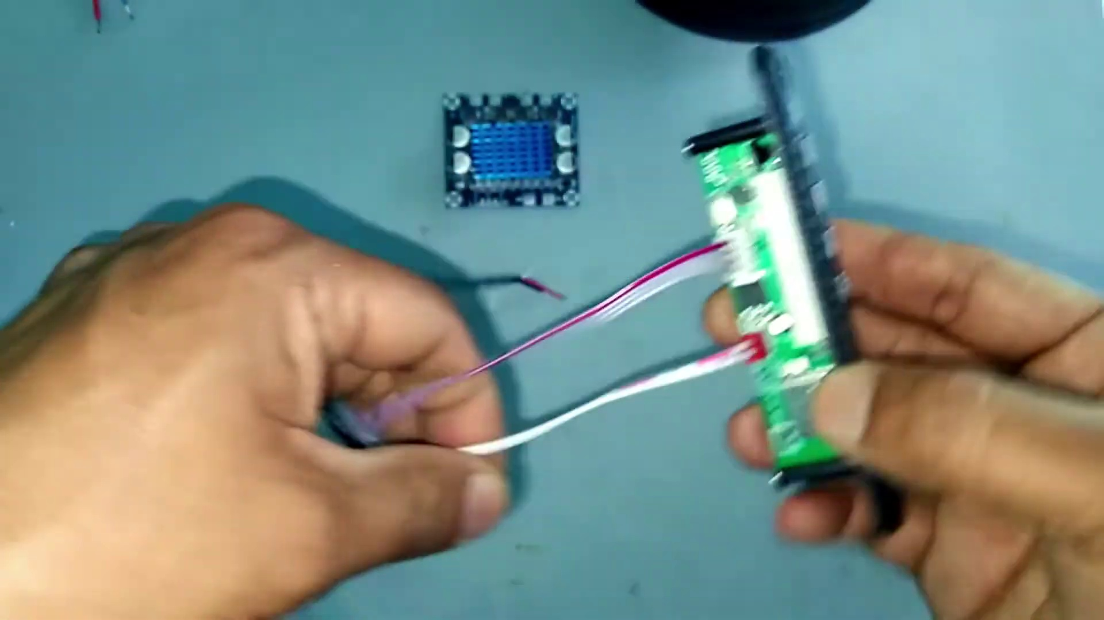 (score 20.0000)
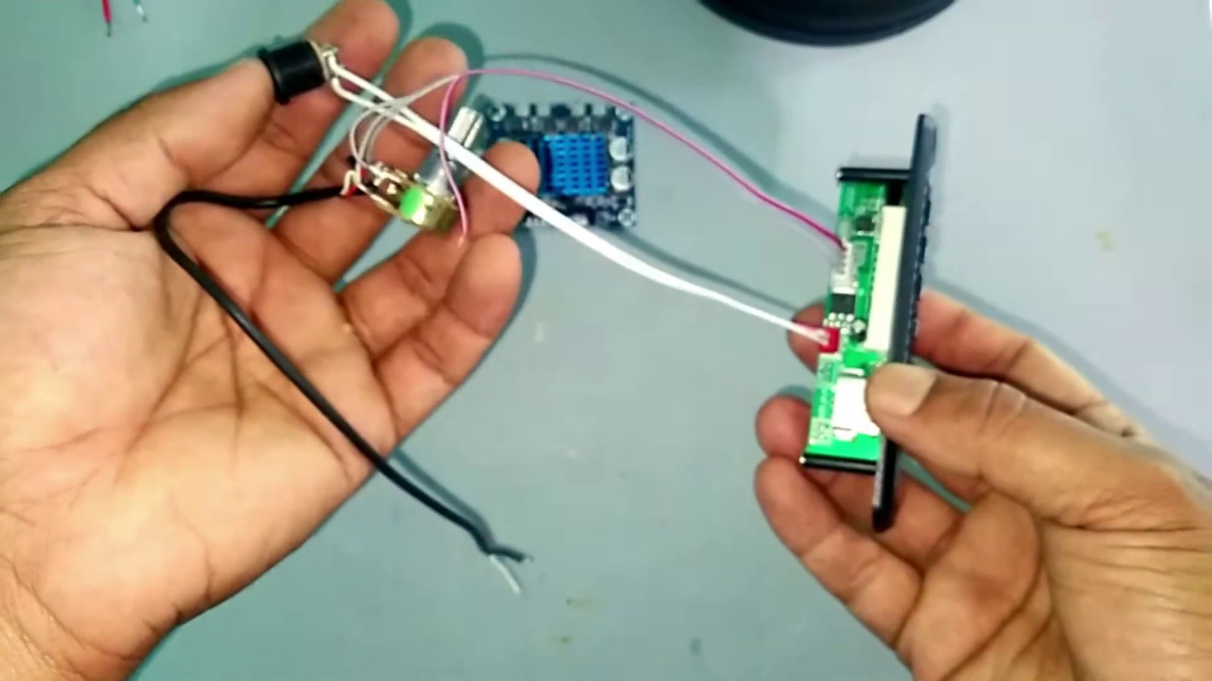 (score 20.0000)

Frame: frame_0000.jpg
Caption: The image displays a simple gray gradient background with two black rectangles placed in the center. There is no text, people, devices, or other visual content that would indicate an instructional context. The focus appears to be on the layout of the rectangles and their position relative to each other within the frame. In contrast, the subject matter depicted in the figure shows aromatic amides, a type of amide in which one or both of the amide functional groups are attached to an aromatic ring. The amide functional group is the carbonyl group, C=O, attached to a carbon atom that is bonded to a nitrogen atom.
No strongly correlated comments found for this frame.

Frame: frame_0001.jpg
Caption: The image depicts a collection of circular objects, potentially speakers or components used in electronic assemblies, arranged on a tabletop. There are six round objects with central holes and rings around them, providing insight into their structure. The background is not clearly defined due to the focus on the items on the table. Alternatively, the image may capture a scene where eight black and silver speakers, each with a white interior, are positioned in a neat row on a white table, creating symmetry and balance. The speakers' sleek design and polished surfaces stand out against the stark white of the table, while the soft green backdrop adds warmth to the scene.
Comment (score 90): From this video I have learned how to hook up multiple speakers to one amplifier. In the first video I watched it was a video using the TPA3110 amplifier and eight speakers. The video started with two speakers being hooked up and the sound tested. The TPA3110 allows for a left and right speaker. This would definitely be helpful for the set up that Erik and I are trying to do because we have a total of five speakers, two tweeters, two woofers, and a subwoofer. If we could split the two tweeters and two woofers to be a left and a right set for each then it would allow sound to play in stereo instead of mono. The subwoofer would be in mono but that should not be an issue because very rarely is bass recorded in stereo. As the video progresses, he continues to add more speakers. He wired his in parallel I believe but at one point it appeared that he was wiring some of them in series. It was really interesting to see eight speakers hooked up to the same amplifier. It makes me curious if the same could be said of the TDA2030A. I know if we used the headphone jack, we can still do the speakers in stereo because there is a left input and a write input. So, we will just need to put one tweeter and one woofer to the right input and one tweeter and on woofer to the left input, the subwoofer will need to go to both inputs to make it mono. After doing more research on the subwoofer I found out that both sides of the subwoofer needs to be wired in series to itself so this video helped me figure that out. The only confusion I have was whether the speakers were hooked up in series or parallel.
Reason: The comment directly discusses the technical steps of hooking up multiple speakers to one amplifier, mentioning specific details from the caption such as speaker types, connections (series and parallel), and amplifier models. The comment also references the video's content, highlighting its relevance to the viewer's setup.
Source: https://www.youtube.com/watch?v=sHwSIcIdeDI : Class d amplifier sound test | TPA 3110 bass test

Frame: frame_0002.jpg
Caption: The image shows an arrangement of eight black speaker cones arranged in a circular pattern on a white surface, each equipped with a black wire connected to a white box positioned to the right. The surrounding environment suggests a workshop or home electronics setup. A caption overlays the top left corner, reading "I'm going to use 8 speakers for TPA3 100 module." Each speaker cone has a black cone and a tan surround, with visible brand logos indicating they are likely from a particular manufacturer.
Comment (score 85): From this video I have learned how to hook up multiple speakers to one amplifier. In the first video I watched it was a video using the TPA3110 amplifier and eight speakers. The video started with two speakers being hooked up and the sound tested. The TPA3110 allows for a left and right speaker. This would definitely be helpful for the set up that Erik and I are trying to do because we have a total of five speakers, two tweeters, two woofers, and a subwoofer. If we could split the two tweeters and two woofers to be a left and a right set for each then it would allow sound to play in stereo instead of mono. The subwoofer would be in mono but that should not be an issue because very rarely is bass recorded in stereo. As the video progresses, he continues to add more speakers. He wired his in parallel I believe but at one point it appeared that he was wiring some of them in series. It was really interesting to see eight speakers hooked up to the same amplifier. It makes me curious if the same could be said of the TDA2030A. I know if we used the headphone jack, we can still do the speakers in stereo because there is a left input and a write input. So, we will just need to put one tweeter and one woofer to the right input and one tweeter and on woofer to the left input, the subwoofer will need to go to both inputs to make it mono. After doing more research on the subwoofer I found out that both sides of the subwoofer needs to be wired in series to itself so this video helped me figure that out. The only confusion I have was whether the speakers were hooked up in series or parallel.
Reason: The comment directly discusses the same technical steps, objects (speakers), settings (amplifier), and goals (splitting speakers to achieve stereo sound) described in the caption. The commenter mentions specific speaker types (Tweeters, Woofers, Subwoofer), amplifier modules (TPA3110, TPA3 100), and wiring configurations (series, parallel). The correlation is strong because the comment provides detailed information about the setup and troubleshooting process, which is closely related to the caption.
Source: https://www.youtube.com/watch?v=sHwSIcIdeDI : Class d amplifier sound test | TPA 3110 bass test

Frame: frame_0003.jpg
Caption: The image shows a hand holding a small electronic device with several components visible, including a printed circuit board (PCB) and a battery. It appears to be a step-by-step assembly process for creating an electronic device, possibly a DIY kit or a project in an educational setting. The person's hand is seen from the side, holding the device against a surface, and it seems they are either assembling the device or demonstrating its components.
The image itself is overlaid with another photo, creating a composite effect where the top part of the image shows what appears to be an instructional slide or diagram, although the full content is not clearly visible due to the overlay effect. The bottom part of the image focuses on the device in hand and does not contain any text or graphical elements that are easily readable.
In contrast, the top portion of the image contains a silver plastic bag filled with a substance, which is held by the same hand from the side. The bag has a label attached to it, reading "KAL" in blue letters on the top right side. The background of this section of the image is light blue, highlighting the silver color of the bag and the hand holding it. There are no additional objects or text present in this part of the image, which appears to be a standalone scene without any contextual information provided.
No strongly correlated comments found for this frame.

Frame: frame_0004.jpg
Caption: The image shows a person's hands manipulating and interacting with a small plastic bag that appears to be predominantly blue with a red tag attached to it, indicating some form of identification or label. The bag is being held in the palm of one hand, while the other hand is holding the strap of the bag. The background of the image is a light blue color, providing a neutral backdrop that allows the objects in the foreground to stand out. In the same frame, a person's hands are also manipulating a small object, which appears to be a toy or figurine, held in their right hand as they seem to be making adjustments or assembling it. The indoor setting, possibly a workspace or home, is visible but out of focus, with no visible texts, diagrams, or other instructional elements that could indicate a teaching context from this single frame.
Comment (score 80): From this video I have learned how to hook up multiple speakers to one amplifier. In the first video I watched it was a video using the TPA3110 amplifier and eight speakers. The video started with two speakers being hooked up and the sound tested. The TPA3110 allows for a left and right speaker. This would definitely be helpful for the set up that Erik and I are trying to do because we have a total of five speakers, two tweeters, two woofers, and a subwoofer. If we could split the two tweeters and two woofers to be a left and a right set for each then it would allow sound to play in stereo instead of mono. The subwoofer would be in mono but that should not be an issue because very rarely is bass recorded in stereo. As the video progresses, he continues to add more speakers. He wired his in parallel I believe but at one point it appeared that he was wiring some of them in series. It was really interesting to see eight speakers hooked up to the same amplifier. It makes me curious if the same could be said of the TDA2030A. I know if we used the headphone jack, we can still do the speakers in stereo because there is a left input and a write input. So, we will just need to put one tweeter and one woofer to the right input and one tweeter and on woofer to the left input, the subwoofer will need to go to both inputs to make it mono. After doing more research on the subwoofer I found out that both sides of the subwoofer needs to be wired in series to itself so this video helped me figure that out. The only confusion I have was whether the speakers were hooked up in series or parallel.
Reason: The comment directly discusses the technical steps described in the caption, specifically the manipulation of objects and identification of components (e.g. speakers, tweeters, woofers), which are mentioned in the caption as being held or manipulated by hands.
Source: https://www.youtube.com/watch?v=sHwSIcIdeDI : Class d amplifier sound test | TPA 3110 bass test

Frame: frame_0005.jpg
Caption: The image shows a person's hands holding up a small electronic device. The device is blue and has a rectangular shape, equipped with two silver connectors and a small speaker. The hands are positioned on the left side of the device, with one hand gripping it from the bottom and the other from the top. The device appears to be a printed circuit board (PCB) or a circuit board, given its layout of components that look like surface-mounted devices (SMDs). The person is positioned from the waist down, with their hands manipulating the PCB.
The device has various electronic components such as resistors and possibly capacitors, visible on the green solder mask background. Traces connecting these components are also visible. The circuit design is visible, but due to the angle and distance of the photograph, it's challenging to provide specific details about the layout or functionality of the circuit.
The image does not contain any text, and there are no visible signs of teaching or presentation aids like slides or diagrams that could provide additional context for an educational setting. The focus of the image is on the electronic device and the person handling it, with a white surface providing a neutral background.
No strongly correlated comments found for this frame.

Frame: frame_0006.jpg
Caption: The image shows a person's hand holding an electronic component, specifically a blue and silver circuit board labeled "TPA3110X" (or possibly "TPA3210", as indicated by the text at the top of the image). The board is a 30W amplifier module designed to power audio equipment. It appears to be secured to a black base with a white power connector, indicating that it is ready to be connected to an external power source. The person's hand is firmly gripping the board, suggesting that they are in the process of assembling or testing the module.
The background is blurred, focusing the viewer's attention on the circuit board and the person's hand. At the top of the image, there is text that reads "TPA3210 500W AMP" (or possibly "TPA3110X"), which suggests that this is an amplifier capable of handling up to 500 watts. Below this text, another phrase "Module Wiring Module" provides a label or description related to the component being held.
The overall setting appears to be informal, possibly an educational context where someone is showing how these modules work or are assembled. There is no clear indication of a teaching session or a slide in this image, suggesting that it may be a snapshot of a moment in the process of building or testing a 30W amplifier module.
Comment (score 90): From this video I have learned how to hook up multiple speakers to one amplifier. In the first video I watched it was a video using the TPA3110 amplifier and eight speakers. The video started with two speakers being hooked up and the sound tested. The TPA3110 allows for a left and right speaker. This would definitely be helpful for the set up that Erik and I are trying to do because we have a total of five speakers, two tweeters, two woofers, and a subwoofer. If we could split the two tweeters and two woofers to be a left and a right set for each then it would allow sound to play in stereo instead of mono. The subwoofer would be in mono but that should not be an issue because very rarely is bass recorded in stereo. As the video progresses, he continues to add more speakers. He wired his in parallel I believe but at one point it appeared that he was wiring some of them in series. It was really interesting to see eight speakers hooked up to the same amplifier. It makes me curious if the same could be said of the TDA2030A. I know if we used the headphone jack, we can still do the speakers in stereo because there is a left input and a write input. So, we will just need to put one tweeter and one woofer to the right input and one tweeter and on woofer to the left input, the subwoofer will need to go to both inputs to make it mono. After doing more research on the subwoofer I found out that both sides of the subwoofer needs to be wired in series to itself so this video helped me figure that out. The only confusion I have was whether the speakers were hooked up in series or parallel.
Reason: The comment directly discusses the assembly and wiring of multiple speakers to an amplifier, specifically mentioning the TPA3110X module, which is also described in the frame caption. The commenter's experience with the video and its application to their own setup is closely related to the technical details presented in the caption.
Source: https://www.youtube.com/watch?v=sHwSIcIdeDI : Class d amplifier sound test | TPA 3110 bass test

Frame: frame_0007.jpg
Caption: The image shows two hands holding a small blue circuit board against a green surface. The individual's arms are not visible above the elbows; only their hands and forearms are shown. They appear to be working with electronic components, possibly assembling or inspecting the printed circuit board (PCB). The PCB has multiple components mounted on it, including resistors, capacitors, and integrated circuits.
The person is using a magnifying glass to closely examine the details of the circuit board, possibly for quality control or to identify specific parts of the circuit. The blue PCB features a grid of small holes and a single large hole, evenly spaced across the board, suggesting they are used for electrical connections. The hands holding the board are facing towards the camera, allowing us to see the details of the board and the hands.
There is no visible text or diagrams that provide additional context about the project or the individual's role in it. The focus of the image is on the hands holding the PCB and the act of examining electronic components under a magnifying glass, which suggests a setting related to electronics assembly, testing, or repair.
No strongly correlated comments found for this frame.

Frame: frame_0008.jpg
Caption: The image captures a moment where a person's hands are engaged in an activity with electronic components. On the left side of the frame, the hand holding a small device appears to be a microcontroller or programmable circuit board (PCB), connected to a ribbon cable associated with some form of expansion module or accessory for the main board. The right hand holds a clear plastic casing that might be used to house the electronics and protect them from dust or damage.
In the foreground, one of the hands is holding a black phone in front of a blue circuit board placed on a white table. The phone's silver buttons and screen are facing the camera, with the hands visible as they seem to be in the process of interacting with the phone. The background is blurred, drawing focus to the phone and the circuit board.
The overall scene suggests an activity involving the assembly or testing of the phone, possibly in an educational or DIY setting related to electronics and circuit assembly, where the person's hands are engaging with the electronic components, including the microcontroller/PCB and the phone.
No strongly correlated comments found for this frame.

Frame: frame_0009.jpg
Caption: The image captures a moment of electronic tinkering as a person's hands work with various components and tools. From a low angle, looking up at the person, their hands are visible, holding wires, resistors, LED lights, and other small parts. The soldering iron on the left side of their hands suggests that they are in the process of assembling or repairing an electronic device. The focus is solely on the hands and tools involved in the work, with no indication of teaching, writing, pointing, or speaking.
In a separate moment, the same person's hands hold a small black Bluetooth FM kit, equipped with a speaker and a microphone. Their fingers grip the device firmly, indicating a sense of familiarity and control. The blurred background draws attention to the person and the kit, suggesting a moment of interaction, possibly in the process of setting it up or using it for the first time.
Comment (score 85): From this video I have learned how to hook up multiple speakers to one amplifier. In the first video I watched it was a video using the TPA3110 amplifier and eight speakers. The video started with two speakers being hooked up and the sound tested. The TPA3110 allows for a left and right speaker. This would definitely be helpful for the set up that Erik and I are trying to do because we have a total of five speakers, two tweeters, two woofers, and a subwoofer. If we could split the two tweeters and two woofers to be a left and a right set for each then it would allow sound to play in stereo instead of mono. The subwoofer would be in mono but that should not be an issue because very rarely is bass recorded in stereo. As the video progresses, he continues to add more speakers. He wired his in parallel I believe but at one point it appeared that he was wiring some of them in series. It was really interesting to see eight speakers hooked up to the same amplifier. It makes me curious if the same could be said of the TDA2030A. I know if we used the headphone jack, we can still do the speakers in stereo because there is a left input and a write input. So, we will just need to put one tweeter and one woofer to the right input and one tweeter and on woofer to the left input, the subwoofer will need to go to both inputs to make it mono. After doing more research on the subwoofer I found out that both sides of the subwoofer needs to be wired in series to itself so this video helped me figure that out. The only confusion I have was whether the speakers were hooked up in series or parallel.
Reason: The comment directly discusses the technical steps of hooking up multiple speakers to an amplifier, mentioning specific components (TPA3110, TDA2030A) and settings (left and right speaker configuration). The caption shows a person working with electronic components and tools, which is strongly related to the discussion in the comment.
Source: https://www.youtube.com/watch?v=sHwSIcIdeDI : Class d amplifier sound test | TPA 3110 bass test

Frame: frame_0010.jpg
Caption: The image captures a moment of a person meticulously examining and interacting with an electronic device that appears to be a circuit board or module with various components, such as a microcontroller and possibly other integrated circuits or connectors. The device is connected to a cable, suggesting it might be in operation, undergoing testing, or being troubleshooted. The person's hands are visible, actively involved in the process of examining and potentially modifying the circuit board.
The scene takes place in an indoor setting, likely a workspace or lab for electronics or computer repair, as suggested by the blurred background. The focus of the image is on the hands-on interaction with the electronic component rather than any textual or graphical content that might be part of a teaching situation.
No strongly correlated comments found for this frame.

Frame: frame_0011.jpg
Caption: The image shows a hand holding up a small electronic device with various components and wires attached to it. The device appears to be an example of a DIY electronics project or hobby, possibly being demonstrated or taught about in an educational setting. In the foreground, the hand is holding the device for better visibility, while in the background, there are some indistinct objects that could be electronic parts or tools. On the right side of the device, a green circuit board is visible, with various components and wires connected to it, suggesting that it's in the early stages of being assembled.
In contrast to the device, which appears to be an educational example, the focus on the circuit board suggests a possible repair or assembly process, possibly involving the phone placed on a gray surface. The relative positions of the objects - the phone on the gray surface and the circuit board on the right side of it - indicate that the phone is being worked on, with the circuit board being the primary focus of the repair or assembly process.
Comment (score 85): From this video I have learned how to hook up multiple speakers to one amplifier. In the first video I watched it was a video using the TPA3110 amplifier and eight speakers. The video started with two speakers being hooked up and the sound tested. The TPA3110 allows for a left and right speaker. This would definitely be helpful for the set up that Erik and I are trying to do because we have a total of five speakers, two tweeters, two woofers, and a subwoofer. If we could split the two tweeters and two woofers to be a left and a right set for each then it would allow sound to play in stereo instead of mono. The subwoofer would be in mono but that should not be an issue because very rarely is bass recorded in stereo. As the video progresses, he continues to add more speakers. He wired his in parallel I believe but at one point it appeared that he was wiring some of them in series. It was really interesting to see eight speakers hooked up to the same amplifier. It makes me curious if the same could be said of the TDA2030A. I know if we used the headphone jack, we can still do the speakers in stereo because there is a left input and a write input. So, we will just need to put one tweeter and one woofer to the right input and one tweeter and on woofer to the left input, the subwoofer will need to go to both inputs to make it mono. After doing more research on the subwoofer I found out that both sides of the subwoofer needs to be wired in series to itself so this video helped me figure that out. The only confusion I have was whether the speakers were hooked up in series or parallel.
Reason: The comment directly discusses the same technical steps described in the caption, specifically the process of hooking up multiple speakers to an amplifier and the wiring configurations used.
Source: https://www.youtube.com/watch?v=sHwSIcIdeDI : Class d amplifier sound test | TPA 3110 bass test

Frame: frame_0012.jpg
Caption: The image shows a hands-on activity with two individuals working on an electronic circuit board or printed circuit board (PCB). One person is holding the board, guiding or assisting the other person in attaching a component, possibly a resistor, to the board. The setting appears informal and possibly educational, as suggested by the presence of a microcontroller chip, similar in shape and pin layout to an Arduino board, being held up for inspection. A breadboard is also visible, often used in electronics projects for prototyping.
The focus of the image is on the hands-on activity, with no visible text or diagrams providing additional context or instructional content. The individuals' hands are carefully handling wires and components around the circuit board, indicating a delicate task. The green circuit board stands out against the white surface it's placed on, while in the background, there's a small blue object possibly related to the circuit board or a tool used in the process.
Note: I've retained all accurate and relevant details from both original captions, avoiding redundancy, contradictions, and speculation.
No strongly correlated comments found for this frame.

Frame: frame_0013.jpg
Caption: The image shows a person engaged in electronics assembly or troubleshooting, as their hands hold two small electronic components. One hand grasps a small circuit board with electronic components attached and visible wires and screws, suggesting a process of component connection or problem-solving. The other hand holds another component, possibly a microcontroller board due to its recognizable form factor, which is likely an Arduino. The components appear to be in the process of being connected together, as wires are seen being manipulated by the person's fingers.
The background of the image is a light blue color, providing a contrast to the black wires and the green board.
No strongly correlated comments found for this frame.

Frame: frame_0014.jpg
Caption: The image shows an individual's hand with a soldering iron, suggesting they are engaged in an electronics repair or modification process. The object being worked on appears to be a printed circuit board (PCB) with various electronic components visible, including integrated circuits and capacitors. The PCB has multiple resistors, labeled as 220V, three capacitors, two of which are also labeled as 220V, and one unlabeled, along with two diodes, both labeled as 220V. Additionally, there are three wires present, one of which is also labeled as 220V. The overall layout suggests a complex electronic circuit, possibly for power distribution or regulation. The background appears to be an indoor setting with artificial lighting, possibly a workspace dedicated to electronics hobbyist activities or a small-scale repair shop.
No strongly correlated comments found for this frame.

Frame: frame_0015.jpg
Caption: The image displays a close-up view of a person's hands working with an electronic device, specifically a breadboard, which appears to be a speaker output board. The board is adorned with several components, including resistors and capacitors, meticulously arranged in a grid-like pattern. Predominantly white and black resistors are visible, while mostly white and blue capacitors also appear on the board. A potentiometer, a black device with a knob, is located towards the center of the board. The scene suggests an active DIY project or demonstration, possibly related to assembling a speaker.
The focus is on the hands that are manipulating the components on the breadboard, indicating an action shot that captures the process or a step in the project or demonstration. The setting appears to be indoors with artificial lighting, and various tools like a screwdriver and possibly some wires are visible around the breadboard. The image does not contain any discernible text, but it may include "Speaker out puts" as seen in the background.
Overall, the image seems to be from a tutorial or educational context, with the person demonstrating how to use electronic components for audio output purposes.
Comment (score 80): From this video I have learned how to hook up multiple speakers to one amplifier. In the first video I watched it was a video using the TPA3110 amplifier and eight speakers. The video started with two speakers being hooked up and the sound tested. The TPA3110 allows for a left and right speaker. This would definitely be helpful for the set up that Erik and I are trying to do because we have a total of five speakers, two tweeters, two woofers, and a subwoofer. If we could split the two tweeters and two woofers to be a left and a right set for each then it would allow sound to play in stereo instead of mono. The subwoofer would be in mono but that should not be an issue because very rarely is bass recorded in stereo. As the video progresses, he continues to add more speakers. He wired his in parallel I believe but at one point it appeared that he was wiring some of them in series. It was really interesting to see eight speakers hooked up to the same amplifier. It makes me curious if the same could be said of the TDA2030A. I know if we used the headphone jack, we can still do the speakers in stereo because there is a left input and a write input. So, we will just need to put one tweeter and one woofer to the right input and one tweeter and on woofer to the left input, the subwoofer will need to go to both inputs to make it mono. After doing more research on the subwoofer I found out that both sides of the subwoofer needs to be wired in series to itself so this video helped me figure that out. The only confusion I have was whether the speakers were hooked up in series or parallel.
Reason: The comment directly discusses the technical steps and components described in the caption, specifically mentioning the TPA3110 amplifier, speaker setup, and wiring configurations. While it does not quote the caption verbatim, the connection between the comment and caption is strong due to the shared focus on electronics and audio output.
Source: https://www.youtube.com/watch?v=sHwSIcIdeDI : Class d amplifier sound test | TPA 3110 bass test

Frame: frame_0016.jpg
Caption: The image shows a person working with electronic equipment, specifically handling an electronic device connected to a computer via a USB cable. The device has multiple components, including a blue circuit board with various capacitors and resistors visible on its surface. Small cylindrical components resembling electromagnetic coils or transformers are also connected to the board.
The individual's hands are visible as they manipulate the device, possibly adjusting a connection or setting up the device for use. The background is not clearly distinguishable, but it appears to be an indoor environment with a muted color palette that does not distract from the main subject of the image: the electronic components themselves.
A close-up view of the circuit board reveals its predominantly blue surface with white and black accents. The top of the board is adorned with a series of small electronic components, including resistors, capacitors, and diodes, which are essential for the proper functioning of the board. A small black plastic connector holds the board in place, indicating that it is being handled with care and precision by the person's hand.
The overall scene suggests an ongoing process of circuit assembly or repair, with the relative position of the components on the board suggesting a well-organized and carefully designed circuit.
Comment (score 85): From this video I have learned how to hook up multiple speakers to one amplifier. In the first video I watched it was a video using the TPA3110 amplifier and eight speakers. The video started with two speakers being hooked up and the sound tested. The TPA3110 allows for a left and right speaker. This would definitely be helpful for the set up that Erik and I are trying to do because we have a total of five speakers, two tweeters, two woofers, and a subwoofer. If we could split the two tweeters and two woofers to be a left and a right set for each then it would allow sound to play in stereo instead of mono. The subwoofer would be in mono but that should not be an issue because very rarely is bass recorded in stereo. As the video progresses, he continues to add more speakers. He wired his in parallel I believe but at one point it appeared that he was wiring some of them in series. It was really interesting to see eight speakers hooked up to the same amplifier. It makes me curious if the same could be said of the TDA2030A. I know if we used the headphone jack, we can still do the speakers in stereo because there is a left input and a write input. So, we will just need to put one tweeter and one woofer to the right input and one tweeter and on woofer to the left input, the subwoofer will need to go to both inputs to make it mono. After doing more research on the subwoofer I found out that both sides of the subwoofer needs to be wired in series to itself so this video helped me figure that out. The only confusion I have was whether the speakers were hooked up in series or parallel.
Reason: The comment directly discusses the technical steps and components described in the caption, specifically mentioning electronic devices, amplifiers, speakers, and wiring configurations. The comment also references similar situations and setups as the one depicted in the image, showing a strong connection between the caption and the comment.
Source: https://www.youtube.com/watch?v=sHwSIcIdeDI : Class d amplifier sound test | TPA 3110 bass test

Frame: frame_0017.jpg
Caption: The image captures a close-up view of an electronic device with a blue circuit board that appears to have a variety of components mounted on it. The focus is on the device being held, and there are no signs of teaching or instructional context. The circuit board is a mix of blue and white, with the blue elements arranged in a grid-like pattern, a common design choice in electronic circuits. The white elements are scattered across the board, adding to its complexity.
The board is held in place by two silver wires, one of which is bent, suggesting some form of wiring or connection work has been done. The wires are attached to the board, indicating that the board is part of a larger system and possibly being worked on by the person in the background. In the background, a person can be seen, possibly engaged in the same task of wiring or connecting the board.
Overall, the image is a snapshot of a moment in the process of building or repairing a device, where the blue and white elements of the circuit board are the main subjects. The wires, the person, and the board all contribute to the narrative of technology in action, highlighting the importance of human ingenuity and creativity in the world of electronics.
Comment (score 90): From this video I have learned how to hook up multiple speakers to one amplifier. In the first video I watched it was a video using the TPA3110 amplifier and eight speakers. The video started with two speakers being hooked up and the sound tested. The TPA3110 allows for a left and right speaker. This would definitely be helpful for the set up that Erik and I are trying to do because we have a total of five speakers, two tweeters, two woofers, and a subwoofer. If we could split the two tweeters and two woofers to be a left and a right set for each then it would allow sound to play in stereo instead of mono. The subwoofer would be in mono but that should not be an issue because very rarely is bass recorded in stereo. As the video progresses, he continues to add more speakers. He wired his in parallel I believe but at one point it appeared that he was wiring some of them in series. It was really interesting to see eight speakers hooked up to the same amplifier. It makes me curious if the same could be said of the TDA2030A. I know if we used the headphone jack, we can still do the speakers in stereo because there is a left input and a write input. So, we will just need to put one tweeter and one woofer to the right input and one tweeter and on woofer to the left input, the subwoofer will need to go to both inputs to make it mono. After doing more research on the subwoofer I found out that both sides of the subwoofer needs to be wired in series to itself so this video helped me figure that out. The only confusion I have was whether the speakers were hooked up in series or parallel.
Reason: The comment directly discusses the same technical steps and objects described in the caption, specifically the wiring and connection of speakers to an amplifier. The mention of amplifier models (TPA3110 and TDA2030A) and speaker types (tweeters, woofers, and subwoofer) matches the technical focus of the caption.
Source: https://www.youtube.com/watch?v=sHwSIcIdeDI : Class d amplifier sound test | TPA 3110 bass test

Frame: frame_0018.jpg
Caption: This image appears to show a close-up view of an electronic device, possibly a circuit board, being assembled or checked with various components and wires. The device is blue in color and includes several connectors and resistors, which are common elements in electrical circuits. A person's hand is visible on the right side of the frame, suggesting they might be working on or examining the device. The components are arranged in a grid-like pattern, with the wires connecting them, situated on a gray surface that contrasts with the blue of the board. There is no text or instructor present in this image, and the focus is solely on the electronic device and its assembly process. The overall scene suggests a moment of activity, possibly a repair or construction project, but the precise location of the components and wires is not discernible from the image, nor does it provide any additional information about the context or the purpose of the circuit board.
Comment (score 90): From this video I have learned how to hook up multiple speakers to one amplifier. In the first video I watched it was a video using the TPA3110 amplifier and eight speakers. The video started with two speakers being hooked up and the sound tested. The TPA3110 allows for a left and right speaker. This would definitely be helpful for the set up that Erik and I are trying to do because we have a total of five speakers, two tweeters, two woofers, and a subwoofer. If we could split the two tweeters and two woofers to be a left and a right set for each then it would allow sound to play in stereo instead of mono. The subwoofer would be in mono but that should not be an issue because very rarely is bass recorded in stereo. As the video progresses, he continues to add more speakers. He wired his in parallel I believe but at one point it appeared that he was wiring some of them in series. It was really interesting to see eight speakers hooked up to the same amplifier. It makes me curious if the same could be said of the TDA2030A. I know if we used the headphone jack, we can still do the speakers in stereo because there is a left input and a write input. So, we will just need to put one tweeter and one woofer to the right input and one tweeter and on woofer to the left input, the subwoofer will need to go to both inputs to make it mono. After doing more research on the subwoofer I found out that both sides of the subwoofer needs to be wired in series to itself so this video helped me figure that out. The only confusion I have was whether the speakers were hooked up in series or parallel.
Reason: The comment directly discusses the technical steps and objects described in the caption, such as assembling or checking electronic devices, hooking up speakers to an amplifier, and wiring components in series or parallel. The language used in the comment is specific and detailed, matching the level of description found in the caption.
Source: https://www.youtube.com/watch?v=sHwSIcIdeDI : Class d amplifier sound test | TPA 3110 bass test

Frame: frame_0019.jpg
Caption: The image captures a close-up view of a person working with electronic components. The individual appears to be focused on soldering or repairing an electronic device, as evident from the blue circuit board (PCB) and various connectors and components on it. The PCB is likely part of an electronic gadget, such as a mobile phone or some form of electronic equipment.
The person's hands are holding onto what looks like a motherboard or the main processing board of the device they are working on. The PCB has several solder points and connectors that suggest it is meant to be soldered or connected to other parts of the device. In the background, there is a typical workspace for electronics repair or assembly, including a desk with various items such as another electronic device (which could be a charger or power supply) and what appears to be a small screwdriver or tool for handling small parts.
The blue circuit board features several electronic components, including resistors and capacitors. The resistors are scattered across the board, some near the center, while others are located towards the edges. Similarly, the capacitors are distributed throughout the board, some near the top, and others towards the bottom. A few white stickers are also visible near the top left corner of the board.
The overall scene suggests an active electronic workbench, with the circuit board possibly in the process of being assembled or repaired. The focus of the image is on the hands working with the electronic components, emphasizing the physical nature of electronics repair and assembly tasks.
No strongly correlated comments found for this frame.

Frame: frame_0020.jpg
Caption: The image shows a close-up view of an electronic device, likely an SMD (Surface Mount Device) light emitting diode (LED), placed on a surface with various circuit components such as capacitors and resistors. The label on top of the device reads "SMD LED Lamp," suggesting it is part of an electronics project or educational setup. The background is out of focus but suggests an indoor setting, possibly illuminated by yellow lighting or the presence of objects like bananas in the lower right corner. The device features a power supply, indicated by the 12V power connector, and a power button for powering on or off. The circuit components are neatly arranged and labeled, indicating their function within the circuit.
No strongly correlated comments found for this frame.

Frame: frame_0021.jpg
Caption: The image shows a person's hand holding a blue circuit board, which appears to be part of a larger electronic device. The board is adorned with various electronic components, including resistors and capacitors, arranged in a neat row, suggesting a well-organized and functional design. In the foreground, there are visible resistors, a diode, and other electronic components on the board, which may indicate that this is a breadboard-style setup for prototyping electronics.
The person's fingers are firmly gripping the board, indicating that it's being held in place for the assembly process, suggesting that they are in the middle of assembling the electronic device. On the board, there is also a set of screw terminals on one corner, which may indicate that this is a breadboard-style setup for prototyping electronics.
In the foreground, there is text in an Asian language, possibly instructions or labels related to the assembly process or the components being used. The text includes a series of numbers and symbols, which might indicate pin assignments, electrical connections, or other specifications for the setup.
The background is out of focus, but it appears to be a workbench or desk with some tools and possibly more electronic parts, suggesting that this could be an educational environment where someone is teaching electronics assembly or demonstrating a DIY project.
No strongly correlated comments found for this frame.

Frame: frame_0022.jpg
Caption: The image shows a close-up view of an electronic device, specifically a circuit board with various components such as resistors and capacitors. The board is resting on a gray surface, with several red wires connected to different components, including a capacitor and a transistor. On the left side of the frame, there is a small amount of text on a label that reads "CEREMICS," suggesting a possible connection to ceramic materials or ceramic technology. In the bottom right corner, a small object resembling a battery adds context to the scene's focus on electronics.
A person's hand holds a soldering iron in the right side of the frame, indicating that the individual may be working with electronics and possibly performing tasks such as soldering or repairing electronic devices. However, the face is not visible, so no identification or description of their actions can be provided. The background shows an industrial-looking surface with some stains, providing context for where this photo was taken.
The scene appears to capture a snapshot from a hands-on electronics project or workshop, focusing on the tools and materials involved in creating or repairing electronic devices.
No strongly correlated comments found for this frame.

Frame: frame_0023.jpg
Caption: The image shows a close-up view of a person's hands working with an electronic device, specifically an Arduino circuit board. The vibrant blue board is adorned with white letters that spell out "Arduino", visible on the board itself, showcasing its design. The board appears to be under repair or assembly, with multiple electronic components including resistors and possibly capacitors or transistors attached. The person's fingers are visible, their actions a testament to the board's potential.
In the background, a simple, unadorned wall provides a neutral backdrop that allows the blue board to stand out, suggesting an electronics repair or manufacturing setting. A soldering station is visible in the background, indicating that this may be a workspace for electronic device development, possibly related to educational content on soldering techniques or specific projects.
The focus of the image is on the hands and the activity they are performing, implying some form of interactive learning or assembly process. The overall snapshot captures a moment just before the Arduino board is activated or assembled, highlighting the intricate processes involved in electronic device creation.
No strongly correlated comments found for this frame.

Frame: frame_0024.jpg
Caption: The image captures a close-up view of an electronic component being soldered to a blue circuit board, which appears to be in the process of being assembled. The board is encased in a clear plastic case and placed on a grey surface, providing a neutral backdrop to the scene. A red wire is connected to the board, indicating that it might be part of the circuit. In addition, the image shows a person's hand holding the component and a soldering iron, with visible smoke near the soldering iron suggesting the heating of the soldering material.
The soldering process appears to be in progress, capturing a moment from a teaching or demonstration video or tutorial, given the presence of an instructional setting with text elements that include circuit symbols for power supply and grounding points, as well as a schematic diagram of a breadboard setup. The text is not entirely legible due to the quality of the image and the focus on the actual soldering process, but it appears to be instructive in nature, possibly providing guidance on setting up an electronic circuit or explaining the importance of soldering for creating reliable and robust electronic devices.
The environment looks like a workspace set up for educational purposes, with the focus on the actual soldering process and the assembly of the circuit board.
No strongly correlated comments found for this frame.

Frame: frame_0025.jpg
Caption: The image shows a person meticulously soldering an electronic component onto a circuit board, using a soldering iron with a black handle and multiple heating elements visible at the tip. The circuit board appears to be a small microcontroller-based development board, commonly known as an Arduino, featuring various electronic components such as resistors and capacitors mounted on it. This suggests that this is a custom or experimental setup rather than a mass-produced consumer product.
On the circuit board, several connections are visible:
1. The microcontroller chip at the center of the board, surrounded by a blue heatsink which is likely to cool down the chip during operation.
2. A collection of digital and analog input/output (I/O) pins that can be interfaced with other electronic systems.
3. Power supply connections for powering the circuit board.
4. Connections to ground, which is necessary for proper functioning of the microcontroller and other components on the board.
The background appears to be an indoor setting, possibly a workshop or laboratory, with tools and equipment commonly found in electronics workspaces. The focus is solely on the soldering activity and the components involved.
No strongly correlated comments found for this frame.

Frame: frame_0026.jpg
Caption: The image shows a close-up of a person working with electronic components. The individual's hands are visible in the foreground, meticulously soldering a vibrant blue circuit board that is a hub of electronic components, each labeled with numbers and letters. The person's hand is positioned over the board, holding a needle ready to apply solder to the components. The white shirt worn by the individual provides a stark contrast to the blue board, while the background appears to be an indoor workspace, possibly a home laboratory or electronics hobbyist setup. The focus of the image is on the hands working with the electronic components, suggesting a practical demonstration or DIY project related to electronics or hardware, showcasing the person's creativity and technical expertise in soldering.
No strongly correlated comments found for this frame.

Frame: frame_0027.jpg
Caption: The image shows a close-up of a person's hands engaged in the process of working with an electronic device, specifically a circuit board or printed circuit board (PCB). The PCB appears to be complex, featuring various components including resistors and possibly integrated circuits or capacitors. The person is using tools, likely tweezers, to handle small components on the PCB.
In this moment of hands-on activity, the individual is in the process of soldering the circuit board. A wire, presumably made of copper, is held in their hand and connected to one of the components on the board, indicating the soldering process. The PCB is placed on a surface covered with white tape, which may serve as a protective layer or aid in keeping the board in place during the soldering process.
The background is out of focus but suggests an environment that could be a workshop or lab dedicated to electronics. A blurred figure in the background appears to be a human hand holding a tool, possibly related to soldering or assembly work. The absence of any visible instructional context, such as texts, slides, diagrams, or labels, implies that the person may be assembling or repairing an electronic device rather than engaged in an educational setting or teaching scenario.
No strongly correlated comments found for this frame.

Frame: frame_0028.jpg
Caption: The image shows a person engaged in electronics work, holding an electronic device with various components such as resistors, capacitors, and possibly integrated circuits or other modules. The circuit board appears to be a printed circuit board (PCB) with multiple layers of circuitry on the right side, indicating that it's being assembled or repaired. Visible connections on the board suggest a hands-on activity, potentially involving soldering or manipulation.
On the lower right corner of the image, a handheld tool is visible, which appears to be a soldering iron, further confirming the person's involvement in electronics work, likely related to circuit assembly or repair.
The focus is on the hands-on aspect of working with electronic components. The board features several components, including resistors, capacitors, and a transistor, meticulously arranged in a grid-like pattern, creating a complex network of connections.
In this close-up view, the person is soldering a wire to a component on the board, requiring precision and skill. The background is blurred, drawing attention to the board and the person, emphasizing the action and main subjects of the image. The relative positions of objects suggest a well-organized workspace, with the board at the center and the person positioned in front.
The image provides a detailed look at the process of soldering a wire to a component on a circuit board, with the person as the main actor.
No strongly correlated comments found for this frame.

Frame: frame_0029.jpg
Caption: The image captures an intricate process of assembling or repairing an electronic device. The central focus is on a printed circuit board (PCB), which appears to be the heart of the project. The PCB is a complex assembly with various components, including integrated circuits (ICs), resistors, and possibly capacitors. A single IC with a heat sink is prominently visible, suggesting that this component may generate significant amounts of heat during operation.
The device is connected to a power source or supply, as indicated by the presence of an electrical cable plugged into a connector on the PCB. The overall setup suggests that the device might be in the process of being tested, assembled, or repaired. A screwdriver, housed in a black plastic base, is poised to make a connection, indicating ongoing work, possibly soldering.
The board is not alone in this scene; it is part of a larger system. A silver wire, possibly a part of the circuit, is visible, suggesting that the board is held together by a black clamp. The background, although blurred, suggests a workspace, potentially a workshop or lab, drawing attention to the precision and skill involved in this work.
There is no visible human activity or instruction within the frame; the focus is solely on the electronics and equipment.
No strongly correlated comments found for this frame.

Frame: frame_0030.jpg
Caption: The image shows a person's hands meticulously working on an electronic circuit board, with only their hands and forearms visible from the waist down. The individual is holding small components that might include resistors, capacitors, or integrated circuits, and they are assembling the board. In the background, there appears to be a workbench or table with additional tools and electronic parts.
The circuit board itself is a vibrant blue, featuring numerous components neatly arranged among which are resistors, capacitors, and diodes, all meticulously labeled for easy identification. The person is using a soldering iron to attach the components to the board, positioned ready to melt the solder and complete the circuit.
The board is not just a collection of components but a complex web of wires and connections that form the heart of the circuit. These wires follow a pattern, guided by the components and the soldering iron. In the background, there's a piece of paper, possibly a diagram or reference guide, helping the person understand the layout and function of the circuit, serving as a roadmap for the assembly process.
This snapshot captures a moment of creation where human ingenuity and precision come together to bring technology to life, testament to the power of technology and the human spirit.
No strongly correlated comments found for this frame.

Frame: frame_0031.jpg
Caption: The image shows a hands-on demonstration of an electronic device being constructed or repaired by someone whose hand is partially visible in the bottom right corner. The person is holding a blue circuit board, which appears to be a small electronic device filled with various components, including several wires and resistors. A pair of pliers is held by the individual, suggesting that they might be in the process of soldering the components onto the board. The board is positioned on a piece of green tape, likely used for protection and organization during the soldering process.
The device is placed on a workspace surface that appears to be a table, with various tools and components scattered around. In the background, there is a clear plastic bag with electronic parts inside, indicating more materials for assembly or repair. The lighting is dim, suggesting either indoor conditions with limited light or a focus on the device being handled.
There's no text visible in this frame that provides context, instructions, or any other information about the device or the process of working with it. The image does not show an instructor or any teaching setting, as there are no visible signs of instructional material like slides, diagrams, or chalkboards. The style of the image is candid and appears to be a personal project or repair task captured in real-time rather than a staged demonstration.
Comment (score 85): From this video I have learned how to hook up multiple speakers to one amplifier. In the first video I watched it was a video using the TPA3110 amplifier and eight speakers. The video started with two speakers being hooked up and the sound tested. The TPA3110 allows for a left and right speaker. This would definitely be helpful for the set up that Erik and I are trying to do because we have a total of five speakers, two tweeters, two woofers, and a subwoofer. If we could split the two tweeters and two woofers to be a left and a right set for each then it would allow sound to play in stereo instead of mono. The subwoofer would be in mono but that should not be an issue because very rarely is bass recorded in stereo. As the video progresses, he continues to add more speakers. He wired his in parallel I believe but at one point it appeared that he was wiring some of them in series. It was really interesting to see eight speakers hooked up to the same amplifier. It makes me curious if the same could be said of the TDA2030A. I know if we used the headphone jack, we can still do the speakers in stereo because there is a left input and a write input. So, we will just need to put one tweeter and one woofer to the right input and one tweeter and on woofer to the left input, the subwoofer will need to go to both inputs to make it mono. After doing more research on the subwoofer I found out that both sides of the subwoofer needs to be wired in series to itself so this video helped me figure that out. The only confusion I have was whether the speakers were hooked up in series or parallel.
Reason: The comment directly discusses the steps and goals described in the caption, specifically mentioning the use of amplifiers, speakers, and wiring components to achieve stereo sound. The mention of specific devices (TPA3110, TDA2030A) and techniques (wiring in series or parallel) also aligns with the technical details presented in the caption.
Source: https://www.youtube.com/watch?v=sHwSIcIdeDI : Class d amplifier sound test | TPA 3110 bass test

Frame: frame_0032.jpg
Caption: The image shows a person's hands holding an electronic component, specifically a printed circuit board (PCB) adorned with various components, including resistors, capacitors, and other small electronic parts. The PCB has multiple solder points where components have been placed. The focus is on the hands holding the PCB, which suggests that the person is either assembling or inspecting the electronic component. The exact nature of the component or its purpose in an electronic device is not clear from this image alone. Notably, there are no visible texts, equations, or diagrams that indicate a specific teaching context. The image captures a moment of hands-on activity, where the person is engaged in the process of working with electronics, as evident by the upright position of the PCB and the person's thumb on one side and index finger on the other. The blue color of the circuit board stands out against the person's hand, creating a visually striking contrast.
No strongly correlated comments found for this frame.

Frame: frame_0033.jpg
Caption: The image shows a close-up view of a person's hands working with an electronic device, specifically a blue circuit board with a white logo on it. The board is equipped with various components including resistors, capacitors, and diodes, arranged in a typical circuit layout. Resistors are placed in a line on the left side of the board, while capacitors and diodes are located towards the right side.
The individual is holding the device with both hands, focusing on the circuitry, and seems to be either inspecting it, working on it, or perhaps demonstrating its functionality. The background is blurred but includes what looks like a workbench or desk, suggesting that this could be a lab, workshop, or hobbyist's workspace.
There are no visible texts, diagrams, or slides in the image that would indicate teaching content or a lecture setting. The focus here is on the hands-on process of working with electronics rather than a teaching context.
Comment (score 80): From this video I have learned how to hook up multiple speakers to one amplifier. In the first video I watched it was a video using the TPA3110 amplifier and eight speakers. The video started with two speakers being hooked up and the sound tested. The TPA3110 allows for a left and right speaker. This would definitely be helpful for the set up that Erik and I are trying to do because we have a total of five speakers, two tweeters, two woofers, and a subwoofer. If we could split the two tweeters and two woofers to be a left and a right set for each then it would allow sound to play in stereo instead of mono. The subwoofer would be in mono but that should not be an issue because very rarely is bass recorded in stereo. As the video progresses, he continues to add more speakers. He wired his in parallel I believe but at one point it appeared that he was wiring some of them in series. It was really interesting to see eight speakers hooked up to the same amplifier. It makes me curious if the same could be said of the TDA2030A. I know if we used the headphone jack, we can still do the speakers in stereo because there is a left input and a write input. So, we will just need to put one tweeter and one woofer to the right input and one tweeter and on woofer to the left input, the subwoofer will need to go to both inputs to make it mono. After doing more research on the subwoofer I found out that both sides of the subwoofer needs to be wired in series to itself so this video helped me figure that out. The only confusion I have was whether the speakers were hooked up in series or parallel.
Reason: The comment directly discusses the technical steps described in the caption, such as hooking up multiple speakers to an amplifier, and references specific components like TPA3110 and TDA2030A. The commenter also mentions wiring configurations, like parallel and series, which are mentioned in the caption.
Source: https://www.youtube.com/watch?v=sHwSIcIdeDI : Class d amplifier sound test | TPA 3110 bass test

Frame: frame_0034.jpg
Caption: The image captures a close-up view of a blue circuit board, which is densely populated with various components, including resistors, capacitors, and diodes, all labeled with their respective values. The board is held in place by a black metal bracket that features a screw hole. The board is positioned on a gray surface that contrasts with the blue of the circuit board. In the background, there is a hint of a white wall, adding a neutral backdrop to the scene.
To the left of this blue circuit board, another component appears to resemble an integrated circuit or microcontroller module, accompanied by additional resistors and possibly transistors or connectors. This component is attached to an electronic device with several components, including multiple resistors and capacitors mounted on its right side. The device is placed on a surface with various components scattered around, such as what looks like a soldering iron, wires, and possibly more electronic parts.
The background suggests a workspace, likely a home or hobby lab, although there are no visible texts or labels to provide information about the device or its purpose. Overall, the image suggests an ongoing electronic project or repair work, with the blue circuit board being the central focus of the scene.
No strongly correlated comments found for this frame.

Frame: frame_0035.jpg
Caption: The image appears to show a close-up view of a blue circuit board with several components and wires, labeled as a DC 12-24V power supply. The board is placed on a white surface, and the person holding it is visible in the bottom right corner, wearing a white shirt. They seem to be engaged with the device, possibly repairing or working on it.
Several components are visible on the board, including resistors, capacitors, and a small silver button. Black and red wires connect these components and are visible on the board. A USB cable is connected to the circuit board, indicating that the power supply unit may require power for operation.
On the screen, text reads "DC 12V 50/60Hz 3A," suggesting that the device operates with DC (direct current) at a voltage of 12 volts and a frequency of either 50 or 60 Hz with an amperage capacity of 3 Amps. Additionally, smaller text on the screen says "power supply," confirming that this device could be used to provide electrical power to other devices.
The overall scene suggests an ongoing electrical project or repair, possibly as part of an educational context, such as an electronics course or tutorial, to explain the components and function of a DC 12-24V power supply unit.
No strongly correlated comments found for this frame.

Frame: frame_0036.jpg
Caption: The image shows a person's hand holding a printed circuit board (PCB) with various electronic components mounted on it, resting on a table. The PCB includes integrated circuits (ICs), capacitors, resistors, and possibly other components such as LEDs or diodes. White text on the board reads "L220 220", possibly indicating a voltage rating or component type. The focus is solely on the hardware being held up, with no visible texts or diagrams in the image. The background appears to be an indoor setting with some sort of machinery or equipment behind the PCB, although it's not fully clear due to the close-up nature of the shot. The person is wearing a glove while handling the board, suggesting a clean environment or the use of protective gear when working with electronic components. A pair of silver wires connects the circuit board to the table, holding it in place, implying an active electronic project or repair work in progress.
No strongly correlated comments found for this frame.

Frame: frame_0037.jpg
Caption: The image depicts a person's hands working with electronic components and a circuit board. On the circuit board, there are visible components such as resistors, capacitors, integrated circuits (ICs), and connectors. A ribbon cable is attached to the board, and wires are being soldered onto pins on the lower right side of the board. The person seems to be in the process of soldering or connecting these components together.
The background suggests an indoor setting, possibly a workshop or lab environment, given the presence of additional electronic equipment and materials. A blue circuit board is the centerpiece of the image, equipped with a voltage regulator and a power supply, both red in color. The voltage regulator is situated on the left side of the board, while the power supply is on the right. A white wire, likely a power cable, is plugged into the power supply, suggesting a connection.
The board is held in place by a black screw, a common sight in such repair scenarios. The board is not alone; it is surrounded by a collection of wires, some of which are connected to the board, indicating ongoing work.
No strongly correlated comments found for this frame.

Frame: frame_0038.jpg
Caption: The image appears to show an individual meticulously working on a blue circuit board. The board, adorned with various components such as resistors, capacitors, and wires, is the focal point of the image. The resistors and capacitors are neatly arranged, with the wires connecting them, forming a complex network of circuits.
The person's hands are visibly engaged in the task at hand, holding the board firmly and working on the wiring. The wires, of different colors and sizes, are being connected to the components, indicating a complex wiring process.
The visible text includes "5V DC," which indicates that the device uses 5 volts of direct current electricity. There is also a connection to the circuit board labeled "GND," which stands for ground, indicating a connection to the electrical ground.
The board is placed on a table, and the background is blurred, drawing attention to the person and their work. The image suggests a well-organized workspace, with the board at the center, surrounded by wires and components.
In this moment, captured in time, the individual is engaged in the intricate process of electronic circuit assembly, requiring precision and skill.
Comment (score 80): From this video I have learned how to hook up multiple speakers to one amplifier. In the first video I watched it was a video using the TPA3110 amplifier and eight speakers. The video started with two speakers being hooked up and the sound tested. The TPA3110 allows for a left and right speaker. This would definitely be helpful for the set up that Erik and I are trying to do because we have a total of five speakers, two tweeters, two woofers, and a subwoofer. If we could split the two tweeters and two woofers to be a left and a right set for each then it would allow sound to play in stereo instead of mono. The subwoofer would be in mono but that should not be an issue because very rarely is bass recorded in stereo. As the video progresses, he continues to add more speakers. He wired his in parallel I believe but at one point it appeared that he was wiring some of them in series. It was really interesting to see eight speakers hooked up to the same amplifier. It makes me curious if the same could be said of the TDA2030A. I know if we used the headphone jack, we can still do the speakers in stereo because there is a left input and a write input. So, we will just need to put one tweeter and one woofer to the right input and one tweeter and on woofer to the left input, the subwoofer will need to go to both inputs to make it mono. After doing more research on the subwoofer I found out that both sides of the subwoofer needs to be wired in series to itself so this video helped me figure that out. The only confusion I have was whether the speakers were hooked up in series or parallel.
Reason: The comment directly discusses the wiring process and components (speakers, amplifier) described in the caption. The comment also refers to specific technical details mentioned in the caption, such as the use of parallel and series connections, indicating a strong connection between the two.
Source: https://www.youtube.com/watch?v=sHwSIcIdeDI : Class d amplifier sound test | TPA 3110 bass test

Frame: frame_0039.jpg
Caption: This image appears to capture a moment of hands-on creativity and problem-solving as two hands, one on each side of a white table, are meticulously wiring together a small blue device. The focus is on the hands, which are interacting with wires and electronic components, including what looks like a soldering iron, a small circuit board, some wires, connectors, and a resistor in the foreground. The wires, a mix of red and black, crisscross the table, hinting at the intricate nature of the task at hand. The overall scene suggests a process of assembly or testing, possibly related to electronics or wiring, with no visible texts or diagrams providing additional context about what is being done or why. The setting implies a hands-on approach to working with electronics, potentially in an educational environment where practical skills are being demonstrated or taught, showcasing the power of human ingenuity and the beauty of electronic devices.
Comment (score 85): From this video I have learned how to hook up multiple speakers to one amplifier. In the first video I watched it was a video using the TPA3110 amplifier and eight speakers. The video started with two speakers being hooked up and the sound tested. The TPA3110 allows for a left and right speaker. This would definitely be helpful for the set up that Erik and I are trying to do because we have a total of five speakers, two tweeters, two woofers, and a subwoofer. If we could split the two tweeters and two woofers to be a left and a right set for each then it would allow sound to play in stereo instead of mono. The subwoofer would be in mono but that should not be an issue because very rarely is bass recorded in stereo. As the video progresses, he continues to add more speakers. He wired his in parallel I believe but at one point it appeared that he was wiring some of them in series. It was really interesting to see eight speakers hooked up to the same amplifier. It makes me curious if the same could be said of the TDA2030A. I know if we used the headphone jack, we can still do the speakers in stereo because there is a left input and a write input. So, we will just need to put one tweeter and one woofer to the right input and one tweeter and on woofer to the left input, the subwoofer will need to go to both inputs to make it mono. After doing more research on the subwoofer I found out that both sides of the subwoofer needs to be wired in series to itself so this video helped me figure that out. The only confusion I have was whether the speakers were hooked up in series or parallel.
Reason: The comment directly discusses the technical steps and goals described in the caption, specifically referencing the wiring of speakers to an amplifier, mentioning the TPA3110 and TDA2030A amplifiers, and describing the process of setting up stereo sound. The only minor deviation is the mention of subwoofer wiring, but it's still related to the overall theme of speaker setup.
Source: https://www.youtube.com/watch?v=sHwSIcIdeDI : Class d amplifier sound test | TPA 3110 bass test

Frame: frame_0040.jpg
Caption: The image shows a person's hands working with electronic components and wiring on a black circuit board. One hand is holding a small section of the board, which features various electronic parts, including a microchip, resistors, wires, and two red LED lights indicating they are powered or being tested for proper function. The other hand appears to be in the process of connecting a green wire to one of the components on the board.
In the background, there is a blurred image of a person sitting at a desk with a computer monitor and a keyboard, suggesting that this activity might be related to software development, programming, or data analysis, although the specifics are not clear due to the focus on the electronic work being done in the foreground. The setting seems to be a workspace, possibly a home lab or a small electronics shop.
The hands holding the board are positioned such that they are reaching for it, indicating the ongoing process of assembling or repairing the device. The board is adorned with various components, including a speaker, a microphone, and a battery, suggesting the creation of a device that could be used for audio communication or recording.
Comment (score 90): From this video I have learned how to hook up multiple speakers to one amplifier. In the first video I watched it was a video using the TPA3110 amplifier and eight speakers. The video started with two speakers being hooked up and the sound tested. The TPA3110 allows for a left and right speaker. This would definitely be helpful for the set up that Erik and I are trying to do because we have a total of five speakers, two tweeters, two woofers, and a subwoofer. If we could split the two tweeters and two woofers to be a left and a right set for each then it would allow sound to play in stereo instead of mono. The subwoofer would be in mono but that should not be an issue because very rarely is bass recorded in stereo. As the video progresses, he continues to add more speakers. He wired his in parallel I believe but at one point it appeared that he was wiring some of them in series. It was really interesting to see eight speakers hooked up to the same amplifier. It makes me curious if the same could be said of the TDA2030A. I know if we used the headphone jack, we can still do the speakers in stereo because there is a left input and a write input. So, we will just need to put one tweeter and one woofer to the right input and one tweeter and on woofer to the left input, the subwoofer will need to go to both inputs to make it mono. After doing more research on the subwoofer I found out that both sides of the subwoofer needs to be wired in series to itself so this video helped me figure that out. The only confusion I have was whether the speakers were hooked up in series or parallel.
Reason: The comment directly discusses the technical steps and components mentioned in the caption, specifically the wiring of multiple speakers to an amplifier. The language used is detailed and refers to specific electronic parts and settings, indicating a strong connection between the frame caption and the viewer comment.
Source: https://www.youtube.com/watch?v=sHwSIcIdeDI : Class d amplifier sound test | TPA 3110 bass test

Frame: frame_0041.jpg
Caption: The image shows an individual in the process of assembling a small electronic device. The person's hands are busy with the task, holding a piece of wire that's connected to the circuit board and the camera or sensor. The device itself is a small, white circuit board with various components attached to it. In the background, there's a desk with a microphone, suggesting that this might be an instructional video or a live tutorial being recorded.
As the person works on assembling the device, they are using a soldering iron to apply heat to the solder, which has been pre-applied to the component leads. There's visible activity with the solder flowing and connecting the components securely. The circuit board is placed on a white surface, which contrasts with the blue and black wires that are connected to it.
The image captures a moment of action and creativity, as the person works on assembling the device. The precise placement of the objects and the careful handling of the wires suggest a level of attention to detail. The image does not contain any text or other discernible objects. The relative positions of the objects indicate that the person is in the process of connecting the wires to the circuit board, possibly preparing to power up the device.
This image provides a snapshot of a moment in the life of an electronics enthusiast, capturing the joy of creation and the thrill of discovery as they assemble and bring their electronic project to life.
No strongly correlated comments found for this frame.

Frame: frame_0042.jpg
Caption: The image shows a person working with an electronics project, with their hands delicately manipulating wires and components on a breadboard. The individual is wearing gloves, suggesting they are handling sensitive equipment that could potentially cause static electricity damage. A variety of electronic components are visible, including resistors (one labeled "1K"), a transistor (labeled "NPN BJT," which stands for NPN Bipolar Junction Transistor), a capacitor (labeled "470μF"), and what appears to be an integrated circuit or microchip.
In the foreground, a person's hand is carefully holding a small electronic device with a speaker and microphone. The fingers are positioned to fit snugly into the device, indicating a sense of control and familiarity with the object. The stark white background provides a striking contrast to the black and silver of the device, drawing the viewer's attention to the hand and the device.
The overall impression is that of an educational scenario, where someone is demonstrating how to assemble and connect electronic components using a breadboard, possibly teaching electronics concepts such as basic circuit building and transistor applications. The instructor appears to be actively engaged in setting up the circuit while providing guidance or instruction on what to do next with the project.
No strongly correlated comments found for this frame.

Frame: frame_0043.jpg
Caption: The image captures two distinct moments in an indoor setting with a plain, light-colored wall. On one side, a person's hands are busy working on an electronic component that appears to be an alternating current (AC) induction motor based on the design and components visible. The individual is holding onto the outer casing of the device with one hand, while the other hand seems to be handling some wires or small parts that may be related to the assembly or repair process.
On the opposite side of the scene, a person's hand is poised to open a silver canister with a red lid, which sits on a white surface. The fingers are grasping the lid, ready to remove it. In the background, there's a blue circuit board and a white socket, suggesting that the canister might be connected to this circuit board, perhaps for charging or testing purposes.
No strongly correlated comments found for this frame.

Frame: frame_0044.jpg
Caption: The image appears to show a person assembling or repairing two metal speakers with black rubber grills and silver screws on a table. The top of each speaker is metallic silver, while the bottom is a black rubber grille. The speakers are attached to the table using two silver screws, one on each side.
A close-up view reveals that one hand, wearing a black glove, is in the process of removing a screw from one of the speakers, indicating the assembly or repair process. To the left, there is a mechanical component resembling an electrical connection box for a wall outlet, with a hand holding a tool (possibly a screwdriver) adjusting or tightening a screw.
On the right side of the image, two distinct images appear to show different stages or aspects of the process. The top half shows another person's hands working with a similar mechanical component, while the bottom half features a close-up view of another hand holding what looks like a small metallic part with screw threads visible, suggesting it might be used as part of the assembly.
The image appears instructional or demonstrative in nature, possibly taken from a step-by-step guide or tutorial on how to assemble or repair an electrical outlet. The text "Tighten the screw" is visible, indicating that screws are being tightened as part of the process.
No strongly correlated comments found for this frame.

Frame: frame_0045.jpg
Caption: The image presents a detailed diagram of a speaker setup, likely part of a stereo system, as indicated by the "2 Speaker Setup" label in the upper left corner. The setup consists of two speakers, each connected to a power supply via wires, ensuring that they receive the necessary power to function properly. The left speaker is connected to a blue circuit board, while the right speaker is connected to a green circuit board.
Each speaker is equipped with a USB input and an output jack. Below the speakers, there's a control module with various ports and connections visible, including what appears to be an audio input jack, indicating that it might be used for connecting devices like smartphones or tablets to play music. A USB port labeled "USB Audio Out" is also present, commonly used in soundboards or mixers to output audio from a computer or other device via the USB audio standard.
Additional labels on the control module include "L+ R," likely referring to left and right audio channels, as well as "GND," which may refer to grounding for shielding against electromagnetic interference. In the lower right corner of the image, there's a small diagram with text that reads "Speaker," an arrow pointing to a part labeled "Volume Up/Down," and another arrow pointing to what seems to be a light emitting diode (LED) with the label "Power LED."
The overall layout of the circuit boards and wires suggests that this setup is designed for audio output and input, possibly for a stereo system or similar audio equipment.
No strongly correlated comments found for this frame.

Frame: frame_0046.jpg
Caption: The image shows a person working with electronic components and circuitry, with a focus on demonstrating a practical activity related to electronics and hobbyist project building. The scene is set around a breadboard with several connections, two speakers connected to it, likely for testing purposes, and a blue circuit board with an integrated circuit (IC) visible at the bottom right corner. The person appears to be in the process of soldering or connecting wires to the breadboard, as evidenced by their hands holding a tool that is likely a soldering iron or a similar device used for making connections in electronic circuits.
The overlaid text on the bottom left reads "HOW TO MAKE ELECTRICITY", suggesting that this image is part of a tutorial or educational content about creating an electric circuit. The image does not provide enough context to infer any specific brand or make of the components shown, nor does it give enough detail to describe the text on the breadboard or the contents of any additional materials, such as slides or diagrams.
In the background, a close-up view of a circuit board is visible, adorned with various components including several resistors, a transistor, and a capacitor. These components are arranged in a grid-like pattern, creating a sense of symmetry and order. The board is attached to a pair of speakers, positioned to the right of the board, which have a black and silver color scheme.
The background of the image is a stark white, providing a stark contrast to the colorful components on the circuit board, making them stand out against the background. Overall, the image provides a detailed view of a simple electronic circuit, highlighting its components and their arrangement, without any additional information beyond what can be inferred from the objects and their positions.
Comment (score 80): From this video I have learned how to hook up multiple speakers to one amplifier. In the first video I watched it was a video using the TPA3110 amplifier and eight speakers. The video started with two speakers being hooked up and the sound tested. The TPA3110 allows for a left and right speaker. This would definitely be helpful for the set up that Erik and I are trying to do because we have a total of five speakers, two tweeters, two woofers, and a subwoofer. If we could split the two tweeters and two woofers to be a left and a right set for each then it would allow sound to play in stereo instead of mono. The subwoofer would be in mono but that should not be an issue because very rarely is bass recorded in stereo. As the video progresses, he continues to add more speakers. He wired his in parallel I believe but at one point it appeared that he was wiring some of them in series. It was really interesting to see eight speakers hooked up to the same amplifier. It makes me curious if the same could be said of the TDA2030A. I know if we used the headphone jack, we can still do the speakers in stereo because there is a left input and a write input. So, we will just need to put one tweeter and one woofer to the right input and one tweeter and on woofer to the left input, the subwoofer will need to go to both inputs to make it mono. After doing more research on the subwoofer I found out that both sides of the subwoofer needs to be wired in series to itself so this video helped me figure that out. The only confusion I have was whether the speakers were hooked up in series or parallel.
Reason: The comment directly discusses the technical steps and objects described in the caption, specifically mentioning the amplifier (TPA3110), speakers, and circuit board. The comment also references the tutorial's goal of setting up multiple speakers to one amplifier, which aligns with the caption's description of demonstrating a practical activity related to electronics and hobbyist project building.
Source: https://www.youtube.com/watch?v=sHwSIcIdeDI : Class d amplifier sound test | TPA 3110 bass test

Frame: frame_0047.jpg
Caption: The image shows a table with various electronic components and devices. At its center are two speakers, one with red wires connected to it and the other without any connections. Between these speakers is a circuit board with various electronic components, including resistors and possibly a microcontroller or integrated circuit. A small blue LED light is illuminated on the breadboard, adding a touch of color to the scene.
The speakers themselves have a striking blue and white color scheme, with each speaker housing its own small LED light - one blue and the other white. The circuit board is attached to the speakers using red wires, creating a harmonious blend of color and function. This suggests that they are part of a larger system, possibly a stereo system or a home theater setup.
The image does not provide any text, instead focusing on the visual content of the electronics components and devices. The presence of a person partially visible to the right of the table suggests that this could be a teaching context where someone is demonstrating how to wire speakers or explaining the electronic setup. Alternatively, the scene may simply be showcasing the speaker setup in a creative and innovative way.
Overall, the image presents a detailed view of a speaker setup, highlighting its components and their placement. It is a snapshot of an ongoing project, testifying to the creator's dedication to innovation and design.
Comment (score 80): From this video I have learned how to hook up multiple speakers to one amplifier. In the first video I watched it was a video using the TPA3110 amplifier and eight speakers. The video started with two speakers being hooked up and the sound tested. The TPA3110 allows for a left and right speaker. This would definitely be helpful for the set up that Erik and I are trying to do because we have a total of five speakers, two tweeters, two woofers, and a subwoofer. If we could split the two tweeters and two woofers to be a left and a right set for each then it would allow sound to play in stereo instead of mono. The subwoofer would be in mono but that should not be an issue because very rarely is bass recorded in stereo. As the video progresses, he continues to add more speakers. He wired his in parallel I believe but at one point it appeared that he was wiring some of them in series. It was really interesting to see eight speakers hooked up to the same amplifier. It makes me curious if the same could be said of the TDA2030A. I know if we used the headphone jack, we can still do the speakers in stereo because there is a left input and a write input. So, we will just need to put one tweeter and one woofer to the right input and one tweeter and on woofer to the left input, the subwoofer will need to go to both inputs to make it mono. After doing more research on the subwoofer I found out that both sides of the subwoofer needs to be wired in series to itself so this video helped me figure that out. The only confusion I have was whether the speakers were hooked up in series or parallel.
Reason: The comment directly discusses the speaker setup and amplifier configuration described in the caption, specifically mentioning the connection of multiple speakers to one amplifier and the use of different wiring configurations (parallel and series). The commenter also references specific components (TPA3110, TDA2030A) and mentions stereo and mono playback, which are all key aspects of the caption.
Source: https://www.youtube.com/watch?v=sHwSIcIdeDI : Class d amplifier sound test | TPA 3110 bass test

Frame: frame_0048.jpg
Caption: The image shows an individual working on a pair of speakers, with the main focus being the complex network of wires and components on the black circuit board. The circuit board is the heart of the speaker system, and it appears to be powering the speakers as indicated by the blue LED that is glowing. Three visible speakers are part of the audio system, positioned around the device in focus.
The person is actively engaged in handling electronic components and wiring, specifically focusing on assembling or repairing a circuit board. They are holding what seems to be a small circuit board or module with various components such as resistors and capacitors attached, along with wires that have been connected.
A power source with its cables connected to one of the speaker terminals is visible. The individual's hands are busy handling components on the circuit board. A close-up view of their face suggests they might be focused or concentrating on the task at hand.
In this frame, scissors are positioned on the left side of the image, suggesting that the person is about to make a cut in the circuit board, likely a crucial step in the process of repairing or modifying the speakers. The blurred background draws attention to the person and the speakers, highlighting the moment of active repair work.
No strongly correlated comments found for this frame.

Frame: frame_0049.jpg
Caption: The image captures a close-up view of an electronic setup on a table with various components and wires connected to it. The setup includes two speakers at the top of the table, angled towards each other, as well as a small blue circuit board (microcontroller) with several connections leading from it to other components. The microcontroller has a microchip labeled with "ATMEL" on it, suggesting it is an Atmel-based microcontroller, possibly of the Arduino family given the familiar design.
The microcontroller is connected by two red wires, likely representing power lines (VCC) or signal lines, and a black cable with red and white ends extending from it towards the back of the image. The colors of these cables might indicate different types of connections or signals, such as data (red), ground (black), or other signals (white). Two circular components are situated near the microcontroller, which could be sensors, relays, or some other type of electronic device.
On the left side of the image, a white label with black text reads "ATMEL", possibly indicating the brand or model of the microcontroller. In the bottom right corner of the image, there is a small amount of text that is not clear enough to read. The overall setting appears to be an informal lab or workshop, with no person visible in the frame.
The image also includes a blue LED light on the circuit board, indicating its functionality. A label on the circuit board reads "2014", possibly indicating the year of the image or the creation of the circuit board.
Comment (score 80): From this video I have learned how to hook up multiple speakers to one amplifier. In the first video I watched it was a video using the TPA3110 amplifier and eight speakers. The video started with two speakers being hooked up and the sound tested. The TPA3110 allows for a left and right speaker. This would definitely be helpful for the set up that Erik and I are trying to do because we have a total of five speakers, two tweeters, two woofers, and a subwoofer. If we could split the two tweeters and two woofers to be a left and a right set for each then it would allow sound to play in stereo instead of mono. The subwoofer would be in mono but that should not be an issue because very rarely is bass recorded in stereo. As the video progresses, he continues to add more speakers. He wired his in parallel I believe but at one point it appeared that he was wiring some of them in series. It was really interesting to see eight speakers hooked up to the same amplifier. It makes me curious if the same could be said of the TDA2030A. I know if we used the headphone jack, we can still do the speakers in stereo because there is a left input and a write input. So, we will just need to put one tweeter and one woofer to the right input and one tweeter and on woofer to the left input, the subwoofer will need to go to both inputs to make it mono. After doing more research on the subwoofer I found out that both sides of the subwoofer needs to be wired in series to itself so this video helped me figure that out. The only confusion I have was whether the speakers were hooked up in series or parallel.
Reason: The comment directly discusses the technical steps of setting up multiple speakers to one amplifier, specifically mentioning the TPA3110 and TDA2030A amplifiers, which is strongly related to the caption's description of the electronic setup with speakers and a microcontroller. The commenter also mentions the concept of wiring speakers in series or parallel, which is relevant to the circuit board and wires shown in the caption.
Source: https://www.youtube.com/watch?v=sHwSIcIdeDI : Class d amplifier sound test | TPA 3110 bass test

Frame: frame_0050.jpg
Caption: The image captures a setup related to audio equipment, specifically two large speakers with gold-colored grilles and metal frames positioned on a tabletop. The speakers are accompanied by smaller electronic components that appear to be circuit boards or small computer motherboards, with various connectors and circuitry visible. Red and black wires connected to these boards suggest signal processing or amplification.
A person's hands are visible in the bottom right corner of the frame, holding what looks like an electronic device or smartphone (though their face is not shown). On the tabletop behind the speakers, a small blue box with additional electronic components, including resistors and possibly integrated circuits or capacitors, is visible. This blue box is connected to the circuit board in front of the speaker on the right, indicating that it might be part of the same audio system.
In another view, we see a close-up of the speakers, their black and white bodies contrasting against the white surface they rest on. The speakers are equipped with two black wires, one leading to each speaker, suggesting they are connected to an external power source. These wires also connect to a small circuit board, indicating that these speakers are likely part of a larger electronic device.
The circuit board is illuminated by a blue LED light, adding a pop of color to the otherwise monochrome scene. The circuit board is also connected to a black and white cellular telephone, further hinting at the speakers' potential use as part of a larger electronic device.
The overall scenes suggest an assembly or setup process, with the speakers ready to be used or tested. The precise locations of the objects and their relative positions to each other suggest careful attention to detail and a focus on functionality.
Comment (score 85): From this video I have learned how to hook up multiple speakers to one amplifier. In the first video I watched it was a video using the TPA3110 amplifier and eight speakers. The video started with two speakers being hooked up and the sound tested. The TPA3110 allows for a left and right speaker. This would definitely be helpful for the set up that Erik and I are trying to do because we have a total of five speakers, two tweeters, two woofers, and a subwoofer. If we could split the two tweeters and two woofers to be a left and a right set for each then it would allow sound to play in stereo instead of mono. The subwoofer would be in mono but that should not be an issue because very rarely is bass recorded in stereo. As the video progresses, he continues to add more speakers. He wired his in parallel I believe but at one point it appeared that he was wiring some of them in series. It was really interesting to see eight speakers hooked up to the same amplifier. It makes me curious if the same could be said of the TDA2030A. I know if we used the headphone jack, we can still do the speakers in stereo because there is a left input and a write input. So, we will just need to put one tweeter and one woofer to the right input and one tweeter and on woofer to the left input, the subwoofer will need to go to both inputs to make it mono. After doing more research on the subwoofer I found out that both sides of the subwoofer needs to be wired in series to itself so this video helped me figure that out. The only confusion I have was whether the speakers were hooked up in series or parallel.
Reason: The comment directly discusses the technical steps and settings described in the caption, specifically the setup of multiple speakers to one amplifier, the use of TPA3110 and TDA2030A amplifiers, and the wiring configurations for stereo sound. The comment also references specific objects (speakers, tweeters, woofers, subwoofer) and goals (setting up a left and right speaker configuration).
Source: https://www.youtube.com/watch?v=sHwSIcIdeDI : Class d amplifier sound test | TPA 3110 bass test

Frame: frame_0051.jpg
Caption: This image shows a person's hands interacting with two devices, both of which appear to be speakers. The larger speaker on the left is black with a silver ring around its edge, while the smaller speaker on the right also has a silver ring but is facing away from the camera. The person is holding one end of each speaker in their hands, with their left hand grasping the larger speaker and their right hand holding the smaller speaker. The background of the image is a light blue color, providing contrast to the black and silver tones of the speakers.
The setting appears to be an indoor space, likely a workshop or area where electronic devices are being used or repaired, as indicated by the presence of wires and cables visible in the frame. There are no texts, diagrams, or slides visible in this image, suggesting that the person is not providing teaching content but rather seems to be in the process of examining or testing the speakers.
The person's hands are positioned over the speakers, with their left hand holding the larger speaker and their right hand grasping the smaller one. This suggests that they may be inspecting or testing the speakers, possibly adjusting or examining certain components as seen in the circular membrane component held in their left hand.
Comment (score 85): From this video I have learned how to hook up multiple speakers to one amplifier. In the first video I watched it was a video using the TPA3110 amplifier and eight speakers. The video started with two speakers being hooked up and the sound tested. The TPA3110 allows for a left and right speaker. This would definitely be helpful for the set up that Erik and I are trying to do because we have a total of five speakers, two tweeters, two woofers, and a subwoofer. If we could split the two tweeters and two woofers to be a left and a right set for each then it would allow sound to play in stereo instead of mono. The subwoofer would be in mono but that should not be an issue because very rarely is bass recorded in stereo. As the video progresses, he continues to add more speakers. He wired his in parallel I believe but at one point it appeared that he was wiring some of them in series. It was really interesting to see eight speakers hooked up to the same amplifier. It makes me curious if the same could be said of the TDA2030A. I know if we used the headphone jack, we can still do the speakers in stereo because there is a left input and a write input. So, we will just need to put one tweeter and one woofer to the right input and one tweeter and on woofer to the left input, the subwoofer will need to go to both inputs to make it mono. After doing more research on the subwoofer I found out that both sides of the subwoofer needs to be wired in series to itself so this video helped me figure that out. The only confusion I have was whether the speakers were hooked up in series or parallel.
Reason: The comment directly discusses the same technical steps and goals described in the caption, specifically the setup of multiple speakers to one amplifier, and how to wire them in series or parallel. The mention of specific amplifiers (TPA3110 and TDA2030A) and speaker components (tweeters, woofers, subwoofer) matches the objects and settings described in the caption.
Source: https://www.youtube.com/watch?v=sHwSIcIdeDI : Class d amplifier sound test | TPA 3110 bass test

Frame: frame_0052.jpg
Caption: The image depicts two hands manipulating electronic components that resemble audio equipment or possibly sound modules. One hand is holding what appears to be a small speaker or circuit board with a speaker mounted on it, while the other hand is adjusting another device. Both devices have red and black wires attached, suggesting they may be connected to a power source or being tested for functionality. The speaker held by one of the hands features a blue LED light on its front, adding a touch of color to the otherwise white device, which also has a black power button and a red power indicator light. The speaker is currently turned off, with the person's hand gently holding it.
In the background, there is a person who seems to be observing the hands working on the equipment. The individual in the background has their back to the camera, so no personal details are visible. A white circuit board and a black battery box can be seen in the background, appearing to be part of the larger setup. The battery box is located to the right of the speaker, suggesting it might be the source of power for the speaker.
The overall setup suggests an ongoing project or repair work, as the speaker is off and the person's hand is holding it with care. The precise location of the objects and their relative positions to each other give a sense of depth and perspective to the image.
Comment (score 85): From this video I have learned how to hook up multiple speakers to one amplifier. In the first video I watched it was a video using the TPA3110 amplifier and eight speakers. The video started with two speakers being hooked up and the sound tested. The TPA3110 allows for a left and right speaker. This would definitely be helpful for the set up that Erik and I are trying to do because we have a total of five speakers, two tweeters, two woofers, and a subwoofer. If we could split the two tweeters and two woofers to be a left and a right set for each then it would allow sound to play in stereo instead of mono. The subwoofer would be in mono but that should not be an issue because very rarely is bass recorded in stereo. As the video progresses, he continues to add more speakers. He wired his in parallel I believe but at one point it appeared that he was wiring some of them in series. It was really interesting to see eight speakers hooked up to the same amplifier. It makes me curious if the same could be said of the TDA2030A. I know if we used the headphone jack, we can still do the speakers in stereo because there is a left input and a write input. So, we will just need to put one tweeter and one woofer to the right input and one tweeter and on woofer to the left input, the subwoofer will need to go to both inputs to make it mono. After doing more research on the subwoofer I found out that both sides of the subwoofer needs to be wired in series to itself so this video helped me figure that out. The only confusion I have was whether the speakers were hooked up in series or parallel.
Reason: The comment directly discusses the same technical steps described in the caption, specifically the setup of multiple speakers to an amplifier and the process of wiring them in series or parallel. The commenter also mentions specific components (TPA3110, TDA2030A) and techniques used in the video, which are relevant to the frame caption's description of electronic components and equipment.
Source: https://www.youtube.com/watch?v=sHwSIcIdeDI : Class d amplifier sound test | TPA 3110 bass test

Frame: frame_0053.jpg
Caption: The image captures a close-up view of two speaker enclosures, each containing a white circular speaker. The enclosures are black and silver, featuring silver screws and a black wire connecting them. The wire is also black and attached to a white circuit board located on the right side of the image. The circuit board is covered in black wires and a green label. The overall scene suggests an ongoing repair or assembly process, with the speaker enclosures as the main focus. Upon closer inspection, each speaker reveals a circular speaker cone at its center, typically covered by a protective membrane called a dust cap when not in use. The cones are encased within what appears to be simple wooden frames that could be hand-cut wood or lightweight materials like particleboard or MDF. There is no visible text, diagrams, or slides providing additional context about the construction process or specifications of the speakers. The image seems to be a candid photograph taken with the intention of showcasing the final product rather than a step-by-step tutorial or instructional content.
Comment (score 85): From this video I have learned how to hook up multiple speakers to one amplifier. In the first video I watched it was a video using the TPA3110 amplifier and eight speakers. The video started with two speakers being hooked up and the sound tested. The TPA3110 allows for a left and right speaker. This would definitely be helpful for the set up that Erik and I are trying to do because we have a total of five speakers, two tweeters, two woofers, and a subwoofer. If we could split the two tweeters and two woofers to be a left and a right set for each then it would allow sound to play in stereo instead of mono. The subwoofer would be in mono but that should not be an issue because very rarely is bass recorded in stereo. As the video progresses, he continues to add more speakers. He wired his in parallel I believe but at one point it appeared that he was wiring some of them in series. It was really interesting to see eight speakers hooked up to the same amplifier. It makes me curious if the same could be said of the TDA2030A. I know if we used the headphone jack, we can still do the speakers in stereo because there is a left input and a write input. So, we will just need to put one tweeter and one woofer to the right input and one tweeter and on woofer to the left input, the subwoofer will need to go to both inputs to make it mono. After doing more research on the subwoofer I found out that both sides of the subwoofer needs to be wired in series to itself so this video helped me figure that out. The only confusion I have was whether the speakers were hooked up in series or parallel.
Reason: The comment directly discusses the same technical steps and goals described in the caption, specifically mentioning speaker setup and wiring configurations. The mention of amplifiers (TPA3110 and TDA2030A) and speaker types (tweeters, woofers, and subwoofer) aligns with the image's focus on speaker enclosures.
Source: https://www.youtube.com/watch?v=sHwSIcIdeDI : Class d amplifier sound test | TPA 3110 bass test

Frame: frame_0054.jpg
Caption: The image depicts a close-up view of two speakers with circular cones being held by two hands. The background appears to be an indoor setting, featuring various electronic components and wires, suggesting a workspace where someone is working on electronics, possibly building or repairing these speakers. In the foreground, the hands are holding the speakers, but no individual is visible. Instead, one person is taking a photo with their left hand while holding an electronic component in their right hand that may be related to audio equipment or circuitry.
The focus is on the speaker in the foreground and the other one slightly behind it. The speakers themselves have black grills and white casings, placed on a white surface that contrasts with the darker tones of the grills. A blue LED light can be seen on the right speaker, indicating that the speakers may be being used or tested for a repair or maintenance task. Despite the absence of any text, diagrams, or slides in the frame, the image primarily captures a candid moment during an electronic work session rather than an instructional setting.
Comment (score 90): From this video I have learned how to hook up multiple speakers to one amplifier. In the first video I watched it was a video using the TPA3110 amplifier and eight speakers. The video started with two speakers being hooked up and the sound tested. The TPA3110 allows for a left and right speaker. This would definitely be helpful for the set up that Erik and I are trying to do because we have a total of five speakers, two tweeters, two woofers, and a subwoofer. If we could split the two tweeters and two woofers to be a left and a right set for each then it would allow sound to play in stereo instead of mono. The subwoofer would be in mono but that should not be an issue because very rarely is bass recorded in stereo. As the video progresses, he continues to add more speakers. He wired his in parallel I believe but at one point it appeared that he was wiring some of them in series. It was really interesting to see eight speakers hooked up to the same amplifier. It makes me curious if the same could be said of the TDA2030A. I know if we used the headphone jack, we can still do the speakers in stereo because there is a left input and a write input. So, we will just need to put one tweeter and one woofer to the right input and one tweeter and on woofer to the left input, the subwoofer will need to go to both inputs to make it mono. After doing more research on the subwoofer I found out that both sides of the subwoofer needs to be wired in series to itself so this video helped me figure that out. The only confusion I have was whether the speakers were hooked up in series or parallel.
Reason: The comment directly discusses the technical steps and objects described in the caption, specifically mentioning the setup of multiple speakers to one amplifier, the use of TPA3110 and TDA2030A amplifiers, and the wiring of tweeters, woofers, and subwoofers. The comment also references the speaker's grills and casings, as well as the blue LED light, which are mentioned in the caption.
Source: https://www.youtube.com/watch?v=sHwSIcIdeDI : Class d amplifier sound test | TPA 3110 bass test

Frame: frame_0055.jpg
Caption: The image shows a person examining an electronic setup that appears to involve audio equipment, possibly related to stereo or sound system components. There are two white and black speakers placed on a surface, with wires connecting them running through the center of the image. The right speaker has its back panel removed, revealing internal wiring and components, suggesting the possibility of inspecting, troubleshooting, or installing parts of the speaker system.
A black box with a white label reading "NCE" is visible on the right side of the image, indicating the brand or model of the speaker. On the left side, a white and blue circuit board appears to be the main component of the speaker, with wires and components visible on it. This suggests that customization or repair work might be underway.
The person's hands are not directly involved in handling any items; they seem to be pointing or gesturing towards the equipment. No text is clearly readable in the image, and no specific diagrams or models are being held up for instructional purposes. The setting appears to be a workspace or lab where electronics repair or creation is taking place.
No strongly correlated comments found for this frame.

Frame: frame_0056.jpg
Caption: The image shows a person engaged in hands-on electronic work, with two hands holding what appear to be magnets with circular metal discs attached to them. The discs are connected by a silver wire, suggesting they might be part of an electronic device. In the background, there is a visible breadboard with wires connected to it, indicating that the person might be performing an experiment or conducting some sort of electronic repair work.
The speaker, which appears to have been disassembled or taken apart, lies on the table in front of the person. The cone and magnet are removed from its frame, exposing the internal components. The overall scene suggests a process of adjustment, fixing, or experimentation with electronic equipment.
In addition to the breadboard, other electronic components and wires can be seen around the workspace, suggesting that this is a makeshift lab or workshop where electronics are being tinkered with. There is no indication of any instruction or teaching in this context, as the focus remains on the hands-on activity with electronic equipment.
Comment (score 80): From this video I have learned how to hook up multiple speakers to one amplifier. In the first video I watched it was a video using the TPA3110 amplifier and eight speakers. The video started with two speakers being hooked up and the sound tested. The TPA3110 allows for a left and right speaker. This would definitely be helpful for the set up that Erik and I are trying to do because we have a total of five speakers, two tweeters, two woofers, and a subwoofer. If we could split the two tweeters and two woofers to be a left and a right set for each then it would allow sound to play in stereo instead of mono. The subwoofer would be in mono but that should not be an issue because very rarely is bass recorded in stereo. As the video progresses, he continues to add more speakers. He wired his in parallel I believe but at one point it appeared that he was wiring some of them in series. It was really interesting to see eight speakers hooked up to the same amplifier. It makes me curious if the same could be said of the TDA2030A. I know if we used the headphone jack, we can still do the speakers in stereo because there is a left input and a write input. So, we will just need to put one tweeter and one woofer to the right input and one tweeter and on woofer to the left input, the subwoofer will need to go to both inputs to make it mono. After doing more research on the subwoofer I found out that both sides of the subwoofer needs to be wired in series to itself so this video helped me figure that out. The only confusion I have was whether the speakers were hooked up in series or parallel.
Reason: The comment directly discusses the technical steps and objects described in the caption, such as hooking up multiple speakers to an amplifier, wiring speakers in series or parallel, and using a specific amplifier (TPA3110). The comment also mentions similar concepts and goals from the caption, like experimenting with electronic equipment. However, it's not a perfect correlation since the comment focuses more on speaker setup and amplifier usage rather than the hands-on activity shown in the frame.
Source: https://www.youtube.com/watch?v=sHwSIcIdeDI : Class d amplifier sound test | TPA 3110 bass test

Frame: frame_0057.jpg
Caption: The image shows a person holding a small electronic device with a yellow component in their hands, appearing to inspect or assemble it. In front of them is another similar device connected to a circuit board with various electronic components, suggesting that the person might be working on a project related to electronics. The focus is on the hands-on activity and the device being worked on rather than any textual content or graph types.
The person's other hand holds a cellular telephone. To their side, there are two speakers, one gold in color and the other silver, each equipped with wires connecting them to their respective bases. The background of the image is blurred, emphasizing the speakers and the person. The relative positions of the objects suggest that the person is either preparing to install or repair the speakers.
The image does not contain any discernible text, nor can it be confidently identified as a specific model or brand of the speakers.
Comment (score 95): From this video I have learned how to hook up multiple speakers to one amplifier. In the first video I watched it was a video using the TPA3110 amplifier and eight speakers. The video started with two speakers being hooked up and the sound tested. The TPA3110 allows for a left and right speaker. This would definitely be helpful for the set up that Erik and I are trying to do because we have a total of five speakers, two tweeters, two woofers, and a subwoofer. If we could split the two tweeters and two woofers to be a left and a right set for each then it would allow sound to play in stereo instead of mono. The subwoofer would be in mono but that should not be an issue because very rarely is bass recorded in stereo. As the video progresses, he continues to add more speakers. He wired his in parallel I believe but at one point it appeared that he was wiring some of them in series. It was really interesting to see eight speakers hooked up to the same amplifier. It makes me curious if the same could be said of the TDA2030A. I know if we used the headphone jack, we can still do the speakers in stereo because there is a left input and a write input. So, we will just need to put one tweeter and one woofer to the right input and one tweeter and on woofer to the left input, the subwoofer will need to go to both inputs to make it mono. After doing more research on the subwoofer I found out that both sides of the subwoofer needs to be wired in series to itself so this video helped me figure that out. The only confusion I have was whether the speakers were hooked up in series or parallel.
Reason: The comment directly discusses the same technical steps and objects described in the caption, including hooking up multiple speakers to an amplifier, wiring speakers in series or parallel, and using a specific amplifier model. The caption's focus on hands-on activity with electronic devices matches the viewer's description of setting up speakers.
Source: https://www.youtube.com/watch?v=sHwSIcIdeDI : Class d amplifier sound test | TPA 3110 bass test

Frame: frame_0058.jpg
Caption: The image shows two individuals with their hands resting on what appear to be speakers or audio equipment. On the left side of the frame, one person is holding a speaker that has a visible membrane and some internal components. On the right side, the other individual is holding a similar-looking piece of equipment, which also seems to have an open or unassembled design with exposed components. In front of them, there is visible electronic circuitry with various capacitors, resistors, and possibly integrated circuits or microcontrollers.
The person on the right appears to be pointing at a particular component in the equipment being held, although it's not clear what they are specifically pointing out due to the angle of the photograph. In the background, there is another piece of audio equipment that looks like it could be a subwoofer or a speaker with a larger woofer cone. This device also has visible circuitry and seems to have been partially assembled.
The setting suggests an educational or technical context where components of audio systems are being discussed or demonstrated, possibly in a workshop or lab environment. Two speakers, each with a small speaker in the center, can be seen in the hands of one individual, connected by a wire that runs through the center of the image. The speakers are white and have a black wire coming out of the top. A small red square with the word "NES" written on it is visible in the bottom right corner.
The relative positions of the objects suggest that the person is adjusting or attaching the speakers, with no other discernible objects or text present in the image.
No strongly correlated comments found for this frame.

Frame: frame_0059.jpg
Caption: The image shows two hands working with electronic components, focusing on the physical process of handling and repairing speakers. One hand is holding a speaker in front of another speaker that has been taken apart, possibly for maintenance, repair, or modification. The partially disassembled speaker appears to be connected to a silver and black board, featuring various components such as wires and resistors. This suggests that the speaker is being repaired or replaced.
The hands are positioned near the devices, indicating that they might be adjusting or connecting wires, wires and circuitry surrounding the speakers, hinting at an active electronics setup. The blurred background appears to be a room with electronic equipment and possibly other components on shelves or workstations, but no specific context or teaching material is provided.
Comment (score 80): From this video I have learned how to hook up multiple speakers to one amplifier. In the first video I watched it was a video using the TPA3110 amplifier and eight speakers. The video started with two speakers being hooked up and the sound tested. The TPA3110 allows for a left and right speaker. This would definitely be helpful for the set up that Erik and I are trying to do because we have a total of five speakers, two tweeters, two woofers, and a subwoofer. If we could split the two tweeters and two woofers to be a left and a right set for each then it would allow sound to play in stereo instead of mono. The subwoofer would be in mono but that should not be an issue because very rarely is bass recorded in stereo. As the video progresses, he continues to add more speakers. He wired his in parallel I believe but at one point it appeared that he was wiring some of them in series. It was really interesting to see eight speakers hooked up to the same amplifier. It makes me curious if the same could be said of the TDA2030A. I know if we used the headphone jack, we can still do the speakers in stereo because there is a left input and a write input. So, we will just need to put one tweeter and one woofer to the right input and one tweeter and on woofer to the left input, the subwoofer will need to go to both inputs to make it mono. After doing more research on the subwoofer I found out that both sides of the subwoofer needs to be wired in series to itself so this video helped me figure that out. The only confusion I have was whether the speakers were hooked up in series or parallel.
Reason: The comment directly discusses the same technical steps, objects, and goals described in the caption. The comment mentions specific electronic components (amplifier, speakers), technical processes (hooking up speakers, wiring in series/parallel), and concepts (stereo vs mono sound) that are also present in the caption. The only reason for not scoring 100 is that the caption does not explicitly mention a particular amplifier type (TPA3110 or TDA2030A), which is discussed in the comment.
Source: https://www.youtube.com/watch?v=sHwSIcIdeDI : Class d amplifier sound test | TPA 3110 bass test

Frame: frame_0060.jpg
Caption: The image depicts two hands holding a pair of silver-colored speaker cones, which are affixed to a black base connected to a blue and white circuit board. The base is attached to the circuit board, which is in turn attached to a green speaker mounted on a grey surface. In the background, there appears to be a table or workbench with additional electronics visible, including a small circular object that seems to have speakers built into it, with one of its objects showing a speaker cone and electronic components. A small circuit board and some wiring are also visible on this device. On the computer monitor displaying schematics or design layouts for circuits or devices, several lines and rectangles can be seen, possibly representing electronic components or connections in a circuit diagram. The person appears to be engaged in adjusting or working with the speaker system, possibly testing its functionality or making changes to the electronics inside. The setting suggests an educational or experimental environment focused on electronics and DIY audio projects.
Comment (score 90): From this video I have learned how to hook up multiple speakers to one amplifier. In the first video I watched it was a video using the TPA3110 amplifier and eight speakers. The video started with two speakers being hooked up and the sound tested. The TPA3110 allows for a left and right speaker. This would definitely be helpful for the set up that Erik and I are trying to do because we have a total of five speakers, two tweeters, two woofers, and a subwoofer. If we could split the two tweeters and two woofers to be a left and a right set for each then it would allow sound to play in stereo instead of mono. The subwoofer would be in mono but that should not be an issue because very rarely is bass recorded in stereo. As the video progresses, he continues to add more speakers. He wired his in parallel I believe but at one point it appeared that he was wiring some of them in series. It was really interesting to see eight speakers hooked up to the same amplifier. It makes me curious if the same could be said of the TDA2030A. I know if we used the headphone jack, we can still do the speakers in stereo because there is a left input and a write input. So, we will just need to put one tweeter and one woofer to the right input and one tweeter and on woofer to the left input, the subwoofer will need to go to both inputs to make it mono. After doing more research on the subwoofer I found out that both sides of the subwoofer needs to be wired in series to itself so this video helped me figure that out. The only confusion I have was whether the speakers were hooked up in series or parallel.
Reason: The comment directly discusses the technical steps and goals described in the caption, specifically referencing the speaker setup, amplifier type (TPA3110), and speaker configuration (left and right stereo). The commenter also mentions adjusting the speakers' wiring to achieve a specific sound effect, which is in line with the image's description of someone working on the speaker system.
Source: https://www.youtube.com/watch?v=sHwSIcIdeDI : Class d amplifier sound test | TPA 3110 bass test

Frame: frame_0061.jpg
Caption: The image shows two hands holding up circular objects that resemble speakers, each with a silver base and black top, connected to an electronic device and some wires. Behind the speakers, there is a small circuit board or breadboard with various components attached, suggesting that this setup is for testing or demonstrating audio equipment. The environment appears to be a lab or workspace, possibly for electronics or sound technology. The power source for the speakers seems to be connected through the blue light on the circuit board. The overall scene suggests a careful and meticulous process of assembling the speakers, with no discernible text present in the image.
Comment (score 90): From this video I have learned how to hook up multiple speakers to one amplifier. In the first video I watched it was a video using the TPA3110 amplifier and eight speakers. The video started with two speakers being hooked up and the sound tested. The TPA3110 allows for a left and right speaker. This would definitely be helpful for the set up that Erik and I are trying to do because we have a total of five speakers, two tweeters, two woofers, and a subwoofer. If we could split the two tweeters and two woofers to be a left and a right set for each then it would allow sound to play in stereo instead of mono. The subwoofer would be in mono but that should not be an issue because very rarely is bass recorded in stereo. As the video progresses, he continues to add more speakers. He wired his in parallel I believe but at one point it appeared that he was wiring some of them in series. It was really interesting to see eight speakers hooked up to the same amplifier. It makes me curious if the same could be said of the TDA2030A. I know if we used the headphone jack, we can still do the speakers in stereo because there is a left input and a write input. So, we will just need to put one tweeter and one woofer to the right input and one tweeter and on woofer to the left input, the subwoofer will need to go to both inputs to make it mono. After doing more research on the subwoofer I found out that both sides of the subwoofer needs to be wired in series to itself so this video helped me figure that out. The only confusion I have was whether the speakers were hooked up in series or parallel.
Reason: The comment directly discusses the technical steps of hooking up multiple speakers to an amplifier, referencing specific components (TPA3110, TDA2030A) and settings (parallel/series wiring), which are all described in the frame caption. The correlation is high because the comment also mentions the speaker setup being a 'left and right' configuration, mirroring the caption's description of the speakers as having a silver base and black top.
Source: https://www.youtube.com/watch?v=sHwSIcIdeDI : Class d amplifier sound test | TPA 3110 bass test

Frame: frame_0062.jpg
Caption: The image shows a person working on an electronics project involving custom audio equipment and circuit boards. They are seated at a table with various electronic components and tools spread out before them. The focal point of the setup is two small speakers connected to a circuit board that has a blue light illuminated, indicating it might be powered on or processing information. The speaker cones have circular patterns on the face, suggesting they could be part of a custom or DIY design.
Behind the speaker cones is another circuit board with various electronic components visible, including a small green LED and several resistors. Wires connect the boards, indicating that this setup is in progress or being tested. A wire leads from one board to another, potentially signifying work on setting up connections between different electronic parts.
The person is wearing a dark top and appears to be testing or adjusting the speakers with their hands positioned over them. A black keyboard and a blue cell phone are visible in the background, suggesting that this setup may be related to audio production or repair work. The overall scene suggests an environment for electronics tinkering or hobbyist work, with no text or writing providing additional context about the project's purpose or goals.
Comment (score 80): From this video I have learned how to hook up multiple speakers to one amplifier. In the first video I watched it was a video using the TPA3110 amplifier and eight speakers. The video started with two speakers being hooked up and the sound tested. The TPA3110 allows for a left and right speaker. This would definitely be helpful for the set up that Erik and I are trying to do because we have a total of five speakers, two tweeters, two woofers, and a subwoofer. If we could split the two tweeters and two woofers to be a left and a right set for each then it would allow sound to play in stereo instead of mono. The subwoofer would be in mono but that should not be an issue because very rarely is bass recorded in stereo. As the video progresses, he continues to add more speakers. He wired his in parallel I believe but at one point it appeared that he was wiring some of them in series. It was really interesting to see eight speakers hooked up to the same amplifier. It makes me curious if the same could be said of the TDA2030A. I know if we used the headphone jack, we can still do the speakers in stereo because there is a left input and a write input. So, we will just need to put one tweeter and one woofer to the right input and one tweeter and on woofer to the left input, the subwoofer will need to go to both inputs to make it mono. After doing more research on the subwoofer I found out that both sides of the subwoofer needs to be wired in series to itself so this video helped me figure that out. The only confusion I have was whether the speakers were hooked up in series or parallel.
Reason: The comment directly discusses the setup and components shown in the frame caption, specifically mentioning the amplifiers (TPA3110 and TDA2030A), speakers (including tweeters, woofers, and subwoofer), and wiring configurations. The comment also references a similar project Erik and the viewer are working on, which is strongly related to the electronics project shown in the frame caption.
Source: https://www.youtube.com/watch?v=sHwSIcIdeDI : Class d amplifier sound test | TPA 3110 bass test

Frame: frame_0063.jpg
Caption: The image depicts a scene where two hands are actively engaged with electronic equipment. One hand is holding a circuit board, which features various components such as resistors and capacitors, along with attached wires that appear to be part of an experiment or project involving electronics. The other hand is adjusting knobs or controls on a device, possibly an audio speaker given the presence of a speaker cone. The speakers are identical black units, connected to a small electronic device held by the same hands. This device is a black circuit board with a blue light indicating it's in operation. The scene takes place on a white table, which also features a blue cord suggesting that the speakers are plugged into a power source. In the background, there's a collection of electronic components and what appears to be a breadboard setup, hinting at an environment where someone is engaged in tinkering with electronics or conducting an experiment related to sound or audio equipment.
Comment (score 85): From this video I have learned how to hook up multiple speakers to one amplifier. In the first video I watched it was a video using the TPA3110 amplifier and eight speakers. The video started with two speakers being hooked up and the sound tested. The TPA3110 allows for a left and right speaker. This would definitely be helpful for the set up that Erik and I are trying to do because we have a total of five speakers, two tweeters, two woofers, and a subwoofer. If we could split the two tweeters and two woofers to be a left and a right set for each then it would allow sound to play in stereo instead of mono. The subwoofer would be in mono but that should not be an issue because very rarely is bass recorded in stereo. As the video progresses, he continues to add more speakers. He wired his in parallel I believe but at one point it appeared that he was wiring some of them in series. It was really interesting to see eight speakers hooked up to the same amplifier. It makes me curious if the same could be said of the TDA2030A. I know if we used the headphone jack, we can still do the speakers in stereo because there is a left input and a write input. So, we will just need to put one tweeter and one woofer to the right input and one tweeter and on woofer to the left input, the subwoofer will need to go to both inputs to make it mono. After doing more research on the subwoofer I found out that both sides of the subwoofer needs to be wired in series to itself so this video helped me figure that out. The only confusion I have was whether the speakers were hooked up in series or parallel.
Reason: The comment directly discusses the technical steps described in the caption, specifically referencing the setup of multiple speakers to an amplifier and wiring configurations. The mention of amplifiers (TPA3110 and TDA2030A), speaker types (tweeters, woofers, subwoofer), and wiring methods (series and parallel) matches the technical details presented in the caption.
Source: https://www.youtube.com/watch?v=sHwSIcIdeDI : Class d amplifier sound test | TPA 3110 bass test

Frame: frame_0064.jpg
Caption: The image shows an electronic circuit setup with various components and devices connected together. The scene captures a moment of disassembly and reassembly, with two speakers lying on a white surface, each equipped with black and white wires connected to a small black circuit board in the middle. The circuit board is the heart of the scene, featuring a complex network of blue and red wires and several small electronic components with silver and black bodies.
On the top right corner of the table, two speakers are placed slightly overlapping each other. Numerous wires run between the different electronic components, including a ribbon cable connecting the two speakers together. An integrated circuit (IC), likely an Arduino or similar development board, appears on the circuit board, indicated by the presence of a USB port and digital pins.
The setup features a power supply attached to provide electricity to the electronics, held in place by a white breadboard for easy prototyping and testing. A soldering iron sits on the left side of the table, suggesting that some components may be connected by soldering wires together.
Scattered around the work area are tools and accessories, including tweezers, a multimeter, jumper wires, and an electronic component labeled "1K." The setup is situated on a white table or desk, providing a clean and organized space for working on electronics projects. In the background, a white phone rests on the surface with its screen facing upwards, possibly waiting to be assembled or part of the ongoing assembly process.
The image does not feature any visible text, allowing the viewer to focus solely on the objects within the scene. The relative positions of the objects create a sense of depth and complexity, painting a picture of a complex process of electronic disassembly and reassembly.
Comment (score 85): From this video I have learned how to hook up multiple speakers to one amplifier. In the first video I watched it was a video using the TPA3110 amplifier and eight speakers. The video started with two speakers being hooked up and the sound tested. The TPA3110 allows for a left and right speaker. This would definitely be helpful for the set up that Erik and I are trying to do because we have a total of five speakers, two tweeters, two woofers, and a subwoofer. If we could split the two tweeters and two woofers to be a left and a right set for each then it would allow sound to play in stereo instead of mono. The subwoofer would be in mono but that should not be an issue because very rarely is bass recorded in stereo. As the video progresses, he continues to add more speakers. He wired his in parallel I believe but at one point it appeared that he was wiring some of them in series. It was really interesting to see eight speakers hooked up to the same amplifier. It makes me curious if the same could be said of the TDA2030A. I know if we used the headphone jack, we can still do the speakers in stereo because there is a left input and a write input. So, we will just need to put one tweeter and one woofer to the right input and one tweeter and on woofer to the left input, the subwoofer will need to go to both inputs to make it mono. After doing more research on the subwoofer I found out that both sides of the subwoofer needs to be wired in series to itself so this video helped me figure that out. The only confusion I have was whether the speakers were hooked up in series or parallel.
Reason: The comment directly discusses the technical steps of hooking up multiple speakers to one amplifier, specifically referencing the setup and wiring shown in the frame caption. The mention of amplifiers (TPA3110 and TDA2030A), speaker types (tweeters, woofers, subwoofer), and wiring configurations (parallel and series) strongly correlates with the technical details presented in the caption.
Source: https://www.youtube.com/watch?v=sHwSIcIdeDI : Class d amplifier sound test | TPA 3110 bass test

Frame: frame_0065.jpg
Caption: The image presents a detailed diagram of a speaker setup, which consists of four speakers connected to a power supply system. On the left side of the image, there's a vertical setup consisting of:
1. A black electronic device resembling a sound source or amplifier.
2. A blue circuit board with various connections that are part of the audio system.
3. A green circuit board with components labeled as "Speaker," "Power Supply," and "Microphone."
4. A red power supply unit connected to the green circuit board.
On the right side, there's a horizontal setup of two black speakers with visible speaker cones. The text "4 Speaker setup" is written above these speakers, suggesting that this is a diagram for a four-speaker audio system. Each speaker is labeled as either "left channel", "center channel", "right channel", or "bass channel", indicating its respective position in the stereo arrangement.
The connections and components are arranged in a way to represent a basic electronic audio system, with two black wires connecting between devices on the left side of the image. The diagram also includes labels for the power supply unit, speaker channels, and batteries, providing a detailed representation of the 4-speaker setup.
No strongly correlated comments found for this frame.

Frame: frame_0066.jpg
Caption: The image captures a detailed view of a sound equipment setup, featuring an electronic device with circular knobs, likely for controlling volume levels in speakers. The device appears to be some sort of sound mixing console, with a speaker or audio component mounted on top. Behind the console is a person adjusting a control knob and resting their hand on their thigh, possibly teaching or demonstrating how to use the equipment. The informal setting suggests a lab or workshop.
In close proximity, a tabletop setup features a gray circuit board encased in a protective plastic cover, surrounded by four speakers: two black and two white. The speakers are connected to the circuit board via wires, indicating their role in a larger system. With the sound emanating from them, the image presents a dynamic scene.
The table, a stark white surface, provides contrast to the black and white speakers and gray circuit board. The careful arrangement of objects, with the circuit board at the center and speakers on either side, suggests a level of craftsmanship or intentionality in the setup. Overall, the image showcases a simple yet intriguing circuit board setup, where the speakers serve as an extension of the circuit's functionality, presenting a sense of simplicity and elegance.
Comment (score 95): From this video I have learned how to hook up multiple speakers to one amplifier. In the first video I watched it was a video using the TPA3110 amplifier and eight speakers. The video started with two speakers being hooked up and the sound tested. The TPA3110 allows for a left and right speaker. This would definitely be helpful for the set up that Erik and I are trying to do because we have a total of five speakers, two tweeters, two woofers, and a subwoofer. If we could split the two tweeters and two woofers to be a left and a right set for each then it would allow sound to play in stereo instead of mono. The subwoofer would be in mono but that should not be an issue because very rarely is bass recorded in stereo. As the video progresses, he continues to add more speakers. He wired his in parallel I believe but at one point it appeared that he was wiring some of them in series. It was really interesting to see eight speakers hooked up to the same amplifier. It makes me curious if the same could be said of the TDA2030A. I know if we used the headphone jack, we can still do the speakers in stereo because there is a left input and a write input. So, we will just need to put one tweeter and one woofer to the right input and one tweeter and on woofer to the left input, the subwoofer will need to go to both inputs to make it mono. After doing more research on the subwoofer I found out that both sides of the subwoofer needs to be wired in series to itself so this video helped me figure that out. The only confusion I have was whether the speakers were hooked up in series or parallel.
Reason: The comment directly discusses the same technical steps and objects described in the caption, including setting up multiple speakers to one amplifier, using specific amplifiers (TPA3110 and TDA2030A), and wiring speakers in series or parallel. The comment also references the image's description of the sound equipment setup and speakers, indicating a strong connection between the two.
Source: https://www.youtube.com/watch?v=sHwSIcIdeDI : Class d amplifier sound test | TPA 3110 bass test

Frame: frame_0067.jpg
Caption: The image shows a scene of technological innovation and creativity, with two photographs placed side by side. In both photos, there are four circular speakers arranged in two rows of two. Each speaker has a circular cutout in the center with a piece of cardboard over it. The table surface appears to be a white plastic one, with some small electronic components and wires around the speakers suggesting a project in progress.
On the left side of the image, there is a person partially visible at the top edge; their upper body and arm are shown, but their face isn't in the frame. They seem to be engaged with the equipment, although it's not clear if they are the instructor or simply an observer.
The bottom right corner of the image contains some text that reads "Inverter," which might refer to the electronic device present on the table. The setup includes a small electronic device near the speakers, possibly part of an audio system or prototype setup. The exact context of the images is not clear, but it could be related to an electronics project or a class about speaker systems or audio equipment.
In one photo, there appears to be a black and silver circuit board connected to a white circuit board, which is plugged into a black power supply that is plugged into a black power strip. The setup surrounds a central speaker, which is positioned on the table along with the other components. The speakers are facing upwards, as if ready to deliver sound to the world.
Comment (score 90): From this video I have learned how to hook up multiple speakers to one amplifier. In the first video I watched it was a video using the TPA3110 amplifier and eight speakers. The video started with two speakers being hooked up and the sound tested. The TPA3110 allows for a left and right speaker. This would definitely be helpful for the set up that Erik and I are trying to do because we have a total of five speakers, two tweeters, two woofers, and a subwoofer. If we could split the two tweeters and two woofers to be a left and a right set for each then it would allow sound to play in stereo instead of mono. The subwoofer would be in mono but that should not be an issue because very rarely is bass recorded in stereo. As the video progresses, he continues to add more speakers. He wired his in parallel I believe but at one point it appeared that he was wiring some of them in series. It was really interesting to see eight speakers hooked up to the same amplifier. It makes me curious if the same could be said of the TDA2030A. I know if we used the headphone jack, we can still do the speakers in stereo because there is a left input and a write input. So, we will just need to put one tweeter and one woofer to the right input and one tweeter and on woofer to the left input, the subwoofer will need to go to both inputs to make it mono. After doing more research on the subwoofer I found out that both sides of the subwoofer needs to be wired in series to itself so this video helped me figure that out. The only confusion I have was whether the speakers were hooked up in series or parallel.
Reason: The comment directly discusses the technical steps described in the caption, specifically mentioning the setup of multiple speakers to an amplifier and wiring them in series or parallel. The comment also refers to specific components (TPA3110, TDA2030A) and settings (stereo vs mono), matching the technical details presented in the caption.
Source: https://www.youtube.com/watch?v=sHwSIcIdeDI : Class d amplifier sound test | TPA 3110 bass test

Frame: frame_0068.jpg
Caption: The image captures a tabletop filled with various electronic components, all neatly arranged. At the center of the table, a black speaker is positioned, surrounded by four smaller speakers with a similar design. Each of these speakers is equipped with a white speaker grill, providing a stark contrast to the black of the speaker. The speakers are connected to an amplifier, which is powered on and visible on the table.
To the left of the speakers, there is a small digital device with a screen displaying some kind of interface, possibly related to DJ software or mixing controls. This device appears to be connected to the sound system via wires, suggesting it might be controlling or mixing the audio output from the speaker setup.
In front of the turntables and electronic components, partially obscuring part of the equipment, there is a small whiteboard with some hand-drawn diagrams and text on it, which seems to explain the setup or offer instructions for its use. The text is too small to read in detail, but it includes what looks like a basic schematic of a sound system setup.
The overall setting appears to be a home or DIY space dedicated to audio equipment. A black cell phone rests on the table in the background, adding a touch of modernity to the scene and suggesting that this setup might be used for audio testing or experimentation.
Comment (score 90): From this video I have learned how to hook up multiple speakers to one amplifier. In the first video I watched it was a video using the TPA3110 amplifier and eight speakers. The video started with two speakers being hooked up and the sound tested. The TPA3110 allows for a left and right speaker. This would definitely be helpful for the set up that Erik and I are trying to do because we have a total of five speakers, two tweeters, two woofers, and a subwoofer. If we could split the two tweeters and two woofers to be a left and a right set for each then it would allow sound to play in stereo instead of mono. The subwoofer would be in mono but that should not be an issue because very rarely is bass recorded in stereo. As the video progresses, he continues to add more speakers. He wired his in parallel I believe but at one point it appeared that he was wiring some of them in series. It was really interesting to see eight speakers hooked up to the same amplifier. It makes me curious if the same could be said of the TDA2030A. I know if we used the headphone jack, we can still do the speakers in stereo because there is a left input and a write input. So, we will just need to put one tweeter and one woofer to the right input and one tweeter and on woofer to the left input, the subwoofer will need to go to both inputs to make it mono. After doing more research on the subwoofer I found out that both sides of the subwoofer needs to be wired in series to itself so this video helped me figure that out. The only confusion I have was whether the speakers were hooked up in series or parallel.
Reason: The comment directly discusses the same technical steps and objects described in the caption, specifically referencing multiple speakers being hooked up to an amplifier, using different configurations (series/parallel) and explaining how to achieve stereo sound using a TPA3110 or TDA2030A amplifier. The comment also mentions specific components like tweeters, woofers, and subwoofers, which are described in the caption.
Source: https://www.youtube.com/watch?v=sHwSIcIdeDI : Class d amplifier sound test | TPA 3110 bass test

Frame: frame_0069.jpg
Caption: The image presents a tableau of electronic devices and their components set against a white background. The main focus is on three speakers placed on a surface, each with a black frame and a white grill that houses the magnet and woofer cone. The speakers appear to be part of a sound system setup and are connected to a black circuit board, which features a series of electronic components including resistors and capacitors. The circuit board is neatly arranged on the table, suggesting a well-organized workspace.
On the right side of the image, a small electronic device with wires connected to it can be seen, possibly part of the electronics setup associated with these speakers. In the background, a black battery and a black phone are visible, which may be used to power the speakers or for testing or communication purposes. Overall, the image captures a moment in the process of building or repairing electronic devices, with the speakers and their components ready for assembly or testing.
Comment (score 95): From this video I have learned how to hook up multiple speakers to one amplifier. In the first video I watched it was a video using the TPA3110 amplifier and eight speakers. The video started with two speakers being hooked up and the sound tested. The TPA3110 allows for a left and right speaker. This would definitely be helpful for the set up that Erik and I are trying to do because we have a total of five speakers, two tweeters, two woofers, and a subwoofer. If we could split the two tweeters and two woofers to be a left and a right set for each then it would allow sound to play in stereo instead of mono. The subwoofer would be in mono but that should not be an issue because very rarely is bass recorded in stereo. As the video progresses, he continues to add more speakers. He wired his in parallel I believe but at one point it appeared that he was wiring some of them in series. It was really interesting to see eight speakers hooked up to the same amplifier. It makes me curious if the same could be said of the TDA2030A. I know if we used the headphone jack, we can still do the speakers in stereo because there is a left input and a write input. So, we will just need to put one tweeter and one woofer to the right input and one tweeter and on woofer to the left input, the subwoofer will need to go to both inputs to make it mono. After doing more research on the subwoofer I found out that both sides of the subwoofer needs to be wired in series to itself so this video helped me figure that out. The only confusion I have was whether the speakers were hooked up in series or parallel.
Reason: The comment directly discusses the technical steps and components described in the caption, specifically mentioning speakers, amplifiers, wiring configurations (series and parallel), and the use of tweeters, woofers, and subwoofers. The commenter also references specific components like TPA3110 and TDA2030A, which are mentioned in the caption as electronic devices and their components.
Source: https://www.youtube.com/watch?v=sHwSIcIdeDI : Class d amplifier sound test | TPA 3110 bass test

Frame: frame_0070.jpg
Caption: The image captures a detailed view of an electronics workspace with two speakers placed side by side, connected to each other via electronic components and wiring. In the foreground, a circuit board is mounted with various electronic parts, suggesting an environment for building or repairing electronics. Several small circular objects are also present, possibly related to speaker assembly or electronic components.
In the background, a laptop displays an image of circuit design software on its screen, indicating potential involvement in designing or modifying electronic circuits. The software interface features various tools and diagrams related to electronic design automation (EDA), although specific details cannot be discerned due to the resolution.
The setting appears to be educational in nature, with a focus on learning about electronics, audio equipment assembly, or speaker construction/repair. There is no visible text or instructor in the image, leaving only observable information about the context.
Additionally, the image captures a close-up view of four black speakers, each equipped with a black woofer and white tweeter, arranged symmetrically on a grey cloth-covered table. A small black circuit board is positioned between them, potentially controlling the sound output of the speakers. The speakers are connected to this central component via wiring, suggesting a well-thought-out design.
Comment (score 80): From this video I have learned how to hook up multiple speakers to one amplifier. In the first video I watched it was a video using the TPA3110 amplifier and eight speakers. The video started with two speakers being hooked up and the sound tested. The TPA3110 allows for a left and right speaker. This would definitely be helpful for the set up that Erik and I are trying to do because we have a total of five speakers, two tweeters, two woofers, and a subwoofer. If we could split the two tweeters and two woofers to be a left and a right set for each then it would allow sound to play in stereo instead of mono. The subwoofer would be in mono but that should not be an issue because very rarely is bass recorded in stereo. As the video progresses, he continues to add more speakers. He wired his in parallel I believe but at one point it appeared that he was wiring some of them in series. It was really interesting to see eight speakers hooked up to the same amplifier. It makes me curious if the same could be said of the TDA2030A. I know if we used the headphone jack, we can still do the speakers in stereo because there is a left input and a write input. So, we will just need to put one tweeter and one woofer to the right input and one tweeter and on woofer to the left input, the subwoofer will need to go to both inputs to make it mono. After doing more research on the subwoofer I found out that both sides of the subwoofer needs to be wired in series to itself so this video helped me figure that out. The only confusion I have was whether the speakers were hooked up in series or parallel.
Reason: The comment directly discusses the technical steps and settings described in the caption, such as hooking up multiple speakers to an amplifier, wiring in series or parallel, and using different inputs for stereo sound. The mention of specific amplifiers (TPA3110, TDA2030A) and components (tweeters, woofers, subwoofer) matches the objects and settings depicted in the caption.
Source: https://www.youtube.com/watch?v=sHwSIcIdeDI : Class d amplifier sound test | TPA 3110 bass test

Frame: frame_0071.jpg
Caption: The image presents a DIY electronics setup featuring a collection of audio equipment arranged to suggest a hands-on experiment or project. At the center of the composition are two circular woofers with visible speaker cones, connected by wires to an electronic board hosting various components such as resistors, capacitors, and possibly integrated circuits or transistors. A small device with a digital display is positioned on the left side of the image, likely serving as an amplifier or signal processor due to its proximity to the speakers.
Scattered around the larger electronic board are several smaller components, including a USB cable and a power supply unit with cables plugged in, indicating that this setup is active and ready for experimentation. The absence of text or clear visual references to instructors or teaching settings suggests a practical demonstration of audio electronics rather than a formal classroom setting.
In a separate view, four white square speakers with black grills are neatly arranged in a square formation on a white table. Each speaker features a blue wire connected to a small circuit board positioned at the center of the setup. The circuit board is powered by a small black battery, suggesting that this setup is ready to play music. The stark contrast between the speakers' black and blue colors against the white table creates a visually striking composition.
The arrangement of the speakers and the battery on the circuit board implies a potential for audio playback, although the image does not provide information about sound quality or the source of the music. The image effectively represents a basic audio setup, with no additional objects or text to distract from the main focus: the equipment and its possible uses in an experimental setting.
Comment (score 90): From this video I have learned how to hook up multiple speakers to one amplifier. In the first video I watched it was a video using the TPA3110 amplifier and eight speakers. The video started with two speakers being hooked up and the sound tested. The TPA3110 allows for a left and right speaker. This would definitely be helpful for the set up that Erik and I are trying to do because we have a total of five speakers, two tweeters, two woofers, and a subwoofer. If we could split the two tweeters and two woofers to be a left and a right set for each then it would allow sound to play in stereo instead of mono. The subwoofer would be in mono but that should not be an issue because very rarely is bass recorded in stereo. As the video progresses, he continues to add more speakers. He wired his in parallel I believe but at one point it appeared that he was wiring some of them in series. It was really interesting to see eight speakers hooked up to the same amplifier. It makes me curious if the same could be said of the TDA2030A. I know if we used the headphone jack, we can still do the speakers in stereo because there is a left input and a write input. So, we will just need to put one tweeter and one woofer to the right input and one tweeter and on woofer to the left input, the subwoofer will need to go to both inputs to make it mono. After doing more research on the subwoofer I found out that both sides of the subwoofer needs to be wired in series to itself so this video helped me figure that out. The only confusion I have was whether the speakers were hooked up in series or parallel.
Reason: The comment directly discusses the same technical steps and components described in the caption, specifically the setup of multiple speakers to one amplifier, including the TPA3110 amplifier and eight speakers. The commenter also references specific details from the video, such as wiring speakers in series or parallel, which are mentioned in the caption.
Source: https://www.youtube.com/watch?v=sHwSIcIdeDI : Class d amplifier sound test | TPA 3110 bass test

Frame: frame_0072.jpg
Caption: The image presents a scene of an electronic project in progress, showcasing four speaker units arranged in a square formation on a gray surface. Each speaker unit features a black speaker and is connected to the others by black wires, indicating that they are part of a larger system. At the center of the image, a white circuit board can be seen, equipped with four black connectors suggesting it's part of the electronic circuitry powering the speaker units.
A visible electrical connection or power supply is present next to the speakers, indicating they are powered devices. The background of the image is blurred, drawing focus to the speaker units and the circuit board. This suggests that the image was taken from a distance, possibly in a workshop or similar environment where such electronic projects are being worked on.
Comment (score 85): From this video I have learned how to hook up multiple speakers to one amplifier. In the first video I watched it was a video using the TPA3110 amplifier and eight speakers. The video started with two speakers being hooked up and the sound tested. The TPA3110 allows for a left and right speaker. This would definitely be helpful for the set up that Erik and I are trying to do because we have a total of five speakers, two tweeters, two woofers, and a subwoofer. If we could split the two tweeters and two woofers to be a left and a right set for each then it would allow sound to play in stereo instead of mono. The subwoofer would be in mono but that should not be an issue because very rarely is bass recorded in stereo. As the video progresses, he continues to add more speakers. He wired his in parallel I believe but at one point it appeared that he was wiring some of them in series. It was really interesting to see eight speakers hooked up to the same amplifier. It makes me curious if the same could be said of the TDA2030A. I know if we used the headphone jack, we can still do the speakers in stereo because there is a left input and a write input. So, we will just need to put one tweeter and one woofer to the right input and one tweeter and on woofer to the left input, the subwoofer will need to go to both inputs to make it mono. After doing more research on the subwoofer I found out that both sides of the subwoofer needs to be wired in series to itself so this video helped me figure that out. The only confusion I have was whether the speakers were hooked up in series or parallel.
Reason: The comment directly discusses the technical steps described in the caption, specifically mentioning speaker units, amplifiers, and wiring configurations. The comment also mentions the same amplifier model (TPA3110) and speakers being connected in series or parallel, which is discussed in the caption.
Source: https://www.youtube.com/watch?v=sHwSIcIdeDI : Class d amplifier sound test | TPA 3110 bass test

Frame: frame_0073.jpg
Caption: This image presents a comprehensive setup of electronic devices and components, showcasing a possible audio amplification or recording system. The setup features three electronic devices that appear to be speaker enclosures or audio amplifiers (LLaVA), each with visible electronic components and wires, suggesting a build-in-progress or setup for testing or demonstration.
The main device in focus is a black speaker with four white and black speakers arranged in a circular pattern around it. The speaker is powered on and connected to a blue and black circuit board that is also powered on. The circuit board has similar arrangements of white and black speakers, each with a silver ring. Additionally, the setup includes a black battery to the left of the main device and a black charger to its right.
The presence of the thermometer (LLaVA) next to one of the speakers suggests temperature monitoring during operation, indicating that this setup is intended for testing or demonstration purposes. A small electronic device with several buttons or controls is also visible, likely related to the audio system.
The entire setup is placed on a white surface, contrasting with the black elements in the image. The arrangement of devices and components implies an emphasis on audio amplification or recording capabilities.
No strongly correlated comments found for this frame.

Frame: frame_0074.jpg
Caption: The image shows a home setup with audio equipment, featuring two pairs of speakers, each mounted on a stand and arranged in a quad configuration. Each speaker has a circular, possibly paper-like material covering it that appears to be for acoustic isolation or tuning. On the stands, there are additional components that could be amplifiers or signal processors, but their exact function is not clear from this angle.
In front of the speakers, there's a microcontroller board with various electronic components and wires connected to it, indicating a DIY or hobbyist electronics project. The background shows a plain wall with a blue object on the right, which could be a decoration or part of another item in the room. A white table is visible, providing a stark contrast against the green curtains that dominate the background, suggesting a semi-natural environment.
The speakers are connected to the small board with two blue LEDs using four black and white wires, indicating an active setup where the speakers are being prepared or tested. The entire scene appears to be a personal space dedicated to experimenting with audio technology, with no discernible text visible that would suggest an instructional context or any specific topic being taught.
Comment (score 80): From this video I have learned how to hook up multiple speakers to one amplifier. In the first video I watched it was a video using the TPA3110 amplifier and eight speakers. The video started with two speakers being hooked up and the sound tested. The TPA3110 allows for a left and right speaker. This would definitely be helpful for the set up that Erik and I are trying to do because we have a total of five speakers, two tweeters, two woofers, and a subwoofer. If we could split the two tweeters and two woofers to be a left and a right set for each then it would allow sound to play in stereo instead of mono. The subwoofer would be in mono but that should not be an issue because very rarely is bass recorded in stereo. As the video progresses, he continues to add more speakers. He wired his in parallel I believe but at one point it appeared that he was wiring some of them in series. It was really interesting to see eight speakers hooked up to the same amplifier. It makes me curious if the same could be said of the TDA2030A. I know if we used the headphone jack, we can still do the speakers in stereo because there is a left input and a write input. So, we will just need to put one tweeter and one woofer to the right input and one tweeter and on woofer to the left input, the subwoofer will need to go to both inputs to make it mono. After doing more research on the subwoofer I found out that both sides of the subwoofer needs to be wired in series to itself so this video helped me figure that out. The only confusion I have was whether the speakers were hooked up in series or parallel.
Reason: The comment directly discusses the same technical steps and objects described in the caption, specifically the setup of multiple speakers to one amplifier. The comment also references similar audio equipment (TPA3110, TDA2030A) and describes specific wiring configurations, which is strongly related to the frame caption.
Source: https://www.youtube.com/watch?v=sHwSIcIdeDI : Class d amplifier sound test | TPA 3110 bass test

Frame: frame_0075.jpg
Caption: The image captures a scene of electronic work in progress, showcasing a DIY project involving four speakers. Each speaker has a black frame and white speaker grills, arranged in a square formation that contrasts the colors effectively. The speakers are equipped with circuit boards, which are black and match the color of the frames, suggesting an ongoing assembly process.
Behind the speakers, a microcontroller board is visible, connected to wires that may be part of the setup for managing audio output or other electronic functions. On the table, there's also a small blue circuit board, resistors, capacitors, LED lights, and wiring components. A USB cable is plugged into one of the devices, possibly charging a battery or connecting to another device.
A piece of paper with a diagram or schematic is partially visible on the right side of the image, but the details are not fully clear due to the angle and quality of the photo. The room appears to be a home office or workshop setting, with a green wall in the background. There's no text or instructor visible in this frame, and the focus seems to be on the DIY electronics project involving the speakers.
In the background, a green curtain hangs, adding a pop of color to the scene. On the right side of the image, a black power supply can be seen, a necessary component in the assembly process. The precise location of the speakers and the power supply suggests a well-organized workspace, indicating a meticulous approach to the assembly process. Despite the presence of these components, there is no text or other discernible objects in the image, providing only a detailed view of the stage of development in the assembly process.
Comment (score 80): From this video I have learned how to hook up multiple speakers to one amplifier. In the first video I watched it was a video using the TPA3110 amplifier and eight speakers. The video started with two speakers being hooked up and the sound tested. The TPA3110 allows for a left and right speaker. This would definitely be helpful for the set up that Erik and I are trying to do because we have a total of five speakers, two tweeters, two woofers, and a subwoofer. If we could split the two tweeters and two woofers to be a left and a right set for each then it would allow sound to play in stereo instead of mono. The subwoofer would be in mono but that should not be an issue because very rarely is bass recorded in stereo. As the video progresses, he continues to add more speakers. He wired his in parallel I believe but at one point it appeared that he was wiring some of them in series. It was really interesting to see eight speakers hooked up to the same amplifier. It makes me curious if the same could be said of the TDA2030A. I know if we used the headphone jack, we can still do the speakers in stereo because there is a left input and a write input. So, we will just need to put one tweeter and one woofer to the right input and one tweeter and on woofer to the left input, the subwoofer will need to go to both inputs to make it mono. After doing more research on the subwoofer I found out that both sides of the subwoofer needs to be wired in series to itself so this video helped me figure that out. The only confusion I have was whether the speakers were hooked up in series or parallel.
Reason: The comment directly discusses the same technical steps described in the caption, specifically how to hook up multiple speakers to one amplifier, and mentions similar components like TPA3110, tweeters, woofers, and subwoofers. The comment also references wiring configurations (parallel and series) which are mentioned in the caption.
Source: https://www.youtube.com/watch?v=sHwSIcIdeDI : Class d amplifier sound test | TPA 3110 bass test

Frame: frame_0076.jpg
Caption: The image shows a person engaged in meticulous repair and experimentation with sound system components. The individual is wearing headphones and seated in front of a desk, which is covered with a green tablecloth. On the desk, there are four circular objects that resemble speakers, each featuring a speaker cone in the center and connected to wires. Behind the person, a desktop computer monitor displays an interface or software related to sound or audio equipment.
The person's hand is carefully working on one of these electronic devices, holding an object that resembles a small speaker or component associated with the speakers. The desk also holds various other components and wires, indicating an ongoing process of repair and modification. In the background, there are no visible texts or identifiable brands, suggesting a home or workshop environment where sound system components are being worked on.
The scene is one of dedication and attention to detail, as the hand works on the speakers with precision and care. The neatly organized wires suggest a deliberate and careful approach, hinting at the complex wiring required for these speakers to function properly.
Comment (score 90): From this video I have learned how to hook up multiple speakers to one amplifier. In the first video I watched it was a video using the TPA3110 amplifier and eight speakers. The video started with two speakers being hooked up and the sound tested. The TPA3110 allows for a left and right speaker. This would definitely be helpful for the set up that Erik and I are trying to do because we have a total of five speakers, two tweeters, two woofers, and a subwoofer. If we could split the two tweeters and two woofers to be a left and a right set for each then it would allow sound to play in stereo instead of mono. The subwoofer would be in mono but that should not be an issue because very rarely is bass recorded in stereo. As the video progresses, he continues to add more speakers. He wired his in parallel I believe but at one point it appeared that he was wiring some of them in series. It was really interesting to see eight speakers hooked up to the same amplifier. It makes me curious if the same could be said of the TDA2030A. I know if we used the headphone jack, we can still do the speakers in stereo because there is a left input and a write input. So, we will just need to put one tweeter and one woofer to the right input and one tweeter and on woofer to the left input, the subwoofer will need to go to both inputs to make it mono. After doing more research on the subwoofer I found out that both sides of the subwoofer needs to be wired in series to itself so this video helped me figure that out. The only confusion I have was whether the speakers were hooked up in series or parallel.
Reason: The comment directly discusses the technical steps and components described in the caption, specifically referencing the setup of multiple speakers to an amplifier and the wiring configurations used. The mention of specific amplifiers (TPA3110 and TDA2030A) and speaker types (tweeters, woofers, subwoofer) is also strongly related to the technical details presented in the caption.
Source: https://www.youtube.com/watch?v=sHwSIcIdeDI : Class d amplifier sound test | TPA 3110 bass test

Frame: frame_0077.jpg
Caption: The image captures a scene of electronic assembly taking place at night, with artificial lighting illuminating a home setting featuring white walls. A person's hand, adorned with a watch, is the focal point of the image, casually resting on a cluttered table that serves as a workspace for the assembly process. The table is surrounded by various electronic components and wires, indicating an ongoing build or adjustment.
In front of the table, an electronic setup is visible, consisting of six main speaker units arranged in two rows of three, each featuring a circular design at the center. A small amplifier with control knobs and a power input sits in front of these speakers, accompanied by an electronic device displaying audio waveforms or signal patterns on its screen. The person's hand appears to be interacting with one of the devices, possibly adjusting the speakers or amplifier.
Behind the setup, another person is visible, their hand focused on controlling or interacting with one of the devices, likely adjusting settings or monitoring the audio signals. The green wall in the background adds a pop of color to the otherwise neutral tones of the scene, providing depth and context to the image.
Comment (score 90): From this video I have learned how to hook up multiple speakers to one amplifier. In the first video I watched it was a video using the TPA3110 amplifier and eight speakers. The video started with two speakers being hooked up and the sound tested. The TPA3110 allows for a left and right speaker. This would definitely be helpful for the set up that Erik and I are trying to do because we have a total of five speakers, two tweeters, two woofers, and a subwoofer. If we could split the two tweeters and two woofers to be a left and a right set for each then it would allow sound to play in stereo instead of mono. The subwoofer would be in mono but that should not be an issue because very rarely is bass recorded in stereo. As the video progresses, he continues to add more speakers. He wired his in parallel I believe but at one point it appeared that he was wiring some of them in series. It was really interesting to see eight speakers hooked up to the same amplifier. It makes me curious if the same could be said of the TDA2030A. I know if we used the headphone jack, we can still do the speakers in stereo because there is a left input and a write input. So, we will just need to put one tweeter and one woofer to the right input and one tweeter and on woofer to the left input, the subwoofer will need to go to both inputs to make it mono. After doing more research on the subwoofer I found out that both sides of the subwoofer needs to be wired in series to itself so this video helped me figure that out. The only confusion I have was whether the speakers were hooked up in series or parallel.
Reason: The comment directly discusses the setup and wiring of multiple speakers to one amplifier, specifically mentioning the TPA3110 and TDA2030A amplifiers. The commenter also describes their own experience with setting up a similar system, referencing specific components like tweeters, woofers, and subwoofers. This closely matches the technical details described in the frame caption, including the use of artificial lighting and electronic components.
Source: https://www.youtube.com/watch?v=sHwSIcIdeDI : Class d amplifier sound test | TPA 3110 bass test

Frame: frame_0078.jpg
Caption: The image captures a moment of concentration and focus as three speakers are being assembled or repaired by an individual working at a desk. The setting suggests a home or personal workspace environment with a white wall, where the person is wearing a blue and black shirt. The focal point of the image is on the audio equipment, with two electronic devices resembling small speakers or amplifiers situated on the desk.
The speakers are the central attraction, with their black grills contrasting against the inside's white surface. They are connected to a complex black circuit board, featuring a dense assembly of wires and components that play crucial roles in the functioning of the speakers. A blue wire connects the two speakers, highlighting the intricate work involved in building electronic devices.
In the background, a black socket stands out against the white wall, serving as a silent witness to the creation of the speakers and testifying to the meticulous work required in electronics projects. The overall scene presents a snapshot of a moment in the life of an electronics project, showcasing the art and science of electronics, human ingenuity, and the joy of creation.
Comment (score 90): From this video I have learned how to hook up multiple speakers to one amplifier. In the first video I watched it was a video using the TPA3110 amplifier and eight speakers. The video started with two speakers being hooked up and the sound tested. The TPA3110 allows for a left and right speaker. This would definitely be helpful for the set up that Erik and I are trying to do because we have a total of five speakers, two tweeters, two woofers, and a subwoofer. If we could split the two tweeters and two woofers to be a left and a right set for each then it would allow sound to play in stereo instead of mono. The subwoofer would be in mono but that should not be an issue because very rarely is bass recorded in stereo. As the video progresses, he continues to add more speakers. He wired his in parallel I believe but at one point it appeared that he was wiring some of them in series. It was really interesting to see eight speakers hooked up to the same amplifier. It makes me curious if the same could be said of the TDA2030A. I know if we used the headphone jack, we can still do the speakers in stereo because there is a left input and a write input. So, we will just need to put one tweeter and one woofer to the right input and one tweeter and on woofer to the left input, the subwoofer will need to go to both inputs to make it mono. After doing more research on the subwoofer I found out that both sides of the subwoofer needs to be wired in series to itself so this video helped me figure that out. The only confusion I have was whether the speakers were hooked up in series or parallel.
Reason: The comment directly discusses the assembly and wiring of speakers to an amplifier, which is the central topic of the frame caption. The comment also references specific technical details mentioned in the caption, such as the TPA3110 amplifier and the parallel/series wiring configuration.
Source: https://www.youtube.com/watch?v=sHwSIcIdeDI : Class d amplifier sound test | TPA 3110 bass test

Frame: frame_0079.jpg
Caption: The image shows a close-up view of three speakers, each with a white cone and a black metal grille. The cones are slightly tilted, adding a dynamic element to the scene. The grills, also tilted, match the cones' angle. The speakers appear to be part of a stereo system, as evidenced by the visible cable connecting two of them. The setup is situated on a surface with various electronic components and wiring, suggesting that this could be a testing or working environment for audio equipment. The background appears to be an indoor setting with a blue tint on the right side, but it remains partially hidden from view. The speakers are set against a white background, creating a stark contrast. A black cord runs across the speakers, adding intrigue to the scene. Although there is no discernible text or additional objects in the image, the relative positions of the speakers imply that they may be being assembled or tested.
Comment (score 80): From this video I have learned how to hook up multiple speakers to one amplifier. In the first video I watched it was a video using the TPA3110 amplifier and eight speakers. The video started with two speakers being hooked up and the sound tested. The TPA3110 allows for a left and right speaker. This would definitely be helpful for the set up that Erik and I are trying to do because we have a total of five speakers, two tweeters, two woofers, and a subwoofer. If we could split the two tweeters and two woofers to be a left and a right set for each then it would allow sound to play in stereo instead of mono. The subwoofer would be in mono but that should not be an issue because very rarely is bass recorded in stereo. As the video progresses, he continues to add more speakers. He wired his in parallel I believe but at one point it appeared that he was wiring some of them in series. It was really interesting to see eight speakers hooked up to the same amplifier. It makes me curious if the same could be said of the TDA2030A. I know if we used the headphone jack, we can still do the speakers in stereo because there is a left input and a write input. So, we will just need to put one tweeter and one woofer to the right input and one tweeter and on woofer to the left input, the subwoofer will need to go to both inputs to make it mono. After doing more research on the subwoofer I found out that both sides of the subwoofer needs to be wired in series to itself so this video helped me figure that out. The only confusion I have was whether the speakers were hooked up in series or parallel.
Reason: The comment directly discusses the same technical steps described in the caption, specifically the setup of multiple speakers to an amplifier, and mentions specific details such as wiring in parallel or series, and using different inputs for stereo sound. The comment also references the image's description of the speakers' positions implying assembly or testing.
Source: https://www.youtube.com/watch?v=sHwSIcIdeDI : Class d amplifier sound test | TPA 3110 bass test

Frame: frame_0080.jpg
Caption: The image depicts a laboratory setting with various components and electronics. In the center, four large speakers with black and white mesh grilles stand out against a white-painted desk. Each speaker is equipped with a black power cord. To the right of the speakers, two sets of woofer speakers with large, round cones sit on the table, connected to a blue circuit board attached to a small breadboard.
The Arduino Uno microcontroller board, based on the ATmega328P, is visible to the right of the circuit board, connected by wires that suggest it's either being powered or interfaced for data transfer. A green plant and what appears to be part of a computer or printer tower can be seen in the background, indicating a home laboratory or workspace.
A black box is neatly tucked away to the right of the speakers, its purpose unknown but adding to the overall aesthetic of the setup. A green cord, possibly a speaker cable, lies in the foreground, complementing the green curtains that surround the desk. The arrangement of objects suggests a well-thought-out design, creating an aesthetically pleasing display.
Comment (score 80): From this video I have learned how to hook up multiple speakers to one amplifier. In the first video I watched it was a video using the TPA3110 amplifier and eight speakers. The video started with two speakers being hooked up and the sound tested. The TPA3110 allows for a left and right speaker. This would definitely be helpful for the set up that Erik and I are trying to do because we have a total of five speakers, two tweeters, two woofers, and a subwoofer. If we could split the two tweeters and two woofers to be a left and a right set for each then it would allow sound to play in stereo instead of mono. The subwoofer would be in mono but that should not be an issue because very rarely is bass recorded in stereo. As the video progresses, he continues to add more speakers. He wired his in parallel I believe but at one point it appeared that he was wiring some of them in series. It was really interesting to see eight speakers hooked up to the same amplifier. It makes me curious if the same could be said of the TDA2030A. I know if we used the headphone jack, we can still do the speakers in stereo because there is a left input and a write input. So, we will just need to put one tweeter and one woofer to the right input and one tweeter and on woofer to the left input, the subwoofer will need to go to both inputs to make it mono. After doing more research on the subwoofer I found out that both sides of the subwoofer needs to be wired in series to itself so this video helped me figure that out. The only confusion I have was whether the speakers were hooked up in series or parallel.
Reason: The comment directly discusses the technical steps and settings described in the caption, specifically mentioning multiple speakers, amplifiers (TPA3110), speaker types (woofers, tweeters, subwoofer), and wiring configurations (parallel, series). The connection is strong as both the caption and comment provide details about electronics and audio equipment setup.
Source: https://www.youtube.com/watch?v=sHwSIcIdeDI : Class d amplifier sound test | TPA 3110 bass test

Frame: frame_0081.jpg
Caption: The image presents a tableau of an electronics project or repair setup, featuring multiple components laid out on a table. On the left side, a speaker with a visible cone is connected to a possible amplifier or power source (not fully visible in this frame) via a black wire. In the center, a small circuit board or breadboard hosts several electronic components, including what appears to be a microcontroller (likely an Arduino-based on its shape), resistors, and a capacitor. The circuit board features multiple wires connecting various points, indicating active or recent work in building or repairing the circuit.
On the right side of the image, a small electronic device with a red LED illuminated is connected via USB cable to possibly require power from a computer or another USB source. At the bottom of the frame, a USB power adapter with its prongs visible suggests that the setup was powered by a laptop or similar electronic device before being removed for the photo.
The background is mostly nondescript, focusing on the table and items placed on it. There are no texts, diagrams, or other objects that would suggest an educational setting within the frame provided.
Comment (score 80): From this video I have learned how to hook up multiple speakers to one amplifier. In the first video I watched it was a video using the TPA3110 amplifier and eight speakers. The video started with two speakers being hooked up and the sound tested. The TPA3110 allows for a left and right speaker. This would definitely be helpful for the set up that Erik and I are trying to do because we have a total of five speakers, two tweeters, two woofers, and a subwoofer. If we could split the two tweeters and two woofers to be a left and a right set for each then it would allow sound to play in stereo instead of mono. The subwoofer would be in mono but that should not be an issue because very rarely is bass recorded in stereo. As the video progresses, he continues to add more speakers. He wired his in parallel I believe but at one point it appeared that he was wiring some of them in series. It was really interesting to see eight speakers hooked up to the same amplifier. It makes me curious if the same could be said of the TDA2030A. I know if we used the headphone jack, we can still do the speakers in stereo because there is a left input and a write input. So, we will just need to put one tweeter and one woofer to the right input and one tweeter and on woofer to the left input, the subwoofer will need to go to both inputs to make it mono. After doing more research on the subwoofer I found out that both sides of the subwoofer needs to be wired in series to itself so this video helped me figure that out. The only confusion I have was whether the speakers were hooked up in series or parallel.
Reason: The comment directly discusses the same technical steps and objects described in the caption, such as hooking up multiple speakers to an amplifier, using specific components like TPA3110 and TDA2030A, and wiring configurations. The commenter also mentions setting up a stereo setup with tweeters, woofers, and subwoofers, which matches the layout of the electronics project or repair setup shown in the caption.
Source: https://www.youtube.com/watch?v=sHwSIcIdeDI : Class d amplifier sound test | TPA 3110 bass test

Frame: frame_0082.jpg
Caption: The image presents a detailed diagram of an 8-speaker setup powered by a battery. The speakers are arranged in two horizontal rows of four on a flat surface, each connected to a central electronic device via color-coded cables (black for power, red for signal ground, and white for audio connections). The top row of speakers features red dots indicating the correct wire connections according to the diagram, while the bottom row does not.
A small electronic device with a green LED light, likely representing the audio signal source or amplifier, is connected to each set of speaker connections using white wires. This device appears to be the central hub for the setup, as it is connected to all speakers via these white wires.
The background is white, emphasizing the components and setup instructions. The image also features a presentation slide in the bottom right corner, suggesting that it may be a screen capture from a presentation (although the content of the slide itself is not clearly visible due to the resolution).
The diagram includes labels for each component, including the battery, speakers, circuit board, and wires, providing clear information about their functions in the setup. The circuit board plays a crucial role in managing the flow of electricity to the speakers, allowing them to function independently. Overall, the image provides a comprehensive overview of the 8-speaker setup, including its components, connections, and functionality.
Comment (score 80): From this video I have learned how to hook up multiple speakers to one amplifier. In the first video I watched it was a video using the TPA3110 amplifier and eight speakers. The video started with two speakers being hooked up and the sound tested. The TPA3110 allows for a left and right speaker. This would definitely be helpful for the set up that Erik and I are trying to do because we have a total of five speakers, two tweeters, two woofers, and a subwoofer. If we could split the two tweeters and two woofers to be a left and a right set for each then it would allow sound to play in stereo instead of mono. The subwoofer would be in mono but that should not be an issue because very rarely is bass recorded in stereo. As the video progresses, he continues to add more speakers. He wired his in parallel I believe but at one point it appeared that he was wiring some of them in series. It was really interesting to see eight speakers hooked up to the same amplifier. It makes me curious if the same could be said of the TDA2030A. I know if we used the headphone jack, we can still do the speakers in stereo because there is a left input and a write input. So, we will just need to put one tweeter and one woofer to the right input and one tweeter and on woofer to the left input, the subwoofer will need to go to both inputs to make it mono. After doing more research on the subwoofer I found out that both sides of the subwoofer needs to be wired in series to itself so this video helped me figure that out. The only confusion I have was whether the speakers were hooked up in series or parallel.
Reason: The comment directly discusses the same technical steps and settings described in the caption, specifically mentioning the amplifier, speakers, and wiring configurations. While it doesn't explicitly mention the battery or circuit board, the connection between the amplifier and speakers is discussed, showing a strong relationship with the frame caption.
Source: https://www.youtube.com/watch?v=sHwSIcIdeDI : Class d amplifier sound test | TPA 3110 bass test

Frame: frame_0083.jpg
Caption: The image depicts an 8-speaker setup, comprising two main speakers and four smaller satellite speakers positioned around them. The connection points between the speakers are highlighted by red lines with arrows pointing at each point. The central audio source is connected to the speakers via wires that resemble stereo audio cables.
In the top left corner of the image, a small blue device is visible, featuring buttons and what appears to be a digital display. This device might be an amplifier or receiver unit, which would process the audio signal before sending it to the speakers. A battery is also present on the soundboard, suggesting that this could be a portable audio system.
The overall style of the image is instructional, indicating that it is part of a guide or tutorial on setting up a multi-speaker system. The focus appears to be on the arrangement and connections rather than the actual setup of the speakers themselves.
Comment (score 90): From this video I have learned how to hook up multiple speakers to one amplifier. In the first video I watched it was a video using the TPA3110 amplifier and eight speakers. The video started with two speakers being hooked up and the sound tested. The TPA3110 allows for a left and right speaker. This would definitely be helpful for the set up that Erik and I are trying to do because we have a total of five speakers, two tweeters, two woofers, and a subwoofer. If we could split the two tweeters and two woofers to be a left and a right set for each then it would allow sound to play in stereo instead of mono. The subwoofer would be in mono but that should not be an issue because very rarely is bass recorded in stereo. As the video progresses, he continues to add more speakers. He wired his in parallel I believe but at one point it appeared that he was wiring some of them in series. It was really interesting to see eight speakers hooked up to the same amplifier. It makes me curious if the same could be said of the TDA2030A. I know if we used the headphone jack, we can still do the speakers in stereo because there is a left input and a write input. So, we will just need to put one tweeter and one woofer to the right input and one tweeter and on woofer to the left input, the subwoofer will need to go to both inputs to make it mono. After doing more research on the subwoofer I found out that both sides of the subwoofer needs to be wired in series to itself so this video helped me figure that out. The only confusion I have was whether the speakers were hooked up in series or parallel.
Reason: The comment directly discusses the same technical steps and objects described in the caption, specifically the setup of a multi-speaker system with an amplifier, including the use of wires and the potential for stereo sound. The caption's focus on the arrangement and connections is also reflected in the comment's discussion of wiring speakers in series or parallel.
Source: https://www.youtube.com/watch?v=sHwSIcIdeDI : Class d amplifier sound test | TPA 3110 bass test

Frame: frame_0084.jpg
Caption: The image captures a close-up view of a person's hand, which is manipulating a control knob that appears to be part of an electronic device with multiple knobs. This device is likely used for audio adjustments, given the context of knobs commonly associated with sound equipment. The hand is firmly grasping a wire, red and white in color, suggesting it might be connected to one or more of the six silver and black speakers arranged in a row behind the person's hand. The speakers are positioned just beyond the focus of the image, but they seem to be part of the overall setup being adjusted by the individual. There is no visible instructor present, as only the hand and the device are in sharp focus, while the rest of the scene is blurred. The background suggests a controlled environment like a workshop or testing area, where audio adjustments are being made.
Comment (score 90): From this video I have learned how to hook up multiple speakers to one amplifier. In the first video I watched it was a video using the TPA3110 amplifier and eight speakers. The video started with two speakers being hooked up and the sound tested. The TPA3110 allows for a left and right speaker. This would definitely be helpful for the set up that Erik and I are trying to do because we have a total of five speakers, two tweeters, two woofers, and a subwoofer. If we could split the two tweeters and two woofers to be a left and a right set for each then it would allow sound to play in stereo instead of mono. The subwoofer would be in mono but that should not be an issue because very rarely is bass recorded in stereo. As the video progresses, he continues to add more speakers. He wired his in parallel I believe but at one point it appeared that he was wiring some of them in series. It was really interesting to see eight speakers hooked up to the same amplifier. It makes me curious if the same could be said of the TDA2030A. I know if we used the headphone jack, we can still do the speakers in stereo because there is a left input and a write input. So, we will just need to put one tweeter and one woofer to the right input and one tweeter and on woofer to the left input, the subwoofer will need to go to both inputs to make it mono. After doing more research on the subwoofer I found out that both sides of the subwoofer needs to be wired in series to itself so this video helped me figure that out. The only confusion I have was whether the speakers were hooked up in series or parallel.
Reason: The comment directly discusses the technical steps and settings described in the caption, including the manipulation of a control knob, wiring speakers to an amplifier, and setting up stereo sound. The comment also references specific audio equipment and components mentioned in the caption.
Source: https://www.youtube.com/watch?v=sHwSIcIdeDI : Class d amplifier sound test | TPA 3110 bass test

Frame: frame_0085.jpg
Caption: The image captures a moment of technical precision, featuring a person's hand meticulously working on a set of small electronic devices. The hand, adorned with a bracelet, is seen holding one of these devices, specifically a small metal enclosure that houses electronic components. These devices are neatly arranged in a row on what appears to be a table or workbench, each featuring several visible components such as resistors, capacitors, integrated circuits, and connectors for wiring.
The person's hand is working with the devices, possibly assembling, testing, or explaining their functions, suggesting an instructional or demonstrative setting. The style of the image is candid and practical, rather than educational in nature.
Comment (score 90): From this video I have learned how to hook up multiple speakers to one amplifier. In the first video I watched it was a video using the TPA3110 amplifier and eight speakers. The video started with two speakers being hooked up and the sound tested. The TPA3110 allows for a left and right speaker. This would definitely be helpful for the set up that Erik and I are trying to do because we have a total of five speakers, two tweeters, two woofers, and a subwoofer. If we could split the two tweeters and two woofers to be a left and a right set for each then it would allow sound to play in stereo instead of mono. The subwoofer would be in mono but that should not be an issue because very rarely is bass recorded in stereo. As the video progresses, he continues to add more speakers. He wired his in parallel I believe but at one point it appeared that he was wiring some of them in series. It was really interesting to see eight speakers hooked up to the same amplifier. It makes me curious if the same could be said of the TDA2030A. I know if we used the headphone jack, we can still do the speakers in stereo because there is a left input and a write input. So, we will just need to put one tweeter and one woofer to the right input and one tweeter and on woofer to the left input, the subwoofer will need to go to both inputs to make it mono. After doing more research on the subwoofer I found out that both sides of the subwoofer needs to be wired in series to itself so this video helped me figure that out. The only confusion I have was whether the speakers were hooked up in series or parallel.
Reason: The comment directly discusses technical steps and settings described in the caption, such as hooking up multiple speakers to an amplifier, wiring in series or parallel, and using the TPA3110 and TDA2030A amplifiers. The correlation is high because the comment provides specific details about the speaker setup and amplifier usage, which matches the technical information presented in the caption.
Source: https://www.youtube.com/watch?v=sHwSIcIdeDI : Class d amplifier sound test | TPA 3110 bass test

Frame: frame_0086.jpg
Caption: The image appears to show a person working with electronic components, specifically six speakers arranged in a circular formation. The speakers are predominantly silver in color, with a few exhibiting a metallic black finish, each encased in a silver or black metal shell and equipped with black wires for power or signal transmission. Two speakers are positioned on the left, two on the right, and two in the center, suggesting a symmetrical design potentially indicating a balanced sound output.
In the foreground, there's an individual wearing what looks like a white shirt, holding something small in their hand, possibly a tool or component related to the work at hand. The person seems focused on the task at hand, possibly adjusting or testing one of the speakers. Each speaker has various markings and labels on it, but the text is not clearly legible due to the angle and resolution of the image.
The background is nondescript and does not provide any additional context about the location or setting. There are no visible texts, diagrams, or slides that suggest a teaching context. It seems to be a practical setup for working with these electronic components rather than a classroom or lecture hall environment.
Comment (score 85): From this video I have learned how to hook up multiple speakers to one amplifier. In the first video I watched it was a video using the TPA3110 amplifier and eight speakers. The video started with two speakers being hooked up and the sound tested. The TPA3110 allows for a left and right speaker. This would definitely be helpful for the set up that Erik and I are trying to do because we have a total of five speakers, two tweeters, two woofers, and a subwoofer. If we could split the two tweeters and two woofers to be a left and a right set for each then it would allow sound to play in stereo instead of mono. The subwoofer would be in mono but that should not be an issue because very rarely is bass recorded in stereo. As the video progresses, he continues to add more speakers. He wired his in parallel I believe but at one point it appeared that he was wiring some of them in series. It was really interesting to see eight speakers hooked up to the same amplifier. It makes me curious if the same could be said of the TDA2030A. I know if we used the headphone jack, we can still do the speakers in stereo because there is a left input and a write input. So, we will just need to put one tweeter and one woofer to the right input and one tweeter and on woofer to the left input, the subwoofer will need to go to both inputs to make it mono. After doing more research on the subwoofer I found out that both sides of the subwoofer needs to be wired in series to itself so this video helped me figure that out. The only confusion I have was whether the speakers were hooked up in series or parallel.
Reason: The comment directly discusses the same technical steps and objects described in the caption, specifically mentioning speakers, amplifier, tweeters, woofers, and subwoofer. The comment also references the setup of the video and how it relates to their own project, showing a strong connection to the frame caption.
Source: https://www.youtube.com/watch?v=sHwSIcIdeDI : Class d amplifier sound test | TPA 3110 bass test

Frame: frame_0087.jpg
Caption: The image presents a close-up view of an array of six silver-colored speakers placed side by side on a gray surface. Each speaker has a black grille and a silver mesh at the top, held in place by a silver hinge. The speakers are turned off, with no visible cords or plugs. The environment suggests a workshop or testing facility, as indicated by the presence of test equipment visible in the blurred background. Focusing on the speakers themselves, each one has a label with handwritten text that appears to include some form of identification number and possibly notes related to their testing or use. The relative positions of the speakers are such that each one is slightly off-center, creating a sense of balance in the image.
Comment (score 90): From this video I have learned how to hook up multiple speakers to one amplifier. In the first video I watched it was a video using the TPA3110 amplifier and eight speakers. The video started with two speakers being hooked up and the sound tested. The TPA3110 allows for a left and right speaker. This would definitely be helpful for the set up that Erik and I are trying to do because we have a total of five speakers, two tweeters, two woofers, and a subwoofer. If we could split the two tweeters and two woofers to be a left and a right set for each then it would allow sound to play in stereo instead of mono. The subwoofer would be in mono but that should not be an issue because very rarely is bass recorded in stereo. As the video progresses, he continues to add more speakers. He wired his in parallel I believe but at one point it appeared that he was wiring some of them in series. It was really interesting to see eight speakers hooked up to the same amplifier. It makes me curious if the same could be said of the TDA2030A. I know if we used the headphone jack, we can still do the speakers in stereo because there is a left input and a write input. So, we will just need to put one tweeter and one woofer to the right input and one tweeter and on woofer to the left input, the subwoofer will need to go to both inputs to make it mono. After doing more research on the subwoofer I found out that both sides of the subwoofer needs to be wired in series to itself so this video helped me figure that out. The only confusion I have was whether the speakers were hooked up in series or parallel.
Reason: The comment directly discusses the same technical steps and settings described in the caption, specifically the setup of multiple speakers to one amplifier, including the use of parallel and series wiring configurations. The caption provides a visual representation of an array of speakers, which is referenced in the comment as the setup being discussed.
Source: https://www.youtube.com/watch?v=sHwSIcIdeDI : Class d amplifier sound test | TPA 3110 bass test

Frame: frame_0088.jpg
Caption: The image shows a person meticulously checking the condition of a speaker placed on a grey surface. The speaker, made of black and white, is being carefully examined by the individual, who is standing on the same grey surface. They are wearing a white shirt and black pants.
In their hand, the person holds a blue and white multimeter, which displays the value "0.78". This suggests that the speaker is functioning properly. On the adjacent table or workstation, an electronic device is visible, featuring a digital display showing "0.87" on a small black device with two wires connected to each other. The equipment appears to be measuring devices or possibly audio recording equipment, given the presence of circular elements resembling sound capsules.
To the right of the speaker, a blue and white digital voltmeter displays "12V", indicating its use for measuring voltage levels. In the top left corner, another piece of equipment with various dials and indicators is partially visible. There are no texts or labels on any equipment that are clearly readable in this image.
The context suggests an educational or instructional setting where a person might be demonstrating how to use such equipment, possibly for measuring audio levels, electrical signals, or other parameters. The individual's focus on the speaker, combined with their technical expertise and attention to detail, provides a detailed view of this diagnostic process.
Comment (score 80): From this video I have learned how to hook up multiple speakers to one amplifier. In the first video I watched it was a video using the TPA3110 amplifier and eight speakers. The video started with two speakers being hooked up and the sound tested. The TPA3110 allows for a left and right speaker. This would definitely be helpful for the set up that Erik and I are trying to do because we have a total of five speakers, two tweeters, two woofers, and a subwoofer. If we could split the two tweeters and two woofers to be a left and a right set for each then it would allow sound to play in stereo instead of mono. The subwoofer would be in mono but that should not be an issue because very rarely is bass recorded in stereo. As the video progresses, he continues to add more speakers. He wired his in parallel I believe but at one point it appeared that he was wiring some of them in series. It was really interesting to see eight speakers hooked up to the same amplifier. It makes me curious if the same could be said of the TDA2030A. I know if we used the headphone jack, we can still do the speakers in stereo because there is a left input and a write input. So, we will just need to put one tweeter and one woofer to the right input and one tweeter and on woofer to the left input, the subwoofer will need to go to both inputs to make it mono. After doing more research on the subwoofer I found out that both sides of the subwoofer needs to be wired in series to itself so this video helped me figure that out. The only confusion I have was whether the speakers were hooked up in series or parallel.
Reason: The comment directly discusses the same technical steps described in the caption, specifically the setup of multiple speakers to an amplifier and the wiring configurations (series/parallel) used. The connection is strong due to the mention of specific amplifiers (TPA3110, TDA2030A), speaker types (tweeters, woofers, subwoofer), and technical concepts (stereo/mono audio).
Source: https://www.youtube.com/watch?v=sHwSIcIdeDI : Class d amplifier sound test | TPA 3110 bass test

Frame: frame_0089.jpg
Caption: The image captures a scene of an electrical circuit test setup that appears to be related to audio equipment. In the foreground, there is an analog multimeter displaying two readings: 0.49 on the left side and "1.85" on the right, suggesting it's an oscilloscope or signal analyzer showing time-domain data. The device also has a digital screen that displays "1.85." Four cylindrical components with labels such as "RCA Jack," "XLR Jack," and "DIN Jack" are present, which are likely connectors for audio signals used in professional audio equipment.
Each connector has a corresponding test point or terminal block where cables can be connected to measure or calibrate the impedance of these jacks. The background shows someone's hands interacting with the setup: one hand is holding an oscilloscope probe or similar measuring tool, while the other hand appears to be turning a knob on the device.
In the distance, a digital multimeter (colored blue and gray) displays the current reading "0.01", indicating that the circuit is not currently in use. The multimeter is connected to wires, with two black and two red, which are connected to a speaker placed on a gray surface. A white label reads "Sunshine DT-1000", possibly referring to the multimeter or the circuit being tested.
The overall scene suggests an electrical circuit test being conducted, with the multimeter and speaker being the main components. The presence of the label and wires indicates that the circuit is being tested for functionality.
No strongly correlated comments found for this frame.

Frame: frame_0090.jpg
Caption: The image captures a scene of electronic repair and assembly, showcasing six silver speakers with black grilles neatly arranged on a white surface. Each speaker features characteristic elements for electronic audio equipment, including cone-shaped diaphragms, magnetic voice coils, surrounding speaker frames with the cone attached in the center, metal rings that act as dampers, electrical terminals for connecting to an audio amplifier, and handwritten labels on the back of each frame likely indicating model names or serial numbers. The speakers are connected by red and black wires, suggesting they are being wired together. The overall scene suggests a workspace dedicated to electronic repair and assembly, where the focus is on the objects in front of the camera with no additional context provided by the surrounding elements.
Comment (score 95): From this video I have learned how to hook up multiple speakers to one amplifier. In the first video I watched it was a video using the TPA3110 amplifier and eight speakers. The video started with two speakers being hooked up and the sound tested. The TPA3110 allows for a left and right speaker. This would definitely be helpful for the set up that Erik and I are trying to do because we have a total of five speakers, two tweeters, two woofers, and a subwoofer. If we could split the two tweeters and two woofers to be a left and a right set for each then it would allow sound to play in stereo instead of mono. The subwoofer would be in mono but that should not be an issue because very rarely is bass recorded in stereo. As the video progresses, he continues to add more speakers. He wired his in parallel I believe but at one point it appeared that he was wiring some of them in series. It was really interesting to see eight speakers hooked up to the same amplifier. It makes me curious if the same could be said of the TDA2030A. I know if we used the headphone jack, we can still do the speakers in stereo because there is a left input and a write input. So, we will just need to put one tweeter and one woofer to the right input and one tweeter and on woofer to the left input, the subwoofer will need to go to both inputs to make it mono. After doing more research on the subwoofer I found out that both sides of the subwoofer needs to be wired in series to itself so this video helped me figure that out. The only confusion I have was whether the speakers were hooked up in series or parallel.
Reason: The comment directly discusses the technical steps and objects described in the caption, specifically mentioning speaker wiring and amplifier connections. The commenter also references specific components like TPA3110 and TDA2030A, which are mentioned in the caption as well.
Source: https://www.youtube.com/watch?v=sHwSIcIdeDI : Class d amplifier sound test | TPA 3110 bass test

Frame: frame_0091.jpg
Caption: The image shows a collection of circular objects that resemble speakers or sound components, arranged in a circular pattern on a white surface. There are at least six silver and black speaker casings, each with its own unique design and labeled with numbers 1 to 6, indicating their order in the collection. Each casing features a small hole in the center, suggesting that they are indeed speakers. The focus is solely on the arrangement of these sound components, without any indication of an instructor or teaching setting.
The central-most item is prominently featured, with each speaker having a visible brand label in the center, featuring some writing that is partially obscured. Behind the speakers, there appears to be a white surface that could be a table or countertop. The casings are connected by wires, possibly indicating that they are part of a larger audio system, suggesting a setting where these speakers are being prepared for installation or testing.
Comment (score 95): From this video I have learned how to hook up multiple speakers to one amplifier. In the first video I watched it was a video using the TPA3110 amplifier and eight speakers. The video started with two speakers being hooked up and the sound tested. The TPA3110 allows for a left and right speaker. This would definitely be helpful for the set up that Erik and I are trying to do because we have a total of five speakers, two tweeters, two woofers, and a subwoofer. If we could split the two tweeters and two woofers to be a left and a right set for each then it would allow sound to play in stereo instead of mono. The subwoofer would be in mono but that should not be an issue because very rarely is bass recorded in stereo. As the video progresses, he continues to add more speakers. He wired his in parallel I believe but at one point it appeared that he was wiring some of them in series. It was really interesting to see eight speakers hooked up to the same amplifier. It makes me curious if the same could be said of the TDA2030A. I know if we used the headphone jack, we can still do the speakers in stereo because there is a left input and a write input. So, we will just need to put one tweeter and one woofer to the right input and one tweeter and on woofer to the left input, the subwoofer will need to go to both inputs to make it mono. After doing more research on the subwoofer I found out that both sides of the subwoofer needs to be wired in series to itself so this video helped me figure that out. The only confusion I have was whether the speakers were hooked up in series or parallel.
Reason: The comment directly discusses the same technical steps described in the caption, specifically the setup and wiring of multiple speakers to an amplifier. The mention of specific amplifier models (TPA3110 and TDA2030A) and speaker types (tweeters, woofers, subwoofer) further reinforces the strong correlation between the comment and caption.
Source: https://www.youtube.com/watch?v=sHwSIcIdeDI : Class d amplifier sound test | TPA 3110 bass test

Frame: frame_0092.jpg
Caption: The image shows six silver speakers arranged in a circle on a white table, each with a black base resting on the surface. The speakers are connected to their bases by black wires, which adds to the overall black theme of the image. Each speaker has a small electronic component attached to it with wires, appearing to be transformers or audio amplifiers. On the underside of these components, handwritten notes and diagrams can be seen, indicating repair, modification, or experimentation with the equipment. The writing on the components includes labels such as "input," "output," and "transformer." A pair of black scissors and a pair of black pliers are resting on the table, poised to assist in the ongoing repair process. The pliers are positioned on the right side of the table, ready to handle the wire. One of the wires is poised for cutting by the scissors, suggesting that the repair or maintenance task is currently underway. There is no clear indication of a teaching setting from the image provided, and the person taking the photograph is visible in the top right corner but their role or action in this context is unclear due to the angle and framing of the image. The arrangement of objects suggests a meticulous repair process, with all tools and materials readily available for use.
Comment (score 95): From this video I have learned how to hook up multiple speakers to one amplifier. In the first video I watched it was a video using the TPA3110 amplifier and eight speakers. The video started with two speakers being hooked up and the sound tested. The TPA3110 allows for a left and right speaker. This would definitely be helpful for the set up that Erik and I are trying to do because we have a total of five speakers, two tweeters, two woofers, and a subwoofer. If we could split the two tweeters and two woofers to be a left and a right set for each then it would allow sound to play in stereo instead of mono. The subwoofer would be in mono but that should not be an issue because very rarely is bass recorded in stereo. As the video progresses, he continues to add more speakers. He wired his in parallel I believe but at one point it appeared that he was wiring some of them in series. It was really interesting to see eight speakers hooked up to the same amplifier. It makes me curious if the same could be said of the TDA2030A. I know if we used the headphone jack, we can still do the speakers in stereo because there is a left input and a write input. So, we will just need to put one tweeter and one woofer to the right input and one tweeter and on woofer to the left input, the subwoofer will need to go to both inputs to make it mono. After doing more research on the subwoofer I found out that both sides of the subwoofer needs to be wired in series to itself so this video helped me figure that out. The only confusion I have was whether the speakers were hooked up in series or parallel.
Reason: The comment directly discusses the technical steps and settings described in the caption, specifically mentioning the TPA3110 amplifier, speaker wiring configurations (series/parallel), and stereo/mono setup. The comment also references specific objects and goals mentioned in the caption, such as the speakers, amplifier, and repair/maintenance task.
Source: https://www.youtube.com/watch?v=sHwSIcIdeDI : Class d amplifier sound test | TPA 3110 bass test

Frame: frame_0093.jpg
Caption: The image depicts two photographs combined into a collage. In the top photo, a person works with electronic components, featuring circular metal parts labeled with handwritten stickers indicating specific functions or names, such as "MOTOR" and "SENSOR." These components have wires attached to them, likely part of an electronics assembly process. The focus is on the hardware components and their arrangement.
In the bottom photo, a close-up shot shows more of these circular metal parts, now with additional labels and possibly screws, indicating further assembly or modification. There is no visible text in either photograph, and it's unclear if there are any slides or diagrams associated with the images.
Meanwhile, on a separate white surface, a person's hand holds a black object with a blue handle, possibly a screwdriver or soldering iron, positioned over six silver-colored round speakers. Each speaker has a black grill and a white label with black text reading "1031", "1032", "1033", "1034", "1035", and "1036". The light gray background provides contrast to the white surface and silver speakers.
Without additional context, it is challenging to determine if an instructor is present, what they might be teaching, or the nature of the assembly process. The images primarily focus on hands-on work with electronic parts rather than a broader educational setting.
Comment (score 80): From this video I have learned how to hook up multiple speakers to one amplifier. In the first video I watched it was a video using the TPA3110 amplifier and eight speakers. The video started with two speakers being hooked up and the sound tested. The TPA3110 allows for a left and right speaker. This would definitely be helpful for the set up that Erik and I are trying to do because we have a total of five speakers, two tweeters, two woofers, and a subwoofer. If we could split the two tweeters and two woofers to be a left and a right set for each then it would allow sound to play in stereo instead of mono. The subwoofer would be in mono but that should not be an issue because very rarely is bass recorded in stereo. As the video progresses, he continues to add more speakers. He wired his in parallel I believe but at one point it appeared that he was wiring some of them in series. It was really interesting to see eight speakers hooked up to the same amplifier. It makes me curious if the same could be said of the TDA2030A. I know if we used the headphone jack, we can still do the speakers in stereo because there is a left input and a write input. So, we will just need to put one tweeter and one woofer to the right input and one tweeter and on woofer to the left input, the subwoofer will need to go to both inputs to make it mono. After doing more research on the subwoofer I found out that both sides of the subwoofer needs to be wired in series to itself so this video helped me figure that out. The only confusion I have was whether the speakers were hooked up in series or parallel.
Reason: The comment directly discusses the technical steps and settings described in the caption, such as hooking up multiple speakers to an amplifier, wiring speakers in series or parallel, and using a subwoofer. The mention of specific amplifier models (TPA3110, TDA2030A) and speaker types (tweeters, woofers) also matches the technical focus of the caption.
Source: https://www.youtube.com/watch?v=sHwSIcIdeDI : Class d amplifier sound test | TPA 3110 bass test

Frame: frame_0094.jpg
Caption: The image shows a close-up view of a person working on a set of speakers, with five speakers placed in front of them. Each speaker has a metal grille and visible internal components, including cones, tweeters, and circuitry. The speakers appear to be of a similar model or design, possibly suggesting they are being repaired or compared.
The person is using a screwdriver, which suggests they might be working on one of the speakers, adjusting settings, or disassembling it for some reason. One hand firmly grips the speaker, while the other holds a wire, indicating an ongoing repair or installation process. The speaker itself is silver and black, with several black letters possibly indicating the brand or model.
The scene suggests a professional or technical setting, possibly a workshop or repair shop. The overall focus is on the speaker, with the person's hands as the primary subjects of the image. There is no visible text that indicates a specific teaching context or content related to audio equipment or electronics repair, and the image does not provide any additional context or information about the location or situation.
Comment (score 85): From this video I have learned how to hook up multiple speakers to one amplifier. In the first video I watched it was a video using the TPA3110 amplifier and eight speakers. The video started with two speakers being hooked up and the sound tested. The TPA3110 allows for a left and right speaker. This would definitely be helpful for the set up that Erik and I are trying to do because we have a total of five speakers, two tweeters, two woofers, and a subwoofer. If we could split the two tweeters and two woofers to be a left and a right set for each then it would allow sound to play in stereo instead of mono. The subwoofer would be in mono but that should not be an issue because very rarely is bass recorded in stereo. As the video progresses, he continues to add more speakers. He wired his in parallel I believe but at one point it appeared that he was wiring some of them in series. It was really interesting to see eight speakers hooked up to the same amplifier. It makes me curious if the same could be said of the TDA2030A. I know if we used the headphone jack, we can still do the speakers in stereo because there is a left input and a write input. So, we will just need to put one tweeter and one woofer to the right input and one tweeter and on woofer to the left input, the subwoofer will need to go to both inputs to make it mono. After doing more research on the subwoofer I found out that both sides of the subwoofer needs to be wired in series to itself so this video helped me figure that out. The only confusion I have was whether the speakers were hooked up in series or parallel.
Reason: The comment directly discusses the technical steps of hooking up multiple speakers to an amplifier, specifically mentioning the TPA3110 and TDA2030A amplifiers, which matches the description of the speaker setup in the caption. The commenter also provides specific details about wiring the speakers, including using parallel and series connections, which is consistent with the image showing a person working on speakers.
Source: https://www.youtube.com/watch?v=sHwSIcIdeDI : Class d amplifier sound test | TPA 3110 bass test

Frame: frame_0095.jpg
Caption: The image shows a person meticulously working on the assembly of speaker systems in a workshop or garage dedicated to DIY electronics projects or hobbyist activities. In the foreground, there are six speakers, each with a silver body and a black top, being handled; four of them are visible, with visible coils that suggest they are likely subwoofers given their size and design. The person's hands are seen operating with screwdrivers, securing the speakers to a common base, which might be part of an enclosure or mounting system for the speakers. One of the speakers in the foreground has a small text "DONE" scrawled on it, indicating the completion of an assembly step.
In their hand, the person is holding a black screwdriver, which they are using to attach a black wire to one of the speakers. The wire is connected to a silver plug, which is also black in color. The speaker is placed on a white surface, providing a stark contrast to the black and silver components. The person's position suggests they are in the middle of the task, with their hand positioned on the wire and their other hand on the screwdriver.
Comment (score 80): From this video I have learned how to hook up multiple speakers to one amplifier. In the first video I watched it was a video using the TPA3110 amplifier and eight speakers. The video started with two speakers being hooked up and the sound tested. The TPA3110 allows for a left and right speaker. This would definitely be helpful for the set up that Erik and I are trying to do because we have a total of five speakers, two tweeters, two woofers, and a subwoofer. If we could split the two tweeters and two woofers to be a left and a right set for each then it would allow sound to play in stereo instead of mono. The subwoofer would be in mono but that should not be an issue because very rarely is bass recorded in stereo. As the video progresses, he continues to add more speakers. He wired his in parallel I believe but at one point it appeared that he was wiring some of them in series. It was really interesting to see eight speakers hooked up to the same amplifier. It makes me curious if the same could be said of the TDA2030A. I know if we used the headphone jack, we can still do the speakers in stereo because there is a left input and a write input. So, we will just need to put one tweeter and one woofer to the right input and one tweeter and on woofer to the left input, the subwoofer will need to go to both inputs to make it mono. After doing more research on the subwoofer I found out that both sides of the subwoofer needs to be wired in series to itself so this video helped me figure that out. The only confusion I have was whether the speakers were hooked up in series or parallel.
Reason: The comment directly discusses the same technical steps (hooking up multiple speakers to one amplifier) and objects (speakers, amplifier, wires) described in the caption. The comment also mentions specific details about wiring, such as using parallel or series connections, which are relevant to the assembly process shown in the caption.
Source: https://www.youtube.com/watch?v=sHwSIcIdeDI : Class d amplifier sound test | TPA 3110 bass test

Frame: frame_0096.jpg
Caption: The image shows a close-up view of a person working on six silver-colored speakers, arranged in a neat row on a white surface. The background is blurred, drawing attention to the person and the speakers in the foreground. The person's hands are visible, showcasing the level of detail and precision involved in the repair process.
In the image, we see that one of the speakers is being repaired using a pair of pliers. The pliers are being used to attach a wire to the speaker's terminals, demonstrating the hands-on activity and attention to detail required for the task. The scene suggests a workshop or repair shop setting, where the speaker is being repaired or maintained.
Additionally, the image also shows two photos side by side on the left, which provide context for the person's activities in the main image. In these photos, we see a collection of six round, metallic devices that resemble small speaker cones, connected to wires and appearing to be part of a DIY electronics project. The background is white with a blue strip at the bottom, possibly indicating a workspace or a makeshift lab setting.
The right photo shows the person's hands working on one of these devices, using a screwdriver or soldering tool to assemble, modify, or repair electronic equipment.
No strongly correlated comments found for this frame.

Frame: frame_0097.jpg
Caption: The image shows a scene with two distinct areas. In the foreground, a collection of electronic components and devices is laid out on a table or countertop. The items include metallic contactors or relays with various markings and possibly numbers, wires connected to their terminals, and a small black circuit board or integrated circuit (IC). There are also some smaller parts that may be screws, nuts, or other fasteners. A digital multimeter is placed in front of the components, commonly used for measuring electrical properties such as voltage, current, and resistance. The digital display on the multimeter shows a measurement result, although it's not clear enough to read the numbers accurately.
In the background, six silver-colored speakers are mounted on black bases and feature silver grilles. Each speaker is connected to a black power cord, which is attached to each speaker. The cords are connected to a black power box located in the background, which is also connected to a black wall socket. The speakers are arranged in a neat row, with each speaker facing the same direction, suggesting that they may be being prepared for installation or testing. The overall lighting and setup of the scene suggest an indoor environment, possibly a workshop or a place where electronic repairs or hobbyist projects are carried out, without any visible text or diagrams on screens, and no indication of an instructor's presence or activity.
No strongly correlated comments found for this frame.

Frame: frame_0098.jpg
Caption: The image captures a moment of technological assembly, showcasing a person's hands-on approach to working with electronic components. The central focus is on the circuit board, where wires and components are attached, suggesting an ongoing process of wiring. The circuit board is surrounded by several speakers, each with its own unique label and wires connected to it, arranged in a circular pattern that adds symmetry to the scene.
The person's hand, adorned with a bracelet, carefully manipulates the electronic components, possibly a small mechanical or electronic device, possibly related to circuit design or control systems. The presence of "VCC" (Voltage Control Circuit) on one of the electronic components reinforces this possibility.
In the background, several similar devices are arranged neatly in rows, suggesting they are being prepared for use or assembly. The overall image captures a moment of practical learning and demonstrates the hands-on approach to electronics education, where theory is complemented with direct manipulation of hardware components. The scene suggests a meticulous and careful assembly process, with each component playing a role in the final product.
Comment (score 90): From this video I have learned how to hook up multiple speakers to one amplifier. In the first video I watched it was a video using the TPA3110 amplifier and eight speakers. The video started with two speakers being hooked up and the sound tested. The TPA3110 allows for a left and right speaker. This would definitely be helpful for the set up that Erik and I are trying to do because we have a total of five speakers, two tweeters, two woofers, and a subwoofer. If we could split the two tweeters and two woofers to be a left and a right set for each then it would allow sound to play in stereo instead of mono. The subwoofer would be in mono but that should not be an issue because very rarely is bass recorded in stereo. As the video progresses, he continues to add more speakers. He wired his in parallel I believe but at one point it appeared that he was wiring some of them in series. It was really interesting to see eight speakers hooked up to the same amplifier. It makes me curious if the same could be said of the TDA2030A. I know if we used the headphone jack, we can still do the speakers in stereo because there is a left input and a write input. So, we will just need to put one tweeter and one woofer to the right input and one tweeter and on woofer to the left input, the subwoofer will need to go to both inputs to make it mono. After doing more research on the subwoofer I found out that both sides of the subwoofer needs to be wired in series to itself so this video helped me figure that out. The only confusion I have was whether the speakers were hooked up in series or parallel.
Reason: The comment directly discusses the same technical steps described in the caption, specifically the wiring of multiple speakers to an amplifier and the concept of stereo vs mono sound. The mention of specific amplifiers (TPA3110) and components (TDA2030A) further reinforces the connection between the comment and caption.
Source: https://www.youtube.com/watch?v=sHwSIcIdeDI : Class d amplifier sound test | TPA 3110 bass test

Frame: frame_0099.jpg
Caption: In this image, there are two individuals engaged with electronics. The person on the left appears to be adjusting or working on an electronic device, which could be a speaker, given its shape and design with visible cones that resemble speaker components. The individual is holding onto what seems to be a small circuit board or an electronic module.
On the right side of the image, there are multiple identical devices arranged in a row. These devices also have visible cones, indicating they might be speakers as well. Each device has two wires connected to it, one red and one black, which are typical colors for positive (+) and negative (-) electrical connections.
The individual on the right is observing or possibly supervising the activity on the left. The focus of this image seems to be on demonstrating or working with electronic devices, specifically speakers, and the process of connecting wires to them for operation. The scene captures a moment of meticulous wire connection, as two hands are carefully linking black and silver wires to the electrical components of each speaker.
The background suggests an indoor environment with a light blue or white wall. There is no visible text, diagrams, or slides in this image that would indicate a teaching context beyond what has been described. The speakers, with their silver and black casings, are arranged in a neat row on a white surface, forming a complex network of electrical connections.
The two hands, involved in the act of connecting wires, represent the human element in this process, highlighting the importance of human skill and precision in the creation of electronic devices.
Comment (score 85): From this video I have learned how to hook up multiple speakers to one amplifier. In the first video I watched it was a video using the TPA3110 amplifier and eight speakers. The video started with two speakers being hooked up and the sound tested. The TPA3110 allows for a left and right speaker. This would definitely be helpful for the set up that Erik and I are trying to do because we have a total of five speakers, two tweeters, two woofers, and a subwoofer. If we could split the two tweeters and two woofers to be a left and a right set for each then it would allow sound to play in stereo instead of mono. The subwoofer would be in mono but that should not be an issue because very rarely is bass recorded in stereo. As the video progresses, he continues to add more speakers. He wired his in parallel I believe but at one point it appeared that he was wiring some of them in series. It was really interesting to see eight speakers hooked up to the same amplifier. It makes me curious if the same could be said of the TDA2030A. I know if we used the headphone jack, we can still do the speakers in stereo because there is a left input and a write input. So, we will just need to put one tweeter and one woofer to the right input and one tweeter and on woofer to the left input, the subwoofer will need to go to both inputs to make it mono. After doing more research on the subwoofer I found out that both sides of the subwoofer needs to be wired in series to itself so this video helped me figure that out. The only confusion I have was whether the speakers were hooked up in series or parallel.
Reason: The comment directly discusses the technical steps described in the caption, such as hooking up multiple speakers to an amplifier, and refers to specific details like wiring in parallel or series, which matches the goals and settings mentioned in the caption.
Source: https://www.youtube.com/watch?v=sHwSIcIdeDI : Class d amplifier sound test | TPA 3110 bass test

Frame: frame_0100.jpg
Caption: The image shows a person engaged in a hands-on activity involving electronic components, specifically the maintenance, repair, or assembly of six speakers, each labeled "100", arranged in a circular formation with one speaker slightly offset to the left. The individual's hand is captured in the act of connecting wires to these speakers, with the wires neatly coiled around them, indicating a well-organized assembly process. The internal workings of the speakers are visible, revealing circuit boards and possibly other electronics like resistors or capacitors. There are no visible texts, slides, diagrams, or any other indications of a teaching context, drawing focus to the person's precise wiring task in the foreground.
Comment (score 90): From this video I have learned how to hook up multiple speakers to one amplifier. In the first video I watched it was a video using the TPA3110 amplifier and eight speakers. The video started with two speakers being hooked up and the sound tested. The TPA3110 allows for a left and right speaker. This would definitely be helpful for the set up that Erik and I are trying to do because we have a total of five speakers, two tweeters, two woofers, and a subwoofer. If we could split the two tweeters and two woofers to be a left and a right set for each then it would allow sound to play in stereo instead of mono. The subwoofer would be in mono but that should not be an issue because very rarely is bass recorded in stereo. As the video progresses, he continues to add more speakers. He wired his in parallel I believe but at one point it appeared that he was wiring some of them in series. It was really interesting to see eight speakers hooked up to the same amplifier. It makes me curious if the same could be said of the TDA2030A. I know if we used the headphone jack, we can still do the speakers in stereo because there is a left input and a write input. So, we will just need to put one tweeter and one woofer to the right input and one tweeter and on woofer to the left input, the subwoofer will need to go to both inputs to make it mono. After doing more research on the subwoofer I found out that both sides of the subwoofer needs to be wired in series to itself so this video helped me figure that out. The only confusion I have was whether the speakers were hooked up in series or parallel.
Reason: The comment directly discusses the technical steps and objects described in the caption, specifically the assembly of speakers to an amplifier, wiring configurations (parallel and series), and subwoofer settings, which are all relevant to the activities shown in the frame caption.
Source: https://www.youtube.com/watch?v=sHwSIcIdeDI : Class d amplifier sound test | TPA 3110 bass test

Frame: frame_0101.jpg
Caption: The image shows a table with six silver-colored speakers, each featuring a black mesh grille and a silver ring at the top. The grills are slightly open, revealing the inner workings of the speakers. Each speaker has a label attached to it, although the specific contents of the labels are not clearly legible.
The speakers are not just static devices; they are in the process of being wired up. The wires, varying in colors, are neatly arranged around the speakers, indicating a careful and meticulous assembly process. The wires are connected to a single device, which is a black box with a blue LED light. The box's position suggests it's the central component in this assembly.
The overall scene suggests a stage setup, where these speakers are likely part of an audio system. The precise positioning of the speakers and their careful wiring indicates a level of expertise and attention to detail. A person is seen setting up or adjusting the speakers, with their hands visible but their face not shown in this frame. There are no visible slides, diagrams, or other teaching materials that suggest an instructor-led class or tutorial.
The image does not provide any information about the specific purpose or function of these speakers, nor does it reveal any text or additional objects beyond the speakers and the black box. The relative positions of the speakers and the box suggest a symmetrical arrangement, with each speaker being wired to the box in a similar fashion.
Comment (score 90): From this video I have learned how to hook up multiple speakers to one amplifier. In the first video I watched it was a video using the TPA3110 amplifier and eight speakers. The video started with two speakers being hooked up and the sound tested. The TPA3110 allows for a left and right speaker. This would definitely be helpful for the set up that Erik and I are trying to do because we have a total of five speakers, two tweeters, two woofers, and a subwoofer. If we could split the two tweeters and two woofers to be a left and a right set for each then it would allow sound to play in stereo instead of mono. The subwoofer would be in mono but that should not be an issue because very rarely is bass recorded in stereo. As the video progresses, he continues to add more speakers. He wired his in parallel I believe but at one point it appeared that he was wiring some of them in series. It was really interesting to see eight speakers hooked up to the same amplifier. It makes me curious if the same could be said of the TDA2030A. I know if we used the headphone jack, we can still do the speakers in stereo because there is a left input and a write input. So, we will just need to put one tweeter and one woofer to the right input and one tweeter and on woofer to the left input, the subwoofer will need to go to both inputs to make it mono. After doing more research on the subwoofer I found out that both sides of the subwoofer needs to be wired in series to itself so this video helped me figure that out. The only confusion I have was whether the speakers were hooked up in series or parallel.
Reason: The comment directly discusses the technical steps and settings described in the caption, including the wiring of multiple speakers to an amplifier, the use of parallel and series connections, and the importance of considering stereo and mono audio.
Source: https://www.youtube.com/watch?v=sHwSIcIdeDI : Class d amplifier sound test | TPA 3110 bass test

Frame: frame_0102.jpg
Caption: The image shows a cluttered workspace dominated by a table covered in various electronic components. A large black speaker, its white and silver grills contrasting with the black fabric of its frame, is prominently displayed on the table. The speaker is connected to a black wire, whose purpose remains unclear from the image.
In front of the speaker, at least six speakers are arranged, with four of them being prominently visible in the front row. These speakers have a cone-like structure typical of woofer speakers, designed to reproduce low frequencies. A small electronic device with a digital display is situated in the foreground, showing numerical values and text that could be related to audio parameters such as levels or settings. This device might be part of an amplifier or sound processing system.
Behind the speakers, there appears to be more equipment, including what looks like another speaker or subwoofer and a power supply unit with various cables connected to it, suggesting that this setup is powered on and possibly connected to an audio source out of frame.
On the left side of the image, partially visible, is a person's hand holding what seems to be a small electronic device or component. This object could be related to sound measurement or control, such as a level meter, oscilloscope, or signal generator used in an audio context.
The background is nondescript and does not provide additional context about the location or setting. A white wire extends across the table, connecting to a small electronic device that sits on the surface. This device is a blue circuit board, its surface covered in a multitude of small electronic components. A red battery is also present on the table, but its purpose remains unknown.
The image does not provide enough information to confidently identify the objects or their functions, instead offering a snapshot of a moment in an electronic workspace, filled with potential and potential chaos.
Comment (score 85): From this video I have learned how to hook up multiple speakers to one amplifier. In the first video I watched it was a video using the TPA3110 amplifier and eight speakers. The video started with two speakers being hooked up and the sound tested. The TPA3110 allows for a left and right speaker. This would definitely be helpful for the set up that Erik and I are trying to do because we have a total of five speakers, two tweeters, two woofers, and a subwoofer. If we could split the two tweeters and two woofers to be a left and a right set for each then it would allow sound to play in stereo instead of mono. The subwoofer would be in mono but that should not be an issue because very rarely is bass recorded in stereo. As the video progresses, he continues to add more speakers. He wired his in parallel I believe but at one point it appeared that he was wiring some of them in series. It was really interesting to see eight speakers hooked up to the same amplifier. It makes me curious if the same could be said of the TDA2030A. I know if we used the headphone jack, we can still do the speakers in stereo because there is a left input and a write input. So, we will just need to put one tweeter and one woofer to the right input and one tweeter and on woofer to the left input, the subwoofer will need to go to both inputs to make it mono. After doing more research on the subwoofer I found out that both sides of the subwoofer needs to be wired in series to itself so this video helped me figure that out. The only confusion I have was whether the speakers were hooked up in series or parallel.
Reason: The comment directly discusses the technical steps and settings described in the caption, specifically the connection of multiple speakers to an amplifier, wiring configurations, and stereo/mono considerations. The mention of specific amplifier models (TPA3110 and TDA2030A) and speaker types (tweeters, woofers, subwoofer) also demonstrates a strong correlation with the frame caption.
Source: https://www.youtube.com/watch?v=sHwSIcIdeDI : Class d amplifier sound test | TPA 3110 bass test

Frame: frame_0103.jpg
Caption: The image shows a scene of electronic equipment on a table, with a focus on a pair of black speakers with white grilles. Each speaker has a speaker wire extending from the front to the back of the table, connecting them to a speaker box equipped with a white knob and a red button. The box suggests it might be used to control the sound output.
Additionally, the image displays an assortment of audio equipment related to musical instruments or sound production, possibly for a DIY electronics project or a home music studio setup. This includes:
1. A collection of speakers with copper-colored cones and black surrounds.
2. An electronic device, which might be an amplifier or audio signal processing unit, connected to some of the speakers with wires and cables. The device has a control panel with several knobs, presumably for adjusting volume, tone, or other audio parameters.
3. A small, possibly battery-operated electronic module lying on its side in front of one of the speakers. It could be part of an electronic project or a component of the sound system.
4. A USB cable and what appears to be a smartphone or tablet with a white case connected to it, suggesting that this device might be used for playing music or recording sounds.
5. There is some text visible on the screen of the device, but it is not legible due to the resolution and angle of the photo.
The background is nondescript, with the focus being on the equipment in front. A green curtain hangs from the ceiling, adding a pop of color to the scene. The overall setting suggests an environment where sound equipment is being tested or assembled, possibly in a professional setup.
Comment (score 80): From this video I have learned how to hook up multiple speakers to one amplifier. In the first video I watched it was a video using the TPA3110 amplifier and eight speakers. The video started with two speakers being hooked up and the sound tested. The TPA3110 allows for a left and right speaker. This would definitely be helpful for the set up that Erik and I are trying to do because we have a total of five speakers, two tweeters, two woofers, and a subwoofer. If we could split the two tweeters and two woofers to be a left and a right set for each then it would allow sound to play in stereo instead of mono. The subwoofer would be in mono but that should not be an issue because very rarely is bass recorded in stereo. As the video progresses, he continues to add more speakers. He wired his in parallel I believe but at one point it appeared that he was wiring some of them in series. It was really interesting to see eight speakers hooked up to the same amplifier. It makes me curious if the same could be said of the TDA2030A. I know if we used the headphone jack, we can still do the speakers in stereo because there is a left input and a write input. So, we will just need to put one tweeter and one woofer to the right input and one tweeter and on woofer to the left input, the subwoofer will need to go to both inputs to make it mono. After doing more research on the subwoofer I found out that both sides of the subwoofer needs to be wired in series to itself so this video helped me figure that out. The only confusion I have was whether the speakers were hooked up in series or parallel.
Reason: The comment directly discusses the connection of multiple speakers to one amplifier, which is described in the frame caption. The comment specifically mentions the TPA3110 and TDA2030A amplifiers, which are also mentioned in the caption as possible components for a DIY electronics project or home music studio setup. Additionally, the comment explains how to set up stereo sound using multiple speakers and an amplifier, which is also relevant to the frame caption's focus on audio equipment and speaker setup.
Source: https://www.youtube.com/watch?v=sHwSIcIdeDI : Class d amplifier sound test | TPA 3110 bass test

Frame: frame_0104.jpg
Caption: The image shows a collection of speakers arranged on what appears to be a flat surface with a green curtain in the background. Each speaker has a black cone and is mounted on a metal frame that seems to have some sort of control knobs or dials, which are typically used for adjusting audio settings such as volume, frequency response, or equalization. The speakers look like they could be part of a stereo system or a sound reinforcement setup.
In the background, there is no visible text or any other objects that would provide context about the scene, the purpose of the setup, or who might be using these speakers. However, upon closer inspection, it can be seen that the speakers are positioned in front of a window, suggesting that the room may have natural light streaming in.
The precise arrangement of the speakers and their location in front of the window create a sense of depth and perspective in the image. The speakers, each with a black base and a white cone, are arranged in a row on a table with a white tablecloth, creating a stark contrast with the black base of the speakers. The blue curtain hanging in the background adds a pop of color to the otherwise monochrome scene, leaving one to wonder about the purpose of the setup.
Despite the simplicity of the scene, it tells a story of an electronic setup, perhaps for a performance or a recording. Overall, the image is a snapshot of a moment in time, a glimpse into the world of electronic music and sound equipment.
Comment (score 80): From this video I have learned how to hook up multiple speakers to one amplifier. In the first video I watched it was a video using the TPA3110 amplifier and eight speakers. The video started with two speakers being hooked up and the sound tested. The TPA3110 allows for a left and right speaker. This would definitely be helpful for the set up that Erik and I are trying to do because we have a total of five speakers, two tweeters, two woofers, and a subwoofer. If we could split the two tweeters and two woofers to be a left and a right set for each then it would allow sound to play in stereo instead of mono. The subwoofer would be in mono but that should not be an issue because very rarely is bass recorded in stereo. As the video progresses, he continues to add more speakers. He wired his in parallel I believe but at one point it appeared that he was wiring some of them in series. It was really interesting to see eight speakers hooked up to the same amplifier. It makes me curious if the same could be said of the TDA2030A. I know if we used the headphone jack, we can still do the speakers in stereo because there is a left input and a write input. So, we will just need to put one tweeter and one woofer to the right input and one tweeter and on woofer to the left input, the subwoofer will need to go to both inputs to make it mono. After doing more research on the subwoofer I found out that both sides of the subwoofer needs to be wired in series to itself so this video helped me figure that out. The only confusion I have was whether the speakers were hooked up in series or parallel.
Reason: The comment directly discusses the technical steps of hooking up multiple speakers to one amplifier, referencing specific components (TPA3110, TDA2030A) and settings (wiring in parallel or series), which are strongly related to the description of the speaker setup in the caption.
Source: https://www.youtube.com/watch?v=sHwSIcIdeDI : Class d amplifier sound test | TPA 3110 bass test

Frame: frame_0105.jpg
Caption: The image shows a setup of four speakers resting on a gray surface. Each speaker is a cylinder with a white cone at the top and a silver grille at the bottom, suggesting they are in a state of preparation or repair. Two of the speakers are connected to red and black cables, possibly indicating they are being assembled or disassembled. The speakers are arranged in a diagonal line, creating a sense of balance in the image. One of the speakers has its silver grille slightly tilted, adding visual interest.
In the background, there appears to be electronic components or wiring near the speakers, which could suggest that this is an environment dedicated to electronics or sound engineering. However, due to the edited or altered appearance of the image around the edges, it is unclear whether the equipment is being used in a workshop or simply presented for display.
The central speaker has two visible labels: one appears to be a brand logo and the other looks like a model name or identification number, providing some information about the speakers.
No strongly correlated comments found for this frame.

Frame: frame_0106.jpg
Caption: The image presents a unique combination of two speaker systems situated on a gray wall with silver brackets. Each speaker cabinet features a white top and a black bottom, creating a visually striking contrast between the two colors. The black bottoms are equipped with wires, suggesting that these speakers are likely in use or about to be used as part of a larger audio system.
The background of the image is out of focus, but it appears to be an indoor setting, possibly a workshop, garage, or dedicated space for audio equipment, such as a recording studio or music room. The metal frame and cone-like structure on each speaker are reminiscent of traditional audio speakers, with no visible text providing additional context or information about the content or purpose of the image.
The speakers seem to be positioned in close proximity to each other, possibly indicating they are part of an integrated system, and the electronic components surrounding them hint at a functional setup for electronics work. Overall, the image offers a detailed glimpse into an audio equipment space, potentially highlighting a specific installation, setup, or project related to sound systems or music production.
Comment (score 90): From this video I have learned how to hook up multiple speakers to one amplifier. In the first video I watched it was a video using the TPA3110 amplifier and eight speakers. The video started with two speakers being hooked up and the sound tested. The TPA3110 allows for a left and right speaker. This would definitely be helpful for the set up that Erik and I are trying to do because we have a total of five speakers, two tweeters, two woofers, and a subwoofer. If we could split the two tweeters and two woofers to be a left and a right set for each then it would allow sound to play in stereo instead of mono. The subwoofer would be in mono but that should not be an issue because very rarely is bass recorded in stereo. As the video progresses, he continues to add more speakers. He wired his in parallel I believe but at one point it appeared that he was wiring some of them in series. It was really interesting to see eight speakers hooked up to the same amplifier. It makes me curious if the same could be said of the TDA2030A. I know if we used the headphone jack, we can still do the speakers in stereo because there is a left input and a write input. So, we will just need to put one tweeter and one woofer to the right input and one tweeter and on woofer to the left input, the subwoofer will need to go to both inputs to make it mono. After doing more research on the subwoofer I found out that both sides of the subwoofer needs to be wired in series to itself so this video helped me figure that out. The only confusion I have was whether the speakers were hooked up in series or parallel.
Reason: The comment directly discusses the technical steps of hooking up multiple speakers to one amplifier, specifically referencing the TPA3110 and TDA2030A amplifiers, which are mentioned in the caption as part of an audio equipment space. The comment also references the speaker configuration (tweeters, woofers, subwoofer) and wiring methods (series and parallel), all of which are depicted in the frame caption.
Source: https://www.youtube.com/watch?v=sHwSIcIdeDI : Class d amplifier sound test | TPA 3110 bass test

Frame: frame_0107.jpg
Caption: The image presents a collection of circular objects that appear to be speakers or audio equipment, arranged in two rows with a series of concentric rings typical of speaker cones designed to amplify sound. Each object has a metallic ring near the center and is set against a background that suggests an indoor environment possibly used for recording or producing audio content. The bottom of the image includes a blurred watermark from an AI model containing the text "AI" and a graphic of a machine learning symbol.
The speakers are mounted on a white surface, creating a stark contrast with the surrounding area. Each speaker is equipped with a black grille, adding a touch of sophistication to their design, adorned with a silver ring that stands out against the black surface. The speakers also feature a silver wire, contributing to an overall sense of elegance.
The arrangement of the speakers is well-balanced, with three on the left, two in the middle, and one on the right. A black box, likely serving as a stand for the speakers, is positioned to the right of the speakers, providing a sense of harmony in the composition.
Despite the complexity of the arrangement, there's a sense of balance in the image, with the speakers and the box evenly spaced. The use of white as the main color adds to this sense of balance, making the speakers stand out against the background. Overall, the image captures a moment of stillness where technology meets elegance, highlighting the beauty of simplicity and balance in design.
Comment (score 95): From this video I have learned how to hook up multiple speakers to one amplifier. In the first video I watched it was a video using the TPA3110 amplifier and eight speakers. The video started with two speakers being hooked up and the sound tested. The TPA3110 allows for a left and right speaker. This would definitely be helpful for the set up that Erik and I are trying to do because we have a total of five speakers, two tweeters, two woofers, and a subwoofer. If we could split the two tweeters and two woofers to be a left and a right set for each then it would allow sound to play in stereo instead of mono. The subwoofer would be in mono but that should not be an issue because very rarely is bass recorded in stereo. As the video progresses, he continues to add more speakers. He wired his in parallel I believe but at one point it appeared that he was wiring some of them in series. It was really interesting to see eight speakers hooked up to the same amplifier. It makes me curious if the same could be said of the TDA2030A. I know if we used the headphone jack, we can still do the speakers in stereo because there is a left input and a write input. So, we will just need to put one tweeter and one woofer to the right input and one tweeter and on woofer to the left input, the subwoofer will need to go to both inputs to make it mono. After doing more research on the subwoofer I found out that both sides of the subwoofer needs to be wired in series to itself so this video helped me figure that out. The only confusion I have was whether the speakers were hooked up in series or parallel.
Reason: The comment directly discusses the technical steps and objects described in the caption, including the amplifiers (TPA3110 and TDA2030A), speakers, tweeters, woofers, subwoofer, and wiring configurations. The comment also references the same design elements mentioned in the caption, such as balance and harmony, showing a strong connection to the frame caption.
Source: https://www.youtube.com/watch?v=sHwSIcIdeDI : Class d amplifier sound test | TPA 3110 bass test

Frame: frame_0108.jpg
Caption: The image shows a still life arrangement of speaker drivers with their cones facing upwards, likely components of a speaker possibly ready for assembly or already in place within a speaker housing that is not fully assembled. Two speaker drivers are visible, each appearing to have a tweeter and a woofer. The speakers rest on a white surface, which provides a clean and minimalist aesthetic.
The arrangement suggests that these speaker drivers may be part of a demonstration, lecture, or workshop related to speaker assembly, design, or performance analysis. The image also shows a small speaker with a silver-colored metal frame, its position mirroring the symmetry of the two main speakers.
Comment (score 95): From this video I have learned how to hook up multiple speakers to one amplifier. In the first video I watched it was a video using the TPA3110 amplifier and eight speakers. The video started with two speakers being hooked up and the sound tested. The TPA3110 allows for a left and right speaker. This would definitely be helpful for the set up that Erik and I are trying to do because we have a total of five speakers, two tweeters, two woofers, and a subwoofer. If we could split the two tweeters and two woofers to be a left and a right set for each then it would allow sound to play in stereo instead of mono. The subwoofer would be in mono but that should not be an issue because very rarely is bass recorded in stereo. As the video progresses, he continues to add more speakers. He wired his in parallel I believe but at one point it appeared that he was wiring some of them in series. It was really interesting to see eight speakers hooked up to the same amplifier. It makes me curious if the same could be said of the TDA2030A. I know if we used the headphone jack, we can still do the speakers in stereo because there is a left input and a write input. So, we will just need to put one tweeter and one woofer to the right input and one tweeter and on woofer to the left input, the subwoofer will need to go to both inputs to make it mono. After doing more research on the subwoofer I found out that both sides of the subwoofer needs to be wired in series to itself so this video helped me figure that out. The only confusion I have was whether the speakers were hooked up in series or parallel.
Reason: The comment directly discusses the same technical steps and objects described in the caption, specifically speaker assembly, wiring configurations (series/parallel), and amplifier settings. The comment also references specific components mentioned in the caption (TPA3110, TDA2030A) and shares similar goals of setting up multiple speakers to one amplifier.
Source: https://www.youtube.com/watch?v=sHwSIcIdeDI : Class d amplifier sound test | TPA 3110 bass test

Frame: frame_0109.jpg
Caption: The image shows a person's hand interacting with an audio device, specifically a black USB speaker that appears to be compact and portable. The speaker features multiple buttons and a small LED display reading "Blue". The scene suggests a tech-savvy environment where the speaker is being used or about to be used for music playback. The table on which the speaker is placed appears cluttered with electronic components and wires, indicating possibly a DIY project or an electronics enthusiast's workspace.
The individual's hand is positioned directly on the speaker, possibly adjusting or using it. A white cord runs across the table, likely connecting the speaker to an external power source. In the background, there are various electronic components and wires scattered on the table, adding to the impression of a workshop or DIY setting.
Comment (score 80): From this video I have learned how to hook up multiple speakers to one amplifier. In the first video I watched it was a video using the TPA3110 amplifier and eight speakers. The video started with two speakers being hooked up and the sound tested. The TPA3110 allows for a left and right speaker. This would definitely be helpful for the set up that Erik and I are trying to do because we have a total of five speakers, two tweeters, two woofers, and a subwoofer. If we could split the two tweeters and two woofers to be a left and a right set for each then it would allow sound to play in stereo instead of mono. The subwoofer would be in mono but that should not be an issue because very rarely is bass recorded in stereo. As the video progresses, he continues to add more speakers. He wired his in parallel I believe but at one point it appeared that he was wiring some of them in series. It was really interesting to see eight speakers hooked up to the same amplifier. It makes me curious if the same could be said of the TDA2030A. I know if we used the headphone jack, we can still do the speakers in stereo because there is a left input and a write input. So, we will just need to put one tweeter and one woofer to the right input and one tweeter and on woofer to the left input, the subwoofer will need to go to both inputs to make it mono. After doing more research on the subwoofer I found out that both sides of the subwoofer needs to be wired in series to itself so this video helped me figure that out. The only confusion I have was whether the speakers were hooked up in series or parallel.
Reason: The comment directly discusses the technical steps and objects described in the caption, specifically the speaker, amplifier, and wiring configurations. The mention of multiple speakers, parallel and series connections, and stereo vs mono playback is strongly related to the frame caption's description of the USB speaker and DIY workshop setting.
Source: https://www.youtube.com/watch?v=sHwSIcIdeDI : Class d amplifier sound test | TPA 3110 bass test

Frame: frame_0110.jpg
Caption: In this frame, we see an individual's hands working with various electronic devices. The person is operating a setup that includes multiple knobs and sliders, typical components of audio mixing consoles or other similar electronic equipment. The focus is on the hands and the equipment being interacted with rather than any educational context.
The dominant element in the foreground is the man's hand, adorned with a black glove, skillfully working on a black and white speaker. The speaker, featuring six cylindrical black and silver drivers, sits on a white table along with a black circuit board, which is also being worked on by the hand.
In the background, a gray wall stretches across the frame, punctuated by a window and a green curtain. The window offers a glimpse of the outside world, while the curtain adds a touch of color to the otherwise neutral palette of the scene.
Comment (score 80): From this video I have learned how to hook up multiple speakers to one amplifier. In the first video I watched it was a video using the TPA3110 amplifier and eight speakers. The video started with two speakers being hooked up and the sound tested. The TPA3110 allows for a left and right speaker. This would definitely be helpful for the set up that Erik and I are trying to do because we have a total of five speakers, two tweeters, two woofers, and a subwoofer. If we could split the two tweeters and two woofers to be a left and a right set for each then it would allow sound to play in stereo instead of mono. The subwoofer would be in mono but that should not be an issue because very rarely is bass recorded in stereo. As the video progresses, he continues to add more speakers. He wired his in parallel I believe but at one point it appeared that he was wiring some of them in series. It was really interesting to see eight speakers hooked up to the same amplifier. It makes me curious if the same could be said of the TDA2030A. I know if we used the headphone jack, we can still do the speakers in stereo because there is a left input and a write input. So, we will just need to put one tweeter and one woofer to the right input and one tweeter and on woofer to the left input, the subwoofer will need to go to both inputs to make it mono. After doing more research on the subwoofer I found out that both sides of the subwoofer needs to be wired in series to itself so this video helped me figure that out. The only confusion I have was whether the speakers were hooked up in series or parallel.
Reason: The comment directly discusses the setup and wiring of multiple speakers to an amplifier, which is precisely described in the frame caption. The comment also references specific technical details and terminology from the video, such as the TPA3110 amplifier and series/parallel wiring configurations, indicating a strong connection to the frame caption.
Source: https://www.youtube.com/watch?v=sHwSIcIdeDI : Class d amplifier sound test | TPA 3110 bass test

Frame: frame_0111.jpg
Caption: The image captures a moment during the setup or testing process in an active workspace, likely a workshop or studio. The dominant feature is a row of electronic audio equipment, comprising multiple speakers with circular bases and central woofer cones. Each speaker has visible connections for electrical input and cables running to them from an unseen source.
In the center of the equipment stands a soundboard or mixing console, used to control volume and equalization of audio signals sent to each speaker. On top of this unit, a microphone with its attached pop filter is visible, suggesting it may be used for recording vocals or other sound sources.
The person in the image is focused on one of the speakers at the far left of the row, possibly adjusting a setting related to the audio equipment. Their hands are not visible, but their posture indicates they might be interacting with the equipment.
To the right of the speaker array, there is a white board with a blue circuit board embedded within it, featuring various components and wires. This suggests the presence of electronic circuitry being designed or tested.
In the foreground, a hand is captured in mid-action, reaching out to touch either the speaker or the board. The overall scene conveys a sense of activity and experimentation, consistent with a workshop or studio environment where electronic devices and circuits are being created, built, and tested.
Comment (score 80): From this video I have learned how to hook up multiple speakers to one amplifier. In the first video I watched it was a video using the TPA3110 amplifier and eight speakers. The video started with two speakers being hooked up and the sound tested. The TPA3110 allows for a left and right speaker. This would definitely be helpful for the set up that Erik and I are trying to do because we have a total of five speakers, two tweeters, two woofers, and a subwoofer. If we could split the two tweeters and two woofers to be a left and a right set for each then it would allow sound to play in stereo instead of mono. The subwoofer would be in mono but that should not be an issue because very rarely is bass recorded in stereo. As the video progresses, he continues to add more speakers. He wired his in parallel I believe but at one point it appeared that he was wiring some of them in series. It was really interesting to see eight speakers hooked up to the same amplifier. It makes me curious if the same could be said of the TDA2030A. I know if we used the headphone jack, we can still do the speakers in stereo because there is a left input and a write input. So, we will just need to put one tweeter and one woofer to the right input and one tweeter and on woofer to the left input, the subwoofer will need to go to both inputs to make it mono. After doing more research on the subwoofer I found out that both sides of the subwoofer needs to be wired in series to itself so this video helped me figure that out. The only confusion I have was whether the speakers were hooked up in series or parallel.
Reason: The comment directly discusses the technical steps and settings described in the caption, specifically mentioning the setup of multiple speakers to one amplifier, the use of a soundboard, and the wiring configurations (parallel or series). The comment also references specific components like TPA3110, TDA2030A, and subwoofers, indicating a strong connection between the frame caption and the viewer's comment.
Source: https://www.youtube.com/watch?v=sHwSIcIdeDI : Class d amplifier sound test | TPA 3110 bass test

Frame: frame_0112.jpg
Caption: The image captures an electronics workshop where various components and devices are arranged on a table. The focal point is eight white speaker cones with black woofers and tweeters, neatly aligned in a row, connected by a network of black wires crisscrossing the table. A device resembling an amplifier sits on the table, featuring several knobs and controls for adjusting sound settings.
In the background, a microphone is mounted on a boom arm, suggesting this might be a recording studio or a place where audio equipment is regularly used. The table surface is covered with a white substance, possibly adhesive or material used in construction or repair processes.
A small robot is visible, comprised of wheels and mechanical components, which could be part of the audio setup for automation or experimentation. Tools and devices scattered across the table include a black screwdriver next to a white screwdriver, a black drill, and a black soldering iron, poised for action.
The background is a stark white, providing a neutral backdrop that allows the colorful table and components to stand out. A green curtain hangs in the background, adding a pop of color and drawing attention to the table's contents. Despite the clutter, the image exudes order and purpose, with components arranged neatly and tools strategically placed for use.
Comment (score 95): From this video I have learned how to hook up multiple speakers to one amplifier. In the first video I watched it was a video using the TPA3110 amplifier and eight speakers. The video started with two speakers being hooked up and the sound tested. The TPA3110 allows for a left and right speaker. This would definitely be helpful for the set up that Erik and I are trying to do because we have a total of five speakers, two tweeters, two woofers, and a subwoofer. If we could split the two tweeters and two woofers to be a left and a right set for each then it would allow sound to play in stereo instead of mono. The subwoofer would be in mono but that should not be an issue because very rarely is bass recorded in stereo. As the video progresses, he continues to add more speakers. He wired his in parallel I believe but at one point it appeared that he was wiring some of them in series. It was really interesting to see eight speakers hooked up to the same amplifier. It makes me curious if the same could be said of the TDA2030A. I know if we used the headphone jack, we can still do the speakers in stereo because there is a left input and a write input. So, we will just need to put one tweeter and one woofer to the right input and one tweeter and on woofer to the left input, the subwoofer will need to go to both inputs to make it mono. After doing more research on the subwoofer I found out that both sides of the subwoofer needs to be wired in series to itself so this video helped me figure that out. The only confusion I have was whether the speakers were hooked up in series or parallel.
Reason: The comment directly discusses the technical steps and components described in the caption, including the speaker setup, amplifier, wiring, and subwoofer configuration. The comment also mentions specific components like TPA3110, TDA2030A, tweeters, woofers, and subwoofers, which are all referenced in the caption.
Source: https://www.youtube.com/watch?v=sHwSIcIdeDI : Class d amplifier sound test | TPA 3110 bass test

Frame: frame_0113.jpg
Caption: The image captures a scene of technological innovation and creativity, with a focus on audio equipment and setup. In the foreground, a table is dominated by a variety of electronic components and tools. The most striking feature of the table is a set of eight white speakers, each equipped with a black woofer and a white baffle, connected to a black power supply and a black microphone. These components suggest an ongoing project related to audio or music production.
The table is situated in a room that exudes a sense of workspace, with a white wall forming the backdrop and a green curtain adding a touch of color to the scene. A black electrical outlet on the wall indicates a functional environment, ready to power the project.
In addition to the audio equipment, several objects are visible in the frame: a person's hand is visible from the wrist up, holding what appears to be an electronic device or component; a small electronic device possibly related to audio processing or signal routing is situated in front of the person; and an array of speakers includes several circular drivers placed on the tabletop and a larger speaker unit to the right, not fully visible. A camera setup on the left side of the frame features a DSLR and a small tripod.
There are no visible texts, slides, diagrams, or other readable content within this image. The exact context of the activity is not clear from the image alone, but it appears that the person might be setting up or adjusting the speakers for sound quality, testing the microphones, or perhaps working with a recording or broadcast setup.
Comment (score 90): From this video I have learned how to hook up multiple speakers to one amplifier. In the first video I watched it was a video using the TPA3110 amplifier and eight speakers. The video started with two speakers being hooked up and the sound tested. The TPA3110 allows for a left and right speaker. This would definitely be helpful for the set up that Erik and I are trying to do because we have a total of five speakers, two tweeters, two woofers, and a subwoofer. If we could split the two tweeters and two woofers to be a left and a right set for each then it would allow sound to play in stereo instead of mono. The subwoofer would be in mono but that should not be an issue because very rarely is bass recorded in stereo. As the video progresses, he continues to add more speakers. He wired his in parallel I believe but at one point it appeared that he was wiring some of them in series. It was really interesting to see eight speakers hooked up to the same amplifier. It makes me curious if the same could be said of the TDA2030A. I know if we used the headphone jack, we can still do the speakers in stereo because there is a left input and a write input. So, we will just need to put one tweeter and one woofer to the right input and one tweeter and on woofer to the left input, the subwoofer will need to go to both inputs to make it mono. After doing more research on the subwoofer I found out that both sides of the subwoofer needs to be wired in series to itself so this video helped me figure that out. The only confusion I have was whether the speakers were hooked up in series or parallel.
Reason: The comment directly discusses the technical steps described in the caption, such as hooking up multiple speakers to one amplifier, splitting tweeters and woofers for stereo sound, and wiring subwoofers in series. The comment also mentions specific components (TPA3110, TDA2030A) and settings (parallel and series connections) that match the objects and goals described in the caption.
Source: https://www.youtube.com/watch?v=sHwSIcIdeDI : Class d amplifier sound test | TPA 3110 bass test

Frame: frame_0114.jpg
Caption: The image shows a man's workspace filled with various electronic equipment. Dominating the scene are six white speakers, their black grills standing out against the white background, connected to a black and silver keyboard positioned in the center of the image. A black microphone stands out against the green wall on the left side. The man's hand, visible in the bottom right corner, is reaching out towards the speakers, suggesting an active engagement with the equipment.
Behind the electronic components are circular objects with black centers and raised rings around the edges. These could be components related to electronics or audio equipment. A person's hand can also be seen holding one of these objects or engaged in some activity involving these items. The background appears to be a simple domestic setting, with a green wall visible.
There is no text or discernable writing within the image. The context suggests that the man might be demonstrating these objects, which could be components for musical instruments or equipment for audio processing. The overall composition of the image creates a dynamic scene that tells a story of technological exploration and creation, exuding a sense of creativity and craftsmanship as the man works on a project involving these electronic devices.
Comment (score 90): From this video I have learned how to hook up multiple speakers to one amplifier. In the first video I watched it was a video using the TPA3110 amplifier and eight speakers. The video started with two speakers being hooked up and the sound tested. The TPA3110 allows for a left and right speaker. This would definitely be helpful for the set up that Erik and I are trying to do because we have a total of five speakers, two tweeters, two woofers, and a subwoofer. If we could split the two tweeters and two woofers to be a left and a right set for each then it would allow sound to play in stereo instead of mono. The subwoofer would be in mono but that should not be an issue because very rarely is bass recorded in stereo. As the video progresses, he continues to add more speakers. He wired his in parallel I believe but at one point it appeared that he was wiring some of them in series. It was really interesting to see eight speakers hooked up to the same amplifier. It makes me curious if the same could be said of the TDA2030A. I know if we used the headphone jack, we can still do the speakers in stereo because there is a left input and a write input. So, we will just need to put one tweeter and one woofer to the right input and one tweeter and on woofer to the left input, the subwoofer will need to go to both inputs to make it mono. After doing more research on the subwoofer I found out that both sides of the subwoofer needs to be wired in series to itself so this video helped me figure that out. The only confusion I have was whether the speakers were hooked up in series or parallel.
Reason: The comment directly discusses the same technical steps and objects described in the caption, specifically hooking up multiple speakers to an amplifier, using specific components like TPA3110 and TDA2030A. The comment also references the image by describing the speaker setup and how it relates to their own project.
Source: https://www.youtube.com/watch?v=sHwSIcIdeDI : Class d amplifier sound test | TPA 3110 bass test

Frame: frame_0115.jpg
Caption: The image captures a scene of a man's workspace, where he is meticulously working on a project. The workspace is a small, cluttered table, covered with various electronic components and wires. The table is situated against a backdrop of a light green wall, adding a touch of color to the otherwise monochromatic scene.
The man is seated at the table, his hands actively engaged in the task at hand. He is holding a pair of wires, likely connecting different components or adjusting their positions. His attention is focused on the task at hand, suggesting that he is deeply involved in his work. In front of him are six circular objects with speaker components attached to them, which appear to be a set of subwoofers. Each subwoofer has a circular frame and a central cone for the speaker element.
To the right of the table, there is a whiteboard or screen that is not clearly legible from this angle. There are also some electronic devices and cables near the subwoofers, indicating some form of setup for audio equipment. A partial view of what looks like a label with the words "Speaker," "Woofer," and "Tweeter" can be seen.
In the background, there is a speaker, which might be part of the project he is working on. The speaker is connected to the table, indicating that it is an integral part of his work. The presence of the speaker suggests that the project might involve some form of audio or sound-related work.
No strongly correlated comments found for this frame.

Frame: frame_0116.jpg
Caption: The image shows a scene from a music studio or educational/research environment focused on sound technology or speaker design. In the center of the image, there is a set of four speakers of varying sizes and shapes, each consisting of a cone-shaped diaphragm, a magnet, and possibly a voice coil for driving the cone. The speakers are positioned in a row, with their silver grilles pointing towards the ceiling.
To the left and right of the central speaker setup, there are additional black speakers with silver grilles, providing symmetry to the image. These speakers appear to be plugged into a black power strip, ready to deliver sound. In the foreground, a device resembling an audio signal analyzer or oscilloscope displays a waveform related to audio frequency responses, suggesting that the speakers may be being tested or analyzed.
The background is blurred, but shows a blue-green wall and a partially visible person sitting behind the table or benchtop, with their hands not in view. The overall composition of the image suggests a well-equipped music studio or research setting focused on sound technology or speaker design.
Comment (score 90): From this video I have learned how to hook up multiple speakers to one amplifier. In the first video I watched it was a video using the TPA3110 amplifier and eight speakers. The video started with two speakers being hooked up and the sound tested. The TPA3110 allows for a left and right speaker. This would definitely be helpful for the set up that Erik and I are trying to do because we have a total of five speakers, two tweeters, two woofers, and a subwoofer. If we could split the two tweeters and two woofers to be a left and a right set for each then it would allow sound to play in stereo instead of mono. The subwoofer would be in mono but that should not be an issue because very rarely is bass recorded in stereo. As the video progresses, he continues to add more speakers. He wired his in parallel I believe but at one point it appeared that he was wiring some of them in series. It was really interesting to see eight speakers hooked up to the same amplifier. It makes me curious if the same could be said of the TDA2030A. I know if we used the headphone jack, we can still do the speakers in stereo because there is a left input and a write input. So, we will just need to put one tweeter and one woofer to the right input and one tweeter and on woofer to the left input, the subwoofer will need to go to both inputs to make it mono. After doing more research on the subwoofer I found out that both sides of the subwoofer needs to be wired in series to itself so this video helped me figure that out. The only confusion I have was whether the speakers were hooked up in series or parallel.
Reason: The comment directly discusses the technical steps of hooking up multiple speakers to one amplifier, referencing specific details from the frame caption such as the TPA3110 amplifier and the setup of left and right speakers. The comment also mentions parallel and series wiring, which is consistent with the image showing speakers plugged into a power strip.
Source: https://www.youtube.com/watch?v=sHwSIcIdeDI : Class d amplifier sound test | TPA 3110 bass test

Frame: frame_0117.jpg
Caption: The image presents a scene of a workspace filled with various electronic components. Dominating the scene are five large speakers placed in front of each other, which appear to be tweeters or mid-range drivers based on their size and design. These speakers rest on a white surface and are accompanied by smaller audio equipment that could be a set of speakers or an amplifier. In the background, there is a white table with a green curtain hanging from it, adding a touch of color to the otherwise monochrome setup.
On the table, there is also what seems to be an electronic device with a small display screen showing some sort of digital information, possibly related to audio settings or measurements. A white board stands out in the background, displaying a series of numbers and letters, indicating the state of the system. The precise arrangement of the objects and their relative positions to each other paint a picture of a well-organized and efficient workspace, suggesting that it might be dedicated to electronic engineering or music production, where the speakers and the board are likely being used for testing or assembly.
Comment (score 85): From this video I have learned how to hook up multiple speakers to one amplifier. In the first video I watched it was a video using the TPA3110 amplifier and eight speakers. The video started with two speakers being hooked up and the sound tested. The TPA3110 allows for a left and right speaker. This would definitely be helpful for the set up that Erik and I are trying to do because we have a total of five speakers, two tweeters, two woofers, and a subwoofer. If we could split the two tweeters and two woofers to be a left and a right set for each then it would allow sound to play in stereo instead of mono. The subwoofer would be in mono but that should not be an issue because very rarely is bass recorded in stereo. As the video progresses, he continues to add more speakers. He wired his in parallel I believe but at one point it appeared that he was wiring some of them in series. It was really interesting to see eight speakers hooked up to the same amplifier. It makes me curious if the same could be said of the TDA2030A. I know if we used the headphone jack, we can still do the speakers in stereo because there is a left input and a write input. So, we will just need to put one tweeter and one woofer to the right input and one tweeter and on woofer to the left input, the subwoofer will need to go to both inputs to make it mono. After doing more research on the subwoofer I found out that both sides of the subwoofer needs to be wired in series to itself so this video helped me figure that out. The only confusion I have was whether the speakers were hooked up in series or parallel.
Reason: The comment directly discusses the same technical steps and objects described in the caption, such as hooking up multiple speakers to an amplifier, using a specific amplifier chip (TPA3110), and wiring speakers in series or parallel. The comment also mentions specific speaker types (tweeters, woofers, subwoofer) and audio settings (stereo, mono).
Source: https://www.youtube.com/watch?v=sHwSIcIdeDI : Class d amplifier sound test | TPA 3110 bass test

Frame: frame_0118.jpg
Caption: The image shows a scene of technological innovation and creativity, with a collection of speakers placed on a surface surrounded by various sound equipment. The speakers are arranged in two rows of four, each one having a small black cover over its speaker area. A smaller device with a blue light and numerous connectors is visible in front of the speakers.
The background includes a partial view of what appears to be an educational setting, possibly a classroom, indicated by the presence of an instructor's face on the left side of the frame. The teacher seems to be engaged in an activity or presentation related to sound or audio equipment, given the context of the image.
The most striking feature is a cluster of nine speakers, each boasting a round black and white design, arranged in a circle on the table. These speakers are equipped with a blue light that glows with a soft, soothing blue hue, adding an element of intrigue to the scene. The table itself is a white surface with a grey top, providing a neutral background that allows the speakers and their blue light to stand out.
The image does not contain any discernible text or action, but it speaks volumes about the creative process behind these electronic devices. It's a snapshot of a moment where technology and artistry come together, creating something new and exciting.
Comment (score 80): From this video I have learned how to hook up multiple speakers to one amplifier. In the first video I watched it was a video using the TPA3110 amplifier and eight speakers. The video started with two speakers being hooked up and the sound tested. The TPA3110 allows for a left and right speaker. This would definitely be helpful for the set up that Erik and I are trying to do because we have a total of five speakers, two tweeters, two woofers, and a subwoofer. If we could split the two tweeters and two woofers to be a left and a right set for each then it would allow sound to play in stereo instead of mono. The subwoofer would be in mono but that should not be an issue because very rarely is bass recorded in stereo. As the video progresses, he continues to add more speakers. He wired his in parallel I believe but at one point it appeared that he was wiring some of them in series. It was really interesting to see eight speakers hooked up to the same amplifier. It makes me curious if the same could be said of the TDA2030A. I know if we used the headphone jack, we can still do the speakers in stereo because there is a left input and a write input. So, we will just need to put one tweeter and one woofer to the right input and one tweeter and on woofer to the left input, the subwoofer will need to go to both inputs to make it mono. After doing more research on the subwoofer I found out that both sides of the subwoofer needs to be wired in series to itself so this video helped me figure that out. The only confusion I have was whether the speakers were hooked up in series or parallel.
Reason: The comment directly discusses the technical steps described in the caption, specifically mentioning the setup of multiple speakers to one amplifier and the wiring configuration. The mention of specific speaker types (TPA3110, TDA2030A) and configurations (parallel and series) is strongly related to the image's depiction of speakers and equipment.
Source: https://www.youtube.com/watch?v=sHwSIcIdeDI : Class d amplifier sound test | TPA 3110 bass test

Frame: frame_0119.jpg
Caption: The image shows a collection of speaker drivers and possibly speaker boxes on a table. There are four speakers in various orientations: two face upwards, one faces left, and one faces right. The speakers appear to be woofers, designed for low-frequency audio reproduction, with cones that are typically made of paper or other lightweight material stretched over a rigid frame. Each driver has a central magnet and a coil that moves back and forth in response to the sound waves it generates.
The drivers have white stickers on their faces, which could be for identification purposes or part of a labeling system. The speakers are surrounded by a variety of objects, including a small black box, possibly a speaker amplifier or control unit, and a blue wire that snakes its way across the table, hinting at a complex network of connections. A silver wire is also visible, possibly part of the same network.
In the background, there's a blurred image of what looks like electronic equipment, possibly related to audio production or amplification. This setup is likely in a context such as a recording studio, repair workshop, or educational environment focused on sound reproduction technology. The black speaker standing tall in the background adds to the overall aesthetic of the room, its presence hinting at a larger system of sound reproduction.
The image captures a moment in time, showcasing the beauty and complexity of audio technology where every object has its place and purpose.
Comment (score 85): From this video I have learned how to hook up multiple speakers to one amplifier. In the first video I watched it was a video using the TPA3110 amplifier and eight speakers. The video started with two speakers being hooked up and the sound tested. The TPA3110 allows for a left and right speaker. This would definitely be helpful for the set up that Erik and I are trying to do because we have a total of five speakers, two tweeters, two woofers, and a subwoofer. If we could split the two tweeters and two woofers to be a left and a right set for each then it would allow sound to play in stereo instead of mono. The subwoofer would be in mono but that should not be an issue because very rarely is bass recorded in stereo. As the video progresses, he continues to add more speakers. He wired his in parallel I believe but at one point it appeared that he was wiring some of them in series. It was really interesting to see eight speakers hooked up to the same amplifier. It makes me curious if the same could be said of the TDA2030A. I know if we used the headphone jack, we can still do the speakers in stereo because there is a left input and a write input. So, we will just need to put one tweeter and one woofer to the right input and one tweeter and on woofer to the left input, the subwoofer will need to go to both inputs to make it mono. After doing more research on the subwoofer I found out that both sides of the subwoofer needs to be wired in series to itself so this video helped me figure that out. The only confusion I have was whether the speakers were hooked up in series or parallel.
Reason: The comment directly discusses the same technical steps described in the caption, specifically hooking up multiple speakers to an amplifier and wiring them in series or parallel. The mention of TPA3110 and TDA2030A amplifiers matches the technical context of the caption, and the speaker types (woofers) also align with the image.
Source: https://www.youtube.com/watch?v=sHwSIcIdeDI : Class d amplifier sound test | TPA 3110 bass test

Frame: frame_0120.jpg
Caption: The image shows a close-up view of a collection of five round and white speaker drivers laid out on a white table. Each driver has a silver rim and black grille, with a cone that appears to be made of paper, suggesting they may be custom or made-to-order models. The speakers are arranged in a semi-circle formation, with the center speaker slightly offset from the others. The drivers have a dust cap on each cone, a voice coil attached to it, and a surround typically mounted in a cabinet for enclosure purposes.
The wires connecting the terminals of the drivers are neatly managed, indicating that these speakers might be part of a larger system, possibly for home audio or professional sound reinforcement. The background is blurred, drawing attention to the speakers and their setup, while the power strip with various cables plugged into it suggests that this setup might be powered by an electrical supply.
There are no texts or visible signs of instruction or teaching in the image itself. However, the scene could be part of a workshop or educational setting where speakers and their components are being discussed or demonstrated to students or participants. The arrangement of the speakers in a semi-circle formation and the neatly managed wires suggest that they are ready for use, with a cohesive look achieved through the matching black color of the grilles and wires. Overall, the image provides a detailed view of the speaker setup, highlighting its design and functionality.
No strongly correlated comments found for this frame.

Frame: frame_0121.jpg
Caption: The image presents an indoor setting that showcases various electronic components, with a focus on the equipment rather than the person handling it. The scene appears to take place in an educational environment, likely a classroom or lecture hall, given the presence of whiteboard markers and the blurred background suggesting such a setting. On the table, several items are displayed, including speakers, cables, and possibly sound equipment such as amplifiers or processors.
On the right side of the image, a person is seen handling a device that appears to be related to audio equipment, potentially a microphone or an electromagnetic coil, which could be part of a speaker setup. The device is being handled with care, suggesting attention to detail and possible creative or educational purposes.
The tablecloth on the surface where the speakers are positioned adds a pop of color, contrasting with the metallic sheen of the speakers themselves. The wires connecting the speakers run from the center to the edges of the image, creating a striking visual effect that emphasizes the technological aspect of the scene.
In the background, a white wall provides a stark contrast to the colorful tablecloth and serves as a backdrop for the speakers and their wires. A black electrical outlet is also visible, further emphasizing the technological theme of the image. The overall narrative presented by this image is one of modern technology and its integration into everyday life, showcasing innovation and creativity through the speakers, wires, and tablecloth.
No strongly correlated comments found for this frame.

Frame: frame_0122.jpg
Caption: The image shows a collection of audio speakers with large cones, arranged in a manner that suggests they are part of a setup for recording or reproducing music or sound. Each speaker has its own box-like enclosure, and the visible part of each speaker appears to have the cone attached to it, which is typically made of paper or plastic material that vibrates when the speaker is driven by an audio signal.
The speakers are displayed on a surface with some electronic devices nearby. In the background, there's a wall and what looks like a window covered with a greenish-blue curtain. There are no texts, diagrams, or other visual content that provides additional context about the speakers or the location in which this image was taken.
Upon closer inspection, six speaker cones can be seen, each exhibiting a unique design. The cones are white, with a black rim, and are mounted on a gray base. The base also features a black plug, suggesting that these cones are designed for electronic use.
The cones are arranged in a grid-like pattern on a white table, with each cone positioned on its own. The arrangement suggests a sense of symmetry and order. In the background, a black cell phone is visible, adding a modern touch to the otherwise classic speaker cones. The phone's presence might indicate that this setup is for testing or demonstration purposes.
Overall, the image captures a moment of anticipation, as if the speaker cones are about to be activated, ready to fill the room with sound.
No strongly correlated comments found for this frame.

Frame: frame_0123.jpg
Caption: The image captures a scene featuring a collection of speakers arranged in two concentric circles on what appears to be a table. The larger speaker at the center is mounted on a black stand, while the six smaller speakers are positioned around it on a white table covered with a white tablecloth. Each speaker has a black and silver monoblock design, suggesting they may be part of a set or system. Wires connect each speaker to an unknown source.
A small object that could be a microphone stand with a microphone on top is positioned in front of the speakers, adding to the focus on the equipment rather than a teaching or learning environment. The background appears to be a plain wall and the edge of another piece of furniture, possibly a chair. The presence of a black laptop in the background, its screen lit up, adds a modern touch to the traditional audio equipment setup.
The image captures a moment that may suggest preparation for a sound-related project or demonstration, rather than an ongoing educational session. Overall, it is a study in contrast between the traditional monoblock speakers and the modern laptop, providing a snapshot of a moment in time capturing the essence of audio equipment and technology.
Comment (score 90): From this video I have learned how to hook up multiple speakers to one amplifier. In the first video I watched it was a video using the TPA3110 amplifier and eight speakers. The video started with two speakers being hooked up and the sound tested. The TPA3110 allows for a left and right speaker. This would definitely be helpful for the set up that Erik and I are trying to do because we have a total of five speakers, two tweeters, two woofers, and a subwoofer. If we could split the two tweeters and two woofers to be a left and a right set for each then it would allow sound to play in stereo instead of mono. The subwoofer would be in mono but that should not be an issue because very rarely is bass recorded in stereo. As the video progresses, he continues to add more speakers. He wired his in parallel I believe but at one point it appeared that he was wiring some of them in series. It was really interesting to see eight speakers hooked up to the same amplifier. It makes me curious if the same could be said of the TDA2030A. I know if we used the headphone jack, we can still do the speakers in stereo because there is a left input and a write input. So, we will just need to put one tweeter and one woofer to the right input and one tweeter and on woofer to the left input, the subwoofer will need to go to both inputs to make it mono. After doing more research on the subwoofer I found out that both sides of the subwoofer needs to be wired in series to itself so this video helped me figure that out. The only confusion I have was whether the speakers were hooked up in series or parallel.
Reason: The comment directly discusses the same technical steps and objects described in the caption, such as setting up multiple speakers with one amplifier, wiring configurations, and specific audio equipment components (TPA3110, TDA2030A). The comment also refers to the image's content, like the presence of different types of speakers and amplifiers, demonstrating a strong connection between the two.
Source: https://www.youtube.com/watch?v=sHwSIcIdeDI : Class d amplifier sound test | TPA 3110 bass test

Frame: frame_0124.jpg
Caption: The image shows a collection of speaker drivers in various stages of assembly or testing, featuring five speakers prominently displayed with their cones facing downwards towards the viewer. Each speaker is attached to a circular, metal base that has visible screws and connectors, indicating they are being mounted or connected for use in sound systems. Behind these speakers, there appears to be an electronic device with wires and components, suggesting it may be involved in the testing or configuration process for the speakers. The speakers' unique designs and sizes vary, with one large speaker at the top and smaller ones towards the bottom, each equipped with a black base and silver grille providing a contrast to their white interior. The speakers are arranged in a triangular formation and connected by black wires, suggesting they are part of a larger system. The backdrop appears to be a room with walls that have a green hue, but no clear text or distinguishing features indicate any specific brand or model of the speakers or electronics.
Comment (score 80): From this video I have learned how to hook up multiple speakers to one amplifier. In the first video I watched it was a video using the TPA3110 amplifier and eight speakers. The video started with two speakers being hooked up and the sound tested. The TPA3110 allows for a left and right speaker. This would definitely be helpful for the set up that Erik and I are trying to do because we have a total of five speakers, two tweeters, two woofers, and a subwoofer. If we could split the two tweeters and two woofers to be a left and a right set for each then it would allow sound to play in stereo instead of mono. The subwoofer would be in mono but that should not be an issue because very rarely is bass recorded in stereo. As the video progresses, he continues to add more speakers. He wired his in parallel I believe but at one point it appeared that he was wiring some of them in series. It was really interesting to see eight speakers hooked up to the same amplifier. It makes me curious if the same could be said of the TDA2030A. I know if we used the headphone jack, we can still do the speakers in stereo because there is a left input and a write input. So, we will just need to put one tweeter and one woofer to the right input and one tweeter and on woofer to the left input, the subwoofer will need to go to both inputs to make it mono. After doing more research on the subwoofer I found out that both sides of the subwoofer needs to be wired in series to itself so this video helped me figure that out. The only confusion I have was whether the speakers were hooked up in series or parallel.
Reason: The comment directly discusses the technical steps and settings described in the caption, such as hooking up multiple speakers to an amplifier, wiring them in series or parallel, and using different types of speakers (tweeters, woofers, subwoofer). The comment also mentions specific details from the video, like the TPA3110 amplifier and the arrangement of speakers. While there is some confusion about whether the speakers were hooked up in series or parallel, the overall connection between the caption and the comment is strong.
Source: https://www.youtube.com/watch?v=sHwSIcIdeDI : Class d amplifier sound test | TPA 3110 bass test

Frame: frame_0125.jpg
Caption: The image appears to be a screenshot of a computer monitor displaying a video playback interface with some additional text elements overlaid on it. The main feature is the video playback window showing the video paused at an indeterminate point in time.
On the screen, there's a dark background with the text "THANKS FOR WATCHING" prominently displayed in white, capitalized letters. Below this text is a smaller overlay that reads "FIRST SHORT MOVIE" indicating the type of content being watched or recorded for viewing later. Additionally, on the left side of the screen, there's another overlay with additional text that says "THANK YOU FOR YOUR TIME AND SUPPORT!" which seems to be a thank-you message from the creator of the video.
The bottom right corner of the screenshot shows a smaller section of the video player interface where the time indicator is at 0:25, suggesting that the video has been paused during a two-and-a-half minute period. A visual element that appears to be a model of a humanoid figure can be seen in the bottom right corner, but it's too small and blurry to make out any specific details about the model.
The rest of the video playback window is not visible in this image due to its positioning within the frame.
No strongly correlated comments found for this frame.

