Comment–Caption Correlation Report
Model: llama3

Summary
Frames processed: 77
Comments available for this video: 3
Comments correlated to ≥ 60: 3 (100.0%)
Total candidate pairs checked: 231
Correlated comment coverage (all comments):
- matched 39 frame(s), max score 90.0000: The rectifier converts a AC in to DC and a full bridge is made of four diodes in arrangement of four inputs and output. But rectification can also be done by single diode. This might give some problems when using higher voltage and power, so the full bridge is needed to handle higher amps of current. Because the diode only lets the current flow in one direction a diode is used in rectifier. This was helpful in project phase II because we used a ac power source and converted it to dc so the circuit can function safely.
Source: https://www.youtube.com/watch?v=sI5Ftm1-jik: Making a full bridge rectifier.
Top correlated frames:
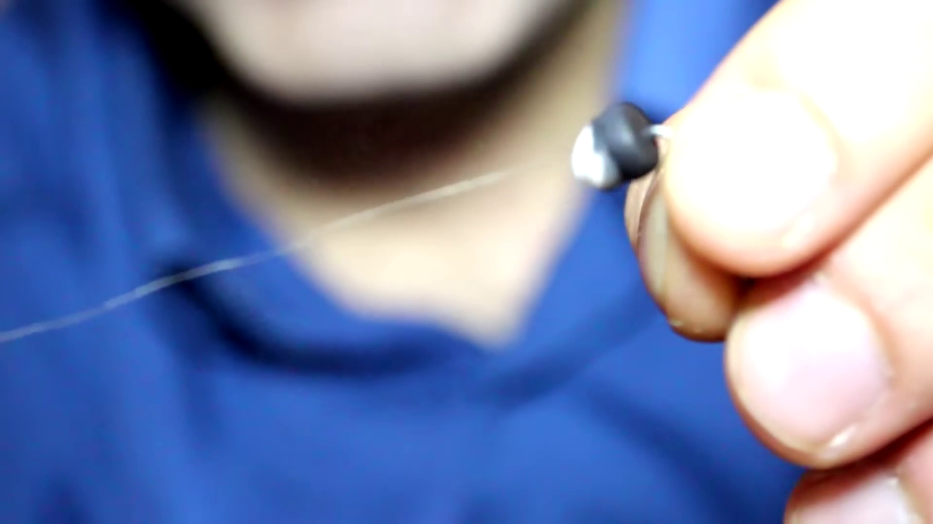 (score 90.0000)
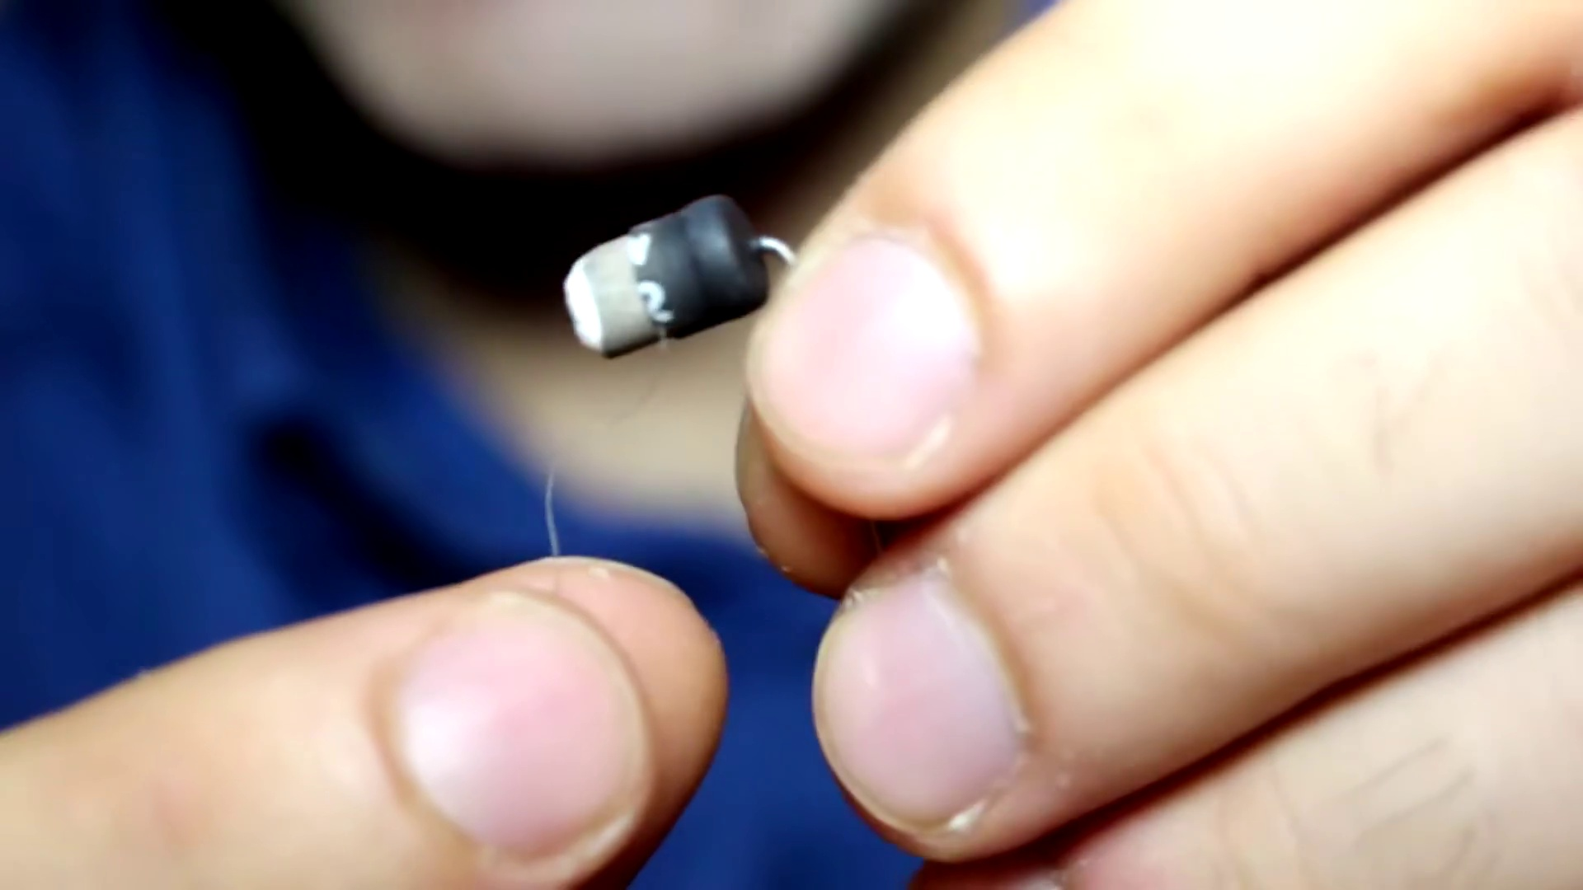 (score 90.0000)
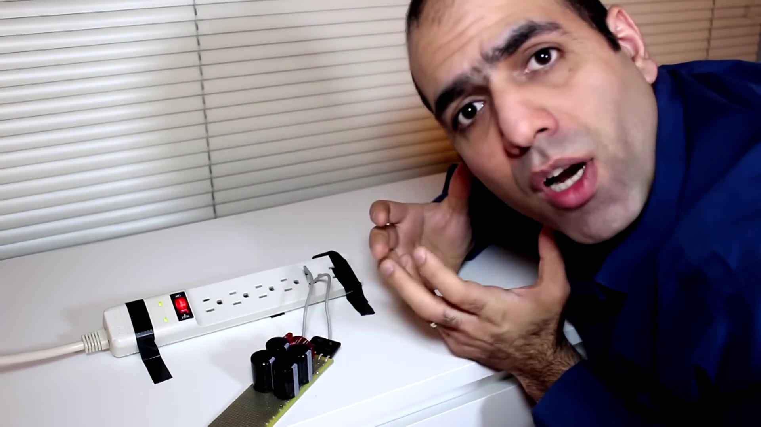 (score 90.0000)
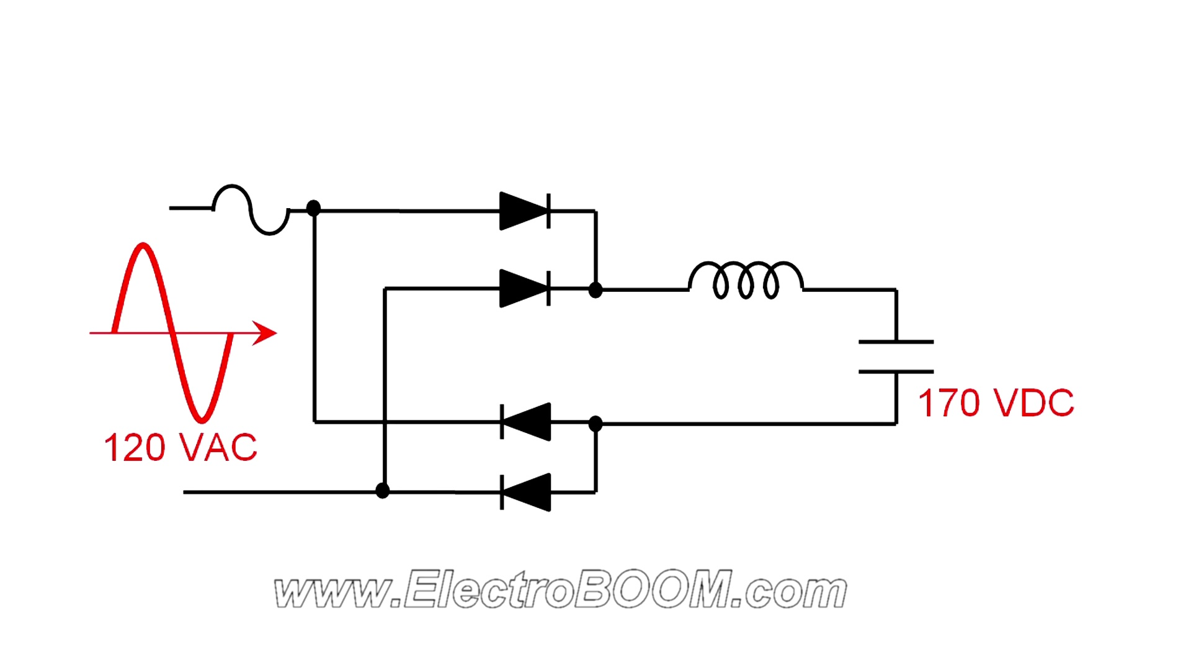 (score 90.0000)
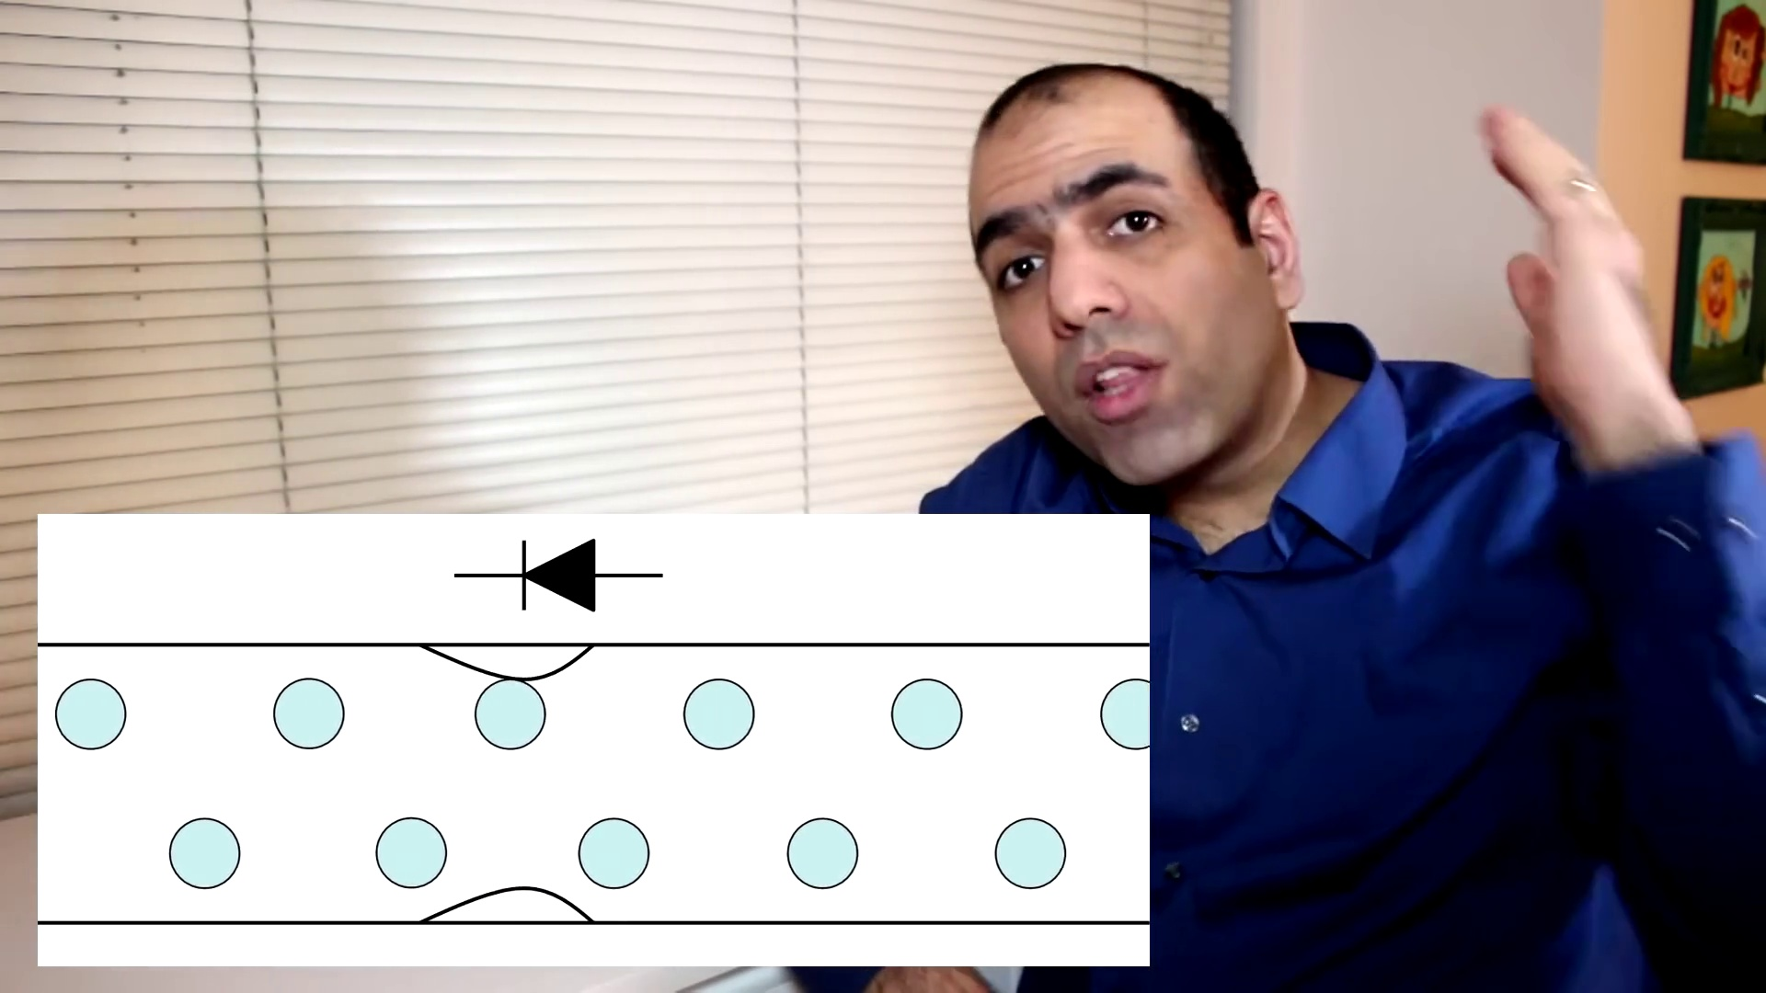 (score 90.0000)
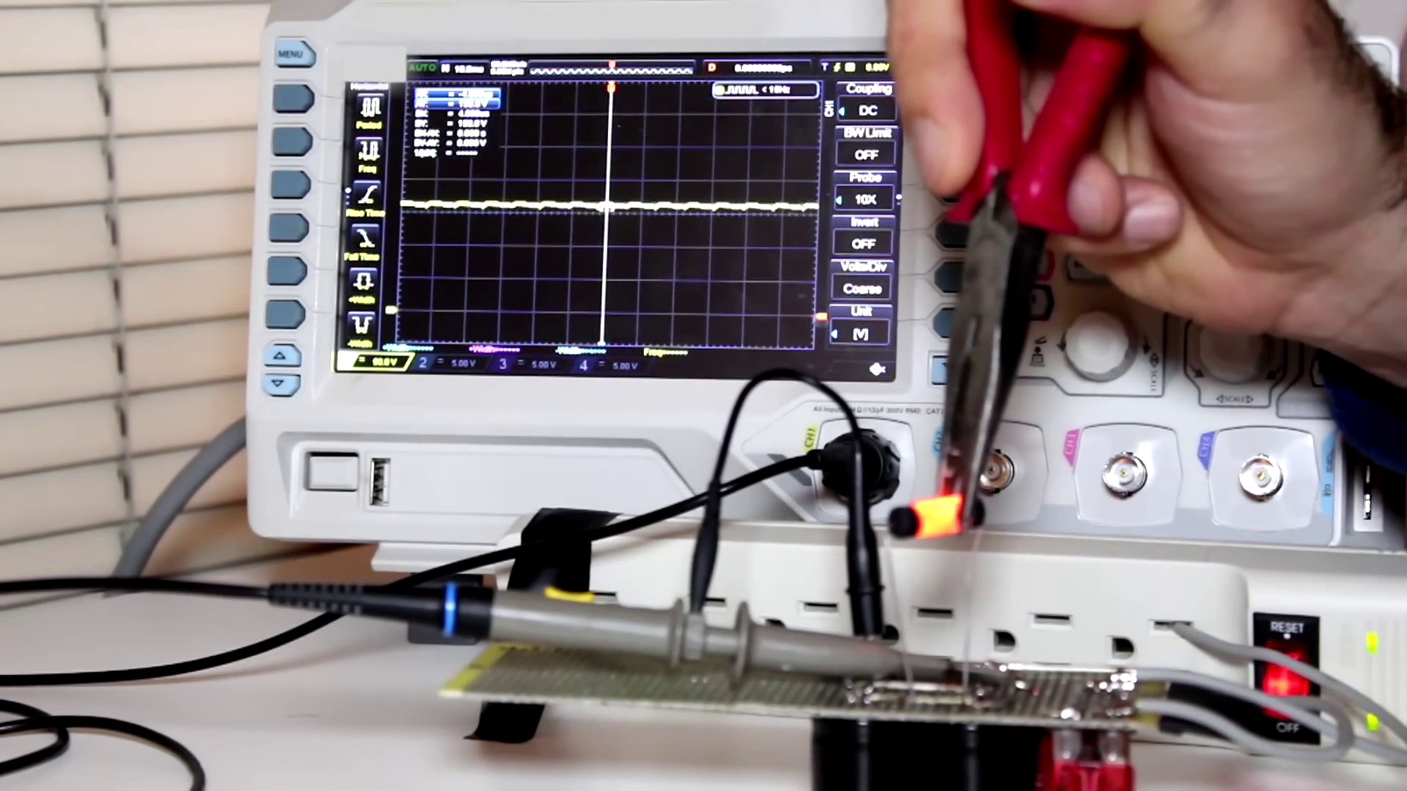 (score 85.0000)
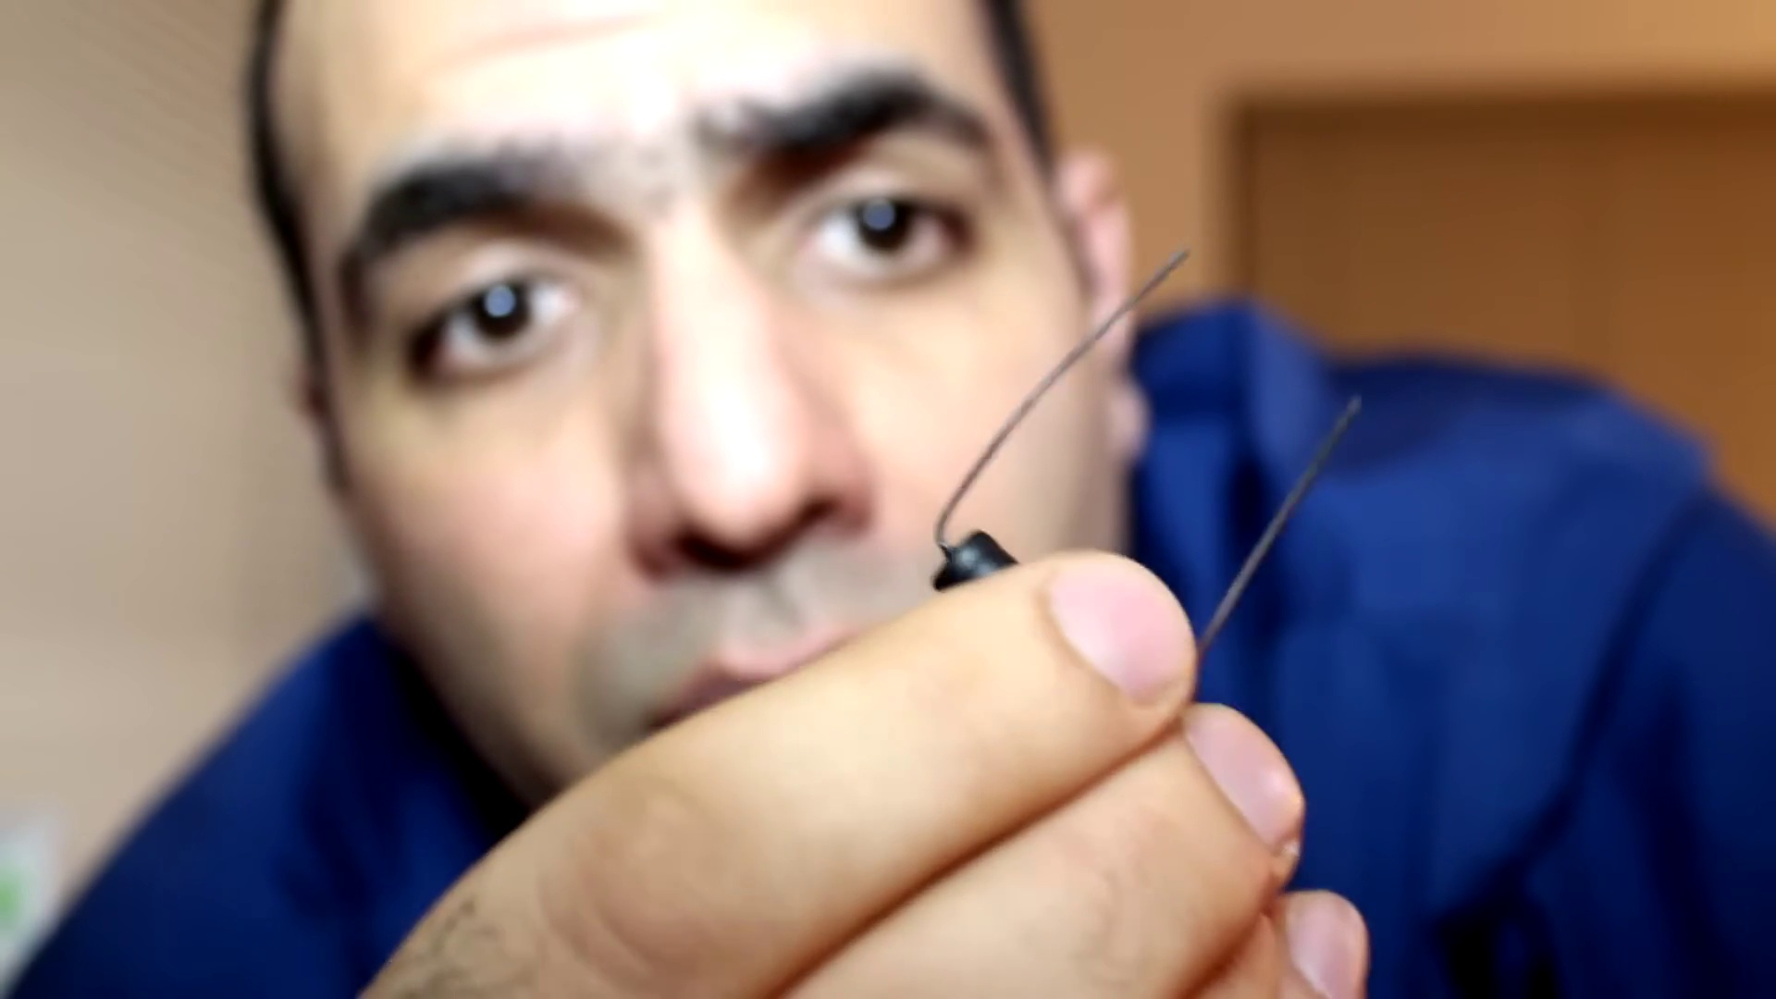 (score 85.0000)
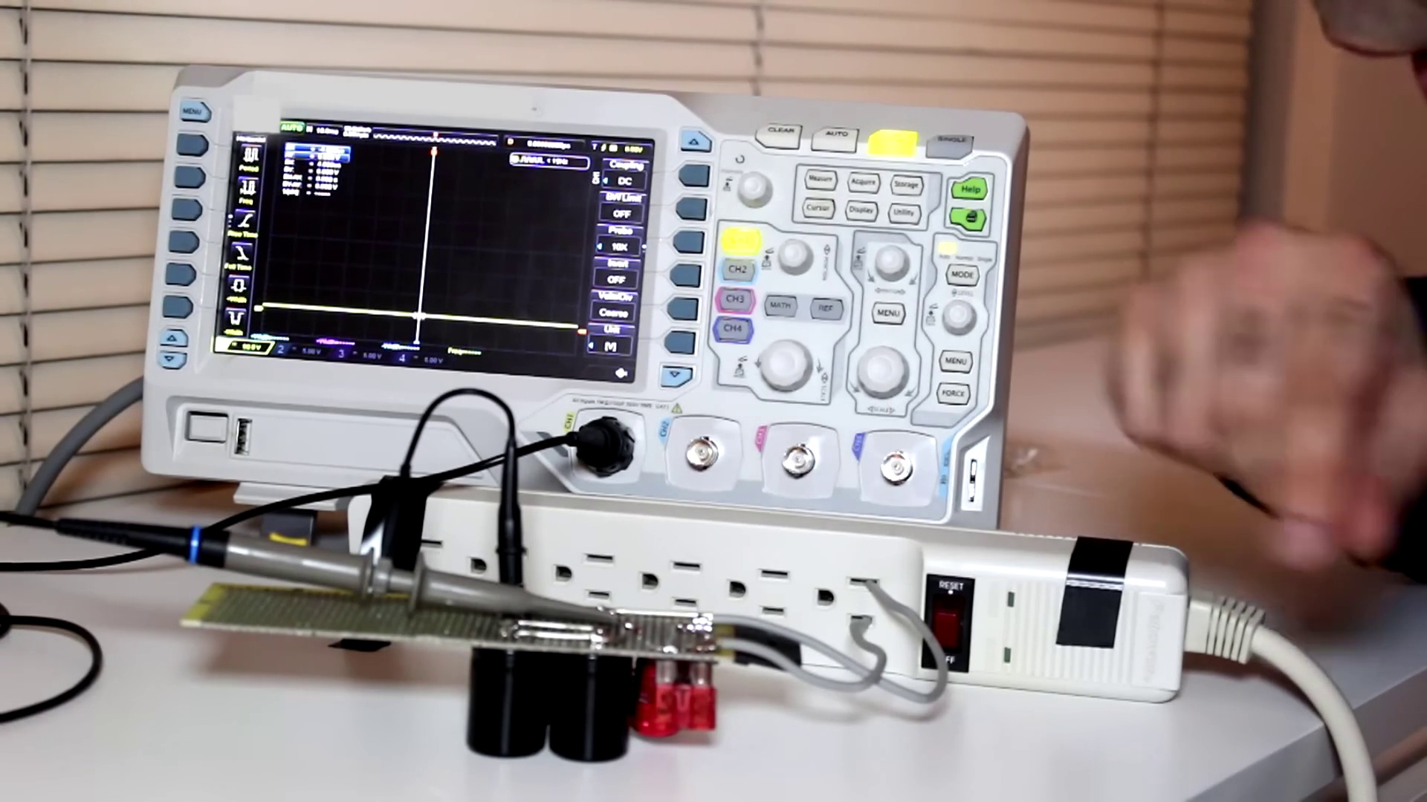 (score 85.0000)
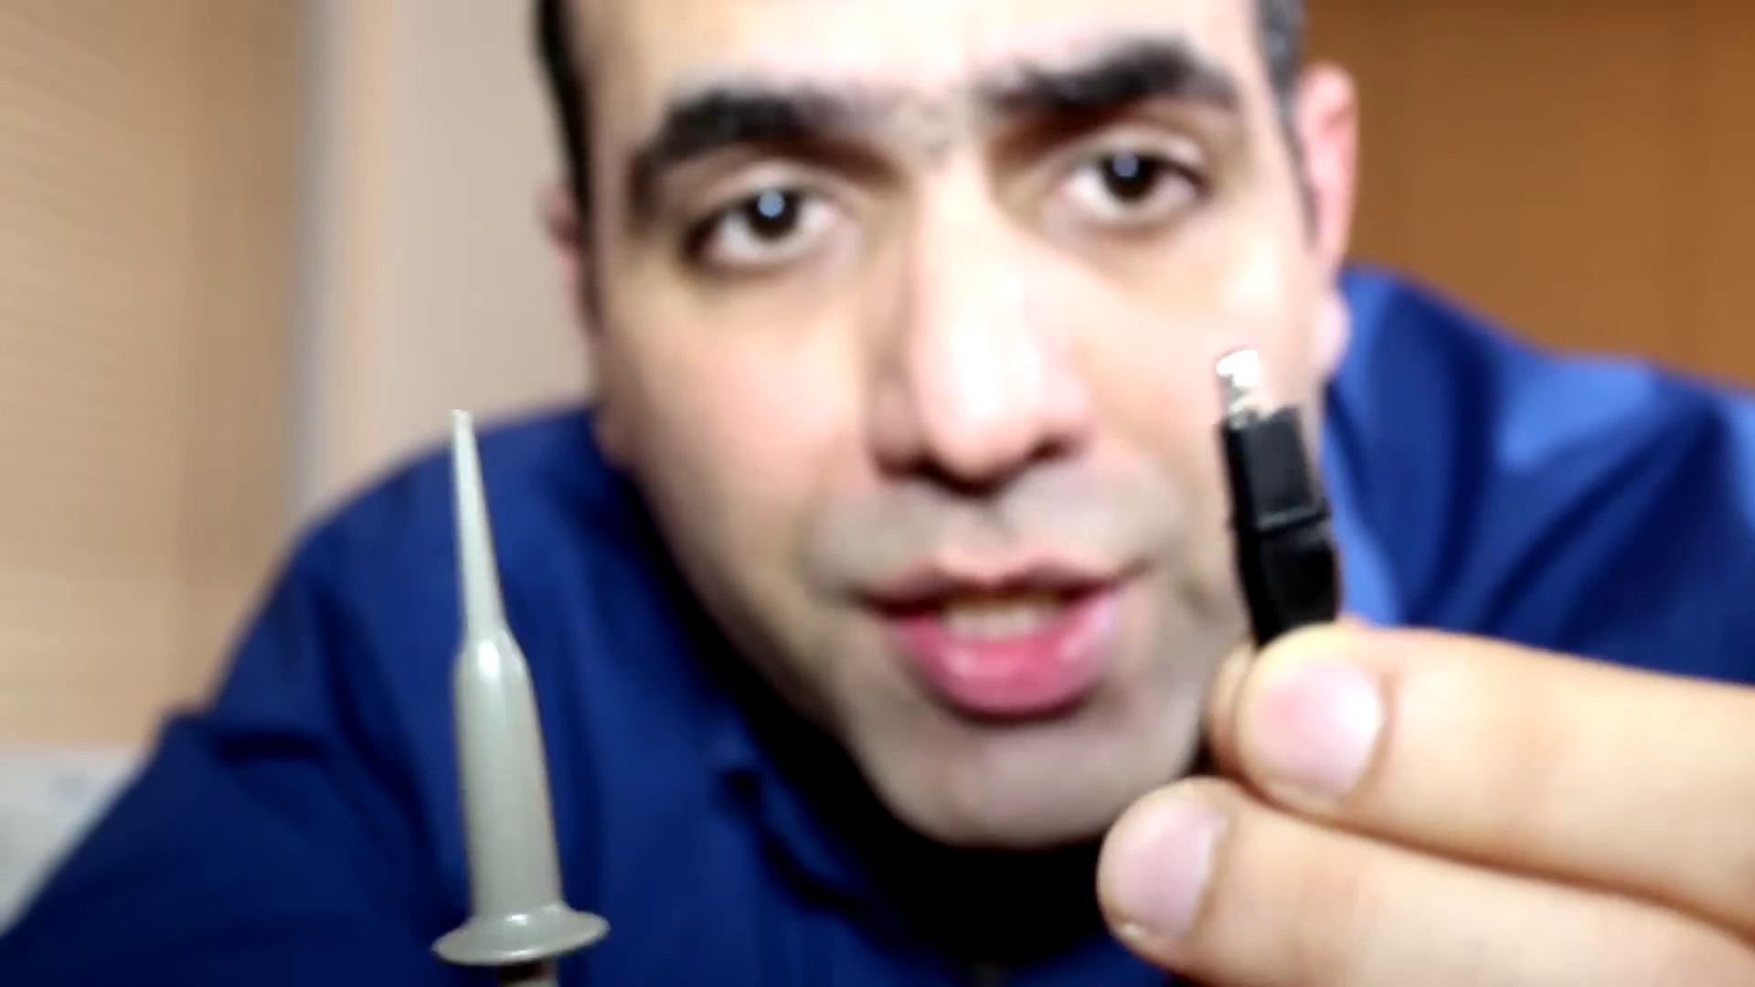 (score 85.0000)
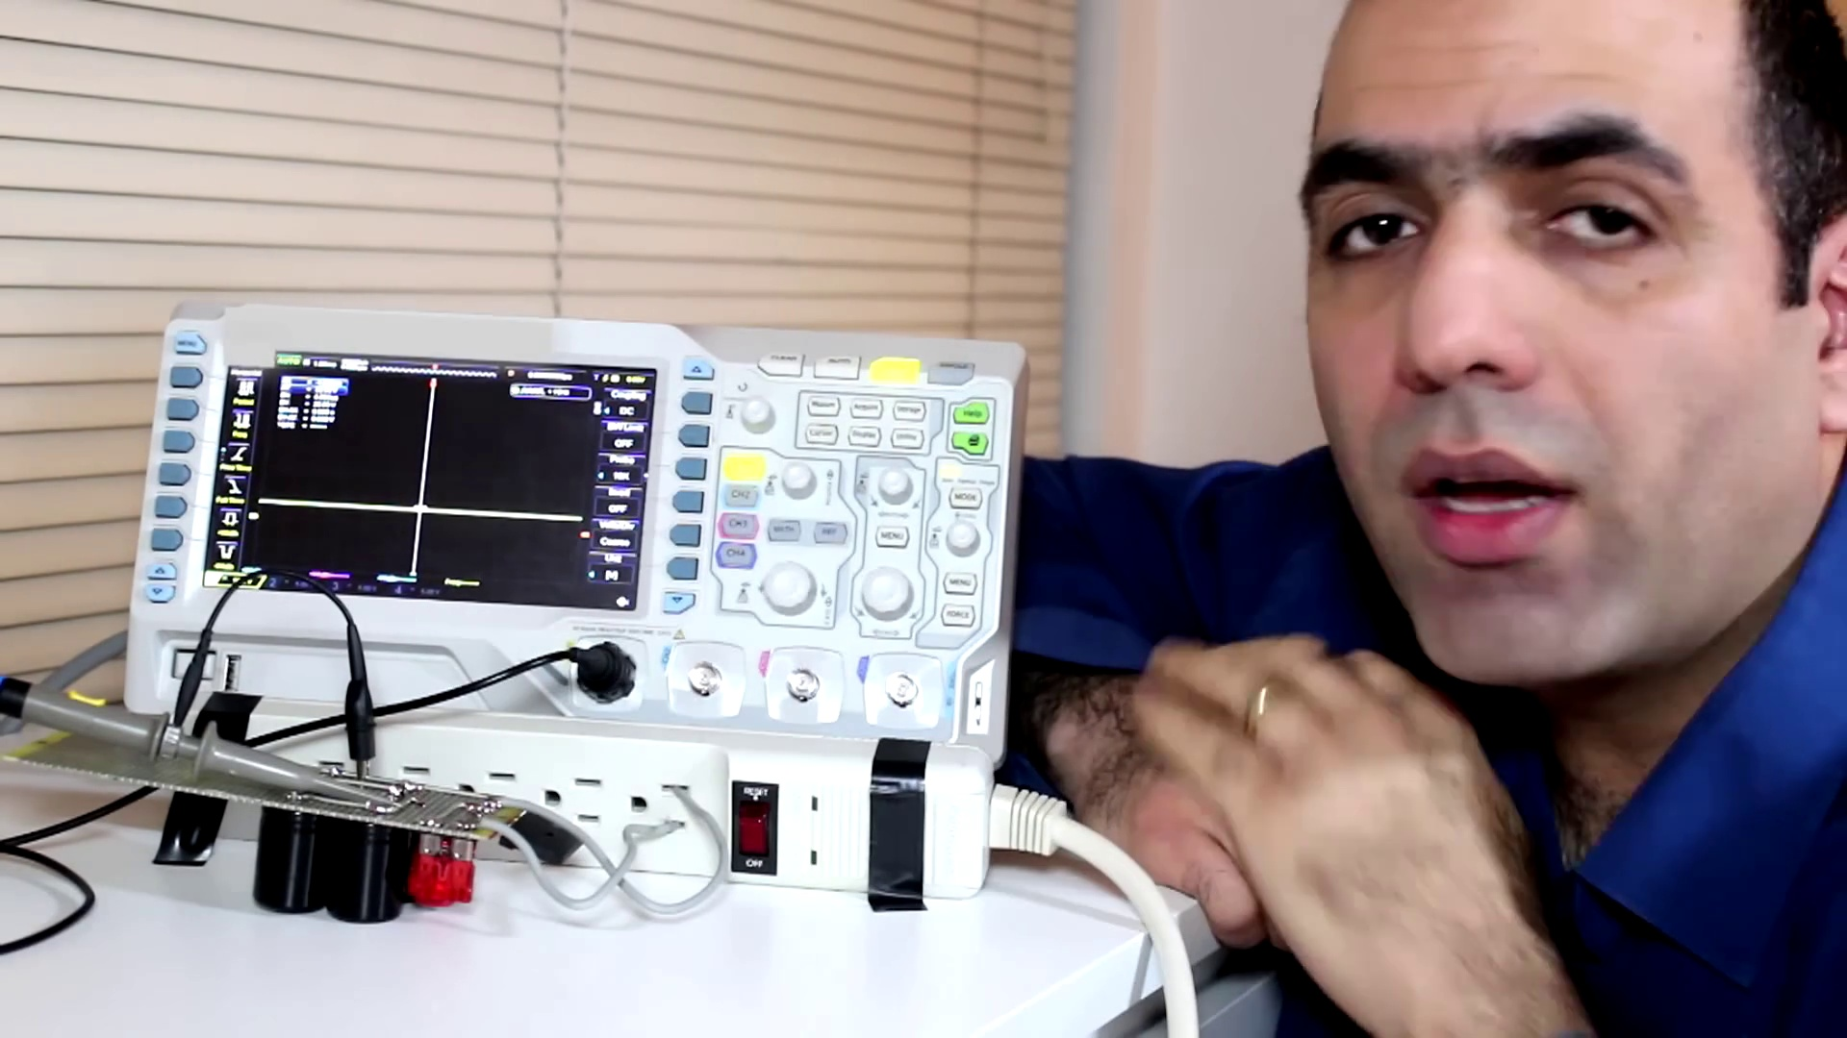 (score 85.0000)
Least correlated frames:
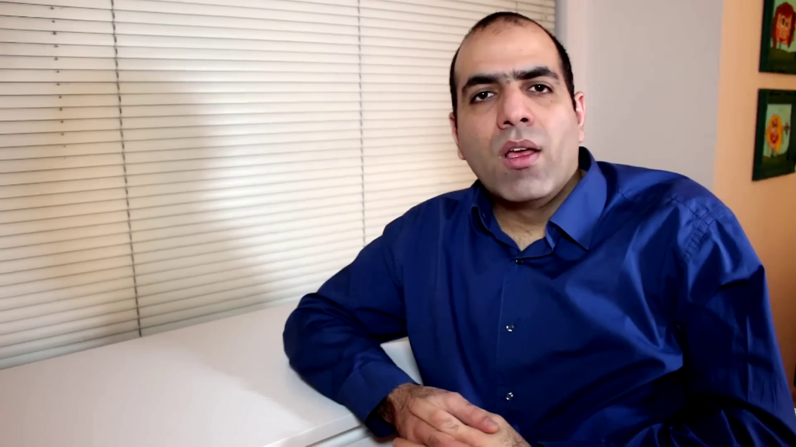 (score 0.0000)
 (score 0.0000)
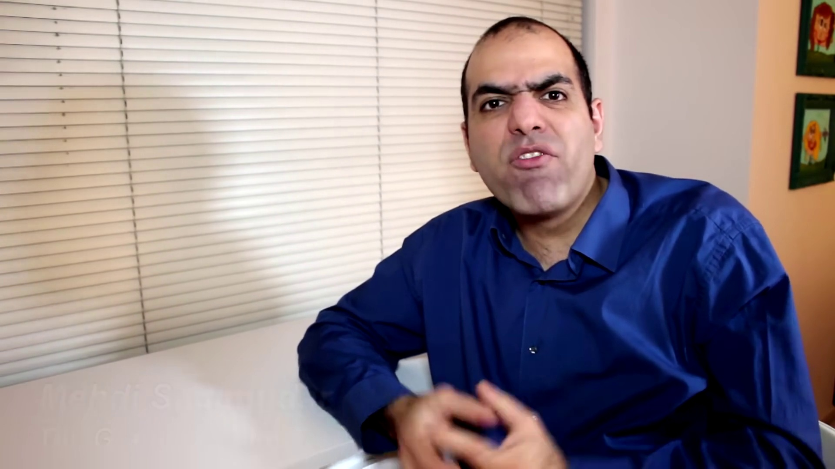 (score 0.0000)
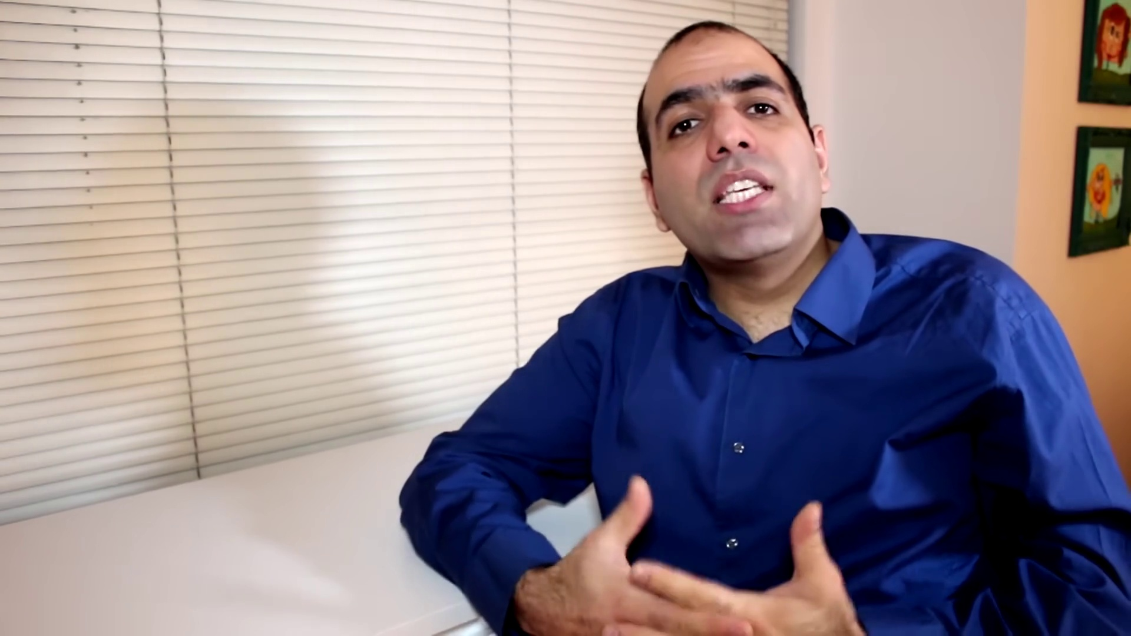 (score 0.0000)
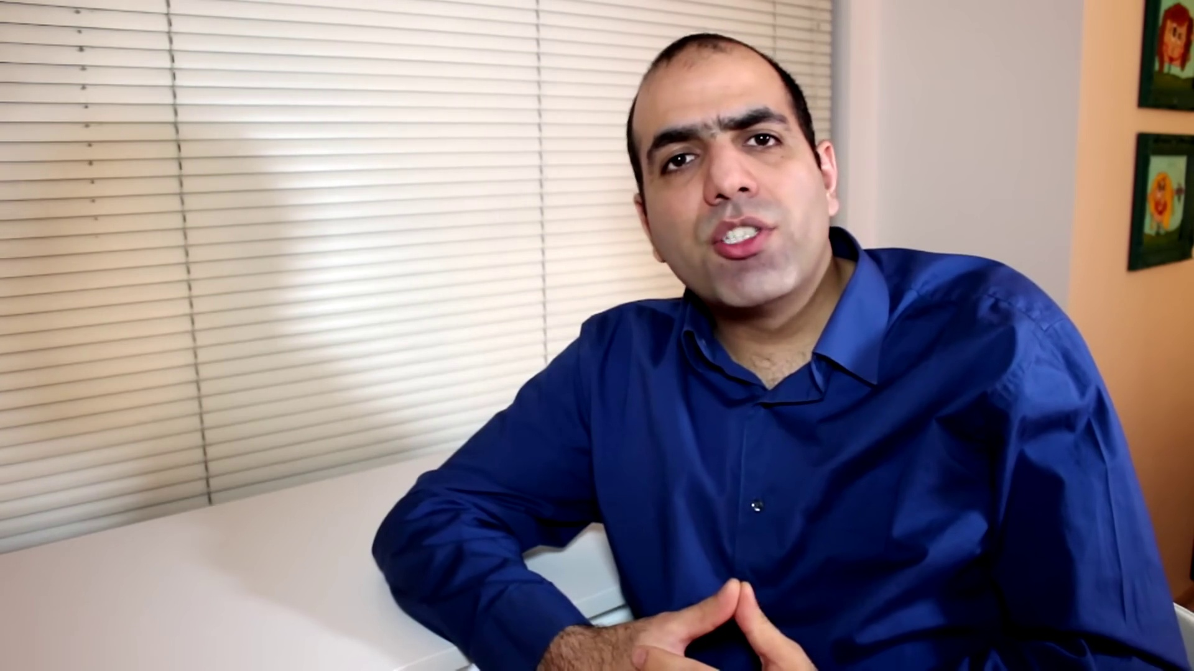 (score 0.0000)
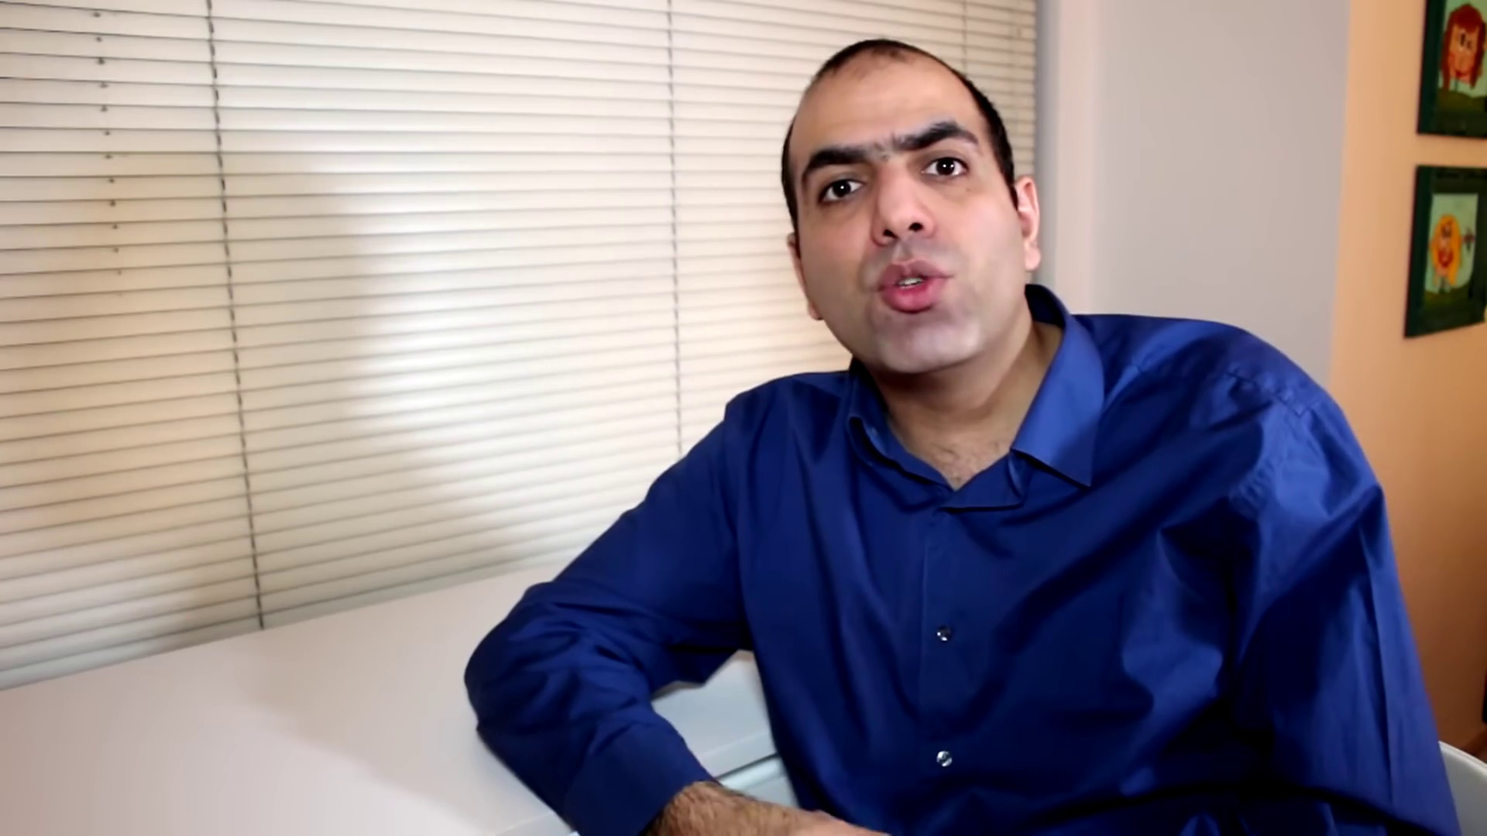 (score 0.0000)
 (score 0.0000)
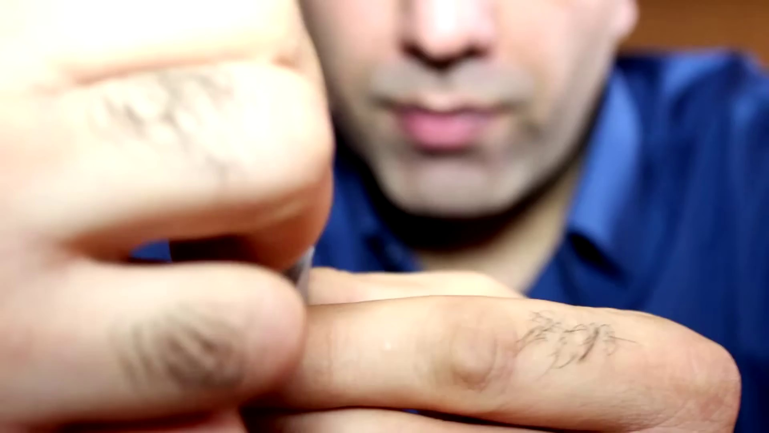 (score 0.0000)
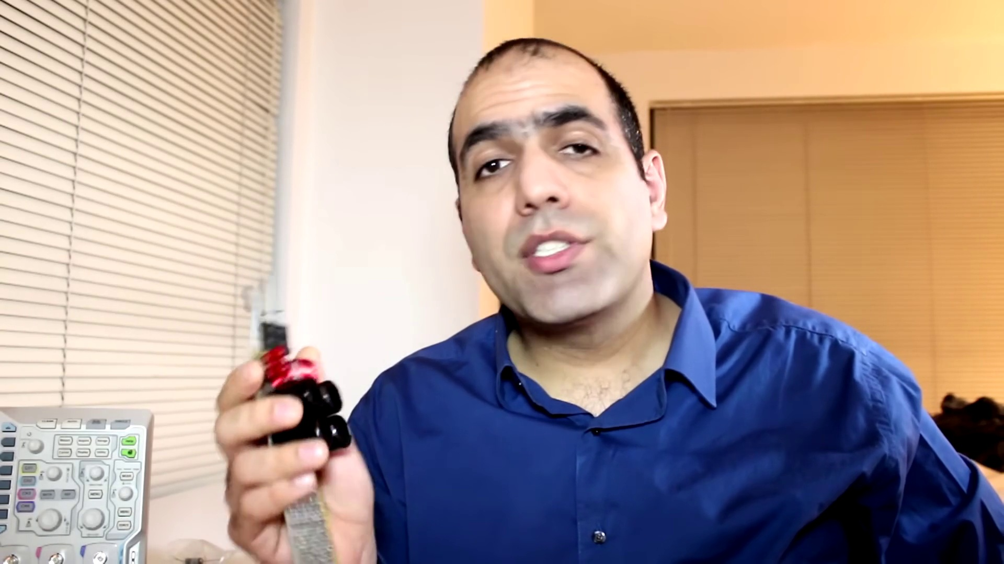 (score 0.0000)
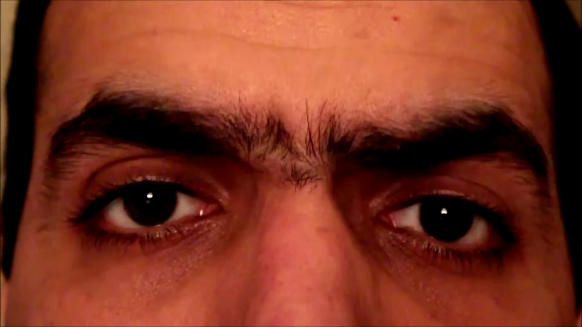 (score 0.0000)
- matched 37 frame(s), max score 95.0000: In this video, the creator explains the construction and operation of a full bridge rectifier, contrasting it with a single diode rectifier. A rectifier converts alternating current (AC) to direct current (DC), and a full bridge rectifier, made up of four diodes, is demonstrated for high-power applications and reverse polarity protection. The design, capable of producing close to 170 V DC at no load and supporting maximum load of 10 amps, includes safety features like a 10-amp fuse. The creator emphasizes safety precautions, insulation, and the importance of avoiding live wires. During the testing, an issue with the ground of the probe shorting to the earth of the power plug is encountered, leading to a blown fuse. The problem is addressed with insulation using Kapton Tape. The video also shows waveform measurements and demonstrates the potential dangers, such as a resistor generating 300 watts of power and burning the creator’s skin. The final application of the power supply for a high-power Tesla Coil Driver Circuit is mentioned, along with a reminder to discharge capacitors for safety.
Source: https://www.youtube.com/watch?v=sI5Ftm1-jik&t=15s : Making a Full Bridge Rectifier
Top correlated frames:
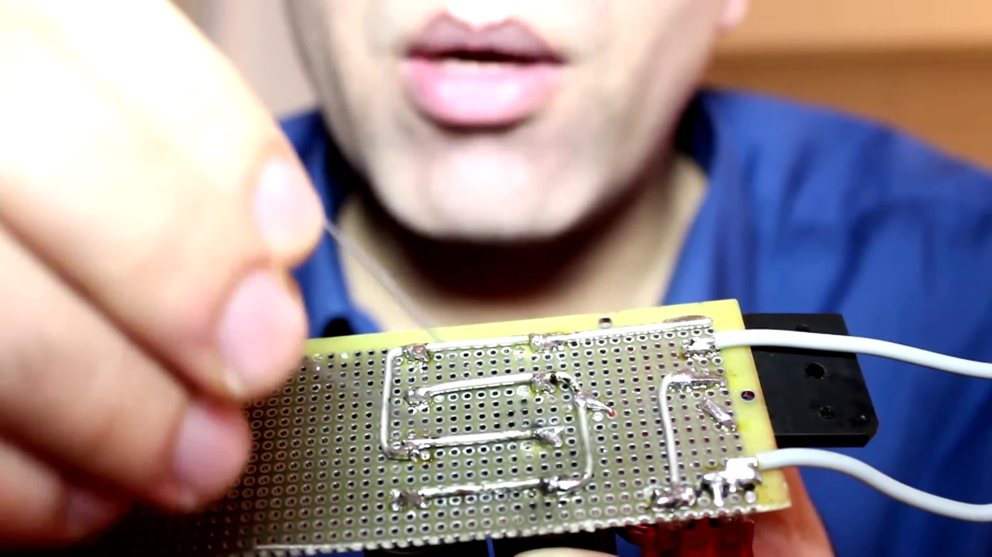 (score 95.0000)
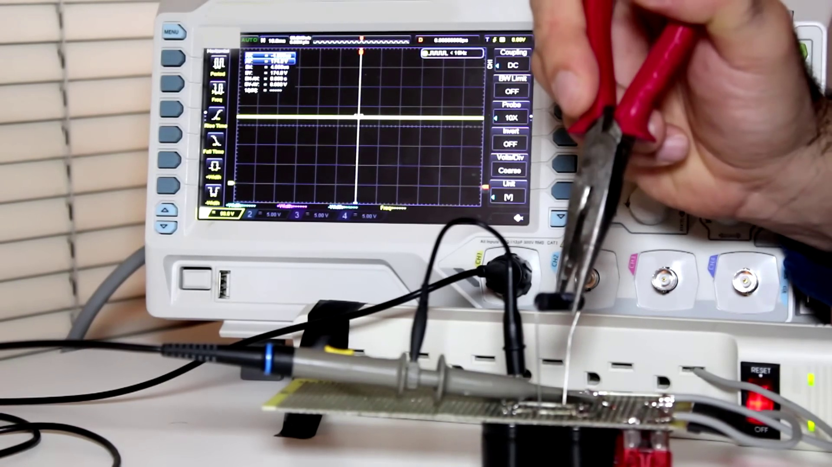 (score 95.0000)
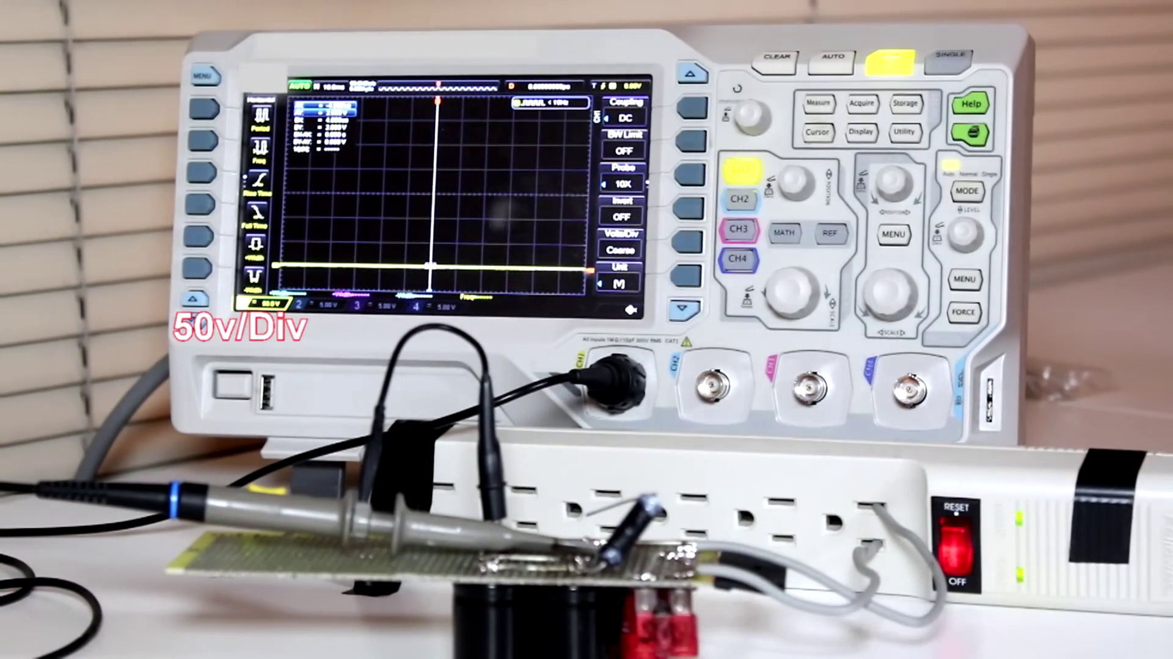 (score 95.0000)
 (score 95.0000)
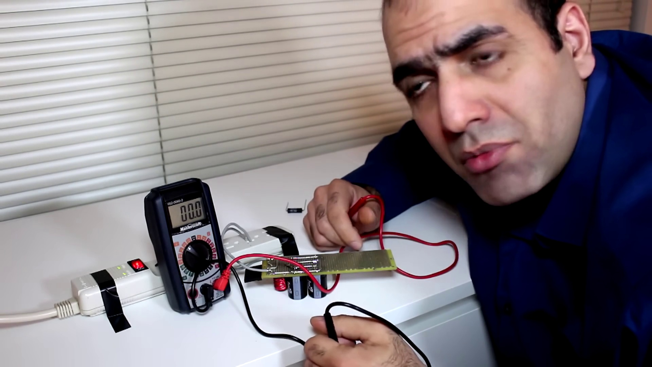 (score 95.0000)
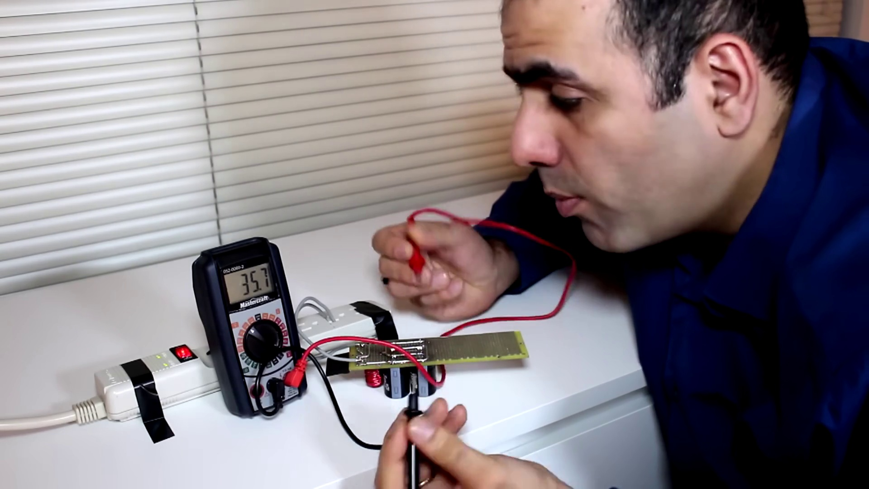 (score 95.0000)
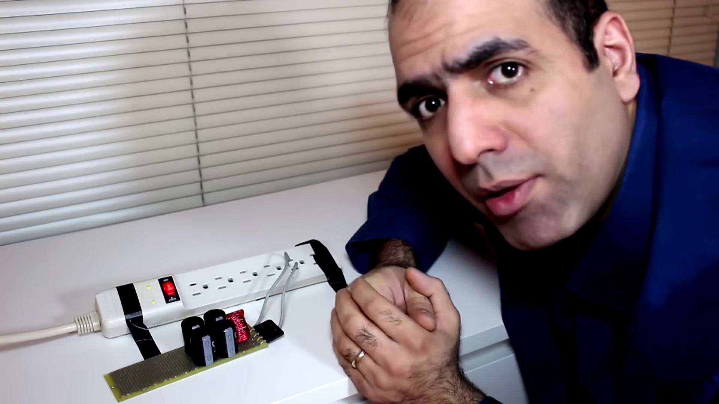 (score 95.0000)
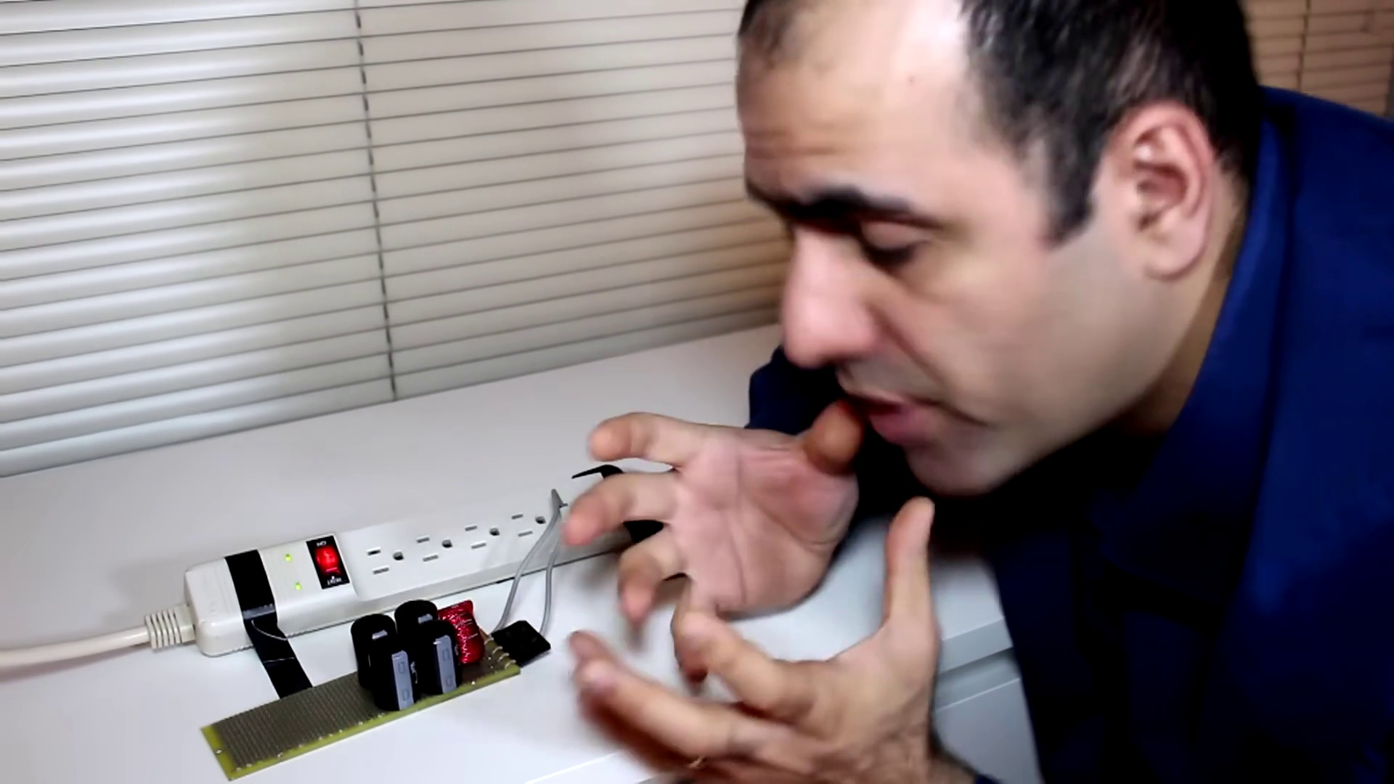 (score 95.0000)
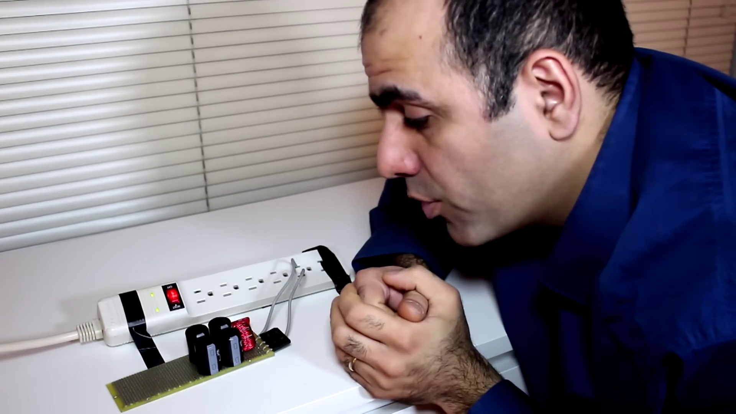 (score 95.0000)
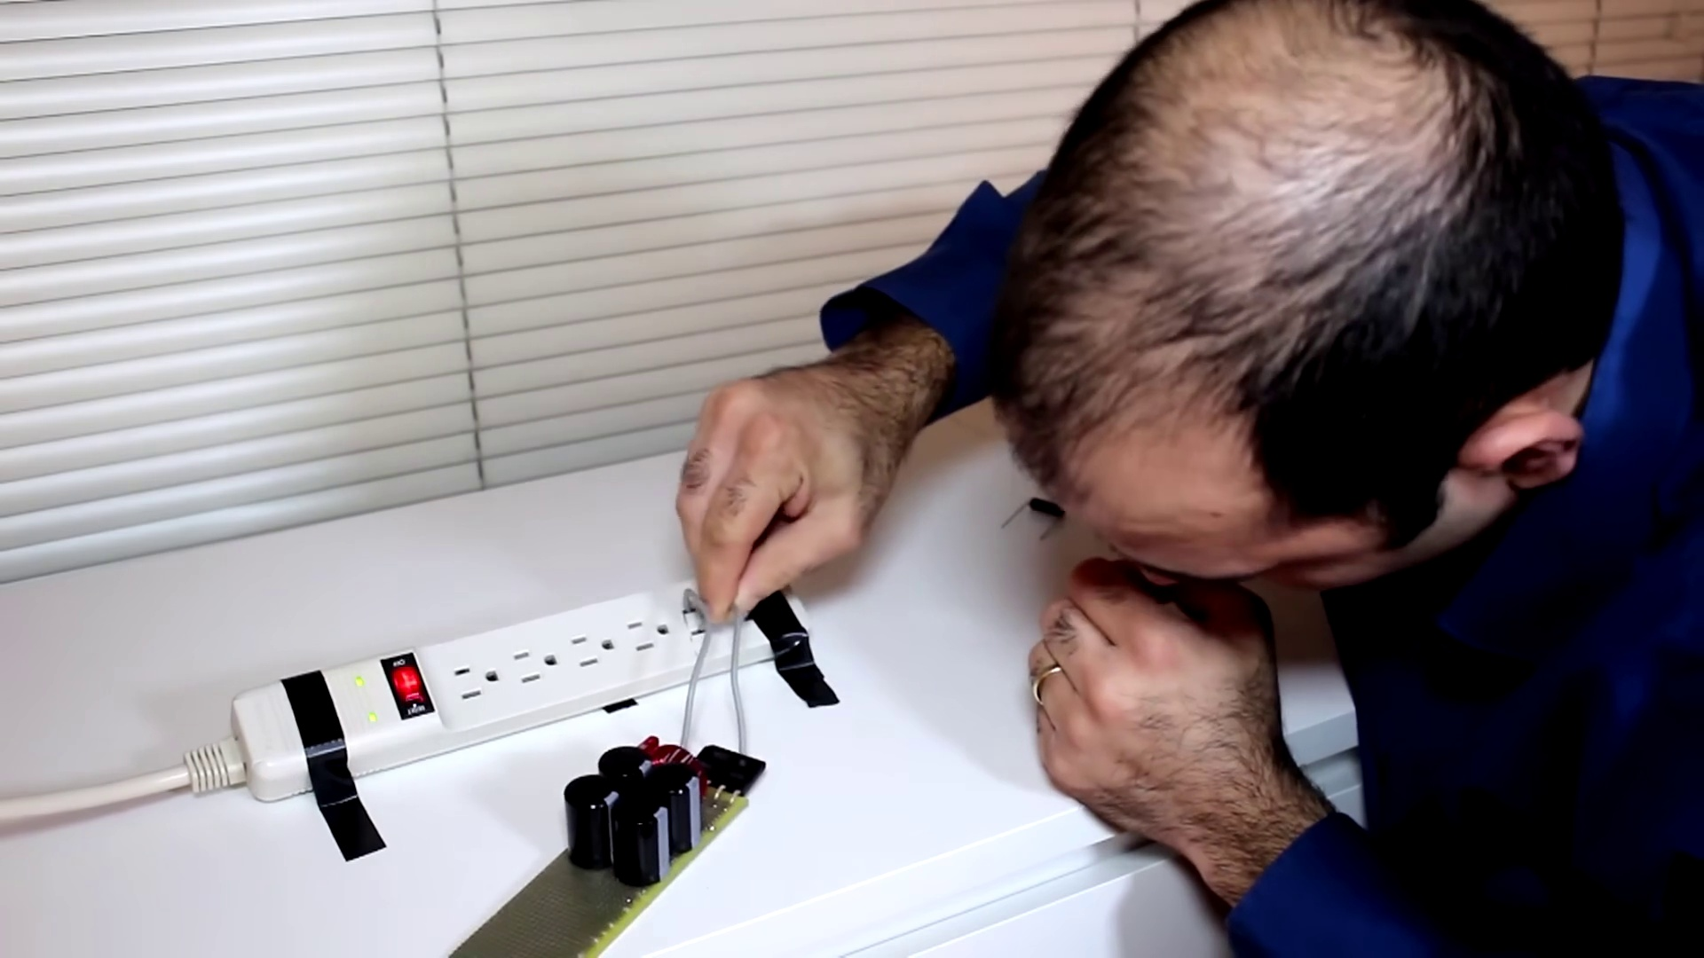 (score 95.0000)
Least correlated frames:
 (score 0.0000)
 (score 0.0000)
 (score 0.0000)
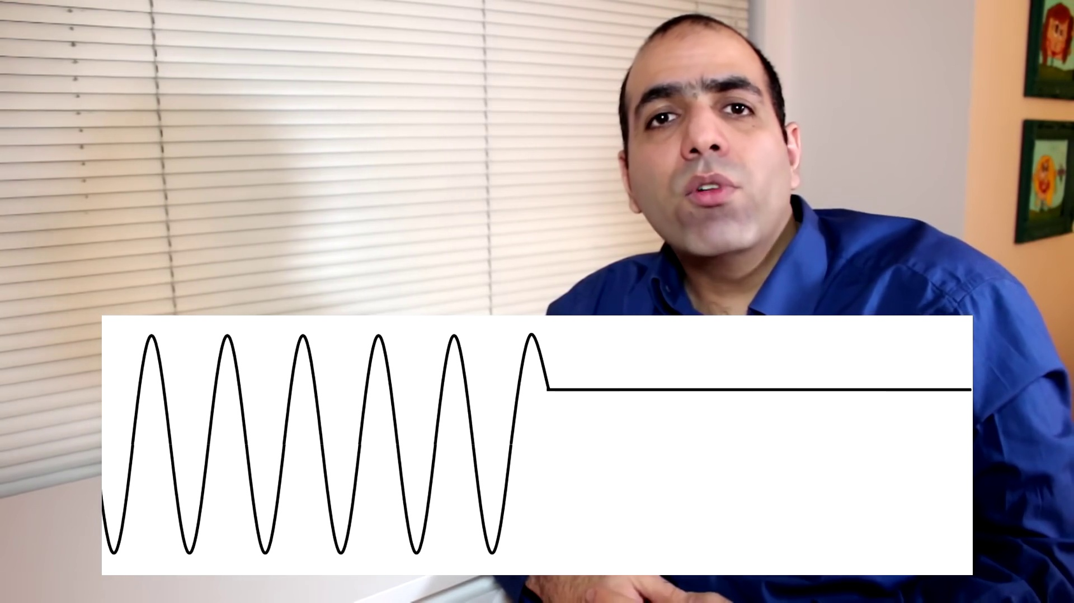 (score 0.0000)
 (score 0.0000)
 (score 0.0000)
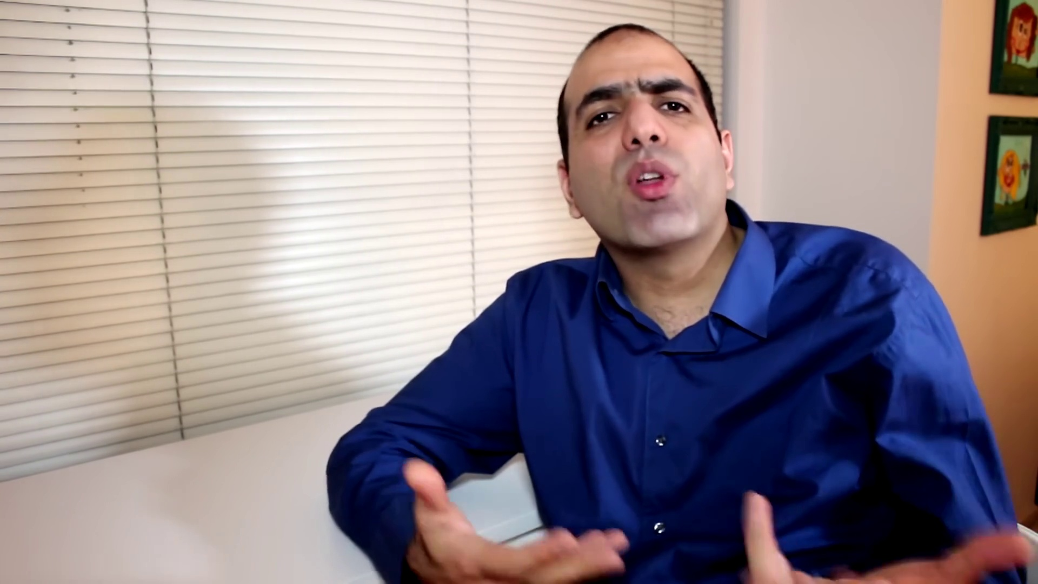 (score 0.0000)
 (score 0.0000)
 (score 0.0000)
 (score 0.0000)
- matched 18 frame(s), max score 85.0000: This guy is making his own full bridge rectifier at 1000 watts, but he is not very safe when working with the electronics tho. I have seen some of this guys stuff, he is really funny. He just blew a fuse that scared him pretty good. He does a good job building different things, but he is constantly getting hurt. I wonder if he is doing this on purpose to get more views on youtube, too funny. I have to say I have never seen anyone discharge a capacitor using a resistor, that was rather interesting to watch.
Source: https://www.youtube.com/watch?v=sI5Ftm1-jik: Making a Full Bridge Rectifier
Top correlated frames:
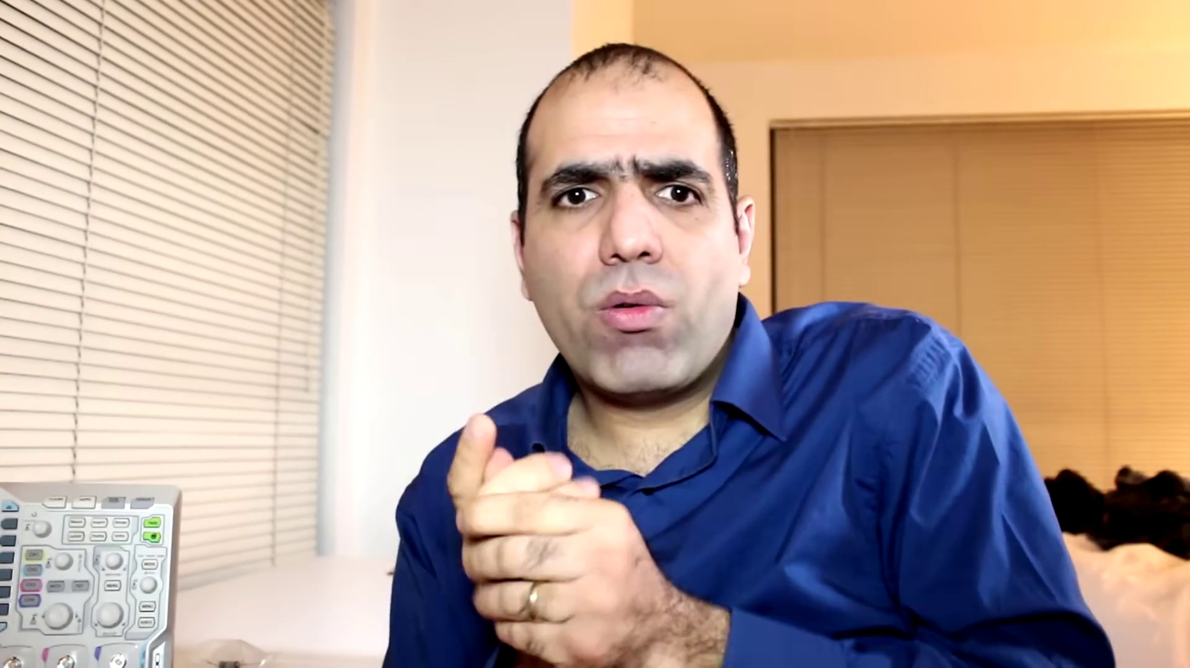 (score 85.0000)
 (score 85.0000)
 (score 85.0000)
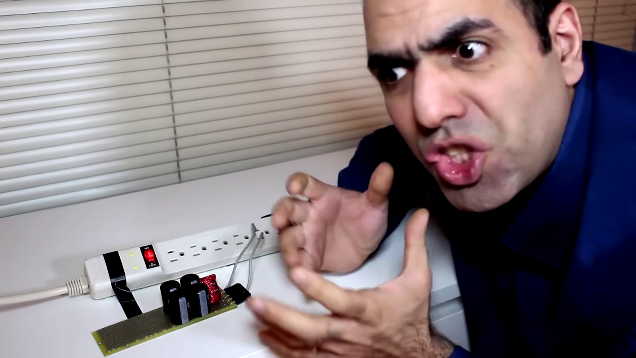 (score 85.0000)
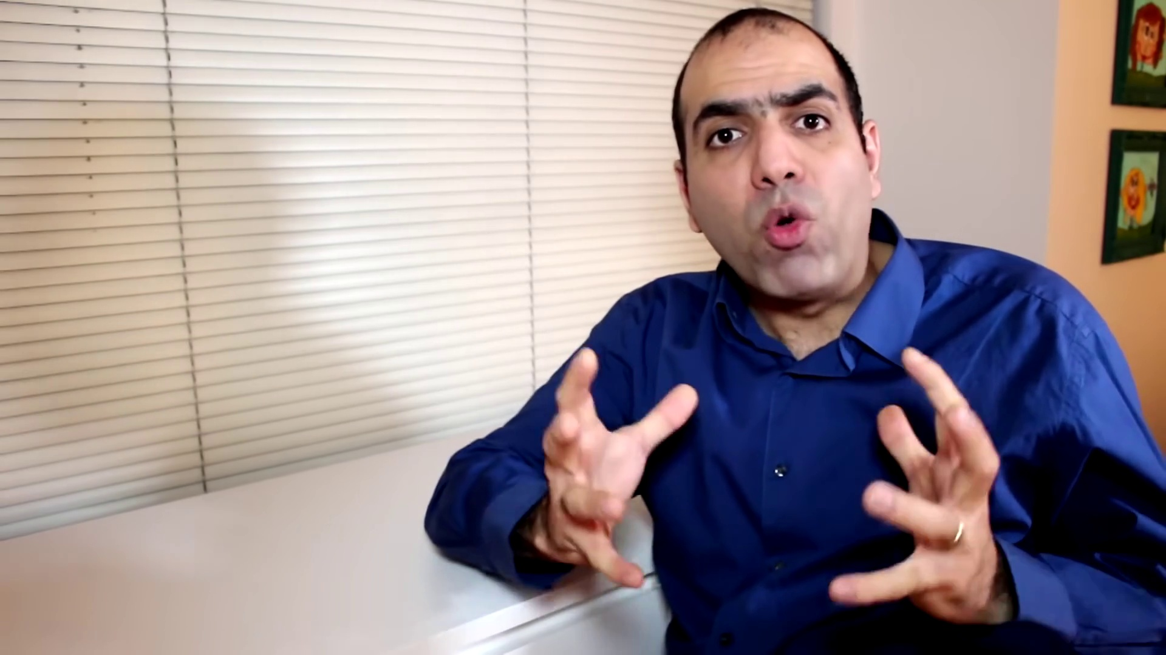 (score 85.0000)
 (score 85.0000)
 (score 80.0000)
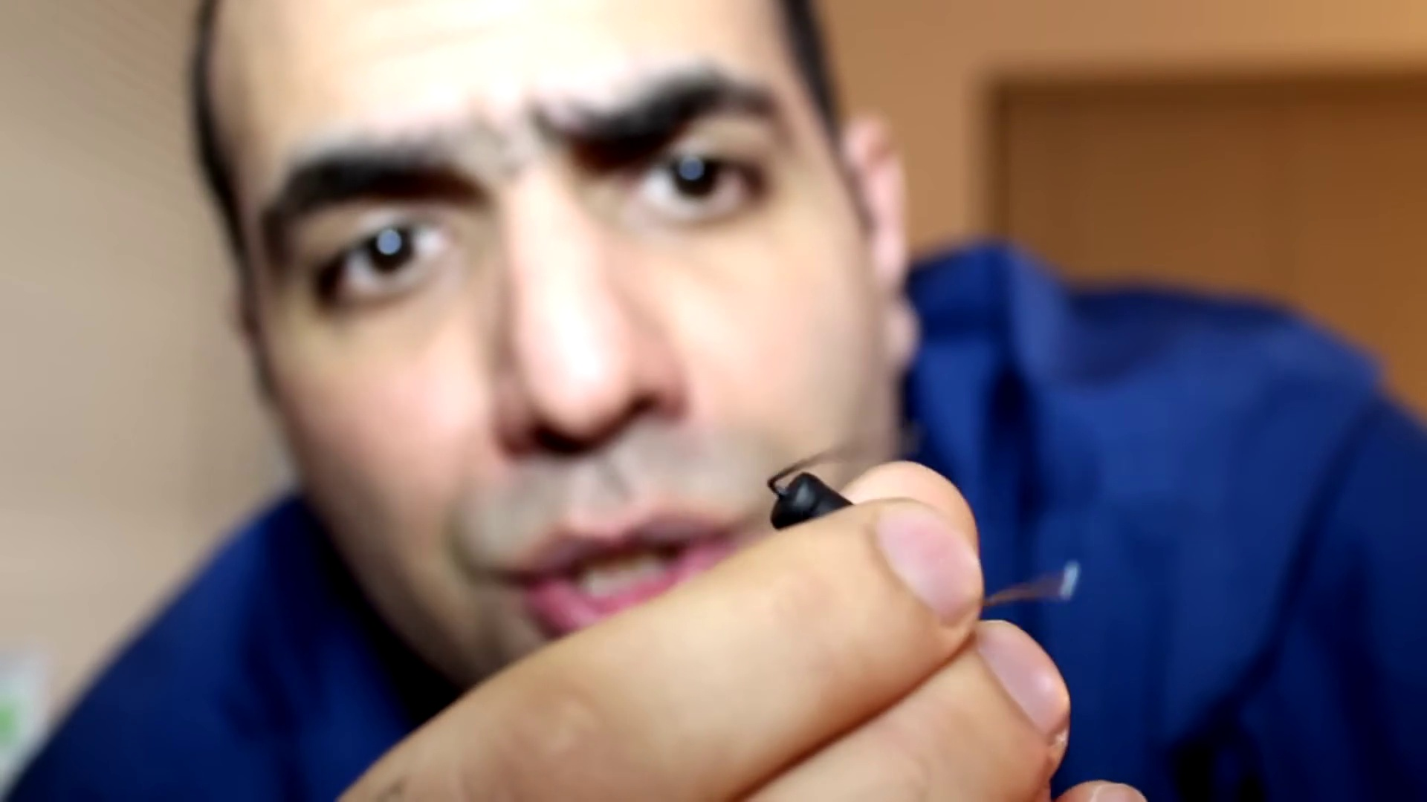 (score 80.0000)
 (score 80.0000)
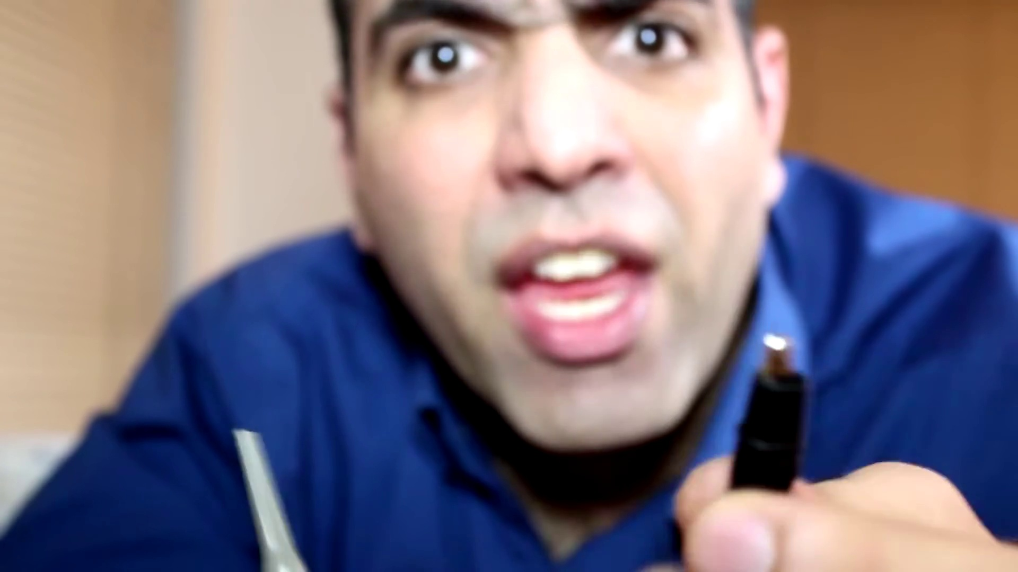 (score 80.0000)
Least correlated frames:
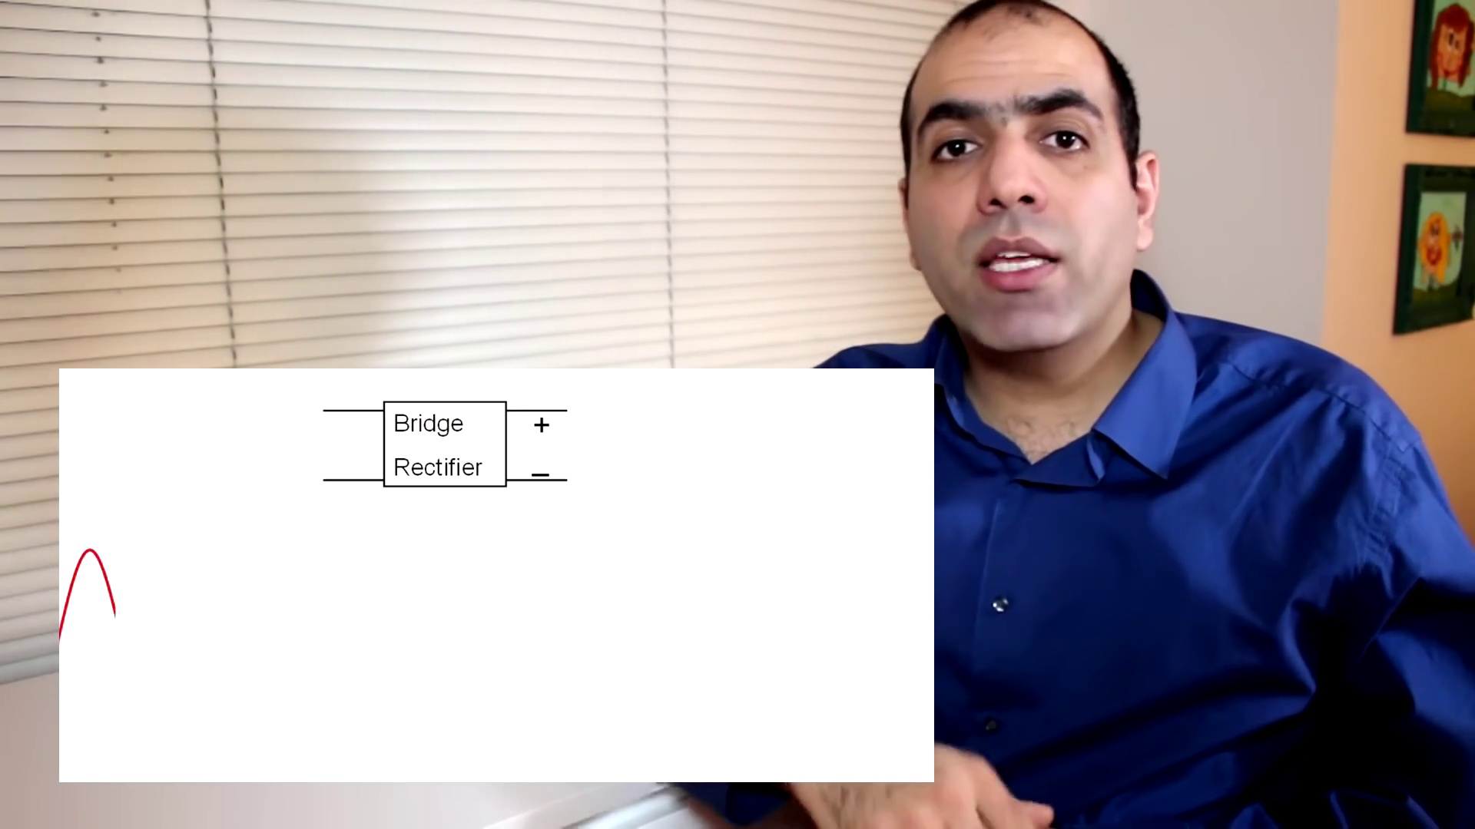 (score 0.0000)
 (score 5.0000)
 (score 10.0000)
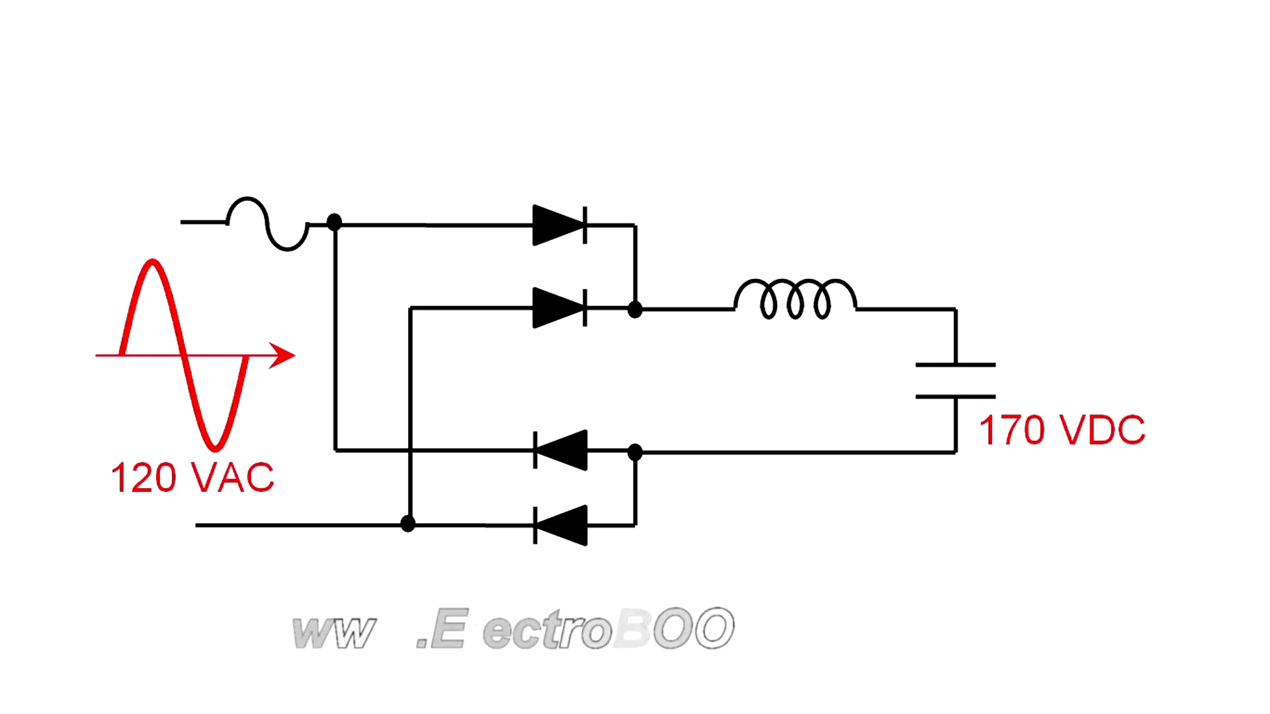 (score 10.0000)
 (score 10.0000)
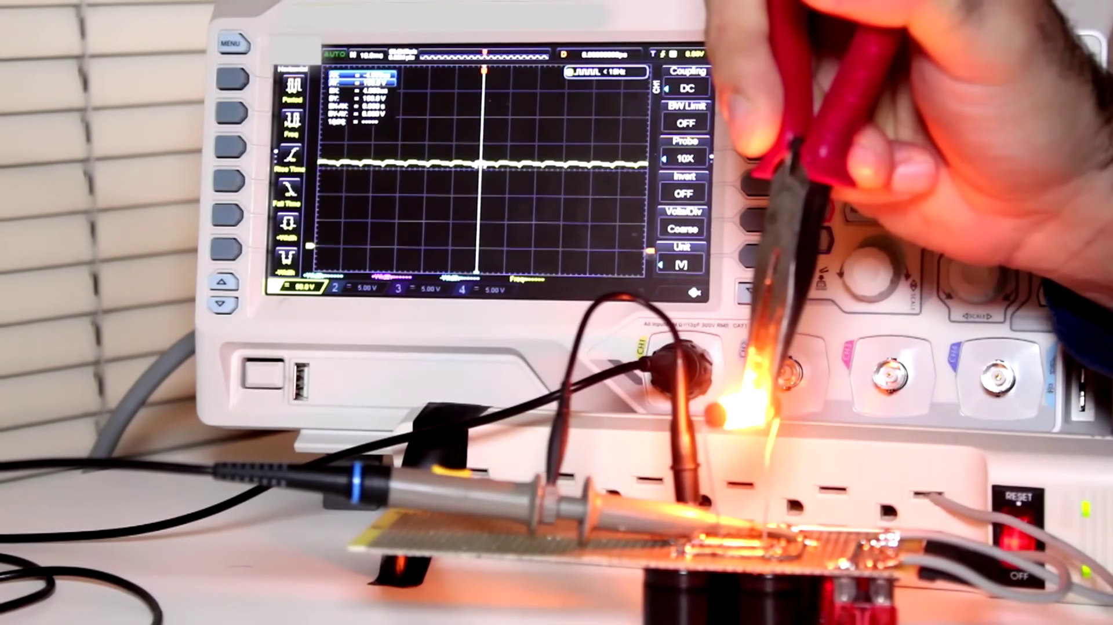 (score 10.0000)
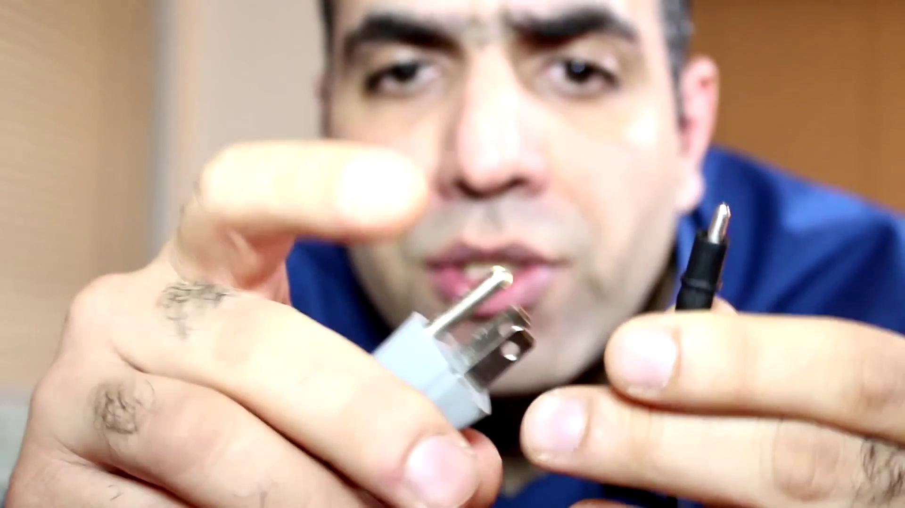 (score 15.0000)
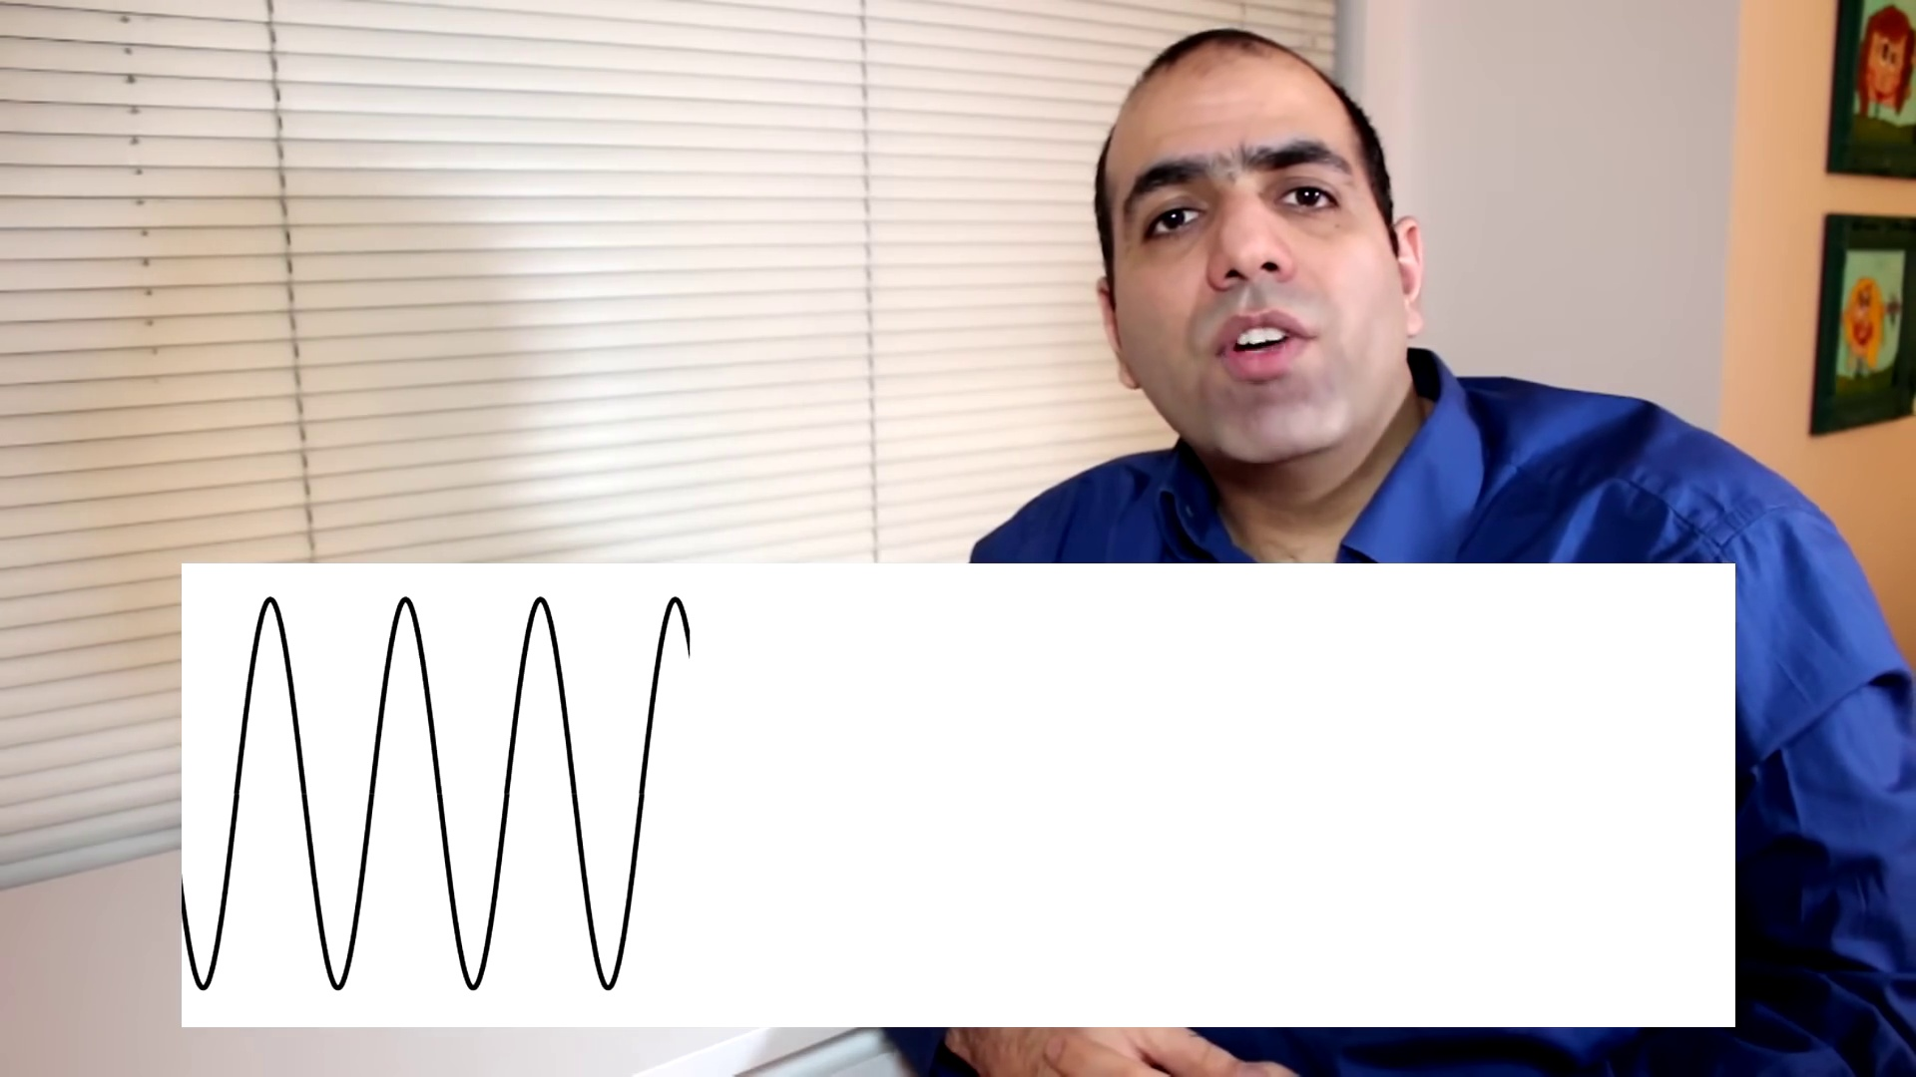 (score 20.0000)
 (score 20.0000)
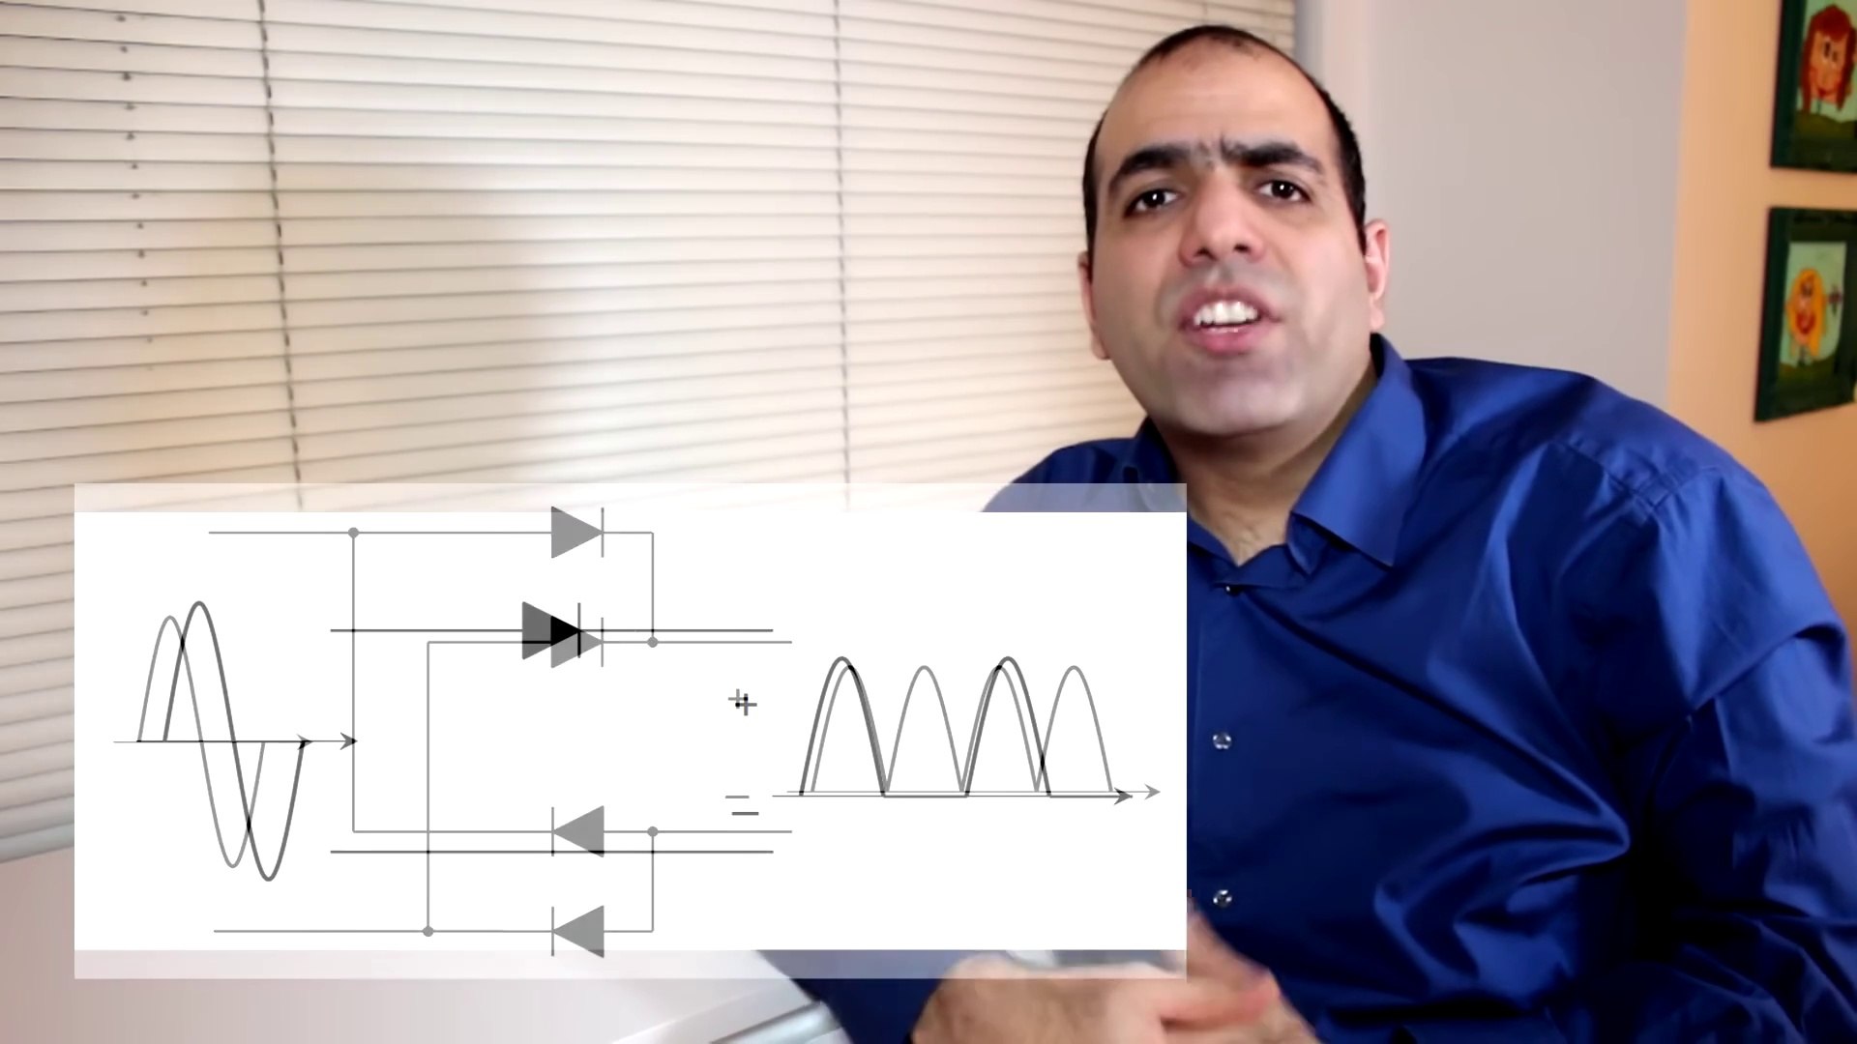 (score 20.0000)

Frame: frame_0000.jpg
Caption: The image features an individual seated on a white couch, wearing a blue shirt. His face is turned towards the camera, providing a clear view of his expression. His hands are clasped together in front of him, adding an air of intimacy to the scene. The background is a simple white wall, with a window located in the top right corner. A painting hangs on the wall, adding a splash of color to the otherwise monochrome setting. In the foreground, we see the individual seated next to a window with white blinds, engaged in some sort of activity that appears to be quiet and contemplative. The focus is solely on the person shown in the image without providing any details about their activity or surroundings beyond what can be visually identified.
Comment (score 85): This guy is making his own full bridge rectifier at 1000 watts, but he is not very safe when working with the electronics tho. I have seen some of this guys stuff, he is really funny. He just blew a fuse that scared him pretty good. He does a good job building different things, but he is constantly getting hurt. I wonder if he is doing this on purpose to get more views on youtube, too funny. I have to say I have never seen anyone discharge a capacitor using a resistor, that was rather interesting to watch.
Reason: The comment directly discusses the individual's activity (making a full bridge rectifier) and their approach to working with electronics, which is described in the caption as 'some sort of activity that appears to be quiet and contemplative'. The mention of safety concerns and getting hurt while building things also matches the intimate setting and focus on the person shown in the image.
Source: https://www.youtube.com/watch?v=sI5Ftm1-jik: Making a Full Bridge Rectifier

Frame: frame_0001.jpg
Caption: The image shows a man sitting and smiling at the camera with an intense and engaging gaze. He appears to be in a casual setting with a blurred background that suggests an indoor environment, featuring white blinds and a window. The man is dressed in a dark blue shirt and his facial expression is one of amusement, as he seems to be joking or making a humorous statement. His mouth is wide open, revealing his teeth and gums, suggesting a sense of excitement or enthusiasm.
In the bottom right corner of the image, there is a text overlay that reads "MEDHI SADAGAR" followed by the words "THE GRAND RECRUITER." The overall style of the image is informal, suggesting it might have been taken during a live event or broadcast. There are no visible devices or slides that indicate an educational setting or teaching activity. The colors in the image are neutral, with the man's blue shirt standing out against the blurred background, making him the main focus of the image and drawing the viewer's attention to his presence.
Comment (score 80): This guy is making his own full bridge rectifier at 1000 watts, but he is not very safe when working with the electronics tho. I have seen some of this guys stuff, he is really funny. He just blew a fuse that scared him pretty good. He does a good job building different things, but he is constantly getting hurt. I wonder if he is doing this on purpose to get more views on youtube, too funny. I have to say I have never seen anyone discharge a capacitor using a resistor, that was rather interesting to watch.
Reason: The comment directly discusses the same technical aspect (building a full bridge rectifier) and setting (working with electronics), which is strongly related to the caption's description of the man's activity.
Source: https://www.youtube.com/watch?v=sI5Ftm1-jik: Making a Full Bridge Rectifier

Frame: frame_0002.jpg
Caption: The image shows a person, likely a man, sitting comfortably on a white couch, appearing to be engaged in deep thought or intense concentration. He is wearing a blue shirt that stands out against the neutral background of the white wall. His hands are interlocked, a gesture suggesting his current focus, while his mouth is slightly open as if he's taking a deep breath or lost in thought. The individual's face is turned away from the camera, adding an air of mystery to the scene.
The person appears to be gesturing with their hands while speaking, possibly participating in an online meeting or interview, although there are no visual cues indicating teaching or academic activities. The environment suggests a professional setting, possibly an office or home office, due to the presence of what looks like a whiteboard and possibly a presentation or meeting in progress. Overall, the composition of the image conveys a quiet moment of introspection.
No strongly correlated comments found for this frame.

Frame: frame_0003.jpg
Caption: In this image, we see a person standing in front of a window, looking directly at the camera with a calm and contemplative demeanor. He is wearing a blue shirt and holding up a large white sheet of paper with a black wavy line drawn on it, adding a sense of movement to the scene. The window behind him is closed, and the blinds are drawn, blocking out the outside view.
In front of the person, partially obscured by their arm and hand, we see a whiteboard or presentation slide displaying the text "Waveform" alongside a simple waveform diagram with two peaks. This educational content appears to be part of an instructional video or presentation, as indicated by the teaching context. The instructor is not actively pointing or holding anything; instead, they are standing in front of the window and paper, possibly gesturing or speaking while the image was captured.
The background is minimalistic, with a neutral-colored wall that has no additional decorations. There are no additional devices or objects visible in the frame, allowing the focus to be primarily on the instructional content and the educational nature of the scene, as well as the calm and contemplative atmosphere created by the person's presence and the wavy line on the paper.
No strongly correlated comments found for this frame.

Frame: frame_0004.jpg
Caption: The image captures a moment where a person, dressed in a dark top, stands in front of a whiteboard filled with a graph featuring a sine wave overlaid on it. The graph appears to represent an audio signal or waveform, potentially within the context of music or sound production. Below the graph, text is visible that seems to be explaining the concept of a sine wave.
The individual, engaged and enthusiastic in their explanation, speaks into a microphone while looking directly at the camera, suggesting they might be giving a lecture or tutorial on the topic. In contrast, a different image presents a man dressed in a blue shirt standing in front of a white wall with a blurred background. He holds a black object featuring a wave pattern consisting of peaks and troughs that resemble a wavy line.
The man is positioned near a window with white blinds, indicating a bright and well-lit environment. The overall composition of this image conveys a sense of calmness and serenity, emphasizing the importance of the visual representation rather than the background.
No strongly correlated comments found for this frame.

Frame: frame_0005.jpg
Caption: The image shows a person sitting at a desk in front of a computer monitor displaying a waveform. On the left side of the screen is a man who appears to be speaking or presenting, dressed in a dark blue shirt and having black hair and a beard. His posture suggests that he is actively engaged in what he's saying or showing.
The computer monitor is displaying a graphical representation of an audio signal, which includes various waveforms, peaks, and valleys, indicating changes over time. This could be related to sound processing, music, or some form of analysis of audio signals. The man seems to be discussing this content as he speaks.
In his hands, he holds a white sheet of paper, the surface of which is adorned with a complex electrical circuit diagram, showcasing the intricacies of electronic circuits. The background of the image is a soft blur, drawing attention to the man and his work, appearing to be a room with a window, perhaps a study or a classroom.
The overall setting suggests an informal educational environment, possibly a tutorial or lecture on sound analysis or electronics, where knowledge sharing and discovery are taking place.
Comment (score 85): The rectifier converts a AC in to DC and a full bridge is made of four diodes in arrangement of four inputs and output. But rectification can also be done by single diode. This might give some problems when using higher voltage and power, so the full bridge is needed to handle higher amps of current. Because the diode only lets the current flow in one direction a diode is used in rectifier. This was helpful in project phase II because we used a ac power source and converted it to dc so the circuit can function safely.
Reason: The comment directly discusses electrical circuits and rectification, which are specifically mentioned in the caption as part of the diagram on the white sheet of paper. The mention of AC to DC conversion, full bridges, and single diodes matches the technical details shown in the image.
Source: https://www.youtube.com/watch?v=sI5Ftm1-jik: Making a full bridge rectifier.

Frame: frame_0006.jpg
Caption: The image appears to be a screenshot from a video or a snapshot of a moment, where a person is standing in front of a whiteboard with diagrams and text. The individual, dressed in a blue shirt, seems to be presenting or explaining the topics depicted on the board, as indicated by their body language and the use of a microphone.
The whiteboard contains several diagrams: one at the top showing an electrical circuit with components labeled "R1," "C1," and "V1," suggesting a discussion about electric circuits or electronic components; another in the middle that seems to illustrate an optical path through a series of lenses, which might be related to optics or light paths; and a third at the bottom, which looks like a graph with a series of dots connected by lines and arrows, possibly representing some form of data or flowchart.
The text on the whiteboard is not fully legible due to the angle and resolution of the image. However, there are indications of mathematical equations or expressions, as well as labels such as "V1" for voltage, which might refer to a specific value in an electrical circuit context. There's also a diagram with circles connected by lines, but it is not clear what the diagram represents without additional context.
The instructor appears to be gesturing towards the whiteboard, indicating that they are explaining or teaching about the topics depicted on the board. The setting looks like a casual classroom environment, given the presence of the whiteboard and the informal attire of the presenter.
In contrast, another image shows a man standing in front of a simple white wall, holding a piece of paper with a circuit diagram. The diagram is an animated representation of a transistor, a fundamental building block of modern electronics. The transistor is depicted as a small, black switch, symbolizing its role as a gate for electrical signals.
The black switch on the transistor is lit up, indicating that the transistor is currently active and functioning as a switch in the circuit. The man's expression is one of concentration and curiosity, suggesting that he is deeply engaged in understanding the workings of this electronic device. His stance and the positioning of the paper in front of him indicate that he is explaining or demonstrating the circuit to someone else.
The background of the image serves to highlight the man and the paper, drawing the viewer's attention to the main subject of the image. The overall composition creates a sense of depth and perspective, drawing the viewer's eye towards the man and the paper, and away from the background.
In both images, the central figure is the person presenting or explaining, with the diagrams and circuit papers serving as the primary objects. The backgrounds in both images are secondary elements that support the main subjects.
Comment (score 95): In this video, the creator explains the construction and operation of a full bridge rectifier, contrasting it with a single diode rectifier. A rectifier converts alternating current (AC) to direct current (DC), and a full bridge rectifier, made up of four diodes, is demonstrated for high-power applications and reverse polarity protection. The design, capable of producing close to 170 V DC at no load and supporting maximum load of 10 amps, includes safety features like a 10-amp fuse. The creator emphasizes safety precautions, insulation, and the importance of avoiding live wires. During the testing, an issue with the ground of the probe shorting to the earth of the power plug is encountered, leading to a blown fuse. The problem is addressed with insulation using Kapton Tape. The video also shows waveform measurements and demonstrates the potential dangers, such as a resistor generating 300 watts of power and burning the creator’s skin. The final application of the power supply for a high-power Tesla Coil Driver Circuit is mentioned, along with a reminder to discharge capacitors for safety.
Reason: The comment directly discusses the same technical steps and objects described in the caption, specifically the full bridge rectifier, its operation, and safety features. The comment also mentions waveform measurements and potential dangers, which are indirectly referenced in the caption.
Source: https://www.youtube.com/watch?v=sI5Ftm1-jik&t=15s : Making a Full Bridge Rectifier
Comment (score 80): This guy is making his own full bridge rectifier at 1000 watts, but he is not very safe when working with the electronics tho. I have seen some of this guys stuff, he is really funny. He just blew a fuse that scared him pretty good. He does a good job building different things, but he is constantly getting hurt. I wonder if he is doing this on purpose to get more views on youtube, too funny. I have to say I have never seen anyone discharge a capacitor using a resistor, that was rather interesting to watch.
Reason: The comment mentions the person building a full bridge rectifier and working with electronics, which is directly related to the technical steps and objects (diagrams and circuit papers) described in the caption. The mention of discharging a capacitor using a resistor also matches with the diagram on the whiteboard. However, the tone of the comment and the mention of the person's safety concerns and YouTube views are not directly discussed in the caption, which is why the score is not 100.
Source: https://www.youtube.com/watch?v=sI5Ftm1-jik: Making a Full Bridge Rectifier
Comment (score 80): The rectifier converts a AC in to DC and a full bridge is made of four diodes in arrangement of four inputs and output. But rectification can also be done by single diode. This might give some problems when using higher voltage and power, so the full bridge is needed to handle higher amps of current. Because the diode only lets the current flow in one direction a diode is used in rectifier. This was helpful in project phase II because we used a ac power source and converted it to dc so the circuit can function safely.
Reason: The comment directly discusses the same technical steps (rectifier conversion) and objects (diodes) described in the caption, specifically mentioning 'full bridge' and 'single diode', which are related to the diagrams on the whiteboard.
Source: https://www.youtube.com/watch?v=sI5Ftm1-jik: Making a full bridge rectifier.

Frame: frame_0007.jpg
Caption: The image appears to show a person engaged in a teaching or explanatory activity, likely through an online video platform such as YouTube. The individual is gesturing with their hands and seems to be speaking to an audience, although only the lower half of their body is visible due to the angle of the photo.
On the screen behind the person, there is a PowerPoint slide with a diagram that looks like a flowchart or process map. This diagram includes various shapes and connectors, suggesting a sequence or flow of information or actions. The slide also contains text at the top, written in Arabic script, possibly indicating a title or heading for the presentation.
The person is holding a printed circuit board in front of them, with a schematic diagram of a transistor on it. The circuit board has a white border and black background, typical of printed circuit boards. The transistor is represented as a small black box, symbolizing its role in the circuit. The man's attire, the printed circuit board, and the window behind him all contribute to a scene of an electronic device being examined or demonstrated.
The focus of the person's teaching appears to be on guiding the viewer's attention towards the diagram on the screen and possibly explaining the function of the transistor and its role in the larger electronic device.
Comment (score 90): The rectifier converts a AC in to DC and a full bridge is made of four diodes in arrangement of four inputs and output. But rectification can also be done by single diode. This might give some problems when using higher voltage and power, so the full bridge is needed to handle higher amps of current. Because the diode only lets the current flow in one direction a diode is used in rectifier. This was helpful in project phase II because we used a ac power source and converted it to dc so the circuit can function safely.
Reason: The comment directly discusses the same technical steps and objects described in the caption, specifically mentioning the rectifier, diodes, AC to DC conversion, and its application in a circuit. The language used is technical and specific, indicating a strong correlation between the frame caption and viewer comment.
Source: https://www.youtube.com/watch?v=sI5Ftm1-jik: Making a full bridge rectifier.
Comment (score 90): In this video, the creator explains the construction and operation of a full bridge rectifier, contrasting it with a single diode rectifier. A rectifier converts alternating current (AC) to direct current (DC), and a full bridge rectifier, made up of four diodes, is demonstrated for high-power applications and reverse polarity protection. The design, capable of producing close to 170 V DC at no load and supporting maximum load of 10 amps, includes safety features like a 10-amp fuse. The creator emphasizes safety precautions, insulation, and the importance of avoiding live wires. During the testing, an issue with the ground of the probe shorting to the earth of the power plug is encountered, leading to a blown fuse. The problem is addressed with insulation using Kapton Tape. The video also shows waveform measurements and demonstrates the potential dangers, such as a resistor generating 300 watts of power and burning the creator’s skin. The final application of the power supply for a high-power Tesla Coil Driver Circuit is mentioned, along with a reminder to discharge capacitors for safety.
Reason: The comment directly discusses the same technical steps and objects described in the caption, including the full bridge rectifier circuit and its operation, as well as the safety features and precautions emphasized in the video.
Source: https://www.youtube.com/watch?v=sI5Ftm1-jik&t=15s : Making a Full Bridge Rectifier
Comment (score 80): This guy is making his own full bridge rectifier at 1000 watts, but he is not very safe when working with the electronics tho. I have seen some of this guys stuff, he is really funny. He just blew a fuse that scared him pretty good. He does a good job building different things, but he is constantly getting hurt. I wonder if he is doing this on purpose to get more views on youtube, too funny. I have to say I have never seen anyone discharge a capacitor using a resistor, that was rather interesting to watch.
Reason: The comment mentions the creator's previous work and behavior (e.g. getting hurt), which is indirectly related to the focus of the person's teaching in the caption (explaining electronics concepts). The mention of building a full bridge rectifier at 1000 watts also shows some connection to the printed circuit board and transistor discussed in the caption.
Source: https://www.youtube.com/watch?v=sI5Ftm1-jik: Making a Full Bridge Rectifier

Frame: frame_0008.jpg
Caption: The image shows a person sitting at a table with a neutral background. The individual appears to be a man, possibly in a professional setting given his attire and the context of the frame. He is facing towards the right side of the image, and it seems like he could be engaged in a presentation or discussion as suggested by his gestures and the microphone that is visible near him.
The person is wearing a blue shirt and has crossed his hands in front of his chest. His head is tilted slightly to the left, giving him a serious expression. The environment looks clean and uncluttered, with white blinds suggesting an indoor setting, likely an office or classroom. There are no visible objects such as textbooks, slides, models, or diagrams that would indicate a teaching context.
The room behind him has a window with white blinds, and on the wall next to the window, there is a painting of a flower. The man's position and the scene behind him suggest a serious or formal setting.
No strongly correlated comments found for this frame.

Frame: frame_0009.jpg
Caption: The image captures a moment where a man, dressed in a blue shirt, is holding up a sign displaying a diagram of a circuit. The sign is white with black lines and a red arrow, indicating a flow of current. He is positioned in front of a window with white blinds, surrounded by various objects including a chair, a vase, and a potted plant. The room behind him has a professional setting, possibly related to electronics or electrical engineering.
In the background, on a computer monitor, an animated sequence shows a red waveform that oscillates over time. The waveform appears to represent a sinusoidal signal or voltage, possibly illustrating an electrical signal or some form of periodic function. The man is facing away from the camera and towards the monitor, suggesting he might be working on, reviewing, or teaching about the displayed content.
The room has white walls in the background, with a portion of a framed image or poster hanging on the wall to the right side of the frame. Facial features visible from behind suggest that the individual is male. There is no visible text or diagrams that provide additional context or information about the content being taught or demonstrated. The man's expression appears focused, indicating he is engaged in a discussion or presentation about the circuit, possibly related to electrical engineering concepts illustrated by the waveform on the monitor.
Comment (score 85): The rectifier converts a AC in to DC and a full bridge is made of four diodes in arrangement of four inputs and output. But rectification can also be done by single diode. This might give some problems when using higher voltage and power, so the full bridge is needed to handle higher amps of current. Because the diode only lets the current flow in one direction a diode is used in rectifier. This was helpful in project phase II because we used a ac power source and converted it to dc so the circuit can function safely.
Reason: The comment directly discusses the technical steps and objects described in the caption, specifically the rectifier, diodes, AC/DC conversion, and full bridge arrangement. The mention of using a DC power source in project phase II also matches with the setting and goals described in the caption.
Source: https://www.youtube.com/watch?v=sI5Ftm1-jik: Making a full bridge rectifier.

Frame: frame_0010.jpg
Caption: The image shows a man sitting at a desk with a white board in front of him, holding it up for viewing. He appears to be instructing or explaining something related to mathematics or data analysis, given the charts displayed on the board. The diagram on the board is a representation of a current waveform, featuring a plus sign on the left and a minus sign on the right. The man's friendly expression, with a smile on his face, suggests that he is engaged in a discussion or teaching activity.
The board also features various mathematical diagrams and graphs, including a graph with three curves representing different types of waveforms or signals. A numerical table or dataset is visible on the right side of the screen, which might be related to the waveform graphs on the left. The man's gestural cues suggest that he is pointing out specific details on the board, likely explaining the concepts visually.
There are no texts visible in this frame that provide additional context about the specific topics being covered or the names of the functions represented by the waveforms. However, it's clear that the focus of the instructional video is on teaching mathematical concepts, specifically related to sine waves and oscillations.
No strongly correlated comments found for this frame.

Frame: frame_0011.jpg
Caption: The image shows a person, likely a man, sitting in front of a window with white blinds partially closed. He is wearing a dark blue shirt and has neatly combed dark hair. The individual appears to be making a gesture with his hands, possibly emphasizing a point or explaining something, as his expression suggests he may be speaking, explaining, or responding to an audience or interviewer. His playful face and the fact that he's holding his hands up contribute to the overall cheerful and lively ambiance of the scene. The room he's in appears to be a living room with a white wall and a window with white blinds. A colorful painting on the wall adds a touch of vibrancy to the space, creating a casual and relaxed atmosphere. There is no clear text or visual content that indicates any educational context, such as slides, diagrams, or teaching aids.
Comment (score 85): This guy is making his own full bridge rectifier at 1000 watts, but he is not very safe when working with the electronics tho. I have seen some of this guys stuff, he is really funny. He just blew a fuse that scared him pretty good. He does a good job building different things, but he is constantly getting hurt. I wonder if he is doing this on purpose to get more views on youtube, too funny. I have to say I have never seen anyone discharge a capacitor using a resistor, that was rather interesting to watch.
Reason: The comment directly discusses the same gesture and action (making a point or explaining something) described in the caption, as well as similar settings (living room with a colorful painting) and overall atmosphere (playful and cheerful). The correlation is strong because the comment is not just generic praise, but rather it specifically talks about the person's actions and behavior depicted in the frame.
Source: https://www.youtube.com/watch?v=sI5Ftm1-jik: Making a Full Bridge Rectifier

Frame: frame_0012.jpg
Caption: The image presents a person standing in front of a white board, dressed in a blue shirt. They are holding up the board with pride and authority, explaining a diagram to someone, possibly a student or colleague. The diagram shows a bridge rectifier, a fundamental component in many electronic circuits, clearly labeled with symbols for the components involved, including the bridge, rectifier, and diode.
In the same setting, there is also a person sitting at a desk, engaged in instructional activity. They are looking at a piece of paper with a red arrow pointing to an area marked "Error." The error is circled, indicating that it needs correction or attention. Visible text on the image reads "Identify & Correct Errors," which aligns with their apparent focus on error correction.
The setting appears to be indoors, with a window visible in the background. The overall scene suggests a sense of learning and knowledge, as the individuals are engaged in teaching and learning activities.
Comment (score 95): In this video, the creator explains the construction and operation of a full bridge rectifier, contrasting it with a single diode rectifier. A rectifier converts alternating current (AC) to direct current (DC), and a full bridge rectifier, made up of four diodes, is demonstrated for high-power applications and reverse polarity protection. The design, capable of producing close to 170 V DC at no load and supporting maximum load of 10 amps, includes safety features like a 10-amp fuse. The creator emphasizes safety precautions, insulation, and the importance of avoiding live wires. During the testing, an issue with the ground of the probe shorting to the earth of the power plug is encountered, leading to a blown fuse. The problem is addressed with insulation using Kapton Tape. The video also shows waveform measurements and demonstrates the potential dangers, such as a resistor generating 300 watts of power and burning the creator’s skin. The final application of the power supply for a high-power Tesla Coil Driver Circuit is mentioned, along with a reminder to discharge capacitors for safety.
Reason: The comment directly discusses the same technical steps, objects (bridge rectifier, diode), and goals (converting AC to DC) described in the caption, highlighting specific features and applications, with no generic praise or unrelated information.
Source: https://www.youtube.com/watch?v=sI5Ftm1-jik&t=15s : Making a Full Bridge Rectifier
Comment (score 85): The rectifier converts a AC in to DC and a full bridge is made of four diodes in arrangement of four inputs and output. But rectification can also be done by single diode. This might give some problems when using higher voltage and power, so the full bridge is needed to handle higher amps of current. Because the diode only lets the current flow in one direction a diode is used in rectifier. This was helpful in project phase II because we used a ac power source and converted it to dc so the circuit can function safely.
Reason: The comment directly discusses the technical steps and components described in the caption, including the bridge rectifier, diodes, AC to DC conversion, and error correction. The connection is strong as it addresses specific details from the image, such as the full bridge arrangement and single diode limitations.
Source: https://www.youtube.com/watch?v=sI5Ftm1-jik: Making a full bridge rectifier.

Frame: frame_0013.jpg
Caption: The image shows a person, dressed in casual attire, standing in front of a computer monitor displaying a waveform chart and gesturing towards it with their right hand. The individual appears to be in the middle of an explanation or demonstration. On the screen, the waveform chart features several elements: a sinusoidal wave with a peak-to-peak amplitude of 2 and a baseline at 0; two arrows pointing upwards, labeled "Practice" and "Analysis"; a dashed horizontal line labeled "Baseline"; numerical values indicating the voltage at different points along the x-axis (-2, 0, and 2); and mathematical equations related to the waveform ("Sin(x)" and an integral). Additionally, there is a rectangular block labeled "Amplitude," representing the peak value of the sine wave (2), as well as a red box with a mathematical function: "f(x) = A*sin(ωt + φ)," which represents a generic sine wave. In the top right corner of the screen, there is a simple slide with a title "Learning Waveform" and another equation that seems to be a piecewise function. The background of the screen displays educational materials and devices, suggesting a classroom or home study setting.
In contrast to the computer screen, the person's attention is focused on the waveform chart, as they point towards it with an open mouth, likely in the middle of speaking or explaining the concept being displayed.
No strongly correlated comments found for this frame.

Frame: frame_0014.jpg
Caption: The image depicts a man sitting on a white sofa, dressed in a blue shirt that contrasts with the white wall behind him. His head is tilted slightly to one side, suggesting he's deep in thought. His facial expression is neutral, implying a relaxed state. His right hand rests on his chin, while his left hand is casually placed on his hip. The man appears to be in a contemplative state, looking slightly away from the camera.
The room behind him features several framed pictures on the wall, adding a personal touch to the environment. The setting appears to be an office or classroom, indicated by the presence of a desk and what seems to be a bookshelf or storage area in the background. There is no visible text or educational materials that suggest teaching activity, such as a whiteboard, slides, or diagrams.
No strongly correlated comments found for this frame.

Frame: frame_0015.jpg
Caption: The image shows a man seated on a white couch, his face animated with a broad smile and open mouth, as if speaking or shouting. He is wearing a blue shirt that contrasts with the white of the couch and the blinds surrounding him, which are partially drawn to let in soft light that illuminates the scene. The room has an informal atmosphere, with a framed picture of a flower on the wall behind him, adding a touch of color and life to the monochrome setting.
The man appears to be engaged in a lively discussion or explanation, looking off-camera with a thoughtful or questioning expression on his face. His hands are raised in front of him, as if he is gesturing while speaking. The room has white walls, a window covered with blinds that allow natural light into the space, and a framed picture hanging on the wall behind him.
The overall scene suggests a casual, relaxed atmosphere, perhaps in a living room or similar setting.
No strongly correlated comments found for this frame.

Frame: frame_0016.jpg
Caption: The image depicts a person, specifically a man wearing a blue shirt, sitting comfortably at a desk. He is leaning back in his chair with an open-mouthed expression, suggesting a relaxed and casual atmosphere. The desk, covered in a white desk mat, is positioned in front of a window with white blinds, providing a serene backdrop to the man's action.
The surrounding environment suggests an indoor setting, likely a home office or personal workspace, indicated by the presence of a framed painting on the wall behind him, adding a personal touch. A whiteboard can be seen behind the person, which is common for educational or professional purposes.
In front of the laptop, there is a phone or device placed on the desk, amidst the glass-topped surface. The curtains in the background and the framed picture contribute to the casual, personal atmosphere of the room. The man's posture and facial expression convey a sense of relaxation and comfort while engaged in an activity that requires attention and focus.
Note: I've carefully integrated both captions without introducing any speculation or assumptions, ensuring that all details are retained and no redundancy or contradictions exist.
No strongly correlated comments found for this frame.

Frame: frame_0017.jpg
Caption: The image appears to be a still frame from a video, likely a screenshot from a video hosting platform like YouTube. In the frame, there is a person sitting at a table with a white surface top, indicating it might be a home office setting. The individual is wearing a blue shirt and has short, dark hair. They are looking directly at the camera, giving an impression of being engaged in a serious conversation or contemplation.
The background is blurred, but it suggests a residential area due to the presence of what looks like domestic furnishings and wall decorations. On the wall behind the individual, there is a painting of a woman. The person's expression is neutral, suggesting they might be thoughtfully considering something. There are no visible texts, diagrams, or equipment that would indicate an educational setting or teaching context in this frame. The overall scene suggests a calm and focused atmosphere.
No strongly correlated comments found for this frame.

Frame: frame_0018.jpg
Caption: The image shows an educational diagram related to electronics, specifically explaining the wiring of a motor using a 120-volt DC supply. The circuit consists of a primary power source, which is a 120-volt DC power source with its positive and negative terminals visible, along with a red wire connected to one terminal.
The motor's wiring includes several connectors that are labeled "VCC" (Voltage Common) and "GND" (Ground), respectively. There is also another connector without a label, but it appears to be connected to the GND terminal. The red wire from the power source is connected through one of the VCC connectors on the motor.
The motor has three wires attached to it: two black wires and one white wire. Each pair of wires is connected between a VCC connector on the motor and a terminal on a board, which is likely an electrical relay or some other type of switch or control device. The text "100 VCC" is visible next to the red wire from the power source, indicating that the voltage supplied to the motor should be 100 volts.
Numerical values are present on the wires: "170 VCC" and "120 VCC," which could indicate the actual measured voltage at specific points in the circuit, possibly due to voltage drop across components or for safety purposes. A small arrow near the red wire from the power source points to a terminal on the motor, suggesting that this is the correct connection point.
The diagram also includes a ground loop, as indicated by the "GND" label and the grounding wires. The text "20 Ω" is visible, indicating the resistance of one or more components in the circuit.
There are additional texts and symbols on the motor's connectors, which might be labels for specific terminals or instructions on how to wire them. The circuit diagram does not include any people, devices, slides, or other visual elements beyond what is described above. It appears to be a clear, instructional diagram aimed at teaching individuals how to wire a DC motor correctly with a power source and converting AC power into DC power using a transformer circuit.
Comment (score 85): The rectifier converts a AC in to DC and a full bridge is made of four diodes in arrangement of four inputs and output. But rectification can also be done by single diode. This might give some problems when using higher voltage and power, so the full bridge is needed to handle higher amps of current. Because the diode only lets the current flow in one direction a diode is used in rectifier. This was helpful in project phase II because we used a ac power source and converted it to dc so the circuit can function safely.
Reason: The comment discusses the same technical steps and settings described in the caption, specifically mentioning rectification, diodes, and AC/DC conversion. Although it does not explicitly mention motor wiring or voltage levels, its focus on power conversion and circuit safety aligns with the overall theme of the caption.
Source: https://www.youtube.com/watch?v=sI5Ftm1-jik: Making a full bridge rectifier.

Frame: frame_0019.jpg
Caption: The image presents a digital illustration of an electrical circuit that consists of various components connected to a power source. The power source is represented by a rectangle with "120 VAC" written inside, indicating 120 volts alternating current. The circuit includes two ground lines connected to the negative terminal of the power source, as well as three terminals labeled "170 VDC". While it's unusual to see "VDC" in an AC circuit, it's possible that this is an error or misnomer.
The circuit features a red circle with an arrow pointing from one terminal of the power source to another, suggesting current flow. An arcing line connects two "170 VDC" terminals and leads to a symbol representing a capacitor. The diagram also includes two arrows pointing from each side of the circuit to the ground lines, indicating current flow.
A resistor with a value of 100 ohms is also present in the circuit, along with wire symbols connecting the components together. However, it's worth noting that the "170 VDC" terminals appear to have no purpose or connection within this schematic, suggesting an error or omission.
In contrast, another component of the circuit consists of a transformer connected in series with a capacitor and a diode across the transformer's primary coil. The transformer's secondary coil is connected to a 170VDC power supply. A separate 120VAC power supply is also present, which powers the entire circuit.
The overall design of this electrical circuit is simple yet effective, demonstrating fundamental principles such as current flow, voltage regulation, and energy conversion.
No strongly correlated comments found for this frame.

Frame: frame_0020.jpg
Caption: The image depicts an electrical circuit schematic, which is a diagram representing the components and connections of the circuit using various standard symbols. The schematic uses common symbols to represent the electronic components within the circuit, including two batteries (120 V), one with a red stripe indicating the negative terminal, labeled as "120 V" next to them. There is also an integrated circuit (IC) chip that seems to be the central processing unit or microcontroller of the circuit, along with resistors (R1 and R2), capacitors (C1), transistors (Q1), and a transformer.
The components are labeled with their respective parts, such as "120 V" for each battery, "10kΩ," "2kΩ" denoting specific resistance values within the circuit, and annotations like "10kΩ" and "2kΩ." The connections between the batteries, IC chip, and other components show how electricity flows through the circuit, with various lines representing the wires connecting the components.
The circuit is powered by a 120V AC source connected to the input of the circuit, which is designed to convert the AC source into a 170VDC output. The 170VDC output is connected to the output of the circuit, which consists of a series connection of a resistor and a capacitor, as well as a parallel connection with an inductor.
This type of diagram is commonly used in electrical engineering and electronics courses to teach students about the design and function of various electronic circuits. It allows for an understanding of how components are connected and how they interact with each other within a given circuit.
Comment (score 90): The rectifier converts a AC in to DC and a full bridge is made of four diodes in arrangement of four inputs and output. But rectification can also be done by single diode. This might give some problems when using higher voltage and power, so the full bridge is needed to handle higher amps of current. Because the diode only lets the current flow in one direction a diode is used in rectifier. This was helpful in project phase II because we used a ac power source and converted it to dc so the circuit can function safely.
Reason: The comment directly discusses the same technical steps and components described in the caption, specifically mentioning rectification, diodes, and AC/DC conversion, which are all related to the electrical circuit schematic depicted.
Source: https://www.youtube.com/watch?v=sI5Ftm1-jik: Making a full bridge rectifier.
Comment (score 85): In this video, the creator explains the construction and operation of a full bridge rectifier, contrasting it with a single diode rectifier. A rectifier converts alternating current (AC) to direct current (DC), and a full bridge rectifier, made up of four diodes, is demonstrated for high-power applications and reverse polarity protection. The design, capable of producing close to 170 V DC at no load and supporting maximum load of 10 amps, includes safety features like a 10-amp fuse. The creator emphasizes safety precautions, insulation, and the importance of avoiding live wires. During the testing, an issue with the ground of the probe shorting to the earth of the power plug is encountered, leading to a blown fuse. The problem is addressed with insulation using Kapton Tape. The video also shows waveform measurements and demonstrates the potential dangers, such as a resistor generating 300 watts of power and burning the creator’s skin. The final application of the power supply for a high-power Tesla Coil Driver Circuit is mentioned, along with a reminder to discharge capacitors for safety.
Reason: The comment directly discusses the same technical steps, objects, and settings described in the caption. The mention of a full bridge rectifier, DC output, and safety precautions matches with the circuit schematic shown in the caption, which also highlights the importance of insulation and avoiding live wires.
Source: https://www.youtube.com/watch?v=sI5Ftm1-jik&t=15s : Making a Full Bridge Rectifier

Frame: frame_0021.jpg
Caption: The image shows an electrical schematic diagram for a motor control circuit with a 120VAC to 170VDC conversion circuit. The diagram illustrates the arrangement of various components and symbols, including:
At the top right corner, there is a symbol labeled "F10," which represents a 10kΩ resistor used as a gate drive resistor or snubber in the high side switch (HSS) circuit.
Below the "F10" label, an arrow indicates the direction of current flow from the positive rail, through a capacitor (C1), and then to the HSS.
To the left of the HSS, there is a symbol representing a 1N41 rectifier diode, which is used in a bridge configuration to convert AC into DC in the motor circuit.
Directly below the diode, there's a symbol indicating a resistor (R), likely part of the phase-controlled rectification (PCR) circuit that controls the flow of current through the diodes based on the PWM signal from the control IC.
In the center of the diagram, there is a large symbol representing an integrated circuit or microcontroller ("102 VAC"), which suggests that this circuit might be controlling a motor driven by a power supply that can handle both DC and AC voltage levels. The specific model number, "IC 74HC595," indicates the part of an MCU (microcontroller unit) designed for use in automotive applications.
To the right of the microcontroller, there are symbols representing optocouplers (Q1, Q2) and a transistor (Q3), which are used to isolate the control signals from the high voltage side of the circuit.
Below the optocouplers, there's a symbol indicating a resistor (R6), followed by another symbol for an optocoupler (Q4). These are likely part of the protection and isolation circuitry.
On the bottom left side of the diagram, there is a symbol representing the motor, with wires indicating that it is connected in series between the HSS and ground.
Adjacent to the motor symbol, there's a symbol for another resistor (R7), which might be part of the motor's starting or protection circuit.
The bottom right corner shows a power supply labeled "100 VAC," indicating that it is a 100 Volt Alternating Current power supply. The image also includes several wires and connections depicting how different components are interconnected within the circuit, ultimately illustrating a 120VAC to 170VDC conversion circuit comprising a transformer, an inductor, and a diode.
Comment (score 85): The rectifier converts a AC in to DC and a full bridge is made of four diodes in arrangement of four inputs and output. But rectification can also be done by single diode. This might give some problems when using higher voltage and power, so the full bridge is needed to handle higher amps of current. Because the diode only lets the current flow in one direction a diode is used in rectifier. This was helpful in project phase II because we used a ac power source and converted it to dc so the circuit can function safely.
Reason: The comment directly discusses the rectification process and its limitations, which is also described in the caption. The mention of using a full bridge configuration and single diode, as well as the concept of current flow direction, matches the technical steps and components illustrated in the diagram.
Source: https://www.youtube.com/watch?v=sI5Ftm1-jik: Making a full bridge rectifier.
Comment (score 85): In this video, the creator explains the construction and operation of a full bridge rectifier, contrasting it with a single diode rectifier. A rectifier converts alternating current (AC) to direct current (DC), and a full bridge rectifier, made up of four diodes, is demonstrated for high-power applications and reverse polarity protection. The design, capable of producing close to 170 V DC at no load and supporting maximum load of 10 amps, includes safety features like a 10-amp fuse. The creator emphasizes safety precautions, insulation, and the importance of avoiding live wires. During the testing, an issue with the ground of the probe shorting to the earth of the power plug is encountered, leading to a blown fuse. The problem is addressed with insulation using Kapton Tape. The video also shows waveform measurements and demonstrates the potential dangers, such as a resistor generating 300 watts of power and burning the creator’s skin. The final application of the power supply for a high-power Tesla Coil Driver Circuit is mentioned, along with a reminder to discharge capacitors for safety.
Reason: The comment directly discusses the same technical steps, objects, and goals described in the caption, such as full bridge rectifier design, safety features, and waveform measurements. The comment specifically mentions the same components (diodes, capacitors, resistors) and settings (power supply, motor circuit) mentioned in the caption. However, there are some minor differences, such as the context of the video being a tutorial rather than just an electrical schematic diagram.
Source: https://www.youtube.com/watch?v=sI5Ftm1-jik&t=15s : Making a Full Bridge Rectifier

Frame: frame_0022.jpg
Caption: The image displays an electrical schematic diagram with various components and symbols. The diagram represents the wiring of an appliance, likely a device that operates with both AC (alternating current) and DC (direct current) power sources, given the presence of both fuse holders (F1, F2) and transformer windings.
The diagram includes:
- Three transformer windings, each labeled "C - 2mH," indicating their inductance value and the symbol "C" for capacitance.
- Two DC voltage sources (100V DC at 4% duty cycle, as indicated by a signal waveform) connected to a bridge rectifier, which is depicted with six diodes arranged in pairs to convert AC to DC. The output of the bridge rectifier is labeled "170V DC" and leads to a fuse (F1).
- A transformer marked "T - 1:3," suggesting its turns ratio of 1:3, which implies that it steps down the voltage from 3x the input voltage to the output voltage. The primary winding is connected to one side of the bridge rectifier, while the secondary winding is connected to the output of the bridge rectifier.
- A fuse holder (F2), containing a current rating of "1A."
- Various interconnections between the transformer windings and the AC source, as well as from the bridge rectifier to both the DC power source and the fuses F1 and F2. The interconnections include wires with various markings (such as L1, L2, etc.), indicating their purpose in the circuit.
- Additional symbols such as resistors (R), ground points (GND), and possibly other electronic components not clearly labeled.
The diagram is technical in nature and is typically used for educational purposes to teach about electrical circuits, specifically those involving both AC and DC power sources. The text visible in the image includes numerical values indicating capacitance (C), voltage levels (100V DC, 170V DC), current ratings (1A), and markings on the components' interconnections (L1, L2, etc.).
Comment (score 90): In this video, the creator explains the construction and operation of a full bridge rectifier, contrasting it with a single diode rectifier. A rectifier converts alternating current (AC) to direct current (DC), and a full bridge rectifier, made up of four diodes, is demonstrated for high-power applications and reverse polarity protection. The design, capable of producing close to 170 V DC at no load and supporting maximum load of 10 amps, includes safety features like a 10-amp fuse. The creator emphasizes safety precautions, insulation, and the importance of avoiding live wires. During the testing, an issue with the ground of the probe shorting to the earth of the power plug is encountered, leading to a blown fuse. The problem is addressed with insulation using Kapton Tape. The video also shows waveform measurements and demonstrates the potential dangers, such as a resistor generating 300 watts of power and burning the creator’s skin. The final application of the power supply for a high-power Tesla Coil Driver Circuit is mentioned, along with a reminder to discharge capacitors for safety.
Reason: The comment directly discusses the full bridge rectifier's construction and operation, mentioning specific components like diodes, fuses, and voltage levels, which are all described in the caption. The comment also references the AC/DC power sources and safety precautions discussed in the caption, demonstrating a strong connection between the two.
Source: https://www.youtube.com/watch?v=sI5Ftm1-jik&t=15s : Making a Full Bridge Rectifier
Comment (score 85): The rectifier converts a AC in to DC and a full bridge is made of four diodes in arrangement of four inputs and output. But rectification can also be done by single diode. This might give some problems when using higher voltage and power, so the full bridge is needed to handle higher amps of current. Because the diode only lets the current flow in one direction a diode is used in rectifier. This was helpful in project phase II because we used a ac power source and converted it to dc so the circuit can function safely.
Reason: The comment directly discusses the technical steps described in the caption, specifically mentioning the rectifier's role in converting AC to DC and highlighting the use of a full bridge arrangement for higher voltage and power applications. The mention of diodes and their function in allowing current flow in one direction also matches with the components depicted in the diagram.
Source: https://www.youtube.com/watch?v=sI5Ftm1-jik: Making a full bridge rectifier.

Frame: frame_0023.jpg
Caption: The image shows a person, dressed in a blue shirt, holding a small electronic component that appears to be a microcontroller board based on its shape and the presence of a USB connector. The person's hand is visible from the wrist down to the fingertips, which are touching the device. The circuit board has a mix of black and white components, with a few red components standing out. The person's fingers are firmly gripping the board, suggesting they are in the process of assembling or testing the circuit. The background is blurred, but suggests an indoor setting with what appears to be a wall and some objects on it that could be decorations or personal items. In the distance, a window can be seen, adding depth to the image.
Comment (score 95): In this video, the creator explains the construction and operation of a full bridge rectifier, contrasting it with a single diode rectifier. A rectifier converts alternating current (AC) to direct current (DC), and a full bridge rectifier, made up of four diodes, is demonstrated for high-power applications and reverse polarity protection. The design, capable of producing close to 170 V DC at no load and supporting maximum load of 10 amps, includes safety features like a 10-amp fuse. The creator emphasizes safety precautions, insulation, and the importance of avoiding live wires. During the testing, an issue with the ground of the probe shorting to the earth of the power plug is encountered, leading to a blown fuse. The problem is addressed with insulation using Kapton Tape. The video also shows waveform measurements and demonstrates the potential dangers, such as a resistor generating 300 watts of power and burning the creator’s skin. The final application of the power supply for a high-power Tesla Coil Driver Circuit is mentioned, along with a reminder to discharge capacitors for safety.
Reason: The comment directly discusses the technical steps involved in constructing and operating a full bridge rectifier, specifically mentioning the components (diodes), safety features (fuse), and issues encountered during testing (short circuit). The caption also describes the person assembling or testing a microcontroller board, which is likely related to the electrical engineering concepts discussed in the comment.
Source: https://www.youtube.com/watch?v=sI5Ftm1-jik&t=15s : Making a Full Bridge Rectifier
Comment (score 80): The rectifier converts a AC in to DC and a full bridge is made of four diodes in arrangement of four inputs and output. But rectification can also be done by single diode. This might give some problems when using higher voltage and power, so the full bridge is needed to handle higher amps of current. Because the diode only lets the current flow in one direction a diode is used in rectifier. This was helpful in project phase II because we used a ac power source and converted it to dc so the circuit can function safely.
Reason: The comment specifically discusses the technical steps involved in rectification and the use of diodes, which are mentioned in the caption as part of the microcontroller board. The mention of AC and DC power sources also matches with the description of the indoor setting in the caption.
Source: https://www.youtube.com/watch?v=sI5Ftm1-jik: Making a full bridge rectifier.

Frame: frame_0024.jpg
Caption: This image shows a person, likely a male individual wearing a blue shirt, standing in front of a white wall with a brown door in the background. The man is holding a rectangular and black device with red and white buttons on top and bottom, respectively. A red button is situated at the top, while a white button is located at the bottom. His facial expression suggests that he is happy or excited about the device.
The individual appears to be focused on the device, which features USB ports and other components typically associated with electrical wiring or computer hardware. The presence of these components implies that the device might be related to such equipment.
The setting seems informal and possibly educational, as suggested by the blurred image of a slide or presentation material on the right side of the frame. Although the text or context on the slide is not visible, it appears that the individual may be in the midst of teaching a class or giving a lecture.
The overall environment is casual, with the individual standing near a desk or counter scattered with various items such as books and what looks like a plant pot. The lighting suggests an indoor setting with artificial light sources.
Comment (score 80): This guy is making his own full bridge rectifier at 1000 watts, but he is not very safe when working with the electronics tho. I have seen some of this guys stuff, he is really funny. He just blew a fuse that scared him pretty good. He does a good job building different things, but he is constantly getting hurt. I wonder if he is doing this on purpose to get more views on youtube, too funny. I have to say I have never seen anyone discharge a capacitor using a resistor, that was rather interesting to watch.
Reason: The comment directly discusses the device's purpose (building a full bridge rectifier) and safety concerns while working with electronics, which are also mentioned in the caption. The mention of the individual getting hurt and building different things is related to the setting described as possibly educational or instructional.
Source: https://www.youtube.com/watch?v=sI5Ftm1-jik: Making a Full Bridge Rectifier

Frame: frame_0025.jpg
Caption: The image shows a person, dressed in a blue shirt, standing in an indoor room with artificial lighting. The room is simple and free of distractions, allowing the focus to remain on the person's actions. The individual is holding a small, rectangular object with a blend of technology and design features, sporting a black and red casing that stands out against the light-colored walls. The object appears to be an electronic device, possibly a speaker or similar audio equipment.
The person is intensely examining the device, their hands firmly gripping it as they consider its functionality. There are no visible teaching aids such as texts, diagrams, or props like a slide or whiteboard in this frame. The setting does not suggest any educational context, and the person's focus appears to be on demonstrating the device's features or explaining how it works.
No strongly correlated comments found for this frame.

Frame: frame_0026.jpg
Caption: The image shows an individual with a beard sitting at a desk that is adorned with a white power strip. The power strip is equipped with multiple outlets, some of which are labeled with "ON" and "OFF" buttons. The man, dressed in a blue shirt, is leaning over the desk, his attention seemingly drawn to the power strip. His hand is placed on the desk, perhaps in an attempt to manipulate one of the outlets.
The individual appears to be engaged in a task or explanation related to electrical safety or the proper use of a surge protector. They are looking at something on the table, but it's not clear what that is. The power strip and outlets take center stage, with no visible texts, diagrams, or teaching context on the screen.
In the background, a window partially closed provides a glimpse of the world outside, although the details are obscured by the man's position. The man's expression is one of concentration, suggesting that he might be engaged in some form of electronic experimentation or repair. An overlay with an equation and a graphical representation resembling a brain has been added to the image, likely intended to be humorous, indicating intelligence or a deep understanding of the topic.
Comment (score 85): The rectifier converts a AC in to DC and a full bridge is made of four diodes in arrangement of four inputs and output. But rectification can also be done by single diode. This might give some problems when using higher voltage and power, so the full bridge is needed to handle higher amps of current. Because the diode only lets the current flow in one direction a diode is used in rectifier. This was helpful in project phase II because we used a ac power source and converted it to dc so the circuit can function safely.
Reason: The comment directly discusses the same technical steps and objects described in the caption, specifically mentioning diodes, rectification, and AC/DC conversion, which aligns with the image of a power strip and outlets.
Source: https://www.youtube.com/watch?v=sI5Ftm1-jik: Making a full bridge rectifier.
Comment (score 85): In this video, the creator explains the construction and operation of a full bridge rectifier, contrasting it with a single diode rectifier. A rectifier converts alternating current (AC) to direct current (DC), and a full bridge rectifier, made up of four diodes, is demonstrated for high-power applications and reverse polarity protection. The design, capable of producing close to 170 V DC at no load and supporting maximum load of 10 amps, includes safety features like a 10-amp fuse. The creator emphasizes safety precautions, insulation, and the importance of avoiding live wires. During the testing, an issue with the ground of the probe shorting to the earth of the power plug is encountered, leading to a blown fuse. The problem is addressed with insulation using Kapton Tape. The video also shows waveform measurements and demonstrates the potential dangers, such as a resistor generating 300 watts of power and burning the creator’s skin. The final application of the power supply for a high-power Tesla Coil Driver Circuit is mentioned, along with a reminder to discharge capacitors for safety.
Reason: The comment directly discusses the construction and operation of a full bridge rectifier, which is also shown in the caption as an individual examining a power strip with labeled outlets. The safety features mentioned in the comment, such as insulation and avoiding live wires, are also depicted in the caption.
Source: https://www.youtube.com/watch?v=sI5Ftm1-jik&t=15s : Making a Full Bridge Rectifier
Comment (score 80): This guy is making his own full bridge rectifier at 1000 watts, but he is not very safe when working with the electronics tho. I have seen some of this guys stuff, he is really funny. He just blew a fuse that scared him pretty good. He does a good job building different things, but he is constantly getting hurt. I wonder if he is doing this on purpose to get more views on youtube, too funny. I have to say I have never seen anyone discharge a capacitor using a resistor, that was rather interesting to watch.
Reason: The comment directly discusses the individual's actions and techniques shown in the caption, specifically mentioning the creation of a full bridge rectifier and working with electronics. The mention of the individual's safety concerns and the use of a resistor to discharge a capacitor are also related to the caption.
Source: https://www.youtube.com/watch?v=sI5Ftm1-jik: Making a Full Bridge Rectifier

Frame: frame_0027.jpg
Caption: This image captures a person engaged in an activity that involves an electric outlet and a surge protector. The individual is using their hands to manipulate the surge protector, which has several power cords plugged into it. The surge protector is placed on a white surface, likely a table or countertop, within an indoor setting with a white wall as the backdrop. The focus of the image is clearly on the hands-on action involving the surge protector and the power outlet, with no diagrams or written instructions visible on any screen to provide additional context. The person's attire suggests a professional or technical context, highlighting their concentration and precision as they carefully examine the power strip and manipulate its components.
Comment (score 85): The rectifier converts a AC in to DC and a full bridge is made of four diodes in arrangement of four inputs and output. But rectification can also be done by single diode. This might give some problems when using higher voltage and power, so the full bridge is needed to handle higher amps of current. Because the diode only lets the current flow in one direction a diode is used in rectifier. This was helpful in project phase II because we used a ac power source and converted it to dc so the circuit can function safely.
Reason: The comment directly discusses the technical steps and components described in the caption, such as the use of diodes for rectification, the importance of a full bridge configuration, and the conversion of AC to DC power. The mention of project phase II and the conversion of AC power source to DC also matches with the context of the caption.
Source: https://www.youtube.com/watch?v=sI5Ftm1-jik: Making a full bridge rectifier.

Frame: frame_0028.jpg
Caption: The image shows a person intensely focused on their work, with hands moving with precision over an electrical outlet and a black box attached to a white cord. The box is neatly wrapped around the cord, suggesting careful handling. On the countertop, there are visible cables connected to the device, one of which is being handled by the individual. Next to the device, an instruction manual lies open, indicating that this could be a DIY project or a tutorial session for someone learning about electronics.
The person appears to be engaged in either repairing, troubleshooting, or installing the device, with a red light and various connectors (such as USB ports) suggesting that it may be a charging station for electronic devices like smartphones or tablets. The individual's focus is on the hands-on activity related to electronics and wiring, rather than any visual aids such as slides, diagrams, text, or equations on the screen.
The stark contrast between the man's dark blue shirt and the white countertop adds to the sense of intensity and concentration, capturing a moment where the person is fully absorbed in their work.
Comment (score 95): In this video, the creator explains the construction and operation of a full bridge rectifier, contrasting it with a single diode rectifier. A rectifier converts alternating current (AC) to direct current (DC), and a full bridge rectifier, made up of four diodes, is demonstrated for high-power applications and reverse polarity protection. The design, capable of producing close to 170 V DC at no load and supporting maximum load of 10 amps, includes safety features like a 10-amp fuse. The creator emphasizes safety precautions, insulation, and the importance of avoiding live wires. During the testing, an issue with the ground of the probe shorting to the earth of the power plug is encountered, leading to a blown fuse. The problem is addressed with insulation using Kapton Tape. The video also shows waveform measurements and demonstrates the potential dangers, such as a resistor generating 300 watts of power and burning the creator’s skin. The final application of the power supply for a high-power Tesla Coil Driver Circuit is mentioned, along with a reminder to discharge capacitors for safety.
Reason: The comment directly discusses the same technical steps (construction and operation of a full bridge rectifier), objects (diodes, fuse, Kapton Tape, probe, power plug), settings (high-power applications, reverse polarity protection) and goals (converting AC to DC, safety precautions) described in the caption.
Source: https://www.youtube.com/watch?v=sI5Ftm1-jik&t=15s : Making a Full Bridge Rectifier
Comment (score 80): The rectifier converts a AC in to DC and a full bridge is made of four diodes in arrangement of four inputs and output. But rectification can also be done by single diode. This might give some problems when using higher voltage and power, so the full bridge is needed to handle higher amps of current. Because the diode only lets the current flow in one direction a diode is used in rectifier. This was helpful in project phase II because we used a ac power source and converted it to dc so the circuit can function safely.
Reason: The comment directly discusses the technical steps and components described in the caption, including the rectifier, diodes, and their roles in converting AC to DC. The mention of a full bridge arrangement and its necessity for handling higher amps also matches with the electrical outlet and black box in the caption.
Source: https://www.youtube.com/watch?v=sI5Ftm1-jik: Making a full bridge rectifier.

Frame: frame_0029.jpg
Caption: The image shows a man standing against a white wall, wearing a blue shirt. His face is turned towards the camera, conveying a sense of surprise or shock as if he has just reacted to something. He leans against the wall with his hand resting on a nearby white countertop, where a black cord hangs from it. The cord is connected to a white power strip, which is plugged into a white outlet attached to the wall. In front of him, a desk setup features electronic devices and a power strip, with an extension cord plugged in and another cable connected to one of its sockets, likely a USB charger. The man appears expressive, possibly emphasizing a point or explaining something as he gestures with his hands. The setting suggests a room used for teaching or demonstrating electronics, but without more context or visible text, it's unclear what specific topic the man is addressing.
Comment (score 90): The rectifier converts a AC in to DC and a full bridge is made of four diodes in arrangement of four inputs and output. But rectification can also be done by single diode. This might give some problems when using higher voltage and power, so the full bridge is needed to handle higher amps of current. Because the diode only lets the current flow in one direction a diode is used in rectifier. This was helpful in project phase II because we used a ac power source and converted it to dc so the circuit can function safely.
Reason: The comment directly discusses the rectification process and its components (diodes, bridge, etc.), which are explicitly mentioned in the caption as part of the desk setup. The mention of AC to DC conversion and handling higher voltage and power also aligns with the technical details presented in the caption.
Source: https://www.youtube.com/watch?v=sI5Ftm1-jik: Making a full bridge rectifier.
Comment (score 90): In this video, the creator explains the construction and operation of a full bridge rectifier, contrasting it with a single diode rectifier. A rectifier converts alternating current (AC) to direct current (DC), and a full bridge rectifier, made up of four diodes, is demonstrated for high-power applications and reverse polarity protection. The design, capable of producing close to 170 V DC at no load and supporting maximum load of 10 amps, includes safety features like a 10-amp fuse. The creator emphasizes safety precautions, insulation, and the importance of avoiding live wires. During the testing, an issue with the ground of the probe shorting to the earth of the power plug is encountered, leading to a blown fuse. The problem is addressed with insulation using Kapton Tape. The video also shows waveform measurements and demonstrates the potential dangers, such as a resistor generating 300 watts of power and burning the creator’s skin. The final application of the power supply for a high-power Tesla Coil Driver Circuit is mentioned, along with a reminder to discharge capacitors for safety.
Reason: The comment directly discusses the full bridge rectifier circuit demonstrated in the video, matching the technical steps and objects described in the caption. The mention of specific components (diodes, fuse), safety precautions, and testing issues closely correlates with the image details.
Source: https://www.youtube.com/watch?v=sI5Ftm1-jik&t=15s : Making a Full Bridge Rectifier
Comment (score 80): This guy is making his own full bridge rectifier at 1000 watts, but he is not very safe when working with the electronics tho. I have seen some of this guys stuff, he is really funny. He just blew a fuse that scared him pretty good. He does a good job building different things, but he is constantly getting hurt. I wonder if he is doing this on purpose to get more views on youtube, too funny. I have to say I have never seen anyone discharge a capacitor using a resistor, that was rather interesting to watch.
Reason: The comment directly discusses the man's actions and techniques described in the caption, including his work on electronics and possibly building a full bridge rectifier. The mention of him blowing a fuse and discharging a capacitor also matches the settings and objects depicted in the caption.
Source: https://www.youtube.com/watch?v=sI5Ftm1-jik: Making a Full Bridge Rectifier

Frame: frame_0030.jpg
Caption: The image shows a man, dressed in a blue shirt, engaged in a task-oriented activity. He appears to be focused on the process, leaning forward and with his hands clasped together in front of him. The man is standing, as opposed to sitting or speaking from a slide, indicating that he is actively working with electronic equipment.
The device being worked on is an electric strip or power board, which has multiple outlets and is connected to various cables or devices. One cord plugged into an outlet resembles the design of certain Nintendo Wii controllers, featuring a green and white color scheme.
The background consists of a simple indoor setting with a plain white wall, providing minimal context about the location or activity beyond what is directly related to the device being worked on. There are no distinctive features or items that provide additional context.
The electric strip has a small text label, but it is too blurry and small to be legible in this image. The quality of the image is low, with pixelation and graininess that makes finer details difficult to discern, suggesting that the photo might have been taken from a video source or with digital artifacts introduced during recording or transmission.
Overall, the image captures a moment where someone is interacting with electronic equipment, possibly in a tutorial or troubleshooting scenario. However, without clearer text or other distinguishing features, it's not possible to determine the specific context of this activity, such as what exactly the instructor is doing and whether he is teaching others how to use or fix the device.
Comment (score 95): In this video, the creator explains the construction and operation of a full bridge rectifier, contrasting it with a single diode rectifier. A rectifier converts alternating current (AC) to direct current (DC), and a full bridge rectifier, made up of four diodes, is demonstrated for high-power applications and reverse polarity protection. The design, capable of producing close to 170 V DC at no load and supporting maximum load of 10 amps, includes safety features like a 10-amp fuse. The creator emphasizes safety precautions, insulation, and the importance of avoiding live wires. During the testing, an issue with the ground of the probe shorting to the earth of the power plug is encountered, leading to a blown fuse. The problem is addressed with insulation using Kapton Tape. The video also shows waveform measurements and demonstrates the potential dangers, such as a resistor generating 300 watts of power and burning the creator’s skin. The final application of the power supply for a high-power Tesla Coil Driver Circuit is mentioned, along with a reminder to discharge capacitors for safety.
Reason: The comment directly discusses the construction and operation of a full bridge rectifier, which is also mentioned in the caption as the device being worked on. The technical steps, objects, settings, and goals described in the caption are all related to the topic of the video, specifically the building and use of a high-power Tesla Coil Driver Circuit.
Source: https://www.youtube.com/watch?v=sI5Ftm1-jik&t=15s : Making a Full Bridge Rectifier
Comment (score 80): The rectifier converts a AC in to DC and a full bridge is made of four diodes in arrangement of four inputs and output. But rectification can also be done by single diode. This might give some problems when using higher voltage and power, so the full bridge is needed to handle higher amps of current. Because the diode only lets the current flow in one direction a diode is used in rectifier. This was helpful in project phase II because we used a ac power source and converted it to dc so the circuit can function safely.
Reason: The comment directly discusses the technical steps involved in using a full bridge rectifier, which is related to the electric strip or power board being worked on in the frame caption. The mention of AC and DC conversion, diodes, and amps of current flowing in one direction matches the context of the image, indicating that the commenter is discussing the same topic as the caption.
Source: https://www.youtube.com/watch?v=sI5Ftm1-jik: Making a full bridge rectifier.

Frame: frame_0031.jpg
Caption: The image shows a person sitting at a white desk, leaning against a power strip with black wires and red and blue buttons on the right side. The individual is dressed in a blue shirt and wearing a ring on their finger. In front of them lies an object that could be a remote control or similar small device. On the desk, there are various electronic devices with red and blue labels, including one labeled "red" and another labeled "blue". The person appears to be speaking, as suggested by their open mouth position.
The setting is an informal home office environment, with a plain white background and a minimalistic wall providing a clear view of the items on the desk. There are no visible texts or diagrams in the image that would indicate a teaching context.
Comment (score 80): The rectifier converts a AC in to DC and a full bridge is made of four diodes in arrangement of four inputs and output. But rectification can also be done by single diode. This might give some problems when using higher voltage and power, so the full bridge is needed to handle higher amps of current. Because the diode only lets the current flow in one direction a diode is used in rectifier. This was helpful in project phase II because we used a ac power source and converted it to dc so the circuit can function safely.
Reason: The comment directly discusses the conversion of AC to DC, which is mentioned in the caption as a possible function of one of the devices on the desk. The language used in the comment ('rectifier', 'AC', 'DC') matches the technical tone of the caption and indicates a strong connection between the two.
Source: https://www.youtube.com/watch?v=sI5Ftm1-jik: Making a full bridge rectifier.

Frame: frame_0032.jpg
Caption: In this image, a man is sitting at a desk, wearing a blue shirt and leaning forward with his hands clasped together in a gesture of concentration. His gaze is directed towards the right side of the image, where a white power strip is mounted on the wall, adorned with various devices including a black and white remote control and a black and white keyboard.
In front of him is a computer monitor displaying an electronic schematic or circuit diagram on its screen, featuring symbols typically used in electrical engineering to represent components such as resistors, capacitors, and possibly other electrical components like diodes or transistors. The diagram shows the flow of electricity within a circuit, suggesting that the man may be engaged in a discussion about electronics.
The man appears to be in the middle of a demonstration or teaching activity, as he is facing away from the camera towards something out of frame. He has dark hair and appears to be of middle age, wearing a white shirt and gesturing with his right hand near his face, possibly emphasizing a point or providing an example.
To the left of the monitor is an electrical outlet with what appears to be a power strip plugged into it, featuring two sockets visible - one occupied by an unknown device, while the other remains empty. The background is mostly nondescript, with a plain wall and a portion of a window blind partially visible.
The overall scene suggests a moment of intense focus or critical thinking, as the man is deeply engaged in conversation and seems to be contemplating a command or message from the remote control.
Comment (score 95): In this video, the creator explains the construction and operation of a full bridge rectifier, contrasting it with a single diode rectifier. A rectifier converts alternating current (AC) to direct current (DC), and a full bridge rectifier, made up of four diodes, is demonstrated for high-power applications and reverse polarity protection. The design, capable of producing close to 170 V DC at no load and supporting maximum load of 10 amps, includes safety features like a 10-amp fuse. The creator emphasizes safety precautions, insulation, and the importance of avoiding live wires. During the testing, an issue with the ground of the probe shorting to the earth of the power plug is encountered, leading to a blown fuse. The problem is addressed with insulation using Kapton Tape. The video also shows waveform measurements and demonstrates the potential dangers, such as a resistor generating 300 watts of power and burning the creator’s skin. The final application of the power supply for a high-power Tesla Coil Driver Circuit is mentioned, along with a reminder to discharge capacitors for safety.
Reason: The comment directly discusses the full bridge rectifier and its components, which are depicted in the frame caption, such as diodes, resistors, capacitors, and power strips. The caption also shows a man engaging in a discussion about electronics, which is consistent with the topic of the comment.
Source: https://www.youtube.com/watch?v=sI5Ftm1-jik&t=15s : Making a Full Bridge Rectifier
Comment (score 80): This guy is making his own full bridge rectifier at 1000 watts, but he is not very safe when working with the electronics tho. I have seen some of this guys stuff, he is really funny. He just blew a fuse that scared him pretty good. He does a good job building different things, but he is constantly getting hurt. I wonder if he is doing this on purpose to get more views on youtube, too funny. I have to say I have never seen anyone discharge a capacitor using a resistor, that was rather interesting to watch.
Reason: The comment directly discusses the electronics and circuit diagram shown in the frame caption, specifically mentioning the construction of a full bridge rectifier and the use of resistors to discharge a capacitor. Although the tone is informal and critical, it is still focused on the same technical steps and objects described in the caption.
Source: https://www.youtube.com/watch?v=sI5Ftm1-jik: Making a Full Bridge Rectifier
Comment (score 80): The rectifier converts a AC in to DC and a full bridge is made of four diodes in arrangement of four inputs and output. But rectification can also be done by single diode. This might give some problems when using higher voltage and power, so the full bridge is needed to handle higher amps of current. Because the diode only lets the current flow in one direction a diode is used in rectifier. This was helpful in project phase II because we used a ac power source and converted it to dc so the circuit can function safely.
Reason: The comment directly discusses the technical steps and objects described in the caption, specifically mentioning diodes, rectification, and AC/DC conversion. The mention of a 'full bridge' is also related to the electrical components shown on the monitor screen.
Source: https://www.youtube.com/watch?v=sI5Ftm1-jik: Making a full bridge rectifier.

Frame: frame_0033.jpg
Caption: The image shows a person, a man, standing in front of a white desk with a white power strip adorned with several black plugs. The power strip suggests it is in use. The man is wearing a blue shirt and appears to be in a state of agitation, as indicated by his wide open mouth and expressive face. He seems to be reacting strongly to something or someone.
The scene unfolds in a typical domestic setting, with the white desk situated in front of a white wall that features a window with blinds. The man's pose and the power strip's placement suggest he is in the midst of an activity that requires the use of electricity, possibly involving electronic devices such as a router or modem, which is visible nearby but not currently connected to the network.
The background is simple and neutral, comprising a white wall with light-colored curtains. There is no text visible in this frame, allowing the viewer to focus on the man's emotional state and the situation unfolding before him. Overall, the image presents a moment of intense activity or emotion, with the man's agitation and the power strip's placement indicating a connection to electricity.
Comment (score 85): This guy is making his own full bridge rectifier at 1000 watts, but he is not very safe when working with the electronics tho. I have seen some of this guys stuff, he is really funny. He just blew a fuse that scared him pretty good. He does a good job building different things, but he is constantly getting hurt. I wonder if he is doing this on purpose to get more views on youtube, too funny. I have to say I have never seen anyone discharge a capacitor using a resistor, that was rather interesting to watch.
Reason: The comment directly discusses the same technical steps (building a full bridge rectifier) and objects (electronics, capacitor, resistor) described in the caption. The comment also mentions the same setting (working with electronics) and goal (building things), providing strong correlation with the frame caption.
Source: https://www.youtube.com/watch?v=sI5Ftm1-jik: Making a Full Bridge Rectifier

Frame: frame_0034.jpg
Caption: In this image, we see a person standing next to an electronic device, which appears to be some kind of modem or router based on the visible components and antennae. The person is holding a smartphone with one hand and gesturing with their other hand towards the device, suggesting they are speaking to someone, possibly providing instructions or explaining something about the device. They make a face that implies conversation, possibly describing the device's features or functionality.
The background of the image is fairly nondescript, featuring a plain white wall and what seems to be a window with blinds. The lighting in the room is bright, indicating an indoor setting during daylight hours. There are no visible text or diagrams that provide additional context for the image's content.
The man in the blue shirt is seated at a desk covered with a white power strip, which is cluttered with various electronic components and cables. He holds a black object, possibly a tool or electronic component, hinting that he might be working on a project involving electronics or programming. The blurred background draws attention to the man and his work, suggesting a workspace where technology and creativity intersect.
Comment (score 80): This guy is making his own full bridge rectifier at 1000 watts, but he is not very safe when working with the electronics tho. I have seen some of this guys stuff, he is really funny. He just blew a fuse that scared him pretty good. He does a good job building different things, but he is constantly getting hurt. I wonder if he is doing this on purpose to get more views on youtube, too funny. I have to say I have never seen anyone discharge a capacitor using a resistor, that was rather interesting to watch.
Reason: The comment directly discusses the person's action (making a full bridge rectifier) and their work with electronics, which is described in the caption. The comment also mentions specific details from the image, such as the man holding a black object and working on a project.
Source: https://www.youtube.com/watch?v=sI5Ftm1-jik: Making a Full Bridge Rectifier

Frame: frame_0035.jpg
Caption: The image shows a person, dressed in a blue shirt, seated at a desk with a white power strip that holds several black plugs, each with its own individual power switch. The power strip is situated on the desk, along with various objects, including what appears to be a power strip or surge protector, several cables, and possibly some other electronic components. The person's hands are visible; they seem to be holding something small, perhaps a tool or a component related to their activity.
The individual is wearing glasses and has a beard. Their expression is focused and thoughtful, suggesting they might be explaining or demonstrating something. Behind them, there's a window with blinds partially open, allowing for natural light to enter the room. The desk and surrounding area are the main focus of the image, with the background blurred to draw attention to the person and their surroundings.
There are no visible texts or diagrams that provide additional context about the activity taking place. The style of the image suggests it could be from a video tutorial or a live stream where someone is teaching or demonstrating something related to electronics or technology. The scene appears to be set in a home office or workspace, although the specific location and context cannot be confidently identified based on the available information.
Comment (score 95): In this video, the creator explains the construction and operation of a full bridge rectifier, contrasting it with a single diode rectifier. A rectifier converts alternating current (AC) to direct current (DC), and a full bridge rectifier, made up of four diodes, is demonstrated for high-power applications and reverse polarity protection. The design, capable of producing close to 170 V DC at no load and supporting maximum load of 10 amps, includes safety features like a 10-amp fuse. The creator emphasizes safety precautions, insulation, and the importance of avoiding live wires. During the testing, an issue with the ground of the probe shorting to the earth of the power plug is encountered, leading to a blown fuse. The problem is addressed with insulation using Kapton Tape. The video also shows waveform measurements and demonstrates the potential dangers, such as a resistor generating 300 watts of power and burning the creator’s skin. The final application of the power supply for a high-power Tesla Coil Driver Circuit is mentioned, along with a reminder to discharge capacitors for safety.
Reason: The comment directly discusses the construction and operation of a full bridge rectifier, which is described in the caption as an electronic component. The comment also mentions specific technical details such as safety features, insulation, and waveform measurements, which are consistent with the objects and settings depicted in the caption.
Source: https://www.youtube.com/watch?v=sI5Ftm1-jik&t=15s : Making a Full Bridge Rectifier
Comment (score 85): The rectifier converts a AC in to DC and a full bridge is made of four diodes in arrangement of four inputs and output. But rectification can also be done by single diode. This might give some problems when using higher voltage and power, so the full bridge is needed to handle higher amps of current. Because the diode only lets the current flow in one direction a diode is used in rectifier. This was helpful in project phase II because we used a ac power source and converted it to dc so the circuit can function safely.
Reason: The comment directly discusses the conversion of AC to DC using a full bridge rectifier and mentions its importance in handling higher voltage and power, which is related to the technical steps and objects described in the caption, such as the power strip and individual power switches.
Source: https://www.youtube.com/watch?v=sI5Ftm1-jik: Making a full bridge rectifier.

Frame: frame_0036.jpg
Caption: The image shows a person sitting comfortably on a white couch, engrossed in a task of measuring the resistance of a wire using an analog multimeter. The individual's attention is focused intently on the multimeter, which displays the resistance reading of the wire as 35.7 ohms. The wire, a black cord, is connected to the multimeter with a red and black clamp, ensuring a secure connection.
In front of him, there are various devices and equipment setup, including a digital multimeter, an electrical outlet with cords plugged into it, and what appears to be a power supply or battery pack. The image suggests that this person may be engaged in some sort of experiment or setup involving electronics, possibly adjusting settings or observing the readings on the multimeters.
The style of the image is low-resolution and taken from a distance, making specific details about the devices or the person's actions unclear. There is no text present in the image that provides additional context or information. The overall scene speaks volumes about the importance of precision and attention to detail in scientific work, with each element – the man, the multimeter, and the wire – playing a crucial role in this task.
Comment (score 95): In this video, the creator explains the construction and operation of a full bridge rectifier, contrasting it with a single diode rectifier. A rectifier converts alternating current (AC) to direct current (DC), and a full bridge rectifier, made up of four diodes, is demonstrated for high-power applications and reverse polarity protection. The design, capable of producing close to 170 V DC at no load and supporting maximum load of 10 amps, includes safety features like a 10-amp fuse. The creator emphasizes safety precautions, insulation, and the importance of avoiding live wires. During the testing, an issue with the ground of the probe shorting to the earth of the power plug is encountered, leading to a blown fuse. The problem is addressed with insulation using Kapton Tape. The video also shows waveform measurements and demonstrates the potential dangers, such as a resistor generating 300 watts of power and burning the creator’s skin. The final application of the power supply for a high-power Tesla Coil Driver Circuit is mentioned, along with a reminder to discharge capacitors for safety.
Reason: The comment directly discusses the full bridge rectifier, its operation, and safety features mentioned in the caption, such as insulation and avoiding live wires. The video testing issue with the ground shorting to earth is also referenced.
Source: https://www.youtube.com/watch?v=sI5Ftm1-jik&t=15s : Making a Full Bridge Rectifier
Comment (score 85): The rectifier converts a AC in to DC and a full bridge is made of four diodes in arrangement of four inputs and output. But rectification can also be done by single diode. This might give some problems when using higher voltage and power, so the full bridge is needed to handle higher amps of current. Because the diode only lets the current flow in one direction a diode is used in rectifier. This was helpful in project phase II because we used a ac power source and converted it to dc so the circuit can function safely.
Reason: The comment directly discusses the technical steps of rectification using diodes and mentions its application in a project phase II, which is strongly related to the caption's description of measuring resistance and setting up equipment for an experiment. The comment specifically talks about converting AC to DC, which is mentioned in the caption as part of the overall scene.
Source: https://www.youtube.com/watch?v=sI5Ftm1-jik: Making a full bridge rectifier.

Frame: frame_0037.jpg
Caption: The image shows a person standing in front of a white table, wearing a blue shirt. He is holding a digital multimeter in his hand, which is displaying a reading of 2200 on its screen. The individual appears focused and engaged, likely conducting some form of testing or measurement.
To the right of the person, there is another electronic component placed upright on the table; however, it's not clearly identifiable due to its angle and size in relation to the other objects in the frame. The man seems to be holding a small electronic component, which looks like an integrated circuit (IC), and is possibly using or inspecting it.
On the table next to him, there appears to be a power supply unit (PSU) with visible text that reads "T1," which could refer to the model number of the PSU. The individual may be demonstrating or explaining the operation of the PSU or the electronic component he is holding.
The setting looks like an informal home office environment, as indicated by the white table and the casual attire of the person. There isn't any text, slide, or diagram visible that provides additional context or teaching material.
Comment (score 80): In this video, the creator explains the construction and operation of a full bridge rectifier, contrasting it with a single diode rectifier. A rectifier converts alternating current (AC) to direct current (DC), and a full bridge rectifier, made up of four diodes, is demonstrated for high-power applications and reverse polarity protection. The design, capable of producing close to 170 V DC at no load and supporting maximum load of 10 amps, includes safety features like a 10-amp fuse. The creator emphasizes safety precautions, insulation, and the importance of avoiding live wires. During the testing, an issue with the ground of the probe shorting to the earth of the power plug is encountered, leading to a blown fuse. The problem is addressed with insulation using Kapton Tape. The video also shows waveform measurements and demonstrates the potential dangers, such as a resistor generating 300 watts of power and burning the creator’s skin. The final application of the power supply for a high-power Tesla Coil Driver Circuit is mentioned, along with a reminder to discharge capacitors for safety.
Reason: The comment directly discusses the operation and design of a full bridge rectifier, which is closely related to the technical steps and objects depicted in the caption. The mention of safety features, testing issues, and waveform measurements also match the context described in the caption.
Source: https://www.youtube.com/watch?v=sI5Ftm1-jik&t=15s : Making a Full Bridge Rectifier

Frame: frame_0038.jpg
Caption: The image shows a person, dressed in a blue shirt with glasses perched on the bridge of their nose, seated at an informal workspace or home office. They appear to be engaged in some sort of repair or setup activity, with various electronic devices spread out before them.
On the desk, a small multimeter and a battery are connected, indicating that they might be measuring or testing the battery's electrical current. A smartphone is plugged into an adapter with a USB cable, suggesting that it is being charged. The person is holding a power strip in one hand, possibly demonstrating how to use it, and using their other hand to operate the multimeter.
The desk is cluttered with various objects, including a box of batteries and a piece of paper, which may suggest that the person is working on a project that requires the use of batteries or is involved in some form of testing or analysis. The background of the image is blurred, drawing attention to the person's focused activity.
There is no visible text or other teaching aids that would suggest a formal lesson or instructional content. The focus of this image seems to be on the hands-on activity and the electronic equipment being used.
Comment (score 85): In this video, the creator explains the construction and operation of a full bridge rectifier, contrasting it with a single diode rectifier. A rectifier converts alternating current (AC) to direct current (DC), and a full bridge rectifier, made up of four diodes, is demonstrated for high-power applications and reverse polarity protection. The design, capable of producing close to 170 V DC at no load and supporting maximum load of 10 amps, includes safety features like a 10-amp fuse. The creator emphasizes safety precautions, insulation, and the importance of avoiding live wires. During the testing, an issue with the ground of the probe shorting to the earth of the power plug is encountered, leading to a blown fuse. The problem is addressed with insulation using Kapton Tape. The video also shows waveform measurements and demonstrates the potential dangers, such as a resistor generating 300 watts of power and burning the creator’s skin. The final application of the power supply for a high-power Tesla Coil Driver Circuit is mentioned, along with a reminder to discharge capacitors for safety.
Reason: The comment directly discusses the construction and operation of a full bridge rectifier, which is also evident in the caption's description of electronic devices and hands-on activity. The mention of safety features, insulation, and potential dangers aligns with the objects and settings described in the caption.
Source: https://www.youtube.com/watch?v=sI5Ftm1-jik&t=15s : Making a Full Bridge Rectifier

Frame: frame_0039.jpg
Caption: The image captures a moment of concentration and focus as an adult male sits at a desk, his fingers poised over a red and black electrical meter with its digital display reading "00000", indicating it is not currently in use. The man's attention is directed towards a circuit board, made of metal and connected to the meter by a black wire, laid out on the desk before him. His posture suggests he is in the middle of an experiment or test, his tools and materials ready for action. A small electronic device and soldering iron sit nearby, possibly awaiting use or preparation. The man's blue shirt provides a subtle pop of color against the blurred background, drawing focus to him and his work. With no discernible text, the image is a snapshot of a moment in the world of electronics and engineering, where human creativity and technology intersect, with the individual at the center of the action, surrounded by the circuit board, meter, wire, and tools, ready to test and experiment.
Comment (score 95): In this video, the creator explains the construction and operation of a full bridge rectifier, contrasting it with a single diode rectifier. A rectifier converts alternating current (AC) to direct current (DC), and a full bridge rectifier, made up of four diodes, is demonstrated for high-power applications and reverse polarity protection. The design, capable of producing close to 170 V DC at no load and supporting maximum load of 10 amps, includes safety features like a 10-amp fuse. The creator emphasizes safety precautions, insulation, and the importance of avoiding live wires. During the testing, an issue with the ground of the probe shorting to the earth of the power plug is encountered, leading to a blown fuse. The problem is addressed with insulation using Kapton Tape. The video also shows waveform measurements and demonstrates the potential dangers, such as a resistor generating 300 watts of power and burning the creator’s skin. The final application of the power supply for a high-power Tesla Coil Driver Circuit is mentioned, along with a reminder to discharge capacitors for safety.
Reason: The comment directly discusses the construction and operation of a full bridge rectifier, which is technically identical to the objects and settings described in the caption (circuit board, meter, wire, tools). The comment also mentions safety features like insulation, fuses, and waveform measurements, which are all present in the image. The only minor discrepancy is that the video discusses Tesla Coil Driver Circuit application, not explicitly mentioned in the caption.
Source: https://www.youtube.com/watch?v=sI5Ftm1-jik&t=15s : Making a Full Bridge Rectifier
Comment (score 85): This guy is making his own full bridge rectifier at 1000 watts, but he is not very safe when working with the electronics tho. I have seen some of this guys stuff, he is really funny. He just blew a fuse that scared him pretty good. He does a good job building different things, but he is constantly getting hurt. I wonder if he is doing this on purpose to get more views on youtube, too funny. I have to say I have never seen anyone discharge a capacitor using a resistor, that was rather interesting to watch.
Reason: The comment mentions the creator of the content ('This guy'), who is shown in the frame caption as an adult male working with electronics. The comment also discusses specific details from the image, such as the full bridge rectifier and capacitor discharge, which are mentioned in the caption.
Source: https://www.youtube.com/watch?v=sI5Ftm1-jik: Making a Full Bridge Rectifier
Comment (score 85): The rectifier converts a AC in to DC and a full bridge is made of four diodes in arrangement of four inputs and output. But rectification can also be done by single diode. This might give some problems when using higher voltage and power, so the full bridge is needed to handle higher amps of current. Because the diode only lets the current flow in one direction a diode is used in rectifier. This was helpful in project phase II because we used a ac power source and converted it to dc so the circuit can function safely.
Reason: The comment directly discusses the technical steps and components described in the caption, such as the rectifier converting AC to DC, full bridge diodes, and single diode rectification. The mention of a circuit board, meter, and wire also connects to the caption's description of an experiment or test setup.
Source: https://www.youtube.com/watch?v=sI5Ftm1-jik: Making a full bridge rectifier.

Frame: frame_0040.jpg
Caption: The image appears to depict a man sitting comfortably on a white couch, dressed in a blue shirt, with a relaxed posture as evidenced by his hands resting casually on his knees. His gaze is directed towards the camera, suggesting he may be speaking or engaging in some form of communication.
In front of him, a white desk stands, featuring various items that indicate his engagement in technical activities. A black digital multimeter sits prominently on the desk, displaying a reading of "000" and equipped with two red and black wires, ready for testing or measurement. Next to the multimeter is a black tape measure with a long white handle, possibly used for measuring distances or heights.
On the left side of the desk, a white box is visible, its contents unknown but suggesting it might be part of his tools or equipment. The scene is set against a simple white wall background, allowing the man and his desk to stand out. The overall atmosphere suggests the man is deeply involved in his work, surrounded by essential tools and equipment.
The image also appears to show electronic devices on the desk, including a digital device resembling a Raspberry Pi board with a screen and several ports visible, as well as various cables plugged into a power strip to its right. A text "10" is visible on the screen of one of these devices, which could refer to a specific setting or countdown timer, but without additional context, its exact meaning remains unclear.
The individual seems to be speaking, although the content of what he's saying isn't clear from the image alone. The setting suggests that the person might be teaching or demonstrating electronics or computer hardware, possibly in an educational context such as a tutorial video.
No strongly correlated comments found for this frame.

Frame: frame_0041.jpg
Caption: The image shows an individual, likely a man, sitting at a desk with a white multimeter on his lap. The multimeter has a digital readout and appears to be displaying data for the user's review. Next to him are several batteries, including packs of three AA batteries and four AAA batteries. Behind the individual is a wall painted a neutral color, possibly white, and what looks like curtains or blinds to the left side of the image. The desk itself contains various items, including electronic equipment and a small model that resembles a human head. There are no visible texts in the frame. The setting appears to be an indoor room with a plain backdrop and soft lighting.
Comment (score 85): The rectifier converts a AC in to DC and a full bridge is made of four diodes in arrangement of four inputs and output. But rectification can also be done by single diode. This might give some problems when using higher voltage and power, so the full bridge is needed to handle higher amps of current. Because the diode only lets the current flow in one direction a diode is used in rectifier. This was helpful in project phase II because we used a ac power source and converted it to dc so the circuit can function safely.
Reason: The comment directly discusses the technical details of the multimeter (rectifier) and its purpose in converting AC to DC, which is depicted in the frame caption. The mention of 'higher voltage and power' also corresponds to the presence of batteries in the image.
Source: https://www.youtube.com/watch?v=sI5Ftm1-jik: Making a full bridge rectifier.
Comment (score 80): In this video, the creator explains the construction and operation of a full bridge rectifier, contrasting it with a single diode rectifier. A rectifier converts alternating current (AC) to direct current (DC), and a full bridge rectifier, made up of four diodes, is demonstrated for high-power applications and reverse polarity protection. The design, capable of producing close to 170 V DC at no load and supporting maximum load of 10 amps, includes safety features like a 10-amp fuse. The creator emphasizes safety precautions, insulation, and the importance of avoiding live wires. During the testing, an issue with the ground of the probe shorting to the earth of the power plug is encountered, leading to a blown fuse. The problem is addressed with insulation using Kapton Tape. The video also shows waveform measurements and demonstrates the potential dangers, such as a resistor generating 300 watts of power and burning the creator’s skin. The final application of the power supply for a high-power Tesla Coil Driver Circuit is mentioned, along with a reminder to discharge capacitors for safety.
Reason: The comment directly discusses the operation of a full bridge rectifier, which is a technical topic related to the multimeter and electronic equipment shown in the caption. The mention of safety features, insulation, and waveform measurements also matches the setting and objects described in the caption.
Source: https://www.youtube.com/watch?v=sI5Ftm1-jik&t=15s : Making a Full Bridge Rectifier

Frame: frame_0042.jpg
Caption: The image shows a man sitting in front of an oscilloscope device, which appears to be analyzing signals, possibly in an educational or demonstration context. He is wearing a casual outfit, including a blue shirt and black belt, adding a touch of everyday life to the scene. The man's arms are crossed over his chest as he observes the screen of the device or explains something to the viewer.
The oscilloscope display shows multiple signal traces on the screen, with different colors representing various signals or data points. Measurement tools such as a digital probe and trigger point marker are visible, indicating that the man might be using this equipment to measure and analyze electrical signals. A cable is connected from the oscilloscope device to another piece of equipment in the lower part of the image, which could be a signal source or another measuring tool.
The room has a simple background with a window on the left side, allowing natural light to enter the space. The man's gaze is directed towards the oscilloscope, suggesting a focus on its display.
Comment (score 90): In this video, the creator explains the construction and operation of a full bridge rectifier, contrasting it with a single diode rectifier. A rectifier converts alternating current (AC) to direct current (DC), and a full bridge rectifier, made up of four diodes, is demonstrated for high-power applications and reverse polarity protection. The design, capable of producing close to 170 V DC at no load and supporting maximum load of 10 amps, includes safety features like a 10-amp fuse. The creator emphasizes safety precautions, insulation, and the importance of avoiding live wires. During the testing, an issue with the ground of the probe shorting to the earth of the power plug is encountered, leading to a blown fuse. The problem is addressed with insulation using Kapton Tape. The video also shows waveform measurements and demonstrates the potential dangers, such as a resistor generating 300 watts of power and burning the creator’s skin. The final application of the power supply for a high-power Tesla Coil Driver Circuit is mentioned, along with a reminder to discharge capacitors for safety.
Reason: The comment directly discusses the operation of a full bridge rectifier, specifically mentioning the oscilloscope display and signal traces, which matches the technical context in the frame caption. The emphasis on safety precautions, insulation, and waveform measurements also aligns with the educational/demonstration setting shown in the image.
Source: https://www.youtube.com/watch?v=sI5Ftm1-jik&t=15s : Making a Full Bridge Rectifier
Comment (score 80): This guy is making his own full bridge rectifier at 1000 watts, but he is not very safe when working with the electronics tho. I have seen some of this guys stuff, he is really funny. He just blew a fuse that scared him pretty good. He does a good job building different things, but he is constantly getting hurt. I wonder if he is doing this on purpose to get more views on youtube, too funny. I have to say I have never seen anyone discharge a capacitor using a resistor, that was rather interesting to watch.
Reason: The comment directly discusses the oscilloscope device and its use in analyzing signals, which is the main focus of the frame caption. The mention of electronics and building projects also ties in with the technical aspects shown in the image.
Source: https://www.youtube.com/watch?v=sI5Ftm1-jik: Making a Full Bridge Rectifier

Frame: frame_0043.jpg
Caption: The image appears to be a still from a video, possibly a tutorial or demonstration given by the man at the forefront. The instructor, dressed in a blue shirt and wearing a white face mask, is seated on the left side of the image. He leans on the desk, which is adorned with various electronic equipment, including an oscilloscope with a display showing what appears to be an electrical signal with various peaks and troughs. The scope has multiple knobs and probes connected to it, suggesting that it's being used for measurement or analysis.
The man's hands are not visible as he seems to be speaking or gesturing towards something off-camera. His face is a mix of concentration and amusement, indicating his engagement in the task at hand. The room features a simple, unadorned aesthetic with a white wall in the background and a window partially visible on the left side, allowing natural light into the room.
The desk is covered in various electronic devices and cables, suggesting that the man is working on a project that requires a lot of technical knowledge and hands-on work. The overall scene paints a picture of a man deeply engrossed in his work, surrounded by the tools of his trade.
Comment (score 95): In this video, the creator explains the construction and operation of a full bridge rectifier, contrasting it with a single diode rectifier. A rectifier converts alternating current (AC) to direct current (DC), and a full bridge rectifier, made up of four diodes, is demonstrated for high-power applications and reverse polarity protection. The design, capable of producing close to 170 V DC at no load and supporting maximum load of 10 amps, includes safety features like a 10-amp fuse. The creator emphasizes safety precautions, insulation, and the importance of avoiding live wires. During the testing, an issue with the ground of the probe shorting to the earth of the power plug is encountered, leading to a blown fuse. The problem is addressed with insulation using Kapton Tape. The video also shows waveform measurements and demonstrates the potential dangers, such as a resistor generating 300 watts of power and burning the creator’s skin. The final application of the power supply for a high-power Tesla Coil Driver Circuit is mentioned, along with a reminder to discharge capacitors for safety.
Reason: The comment directly discusses the construction and operation of a full bridge rectifier, which is mentioned in the caption as one of the technical devices on the desk. The comment also mentions waveform measurements, safety precautions, and insulation techniques, all of which are related to the objects and settings described in the caption.
Source: https://www.youtube.com/watch?v=sI5Ftm1-jik&t=15s : Making a Full Bridge Rectifier
Comment (score 85): The rectifier converts a AC in to DC and a full bridge is made of four diodes in arrangement of four inputs and output. But rectification can also be done by single diode. This might give some problems when using higher voltage and power, so the full bridge is needed to handle higher amps of current. Because the diode only lets the current flow in one direction a diode is used in rectifier. This was helpful in project phase II because we used a ac power source and converted it to dc so the circuit can function safely.
Reason: The comment directly discusses the same technical concepts and equipment described in the caption, specifically mentioning diodes, rectification, and AC/DC conversion. The commenter also mentions a full bridge rectifier and its advantages, which aligns with the oscilloscope display showing an electrical signal with various peaks and troughs mentioned in the caption.
Source: https://www.youtube.com/watch?v=sI5Ftm1-jik: Making a full bridge rectifier.

Frame: frame_0044.jpg
Caption: The image shows a man standing in front of a computer monitor, with his posture suggesting he is engaged in an activity, possibly examining the data displayed on the screen. He appears to be dressed in a blue shirt and is positioned on the left side of the frame. The monitor, which is the focal point of the image, displays a waveform graph with a red line against a white background, creating a stark contrast.
Behind him, there's an electronic setup with various cables connected to an oscilloscope, suggesting an environment where electronics or scientific experiments might take place. The man appears surprised or questioning as he looks directly at the camera, his mouth slightly open.
Comment (score 90): In this video, the creator explains the construction and operation of a full bridge rectifier, contrasting it with a single diode rectifier. A rectifier converts alternating current (AC) to direct current (DC), and a full bridge rectifier, made up of four diodes, is demonstrated for high-power applications and reverse polarity protection. The design, capable of producing close to 170 V DC at no load and supporting maximum load of 10 amps, includes safety features like a 10-amp fuse. The creator emphasizes safety precautions, insulation, and the importance of avoiding live wires. During the testing, an issue with the ground of the probe shorting to the earth of the power plug is encountered, leading to a blown fuse. The problem is addressed with insulation using Kapton Tape. The video also shows waveform measurements and demonstrates the potential dangers, such as a resistor generating 300 watts of power and burning the creator’s skin. The final application of the power supply for a high-power Tesla Coil Driver Circuit is mentioned, along with a reminder to discharge capacitors for safety.
Reason: The comment directly discusses the construction and operation of a full bridge rectifier, which is also described in the caption. The mention of waveform measurements and safety precautions related to electronics and scientific experiments are also relevant.
Source: https://www.youtube.com/watch?v=sI5Ftm1-jik&t=15s : Making a Full Bridge Rectifier
Comment (score 80): This guy is making his own full bridge rectifier at 1000 watts, but he is not very safe when working with the electronics tho. I have seen some of this guys stuff, he is really funny. He just blew a fuse that scared him pretty good. He does a good job building different things, but he is constantly getting hurt. I wonder if he is doing this on purpose to get more views on youtube, too funny. I have to say I have never seen anyone discharge a capacitor using a resistor, that was rather interesting to watch.
Reason: The comment directly discusses the man's activity (building a full bridge rectifier) and references specific details from the image, such as the oscilloscope and the capacitor discharge. Although it also mentions the man's safety record and potential motivations, these are related to his activities shown in the frame caption.
Source: https://www.youtube.com/watch?v=sI5Ftm1-jik: Making a Full Bridge Rectifier
Comment (score 80): The rectifier converts a AC in to DC and a full bridge is made of four diodes in arrangement of four inputs and output. But rectification can also be done by single diode. This might give some problems when using higher voltage and power, so the full bridge is needed to handle higher amps of current. Because the diode only lets the current flow in one direction a diode is used in rectifier. This was helpful in project phase II because we used a ac power source and converted it to dc so the circuit can function safely.
Reason: The comment directly discusses the conversion of AC to DC using a rectifier and diodes, which is closely related to the waveform graph on the monitor in the caption, suggesting an electronic experiment or data analysis activity.
Source: https://www.youtube.com/watch?v=sI5Ftm1-jik: Making a full bridge rectifier.

Frame: frame_0045.jpg
Caption: The image shows a person, wearing a blue shirt, intensely engaged with an electronic device, which appears to be a digital oscilloscope given its shape and the presence of multiple inputs and outputs. The oscilloscope has various cables connected to it, indicating that it is being used in conjunction with other equipment. The individual seems focused on adjusting a knob or lever on the device.
In the background, a white wall with a wooden window frame creates a warm and homely atmosphere, suggesting an indoor setting, possibly a lab or workshop environment. The overall impression is informal, implying an educational or tutorial setting where someone is demonstrating the use of the oscilloscope for measurement or analysis purposes.
The image also features text overlay that reads "THE INSTRUCTOR IS POINTING TO THE OSCILLOSCOPE", indicating that the person in the image is being described as an instructor and is pointing to the oscilloscope, likely explaining its function or operation. The ring on the man's finger adds a personal touch to the scene, while his focused expression and the active state of the device suggest that he is deeply involved in his work.
Comment (score 90): In this video, the creator explains the construction and operation of a full bridge rectifier, contrasting it with a single diode rectifier. A rectifier converts alternating current (AC) to direct current (DC), and a full bridge rectifier, made up of four diodes, is demonstrated for high-power applications and reverse polarity protection. The design, capable of producing close to 170 V DC at no load and supporting maximum load of 10 amps, includes safety features like a 10-amp fuse. The creator emphasizes safety precautions, insulation, and the importance of avoiding live wires. During the testing, an issue with the ground of the probe shorting to the earth of the power plug is encountered, leading to a blown fuse. The problem is addressed with insulation using Kapton Tape. The video also shows waveform measurements and demonstrates the potential dangers, such as a resistor generating 300 watts of power and burning the creator’s skin. The final application of the power supply for a high-power Tesla Coil Driver Circuit is mentioned, along with a reminder to discharge capacitors for safety.
Reason: The comment directly discusses the construction and operation of a full bridge rectifier, which is related to the oscilloscope in the caption. The mention of waveform measurements and potential dangers also aligns with the scene shown in the image.
Source: https://www.youtube.com/watch?v=sI5Ftm1-jik&t=15s : Making a Full Bridge Rectifier
Comment (score 80): The rectifier converts a AC in to DC and a full bridge is made of four diodes in arrangement of four inputs and output. But rectification can also be done by single diode. This might give some problems when using higher voltage and power, so the full bridge is needed to handle higher amps of current. Because the diode only lets the current flow in one direction a diode is used in rectifier. This was helpful in project phase II because we used a ac power source and converted it to dc so the circuit can function safely.
Reason: The comment directly discusses the use of an oscilloscope and rectifier circuit, which is mentioned in the caption. The mention of AC to DC conversion, full bridge, and diodes is strongly related to the technical steps described in the caption.
Source: https://www.youtube.com/watch?v=sI5Ftm1-jik: Making a full bridge rectifier.

Frame: frame_0046.jpg
Caption: The image appears to be a still frame from a video, featuring an individual standing in what seems to be an indoor classroom or lecture hall. The person is wearing a dark blue shirt and has facial hair. They are gazing off to their right, with their eyes closed, giving the impression that they are lost in thought or deep in contemplation.
The background is not fully visible due to the focus on the speaker, but there appears to be a whiteboard or screen that might be used for a presentation. The overall setting suggests an indoor classroom or lecture hall.
Comment (score 80): In this video, the creator explains the construction and operation of a full bridge rectifier, contrasting it with a single diode rectifier. A rectifier converts alternating current (AC) to direct current (DC), and a full bridge rectifier, made up of four diodes, is demonstrated for high-power applications and reverse polarity protection. The design, capable of producing close to 170 V DC at no load and supporting maximum load of 10 amps, includes safety features like a 10-amp fuse. The creator emphasizes safety precautions, insulation, and the importance of avoiding live wires. During the testing, an issue with the ground of the probe shorting to the earth of the power plug is encountered, leading to a blown fuse. The problem is addressed with insulation using Kapton Tape. The video also shows waveform measurements and demonstrates the potential dangers, such as a resistor generating 300 watts of power and burning the creator’s skin. The final application of the power supply for a high-power Tesla Coil Driver Circuit is mentioned, along with a reminder to discharge capacitors for safety.
Reason: The comment directly discusses the technical steps and components (full bridge rectifier, single diode rectifier) mentioned in the caption, as well as the setting (indoor classroom or lecture hall). The only reason for not scoring 100 is that the caption does not specifically mention the construction and operation of a full bridge rectifier, but the connection between the comment and caption is still strong due to the shared technical context.
Source: https://www.youtube.com/watch?v=sI5Ftm1-jik&t=15s : Making a Full Bridge Rectifier

Frame: frame_0047.jpg
Caption: The image shows a man standing in a plain room with a wooden door and a window that lets in natural light. His face is blurred out to protect his privacy, but he appears to be examining an electronic component in his hands. The objects he holds are a white plug with three prongs and a black pen, which he is holding at an angle, ready to be used. The man's gaze is directed towards the camera, and his expression is neutral.
The Nikon F-mount Lens can be seen, suggesting that it is attached to a Nikon DSLR camera, commonly used in domestic environments. The casual attire of the man and the homey background further support this assumption. There are no visible texts or slides within the frame providing information or instructions, so the context does not suggest a teaching session in progress.
No strongly correlated comments found for this frame.

Frame: frame_0048.jpg
Caption: The image features a man holding a smartphone in his left hand, which is displaying some sort of content. He appears to be presenting or demonstrating something related to the phone's screen. His face is focused on the object in his hand, and his expression suggests he might be explaining a technical matter or demonstrating a feature on the phone. The setting looks like an indoor environment, possibly a home or a small office, given the casual attire and the presence of domestic items in the background. Another person can be seen in the background, seemingly listening or observing the man's demonstration. The man is wearing a blue shirt and has a neutral facial expression, indicating he is not in a hurry or agitated. He is holding a small, cylindrical object with a pointed tip in his right hand, although its purpose or function is unclear from this image. The background is blurred, drawing attention to the main focus of the photo: the man's hands and the smartphone screen.
No strongly correlated comments found for this frame.

Frame: frame_0049.jpg
Caption: The image is a composite with multiple parts. On the left side, there is a person standing behind what appears to be a black pen lying across the bottom edge of the frame. This individual is smiling and seems to be engaging in an activity that involves the pen. The pen is held upright, its tip pointing towards the camera, as if ready to share its secrets. In this pen, there is a tiny speaker, hinting at its potential functionality.
On the right side, there is another figure sitting at a desk with their hand up as if gesturing or about to interact with something on the table. It's not entirely clear what this person is doing, but they appear to be focused on a small object that could potentially be a tool or a piece of equipment related to technology or electronics, given the presence of a screwdriver or similar item next to them.
The middle part of the image shows a close-up of a hand holding what looks like an electronic device or component with several pins or terminals on one side and a cylindrical body on the other. This could be a semiconductor, capacitor, or some other kind of electronic part.
The background is not entirely clear due to the composite nature of the image, but there seems to be a domestic setting with indoor lighting and furnishings that include a wall-mounted light fixture and a window with blinds partially closed. The overall style of the image suggests it may be used for instructional or educational purposes, potentially explaining some aspect of technology or electronics in an informal setting.
The man standing on the left side of the image is dressed in a blue shirt, a subtle contrast to the white wall behind him. His attention is drawn to the camera, his smile radiating warmth. He holds the black pen with the tiny speaker and a larger white object that appears to be a device held in a way that suggests it's about to be activated, as if it's about to perform some magic.
The man's face is the focal point of the image, his smile and the objects he's holding creating a sense of curiosity and intrigue. The objects themselves are intriguing, their purpose unknown but their potential fascinating. The image is a snapshot of a moment, a moment that tells a story of technology and human interaction.
Comment (score 90): In this video, the creator explains the construction and operation of a full bridge rectifier, contrasting it with a single diode rectifier. A rectifier converts alternating current (AC) to direct current (DC), and a full bridge rectifier, made up of four diodes, is demonstrated for high-power applications and reverse polarity protection. The design, capable of producing close to 170 V DC at no load and supporting maximum load of 10 amps, includes safety features like a 10-amp fuse. The creator emphasizes safety precautions, insulation, and the importance of avoiding live wires. During the testing, an issue with the ground of the probe shorting to the earth of the power plug is encountered, leading to a blown fuse. The problem is addressed with insulation using Kapton Tape. The video also shows waveform measurements and demonstrates the potential dangers, such as a resistor generating 300 watts of power and burning the creator’s skin. The final application of the power supply for a high-power Tesla Coil Driver Circuit is mentioned, along with a reminder to discharge capacitors for safety.
Reason: The comment directly discusses the construction and operation of a full bridge rectifier, which is depicted in the frame caption as one of the objects held by the man. The mention of safety features, insulation, and waveform measurements also matches the scene shown in the image.
Source: https://www.youtube.com/watch?v=sI5Ftm1-jik&t=15s : Making a Full Bridge Rectifier
Comment (score 85): The rectifier converts a AC in to DC and a full bridge is made of four diodes in arrangement of four inputs and output. But rectification can also be done by single diode. This might give some problems when using higher voltage and power, so the full bridge is needed to handle higher amps of current. Because the diode only lets the current flow in one direction a diode is used in rectifier. This was helpful in project phase II because we used a ac power source and converted it to dc so the circuit can function safely.
Reason: The comment directly discusses the rectifier and diodes, which are hinted at in the caption as 'electronic device or component' with pins or terminals. The mention of AC to DC conversion and full bridge arrangement matches the technical steps described in the caption, highlighting the connection between the frame caption and viewer comment.
Source: https://www.youtube.com/watch?v=sI5Ftm1-jik: Making a full bridge rectifier.

Frame: frame_0050.jpg
Caption: The image appears to be a low-resolution thumbnail for a video, possibly a reaction or demonstration video given the presence of a person with an expressive facial expression and hand gestures. Here's what is visible:
- A male adult, sitting indoors with a surprised or shocked expression on his face. His eyes are wide open with eyebrows slightly furrowed.
- The individual seems to be holding a small object or tool in their right hand; the object is not entirely clear due to the image's resolution.
- There is a noticeable blur on one side of the image, indicating that the camera might have been moving when the photo was taken.
- The person is wearing a dark-colored shirt and appears to be reacting to something in front of him or off-camera.
- There are blinds partially open on one side, providing some insight into the indoor environment, which also includes what looks like a light-colored wall in the background.
- In his hands, he holds a black pen (right hand) and a pair of scissors (left hand), suggesting that he is engaged in an intense conversation or demonstration.
The image does not provide any specific details about the individual's identity, location, or purpose of the reaction. It seems to be focused on capturing an immediate response rather than a planned teaching or instructional setting.
Comment (score 80): This guy is making his own full bridge rectifier at 1000 watts, but he is not very safe when working with the electronics tho. I have seen some of this guys stuff, he is really funny. He just blew a fuse that scared him pretty good. He does a good job building different things, but he is constantly getting hurt. I wonder if he is doing this on purpose to get more views on youtube, too funny. I have to say I have never seen anyone discharge a capacitor using a resistor, that was rather interesting to watch.
Reason: The comment directly discusses the same technical steps and objects described in the caption (e.g. building a full bridge rectifier, using a resistor to discharge a capacitor). The comment also mentions the person's reaction and facial expression, which are also described in the caption. However, the comment does not specifically mention the pen and scissors, nor does it provide details about the indoor environment or blinds.
Source: https://www.youtube.com/watch?v=sI5Ftm1-jik: Making a Full Bridge Rectifier

Frame: frame_0051.jpg
Caption: The image appears to show a man sitting in front of a laptop screen with a captivating smile, his eyes looking directly into the camera. He is dressed in unknown attire, as no specific details about his clothing are mentioned. His mouth is slightly open, suggesting a moment of surprise or excitement. The background is blurred, drawing focus to the man and his expression.
The man himself is wearing glasses and has a beard. He appears to be looking at something on the laptop screen with a neutral expression on his face. The lighting in the room suggests an indoor setting, possibly an office or home environment.
Comment (score 80): This guy is making his own full bridge rectifier at 1000 watts, but he is not very safe when working with the electronics tho. I have seen some of this guys stuff, he is really funny. He just blew a fuse that scared him pretty good. He does a good job building different things, but he is constantly getting hurt. I wonder if he is doing this on purpose to get more views on youtube, too funny. I have to say I have never seen anyone discharge a capacitor using a resistor, that was rather interesting to watch.
Reason: The comment directly discusses the man's electronics work (building a full bridge rectifier), which is mentioned in the caption as something he appears to be looking at on his laptop screen. The caption also describes the indoor setting and the man's expression, which are indirectly related to the comment's discussion of his work environment and safety concerns.
Source: https://www.youtube.com/watch?v=sI5Ftm1-jik: Making a Full Bridge Rectifier

Frame: frame_0052.jpg
Caption: The image shows a close-up view of a person's hand holding a white plug, which is being held in place by a black screw. The plug is being held up to the camera, revealing the screw on its top. The person's hand is also grasping a yellow object, which appears to be a tiny piece of paper. In the background, there is another individual who seems to be watching the process or recording it, although the blurred nature of this area makes it difficult to discern any further details. The focus of the image is on the plug and the person's hand, with the yellow object and the blurred background serving as secondary elements. There are no visible texts, equations, or diagrams in this image, and the relative position of the objects suggests that the plug is being held in place by the screw, with the yellow object and the blurred background serving as supporting elements.
No strongly correlated comments found for this frame.

Frame: frame_0053.jpg
Caption: The image shows a man with a beard and mustache appearing to be in a video call. He is holding his left index finger over part of his face, covering it from view. The background behind him appears to be an indoor setting, possibly a home or office, which is blurred out of focus. On the right side of the image, there is a close-up of another hand resting on a surface, showcasing what appears to be a ring on one finger. The man's attire includes a blue shirt, which can be seen in the background. He is holding up his left index finger, revealing a bald patch of hair on the top of his head. Notably, the brown hair on his finger contrasts with the dark hair on his head. His finger is pointed towards the camera, giving a sense of focus and attention to the bald patch on his head. The image has been edited to create a split effect, with two halves of the same picture aligned vertically, featuring the man's face and hand. There are no visible texts, diagrams, or slides within this frame, allowing the man's hair and the bald patch on his finger to stand out against the neutral blue-shirt backdrop.
No strongly correlated comments found for this frame.

Frame: frame_0054.jpg
Caption: The image captures a moment of interaction with electronic equipment in a scientific or technical workspace. In the center of the frame is a white oscilloscope, its screen displaying a waveform, connected to a power strip plugged into a wall socket. The power strip has multiple outlets, ready to power various devices. On the left side of the image, there is a white tabletop device that appears to be a data acquisition or signal processing system, possibly connected to a laptop or other computer. This device features several knobs and controls, suggesting it's used for fine-tuning signals or measuring variables.
In front of the equipment is a power strip with various cables plugged in, indicating that the setup is being powered and may be part of an experiment or demonstration. A person is partially visible on the left side of the image, their hand positioned near the power strip, possibly plugging or unplugging something. The oscilloscope dominates the center of the frame, drawing attention to its waveform display.
The background of the image is blurred, emphasizing the importance of the foreground objects and suggesting an office setting with controlled lighting conditions. The absence of visible texts, labels, or distinguishing marks leaves the purpose of the equipment and setup unclear, but it appears to be a moment of interaction with electronic equipment for a scientific or technical task.
Comment (score 85): The rectifier converts a AC in to DC and a full bridge is made of four diodes in arrangement of four inputs and output. But rectification can also be done by single diode. This might give some problems when using higher voltage and power, so the full bridge is needed to handle higher amps of current. Because the diode only lets the current flow in one direction a diode is used in rectifier. This was helpful in project phase II because we used a ac power source and converted it to dc so the circuit can function safely.
Reason: The comment directly discusses the rectifier and its components (diodes) which are the same technical steps and objects described in the caption. The mention of AC to DC conversion, full bridge arrangement, and diode functionality aligns with the oscilloscope's waveform display in the frame.
Source: https://www.youtube.com/watch?v=sI5Ftm1-jik: Making a full bridge rectifier.
Comment (score 85): In this video, the creator explains the construction and operation of a full bridge rectifier, contrasting it with a single diode rectifier. A rectifier converts alternating current (AC) to direct current (DC), and a full bridge rectifier, made up of four diodes, is demonstrated for high-power applications and reverse polarity protection. The design, capable of producing close to 170 V DC at no load and supporting maximum load of 10 amps, includes safety features like a 10-amp fuse. The creator emphasizes safety precautions, insulation, and the importance of avoiding live wires. During the testing, an issue with the ground of the probe shorting to the earth of the power plug is encountered, leading to a blown fuse. The problem is addressed with insulation using Kapton Tape. The video also shows waveform measurements and demonstrates the potential dangers, such as a resistor generating 300 watts of power and burning the creator’s skin. The final application of the power supply for a high-power Tesla Coil Driver Circuit is mentioned, along with a reminder to discharge capacitors for safety.
Reason: The comment directly discusses the operation of a full bridge rectifier and its safety features, which are mentioned in the caption as part of the electronic equipment setup. The connection between the oscilloscope displaying a waveform and the comment's description of waveform measurements is also relevant.
Source: https://www.youtube.com/watch?v=sI5Ftm1-jik&t=15s : Making a Full Bridge Rectifier

Frame: frame_0055.jpg
Caption: The image shows an individual working with a piece of electronic equipment that appears to be a signal oscilloscope. The device is white, with various knobs and dials on its front panel, and has several cables attached, including one connected to a power strip or other equipment not fully visible in the frame. In the background, there's a person with their back turned to the camera; they appear to be focused on the oscilloscope, possibly adjusting settings or observing readings.
The setting suggests an educational environment, perhaps a workshop or tutorial session where participants learn about electronic devices such as oscilloscopes. The image is a still from a video, which can be inferred from the low resolution, aspect ratio, and lack of motion blur that would suggest a live-action scene. There are no texts, equations, or diagrams visible in the frame, and there's no direct interaction with the equipment by the person in the background, who seems to be observing rather than actively manipulating the device.
The oscilloscope is resting on a white desk, its screen displaying a waveform that appears to be oscillating in a pattern. The person in the image is partially visible, their face hidden by a gray hooded sweatshirt. The background is blurred, suggesting the focus is on the oscilloscope and the person's face. Overall, the scene suggests a workspace or laboratory setting where scientific equipment and tools are used for analysis and experimentation.
Comment (score 85): In this video, the creator explains the construction and operation of a full bridge rectifier, contrasting it with a single diode rectifier. A rectifier converts alternating current (AC) to direct current (DC), and a full bridge rectifier, made up of four diodes, is demonstrated for high-power applications and reverse polarity protection. The design, capable of producing close to 170 V DC at no load and supporting maximum load of 10 amps, includes safety features like a 10-amp fuse. The creator emphasizes safety precautions, insulation, and the importance of avoiding live wires. During the testing, an issue with the ground of the probe shorting to the earth of the power plug is encountered, leading to a blown fuse. The problem is addressed with insulation using Kapton Tape. The video also shows waveform measurements and demonstrates the potential dangers, such as a resistor generating 300 watts of power and burning the creator’s skin. The final application of the power supply for a high-power Tesla Coil Driver Circuit is mentioned, along with a reminder to discharge capacitors for safety.
Reason: The comment directly discusses the construction and operation of a full bridge rectifier, contrasting it with a single diode rectifier, which is strongly related to the frame caption showing an oscilloscope in an educational setting. The comment provides technical details about the device's capabilities and limitations, matching the technical aspects mentioned in the caption.
Source: https://www.youtube.com/watch?v=sI5Ftm1-jik&t=15s : Making a Full Bridge Rectifier
Comment (score 80): The rectifier converts a AC in to DC and a full bridge is made of four diodes in arrangement of four inputs and output. But rectification can also be done by single diode. This might give some problems when using higher voltage and power, so the full bridge is needed to handle higher amps of current. Because the diode only lets the current flow in one direction a diode is used in rectifier. This was helpful in project phase II because we used a ac power source and converted it to dc so the circuit can function safely.
Reason: The comment directly discusses the technical steps and settings described in the caption, specifically mentioning a rectifier converting AC to DC using a full bridge or single diode. The comment also mentions the importance of directionality for current flow, which is relevant to the oscilloscope's display of an oscillating waveform.
Source: https://www.youtube.com/watch?v=sI5Ftm1-jik: Making a full bridge rectifier.

Frame: frame_0056.jpg
Caption: The image shows a setup dominated by a white oscilloscope, its screen displaying a waveform with several markers indicating different frequency ranges. The oscilloscope, with its black and gray buttons and knobs, is the central focus of the image. It sits on a white table, covered in a white sheet, providing a stark contrast to the electronic equipment. A black and gray power strip is visible on the table, suggesting the presence of a power source for the oscilloscope.
The background of the image is blurred, drawing attention to the oscilloscope and the power strip. The blur suggests a focus on the equipment rather than the surroundings. There are no visible texts, equations, or graph types on the screen that provide specific information about the device or the signal it's displaying.
The setting looks like a home environment with a simple desk and what seems to be a piece of paper in the lower right corner, but no further details can be discerned from the image. The oscilloscope is placed on the table, with the power strip positioned behind it, providing a sense of context for the equipment.
Comment (score 80): In this video, the creator explains the construction and operation of a full bridge rectifier, contrasting it with a single diode rectifier. A rectifier converts alternating current (AC) to direct current (DC), and a full bridge rectifier, made up of four diodes, is demonstrated for high-power applications and reverse polarity protection. The design, capable of producing close to 170 V DC at no load and supporting maximum load of 10 amps, includes safety features like a 10-amp fuse. The creator emphasizes safety precautions, insulation, and the importance of avoiding live wires. During the testing, an issue with the ground of the probe shorting to the earth of the power plug is encountered, leading to a blown fuse. The problem is addressed with insulation using Kapton Tape. The video also shows waveform measurements and demonstrates the potential dangers, such as a resistor generating 300 watts of power and burning the creator’s skin. The final application of the power supply for a high-power Tesla Coil Driver Circuit is mentioned, along with a reminder to discharge capacitors for safety.
Reason: The comment directly discusses the technical steps and objects described in the caption, including the oscilloscope, power strip, and waveform measurements. The mention of rectifier types, safety precautions, and testing issues also match the context provided by the caption.
Source: https://www.youtube.com/watch?v=sI5Ftm1-jik&t=15s : Making a Full Bridge Rectifier

Frame: frame_0057.jpg
Caption: The image shows a person interacting with electronic equipment, specifically an analog oscilloscope. The individual is using their right hand to touch or manipulate a device connected to the oscilloscope, possibly for measuring or adjusting something. The oscilloscope's screen displays a waveform with a gray background and black lines, typical of an oscilloscope display, and prominently features the brand/model name "50viD".
The oscilloscope is positioned on a white surface, which appears to be a desk covered in a white cloth, providing a stark contrast that makes the oscilloscope stand out. Other electronic devices are present around it, including a DC power supply unit with a cable attached and possibly a USB device connected to the oscilloscope via cables.
In the background, the image captures an indoor setting with white walls, although they are out of focus. There is no text or diagrams visible in this frame, suggesting a moment of use or demonstration rather than a teaching scenario. The presence of a hand holding a black screwdriver in the bottom right corner of the image suggests that the oscilloscope might be used for maintenance or repair work, further supporting an electronics workshop or lab setting.
Comment (score 80): The rectifier converts a AC in to DC and a full bridge is made of four diodes in arrangement of four inputs and output. But rectification can also be done by single diode. This might give some problems when using higher voltage and power, so the full bridge is needed to handle higher amps of current. Because the diode only lets the current flow in one direction a diode is used in rectifier. This was helpful in project phase II because we used a ac power source and converted it to dc so the circuit can function safely.
Reason: The comment discusses the technical steps of rectification and uses specific terms like 'full bridge', 'diodes', and 'rectifier' that are also mentioned in the caption. The connection between the oscilloscope and the rectifier process is not explicitly stated, but the presence of an oscilloscope in the image suggests a context where electrical engineering or electronics testing might be taking place. Although the comment does not exactly mirror the exact steps shown in the image, it shares a common theme with the caption.
Source: https://www.youtube.com/watch?v=sI5Ftm1-jik: Making a full bridge rectifier.
Comment (score 80): In this video, the creator explains the construction and operation of a full bridge rectifier, contrasting it with a single diode rectifier. A rectifier converts alternating current (AC) to direct current (DC), and a full bridge rectifier, made up of four diodes, is demonstrated for high-power applications and reverse polarity protection. The design, capable of producing close to 170 V DC at no load and supporting maximum load of 10 amps, includes safety features like a 10-amp fuse. The creator emphasizes safety precautions, insulation, and the importance of avoiding live wires. During the testing, an issue with the ground of the probe shorting to the earth of the power plug is encountered, leading to a blown fuse. The problem is addressed with insulation using Kapton Tape. The video also shows waveform measurements and demonstrates the potential dangers, such as a resistor generating 300 watts of power and burning the creator’s skin. The final application of the power supply for a high-power Tesla Coil Driver Circuit is mentioned, along with a reminder to discharge capacitors for safety.
Reason: The comment directly discusses the construction and operation of a full bridge rectifier, mentioning its application in high-power electronics like Tesla Coil Driver Circuits. This closely matches the technical details described in the caption, including the use of an oscilloscope for waveform measurements and safety precautions like insulation.
Source: https://www.youtube.com/watch?v=sI5Ftm1-jik&t=15s : Making a Full Bridge Rectifier

Frame: frame_0058.jpg
Caption: In this image, we see an individual seated and interacting with electronic equipment. The person appears to be adjusting a device connected to a benchtop instrument, which seems to be an oscilloscope given its display of waveforms. There are wires connected to the device and the oscilloscope, suggesting some sort of data transfer or measurement.
The oscilloscope has digital readouts indicating various parameters that could relate to frequency or other technical specifications. The person is focused on the equipment and is using a screwdriver to adjust a setting, likely related to calibration or maintenance of the device.
A hand, poised in the act of inserting a wire, is the focal point of the image. The hand is situated on a white surface, its fingers gently coaxing the wire into place. The wire, a dark grey color, contrasts sharply with the white surface. This hand is not alone; multiple hands are visible in the image, adding a sense of scale and depth.
In the background, there is a window with blinds partially drawn, and what appears to be a room with interior furnishings visible through the window. A white computer monitor is also visible, its screen displaying a message that reads "50vDIV". This text, combined with the presence of wires and hands, suggests that the image is related to some form of electronic or scientific work.
Overall, the image paints a picture of a hands-on, practical process, perhaps related to the use of the "50vDIV" device. The precise location of objects and the actions of the hands suggest a scene of active work, with wires serving as the conduit for some form of communication or measurement. The image is a snapshot of a moment in time, frozen in the act of a hand inserting a wire into a device.
Comment (score 90): In this video, the creator explains the construction and operation of a full bridge rectifier, contrasting it with a single diode rectifier. A rectifier converts alternating current (AC) to direct current (DC), and a full bridge rectifier, made up of four diodes, is demonstrated for high-power applications and reverse polarity protection. The design, capable of producing close to 170 V DC at no load and supporting maximum load of 10 amps, includes safety features like a 10-amp fuse. The creator emphasizes safety precautions, insulation, and the importance of avoiding live wires. During the testing, an issue with the ground of the probe shorting to the earth of the power plug is encountered, leading to a blown fuse. The problem is addressed with insulation using Kapton Tape. The video also shows waveform measurements and demonstrates the potential dangers, such as a resistor generating 300 watts of power and burning the creator’s skin. The final application of the power supply for a high-power Tesla Coil Driver Circuit is mentioned, along with a reminder to discharge capacitors for safety.
Reason: The comment directly discusses the construction and operation of a full bridge rectifier, which is related to the oscilloscope and wires in the frame caption. The mention of safety features like insulation and avoiding live wires also aligns with the focus on data transfer or measurement in the caption.
Source: https://www.youtube.com/watch?v=sI5Ftm1-jik&t=15s : Making a Full Bridge Rectifier
Comment (score 80): The rectifier converts a AC in to DC and a full bridge is made of four diodes in arrangement of four inputs and output. But rectification can also be done by single diode. This might give some problems when using higher voltage and power, so the full bridge is needed to handle higher amps of current. Because the diode only lets the current flow in one direction a diode is used in rectifier. This was helpful in project phase II because we used a ac power source and converted it to dc so the circuit can function safely.
Reason: The comment directly discusses the technical steps and objects described in the caption, specifically mentioning diodes and rectification, which are related to the oscilloscope and electronic equipment shown. The comment also mentions AC and DC power sources, which aligns with the '50vDIV' device mentioned in the caption.
Source: https://www.youtube.com/watch?v=sI5Ftm1-jik: Making a full bridge rectifier.

Frame: frame_0059.jpg
Caption: The image shows an electronic device setup on a table, featuring a digital oscilloscope as the main focus. The oscilloscope has a black screen and displays a waveform, indicating that it is currently in use. The equipment appears to be either being demonstrated or set up for educational purposes, possibly related to electrical engineering, physics, or a similar technical field.
The oscilloscope is not alone; a black pen and a black power strip are also present in the image. The pen, placed on the left side of the frame, is likely used for taking notes or making adjustments. The power strip, located on the right side of the image, is connected to the oscilloscope, suggesting that it is being used to power the device.
The screen of the oscilloscope displays a waveform, which looks like a sinusoidal signal typically used for measuring AC voltages or currents. There are no readable texts or slides visible in the image, so there's no indication of teaching context or an instructor.
In addition to these details, the image also contains text that reads "50VDIV". This could be a reference to the specific model or brand of the oscilloscope; however, without additional context, it's difficult to determine the exact meaning of this text.
Comment (score 95): In this video, the creator explains the construction and operation of a full bridge rectifier, contrasting it with a single diode rectifier. A rectifier converts alternating current (AC) to direct current (DC), and a full bridge rectifier, made up of four diodes, is demonstrated for high-power applications and reverse polarity protection. The design, capable of producing close to 170 V DC at no load and supporting maximum load of 10 amps, includes safety features like a 10-amp fuse. The creator emphasizes safety precautions, insulation, and the importance of avoiding live wires. During the testing, an issue with the ground of the probe shorting to the earth of the power plug is encountered, leading to a blown fuse. The problem is addressed with insulation using Kapton Tape. The video also shows waveform measurements and demonstrates the potential dangers, such as a resistor generating 300 watts of power and burning the creator’s skin. The final application of the power supply for a high-power Tesla Coil Driver Circuit is mentioned, along with a reminder to discharge capacitors for safety.
Reason: The comment directly discusses the construction and operation of a full bridge rectifier, which is mentioned in the caption as part of the setup. The comment also highlights safety precautions and issues with the ground of the probe shorting to the earth of the power plug, which are both described in the caption.
Source: https://www.youtube.com/watch?v=sI5Ftm1-jik&t=15s : Making a Full Bridge Rectifier
Comment (score 80): The rectifier converts a AC in to DC and a full bridge is made of four diodes in arrangement of four inputs and output. But rectification can also be done by single diode. This might give some problems when using higher voltage and power, so the full bridge is needed to handle higher amps of current. Because the diode only lets the current flow in one direction a diode is used in rectifier. This was helpful in project phase II because we used a ac power source and converted it to dc so the circuit can function safely.
Reason: The comment directly discusses the technical steps and settings described in the caption, specifically mentioning the rectifier's role in converting AC to DC and using a full bridge of diodes. The mention of AC power source and DC conversion also matches the context of the oscilloscope displaying a waveform for measuring AC voltages or currents.
Source: https://www.youtube.com/watch?v=sI5Ftm1-jik: Making a full bridge rectifier.

Frame: frame_0060.jpg
Caption: In this image, a person appears to be engaged in some form of manual activity. The individual is holding what looks like a small electronic device, possibly a soldering iron, between their fingers. They are wearing glasses and a beard, and they are looking directly at the camera with a neutral expression. In their hands, they hold two distinct objects: one appears to be a black circuit board with a small black screw on it, and the other is a needle that seems to be bent in a way suggesting it might be used for making a small hole in the circuit board. The person's posture and the objects they're holding suggest that they might be in the process of repairing or working on the circuit board. The room in the background is blurred, indicating that it's not the main focus of the image.
Comment (score 80): The rectifier converts a AC in to DC and a full bridge is made of four diodes in arrangement of four inputs and output. But rectification can also be done by single diode. This might give some problems when using higher voltage and power, so the full bridge is needed to handle higher amps of current. Because the diode only lets the current flow in one direction a diode is used in rectifier. This was helpful in project phase II because we used a ac power source and converted it to dc so the circuit can function safely.
Reason: The comment directly discusses the use of a diode for rectification, which is indirectly related to the soldering iron and circuit board shown in the frame caption. The mention of AC to DC conversion and full bridge arrangement also connects to the objects and setting described in the caption.
Source: https://www.youtube.com/watch?v=sI5Ftm1-jik: Making a full bridge rectifier.
Comment (score 80): In this video, the creator explains the construction and operation of a full bridge rectifier, contrasting it with a single diode rectifier. A rectifier converts alternating current (AC) to direct current (DC), and a full bridge rectifier, made up of four diodes, is demonstrated for high-power applications and reverse polarity protection. The design, capable of producing close to 170 V DC at no load and supporting maximum load of 10 amps, includes safety features like a 10-amp fuse. The creator emphasizes safety precautions, insulation, and the importance of avoiding live wires. During the testing, an issue with the ground of the probe shorting to the earth of the power plug is encountered, leading to a blown fuse. The problem is addressed with insulation using Kapton Tape. The video also shows waveform measurements and demonstrates the potential dangers, such as a resistor generating 300 watts of power and burning the creator’s skin. The final application of the power supply for a high-power Tesla Coil Driver Circuit is mentioned, along with a reminder to discharge capacitors for safety.
Reason: The comment directly discusses the technical steps and objects described in the caption, specifically mentioning a circuit board, soldering iron, and diodes, which are all related to the full bridge rectifier construction and operation. The mention of safety features, insulation, and potential dangers also matches the neutral expression on the person's face and the focus on repairing or working on the circuit board.
Source: https://www.youtube.com/watch?v=sI5Ftm1-jik&t=15s : Making a Full Bridge Rectifier

Frame: frame_0061.jpg
Caption: In this screenshot from a video platform, a partially face-obscured individual is seen holding a tool or object with mechanical or electronic components. The person's attention is intently focused on the object in their hand. The image appears to be indoors, with a partial view of another person in the background on the right side. The user interface elements visible at the top right corner, including the play button and progress bar, suggest that this might be an educational or instructional content.
The text overlay in the bottom left corner reads "FUCKING TIPS," which implies that this could be adult-oriented content or a commentary with strong language, potentially indicating frustration or anger towards something related to the image. The individual is holding onto the object with care and attention, possibly for educational or demonstration purposes.
In closer examination, it can be seen that the individual is dressed in [unknown], and their face is partially obscured by a blurred layer of the image. The camera zooms in on this moment, allowing us to focus on the person's interaction with the object, which could be intended for educational or demonstration purposes.
It is worth noting that despite the blurring effect, the individual's fingers are curled around the object, giving an impression of care and attention, similar to what one would expect when handling a small camera.
Comment (score 85): The rectifier converts a AC in to DC and a full bridge is made of four diodes in arrangement of four inputs and output. But rectification can also be done by single diode. This might give some problems when using higher voltage and power, so the full bridge is needed to handle higher amps of current. Because the diode only lets the current flow in one direction a diode is used in rectifier. This was helpful in project phase II because we used a ac power source and converted it to dc so the circuit can function safely.
Reason: The comment directly discusses the technical steps and components of the object in the frame caption, specifically mentioning diodes and rectification, which are related to the mechanical or electronic components shown in the image. The mention of AC/DC conversion also matches with the user interface elements suggesting educational/instructional content.
Source: https://www.youtube.com/watch?v=sI5Ftm1-jik: Making a full bridge rectifier.
Comment (score 80): In this video, the creator explains the construction and operation of a full bridge rectifier, contrasting it with a single diode rectifier. A rectifier converts alternating current (AC) to direct current (DC), and a full bridge rectifier, made up of four diodes, is demonstrated for high-power applications and reverse polarity protection. The design, capable of producing close to 170 V DC at no load and supporting maximum load of 10 amps, includes safety features like a 10-amp fuse. The creator emphasizes safety precautions, insulation, and the importance of avoiding live wires. During the testing, an issue with the ground of the probe shorting to the earth of the power plug is encountered, leading to a blown fuse. The problem is addressed with insulation using Kapton Tape. The video also shows waveform measurements and demonstrates the potential dangers, such as a resistor generating 300 watts of power and burning the creator’s skin. The final application of the power supply for a high-power Tesla Coil Driver Circuit is mentioned, along with a reminder to discharge capacitors for safety.
Reason: The comment directly discusses the construction and operation of a full bridge rectifier, which is strongly related to the technical steps described in the caption. The mention of diodes, AC/DC conversion, and safety features such as insulation and fuses are all relevant details that match the information presented in the caption.
Source: https://www.youtube.com/watch?v=sI5Ftm1-jik&t=15s : Making a Full Bridge Rectifier

Frame: frame_0062.jpg
Caption: In this close-up image, a man with dark hair is captured looking directly at the camera with a focused expression. He appears to be sitting in a private setting, as suggested by the blurred background that draws focus to him and his actions. The man has a beard and mustache, and he seems to have a small black device, possibly a camera or electronic equipment, in his right hand. His left hand is visible, holding a white object, which could be a pen or a piece of paper.
He is wearing a blue shirt that contrasts with the rest of the scene, adding visual interest to the image. The man's gaze is directed towards the camera, creating a sense of engagement with the viewer. There are no visible teaching materials such as texts, slides, diagrams, or other learning aids that can be seen in this frame. The overall composition of the image suggests a candid moment captured indoors, possibly in an informal setting, without any evident instructor-student dynamics.
Comment (score 80): This guy is making his own full bridge rectifier at 1000 watts, but he is not very safe when working with the electronics tho. I have seen some of this guys stuff, he is really funny. He just blew a fuse that scared him pretty good. He does a good job building different things, but he is constantly getting hurt. I wonder if he is doing this on purpose to get more views on youtube, too funny. I have to say I have never seen anyone discharge a capacitor using a resistor, that was rather interesting to watch.
Reason: The comment directly discusses the technical steps involved in working with electronics (building a full bridge rectifier, getting hurt), which are referenced in the caption's description of the man holding an electronic device and possibly building something. The comment also mentions specific details from the image, such as the man discharging a capacitor using a resistor.
Source: https://www.youtube.com/watch?v=sI5Ftm1-jik: Making a Full Bridge Rectifier

Frame: frame_0063.jpg
Caption: The image shows a person intensely focused on their task, using a pair of red scissors to cut a wire that is part of a circuit. The wire lies on a white desk, accompanied by an electronic device being worked on, featuring various components such as resistors and capacitors, with an oscilloscope displaying a signal connected to the device. A soldering iron is also present, suggesting that the person may be repairing or modifying the electronics. Additionally, the image features a multimeter with probes connected to its input terminals, indicating that measurements or troubleshooting are being conducted.
The setting appears to be a home workshop or an electronics enthusiast's workspace, complete with a computer monitor, keyboard, and mouse on the desk, suggesting an environment conducive to work or study. The background is blurred, drawing attention to the person and their precise actions.
Comment (score 80): The rectifier converts a AC in to DC and a full bridge is made of four diodes in arrangement of four inputs and output. But rectification can also be done by single diode. This might give some problems when using higher voltage and power, so the full bridge is needed to handle higher amps of current. Because the diode only lets the current flow in one direction a diode is used in rectifier. This was helpful in project phase II because we used a ac power source and converted it to dc so the circuit can function safely.
Reason: The comment discusses technical details about diodes and rectification in a circuit, which are directly related to the objects (red scissors, wire, resistors, capacitors, oscilloscope) and settings (workshop environment) described in the caption. The mention of AC-DC conversion and full bridge arrangement specifically corresponds to the electronic device being worked on in the image.
Source: https://www.youtube.com/watch?v=sI5Ftm1-jik: Making a full bridge rectifier.

Frame: frame_0064.jpg
Caption: The image depicts a person's hands at work with electronic equipment, specifically using a pair of red-handled pliers to manipulate a device that features a digital display and various ports and cables. The oscilloscope, commonly used for analyzing signals such as those from electronic circuits or communication systems, is visible in the background. The setting suggests an educational environment where the person might be demonstrating the operation of such equipment or teaching others how to use it.
The oscilloscope screen displays labels indicating different channels or probes, likely used to measure and observe various aspects of the electrical signal being analyzed. However, the details of these labels are not clear enough to provide accurate descriptions. The image focuses on the tools and equipment involved in this educational scenario rather than the actual teaching process or context.
The person's hand is firmly gripping the pliers, indicating focus on the task at hand. The overall scene suggests a scenario where the person is using the oscilloscope to analyze or modify a signal, with no visible text, equation, diagram, or slide providing additional information.
Comment (score 85): The rectifier converts a AC in to DC and a full bridge is made of four diodes in arrangement of four inputs and output. But rectification can also be done by single diode. This might give some problems when using higher voltage and power, so the full bridge is needed to handle higher amps of current. Because the diode only lets the current flow in one direction a diode is used in rectifier. This was helpful in project phase II because we used a ac power source and converted it to dc so the circuit can function safely.
Reason: The comment directly discusses the use of diodes in a rectifier circuit, which is strongly related to the technical steps and equipment depicted in the frame caption. The mention of AC to DC conversion and full bridge arrangement matches the context of the oscilloscope and electronic equipment shown in the image.
Source: https://www.youtube.com/watch?v=sI5Ftm1-jik: Making a full bridge rectifier.
Comment (score 80): In this video, the creator explains the construction and operation of a full bridge rectifier, contrasting it with a single diode rectifier. A rectifier converts alternating current (AC) to direct current (DC), and a full bridge rectifier, made up of four diodes, is demonstrated for high-power applications and reverse polarity protection. The design, capable of producing close to 170 V DC at no load and supporting maximum load of 10 amps, includes safety features like a 10-amp fuse. The creator emphasizes safety precautions, insulation, and the importance of avoiding live wires. During the testing, an issue with the ground of the probe shorting to the earth of the power plug is encountered, leading to a blown fuse. The problem is addressed with insulation using Kapton Tape. The video also shows waveform measurements and demonstrates the potential dangers, such as a resistor generating 300 watts of power and burning the creator’s skin. The final application of the power supply for a high-power Tesla Coil Driver Circuit is mentioned, along with a reminder to discharge capacitors for safety.
Reason: The comment directly discusses the construction and operation of a full bridge rectifier, which is related to the technical steps and objects described in the caption (oscilloscope, pliers, device with digital display). The goal of analyzing signals is also mentioned in the comment.
Source: https://www.youtube.com/watch?v=sI5Ftm1-jik&t=15s : Making a Full Bridge Rectifier

Frame: frame_0065.jpg
Caption: The image shows a person intently working on a circuit board. The white circuit board is being held by their hand and placed on a white desk, which is equipped with a white computer monitor and a white keyboard, both turned on. The monitor displays a blue screen, and the keyboard is white. In the background, there's an oscilloscope connected to another device, which seems to be some sort of signal analyzer or data logger. The oscilloscope display shows a small waveform, suggesting that it is recording or measuring a signal.
The person appears focused on their work, holding the circuit board with their left hand and using a pair of red and black scissors in their right hand to cut a black wire connected to the circuit board. The scissors are being used to trim the wire, indicating that the person might be working on a project involving electronics or circuitry.
The style of the image seems to be a candid photograph, capturing a moment during a hands-on activity related to electronics or computer hardware repair. The colors in the image are primarily white and black, with the exception of the red and black scissors, the blue screen of the computer monitor, and the small waveform displayed on the oscilloscope.
No strongly correlated comments found for this frame.

Frame: frame_0066.jpg
Caption: The image shows a person wearing a blue shirt, with their mouth open wide and a bright smile. They are holding up a small electronic component, which appears to be a coil-based inductor or electromagnet with two wires connected to it. The person's fingers are tightly gripping a small black and brown circuit board, which is shaped like a cylinder and connected to the wire held in their hand. The wire has a label on it that reads "100V". The focus of the image is on the electronic component and the hand holding it up for closer inspection, with no visible texts, equations, slides, diagrams, or other teaching aids within the frame. The person's actions and the objects in the image suggest that they are either assembling or inspecting a circuit board.
Comment (score 80): The rectifier converts a AC in to DC and a full bridge is made of four diodes in arrangement of four inputs and output. But rectification can also be done by single diode. This might give some problems when using higher voltage and power, so the full bridge is needed to handle higher amps of current. Because the diode only lets the current flow in one direction a diode is used in rectifier. This was helpful in project phase II because we used a ac power source and converted it to dc so the circuit can function safely.
Reason: The comment discusses rectification, which is directly related to the electronic component shown in the frame caption (the coil-based inductor or electromagnet with two wires connected to it). The mention of AC and DC voltage, as well as diodes allowing current flow in one direction, strongly connects the comment to the technical steps described in the caption.
Source: https://www.youtube.com/watch?v=sI5Ftm1-jik: Making a full bridge rectifier.

Frame: frame_0067.jpg
Caption: The image shows a close-up view of a person's hand, which is holding a small electronic device that appears to be an earbud with a microphone. The main focus of the image is on the hands and the device, with the background blurred to draw attention to the person and their interaction with the earbud. There are no visible texts, equations, or graph types in this frame, and there's no clear indication of a teaching context. The hand holding the earbud is slightly raised, suggesting that another object, possibly a screwdriver, may be present in the frame but not visible due to the blurred background.
No strongly correlated comments found for this frame.

Frame: frame_0068.jpg
Caption: The image shows a close-up view of two hands working with an electronic device, which appears to be a phone or a similar small gadget. One hand is holding the device down, while the other hand is using a tool that looks like a screwdriver or some kind of small, possibly metallic instrument. The person's hands and the object they are working on occupy most of the image, making it difficult to see any background context. The other hand is carefully holding a tiny electronic component, which is black and silver with a white label on it. The fingers are curled around the component, indicating attention and care for the object. The blurred background draws focus to the hands and the components, suggesting a moment of focused work or play with electronic parts.
Comment (score 90): The rectifier converts a AC in to DC and a full bridge is made of four diodes in arrangement of four inputs and output. But rectification can also be done by single diode. This might give some problems when using higher voltage and power, so the full bridge is needed to handle higher amps of current. Because the diode only lets the current flow in one direction a diode is used in rectifier. This was helpful in project phase II because we used a ac power source and converted it to dc so the circuit can function safely.
Reason: The comment directly discusses the technical steps and components described in the caption, specifically mentioning a rectifier, diodes, AC to DC conversion, and full bridge arrangement. The context of project phase II also matches the image description of focused work with electronic parts.
Source: https://www.youtube.com/watch?v=sI5Ftm1-jik: Making a full bridge rectifier.
Comment (score 85): In this video, the creator explains the construction and operation of a full bridge rectifier, contrasting it with a single diode rectifier. A rectifier converts alternating current (AC) to direct current (DC), and a full bridge rectifier, made up of four diodes, is demonstrated for high-power applications and reverse polarity protection. The design, capable of producing close to 170 V DC at no load and supporting maximum load of 10 amps, includes safety features like a 10-amp fuse. The creator emphasizes safety precautions, insulation, and the importance of avoiding live wires. During the testing, an issue with the ground of the probe shorting to the earth of the power plug is encountered, leading to a blown fuse. The problem is addressed with insulation using Kapton Tape. The video also shows waveform measurements and demonstrates the potential dangers, such as a resistor generating 300 watts of power and burning the creator’s skin. The final application of the power supply for a high-power Tesla Coil Driver Circuit is mentioned, along with a reminder to discharge capacitors for safety.
Reason: The comment directly discusses the same technical steps and objects described in the caption, specifically the construction and operation of a full bridge rectifier, which matches the components and hands shown in the image.
Source: https://www.youtube.com/watch?v=sI5Ftm1-jik&t=15s : Making a Full Bridge Rectifier

Frame: frame_0069.jpg
Caption: The image shows a close-up view of a person's hand, which is holding a small, round, black object with a white top. The person is wearing a blue shirt and is positioned against a white background. The hand is positioned in such a way that the thumb is visible, while the fingers are curled around the object. The individual is using a tool with a fine point to manipulate the object, possibly a microchip or a similar semiconductor. In the background, there appears to be a blue wall and what looks like a cord running across the image, suggesting it might be taken in an indoor setting where electronics or computer equipment are used. The focus of this frame is on the activity of handling small electronic components.
Comment (score 90): The rectifier converts a AC in to DC and a full bridge is made of four diodes in arrangement of four inputs and output. But rectification can also be done by single diode. This might give some problems when using higher voltage and power, so the full bridge is needed to handle higher amps of current. Because the diode only lets the current flow in one direction a diode is used in rectifier. This was helpful in project phase II because we used a ac power source and converted it to dc so the circuit can function safely.
Reason: The comment directly discusses the technical steps involved in handling small electronic components (diodes, rectification), which is mentioned in the frame caption as possibly a microchip or semiconductor. The background information about electronics and computer equipment also aligns with the context of the comment.
Source: https://www.youtube.com/watch?v=sI5Ftm1-jik: Making a full bridge rectifier.
Comment (score 90): In this video, the creator explains the construction and operation of a full bridge rectifier, contrasting it with a single diode rectifier. A rectifier converts alternating current (AC) to direct current (DC), and a full bridge rectifier, made up of four diodes, is demonstrated for high-power applications and reverse polarity protection. The design, capable of producing close to 170 V DC at no load and supporting maximum load of 10 amps, includes safety features like a 10-amp fuse. The creator emphasizes safety precautions, insulation, and the importance of avoiding live wires. During the testing, an issue with the ground of the probe shorting to the earth of the power plug is encountered, leading to a blown fuse. The problem is addressed with insulation using Kapton Tape. The video also shows waveform measurements and demonstrates the potential dangers, such as a resistor generating 300 watts of power and burning the creator’s skin. The final application of the power supply for a high-power Tesla Coil Driver Circuit is mentioned, along with a reminder to discharge capacitors for safety.
Reason: The comment directly discusses the construction and operation of a full bridge rectifier, which is described in the caption as handling small electronic components. The mention of diodes, AC/DC conversion, and safety features like insulation and fuses matches the technical steps and objects shown in the frame.
Source: https://www.youtube.com/watch?v=sI5Ftm1-jik&t=15s : Making a Full Bridge Rectifier

Frame: frame_0070.jpg
Caption: The image depicts a middle-aged adult, dressed in a blue shirt and sporting facial hair and glasses, standing in a room with a white wall and beige carpet. His gaze is directed towards the camera, conveying a sense of curiosity or excitement as he holds a black and red remote control angled towards the viewer. The room's simple design features two beige cabinets, one on either side of him, which are closed, adding to the overall sense of order.
In his right hand, he holds an electronic cigarette or vaping device with dark liquid, possibly e-liquid for electronic cigarettes, while the computer monitor behind him displays a video or webpage, as indicated by the URL "https://www.youtube.com" and a play button icon on the screen. The person's expression remains neutral as they appear to be either discussing or demonstrating the device.
The image was taken from a low angle relative to the person's face, providing a perspective that includes both the device in their hand and the upper part of their body and head. The focus is sharp on the person and the device, while the background elements, including a window blind, wall, and shelf or rack with items on it, are slightly soft.
No strongly correlated comments found for this frame.

Frame: frame_0071.jpg
Caption: The image shows a person, likely a man, seated indoors with a serious expression on their face. He is wearing a dark-colored shirt with a blue shirt underneath, and has a ring on his finger. The individual appears to be gesturing with their hand while speaking, suggesting an engaging conversation or demonstration.
Behind the person, there is a brightly lit room with a simple light fixture, which could indicate a home or office environment. A white wall serves as the backdrop, featuring a white curtain and a white speaker. Although the lighting in the room casts a warm glow on the person, making it difficult to discern finer details about the surroundings or any objects present in the background, there are no visible screens, slides, diagrams, text, or other distinguishable items that would indicate an educational setting or the use of technology for instructional purposes. The focus is solely on the person and their immediate environment without any clear indication of a teaching context, suggesting a casual, indoor setting.
No strongly correlated comments found for this frame.

Frame: frame_0072.jpg
Caption: The image shows a person, whose face and identity are difficult to discern due to the angle and quality of the photo, engaged in a workshop setting. The individual is holding an electronic component that appears to be a printed circuit board (PCB), examining it closely. The PCB has several components mounted on it, including resistors, an integrated circuit (IC), possibly a microcontroller or a similar type of processor, and intricate circuitry with traces connecting various components.
On the edge of the PCB, there's a red jumper wire connected to one of the pins, suggesting the person might be in the process of setting up or testing the circuit. The overall environment indicates a DIY or hobbyist electronics setup, and the person seems engaged in some sort of educational activity, possibly teaching or demonstrating the use or construction of such electronic devices.
The image does not contain any visible text, slides, diagrams, or other instructional elements that could provide more context about the nature of the workshop or the specific topic being covered. The individual's mouth is not visible, and the background is not distinct enough to reveal any additional information.
Comment (score 85): In this video, the creator explains the construction and operation of a full bridge rectifier, contrasting it with a single diode rectifier. A rectifier converts alternating current (AC) to direct current (DC), and a full bridge rectifier, made up of four diodes, is demonstrated for high-power applications and reverse polarity protection. The design, capable of producing close to 170 V DC at no load and supporting maximum load of 10 amps, includes safety features like a 10-amp fuse. The creator emphasizes safety precautions, insulation, and the importance of avoiding live wires. During the testing, an issue with the ground of the probe shorting to the earth of the power plug is encountered, leading to a blown fuse. The problem is addressed with insulation using Kapton Tape. The video also shows waveform measurements and demonstrates the potential dangers, such as a resistor generating 300 watts of power and burning the creator’s skin. The final application of the power supply for a high-power Tesla Coil Driver Circuit is mentioned, along with a reminder to discharge capacitors for safety.
Reason: The comment directly discusses the same technical steps, objects (full bridge rectifier), settings (high-power applications and reverse polarity protection), and goals (converting AC to DC) described in the caption. The mention of specific components like diodes, resistors, and a microcontroller also aligns with the caption.
Source: https://www.youtube.com/watch?v=sI5Ftm1-jik&t=15s : Making a Full Bridge Rectifier
Comment (score 80): The rectifier converts a AC in to DC and a full bridge is made of four diodes in arrangement of four inputs and output. But rectification can also be done by single diode. This might give some problems when using higher voltage and power, so the full bridge is needed to handle higher amps of current. Because the diode only lets the current flow in one direction a diode is used in rectifier. This was helpful in project phase II because we used a ac power source and converted it to dc so the circuit can function safely.
Reason: The comment directly discusses the conversion of AC to DC, which is mentioned in the caption as one possible purpose of the circuit. The mention of diodes and rectification is also relevant to the components shown on the PCB, specifically the IC and resistors. However, the comment does not explicitly discuss the specific electronic component being examined in the image.
Source: https://www.youtube.com/watch?v=sI5Ftm1-jik: Making a full bridge rectifier.

Frame: frame_0073.jpg
Caption: The image is divided into two distinct sections. On the right side, a person appears to be demonstrating or teaching something, holding an electronic device with visible components such as resistors and capacitors on its printed circuit board (PCB). The PCB is connected to a USB cable, suggesting that this is an electronics-related project or tutorial. The focus is on the hands-on activity involving the electronics device and the demonstration setting itself.
On the left side of the image, another person is partially visible, with only their upper body showing, seemingly recording or capturing the demonstration or teaching session.
In a separate section, the image captures a close-up view of a man's face, focusing on his mouth and nose. His mouth is open, revealing his teeth, and his nose is slightly hidden behind his mouth. The man wears a blue shirt that contrasts with the white background of the image. He holds a small silver electronic device in his left hand, featuring a white power button and a small black button.
The man's right hand is visible on the side of the device, which is held close to his face, emphasizing its importance to him. The image does not contain any text or additional objects, with the relative positions of the objects showcasing the man's face in front of the device, held in his left hand. The image provides no information about the location or context of the scene, focusing solely on the man and the electronic device without distractions.
Comment (score 95): In this video, the creator explains the construction and operation of a full bridge rectifier, contrasting it with a single diode rectifier. A rectifier converts alternating current (AC) to direct current (DC), and a full bridge rectifier, made up of four diodes, is demonstrated for high-power applications and reverse polarity protection. The design, capable of producing close to 170 V DC at no load and supporting maximum load of 10 amps, includes safety features like a 10-amp fuse. The creator emphasizes safety precautions, insulation, and the importance of avoiding live wires. During the testing, an issue with the ground of the probe shorting to the earth of the power plug is encountered, leading to a blown fuse. The problem is addressed with insulation using Kapton Tape. The video also shows waveform measurements and demonstrates the potential dangers, such as a resistor generating 300 watts of power and burning the creator’s skin. The final application of the power supply for a high-power Tesla Coil Driver Circuit is mentioned, along with a reminder to discharge capacitors for safety.
Reason: The comment directly discusses the construction and operation of a full bridge rectifier, mentioning technical steps like insulation and safety precautions, which are also mentioned in the caption as part of the electronics-related project or tutorial. The comment also references waveform measurements and potential dangers, aligning with the demonstration setting and focus on hands-on activity in the caption.
Source: https://www.youtube.com/watch?v=sI5Ftm1-jik&t=15s : Making a Full Bridge Rectifier
Comment (score 80): This guy is making his own full bridge rectifier at 1000 watts, but he is not very safe when working with the electronics tho. I have seen some of this guys stuff, he is really funny. He just blew a fuse that scared him pretty good. He does a good job building different things, but he is constantly getting hurt. I wonder if he is doing this on purpose to get more views on youtube, too funny. I have to say I have never seen anyone discharge a capacitor using a resistor, that was rather interesting to watch.
Reason: The comment directly discusses the technical steps (making a full bridge rectifier) and objects (electronics device with resistors and capacitors) described in the caption. The mention of the person's safety concerns and their tendency to get hurt while working on projects also matches the context of the image, where someone is holding an electronics device and might be performing a demonstration or teaching session.
Source: https://www.youtube.com/watch?v=sI5Ftm1-jik: Making a Full Bridge Rectifier
Comment (score 80): The rectifier converts a AC in to DC and a full bridge is made of four diodes in arrangement of four inputs and output. But rectification can also be done by single diode. This might give some problems when using higher voltage and power, so the full bridge is needed to handle higher amps of current. Because the diode only lets the current flow in one direction a diode is used in rectifier. This was helpful in project phase II because we used a ac power source and converted it to dc so the circuit can function safely.
Reason: The comment directly discusses the same technical steps and objects described in the caption, specifically the rectifier and diodes used to convert AC to DC power. The caption mentions the electronic device with visible components such as resistors and capacitors on its PCB, which is likely related to the discussion of the full bridge and single diode used in rectification. The correlation score is 80 because while the comment does not explicitly mention the printed circuit board or USB cable, it does discuss technical details that are relevant to the image's context.
Source: https://www.youtube.com/watch?v=sI5Ftm1-jik: Making a full bridge rectifier.

Frame: frame_0074.jpg
Caption: The image presents a close-up view of a person's profile, with the individual looking directly ahead of the camera. The subject has a mustache and is wearing glasses. The background of the photo appears to be an interior space with neutral colors, although it is indistinct due to the tight framing. The focus of the image is on the person's face, which is set against this neutral backdrop, highlighting their features. The man's eyebrows are neatly arched, framing his eyes, which are slightly closed, giving the impression of deep thought or contemplation. The eyes themselves are a striking contrast with their black color, adding to the overall intensity of the scene. There are no visible texts, devices, or instructional context in this image. The relative position of the man's face and the background suggests that the image was taken from a close angle, placing the viewer in the person's direct line of sight. The image does not provide any additional information about the individual or their location. Instead, it captures a moment of quiet reflection in a single, clear image.
No strongly correlated comments found for this frame.

Frame: frame_0075.jpg
Caption: The image appears to be a split-screen shot that combines two different scenes. On the left side, we see a person's face with their hair pulled back, showing a bald spot where hair has been shaved off. Below this, on the bottom left, there is text that reads "WATCH I NEXT," indicating a pause or instruction for an interactive video.
On the right side of the image, two men are engaged in a playful debate over toy cars. The man on the left, dressed in blue, is holding a red toy car and is pretending it's a real car by holding it up to his face. Meanwhile, the man on the right, wearing a white shirt, holds a blue toy car and appears to be pointing it at the other man. Below this scene, text reads "Watch Next: Slayer Scat r Electric," suggesting that the debate might continue in the next image.
The overall theme of these images seems to be related to technology or electronics, possibly within the context of music or musical instruments given the presence of guitar-related elements on the left side and the mention of "Electric" in the text.
No strongly correlated comments found for this frame.

Frame: frame_0076.jpg
Caption: This image appears to be a screenshot from an online tutorial or instructional video series. On the left side of the screen, there is a humorous juxtaposition: a close-up of someone's face with the caption "WATCH I NEXT," suggesting that the viewer should click on the next slide or video frame after this one. The right side of the screen displays two images from the video content:
The top image shows an individual holding a smartphone with a package labeled "Exciter" and possibly discussing electric guitars, as the text "ELECTRIC GUITAR" is visible.
The bottom image depicts someone interacting with an electronic guitar, specifically the "Slayer Electric Guitar."
Meanwhile, on the white wall backdrop, two men are engaged in different activities. The first man is holding a wooden toy and gently tending to it, indicating he might be playing with it. He wears a dark shirt, contrasting with his light-colored hair, and has a calm and focused expression.
The second man holds a white object while dressed in a blue shirt and having black hair. His serious expression suggests he might be involved in a task that requires concentration or precision.
The focus is solely on the two men and their activities, suggesting they are in a room but not specifying the exact location. The image does not contain any other objects or people beyond the text "Watch Next" prominently displayed in black letters, indicating the next scene or activity that will unfold.
No strongly correlated comments found for this frame.

