Comment–Caption Correlation Report
Model: llama3

Summary
Frames processed: 138
Comments available for this video: 1
Comments correlated to ≥ 60: 1 (100.0%)
Total candidate pairs checked: 138
Correlated comment coverage (all comments):
- matched 73 frame(s), max score 95.0000: What I have learned from the video: I learned that adding a load can drastically increase noise in both the input and output source. Therefore, decoupling capacitors are very critical to the output sound of a speaker. The video explained several noise elimination techniques such as shielding, filtering, differential signaling, grounding, isolation, surge protection, and ground loop elimination. It was helpful for Phase 2 by showing how to test for noise sources and eliminate them effectively. Any questions not answered through the video: One question I had was why two parallel capacitors are used instead of one. This was answered—one filters low frequency noise, the other high. However, I didn’t fully understand some of the other noise elimination techniques.
Source: https://www.youtube.com/watch?v=u40kX1DYKdA: Decoupling Capacitors - And why they are important
Top correlated frames:
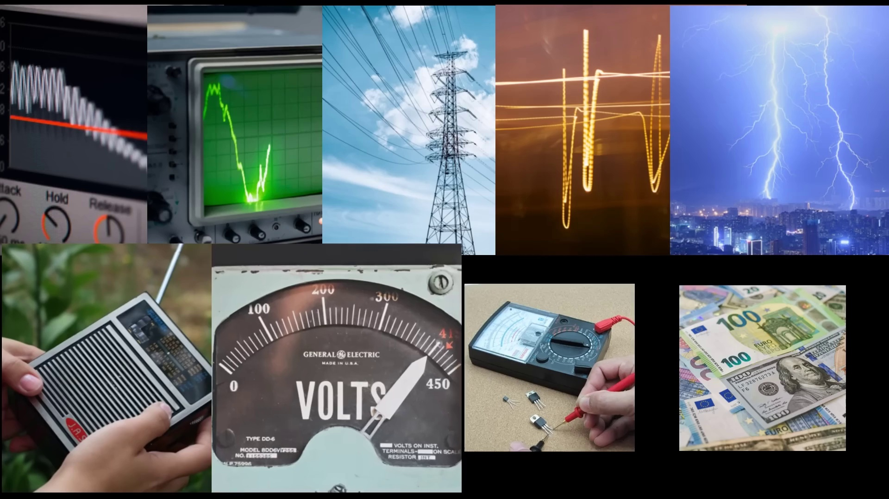 (score 95.0000)
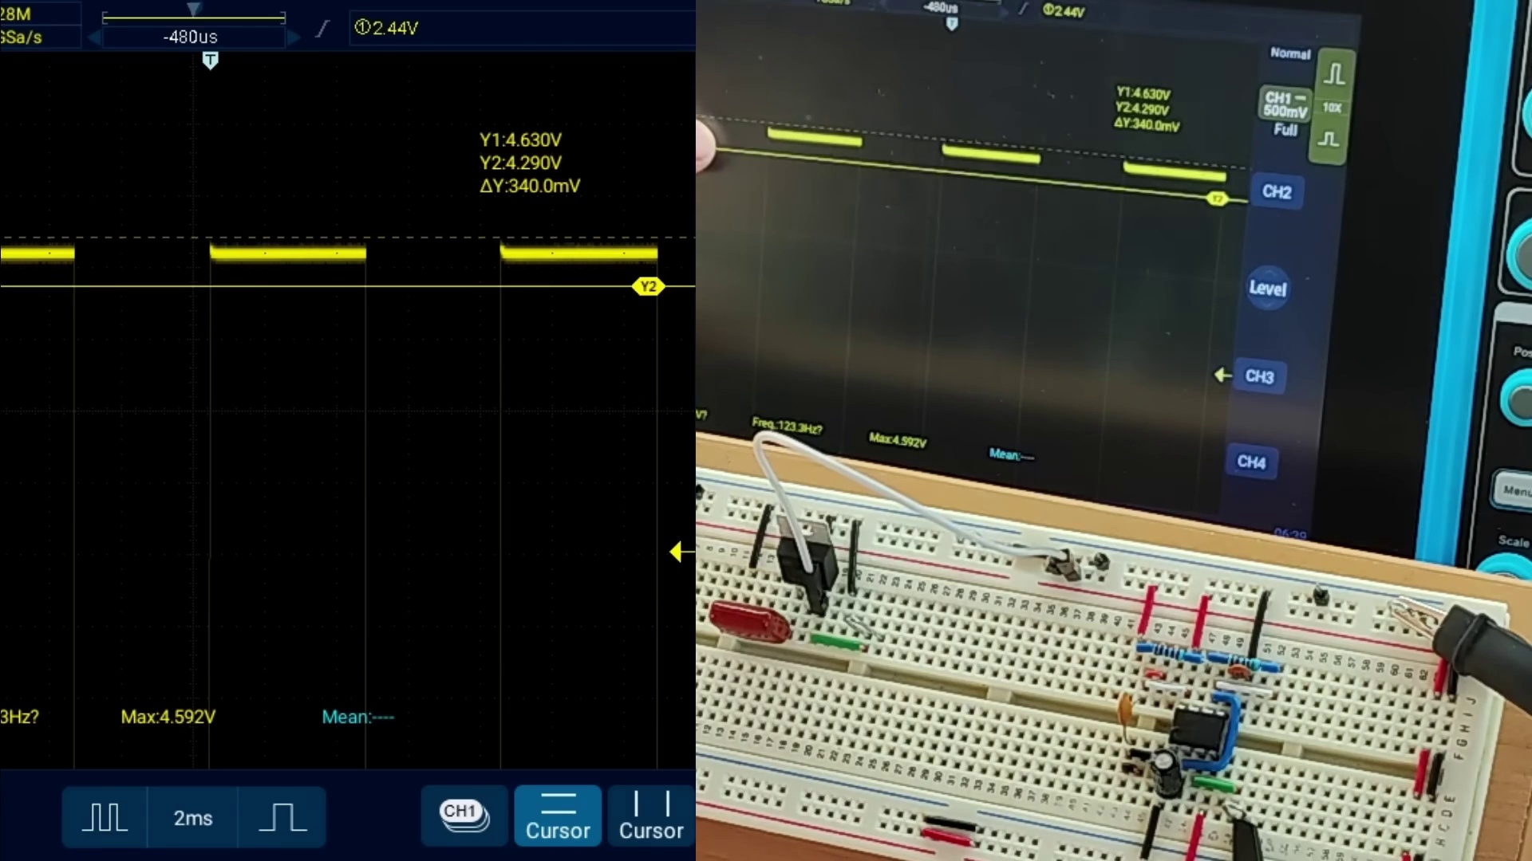 (score 95.0000)
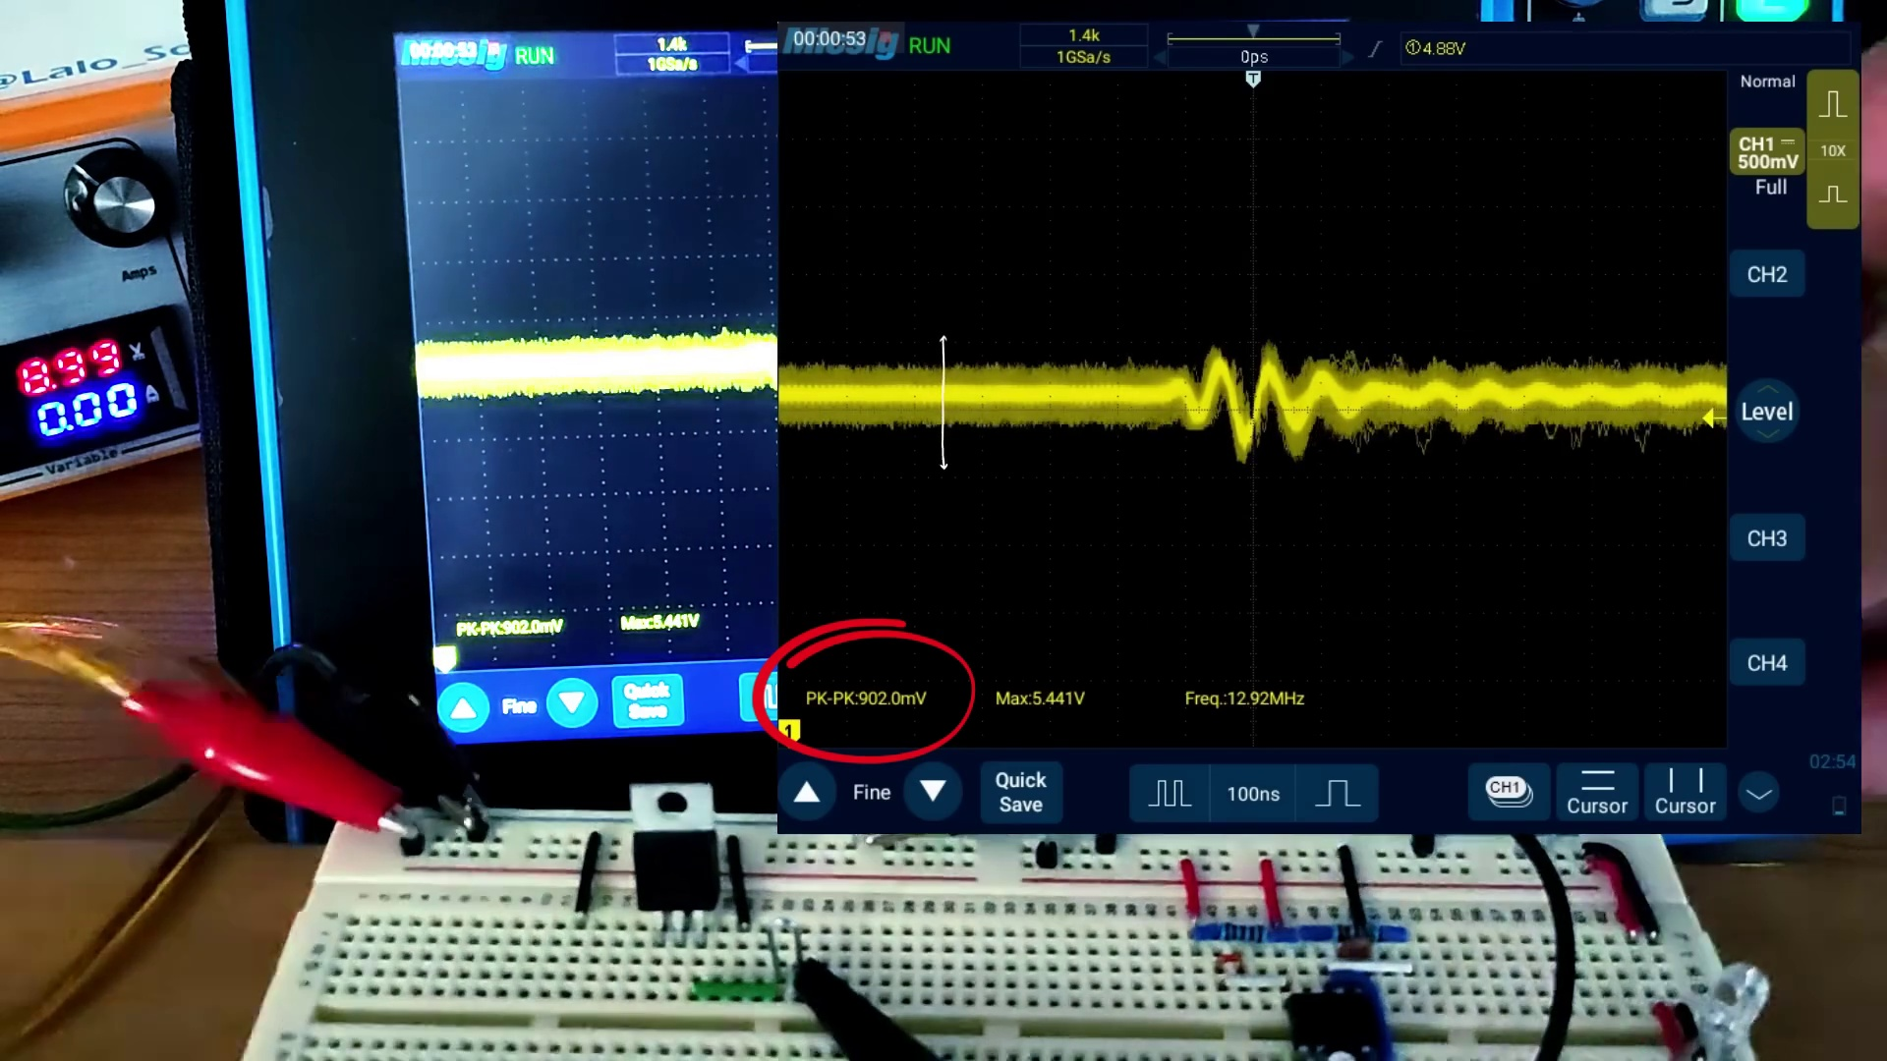 (score 95.0000)
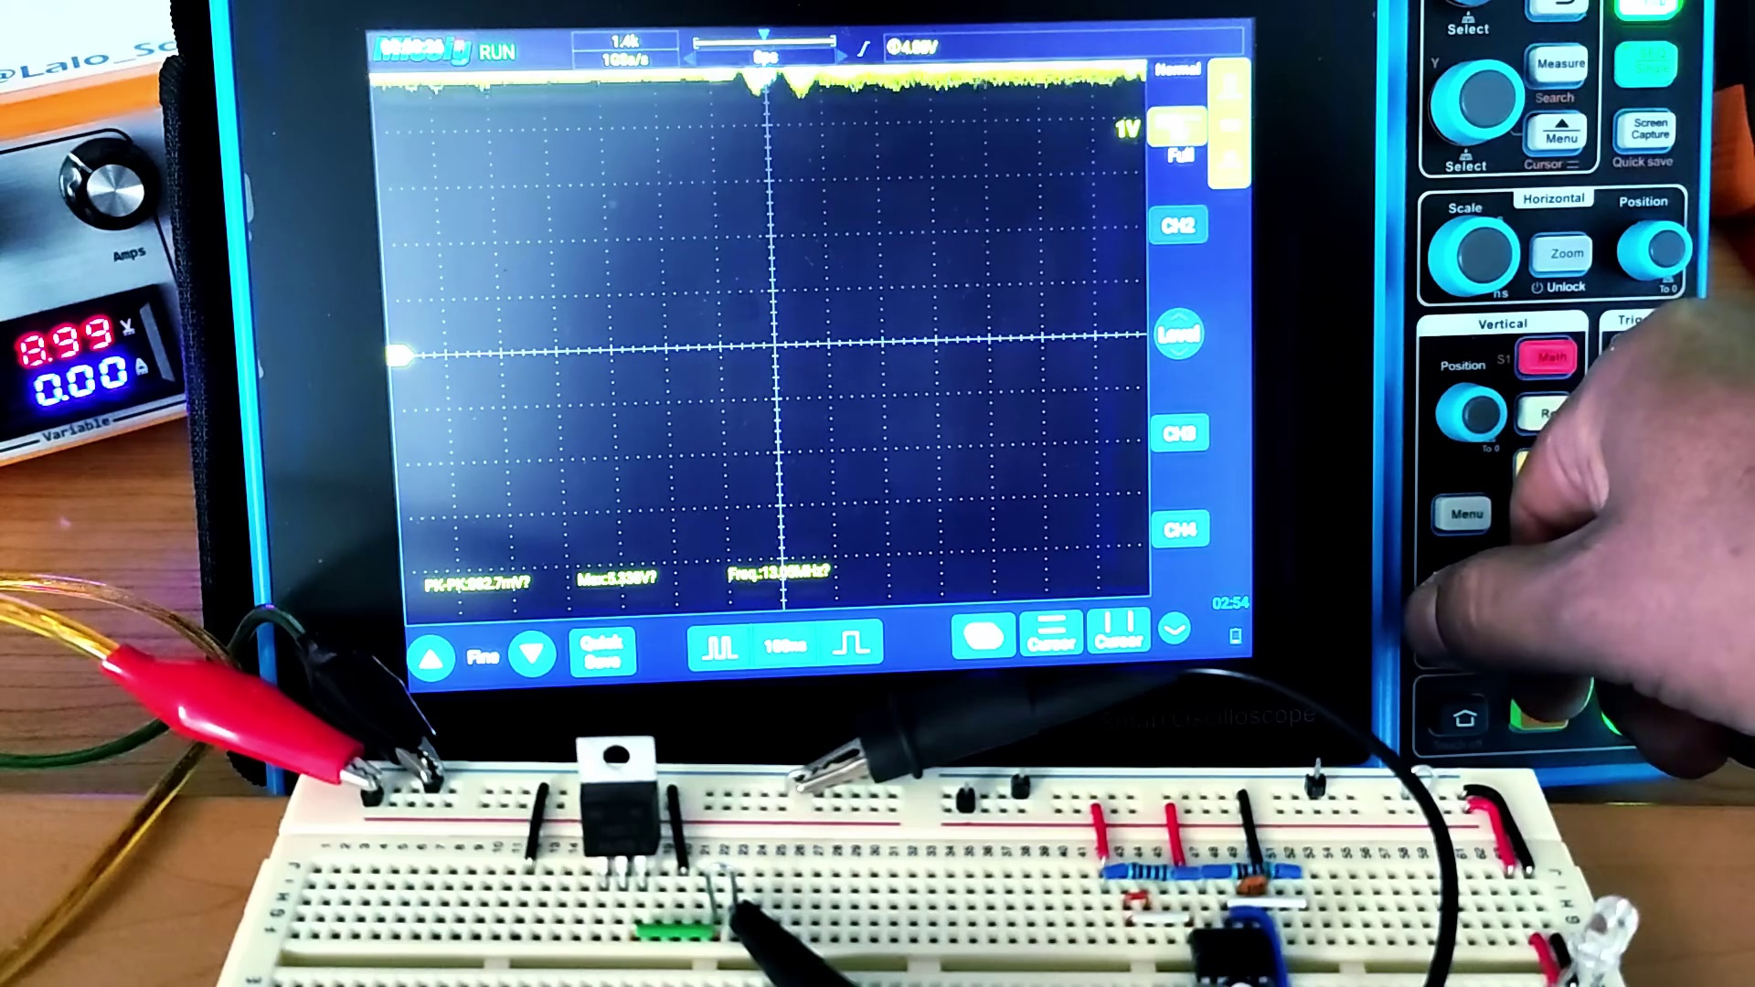 (score 95.0000)
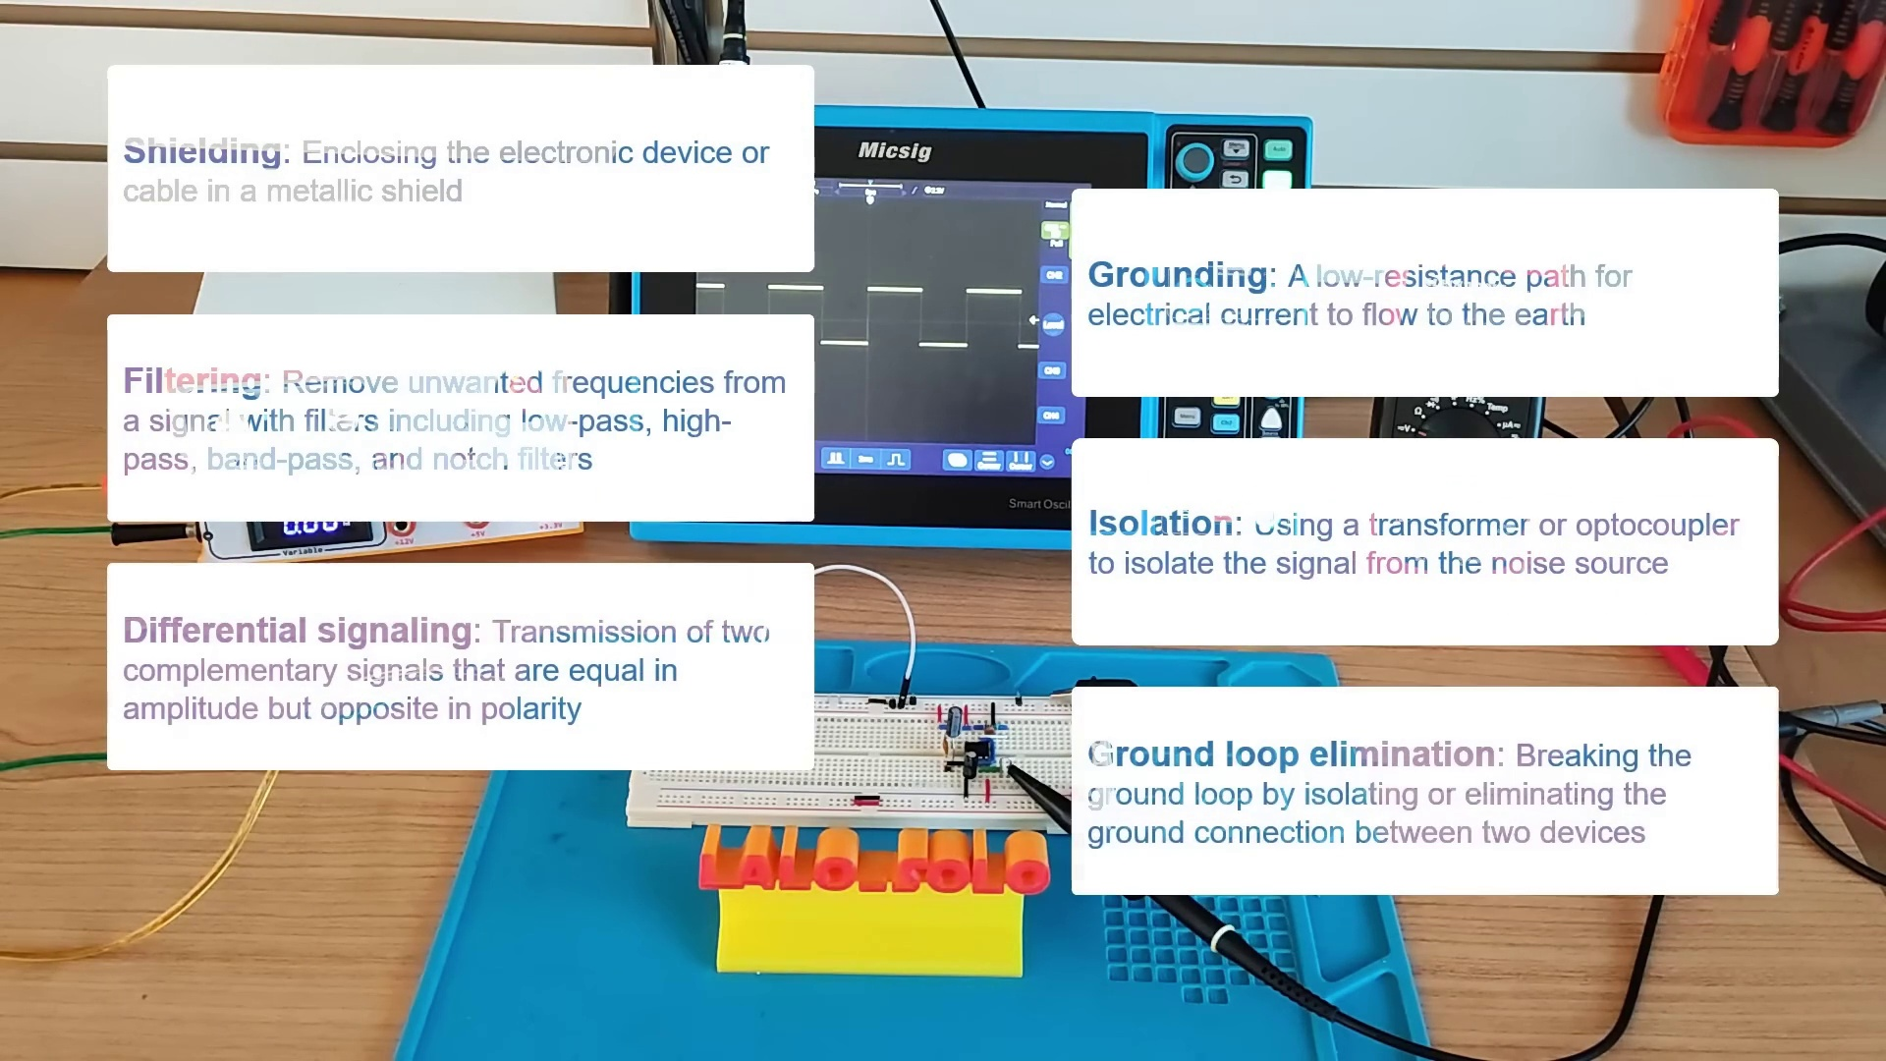 (score 90.0000)
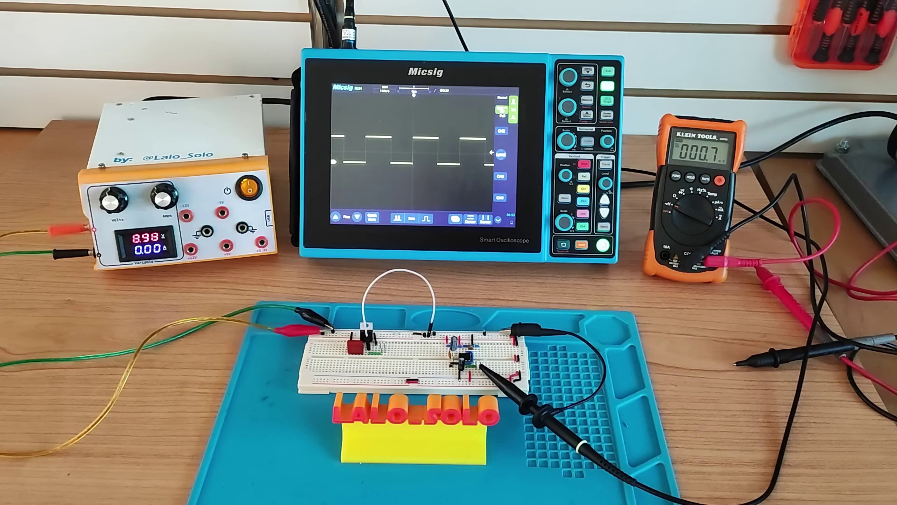 (score 90.0000)
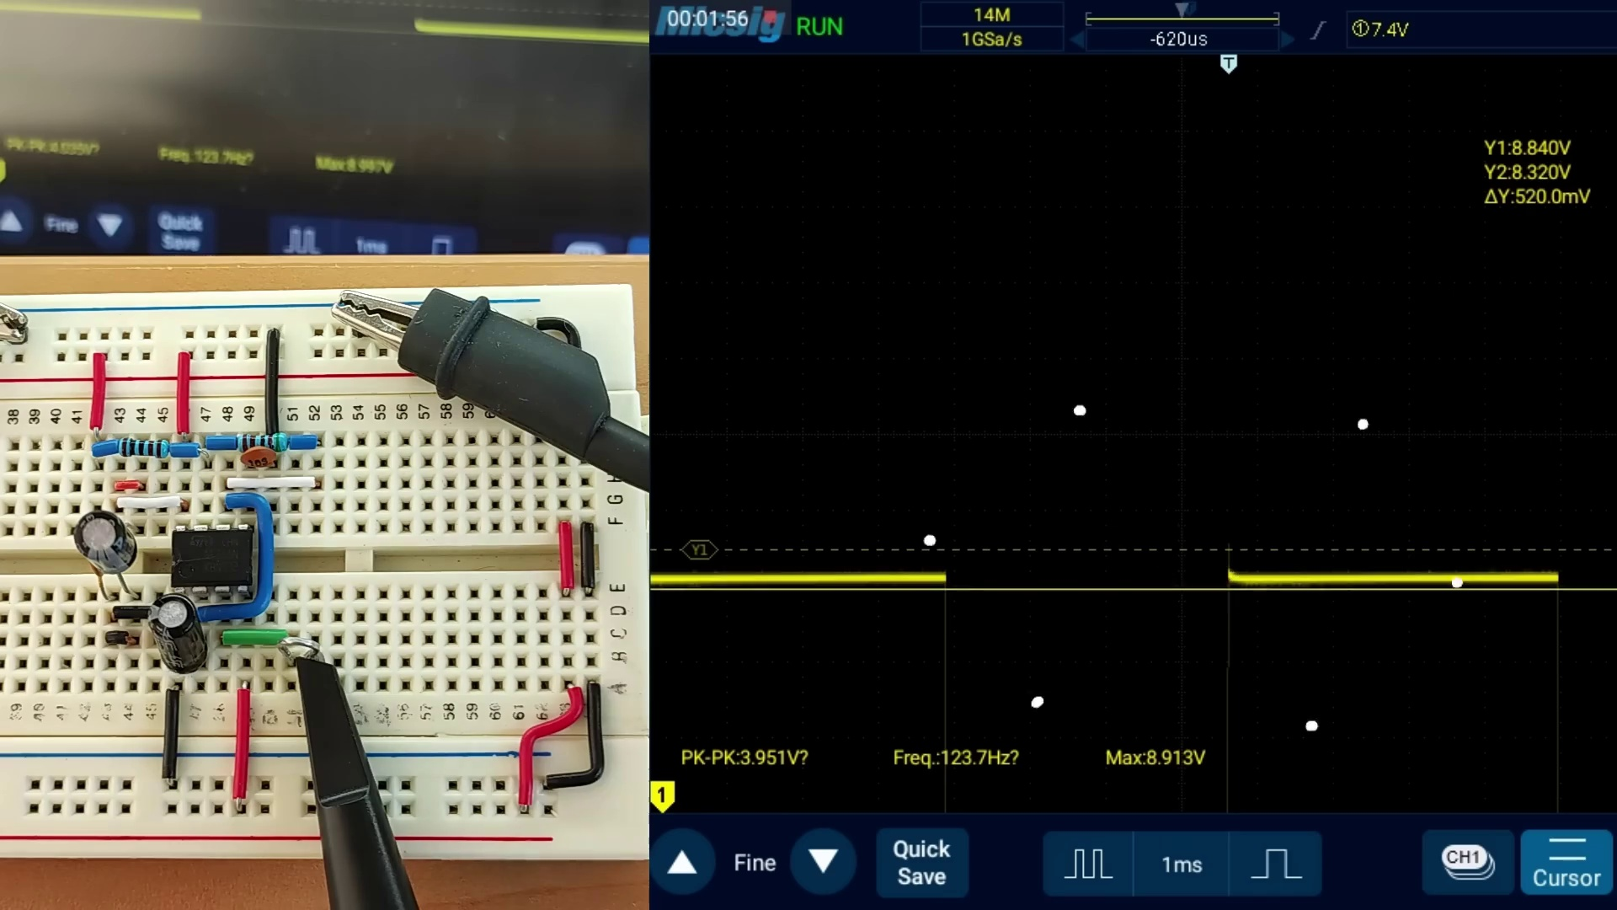 (score 90.0000)
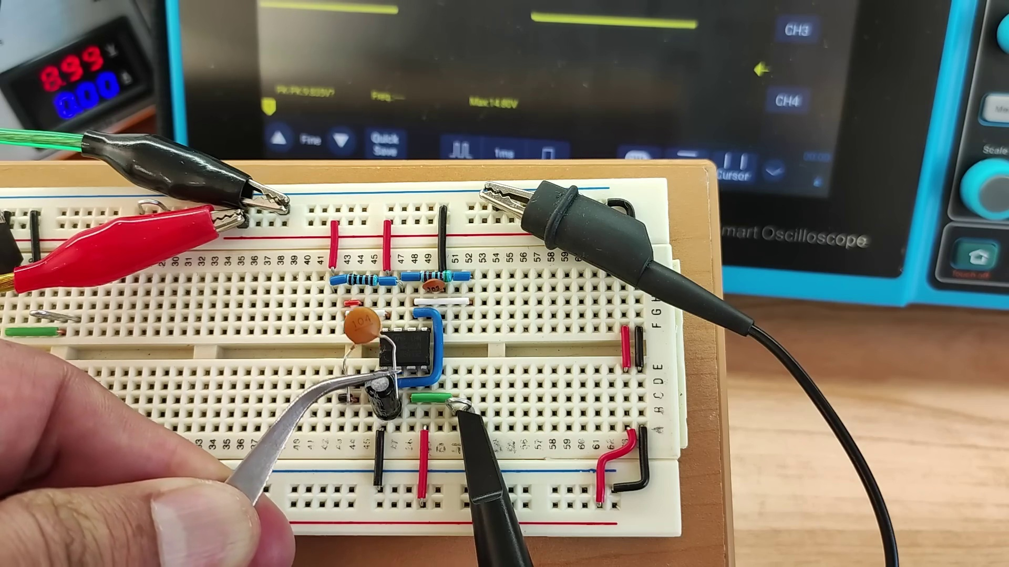 (score 90.0000)
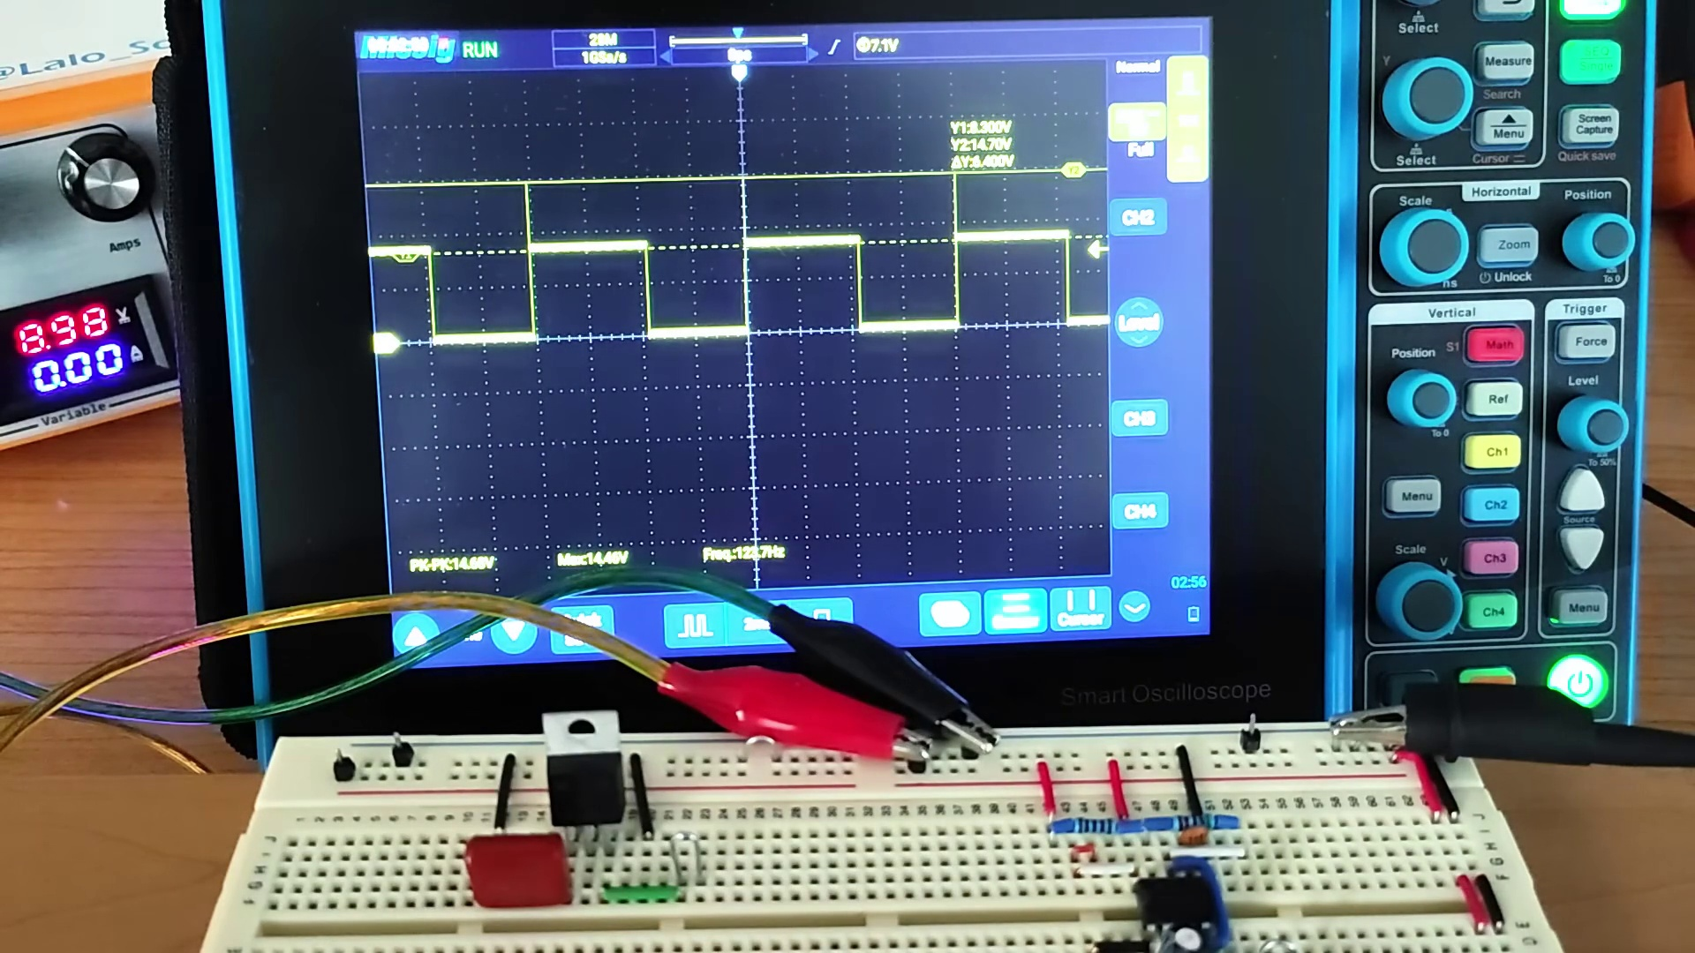 (score 90.0000)
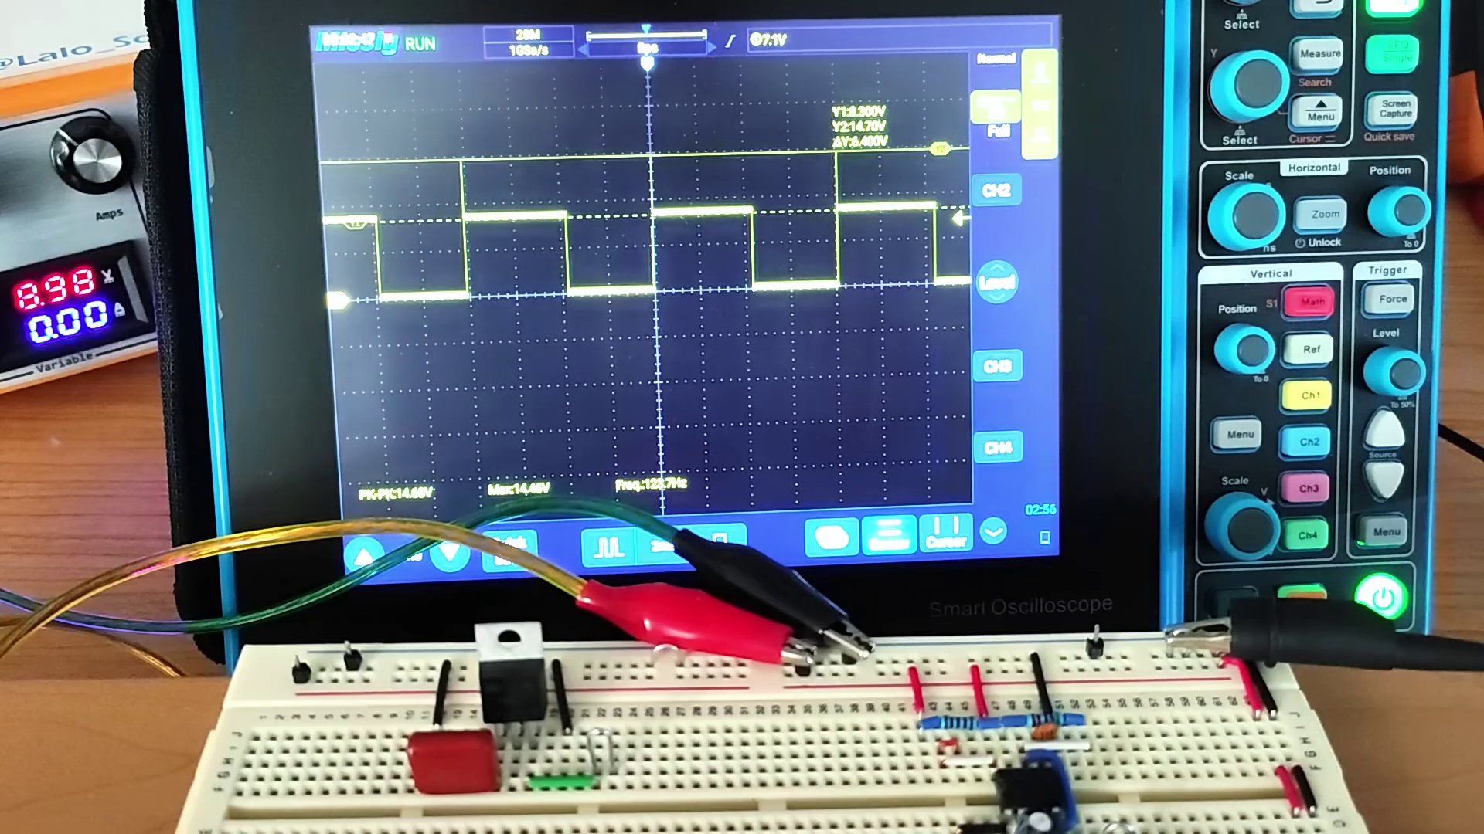 (score 90.0000)
Least correlated frames:
 (score 0.0000)
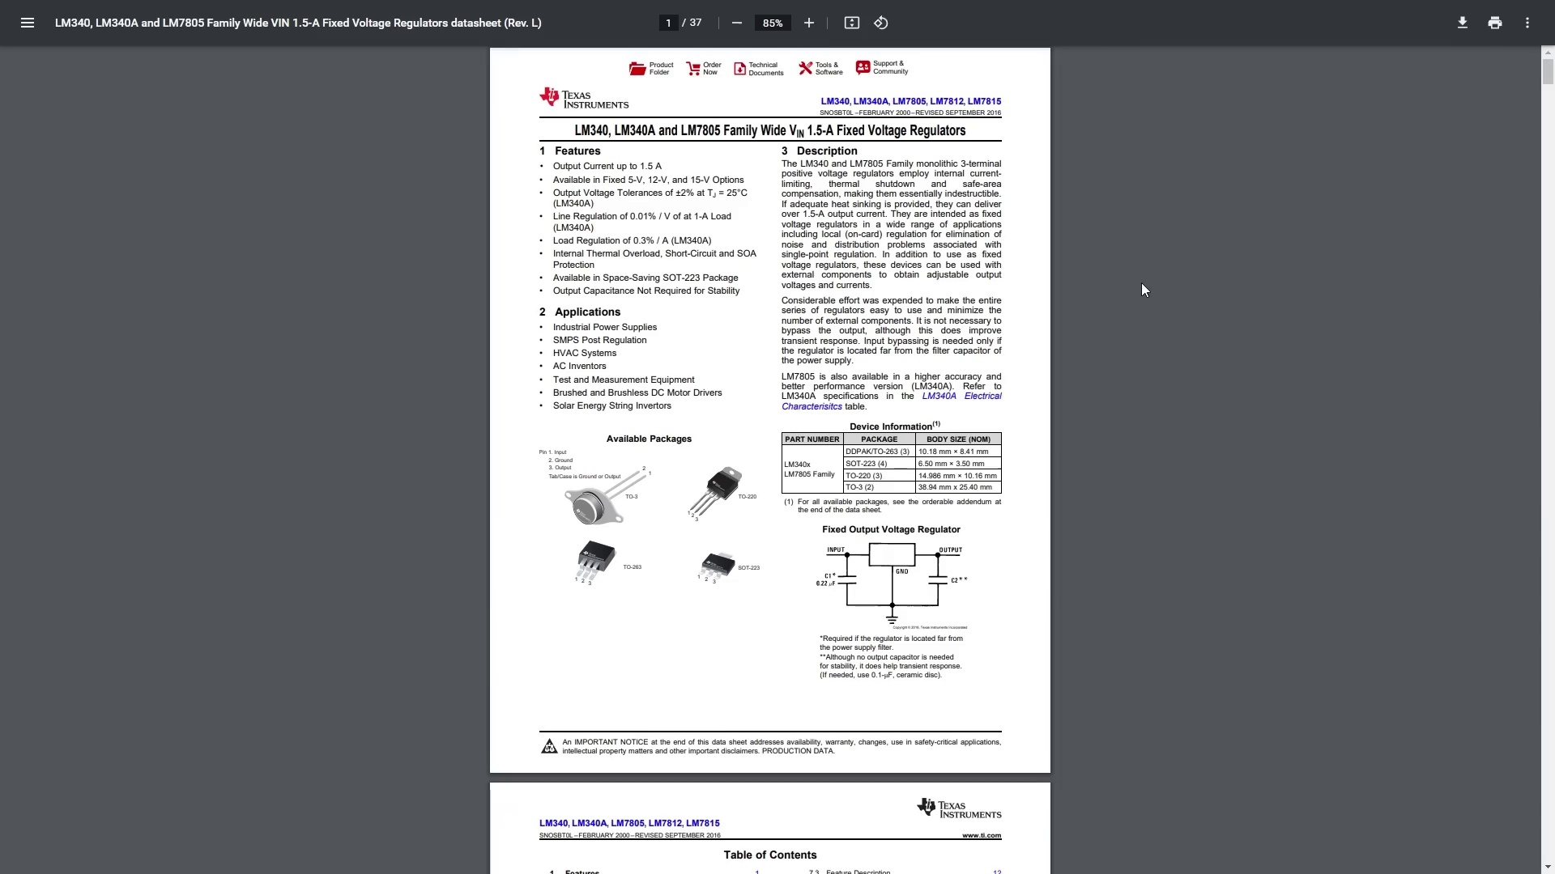 (score 0.0000)
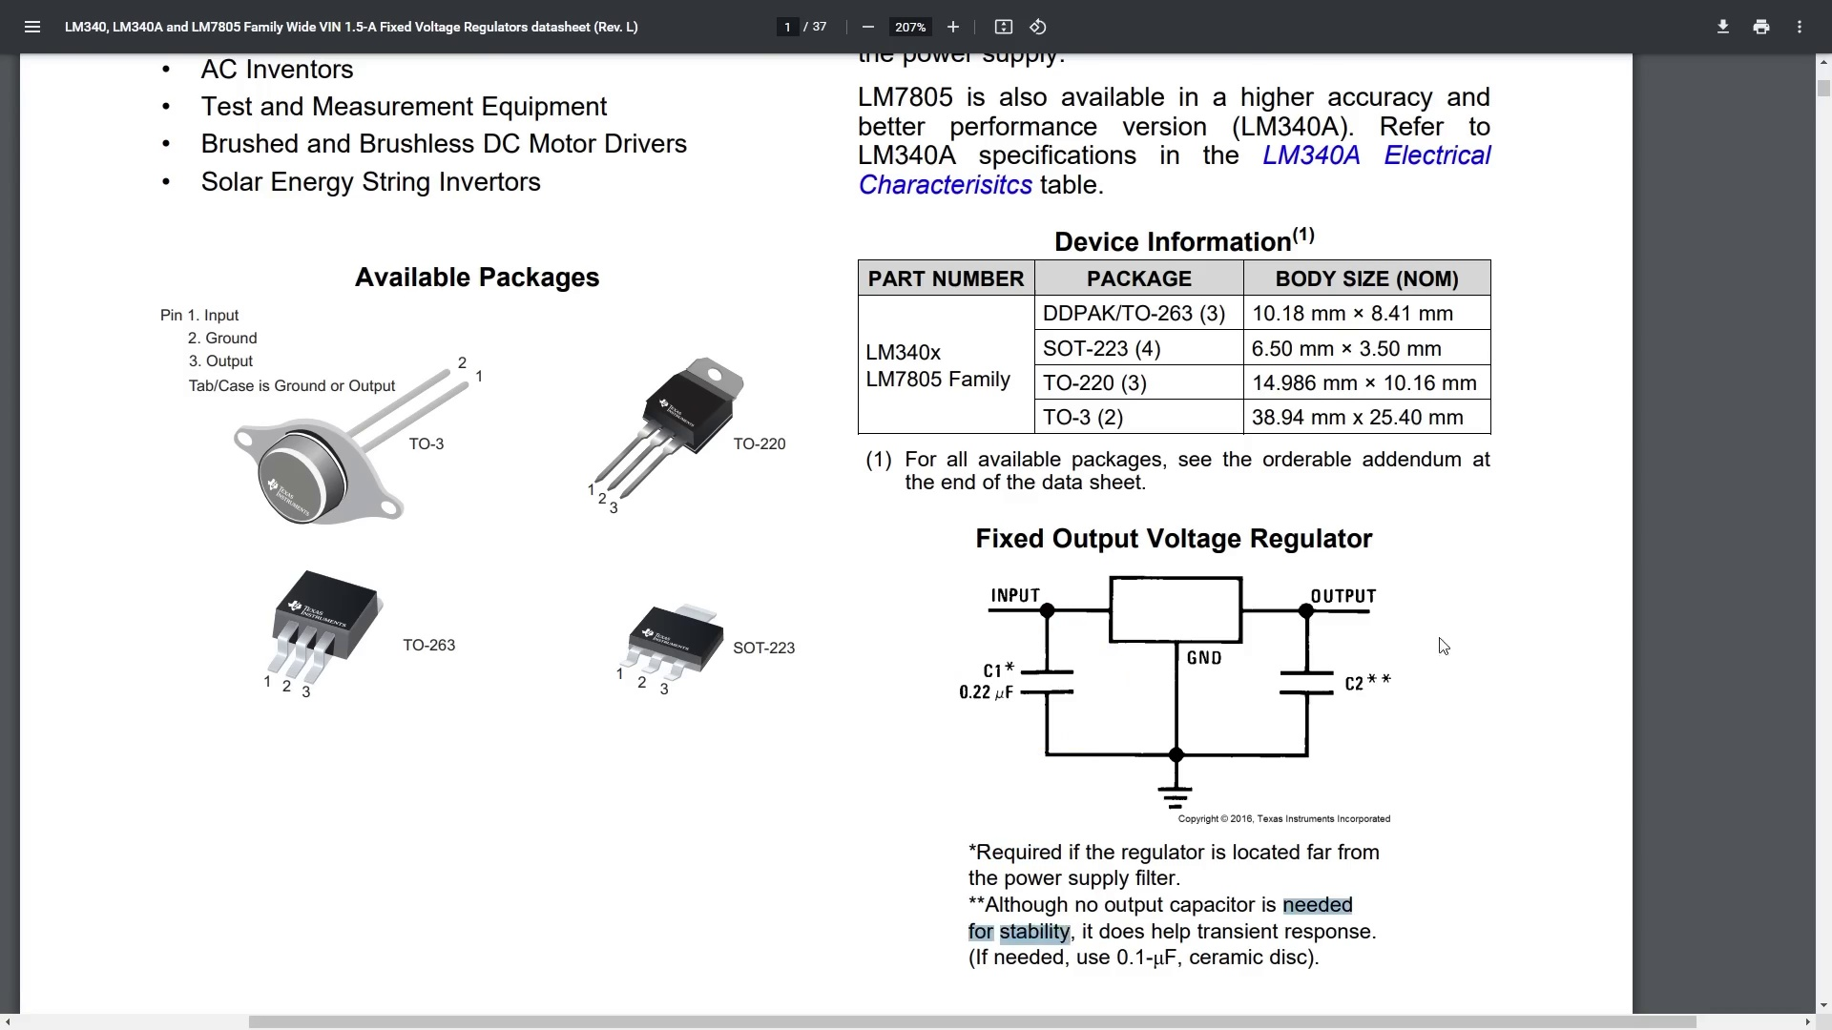 (score 0.0000)
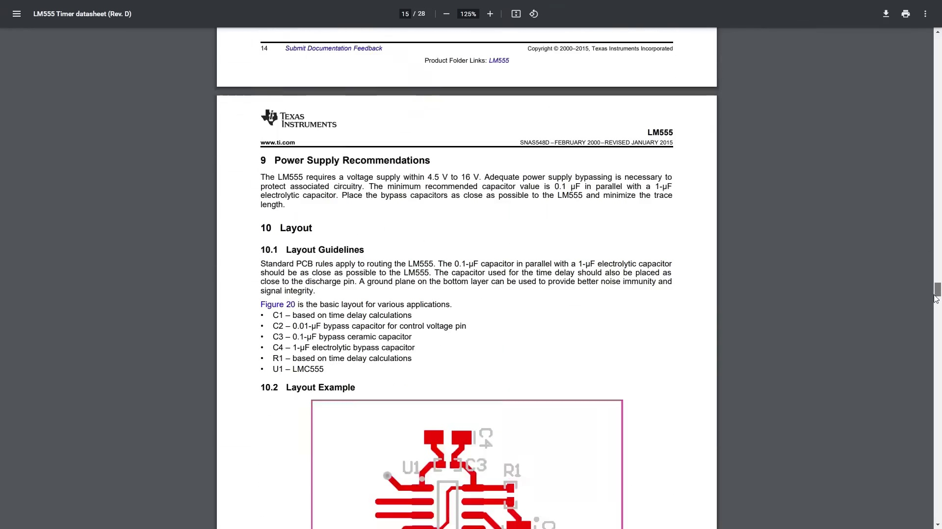 (score 0.0000)
 (score 0.0000)
 (score 0.0000)
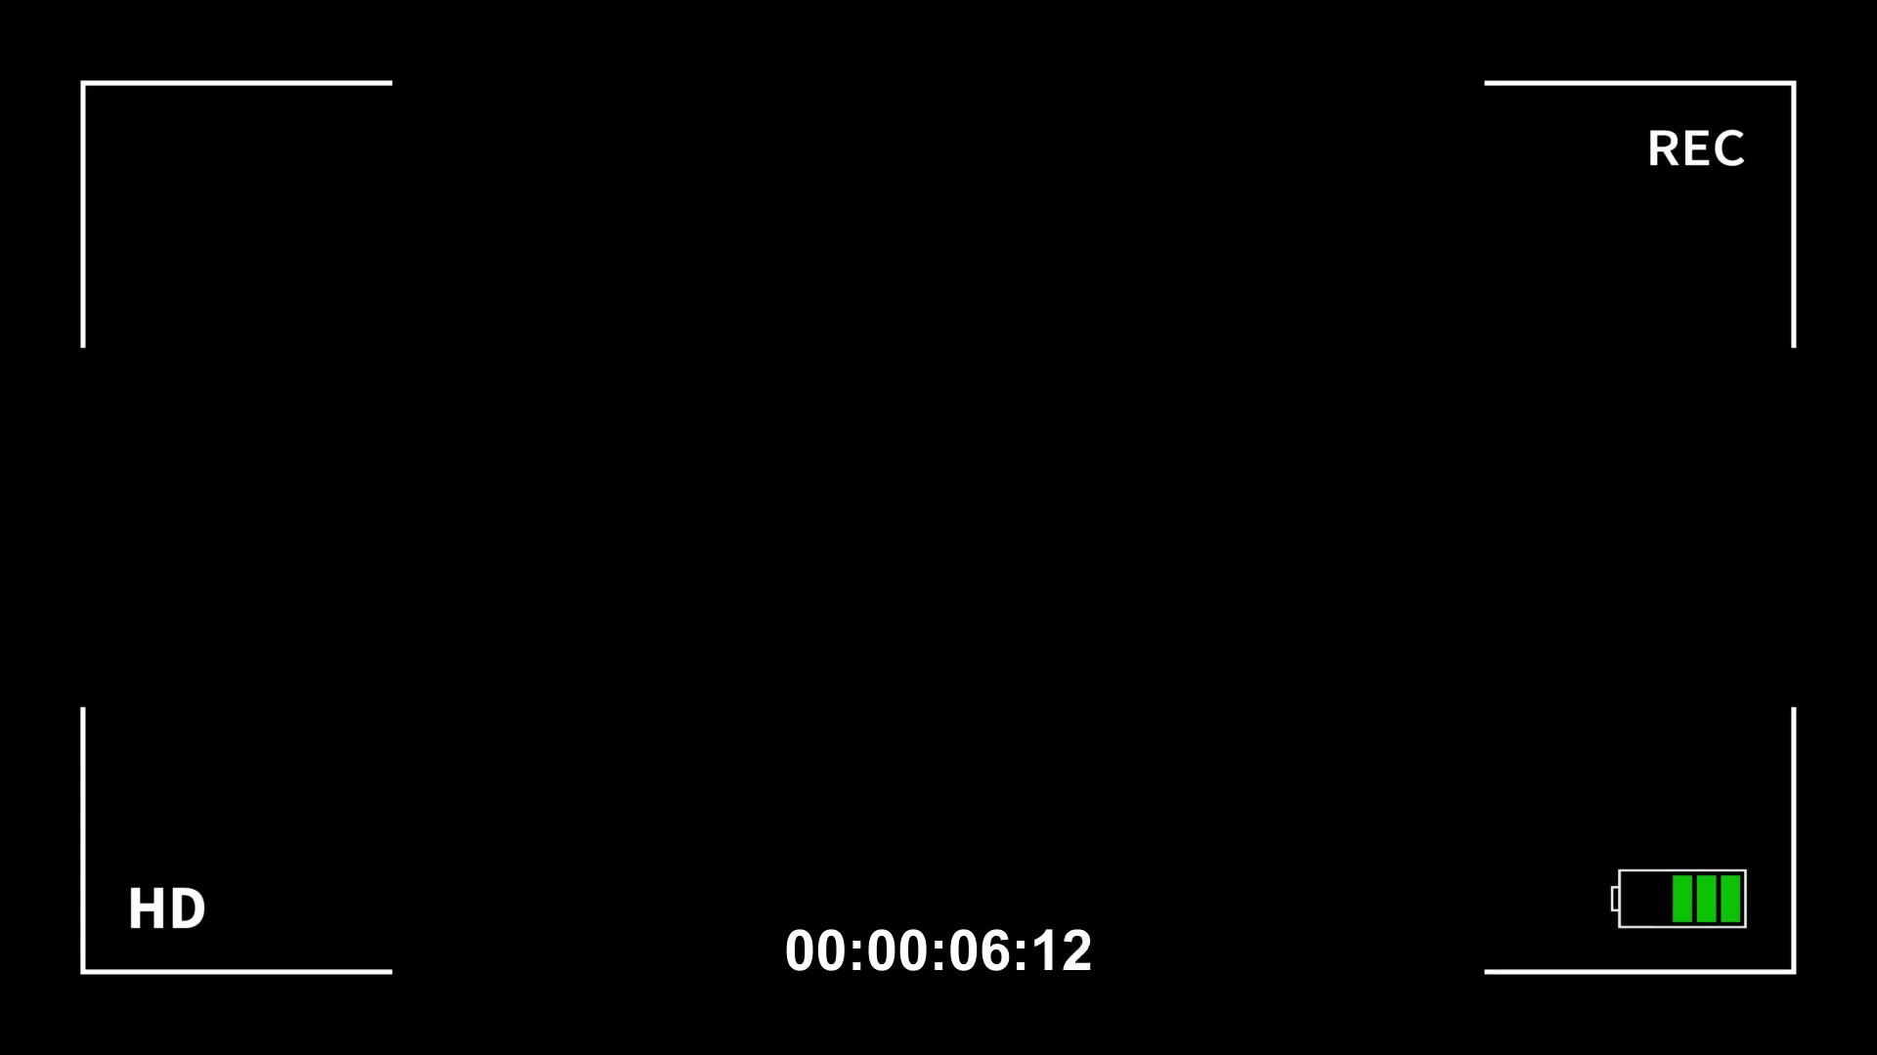 (score 0.0000)
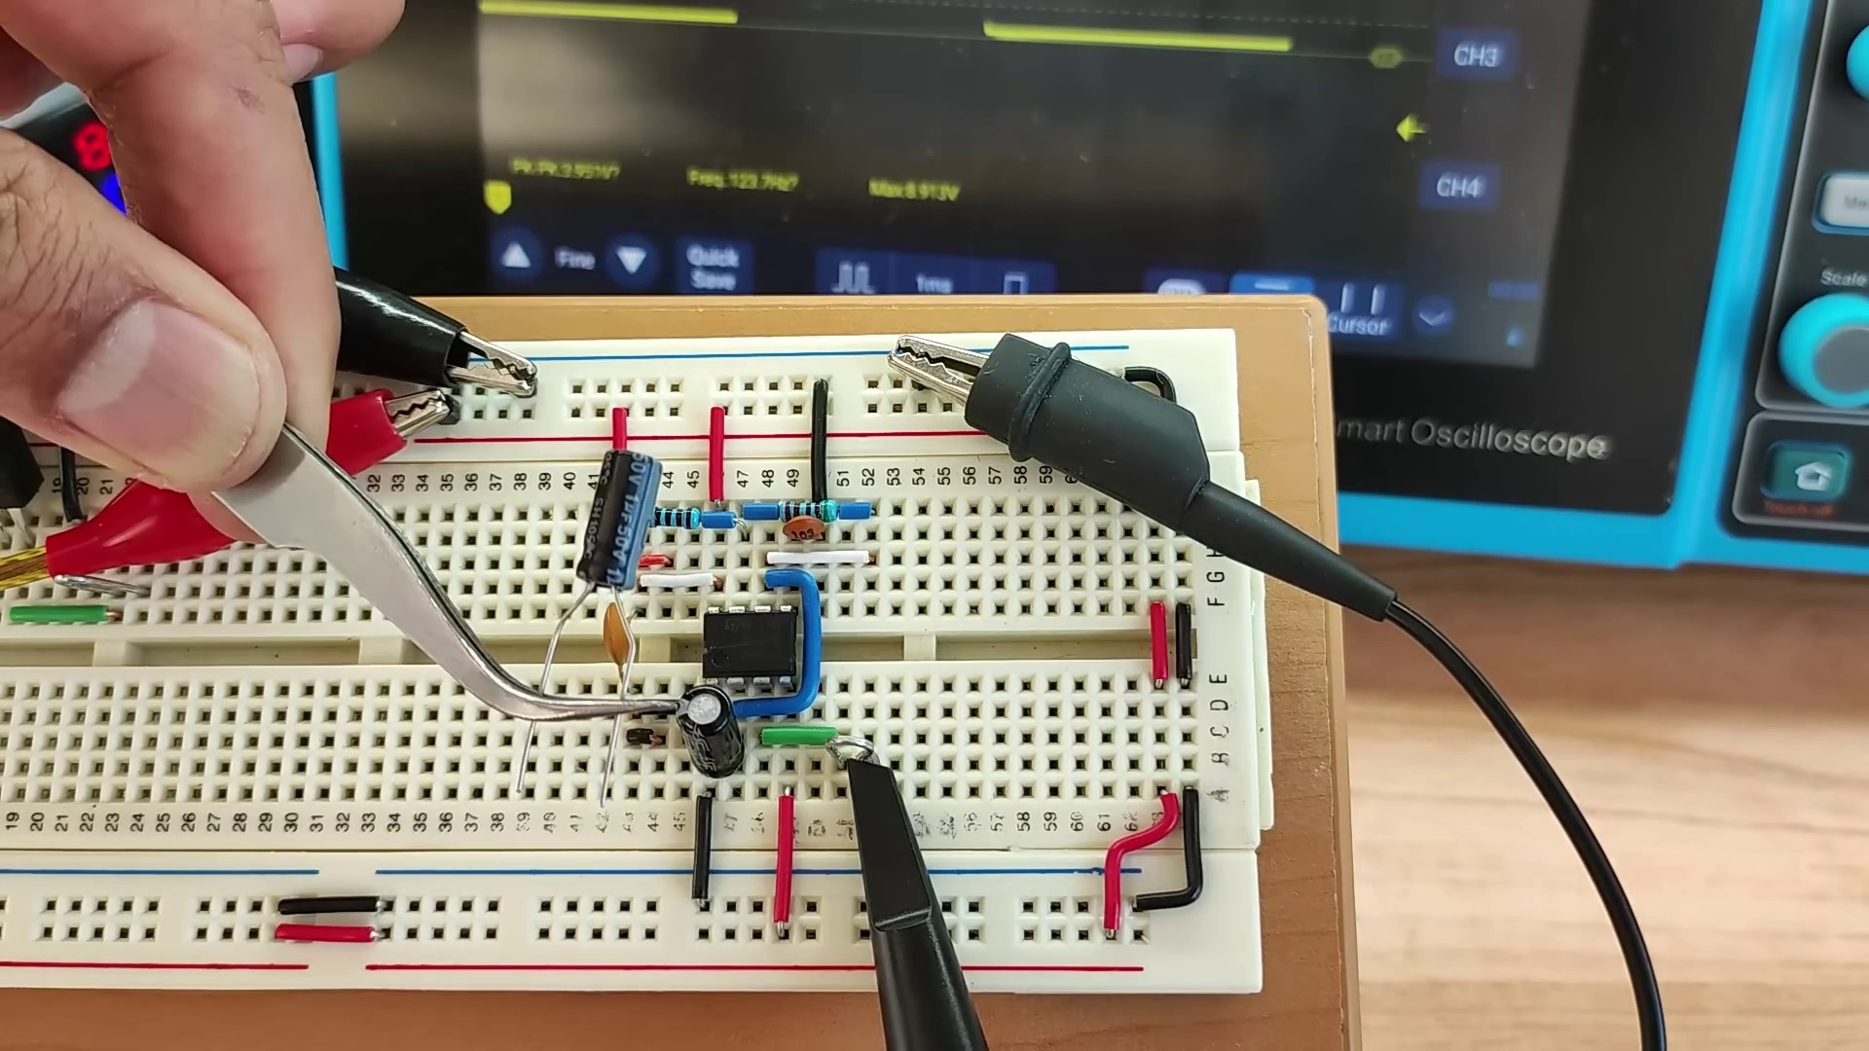 (score 5.0000)
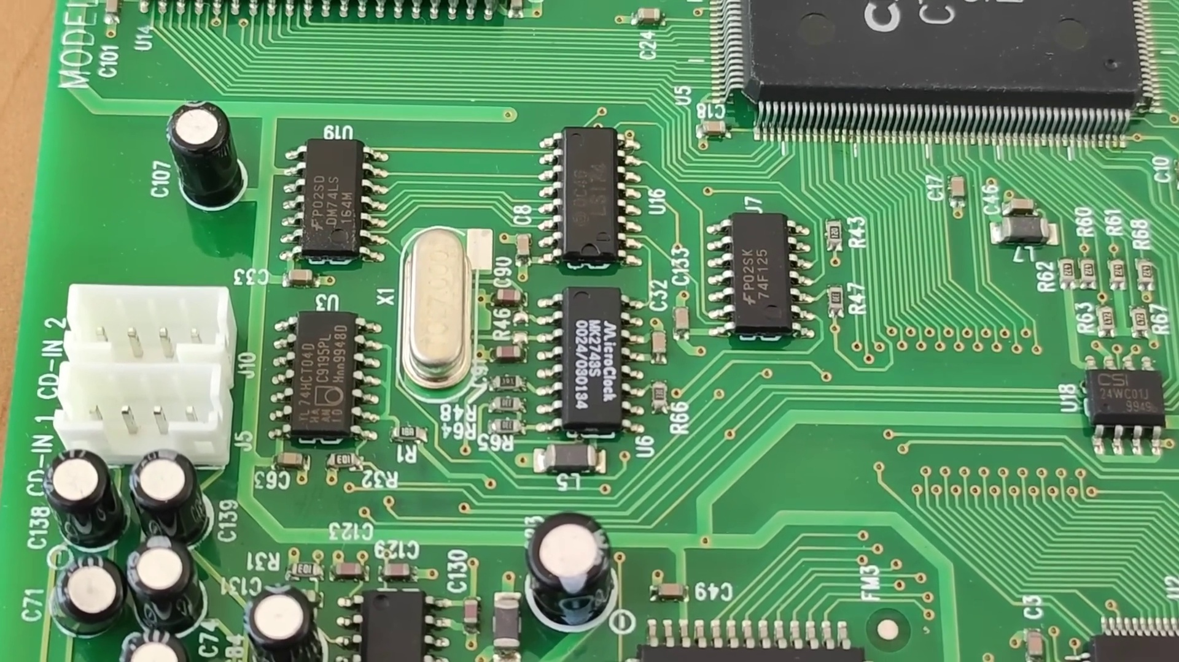 (score 10.0000)
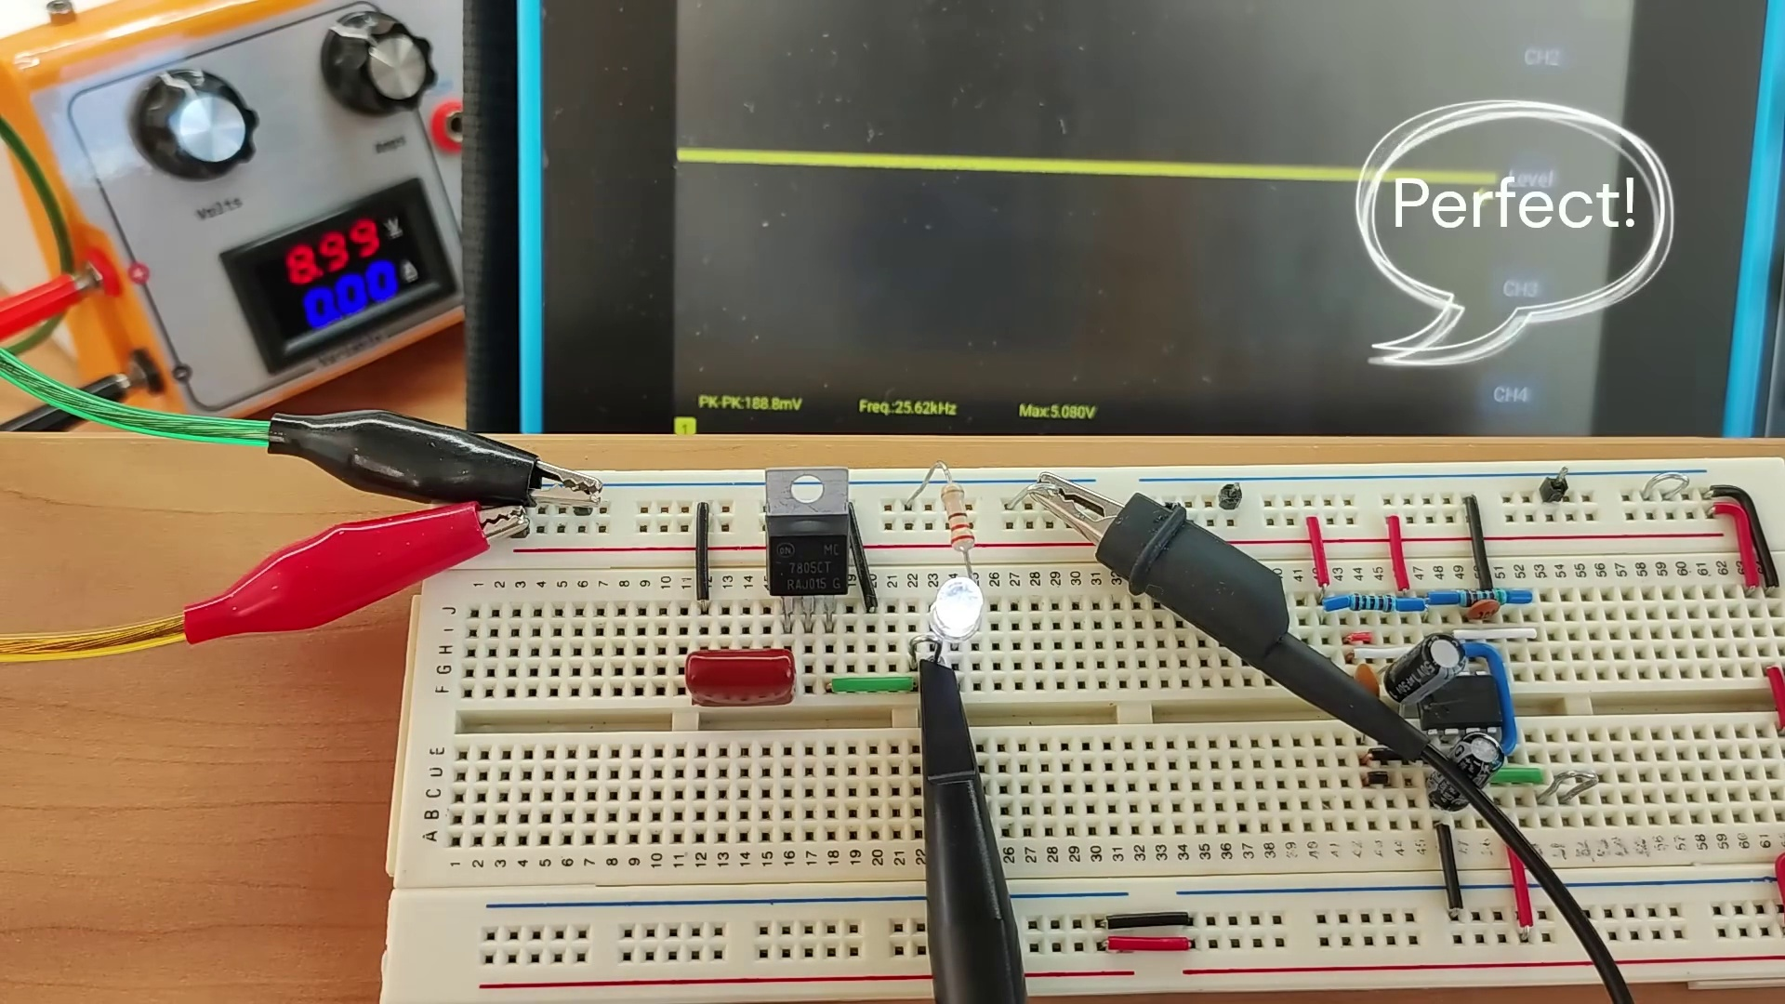 (score 10.0000)

Frame: frame_0000.jpg
Caption: The image displays three separate photographs, each depicting a different stage of a DIY electronics project involving an Arduino Uno board. In the first photo at the top left, there is a close-up view of an Arduino Uno microcontroller board with various electronic components connected to it. The board has a USB cable plugged into it, which typically provides power and connectivity for programming the Arduino. There are also several resistors, LEDs, and wires that have been soldered or clipped together to create a circuit.
In the second photo at the top right, there is a zoomed-in view of an oscilloscope screen displaying the result of the circuit's operation. The screen shows a sine wave with a peak amplitude of approximately 5 volts and a frequency that appears to be around 628 Hz, which is consistent with the 555 timer IC that is commonly used for generating square waves in such projects.
The third photo at the bottom center shows a schematic diagram of the circuit that has been constructed on the breadboard. The diagram includes symbols for electronic components like resistors, LEDs, and capacitors, along with their connections to the Arduino Uno board and the power supply. There are also numerical values indicating the resistance (in ohms) and the connections between different parts of the circuit.
In addition, the image provides a detailed view of the circuit board itself, which is divided into three sections labeled '1', '2', and '3'. Each section contains various electronic components, including resistors, capacitors, and a transistor. The resistors are colored in black, while the capacitors are colored in red. The transistor is colored in green. Text on the image reads "I2M" and "Data Sheets", indicating the name of the circuit and the source of the data.
Overall, the image appears to be part of a tutorial or guide on how to create and operate basic electronic circuits using an Arduino Uno board and a breadboard, as well as offering a glimpse into the inner workings of an electronic device. The image seems to be a step-by-step demonstration for those interested in learning about electronics and programming microcontrollers.
No strongly correlated comments found for this frame.

Frame: frame_0001.jpg
Caption: The image is a vibrant collage of various electronic components and circuits, divided into three sections. The top section features a circuit board with various components including resistors, capacitors, and a transistor, depicted in a variety of colors.
Starting from the top left and moving clockwise, the first image shows a breadboard with various electronic components attached to it, a basic tool for assembling circuits that allows for easy modification by inserting or removing components. The second image features a computer motherboard, the central printed circuit board (PCB) of most general-purpose computers that holds and allows communication between many essential electronic components.
The third image displays a computer's CPU (Central Processing Unit), often referred to as the "brain" of the computer, responsible for executing instructions stored in memory. The fourth image provides a close-up view of a computer's RAM (Random Access Memory) module, which temporarily stores data and instructions for the processor to access quickly.
In the center, there is a purple banner with white text that reads "Electronics," indicating that the collage is related to the subject of electronics or computing. The fifth image appears to be a screenshot of a presentation slide, showing three circuit diagrams: one on the left labeled "1," another in the middle, and a third one on the right. These diagrams represent electrical circuits, likely used as educational material to teach about how these components are typically connected or configured for use in various electronic devices.
The background is a rich brown, providing a contrast to the white paper that serves as the base for the collage. Each section of the collage is accompanied by text that reads "Electronics," serving as a title for the collage and providing a clear indication of its content. The overall impression is that of an instructional or informational context focused on electronics or computer hardware, possibly from an online class, tutorial, or educational resource.
Comment (score 80): What I have learned from the video: I learned that adding a load can drastically increase noise in both the input and output source. Therefore, decoupling capacitors are very critical to the output sound of a speaker. The video explained several noise elimination techniques such as shielding, filtering, differential signaling, grounding, isolation, surge protection, and ground loop elimination. It was helpful for Phase 2 by showing how to test for noise sources and eliminate them effectively. Any questions not answered through the video: One question I had was why two parallel capacitors are used instead of one. This was answered—one filters low frequency noise, the other high. However, I didn’t fully understand some of the other noise elimination techniques.
Reason: The comment directly discusses the same technical steps and concepts described in the caption, specifically noise elimination techniques and decoupling capacitors.
Source: https://www.youtube.com/watch?v=u40kX1DYKdA: Decoupling Capacitors - And why they are important

Frame: frame_0002.jpg
Caption: The image appears to be a still from a movie, showing an individual standing next to a black and silver object labeled as a "Capacitor" with a red sticker on it that reads "Not this one." The man is inspecting the object, possibly checking its functionality or preparing to use it. The background of the image is dark, adding to the suspense and mystery surrounding the scene.
Above this scene is a humorous text that reads "NOT THIS CAPACITOR," which is placed in such a way that it appears to be referring to the actual image below. The term "capacitor" is a play on words, suggesting a misunderstanding or misrepresentation of the image on the left as being about capacitors when it actually shows a different kind of electronic component.
The text on the right side of the split-screen is in white and reads "CAPACITOR." The word "capacitor" is stylized with different fonts, creating an amusing visual effect that mimics how a textbook might define different types of capacitors.
Comment (score 80): What I have learned from the video: I learned that adding a load can drastically increase noise in both the input and output source. Therefore, decoupling capacitors are very critical to the output sound of a speaker. The video explained several noise elimination techniques such as shielding, filtering, differential signaling, grounding, isolation, surge protection, and ground loop elimination. It was helpful for Phase 2 by showing how to test for noise sources and eliminate them effectively. Any questions not answered through the video: One question I had was why two parallel capacitors are used instead of one. This was answered—one filters low frequency noise, the other high. However, I didn’t fully understand some of the other noise elimination techniques.
Reason: The comment directly discusses the concept of decoupling capacitors and their importance in eliminating noise, which is also described in the caption as a key component labeled 'Capacitor'.
Source: https://www.youtube.com/watch?v=u40kX1DYKdA: Decoupling Capacitors - And why they are important

Frame: frame_0003.jpg
Caption: The image presents a close-up view of a green circuit board, which appears to be an electronic circuit board with various components mounted on it. The circuit board features a dense array of surface-mounted devices (SMDs), including resistors, capacitors, and integrated circuits (ICs), all meticulously arranged in a grid pattern consistent with electrical connections. The SMDs are labeled with white text, and some have additional connectors attached.
The background suggests an indoor setting, possibly a workshop or lab where electronic work is being done. There is no visible instructor or teaching context within the image provided.
No strongly correlated comments found for this frame.

Frame: frame_0004.jpg
Caption: The image shows two distinct visual elements: a computer screen displaying a digital rendering of a geographical map and a close-up view of a circuit board. The map appears to represent an island with various labeled components, possibly signifying different zones within the island. There are symbols representing infrastructure elements such as roads, buildings, and possibly communication towers or other structures related to telecommunications.
In the top right corner of the screen, a watermark text "Teacher's Pet" suggests that this software is used for educational purposes, potentially for teaching geography, urban planning, or cartography. The name on the screen indicates the software being used is named "Teacher's Pet." A tab with "Teacher's Pet" in white text against a red background and another tab labeled "Training" implies that this could be part of a training session to learn how to use the software effectively.
The bottom left corner of the screen displays a text chat window, although it is unclear what was written or by whom due to the image resolution. The bottom right corner features some interface elements and possibly another instance of the map being used. An instructor appears to be pointing at a particular area of the map, possibly explaining what each labeled component represents.
In contrast, the close-up view shows a detailed representation of electronic components on a circular circuit board. The board's edges are adorned with gold-colored pins, each with a unique number indicating their respective functions. A blue rectangular frame serves as a protective cover for the board, slightly tilted to the right, adding a dynamic element to the scene.
A white text box in the top right corner reads "Openhelp", suggesting that this might be a tool or software for designing or managing circuit boards. Overall, the image captures an educational setting where someone is teaching or demonstrating how to use both Teacher's Pet software and Openhelp for creating maps with labeled components and infrastructure symbols, as well as designing electronic circuits.
No strongly correlated comments found for this frame.

Frame: frame_0005.jpg
Caption: The image presents a striking display of text and illustration. At its center is a curved shape that is predominantly white, but features blue and white text that reads "Lalo Solo" diagonally across the shape. This design creates a sense of movement and dynamism. Above this larger text, a smaller blue and white rectangle contains the word "Ele", situated in the top right corner.
To the left of the curved shape is a block with a textured surface, giving it a tactile appearance, inscribed with the word "Lalo". The block appears to be surrounded by a neutral background that does not provide additional context or details about the object. Below this block is another one with the word "Solo" on it.
A large, bold text above the blocks reads "ELECTRIC", with the font color alternating between blue and red. The overall aesthetic of the image has a professional and clean appearance typical of technical presentations or digital renderings.
Comment (score 80): What I have learned from the video: I learned that adding a load can drastically increase noise in both the input and output source. Therefore, decoupling capacitors are very critical to the output sound of a speaker. The video explained several noise elimination techniques such as shielding, filtering, differential signaling, grounding, isolation, surge protection, and ground loop elimination. It was helpful for Phase 2 by showing how to test for noise sources and eliminate them effectively. Any questions not answered through the video: One question I had was why two parallel capacitors are used instead of one. This was answered—one filters low frequency noise, the other high. However, I didn’t fully understand some of the other noise elimination techniques.
Reason: The comment discusses decoupling capacitors and noise elimination techniques mentioned in the caption, including grounding and surge protection.
Source: https://www.youtube.com/watch?v=u40kX1DYKdA: Decoupling Capacitors - And why they are important

Frame: frame_0006.jpg
Caption: The image presents a digital rendering of the Lalo-Solo Electronic Workbench, which appears to be a 3D print or sculpture with text on its surface. The text is in white and reads "LALO-SOLID" and "ELECTRIC WORKBENCH," suggesting it might be a promotional image for a product related to electronics. The workbench itself has a modern and sleek design, featuring sharp angles and a glossy finish that reflects light.
The Lalo-Solo Electronic Workbench is composed of two parts: the top part features blue letters spelling out "Lalo-Solo" in a diagonal line, creating a sense of movement and dynamism. The bottom part is a stark white, providing contrast to the blue letters. The workbench is positioned on a dark grey background, which provides a subtle contrast that highlights the workbench.
There are no people or other items visible in this frame, focusing solely on the Lalo-Solo Electronic Workbench and its textual information.
No strongly correlated comments found for this frame.

Frame: frame_0007.jpg
Caption: The image shows a screenshot of a Wikipedia page titled "Noise (electronics)" with the language set to German. The title of the page is prominently displayed at the top, above the main content section. The page is divided into two sections: "History" and "Electronics". The "History" section provides a brief overview of the history of noise in electronics, while the "Electronics" section delves into the various types of noise in electronics, including references to white noise, pink noise, and brown noise. Below the main content section, there is a list of references for further reading.
The Wikipedia page also includes interface elements such as the search bar, navigation links (Article, Talk, Lists, Categories), and tabs for different languages. At the bottom of the page, there are links for 'Cite this page', 'Edit this page', and various other options typically found on a Wikipedia article page. The screenshot does not provide enough detail to describe any specific text or diagrams beyond what has been described.
Comment (score 85): What I have learned from the video: I learned that adding a load can drastically increase noise in both the input and output source. Therefore, decoupling capacitors are very critical to the output sound of a speaker. The video explained several noise elimination techniques such as shielding, filtering, differential signaling, grounding, isolation, surge protection, and ground loop elimination. It was helpful for Phase 2 by showing how to test for noise sources and eliminate them effectively. Any questions not answered through the video: One question I had was why two parallel capacitors are used instead of one. This was answered—one filters low frequency noise, the other high. However, I didn’t fully understand some of the other noise elimination techniques.
Reason: The comment directly discusses technical steps and concepts described in the caption, such as noise elimination techniques (shielding, filtering, differential signaling, etc.), which are mentioned in the 'Electronics' section of the Wikipedia page.
Source: https://www.youtube.com/watch?v=u40kX1DYKdA: Decoupling Capacitors - And why they are important

Frame: frame_0008.jpg
Caption: The image displays a combined representation of an academic discussion on noise in electronic systems, sourced from both an online article and the Wikipedia page for "noise". At the top of the screen, the title mentions "noise electronics", with an abstract or summary text discussing the detrimental effects of noise on both electronic devices and human hearing. The passage specifically highlights the impact of noise on electronic components such as transistors and microchips, in addition to its potential harm to human ears.
In the middle of the page, a screenshot of a noisy environment is displayed, possibly depicting an industrial setting with high levels of ambient noise. This image likely relates to the discussion on noise in electronic systems. The scene shows various electronic devices, including what appears to be a microchip and a transistor on a breadboard, along with wires and components commonly used for electronic testing or development.
To the right of the screen, there is another screenshot showing a graph, which seems to display data over time. The graph includes labels such as "Noise Level", "Time", and "Unit", but the specific values are not legible due to the image's resolution. This graph may illustrate how noise levels change with time or under different conditions.
The webpage itself contains additional text that is too small to read in detail from this image, without any visible slides or diagrams providing further information on the topic. A reference citation in the form of "adress" is also present, although it is unclear where the specific address is located on the page.
In conjunction with the online article, the Wikipedia page provides a comprehensive explanation of noise as an unwanted disturbance in an electrical signal. The page defines various types of noise, including electrical noise, thermal noise, and random noise.
Comment (score 85): What I have learned from the video: I learned that adding a load can drastically increase noise in both the input and output source. Therefore, decoupling capacitors are very critical to the output sound of a speaker. The video explained several noise elimination techniques such as shielding, filtering, differential signaling, grounding, isolation, surge protection, and ground loop elimination. It was helpful for Phase 2 by showing how to test for noise sources and eliminate them effectively. Any questions not answered through the video: One question I had was why two parallel capacitors are used instead of one. This was answered—one filters low frequency noise, the other high. However, I didn’t fully understand some of the other noise elimination techniques.
Reason: The comment directly discusses the same technical steps and goals described in the caption, specifically mentioning noise elimination techniques and their importance in speaker output.
Source: https://www.youtube.com/watch?v=u40kX1DYKdA: Decoupling Capacitors - And why they are important

Frame: frame_0009.jpg
Caption: The image shows a computer screen displaying a graph that displays a relationship between an unknown variable (represented by horizontal lines) and FUDGE, which is represented by vertical lines with shading beneath them. The title of the graph is "FUDGE," but the full meaning isn't provided within this view.
The graph includes multiple series represented by lines with shading beneath them, indicating confidence intervals or some form of uncertainty quantification in each category along the horizontal axis. The vertical axis is labeled "Value," but there are no specific values visible on the graph itself.
Below the graph, there's a URL in the search bar: "https://www.youtube.com/watch?v=qKcT04zXvE&feature=youtube_gdata." This suggests that the image may have been captured from a YouTube video or that the user is sharing a link to such a video.
The computer's desktop environment is visible, with various icons and windows typical of a Windows operating system. The interface also includes a start button in the lower-left corner and a taskbar at the bottom, which includes shortcuts to common applications like File Explorer and Settings. There are additional text elements on the screen, but they are not fully legible due to the resolution of the image.
The graph provides a clear visual representation of the correlation between FUDGE and the unknown variable, with intersecting points indicating specific relationships between the two variables.
No strongly correlated comments found for this frame.

Frame: frame_0010.jpg
Caption: The image shows a computer monitor displaying a signal on an oscilloscope application, alongside a digital audio workstation (DAW) interface. The oscilloscope is set up with multiple channels and time scales for analyzing signals over time.
On the left side of the screen, there's a control panel with various buttons and sliders for adjusting the oscilloscope settings, such as amplitude, time scale, frequency analyzer parameters, etc. The interface suggests that the software is capable of performing advanced signal analysis tasks.
In the main section of the oscilloscope display, four visible sections provide detailed views of the waveform. These include:
1. A zoomed-in portion of the oscilloscope waveform, which appears to be a digital signal or a sampled analog signal. This part has a yellow line representing the signal amplitude on the vertical axis and a horizontal axis that represents time. The waveform shows a pattern with several peaks and troughs across different horizontal time intervals.
2. Below the main oscilloscope display, there are smaller zoomed-in sections of the waveform at different stages, showing the same yellow line. These smaller sections provide closer views of specific details in the larger oscilloscope signal above them.
3. At the bottom right corner, there's a frequency analyzer window open, which typically represents the spectrum of frequencies present in a periodic signal. However, due to the resolution of the image, it is not possible to provide specific details about the spectrum or the oscilloscope settings.
4. On the right side of the screen, a digital audio workstation (DAW) interface is displayed, specifically the Micsign Run feature. The interface is dominated by a black screen displaying a graph of a signal, which is in the middle of the graph, indicating it is being processed or analyzed by the DAW.
The DAW interface has various controls, including a volume knob, a mute button, and a slider for adjusting the gain, allowing users to analyze and process audio signals. A small icon labeled "Micsign Run" is located in the top left corner of the interface, which could be a function or feature within the DAW that allows users to analyze or process audio signals.
The monitor is situated on a surface that seems to be a table or desk, with additional electronic equipment visible behind it. There is no text or distinctive marks that provide information about the context of the image, such as an instructor writing on a whiteboard, teaching a class, or providing guidance. The focus is solely on the oscilloscope display and its settings.
Comment (score 80): What I have learned from the video: I learned that adding a load can drastically increase noise in both the input and output source. Therefore, decoupling capacitors are very critical to the output sound of a speaker. The video explained several noise elimination techniques such as shielding, filtering, differential signaling, grounding, isolation, surge protection, and ground loop elimination. It was helpful for Phase 2 by showing how to test for noise sources and eliminate them effectively. Any questions not answered through the video: One question I had was why two parallel capacitors are used instead of one. This was answered—one filters low frequency noise, the other high. However, I didn’t fully understand some of the other noise elimination techniques.
Reason: The comment directly discusses signal analysis and noise elimination techniques, which are strongly related to the oscilloscope display and settings in the frame caption. The mention of decoupling capacitors, shielding, filtering, differential signaling, grounding, isolation, surge protection, and ground loop elimination matches with the features and controls shown in the DAW interface and oscilloscope settings.
Source: https://www.youtube.com/watch?v=u40kX1DYKdA: Decoupling Capacitors - And why they are important

Frame: frame_0011.jpg
Caption: The image captures a single moment of electrical experimentation and use. A person's hand, firmly gripping a black object that appears to be a high-wattage electrical device, possibly a soldering iron with a tip glowing blue and red sparks, suggesting it is in use. The hand is holding the device over a light switch on the wall, which is out of focus but visible in the background. Alternatively, the hand is poised to insert the black plug into a standard white design socket, releasing a burst of purple energy into the socket as seen by the lit-up socket. The image focuses on the action of the person engaging with the electrical device or the experiment, without any teaching aids like slides or diagrams present in the frame.
Comment (score 85): What I have learned from the video: I learned that adding a load can drastically increase noise in both the input and output source. Therefore, decoupling capacitors are very critical to the output sound of a speaker. The video explained several noise elimination techniques such as shielding, filtering, differential signaling, grounding, isolation, surge protection, and ground loop elimination. It was helpful for Phase 2 by showing how to test for noise sources and eliminate them effectively. Any questions not answered through the video: One question I had was why two parallel capacitors are used instead of one. This was answered—one filters low frequency noise, the other high. However, I didn’t fully understand some of the other noise elimination techniques.
Reason: The comment directly discusses electrical experimentation and uses specific technical terms like 'noise elimination techniques', 'decoupling capacitors', and 'ground loop elimination', which are strongly related to the description of the frame caption.
Source: https://www.youtube.com/watch?v=u40kX1DYKdA: Decoupling Capacitors - And why they are important

Frame: frame_0012.jpg
Caption: The image shows a computer screen displaying a Wikipedia page with the title "Depleting Capacitor" at the top, indicating the content of the page. The text visible in the image discusses depletion and accumulation regions in semiconductor physics, specifically relating to capacitors in integrated circuits (ICs). The page also delves into the concept of decoupling capacitors, providing an in-depth explanation of its history, types, and applications.
The page includes a figure labeled as "Fig 1," which depicts an integrated circuit with different layers and regions such as the substrate, source, drain, gate, channel, p-n junction, depletion region, accumulation region, source/drain diffusion profile, and an illustration of the formation of a depletion region. This visual content aims to teach the reader about the concept of depletion regions in the context of capacitors in integrated circuits.
The accompanying text on the page discusses the behavior of semiconductors in depletion regions and their importance in creating capacitors within ICs. The language used is academic and technical, suggesting that it may be used as a teaching resource for students or professionals learning about semiconductor physics and electronics design.
No strongly correlated comments found for this frame.

Frame: frame_0013.jpg
Caption: The image shows a screenshot of a computer monitor displaying a webpage with an article titled "Decoupling Capacitor" in English. The title is prominently displayed at the top of the page, and below it, there's a paragraph that begins with:
"This comprehensive guide provides an overview of decoupling capacitors. Learn how they are used to store and release energy in electronic circuits, and understand their essential role in maintaining stability."
The webpage appears to be educational in nature, offering information about decoupling capacitors and their applications. The text discusses the properties of capacitors, including capacitance, voltage, and current, as well as the different types of capacitors and how they are used in various industries.
A visual diagram or schematic is shown, comparing the structure of a traditional capacitor to that of a duplex capacitor. The traditional capacitor is depicted on the left with its two plates separated by a dielectric, while the duplex capacitor is illustrated on the right with additional structures allowing for greater storage capacity.
The webpage's design includes a menu bar at the top with options like "Home," "About," and others, suggesting it's part of a larger website. The color scheme of the webpage is simple with a white background and black text. There are no visible images or videos within this screenshot, and there's no indication of any teaching activity such as an instructor writing on a board, holding up a model, or pointing to a slide.
The overall layout suggests that the website is user-friendly, intended for individuals who want to learn about decoupling capacitors in a straightforward and educational manner. The text visible on the webpage indicates a focus on providing clear explanations of how decoupling capacitors function and their applications in various industries.
No strongly correlated comments found for this frame.

Frame: frame_0014.jpg
Caption: The image shows a computer screen displaying a webpage discussing the concept of deploying capacitors. The title of the article, written in a foreign language, is not clearly readable. Below the title, a paragraph of text explains how capacitors can be deployed between different types of power sources, such as batteries or other electronics. To the right of the text, a diagram shows a simple electrical circuit with two batteries connected by a piece of wire, labeled "Battery A" and "Battery B", with a single component, presumably the capacitor being discussed in the article.
On the left side of the image, partially visible, is the browser interface with tabs at the top for different pages or sections within the website, as well as a search bar option above the main content area. The rest of the browser interface is not clearly visible due to the angle and framing of the photo.
The webpage also contains related terms and definitions, including "capacitor", "decoupling", and "noise", providing additional context for readers with a basic understanding of electronics and electrical engineering.
Comment (score 90): What I have learned from the video: I learned that adding a load can drastically increase noise in both the input and output source. Therefore, decoupling capacitors are very critical to the output sound of a speaker. The video explained several noise elimination techniques such as shielding, filtering, differential signaling, grounding, isolation, surge protection, and ground loop elimination. It was helpful for Phase 2 by showing how to test for noise sources and eliminate them effectively. Any questions not answered through the video: One question I had was why two parallel capacitors are used instead of one. This was answered—one filters low frequency noise, the other high. However, I didn’t fully understand some of the other noise elimination techniques.
Reason: The comment directly discusses the concept of decoupling capacitors and their importance in reducing noise, which is also described in the frame caption. The comment also mentions specific techniques for noise elimination, such as shielding and filtering, which are relevant to the context of the image.
Source: https://www.youtube.com/watch?v=u40kX1DYKdA: Decoupling Capacitors - And why they are important

Frame: frame_0015.jpg
Caption: The image captures a close-up view of a breadboard, a versatile tool in electronics and circuits. The breadboard is white and adorned with black lines, providing a stark contrast against the white surface. The breadboard is filled with various components, each meticulously arranged according to their placement on the board. The components include resistors, possibly capacitors or other passive components, integrated circuits (ICs), and possibly wires. The resistors, black in color, are arranged in a line on the board, their red and black markings clearly visible. A transistor, distinguished by its gray and black color, is also part of the arrangement. The wires, colored differently to aid in identification, are connected to the resistors and the transistor, forming a complex network of connections.
On the left side of the image, there's a red line drawn from the bottom-left corner upwards and then horizontally towards the top-right corner of the image, which might indicate a path or direction to follow in the context of this educational setup. The layout suggests it could be an educational setup, as the person taking the photo is holding a model that seems to be related to the circuit board, perhaps demonstrating how the components are arranged for a specific purpose.
The breadboard is positioned on a white surface, with the components lying flat on it. The image is taken from a top-down perspective, allowing for a detailed view of the components and their arrangement on the breadboard.
Comment (score 80): What I have learned from the video: I learned that adding a load can drastically increase noise in both the input and output source. Therefore, decoupling capacitors are very critical to the output sound of a speaker. The video explained several noise elimination techniques such as shielding, filtering, differential signaling, grounding, isolation, surge protection, and ground loop elimination. It was helpful for Phase 2 by showing how to test for noise sources and eliminate them effectively. Any questions not answered through the video: One question I had was why two parallel capacitors are used instead of one. This was answered—one filters low frequency noise, the other high. However, I didn’t fully understand some of the other noise elimination techniques.
Reason: The comment directly discusses the noise elimination techniques mentioned in the caption, such as decoupling capacitors and shielding, which are related to the components and circuitry described in the caption.
Source: https://www.youtube.com/watch?v=u40kX1DYKdA: Decoupling Capacitors - And why they are important

Frame: frame_0016.jpg
Caption: The image shows an electronics assembly setup with various components and materials. At the center is an electronic device that appears to be an electronic control module (ECU), possibly for a vehicle. This device has various connectors and ports, including USB ports, which are commonly used for data transfer in such systems.
To the right of the ECU is a white breadboard with jumper wires connecting it to other parts of the setup. The breadboard is an essential tool for prototyping electronics, allowing components to be easily arranged and tested before being integrated into a final circuit. A red arrow pointing from the ECU to the breadboard indicates how the jumper wires connect the two components, suggesting a demonstration or educational context where the instructor might be showing the connection process for assembling the circuit around the ECU.
Behind the breadboard are what appear to be additional electronic components and cables. These could include resistors, capacitors, or other active elements that would interface with the ECU or form part of the circuit. A small control panel with buttons and switches is also visible, which could be used to interact with the system being assembled. The text "STEP 1" on this control panel suggests that this image might capture the initial stages of setting up or programming the ECU before moving on to additional steps in the assembly process.
On a separate surface nearby, a digital multimeter is positioned, labeled as S878052, providing a comprehensive view of its structure and features. The blue and red arrow pointing towards the multimeter indicates its use for measuring various electrical quantities such as voltage, current, and resistance.
The overall setting appears to be a classroom or workshop dedicated to electronics education or hands-on projects. The focus is on teaching the assembly and connection process for an automotive ECU, which could be part of an educational program or project for students interested in automotive electronics or similar technical fields.
No strongly correlated comments found for this frame.

Frame: frame_0017.jpg
Caption: The image presents a close-up view of an educational setting focused on basic electrical circuit setup. A small black circuit breaker with a red needle indicating it is currently ON is situated on the left side of a circuit board. White wires run from the breaker to different parts of the circuit, which include resistors and possibly other passive components. On the right side of the board, an arrow points upwards with the text "5 volts" above it, suggesting that the circuit is powered by a 5-volt source. A smaller arrow pointing downward indicates "6 volts," potentially directing attention to the circuit breaker or the battery/power supply not visible in this frame.
In the bottom left corner of the board, there's a label with the number "1" and a small rectangular component, which appears to be a resistor due to its square shape with rounded corners. This suggests that the components are being labeled for instructional purposes.
On the breadboard platform, a small black transistor (ST8052) is attached to two wires, one red and one black, indicating their part in the circuit. The breadboard itself has a white surface surrounded by a black border, providing a flat area for assembling the circuit. A red arrow pointing to the left indicates the direction of current flow in the circuit, a common symbol used in electrical diagrams.
Finally, there's a label on the board that reads "5 volts," indicating the voltage supply for the circuit, which is crucial for understanding its operating conditions. The overall setting presents a simple yet essential component of electronic circuits - the transistor, its components, and its surroundings on the breadboard.
No strongly correlated comments found for this frame.

Frame: frame_0018.jpg
Caption: The image presents a close-up view of an electronic circuit board (PCB) with various components attached, including capacitors and resistors. A black label on one of the capacitors reads "330uF," indicating its capacitance value in microfarads. On the right side, a circuit diagram is drawn using different colors to represent different types of elements: yellow for power supply (Vcc), green for ground, red for resistors, and blue for wires or traces on the PCB. The diagram appears to be educational in nature, possibly teaching about basic electronics components and their connections in a circuit.
On the left side, the text "5 Volts" is accompanied by an arrow pointing towards the power supply pin on the PCB, suggesting that this part of the board receives 5V. A scale is also present at the bottom right corner, indicating measurements in micrometers (µm). The image is presented in a teaching context, likely as part of an online educational course or resource, given its clean and well-organized setup.
In addition to the PCB, a separate circuit diagram is visible, which shows two resistors labeled "5 Volts" connected to a transistor, labeled "SFST805". The transistor is connected to the output of the circuit. This secondary diagram appears to be a simple representation of a basic digital circuit, with one of the "5 Volts" resistors serving as a power source for the transistor.
No strongly correlated comments found for this frame.

Frame: frame_0019.jpg
Caption: The image shows a detailed view of an electronic circuit board with various components meticulously arranged. The board is white, providing a stark contrast to the black components that populate it. These components are neatly labeled with numbers and letters, indicating their purpose and location. The board is divided into two distinct sections by a red line, which adds a pop of color to the otherwise monochrome scene. The red line is marked with the number "29", suggesting its role in dividing the board into two sections.
In addition to the circuit board, the image also features a breadboard with various electronic components connected to it. There's a black resistor and two jumper wires inserted into the breadboard. On the right side of the breadboard, there are several holes with no connections. The background is a plain surface that provides a clear view of the breadboard and its components.
The top left corner of the image includes an overlaid red rectangle, possibly used for teaching or explaining purposes. There is no visible text, equations, or graph types in this frame.
No strongly correlated comments found for this frame.

Frame: frame_0020.jpg
Caption: The image presents a detailed view of an electronic circuit board with various components mounted on it. The board is likely used for processing or memory purposes within a computer system, as indicated by the integrated circuits (ICs) visible on the surface. These ICs have labels and markings that indicate their pins and functions.
In the lower right corner, there is a red dashed box with arrows pointing from one end to another, suggesting some form of path or connection being highlighted or explained. Additionally, a small white rectangle with the number "2306" written on it may represent a model number or part number for the circuit board.
The focus of the image appears to be on the electronic components themselves and their arrangement, rather than an instructor or students, suggesting that this is taken in a teaching or training environment during a presentation or demonstration about electronics and circuits. The grid pattern of the components allows for efficient use of space and easy identification of connections, indicating that the board is not just a static display but a dynamic representation of a circuit.
The board is labeled with a red arrow and the number 8522, possibly indicating the part number or a specific configuration. The arrow points towards a red capacitor and a black diode, suggesting their respective positions in the circuit. In the background, there is a red line that cuts across the board, which could be a guide or marker helping with the assembly or testing of the board.
Overall, this image captures a moment in the life of a circuit board, from its design and layout to its functional components, providing a snapshot of an electronic device in its infancy, waiting to be brought to life by the hands of a skilled engineer.
No strongly correlated comments found for this frame.

Frame: frame_0021.jpg
Caption: The image shows a portion of an electronic circuit board with various electronic components installed, including resistors, integrated circuits, and a transistor. A breadboard with jumper wires connects it to the main circuit board. The photo is taken at an angle that obscures part of the breadboard.
The red arrow points to two specific components on the breadboard: an integrated circuit chip (IC) labeled "NE558" and another IC labeled "U61". These chips are likely part of the main microcontroller or signal processing unit in this setup. The breadboard also features a label with the text "M3", which typically refers to a screw mounting hole pattern commonly used for securing circuit boards to a printed circuit board (PCB) or other surface.
The background appears to be an educational setting where a lesson or demonstration is being conducted. A red dotted line in the upper right corner suggests that the image may have been digitally enhanced or edited, as it seems out of place and does not correspond to any visible object in the actual photo.
The breadboard itself is white with a black grid pattern running across it, marked with numbers 1 through 28 indicating various connection points. A red dot at the top left corner could possibly be a marker or point of reference for the user. The components on the breadboard include resistors colored in red and black, arranged in a grid-like pattern; a transistor also colored in red and black, located towards the right side; and a capacitor colored in green and black, situated towards the left side.
The overall layout of the components suggests a well-organized and systematic approach to the design of an electronic circuit. The precise arrangement of the components, their colors, and their positions on the breadboard contribute to a clear and understandable representation of the circuit's structure.
No strongly correlated comments found for this frame.

Frame: frame_0022.jpg
Caption: The image captures a moment in an electronics workshop, showcasing a hub of activity on a wooden table. A white circuit board is the center of attention, featuring various components such as resistors and capacitors mounted on it. The PCB has a display or digital readout (DRO) displaying "105", with a multimeter attached to measure something, possibly current or voltage. A power supply in the background provides electricity to the components.
An oscilloscope displays the waveform of the signal being measured by the multimeter, centered around 105 volts, matching the reading on the DRO. Probe wires connect the oscilloscope and multimeter to the circuit board, allowing for precise measurement of specific points within the circuit.
On the table beside the circuit board, a digital clock displaying "12:55" adds a touch of contrast to the scene. Next to it is a multimeter with a display reading "1035.45 Volts", indicating that the circuit is operational. A red LED and black resistor are clearly visible on the circuit board, their colors contrasting against the white background.
A soldering iron on a stand in the lower left corner suggests that soldering or repair work may be part of the activity shown in the image. Various electronic components and wires are connected to the multimeter and oscilloscope probes, highlighting the hands-on experience of working with electronic components and instruments for measuring their properties. The overall setting suggests a workshop or laboratory dedicated to electronics hobbyist activities or educational classes focused on electronics experimentation and measurement techniques.
Comment (score 80): What I have learned from the video: I learned that adding a load can drastically increase noise in both the input and output source. Therefore, decoupling capacitors are very critical to the output sound of a speaker. The video explained several noise elimination techniques such as shielding, filtering, differential signaling, grounding, isolation, surge protection, and ground loop elimination. It was helpful for Phase 2 by showing how to test for noise sources and eliminate them effectively. Any questions not answered through the video: One question I had was why two parallel capacitors are used instead of one. This was answered—one filters low frequency noise, the other high. However, I didn’t fully understand some of the other noise elimination techniques.
Reason: The comment directly discusses the importance of decoupling capacitors and noise elimination techniques mentioned in the caption, specifically referencing the oscilloscope display and multimeter readings.
Source: https://www.youtube.com/watch?v=u40kX1DYKdA: Decoupling Capacitors - And why they are important

Frame: frame_0023.jpg
Caption: The image shows a person's hands at work with electronic components on a breadboard, which is a prototyping board commonly used in electronics to create circuits. Several electronic components are visible: resistors (with their characteristic stripes of color), an integrated circuit chip (marked with 'IC' which stands for Integrated Circuit), and a transistor (labeled as 'NPN'). The person is holding a multimeter, a device used to measure electrical properties such as voltage, current, and resistance. The display of the multimeter shows that it is in the process of measuring current through the circuit being built on the breadboard.
In the background, there's a ruler with a red section highlighted, which might be for measurement purposes. Various tools are scattered around, including pliers and other small components that could be electronic parts or probes used with the multimeter. The setting looks like a workshop or DIY electronics space, indicating an educational or hands-on project is being demonstrated.
The image captures a moment of scientific experimentation, with the digital multimeter standing as the central focus. The multimeter's black and white display glows with a red LED, connected to a breadboard housing several electronic components, including a red wire, a black wire, and a red LED. The precise arrangement of the components suggests a careful and methodical approach to the experiment.
The image does not contain any text, but the relative positions of the objects suggest a careful arrangement for optimal functionality. The breadboard is centrally located, while the multimeter is positioned to the right of it. The red wire connects to the multimeter's red LED, while the black wire connects to the multimeter's black keys.
No strongly correlated comments found for this frame.

Frame: frame_0024.jpg
Caption: This image captures a moment of interaction with electronic devices, showcasing a hands-on demonstration of scientific experimentation and practical application of soldering techniques. A person's hand, presumably of an instructor or student, is using a red soldering iron to solder two wires together on a homemade electronic circuit board featuring various components such as resistors, capacitors, and possibly integrated circuits or microcontrollers. Jumper wires are connected to the breadboard, a common prototyping board used in electronics hobbyist projects.
In the background of the image, a wooden surface features an analog multimeter set to "10V" and "DC," suggesting that voltage measurement is being demonstrated or verified. The presence of the multimeter implies that the activity might be related to understanding the behavior of circuits under different conditions.
Additionally, in this moment of experimentation, another person's hand (wearing a white glove) holds a red and black multimeter, plugged into a red and black power supply connected to a red and black wire. The power supply is turned on, indicated by the green light on the device. The multimeter is set to measure voltage, as indicated by the green voltage setting on the device. The person's hand is positioned over the multimeter, ready to take a reading. This snapshot of the experiment process shows the critical moment where the person is monitoring the voltage being supplied by the power supply.
The image does not provide any additional context or information about the experiment being conducted; however, it highlights the hands-on nature of the activity and the importance of measurement in scientific experimentation.
No strongly correlated comments found for this frame.

Frame: frame_0025.jpg
Caption: The image captures a moment of meticulous electronic work. A person's hands are manipulating a red cable with a small electronic device at one end, which has a digital display showing "50.2". The device is connected to an oscilloscope, displaying a signal labeled as "DAC", indicating that the signal from the Digital-to-Analog Converter (DAC) is being measured or observed. In the background, other electronic components are visible, including what appears to be a microcontroller board with various connectors and a USB cable attached. A voltmeter is also present, showing "0.2 V" on its digital display, suggesting that it's measuring voltage at this moment.
The person's hands are holding a red multimeter, which is switched on and displaying the time as 05:02. The multimeter is plugged into a black circuit board, which is connected to a red wire. The circuit board is further connected to a white digital multimeter, displaying the voltage of the circuit board. The overall scene suggests an ongoing electrical experiment or repair.
No strongly correlated comments found for this frame.

Frame: frame_0026.jpg
Caption: The image shows a person interacting with multiple electronic devices that appear to be a circuit board or breadboard and a digital multimeter. The individual is attaching wires to the breadboard using a pair of pliers, with visible connections including red and black wires likely representing positive and negative polarity in the context of electronics.
To the left of the breadboard, there is a small electronic device with an OLED screen displaying a graphical representation that could be interpreted as a signal waveform or other data visualization. This device has various buttons on it, suggesting it might be used to control or interact with the project at hand. The exact function of this device is not clear from the image alone.
In the foreground, the digital multimeter displays a reading of 900 Volts, accompanied by a green light indicating that the device is functioning correctly. The multimeter's display shows a blue and red waveform, suggesting a DC signal. The overall scene suggests an active scientific or technical investigation, with the multimeter being used to measure voltage levels.
The person appears to be engaged in an educational activity, possibly demonstrating a concept related to electronics, circuit building, or prototyping. There are no visible texts or labels that provide specific information about the devices or the context of the lesson. The focus is on the hands-on action of connecting wires to the breadboard, which would be part of learning how circuits work and how components can be integrated into a working circuit.
The image quality is low, which limits the ability to read fine details or text. Additionally, the angle at which the photo was taken does not provide a clear view of any additional equipment or background context that might give more information about the setting or the nature of the project.
Comment (score 80): What I have learned from the video: I learned that adding a load can drastically increase noise in both the input and output source. Therefore, decoupling capacitors are very critical to the output sound of a speaker. The video explained several noise elimination techniques such as shielding, filtering, differential signaling, grounding, isolation, surge protection, and ground loop elimination. It was helpful for Phase 2 by showing how to test for noise sources and eliminate them effectively. Any questions not answered through the video: One question I had was why two parallel capacitors are used instead of one. This was answered—one filters low frequency noise, the other high. However, I didn’t fully understand some of the other noise elimination techniques.
Reason: The comment directly discusses circuit building and noise elimination techniques, which are strongly related to the technical steps described in the caption, such as attaching wires to a breadboard and using a digital multimeter. The comment also mentions decoupling capacitors, which is relevant to the multimeter's reading of 900 Volts.
Source: https://www.youtube.com/watch?v=u40kX1DYKdA: Decoupling Capacitors - And why they are important

Frame: frame_0027.jpg
Caption: The image shows an electronic setup with a computer monitor displaying a waveform with a frequency of 900 Hz. The monitor, turned on and displaying a green color, displays a red "0" and a yellow "1". Placed on a wooden desk, the monitor is surrounded by various electronic components, including a pair of red and black wires, a red and black connector, and a white circuit board. The circuit board appears to be the platform for these components to function.
In front of the setup, there's a small digital display indicating some form of measurement or data. Although the specific readings are not clearly visible from this angle, the focus of the image seems to be on the electronic setup itself and someone interacting with it rather than a teaching context or presentation material. The person in the image is taking a photograph or inspecting the setup with a focused gaze.
The background of the image is not entirely clear due to the camera angle and framing, but it appears to be an indoor setting, possibly a classroom or workshop space.
No strongly correlated comments found for this frame.

Frame: frame_0028.jpg
Caption: The image captures a moment of learning and experimentation in the field of electronics. In the foreground, a breadboard setup is visible, featuring multiple connections to jumper wires, integrated circuits (ICs), resistors, and possibly capacitors or other circuit elements. A small digital display shows numerical values, with "400" being one example, suggesting measurements or readings from the device under test.
In the background, an electronic device with a liquid crystal display (LCD) screen and buttons is visible, which could be a control system for the breadboard setup. The device has several cables connected to it, including USB and other types of wiring, indicating that it might be used to interface with or power the breadboard circuit.
Meanwhile, in front of the breadboard, a computer monitor displays a waveform on its screen. The waveform is colored in green and red, suggesting it might be displaying a signal or a waveform. This monitor appears to be positioned as the primary source of information for the person working on the circuit board, possibly providing real-time feedback or data analysis.
The overall scene suggests an educational setting where learners are designing, testing, or repairing electronics, with a focus on hands-on experimentation and exploration.
Comment (score 80): What I have learned from the video: I learned that adding a load can drastically increase noise in both the input and output source. Therefore, decoupling capacitors are very critical to the output sound of a speaker. The video explained several noise elimination techniques such as shielding, filtering, differential signaling, grounding, isolation, surge protection, and ground loop elimination. It was helpful for Phase 2 by showing how to test for noise sources and eliminate them effectively. Any questions not answered through the video: One question I had was why two parallel capacitors are used instead of one. This was answered—one filters low frequency noise, the other high. However, I didn’t fully understand some of the other noise elimination techniques.
Reason: The comment directly discusses the breadboard setup, jumper wires, integrated circuits (ICs), and capacitors mentioned in the caption. The comment also references noise elimination techniques that are visually depicted in the background of the scene, such as surge protection and ground loop elimination.
Source: https://www.youtube.com/watch?v=u40kX1DYKdA: Decoupling Capacitors - And why they are important

Frame: frame_0029.jpg
Caption: The image captures a scene from an electronics workshop or educational setting, where an experiment is being conducted or prepared. At the center of the table is a breadboard with various electronic components attached to it, connected by wires. A small multimeter device is connected to one of the jacks on the breadboard, possibly measuring the circuit's resistance or other parameters.
A USB cable is plugged into the top right corner of the breadboard, suggesting that it may be powered by a USB source or connected to a computer for data monitoring or control purposes. Behind the breadboard, an oscilloscope displays a waveform, indicating that the device is measuring some form of voltage signal over time. The waveform shows peaks and troughs, which could represent digital signals or analog data.
To the right of the oscilloscope, there's an electronic device with several buttons and switches, potentially part of the setup or for calibration purposes. On top of this device, a digital multimeter displays "3.40", which may indicate a measurement in volts, amperes, or another unit.
On the table, a white circuit board is filled with various components, including resistors, capacitors, and an integrated circuit. The resistors are arranged in a neat row, while the capacitors are scattered across the board. The integrated circuit is centrally located on the board. The components are connected by wires of different colors, each representing a different component or function.
A computer monitor displays a waveform with a frequency of 900 Hz, providing a visual representation of the electronic signal being measured. In the background, there's a bench, suggesting that this is a dedicated space for electronic work.
Comment (score 80): What I have learned from the video: I learned that adding a load can drastically increase noise in both the input and output source. Therefore, decoupling capacitors are very critical to the output sound of a speaker. The video explained several noise elimination techniques such as shielding, filtering, differential signaling, grounding, isolation, surge protection, and ground loop elimination. It was helpful for Phase 2 by showing how to test for noise sources and eliminate them effectively. Any questions not answered through the video: One question I had was why two parallel capacitors are used instead of one. This was answered—one filters low frequency noise, the other high. However, I didn’t fully understand some of the other noise elimination techniques.
Reason: The comment directly discusses the same technical steps and objects described in the caption, specifically decoupling capacitors, noise elimination techniques, and surge protection, which are all related to the experiment setup and measurement of electronic signals in the caption.
Source: https://www.youtube.com/watch?v=u40kX1DYKdA: Decoupling Capacitors - And why they are important

Frame: frame_0030.jpg
Caption: The image captures a moment during an electronics project, showcasing a breadboard setup with various electronic components such as resistors, capacitors, integrated circuits (ICs), and wires. Test probes indicate measurement points or paths in the circuit. A digital oscilloscope is connected to the breadboard, displaying what appears to be an electrical signal or waveform. On the right side of the frame, a smartphone screen shows a graph with two curves representing two different signals or measurements.
In the background, a computer board and monitor are present. The computer board is a canvas of white, dotted with electronic components, each contributing to the intricate network of circuits. A yellow LED stands out prominently against the white background, while a red and black circuit board rests nearby, its dark surface contrasting with the main board's white surface.
A red and black screwdriver lies on the board, hinting at the hands that have shaped these electronic entities. The computer monitor glows with an orange hue, displaying a waveform that represents electrical signals. This snapshot captures the interplay of light, color, and technology, showcasing the beauty of electronic devices and the intricate processes involved in their creation.
The digital clock in the top left corner displays "09:45," suggesting that the photo was taken in the morning. The background is not distinctly clear due to the focus being on the electronic setup. There are no texts, diagrams, or visible indicators that suggest a teaching context. The style of the image is candid and informal, capturing a moment without any staging or planned composition.
No strongly correlated comments found for this frame.

Frame: frame_0031.jpg
Caption: The image captures a hands-on electronic breadboard setup on a wooden surface, with various components and wires connected to it. On the left side of the frame, there's a small white electronics device resembling a Raspberry Pi single-board computer, which is powered on and displays what appears to be a graphical user interface or some type of output. To the right of this device, there's a green box that seems to house additional electronic components or parts.
The breadboard itself has several jumper wires connected to it, indicating a circuit setup for testing or demonstrating electronics concepts. On top of the breadboard, there is a small red power adapter connected to one of the jumper wires. The board is surrounded by various connectors and resistors mounted on the breadboard, along with what looks like a small USB device.
The image also provides a close-up view of a multi-layered breadboard placed on a wooden table, featuring a complex network of wires connected to a variety of electronic components, including resistors, capacitors, and transistors. The resistors are located on the board, their black bodies contrasting with the white of the circuit board, controlling the flow of current in a circuit.
A capacitor is also visible on the board, its white body and black top contrasting with the rest of the components, serving as a storage unit for electrical energy. A transistor is also part of the circuit board, its black body and silver top adding to the complexity of the board, serving as a key component in electronic circuits.
The breadboard setup seems to be related to an educational or demonstration environment, possibly for teaching electronics concepts, as indicated by the presence of a book or manual in the lower left corner of the frame. The image is set against a backdrop of a computer monitor displaying a waveform, suggesting that the circuit board is part of a larger electronic system. Overall, the image provides a detailed view of an electronic circuit board and breadboard setup, showcasing the various components and their connections.
Comment (score 80): What I have learned from the video: I learned that adding a load can drastically increase noise in both the input and output source. Therefore, decoupling capacitors are very critical to the output sound of a speaker. The video explained several noise elimination techniques such as shielding, filtering, differential signaling, grounding, isolation, surge protection, and ground loop elimination. It was helpful for Phase 2 by showing how to test for noise sources and eliminate them effectively. Any questions not answered through the video: One question I had was why two parallel capacitors are used instead of one. This was answered—one filters low frequency noise, the other high. However, I didn’t fully understand some of the other noise elimination techniques.
Reason: The comment directly discusses the decoupling capacitors and noise elimination techniques mentioned in the caption, specifically mentioning shielding, filtering, differential signaling, grounding, isolation, surge protection, and ground loop elimination.
Source: https://www.youtube.com/watch?v=u40kX1DYKdA: Decoupling Capacitors - And why they are important

Frame: frame_0032.jpg
Caption: The image captures a moment of digital experimentation and electronics learning, as a person works on an electronic device. The central focus is the large display showing graphs and readings typical of an oscilloscope interface, with waveforms featuring different colors representing various signals, possibly electrical or radio frequency signals. A scale on the horizontal axis indicates time, while another axis shows amplitude.
On the right side of the screen, the person's hand holds a model device connected to the oscilloscope via cables, which has multiple input and output ports, suggesting it may be used for generating or measuring electrical signals. The person's hand is resting on this model device, indicating they are either demonstrating its operation or preparing to connect it to the oscilloscope.
In the foreground, a smaller display shows additional information, possibly settings or configuration of the oscilloscope, with text visible but too small to read clearly. A table in the background, filled with various electronic components and tools, serves as a backdrop for this digital experiment. The table is a testament to the complexity and intricacy of modern technology, featuring wires, resistors, and other components.
A red light in the top right corner of the image may indicate a successful experiment or warning of an error, standing out against the blue background of the monitor and table. Overall, the image portrays a moment of digital exploration and experimentation, where human ingenuity meets technological advancement in an educational setting.
Comment (score 95): What I have learned from the video: I learned that adding a load can drastically increase noise in both the input and output source. Therefore, decoupling capacitors are very critical to the output sound of a speaker. The video explained several noise elimination techniques such as shielding, filtering, differential signaling, grounding, isolation, surge protection, and ground loop elimination. It was helpful for Phase 2 by showing how to test for noise sources and eliminate them effectively. Any questions not answered through the video: One question I had was why two parallel capacitors are used instead of one. This was answered—one filters low frequency noise, the other high. However, I didn’t fully understand some of the other noise elimination techniques.
Reason: The comment directly discusses technical steps and concepts related to the frame caption, such as noise elimination techniques (decoupling capacitors, shielding, filtering, etc.) and their application in an educational setting. The mention of oscilloscope readings and amplitude is also connected to the image.
Source: https://www.youtube.com/watch?v=u40kX1DYKdA: Decoupling Capacitors - And why they are important

Frame: frame_0033.jpg
Caption: The image shows a moment of scientific inquiry where an individual is interacting with an oscilloscope connected to a breadboard and various electronic components. The person appears to be pointing at something on the oscilloscope's screen, which displays a graph with peaks and troughs, potentially representing some form of signal or data being measured by the oscilloscope. A digital display on the oscilloscope itself shows a waveform.
The setting suggests an educational or experimental environment, possibly for teaching electronics or conducting a scientific experiment. The breadboard is connected to components that include resistors, capacitors, and possibly integrated circuits or other electronic devices, but their specific functions or types cannot be discerned from this angle.
In the background, a blue cord stretches across the desk, connecting the oscilloscope to an unknown device. This suggests that the monitor is in use, perhaps conducting an experiment or analyzing data. The cord's presence adds an element of mystery to the scene.
Note:
Comment (score 90): What I have learned from the video: I learned that adding a load can drastically increase noise in both the input and output source. Therefore, decoupling capacitors are very critical to the output sound of a speaker. The video explained several noise elimination techniques such as shielding, filtering, differential signaling, grounding, isolation, surge protection, and ground loop elimination. It was helpful for Phase 2 by showing how to test for noise sources and eliminate them effectively. Any questions not answered through the video: One question I had was why two parallel capacitors are used instead of one. This was answered—one filters low frequency noise, the other high. However, I didn’t fully understand some of the other noise elimination techniques.
Reason: The comment directly discusses the oscilloscope and its role in measuring signals or data, which is described in the caption. The mention of noise elimination techniques and their importance in speaker output also matches the technical context of the image, which shows an individual interacting with an oscilloscope connected to electronic components.
Source: https://www.youtube.com/watch?v=u40kX1DYKdA: Decoupling Capacitors - And why they are important

Frame: frame_0034.jpg
Caption: The image captures a moment of scientific exploration in an educational setting focused on learning electronic engineering concepts. At its center is a computer monitor displaying a waveform, a visual representation of a signal, with hues of blue and yellow. The monitor is attached to a breadboard, filled with various components, which is a common tool in electronic experiments.
On the screen, the central part displays a software interface used for setting up oscilloscopes or waveform analyzers. On the right side, there's a section showing a live signal with different types of waveforms, such as sine waves and possibly some form of audio or digital signals. There are also controls for adjusting parameters like frequency, amplitude, and time scale.
To the left of the screen is a red device labeled "signal generator," which seems to be used to produce various signal types that can then be analyzed on the oscilloscope. Below the signal generator lies an oscilloscope with a screen displaying multiple waveforms, likely connected to the signal generator for real-time analysis.
On the lower right side of the image, there's a breadboard with wires attached to it, suggesting some form of electronic experiment or setup is being demonstrated. A small setup on the table features various electronic components and cables, possibly part of an experiment or demonstration related to signal generation and analysis.
In the background, a person is partially visible, focusing on the oscilloscope screen. Two books lying on the surface behind the equipment may contain relevant textbook material for the class. Additionally, there's a clock with a black and white display, indicating the time, which could be crucial for tracking the progress of the experiment.
Overall, this image portrays a moment of scientific inquiry, where technology and nature intersect to explore the mysteries of electronic engineering and physics.
Comment (score 90): What I have learned from the video: I learned that adding a load can drastically increase noise in both the input and output source. Therefore, decoupling capacitors are very critical to the output sound of a speaker. The video explained several noise elimination techniques such as shielding, filtering, differential signaling, grounding, isolation, surge protection, and ground loop elimination. It was helpful for Phase 2 by showing how to test for noise sources and eliminate them effectively. Any questions not answered through the video: One question I had was why two parallel capacitors are used instead of one. This was answered—one filters low frequency noise, the other high. However, I didn’t fully understand some of the other noise elimination techniques.
Reason: The comment directly discusses the same technical steps and concepts described in the caption, including electronic engineering principles, noise elimination techniques, and the importance of decoupling capacitors.
Source: https://www.youtube.com/watch?v=u40kX1DYKdA: Decoupling Capacitors - And why they are important

Frame: frame_0035.jpg
Caption: The image shows a computer lab setting with a computer monitor dominating the scene. The monitor displays a digital waveform, possibly representing an audio signal or sound, with hues of blue and yellow suggesting a mix of high and low frequencies. The waveform is accompanied by the command "RUN" on the monitor. To the left of the monitor, a breadboard is visible, filled with various components that are unclear from the image.
In the foreground, an electronic device with a digital display appears to be showing some form of audio signal measurement or analysis. The display includes waveforms and numerical values that likely correspond to peak amplitude, average levels, or other relevant parameters for monitoring audio levels. Various buttons and controls are present on the right side of the device, possibly used to adjust settings or initiate operations related to audio analysis.
Below the device, a breadboard setup is connected by wires to what appears to be an oscilloscope interface, suggesting someone is demonstrating how to connect and use an oscilloscope to measure audio signals. The breadboard has jumper cables inserted into it, but specific components are not clearly visible due to the camera angle and focus on the device above.
In the background, a clock displays the time as 12:00, indicating that the image was taken during the daytime. A watermark at the bottom of the image reads "copyright 2021", indicating protection under copyright law.
Comment (score 85): What I have learned from the video: I learned that adding a load can drastically increase noise in both the input and output source. Therefore, decoupling capacitors are very critical to the output sound of a speaker. The video explained several noise elimination techniques such as shielding, filtering, differential signaling, grounding, isolation, surge protection, and ground loop elimination. It was helpful for Phase 2 by showing how to test for noise sources and eliminate them effectively. Any questions not answered through the video: One question I had was why two parallel capacitors are used instead of one. This was answered—one filters low frequency noise, the other high. However, I didn’t fully understand some of the other noise elimination techniques.
Reason: The comment directly discusses technical steps and concepts related to the video frame caption, including noise elimination techniques, decoupling capacitors, shielding, filtering, and grounding. The mention of testing for noise sources and eliminating them effectively also matches with the breadboard setup in the image, suggesting someone is demonstrating how to measure audio signals.
Source: https://www.youtube.com/watch?v=u40kX1DYKdA: Decoupling Capacitors - And why they are important

Frame: frame_0036.jpg
Caption: The image captures a workspace where electronics projects are being worked on, with an electronic device featuring a screen displaying an oscilloscope waveform. The waveform appears to be a square wave at a fixed frequency. On the left side of the image, there is a soldering iron on a heat-resistant surface, suggesting that some electronics work might be underway or completed. In another part of the image, a computer monitor displays a digital waveform colored in red and yellow, indicating it's an analog signal being recorded using a device labeled "USB-201". The frequency is set to 440 Hz, and the signal is in the middle of a recording. The monitor's clock shows the time as 11:03. To the left of the monitor, there is a computer keyboard and mouse, indicating that the monitor is being used for data collection and analysis.
Comment (score 80): What I have learned from the video: I learned that adding a load can drastically increase noise in both the input and output source. Therefore, decoupling capacitors are very critical to the output sound of a speaker. The video explained several noise elimination techniques such as shielding, filtering, differential signaling, grounding, isolation, surge protection, and ground loop elimination. It was helpful for Phase 2 by showing how to test for noise sources and eliminate them effectively. Any questions not answered through the video: One question I had was why two parallel capacitors are used instead of one. This was answered—one filters low frequency noise, the other high. However, I didn’t fully understand some of the other noise elimination techniques.
Reason: The comment directly discusses the oscilloscope waveform and analog signal being recorded using a device labeled 'USB-201', which are described in the caption. The comment also mentions noise elimination techniques that were presented in the video, such as shielding, filtering, and grounding, which are relevant to the technical steps shown in the image.
Source: https://www.youtube.com/watch?v=u40kX1DYKdA: Decoupling Capacitors - And why they are important

Frame: frame_0037.jpg
Caption: The image captures a moment of scientific experimentation, showcasing an electronic setup with various components and screens. At the center is an oscilloscope displaying several waveforms that appear to be signal processing or communication-related signals, possibly representing audio waves. The presence of someone working with this equipment is hinted at by the visible elbow on the left side of the image.
In the foreground on the right, a laptop screen displays a signal processing or communication software interface with various windows and graphs open, including one graph annotated as "1. Sine Wave" and "2. Signal Processing." This suggests that the software is used for analyzing, possibly modifying or monitoring audio signals.
The background features a breadboard with several electronic components attached, which could be part of the signal processing setup. Cables and connections appear to be part of a DIY electronics project or experimentation. The overall impression is one of an educational setting where someone is either conducting an experiment or demonstrating how to analyze and process audio signals using electronic equipment.
On the desk in front of the laptop, a computer monitor dominates the scene, displaying a complex waveform colored in red, yellow, and green. The yellow waves are the most prominent, suggesting a current flow or signal, while the green waves add a contrasting element to the image, possibly representing a different type of signal or measurement. The monitor displays the current time, 03:04, indicating that the experimenter is actively engaged in the process.
The keyboard and mouse visible on the desk suggest that the experimenter is working closely with the equipment to track progress or schedule other tasks. Overall, the image portrays a detailed and focused scientific experiment, with the waveform serving as a visual representation of the ongoing process.
No strongly correlated comments found for this frame.

Frame: frame_0038.jpg
Caption: The image shows a person interacting with an electronic device setup, possibly in the context of an educational setting or tutorial. A breadboard is at the center of the scene, featuring several jumper wires connected to it, suggesting that circuits are being demonstrated or built. The individual's hand is firmly grasping a multimeter, which is displaying a reading of 89.1 V and set to measure frequency at 100 Hz. This indicates that the multimeter is likely measuring the frequency of the signal being tested.
The breadboard has an analog signal indicator on the bottom right corner, possibly part of an oscilloscope setup, used for observing changes in voltage over time. A digital display is visible on the top left corner, showing some sort of measurement or data output, but the specific content is not clear due to the resolution and angle of the photograph.
The background features a digital clock with a red LED display, indicating that the image was taken during daylight hours as it shows "12:34" on the clock face. There is also a partial view of another electronic device with a large screen and buttons to its right, which might be a microcontroller development board or an Arduino-like interface.
Overall, the scene appears to capture a teaching moment where someone is demonstrating how to build or test circuits using a breadboard setup, emphasizing practical electronics education. The multimeter's measurement suggests that the individual is actively testing a circuit, possibly to verify its functionality or troubleshoot issues.
No strongly correlated comments found for this frame.

Frame: frame_0039.jpg
Caption: The image shows a person's hand manipulating a piece of electronic equipment, which appears to be a breadboard with various components attached to it. These include what looks like a microcontroller (such as an Arduino) and several other modules or circuitry elements, some of which are connected by jumper wires. The setup is set on a desk with a laptop in the background displaying a graphical user interface that includes a chart with waveform data.
The person appears to be working with electronic circuits, possibly for educational purposes given the setting and the clear demonstration of the components involved. In the foreground, the hand, adorned with a black wristband, is seen pressing a button on the circuit board. The circuit board, which is white and brown, is covered in various components such as resistors, capacitors, and diodes.
The background reveals a workspace with a computer monitor displaying an oscilloscope, which seems to be aiding in the understanding of the circuit's functionality by displaying a waveform. The overall scene suggests a hands-on approach to learning about electronics and circuit design, emphasizing the physical setup rather than written content.
Comment (score 85): What I have learned from the video: I learned that adding a load can drastically increase noise in both the input and output source. Therefore, decoupling capacitors are very critical to the output sound of a speaker. The video explained several noise elimination techniques such as shielding, filtering, differential signaling, grounding, isolation, surge protection, and ground loop elimination. It was helpful for Phase 2 by showing how to test for noise sources and eliminate them effectively. Any questions not answered through the video: One question I had was why two parallel capacitors are used instead of one. This was answered—one filters low frequency noise, the other high. However, I didn’t fully understand some of the other noise elimination techniques.
Reason: The comment directly discusses the same technical steps and goals described in the caption, specifically decoupling capacitors, noise elimination techniques, and testing for noise sources. The correlation is strong because the comment mentions specific components (e.g., speaker, capacitors) and settings (e.g., shielding, grounding), which are all present in the frame caption.
Source: https://www.youtube.com/watch?v=u40kX1DYKdA: Decoupling Capacitors - And why they are important

Frame: frame_0040.jpg
Caption: The image shows a versatile electronic setup featuring various components arranged on a breadboard. At the top of the photo, there is a label "Words" suggesting that this could be a presentation or explanation about the electronics.
A digital oscilloscope is displayed in front of the breadboard, showing a signal that appears to be a square wave with its voltage levels on the vertical axis and time on the horizontal axis. The frequency is indicated as 500 kHz at the bottom of the screen. Power supply units are connected to the circuitry on the right side of the board, indicating that the setup may be powered by an AC source.
Multiple jumper wires connect various components on the breadboard, suggesting a project or experiment in progress. A person with their back turned towards the camera is engaged in the setup or explanation, wearing headphones and appearing focused on the task at hand. The background reveals the individual's presence without any visible texts or labels that provide additional information about the electronics or the purpose of the setup.
In the foreground, a digital multimeter is resting on the breadboard, its black body contrasting with the white board. The multimeter is equipped with a red and black probe, indicating it's ready for measurements. A few components are visible on the breadboard, including a transistor, resistor, and capacitor, all essential for controlling the flow of electricity in electronic circuits.
The breadboard is placed on a wooden table, providing a stable surface for the components. In the background, a computer monitor is visible, suggesting that this might be a workspace for electronics and programming, further emphasizing the focus on practical demonstration rather than theoretical teaching context.
Comment (score 85): What I have learned from the video: I learned that adding a load can drastically increase noise in both the input and output source. Therefore, decoupling capacitors are very critical to the output sound of a speaker. The video explained several noise elimination techniques such as shielding, filtering, differential signaling, grounding, isolation, surge protection, and ground loop elimination. It was helpful for Phase 2 by showing how to test for noise sources and eliminate them effectively. Any questions not answered through the video: One question I had was why two parallel capacitors are used instead of one. This was answered—one filters low frequency noise, the other high. However, I didn’t fully understand some of the other noise elimination techniques.
Reason: The comment directly discusses the same technical steps (decoupling capacitors) and goals (noise elimination techniques) described in the caption, which are all relevant to controlling the flow of electricity in electronic circuits.
Source: https://www.youtube.com/watch?v=u40kX1DYKdA: Decoupling Capacitors - And why they are important

Frame: frame_0041.jpg
Caption: The image captures a moment in an electronics laboratory or workspace where someone is conducting an experiment or demonstrating how to use a function generator with an oscilloscope. The setup includes various components, such as a breadboard with wires inserted into it, likely used for prototyping, and multiple cables and connectors indicating an electronics project or experiment.
In the center of the image, there appears to be a function generator or signal source, indicated by the text "Function Generator" and the frequency display on its screen. The device has an LCD screen showing what seems to be a graphical output of a signal, possibly a sine wave. On the right side, there is an oscilloscope with a signal being displayed on its screen, suggesting that the person using this equipment might be analyzing or measuring signals.
In the background, the image features a wooden surface and electronic components and wires, reinforcing the setting as an electronics laboratory or workspace. The overall impression is of an educational or technical environment where someone is conducting an experiment or demonstrating how to use a function generator with an oscilloscope.
Furthermore, on a white wooden desk in front of the setup, there is a computer monitor displaying a waveform with a digital display indicating a frequency of 89.1 Hz. The monitor's screen is a stark white, with the digital display in red and blue. The background of the image is a light brown color, providing a neutral backdrop for the monitor.
The desk itself is covered in a complex network of wires and components on a white circuit board, suggesting it is part of some electronic device or circuit. The circuit board is a mix of black and white, with black wires arranged in a grid-like pattern, potentially forming part of a larger circuit. Scattered throughout the board are resistors, capacitors, and an antenna, indicating that the board is likely used for some electronic project or experiment.
The digital display on the monitor suggests that the frequency being measured or tested might be 89.1 Hz, providing further insights into the nature of the project or experiment. The precise location of the components on the circuit board and the monitor's screen might provide additional information about the project or experiment being conducted.
Comment (score 80): What I have learned from the video: I learned that adding a load can drastically increase noise in both the input and output source. Therefore, decoupling capacitors are very critical to the output sound of a speaker. The video explained several noise elimination techniques such as shielding, filtering, differential signaling, grounding, isolation, surge protection, and ground loop elimination. It was helpful for Phase 2 by showing how to test for noise sources and eliminate them effectively. Any questions not answered through the video: One question I had was why two parallel capacitors are used instead of one. This was answered—one filters low frequency noise, the other high. However, I didn’t fully understand some of the other noise elimination techniques.
Reason: The comment directly discusses the technical steps and objects described in the caption, specifically mentioning the function generator and oscilloscope, as well as concepts related to noise elimination and decoupling capacitors. The caption's mention of a waveform display on the monitor is also referenced in the comment.
Source: https://www.youtube.com/watch?v=u40kX1DYKdA: Decoupling Capacitors - And why they are important

Frame: frame_0042.jpg
Caption: The image shows a table setup with various electronics and devices, suggesting an educational setting possibly related to STEM (science, technology, engineering, mathematics) or electronic hobbyist activities. On the left side of the table, there is an oscilloscope displaying a signal with a digital readout showing "327," which may refer to a measurement, count, or status on the device.
The table is equipped with different types of wires and connections, including jumper cables commonly used in electronics for testing, debugging, or making quick connections between components. A breadboard is also visible, often used in prototyping electronic circuits. In the background, a person's upper body is partially visible, possibly supervising or participating in the activity.
On the right side of the image, there is a digital screen displaying a graph with two sets of data that appear to be related to an experiment or demonstration. The graph shows two lines, each representing different data points, which could represent measurements over time, with one line likely corresponding to a control variable and the other to the observed outcome.
In the foreground, a computer monitor displays a close-up view of a waveform on a breadboard. The waveform is colored in yellow and black, indicating a DC signal. The frequency of the signal is displayed as 89.1 Hz. A label "Quick Start" and the number "89.1" are also visible.
Comment (score 90): What I have learned from the video: I learned that adding a load can drastically increase noise in both the input and output source. Therefore, decoupling capacitors are very critical to the output sound of a speaker. The video explained several noise elimination techniques such as shielding, filtering, differential signaling, grounding, isolation, surge protection, and ground loop elimination. It was helpful for Phase 2 by showing how to test for noise sources and eliminate them effectively. Any questions not answered through the video: One question I had was why two parallel capacitors are used instead of one. This was answered—one filters low frequency noise, the other high. However, I didn’t fully understand some of the other noise elimination techniques.
Reason: The comment directly discusses noise elimination techniques and their importance in a speaker's output sound, which is strongly related to the caption's description of an oscilloscope displaying a signal with a digital readout showing '327', possibly referring to a measurement or status on the device. The mention of decoupling capacitors, shielding, filtering, differential signaling, grounding, isolation, surge protection, and ground loop elimination in the comment matches the technical steps and goals described in the caption.
Source: https://www.youtube.com/watch?v=u40kX1DYKdA: Decoupling Capacitors - And why they are important

Frame: frame_0043.jpg
Caption: The image captures a moment in an electronic workshop, where a breadboard and an oscilloscope are the main objects of interest. The breadboard is populated with various components, including a potentiometer, an amplifier, and a transistor, with connections made using jumper wires. The potentiometer is connected to the amplifier, while the transistor is positioned on the breadboard.
The oscilloscope is displaying a waveform and numerical readouts, including time stamp and frequency information at the bottom, suggesting that this is part of an analysis process related to the digital signal displayed on the screen. Numerical values labeled "Time," "Frequency," "Voltage," "Amplitude," and "Duration" are visible on the screen, indicating parameters being measured or recorded.
In the background, a computer monitor is visible, displaying additional data, including what appears to be a digital signal with frequency information at the bottom, suggesting that this is part of an analysis process related to the signals displayed on the oscilloscope. The setting appears to be an educational context, as there are no other objects or people that would indicate this is a live, operational setting.
A person is partially visible on the left side of the image, possibly monitoring or adjusting the settings for the measurement. The individual's role in relation to the equipment is not clear.
No strongly correlated comments found for this frame.

Frame: frame_0044.jpg
Caption: The image shows a setup that appears to be related to electronics or robotics, given the presence of components such as wires, resistors, and electronic devices. In front of the setup is a breadboard with various electronic components connected to it. To the right of the breadboard, there's an oscilloscope displaying a signal that looks like it could be from a microcontroller or similar device.
On the left side of the image, there's a digital instrument panel with knobs and dials, suggesting some sort of control interface for whatever is being measured or controlled. The background includes what seems to be an analog instrument panel with more dials and gauges, indicating that this setup might be used for tuning or calibration tasks.
On the right side of the image, there's a laptop screen displaying what appears to be a signal graph overlaid on a waveform, possibly representing the signals being measured on the oscilloscope. The graph has a yellow and white striped pattern, but the details are not clearly visible due to the resolution of the image.
In addition, a close-up view of a circuit board, digital multimeter, and pair of scissors is captured, revealing an active circuit with numerous wires, a device ready to measure electrical parameters, and scissors positioned next to the board, suggesting recent or imminent cutting action. The overall scene suggests an active workshop or laboratory setting where someone may be demonstrating or teaching about electronic circuits, signal analysis, or some form of hardware programming.
Comment (score 80): What I have learned from the video: I learned that adding a load can drastically increase noise in both the input and output source. Therefore, decoupling capacitors are very critical to the output sound of a speaker. The video explained several noise elimination techniques such as shielding, filtering, differential signaling, grounding, isolation, surge protection, and ground loop elimination. It was helpful for Phase 2 by showing how to test for noise sources and eliminate them effectively. Any questions not answered through the video: One question I had was why two parallel capacitors are used instead of one. This was answered—one filters low frequency noise, the other high. However, I didn’t fully understand some of the other noise elimination techniques.
Reason: The comment directly discusses the importance of decoupling capacitors in reducing noise, which is closely related to the setup and components shown in the caption, such as the oscilloscope and breadboard.
Source: https://www.youtube.com/watch?v=u40kX1DYKdA: Decoupling Capacitors - And why they are important

Frame: frame_0045.jpg
Caption: The image shows a snapshot of an electronics project or demonstration in progress, captured just after or during construction or testing. A digital oscilloscope with a waveform display is visible on the left side of the frame, suggesting signal analysis might be taking place. The main focus of the scene is a complex electrical setup consisting of multiple circuits, including red and black wires connected to a green circuit. A digital multimeter with a frequency reading of 100 Hz is prominently displayed on a white board, indicating it's measuring the frequency of the circuit. The clock on the multimeter shows the time as 10:20. The breadboard-based electronic project in the center of the frame features various components such as resistors, capacitors, and an LED, attached to a perf board mounted on the equipment. Overall, the scene suggests an ongoing experiment or testing of electrical components in a laboratory setting, possibly focused on electronic engineering or experimentation.
Comment (score 80): What I have learned from the video: I learned that adding a load can drastically increase noise in both the input and output source. Therefore, decoupling capacitors are very critical to the output sound of a speaker. The video explained several noise elimination techniques such as shielding, filtering, differential signaling, grounding, isolation, surge protection, and ground loop elimination. It was helpful for Phase 2 by showing how to test for noise sources and eliminate them effectively. Any questions not answered through the video: One question I had was why two parallel capacitors are used instead of one. This was answered—one filters low frequency noise, the other high. However, I didn’t fully understand some of the other noise elimination techniques.
Reason: The comment directly discusses the noise elimination techniques and their importance in the video, which is strongly related to the frame caption describing an electronics project focused on signal analysis and testing for noise sources. The mention of decoupling capacitors and shielding also connects to the oscilloscope and multimeter readings in the caption.
Source: https://www.youtube.com/watch?v=u40kX1DYKdA: Decoupling Capacitors - And why they are important

Frame: frame_0046.jpg
Caption: The image shows a person's hand, poised over a breadboard with various electronic components and wires attached, meticulously connecting a white wire to a red component. The breadboard itself is a vibrant array of red, white, and blue, serving as a platform for the different components. The focus is on the hand-eye interaction between the person and the electronics, highlighting the importance of precise connections in this work. The image does not contain any discernible text or indications of a teaching context, with the surrounding environment blurred to draw attention solely to the activity at the breadboard.
Comment (score 80): What I have learned from the video: I learned that adding a load can drastically increase noise in both the input and output source. Therefore, decoupling capacitors are very critical to the output sound of a speaker. The video explained several noise elimination techniques such as shielding, filtering, differential signaling, grounding, isolation, surge protection, and ground loop elimination. It was helpful for Phase 2 by showing how to test for noise sources and eliminate them effectively. Any questions not answered through the video: One question I had was why two parallel capacitors are used instead of one. This was answered—one filters low frequency noise, the other high. However, I didn’t fully understand some of the other noise elimination techniques.
Reason: The comment directly discusses technical steps and goals described in the caption, specifically mentioning decoupling capacitors and noise elimination techniques, which are also highlighted in the image.
Source: https://www.youtube.com/watch?v=u40kX1DYKdA: Decoupling Capacitors - And why they are important

Frame: frame_0047.jpg
Caption: The image captures an experiment in progress involving electronic components, wiring, and measurement tools. In the foreground, a digital multimeter is displayed with a reading of 320V, connected to a circuit board adorned with various electronic components and wires. The multimeter is hooked up to a computer monitor, which shows a graph displaying a blue-and-white colored waveform, indicating the presence of a signal.
On the left side of the image, a table with various electronic parts mounted on a breadboard can be seen. These include resistors with color bands indicating their resistance value, a capacitor, and possibly other passive components such as diodes or integrated circuits. The breadboard is connected to a USB device, suggesting that the setup might be powered by a computer or another USB-powered source for testing purposes.
In the background, an oscilloscope displays a square wave signal on its screen, with annotations pointing to specific parts of the signal and their measurements in milliseconds (ms). The time is also indicated at the bottom of the scope with "30 ms" written below the signal. A whiteboard with text related to an educational context can be seen in the background, although it's not entirely legible due to the resolution and angle of the photo.
The overall scene suggests a detailed analysis of electrical signals in a controlled laboratory environment, likely in an educational setting where an instructor is guiding students through the experiment.
Comment (score 80): What I have learned from the video: I learned that adding a load can drastically increase noise in both the input and output source. Therefore, decoupling capacitors are very critical to the output sound of a speaker. The video explained several noise elimination techniques such as shielding, filtering, differential signaling, grounding, isolation, surge protection, and ground loop elimination. It was helpful for Phase 2 by showing how to test for noise sources and eliminate them effectively. Any questions not answered through the video: One question I had was why two parallel capacitors are used instead of one. This was answered—one filters low frequency noise, the other high. However, I didn’t fully understand some of the other noise elimination techniques.
Reason: The comment directly discusses the same technical steps (noise elimination techniques) and objects (decoupling capacitors, speaker) described in the caption. The mention of specific concepts like shielding, filtering, differential signaling, grounding, isolation, surge protection, and ground loop elimination also aligns with the experiment setup shown in the image.
Source: https://www.youtube.com/watch?v=u40kX1DYKdA: Decoupling Capacitors - And why they are important

Frame: frame_0048.jpg
Caption: The image shows an electronics workshop setup featuring a breadboard with various components connected together. The breadboard is attached to a computer monitor, which displays the results of an experiment. The monitor's screen shows a mix of data and graphs, with the current reading of 320V displayed prominently.
On the left side of the frame, there appears to be a signal generator or oscilloscope displaying some form of waveform. To the right, a circuit board or breadboard is visible, featuring multiple electronic components mounted on it. These components include an integrated circuit (IC), possibly an Arduino module due to the visible text and logo, as well as other small electronic parts such as capacitors, resistors, and perhaps a transistor or other active component.
Next to this setup, a label indicates that the output is "analog," suggesting that the circuitry is designed to generate analog signals rather than digital data. At the top of the image, overlaid text reads "Out put," which seems to be incorrect and may have been intended as a caption or annotation for the viewer.
The overall scene suggests that someone might be teaching about electronics, possibly demonstrating how to set up a signal generator, analyze its output on an oscilloscope, and design a simple electronic circuit.
Comment (score 75): What I have learned from the video: I learned that adding a load can drastically increase noise in both the input and output source. Therefore, decoupling capacitors are very critical to the output sound of a speaker. The video explained several noise elimination techniques such as shielding, filtering, differential signaling, grounding, isolation, surge protection, and ground loop elimination. It was helpful for Phase 2 by showing how to test for noise sources and eliminate them effectively. Any questions not answered through the video: One question I had was why two parallel capacitors are used instead of one. This was answered—one filters low frequency noise, the other high. However, I didn’t fully understand some of the other noise elimination techniques.
Reason: The comment discusses technical steps and objects (adding a load, decoupling capacitors) mentioned in the caption. It also references specific settings (noise elimination techniques) and goals (testing for noise sources) described in the caption.
Source: https://www.youtube.com/watch?v=u40kX1DYKdA: Decoupling Capacitors - And why they are important

Frame: frame_0049.jpg
Caption: The image is a composite of two screenshots, featuring educational material on Taiwanese culture and UL Legal and Family Voltage Regulators. The Taiwan-focused content appears to be educational in nature, with a header displaying the name "Taiwan" followed by text in Chinese characters, possibly related to Taiwanese culture, language, or education.
The main body of the document is divided into sections with bold headings, accompanied by images and text descriptions in English and Chinese characters. These images include a small model car and an illustration or diagram relevant to the text content. The text on the document includes phrases like "Introduction" and "Cultural Characteristics," suggesting that it may discuss cultural aspects or introduce a subject related to Taiwanese culture, education, or society.
The educational material is presented in a structured manner, featuring tables and lists, which may contain data or information organized for students learning about Taiwan. One section includes a table with two columns labeled "English" and "Chinese," respectively. However, the content of the tables is not fully visible due to the image resolution.
In contrast, the UL Legal and Family Voltage Regulators webpage appears on the same screenshot, displaying a white background and prominent text at the top. The webpage provides a detailed description of the product, divided into two sections: an overview and features. A list of specifications for the product is presented in a table format, including details like voltage, current, and frequency.
The webpage also includes a list of related products, presented in another table format. Notably, the webpage is currently under construction, as indicated by the text "Under construction." The entire webpage is designed to be user-friendly, with clear headings and a consistent layout throughout, written entirely in English.
No strongly correlated comments found for this frame.

Frame: frame_0050.jpg
Caption: The image shows a document on a computer screen with a paper attached to it. The document appears to be a product datasheet or user manual for an electrical component or appliance, likely provided by Texas Instruments. It includes text, illustrations, and diagrams. The visible content includes:
- A title at the top that is not fully legible due to the image's resolution.
- A list of bullet points under a header that includes information about the product such as "Product Name," "Type," "Voltage," and "Current."
- Graphical diagrams showing how the product might be connected or installed, including symbols for electrical connections and switches.
- Text providing information on the specifications of the product, including measurements like dimensions or wire gauges.
- A photograph of the actual product, which is an electrical fitting with a hexagonal shape, indicating it could be used for securing wires or cables in place.
- A note that seems to caution against using the wrong size, with a visual example showing the correct (large) and incorrect (small) size fittings.
- A label with "WRONG" written on it next to an improperly sized component, emphasizing the importance of correct sizing.
- There is also some text that reads "100% Satisfaction Guarantee," which suggests a company promise regarding product satisfaction.
The document appears to be related to electrical work and possibly being used for educational purposes. The content suggests that the instructor or presenter might be using this document as a teaching tool to explain the proper use and installation of such electrical components. The webpage, divided into two main sections: "Applications" and "Specifications", provides detailed information about capacitors and voltage regulators, including their voltage ratings, capacitance values, and other technical specifications.
No strongly correlated comments found for this frame.

Frame: frame_0051.jpg
Caption: The image appears to be a screenshot of a presentation slide or a documentation page related to electronic components. The slide/document provides information about the LM3905 DC/DC converter chip, specifically highlighting its specifications and functionality.
At the top of the slide, there is a title that reads "MPPT Charge Controller," which initially suggests an educational context focused on solar energy systems. However, further examination reveals that this title likely refers to the component being discussed, rather than the presentation's overall topic.
On the left side of the slide, there is an image showing a charge controller device used in solar energy systems to manage power supplied by solar panels and direct it effectively for charging batteries or other electrical loads. The charge controller has several ports and cables attached, indicating its functional role within the system.
Below the image, there is text that provides information about the charge controller, including details such as "Input Voltage Range," "Output Voltage Range," and other technical specifications. Diagrams or icons representing various electrical parameters are also present in this section.
The slide contains bullet points that likely provide additional information about the charge controller, although the text is too small to read clearly. A visual representation of solar panels connected to a battery on the right side of the slide illustrates how solar energy systems work, converting solar energy into usable electricity for charging batteries or other loads.
At the bottom of the slide, there is a footer that seems to provide additional information about the slide or presentation, but the text is too small to read clearly. This section might include details about the presenter, the context, or any relevant references.
Overall, this image appears to be part of an educational presentation or documentation page focused on electronic components and their applications in solar energy systems. The LM3905 DC/DC converter chip is a key component discussed in the presentation/document, providing information about its specifications, functionality, and potential uses within these systems.
No strongly correlated comments found for this frame.

Frame: frame_0052.jpg
Caption: The image displays a white paper with black text, which appears to be a manual or guide for a specific device or circuit. The text is predominantly written in black, with some white text and numbers interspersed throughout. The manual is organized into sections, each labeled with a different color. The first section is labeled "AC Test & Measurement Equipment", followed by "Brushed and Brushless DC Motors" and "Solar Energy Strings". The third section is titled "Solar Energy Strings", which is further divided into two sub-sections: "Solar Energy Strings - Part Details" and "Solar Energy Strings - Wiring Diagram".
In the bottom right corner of the manual, there's a small red dot, possibly highlighting a particular part of the text for emphasis. Additionally, the image also includes a screenshot of a computer monitor with content related to electronics or electrical engineering. On the left side of the screen is a photograph of an electronic device or component, which looks like an integrated circuit (IC) or microchip given its small size and dense packaging.
On the right side of the screen, there is a text document that seems to contain information about a product or service related to solar energy systems. The visible text includes "Solar Energy Systems", "Accessories Packages", "MPPT" (with an icon featuring a red exclamation mark), and some technical specifications such as "Input Power: 30 VDC, 150 Wp, 12V/36V" and "Output Power: 100 Watts (Max)". The style of the document suggests it could be a product datasheet or specification sheet with technical details and specifications. Overall, the screenshot appears to be part of an online course or tutorial that might be teaching about solar energy systems and their components.
No strongly correlated comments found for this frame.

Frame: frame_0053.jpg
Caption: The image shows a screenshot of a presentation slide displayed on a computer monitor. The slide appears to be educational, possibly about electrical systems or components, given the presence of symbols and labels associated with electronics.
At the top of the slide, there is a title that reads "Hydraulic System" in bold letters. Below the title, a subtitle states "Safety Injection Systems." The body of the slide contains two main sections: a diagram or graphic on the left and text on the right side.
On the left side, there is a detailed technical drawing of a hydraulic system component with annotations, such as "Hydraulic Motor," "Electric Pump Motor," "Solenoid Valve," "Hydraulic Fluid," and "Pump Assembly." The diagram shows the connections between these components. Additionally, the slide contains an image of an inverter at the bottom, which is typically used to convert direct current (DC) electricity from solar panels into alternating current (AC) for use in homes, offices, or industrial applications. A red circle highlighting the inverter on the bottom right suggests that it may be a key point or topic being discussed.
On the right side of the slide, there is text that seems to be a description or explanation related to the hydraulic system diagram. It appears to include phrases like "Information Package" with a bullet point, followed by a reference to a specific page or document number ("Page 89"). The text also includes what looks like a technical drawing icon and the label "Solar Energy Inverter."
The slide seems to have been created using presentation software, and the layout indicates an educational setting where technical concepts are being taught or presented.
No strongly correlated comments found for this frame.

Frame: frame_0054.jpg
Caption: The image appears to be a screenshot of a computer screen displaying a document with text and diagrams, along with an external monitor that shows the same content. On the main screen, we see:
1. A title at the top left corner of the page that reads "Local Solar Energy Project."
2. A logo or emblem, but the details are not clear enough to discern its contents.
3. A paragraph with text related to solar energy projects and components, although the specific details of the text are not entirely legible due to the resolution.
4. Two images of solar panels, one on the left and another on the right side of the page. Both panels have visible connectors or interfaces at the bottom.
5. A diagram or flowchart placed next to the panel on the right, with various labeled components that seem to represent parts of a solar energy system. The labels are too small to read clearly in this image.
6. Below the diagram and to the left of the solar panels, there is a section titled "Solar Energy Sensor," which includes another image of a sensor device or instrument.
7. A table with rows labeled "Temperature Sensor," "Humidity Sensor," and "Light Intensity Sensor." Each row has corresponding numerical values, although the numbers are not clearly visible due to the resolution.
8. At the bottom left corner, there is a section titled "Solar Energy Sensor Packages," with a list of items that are too small to read in this image.
9. On the bottom right corner of the page, there's an icon or button labeled "View 1 of 14 slides." This indicates that the document is part of a presentation, and this particular page corresponds to one of fourteen slides.
The context suggests that this document is likely used for educational purposes to teach about solar energy components and their applications in a solar energy project. The instructor appears to be presenting the material and might be providing explanations or pointing at the different elements on the screen.
Note: There is no relevant information from the MiniCPM caption that can be integrated into this caption, as it seems to describe a different document entirely (a user manual for an LM358-LM358D power supply circuit).
No strongly correlated comments found for this frame.

Frame: frame_0055.jpg
Caption: The image captures a scene of electronic experimentation, where a digital multimeter prominently displayed on a wooden table is displaying a reading with a green glow, indicating its current use. The multimeter is connected to a breadboard, which provides a platform for testing and prototyping electronic circuits. On the breadboard, several components are visible, including a transistor and a resistor. A circuit board, also used for testing and prototyping, can be seen in the background.
Nearby, an electronic prototype board with various components mounted on it, such as integrated circuits (ICs), resistors, capacitors, and a ribbon cable connected to it, is visible. Alongside the breadboard, there's a microcontroller that appears to be the central processing unit of this setup. In front of the prototype board, a tablet displaying a signal scope or oscilloscope trace is seen, likely related to testing or analyzing the prototype's functionality.
The environment suggests a workspace or laboratory where electronic testing and development are taking place. A digital display on the multimeter reads "89.1" and "1.2", indicating the readings from the circuit under test. This image showcases a moment of electronic experimentation, with various tools and components being used to test and prototype an electronic circuit.
No strongly correlated comments found for this frame.

Frame: frame_0056.jpg
Caption: This image captures a moment of meticulous electronics assembly and hands-on learning or demonstration involving electronics and wiring. A person's hand is holding a red screwdriver firmly in its grasp, emphasizing the importance of the tool in the task at hand. The hand's position is such that it's seen from the side, highlighting the precision required for this intricate process.
The screwdriver is in close proximity to a white circuit board, which serves as the central focus of the image. The circuit board is a testament to the complexity of the task, with numerous wires and components scattered across its surface. One such component is an integrated circuit (IC), resistor, and small capacitor visible on the bottom right corner of the board.
The circuit board is nestled within a white rectangular box, which serves as a protective enclosure and essential tool for the assembly process. This box provides a stable platform for the board, allowing for precise placement of components and connections.
Below the device, there is a breadboard setup on the circuit board with multiple color-coded wires leading from it. The breadboard is a common tool used in electronics hobbyist and education environments for prototyping circuits. An oscilloscope displaying an audio waveform to the left of the device suggests that this setup might be related to audio electronics or testing, providing insight into how electronic circuits can interface with devices like oscilloscopes to observe their performance.
The overall context suggests that the person involved in this activity is likely learning about electronic circuits and how they can be used to create functional devices. The image presents a snapshot of an ongoing project, showcasing the precision and care required for electronics assembly.
Comment (score 80): What I have learned from the video: I learned that adding a load can drastically increase noise in both the input and output source. Therefore, decoupling capacitors are very critical to the output sound of a speaker. The video explained several noise elimination techniques such as shielding, filtering, differential signaling, grounding, isolation, surge protection, and ground loop elimination. It was helpful for Phase 2 by showing how to test for noise sources and eliminate them effectively. Any questions not answered through the video: One question I had was why two parallel capacitors are used instead of one. This was answered—one filters low frequency noise, the other high. However, I didn’t fully understand some of the other noise elimination techniques.
Reason: The comment directly discusses decoupling capacitors and noise elimination techniques, which are mentioned in the caption as part of the electronics assembly process. The correlation is strong because the comment explains specific technical steps and concepts related to the image, such as shielding, filtering, and grounding.
Source: https://www.youtube.com/watch?v=u40kX1DYKdA: Decoupling Capacitors - And why they are important

Frame: frame_0057.jpg
Caption: In the image, a person is operating an oscilloscope and interacting with a device that appears to be an electronic breadboard with various components such as resistors, capacitors, and connectors. The oscilloscope display shows a signal with varying amplitudes and frequencies, as indicated by the horizontal and vertical lines representing time and amplitude. On the right side of the oscilloscope screen, there is a digital readout displaying values such as "960" and "21.38," possibly indicating parameters like a sampling rate (960) and a frequency value (21.38), which could be related to the signal being measured or analyzed.
The person's hand is gripping a piece of electronics equipment, specifically the breadboard, which is covered in electronic components, including resistors, a capacitor, and a transistor. The breadboard is set against a black background, contrasting with its white color. In the top right corner of the image, a red LED adds a pop of color to the scene.
In the larger context, a digital display is visible, displaying a frequency of 89.99 Hz, indicating some sort of measurement or data being processed. The overall image gives a sense of a moment frozen in time, where a person is engaged in the process of working with electronics, perhaps testing or adjusting the components on the breadboard.
Comment (score 80): What I have learned from the video: I learned that adding a load can drastically increase noise in both the input and output source. Therefore, decoupling capacitors are very critical to the output sound of a speaker. The video explained several noise elimination techniques such as shielding, filtering, differential signaling, grounding, isolation, surge protection, and ground loop elimination. It was helpful for Phase 2 by showing how to test for noise sources and eliminate them effectively. Any questions not answered through the video: One question I had was why two parallel capacitors are used instead of one. This was answered—one filters low frequency noise, the other high. However, I didn’t fully understand some of the other noise elimination techniques.
Reason: The comment directly discusses the technical steps and goals described in the caption, specifically mentioning noise elimination techniques such as shielding, filtering, and decoupling capacitors. The caption mentions the oscilloscope display showing a signal with varying amplitudes and frequencies, which is related to the discussion of noise sources and elimination techniques in the comment.
Source: https://www.youtube.com/watch?v=u40kX1DYKdA: Decoupling Capacitors - And why they are important

Frame: frame_0058.jpg
Caption: The image shows a close-up view of an electronics workstation with a breadboard at its center, lying on a wooden desk. The breadboard is a grid of small, square holes that are used to connect various electronic components. The holes are filled with red and black wires, ready to be connected to the components.
A transistor, a key component in many electronic devices, is located in the middle of the breadboard, surrounded by other components such as resistors and integrated circuits (ICs). On top of the breadboard, there is a yellow and black USB cable connected to a red power supply unit. To the left of the breadboard, there's a digital multimeter displaying the measurement "0.5V" on its screen.
The breadboard also features a digital display that reads "Perfect!", indicating that the circuit is functioning correctly. In front of the breadboard and multimeter, there is a laptop screen displaying a diagram of electronic components connected in series, which appears to be part of a tutorial or demonstration on how to use the tools shown in the image.
In the background, there's a computer monitor displaying a graph with a voltage reading of 89.91 V, suggesting that the circuit board is being tested or programmed. The setting seems to be an educational environment, as indicated by the whiteboard with handwritten notes or equations and a green box with reference text "45° 180° 360°" inside, providing guidance for the work being done.
Overall, the image provides a detailed view of a circuit board setup, showcasing the components and the digital display that indicates the circuit's functionality.
No strongly correlated comments found for this frame.

Frame: frame_0059.jpg
Caption: The image captures an intense moment of focus in a laboratory setting, with various electronic components and equipment set up on a wooden desk. On the left side of the photo, there appears to be an educational context where a person is working or demonstrating a project involving electronics. The individual is pointing at a breadboard with an electronic circuit on it, which includes resistors, a LED (light-emitting diode), and wires connecting different components. The person is wearing headphones and has a microphone setup nearby, suggesting they might be recording an audio commentary or conducting an online tutorial.
In the center of the image, there's a digital scope displaying some kind of signal or waveform. The screen shows a graph with lines representing different aspects of the signal, such as amplitude and frequency. A white digital multimeter is set to a voltage reading of 89.91V, lit up with various digital numbers and symbols, indicating an ongoing test.
The desk is cluttered with electronic components, including a small circuit board (PCB), which seems to be part of the project being demonstrated. There's also a breadboard with jumper wires connected to it, suggesting it may be used for testing or prototyping the circuit. A clock on the wall in the background hints at a domestic setting, while the presence of the microphone, headphones, and other electronics equipment indicates that this might be an educational session focused on electronics and computer vision concepts.
The room is dimly lit, with a single lamp casting a soft glow in the background. The lamp's light shines on the multimeter and the circuit board, highlighting the devices and creating a shadow on the desk. A watermark at the bottom right corner indicates that this image has been digitally edited or manipulated, with text related to the field of computer vision: "Deep Learning," "Convolutional Neural Networks (CNN)," and "Semantic Segmentation." The text visible in the image reads "Computer Vision," followed by "Deep Learning," "Convolutional Neural Networks (CNN)," and "Semantic Segmentation," suggesting that the project involves machine learning algorithms designed to interpret and understand visual data.
No strongly correlated comments found for this frame.

Frame: frame_0060.jpg
Caption: The image shows an electronics workshop with various tools and equipment. At the center, a breadboard sits on a wooden table, adorned with several electronic components, including a microcontroller board connected to other components via jumper wires. To the right of the breadboard, a signal oscilloscope displays an output signal on its screen, featuring waveforms and numerical measurements.
Behind the breadboard, a computer monitor displays a software interface with graphical representations of various waveforms and signals, suggesting data analysis or monitoring for an electronics experiment. Additionally, a device with a digital display and control buttons is present in the bottom left corner, likely part of the experimental setup.
In the background, an electronic soldering station is visible, contributing to the overall lab-like setting. The activities of any individuals are not discernable from this image, but the presence of a keyboard and monitor on the wooden table implies that the user may be working on a computer-based project or programming electronic components.
Several key components are attached to the breadboard, including a potentiometer connected via red and black wire, a transistor, and a resistor. The digital display with red and white markings could be part of the breadboard or a separate device, hinting at the possibility of electronic experimentation or programming.
No strongly correlated comments found for this frame.

Frame: frame_0061.jpg
Caption: The image shows a close-up view of a breadboard, a common tool in electronics and circuit design. The breadboard, white in color, is adorned with numerous red and black wires, each with its own corresponding red and black plugs. These wires and plugs are neatly arranged on the breadboard, indicating a complex and intricate circuit design. At least two jumper wires connect different terminals, and some small resistors are visible.
A digital display screen is present in the scene, displaying the time as "08:39", suggesting that the image was taken during the daytime. The setting appears to be a workshop or classroom focused on electronics or tinkering projects, with the individual actively working with the device or demonstrating how it functions.
The exact nature of the project or objective of the activity is not clear from this image alone, but the image captures a moment of interaction with an electronics device, emphasizing hands-on learning and experimentation in the field of electronics.
Comment (score 75): What I have learned from the video: I learned that adding a load can drastically increase noise in both the input and output source. Therefore, decoupling capacitors are very critical to the output sound of a speaker. The video explained several noise elimination techniques such as shielding, filtering, differential signaling, grounding, isolation, surge protection, and ground loop elimination. It was helpful for Phase 2 by showing how to test for noise sources and eliminate them effectively. Any questions not answered through the video: One question I had was why two parallel capacitors are used instead of one. This was answered—one filters low frequency noise, the other high. However, I didn’t fully understand some of the other noise elimination techniques.
Reason: The comment directly discusses noise elimination techniques and decoupling capacitors, which are technical steps mentioned in the frame caption. Although the caption does not specifically mention adding a load or surge protection, it does describe a workshop setting focused on electronics experimentation, which aligns with the context of the comment.
Source: https://www.youtube.com/watch?v=u40kX1DYKdA: Decoupling Capacitors - And why they are important

Frame: frame_0062.jpg
Caption: The image shows a moment of a circuit board, meticulously wired and connected, resting on a wooden table. The board is a canvas of wires, each one a thread in the tapestry of this electronic marvel. A red LED, a beacon of light, sits proudly at the center of the board, its glow adding a touch of warmth to the otherwise cold metallic components.
In the foreground, a white breadboard, a platform for experimentation and prototyping, serves as a bridge between the board and the world outside, ready to connect and communicate with the world. The breadboard is set up with red and black wires connected to it, and several electronic components such as resistors, capacitors, diodes, and possibly a transistor or integrated circuit are mounted on it.
Nearby, a soldering iron suggests that soldering work may have been done recently. On the right side of the photo, a screen displays an oscilloscope with multiple lines and channels showing waveforms, which might be part of the educational content being taught or demonstrated. The oscilloscope interface shows various adjustments such as time scaling, frequency settings, and amplitude scales, indicating that the person may be demonstrating how to use an oscilloscope for signal analysis.
In the background, a clock and a timer silently observe the board's activity, marking the passage of time in this workshop of invention. The overall setting suggests that this could be a workshop or class on electronic circuits or waveform analysis, possibly in an educational or technical environment.
Comment (score 85): What I have learned from the video: I learned that adding a load can drastically increase noise in both the input and output source. Therefore, decoupling capacitors are very critical to the output sound of a speaker. The video explained several noise elimination techniques such as shielding, filtering, differential signaling, grounding, isolation, surge protection, and ground loop elimination. It was helpful for Phase 2 by showing how to test for noise sources and eliminate them effectively. Any questions not answered through the video: One question I had was why two parallel capacitors are used instead of one. This was answered—one filters low frequency noise, the other high. However, I didn’t fully understand some of the other noise elimination techniques.
Reason: The comment directly discusses the same technical steps and settings described in the caption, specifically mentioning noise elimination techniques such as decoupling capacitors, shielding, filtering, and grounding. The comment also references specific components mentioned in the caption, like resistors and capacitors. However, the correlation is not perfect due to some unrelated information provided in the comment, such as the speaker's output sound.
Source: https://www.youtube.com/watch?v=u40kX1DYKdA: Decoupling Capacitors - And why they are important

Frame: frame_0063.jpg
Caption: The image shows a person's work area dominated by a digital display screen displaying a waveform graph that traces the movement of a signal over time. The graph is a complex network of lines, each representing a different part of the signal. On the right side of the display, a white arrow points to a button that a person's hand is poised to press.
In the foreground, a microcontroller development board with various components attached, including a breadboard and jumper wires, is visible on a table or desk. The device appears to be powered on, as indicated by the green power light. A person's hand is also visible in the foreground, pointing at the breadboard, possibly demonstrating or explaining how it works.
On the screen of the device, two interfaces are visible: a terminal emulator window and a graphical user interface (GUI) window that looks like an oscilloscope displaying a signal waveform with measurements and labels along the sides. The GUI window has several icons or buttons, but the details on those are not clear enough to describe.
The background suggests this could be a classroom or learning environment, as there's a whiteboard that might contain diagrams or notes, although they are not readable in the image provided. The overall setting indicates a teaching or educational context, likely related to electronics engineering or programming.
Comment (score 85): What I have learned from the video: I learned that adding a load can drastically increase noise in both the input and output source. Therefore, decoupling capacitors are very critical to the output sound of a speaker. The video explained several noise elimination techniques such as shielding, filtering, differential signaling, grounding, isolation, surge protection, and ground loop elimination. It was helpful for Phase 2 by showing how to test for noise sources and eliminate them effectively. Any questions not answered through the video: One question I had was why two parallel capacitors are used instead of one. This was answered—one filters low frequency noise, the other high. However, I didn’t fully understand some of the other noise elimination techniques.
Reason: The comment directly discusses the noise elimination techniques mentioned in the caption, including decoupling capacitors and shielding, which are relevant to the waveform graph and oscilloscope display on the screen. The comment also mentions testing for noise sources and eliminating them effectively, which is consistent with the educational context of the image.
Source: https://www.youtube.com/watch?v=u40kX1DYKdA: Decoupling Capacitors - And why they are important

Frame: frame_0064.jpg
Caption: The image captures a scene where an electronic device with various components and wires attached to it is being used to visualize the waveform of an electrical signal. On top of the device, there is a digital display screen that displays what appears to be a signal frequency spectrum or an oscilloscope trace with several peaks, indicating signals at different frequencies.
To the right of the device, a person's hand holds a pen, pointing to something on the screen. The individual seems to be in the process of explaining or demonstrating how to interpret the displayed signal, possibly discussing the setup for testing electronic signals or equipment.
The bottom part of the image shows an electronics breadboard with multiple jumper wires connected between different terminals, suggesting that this is a test setup to study or evaluate circuit performance. The breadboard has several power supply lines and connectors visible, which are likely used to supply power to the electronic device being tested.
On the screen of the oscilloscope, a waveform labeled "m0" appears to be a sine wave with a frequency of 33.33 Hz. The oscilloscope is connected to a computer via a USB cable, as indicated by the USB connector visible on the left side of the device. The oscilloscope is set to display the signal in a digital format, as indicated by the "D" symbol on the display.
The person's hand presses a button on the oscilloscope, likely to record or display the signal, adding another layer of detail to this demonstration process.
No strongly correlated comments found for this frame.

Frame: frame_0065.jpg
Caption: The image captures a moment of scientific inquiry, featuring an electronic setup with various components. On the left side of the frame, there is a breadboard with several jumper wires connected to it and other devices. Attached to the breadboard are a small, blue circuit board and a red power supply unit, which appears to be connected to the circuit board.
In the center, there is a laptop displaying a graphical user interface (GUI) with various windows and panels open. One of the visible windows shows a signal trace that resembles an oscilloscope display, featuring waveforms and possibly some digital signals or graphs. Several other panels on the screen are too small to discern details.
On the right side of the image, there is a table with an electronic device, which has a red LED (light-emitting diode) connected to a green resistor, suggesting a basic electronics experiment or demonstration. The table also features another breadboard with several jumper wires connected to it and various components including another circuit board and other electronic parts.
The digital oscilloscope, turned on and displaying the waveform of a signal, is prominently featured in the image. The circuit board, a platform for experimentation and analysis, is connected to the oscilloscope, indicating that a test or measurement is being conducted. The precise location and relative positions of the objects suggest a careful and precise process of scientific investigation. Overall, the image captures the joy and intrigue of exploring the world of electronics, showcasing the equipment and setup used by an electronics enthusiast in their moment of intense scientific inquiry.
Comment (score 80): What I have learned from the video: I learned that adding a load can drastically increase noise in both the input and output source. Therefore, decoupling capacitors are very critical to the output sound of a speaker. The video explained several noise elimination techniques such as shielding, filtering, differential signaling, grounding, isolation, surge protection, and ground loop elimination. It was helpful for Phase 2 by showing how to test for noise sources and eliminate them effectively. Any questions not answered through the video: One question I had was why two parallel capacitors are used instead of one. This was answered—one filters low frequency noise, the other high. However, I didn’t fully understand some of the other noise elimination techniques.
Reason: The comment directly discusses noise elimination techniques and their application in electronics experimentation, which is strongly related to the technical steps, objects, settings, and goals described in the caption. The mention of decoupling capacitors, shielding, filtering, and grounding are all relevant to the setup and experiment shown in the image.
Source: https://www.youtube.com/watch?v=u40kX1DYKdA: Decoupling Capacitors - And why they are important

Frame: frame_0066.jpg
Caption: The image captures a moment in a digital laboratory where electronics and measurement techniques are being demonstrated. On the left side, a breadboard is visible with various components attached to it, including resistors, LEDs (light-emitting diodes), a pushbutton switch, and wires connecting them. A digital multimeter with probes plugged into it suggests measurements or tests are being conducted or demonstrated.
In the center of the image, a digital oscilloscope displays an electrical signal on its screen, showing one channel with a waveform that includes both positive and negative peaks, indicating an alternating current (AC) or varying voltage signal. Below the oscilloscope's screen, test probes connected to the breadboard are being used for measurement or demonstration.
On the right side of the image, a digital readout displays numerical values, likely representing measurements taken by the equipment. The numbers "21" and "40" can be seen, possibly indicating voltage levels in volts. A computer monitor dominates the right side of the image, displaying a waveform graph with a frequency of 120 Hz and a voltage of 200 V. The graph is colored red, indicating the presence of a signal. Additionally, the monitor's screen displays a text message that reads "Arduino 09/07/2019 - 11:47:47", suggesting an experiment or analysis being conducted on a digital platform.
In the background, an educational diagram or schematic related to the setup on the breadboard is visible, although due to image resolution, specific details about its content cannot be provided. The overall setting suggests that someone is teaching others about electronics, specifically with regards to measurement and signal analysis using test equipment and a schematic diagram.
Comment (score 85): What I have learned from the video: I learned that adding a load can drastically increase noise in both the input and output source. Therefore, decoupling capacitors are very critical to the output sound of a speaker. The video explained several noise elimination techniques such as shielding, filtering, differential signaling, grounding, isolation, surge protection, and ground loop elimination. It was helpful for Phase 2 by showing how to test for noise sources and eliminate them effectively. Any questions not answered through the video: One question I had was why two parallel capacitors are used instead of one. This was answered—one filters low frequency noise, the other high. However, I didn’t fully understand some of the other noise elimination techniques.
Reason: The comment directly discusses the same technical steps and concepts described in the caption, including measurement techniques (adding a load, noise elimination), test equipment (decoupling capacitors), and signal analysis (grounding, isolation). The only slight mismatch is that the video appears to be about electronics and signal analysis, whereas the comment focuses on noise elimination, but this is still strongly related to the overall theme of the caption.
Source: https://www.youtube.com/watch?v=u40kX1DYKdA: Decoupling Capacitors - And why they are important

Frame: frame_0067.jpg
Caption: The image shows an educational setting focused on electronics and technology, likely in a classroom or lab environment. On the left side of the photo, there is a small whiteboard or display stand with various components and wiring, suggesting a DIY electronics project being demonstrated or constructed. The breadboards seem to be used for prototyping circuits, with electronic components inserted into them, possibly including resistors, capacitors, diodes, or integrated circuits.
To the right of the whiteboard, there is a large screen displaying a software interface that appears to be for an oscilloscope or a similar signal analysis tool. The interface shows a waveform with peaks and troughs on a graph, suggesting it is displaying some form of analog or digital signal. On the left side of the interface, there are what look like measurements or settings, such as vertical scale indicators and possibly measurement tools like a cursor or distance ruler.
Below this software interface, there is a breadboard with several components connected to it, including what appears to be an Arduino microcontroller board. This setup suggests that the software on the screen might be controlling or monitoring the signals generated by the electronics on the breadboard, possibly as part of an educational exercise in understanding and working with electronic circuits.
The image also features a computer monitor displaying a waveform, standing out against a wooden table with a red and green LED light visible. In front of the monitor, a black and white oscilloscope is set up, accompanied by a digital clock indicating the time when the experiment or analysis was conducted. The precise location of these objects on the wooden table provides a sense of depth and context to the image.
Comment (score 90): What I have learned from the video: I learned that adding a load can drastically increase noise in both the input and output source. Therefore, decoupling capacitors are very critical to the output sound of a speaker. The video explained several noise elimination techniques such as shielding, filtering, differential signaling, grounding, isolation, surge protection, and ground loop elimination. It was helpful for Phase 2 by showing how to test for noise sources and eliminate them effectively. Any questions not answered through the video: One question I had was why two parallel capacitors are used instead of one. This was answered—one filters low frequency noise, the other high. However, I didn’t fully understand some of the other noise elimination techniques.
Reason: The comment directly discusses the technical steps and objects described in the caption, specifically mentioning decoupling capacitors, noise elimination techniques (shielding, filtering, differential signaling, grounding, isolation, surge protection, ground loop elimination), and testing for noise sources. The comment also refers to the oscilloscope and Arduino microcontroller board mentioned in the caption.
Source: https://www.youtube.com/watch?v=u40kX1DYKdA: Decoupling Capacitors - And why they are important

Frame: frame_0068.jpg
Caption: The image captures a moment in an educational setting, likely a classroom or makerspace, where students or hobbyists are learning about electronics and electronic circuitry. The setup consists of a breadboard with various components such as resistors, capacitors, and possibly integrated circuits, connected by several wires. This suggests that the project is part of an experiment or demonstration involving electrical circuits.
In the background, a television is displaying a signal on an oscilloscope screen, showing a square wave with visible peaks and troughs. The presence of an oscilloscope and components on a breadboard indicates that this setup could be used for teaching concepts such as signal generation, amplification, filtering, or other aspects of electrical engineering.
The scene also features a person's hands holding a model or piece of equipment, but the individual is not visible. The focus remains on the electronics project and the oscilloscope screen in the background.
Additionally, there is a computer monitor positioned on a wooden desk nearby, displaying a blue background with a waveform labeled "M2000A", likely indicating a multimeter reading. Next to the monitor, a digital oscilloscope displays a waveform of a signal labeled "000" with a frequency of 233 Hz.
In the distant background, there is a whiteboard with a red number 233 written on it, suggesting a reference or measurement value. The overall scene suggests an active research or testing environment, where scientists or engineers are using advanced equipment to analyze and measure signals.
No strongly correlated comments found for this frame.

Frame: frame_0069.jpg
Caption: The image captures a moment of meticulous precision in an educational setting, possibly a laboratory or workshop. A person is seen holding a pair of tweezers, carefully positioning a small electronic component onto a breadboard that appears to be part of a larger project involving various wires and components, including resistors, capacitors, and integrated circuits (ICs). The breadboard is surrounded by electrical schematics or a wiring diagram on a piece of paper, suggesting that the project may involve circuit assembly or design.
The person's focus is directed towards a digital multimeter, which is displaying a reading on the screen. The multimeter is a crucial tool used to measure electrical quantities such as voltage, current, and resistance, ensuring that the electronic component is correctly positioned and functioning as intended. In the background, a microwave oven is visible, indicating that the laboratory or workshop is equipped for a variety of tasks.
The individual's attention to detail is evident as they use the multimeter to inspect and possibly assemble the electronics project, demonstrating or explaining the steps involved in building the device. The overall atmosphere suggests a scientific experiment where precision and attention to detail are essential, potentially involving some form of circuit design or assembly.
Comment (score 90): What I have learned from the video: I learned that adding a load can drastically increase noise in both the input and output source. Therefore, decoupling capacitors are very critical to the output sound of a speaker. The video explained several noise elimination techniques such as shielding, filtering, differential signaling, grounding, isolation, surge protection, and ground loop elimination. It was helpful for Phase 2 by showing how to test for noise sources and eliminate them effectively. Any questions not answered through the video: One question I had was why two parallel capacitors are used instead of one. This was answered—one filters low frequency noise, the other high. However, I didn’t fully understand some of the other noise elimination techniques.
Reason: The comment directly discusses the importance of decoupling capacitors and noise elimination techniques in electronics, which is a technical step mentioned in the caption (using multimeter to inspect/assemble the project). The mention of specific techniques like shielding, filtering, etc. also matches the objects/settings described in the caption (breadboard, wiring diagram, etc.).
Source: https://www.youtube.com/watch?v=u40kX1DYKdA: Decoupling Capacitors - And why they are important

Frame: frame_0070.jpg
Caption: The image shows a person's hands at work with an electronic device that appears to be a breadboard with various components plugged into it, including resistors and possibly integrated circuits or other electronic modules. The person is holding a multimeter probe, which suggests they are measuring something related to the electronics being set up on the breadboard. Multiple wires connect the components together, and the breadboard itself has rows of holes where the components can be inserted.
In the foreground, a digital multimeter (DMM) displays a reading of 12.5V, indicating a voltage measurement. The DMM screen is set to the "On" position, with the "CHG" button pressed. The device is placed on a white circuit board, which is filled with various components such as resistors, capacitors, and a transistor. A metal clamp holds the circuit board in place.
The background shows a workspace that includes a wooden workbench or table, where another electronic device is situated. There are no visible texts, diagrams, or slides providing additional context or instructions about the task being performed. The focus of the image is on the hands and tools used to assemble or test an electrical circuit, which could be related to a hobbyist project, an educational demonstration, or a DIY electronics tutorial.
No strongly correlated comments found for this frame.

Frame: frame_0071.jpg
Caption: The image depicts a person engaged in hands-on electronics work, sitting at what appears to be a laboratory or workshop setting. In front of them is a prototype device with an electronic circuit board featuring various components such as resistors, capacitors, and a 3-pin DIP switch, which might serve as an interface for selecting different settings or channels within the device. Jumper wires are used to connect these components, suggesting that the individual is testing or setting up the circuit on a breadboard.
The person is holding a multimeter, indicating that they may be measuring the circuit, checking for continuity and resistance, or troubleshooting any issues. The overall scene emphasizes practical skills such as circuit assembly, component placement, and multimeter use for testing.
Comment (score 80): What I have learned from the video: I learned that adding a load can drastically increase noise in both the input and output source. Therefore, decoupling capacitors are very critical to the output sound of a speaker. The video explained several noise elimination techniques such as shielding, filtering, differential signaling, grounding, isolation, surge protection, and ground loop elimination. It was helpful for Phase 2 by showing how to test for noise sources and eliminate them effectively. Any questions not answered through the video: One question I had was why two parallel capacitors are used instead of one. This was answered—one filters low frequency noise, the other high. However, I didn’t fully understand some of the other noise elimination techniques.
Reason: The comment directly discusses technical steps (adding a load, decoupling capacitors) and settings (shielding, filtering, differential signaling) mentioned in the caption, indicating strong correlation.
Source: https://www.youtube.com/watch?v=u40kX1DYKdA: Decoupling Capacitors - And why they are important

Frame: frame_0072.jpg
Caption: The image presents a computer screen with a document displayed on it, showcasing a formal letter or memo with headings and bullet points typical of business correspondence. The document has a plain white background with black text, presented in a portrait orientation, suggesting a screenshot taken from a computer or tablet interface, possibly related to productivity or office software.
The visible parts of the text include "Agreement for" followed by an unreadable name, a list with bullet points likely describing terms or conditions related to an agreement or contract, and a section titled "Scope," which might outline the extent or boundaries of the agreement being discussed. The document features standard formatting like bold and italic fonts, often used to highlight important information within a letter or memo.
The overall appearance is typical for a professional business context, suggesting that this could be related to legal documents, contracts, or agreements within a corporate setting.
No strongly correlated comments found for this frame.

Frame: frame_0073.jpg
Caption: The image shows a page from a Texas Instruments document dated "February 20XX REVISED JANUARY 20XX" that provides power supply recommendations. The document is titled "Power supply recommendations" and contains specifications for an unnamed device that requires voltage within the range of 2.5-3.5 V, with certain conditions applying. Specifically, it specifies that electrolyte capacity should be accessible within 1.5 seconds, measured by the LM360 current meter.
The text also includes a reference to a specific page or section (Page 7, Line 19) in this document, along with annotations indicating revisions made on January 20XX. A note warns that the device should not run below 1.5 seconds, referencing "Figure 1" from an unspecified publication or report.
The document provides guidance on how to set up the device using a specific model, which appears to be related to current measurement (presumably an LM360). It also includes a recommendation for power supply requirements and electrolyte capacity within the given timeframe.
No strongly correlated comments found for this frame.

Frame: frame_0074.jpg
Caption: The image shows a person working with an electronic device, possibly demonstrating a project related to electronics or engineering. On the left side of the image, there is a breadboard with various components connected, suggesting an ongoing circuit construction or testing. A multimeter is being used, as indicated by the red probe touching one component, which helps to measure electrical properties like voltage, current, and resistance.
On the right side of the image, a computer screen displays a graphical user interface (GUI) with what appears to be an oscilloscope application showing waveforms, likely corresponding to the signals being measured with the multimeter. The waveform is colored in red and green, suggesting the presence of both positive and negative voltage. There are two graphs: one on the upper left corner that seems to represent data over time, and another on the right side of the screen showing a signal at different time points.
The circuit under analysis is displayed on the computer screen, with a simple series circuit consisting of two resistors and a voltage divider. The resistors are connected in series, and the voltage divider consists of two resistors in series, with one being 470 Ohms and the other 100 Ohms. The circuit's analysis results are displayed in a table format, showing the voltage across each resistor, the current through each resistor, and the total voltage across the circuit.
The voltage across each resistor is calculated using Ohm's Law (V = IR), where V is the voltage, I is the current, and R is the resistance. The person's face is partially obscured, and they appear to be focused on their work with the multimeter and the equipment connected to the breadboard. Various cables and connectors are attached to the breadboard, which might indicate a setup for some form of testing or measurement in an electronic or educational setting.
No strongly correlated comments found for this frame.

Frame: frame_0075.jpg
Caption: This image depicts a screenshot of a computer screen with a focus on an electronic project being worked on in a classroom setting or digital laboratory. The left side of the screen displays a photograph showing a breadboard with various electronic components connected to it, and a soldering iron held in a hand. A 5-voltage, 3-ampere power source is visible on the breadboard, labeled "5V 3A", indicating that there's a power source connected to the circuit.
The right side of the screen displays a digital oscilloscope that appears to be measuring or analyzing some sort of signal or waveform, possibly related to the electronics project shown on the left. A diagram or schematic is visible in the upper-right portion of the image, representing an electrical circuit or part of a larger system.
Meanwhile, the right side of the image features a circuit board, represented as a black-colored representation of a circuit. The waveform displayed on the left side of the screen is colored in red and blue, with the colors used to represent the amplitude of the signal. The waveform is positioned below the circuit board, indicating that it represents the circuit.
The image also includes timestamps: "01:48:01" and "02:00:00", which likely indicate the time at which the image was taken. Additionally, a note on the screen reads "Fuse 100" and "Max Quick Save", which may be related to the circuit board or waveform.
Overall, this screenshot provides a snapshot of a moment in an educational setting or digital laboratory, where a waveform is being analyzed on a circuit board as part of an electronics project. The image does not provide enough information to determine if an instructor is present or what their role might be during this activity, but the context suggests an educational purpose.
Comment (score 80): What I have learned from the video: I learned that adding a load can drastically increase noise in both the input and output source. Therefore, decoupling capacitors are very critical to the output sound of a speaker. The video explained several noise elimination techniques such as shielding, filtering, differential signaling, grounding, isolation, surge protection, and ground loop elimination. It was helpful for Phase 2 by showing how to test for noise sources and eliminate them effectively. Any questions not answered through the video: One question I had was why two parallel capacitors are used instead of one. This was answered—one filters low frequency noise, the other high. However, I didn’t fully understand some of the other noise elimination techniques.
Reason: The comment directly discusses the same technical steps and concepts described in the caption, such as decoupling capacitors, noise elimination techniques, and shielding. The comment also references specific components and settings mentioned in the caption, indicating a strong correlation between the two.
Source: https://www.youtube.com/watch?v=u40kX1DYKdA: Decoupling Capacitors - And why they are important

Frame: frame_0076.jpg
Caption: The image appears to capture a moment in an educational setting or digital workspace focused on electronics and technology. On the left side of the frame, a person's hand holds an electronic device possibly connected to a breadboard as part of an electronics setup. The device is accompanied by a digital oscilloscope displaying waveforms and readouts, suggesting a measurement or testing process related to the device.
In front of the oscilloscope, a screenshot of a computer screen displays circuit design software or an electronics simulation platform with various schematic diagrams open, featuring components such as resistors and capacitors. Test points labeled with letters and numbers may indicate specific nodes in the circuit. The background suggests an indoor environment with a neutral color scheme.
The workspace is dominated by a white board adorned with various electronic components, including resistors, a capacitor, and a transistor. The board is secured to a white table nestled within a black enclosure. A computer monitor displays a colorful interface, primarily featuring a clock set to 01:09:65, with its striking red face providing a contrast to the monochrome interface.
A computer keyboard is positioned to the left of the workspace, with standard key arrangements visible, including arrow keys and a number pad. In the background, a speaker can be seen, suggesting audio or video processing capabilities. The speaker is situated slightly behind the monitor to the right of the workspace.
The white board, with its components, serves as the central focus of the workspace, surrounded by organized electronics equipment.
No strongly correlated comments found for this frame.

Frame: frame_0077.jpg
Caption: The image shows a close-up of an electronic breadboard with various electronic components attached to it, including red wires connecting the components. The circuit appears to be set up and possibly being tested, as seen on the right side of the image where there is a digital display showing what appears to be a graph or chart with data points, time intervals, and labels indicating "Pulse," "Voltage," and "Temperature." At the top left corner of this display, the label "1.20" indicates a specific reading on the equipment being measured.
In the lower right corner, there is an image on a computer screen that includes a breadboard with electronic components similar to what is seen in the foreground. This suggests that the image might be part of an educational resource or tutorial for learning electronics, possibly related to a science or engineering course. The background appears to be an office setting, as indicated by the blurred computer monitor and keyboard visible in the upper left corner.
The text on the screen reads "1:09:09 Run" and "120s", suggesting that the debugging process is in progress, and the time taken to complete the task is being tracked. The green background of the monitor's screen also indicates that it is set to a dark mode.
Comment (score 80): What I have learned from the video: I learned that adding a load can drastically increase noise in both the input and output source. Therefore, decoupling capacitors are very critical to the output sound of a speaker. The video explained several noise elimination techniques such as shielding, filtering, differential signaling, grounding, isolation, surge protection, and ground loop elimination. It was helpful for Phase 2 by showing how to test for noise sources and eliminate them effectively. Any questions not answered through the video: One question I had was why two parallel capacitors are used instead of one. This was answered—one filters low frequency noise, the other high. However, I didn’t fully understand some of the other noise elimination techniques.
Reason: The comment directly discusses the technical steps and goals described in the caption, such as noise elimination techniques and decoupling capacitors. While it doesn't specifically mention the breadboard or electronic components shown in the image, it mentions the video's explanation of these concepts and how they relate to Phase 2.
Source: https://www.youtube.com/watch?v=u40kX1DYKdA: Decoupling Capacitors - And why they are important

Frame: frame_0078.jpg
Caption: The image shows a detailed view of a breadboard, a common tool in electronics and circuit design, with various components mounted on it. The breadboard, made of white plastic, is filled with resistors, capacitors, a transistor, and other electronic components. The numbers 0-9 are clearly visible on the board, indicating the positions of the components. In the foreground, a finger is holding a tiny brown wire, possibly connecting the components together to form an electronic circuit. A black screwdriver is also present in the background, suggesting that the circuit may be being tested or adjusted.
The focus of the image is on the breadboard and its components, with the blurred background drawing attention to the details on the board. The presence of the finger holding the wire implies that the circuit is being designed or assembled, while the screwdriver hints at the possibility of testing or fine-tuning the connections. Overall, the image provides a clear view of a simple electronic circuit in progress, highlighting the process of connecting components on a breadboard.
No strongly correlated comments found for this frame.

Frame: frame_0079.jpg
Caption: The image shows a close-up view of a breadboard, a common tool in electronics, being assembled. The breadboard, white in color, is filled with various electronic components and wires, indicating the ongoing process of building an electronic circuit or device. A person's thumb is seen pressing down on one of the components, likely to attach it to the breadboard, while their fingers are visible, suggesting a hands-on approach to assembly. The focus is on the practical demonstration of wiring and connecting electronic components together.
On the breadboard, several electronic components are connected, including resistors and diodes. There seems to be a small circuit or experiment set up, possibly involving a light bulb and other components like transistors or integrated circuits (ICs). The person is pointing to one of the components, which might suggest an educational context, such as teaching about electrical circuits or component connections in electronics.
No strongly correlated comments found for this frame.

Frame: frame_0080.jpg
Caption: This image shows a close-up view of an electronic circuit board that appears to be handmade, with several components mounted on breadboard strips. The layout is neat with each component labeled or connected as needed for the project. In the foreground, a person's hand is seen holding a needle, which is being used to attach a component to the breadboard. The person's fingers are visible, suggesting active engagement in the task.
The breadboard itself is a grid of black squares, each holding a component. The grid is filled with various components, including resistors, capacitors, and diodes, all of which are black and white in color. These components are arranged in a neat and orderly manner on the breadboard, ready for further connections and testing.
In the background, there's a person whose face is not visible due to the angle of the photo; they are focused on working with the circuit board. The setting seems to be a DIY workspace or a classroom with a focus on electronics and possibly computer science or engineering.
No strongly correlated comments found for this frame.

Frame: frame_0081.jpg
Caption: The image shows a person's hand holding an electronic device that appears to be a white breadboard with various components connected, including integrated circuits (ICs), resistors, and possibly other electrical components like diodes or transistors. The breadboard has multiple wires attached to it, with one wire being connected to the white wire held by the person's hand. The person's hand is positioned in such a way that it appears as if they are holding the white wire in the center of the breadboard. The background of the image is blurred, which makes it difficult to determine what else is present in the scene. The image does not contain any text or other objects besides the person's hand, which is clearly visible in the foreground, holding the white wire. The breadboard and wires are also clearly visible, but they are positioned in the background in a horizontal orientation.
Comment (score 80): What I have learned from the video: I learned that adding a load can drastically increase noise in both the input and output source. Therefore, decoupling capacitors are very critical to the output sound of a speaker. The video explained several noise elimination techniques such as shielding, filtering, differential signaling, grounding, isolation, surge protection, and ground loop elimination. It was helpful for Phase 2 by showing how to test for noise sources and eliminate them effectively. Any questions not answered through the video: One question I had was why two parallel capacitors are used instead of one. This was answered—one filters low frequency noise, the other high. However, I didn’t fully understand some of the other noise elimination techniques.
Reason: The comment directly discusses the decoupling capacitors and noise elimination techniques mentioned in the caption, specifically mentioning breadboards, wires, and electrical components like ICs and resistors. The connection is strong due to the technical details shared in both the caption and the comment.
Source: https://www.youtube.com/watch?v=u40kX1DYKdA: Decoupling Capacitors - And why they are important

Frame: frame_0082.jpg
Caption: The image captures a close-up view of an electronic breadboard with various components connected to it. The breadboard is white, providing a stark contrast to the various components it holds. The focus is on the breadboard and its components, which suggests that this might be part of an educational setting where students learn about electronics, specifically working with a basic setup to understand how circuits function.
The top row of the breadboard features a 9-volt power supply connected to the positive (red) and ground (black) rails. There are two jumper wires attached to components on the lower rows, but the specific components or their functions are not clear from this angle.
The lower rows of the breadboard contain multiple components, including integrated circuits (ICs), which seem to have pins connected to the breadboard's terminals. ICs are commonly used for digital logic and signal processing in electronics projects. There is also a resistor, as indicated by its shape with color bands, likely providing a current path or voltage divider in the circuit.
The components on the breadboard are arranged in a grid-like pattern, each connected to other components by wires that are red, black, and white. In the center of the breadboard, there's a red component, possibly a potentiometer, suggesting it's a crucial part of the circuit. The top and bottom of the breadboard are marked with numbers, likely indicating the positions of the components, up to 40 in total.
The background of the image is blurred, drawing focus to the breadboard and its components. Overall, the image provides a detailed view of a breadboard in use, showcasing its grid-like structure and the various components it holds.
No strongly correlated comments found for this frame.

Frame: frame_0083.jpg
Caption: The image shows a desktop workspace with a focus on electronic components and devices. On the laptop screen, an open-source computer lab interface is displayed, featuring various icons and tools, suggesting that this setup might be used for teaching or practicing electronics.
In the center of the image, a blue sticky note with white text indicates "Arduino Lab," followed by the word "supply" in a yellow box, which suggests that this is an Arduino supply kit or lab setup. The Arduino logo is visible at the top right of the screen.
The workspace features several electronic components and devices, including an Arduino Uno board, wires, and other small electronic parts. A small, colorful device resembling a Raspberry Pi is seen to the left side of the laptop. In front of the laptop is a soldering iron, resting on a blue surface that appears to be a custom-made desk designed for electronic projects.
On the left side of the image, there's a wooden surface that could be part of a shelf or additional workspace area. The overall setting suggests an environment dedicated to learning and working with electronics, possibly in a maker space, a classroom, or a personal lab setup.
The countertop is cluttered with various electronic components and tools, suggesting an ongoing project or recent one. In the center of the countertop, a black and yellow digital oscilloscope stands out, its screen displaying a waveform. The oscilloscope, with its digital display and analog input, is a powerful tool for analyzing and understanding the behavior of electrical signals.
Next to the oscilloscope, a white power supply is visible. The power supply, often used to provide a stable source of power for electronic devices, is a crucial component in many electronics projects. A few notes and diagrams are scattered around the countertop, perhaps serving as guides or reminders for the project.
A yellow sticker with the word "LALE SOLO" is present, adding a personal touch to the workspace. Overall, the image presents a snapshot of an active electronic project, with the oscilloscope and power supply at the heart of the workspace, suggesting that the creator is actively involved in the project, perhaps making adjustments or troubleshooting.
No strongly correlated comments found for this frame.

Frame: frame_0084.jpg
Caption: The image shows a vibrant workspace with a computer desktop as the backdrop. On the left side of the screen, there is a laptop with various tabs open, including what appears to be a CAD software application titled "Fusion 360." The right side of the desktop features a stylus drawing tablet displaying a circuit design with electronic components, including resistors, capacitors, and a potentiometer arranged in a grid-like pattern. Dominating the center of the frame is a blue circuit board adorned with various electronic components.
To the right of the circuit board, a red LED and a black voltage regulator stand out against the blue backdrop. The LED, glowing red, adds a touch of color to the otherwise monochromatic scene. The voltage regulator, black in color, stands as a silent guardian of the circuit board's power supply. On the left side of the circuit board, a white timer and a yellow power supply can be seen. The timer, white in color, stands in stark contrast to the black power supply.
In the lower right corner of the screen, there is a window with a green button labeled "START" and several sliders and numeric inputs that likely relate to the settings or parameters of the circuit being designed on the tablet. Overlaid on the desktop is an image of two robots, one with a blue and yellow color scheme and the other with an orange and black color scheme, holding what looks like a book titled "Robotics 101," suggesting a learning context for robotics.
The overall setting suggests an educational environment, perhaps a classroom or tutorial session focused on learning about robotics through hands-on experience with electronic components. The image is a testament to the complexity and beauty of electronic devices, capturing the intricate workings of technology in a moment in time.
No strongly correlated comments found for this frame.

Frame: frame_0085.jpg
Caption: The image captures a scene of electronics experimentation, showcasing a desktop workspace with various items indicating an electronics or maker project. In the center of the frame is a circuit board, adorned with numerous components each playing a crucial role in the functioning of the circuit. A power supply ensures that the circuit receives the necessary energy to function, while a regulator maintains a constant output voltage.
A robotic arm is positioned in front of a blue screen, possibly a monitor displaying some sort of programming interface or code editor. On the right side of the screen, there's a device that appears to be a computer or workstation given the presence of cables and a keyboard.
In the background, a laptop can be seen, open and appearing to display a software interface. This suggests that the circuit board is being controlled by this software, perhaps for testing or programming purposes.
The laptop screen displays a graphical user interface (GUI) with various icons and text that could pertain to programming or a digital workspace. The text on the screen includes "AC," which may refer to alternating current, and "Volt" indicating voltage measurement. There are also symbols of what seems to be an electrical circuit or schematic and a battery icon.
The overall setting suggests a learning environment where someone might be engaged in educational activities related to robotics, electronics, or coding. The robotic arm, along with the laptop, implies that there is an element of automation or robotics being taught or demonstrated. The text on the screen could suggest that the individual is working on a project involving control systems for a robot, possibly as part of a class or workshop.
The image does not depict any people, and no writing or speaking from slides or diagrams is visible. All the information seems to be presented through the visual content on the laptop screen and the physical components such as the robotic arm and the electronic workstation.
Comment (score 80): What I have learned from the video: I learned that adding a load can drastically increase noise in both the input and output source. Therefore, decoupling capacitors are very critical to the output sound of a speaker. The video explained several noise elimination techniques such as shielding, filtering, differential signaling, grounding, isolation, surge protection, and ground loop elimination. It was helpful for Phase 2 by showing how to test for noise sources and eliminate them effectively. Any questions not answered through the video: One question I had was why two parallel capacitors are used instead of one. This was answered—one filters low frequency noise, the other high. However, I didn’t fully understand some of the other noise elimination techniques.
Reason: The comment directly discusses the noise elimination techniques mentioned in the caption, such as shielding and decoupling capacitors. The mention of speaker output and surge protection also matches with the circuit board components shown in the frame.
Source: https://www.youtube.com/watch?v=u40kX1DYKdA: Decoupling Capacitors - And why they are important

Frame: frame_0086.jpg
Caption: The image shows an electronics workbench with various components and tools scattered about. At the center of the workspace, there's a breadboard with several jumper wires connected to it. An Arduino Uno board is situated on the table alongside a small DC motor connected to the breadboard via jumper wires. A red LED (light-emitting diode) is connected to the Arduino Uno board.
To the right side of the workbench, a digital multimeter has its probes connected to a battery pack, indicating it's being used for measurement purposes. Near the multimeter, a small electronic speaker is connected to another jumper wire on the breadboard. A clear plastic container holds various electronic components such as resistors and capacitors.
On the table, there are several other small electronic parts scattered about. In the background, a laptop screen displays a schematic or diagram related to electronics, specifically involving an Arduino board. The text on the screen reads "AC/DC Power Supply" and indicates connections between components, serving as a visual aid likely used for educational purposes.
To one side of the workbench, a blue stand supports a circuit board with three distinct components: a voltage regulator, a power supply, and a timer situated towards the bottom right corner. A black keyboard is placed to the left side of the circuit board, completing the workspace. The overall image captures the essence of a hands-on electronics project, possibly in an educational setting where individuals are learning about electronic components, circuit building, and programming the Arduino board with the appropriate code to control the LED and motor through the breadboard.
No strongly correlated comments found for this frame.

Frame: frame_0087.jpg
Caption: The image shows an individual engaged in hands-on learning, actively experimenting on a wooden desk covered in various electronic components and wires. The desk serves as the stage for the experiment, featuring a computer monitor on the right side, displaying a blue waveform that provides real-time feedback on the experiment's progress.
In front of the monitor, a breadboard with several electronic components is laid out, including resistors, capacitors, and a battery, arranged in a manner suggesting they are being used to create a circuit. The components and wires connecting them form a functional circuit at the heart of the experiment.
The person appears to be demonstrating or explaining the electronics setup, pointing at one particular component on the breadboard. The instructor seems to be teaching or explaining something related to the electronic components and their connection to the circuit board, possibly in an educational environment focused on practical electronics projects or hands-on learning experiences in technical fields like engineering, physics, or computer science.
On the screen, we can see graphs with plots of data or measurements against time, along with numerical values representing data points or variables. The interface also includes words such as "data," "time," and "plot" visible on the screen. Additionally, there's a text box with some sort of equation or code, although it's not entirely clear due to the angle and resolution of the image.
The individual's hand is visible in the image, touching a component on the breadboard, suggesting they are in the process of adjusting or testing the circuit, further emphasizing the hands-on nature of the experiment.
Comment (score 85): What I have learned from the video: I learned that adding a load can drastically increase noise in both the input and output source. Therefore, decoupling capacitors are very critical to the output sound of a speaker. The video explained several noise elimination techniques such as shielding, filtering, differential signaling, grounding, isolation, surge protection, and ground loop elimination. It was helpful for Phase 2 by showing how to test for noise sources and eliminate them effectively. Any questions not answered through the video: One question I had was why two parallel capacitors are used instead of one. This was answered—one filters low frequency noise, the other high. However, I didn’t fully understand some of the other noise elimination techniques.
Reason: The comment directly discusses the concept of noise elimination in a circuit, which is related to the technical steps and objects described in the caption (e.g., decoupling capacitors, shielding). The comment also mentions specific techniques mentioned in the video, such as differential signaling and grounding, which are consistent with the educational content presented in the frame caption.
Source: https://www.youtube.com/watch?v=u40kX1DYKdA: Decoupling Capacitors - And why they are important

Frame: frame_0088.jpg
Caption: In this image, we see a table with a breadboard containing electronic components such as resistors and capacitors connected to it. On top of the breadboard is a small circuit board with jumper wires attached, suggesting that someone has been working on a project or an experiment involving electronics. A person's hand is seen pointing towards the circuit board, which is set on the table, indicating ongoing work on this electronic project.
The power supply for the circuit board is turned on and sits beside it, providing energy to the complex network of wires and components that make up the board. In the background, a computer monitor displays digital data, showing various settings and parameters, suggesting that the person is working with digital information as part of their project.
On the screen in front of the pointing hand, an oscilloscope graph appears, displaying multiple waveforms with varying amplitudes and frequencies. The screen also contains text and numerical values, possibly indicating parameters for the oscilloscope settings. It's not clear whether the instructor is writing or speaking from a slide, as no slide or diagram is visible in this frame.
The overall scene captures a moment of instruction or demonstration related to electronics or electrical engineering, with the person pointing at the screen explaining how the oscilloscope works and how to interpret the data displayed on it.
Comment (score 85): What I have learned from the video: I learned that adding a load can drastically increase noise in both the input and output source. Therefore, decoupling capacitors are very critical to the output sound of a speaker. The video explained several noise elimination techniques such as shielding, filtering, differential signaling, grounding, isolation, surge protection, and ground loop elimination. It was helpful for Phase 2 by showing how to test for noise sources and eliminate them effectively. Any questions not answered through the video: One question I had was why two parallel capacitors are used instead of one. This was answered—one filters low frequency noise, the other high. However, I didn’t fully understand some of the other noise elimination techniques.
Reason: The comment directly discusses the concept of decoupling capacitors in the context of noise elimination, which is also described in the caption as part of an electronics project. The video's oscilloscope graph and waveform analysis are indirectly related to the comment's mention of noise sources and filtering techniques.
Source: https://www.youtube.com/watch?v=u40kX1DYKdA: Decoupling Capacitors - And why they are important

Frame: frame_0089.jpg
Caption: The image captures a moment of scientific exploration and experimentation, showcasing hands-on activity with an electronic device. A person's hand holds an electronic device with a green LED light attached to a breadboard with various components, including a transistor and resistors. The device appears to be a simple circuit, with multiple inputs and outputs at the back.
The background features a table with an electronic device or machine that has a digital display showing graphs and what appears to be a sine wave or other signal on the screen. The machine is equipped with knobs and buttons, suggesting it's for adjusting settings or parameters of whatever process is being controlled. The device also has multiple inputs and outputs at the back.
The green light glowing from the circuit is casting a vibrant hue on the surrounding components, symbolizing its activity. This light is connected to a black and white board, which houses several other components, showcasing the complexity of the circuit. The board's many wires and components hint at the intricate dance of electricity.
In the background, a screen displays the results of the circuit's operation, serving as a window into the world of digital data, representing the circuit's activity. The numbers on the screen are in a different color, possibly indicating the state of the circuit or the output of a specific component.
The image is a snapshot of a moment of discovery, where science and technology intersect in a dance of light and electricity. It's a moment of learning, exploration, and wonder, highlighting the hands-on activity with electronics and the complexity of the circuit.
Comment (score 80): What I have learned from the video: I learned that adding a load can drastically increase noise in both the input and output source. Therefore, decoupling capacitors are very critical to the output sound of a speaker. The video explained several noise elimination techniques such as shielding, filtering, differential signaling, grounding, isolation, surge protection, and ground loop elimination. It was helpful for Phase 2 by showing how to test for noise sources and eliminate them effectively. Any questions not answered through the video: One question I had was why two parallel capacitors are used instead of one. This was answered—one filters low frequency noise, the other high. However, I didn’t fully understand some of the other noise elimination techniques.
Reason: The comment directly discusses the technical steps and objects described in the caption, specifically mentioning the importance of decoupling capacitors, noise elimination techniques, and shielding in a circuit, which are all referenced in the frame caption. The comment also mentions the breadboard and components shown in the image, indicating a strong connection between the two.
Source: https://www.youtube.com/watch?v=u40kX1DYKdA: Decoupling Capacitors - And why they are important

Frame: frame_0090.jpg
Caption: The image captures an electronic setup with various components, featuring a breadboard with numerous jumper wires connected to it, suggesting that this might be an electronics project in progress. To the right of the breadboard, an oscilloscope is displayed, showcasing some sort of signal or data graphically represented on its screen. The display on the screen shows lines and markers, likely indicating waveforms or digital signals.
In front of this setup, a wooden board with several banana jacks, commonly used for connecting wires to electronic equipment, can be seen. This suggests that the setup may be in the process of being tested or set up for some experimentation.
Additionally, a close-up view of a computer monitor displaying a waveform is captured. The waveform is colored in yellow and green, indicating a voltage level of 0.94 volts. The monitor is placed on a wooden table covered with a white board, adorned with various electronic components, including a circuit board and a power supply. The circuit board is a key component, suggesting it's a part of the electronic device being tested, while the power supply provides necessary power for its operation.
The image provides a glimpse into the world of electronics, showcasing the intricate details and components that make up an electronic device.
Comment (score 80): What I have learned from the video: I learned that adding a load can drastically increase noise in both the input and output source. Therefore, decoupling capacitors are very critical to the output sound of a speaker. The video explained several noise elimination techniques such as shielding, filtering, differential signaling, grounding, isolation, surge protection, and ground loop elimination. It was helpful for Phase 2 by showing how to test for noise sources and eliminate them effectively. Any questions not answered through the video: One question I had was why two parallel capacitors are used instead of one. This was answered—one filters low frequency noise, the other high. However, I didn’t fully understand some of the other noise elimination techniques.
Reason: The comment discusses technical steps and objects mentioned in the caption, such as decoupling capacitors, noise elimination techniques, and a circuit board. The only unrelated mention is the speaker, which is not present in the frame caption.
Source: https://www.youtube.com/watch?v=u40kX1DYKdA: Decoupling Capacitors - And why they are important

Frame: frame_0091.jpg
Caption: The image shows an educational setting where someone appears to be instructing or demonstrating technical devices or concepts. On the left side of the image, there is a person's hand pointing at a breadboard with various electronic components attached to it, connected by wires. The overall layout suggests some form of electronics experimentation or teaching.
The focus of the image seems to be on the right side where a tablet displays an oscilloscope trace, indicating that the device being demonstrated is related to signal analysis or frequency analysis in the field of electronics. The graph displayed on the screen has multiple lines, which could represent different signals or measurements over time, and the person's hand pointing to it might indicate an explanation of the various elements of the oscilloscope display.
In the foreground, a digital multimeter with its bright green and yellow display is turned on and showing a reading of 9.4 V, possibly used in conjunction with the experiment being demonstrated. The breadboard, a colorful array of wires and components, is open and waiting to be used. A wooden desk sits behind the electronics setup, providing a clean and organized workspace.
A white board is visible in the background, adding to the technological ambiance of the scene. The precise location of the objects and their relative positions create a snapshot of a moment in a laboratory or workshop, where technology is being used to explore and understand the world around us.
No strongly correlated comments found for this frame.

Frame: frame_0092.jpg
Caption: The image shows an electronic setup with various components. On the left side of the photo, there is an Arduino board with a breadboard attached to it, which is used for building circuits and interfacing with sensors or other expansion boards. There are wires connected to the breadboard and the Arduino board, suggesting that some sort of electronic project is being set up.
In front of the Arduino setup, there is a large screen displaying what appears to be a graph or chart with two lines representing data over time. The y-axis of the graph is labeled "Count," while the x-axis is labeled "Time." Both axes are numerical and have increments marked on them.
On the right side of the photo, there's an electronic device with a digital display showing numerical values, though they are not legible in this image. This device looks like it could be a multimeter or a similar instrument for measuring electrical properties.
In the background, there is a wooden table providing a contrasting backdrop to the electronic display. On the table, there's a white keyboard and a computer monitor, suggesting that this might be a workspace or an educational environment. A red LED light adds a pop of color to the scene.
The image also contains text that reads "Lalo", which could be a reference to the person who took the photo or a brand name. The overall setting suggests that someone is either assembling an electronics project, demonstrating the use of the Arduino board and electronic instruments, or discussing the project with someone not visible in the image. The educational context implies that the setup might be related to teaching about electronics, sensors, and data acquisition.
No strongly correlated comments found for this frame.

Frame: frame_0093.jpg
Caption: The image shows an electronic project setup on a wooden table, with various components and devices. On one side of the table, there is a breadboard with several components, including resistors and connectors, suggesting that this could be an electronics experiment or educational demonstration.
In front of the breadboard, there is a small device with a digital display showing various lines and curves indicative of signal analysis or data visualization, possibly indicating waveforms or other electronic signals. The device has buttons around its edge, which are likely used to navigate through different screens or settings.
On the opposite side of the table, there is a computer monitor displaying a graphical user interface (GUI) with a software application or dashboard. On this screen, there is a green signal line labeled "10V" and a red signal line labeled "5V." Below these lines are several numerical values in blue boxes, suggesting some form of measurement or data recording:
* The top blue box contains the number "4.6," which might represent a current reading or voltage level.
* Below it, another blue box indicates "20," which could be another measurement or setting.
* The third blue box with a label reads "98%," possibly indicating some form of completion status or percentage in an experiment or test.
Nearby, on the digital circuit board at the center of the image, there is a large digital display set to "100%", indicating that the board is fully operational. A red circle is centered on the display, possibly representing a specific component or function.
The circuit board is not just a static object but is also in the midst of an experiment. A red wire is connected to the board, suggesting that it's part of a circuit. The board is equipped with a digital multimeter, indicating that it's being used to measure electrical properties.
In the background, there is a laptop with a lit-up blue display, suggesting that this is a working environment where technology is being used to understand and manipulate the world around us. Overall, the image portrays a moment of active experimentation, where technology is being used to test, analyze, and learn about electronic signals and circuitry.
Comment (score 80): What I have learned from the video: I learned that adding a load can drastically increase noise in both the input and output source. Therefore, decoupling capacitors are very critical to the output sound of a speaker. The video explained several noise elimination techniques such as shielding, filtering, differential signaling, grounding, isolation, surge protection, and ground loop elimination. It was helpful for Phase 2 by showing how to test for noise sources and eliminate them effectively. Any questions not answered through the video: One question I had was why two parallel capacitors are used instead of one. This was answered—one filters low frequency noise, the other high. However, I didn’t fully understand some of the other noise elimination techniques.
Reason: The comment directly discusses decoupling capacitors and noise elimination techniques mentioned in the caption, specifically mentioning shielded devices, filtering, differential signaling, grounding, isolation, surge protection, and ground loop elimination. The video's focus on electronics experimentation and signal analysis is also reflected in the comment's discussion of adding a load to increase noise and the importance of decoupling capacitors. However, some minor details like parallel capacitors for filtering low and high frequency noise are not explicitly discussed in the caption.
Source: https://www.youtube.com/watch?v=u40kX1DYKdA: Decoupling Capacitors - And why they are important

Frame: frame_0094.jpg
Caption: The image captures an informal or DIY electronics workspace where someone is working on an electronics project. On a wooden tabletop, there are various electronic modules connected by wires to a breadboard that contains several electronic components inserted into it. Electronic test probes are also nearby. In front of this setup, a laptop screen displays a digital oscilloscope interface with waveforms and a measurement bar at the bottom, showing a peak value of 205 millivolts.
In the background, there is a cardboard box used for organizing components, adding to the DIY feel of the workspace. A small green plant brings some natural color to the scene. The overall setting suggests that someone is working on an electronics project or teaching others about electronic principles, such as measurements with test probes and oscilloscope usage.
On a nearby wooden desk, a white computer monitor stands prominently, displaying a waveform in shades of yellow and red. This graphical representation of a signal appears to be oscillating, possibly representing a signal in a digital or analog circuit. In front of the monitor, another breadboard contains various components like resistors, capacitors, and a potentiometer, arranged in a way that suggests they might be part of a circuit being tested or built.
In the background, there is also a blue speaker indicating the presence of audio equipment in the lab, although it appears to be turned off, suggesting that the lab is not currently in use.
Comment (score 80): What I have learned from the video: I learned that adding a load can drastically increase noise in both the input and output source. Therefore, decoupling capacitors are very critical to the output sound of a speaker. The video explained several noise elimination techniques such as shielding, filtering, differential signaling, grounding, isolation, surge protection, and ground loop elimination. It was helpful for Phase 2 by showing how to test for noise sources and eliminate them effectively. Any questions not answered through the video: One question I had was why two parallel capacitors are used instead of one. This was answered—one filters low frequency noise, the other high. However, I didn’t fully understand some of the other noise elimination techniques.
Reason: The comment discusses technical steps and concepts directly related to the frame caption, such as noise elimination techniques, decoupling capacitors, and grounding, which are also mentioned in the caption. The comment also references specific components and settings described in the caption, like breadboards and oscilloscope interfaces.
Source: https://www.youtube.com/watch?v=u40kX1DYKdA: Decoupling Capacitors - And why they are important

Frame: frame_0095.jpg
Caption: The image captures a moment of intense focus as a person engages in an electronic experiment on a wooden desk. Their hand, poised over a white circuit board, holds a red wire, suggesting the connection and testing of various electronic components. The circuit board is a key component in the experiment, providing a platform for the integration and analysis of different components.
On the left side of the image, a breadboard with various wires connected to it, including what appears to be a microcontroller module (possibly an Arduino or similar board) and other components such as resistors and capacitors, is visible. The person's hand is pointing at the breadboard, indicating they might be explaining or demonstrating how to build an electronic circuit or prototype.
In the background, there's a table with additional electronic equipment, including what seems to be an oscilloscope displaying a signal on its screen. On the computer monitor next to it, a software interface for a microcontroller development environment (IDE) is displayed, showing a schematic diagram of the breadboard setup, complete with labels such as "D1," "D2," and so forth indicating the pins on the microcontroller. Numerical values near each pin likely represent resistance or other specifications.
The image does not provide enough context to describe any teaching context or the nature of the instructions provided by the person in the photo. The focus is on the demonstration of a circuit-building process using electronic components and software for programming and testing the microcontroller.
No strongly correlated comments found for this frame.

Frame: frame_0096.jpg
Caption: The image captures a moment in a digital circuit design process. In the photograph, an individual is interacting with electronic components on a breadboard. They have their hand extended over the components on the board, suggesting they might be adjusting connections or making a change to the setup. The focus is on the hands and the breadboard, which include resistors, a transistor, and a potentiometer, indicating that this could be an educational setting related to electronics and circuits.
To the right of the photograph, there is a screenshot of a computer interface displaying a circuit diagram with various labeled components and connections. The circuit includes resistors, capacitors, and a transistor, all colored in vibrant hues of yellow and green. The circuit is connected to a breadboard, which is filled with various wires and connectors. These components are connected to the circuit in a way that allows for the flow of electricity, creating a pathway for the signal to travel through the circuit.
In the background, the person working on the circuit is standing near the monitor, possibly adjusting the settings or observing the circuit's behavior. Their position suggests they are deeply engaged in the process of designing and testing the circuit. The overall scene suggests a dynamic and complex process of digital circuit design, where each component and connection plays a crucial role in the functionality of the circuit.
No strongly correlated comments found for this frame.

Frame: frame_0097.jpg
Caption: The image shows two photographs placed side by side. On the left, there's an individual holding up a small red device with various ports and buttons to a screen displaying graphs and numbers, suggesting some form of data analysis or monitoring. The person is not writing or speaking from a slide; they seem to be demonstrating the functionality of the red device to someone off-camera.
On the right side of the image is a close-up of a digital display showing a schematic diagram with various electronic components such as resistors, capacitors, and integrated circuits (ICs). There are also numerical values on the screen and what appears to be a breadboard layout for an electrical circuit. The schematic includes annotations for different parts of the circuit, although the details are too small to read in this image.
In the background, a computer monitor is visible, displaying a waveform with yellow lines, each representing electrical signals. The monitor is set to a resolution of 1280x720 and displays the time (11:50) and date (23/02/2021). A keyboard and mouse lie silently in the background, essential components of the digital workspace.
Near the computer, a printer stands ready to print at a moment's notice, suggesting a fully equipped workspace. Additionally, the image is set to auto save, emphasizing the importance of documentation and preserving work for the future.
The focus of the teaching or demonstration on the left seems to be on the practical application and construction of electronic circuits using the red device shown on the right.
Comment (score 80): What I have learned from the video: I learned that adding a load can drastically increase noise in both the input and output source. Therefore, decoupling capacitors are very critical to the output sound of a speaker. The video explained several noise elimination techniques such as shielding, filtering, differential signaling, grounding, isolation, surge protection, and ground loop elimination. It was helpful for Phase 2 by showing how to test for noise sources and eliminate them effectively. Any questions not answered through the video: One question I had was why two parallel capacitors are used instead of one. This was answered—one filters low frequency noise, the other high. However, I didn’t fully understand some of the other noise elimination techniques.
Reason: The comment directly discusses the same technical steps and goals described in the caption, specifically mentioning noise elimination techniques (shielding, filtering, differential signaling, grounding, isolation, surge protection, ground loop elimination) and their application to electronic circuits. Although some details are not fully understood, the main topic of the video (noise reduction) is clearly related to the caption.
Source: https://www.youtube.com/watch?v=u40kX1DYKdA: Decoupling Capacitors - And why they are important

Frame: frame_0098.jpg
Caption: The image captures two different views from an electronic project being displayed on a screen, possibly in an educational setting like a workshop or lecture. On the left side of the image is the view from the audience's perspective, showing a close-up of a device with various components such as an LED (light emitting diode) and resistors connected to a small circuit board, which is being used in conjunction with a breadboard. The breadboard is a tool used for prototyping electronics without soldering the parts together permanently.
On the right side of the image is the view from the presenter's perspective, showing what they are displaying to their audience. It appears to be a slide from a presentation, with text that reads "Raspberry Pi" and another slide titled "LED Control," suggesting that the presentation might be about controlling LEDs using a Raspberry Pi, which is a small single-board computer. There's also an image on this slide of a Raspberry Pi with various components connected to it, indicating a completed setup or project related to controlling LEDs.
The overall setting seems to be an educational environment where someone is teaching others about electronics projects and possibly the basics of controlling LED lights using a computer like the Raspberry Pi. In the bottom left corner of the screen, there's a white text that reads "18:26:RUN", suggesting the time when the graph was last displayed. A black arrow is also present in the bottom right corner, possibly indicating the direction of the data or a point of interest.
The screen itself is a black background, with a white text that reads "40440". This could be a code or a measurement related to the data displayed on the graph.
No strongly correlated comments found for this frame.

Frame: frame_0099.jpg
Caption: The image shows a split-screen display with two photographs. On the left side, there is a photograph of a person using an electronic device with buttons and wires attached to it. The individual appears to be engaged in some sort of electronics project or experiment, potentially working with circuit components such as resistors, capacitors, or transistors on a breadboard.
On the right side, there is another photograph showing a screenshot of what seems to be an electronic data interface or software application. The interface has several graphical elements: a horizontal line at the top that displays various numerical values and possibly waveform signals in real-time or animation mode; below this line, vertical bars with yellow rectangles on top, which might represent digital signal processing (DSP) parameters like frequency response or digital signal filters; a vertical column with multiple graphs, each showing different waveforms and signals that are likely related to the electronic device in the left photograph. At the top of the right screenshot, there is text on a yellow background with what appears to be a handwritten note that says "MICROPHONE 250 Hz." This could indicate the sampling rate or frequency for the signals being processed or analyzed.
In the background, a computer monitor displays a complex graph labeled with units of voltage and current, indicating a measurement of electrical performance. The monitor also displays text that reads "M2030 Run", suggesting that this is a test run for a specific project or experiment. The monitor is accompanied by a keyboard, mouse, and computer mouse, likely used to interact with the computer and navigate through the data on the screen.
The background reveals a multi-monitor setup, suggesting a larger laboratory or research environment where scientific research is conducted. The overall setting appears educational, possibly a classroom or workshop focused on engineering or electronics projects, where the person in the left photograph is either teaching or learning about electronic signal processing and measurement techniques.
No strongly correlated comments found for this frame.

Frame: frame_0100.jpg
Caption: The image shows an educational setting where a small electronic project is being demonstrated or built. On the left side of the frame, there's a person who appears to be instructing or explaining something related to electronics or engineering. They are holding a model that seems to be part of the project they are working on, which includes what looks like a breadboard and several electronic components connected to it.
In front of the model, there is a laptop open with a screen displaying a digital oscilloscope. The oscilloscope's interface suggests that it is being used for signal analysis or waveform visualization, possibly related to the project on the breadboard. A computer monitor sits on a wooden desk, its screen displaying a digital waveform, a visual representation of the electrical signals being studied.
The breadboard, a common tool in electronics experiments, is laid out in front of the monitors. It's a patchwork of wires and components, each component playing a crucial role in the complex dance of electricity. A multimeter, a device used to measure electrical quantities, is connected to the breadboard, ready to provide valuable insights into the electrical signals being generated.
The red leads from the probes on the multimeter indicate that it's ready to measure something. The right side of the frame features various electronic devices and components visible, suggesting a work-in-progress or demonstration of an electrical or electronics project. Other items on the wooden surface in the background include what looks like another electronic device or component.
The overall scene suggests a moment frozen in time as someone delves into the mysteries of electricity, with the person instructing or demonstrating, the breadboard and its components, the laptop displaying the oscilloscope, and the multimeter all working together to facilitate the educational activity.
Comment (score 80): What I have learned from the video: I learned that adding a load can drastically increase noise in both the input and output source. Therefore, decoupling capacitors are very critical to the output sound of a speaker. The video explained several noise elimination techniques such as shielding, filtering, differential signaling, grounding, isolation, surge protection, and ground loop elimination. It was helpful for Phase 2 by showing how to test for noise sources and eliminate them effectively. Any questions not answered through the video: One question I had was why two parallel capacitors are used instead of one. This was answered—one filters low frequency noise, the other high. However, I didn’t fully understand some of the other noise elimination techniques.
Reason: The comment directly discusses noise elimination techniques and decoupling capacitors, which are closely related to the digital oscilloscope and waveform visualization shown in the frame caption. The mention of filtering and grounding also matches with the multimeter being used for signal measurement.
Source: https://www.youtube.com/watch?v=u40kX1DYKdA: Decoupling Capacitors - And why they are important

Frame: frame_0101.jpg
Caption: The image shows two distinct views, likely taken to illustrate the concept of learning or teaching technology, specifically electronics. The left image depicts a hand holding a breadboard with various electronic components connected to it. The person appears to be examining or demonstrating the setup, possibly explaining how circuits are built using this type of prototyping board. There are no visible slides or diagrams in this view.
The right image shows a computer screen displaying a software interface for an electronics project, likely related to circuit design or analysis. The software seems to have several components and settings, including what looks like a signal generator with its display showing a series of waveforms, potentially representing different types of signals such as sine waves, rectangular waves, or pulse width modulated (PWM) signals. The user interface also includes other panels that may represent oscilloscopes or other measuring tools, but the details are not clear enough to provide further information.
In the background of the image, a computer monitor is visible, displaying a blue screen with white text, possibly indicating the status of the circuit board or calculations being performed. This suggests that the experiment is ongoing and is being monitored or controlled by a computer. The image also contains a text that reads "Y1 433V Y2 240V", which could be part of the circuit or a measurement result. The text "Y1 Y2" might be related to the circuit components or the experiment.
Overall, the image captures a moment in a laboratory setting where a hand is working on a circuit board, possibly adjusting its components.
No strongly correlated comments found for this frame.

Frame: frame_0102.jpg
Caption: The image captures a comparison between a digital representation and its physical counterpart. On the left side, there is a screenshot of a digital interface displaying various graphs and waveforms on a screen, with numerical values labeled above indicating time-stamped measurements or data points. The specific content of the graph is not clear due to the resolution and angle of the photo.
On the right side, a photograph shows an actual device resembling an oscilloscope or signal analyzer, featuring control knobs, a display screen, and other controls. Text on the upper left corner reads "0" and "1", possibly related to different measurement channels or settings. There is no instructor visible in this frame, and the focus of the image appears to be on comparing the digital representation with its physical counterpart, potentially for educational purposes.
In the background, a laboratory environment is partially visible. A computer monitor displaying a digital waveform, representing a signal with colors indicating different levels of intensity, captures the attention. Adjacent to the monitor, a breadboard holds several components, including resistors and a potentiometer, essential for electronic devices.
A whiteboard, keyboard, and mouse are also present, suggesting a workspace dedicated to electronic experimentation. The overall scene conveys a space focused on studying and testing digital signals and electronic devices, providing a snapshot of the laboratory's work at a particular moment in time.
Comment (score 80): What I have learned from the video: I learned that adding a load can drastically increase noise in both the input and output source. Therefore, decoupling capacitors are very critical to the output sound of a speaker. The video explained several noise elimination techniques such as shielding, filtering, differential signaling, grounding, isolation, surge protection, and ground loop elimination. It was helpful for Phase 2 by showing how to test for noise sources and eliminate them effectively. Any questions not answered through the video: One question I had was why two parallel capacitors are used instead of one. This was answered—one filters low frequency noise, the other high. However, I didn’t fully understand some of the other noise elimination techniques.
Reason: The comment directly discusses decoupling capacitors and their importance in eliminating noise, which is closely related to the frame caption's focus on comparing digital representations with physical counterparts. The techniques mentioned in the comment, such as shielding, filtering, differential signaling, grounding, isolation, surge protection, and ground loop elimination, are also relevant to the laboratory environment shown in the frame.
Source: https://www.youtube.com/watch?v=u40kX1DYKdA: Decoupling Capacitors - And why they are important

Frame: frame_0103.jpg
Caption: The image shows two separate views. On the left is a photograph of an electronic device with various components and wires connected to it, appearing to be in a laboratory setting with tools and equipment around it. There are no people visible in this frame. On the right side of the image is a screenshot of a computer interface displaying a graphical user interface (GUI). The GUI has multiple windows open, showing data and graphs that seem to be related to electrical engineering or electronics.
The GUI displays numerical values such as "10V," "1.25A," and "0.4 ohms" and includes a text box with the label "R1" and a numerical value, possibly referring to resistance in an electronic circuit. The interface also features various icons that could represent different software tools or functions.
In the foreground of the image is a breadboard filled with wires and components, suggesting a hands-on experiment involving the manipulation of electrical signals. A timestamp indicating 2:44 pm is visible at the bottom of the image, possibly marking a reference point for future analysis.
The computer monitor in the foreground displays a waveform graph, colored in shades of blue and yellow, providing a visual representation of an electrical signal. The x-axis and y-axis are clearly labeled, with the x-axis indicating time and the y-axis representing voltage. The graph is set against a black background, making the colors stand out.
The image does not contain any discernible text, focusing solely on the technical elements of the experiment. The relative positions of the objects are clear - the computer monitor is in the foreground, the breadboard is in the middle ground, and the timestamp is at the bottom.
Comment (score 85): What I have learned from the video: I learned that adding a load can drastically increase noise in both the input and output source. Therefore, decoupling capacitors are very critical to the output sound of a speaker. The video explained several noise elimination techniques such as shielding, filtering, differential signaling, grounding, isolation, surge protection, and ground loop elimination. It was helpful for Phase 2 by showing how to test for noise sources and eliminate them effectively. Any questions not answered through the video: One question I had was why two parallel capacitors are used instead of one. This was answered—one filters low frequency noise, the other high. However, I didn’t fully understand some of the other noise elimination techniques.
Reason: The comment directly discusses the concept of decoupling capacitors and noise elimination techniques in relation to the graphical user interface (GUI) showing electrical signal waveform graph, which is the main focus of the frame caption.
Source: https://www.youtube.com/watch?v=u40kX1DYKdA: Decoupling Capacitors - And why they are important

Frame: frame_0104.jpg
Caption: The image shows a split-screen presentation with two main parts: the left side displays a digital interface on a computer monitor, while the right side shows a physical electronic project setup on a breadboard. On the left side of the screen, Multisim is being used to simulate an electronic circuit, displaying a waveform with frequencies "10Hz" and "square" labeled as one, and "triangle" labeled as another, indicating the software is simulating signals or testing the functionality of the circuit. Numerical values such as "2V" are also visible in the interface.
Next to the monitor, a breadboard setup is visible, featuring components like a small microcontroller or integrated circuit (IC), two digital potentiometers (DACs) for generating analog signals from digital data, resistors and capacitors, and a 5V power source. A multimeter is also present, used to measure electrical properties such as voltage, current, resistance, or temperature.
The background appears to be an indoor setting with ambient lighting, with no visible texts or labels providing specific information about the context or objects shown. The overall impression suggests someone might be teaching electronics or engineering concepts using both a virtual simulation environment and hands-on hardware.
Comment (score 80): What I have learned from the video: I learned that adding a load can drastically increase noise in both the input and output source. Therefore, decoupling capacitors are very critical to the output sound of a speaker. The video explained several noise elimination techniques such as shielding, filtering, differential signaling, grounding, isolation, surge protection, and ground loop elimination. It was helpful for Phase 2 by showing how to test for noise sources and eliminate them effectively. Any questions not answered through the video: One question I had was why two parallel capacitors are used instead of one. This was answered—one filters low frequency noise, the other high. However, I didn’t fully understand some of the other noise elimination techniques.
Reason: The comment directly discusses the technical steps and objects described in the caption, specifically mentioning the importance of decoupling capacitors in reducing noise, which is also visible in the simulation environment shown. The comment also mentions testing for noise sources and eliminating them effectively, which aligns with the breadboard setup and multimeter present in the image.
Source: https://www.youtube.com/watch?v=u40kX1DYKdA: Decoupling Capacitors - And why they are important

Frame: frame_0105.jpg
Caption: The image captures a moment of intense focus, as a person works on a computer displaying various graphs and charts. The individual is engrossed in the task at hand, their hands moving with precision over the keyboard. In the background, a circuit board lies on a desk, showcasing a complex network of wires and components, highlighting the intricate workings of electronics. The circuit board is connected to the computer, indicating the technological task at hand.
The person is wearing a white lab coat, a common attire in scientific and technical fields, neatly tucked into a blue shirt, suggesting a level of professionalism and attention to detail. A white text box with black text reads "24:44", which could be a timestamp or schedule, providing context to the time of the image.
To the left of the computer screen, there's an electronic device displaying a digital signal processing interface with various graphs and indicators, likely part of an electronics setup or equipment being demonstrated or used for teaching purposes. Different meters show signal levels and frequencies, as well as waveforms and numerical values related to audio frequency analysis or audio engineering software.
On the right side of the image, there's a photograph of a whiteboard with a person's hand holding an electronic device that appears to be controlling or measuring the digital interface on the screen. The whiteboard has several text elements, although they are not entirely legible due to the angle and focus of the photo; however, it seems to have some notes or diagrams related to the equipment and its usage.
The overall setting suggests a teaching or learning environment where electronic signals or audio processing are being demonstrated or explained, possibly in a professional setting such as a laboratory or research facility. The person's focused demeanor and the meticulous arrangement of the circuit board and computer indicate a serious and dedicated approach to their work.
Comment (score 95): What I have learned from the video: I learned that adding a load can drastically increase noise in both the input and output source. Therefore, decoupling capacitors are very critical to the output sound of a speaker. The video explained several noise elimination techniques such as shielding, filtering, differential signaling, grounding, isolation, surge protection, and ground loop elimination. It was helpful for Phase 2 by showing how to test for noise sources and eliminate them effectively. Any questions not answered through the video: One question I had was why two parallel capacitors are used instead of one. This was answered—one filters low frequency noise, the other high. However, I didn’t fully understand some of the other noise elimination techniques.
Reason: The comment directly discusses decoupling capacitors and noise elimination techniques mentioned in the frame caption, specifically shielding, filtering, differential signaling, grounding, isolation, surge protection, and ground loop elimination. The comment also mentions testing for noise sources and eliminating them effectively, which is relevant to the setting and objects described in the caption.
Source: https://www.youtube.com/watch?v=u40kX1DYKdA: Decoupling Capacitors - And why they are important

Frame: frame_0106.jpg
Caption: The image captures a moment in an educational or demonstration setting, likely related to electrical engineering or electronics hobbyism. The scene features two main components: on the left side, a computer screen displaying a graphical user interface (GUI) that includes a signal analyzer application with various parameters and graphs visible. The GUI shows an oscilloscope-like window with waveforms and frequency indicators, along with what appears to be a spectrum analyzer displaying frequencies and their associated amplitudes or levels.
On the right side of the image, a workbench is set up with electronic components such as breadboards, jumper wires, and a small microcontroller board (resembling an Arduino Uno). The board has a series of LEDs attached to it, suggesting that it might be used for some kind of experiment or demonstration involving digital signal processing. In the background, there's a white wall and an open window, allowing natural light to enter the laboratory.
The computer monitor, with its red background, displays a graph of voltage and current on the screen, providing a visual representation of the data being processed. The graph is a mix of red and green, indicating the presence of both voltage and current in the circuit. A multi-layer circuit board, covered in solder, sits on a white surface, surrounded by various components and wires.
The overall image gives a sense of a typical laboratory scene, with the computer monitor and circuit board representing the tools used for data analysis and experimentation. The open window and well-lit environment further suggest that this is a comfortable and accessible workspace, ideal for learning and exploring the world of electrical engineering or electronics hobbyism.
Comment (score 80): What I have learned from the video: I learned that adding a load can drastically increase noise in both the input and output source. Therefore, decoupling capacitors are very critical to the output sound of a speaker. The video explained several noise elimination techniques such as shielding, filtering, differential signaling, grounding, isolation, surge protection, and ground loop elimination. It was helpful for Phase 2 by showing how to test for noise sources and eliminate them effectively. Any questions not answered through the video: One question I had was why two parallel capacitors are used instead of one. This was answered—one filters low frequency noise, the other high. However, I didn’t fully understand some of the other noise elimination techniques.
Reason: The comment directly discusses signal processing and noise elimination techniques mentioned in the caption, specifically referencing decoupling capacitors and their importance for speaker output. The mention of 'output sound' and 'noise sources' also aligns with the oscilloscope-like window and spectrum analyzer graphs shown in the image.
Source: https://www.youtube.com/watch?v=u40kX1DYKdA: Decoupling Capacitors - And why they are important

Frame: frame_0107.jpg
Caption: The image captures a moment of intense focus and precision, as a person works with electronic equipment on a breadboard, surrounded by various components such as resistors, capacitors, and wires connected to a small signal processing board. An oscilloscope displays a waveform on the screen, suggesting that the person might be monitoring or analyzing some sort of electrical signal.
On the left side of the image, a laptop is open with a display showing an audio frequency response graph, which seems to be related to the equipment being worked with. The laptop's screen also shows several windows and tabs open, indicating it might be used for data analysis or control purposes.
The person is holding a small device that could be a projector or another kind of display connected to the breadboard and oscilloscope. Various switches, buttons, and possibly a USB cable run from the breadboard to the device in their hand.
In the foreground on the left side of the image, a smartphone with a charging cable plugged into its port is visible, although the screen is not clearly visible due to the angle and resolution of the image.
The person's hand, adorned with a blue and white striped glove, is meticulously adjusting a circuit board, where wires and components create a complex canvas. A green and red LED is being adjusted, its vibrant colors contrasting against the neutral tones of the board.
In the background, a computer monitor displays a digital waveform on its screen, a dynamic representation of signals that suggests a process of experimentation and exploration. The monitor's screen, along with the person's hand, captures the intersection of the human hand and the digital world in a dance of creation and discovery.
Comment (score 85): What I have learned from the video: I learned that adding a load can drastically increase noise in both the input and output source. Therefore, decoupling capacitors are very critical to the output sound of a speaker. The video explained several noise elimination techniques such as shielding, filtering, differential signaling, grounding, isolation, surge protection, and ground loop elimination. It was helpful for Phase 2 by showing how to test for noise sources and eliminate them effectively. Any questions not answered through the video: One question I had was why two parallel capacitors are used instead of one. This was answered—one filters low frequency noise, the other high. However, I didn’t fully understand some of the other noise elimination techniques.
Reason: The comment directly discusses the same technical steps and concepts described in the caption, such as decoupling capacitors, noise elimination techniques (shielding, filtering, differential signaling, grounding, isolation, surge protection, ground loop elimination), and testing for noise sources. The caption mentions electronic equipment on a breadboard, oscilloscope, and laptop, which are all related to the video's topic of audio signal processing and noise elimination.
Source: https://www.youtube.com/watch?v=u40kX1DYKdA: Decoupling Capacitors - And why they are important

Frame: frame_0108.jpg
Caption: The image shows an electronics workshop scene, dominated by a black computer monitor displaying a blue and white interface with prominent buttons. To the right of the monitor is a wooden table covered in various electronic components, wires, and a breadboard, indicating an active work area dedicated to electronic experimentation and design.
On the left side of the table, there is a breadboard-based circuit board with multiple electronic components such as resistors, capacitors, and connectors connected to it. In front of this circuit board is a laptop open to what appears to be a schematic or diagram of an electronic project, possibly in a digital simulation environment.
To the right of the breadboard is a device with an LCD screen displaying another electronic design, potentially related to the physical circuit on the breadboard. The design on the screen includes components like capacitors and resistors, suggesting that it may be for a similar or related project.
On the left side of the image, partially visible in the lower part, is an oscilloscope with a probe connected to one end of the circuit board. This device is used to display and analyze signals such as voltage, current, or frequency, which could be used to test or debug the electronic design.
In the background, there is a person whose torso is visible; they appear to be engaged in setting up the equipment or observing it.
Comment (score 80): What I have learned from the video: I learned that adding a load can drastically increase noise in both the input and output source. Therefore, decoupling capacitors are very critical to the output sound of a speaker. The video explained several noise elimination techniques such as shielding, filtering, differential signaling, grounding, isolation, surge protection, and ground loop elimination. It was helpful for Phase 2 by showing how to test for noise sources and eliminate them effectively. Any questions not answered through the video: One question I had was why two parallel capacitors are used instead of one. This was answered—one filters low frequency noise, the other high. However, I didn’t fully understand some of the other noise elimination techniques.
Reason: The comment directly discusses the same technical steps (decoupling capacitors, noise elimination techniques) and objects (speaker, capacitors, shielding, filtering) described in the caption.
Source: https://www.youtube.com/watch?v=u40kX1DYKdA: Decoupling Capacitors - And why they are important

Frame: frame_0109.jpg
Caption: The image shows an electronic workshop setup featuring a wooden desk with a circuit board as the primary focus. The circuit board is color-coded in red, green, and yellow, indicating various components and their states. A red wire is attached to a green component, while a yellow wire is connected to a red component. In front of the circuit board, there's a transparent display that appears to be an electronic circuit board or PCB (Printed Circuit Board), with "Arduino Uno" text visible on it, indicating that it's a development board based on the Atmel ATmega328P microcontroller.
To the right of the PCB is a breadboard with several electronic components connected to it, including resistors and integrated circuits, suggesting a DIY electronics project or tutorial. An oscilloscope displays a signal on the left side of the setup, while a digital multimeter or similar measurement device with various probes attached sits in the background, used for measuring voltage, current, and resistance in electrical circuits.
The overall scene suggests an electronic workshop dedicated to testing, troubleshooting, and engineering electronic circuits, with the Arduino-based development board serving as a central component.
No strongly correlated comments found for this frame.

Frame: frame_0110.jpg
Caption: The image captures a scene of an electronics workshop, where DIY enthusiasts are actively engaged in prototyping or testing electronic circuits. In the foreground, an audio mixing console or similar equipment is visible, with various interfaces and cables connected to it. A breadboard with electronic components attached to it lies in front of the device, suggesting that someone is working on a project. The setting appears to be a workspace or lab, with an open laptop screen showing a signal processing software interface in the background.
A cartoon speech bubble overlaid on the image reads "mmm...", leaving the thought unfinished and inviting interpretation. Above the keyboard and circuit board, a white screen displays the message "MMmmh!", accompanied by a playful cartoon character, adding a whimsical touch to the scene.
The dominant feature of the image is a blue and black computer keyboard with highlighted red keys, indicating recent activity or a specific command. Next to it lies a black and white circuit board on a wooden table, comprising wires, resistors, and a potentiometer, forming a complex network of connections. The overall atmosphere suggests an active work environment where electronics and programming are being studied and experimented with, reflecting a hands-on approach to learning.
The caption "DIY Electronics" at the bottom of the image reinforces the idea that this setup is part of a DIY project or hobby, possibly related to audio mixing, signal processing, or circuit prototyping.
Comment (score 85): What I have learned from the video: I learned that adding a load can drastically increase noise in both the input and output source. Therefore, decoupling capacitors are very critical to the output sound of a speaker. The video explained several noise elimination techniques such as shielding, filtering, differential signaling, grounding, isolation, surge protection, and ground loop elimination. It was helpful for Phase 2 by showing how to test for noise sources and eliminate them effectively. Any questions not answered through the video: One question I had was why two parallel capacitors are used instead of one. This was answered—one filters low frequency noise, the other high. However, I didn’t fully understand some of the other noise elimination techniques.
Reason: The comment directly discusses technical steps and concepts related to the caption's description of an electronics workshop, specifically mentioning noise elimination techniques and decoupling capacitors, which are relevant to signal processing and circuit prototyping.
Source: https://www.youtube.com/watch?v=u40kX1DYKdA: Decoupling Capacitors - And why they are important

Frame: frame_0111.jpg
Caption: This image captures an educational setting where someone is engaged in hands-on experimentation with electronic equipment. The scene is dominated by a table with various items, including an open laptop screen displaying a software interface possibly related to signal processing or audio mixing. The interface features panels for levels, panning, mute, and solo functions.
To the left of the laptop, a breadboard is set up with a microphone module attached, suggesting a circuit being built or tested. A small electronic device resembling a radio transmitter or receiver sits nearby, possibly for educational demonstration purposes. A digital display shows an oscilloscope waveform with lines and values at the bottom, indicating an audio signal.
A wooden box resembling a small workbench or display case is also present, but its contents are unclear. A pair of headphones rests on top of the breadboard, likely used to monitor the audio signal during the experiment.
In terms of text and other visible information, the laptop features a sticker that reads "Arduino," hinting at the software's connection to Arduino programming, an open-source electronics platform based on Atmel microcontrollers. However, no further details can be discerned from this image.
In the background, a digital multimeter stands on a wooden table, its white display screen illuminated. The multimeter is connected to another breadboard, a versatile platform for prototyping and testing electronic circuits. A computer monitor with a green screen sits in the background, turned off, suggesting that the user is currently focused on the hands-on experimentation.
The overall impression is of an active learning environment where someone is teaching or experimenting with audio electronics, possibly as part of a course in electronics, radio technology, or a similar field. The setting appears informal and hands-on, encouraging students to build and understand circuits and the signals they process.
Comment (score 80): What I have learned from the video: I learned that adding a load can drastically increase noise in both the input and output source. Therefore, decoupling capacitors are very critical to the output sound of a speaker. The video explained several noise elimination techniques such as shielding, filtering, differential signaling, grounding, isolation, surge protection, and ground loop elimination. It was helpful for Phase 2 by showing how to test for noise sources and eliminate them effectively. Any questions not answered through the video: One question I had was why two parallel capacitors are used instead of one. This was answered—one filters low frequency noise, the other high. However, I didn’t fully understand some of the other noise elimination techniques.
Reason: The comment directly discusses technical steps and concepts related to the frame caption, specifically noise elimination techniques and their application in audio electronics. The mention of decoupling capacitors, shielding, filtering, and grounding are all referenced in the caption, indicating a strong connection between the two.
Source: https://www.youtube.com/watch?v=u40kX1DYKdA: Decoupling Capacitors - And why they are important

Frame: frame_0112.jpg
Caption: The image captures a scene of electronic music production or audio signal processing. On the left side of the frame is an instrument panel with various knobs and buttons, likely controlling different aspects of sound such as volume, tone, pitch, or other parameters. A red wire connects this panel to a small wooden breadboard in front of a computer monitor displaying a software interface for digital audio workstation (DAW) software. The mixer layout and waveform visualization tools on the monitor suggest that the equipment is being used for music production.
The breadboard itself features electronic components connected, including what appears to be a microcontroller board and other DIY electronics or hobbyist project-related components. A multimeter, with its blue and white buttons and dials, sits on top of the wooden table beside the breadboard. The multimeter's screen displays various readings and graphs, while it is connected to the breadboard by red and green wires.
In the background, a clock and speaker add depth to the image. The clock, with its white and black numbers, sits near the edge of the frame, while the speaker, with blue and white wires and components, appears to be mounted on the wall or table behind the electronics setup. The scene presents a detailed and informative snapshot of electronic music production, DIY electronics, and audio signal processing, with the multimeter providing additional insight into the circuitry and readings.
Comment (score 85): What I have learned from the video: I learned that adding a load can drastically increase noise in both the input and output source. Therefore, decoupling capacitors are very critical to the output sound of a speaker. The video explained several noise elimination techniques such as shielding, filtering, differential signaling, grounding, isolation, surge protection, and ground loop elimination. It was helpful for Phase 2 by showing how to test for noise sources and eliminate them effectively. Any questions not answered through the video: One question I had was why two parallel capacitors are used instead of one. This was answered—one filters low frequency noise, the other high. However, I didn’t fully understand some of the other noise elimination techniques.
Reason: The comment directly discusses technical steps and settings described in the caption, specifically noise elimination techniques such as decoupling capacitors, shielding, filtering, and grounding. The comment also references specific components and tools shown in the image, including the multimeter and breadboard.
Source: https://www.youtube.com/watch?v=u40kX1DYKdA: Decoupling Capacitors - And why they are important

Frame: frame_0113.jpg
Caption: The image shows an electronic system in operation, with two devices, a computer monitor and an oscilloscope, connected and displaying graphical representations of electronic signals. The monitor's screen displays a waveform, likely representing an electrical signal at different points in time, with measurements along the horizontal axis labeled "t" (time) and a vertical ruler showing voltage values in millivolts (mV). Small text boxes on the right side of the screen contain additional information about the signals or parameters used to generate them.
The oscilloscope's screen captures an output similar to that of the monitor, featuring various waves and graphs, including a square wave signal and a sawtooth or triangular waveform. The device appears to be capturing the output of an instrument capable of analyzing and measuring electronic signals.
Below the oscilloscope screen is a breadboard with jumper wires connected to what seems to be an electronic device or prototype board, commonly used in electronics prototyping for creating temporary circuits. A wooden surface, likely a table, supports these devices. The absence of visible texts or identifiable brands provides no additional context about the location or activity being carried out.
In the background, a clock is visible, with its hands pointing to 08:30, suggesting that the image was taken during the day, possibly in the early morning or late afternoon. This adds a temporal element to the image, indicating the time when it was captured. The two devices and their interconnected nature visually represent the complex world of electronics and the importance of understanding electronic signals.
Comment (score 70): What I have learned from the video: I learned that adding a load can drastically increase noise in both the input and output source. Therefore, decoupling capacitors are very critical to the output sound of a speaker. The video explained several noise elimination techniques such as shielding, filtering, differential signaling, grounding, isolation, surge protection, and ground loop elimination. It was helpful for Phase 2 by showing how to test for noise sources and eliminate them effectively. Any questions not answered through the video: One question I had was why two parallel capacitors are used instead of one. This was answered—one filters low frequency noise, the other high. However, I didn’t fully understand some of the other noise elimination techniques.
Reason: The comment discusses specific technical steps and concepts related to electronic signals, noise elimination, and decoupling capacitors, which are directly connected to the objects (oscilloscope, computer monitor), settings (electronic devices), and goals (understanding electronic signals) described in the caption. The comment also mentions a video that explains these concepts, which is strongly related to the frame caption.
Source: https://www.youtube.com/watch?v=u40kX1DYKdA: Decoupling Capacitors - And why they are important

Frame: frame_0114.jpg
Caption: The image shows an electronic device with a display that resembles an oscilloscope, situated on a wooden desk amidst various tools and devices. The screen of the device displays a waveform with several peaks and troughs, suggesting it might be analyzing some form of signal or data. This device appears to be connected to another piece of equipment partially visible in the foreground on the left side of the image, featuring an interface with various buttons and possibly a screen displaying additional information.
The monitor, displaying a map, is powered on, its screen a vivid display of blue and white. The keyboard, black and white, sits beside the monitor, ready for use. A red light on the monitor indicates that it's in use, possibly running a program. The overall scene suggests a workspace or study area where digital technology and human ingenuity intersect, possibly related to electronics, engineering, or computer science, perhaps a laboratory or an educational setup for teaching about electronic signals and analysis.
Comment (score 80): What I have learned from the video: I learned that adding a load can drastically increase noise in both the input and output source. Therefore, decoupling capacitors are very critical to the output sound of a speaker. The video explained several noise elimination techniques such as shielding, filtering, differential signaling, grounding, isolation, surge protection, and ground loop elimination. It was helpful for Phase 2 by showing how to test for noise sources and eliminate them effectively. Any questions not answered through the video: One question I had was why two parallel capacitors are used instead of one. This was answered—one filters low frequency noise, the other high. However, I didn’t fully understand some of the other noise elimination techniques.
Reason: The comment directly discusses the technical steps and concepts described in the caption, specifically mentioning decoupling capacitors, noise elimination techniques such as shielding and filtering, and ground loop elimination. The comment also references the video's explanation of these topics and how they were helpful for Phase 2.
Source: https://www.youtube.com/watch?v=u40kX1DYKdA: Decoupling Capacitors - And why they are important

Frame: frame_0115.jpg
Caption: The image captures an electronic device with a digital display resembling a heartbeat monitor, which features various colorful lines and graphs superimposed over a grid-like background, indicating different channels or signals. Two red bars are visible on the right side of the screen, possibly representing heart rate or some form of measurement. Below the digital display is a circuit board with multiple components connected together, including resistors and capacitors, suggesting that the device is an electronic prototype or model being developed.
On the top left corner of the image, there is a small device that looks like a miniaturized version of the circuit board beneath it, possibly indicating a prototype or a development kit for electronics prototyping. A keyboard with various keys labeled with letters and numbers is visible in the lower right corner, likely for programming or data input, and appears to be from a small form factor keyboard, possibly associated with a microcontroller-based system.
In the background, on a wooden desk, an electronic tool, specifically a digital oscilloscope, is displayed. The screen of the oscilloscope shows a waveform, which is a representation of a time-varying signal and appears to be of a sine wave, characterized by its repeating pattern of peaks and troughs. The oscilloscope is turned on, indicating that it is currently in use, and displays a measurement of 330.00 on its digital display, suggesting that the oscilloscope is currently displaying the time-domain representation of the signal. The oscilloscope is set to the Run mode, indicating that it is currently in operation.
Comment (score 80): What I have learned from the video: I learned that adding a load can drastically increase noise in both the input and output source. Therefore, decoupling capacitors are very critical to the output sound of a speaker. The video explained several noise elimination techniques such as shielding, filtering, differential signaling, grounding, isolation, surge protection, and ground loop elimination. It was helpful for Phase 2 by showing how to test for noise sources and eliminate them effectively. Any questions not answered through the video: One question I had was why two parallel capacitors are used instead of one. This was answered—one filters low frequency noise, the other high. However, I didn’t fully understand some of the other noise elimination techniques.
Reason: The comment directly discusses decoupling capacitors and noise elimination techniques in the context of a circuit, which is strongly related to the technical steps and components described in the caption. The only reason for not scoring 100 is that the video mentioned does not seem to be exactly the same as the one being analyzed.
Source: https://www.youtube.com/watch?v=u40kX1DYKdA: Decoupling Capacitors - And why they are important

Frame: frame_0116.jpg
Caption: The image captures a moment of hands-on learning in an educational setting, where electronics are being assembled or tested. An electronic device with various components, including a small display, buttons, and connectors, is partially assembled, with wires connected to its parts. In front of this device, a breadboard is set up with resistors, capacitors, and other electronics components attached to it, likely as part of an educational setup for teaching electronics to beginners. The presence of text that reads "Electronics 101" suggests this could be a beginner's course in the field.
In the background, a laptop screen displays an educational program or software application related to electronics, but the user interface is not detailed enough to provide specific information about the content displayed. Given the context, it's likely that diagrams or schematics are visible on the screen, which could be part of a tutorial or lesson plan for an electronics class.
The overall setting suggests a hands-on learning environment where students or learners are actively engaged in building and understanding electronic circuits, with guidance provided through the educational software on the laptop. The image is devoid of any text or additional objects, allowing the viewer to focus solely on the setup and process of assembling electronics.
In contrast, the image also presents a snapshot of a moment in time in a laboratory setting, where digital and physical worlds intersect. A black computer keyboard sits at the ready, its keys arranged in a neat grid, accompanied by a blue computer monitor displaying a waveform with lines tracing a path of power and energy. In the foreground, a black circuit board is laid out, its components visible in stark contrast to the surrounding white.
The precise arrangement of the objects and their relative positions create a sense of order and precision, a testament to the discipline and skill of those who work in such environments. The overall scene presents a moment of intense focus and precision, where digital and physical worlds come together in a laboratory setting.
Comment (score 85): What I have learned from the video: I learned that adding a load can drastically increase noise in both the input and output source. Therefore, decoupling capacitors are very critical to the output sound of a speaker. The video explained several noise elimination techniques such as shielding, filtering, differential signaling, grounding, isolation, surge protection, and ground loop elimination. It was helpful for Phase 2 by showing how to test for noise sources and eliminate them effectively. Any questions not answered through the video: One question I had was why two parallel capacitors are used instead of one. This was answered—one filters low frequency noise, the other high. However, I didn’t fully understand some of the other noise elimination techniques.
Reason: The comment directly discusses electronics assembly and noise elimination techniques mentioned in the caption, specifically decoupling capacitors, shielding, filtering, differential signaling, grounding, isolation, surge protection, and ground loop elimination. The comment also references testing for noise sources and eliminating them effectively, which is related to the educational setting described in the caption.
Source: https://www.youtube.com/watch?v=u40kX1DYKdA: Decoupling Capacitors - And why they are important

Frame: frame_0117.jpg
Caption: The image shows an electronic setup with various devices connected together on a wooden surface. In the foreground, there is a breadboard with multiple wires plugged into it, indicating an electrical circuit is being demonstrated or constructed. Two multimeters are attached to the breadboard, suggesting measurements of electrical parameters such as voltage and current are being taken. Above the breadboard, a small, portable oscilloscope connected with probes is likely monitoring the signal generated by the circuit.
To the left of the setup, there appears to be a device that could be a signal generator or similar electronic device, used to produce specific signals for testing and measuring. In the background, a laptop with an open lid displays what seems to be a digital oscilloscope interface, possibly showing real-time data from the oscilloscope in the foreground. The laptop screen shows several channels and various measurements such as frequency, duty cycle, and period.
On the left side of the image, there is a microphone with a stand, suggesting audio measurement or recording might be part of this project. On the right side, an Arduino board with USB cables attached could be part of an embedded electronics project. The overall scene suggests a hands-on, interactive learning experience focused on teaching electronic concepts and skills, such as circuit construction, signal measurement, and possibly programming or control using an Arduino microcontroller.
Comment (score 85): What I have learned from the video: I learned that adding a load can drastically increase noise in both the input and output source. Therefore, decoupling capacitors are very critical to the output sound of a speaker. The video explained several noise elimination techniques such as shielding, filtering, differential signaling, grounding, isolation, surge protection, and ground loop elimination. It was helpful for Phase 2 by showing how to test for noise sources and eliminate them effectively. Any questions not answered through the video: One question I had was why two parallel capacitors are used instead of one. This was answered—one filters low frequency noise, the other high. However, I didn’t fully understand some of the other noise elimination techniques.
Reason: The comment directly discusses the decoupling capacitors mentioned in the caption and explains how they relate to the electronic setup. The comment also mentions noise elimination techniques that are visually demonstrated in the image, such as shielding and filtering.
Source: https://www.youtube.com/watch?v=u40kX1DYKdA: Decoupling Capacitors - And why they are important

Frame: frame_0118.jpg
Caption: The image captures a scene of a workspace dominated by a large computer monitor displaying a blue background with various digital information. The screen features a series of blue buttons and a green light, suggesting it might be a control panel or tool for an electronics project. In front of the monitor, a breadboard is filled with various components, including wires and a few LEDs, indicating that it's being used or has been used recently.
The workstation also includes a small, white breadboard at its center, featuring electronic components such as resistors, capacitors, and possibly integrated circuits or diodes connected together by wires. A blue tablet displaying an app or software interface for electronic design automation (EDA) or schematic capture is located to the left of the main breadboard, with various graphical elements and lines representing circuits or connections.
The wooden desk provides a stable surface for these objects, which are placed in front of it. The workspace appears to be focused on prototyping or testing, given the presence of multiple electronic components connected together on the wooden base in front of the tablet and main breadboard. The background is out of focus but suggests an indoor setting with lighting fixtures hanging from the ceiling.
No strongly correlated comments found for this frame.

Frame: frame_0119.jpg
Caption: The image captures a scene from an electronics workshop, dominated by a large blue and white computer monitor. The monitor displays a waveform, indicating that the user might be working on some form of digital signal processing. The monitor is placed on a wooden desk, which also houses a white breadboard filled with various electronic components, including resistors, capacitors, and wires. In front of the desk, an electronic device appears to be some kind of electronic test equipment or oscilloscope, featuring various controls and screens. A digital display within the device shows a signal trace, with several smaller displays indicating different channels or signals being measured. To the right of the device is a breadboard with additional electronic components connected to it, suggesting that this equipment is used for testing electronic circuits or analyzing signal behavior. The image is taken from an angle where the top of a person is partially visible, possibly observing or operating the equipment. The setting appears to be a laboratory or workshop environment, lacking any texts or distinctive markings that provide additional context about the exact nature of the device or activity being carried out.
Comment (score 80): What I have learned from the video: I learned that adding a load can drastically increase noise in both the input and output source. Therefore, decoupling capacitors are very critical to the output sound of a speaker. The video explained several noise elimination techniques such as shielding, filtering, differential signaling, grounding, isolation, surge protection, and ground loop elimination. It was helpful for Phase 2 by showing how to test for noise sources and eliminate them effectively. Any questions not answered through the video: One question I had was why two parallel capacitors are used instead of one. This was answered—one filters low frequency noise, the other high. However, I didn’t fully understand some of the other noise elimination techniques.
Reason: The comment directly discusses technical steps and goals described in the caption, specifically decoupling capacitors, noise elimination techniques, and testing for noise sources. The mention of shielding, filtering, differential signaling, grounding, isolation, surge protection, and ground loop elimination matches the electronic test equipment or oscilloscope displayed in the image.
Source: https://www.youtube.com/watch?v=u40kX1DYKdA: Decoupling Capacitors - And why they are important

Frame: frame_0120.jpg
Caption: The image captures an educational setup with various electronics and equipment, highlighting the excitement of electronic experimentation. The scene is dominated by a computer monitor displaying a blue screen, flanked by orange and black test tools on the right and black and red test tools on the left. This dynamic display suggests that the experiment is ongoing, as indicated by the waveform being displayed.
In front of these items, an orange block and a set of small screws and bolts are visible, possibly part of an electronic kit used for building or testing circuits. The desk also features a small electronic device connected to another piece of hardware resembling a multimeter or oscilloscope, with a screen displaying waveform or signal data.
On the wall behind the electronics setup, a large screen displays several graphs and waveforms, including what appears to be an oscilloscope trace of a signal being measured by the device on the desk. This signal is likely electrical or electronic in nature, given the context.
The floor features a blue mat serving as a makeshift workspace, where various tools are placed, ready for use. The vibrant color of the mat provides a striking contrast to the muted tones of the electronic equipment, adding visual interest to the scene.
Comment (score 90): What I have learned from the video: I learned that adding a load can drastically increase noise in both the input and output source. Therefore, decoupling capacitors are very critical to the output sound of a speaker. The video explained several noise elimination techniques such as shielding, filtering, differential signaling, grounding, isolation, surge protection, and ground loop elimination. It was helpful for Phase 2 by showing how to test for noise sources and eliminate them effectively. Any questions not answered through the video: One question I had was why two parallel capacitors are used instead of one. This was answered—one filters low frequency noise, the other high. However, I didn’t fully understand some of the other noise elimination techniques.
Reason: The comment directly discusses the same technical steps and concepts described in the caption, such as noise elimination techniques, shielding, filtering, grounding, and decoupling capacitors. The comment also mentions specific electronic components and their functions, which are depicted in the caption.
Source: https://www.youtube.com/watch?v=u40kX1DYKdA: Decoupling Capacitors - And why they are important

Frame: frame_0121.jpg
Caption: This image depicts a setup that appears to be a well-organized and efficient workspace for hands-on learning and experimentation in electronics and technology. On the left side of the photo, there is an electronic device that looks like a microcontroller development board, accompanied by a small breadboard with some electronic components connected to it. Next to this setup is a small monitor displaying what seems to be a code editor or integrated development environment (IDE), suggesting programming activities are taking place.
To the right of these devices, there's an assortment of electronics equipment including a soldering iron, various tools, and more electronic components, indicating that this workspace is suitable for hands-on learning in electronics. Two yellow pieces of hardware on the breadboard appear to be small projectors or LED displays.
In front of these devices, there's a blue box with yellow blocks, which could be teaching aids or props related to electronics or robotics. The background shows a person whose back is facing the camera, engaged in using or working with the equipment, possibly an instructor or learner.
The workspace also features a large Micsig digital multimeter set to the "0" position, indicating it is currently not in use. Adjacent to the multimeter, there's a blue circuit board, presumably used for testing or debugging purposes. A yellow digital multimeter is present on the left side of the workspace, presumably for checking voltage and current.
The image also includes a red and yellow tape measure, suggesting that the workspace is equipped for various testing and measuring tasks. The presence of multiple multimeters and the tape measure indicates that this workspace is likely used for electronic testing and maintenance. Overall, the focus appears to be on hands-on learning and experimentation rather than lecture-based or theoretical instruction.
No strongly correlated comments found for this frame.

Frame: frame_0122.jpg
Caption: The image captures a scene that combines practical electronics work with social media humor. In an educational setting, likely a classroom or learning center, students are taught about electronics through hands-on activities. On the left side of the table, various electronic devices and components are arranged, including a soldering iron, a soldering board, and a small breadboard with wires connected to it, suggesting the creation or repair of an electronic circuit. A text in front of these devices reads, "Smack someone doing soldering or circuit assembly."
On the right side of the table, two smartphones display messages on their screens. One shows a conversation between the teacher and student, with the teacher advising the student to end the week early to avoid exhaustion for Sunday's quiz. The other phone displays a post featuring three images: a soldering iron and components similar to those on the table; a circuit with various electronic components; and a finished project, possibly an electronic device or model.
Below the smartphones is a desktop computer with a monitor displaying a graphical user interface (GUI) that includes electronic schematics and what appears to be a 3D model of an electronic device or component. The GUI also features text elements with the message "Do NOT touch any components on this board." A small electronic breadboard set up in front of these devices, with wires connected to it, suggests the instructor may be demonstrating how to create a simple electronic circuit or using soldering equipment.
In the background, two white signs stand out against the blue tray that serves as a makeshift table. The first sign reads "Shielding, Ending the electronic device cable in a metallic shield", indicating protective measures taken to shield the electronic device. The second sign, "Grounding, A low resistance path to current to the earth", speaks to the grounding of the circuit.
The image provides a glimpse into the world of electronic engineering, showcasing the intricacies of electronic circuits and the importance of grounding in maintaining a stable electrical connection.
Comment (score 80): What I have learned from the video: I learned that adding a load can drastically increase noise in both the input and output source. Therefore, decoupling capacitors are very critical to the output sound of a speaker. The video explained several noise elimination techniques such as shielding, filtering, differential signaling, grounding, isolation, surge protection, and ground loop elimination. It was helpful for Phase 2 by showing how to test for noise sources and eliminate them effectively. Any questions not answered through the video: One question I had was why two parallel capacitors are used instead of one. This was answered—one filters low frequency noise, the other high. However, I didn’t fully understand some of the other noise elimination techniques.
Reason: The comment directly discusses grounding and shielding techniques explained in the caption, which are critical to maintaining a stable electrical connection. The mention of noise elimination techniques also matches the context provided in the caption. However, the focus on audio engineering concepts (e.g., decoupling capacitors) slightly reduces the correlation score.
Source: https://www.youtube.com/watch?v=u40kX1DYKdA: Decoupling Capacitors - And why they are important

Frame: frame_0123.jpg
Caption: The image captures a scene of an electronics workshop, featuring a collection of electronic components and devices spread out across a surface. The items include an Arduino Uno board with various integrated circuits (ICs) and resistors, jumper wires connecting the components together, LEDs, resistors, a breadboard, a transistor or IC, a speaker, an electromotive force (EMF) coil with a copper wire wrapped around it, a small microphone, and miscellaneous parts.
The background features a wall with some indistinct items on the shelves and a window with blinds partially drawn, allowing natural light to enter. Overlaid on this image are text boxes with English text that appears to be related to an educational setting, possibly for students or learners in an electronics class or project. The text includes phrases such as "Soldering", "Exponential growth", "Difficulty of tracking", "Transistors", "Signals between devices", "Current flow through an unstable path", "Electromagnetic waves", "Amplitude", "Frequency", and "Wavelength". Each text box is accompanied by a relevant image, such as an illustration of a transistor or an electromagnetic wave graphic.
The scene also features a blue table covered with a white plastic sheet, hosting a collection of electronic components and tools. The components include resistors, capacitors, wires, and an antenna. A pair of scissors, a screwdriver, and a multimeter are present on the table, suggesting the ongoing activity of assembling or testing these components. The table is set against a backdrop of a white wall with a blue line, often used to mark the boundaries of work areas or indicate the flow of electricity.
The text overlay provides context to the scene, reading "Shelving: Encountering the electronic device in a metallic cable", "Growing: A path for electrical current in the earth", "Lining: Removing unwanted unregulated signals", "Isolating: Separating a transformer from its coils", "Differential: Using two different inputs to isolate a circuit", and "Looping: Two opposite poles of a capacitor". These phrases suggest that the workshop is engaged in the process of assembling and testing electronic circuits.
Overall, this image presents a snapshot of an active electronics workshop, filled with tools and components, and marked by the blue line that guides the flow of electricity.
No strongly correlated comments found for this frame.

Frame: frame_0124.jpg
Caption: The image shows a collection of photographs arranged in a grid format. Each photograph captures a different moment during an electronics or computer-related activity.
Starting from the top left, the first photo shows a person's hands holding a small, electronic device with several buttons and ports. The individual appears to be demonstrating or examining the device.
Moving to the second row, the second photograph captures a close-up view of electronic components connected to each other on a breadboard. This suggests an experiment or demonstration involving circuitry.
In the third photo, there is a text that reads "shakburg," which could indicate the name of the software or tool being used, possibly related to electronics or computer hardware and programming.
The fourth photo shows another set of electronic components on a breadboard with cables connecting them. This image may relate to setting up an electronic circuit or system.
On the second row, the fifth photo displays a laptop screen with text and diagrams that are not clearly legible due to the resolution. However, it appears to be a presentation or tutorial related to electronics or programming.
In the third photograph of the bottom row, there is a close-up view of electronic components on a breadboard. The components include resistors, LEDs (light-emitting diodes), and possibly a microcontroller or an integrated circuit, with connections made using jumper wires.
The sixth photo shows another person's hands working on a similar setup to the one seen in the first photo, suggesting that this might be part of a collaborative project or workshop.
The seventh photo captures additional electronic components being set up or worked on, with connections and cables visible between them. This setup appears to involve both digital and analog electronics, as indicated by the presence of what could be a power source, LEDs, and possibly a microcontroller board.
In the bottom right photo, there is a text that reads "differentiation," which might be related to data processing or handling in a computer or electronic system.
Finally, the eighth photo shows a collection of small electronic components on a breadboard, with connections being made among them. This could represent the process of setting up an electronics project or experiment.
The overall context suggests that these images are taken from a tutorial or workshop session where participants are engaged in learning and hands-on practice related to electronics and possibly computer hardware and programming. The specific content or instructions provided in the text is not clearly legible due to the image's resolution and angle, but it is evident that they involve electronic components being connected and used.
No strongly correlated comments found for this frame.

Frame: frame_0125.jpg
Caption: The image appears to be a collage of various photographs related to electricity and electronic devices, possibly for educational purposes. Here are the details visible in each part of the collage:
1. **Top Left**: A close-up photo of an oscilloscope with the display showing a signal waveform. The scale on the time axis is not fully visible, but it appears to be set up for analyzing electronic signals or waves.
2. **Top Middle**: An image showing a lightning bolt superimposed over a sky with clouds, suggesting electricity and its potential dangers.
3. **Top Right**: A photo of a voltage meter, which is used to measure the voltage level in an electrical circuit. The needle points towards 140 volts, indicating that this device is monitoring a power supply or some other form of electricity.
4. **Middle Left**: An illustration showing a simple electric circuit with a battery, switch, and light bulb. It's a basic diagram to explain how an electrical current can be controlled by a switch.
5. **MiniCPM Images**:
The first image, "Volts", features a black and white analog clock displaying a time of 11:55 against a backdrop of a green waveform, possibly representing a voltage reading.
The second image, "Power Line", depicts a power line stretching across a clear blue sky. The power line appears to be in motion, suggesting the presence of electricity.
The third image, "Electrical Panel", shows a black electrical panel with a green light on it. The green light could be indicating an electrical signal or a power source.
The fourth image, "Electrical Box", is a close-up of an electrical box. The box is black and white, with a green light on it. The green light could be a signal or a power source.
The fifth image, "Electrical System", shows a black and white image of an electrical system. The system appears to be in operation, suggesting the presence of electricity.
The sixth and final image, "Electrical Wave", shows a black and white wave pattern, possibly representing an electrical wave or signal.
6. **Bottom Middle**: A picture of a voltage tester, which is used to determine if the voltage level in a device or circuit is within acceptable safety limits. The device seems to be indicating that there is 120 volts present.
7. **Bottom Right**: An image of an electronic device labeled "Volt LT" and "120V." This suggests that the device is designed to operate at a low-voltage level of 120 volts AC, which is typical for household electricity in many countries.
8. **Electrical Outlet Image**: An image of an electrical outlet with a device plugged into it, indicating that the device is currently in use or being tested. The text on the device reads "ELECTRICITY," further emphasizing its function within the context of this collage.
The overall theme of the collage appears to be educational, focusing on various aspects and uses of electricity and electronic devices.
No strongly correlated comments found for this frame.

Frame: frame_0126.jpg
Caption: The image appears to be a collection of various pictures related to electrical and electronic engineering. It's divided into six frames, each containing different visual elements:
1. **Top Left**: A photograph with an oscilloscope displaying a signal on its digital screen, showing the time axis and amplitude on the Y-axis. Two probes are connected to the oscilloscope.
2. **Next to it**: An image of a radio's screen displaying a waveform and a dial, suggesting it's displaying a signal.
3. **Top Right**: A photograph of lightning in the sky, suggesting a topic related to electrical currents and weather phenomena.
4. **Bottom Left**: A picture showing a person using a multimeter with clips attached to the probes. The multimeter appears to be measuring voltage or resistance.
5. **Bottom Center**: A collage of images featuring various meters, including an analog speedometer, a voltmeter, and a wattmeter. Each meter has needle indicators, and there is a coin present in one of the meters, indicating that it may be demonstrating how coins are weighed.
6. **Bottom Right**: A collection of pictures related to electrical circuits and components. There's a small circuit board with various electronic components like resistors and capacitors. Other images include a breadboard for prototyping electronics, an LED light, a coil (likely representing an inductor), and a set of wires connecting these components.
The text visible in the collage reads "Speedometer" on the top left, "Meters" on the bottom center, and "Circuit Board" on the bottom right. The style of the image suggests it might be part of an educational presentation or tutorial about electronic devices and components.
Comment (score 75): What I have learned from the video: I learned that adding a load can drastically increase noise in both the input and output source. Therefore, decoupling capacitors are very critical to the output sound of a speaker. The video explained several noise elimination techniques such as shielding, filtering, differential signaling, grounding, isolation, surge protection, and ground loop elimination. It was helpful for Phase 2 by showing how to test for noise sources and eliminate them effectively. Any questions not answered through the video: One question I had was why two parallel capacitors are used instead of one. This was answered—one filters low frequency noise, the other high. However, I didn’t fully understand some of the other noise elimination techniques.
Reason: The comment directly discusses decoupling capacitors and noise elimination techniques related to electrical engineering, which are technical steps, objects, settings, and goals described in the caption.
Source: https://www.youtube.com/watch?v=u40kX1DYKdA: Decoupling Capacitors - And why they are important

Frame: frame_0127.jpg
Caption: The image presents a collage of several photos related to electricity and electrical equipment, suggesting an educational theme. At the top left, there is a photo of a person with a device that appears to be measuring electrical voltage, with the needle pointing just above 0. Next to this, a photo displays two voltmeters showing readings: one is at 13.5 V and the other at 27.5 V. To the right, there is an image of a lightning bolt with power lines running through it.
In the middle row, on the left, there's a photo showing two meters; one is labeled "Amps" with a reading just below 10 A, and the other is marked "Watts," indicating a reading of approximately 27.5 W. In the center, there's an image of lightning and power lines, and in the middle right, there's a photo of a device showing a reading of 123 V, with a lightning bolt superimposed on it.
The bottom row features more educational images: on the left, there's a device labeled "Voltmeter" with the needle pointing at 0 and displaying a reading that is not visible. In the middle right, there's an image of a lightning bolt with a power line running through it, and in the bottom left, there's a photo showing a voltmeter with the needle just above 0, indicating a voltage of about 125 V.
The images on the top right show a device displaying a graph or signal that resembles an ECG (electrocardiogram) pattern and a lightning bolt with power lines running through it. The bottom right image features various meters and gauges, one labeled "Watts" showing a reading of about 125 W and the other labeled "Amps," displaying a reading of just over 10 A.
Throughout the collage, there are additional images that do not directly relate to electricity, including a digital clock displaying the time as 4:50, a phone, a hand, a building, money, and a guitar. These images suggest themes of communication, human touch, structure and stability, wealth or prosperity, and creativity or passion.
Overall, the collage presents a mix of educational and non-educational images, each representing different concepts and ideas. The juxtaposition of these images creates a visually interesting and thought-provoking piece.
Comment (score 95): What I have learned from the video: I learned that adding a load can drastically increase noise in both the input and output source. Therefore, decoupling capacitors are very critical to the output sound of a speaker. The video explained several noise elimination techniques such as shielding, filtering, differential signaling, grounding, isolation, surge protection, and ground loop elimination. It was helpful for Phase 2 by showing how to test for noise sources and eliminate them effectively. Any questions not answered through the video: One question I had was why two parallel capacitors are used instead of one. This was answered—one filters low frequency noise, the other high. However, I didn’t fully understand some of the other noise elimination techniques.
Reason: The comment directly discusses decoupling capacitors and noise elimination techniques mentioned in the caption, including shielding, filtering, differential signaling, grounding, isolation, surge protection, and ground loop elimination. The connection is strong as the comment explains specific technical steps and concepts related to the images shown.
Source: https://www.youtube.com/watch?v=u40kX1DYKdA: Decoupling Capacitors - And why they are important

Frame: frame_0128.jpg
Caption: The image presents a comprehensive collage of various aspects related to electricity and electronics, likely intended for educational purposes. In the center, an individual is holding a volt meter with the needle indicating a reading just above 100 volts, surrounded by photographs illustrating different concepts.
To the left, images show electronic devices such as an oscilloscope displaying waveforms and a signal generator, suggesting discussions about signal generation and measurement. The right side features images demonstrating electricity in motion, represented by sparks or lightning bolts, possibly related to electrical circuits or electromagnetism.
In the bottom left corner, an image shows a multimeter with various probes attached, implying the measurement of different electrical parameters like voltage, current, and resistance. A nearby image displays an electronic breadboard with jumper wires connected, commonly used for constructing simple electronic circuits.
Additional images include devices such as a soldering iron and other components associated with electronics and electrical work. The collage does not contain visible text but aims to explain various concepts related to electricity and electronics through visual aids.
The style of the collage presents a comprehensive view of the multifaceted nature of electrical engineering, covering topics such as signal generation, measurement, transmission, distribution, and protection.
Comment (score 80): What I have learned from the video: I learned that adding a load can drastically increase noise in both the input and output source. Therefore, decoupling capacitors are very critical to the output sound of a speaker. The video explained several noise elimination techniques such as shielding, filtering, differential signaling, grounding, isolation, surge protection, and ground loop elimination. It was helpful for Phase 2 by showing how to test for noise sources and eliminate them effectively. Any questions not answered through the video: One question I had was why two parallel capacitors are used instead of one. This was answered—one filters low frequency noise, the other high. However, I didn’t fully understand some of the other noise elimination techniques.
Reason: The comment directly discusses signal generation and measurement, mentioning concepts like noise elimination techniques, which are related to the technical steps and objects described in the caption.
Source: https://www.youtube.com/watch?v=u40kX1DYKdA: Decoupling Capacitors - And why they are important

Frame: frame_0129.jpg
Caption: The image appears to be a social media post with an overlaid meme that uses an augmented reality (AR) feature on a smartphone. The text on the meme reads, "WHEN YOUR NEW DESIGN DOESN’T WORK STRAIGHT AWAY." In the top right corner of the image, there's a blurry text that is not legible due to the focus being on the AR interaction.
Below the main text and meme, another text overlay with the caption "INSTYLE YOUR DESIGN WITH AN AI" suggests an advertisement or informational graphic about using artificial intelligence in design work. The main focus of the image is the smartphone's screen where we can see a layer of AR graphics being manipulated by a person. There are small, floating cubes and other objects that suggest the AR interface is interactive and allows for the creation or alteration of 3D models.
The individual's hands are shown in the bottom right corner, appearing to use gestures or movements with the smartphone to control the AR environment. The background of the image shows a blurred indoor setting, providing no additional context. The style of the image is consistent with promotional material for technology applications or software features, often used in marketing and educational materials to showcase new features or tools.
In the midst of this digital scene, we see a humorous moment unfolding. A man, casually dressed in a white shirt and sunglasses, is shown throwing a white cube. The cube is caught mid-air, suspended in a moment of motion. The room itself is filled with various objects, including a plant, a potted plant, and a window, situated on the far right.
The juxtaposition of the man's action of throwing the cube adds a touch of humor and unpredictability to the scene. The room's setting, with its various objects and the presence of the man, adds depth to the image, creating a narrative that invites viewers to interpret and imagine the story behind the scene.
No strongly correlated comments found for this frame.

Frame: frame_0130.jpg
Caption: The image shows a person in the midst of an action, possibly involving creativity and technology. They appear to be holding multiple cubes, each unique in shape and size, scattered in a chaotic pattern with their left hand. The individual is dressed casually in a white t-shirt and sunglasses, and seems focused on the task at hand.
The setting appears to be a room or workspace used for creative purposes, given the presence of what might be presentation equipment or other technological devices. The background features a wall adorned with black panels and a window, providing a stark contrast to the colorful surroundings.
Notably, the person is captured in a moment of pause, as if taking a break from the creative process. A green plant adds a touch of nature to the urban setting, while the statement "When your new design doesn't work straight away" on the image suggests that this individual may be in the process of creating or adjusting their design.
The dynamic pose and blurred background indicate motion, as if the person is about to continue working on their design. Overall, the image captures a playful moment amidst the creative process, showcasing the ups and downs of innovation.
No strongly correlated comments found for this frame.

Frame: frame_0131.jpg
Caption: The image shows a workspace dominated by a digital display screen, which is open and displaying a waveform - a digital oscilloscope used to analyze and measure electronic signals. To the left of the screen, a blue mat serves as a makeshift workspace, providing a stable surface for various electronic components. On the right side of the screen, a red button is visible, likely used to trigger or control some function related to the oscilloscope.
In front of the digital oscilloscope, there's a wooden desk with various electronic components and devices. On the left side of the desk, a microcontroller board is connected to a breadboard with jumper wires, indicating an ongoing electronics project or experiment. Next to this, there's a small blue device labeled "BLE," suggesting it might be related to Bluetooth technology. A red LED (light-emitting diode) attached to the breadboard and a digital multimeter displaying some measurements are also present, possibly related to the project at hand.
In the middle of the desk, there is a small electronic device with a display screen showing numerical values and graphs, which may represent data measurement or processing from an Arduino board. This device has a blue LED on it.
On the right side of the desk, there's a small laptop open, displaying code on the screen, possibly related to the programming of the microcontroller board. To the left of the laptop, a pair of tweezers is visible, indicating precision work or component placement during the project.
In the background, there are various other electronic components and devices, including another breadboard with more jumper wires and circuitry, as well as an oscilloscope connected to the microcontroller board, used for measuring and displaying varying electrical signals. The image also includes text in the top right corner that reads "Lalo Solo" followed by "@LaloSolo" and a Twitter logo, suggesting that this account is associated with the content or creator of this electronics setup.
The presence of a keyboard in the lower left corner indicates the workspace is actively used for both hardware and software development or experimentation. The objects on the desk are arranged to suggest an active, hands-on learning environment, possibly related to electronics engineering, programming, or hobbyist work with microcontrollers and embedded systems.
Comment (score 80): What I have learned from the video: I learned that adding a load can drastically increase noise in both the input and output source. Therefore, decoupling capacitors are very critical to the output sound of a speaker. The video explained several noise elimination techniques such as shielding, filtering, differential signaling, grounding, isolation, surge protection, and ground loop elimination. It was helpful for Phase 2 by showing how to test for noise sources and eliminate them effectively. Any questions not answered through the video: One question I had was why two parallel capacitors are used instead of one. This was answered—one filters low frequency noise, the other high. However, I didn’t fully understand some of the other noise elimination techniques.
Reason: The comment directly discusses the same technical steps and settings described in the caption, specifically decoupling capacitors and noise elimination techniques. The mention of testing for noise sources and eliminating them effectively is also related to the objects and goals shown in the caption.
Source: https://www.youtube.com/watch?v=u40kX1DYKdA: Decoupling Capacitors - And why they are important

Frame: frame_0132.jpg
Caption: The image depicts a workshop scene dominated by electronics and engineering equipment. At the center of the frame is a digital oscilloscope from Micsig, displaying a waveform with a frequency of 898 Hz, plugged into a black power adapter. To its left, a yellow circuit board lies on a blue mat, featuring various electronic components including a red LED, green light, black wire, and white circuit board arranged in a specific pattern.
On the desk to the left, a small projector is displaying a presentation slide, possibly related to electronics or engineering, with a portable electronic device connected to it. The device has several buttons and switches on its front panel, suggesting it might be a control box or interface for the projected content. Next to the projector, an electronics kit containing components like resistors, capacitors, and wires is laid out, along with small yellow blocks resembling Lego pieces or building materials used in hands-on learning activities.
An electronic device with a digital display is plugged into the same electronic box as the projector, indicating that this setup might be part of an experiment or demonstration. The text on the digital display is not legible due to the image's resolution and angle. To the right of these items, two additional small electronics boxes with various components like wires, resistors, and possibly integrated circuits or LEDs are seen, one of which has a power strip connected to it, suggesting that it is being powered for use in an experiment or demonstration.
In the foreground, a blue electronic tester with multiple probes attached to it is visible, used for testing electrical signals or properties. Next to the tester is an oscilloscope set up on a stand, used for analyzing and measuring varying signal voltages as a two-dimensional plot of one or more signals as a function of time.
The overall impression is that this setup is being used for teaching electronics, with various components and equipment laid out to facilitate hands-on learning or demonstration of electrical principles and concepts. A yellow screwdriver lies on the table, and a black and yellow multimeter rests nearby, with a blue and white toolbox in the background containing unknown contents.
Comment (score 80): What I have learned from the video: I learned that adding a load can drastically increase noise in both the input and output source. Therefore, decoupling capacitors are very critical to the output sound of a speaker. The video explained several noise elimination techniques such as shielding, filtering, differential signaling, grounding, isolation, surge protection, and ground loop elimination. It was helpful for Phase 2 by showing how to test for noise sources and eliminate them effectively. Any questions not answered through the video: One question I had was why two parallel capacitors are used instead of one. This was answered—one filters low frequency noise, the other high. However, I didn’t fully understand some of the other noise elimination techniques.
Reason: The comment directly discusses decoupling capacitors and noise elimination techniques mentioned in the caption, specifically referencing 'shielding', 'filtering', 'differential signaling', 'grounding', 'isolation', 'surge protection', and 'ground loop elimination'. The connection is strong due to the technical steps and concepts described in the caption being directly addressed in the comment.
Source: https://www.youtube.com/watch?v=u40kX1DYKdA: Decoupling Capacitors - And why they are important

Frame: frame_0133.jpg
Caption: The image shows a snapshot of a video recording, presenting a screenshot that focuses on the interface and settings of a device. At the top of the screen, there is a red dot indicator, typically used to mark a specific point within a video during playback. Below the dot, there is a timeline with two main sections: the time code "01:23" on one side and the duration "03:15" on the other, suggesting that this video is 3 minutes and 15 seconds long.
To the left of the screen, there's a black and white image of what appears to be a camera with zoom or focus control dials, indicating that this interface is for managing camera functions during video recording. The play button on the right side of the screen is visible, and it seems to be paused at the moment as no playhead is visible.
On the bottom left, there's a small white rectangle with the text "HD," which likely refers to high-definition output. Next to it, there is a red arrow pointing upwards towards a smaller rectangle that reads "1920 x 1080," indicating that this device is set to record in a high-definition format of 1920x1080 pixels.
At the center of the image, a rectangular frame with a black border and a striking green background stands out. The frame has a red border and is positioned centrally in the image, bordered by a white line that runs horizontally across it. In the top right corner of the frame, there's a red circle with a white dot in the center, adding a touch of color to the otherwise monochromatic frame.
The bottom of the frame is filled with white text that reads "REC." This text, along with the red circle and white dot, suggests that the frame is a recording or a video capture. The overall composition of the image suggests it could be a screenshot or a still image from a video recording, with the precise location of the objects and their relative positions contributing to the overall aesthetic and functionality of the frame.
No strongly correlated comments found for this frame.

Frame: frame_0134.jpg
Caption: The image appears to be a combination of two distinct interfaces, showcasing both video editing software and a stopwatch. On the left side of the frame, there is a section displaying various properties and metadata about the video clip being edited, which could include details such as the clip's name, duration, resolution, codec, and other technical information relevant to video editing.
To the right of this section, there are several key elements that suggest the image is from a video editing software interface. A **Video Preview Window** in the center of the frame displays what appears to be a paused video clip on a black screen with a white border, indicating that the editor is currently not playing the clip.
Below the preview window and to the right, there is a timeline representing the duration of the video clip, featuring a red horizontal bar likely indicating the current in-point or out-point. Standard **Playback Controls**, including "Play" and "Stop" buttons, as well as what seems to be a "1/2" step forward and backward button, are located at the bottom of the screen.
Additionally, a **Timecode Display** shows "00:00:00", indicating the current time within the video clip. On the left side of the frame, there is also a small status bar with some icons, which could represent different modes or tools available within the software.
In the top-right corner of the image, a separate interface appears to be a stopwatch. A white "REC" symbol at the top of the frame serves as a start or pause button for recording, and a green circle with a red dot at the bottom represents the current time or stopwatch position.
No strongly correlated comments found for this frame.

Frame: frame_0135.jpg
Caption: The image appears to show a video recording setup with a camera and a monitor displaying the current frame of the recording. The monitor shows a black background with a red "REC" circle, inscribed with the text "REC", at the bottom center, indicating that the video is currently being recorded. On the screen, there are white horizontal lines suggesting that the video might be paused or still at some point during editing or playback. A green checkmark graphic is visible at the top center of the monitor, which could represent an error message or a status indicator in some software interface related to video editing or monitoring tools.
Beneath the "REC" circle, the words "00:00:09:22" are visible, written in white and providing a timestamp for the recording. This timestamp suggests that the recording began at 00:00:09 and ended at 00:00:22. The overall image composition suggests a recording process, with the timestamp indicating the duration of the recording.
No strongly correlated comments found for this frame.

Frame: frame_0136.jpg
Caption: The image presents a dual-screen display with two distinct interfaces. On the top half of the screen is a camera display with a control panel interface that includes various video and audio controls, specifically labeled as "RECORD," "PLAY," "STOP," and "MUTE." Below this interface is the preview window of the camera, which currently shows a black screen without any content displayed. A green button labeled "PLAY" indicates that recording is currently inactive mode. The background is a simple gray gradient with no additional context or elements visible beyond the camera display and its interface.
In the bottom half of the screen is a digital frame serving as a stopwatch. The frame is black, providing a stark contrast to the white numbers that mark the seconds and minutes. The stopwatch is set to "00:00:02", indicating that the current time is exactly 2 seconds. The background of the frame is also black, further emphasizing the simplicity of the digital stopwatch. The frame itself is a square, with a red dot at its center, which serves as the recording button. The overall image is devoid of any text or additional elements, focusing solely on the camera display and its interface, as well as the digital stopwatch and its current time.
No strongly correlated comments found for this frame.

Frame: frame_0137.jpg
Caption: The image appears to be a combination of two visual representations: a digital video recorder (VCR) interface and a camera's frame. The VCR interface features a black screen with a white timebar at the bottom, displaying a playhead marker indicating the current position within recorded material. To the left of the timebar is the word "RECS," suggesting that the device's function or feature being displayed or selected is related to recording. The VCR interface includes buttons and symbols typically found on such devices, including a power button, a stop button, a fast-forward button, and a rewind button.
In contrast, the camera's frame appears in a stark black background with a white rectangle divided into two halves. The top half of the frame is a dotted line, featuring a series of circles representing different time durations. These durations are indicated in seconds, with the longest duration being 00:06:12. This suggests that the camera is capturing a video with a duration of 6 minutes and 12 seconds.
The bottom half of the rectangle is filled with green, symbolizing the status of the recording. The green color indicates that the recording is currently active and not paused. Overall, the image provides a clear visual representation of the camera's current recording status and duration, combining the VCR interface with the camera's frame to provide a comprehensive overview.
No strongly correlated comments found for this frame.

