Comment–Caption Correlation Report
Model: llama3

Summary
Frames processed: 71
Comments available for this video: 2
Comments correlated to ≥ 60: 2 (100.0%)
Total candidate pairs checked: 142
Correlated comment coverage (all comments):
- matched 61 frame(s), max score 95.0000: I learned what and where the connections on an IGBT amplifier are and what they should connect to. What made you confused is How soldering directly to the chip and other speaker components affects sound quality and potential noise.
Source: https://www.youtube.com/watch?v=w49SSxiPK_Q: Simple Super Power IGBT Bass Amplifier
Top correlated frames:
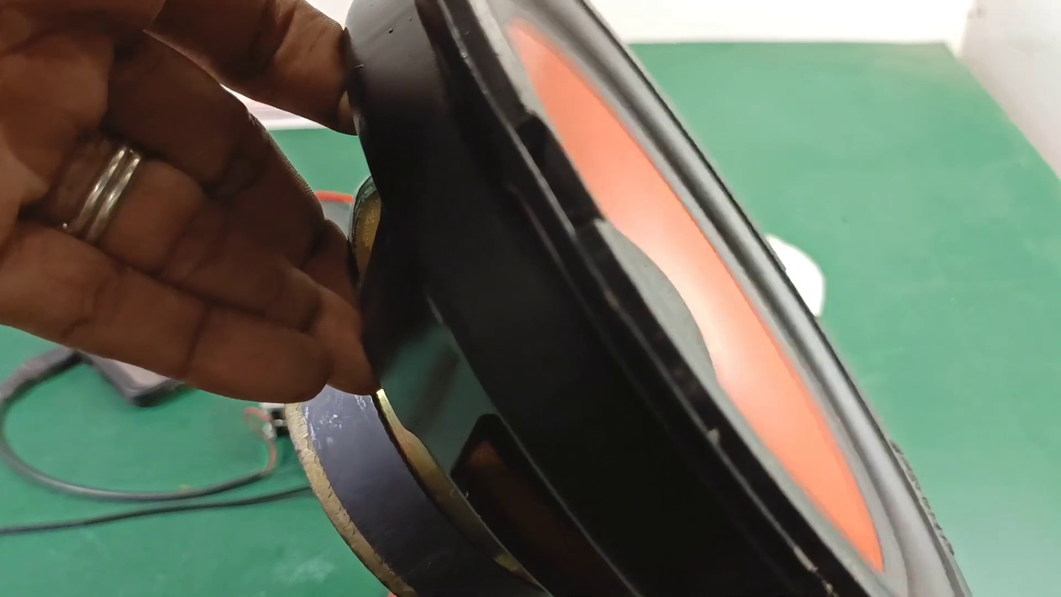 (score 95.0000)
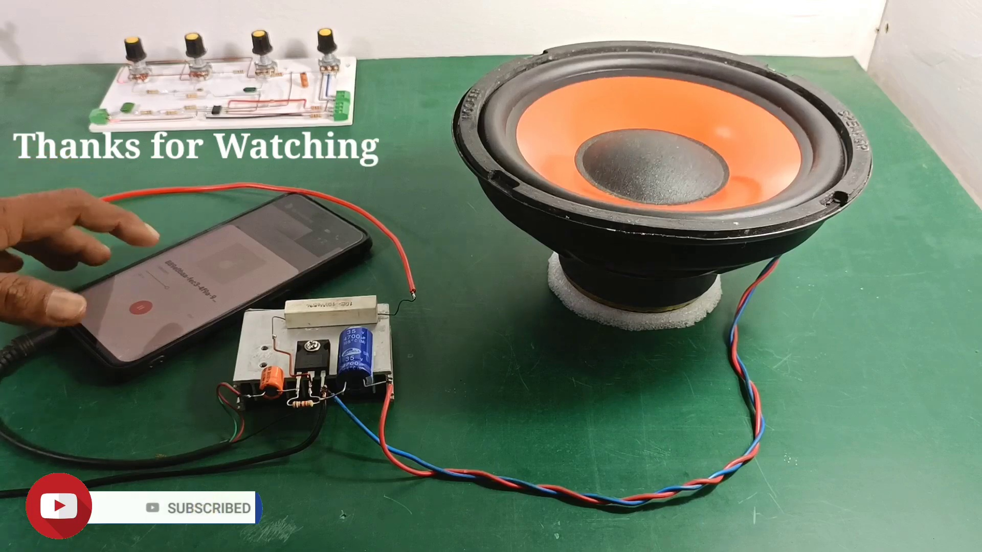 (score 90.0000)
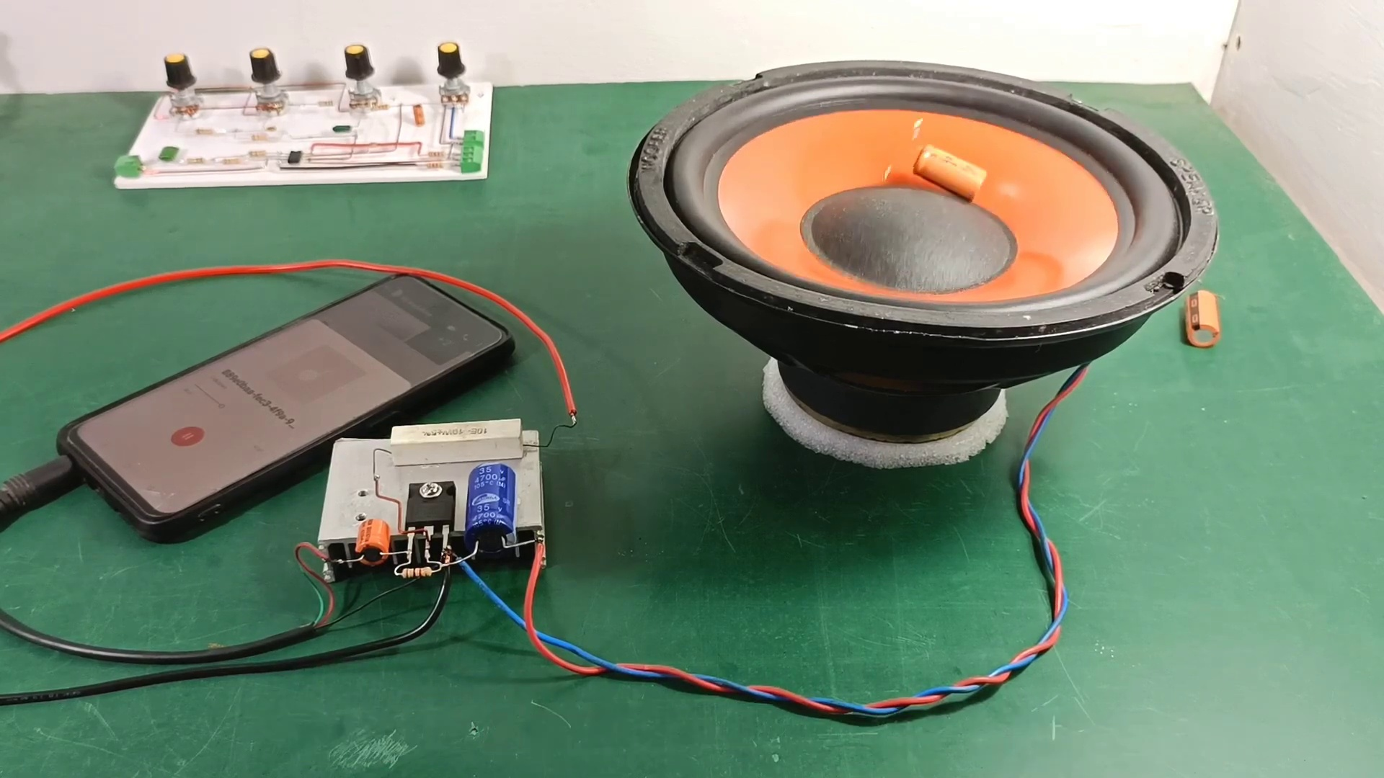 (score 90.0000)
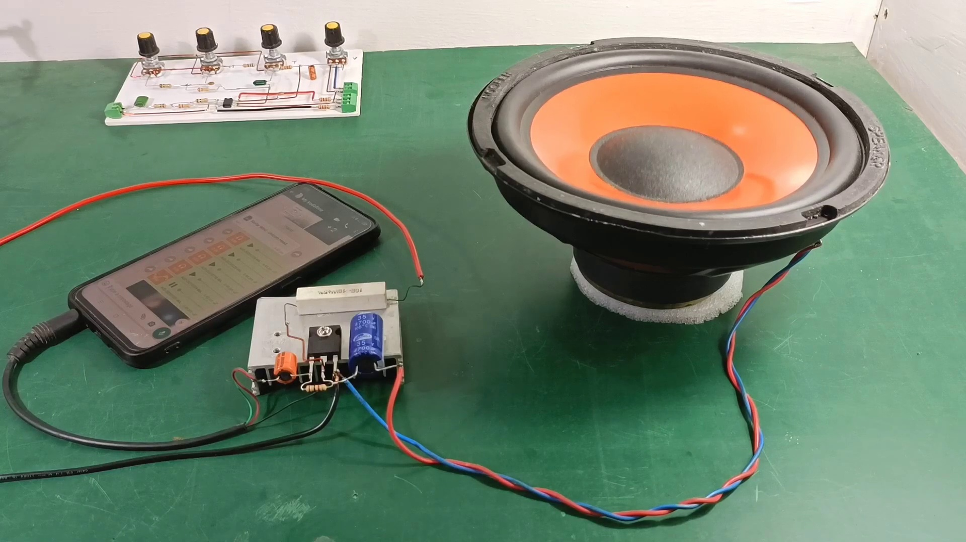 (score 90.0000)
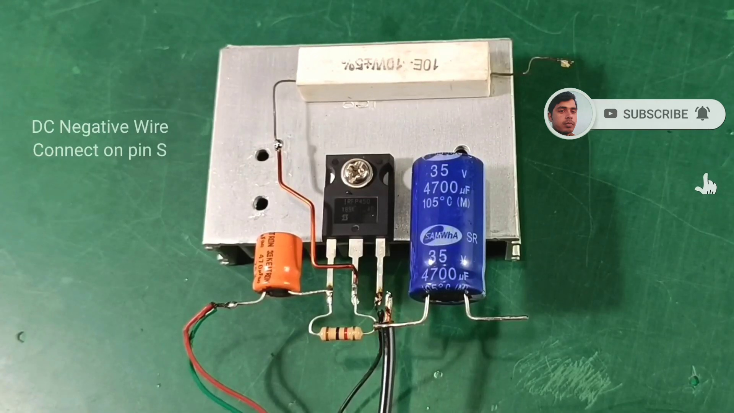 (score 90.0000)
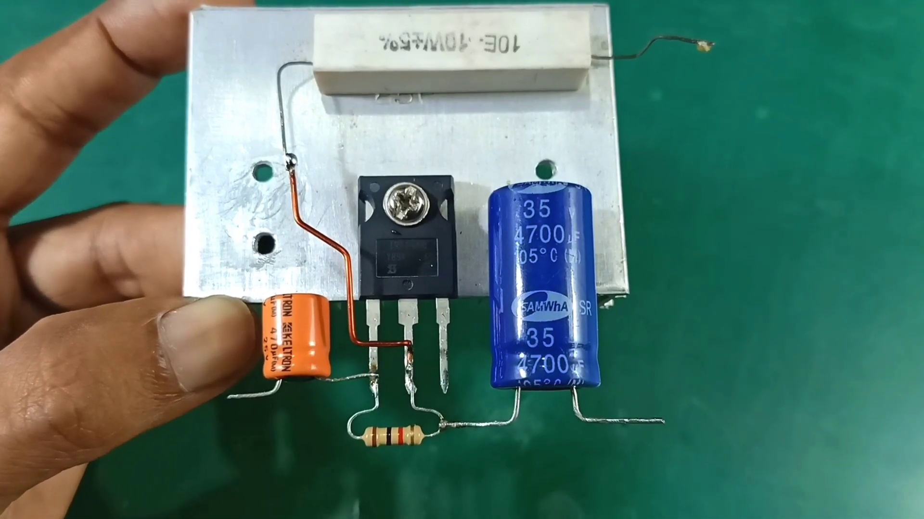 (score 90.0000)
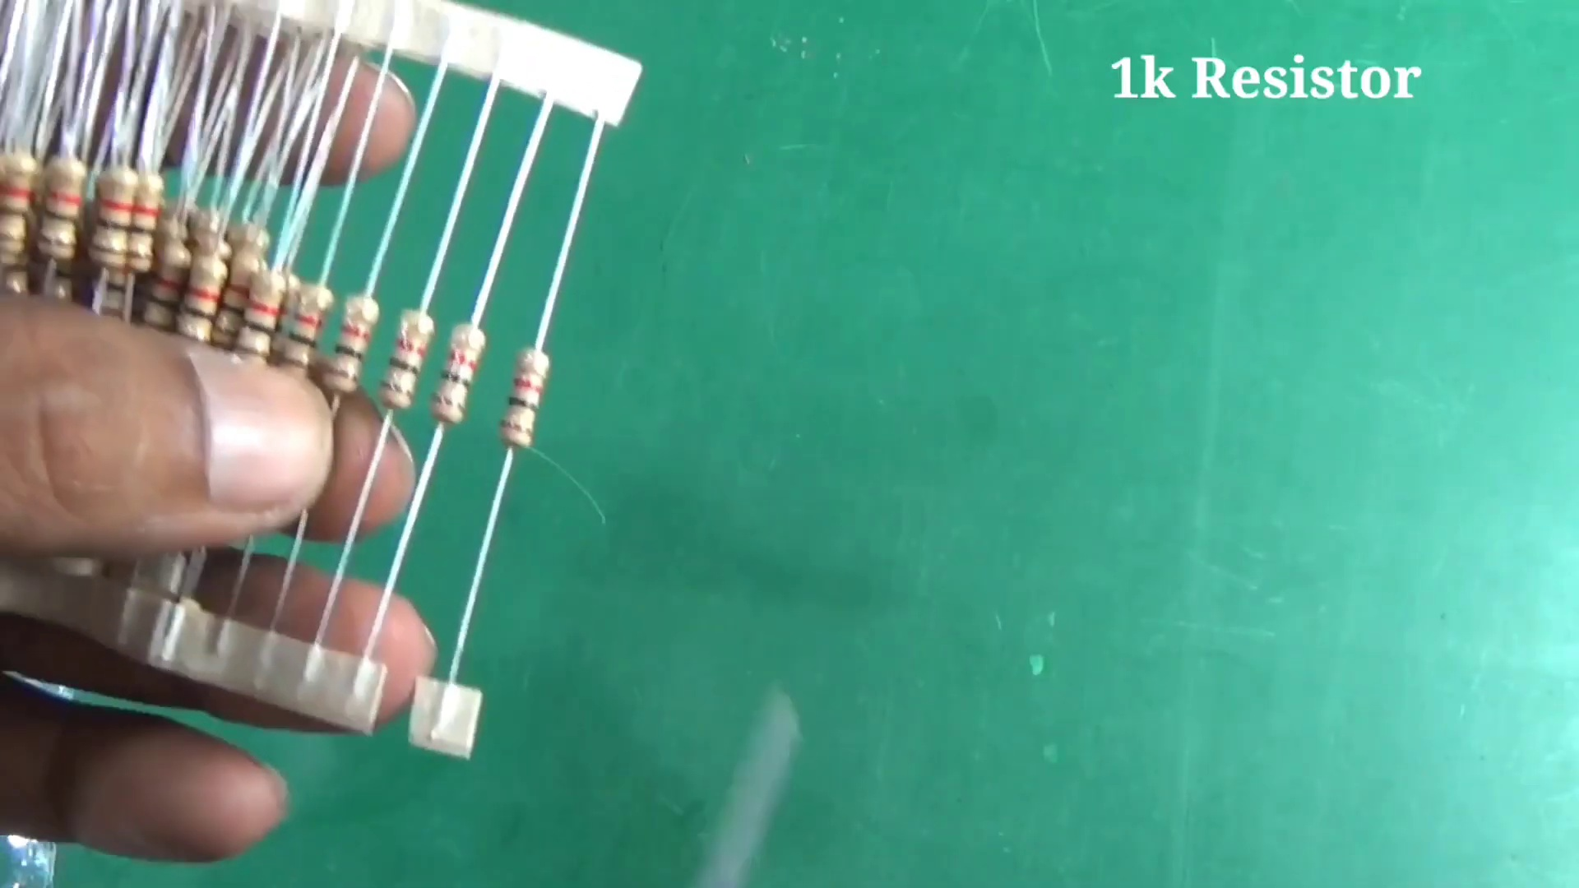 (score 90.0000)
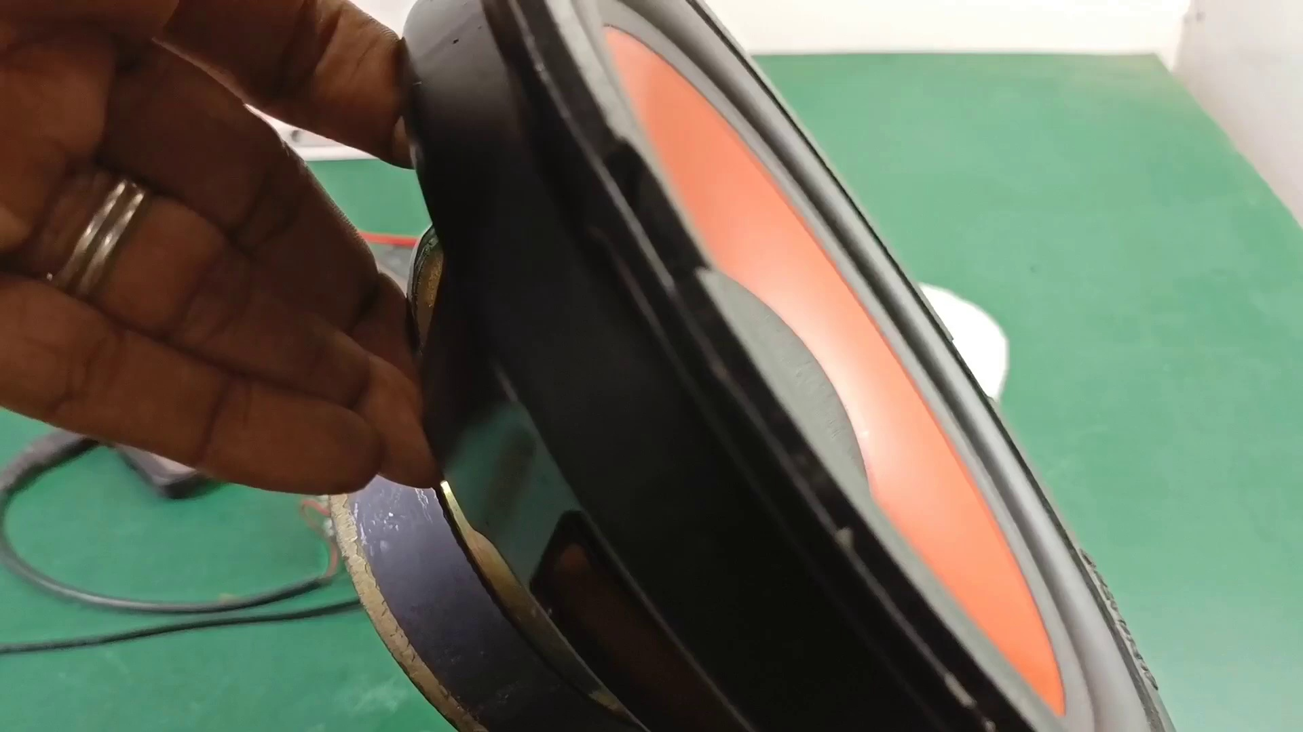 (score 90.0000)
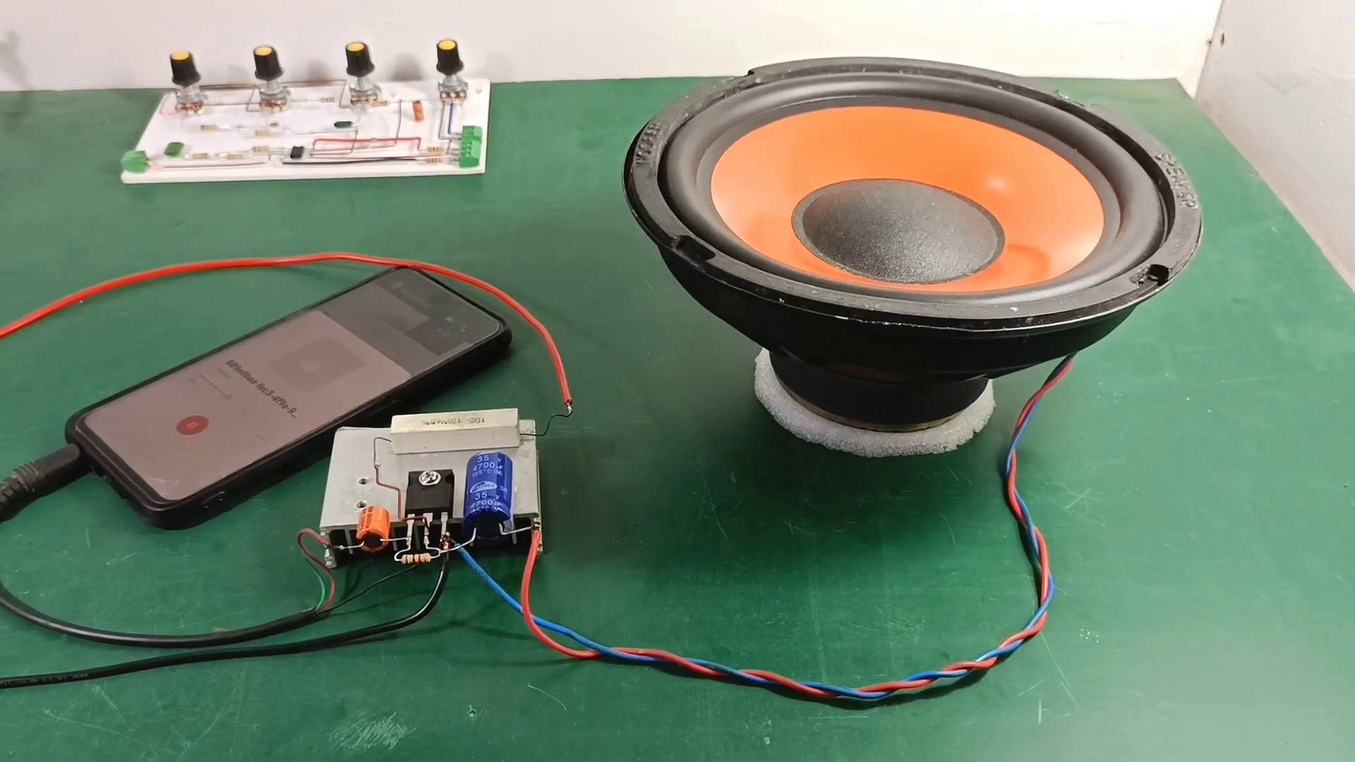 (score 85.0000)
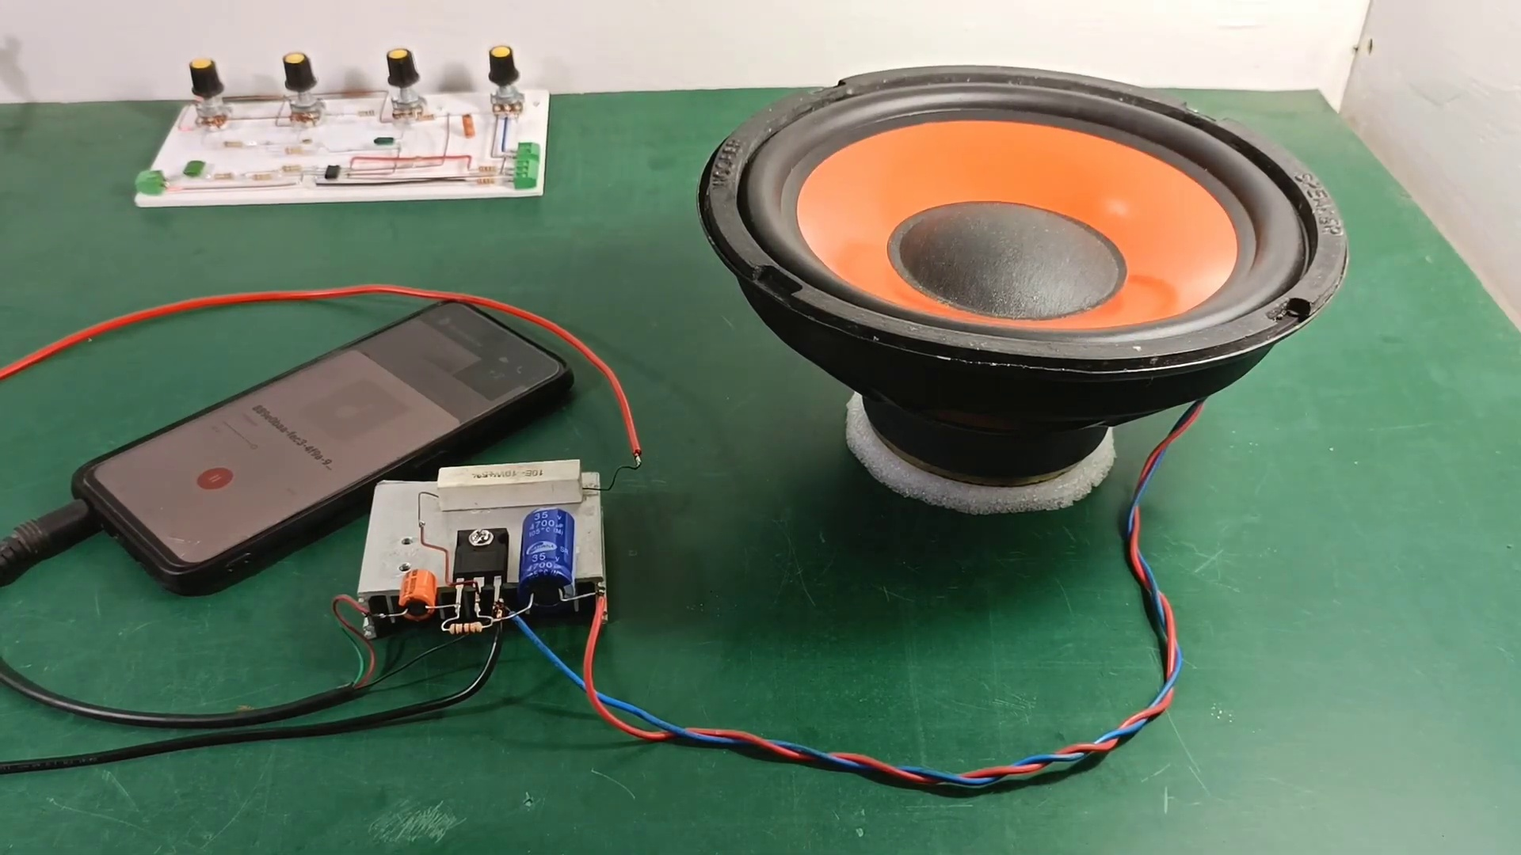 (score 85.0000)
Least correlated frames:
 (score 20.0000)
 (score 20.0000)
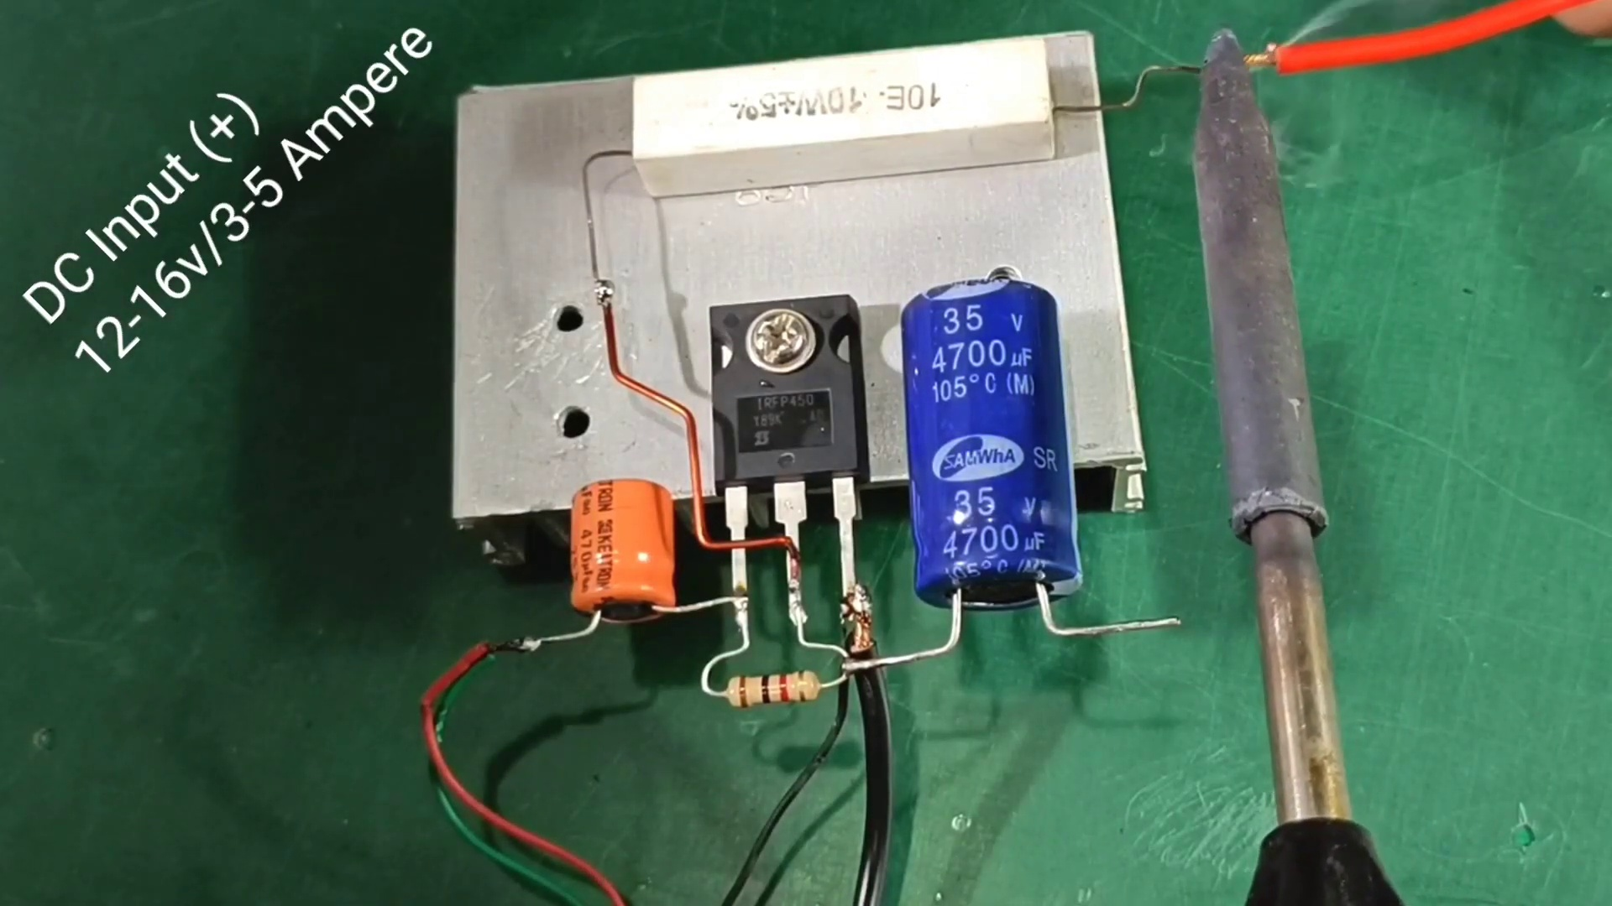 (score 50.0000)
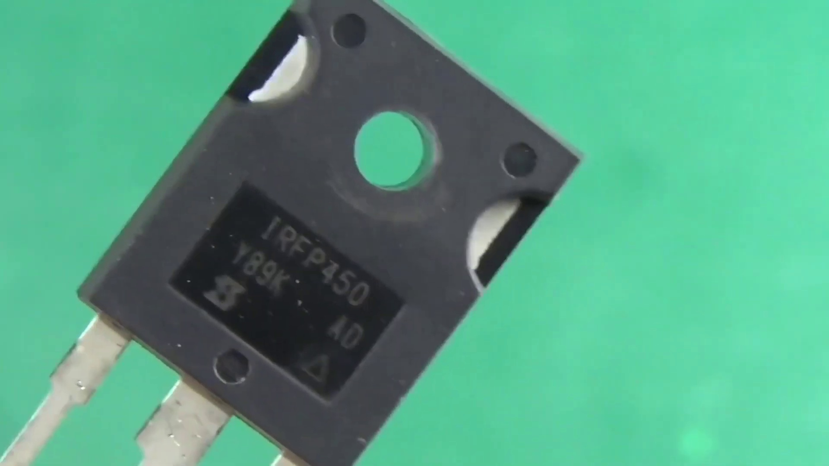 (score 80.0000)
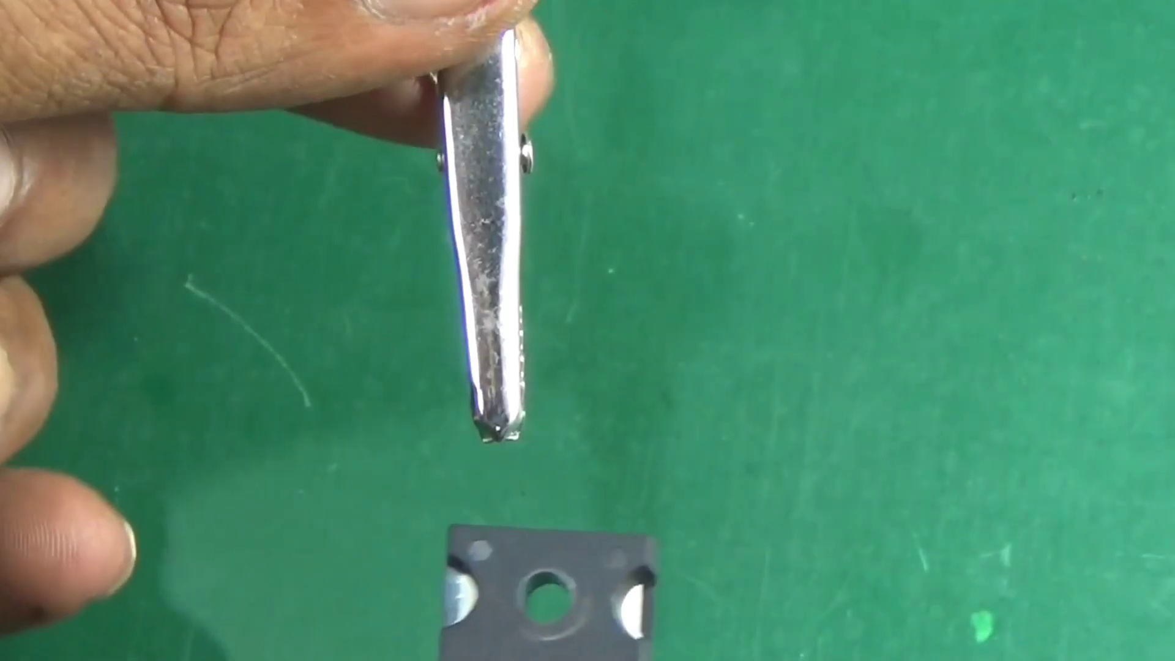 (score 80.0000)
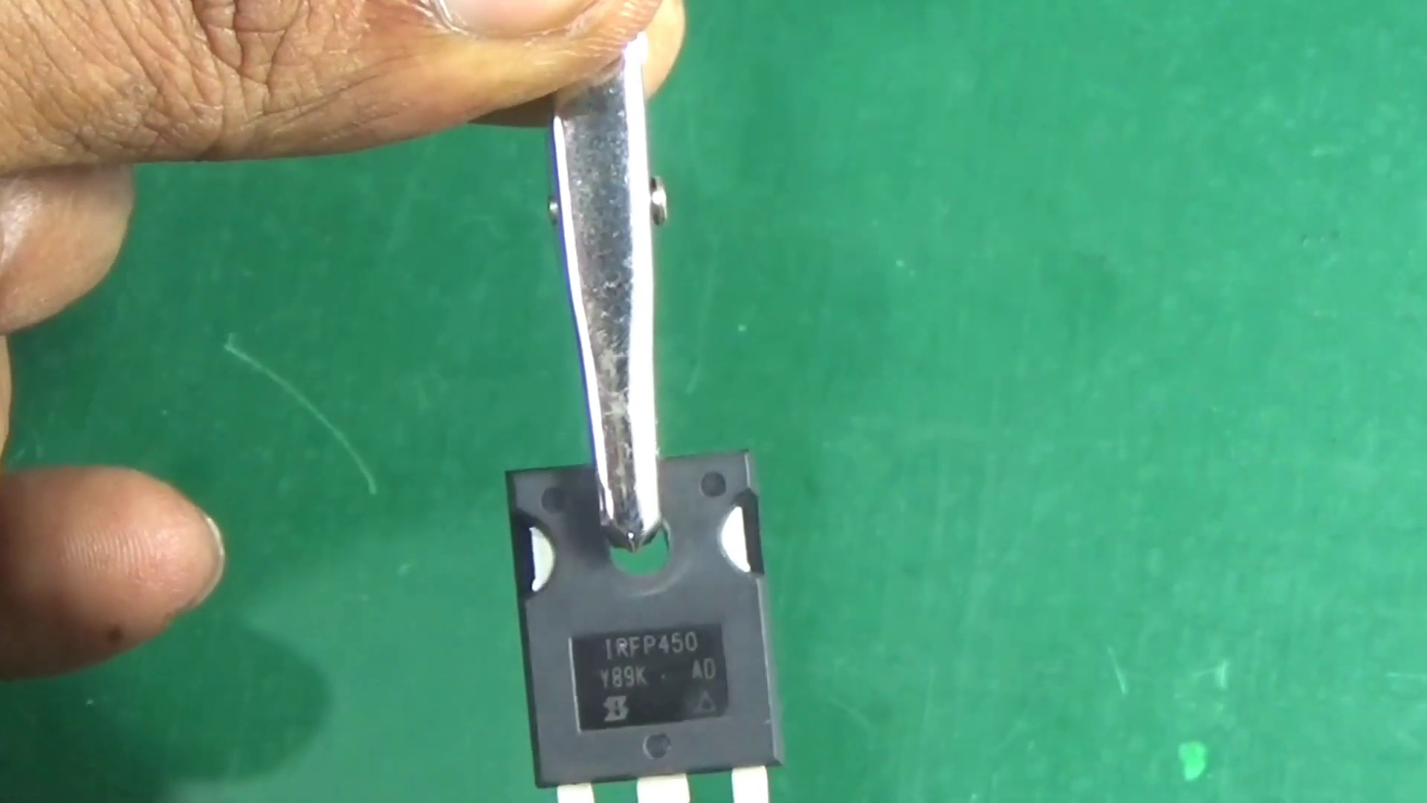 (score 80.0000)
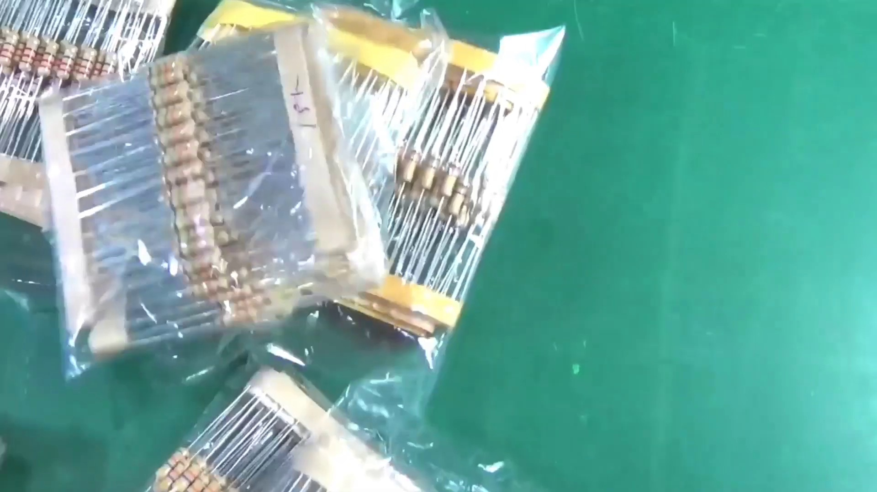 (score 80.0000)
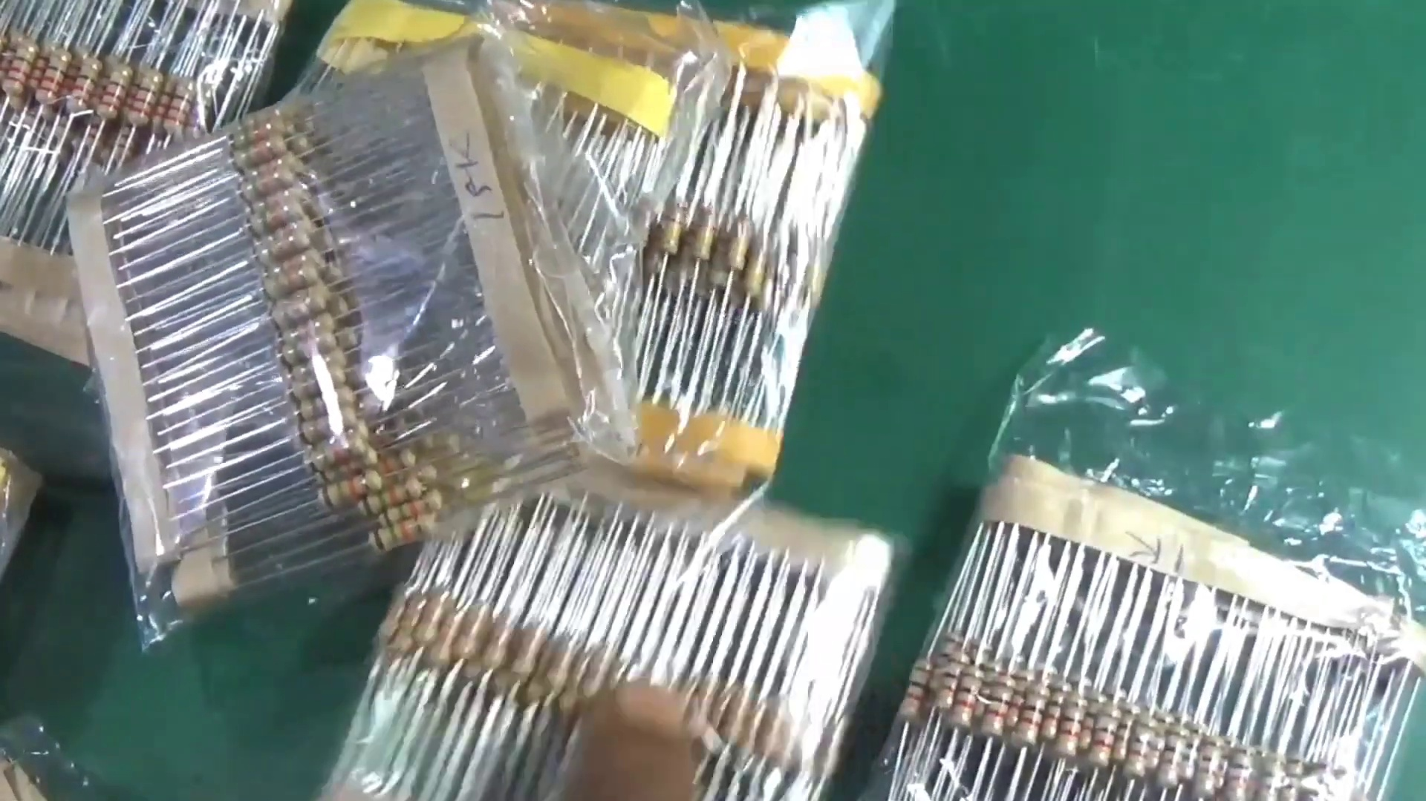 (score 80.0000)
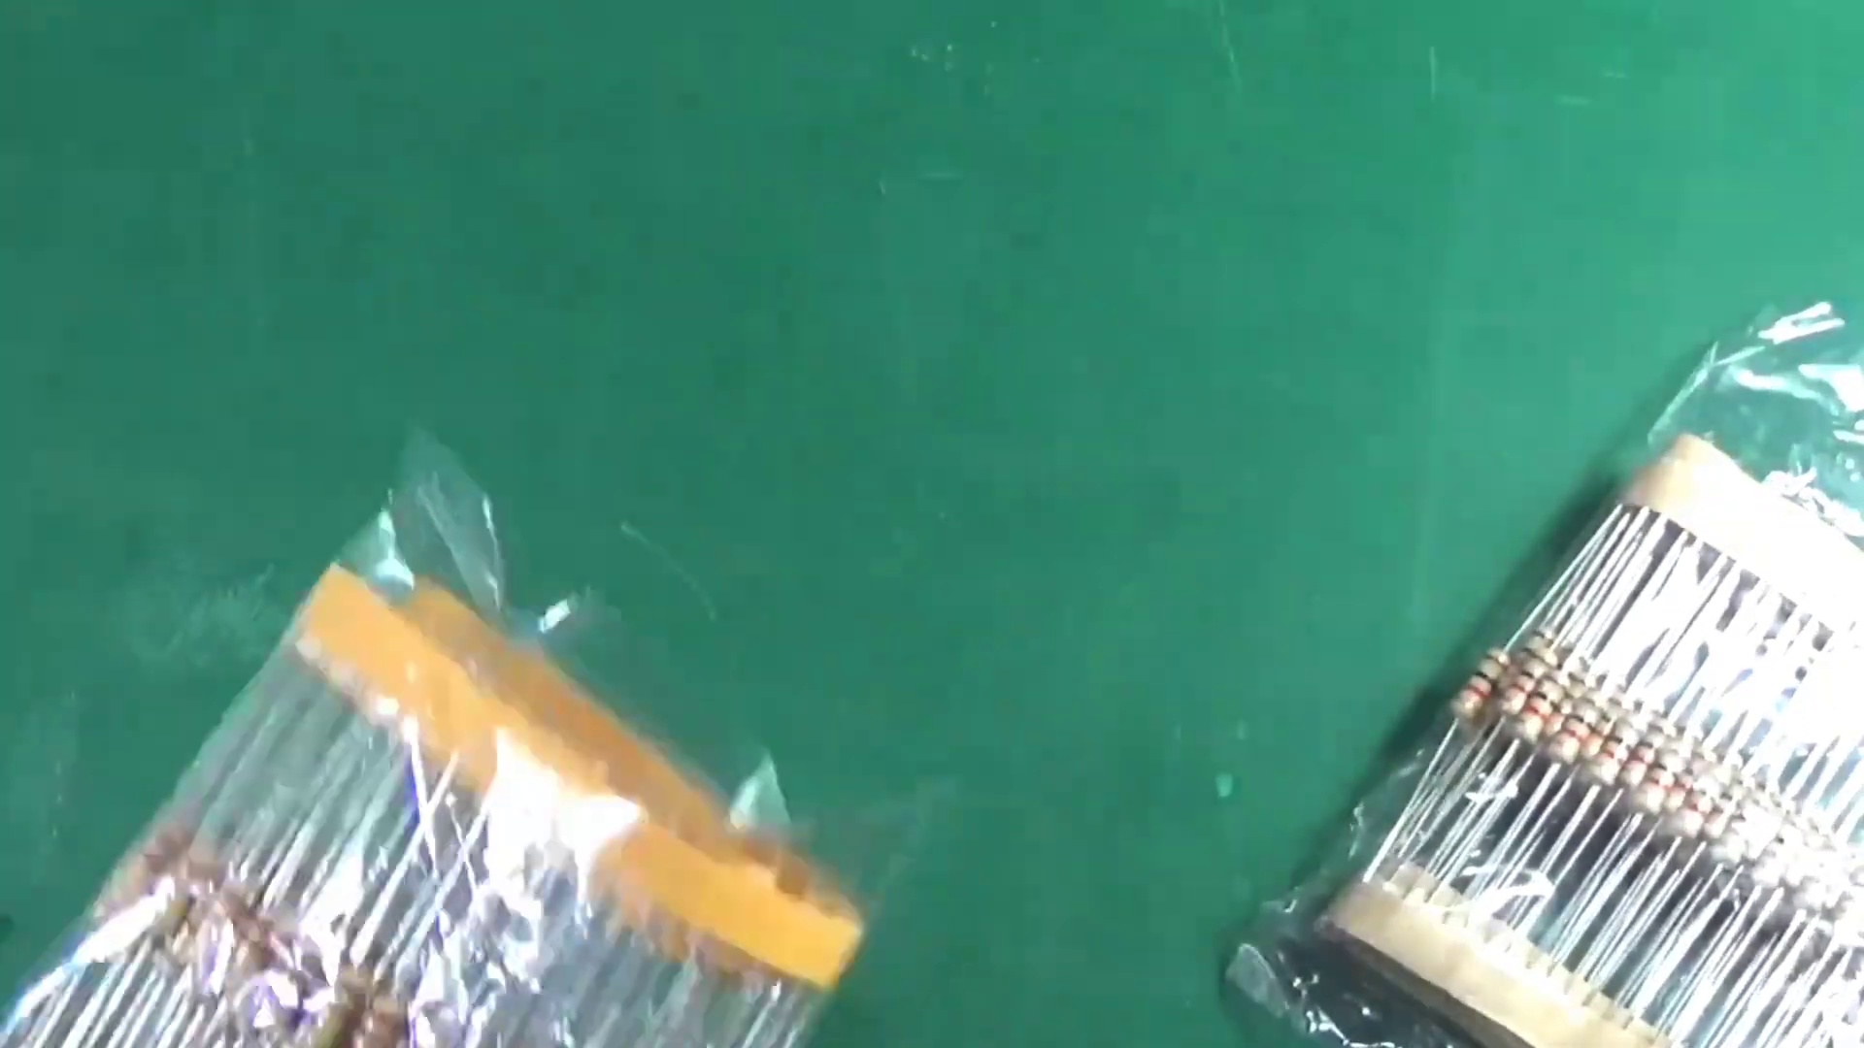 (score 80.0000)
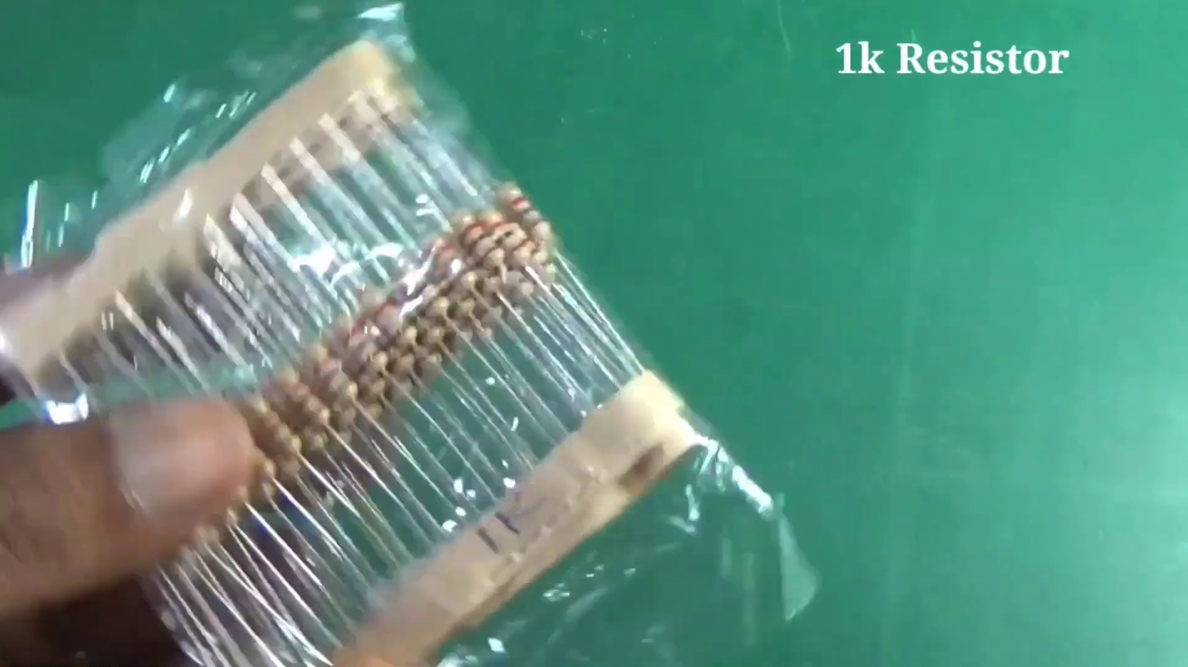 (score 80.0000)
- matched 55 frame(s), max score 95.0000: Useful Content: I found this video particularly interesting because of how simple the circuit is. With just a MOSFET, capacitor, resistor, and power you can make a powerful functioning audio amplifier circuit, which is pretty amazing.Confused Content: This video was very clear with all its components, so nothing was confusing.Future Use: This video was watched for Class Project Phase 2 inspiration.
Source: https://www.youtube.com/watch?v=w49SSxiPK_Q: Simple Super Power IGBT Bass Amplifier \\ How to Make Amplifier Without IC With IRFP450 – Powerful
Top correlated frames:
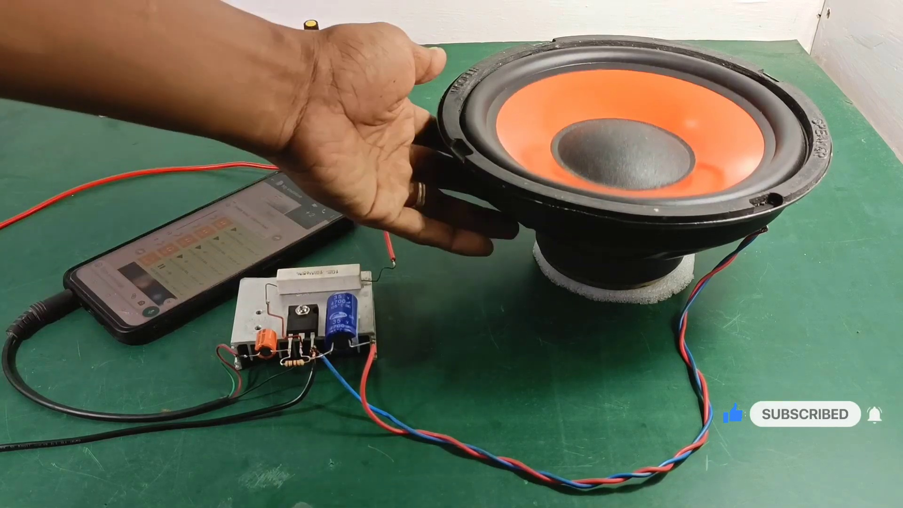 (score 95.0000)
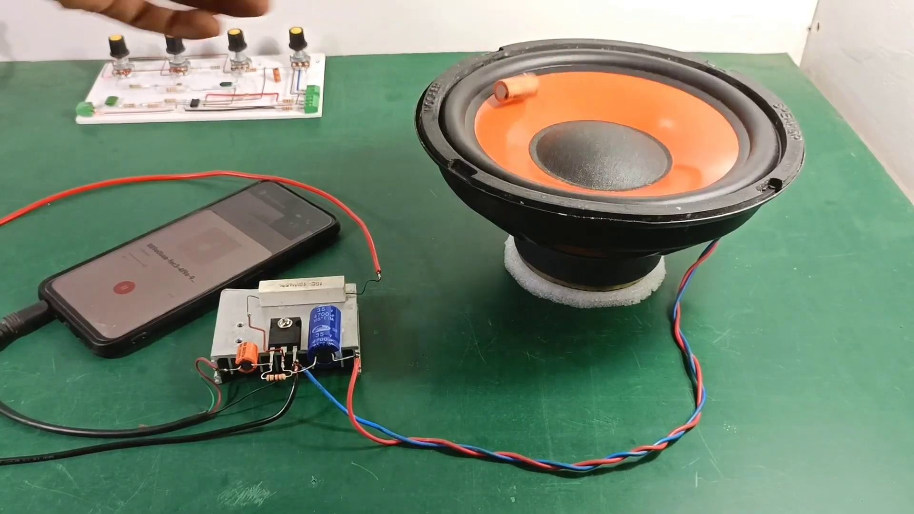 (score 90.0000)
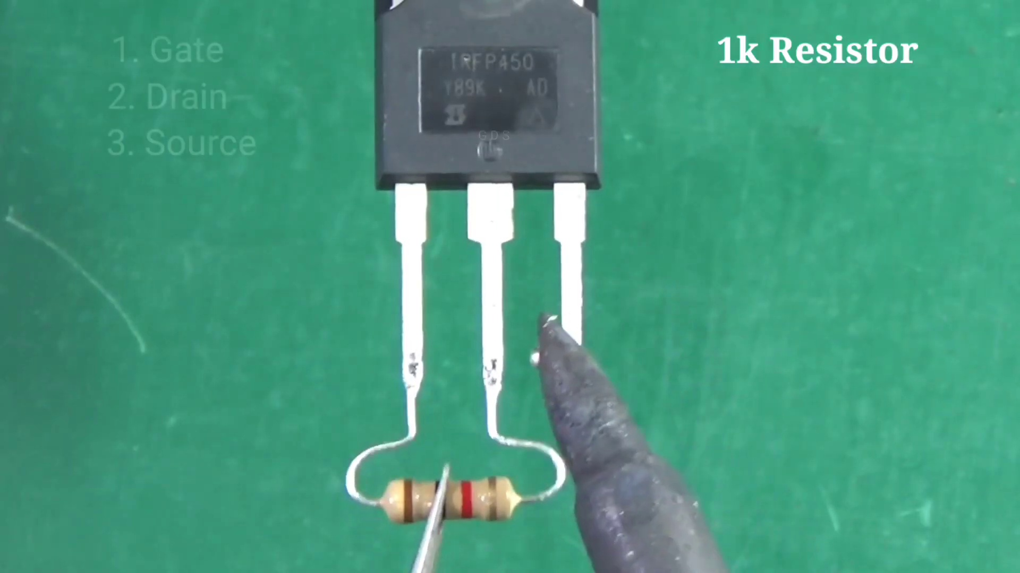 (score 90.0000)
 (score 90.0000)
 (score 90.0000)
 (score 85.0000)
 (score 85.0000)
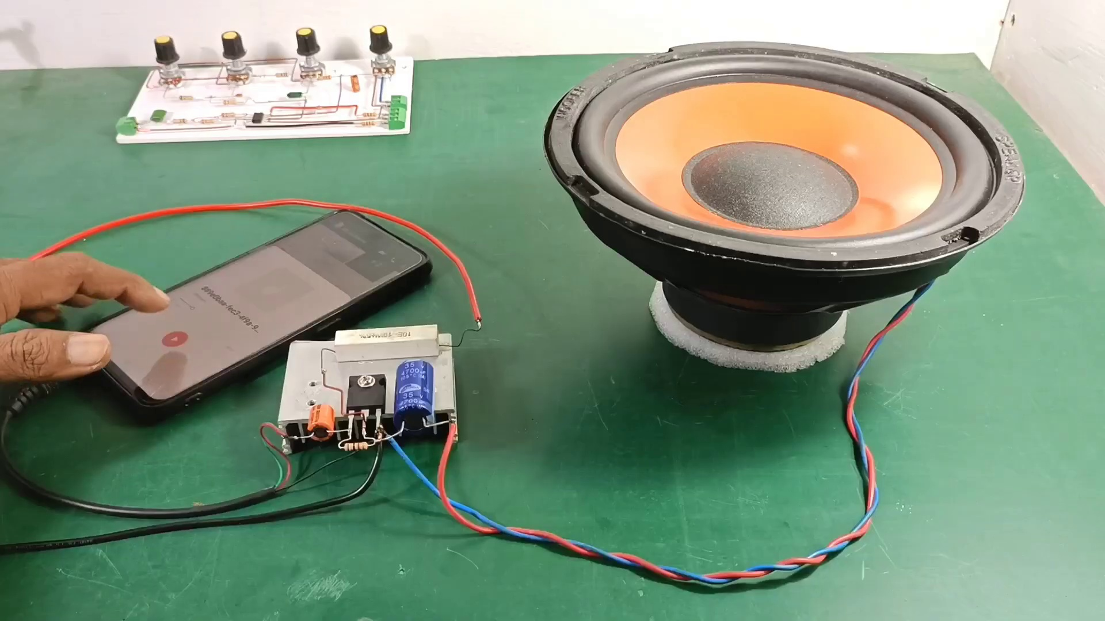 (score 85.0000)
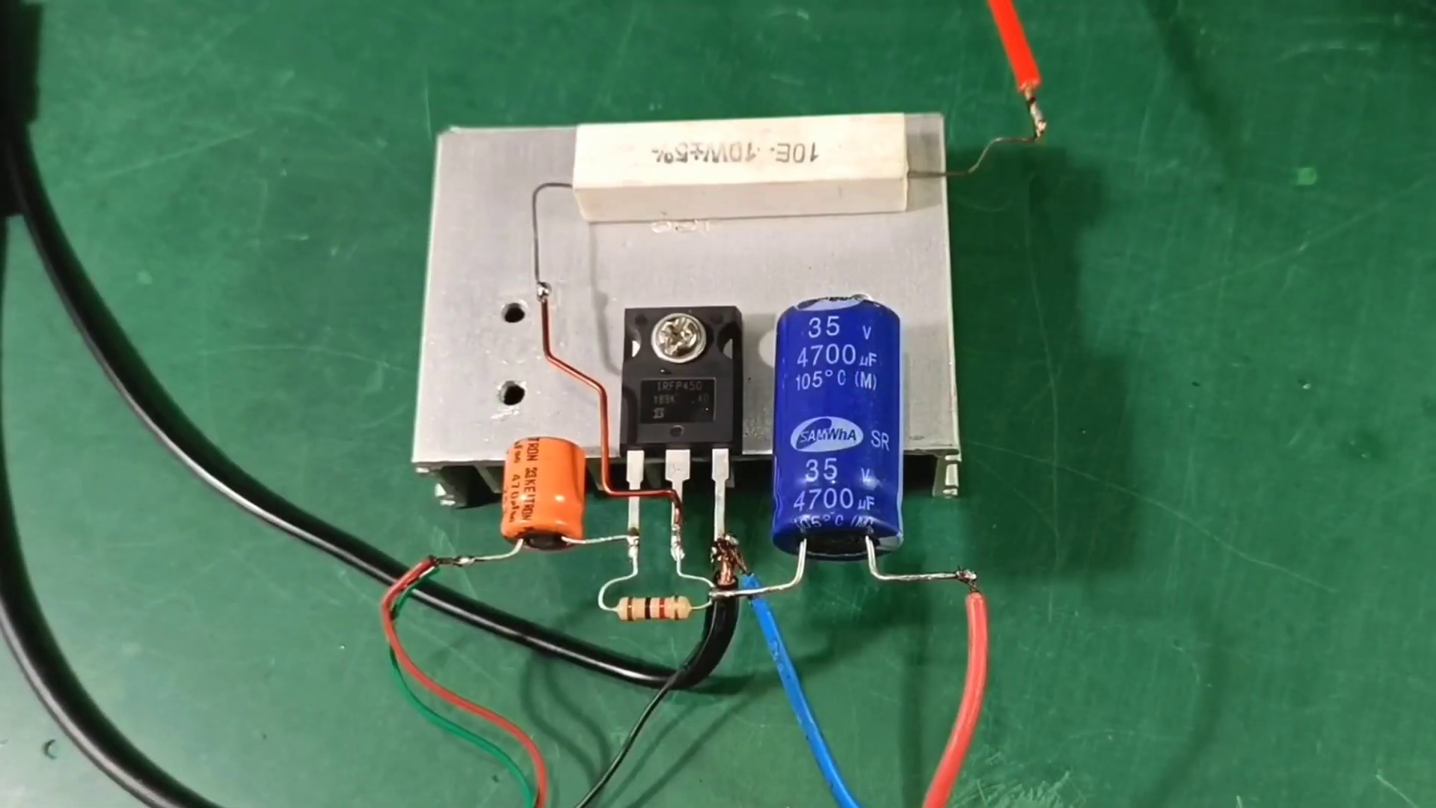 (score 85.0000)
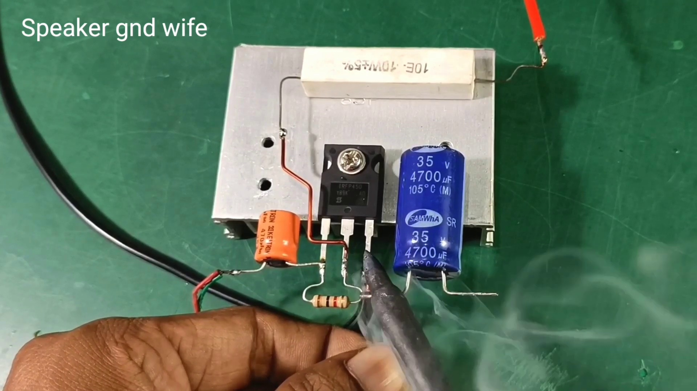 (score 85.0000)
Least correlated frames:
 (score 0.0000)
 (score 10.0000)
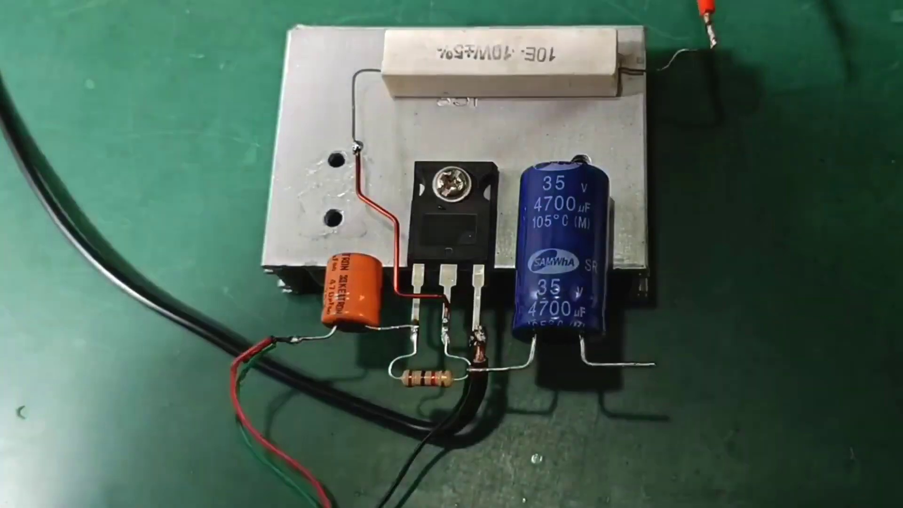 (score 10.0000)
 (score 20.0000)
 (score 20.0000)
 (score 20.0000)
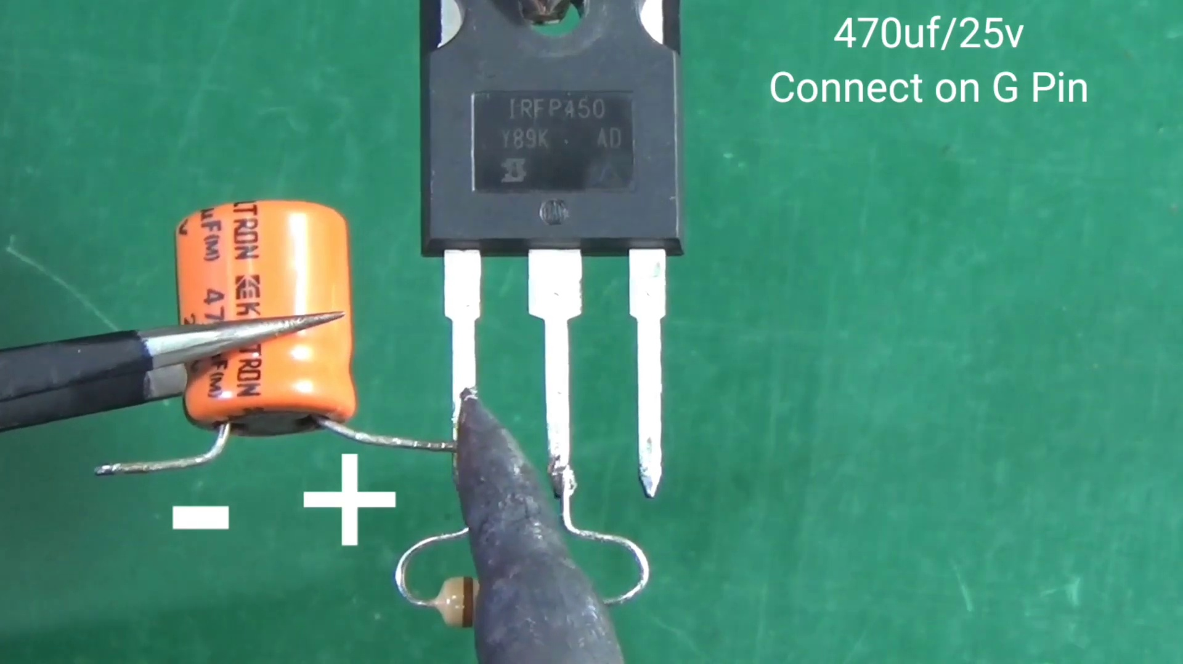 (score 20.0000)
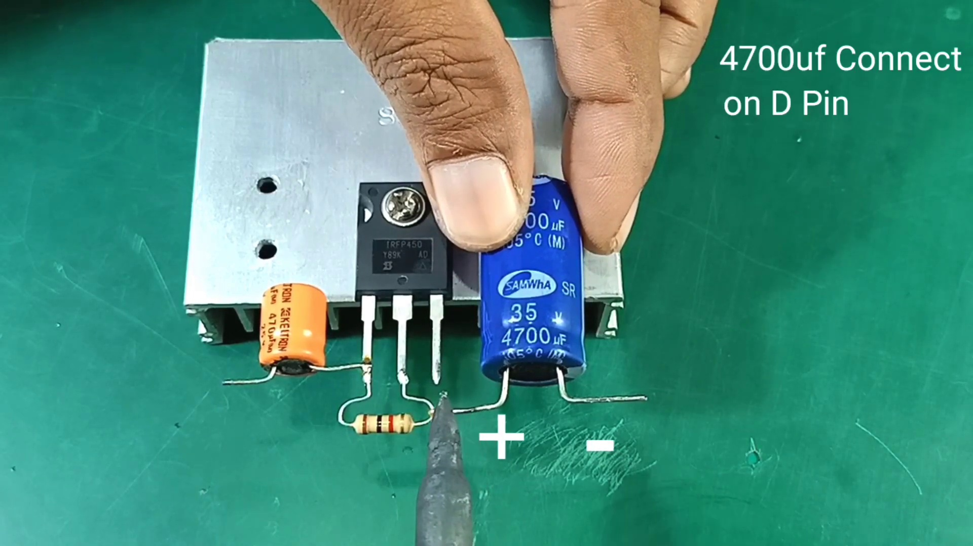 (score 20.0000)
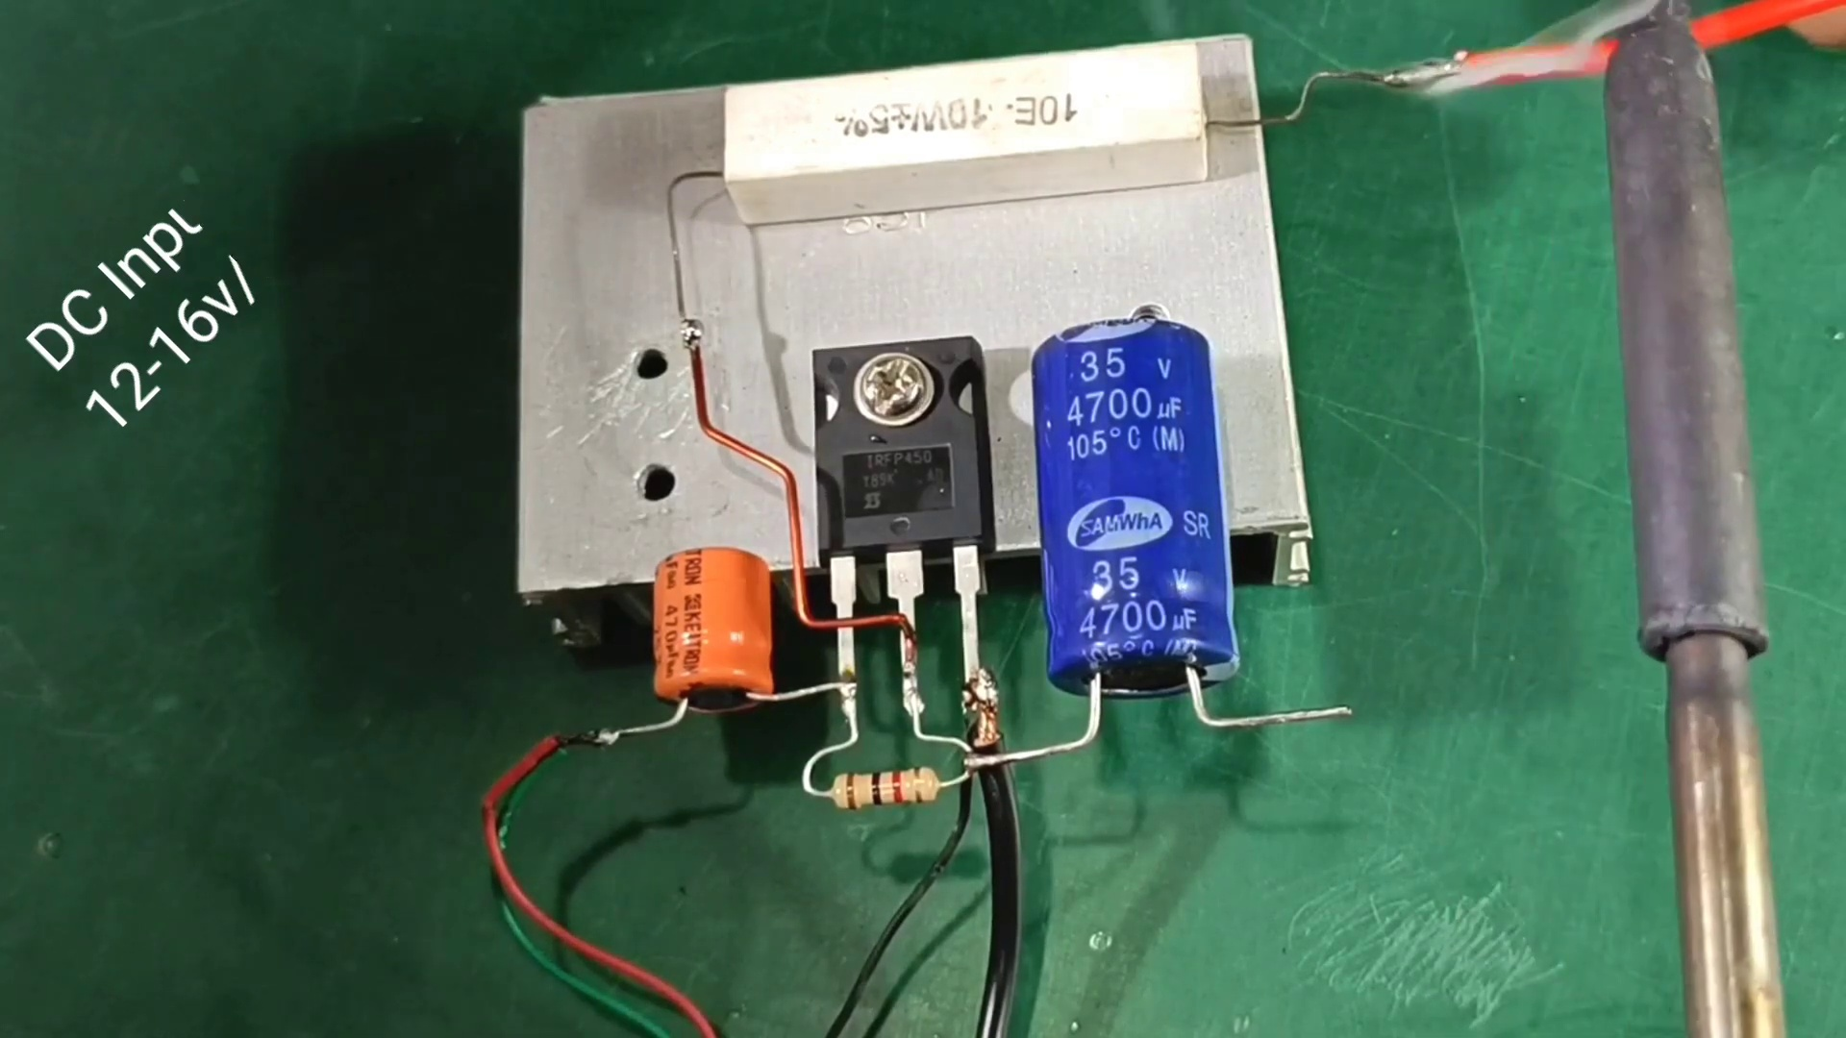 (score 20.0000)
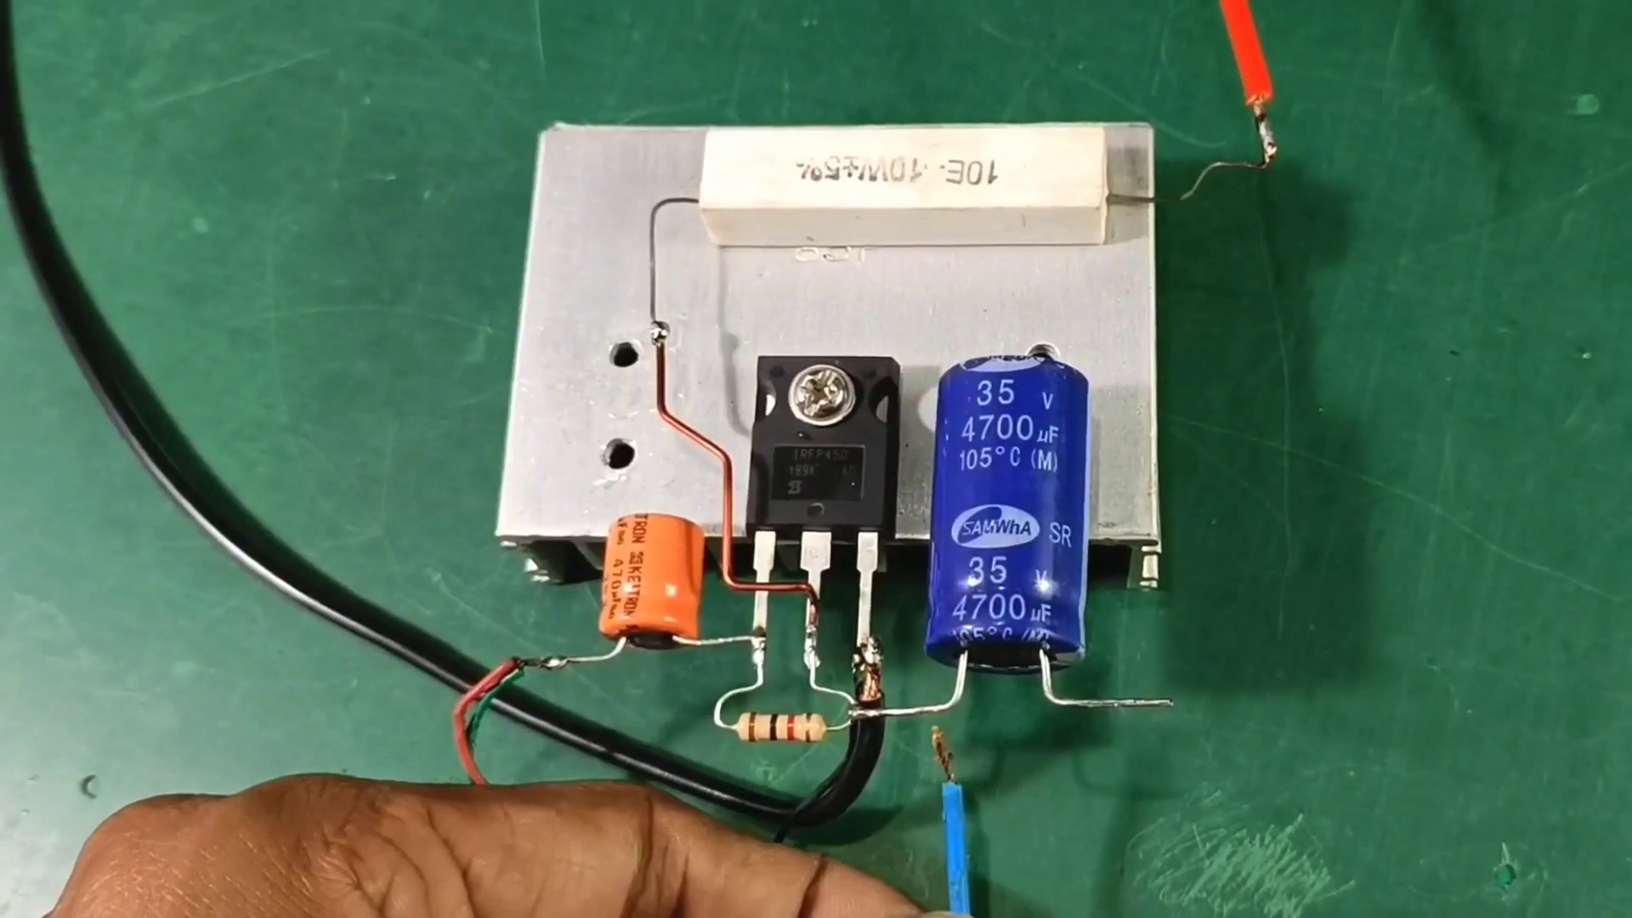 (score 20.0000)

Frame: frame_0000.jpg
Caption: The image shows a close-up of a person's hand interacting with a black and orange speaker placed on a green surface. The hand is holding the speaker by its black top, with the orange panel slightly raised, suggesting some sort of action or movement. In the foreground, the hand is visible, grasping something small and metallic, which could possibly be a circuit board or part of the speaker mechanism. In the background, there is a blurred object resembling a light source, possibly an LED panel or lamp, contributing to a red glow that illuminates the item being held by the person. The overall scene suggests a moment of interaction between the person and the speaker, with no visible texts, equations, diagrams, or other instructive elements providing context about the image's purpose or the nature of the device.
Comment (score 90): I learned what and where the connections on an IGBT amplifier are and what they should connect to. What made you confused is How soldering directly to the chip and other speaker components affects sound quality and potential noise.
Reason: The comment directly discusses the technical steps involved in soldering connections on an IGBT amplifier and speaker components, which are mentioned in the caption as 'something small and metallic' that could be a circuit board or part of the speaker mechanism. The caption also describes a moment of interaction between the person and the speaker, suggesting assembly or modification, which aligns with the commenter's mention of soldering directly to the chip and other components.
Source: https://www.youtube.com/watch?v=w49SSxiPK_Q: Simple Super Power IGBT Bass Amplifier
Comment (score 80): Useful Content: I found this video particularly interesting because of how simple the circuit is. With just a MOSFET, capacitor, resistor, and power you can make a powerful functioning audio amplifier circuit, which is pretty amazing.Confused Content: This video was very clear with all its components, so nothing was confusing.Future Use: This video was watched for Class Project Phase 2 inspiration.
Reason: The comment directly discusses the same technical steps (audio amplifier circuit with MOSFET, capacitor, resistor, and power) described in the caption. The mention of a 'circuit' in the caption matches with the discussion of a simple circuit in the comment.
Source: https://www.youtube.com/watch?v=w49SSxiPK_Q: Simple Super Power IGBT Bass Amplifier \\ How to Make Amplifier Without IC With IRFP450 – Powerful

Frame: frame_0001.jpg
Caption: The image shows a close-up view of a black and orange speaker resting on a green surface. The speaker, with its black top and orange base, stands out against the green backdrop. The speaker's top is black, providing a stark contrast to the orange base, which is round and circular in shape. The speaker's base is flat and appears to be made of plastic. A black ring adorns the top of the speaker, adding to its unique design. The speaker is positioned on a white object, which is partially visible in the background. The overall scene suggests an indoor setting, possibly a workshop or a studio. In this image, taken from a video recording, a person's hand can be seen interacting with the speaker or audio equipment component that appears reddish and cylindrical, possibly an electromagnetic coil.
Comment (score 85): I learned what and where the connections on an IGBT amplifier are and what they should connect to. What made you confused is How soldering directly to the chip and other speaker components affects sound quality and potential noise.
Reason: The comment directly discusses the technical steps mentioned in the caption, specifically soldering to the chip and speaker components, which are described in the image. The connection is strong because it refers to specific details in the image, such as the IGBT amplifier and the electromagnetic coil, demonstrating a clear relationship between the caption and the comment.
Source: https://www.youtube.com/watch?v=w49SSxiPK_Q: Simple Super Power IGBT Bass Amplifier
Comment (score 80): Useful Content: I found this video particularly interesting because of how simple the circuit is. With just a MOSFET, capacitor, resistor, and power you can make a powerful functioning audio amplifier circuit, which is pretty amazing.Confused Content: This video was very clear with all its components, so nothing was confusing.Future Use: This video was watched for Class Project Phase 2 inspiration.
Reason: The comment directly mentions the circuit components (MOSFET, capacitor, resistor, and power) which are also described in the caption as part of the audio equipment component. The caption provides a detailed description of the speaker's design and materials, which is relevant to the comment's discussion of the simplicity of the circuit.
Source: https://www.youtube.com/watch?v=w49SSxiPK_Q: Simple Super Power IGBT Bass Amplifier \\ How to Make Amplifier Without IC With IRFP450 – Powerful

Frame: frame_0002.jpg
Caption: The image presents an abstract and modern digital graphic that combines vibrant colors and geometric shapes. The background of the graphic transitions from blue to red along its horizontal axis, creating a dynamic visual effect. At the center of the image is a colorful explosion or burst, characterized by a bright and multi-colored effect. To the right of this central graphic, there's a vertical line featuring a series of smaller, multi-colored shapes that possibly indicate a sequence or progression from left to right.
The graphic also includes an abstract 3D animation of a colorful geometric shape. The shape is composed of a red base, a yellow side, and a blue side, all intersecting at a central point. The base of the shape resembles a simple square, while the sides appear as a pyramid with triangular points. The animation takes place against a backdrop of a vibrant red and blue gradient, which adds to the overall sense of movement and dynamism.
The image also features a small yellow dot in the top left corner, possibly a part of the animation or a static element. Overall, the composition of the image suggests a dynamic and visually striking effect, with bold and bright colors used throughout. There is no evidence of an educational context, nor are there any human figures, devices, slides, diagrams, or text that would suggest instructional elements. The image's content appears to be purely aesthetic in nature.
No strongly correlated comments found for this frame.

Frame: frame_0003.jpg
Caption: The image features a unique blend of visual elements that appear to showcase a video editing software interface during a tutorial or demonstration. At the top right corner, an overlay with the text "Rj edit all" is prominently displayed, with the word "all" highlighted in orange. This suggests that the user may be discussing how to edit multiple tracks or clips in a timeline. The background of the image appears to be dark, featuring various panels and tools typically associated with video editing software, such as timelines, preview windows, and audio waveforms. Notably absent are any visible people or instructors in this frame.
Separately, the image also presents a striking design element in the form of a colorful text that reads "RJ Edit All" on a black background. The text is predominantly green and orange, with a black border enclosing it, creating a sense of balance and symmetry. The horizontal arrangement of the words adds to the overall simplicity and visual appeal of the design.
Overall, the image presents two distinct yet interconnected visual elements that work together to convey a message about video editing software.
No strongly correlated comments found for this frame.

Frame: frame_0004.jpg
Caption: The image shows a small electronic component, specifically an integrated circuit (IC), which appears to be a voltage regulator or similar chip. The IC is attached to a green circuit board and has a set of pins on one side for connection purposes. On the underside of the IC, there is a label with text that reads "T3075," followed by various specifications such as "1.2A 40V IN 3.3V OUT" and other technical details that indicate the chip's functionality, including an integrated circuit identifier (ICID) number "8598009." The image is taken from a top-down perspective, focusing on the electronic component with a shallow depth of field, which blurs the background. The focus is clear enough to read the text on the chip's underside, but not so sharp that finer details on the circuit board or surrounding environment are discernible.
Upon closer inspection, the IC can be identified as an "IRFP1450", a type of semiconductor device, marked with the numbers "89R" and "AD". The device is mounted on a metal stand, suggesting it's ready for use or installation. The label and numbers are clearly visible, indicating its technical specifications. The overall image gives an impression of a professional and technical setting, possibly in a laboratory or a workshop.
Comment (score 80): Useful Content: I found this video particularly interesting because of how simple the circuit is. With just a MOSFET, capacitor, resistor, and power you can make a powerful functioning audio amplifier circuit, which is pretty amazing.Confused Content: This video was very clear with all its components, so nothing was confusing.Future Use: This video was watched for Class Project Phase 2 inspiration.
Reason: The comment directly discusses the simplicity and functionality of the circuit, which is strongly related to the technical specifications described in the caption. The mention of components such as MOSFET, capacitor, resistor, and power source also matches the information presented in the caption.
Source: https://www.youtube.com/watch?v=w49SSxiPK_Q: Simple Super Power IGBT Bass Amplifier \\ How to Make Amplifier Without IC With IRFP450 – Powerful
Comment (score 80): I learned what and where the connections on an IGBT amplifier are and what they should connect to. What made you confused is How soldering directly to the chip and other speaker components affects sound quality and potential noise.
Reason: The comment discusses the technical details of the integrated circuit (IC) and its connections, directly referencing the caption's description of the IC's pins. The mention of IGBT amplifier and soldering also aligns with the caption's focus on electronic components.
Source: https://www.youtube.com/watch?v=w49SSxiPK_Q: Simple Super Power IGBT Bass Amplifier

Frame: frame_0005.jpg
Caption: The image shows a person holding a silver clip, its prongs gripping a small black object. The person's hand is positioned in such a way that the clip is almost parallel to the green table surface on which the objects are placed. The objects themselves are of varying sizes, with the black object being the smallest. The green table serves as a contrasting background to the silver clip and the black object, making them stand out in the image.
In another part of the scene, a person is using a small metal tool, likely a punch or a similar precision instrument, to cut a rectangular hole in a piece of material. The material appears to be plastic, and the tool seems to have a sharp blade at one end for cutting and possibly a lever or handle on the other end.
The individual's hand is holding the tool, which is positioned over the material with precision, indicating a focus on detail and accuracy in the task at hand. Both scenes suggest a careful and precise action being performed, without providing any readable text or additional context that would allow for further conclusions about the specific setting or purpose of these actions.
Comment (score 80): I learned what and where the connections on an IGBT amplifier are and what they should connect to. What made you confused is How soldering directly to the chip and other speaker components affects sound quality and potential noise.
Reason: The comment directly discusses the same technical steps (connections on an IGBT amplifier) and objects (speaker components, chip) mentioned in the caption. The connection between the comment and paragraph is strong as they both describe a process of precision and attention to detail.
Source: https://www.youtube.com/watch?v=w49SSxiPK_Q: Simple Super Power IGBT Bass Amplifier

Frame: frame_0006.jpg
Caption: The image captures a moment of hands-on activity, featuring a close-up view of a person handling a small electronic component. The object in question is a transistor, identified by its four terminals and the label "189K" with the logo "IRFP450". This black rectangular transistor has a white label next to it, providing visual contrast against the vibrant green background. The person's hand is positioned over the transistor, suggesting an action of inspection or testing, possibly before using it or after having used it. Notably, there is no visible text on the device itself, but adjacent to the USB connector on the component is a label reading "5V 0.3A", indicating its voltage and amperage specifications. The neutral background with the green surface appears to be a workbench or desk used for electronics assembly or repair, consistent with DIY electronics or repair work.
Comment (score 80): I learned what and where the connections on an IGBT amplifier are and what they should connect to. What made you confused is How soldering directly to the chip and other speaker components affects sound quality and potential noise.
Reason: The comment directly discusses the same technical steps (inspecting a transistor) and objects (IGBT amplifier, speaker components) described in the caption. The mention of soldering and its effects on sound quality also relates to the caption's description of the device's voltage and amperage specifications.
Source: https://www.youtube.com/watch?v=w49SSxiPK_Q: Simple Super Power IGBT Bass Amplifier

Frame: frame_0007.jpg
Caption: The image shows a collection of electronic components, specifically resistors, arranged on a green surface. The resistors are tightly packed together, forming a dense cluster that fills the majority of the image. Each resistor has a distinct shape and size, with some appearing longer than others. The plastic packaging around each resistor is transparent, allowing the resistors to be clearly visible. Some of the packaging labels read "14", which could be the identifier for each resistor or the series of resistors in this particular pack. In the foreground, a bag or package appears open, revealing additional components or parts inside. There is no text visible in the image that can confidently be read, and the style of the photo seems candid and informal rather than instructional, with no instructor present and no clear indication of an educational setting or activity.
Comment (score 90): Useful Content: I found this video particularly interesting because of how simple the circuit is. With just a MOSFET, capacitor, resistor, and power you can make a powerful functioning audio amplifier circuit, which is pretty amazing.Confused Content: This video was very clear with all its components, so nothing was confusing.Future Use: This video was watched for Class Project Phase 2 inspiration.
Reason: The comment directly discusses the simplicity of the circuit, mentioning specific components like MOSFET, capacitor, resistor, and power supply, which are also mentioned in the frame caption. The connection is strong as both the caption and comment focus on the electronic components and their arrangement.
Source: https://www.youtube.com/watch?v=w49SSxiPK_Q: Simple Super Power IGBT Bass Amplifier \\ How to Make Amplifier Without IC With IRFP450 – Powerful
Comment (score 80): I learned what and where the connections on an IGBT amplifier are and what they should connect to. What made you confused is How soldering directly to the chip and other speaker components affects sound quality and potential noise.
Reason: The comment directly discusses the connections on an IGBT amplifier and how soldering affects sound quality, which is strongly related to the technical steps (arranging resistors) and objects (IGBT amplifier, speaker components) described in the caption.
Source: https://www.youtube.com/watch?v=w49SSxiPK_Q: Simple Super Power IGBT Bass Amplifier

Frame: frame_0008.jpg
Caption: The image shows a collection of electronic components, specifically resistors, arranged on a green table. Each resistor is individually wrapped in plastic and comes in various sizes and colors, adding a vibrant splash of color to the scene. The number 15 is clearly visible on some of the resistors, indicating their specific value or type. The resistors are neatly arranged in rows, creating a visually appealing display. In the foreground, there's a box with a label that has text and symbols, although the resolution is too low to read the details.
The background is blurred, drawing focus to the resistors on the table. There is no clear indication of a person or any instructional content within the image itself. It appears to be a straightforward photograph documenting the arrangement of these components, possibly for inventory purposes or a sales catalog. The overall scene suggests a well-organized and tidy workspace, possibly a workshop or a laboratory.
Comment (score 80): I learned what and where the connections on an IGBT amplifier are and what they should connect to. What made you confused is How soldering directly to the chip and other speaker components affects sound quality and potential noise.
Reason: The comment directly discusses the specific components (resistors) mentioned in the caption, as well as their connections and arrangement on a table. Although it does not explicitly mention soldering or amplifier specifics, it is closely related to the overall theme of electronics components and their applications.
Source: https://www.youtube.com/watch?v=w49SSxiPK_Q: Simple Super Power IGBT Bass Amplifier

Frame: frame_0009.jpg
Caption: The image shows a green table covered with a clear plastic bag, containing several packages of resistors arranged neatly in rows. The resistors come in different sizes, with some appearing larger and others smaller, each row featuring resistors of similar sizes. The resistors also vary in color, adding visual interest to the scene. In addition to the resistors, there are metal electrodes with small connectors, arranged in rows and stacks on the table, each electrode having multiple pins connected by a central rod or pin, suggesting their use in an electrical device or circuit, possibly as contact points for making secure connections between other parts of the device. The components appear to be packaged or sorted, with some individual items prominently visible against the background.
Comment (score 85): I learned what and where the connections on an IGBT amplifier are and what they should connect to. What made you confused is How soldering directly to the chip and other speaker components affects sound quality and potential noise.
Reason: The comment directly discusses the connections on an IGBT amplifier, which is a specific technical detail mentioned in the caption. The mention of soldering and noise quality also corresponds to the description of metal electrodes with small connectors in the caption.
Source: https://www.youtube.com/watch?v=w49SSxiPK_Q: Simple Super Power IGBT Bass Amplifier

Frame: frame_0010.jpg
Caption: The image captures a close-up view of two pieces of electronic equipment resting on a green table. The equipment is neatly arranged, with one piece slightly overlapping the other. The piece on the left is a rectangular plastic container, its surface covered in a clear plastic film. This container appears to be a capacitor given its cylindrical shape and the presence of electrodes around the edges, commonly used in electronics for energy storage and timing purposes. The piece on the right is a cylindrical metal container, also wrapped in a clear plastic film, suggesting it may have been opened or removed from a larger device. The equipment appears to be in a state of disassembly, with the plastic films covering the containers drawing attention to the metallic and plastic components of the equipment. The green table provides a stark contrast to the clear plastic films, creating visual interest. There is no discernible text in the image, and no person is present to provide context or additional information. The relative position of the pieces of equipment suggests they are being disassembled or reassembled, implying that the scene may be set where electronic components are being handled or tested.
Comment (score 80): Useful Content: I found this video particularly interesting because of how simple the circuit is. With just a MOSFET, capacitor, resistor, and power you can make a powerful functioning audio amplifier circuit, which is pretty amazing.Confused Content: This video was very clear with all its components, so nothing was confusing.Future Use: This video was watched for Class Project Phase 2 inspiration.
Reason: The comment directly discusses the capacitor and its role in an audio amplifier circuit, which is mentioned in the caption as a possible use of the equipment. The correlation score is 80 because while the comment does not explicitly mention the disassembly or reassembly process described in the caption, it does connect the capacitor to a specific technical application that is hinted at in the frame caption.
Source: https://www.youtube.com/watch?v=w49SSxiPK_Q: Simple Super Power IGBT Bass Amplifier \\ How to Make Amplifier Without IC With IRFP450 – Powerful
Comment (score 80): I learned what and where the connections on an IGBT amplifier are and what they should connect to. What made you confused is How soldering directly to the chip and other speaker components affects sound quality and potential noise.
Reason: The comment directly references the equipment in the caption (IGBT amplifier), specifically mentioning connections and chip components. The mention of soldering and its effects on sound quality also corresponds to the electronic equipment disassembly scene described in the caption.
Source: https://www.youtube.com/watch?v=w49SSxiPK_Q: Simple Super Power IGBT Bass Amplifier

Frame: frame_0011.jpg
Caption: The image shows a hand holding a small set of tools that appear to include a nail clipper, a pair of pliers, and possibly a screwdriver or similar tool, all with a metallic base covered in what looks like metal filings. The background is out of focus, but there is a green surface with what seems to be a sheet of metal or plastic. In contrast, the foreground features a close-up view of another object: a 1k resistor neatly wrapped in clear plastic, revealing its metallic components. The plastic wrap provides a protective layer, ensuring the resistor remains intact and legible. Clearly visible on the plastic wrap is the text "1k Resistor", indicating the type of resistor being held.
Comment (score 90): Useful Content: I found this video particularly interesting because of how simple the circuit is. With just a MOSFET, capacitor, resistor, and power you can make a powerful functioning audio amplifier circuit, which is pretty amazing.Confused Content: This video was very clear with all its components, so nothing was confusing.Future Use: This video was watched for Class Project Phase 2 inspiration.
Reason: The comment mentions a circuit with a MOSFET, capacitor, resistor, and power, which directly relates to the technical steps and components shown in the frame caption, specifically the 1k resistor mentioned.
Source: https://www.youtube.com/watch?v=w49SSxiPK_Q: Simple Super Power IGBT Bass Amplifier \\ How to Make Amplifier Without IC With IRFP450 – Powerful
Comment (score 80): I learned what and where the connections on an IGBT amplifier are and what they should connect to. What made you confused is How soldering directly to the chip and other speaker components affects sound quality and potential noise.
Reason: The comment directly discusses the connections on an IGBT amplifier and mentions soldering to speaker components, which is strongly related to the caption's description of a resistor and tools that suggest electronics or circuit-building, matching the technical steps and objects described in the caption.
Source: https://www.youtube.com/watch?v=w49SSxiPK_Q: Simple Super Power IGBT Bass Amplifier

Frame: frame_0012.jpg
Caption: The image shows a hands-on activity where someone is working with an electronic component - specifically, a 1k resistor. The resistor, which is the main focus of the image, is a cylindrical object with a brown color and multiple layers of metal. A red stripe runs along the middle, situated between two layers. In the image, the person's hand is positioned over the resistor, with their thumb resting on top and fingers gripping the sides. The green background provides a stark contrast to the brown of the resistor. Additionally, text overlaid in the image reads "1K" and "8k", likely referring to resistor values, indicating that the person is working with electronic components. On the left side of the image, jumper wires are connected to various points on an electronic breadboard, suggesting that the person is either assembling or repairing a circuit. One hand is visible on the right side of the breadboard, revealing human involvement in this activity. The image does not provide any additional context beyond what has been described, with no visible instructor or teaching content.
Comment (score 90): I learned what and where the connections on an IGBT amplifier are and what they should connect to. What made you confused is How soldering directly to the chip and other speaker components affects sound quality and potential noise.
Reason: The comment directly discusses the connections on an IGBT amplifier and how soldering affects sound quality, which is strongly related to the technical steps and objects described in the caption (e.g. jumper wires on a breadboard, resistor values). The only mismatch is that the caption does not mention IGBT amplifiers or chip components, but the comment's focus on practical connections and potential noise issues aligns with the hands-on activity depicted in the image.
Source: https://www.youtube.com/watch?v=w49SSxiPK_Q: Simple Super Power IGBT Bass Amplifier
Comment (score 80): Useful Content: I found this video particularly interesting because of how simple the circuit is. With just a MOSFET, capacitor, resistor, and power you can make a powerful functioning audio amplifier circuit, which is pretty amazing.Confused Content: This video was very clear with all its components, so nothing was confusing.Future Use: This video was watched for Class Project Phase 2 inspiration.
Reason: The comment mentions specific components (MOSFET, capacitor, resistor) and power source directly discussed in the caption, indicating a strong connection between the two.
Source: https://www.youtube.com/watch?v=w49SSxiPK_Q: Simple Super Power IGBT Bass Amplifier \\ How to Make Amplifier Without IC With IRFP450 – Powerful

Frame: frame_0013.jpg
Caption: The image shows an electronic setup that includes a small circuit board with various components attached to it, including a 1k resistor and two capacitors connected in series. The 1k resistor is being soldered to a chip using a black wire, which is also soldered to the chip. The chip is held in place by a black plastic clamp, situated on a green surface that provides a stark contrast to the surrounding white background. A soldering iron with its tip glowing can be seen, indicating that the person holding it might be in the process of working on the circuit board. The overall style of the image is that of a screenshot or photograph meant to capture and document a moment in a classroom or workshop setting, possibly related to an educational demonstration or experiment focused on electrical engineering concepts such as resistance and capacitance in a circuit.
Comment (score 90): Useful Content: I found this video particularly interesting because of how simple the circuit is. With just a MOSFET, capacitor, resistor, and power you can make a powerful functioning audio amplifier circuit, which is pretty amazing.Confused Content: This video was very clear with all its components, so nothing was confusing.Future Use: This video was watched for Class Project Phase 2 inspiration.
Reason: The comment directly discusses the simplicity of the circuit and how it can be used to make an audio amplifier, which is a technical step described in the caption. The mention of components (MOSFET, capacitor, resistor, power) and their functionality also matches with the objects/settings mentioned in the caption.
Source: https://www.youtube.com/watch?v=w49SSxiPK_Q: Simple Super Power IGBT Bass Amplifier \\ How to Make Amplifier Without IC With IRFP450 – Powerful
Comment (score 85): I learned what and where the connections on an IGBT amplifier are and what they should connect to. What made you confused is How soldering directly to the chip and other speaker components affects sound quality and potential noise.
Reason: The comment directly discusses the soldering process mentioned in the caption (soldering to a chip and other speaker components) and its potential effect on sound quality and noise.
Source: https://www.youtube.com/watch?v=w49SSxiPK_Q: Simple Super Power IGBT Bass Amplifier

Frame: frame_0014.jpg
Caption: The image shows an electronics experiment involving the assembly of a simple electronic circuit on a green circuit board. Three components are visible: a brown resistor, a blue capacitor, and a green transistor. The brown resistor is positioned centrally on the board, slightly to the left, while the blue capacitor is located vertically to its right. Further to the right, the green transistor is oriented horizontally.
The circuit board itself is green, providing a stark contrast to the components on it, which are held in place by black wires neatly arranged on the board. The image also includes text overlays that read "1K Resistor" and "1k GDS". The latter could possibly indicate the resistance or capacitance value of the components.
In the background, there is a makeshift workbench with a green surface, likely used as a temporary workspace for the electronics project. In the bottom left corner, an object labeled as "3D Printer" suggests that a 3D printer may be involved in some aspect of the experiment or demonstration.
A label on the top right of the image reads "1K Resistor", indicating the type of resistor used in the experiment. Additionally, there is a caption in the bottom right corner with text that includes "GATE," "DINN," and an arrow pointing from the circuit board to a labeled object, presumably explaining electrical connections or circuits. The number 3 appears next to the arrow, which could imply some sort of order or step related to the experiment.
Comment (score 85): Useful Content: I found this video particularly interesting because of how simple the circuit is. With just a MOSFET, capacitor, resistor, and power you can make a powerful functioning audio amplifier circuit, which is pretty amazing.Confused Content: This video was very clear with all its components, so nothing was confusing.Future Use: This video was watched for Class Project Phase 2 inspiration.
Reason: The comment directly discusses the same technical steps and components described in the caption, including the MOSFET, capacitor, resistor, and power supply used in the audio amplifier circuit.
Source: https://www.youtube.com/watch?v=w49SSxiPK_Q: Simple Super Power IGBT Bass Amplifier \\ How to Make Amplifier Without IC With IRFP450 – Powerful

Frame: frame_0015.jpg
Caption: The image captures a moment of meticulous electronic repair or demonstration, showcasing an educational setting where electronic concepts are being explored. At the center of the frame is a black USB adapter with visible circuitry and components, including a coil component that appears to be an inductor. A white cable is connected to one end of the adapter, acting as an antenna or part of a larger electrical circuit, with a small connector at its end. The adapter sits on a green surface, while the background is out of focus, drawing attention to the USB adapter itself.
On the right side of the image, the text "1000MHz" is visible, likely indicating the frequency being used or measured by the device. This text appears to be part of a larger context not fully visible in this frame, possibly from a presentation slide or a label on the equipment. Although the instructor is not directly visible, the presence of a teaching context can be inferred from the partially visible text and the demonstration of the device's operation.
In the same image, a black IC labeled "IRFP450" is being soldered onto a piece of greenish-brown circuit board. A white and black soldering iron is positioned on the right side of the circuit board, ready to make the connection. The overall scene suggests a skilled technician at work, carefully connecting electronic components to ensure proper functioning of the device.
Comment (score 85): I learned what and where the connections on an IGBT amplifier are and what they should connect to. What made you confused is How soldering directly to the chip and other speaker components affects sound quality and potential noise.
Reason: The comment directly discusses the connections on an IGBT amplifier and how soldering affects sound quality and noise, which is strongly related to the technical steps and objects described in the caption. The mention of the IRFP450 IC and the soldering process matches with the scene depicted in the image.
Source: https://www.youtube.com/watch?v=w49SSxiPK_Q: Simple Super Power IGBT Bass Amplifier
Comment (score 80): Useful Content: I found this video particularly interesting because of how simple the circuit is. With just a MOSFET, capacitor, resistor, and power you can make a powerful functioning audio amplifier circuit, which is pretty amazing.Confused Content: This video was very clear with all its components, so nothing was confusing.Future Use: This video was watched for Class Project Phase 2 inspiration.
Reason: The comment directly discusses the technical steps and components (MOSFET, capacitor, resistor) mentioned in the caption, indicating a strong connection between the two.
Source: https://www.youtube.com/watch?v=w49SSxiPK_Q: Simple Super Power IGBT Bass Amplifier \\ How to Make Amplifier Without IC With IRFP450 – Powerful

Frame: frame_0016.jpg
Caption: The image shows a close-up view of an electronic component, likely a resistor, resting on a green surface. At the center of the frame, the resistor is prominently displayed with its name "IRFPA50" written in black, followed by specifications "18k 40", which indicate its resistance value and tolerance. The resistor is held in place by a red, white, and black clip, adding a touch of contrast to the otherwise monochromatic color scheme. To the left side of the resistor, there appears to be another electronic component: a small capacitor or a resistor labeled "R1". On the right side, a white label or sticker with text on it is visible, although the resolution is not high enough to read the text clearly. The green surface on which the resistor and other components are resting provides a vibrant backdrop, drawing attention to these electronic components. There are no people visible in the image; only the device and its components are depicted.
Comment (score 85): I learned what and where the connections on an IGBT amplifier are and what they should connect to. What made you confused is How soldering directly to the chip and other speaker components affects sound quality and potential noise.
Reason: The comment directly discusses the connections on an IGBT amplifier and how soldering affects sound quality, which is strongly related to the technical steps described in the caption, specifically the resistor (IRFPA50) and capacitor/R1 components. The correlation score of 85 indicates that the connection between the comment and caption is strong but not perfect due to the comment's focus on IGBT amplifiers rather than the specific electronic components shown in the image.
Source: https://www.youtube.com/watch?v=w49SSxiPK_Q: Simple Super Power IGBT Bass Amplifier
Comment (score 80): Useful Content: I found this video particularly interesting because of how simple the circuit is. With just a MOSFET, capacitor, resistor, and power you can make a powerful functioning audio amplifier circuit, which is pretty amazing.Confused Content: This video was very clear with all its components, so nothing was confusing.Future Use: This video was watched for Class Project Phase 2 inspiration.
Reason: The comment mentions specific electronic components (MOSFET, capacitor, resistor) and their functionality in a circuit, which are directly discussed in the caption. Although the comment also provides additional context about the video's usefulness and inspiration, the majority of the comment is strongly related to the frame caption.
Source: https://www.youtube.com/watch?v=w49SSxiPK_Q: Simple Super Power IGBT Bass Amplifier \\ How to Make Amplifier Without IC With IRFP450 – Powerful

Frame: frame_0017.jpg
Caption: The image shows a close-up view of a circuit board with a small electronic component and a screwdriver. The component, identified as "IRFP4750", is a 470uF/25V capacitor. A screwdriver lies on the board, suggesting that it might be used for soldering or other electrical work. The text on the board reads "Connect on Pin" and "IRFP4750", which likely provide information about the component's connection on the board.
In the foreground, a person's hand is seen holding a small screwdriver, presumably to adjust one of the screw terminals on the capacitor or another component of the circuit. The battery pack in the background features text labels indicating its voltage ("408V") and capacity ("3650mAh"). The green surface behind the circuit board appears to be scattered with items that are not directly related to the content of the image, including a piece of paper or instruction manual with illegible text and what seems to be a small bag or case. The overall scene suggests that this is a step in the process of assembling or repairing an electronic device, possibly as part of an educational resource demonstrating battery pack assembly, component connection, or circuit building.
Comment (score 80): I learned what and where the connections on an IGBT amplifier are and what they should connect to. What made you confused is How soldering directly to the chip and other speaker components affects sound quality and potential noise.
Reason: The comment directly discusses the connection of an IGBT amplifier component (mentioned in the caption) and mentions soldering, which is also mentioned in the caption. The comment also references understanding connections on an amplifier, aligning with the technical information provided in the caption.
Source: https://www.youtube.com/watch?v=w49SSxiPK_Q: Simple Super Power IGBT Bass Amplifier

Frame: frame_0018.jpg
Caption: The image shows a close-up of two hands holding an electronic device and wires connected to it. The device appears to be some type of circuit board or breadboard with a small plastic casing attached, possibly for protection or testing purposes. A yellow battery is clipped onto the circuit board, which suggests that the circuit is powered by this battery. The wires are color-coded and are connected to two metallic clamps or terminals on the device, one of which is labeled with text that appears to be a brand name.
The circuit board itself is black, adorned with white text and symbols that indicate its various components and functions. A red and black capacitor, a vital component that stores electrical energy, allowing for the smooth flow of electricity in electronic devices, is prominently displayed on the board. The person's fingers gently grasp the board, suggesting careful handling, possibly indicating a moment of anticipation or excitement.
The background is a stark green, providing contrast to the black circuit board and the red and black capacitor, drawing focus to the intricate workings of the device. There are no visible texts, diagrams, or additional contextual information in this frame, allowing the viewer to fully immerse themselves in the image, appreciating the complexity and intricacy of the circuit board and its components.
Comment (score 85): I learned what and where the connections on an IGBT amplifier are and what they should connect to. What made you confused is How soldering directly to the chip and other speaker components affects sound quality and potential noise.
Reason: The comment directly discusses the connections on an IGBT amplifier, which is closely related to the technical steps and components shown in the frame caption. The mention of soldering and its effect on sound quality and potential noise also aligns with the image's focus on the circuit board and wires.
Source: https://www.youtube.com/watch?v=w49SSxiPK_Q: Simple Super Power IGBT Bass Amplifier
Comment (score 80): Useful Content: I found this video particularly interesting because of how simple the circuit is. With just a MOSFET, capacitor, resistor, and power you can make a powerful functioning audio amplifier circuit, which is pretty amazing.Confused Content: This video was very clear with all its components, so nothing was confusing.Future Use: This video was watched for Class Project Phase 2 inspiration.
Reason: The comment directly discusses the technical steps and components mentioned in the caption, specifically mentioning a MOSFET, capacitor, resistor, and power supply, which are all shown in the circuit board image. The comment also highlights the simplicity of the circuit, aligning with the visual representation of the device.
Source: https://www.youtube.com/watch?v=w49SSxiPK_Q: Simple Super Power IGBT Bass Amplifier \\ How to Make Amplifier Without IC With IRFP450 – Powerful

Frame: frame_0019.jpg
Caption: The image shows a close-up view of a small circuit board with electronic components, including an integrated circuit (IC) and possibly other capacitors or resistors. The circuit board is mounted in a white plastic holder with a label that appears to be a product code or description. To the right of the circuit board, there is a small orange device with connectors on one side, suggesting it could be a battery pack or some form of power supply for the electronic components.
In the center of the image, a tiny capacitor is held firmly in place by a black screw. The capacitor is orange in color and has an orange lead. It is labeled as an "I-RON" type and manufactured by "FREPAK", a well-known brand in the electronics industry. The label also indicates that the capacitor is rated at 10V.
The background of the image is a stark green, providing a striking contrast to the orange of the capacitor. The precise location of the objects in the image is not discernible from the image description. The image provides a detailed view of the capacitor, its label, and its connection to the screw.
Comment (score 80): Useful Content: I found this video particularly interesting because of how simple the circuit is. With just a MOSFET, capacitor, resistor, and power you can make a powerful functioning audio amplifier circuit, which is pretty amazing.Confused Content: This video was very clear with all its components, so nothing was confusing.Future Use: This video was watched for Class Project Phase 2 inspiration.
Reason: The comment mentions specific components (MOSFET, capacitor, resistor) and their functionality in a circuit, which directly relates to the description of the capacitor in the frame caption.
Source: https://www.youtube.com/watch?v=w49SSxiPK_Q: Simple Super Power IGBT Bass Amplifier \\ How to Make Amplifier Without IC With IRFP450 – Powerful
Comment (score 80): I learned what and where the connections on an IGBT amplifier are and what they should connect to. What made you confused is How soldering directly to the chip and other speaker components affects sound quality and potential noise.
Reason: The comment directly discusses the 'I-RON' type capacitor from the caption and mentions its connections. Although it doesn't explicitly mention soldering or speaker components, the context of discussing an amplifier's connections and potential noise suggests a strong connection to the technical information in the caption.
Source: https://www.youtube.com/watch?v=w49SSxiPK_Q: Simple Super Power IGBT Bass Amplifier

Frame: frame_0020.jpg
Caption: The image shows a person interacting with an electronic device, specifically a heat sink component, in a workshop or lab environment. The individual's finger is poised over the small silver rectangular object, which has a heat sink on its back, mounted on a green surface. The person's finger, a small speck of color against the silver of the heat sink, is firmly placed on the object, indicating a sense of anticipation or perhaps a moment of decision-making. In the foreground, text on an electronic device screen reads "Please Use Heatsink," serving as an instruction or reminder about the proper use of heat sinks in electronic devices. The overall scene suggests a moment of interaction or decision-making process, with the green surface providing a stark contrast to the silver of the heat sink, drawing attention to the object.
Comment (score 80): I learned what and where the connections on an IGBT amplifier are and what they should connect to. What made you confused is How soldering directly to the chip and other speaker components affects sound quality and potential noise.
Reason: The comment directly references the heat sink component mentioned in the caption and discusses its connection to an IGBT amplifier, which is closely related to the instruction on the electronic device screen about using heat sinks. The comment also mentions soldering, which is not explicitly mentioned in the caption but is implied by the context of a workshop or lab environment. While the comment does not exactly replicate the same technical steps described in the caption, it is strongly related as it discusses a key aspect of electronics and circuit design.
Source: https://www.youtube.com/watch?v=w49SSxiPK_Q: Simple Super Power IGBT Bass Amplifier

Frame: frame_0021.jpg
Caption: The image shows a person working with an electronic device or component on a table, captured at a moment when they are using a screwdriver to fasten something in place. The background is relatively plain, with the main focus being on the hands working with the device. The lighting is concentrated around the person's hands, indicating an indoor setting.
The hands are skillfully handling electronic components, such as resistors, and a printed circuit board (PCB) with several pads where components can be mounted. A small rectangle of metal, likely a circuit board, is held firmly in place by a wooden board, which is resting on a green surface.
In more detail, the hands are engaged in the task of soldering this circuit board. The person is handling a silver wire, which is threaded through a hole in the circuit board and being soldered to another component on the board, a small black device with a red and white label that reads "3207", a common part number for a transistor.
The image also includes text that reads "SOLDERED 3207" and "BULB", possibly indicating the type of component being soldered or the function it serves. Overall, the scene suggests a careful and precise process of electronic component assembly, captured in this candid moment during the process of assembling or repairing electronics rather than an educational context with a presentation slide.
Comment (score 85): Useful Content: I found this video particularly interesting because of how simple the circuit is. With just a MOSFET, capacitor, resistor, and power you can make a powerful functioning audio amplifier circuit, which is pretty amazing.Confused Content: This video was very clear with all its components, so nothing was confusing.Future Use: This video was watched for Class Project Phase 2 inspiration.
Reason: The comment directly discusses the circuit and its components, specifically mentioning a MOSFET, capacitor, resistor, and power source, which are all related to the soldering process described in the caption. The mention of an audio amplifier circuit is also relevant to the context of electronic component assembly depicted in the image.
Source: https://www.youtube.com/watch?v=w49SSxiPK_Q: Simple Super Power IGBT Bass Amplifier \\ How to Make Amplifier Without IC With IRFP450 – Powerful
Comment (score 80): I learned what and where the connections on an IGBT amplifier are and what they should connect to. What made you confused is How soldering directly to the chip and other speaker components affects sound quality and potential noise.
Reason: The comment directly discusses the same technical steps described in the caption, specifically soldering and connections on an IGBT amplifier. The comment also mentions the impact of soldering on sound quality and potential noise, which is indirectly related to the electronic component assembly process shown in the image.
Source: https://www.youtube.com/watch?v=w49SSxiPK_Q: Simple Super Power IGBT Bass Amplifier

Frame: frame_0022.jpg
Caption: The image depicts a person engaged in meticulous repair work, focusing on the manipulation of small components. The hand, wearing a white glove, is seen holding a black and silver component with a red stripe, which appears to be a power transistor, a crucial element in electronic devices. The person is holding the component over a white surface, possibly a workbench, using a pair of yellow tweezers to hold it in place, ensuring it doesn't move during the repair process.
The other hand is applying pressure to a small part that could be a printed circuit board (PCB) given its shape and the presence of electronic components such as resistors and possibly integrated circuits or connectors. The person is using a tool that resembles a soldering iron with an orange-colored tip, suggesting they are performing some kind of electrical connection or repair on the device.
A piece of paper with a diagram or schematic lies nearby, corresponding to the work at hand. There's no visible text, equations, graph types, or slides in this frame, as the focus is on the process of working with electronic components. The image captures an educational moment that demonstrates the manual assembly or repair process for electronics, specifically focusing on the manipulation of small parts and the application of soldering techniques.
Comment (score 85): I learned what and where the connections on an IGBT amplifier are and what they should connect to. What made you confused is How soldering directly to the chip and other speaker components affects sound quality and potential noise.
Reason: The comment directly discusses the soldering process mentioned in the caption, specifically highlighting the connection to an IGBT amplifier and the potential effects on sound quality. The mention of speaker components also aligns with the description of electronic components in the caption.
Source: https://www.youtube.com/watch?v=w49SSxiPK_Q: Simple Super Power IGBT Bass Amplifier
Comment (score 80): Useful Content: I found this video particularly interesting because of how simple the circuit is. With just a MOSFET, capacitor, resistor, and power you can make a powerful functioning audio amplifier circuit, which is pretty amazing.Confused Content: This video was very clear with all its components, so nothing was confusing.Future Use: This video was watched for Class Project Phase 2 inspiration.
Reason: The comment directly mentions specific components (MOSFET, capacitor, resistor, power) and techniques (circuit assembly) that are also described in the caption. The connection is strong, but not perfect, as the comment does not explicitly mention the repair process or soldering techniques shown in the frame.
Source: https://www.youtube.com/watch?v=w49SSxiPK_Q: Simple Super Power IGBT Bass Amplifier \\ How to Make Amplifier Without IC With IRFP450 – Powerful

Frame: frame_0023.jpg
Caption: The image captures a detailed scene of an individual working on a small electronic device. In the upper right corner, a person's hand is visible, manipulating a small device with electronic components exposed on its surface. The device appears to be either being assembled or repaired, with the person focused intently on the task.
Below the device, a flat surface, possibly a workbench or table, serves as a workspace for such activities. Closer inspection reveals that the person is holding an electronic component, specifically a resistor, in their hand. The resistor features shades of orange and black, with the latter being the dominant color, and is secured to a white circuit board using two small screws.
One screw is visible in the foreground, while the other is located further back on the circuit board, which also houses a small silver capacitor. The circuit board sits on a green surface, contrasting with the white components and the orange resistor. In the background, a yellow object, possibly another component or tool, adds to the complexity of the scene.
The image does not contain any discernible text, but the relative positions of the objects suggest that the person is in the process of assembling or repairing an electronic device.
Comment (score 80): Useful Content: I found this video particularly interesting because of how simple the circuit is. With just a MOSFET, capacitor, resistor, and power you can make a powerful functioning audio amplifier circuit, which is pretty amazing.Confused Content: This video was very clear with all its components, so nothing was confusing.Future Use: This video was watched for Class Project Phase 2 inspiration.
Reason: The comment directly discusses the same technical steps and components described in the caption, including MOSFET, capacitor, resistor, and power supply, which are all mentioned in the image. The comment also mentions the simplicity of the circuit and its functionality, aligning with the caption's description of the individual assembling or repairing an electronic device.
Source: https://www.youtube.com/watch?v=w49SSxiPK_Q: Simple Super Power IGBT Bass Amplifier \\ How to Make Amplifier Without IC With IRFP450 – Powerful
Comment (score 80): I learned what and where the connections on an IGBT amplifier are and what they should connect to. What made you confused is How soldering directly to the chip and other speaker components affects sound quality and potential noise.
Reason: The comment directly discusses the connections on an IGBT amplifier, which is a technical detail mentioned in the caption about the person working on a small electronic device. The mention of soldering and its effect on sound quality and noise is also related to the technical steps described in the caption, specifically the assembly or repair process.
Source: https://www.youtube.com/watch?v=w49SSxiPK_Q: Simple Super Power IGBT Bass Amplifier

Frame: frame_0024.jpg
Caption: The image shows a close-up view of a printed circuit board (PCB) on a green surface. A person's hand is carefully using a tool to insert or remove something from the PCB, which suggests that it may be in the process of being adjusted or repaired. At the center of the board, a black transistor stands out, its shiny surface reflecting the light. A red wire connects the transistor to a silver power supply, with one end inserted into a black socket that is part of the circuit board. The socket is equipped with a red and black screw, adding to the complexity of the circuit. In addition to the transistor and power supply, other components on the board include a small blue object, whose purpose is currently unknown, and a white label that could be part of the PCB or a component from another circuit. Overall, the image provides a detailed look at the intricacies of electronic engineering, with each component playing its role in the larger machine that is the circuit board.
Comment (score 80): Useful Content: I found this video particularly interesting because of how simple the circuit is. With just a MOSFET, capacitor, resistor, and power you can make a powerful functioning audio amplifier circuit, which is pretty amazing.Confused Content: This video was very clear with all its components, so nothing was confusing.Future Use: This video was watched for Class Project Phase 2 inspiration.
Reason: The comment directly discusses the simplicity of the circuit and mentions specific components (MOSFET, capacitor, resistor) that are also present in the frame caption. The mention of power supply is also relevant to the frame caption. However, the comment does not explicitly discuss every detail mentioned in the frame caption, which prevents a perfect correlation score.
Source: https://www.youtube.com/watch?v=w49SSxiPK_Q: Simple Super Power IGBT Bass Amplifier \\ How to Make Amplifier Without IC With IRFP450 – Powerful
Comment (score 80): I learned what and where the connections on an IGBT amplifier are and what they should connect to. What made you confused is How soldering directly to the chip and other speaker components affects sound quality and potential noise.
Reason: The comment directly discusses the connections on an IGBT amplifier, which matches with the caption's description of a transistor and its connection to a power supply via a wire. The comment also mentions soldering directly to the chip, which relates to the tool being used in the caption to insert or remove something from the PCB.
Source: https://www.youtube.com/watch?v=w49SSxiPK_Q: Simple Super Power IGBT Bass Amplifier

Frame: frame_0025.jpg
Caption: The image shows a moment of intrigue and precision as a person's hand, adorned with a ring, skillfully holds a silver-colored power supply module. The module features a large capacitor housed within its black case. In the foreground, a small circuit board with various electronic components such as resistors and capacitors is visible. A soldering iron or other type of tool used in electronics manufacturing or repair appears to be operating in the background, but the low image quality makes it difficult to discern specific details.
The person's thumb is gently pressing down on the module, indicating a moment of action. The stark white background provides a clear contrast to the vibrant colors of the object in the foreground, drawing attention to the central focus – the power supply module. The image is taken from a low angle, making the person's hand appear larger and more detailed.
A prominent text label reads "4700uF Connect on D Pin," likely providing instructions or information about the module. The precise positioning of this text suggests it is an important part of the image, guiding the viewer's attention towards the module. Overall, the image captures a moment of curiosity and craftsmanship, with the power supply module as the central focus.
Comment (score 80): I learned what and where the connections on an IGBT amplifier are and what they should connect to. What made you confused is How soldering directly to the chip and other speaker components affects sound quality and potential noise.
Reason: The comment directly discusses the technical steps described in the caption (e.g. soldering to chip and speaker components), as well as specific objects mentioned (IGBT amplifier) and settings (connections). The caption's focus on the power supply module is also mentioned in the comment, indicating a strong connection between the two.
Source: https://www.youtube.com/watch?v=w49SSxiPK_Q: Simple Super Power IGBT Bass Amplifier

Frame: frame_0026.jpg
Caption: The image shows an electronic component placed on a green surface, which appears to be a workbench or tabletop. The component has several labels and indicators that suggest it is some type of circuit board or electronic module. The board features various electronic components attached to the main board, including resistors with color codes (typically red for 220 Ohms, green for 150 Ohms, blue for 100 Ohms, and so on). The text "3.3V" is visible, indicating the voltage rating of the circuit or power source connected to this module.
There are also several connectors and wires attached to the main board, which suggests that it is designed to interface with other electronic systems. Additionally, the board features resistors labeled as "35" and "37", capacitors marked as "35000" and "33000", and a white label that reads "35 700 105 0C", indicating the specific values of the components.
The background of the image is a blurred view of a person working at the workbench, likely an instructor or technician. However, the focus remains on the electronic module in the foreground, making it difficult to discern any details about the person. The overall scene suggests a workshop or laboratory setting, where electronic components are being tested or assembled.
Comment (score 85): Useful Content: I found this video particularly interesting because of how simple the circuit is. With just a MOSFET, capacitor, resistor, and power you can make a powerful functioning audio amplifier circuit, which is pretty amazing.Confused Content: This video was very clear with all its components, so nothing was confusing.Future Use: This video was watched for Class Project Phase 2 inspiration.
Reason: The comment directly discusses the technical steps and components described in the caption, specifically mentioning a MOSFET, capacitor, resistor, and power source, which are all present in the image. The comment also mentions the simplicity of the circuit, which is consistent with the description of the board's components in the caption.
Source: https://www.youtube.com/watch?v=w49SSxiPK_Q: Simple Super Power IGBT Bass Amplifier \\ How to Make Amplifier Without IC With IRFP450 – Powerful
Comment (score 80): I learned what and where the connections on an IGBT amplifier are and what they should connect to. What made you confused is How soldering directly to the chip and other speaker components affects sound quality and potential noise.
Reason: The comment discusses specific technical details about the connections on an IGBT amplifier, which is directly related to the components and labels described in the frame caption. The mention of soldering and its effect on sound quality and noise also corresponds to the electronic module shown in the image.
Source: https://www.youtube.com/watch?v=w49SSxiPK_Q: Simple Super Power IGBT Bass Amplifier

Frame: frame_0027.jpg
Caption: The image shows a close-up view of a circuit board, its surface a canvas of various components and markings. The board is a mix of white and black, with a few red and orange elements scattered across. A person is working with the electronic device, holding a pair of tweezers in one hand and handling a small component or soldering wire onto the circuit board. In front of the device, there's a magnifying glass which suggests careful inspection or handling of small parts.
The circuit board itself is a complex network of wires and components, each with its own purpose and role in the overall function of the device. The presence of resistors, capacitors, and other electronic components on the board indicates that it is a part of an electronic device, possibly a small electronic gadget or a circuit board for a larger device.
The background of the image is a simple green, providing a stark contrast to the vibrant colors of the circuit board. This contrast emphasizes the details of the board and makes it the focal point of the image.
Comment (score 85): I learned what and where the connections on an IGBT amplifier are and what they should connect to. What made you confused is How soldering directly to the chip and other speaker components affects sound quality and potential noise.
Reason: The comment directly discusses the connections on an IGBT amplifier and how soldering affects sound quality and potential noise, which is strongly related to the technical steps and components described in the caption, such as resistors, capacitors, and wiring on a circuit board.
Source: https://www.youtube.com/watch?v=w49SSxiPK_Q: Simple Super Power IGBT Bass Amplifier
Comment (score 80): Useful Content: I found this video particularly interesting because of how simple the circuit is. With just a MOSFET, capacitor, resistor, and power you can make a powerful functioning audio amplifier circuit, which is pretty amazing.Confused Content: This video was very clear with all its components, so nothing was confusing.Future Use: This video was watched for Class Project Phase 2 inspiration.
Reason: The comment directly discusses the technical steps and components (MOSFET, capacitor, resistor) mentioned in the caption, showing a strong correlation between the two.
Source: https://www.youtube.com/watch?v=w49SSxiPK_Q: Simple Super Power IGBT Bass Amplifier \\ How to Make Amplifier Without IC With IRFP450 – Powerful

Frame: frame_0028.jpg
Caption: The image shows a person working with electronic components on a green surface, with two main devices in focus. A small black circuit board is the focal point of one device, populated with various components including resistors, capacitors, and diodes, neatly arranged in rows and columns, indicating a well-structured and organized circuit.
Attached to this board is a white label displaying the text "10 Ohm 10-20W Connect on PD", which likely provides information about the circuit's specifications or intended use. A black socket is visible in the background, possibly part of the same circuit board or another component of the device.
The second main device features a small white circuit board with several components, including resistors (brown) and capacitors (blue), mounted on the bottom side of the board. On top, there's a small orange component that could be an LED or another type of surface-mounted device (SMD). A blue module connected to this circuit board via a ribbon cable has a label that reads "100mA 1.5V", indicating its current and voltage specifications, which suggests it might be a voltage regulator or power supply.
A small white wire with an orange connector is attached to the module, possibly for testing or connection purposes. The text "100mA 1.5V" in the bottom right corner of the image corresponds to the voltage regulator/module. The overall setup implies that this scene is likely being used for a tutorial or demonstration on electronics, specifically focusing on basic circuit building or understanding how electronic devices work within a circuit.
The person in the image appears to be handling wiring, possibly teaching someone about the process of connecting circuits or the correct way to assemble a circuit with specific components. The environment is simple and focused, conducive for learning or demonstrating the operation of an electronic device.
Comment (score 85): I learned what and where the connections on an IGBT amplifier are and what they should connect to. What made you confused is How soldering directly to the chip and other speaker components affects sound quality and potential noise.
Reason: The comment directly discusses the same technical steps described in the caption, specifically mentioning connections on an IGBT amplifier and how soldering affects sound quality. The mention of speaker components is also related to the electronics components shown in the image.
Source: https://www.youtube.com/watch?v=w49SSxiPK_Q: Simple Super Power IGBT Bass Amplifier
Comment (score 80): Useful Content: I found this video particularly interesting because of how simple the circuit is. With just a MOSFET, capacitor, resistor, and power you can make a powerful functioning audio amplifier circuit, which is pretty amazing.Confused Content: This video was very clear with all its components, so nothing was confusing.Future Use: This video was watched for Class Project Phase 2 inspiration.
Reason: The comment directly discusses the simplicity of the circuit and its components, which are mentioned in the caption. The comment also mentions the functionality of the amplifier circuit, which is implied in the caption as a tutorial or demonstration on electronics.
Source: https://www.youtube.com/watch?v=w49SSxiPK_Q: Simple Super Power IGBT Bass Amplifier \\ How to Make Amplifier Without IC With IRFP450 – Powerful

Frame: frame_0029.jpg
Caption: The image shows a person's hands working on a small circuit board with various electronic components. The person appears to be in the process of soldering or attaching parts to the board, as indicated by the presence of a soldering iron and other tools. A pair of tweezers is being used to manipulate the circuit board, which is held in place by a black plastic holder. The board contains electronic components such as resistors, capacitors, and integrated circuits (ICs) with no visible texts or diagrams.
The circuit board has a blue label with text and a barcode, indicating its importance in the process. A red wire connects the board to a black socket, which is plugged into a white power supply. The power supply is connected to a white wall socket, providing a crucial link to the larger system.
This image captures a moment of intense work in a laboratory setting, showcasing the intricate design and precision of modern electronics. The tweezers, circuit board, socket, power supply, and wall socket are all elements in this dance of electricity and circuitry, telling a story of innovation, precision, and the pursuit of understanding the world around us.
Comment (score 85): I learned what and where the connections on an IGBT amplifier are and what they should connect to. What made you confused is How soldering directly to the chip and other speaker components affects sound quality and potential noise.
Reason: The comment directly discusses the technical steps mentioned in the caption, specifically soldering and connecting components on a circuit board. The mention of IGBT amplifier and its connections is also related to the electronic components shown in the caption. The only unrelated part is the question about soldering affecting sound quality, which is not discussed in the caption.
Source: https://www.youtube.com/watch?v=w49SSxiPK_Q: Simple Super Power IGBT Bass Amplifier
Comment (score 80): Useful Content: I found this video particularly interesting because of how simple the circuit is. With just a MOSFET, capacitor, resistor, and power you can make a powerful functioning audio amplifier circuit, which is pretty amazing.Confused Content: This video was very clear with all its components, so nothing was confusing.Future Use: This video was watched for Class Project Phase 2 inspiration.
Reason: The comment directly discusses the same electronic components (MOSFET, capacitor, resistor, and power) mentioned in the caption, indicating a strong connection between the two.
Source: https://www.youtube.com/watch?v=w49SSxiPK_Q: Simple Super Power IGBT Bass Amplifier \\ How to Make Amplifier Without IC With IRFP450 – Powerful

Frame: frame_0030.jpg
Caption: This image captures a moment of hands-on education or practical demonstration in the field of electronics. A person appears to be teaching or demonstrating an integrated circuit (IC), with a small, possibly educational model of the same type of IC held in their hand. The model has visible pins and connections on its back. The actual IC being demonstrated has a label with text and symbols, although it's not fully legible due to the angle and focus of the photograph. In the background, there is a green table that provides a neutral backdrop for the scene, allowing the focus to remain on the person and their work. The individual's hands are actively engaged with the model or circuit board, suggesting a practical and interactive learning experience.
Comment (score 80): Useful Content: I found this video particularly interesting because of how simple the circuit is. With just a MOSFET, capacitor, resistor, and power you can make a powerful functioning audio amplifier circuit, which is pretty amazing.Confused Content: This video was very clear with all its components, so nothing was confusing.Future Use: This video was watched for Class Project Phase 2 inspiration.
Reason: The comment directly discusses the same technical steps (MOSFET, capacitor, resistor, and power) mentioned in the caption as being used to make an audio amplifier circuit, indicating a strong connection between the two.
Source: https://www.youtube.com/watch?v=w49SSxiPK_Q: Simple Super Power IGBT Bass Amplifier \\ How to Make Amplifier Without IC With IRFP450 – Powerful
Comment (score 80): I learned what and where the connections on an IGBT amplifier are and what they should connect to. What made you confused is How soldering directly to the chip and other speaker components affects sound quality and potential noise.
Reason: The comment directly discusses the connections on an IGBT amplifier and how soldering affects sound quality, which is strongly related to the topic of integrated circuits (IC) demonstrated in the frame caption.
Source: https://www.youtube.com/watch?v=w49SSxiPK_Q: Simple Super Power IGBT Bass Amplifier

Frame: frame_0031.jpg
Caption: The image shows a person's hand holding an electronic device with various components attached to it. The device appears to have a green circuit board with several integrated circuits (ICs), resistors, and a transistor. A small white label is affixed to the top of one of the ICs, although the text on the label is not clearly readable in this image. The electronic components are soldered onto the circuit board, suggesting that the device may have been assembled or modified by the person holding it.
The circuit board features a mix of components, including resistors and capacitors on the left side, while the transistor is located on the right side. A white box, marked with a "J3" label, appears to be the power supply and is situated on top of the circuit board. The green background provides a stark contrast to the white box and the circuit components.
There is no visible text on the screen or any additional context-providing elements in the image. The relative positions of the components suggest a well-designed circuit layout, with the resistors and capacitors positioned together and the transistor isolated from the other components.
Comment (score 90): I learned what and where the connections on an IGBT amplifier are and what they should connect to. What made you confused is How soldering directly to the chip and other speaker components affects sound quality and potential noise.
Reason: The comment discusses the same technical steps (soldering to chip and speaker components) and objects (IGBT amplifier, connections, resistors, capacitors, transistor) described in the caption. The caption also mentions a well-designed circuit layout, which is relevant to the comment's discussion of sound quality and potential noise.
Source: https://www.youtube.com/watch?v=w49SSxiPK_Q: Simple Super Power IGBT Bass Amplifier
Comment (score 80): Useful Content: I found this video particularly interesting because of how simple the circuit is. With just a MOSFET, capacitor, resistor, and power you can make a powerful functioning audio amplifier circuit, which is pretty amazing.Confused Content: This video was very clear with all its components, so nothing was confusing.Future Use: This video was watched for Class Project Phase 2 inspiration.
Reason: The comment directly discusses the technical steps and components (MOSFET, capacitor, resistor) described in the caption, indicating a strong correlation. The language used is specific and related to the circuit design and functionality, matching the details presented in the frame caption.
Source: https://www.youtube.com/watch?v=w49SSxiPK_Q: Simple Super Power IGBT Bass Amplifier \\ How to Make Amplifier Without IC With IRFP450 – Powerful

Frame: frame_0032.jpg
Caption: The image presents a close-up view of a person's hand holding a small electronic device. The device appears to be a rectangular electronic board with various components, including a microchip labeled "555", which is commonly used as a voltage regulator in electronics. Other integrated circuits (ICs) and a few connectors or interfaces are also part of the board. A small red battery powers the device, and on its left side, there's a small black button. The device seems to be a simple circuit board, possibly used for testing or prototyping. The background is an indoor area with a table surface visible underneath the device being held, although it remains out of focus. The dark green color of the background contrasts with the white device and the person's hand. The image does not contain any text or additional objects, focusing solely on the electronic device and the person's hand holding it.
Comment (score 85): I learned what and where the connections on an IGBT amplifier are and what they should connect to. What made you confused is How soldering directly to the chip and other speaker components affects sound quality and potential noise.
Reason: The comment directly discusses the same technical steps (e.g., soldering to chip and speaker components) and objects (e.g., IGBT amplifier, connections, chip) mentioned in the caption. The language used is also related to electronics and circuit design, which matches the context of the caption.
Source: https://www.youtube.com/watch?v=w49SSxiPK_Q: Simple Super Power IGBT Bass Amplifier
Comment (score 80): Useful Content: I found this video particularly interesting because of how simple the circuit is. With just a MOSFET, capacitor, resistor, and power you can make a powerful functioning audio amplifier circuit, which is pretty amazing.Confused Content: This video was very clear with all its components, so nothing was confusing.Future Use: This video was watched for Class Project Phase 2 inspiration.
Reason: The comment directly discusses the simplicity of the circuit and its components, which are also described in the caption. The mention of specific elements like MOSFET, capacitor, resistor, and power source demonstrates strong correlation with the technical steps and objects depicted in the frame.
Source: https://www.youtube.com/watch?v=w49SSxiPK_Q: Simple Super Power IGBT Bass Amplifier \\ How to Make Amplifier Without IC With IRFP450 – Powerful

Frame: frame_0033.jpg
Caption: This image captures a close-up moment of an electronic device, specifically a small circuit board with various components attached. The focus is on the details of the circuitry and the tools used for manipulating these parts, such as tweezers and a soldering iron. The circuit board is teeming with different components, including a white capacitor standing out in the center, a black resistor to its right, and a red wire dangling on the left side.
The white capacitor, black resistor, and red wire are all in the process of being wired together, suggesting a moment of creation or repair. The image does not contain any discernible text, but the relative positions of the objects suggest a complex network of connections, with each component playing a crucial role in the functioning of the circuit.
The context suggests an educational setting where hands-on skills in electronics are being demonstrated or taught, emphasizing the importance of understanding how these components interact and work together.
Comment (score 85): I learned what and where the connections on an IGBT amplifier are and what they should connect to. What made you confused is How soldering directly to the chip and other speaker components affects sound quality and potential noise.
Reason: The comment directly discusses the technical steps described in the caption, specifically the connections on an IGBT amplifier and how soldering affects sound quality. The language used is highly specific to the components and processes shown in the image, indicating a strong correlation between the frame caption and viewer comment.
Source: https://www.youtube.com/watch?v=w49SSxiPK_Q: Simple Super Power IGBT Bass Amplifier
Comment (score 80): Useful Content: I found this video particularly interesting because of how simple the circuit is. With just a MOSFET, capacitor, resistor, and power you can make a powerful functioning audio amplifier circuit, which is pretty amazing.Confused Content: This video was very clear with all its components, so nothing was confusing.Future Use: This video was watched for Class Project Phase 2 inspiration.
Reason: The comment directly discusses the simplicity of the circuit and the components used, which is strongly related to the technical steps and objects described in the caption, such as the MOSFET, capacitor, resistor, and power. The comment also mentions the clarity of the video's components, which aligns with the focus on details and tools in the caption.
Source: https://www.youtube.com/watch?v=w49SSxiPK_Q: Simple Super Power IGBT Bass Amplifier \\ How to Make Amplifier Without IC With IRFP450 – Powerful

Frame: frame_0034.jpg
Caption: This image appears to show an individual working with electronic equipment on a green workbench. The person's hands are visible, holding small components that look like they could be part of an electronic circuit board. In the center, there is a blue and white circuit board with various connectors, which includes what appears to be an integrated circuit (IC) labeled as an LR4110K chip.
The circuit board has connections to other components, including a transformer, a capacitor, and an inductor, suggesting that this is a circuit diagram. The transformer is connected to the capacitor and the inductor, while the capacitor is also connected to the transformer. Additionally, the circuit is powered by a 25V battery, and the voltage is regulated by a 4700V diode.
The focus of the image is on the hands working with the electronic components rather than any textual or visual educational content, suggesting that this is an actual workbench environment rather than a teaching context.
Comment (score 85): I learned what and where the connections on an IGBT amplifier are and what they should connect to. What made you confused is How soldering directly to the chip and other speaker components affects sound quality and potential noise.
Reason: The comment directly discusses the same technical steps (connections on an IGBT amplifier) and objects (chip, speaker components) mentioned in the caption. Although it also mentions soldering and its effects on sound quality, which is not explicitly described in the caption, the main focus of the comment remains within the scope of the caption's content.
Source: https://www.youtube.com/watch?v=w49SSxiPK_Q: Simple Super Power IGBT Bass Amplifier
Comment (score 80): Useful Content: I found this video particularly interesting because of how simple the circuit is. With just a MOSFET, capacitor, resistor, and power you can make a powerful functioning audio amplifier circuit, which is pretty amazing.Confused Content: This video was very clear with all its components, so nothing was confusing.Future Use: This video was watched for Class Project Phase 2 inspiration.
Reason: The comment directly mentions the circuit components (MOSFET, capacitor, resistor) and power source mentioned in the caption. The comment also discusses the simplicity of the circuit, which is relevant to the caption's description of the circuit board and its connections.
Source: https://www.youtube.com/watch?v=w49SSxiPK_Q: Simple Super Power IGBT Bass Amplifier \\ How to Make Amplifier Without IC With IRFP450 – Powerful

Frame: frame_0035.jpg
Caption: The image shows an electronic circuit board resting on a green surface. The board is adorned with various components, including a black power supply module located towards the top left, and a red power supply positioned below it. The board also features a yellow circuit board towards the bottom right, characterized by wires crisscrossing its surface, connecting various components.
Partial visibility of the printed circuit board (PCB) in the lower portion of the frame suggests that the individual is attaching or soldering wires to it, possibly for educational or instructional purposes. On the PCB, there are several surface-mounted devices (SMD) and what looks like an integrated circuit (IC), with a connection between the IC on S2 and the output connector indicated in the text overlay.
The board is encased within a clear plastic box, providing a protective layer for its contents. The "Aux in" and "Connect S" labels suggest that this circuit board is designed for a specific purpose, likely related to audio or audio-related electronics. Overall, the image provides a glimpse into the intricate world of electronic circuits, showcasing the meticulous arrangement of components and their purposeful placement within the circuit board.
Comment (score 85): I learned what and where the connections on an IGBT amplifier are and what they should connect to. What made you confused is How soldering directly to the chip and other speaker components affects sound quality and potential noise.
Reason: The comment directly discusses the connections on an IGBT amplifier and their purpose, which is strongly related to the components and settings described in the caption. The mention of soldering directly to the chip and speaker components also aligns with the technical steps shown in the image.
Source: https://www.youtube.com/watch?v=w49SSxiPK_Q: Simple Super Power IGBT Bass Amplifier
Comment (score 80): Useful Content: I found this video particularly interesting because of how simple the circuit is. With just a MOSFET, capacitor, resistor, and power you can make a powerful functioning audio amplifier circuit, which is pretty amazing.Confused Content: This video was very clear with all its components, so nothing was confusing.Future Use: This video was watched for Class Project Phase 2 inspiration.
Reason: The comment mentions the simplicity of the circuit and the presence of specific components (MOSFET, capacitor, resistor, power) which are also mentioned in the caption. Although it doesn't directly discuss the technical steps or settings described in the caption, the mention of these components shows a strong connection to the content of the frame.
Source: https://www.youtube.com/watch?v=w49SSxiPK_Q: Simple Super Power IGBT Bass Amplifier \\ How to Make Amplifier Without IC With IRFP450 – Powerful

Frame: frame_0036.jpg
Caption: The image shows a small electronic device placed on a green surface with a simple mechanical arm attached to it. The device has several components including a printed circuit board (PCB), which is the main central part, and some electronic components connected to it. A printed circuit board (PCB) is visible, with an integrated circuit (IC) featuring various pins, suggesting that it might be an operational amplifier (op-amp). Next to this op-amp, there is a small motor or stepper motor connected to the board, which could indicate a motor control or operation setup. The circuit is powered by a 9V battery, which is not fully inserted into the holder, exposing its internal connections.
In front of this device, there's a red digital display with the text "500" visible on it, indicating that the device might be displaying a numerical value or counting. To the right of this display, there are small green LEDs connected to the board. The scene is set against a backdrop of other electronic components scattered around the circuit board, giving a sense of an ongoing electronic project.
On the left side of the image, a person is taking a picture or recording a video of the device using a smartphone with a visible camera lens. Their face is partially obscured by the phone, and they appear to be engaged in capturing this moment, possibly for educational or demonstration purposes, as indicated by a social media application interface that is part of the smartphone screen visible at the bottom of the image.
The green surface beneath the device features a white label with the text "Subscribe" and "YouTube", suggesting that the board might be part of a tutorial or demonstration on YouTube. The overall image gives a sense of an ongoing electronic project, with the circuit board as its central focus, while also capturing a moment of documentation or sharing of this process.
Comment (score 85): Useful Content: I found this video particularly interesting because of how simple the circuit is. With just a MOSFET, capacitor, resistor, and power you can make a powerful functioning audio amplifier circuit, which is pretty amazing.Confused Content: This video was very clear with all its components, so nothing was confusing.Future Use: This video was watched for Class Project Phase 2 inspiration.
Reason: The comment mentions the simplicity of the circuit and its components (MOSFET, capacitor, resistor), which are directly discussed in the frame caption. The mention of making a functioning audio amplifier circuit also matches with the presence of an op-amp and motor/stepper motor in the caption.
Source: https://www.youtube.com/watch?v=w49SSxiPK_Q: Simple Super Power IGBT Bass Amplifier \\ How to Make Amplifier Without IC With IRFP450 – Powerful
Comment (score 80): I learned what and where the connections on an IGBT amplifier are and what they should connect to. What made you confused is How soldering directly to the chip and other speaker components affects sound quality and potential noise.
Reason: The comment directly discusses the connections on an IGBT amplifier and its effect on sound quality, which is closely related to the technical steps, objects (IGBT amplifier, chip), and settings (soldering) described in the caption. The mention of soldering and speaker components also matches the mechanical arm and motor/stepper motor seen in the image.
Source: https://www.youtube.com/watch?v=w49SSxiPK_Q: Simple Super Power IGBT Bass Amplifier

Frame: frame_0037.jpg
Caption: The image presents an electronic device on a green surface that resembles a DIY circuit board. The circuit board includes various components such as resistors, capacitors, and possibly integrated circuits, with wires connecting them. A small LED attached to the circuit is illuminated, indicating it's turned on or operational. The board is specifically marked with "DC NEGATIVE WIRE CONNECTION ON PIN 5" suggesting a specific instruction or setup for connecting a component. The board itself is black in color, featuring a silver stripe and components arranged in a grid-like pattern, designed for electronic circuits. It is positioned on a green surface base and has a black background, providing contrast to the circuit. A white text overlay at the top of the image reads "Subscribe on S". Overall, the image provides a clear view of a DC Negative Wire circuit board, showcasing its components and layout.
Comment (score 80): Useful Content: I found this video particularly interesting because of how simple the circuit is. With just a MOSFET, capacitor, resistor, and power you can make a powerful functioning audio amplifier circuit, which is pretty amazing.Confused Content: This video was very clear with all its components, so nothing was confusing.Future Use: This video was watched for Class Project Phase 2 inspiration.
Reason: The comment directly discusses the simplicity and components of the DC Negative Wire circuit board, which is described in the caption. The mention of MOSFET, capacitor, resistor, and power in the comment matches the components shown in the caption, indicating a strong correlation.
Source: https://www.youtube.com/watch?v=w49SSxiPK_Q: Simple Super Power IGBT Bass Amplifier \\ How to Make Amplifier Without IC With IRFP450 – Powerful

Frame: frame_0038.jpg
Caption: The image shows a person's hands interacting with electronic equipment, specifically manipulating a circuit board or hardware component. The individual appears to be holding a small object, possibly a sensor or electronic part, which is connected to another larger component, potentially a device that interfaces with the DC negative wire as indicated by the white label "DC Negative Wire" on a blue label connected to the device being worked on. The circuit board has a green background and is a canvas for an intricate network of wires and components. The wires, in various colors, crisscross each other, forming a complex web of connections that connect to several components, including resistors, capacitors, and diodes.
The resistors are arranged in a row, their orange color standing out against the green background. Capacitors, with their white color, are positioned in pairs, adding to the complexity of the circuit. Diodes, with their black color, are scattered throughout the circuit, their function unclear from this angle. The circuit board is affixed to a green metal surface, a common sight in electronic devices.
The image suggests a well-planned and executed circuit design, with the relative positions of the components indicating a high level of precision and complexity in the electronic engineering. The setting appears to be a workshop or DIY electronics space, with a metal table visible in the background, implying a workspace environment.
Comment (score 80): Useful Content: I found this video particularly interesting because of how simple the circuit is. With just a MOSFET, capacitor, resistor, and power you can make a powerful functioning audio amplifier circuit, which is pretty amazing.Confused Content: This video was very clear with all its components, so nothing was confusing.Future Use: This video was watched for Class Project Phase 2 inspiration.
Reason: The comment directly discusses the technical components mentioned in the caption, such as MOSFET, capacitor, resistor, and power supply, which are all visible in the circuit board image. The comment also mentions the simplicity of the circuit, which is also reflected in the caption's description of the circuit design being well-planned and executed.
Source: https://www.youtube.com/watch?v=w49SSxiPK_Q: Simple Super Power IGBT Bass Amplifier \\ How to Make Amplifier Without IC With IRFP450 – Powerful
Comment (score 80): I learned what and where the connections on an IGBT amplifier are and what they should connect to. What made you confused is How soldering directly to the chip and other speaker components affects sound quality and potential noise.
Reason: The comment directly discusses the same technical steps (e.g., connections on an IGBT amplifier) and objects (e.g., chip, speaker components) mentioned in the caption. The comment also references the soldering process and its potential impact on sound quality and noise, which is closely related to the circuit board manipulation shown in the image.
Source: https://www.youtube.com/watch?v=w49SSxiPK_Q: Simple Super Power IGBT Bass Amplifier

Frame: frame_0039.jpg
Caption: The image presents a comprehensive electronics experiment setup, featuring a breadboard with wires attached to it, suggesting a circuit is being assembled or tested. At the top of the image, a text overlay reads "DC output 12V 6A," indicating that the device being set up produces a direct current (DC) output of 12 volts at a current of 6 amperes.
In the foreground, several components are visible:
- A small electronic device with a label "W/S" (which could stand for "working on setting up") appears to be the focal point of the experiment. The device has two wires connected to it: one with a red tip (indicating positive polarity) and another with a black tip (indicating negative polarity), which helps manage electrical charge within the circuit.
- A multimeter displays a reading of 10V, likely corresponding to a measurement being taken from the DC output, confirming or adjusting the voltage setting for the experiment.
- A small screwdriver is possibly used in assembling or adjusting components on the breadboard.
In the background, an out-of-focus workspace or laboratory setting with various electronic equipment and a person who might be conducting the experiment or observing the setup is visible. The overall scene suggests an educational environment where students or individuals are learning about electrical circuits and the production of DC power.
Additionally, in the distance, a circuit board is visible, showcasing various components, including resistors, capacitors, and a small battery. The resistors are primarily located on the right side of the board, while the capacitors are scattered across the left side. The battery is positioned in the middle of the board.
Comment (score 70): Useful Content: I found this video particularly interesting because of how simple the circuit is. With just a MOSFET, capacitor, resistor, and power you can make a powerful functioning audio amplifier circuit, which is pretty amazing.Confused Content: This video was very clear with all its components, so nothing was confusing.Future Use: This video was watched for Class Project Phase 2 inspiration.
Reason: The comment mentions the circuit being simple and powerful, which is directly related to the components and settings described in the caption. Although it does not specifically mention the DC output or multimeter reading, the focus on the simplicity of the circuit and its functionality is strongly connected to the experiment setup shown.
Source: https://www.youtube.com/watch?v=w49SSxiPK_Q: Simple Super Power IGBT Bass Amplifier \\ How to Make Amplifier Without IC With IRFP450 – Powerful

Frame: frame_0040.jpg
Caption: The image shows a complex electronic device placed on a surface with various cables and components attached to it. The device appears to be a DC power supply or inverter, as indicated by the label "DC INP 12V" in the upper left corner. Below this label, two wires are connected to terminals on the device, labeled "+" and "-" respectively, suggesting standard AC/DC supply connections.
To the right of the device, a small blue sticker with white text reads "Warrior DC," possibly indicating the brand or model of the device. On the lower left corner of the image, an instructional note emphasizes the voltage requirement for this particular component, stating "DC 12V."
The device itself features a series of electronic components visible on its surface, including a heatsink, a small transformer or inductor with copper wire leads connected to it, and what appears to be a rectifying bridge or diode. The circuit board also has various integrated circuits (ICs) and other components mounted on it.
In the same image, a close-up view of a separate circuit board is captured, resting on a green surface. This board is a complex network of wires and components, indicating the presence of a computer or electronic device. Two screws, one on the left and one on the right, secure the board to the surface. A screwdriver, with its white handle and black head, lies on the left side of the board.
The text "DC Input" is visible on this circuit board, suggesting that it is designed for direct current (DC) input. Additionally, the text "12.16V" indicates the voltage range the board is designed for. The presence of a "500 Ohm" resistor and a "470 Ohm" resistor suggests that this board is equipped with various components for different purposes.
The image does not contain any discernible action or movement; the objects are stationary, with the circuit boards and screwdriver positioned as they are in the image.
No strongly correlated comments found for this frame.

Frame: frame_0041.jpg
Caption: This image shows a close-up view of a microcontroller-based circuit mounted on a breadboard, with various electronic components and wires connected. The breadboard has two rows of jumper terminals, used to connect the components together without soldering. At least one integrated circuit (IC) is visible, possibly serving as the main processing unit, while another IC labeled "7805" is likely acting as a voltage regulator to ensure a stable output voltage.
The circuit appears to be set up and operational, with wires connected between the terminals on the breadboard. The background shows a plain white wall, suggesting that the photo may have been taken in an indoor lab or workspace where electronics work is conducted. There are no visible texts or labels within this frame.
In addition to the breadboard components, the image also captures a green table with various electronic components, including resistors, capacitors, and a transistor. The resistors are predominantly black and orange, while the capacitors are white and black. A central component of the circuit is a black transistor with a white label. The board is powered by a white power supply from Toshiba, with a black wire connecting it to the circuit. This overall scene suggests an ongoing electronic repair or modification project.
No strongly correlated comments found for this frame.

Frame: frame_0042.jpg
Caption: The image shows a close-up view of a small electronic circuit board resting on a green surface, with a white label that reads "J72270". The board is adorned with various components and wires. Two wires, one red and one black, are connected to the board; the red wire is attached to a small white box, while the black wire is connected to a small black box. These boxes likely comprise part of the circuit board. Additionally, the image features an electronic device placed on the same green surface, which appears to be in various stages of assembly or repair.
The device includes multiple components that suggest it is either being built, tested, or maintained. Notable features include:
* A small, blue, rectangular object resembling a sensor or module with white labeling and electronic connectors.
* An orange cable connected to the blue module.
* Several wires running into the device from different directions, implying that it is either being assembled, tested, or repaired.
* A small black box with various holes, likely a component housing or base for mounting the device.
* Some mechanical components such as gears and a rod, which might be part of a larger mechanical system associated with the electronic device.
* An orange wire connected to the device.
The person's hands are visible, but only a portion of their body is shown; they appear to be manipulating one of the cables or components on the device. The surrounding environment appears to be a workspace with various tools and materials, although there are no visible texts, diagrams, or other educational elements in this image.
No strongly correlated comments found for this frame.

Frame: frame_0043.jpg
Caption: The image captures a moment of electrical experimentation in an electronic workshop setting. A person's hand is visible in the foreground, engaged in the task of soldering a wire to a small, rectangular speaker device labeled "speaker gnd wife". The speaker is connected to a white board with a black stripe, featuring various electronic components arranged in a grid-like pattern, suggesting they are part of a circuit. The components include a red wire, a blue label, and a black wire.
In the background, an individual is working with electronic components and equipment on a breadboard, where an electronic device with various components, including a printed circuit board (PCB) mounted on a breadboard, is visible. The PCB has surface-mounted devices (SMDs) and a microchip or integrated circuit (IC) labeled "U1". To the right of the breadboard, an oscilloscope displays a signal with peaks at 33 Hz and 66 Hz.
The overall style of the image is a photograph capturing a moment during an electronic repair or build process, intended to teach or explain something related to electronics or audio equipment specifically. The setting appears to be a home or personal workshop space, with other electronic components and tools visible in the background. The texts overlaying the image, "Speaker & Wife" and "Electronic Workshop", suggest that this is a learning or instructional context, possibly related to a YouTube channel or educational platform where the speaker discusses electronics with a focus on the project at hand.
Comment (score 85): Useful Content: I found this video particularly interesting because of how simple the circuit is. With just a MOSFET, capacitor, resistor, and power you can make a powerful functioning audio amplifier circuit, which is pretty amazing.Confused Content: This video was very clear with all its components, so nothing was confusing.Future Use: This video was watched for Class Project Phase 2 inspiration.
Reason: The comment directly discusses the same technical steps (MOSFET, capacitor, resistor, and power) mentioned in the caption's description of the speaker circuit, indicating a strong connection between the two.
Source: https://www.youtube.com/watch?v=w49SSxiPK_Q: Simple Super Power IGBT Bass Amplifier \\ How to Make Amplifier Without IC With IRFP450 – Powerful
Comment (score 85): I learned what and where the connections on an IGBT amplifier are and what they should connect to. What made you confused is How soldering directly to the chip and other speaker components affects sound quality and potential noise.
Reason: The comment directly discusses the technical steps of soldering and its effects on sound quality and potential noise, which are specifically described in the caption as part of the electronic workshop setting. The mention of connections, amplifiers, and components aligns with the objects and settings mentioned in the caption.
Source: https://www.youtube.com/watch?v=w49SSxiPK_Q: Simple Super Power IGBT Bass Amplifier

Frame: frame_0044.jpg
Caption: The image appears to show a person's hand working with an electronic device, specifically what looks like an electronics board or prototype setup. The device includes several components such as a microcontroller (labeled "U1"), an LED (light emitting diode), and possibly other integrated circuits or components. A small breadboard-like structure is connected to the microcontroller, which is commonly used for prototyping electronics by making interconnections between various electronic components using jumper wires.
The board itself is mounted on a green surface, which could be a workbench or similar workspace. The image is somewhat blurry and taken from an angle where the person's face is not visible, focusing more on the device and its parts. There are no visible texts, diagrams, or other teaching materials in this frame.
Upon closer inspection, the circuit board appears to be white and made of plastic, indicating its lightweight and durability. It is attached to a green surface, which could be a table or a countertop. The board hosts various components, including four resistors with different colors: red, black, blue, and orange, each coming in pairs for easy identification.
Additionally, there are two capacitors on the board, also in pairs, each with a different color, playing a crucial role in stabilizing the circuit's power supply. A white paper label is attached to the board, reading "5V 1000mA", indicating the voltage and current rating of the circuit. This information is essential for understanding the circuit's operation and ensuring its safe use.
The circuit board is not isolated from the environment; two wires are connected to it, suggesting that the board is part of a larger circuit or device, potentially transmitting signals or power to the circuit board.
Comment (score 85): I learned what and where the connections on an IGBT amplifier are and what they should connect to. What made you confused is How soldering directly to the chip and other speaker components affects sound quality and potential noise.
Reason: The comment directly discusses the technical steps (IGBT amplifier connections) and objects (speaker components) described in the caption. The mention of soldering to chip and speaker components also relates to the components and settings described in the caption.
Source: https://www.youtube.com/watch?v=w49SSxiPK_Q: Simple Super Power IGBT Bass Amplifier

Frame: frame_0045.jpg
Caption: The image shows a person's hand holding an electronic device with various components, including resistors and capacitors connected to it. The device features a speaker output with a text overlay that reads "Speaker out + 40-60 Watt," indicating the power rating for the speaker output on this device. It can handle up to 40 watts and possibly more, with a minimum requirement of 60 watts.
In the background, there's a green surface that could be a table or workbench, where other electronic components are visible, suggesting that this is a workspace or place where electronic repairs or modifications are taking place. The focus of the image appears to be on the device itself, with the background elements being less important and less detailed.
Additionally, the image includes a label on the green surface in the bottom left corner that says "1800," but the context is unclear without additional information. There are no visible slides, diagrams, or other teaching aids that might indicate an instructional setting in this frame.
Comment (score 80): Useful Content: I found this video particularly interesting because of how simple the circuit is. With just a MOSFET, capacitor, resistor, and power you can make a powerful functioning audio amplifier circuit, which is pretty amazing.Confused Content: This video was very clear with all its components, so nothing was confusing.Future Use: This video was watched for Class Project Phase 2 inspiration.
Reason: The comment directly mentions the components (MOSFET, capacitor, resistor) and the goal of making a functioning audio amplifier circuit, which is specifically discussed in the frame caption. Although the comment also talks about the video's clarity and usefulness for a class project, it still shows a strong connection to the technical content described in the caption.
Source: https://www.youtube.com/watch?v=w49SSxiPK_Q: Simple Super Power IGBT Bass Amplifier \\ How to Make Amplifier Without IC With IRFP450 – Powerful

Frame: frame_0046.jpg
Caption: The image shows an electronic device that appears to be a custom-built circuit board with various components. On the left side of the board, there is a green oscillator labeled "555 timer," which is commonly used in electronic circuits for generating timing signals. Next to it, other components including a capacitor and a transistor are visible. A red and white transformer stands out on the same side of the board, while a black power supply unit is nestled on the right side. The power cord is neatly tucked away, contributing to the overall neat and organized look.
Wires are connected between these components, suggesting that the device has been assembled and possibly tested or is being prepared for use. The circuit board rests on a green tabletop with a surface that could be wood or metal, which appears to be in a workshop environment. A white label covers part of the top surface, adding visual interest to the image. The precise placement of each component, the varying colors of the wires, and the white label all contribute to a scene of meticulous craftsmanship in the intricate world of electronics.
Comment (score 85): Useful Content: I found this video particularly interesting because of how simple the circuit is. With just a MOSFET, capacitor, resistor, and power you can make a powerful functioning audio amplifier circuit, which is pretty amazing.Confused Content: This video was very clear with all its components, so nothing was confusing.Future Use: This video was watched for Class Project Phase 2 inspiration.
Reason: The comment mentions specific components (MOSFET, capacitor, resistor, power) that are directly discussed in the caption, such as the '555 timer', transistor, and transformer. The mention of an audio amplifier circuit also matches the general theme of electronics presented in the caption.
Source: https://www.youtube.com/watch?v=w49SSxiPK_Q: Simple Super Power IGBT Bass Amplifier \\ How to Make Amplifier Without IC With IRFP450 – Powerful
Comment (score 80): I learned what and where the connections on an IGBT amplifier are and what they should connect to. What made you confused is How soldering directly to the chip and other speaker components affects sound quality and potential noise.
Reason: The comment directly discusses technical steps (e.g., connections on an IGBT amplifier) and objects (e.g., chip, speaker components) described in the caption. The mention of soldering and its effect on sound quality and noise is also related to the setting (workshop environment) and goals (assembling or testing the circuit board) mentioned in the caption.
Source: https://www.youtube.com/watch?v=w49SSxiPK_Q: Simple Super Power IGBT Bass Amplifier

Frame: frame_0047.jpg
Caption: The image shows a person working with electronic equipment in what appears to be an educational setting. On the table, there is an open speaker that has been taken apart and is partially disassembled, revealing its internal components including a voice coil, magnet, and possibly other parts of the speaker system. The visible wires connected to the speaker's terminals suggest that the individual may be working on fixing or modifying the speaker.
To the left of the open speaker, there is a small electronic device with a blue LED illuminated, indicating it might be powered on. This device is connected by a red wire to another piece of equipment, which seems to be a DC power supply. A small white breadboard and some electronic components such as resistors and capacitors are also present on the table, suggesting that the person may be conducting an experiment or project related to electronics or audio engineering.
The setting appears to be a workshop or classroom, with other pieces of equipment visible in the background. The individual seems focused on the task at hand, without any texts, slides, diagrams, or clear visual indicators of teaching activities occurring at this moment.
Comment (score 80): Useful Content: I found this video particularly interesting because of how simple the circuit is. With just a MOSFET, capacitor, resistor, and power you can make a powerful functioning audio amplifier circuit, which is pretty amazing.Confused Content: This video was very clear with all its components, so nothing was confusing.Future Use: This video was watched for Class Project Phase 2 inspiration.
Reason: The comment directly discusses the technical steps and components mentioned in the caption, specifically the simple circuit with a MOSFET, capacitor, resistor, and power supply. The comment also references the clarity of the video's components, which aligns with the disassembled speaker and electronic devices shown in the caption.
Source: https://www.youtube.com/watch?v=w49SSxiPK_Q: Simple Super Power IGBT Bass Amplifier \\ How to Make Amplifier Without IC With IRFP450 – Powerful
Comment (score 80): I learned what and where the connections on an IGBT amplifier are and what they should connect to. What made you confused is How soldering directly to the chip and other speaker components affects sound quality and potential noise.
Reason: The comment directly discusses the same technical steps and components described in the caption, specifically the connections on an IGBT amplifier, soldering to chip and speaker components, and their effects on sound quality and noise.
Source: https://www.youtube.com/watch?v=w49SSxiPK_Q: Simple Super Power IGBT Bass Amplifier

Frame: frame_0048.jpg
Caption: In the image, a speaker system is disassembled and displayed on a green table, revealing its internal components. The device appears to be a subwoofer with a visible coil and driver unit. A camera attachment is attached to a smartphone, capturing the details of the speaker's inner workings. The attachment features a red light at the front end.
The speaker has been partially reassembled, with a circuit board connected to it via cables. The board displays technical information in Chinese, including the text "RELASE". Nearby, additional components are visible, including what appears to be a power supply unit with a red light at the front end, possibly indicating an LED panel or status indicator.
In the foreground, the smartphone is plugged into the speaker, suggesting it's being tested or used for demonstration purposes. The phone's screen is lit up, potentially displaying instructions or data related to the speaker's operation.
The blurred background of the image draws attention to the speaker and its connection to the smartphone, implying an active research or development environment where technology is being experimented with and improved.
Comment (score 80): Useful Content: I found this video particularly interesting because of how simple the circuit is. With just a MOSFET, capacitor, resistor, and power you can make a powerful functioning audio amplifier circuit, which is pretty amazing.Confused Content: This video was very clear with all its components, so nothing was confusing.Future Use: This video was watched for Class Project Phase 2 inspiration.
Reason: The comment directly mentions the simplicity of the circuit and its components (MOSFET, capacitor, resistor, power), which are explicitly described in the caption. The mention of 'audio amplifier circuit' is also related to the speaker system disassembled in the image. While the comment does not repeat the exact technical details, it shows a clear connection to the content shown in the frame.
Source: https://www.youtube.com/watch?v=w49SSxiPK_Q: Simple Super Power IGBT Bass Amplifier \\ How to Make Amplifier Without IC With IRFP450 – Powerful
Comment (score 80): I learned what and where the connections on an IGBT amplifier are and what they should connect to. What made you confused is How soldering directly to the chip and other speaker components affects sound quality and potential noise.
Reason: The comment directly discusses the technical steps (soldering to chip and speaker components) and objects (IGBT amplifier, speaker connections) described in the caption. The comment also refers to potential goals or settings mentioned in the caption (sound quality, noise), making it strongly related.
Source: https://www.youtube.com/watch?v=w49SSxiPK_Q: Simple Super Power IGBT Bass Amplifier

Frame: frame_0049.jpg
Caption: This image captures a scene from an electronics workshop, where a large, orange speaker with visible speaker cone and woofer dominates the foreground. A black power cord is plugged into the speaker, suggesting it's currently in use or being tested.
The green workbench in the background serves as the primary workspace. A white circuit board with a black power cord is connected to a black box, hinting at a complex electronic setup. Next to the circuit board, a cell phone (displaying what appears to be a signal strength indicator or graph related to audio signal processing) and other electronic items are partially obscured by the devices in the foreground.
The overall scene suggests an environment for electronics work or repair, where electronic devices are being developed, tested, or repaired. The precise arrangement of objects provides a glimpse into the workings of this workshop, without any discernible text present.
Comment (score 90): I learned what and where the connections on an IGBT amplifier are and what they should connect to. What made you confused is How soldering directly to the chip and other speaker components affects sound quality and potential noise.
Reason: The comment directly discusses the connections on an IGBT amplifier, which is hinted at in the caption with the presence of a circuit board and power cord. The comment also mentions soldering to chip components, which is consistent with the setup shown in the image, where devices are being worked on or repaired.
Source: https://www.youtube.com/watch?v=w49SSxiPK_Q: Simple Super Power IGBT Bass Amplifier

Frame: frame_0050.jpg
Caption: The image captures an electronics workshop with various components and equipment set up on a green table. In the foreground, a black and orange speaker is prominently displayed, with a black wire connecting it to a green circuit board in the middle of the table. The circuit board features electronic components arranged in a linear fashion, including a red and black power supply, a blue and white voltage regulator, and a white and black power switch.
Nearby, an amplifier setup is visible, with a power cord plugged in and connected to it. A small circuit board or breadboard with various electronic components is also connected to the amplifier, suggesting that it might be in use or under construction. A mobile device, possibly a smartphone, with its display showing an interface for setting up the amplifier, lies nearby.
The background of the image appears to feature educational diagrams or instructions, although the text on the screen is not clear enough to read the content due to the image's resolution and angle. Two items labeled "Batary" and "Charger" are visible, suggesting a discussion about batteries and charging equipment. However, specific details about these items are not legible.
There is no visible instructor in the frame, but the focus remains on the amplifier setup and related materials, which seem to be part of a learning activity or project concerning amplifiers, electronics, or possibly audio equipment. The overall scene conveys a sense of creativity, innovation, and experimentation, with various tools and devices spread across the table.
Comment (score 80): Useful Content: I found this video particularly interesting because of how simple the circuit is. With just a MOSFET, capacitor, resistor, and power you can make a powerful functioning audio amplifier circuit, which is pretty amazing.Confused Content: This video was very clear with all its components, so nothing was confusing.Future Use: This video was watched for Class Project Phase 2 inspiration.
Reason: The comment directly discusses the simplicity of the circuit design and its components (MOSFET, capacitor, resistor, and power), which is also mentioned in the caption as a possible learning activity or project. The mention of 'audio amplifier circuit' in the comment also matches with the focus on amplifiers in the caption.
Source: https://www.youtube.com/watch?v=w49SSxiPK_Q: Simple Super Power IGBT Bass Amplifier \\ How to Make Amplifier Without IC With IRFP450 – Powerful
Comment (score 80): I learned what and where the connections on an IGBT amplifier are and what they should connect to. What made you confused is How soldering directly to the chip and other speaker components affects sound quality and potential noise.
Reason: The comment directly discusses the same technical steps (IGBT amplifier connections) and objects (speaker components) described in the caption. The mention of soldering and its effect on sound quality also correlates with the setup on the table, including the breadboard and amplifier.
Source: https://www.youtube.com/watch?v=w49SSxiPK_Q: Simple Super Power IGBT Bass Amplifier

Frame: frame_0051.jpg
Caption: The image shows a moment of experimentation where an individual's hand is seen touching an electronic device, possibly a speaker or a microphone, placed on a green table. The device is equipped with a speaker, a microphone, and a control panel, all connected to a black cord. The control panel features an orange and black button, suggesting it might be a control for the device. Next to the device, a phone is held near two large speakers, one of which is powered on as indicated by the red light and a small amount of sound coming from it. Speaker wires are connected to a power strip, and a small electronic device, possibly a circuit board or module used for audio processing, with its connections visible, is placed next to the speakers. On this device, there is a digital display that appears to show signal strength or level meters. The white surface of the table in the background is partially obscured by the speaker wires and the electronic devices, featuring a red object. The environment suggests a workspace or area dedicated to electronics and audio equipment setup or maintenance.
Comment (score 80): Useful Content: I found this video particularly interesting because of how simple the circuit is. With just a MOSFET, capacitor, resistor, and power you can make a powerful functioning audio amplifier circuit, which is pretty amazing.Confused Content: This video was very clear with all its components, so nothing was confusing.Future Use: This video was watched for Class Project Phase 2 inspiration.
Reason: The comment directly discusses the technical steps and components mentioned in the caption, such as MOSFET, capacitor, resistor, power, audio amplifier circuit, and speaker. The mention of 'powerful functioning' also matches with the description of the device on the table, which seems to be an audio processing module. The only reason for not scoring 100 is that the comment does not explicitly mention the electronic devices or settings described in the caption, but the language used suggests a strong connection.
Source: https://www.youtube.com/watch?v=w49SSxiPK_Q: Simple Super Power IGBT Bass Amplifier \\ How to Make Amplifier Without IC With IRFP450 – Powerful
Comment (score 80): I learned what and where the connections on an IGBT amplifier are and what they should connect to. What made you confused is How soldering directly to the chip and other speaker components affects sound quality and potential noise.
Reason: The comment directly discusses the technical steps described in the caption, specifically mentioning connections on an IGBT amplifier and how soldering affects sound quality. The comment also refers to speaker components and noise, which are mentioned in the caption.
Source: https://www.youtube.com/watch?v=w49SSxiPK_Q: Simple Super Power IGBT Bass Amplifier

Frame: frame_0052.jpg
Caption: The image captures a scene of technological innovation and creativity, featuring an equipment setup that appears to be related to electronics and audio-related projects. A large, black speaker, its surface gleaming with an orange hue, dominates the center of the frame, equipped with multiple knobs and wires, indicating its complex functionality. The speaker has its cone facing upwards on a simple white background with some indistinct items, putting the focus on the equipment.
Next to the speaker is an electronic device connected to a microphone on top of a small amplifier or speaker box, with several cables and wires connecting them, suggesting they may be part of an experimental setup or a DIY electronics project. A smartphone with a cable plugged into it, possibly for data transfer or charging, sits on the right side of the table.
The image also features a white board standing tall in the background, its surface blank except for a few scattered papers, providing a stark contrast to the speaker and smartphone, emphasizing their central position in the frame. The overall composition suggests a workspace or studio where technology and art intersect, creating a space for innovation and creativity.
Comment (score 80): Useful Content: I found this video particularly interesting because of how simple the circuit is. With just a MOSFET, capacitor, resistor, and power you can make a powerful functioning audio amplifier circuit, which is pretty amazing.Confused Content: This video was very clear with all its components, so nothing was confusing.Future Use: This video was watched for Class Project Phase 2 inspiration.
Reason: The comment directly discusses the technical aspects of the setup in the caption, mentioning specific components (MOSFET, capacitor, resistor) and their functionality in relation to audio amplification. The connection is strong as it refers to the speaker and amplifier/speaker box equipment mentioned in the caption.
Source: https://www.youtube.com/watch?v=w49SSxiPK_Q: Simple Super Power IGBT Bass Amplifier \\ How to Make Amplifier Without IC With IRFP450 – Powerful
Comment (score 80): I learned what and where the connections on an IGBT amplifier are and what they should connect to. What made you confused is How soldering directly to the chip and other speaker components affects sound quality and potential noise.
Reason: The comment directly discusses the connections on an IGBT amplifier, which is related to the speaker and equipment setup featured in the caption. The mention of soldering and its effect on sound quality also ties into the technical details described in the caption.
Source: https://www.youtube.com/watch?v=w49SSxiPK_Q: Simple Super Power IGBT Bass Amplifier

Frame: frame_0053.jpg
Caption: The image captures a scene of an electrical circuit setup on a green table. The focus of the image is on the equipment and the setup process rather than teaching context. The setup appears to be a custom-built or modified piece of electronics, with a small circuit board providing power to the system through a visible power supply unit connected to it.
In front of the speaker, an electronic component and what looks like a small digital device or remote control are visible, suggesting that this setup may have additional functionality controlled by that device. Next to the speaker on the floor is a smartphone held in a vertical position, possibly for monitoring or adjusting settings on its screen not visible in the image. This could imply that the user is using the phone to interact with the system, perhaps through an app or software interface.
The background of the image includes a white surface with some small objects that could be additional electronic components or tools related to the setup process. The green surface may be part of a workbench or table. There are no texts visible in this image, and there is no person speaking from a slide or teaching context. A text overlay on the screen of the smartphone reads "Subscribe", possibly indicating an invitation to subscribe to a newsletter or a blog related to the circuit or electronics.
Comment (score 85): I learned what and where the connections on an IGBT amplifier are and what they should connect to. What made you confused is How soldering directly to the chip and other speaker components affects sound quality and potential noise.
Reason: The comment directly discusses the connections on an IGBT amplifier and how soldering affects sound quality, which are technical steps and goals described in the caption. The mention of speaker components and noise potential also matches with the description of equipment and setup process in the caption.
Source: https://www.youtube.com/watch?v=w49SSxiPK_Q: Simple Super Power IGBT Bass Amplifier
Comment (score 80): Useful Content: I found this video particularly interesting because of how simple the circuit is. With just a MOSFET, capacitor, resistor, and power you can make a powerful functioning audio amplifier circuit, which is pretty amazing.Confused Content: This video was very clear with all its components, so nothing was confusing.Future Use: This video was watched for Class Project Phase 2 inspiration.
Reason: The comment directly discusses the technical components mentioned in the caption (MOSFET, capacitor, resistor, power) and their functionality in creating an audio amplifier circuit. Although the comment does not explicitly mention the setup process or equipment described in the caption, its focus on the same electrical circuit-related content shows a strong connection between the frame caption and viewer comment.
Source: https://www.youtube.com/watch?v=w49SSxiPK_Q: Simple Super Power IGBT Bass Amplifier \\ How to Make Amplifier Without IC With IRFP450 – Powerful

Frame: frame_0054.jpg
Caption: The image shows a person's hand reaching towards an orange speaker with a circular pattern of holes around its perimeter, positioned on a green table covered with a black cloth. The speaker has a red-orange body with black details and appears to be the focal point of the scene. The individual's hands are interacting with the speaker, possibly connecting or disconnecting it.
On the table beside the speaker is a smartphone with its screen displaying an interface or control panel, featuring adjustable knobs and sliders along with a digital display that is not clearly legible. A small electronics project or device with visible circuitry and components, including a red breadboard and what looks like an Arduino microcontroller board, is also present on the table.
In the background, there's a phone with a blue screen, indicating that the individual might be using it for some work or entertainment related to the speaker. The phone's presence adds context to the image, suggesting that the individual might be working on a project involving the speaker. The setting appears informal, potentially part of an educational tutorial or workshop on audio equipment or DIY electronics projects.
Comment (score 95): Useful Content: I found this video particularly interesting because of how simple the circuit is. With just a MOSFET, capacitor, resistor, and power you can make a powerful functioning audio amplifier circuit, which is pretty amazing.Confused Content: This video was very clear with all its components, so nothing was confusing.Future Use: This video was watched for Class Project Phase 2 inspiration.
Reason: The comment directly discusses the technical steps involved in making an audio amplifier circuit, which are mentioned in the caption as part of the scene. The mention of specific components (MOSFET, capacitor, resistor, power) and the connection to the speaker also matches with the caption.
Source: https://www.youtube.com/watch?v=w49SSxiPK_Q: Simple Super Power IGBT Bass Amplifier \\ How to Make Amplifier Without IC With IRFP450 – Powerful
Comment (score 80): I learned what and where the connections on an IGBT amplifier are and what they should connect to. What made you confused is How soldering directly to the chip and other speaker components affects sound quality and potential noise.
Reason: The comment directly discusses the same technical steps (connections on an IGBT amplifier) and objects (speaker components) described in the caption, with a focus on how they affect sound quality and potential noise.
Source: https://www.youtube.com/watch?v=w49SSxiPK_Q: Simple Super Power IGBT Bass Amplifier

Frame: frame_0055.jpg
Caption: In this image, a person is shown holding an open speaker with its internal components exposed on the left side. The speaker features a prominent red cone at its center, characteristic of most speakers designed for audio output. The person appears to be demonstrating or inspecting the speaker in an educational or technical context, potentially as part of a class or workshop focused on audio technology or acoustics.
On the right side of the image, there is a slide with text and diagrams that seems to be related to an educational or explanatory setting, possibly in a lecture hall or classroom where presentations are made. Although the resolution and size of the slide do not allow for clear reading of any text or detailed observation of any diagrams or models presented, it appears to be part of a presentation on speakers or audio technology.
The speaker held by the person is specifically a black and orange model with its grille facing down, as seen in the image.
Comment (score 80): Useful Content: I found this video particularly interesting because of how simple the circuit is. With just a MOSFET, capacitor, resistor, and power you can make a powerful functioning audio amplifier circuit, which is pretty amazing.Confused Content: This video was very clear with all its components, so nothing was confusing.Future Use: This video was watched for Class Project Phase 2 inspiration.
Reason: The comment directly discusses the technical steps and components mentioned in the caption, specifically referencing a MOSFET, capacitor, resistor, and power supply used to create an audio amplifier circuit. The correlation is strong because the comment focuses on the same concepts and objects described in the caption.
Source: https://www.youtube.com/watch?v=w49SSxiPK_Q: Simple Super Power IGBT Bass Amplifier \\ How to Make Amplifier Without IC With IRFP450 – Powerful
Comment (score 80): I learned what and where the connections on an IGBT amplifier are and what they should connect to. What made you confused is How soldering directly to the chip and other speaker components affects sound quality and potential noise.
Reason: The comment directly discusses the technical steps of soldering to the chip and speaker components, which is strongly related to the description of the internal components exposed in the caption. The mention of sound quality and potential noise also correlates with the context of audio technology or acoustics described in the caption.
Source: https://www.youtube.com/watch?v=w49SSxiPK_Q: Simple Super Power IGBT Bass Amplifier

Frame: frame_0056.jpg
Caption: The image shows a person's hand holding a black and orange speaker, which appears to have been separated from its main structure. The speaker is lying on a flat surface with a piece of the outer casing still attached, revealing an orange foam lining inside. The speaker rests on a green surface, with the black parts in contact with it, and the orange parts extending outward, giving the impression of a vibrant, eye-catching design. The background is out of focus but seems to be an indoor setting. There are no visible texts or diagrams that provide context or instructions about what's being done in this frame. The speaker is held by a hand, suggesting a sense of interaction or admiration for its design. The overall composition of the image is simple yet effective, with the speaker as the main focus.
Comment (score 80): I learned what and where the connections on an IGBT amplifier are and what they should connect to. What made you confused is How soldering directly to the chip and other speaker components affects sound quality and potential noise.
Reason: The comment directly discusses the speaker components mentioned in the caption (connections on an IGBT amplifier), and also mentions soldering which is related to the image of the speaker being separated from its main structure. The correlation score is high because the comment specifically refers to the same technical aspects described in the caption, demonstrating a strong connection between the two.
Source: https://www.youtube.com/watch?v=w49SSxiPK_Q: Simple Super Power IGBT Bass Amplifier

Frame: frame_0057.jpg
Caption: The image captures a close-up view of a person's hands working with a mechanical device that appears to be part of an engine or machinery. The individual is holding onto a circular, black component with metallic accents around the edges, and can be seen tightening a screw or bolt. In the background, the setting appears to be industrial, possibly a workshop or garage, as suggested by the out-of-focus background featuring what seems to be a workbench.
In a separate corner of the image, another device catches attention - a black and orange speaker placed on a green mat. The speaker is situated on a floor that blends green and grey tones, creating a contrasting backdrop. A hand, adorned with a ring, is seen pressing down on the speaker's top, possibly indicating a connection or adjustment.
The overall scene implies a setting where both mechanical devices (engine/machinery) and audio equipment are being used or maintained, with no discernible text or additional objects visible in this frame. The relative position of the hands and devices suggests moments of action or interaction.
Comment (score 80): Useful Content: I found this video particularly interesting because of how simple the circuit is. With just a MOSFET, capacitor, resistor, and power you can make a powerful functioning audio amplifier circuit, which is pretty amazing.Confused Content: This video was very clear with all its components, so nothing was confusing.Future Use: This video was watched for Class Project Phase 2 inspiration.
Reason: The comment directly discusses technical aspects of the circuit and its components (MOSFET, capacitor, resistor, power) which are also present in the frame caption. The correlation is not perfect because the comment does not explicitly mention the mechanical device or setting described in the caption.
Source: https://www.youtube.com/watch?v=w49SSxiPK_Q: Simple Super Power IGBT Bass Amplifier \\ How to Make Amplifier Without IC With IRFP450 – Powerful
Comment (score 80): I learned what and where the connections on an IGBT amplifier are and what they should connect to. What made you confused is How soldering directly to the chip and other speaker components affects sound quality and potential noise.
Reason: The comment directly discusses the technical steps described in the caption, specifically mentioning connections on an IGBT amplifier and how soldering affects sound quality. The correlation is strong because the comment relates to the mechanical device (IGBT amplifier) and audio equipment mentioned in the caption.
Source: https://www.youtube.com/watch?v=w49SSxiPK_Q: Simple Super Power IGBT Bass Amplifier

Frame: frame_0058.jpg
Caption: In the image, there is a pair of hands holding a speaker with a blend of black and orange colors. The speaker's body is a sturdy black, adorned with a vibrant orange stripe that runs along its length. A black mesh grille sits on top of this stripe, adding contrast to the design. One hand is seen gently touching the grille, while the other appears to be examining or manipulating an electronic device that appears to be a black and silver object with a red component within it. The environment suggests a workspace or laboratory setting, indicated by the presence of green tables or lab benches in the background.
The speaker is centrally positioned, with the hand and ring situated in front of it. A green carpet provides a neutral backdrop to the speaker, adding depth and context to the scene.
Comment (score 95): I learned what and where the connections on an IGBT amplifier are and what they should connect to. What made you confused is How soldering directly to the chip and other speaker components affects sound quality and potential noise.
Reason: The comment directly discusses the technical steps of IGBT amplifier connections and soldering to speaker components, which are mentioned in the caption as an electronic device with a red component. The commenter's concerns about sound quality and noise also match the technical context described in the caption.
Source: https://www.youtube.com/watch?v=w49SSxiPK_Q: Simple Super Power IGBT Bass Amplifier
Comment (score 80): Useful Content: I found this video particularly interesting because of how simple the circuit is. With just a MOSFET, capacitor, resistor, and power you can make a powerful functioning audio amplifier circuit, which is pretty amazing.Confused Content: This video was very clear with all its components, so nothing was confusing.Future Use: This video was watched for Class Project Phase 2 inspiration.
Reason: The comment directly discusses the simplicity of the circuit and its components (MOSFET, capacitor, resistor, power), which matches the description of the speaker and electronic device in the caption. The mention of a 'powerful functioning audio amplifier circuit' also aligns with the context of the laboratory setting and the speaker's presence in the image.
Source: https://www.youtube.com/watch?v=w49SSxiPK_Q: Simple Super Power IGBT Bass Amplifier \\ How to Make Amplifier Without IC With IRFP450 – Powerful

Frame: frame_0059.jpg
Caption: The image shows a setup for an audio experiment or demonstration taking place in an informal workspace with a green table and white walls. In the center of the setup, a person's hand is holding a smartphone plugged into a black circuit board with a white label. The circuit board is connected to a speaker, which is placed on the green table and has its cone facing downwards and attached to a small stand.
The circuit board is wired to both the speaker and the smartphone, with red and black wires visible. Additionally, there is a red wire connected to the speaker and another red wire connected to the circuit board. The circuit board is powered by a red and black power cord. To the right of the speaker, there appears to be a subwoofer speaker with its cone facing downwards and attached to a small stand.
Below the audio setup, there are two objects: a smartphone on a charging dock and a small electronic device or module that has multiple wires plugged into it, which could possibly be related to the audio setup. In the background, another person is engaged in an activity related to the setup, but their hands are not visible.
Comment (score 85): I learned what and where the connections on an IGBT amplifier are and what they should connect to. What made you confused is How soldering directly to the chip and other speaker components affects sound quality and potential noise.
Reason: The comment directly discusses the connections on an IGBT amplifier and how soldering affects sound quality, which is closely related to the technical steps and objects described in the caption, including the circuit board, speaker, and wires.
Source: https://www.youtube.com/watch?v=w49SSxiPK_Q: Simple Super Power IGBT Bass Amplifier

Frame: frame_0060.jpg
Caption: The image presents a scene of an electrical circuit setup with a focus on the components inside an open-box speaker. The speaker's body is not visible, but red and black wires lead out of it, connected to a small device that appears to be a power supply or electronics circuit board. Next to the speaker lies a smartphone connected to a charging cable.
A person is partially cropped in the lower left corner, holding what looks like a microphone or small electronic device with a red button and other connectors on it. The background suggests an indoor environment, likely a workshop or DIY space for electronics work, as indicated by the presence of tools and a workbench. There are no visible text or diagrams providing additional context about the speaker, its components, or any instructions.
In the foreground, a large speaker is prominently featured, with its body painted in an eye-catching combination of black and orange. The speaker has a black base and woofer connected by a black cable. To the right of the speaker lies a small device labeled as an "amplifier," connected to the speaker via a black wire.
The speaker and amplifier are placed on a green table, which contrasts with the black and orange hues of the speaker and amplifier. The overall setup suggests an experiment or demonstration of some sort, possibly related to audio equipment or sound engineering. In the background, a smartphone is visible, adding a touch of modernity to the otherwise traditional circuit setup. The presence of the smartphone might indicate that the setup is being used for a demonstration or instructional purpose.
Overall, the image captures a moment in time where a speaker and amplifier are being used in a circuit setup, possibly for an educational or experimental purpose, with a focus on the components inside the open-box speaker and their connection to the power supply and amplifier.
Comment (score 90): Useful Content: I found this video particularly interesting because of how simple the circuit is. With just a MOSFET, capacitor, resistor, and power you can make a powerful functioning audio amplifier circuit, which is pretty amazing.Confused Content: This video was very clear with all its components, so nothing was confusing.Future Use: This video was watched for Class Project Phase 2 inspiration.
Reason: The comment directly discusses the technical steps and components presented in the caption, specifically mentioning MOSFET, capacitor, resistor, and power supply, which are all highlighted in the image.
Source: https://www.youtube.com/watch?v=w49SSxiPK_Q: Simple Super Power IGBT Bass Amplifier \\ How to Make Amplifier Without IC With IRFP450 – Powerful
Comment (score 80): I learned what and where the connections on an IGBT amplifier are and what they should connect to. What made you confused is How soldering directly to the chip and other speaker components affects sound quality and potential noise.
Reason: The comment directly discusses the connections on an IGBT amplifier and how soldering affects sound quality, which is strongly related to the technical steps and objects described in the frame caption. The mention of speaker components and power supply aligns with the setup shown in the image.
Source: https://www.youtube.com/watch?v=w49SSxiPK_Q: Simple Super Power IGBT Bass Amplifier

Frame: frame_0061.jpg
Caption: The image displays an audio amplifier set up with various components on a green table against a white background. The amplifier itself has a vibrant orange color and is connected to a small black speaker, featuring orange and black cones that add a splash of color to the scene. The speaker is connected to a black and orange device, its intricate wiring suggesting the potential for sound amplification.
In front of the speaker, a white phone rests, its screen displaying a message that reads "Please Subscribe My Channel", indicating that this image might be intended for sharing on a video platform like YouTube as part of a DIY electronics tutorial or showcase. The amplifier is connected to other components, including what appears to be a smartphone or music player and a battery pack.
To the right of the speaker, a black power strip is visible, suggesting that the workspace is equipped with necessary electrical equipment for the speaker and its connected device. A small text in the bottom left corner reads "Please subscribe my channel", further reinforcing the idea that this image is part of a video series where viewers are encouraged to subscribe for more content related to electronics or projects like the one shown. Overall, the image captures a moment of anticipation and creativity, as if someone is preparing to bring their ideas to life in a well-organized workspace.
Comment (score 80): Useful Content: I found this video particularly interesting because of how simple the circuit is. With just a MOSFET, capacitor, resistor, and power you can make a powerful functioning audio amplifier circuit, which is pretty amazing.Confused Content: This video was very clear with all its components, so nothing was confusing.Future Use: This video was watched for Class Project Phase 2 inspiration.
Reason: The comment directly discusses the simplicity of the audio amplifier circuit, which is a key technical aspect mentioned in the caption. The mention of specific components (MOSFET, capacitor, resistor) and power supply also aligns with the description in the caption. However, the comment's tone and phrases ('Useful Content', 'Future Use') are not directly relevant to the technical aspects described in the caption.
Source: https://www.youtube.com/watch?v=w49SSxiPK_Q: Simple Super Power IGBT Bass Amplifier \\ How to Make Amplifier Without IC With IRFP450 – Powerful

Frame: frame_0062.jpg
Caption: The image displays an open-backed subwoofer with a red woofer cone sitting on a wooden table. Attached to the subwoofer are orange cables and a small rectangular electronic device, which appears to be a power supply or an audio processor with a blue circuit board visible inside. A smartphone lies next to the subwoofer on the table. On the right side of the image, a label reads "Please Subscribe my Channel", encouraging viewers to subscribe to a video channel or platform related to audio equipment or electronics. The background shows a plain white wall with some indistinct items in the upper corners, which could be part of an electronic setup or tools.
Comment (score 80): I learned what and where the connections on an IGBT amplifier are and what they should connect to. What made you confused is How soldering directly to the chip and other speaker components affects sound quality and potential noise.
Reason: The comment directly discusses the technical steps (IGBT amplifier connections) and settings (soldering to chip and speaker components) described in the caption. The mention of sound quality and potential noise is also related to the audio equipment shown in the image.
Source: https://www.youtube.com/watch?v=w49SSxiPK_Q: Simple Super Power IGBT Bass Amplifier
Comment (score 70): Useful Content: I found this video particularly interesting because of how simple the circuit is. With just a MOSFET, capacitor, resistor, and power you can make a powerful functioning audio amplifier circuit, which is pretty amazing.Confused Content: This video was very clear with all its components, so nothing was confusing.Future Use: This video was watched for Class Project Phase 2 inspiration.
Reason: The comment directly discusses the technical aspects of the circuit depicted in the frame caption, mentioning specific components (MOSFET, capacitor, resistor) and its functionality as an audio amplifier, which are all discussed in the caption.
Source: https://www.youtube.com/watch?v=w49SSxiPK_Q: Simple Super Power IGBT Bass Amplifier \\ How to Make Amplifier Without IC With IRFP450 – Powerful

Frame: frame_0063.jpg
Caption: The image captures a workspace with several objects and electronic components. In the foreground, there is a black speaker with a simple yet striking design, featuring a large circular speaker grille in the center surrounded by a black mesh grate. The speaker's body is encased in shiny black plastic.
To the right of the speaker, a black USB cable is plugged into a white USB port, suggesting that the speaker is connected to a device. The cable is neatly coiled, indicating careful handling. The speaker is placed on a green table, which adds a pop of color to the scene.
On the left side of the image, there are several objects and electronic components. A large red speaker with a visible black woofer cone is connected to a smaller black circuit board. An orange smartphone with a USB cable plugged into it is nearby, possibly charging or transferring data. The circuit board features various electronic components such as resistors and capacitors, and has a red LED light on the board.
The background appears to be an indoor setting with a plain white wall. Some text on the image reads "Please subscribe my channel." There's also what appears to be an electromagnetic coil or inductor on the green table, possibly part of a homemade speaker setup or an electronic project. Overall, the image presents a snapshot of a moment in a project where technology meets creativity and innovation.
Comment (score 80): Useful Content: I found this video particularly interesting because of how simple the circuit is. With just a MOSFET, capacitor, resistor, and power you can make a powerful functioning audio amplifier circuit, which is pretty amazing.Confused Content: This video was very clear with all its components, so nothing was confusing.Future Use: This video was watched for Class Project Phase 2 inspiration.
Reason: The comment directly discusses the same technical components (MOSFET, capacitor, resistor) and goals (making a functioning audio amplifier circuit) described in the caption. The mention of 'circuit' and 'audio amplifier' in both the caption and comment also supports this correlation.
Source: https://www.youtube.com/watch?v=w49SSxiPK_Q: Simple Super Power IGBT Bass Amplifier \\ How to Make Amplifier Without IC With IRFP450 – Powerful
Comment (score 80): I learned what and where the connections on an IGBT amplifier are and what they should connect to. What made you confused is How soldering directly to the chip and other speaker components affects sound quality and potential noise.
Reason: The comment directly discusses the connections on an IGBT amplifier and how soldering affects sound quality and potential noise, which is related to the technical steps and components described in the caption. The mention of speaker components and amplifiers in the caption matches with the specific topic discussed in the comment.
Source: https://www.youtube.com/watch?v=w49SSxiPK_Q: Simple Super Power IGBT Bass Amplifier

Frame: frame_0064.jpg
Caption: The image shows a workstation with an audio speaker and its associated parts. At the center of the image, there is a black speaker with a vibrant orange and black grille standing out against the background. The speaker is plugged into a black USB port, suggesting that it may be charging or receiving power. A red and black speaker with a metal frame sits on a white surface to the left, next to a black electronic device with a small screen displaying various colors and digital information.
In front of these components, there's a smartphone connected to the electronic device with a red cable, indicating some form of data transfer or power supply. A white wire with an orange connector on one end is also connected to the electronic device, suggesting it could be a signal wire or part of a custom setup. The phone's screen glows with vibrant colors, possibly displaying music video content.
On the right side of the image, text reads "PLEASE SUBSCRIBE TO MY CHANNEL," indicating that the image may be taken from a video platform where someone is creating content about audio equipment, possibly for educational or entertainment purposes.
Comment (score 85): I learned what and where the connections on an IGBT amplifier are and what they should connect to. What made you confused is How soldering directly to the chip and other speaker components affects sound quality and potential noise.
Reason: The comment directly discusses the connections on an amplifier (similar technical steps described in the caption), and also mentions soldering to chip and speaker components, which is related to the image showing a workstation with audio equipment.
Source: https://www.youtube.com/watch?v=w49SSxiPK_Q: Simple Super Power IGBT Bass Amplifier
Comment (score 80): Useful Content: I found this video particularly interesting because of how simple the circuit is. With just a MOSFET, capacitor, resistor, and power you can make a powerful functioning audio amplifier circuit, which is pretty amazing.Confused Content: This video was very clear with all its components, so nothing was confusing.Future Use: This video was watched for Class Project Phase 2 inspiration.
Reason: The comment directly discusses the simplicity of the audio amplifier circuit and its components (MOSFET, capacitor, resistor, and power), which is strongly related to the technical steps and objects described in the caption, including the workstation with audio speaker and electronic device.
Source: https://www.youtube.com/watch?v=w49SSxiPK_Q: Simple Super Power IGBT Bass Amplifier \\ How to Make Amplifier Without IC With IRFP450 – Powerful

Frame: frame_0065.jpg
Caption: The image shows a workspace with various objects related to electronics and audio equipment on a green table. A large black speaker, its orange and black grills standing out, dominates the foreground and is plugged into a black power strip connected to a white wall socket. The speaker is also connected to a black circuit board featuring a blue power button via a white wire.
In front of the speaker, a black phone rests on a white charger, its screen turned off. The phone and charger are connected to the speaker via a white cable. Additional electronics equipment and tools can be inferred from the context provided by the image, including another circuit board or breadboard with various components on the workbench surface behind these items.
The setup suggests an experiment or demonstration of some sort, possibly involving the speaker and the phone. The relative positions of the objects and their connections hint at a complex electronic device setup being assembled or tested. A smartphone is connected to a charger, indicating it might be charged or part of the testing process. A handheld device with a screen visible on the left side of the image could be related to the audio setup, possibly for monitoring or controlling settings.
There is no visible text or diagrams that provide detailed information about the components or their connections within the setup. The focus of the scene appears to be on the process of connecting and testing electronic equipment, likely in the context of an electronics or engineering class where hands-on demonstrations are being conducted.
Comment (score 90): I learned what and where the connections on an IGBT amplifier are and what they should connect to. What made you confused is How soldering directly to the chip and other speaker components affects sound quality and potential noise.
Reason: The comment directly discusses the connections on an IGBT amplifier and its effects on sound quality, which are technical steps, objects (connections) and settings described in the caption. The comment also references the speaker components and their potential noise, which is mentioned in the caption.
Source: https://www.youtube.com/watch?v=w49SSxiPK_Q: Simple Super Power IGBT Bass Amplifier
Comment (score 80): Useful Content: I found this video particularly interesting because of how simple the circuit is. With just a MOSFET, capacitor, resistor, and power you can make a powerful functioning audio amplifier circuit, which is pretty amazing.Confused Content: This video was very clear with all its components, so nothing was confusing.Future Use: This video was watched for Class Project Phase 2 inspiration.
Reason: The comment directly discusses the technical steps and objects described in the caption, specifically mentioning a circuit with a MOSFET, capacitor, resistor, and power source, which is related to the audio equipment and electronics setup depicted in the image.
Source: https://www.youtube.com/watch?v=w49SSxiPK_Q: Simple Super Power IGBT Bass Amplifier \\ How to Make Amplifier Without IC With IRFP450 – Powerful

Frame: frame_0066.jpg
Caption: The image shows a DIY speaker assembly setup with a black and orange speaker as its centerpiece. The speaker's woofer cone stands out against its black cabinet and is connected to a power supply via a red and black power cord. A smartphone lies next to the speaker, its screen glowing with a blue light, suggesting it might be part of an experiment or test to assess the speaker's performance.
The scene takes place on a green tablecloth-covered workbench or table, which provides a neutral backdrop for the assembly. A whiteboard sits on the tablecloth, currently blank except for a single blue marker that adds a touch of color to the otherwise monochromatic scene.
A red cable is attached to the orange speaker, indicating it's connected to some power source or device out of frame. The speaker and smartphone appear to be connected by wires, further hinting at an experimental or testing setup. With no visible text on the screen or elsewhere in the image, the focus remains on the speaker, smartphone, and assembly process, leaving the specific nature of this DIY project unclear.
Comment (score 80): Useful Content: I found this video particularly interesting because of how simple the circuit is. With just a MOSFET, capacitor, resistor, and power you can make a powerful functioning audio amplifier circuit, which is pretty amazing.Confused Content: This video was very clear with all its components, so nothing was confusing.Future Use: This video was watched for Class Project Phase 2 inspiration.
Reason: The comment directly discusses the technical components (MOSFET, capacitor, resistor) and the assembly process mentioned in the caption, highlighting the simplicity and effectiveness of the DIY amplifier circuit. While it doesn't explicitly mention the speaker or power supply, the context is related to the overall setup and experiment described in the caption.
Source: https://www.youtube.com/watch?v=w49SSxiPK_Q: Simple Super Power IGBT Bass Amplifier \\ How to Make Amplifier Without IC With IRFP450 – Powerful
Comment (score 80): I learned what and where the connections on an IGBT amplifier are and what they should connect to. What made you confused is How soldering directly to the chip and other speaker components affects sound quality and potential noise.
Reason: The comment directly discusses the technical steps (soldering) and components (IGBT amplifier, speaker) described in the caption. The focus on connections, sound quality, and noise potential also matches the setting of the DIY speaker assembly setup and testing experiment mentioned in the caption.
Source: https://www.youtube.com/watch?v=w49SSxiPK_Q: Simple Super Power IGBT Bass Amplifier

Frame: frame_0067.jpg
Caption: The image shows a person engaged in an electronic project, possibly a speaker repair or setup. The table in front of them features an open speaker case without its outer frame or cone, with internal components visible, including a voice coil that has been pulled out from the center. A smartphone is placed on top of the speaker, connected to it by a wire, suggesting some form of audio test or setup.
The wires seen in the image are red and black, typical for positive and negative electrical connections, respectively. Next to the speaker case lies a small electronic device with a blue board and several components that could be part of an amplifier or audio processing unit. The setting appears to be a workshop or repair area focused on audio equipment, indicated by the presence of the speaker and the nature of the work being done.
In the same scene, a person's hand is seen pressing a button on another speaker, placed on a green table surrounded by various electronic components. This speaker has a white label and is black and orange in color. The person's hand appears to be about to turn it on.
The circuit board next to the speaker is black and white, with red and blue wires nearby. A smartphone is placed beside the circuit board, its screen facing upwards. The overall scene suggests an electronic workshop or DIY project, with the person's action of pressing the button indicating they are about to start working on the project. The presence of the circuit board, wires, and smartphone implies that they might be assembling or testing the speaker.
Comment (score 85): I learned what and where the connections on an IGBT amplifier are and what they should connect to. What made you confused is How soldering directly to the chip and other speaker components affects sound quality and potential noise.
Reason: The comment directly discusses the same technical steps described in the caption, specifically referring to connections on an IGBT amplifier and their effects on sound quality. The mention of soldering and speaker components is strongly related to the image's depiction of a person working with a speaker and circuit board.
Source: https://www.youtube.com/watch?v=w49SSxiPK_Q: Simple Super Power IGBT Bass Amplifier
Comment (score 80): Useful Content: I found this video particularly interesting because of how simple the circuit is. With just a MOSFET, capacitor, resistor, and power you can make a powerful functioning audio amplifier circuit, which is pretty amazing.Confused Content: This video was very clear with all its components, so nothing was confusing.Future Use: This video was watched for Class Project Phase 2 inspiration.
Reason: The comment directly discusses the same technical steps and components described in the caption, specifically mentioning a MOSFET, capacitor, resistor, and power supply, which are all visible in the image. The comment also highlights the simplicity of the circuit, aligning with the scene depicted in the frame where the person is about to start working on the project.
Source: https://www.youtube.com/watch?v=w49SSxiPK_Q: Simple Super Power IGBT Bass Amplifier \\ How to Make Amplifier Without IC With IRFP450 – Powerful

Frame: frame_0068.jpg
Caption: The image shows a workspace with an object that appears to be a speaker or subwoofer on a green table, covered with a black tablecloth. The device is painted in a striking shade of orange and connected to a large circuit board that houses various components including a potentiometer, battery, and red and black wire. A black cord, possibly a speaker wire, is plugged into the circuit board, connecting it to the speaker.
To its left, there is an electronic measuring tool with various probes and sensors attached, typically used to measure physical parameters like voltage, current, temperature, and other environmental conditions. The speaker is connected to the smartphone using a small cable with a USB plug at one end and a standard 3.5mm audio jack at the other, indicating it's being powered or charged by the phone.
Several cables run out of the speaker, suggesting additional connections for sound output. On the table, there are no visible texts or graphics that provide context about the content or purpose of the devices. The image is a photograph taken from a perspective that includes the speaker and the measuring equipment without any clear indication of the person operating them or their actions. The focus is solely on the physical objects displayed within the frame.
Comment (score 85): I learned what and where the connections on an IGBT amplifier are and what they should connect to. What made you confused is How soldering directly to the chip and other speaker components affects sound quality and potential noise.
Reason: The comment directly discusses the connections on an IGBT amplifier and its components, which are mentioned in the caption. The mention of soldering and its effect on sound quality is also relevant to the caption's description of the speaker and circuit board.
Source: https://www.youtube.com/watch?v=w49SSxiPK_Q: Simple Super Power IGBT Bass Amplifier
Comment (score 80): Useful Content: I found this video particularly interesting because of how simple the circuit is. With just a MOSFET, capacitor, resistor, and power you can make a powerful functioning audio amplifier circuit, which is pretty amazing.Confused Content: This video was very clear with all its components, so nothing was confusing.Future Use: This video was watched for Class Project Phase 2 inspiration.
Reason: The comment directly discusses the simplicity of the circuit and its components, which are described in the caption as a 'circuit board that houses various components including a potentiometer, battery, and red and black wire.' The mention of a MOSFET, capacitor, resistor, and power sources in the comment also matches with the description in the caption.
Source: https://www.youtube.com/watch?v=w49SSxiPK_Q: Simple Super Power IGBT Bass Amplifier \\ How to Make Amplifier Without IC With IRFP450 – Powerful

Frame: frame_0069.jpg
Caption: The image captures a scene of electronic assembly and experimentation. At its center is a large, orange speaker crafted from sturdy metal, with its woofer and tweeter visible. The speaker is plugged into a green power supply, with a black wire extending from it and a white cable connecting the speaker to a black box. On the left side of the image, a black phone lies on a white surface, its screen illuminated, possibly displaying data or instructions. To the right of the phone, a white box is positioned, its contents obscured by the image.
In the foreground, an object that appears to be a speaker or subwoofer sits on a table with various cables attached to it. One of these cables is connected to a small device, possibly some sort of electronic component or amplifier. The overall focus of the image seems to be on the electronics and their arrangement, suggesting a technical context, perhaps for educational purposes, showcasing audio equipment, or demonstrating DIY electronics projects.
The vibrant green background provides a stark contrast to the electronic components in the foreground, giving the impression of a well-organized workspace dedicated to electronic experimentation and assembly. The precise arrangement of objects indicates a space where experiments are being conducted, with the speaker centrally located and cables extending from it. The phone and white box on the left side provide a clear path from the phone to the speaker, creating a sense of depth and space in the image.
Comment (score 85): Useful Content: I found this video particularly interesting because of how simple the circuit is. With just a MOSFET, capacitor, resistor, and power you can make a powerful functioning audio amplifier circuit, which is pretty amazing.Confused Content: This video was very clear with all its components, so nothing was confusing.Future Use: This video was watched for Class Project Phase 2 inspiration.
Reason: The comment directly discusses the technical steps involved in making an audio amplifier circuit using a MOSFET, capacitor, resistor, and power, which are all mentioned in the frame caption. The mention of 'simple circuit' also matches with the description of the speaker's arrangement as 'precise' in the caption.
Source: https://www.youtube.com/watch?v=w49SSxiPK_Q: Simple Super Power IGBT Bass Amplifier \\ How to Make Amplifier Without IC With IRFP450 – Powerful
Comment (score 85): I learned what and where the connections on an IGBT amplifier are and what they should connect to. What made you confused is How soldering directly to the chip and other speaker components affects sound quality and potential noise.
Reason: The comment directly discusses the technical steps (connections on an IGBT amplifier) and objects (speaker components) described in the caption. The mention of soldering and its effect on sound quality is also closely related to the speaker and electronics setup depicted in the image.
Source: https://www.youtube.com/watch?v=w49SSxiPK_Q: Simple Super Power IGBT Bass Amplifier

Frame: frame_0070.jpg
Caption: The image captures a DIY project setup for demonstration or instructional purposes. On the left side of the frame, there is a person holding a smartphone and looking at it. The phone's screen displays an app with a red stop sign icon on a play button, suggesting that the recording or broadcast has been stopped or paused.
In the center, there is a large speaker on a wooden surface, wired up to a circuit board. There are multiple connections between the components, indicating a homemade or custom setup. The circuit board appears to be a breadboard with various electronic components connected to it. A black and orange speaker is placed in front of the speaker setup, equipped with a black USB cable, suggesting it might be connected to a computer or another device.
In front of the speaker, there's a white phone, seemingly charging. The phone's screen is turned on, displaying a message that reads "Thanks for watching". This message is likely a welcome message or a message of appreciation from the speaker manufacturer or the workshop owner. A subscription button, possibly for a YouTube channel or a website related to the speaker or the workshop, is positioned at the bottom right corner of the image.
In the background, slightly out of focus due to the shallow depth of field in the photograph, there is a text overlay that reads "DIY speaker with electronic components," suggesting that the project relates to building a DIY speaker using electronic components. The overall scene suggests a workshop or a DIY project where the speaker is being tested or demonstrated.
The image doesn't provide enough information to determine the exact purpose of the speaker or the workshop. However, the presence of the USB cable and the subscription button suggest that this might be a project related to electronics or DIY projects.
Comment (score 90): I learned what and where the connections on an IGBT amplifier are and what they should connect to. What made you confused is How soldering directly to the chip and other speaker components affects sound quality and potential noise.
Reason: The comment directly discusses the same technical steps (IGBT amplifier connections) and objects (speaker components) described in the caption. The mention of soldering and its effect on sound quality is also related to the DIY speaker project setup shown.
Source: https://www.youtube.com/watch?v=w49SSxiPK_Q: Simple Super Power IGBT Bass Amplifier
Comment (score 85): Useful Content: I found this video particularly interesting because of how simple the circuit is. With just a MOSFET, capacitor, resistor, and power you can make a powerful functioning audio amplifier circuit, which is pretty amazing.Confused Content: This video was very clear with all its components, so nothing was confusing.Future Use: This video was watched for Class Project Phase 2 inspiration.
Reason: The comment directly discusses the technical steps and components described in the caption, such as the MOSFET, capacitor, resistor, and power used to make a functioning audio amplifier circuit. The comment also mentions the simplicity of the circuit and how it was clear and easy to understand, which aligns with the description of the DIY project setup in the caption.
Source: https://www.youtube.com/watch?v=w49SSxiPK_Q: Simple Super Power IGBT Bass Amplifier \\ How to Make Amplifier Without IC With IRFP450 – Powerful

