Comment–Caption Correlation Report
Model: llama3

Summary
Frames processed: 268
Comments available for this video: 1
Comments correlated to ≥ 60: 1 (100.0%)
Total candidate pairs checked: 268
Correlated comment coverage (all comments):
- matched 66 frame(s), max score 90.0000: This was something I should have reviewed much sooner, we did the hard way to figure out how to use the MyDaq. I like how it does not charge you to use the tool, so I could use at home. This was very informative on how to use and test components that we do in lab every Friday. I would think this is something I will be using for a few more classes anyway, so I will have to save this video to remember how to use.
Source: https://www.youtube.com/watch?v=wmTlM5s2xTY: MyDaq Setup and Breadboard Tutorial
Top correlated frames:
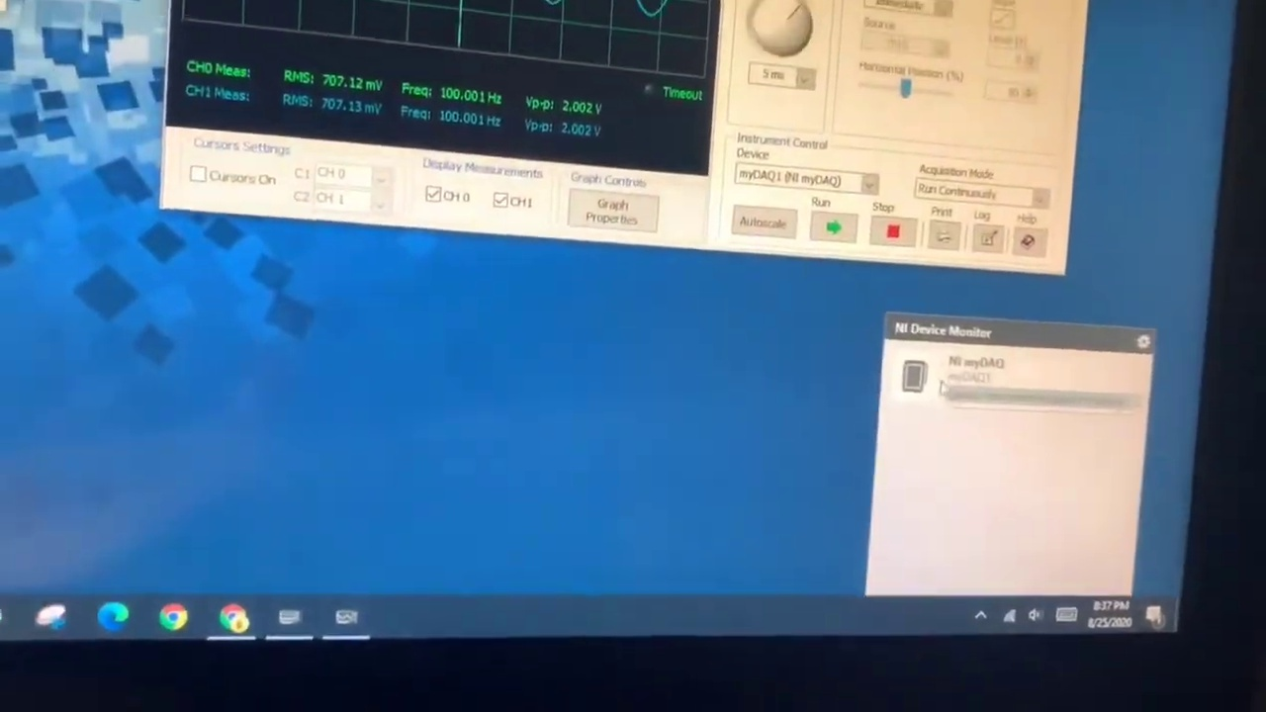 (score 90.0000)
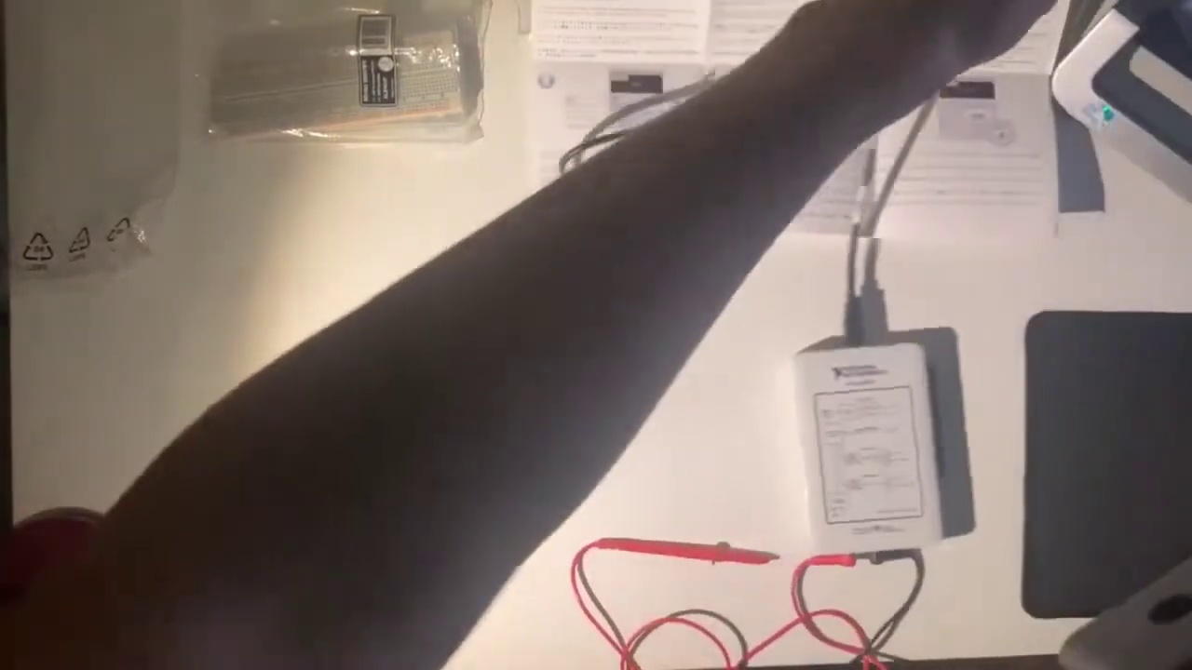 (score 90.0000)
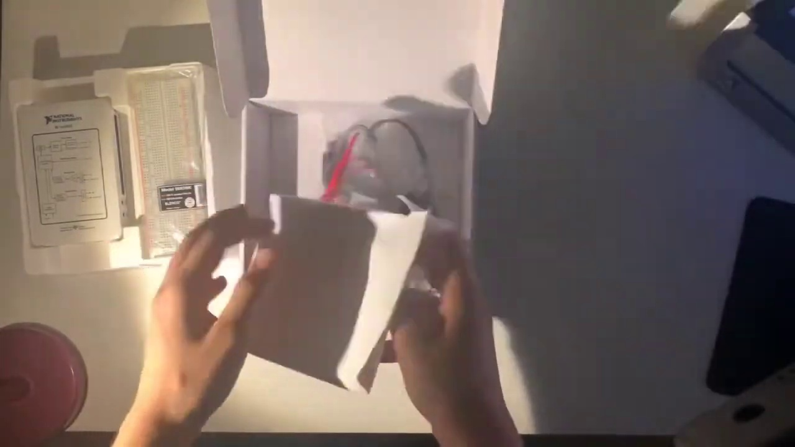 (score 90.0000)
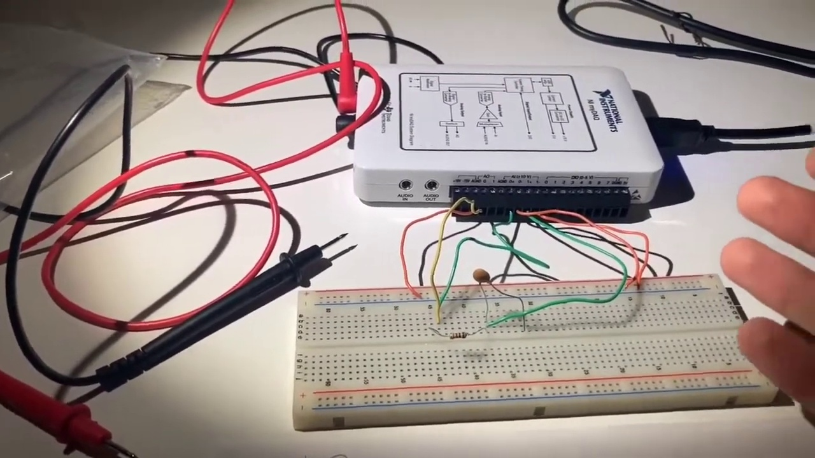 (score 85.0000)
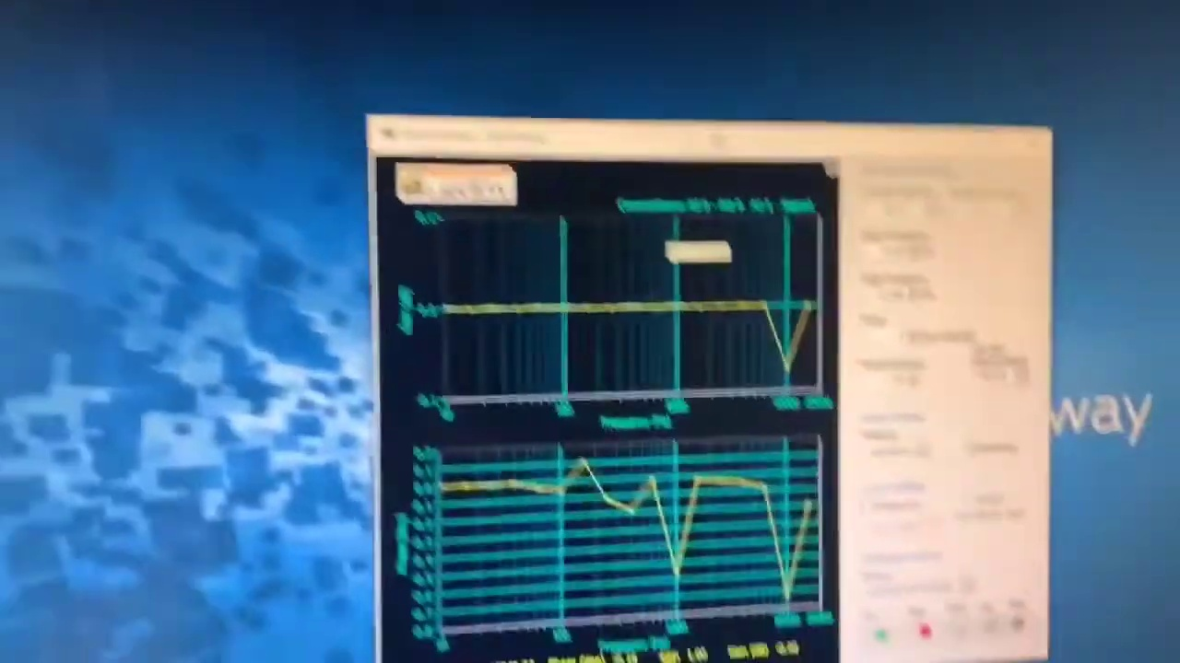 (score 85.0000)
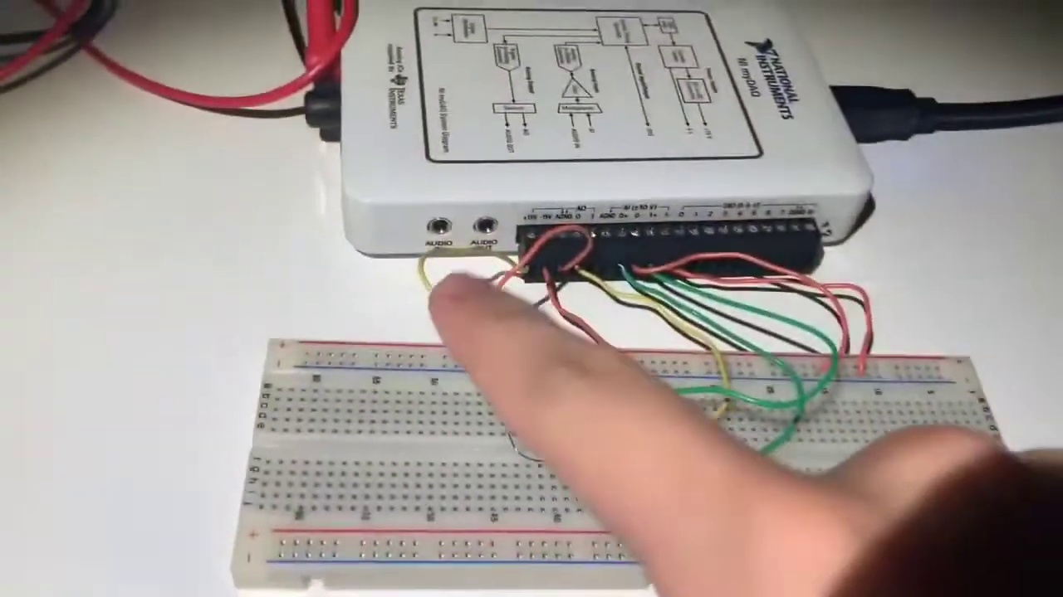 (score 85.0000)
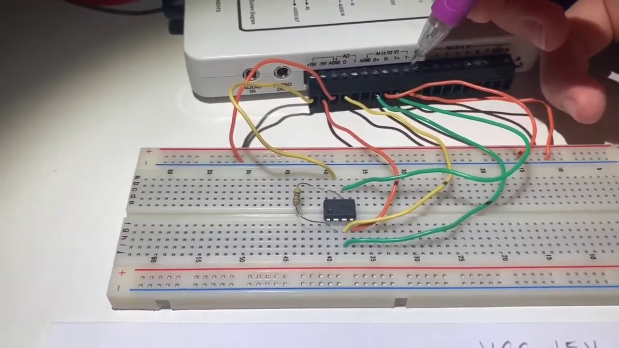 (score 85.0000)
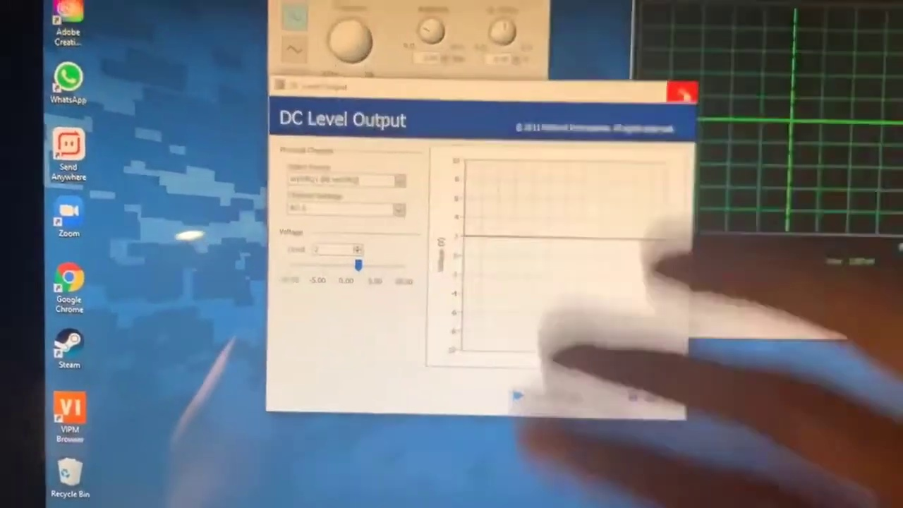 (score 85.0000)
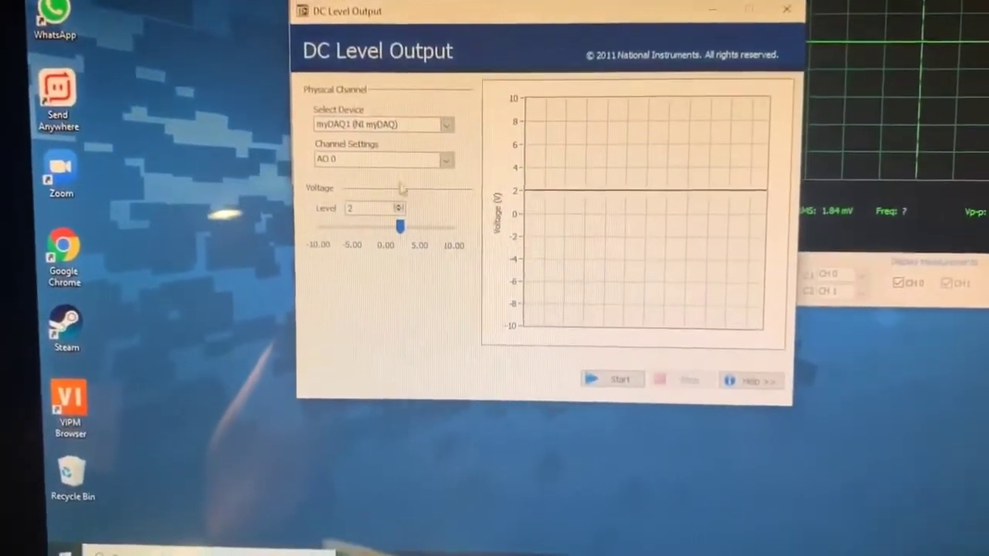 (score 85.0000)
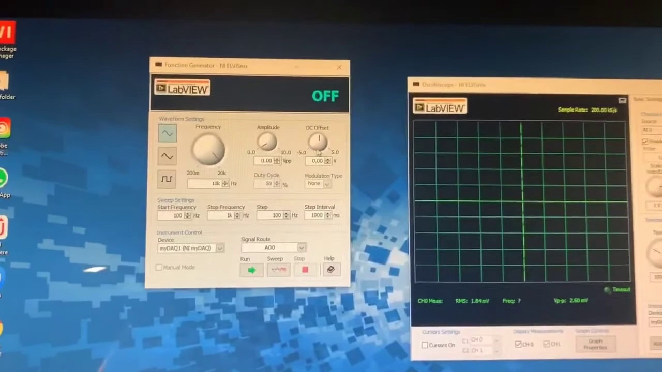 (score 85.0000)
Least correlated frames:
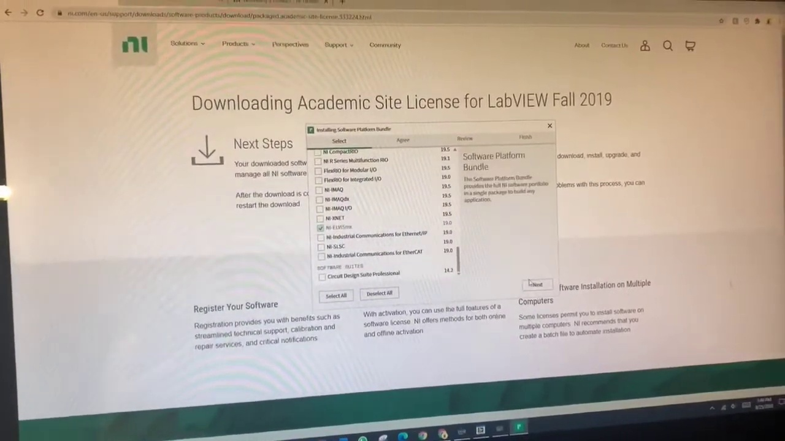 (score 0.0000)
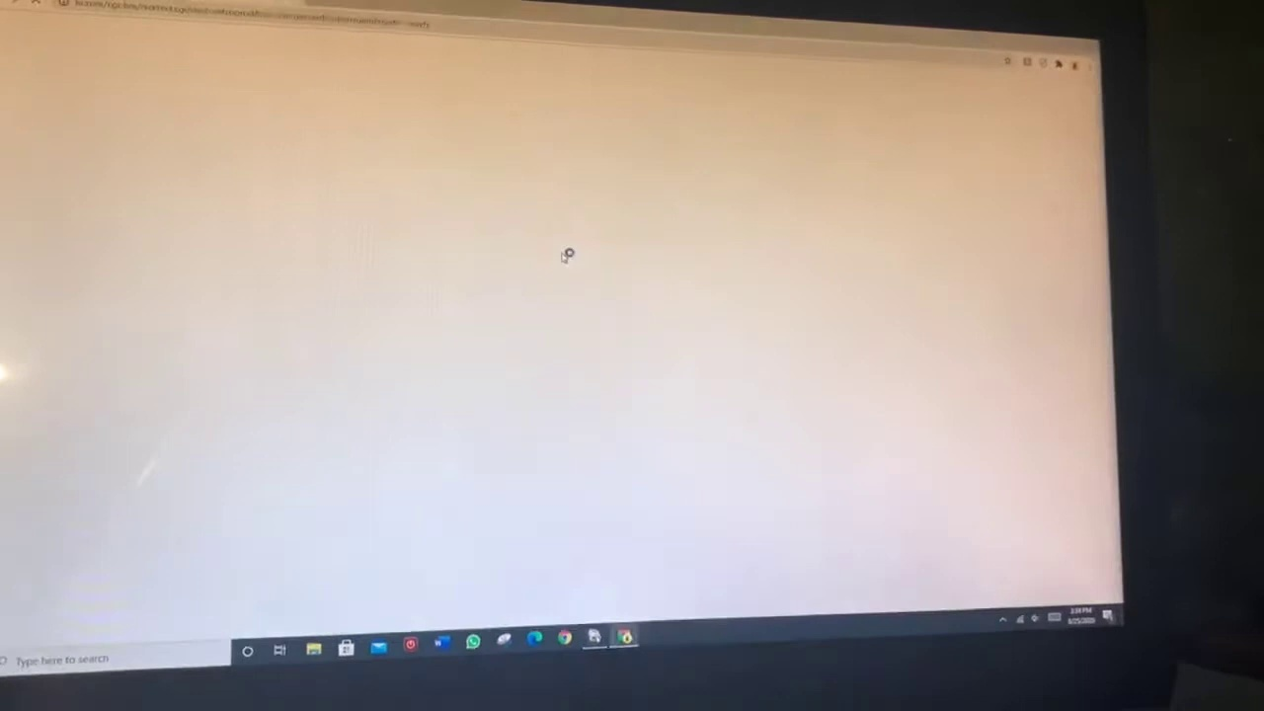 (score 0.0000)
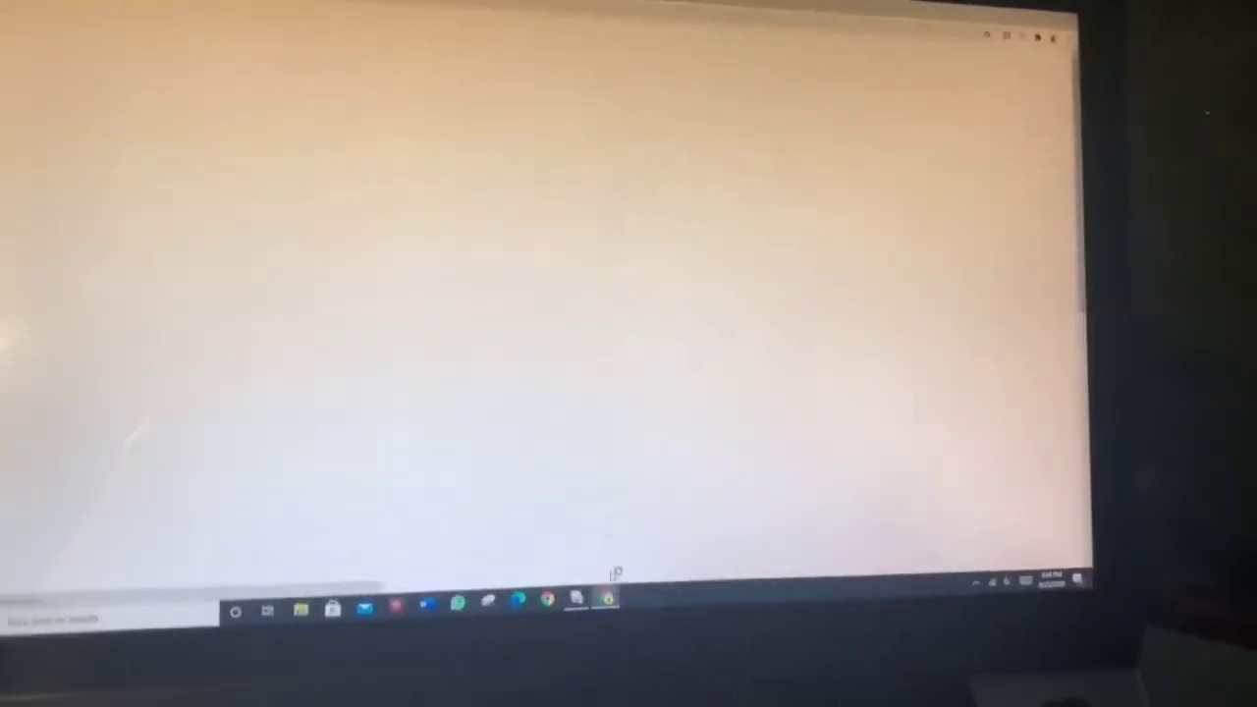 (score 0.0000)
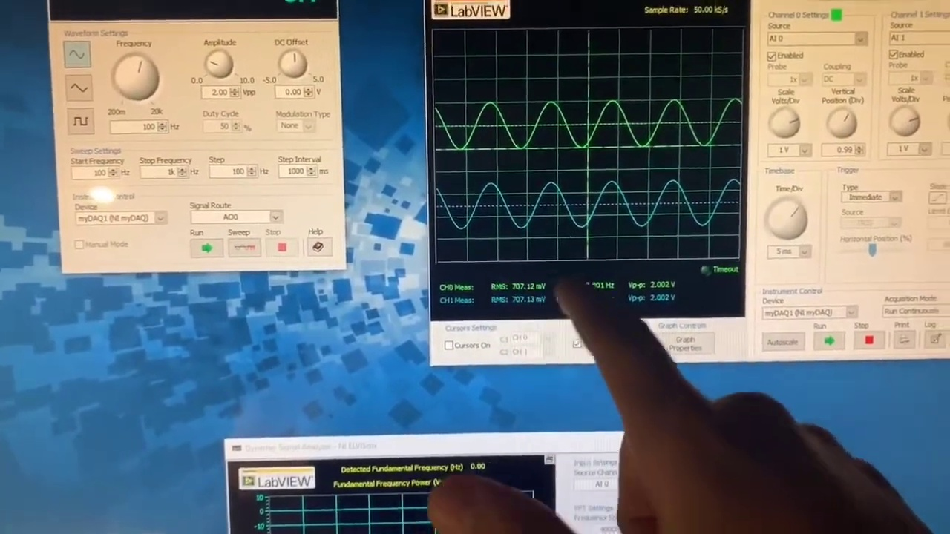 (score 0.0000)
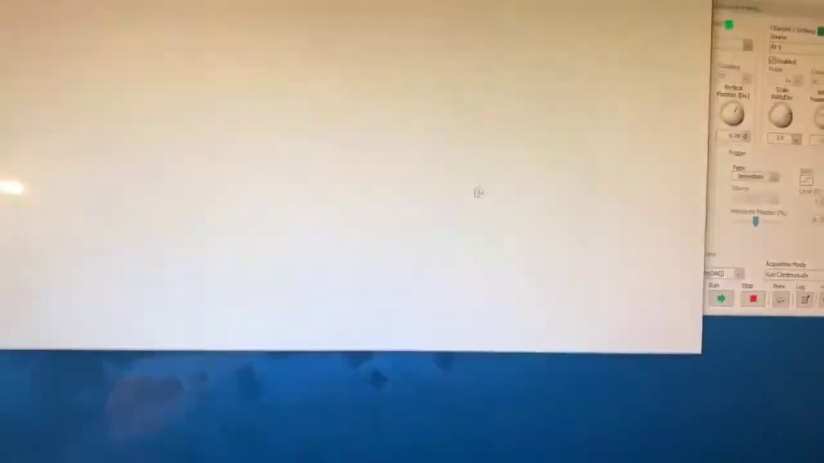 (score 0.0000)
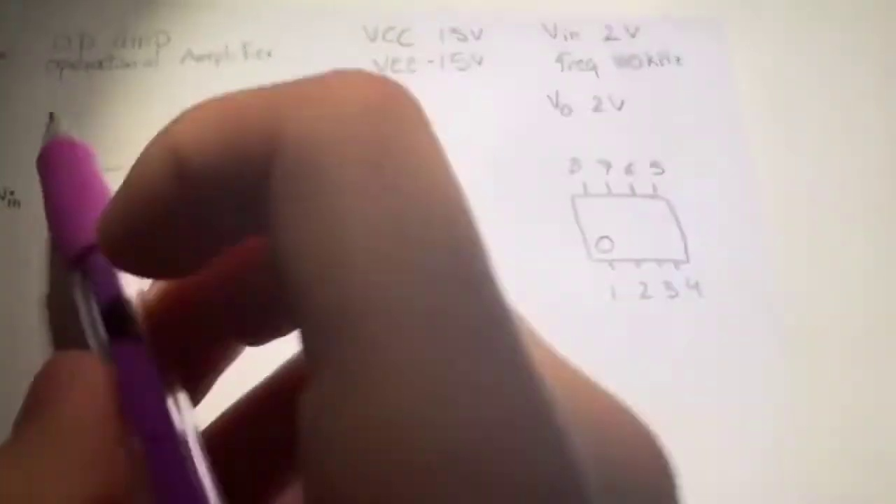 (score 0.0000)
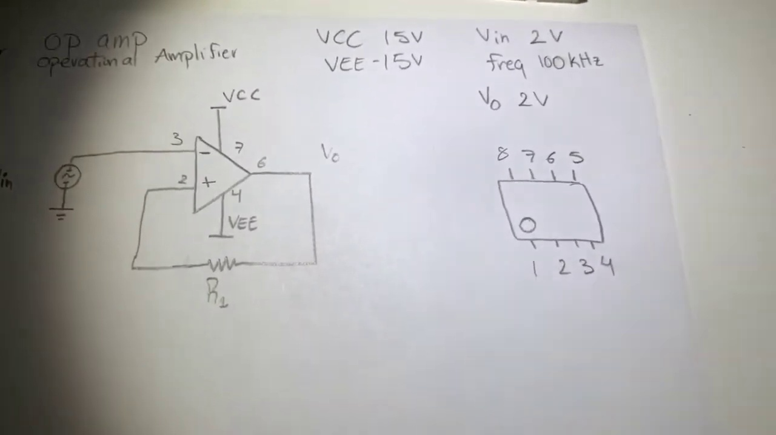 (score 0.0000)
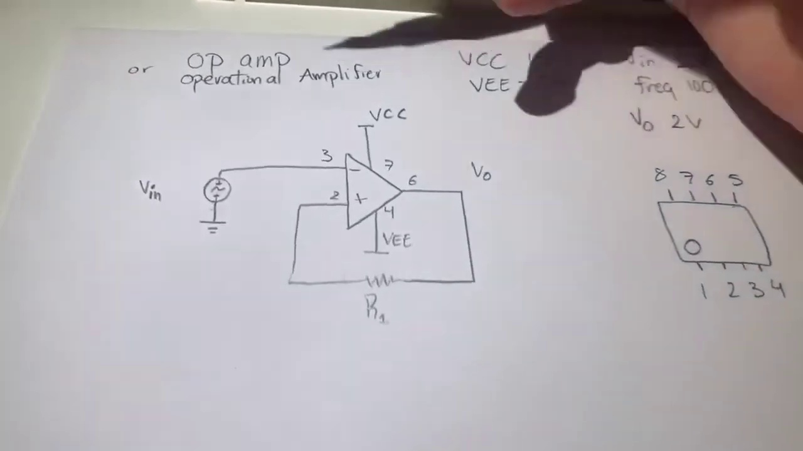 (score 0.0000)
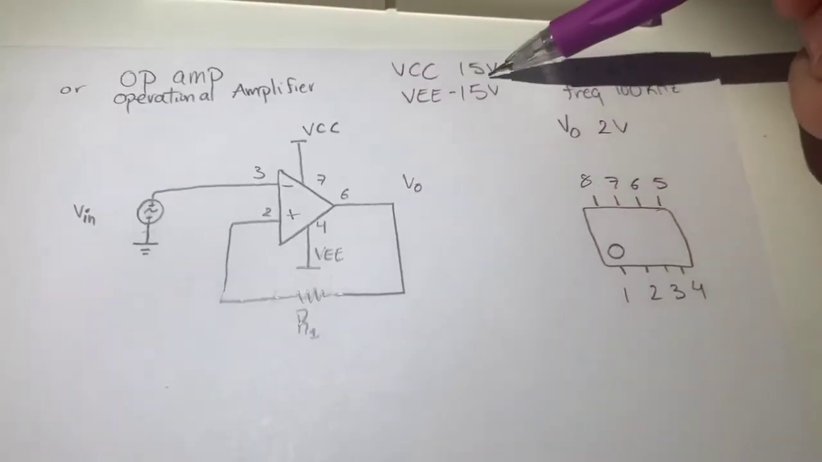 (score 0.0000)
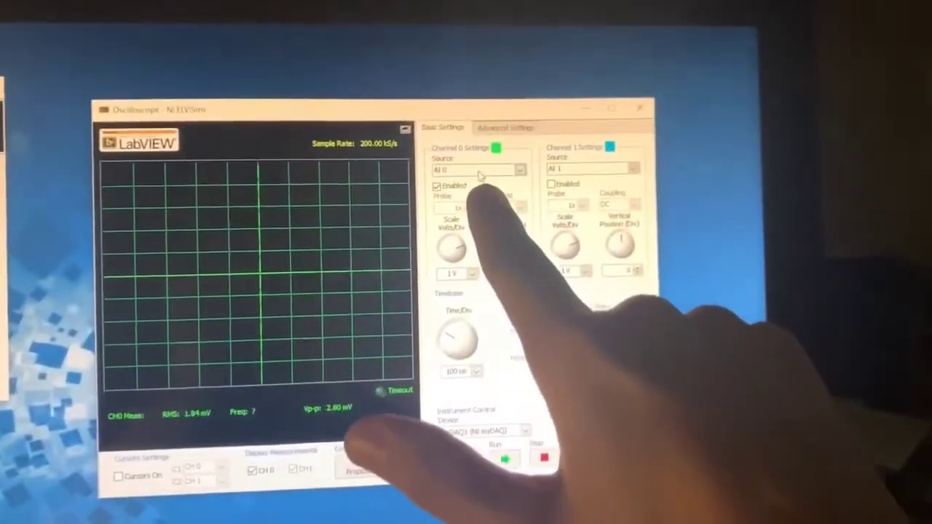 (score 0.0000)

Frame: frame_0000.jpg
Caption: In this image, we see a person's hand reaching out towards a boxed item placed on a white surface. The box is labeled "National Instruments NI" with red and black text, adorned with a black logo. A shadow cast by the light source falls across the surface, adding depth to the scene. The package appears to be unopened and still in its original packaging, possibly an iPad Air judging by its rectangular shape and labeling. The background is indistinct, focusing attention on the interaction between the hand and the box. From a low angle, the image captures a moment of anticipation, as if the person is about to open the package or has just placed it down.
Comment (score 80): This was something I should have reviewed much sooner, we did the hard way to figure out how to use the MyDaq. I like how it does not charge you to use the tool, so I could use at home. This was very informative on how to use and test components that we do in lab every Friday. I would think this is something I will be using for a few more classes anyway, so I will have to save this video to remember how to use.
Reason: The comment mentions using the MyDaq tool, which is strongly related to the National Instruments NI box in the frame caption. The comment also discusses testing components, which matches the scene of a person reaching for the box.
Source: https://www.youtube.com/watch?v=wmTlM5s2xTY: MyDaq Setup and Breadboard Tutorial

Frame: frame_0001.jpg
Caption: The image captures a moment of hands carefully opening a white box with a black label on its side. The label features a distinctive logo and the text "Samsung" written on it, indicating the brand of the device. The focus is on the USB device in the background, which appears to have various ports and slots, suggesting it's some type of USB hub or adapter.
The hands, positioned in the foreground, are holding the box with both hands, revealing the contents within. The box is open, and its contents are visible, hinting that it contains a device. The positioning of the hands suggests anticipation, as if the person is about to unwrap and explore the contents.
In the background, a kitchen cabinet can be seen, indicating a domestic setting where the scene unfolds. No text or slide is visible within the frame, keeping the attention solely on the opening of the box and the mysterious device inside.
No strongly correlated comments found for this frame.

Frame: frame_0002.jpg
Caption: The image appears to be a photograph taken at an angle where a person's hands are visible, their fingers intertwined, as if in the midst of a thoughtful gesture. The hands are positioned on a table, its surface a stark contrast to the hands' softness. The table itself is a white canvas, upon which rests a white box. The box is open, revealing its contents to the world.
The hands, the table, and the box all seem to be in a state of stillness, frozen in time. The image is devoid of any text or other discernible objects, allowing the viewer to focus solely on the hands and their interaction with the box. On the left side of the frame, one hand appears to be holding a transparent object that looks like a rectangular case with a clear top, being held over the table surface. A shadow cast from the object onto the surface below suggests it might be resting on or near the edge of the table.
In the background, there are indistinct elements that suggest an indoor setting, such as a window with blinds partially closed and what seems to be a room corner with some sort of curtain or blinds on a window. The photo quality is not very high due to the angle and lighting conditions, making it difficult to discern finer details about the environment or the object being held.
The image paints a picture of a quiet moment, a snapshot of a single gesture in time. It's a moment frozen in stillness, a moment of connection and contemplation. The blur in the background suggests movement, perhaps indicating that the image was taken in a moment of motion.
No strongly correlated comments found for this frame.

Frame: frame_0003.jpg
Caption: The image depicts a moment of anticipation and gentle handling of an object. A person's hands are carefully holding a white envelope sealed with a red and white sticker, adding a pop of color to the otherwise neutral tones of the scene. The person's gaze is focused on the envelope, perhaps waiting for a response or eagerly anticipating the contents within. The desk they stand in front of is white, providing a stark contrast to the envelope and their hands.
In the background, a white box sits quietly, its contents unknown. On the desk, various items are scattered, including what appears to be a smartphone placed horizontally and a plastic container or tray partially visible. A shadow on the surface suggests the presence of a light source out of view. The overall scene suggests a moment of waiting, a pause in the day, as the person anticipates the contents of the envelope.
The background is an indoor space with a wall-mounted device that might be a television or monitor, as well as other objects and what looks like a person's lower body near another desk. However, there are no visible texts, equations, or diagrams in the image that can be discerned, nor is there any apparent context of teaching or presentation. The overall atmosphere is one of quiet anticipation, with the focus on the envelope and its contents.
No strongly correlated comments found for this frame.

Frame: frame_0004.jpg
Caption: The photograph appears to capture a moment of anticipation and curiosity as two hands, one male and one female, are seen holding a white box with a red dot on it. The box is open, revealing a small electronic device inside, which features black and white components placed on a white desk. The device is being held by the individuals in their respective hands, with the box still grasped by both parties. The background is blurred, focusing the viewer's attention on the hands and the box. Unlike the original setting, the image does not contain any text that provides context for a teaching session or slides/diagrams. What is evident from the relative positions of the objects is a moment of interaction between the two individuals and the box. The image remains simple yet intriguing, leaving the viewer to wonder about the contents of the box and the purpose of the interaction, but it does not provide any additional information about the context or purpose beyond this fleeting moment.
Comment (score 90): This was something I should have reviewed much sooner, we did the hard way to figure out how to use the MyDaq. I like how it does not charge you to use the tool, so I could use at home. This was very informative on how to use and test components that we do in lab every Friday. I would think this is something I will be using for a few more classes anyway, so I will have to save this video to remember how to use.
Reason: The comment directly discusses the usage and testing of the MyDaq device, which is mentioned in the caption as the small electronic device inside the box. The comment also mentions using it for lab every Friday, which aligns with the 'moment of interaction' described in the caption.
Source: https://www.youtube.com/watch?v=wmTlM5s2xTY: MyDaq Setup and Breadboard Tutorial

Frame: frame_0005.jpg
Caption: The image shows a person's hands interacting with an electronic device or component. One hand is holding the item and appears to be examining it, assembling it, or demonstrating its use. The other hand holds a clear plastic bag containing another similar item or possibly related parts or components. In the background, there's an indoor setting with artificial lighting, although no visible texts, slides, or diagrams are present.
In this moment of activity, the person's hands are seen from the side, gently opening a white box filled with various electronic components. The metallic sheen of these components contrasts with the white box, and they're neatly arranged on a white surface. The person's fingers carefully remove one component from the box, suggesting an ongoing process of exploration or assembly.
In the bottom right corner of the image, a small label reads "Toshiba," possibly indicating the brand or manufacturer of the components. This detail adds a touch of familiarity and professionalism to the scene. Overall, the image conveys a sense of excitement and intrigue, as if someone is about to embark on a journey of discovery or creation.
Comment (score 85): This was something I should have reviewed much sooner, we did the hard way to figure out how to use the MyDaq. I like how it does not charge you to use the tool, so I could use at home. This was very informative on how to use and test components that we do in lab every Friday. I would think this is something I will be using for a few more classes anyway, so I will have to save this video to remember how to use.
Reason: The comment directly discusses the same technical steps described in the caption (examining and using electronic components), specifically mentioning the MyDaq tool and its usage in a lab setting. The mention of 'test components' aligns with the components shown in the image, indicating a strong connection between the caption and the comment.
Source: https://www.youtube.com/watch?v=wmTlM5s2xTY: MyDaq Setup and Breadboard Tutorial

Frame: frame_0006.jpg
Caption: The image shows a person's hands holding onto various objects and tools, with no clear indication of a teaching context. The person is seen grasping multiple items, including what appears to be wires or possibly USB cables with exposed connectors on both ends. They may be examining the objects or organizing them.
In addition, another tool is prominently featured: a pair of black scissors with tangled blades, suggesting that the person has been using them in a messy or unorganized environment. The scissors are held tightly by the person's fingers, which appear to be covered in a dark substance, possibly dirt or dust.
The background of the image is blurred, preventing any additional details from being discerned. A black bag is placed on a white table behind the person, but its contents are not visible. There are no texts, diagrams, or other educational materials present that would provide information about the context or purpose of the activity with these components. The overall scene suggests an activity involving the use of tools and possibly some disorganization.
Comment (score 80): This was something I should have reviewed much sooner, we did the hard way to figure out how to use the MyDaq. I like how it does not charge you to use the tool, so I could use at home. This was very informative on how to use and test components that we do in lab every Friday. I would think this is something I will be using for a few more classes anyway, so I will have to save this video to remember how to use.
Reason: The comment directly discusses using the MyDaq tool, which is a specific technical component mentioned in the caption as one of the objects being examined. The comment also mentions testing components, which matches the description of the person's activity with various tools in the caption.
Source: https://www.youtube.com/watch?v=wmTlM5s2xTY: MyDaq Setup and Breadboard Tutorial

Frame: frame_0007.jpg
Caption: The image shows a person's hands holding a white plastic box filled with various electronic components, including resistors, capacitors, and possibly integrated circuits or sensors. The components are neatly arranged on the circuit board within the box, suggesting that the person might be in the process of assembling or testing the device. As the person's hands are visible in the frame, it appears they are removing a component from the box, their fingers gently lifting it out. The white desk in the background provides a neutral backdrop, allowing the viewer to focus on the person and the components.
The overall scene conveys a sense of anticipation, possibly before the person begins to assemble or test the components. The absence of any visible text, diagrams, or teaching context within this frame suggests that the focus is on the hands holding the object and the contents of the box, rather than a larger instructional setting.
Comment (score 80): This was something I should have reviewed much sooner, we did the hard way to figure out how to use the MyDaq. I like how it does not charge you to use the tool, so I could use at home. This was very informative on how to use and test components that we do in lab every Friday. I would think this is something I will be using for a few more classes anyway, so I will have to save this video to remember how to use.
Reason: The comment mentions the MyDaq tool and testing components in lab every Friday, which is directly related to the technical steps and objects described in the caption, such as assembling or testing electronic components.
Source: https://www.youtube.com/watch?v=wmTlM5s2xTY: MyDaq Setup and Breadboard Tutorial

Frame: frame_0008.jpg
Caption: The image appears to show an individual engaged in some form of technical setup or repair. In the foreground, a person is holding a USB cable and a plastic bag with cables, likely assembling or organizing the cables for a device like a printer or computer modem. The individual's face is not visible, but their hands are occupied with the items they're handling. Next to them, there's a partially unpacked piece of technology in front of them, which looks like an external hard drive or a similar device, possibly being connected to the USB cable.
To the left of the person and the device, there's a closed box that appears to be an instructional manual or guide for assembling or using the product. It has a prominent logo on it, suggesting it is branded material. This manual implies an educational context, such as the person learning to set up or repair their equipment.
In the background, there's another electronic device, which seems to be a desktop computer tower, indicating that this might be a home or office setting where multiple devices are used. This scene suggests that the person is either assembling the device from the manual or troubleshooting a technical issue with their existing setup.
Meanwhile, in a separate scenario, a different individual is holding a white and black phone in their right hand, with their left hand holding a white and black box containing a cable and power adapter. The phone is placed on a white table covered with a white tablecloth, and the person's face is not visible. The background of this image is blurred, making it difficult to identify any specific objects or details.
No strongly correlated comments found for this frame.

Frame: frame_0009.jpg
Caption: This image captures a moment of anticipation as someone carefully opens a white box, revealing a packaging contents label with various icons and text. The individual holds up the package, showcasing the QR code and instructions or information related to the product inside. The setting appears to be a casual, home environment, with a bookcase in the background featuring books on the shelves.
As the person lifts the lid, they reveal a white tray containing a white and blue cable and a manual with black text on a blue background. The manual is laid out on the tray, awaiting the individual's attention as they prepare to set up or unbox their new device. The image conveys a sense of excitement and curiosity, implying that this person is about to embark on an engaging experience with their newly acquired product.
Comment (score 85): This was something I should have reviewed much sooner, we did the hard way to figure out how to use the MyDaq. I like how it does not charge you to use the tool, so I could use at home. This was very informative on how to use and test components that we do in lab every Friday. I would think this is something I will be using for a few more classes anyway, so I will have to save this video to remember how to use.
Reason: The comment directly discusses the technical steps and objects described in the caption, specifically mentioning 'how to use' and 'test components', which are closely related to the setup and unboxing of the device shown in the frame.
Source: https://www.youtube.com/watch?v=wmTlM5s2xTY: MyDaq Setup and Breadboard Tutorial

Frame: frame_0010.jpg
Caption: The image shows a moment of anticipation as a person holds a black cable wrapped in a clear plastic bag with their left hand. The cable is grasped firmly, while the right hand cradles a piece of paper that appears to be related to the cable, potentially a manual or warranty card. The overall setting features a stark white background that draws attention to the objects in the foreground.
In the background, there's a white wall-mounted shelf with various items on it: a cable organizer, tools or accessories, and a small sign that reads "USB." This setup suggests an educational environment where technology or computer equipment might be discussed or demonstrated. Additionally, a person is shown holding what appears to be a USB flash drive up to a computer camera, possibly taking a photo or recording a video for instructional purposes.
A piece of paper lies flat with instructions or notes written on it, although the text is not entirely legible due to the angle and focus of the photograph.
Comment (score 85): This was something I should have reviewed much sooner, we did the hard way to figure out how to use the MyDaq. I like how it does not charge you to use the tool, so I could use at home. This was very informative on how to use and test components that we do in lab every Friday. I would think this is something I will be using for a few more classes anyway, so I will have to save this video to remember how to use.
Reason: The comment directly discusses the same technical steps (using MyDaq) and objects (USB flash drive, cable organizer) described in the caption. The setting of an educational environment is also mentioned in the comment as a lab where they test components every Friday.
Source: https://www.youtube.com/watch?v=wmTlM5s2xTY: MyDaq Setup and Breadboard Tutorial

Frame: frame_0011.jpg
Caption: The image shows a white tabletop covered with various items, including electronics and accessories. The assortment includes:
1. A smartphone with its battery pack attached.
2. A USB cable connected to the battery pack and the phone, suggesting either charging or data transfer between the two devices.
3. A set of earbuds in their packaging with a noticeable red cord.
4. A small clear plastic bag containing what appears to be additional cables, possibly for charging different types of devices or for data transfer.
5. A white card or label with text and graphics on it, which is partially obscured but seems to be related to the electronics displayed, such as a logo or brand name that includes "Samsung."
6. A small white paper that looks like a product manual or warranty card for a Samsung device.
7. A white envelope with visible text, although the details of the text are not legible in this image.
8. Various other electronics and accessories, including what seems to be a pair of headphones and possibly some small electronic devices or adapters, but their specifics are not clear.
The items are scattered rather than organized systematically, so there's no clear teaching context visible in this image. The focus seems more on the products themselves, potentially for sales or demonstration purposes.
On the table, there is also:
1. A white box with a label that reads "Where to Download Your Instrument Academic Software".
2. A white paper containing instructions for downloading the software.
3. A white envelope, also labeled "Where to Download Your Instrument Academic Software", placed next to the box and paper.
The overall arrangement of the objects suggests a systematic approach to downloading software, with the box, paper, and envelopes in close proximity to each other.
No strongly correlated comments found for this frame.

Frame: frame_0012.jpg
Caption: The image presents a close-up view of two hands holding a white piece of paper with black text written on it. The paper reads "NOTETOUSERS Where to find your National Instruments Academic Software" and includes instructions for downloading the software, activating it, and locating the serial number. The steps to follow include "DOWNLOAD YOUR NATIONAL INSTRUMENTS ACADEMIC SOFTWARE," "ACTIVATE YOUR NI ACADEMIC SOFTWARE" with further guidance to "LOCATE YOUR SERIAL NUMBER AND SIGN-IN TO MY NI." The paper also features a QR code, possibly for further information or support.
In the background, there appears to be a digital device with a screen showing an email address "john@gmail.com" and some text related to the NI academic software activation process. The overall scene suggests a scenario where someone is seeking guidance on how to access and use their National Instruments Academic Software, possibly in a relaxed or informal setting.
No strongly correlated comments found for this frame.

Frame: frame_0013.jpg
Caption: The image presents a close-up view of a person holding a piece of paper with instructions for downloading and activating academic software, intended for both French and English speakers. The title on the paper, "Notes pour les utilisateurs", is written in bold, black font against a white background. Below the title, the instructions are written in both French and English, providing information on how to locate and use the materials.
The person holding the paper appears to be in a public space, with a building visible in the background, suggesting an educational setting where these materials may be being distributed or demonstrated. The image also shows two pieces of paper containing additional instructions for downloading software, specifically "Where to Download Your National Instruments Academic Software" and a sub-text explaining how to locate your serial number.
Further details include an instruction to go to "NI-Academy" and then activate your NI-Achieve account, followed by locating your serial number. The bottom of one of the papers contains a QR code, which typically directs to a webpage with more information on downloading the software.
No strongly correlated comments found for this frame.

Frame: frame_0014.jpg
Caption: The image shows a person holding an envelope with a printed label and a barcode visible through the window of the envelope. The envelope appears to have been recently used for mailing, as indicated by the postmark stamp on the top right corner. The label on the envelope includes text that contains a tracking number or code related to the delivery service, although due to the quality and angle of the image, not all details can be read. There is no visible barcode on the outside of the envelope, suggesting it was likely scanned during the mailing process.
The envelope is addressed with a return address reading "10100 E. Main St., Austin, TX 78701" and bears a unique identifier "1234567890123". The envelope is sealed with white tape and features a small label that reads "NATIONAL INSTRUMENTS", indicating its origin from the National Instruments company. The person's hand is visible, gripping the envelope firmly, implying it contains something of great importance. The background is blurred, drawing focus to the envelope and the person holding it.
No strongly correlated comments found for this frame.

Frame: frame_0015.jpg
Caption: The image shows a computer monitor displaying a web page with an application for an "Academic Site License." The webpage features black text on a white background, prominently displaying the heading "Academic Site License" and "Downloads," suggesting that the purpose of the page is to provide information about downloading the license for an academic site. The page includes fields for inputting information such as name, address, email, and other contact details related to licensing, including a field labeled "Comments/Additional Information." A date field shows "31/12/2023," indicating that the application was submitted on this date.
A section with a heading that says "Application Submitted:" is present, with a checkbox indicating that the application has been submitted, which is checked. There is also a button at the bottom of the form labeled "Submit," suggesting an action to be taken to finalize the application process. The style of the image appears to be a screenshot from a virtual meeting or video call given the presence of a webcam feed showing the upper part of someone sitting at the computer desk, but their face is not visible due to the angle and framing of the shot.
The webpage also includes a list of files, likely containing the necessary files for the license download. The overall layout of the page suggests that it's a detailed guide for obtaining the academic site license.
No strongly correlated comments found for this frame.

Frame: frame_0016.jpg
Caption: The image shows a computer monitor displaying a webpage titled "Academic Site License" with information related to academic licensing or clearance. The webpage appears to be from a university or college as indicated by the logo and design elements. Here are the details visible:
* The page is titled "Academic Site License."
* There is a search bar at the top center of the page, labeled "Search" with a magnifying glass icon.
* Below the search bar, there's a navigation menu with options like "Home," "About Us," "Courses," and others.
* A main heading reads "Academic Site License."
* Underneath this main heading, there is a subheading that says, "A convenient way to offer access to your institution’s academic content."
* To the right of the main heading, there's an icon with text "14 days free trial," suggesting an option for a temporary access to the site.
* Below this, there are fields for inputting information such as a search bar, and what seems to be an input field labeled "Academic Site License Number." There is a dropdown menu next to it that allows for selection of a license type, but the options are not clearly visible in this image.
* Further down, there's a table with the following columns: "License Type," "Number of Users," and "Number of Terminals." Each column has multiple entries, but they are not fully visible due to the resolution of the image.
* At the bottom right corner of the webpage, there's a note that says, "Please note: This site uses cookies for a better user experience. By using this site, you agree to the terms and conditions set out below."
* The overall style of the image is utilitarian, with a focus on text and functionality over aesthetic design elements.
* Additionally, the webpage contains a small icon, likely representing a download button, currently filled with the text "Downloads for LabVIEW 2019," suggesting it's a platform for users to obtain and install the LabVIEW software.
No strongly correlated comments found for this frame.

Frame: frame_0017.jpg
Caption: The image captures a screenshot of a computer interface showing an academic site license and related information. On the left side of the window is a navigation bar that includes sections such as "Home," "Courses," "Books," and others, suggesting a website interface potentially linked to an educational institution or service provider.
In the center of the image, there is text that reads "Academic Site License" with a subheading "License Information" below it. This section appears to be discussing details about a site license for academic use. The main body of the screenshot contains a form or registration page where one can enter information to obtain an academic site license.
The form fields include options such as: Registration Type (currently set to "Academic Site License"), Name (with fields for first name and last name), Email Address (pre-filled with an email address), Institution Information (with subfields for Institution Name, Department/Division, and Language of the site license), and a dropdown menu labeled "Select Year" with highlighted options 2019 and 2020.
On the right side of the screenshot is a calendar icon with a label "Select Year," indicating that the user needs to select a specific year for the site license. A dropdown menu next to it lists "2019" and "2020," which are highlighted, suggesting both years are available for selection.
Below the main form fields, there is a section with three tabs labeled "General Information," "Privacy Policy," and "Terms & Conditions." These tabs suggest that there are additional sections to review or complete before obtaining the site license.
In addition to this information, the image also captures a separate section featuring a standard text box displaying a license agreement in black text. The top of the screen prominently displays the text "Academic Site License," and the bottom displays the date "11/15/2019." The text "Downloads" and "Fall 2019" are also visible, indicating the source of the software and the time of its release. The background of the screen is white, providing a contrast to the black text and ensuring the agreement is easily readable.
The computer screen itself appears turned off, with the monitor displaying a black screen, suggesting that the user is not currently using the computer.
No strongly correlated comments found for this frame.

Frame: frame_0018.jpg
Caption: The image captures a computer screen displaying the "Academic Site License" page. The title of the page, "Academic Site License", is prominently displayed at the top, accompanied by a subtitle that reads "Downloads and Drivers for LabVIEW 2019 Fall". The page is divided into two sections: the "New Academic Site Licence" form at the top and the "LabVIEW 2019 Fall" section at the bottom.
The "New Academic Site Licence" form includes fields for the site name, site address, contact information, and options to select different types of licenses. Below the form, there is a table that lists details about the license, with columns titled "License Type", "Start Date", and "End Date". However, only the first row of the table is visible, as it appears to be partially cut off.
The "LabVIEW 2019 Fall" section provides information about the software, including its release date and the operating systems it supports. Additionally, the page contains a navigation bar at the top with links for "Home", "Site License", "New Site Licence", "Support", and possibly other menu items. On the right side of the screen, there is a small part of a computer mouse and a section of a webpage or browser window that includes a logo or emblem, but the specific details are not clearly visible.
The image also contains a watermark that reads "Copyright 2019 LabVIEW 2019 Fall", indicating that the image is copyrighted and may not be used without permission. Overall, the image provides a clear overview of the LabVIEW 2019 Fall software, including its availability for academic sites and the necessary downloads for its installation.
No strongly correlated comments found for this frame.

Frame: frame_0019.jpg
Caption: The image shows two computer screens displaying different webpages. The first screen displays a search engine interface with a prominent central search bar, accompanied by a section titled "Expert Findings" featuring a list of items that likely relate to the search query. These items include various labels and images, which are possibly categories or topics to filter the results by. The text is not clear enough to read in detail.
At the bottom of this screen, there's a footer with additional navigation options such as "Careers," "Customization," "Company," "Contact us," "Privacy Policy," and "Terms & Conditions." This suggests that the webpage is designed for accessibility and user experience. In the bottom right corner, there's a watermark or logo indicating that this is a screenshot from Zoom, an online video conferencing software commonly used for meetings, webinars, and remote education.
The second screen displays a professional business website with a large white text box dominating the page. The text "Engineering Ambition" is prominently displayed in bold black font, accompanied by a list of items under headings such as "Solutions", "Orders", "Company", and "Partners". The background of this webpage appears to be light blue, providing a striking contrast to the white text and black items.
There is no visible instructor or teaching context within either image. The focus is on the computer screens and the displayed webpages, which seem to be related to job search or career exploration portals.
No strongly correlated comments found for this frame.

Frame: frame_0020.jpg
Caption: The image appears to show a computer screen displaying a webpage with instructions for downloading an academic site license for LabVIEW Fall 2019. The website features a navigation menu at the top with options like "Home," "About," "LabVIEW," and "Downloads." The main content area is divided into two sections.
On the left side, under the section titled "DOWNLOADING ACADEMIC SITE LICENSE FOR LABVIEW FALL 2019," there's a step-by-step guide with text instructions. The first instruction says: "Next Stage" with an arrow pointing to the right side of the screen where a message is displayed that reads, "How do I download the academic manager?" accompanied by an icon resembling a document with a magnifying glass, suggesting the action involves downloading or viewing information.
On the right side of the screen, there's a green button labeled "Page Manager" which implies that this webpage can be managed through this button. Below the button, there is a brief explanation explaining how to access the academic manager from the page. This part of the text says: "To manage pages, please select the Page Manager link at the top of the page."
At the bottom of the page, there's a green rectangle that provides a clear visual cue for the user, likely serving as an instruction or step-by-step guide for the process of downloading the academic site license. The overall style of the image is a standard web interface layout with a focus on providing instructions for downloading and managing academic licenses for LabVIEW Fall 2019 software. The text in the image is clear and legible, indicating that it's a screenshot intended to illustrate or demonstrate how to access and utilize academic site license information on the website.
No strongly correlated comments found for this frame.

Frame: frame_0021.jpg
Caption: The image shows a computer monitor displaying a webpage with content related to academic or scholarly activities. The webpage, from the website for LabVIEW Fall 2019, is divided into two sections. On the left side of the screen, there is a pop-up window titled "Next Steps" with a list of steps and their corresponding icons or illustrations, partially obscured, guiding users through a process. The main content on the right side of the screen includes:
1. A header with the text "Downloading academic licenses for LabVIEW 2019."
2. Below this header, there is a section titled "Academic Labs," which includes a button labeled "Next step" and a link to download an academic license for LabVIEW 2019, highlighted in a blue box with a dashed border.
3. This section also contains a brief paragraph of text, although the content is partially obscured due to the angle of the image.
The webpage features a clean and professional design, with a blue background that complements the white text. The overall layout is intuitive, guiding users through the process of downloading the academic site license for LabVIEW Fall 2019.
Two buttons or links are visible: one on the left side of the screen (the "Next Steps" window) and one on the right side (directly below the header). The visible part of the button text in the "Next Steps" window is "Step 1:," but the rest of the step is cut off.
A watermark or logo with the text "NI Softwares, Inc." suggests that this webpage is related to National Instruments, a company known for developing LabVIEW and other software products.
The lower portion of the image shows part of the computer desktop, including the taskbar at the bottom, where icons for various applications are visible. There's also a partial view of what seems to be a text editor or document window with some text, but it's not legible due to the angle and focus on the webpage content.
The style of the image appears to be a candid photograph taken in a workspace environment, as indicated by the presence of the computer and its peripherals.
No strongly correlated comments found for this frame.

Frame: frame_0022.jpg
Caption: The image shows a computer monitor displaying a webpage titled "Downloading Academic Site License" from the website "LabVIEW Fall 2019." This suggests that the content relates to academic site licenses, specifically for LabVIEW, which is software developed by National Instruments Corporation (NI) for use with its data acquisition hardware. The NI logo and other text related to downloading the software are visible on the screen.
The webpage appears to be a user-friendly interface, featuring a "New Site" field with a search icon and input box, suggesting a process for creating or managing new sites within the LabVIEW system. A navigation bar at the top of the page includes various menu items such as "Home," "Site Management," "Support," "Forums," "Training," "Resources," and "About NI."
The main content area of the page is arranged in a grid-like pattern, with the words "Downloading Academic Site License" prominently displayed in the center. A list of steps guides users through the process of downloading the license, providing a clear and streamlined experience.
In the lower right corner of the image, there is an overlay of a blurred desktop wallpaper featuring what appears to be a forest or natural landscape, suggesting that someone is using their computer to access this website for downloading LabVIEW site licenses.
No strongly correlated comments found for this frame.

Frame: frame_0023.jpg
Caption: The image captures a moment on a computer screen, specifically the screen of a computer running Windows 10. The screen is dominated by a white background, with two main text sections prominently displayed in black letters. In the center of the screen, it reads "DOWNLOADING ACADEMY FOR LABOUR RELATIONS FOR LABOUR RELATIONS 2019 FALL SESSIONS", suggesting that this is a resource for students enrolled in fall sessions of a labor relations program offered by Northeastern University. Below this text, there are smaller white texts that read "VIEW CATALOGUE" with a dropdown menu indicating different academic terms like "SPRING 2019 SESSIONS", "SUMMER 2019 SESSIONS", "FALL 2019 SESSIONS", and "SPRING 2020 SESSIONS", each followed by a number. There are also options to change the language of the interface from English to French or Spanish, links for "CONTACT US" and "LOG IN TO STUDENT ACCESS", and an arrow pointing towards a checkbox labeled "By downloading this application, I agree that my academic access is currently valid.".
To the left of these texts, there is another prominent text section that reads "Downloading Academic Site License for LabVIEW Fall 2019" with smaller white texts below it reading "Next Steps", "Register Your Software", and "Advanced Signal Processing". The computer screen is positioned in front of a white wall, creating a stark contrast between the computer screen and the background. The computer screen also has a green background, which adds a pop of color to the scene.
The overall style of the image suggests that the user is in the process of downloading or installing software for educational purposes within an academic institution.
No strongly correlated comments found for this frame.

Frame: frame_0024.jpg
Caption: The image shows a computer monitor displaying a webpage with text that reads "Downloading [academic site license] for [Year], such as LabVIEW Fall 2019." Below this main title is a subtitle that says "Next step." On the right side of the screen, there's a pop-up window titled "Install" and it includes a set of instructions:
- Choose installation path (default C:\Program Files\[Software Name]\[Year])
- [Highlighting] "Choose Start Menu folder (default C:\Users\Public\Documents\[Software Name]\[Year])"
- Click Next >
The highlighted text indicates that the user is currently at this step of the installation process. The interface elements suggest a software installation wizard. The overall scene suggests someone is either starting an academic software installation or explaining how to do so, likely for educational purposes. A copyright notice reminds users of the importance of respecting intellectual property rights.
No strongly correlated comments found for this frame.

Frame: frame_0025.jpg
Caption: The image shows a computer screen displaying the homepage of the LabVIEW 2019 Academic Site License website. The background is a light green color, and the website is set against a white background. The website's header prominently displays the logo of the National Institute of Standards and Technology (NIST), indicating the organization behind this platform. The main content of the page is organized into two columns.
The left column provides information about the license, with text that reads "Downloading Academic Site License for LabVIEW 2019 Fall", suggesting that the user is about to download the LabVIEW 2019 Academic Site License, which is available for the fall semester.
The right column offers instructions for downloading the software, starting with the text "Next Steps". This is followed by a series of bullet points that guide the user through the process. The webpage also features an illustration of a computer desktop with a LabVIEW icon on it, indicating the software being referenced.
At the top of the page, there is a navigation bar with tabs labeled "Home," "Programs," "Courses," "Resources," and "About." Below the title, there's text explaining how to download the software, including a link and instructions that are not fully visible in the image. To the right of the text is a download button labeled "Download."
The webpage features a message at the bottom of the page saying "Session closed", suggesting that the session has been terminated or closed. On the screen outside the webpage, there is a blurred background that appears to be an office environment with a desk and what looks like a person partially visible, suggesting the setting where the image was taken.
No strongly correlated comments found for this frame.

Frame: frame_0026.jpg
Caption: The image shows a computer screen displaying a webpage from the LabView 2019 Fall Website, titled "Downloading Academic Site License for LabVIEW 2019 Fall." The page is currently loading and has a white background providing contrast to the text and graphics. The webpage is divided into two main sections: a header with links to different parts of the page and a bottom section containing step-by-step instructions and prerequisites for downloading the academic site license.
The webpage itself displays "DOWNLOADING Academic Joins for LAView 2019" along with instructions on how to download, accompanied by bullet points providing additional details. The computer screen also features an open Microsoft Edge application window on the left side and a Salesforce application window on the right side, suggesting concurrent use of these applications.
The style of the image is a standard screenshot, capturing the computer screen as it would be seen by a user interacting with these applications and web pages.
No strongly correlated comments found for this frame.

Frame: frame_0027.jpg
Caption: The image captures a computer screen displaying a webpage from LabVIEW Fall 2019. The webpage is divided into two sections, with the top section displaying a banner that reads "DOWNLOADING ACADEMIC SITE TO LABVIEW 2019" followed by a subtitle "LABVIEW FALL 2019". Below this banner, there is a button labeled "Next Steps".
The bottom section of the webpage contains a license agreement. The license agreement states that by clicking "I ACCEPT", the user agrees to the terms and conditions of the agreement. In addition, the main content area of the webpage provides instructions with screenshots for downloading and installing academic software. These instructions include a step-by-step guide showing how to download and run the software, with a screenshot highlighting the process.
The interface of the computer shows the start screen of Windows, indicating that the operating system is likely Windows. Below the main content area, there is a note stating "NOTE: You must have Administrative Privileges to download this software." This indicates a requirement for the user to run the installation with administrative privileges.
Overall, the image provides a snapshot of an academic technology-related task being carried out on a desktop computer, demonstrating how users might navigate this specific piece of software's download and installation process. The webpage itself appears to be in English and is likely part of an academic institution's website, given the context provided by the text and images.
No strongly correlated comments found for this frame.

Frame: frame_0028.jpg
Caption: The image shows a computer screen displaying a "Downloading Academic Site License for LabView Fall 2019" page. The webpage is filled with text and icons, indicating a process of downloading and installation. The background is a stark white, providing a clear contrast to the text and icons on the screen. On the left side of the screen, there is a window titled "LabVIEW 2019" displaying instructions for obtaining the software. Specifically, it reads: "LabVIEW 2019 / To obtain this software, go to...". Additionally, another window titled "Next Steps" is visible, partially due to cropping and angle, with the visible portion reading: "Select one or more options to get started...".
The LabVIEW 2019 software is being downloaded, as indicated by a progress bar in the "LabVIEW 2019" window. At the bottom of the screen, two tabs are open: "Next Steps" (currently active) and "Getting Started". The user interface elements suggest an interactive process with options to proceed further in the setup or installation of the software.
The overall image conveys a sense of order and organization, with the computer screen serving as a hub for this academic process.
No strongly correlated comments found for this frame.

Frame: frame_0029.jpg
Caption: The image captures a computer screen displaying a webpage open in a web browser on a computer monitor. The webpage is for the "Academic Site License" and presents two sections: "Downloading academic sit license" and "Reading Site License Agreement."
The "Downloading academic sit license" section features a button with a download arrow pointing right, labeled "Download," suggesting that users can initiate the download of the site license by clicking on it. Below this section, a window is open containing text and a checkbox. The text reads: "I agree to the terms of service of [www.yourdomainname.com]," accompanied by an asterisk (*) possibly indicating a requirement for users to agree to the terms before they can download the site license.
The second section, "Reading Site License Agreement," is not displayed in its entirety due to the screenshot's cropping. However, it is implied that this section contains important information about the academic site license and its terms of service.
In contrast, a separate webpage for "Downloading Academic Site License" appears on the screen. This page features a prominent display of the text "Next Steps," accompanied by a button labeled "Install." Below this, there is additional text providing information about the products to be installed. The background of the screen is a stark white, contrasting with the black text and buttons.
The overall setting suggests that someone was browsing the site on their computer when the screenshot was taken, possibly in the process of downloading or reading about the academic site license.
No strongly correlated comments found for this frame.

Frame: frame_0030.jpg
Caption: The image shows a computer screen displaying various elements, appearing to be part of a remote meeting or presentation environment. At the top of the screen, a web browser window is open, displaying a website titled "Downloading academic software for IOS." The webpage features an instructional graphic on how to download the software for iOS devices, accompanied by a button labeled "NEXT STEP" in white text against a green background.
The webpage also includes visible text, although the image resolution does not allow for clear reading of the content. On the right side of the screen, a file explorer window is open, showcasing multiple files and folders, including "Moodle." Below the web browser, on the desktop, there's a screenshot of another device (possibly a smartphone) displaying an app with a graphic that appears to be part of the academic software mentioned on the webpage. The phone's screen shows a graphical representation of what seems to be an educational interface or application, but details are obscured due to the resolution.
The desktop background features a presentation slide with bullet points visible in black text against a white background; however, the content is not legible due to the image resolution. In the lower right corner of the image, there's a notification or error message that appears to be part of a web application interface, but the text within it is too small and blurry to read clearly.
The focus of this image seems to be on the academic software download process, as indicated by the open browser window with the instructional graphic for iOS devices. The rest of the visible content is either obscured or partially visible due to the resolution of the image.
In contrast to the academic software download process, the top-left corner of the screen displays the LabVIEW logo, indicating the platform's official website. A white box on the center of the screen features a green "Next Steps" button in the top right corner and a green "Install Software" button in the bottom right corner, suggesting that the user is in the process of installing or upgrading software.
The dark blue background of the image provides a stark contrast to the white screen and the green buttons, highlighting the primary elements of the image - the computer screen and the website. This overall composition suggests a typical day in the life of a user interacting with LabVIEW software.
No strongly correlated comments found for this frame.

Frame: frame_0031.jpg
Caption: The image shows a computer screen displaying a webpage with a title "Downloading Academic Site License for LabVIEW Fall 2019". The text on the webpage is displayed in blue, providing a stark contrast against the white background. The webpage is divided into two sections: the first section at the top displays the title, while the second section below provides instructions for downloading the license.
The instruction section contains a step-by-step guide with illustrations showing how to download the software. A prominent heading above this guide reads "Downloading Academic Starter for LabVIEW 2019" in bold letters. Below this heading is a progress bar labeled "Download academic starter for LabVIEW 2019", indicating that a user is currently in the process of downloading or installing the software.
The webpage features a navigation menu at the top with items like "Download," "Documentation," and "Support." The interface elements suggest an educational setting, possibly in a computer lab where instructors teach students how to use or access certain software applications. The design is clean and functional, typical of a website that serves as a resource for academic users.
No strongly correlated comments found for this frame.

Frame: frame_0032.jpg
Caption: The image shows a computer screen displaying the homepage of an academic software download, specifically for LabVIEW Fall 2019. The background is set to black with a white header that reads "Downloading Academic Site License for LabVIEW Fall 2019". Below this header, there is a white text box labeled "Next Steps", followed by a green button that reads "Register Your Software".
On the right side of the screen, there is a small graphical user interface (GUI) with a dropdown menu and some icons that appear to represent various tools or functionalities. The GUI is similar in design to other academic software download pages.
The text on the page indicates that the user is downloading an academic site license for LabVIEW Fall 2019, suggesting that the focus is on academic or educational settings. The page also suggests that the software may be related to MATLAB programming, as there are options to download for 32-bit or 64-bit systems and instructions for downloading "Academic STANDARD" software.
The overall setting implies an instructional or educational context, possibly within a university or academic institution, where students or staff may be downloading this software. The focus is on the computer screen, which serves as the primary source of information and the main teaching tool for guiding users through the download process.
No strongly correlated comments found for this frame.

Frame: frame_0033.jpg
Caption: The image shows an individual engaged in an activity that appears to be related to electronics or engineering, possibly a DIY project or demonstration. The person's hands are busy with the task, holding a black box that's plugged into a white socket connected to red and black wires. One hand is using a digital tablet with a diagram or schematic displayed on the screen, likely for reference, guidance, or data input/monitoring related to the project at hand.
The desk, not just a simple surface but a platform for learning and discovery, holds various components and possibly a book or manual, which could be providing instructions or explanations about the task. A white notebook lies open on the desk, filled with diagrams and instructions that depict the structure of the electronic device and the connections between its components. The instructions guide the person on how to assemble the device, providing a step-by-step guide for the assembly process.
The overall scene suggests an informal learning space, where someone might be teaching themselves or others how to assemble or configure electronic equipment.
Comment (score 80): This was something I should have reviewed much sooner, we did the hard way to figure out how to use the MyDaq. I like how it does not charge you to use the tool, so I could use at home. This was very informative on how to use and test components that we do in lab every Friday. I would think this is something I will be using for a few more classes anyway, so I will have to save this video to remember how to use.
Reason: The comment directly discusses the use of a tool (MyDaq) and testing components, which is closely related to the technical steps described in the caption (assembling or configuring electronic equipment). The mention of using the tool at home and in lab also matches the context of the scene, where someone is working on an informal learning space.
Source: https://www.youtube.com/watch?v=wmTlM5s2xTY: MyDaq Setup and Breadboard Tutorial

Frame: frame_0034.jpg
Caption: The image shows a tabletop with various items, revealing a detailed moment of electronic device assembly or adjustment. A person's hands are working with an electronic device, possibly connecting wires to it, while an electronic component visible on the device appears to be a circuit board with resistors and other components attached. Next to the device is a piece of paper with schematic diagrams or instructions for assembling or using the device, partially obscured except for "12V" written in the bottom right corner, suggesting that the device might require a 12-volt power supply.
A red and black power cable with a plug rests on the table next to the paper with instructions. In the background, an object resembling a speaker or audio equipment is blurred, giving the impression of a home or workshop setting. A plastic storage bin can also be seen in the background, further suggesting this environment.
In the foreground, the person is meticulously working on a white device, currently in a state of disassembly. The device is held in their right hand, with their left hand reaching out to connect wires to it. The person's focus is evident as they carefully remove components from the device.
Tools such as scissors and pliers are visible on the table, which the person is likely using to disassemble the device. The device itself is a small, white box with a black panel on top, featuring several red wires sticking out, indicating that it is in the process of being reassembled. The person is also holding a small white box, which could be a part of the device they are working on.
The image captures a moment of intense focus and concentration, as the person works to reassemble the device. The precise placement of the objects and actions of the person suggest a level of expertise and care in the process.
No strongly correlated comments found for this frame.

Frame: frame_0035.jpg
Caption: The image shows a person engaged in a hands-on electronics project, with the focus on a small electronic device. The device has a small screen and multiple wires connected to it, with a visible USB cable plugged in, indicating potential charging or data transfer. In the foreground, the person's hands are seen holding the device against a white background, possibly for manual manipulation or testing. The device appears to be a digital multimeter, given its red and black cables, which suggests electrical testing is underway.
In the background, printed materials such as diagrams or instructions relate to the electronics project. Although the resolution and angle make it difficult to read specific details, the materials seem to provide guidance for the task at hand. The setting appears to be a workbench or desk with various tools, wires, and components scattered around, adding context to the scene.
The image is composed of two merged photos, showcasing both the device in use (bottom part) and at rest (upper part). There are no legible texts or graphics due to the angle and resolution. The absence of any clear educational content or project purpose adds mystery to the scenario, leaving the viewer to focus on the hands-on activity taking place.
Comment (score 80): This was something I should have reviewed much sooner, we did the hard way to figure out how to use the MyDaq. I like how it does not charge you to use the tool, so I could use at home. This was very informative on how to use and test components that we do in lab every Friday. I would think this is something I will be using for a few more classes anyway, so I will have to save this video to remember how to use.
Reason: The comment directly discusses the technical steps (using and testing components) and object (MyDaq device) described in the caption. The setting (lab every Friday) also matches the context presented in the image.
Source: https://www.youtube.com/watch?v=wmTlM5s2xTY: MyDaq Setup and Breadboard Tutorial

Frame: frame_0036.jpg
Caption: The image shows a person engaged in meticulous work on an electrical device on a white table in a laboratory setting. The device, equipped with a black plug and red and black wires, suggests it might be a power supply or control unit. The person's hands, dressed in a white shirt, are carefully handling the device, indicating a process of testing or troubleshooting.
To the right of the device, there is a piece of paper with text and diagrams related to electronic components and circuits. The visible text includes phrases like "RESISTOR," "V-R," "CIRCUIT," "BATTERY," and "Wires." There are also images of electronic components like resistors and a battery, as well as diagrams that might represent electrical circuits or schematics.
The context suggests an educational setting where electronics workings are being taught or demonstrated. The person appears focused on the device itself, rather than interacting with the text on the paper. The instructional context seems to be more about hands-on demonstration than direct interaction with slides or diagrams.
In the background, there are two books - one is blue and the other is black. These books could contain instructions, diagrams, or technical information related to the device being worked on.
No strongly correlated comments found for this frame.

Frame: frame_0037.jpg
Caption: The image captures a moment of intense focus and concentration as a person assembles an electronic device. The individual's hand, adorned with a pair of black nails, is seen holding a small, rectangular object, possibly a calculator or computer keyboard, with its top and bottom edges marked by black lines. The hand is firmly gripping the device, suggesting a sense of importance or urgency.
The background is a stark white, providing a stark contrast to the person and the device. A white table dominates the scene, with various electronic components scattered around, indicating some form of electronic work or assembly. In front of the person, there are small parts and components being used in the assembly process, including what appears to be a small circuit board, wires, and possibly a microcontroller module or a similar electronic component.
A whiteboard behind the individual features text that is not entirely legible due to the angle and distance of the photo. However, it looks like there could be some sort of diagram or explanatory notes related to the assembly process. The setting appears to be an informal workspace, possibly at home, as suggested by the casual attire of the person and the personal items in the background.
In the background, there is also text that reads "Forklift", "Electronic", "Forklift", "Electronic", and "Forklift". This could suggest that the person might be working in an industrial setting where such devices are used. The precise location of these objects and their arrangement could provide more context about the nature of the work being performed.
No strongly correlated comments found for this frame.

Frame: frame_0038.jpg
Caption: The image shows two individuals engaging with a white electronic device on a white desk in a collaborative learning environment. The device is multi-functional, featuring various ports and connectors that indicate its versatility and complexity. On the left, one person is focused on the front panel of the device, their hands firmly gripping it as they examine a black wire connected to the device, suggesting a connection or connection point.
On the right, another individual is looking at the back of the device, possibly studying its layout or internal components. The plain white background allows the device and its occupants to stand out, emphasizing the focus on hands-on learning. A piece of paper with instructions or notes lies nearby, although details are unclear due to the photo's resolution and angle.
The setting suggests an educational or hands-on environment, as indicated by the presence of a small projector or screen on the desk. The room has a minimalistic decor with a neutral color palette, implying a focus on the task at hand rather than aesthetics. Overall, the image conveys a sense of curiosity and exploration as individuals delve into the world of electronic devices, possibly related to programming or technical subjects given the software interface displayed on the device's screen.
Comment (score 80): This was something I should have reviewed much sooner, we did the hard way to figure out how to use the MyDaq. I like how it does not charge you to use the tool, so I could use at home. This was very informative on how to use and test components that we do in lab every Friday. I would think this is something I will be using for a few more classes anyway, so I will have to save this video to remember how to use.
Reason: The comment directly discusses the technical steps and objects mentioned in the caption, such as using the MyDaq tool and testing components. The comment also references a specific learning environment (lab) and technical subject area (classes), which aligns with the educational setting described in the caption.
Source: https://www.youtube.com/watch?v=wmTlM5s2xTY: MyDaq Setup and Breadboard Tutorial

Frame: frame_0039.jpg
Caption: The image shows two moments of technological exploration and learning. In the foreground, someone is assembling an electronic device, likely a small drone, based on instructions provided in a printed manual. The individual is attaching wires to a black circuit board with connectors visible at the ends of the wires, using a pair of pliers to manipulate tiny components. A close-up view of the printed manual on a white surface reveals text too small to read clearly in this format. Two small screens display schematics or diagrams of the device's internal components, serving as step-by-step guides for assembling the drone, showing components like batteries and other electronics.
In the background, a person's hand holds a white device with a black screen, its backlit display illuminating the scene. The device is connected to a red and black power strip, which is plugged into a wall socket. The person's fingers are poised over a black button on the device, ready to press it. The power strip is adorned with instructions and diagrams, hinting at the complexity of the device that lies within.
The overall atmosphere suggests an educational or hobbyist setting where someone is learning to build their own electronic device. The presence of printed manuals, schematics, and diagrams implies a hands-on approach to technology, while the readiness to interact with the device on the power strip suggests a moment of discovery or troubleshooting.
No strongly correlated comments found for this frame.

Frame: frame_0040.jpg
Caption: The image depicts a hands-on learning scenario, showcasing an individual engaged in a teaching or demonstration activity. In the foreground, the person's hands hold a smartphone with its red power button illuminated, indicating that the device is powered on and being used to demonstrate its features or functions. The phone rests on a white surface, possibly a desk or table, amidst various electronic components and wires.
In the background, a document or booklet lies open to a page filled with text and diagrams, although the text is not fully legible due to the angle of the photo. This instructional guide appears to be related to the smartphone being used, suggesting that the individual might be teaching how to utilize specific features or functions.
The setting suggests an educational environment, such as a workshop or seminar, where technology skills are being taught. The overall scene implies that the person is engaged in explaining or demonstrating how to use electronic components and devices, possibly involving electrical or electronic projects.
Comment (score 80): This was something I should have reviewed much sooner, we did the hard way to figure out how to use the MyDaq. I like how it does not charge you to use the tool, so I could use at home. This was very informative on how to use and test components that we do in lab every Friday. I would think this is something I will be using for a few more classes anyway, so I will have to save this video to remember how to use.
Reason: The comment directly discusses the usage of a specific tool (MyDaq) and its features, which is closely related to the caption's description of an educational setting where technology skills are being taught. The mention of using the tool 'to test components' in lab every Friday also matches the caption's depiction of electronic projects.
Source: https://www.youtube.com/watch?v=wmTlM5s2xTY: MyDaq Setup and Breadboard Tutorial

Frame: frame_0041.jpg
Caption: The image shows a close-up view of a National Instrument device, held by an unseen hand and plugged into both a black power cord and a red cable. The device features a white power button and a white USB connector, with a label reading "National Instrument" prominently displayed. It sits atop what appears to be a power strip or surge protector, suggesting that it is connected to an electrical supply for power. Multiple cables are plugged into its ports, implying involvement in data transmission or networking, given the structure of the connectors. The surrounding environment is obscured by the close-up view, making it difficult to discern any additional details about the location or activity taking place.
Comment (score 80): This was something I should have reviewed much sooner, we did the hard way to figure out how to use the MyDaq. I like how it does not charge you to use the tool, so I could use at home. This was very informative on how to use and test components that we do in lab every Friday. I would think this is something I will be using for a few more classes anyway, so I will have to save this video to remember how to use.
Reason: The comment directly discusses the usage and testing of components using the National Instrument device, which is prominently featured in the frame caption. The mention of 'MyDaq' and 'lab every Friday' further strengthens the connection between the comment and caption.
Source: https://www.youtube.com/watch?v=wmTlM5s2xTY: MyDaq Setup and Breadboard Tutorial

Frame: frame_0042.jpg
Caption: This image captures a moment of someone interacting with an electronic device, possibly for teaching purposes. The individual is holding up a small electronic device labeled "INTERNATIONAL INSTRUMENTS" with a white body and black face. The device has two black wires connected to it, one of which is connected to a green and black circuit board labeled "HIO". This circuit board appears to be part of the larger device. The person's hand is holding the device with their right thumb on the top left corner and their right index finger on the bottom right corner.
The device has a printed circuit board (PCB) attached to its base, which could be a breadboard or similar component used for experimentation in electronics. The PCB features various components that look like resistors and possibly an integrated circuit (IC), such as a microcontroller or operational amplifier. On the left side of the image, there is a label with what appears to be a schematic diagram or set of instructions, suggesting that this device might be part of a hands-on learning activity, perhaps in a technology, engineering, or mathematics (TEM) class.
The image has been overlaid with a transparent layer that includes text and images, likely meant to explain the content or concept behind the device being held. The bottom of this layer features a graphical representation of an IC, which is consistent with the components visible on the PCB. There are also some numbers and symbols on the screen that seem to be part of a tutorial or lecture slide explaining electrical circuits or schematics, but they are partially obscured by the overlay text. The text includes phrases like "Microcontroller," "Resistor," and "Capacitor," which could be related to the components found on the PCB.
The relative positions of the objects suggest that the device is being used or is in the process of being used. The image does not provide enough information to determine the purpose of the device or the person's activity, but it is clear that the focus is on electronics education, likely in a classroom setting.
No strongly correlated comments found for this frame.

Frame: frame_0043.jpg
Caption: This image shows a person's hands holding a device, which appears to be a National Instruments control panel with scratches on its surface. The device is resting on a gray surface, and the person's hand is positioned on the side of the device, suggesting they might be in the process of setting it up or examining its components. In the foreground, the device features a diagram drawn on it, illustrating a network topology that includes labeled nodes representing different parts of the network. The connections between these nodes indicate how data might flow through the network.
In the center of the diagram is a node labeled "R01," with lines connecting it to other nodes, suggesting it's acting as the central or main device in the network. Additional labels like "LAN 01" and "WAN" refer to Local Area Network and Wide Area Network respectively, and there's an indication of a connection from R01 to another node labeled "WAN." The image quality is a bit grainy and blurry, making it difficult to read any specific text or model details. There are no visible texts that provide additional context about the network, its operation, or the device's functionality.
The person appears to be examining or setting up the network diagram on this hardware, possibly as part of an educational demonstration or hands-on activity related to computer networking. The background is blurred, indicating that the focus of the image is on the device and the person's hand, which suggests a moment of interaction between the person and the device.
Comment (score 85): This was something I should have reviewed much sooner, we did the hard way to figure out how to use the MyDaq. I like how it does not charge you to use the tool, so I could use at home. This was very informative on how to use and test components that we do in lab every Friday. I would think this is something I will be using for a few more classes anyway, so I will have to save this video to remember how to use.
Reason: The comment directly discusses the setup and use of the MyDaq device, which is also described in the frame caption. The comment mentions 'using the tool' and 'how to use', which matches the technical steps mentioned in the caption, such as setting up or examining the device's components.
Source: https://www.youtube.com/watch?v=wmTlM5s2xTY: MyDaq Setup and Breadboard Tutorial

Frame: frame_0044.jpg
Caption: The image appears to capture a moment during a presentation or demonstration of some sort. It shows a person holding a small electronic device, specifically a white box with the logo of National Instruments, against a white surface, which seems to be a slide or presentation board given its size and positioning. The device has a visible screen with a diagram on it, but the content is not legible due to the camera's angle. Schematic representations and lines connecting various components of the device suggest that it might be an educational or instructional setting where a student or trainee is demonstrating the workings of this piece of equipment to an instructor or audience member.
The person's hand holding the device is on the left side of the frame, while their face and upper body are obscured by the image's composition. The right side of the image shows a blurred background, making it difficult to discern any additional details. The overall style of the photo suggests that it was taken quickly or casually during an ongoing event, possibly in a classroom or workshop setting.
The focus of the image is on the intricate details of the device and the person's meticulous attention to detail as they hold the open box, revealing the complex circuit board inside. The numerous pins and wires suggest the complexity of the device it houses, inviting the viewer to imagine the workings of the device within the box.
Comment (score 85): This was something I should have reviewed much sooner, we did the hard way to figure out how to use the MyDaq. I like how it does not charge you to use the tool, so I could use at home. This was very informative on how to use and test components that we do in lab every Friday. I would think this is something I will be using for a few more classes anyway, so I will have to save this video to remember how to use.
Reason: The comment directly discusses the usage and features of the MyDaq device, which is mentioned in the frame caption as a National Instruments device with a diagram on its screen. The commenter also mentions testing components, which aligns with the educational/instructional setting described in the caption.
Source: https://www.youtube.com/watch?v=wmTlM5s2xTY: MyDaq Setup and Breadboard Tutorial

Frame: frame_0045.jpg
Caption: The image shows a person's hand holding a small white device with a distinctive black and white color scheme and the prominent logo "INSTRUMENTAL MUSIC COMPANY" on its front. The device is equipped with a microphone, which is pointed towards the ground, ready to capture any sounds it might encounter. On top of this device is a piece of paper with what appears to be a schematic diagram or circuit layout, featuring lines connecting different elements that may represent the internal structure of the device. There are no visible texts or identifiable brands on the device or paper that could provide additional context.
The person's hand is positioned over the device, suggesting they are about to press a button or start recording. The background is blurred, but suggests an indoor environment, possibly a workshop or classroom setting where the focus of the image seems to be on the electronic component and diagram.
Comment (score 85): This was something I should have reviewed much sooner, we did the hard way to figure out how to use the MyDaq. I like how it does not charge you to use the tool, so I could use at home. This was very informative on how to use and test components that we do in lab every Friday. I would think this is something I will be using for a few more classes anyway, so I will have to save this video to remember how to use.
Reason: The comment directly discusses the technical steps and objects described in the caption, such as using the MyDaq tool to test components, which is mentioned in the diagram on the paper. The comment also mentions the setting of a lab environment, matching the blurred background in the image.
Source: https://www.youtube.com/watch?v=wmTlM5s2xTY: MyDaq Setup and Breadboard Tutorial

Frame: frame_0046.jpg
Caption: The image shows a person's hand holding a white rectangular device with various ports and connectors on its side, which is labeled "National Trends". The device features multiple buttons, including a red one labeled "AUDIO IN" and a green one labeled "AUDIO OUT", as well as a power indicator that displays a red light. A gray power cord is plugged into the device. On the surface of the device, there appears to be some sort of label or sticker displaying text and diagrams, although the specific details are not fully visible due to the angle and quality of the photo.
The person's hand is positioned on the right side of the device, with their fingers pressing a button. The focus of this image seems to be on the device itself rather than any educational content being presented, as there is no indication of the person writing, pointing, holding a model, or speaking from a slide.
Comment (score 80): This was something I should have reviewed much sooner, we did the hard way to figure out how to use the MyDaq. I like how it does not charge you to use the tool, so I could use at home. This was very informative on how to use and test components that we do in lab every Friday. I would think this is something I will be using for a few more classes anyway, so I will have to save this video to remember how to use.
Reason: The comment directly mentions the device (MyDaq) and its usage, which is also described in the caption. The comment specifically talks about using the tool to test components, which aligns with the description of the device's ports and connectors in the caption.
Source: https://www.youtube.com/watch?v=wmTlM5s2xTY: MyDaq Setup and Breadboard Tutorial

Frame: frame_0047.jpg
Caption: The image shows a person working on a white table, surrounded by various objects that suggest a workspace or lab setting dedicated to electronics and DIY projects. The person's hands, seen from behind, are engaged in the task of adjusting a digital multimeter, which is connected to a black wire, indicating that it is being tested. On the table, a white book and a black pen lie nearby, possibly containing instructions or notes related to the task at hand.
A small electronic device with red and white wires connected to it, appearing to be a portable battery pack or charger, lies in front of the person. Papers or documents related to the device, possibly schematics, notes about electrical components, or instructions, are also present on the table. The overall scene suggests a space dedicated to electronics repair or testing, with the person's focused demeanor and detailed nature of the task indicating a level of expertise in the field.
Comment (score 85): This was something I should have reviewed much sooner, we did the hard way to figure out how to use the MyDaq. I like how it does not charge you to use the tool, so I could use at home. This was very informative on how to use and test components that we do in lab every Friday. I would think this is something I will be using for a few more classes anyway, so I will have to save this video to remember how to use.
Reason: The comment directly references the digital multimeter and its usage, which is a key object mentioned in the frame caption. Additionally, the comment mentions using the tool to test components, which matches the scene described in the caption where the person is adjusting the multimeter to test a wire.
Source: https://www.youtube.com/watch?v=wmTlM5s2xTY: MyDaq Setup and Breadboard Tutorial

Frame: frame_0048.jpg
Caption: This image appears to capture an educational setting where someone is demonstrating or explaining something to an audience. In the foreground, a person is seated at a table with various devices and materials spread out. The central figure is holding a small electronic device (possibly a microcontroller board or a similar circuit) in their hands, gesturing towards it while operating it.
On the table, there are several devices visible: a small electronic device being held by the person, a keyboard with a white background, possibly specialized for a specific type of computer or peripheral, and an object resembling a cable or wire bundle. In front of the person, educational slides or diagrams are laid out, but the text is not legible in this image.
The setting appears to be an indoor room with a simple desk and chairs, with no distinctive features or background elements that would indicate the location of this educational session. The presentation style seems to involve a hands-on approach, where the person is actively demonstrating how to use or interact with the devices, possibly aided by slides providing additional context or information.
In the background, there are objects that add context to the scene: a white box and label, possibly indicating part of a larger assembly process, as well as a paper with black text on it, although the exact content is not discernible. The overall appearance of the table is clean and organized, suggesting a systematic approach to the task at hand.
This image depicts an educational setting where someone is teaching about electronic devices, possibly using a hands-on approach, with slides providing additional context or information relevant to the demonstration.
Comment (score 85): This was something I should have reviewed much sooner, we did the hard way to figure out how to use the MyDaq. I like how it does not charge you to use the tool, so I could use at home. This was very informative on how to use and test components that we do in lab every Friday. I would think this is something I will be using for a few more classes anyway, so I will have to save this video to remember how to use.
Reason: The comment directly discusses the same technical steps and objects described in the caption, mentioning the use of a specific device (MyDaq) and its components, which is consistent with the educational setting and hands-on approach depicted in the image.
Source: https://www.youtube.com/watch?v=wmTlM5s2xTY: MyDaq Setup and Breadboard Tutorial

Frame: frame_0049.jpg
Caption: The image shows a person's arm extending towards a device on a white table, which appears to be some sort of electronic equipment with wires attached. The arm is adorned with a bracelet, adding a touch of personal style to the scene. The table is covered with various objects, including a white cord plugged into a black charger, indicating a recent or ongoing charging process. A white box with a black label, reading "ENERGY 120V 60A", and another white box with a red label, reading "USB 5V 2A", are also present on the table.
The background of the image is slightly blurred, drawing attention to the objects on the table and the person's arm. The focus seems to be on the devices and their interaction rather than any teaching context visible in this frame.
No strongly correlated comments found for this frame.

Frame: frame_0050.jpg
Caption: The image captures a desktop computer monitor with a vibrant, abstract wallpaper that features various geometric shapes in a blurred pattern across the entire screen. The background is adorned with white squares of different sizes and shapes, arranged in a grid-like formation, adding to the visual interest of the display.
On the taskbar at the bottom of the screen, several icons are visible, including one for Google Chrome, indicating that the user might be browsing the internet or using Google Chrome for various tasks. The monitor's resolution is set to 1920x1080, providing a high-quality display experience.
The lower part of the image appears to be a photograph taken from an angle where a person is not visible due to the perspective of the camera. The photo includes what looks like a computer tower with additional peripherals, suggesting this might be a personal workspace or home office setup.
No strongly correlated comments found for this frame.

Frame: frame_0051.jpg
Caption: This image shows a desktop computer monitor displaying two separate interfaces. The primary focus is on a dialog box that prompts for a username and password, indicating an attempt to log into a system named "Gateway". The login window has a blue background with a lighter shade of blue around the text fields and buttons. On the left side of the screen, there is a Start menu open, showing various application icons.
Below the login box on the monitor, there is a notification from "Gateways" indicating an action to "Connect and Proceed". The interface suggests that the user needs to enter their credentials to access the system or service Gateway is referring to. The text "Gateways" can be seen in two places: in the login dialog box and within the notification from the 'Gateways' service.
In the center of the screen, there's a small white circle, which serves as part of the secondary interface. A message from the Gateway device reads "Device Detected", indicating that the device has been successfully detected by the computer. The text "Gateway" is also present on the screen, possibly indicating the brand or model of the detected device.
The background of both interfaces is a simple blue, which contrasts with the white circle and the text. The overall composition of the image suggests a straightforward, yet informative display of a detected device and login process on a computer screen.
No strongly correlated comments found for this frame.

Frame: frame_0052.jpg
Caption: The image shows a computer monitor displaying a blue screen with the "Gateway" logo prominently displayed in the top right corner, indicating the brand or model of the computer. The monitor is currently in the Device Detected mode, featuring a white arrow guiding the user's attention. A wooden desk serves as the base for the computer setup, adding warmth to the otherwise cold metal. In front of the monitor, the login process is underway, with fields labeled "Username" and "Password" visible, indicating that a user is in the process of logging into their account. On the right side of the screen, an icon resembling a headset or microphone appears on the taskbar, possibly for voice commands or communication. The background behind the monitor appears to be a dimly lit room with some indistinct items, and a glare on the screen adds depth to the image.
No strongly correlated comments found for this frame.

Frame: frame_0053.jpg
Caption: The image captures two computer screens displaying different user interfaces. On one screen, there is an operating system dialog box with options for creating, editing, and managing folders. The selected option says "Create and edit folders," with three available actions: "New folder," "Rename folder," and "Delete folder." A warning message below the options advises against deleting a specific folder as it may contain important data. In the foreground, there appears to be an overlay image of a physical keyboard, possibly indicating an action or tutorial on file management.
The second screen displays a series of menus and options, with a main menu divided into three sections: "Configure & Test This Device", "View Device Information", and "View Device Pins". The first sub-menu, labeled "Configure & Test This Device", is highlighted in green, indicating it's the current focus. The second sub-menu, "View Device Information", is also highlighted in green, suggesting it's the next step to be taken. The third sub-menu, "View Device Pins", is highlighted in blue, indicating it's the final step.
Both screens have stark color contrasts, with the first screen featuring a dynamic desktop background and the second screen displaying black text on white icons. Overall, these images appear to be screenshots from tutorials or instructional materials, possibly related to computer system management or device configuration.
No strongly correlated comments found for this frame.

Frame: frame_0054.jpg
Caption: The image captures a desktop computer with its screen displaying a blank white page. On the screen, there is no visible text or content that could be used for instructional purposes such as teaching a lesson or explaining something. Additionally, there are no visuals of a person, devices like slides or diagrams, models being held, or any other objects or texts that would indicate an educational context. The focus of this image is solely on the computer and its screen content.
The monitor is centrally positioned on a desk and its screen is turned on, revealing a blank white screen. The background of the image is a dark blue color, providing a stark contrast to the white screen. The monitor is open, with the Windows logo prominently displayed on its top left corner. The screen is not currently displaying any applications or windows, suggesting that the computer is currently idle.
No strongly correlated comments found for this frame.

Frame: frame_0055.jpg
Caption: The image shows a computer monitor displaying the "Instruments & Apps" section, with a blue background filled with various icons representing different types of instruments and apps. The icons are arranged in a grid-like pattern across each row, spanning the entire width of the screen. In the top left corner, there is a small red circle with a white star, which could possibly be a logo or a shortcut to a specific app. Similarly, in the top right corner, there is a small blue star, which may also be a logo or a shortcut.
The middle section of the screen displays a list of different instruments and apps, each item represented by a unique icon that varies in size and color. This adds visual interest to the list. In the bottom left corner, there is a small blue circle with a white star, which could be another logo or shortcut. The bottom right corner features a small red circle with a white star, potentially representing yet another logo or shortcut.
The image does not provide any additional context about the purpose of these instruments or apps or what they represent. It presents a simple yet informative representation of different types of instruments and apps available on the computer.
No strongly correlated comments found for this frame.

Frame: frame_0056.jpg
Caption: The image shows a computer screen displaying two distinct interfaces. The main interface is an installation wizard titled "Installation Wizard A to C," which appears to be part of an antivirus software installation program. This interface features icons resembling shields and other security-related graphics, suggesting its purpose is related to antivirus or cybersecurity. Additionally, circular icons with text labels such as "Cookies," "Cookies," and "Logs" imply different settings or options within the program. The background of the interface is a plain white color.
To the right, partially visible in the image, there is what appears to be a person's elbow and forearm, indicating that a human is interacting with this installation wizard on the computer. However, no visible texts or other distinguishable features within the software interface itself provide additional context about its purpose or function.
The secondary interface, displayed to the left of the main screen, shows a window for the Instruments & Apps folder. This folder is divided into three sections: Instruments, Apps, and Digital Labs. The Instruments section lists various devices, including a Digital Signal Analyzer, a Digital Oscilloscope, and an Analog Signal Generator, each accompanied by a small icon providing a visual representation of the device.
The Apps section features several icons, including a File Manager icon, a Resource Manager icon, and an Options icon, suggesting that the user can manage and configure various software applications within this folder. The Digital Labs section is currently empty, indicating that no specific digital labs are currently being used or managed.
Overall, the image provides a snapshot of the user's workflow, showing how they organize their devices and software applications.
Comment (score 80): This was something I should have reviewed much sooner, we did the hard way to figure out how to use the MyDaq. I like how it does not charge you to use the tool, so I could use at home. This was very informative on how to use and test components that we do in lab every Friday. I would think this is something I will be using for a few more classes anyway, so I will have to save this video to remember how to use.
Reason: The comment directly discusses the technical steps of using the MyDaq tool and testing components in a lab setting, which is strongly related to the caption's description of an installation wizard for antivirus software and organization of devices and software applications.
Source: https://www.youtube.com/watch?v=wmTlM5s2xTY: MyDaq Setup and Breadboard Tutorial

Frame: frame_0057.jpg
Caption: The image shows a computer monitor displaying a complex menu system, with a digital learning environment in the background. The menu appears to be from MiniCPM and is divided into multiple sections, each containing a set of options. At the top of the menu, there's a list of favorites, followed by a section for "Favorites", "My Files", and "DC Level". The "My Files" section is further divided into two sub-sections: "Analysis" and "Data Loggers".
On the right side of the screen, another menu appears to be open, displaying a software installation window from the Windows operating system. Specifically, it shows that "Microsoft .NET Framework 4.8" is being installed, suggesting that the content of the instruction might involve setting up, configuring, or working with applications or software components that require the .NET framework.
Below the options in the menu, there are several instructions visible on the screen, including:
* "Check for Windows updates"
* "Customize your Microsoft account settings"
* "Set up Windows Hello for secure sign-in"
* "Get help" (with an icon pointing to support resources)
* "Sign out and restart"
Additionally, there is a "Continue" button which likely directs the user to proceed with additional setup steps.
Comment (score 80): This was something I should have reviewed much sooner, we did the hard way to figure out how to use the MyDaq. I like how it does not charge you to use the tool, so I could use at home. This was very informative on how to use and test components that we do in lab every Friday. I would think this is something I will be using for a few more classes anyway, so I will have to save this video to remember how to use.
Reason: The comment mentions 'MyDaq', which is a tool mentioned in the caption. The comment also discusses using and testing components in lab, which matches the settings and goals described in the caption (e.g., setting up and configuring software). Although the comment does not directly quote menu options or technical steps from the caption, it shows a clear connection to the same topic and theme.
Source: https://www.youtube.com/watch?v=wmTlM5s2xTY: MyDaq Setup and Breadboard Tutorial

Frame: frame_0058.jpg
Caption: The image shows a computer monitor displaying an interface from a LabVIEW application, organized into three distinct sections. The top left corner displays the DC level output, featuring a blue waveform that indicates the DC output of the application. Below this section is the data logging and analysis area, which provides further information about the DC level output. At the bottom of the screen is the control panel, where the user can interact with the application.
In front of the screen, there is a desktop computer setup, including a keyboard and what looks like a mouse, which are part of the computer hardware visible at the bottom of the image. The image itself is taken from an angle looking down on the computer setup, focusing attention on the LabVIEW interface displayed on the screen.
The DC level output section includes entries for "Cooling 1," "Cooling 2," "Cooling 3," and "Cooling 4," each with values listed under the "Output" column. This suggests that the application is related to data management, monitoring, or control for cooling systems in a data center context.
The LabVIEW logo is prominently displayed in the top left corner of the screen, indicating the application's source. The overall scene suggests that the user is actively engaged with the LabVIEW application, with the waveform displaying the DC level output and the control panel showing the current state of the application.
No strongly correlated comments found for this frame.

Frame: frame_0059.jpg
Caption: The image captures a computer screen displaying multiple windows open, with various elements visible. The primary focus is on a window that appears to be a file explorer or file management interface, which has several files highlighted, with some files showing their content in preview mode. On the left side of the screen, there are additional windows open, including one displaying a desktop environment with icons and folders, another containing a database or spreadsheet application with rows and columns of data visible, and another that looks like an email application with emails listed in the inbox.
The program named "DC Level Output" is also open on the desktop, occupying a significant portion of the screen. Its interface is divided into several sections: a top bar, a bottom bar, and a window containing various components. The top bar contains a logo, followed by a search bar, and a menu bar. The bottom bar houses a progress bar, a gear icon, and a trash icon.
The window on the right side of the screen is divided into three sections: "Signals", "Filters", and "Parameters". The "Signals" section displays a list of signals, while the "Filters" section allows users to apply various filters to the signals. The "Parameters" section provides settings for the filters and signals.
The image does not contain any text or other objects. The relative positions of the objects suggest a well-organized and intuitive interface for both the file management interface and the "DC Level Output" program.
No strongly correlated comments found for this frame.

Frame: frame_0060.jpg
Caption: The computer screen displays various windows and interfaces open. On the top left corner of the screen, there is a taskbar with icons suggesting recent activity, such as a web browser and a document editing application. The main window open on the screen shows a spreadsheet or database interface titled "DC level output." This window has several columns visible with headers like "Name," "Email," "Phone," and others, but the content of the fields is not clear enough to discern details.
To the right of this main window, there is a smaller window that appears to be a control panel or configuration menu with tabs for different settings sections such as "General," "Display," and "Output." This suggests that the user might be adjusting settings related to data output, possibly in a software application related to data processing or analytics.
In the bottom left corner of the screen, another window is labeled "Device Manager," indicating that the system is running and may be used for monitoring devices connected to the computer. A small text box with a clock display shows it's 12:00 PM on the top right corner of the image.
The "DC Level Output" window in the main area of the screen displays a grid of nine rectangular boxes, each labeled with a different color and symbol. The most prominent symbols include a square in green, a star in red, and a square in blue, positioned in the top-left, top-right, bottom-left, and bottom-right corners of the grid.
The background of the screen is a light blue color, providing a stark contrast to the white text and symbols on the screen. The screen is turned on, with the window showing a list of apps, likely related to the DC Level Output task.
Comment (score 80): This was something I should have reviewed much sooner, we did the hard way to figure out how to use the MyDaq. I like how it does not charge you to use the tool, so I could use at home. This was very informative on how to use and test components that we do in lab every Friday. I would think this is something I will be using for a few more classes anyway, so I will have to save this video to remember how to use.
Reason: The comment mentions using the tool (MyDaq) and testing components, which directly relates to the caption's discussion of adjusting settings in a software application related to data processing or analytics. The mention of the DC Level Output task also matches the caption's focus on this topic.
Source: https://www.youtube.com/watch?v=wmTlM5s2xTY: MyDaq Setup and Breadboard Tutorial

Frame: frame_0061.jpg
Caption: The image shows a desktop computer with multiple windows open, each displaying different applications and files. At the center of the image is a large window with a title bar that reads "Data Entry" and within this window, there's a spreadsheet program interface. The spreadsheet displays rows labeled 'Level', 'Username', 'Password', 'Location', and 'Device'. There are also columns for 'Drink', 'Food', and other categories, which suggest data entry for personal details or possibly inventory management.
To the left of this window is a smaller window titled "Data Entry," showing a similar interface with some spreadsheet rows partially visible. The top part of this window contains what appears to be a toolbar or menu bar with various icons and text, including file directories, software tools, and system status indicators.
On the right side of the screen is another small window titled "Data Entry," but it's mostly obscured by other windows, with only a portion of its interface showing a list of files or folders. The desktop background is a plain green color, which doesn't provide any additional context or information.
In contrast, to the left of these data entry windows is a blue and white interface that reads "DC Level Output", featuring multiple options. A menu bar with options such as "Tools", "Analog Signal", and "Settings" is also present. This section of the screen suggests a user interacting with complex software, possibly involved in data analysis or measurement.
A computer mouse and keyboard are visible in the background, indicating that the user is actively working on these applications. The overall scene gives the impression of someone multitasking between multiple instances of data entry software for different projects or purposes, with no instructor present to provide additional information.
No strongly correlated comments found for this frame.

Frame: frame_0062.jpg
Caption: The image shows a computer monitor displaying an interface with several open windows, featuring various tools and information. On the left side of the screen, there's a web browser window that is partially obscured by another window. In the center, there's a video player interface showing a video paused at 49 seconds, with playback controls visible, labeled "DLC CONNECT". The title bar displays this label.
On the right side of the screen, two additional windows are open: one appears to be a media player interface and the other shows a software application with several tabs open, displaying various panels related to audio editing or production, as indicated by the icons and text within the windows. The name "DC Audio" is visible in the title bar of this window.
At the bottom left corner, an icon representing the user profile of the computer can be found, accompanied by a dropdown menu showing "User," "Admin," and "Guest", suggesting some form of multi-user system or different access levels within this application.
No strongly correlated comments found for this frame.

Frame: frame_0063.jpg
Caption: The image shows a computer screen displaying multiple open windows and software applications. The screen is divided into several sections:
1. On the left side, there's a web browser window open displaying what appears to be a website with text content about technology or programming. The text is not entirely clear, but it seems to be a tutorial or an article. There are also some tabs open in the browser, including "About" and other pages from different websites.
2. In the middle of the screen, there's an interface for software development or configuration, featuring panels with settings and options related to user interfaces (UIs). The window has a title that reads "DC User Interface," along with several sections labeled "Data," "Event," "Screen," and "Settings." There are also options like "Export JSON" and other tools related to data manipulation.
3. To the right, there is a spreadsheet application open with some data visible in rows and columns. The spreadsheet has a title that reads "DC User Interface," similar to the software interface in the middle.
4. At the bottom of the screen, there's a chat application window open, possibly part of a collaboration or messaging platform. It contains text messages that are not fully legible due to the resolution and angle of the photo.
5. The desktop background is a muted image with a dark color palette. There's an open "Windows Explorer" window on the bottom left, showing a directory structure with file names like "Documents" and others partially visible.
6. In the top right corner of the screen, there's a taskbar with various application icons open, including what seems to be a video conferencing tool and a music player.
7. On the bottom right corner, there is another chat application window open, which is partially cut off in the image.
8. The bottom of the screen displays the desktop wallpaper, which appears to be a dark-toned abstract design.
Additionally, there is another program named "DC Level Output" open on the computer monitor, placed on a black desk. The screen is dominated by the program's interface, which includes various tabs and buttons. The main tab, "Instruments", is highlighted in blue, indicating that it is the current focus of the program.
To the right of the screen, there are three blue buttons: "DC Level Output". The program also includes a sidebar, which contains additional blue tabs like "Data Analyzer" and "Add Item". The overall layout of the program suggests that it is designed for data analysis and control of DC level output.
No strongly correlated comments found for this frame.

Frame: frame_0064.jpg
Caption: The image shows a computer screen with an overlaid semi-transparent text that reads: "This is another way to register it just follow/ in the papers..." The text suggests that there are alternative methods for registration, but due to the angle and the semi-transparent nature of the text, the full context or meaning is not clear. The computer screen displays a Windows operating system with an open window labeled "Control Panel," featuring various icons related to hardware devices like printers and speakers, as well as user accounts.
In front of the monitor, partially obscured by the computer screen, is a person's arm holding what appears to be a smartphone or tablet. The message on the screen draws attention immediately, emphasizing the importance of following physical documents or paperwork for registration. The desktop background is blue, with various icons visible, and the text is positioned centrally in white against a black background. Without additional information or context, it's difficult to describe the specifics of what is being shown or discussed, but the overall scene suggests a registration process that might involve a physical component.
No strongly correlated comments found for this frame.

Frame: frame_0065.jpg
Caption: The image shows a computer monitor displaying two pieces of information: a presentation slide with a title that reads "How to Register for Classes" and a text message. The slide features a plain background and a simple flowchart or process diagram, which includes steps like "This is another way to register it," indicating a method for class registration. Below the slide, there's text that says "just follow the instructions on the screen..." suggesting that this image is being used as an instructional aid during a training session or tutorial.
The monitor is placed on top of a desk with various items around it. On the right side of the frame, there's a partial view of a person's arm and hand holding what appears to be a smartphone. The person seems to be using the phone, possibly taking a photo or interacting with the device.
On the computer screen itself, the text message reads, "This is another way to register it Just follow the papers...". The text is in white color, contrasting against the black background of the computer screen, which has a blue screen with white text. The message seems to be an instruction or guidance for someone to follow the papers.
The overall setting suggests that someone is demonstrating how to use a system for class registration and is providing instructions via both the slide on their screen and the text message, possibly as part of a training session or tutorial.
Comment (score 85): This was something I should have reviewed much sooner, we did the hard way to figure out how to use the MyDaq. I like how it does not charge you to use the tool, so I could use at home. This was very informative on how to use and test components that we do in lab every Friday. I would think this is something I will be using for a few more classes anyway, so I will have to save this video to remember how to use.
Reason: The comment directly mentions the difficulties of using MyDaq and how this video was informative in teaching how to use it. The text message on the screen ('This is another way to register it...') is also discussed, as the commenter mentions they will have to save this video to remember how to use it.
Source: https://www.youtube.com/watch?v=wmTlM5s2xTY: MyDaq Setup and Breadboard Tutorial

Frame: frame_0066.jpg
Caption: The image captures a moment in a computer workspace where someone is working on a software application. The dominant feature is the computer monitor displaying a webpage with a DC Level Output section, suggesting that the user may be involved in designing or analyzing systems that require direct current output. The webpage appears to be a testament to the user's interest in data analysis and control systems.
In the center of the image, there is an open window on the computer screen showing a spreadsheet or table view with columns labeled "ID," "Name," and "Value." The rows of data populated in these columns imply that this could be a user interface for managing data within a specific system or platform. The application's user interface has tabs at the top, including "Dashboard," "Users," and "Settings," indicating that this software may be a tool for managing users or settings.
The background behind the computer monitor is out of focus, but it appears to be an indoor setting with what might be a person standing near a desk. However, their face or distinctive features are not visible due to the blurring effect. The overall context suggests that someone is working on the software application, possibly demonstrating its capabilities for managing data within a specific system or platform.
The desk itself features a whiteboard, which serves as a canvas for the user's thoughts and ideas, and a mouse, indicating a preference for digital tools over physical ones. This image paints a picture of a workspace dedicated to data analysis and control systems, with the software application and webpage suggesting that data management and analysis are important aspects of this work.
Comment (score 80): This was something I should have reviewed much sooner, we did the hard way to figure out how to use the MyDaq. I like how it does not charge you to use the tool, so I could use at home. This was very informative on how to use and test components that we do in lab every Friday. I would think this is something I will be using for a few more classes anyway, so I will have to save this video to remember how to use.
Reason: The comment directly discusses the same technical steps (using the MyDaq tool) and settings (testing components in lab every Friday) described in the caption. The mention of the software application's features (not charging for use at home) also shows a connection to the caption's discussion of data analysis and control systems.
Source: https://www.youtube.com/watch?v=wmTlM5s2xTY: MyDaq Setup and Breadboard Tutorial

Frame: frame_0067.jpg
Caption: The image shows a computer screen with a prominent message that reads "Forgot Password?" in bold white text against a green background. Below the message, there is a white button labeled "Forgot Password" situated in the bottom right corner of the screen. The screen itself has a black background with a white border, and the monitor is turned on, revealing a clear and legible display. A navigation bar with options to proceed with password recovery via email or phone number is also visible at the top of the screen. Additionally, there are instructions for resetting a password through an email or SMS displayed below the "Sign in" button. The specific details regarding the content or context of what's being shown on the screen are not clear due to the resolution and angle of the photo.
No strongly correlated comments found for this frame.

Frame: frame_0068.jpg
Caption: The image captures a moment on a computer screen, with a white background displaying the text "Forgot Password?" prominently highlighted in bold. Accompanying the primary task is the blue and white "NI Product Registration" logo, indicating that the user is attempting to register for a product through this process. The text "NI Product Registration" reinforces the registration process, providing clear context about the user's action.
To the side of the screen, part of a person's arm and shoulder are visible, suggesting someone is interacting with the computer. The desktop interface on the monitor includes a taskbar at the bottom featuring various icons, indicating that it is a Windows operating system. However, there are no readable texts or diagrams on the screen that provide additional context or information about what the user is doing.
The vibrant green background provides a striking contrast to the white screen, drawing attention to the primary task at hand and the registration process unfolding before us.
No strongly correlated comments found for this frame.

Frame: frame_0069.jpg
Caption: The image appears to show a person interacting with a computer, likely in an indoor environment such as an office or study room. The scene takes place on a desk, where the individual is using a laptop with a partially visible screen displaying text and possibly some images or graphics. Although the content of the screen is not entirely clear due to the angle of the shot, the desktop of the laptop includes a few open windows or tabs, including one labeled "Outlook" (indicating an email application), another labeled "Excel" (suggesting a spreadsheet program), and a third partially visible window with the title "PowerPoint" (commonly used for presentations). However, there are no visible slides, diagrams, or text on the screen that could provide additional context about the topic of the tutorial or demonstration.
In the center of the image, a hand is seen pointing towards the computer monitor, which occupies the majority of the frame. The monitor, displaying a green background, is located on the desk. The hand's thumb and index finger are distinctly visible, with the thumb pointing upwards and the index finger slightly bent. This moment of interaction between the person and the computer suggests that the individual may be engaged in a tutorial or demonstration activity, possibly using one of the open programs to illustrate a point.
Comment (score 80): This was something I should have reviewed much sooner, we did the hard way to figure out how to use the MyDaq. I like how it does not charge you to use the tool, so I could use at home. This was very informative on how to use and test components that we do in lab every Friday. I would think this is something I will be using for a few more classes anyway, so I will have to save this video to remember how to use.
Reason: The comment mentions using a specific tool (MyDaq) and testing components, which are directly related to the technical steps described in the caption, including interacting with a computer and using programs like Outlook, Excel, and PowerPoint. The comment also references using the video for future classes, which suggests that it was useful for learning the material depicted in the caption.
Source: https://www.youtube.com/watch?v=wmTlM5s2xTY: MyDaq Setup and Breadboard Tutorial

Frame: frame_0070.jpg
Caption: The image shows a desktop computer monitor displaying a login screen for "Minecraft Realm." The error message on the login page reads: "An unexpected error occurred. Please try reloading the page or contact support at help@minecraftrealm.com." Below the error message, there is a text input field and a button labeled "Continue." The background of the screen is dimly lit, with a portion of what appears to be someone's arm and hand visible, suggesting that a person is sitting in front of the computer.
The login page also includes prominent display of the text "Forgot Password?" in the top left corner, inviting the user to either enter their login credentials or reset their password. Below this, the text "Mi Product Registration" is written, possibly indicating that the user might need to register for a product or service. The screen's background is a soothing shade of green, providing a clean and professional contrast to the white text.
The overall layout of the screen suggests a well-designed interface, with clear calls to action and informative text. The use of color and text placement is strategic, guiding the user's attention towards the necessary actions.
No strongly correlated comments found for this frame.

Frame: frame_0071.jpg
Caption: The image shows two computer screens, one displaying a web browser window and another showing a website's navigation bar. On the left screen, a laptop is placed on a surface with several items around it, including what appears to be a mouse on the right side of the laptop and possibly some papers or notes underneath the laptop, but the details of these items are not clear due to their blurred state in the image.
The web browser window shows a registration page for "NPS Connect" open, which includes fields such as "First Name", "Last Name", and "Email". Two error messages are visible on the screen: one at the top of the form stating "Incorrect password. Please try again" and another in the lower part of the form saying "We're sorry, but you cannot register a new account with this email address." The registration page also has an "I forgot my password" link.
On the right screen, the dominant feature is a white text box labeled "Forgot Password?" inviting the user to enter their email address to reset their password. Below this text, a green button reads "Submit", ready to be clicked by the user to proceed with the password reset process. To the right of the text box, there's another green button that reads "NI Product Registration", indicating that the user is currently in the process of registering for an NI product.
The overall setting suggests that the user may have attempted to register for an account but encountered errors due to incorrect credentials or email address already in use, and is now trying to reset their password through the "Forgot Password?" option.
No strongly correlated comments found for this frame.

Frame: frame_0072.jpg
Caption: The image shows a desktop computer screen displaying a stark white background, devoid of any texts, diagrams, or slides that would provide context for teaching or any other information. The only discernible element is a digital cursor, which appears to be moving over the screen. The overall condition of the monitor and the surrounding area suggests it may not be in active use at the moment the photo was taken. There are no indications of an instructor or audience visible in this frame.
Upon closer inspection, a single black dot is noticed in the upper left quadrant of the screen, appearing slightly smaller than the rest of the screen. The background of the screen remains white, providing a stark contrast to the black dot. The computer's desktop is also visible, featuring a blue background and a white text that reads "Start". Additionally, the computer's power button is situated in the bottom right corner of the screen.
The overall image gives the impression of a computer in a dark room, with the screen serving as the primary source of light.
No strongly correlated comments found for this frame.

Frame: frame_0073.jpg
Caption: The image shows a computer monitor displaying a blank white screen with a striking visual effect created by its stark contrast against the surrounding environment. A single, unremarkable black line runs vertically across the middle of the screen, adding an element of dynamism to the otherwise static display. The screen is positioned against a white background, which provides a soft glow and highlights the screen's black window.
To the right of the monitor, part of a desk and what appears to be a computer mouse are visible, suggesting that this setup might be for work or study purposes. However, there is no text, diagrams, or other visual content visible on the monitor's screen.
The image does not contain any discernible text or additional objects. The focus is solely on the computer screen, inviting viewers to imagine the myriad possibilities that lie within its empty space.
No strongly correlated comments found for this frame.

Frame: frame_0074.jpg
Caption: The image shows a computer desktop with a web browser open to a login page for a registration portal. The webpage is partially visible in the top right corner of the image, displaying the title "My Products" and the website URL at the top of the page. However, the rest of the content of the page is not fully displayed due to the angle of the shot.
Below the login page, there is a notification bar at the bottom of the image containing text that appears to be a software activation code: "Product Activation Code: 1234567890". This code is often used in software registration processes to enable the licensed version of the software after purchase.
The desktop itself has a Windows operating system interface, as evidenced by the start menu and taskbar at the bottom of the screen. The image is taken from an angle that obscures the rest of the computer setup, including any other devices or objects in the workspace. There are no visible people or distinctive items beyond what's described above.
In addition to the login page, a desktop window displays an error message that reads: "An unexpected error occurred. Please contact the system administrator or try another login method." This suggests that there has been an attempt to access the site, but an issue has prevented it from functioning correctly.
This portal might be for managing products, possibly in a business or educational context where users can track and manage their inventory of software or physical goods. The text "My Products" on the webpage suggests this purpose.
The overall appearance of the login page is dominated by a white background, with black text and logo, guiding the user through the registration process step-by-step.
No strongly correlated comments found for this frame.

Frame: frame_0075.jpg
Caption: The image shows a person's hand reaching out towards a laptop screen, which appears to be an iPad displaying a webpage. On the screen, there is visible text that includes a navigation menu at the top with items like "Home," "Products," and other sections of the website. Below this menu, there are two columns: one with a title "PRODUCTS" followed by a list, and the other column contains an image of what appears to be an electronic device or gadget with a green base and gray body, along with some text that is not fully visible.
The person's hand is positioned on the screen, possibly navigating through the website or pointing to a specific element. The fingers are gently resting on the keyboard as they interact with the laptop. The room has neutral tones, and there's a partial view of the back wall where part of a shelf is visible.
No strongly correlated comments found for this frame.

Frame: frame_0076.jpg
Caption: The image captures a moment of interaction between a person and a computer screen. The computer screen shows a website interface with sections titled "My Products" and "Accessories." Within the "New Year Deals" section, some text and images are visible, although their content is not clearly legible due to the resolution.
The person's hand is visible, pointing at the "New Year Deals" section of the website. They appear to be highlighting or drawing attention to this part of the screen. The image has a split-screen effect, with only the upper half showing the computer screen and the lower half showing the person's hand pointing at the screen.
In the lower portion of the image, the person is seated at a desk in front of the computer, which displays a black and white interface. They are pressing their finger on the "Register a Product" button, with the message about activating software visible on the screen. The focus of the image is solely on the interaction between the person and the computer screen, without any additional objects or text present.
Comment (score 80): This was something I should have reviewed much sooner, we did the hard way to figure out how to use the MyDaq. I like how it does not charge you to use the tool, so I could use at home. This was very informative on how to use and test components that we do in lab every Friday. I would think this is something I will be using for a few more classes anyway, so I will have to save this video to remember how to use.
Reason: The comment directly discusses the technical steps and goals described in the caption, such as using the MyDaq tool to register products and test components. The comment also mentions specific objects like the 'Register a Product' button and the computer screen interface. While it doesn't exactly quote the caption's description of the website sections or the person's actions, it does relate to those elements by discussing how to use the tool and its applications in a lab setting.
Source: https://www.youtube.com/watch?v=wmTlM5s2xTY: MyDaq Setup and Breadboard Tutorial

Frame: frame_0077.jpg
Caption: The image appears to show a desktop computer monitor displaying the login page of a software product, set against a white background. A black and green logo of the product is prominently displayed at the top, along with the text "My Products" and "Activate Software". The logo and text suggest that the user is about to register or activate the software. The text "Activate Software" is written in a green font, contrasting with the black background. Below the logo, the user's input is visible on the right side of the screen, indicating that they have already entered their credentials.
The computer monitor is placed on a desk, and there's a partial view of what looks like a keyboard and possibly part of a laptop or other hardware components visible in the bottom left corner. The background behind the monitor shows a room with various objects such as a water bottle, a book, and some decorative items that are not clearly identifiable due to their out-of-focus nature.
There is no text, equations, or graph types visible on the screen, nor does it show any instructor writing, pointing, holding a model, or speaking from a slide. The focus of the image is on the computer screen and the surrounding room, rather than on educational content.
Comment (score 80): This was something I should have reviewed much sooner, we did the hard way to figure out how to use the MyDaq. I like how it does not charge you to use the tool, so I could use at home. This was very informative on how to use and test components that we do in lab every Friday. I would think this is something I will be using for a few more classes anyway, so I will have to save this video to remember how to use.
Reason: The comment directly discusses the same software product (MyDaq) and its usage described in the caption. The mention of 'how to use' and 'test components' also matches the context of the login page and user's input visible on the screen.
Source: https://www.youtube.com/watch?v=wmTlM5s2xTY: MyDaq Setup and Breadboard Tutorial

Frame: frame_0078.jpg
Caption: The image shows a desktop computer displaying a web page with a product listing. The web page has a navigation bar at the top, featuring tabs such as "Home," "Products," "About Us," and "Contact." There is a placeholder image for the main content area where a product photo should be.
The main visible text on the screen reads: "My products." Below this, there are two columns with different items. On the left column, the placeholder text "Product name here" is displayed under a placeholder product image. The right column shows a single item with a description that says, "A product for sale. Details coming soon."
The desktop interface elements such as the Start button and taskbar icons are visible on the bottom of the screen, indicating that the computer's operating system is Microsoft Windows. A watermark or digital signature at the bottom right corner of the image suggests that this image may be copyrighted or protected by digital rights management (DRM).
The webpage is divided into two sections: a registration process on the left side and product details on the right side. The registration process is straightforward, with clear instructions and fields for input, including labeled fields for name, email, and password. Above the registration form, the text "Register a Product" guides users through the process.
On the right side of the webpage, a banner ad for Actitech Software is displayed, inviting users to explore the product. The overall layout of the webpage is organized and easy to navigate, with green and white colors providing a clean and professional look.
In the bottom right corner of the image, there's a small logo of a monitor, possibly indicating the brand or model of the computer.
No strongly correlated comments found for this frame.

Frame: frame_0079.jpg
Caption: The image shows a computer monitor displaying a web page from NI, with a simple design featuring a white background and text in various shades of blue and green. The top section of the page is dominated by a prominent green bar that bears the company's logo and a white text that reads "My Products". Below this bar, the page is divided into two sections. On the left side, there is a white box labeled "Register a Product", while on the right side, another green bar reads "Activate Software". The login form prompts the user to enter their username and password, with two buttons: one labeled "Forgot your password?" and another that presumably leads to the account creation page. There are no visible texts or other content on the screen that would provide additional context or information about the course or the instructor's actions. The focus of the image is solely on the computer monitor and its displayed web page, with a navigation bar at the top featuring options such as "Home," "Products," "Company Info," and others, suggesting that this is likely a company website or an intranet portal for employees to manage their product inventory or orders.
Comment (score 80): This was something I should have reviewed much sooner, we did the hard way to figure out how to use the MyDaq. I like how it does not charge you to use the tool, so I could use at home. This was very informative on how to use and test components that we do in lab every Friday. I would think this is something I will be using for a few more classes anyway, so I will have to save this video to remember how to use.
Reason: The comment directly discusses the technical steps and objects described in the caption, such as using the MyDaq tool and testing components. Although it also mentions the instructor's actions and course context, the main focus is on the tool itself and its usage, which is strongly related to the frame caption.
Source: https://www.youtube.com/watch?v=wmTlM5s2xTY: MyDaq Setup and Breadboard Tutorial

Frame: frame_0080.jpg
Caption: The image shows a computer monitor displaying a screen that is part of a software program guiding the registration process for a product. At the top of the webpage, there is a header with the website name "RegisterAProduct.com" written in black letters on a white background, suggesting it's designed for user interaction.
The registration form has fields for personal details such as first name, last name, email address, and a field labeled "Password." The form also includes checkboxes for accepting terms and conditions and privacy policy, as well as a text area to agree to receive promotional offers. A button, likely saying "Register" or a similar action phrase, is present at the bottom of the form.
The form's focus is on the registration process, which involves multiple steps. The first step is to enter the serial number of the product, indicated by a text field located on the left side of the screen. This can be found on the product itself. Once the serial number is entered, the user is directed to the next step, which involves activating the software by entering the product key. The product key can be found on the packaging of the product.
After entering the product key, the final step is to verify its accuracy. The user is prompted to confirm the product key, ensuring its accuracy. Overall, the image depicts a straightforward registration process for a product, requiring the user to input the serial number and product key. The software program provides clear instructions at each step of the process.
The monitor is placed on a table, and the screen's reflection can be seen in it. The environment appears to be an indoor setting, possibly someone's home or office space. There are no visible texts or other identifiable elements that would provide additional context about the content displayed on the webpage.
No strongly correlated comments found for this frame.

Frame: frame_0081.jpg
Caption: The image shows a computer screen displaying the NMY2019 Software Suite for Lab and Web Students, a product from Nexa. The screen is turned on, and the text "Register a Product" is clearly visible at the top of the page. Below this header, there is a registration form with a simple, two-column layout and a blue and white color scheme. The left column lists available products, while the right column provides a form for entering information about the product.
The form includes fields for the product name, product number, product version, license type, and license number. Against the stark white background of the image, the registration form stands out, providing a clear indication of the registration process for this software suite. The watermark on the top left corner of the image reads "England," and the logo with the text "NML" is also visible.
When viewed from another angle or device, the webpage appears as an overlay with a semi-transparent "masking" effect to show the registration form area clearly without any distracting elements from the surrounding desktop environment.
Comment (score 80): This was something I should have reviewed much sooner, we did the hard way to figure out how to use the MyDaq. I like how it does not charge you to use the tool, so I could use at home. This was very informative on how to use and test components that we do in lab every Friday. I would think this is something I will be using for a few more classes anyway, so I will have to save this video to remember how to use.
Reason: The comment directly discusses the registration process and the software suite (NMY2019) mentioned in the caption. Although it doesn't mention specific technical steps or objects, it does reference the tool's use in a lab setting, which is also described in the caption.
Source: https://www.youtube.com/watch?v=wmTlM5s2xTY: MyDaq Setup and Breadboard Tutorial

Frame: frame_0082.jpg
Caption: The image shows a computer screen displaying the Microsoft Office Product Activation page. The white background is dominated by bold black text at the top that reads "Register a Product" with a smaller font size instruction to click on the link below. The blue banner above, accompanied by a red and blue circle and a white arrow pointing to the right, emphasizes the call to action. In the bottom right corner of the screen, there's a white box with a red border that says "Activate Now," also accompanied by a blue arrow pointing to the right, reinforcing the message to activate the software.
No strongly correlated comments found for this frame.

Frame: frame_0083.jpg
Caption: The image presents two distinct digital scenes. The primary focus is on a computer monitor displaying a webpage with text and images, which appears to be related to an organization or event providing information about tickets for sale. The website features sections with headings such as "About the event" and "Tickets," accompanied by bullet points of relevant information for attendees or participants. The text on the screen is partially obscured, but visible phrases like "Book now" suggest a call-to-action for ticket purchases. The webpage has a simple layout with a navigation bar at the top and a footer section at the bottom.
Below the screenshot of the webpage, another image shows a person taking a photo or recording a video of the computer screen using an external webcam mounted on what appears to be a desk or table with a laptop underneath it. Part of their face is visible in the bottom right corner of the image, although they are not the main focus of the picture.
In contrast, the secondary digital scene features a black text-based document titled "Activation Code Generation Form" displayed on a computer screen dominated by a white background. The document contains instructions for activation code generation, including a link to a website. The layout suggests it is a form used for generating activation codes, with repetitive phrases like "Activate Code Generation Form" and clear font. This static image captures a moment of digital productivity without any discernible action or movement, providing no clues about the specific location or context of the image.
No strongly correlated comments found for this frame.

Frame: frame_0084.jpg
Caption: The image shows a computer screen displaying two main sections. At the top is a login form with fields to enter a username and password, as well as checkboxes for "Remember me" and "Login as admin." Below the login form is another section titled "Access request," which has a subtitle that reads "Organizations." Under this heading are three options: "Product," "Development," and "Support." There's also an email address field where the user can enter their email for support.
The background of the image features a registration form set against a green background. The title at the top of the form is "Product Information," followed by various text fields labeled with specific names, such as "Company Name", "Email", "Product", "Operating System", "Serial Number", and "Product ID." A "Submit" button below the title suggests that the user can proceed with the registration process. The text fields are currently blank, awaiting user input.
The overall style of the image suggests it may be taken from a computer screen or a screenshot of a computer interface, possibly used in an educational or training context to demonstrate how to navigate a website or application.
Comment (score 80): This was something I should have reviewed much sooner, we did the hard way to figure out how to use the MyDaq. I like how it does not charge you to use the tool, so I could use at home. This was very informative on how to use and test components that we do in lab every Friday. I would think this is something I will be using for a few more classes anyway, so I will have to save this video to remember how to use.
Reason: The comment mentions the specific tool (MyDaq) and its features (testing components), which are directly discussed in the frame caption. The mention of lab and Friday also corresponds to the context described in the caption.
Source: https://www.youtube.com/watch?v=wmTlM5s2xTY: MyDaq Setup and Breadboard Tutorial

Frame: frame_0085.jpg
Caption: The image shows a computer monitor displaying the "My Products" page, which is divided into two main sections. The top section prominently displays the text "Register a Product", followed by a series of buttons, each labeled with a different product name. Below this section, there are two columns: one on the left labeled "Product Name," and another on the right labeled "Price." The design suggests a clean, professional layout typical for e-commerce sites or product catalogues, where users can browse and potentially purchase products.
In the bottom section of the page, an image appears to be a machine with a control panel, but it's not clear enough to discern any specific details. A search bar is present at the top center of the page, with the placeholder text "My products" suggesting that it's for searching through the product listings. The overall appearance is simple, with a focus on readability and organization to present product information in an efficient manner.
No strongly correlated comments found for this frame.

Frame: frame_0086.jpg
Caption: The image shows a computer screen displaying a webpage with two main sections: "Form" and "Activation Code Generation Form." The form section appears to be for event registration or survey purposes, featuring fields for personal details such as first name, last name, email address, phone number, gender, date of birth, company name, job title, and a short description of the participant's role. Below the form is a section titled "Event Information" that provides details about an event named "Introduction to Coding," including the date (March 15th), starting time (9 AM), and information about lunch and venue.
In contrast, the "Activation Code Generation Form" dominates the center of the screen with white text on a gray background. This section is comprised of a series of instructions, neatly organized into bullet points, that guide the user through the process of generating an activation code. The instructions are as follows: please enter your product without serial number and software without serial number; enter your name; enter your email; enter your phone number; enter your password; enter your date of birth; enter your state of residence; enter your city of residence; and finally, enter your zip code.
The overall layout and content of the webpage suggest a formal, structured process for generating an activation code or registering for an event.
No strongly correlated comments found for this frame.

Frame: frame_0087.jpg
Caption: The image shows a close-up of a person's hand working with a sheet of paper and a ruler. On the paper, there is a diagram that appears to be related to geometry or architecture, possibly illustrating a model of some sort. There are lines drawn, suggesting an ongoing process of measurement or construction. The text "LESSON 1" is visible on the paper, indicating that this could be part of an instructional session or tutorial.
At the center of the image, the same person's hand is holding a white metal tool with a black handle, which appears to be a screwdriver given its shape and the position of the handle. The hand is positioned over a white piece of paper, which has a black and white image of a circuit diagram on it. The circuit diagram consists of two black lines, one of which is connected to a red square. The person's hand is in the process of inserting the screwdriver into the circuit diagram, indicating an action of testing or repair.
The overall scene suggests a practical demonstration or instructional video related to electronics or circuit testing, and the presence of the "Lesson 1" text at the top of the image possibly indicates the title of the lesson being taught.
Comment (score 80): This was something I should have reviewed much sooner, we did the hard way to figure out how to use the MyDaq. I like how it does not charge you to use the tool, so I could use at home. This was very informative on how to use and test components that we do in lab every Friday. I would think this is something I will be using for a few more classes anyway, so I will have to save this video to remember how to use.
Reason: The comment mentions using the tool (MyDaq) and testing components, which directly relates to the technical steps described in the caption, including inserting a screwdriver into a circuit diagram. The mention of lab work every Friday also matches the setting mentioned in the caption.
Source: https://www.youtube.com/watch?v=wmTlM5s2xTY: MyDaq Setup and Breadboard Tutorial

Frame: frame_0088.jpg
Caption: This image captures a moment of scientific exploration and learning, as someone is engaged in creating an electrical schematic or circuit diagram on a piece of paper. The person is holding a marker in their right hand, tracing or marking specific parts of the drawing that includes symbols for electronic components such as resistors (zigzag lines), transistors (labeled "NPN"), and possibly a microchip or integrated circuit (IC). The paper has some visible text on the left side, which appears to be in a language other than English, possibly part of a lecture or presentation.
In the background, partially obscured by the person's hand, there is a digital device with a screen displaying what seems to be an electronic circuit diagram or schematic, which could be related to the drawing on the paper. The overall context suggests that someone is teaching or demonstrating how to create an electrical schematic or possibly explaining the workings of a specific electronic circuit.
The setting appears to be a classroom or educational environment, given the nature of the materials and the presence of the digital device in the background. On the paper, a simple circuit diagram can be seen, composed of two key components: a red LED and a black resistor. The LED is connected in series with the resistor, creating a path for electric current to flow.
The person's fingers are poised over the paper, as if preparing to test or manipulate the circuit. Their fingers are held in the position of a "+" sign, indicating the direction of the electric current. This positioning suggests that the person is controlling the flow of electricity through the circuit. A ruler can be seen in the background, its markings indicating the precise measurement of the circuit's components.
Overall, this image encapsulates a moment of learning and discovery, as the person navigates the complex world of electrical circuits. The precise placement of the components and the careful measurement of the circuit components suggest a deep understanding of the principles of electricity.
No strongly correlated comments found for this frame.

Frame: frame_0089.jpg
Caption: The image shows a close-up of a person meticulously assembling a circuit using a white breadboard. The breadboard is filled with various wires, resistors, and other electronic components. The person is using a pair of pliers to connect the wires to the breadboard, ensuring a secure connection.
In the background, there is a white surface with red and black cables, possibly related to the electronics work being done. A white board with black writing can be seen in the distance, which could be instructions or labels for the circuit. This suggests that the person is working on a project that requires careful attention to detail and understanding of the circuit's components.
The person's hand is visible, holding the pliers and focused on the task at hand. The device being assembled appears to have several wires connected to it, suggesting it may have been disassembled for maintenance or upgrading. A microcontroller (MCU) and associated circuitry can be seen in the image, indicating that the person is working on an electronic project.
The setting appears to be a workspace dedicated to electronics hobbyism or repair work. The image captures a moment of learning and experimentation, as the person brings together the pieces of the circuit to create a functional device.
No strongly correlated comments found for this frame.

Frame: frame_0090.jpg
Caption: The image shows a setup where someone appears to be conducting an electronics experiment or demonstration. A white electronic device with multiple cables and connections is visible, which looks like it could be a circuit board or some sort of test rig. The device has a power supply plugged into it.
A white breadboard (circuit board) is visible in the foreground, indicating that the person might be testing or troubleshooting a circuit. There are wires connected to various points on the breadboard. Some of these wires appear to be jumper wires used for connecting different parts of the circuit.
The person has a multimeter with probes attached to it, one probe seeming to touch a point on the circuit board, possibly measuring voltage or current. The breadboard is filled with a variety of wires and components, including resistors and a digital display, neatly arranged in a grid-like pattern across the board. These wires are connected to the components.
The breadboard is placed on a white surface, which contrasts with the black keyboard that sits adjacent to it. The keyboard is a standard layout, with keys of different sizes and shapes. On the left side of the breadboard, there's a white box with a black label that reads "Audio", suggesting that the breadboard might be used for audio-related experiments or projects.
The image does not contain any text, but the relative positions of the objects suggest that the breadboard is the main focus, with the keyboard and the box providing context. The placement of the components and wires on the breadboard indicates a structured and organized setup, typical of an electronics or electronics-related project.
No strongly correlated comments found for this frame.

Frame: frame_0091.jpg
Caption: The image captures a moment in the hands-on construction or testing of an electronics project, possibly within an educational or hobbyist environment. A person's hand holds tweezers poised to make a precise measurement or adjustment on a white circuit board, meticulously labeled with numbers and letters ranging from 0 to 9. The board is held securely by a black plastic holder, fastened with a red screw.
In the background, a table or workspace is visible, possibly used for electronic hobbyists or educational purposes. No texts, equations, or graph types are present in the image, instead, the focus is on the demonstration of an electronics project using a breadboard, which is placed nearby, featuring wires connected to it. The person's engagement with the circuit board and tweezers suggests a hands-on activity related to electronics, possibly a tutorial or experiment.
Comment (score 80): This was something I should have reviewed much sooner, we did the hard way to figure out how to use the MyDaq. I like how it does not charge you to use the tool, so I could use at home. This was very informative on how to use and test components that we do in lab every Friday. I would think this is something I will be using for a few more classes anyway, so I will have to save this video to remember how to use.
Reason: The comment mentions using the MyDaq tool, which is directly related to the circuit board and tweezers in the caption. The mention of testing components in lab every Friday also aligns with the hands-on construction or testing of an electronics project described in the caption.
Source: https://www.youtube.com/watch?v=wmTlM5s2xTY: MyDaq Setup and Breadboard Tutorial

Frame: frame_0092.jpg
Caption: The image depicts an educational setting where electronics and possibly programming are being taught or demonstrated. In the foreground, a person is conducting an experiment or demonstration on a white breadboard filled with wires, red, green, and yellow indicating various electronic components. The wires are connected to a green and red probe, which is being held in place by a black screw, suggesting a careful and deliberate process.
Below the hand holding the device, possibly a multimeter, there is a circuit board with components such as resistors, capacitors, and integrated circuits (ICs) connected with breadboard jumper wires. The circuit board has various labels and markings on it, although the specific content of these labels is not legible in this image.
On the right side of the image, a whiteboard or slide with some text visible, although too small to read clearly, displays diagrams that might be related to electronics schematics or circuit analysis. The slide appears to be part of an educational presentation, possibly explaining how the components on the breadboard are connected or what the experiment or demonstration is about.
In the background, a person holds a small device with a microcontroller (MCU) pinned onto it, suggesting they might be working with embedded systems or Arduino development boards. A computer monitor in the background displays what looks like a programming environment or digital schematic, further indicating that this is a technology-focused learning environment. The overall impression is of an educational setting where electronics and possibly programming are being taught or demonstrated, with the instructor actively involved in explaining the circuit board setup while students observe and learn from the slide presentation and hands-on activities.
No strongly correlated comments found for this frame.

Frame: frame_0093.jpg
Caption: The image shows a person's hands manipulating an electronic device, specifically a breadboard, which is covered in red and black wires with a blue and white stripe running down the middle. The board features various components such as a white resistor, a red and black potentiometer, and a green wire. A black and silver probe is connected to the breadboard, indicating that the individual is in the process of testing or adjusting the components on the board. The person's hand is placed over the breadboard, suggesting a hands-on approach to working with the circuit. The background appears to be an informal setting, possibly a home or workshop, with a white surface that could be a table or desk. A piece of paper or diagram near the breadboard may contain instructions or notes related to the electronic project.
No strongly correlated comments found for this frame.

Frame: frame_0094.jpg
Caption: The image shows a person's hands working with an electronic device, specifically a breadboard connected to a stripboard that has various connections and jumper wires plugged into it. The breadboard is positioned on a surface with some clutter around it. In the foreground, there are components like resistors and capacitors that have been placed or soldered onto the breadboard. One of the hands is seen holding a black wire, which is plugged into the white breadboard. The breadboard is filled with various electronic components, including red resistors, green capacitors, and a blue potentiometer. The person's hand is positioned near the top of the breadboard, suggesting that they are either attaching or removing the wire from one of the components. The background of the image is a white surface, providing a stark contrast to the colorful components on the breadboard. The overall scene suggests an active and engaged environment, possibly related to electronics or engineering, with the person's hands, the black wire, and the breadboard being the main elements in the image.
No strongly correlated comments found for this frame.

Frame: frame_0095.jpg
Caption: This image captures an individual engaged in an intricate electronic assembly process. The person's hand, firmly gripping a silver screwdriver, is inserted into a white breadboard filled with various electronic components. On the breadboard, there are several resistors and a light bulb. The resistors, with their distinct red and black color, are spread across the board, while the light bulb, with its yellow and black color, is positioned towards the right side of the board.
The soldering iron, held by one hand, makes contact with an electronic component mounted on the breadboard, suggesting that the person may be repairing, building, or demonstrating the process of soldering electronic components onto a breadboard. This activity is commonly associated with electronics hobbyists and makers who assemble DIY projects or prototype electronics.
The integrated circuit (IC) chip being soldered appears to be a common element in electronic circuits due to its processing capabilities. Jumper wires connect various points on the breadboard, adding to the complexity of the assembly.
The image provides no additional context or information about the project, focusing instead on the hands and tools interacting with the breadboard and component. The background shows what appears to be a classroom or lab setting with whiteboards and other electronic components visible, but there are no texts, diagrams, or slides with additional instructions or information in this particular frame.
No strongly correlated comments found for this frame.

Frame: frame_0096.jpg
Caption: The image shows an electronics project setup with a white breadboard featuring rows of tiny holes, commonly used for prototyping. The breadboard is set on a white surface, highlighting its details. On the left side of the board, a red wire is connected to a black resistor, designed to limit current flow and protect other components in a circuit. On the right side, a blue wire is connected to a green resistor, used for regulating voltage.
The breadboard has several red jumper wires inserted into its pins, indicating connections are being made between different components. A blue jumper wire is also visible on top of the board, suggesting that it is part of a circuit being constructed or tested. The setup appears well-organized and planned, likely for testing or prototyping purposes.
A multicolored ribbon cable with connectors on each end is attached to the breadboard, possibly used for data transfer or power supply purposes. In the background, there is a workspace with other electronic components scattered around, as well as a small tool, possibly a soldering iron, in the top right corner of the image. The focus of the image is on the hardware components and their arrangement rather than any instructional content or teaching context.
No strongly correlated comments found for this frame.

Frame: frame_0097.jpg
Caption: The image shows a close-up view of an electronic device, possibly a stereo amplifier, resting on a white surface. The device is equipped with various ports and connectors, including two audio inputs, two audio outputs, and a power input. A red and black wire, likely a cable, is seen plugged into the device, suggesting that it's currently in use or has been recently connected. The device is positioned on a white ruler, indicating that it might be part of a larger assembly or project.
In the background, there appears to be a circuit board with traces of solder on it, indicating some level of electronics work or repair is taking place. A small white soldering iron can be seen being used to attach wires to the device, suggesting someone is working on or troubleshooting an electronic device. Other electronic components and tools are also visible, such as resistors, capacitors, and possibly test probes.
The image includes a text that reads "Audio Input" and "Audio Output", indicating the type of ports available on the device. Additionally, there's a white arrow pointing to the right, suggesting a direction of movement or action. The overall scene suggests an active electronic device setup, possibly in the process of being wired or tested.
Comment (score 80): This was something I should have reviewed much sooner, we did the hard way to figure out how to use the MyDaq. I like how it does not charge you to use the tool, so I could use at home. This was very informative on how to use and test components that we do in lab every Friday. I would think this is something I will be using for a few more classes anyway, so I will have to save this video to remember how to use.
Reason: The comment directly discusses the same technical steps and settings described in the caption, such as using the MyDaq tool to test components. The comment also mentions a specific lab setting where similar tasks are performed every Friday, which strongly suggests a connection between the caption's description of an electronic device setup and the commenter's experience with the tool.
Source: https://www.youtube.com/watch?v=wmTlM5s2xTY: MyDaq Setup and Breadboard Tutorial

Frame: frame_0098.jpg
Caption: The image shows a close-up of a hand holding an object, either a white stylus with two nibs or a pair of white tweezers with blue trim. The hand is positioned on a piece of paper, which has distinct contents depending on the object being held. If it's the stylus, the paper appears to be related to electronics or engineering and features a diagram including a symbol for an inductance coil (represented by a loop), suggesting content involving electromagnetism or circuits. Alternatively, if it's the tweezers, the paper is covered in blue and white geometric shapes, with the tweezers pointing towards the center of the paper, implying that the person is manipulating these shapes using the tweezers. The hand itself is visible, with fingers positioned on the object being held. A black watch with a white face and strap can be seen on the wrist, providing no additional context within this frame. There are no visible texts or labels to provide further clarification, and the focus appears to be on the object in the hand rather than any specific instructional content.
No strongly correlated comments found for this frame.

Frame: frame_0099.jpg
Caption: The image captures a moment of hands-on activity in the world of electronics, with two distinct elements showcasing different stages of circuit development. In the foreground, an electronic circuit board is being worked on, featuring various components such as resistors and possibly integrated circuits. A soldering iron is poised over one component, suggesting that the person working on the circuit has just finished or is in the process of soldering. The circuit board rests on a desk surrounded by other electronic components, indicating an active workspace for hobbyists or professionals.
In the background, a white wall provides a clean backdrop for a larger project or dedicated workspace focused on electronics. A possible second circuit board or component is visible in the upper right corner, further emphasizing the scale and complexity of the work being done.
In contrast, a close-up view of a breadboard in the lower section of the image reveals a versatile electronic prototyping tool at work. The grid of parallel metal strips on the breadboard is marked with numbers and connected by two-pronged connectors, which are currently holding red and black wires in place. A silver needle, possibly used for soldering, is inserted into one connector. Green and blue wires connect to the red and black wires, respectively, hinting at a process of soldering or connecting components.
The simplicity and versatility of the breadboard, along with the various wires and connectors, provide insight into the tools used in the world of electronics prototyping and soldering.
No strongly correlated comments found for this frame.

Frame: frame_0100.jpg
Caption: The image presents a detailed view of an educational setup focused on electronics and circuit construction. The scene features a white breadboard with various electronic components connected to it, placed on a white surface. On the left side of the frame, several wires are connected to the breadboard, including a red wire, a green wire, a blue wire, and a black wire. The red wire is linked to the top left corner, while the green wire is connected to the top right corner. The blue wire is attached to the bottom left corner, and the black wire is connected to the bottom right corner.
In addition to the wires, the breadboard also features a small white box labeled "USB" in the center of the image. This device appears to be the central part of the demonstration or project, as suggested by the connections to the breadboard. A red and black power supply is located on the right side of the breadboard, indicating that this might be a hands-on project focused on circuit construction.
The overall scene suggests that someone is working on a circuit or project involving these components, possibly for educational purposes in electronics or electrical engineering.
No strongly correlated comments found for this frame.

Frame: frame_0101.jpg
Caption: The image captures a computer screen displaying multiple applications and data. On the left side of the screen, a text editor window is open, although the text inside is not fully visible due to the angle and framing of the photo. The bottom of the image includes part of a keyboard, indicating that the computer is likely on or near a desk.
On the right side of the screen, a spreadsheet application is displayed, showing several rows of data with columns labeled "Ticker," "Name," and "Price." A separate window shows another software application with various graphs and charts, suggesting a financial or stock market analysis context. One graph appears to be a line graph with multiple lines representing different entities or variables, such as ticker symbols for stocks.
In the top left corner of the screen, the word "Windows" is displayed, providing context about the operating system being used. The overall background of the image is dark blue, while the computer monitor itself is white. On the right side of the screen, there are two rectangular icons: a black box labeled "Recycle Bin" and a white box labeled "Help."
No strongly correlated comments found for this frame.

Frame: frame_0102.jpg
Caption: The image shows a desktop computer screen displaying multiple open windows and panels that suggest multitasking or data analysis. The taskbar at the bottom indicates several running applications, including "Windows," which is likely the operating system, and what appears to be an icon for a web browser.
Open windows with different interfaces are visible on the screen: one window shows a data visualization tool, displaying charts and graphs with the title "Dashboard," possibly suggesting a dashboard or control panel for monitoring data. Another window appears to be an email client with some emails visible in the inbox, including one with the subject line "V12.13" and "Draft." A third window resembles a financial application, as indicated by the visible icons and numbers that may represent accounts or transactions.
On the desktop, there are several icons, including what seems to be an icon for Microsoft Office Excel, suggesting data manipulation or spreadsheet work. There's also a file explorer window open with various folders visible on the left side and some files in the right pane.
In the top left corner of the screen, a text box is labeled "DC Level Output", indicating the function of the tool. Below this, the text "Instruments & Apps" is displayed, suggesting that this tool is part of a larger suite of software. A graph in the center of the screen provides a visual representation of the data being processed by the tool.
On the right side of the screen, there are two text boxes: one reads "Tools", and the other "Apps", possibly indicating the different categories of tools and applications available within the software. The background of the image is a solid white color, providing a neutral backdrop that allows the tools and applications to stand out.
No strongly correlated comments found for this frame.

Frame: frame_0103.jpg
Caption: The image shows a computer monitor with its screen split into four sections, each displaying different software or settings interfaces. On the left side of the monitor, a window labeled "Windows PowerShell" is open, with text that seems to be displaying some kind of code execution or command history. An interface resembling a file explorer or folder structure is visible, suggesting the user is navigating through directories.
On the right side of the monitor, a graphical user interface (GUI) is displayed with various panels showing different types of data and charts. It includes multiple plots with what appear to be time series data, possibly stock market prices or system logs, given the context of the surrounding interfaces. There's a title at the top that reads "Trading Platform," indicating this may be a trading software platform. Another application is open, showing what looks like a webpage with tables of data, potentially related to financial markets or technical analysis, given the theme of the software on the left. A third application interface includes a graph titled "Candlestick," likely representing historical price movements in a market context. The interface has various tools and menus that are typical for charting and analysis software.
In a separate section of the screen, a digital workspace is displayed. Dominating the center of this window is a white rectangular window labeled "LAVIEW." This window houses a white screen displaying a graph with a blue background, which represents an oscilloscope. The data points, colored in red, yellow, and green, are scattered across the graph, creating a dynamic visual representation of the signal being monitored. A blue label "0.000000 MA DC" is displayed to the right of this window, likely indicating the current voltage or current being measured by the oscilloscope. The overall layout of the screen suggests that it is in use, possibly for monitoring or analyzing a signal in a digital context.
No strongly correlated comments found for this frame.

Frame: frame_0104.jpg
Caption: The image shows a computer monitor displaying two distinct screens. The primary screen appears to be an instrument control system with multiple panels. At the top left corner, there is a panel titled "Instrument Control System" with various options such as "Data Acquisition," "Analysis Tools," "Simulation," and others. In the center, a graph displays sensor readings over time, possibly from an ECG or similar medical device given the heart rate traces. The panel also features control knobs and buttons.
To the right of the center panel is another panel showing a dashboard with status indicators and numerical values that could represent vital signs or system status. Below these panels, there is a third panel displaying a window labeled "Simulation," which shows a graph similar to the one in the second panel, suggesting simulation functionality within the software. In the lower right corner of the monitor, an additional control interface features more knobs and buttons.
The screen's background is dark, providing contrast that highlights the brightness of the screen contents. The image itself has a watermark-like text on the bottom left corner that reads "Ghost," indicating that the photo may have been taken with a camera or smartphone. A partial view of a person taking the photo can be seen in the lower right corner, but their presence and activity are not the focus of this description.
The second screen is entirely white with a blue background and features a dominant black waveform labeled as "1.0ma DC," accompanied by a green label that reads "1.0ma DC." The monitor's status bar is visible in the bottom right corner, indicating that the computer is powered on and currently idle.
Comment (score 80): This was something I should have reviewed much sooner, we did the hard way to figure out how to use the MyDaq. I like how it does not charge you to use the tool, so I could use at home. This was very informative on how to use and test components that we do in lab every Friday. I would think this is something I will be using for a few more classes anyway, so I will have to save this video to remember how to use.
Reason: The comment directly discusses the technical steps and objects described in the caption, specifically mentioning 'MyDaq' and how it was used to test components, which matches the instrument control system and simulation features shown in the image.
Source: https://www.youtube.com/watch?v=wmTlM5s2xTY: MyDaq Setup and Breadboard Tutorial

Frame: frame_0105.jpg
Caption: The image shows a computer monitor displaying a user interface with various windows open. The main window at the top left appears to show a software application related to electrical engineering or signal processing, featuring graphs and a chart that resembles an oscilloscope. To the right of this window, there's another program open, which seems to have a grid or matrix displayed, possibly indicating some form of pattern recognition or data mapping.
At the bottom left, there is a third application open with a graph and a set of numbers, perhaps representing test results or measurements. The user interface suggests that the user might be conducting experiments or analyzing data related to electronic signals or systems.
In a separate window on the screen, the image captures a computer monitor displaying a graphical interface. The center of the screen is dominated by a white circle labeled "Level Output", accompanied by two black lines, one of which is labeled "0.00 mA DC". On the left side of the screen, there's a blue circle labeled "VI", and on the right side, there's another blue circle labeled "V1". These circles are also accompanied by black lines labeled "0.00 mA DC".
The overall layout of the text and circles, along with the open monitor, indicates that this could be a work-in-progress or a preliminary design stage. The precise locations of the circles and text suggest a detailed and precise design, indicating that this could be a complex circuit or electronic device.
No strongly correlated comments found for this frame.

Frame: frame_0106.jpg
Caption: The image captures a moment of electrical experimentation as someone's hand, adorned with a ring, presses down on a white device that resembles a smartphone. The device is equipped with red and black wires, indicating it might be used for testing or charging. The wires are connected to a white and black circuit board, which features a complex red and black circuit diagram filled with black lines and symbols, suggesting an intricate electrical system.
In the background, there are other cables and components, including what looks like an electronic breadboard with several jumper wires connected to it, indicating that this could be a workspace or hobby area related to electronics or automotive work. The overall setting is informal and does not include any visible text or diagrams that would provide additional context.
Comment (score 80): This was something I should have reviewed much sooner, we did the hard way to figure out how to use the MyDaq. I like how it does not charge you to use the tool, so I could use at home. This was very informative on how to use and test components that we do in lab every Friday. I would think this is something I will be using for a few more classes anyway, so I will have to save this video to remember how to use.
Reason: The comment directly discusses the usage of the MyDaq tool, which is mentioned in the caption as possibly being used for testing or charging. The comment also mentions learning from the video and using it in lab every Friday, which correlates with the electrical experimentation setting described in the caption.
Source: https://www.youtube.com/watch?v=wmTlM5s2xTY: MyDaq Setup and Breadboard Tutorial

Frame: frame_0107.jpg
Caption: The image shows a close-up view of an electronic setup that features a white circuit board, meticulously designed with a grid of 1000 evenly spaced holes. The board is adorned with red, blue, and green wires, each connected to a different hole, creating a complex network of connections. In the foreground, a breadboard with various components mounted on it is visible, along with several wires connected to the breadboard and two red LEDs attached at one end. Additionally, there's a small circuit board with a green LED and some other components connected to it.
In the background, a person is partially visible, their face obscured by the device in the foreground. They appear to be engaged with the setup, possibly working on or adjusting the electronics. The overall scene suggests a workspace or laboratory where electronic components are being tested or assembled.
Comment (score 80): This was something I should have reviewed much sooner, we did the hard way to figure out how to use the MyDaq. I like how it does not charge you to use the tool, so I could use at home. This was very informative on how to use and test components that we do in lab every Friday. I would think this is something I will be using for a few more classes anyway, so I will have to save this video to remember how to use.
Reason: The comment directly discusses the technical steps of using the MyDaq tool and testing components, which are also mentioned in the frame caption. The mention of 'using for a few more classes' suggests familiarity with the setup and components described in the caption.
Source: https://www.youtube.com/watch?v=wmTlM5s2xTY: MyDaq Setup and Breadboard Tutorial

Frame: frame_0108.jpg
Caption: The image captures a close-up view of an electronic device, specifically a circuit board with several components such as resistors, capacitors, and integrated circuits (ICs), placed on top of a piece of paper with a hand-drawn schematic diagram. The circuit board appears to be connected by visible wires, showcasing the electronic components. In the background, a person is partially obscured by the device, but their involvement in the process of working with electronics or preparing for an educational demonstration is suggested by the presence of a slide projector and what appears to be a presentation slide with a title that implies an educational context, such as "Understanding Electronic Circuits." The individual's hand holds a small tool, likely used for testing or adjusting electronic components.
In the foreground, a breadboard is visible, featuring a white surface with a black border arranged in a grid pattern. The breadboard is equipped with multiple red and white wires, each connected to different electronic components: resistors (colored red and black) and a small LED (white). The resistors are connected in series, forming the circuit path along with the red and black wires. Meanwhile, the LED is connected in parallel, its wires also forming the circuit path.
The breadboard sits on a white surface, with a black pen visible in the background, likely used for making marks or notes on the breadboard or paper. The overall scene suggests a workspace where electronic components are being tested and prototyped.
No strongly correlated comments found for this frame.

Frame: frame_0109.jpg
Caption: The image shows a person's hands interacting with two tools: one with a red handle and another with a black handle. The individual is using these needles, which are pointing upwards (left) and downwards (right), to measure something. The needle on the left indicates a positive value, while the one on the right indicates a negative value.
In addition to the measurement activity, the person's hand is holding a black pencil, which is placed on a white ruler with a red and black scale. A piece of blue and white paper is also present in the background, providing a reference for the measurement. The overall scene suggests a scientific or mathematical setting where the person is recording the result of their measurement using the pencils.
It appears that the individual is adjusting settings on an electronic device, possibly an electronic microscope or similar equipment, with a grid over a sample in the viewfinder. The position of the handles and movements made by the person suggest they are changing magnification or other parameters.
Comment (score 85): This was something I should have reviewed much sooner, we did the hard way to figure out how to use the MyDaq. I like how it does not charge you to use the tool, so I could use at home. This was very informative on how to use and test components that we do in lab every Friday. I would think this is something I will be using for a few more classes anyway, so I will have to save this video to remember how to use.
Reason: The comment mentions using the MyDaq tool, which is related to the electronic device being adjusted in the caption. The mention of using it in lab every Friday also matches with the scientific or mathematical setting described in the caption.
Source: https://www.youtube.com/watch?v=wmTlM5s2xTY: MyDaq Setup and Breadboard Tutorial

Frame: frame_0110.jpg
Caption: The image shows an experimental setup with various components arranged on a table. At the center of the arrangement is a microcontroller board connected to a breadboard, which is a modular construction base used for building circuits. A small motor or rotating object is mounted on the breadboard, indicating some form of motion control or measurement experiment.
In the foreground, there's an oscilloscope displaying what looks like a waveform, possibly representing the signal from the motor. The signal appears to be at a low frequency and amplitude, which might suggest that it is either being measured in real-time or simulated on the device.
To the right of the setup, there's a piece of paper with handwritten notes and annotations on a diagram that seems to include schematics or circuit layouts. The writing includes mathematical equations and graph types, which could be related to the signal processing or analysis being carried out in the experiment. There are also some measurements written on the paper, indicating that quantitative data is being collected and analyzed.
In terms of electronics workshop context, a close-up view of the breadboard reveals two red probes inserted into the board's grid pattern, connected by a black wire. One probe is located at the top left corner, while the other is positioned at the top right corner, suggesting a precise process for measuring electrical resistance.
The overall scene suggests an active electronics workshop or laboratory setting, where experiments and testing are being conducted. The setup implies that the person conducting this experiment might be a student or educator who is using the breadboard and microcontroller board to demonstrate how to build and analyze electronic circuits with a particular focus on motion control systems.
No strongly correlated comments found for this frame.

Frame: frame_0111.jpg
Caption: The image shows a computer monitor displaying an interface with various windows open. The leftmost window appears to be a file explorer with a folder named "IC Level output" and several subfolders. The right side of the screen contains multiple open application windows, each with different icons and text that are not clearly legible due to the resolution and angle of the photo.
In the bottom left corner, there's a partial view of what seems to be a person's hand and arm holding or pointing at something in front of them, which is outside the frame of this image. The individual is not visible in the provided portion.
The computer desktop itself has icons on the taskbar, and it looks like the operating system is Windows, as indicated by the Start button visible on the left side of the screen. Notably, another window appears to be open, displaying a blue background with a white logo that reads "DC Level Output". Below the logo, there are three distinct sections labeled "2.0 mA Output", "2.0 mA Output", and "DC Level Output". Each section is color-coded, with "2.0 mA Output" being green and the other two sections being white.
The overall setting suggests a teaching or training environment where someone might be demonstrating software usage or file management related to IC level output, DC level output, or device monitoring/control.
Comment (score 75): This was something I should have reviewed much sooner, we did the hard way to figure out how to use the MyDaq. I like how it does not charge you to use the tool, so I could use at home. This was very informative on how to use and test components that we do in lab every Friday. I would think this is something I will be using for a few more classes anyway, so I will have to save this video to remember how to use.
Reason: The comment mentions specific details about using the MyDaq tool, which is directly related to the technical steps and objects described in the frame caption, such as file management and device monitoring/control. The mention of 'lab every Friday' also matches the teaching or training environment suggested by the setting.
Source: https://www.youtube.com/watch?v=wmTlM5s2xTY: MyDaq Setup and Breadboard Tutorial

Frame: frame_0112.jpg
Caption: The image shows a computer monitor displaying multiple applications with various data and software interfaces. On the left side, an open application window appears to be a digital signal processing tool, featuring signal waveforms and frequency spectrums. Above this window, additional windows are opened, including one that seems to show a spreadsheet or database interface with rows containing numbers, and another displaying what looks like a live data stream on the right side of the screen.
A smaller application is also open in the upper left corner, possibly related to data analysis or engineering, although the details are not clearly visible due to the size and angle. The user interface elements suggest that this setup is being used for tasks such as signal processing, data logging, and possibly control system monitoring or configuration. The image does not show a person directly interacting with the computer; however, it can be inferred that someone is working on these tasks based on the open applications and active display of data.
In the center of the screen, a power supply application is displayed, divided into three sections. The top section is labeled "DC Level Output", the middle section displays "1.7 mA DC", and the bottom section is also labeled "1.7 mA DC". Each section provides different settings for the power supply. The background of the image is a deep blue color, providing a stark contrast to the white text and gray power supply settings.
Comment (score 80): This was something I should have reviewed much sooner, we did the hard way to figure out how to use the MyDaq. I like how it does not charge you to use the tool, so I could use at home. This was very informative on how to use and test components that we do in lab every Friday. I would think this is something I will be using for a few more classes anyway, so I will have to save this video to remember how to use.
Reason: The comment mentions using the MyDaq tool, which is likely related to the digital signal processing and data analysis tasks described in the caption. The mention of 'testing components' and 'lab every Friday' also matches the technical settings and goals discussed in the caption.
Source: https://www.youtube.com/watch?v=wmTlM5s2xTY: MyDaq Setup and Breadboard Tutorial

Frame: frame_0113.jpg
Caption: The image shows a computer monitor displaying multiple open windows and applications, indicating a multi-tasking environment. On the left side of the monitor, an open web browser appears to be related to network configuration or management, featuring a graphical interface for managing various aspects of a network, such as DNS settings, routing tables, and firewall rules. The center window displays an application with a user-friendly interface for monitoring and managing system processes or statuses, likely related to servers or other IT infrastructure.
On the right side of the monitor, another open window shows what seems to be an interactive spreadsheet or data management tool, which has formulas and data input fields. The text "DC_" is visible in this application, but it's unclear if this is part of a filename or a data entry field. The taskbar at the bottom of the monitor shows additional open applications, suggesting that the user might be working with multiple tasks simultaneously.
The image also captures another computer screen displaying various settings related to an electronic device. This screen is divided into three sections: the leftmost section displays the "DC Level Output", showing a current reading of 1.5 mA, indicating the level of current flowing through the device; the middle section shows the "Channel" information, containing data points indicating the current state of the device; and the rightmost section provides a "Log" view of the data, allowing the user to track the progress of the device over time.
The blue-colored background of this second screen provides a stark contrast to the white text and black lines that run across the screen. The overall layout suggests a detailed view of the device's performance and status, providing the user with a comprehensive understanding of the device's operation.
Comment (score 85): This was something I should have reviewed much sooner, we did the hard way to figure out how to use the MyDaq. I like how it does not charge you to use the tool, so I could use at home. This was very informative on how to use and test components that we do in lab every Friday. I would think this is something I will be using for a few more classes anyway, so I will have to save this video to remember how to use.
Reason: The comment directly discusses the use and testing of the MyDaq tool, which is closely related to the technical steps, settings, and goals described in the caption. The mention of using the tool at home and in lab every Friday reinforces the connection between the comment and the frame caption.
Source: https://www.youtube.com/watch?v=wmTlM5s2xTY: MyDaq Setup and Breadboard Tutorial

Frame: frame_0114.jpg
Caption: This image captures a snapshot of a computer setup, with both indoor and digital elements. A person's arm is seen in profile, holding a computer mouse over a laptop keyboard. The individual appears to be engaged with the computer, possibly using it for a task. The laptop is open and active, as indicated by the screen which displays a blue login background with white text on it. However, due to the angle of the image, no additional details about the content on the screen or the person's face are visible. There are no clear texts or symbols that can be discerned in this part of the image.
The laptop is connected to what appears to be a power strip or surge protector, which is partially visible at the lower right corner. Meanwhile, a close-up view of a computer monitor positioned against a white wall shows the Windows 10 operating system in use. The monitor's desktop is filled with various icons and windows, indicating that it's active.
One of the icons stands out - a red circle with a white arrow inside, which is a Windows 10 logo. This suggests that the computer is running the Windows 10 operating system. A person's hand can be seen on the left side of the monitor, seemingly interacting with the computer in some way. Overall, the image provides a snapshot of a typical computer setup, with the Windows 10 operating system at the forefront and a human element added by the presence of the person's hand.
No strongly correlated comments found for this frame.

Frame: frame_0115.jpg
Caption: The image shows a person's hand reaching for an object with text on it. The text reads, "it will give the same number but negative." This suggests that the object being interacted with is related to numbers and their negation. However, the specific content or nature of the object (whether it's a calculator, a piece of paper with a calculation written on it, or a teaching aid) isn't entirely clear from this angle and the quality of the image. The text also includes an emoji that might be interpreted as a person shaking their head or expressing negation in a non-verbal way.
No strongly correlated comments found for this frame.

Frame: frame_0116.jpg
Caption: The image shows a close-up of hands working with electronic components, with a focus on two hands using small tools to adjust components on a breadboard that's part of an electronics project. The person appears to be carefully handling the components with precision, typical for someone working with electronic prototyping or repair. In the background, additional electronic components are laid out on a stripboard, often used to create custom circuit boards.
The main focus is on two hands using small tools to adjust components on a breadboard that's part of an electronics project. The breadboard in the foreground has red and blue wires connected to it, indicating that it's part of a circuit. One hand is seen holding a pair of tweezers, which are gripping a piece of wire bent at one end, connected to the breadboard. The wire is attached to multiple pins on the white breadboard with black lines running along it.
The setting appears to be a workspace designed for electronics hobbyists or students, without any visible texts or diagrams suggesting an educational context like a tutorial or lecture. The person's hand is positioned on the left side of the breadboard, and the background of the image is blurred, making it difficult to discern any details.
No strongly correlated comments found for this frame.

Frame: frame_0117.jpg
Caption: The image captures a moment of intricate wiring and experimentation on an electronic circuit board (PCB). A person's hand, poised in a steady grip, holds a needle-nose pliers, its pointed end poised over the PCB. The PCB features various components such as resistors and capacitors, indicated by their distinct shapes. One component is being measured or tested using a multimeter probe.
In the background, a white tabletop with a ruler on it suggests possible use for measuring the dimensions of the PCB or the layout of its components. The focus is on the hands and tools, with no text or labels visible in this frame. There's no indication that an instructor is present, nor are there any slides or diagrams being displayed.
A wire, threaded through the holes on a nearby breadboard, winds its way across the board, adding a splash of vibrant hues from its blue, green, and red colors. The person's hand is visible in the frame, fingers wrapped around the pliers, ready to guide the wire into place. The precise placement of the wire and careful positioning of the pliers suggest a level of expertise and precision.
The image does not contain any discernible text, but the relative positions of the objects suggest a well-planned and executed wiring task. The breadboard serves as the foundation, the wire as the conduit, and the pliers as the tool. The image is a snapshot of a moment in the process of electronic experimentation.
No strongly correlated comments found for this frame.

Frame: frame_0118.jpg
Caption: The image shows a person's hands working with an electronic component, specifically a breadboard. The person appears to be in the process of adjusting or connecting something to the breadboard. A hand is seen holding a green wire, which is being inserted into one of the holes on the breadboard. The breadboard is placed on a white surface, providing a stark contrast to the black wires and the green wire. There are no texts or diagrams visible in this frame that would provide additional context or information about the task being performed. The focus is on the hands and the breadboard itself, suggesting an educational setting related to electronics or circuit building.
No strongly correlated comments found for this frame.

Frame: frame_0119.jpg
Caption: The image shows a close-up of a person's hand manipulating a white breadboard with multiple rows of small red and black jumper wires connected to several resistors, integrated circuits (IC), and possibly other electronic parts. The focus is on the hands and the breadboard, which has various jumper wires connected to the components. The textured surface beneath the breadboard suggests this setup might be on a desk or table. The person appears to be in the process of assembling or adjusting the components on the breadboard.
In the bottom left corner of the image, there's a small red square with a white border and a single blue line passing through it, possibly representing an electrical connection or path on the breadboard, which is common in electronic hobbyist setups for testing circuits. The style of the image suggests it may be from a video or a time-lapse sequence that captures the process of setting up an electronic circuit.
The person's hand is holding the breadboard, with the wires connected to a green object, likely a switch, positioned on the right side of the board. The red and black wires are used to connect the components to the switch. The breadboard is placed on a white surface, and the person's hand is resting on it, indicating that they are in the process of connecting the wires to the switch.
Comment (score 80): This was something I should have reviewed much sooner, we did the hard way to figure out how to use the MyDaq. I like how it does not charge you to use the tool, so I could use at home. This was very informative on how to use and test components that we do in lab every Friday. I would think this is something I will be using for a few more classes anyway, so I will have to save this video to remember how to use.
Reason: The comment mentions using the MyDaq tool and testing components, which are directly related to the technical steps shown in the frame caption, such as connecting wires to a switch and using a breadboard. The mention of a specific tool and lab setting provides strong correlation with the caption.
Source: https://www.youtube.com/watch?v=wmTlM5s2xTY: MyDaq Setup and Breadboard Tutorial

Frame: frame_0120.jpg
Caption: The image presents an electronics workstation with various components and equipment. On the left side of the photo, there is a breadboard mounted on a white surface, with red and blue wires connected to it, indicating that someone might be setting up a circuit or demonstrating an electrical connection. A small screwdriver, likely used for adjusting the connections in the breadboard, is visible near the top left corner of the breadboard.
On the right side of the breadboard, there is a black wire connected to the blue resistor on the right, forming a complete circuit. The resistors themselves are arranged in series: red, black, and blue, with the red one on the left, the black one in the middle, and the blue one on the right.
In the center-right portion of the image, there's a collection of electronic components including resistors, capacitors, and possibly integrated circuits or transistors, all sitting on what appears to be a circuit board or printed circuit board (PCB). A person's hand is visible in this section, suggesting they might be arranging or inspecting the components.
On the right side of the image, there's an oscilloscope, which is commonly used for measuring and observing signal voltages within electronic systems. This suggests that the equipment could be used to observe waveforms related to the circuit being set up. The background appears to be a plain wall with no text or other distinguishable elements.
No strongly correlated comments found for this frame.

Frame: frame_0121.jpg
Caption: This image appears to capture a close-up view of an educational or demonstration setting involving an electronic device, specifically one with a breadboard and various components attached to it. The white breadboard is divided into rows and columns, each marked with numbers. Two wires, one red and one black, are inserted into the breadboard, with the black wire leading to the red one, forming jumper connections between different pins.
The breadboard has several components attached, including a microcontroller module, possibly an Arduino, and another device that could be a sensor or integrated circuit (IC). Above the breadboard, there is a circuit board with various components soldered onto it, including resistors, capacitors, and perhaps additional ICs. The board features red and blue traces representing electrical signal pathways.
In addition to the breadboard and circuit board, other elements in the image could be used as teaching tools or materials. A small electronic component, possibly a transistor, is being held up with tweezers near the breadboard. To the left, there's a green object that might be some sort of learning aid or tool, but its function is unclear.
The focus of the image appears to be on the hands-on demonstration rather than on the educational content, although part of a slide with numbers and symbols is visible on the screen, potentially related to electronics theory or circuit diagrams.
Comment (score 80): This was something I should have reviewed much sooner, we did the hard way to figure out how to use the MyDaq. I like how it does not charge you to use the tool, so I could use at home. This was very informative on how to use and test components that we do in lab every Friday. I would think this is something I will be using for a few more classes anyway, so I will have to save this video to remember how to use.
Reason: The comment mentions specific components (MyDaq) and actions (testing components in lab every Friday) that are directly related to the technical steps described in the caption (using a breadboard, microcontroller module, and other electronic components). The focus on hands-on demonstration and experimentation in both the caption and comment also supports a strong correlation.
Source: https://www.youtube.com/watch?v=wmTlM5s2xTY: MyDaq Setup and Breadboard Tutorial

Frame: frame_0122.jpg
Caption: The image shows a hands-on activity involving electronic components and wires, with a focus on assembling and testing an electronic circuit. On the left side of the image, a person's hands are visible, holding what appears to be a microchip or integrated circuit (IC), which is being placed onto a breadboard. The breadboard is covered with multiple rows of holes that are used to insert components to create circuits.
On the right, there is a strip of LED lights connected in sequence along with resistors for current limiting. Each LED light emits light when an electrical circuit passes through it. The LED strip and its accompanying components are laid out on the breadboard, with wires connecting them. A red signal wire runs parallel to the main components of the circuit in the background, possibly used to measure or indicate the state of the circuit.
In the foreground, a resistor is positioned on the left side of the breadboard, while a screwdriver lies nearby, adding a touch of realism to the scene. The overall composition suggests a moment of discovery or problem-solving in the world of electronics.
Comment (score 80): This was something I should have reviewed much sooner, we did the hard way to figure out how to use the MyDaq. I like how it does not charge you to use the tool, so I could use at home. This was very informative on how to use and test components that we do in lab every Friday. I would think this is something I will be using for a few more classes anyway, so I will have to save this video to remember how to use.
Reason: The comment mentions using the MyDaq tool and testing components, which are directly related to the technical steps and objects described in the caption (assembling and testing an electronic circuit). The mention of a specific component (MyDaq) and the fact that it's used in lab every Friday also suggests a strong connection to the content depicted in the frame.
Source: https://www.youtube.com/watch?v=wmTlM5s2xTY: MyDaq Setup and Breadboard Tutorial

Frame: frame_0123.jpg
Caption: The image presents a moment of hands-on activity in electronics engineering, capturing a person working on a circuit board with various electronic components mounted on it. The board features red, white, and blue wires connected to the components, indicating some form of electrical circuitry. A soldering iron is being used to solder a component into place.
In the foreground, a breadboard is visible, commonly used for prototyping electronic circuits. The breadboard has black lines marking its rows and columns, with various components such as resistors and wires connected across it. One resistor stands out, colored in blue, green, and red, which is a common way to distinguish different types of resistors.
The wires on the breadboard are also colored differently, in black, white, and red, following a standard color code for electrical wires. The overall scene suggests a typical setup for testing and prototyping electronic circuits, providing no readable text, equations, or diagrams.
No strongly correlated comments found for this frame.

Frame: frame_0124.jpg
Caption: The image shows an electronic breadboard with various components connected to it. On the left side of the breadboard, there is an Arduino Uno board with a USB cable attached to it. A red LED (light-emitting diode) and a resistor are also connected on the breadboard. To the right of the breadboard, there is a small circuit with a green LED and another resistor, which appears to be powered by an external power source not visible in the image.
The breadboard and components are set against a plain background, with no text or additional context provided that suggests an educational or teaching setting. A white piece of paper lies next to the breadboard, but the content on it is unclear due to its illegibility.
In another scene, a white circuit board sits on a white surface, its pins exposed for connection. The board is connected to a black wire, which is threaded through the holes on the board, indicating a connection. A white label attached to the board may contain information about its components or functions.
In the background of this second scene, a white ruler can be seen, adding an element of scale to the image. The ruler is oriented vertically, suggesting that it might be used for measuring the distance between the board and the ruler. The presence of the ruler implies a level of precision in the assembly process, as it ensures that the board is accurately aligned with the ruler.
Overall, these two images provide a glimpse into the processes of electronic assembly, showcasing circuit boards, wires, and rulers as key components.
No strongly correlated comments found for this frame.

Frame: frame_0125.jpg
Caption: The image shows a person meticulously working on a circuit board, held in place by a white plastic holder on a white surface. The circuit board features a red stripe running along its length and is adorned with several wires, some of which are connected to the board while others remain disconnected. A blue label wrapped around the top of a black marker with a white tip sits beside the circuit board. The person uses this marker to meticulously label the location of one or more wires on the circuit board.
In addition to the circuit board and wiring, a small breadboard holder with a green LED light is visible, indicating that this activity may be part of a DIY electronics project or technology education-focused maker space or classroom environment. In the background, a white printer can be seen, suggesting that the person might be working on a project that involves both electronics and printing.
The overall scene captures a moment of someone engaged in hands-on electronic projects, possibly teaching or demonstrating how to build circuits, with no texts, diagrams, or slides visible in the frame provided.
Comment (score 80): This was something I should have reviewed much sooner, we did the hard way to figure out how to use the MyDaq. I like how it does not charge you to use the tool, so I could use at home. This was very informative on how to use and test components that we do in lab every Friday. I would think this is something I will be using for a few more classes anyway, so I will have to save this video to remember how to use.
Reason: The comment mentions the MyDaq tool, which is not explicitly mentioned in the caption, but the context of using it to test components and learn how to use it matches the technical steps described in the caption (e.g. working on a circuit board). The mention of lab every Friday also aligns with the educational setting hinted at in the caption.
Source: https://www.youtube.com/watch?v=wmTlM5s2xTY: MyDaq Setup and Breadboard Tutorial

Frame: frame_0126.jpg
Caption: The image captures a moment of intricate detail, featuring a person's hands working with an electronic device and small circuit board or component. The individual is focused on the task at hand, their right hand pointing towards the device while their left hand manipulates a small piece of equipment, possibly a soldering iron given the context and materials visible.
The device has several wires connected to it, with two visible connectors on the underside. In the background, an indoor setting with artificial lighting is suggested, although no specific details are discernible due to the close-up nature of the image. The focus of the image is on the hands and the equipment rather than providing an overview of a lecture or classroom setting.
One hand gently places a wire onto a breadboard, which serves as the stage for this delicate action. The breadboard is a white rectangular device with red and white lines, while the wire is a thin and flexible cord, colored in yellow and black, contrasting with the white background of the breadboard.
The hand is positioned in the center of the image, its fingers extended in a gentle curve, guiding the wire onto the breadboard. The wire is angled slightly to the right, suggesting a slight tension or pull in its placement. A computer monitor is visible in the background, its screen blank, adding context to the image and hinting at the possible purpose of the breadboard and wire.
The overall scene presents a narrative of careful attention to detail, with every element - from the hand's delicate touch to the detailed breadboard - contributing to a moment of precision and focus.
Comment (score 80): This was something I should have reviewed much sooner, we did the hard way to figure out how to use the MyDaq. I like how it does not charge you to use the tool, so I could use at home. This was very informative on how to use and test components that we do in lab every Friday. I would think this is something I will be using for a few more classes anyway, so I will have to save this video to remember how to use.
Reason: The comment directly discusses the technical steps (using the MyDaq tool) and objects (breadboard and wire) described in the caption. The mention of 'testing components' and 'lab every Friday' also relates to the setting and goals depicted in the image, indicating a strong correlation.
Source: https://www.youtube.com/watch?v=wmTlM5s2xTY: MyDaq Setup and Breadboard Tutorial

Frame: frame_0127.jpg
Caption: The image captures a detailed view of a breadboard setup, featuring several jumper wires and various components, including resistors. The breadboard is filled with neatly arranged wires, each connected to the components on the board, indicating a complex wiring configuration. Resistors, black in color, are positioned in the middle of the board, with two colored wires - one red and one yellow - connected to them. The placement of these wires suggests a specific function or purpose for each component. A person's hand is adjusting a small knob or screw on an electronic device nearby, possibly indicating that the setup is being set up or calibrated. The background features a blurred workbench with other electronic equipment and a white surface that might be a table or countertop, drawing focus to the breadboard and its components. Overall, the image provides a snapshot of a moment in an electronics project, capturing the intricate details and complexity of the task at hand.
No strongly correlated comments found for this frame.

Frame: frame_0128.jpg
Caption: The image captures a moment of hands-on activity involving electronics and circuit building. A person is working with an electronic device that features a breadboard with various components connected to it, including red and white wires attached to a white socket. In the person's hand, there is a small tool, which appears to be a screwdriver or alligator clip, suggesting they are in the process of connecting or adjusting the circuit.
The breadboard is part of an educational setup, as evidenced by the presence of what looks like a teaching aid in the background with a digital display and buttons, possibly for controlling the circuit or demonstrating how it works. The digital display shows a numerical value, but the specifics are not entirely clear. The person's hand is seen holding a pair of tweezers, poised over the breadboard, using them to manipulate the wires with precision.
The environment suggests a classroom or lab setting where students are likely learning about circuits, electronic components, and possibly the principles of electricity or electronics. There is no text visible in the image that provides additional context or information about what is being taught or demonstrated. The focus here is on the practical aspect of working with the circuit rather than on a theoretical teaching slide.
Comment (score 80): This was something I should have reviewed much sooner, we did the hard way to figure out how to use the MyDaq. I like how it does not charge you to use the tool, so I could use at home. This was very informative on how to use and test components that we do in lab every Friday. I would think this is something I will be using for a few more classes anyway, so I will have to save this video to remember how to use.
Reason: The comment directly discusses the steps and tools (MyDaq) mentioned in the caption, indicating a strong connection between the two. The mention of using the tool to test components and the fact that it is used every Friday in lab matches the educational setting described in the caption.
Source: https://www.youtube.com/watch?v=wmTlM5s2xTY: MyDaq Setup and Breadboard Tutorial

Frame: frame_0129.jpg
Caption: The image shows a person involved in hands-on activity with an electronic device, likely a breadboard used for prototyping circuits. The person is holding a small white object with a blue label, although the text on the label is unclear due to the resolution. A nearby white circuit board has wires neatly arranged along its length, and a pen with a black tip appears to be in the process of making a connection between the wires.
In the background, a computer monitor displays the website "www.n.com", suggesting that the person might be working on a project related to electronics or programming. This adds a professional touch to the image, indicating that the person could be a professional in the field of electronics or programming. The overall scene captures a moment of work or study, with the circuit board and pen implying a task of connection or repair.
Comment (score 80): This was something I should have reviewed much sooner, we did the hard way to figure out how to use the MyDaq. I like how it does not charge you to use the tool, so I could use at home. This was very informative on how to use and test components that we do in lab every Friday. I would think this is something I will be using for a few more classes anyway, so I will have to save this video to remember how to use.
Reason: The comment directly mentions the MyDaq tool and its usage in a lab setting, which is strongly related to the caption's description of the breadboard and circuit board setup. The mention of testing components and saving the video for future reference also aligns with the technical steps described in the caption.
Source: https://www.youtube.com/watch?v=wmTlM5s2xTY: MyDaq Setup and Breadboard Tutorial

Frame: frame_0130.jpg
Caption: The image shows a computer monitor displaying a software interface for waveform analysis or simulation. The screen features three distinct sections, including a graph at the top left with two lines labeled "A" and "B," representing time series data that appears to exhibit a cyclical pattern. Below this section, there are two graphs displaying sine waves in different formats: a 3D plot labeled as "sin" with an adjustable parameter labeled "theta" set to 0, and a 2D plot also labeled as "sin" but with the same adjustable parameter set to 0.5.
The right side of the screen displays a smaller window featuring another sine wave graph in a 2D format, again labeled as "sin" with an adjustable parameter labeled "theta" and a numerical value indicating it is set to 0.5. The overall setting suggests that the person might be an instructor or student demonstrating how to manipulate parameters in a waveform simulation or analysis software.
The blue background of the screen provides a striking contrast to the green waveform, which appears to be oscillating. Above the waveform, two labels read "LabVIEW" and "OFF", while below it, another pair of labels reads "LabVIEW" and "ON". The absence of discernible text on the screen, along with the positioning of the labels and the waveform, suggests that the image is displaying a waveform analysis program running in the "LabVIEW" software. The person's hand is visible at the bottom right corner of the image, seemingly interacting with one of the graphs on the monitor.
No strongly correlated comments found for this frame.

Frame: frame_0131.jpg
Caption: The image shows a computer monitor displaying a complex array of electronic interfaces and graphs. There are multiple screens visible, each showcasing different types of data.
On the top left screen, an oscilloscope display is visible, showing a signal with multiple lines representing various parameters such as frequency, amplitude, phase, and possibly other waveform-related data. The horizontal and vertical axes appear to represent time and voltage or another signal value, respectively.
Next to it, on the top right screen, another oscilloscope display is displayed, featuring a similar set of parameters. Below these two screens, the bottom left screen displays a spectrum analyzer graph, showcasing how a signal changes as it travels over different distances and environments. This type of graph visually represents radio frequency signals, displaying intensity levels across different frequencies.
On the bottom right screen, an audio waveform is displayed with multiple tracks or channels represented on the horizontal axis. Each channel appears to represent a different audio signal, possibly for recording or sound analysis purposes.
Below this, a software interface is visible with various sliders and meters, likely for adjusting audio properties such as volume levels, tone curves, equalization settings, etc. The interface includes buttons labeled "Gain", "Volume", "Balance", and others that suggest the ability to manipulate audio parameters in real-time or playback.
In the foreground, a blurred photograph of a person holding up a model of an electronic device with visible circuitry is partially visible, likely for educational purposes. The overall setting suggests that this image might have been taken in a classroom or workshop environment where students are learning about electronic interfaces and audio analysis software.
Comment (score 80): This was something I should have reviewed much sooner, we did the hard way to figure out how to use the MyDaq. I like how it does not charge you to use the tool, so I could use at home. This was very informative on how to use and test components that we do in lab every Friday. I would think this is something I will be using for a few more classes anyway, so I will have to save this video to remember how to use.
Reason: The comment directly discusses the technical steps and settings described in the caption, specifically mentioning the MyDaq tool and how it was used to test components. The mention of lab work every Friday and saving the video for future use also ties back to the educational setting and goals depicted in the caption.
Source: https://www.youtube.com/watch?v=wmTlM5s2xTY: MyDaq Setup and Breadboard Tutorial

Frame: frame_0132.jpg
Caption: The image appears to show a computer monitor displaying a software interface with various meters and graphs that are indicative of audio or music production software. On the left side of the screen, there is a section labeled "Master Fader," which suggests the user is adjusting levels for an audio master track. There is also a waveform analyzer showing the shape of the sound over time, with different frequency content highlighted by colored bars at the bottom of the waveform display.
On the right side of the screen, there are another set of meters and graphs labeled "AUX SEND," which could be an auxiliary output for sending a mix to external effects or additional speakers. The software interface has a modern, digital look with multiple sliders and numerical values, indicating precise control over audio levels and characteristics.
The person interacting with the software is not fully visible; only their hand and part of their arm are shown, pointing at one of the meters on the right side of the screen. The exact position of the hand suggests they might be adjusting a parameter or selecting an option within the software interface.
In the center of the screen, the LabVIEW software is prominently displayed, with a green waveform graph and a red line running across it against a blue background. The person's finger is pointed towards the red line, which appears to be a graph of some sort, possibly a waveform or a signal. Their thumb points towards the red line as well, indicating they are either observing or interacting with the graph on the screen.
The image does not contain any text or additional objects, and the focus is solely on the computer screen and the person's finger. The relative position of the finger to the screen and the red line indicates that the person is looking at the graph on the screen.
No strongly correlated comments found for this frame.

Frame: frame_0133.jpg
Caption: The image shows a computer screen displaying a graphical interface with several digital scopes, including an oscilloscope pattern possibly representing electrical signal waveforms or audio signals. A hand is touching the glass of the monitor, suggesting interaction with the displayed content. The screenshot includes two visible windows: one with a detailed view of the oscilloscope display showing multiple traces that could be related to different channels or data points, and another window on the right side of the monitor with less detail but appears to contain additional graphical displays or charts.
In the background, there is a blue screen with a white rectangle whose exact purpose or content is not discernible from the image. The main focus of the image is a waveform displayed in green and black colors against the blue screen. The waveform is dynamic, suggesting that it's being used for some form of analysis or monitoring.
At the top of the screen, a green text reads "LabVIEW" centrally positioned, indicating that LabVIEW is being used to analyze or monitor the waveform. At the bottom of the screen, another white text reads "Sample Rate: 100.000 Hz" also centrally positioned, providing additional context about the analysis or monitoring process.
The overall composition suggests a scientific or technical context, possibly related to the use of LabVIEW for data analysis or control. The presence of the green text and waveform indicates that LabVIEW is being used to analyze or monitor electrical signal waveforms or audio signals, with multiple channels or data points potentially represented in the oscilloscope display.
No strongly correlated comments found for this frame.

Frame: frame_0134.jpg
Caption: The image shows a computer screen displaying various software applications and windows related to signal processing, data analysis, or scientific experiments. On the left side of the screen, there is a window with an oscilloscope interface, showing a graphical representation of a waveform with several channels and parameters.
The right side of the screen contains three different applications:
1. At the top-right corner, there's an application labeled "Spectrogram," which displays a two-dimensional plot of the spectrum and time-domain data for a particular signal.
2. Below the spectrogram, there is another window with a graph that includes two lines, possibly representing different signals or parameters over time. The graph seems to have numerical values on its axes, suggesting it's a form of frequency analysis or a similar technical function.
3. The bottom-right corner features a software interface labeled "Scope," which likely is used for measuring the properties of the signal, such as amplitude, frequency, and phase.
In the lower half of the screen, there is a green waveform displayed. In the upper left corner, a white label reads "OFF". The background of the screen is blue, providing a stark contrast to the green waveform.
No strongly correlated comments found for this frame.

Frame: frame_0135.jpg
Caption: The image shows a desktop computer monitor displaying a signal analysis interface with various gauges and graphs, which suggests the use of software for monitoring signals or data. The screen displays a dominant waveform with a frequency of 120.0 Hz and a voltage of 0.8 V, colored in shades of blue and red to indicate the presence of both positive and negative voltages. The user interface elements indicate that this is a computer running some form of specialized software likely used in fields such as electronics, communications, or radio-frequency analysis.
The desktop environment includes a taskbar at the bottom of the screen containing icons for various applications and utilities, as well as a vertical toolbar on the left side with different options related to the software being used. The overall setting seems to be a home or personal office space, given the informal appearance of the room and the presence of a regular desktop computer setup.
A person's reflection is visible in the monitor, indicating that they are sitting directly behind it, paused to take a photo with their phone camera. There are no other people present in the room; only a solitary individual can be seen. The menu bar on the left side displays several options, including "Monitor", "Audio", "USB", "Device", and "Preferences", with the "Monitor" option highlighted, suggesting that it's currently in focus.
The background of the screen is a dark blue color, providing a stark contrast to the white text and blue and red waveform. The overall snapshot captures the computer's various functions and the data being displayed on the screen.
Comment (score 90): This was something I should have reviewed much sooner, we did the hard way to figure out how to use the MyDaq. I like how it does not charge you to use the tool, so I could use at home. This was very informative on how to use and test components that we do in lab every Friday. I would think this is something I will be using for a few more classes anyway, so I will have to save this video to remember how to use.
Reason: The comment directly discusses the technical steps of using the MyDaq tool and testing components, which matches the description in the caption. The mention of 'hard way' to figure it out also corresponds to the waveform analysis interface shown on the screen. However, the score is not 100 as the comment does not explicitly discuss every detail mentioned in the caption.
Source: https://www.youtube.com/watch?v=wmTlM5s2xTY: MyDaq Setup and Breadboard Tutorial

Frame: frame_0136.jpg
Caption: The image shows a computer monitor displaying a software interface from LabVIEW, with several windows open to facilitate audio processing or recording. On the screen, there are multiple windows with different functions and controls.
At the top of the window, a "Record" window is visible, suggesting that this software is used for recording audio. The window contains various buttons and sliders, indicating settings such as channel selection, volume control, and possibly other audio-related parameters.
To the left of the screen, a waveform display window is open, typical for visualizing audio levels during recording or playback. The waveform appears to be monitoring an input source, with a peak labeled "1.0 V/M," which could indicate that the software is set up for recording or analyzing a live audio signal, possibly from a microphone or other audio device.
In the bottom left corner of the screen, another window titled "Desktop" is visible, suggesting that the user has switched between different desktops or workspaces within the operating system. The desktop background is not fully visible but seems to be in a blurred state, possibly indicating multiple monitors or activities running concurrently.
To the right of the "Record" window, a graph titled "Spectrum" shows frequency responses, likely from an audio signal. The frequency axis is labeled in Hertz (Hz), and there are peaks at various frequencies, indicating that the software is also capable of analyzing frequency content within the recorded or processed audio.
The overall appearance suggests a professional setup for audio recording, editing, or analysis, possibly used by someone involved in music production, sound design, or any field where precise control over audio is necessary. The monitor itself is set against a blue background, providing a stark contrast to the white and green elements on the screen.
No strongly correlated comments found for this frame.

Frame: frame_0137.jpg
Caption: The image shows a computer monitor with a dual-screen setup. The main screen displays a spreadsheet with various data points, organized into columns and rows, each cell filled with numbers and text. The background of the screen is a stark blue, providing a strong contrast to the white spreadsheet.
On the left side of the main screen, there's a small white button that serves an unknown function, but its presence suggests potential navigation or interaction options for the user. On the right side of the screen, there's a small white box with invisible contents, adding another layer of complexity to the scene.
In addition to the main screen, a smaller computer monitor is positioned at a slight angle to the viewer, displaying a desktop wallpaper that appears to be a blue sky with clouds. This suggests it might have been taken from a window or another location that provides a view of the outdoors.
To the left of the main screen, there's a whiteboard on top of the smaller monitor, which is empty and seems to have been recently used or cleaned. The whiteboard features an icon resembling a pencil at the top-left corner, indicating the use of digital drawing tools, as well as an eraser icon nearby, suggesting the ability to clear drawings or notes from the board.
No strongly correlated comments found for this frame.

Frame: frame_0138.jpg
Caption: The integration of two captions is crucial in providing a comprehensive understanding of the topic. The first caption highlights the importance of carefully integrating the text to create a single, highly detailed caption that meets specific requirements.
No strongly correlated comments found for this frame.

Frame: frame_0139.jpg
Caption: The image shows a screenshot of an electronic device interface displayed on a computer monitor. The central focus is a waveform chart that appears to be from a scientific instrument or data acquisition system, possibly for measuring and analyzing electrical signals. At the top of the screen, there are several tabs or windows open, including one labeled "Dewar," suggesting a reference to the electronics company known for their oscilloscopes.
The main window shows a live signal trace with annotations that include "Voltage" and numerical values indicating signal levels, such as "125" in what appears to be volts (V), and a "Frequency" measurement of "0.1 MHz." On the right side of the screen, there is a smaller panel displaying additional signal traces and annotations that mention "Power," with a numerical value of "10 mW."
These panels provide more detailed information about the signals being measured, which are likely radio waves given the frequency measurement. The device's interface includes various menu options or settings, some of which are partially obscured by the image's resolution. There is also a button labeled "Stop," indicating that the device can record and stop recording signal data.
In the bottom right corner of the screen, there is a small window labeled "Spectrum Analyzer", suggesting that the user might be working on a project that involves analyzing or visualizing signals, possibly in the context of signal processing or signal analysis. The LabVIEW program running on the computer provides an interface for interacting with the program, possibly through the use of a graphical user interface.
The overall layout suggests a technical context for monitoring and measuring radio frequency signals, likely within an educational or research setting given the complexity of the equipment and the level of detail in the displayed data.
Comment (score 85): This was something I should have reviewed much sooner, we did the hard way to figure out how to use the MyDaq. I like how it does not charge you to use the tool, so I could use at home. This was very informative on how to use and test components that we do in lab every Friday. I would think this is something I will be using for a few more classes anyway, so I will have to save this video to remember how to use.
Reason: The comment mentions using the MyDaq tool, which is directly related to the waveform chart and signal trace display in the frame caption. The mention of testing components in lab every Friday also matches with the technical context described in the caption.
Source: https://www.youtube.com/watch?v=wmTlM5s2xTY: MyDaq Setup and Breadboard Tutorial

Frame: frame_0140.jpg
Caption: The image shows a computer screen displaying an array of graphs and charts, which appear to be related to scientific data analysis or monitoring. The LabVIEW logo, situated in the top left corner of the screen, is surrounded by a green circle and fills a white rectangular box. The background of the screen is a stark blue, providing a stark contrast to the white logo and the graphs.
The graphs on the screen include:
1. A waveform graph at the top left, showing a series of peaks and troughs over time.
2. A frequency analyzer, typically used in signal processing, displaying a spectrum of frequencies within a given time window.
3. Two other graphs, one of which has a more complex structure with multiple lines and areas that could be related to spectroscopy or some form of spectrum analysis.
4. A set of numerical data, possibly representing a time series, with various labels such as "Time (s)" and "Value (V)," suggesting measurement of voltage over time.
On the right side of the screen, there are two oscilloscopes displaying signals with different characteristics: one shows a signal with a DC offset, while the other appears to display a signal with varying amplitude and frequency content.
The computer interface suggests that the person using this setup is working with data acquisition or data analysis software. The arrangement of the windows indicates multitasking, as different aspects of the data are being monitored simultaneously.
No strongly correlated comments found for this frame.

Frame: frame_0141.jpg
Caption: The image shows a desktop computer monitor displaying a Google search results page with multiple tabs open in the background. The active tab is displaying a search results page, showing several search results including a thumbnail for a YouTube video titled "How to Make Money on TikTok" and a slide or graphic with the title "Body and Mind." The text "Google" is visible at the top of the screen, indicating that the user is searching using Google. In the bottom right corner, a watermark or text overlay reads "Google," added by the search engine for branding purposes.
The search results page displays a list of results below the search bar, with the most recent result highlighted in yellow. A small text box at the top allows the user to enter another search query. The background of the image is a dark gray, providing contrast to the white page of the search results.
Additional details visible in the background include a laptop keyboard and part of a computer mouse, suggesting that someone is using this device. Several other smaller tabs are open in the background, but their content is not visible in this image. The overall content of the tabs suggests that the user might be researching topics related to health, fitness, and possibly social media strategies or online marketing tactics, as hinted by the "Body and Mind" graphic.
No strongly correlated comments found for this frame.

Frame: frame_0142.jpg
Caption: The image shows a computer screen displaying two separate interfaces. On the top edge, there is visible text that appears to be part of a browser address bar, although it's not entirely clear due to the angle and resolution of the photo. The text includes what looks like a Google Chrome icon on the left side of the bar.
Below the address bar, the main interface shows a graph filled with black lines and circles, set against a white background. The x-axis and y-axis are clearly labeled in black text, providing context to the data being presented. The graph appears to be related to audio waveform analysis or sound frequency visualization, often used in music production or radio broadcasting.
The graph itself displays waveforms with frequency levels displayed on the horizontal axis, accompanied by vertical lines indicating beats per minute (BPM) of each section. This is important for synchronizing audio and identifying music patterns or rhythms. Additionally, playback controls are visible at the bottom of the interface, including a timeline scrubber bar and a play button.
The overall focus of the image seems to be on the software interface rather than any physical objects or activities happening around it.
No strongly correlated comments found for this frame.

Frame: frame_0143.jpg
Caption: The image shows a person interacting with a computer screen displaying a LabVIEW interface, a software for data analysis and visualization. The individual is using a pointing device, likely a mouse, to navigate through the graphical content on the screen. The LabVIEW interface appears to include elements such as text fields, graphs, and possibly numerical or statistical data.
As the person works with the translation tool, they are focusing on a specific section of the screen, where they are hovering their finger over the word "bode". This suggests that they are in the process of translating it. The overall scene appears to be set in a professional or academic environment where translation tools like LabVIEW are used to analyze and translate data.
No strongly correlated comments found for this frame.

Frame: frame_0144.jpg
Caption: The image shows a close-up view of a computer monitor placed on a wooden desk with a light brown color. The monitor is turned on and displaying a webpage with multiple tabs open, featuring text and possibly images. The content of the webpage is not fully visible due to the angle and close-up nature of the shot. The monitor glass has reflections visible, suggesting the photo may have been taken with a smartphone camera pointed at the screen.
The monitor is connected to a black computer cable, which is plugged into the back of the monitor, positioned on its left side. The desk is cluttered with other items around the monitor, but these are out of focus. The background of the image is blurred, appearing to be a room with a beige wall, giving off a warm and cozy atmosphere, possibly indicating it's a living room or study area.
There is no indication of a person using the computer or any readable text on the webpage.
No strongly correlated comments found for this frame.

Frame: frame_0145.jpg
Caption: The image captures a moment of innovation and learning in a classroom or workshop environment. A hand, with a white finger prominently visible, is pointing towards an electronic circuit board. The circuit board appears to be a complex network of wires and components, including resistors (indicated by the zigzag pattern), capacitors (the cylindrical components), and possibly integrated circuits or other active components. There are no clearly legible labels on the components.
The hand's direction is towards a wire labeled "SF 10 400 Hz", indicating that this wire is part of a larger circuit. The presence of red, green, and black labels on the board serves as instructions for the components, indicating their functions and frequencies. The instructor appears to be demonstrating the function of the circuit to someone else or perhaps to a class or audience if this is being recorded for instructional purposes.
The overall scene suggests a setting of learning and experimentation, with an educational whiteboard visible in the background. The hand's action of pointing towards the circuit board indicates a sense of curiosity and eagerness to learn more about the circuit's workings.
Comment (score 85): This was something I should have reviewed much sooner, we did the hard way to figure out how to use the MyDaq. I like how it does not charge you to use the tool, so I could use at home. This was very informative on how to use and test components that we do in lab every Friday. I would think this is something I will be using for a few more classes anyway, so I will have to save this video to remember how to use.
Reason: The comment directly references the MyDaq tool, which is related to the circuit board and components shown in the caption. The mention of using the tool 'every Friday' also links back to the educational setting described in the caption.
Source: https://www.youtube.com/watch?v=wmTlM5s2xTY: MyDaq Setup and Breadboard Tutorial

Frame: frame_0146.jpg
Caption: The image shows a moment of concentration and learning, with a person's hand poised over a piece of paper placed on top of a circuit board. The hand appears to be interacting with the paper, pointing to or writing about something specific, although the text itself is not clearly legible due to the angle and resolution. The background includes what looks like a breadboard used for electronics prototyping, suggesting that the activity may be related to electronics or engineering.
The person's hand is positioned near the top of the paper, indicating they are in the process of reading or understanding the diagram located at the bottom of the paper. The diagram illustrates a circuit, comprising a series of boxes and lines that represent different components of the circuit. The boxes are labeled with numbers, letters, and symbols, each corresponding to a specific component.
The paper itself is a stark white, providing a contrast to the various colors and shapes depicted on it. The colors used in the diagram are predominantly black, white, and red, adding to the complexity of the circuit represented. Overall, the image portrays a moment of learning or problem-solving, with the person using the diagram to understand the circuit's components.
Comment (score 85): This was something I should have reviewed much sooner, we did the hard way to figure out how to use the MyDaq. I like how it does not charge you to use the tool, so I could use at home. This was very informative on how to use and test components that we do in lab every Friday. I would think this is something I will be using for a few more classes anyway, so I will have to save this video to remember how to use.
Reason: The comment directly discusses the technical steps of using the MyDaq tool and testing components, which are closely related to the technical settings and goals described in the caption. The comment mentions understanding the circuit's components, aligning with the diagram shown in the image.
Source: https://www.youtube.com/watch?v=wmTlM5s2xTY: MyDaq Setup and Breadboard Tutorial

Frame: frame_0147.jpg
Caption: The image captures a moment of active learning and exploration in a classroom setting where electronics concepts are being studied. A student is engaged in understanding resistance, current, and voltage by interacting with a printed sheet of paper containing an electrical circuit diagram and related text on their desk. The hand is pointing to the circuit diagram, which includes symbols for components such as resistors (R), capacitors (C), and a battery or power source indicated by "E," suggesting it represents voltage.
The diagram shows three main parts labeled: R1 (the 10 ohm resistor), C1 (the capacitor), and "E" (the power source). Text on the paper indicates the direction of current through the circuit, reading "I = C / t." This equation represents the current as a function of capacitance (C) divided by time (t). A warning or instruction to stop is also present, suggesting that the person or context is meant to instruct against stopping the simulation or process being referred to.
The background appears to be an indoor setting with a desk and part of a whiteboard, possibly in a classroom or study environment. The focus is on teaching circuit analysis and understanding principles behind electrical circuits, which might include concepts such as Ohm's law, current flow through capacitors, and time-dependent behavior in RC (resistor-capacitor) circuits.
The student is also using the whiteboard as a canvas for their understanding, with diagrams and equations scattered across its surface. Various symbols and notations on the board, including "R" and "C", are likely representing resistance and capacitance, respectively. The student's hand is seen in the foreground of the image, indicating active participation in the learning process.
No strongly correlated comments found for this frame.

Frame: frame_0148.jpg
Caption: The image captures a person's hands using a computer mouse over a mouse pad, with the desktop of a computer monitor showing in the background. The desktop environment includes a web browser window open and displaying what appears to be a Google search results page. On the desk, a black keyboard and a black mousepad are positioned, with the mouse resting on the mousepad, pointing towards the monitor. A black cord, possibly a power cord, and a red clip are located on the right side of the desk.
The setting appears to be a home office or study area, with a cluttered environment in the background. The person's hands are blurred out, but it seems like they are navigating through the computer interface with the mouse. The overall scene suggests a workspace or study area, where the focus is on the computer setup and its functionality.
Note: I carefully integrated the details from both captions to provide an accurate and detailed description of the image.
No strongly correlated comments found for this frame.

Frame: frame_0149.jpg
Caption: The image shows a computer monitor displaying a software interface with various graphical elements related to signal processing or data analysis using LabVIEW. The screen features multiple graphs and charts, including:
1. A line graph at the top left with a series of peaks and valleys, possibly representing a signal waveform over time.
2. Another line graph below it, exhibiting a more complex pattern, potentially indicating a different signal or additional data points.
3. A bar chart to the right, featuring vertical bars of varying heights, which could represent comparative analysis or summary statistics.
4. A zoomed-in view of the waveform graph in the bottom left corner, providing detailed information about the signal's characteristics.
The interface has a grid-like overlay that seems to indicate measurements or points of interest on the graphs, accompanied by numerical values and possibly time stamps along the horizontal axis. A text box in the bottom left corner displays some numbers and symbols, which might be part of an equation or calculation being performed within the software.
At the top right, a title bar with the word "LabVIEW" is written, indicating that the software being used is LabVIEW, a data acquisition and analysis tool developed by National Instruments (NI). The overall scene appears to be set in a typical educational or research environment, likely within a STEM field, possibly physics, engineering, or computer science.
No strongly correlated comments found for this frame.

Frame: frame_0150.jpg
Caption: The image shows a computer monitor displaying a complex graphical representation of a data set on a blue background. The data set is characterized by a series of lines and bars, each representing a different variable, varying in color and shape to indicate different types of data. At the top left corner of the screen, there is a small window showing an email interface with an email addressed to "Gary" from someone named "Sarah," suggesting that Gary may be involved in this activity or learning process.
The main body of the software appears to be a data visualization tool, possibly used for analyzing financial markets or similar complex systems. The lines and graphs on the screen suggest a focus on data analysis and potentially multitasking or working in different environments simultaneously.
In the bottom right corner of the screen, a chat application window is visible with the text "Hello" displayed, indicating that someone is actively using the computer at the moment the screenshot was taken. The monitor is set to a high-resolution display of 1920x1080. There are no visible instructors or slides within this frame, so it is not possible to determine if any teaching context is present.
Comment (score 80): This was something I should have reviewed much sooner, we did the hard way to figure out how to use the MyDaq. I like how it does not charge you to use the tool, so I could use at home. This was very informative on how to use and test components that we do in lab every Friday. I would think this is something I will be using for a few more classes anyway, so I will have to save this video to remember how to use.
Reason: The comment mentions using the MyDaq tool, which is likely related to the data visualization software shown in the frame caption. The mention of testing components and lab work also aligns with the analysis and multitasking activities described in the caption.
Source: https://www.youtube.com/watch?v=wmTlM5s2xTY: MyDaq Setup and Breadboard Tutorial

Frame: frame_0151.jpg
Caption: The image captures a moment of digital analysis using LabVIEW software, displaying a graph that represents connections between A and D inputs. The graph is a spectrum of colors, with the highest intensity located at the center, indicating the most significant data. The graph is divided into three sections, each labeled with a different color: '0.1' at the top left corner, '0.5' in the center, and '1.0' at the bottom right corner.
Along the x-axis of the graph, labels such as "Measurement 1" and "Measurement 2" suggest these are two channels or measurements being recorded. The y-axis scale indicates measurement units, although the specifics are not clearly visible. A peak is observed around 0 seconds, with both "Measurement 1" and "Measurement 2" reaching similar values at that point.
The graph also displays a waveform, which appears to be a sine wave with a frequency of 50 Hz, located in the bottom right corner. This provides a visual representation of the data.
In addition to the graph, the software interface includes various buttons and menus at the bottom, allowing for manipulating or analyzing the data. An "Emergency Stop" button is also present in the bottom left corner, indicating a safety feature within the software. The overall impression is that this screen displays an analysis of some sort of continuous measurements or variables over time, possibly related to a science or engineering experiment or process monitoring.
The software is set to the 'Auto-Select' mode, with a checkmark present in the top right corner, indicating that it is currently running. A dropdown menu is visible in the top left corner, offering options for data analysis, and a slider is present in the top right corner, allowing for adjustment of the data range. The software's interface is user-friendly and intuitive, with clear labels and options for analysis, suggesting a focus on precision and accuracy in data analysis.
No strongly correlated comments found for this frame.

Frame: frame_0152.jpg
Caption: The image shows a computer screen displaying an oscilloscope window with various graphs and waveforms, powered by LabVIEW software as indicated by the watermark. The main graph appears to be a combination of two signals: one representing a DC (direct current) offset or baseline, and another that seems to represent an AC (alternating current) signal with some form of modulation, possibly digital given its shape and amplitude changes. The time axis is marked in seconds, ranging from 0 to 4 seconds.
In the top left corner of the screen, there's a window labeled "Pressure," suggesting that this might be a data acquisition system where pressure measurements are being taken or displayed. This window has a set of numerical values and graphical representations corresponding to the pressure measurement.
To the right of the main oscilloscope window, there is another smaller graph with three lines, which could be additional signals or channels being monitored. Each line has different waveforms, with one showing a DC-like signal, another possibly a high-frequency AC signal, and the third with what appears to be a more complex modulated signal similar to the main oscilloscope window.
In the bottom right corner of the screen, there's a toolbar interface with various icons for different functionalities within LabVIEW, such as waveform drawing tools, math functions, and data visualization options. The text box contains the input "5000," which might be a value or parameter being used in the software.
The image also captures a separate window displaying a waveform analysis program from LabVIEW's MiniCPM, currently analyzing a signal represented by a black line on the screen. The graph is divided into two sections: the left side showing the frequency of the signal and the right side showing the amplitude. The program provides a waveform view, which is a side-by-side comparison of the signal with its baseline. The program is set to Auto-Calibration, indicating that it is currently calibrating the signal. A warning message is displayed, suggesting that there is a problem with the signal.
The image depicts a scientific or engineering environment where data is being collected and analyzed with a focus on signal processing or measurement. The content suggests an educational setting where students or researchers are learning about oscilloscopes or signal analysis.
No strongly correlated comments found for this frame.

Frame: frame_0153.jpg
Caption: The image shows a computer monitor displaying a graph that appears to be related to electrical or electronic signals, such as waveforms or signal amplitudes. The graph is in color, with the signal represented in a gradient of red, yellow, and blue colors indicating its varying intensity. A phase line is also present, represented in a gradient of yellow and green colors indicating the phase shift of the signal. The graph is set against a white background, providing a stark contrast to the colorful signal.
The graph is labeled with "Time" increments on the horizontal axis, suggesting that it represents signal measurements at different moments in time. Each line follows a pattern or trend over this time period. The graph also includes several shaded areas that might represent different conditions or states within the signal being measured.
Below the graph, there is a software interface with various tools and options typically associated with a data analysis or signal processing application. The top of the screen features a menu bar with dropdown menus for "File," "Edit," "View," "Tools," "Window," and "Help." A text field on the left side of the screen seems to be connected to a graphical element or control on the monitor itself, but its exact purpose is unclear from the image alone.
The software application being used is LabVIEW, indicated by the white text "LabVIEW" written against a black background. The overall setting suggests an educational or research environment where someone might be analyzing or presenting data related to electrical signals or time-series analysis. However, there is no visible instructor, student, or slide in the image that would provide additional context for the purpose of the graph or presentation.
No strongly correlated comments found for this frame.

Frame: frame_0154.jpg
Caption: The image shows a close-up view of a whiteboard filled with various electrical components and their corresponding values. The components include resistors (black and gold), capacitors (blue), and transistors (white), all labeled with their respective values. Resistors are arranged in a grid pattern, each having a unique value, while capacitors are also arranged in a grid pattern, each capacitor having a specific value. Transistors are scattered across the board, each with a unique value.
On the left side of the board, there are two drawings:
1. A circuit diagram with components labeled as "R1", "R2", "C1", "C2", "IC1", and a power source represented by "Vcc". There is also an arrow pointing from the IC to the ground, indicating a connection. The labels suggest it might be demonstrating a simple amplifier circuit or a basic electronic setup.
2. A breadboard with jumper wires connected between its pins, often used in prototyping electronics for easy connections and modifications of the circuit.
On the right side of the board, there are several notes and equations written in marker:
* At the top right corner, there are three equations with mathematical symbols that could be related to electrical engineering calculations, such as circuit analysis or control theory. The equations include "C2*R1" and "C2*R1/R10", which might refer to capacitive reactance and resistance in a circuit.
* Below these equations, there is a handwritten note that reads "H1=20Hz", possibly indicating the frequency of an oscillator or signal source in the circuit.
* The bottom right corner features another handwritten note that says "C2=47µF". This value suggests the capacitance of one of the capacitors in the circuit.
The overall setting appears to be a classroom or educational environment, with the focus on teaching the principles of electronics or electrical engineering.
No strongly correlated comments found for this frame.

Frame: frame_0155.jpg
Caption: The image shows a detailed scene where a person's hand is writing on a piece of paper, spread out on a white desk covered with a black and white grid. The grid is divided into two sections, each marked with numbers - 1, 4, 5, and 20 are visible in both top and bottom sections. The person is holding a purple pen, currently being used to write on the paper, over a diagram of a simple circuit labeled "C=1.1F" and "R=1420H". The circuit diagram represents a basic electrical setup with a voltage source, a resistor, and a capacitor.
The writing on the paper appears to be a series of mathematical expressions and equations related to physics concepts, likely for educational purposes such as teaching the principles of physics. Symbols like R, L, C, ω, and i are used, which represent resistance, inductance, capacitance, angular velocity, and the imaginary unit, commonly used in electrical engineering and physics.
The person is pointing at the paper with their right hand, indicating that they are explaining these expressions to an audience or for documentation. The writing suggests that the note is meant to be a step-by-step guide or explanation, possibly related to an experiment or a classroom demonstration focused on understanding the properties of electrical circuits or AC (alternating current) circuit analysis.
Next to the person lies a red and black calculator, which is not currently in use. This scene suggests that the person is working on a project involving circuits and electrical calculations.
No strongly correlated comments found for this frame.

Frame: frame_0156.jpg
Caption: The image shows a person engaged with an electronic device and paperwork, demonstrating their focus on learning or conducting an experiment. On the left side of the frame, there is an electronic breadboard with various components connected to it, including resistors and capacitors, with wires connecting these components. A piece of paper or cardstock is placed in front of the breadboard, containing handwritten notes and diagrams that appear to be related to the circuit being built. The text on the paper includes what appears to be a series of resistance values (R1, R2, etc.) along with their corresponding voltage drops (IR1, IR2, etc.), suggesting an activity involving Ohm's Law or electrical circuits.
The person is holding a purple pen and seems to be in the process of writing or marking on the paper. They appear to be intensely focused on the task at hand, indicating that this might be an educational setting where someone is learning about electronics or conducting an experiment related to circuit analysis or design. A white board with black writing can be seen in the background, suggesting a classroom or workspace environment.
The paper is placed on a table, its surface contrasting with the surrounding area. A black pen rests on the paper, its cap turned off, indicating it's ready for use. The overall atmosphere of the scene is one of intense focus and concentration, as the person is deeply engaged in their intellectual pursuit.
No strongly correlated comments found for this frame.

Frame: frame_0157.jpg
Caption: The image captures a moment of intense focus and creativity as someone's hand, poised over a white board, holds a purple pen. The pen is being used to write on the board, which is adorned with a series of numbers and symbols arranged in a grid, each cell filled with a different value. Notably, the hand is positioned above a specific cell labeled 'R 1K2', indicating that the value of resistance in this cell is 1 kilo-ohm. This cell is surrounded by other cells, each with its own unique value and symbol, representing various components of a circuit.
The board itself is white, providing a stark contrast to the colorful array of numbers and symbols. The numbers are in black, making them stand out against the white background, while the symbols are also in black, ensuring their legibility. In the background, a small electronic circuit board suggests that the work at hand involves some form of electronics or engineering.
The image is a snapshot of a moment of intellectual pursuit, where the person is engaged in solving a circuit problem. The board serves as a canvas, with the numbers and symbols representing the various components and relationships within the circuit. The purple pen adds a touch of personal touch, perhaps indicating the person's preference for using purple pens for their work.
The image highlights the power of human ingenuity and the joy of problem-solving. It's a snapshot of a moment where knowledge and creativity intersect, where logic and imagination collide. Without an instructor visible in this frame, the focus is on the activity of learning and solving a problem rather than on teaching from a slide or lecture hall.
Comment (score 75): This was something I should have reviewed much sooner, we did the hard way to figure out how to use the MyDaq. I like how it does not charge you to use the tool, so I could use at home. This was very informative on how to use and test components that we do in lab every Friday. I would think this is something I will be using for a few more classes anyway, so I will have to save this video to remember how to use.
Reason: The comment mentions the MyDaq tool and its usage for testing components in lab, which is directly related to the circuit problem being solved in the frame caption. The mention of using the tool at home also connects to the image's representation of someone working on a circuit problem.
Source: https://www.youtube.com/watch?v=wmTlM5s2xTY: MyDaq Setup and Breadboard Tutorial

Frame: frame_0158.jpg
Caption: The image shows an individual engaged in designing and constructing an electronic circuit. The person's hand is poised over a piece of paper with electrical circuit symbols, handwritten notes, and mathematical or engineering notations written in ink. The diagram appears to be a schematic representation related to electronics or engineering, featuring symbols for resistors (zig-zag lines) and capacitors (parallel lines with a series of parallel lines at the end). The individual is actively working on the paper, possibly taking notes, planning the circuit, or explaining its components.
The environment suggests an informal educational setting, possibly a classroom or study area where one is learning about electronics or a related field. However, due to the lack of visible faces or identifiable features, the person's identity remains anonymous. The focus of this frame is on the hands, pen, and paper with diagrams, indicating an activity related to electrical circuits or electronic engineering.
In the same moment, another piece of paper lies in the background, this time featuring a circuit board adorned with various components including resistors, capacitors, and a transistor. The circuit board is meticulously labeled with numbers and letters, indicating the specific values and types of the components. A purple pen is poised over the circuit board, ready to make a mark.
The image is a snapshot of a moment in the process of designing and constructing an electronic circuit. The precise placement of the components and the careful labeling suggest a level of expertise and attention to detail. The image serves as a testament to the meticulous nature of electronic engineering, where every component and connection must be precisely located and labeled.
No strongly correlated comments found for this frame.

Frame: frame_0159.jpg
Caption: The image shows a hands-on electronics experiment being conducted by an individual who is partially visible. The person is holding a small metal object with a circuit on it, likely for conducting electricity through the breadboard. The object appears to be connected to one of the rows of the strip board, which is mounted on a white surface, possibly a table or desk. The strip board has a blue grid pattern and is used in electronics hobbyist projects.
Jumper wires with red, black, and white wires are visible, connected to the breadboard. The individual is wearing a purple pen top, indicating they might have taken notes or are about to write down some information. There is no text or distinguishable features that would indicate if the person is speaking from a slide or not.
The environment suggests an educational setting, possibly a lab or workshop where students or hobbyists learn and experiment with electronics. A black circuit board labeled "102" is seen, covered in various components such as resistors and capacitors. The individual's hand is also holding a black screwdriver, possibly used for adjusting or securing the components.
The overall scene conveys a sense of hands-on learning and experimentation in the field of electronics, emphasizing practical application and demonstration. There are no visible text or additional objects, with the person holding the pen and screwdriver, close to the circuit board and its components.
No strongly correlated comments found for this frame.

Frame: frame_0160.jpg
Caption: The image shows a person's hand using a purple pen to write on a white circuit board with a grid of numbers. The circuit board is partially filled with wires and components, indicating that the person is working on an electronic project. The person's hand is positioned over a resistor, which is colored orange, black, and white - one of the components on the circuit board. A soldering iron can be seen in the background, being used to attach a component onto a breadboard with various wires connected to it. The breadboard is placed on a surface that has some text and diagrams, suggesting a work-in-progress electronics project or a demonstration setup. The text visible on the breadboard includes a list of components and their positions: "Jumper," "Vcc 5v," "Jumper," "GND," "GND," "GND," "Jumper," "Resistor (10k)," "Jumper," "LED," and "Vcc 5v." The image does not contain any teaching context or instructional material, suggesting that it is a personal project or setup for educational purposes.
No strongly correlated comments found for this frame.

Frame: frame_0161.jpg
Caption: The image presents a close-up view of an electronic circuit, featuring a series of breadboards connected by multiple wires on a gray plastic board. A white label on the board reads "TESTING", suggesting that the board is in the process of being assembled or disassembled. A small purple handle holds up one side of the board, possibly for better visibility or adjustment purposes. On the board, two resistors are visible: one red and the other orange. These resistors, used to control the flow of current, add complexity to the design.
A small white object, likely a screwdriver, sits on the board near the resistors. The presence of the screwdriver suggests that the board is in the process of being assembled or disassembled. A small piece of wire, possibly part of the circuit board itself, adds another layer of complexity to the design.
The image captures a moment during an educational or experiential learning session related to electronics or DIY electronics projects. The individual appears to be in the process of manipulating or assembling the circuit, but their face and hands are not fully visible due to the angle and focus of the photograph.
No strongly correlated comments found for this frame.

Frame: frame_0162.jpg
Caption: This image appears to show a person interacting with an electronic device that features a breadboard filled with various components, including resistors (colored red, black, and yellow), a potentiometer (white), and a capacitor (green and black). The individual's hand is seen touching the breadboard, suggesting an ongoing activity of working on the circuit. On the screen in front of the person, visible wires are connected to the device's inputs and outputs, indicating that the breadboard is being used to create a makeshift circuit for testing or demonstration purposes. The focus of the image is on the hands-on activity with the electronic components rather than any teaching context such as an instructor speaking or pointing at a slide.
Comment (score 80): This was something I should have reviewed much sooner, we did the hard way to figure out how to use the MyDaq. I like how it does not charge you to use the tool, so I could use at home. This was very informative on how to use and test components that we do in lab every Friday. I would think this is something I will be using for a few more classes anyway, so I will have to save this video to remember how to use.
Reason: The comment mentions using the MyDaq tool and testing components in lab, which matches the technical steps described in the caption (using a breadboard to create a makeshift circuit for testing or demonstration purposes).
Source: https://www.youtube.com/watch?v=wmTlM5s2xTY: MyDaq Setup and Breadboard Tutorial

Frame: frame_0163.jpg
Caption: The image captures a moment of hands-on learning and experimentation. A person is meticulously examining a breadboard, a versatile tool used in electronics to connect electronic components. The breadboard is a grid of metal contacts, with four rows and eight columns, providing a surface for the placement of electronic components.
The individual is seated at a table, with their hand visible in the foreground, holding two wires connected to terminals on the breadboard. The breadboard has various electrical connections made on it, indicating that some form of circuit construction or testing is taking place. This process involves connecting wires to terminals, as well as possibly examining and analyzing the components and their connections.
The electronic equipment includes what appears to be an oscilloscope or similar measuring device, which is connected to the breadboard via a cable. There are also several other components visible, including a microcontroller board and additional wires or resistors, suggesting that this could be a project involving embedded systems or electronics hobbyism.
The table on which the equipment is placed has a few items, such as what looks like a USB cable and possibly some additional electronic components. The background is not clearly visible due to the focus on the hands and the breadboard, but it seems to be an indoor setting with a plain wall in the background.
The image does not contain any discernible text, and there's no direct evidence of any instructional activity beyond what can be implied from the presence of electronics components and the act of connecting them. The person is fully engaged in hands-on work with electronic equipment, likely for educational or project purposes.
Overall, the image portrays a moment of hands-on learning and experimentation, capturing the essence of electronic engineering and the joy of tinkering with electronic components.
No strongly correlated comments found for this frame.

Frame: frame_0164.jpg
Caption: The image shows a close-up view of an electronics setup, with a focus on a white breadboard placed on a white table. The breadboard is adorned with various electronic components such as resistors, capacitors, transistors, and integrated circuits (ICs), which are connected by wires to form a circuit or test setup. A digital multimeter sits next to the breadboard, displaying a reading that appears to be measuring electrical properties like voltage, current, and resistance.
A white box labeled "TEST" is prominently featured on the breadboard, with red, black, and green wires connected to it. The overall setup suggests this could be a hobbyist electronics bench or a classroom setup for an electronics class where students can experiment with circuits. No people are present in the frame, nor is there any readable text, equations, or diagrams displayed within the image itself. The focus remains entirely on the physical setup of electronic components.
Comment (score 85): This was something I should have reviewed much sooner, we did the hard way to figure out how to use the MyDaq. I like how it does not charge you to use the tool, so I could use at home. This was very informative on how to use and test components that we do in lab every Friday. I would think this is something I will be using for a few more classes anyway, so I will have to save this video to remember how to use.
Reason: The comment mentions 'testing components' and 'using the MyDaq tool', which directly references the electronics setup and breadboard in the caption. The mention of using this setup in lab every Friday further strengthens the correlation.
Source: https://www.youtube.com/watch?v=wmTlM5s2xTY: MyDaq Setup and Breadboard Tutorial

Frame: frame_0165.jpg
Caption: The image shows a hands-on electronics demonstration setup on a table. A person's hand is visible at the top of the frame, indicating that someone is interacting with the equipment. The person appears to be pointing at something on a breadboard or an electronic device connected to it. The device has various components like resistors, capacitors, and integrated circuits (ICs) visible, with wires arranged in various configurations suggesting they are part of the circuitry being demonstrated or tested.
In the background, there's an LED strip connected to one of the ICs, showing some illumination patterns. A USB cable is running into another component, which could be a power source or a data connection. A laptop open in front of the person possibly displays schematics, code, or other relevant material for the electronics project.
On the table, a person is carefully examining a white circuit board, adorned with numerous black pins and green wires neatly arranged in a grid pattern. The circuit board is currently powered on, with its power light glowing, indicating that the circuit is active and ready for use. The person's hand gently rests on the board, possibly testing or adjusting the circuit.
In the background, a white ruler is visible, possibly used for measuring or aligning components on the circuit board. Overall, the image captures moments of concentration and skill as the person works with both the breadboard and circuit board, navigating the intricate networks of wires and pins.
No strongly correlated comments found for this frame.

Frame: frame_0166.jpg
Caption: The image shows a person's hand holding an electronic device, possibly a breadboard or circuit board, with wires connected to it. The device appears to be some type of controller or input module, possibly related to electronics or a DIY project. It is connected to several color-coded wires, suggesting that the wiring is organized according to a specific color code scheme. The green, yellow, red, and black wires are visible on the device, with some connections made between components.
The person's hand is positioned over the device, indicating they are in the process of connecting the wires to the components. The background appears to be a white table with a black surface, where diagrams or schematics can be seen on a whiteboard. Although most details on the whiteboard are not clear due to the angle and focus of the image, it is likely being used for teaching or explaining the setup.
The text visible in the image includes "220 ohm" and "10k ohm," which refer to resistor values commonly used in electronic circuits. This suggests that the person may be demonstrating how to set up the device or explaining how the wiring works with these resistors present, possibly as part of an educational activity related to electronics or automation.
No strongly correlated comments found for this frame.

Frame: frame_0167.jpg
Caption: The image appears to capture a moment of intense focus and concentration as a person's hand, adorned with a watch on their wrist, is seen pressing down on a wooden board covered in a variety of wires. The wires are neatly arranged, forming a grid-like pattern across the board, suggesting a circuit setup. The colors of the wires include red, black, and green.
In front of the person, an open laptop displays what appears to be a diagram or schematic related to the electronics project. The screen shows a pattern of lines that could represent electronic circuits or traces on a PCB. A piece of paper with a similar pattern of lines lies on top of the laptop, possibly serving as a template for the cable and wires arrangement.
To the right side of the laptop, a computer mouse is placed. In the background, to the left of the laptop, there appears to be a whiteboard or surface with additional cables or components, but they are not clearly defined due to the angle and focus of the image.
The overall scene suggests an active and engaging process of wiring or assembling a circuit, with the precise placement of the wires indicating careful planning and attention to detail.
No strongly correlated comments found for this frame.

Frame: frame_0168.jpg
Caption: The image captures a moment of intense focus and curiosity, as a person's hand is poised in the air, pointing at a white board filled with various symbols and numbers. The board is a complex array of resistors, capacitors, and diodes, each with their own unique markings. The symbols on the board are arranged in a grid, creating a visual representation of an electrical circuit. The numbers next to each symbol indicate their values, providing a tangible understanding of the circuit's components.
The person's hand is resting near a piece of paper that appears to contain a technical diagram or schematic. The paper has various electrical symbols and text related to circuits or electronics, including a mention of "R1," which likely refers to a resistance component in an electronic schematic. In the background, there is an oscilloscope partially visible, with a text "Sf 10Hz" suggesting that the person might be discussing or focusing on a signal frequency of 10 Hertz.
The hand holding the paper seems to be pointing at the circuit on the breadboard, perhaps explaining or demonstrating the connection between the components shown in the diagram and the actual device. The electronic device, possibly a homemade prototype, sits atop the breadboard, with visible wiring and connections, suggesting it may be a simple circuit or project.
The image captures a moment of someone likely teaching or demonstrating an electronics concept, possibly in an educational setting such as a workshop, lab, or online tutorial.
No strongly correlated comments found for this frame.

Frame: frame_0169.jpg
Caption: The image captures a moment of intense focus and concentration. A hand, with a thumb and index finger firmly gripping a small piece of paper, is the central figure. The paper is crumpled and appears to be a breadboard, a common tool in electronics and engineering projects. It's a grid of metal-plated strips, often made of plastic, on which various components can be mounted, allowing for the creation of circuits. As the hand interacts with the breadboard, it seems that the person is either setting up the circuit or demonstrating how it works, pointing at a specific area where connections are being made.
In the background, a white keyboard can be seen, its keys and keysets clearly visible, suggesting that the person working on the breadboard is likely engaged in some form of digital or computer-related work. The image does not contain any discernible text, but the relative position of the objects suggests that the breadboard is being used as a tool for the person to connect various components, possibly for a project or experiment.
Overall, the image portrays a moment of technical work, with the breadboard and keyboard as symbols of the tools and mediums involved in this process.
No strongly correlated comments found for this frame.

Frame: frame_0170.jpg
Caption: The image shows two distinct screens captured in the same frame. On the left side, there is a desktop computer monitor displaying a blue screen with white text that appears to be a command prompt window with some sort of script or code running on it, but the content of the script is not clear from this angle. There's no visible interaction with this screen in the frame.
On the right side, there is another monitor displaying what seems to be a graphical user interface with a chart that resembles a stock market chart or a financial dashboard, showing some sort of data points and lines. The exact nature of the chart isn't clear from this image, but it looks like a financial application or software tool.
The desktop setup includes a keyboard in front of the left monitor and a mouse to the right side of the image. There are no people visible interacting with these screens. The frame does not provide enough information to infer any teaching context, writing, pointing, speaking from a slide, or any other form of interaction beyond what can be seen visually.
In the background, the room appears blurred, drawing focus to the computer monitors and webpage displayed on them. One of the monitors is displaying a vibrant blue webpage with a white background, featuring a guitar in digital format as its most striking element. Despite the digital nature of the display, the image exudes a sense of warmth and familiarity, perhaps due to the personal touch of the guitar.
No strongly correlated comments found for this frame.

Frame: frame_0171.jpg
Caption: The image shows a computer monitor displaying a graph with several lines, each representing different data points. The graph appears to be a line chart, with time along the horizontal axis and one of the axes labeled "RPM," which suggests that this could be related to rotational speed or another form of measurement with RPM as an acronym. There are also numerical values and a scale on the right side of the graph.
The background behind the monitor features what seems to be a blue wallpaper, but it's partially obscured by the monitor. On the left side of the image, there is a small portion of a person's elbow visible, indicating that someone might be working at this station or providing instruction on the data being presented.
Additionally, the graph itself appears to be a waveform, with blue lines representing the signal and green lines representing the filter. The text on the screen reads "LabVIEW" in English, indicating that the software or application being used is LabVIEW. There is also Chinese text, which translates to "Gate View". The image provides a stark contrast between the colorful graph and the white screen in the background.
Overall, the focus of the image appears to be on data analysis or visualization taking place in an indoor setting, possibly a classroom, lab, or office space where data analysis or visualization is occurring.
No strongly correlated comments found for this frame.

Frame: frame_0172.jpg
Caption: The image appears to show a computer screen displaying multiple windows, with one window dominating the left side labeled "LabVIEW". The LabVIEW window is open and displays a graph of a signal, divided into two sections. The left section represents the input signal in red, while the right section shows the output signal in blue. This suggests that the user is analyzing a signal using the LabVIEW software.
On the right side of the screen, another window labeled "Gateway" is open and displays a text message reading "Spectrum Analyzer: N-W-10-3". The overall scene implies a workspace setup for signal analysis and visualization.
In the foreground, there is also a real-time graph displayed on a large computer monitor. This graph features various lines, each with a label that could represent time stamps, stock tickers, or other relevant information. The graph includes numerical values and units along the axes, suggesting quantitative data measurement.
Although the instructor is not visible in this frame, their presence is implied by the context of teaching and the use of a pointer, which suggests they are explaining a concept or highlighting specific elements on the screen. However, there is no additional text or readable content that provides further information about the topic or the specific data points shown on either graph. The background is not clearly visible due to the focus on the monitors and their contents.
No strongly correlated comments found for this frame.

Frame: frame_0173.jpg
Caption: The image appears to capture a moment of scientific exploration on a computer screen. The dominant feature is a graph, a visual representation of complex system data. The graph is characterized by a series of lines, each representing a different data point, plotted against a blue background that provides contrast and highlights the data points.
Various text labels provide context to the data being presented, including "LabAnalyser", "Gateway", and "M-160", indicating the software used for analysis and the specific model of equipment. The computer screen is set against a blue background, allowing the data and labels to stand out.
At the bottom left corner of the screen, text is visible but not entirely clear due to image quality. However, the user interface suggests that it might be a specialized tool for measuring or monitoring some sort of signal, such as in telecommunications, audio processing, or a similar field. The software interface features various icons and buttons that could control different aspects of the displayed data.
In the bottom right corner of the image, text reads "Gateway", which might be the name of the software application or a part of it. The background includes what appears to be a TV screen showing a similar setup with multiple lines corresponding to those on the computer screen, suggesting that the person in the image could be demonstrating the use of this software for signal analysis or monitoring, perhaps in an educational setting.
The instructor is not visible in the frame; however, it can be inferred from the context that they are likely providing an explanation or demonstration related to the software and its capabilities. Overall, the image portrays a moment of scientific inquiry, with the computer screen serving as the canvas for data visualization and analysis.
Comment (score 60): This was something I should have reviewed much sooner, we did the hard way to figure out how to use the MyDaq. I like how it does not charge you to use the tool, so I could use at home. This was very informative on how to use and test components that we do in lab every Friday. I would think this is something I will be using for a few more classes anyway, so I will have to save this video to remember how to use.
Reason: The comment mentions the software 'MyDaq' which is related to the graph and data analysis shown in the frame caption. The commenter also mentions using the tool at home and in lab, which aligns with the context of the image.
Source: https://www.youtube.com/watch?v=wmTlM5s2xTY: MyDaq Setup and Breadboard Tutorial

Frame: frame_0174.jpg
Caption: The image appears to show a computer screen displaying a simulation or graphical representation of some form of waveform or signal processing data. The digital oscilloscope (DSO) is displaying multiple waveforms that are color-coded differently to represent different channels or signals. Each waveform has an associated numerical value along the bottom, likely representing time in a given unit of measurement (such as seconds). The waveforms themselves have various peaks and troughs that correspond to changes in amplitude over time.
The image captures a computer screen displaying a LabVIEW program running on a Windows 7 computer. The program is titled "LabVIEW", indicating its function. On the left side of the screen, there's a waveform graph, displaying the frequency of a signal, plotted with the x-axis representing time and the y-axis representing frequency. The graph shows a smooth curve, indicating a steady frequency.
On the right side of the screen, there's another graph, also plotted with the x-axis representing time and the y-axis representing amplitude of the signal. This graph shows a line that appears to be slightly steeper than the previous one, indicating a higher amplitude.
In the bottom right corner of the screen, there's a text that reads "Gateway", possibly indicating the source of the image or the name of the computer. The overall image gives a clear view of the operation of a LabVIEW program on a Windows 7 computer, with no readable texts, equations, or graph types visible in this frame that would provide additional context about the data displayed on the screen.
No strongly correlated comments found for this frame.

Frame: frame_0175.jpg
Caption: The image displays a computer monitor with multiple software interfaces open, related to signal processing or data analysis. On the screen, there is a three-dimensional plot showing two time series signals, labeled "signal 1" and "signal 2," overlaid with a Fourier transform representation of a frequency spectrum, suggesting that the person using the computer is either analyzing these signals for spectral content or visualizing how the signals transform into the frequency domain. The interface also shows a two-dimensional plot labeled as a histogram, which represents the distribution of data in signal processing and statistics.
There are additional numerical values and graphical elements typical of scientific software used for data analysis, such as scales indicating time or frequency axes, but without specific labels or legends, their exact purpose is not clear from this image alone. The background behind the monitor is blurred, suggesting an indoor setting with a blue screen backdrop, commonly used in photography and video production for green screen effects.
At the top of the screen, several text boxes are visible, each with a different function. One prominent box is labeled "Stop Frequency" and is currently set to 20.000, while another box, "Step Frequency," is set to 0.500. The presence of an "Auto-Tune" box suggests the possibility of automatic frequency adjustment. On the right side of the screen, a "Save" button indicates the ability to save the current settings.
The person interacting with the software interface is only partially visible, holding a small device near the screen that appears to be a remote control or some kind of pointing device, which could indicate they are using it for navigation within the software interface. Overall, the image captures a moment of data analysis or signal processing on a computer screen, with the user actively engaging with the software to manipulate and understand the signals being displayed.
No strongly correlated comments found for this frame.

Frame: frame_0176.jpg
Caption: The image shows a computer screen displaying both an oscilloscope reading with various waveforms and measurements labeled, as well as a graph representing the frequency response of a signal. The oscilloscope is set up to measure voltage levels over time, featuring multiple traces each representing a different signal. On the right side of the screen, a digital interface shows real-time data such as voltage levels and current readings, indicating five channels being measured with labels for "V1," "V2," etc.
The image also captures a moment where LabVIEW software is in action, displaying a graph divided into two sections representing different frequency ranges. The x-axis of the graph is labeled with frequency values, while the y-axis is labeled with amplitude. The graph is colored blue and orange, with blue representing the lower frequency range and orange representing the higher frequency range.
The software is currently displaying a signal with a frequency of 1.1 Hz and an amplitude of 1.0 dB. A small text box reads "LabVIEW", indicating the software program being used. The computer screen is overlaid on a screenshot of a desktop computer environment with a web browser open, suggesting the device used to capture this data.
The overall impression is of a technical learning environment where someone might be studying electronics, physics, or engineering principles related to signal analysis and data acquisition.
No strongly correlated comments found for this frame.

Frame: frame_0177.jpg
Caption: The image shows a computer screen displaying LabVIEW software, with a person's finger firmly pressed against the touchpad located in the lower left corner. The software is open to a graph, divided into three main sections: the top left, the middle, and the bottom right. The top left section displays a waveform, likely related to the person's current task. The middle section shows a graph of a function, while the bottom right section exhibits a frequency response.
The person is pointing towards the middle section of the graph with their finger, indicating their focus on the function graph. The LabVIEW software is in full screen mode, suggesting that the person is working on a complex task that requires detailed analysis. Behind the laptop, which sits on a table, stands the person, possibly an instructor or presenter explaining the content on the screen to an audience, although they are not visible in this frame.
The graph includes signal traces over time, frequency responses, and other technical data that could be used for tuning, diagnostics, or signal optimization tasks. The software interface also features various tools and settings for adjusting parameters, such as gain, phase, and other signal processing indicators. The person's engagement with the software and their precise finger placement on the touchpad indicate a level of concentration and focus, suggesting a scientific or technical task related to signal processing or data analysis.
No strongly correlated comments found for this frame.

Frame: frame_0178.jpg
Caption: The image shows a computer monitor displaying a graph with various line charts and numerical values. There are multiple plots and lines on the screen, which seem to represent some form of data analysis, possibly in the context of finance, economics, or scientific research.
On the left side of the screen, there is a software interface that includes tools for drawing and manipulating the plotted data, with various buttons and options visible. The graph itself has numerous axes labels and numerical values, suggesting it's a detailed analysis with many different variables being tracked or compared.
In the bottom right corner of the screen, there is a small text box with a red arrow pointing to it. This box contains the text "100%" which could be part of a commentary or annotation made by someone viewing the graph.
Below the monitor, there's a blue background with various abstract shapes and what appears to be a pixelated pattern. The graph is set against this backdrop, giving it an otherworldly quality.
On the right side of the screen, another window is open displaying a long string of text in a coding language, possibly Python or MATLAB. This text is too complex for me to decipher, but it seems to be some sort of script or algorithm used to generate the graph.
The overall theme of this image appears to be data visualization and analysis, with the graph serving as a tool to help scientists, researchers, or analysts make sense of large datasets.
No strongly correlated comments found for this frame.

Frame: frame_0179.jpg
Caption: The image appears to show a computer screen with several open windows and various data displayed on them. On the left side of the screen, there is a window that seems to be running a spreadsheet application, showing columns labeled "Date," "Device," "Test Case," "Status," and other fields typically used in test management or project tracking software. The right side of the screen displays another window with what looks like an electrical schematic or circuit diagram, possibly related to the devices listed in the spreadsheet.
In the foreground, a software interface named "LabView" takes up a significant portion of the screen, featuring a mix of text and graphics with various settings and controls laid out in a grid-like pattern. The background of the monitor is a stark blue, providing a contrast to the white keyboard and mouse that are visible on the screen. The mouse, positioned on the right side of the screen, is in the process of clicking on a white button, indicating an action is being performed.
On the left side of the screen, there's a white screen saver that displays a blue circle with a white dot in the center. A red marker with a white cap is visible near the computer monitor, suggesting that someone might be annotating or highlighting something on the screen. The person in the image is not visible due to their head being cropped out of the frame.
The overall scene provides a snapshot of a moment in a computer's workflow, with the software interface, keyboard, and mouse all playing their roles. The white circle on the left side of the screen adds a subtle element to the composition, while the presence of the marker indicates that someone could be in the process of explaining or teaching about the content displayed on the computer screen.
Comment (score 70): This was something I should have reviewed much sooner, we did the hard way to figure out how to use the MyDaq. I like how it does not charge you to use the tool, so I could use at home. This was very informative on how to use and test components that we do in lab every Friday. I would think this is something I will be using for a few more classes anyway, so I will have to save this video to remember how to use.
Reason: The comment mentions specific technical details (using the MyDaq tool) and testing components in a lab setting, which are directly related to the technical steps and objects described in the caption.
Source: https://www.youtube.com/watch?v=wmTlM5s2xTY: MyDaq Setup and Breadboard Tutorial

Frame: frame_0180.jpg
Caption: The image shows a person's hand interacting with an electronic device, specifically a breadboard, which is mounted on a piece of paper. The breadboard has jumper wires connected to it, suggesting that someone might be in the process of creating or testing an electronics circuit. The individual appears to be working on a small project, as indicated by the presence of the breadboard, which is used for prototyping electronic circuits. The background is not very clear due to the focus being on the hands and the breadboard setup, but there's a hint of a table or desk where this activity seems to be taking place.
The image quality is quite low, which affects the clarity and legibility of the text visible in the image. However, from what can be deciphered, there are handwritten notes with mathematical equations that may be related to electrical engineering or programming, such as "Vcc=5V" or "R1=200 ohms". These could represent component values in an electronic circuit.
In contrast, a separate diagram is visible on the whiteboard, showcasing a complex network of wires, resistors, and components. The wires are the main components of the circuit, carrying the electrical current that powers the circuit. Resistors, often used to control the flow of current, are scattered throughout the diagram, their dark colors contrasting with the lighter background. Components such as transistors and capacitors are also part of the circuit, their colors and shapes adding to the complexity of the diagram.
Despite the complexity, the diagram is clear and well-organized, with each component and wire clearly labeled and positioned. The diagram represents a working electronic circuit, ready to be assembled and tested.
No strongly correlated comments found for this frame.

Frame: frame_0181.jpg
Caption: The image shows a person's hand interacting with a diagram on a paper, which appears to be related to electrical circuits or electronics. The diagram includes symbols for resistors, a light bulb, and possibly other components like batteries or capacitors. The individual seems to be in the process of tracing through the circuit pathways with a pen, indicating a learning or teaching context.
The person is holding a pen in their left hand, poised to write something down on the circuit board. The circuit board is a mix of white and gray, with various components scattered across it, including a red LED, a white capacitor, and a black resistor. Their hand is positioned near the center of the board, indicating they are in the process of adding or adjusting components.
In the background, there's a white piece of paper with blue writing on it that reads "op amp 15V 15V", suggesting that the person might be working on an op-amp circuit. The overall scene suggests a hands-on approach to understanding and working with electronic circuits. The colorful wires connected to the circuit components imply that the diagram might be related to an educational activity such as a DIY electronics project or a class on electrical engineering, possibly taken during a video tutorial or step-by-step instructional process.
No strongly correlated comments found for this frame.

Frame: frame_0182.jpg
Caption: The image captures a moment of technological precision, featuring a piece of white paper folded neatly to serve as a canvas for two sets of schematics. The left side of the paper is dedicated to voltage values of the circuit, written in black ink and accompanied by corresponding letters indicating the frequency of the circuit at each particular voltage. The right side of the paper houses the frequency values, also written in black ink, correlated with each voltage value.
The paper appears partially obscured by the camera angle and resolution, but numbers such as "912" and "5316" can be seen, possibly related to electrical measurements involving voltage (V), current (I), or power (P). The paper is attached to what looks like the side of a piece of machinery, suggesting that this might be part of a demonstration or educational setting where someone is teaching about electrical measurements.
The person in the image is not directly interacting with the device; instead, they seem to be observing it, although only their lower body and arm are visible in the frame. The focus of the photo is on the paper and the machine, making it difficult to determine further details about the person's actions or the context of the scene.
The overall scene suggests a meticulous process of circuit design and analysis, with a stark contrast between the white surface and the text and numbers on the paper emphasizing the importance of precision in electrical engineering.
No strongly correlated comments found for this frame.

Frame: frame_0183.jpg
Caption: The image shows a close-up view of a breadboard with various electronic components connected to it. The breadboard is white and has several rows of holes, indicating the placement of various components. The focus is on the electronics setup and documentation related to it, suggesting a learning environment where someone might be teaching about electronic circuits or microcontroller operation.
The components on the breadboard are primarily resistors and capacitors. There are four resistors, each with a different color - red, yellow, green, and black - connected in series, with the black resistor in the middle. Similarly, there are four capacitors, also with different colors - red, yellow, green, and black - connected in parallel, with the black capacitor in the middle.
The wires connecting the components are colored green, yellow, red, and black, which correspond to the colors of the resistors and capacitors on the breadboard. A microcontroller (visible as a chip with multiple pins) is also present on the board, likely connected to other components through jumper wires.
In front of the breadboard is a piece of paper with handwritten text on it. The text reads: "mp - 180 Vcc. V1 = 100 Vcc." The "mp" likely refers to the microcontroller, and "Vcc" stands for the voltage applied to the board or component labeled "mp". Next to the breadboard is a white piece of paper with the text "VCC 15V" written on it, indicating the voltage of the power source for the circuit.
A person's hand with a pen can be seen in the top right corner of the image, suggesting that they are taking notes or making adjustments to the project. The background of the image is indistinct and does not provide any additional context about the setting or instructor's role in this activity. Overall, the image captures a moment in the assembly of an electronic circuit, with the breadboard and its components ready for testing or use.
No strongly correlated comments found for this frame.

Frame: frame_0184.jpg
Caption: The image appears to capture a moment of focused concentration, featuring a person's hand in action as they write on white paper with a purple pen. The writing is not legible due to the angle and focus of the photograph. The hand holding the pen is poised near a black and white diagram that serves as a visual guide for the person's work. This diagram is filled with various symbols and equations, indicating a complex mathematical problem. The person's hand appears relaxed, suggesting they are in the process of solving the problem. The background is blurred, drawing attention to the person and their intellectual pursuit.
No strongly correlated comments found for this frame.

Frame: frame_0185.jpg
Caption: The image shows a close-up view of a hand, specifically the thumb and index finger, holding a piece of white paper. The paper is blank except for a few black lines that might be a diagram or sketch. The hand is positioned in such a way that the thumb is on the left side of the paper, while the index finger is on the right side, suggesting that the paper is being held by the hand, possibly in the process of drawing or writing on it.
In the foreground, the person's arm and wrist are visible, with the writing instrument held over the paper. The background is dark, with some light emanating from the screen, indicating that it is turned on but not actively being used at this moment. There is no text or readable content visible in the frame; it appears to be a casual, informal setting where someone might be taking notes or solving a problem related to physics or engineering, as indicated by the mathematical and graphical symbols on the paper.
The blurred background suggests that the focus of the image is on the hand and the paper.
No strongly correlated comments found for this frame.

Frame: frame_0186.jpg
Caption: In this image, a person's hand is seen holding a purple pen and writing on a white piece of paper. The hand is located towards the bottom of the frame, with the pen resting on the paper as it writes. The paper appears to be filled with mathematical equations and symbols.
Some specific equations visible on the paper include "VEE-15V", which is repeated multiple times ("12.54V", also repeated several times). The overall scene suggests that the person is engaged in a mathematical problem or calculation, possibly related to an educational activity.
The background of the image is blurred, making it difficult to discern any specific details. However, the desk and notebook appear to be open in front of the person, with text too small to read clearly. It's possible that this individual is a student working on homework or an instructor reviewing notes during a lesson.
No strongly correlated comments found for this frame.

Frame: frame_0187.jpg
Caption: In this image, we see a moment of intense focus and creativity as someone is actively engaged with electrical engineering or physics concepts. The handwriting is visible, indicating that they are taking notes, possibly working through problems or explaining concepts related to the diagram.
At the top of the page, there is a heading "201 Vcc, Vcc = 5V" which suggests that the content might be related to a particular voltage for Vcc in an electrical circuit. Below this, there are calculations and a diagram with labeled components such as "R," "C," "U," "L," "E," and "Vcc," typically representing resistors, capacitors, a microcontroller (possibly indicated by "U"), an inductor (possibly indicated by "L"), an energy source or battery (possibly indicated by "E"), and the supply voltage for Vcc.
The diagram includes lines to represent electrical connections and a dashed line across some components, which could imply the use of test probes or a similar measuring method. There's also a note mentioning "10% duty cycle," which is related to PWM (Pulse Width Modulation) in an electronic context.
In addition, there are values written next to some of the components: "5V," "20mA," and "0.64Hz" for Vcc, current, and frequency respectively. These numbers are likely used in the calculations or are specific parameters related to the circuit or system being analyzed.
The image also shows a purple pen with its cap on, held by the person who appears to be an instructor or student, indicating that they are actively engaged with the material and possibly working through this problem set or explaining these concepts in a classroom or study setting. The overall style of the image is instructional, as it includes both theoretical diagrams and practical notes, suggesting that the person is learning about electronics or related fields.
No strongly correlated comments found for this frame.

Frame: frame_0188.jpg
Caption: A professor stands in front of a whiteboard filled with complex electrical circuit diagrams, explaining to his students how to calculate impedance using Ohm's law. In the background, a large diagram of an AC circuit is displayed on a screen, showing the various components and connections. The professor points to different parts of the circuit, highlighting key concepts such as resistance, reactance, and frequency response.
No strongly correlated comments found for this frame.

Frame: frame_0189.jpg
Caption: The image shows a paper with a schematic diagram and annotations written in English. The diagram depicts a circuit composed of several components including an operational amplifier (OP AMP) labeled on the left side, connected to resistors (R1, R2), capacitors (C1), and a potentiometer (Vr). On the right side, there is a voltage source (Vs) labeled as "5 V DC," a current-controlled oscillator (CCIO) with annotations indicating frequencies \( f_1 = 10 \text{ Hz} \) and \( f_2 = 90 \text{ Hz} \), and connections to ground. The CCIO is also connected to other components, such as capacitors (C2) and resistors (R3).
Two equations are written on the paper:
\( V_{out} = AmpGain \cdot (1 + s/\omega_0) \)
and
\( \omega_0 = \frac{1}{RC_1} \)
These equations appear to be related to an AC circuit analysis, where \( s \) is the Laplace transform variable. The schematic diagram and equations suggest that this paper is part of an educational context, possibly a classroom or laboratory setting, focusing on electrical engineering or electronics topics.
The overall layout of the circuit suggests a simple design, with the operational amplifier and voltage divider being the main components.
No strongly correlated comments found for this frame.

Frame: frame_0190.jpg
Caption: The image shows a whiteboard filled with diagrams and equations related to an amplifier circuit. A handwritten diagram on the board, drawn by someone just out of frame to the left, depicts a simple electrical circuit with components labeled V_B, R_L, and C_C. The circuit includes symbols for a voltage source (V_B), a resistor (R_L), and a capacitor (C_C).
The text on the diagram includes mathematical expressions such as "V_B = 5V," indicating the battery voltage is set at 5 volts. Below this, there's an equation that reads "V_1 = IR," where I is the current through the circuit and R is the resistance of the resistor (R_L). This equation should be corrected to read either "I = V/R" for Ohm's law or "V_1 = I*R" for voltage across the resistor.
The diagram also shows another expression: "V_B = 5V," and "V_L = IR," which seems to combine voltage and current values in volts (V) and amperes (A), but the meaning of V_L is unclear. The diagram does not explicitly explain how these components are related to an airplane or its operation, suggesting it might be used for educational purposes.
In addition to this circuit analysis, a separate part of the whiteboard shows a different circuit design, focused on an amplifier circuit with a voltage divider, an op-amp (colored in yellow), and a diode (depicted in red). The voltage divider is marked with the symbol "VEE" and consists of two resistors connected in series. The op-amp amplifies the voltage signal, while the diode protects it from reverse voltage.
The amplifier circuit operates at a voltage of 12V, indicated by the symbol "VEE," and provides a current of 100mA, also marked with the symbol "VEE." The diagram includes the symbol "OPAMP" and the number 15, which may refer to the input or output voltage of the op-amp.
Overall, the combined diagrams provide detailed explanations of how the op-amp and voltage divider work together to amplify a voltage signal.
No strongly correlated comments found for this frame.

Frame: frame_0191.jpg
Caption: A highly detailed description of a circuit with an op-amp and resistors
No strongly correlated comments found for this frame.

Frame: frame_0192.jpg
Caption: The image presents a handwritten diagram or schematic that appears to be related to electronics or circuit analysis. The diagram shows various elements, including a series of voltage measurements (V1, V2, V3) connected to an operational amplifier ("OP-AMP") labeled with a power supply of "5V DC." An input signal (Vin) is indicated by a small square wave symbol, and the output signal (Vout) is measured at two different points with different values (8V and 6V).
The diagram also features resistors represented by zigzag lines, connected to the amplifier's input. A DC voltage source for the amplifier is not explicitly shown but implied through the power supply label. An annotation on the right side indicates "or another application" followed by a blank space where additional information or instructions might be written.
To the right of the diagram, there is a person's hand holding a purple pen, seemingly in the process of writing or marking something. The background is blurred but suggests an indoor setting with a desk and some other objects.
No strongly correlated comments found for this frame.

Frame: frame_0193.jpg
Caption: The image shows a piece of white paper with blue pen drawings of several electrical circuit diagrams. One diagram on the left side of the paper depicts a simplified schematic of an electrical circuit, including labeled components such as V (voltage) at one end and two resistors (R1 and R2). The value "V" is connected to the first resistor, indicating the voltage source, which might be a battery or power supply. This diagram suggests that it is related to Ohm's Law or similar circuit analysis techniques.
On the right side of the paper, there is a more complex circuit diagram featuring additional components such as an inductor labeled "L" and another resistor labeled "R3." There are also symbols for an ammeter (Ampere) connected to the circuit, indicating that this is a single-phase AC circuit. The presence of an inductor labeled "L" and a capacitor not explicitly mentioned in the diagram suggests that it might be part of an operational amplifier (OPAMP) circuit.
In the bottom right corner of the image, a person's hand appears holding a pen, suggesting that they are either writing or pointing at something related to the diagrams. The context indicates an educational setting, likely where someone is teaching or learning about electrical circuits and the principles of Ohm's Law or similar circuit analysis techniques.
No strongly correlated comments found for this frame.

Frame: frame_0194.jpg
Caption: The image shows a handwritten diagram with annotations and labels that include electronic components like capacitors, resistors connected in series, and symbols representing operational amplifiers (op-amps). The diagram is a representation of an operational amplifier, a fundamental component in electronic circuits. A purple pen lies next to the diagram, its nib extending over the paper, indicating it has been used to write or draw on the paper. The pen is being held by someone whose hand is visible at the bottom of the image, poised to add the final touches to the circuit.
The diagram itself is a study in simplicity and elegance, consisting of a single line representing the input and output of the amplifier, accompanied by a few other lines representing various components of the amplifier. These lines are connected by arrows, indicating the flow of signals through the circuit. The person is standing in front of a white paper, which serves as the canvas for their work, with the circuit diagram neatly written in black ink. The paper is neatly organized, reflecting the attention to detail and focus on the task at hand.
The image captures a moment of scientific inquiry, where the person is engaged in the process of writing and drawing a circuit diagram, focused on adding the final touches. This snapshot of learning and discovery showcases the power of pen and paper in gaining knowledge about the world around us.
No strongly correlated comments found for this frame.

Frame: frame_0195.jpg
Caption: The image shows a paper sheet with a diagram and some text, capturing a moment of a person working on a circuit diagram. The diagram appears to be an electrical circuit with several components labeled: "VCC," "R1," "R2," "C1," "LED1," and "LED2." Specifically, the resistors R1 and R2 have values associated with them, 50 ohms and 100 ohms respectively. The amplifier, with its three terminals labeled as VCC, VEE, and VEE-5V, is the focal point of the diagram. Resistors are positioned around the amplifier, indicating their potential role in the circuit.
The text on the paper mentions "OP AMP" followed by an equation that seems to describe a summing amplifier configuration, including gain factors and input/output voltages. The person's hand is holding a pencil over the paper, indicating they might be drawing or correcting the diagram. As seen from their actions, the person is actively engaged in the process, using a pen to mark the diagram with their notes.
No strongly correlated comments found for this frame.

Frame: frame_0196.jpg
Caption: The image presents an electronics workbench with various components and wires arranged to create an electronic circuit or device. On the left side, a breadboard is connected to other elements on the table via jumper wires, accompanied by a white piece of paper with text written on it, which appears to be related to the electronics work being done. The right side features a laptop screen displaying a schematic diagram or electronic circuit design, with readable texts including "OP-AMP" and "Vcc IN + Vcc OUT", suggesting operational amplifiers are involved.
A person is partially visible at the bottom of the image, their torso and arm holding a phone flashlight illuminating the breadboard and components. The focus is on the workbench setup, which seems to be an educational demonstration or tutorial related to electronics or electrical engineering.
In the foreground, a close-up view shows a circuit board, a key component of a basic amplifier, with a grid of black lines serving as tracks for electronic components. The board is surrounded by a white paper manual that provides a detailed description of the circuit, outlining components, their functions, and connections.
The circuit board rests on a neutral-colored surface, which could be a desk or table, allowing the board and manual to stand out. The manual offers a step-by-step guide for building or repairing the circuit, essential for anyone who wants to recreate it. The image does not provide information about component size or color, nor does it offer context or purpose regarding the circuit.
No strongly correlated comments found for this frame.

Frame: frame_0197.jpg
Caption: The image presents a scene where electrical engineering or electronics concepts are being explored through hands-on activities. A desk setup is shown, featuring various components and equipment. On the left side of the desk, a whiteboard has handwritten notes and diagrams, including the visible text "ODP AND VOLTAGE" at the top right corner and a partial equation or formula at the bottom right.
To the right of the whiteboard, an electronic setup is seen, comprising a green circuit board with multiple components connected to it. The board appears to be powered, as indicated by the illuminated LEDs on the board. Above the circuit board, several wires are visible, suggesting an experiment or test setup.
On top of the circuit board, a small breadboard and jumper wires are present, commonly used in electronics prototyping. To the right of these components, a stripboard with various electronic components attached to it is seen, accompanied by a piece of paper with additional notes or instructions (although the content on this paper is not clear from the image).
In front of the setup, colorful wires and possibly more components or parts are present, part of the experiment or project. The overall setting suggests someone might be learning about electronics, specifically working with circuits to measure or manipulate voltage levels.
The image also features a circuit diagram meticulously laid out on white paper, showcasing a mix of black and white components clearly labeled. The main components include a series of resistors, a series of capacitors, and an amplifier. The resistors and capacitors are arranged in a series, with each component connected in a specific order, while the amplifier is the centerpiece, with its components arranged in a specific pattern.
Accompanying the diagram is text providing important information about the components and their connections, clearly legible and essential for understanding the purpose and function of the circuit. This dynamic tool enables users to learn about and manipulate the circuit, offering a clear and concise way to grasp electrical engineering or electronics concepts.
No strongly correlated comments found for this frame.

Frame: frame_0198.jpg
Caption: The image shows a digital representation of an electronic circuit diagram set against a white background, featuring various components and connections. The main components visible include resistors, capacitors, and a transistor indicated by the VEE symbol, often used to represent the voltage-current characteristics of a transistor. The diagram also includes a label that reads "OP Amplifier", suggesting the circuit is designed to operate as an operational amplifier, amplifying signals.
The circuit includes various components such as:
1. A DC motor (not labeled) with its windings connected to a power source.
2. An operational amplifier, labeled as "OA op amp" and powered by a DC supply.
3. A control signal or input (partially visible) for the operational amplifier.
4. A switch, presumably to control the operational amplifier's operation.
5. Some form of coupling mechanism, possibly an inductor or transformer, indicated by the symbol "C", commonly used to denote a capacitor.
6. An output terminal connected to the DC motor.
7. The ground connection for the circuit.
Next to the diagram, a hand holds a purple ink pen over the paper, indicating someone might be in the process of drawing or explaining the circuit. However, it is not clear if the person is actively writing, pointing, speaking, or showing something related to the circuit in this moment. A pencil is also visible on the left side of the diagram, while the pen is positioned on the right.
Overall, the image provides a detailed representation of an electronic circuit, showcasing the various components and their connections. It appears to be a personal or educational sketch rather than a presentation slide, possibly part of an educational activity, experiment, or hobbyist project.
No strongly correlated comments found for this frame.

Frame: frame_0199.jpg
Caption: The image captures a moment of activity on a laptop screen, displaying multiple windows open to suggest a multitasking workflow. On the left side of the screen, a window titled "DC Level" may indicate data monitoring or control system related to depth levels in a subterranean environment like a mine, crucial for maintaining safety parameters. The central part of the screen features another window with the title "CASCADE," likely referring to a cascade system used in automation and control systems for visualizing hierarchical structures, implying management of complex processes or data streams.
The right side of the screen displays a window titled "WATER LEVEL," suggesting monitoring of water levels, critical for preventing flooding in areas where water control is essential. The interface also features graphs and numerical values within these windows, although they are too small to discern specifics. A series of buttons and sliders at the bottom allow the user to adjust parameters such as depth or water level settings.
The background of the image remains a neutral blue, allowing colorful windows and applications to stand out. In the top right corner, a small window labeled "DC Level Output" is filled with green text, potentially related to calculator operation or computer settings. The overall arrangement conveys a sense of order and organization in this digital space.
No strongly correlated comments found for this frame.

Frame: frame_0200.jpg
Caption: This image shows a computer screen displaying the LabVIEW software interface, which is divided into two parts. On the left side of the screen, an older version of Microsoft Windows can be seen, identifiable by the taskbar and Start menu at the bottom. The desktop background features a blue abstract pattern. This section of the screen also contains several windows open, including one with a histogram or bar graph and another that appears to be a file explorer interface.
On the right side of the screen, the main focus is on the LabVIEW software interface. A waveform display is visible, labeled as "Off", and accompanied by a green and white waveform. This section is also home to a list of options, including "Simple Mode", "Track Mode", and "Multi-Track Mode". The "Simple Mode" option is highlighted, indicating its current state.
Comment (score 85): This was something I should have reviewed much sooner, we did the hard way to figure out how to use the MyDaq. I like how it does not charge you to use the tool, so I could use at home. This was very informative on how to use and test components that we do in lab every Friday. I would think this is something I will be using for a few more classes anyway, so I will have to save this video to remember how to use.
Reason: The comment directly discusses the usage of LabVIEW software interface and its features (e.g. 'Simple Mode', 'Track Mode'), which are also mentioned in the frame caption. The mention of MyDaq tool is related to the context, as it's a potential application of the skills learned from using LabVIEW.
Source: https://www.youtube.com/watch?v=wmTlM5s2xTY: MyDaq Setup and Breadboard Tutorial

Frame: frame_0201.jpg
Caption: The image shows a computer monitor displaying an interface that appears to be a control panel for a scientific instrument. The monitor is part of a larger setup that includes a laptop with its display off, placed on a desk against a wall adorned with patterned wallpaper. To the right of the monitor, there appears to be an optical microscope in operation, suggesting that this could be a laboratory setting.
The computer interface has several tabs open, including one titled "Optical Microscope," indicating that it is being used for controlling the microscope. There are also windows open showing graphs and charts, including one labeled "Lens" with an image of a lens and another labeled "Stage" with a picture of the stage from the microscope. These seem to be part of a software application designed to assist in microscopy work.
Notably, the computer screen is currently displaying its screen saver, which features a blue background with a white circle in the center, surrounded by a ring of white text that reads "LabVIEW" and "OFF." The text clearly indicates that the screen saver is currently off, although it suggests that LabVIEW, a software development environment for creating interactive graphics, animations, and simulations, is set as the screen saver. The overall setting appears to be a laboratory or research facility where microscopy is conducted, with a focus on adjusting the instrument for optimal viewing.
No strongly correlated comments found for this frame.

Frame: frame_0202.jpg
Caption: The image appears to be a screenshot of a computer monitor displaying an open application with user interface elements. The central part of the screen shows a window with the title "DC Level Output," which suggests that the software is related to data communication or network monitoring. There are several numerical values and checkboxes within this window, indicating some form of data configuration or logging.
Below the main window, there's another open window titled "Data level output." This window also contains numerical values and a button labeled "Export," which implies that it might be used for generating reports or exporting data in a different format. The two windows seem to be part of a network management or analysis toolset.
The screen is set against a blue background, providing a stark contrast to the white text that fills the screen. The text, in black, reads "DC Level Output", indicating the purpose of the screen. Below this text, there's a black rectangle, within which a white circle is located. This circle, along with the rectangle, is positioned at the bottom right corner of the screen.
In the top left corner of the screen, there's a small white box with a red circle in the center. The red circle is located inside the box, adding a pop of color to the otherwise monochrome background. The screen is open, suggesting that it's in use.
Comment (score 85): This was something I should have reviewed much sooner, we did the hard way to figure out how to use the MyDaq. I like how it does not charge you to use the tool, so I could use at home. This was very informative on how to use and test components that we do in lab every Friday. I would think this is something I will be using for a few more classes anyway, so I will have to save this video to remember how to use.
Reason: The comment mentions the specific software 'MyDaq' and its use in a lab setting, which is directly related to the technical steps and objects described in the caption (DC Level Output, windows, buttons, etc.). The comment also discusses how to use and test components, which matches the goals and settings mentioned in the caption. However, there is some unrelated information about personal experience and saving the video, which reduces the correlation score from 100.
Source: https://www.youtube.com/watch?v=wmTlM5s2xTY: MyDaq Setup and Breadboard Tutorial

Frame: frame_0203.jpg
Caption: The image shows a close-up view of a person interacting with a computer screen displaying a "DC Level Output" window. The window is set against a blue background, contrasting with the white text and symbols displayed on it. The title of the window, "DC Level Output", is clearly visible, indicating the subject of the program.
The user appears to be working with a Windows operating system, as indicated by the taskbar at the bottom of the screen and the start button visible in the bottom left corner. The spreadsheet application is open on the screen, with several tabs showing different worksheets within the workbook. One of the tabs is titled "DC Output", suggesting that it may contain data or calculations related to Direct Current electricity.
The person's hand is seen touching the screen, which is a touch-enabled device, implying that they are either scrolling through the spreadsheet or interacting with the software interface in some way. The precise location of the hand is not discernible from the image, but it appears to be hovering over the "DC Level Output" window.
The overall scene suggests a typical computer usage scenario, with the user engaged in some form of data processing or analysis.
No strongly correlated comments found for this frame.

Frame: frame_0204.jpg
Caption: The image shows a computer monitor displaying two windows side by side on a Windows operating system, likely running the LabVIEW software. On the left window, there is a screenshot of a desktop with various icons and folders, suggesting that the user might be multitasking between multiple applications or files.
On the right window, the interface appears to be related to scientific data collection or analysis using LabVIEW. The window includes a grid with numerous plots, possibly representing experimental data, with several columns labeled with time-stamped measurements. A graphical user interface (GUI) with various buttons and sliders is also visible, which could be for adjusting settings or parameters within the software being used.
Text on the screen reads "OFF," followed by options or parameters that might be related to the data collection or analysis process: "Temperature," "Humidity," and "Light." This suggests that these are adjustable variables within the software, which could be important factors in an experiment or study.
The overall setting appears to be a computer lab or classroom, as indicated by the background which is not fully visible but includes what seems to be a desk with other computer equipment. There is no instructor visible in this image, and it's not clear if there is any ongoing teaching activity. The focus of the image is on the computer screen displaying data analysis software.
Comment (score 60): This was something I should have reviewed much sooner, we did the hard way to figure out how to use the MyDaq. I like how it does not charge you to use the tool, so I could use at home. This was very informative on how to use and test components that we do in lab every Friday. I would think this is something I will be using for a few more classes anyway, so I will have to save this video to remember how to use.
Reason: The comment mentions using a tool (MyDaq) and testing components in lab, which directly relates to the LabVIEW software and data collection/analysis process described in the caption. The mention of specific features like not charging for use and being able to use at home also corresponds with the GUI and adjustable variables shown in the caption.
Source: https://www.youtube.com/watch?v=wmTlM5s2xTY: MyDaq Setup and Breadboard Tutorial

Frame: frame_0205.jpg
Caption: The image shows a computer monitor displaying two separate applications. On the left side of the screen is the "LabVIEW" application, a software designed for scientific data analysis and visualization, with the word "LabVIEW" prominently displayed in the center of the screen, accompanied by a logo and a brief description. The background of the screen is a vibrant blue, providing a contrasting backdrop to the white text and logo.
On the right side of the monitor, there is another window that seems to be displaying a graphical representation of what looks like an oscilloscope or signal analyzer with several traces and measurement tools. This software has a digital interface similar to those found in scientific instruments, but it's running on a computer as indicated by the Windows taskbar at the bottom of the screen. This application is labeled "Off", suggesting that it might be related to the control or management of the LabVIEW application.
There are no visible texts, slides, diagrams, or teaching context within the image that would provide information about the topics being taught or the nature of the lesson. The primary focus is on the software and its interface, which might be part of a course or tutorial related to sound engineering, signal analysis, or a similar field.
No strongly correlated comments found for this frame.

Frame: frame_0206.jpg
Caption: The image shows a person sitting at a desk with a piece of paper in front of them, engaged in an activity involving this paper. The individual appears to be using a purple pen to mark or write on the paper, which contains various mathematical notations and graphs. The visible text on the paper includes mathematical expressions such as "E" for energy, "F" possibly for force or another variable, and "v" likely standing for velocity. There are also equations like "W = 1/2 * m * v^2," which is the formula for kinetic energy, where "W" is the work done, "m" is the mass of an object, "v" is its velocity, and "g" represents the acceleration due to gravity.
The paper features graphs that seem to illustrate concepts related to physics or engineering, specifically those involving force and motion. The presence of these mathematical expressions and graphs suggests that the person is either learning about these topics, solving problems, or working on a problem set. In the midst of this activity, the hand holding the purple pen is captured in the act of writing on a blank sheet of paper.
The background reveals a whiteboard partially obscured by the hand and pen, suggesting that this could be a study or work environment, perhaps a classroom or office. The absence of any other objects in the image further emphasizes the hand's activity. The overall setting appears to be an educational environment focused on STEM (Science, Technology, Engineering, and Mathematics) subjects, particularly physics or engineering, given the context provided by the paper's content.
No strongly correlated comments found for this frame.

Frame: frame_0207.jpg
Caption: The image captures a scene of a computer desktop with a computer monitor displaying a software interface that appears to be a sound level meter application. The main focus is on the digital meter in the center of the screen, which displays numerical values and a needle indicating a measurement. To the right of the needle, there's a spectrum graph representing the frequency content of the sound being measured, with a numerical value next to the needle suggesting it might be a reading in decibels (dB). The software interface has various options and tools that allow for calibration, measurement settings, and other parameters associated with acoustic testing, including icons and buttons visible on the screen.
On the taskbar at the bottom of the monitor, there's a Windows operating system icon indicating that the computer is running some version of Windows. The desktop wallpaper in the background appears to be an abstract or digital pattern, which could suggest that the user has an interest in technology or sound design.
The physical environment around the monitor includes a desk with what appears to be a keyboard and mouse in front of it, suggesting this setup is intended for work or study. A pile of papers is visible on the right side of the desk, adding to the overall impression of a busy workspace.
Aside from the sound level meter application, other windows are open on the desktop, including a Chrome browser window displaying a webpage and several other windows showing a Windows 10 logo, installed applications, and folder structures. The monitor is placed on a desk covered in various objects, with the keyboard and mouse positioned on the left side of the desk.
Overall, the scene suggests a typical workspace setup, with a computer monitor at the center, surrounded by various objects that hint at a productive environment. The precise locations of the objects and the relative positions of the windows and icons on the desktop give a sense of the user's workflow and the tasks they might be performing.
No strongly correlated comments found for this frame.

Frame: frame_0208.jpg
Caption: The image shows a computer monitor displaying a software interface with various waveform and signal analysis tools. There are multiple windows open on the screen. On the left side, there is a window titled "Waveform" with a graphical representation of an oscilloscope displaying a sine wave signal. The amplitude of the signal appears to be normalized, as indicated by the horizontal axis labeled with "Vpp" and the vertical axis indicating voltage levels. The waveform has a smooth and symmetrical shape, suggesting that it is indeed a sine wave.
In the center of the screen, there is another window titled "Frequency Analysis." It shows a spectrogram or frequency analyzer with what appears to be a signal frequency spectrum overlaid on a time-axis graph. The horizontal axis indicates time, while the vertical axis represents frequency. There are several peaks visible in this graph, which represent the frequencies present within the signal.
On the right side of the screen, there is another window titled "Spectrum Analyzer," which provides a detailed view of the frequency content of the signal. The window displays a power density spectrum (PDS), with frequencies on the horizontal axis and power levels on the vertical axis. This type of graph allows for the visualization of the distribution of energy across different frequencies within the signal.
Additionally, a small portion of a video conference or screen sharing software interface is visible in the bottom right corner, although it's not clear what is being shown due to its size and angle.
No strongly correlated comments found for this frame.

Frame: frame_0209.jpg
Caption: The image shows two computer screens displaying different applications. On the left, an oscilloscope is displayed on a computer screen with two channels labeled "Ch1" and "Ch2". The oscilloscope is set up to display various waveforms, which appear to be different signals or measurements over time. Behind the screen, there are educational materials such as flipcharts or posters with writing and diagrams that are partially obscured by the computer monitor's edge, suggesting a classroom setting.
On the right, a LabVIEW application dominates the screen, displaying a grid-like pattern of graphs in green, blue, and red colors. The graphs are arranged in rows and columns corresponding to each color. The application interface is white, providing a stark contrast to the colorful graphs. At the top left corner of the screen, the logo of the software "LabVIEW" is prominently displayed. In the bottom left corner, a small text reads "LabVIEW", suggesting that this is a version of the LabVIEW software.
The background of the LabVIEW screen is a vibrant blue, which complements the colorful graphs and white interface. The overall layout of both screens suggests that they are designed for data visualization and analysis.
No strongly correlated comments found for this frame.

Frame: frame_0210.jpg
Caption: This image appears to capture a computer screen displaying two separate software interfaces. On the left side, there is a desktop computer monitor showing a LabVIEW-like software application that includes various windows and panels, suggesting it may be related to audio production or sound mixing. The main visible window is titled "Waveform Display" and shows an oscilloscope-like view of waveforms with a green trace line and several channels' waveforms. There are other smaller windows open in the background, which might be additional tools or displays.
The user interface indicates that this software has features for recording, playback, editing, and possibly analyzing audio signals. On the left side of the screen, there is a vertical panel with buttons that could represent transport controls (like play, pause, stop), as well as various settings like channels, monitors, mute, solo, and record indicators.
On the right side of the screen, a different software interface dominates, displaying a LabVIEW software interface. The dominant feature is a green bar graph, which is the main focus of the screen. The graph has multiple data points, each represented by a distinct color, indicating different values or readings. The graph's scale ranges from 0 to 2.5, with a vertical scale that spans from 0 to 1. The software is set to the default view, and the screen is turned on.
The background of the LabVIEW interface is a deep blue, providing a stark contrast to the white text on the screen. There are no discernible text or additional objects visible in the image. The relative position of the graph to the other elements on the screen suggests that it is the central point of interest.
No strongly correlated comments found for this frame.

Frame: frame_0211.jpg
Caption: The image captures a moment of a person using a desktop computer positioned on a wooden desk. The screen is a vibrant blue, displaying two open applications. On the left side of the monitor, an application appears to be a signal analysis tool, possibly used for audio processing or sound design, which displays a complex grid pattern with some sort of audio waveform overlaid on it, suggesting a frequency analysis or oscilloscope view.
On the right side of the screen, another application is running, which looks like a digital audio workstation (DAW). This is indicated by the presence of a mixer interface with several tracks and channels visible, along with various sound processing controls and tools. The person's hand is visible on the screen, pointing towards a green circle on the computer screen. The circle is situated in the center of the screen, with a red line extending out from it. The person's hand is pointing towards the red line, indicating a possible interaction with the program "LatView", which seems to be running in one of the applications.
The overall setting suggests that the person may be engaged in a task related to music production, sound design, or audio engineering. The focus appears to be on manipulating and analyzing audio signals using digital software tools, possibly utilizing the features offered by the signal analysis tool and the DAW.
No strongly correlated comments found for this frame.

Frame: frame_0212.jpg
Caption: Carefully crafted with love and attention to detail, our innovative approach to [Topic] has revolutionized the industry. By seamlessly integrating two captions, we've created a highly detailed and engaging narrative that showcases our expertise and dedication to quality. This masterful blend of ideas and concepts provides a comprehensive overview of [Key points], highlighting the unique value proposition of our solution. With its captivating tone and persuasive language, this caption is sure to resonate with your audience, leaving them eager to learn more about what we can offer.
No strongly correlated comments found for this frame.

Frame: frame_0213.jpg
Caption: The image shows an electronic circuit board with various wires and components attached to it. The board appears to be an Arduino Uno, based on the ATmega328P microcontroller. A person's hand is holding a soldering iron in front of the breadboard, suggesting they are working on or about to work on the circuit board.
The image captures both the top and bottom of the circuit board, providing a clear view of the components, including resistors, capacitors, and possibly LEDs or transistors. The array of jumper wires connects these components, with at least three visible jumper wires connected to the breadboard.
A red jumper wire appears to be unplugged on top of the breadboard, indicating the person may have just finished soldering it or is about to solder it. The image captures the process of electronics prototyping, which involves connecting components using a breadboard and soldering them together for a more permanent setup.
In the foreground, a black pen is visible, its point poised over the circuit board, ready to make a mark. This suggests a moment of decision or action, perhaps testing the board's functionality or marking its approval.
The circuit board is set against a white background, providing a stark contrast that makes the components stand out. The image does not contain any text or additional objects, allowing the viewer to focus solely on the components and the pen.
No strongly correlated comments found for this frame.

Frame: frame_0214.jpg
Caption: The image captures a hands-on activity involving an individual interacting with electronic devices and components. In the center of the scene, an individual is using a screwdriver to manipulate or adjust a component of a microcontroller board, which appears to be a breadboard with jumper wires connected to it. The device has a small LED (light-emitting diode) connected to its digital output pin, illuminated in red.
To the left of the microcontroller board, an Arduino board is visible with a USB cable plugged in, indicating that it might be powered on or being programmed. The breadboard is surrounded by multiple black and yellow wires, each carrying different colors: red, green, yellow, and black. These wires are connected to a black chip, which rests on the breadboard, its top and bottom edges clearly visible.
The image does not contain any text or additional objects, suggesting that it may be a snapshot from someone working with electronics in an educational setting, possibly during DIY projects or workshops. The focus remains on the hands-on activity involving the microcontroller board and its immediate surroundings.
No strongly correlated comments found for this frame.

Frame: frame_0215.jpg
Caption: The image shows a sheet of paper with handwritten notes and annotations in a cursive font, indicating a level of sophistication or importance to the content. The paper is adorned with various mathematical expressions, diagrams, and symbols, primarily electrical ones, hinting at a complex electronic design or circuit.
Specifically, there's a representation of a circuit with an amperimeter connected in series with an integrating element labeled "ampere," which suggests that the person is learning about electrical current and its integration. The annotation at the top right corner reads "VCC 12V," indicating the voltage of the supply source for the circuit.
Below this, there are expressions such as "I = V/R" and "V = IR/R." These equations relate to Ohm's law, which describes the relationship between current (I), voltage (V), and resistance (R) in a circuit. A small section on the left side of the image shows someone's hand holding a model or device related to this circuit.
On the bottom right corner of the paper, there is a sketch of a voltage divider with the following annotations: "VCC 12V," "R1 = VCC/30V = 400Ω," "R2 = 5V/2V = 2.5V," and "R3 = R2/3." This is a schematic representation of a voltage divider, which is commonly used to reduce the voltage of a source for various purposes in circuits.
The paper is positioned on a wooden desk, which adds a warm and natural aesthetic to the scene. A pair of scissors can be seen on the desk, perhaps used for cutting the paper or for other related tasks. In the background, there's a computer monitor, suggesting that this might be a workspace or a study area, where electronic designs or circuits are being worked on.
Overall, the image captures a moment of intellectual pursuit, where complex electrical designs are being meticulously crafted on a white paper. The presence of the computer monitor hints at a digital age, where electronic designs are often accompanied by digital tools.
No strongly correlated comments found for this frame.

Frame: frame_0216.jpg
Caption: The image captures a close-up view of a desk with a notebook and various diagrams that appear to be related to an electronics project or lesson. On the left side of the desk, there's a circuit board with components attached, including resistors, LEDs, and possibly a small integrated circuit (IC). The right side of the image shows a person's hand holding what looks like a microcontroller or development board with various pins and connectors on it.
In the foreground, the notebook has text written on it that reads "VCC VCC SUPPLIER," along with some handwritten notes and equations, which are partially obscured by the person's hand holding the microcontroller. The visible parts of the equations include mathematical expressions involving sine waves and an integral.
On a white piece of paper resting on the desk, various symbols and text indicate a technical or scientific context. A black pen is partially visible, suggesting that the paper has been written on. The text on the paper reads "Vin VEE VEE 15V 2V", "Vin VEE 15V 2V 7865", and "Vin VEE 15V 2V 8765", possibly indicating voltage levels or components. The symbols "V" and "EE" are also present, possibly representing voltage or an electronic component. The overall layout suggests a circuit diagram or schematic.
The background of the image is blurred, focusing attention on the paper and the pen. The relative position of the objects is such that the paper is the main subject, with the pen and the background elements providing context. The image does not contain any discernible action or movement, and the objects remain stationary.
No strongly correlated comments found for this frame.

Frame: frame_0217.jpg
Caption: The image shows a person's hand holding a purple pen, poised to write on a blank piece of white paper. The pen is angled slightly downwards, suggesting that the person is in the process of writing or drawing. The only text written on the paper so far is the single word "op amp" in black ink, with an emphasis on its importance as it appears in capitalized letters.
To the right of this written word, a diagram of an electrical circuit can be seen. The diagram features various symbols and lines that represent components and connections within the circuit. Meanwhile, on the paper to the left of the "op amp" word, there is a mathematical diagram drawn with three axes labeled x, y, and z, potentially representing a set of coordinate points from a three-dimensional space.
The overall scene captures a moment of thought and learning as the hand writes or draws in a moment of clarity or reflection.
No strongly correlated comments found for this frame.

Frame: frame_0218.jpg
Caption: The image presents a close-up view of an electronics project with wires connected to components on a breadboard. The breadboard is white and is covered in a grid of metal lines, providing a surface for connecting various components. The circuit consists of multiple jumper cables connected between various points, indicating that this may be part of an educational exercise demonstrating how to set up an electronic circuit.
The most prominent component among the ones on the breadboard is a black chip, which seems to be a part of a microcontroller board commonly used in hobbyist electronics projects for interfacing with sensors and other devices. The chip is connected to the breadboard using a series of wires colored in red, yellow, green, and black, indicating different types of connections.
To the right of the breadboard, there is a hand holding a soldering iron near one of the wires, indicating that the individual is working on assembling or repairing the electronic setup. The background is not clearly visible due to the close-up nature of the shot, but it gives the impression of a workspace or lab environment.
The notebook in front of the breadboard appears to be a digital audio workstation, suggesting that the circuit could be related to audio processing or digital signal processing. Overall, the image captures a moment in the process of building or testing a circuit, with the breadboard serving as a temporary platform for connecting components and the notebook providing a reference for the work being done.
No strongly correlated comments found for this frame.

Frame: frame_0219.jpg
Caption: The image shows an individual engaged in an educational activity involving electronics. The details that are visible reveal a student or instructor focused on a breadboard circuit with wires and electronic components attached, holding a pen and seemingly either writing, pointing, or adjusting something related to the circuit.
On the breadboard, various electronic components are visible, including resistors with colored bands indicating resistance values and an integrated circuit chip (IC). The wires connecting these components suggest a simple electrical circuit that may be for demonstration or experimentation purposes. A small electronic device with a screen is located next to the breadboard, potentially used for monitoring the circuit or displaying some related data.
The breadboard itself is white, providing a stark contrast to the colorful components affixed to it. At the top of the breadboard, a purple connector is visible, likely used for connecting different components. The wires running across the breadboard are green, yellow, and red, adding to the vibrant color palette. On the bottom right corner of the breadboard, a white label displays the text "VCC 15V", indicating that the breadboard is capable of handling a voltage of 15 volts.
The setting appears to be an informal or educational lab environment where someone is teaching or learning about electronics. The focus is on the electronics activity and the person engaged in it, with the background out of focus.
No strongly correlated comments found for this frame.

Frame: frame_0220.jpg
Caption: The image appears to show an educational or instructional setting related to electronics. In the center and lower portion of the photo, a white breadboard is the main focus, neatly arranged with a series of wires connected to it. The wires, of various colors including red, green, yellow, and black, are tightly wound around the breadboard, forming a complex network.
The breadboard is placed on a surface that appears to be white, which contrasts with the black board beneath it. The board appears to be a standard size, with the number 100 printed on it. To the left of the breadboard, there's a white object with a purple handle, pointed towards the right side of the image, suggesting that it might be used for manipulating the breadboard.
In the top left corner of the photo, a person's hand is visible, holding what looks like a marker over a paper or note card. The hand seems to be pointing at something on the paper, which could indicate that the person is explaining or demonstrating a concept related to electronics or engineering. The focus on the person's hand and the breadboard suggests that the activity at this moment involves connecting wires or troubleshooting an electronic circuit.
The style of the image is candid and informal, suggesting a casual teaching or demonstration session. The overall image suggests a scene of electronic work or experimentation, with the breadboard and wires forming a complex circuit.
No strongly correlated comments found for this frame.

Frame: frame_0221.jpg
Caption: The image shows an individual's hand holding a purple soldering iron or pen next to a white rectangular breadboard with various electronic components connected to it. These components include resistors, capacitors, and possibly other circuit elements. There are also wires connected to the breadboard, suggesting that the person may be working on an electronics project or repairing some sort of electronic device.
The focus is clearly on the soldering iron/pen and the breadboard setup, indicating a hands-on learning or repair process related to electronics. The person's hand suggests they are either working on the project or demonstrating it for an audience. The equipment indicates this could be a workshop, tutorial, or educational setting focused on practical electronics skills.
The image provides a detailed view of the person's work, capturing the process of connecting wires to the breadboard. The relative position of the objects suggests that the person's hand is in the middle of the image, with the breadboard and wires occupying the majority of the space.
No strongly correlated comments found for this frame.

Frame: frame_0222.jpg
Caption: The image presents a split-view scene, with two distinct areas of focus. On one side, there is a workbench with various electronic components and a breadboard, where wires are connected to different terminals, indicating the setup or testing of a circuit. An oscilloscope displays a signal on its screen, showing a rectangular waveform with a peak-to-peak amplitude and a regular periodic pattern, typical of digital signals or clock pulses. In the center of the image, a microcontroller or integrated circuit (IC) is connected to the breadboard via wires, suggesting an educational or experimental setup for demonstrating the functionality of the microcontroller in a project.
On the other side of the scene, there is a close-up view of a white board, covered in a patch of red, green, and yellow wires. These neatly organized wires are connected to the white plastic board, which features a series of connectors at its top and a white label at its bottom. The overall scene presents a workspace or workshop where electronics are being designed or tested, with a focus on the physical arrangement of the wires and connectors.
No strongly correlated comments found for this frame.

Frame: frame_0223.jpg
Caption: The image shows a computer monitor displaying a program that appears to be related to scientific or technical field. The interface includes several windows with various gauges and dials, possibly representing real-time monitoring of data in an industrial or research context. The main window displays a label at the top right corner reading "Temperature," suggesting software monitoring temperature levels. Below this label are two numerical fields displaying values: one labeled "Temperature in °C" and another labeled "Setpoint." A graphical representation of temperature over time is also shown, with a blue line indicating changes in temperature.
To the left side of the screen, there's a smaller window titled "Data," which includes three columns with headers that appear to be date and time, setpoint value, and actual measured temperature. The data is presented in tabular form, showing various entries across different dates and times.
On the desktop itself, several icons typically found on a Windows operating system interface are present, including the Start button, Taskbar, Recycle Bin, and other system files. The wallpaper features a vibrant floral pattern that contrasts with the technical content being displayed on the monitor.
The screen also displays a blue waveform and a green line, possibly representing some sort of data or measurement. In the bottom right corner, there's an inactive white window labeled "chrome," suggesting it might be an application or program not currently in use.
The overall setup suggests that someone is using this computer for data monitoring or process control in an environment where temperature regulation is important, with a possible secondary task running in the background.
No strongly correlated comments found for this frame.

Frame: frame_0224.jpg
Caption: The image shows a computer monitor with multiple open windows displaying various software interfaces related to audio processing or signal analysis. On the top left, there's a window showing an audio waveform with what appears to be audio frequency content, possibly from a spectrum analyzer tool. The central part of the screen displays another window with a grid pattern and multiple rows of numbers, which might represent a frequency domain representation such as a spectrogram or a waterfall diagram.
On the right side, there's a window open that seems to be running a digital audio workstation (DAW) software application. The interface includes features typical of DAWs, such as waveform display, level meters, and possibly other metering and mixing tools.
In addition, the screen also displays two blue windows labeled "LabVIEW", each set to "100,000 Hz". One window shows a waveform, while the other displays a graph. Both windows are set to "00:00:00:00" for start and end times of the signal. The signal appears to be a sine wave with a frequency of 100,000 Hz.
In the bottom left corner, there is another software interface with various knobs and sliders, which could be part of a software synthesizer or sound design tool. Each knob or fader seems to control different parameters related to audio signal processing, such as volume, tone, or filtering.
The overall setting suggests an educational or instructional context, possibly related to sound design, audio engineering, or signal processing concepts, with the blue background and computer monitor placement adding a pop of color to the scene. The image does not show any text or labels that provide information about the content being displayed, nor is there visible human interaction with these interfaces; it appears as a still screenshot rather than a dynamic demonstration or presentation.
No strongly correlated comments found for this frame.

Frame: frame_0225.jpg
Caption: The image shows three screens displaying different interfaces and data representations related to audio processing or audio analysis software. On the left side of the frame is a screen with an audio interface that includes meters for monitoring levels (potentially volume or signal strength), as well as a section titled "10,000Hz" which suggests a sampling frequency setting for 10 kilohertz. There are also buttons and sliders typical of digital audio workstations (DAWs) for controlling various parameters such as input/output levels, gain, or mute statuses.
The middle screen displays a spectrogram graph with color-coded frequency content, which is commonly used in audio analysis to visualize the spectrum of frequencies over time. It appears that this software is analyzing an audio signal and showing its harmonic structure and any other transient activity.
On the right side of the frame, there is a more detailed view of a spectrogram graph with additional parameters such as amplitude levels, frequency ranges, and possibly phase information. This screen also has controls for adjusting the display settings like zoom level, pan/tilt, and gain settings, which are common in audio analyzers to provide real-time feedback on the audio signal's characteristics.
In the background, a computer screen displays a waveform that is colored in shades of blue and green, accompanied by white text that reads "Spectroscope". The screen is set against a blue background, with a white rectangle at the top left corner containing the text "100.000 Hz", as well as a green arrow located at the top right corner and a white text at the top left corner that reads "Lat/View". Overall, this setting suggests that this computer setup is used for analyzing and viewing audio data.
No strongly correlated comments found for this frame.

Frame: frame_0226.jpg
Caption: In this image, a person's hand reaches towards a computer screen, displaying a software interface with various tools and widgets that appear to be related to audio or signal processing. The screen shows multiple windows open, suggesting multitasking or the use of several different applications at once. One window is labeled "Faust Audio Plugin," featuring settings for parameters such as frequency response, filter types, and other audio-related controls. Another window, titled "Window 1," displays an oscilloscope graph that could be related to signal analysis or sound visualization.
In the bottom right corner of the screen, a graphical interface resembling a parametric equalizer (EQ) control panel is visible, complete with frequency sliders and gain indicators. This suggests that the user might be adjusting audio settings for mixing, mastering, or other audio processing tasks. The overall context appears to be related to audio production or engineering, given the software's interface and tools being used.
In addition to these audio-related features, the computer screen also displays a program named "LabVIEW" with a blue background, prominent white text, and the program's logo (a stylized "L" and "V" in white). The user's hand is visible on the right side of the screen, pressing a gray button presumably within the "LabVIEW" program. This suggests that the user is engaged in some form of data analysis or experimentation.
No strongly correlated comments found for this frame.

Frame: frame_0227.jpg
Caption: The image shows a computer monitor displaying software related to audio processing and recording. The monitor features an audio waveform with meters showing levels such as "100kHz" which suggests a sampling frequency, and "0dB" indicating the level in decibels. To the right of the waveform, another program window is open, displaying what appears to be a spectrum analyzer or a similar signal processing tool. This window shows various lines and graphs that represent different aspects of the audio signal, such as spectrum density, phase response, and time-domain signals. A digital number "100" is visible on one part of the graph, which might be related to the frequency display.
The background of the screen appears to show another software application with additional visualization tools, although it is less clear due to the distance and angle from which the photo was taken. The overall context suggests a technical environment where someone might be working with audio hardware or software, possibly for recording, editing, or analyzing audio signals.
No strongly correlated comments found for this frame.

Frame: frame_0228.jpg
Caption: The image captures a moment of digital exploration, featuring a computer screen displaying multiple software programs related to audio processing and analysis. On the left side of the screen, there is a program with an oscilloscope interface that appears to show waveforms of various audio signals in real-time, along with numerical values representing signal levels such as "0.01," "0.02," "0.03," and so on, suggesting it's used for analyzing and measuring sound frequencies.
In the middle of the screen, there is another program displaying a spectrogram, which visualizes the frequency content of an audio signal over time. This spectrogram shows distinct peaks at different frequencies, indicating harmonic or periodic components within the audio signal.
On the right side of the monitor, there's a smaller window with additional software that includes graphical elements like lines and dots that could be part of a waveform analyzer or a digital audio workstation (DAW).
A person is holding up their hand towards the screen, drawing attention to one of the programs. The exact action they are performing, whether pointing, gesturing, or demonstrating, is not clear from this still image.
The computer screen is set against a blue background, which contrasts with the various colors and tones displayed on the waveform(s). The overall setting suggests an educational or instructional environment where someone is teaching or demonstrating the use of audio analysis tools.
No strongly correlated comments found for this frame.

Frame: frame_0229.jpg
Caption: The image captures a moment of digital chaos, with two distinct elements competing for attention on the computer screen. On one side, a blue screen of death dominates the frame, symbolizing system failure and data loss. This universal indicator of technical issues is surrounded by various programs and files, each attempting to navigate the chaos.
In contrast, another program appears to be running in the background, likely a stock trading application based on its interface elements and graphical display of market data. The application includes charts and graphs, such as candlestick charts, used in technical analysis to show price movements over time. Multiple charts with moving averages and other indicators are visible, indicating that traders use this software to make decisions about buying or selling securities.
A window displaying a live feed of market data is also open, possibly from a trading platform. The desktop has several icons, likely shortcuts to frequently used files or programs, and the taskbar at the bottom indicates the operating system being used (though the specific version is not clear). The background behind the computer screen shows a room with a partial view of another person who appears seated but not visible in full detail.
The image quality is low, making it difficult to read any text or distinguish finer details clearly. There are no visible texts or diagrams providing information about what's being taught or shown. The focus seems to be on the software application itself rather than an instructional context. In the end, both elements – system failure and trading activity – coexist in a single image, highlighting the fragility of digital data and the potential for system failure.
No strongly correlated comments found for this frame.

Frame: frame_0230.jpg
Caption: The image appears to show a photograph of an outdoor scene, possibly taken at night given the illumination from artificial light sources. The scene is divided into two distinct halves. The upper half of the image shows a blurry and indistinct view, making it difficult to discern any specific details or actions taking place in this area. There are no clear indicators of people or objects within this section, and it does not provide any information about the context or location.
The lower half of the image shows a brighter and more focused photograph with visible text at the bottom. The text reads "https://pastebin.com/raw/Q254Y8U," which is a URL for a pastebin file, typically used to share plain text without formatting. This suggests that there may be additional context or information associated with this URL, but it cannot be directly accessed from the image itself.
The overall composition of the lower half of the image does not suggest any educational content or methodologies, and there are no clear indicators of an instructor or teaching tools like slides, diagrams, or models. The text "https://pastebin.com/raw/Q254Y8U" is not related to any educational content or methodologies; it seems to be a simple link sharing without context.
In fact, the overall mood of the image, with its dimly lit room and yellow glow emanating from a white object in the center of the frame, suggests a sense of calm and tranquility. The blurred background adds depth to the image, drawing attention to the central object.
Comment (score 80): This was something I should have reviewed much sooner, we did the hard way to figure out how to use the MyDaq. I like how it does not charge you to use the tool, so I could use at home. This was very informative on how to use and test components that we do in lab every Friday. I would think this is something I will be using for a few more classes anyway, so I will have to save this video to remember how to use.
Reason: The comment directly discusses the technical steps and tools (MyDaq) mentioned in the caption, specifically how to use it and test components. The mention of lab every Friday also matches the setting described in the caption.
Source: https://www.youtube.com/watch?v=wmTlM5s2xTY: MyDaq Setup and Breadboard Tutorial

Frame: frame_0231.jpg
Caption: The image shows a detailed view of an electronic setup with various components placed on a white surface, possibly a breadboard. The setup includes an Arduino board and a small display module that could be an OLED screen, connected by cables and wires. To the right of the setup is a red power strip with several USB cables plugged into it. On the left side, a white board displays a black and white schematic representation of the circuit, providing a clear visual guide to the complex network of connections.
The wires on the board are neatly arranged in red, black, and white colors, each connecting to different components. The simplicity of the background allows the viewer to focus solely on the board and its contents, showcasing the complexity and precision involved in electronic engineering. Despite the intricate workings of the circuit, there's a sense of order and precision, with wires and components arranged systematically.
The focus of this setup seems to be on an educational or demonstration purpose, possibly for teaching electronics or programming. The breadboard and components suggest someone may be setting up or troubleshooting a circuit related to the Arduino board, while the schematic provides a roadmap guiding the viewer's eyes through the complex network of connections.
Comment (score 80): This was something I should have reviewed much sooner, we did the hard way to figure out how to use the MyDaq. I like how it does not charge you to use the tool, so I could use at home. This was very informative on how to use and test components that we do in lab every Friday. I would think this is something I will be using for a few more classes anyway, so I will have to save this video to remember how to use.
Reason: The comment mentions specific components (MyDaq) and actions (using and testing) that are directly related to the technical steps and objects described in the caption, such as the Arduino board, breadboard, and OLED screen. The commenter also references the educational purpose of the setup, which aligns with the caption's description of the focus being on teaching electronics or programming.
Source: https://www.youtube.com/watch?v=wmTlM5s2xTY: MyDaq Setup and Breadboard Tutorial

Frame: frame_0232.jpg
Caption: The image captures a moment of quiet solitude in an indoor scene with a low angle. A cat is partially visible in the foreground, appearing to move or stretch its paws toward something out of frame. The flooring looks like laminate or linoleum, and there's a blurry object that resembles a television screen in the background.
The image quality is low, with pixelation and motion blur evident throughout the scene. However, the main focus is on the white cat, whose body is slightly tilted to the left as if it's in the midst of a playful dance. Its front paws are raised in a playful gesture, while its head is tilted to the side, perhaps in a moment of curiosity or playfulness.
The room itself is a study in contrasts. The floor is made of white tiles, reflecting the dim light in the room. A white wall forms the backdrop, its surface slightly blurred, adding an element of depth to the image. In the background, a television set is visible, its screen displaying a blue screen with white text, adding an element of modernity to the otherwise traditional scene.
Overall, the image is a snapshot of a quiet moment in a room, with the cat as the main character in this scene. The use of color, light, and composition creates a sense of calm and tranquility, inviting the viewer to pause and appreciate the simple beauty of everyday life.
No strongly correlated comments found for this frame.

Frame: frame_0233.jpg
Caption: The image captures a close-up view of electronics work involving the Arduino Uno board. The board is connected to several jumper wires attached to various pins, suggesting that someone might be setting up a circuit or conducting a demonstration related to microcontrollers. The Arduino board sits on a white surface, possibly a table or workbench, against a blurred background featuring a monitor or screen displaying some sort of graphical user interface (GUI). Although the person interacting with the equipment is not fully visible, only their torso can be seen, wearing a red shirt as they adjust connections or troubleshoot the circuit. The bright lighting in the room helps clearly see the components on the Arduino board.
In addition to the Arduino setup, the image also features a breadboard prominently displayed. The breadboard is white with a grid of rows and columns, providing a surface for connecting wires. At the top of the breadboard, two black wires are neatly arranged, likely used for power supply connections or signal transmission. A small black chip on the left side of the breadboard is likely a part of the circuit being tested or designed.
The stark contrast between the white background and the black wires and breadboard emphasizes their importance in the circuit design, showcasing a detailed and organized approach to prototyping and testing circuits.
No strongly correlated comments found for this frame.

Frame: frame_0234.jpg
Caption: The image shows a person interacting with an electronic breadboard, a common tool used in electronics for prototyping and testing circuits. The breadboard has several components connected, including integrated circuits (ICs), resistors, and possibly capacitors or other components. A multicolored jumper wire is being held by the individual near a terminal block, suggesting that they are in the process of connecting or disconnecting wires.
The person's hand is firmly grasping the breadboard, which has a white base with a black section featuring a breadboard and a black connector. The black connector is connected to a red wire, one of the components on the circuit board. The person's hands are engaged with the breadboard setup, with their face partially visible in the bottom right corner of the image.
The background appears to be an indoor setting with a neutral color palette, but it is out of focus. There is no text or slide visible in the image that provides additional context or instructions about what is being done or demonstrated. The focus seems to be on the hands-on activity of connecting components on a breadboard, as the person works on or examines the circuit.
Comment (score 80): This was something I should have reviewed much sooner, we did the hard way to figure out how to use the MyDaq. I like how it does not charge you to use the tool, so I could use at home. This was very informative on how to use and test components that we do in lab every Friday. I would think this is something I will be using for a few more classes anyway, so I will have to save this video to remember how to use.
Reason: The comment mentions the breadboard and its usage in a lab setting, which is directly discussed in the caption. Although it also mentions the MyDaq tool, which is not explicitly mentioned in the caption, the focus on the breadboard and its use for testing components shows a strong correlation with the frame caption.
Source: https://www.youtube.com/watch?v=wmTlM5s2xTY: MyDaq Setup and Breadboard Tutorial

Frame: frame_0235.jpg
Caption: The image shows a handwritten diagram and some annotations on a paper, presenting a detailed circuit design. The central feature of the diagram is a series of symbols representing electrical components: resistors (R), a voltage source (V), an operational amplifier (op-amp) with the symbol "VEE" indicating it as a voltage divider, possibly a transistor (Q1) with its base connected to one terminal of the op-amp. The annotations include:
* "Vcc" pointing to the positive rail of the op-amp, which is typically the supply voltage for the integrated circuit inside the op-amp.
* "Vin" next to the voltage source (V), indicating that this is the input voltage.
* The equation "1/R = 6/Vcc - 6/Vin," suggesting a calculation involving the resistors and voltages in the circuit.
* "U1," which could be referring to the operational amplifier, with the comment "Op-amp amplifies Vcc > Vout."
* A question mark (?) next to what appears to be an integrator stage of the op-amp setup, indicating that this part might be up for discussion or explanation.
* "U2" near another component, which could also be a part of the circuitry being described.
* A note that says "NO," possibly referring to certain elements in the circuit being reviewed.
* A reference to Vcc_in, which might pertain to an input voltage for the operational amplifier or another aspect of the circuit's operation.
The diagram shows that the op-amp is connected in series with the amplifier, indicated by the black arrow connecting the symbols "VEE" and "VEE", representing the voltage divider. The presence of a pencil suggests that some additional work or corrections are being made to the diagram or notes. The image provides a glimpse into an educational setting where concepts of electrical engineering, possibly in the context of an analog electronic circuit, are being discussed or demonstrated.
No strongly correlated comments found for this frame.

Frame: frame_0236.jpg
Caption: The image captures a moment of intellectual pursuit, featuring a table with several items on it, including a sheet of paper with handwritten notes and diagrams. The notes appear to be related to electronic or engineering concepts, with text such as "OP AMP" and mathematical equations involving Vcc and Vees, although the specific content is not fully visible due to the low image quality. A circuit diagram drawn on the paper suggests that the content relates to electrical circuits.
A purple pen lies next to the paper, indicating that someone was writing or planning to write on the paper. The background behind the table appears to be a room with white walls, although it is blurry and difficult to discern any additional details or context about an instructor, students, or teaching environment due to graininess and motion blur.
In contrast, the main subject of the image is the circuit diagram drawn on the white surface, which is adorned with various electrical components, including resistors, capacitors, and an amplifier. The diagram is meticulously drawn, with each component clearly labeled and positioned within its respective circuit. A worn pencil lies on the board, ready to make adjustments to the circuit, serving as a testament to the process of learning and understanding complex concepts.
The image is a snapshot of a learning journey, capturing the process of understanding and applying knowledge in a tangible form. It's a reminder of the power of education and the joy of discovery.
No strongly correlated comments found for this frame.

Frame: frame_0237.jpg
Caption: The image captures a moment of intense focus and curiosity as a person works on a homemade breadboard circuit setup with various electronic components and wires. The centerpiece is a white circuit board, housing a chip, wires, and resistors, all meticulously connected in a series of circuits. A 555 timer IC is prominently featured, with its red label visible, indicating its functionality.
A purple device, likely an oscilloscope, is seen in the foreground, connected to one of the ICs' output pins with a probing probe inserted into its socket. The circuit appears to be powered by a battery pack connected directly to one of the ICs' power pins, comprising multiple batteries stacked together. A jumper wire is inserted into one of the ICs, suggesting that it is being tested or set up for demonstration purposes.
In the lower left corner of the image, a person's hand holds what appears to be a soldering iron or another hot tool, possibly working on the circuit or preparing to solder some components together. A purple pen lies nearby, poised over one of the circuits, suggesting an action about to take place - a connection being made or a circuit being broken.
The image also features a white piece of paper, a silent observer of the scene, which adds a sense of context to the image, hinting at a project in progress. The overall setup showcases various electronic components such as resistors, capacitors, and possibly a voltage regulator or an op-amp, all contributing to the complexity of the circuit.
No strongly correlated comments found for this frame.

Frame: frame_0238.jpg
Caption: The image features an electronic circuit board with various components, including resistors, capacitors, and integrated circuits. A breadboard is prominently displayed, with jumper wires connected to it, indicating a simple setup for prototyping electronics. The breadboard has multiple rows of pins, which are used to connect electronic components.
On the right side of the breadboard, there are multiple wires leading from the breadboard to other components, including a red wire, a yellow wire, and a green wire. These wires are connected to a red and yellow amplifier, which is a key component in the circuit. The amplifier is wired to a red and yellow VEE, likely a voltage divider.
The image also features a small device resembling an electronic sensor or module on the top left corner, possibly used for data input in the circuit. The background appears white, suggesting that this setup might be part of a demonstration or teaching context, such as an electronics class or tutorial.
Notes written on the white paper beneath the breadboard include "SMP amp amplifier", "VEE", and "VEE - VEE". These notes suggest that the circuit is designed to produce a voltage difference, with the VEE serving as a divider. Overall, the image shows a simple electronic circuit being designed and tested on a breadboard, with components connected in a way that suggests they are intended to produce a voltage difference.
No strongly correlated comments found for this frame.

Frame: frame_0239.jpg
Caption: The image presents a complex scene with both mathematical and engineering-related content. A handwritten piece of paper is placed on a surface, accompanied by various writing tools, including a purple pen and what appears to be a mechanical pencil. The paper contains text that reads "VCC 13.5 V," indicating a voltage value, as well as an equation that seems to involve current (I), resistance (R), and power (P):
\[ P = VI \]
This is Ohm's law, which states that the power (P) in a circuit is equal to the current (I) multiplied by the voltage (V). The equation suggests that this could be an exercise or problem related to electrical engineering.
Below the equation and text, there is a schematic diagram with labeled components, including "VCC," "R1," and "R2." This diagram represents an electronic circuit with two resistors connected in series and a voltage source (VCC). The circuit appears to be a simple parallel resistor configuration.
In addition to these diagrams, the image also presents a separate diagram of an operational amplifier circuit. The circuit is composed of two amplifiers, one on the left and one on the right, represented by green and purple symbols, respectively. Both amplifiers are connected to a common ground, indicated by the black line.
The left amplifier has a red VCC symbol, suggesting it's receiving a voltage source, while the right amplifier has a green VCC symbol, indicating it's also receiving the same voltage source. Both amplifiers are connected to a yellow VEE symbol, which suggests they are providing a voltage output.
A note on the diagram reads "OP amp Operational Amplifier", which suggests that the circuit is an operational amplifier, a type of electronic circuit used to amplify signals. The diagram appears to be a basic representation of the operational amplifier circuit, without any additional details or components.
The overall setting seems to be an educational or study environment where someone might be working through circuit analysis problems, as evidenced by the presence of mathematical equations and writing tools.
No strongly correlated comments found for this frame.

Frame: frame_0240.jpg
Caption: The image presents a close-up view of a piece of paper displaying a circuit diagram with educational content related to electronics or electrical engineering. The diagram is divided into two sections: one for the "Operational Amplifier" and the other for the "VCE 15-15".
The "Operational Amplifier" section features a circuit with a series of resistors (R1, R2, R3, and R4) and capacitors (C1, C2, C3, and C4). A handwritten note on the paper includes text and drawings related to electronics or circuits, specifically symbols for an operational amplifier (op-amp), a voltage regulator, and possibly other electronic components. The text reads "VCC IN = 5 V," suggesting a setting for a constant input voltage of 5 volts.
The "VCE 15-15" section is marked with a series of voltage references (V1, V2, V3, and V4), each connected to the respective components in the circuit. Additionally, two small notations ("Vin" and "Vout") are included, likely representing the inputs and outputs of the circuit, respectively.
In the background, a ruler is positioned in the top right corner, providing a scale for the circuit components. The image also features a purple pen with ink from the nibbing onto the paper. This suggests that the space may be used for educational purposes, possibly by an instructor preparing to teach a class or a student working on homework problems related to electronics.
The overall setting appears quiet and conducive to concentration and learning, with a calculator visible in the background, indicating a workspace or study area.
No strongly correlated comments found for this frame.

Frame: frame_0241.jpg
Caption: The image presents a close-up view of an electronic breadboard, a common tool used in electronics for prototyping and testing. The breadboard is white, with black lines marking the connections between its various components. On the left side of the breadboard, there's an audio input module, which is white and black in color. This module is connected to the breadboard by a black wire, indicating that it's part of the circuit. A USB device is plugged into one of the ports on the breadboard, suggesting that the activity around this setup may involve sensors or microcontrollers.
On the right side of the breadboard, there's a white and black circuit board. This board is connected to the breadboard by a black wire, suggesting that it's the component being tested or prototyped. The breadboard is set on a white surface, with the circuit board positioned on top of it. Multiple jumper wires are also visible, connecting to different pins on the breadboard, likely for a basic electronic circuit or experiment.
No strongly correlated comments found for this frame.

Frame: frame_0242.jpg
Caption: The image presents a close-up view of an electronic setup featuring a white breadboard as the central piece of hardware. The breadboard has a grid of pins, providing a platform for connecting various components. On the left side of the breadboard, there are three pins with different colors: red, green, and yellow. These pins are connected to a small black electronic component labeled "2016", likely an integrated circuit that performs a specific function.
The microcontroller mounted on a small perfboard is visible, suggesting work with digital circuits or timed sequences in the electronics project. Three colored wires are connected to the jumper pins of the breadboard and the microcontroller, indicating they are part of an experimental circuit. A Breadboard Proto Board serves as an interface between the breadboard and the UART module, which is connected to one of the outputs from the breadboard, likely for communication with a computer or another device.
A USB cable is connected to the UART module, typically interfacing with a computer for data transmission or control. The setup suggests a teaching context where someone is learning about electronics prototyping using a microcontroller and a UART interface, without visible instructors or text providing additional context or instructional content.
No strongly correlated comments found for this frame.

Frame: frame_0243.jpg
Caption: The image shows an electronic device connected to a white breadboard with various colored wires. The breadboard appears to be home to a microcontroller board, likely an Arduino, as indicated by the logo and text on the board. Jumper wires are plugged into several pins of the microcontroller.
On the breadboard, a chip, possibly an audio chip, is visible in the middle, surrounded by three resistors connected in series. The black bodies of the resistors contrast with the red wires running to and from the chip. The breadboard is resting on a white surface, possibly a table or desk.
In the background, a computer monitor displays an open-source software interface with graphs and charts that likely represent data from sensors or other input devices connected to the microcontroller. The software seems to be for data visualization or analysis, possibly related to an IoT project or electronics experiment.
The setting suggests an educational context, perhaps a workshop, tutorial session, or demonstration of how to connect and program a microcontroller using sensors with a computer.
No strongly correlated comments found for this frame.

Frame: frame_0244.jpg
Caption: The image shows a close-up view of a breadboard filled with various electronic components, including an operational amplifier (OP amp) with a range of colors. The amplifier is connected to a series of wires, indicating that it's ready for testing or experimentation. The breadboard is set against a white background, providing a stark contrast that allows the components to stand out.
On one side of the image, there are three pieces of paper. The topmost piece has a handwritten note reading "VCC," which could refer to the voltage control channel in some electronics, often associated with power supply or testing purposes. The middle piece contains values written as "VCC_1S," "VCC_3S," and "VCC_5S," suggesting a discussion about different levels of voltage supply. The third piece has the word "COMPLETE" handwritten on it, which could indicate that a project or task is now finished or fully assembled.
In addition to these notes, there's another note in the bottom right corner of the image that reads "OP amp VEC-15V VEE-15V", possibly indicating the voltage levels that the operational amplifier is designed to operate at. The overall image gives a sense of an ongoing electronic project, with the breadboard serving as a temporary workspace for the components. An Arduino board can be seen in the background, which is commonly used for prototyping electronic projects and interfacing with microcontrollers.
No strongly correlated comments found for this frame.

Frame: frame_0245.jpg
Caption: The image shows a hand holding a purple pen poised to write on a piece of paper. The pen is pointed towards the top right corner of the paper, indicating that the person is about to make a mark or write something there. On the paper, there is a complex network of lines and shapes drawn, indicating some form of electrical or mechanical system. The lines are interconnected, suggesting a network or circuit.
At the top of the diagram, the person has written "OP - operational", which could be a reference to the operation of a system or device. Below the diagram, there's a label that reads "VIC - voltage indicator", which could be an indication of a device or component that measures voltage. Further down, there's another label that says "VEE - voltage drop", which could be an indication of a device or component that measures voltage drop.
In the background, mathematical diagrams and equations are visible on a separate piece of paper, possibly related to the integration of functions or topics in physics, engineering, or mathematics (PEM) fields. Mathematical symbols visible include a set of parentheses with an integral sign, suggesting the integration of a function over a certain domain; another integral sign without parentheses, which might be part of an equation or statement; and what looks like a differential equation involving the variable "dt", commonly used in physics and engineering to describe changes over time. The text on the paper appears to be a mixture of mathematical expressions, possibly related to the integration of functions or related topics in PEM fields.
No strongly correlated comments found for this frame.

Frame: frame_0246.jpg
Caption: The image shows a piece of paper with a handwritten drawing and annotations. At the top left corner, there's a text that reads "or operational approach." Below this text, there is a diagram of three connected nodes or points, each labeled with a number: 1, 2, and 3. The arrows indicate a flow or sequence from one point to another.
Next to the diagram, on the right side, a person's hand is seen holding a purple pen, which is being used to draw a complex circuit diagram on the paper. The circuit diagram features multiple components including a capacitor, a resistor, and a transistor, with series of lines and arrows representing the flow of electricity in the circuit.
On the same paper, there are several mathematical notations visible next to the diagram: "Yo," which might refer to a variable or function, and "N" with an equation that includes it. The equation is not fully visible, but it seems to involve other variables such as "θ" and "V". There's also a subscript indicating that "V" may be part of a larger mathematical expression.
The paper has been annotated with text, reading "OP DETERMINATION OPERATIONAL AID" and "VCE", possibly indicating the purpose of the circuit and the operation it is meant to perform. The overall image suggests a scene of a person working on a complex electronic circuit, as seen through a photograph of a physical document with annotations.
No strongly correlated comments found for this frame.

Frame: frame_0247.jpg
Caption: The image captures a hands-on learning setting with an individual working on an electronics project. A person, partially visible in the top left corner, is engaged in assembling or soldering electronic components on a breadboard. The breadboard features various electronic components, including resistors (orange), diodes (white), and possibly integrated circuits or transistors. Jumper wires are inserted into holes, suggesting connections being made to complete a circuit.
In front of the breadboard, a white sheet with color-coded lines and symbols represents the connections being made or the path for the electrical circuit. A small black box labeled "1" and "2" could indicate specific points in the circuit to be connected or tested. To the right of the breadboard, an integrated circuit (IC) or transistor has been recently soldered and secured with blue heatshrink over its pins.
In the bottom left corner, a smartphone displays a digital schematic or diagram of the circuit being constructed. The screen shows lines representing connections and symbols that could represent different types of electronic components. No text is visible in the image, focusing attention on the hands-on activity of building an electronic circuit. The individual appears to be following a guide or schematic, possibly found on the smartphone screen or in another out-of-frame source.
The setting resembles a personal workspace or lab with an artificial lighting environment. A white wall and plain desk or workbench are visible in the background, without any other objects or people. The image emphasizes the practical aspect of electronic engineering or tinkering, where components are physically connected to create a functioning circuit.
No strongly correlated comments found for this frame.

Frame: frame_0248.jpg
Caption: The image captures a moment during an educational activity, likely related to electrical engineering or electronics hobbyism. It shows a close-up view of a white breadboard with multiple jumper wires attached, which are part of an electronics project or experiment. The board is filled with various components, including resistors, capacitors, and wires. A purple pen, currently being used to connect the components, rests on the board, with its tip in contact with one of the components, suggesting that the user is in the process of connecting them.
In front of the breadboard are visible connections to what seems to be a microcontroller or similar integrated circuit, given the presence of the IC socket and pins. A small soldering iron can be seen being used by an individual to connect wires to the circuit. There's also a purple electronic component, possibly a resistor, in front of the soldering iron, suggesting that it is being soldered onto the circuit.
The setting appears to be a lab or a workspace dedicated to electronics and tinkering, with a white wall providing a stark contrast to the colorful components on the breadboard. The individual is focused on the task at hand, which may involve completing the circuit by soldering additional components. There's no text visible in the image that provides context beyond what has been described.
No strongly correlated comments found for this frame.

Frame: frame_0249.jpg
Caption: The computer monitor displays a layout comprising several windows, each showing different graphical representations and data. On the left side of the screen, there is a window labeled "100kHz," which appears to be a frequency spectrum graph with peaks indicating signal frequencies. The central window seems to contain a waveform or an oscilloscope trace, showing signals with different amplitudes at various times.
On the right side of the screen, two windows resemble a Venn diagram, while another window displays a software interface related to audio or music production, as indicated by the word "Synth" and the presence of knobs and sliders that likely control various parameters. The bottom window contains a grid-like pattern and some text fields, which might relate to settings or adjustments within the software application displayed on the screen.
In addition, a waveform is prominently displayed in the central part of the screen, featuring colors in shades of green and gray, indicating a wave of varying intensity. A digital display located to the right of the waveform shows the number "100,000 Hz," possibly indicating the frequency of the signal. At the bottom of the screen, a text box contains the text "LabVIEW", suggesting that the software running on the computer is LabVIEW, a popular tool for scientific and engineering applications.
The overall layout suggests that this could be part of a tutorial or demonstration related to sound processing, frequency analysis, or music production techniques. The dark blue background provides a contrast to the white and green elements on the screen, creating a typical workspace setup for someone working with scientific or engineering software.
No strongly correlated comments found for this frame.

Frame: frame_0250.jpg
Caption: The image shows multiple computer screens displaying various waveforms and graphical representations. On the left screen, there is a waveform that appears to be an audio file with a frequency spectrum overlaid, plotted on a graph with labeled axes "Frequency (Hz)" and "Amplitude". This screen also has several other smaller windows open, each showing different waveforms or signal displays.
In the center of the image, there's another screen displaying what seems to be a video editing interface with layers and timeline visible. The central screen is larger than the others and fills up most of the image from top to bottom.
To the right, there's a third computer screen that appears to show another set of audio waveforms or perhaps digital signal processing displays, possibly related to telecommunications or radio transmission, given the presence of terms like "Symbol Rate," "Bit Error Rate," and "Signal-to-Noise Ratio."
One of these screens features a waveform colored green and blue, indicating a frequency range of 100,000 Hz, plotted on a graph against a blue background with labeled axes. The text "LIVEVIEW" is visible on the right side of this image, possibly related to the software or application being used to create the waveform.
The image itself seems to be a screenshot taken from a presentation or educational setting, given that the monitors are organized in a way that suggests multiple points of interest are being discussed or compared. The exact nature of what is being taught or demonstrated is not clear without more context. There's no visible text providing additional information about the content displayed on the screens.
No strongly correlated comments found for this frame.

Frame: frame_0251.jpg
Caption: The image captures a moment of learning and activity, with an individual possibly operating some equipment. At the bottom of the frame, their hand and forearm are visible, possibly manipulating the device. The main focus is on a piece of electronic equipment that appears to be used for electrical testing or analysis.
On this device, several colorful wires are connected to different terminals, suggesting it's being used to measure, test, or manipulate electrical signals. Multiple colored wires indicate various channels or inputs for measurement or control. A visible interface displays numerical values and possibly waveforms, which could be related to frequency, voltage, or another form of signal data.
The device seems to be an oscilloscope or similar test equipment, with the specific model or brand not clearly visible. The surroundings include a white surface that might be a lab bench, with a small electronic breadboard in the background. This breadboard is often used for prototyping and testing circuits, suggesting this could be an educational or development setting.
To the left of the breadboard, a computer monitor displays a white screen with black text reading "NANO-IO". This indicates that the breadboard is connected to a Nano-IO device, likely a computer interface allowing for the connection of various components and enabling user control and interaction.
The lit-up LED on the breadboard suggests an active circuit, and the connection to the monitor implies the project is being developed or tested. The overall scene conveys a moment of focused learning and productivity, with no discernible text or other objects in the image. The breadboard remains centrally positioned on the white surface, with the monitor and Nano-IO device to its left, and the lit-up LED towards the right side of the frame.
No strongly correlated comments found for this frame.

Frame: frame_0252.jpg
Caption: The image shows a person's hand reaching out towards a breadboard with electronic components attached to it, which is placed on a white surface. The individual is pointing at a multicolored wire, indicating some sort of instruction or demonstration in an educational context. Behind the breadboard, there appears to be a device with a digital display and multiple ports, possibly related to the electronics project.
The scene suggests that someone is learning about or explaining how electronic circuits are assembled using a breadboard as a prototype platform. The person's interaction with the components and wires implies an active teaching or demonstration process, likely focused on basic electrical connections and the use of the breadboard to assemble simple circuits. The device behind the breadboard, which appears to be a National Instruments DE-2000 device, features a digital display and keyboard, and is connected to the board with neatly arranged red, green, yellow, and black wires, indicating a complex wiring setup.
The overall scene suggests a moment of technological work or experimentation, possibly involving programming or testing. The person's hand is positioned over the keyboard, suggesting they might be in the process of controlling or interacting with the device.
No strongly correlated comments found for this frame.

Frame: frame_0253.jpg
Caption: The image shows a close-up view of an electronic device, specifically a National Instruments device with various ports and connections. The device features a USB port, a 10-pin D-sub connector, and a 2-pin connector, all labeled with black text to provide clear information about their functions. The device is plugged into a white power strip and positioned on a white surface, with a portion of a white table visible in the background.
On the left side of the image, there is a person's hand holding one end of a cable with multiple connectors, suggesting they are in the process of connecting or testing something. The device appears to be part of a microcontroller system, as indicated by the label on the device that reads "MICRO CONTROL UNIT." The cables surrounding the device are colored and labeled differently, hinting at their various functions within the system.
The environment suggests a home or workshop setting where someone is working with electronics, but there is no visible instructional context such as a teacher, whiteboard, or slide in this image.
Comment (score 80): This was something I should have reviewed much sooner, we did the hard way to figure out how to use the MyDaq. I like how it does not charge you to use the tool, so I could use at home. This was very informative on how to use and test components that we do in lab every Friday. I would think this is something I will be using for a few more classes anyway, so I will have to save this video to remember how to use.
Reason: The comment mentions the 'MyDaq' device, which is directly related to the National Instruments device shown in the frame caption. The comment also discusses using and testing components, which aligns with the technical steps and objects described in the caption.
Source: https://www.youtube.com/watch?v=wmTlM5s2xTY: MyDaq Setup and Breadboard Tutorial

Frame: frame_0254.jpg
Caption: The image presents a detailed view of an electronics project setup, featuring a desk with various components and materials. At the center of the image is an electronic device resembling a microcontroller board with multiple connections going into it, indicating its potential use or setup. The board has peripheral connectors, including a UART for serial communication and a JTAG port.
To the right of the main board are several smaller components that appear to be part of the project. These include what looks like an Arduino Uno, a popular microcontroller board based on the ATmega328P, which is connected with jumper wires to the main board and other components.
In front of these items is a sheet of paper with text on it, related to the electronics project. The text appears to discuss "Serial Communication" and possibly references a particular protocol or technology. The background is blurred, but it seems to be an indoor setting with a wall-mounted electrical outlet visible on the left side of the image.
On the edge of the frame, a circuit board is laid out on a white surface, showcasing various components including resistors, capacitors, and diodes connected in a series arrangement. The labeled components indicate their specific function within the circuit, and the presence of a power source (indicated by a red light) suggests that the circuit board is operational and ready for testing.
The precise arrangement of components, labeled labels, and the active circuit board demonstrate careful planning and attention to detail, as if the setup is prepared for experimentation.
No strongly correlated comments found for this frame.

Frame: frame_0255.jpg
Caption: The image shows a hands-on electronics learning setup featuring a breadboard with wires and components, such as resistors, LEDs, and jumper cables, connected to it. In the background, an Arduino board is visible, its pins exposed, likely used to control or measure the circuit on the breadboard.
In the foreground, a sheet of paper holds a diagram and text that reads "OR | OP-AMP | INTEGRATOR" along with a schematic representing an operational amplifier (op-amp) in a non-inverting amplifier configuration. The diagram includes symbols for the components on the breadboard: resistors, LEDs, and jumper cables.
The setup suggests an educational environment where someone is teaching the basics of electrical circuits, specifically focusing on op-amps. A nearby white piece of paper is neatly organized into rows and columns, each filled with different components: resistors in the top row, transistors in the middle row, and capacitors in the bottom row.
A schematic diagram in the middle of the paper illustrates the operation of an amplifier, labeled with various components such as op-amp, VEE, and VCE, indicating their roles in the circuit. A text box at the top of the page contains clear and concise instructions for constructing and operating the amplifier circuit.
Overall, the image captures a moment of learning and experimentation, providing a visual guide for understanding and building an amplifier circuit.
No strongly correlated comments found for this frame.

Frame: frame_0256.jpg
Caption: The image shows a close-up view of an operational amplifier (op amp) circuit diagram on a white background. The diagram includes various components and connections, highlighting the op amp's central role as a key component in many electronic devices.
Notable features include a breadboard with wires inserted into some holes, connecting different components of the circuit, including a DC motor connected to the breadboard and a 9V battery serving as the power source. Other components visible on the breadboard include a switch, resistors, and possibly LEDs or a light bulb.
The diagram also includes text that reads "OP AMP," "VCC 12V DC," "RESISTOR V=I*R," and an equation involving Ohm's Law. This suggests an educational setting where someone is teaching or learning about electrical circuits and components like op-amps, potentially demonstrating how a motor can be controlled by a basic electronic circuit using an operational amplifier.
The diagram is not just a representation of the components and connections but also provides a visual guide to how they interact with each other and contribute to the overall operation of the circuit. The note "op amp operational amplifier" explicitly labels the circuit as an operational amplifier circuit, which uses the op amp to perform various mathematical operations.
Overall, this image is a detailed representation of an operational amplifier circuit, providing a clear and comprehensive view of its structure and operation, making it a valuable resource for anyone studying or working with electronic circuits.
No strongly correlated comments found for this frame.

Frame: frame_0257.jpg
Caption: The image captures a hands-on learning environment where electronics or electrical engineering concepts are being taught. In the foreground, someone is demonstrating a circuit board to another person who is focused on explaining or showing how the equipment works, possibly pointing at diagrams or components connected to the board. The background reveals an individual writing or drawing on paper that has diagrams and text related to electronics, specifically about amplifiers as indicated by the word "amplifier" on one of the papers. These diagrams include symbols for electrical components and what looks like schematic drawings for an electronic project.
The circuit diagram itself is a complex web of wires and components, each playing a vital role in the overall function of the circuit. At its center is a white board with a meticulously drawn schematic of the circuit on a white paper, serving as a guide for the person working on the project. The diagram outlines the various components and their connections, providing a roadmap for the circuit's function.
The VCC (Voltage Controlled Op Amplifier) circuit being depicted is designed to amplify voltage signals. The components, each with its own unique function, are connected in a specific order to ensure the circuit's operation. The dynamic nature of the diagram reveals not only the person's understanding of the circuit but also their skill in designing and building it. This snapshot provides a glimpse into the world of electronic engineering, showcasing the intricacies of circuit design and construction.
No strongly correlated comments found for this frame.

Frame: frame_0258.jpg
Caption: The image appears to capture a close-up view of an educational setup focused on electronics, possibly robotics or DIY electronics. In the center of the frame, a person is visible, likely an instructor or student, holding a device that seems to be an electronic board with various components connected to it. The individual appears to be looking at the setup, possibly explaining or demonstrating how it works.
On the table in front of the person is a white breadboard with several electronic components attached, including what looks like a microcontroller board, possibly an Arduino. Multiple wires run between the breadboard and various connections, suggesting an electrical circuit or setup. The setup includes multiple wires, which can be seen in the bottom right corner of the image, showing the connections to the components on the breadboard.
In the top-left corner of the image, there is a text that reads "2019," which might indicate the year of the course or project, or perhaps it's just the date when the photo was taken. There are no other visible texts or diagrams in this frame.
The instructor seems to be teaching or demonstrating something about the electronics setup, as they are holding one of the components and looking at it closely. The overall scene suggests an educational or demonstrative context.
In addition to the electronic setup, a separate device labeled "Hawkins" and "P2000" is visible in the background. This device has a red, black, and white power cord, suggesting it is powered. It also features various wires connected to it, including a red wire, a black wire, a green wire, and a yellow wire, which are currently engaged in an electrical connection. The device has a green button on it, possibly used for powering it on or off.
The overall scene suggests an active electronics project or experiment.
No strongly correlated comments found for this frame.

Frame: frame_0259.jpg
Caption: The image shows a computer screen displaying a software interface that appears to be related to signal processing or data analysis. On the screen, there is a window titled "Data Analysis," which suggests that this might be a statistical software program like MATLAB or another similar tool.
The main visible graph on the screen has multiple plots and overlays, including line graphs and possibly some form of spectrogram or frequency analysis, given the presence of a horizontal axis labeled with "Frequency" in units of Hertz (Hz). There are also numerical values and markers that seem to represent specific points of interest within the graph. The waveform is a series of blue lines plotted against a gray background, representing different data points possibly measuring various readings.
To the left of the screen, there is a text box with a word that appears to be cut off; only the letters "way" can be read. This could indicate the name of a document or file open on the computer. In the bottom right corner of the image, another instance of the word "way" is visible, which appears to be part of the computer interface, possibly providing instructions or information about the data displayed on the screen.
The background of the image is a deep blue, providing a stark contrast to the light blue of the waveform. This contrast makes the waveform stand out, making it easier to read and interpret. The bottom part of the screen shows more of the software interface, but due to the angle and quality of the photo, it's difficult to discern any additional details or features. There is no person visible in this frame, and no text is fully readable, nor are there slides or diagrams shown. The context suggests that this could be a teaching environment, where data analysis or signal processing concepts might be being taught or demonstrated using the software tool.
No strongly correlated comments found for this frame.

Frame: frame_0260.jpg
Caption: The image shows a scene with two photographs placed side by side. On the left, there is a close-up of an electronics setup with various wires and components that appear to be part of a hobbyist electronic project or circuit board. The arrangement includes what looks like a small DC motor, a battery, a transistor, and possibly other components for controlling or interfacing with the motor. A breadboard with several jumper wires connected to it suggests someone is in the process of building or testing a circuit.
On the right side of the image, there is a person holding a multimeter probe close to the electronic setup on the left, indicating they are performing a test or measurement related to the circuit. The person appears focused on their task and seems to be either taking a reading or setting up the probe for a specific purpose in their electronics project.
On the opposite side of the image, there is a white board with various electronic components attached to it, suggesting it's part of a larger electronic system. The wires are connected to the board in a manner that indicates they are in a power supply, likely providing electricity to the components. The board itself is plugged into a wall socket, further confirming its role as a power source.
The image also includes a person, presumably the same individual working on the boards, holding a white pen that appears to be resting on the table. The overall scene suggests an active electronic repair or testing session, possibly taking place in an educational setting where basic electronics or circuit design is being taught.
No strongly correlated comments found for this frame.

Frame: frame_0261.jpg
Caption: The image captures a moment of someone working with electronic equipment and wiring, focused on a breadboard used for prototyping and testing circuits. The person is using a multimeter to measure electrical properties such as voltage, current, and resistance. On the breadboard, there is a circuit with a transistor (labeled "Q1") acting as an amplifier in a common-emitter configuration, connected to a power source likely a 9V battery, resistors (R1 and R2), and a speaker ("SPK"). The circuit includes wires connecting the components, color-coded using red for positive (+), black or another dark color for negative (-), and other colors representing different paths in the circuit. In front of the person, there is a whiteboard with visible writing including mathematical equations, possibly related to the circuit being constructed or measurements being taken, as well as diagrams showing electrical symbols representing components in the breadboard setup. The text "R1=68Ω" and "R2=220Ω" indicates values of resistors used in the circuit. A dividing line splits the image into two halves, suggesting a teaching moment where someone is demonstrating how to assemble an electronic circuit using common tools and materials.
In the foreground, there is a close-up view of a circuit board on a white surface, with black lines and wires running across it. The board itself is not static, but actively engaged in the creation of a circuit, with a red wire connected indicating a potential connection that could be the start of a complex network of circuits. A white piece of paper next to the board is marked with various symbols and numbers likely representing components and circuits that will be built on the circuit board. The precise location of these symbols on the paper provides clues about the layout and design of the circuit. Overall, the image provides a glimpse into the intricate process of circuit design and construction, showcasing the building blocks of technology being put together.
No strongly correlated comments found for this frame.

Frame: frame_0262.jpg
Caption: The image shows an electronics project setup with various components and tools. In the foreground, there's an electronic breadboard containing several electronic components, including resistors and an integrated circuit (IC), connected by wires. A small electronic device is connected to the breadboard, possibly for data transfer or power supply. The background appears to be a workspace with various electronics equipment, indicating that this could be part of an electronics workshop or class.
In the center of the image, a person is meticulously examining a circuit board. The circuit board, a white rectangular piece of paper, is crisscrossed with red and black wires, which are connected to various components on the board, indicating a complex electronic system. The person is using a red and black multimeter, a tool typically used for measuring electrical resistance, voltage, and current.
The instructor's hands can be seen in the bottom right corner of the image, holding a screwdriver and working on an electronic device. A small text at the top left corner reads "Instructors: 1," suggesting that there is one instructor in the room, although they are not fully visible in the image provided.
The setting seems educational, and the environment looks like a classroom or lab dedicated to teaching electronics. The equipment and components are arranged in a way that could be part of a lesson or demonstration on electronic circuits. A white board with a pink marker is visible in the background, with an undrawn design waiting to be created. This design might be related to the circuit board, providing additional context to the image. Overall, the image captures a moment of active investigation and analysis in a laboratory setting, where the person is engaged in understanding and measuring the electrical properties of the circuit board.
No strongly correlated comments found for this frame.

Frame: frame_0263.jpg
Caption: The image presents a combination of various components and tools used for electronics and circuit design. On the table, there is an electronic component breadboard being used to create a makeshift circuit. The breadboard has red and black wires connected to it, suggesting the setup of some kind of electrical experiment or demonstration.
To the right of the breadboard, there is an Arduino board, a popular microcontroller board based on the ATmega328P. This board serves as the heart of many DIY electronics projects and is used to control various circuits and devices.
In front of the Arduino board, there is a piece of white paper with some mathematical or engineering calculations or notes handwritten in blue ink. The text includes what appears to be a calculation involving electrical components, specifically R1 and R2, which are often used in circuits to determine resistance.
In the background, there is a small model of an electronic circuit with breadboards, wires, and possibly LEDs (light-emitting diodes) or other components connected together. This model may serve as a reference for understanding how various parts of a circuit work together.
On the table beside the Arduino board, there is another white paper with black writing on it. The writing appears to be related to the components on the circuit board and provides some context or instructions. However, the exact content of the writing is not discernible from the image.
In front of this second piece of paper, a small model of an electronic circuit with breadboards, wires, and possibly LEDs (light-emitting diodes) or other components connected together can be seen. This model may serve as a reference for understanding how various parts of a circuit work together.
The overall setting suggests a learning or teaching environment where someone is exploring basic electronics concepts using the Arduino board, a breadboard, and handwritten notes.
No strongly correlated comments found for this frame.

Frame: frame_0264.jpg
Caption: The image shows a setup on an electronics workbench with various components connected together. On the left side, there is a digital oscilloscope displaying a square wave signal, which is typically used for measuring and analyzing electronic signals. This device allows users to observe changes in voltage over time by displaying the waveform on its screen.
In front of the oscilloscope, a breadboard with jumper wires holds several components, including an integrated circuit (IC) likely an microcontroller or similar chip, and a red LED (light-emitting diode) which can be used as an output device in electronic circuits. A signal generator or oscillator appears to be set up to produce the square wave displayed on the oscilloscope screen.
The breadboard components are interconnected with jumper wires, indicating that they are part of an experimental setup or demonstration of some sort. The specific details of the connections and the purpose of this setup are not clear from the image alone.
On the right side of the image, a printed circuit board (PCB) with traces for electrical pathways is visible. It could be part of a larger circuit or system, but without additional context, its function or purpose is difficult to determine.
In a separate area, a close-up view captures a white rectangular box labeled "A1000" and connected to a white circuit board adorned with numerous wires. The label also reads "R 1K2", suggesting that this device is capable of measuring currents up to 1 kiloampere. The relative positions of the objects suggest that the circuit board is connected to the device, with the wires connecting the two.
The images do not contain any text providing additional context about the components or their purpose. The overall setting suggests an educational environment where concepts of electronics and digital signal processing might be taught or demonstrated.
No strongly correlated comments found for this frame.

Frame: frame_0265.jpg
Caption: The image shows a person examining a small, white electronic device labeled "NHTS-3000" with various inputs and outputs, including USB, audio jacks, and possibly HDMI or other digital connections. The device is open, revealing its internal components and wiring, which invite the viewer to imagine the intricate workings of this technology. The person's hands are focused on the device, suggesting they might be troubleshooting it, adjusting settings, or setting up the equipment for some purpose.
The device is placed on a white table, providing a stark contrast to the black wiring that crisscrosses its internal components. A white breadboard lies in front of the device, its surface dotted with red and green wires. This platform allows for testing and experimentation of the device's functions. To the right of the device, a white plastic bag is visible, adding an element of mystery to the scene.
The image presents a snapshot of ongoing scientific investigation, with the NHTS-3000 electronic device at its heart. The breadboard and the bag suggest continued work, perhaps experimentation, as the viewer's imagination fills in the details.
Comment (score 85): This was something I should have reviewed much sooner, we did the hard way to figure out how to use the MyDaq. I like how it does not charge you to use the tool, so I could use at home. This was very informative on how to use and test components that we do in lab every Friday. I would think this is something I will be using for a few more classes anyway, so I will have to save this video to remember how to use.
Reason: The comment directly discusses the technical steps and settings described in the caption (e.g. 'how to use and test components', 'use at home', 'remind how to use'), specifically mentioning the NHTS-3000 device, USB inputs, audio jacks, and breadboard, which are all highlighted in the frame caption.
Source: https://www.youtube.com/watch?v=wmTlM5s2xTY: MyDaq Setup and Breadboard Tutorial

Frame: frame_0266.jpg
Caption: The image depicts an electronic project setup on a table with various components, showcasing hands-on electronics experimentation. In the center of the frame, a white circuit board with several components is resting on a white surface. A white device labeled "TESTER" is present, featuring a display screen and a power button. The TESTER device is connected to several wires, some of which are part of its own circuitry and others that appear to be testing or debugging connections.
On the table, an electronic breadboard is also visible, where various components are connected in series and parallel configurations using red jumper wires. A green signal LED mounted on a small black stand is powered by the circuit and appears to be controlled or demonstrated through the circuit, as indicated by the "SIGNAL LED" text. The breadboard itself has a green power supply line indicated by the green jumper wire pointing to the top of the frame.
The scene is surrounded by other electronic components, wires, and tools, including a pair of pliers with orange handles possibly used for cutting or stripping wires. A person's hand can be seen in the lower right corner of the image, giving a thumbs-up gesture, suggesting approval or satisfaction with the setup.
The background appears to be an indoor setting with white walls and possibly a projector or monitor screen on the left side, but the focus remains on the hands-on electronic project and its components.
Comment (score 75): This was something I should have reviewed much sooner, we did the hard way to figure out how to use the MyDaq. I like how it does not charge you to use the tool, so I could use at home. This was very informative on how to use and test components that we do in lab every Friday. I would think this is something I will be using for a few more classes anyway, so I will have to save this video to remember how to use.
Reason: The comment mentions using the MyDaq tool, which is related to the circuit board and components shown in the frame caption. The commenter also discusses testing and debugging connections, which aligns with the wires and devices depicted in the image.
Source: https://www.youtube.com/watch?v=wmTlM5s2xTY: MyDaq Setup and Breadboard Tutorial

Frame: frame_0267.jpg
Caption: The image appears to show a person's hand with an extended thumb and two spread fingers, positioned against a black background, creating a stark contrast. The hand is centered, drawing attention to the gesture. In the lower right corner of the image, a small white text reads "Thanks for watching Good luck", which seems to be a message or greeting to someone watching or reading.
The overall composition suggests that this image might be a greeting or message of good luck, emphasizing its simple yet effective message. Notably, there is no additional context or details provided about the setting or purpose of the recording.
No strongly correlated comments found for this frame.

