Comment–Caption Correlation Report
Model: llama3

Summary
Frames processed: 176
Comments available for this video: 1
Comments correlated to ≥ 60: 1 (100.0%)
Total candidate pairs checked: 176
Correlated comment coverage (all comments):
- matched 119 frame(s), max score 95.0000: Useful Content: I found the usage of four transistors in the circuit very interesting. The diode connection between the transistors was also fascinating from an electronics standpoint. The Circuit overall seems to work very well for its intended purpose.Confused Content: Some of the components used in the circuit were not clearly shown, so I am unsure about exactly what they are. Future Use: I chose this video to help get inspiration for Class Project Phase 2.
Source: https://www.youtube.com/watch?v=zZE4AejgDOA&t=12s: DIY Powerful Ultra Bass Amplifier Supply Transistor , New Circuit, How to Make Powerful Ultra Bass
Top correlated frames:
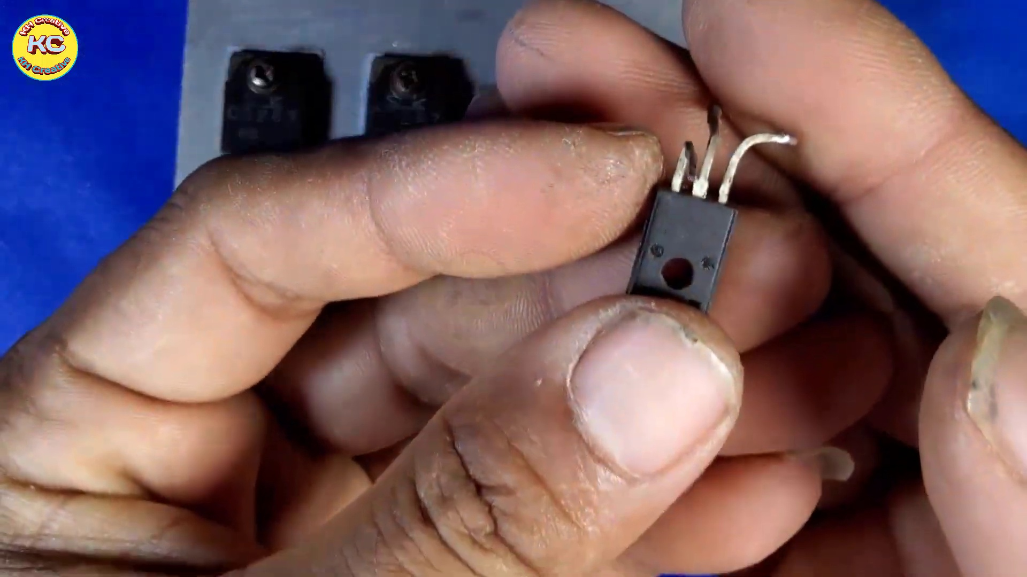 (score 95.0000)
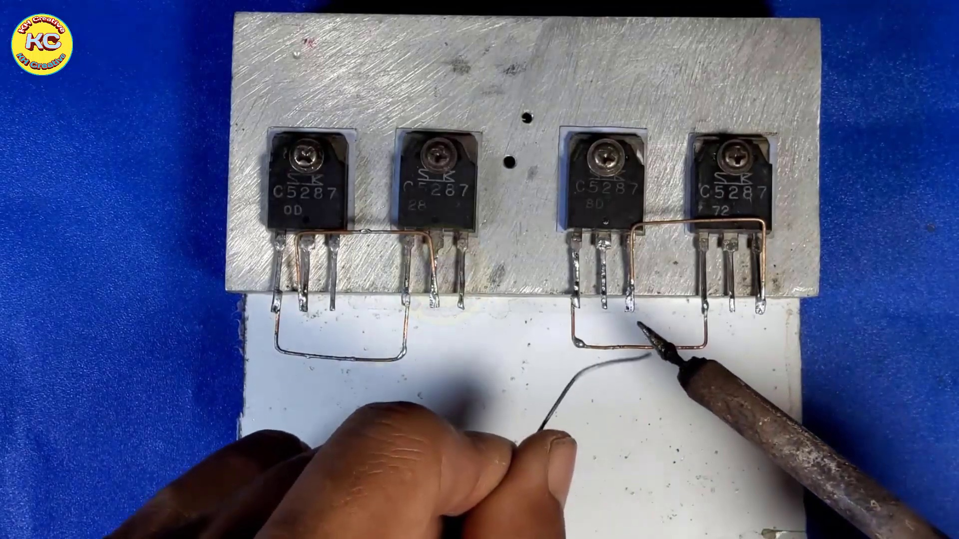 (score 95.0000)
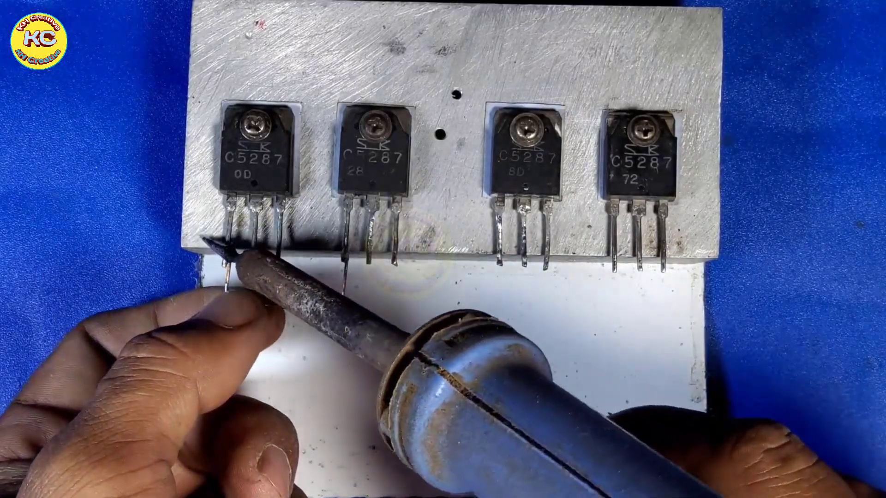 (score 95.0000)
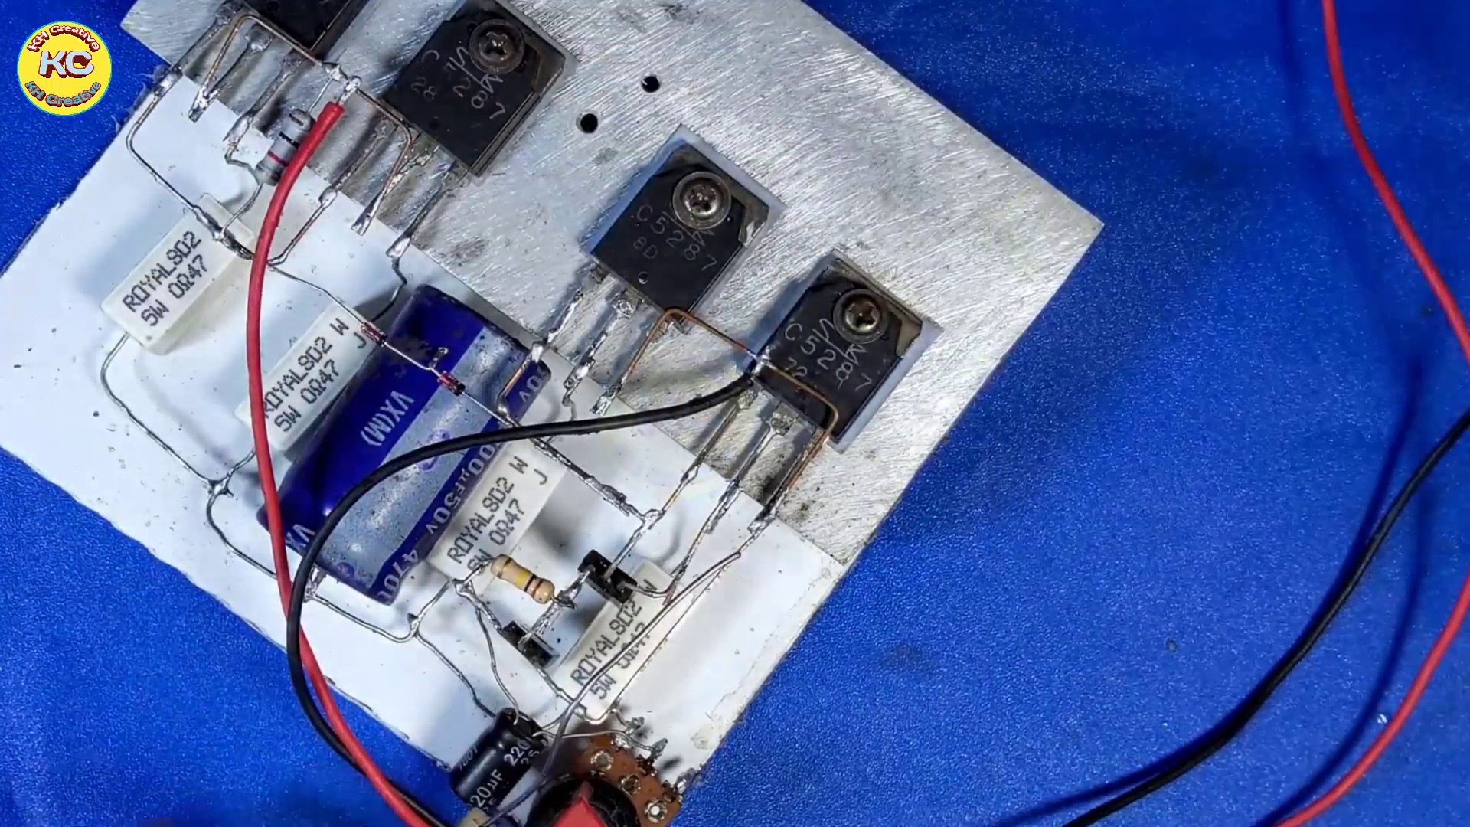 (score 90.0000)
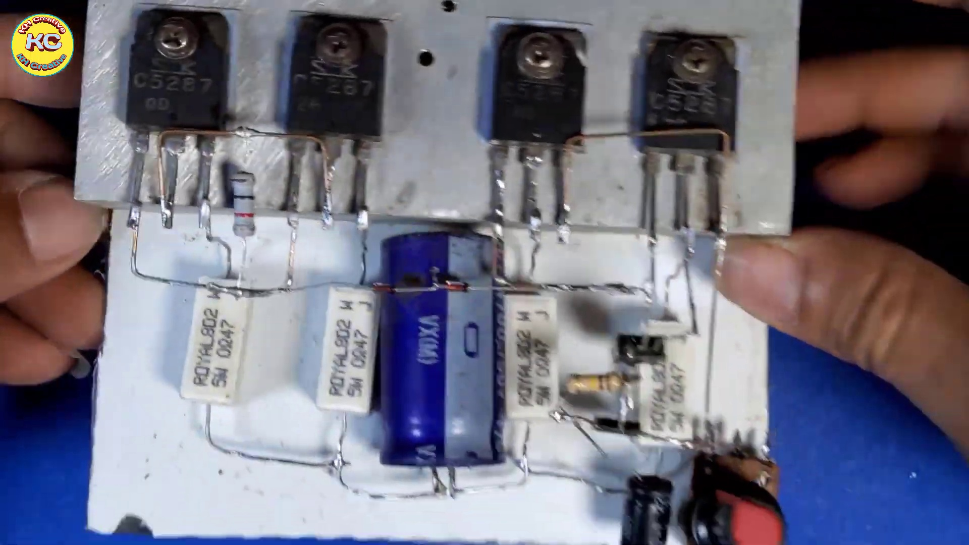 (score 90.0000)
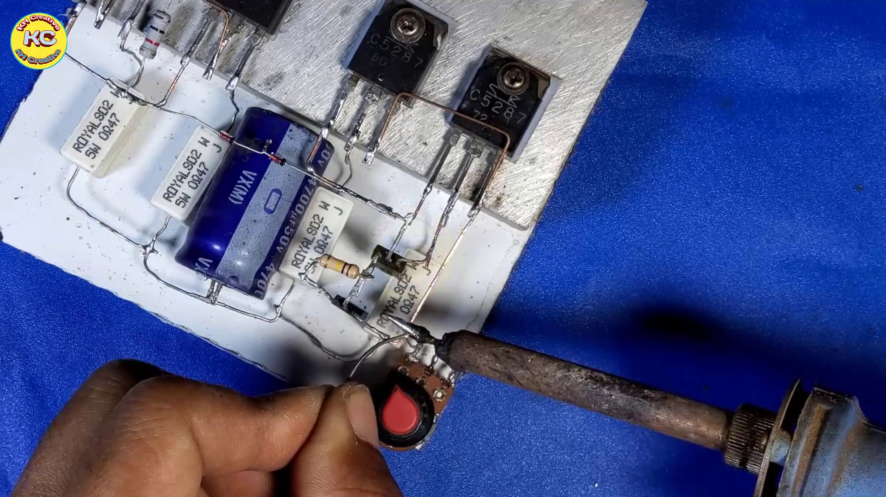 (score 90.0000)
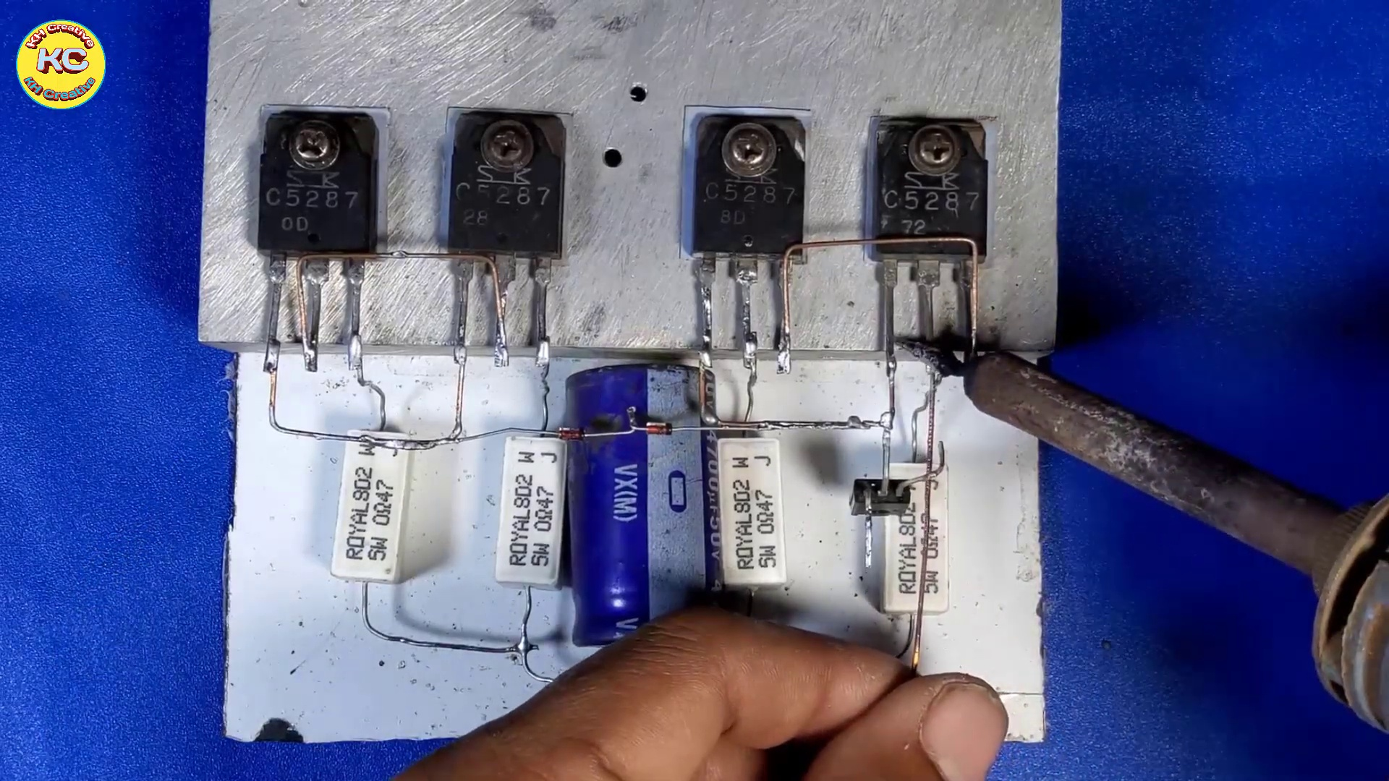 (score 90.0000)
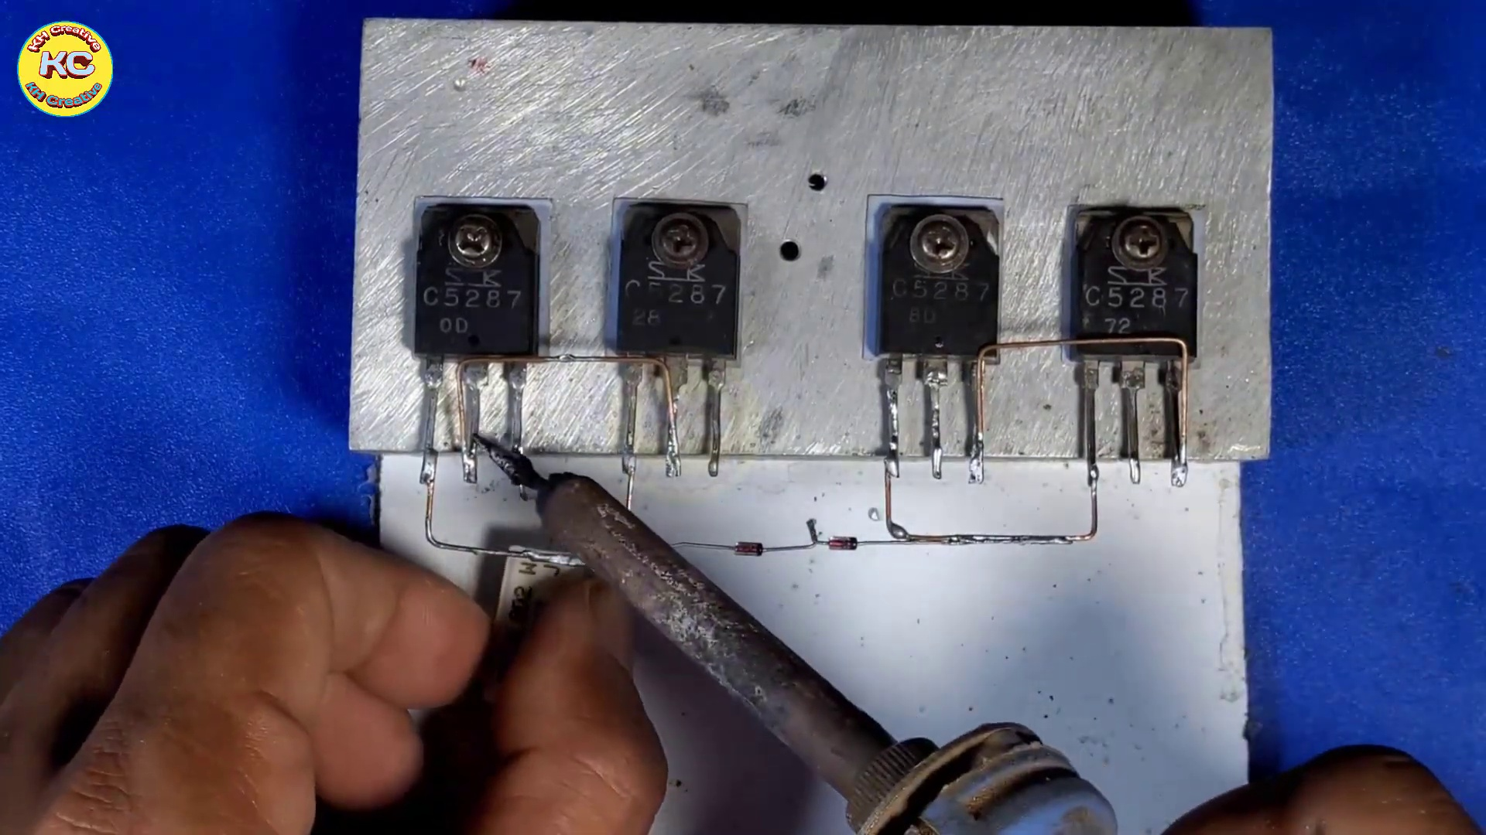 (score 90.0000)
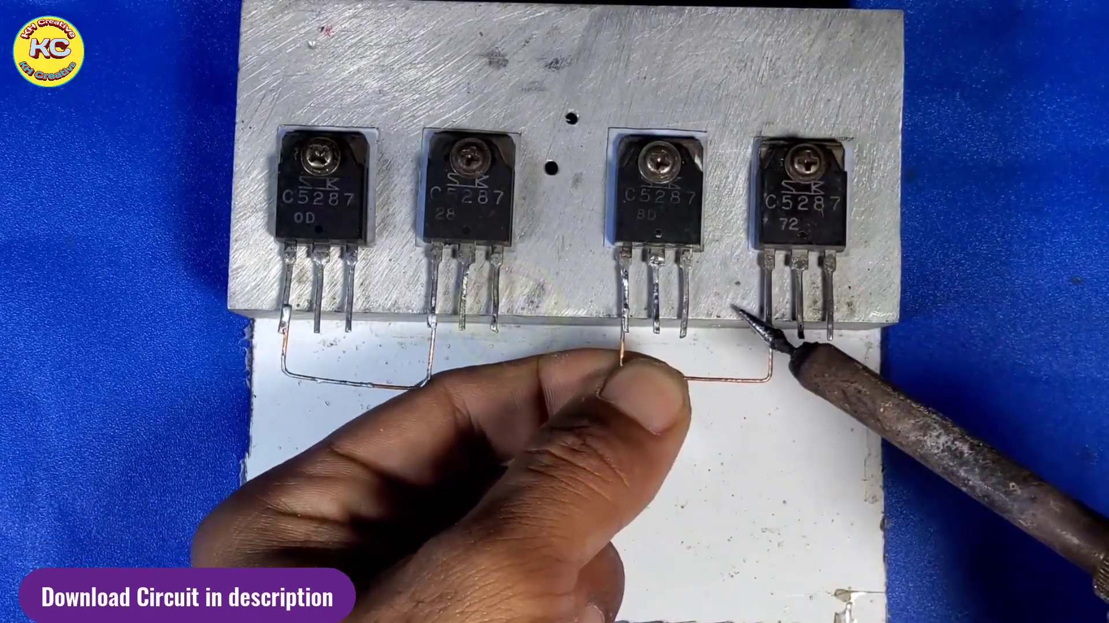 (score 90.0000)
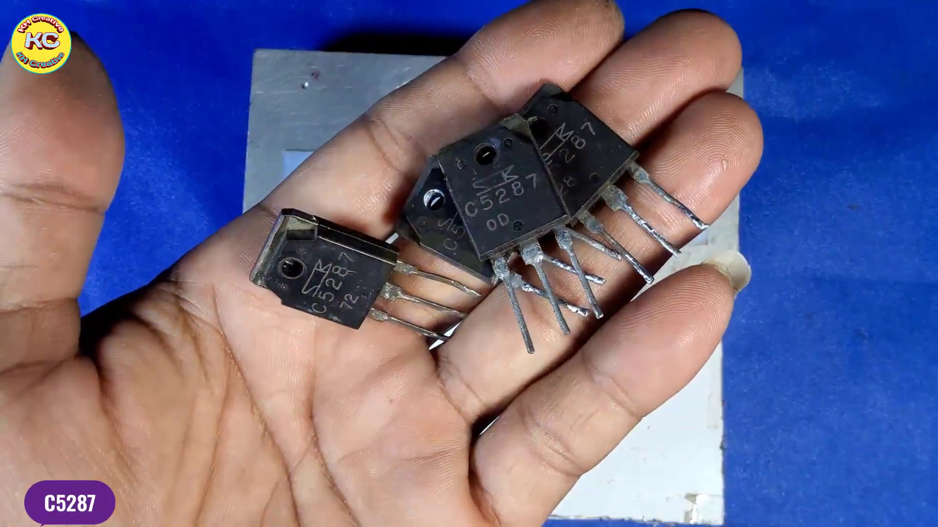 (score 90.0000)
Least correlated frames:
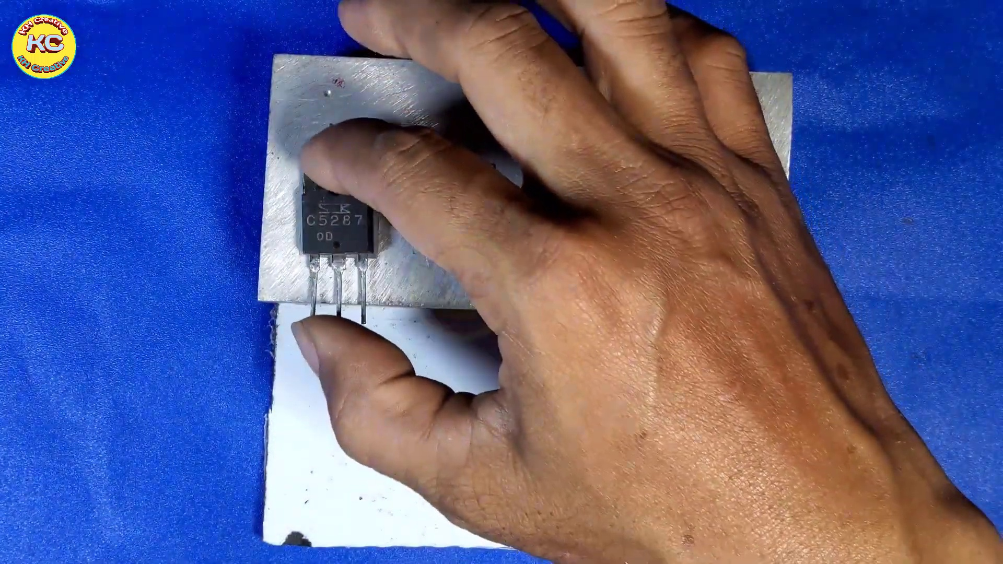 (score 0.0000)
 (score 0.0000)
 (score 0.0000)
 (score 10.0000)
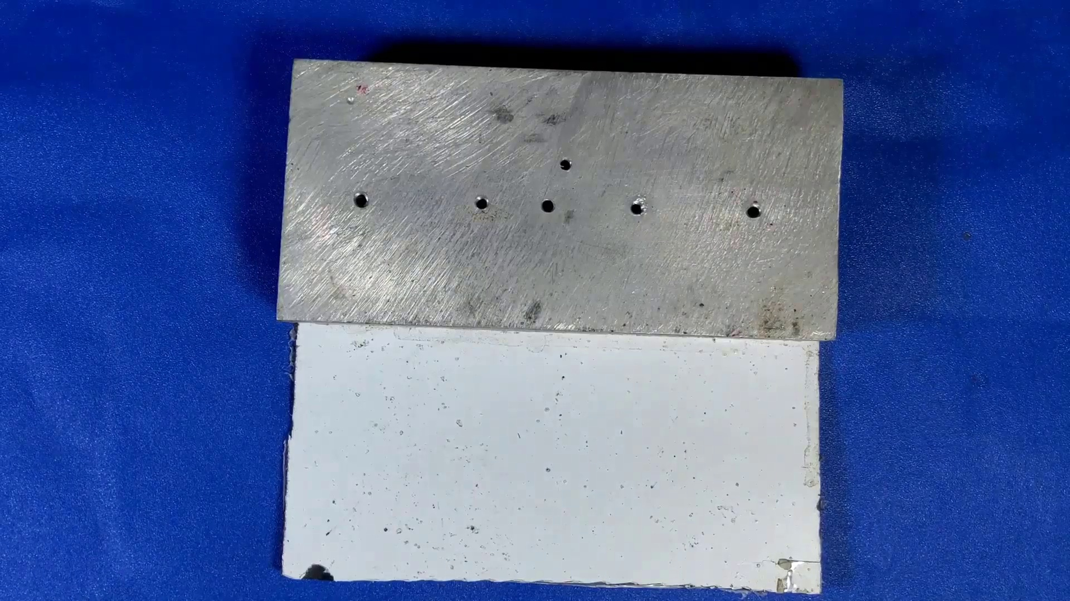 (score 10.0000)
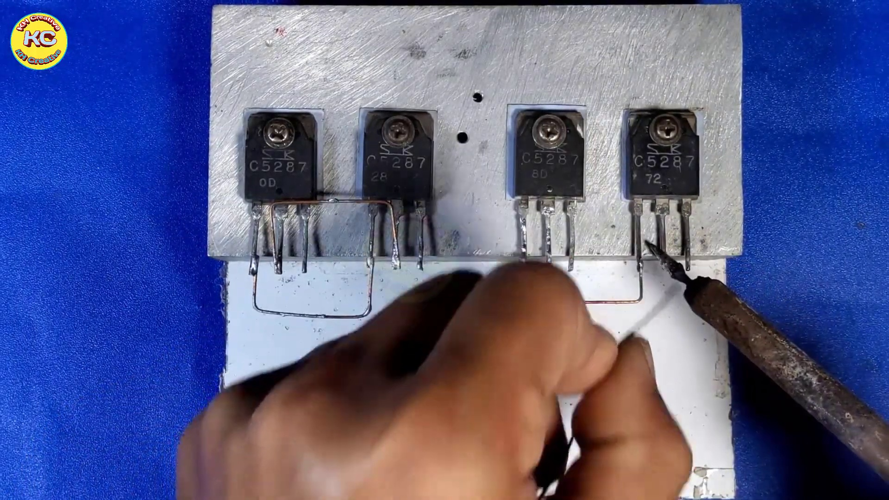 (score 10.0000)
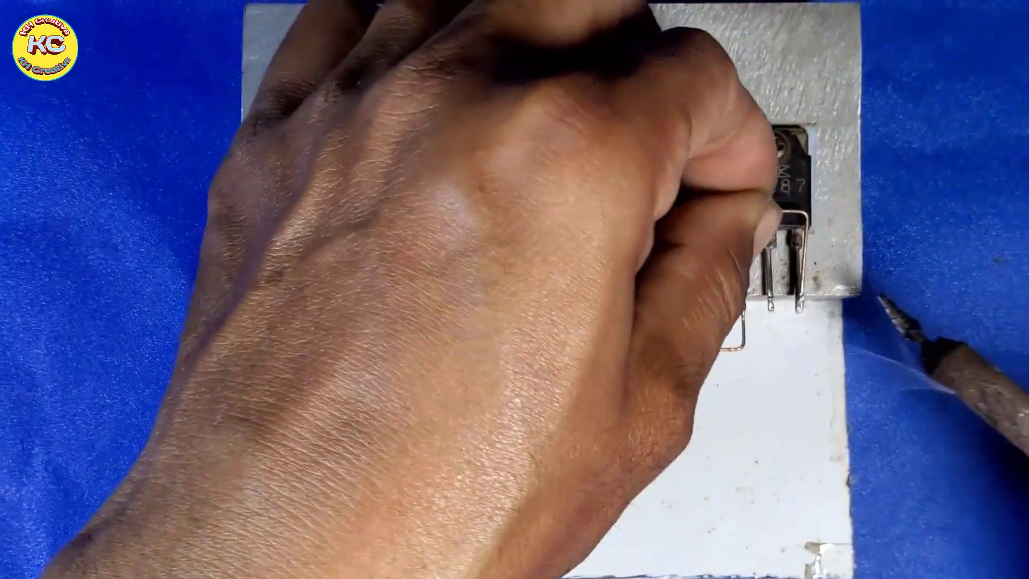 (score 10.0000)
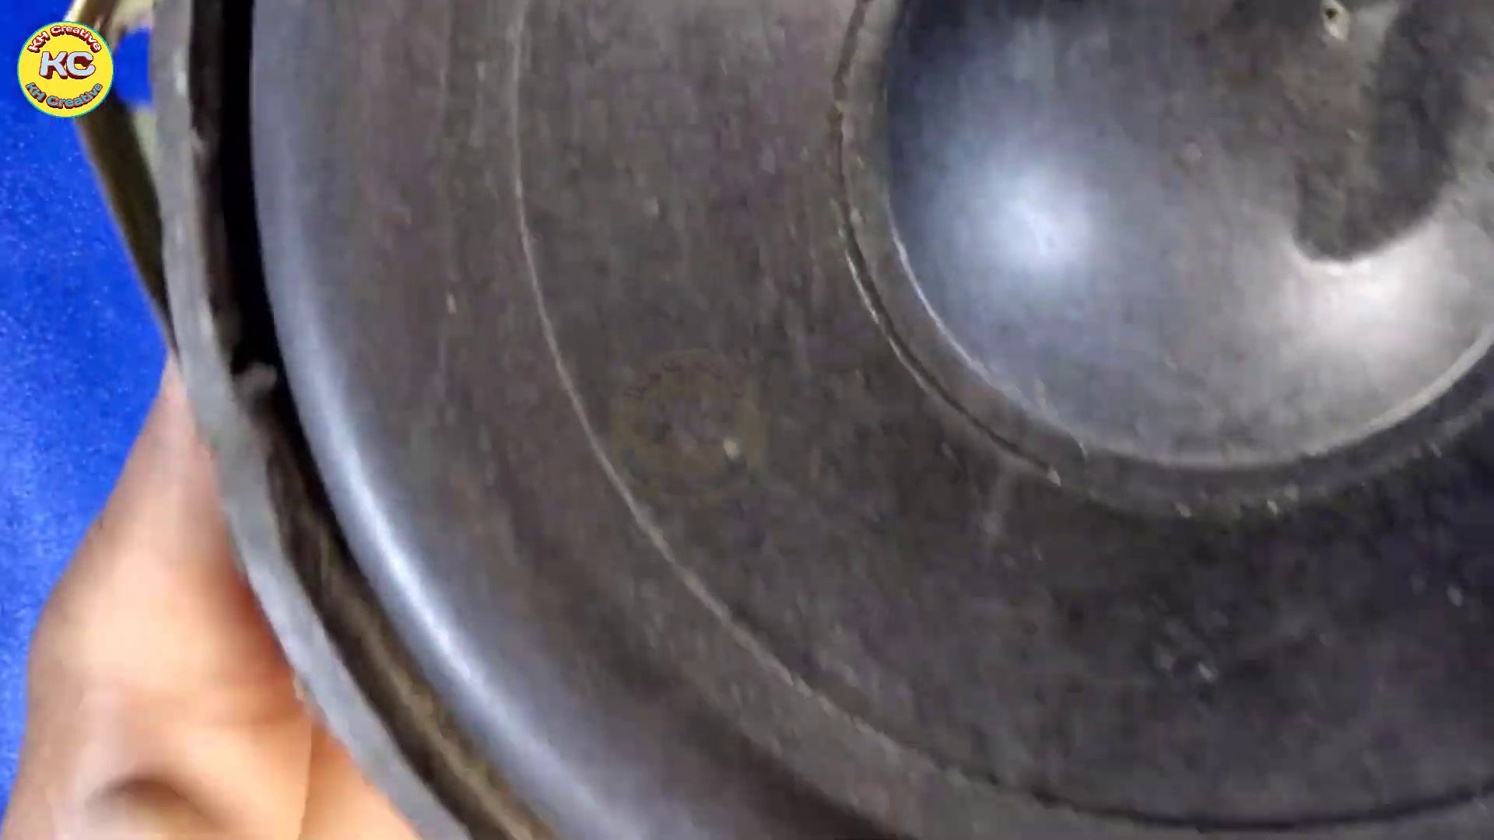 (score 10.0000)
 (score 10.0000)
 (score 20.0000)

Frame: frame_0000.jpg
Caption: The provided image appears to be a slide from a presentation or lecture, featuring a dark background with a single prominent element at the bottom. The content on the slide is not legible in this resolution, but it seems to contain text and possibly other visual elements such as diagrams, tables, or illustrations that would provide context for an instructional setting. On the dark canvas, a small, round object stands out, resembling a white marble. This object is positioned towards the left side of the image, slightly tilted, giving it an off-center appearance. The absence of any other elements in the image emphasizes the object, making it the focal point of the picture.
No strongly correlated comments found for this frame.

Frame: frame_0001.jpg
Caption: The image shows a captivating piece of artwork featuring a graphic design with the text "KH Creative" prominently displayed in bold, stylized letters at the top center of the image. Below this text is a circular emblem that radiates a warm orange hue and is encased in a black border, adding contrast to the overall design.
The logo itself is not just a static symbol but a dynamic representation of a creative process. The letters 'KH' are arranged in a circular pattern, reminiscent of a digital circuit or a star map, with each letter appearing as a small globe representing the interconnectedness of ideas and concepts. The letters are also adorned with a playful pattern of colorful dots in shades of pink, blue, and green, creating a vibrant and eye-catching visual effect.
The background of the image is a solid black, providing a stark contrast to the colorful logo and adding depth to the overall composition. The simplicity of the background allows the logo to stand out prominently, drawing the viewer's attention to its message about the creative process.
No strongly correlated comments found for this frame.

Frame: frame_0002.jpg
Caption: The image shows a piece of metal with two distinct surfaces. One surface appears to be made up of six evenly spaced holes, suggesting it may be used for mounting or fastening purposes. The plate's surface is marked with scratches, indicating it has been used or handled extensively. On the right side of the image, there is text that appears to read "HARDWARE FORMWORK," which indicates that this metal plate is part of formwork hardware used in the construction industry for building concrete structures, often as a temporary framework from which concrete can be poured and later removed once the concrete has cured.
The background is a deep blue, providing a stark contrast to the white surface underneath the plate. The overall scene is simple yet functional, with the plate and its surroundings clearly visible. The image does not contain any discernible text or additional objects, and there are no actions depicted as the plate is stationary and the holes remain unoccupied.
No strongly correlated comments found for this frame.

Frame: frame_0003.jpg
Caption: The image depicts a person's hands at work on a mechanical device or electronic component, possibly a circuit board given its rectangular shape and the presence of what appears to be a solder pad and metal components with holes. The individual is holding a tool in their right hand, which they are using to manipulate the object. Notably, one of the object's features is a small hole in the center, accompanied by two small metal screws pointing upwards. The object is situated on a blue cloth background, indicating a workshop setting. In the bottom right corner of the image, a small white rectangle with a black square and the word "KC" written in black adds context, though its significance remains unclear without additional information. The focus of the image remains on the hands-on activity involving the device and tool being used.
Comment (score 90): Useful Content: I found the usage of four transistors in the circuit very interesting. The diode connection between the transistors was also fascinating from an electronics standpoint. The Circuit overall seems to work very well for its intended purpose.Confused Content: Some of the components used in the circuit were not clearly shown, so I am unsure about exactly what they are. Future Use: I chose this video to help get inspiration for Class Project Phase 2.
Reason: The comment directly discusses the technical steps and components mentioned in the caption, specifically transistors, diode connections, and the circuit's functionality. The only uncertainty is the lack of clarity on some component identities, but this does not detract from the strong correlation between the comment and caption.
Source: https://www.youtube.com/watch?v=zZE4AejgDOA&t=12s: DIY Powerful Ultra Bass Amplifier Supply Transistor , New Circuit, How to Make Powerful Ultra Bass

Frame: frame_0004.jpg
Caption: The image captures a close-up view of a small, rectangular metal plate being held by a person's hand. The device has four small holes and four silver buttons, which are being gently pressed down on by the person's fingers, as if they are testing or adjusting the device. The background is a stark white, providing a contrast to the metallic gray of the device. The top right corner of the image features the text "KC", suggesting the possible brand or manufacturer of the device. The solid blue color of the surrounding area could indicate that the photo was taken against a blue-painted surface or backdrop, but there is no additional context visible in this frame to provide information about the device's function or purpose.
Comment (score 85): Useful Content: I found the usage of four transistors in the circuit very interesting. The diode connection between the transistors was also fascinating from an electronics standpoint. The Circuit overall seems to work very well for its intended purpose.Confused Content: Some of the components used in the circuit were not clearly shown, so I am unsure about exactly what they are. Future Use: I chose this video to help get inspiration for Class Project Phase 2.
Reason: The comment directly discusses the technical steps and components (transistors, diode connection) mentioned in the caption, specifically referring to the circuit and its functionality. The only unclear point is the identity of some components, but the general focus on the device's inner workings matches the description in the caption.
Source: https://www.youtube.com/watch?v=zZE4AejgDOA&t=12s: DIY Powerful Ultra Bass Amplifier Supply Transistor , New Circuit, How to Make Powerful Ultra Bass

Frame: frame_0005.jpg
Caption: The image shows a rectangular metal object standing upright on its side, with four distinct areas along one edge. Each of these areas contains two small holes, creating a total of eight evenly spaced holes. The object appears to be a piece of machinery or equipment, possibly designed for attachment purposes or as part of some function within the device. The background is plain and does not provide additional context, with no texts, diagrams, or other elements suggesting an instructional or educational setting.
The rectangular metal object features a square metal board affixed to it, standing upright on its side. This board has four holes, each slightly different in size, creating a symmetrical pattern. The holes are evenly spaced and do not appear to be randomly distributed. The square board is metallic in appearance and contrasts with the blue background, which provides a visually appealing contrast.
A yellow sticker bearing the "KCC" logo adorns the right side of the square board, adding a pop of color to the otherwise monochromatic scene. The image does not contain any discernible text, allowing the viewer's attention to focus on the unique features of the square metal board and its holes. The overall composition of the image suggests a minimalist design, with the focus on the square board and its distinctive features.
No strongly correlated comments found for this frame.

Frame: frame_0006.jpg
Caption: In this close-up image, a human hand holds a small, white object placed on a solid blue surface. The object is a pair of transistors, specifically M15887 transistors, as indicated by the text on the device. The transistors are arranged in a line, with one on the left and one on the right. The electronic devices held by the hand also have pins sticking out of them, possibly for soldering or testing purposes, and appear to have electronic components attached. There is no indication of an instructor interacting with any of the devices, and there are no texts, equations, diagrams, or slides visible in the image. The background is a solid blue surface, suggesting that the photo may have been taken indoors against a backdrop.
Comment (score 90): Useful Content: I found the usage of four transistors in the circuit very interesting. The diode connection between the transistors was also fascinating from an electronics standpoint. The Circuit overall seems to work very well for its intended purpose.Confused Content: Some of the components used in the circuit were not clearly shown, so I am unsure about exactly what they are. Future Use: I chose this video to help get inspiration for Class Project Phase 2.
Reason: The comment directly discusses the same technical steps (usage of four transistors in the circuit, diode connection) and objects (transistors) described in the caption. The mention of 'Circuit overall' also matches with the description of electronic devices held by the hand in the caption.
Source: https://www.youtube.com/watch?v=zZE4AejgDOA&t=12s: DIY Powerful Ultra Bass Amplifier Supply Transistor , New Circuit, How to Make Powerful Ultra Bass

Frame: frame_0007.jpg
Caption: The image shows a close-up view of someone's hand interacting with a small, silver-colored object affixed to a square piece of metal. The metal plate is situated on a blue surface, providing a contrasting background. The person's thumb is resting on the metal, while their index and middle fingers are curled around the object. A label on the device reads "Speed," suggesting it may be related to controlling the speed of something, possibly machinery or an appliance.
The hand appears to be adjusting the settings of the device, possibly during a moment of instruction or demonstration in an educational or workshop setting. The absence of any additional context or visual aids, such as slides or diagrams, suggests that the focus is solely on the object and the person's interaction with it. A small identifier "00" can also be seen on the metal plate, which may serve as a label or identifier for the device.
No strongly correlated comments found for this frame.

Frame: frame_0008.jpg
Caption: The image shows a person engaging with small electronic components and an electronic device. On the blue surface, likely a workbench or table, the individual is holding a set of four transistors, each labeled C5227, in their left hand. Their thumb and index finger are positioned on top and bottom of the component respectively, indicating a careful handling.
In addition to the electronic components, the image also features an electronic device with a circuit board or microcontroller unit (MCU) mounted on it. The device has various components such as connectors, resistors, and possibly integrated circuits (ICs), typical for electronics projects.
The person is seen working with this device by either adjusting, soldering, or connecting wires to the board, suggesting they might be preparing to work on the device further. A tool used for cutting or stripping wire insulation is present, implying that additional work may be underway.
There is no text visible in this image to provide additional context or information about the content of the image. The focus remains on the act of working with electronics hardware and the small electronic components.
Comment (score 85): Useful Content: I found the usage of four transistors in the circuit very interesting. The diode connection between the transistors was also fascinating from an electronics standpoint. The Circuit overall seems to work very well for its intended purpose.Confused Content: Some of the components used in the circuit were not clearly shown, so I am unsure about exactly what they are. Future Use: I chose this video to help get inspiration for Class Project Phase 2.
Reason: The comment directly discusses the same technical steps, objects (four transistors), and settings (circuit) described in the caption. It also mentions the diode connection between the transistors, which is a specific detail from the image.
Source: https://www.youtube.com/watch?v=zZE4AejgDOA&t=12s: DIY Powerful Ultra Bass Amplifier Supply Transistor , New Circuit, How to Make Powerful Ultra Bass

Frame: frame_0009.jpg
Caption: The image presents a dual-view perspective, featuring a white rectangular metal box resting on a blue background. The box is adorned with black numbers and letters, evenly distributed across its surface, forming individual words. The same attention to detail is also seen in the arrangement of four identical square-shaped electronic components, each bearing a black number and letter, which form a symmetrical square pattern around the box.
On the bottom edge of the metal box, four integrated circuits (ICs) are mounted, including one prominently labeled "U1," accompanied by other passive components such as capacitors and resistors. The presence of these components suggests that the metal box is part of a larger system or device requiring external connections.
The photograph provides a close-up view of the metal box, emphasizing its design features and the symmetry of the electronic components. The blue background adds depth to the image, while the focus on the box and its components creates a clear visual representation of this electronic device.
Comment (score 80): Useful Content: I found the usage of four transistors in the circuit very interesting. The diode connection between the transistors was also fascinating from an electronics standpoint. The Circuit overall seems to work very well for its intended purpose.Confused Content: Some of the components used in the circuit were not clearly shown, so I am unsure about exactly what they are. Future Use: I chose this video to help get inspiration for Class Project Phase 2.
Reason: The comment directly discusses the technical steps and components (transistors, diode connection) described in the caption, specifically referencing the circuit design and functionality.
Source: https://www.youtube.com/watch?v=zZE4AejgDOA&t=12s: DIY Powerful Ultra Bass Amplifier Supply Transistor , New Circuit, How to Make Powerful Ultra Bass

Frame: frame_0010.jpg
Caption: The image shows a person's hands holding a small rectangular object that appears to be a white circuit board with several black squares and red numbers arranged in a grid pattern. The focus is on the hands, device, and possibly the person inspecting or demonstrating the circuit board. The person's hands are gripping the board firmly, indicating that they are in the process of assembling or working on the board.
Comment (score 80): Useful Content: I found the usage of four transistors in the circuit very interesting. The diode connection between the transistors was also fascinating from an electronics standpoint. The Circuit overall seems to work very well for its intended purpose.Confused Content: Some of the components used in the circuit were not clearly shown, so I am unsure about exactly what they are. Future Use: I chose this video to help get inspiration for Class Project Phase 2.
Reason: The comment directly discusses the technical details of the circuit board, specifically mentioning transistors and diodes, which are described in the caption. The focus on the components and their functionality is strongly related to the image.
Source: https://www.youtube.com/watch?v=zZE4AejgDOA&t=12s: DIY Powerful Ultra Bass Amplifier Supply Transistor , New Circuit, How to Make Powerful Ultra Bass

Frame: frame_0011.jpg
Caption: The image shows a close-up of an electronic device, possibly a printed circuit board (PCB), with electronic components and copper traces visible. On top of the PCB, someone is holding a silver tool with a handle and a small, round tip, which appears to be in the process of attaching or adjusting a component on the PCB. The component being worked on has a black case with gold pins, indicating it may be an integrated circuit (IC). In the background, a workspace environment is suggested, possibly a lab or workshop, although no readable text or clear diagrams are visible.
In this moment, a black soldering iron with its needle-like tip is being used to connect two black components, presumably transistors, on a white circuit board. The circuit board is held in place by a metal clamp, which is also silver in color. The transistors on the board are labeled with numbers, indicating their specific parts within the circuit. The background of the image features a blue fabric, providing a stark contrast to the white circuit board and the black soldering iron.
The overall scene suggests a hands-on, technical task being performed, possibly part of an educational context teaching about electronics assembly, soldering techniques, or hardware modification.
Comment (score 80): Useful Content: I found the usage of four transistors in the circuit very interesting. The diode connection between the transistors was also fascinating from an electronics standpoint. The Circuit overall seems to work very well for its intended purpose.Confused Content: Some of the components used in the circuit were not clearly shown, so I am unsure about exactly what they are. Future Use: I chose this video to help get inspiration for Class Project Phase 2.
Reason: The comment directly discusses the technical details of the circuit board and components shown in the caption, including the usage of transistors, diode connections, and component labeling. While some components are not clearly shown, the comment focuses on the circuit's functionality and intended purpose, which is strongly related to the caption.
Source: https://www.youtube.com/watch?v=zZE4AejgDOA&t=12s: DIY Powerful Ultra Bass Amplifier Supply Transistor , New Circuit, How to Make Powerful Ultra Bass

Frame: frame_0012.jpg
Caption: The image shows a person engaging in a DIY (Do-It-Yourself) activity or repair, possibly soldering components onto a circuit board. The individual is actively holding the electronic components in place with a pair of silver-colored pliers, while their hands are visibly connected to the board by five jumper wires. The equipment being worked on appears to be a black box with white text on it, situated on a blue surface that suggests an indoor setting, possibly a workbench or desk.
Comment (score 80): Useful Content: I found the usage of four transistors in the circuit very interesting. The diode connection between the transistors was also fascinating from an electronics standpoint. The Circuit overall seems to work very well for its intended purpose.Confused Content: Some of the components used in the circuit were not clearly shown, so I am unsure about exactly what they are. Future Use: I chose this video to help get inspiration for Class Project Phase 2.
Reason: The comment directly discusses the technical aspects of the circuit shown in the caption, mentioning specific components (transistors, diode) and connections, which are all referenced in the caption. The only reason it's not a perfect score is that some components were unclear, as mentioned in the comment itself.
Source: https://www.youtube.com/watch?v=zZE4AejgDOA&t=12s: DIY Powerful Ultra Bass Amplifier Supply Transistor , New Circuit, How to Make Powerful Ultra Bass

Frame: frame_0013.jpg
Caption: The image shows a close-up view of a small, square electronic component, likely a transistor, resting on a silver plate. The plate, which is black, is affixed to a blue surface with two small screws, adding a layer of detail to the scene. The transistor is marked with the numbers "5287" and "00", indicating its specific model and series. In the background, there appears to be a metal jig with multiple holes where components are inserted for soldering or mounting. A screwdriver can be seen in the foreground, suggesting that some form of installation or adjustment process is taking place. The image is taken in an electronics workshop or lab setting, as suggested by the blue table surface and what looks like a bench or workstation.
Comment (score 80): Useful Content: I found the usage of four transistors in the circuit very interesting. The diode connection between the transistors was also fascinating from an electronics standpoint. The Circuit overall seems to work very well for its intended purpose.Confused Content: Some of the components used in the circuit were not clearly shown, so I am unsure about exactly what they are. Future Use: I chose this video to help get inspiration for Class Project Phase 2.
Reason: The comment directly discusses technical details of transistors and their connections in a circuit, which are also mentioned in the caption. The comment's mention of 'four transistors' and 'diode connection' matches with the image showing multiple components on a plate, and the screws suggesting installation or adjustment process. The only mismatch is the mention of a 'circuit', which is not explicitly shown in the image.
Source: https://www.youtube.com/watch?v=zZE4AejgDOA&t=12s: DIY Powerful Ultra Bass Amplifier Supply Transistor , New Circuit, How to Make Powerful Ultra Bass

Frame: frame_0014.jpg
Caption: The image depicts two hands engaged in a soldering process, as one hand holds a wire and a small screwdriver, while the other hand works with an electrical component, specifically a switch. The switch has four metal contacts that are part of the switching mechanism, each with black insulators on the sides to keep them separate from other components. The background is blue and out of focus, drawing attention to the hands' work being done.
The board, which appears to be white and blue, is the main focal point of the image. It has a few electronic components attached, including a transistor and a resistor. A small iron is placed next to the board, suggesting that the person is in the process of soldering the components onto it. The screwdriver is positioned close to the wire, indicating its possible use to tighten the components onto the board.
No visible texts or labels provide additional context or instructions related to teaching. The focus appears to be on the physical process of assembling or disassembling the switch and soldering electronic components onto the board. There is no person providing instruction or explanation in the image, nor is there any text or diagram visible to describe the function of the switches, the steps being taken in the assembly process, or the purpose of the project involving electronic components.
No strongly correlated comments found for this frame.

Frame: frame_0015.jpg
Caption: The image shows a close-up view of hands working with a device that appears to have electronic components, specifically focused on soldering and component insertion. A small silver-colored soldering iron is being used to heat up the solder, which is being applied to connect two metal pieces together on a printed circuit board (PCB). The PCB contains multiple connections that need to be made for proper functioning of the device, featuring several electronic components including resistors and capacitors. These components are essential parts of an electronic circuit, crucial for storing or regulating electrical energy within the circuit.
The image also captures the process of attaching a set of four transistors to the circuit board using the soldering iron. The black and white PCB has printed numbers and letters indicating the type of components and their respective positions on the board. The blue-colored background provides a stark contrast to the objects in focus, suggesting an active process of electronic assembly or repair.
No strongly correlated comments found for this frame.

Frame: frame_0016.jpg
Caption: The image presents a close-up view of an electronic device with various components attached to it. The device features five screw terminals, possibly for wiring connections, and a circuit board with integrated circuits (ICs) on its surface. A soldering iron is being used in the process of making electrical connections between the terminals and the circuit board.
In the background, there's a blue fabric surface serving as a workbench or tabletop. The focus of the image is on the device itself, without any text or additional context visible to provide information about the object beyond what is immediately apparent from the image. The style of the image suggests it might be used for educational purposes, possibly in a tutorial about electronics repair or construction.
Upon closer inspection, the circuit board appears to have four silver-colored transistors arranged in a square pattern, with the first and last one on the left and the second and third one on the right. Each transistor is labeled with the number 27. The pen, possibly used for drawing or writing on the circuit, lies nearby, adding a contrast to the silver of the transistors.
The image does not contain any text, and the relative positions of the objects remain constant. The device and its components occupy the top portion of the image, while the circuit board, pen, and transistors are located in the bottom left corner.
Comment (score 80): Useful Content: I found the usage of four transistors in the circuit very interesting. The diode connection between the transistors was also fascinating from an electronics standpoint. The Circuit overall seems to work very well for its intended purpose.Confused Content: Some of the components used in the circuit were not clearly shown, so I am unsure about exactly what they are. Future Use: I chose this video to help get inspiration for Class Project Phase 2.
Reason: The comment directly discusses the same technical steps, objects (transistors) and settings (circuit board) described in the caption. The mention of diode connection and circuit overall functioning as intended are also related to the specific components shown in the image.
Source: https://www.youtube.com/watch?v=zZE4AejgDOA&t=12s: DIY Powerful Ultra Bass Amplifier Supply Transistor , New Circuit, How to Make Powerful Ultra Bass

Frame: frame_0017.jpg
Caption: The image displays a candid and informal moment of someone working on an electronics project. A person's hands are visible in the foreground, adjusting components within three black sockets mounted in a row on a white circuit board or prototype panel. The individual is holding a tool, possibly used for assembly or repair, and appears to be focusing on the electronic device. To the right of the work area, there is a blue surface that could be a desk or table, with a few more electronic parts, such as resistors or capacitors, placed upon it. These components may be used in the project being worked on. The background is out of focus but suggests an indoor setting with a plain blue wall visible behind the work area. In addition to the circuit board and tool, there is no other context-indicating text or elements within this frame, such as teaching materials.
Comment (score 85): Useful Content: I found the usage of four transistors in the circuit very interesting. The diode connection between the transistors was also fascinating from an electronics standpoint. The Circuit overall seems to work very well for its intended purpose.Confused Content: Some of the components used in the circuit were not clearly shown, so I am unsure about exactly what they are. Future Use: I chose this video to help get inspiration for Class Project Phase 2.
Reason: The comment directly discusses the usage of transistors and diodes in the circuit, which is mentioned in the caption as 'adjusting components within three black sockets'. The comment also mentions the overall functionality of the circuit, which is consistent with the context shown in the frame.
Source: https://www.youtube.com/watch?v=zZE4AejgDOA&t=12s: DIY Powerful Ultra Bass Amplifier Supply Transistor , New Circuit, How to Make Powerful Ultra Bass

Frame: frame_0018.jpg
Caption: The image presents a scene of a circuit board, resting on a white surface, with four connections or components mounted on its surface, each labeled with numbers 1 through 4. The circuit board is adorned with a series of components, including four transistors and a few resistors. The transistors are neatly arranged in a row, while the resistors are scattered across the board. A screwdriver is also present, suggesting recent or upcoming assembly work on the circuit board. The board itself has a few screws visible, which are likely used for securing the components on the board. The background of the image appears to be an industrial or manufacturing setting, with a metallic surface and possibly some machinery or tools in view. Notably, the circuit board is labeled with the text "CIRCUIT IN DEVELOPMENT," indicating that this is a work-in-progress related to electronics. The model numbers 5267, 228, 20, and 72 are also visible on the board, providing specific information about the components used in the circuit.
Comment (score 85): Useful Content: I found the usage of four transistors in the circuit very interesting. The diode connection between the transistors was also fascinating from an electronics standpoint. The Circuit overall seems to work very well for its intended purpose.Confused Content: Some of the components used in the circuit were not clearly shown, so I am unsure about exactly what they are. Future Use: I chose this video to help get inspiration for Class Project Phase 2.
Reason: The comment directly discusses the usage of four transistors in the circuit, which is specifically mentioned in the caption. Additionally, the mention of diode connection between transistors and the overall functionality of the circuit are all related to the technical details described in the caption.
Source: https://www.youtube.com/watch?v=zZE4AejgDOA&t=12s: DIY Powerful Ultra Bass Amplifier Supply Transistor , New Circuit, How to Make Powerful Ultra Bass

Frame: frame_0019.jpg
Caption: The image presents a close-up view of a circuit board, which is neatly arranged with various components, including resistors and transistors. These components are labeled with numbers and letters, indicating their specific functions within the circuit. A person's hand is seen holding a screwdriver, suggesting an ongoing repair or construction process. The screwdriver is in the position of making a connection to one of the components on the board.
In the background, blurred out of focus, there appears to be a workspace with multiple parts connected to a mechanical device, including a lever or switch, and a soldering iron in use. This suggests that the repair or construction process may be part of a larger project involving both electronics and mechanics. The image does not contain any text or additional objects, allowing the circuit board and the person's actions to take center stage.
The focus is solely on the circuit board and the person's actions, creating a clear and detailed representation of a repair or construction process.
Comment (score 90): Useful Content: I found the usage of four transistors in the circuit very interesting. The diode connection between the transistors was also fascinating from an electronics standpoint. The Circuit overall seems to work very well for its intended purpose.Confused Content: Some of the components used in the circuit were not clearly shown, so I am unsure about exactly what they are. Future Use: I chose this video to help get inspiration for Class Project Phase 2.
Reason: The comment directly discusses the specific components (transistors and diode connection) mentioned in the caption, indicating a strong correlation between the two.
Source: https://www.youtube.com/watch?v=zZE4AejgDOA&t=12s: DIY Powerful Ultra Bass Amplifier Supply Transistor , New Circuit, How to Make Powerful Ultra Bass

Frame: frame_0020.jpg
Caption: The image shows a hands-on activity involving an electronic component, specifically a circuit board (CB) with small components and wires being assembled. A person is meticulously working on the CB, using a pair of tools - possibly pliers or tweezers - to hold a small piece of wire in place. The wire is connected to a small electronic component, which is part of the larger circuit. The CB, marked with numbers and letters, serves as the base for the assembly process.
In the upper right corner of the image, text reads "Download Crack in description," suggesting that this may be a tutorial from an online source that includes instructions or tools related to electronic devices. A hyperlink on the screen prompts viewers to download a file named "crack" for more information, which might imply further instructions or educational resources are available outside of the image's context.
The overall impression is that this image captures a moment of someone engaging in DIY electronics work, possibly as part of an online tutorial series, where they are carefully assembling and installing components onto the circuit board.
Comment (score 80): Useful Content: I found the usage of four transistors in the circuit very interesting. The diode connection between the transistors was also fascinating from an electronics standpoint. The Circuit overall seems to work very well for its intended purpose.Confused Content: Some of the components used in the circuit were not clearly shown, so I am unsure about exactly what they are. Future Use: I chose this video to help get inspiration for Class Project Phase 2.
Reason: The comment directly discusses specific technical details in the frame caption, such as transistors and diode connections, which are part of the circuit assembly process. The mention of components not being clearly shown suggests the commenter was paying attention to the same scene described in the caption.
Source: https://www.youtube.com/watch?v=zZE4AejgDOA&t=12s: DIY Powerful Ultra Bass Amplifier Supply Transistor , New Circuit, How to Make Powerful Ultra Bass

Frame: frame_0021.jpg
Caption: The image shows a close-up view of a person using a soldering iron to solder a circuit board. A set of four small circuit boards with various components such as resistors, capacitors, and integrated circuits are mounted on a base plate, often referred to as a breadboard in the context of electronics. The individual is not the focus of the image, but their hand is visible at the bottom, holding what appears to be a soldering iron or some other tool associated with electronics work.
The circuit board being soldered has four transistors and two resistors neatly arranged on its surface. The transistors are positioned on the top and bottom of the board, while the resistors are placed on the sides. In the background, a workspace or laboratory setting is visible, capturing a moment during the assembly process. There is no text, diagram, or slide visible in the frame that provides specific instructions or information about the device being constructed. The image suggests an ongoing electronic repair or assembly process.
Comment (score 80): Useful Content: I found the usage of four transistors in the circuit very interesting. The diode connection between the transistors was also fascinating from an electronics standpoint. The Circuit overall seems to work very well for its intended purpose.Confused Content: Some of the components used in the circuit were not clearly shown, so I am unsure about exactly what they are. Future Use: I chose this video to help get inspiration for Class Project Phase 2.
Reason: The comment specifically mentions the transistors and diodes in the circuit, which are also described in the caption. The commenter's interest in the electronic aspects of the circuit, such as its intended purpose, further reinforces the connection between the caption and the comment.
Source: https://www.youtube.com/watch?v=zZE4AejgDOA&t=12s: DIY Powerful Ultra Bass Amplifier Supply Transistor , New Circuit, How to Make Powerful Ultra Bass

Frame: frame_0022.jpg
Caption: The image shows a close-up view of electronic components, including a four-pin microprocessor module, surrounded by other circuitry elements. The module itself is beige-colored and features a label reading "Download Circuit in Description" positioned towards the top. This suggests that the image may have been shared on an online platform, such as YouTube, allowing viewers to click the link provided to receive credit for engaging with the content. The microprocessor module is placed on a white surface alongside two resistors (one black and one white) and a blue capacitor. The overall scene presents an active electronics project, with the central piece being the microprocessor module.
No strongly correlated comments found for this frame.

Frame: frame_0023.jpg
Caption: The image shows a close-up view of an electronic component, specifically a circuit board that is encased within a silver enclosure and held in place by a metal clip. The enclosure rests on a blue surface, providing a stark contrast to the silver of the board. The circuit board itself features four electronic components: two resistors positioned vertically, one capacitor situated at the top, and one diode also located at the top. A hand is visible in the top left corner, holding a soldering iron or tool next to the component being worked on. This suggests that the main activity depicted is related to assembling or repairing electronic hardware. The background of the image is not clearly visible due to the close-up angle and focus on the component, but it appears to be a workspace with a blue surface that might be a table or workbench.
No strongly correlated comments found for this frame.

Frame: frame_0024.jpg
Caption: The image captures a close-up view of someone working with electronic components. In the foreground, a person's hand holds two small devices, which appear to be integrated circuits (ICs) or possibly connectors for wiring. The background is blurred but suggests a workspace environment, possibly an electronics lab or workshop. A blue surface, likely a workbench or tabletop, is visible in the distance.
On the left side of the image, a metallic tool that looks like a vice grip can be seen, which could be used to hold components securely during assembly or repair work. The overall setting suggests that the person is either assembling an electronic device, performing maintenance on electronics, or conducting some kind of demonstration or tutorial related to electronics work.
In the center of the image, a pair of tweezers are being used to remove a red and black capacitor from a nearby circuit board. The capacitor, with its black metal body and red and black caps, is placed on the blue surface. The tweezers, which are silver and black, are gripping the capacitor with their tips pointing towards the board. The circuit board itself is white, providing a stark contrast to the red and black of the capacitor. The image is taken from a side angle, giving a clear view of the tweezers in action.
No strongly correlated comments found for this frame.

Frame: frame_0025.jpg
Caption: The image shows a close-up view of someone's hand engaged in a task, manipulating a small object with their fingers. The object appears to be a small electronic device, possibly a button or a switch, and is being pressed against a white background by the person's hand. The hand is firmly grasping the object, indicating an action of interaction or control. The blue background provides a stark contrast to the white object and the person's hand.
The style of the image suggests it might be part of a tutorial or instructional video, given the clear focus on the task at hand and the use of close-up photography to emphasize the action. However, there are no visible texts, slides, diagrams, or any other contextual elements that would provide additional information about the content or purpose of this image within an educational context.
The primary emphasis is on the act of manipulation with a tool or device being held by the person in the frame. The relative position of the objects suggests that the person's hand is pressing the device against the white background, but the specific action being performed and the purpose of the device remain unclear without additional context.
No strongly correlated comments found for this frame.

Frame: frame_0026.jpg
Caption: The image appears to capture a moment of precise assembly. A hand, clad in a black glove, is seen gripping a silver screwdriver, poised to make contact with a small, black object affixed to a white surface. The white surface, serving as a simple backdrop, adds contrast to the scene. In the top right corner, a red arrow points to the right, guiding the viewer's gaze towards the object being prepared for assembly.
The image showcases meticulous attention to detail in the assembly process. The hand and screwdriver are precisely positioned, with the small black object and white surface contributing to an atmosphere of order and precision. The scene tells a story of careful work, highlighting the importance of deliberate action in achieving accurate results.
No strongly correlated comments found for this frame.

Frame: frame_0027.jpg
Caption: The image shows a close-up of someone's hands diligently working on a circuit board. The person is using a soldering iron to attach a small red and black component to the board, with their hand positioned over the soldering iron, ready to apply heat to the component. The focus is on the activity of working with electronics rather than any theoretical content typically associated with educational diagrams. The circuit board itself is white, providing a stark contrast to the red and black component. In the background, a blue wall provides a neutral backdrop that allows the action of the person to stand out. Various electronic components, such as resistors, possibly capacitors or integrated circuits, are visible on the circuit board. A soldering iron can be seen in the person's hand, being used for the task at hand.
No strongly correlated comments found for this frame.

Frame: frame_0028.jpg
Caption: The image presents a close-up view of a silver board, resting on a blue surface. The board is adorned with four rectangular-shaped electronic components, each labeled with a number and a letter. These components are connected by wires, suggesting that they are in the process of being assembled or tested. The board itself is affixed to the blue surface using a silver clip, indicating a level of precision and care in the assembly process. The components on the board appear to be arranged in a straight line, with three sets of terminals or connectors visible. Each set consists of a central connector surrounded by smaller connectors. The background is a simple, neutral color, providing a clear view of the object. There are no additional objects, text, diagrams, or any other visual content that would suggest an educational context or a teaching activity in this image. The precise positioning of the components and their connections suggest a level of complexity and care in the assembly process.
Comment (score 80): Useful Content: I found the usage of four transistors in the circuit very interesting. The diode connection between the transistors was also fascinating from an electronics standpoint. The Circuit overall seems to work very well for its intended purpose.Confused Content: Some of the components used in the circuit were not clearly shown, so I am unsure about exactly what they are. Future Use: I chose this video to help get inspiration for Class Project Phase 2.
Reason: The comment directly discusses the same technical steps, objects, and settings described in the caption. The mention of transistors, diodes, and a circuit matches the components and connections depicted in the image. Although some confusion is expressed about unknown components, the majority of the comment focuses on the same electronic concepts as the caption.
Source: https://www.youtube.com/watch?v=zZE4AejgDOA&t=12s: DIY Powerful Ultra Bass Amplifier Supply Transistor , New Circuit, How to Make Powerful Ultra Bass

Frame: frame_0029.jpg
Caption: The image shows a person meticulously working on a circuit board, with two small circuit boards that have copper-colored pins and possibly electronic components attached to them held in their hands. One of the boards appears to have connectors already attached to it, suggesting a workspace or lab environment used for electronics assembly or tinkering. The background is blurred, but the overall setting implies a precise and organized environment.
The person is carefully working on one of the circuit boards, which is covered in small, black, rectangular components that are part of an electronic circuit. These components are arranged in a neat and organized layout, creating a visually appealing arrangement. The person is holding a black wire, which appears to be part of the circuit, and it's connected to one of the components on the board, indicating that it's being used to complete the circuit.
The board itself is white, providing a stark contrast to the black components, which are labeled with numbers, including C5287, C5287, and C5287, suggesting that they're part of a larger circuit design. The image captures a moment of work in progress, with the person focused on completing the circuit. The precise arrangement of the components and the careful handling of the wire suggest a level of expertise and attention to detail, indicating that the person is a skilled practitioner in the field of electronics assembly or tinkering.
No strongly correlated comments found for this frame.

Frame: frame_0030.jpg
Caption: The image shows a close-up view of an electronic component, likely a transistor, labeled "C5287" and "C5287", resting on a metal surface. The component has four neatly aligned pins, with the top two pointing towards the left side of the image and the bottom two towards the right side. A label indicating "0" is visible on the component, possibly suggesting its voltage rating. The background of the image is a blue color, providing a stark contrast to the silver metal surface of the component.
In the distance, an electronic device with several connectors can be seen, supported by a metallic structure. The device appears to be a printed circuit board (PCB) with various components mounted on it, featuring visible traces that may indicate the path for electric current. The image is taken from an angle where the back side of the PCB is facing us, showing pins possibly indicating where components are connected to the device.
The overall scene suggests a laboratory or workshop setting, where electronic components are being tested or assembled.
Comment (score 85): Useful Content: I found the usage of four transistors in the circuit very interesting. The diode connection between the transistors was also fascinating from an electronics standpoint. The Circuit overall seems to work very well for its intended purpose.Confused Content: Some of the components used in the circuit were not clearly shown, so I am unsure about exactly what they are. Future Use: I chose this video to help get inspiration for Class Project Phase 2.
Reason: The comment directly discusses the same technical steps (usage of four transistors), objects (transistors and diode connections) and settings (circuit) described in the caption. The mention of components not being clearly shown is a minor detail that does not detract from the overall correlation between the caption and comment.
Source: https://www.youtube.com/watch?v=zZE4AejgDOA&t=12s: DIY Powerful Ultra Bass Amplifier Supply Transistor , New Circuit, How to Make Powerful Ultra Bass

Frame: frame_0031.jpg
Caption: The image shows a close-up view of a person's hand holding a small electronic component, with various components such as resistors and capacitors visible on the circuit board. The hand is prominently positioned on the left side of the image, indicating that the person is the main focus of the image. The electronic component, located on the right side, appears to be a small, cylindrical device with a silver color. The device is connected to a wire, which extends from the device to the person's hand, suggesting that the device is being used or held by the person.
Visible soldering work is taking place using a soldering iron, indicating that the device is either being repaired or constructed. The soldering process involves melting metal to create an electrically conductive path between two surfaces.
In the blurred background of the image, there appears to be a workbench with additional electronics and possibly tools related to electronic work. The blurred text "N108" could refer to a product code, part number, or serial number, but it is not clear enough to read accurately.
The context suggests that the person is likely engaged in a project involving electronic repair or construction, potentially for educational purposes given the focus on the process and demonstration of soldering techniques. The image does not provide any visible slides, diagrams, or texts with specific instructions or explanations; the teaching element seems to be implied rather than explicitly displayed.
Comment (score 80): Useful Content: I found the usage of four transistors in the circuit very interesting. The diode connection between the transistors was also fascinating from an electronics standpoint. The Circuit overall seems to work very well for its intended purpose.Confused Content: Some of the components used in the circuit were not clearly shown, so I am unsure about exactly what they are. Future Use: I chose this video to help get inspiration for Class Project Phase 2.
Reason: The comment directly discusses the electronic component (transistors and diode connection) described in the caption. The focus on circuit design and functionality is strongly related to the technical steps and objects depicted in the image, indicating a high correlation score.
Source: https://www.youtube.com/watch?v=zZE4AejgDOA&t=12s: DIY Powerful Ultra Bass Amplifier Supply Transistor , New Circuit, How to Make Powerful Ultra Bass

Frame: frame_0032.jpg
Caption: The image shows a person intensely working on a complex circuit board, surrounded by various tools and components on a workbench. The individual is handling small pieces of wire with tweezers, carefully manipulating them to connect to metal posts or other electronic components. The circuit board itself features a network of meticulously labeled transistors, resistors, and other components, showcasing the intricate details required for electronic repair and assembly. In this hands-on setting, the person may be soldering components into place using a soldering iron, demonstrating their expertise in electronics assembly.
Comment (score 95): Useful Content: I found the usage of four transistors in the circuit very interesting. The diode connection between the transistors was also fascinating from an electronics standpoint. The Circuit overall seems to work very well for its intended purpose.Confused Content: Some of the components used in the circuit were not clearly shown, so I am unsure about exactly what they are. Future Use: I chose this video to help get inspiration for Class Project Phase 2.
Reason: The comment directly discusses the same technical steps (usage of four transistors), objects (transistors, diode connection), and settings (circuit board) described in the caption. The mention of specific components and their functionality in the circuit also shows a strong connection to the frame's content.
Source: https://www.youtube.com/watch?v=zZE4AejgDOA&t=12s: DIY Powerful Ultra Bass Amplifier Supply Transistor , New Circuit, How to Make Powerful Ultra Bass

Frame: frame_0033.jpg
Caption: The image shows a close-up view of a person working on a printed circuit board (PCB) with a white surface and a blue background, covered in black letters that contain information about the components. The person is dressed in a white shirt and a black cap, and is holding a pair of pliers in their right hand. They are bending a black wire around a black terminal, which has a tight fit, indicating a process of soldering or manual assembly of electronic components. The person is wearing safety goggles, suggesting they are working on a potentially hazardous task. In the background, an indoor setting with a blue surface (likely a workbench) is out of focus. The electronic components being handled appear to be integrated circuits (IC) or similar integrated parts, which are possibly being soldered onto the PCB. The person's actions and the components on the board suggest they are engaged in manual assembly or soldering of the electronic components, a common task in electronics manufacturing and hobbyist projects.
No strongly correlated comments found for this frame.

Frame: frame_0034.jpg
Caption: The image shows an electronic circuit board with four integrated circuits (ICs) mounted on it. There are two ICs that appear to be of a similar type, both marked with labels and connected to other components, possibly resistors or capacitors, using what looks like a soldering iron. On the left side of the image, there is a close-up view of one of the ICs, revealing its pins and the soldered connections. The circuit board has the serial numbers "C5287" and "C267" marked on it.
Two black wires are attached to the circuit board, one connected to a white component using a black screwdriver, while the other wire is connected to a red component also using the same tool. The circuit board is held in place by a blue object, possibly a clamp or holder. The entire scene is set against a backdrop of a blue background, providing a stark contrast to the black circuit board and the white and red components.
Comment (score 80): Useful Content: I found the usage of four transistors in the circuit very interesting. The diode connection between the transistors was also fascinating from an electronics standpoint. The Circuit overall seems to work very well for its intended purpose.Confused Content: Some of the components used in the circuit were not clearly shown, so I am unsure about exactly what they are. Future Use: I chose this video to help get inspiration for Class Project Phase 2.
Reason: The comment directly discusses the usage of transistors and diodes in the circuit, which is specifically mentioned in the caption as part of the electronic components used. The correlation score is 80 because while the comment does not explicitly mention the soldering iron or specific object labels, it still focuses on the technical aspects of the circuit design and functionality.
Source: https://www.youtube.com/watch?v=zZE4AejgDOA&t=12s: DIY Powerful Ultra Bass Amplifier Supply Transistor , New Circuit, How to Make Powerful Ultra Bass

Frame: frame_0035.jpg
Caption: The image shows a close-up of someone's hands engaged in a task that involves electronics or circuit assembly. The person is holding a small electronic device, which appears to be either an integrated circuit (IC) socket or mounting hardware for electronic components. The background is blurred but suggests an indoor environment with a blue surface, possibly a table or workbench.
The focus is on the hands and the device they are handling, implying this could be part of an instructional video or tutorial where the person might be demonstrating how to mount electronic components onto a printed circuit board (PCB). The individual's hand is gripping a small electronic component with a white casing and black letters labeled "C5287" attached to a white circuit board with black letters and numbers.
The overall scene suggests a process of component removal or replacement in an electronic device, possibly as part of a hands-on teaching situation where the individual is showing or demonstrating the installation process.
No strongly correlated comments found for this frame.

Frame: frame_0036.jpg
Caption: The image shows a person's hand working with electronic components, specifically engaged in the task of soldering or installing small modules. There are four electronic modules with various connectors and printed circuit boards (PCBs) mounted on them, one of which is being held by the person while they examine it closely. The background suggests a workbench or workspace with industrial tools and a blue surface that could be a desk or benchtop.
In this close-up view, the person's hand is firmly gripping a silver wire as it is being soldered to a small electronic component, specifically a transistor. A small piece of dark metal solder is melting onto the wire, creating a strong bond between the two. The blue fabric background provides a stark contrast to the white wire and the silver solder, highlighting the precision and focus required in this moment of assembling an electronic device.
Comment (score 80): Useful Content: I found the usage of four transistors in the circuit very interesting. The diode connection between the transistors was also fascinating from an electronics standpoint. The Circuit overall seems to work very well for its intended purpose.Confused Content: Some of the components used in the circuit were not clearly shown, so I am unsure about exactly what they are. Future Use: I chose this video to help get inspiration for Class Project Phase 2.
Reason: The comment mentions specific components (transistors, diodes) and their connections, which are directly related to the technical steps described in the caption (soldering a transistor). The mention of a circuit also matches with the settings and goals described in the caption.
Source: https://www.youtube.com/watch?v=zZE4AejgDOA&t=12s: DIY Powerful Ultra Bass Amplifier Supply Transistor , New Circuit, How to Make Powerful Ultra Bass

Frame: frame_0037.jpg
Caption: The image captures a scene of electronic repair and assembly within a workshop or laboratory setting. In the foreground, a person is working on a mechanical device that appears to be some sort of assembly or testing equipment, possibly related to electronic circuits or machinery given the presence of wires and components. The specific details about the machine are not fully visible due to angle and distance from the camera.
The person is engaged with one of the parts or mechanisms, holding a tool in their hand. Although their arm and part of their face can be seen, they are not speaking to an audience or explaining something through text or images. The background appears to be out of focus, but it provides context about the setting being a workshop or laboratory due to the presence of other machinery and work surfaces.
In the midst of this scene, a black heat gun is being used to heat a 0-series capacitor, identified by its white label. The capacitor sits on a silver board with a red stripe running along its edge, which is supported by a black stand. The blue background provides a striking contrast to the white and black elements in the foreground. It appears that the heat gun is being used to heat the metal piece, possibly to melt or fuse it to the board.
Comment (score 80): Useful Content: I found the usage of four transistors in the circuit very interesting. The diode connection between the transistors was also fascinating from an electronics standpoint. The Circuit overall seems to work very well for its intended purpose.Confused Content: Some of the components used in the circuit were not clearly shown, so I am unsure about exactly what they are. Future Use: I chose this video to help get inspiration for Class Project Phase 2.
Reason: The comment directly discusses the circuit and its components (transistors, diode connection) which are also described in the caption. Although the specific details about the machine are not fully visible due to angle and distance from the camera, the mention of four transistors and diode connection connects to the technical steps discussed in the caption.
Source: https://www.youtube.com/watch?v=zZE4AejgDOA&t=12s: DIY Powerful Ultra Bass Amplifier Supply Transistor , New Circuit, How to Make Powerful Ultra Bass

Frame: frame_0038.jpg
Caption: The image shows an electronic device being constructed or repaired by a person whose hands are not fully visible in the frame. The device appears to be an older model electrical component, possibly a relay or a switch, given the multiple terminals and the presence of a coil. A soldering iron is in use, suggesting that some work related to electronics repair is being done.
In the background, a circuit board is being assembled with various components on a white board with a blue frame. The components are neatly arranged in rows, with the number "5287" prominently displayed on them. On the left side of the board, there are four components labeled "5287", and on the right side, another four components also bear this label, suggesting that the board is designed to accommodate a total of eight components.
The components are connected to each other using black wires, indicating that the board is ready for use. In the bottom right corner of the image, there's a red and white label that reads "K 10", which could be a part of the circuit board design or a label for the assembly process.
Overall, the image captures a moment of electronic assembly, with the circuit board ready for use. The precise arrangement of components and the use of wires suggests a well-thought-out design, while the presence of the "K 10" label could indicate a specific part of the assembly process or a design element.
Comment (score 80): Useful Content: I found the usage of four transistors in the circuit very interesting. The diode connection between the transistors was also fascinating from an electronics standpoint. The Circuit overall seems to work very well for its intended purpose.Confused Content: Some of the components used in the circuit were not clearly shown, so I am unsure about exactly what they are. Future Use: I chose this video to help get inspiration for Class Project Phase 2.
Reason: The comment discusses specific electronic components (transistors) and their connections (diode), which are directly related to the technical steps and objects described in the caption. The comment also mentions the circuit's intended purpose, which aligns with the settings and goals described in the caption.
Source: https://www.youtube.com/watch?v=zZE4AejgDOA&t=12s: DIY Powerful Ultra Bass Amplifier Supply Transistor , New Circuit, How to Make Powerful Ultra Bass

Frame: frame_0039.jpg
Caption: The image shows a printed circuit board (PCB) featuring four surface-mounted devices (SMDs) arranged in a line. These SMDs, which could be resistors, capacitors, or other components based on their shape and size, are neatly packaged in white boxes bearing the text "02" and "00". Additionally, there is a series connection of the transistors, with one at the top, followed by two in the middle, and one at the bottom. The circuit board itself, also white, carries the text "0.475W", suggesting a small electronic circuit or module possibly used in a simple electronic device or circuit.
Comment (score 80): Useful Content: I found the usage of four transistors in the circuit very interesting. The diode connection between the transistors was also fascinating from an electronics standpoint. The Circuit overall seems to work very well for its intended purpose.Confused Content: Some of the components used in the circuit were not clearly shown, so I am unsure about exactly what they are. Future Use: I chose this video to help get inspiration for Class Project Phase 2.
Reason: The comment directly discusses the usage of transistors and their connection in the circuit, which is specifically mentioned in the caption. The mention of unclear components is not a strong correlation with the caption.
Source: https://www.youtube.com/watch?v=zZE4AejgDOA&t=12s: DIY Powerful Ultra Bass Amplifier Supply Transistor , New Circuit, How to Make Powerful Ultra Bass

Frame: frame_0040.jpg
Caption: The image depicts a scene of electronic assembly, with the focus on hands-on work. A printed circuit board (PCB) is at the center, featuring various components such as resistors and possibly integrated circuits or other electronic parts. Three knobs or dials are visible on the PCB. To the right of the PCB, a hand is holding a soldering iron, suggesting that repair or modification work is being done on the device.
The board itself is perched on a blue surface, which provides a striking contrast to its metallic color. A metal board, adorned with four identical chips, is also visible, each chip marked with a unique number and connected to the board by a wire. The wire runs from left to right, securely fastened to the board.
The overall scene suggests an ongoing project of electronic circuit assembly or repair, with the soldering iron indicating that some hands-on work is being done.
Comment (score 85): Useful Content: I found the usage of four transistors in the circuit very interesting. The diode connection between the transistors was also fascinating from an electronics standpoint. The Circuit overall seems to work very well for its intended purpose.Confused Content: Some of the components used in the circuit were not clearly shown, so I am unsure about exactly what they are. Future Use: I chose this video to help get inspiration for Class Project Phase 2.
Reason: The comment directly discusses the technical steps and components (transistors, diode connection) described in the caption, indicating a strong relationship between the frame caption and viewer comment.
Source: https://www.youtube.com/watch?v=zZE4AejgDOA&t=12s: DIY Powerful Ultra Bass Amplifier Supply Transistor , New Circuit, How to Make Powerful Ultra Bass

Frame: frame_0041.jpg
Caption: In this image, a person is meticulously repairing a circuit board. The individual is holding a soldering iron with a black tip and appears to be in the process of joining two wires together on the blue board. The wires are connected to a set of four identical electronic components, each labeled with the numbers 5287 and 5287, suggesting they might be identical components. Several black electronic components are visible on the board, which look like integrated circuits (ICs). The work is being done on a white background, which emphasizes the focus on the task at hand. A red power strip is visible next to the circuit board, and a blue surface or workspace appears in the background. The image does not contain any discernible text, and the relative positions of the objects suggest that the soldering iron is the focal point of the repair work, with the wires and components arranged neatly around it.
Comment (score 80): Useful Content: I found the usage of four transistors in the circuit very interesting. The diode connection between the transistors was also fascinating from an electronics standpoint. The Circuit overall seems to work very well for its intended purpose.Confused Content: Some of the components used in the circuit were not clearly shown, so I am unsure about exactly what they are. Future Use: I chose this video to help get inspiration for Class Project Phase 2.
Reason: The comment directly discusses the same technical steps and components described in the caption, specifically mentioning transistors, diodes, and circuit functionality. The mention of 'Circuit overall' and 'components used in the circuit' also correlates with the description of the circuit board repair in the caption.
Source: https://www.youtube.com/watch?v=zZE4AejgDOA&t=12s: DIY Powerful Ultra Bass Amplifier Supply Transistor , New Circuit, How to Make Powerful Ultra Bass

Frame: frame_0042.jpg
Caption: The image captures a close-up moment of a person meticulously working with electronic components. In front of them is a small circuit board that appears to be under construction or repair, featuring various components including resistors, capacitors, and possibly integrated circuits or diodes. Four distinct electronic components are visible: two resistors, one small capacitor, and what looks like an integrated circuit or a diode.
The person, positioned out of frame, is holding a soldering iron in their right hand, using it to connect wires to the components on the board. The soldering iron has a metal tip that is in contact with one of the components on the board, indicating a process of soldering or electrical work.
The circuit board has a linear arrangement of electronic components, forming a complex network of circuits. The person's hands and tools are the focus of the image, rather than their face, which is not visible due to the close-up angle. The background is a stark blue, providing a neutral backdrop that allows the viewer to concentrate on the person and their task.
The relative position of the person, soldering iron, and soldered component suggests a precise and controlled process, a testament to the precision required in electronic repair and maintenance.
No strongly correlated comments found for this frame.

Frame: frame_0043.jpg
Caption: The image presents a close-up view of an experimental setup or demonstration piece, showcasing a small electronic device with various components. The top of the device features three sets of terminals with wires connected to them, which could be for electrical connections or testing purposes. Below the terminals, a set of components can be seen, including what appears to be a small printed circuit board (PCB) and possibly some integrated circuits or other electronic parts.
In the bottom right corner of the image, a human hand holds a tool that could be a screwdriver or pliers, indicating someone is actively working on the device. The focus remains on the device itself, with no visible texts or instructions suggesting an educational context beyond what is described. The style of the image is candid, capturing a moment in progress rather than a staged setup.
Upon closer inspection, the circuit board itself reveals four identical black and silver transistors, each labeled with the numbers 528 and 527. These transistors are arranged in a line, with the number 528 positioned on the left, 527 on the right, and the numbers 528 and 527 in between. The circuit board rests on a blue surface, which contrasts with the silver of the circuit board, giving a sense of a complex electronic device in the process of being assembled.
Comment (score 85): Useful Content: I found the usage of four transistors in the circuit very interesting. The diode connection between the transistors was also fascinating from an electronics standpoint. The Circuit overall seems to work very well for its intended purpose.Confused Content: Some of the components used in the circuit were not clearly shown, so I am unsure about exactly what they are. Future Use: I chose this video to help get inspiration for Class Project Phase 2.
Reason: The comment directly discusses the same technical steps (usage of four transistors) and objects (transistors, circuit board) described in the caption. The commenter also mentions specific components and their connections, which matches the detailed description provided in the caption.
Source: https://www.youtube.com/watch?v=zZE4AejgDOA&t=12s: DIY Powerful Ultra Bass Amplifier Supply Transistor , New Circuit, How to Make Powerful Ultra Bass

Frame: frame_0044.jpg
Caption: The image shows a close-up of a person's hands working with electronic components, specifically a circuit board with three visible connectors that are likely for power supply or signal routing. The individual is soldering or repairing the board with a small screwdriver being used to adjust one of the components, possibly an integrated circuit (IC). The background is not clearly visible due to the focus on the hands and the object being worked on.
The man in this image is intently focused on his task, clad in a white shirt and blue jeans. He holds a soldering iron, its tip glowing with a soft orange light, ready to connect the circuit board to the next step. The circuit board itself is a marvel of electronic components, featuring a series of red and black wires crisscrossing its surface, each carrying a label marking its purpose in the circuit.
The man's task is to solder these wires together, creating a complete circuit. The stark blue background provides a striking contrast to the vibrant colors of the circuit board and the man's white shirt, capturing a moment of meticulous work on this intricate electronic device.
Comment (score 90): Useful Content: I found the usage of four transistors in the circuit very interesting. The diode connection between the transistors was also fascinating from an electronics standpoint. The Circuit overall seems to work very well for its intended purpose.Confused Content: Some of the components used in the circuit were not clearly shown, so I am unsure about exactly what they are. Future Use: I chose this video to help get inspiration for Class Project Phase 2.
Reason: The comment directly discusses the technical steps and components described in the caption, specifically mentioning transistors, diodes, and circuit connections. The mention of a Class Project Phase 2 also indicates that the viewer is focused on understanding the electronics concepts presented in the video.
Source: https://www.youtube.com/watch?v=zZE4AejgDOA&t=12s: DIY Powerful Ultra Bass Amplifier Supply Transistor , New Circuit, How to Make Powerful Ultra Bass

Frame: frame_0045.jpg
Caption: The image shows a close-up view of an electronics project or hobby activity, with a soldering iron currently in use. The soldering iron, featuring a black handle and a red tip, is positioned on a blue surface. It appears to be in the process of connecting two components, possibly resistors, as indicated by the visible solder and the white label attached to one of the components. The label bears the text "000" and the number "5287", suggesting a part number.
In the background, out of focus, is an indoor environment with a blue surface that could be a table or workbench. On this surface are three integrated circuits (ICs) mounted on a small board or breadboard, which is part of the electronics project. The ICs have their pins exposed for insertion into a circuit.
A person's hand is seen holding one of the ICs while another IC is already mounted on the breadboard. It seems like they might be setting up an electronic circuit, possibly for educational purposes or as part of a repair or assembly task.
No strongly correlated comments found for this frame.

Frame: frame_0046.jpg
Caption: The image captures a moment of hands-on activity as a person carefully connects electronic components to a white platform, likely a breadboard. The focus is on the person's hands, which firmly grip a black wire as they work with integrated circuits (ICs) placed in the breadboard. The ICs are arranged in a linear fashion, creating a clear path for the wire, and their specific roles are indicated by numbers. The overall scene suggests an educational context related to electronic assembly or circuit construction.
There is no visible text, diagrams, or slides within the frame that can be confidently described, but some faint text may be present, possibly indicating a label or part of the instructions for the circuit. The image does not contain any other notable features, such as a workbench or tabletop, and its blue surface is likely a distant background.
Comment (score 85): Useful Content: I found the usage of four transistors in the circuit very interesting. The diode connection between the transistors was also fascinating from an electronics standpoint. The Circuit overall seems to work very well for its intended purpose.Confused Content: Some of the components used in the circuit were not clearly shown, so I am unsure about exactly what they are. Future Use: I chose this video to help get inspiration for Class Project Phase 2.
Reason: The comment directly discusses the electronic components shown in the caption (transistors and diodes) and provides specific details about their usage in the circuit. The mention of the circuit's intended purpose and its overall functionality also aligns with the educational context implied by the caption.
Source: https://www.youtube.com/watch?v=zZE4AejgDOA&t=12s: DIY Powerful Ultra Bass Amplifier Supply Transistor , New Circuit, How to Make Powerful Ultra Bass

Frame: frame_0047.jpg
Caption: The image captures a moment of meticulous electronics assembly, featuring a person dressed in a white shirt carefully working with electronic components. The individual is seen grasping a pair of tweezers, suggesting they are delicately placing or adjusting surface-mounted devices (SMDs) on two small circuit boards. One board is held firmly by a pair of black pliers, while the other is being worked on in the foreground. The person's attention is focused on a large black circuit board to the right, covered in various electronic components including resistors and transistors. Their fingers are seen reaching out to adjust the position of these components, indicating an ongoing process of soldering or rewiring.
The background of the image is a blue cloth, providing a stark contrast to the white and black elements in the foreground. The person's hands and tools are in sharp focus, allowing the viewer to appreciate the intricate details of the electronics assembly process. The image does not contain any visible text, but rather provides a snapshot of a moment in time, capturing the essence of electronic assembly.
No strongly correlated comments found for this frame.

Frame: frame_0048.jpg
Caption: The image presents a close-up view of a printed circuit board (PCB) hardware with multiple connectors on it. The PCB appears to be a piece of electronic componentry, featuring integrated circuits or other unidentified components. Two visible connectors are present at the top right and bottom left respectively, below which additional components are attached.
In the foreground, a piece of paper or material with text is visible, although the resolution does not allow for clear reading of the text. The image seems to be taken in a workshop or manufacturing setting, as indicated by the presence of what looks like a workbench and possibly industrial equipment in the background. However, there are no texts, diagrams, or other visual elements that suggest an instructional context within this image.
Upon closer inspection, the PCB is found to feature four identical transistors, each labeled with the numbers 5287 and 0. These transistors are connected in a series configuration, indicating they work together to perform a specific function. The board is set against a blue background, which contrasts with the white of the circuit board, making it stand out and highlighting its components.
In the top right corner of the image, a white rectangle with the letters "KC" written on it is visible. This could be an identifier or label for the circuit board or the device it's part of. The absence of any additional objects or text in the image suggests a focus on showcasing the PCB and its components, providing a detailed view of their configuration and arrangement.
Overall, the image provides a snapshot of a moment in the creation of an electronic device, capturing the essence of electronic engineering and design.
Comment (score 85): Useful Content: I found the usage of four transistors in the circuit very interesting. The diode connection between the transistors was also fascinating from an electronics standpoint. The Circuit overall seems to work very well for its intended purpose.Confused Content: Some of the components used in the circuit were not clearly shown, so I am unsure about exactly what they are. Future Use: I chose this video to help get inspiration for Class Project Phase 2.
Reason: The comment directly discusses the same technical steps (usage of four transistors, diode connection) and objects (circuit components) described in the caption. The mention of unclear components also aligns with the description of unidentified components in the caption.
Source: https://www.youtube.com/watch?v=zZE4AejgDOA&t=12s: DIY Powerful Ultra Bass Amplifier Supply Transistor , New Circuit, How to Make Powerful Ultra Bass

Frame: frame_0049.jpg
Caption: The image shows a close-up of a person's hand holding a soldering iron, which is in the process of heating up. The hand is positioned over a series of electronic components, including resistors and diodes, neatly arranged on a blue surface. Specifically, the resistors are labeled as "C5278" and "C5287", while the diodes are labeled as "D02" and "D03". The person's hand is seen holding the soldering iron over the diodes, suggesting that they are being soldered together. The circuit board in the background appears to have some sort of control module or panel mounted on it, with several small, screw-in terminals and connectors visible. The industrial setting, with metallic surfaces and blue elements that could be part of machinery or equipment, provides a blurred background for the image.
Comment (score 85): Useful Content: I found the usage of four transistors in the circuit very interesting. The diode connection between the transistors was also fascinating from an electronics standpoint. The Circuit overall seems to work very well for its intended purpose.Confused Content: Some of the components used in the circuit were not clearly shown, so I am unsure about exactly what they are. Future Use: I chose this video to help get inspiration for Class Project Phase 2.
Reason: The comment directly discusses the same technical steps (diode connection between transistors) and objects (transistors, diodes) described in the caption. The mention of a circuit and its intended purpose also matches the settings and goals described in the caption.
Source: https://www.youtube.com/watch?v=zZE4AejgDOA&t=12s: DIY Powerful Ultra Bass Amplifier Supply Transistor , New Circuit, How to Make Powerful Ultra Bass

Frame: frame_0050.jpg
Caption: The image shows a close-up view of an electronic device with various components, such as resistors, capacitors, and integrated circuits (ICs). There are four ICs in the center of the frame, which are likely part of the circuit being assembled or repaired. A person's hand is visible on the left side of the image, holding one of the electronic parts, possibly a resistor, with another one placed nearby. The device appears to be an educational prototype or demonstration, as suggested by the text on the slide in the upper right corner that reads "YOUR LESSON IS..." followed by what seems to be an equation involving capacitors (C) and resistors (R), which is part of a series of slides or diagrams. The slide number is 3, indicating that this might be part of a tutorial or educational material. A pair of four-pole relays are prominently displayed on the board, each marked with their respective numbers. The board is connected to a power supply, as indicated by the presence of a wire that is connected to the board and connected to a red wire, suggesting a direct connection. The board is placed on a blue surface, providing a contrasting background to the components.
Comment (score 80): Useful Content: I found the usage of four transistors in the circuit very interesting. The diode connection between the transistors was also fascinating from an electronics standpoint. The Circuit overall seems to work very well for its intended purpose.Confused Content: Some of the components used in the circuit were not clearly shown, so I am unsure about exactly what they are. Future Use: I chose this video to help get inspiration for Class Project Phase 2.
Reason: The comment directly discusses the same technical components (transistors) and connections (diode) mentioned in the caption, showing a strong correlation between the two.
Source: https://www.youtube.com/watch?v=zZE4AejgDOA&t=12s: DIY Powerful Ultra Bass Amplifier Supply Transistor , New Circuit, How to Make Powerful Ultra Bass

Frame: frame_0051.jpg
Caption: The image captures a hands-on setting where someone is working with an electronic device. In the foreground, a small circuit board with multiple components, including resistors and possibly integrated circuits or transistors, sits on a blue surface, which might be a tabletop. The person's fingers are resting on a breadboard being used as a prototyping tool to connect the components together.
In the background, a clear blue surface is visible, although the image quality seems compromised by motion blur or focus issues. There is no text visible that provides context about what the device does, what it's called, or what is being demonstrated.
The focus of this image is on the act of working with electronic components, likely for educational purposes such as teaching electronics, circuit design, or breadboarding techniques. This hands-on approach emphasizes the importance of experimentation and prototyping in the development of electronic devices.
In a separate but closely related image, a close-up view captures a white circuit board with a blue background, highlighting its intricate details. The circuit board features various electronic components, including transistors, resistors, and capacitors, arranged in a grid-like pattern, indicating a complex and possibly sophisticated design.
A red light glows at the center of the circuit board, perhaps indicating a power source or a working component, standing out against the white background. The blue hinge on the left side of the image holds the circuit board in place, ensuring its stability and functionality.
Both images focus exclusively on electronic engineering, showcasing the careful arrangement of components and the importance of each component in the overall functionality of the circuit. The absence of text or additional objects emphasizes the visual nature of these images, providing a detailed and informative view of electronic design.
Comment (score 80): Useful Content: I found the usage of four transistors in the circuit very interesting. The diode connection between the transistors was also fascinating from an electronics standpoint. The Circuit overall seems to work very well for its intended purpose.Confused Content: Some of the components used in the circuit were not clearly shown, so I am unsure about exactly what they are. Future Use: I chose this video to help get inspiration for Class Project Phase 2.
Reason: The comment directly discusses the same technical steps and objects described in the caption, specifically mentioning transistors, diodes, and circuit components. The focus on electronics engineering and the discussion of the circuit's functionality and intended purpose show a strong connection to the frame caption.
Source: https://www.youtube.com/watch?v=zZE4AejgDOA&t=12s: DIY Powerful Ultra Bass Amplifier Supply Transistor , New Circuit, How to Make Powerful Ultra Bass

Frame: frame_0052.jpg
Caption: The image presents a close-up view of an electronic device with several components mounted on a printed circuit board (PCB). The PCB has multiple solder points, typically used to connect electronic components together. Three main parts can be identified:
1. A microchip or integrated circuit (IC) in the center, which appears to be a 555 timer IC commonly used for timekeeping and various other applications in electronics.
2. Two resistors placed side by side above the IC, possibly forming part of a circuit configuration.
3. A diode mounted below the microchip, with its cathode pointing towards it.
The PCB is not just a static object, but it's also in the midst of a process. The person's hand is visible in the bottom left corner, indicating that they might be working on or inspecting the device. The image does not include any visible texts, slides, diagrams, or other teaching materials; instead, the focus is solely on the electronic device itself and the person's interaction with it.
In the midst of this process, two hands are seen carefully working on the board, with one hand positioned on the right side and the other on the left. They appear to be engaged in the task of soldering, a crucial step in the assembly of electronic devices. The circuit board is adorned with various components, including several transistors, resistors, and capacitors. The transistors are prominently positioned, with some even labeled with their respective numbers. The resistors and capacitors are scattered across the board, each contributing to the intricate network of the circuit.
The background of the image is a simple blue, providing a stark contrast to the colorful components of the circuit board. This blue background serves to highlight the details of the circuit board, making it the central focus of the image. Overall, the image captures a moment in the process of assembling an electronic device, with the circuit board as the central stage. The hands working on the board, the various components, and the blue background all contribute to a scene that speaks volumes about the intricacies of electronic engineering.
Comment (score 85): Useful Content: I found the usage of four transistors in the circuit very interesting. The diode connection between the transistors was also fascinating from an electronics standpoint. The Circuit overall seems to work very well for its intended purpose.Confused Content: Some of the components used in the circuit were not clearly shown, so I am unsure about exactly what they are. Future Use: I chose this video to help get inspiration for Class Project Phase 2.
Reason: The comment directly discusses the technical steps and components described in the caption, specifically mentioning transistors, diodes, and circuit configuration. The comment shows a strong understanding of electronics concepts and explicitly references the image, making it strongly correlated with the frame caption.
Source: https://www.youtube.com/watch?v=zZE4AejgDOA&t=12s: DIY Powerful Ultra Bass Amplifier Supply Transistor , New Circuit, How to Make Powerful Ultra Bass

Frame: frame_0053.jpg
Caption: The image presents an electrical device with various components. On the left side, there are four black rectangular modules that appear to be integrated circuits (ICs) mounted in a row, each with multiple pins. These ICs might be part of a microcontroller or other specialized hardware. To the right of these ICs, there is a white surface with a label indicating "W1", "W2", "GND", and "5V". This suggests that this section could be part of a power supply circuit, possibly providing power to the device.
In the background, there appears to be a blurred blue color, which indicates that the photo might have been taken indoors under artificial lighting. The image does not feature any people or other objects in focus. The style of the image appears to be a casual photograph with a focus on the hardware components rather than a formal teaching setting.
In the foreground, a white board, adorned with black numbers and letters, serves as the backdrop for the scene. The board is populated with several electronic components, including four identical black resistors and two identical silver transistors. The resistors are connected in a parallel configuration, while the transistors are connected in a series configuration. Additionally, one of the resistors features the number "C527" prominently displayed, indicating its model or type.
The overall scene suggests a complex electronic circuit setup, with various components and connections that appear to be part of a larger system or project.
Comment (score 80): Useful Content: I found the usage of four transistors in the circuit very interesting. The diode connection between the transistors was also fascinating from an electronics standpoint. The Circuit overall seems to work very well for its intended purpose.Confused Content: Some of the components used in the circuit were not clearly shown, so I am unsure about exactly what they are. Future Use: I chose this video to help get inspiration for Class Project Phase 2.
Reason: The comment directly discusses the technical steps and objects described in the caption, specifically mentioning the transistors, diode connection, and circuit components. The language used is technical and specific to electronics, indicating a strong connection between the caption and the comment.
Source: https://www.youtube.com/watch?v=zZE4AejgDOA&t=12s: DIY Powerful Ultra Bass Amplifier Supply Transistor , New Circuit, How to Make Powerful Ultra Bass

Frame: frame_0054.jpg
Caption: The image shows an electronic device with several components, specifically a printed circuit board (PCB) with various electronic parts mounted on it. The PCB appears to be under construction or repair, as suggested by the presence of a person's hand holding a tool. At least four integrated circuits (ICs) are visible, which are likely responsible for the functionality of the device. Additionally, other passive components such as resistors, capacitors, or inductors might also be present. A connection point is visible where wires could be connected to complete an electrical circuit.
A closer inspection reveals a grid pattern arrangement of electronic components on the board. The PCB is affixed to a blue surface and features a series of ceramic capacitors, each marked with the number "C5287", which are connected to a white resistor marked with the number "C102". The board also hosts a white LED and a red and white light-emitting diode (LED). This detailed electronic circuit design or assembly process suggests a high level of precision and attention to detail.
Comment (score 80): Useful Content: I found the usage of four transistors in the circuit very interesting. The diode connection between the transistors was also fascinating from an electronics standpoint. The Circuit overall seems to work very well for its intended purpose.Confused Content: Some of the components used in the circuit were not clearly shown, so I am unsure about exactly what they are. Future Use: I chose this video to help get inspiration for Class Project Phase 2.
Reason: The comment directly discusses specific components (transistors) and their connections (diode connection between transistors) mentioned in the caption. The comment also shows understanding of the circuit's functionality, suggesting a strong relationship with the caption.
Source: https://www.youtube.com/watch?v=zZE4AejgDOA&t=12s: DIY Powerful Ultra Bass Amplifier Supply Transistor , New Circuit, How to Make Powerful Ultra Bass

Frame: frame_0055.jpg
Caption: The image captures a moment during the assembly or repair process of a mechanical device, with a blue surface possibly serving as a workbench or table. A person is partially visible, holding what appears to be a gear or mechanical component near the device's motor or engine assembly. The focus is on the gears and the action of fitting them into place.
The image features five gears with holes along their circumferences, suggesting they may be part of a larger mechanical system. One set of three gear teeth aligns with another set of two gear teeth, implying a precise fit within the device. A person is engaged in the assembly process, possibly demonstrating how gears fit into a mechanism or explaining their function within an engine.
In contrast to this mechanical scene, the image also provides a glimpse into electronic circuit assembly. On the left side of the board, four resistors are connected in series, each marked with a number indicating its specific value. On the right side, two capacitors are connected in parallel, also marked with numbers denoting their respective values.
A white label with black text reads "C5277", likely referring to the type or model of the components on the board. Overall, this image presents a detailed view of both mechanical and electronic assembly processes, showcasing the careful placement and connection of each component to form complete systems.
No strongly correlated comments found for this frame.

Frame: frame_0056.jpg
Caption: The image presents a highly detailed scene of electronic assembly. In the foreground, a pair of tweezers is seen skillfully handling one of the components on a white board marked with the number 27. The board features four white components, each uniquely numbered and labeled with the letters "C" and "D," arranged in a linear fashion to create a neat display.
The focus of the image is on the hands working with the electronics, as opposed to providing a detailed view of any instructional context or additional equipment. There are no visible texts or labels that provide additional information about the task at hand.
In the background, the stark blue color provides a striking contrast to the white components and tweezers, enhancing their visibility and making them stand out against the backdrop. The image captures a moment in the assembly process of an electronic component, with the tweezers and components serving as the main subjects. The careful handling of the components by the tweezers and the precision of the assembly process are evident, reflecting the intricate and meticulous nature of electronic assembly. In another part of the scene, a small electrical circuit board with several components, such as resistors and perhaps capacitors or integrated circuits, is being held up by an individual who is working on it.
Comment (score 80): Useful Content: I found the usage of four transistors in the circuit very interesting. The diode connection between the transistors was also fascinating from an electronics standpoint. The Circuit overall seems to work very well for its intended purpose.Confused Content: Some of the components used in the circuit were not clearly shown, so I am unsure about exactly what they are. Future Use: I chose this video to help get inspiration for Class Project Phase 2.
Reason: The comment directly discusses the usage of components (transistors) and connections (diode) mentioned in the caption, showing a strong correlation between the two.
Source: https://www.youtube.com/watch?v=zZE4AejgDOA&t=12s: DIY Powerful Ultra Bass Amplifier Supply Transistor , New Circuit, How to Make Powerful Ultra Bass

Frame: frame_0057.jpg
Caption: This close-up image shows a person working on an electrical circuit board, which appears to have several resistors installed. The board, resting on a plain blue surface, is a vibrant mix of white and silver, with black wires crisscrossing it. A white component, the heart of the circuit, is clearly visible - a square-shaped device with four neatly marked black numbers, labeled as a "4N2222" transistor, which serves as the centerpiece of the circuit. The board also features other numbers and symbols indicating the connections and functionality of its components.
The person's hand can be seen holding onto one of the resistors, suggesting that they are either installing it or inspecting it. Their posture suggests that they are in the midst of an intricate task, with their attention focused on the board as they move their fingers over the components with purpose. The background is blurred, drawing focus to the person and their work, which appears to be a meticulous process of circuit assembly.
Comment (score 80): Useful Content: I found the usage of four transistors in the circuit very interesting. The diode connection between the transistors was also fascinating from an electronics standpoint. The Circuit overall seems to work very well for its intended purpose.Confused Content: Some of the components used in the circuit were not clearly shown, so I am unsure about exactly what they are. Future Use: I chose this video to help get inspiration for Class Project Phase 2.
Reason: The comment directly discusses the technical steps and components described in the caption, specifically mentioning the transistors, diodes, and circuit functionality. While some components are not clearly shown, this is acknowledged as a limitation rather than unrelated information.
Source: https://www.youtube.com/watch?v=zZE4AejgDOA&t=12s: DIY Powerful Ultra Bass Amplifier Supply Transistor , New Circuit, How to Make Powerful Ultra Bass

Frame: frame_0058.jpg
Caption: The image shows a person's hands manipulating an electronic device that appears to be a circuit board with various components attached to it. The board has at least four connectors or integrated circuits (ICs) mounted on it, each with different pin configurations. The individual is holding a small white and blue battery in their left hand, possibly assembling or testing the electronic device. The battery has a black strip of paper on it.
The circuit board itself has a silver case and is labeled with the letters "IC" and "T". Four small electronic components are positioned on the board, each labeled with a different letter. The person's hand is positioned over the battery, suggesting that they are either testing or assembling the circuit board. The background of the image is a blue color, providing a neutral backdrop to the objects in the foreground.
The person is standing directly in front of the circuit board and the battery, with their body positioned to the right of the objects. There are no other objects present in the image, and the focus is on the hands-on interaction with the hardware, indicating a practical demonstration or educational activity related to electronics assembly or repair.
Comment (score 80): Useful Content: I found the usage of four transistors in the circuit very interesting. The diode connection between the transistors was also fascinating from an electronics standpoint. The Circuit overall seems to work very well for its intended purpose.Confused Content: Some of the components used in the circuit were not clearly shown, so I am unsure about exactly what they are. Future Use: I chose this video to help get inspiration for Class Project Phase 2.
Reason: The comment directly discusses the circuit board and its components (transistors, diodes), which are also mentioned in the caption. The mention of 'Circuit overall seems to work very well' is related to the assembly or testing process described in the caption.
Source: https://www.youtube.com/watch?v=zZE4AejgDOA&t=12s: DIY Powerful Ultra Bass Amplifier Supply Transistor , New Circuit, How to Make Powerful Ultra Bass

Frame: frame_0059.jpg
Caption: The image presents a moment where someone is assembling, repairing, or connecting electronic components with an automotive or vehicle electronics setup. The person is shown holding one of these components and appears to be in the process of connecting it to another device, which has visible wires connected to terminals, suggesting a process of electrical connection or repair.
In the background, there's a blue surface that could be a workbench or table, with a textured pattern that might be a piece of rubber or protective material. The focus is on the hands-on activity of working with electronic components, possibly capturing an educational moment where someone is demonstrating how to assemble, repair, or connect parts of a machine or system, likely teaching others through instructional content.
A closer look at the image reveals a circuit board that's being assembled with various electronic components, including resistors, capacitors, and transistors. The resistors are colored in black and white, while the capacitors are blue and white, and the transistors are red and black. The board is held in place by a blue and white metal bracket against a white background.
The relative positions of the components suggest that they're being arranged in a specific sequence, likely to create a functional circuit. The blue and white capacitors and the red and black transistors are located near the center of the board, possibly serving as key components of the circuit. The black and white resistors are placed on the edges of the board, which could indicate they're acting as stabilizers or protectors for the other components.
The overall arrangement of the components suggests a well-planned and organized circuit design, with each component playing its part in creating a functional electronic system.
Comment (score 80): Useful Content: I found the usage of four transistors in the circuit very interesting. The diode connection between the transistors was also fascinating from an electronics standpoint. The Circuit overall seems to work very well for its intended purpose.Confused Content: Some of the components used in the circuit were not clearly shown, so I am unsure about exactly what they are. Future Use: I chose this video to help get inspiration for Class Project Phase 2.
Reason: The comment directly discusses the technical steps and components described in the caption, specifically mentioning transistors, diodes, and the circuit's functionality. The mention of 'usage of four transistors' and 'diode connection' strongly relates to the description of the circuit board assembly in the caption.
Source: https://www.youtube.com/watch?v=zZE4AejgDOA&t=12s: DIY Powerful Ultra Bass Amplifier Supply Transistor , New Circuit, How to Make Powerful Ultra Bass

Frame: frame_0060.jpg
Caption: The image shows a person's hands at work on an electronic device that appears to be some sort of circuit board with various components attached, such as resistors and possibly integrated circuits or connectors. The background is out of focus but seems to be a workshop setting with a blue surface, indicating the photo might have been taken in an informal learning environment or a workspace where electronics are being built or repaired.
The person is engaged in soldering components onto the board, which is a common process in electronics manufacturing and repair. The soldering iron they are holding suggests that they are actively working on the device. The device itself includes multiple integrated circuits (ICs) visible, along with passive components like resistors, which are essential for establishing electrical pathways and defining circuit behavior.
A closer look at the board reveals a black circuit board with several components attached, including a resistor labeled as "C5287" located in the center of the board, and a capacitor labeled as "C4027" positioned towards the top left of the board. The overall layout of the components suggests a basic circuit setup, with the resistor and capacitor serving as the primary components. There is no text or additional objects in the image; the focus is solely on the circuit board and its components, providing no information about the purpose or function of the device.
Comment (score 80): Useful Content: I found the usage of four transistors in the circuit very interesting. The diode connection between the transistors was also fascinating from an electronics standpoint. The Circuit overall seems to work very well for its intended purpose.Confused Content: Some of the components used in the circuit were not clearly shown, so I am unsure about exactly what they are. Future Use: I chose this video to help get inspiration for Class Project Phase 2.
Reason: The comment directly discusses the same technical steps and objects described in the caption, specifically mentioning transistors, diodes, and circuit components. While some components are not clearly shown, the comment does discuss the overall functionality of the circuit.
Source: https://www.youtube.com/watch?v=zZE4AejgDOA&t=12s: DIY Powerful Ultra Bass Amplifier Supply Transistor , New Circuit, How to Make Powerful Ultra Bass

Frame: frame_0061.jpg
Caption: The image presents a close-up view of an electrical device with various components. At the bottom, there are four screw terminals connected to wires. On top of these terminals, there is a circuit board that features several electronic components soldered onto it. These include resistors and possibly integrated circuits or other electronic parts. The circuit board itself is predominantly blue, contrasting with the white components strategically placed across it.
The most prominent component on the board is a capacitor, positioned towards the left side of the board. The capacitor is distinguished by its white color and is labeled with the number C5287. It is connected to the board by a wire, which is brown in color. To the right of the capacitor, there's a silver resistor, labeled with the number C276, connected to the board by a wire.
On the right side of the board, there's a silver battery, labeled with the number C328, connected to the board by a wire. The board is held together by four wires, each labeled with the number 276, which connect the various components, forming a complex network of electrical connections.
The overall layout of the components and wires suggests a well-designed circuit, ready to power up and perform its intended function.
Comment (score 85): Useful Content: I found the usage of four transistors in the circuit very interesting. The diode connection between the transistors was also fascinating from an electronics standpoint. The Circuit overall seems to work very well for its intended purpose.Confused Content: Some of the components used in the circuit were not clearly shown, so I am unsure about exactly what they are. Future Use: I chose this video to help get inspiration for Class Project Phase 2.
Reason: The comment directly discusses the capacitor, resistor, and battery components mentioned in the caption, as well as their connections, showing a strong connection to the technical details described.
Source: https://www.youtube.com/watch?v=zZE4AejgDOA&t=12s: DIY Powerful Ultra Bass Amplifier Supply Transistor , New Circuit, How to Make Powerful Ultra Bass

Frame: frame_0062.jpg
Caption: The image captures a scene of electronic repair and assembly as a person, clad in a blue shirt and white pants, intently works on an integrated circuit board (PCB) with various components mounted on it. The board appears to include resistors, capacitors, transistors, and other parts commonly found in electronics projects. As the focus is on the hands working on the device rather than a teaching context, there are no visible texts or diagrams that would provide additional context.
The person's hand is delicately placing a resistor onto the board, specifically a black plastic resistor labeled with the number "C5287". The circuit board rests on a blue surface, providing a stark contrast to the white pants of the person. The background is a simple blue, emphasizing the focus on the circuit board and its components.
The image exudes a sense of intrigue and precision, capturing a moment in the world of electronics repair and assembly as the person meticulously soldered various components onto the board, including resistors, capacitors, and diodes.
Comment (score 85): Useful Content: I found the usage of four transistors in the circuit very interesting. The diode connection between the transistors was also fascinating from an electronics standpoint. The Circuit overall seems to work very well for its intended purpose.Confused Content: Some of the components used in the circuit were not clearly shown, so I am unsure about exactly what they are. Future Use: I chose this video to help get inspiration for Class Project Phase 2.
Reason: The comment directly discusses specific components and their connections (e.g., transistors, diodes) which are also mentioned in the caption. The mention of the circuit's intended purpose and the fact that some components were not clearly shown also aligns with the caption's description of the PCB.
Source: https://www.youtube.com/watch?v=zZE4AejgDOA&t=12s: DIY Powerful Ultra Bass Amplifier Supply Transistor , New Circuit, How to Make Powerful Ultra Bass

Frame: frame_0063.jpg
Caption: The image depicts an individual engaged in a task related to electronics or mechanical assembly, with hands working on what appears to be an electronic device or component, specifically a white module with several connectors and components that include resistors and possibly capacitors or integrated circuits. The person is attentive and focused on their task, which could be part of an educational demonstration or hands-on learning activity.
The background appears to be a workshop or lab environment, as suggested by the blue surface beneath the work area. While the text visible on the screen is too small to read clearly, it seems likely that there might be some instructions or guidance related to the assembly or configuration of the device being worked on.
In the foreground, a pair of hands are meticulously soldering a circuit board, with various components and wires neatly arranged. The blue component in the hands is identified as a capacitor, a fundamental component in electronic circuits. The stark white background provides a contrast that makes the components stand out, emphasizing the skill and precision involved in this task.
The overall composition of the image suggests a scene of meticulous work, where every component and wire has its place and purpose. The presence of the letters "KC" and "K" in the lower right corner may indicate a product or service related to electronics or circuit assembly.
No strongly correlated comments found for this frame.

Frame: frame_0064.jpg
Caption: The image shows two distinct electrical components: an electrical panel with various switches and possibly fuses or circuit breakers, and a close-up view of a circuit board. The electrical panel features five switches labeled with numbers from 1 to 5, printed in white text on the switches themselves. The panels appear to be part of an electrification system, likely for industrial or commercial use given their robustness and number of components visible.
The background of the image is a plain blue surface, suggesting this might be a staging area or facility where such equipment is built or maintained. In contrast, the circuit board is positioned on a different blue surface, providing a clear backdrop to highlight its intricate details.
The circuit board is silver in color and covered with a layer of blue tape, likely protecting it from external elements during assembly or modification. Various components are strategically placed on the board, forming a complex network of circuits. These components include resistors, capacitors, and a transistor, indicating a well-planned and thought-out design.
The image does not contain any text or additional objects, focusing solely on the electrical panel and circuit board. The absence of other objects allows the viewer to focus on the intricate details of these components, showcasing the complexity and intricacy of electronic devices.
Comment (score 80): Useful Content: I found the usage of four transistors in the circuit very interesting. The diode connection between the transistors was also fascinating from an electronics standpoint. The Circuit overall seems to work very well for its intended purpose.Confused Content: Some of the components used in the circuit were not clearly shown, so I am unsure about exactly what they are. Future Use: I chose this video to help get inspiration for Class Project Phase 2.
Reason: The comment directly discusses the transistors and diode connection mentioned in the caption, showing a strong correlation between the frame caption and viewer comment.
Source: https://www.youtube.com/watch?v=zZE4AejgDOA&t=12s: DIY Powerful Ultra Bass Amplifier Supply Transistor , New Circuit, How to Make Powerful Ultra Bass

Frame: frame_0065.jpg
Caption: The image presents an electronic device, which appears to be some sort of relay module or electronic board with multiple components and labels. The board is predominantly white, with black text and numbers adorning it, as well as two large capacitors placed side by side. One capacitor has the number 5287 on it, while the other has the number 400 on it, with the larger and more prominent number being 5287. Between these capacitors, there is a small white resistor with the number 200 on it, creating a small circuit within the board.
The capacitors are connected to a pair of wires, one red and one blue, which suggest a potential connection or power source for the circuit. The circuit board is mounted in a metal case, with visible branding and model information on the front panel. The image suggests an indoor setting, possibly a workshop or educational facility, indicated by the blue table and the presence of what looks like tools or parts in the top right corner.
The overall image presents a well-constructed and functional circuit board, ready for use in various electronic devices. The image quality is low, which affects clarity but does not provide any additional context or elements beyond what has been described.
Comment (score 70): Useful Content: I found the usage of four transistors in the circuit very interesting. The diode connection between the transistors was also fascinating from an electronics standpoint. The Circuit overall seems to work very well for its intended purpose.Confused Content: Some of the components used in the circuit were not clearly shown, so I am unsure about exactly what they are. Future Use: I chose this video to help get inspiration for Class Project Phase 2.
Reason: The comment directly discusses the circuit's components and connections (transistors, diodes), which are also mentioned in the caption. The mention of the capacitors' values and their connection to wires matches the description in the caption. However, the comment does not explicitly state 'relay module' or 'electronic board', which is why the score is not 100.
Source: https://www.youtube.com/watch?v=zZE4AejgDOA&t=12s: DIY Powerful Ultra Bass Amplifier Supply Transistor , New Circuit, How to Make Powerful Ultra Bass

Frame: frame_0066.jpg
Caption: The image shows a person's hand holding an object that appears to be a small metal cylinder with a white substance in the center and a metallic top. The object is being shown against a blue background. On the bottom right, there's another image within the frame, which seems to show a different process or object related to this central item. A red wire connects the central object to a black and white object, which appears to be a capacitor. The person is holding the capacitor on its side, with its top facing upwards. The background of the image remains blue, and there are no visible diagrams, slides, or any other instructional elements within the frame that suggest an educational setting. A small portion of text is present in the top left corner of the image, which appears to be in a scripted language, possibly Chinese, but it is not legible enough to read clearly.
No strongly correlated comments found for this frame.

Frame: frame_0067.jpg
Caption: The image presents a close-up view of an individual manipulating electronic components that are part of a printed circuit board (PCB). The person is holding one of the components with tweezers, examining it closely. A blue label on the component suggests it has been identified or tagged for a specific purpose. The background is nondescript and out of focus, but appears to be a blue surface that could indicate a workbench or table.
The PCB itself has several components mounted on it: resistors, capacitors, and possibly integrated circuits. These components are crucial in electronics, as they control the flow of electrical current. The exact nature of the device being constructed is not entirely clear from the image, but given the presence of power source and connectors, it's likely that this PCB is part of an electronic circuit or system that may be used for a variety of applications, such as data transfer, signal processing, or power regulation.
The components on the board are meticulously crafted with four electronic components arranged in a grid-like pattern, each with its own label and value. The labels read "C5277", "C2827", "R401", and "R201", indicating their respective types and values. The board is white, providing a stark contrast to the black components.
Comment (score 85): Useful Content: I found the usage of four transistors in the circuit very interesting. The diode connection between the transistors was also fascinating from an electronics standpoint. The Circuit overall seems to work very well for its intended purpose.Confused Content: Some of the components used in the circuit were not clearly shown, so I am unsure about exactly what they are. Future Use: I chose this video to help get inspiration for Class Project Phase 2.
Reason: The comment directly discusses the same technical steps and objects described in the caption, such as the usage of transistors and diodes in the circuit. Although some components are not clearly shown, the comment mentions the overall working of the circuit, which is related to the PCB and electronic components described in the caption.
Source: https://www.youtube.com/watch?v=zZE4AejgDOA&t=12s: DIY Powerful Ultra Bass Amplifier Supply Transistor , New Circuit, How to Make Powerful Ultra Bass

Frame: frame_0068.jpg
Caption: The image captures a moment of curiosity and creativity, as a person's hand, adorned with a ring on their thumb, carefully handles a small electronic component. The component, a black square with four tiny wires, rests on a blue surface. The person's fingers are deliberately manipulating the component, suggesting a sense of care and attention to detail. In the foreground, one hand is holding the component, while the other hand appears to be using some sort of tool or jig to insert or remove a component from a USB flash drive. The flash drive itself has a visible LED light at its top end. The background is out of focus, providing no additional details that could help in understanding the context or activity being captured.
Comment (score 95): Useful Content: I found the usage of four transistors in the circuit very interesting. The diode connection between the transistors was also fascinating from an electronics standpoint. The Circuit overall seems to work very well for its intended purpose.Confused Content: Some of the components used in the circuit were not clearly shown, so I am unsure about exactly what they are. Future Use: I chose this video to help get inspiration for Class Project Phase 2.
Reason: The comment directly discusses the technical steps and components described in the caption, specifically mentioning transistors, diodes, and a circuit, which are all mentioned in the caption as well.
Source: https://www.youtube.com/watch?v=zZE4AejgDOA&t=12s: DIY Powerful Ultra Bass Amplifier Supply Transistor , New Circuit, How to Make Powerful Ultra Bass

Frame: frame_0069.jpg
Caption: The image shows a close-up view of a person's hands, with a small electronic component held securely within their grasp using tweezers. The component, which appears to be a microchip or integrated circuit (IC), is black and rectangular in shape, featuring a silver stripe running along its side. The component is situated on a blue surface, providing a striking contrast to its dark color. The person's hands are positioned with precision, allowing their fingers to be visible as they carefully manipulate the component. This focus on the hands and the microchip suggests that the individual is engaged in an activity involving electronics repair or assembly, requiring a high degree of control and dexterity.
No strongly correlated comments found for this frame.

Frame: frame_0070.jpg
Caption: The image shows an individual carefully working on a circuit board, which is resting on a blue surface. The circuit board is adorned with various electronic components, including resistors and integrated circuits. The person is using a screwdriver to adjust these components, indicating hands-on learning or repair activity. A pair of pliers can also be seen being used to handle one of the components, suggesting a high level of precision and attention to detail in their work. The components are arranged in a neat line on the circuit board, indicating a well-structured and organized design. The person's focus and the precision of their actions suggest that they are engaged in a complex electronic project, likely involving printed circuit boards (PCBs) with multiple electronic components mounted on them.
Comment (score 80): Useful Content: I found the usage of four transistors in the circuit very interesting. The diode connection between the transistors was also fascinating from an electronics standpoint. The Circuit overall seems to work very well for its intended purpose.Confused Content: Some of the components used in the circuit were not clearly shown, so I am unsure about exactly what they are. Future Use: I chose this video to help get inspiration for Class Project Phase 2.
Reason: The comment directly discusses specific components (transistors, diode connection) and their functionality in the circuit board, which is described in detail in the caption. The mention of unclear components and seeking inspiration for a project also relates to the technical steps and goals described in the caption.
Source: https://www.youtube.com/watch?v=zZE4AejgDOA&t=12s: DIY Powerful Ultra Bass Amplifier Supply Transistor , New Circuit, How to Make Powerful Ultra Bass

Frame: frame_0071.jpg
Caption: The image presents a close-up view of a DIY project on an electronic device, possibly a circuit board or breadboard setup. The components attached to the board include various electronic parts, and a soldering iron is present in the foreground, suggesting that the individual working on this device might be involved in the soldering process or repairing the circuit. The text "BONNARI" is visible in the lower left corner of the image, indicating the brand or model of the electronic components used in the project.
The board itself features several electronic components, including four transistors and a capacitor, each meticulously labeled with a code to indicate their specific functions within the circuit. The board is held firmly in place by a silver bracket, which adds a pop of blue color to the overall scene. A black screwdriver, possibly used for soldering or other electrical work, is visible in the frame, suggesting ongoing or recent activity on the board.
In the background, a piece of paper with handwritten notes is partially visible, but the content of those notes is not clear enough to discern any specific information about the device or the task at hand. The overall setting appears to be a workshop or laboratory environment where electronics repair or construction takes place.
No strongly correlated comments found for this frame.

Frame: frame_0072.jpg
Caption: The image shows a person's hands working with an electronic device, which appears to be a circuit board with various electronic components attached. On the top left of the device, there are three resistors visible, and they seem to be the focus of the work being done. The individual's right hand is adjusting or soldering one of these resistors to the circuit board.
The background is out of focus but suggests a workshop or laboratory environment, indicated by the blue surface which could be a table or bench. In close-up view, the man's hand holding a metal tool is poised over the silver object, which is a rectangular board with electronic components, including transistors marked with specific models: 0527, 0528, 0529, 0530, and 0531.
The scene suggests a moment of intense focus and concentration in the process of electronic repair or assembly, emphasizing hands-on work on the circuit board.
Comment (score 80): Useful Content: I found the usage of four transistors in the circuit very interesting. The diode connection between the transistors was also fascinating from an electronics standpoint. The Circuit overall seems to work very well for its intended purpose.Confused Content: Some of the components used in the circuit were not clearly shown, so I am unsure about exactly what they are. Future Use: I chose this video to help get inspiration for Class Project Phase 2.
Reason: The comment directly discusses the transistors and their connection in the circuit board, which is specifically mentioned in the caption as 'transistors marked with specific models: 0527, 0528, 0529, 0530, and 0531'. The comment also mentions the diode connection between the transistors, which further supports the strong correlation.
Source: https://www.youtube.com/watch?v=zZE4AejgDOA&t=12s: DIY Powerful Ultra Bass Amplifier Supply Transistor , New Circuit, How to Make Powerful Ultra Bass

Frame: frame_0073.jpg
Caption: The image shows a person's hand using a tool to work with electronic components. Specifically, we see a set of three electronic connectors or chips being handled by the individual. These connectors appear to have multiple pins on the bottom edge and are likely used for circuit assembly or repair. The background is an indoor setting with a blue surface that could be a table or workbench; however, there's no text, diagrams, or slides visible in this frame. The primary focus is on the hands-on interaction with the electronic components.
As we take a closer look at the scene, we notice the individual holding a piece of wire, which is bent and connected to a silver board adorned with various electronic components, including resistors and transistors. These components are marked with the numbers 5487 and 0227R, suggesting they might be part of a larger circuit or module. The background remains a stark blue, providing a striking contrast to the silver of the board and the white of the wire.
The overall scene suggests a moment of repair or assembly, perhaps in the context of electronics or technology. The human involvement implies that this image may be related to an educational setting, although it is not explicitly stated.
Comment (score 85): Useful Content: I found the usage of four transistors in the circuit very interesting. The diode connection between the transistors was also fascinating from an electronics standpoint. The Circuit overall seems to work very well for its intended purpose.Confused Content: Some of the components used in the circuit were not clearly shown, so I am unsure about exactly what they are. Future Use: I chose this video to help get inspiration for Class Project Phase 2.
Reason: The comment directly discusses specific electronic components (transistors) and their connection in the circuit, which are mentioned in the caption as part of the scene. The commenter also mentions the diode connection between transistors, which is hinted at in the caption's description of the silver board with various electronic components.
Source: https://www.youtube.com/watch?v=zZE4AejgDOA&t=12s: DIY Powerful Ultra Bass Amplifier Supply Transistor , New Circuit, How to Make Powerful Ultra Bass

Frame: frame_0074.jpg
Caption: The image shows a moment of intricate work, as a person's hand is seen manipulating electronic components mounted on a circuit board. The individual appears to be in the process of working with these parts, possibly assembling or testing the circuitry. Close-up details reveal integrated circuits (ICs) and other electronic components such as resistors and capacitors. In the foreground, the image captures a specific moment of soldering, where the person is using a black soldering iron to connect two silver components, likely part of a larger electronic device. The soldering iron is positioned near the right side of the image, while the two silver components are situated on the left side, ready for the soldering process. The stark blue background provides a contrast to the silver components and the black soldering iron, suggesting a process of electronic repair or assembly.
Comment (score 80): Useful Content: I found the usage of four transistors in the circuit very interesting. The diode connection between the transistors was also fascinating from an electronics standpoint. The Circuit overall seems to work very well for its intended purpose.Confused Content: Some of the components used in the circuit were not clearly shown, so I am unsure about exactly what they are. Future Use: I chose this video to help get inspiration for Class Project Phase 2.
Reason: The comment directly discusses the soldering process and electronic components (transistors) mentioned in the caption, showing a strong connection to the technical steps and objects described.
Source: https://www.youtube.com/watch?v=zZE4AejgDOA&t=12s: DIY Powerful Ultra Bass Amplifier Supply Transistor , New Circuit, How to Make Powerful Ultra Bass

Frame: frame_0075.jpg
Caption: The image shows a person's hands working with electronic components on a breadboard, exhibiting intense focus and precision. The person is dressed in casual attire, possibly indicating an informal setting or workshop environment. There are several integrated circuits (ICs) attached to the board, including voltage regulators and possibly other types of chips, given their rectangular shape and pin configuration typical of microcontrollers or transistors. The person is holding a wire in one hand, likely connecting it to the breadboard, while observing the setup with the other.
The background is out of focus but appears to be a simple industrial or workshop setting, possibly indicating that this activity is related to electronics repair or construction. A soldering iron, glowing red, is being skillfully maneuvered by the person's hands over a series of electronic components, firmly held in place by a black clamp on a blue surface. The image serves as a snapshot of a moment of creation, a testament to human ingenuity and the power of technology brought together through hands-on assembly of electronic circuits.
Comment (score 90): Useful Content: I found the usage of four transistors in the circuit very interesting. The diode connection between the transistors was also fascinating from an electronics standpoint. The Circuit overall seems to work very well for its intended purpose.Confused Content: Some of the components used in the circuit were not clearly shown, so I am unsure about exactly what they are. Future Use: I chose this video to help get inspiration for Class Project Phase 2.
Reason: The comment directly discusses specific components mentioned in the caption (transistors, diode connection), which are part of the same electronics circuit being assembled. The only uncertainty is about some unclear components, but overall the comment stays focused on the technical aspects of the circuit.
Source: https://www.youtube.com/watch?v=zZE4AejgDOA&t=12s: DIY Powerful Ultra Bass Amplifier Supply Transistor , New Circuit, How to Make Powerful Ultra Bass

Frame: frame_0076.jpg
Caption: The image presents a close-up view of an electronic component that appears to be a printed circuit board (PCB). The PCB has several electronic components mounted on it, including resistors, capacitors, and an integrated circuit (IC) labeled with the text "VCC." There is also a blue component resembling a transformer or inductor, which could possibly be a coil of wire. One of the electronic components being held by the person in the image is specifically a capacitor, appearing to be either demonstrated for its use or shown how it fits into the circuitry on the PCB.
The background is slightly blurred, but it looks like an industrial setting with a blue floor, providing a contrasting backdrop that accentuates the details of the electronic components and circuitry. The focus is solely on the PCB and its components, highlighting the intricate details of electronic engineering.
Comment (score 85): Useful Content: I found the usage of four transistors in the circuit very interesting. The diode connection between the transistors was also fascinating from an electronics standpoint. The Circuit overall seems to work very well for its intended purpose.Confused Content: Some of the components used in the circuit were not clearly shown, so I am unsure about exactly what they are. Future Use: I chose this video to help get inspiration for Class Project Phase 2.
Reason: The comment directly discusses the same electronic components mentioned in the caption (transistors, diodes) and provides specific details about their usage and connection, which is strongly related to the technical steps and objects described in the caption.
Source: https://www.youtube.com/watch?v=zZE4AejgDOA&t=12s: DIY Powerful Ultra Bass Amplifier Supply Transistor , New Circuit, How to Make Powerful Ultra Bass

Frame: frame_0077.jpg
Caption: The image shows a close-up of a person's hand working with an electronic device, specifically soldering components onto a circuit board. The individual appears to be constructing or repairing the device, as their actions suggest. The circuit board is a black rectangle covered with various electronic components and a few wires. Four distinct components are mounted on the board: two resistors, one capacitor, and one integrated circuit (IC) with multiple pins visible, possibly indicating it's a microcontroller or another type of chip.
The person is holding a soldering iron in their right hand, using it to apply heat and solder the components onto the board. The background appears to be an indoor setting with a blue surface that could be a table or workbench, providing a stark contrast to the black circuit board and the person's hand.
The focus of the image is on the mechanical process of soldering, which is part of electronics assembly and repair.
No strongly correlated comments found for this frame.

Frame: frame_0078.jpg
Caption: This close-up image shows a printed circuit board (PCB) with various electronic components, including capacitors, resistors, and integrated circuits (ICs). The board appears to be white in color, with several components visible. Four black transistors are labeled as C5277, C5278, C5279, and C5280, and a single black capacitor is labeled as C301. Some of the components have handwritten notes, although the text is not clearly legible due to the resolution and angle of the photograph. A small screwdriver is present in the bottom right corner, suggesting that someone might be working on or inspecting this device. The background is out of focus, but it appears to be a workshop or lab setting with a blue tabletop and a piece of paper or cardboard on the left side of the image. A label on the board reads "KC", and a soldering iron and wires are also present, indicating that the circuit board is being prepared for soldering. The overall context of the image is related to electronics, tinkering, or DIY projects.
Comment (score 80): Useful Content: I found the usage of four transistors in the circuit very interesting. The diode connection between the transistors was also fascinating from an electronics standpoint. The Circuit overall seems to work very well for its intended purpose.Confused Content: Some of the components used in the circuit were not clearly shown, so I am unsure about exactly what they are. Future Use: I chose this video to help get inspiration for Class Project Phase 2.
Reason: The comment directly discusses the same technical steps (usage of four transistors in the circuit) and objects (transistors, diode connection) described in the caption. The mention of the circuit's intended purpose also matches the context provided in the caption.
Source: https://www.youtube.com/watch?v=zZE4AejgDOA&t=12s: DIY Powerful Ultra Bass Amplifier Supply Transistor , New Circuit, How to Make Powerful Ultra Bass

Frame: frame_0079.jpg
Caption: The image shows two hands holding a small electronic component, which appears to be black and is positioned in the center of the frame. The hands are situated on a blue surface, possibly a table or workbench, with no visible text, slides, diagrams, or other objects that would suggest an educational context. In the background, there's a blurred image of a person taking a picture, indicating that this photo was likely taken by someone else using their phone. The white "KC" logo is visible in the top right corner, adding to the overall scene's close-up view of the component. The hands are holding the component firmly, suggesting a sense of intimacy or personal interaction with the object.
Comment (score 80): Useful Content: I found the usage of four transistors in the circuit very interesting. The diode connection between the transistors was also fascinating from an electronics standpoint. The Circuit overall seems to work very well for its intended purpose.Confused Content: Some of the components used in the circuit were not clearly shown, so I am unsure about exactly what they are. Future Use: I chose this video to help get inspiration for Class Project Phase 2.
Reason: The comment directly discusses the same technical aspects mentioned in the caption (e.g. the usage of transistors and diode connections), which are specific to the electronic component shown in the frame.
Source: https://www.youtube.com/watch?v=zZE4AejgDOA&t=12s: DIY Powerful Ultra Bass Amplifier Supply Transistor , New Circuit, How to Make Powerful Ultra Bass

Frame: frame_0080.jpg
Caption: The image shows a close-up of a person's hands working with electronic components, specifically a small circuit board that has been partially assembled. The individual appears to be soldering the board, which features visible electronic components such as resistors and integrated circuits (ICs). The focus of the image is on the hands and the device being worked on, with no additional text or diagrams discernible from this perspective.
The person's hands are seen holding a small, rectangular component with a white label on it, bearing the text "555 timer" and "C555", indicating its function and type. The individual is using tweezers to carefully handle the component, demonstrating a sense of precision and care. The background is a stark blue, providing a contrast that makes the component stand out.
The overall scene suggests a moment of meticulous repair work, with the person working on an electronic device likely related to electronics repair or hobbyist work. The style of the image indicates it could be a step-by-step guide or tutorial for soldering or working with small electronics.
Comment (score 85): Useful Content: I found the usage of four transistors in the circuit very interesting. The diode connection between the transistors was also fascinating from an electronics standpoint. The Circuit overall seems to work very well for its intended purpose.Confused Content: Some of the components used in the circuit were not clearly shown, so I am unsure about exactly what they are. Future Use: I chose this video to help get inspiration for Class Project Phase 2.
Reason: The comment directly discusses the usage of transistors and diodes in the circuit, which is mentioned in the caption as electronic components on the circuit board. The comment also mentions the overall function of the circuit, aligning with the goal of repairing or working with small electronics.
Source: https://www.youtube.com/watch?v=zZE4AejgDOA&t=12s: DIY Powerful Ultra Bass Amplifier Supply Transistor , New Circuit, How to Make Powerful Ultra Bass

Frame: frame_0081.jpg
Caption: The image shows an individual working with electronic components and circuitry, specifically assembling or repairing a printed circuit board (PCB). The person is holding a soldering iron, using it to join two electronic components together. One of these components is a white capacitor located on the left side of the dark blue PCB, while the other is a black transistor situated on the right side. The presence of a transformer and other audio-related components suggests that the individual is working on an amplifier or audio equipment. The soldering iron's red tip and silver body are visible as it makes contact with the electronic parts. The focus of the image is on the hands at work, highlighting the intricate process of electronic engineering as the individual connects the white capacitor and black transistor together.
Comment (score 80): Useful Content: I found the usage of four transistors in the circuit very interesting. The diode connection between the transistors was also fascinating from an electronics standpoint. The Circuit overall seems to work very well for its intended purpose.Confused Content: Some of the components used in the circuit were not clearly shown, so I am unsure about exactly what they are. Future Use: I chose this video to help get inspiration for Class Project Phase 2.
Reason: The comment specifically mentions the transistors and diode connection in the circuit, which are directly discussed in the caption as part of the printed circuit board (PCB) assembly process. The correlation is strong because the comment refers to specific technical steps and components described in the caption.
Source: https://www.youtube.com/watch?v=zZE4AejgDOA&t=12s: DIY Powerful Ultra Bass Amplifier Supply Transistor , New Circuit, How to Make Powerful Ultra Bass

Frame: frame_0082.jpg
Caption: The image shows a close-up view of a person's hands working with electronic components, showcasing meticulous attention to detail. The person appears to be in the process of assembling or repairing an electronic circuit board or module, carefully handling six visible integrated circuits (ICs) on a breadboard. Wiring and connections lead between the ICs, demonstrating the complexity of the electronics project.
In the top-right corner of the image, text reads "ELECTRONIC WORKSHOP," suggesting this might be an educational setting or demonstration. The out-of-focus blue background appears to be the workshop floor, providing a subtle context for the scene.
The person's hand is poised with a steady grip, holding a white object with black numbers and letters - a resistor, a crucial component in electronic circuits. Their hand is positioned over a black socket, which seems to be holding the resistor in place, illustrating the precision and focus required for this task.
The stark contrast between the blue backdrop and the white object and black socket creates a visually striking image, emphasizing the importance of attention to detail in the world of electronics.
Comment (score 85): Useful Content: I found the usage of four transistors in the circuit very interesting. The diode connection between the transistors was also fascinating from an electronics standpoint. The Circuit overall seems to work very well for its intended purpose.Confused Content: Some of the components used in the circuit were not clearly shown, so I am unsure about exactly what they are. Future Use: I chose this video to help get inspiration for Class Project Phase 2.
Reason: The comment directly discusses the electronic components (transistors, diodes) and their connections mentioned in the caption, showing a strong connection to the technical steps and objects described.
Source: https://www.youtube.com/watch?v=zZE4AejgDOA&t=12s: DIY Powerful Ultra Bass Amplifier Supply Transistor , New Circuit, How to Make Powerful Ultra Bass

Frame: frame_0083.jpg
Caption: The image captures a close-up view of a person's hand interacting with a circuit board, resting on a blue surface. The board is adorned with various electronic components, including resistors, diodes, and transistors, all meticulously labeled with their respective numbers. Specifically, the resistors are predominantly white and black, with the numbers 01 and 02 prominently displayed, while the diodes are black and white, with the number 02 visible, and the transistors, a mix of white and black, are labeled with the number 01. The circuit board itself is a complex network of wires, connecting the components and forming the intricate web of the electronic device. As the person's hand interacts with the device, it appears to be working on or inspecting the circuit board, possibly testing its functionality. The overall scene suggests a moment of meticulous work, as the circuit board is being assembled or repaired.
Comment (score 80): Useful Content: I found the usage of four transistors in the circuit very interesting. The diode connection between the transistors was also fascinating from an electronics standpoint. The Circuit overall seems to work very well for its intended purpose.Confused Content: Some of the components used in the circuit were not clearly shown, so I am unsure about exactly what they are. Future Use: I chose this video to help get inspiration for Class Project Phase 2.
Reason: The comment directly references specific components and connections on the circuit board, such as transistors, diodes, and their relationships (e.g., 'diode connection between the transistors'), which are also described in the caption. The commenter's curiosity about unclear components and mention of the circuit's functionality align with the technical details presented in the caption.
Source: https://www.youtube.com/watch?v=zZE4AejgDOA&t=12s: DIY Powerful Ultra Bass Amplifier Supply Transistor , New Circuit, How to Make Powerful Ultra Bass

Frame: frame_0084.jpg
Caption: The image shows a person engaged in a meticulous task, either working on an electronic component or assembling a circuit board. The individual is holding a tool, possibly a screwdriver, poised to make contact with one of the components on the board. In the foreground, four switches are visible in a horizontal row, each with metal contacts currently connected to a ground rail at the bottom. A wire or cable appears to be being attached to one of the switches, indicating some sort of wiring process.
The background is out of focus, but it seems to be a workshop or lab environment, given the presence of other electronic components and possibly tools. The image lacks any visible text that could provide context or instructions for what is happening. Instead, it appears focused on demonstrating a hands-on activity related to electronics or electrical wiring.
No strongly correlated comments found for this frame.

Frame: frame_0085.jpg
Caption: The image captures a scene that appears to be related to electronics or machine components. An individual is engaged in an activity involving what seems to be a small electronic device or component, possibly with the intention of inspecting it or demonstrating its function. The device has multiple connectors, including a power input socket and buttons or switches, but lacks visible text or labels. The focus is on the person's interaction with the device, as there are no slides or diagrams visible in this frame.
In the background, a circuit board is partially visible, showcasing a complex design with meticulously arranged components in a grid-like pattern. A pair of transistors, surrounded by several resistors and a capacitor, stand out against the silver case, which features a white label reading "KC". This suggests that the board is part of a larger electronic device.
The arrangement of these components on the board implies a complex operation is underway, highlighting the intricacy of electronic design.
Comment (score 80): Useful Content: I found the usage of four transistors in the circuit very interesting. The diode connection between the transistors was also fascinating from an electronics standpoint. The Circuit overall seems to work very well for its intended purpose.Confused Content: Some of the components used in the circuit were not clearly shown, so I am unsure about exactly what they are. Future Use: I chose this video to help get inspiration for Class Project Phase 2.
Reason: The comment directly discusses the same technical steps and components (transistors) mentioned in the caption, indicating a strong connection.
Source: https://www.youtube.com/watch?v=zZE4AejgDOA&t=12s: DIY Powerful Ultra Bass Amplifier Supply Transistor , New Circuit, How to Make Powerful Ultra Bass

Frame: frame_0086.jpg
Caption: The image shows a person's hands engaged in electronic assembly, with their fingers delicately placing a small capacitor onto a white, rectangular circuit board labeled "OXY". The circuit board appears to be part of an assembly line, surrounded by other boards and components. The individual is holding a black and white soldering iron, with the white-tipped end poised over the circuit board, suggesting they are in the process of soldering the component into place.
The background of the image is a blue fabric, which provides context for the scene by indicating that the assembly line is taking place indoors. The focus remains solely on the person and the assembly process, capturing the precision and skill involved in this moment.
No strongly correlated comments found for this frame.

Frame: frame_0087.jpg
Caption: The image presents a close-up view of an electronic component or device, possibly related to music or audio production. The object features multiple wires and connectors, with no text visible to provide additional context or information about its purpose. The background is a blue surface that provides a contrasting backdrop for the colorful wires and connectors. The device does not appear to have any people or instructors in the frame, focusing solely on the object and its details.
Upon closer inspection, it becomes clear that the image actually shows a close-up view of a white circuit board, which is covered in various components. These components include a white capacitor, a black resistor, a silver diode, and a yellow transistor. The board is held in place by two silver clips, suggesting a complex electronic circuit. The overall layout of the components and the circuit board implies that this could be a detailed illustration of a specific electronic circuit or component.
The blue background contrasts with the white of the circuit board and the black of the components, making for an visually striking image that highlights the intricate details of the device.
Comment (score 85): Useful Content: I found the usage of four transistors in the circuit very interesting. The diode connection between the transistors was also fascinating from an electronics standpoint. The Circuit overall seems to work very well for its intended purpose.Confused Content: Some of the components used in the circuit were not clearly shown, so I am unsure about exactly what they are. Future Use: I chose this video to help get inspiration for Class Project Phase 2.
Reason: The comment directly discusses the technical steps and components (transistors, diode connection) described in the caption, indicating a strong correlation between the two.
Source: https://www.youtube.com/watch?v=zZE4AejgDOA&t=12s: DIY Powerful Ultra Bass Amplifier Supply Transistor , New Circuit, How to Make Powerful Ultra Bass

Frame: frame_0088.jpg
Caption: The image presents a detailed view of electronic components, featuring integrated circuits (ICs), connectors, and various other components on a breadboard. The scene appears to be part of an educational process related to electronics, with the person in the middle of assembling or testing a circuit. Three ICs are mounted on the breadboard, connected by jumper wires that link their pins together. A silver metal bracket is visible on the right side of the board, attached with screws.
In addition to the ICs and connectors, the image highlights a separate circuit board featuring a variety of electronic components. The white board displays four capacitors with distinct colors - blue, red, green, and yellow - arranged in a grid pattern: two on the left, one in the middle, and one on the right. Two resistors are positioned in the middle of the board, one red and one yellow.
The text "C287 0.22" is visible on the image, possibly referencing a specific component or part number on the circuit board. The dark blue background provides contrast to the white circuit board, emphasizing the focus on the components. The carefully designed layout of the components suggests a well-organized circuit, with no other objects or text present in the image.
No strongly correlated comments found for this frame.

Frame: frame_0089.jpg
Caption: In this image, a person's hand is visible at the bottom of the frame, meticulously working on an electronic device that appears to be a circuit board with multiple components such as resistors and connectors. The individual seems to be soldering or modifying wires connected to these components, carefully coiling a piece of wire around another black wire, part of the circuit board. A small electronic component, possibly a resistor or capacitor, is also being held in their hand, adding complexity to the circuit.
The background, although not entirely clear due to the focus on the person's hands, appears to be a workspace with tools and equipment commonly used in electronics repair or hobbyist work. The image quality is low, making some details harder to discern, but it suggests a hands-on learning environment where someone might be demonstrating a process of soldering, repairing electronics, or creating a custom circuit board.
The circuit board itself is adorned with several resistors and capacitors, their black and silver forms standing out against the white surface. The resistors are labeled with numbers and letters, indicating their function in the circuit. The person's attention to detail and pursuit of precision in electronic work are evident as they carefully work on the circuit, capturing not just the physical objects but also the process of creating and understanding circuits.
No strongly correlated comments found for this frame.

Frame: frame_0090.jpg
Caption: The image captures a moment of precision and technical skill as an individual works on an electronic circuit board. The board features three rows of integrated circuits (ICs) mounted on a breadboard, a common tool used for prototyping and testing circuits without the need for soldering. The person appears to be attaching or adjusting one of the ICs to the breadboard, holding a screwdriver in their hand that suggests they are tightening a connection.
In the background, there is a blue surface that could be a table or workbench, and a blue card with some text on it, although the specific content is not legible. The lighting in the room suggests an indoor setting, and there are no other visible people or objects in the immediate vicinity of the person working with the circuit board.
The individual's white shirt adds a pop of color to the scene, providing a striking contrast against the blue background and emphasizing their importance in this technical landscape. As they work on the circuit board, holding a wire that connects to a white component, the image captures a moment of human ingenuity and creativity as the person carefully crafts and perfects their electronic creation.
Comment (score 80): Useful Content: I found the usage of four transistors in the circuit very interesting. The diode connection between the transistors was also fascinating from an electronics standpoint. The Circuit overall seems to work very well for its intended purpose.Confused Content: Some of the components used in the circuit were not clearly shown, so I am unsure about exactly what they are. Future Use: I chose this video to help get inspiration for Class Project Phase 2.
Reason: The comment directly references specific components and connections mentioned in the caption (e.g. transistors, diode connection), indicating a strong correlation between the two.
Source: https://www.youtube.com/watch?v=zZE4AejgDOA&t=12s: DIY Powerful Ultra Bass Amplifier Supply Transistor , New Circuit, How to Make Powerful Ultra Bass

Frame: frame_0091.jpg
Caption: The image captures a close-up view of a small electronic circuit board held by a person's hand. The board is a complex array of components, including a microchip, resistors, and possibly other integrated circuits or capacitors. The resistors are evenly spaced across the board, with some even appearing to be in the process of being soldered. The capacitors, with their blue and black caps, are also scattered across the board. The board appears to have connectors on both ends, suggesting it might be used as part of an electronic device or project. The overall scene suggests a moment of examination or possibly repair, with the circuit board being carefully held by the person's hand. Despite the complexity, some components appear to be in the process of being removed, indicating a state of disassembly or possible maintenance.
Comment (score 80): Useful Content: I found the usage of four transistors in the circuit very interesting. The diode connection between the transistors was also fascinating from an electronics standpoint. The Circuit overall seems to work very well for its intended purpose.Confused Content: Some of the components used in the circuit were not clearly shown, so I am unsure about exactly what they are. Future Use: I chose this video to help get inspiration for Class Project Phase 2.
Reason: The comment directly discusses specific components (transistors and diode connections) and their functionality, which are also mentioned in the frame caption. The mention of the circuit's intended purpose and Class Project Phase 2 suggests a connection to the examination or repair scenario depicted in the caption.
Source: https://www.youtube.com/watch?v=zZE4AejgDOA&t=12s: DIY Powerful Ultra Bass Amplifier Supply Transistor , New Circuit, How to Make Powerful Ultra Bass

Frame: frame_0092.jpg
Caption: The image captures a moment during a hands-on activity related to electronics assembly or repair. A person's hand is visible, holding a small electronic component near a circuit board adorned with various components, including transistors, resistors, and capacitors. The transistors are colored in shades of black and silver, their intricate patterns showcasing their complex functionality. Resistors, with their brown color, stand out against the white surface of the board. Capacitors, vital for stabilizing voltage levels, are also part of this circuit, their blue color providing a stark contrast to the rest of the components. The board itself is a silver color, its surface gleaming under the light. The image does not contain any discernible text, and the relative positions of the components suggest a well-designed circuit, with each component carefully placed for optimal performance.
Comment (score 85): Useful Content: I found the usage of four transistors in the circuit very interesting. The diode connection between the transistors was also fascinating from an electronics standpoint. The Circuit overall seems to work very well for its intended purpose.Confused Content: Some of the components used in the circuit were not clearly shown, so I am unsure about exactly what they are. Future Use: I chose this video to help get inspiration for Class Project Phase 2.
Reason: The comment directly discusses the same technical details described in the caption, specifically mentioning the usage of transistors and their connections, which are also highlighted in the caption. The mention of the circuit's performance and purpose also matches with the description in the caption.
Source: https://www.youtube.com/watch?v=zZE4AejgDOA&t=12s: DIY Powerful Ultra Bass Amplifier Supply Transistor , New Circuit, How to Make Powerful Ultra Bass

Frame: frame_0093.jpg
Caption: The image presents a captivating scene within the world of electronics. At the center of the frame is an electronic component with various labels and numbers attached to it, featuring screw terminals connected to different pins or connections within the device. The component appears to be part of an electromagnetic coil or similar structure based on the pattern of the windings.
In the background, a person is visible, handling or inspecting the equipment, although their face and identity are not disclosed due to privacy concerns. The individual is wearing protective gloves, suggesting that they might be working with electronic components in a laboratory or workshop setting. Notably, there is no text or diagram on a screen visible within this image.
The scene takes a turn as it transitions to the foreground, revealing a circuit board meticulously wired with various components, including resistors, capacitors, and transistors. The board is arranged in a grid-like pattern, with each component placed in its respective position. The circuit board is affixed to a white surface, which provides a striking contrast to the blue background.
The scene gains an added layer of dynamism as a red light begins to shine on the circuit board, casting a warm glow that illuminates the board and the surrounding area. This subtle yet significant detail adds a sense of activity and functionality to the image, implying that the circuit board is not just a static object but rather in the midst of operation.
The image captures a moment in time within the world of electronics, showcasing both the intricate wiring and components of the circuit board as well as the power and function it possesses. The presence of the red light serves as a testament to the board's operational state, ready to perform its designated tasks.
Comment (score 85): Useful Content: I found the usage of four transistors in the circuit very interesting. The diode connection between the transistors was also fascinating from an electronics standpoint. The Circuit overall seems to work very well for its intended purpose.Confused Content: Some of the components used in the circuit were not clearly shown, so I am unsure about exactly what they are. Future Use: I chose this video to help get inspiration for Class Project Phase 2.
Reason: The comment directly discusses the technical details of the circuit board, specifically mentioning transistors and their connection with diodes. It also references the overall functionality of the circuit, which is described in the caption as 'in the midst of operation'. The comment does not contain generic praise or unrelated information.
Source: https://www.youtube.com/watch?v=zZE4AejgDOA&t=12s: DIY Powerful Ultra Bass Amplifier Supply Transistor , New Circuit, How to Make Powerful Ultra Bass

Frame: frame_0094.jpg
Caption: The image presents a meticulous view of an electrical component with multiple terminals and a label that appears to have product information, including a barcode and some other markings which are not clearly legible due to the resolution of the photo. The component is placed on a blue surface, with no visible text or diagrams in this frame that provide instructional context, so it's unclear whether there is an instructor present, writing, pointing, holding a model, or speaking from a slide. The focus is solely on the component itself and its labeling details.
In close proximity to this component, a circuit board comes into view, meticulously assembled with various electronic components. The board is a vibrant combination of blue and silver, with a white label providing a stark contrast. On the left side of the board, a series of resistors and capacitors are neatly arranged, their cylindrical forms standing out against the more rectangular components on the right. The resistors, with their distinct black bodies and white labels, are positioned in a line, their round bodies serving as the foundation for the circuit.
On the right side of the board, a few resistors and a capacitor are also visible, arranged in a more random manner, their shapes and sizes varying slightly. The board itself is held in place by a small silver clamp, its metal surface gleaming under the light, positioned on the left side of the board, serving as evidence of the careful thought and precision that went into its creation.
The overall image gives a sense of a well-organized circuit board, each component precisely placed for optimal function. The blue and silver color scheme adds a touch of elegance to the scene, while the white label provides a clear indication of the components' functions. The image captures not just the physical elements of the circuit board but also the careful thought and precision that went into its creation, as well as the electrical component with multiple terminals and labeling details.
No strongly correlated comments found for this frame.

Frame: frame_0095.jpg
Caption: The image shows a close-up view of an electronic circuit board, held in place by a silver screw. The board is a complex network of wires and components, each serving a specific purpose, with what appears to be surface-mounted devices (SMDs), possibly integrated circuits (ICs), and capacitors visible. A blue battery is attached to the board, powering the circuit. The board is held in place by a silver screw, its sharp point pointing towards the board. The circuit board is placed on a blue surface, providing a stark contrast to its metallic color.
In the surrounding environment, a person's hands are working with electronic components, possibly assembling or repairing an electronic device that resembles a control box for a vehicle, such as a car door opener or similar component. The individual appears to be focused on the mechanical and electronic processes involved in repairing or assembling this equipment.
The main visible components include printed circuit boards (PCBs), surface-mounted devices (SMDs), possibly integrated circuits (ICs), and small blue electronic devices that could be electronic control units (ECUs) for vehicles, as indicated by the text on them. There is a variety of electronic components visible, including capacitors, resistors, connectors, and possibly some other form of integrated circuit or microcontroller.
The setting appears to be a workspace with a blue surface, possibly a workbench or table. The focus here seems to be on the mechanical and electronic processes involved in repairing or assembling such equipment, without any visible text or diagrams providing further context about the activity or the type of device being worked on.
Comment (score 80): Useful Content: I found the usage of four transistors in the circuit very interesting. The diode connection between the transistors was also fascinating from an electronics standpoint. The Circuit overall seems to work very well for its intended purpose.Confused Content: Some of the components used in the circuit were not clearly shown, so I am unsure about exactly what they are. Future Use: I chose this video to help get inspiration for Class Project Phase 2.
Reason: The comment directly discusses the same technical steps, objects, and settings described in the caption, specifically mentioning transistors, diodes, and components used in the circuit, which are all visible in the image. The only uncertainty is about some of the less clear components.
Source: https://www.youtube.com/watch?v=zZE4AejgDOA&t=12s: DIY Powerful Ultra Bass Amplifier Supply Transistor , New Circuit, How to Make Powerful Ultra Bass

Frame: frame_0096.jpg
Caption: The image shows a close-up view of an electronic circuit board (PCB) with various components mounted on it, placed on a blue surface. The PCB is a complex network of wires and components, including resistors, capacitors, diodes, and at least one integrated circuit (IC) chip. The IC chip has a label on its side which is partially obscured, showing some text that is not entirely legible due to the angle and resolution of the image.
The components are arranged in a grid-like pattern, with each component labeled with a unique identifier. Two small screws are visible, attaching the board to the blue surface. The blue surface provides a contrasting background to the white circuit board, making the components and labels stand out clearly. A small screwdriver is seen in the upper right corner of the image, suggesting that it might have been used for assembly or maintenance of the circuit board.
The overall setting suggests an active electronic circuit in operation, possibly in a hobbyist or educational context focused on electronics or DIY projects related to circuit building and component assembly.
Comment (score 80): Useful Content: I found the usage of four transistors in the circuit very interesting. The diode connection between the transistors was also fascinating from an electronics standpoint. The Circuit overall seems to work very well for its intended purpose.Confused Content: Some of the components used in the circuit were not clearly shown, so I am unsure about exactly what they are. Future Use: I chose this video to help get inspiration for Class Project Phase 2.
Reason: The comment directly discusses specific components and connections (e.g. transistors, diodes) mentioned in the caption, indicating a strong relationship between the two.
Source: https://www.youtube.com/watch?v=zZE4AejgDOA&t=12s: DIY Powerful Ultra Bass Amplifier Supply Transistor , New Circuit, How to Make Powerful Ultra Bass

Frame: frame_0097.jpg
Caption: The image presents a close-up view of a circuit board, which is a crucial component in electronic devices. The board is black in color and is adorned with various electronic components. One of the most prominent components on the board is a capacitor, identifiable by its label "C5287", situated towards the center of the board. This capacitor is blue in color.
Another component that stands out is a resistor, labeled "C2807", located towards the right side of the board. The board also features a series of resistors and capacitors, indicating complex circuitry at play. The placement of these components suggests a well-designed and efficient circuit.
The image shows a close-up of an electronic component being held in front of someone's hand, which is taking a photograph. The electronic component appears to be a semiconductor device, possibly a diode given its shape and the presence of metal contacts on either side. The image is taken from a perspective where the viewer looks down upon the object. There are no texts or labels visible in this frame.
The overall image gives a sense of a working electronic device, with its components meticulously arranged and labeled. The absence of any text or additional objects suggests a focus solely on the circuit board and its components. The image does not provide any information about the location or context of the circuit board. However, the presence of such components and their arrangement suggests that this is a part of a larger electronic device, perhaps a radio or a similar device.
The image is a testament to the intricate world of electronics, where every component has a specific role and is essential for the device's operation. It's a snapshot of a moment in the life of an electronic device, frozen in time for us to appreciate its complexity and beauty.
Comment (score 80): Useful Content: I found the usage of four transistors in the circuit very interesting. The diode connection between the transistors was also fascinating from an electronics standpoint. The Circuit overall seems to work very well for its intended purpose.Confused Content: Some of the components used in the circuit were not clearly shown, so I am unsure about exactly what they are. Future Use: I chose this video to help get inspiration for Class Project Phase 2.
Reason: The comment directly discusses specific components (transistors, diode) and their connections mentioned in the caption, indicating a strong correlation between the two. The score is lower than 100 because the comment does not explicitly mention the capacitor or resistor, but still shows an understanding of the circuit's functionality and design.
Source: https://www.youtube.com/watch?v=zZE4AejgDOA&t=12s: DIY Powerful Ultra Bass Amplifier Supply Transistor , New Circuit, How to Make Powerful Ultra Bass

Frame: frame_0098.jpg
Caption: The image presents a close-up view of a person's hand holding an electronic device with various components attached to it. The device features a circuit board with several resistors and capacitors, including a blue VIA capacitor, its metallic body gleaming under the light. The resistors are arranged in a grid-like pattern, each one connected to the next in a linear sequence, surrounding the centrally positioned capacitor. Additionally, integrated circuits are present on the circuit board.
The device is not alone; it is nestled within a white container, its surface gleaming in the light. The container serves as both a receptacle for the circuit board and a stable platform for the electronic components.
The person's hand is focused on this assembly, possibly working on or checking the device's functionality. The background appears to be an indoor setting with a blue surface that could be a workbench or tabletop.
Comment (score 85): Useful Content: I found the usage of four transistors in the circuit very interesting. The diode connection between the transistors was also fascinating from an electronics standpoint. The Circuit overall seems to work very well for its intended purpose.Confused Content: Some of the components used in the circuit were not clearly shown, so I am unsure about exactly what they are. Future Use: I chose this video to help get inspiration for Class Project Phase 2.
Reason: The comment directly discusses the same technical components (transistors, diodes) and settings (circuit board) described in the caption. The mention of 'usage' and 'connection' also matches the language used to describe the circuit's layout and functionality in the caption.
Source: https://www.youtube.com/watch?v=zZE4AejgDOA&t=12s: DIY Powerful Ultra Bass Amplifier Supply Transistor , New Circuit, How to Make Powerful Ultra Bass

Frame: frame_0099.jpg
Caption: The image presents an electronic device that appears to be a control panel or interface with various components. At the top of the panel, there are four switches or buttons that could be used for input or control functions. Below these switches, a row of knobs or dials might adjust settings or parameters related to the device's operation.
In front of the switches and knobs, a small blue box with visible electronic components such as integrated circuits or other semiconductors is visible. This suggests that the panel may be part of an automated system or a programmable device that can be configured through these controls.
The background is nondescript, with a plain surface and what seems to be a piece of white paper or fabric at the bottom right corner, partially visible with some text on it, but the text is not clear enough to read accurately. The overall setting appears to be indoors, possibly in a workshop or laboratory, given the focus on electronic equipment and controls.
In addition to the control panel, the image also presents a circuit board with various electronic components. The board is primarily white, with a blue border adding a pop of color. A capacitor, identified by its label as "10uF", sits at the center of the board. To the right of the capacitor, a transistor with the label "C5287" can be seen.
The circuit board is affixed to a blue background, providing a stark contrast that makes the components stand out. The overall image gives the impression of well-constructed and functional electronic devices, possibly used in an automated system or engineering application.
Comment (score 80): Useful Content: I found the usage of four transistors in the circuit very interesting. The diode connection between the transistors was also fascinating from an electronics standpoint. The Circuit overall seems to work very well for its intended purpose.Confused Content: Some of the components used in the circuit were not clearly shown, so I am unsure about exactly what they are. Future Use: I chose this video to help get inspiration for Class Project Phase 2.
Reason: The comment directly discusses the same technical components mentioned in the caption, such as transistors and a diode connection, indicating a strong correlation.
Source: https://www.youtube.com/watch?v=zZE4AejgDOA&t=12s: DIY Powerful Ultra Bass Amplifier Supply Transistor , New Circuit, How to Make Powerful Ultra Bass

Frame: frame_0100.jpg
Caption: The image shows a close-up view of two hands, each holding a tiny black and white resistor. One hand is holding a soldering iron with molten solder nearby, suggesting that the process of soldering has recently taken place or is about to begin. The other hand is handling the same type of resistor, which appears to be held up to the light to reveal its red and black stripe design. In the bottom right corner of the image, the text "1K1W" is visible, likely indicating the value and type of the resistor.
The overall composition of the image suggests a close-up view of small electronic components in an educational or workshop setting, possibly related to electronics or electrical engineering. The style of the image is candid, capturing a moment of hands working with these tiny parts in a workshop environment.
No strongly correlated comments found for this frame.

Frame: frame_0101.jpg
Caption: The image depicts a person engaged in hands-on activity, working on electronic equipment and wiring in a workshop or lab setting. The background features blue walls, suggesting that the area is designated for electrical work or electronics assembly. The focus is on the person's task of assembling or modifying electronic components.
In the foreground, several switches are visible, labeled "M2" and "M3", which may refer to models or parts. The person is handling a wire harness, attaching it to one of the switches. Nearby, there are various components on display, including a large capacitor and multiple resistors with numerical labels, indicating their specific function within the circuit.
The image also shows the person using a screwdriver to attach a wire to one of the resistors, capturing a moment of active circuit building. The stark contrast between the white circuit board and the blue fabric in the background adds visual interest to the scene.
Comment (score 80): Useful Content: I found the usage of four transistors in the circuit very interesting. The diode connection between the transistors was also fascinating from an electronics standpoint. The Circuit overall seems to work very well for its intended purpose.Confused Content: Some of the components used in the circuit were not clearly shown, so I am unsure about exactly what they are. Future Use: I chose this video to help get inspiration for Class Project Phase 2.
Reason: The comment directly discusses specific technical details from the caption, such as the usage of transistors and diodes in the circuit, which matches the focus on electronic components and wiring in the frame caption.
Source: https://www.youtube.com/watch?v=zZE4AejgDOA&t=12s: DIY Powerful Ultra Bass Amplifier Supply Transistor , New Circuit, How to Make Powerful Ultra Bass

Frame: frame_0102.jpg
Caption: The image captures a moment of meticulous repair work on an electronic device or appliance. A person's hand is visible from the wrist up and appears to be holding an orange insulation sleeve that has been pulled over a wire, suggesting a repair or installation process. On the circuit board, there are several resistors with standard color coding (red, white, brown, etc.), which provides context for the electronic components being worked on.
In the foreground, a black soldering iron with its red tip glowing is being used to attach a silver wire to a white plastic casing, labeled "C5287", which is a key component of the repair. The label also carries the letters "C", "D", "E", "F", and "G", potentially indicating the part number or type of component.
The repair is taking place on a blue surface, providing a stark contrast to the white casing and the black soldering iron. The focus remains on the hands' action with the orange sleeve and the electronic components, highlighting the intricate process of electronics repair where even the smallest details can make a significant difference.
No strongly correlated comments found for this frame.

Frame: frame_0103.jpg
Caption: The image shows a person engaged in hands-on activity, repairing or modifying an electronic device. The individual's right hand is holding a screwdriver, and they are actively working on the device. The device appears to have multiple connectors and components that may include resistors or other electronic parts. In the background, it seems to be a workshop or laboratory setting with various items and possibly additional electronic equipment, although the focus remains on the repair activity.
Closer inspection reveals a circuit board being worked on by the person. The board is a complex assembly of electronic components, including several capacitors and resistors. The person is using a red and black soldering iron to attach these components to the board. A blue metal clamp holds the board in place as the person stands in front of it, demonstrating their active engagement in the task.
Comment (score 80): Useful Content: I found the usage of four transistors in the circuit very interesting. The diode connection between the transistors was also fascinating from an electronics standpoint. The Circuit overall seems to work very well for its intended purpose.Confused Content: Some of the components used in the circuit were not clearly shown, so I am unsure about exactly what they are. Future Use: I chose this video to help get inspiration for Class Project Phase 2.
Reason: The comment directly discusses the technical steps and components (transistors, diodes) described in the caption, indicating a strong connection between the two.
Source: https://www.youtube.com/watch?v=zZE4AejgDOA&t=12s: DIY Powerful Ultra Bass Amplifier Supply Transistor , New Circuit, How to Make Powerful Ultra Bass

Frame: frame_0104.jpg
Caption: The image shows a person engaged in the process of soldering or repairing an electronic device that appears to have been taken apart or disassembled. The individual is using a small, black soldering iron to connect components on a complex circuit board, which features a network of wires and various electronic components, including integrated circuits (ICs), capacitors, resistors, and transistors.
In the foreground, multiple electronic components are visible, with the person's hands holding one IC that has been removed from the device. The soldering iron is being used to connect exposed circuit points on the board.
The background shows a blue surface, which provides a stark contrast to the black soldering iron and serves as a backdrop to the circuit board. The person is standing in front of the circuit board, which is placed on the blue surface, suggesting that they are in the process of soldering the components.
Overall, the image captures a moment of electronic assembly, with the person carefully connecting the components on the circuit board using a soldering iron.
Comment (score 80): Useful Content: I found the usage of four transistors in the circuit very interesting. The diode connection between the transistors was also fascinating from an electronics standpoint. The Circuit overall seems to work very well for its intended purpose.Confused Content: Some of the components used in the circuit were not clearly shown, so I am unsure about exactly what they are. Future Use: I chose this video to help get inspiration for Class Project Phase 2.
Reason: The comment directly discusses specific electronic components (transistors, diodes) and their connections on the circuit board, which are also described in the caption. The mention of the circuit's intended purpose and the usage of transistors is strongly related to the technical steps and objects shown in the caption.
Source: https://www.youtube.com/watch?v=zZE4AejgDOA&t=12s: DIY Powerful Ultra Bass Amplifier Supply Transistor , New Circuit, How to Make Powerful Ultra Bass

Frame: frame_0105.jpg
Caption: The image displays an electronic circuit board mounted on a blue surface, featuring various electronic components such as resistors, integrated circuits (ICs), and possibly a transformer or inductor coil in the lower right corner. The resistors are scattered across the board, with some located near the center and others towards the edges. One resistor is labeled with values written on it: "R1" and "0.2 ohm". Additionally, there's a label with the number "2" next to what looks like an IC, which might be an op-amp or another type of integrated circuit.
The components are arranged in a way that suggests a complex electrical circuit, possibly for a specific purpose or function. The board is placed on a blue surface, which contrasts with the black of the components and the circuit board. A small blue object in the lower left corner of the board could be a test probe or a multimeter probe, indicating some form of measurement is being made or about to be made. This device has copper wires attached to it and connected to the circuit board.
The overall setting suggests an educational environment where the circuit board is being demonstrated or discussed. The image does not contain any text providing additional context about the purpose of this setup or the nature of the class or tutorial.
Comment (score 85): Useful Content: I found the usage of four transistors in the circuit very interesting. The diode connection between the transistors was also fascinating from an electronics standpoint. The Circuit overall seems to work very well for its intended purpose.Confused Content: Some of the components used in the circuit were not clearly shown, so I am unsure about exactly what they are. Future Use: I chose this video to help get inspiration for Class Project Phase 2.
Reason: The comment directly discusses the same technical steps and components described in the caption (transistors, diode connection), showing a strong correlation between the two.
Source: https://www.youtube.com/watch?v=zZE4AejgDOA&t=12s: DIY Powerful Ultra Bass Amplifier Supply Transistor , New Circuit, How to Make Powerful Ultra Bass

Frame: frame_0106.jpg
Caption: The image shows an electronic circuit board with various components such as resistors, capacitors, diodes, and integrated circuits (ICs). The circuit appears to be a small project or prototype, possibly related to electronics or hobbyist electronics, given the visible breadboard used for prototyping and testing. There are wires connecting the components on the board.
In the foreground, there's a label that seems to be part of an educational setup, as indicated by the red circle with a number 1 inside, suggesting this is the first component or step in a process being demonstrated. The label text is not fully visible due to the resolution and angle of the photo. The focus is clearly on the circuit board itself and the educational nature of the image suggests that it may be used in a teaching context to explain the assembly or functioning of an electronic device.
The board has several labeled components, including a diode labeled "K1", a capacitor labeled "C1", and resistors labeled "R1" to "R6" as well as one labeled "R228". The stickers on the board are in red and blue, possibly containing information about the components or the circuit. The overall layout of the board suggests it might be part of a larger circuit, possibly for a project or experiment.
Comment (score 80): Useful Content: I found the usage of four transistors in the circuit very interesting. The diode connection between the transistors was also fascinating from an electronics standpoint. The Circuit overall seems to work very well for its intended purpose.Confused Content: Some of the components used in the circuit were not clearly shown, so I am unsure about exactly what they are. Future Use: I chose this video to help get inspiration for Class Project Phase 2.
Reason: The comment directly discusses technical steps (usage of four transistors) and objects (diode connection between transistors, components on the circuit board) described in the caption. The comment also mentions the functioning of the circuit ('works very well for its intended purpose'), which is a goal mentioned in the caption.
Source: https://www.youtube.com/watch?v=zZE4AejgDOA&t=12s: DIY Powerful Ultra Bass Amplifier Supply Transistor , New Circuit, How to Make Powerful Ultra Bass

Frame: frame_0107.jpg
Caption: The image shows an electronic device lying on a surface with several components visible. There are no people in the frame, so there is no instructor. The device appears to have a printed circuit board (PCB) at its core, with various capacitors and possibly other components like resistors or integrated circuits. On the PCB, we can see a red component that could be an LED, as well as several other electronic parts. There are also some wires connected to the device. The background is out of focus, but it seems to be a dark room with a hint of a blue object that might be a piece of equipment or furniture, which is not in clear view. On closer inspection, the PCB appears to be disassembled, revealing several resistors, including some colored blue and others black, scattered throughout the board. The capacitors, also colored blue, are located near the top of the board. A complex network of wires, some black and others white, connects the components on the board. Additionally, a small button-like device is present near the bottom of the board, which appears to be part of the circuit board. Overall, the image provides a detailed view of an electronic circuit board, with a focus on the various components that make up the circuit.
Comment (score 85): Useful Content: I found the usage of four transistors in the circuit very interesting. The diode connection between the transistors was also fascinating from an electronics standpoint. The Circuit overall seems to work very well for its intended purpose.Confused Content: Some of the components used in the circuit were not clearly shown, so I am unsure about exactly what they are. Future Use: I chose this video to help get inspiration for Class Project Phase 2.
Reason: The comment directly discusses the components and connections (transistors, diode) mentioned in the caption, showing a strong connection to the frame's content.
Source: https://www.youtube.com/watch?v=zZE4AejgDOA&t=12s: DIY Powerful Ultra Bass Amplifier Supply Transistor , New Circuit, How to Make Powerful Ultra Bass

Frame: frame_0108.jpg
Caption: The image shows a person meticulously working on a small electronic device that appears to be a circuit board or module with various colorful components mounted on it. The device has a ribbon cable connected to its edge, and other connectors are visible as well. A screwdriver is present in the right hand of the individual, suggesting they might be adjusting or repairing the device.
The background is out of focus, but it seems to be an indoor setting with a blue surface beneath the device, providing a stark contrast to the vibrant colors of the components. The lighting is bright, and the focus is on the device itself rather than the surroundings. There are no visible texts or diagrams that provide additional context about what is being done or taught.
The person is using their left hand to hold the soldering iron, carefully connecting the colorful components on the board. Their right hand is holding the board in place, demonstrating a moment of focus and concentration as they work to bring the circuit back to life. The activity depicted suggests a practical demonstration of electronics work, possibly related to an educational setting where someone is learning or demonstrating how to solder, adjust components, or troubleshoot electronic equipment.
No strongly correlated comments found for this frame.

Frame: frame_0109.jpg
Caption: The image shows a person's hands engaged in meticulous repair work as they use a soldering iron to attach a red wire to a white circuit board. The circuit board, with various electronic parts attached, including resistors and possibly integrated circuits or connectors, appears to be the focal point of their task. In the foreground, the soldering iron is being used to bond the wire to the board, highlighting the precision and skill required for this work. The person's focus is unwavering as they concentrate on the specific component they are working with, possibly in the process of soldering or connecting wires. The blue surface behind them provides a stark contrast to the white circuit board, drawing attention to the red wire and the soldering iron. In the background, additional circuit boards or parts are scattered around, indicating a workspace dedicated to electronics repair or assembly.
Comment (score 80): Useful Content: I found the usage of four transistors in the circuit very interesting. The diode connection between the transistors was also fascinating from an electronics standpoint. The Circuit overall seems to work very well for its intended purpose.Confused Content: Some of the components used in the circuit were not clearly shown, so I am unsure about exactly what they are. Future Use: I chose this video to help get inspiration for Class Project Phase 2.
Reason: The comment directly discusses the circuit board and electronic components described in the caption, specifically mentioning transistors and diodes used in the circuit. The mention of unclear components and seeking inspiration for a class project also shows a strong connection to the frame caption's description of electronics repair or assembly work.
Source: https://www.youtube.com/watch?v=zZE4AejgDOA&t=12s: DIY Powerful Ultra Bass Amplifier Supply Transistor , New Circuit, How to Make Powerful Ultra Bass

Frame: frame_0110.jpg
Caption: The image shows a person's hand reaching towards a circuit board or microcontroller setup with various electronic components mounted on it, resting on a solid blue surface. The individual is focused on the device and seems to be working or testing it, with their hand in close proximity to the board, suggesting a moment of concentration as they study the components. The circuit board itself appears to be a white rectangle with a blue and black design, adorned with various electronic components, including resistors, capacitors, and transistors, all of which are clearly labeled with their respective numbers. There is no visible text, diagram, or additional context that would indicate this is an educational setting like a classroom or workshop, nor any clear indication of what the device does beyond being a piece of electronics. The overall scene suggests an environment conducive to learning and experimentation in electronics.
Comment (score 85): Useful Content: I found the usage of four transistors in the circuit very interesting. The diode connection between the transistors was also fascinating from an electronics standpoint. The Circuit overall seems to work very well for its intended purpose.Confused Content: Some of the components used in the circuit were not clearly shown, so I am unsure about exactly what they are. Future Use: I chose this video to help get inspiration for Class Project Phase 2.
Reason: The comment directly discusses the same technical steps (usage of four transistors in the circuit), objects (transistors and diode connection), and settings (electronics) described in the caption. The language used is specific to electronics, indicating a strong correlation with the frame caption.
Source: https://www.youtube.com/watch?v=zZE4AejgDOA&t=12s: DIY Powerful Ultra Bass Amplifier Supply Transistor , New Circuit, How to Make Powerful Ultra Bass

Frame: frame_0111.jpg
Caption: The image presents a close-up view of someone working with electronic components on a blue surface. The person is using a screwdriver to adjust or replace one of the components, which appears to be part of an open circuit board. The circuit board is composed of several components, including what looks like resistors and possibly other integrated circuits (ICs) or capacitors.
The battery is located at the top left corner of the board, while the resistor and capacitor are positioned towards the center, with the resistor located between the battery and the capacitor, suggesting a potential electrical connection between them. The components are not yet connected to each other, indicating that the board is not yet assembled. The overall layout of the components suggests a simple circuit design, with the battery acting as a power source and the resistor and capacitor possibly forming part of a basic circuit.
The surrounding area appears to be a workspace with other tools and items commonly found in an electronics hobbyist's environment. The person is engaged in some form of DIY electronics work or repair, focusing on the assembly or maintenance of the device's internal circuitry.
No strongly correlated comments found for this frame.

Frame: frame_0112.jpg
Caption: The image shows an electronic device with multiple components mounted on a printed circuit board (PCB). The device appears to be a model for educational purposes, possibly used to teach about electronics, circuits, and wiring. There are no visible text, equations, or graph types on the device itself.
The PCB has several integrated circuits (ICs), connectors, and resistors, with wires connecting some of these components, suggesting that the model might be used to demonstrate how different parts of an electronic circuit interact with each other. The board is white, providing a contrasting backdrop for the device, which could aid in visualization and understanding during an educational session.
The board features four transistors arranged in a row, with one on the left, one in the middle, and two on the right, as well as two resistors positioned between the transistors. The blue surface below the board provides a contrasting background that highlights the device's components.
Comment (score 85): Useful Content: I found the usage of four transistors in the circuit very interesting. The diode connection between the transistors was also fascinating from an electronics standpoint. The Circuit overall seems to work very well for its intended purpose.Confused Content: Some of the components used in the circuit were not clearly shown, so I am unsure about exactly what they are. Future Use: I chose this video to help get inspiration for Class Project Phase 2.
Reason: The comment directly discusses the technical steps and objects described in the caption, specifically mentioning the four transistors, diode connection, and circuit components. The mention of the device's intended purpose also correlates with the educational context described in the caption.
Source: https://www.youtube.com/watch?v=zZE4AejgDOA&t=12s: DIY Powerful Ultra Bass Amplifier Supply Transistor , New Circuit, How to Make Powerful Ultra Bass

Frame: frame_0113.jpg
Caption: This image captures a scene of a printed circuit board (PCB) being meticulously worked on with various electronic components. The board itself is a canvas of black and silver, showcasing the intricate work of electronic engineering. On the board, a blue capacitor is visible, suggesting its placement in a circuit, possibly charging or discharging. A white resistor, a critical component in electronic circuits for controlling current flow, is also present, adjacent to the capacitor.
A silver wire, common in electronic circuits, connects the capacitor and resistor, further reinforcing the circuit's functionality. The image appears to show an individual assembling or repairing an electronic device, as they hold up one of the integrated circuits (ICs) mounted on the PCB and are in the process of connecting it using tweezers.
The background is indistinct, but it looks like a blue surface that could be a workbench or table. The image itself has low resolution, making it challenging to identify specific brands or models of components, and any fine details are difficult to discern. However, the focus remains on the activity being performed rather than detailed technical information.
Comment (score 80): Useful Content: I found the usage of four transistors in the circuit very interesting. The diode connection between the transistors was also fascinating from an electronics standpoint. The Circuit overall seems to work very well for its intended purpose.Confused Content: Some of the components used in the circuit were not clearly shown, so I am unsure about exactly what they are. Future Use: I chose this video to help get inspiration for Class Project Phase 2.
Reason: The comment directly discusses the same technical components and connections mentioned in the caption, such as transistors, diodes, and capacitors. Although it doesn't explicitly mention the PCB or electronic engineering, the focus on electronics and circuit functionality aligns with the caption's description.
Source: https://www.youtube.com/watch?v=zZE4AejgDOA&t=12s: DIY Powerful Ultra Bass Amplifier Supply Transistor , New Circuit, How to Make Powerful Ultra Bass

Frame: frame_0114.jpg
Caption: The image shows an electronic device with various components, such as resistors and possibly integrated circuits or other electronics. A person's hand is visible at the bottom of the frame, suggesting someone is handling this equipment. The device features several labels in Arabic script, although due to the image quality and resolution, it is not possible to provide specific details about these labels or their content. The setting appears to be a workspace or lab, as indicated by the blue surface beneath the equipment. The overall context of the image suggests a technical or educational environment where electronic components are being used, possibly for demonstration or teaching purposes.
At the center of the frame is a white circuit board adorned with various components, including resistors, capacitors, and a transistor. The resistors are colored in black and red, while the capacitors are white. A transistor is also present on the board, with its label clearly visible. The board is attached to a blue surface, providing a stark contrast to the white circuit board.
Comment (score 85): Useful Content: I found the usage of four transistors in the circuit very interesting. The diode connection between the transistors was also fascinating from an electronics standpoint. The Circuit overall seems to work very well for its intended purpose.Confused Content: Some of the components used in the circuit were not clearly shown, so I am unsure about exactly what they are. Future Use: I chose this video to help get inspiration for Class Project Phase 2.
Reason: The comment directly discusses the usage of transistors and diodes on the circuit board, which is also described in the caption. The mention of 'four transistors' and 'circuit overall' shows a clear connection to the technical steps and objects described in the caption.
Source: https://www.youtube.com/watch?v=zZE4AejgDOA&t=12s: DIY Powerful Ultra Bass Amplifier Supply Transistor , New Circuit, How to Make Powerful Ultra Bass

Frame: frame_0115.jpg
Caption: The image shows a person's hands carefully handling a project related to electronics or circuitry. The components visible include a blue battery pack with white and black labels, possibly indicating model numbers or product specifications; an electronic component, possibly an integrated circuit (IC) or microprocessor, with exposed pins on top; an unidentified small electronic device, possibly a relay or switch/actuator, connected to the IC; and a red wire being crimped into place, potentially related to electrical connections. The background of the photo shows a blue surface, likely a table, and text on the upper right corner reads "www.yadavtech", which could be related to the source or creator of this project or image.
The hands are seen holding an unidentified circuit board, white in color, adorned with various components including resistors, capacitors, and diodes. The resistors, with black and yellow labels, are neatly arranged on the board; the capacitors, also labeled with black and yellow numbers, are scattered across the board; and the diodes, identifiable by their green labels, are strategically placed to regulate current and voltage. A silver clamp holds the board in place, its metallic sheen contrasting with the white color.
The image, taken from a low angle, adds depth and perspective to the scene. The hands, visible in the foreground, hold the board with care, hinting at the intricate process of circuit assembly.
No strongly correlated comments found for this frame.

Frame: frame_0116.jpg
Caption: The image shows a close-up view of a circuit board, with various components including integrated circuits (ICs), resistors, and other passive elements. The focus is on the intricate details of the board, with wires crisscrossing the surface, guiding the flow of electricity and marked with symbols representing different components or functions. A capacitor, labeled as such, can be seen among the components, storing and releasing energy.
In this precise setting, a person's hands are working with the circuit board, specifically soldering or preparing to solder, as indicated by the small flame visible near one of the ICs. The setting appears to be a workspace, possibly a classroom or workshop, given the presence of tools and equipment typically used for electronic work.
The blue surface beneath the board provides a striking contrast to the white wires and components, while the blurred background draws attention to the intricate details of the circuit. Despite its complexity, the image conveys a sense of order and precision, with each component, wire, and symbol playing its part in contributing to the overall functionality of the circuit.
Comment (score 80): Useful Content: I found the usage of four transistors in the circuit very interesting. The diode connection between the transistors was also fascinating from an electronics standpoint. The Circuit overall seems to work very well for its intended purpose.Confused Content: Some of the components used in the circuit were not clearly shown, so I am unsure about exactly what they are. Future Use: I chose this video to help get inspiration for Class Project Phase 2.
Reason: The comment directly discusses specific components (transistors, diode) and their connection in the circuit, which are mentioned in the caption. The mention of 'Class Project Phase 2' is not strongly correlated with the caption.
Source: https://www.youtube.com/watch?v=zZE4AejgDOA&t=12s: DIY Powerful Ultra Bass Amplifier Supply Transistor , New Circuit, How to Make Powerful Ultra Bass

Frame: frame_0117.jpg
Caption: The image presents a close-up view of an electronic device that appears to be a circuit board with various components and connections. At least two integrated circuits (ICs) are mounted on the board, each with several pins. On one side of the ICs, there is a series of discrete capacitors, which seem to be part of the circuitry or perhaps just stored near the circuit board for use in other projects.
The board itself is not branded or marked with specific functions or models, and its silver color provides a neutral background. The various electronic components on the board include resistors, capacitors, and transistors, each labeled with a number and symbol indicating its function within the circuit. The resistors are arranged in a series configuration, while the capacitors are arranged in a parallel configuration. The transistors, identifiable by their white color, are also arranged in parallel.
The overall layout of the components suggests a complex and intricate electronic circuit. The blue surface behind the circuit board appears to be plain, with some blurred text that reads "AI SCIENCE," but it is not clear enough to read accurately or discern the context.
Comment (score 85): Useful Content: I found the usage of four transistors in the circuit very interesting. The diode connection between the transistors was also fascinating from an electronics standpoint. The Circuit overall seems to work very well for its intended purpose.Confused Content: Some of the components used in the circuit were not clearly shown, so I am unsure about exactly what they are. Future Use: I chose this video to help get inspiration for Class Project Phase 2.
Reason: The comment directly discusses specific components of the circuit (transistors) and their connections, which are also mentioned in the frame caption. The mention of a diode connection between transistors also corresponds to the description of transistors being arranged in parallel in the caption.
Source: https://www.youtube.com/watch?v=zZE4AejgDOA&t=12s: DIY Powerful Ultra Bass Amplifier Supply Transistor , New Circuit, How to Make Powerful Ultra Bass

Frame: frame_0118.jpg
Caption: The image shows a close-up of an electronic circuit board being assembled or repaired by a person wearing a white shirt. The person's hands are visible in the lower part of the frame, busy with soldering wire as they work with small components that include resistors, capacitors, and possibly integrated circuits (ICs). These components are placed on the circuit board which appears to be made from metal, likely aluminum or copper, as indicated by the color and reflections on the surface.
On the circuit board, we can observe a blue capacitor labeled with white text, partially obscured but readable as "63" of a certain voltage rating (45V). The surrounding components are of various sizes and colors, suggesting they might include different resistor values or other electronic parts. The setting is informal, with the blue surface underneath being out of focus, but it appears to be a workspace where such repairs or constructions take place.
The image captures a moment of intricate electronics repair, showcasing the person's focus and precision as they work on solving the problem at hand. Their attention is directed towards the series of components on the circuit board, each one a potential key to resolving the issue. The image quality is not very high, making some details hard to discern, but it provides a snapshot of a moment in time, demonstrating the art and skill involved in electronics repair.
Comment (score 85): Useful Content: I found the usage of four transistors in the circuit very interesting. The diode connection between the transistors was also fascinating from an electronics standpoint. The Circuit overall seems to work very well for its intended purpose.Confused Content: Some of the components used in the circuit were not clearly shown, so I am unsure about exactly what they are. Future Use: I chose this video to help get inspiration for Class Project Phase 2.
Reason: The comment directly discusses the same technical steps and objects described in the caption, mentioning transistors, diodes, and components used in the circuit, which are all relevant to the image of the electronic circuit board being assembled or repaired.
Source: https://www.youtube.com/watch?v=zZE4AejgDOA&t=12s: DIY Powerful Ultra Bass Amplifier Supply Transistor , New Circuit, How to Make Powerful Ultra Bass

Frame: frame_0119.jpg
Caption: The image displays a close-up view of a circuit board with various components, including resistors, capacitors, and a battery. The resistors are arranged in a grid-like pattern, with some located near the top and others towards the bottom. The capacitors are distributed across the board, with a few situated near the middle. The battery, a cylindrical object, is positioned towards the bottom of the board. The circuit board rests on a blue surface, which contrasts with its silver color. There are no people or text visible in the image, and the focus is on the device itself, which appears to be a model or demonstration of an electronic assembly that could be part of an educational tool or a hobbyist project. The components are organized in a way that might suggest a specific configuration for electrical flow or energy storage, but without additional context, it's difficult to determine the exact purpose or function of this device.
Comment (score 85): Useful Content: I found the usage of four transistors in the circuit very interesting. The diode connection between the transistors was also fascinating from an electronics standpoint. The Circuit overall seems to work very well for its intended purpose.Confused Content: Some of the components used in the circuit were not clearly shown, so I am unsure about exactly what they are. Future Use: I chose this video to help get inspiration for Class Project Phase 2.
Reason: The comment directly discusses specific components (transistors and diodes) and their connections on the circuit board, which are described in the caption. The comment also references the overall functionality of the circuit, matching the focus of the caption on the device's purpose.
Source: https://www.youtube.com/watch?v=zZE4AejgDOA&t=12s: DIY Powerful Ultra Bass Amplifier Supply Transistor , New Circuit, How to Make Powerful Ultra Bass

Frame: frame_0120.jpg
Caption: The image shows a close-up view of an electronic circuit board with various components, including resistors, capacitors, and integrated circuits. The board is white in color and features a grid-like pattern, suggesting a well-designed and functional circuit. The resistors are located in the middle of the board, while the capacitors are distributed towards the left and right sides. A potentiometer is positioned towards the right side of the board.
In the right side of the image, there is a close-up view of one component, which appears to be a resistor or a similar passive electronic part. The background is out of focus but seems to be an indoor environment with blue flooring that suggests it could be a workshop or hobbyist space.
The image also includes text, which reads "Royal 502 M", "KX500", and "047", possibly indicating the components or model numbers. This text provides additional information about the components and their relationships within the circuit, offering insight into the board's functionality. The focus of the image is on the electronic circuit board and its components, suggesting a process of assembling, repairing, or modifying an electronic device.
Comment (score 80): Useful Content: I found the usage of four transistors in the circuit very interesting. The diode connection between the transistors was also fascinating from an electronics standpoint. The Circuit overall seems to work very well for its intended purpose.Confused Content: Some of the components used in the circuit were not clearly shown, so I am unsure about exactly what they are. Future Use: I chose this video to help get inspiration for Class Project Phase 2.
Reason: The comment directly discusses the transistors and diode connection in the circuit, which are mentioned in the caption as part of the electronic components. Although it doesn't mention every detail, such as the resistors' placement or the text labels, the discussion is focused on the technical aspects of the circuit, showing a strong correlation with the caption.
Source: https://www.youtube.com/watch?v=zZE4AejgDOA&t=12s: DIY Powerful Ultra Bass Amplifier Supply Transistor , New Circuit, How to Make Powerful Ultra Bass

Frame: frame_0121.jpg
Caption: The image captures a close-up view of a person's hands working with an electronic circuit board, which appears to be a DIY project or repair task. The circuit board is white and has various electronic components attached, including resistors and possibly integrated circuits or other types of chips. There are four jumper wires connected between the pins on the board.
In the background, there's a blue surface, possibly a table or workbench, providing a contrasting color to the circuit board. The person is holding one end of a black cable with a connector that seems to be from an automotive battery charger or similar device. Three white wires, each of a different length, are attached to the board and arranged in a triangular formation.
The components on the board include a blue capacitor labeled "C527", a red resistor labeled "R520", a white transistor labeled "D123", and a white diode labeled "D124". The precise placement of these components suggests careful planning and attention to detail, hinting at a complex circuit possibly for electronic experimentation or repair.
Comment (score 90): Useful Content: I found the usage of four transistors in the circuit very interesting. The diode connection between the transistors was also fascinating from an electronics standpoint. The Circuit overall seems to work very well for its intended purpose.Confused Content: Some of the components used in the circuit were not clearly shown, so I am unsure about exactly what they are. Future Use: I chose this video to help get inspiration for Class Project Phase 2.
Reason: The comment directly discusses the technical components and connections described in the caption (transistors, diode connection), demonstrating a strong correlation.
Source: https://www.youtube.com/watch?v=zZE4AejgDOA&t=12s: DIY Powerful Ultra Bass Amplifier Supply Transistor , New Circuit, How to Make Powerful Ultra Bass

Frame: frame_0122.jpg
Caption: The image presents an electronic device with various components mounted on a printed circuit board (PCB). At the top right corner of the PCB, there is a label or sticker with writing in Cyrillic script, which is used for several Slavic languages including Russian and Ukrainian. Below this, four integrated circuits (ICs) with visible pins are arranged in a row. To the left of these ICs, a small red switch and what appears to be a small metal connector or clamp, possibly for securing cables or components to the PCB, are visible.
The PCB is home to various electronic components, including resistors, capacitors, and diodes, which are arranged in a grid-like pattern. The resistors, characterized by their black color, are placed in different locations across the board, controlling the flow of current in the circuit. Capacitors, with their white color, are also scattered around the board, storing and releasing electrical energy. Diodes, distinguished by their black color, are found in multiple locations on the board, regulating the flow of current in the circuit.
The overall setting suggests a classroom or workshop environment where an electronic project is being demonstrated or worked on, with no people visible in the frame. The focus remains solely on the device itself and its various parts, offering a glimpse into the complex world of electronic circuits.
Comment (score 80): Useful Content: I found the usage of four transistors in the circuit very interesting. The diode connection between the transistors was also fascinating from an electronics standpoint. The Circuit overall seems to work very well for its intended purpose.Confused Content: Some of the components used in the circuit were not clearly shown, so I am unsure about exactly what they are. Future Use: I chose this video to help get inspiration for Class Project Phase 2.
Reason: The comment directly discusses specific components mentioned in the caption (transistors, diodes), their connections and functionality, which are all described in the caption. The only unclear component is one that was not shown clearly in the circuit, but this does not detract from the overall correlation.
Source: https://www.youtube.com/watch?v=zZE4AejgDOA&t=12s: DIY Powerful Ultra Bass Amplifier Supply Transistor , New Circuit, How to Make Powerful Ultra Bass

Frame: frame_0123.jpg
Caption: The image presents an electronic device that appears to be a control panel with several components, possibly part of an educational setup or demonstration for teaching purposes. The control panel features four main knobs or dials that may be used for adjusting settings within the equipment. Below these controls, there is a small circuit board with various electronic components such as resistors and capacitors connected to it.
The circuit board itself is a mix of silver and black, with the silver components appearing to be the main power source for the circuit. A simple circuit is formed by the connection of two resistors, one labeled "1000" and the other also labeled "1000", to a small white VIA capacitor with a value of 100uF at the center of the board. These resistors are connected to the capacitor, forming a functional electronic circuit.
The black wires connect these components, forming the path for the electrical current to flow. The overall layout of the circuit board suggests a simple yet functional electronic circuit.
No strongly correlated comments found for this frame.

Frame: frame_0124.jpg
Caption: The image shows a person diligently working on a printed circuit board (PCB) with multiple integrated circuits (ICs) mounted on it. The individual appears to be using a tool, possibly an electric drill or screwdriver, to manipulate the PCB, with one of the ICs being worked on directly and other components visible, such as resistors and connectors. The person's hand is holding a small screw or pin that might be used for adjusting or securing the components in place.
The PCB itself has several electronic components mounted on it, suggesting that this could be a DIY electronics project or an assembly task. The background is indistinct but does not appear to be a typical classroom setting, as there are no signs of a traditional educational environment like whiteboards or desks.
In more detail, the person is using a soldering iron with a red handle to attach a wire to one of the components on the circuit board, which is placed on a blue surface that contrasts with the white background. The person's hand is visible, indicating active engagement in the task at hand. The soldering iron, the wire, and the circuit board all contribute to the overall scene of a person working on a circuit board.
The image does not contain any text or other discernible objects, and the relative positions of the objects suggest a focused and precise action, with the soldering iron being the primary tool used. The person's hand is positioned in a way that it is directly interacting with the soldering iron, indicating the active nature of the task. The circuit board and the soldering iron are the main components of the image, with the wire connecting the two. The blue surface on which the circuit board is placed provides a neutral backdrop, allowing the focus to remain on the person and their task.
Comment (score 85): Useful Content: I found the usage of four transistors in the circuit very interesting. The diode connection between the transistors was also fascinating from an electronics standpoint. The Circuit overall seems to work very well for its intended purpose.Confused Content: Some of the components used in the circuit were not clearly shown, so I am unsure about exactly what they are. Future Use: I chose this video to help get inspiration for Class Project Phase 2.
Reason: The comment directly discusses the technical steps and components described in the caption, specifically mentioning transistors, diodes, and a circuit. The caption provides detailed information about the soldering iron, wire, and PCB, which are also mentioned in the comment as part of the overall circuit.
Source: https://www.youtube.com/watch?v=zZE4AejgDOA&t=12s: DIY Powerful Ultra Bass Amplifier Supply Transistor , New Circuit, How to Make Powerful Ultra Bass

Frame: frame_0125.jpg
Caption: The image presents a close-up view of an electric circuit board with various electronic components mounted on it. The board is predominantly white in color and affixed to a blue background, providing a stark contrast. A few components are visible on the board, including resistors, capacitors, diodes, potentiometers (potentiometer meters), and possibly other small components such as a small white button for testing or adjusting the circuit and a small screw for securing the components in place.
The resistors are distributed across the board, with one prominently placed near the center. Capacitors are scattered throughout the board, with one notably situated towards the top right corner. Diodes are found towards the bottom right of the board. Four potentiometers are connected in a series on the top left side of the circuit board, along with some other components including resistors and a capacitor.
A person's hand is visible at the bottom right corner of the image, holding what appears to be a soldering iron or heat gun, suggesting that the individual may be involved in the assembly, repair, or maintenance of the electronics. The background of the photo is blurred but seems to be an indoor setting with blue walls, which might indicate a workshop or lab environment. There's no text visible on the screen, and it doesn't appear that there's any instructional content being taught beyond what can be directly observed in the image.
Comment (score 75): Useful Content: I found the usage of four transistors in the circuit very interesting. The diode connection between the transistors was also fascinating from an electronics standpoint. The Circuit overall seems to work very well for its intended purpose.Confused Content: Some of the components used in the circuit were not clearly shown, so I am unsure about exactly what they are. Future Use: I chose this video to help get inspiration for Class Project Phase 2.
Reason: The comment directly discusses the technical steps (usage of four transistors) and objects (diode connection between transistors) described in the caption. Although it does not mention specific components like resistors or capacitors, the focus on electronics and circuit functionality aligns with the caption's description of the electric circuit board.
Source: https://www.youtube.com/watch?v=zZE4AejgDOA&t=12s: DIY Powerful Ultra Bass Amplifier Supply Transistor , New Circuit, How to Make Powerful Ultra Bass

Frame: frame_0126.jpg
Caption: The image shows a close-up view of a person's hands working on an electronic device. The individual appears to be soldering a component onto a printed circuit board (PCB), which has various components such as resistors and capacitors, and is engaged in a repair or assembly task with precision. The focus of the image is on the hands working on the electronic device, with a red wire near the person's hand, possibly indicating a connection being made or repaired.
The board is nestled in a white box that provides a secure and clean environment for the soldering process. The repair work takes place against a backdrop of a blue cloth, which adds a serene contrast to the intense focus of the repair work. A Canadian flag stands tall and proud in the background, hinting at the location and nationality of the repair work.
The image presents a snapshot of a moment in electronic repair work, where precision, skill, and attention to detail come together. The individual is intently engaged in the task, with their fingers delicately holding the red wire as they meticulously solder it to the silver board.
Comment (score 80): Useful Content: I found the usage of four transistors in the circuit very interesting. The diode connection between the transistors was also fascinating from an electronics standpoint. The Circuit overall seems to work very well for its intended purpose.Confused Content: Some of the components used in the circuit were not clearly shown, so I am unsure about exactly what they are. Future Use: I chose this video to help get inspiration for Class Project Phase 2.
Reason: The comment directly discusses technical steps (e.g. diode connection between transistors) and objects (e.g. transistors, circuit) mentioned in the caption, indicating a strong correlation.
Source: https://www.youtube.com/watch?v=zZE4AejgDOA&t=12s: DIY Powerful Ultra Bass Amplifier Supply Transistor , New Circuit, How to Make Powerful Ultra Bass

Frame: frame_0127.jpg
Caption: This image shows a hands-on activity where an individual appears to be working with electronic components, possibly for teaching electronics, circuit assembly, or hands-on robotics. The person is not visible in full but seems focused on the task at hand, which involves attaching or manipulating small parts using tools such as pliers. The components are mounted on a blue base, and there is a screwdriver or similar tool being used. In the background, there's a blurred image of a person's hands holding an object, but it's not clear what that object is due to the focus on the task in the foreground.
A closer look reveals that the individual is actually using a soldering iron to repair a circuit board. The soldering iron, which is blue in color, is being held by the person's hand and is in contact with the circuit board, indicating that the soldering process is underway. The circuit board, which is black in color, is resting on a blue surface.
The image also contains text in multiple languages, including English and Hindi. The text reads "SOLDERITE" and "Surprise", suggesting that this might be a tutorial or instructional video about soldering. The word "Surprise" is written in red, which stands out against the blue background.
Overall, the image suggests a scenario where someone is learning or practicing soldering techniques on a circuit board, with the use of the word "Surprise" in the text possibly indicating that this is a tutorial or instructional video that provides unexpected or surprising insights into the process of soldering.
Comment (score 80): Useful Content: I found the usage of four transistors in the circuit very interesting. The diode connection between the transistors was also fascinating from an electronics standpoint. The Circuit overall seems to work very well for its intended purpose.Confused Content: Some of the components used in the circuit were not clearly shown, so I am unsure about exactly what they are. Future Use: I chose this video to help get inspiration for Class Project Phase 2.
Reason: The comment directly references specific technical details mentioned in the caption, such as the usage of transistors and diodes in the circuit, which are described in the caption. The comment also shows an understanding of the electronics involved, demonstrating a strong connection to the content depicted in the frame.
Source: https://www.youtube.com/watch?v=zZE4AejgDOA&t=12s: DIY Powerful Ultra Bass Amplifier Supply Transistor , New Circuit, How to Make Powerful Ultra Bass

Frame: frame_0128.jpg
Caption: The image shows a person working meticulously with electronic components, specifically a circuit board, which is composed of various essential components including capacitors, resistors, and a transistor. The person is using a soldering iron to connect wires to a small component on the board, emphasizing manual skills in electronics work.
The focus is on the hands-on action of the soldering process, with the soldering iron positioned near a black wire that is being attached to another component. The circuit board has several electronic components visible, showcasing the importance of precise connection and bond creation between two surfaces using the soldering iron.
Notably, the circuit board is placed on a blue surface, providing a stark contrast to the black components on it, highlighting the complexity of the repair process. Additionally, the blue surface contrasts with the black wires connected to the circuit board, further emphasizing the precision required for this task.
The image captures a moment of meticulous repair work, with the soldering iron and circuit board as the main focus. The person's hands and the soldering iron suggest a sense of skill and precision, while the circuit board and its components hint at the complexity of the repair task.
Comment (score 80): Useful Content: I found the usage of four transistors in the circuit very interesting. The diode connection between the transistors was also fascinating from an electronics standpoint. The Circuit overall seems to work very well for its intended purpose.Confused Content: Some of the components used in the circuit were not clearly shown, so I am unsure about exactly what they are. Future Use: I chose this video to help get inspiration for Class Project Phase 2.
Reason: The comment directly discusses the same technical steps (usage of transistors) and objects (circuit board, components) described in the caption. Although it also mentions confusion about some components, the majority of the comment is focused on analyzing the circuit's design and functionality, which aligns with the caption's description of the repair process.
Source: https://www.youtube.com/watch?v=zZE4AejgDOA&t=12s: DIY Powerful Ultra Bass Amplifier Supply Transistor , New Circuit, How to Make Powerful Ultra Bass

Frame: frame_0129.jpg
Caption: The image captures a moment of intricate repair work, showcasing a person's hands working on an electronic device. The circuit board, a dark blue object, is the centerpiece of the image, with various components attached, including a black component that could be a transformer or another type of inductor. Visible wiring and soldering work are being done, as indicated by the melted solder on one side of the device.
The person's hands are carefully adjusting something on the circuit board, suggesting they might be an instructor or technician working on the electronics. One hand is holding a blue soldering iron with a black handle, while the other hand holds a wire that is being attached to a component on the circuit board. The image provides a detailed snapshot of the repair process, focusing on the soldering iron and the wire as the tools involved.
The background is mostly blue and white, providing a neutral backdrop that focuses attention on the work being done. The image is taken from a close-up angle, emphasizing the details of the electronic device and the hands working on it.
Comment (score 85): Useful Content: I found the usage of four transistors in the circuit very interesting. The diode connection between the transistors was also fascinating from an electronics standpoint. The Circuit overall seems to work very well for its intended purpose.Confused Content: Some of the components used in the circuit were not clearly shown, so I am unsure about exactly what they are. Future Use: I chose this video to help get inspiration for Class Project Phase 2.
Reason: The comment directly discusses specific components (transistors, diode) and their connections in the circuit board, which are described in the caption. The mention of the circuit's intended purpose and potential use for a class project also aligns with the focus on repair work and electronics in the caption.
Source: https://www.youtube.com/watch?v=zZE4AejgDOA&t=12s: DIY Powerful Ultra Bass Amplifier Supply Transistor , New Circuit, How to Make Powerful Ultra Bass

Frame: frame_0130.jpg
Caption: The image shows an electronic device that appears to be a small electronic assembly, featuring multiple components visible on a silver board with a blue background. The board is adorned with various electronic components, including a red and black voltage regulator, a silver resistor, and a black and white capacitor. These components are interconnected by wires, forming a complex network of circuits. A red wire with a connector is connected to one of the components, suggesting some level of electrical activity or testing is taking place. The relative positions of the components suggest a well-structured and functional circuit. The board is situated on a blue surface, adding a pop of color to the scene, but does not contain any discernible text or additional objects.
Comment (score 90): Useful Content: I found the usage of four transistors in the circuit very interesting. The diode connection between the transistors was also fascinating from an electronics standpoint. The Circuit overall seems to work very well for its intended purpose.Confused Content: Some of the components used in the circuit were not clearly shown, so I am unsure about exactly what they are. Future Use: I chose this video to help get inspiration for Class Project Phase 2.
Reason: The comment directly discusses the technical details mentioned in the caption, specifically the usage of transistors and diodes in the circuit, which are described in the caption as part of the complex network of circuits.
Source: https://www.youtube.com/watch?v=zZE4AejgDOA&t=12s: DIY Powerful Ultra Bass Amplifier Supply Transistor , New Circuit, How to Make Powerful Ultra Bass

Frame: frame_0131.jpg
Caption: The image shows a close-up view of a person's hands engaged in the process of soldering a wire to a circuit board. On the device, several components are visible: a breadboard holding various electronic components, wires connecting these components to form a circuit, and a small cylindrical object that appears to be a battery or power source. A black circuit board with multiple holes and pins is also present, which could be part of a larger circuit or project. The person's hands are carefully soldering resistors and capacitors onto the circuit board using a soldering iron, which is glowing hot, indicating it is in use. Some wires are coming out of the device that are not connected to anything, suggesting that the device might be incomplete or under construction.
Comment (score 85): Useful Content: I found the usage of four transistors in the circuit very interesting. The diode connection between the transistors was also fascinating from an electronics standpoint. The Circuit overall seems to work very well for its intended purpose.Confused Content: Some of the components used in the circuit were not clearly shown, so I am unsure about exactly what they are. Future Use: I chose this video to help get inspiration for Class Project Phase 2.
Reason: The comment directly discusses the technical details of the circuit board, mentioning specific components like transistors and diodes. It also references the overall functionality of the circuit, which is described in the caption as part of a larger project or device.
Source: https://www.youtube.com/watch?v=zZE4AejgDOA&t=12s: DIY Powerful Ultra Bass Amplifier Supply Transistor , New Circuit, How to Make Powerful Ultra Bass

Frame: frame_0132.jpg
Caption: The image captures a moment of electronic assembly, set against an unspecified background. A person, wearing clothing that is not specified to be white or any other color, is engrossed in the task of working with electronic components on a printed circuit board (PCB). The PCB itself has various components, including resistors and capacitors, connected together with metal traces that create conductive pathways.
The individual is holding a small red object and using some sort of device, possibly a multimeter or similar instrument, which has probes attached to the PCB. The person may be testing the red object against another component or adjusting something on the board.
In the background, there are Hindi text labels visible on the circuit board, indicating instructions or specific information for the assembly process. The overall scene suggests a moment of meticulous work, where the person is skillfully connecting and potentially soldering the components of the circuit board.
Comment (score 85): Useful Content: I found the usage of four transistors in the circuit very interesting. The diode connection between the transistors was also fascinating from an electronics standpoint. The Circuit overall seems to work very well for its intended purpose.Confused Content: Some of the components used in the circuit were not clearly shown, so I am unsure about exactly what they are. Future Use: I chose this video to help get inspiration for Class Project Phase 2.
Reason: The comment directly discusses specific technical aspects of the circuit, such as the usage of four transistors and diode connections, which are mentioned in the caption. The mention of 'electronics standpoint' also shows an understanding of the context described in the caption.
Source: https://www.youtube.com/watch?v=zZE4AejgDOA&t=12s: DIY Powerful Ultra Bass Amplifier Supply Transistor , New Circuit, How to Make Powerful Ultra Bass

Frame: frame_0133.jpg
Caption: The image shows a person engaging in hands-on electronics work, possibly in an informal setting such as an electronics workshop or hobbyist space. The individual is working with an electronic device that appears to be a simple circuit or module mounted on a white plastic base. This device features a microcontroller or integrated circuit (IC) at its center, connected to other components that might include resistors, capacitors, and LEDs.
The person's hands are visible, holding what looks like a small screwdriver as they work on the device. The circuit is powered by a red wire connected to a power source, which appears to be a battery or 9V DC adapter, as indicated by the labels "Battery" and "Power Supply." In the background, there's a blue object that could be part of the equipment used for this activity, possibly an educational setup.
Meanwhile, another individual is meticulously soldering a circuit board in the same image. The circuit board is a complex assembly of various components, including resistors, capacitors, and transistors. The person is using a soldering iron to attach these components to the board, with the red-tipped iron poised to make a connection on the board placed on a blue surface.
Comment (score 80): Useful Content: I found the usage of four transistors in the circuit very interesting. The diode connection between the transistors was also fascinating from an electronics standpoint. The Circuit overall seems to work very well for its intended purpose.Confused Content: Some of the components used in the circuit were not clearly shown, so I am unsure about exactly what they are. Future Use: I chose this video to help get inspiration for Class Project Phase 2.
Reason: The comment specifically mentions technical details such as 'four transistors', 'diode connection', and components used in the circuit, which are all present in the frame caption. The mention of specific electronic concepts like transistors and diodes shows a strong connection to the content described in the caption.
Source: https://www.youtube.com/watch?v=zZE4AejgDOA&t=12s: DIY Powerful Ultra Bass Amplifier Supply Transistor , New Circuit, How to Make Powerful Ultra Bass

Frame: frame_0134.jpg
Caption: This image captures two moments of intricate electrical work. In one instance, an individual is seen using their hands to manipulate a device with electronic components and cables, which appears to be a homemade contraption or project in progress. The person is sitting in front of this device, focusing intently on the task at hand. There is a visible red wire connected to a component labeled "R1," and another part labeled "IC1." This suggests that the individual might be working on an electronics project or repairing a device.
In the other moment, a black soldering iron with its red tip glowing is in the midst of a task. The tip of the soldering iron is firmly inserted into a small black socket, which holds a tiny white and black electronic component. The component appears to be the focus of the soldering process. The soldering iron is positioned on a blue cloth, which serves as a makeshift workspace, creating a striking visual effect.
The image does not contain any text or additional objects, focusing solely on these two moments in the process of electronic repair or assembly, where both hands-on work and soldering tasks become complex processes of connecting and securing components. The relative positions of the objects are clear: the soldering iron is in the foreground, the socket and component are in the middle, and the cloth is in the background.
Comment (score 85): Useful Content: I found the usage of four transistors in the circuit very interesting. The diode connection between the transistors was also fascinating from an electronics standpoint. The Circuit overall seems to work very well for its intended purpose.Confused Content: Some of the components used in the circuit were not clearly shown, so I am unsure about exactly what they are. Future Use: I chose this video to help get inspiration for Class Project Phase 2.
Reason: The comment directly discusses specific components (transistors, diodes) and their connections in the circuit, which are also mentioned in the caption. Although some components are not clearly shown, the comment still focuses on technical aspects of the electronics project described in the caption.
Source: https://www.youtube.com/watch?v=zZE4AejgDOA&t=12s: DIY Powerful Ultra Bass Amplifier Supply Transistor , New Circuit, How to Make Powerful Ultra Bass

Frame: frame_0135.jpg
Caption: The image shows a close-up view of a circuit board, meticulously assembled with various components. The board is white, providing a stark contrast to the black wires that crisscross it, connecting the different components. One hand is holding a wire with a red connector, which appears to be in the process of being soldered or attached to the circuit board, while the other hand is adjusting a component, possibly checking connections or making sure everything is secure before soldering or finalizing the setup.
The focus is on the hands and the component being worked on, indicating that this might be part of an instructional video or tutorial on building electronic circuits or repairing electronic devices. The background is blurred but suggests an indoor environment, possibly a workshop or lab where electronics are used.
In addition to the circuit board, there's a battery located towards the center of the board, standing out against the black wires with its red color. Other components on the board have their own functions and are connected by wires, indicating that they are part of the same circuit.
The circuit board is placed on a blue cloth, providing a neutral background that allows the circuit board and its components to stand out. The cloth's color also adds a touch of contrast to the image, making the circuit board and its components more visible. Overall, the image provides a detailed view of a circuit board, showcasing its components and their arrangement within the circuit, with the battery being the focal point.
Comment (score 85): Useful Content: I found the usage of four transistors in the circuit very interesting. The diode connection between the transistors was also fascinating from an electronics standpoint. The Circuit overall seems to work very well for its intended purpose.Confused Content: Some of the components used in the circuit were not clearly shown, so I am unsure about exactly what they are. Future Use: I chose this video to help get inspiration for Class Project Phase 2.
Reason: The comment directly discusses the same technical steps (usage of transistors and diode connection) and objects (circuit components) described in the caption. The mention of a circuit overall working well for its intended purpose is also related to the goals and settings presented in the caption.
Source: https://www.youtube.com/watch?v=zZE4AejgDOA&t=12s: DIY Powerful Ultra Bass Amplifier Supply Transistor , New Circuit, How to Make Powerful Ultra Bass

Frame: frame_0136.jpg
Caption: The image shows a black ceramic bowl with an intricate circular design on its smooth surface. The bowl is held in the hand of a person, suggesting it has been or is being used, and the visible hand indicates that the bowl is not far from the viewer. The background is blurred, drawing attention to the bowl's design. The overall image gives the impression of a moment frozen in time, capturing the beauty and intricacy of the ceramic bowl. In the same setting, possibly an indoor workshop or laboratory with a blue surface that could be a workbench, there is an object that appears to be a circular metal plate with a series of grooves around its edge and a central hole. The focus seems to be on examining this metal plate, rather than using any visual aid or teaching tool like a slide or diagram, and there is no visible text to provide context for the instructor's teaching.
No strongly correlated comments found for this frame.

Frame: frame_0137.jpg
Caption: The image presents a person working with electronic components and equipment, likely part of an educational setting or demonstration. The individual is interacting with a small circuit board that has several integrated circuits (ICs), possibly microcontrollers or similar chips, as well as various connectors and wires attached to it.
On the circuit board, there are visible ICs, resistors, and possibly capacitors or other components. A transistor, resistor, capacitor, and a few others can also be seen. The wires are connected to these components, forming a network of connections that suggests they are part of a larger circuit.
In the foreground, a person's hand is visible, possibly holding a tool related to electronics work. The individual is looking down at the circuit board, indicating that they might be checking connections, troubleshooting issues, or simply examining their project.
The setup includes a soldering iron, hinting at some recent or ongoing work in the area of electronics assembly or repair. A breadboard with jumper wires connected to it suggests that the person may be testing or prototyping an electronic project.
The image is set against a blue surface, providing a calming and neutral background for the vibrant colors of the circuit board. The components and wires are arranged in a way that suggests they are part of a larger circuit, waiting to come together to form a complex network of connections. Overall, the image captures a moment of creation, with the circuit board ready to be assembled into a functional electronic device.
Comment (score 80): Useful Content: I found the usage of four transistors in the circuit very interesting. The diode connection between the transistors was also fascinating from an electronics standpoint. The Circuit overall seems to work very well for its intended purpose.Confused Content: Some of the components used in the circuit were not clearly shown, so I am unsure about exactly what they are. Future Use: I chose this video to help get inspiration for Class Project Phase 2.
Reason: The comment directly discusses the technical steps and components (transistors, diodes) described in the caption, showing a strong correlation between the two.
Source: https://www.youtube.com/watch?v=zZE4AejgDOA&t=12s: DIY Powerful Ultra Bass Amplifier Supply Transistor , New Circuit, How to Make Powerful Ultra Bass

Frame: frame_0138.jpg
Caption: The image shows an electronic device with various components attached to a breadboard, featuring a blue circuit board (PCB) with traces connecting different pins. The breadboard has multiple wires connecting resistors, diodes, and possibly integrated circuits or transistors. In the foreground, a person's hand is holding one of the wires, suggesting assembly or testing of the circuit. Notable on this wire is visible text: "3V DC", indicating it may be a power supply.
The PCB appears to be part of an electronic device, covered in white and featuring various components, including resistors (black and white), capacitors (blue and white), and a small black transistor situated near the center. The board is not isolated but connected to other parts of the device through white wires, suggesting it may have been disassembled for repair or replacement.
Comment (score 85): Useful Content: I found the usage of four transistors in the circuit very interesting. The diode connection between the transistors was also fascinating from an electronics standpoint. The Circuit overall seems to work very well for its intended purpose.Confused Content: Some of the components used in the circuit were not clearly shown, so I am unsure about exactly what they are. Future Use: I chose this video to help get inspiration for Class Project Phase 2.
Reason: The comment directly discusses specific components mentioned in the caption (transistors, diodes), and also references the circuit's functionality and purpose, which is described in the caption. The only unclear points are the unknown components, but this does not disrupt the overall correlation.
Source: https://www.youtube.com/watch?v=zZE4AejgDOA&t=12s: DIY Powerful Ultra Bass Amplifier Supply Transistor , New Circuit, How to Make Powerful Ultra Bass

Frame: frame_0139.jpg
Caption: The image shows a person's hands handling electronic components and wires, indicating that they are assembling or repairing an electronic device. The device appears to be a small, rectangular box with several buttons and slots on its front panel, suggesting it might be a remote control or some other type of input/output module. A wire is seen being held by the individual, which is connected to a circuit board. The circuit board is a complex network of components, including resistors, capacitors, and diodes, arranged in a grid-like pattern.
The person is working on the device, possibly testing its operation or troubleshooting an issue. There are visible connections where wires have been soldered or connected to terminals or connectors. The individual is wearing a dark-colored shirt and is positioned in front of the device with their hands focused on the connections between the device and the wires. The background is nondescript, providing no additional context about the location or setting of this activity.
The image also features text in Hindi, suggesting it might be from India, which adds to the overall scene's suggestion of assembling an electronic device.
Comment (score 80): Useful Content: I found the usage of four transistors in the circuit very interesting. The diode connection between the transistors was also fascinating from an electronics standpoint. The Circuit overall seems to work very well for its intended purpose.Confused Content: Some of the components used in the circuit were not clearly shown, so I am unsure about exactly what they are. Future Use: I chose this video to help get inspiration for Class Project Phase 2.
Reason: The comment directly discusses specific components (transistors, diodes) and their connections in the circuit board shown in the caption, indicating a strong relationship.
Source: https://www.youtube.com/watch?v=zZE4AejgDOA&t=12s: DIY Powerful Ultra Bass Amplifier Supply Transistor , New Circuit, How to Make Powerful Ultra Bass

Frame: frame_0140.jpg
Caption: The image shows a close-up of a white circuit board with various electronic components and wires, placed on a blue surface. The board features several resistors arranged in a linear fashion, two capacitors positioned at the corners, a centrally located transistor, and other electronic parts. The wires connecting these components are visible on the board, suggesting a complex wiring scheme. Four integrated circuits (ICs) are also present, each accompanied by capacitors and resistors connected in a configuration that may be related to a power supply or signal processing. A person's hand is visible adjusting one of the connections, indicating hands-on interaction with the electronic device, potentially for assembling, troubleshooting, or demonstrating its function. The simple blue background provides a neutral backdrop, allowing for clear visibility of the components and the person's action, without any distracting texts or readable elements that might draw attention away from the main focus on the circuit board and its manipulation.
Comment (score 80): Useful Content: I found the usage of four transistors in the circuit very interesting. The diode connection between the transistors was also fascinating from an electronics standpoint. The Circuit overall seems to work very well for its intended purpose.Confused Content: Some of the components used in the circuit were not clearly shown, so I am unsure about exactly what they are. Future Use: I chose this video to help get inspiration for Class Project Phase 2.
Reason: The comment directly discusses the same technical steps (usage of transistors) and objects (circuit components, diode connection) described in the caption, indicating a strong correlation.
Source: https://www.youtube.com/watch?v=zZE4AejgDOA&t=12s: DIY Powerful Ultra Bass Amplifier Supply Transistor , New Circuit, How to Make Powerful Ultra Bass

Frame: frame_0141.jpg
Caption: The image shows a person working on a dark blue circuit board placed on a light blue surface. The person's right hand is positioned on the circuit board, with their thumb and index finger touching the board. The circuit board is covered in various electronic components, including transistors, resistors, and capacitors. Specifically, the transistors are labeled with numbers 5227, 60, and 5287, while the resistors are labeled with numbers 0.22, 0.1, and 0.01. The capacitors are also labeled with numbers 100, 10, and 1. In addition to the circuit board, a small electronic device is operated by the person's hand in the background. The device appears to have multiple connectors and possibly some digital components. The plain blue surface behind the device provides a contrasting backdrop for the objects in focus. The setting suggests a demonstration of electrical connections or a related field of electronics, with the person focused on their work as they carefully manipulate the circuit board and electronic devices.
Comment (score 80): Useful Content: I found the usage of four transistors in the circuit very interesting. The diode connection between the transistors was also fascinating from an electronics standpoint. The Circuit overall seems to work very well for its intended purpose.Confused Content: Some of the components used in the circuit were not clearly shown, so I am unsure about exactly what they are. Future Use: I chose this video to help get inspiration for Class Project Phase 2.
Reason: The comment directly discusses technical aspects of the circuit board, such as the usage of four transistors and diode connections between them, which are mentioned in the frame caption. The comment also shows understanding of electronic components and their functionality, aligning with the description of the circuit board in the caption.
Source: https://www.youtube.com/watch?v=zZE4AejgDOA&t=12s: DIY Powerful Ultra Bass Amplifier Supply Transistor , New Circuit, How to Make Powerful Ultra Bass

Frame: frame_0142.jpg
Caption: The image shows an electronic test device with a label that reads "Test amplifier." Below this label is a graphic of the same device, and there's a caption saying "Thank you for much appreciate" along with another text that reads "Test amplifier" again. The device itself appears to be a piece of electrical or electronic test equipment, likely used for amplifying signals in an electronic testing context. It has several connectors on its front panel, which would be used to input and output signals for testing purposes.
The test amplifier is housed in a rectangular box with a silver hue, featuring four components: two resistors, two capacitors, and two transistors. These components are neatly arranged in a grid-like pattern on the surface of the amplifier, their positions carefully aligned for optimal performance. The components are connected by wires, their paths leading from the components to the amplifier's output, ready to pass on the electrical signal. The wires, in a mix of red and white, add a pop of color to the otherwise metallic tones of the image.
Above the amplifier, the phrase "Test Amplifier Thank so much" is written in bold black letters. The words, though simple, carry a sense of purpose and accomplishment, a testament to the meticulous work that went into creating this device.
Comment (score 80): Useful Content: I found the usage of four transistors in the circuit very interesting. The diode connection between the transistors was also fascinating from an electronics standpoint. The Circuit overall seems to work very well for its intended purpose.Confused Content: Some of the components used in the circuit were not clearly shown, so I am unsure about exactly what they are. Future Use: I chose this video to help get inspiration for Class Project Phase 2.
Reason: The comment directly discusses the same technical components described in the caption, such as transistors and diodes. The viewer also mentions the circuit's functionality and intended purpose, which is consistent with the description of the test amplifier's usage in the caption.
Source: https://www.youtube.com/watch?v=zZE4AejgDOA&t=12s: DIY Powerful Ultra Bass Amplifier Supply Transistor , New Circuit, How to Make Powerful Ultra Bass

Frame: frame_0143.jpg
Caption: The image shows an electronic setup with various components on a blue table surface, featuring a small circuit board with several resistors and wires connected to it. In the background, there are three other circuit boards displayed. To the right of these main boards, a DC power supply is seen with a red cable attached to it.
In the foreground, an oscilloscope displays what appears to be signal waveforms, likely related to the electronic setup. A multimeter on a stand suggests that some form of electrical testing or measurement is taking place. The focus of the image seems to be on the test equipment and the circuit boards.
A close-up view of one of the circuit boards reveals intricate wiring with several wires of varying colors neatly arranged in a grid-like pattern. The board itself features various components, labeled with numbers and letters, showcasing the complexity of electronics. A prominent power supply module, marked "C527" and "C528", is equipped with multiple resistors and capacitors, adding to the circuit's intricacy.
No strongly correlated comments found for this frame.

Frame: frame_0144.jpg
Caption: The image captures a scene of electronic experimentation or project development. On the left side of the photo, there's a smartphone connected to a small electronic device that appears to be some kind of audio equipment, possibly an amplifier or mixer given the presence of multiple inputs and wires/cables. This setup suggests it might be in the process of being assembled or modified.
On the right side of the photo, another smartphone shows a close-up view with a digital signal displaying a waveform resembling audio output. This could indicate that the device on the left is sending an audio signal to this phone for monitoring purposes.
In the background, a surface featuring various electronic components and circuit boards can be seen, possibly related to the setup in the foreground. The overall setting suggests someone might be working on or demonstrating some form of electronic audio project. The blue surface beneath one smartphone provides a stark contrast to the white cord, black device, and other elements in the image.
Note: I carefully integrated the details from both captions while avoiding redundancy, contradictions, and speculation.
No strongly correlated comments found for this frame.

Frame: frame_0145.jpg
Caption: The image shows a close-up view of a small electronic circuit board, held by a pair of tweezers on a blue surface. The board is a mix of various electronic components, including resistors, capacitors, and a transistor. The resistors are of different colors, with red and yellow being the most prominent, while the capacitors are white and the transistor is black. The tweezers, with their metal tips, are firmly gripping the board, preventing any accidental movement of the components. In the background, there appears to be a laboratory setting with blue walls, providing a clean environment for electronic work. The individual holding the tweezers is focused on examining or adjusting the circuitry, possibly soldering or manipulating wires.
No strongly correlated comments found for this frame.

Frame: frame_0146.jpg
Caption: The image captures a scene of an electronic device resting on a blue surface. The device is a silver box, adorned with a red and white logo on top. It appears to be mounted on a base that could be a breadboard or some form of mounting hardware for printed circuit boards (PCBs). The device is equipped with four black wires, each connected to a silver module, suggesting it might be a circuit board. The wires are neatly arranged in a zigzag pattern, indicating a complex network of connections. Several wires are also connected to various components such as resistors, capacitors, and possibly integrated circuits or connectors on the printed circuit board (PCB). There is no clear indication of any teaching context or instructor in this image. The blue surface provides a neutral background, allowing the silver box and its components to stand out, with the overall scene suggesting an active and functional electronic device, ready to be used or tested.
Comment (score 80): Useful Content: I found the usage of four transistors in the circuit very interesting. The diode connection between the transistors was also fascinating from an electronics standpoint. The Circuit overall seems to work very well for its intended purpose.Confused Content: Some of the components used in the circuit were not clearly shown, so I am unsure about exactly what they are. Future Use: I chose this video to help get inspiration for Class Project Phase 2.
Reason: The comment directly discusses the same technical steps and components (transistors, diodes) described in the caption, specifically the circuit board and its connections. The mention of 'four transistors' and 'diode connection between the transistors' is strongly related to the description of the device's components and their arrangement in the caption.
Source: https://www.youtube.com/watch?v=zZE4AejgDOA&t=12s: DIY Powerful Ultra Bass Amplifier Supply Transistor , New Circuit, How to Make Powerful Ultra Bass

Frame: frame_0147.jpg
Caption: The image shows two circular black speakers placed side by side on a blue surface, with each speaker featuring a black cone and connected to wires attached to a small, rectangular electronic component. The speakers are facing opposite directions, with the front of one speaker facing the back of the other. The wires, colored in white and red, are visible at the front of the speakers, suggesting they are being used for audio output. There is no text visible in the frame. The overall setting suggests a context of discussing audio equipment, such as speakers and their components, which is relevant to electronics and possibly home theater systems.
No strongly correlated comments found for this frame.

Frame: frame_0148.jpg
Caption: The image shows two black and silver speakers resting on a blue surface, with their black grills facing towards the left side. Each speaker is equipped with a black woofer and a silver tweeter, a common design for high-quality sound reproduction. The grills, made of black metal, contrast with the silver of the tweeter and woofer, adding a touch of elegance to the overall design. Between the speakers is a cable harness with several wires connected, likely for installation purposes. The speakers are connected by a silver wire, which runs along the bottom of the image, suggesting they are ready for use. In the top right corner of the image, there is text that reads "DOWNLOAD INSTRUCTION" in a bold font, implying that instructions are available for this setup or product. The overall setting appears to be an informal or workshop environment, indicated by the casual placement of the speakers and the simplicity of the surroundings. There is no visible instructor or teaching content within this frame, as it only focuses on the physical components without context or explanation.
No strongly correlated comments found for this frame.

Frame: frame_0149.jpg
Caption: The image shows a pair of black speakers placed next to each other on a blue surface. The speakers are connected by two black wires, which are colored red and white at their ends, suggesting they form part of a stereo system. Each speaker features a circular woofer and a circular tweeter, typical of many loudspeaker designs. There is no visible text or any identifiable objects or labels that would provide context for what's being shown or who might be associated with the image. The background appears to be an interior space, possibly with a blue object in the upper right corner that could be part of machinery or equipment. The speakers are positioned facing each other, implying they are ready for use.
No strongly correlated comments found for this frame.

Frame: frame_0150.jpg
Caption: The image shows a set of speakers with two visible woofers and one tweeter. The woofers are large, round-shaped devices with cones that appear to be made of paper or cardboard, suggesting they might be DIY or prototype models rather than finished products. In the upper left corner, there is text in a script that seems to be Chinese or similar, but unfortunately, without proper font recognition software, it's not possible to translate or transcribe the text accurately. Below this text, a small digital display shows "Download CROUCH" and what appears to be a button or link labeled "DOWNLOAD." The image was taken indoors in a room with a blue floor, as indicated by the reflection on the ground.
In the foreground, a pair of black and silver speakers rest upside down on a blue surface. Their black grills face upwards, while the front of each speaker is covered in white plastic, providing a stark contrast to the black and silver of the rest of the speakers. The bottom of each speaker is black, and the sides are silver, adding to their overall metallic appearance.
Nearby, a white paper towel lies on the blue surface, as if it has been used for cleaning or polishing. The paper towel slightly overlaps with the speakers, creating a sense of depth in the image.
In the top right corner of the image, small text reads "Download Circuit Description." This could be a reference to the speakers' specifications or instructions for assembly and operation.
No strongly correlated comments found for this frame.

Frame: frame_0151.jpg
Caption: The image shows a pair of vintage speaker cones set against a blue background with some electronic components and wiring visible in the foreground. The speakers appear to have been taken out from their original housings, exposing the cones which are brown with a central black area for voice coils. The speakers are resting on a blue surface, with their front facing the camera, featuring a black, wavy design on top. They are connected by wires that run from the top to the bottom of the image, with the wires being white and red, adding a pop of color to the otherwise monochrome scene.
The blue background has some electronic components and wiring visible, suggesting it might be used for educational purposes, possibly teaching about audio equipment or speaker design. In the bottom right corner, there is a small text that appears to say "DOWNLOAD A CROSS IN DISPLAY," but it's too small to read in detail. The speakers are centrally positioned, with the wires running horizontally across the image and connected at the top, indicating a direct connection between the speakers and the wires.
Overall, the image presents a simple yet detailed view of a pair of speakers, with the wires connecting them to each other.
No strongly correlated comments found for this frame.

Frame: frame_0152.jpg
Caption: The image shows two circular objects, which appear to be speaker components with visible wires connected to them. One of the speakers has a red wire running through it, possibly for testing or installation purposes. The speakers are placed on a blue surface, although the items on the surface are not clearly identifiable. In addition to the speakers, the image also contains text that reads "DOWNLOAD INSTRUCTION" along with an arrow pointing to the right, suggesting that the image may be associated with a process of learning or teaching, possibly related to electronics or audio equipment assembly or repair. The word "Download Circuit Description" is prominently displayed in the bottom right corner of the image, implying that the speakers are part of a larger electronic circuit. Overall, the scene suggests a setting where these speakers are being used or tested, with no visible instructor present to provide instructions.
Comment (score 85): Useful Content: I found the usage of four transistors in the circuit very interesting. The diode connection between the transistors was also fascinating from an electronics standpoint. The Circuit overall seems to work very well for its intended purpose.Confused Content: Some of the components used in the circuit were not clearly shown, so I am unsure about exactly what they are. Future Use: I chose this video to help get inspiration for Class Project Phase 2.
Reason: The comment directly discusses the transistors and diode connection in the circuit, which are specifically mentioned in the caption. The mention of the circuit's intended purpose also aligns with the learning/teaching context suggested by the image.
Source: https://www.youtube.com/watch?v=zZE4AejgDOA&t=12s: DIY Powerful Ultra Bass Amplifier Supply Transistor , New Circuit, How to Make Powerful Ultra Bass

Frame: frame_0153.jpg
Caption: The image presents an open speaker box with its internal components exposed, featuring a single black speaker cone surrounded by an array of electronic components. A red capacitor and resistors in various colors are visible, as well as possibly other passive components like an inductor or transformer. The inside of the speaker box is blue, providing a striking contrast to the black speaker cone and colorful electronic components.
In the foreground, two wires are connected to the speaker terminals: one is the positive wire, indicated by the red color of its capacitor, while the other is not visible in the image. A white electrical wire with a stripped end suggests it's a positive lead. The scene does not contain any readable texts or graphical elements.
The overall setting appears to be a setup for sound reproduction, possibly in a room or studio. This is suggested by the open speaker box and the wires connected to the terminals, implying that the speakers are ready for action. The blue surface on which they rest provides a stark contrast to the black of the speakers, making the white wire and silver clamp stand out even more.
Comment (score 85): Useful Content: I found the usage of four transistors in the circuit very interesting. The diode connection between the transistors was also fascinating from an electronics standpoint. The Circuit overall seems to work very well for its intended purpose.Confused Content: Some of the components used in the circuit were not clearly shown, so I am unsure about exactly what they are. Future Use: I chose this video to help get inspiration for Class Project Phase 2.
Reason: The comment directly discusses the technical components and circuit details mentioned in the caption, including transistors, diodes, and wire connections. The only minor disconnect is that the caption doesn't specifically mention the number of transistors used, but the overall topic of electronics and circuit design is closely tied to the frame caption.
Source: https://www.youtube.com/watch?v=zZE4AejgDOA&t=12s: DIY Powerful Ultra Bass Amplifier Supply Transistor , New Circuit, How to Make Powerful Ultra Bass

Frame: frame_0154.jpg
Caption: The image shows an electronic device placed on a gray-colored circuit board, which is situated on a silver metal base. The board contains four electronic components: three resistors with colors black, red, and white respectively, and one capacitor with blue and white coloring. These components are neatly arranged in a grid pattern on the board. At the top of the board, there is a label that reads "Download Circuit Description in Description" in white. Below this label, four control knobs are aligned horizontally on the top of the board, and underneath them, a smaller component or sub-assembly appears to be connected to the main board. On the right side of the image, a red cable is connected to one of the knobs. The background behind the device suggests an indoor setting, possibly a laboratory or workshop. Additionally, the text visible in the image reads "Download Circuit In Descriptions." This indicates that the image likely serves as a promotional or informational material for the electronic device, with instructions for downloading a related circuit design from the description section of the image's platform (which could be an online store or marketplace). The style of the image is straightforward and informative, with no additional objects or people present to suggest teaching context.
Comment (score 80): Useful Content: I found the usage of four transistors in the circuit very interesting. The diode connection between the transistors was also fascinating from an electronics standpoint. The Circuit overall seems to work very well for its intended purpose.Confused Content: Some of the components used in the circuit were not clearly shown, so I am unsure about exactly what they are. Future Use: I chose this video to help get inspiration for Class Project Phase 2.
Reason: The comment directly discusses the electronic components (transistors and diodes) described in the caption, specifically their usage and connection in the circuit. The mention of 'four transistors' matches the description of four electronic components in the caption.
Source: https://www.youtube.com/watch?v=zZE4AejgDOA&t=12s: DIY Powerful Ultra Bass Amplifier Supply Transistor , New Circuit, How to Make Powerful Ultra Bass

Frame: frame_0155.jpg
Caption: The image presents a detailed view of an electronic device, possibly related to electronics education or experimentation. The device features two circuit boards mounted on a base with multiple sockets and wires connecting them. One circuit board has a red heat-shrink wrap over some components, indicating recent work or preparation for use. Both boards have various electronic components such as resistors, capacitors, and integrated circuits visible. Labels are attached to the circuit boards, but the text is not legible in this resolution. In the background, there's a blue surface, which could be part of a desk or workbench. The focus appears to be on presenting or showcasing the electronic equipment rather than instructional content.
Upon closer inspection, one of the circuit boards is shown in greater detail, featuring a silver-colored board affixed to a silver metal frame and covered in a black protective layer. This board is surrounded by various electronic components, including four red wires of varying lengths that are likely used to provide power or signal to the board. A black box is also present, which could contain additional components or tools.
Notably, the image includes text that reads "Download Circuit Description in Description", suggesting that this image may be part of a tutorial or instructional guide for assembling or working with electronic devices. Overall, the image provides a detailed view of a circuit board and its surrounding components, offering insights into the workings of electronic devices.
Comment (score 85): Useful Content: I found the usage of four transistors in the circuit very interesting. The diode connection between the transistors was also fascinating from an electronics standpoint. The Circuit overall seems to work very well for its intended purpose.Confused Content: Some of the components used in the circuit were not clearly shown, so I am unsure about exactly what they are. Future Use: I chose this video to help get inspiration for Class Project Phase 2.
Reason: The comment directly discusses the same technical steps (four transistors) and components (diode connection between transistors) described in the caption, which suggests a strong correlation between the two.
Source: https://www.youtube.com/watch?v=zZE4AejgDOA&t=12s: DIY Powerful Ultra Bass Amplifier Supply Transistor , New Circuit, How to Make Powerful Ultra Bass

Frame: frame_0156.jpg
Caption: The image shows two pairs of vintage speakers placed on a surface, possibly a table. The speakers feature cones with circular dust covers and what appear to be metal speaker frames, displaying visible branding suggesting they might be from a specific manufacturer or era. One pair has text overlays in front that read "DOWNLOAD CIRCUIT IN DESCRIPTION," indicating that the image may be part of an educational resource, possibly a video or tutorial, where circuit diagrams for these speakers are provided.
The background appears to be a workspace or room with some objects and what seems to be a person partially visible at the edge of the frame, but their activities are not clear from this angle. The style of the image is casual, possibly taken during a break from work or a DIY project related to electronics repair or restoration.
Comment (score 80): Useful Content: I found the usage of four transistors in the circuit very interesting. The diode connection between the transistors was also fascinating from an electronics standpoint. The Circuit overall seems to work very well for its intended purpose.Confused Content: Some of the components used in the circuit were not clearly shown, so I am unsure about exactly what they are. Future Use: I chose this video to help get inspiration for Class Project Phase 2.
Reason: The comment directly discusses the technical steps (usage of four transistors) and objects (diode connection between transistors) mentioned in the caption. The comment also refers to the circuit's intended purpose, which is consistent with the caption's suggestion that the image may be part of an educational resource or tutorial.
Source: https://www.youtube.com/watch?v=zZE4AejgDOA&t=12s: DIY Powerful Ultra Bass Amplifier Supply Transistor , New Circuit, How to Make Powerful Ultra Bass

Frame: frame_0157.jpg
Caption: The image presents two speakers placed side by side on a blue surface that appears to be part of an indoor setting. Each speaker has a visible circular cone at the front, which is typically the woofer component of a speaker setup. The cones are brown and appear to have a textured surface, possibly made of paper or fiberglass.
At the top of the image, there is a text overlay that reads "Download Crux in description," suggesting that the image might be part of an online tutorial or course related to audio equipment, specifically speakers. The viewers are being instructed where to find more information on the subject.
The speakers are equipped with red wires leading out of frame, which could be associated with the functioning or powering of the speakers. Additionally, there is a text overlay that reads "Download Circuit Description" and "KC." This text might be related to the speaker components, indicating a possible technical description or instructions for their use.
The overall image gives a sense of a technical or electronic setting, possibly related to audio equipment or sound systems, with a portrait orientation and a resolution suggesting it might have been taken from a video.
No strongly correlated comments found for this frame.

Frame: frame_0158.jpg
Caption: The image presents two speaker components resting on a blue surface, possibly a table or similar surface. The speakers are facing the camera, with visible labels indicating "DOWNLOAD CROSS IN DESCRIPTION" along with an arrow pointing to the left. The text next to the speakers reads "INSTRUCTOR," suggesting that someone is providing information or instructions related to the components shown. The speakers themselves have black bodies and white grilles, which are slightly raised from the surface, adding a touch of contrast to the otherwise monochromatic color scheme. Each speaker has two black wires connected to its grille: one red and one white. The speaker's body is slightly tilted, as if ready to be placed on a stand or a table. The image does not contain any additional text beyond the "INSTRUCTOR" label. The overall setting suggests an educational or tutorial environment, possibly focused on audio technology or repair, with a blurred background that appears to be indoors and features a white wall and a patterned surface.
No strongly correlated comments found for this frame.

Frame: frame_0159.jpg
Caption: The image shows two circular-shaped black speakers placed side by side on a blue surface. Each speaker has a conical shape at the top and a round area at the bottom where the woofer is located. One of the speakers has a red wire attached to it, which appears to be disconnected, suggesting that the speakers are not currently in use. The wire runs between the two speakers, which appear to be facing each other. There are visible connections, possibly cables or lines, running from one of the speakers to an external component that appears to be part of a stereo system. The background is simple and blue, with no additional visual elements or text present. A watermark in the upper right corner reads "www.instructivearticles.com," implying that the image may have been used for an instructional article or tutorial on speaker setup or construction.
No strongly correlated comments found for this frame.

Frame: frame_0160.jpg
Caption: The image shows two old-fashioned speakers placed next to each other on a blue surface. Each speaker has a circular membrane at its center, with a cone shape attached to the back, designed to move back and forth and create sound waves. The cones are attached to the central part by a metal bracket.
On the right side of each speaker, there's an electrical component connected to what seems to be a power source or a control box with wires and connections. There is also some text in the image, although it's not entirely legible due to the resolution, which appears to include technical terms related to the speakers' operation or specifications.
The speakers are connected by a white cord running between them, adding a touch of color to the scene. The cords hang down from the speakers and are connected by a red and white stripe at the top. The black color of the speakers contrasts sharply against the blue surface, making them the main focus of the image.
Comment (score 85): Useful Content: I found the usage of four transistors in the circuit very interesting. The diode connection between the transistors was also fascinating from an electronics standpoint. The Circuit overall seems to work very well for its intended purpose.Confused Content: Some of the components used in the circuit were not clearly shown, so I am unsure about exactly what they are. Future Use: I chose this video to help get inspiration for Class Project Phase 2.
Reason: The comment mentions specific components and connections (transistors, diode) that are directly related to the technical steps, objects, or goals described in the caption. The mention of 'circuit' and 'components used' also corresponds to the electrical components shown in the image.
Source: https://www.youtube.com/watch?v=zZE4AejgDOA&t=12s: DIY Powerful Ultra Bass Amplifier Supply Transistor , New Circuit, How to Make Powerful Ultra Bass

Frame: frame_0161.jpg
Caption: The image presents two pairs of speaker cones, each consisting of a woofer (the larger cone) and a tweeter (the smaller one). The woofers are positioned on the left side of each pair while the tweeters are on the right. Each pair of speakers appears to be lying face down, possibly indicating that they are being repaired or set up for use. There is no visible text, person, or additional context that would suggest an educational setting or instructor teaching. The background is plain and does not provide any additional information about the speakers or their purpose.
Note that one of the speaker pairs has wires running across a blue surface, with one wire being red and the other white. These wires appear to be in the process of being wired together, suggesting that these speakers are currently being assembled or repaired.
No strongly correlated comments found for this frame.

Frame: frame_0162.jpg
Caption: The image shows two black speaker cones resting on a blue surface, slightly tilted to the right, creating a dynamic visual effect. Each cone is equipped with a silver wire, which is attached to a red cord. The cords are coiled around the cones, suggesting they are ready for use. A noticeable amount of dust can be seen on the cones and surrounds, indicating that the speakers might not have been used recently or are in storage. The surrounding metal structures and industrial/warehouse setting suggest that the location may be related to manufacturing or distribution of speakers or other electronics.
No strongly correlated comments found for this frame.

Frame: frame_0163.jpg
Caption: The image shows a pair of black speakers resting side by side on a blue surface, with each speaker having a circular shape and a diameter of 12 inches. The speakers are equipped with black grills, providing a sleek and modern look, while their inner surfaces are covered in black rubber material that is also visible on the exterior. A set of wires connects the speakers, suggesting they are ready to be used. Each speaker has a cone as part of its structure, with visible connections, possibly wires or cables, attached to them. The blue surface underneath the speakers appears to indicate they are being displayed or prepared for installation. The image quality is somewhat low, making some details harder to discern. In the background, an indoor environment can be seen, including a ceiling light fixture partially visible on the right side of the frame. There is no clear text, instructional diagrams, or any indication of a teaching context in this image. The focus seems to be on displaying the speakers, rather than providing instructions or explaining concepts related to audio equipment.
No strongly correlated comments found for this frame.

Frame: frame_0164.jpg
Caption: The image shows a combination of two black speaker cones placed side by side on a blue surface. Each cone has a small hole in its center and is connected to wires that run from the top to the bottom, suggesting they are part of a larger device. The speakers appear to be robust and weathered, possibly old or vintage in design. Each speaker features a cone-shaped diaphragm on the front, surrounded by a metal frame. There is no visible text or additional context providing information about the speakers' make or model. The background of the image is out of focus, but it appears to be taken indoors during a demonstration or showcase, as hinted by the blue surface.
Comment (score 80): Useful Content: I found the usage of four transistors in the circuit very interesting. The diode connection between the transistors was also fascinating from an electronics standpoint. The Circuit overall seems to work very well for its intended purpose.Confused Content: Some of the components used in the circuit were not clearly shown, so I am unsure about exactly what they are. Future Use: I chose this video to help get inspiration for Class Project Phase 2.
Reason: The comment directly discusses the same technical steps (diode connection between transistors) and objects (speakers) mentioned in the caption. The focus on circuit details and electronics principles matches the description of speakers as part of a larger device, suggesting a strong connection.
Source: https://www.youtube.com/watch?v=zZE4AejgDOA&t=12s: DIY Powerful Ultra Bass Amplifier Supply Transistor , New Circuit, How to Make Powerful Ultra Bass

Frame: frame_0165.jpg
Caption: The image captures a close-up view of two black speaker cones sitting next to each other with their surrounding elements intact. The cones appear to be made of a black plastic material and have visible dust and debris on them, suggesting they have been used or stored in a less than clean environment. In the background, there is a piece of wire running horizontally across a surface, possibly indicating that some electrical work was being done. Notably, the image itself seems to be taken with a low-resolution camera, which affects the clarity of the details in the background.
The speakers are placed on a surface, although the exact color is not specified, allowing for the possibility of any blue or other-colored surface. The red cord running through the center of each speaker adds a pop of color to the otherwise monochromatic scene. The speakers are facing towards the right side of the image, as if ready to play a song at any moment.
The image does not contain any text or additional objects, and the relative positions of the speakers and the cord suggest they are in a state of preparation or disassembly. Overall, the image is a snapshot of a moment in the life of these speakers, frozen in time.
No strongly correlated comments found for this frame.

Frame: frame_0166.jpg
Caption: The image captures a unique perspective of two speakers with their backs facing towards us, displaying the internal components. One speaker appears to have a black woofer cone, while the other has a brown one, both showcasing the vibrating material designed to move in response to sound waves, creating sound. The inner part of each cone is visible, revealing the mechanism that produces sound.
In the background, a red cable runs from what seems to be a power source, possibly indicating that these speakers are set up for demonstration or testing purposes. This setting suggests an educational context about speaker technology and assembly, potentially taking place in a workshop or lab environment.
The overall scene also features a pair of black speakers resting on a blue surface, with their shiny grills facing upwards, as if ready to deliver a powerful sound. The grills provide a striking contrast to the white wires threaded through them, adding visual interest to the otherwise monochromatic scene. A white cord is also present, suggesting that the speakers are connected to an external device, potentially in use or about to be used in a music studio or home theater setup.
The image includes a text that reads "Subscribe", possibly indicating an online platform or newsletter associated with the speakers. This detail adds another layer of context, hinting at the possibility of an online presence or community centered around the speakers' technology and use cases.
No strongly correlated comments found for this frame.

Frame: frame_0167.jpg
Caption: The image shows two black speakers placed side by side against a plain blue surface, with each speaker featuring a black grille and a silver ring. The speakers appear to be in the middle of a repair process, with red and white wires attached to them, indicating a connection to their electrical components. The overall setting suggests a DIY audio setup or a repair job in progress.
Notable details include a small circuit board with wires connected to it situated between the speakers, as well as a visible cone on each speaker. Brown paper labels appear to be part of the speakers' construction or packaging. To the right of the speakers, a red wire is seen with two connections; one end is plugged into a power source with a green cable. A red button or switch is also visible near the bottom right corner of the image.
The overall scene appears to take place in an informal workspace or garage where electronic equipment is being used or displayed, providing a glimpse into the repair process of these speakers.
Comment (score 85): Useful Content: I found the usage of four transistors in the circuit very interesting. The diode connection between the transistors was also fascinating from an electronics standpoint. The Circuit overall seems to work very well for its intended purpose.Confused Content: Some of the components used in the circuit were not clearly shown, so I am unsure about exactly what they are. Future Use: I chose this video to help get inspiration for Class Project Phase 2.
Reason: The comment directly discusses the technical details of the circuit board and components shown in the caption, specifically mentioning transistors, diodes, and their connections. The comment also expresses interest in the overall functionality of the circuit, which is in line with the repair process described in the caption.
Source: https://www.youtube.com/watch?v=zZE4AejgDOA&t=12s: DIY Powerful Ultra Bass Amplifier Supply Transistor , New Circuit, How to Make Powerful Ultra Bass

Frame: frame_0168.jpg
Caption: The image shows a pair of speaker cones, typically used in audio equipment to convert electric signals into sound waves. Each cone has its central part cut out, revealing the voice coil and magnet system that creates movement during the creation of sound waves. The speakers are placed on a blue surface with small white dots, giving off a sense of randomness. A power cable extends from one speaker to another, featuring a red and black color scheme indicating polarity or signal type.
In addition to the speakers, there is a small circuit board or breadboard with electronic components connected by wires across the surface. These components seem to be part of an experimental setup or electronics project related to audio equipment. The background behind the speakers is not fully visible due to the angle and cropping of the photograph, but it appears to be a flat surface in a room or workshop setting.
The speaker cones themselves are black with grilles in the center, slightly open as if preparing to produce sound. The cones are tilted, giving the impression that they're ready for action.
Comment (score 85): Useful Content: I found the usage of four transistors in the circuit very interesting. The diode connection between the transistors was also fascinating from an electronics standpoint. The Circuit overall seems to work very well for its intended purpose.Confused Content: Some of the components used in the circuit were not clearly shown, so I am unsure about exactly what they are. Future Use: I chose this video to help get inspiration for Class Project Phase 2.
Reason: The comment directly discusses technical aspects of the circuit, including transistors and diodes, which are mentioned in the caption as part of the electronic components connected to the breadboard. The commenter's interest in the circuit's functionality and their intention to use this video for inspiration also aligns with the context of the caption.
Source: https://www.youtube.com/watch?v=zZE4AejgDOA&t=12s: DIY Powerful Ultra Bass Amplifier Supply Transistor , New Circuit, How to Make Powerful Ultra Bass

Frame: frame_0169.jpg
Caption: The image shows a close-up view of an electronic device that appears to be a printed circuit board (PCB) with several components attached. The PCB features six transistors arranged in two rows of three, each transistor having a heat sink mounted on it and connected to a central ground point by traces on the PCB. The board also includes multiple resistors, one capacitor, and wires connecting the components together.
The device is placed on a blue surface, which provides contrast with the silver rectangular shape of the PCB. A black and white label on the device reads "C528", "C628", "C527", and "C627", indicating the values of the capacitors. The four electronic components - a transistor, capacitor, resistor, and diode - are arranged in a grid-like pattern, with each component positioned in the center of a square.
The background is not fully visible due to the angle and framing of the photo, but it appears to be an indoor environment with possible white or light-colored surfaces. The focus on the PCB suggests that the image may have been taken during an educational activity related to electronics or engineering, providing a detailed view of the electronic device and its components.
Comment (score 80): Useful Content: I found the usage of four transistors in the circuit very interesting. The diode connection between the transistors was also fascinating from an electronics standpoint. The Circuit overall seems to work very well for its intended purpose.Confused Content: Some of the components used in the circuit were not clearly shown, so I am unsure about exactly what they are. Future Use: I chose this video to help get inspiration for Class Project Phase 2.
Reason: The comment directly discusses the technical steps and components mentioned in the caption, specifically mentioning the transistors, diode connection, and circuit functionality.
Source: https://www.youtube.com/watch?v=zZE4AejgDOA&t=12s: DIY Powerful Ultra Bass Amplifier Supply Transistor , New Circuit, How to Make Powerful Ultra Bass

Frame: frame_0170.jpg
Caption: The image captures an intricate electronic circuit board, resting on a blue surface. The board is neatly arranged with multiple wires connected to various components, including capacitors, resistors, and an integrated circuit (IC). On the bottom right corner of the board, there is a red power button, indicating that this device can be powered on or off.
A blue USB cable is attached to one end of the circuit, suggesting that the device can be powered by a USB source or connected to a computer for data transfer or programming. Additionally, three white labels with black text are visible next to each component, possibly indicating their purpose or function in the circuit, although the text on the labels is not legible.
In the foreground of the image, there's a red cable and an additional electronic component, mostly obscured by the main circuit board. The background appears to be a table or desk with various items on it, but no visible texts, instructors, or teaching contexts are present in this image.
Upon closer inspection, the left side of the board features a red wire connected to a black capacitor labeled "1000uF", indicating its capacitance. On the right side of the board, a white wire is connected to a silver resistor labeled "220 Ohms", revealing its resistance. The middle of the board hosts a white wire connected to a blue transistor labeled "NPN", displaying its type.
Finally, on the bottom right of the board, a black wire is connected to a red switch labeled "ON", indicating its state. This intricate circuit board showcases the complex workings of electronic devices, with each component playing a vital role in the overall functionality.
Comment (score 80): Useful Content: I found the usage of four transistors in the circuit very interesting. The diode connection between the transistors was also fascinating from an electronics standpoint. The Circuit overall seems to work very well for its intended purpose.Confused Content: Some of the components used in the circuit were not clearly shown, so I am unsure about exactly what they are. Future Use: I chose this video to help get inspiration for Class Project Phase 2.
Reason: The comment directly discusses the same technical steps (usage of transistors) and objects (transistors, diodes, circuit components) described in the caption. The mention of the circuit's functionality and purpose also matches with the information provided in the caption.
Source: https://www.youtube.com/watch?v=zZE4AejgDOA&t=12s: DIY Powerful Ultra Bass Amplifier Supply Transistor , New Circuit, How to Make Powerful Ultra Bass

Frame: frame_0171.jpg
Caption: The image shows an electronic device on a blue surface, which appears to be a tabletop workspace. In the foreground, there is a printed circuit board (PCB) with various components such as resistors and capacitors, as well as two small motors connected in parallel. Wires are attached to the components, suggesting that this might be part of an educational demonstration or experiment related to electronics or robotics.
The PCB has several components, including resistors, a transistor, and a capacitor, which are connected in a specific pattern. The resistor is connected to the board, while the transistor is positioned in the middle of the board, and the capacitor is located towards the right side of the board. The board itself is labeled with the letters "C528" and "K11", indicating its identification.
In the foreground, there is a red button labeled "STOP", which suggests that this might be a safety measure for stopping whatever action or process the device is carrying out. The background includes additional electronic components and wires, which suggests that this could be an environment where hobbyists or engineers are working on electronic projects or prototypes.
The focus of the image is on the device itself, highlighting its construction and the interconnections of its parts. There's no visible text or diagrams that provide context or teaching materials within the frame. The setting appears to be a do-it-yourself (DIY) or educational environment where hands-on learning and experimentation are taking place.
Comment (score 85): Useful Content: I found the usage of four transistors in the circuit very interesting. The diode connection between the transistors was also fascinating from an electronics standpoint. The Circuit overall seems to work very well for its intended purpose.Confused Content: Some of the components used in the circuit were not clearly shown, so I am unsure about exactly what they are. Future Use: I chose this video to help get inspiration for Class Project Phase 2.
Reason: The comment directly discusses specific components and connections in the circuit board, such as transistors and diodes, which are mentioned in the caption. The commenter also provides technical feedback on the circuit's functionality, which is strongly related to the details described in the caption.
Source: https://www.youtube.com/watch?v=zZE4AejgDOA&t=12s: DIY Powerful Ultra Bass Amplifier Supply Transistor , New Circuit, How to Make Powerful Ultra Bass

Frame: frame_0172.jpg
Caption: The image shows a captivating scene that can be interpreted as both a movie still and a digital screenshot. The main focus is on red and white text that reads "THANKS FOR WATCHING" in a central position, drawing immediate attention. The background appears to be a stark black, providing a stark contrast to the text and highlighting its importance.
The text is arranged in a way that it appears to be floating in mid-air, adding a dynamic element to the scene. In addition to this image, there is also a digital screenshot with a video playing in a window that spans across most of the image. The central part of the image is a bit blurred due to motion, but you can make out that there's text overlaying the video content.
The visible text in the digital screenshot reads: "THANKS FOR WATCHING" as a title or header at the top of the video window, while the same phrase "WATCHING" is repeated below it. The context suggests that the video may be related to an acknowledgment or thank you message for viewers who have watched the content.
The overall style of both images looks like digital screenshots, possibly from a video conferencing tool, with the desktop environment providing a windowed view of the video being played. The rest of the desktop appears typical for computer use, including what might be icons or shortcuts on the bottom left corner, but they are too small and blurry to provide specific details about their content.
The black background in the movie still serves to emphasize the text, making it stand out and become the focal point of the image. The precise location of the text and the background elements create a sense of depth and dimension in both images.
No strongly correlated comments found for this frame.

Frame: frame_0173.jpg
Caption: The image displays a combination of digital elements that convey a common social media engagement practice. At the top, a message reads "Like & Comment" in a standard format for encouraging user interaction on various platforms. Below this text, a meme featuring two characters takes center stage. The left side shows a character with a speech bubble containing a red heart symbol and an exclamation mark (!), while the right side features another character with a thought bubble holding the text "💣 I'm about to delete my account." The overall aesthetic suggests that the image may have been taken from a screenshot of a video, given its low-resolution quality and overlaid text and meme. The informal and casual style is typical of internet humor and social media sharing.
At the bottom of the image, a faded-out portion appears to be part of a comment section or slideshow footer, but the content is not clearly visible due to the low opacity and blurriness. In contrast, the main area of the image is distinct, showcasing a striking visual of a red thumbs-up symbol against a black background. The word "LIKE" is written in bold white text above the thumbs-up, while the word "COMMENT" appears below it in smaller but still clear white font. This simple yet impactful design draws attention to the message conveyed by the text and symbol, which emphasizes the importance of engagement on social media platforms.
No strongly correlated comments found for this frame.

Frame: frame_0174.jpg
Caption: The image shows a striking and attention-grabbing design that appears to be a thumbnail for a video or educational content on a platform like YouTube. The focus of the image is primarily on the call to action, as evidenced by the prominent placement of a red button with white text that reads "Subscribe" in bold, capital letters. The button itself is rectangular in shape and appears to be flat, with no visible texture or shading. Against this stark black background, the button stands out, drawing attention to its clear message.
Below the red banner, there is a dark background with text that reads "Knowledge Is Free" in large, white letters, which adds an inspirational and educational tone to the image. There are no visible people, devices, or other objects that can be confidently identified in this frame. The overall design gives the impression of a call to action, inviting viewers to subscribe to something, with the emphasis on the importance of knowledge being freely available.
No strongly correlated comments found for this frame.

Frame: frame_0175.jpg
Caption: The image appears to be a screenshot of an online educational or training session, possibly from an online classroom or webinar. On the left side of the screen, there is a person facing away from the camera, likely an instructor or presenter, who seems to be writing or pointing at something on the right side of the screen that is not in view.
The right side of the screen displays a simple graphical representation of an annulus, a donut-shaped object with a hole in the center. The annulus has a dark grey border and appears on a blank white background without any visible text, equations, or graph types. The overall setting suggests that this is part of a session where mathematical or scientific concepts related to rings, annuli, or similar geometric structures are being explained.
In contrast to the complex graphical representation, the remaining portion of the image features a striking and simple composition: a perfectly circular white object against a black background. The circle has a diameter approximately 2.5 times its height and is centrally located within the image. The black background provides a stark contrast to the white circle, making it stand out prominently. There are no visible texts or other discernible objects in this portion of the image.
No strongly correlated comments found for this frame.

