Engagement Analysis: -qCO7NUpLc0

Section 0: A Speaker and Various Electronic Components
Time: 7:00 - 7:05

Summary
The scene shows a speaker with various electronic components surrounding it, including circuit boards, wires, and tools. The image suggests a hands-on learning environment where individuals may be repairing or constructing electronic devices.

Representative Frames
7:00  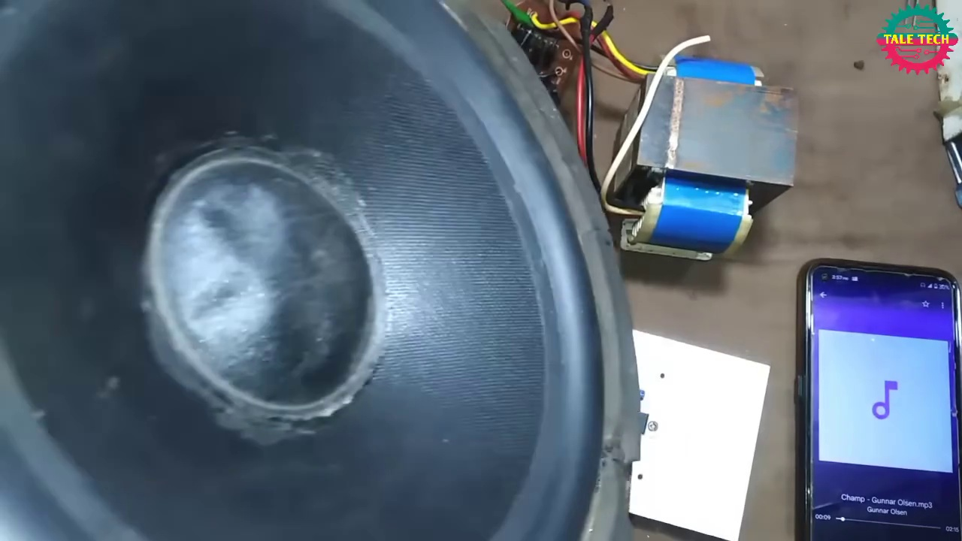 | 7:01   | 7:02   | 7:03  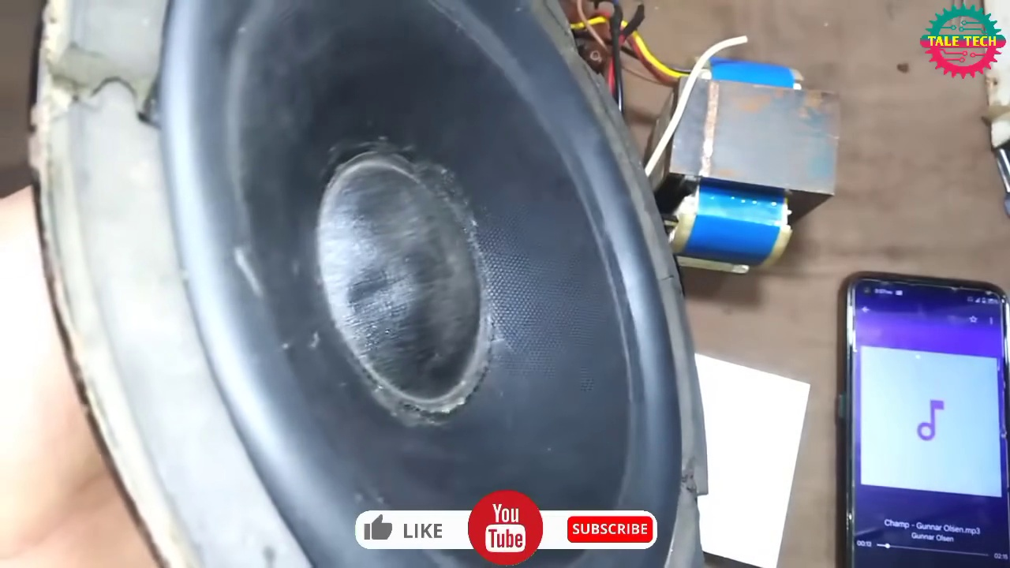 | 7:04  

Transcript
(No speech detected in this section)

Section 0: A Close-up View of a Speaker
Time: 7:05 - 7:10

Summary
The scene shows a close-up view of a speaker with its cone facing towards the left. The image suggests that the speaker is being examined or inspected, rather than being used for demonstration or educational purposes.

Representative Frames
7:05   | 7:06  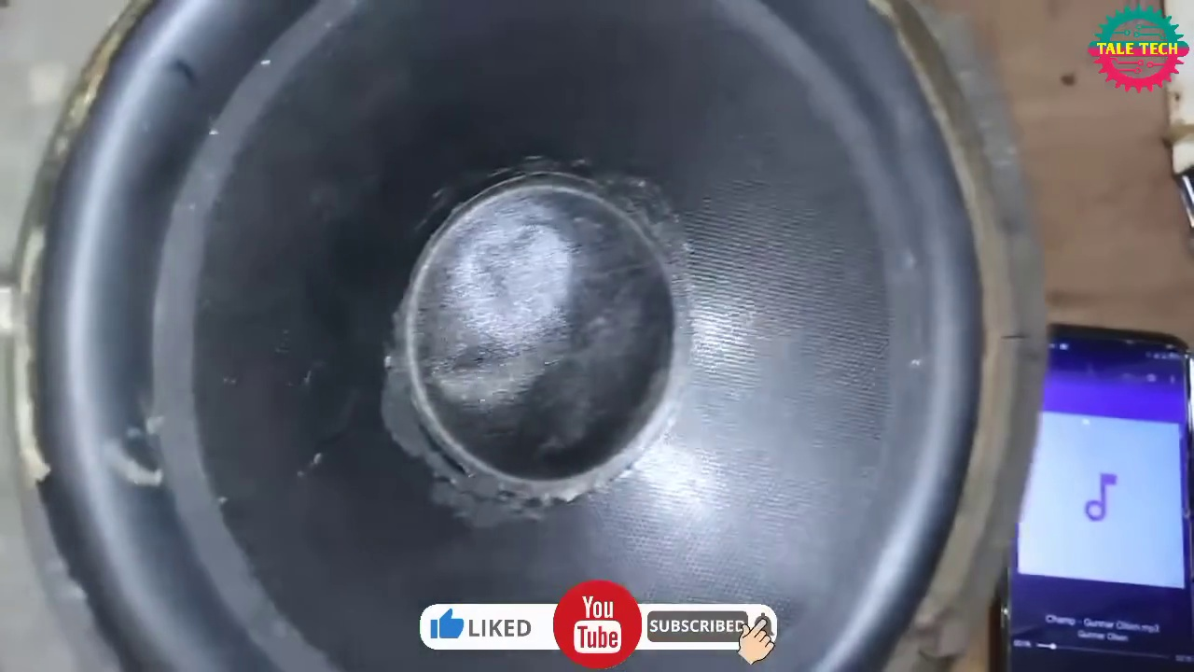 | 7:07   | 7:08   | 7:09  

Transcript
(No speech detected in this section)

Section 0: A Workspace with Electronic Equipment and Components
Time: 7:10 - 7:15

Summary
The scene shows a workspace with electronic equipment and components, primarily featuring a speaker and a transformer. The image suggests that someone may have been working on repairing or modifying electronic components.

Representative Frames
7:10  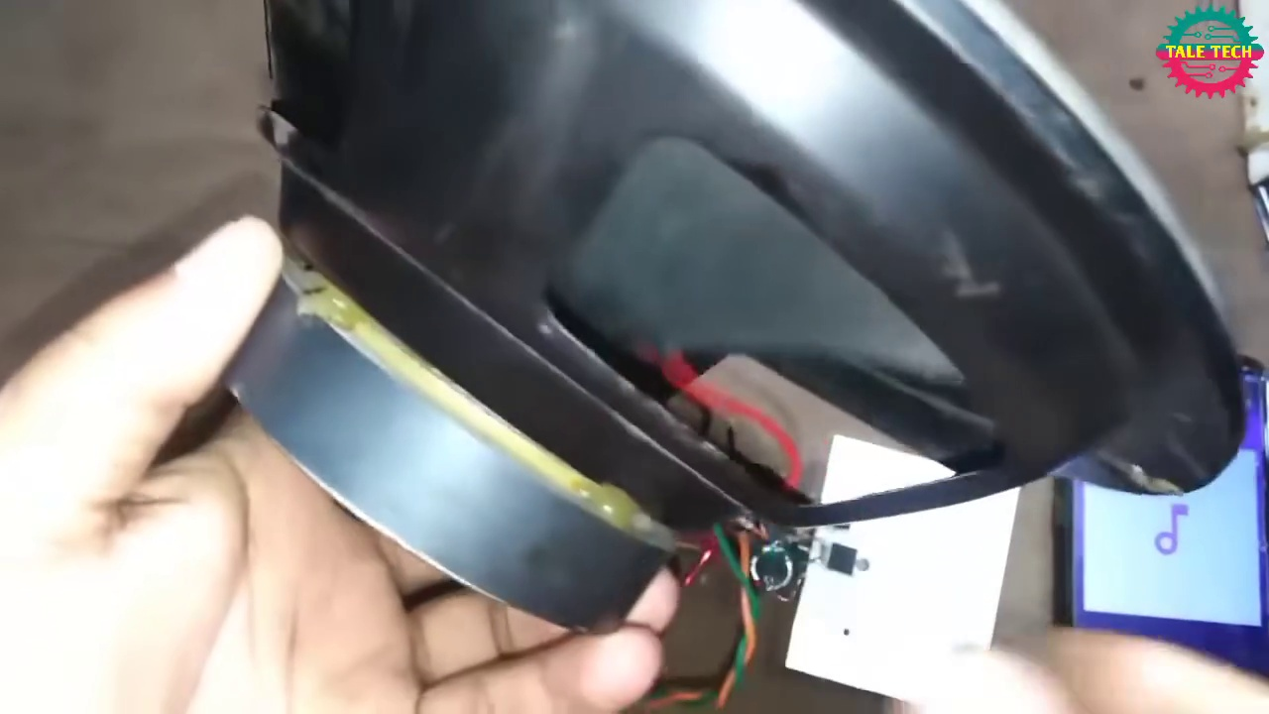 | 7:11   | 7:12   | 7:13  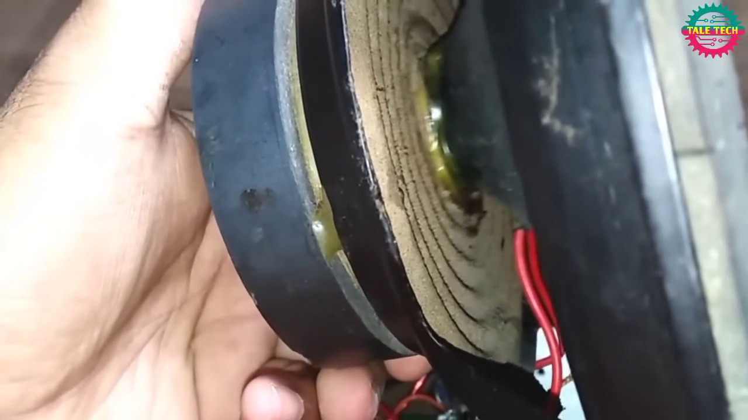 | 7:14  

Transcript
(No speech detected in this section)

Section 0: A Close-up of a Person's Hands Interacting with Electronic Devices
Time: 7:15 - 8:01

Summary
The scene shows a close-up view of a person's hands interacting with electronic devices. The image suggests that the person is pointing to a speaker and possibly expressing gratitude.

Representative Frames
7:22  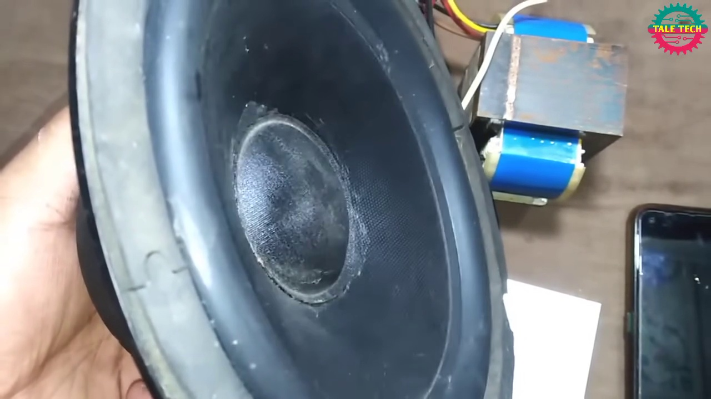 | 7:30  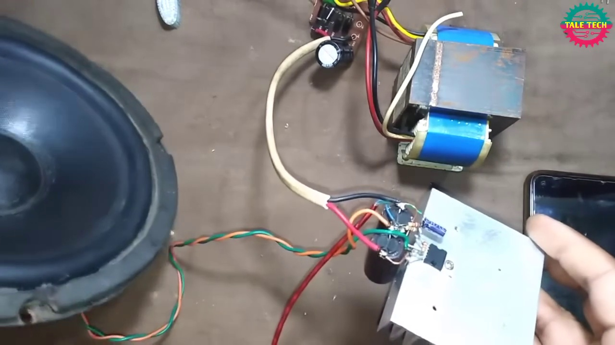 | 7:38  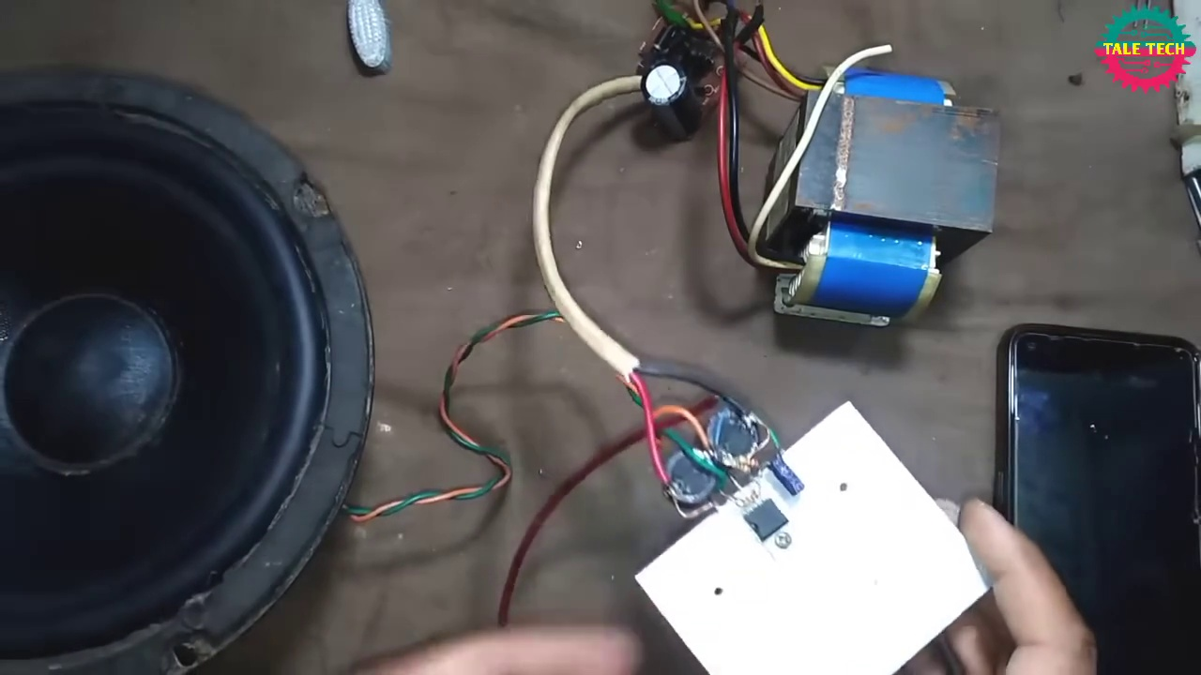 | 7:46  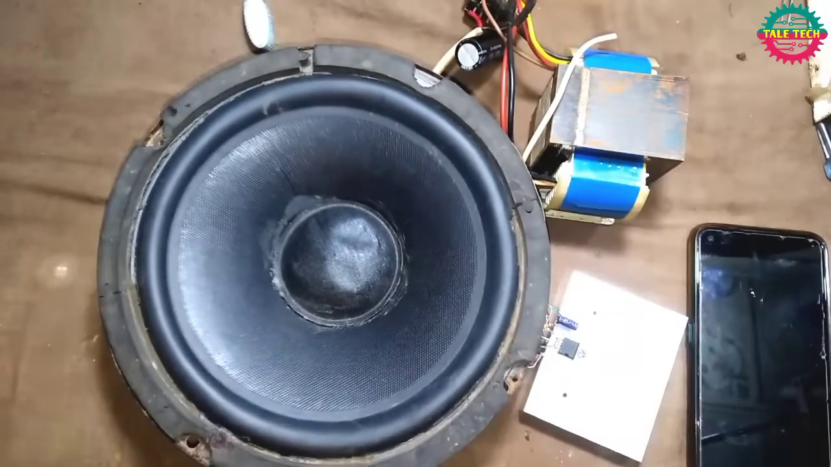 | 7:54  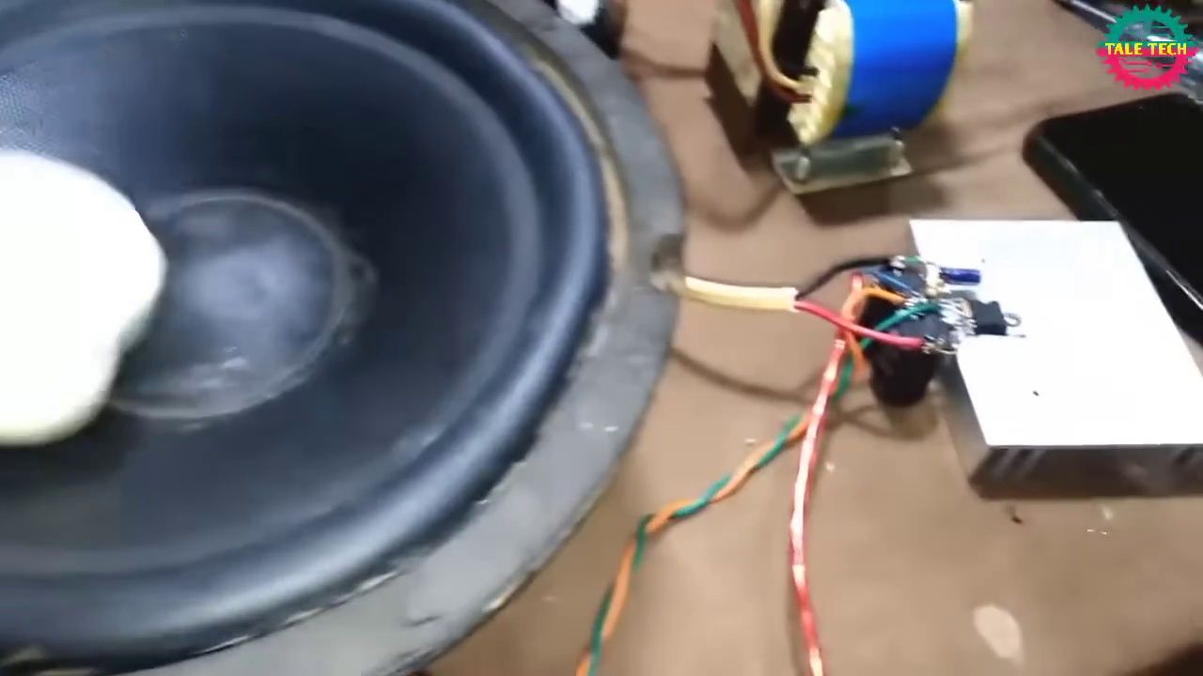

Transcript
[7:02] Thank you.
[7:32] Thank you.

