Engagement Analysis: 09c4bdKM5Kw

Section 0: Electronic Circuitry and Development - Introduction
Time: 0:00 - 0:03

Summary
Introduction to various electronic projects, including a drone setup, a Raspberry Pi project, and a SmarM V3 FPV drone assembly.

Representative Frames
0:00  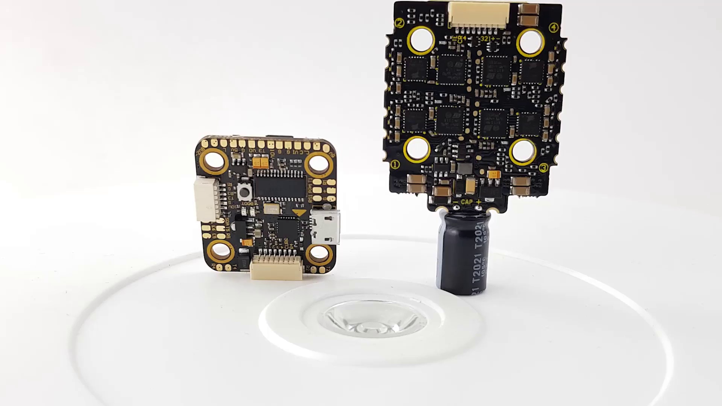 | 0:01   | 0:01   | 0:02  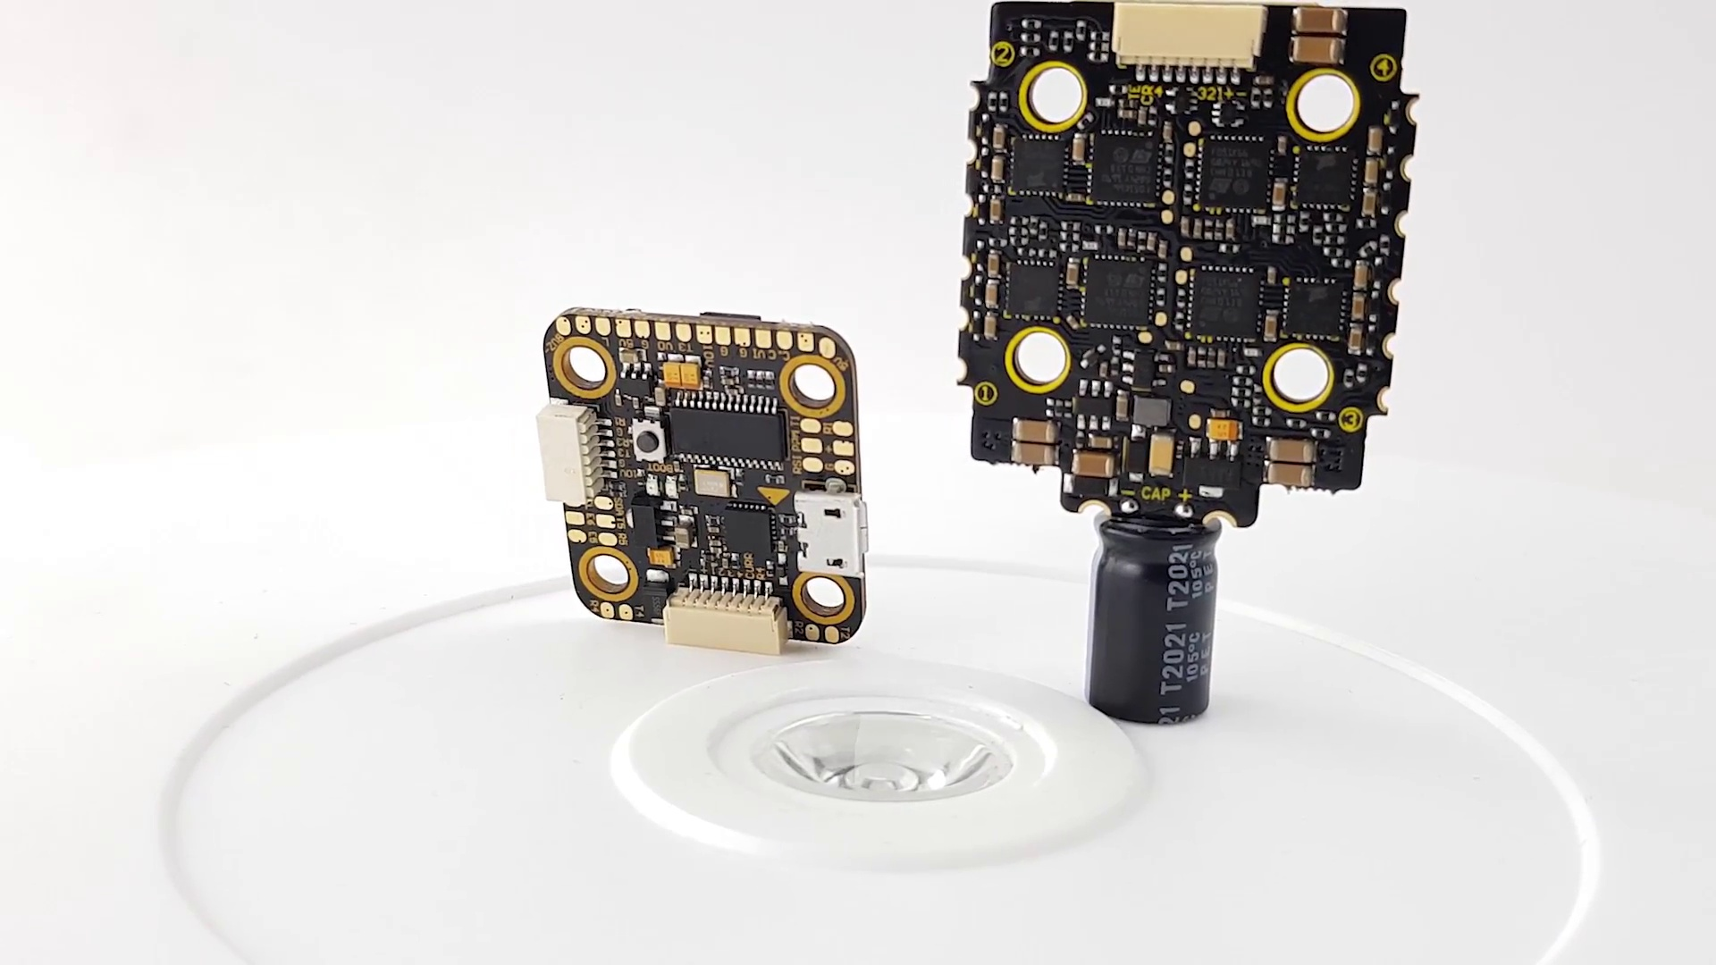 | 0:02  

Transcript
[0:00] In today's video, we're going to be taking a look at an all-new stack from T-Motor.

Section 0: Raspberry Pi Project with GPIO Pins
Time: 0:03 - 0:05

Summary
Explanation of how to connect Raspberry Pi's GPIO pins to a breadboard using wiring techniques and setup for monitoring temperature using a thermocoupler.

Representative Frames
0:03  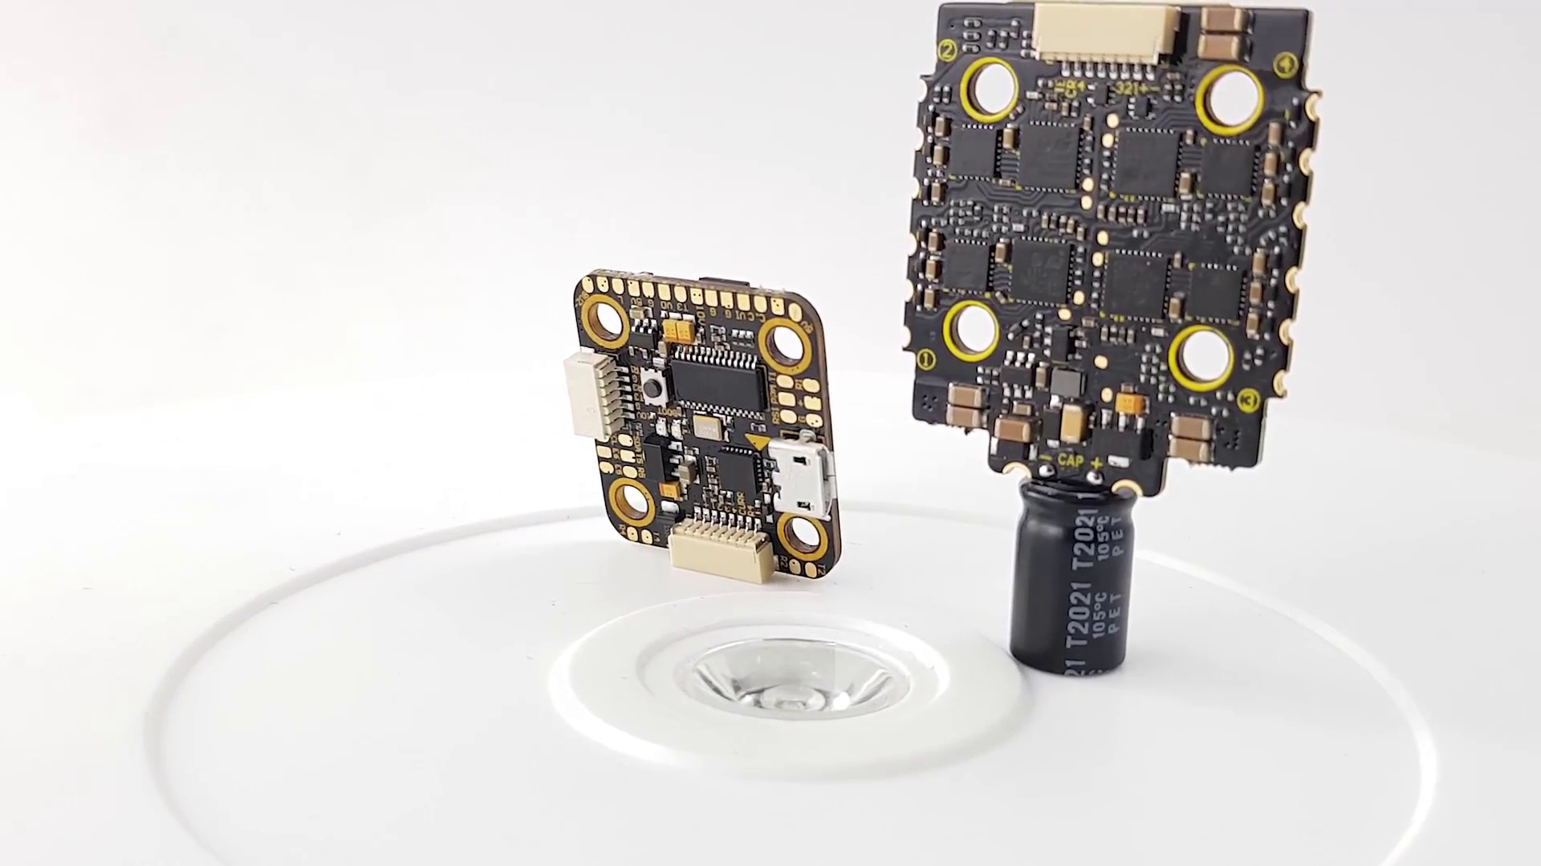 | 0:03   | 0:04   | 0:04   | 0:04  

Transcript
(No speech detected in this section)

Section 0: Smarter IVC Board Circuit Diagram
Time: 0:05 - 0:07

Summary
Separate circuit diagram for the Smarter IVC board, showing its components and connections in series, with an unrelated setup compared to the Raspberry Pi project.

Representative Frames
0:05  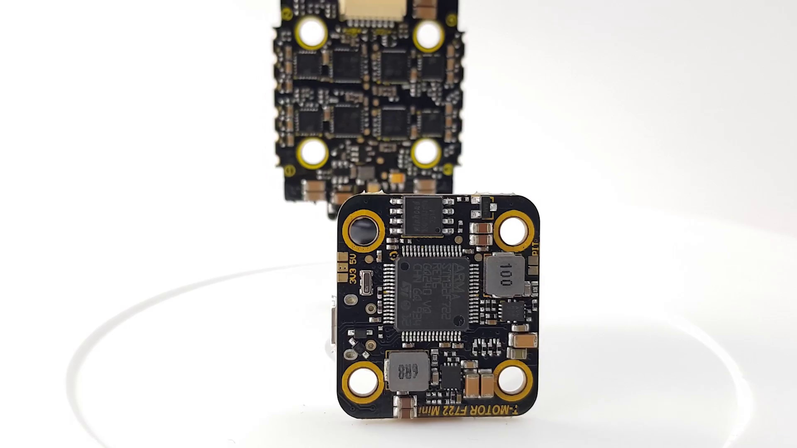 | 0:05   | 0:06   | 0:06   | 0:06  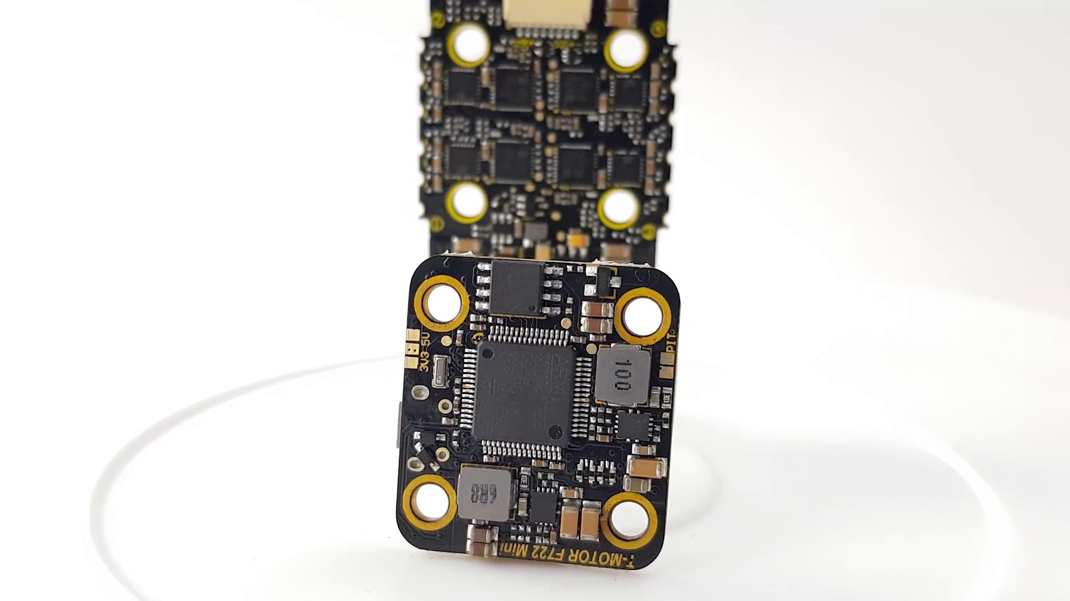

Transcript
[0:03] Now, this is a 20x20 stack that comes with the ESC flight controller.

Section 0: Assembling a SmarM V3 FPV Drone
Time: 0:07 - 0:09

Summary
Process of assembling or demonstrating the electronic device, specifically a SmarM V3 FPV drone, with focus on wiring and soldering techniques.

Representative Frames
0:07   | 0:07   | 0:08   | 0:08  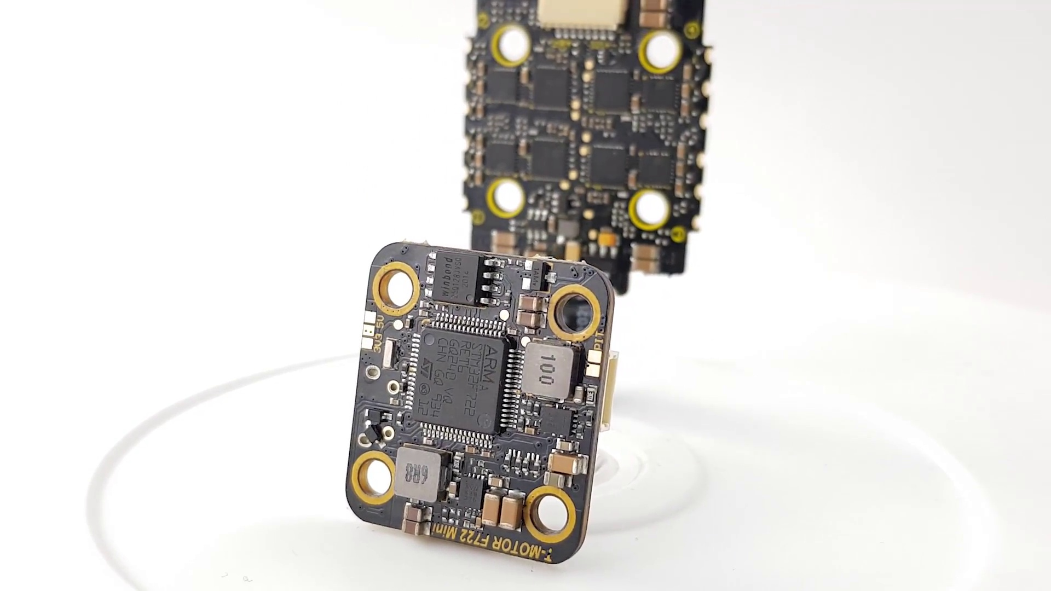 | 0:08  

Transcript
[0:07] It is an F7.

Section 0: Device Testing and Analysis
Time: 0:09 - 14:36

Summary
Testing and analysis of the assembled device using an oscilloscope to display signals, indicating successful operation at 5 volts.

Representative Frames
2:33  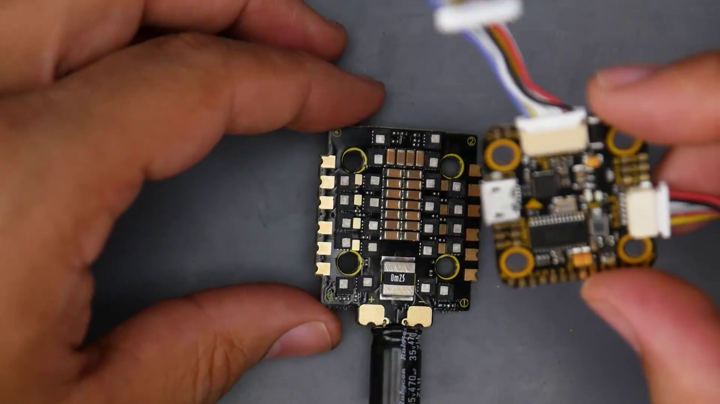 | 4:58  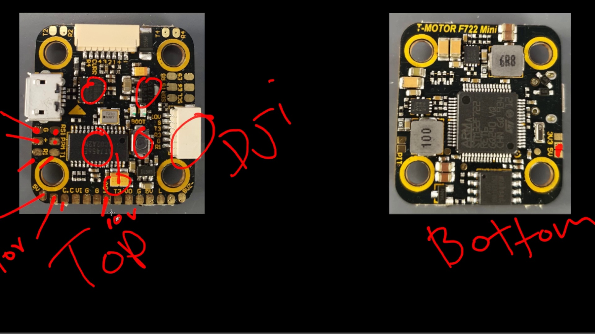 | 7:22  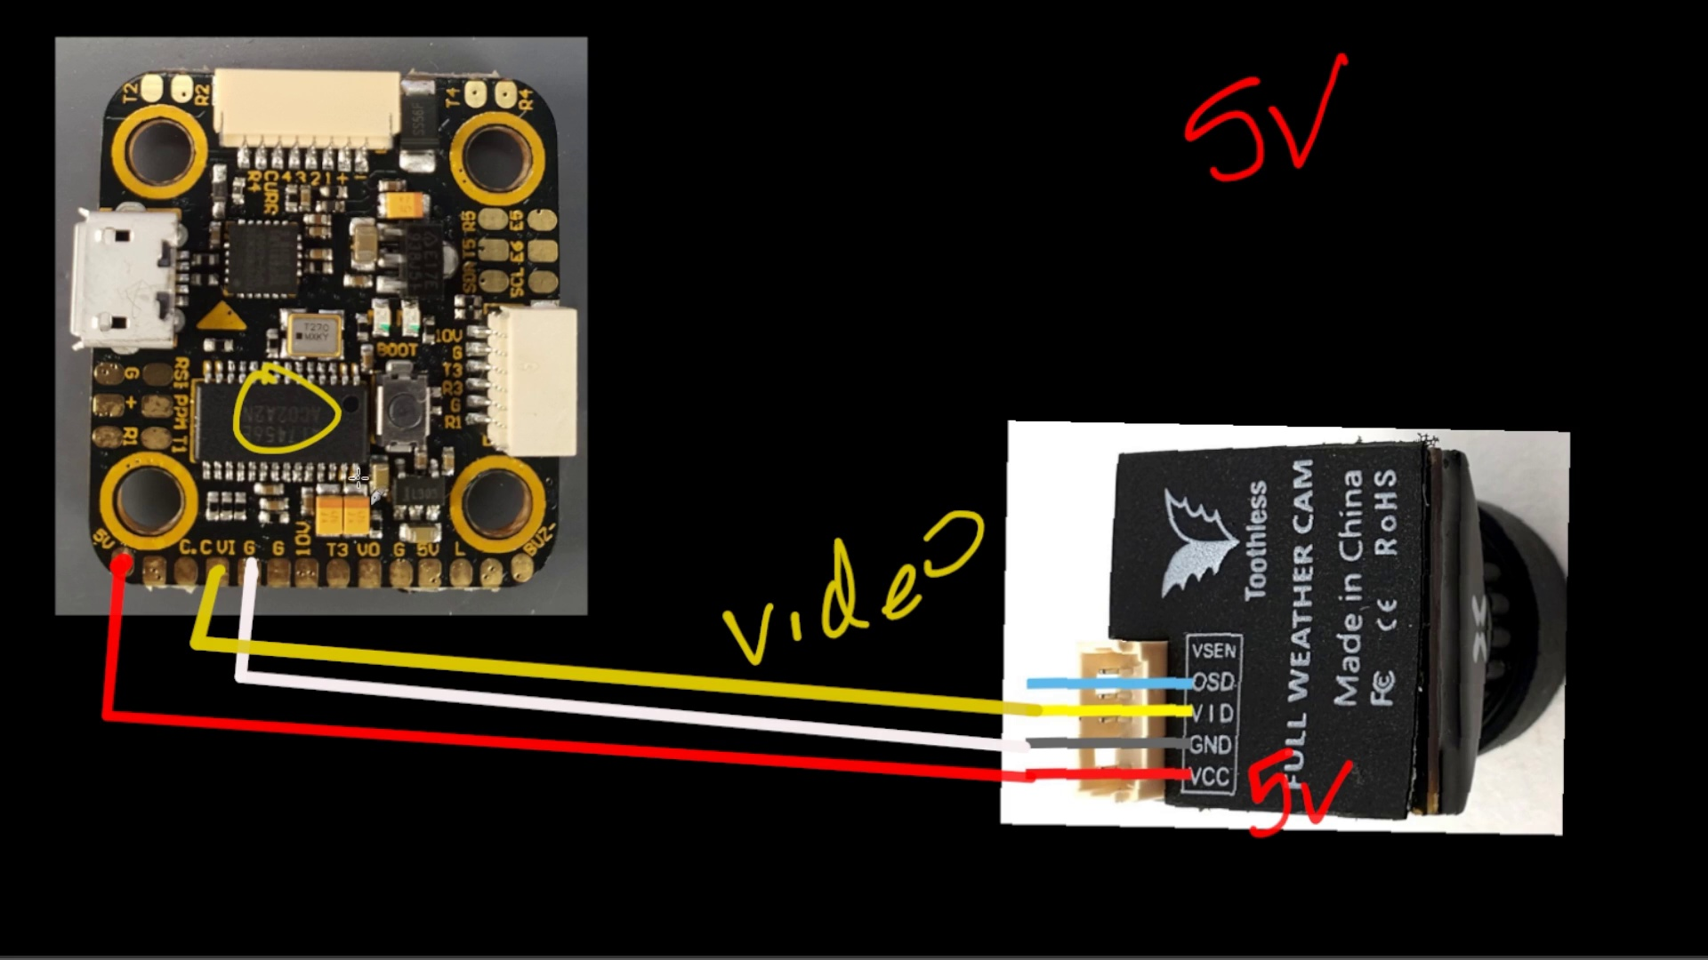 | 9:47  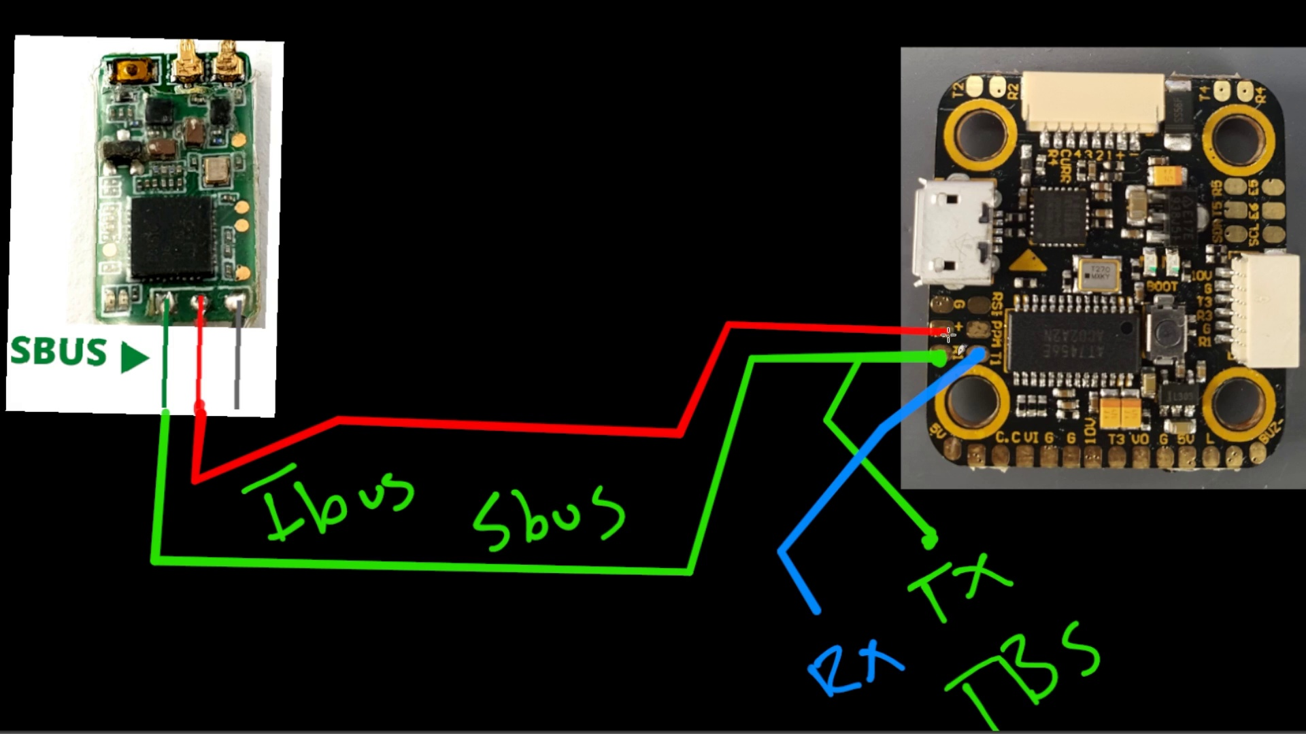 | 12:11  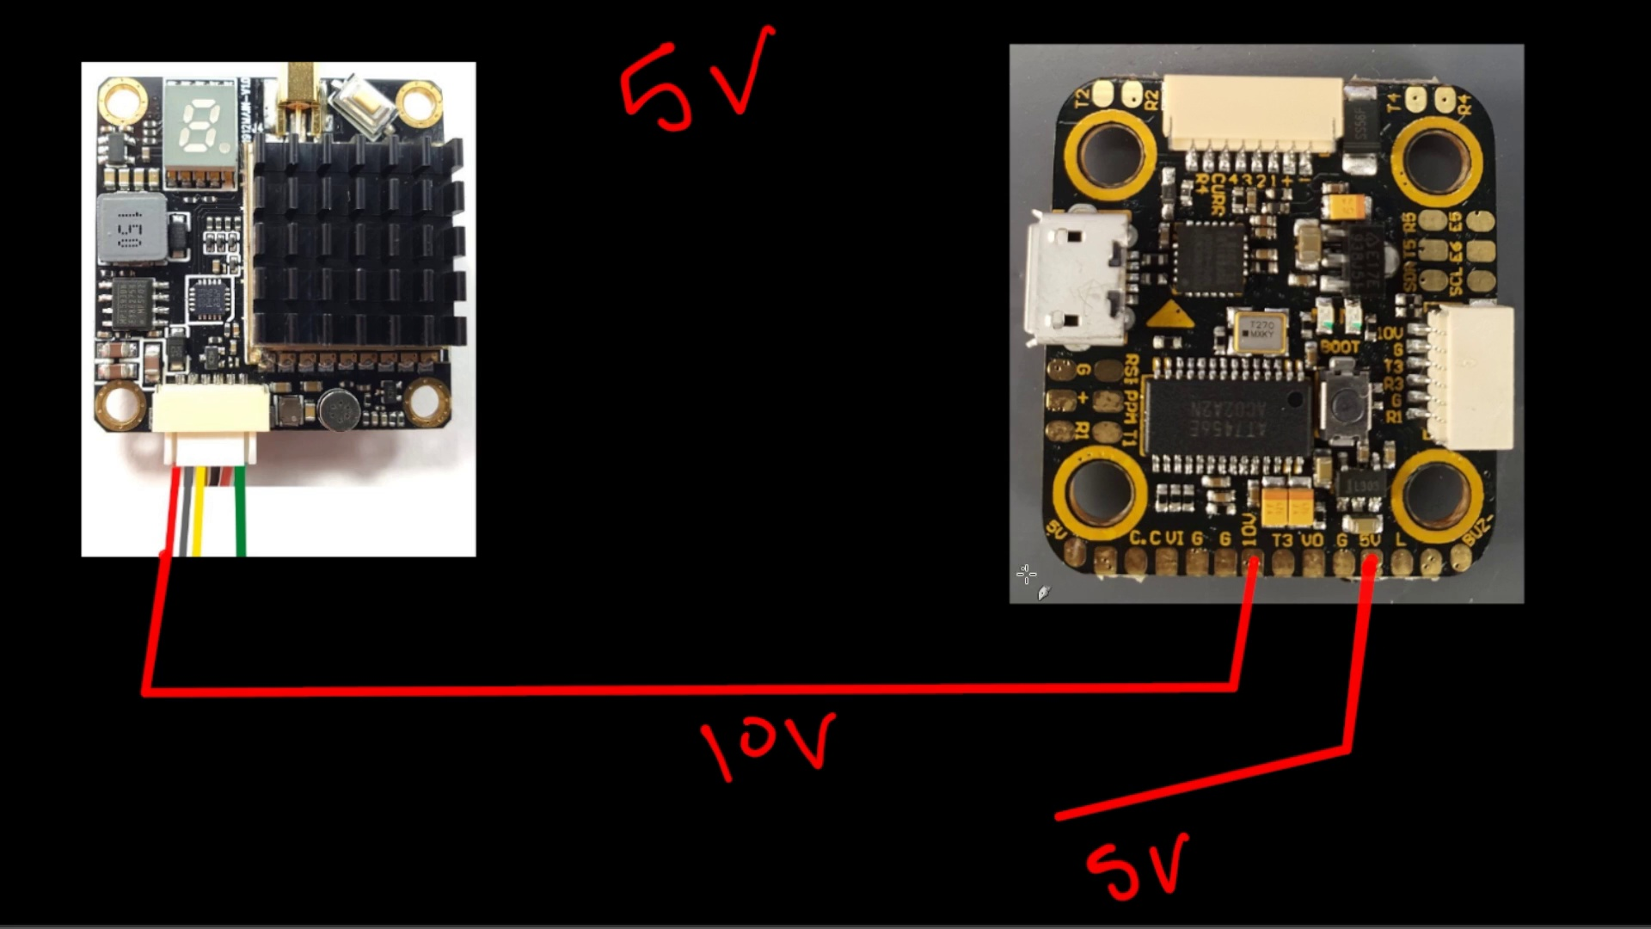

Transcript
[0:08] It does have a 10-volt regulator, and it does have a direct connection to the DJI setup.
[0:14] However, just because it's incorporating the DJI setup doesn't mean they've even removed the OSD.
[0:20] You still have your on-screen display for analog setups if you needed that, which is really, really nice.
[0:26] So what we're going to cover today is we're going to go ahead and take a look at some of the accessories.
[0:29] Also, a detailed connection setup guide.
[0:32] So with that being said, let's go ahead and get started.
[0:40] So taking a look at some of the accessories here, you can tell they have a pre-made XT60 made for us,
[0:45] which is a 14-gauge wire XT60 right here, which is really nice to see.
[0:50] Also, a baggie with 10 rubber grommets because the ESC and the flight controller incorporate these rubber grommets.
[0:59] And also some metal screws and some metal nuts as well.
[1:02] So that's really nice.
[1:03] You get two extra rubber grommets in case you lose one.
[1:06] You do get the ESC with the capacitor pre-installed.
[1:10] And they are using a Rubicon capacitor here.
[1:13] This is a 35-volt, 470 microfarad capacitor that's set up right here.
[1:18] You also obviously do get the flight controller, which is an F7.
[1:21] And we get the connector for the DJI setup.
[1:24] This is for the larger DJI modules.
[1:27] As you can tell, you just plug that in.
[1:28] You plug this right in there.
[1:30] And it routes basically everything for you.
[1:32] So that's really nice to see here.
[1:34] And they also give us the connector, which will route our ESC to our flight controller.
[1:39] Now, there are a lot of options on this flight controller, which we're going to take a look at in a bit here,
[1:43] such as pit mode and the 10-volt regulator.
[1:46] And we also obviously do have an F7 memory.
[1:50] And yeah, so it's really nice.
[1:51] We're going to take a closer look at that in a bit here.
[1:53] So for the ESC, they went into a kind of a strange design here because the FETs are so tiny.
[1:59] But they also do have some sort of a heatsink built in within them here to keep them cool.
[2:05] But I have no idea how these are going to test right here.
[2:08] These are, as I believe, DSHOT 1200, so BLHeli32 ESCs here.
[2:14] Filtration is somewhat minimal.
[2:16] But it's really good that they've provided that low-Ease R capacitor.
[2:19] And if you didn't know how to install this, just a quick heads up.
[2:22] This should be in the back.
[2:23] And you could read motor 1, 2, 3, 4.
[2:26] Install it just like this in your quadcopter or else it will never fly unless you know what you're doing.
[2:31] The camera should be right there in the front.
[2:33] Same thing with the flight controller here.
[2:34] Watch that arrow right there.
[2:36] The USB should be on top and to the left here.
[2:39] And this is how it would be set up in your quadcopter.
[2:41] So now let's go ahead and jump into the advanced breakdown of the flight controller and also the beginner setup guide right after that.
[2:48] All right, guys.
[2:48] So right now we're going to be doing the advanced breakdown of the T-Motor flight controller here.
[2:52] So let's go ahead and take a look at it.
[2:53] There isn't much going on here.
[2:55] And it's really nice that they're able to fit all this stuff into one 20 by 20 board here.
[3:00] So on the left here, we're looking at the top side.
[3:03] And as we can tell, we have an on-screen display, which is really nice.
[3:05] And at the same time, we also do have a connector for the DJI setups here, the DJI HD module setups.
[3:11] And they're using tantalum capacitors for the on-screen display, which is really good.
[3:15] Minimizes the chances of lines or your OSD flickering here.
[3:19] And this seems like a barometer, but I don't think it's a barometer.
[3:23] I think it's a 27 megahertz crystal for the on-screen display here.
[3:27] Here we have our boob button if we ever get stuck.
[3:29] 3.3 volt regulator.
[3:31] MPU 6000 gyro.
[3:33] And here we have two selectable pads, which are very important.
[3:37] This one not as important.
[3:39] This is to enable pit mode.
[3:40] So if you wanted to set that up, which means it'll basically power off your video transmitter.
[3:46] But you'd have to bridge these in order to enable them in the software.
[3:49] So you have to keep that in mind.
[3:51] And for the receiver side, as you can tell, this is meant to be for the receiver side.
[3:55] We have RSSI.
[3:57] We have PPM.
[3:58] I don't know if anybody still uses PPM.
[4:00] And we have RX1 and RX2 here.
[4:03] These are for the receiver.
[4:04] However, here's the plus, which is going to be the positive for the receiver and the ground.
[4:09] Now, for the positive side, it's not going to give any power until you actually bridge one of these two here.
[4:15] So if you wanted 3.3 volt, you'd have to solder these two together.
[4:19] And if you wanted 5 volt in the middle one with the bottom one here, you'd have to solder those two together.
[4:24] And that would give the output power to this plus sign right here.
[4:28] So, for example, let's remove these.
[4:30] We wanted 5 volts because most of our receivers nowadays are 5 volts.
[4:34] Then this pad right here would be 5 volt.
[4:36] And if you didn't bridge these, then you will get no power and you'd be going crazy while your receiver is not turning on.
[4:42] And that would be the case.
[4:43] We also do have the 10 volt broken out down here and another one broken out right here.
[4:49] This is camera control.
[4:50] This is really nice.
[4:51] You have two 10 volt pads, which you could use.
[4:53] You could either use it for your camera if you wanted to.
[4:56] But I'd recommend you go with that 5 volt.
[4:58] And if you wanted the 10 volt for your video transmitter, this is the area where you'd want it.
[5:03] Because they also have a T3 right there for you for like smart audio or RC TRAM protocol.
[5:07] That's for the analog setups also.
[5:10] And you can tell right here R1 is being set up, also used for the DJI.
[5:16] So, if you don't have this, if you don't have the controller for the DJI, you want to remove these two right here wires, the last two wires from this connector.
[5:25] And just worry about T3 and R3, which would be the MSP serial protocol between the DJI module.
[5:32] So, it can give you the telemetry data, ground, and the power for the DJI module right there.
[5:37] We still have quite a lot of things going on for it.
[5:40] And that's currently it for the advanced breakdown.
[5:43] There isn't really much else to say.
[5:45] Here we have memory.
[5:46] Again, it's an F7.
[5:47] And we have our voltage regulators.
[5:48] We have two voltage regulators.
[5:50] We have a 10 volt.
[5:51] And we have the 5 volt here.
[5:53] And that's about it for the advanced breakdown.
[5:55] Let's go ahead and jump into the beginner setup guide here.
[5:57] Alright guys, so right now we're going to be talking about the FPV camera.
[6:00] Now, most of these cameras take anywhere between 5 volts all the way up to 30 plus volts.
[6:06] But again, even though it does that, I really recommend you set it up on a 5 volt regulator.
[6:11] Just stick to a 5 volt because this reduces the chances of you getting some weird lines or some weird flickers in your video feed which can be really annoying and hinder your flying performance.
[6:20] So, for example, here it says VCC because it does that.
[6:23] But we always want to give it just that 5 volts.
[6:25] It makes things so much better here.
[6:27] Now, the place where we want to go ahead and set up our 5 volts, there's plenty of places actually where we can do that.
[6:33] But we can grab our first 5 volt from this right there, right at the edge right there.
[6:37] And now we'll give our camera 5 volts.
[6:38] Then we're going to need a ground.
[6:41] And it's so weird because the ground is this far away right here.
[6:44] Let's actually use a different color.
[6:45] We're going to use white for that.
[6:48] So we're going to grab our ground wire right there.
[6:50] This is for the camera.
[6:51] This is how it was intended to be installed.
[6:54] But again, you could change out the layout if you wanted to.
[6:57] But make sure you get a ground also.
[6:59] Here's the VI, which means video input.
[7:02] And that is going to be for your camera right there.
[7:05] And that's about it.
[7:06] This is the video line.
[7:07] So the camera needs positive and a negative, which are the white and red wires right here.
[7:11] And the video is going to be the video signal coming in.
[7:14] And it goes into the flight control.
[7:15] Now, why does it go into the flight controller?
[7:17] It's because it goes through this chip right here, which overlays the useful information, such as your battery and many other things as well.
[7:25] And then it'll output that back out to your video, especially on analog.
[7:29] And if it's not on analog, it'll go through the UART for the DJI stuff here.
[7:32] And that's about it for the FPV camera.
[7:34] Very simple stuff.
[7:35] Let's go to the next step.
[7:38] Okay.
[7:38] So in this part of the video, we're going to be talking about how to connect, for example, SBUS.
[7:42] So SBUS, also IBUS for FlySky, and also the TBS Crossfire.
[7:49] So we'll just say TBS.
[7:51] There we go.
[7:52] TBS.
[7:52] So we're going to show all these.
[7:54] Now, it's actually going to be pretty identical because this is an F7 flight controller.
[7:58] And they all go into basically the same place.
[8:01] So let's get started here.
[8:02] First of all, we'll start off with just an SBUS.
[8:05] So we're going to use the green wire here.
[8:07] So SBUS is supposed to be, or at least when they've designed this, they want you to stick it on R1, which would be RX1 here.
[8:14] And it'll be very simple for you to follow along with the instructions from the webpage also of how to set this up in Betaflight.
[8:21] Basically, you just enable serial RX in the ports tab on UART1.
[8:26] So this is SBUS right here.
[8:27] Very simple stuff.
[8:28] Now, how would we connect the IBUS signal?
[8:31] Then we're going to jump into the power in a little bit here.
[8:33] So an IBUS signal is going to be also the same exact thing.
[8:37] There's nothing else to do here.
[8:39] IBUS and SBUS are going to go in the same place.
[8:41] Now, let's just say we have a TBS crossfire.
[8:44] We're going to do that down here.
[8:45] We're just going to call it TBS.
[8:47] Now, those usually have two pads.
[8:49] They will have an RX and they will have a TX.
[8:53] So we're going to say TX right there.
[8:56] And I'm going to remove this from here.
[8:57] And we'll just call it down here TBS.
[8:59] So if you have the TBS crossfire.
[9:01] Okay.
[9:02] So what you want to do is you want to grab the TX of your TBS,
[9:06] the pad that says TX.
[9:07] And we're just going to do it like that.
[9:08] And that's going to go exactly in the same place as the SBUS and IBUS.
[9:12] However, now we have the RX, which this thing will receive data.
[9:15] That's what the RX stands for.
[9:16] It's going to receive data.
[9:18] So we're going to need a transmit pin from the flight controller,
[9:20] which is usually a T.
[9:22] And it's right over here.
[9:23] So we're just going to go ahead and grab that, set that up.
[9:26] And bam, we're done with the signal wires.
[9:29] Now comes the power.
[9:30] Now the power is usually pretty straightforward.
[9:31] However, here there is a little extra step that we're going to have to take into consideration,
[9:35] which we're going to cover as well.
[9:37] So first of all, let's start with the power.
[9:39] So here's the power signal.
[9:41] You would hopefully know which one's the 5 volt on your receiver here.
[9:46] And that's where it's going to go, the 5 volt.
[9:48] And next one over is going to be ground.
[9:50] We're going to use white here.
[9:51] And it's right there.
[9:53] And bam.
[9:54] There we go.
[9:55] We'll call this ground ground.
[9:57] Now, when you set this all up and you boot it up, the thing is, your receiver will not
[10:02] boot, basically.
[10:03] Because on the other side of the flight controller, if we actually bring this in and move it somewhere
[10:08] a little bit nicer.
[10:09] So sorry about the little messy layout.
[10:12] But if we look at the backside of the flight controller, there's going to be this little
[10:16] pad right here.
[10:17] And I think it's under this right there.
[10:19] Yeah, it's by the USB.
[10:20] So it's on the backside of this section right there.
[10:23] And what you can see is we can see three pads here.
[10:25] Now, if you're using any of these three receivers, then what you want to do is you want to add
[10:31] solder on the middle one and this one.
[10:33] Connect those two together.
[10:35] And what that'll do is it'll output 5 volts on this line.
[10:39] Now, if yours was a 3.3 volt, then you're going to want to do the 3.3 volt with the
[10:44] middle one right here.
[10:46] Then this will become 3.3 volts.
[10:49] However, again, if you're using any of the ones that I have listed down here, you want
[10:53] to connect the 5 volts.
[10:55] So we want to connect those two.
[10:56] And that should be 5 volts.
[10:58] Then you're good to go.
[10:59] And that's about it for this step.
[11:01] Let's go ahead and jump into the next step.
[11:02] All right.
[11:03] So in this part of the video, we are going to be covering the video transmitter.
[11:06] To be exact, the analog variance.
[11:09] Now, the first thing you need to identify, which is very important, is what your video
[11:13] transmitter takes as a power input.
[11:16] There's only two in the market, 5 volts and 7 to whatever volts.
[11:21] We'll just say XX volts.
[11:23] So you need to identify which one you have here.
[11:26] We call this the battery voltage video transmitter.
[11:28] And we'll call this a 5 volt video transmitter.
[11:30] I'll be showing you both.
[11:31] First of all, let's start with the battery voltage video transmitter.
[11:37] And that's going to basically go on the 10 volt right there.
[11:41] So we're going to go ahead and grab the red wire here.
[11:44] And we're just going to set that up right over here.
[11:46] And that is the 10 volts for battery voltage video transmitters.
[11:50] Now, if yours was the 5 volt, the only difference of the connection set up here is only going
[11:55] to be this red wire.
[11:57] So if you had the 5 volt version, then you're going to want to set up the red wire right there
[12:02] for your 5 volt.
[12:03] So again, this is the only difference between those two video transmitters.
[12:07] The battery voltage video transmitter will go on the 10 volt and your 5 volt will go on
[12:11] this 5 volt.
[12:11] We can't use this one because we used this for the camera earlier.
[12:14] And that's about it here.
[12:16] So now we need ground.
[12:18] So always the power.
[12:19] I always recommend setting up the power first.
[12:21] So we're going to go ahead and grab ground.
[12:23] And we could basically grab ground from anywhere, any of those G pads.
[12:27] But we'll just take it from here because it's right next to it.
[12:29] And it's just going to make everything so much more simple.
[12:32] Now, the next thing we need is the video line, which is usually the yellow wire here.
[12:36] So let's go ahead and grab that real quick.
[12:39] And that's going to go into VO.
[12:41] So we're going to have to cross over here.
[12:43] And we're going to go right there.
[12:44] This is video output.
[12:45] And because the camera comes in on a video input, it goes through here, goes through
[12:49] this chip.
[12:49] This chip puts all the useful information and then spits it back out to the video transmitter
[12:54] right over here.
[12:55] And you'll be able to get that nice telemetry data that you want.
[12:59] So now we're left with one more wire, usually sometimes three more wires, which would be
[13:04] another black and a red one, which would say 5 volt.
[13:07] But be careful because that's a 5 volt output.
[13:10] And you want to completely ignore that.
[13:12] Those are usually used for RC wings where they don't have a flight controller and the video
[13:18] transmitter usually powers on the camera.
[13:20] So you want to ignore those.
[13:21] But there is one little extra one that's going to be the, for example, smart, they call it
[13:26] smart audio or the IRC tram protocol.
[13:29] And usually it would be green or purple or something of that nature.
[13:32] And the place where you want to set this wire up is going to be, so it's going to be right
[13:37] here on T3.
[13:39] So this is a TX3.
[13:42] And now it's going to be the place where you set up your ports tab.
[13:45] You go under UART3 peripherals and you choose whether you have smart audio, video transmitter
[13:50] or IRC.
[13:52] And that's found in the documentation.
[13:53] I think this one right here was smart audio protocol.
[13:56] And this will allow you to change the channel and output power through the onscreen display
[13:59] instead of having to come here and play around with the button and start changing stuff.
[14:04] So yeah, that's the only thing.
[14:05] You really don't need to connect it.
[14:07] But if you do connect it, it makes your life a little bit easier.
[14:09] And with that being said, that's about it for this video, guys.
[14:12] I really hope you guys enjoyed it.
[14:13] Please come join my Patreon.
[14:15] I do a ton of giveaways.
[14:16] And I do, you get access to a lot of crazy stuff.
[14:18] Secret Access Shop, which is my shop where I sell stuff for like super cheap that I've used
[14:22] and just no longer using.
[14:23] You also get access to my open hardware schematic files for the flight controller as well as
[14:28] ESCs.
[14:30] And well, that's really it, guys.
[14:31] Everything's linked down below.
[14:32] If you could check those out, it's a great support channel.
[14:34] I'll see you guys in the next one.
[14:35] Peace.

