Engagement Analysis: 15cdyl2PU-E

Section 0: Image Descriptions with Timestamps
Time: 0:00 - 0:03

Summary

Representative Frames
0:00   | 0:01   | 0:01   | 0:02   | 0:02  

Transcript
(No speech detected in this section)

Section 0: Descriptive Title: Image of a person in the background with text overlay 'Thank You for Watching! Please Subscribe!' on top of a video or presentation.
Time: 0:03 - 0:06

Summary
The image appears to be from an online class, educational content, or webinar.

Representative Frames
0:03  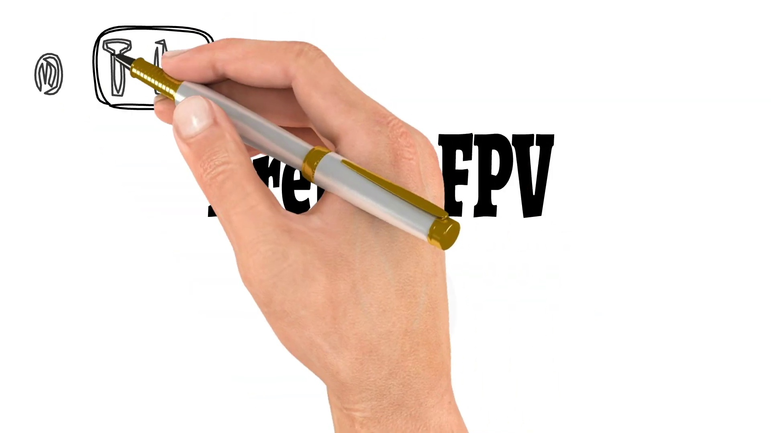 | 0:04   | 0:04   | 0:05   | 0:05  

Transcript
[0:00] Hello guys and welcome back to my channel. Today I'm going to check a new DJI-friendly F7 flight

Section 0: Descriptive Title: Image of a hand holding a pen or marker used to highlight text on a whiteboard.
Time: 0:06 - 0:09

Summary
The image is likely from an online class or educational content related to starting an ecommerce business.

Representative Frames
0:06   | 0:07  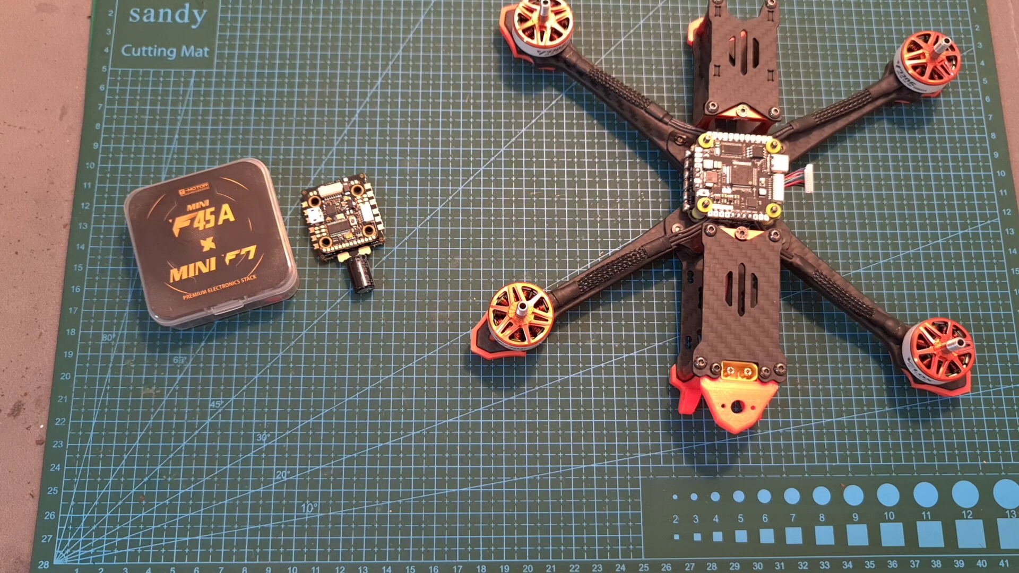 | 0:07   | 0:08   | 0:08  

Transcript
(No speech detected in this section)

Section 0: Descriptive Title: Cartoon character wearing a headset with a sign reading 'Thank You for Watching! Please Subscribe!' on top of a white background.
Time: 0:09 - 0:12

Summary
The image style suggests it may be from a webinar, online class, or educational content platform.

Representative Frames
0:09   | 0:10  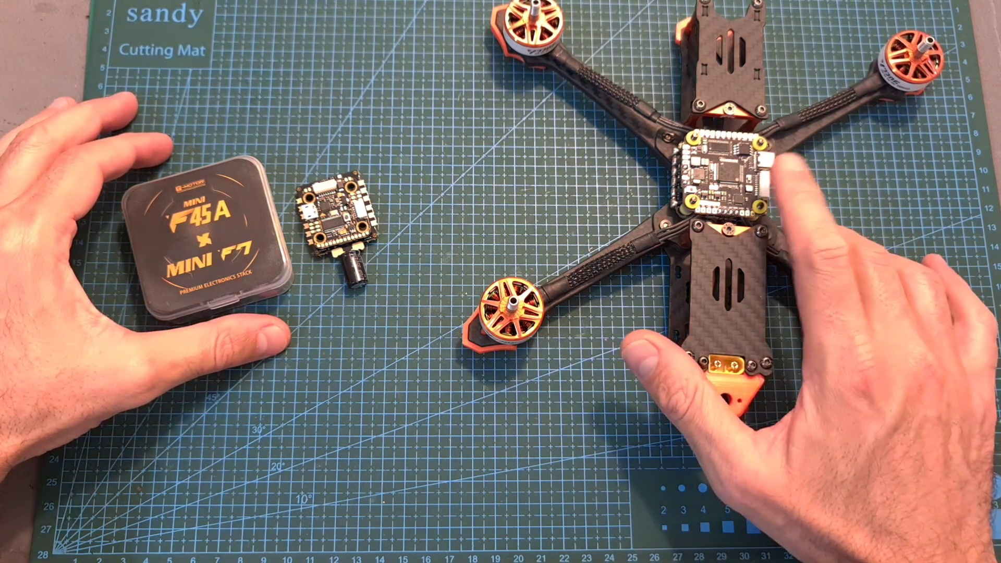 | 0:10   | 0:11   | 0:11  

Transcript
(No speech detected in this section)

Section 0: Descriptive Title: Screenshot of a presentation slide with a message reading 'Thank You for Watching! P Lease Subscribe' at the top and 'Please like and subscribe' at the bottom.
Time: 0:12 - 0:15

Summary
The image appears to be part of an educational or instructional session, possibly related to technology or media production.

Representative Frames
0:12   | 0:13   | 0:13  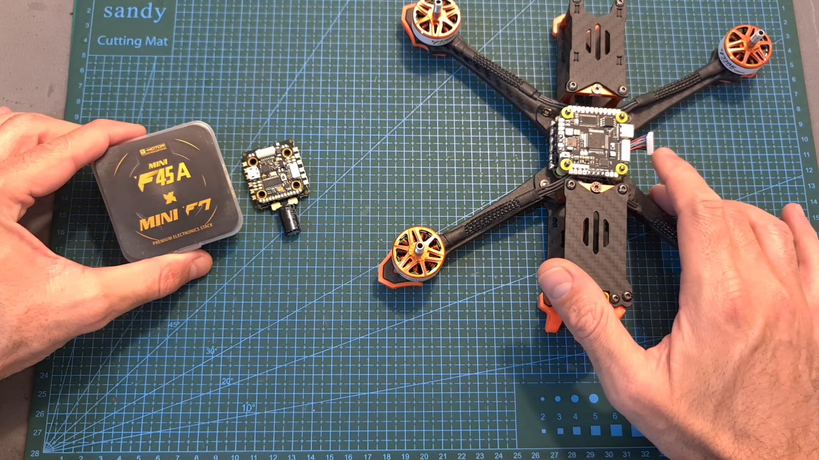 | 0:14   | 0:14  

Transcript
[0:10] controller and a very capable 20x20mm stack by T-Motor. In this video I'm going to go over their

Section 0: Descriptive Title: Minimalistic graphic design with a cartoon head wearing a headset and a thank-you message.
Time: 0:15 - 7:07

Summary
The image serves as a thank-you message for viewers, accompanied by a call to action to subscribe.

Representative Frames
1:23  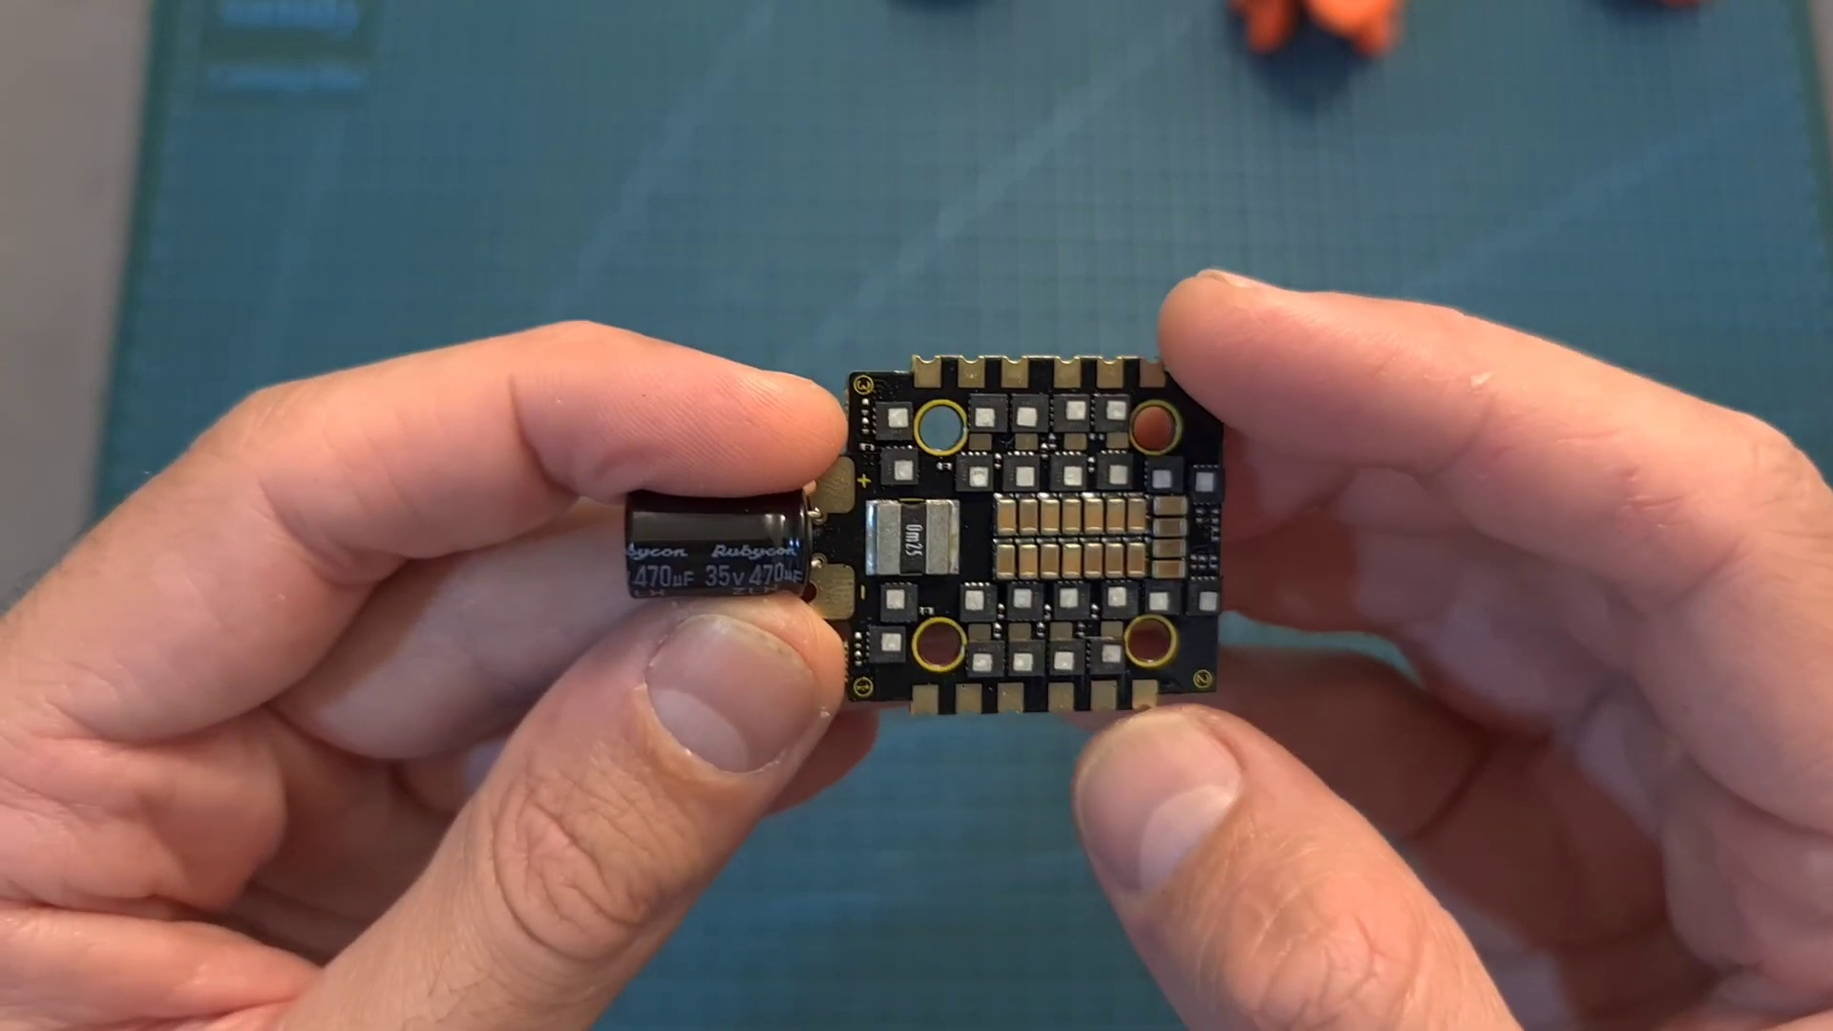 | 2:32  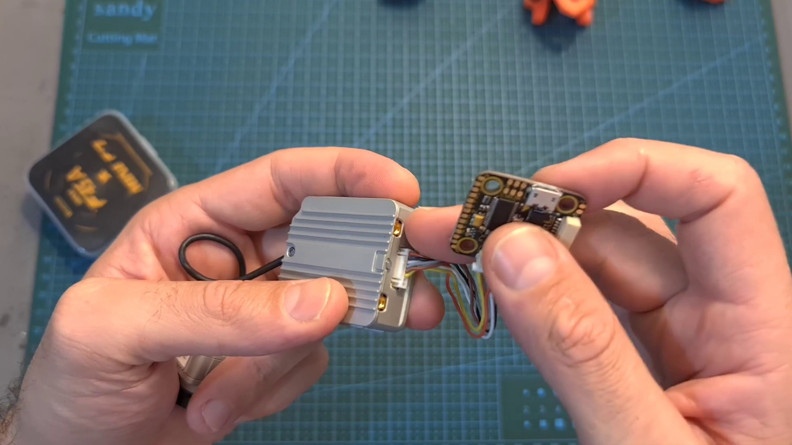 | 3:41  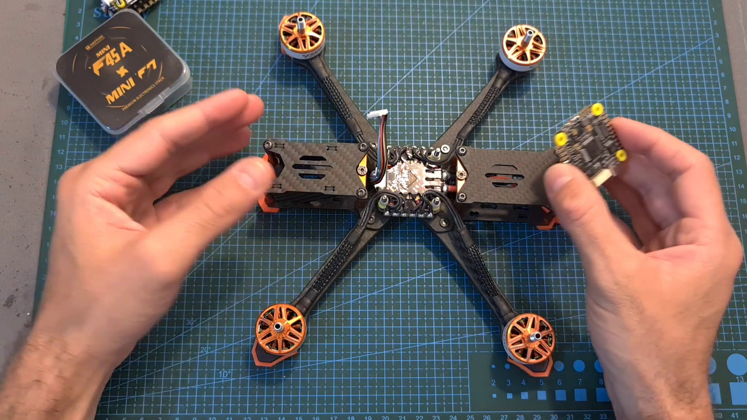 | 4:49  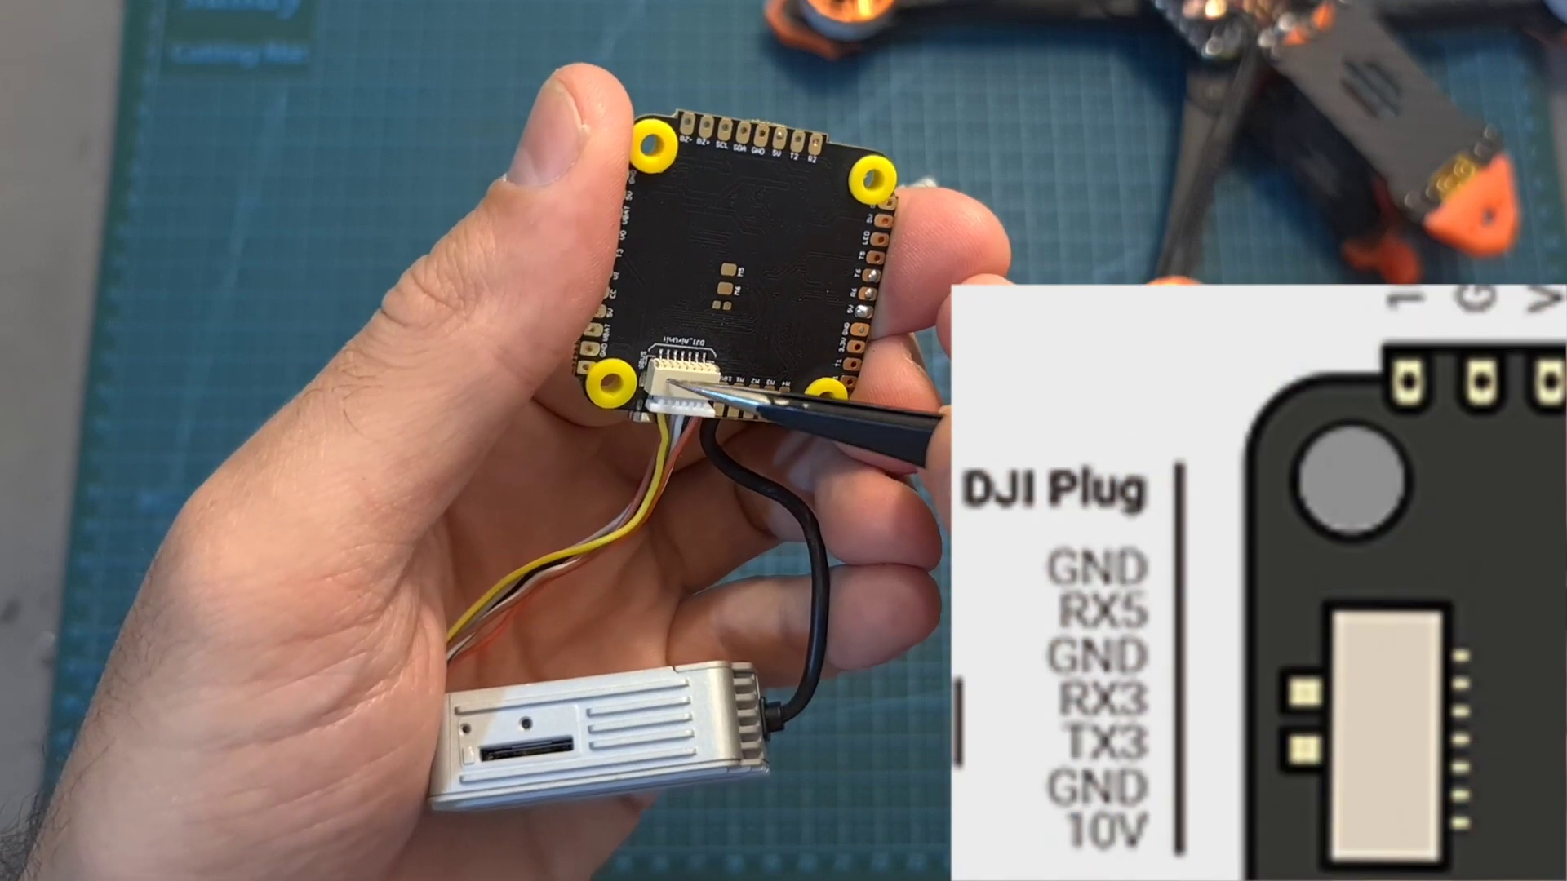 | 5:58  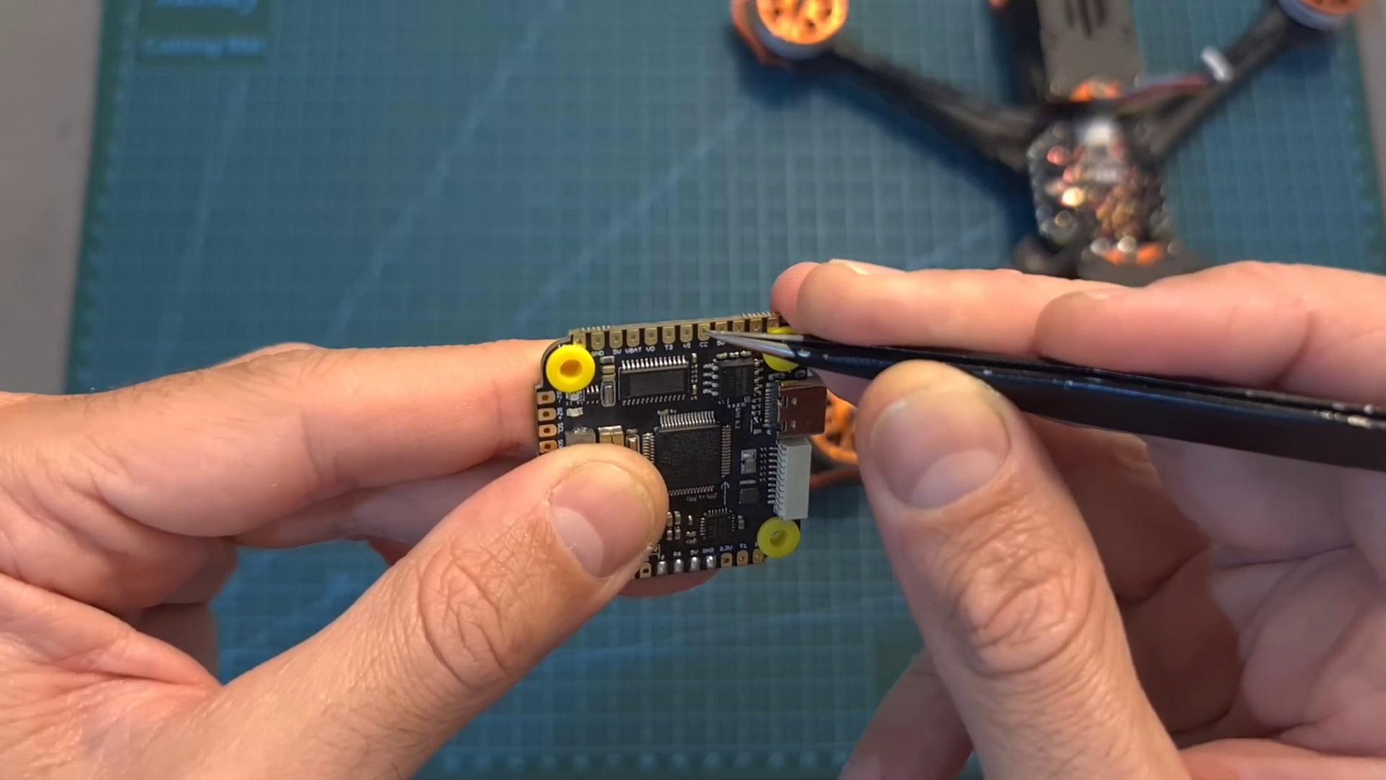

Transcript
[0:17] features and specs and show you how to set them up using both digital and analog systems.
[0:22] First let's start with the 20x20mm stack. In terms of packaging, inside the box you can find the
[0:29] flight controller. The 4-in-1 ESC which comes with a pre-soldered 35V 470μF capacitor. A bag with M3
[0:38] screws, nuts and silicone grammets. A high quality XT60 battery connector with pre-soldered 14G silicone
[0:46] coated wires. A harness for connecting the 4-in-1 ESC and the flight controller and a GST connector
[0:53] that will enable you to easily connect a DJI air unit. In terms of specs, the flight controller
[0:59] features an F7 processor, 5 full U-out ports, in addition to a 5V BEC, a 10V BEC which is useful
[1:07] for powering a DJI air unit and a dedicated connector for hooking it up. As for the 4-in-1 ESC,
[1:14] its current rating is 45A, it features well-separated motor and battery pads, a built-in current sensor,
[1:21] it's running BLL32 firmware and just like the flight controller, it can be powered with up to 6S batteries.
[1:29] In addition, the weight of the flight controller is 5.3 grams. The weight of the 4-in-1 ESC including the
[1:35] capacitor is 10.9 grams. They are both using 20x20mm M3 mounting holes. The outer dimensions of the flight
[1:44] controller are 27.7 x 29.9 x 6.4 millimeters. The 4-in-1 ESC is a little bit bigger and its outer
[1:53] dimensions are 33.4 x 39.3 x 6.4 millimeters and the total weight of the stack including the GST
[2:01] harness is 17.1 grams. Now let's quickly go over a couple of guidelines when installing the stack.
[2:08] Next to the micro USB port, you can find dedicated pads for connecting a ready receiver and you can
[2:14] choose whether to power the ready receiver using 3.3 or 5 volts by bridging the center pad with the
[2:20] right one or with the left one. Pay attention that if you are going to leave it unbridged,
[2:25] the ready receiver is not going to be powered up. The easiest way to connect the DJI air unit to the
[2:31] flight controller is using the provided GST connector. The air unit is going to be powered using the 10V
[2:37] BAC. In order to display the OSD data, you need to enable the MSP switch on UART3 and pay attention
[2:44] that in case you are going to use an external ready receiver, you need to disconnect the yellow wire as
[2:49] it is wired to UART1. On the back of the flight controller, you can find the relevant pads for
[2:54] connecting an analog VTX and in case you would like to control the 10V BAC using an auxiliary switch,
[3:02] you can solder these two pads over here and then assign an auxiliary switch to the user
[3:07] one mod on bit of light. Pay attention that this feature only applies to the 10V pads,
[3:13] which means that in case you would like to use it, you can't use VTXs that only support a DC input
[3:18] voltage of 5V. Here you can see what it looks like when the stack is assembled. So it features a slim
[3:25] home factor and it is quite remarkable that such a small stack can power a 5-inch 6S build.
[3:31] Now let's move on to the newly introduced single-sided Pacer F7 flight controller,
[3:36] which actually came as a part of this plug-and-play build, which as far as I know is still not available.
[3:42] In terms of specs, this flight controller features an F7 processor, a USB Type-C connector,
[3:48] 6 full UO ports, a dedicated connector for a DJI air unit. In addition to a 10-pin-suggester connector
[3:57] for connecting the flight controller with the 4-in-1 ESC, you can find the matching pads on the
[4:02] bottom of the flight controller. Most of the pads can be accessed from both top and bottom sides of
[4:08] the flight controller. On its bottom, there are no electronic parts and pay attention that it only features
[4:14] a 5V BAC and all the 10V pads are just pass-through pads, which rely on the fact that you are going
[4:21] to use a 4-in-1 ESC, which features a built-in 10V BAC. In addition, the flight controller is using 30.5 by
[4:30] 30.5 mm M3 mounting holes. It weighs 8 grams and its outer dimensions are 40.1 by 39.2 by 7.8 mm.
[4:40] In case you are going to use a DJI air unit and connect it to the dedicated connector, pay attention
[4:46] that in case you are going to use a 6-pin GST connector, it is connected all the way to the right,
[4:52] as the left pin is an extra ground pin which is not in use. In order to display the OSD data on your DJI
[4:58] goggles, you need to enable the MSP switch on your 3D. And remember that as I just mentioned, the 10V pad
[5:05] is just a pass-through, so in case you are not going to use a supported 4-in-1 ESC, the DJI air unit is not
[5:12] going to be powered up, so what you can do is to bridge the VBAT and 10V pads, but keep in mind
[5:18] that the DJI air unit can be powered directly with up to 4S batteries. As for the rest of the setup,
[5:24] you can wire the ready receiver to the pads which are located on the back of the flight controller,
[5:28] and then power it either using 3.3 or 5V. Pay attention that in case you are going to use an
[5:35] S-Bus receiver, you will need to use the RX5 pin of the DJI air unit connector. Finally, in case you
[5:42] are going to use an analog setup, the VTX and FEB camera are going to be wired to the pads which are
[5:47] located on the front of the flight controller. You can power them either using 10V, 5V and VBAT,
[5:53] and in addition you can also find a dedicated pad for camera control for configuring an analog FPV camera.
[6:00] So overall, the T-Motor Pacer F7 flight controller looks like a pretty good option for a DJI air unit
[6:06] setup, but keep in mind that you need to match it with a compatible 4-in-1 ESC since it lakes a 10V BC.
[6:14] As for the mini stack, as far as I can tell it looks like a pretty good option for a light 5-inch
[6:19] build. Its main downside, which is subjective, is that it's a little bit on the pricey side
[6:24] since it costs around $100 and soon I'm going to feature it in a build-in-flight video,
[6:29] so we'll see how it goes. Anyway, that's going to be it for this quick video. As always,
[6:34] if you have any questions, feel free to ask them in the comments section down below.
[6:38] Don't forget to leave a thumbs up if you like this video and consider subscribing to my channel
[6:43] and hitting the notifications bell if you're not already subscribed. See you on my next videos,
[6:48] and goodbye.

