Engagement Analysis: 31ArBvYoG2Q

Section 0: Assembling a Quadcopter Drone
Time: 0:02 - 0:11

Summary
The host begins assembling a quadcopter drone, explaining that he is tired and cannot think of anything else to do.

Representative Frames
0:03   | 0:05   | 0:06   | 0:08   | 0:09  

Transcript
[0:03] So in this video, we're going to be building the Tyro 69 kit.

Section 0: Explaining the Assembly Process
Time: 0:11 - 0:16

Summary
The host continues assembling the drone, focusing on attaching the four arms to a black base equipped with a camera.

Representative Frames
0:11   | 0:12   | 0:13  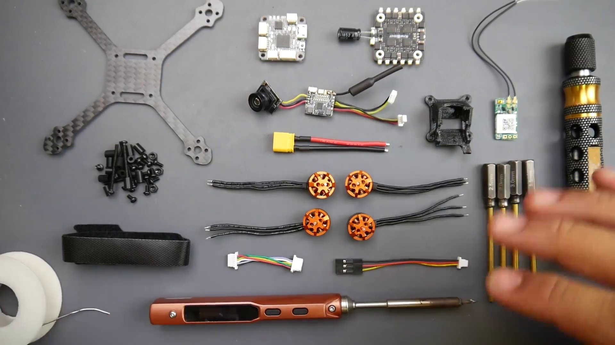 | 0:14   | 0:15  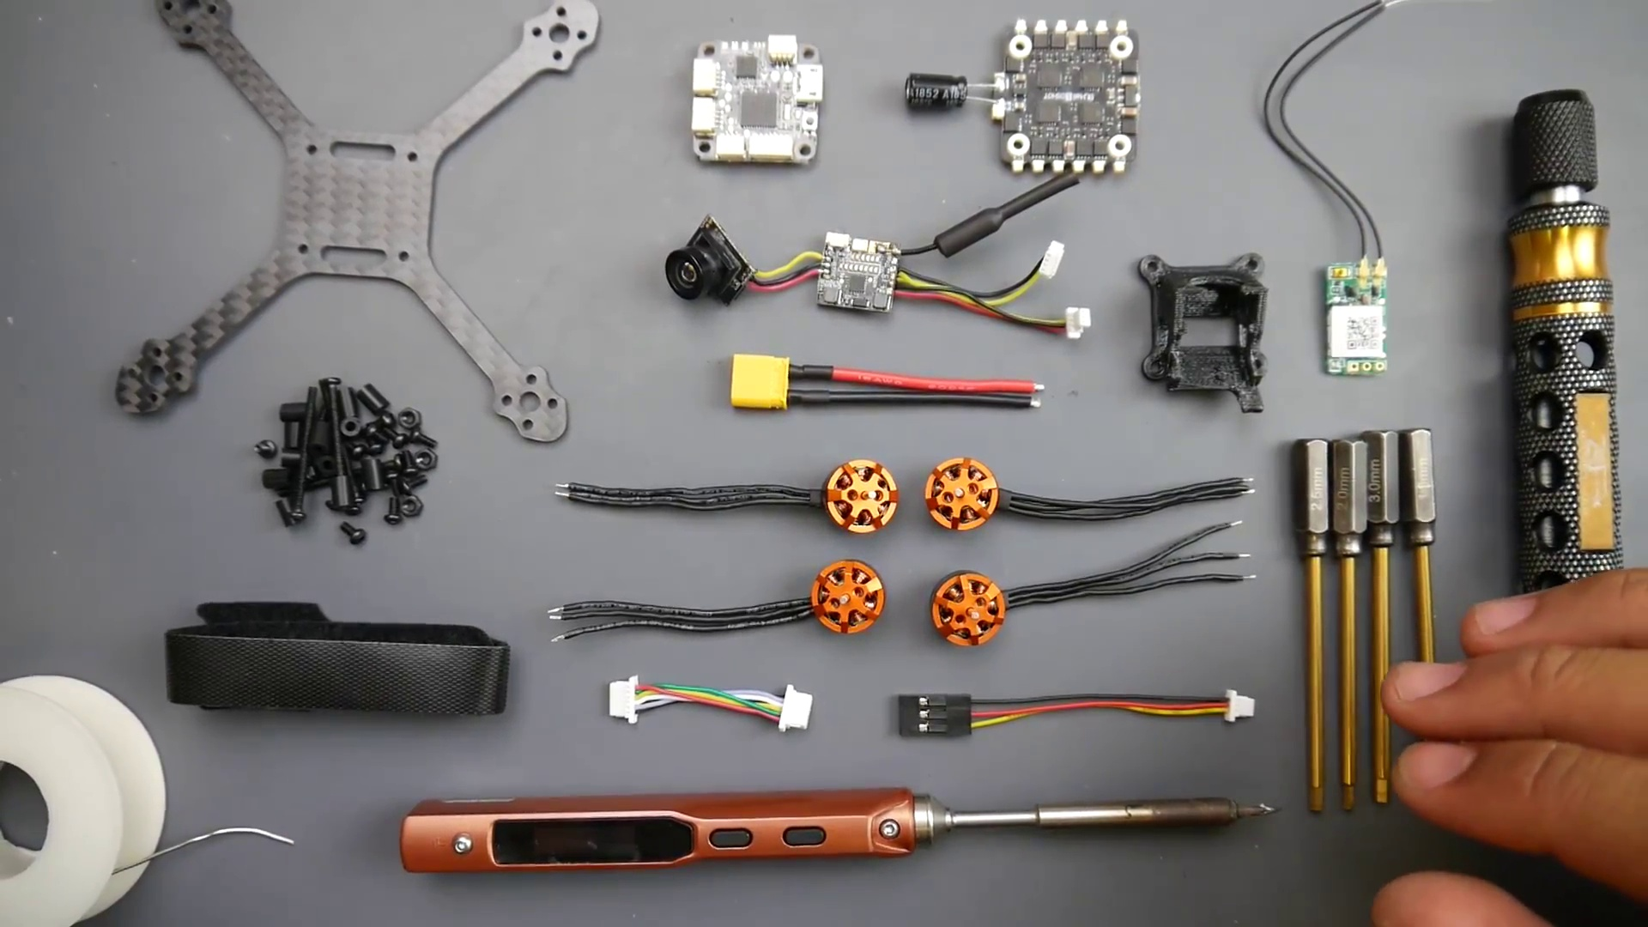

Transcript
(No speech detected in this section)

Section 0: Providing Links for Related Materials
Time: 0:16 - 0:22

Summary
The host mentions that links for batteries and other materials used in the build are available below.

Representative Frames
0:17  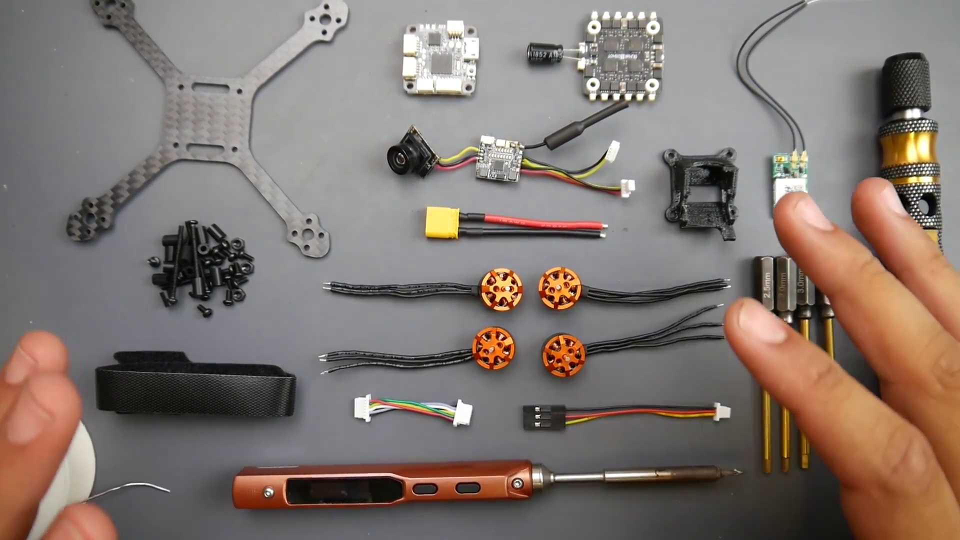 | 0:18   | 0:19  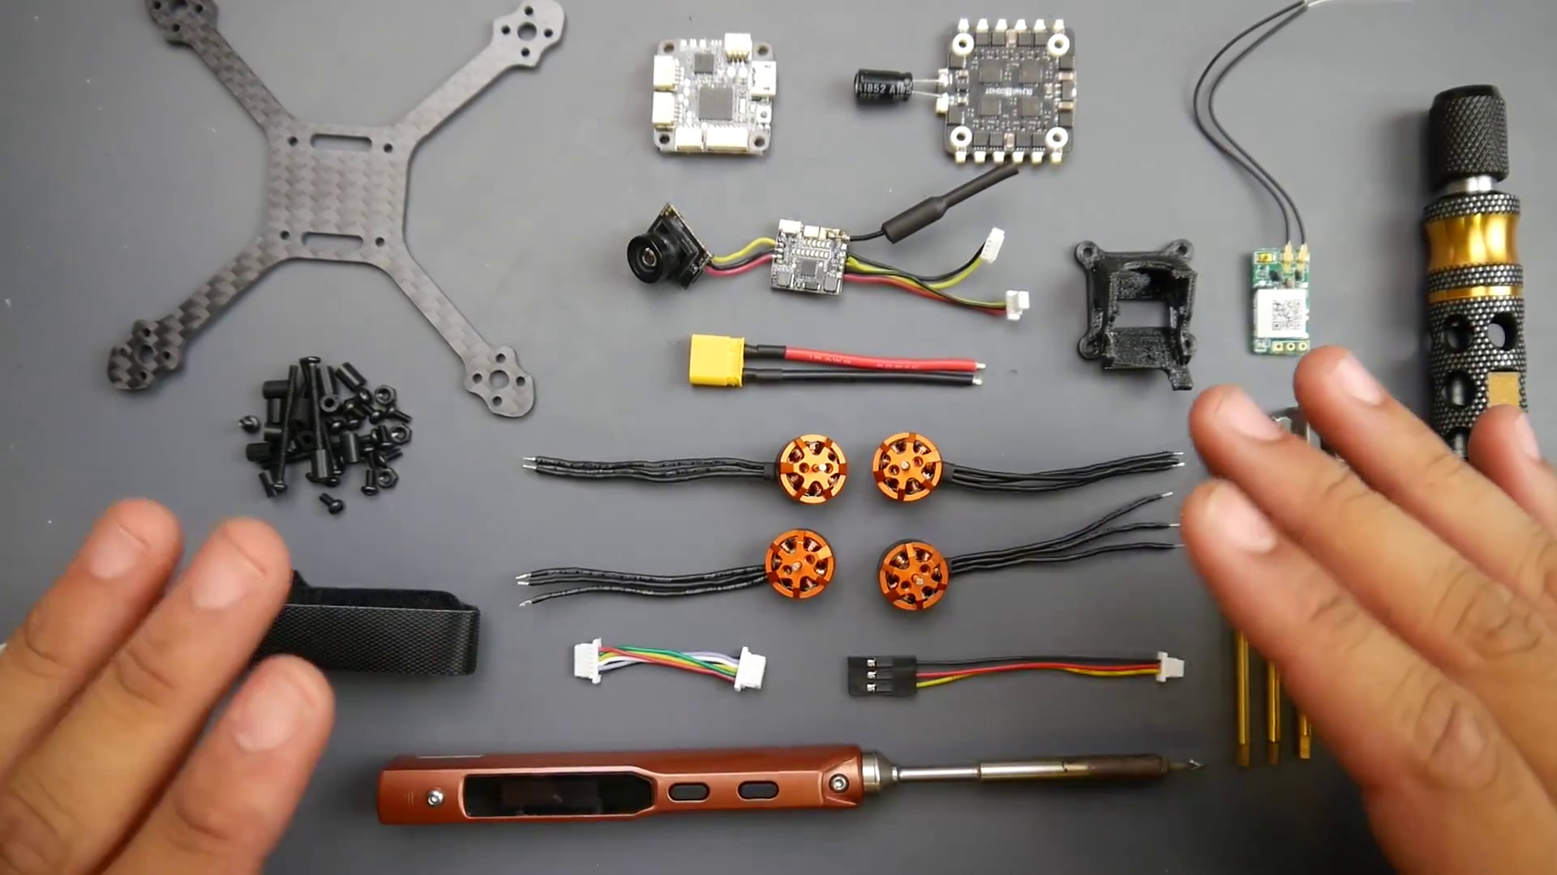 | 0:20   | 0:21  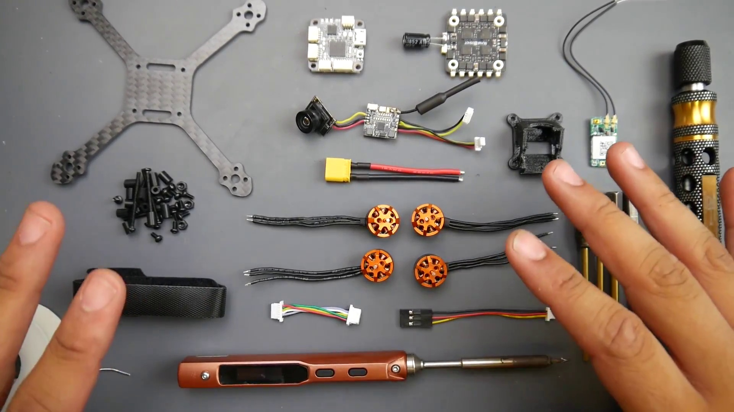

Transcript
[0:15] Now, this will be a beginner's guide into how to build it, solder it, and what are good techniques to use,
[0:20] and some of the issues you might come up against and how to solve them.

Section 0: Discussing Soldering Iron and Tools Used
Time: 0:22 - 0:24

Summary
The host explains that he will provide links to the soldering iron and tools used in the build at a later time.

Representative Frames
0:22  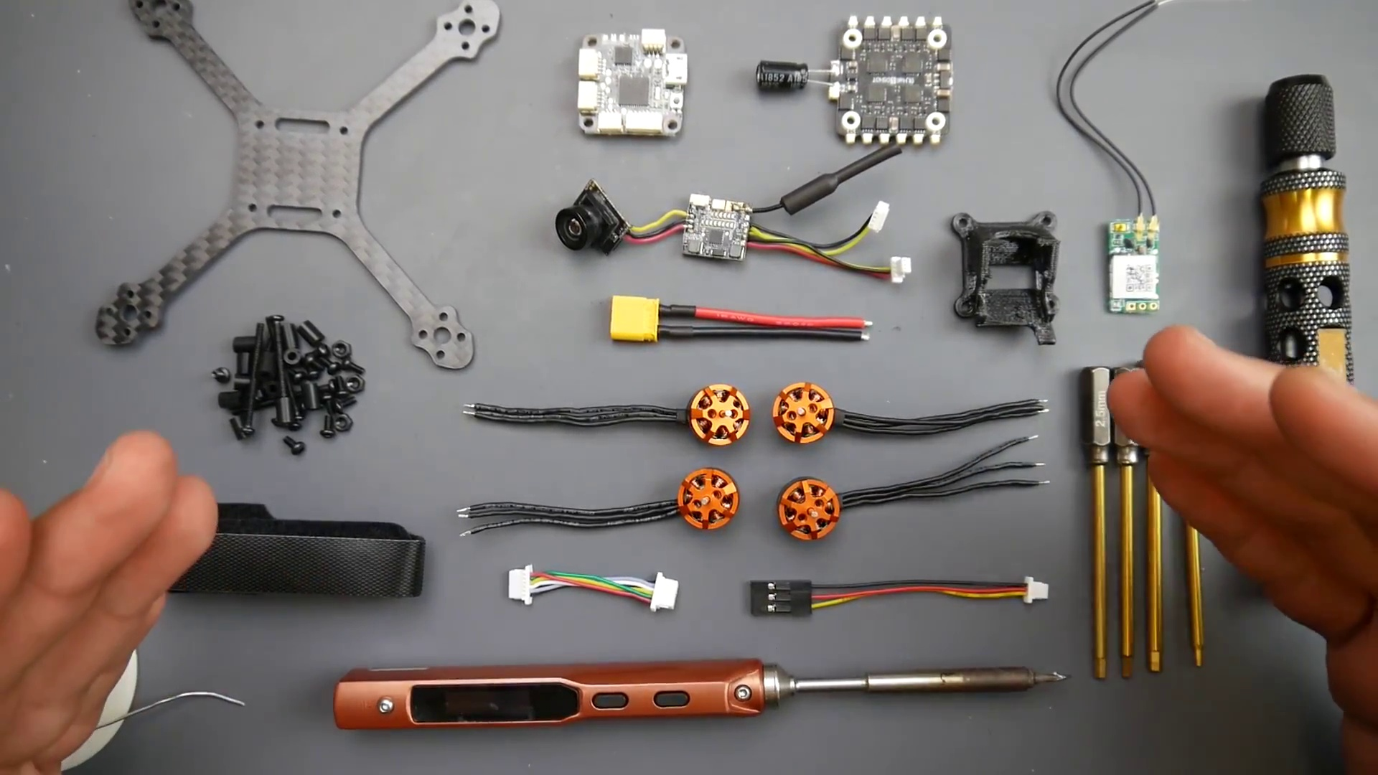 | 0:22   | 0:23   | 0:23   | 0:23  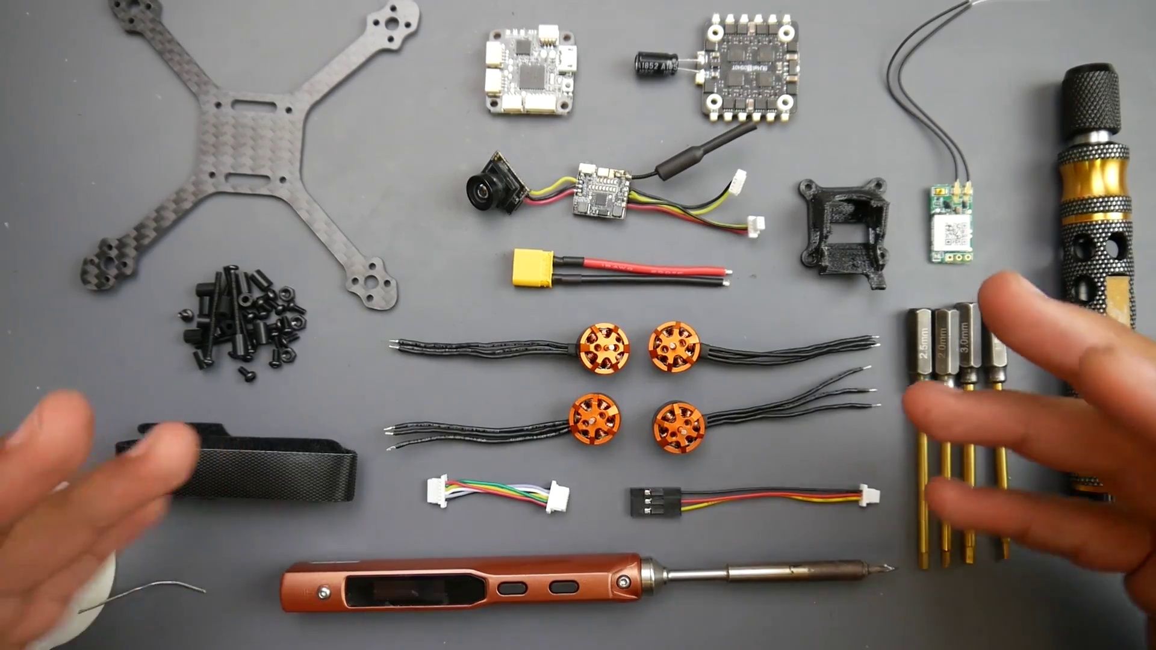

Transcript
(No speech detected in this section)

Section 0: Wrapping Up for Now
Time: 0:24 - 27:28

Summary
The host wraps up the video, stating that he will see his viewers in the next one.

Representative Frames
4:54  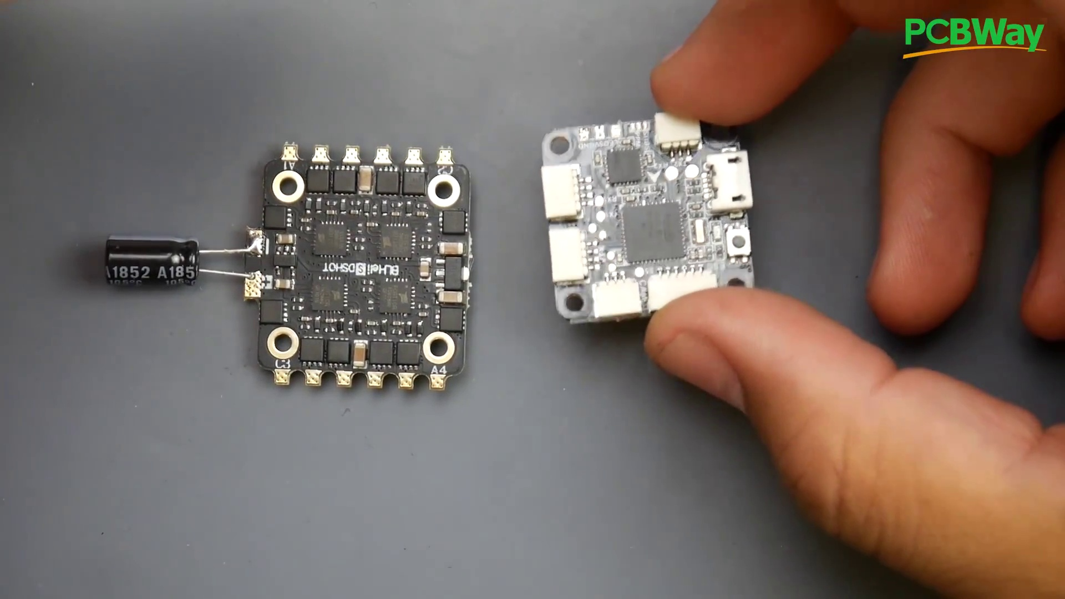 | 9:25  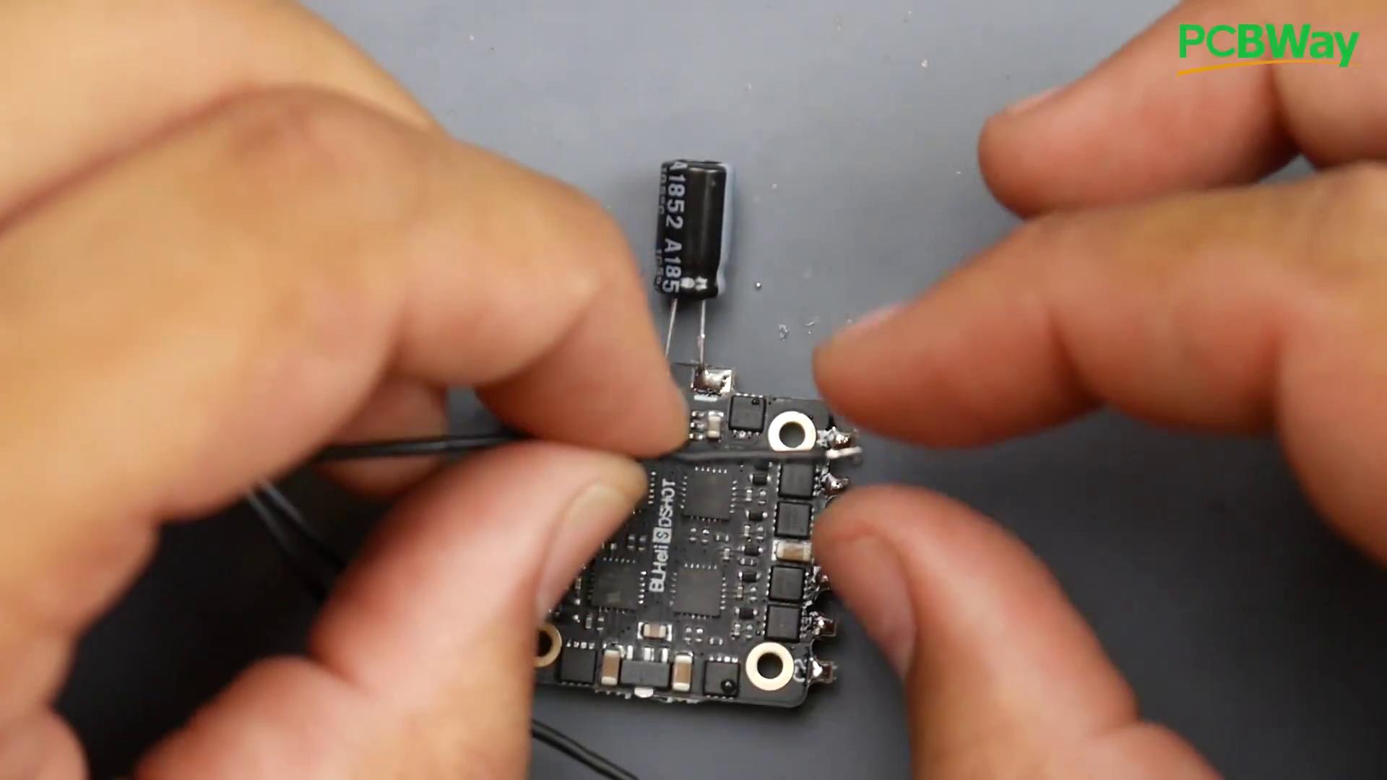 | 13:56  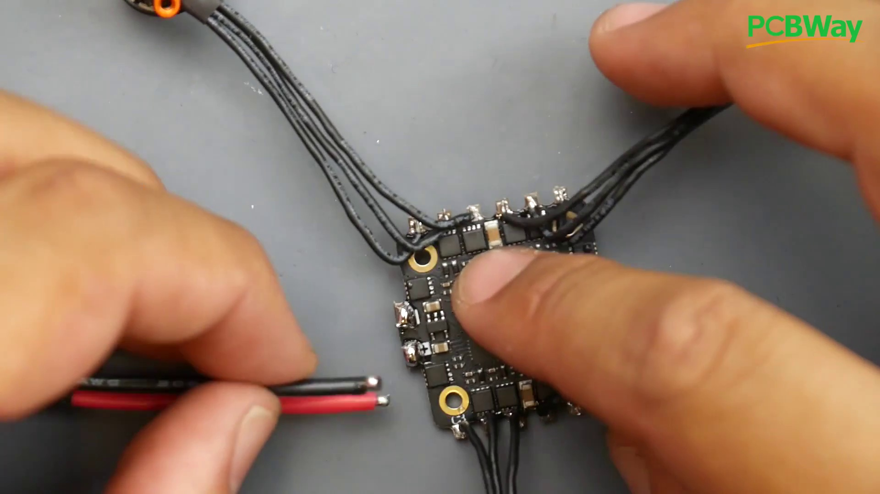 | 18:27  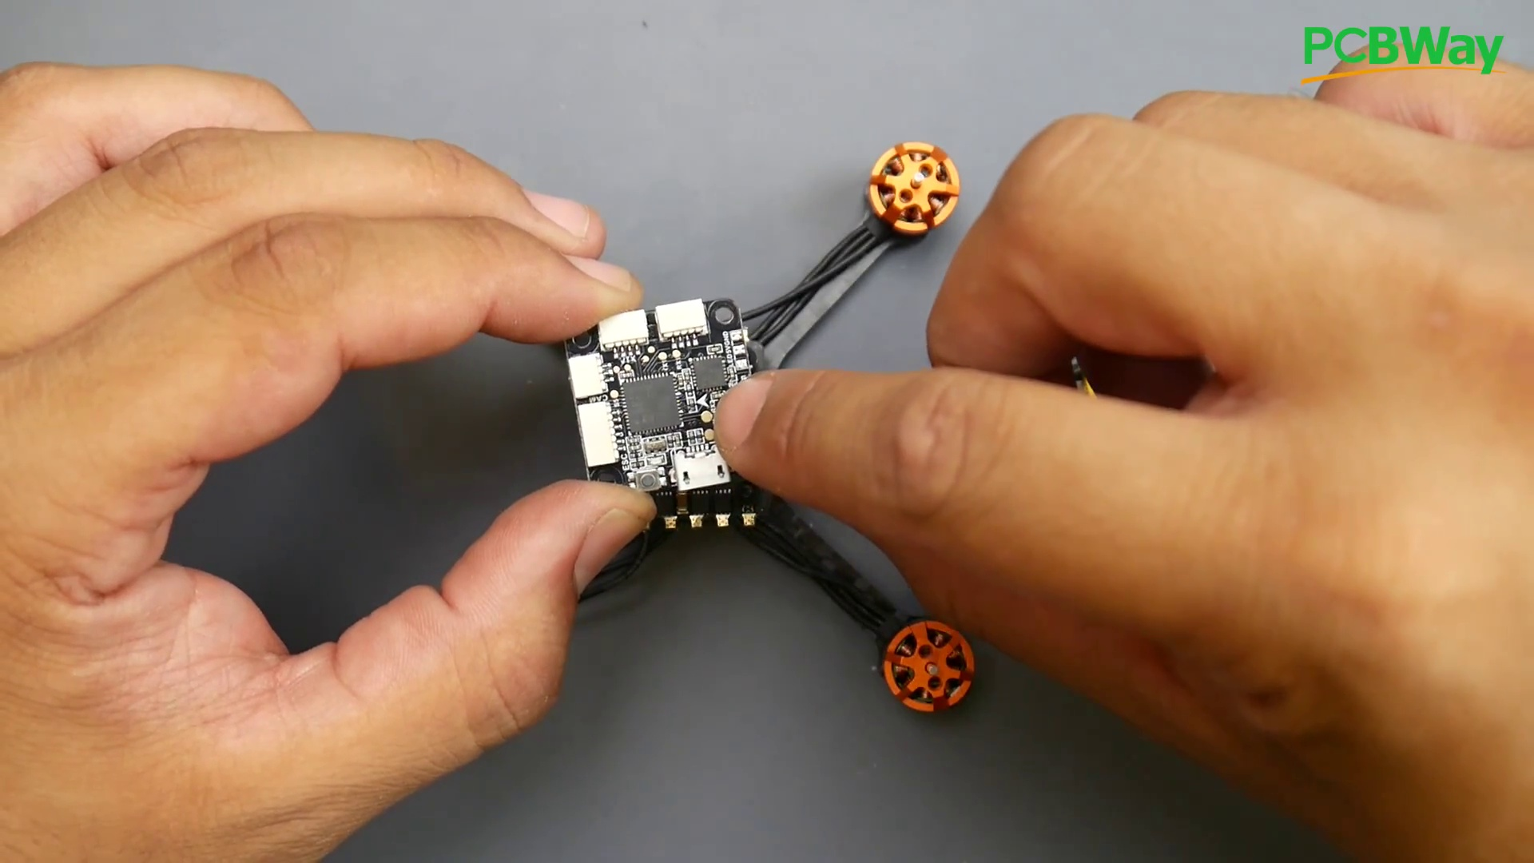 | 22:57  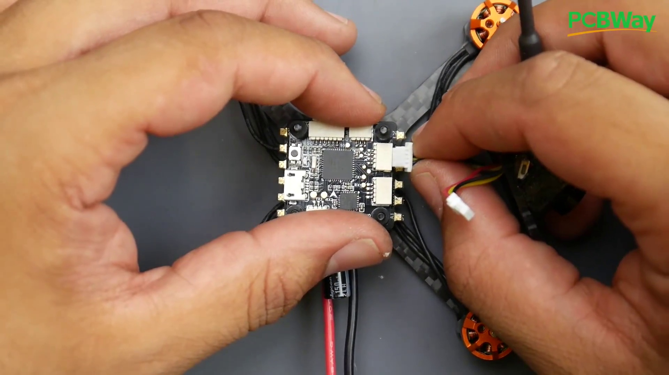

Transcript
[0:23] So we're going to do this together as fast, efficient, yet full of detail as possible.
[0:28] So PCBWay is one of the leading PCB manufacturers that I even use on a daily basis,
[0:33] not only to do my projects, but also some of the products that I've designed that's currently in the market,
[0:37] like the Drone Mesh VUSB, and I'm constantly using them for prototyping,
[0:42] and I'm also using their assembly services, and they also do have flashing services for specific hardware requirements.
[0:47] So it's a really great place to have your PCB manufactured or prototyped.
[0:51] All right, so let's talk about some of the tools we're going to need, because we're not going to really need much,
[0:54] and also some tools I'd highly recommend, which have dropped in price pretty insane.
[0:59] So this right here is a soldering iron. This is a portable soldering iron.
[1:02] This thing used to go for $80, $90. That's when I got mine, and right now it's like $40 or $50.
[1:08] This is the thing that I carry with me to the field always.
[1:11] I replaced big motors, big XC60, and I'd highly recommend this little tool, and it can run as your main driver.
[1:19] I've had this running as my main driver before, because it is just a well-built beast, and anybody would tell you that.
[1:25] So for this build, we're actually going to be using this to show you how good it actually is,
[1:29] and we're using this flat tip that it comes with. This will be really good, especially for this small stuff right here.
[1:34] Also, something that's not included in the kit is the tools.
[1:37] I do highly recommend this tool right here. I've been using it for quite a while.
[1:40] You'll probably see it in a couple of my videos.
[1:42] If you are thinking of getting into drones, this is a must-have tool, because this is titanium-coated,
[1:47] and these are hex drivers, and every single size you're going to need, which is 1.5mm all the way up to 3mm.
[1:53] Usually, all micros are 1.5mm, and that's the only thing we're going to be using for this whole build.
[1:58] So we're just going to stick this one on and take it out, and especially in the field, this is very useful,
[2:02] because it takes less space, so you just carry those and then just put them in here.
[2:06] Next thing that we're going to need, which they don't provide, is a receiver.
[2:09] Now, I'm going to be using the XM Plus radio here.
[2:12] If you're using FlySky, then they have other receivers.
[2:15] However, I'll have some iBus receivers, which are FlySky receivers linked down below,
[2:19] and I'll also have some FRSky receivers for the FRSky system.
[2:24] So again, I'm using XM Plus.
[2:25] They're super cheap.
[2:26] They get great distance and really great to use overall.
[2:30] All right, so now let's take a closer look at what the package actually gives you.
[2:33] It gives you a bunch of propellers, which is something you're going to need,
[2:36] and that's quite a lot, which is really nice, and they've also labeled them for you.
[2:39] So this would be the R.
[2:40] This would be the normal, and we'll get into how to place these in a bit.
[2:44] Now, they provide you with the four motors, almost cut to the exact length you'll need,
[2:48] but I'm going to show you a nice trick to keep it super clean
[2:50] and reduces your chance of actually ruining something when soldering these motors.
[2:55] So they give you the motors.
[2:56] They're 1105, 8,500 kV.
[2:59] Sorry, 1104, 8,500 kV.
[3:02] And the 8,500 kV is what I consider the sweet spot for these types of builds
[3:06] because you can run either a 2SHV or a 3SHV and still enjoy and get a bunch of efficiency.
[3:12] I will also have these motors tested on my benchmark in a later video
[3:15] so we can compare it to the other motors in the market.
[3:18] Now, they will give you every single connector you're going to need,
[3:20] and what's really nice about this, you're not going to have to solder much.
[3:23] All you're going to have to solder is your receiver, the XT30, and the motors, and that's about it.
[3:30] So here we have three wires, five, so with the two here, so that's five wires.
[3:34] And then here we have three times three, which is, oh, sorry, three times four, which is 12.
[3:39] So we have a total of 17 things to solder, and everything else is using connectors.
[3:44] So also something really nice with the kit is they give you the camera already pre-soldered and ready
[3:48] with just the connectors here, and I'll show you where those go.
[3:50] Those will go on the flight controller.
[3:51] All we have to do is connect them, insert it into the 3D printed part to hold it in place,
[3:55] and we'll be done with the camera in VTX, which makes our life really, really easy.
[3:59] Also, the ESC they're using is actually a pretty good ESC.
[4:03] I'm quite surprised at the ESC they're using.
[4:05] I'm pretty sure you'll probably break the thing before you ever burn this ESC.
[4:10] But then again, this is all theoretical.
[4:11] Just because the filtration is really good, especially for something of this size,
[4:15] and the fact that they even provide you with an installed 150 microfarad low ESR capacitor here.
[4:19] And it is a Rubicon, which is pretty insane.
[4:21] That's a well-known brand.
[4:23] It's a pretty good brand here.
[4:24] However, we're going to have to shorten these leads,
[4:26] or you're more than likely to actually ruin this thing if these two touch the carbon fiber frame
[4:31] because it's going to be sitting solo to the frame.
[4:33] So once we get into that step, we'll take a closer look at that.
[4:36] Now, for the flight controller, they're providing us with an F4 flight controller,
[4:38] which is really great.
[4:39] And it has all the features.
[4:40] We have the OSD here.
[4:41] We have, I think, an MPU 6000 gyro, USB.
[4:44] Obviously, everything has USB.
[4:46] And connectors for everything you're going to need.
[4:48] So usually, I'd recommend we start with the flight controller here.
[4:51] But the flight controller doesn't need anything soldered onto it.
[4:53] And it's just connectors.
[4:54] So we're going to keep it for later.
[4:56] So for this ESC, it does matter which way you place it,
[4:58] or else you have a nightmare and you won't know why.
[5:01] With the arrow here pointing forward, this should be on top.
[5:04] Because if it's not on top, it'll never fly.
[5:07] Because the motor ordering will be completely different.
[5:09] So keep that in mind.
[5:11] Now, when I mentioned earlier that the motor wires were almost perfect length.
[5:15] So instead of cutting them and making ourselves a bit more time,
[5:18] and just making it more time consuming,
[5:20] we can do a nice little trick that'll make it look like a professional's job.
[5:25] All right.
[5:26] So the first thing now I want to do is I want to just apply power.
[5:29] I have this little cheap wool adapter that actually fits here,
[5:32] and it's 12 volts.
[5:33] And we can go ahead and start this guy up.
[5:36] I just want to see what temperature I have it set to,
[5:37] because I don't know.
[5:38] 400, which is maximum.
[5:40] This comes with different crazy firmwares that you can set up.
[5:42] I just left it on default.
[5:44] And we can watch how quickly it heats up.
[5:46] It depends on the power supply that you're using for it.
[5:48] It just dictates how fast it heats up.
[5:51] So we'll just let that heat up real quick.
[5:53] Now, something you should always be aware of here.
[5:55] If you're going to set your temperature slightly higher than,
[5:57] let's say, 350 degrees Celsius,
[5:59] you want to add solder.
[6:01] Keep adding solder onto this every, you know,
[6:03] like a couple minutes or so,
[6:05] and cleaning it off.
[6:06] Because before you start soldering,
[6:07] you always want it to look like this.
[6:09] You want it to look super shiny and super clean.
[6:12] And that means that the heat's going to transfer very quickly.
[6:14] And you're not going to hold it there for half an hour.
[6:15] Nothing happens.
[6:16] And that is a usual case why, for example,
[6:18] the wire would not stick to the pad.
[6:21] And another thing to take note of here
[6:22] is you don't want to hit it with the tip just like this.
[6:25] You want to actually kind of get as much of a flat area as possible
[6:28] to land on it.
[6:29] So if it's not really melting,
[6:31] then kind of just do this little twisting motion
[6:33] and it'll push that wire right into place.
[6:35] Now, I did hire a new assistant
[6:37] and I've actually noticed a couple things he was doing wrong,
[6:40] which I was really hoping that I'm going to come here
[6:42] and show you today.
[6:43] And I'm very happy that that's going to happen.
[6:45] So for the ESC, what we want to do first,
[6:47] we want to add the solder to the pads.
[6:49] This is the top here.
[6:50] But the trick here is we're going to add them to the bottom.
[6:53] And why is that?
[6:54] It's so we can make the motor wires really nice and clean.
[6:56] So we're going to start adding solder to the pads.
[6:59] Now, take a note of where I'm starting.
[7:01] I'm starting from the left here,
[7:02] but this is really dangerous
[7:03] because I can have some solder come to here
[7:05] and burn a component off.
[7:08] So instead, I'm just going to go here
[7:09] because I have less risk of actually burning anything
[7:12] coming down to the right.
[7:14] What I like to do first always is touch the pad
[7:17] and then add the solder to both the pad
[7:20] and the soldering tip.
[7:22] And there we go.
[7:22] We have our first little solder blob thingy.
[7:24] Now, again, I'm touching half of the pad here
[7:27] and I'm going to come and just add the solder on the pad.
[7:30] And there we go.
[7:32] Now, as you can tell,
[7:33] my soldering iron tip is getting pretty full and dirty.
[7:36] So I'm just going to clean it slightly.
[7:39] Now, if you are using water,
[7:40] the temperature will drop slightly.
[7:42] So you'd want to just wait a tiny bit
[7:43] and make sure the tip is back up to temperature here.
[7:46] But we're soldering at 400 degrees right now.
[7:48] So it should be pretty good.
[7:50] And you can kind of see the technique.
[7:52] Try to understand what I'm doing here.
[7:54] And don't be scared of keeping the tip on for too long.
[7:58] I mean, don't keep it on for like 30 seconds.
[8:00] But it's fine if you keep it there for five seconds.
[8:03] That's totally fine.
[8:04] I'll even show you that right now.
[8:05] So I have the tip.
[8:07] One, two, three, four, five, six, seven, eight, nine.
[8:14] Nothing happened.
[8:15] You see that?
[8:16] And did you see how it flicked?
[8:17] That's very dangerous
[8:18] because this little solder blob right there
[8:20] could have landed somewhere here
[8:21] and I couldn't see it.
[8:23] And once I applied the battery,
[8:24] then the whole ESC could short circuit.
[8:27] And then people start complaining,
[8:29] oh, this is the worst product on the planet.
[8:32] And that usually does happen actually quite a lot.
[8:34] So we'll just add a little bit more here
[8:36] and add a little bit more here.
[8:38] You want to see them really shiny.
[8:40] So that's really good.
[8:42] There we go.
[8:43] See, this last one wasn't really great.
[8:45] So how would you fix one that's sticking up like this?
[8:47] You kind of see that.
[8:48] You just come in just really flat
[8:50] and then just push out.
[8:52] And that looks really great.
[8:53] So now we've added that.
[8:55] Now, what's really great with these wires
[8:56] is they have some solder on them.
[8:58] So it's just going to make our life a little bit easier.
[9:00] Now, if they didn't, you'd want to strip them,
[9:02] twist them and add solder
[9:03] before you solder to the pads here.
[9:05] So and again, keep in mind,
[9:06] this is the bottom side right now.
[9:09] And we're going to do something
[9:10] a little bit different here.
[9:12] So what I'm going to do is
[9:13] I'm going to straighten out the wires
[9:14] just like that.
[9:16] And I'm actually going to install them like this.
[9:18] So I'm going to do again,
[9:20] start from this side
[9:21] so I don't risk damaging a component here.
[9:23] So I'm going to come like this
[9:25] and then install that right there.
[9:28] Now, a really nice technique to do this
[9:30] is to heat up the pad first,
[9:31] just slightly,
[9:33] and then come in with the wire.
[9:35] And you don't have to be in a hurry.
[9:37] Just take your time
[9:37] and put that into place.
[9:39] Now, we didn't have much solder
[9:40] on the pad already,
[9:42] but we'll come back and fix that later.
[9:44] Let's move on to the second one here.
[9:47] So there we go.
[9:48] So here's the other one.
[9:49] We're going to add some heat,
[9:51] melt the pad,
[9:52] and then come back on top of the wire here.
[9:56] There we go.
[9:59] And we're going to do the same thing to this one.
[10:02] You could trim these off.
[10:03] I'd highly recommend you trim them off
[10:04] before you start soldering.
[10:07] So there we go.
[10:08] And be careful touching the ESE.
[10:09] It's actually toasty right now.
[10:11] Really, really toasty.
[10:12] So the whole idea of why I did it this way
[10:14] is because when we flip it over,
[10:17] it's going to look really nice once you install it.
[10:19] So these motor wires will just go in like this
[10:22] and they'll be really flat
[10:24] and it'll just be perfect.
[10:25] It's not going to have any bends or creases or anything
[10:28] that's sticking out of the quadcopter
[10:30] for it to catch on anything.
[10:31] But as you can tell,
[10:32] these were slightly longer than we'd like them to be.
[10:34] And I'll come back and fix this later.
[10:36] And here we're going to do one more together.
[10:38] Now, if you're going to cut wire,
[10:39] never cut wires on top of any component
[10:42] because it could also create a pretty big nightmare.
[10:44] So I'm going to trim these slightly a bit here
[10:46] and I'm going to do the same thing.
[10:47] And again, taking I am on the bottom again,
[10:49] there is no arrow here.
[10:50] Now, the motor wire order doesn't really matter right now.
[10:54] So because the whole idea here is
[10:57] you can always anytime
[10:58] if the motor is not spinning in the correct direction,
[11:00] just flip any two wires
[11:02] and it'll spin in the right direction.
[11:04] So don't stress that part too much right now.
[11:09] There we go.
[11:10] And right now I'm not really heating up the pad
[11:13] because it's a really small pad
[11:16] and the heat is going to transfer really well.
[11:21] So here, I just want to...
[11:22] There we go.
[11:24] All right.
[11:25] So this is on 400 right now.
[11:27] So you're going to have the same exact experience as me
[11:29] while you're soldering.
[11:31] Just make sure you're comfortable.
[11:33] That's one of the most important things
[11:35] when you're soldering, in my opinion,
[11:36] is you're comfortable.
[11:38] Okay.
[11:39] Nothing is touching.
[11:39] They're very well-placed paths.
[11:41] They're very far apart from each other.
[11:43] And this one, again,
[11:44] I'm going to come back and fix up later on.
[11:47] All right.
[11:47] So I'm going to skip the rest of the motors
[11:49] and then we'll see what is the next step.
[11:51] All right.
[11:51] So now when we're done,
[11:52] we should have something that looks like this.
[11:54] Now, the next thing I want to do
[11:55] is actually remove this low ESR capacitor.
[11:58] And it's going to be a little bit tricky
[11:59] because we're going to have to heat up this side
[12:01] because it's actually sticking in
[12:03] through the hole right here.
[12:04] Or we can do something just a lot easier
[12:07] and we can actually just cut it.
[12:08] I mean, that'll just work really great.
[12:10] There we go.
[12:11] We don't really have to worry about these
[12:12] and they can even stay in there.
[12:13] It's not really a big problem.
[12:14] All right.
[12:14] So now once the capacitor is removed or cut off,
[12:17] we're left with shorter leads
[12:18] and this is exactly what we want.
[12:20] However, what we also want to do is
[12:22] since it was on the bottom side,
[12:23] we actually want to put it on the upper side.
[12:26] However, we're going to leave this step for now
[12:27] and bring in our XT30
[12:28] where our battery will be connected,
[12:30] supplying power to the whole micro quadcopter here.
[12:33] Now I want to install this on the bottom side
[12:35] and you'll see why
[12:37] once we actually start putting this together,
[12:39] it reduces the chances of the positive and negative
[12:42] touching the carbon fiber frame
[12:44] because it is conductive
[12:45] so we don't have a short circuit
[12:47] and blow the whole thing up.
[12:48] So I'm going to come in
[12:50] and I'm just going to add solder to the pad.
[12:51] Same thing we did with the motor wires.
[12:53] Same thing here.
[12:54] Now, if you have the same soldering iron,
[12:56] you need to take something into consideration.
[12:58] If you leave it for a while,
[12:59] then it'll just go into sleep mode
[13:01] and drop the temperature.
[13:03] So you might just have to wait
[13:04] just a tiny bit for it to come back.
[13:06] It won't drop it all the way to zero
[13:07] and it'll quickly gain its temperature back.
[13:11] So now we've added solder to that.
[13:12] Now, here's a really nice technique.
[13:14] I usually like to bring my solder
[13:15] and just stand it up straight,
[13:18] even though these have solder on it,
[13:19] but I don't know how old it is.
[13:21] So I stand it up straight
[13:22] and then I would come in,
[13:24] add solder to the bottom of my soldering iron,
[13:28] tip,
[13:28] and then start following along
[13:30] just like this while holding the wire.
[13:33] And now I have a really nice solder on the wire.
[13:36] However, you need to take something into consideration.
[13:38] The wire will get really hot
[13:40] and it's actually really toasty right now.
[13:43] So as you can tell,
[13:43] I'm not holding it anymore.
[13:45] So keep that in mind also.
[13:46] Heat is real,
[13:47] especially when you're soldering.
[13:49] It might not look like there's no heat,
[13:50] but there's a ton of heat.
[13:51] And if it touches you,
[13:52] you're going to burn yourself.
[13:54] All right.
[13:54] So now we're going to install the battery
[13:56] into place here or the XT60.
[13:58] And again,
[13:58] look,
[13:59] we are on the bottom side of the board.
[14:01] So I'm going to heat up the pad
[14:02] because these are bigger pads.
[14:03] And then I'm going to come in
[14:04] with the soldering iron on top of the wire.
[14:07] And that should give us a really nice connection.
[14:11] And that wire got really hot very fast.
[14:15] So here we go.
[14:16] And again,
[14:16] make sure the plus is the red wire
[14:19] and the minus or the negative is the black wire.
[14:22] And there we go.
[14:26] Try to resist the heat
[14:27] and keep it into place
[14:28] after you move the soldering iron
[14:29] for everything to cool.
[14:31] So now we're basically almost done.
[14:32] All we need to solder here now
[14:33] is the low ESR capacitor back into place.
[14:36] And how does this go back into place?
[14:38] Well,
[14:38] wherever these dash signs are,
[14:40] this will go to the ground,
[14:40] which is the negative.
[14:41] And then the other side
[14:42] is just going to go to the positive.
[14:44] And here,
[14:44] since we know we put these in the correct way,
[14:46] so we just put the negative side to the black here
[14:49] and then the other side to the red.
[14:51] So let's do this together here.
[14:53] Now,
[14:53] it's also really nice to add solder onto this.
[14:56] It'll help slightly transfer the heat a little bit better.
[14:59] And again,
[14:59] I'm just going to stand up my solder
[15:01] and just touch it here.
[15:04] Just add on this.
[15:06] Sometimes it won't stick.
[15:07] It might not look like anything,
[15:09] but it'll help in the long run here.
[15:11] All right.
[15:12] And this side where it has the dashes,
[15:15] as you can tell,
[15:16] is going to go to the ground.
[15:18] But I'm going to start with the positive
[15:19] because I think it'll be a little bit easier for me.
[15:21] So I'm going to push this one
[15:23] a little bit out of the way for now.
[15:25] We could always bring it back into place.
[15:27] So I'm going to heat up the pad.
[15:28] Now we're on top of the ESC here.
[15:31] So I'm going to heat up the pad here.
[15:33] And then I'm going to bring in this guy into place.
[15:37] You don't want to heat up the pad too much
[15:38] because it might desolder the bottom one.
[15:40] So keep that in mind.
[15:41] All right.
[15:44] Now I'm going to do the same thing here.
[15:46] I'm going to heat up the pad.
[15:49] Try not to touch anything like I did.
[15:53] Okay.
[15:54] There we go.
[15:56] And that should not be touching anytime soon
[15:58] because now the frame,
[15:59] the carbon fiber is on the bottom here.
[16:01] Even if this were to bend,
[16:03] it's not going to touch the frame
[16:04] because this is acting as an insulator
[16:06] because it's pushing it away.
[16:07] However, if this twists and these two touch together,
[16:10] then you'll have a really big problem.
[16:12] This will probably pop,
[16:14] but it's not really high voltage,
[16:15] but you know, just, yeah, just be careful.
[16:18] So now the ESC is basically done
[16:20] and it looks like a moving spider here.
[16:22] Look at this.
[16:24] Wait.
[16:25] All right.
[16:25] So now we have the frame into place
[16:27] and you want to bring in the longest screws
[16:30] and there's only four of these guys.
[16:32] So let's bring those into place.
[16:34] We're just going to install them
[16:35] and keeping them standing.
[16:37] Up for now.
[16:38] This is the easiest way to do it.
[16:40] So right now they're just standing into place.
[16:42] I'm going to lift this up.
[16:43] They're going to go right in,
[16:45] flip it over and then put it down.
[16:47] So now the screws are all standing up here.
[16:49] We're going to get any four of these,
[16:51] you know, these little dampeners here.
[16:54] I'm just going to install them into the frame.
[16:56] So now we have one on each screw here.
[16:58] So the thing is,
[16:59] I don't want to lift it up
[17:00] because they're all going to come down
[17:01] unless I hold it like this.
[17:02] There you go.
[17:02] You can kind of see that now.
[17:04] So the next step is obviously insert the ESC,
[17:06] but it does matter how you insert the ESC.
[17:09] You want the holes to be on the side
[17:11] so the battery will hold like this
[17:12] unless you want the battery in another way.
[17:14] That's your decision.
[17:15] But usually the battery is forward and back.
[17:18] So you want these to be on the sides,
[17:20] the holes to be on the side.
[17:21] And then we're going to figure out where's the front.
[17:23] We're going to call that the front.
[17:24] So we want to make sure that the arrow is on top
[17:26] so we can see it
[17:27] and that it's pointing forward.
[17:29] And that is perfect.
[17:30] And we're just going to slide this guy right in.
[17:32] And now we're going to install the motor screws,
[17:34] which I'll skip over.
[17:35] However, the screw is going to be this one
[17:37] and it's not going to be very hard to find it
[17:39] because you only get four long screws
[17:40] and a bunch of these little ones
[17:42] that are exactly the same size.
[17:44] And those are for your motors.
[17:45] So I'm going to go ahead and start doing that.
[17:47] All right.
[17:47] So once the motors are installed,
[17:48] it's going to look something like this.
[17:50] Now what you want to take note of is
[17:51] it's going to kind of act like a spring
[17:53] because of the motor wire.
[17:54] So what you want to do is push kind of hard,
[17:56] just allow them to bend into place here.
[17:58] Make sure all the motor wires are going from the inside part
[18:01] to make your life a little bit easier.
[18:03] So the next step is to add more of these little rubber ones
[18:06] and they're all the same size.
[18:07] They're actually, it seemed like it used to be like a tube
[18:10] and they just had one guy cutting it piece by piece.
[18:13] So they're not all cut perfect,
[18:14] but I mean, what do you expect for 70 bucks or something?
[18:17] So here's the arrow pointing forward.
[18:18] Now this is very important also.
[18:20] So the arrow is pointing forward.
[18:21] You want to find the arrow also on the flight controller,
[18:24] which is right there.
[18:25] It's right in the middle right there.
[18:27] It's saying this way.
[18:27] So I'm going to install the quadcopter like this
[18:30] and that's the arrow.
[18:32] And then I have my four rubbers here.
[18:34] So there we go.
[18:35] My arrows forward.
[18:37] Awesome.
[18:38] So now we have those set into place.
[18:41] Now I'm going to bring in some more rubbers
[18:43] right on top of this.
[18:45] They provide you with a total of 12, 12, no, nine, no 12.
[18:50] So they give you a total of 12 here
[18:52] and we have those set into place.
[18:54] And I'm just going to give you an example here
[18:56] without having to lose these.
[18:58] So you can kind of see how it is.
[19:00] We have one rubber, two rubber, three rubber here.
[19:02] All right.
[19:02] So now let's connect the electronic speed controller
[19:04] or the ESC to the flight controller.
[19:06] And it's done with this connector right here.
[19:08] It's the biggest and shortest one.
[19:10] So this connector is going to connect right into the big connector
[19:13] up in front of the flight controller, which is the arrow.
[19:16] That's going to go straight down.
[19:18] Now, if it's not going in, then you want to flip the connector
[19:20] and just be careful.
[19:22] Don't force it in.
[19:24] It'll go in very nicely if it's in the correct orientation.
[19:28] There we go.
[19:29] That's really nice.
[19:30] We're going to bend this slightly here
[19:31] because we don't want this hanging out later on
[19:33] and getting caught with a propeller.
[19:35] So now the ESC is actually connected.
[19:36] So if we actually gave this power right now, the motors would light up
[19:40] and the flight controller will light up and just about everything.
[19:43] All we're missing are the camera and the receiver.
[19:47] So let's go ahead and prepare the receiver
[19:49] and I'll show you how this will actually work.
[19:51] So I'm going to just cut these off just like that.
[19:55] And these are not silicone for some reason or some sort of...
[19:58] So stripping these might be a bit difficult
[20:00] if you don't have the correct tools
[20:01] or you don't have the experience to do it.
[20:04] So I just did it with a little cutter right here.
[20:06] All right.
[20:07] So now I've gone ahead and twisted the wires up top here.
[20:10] Once I stripped them, I'm just going to add some solder to these
[20:13] because these are going to go into our receiver here.
[20:16] And the other side where the white connector is,
[20:18] is going to go into the flight controller.
[20:21] So I'm going to trim these wires because they're a bit too long.
[20:23] And again, don't cut or solder on top of any electrical component
[20:28] nor the motors themselves.
[20:29] So keep that in mind.
[20:31] So here I have my XM plus radio
[20:33] and I'm going to go ahead and solder onto it.
[20:36] Now, if I remember correctly, this is SBUS.
[20:38] And then I think it's 5 volt, then it's ground.
[20:42] But I could be wrong.
[20:44] I'll double check later, but I'm going to install them like that right now.
[20:47] So if you had IBUS, then the yellow wire would be your signal, your IBUS.
[20:52] And if you had SBUS, then the yellow wire would be your SBUS.
[20:56] However, we do need to make a modification on the flight controller for the receiver to actually work,
[21:01] which is choosing if it's going to be IBUS or if it's going to be an SBUS.
[21:07] And this is very important that you know the difference
[21:09] and know what your transmitter could broadcast that.
[21:14] All right.
[21:14] So now we have the receiver here.
[21:16] So the modification we're going to have to do to the flight controller
[21:19] is going to be somewhere pretty, pretty tiny, which is these three pads right here.
[21:24] Now, if you're going to be using SBUS, these three pads here,
[21:27] the middle one is going to have to be bridged with the left one.
[21:31] If you're using IBUS or PPM, then the middle one is going to have to be bridged with the right one.
[21:37] Don't bridge all of them together.
[21:39] So let's try to attempt this together here.
[21:43] This is really nice, but I wish these pads were slightly larger to help new people
[21:48] because it can be pretty hard.
[21:51] See, like right now, you see how difficult it is for me to solder?
[21:54] That's because it went to sleep mode and then the temperature now is just coming back up.
[21:58] All right.
[21:58] So now they're bridging.
[21:59] I do apologize.
[22:00] I just looked up and it turns out I had it off camera
[22:02] because I had to bring it closer to me.
[22:04] And you can see now the middle one is bridged with the left one here
[22:07] because I'm using SBUS.
[22:09] And again, if you're IBUS, you bridge the middle one with the right one.
[22:12] And that's what we did here.
[22:13] So now our receiver is ready and we're basically done.
[22:16] So we just got to connect everything up together.
[22:18] All right, guys.
[22:19] So next we want to install the camera into the little canopy here.
[22:22] Now, I'd highly recommend you add some like double-sided tape behind the VTX.
[22:27] Now, it's very important that you see the solder is coming up from this side.
[22:30] And also you have this little extra piece taken out.
[22:32] It's telling you, oh, the antenna is going to go on this side.
[22:34] So it has the hole for the button here.
[22:37] Now, this will go into sideways.
[22:39] If you have it the other way, it'll just it just won't fit.
[22:41] So you have to put it in the correct way.
[22:43] And the wires, I've routed them through the back of the VTX down this hole.
[22:48] So now to know where these actually connect.
[22:50] Well, let's take a closer look.
[22:50] So here's the arrow.
[22:52] The VTX is going to go here or the four pin connector is going to go here
[22:56] because it's a four and a three pin connector.
[22:58] So this is the VTX here and that's in.
[23:02] And then the other one is the front one here.
[23:05] So again, here's the arrow.
[23:06] The USB is on the left.
[23:07] So this one here is where the camera would go in.
[23:10] And if you actually take a closer look at your board, if you do have this,
[23:13] you'll see the word cam right in between the big connector and the little connector.
[23:17] So now we have that in place.
[23:19] And obviously, we want the camera to point forward.
[23:22] So now once you put the nuts in place, don't think you have to tighten it from up here.
[23:26] So what we're going to do is we're going to have something holding up from the top
[23:29] and then we'll just use the screw driver from the bottom or the hex driver from the bottom
[23:34] to actually tighten it as we please.
[23:36] Now, try not to bend the VTX antenna so much because it'll probably end up breaking.
[23:41] And that goes for a lot of wires.
[23:43] So that goes even for motor wires as well.
[23:45] So keep that in mind.
[23:46] Try not to keep hitting it by mistake because soldering one of those back into place
[23:50] is much more difficult, especially if you're new.
[23:53] All right.
[23:54] So right now we're just tightening everything here.
[23:58] And like I mentioned before, you don't have to keep it.
[24:01] Just get the nut to grip.
[24:03] And then that's what she said.
[24:05] Yeah.
[24:05] So just get the nut to grip.
[24:07] And that should be good in that perspective.
[24:11] I had to redo this part a bunch of times because that's what she said.
[24:17] All right.
[24:18] All right.
[24:18] And this is how it's supposed to look like when it's complete.
[24:21] Really nice.
[24:21] Really simple.
[24:22] The guts are kind of sticking out, but that was the whole idea here.
[24:25] It's supposed to be all exposed, super light, 20 by 20 stack, which is actually pretty good
[24:30] that it's using a 20 by 20 stack.
[24:31] And again, if you take a look at the low ESR capacitor, this is the reason why I told
[24:34] you you want to solder it on top of the ESC instead of the bottom.
[24:38] So the battery wires here will not allow it to bend any further and touch this carbon
[24:42] fiber because it was also pretty long.
[24:44] So it would easily touch the carbon fiber, short circuited the whole thing.
[24:48] So keep that in mind.
[24:49] That's something really important.
[24:50] Also, if you're new, I actually don't recommend you add your motor wires to the bottom of the
[24:54] ESC.
[24:55] I'd probably do it on top of the ESC.
[24:56] It'd probably be a little bit easier and keep the extra slack and do something else with
[25:00] it.
[25:01] But if you just push it, it'll be fine.
[25:03] But it might be a bit fiddly for you if you don't have much experience.
[25:06] Also, the VTX here, it seems pretty stable, but I would definitely add some sort of something
[25:14] to hold it in place.
[25:15] I wouldn't add a zip tie because zip ties usually will tend to rip off components from
[25:20] here.
[25:20] So I'd probably add some double sided tape right below here.
[25:24] Hot glue won't work because if you add hot glue, it'll just basically melt because these
[25:27] do get pretty toasty.
[25:28] And for this antenna here, I'd want to secure it with possibly some sort of a zip tie that's
[25:35] going to go through here to here and just stick out like that.
[25:38] And then I'll just heat shrink something on top of it.
[25:41] And I'll actually do that.
[25:43] All right.
[25:43] So what I've done here is I should have actually left the zip tie slightly longer.
[25:46] But what I've done is obviously I brought a little fatter heat shrink, put it on top,
[25:49] and now it's holding the VTX with the heat shrink.
[25:52] And that's not going anywhere.
[25:53] It's just going to stay there.
[25:54] And you don't want this to keep playing because it'll eventually break off the solder like
[25:57] with any other wire.
[25:59] And it's looking pretty nice to be honest.
[26:03] I really like that yellow on there.
[26:05] Now what you'll be left with is the receiver.
[26:07] Right now it's like one in the morning and I really am tired and I just not going to have
[26:12] a nice solution for this just yet.
[26:15] But you can get creative.
[26:16] Like what I'm thinking of doing is probably putting it somewhere here on the side because
[26:21] there are some holes.
[26:22] Put a heat shrink around this and then use double-sided tape to hold it into place.
[26:28] I wouldn't put this on top of the flight controller because this is loose.
[26:32] And then these little touches will touch the gyro and make it do weird stuff.
[26:36] So you'll just not have a really pleasant experience and you won't know why.
[26:40] So the best thing overall to do is to put it somewhere here on the side just like this.
[26:46] And I'll figure that out in a later video.
[26:48] Or I might even design and 3D print something else for this quadcopter and I'll share it
[26:52] with you guys.
[26:53] So I'll be flying this within the next two days once the rain clears up because now we're
[26:57] starting to rain here.
[26:58] And I'll show you the final result of how I got it to be and share everything else with
[27:03] you guys.
[27:04] But this is how you build it.
[27:05] All you need to do is find a placement for your receiver.
[27:07] And it's 1 in the morning right now so I'm really tired and I can't really think of anything
[27:11] to do for that.
[27:12] And again, all the links are down below.
[27:13] If you could check them out, it does really support the channel.
[27:16] I'll have links to the batteries to use for this.
[27:18] I'll also have the links for the heat shrinks, the tools I use, and that soldering iron that
[27:22] we just used for this whole build here.
[27:24] And I'll see you in the next one.
[27:27] Peace out.

