Engagement Analysis: 35YuILUlfGs

Section 0: Image Description and Analysis
Time: 0:00 - 0:05

Summary
The output contains a series of image descriptions, each with a corresponding audio timestamp. The images depict various aspects of electronic circuit design and analysis, including PCB (Printed Circuit Board) diagrams, component labels, and circuit layouts.

Representative Frames
0:00   | 0:01   | 0:02   | 0:03   | 0:04  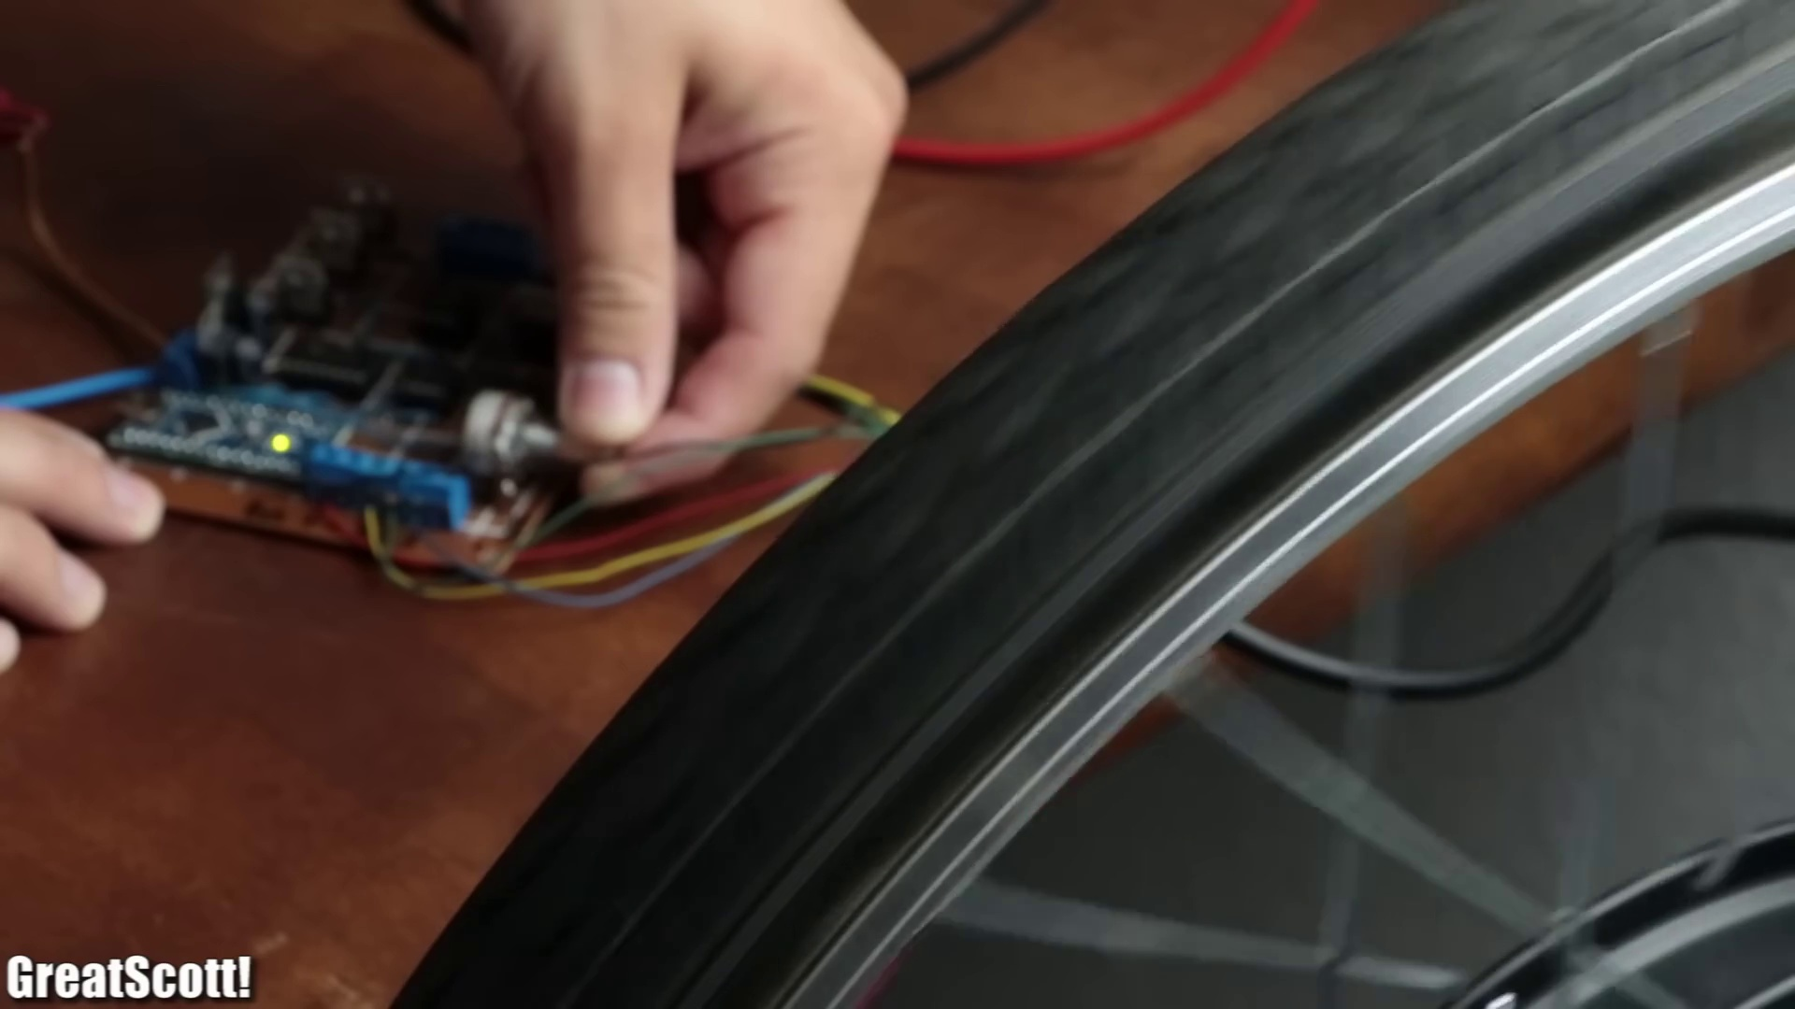

Transcript
[0:00] Let's face it, we've all been at one point where an electronic circuit works so well on perfboards

Section 0: PCB Design and Layout
Time: 0:05 - 0:10

Summary
The first image shows a computer screen displaying a detailed diagram of an electronic circuit with various components labeled and connected. The layout includes wires connecting different components such as resistors, a battery, and a light bulb.

Representative Frames
0:05   | 0:06   | 0:07   | 0:08  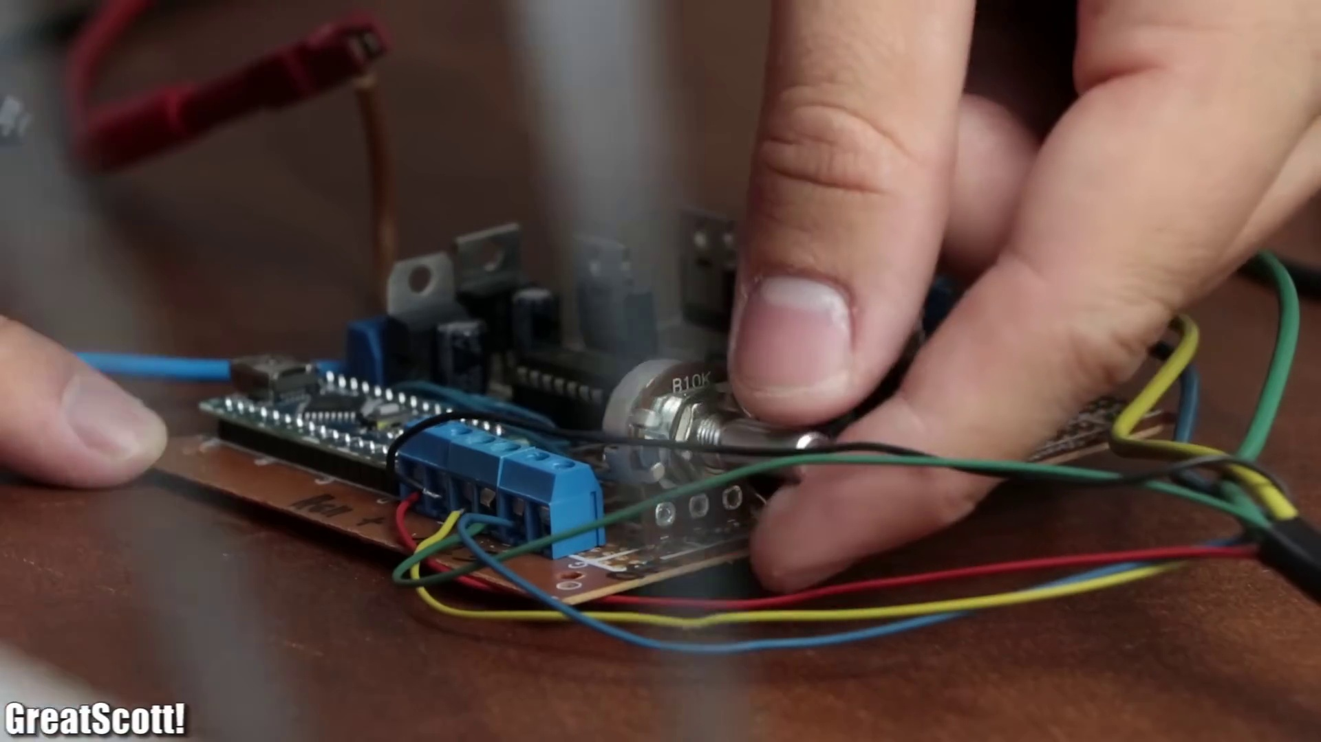 | 0:09  

Transcript
[0:07] that you want to build more units of it.

Section 0: Virtual vs. Actual PCB
Time: 0:10 - 0:15

Summary
The next image captures both the virtual representation of the circuit board on a computer screen and a close-up view of an actual printed circuit board (PCB). The two perspectives provide a comprehensive view of an electronic circuit, highlighting its complexity, organization, and functionality.

Representative Frames
0:10   | 0:11   | 0:12  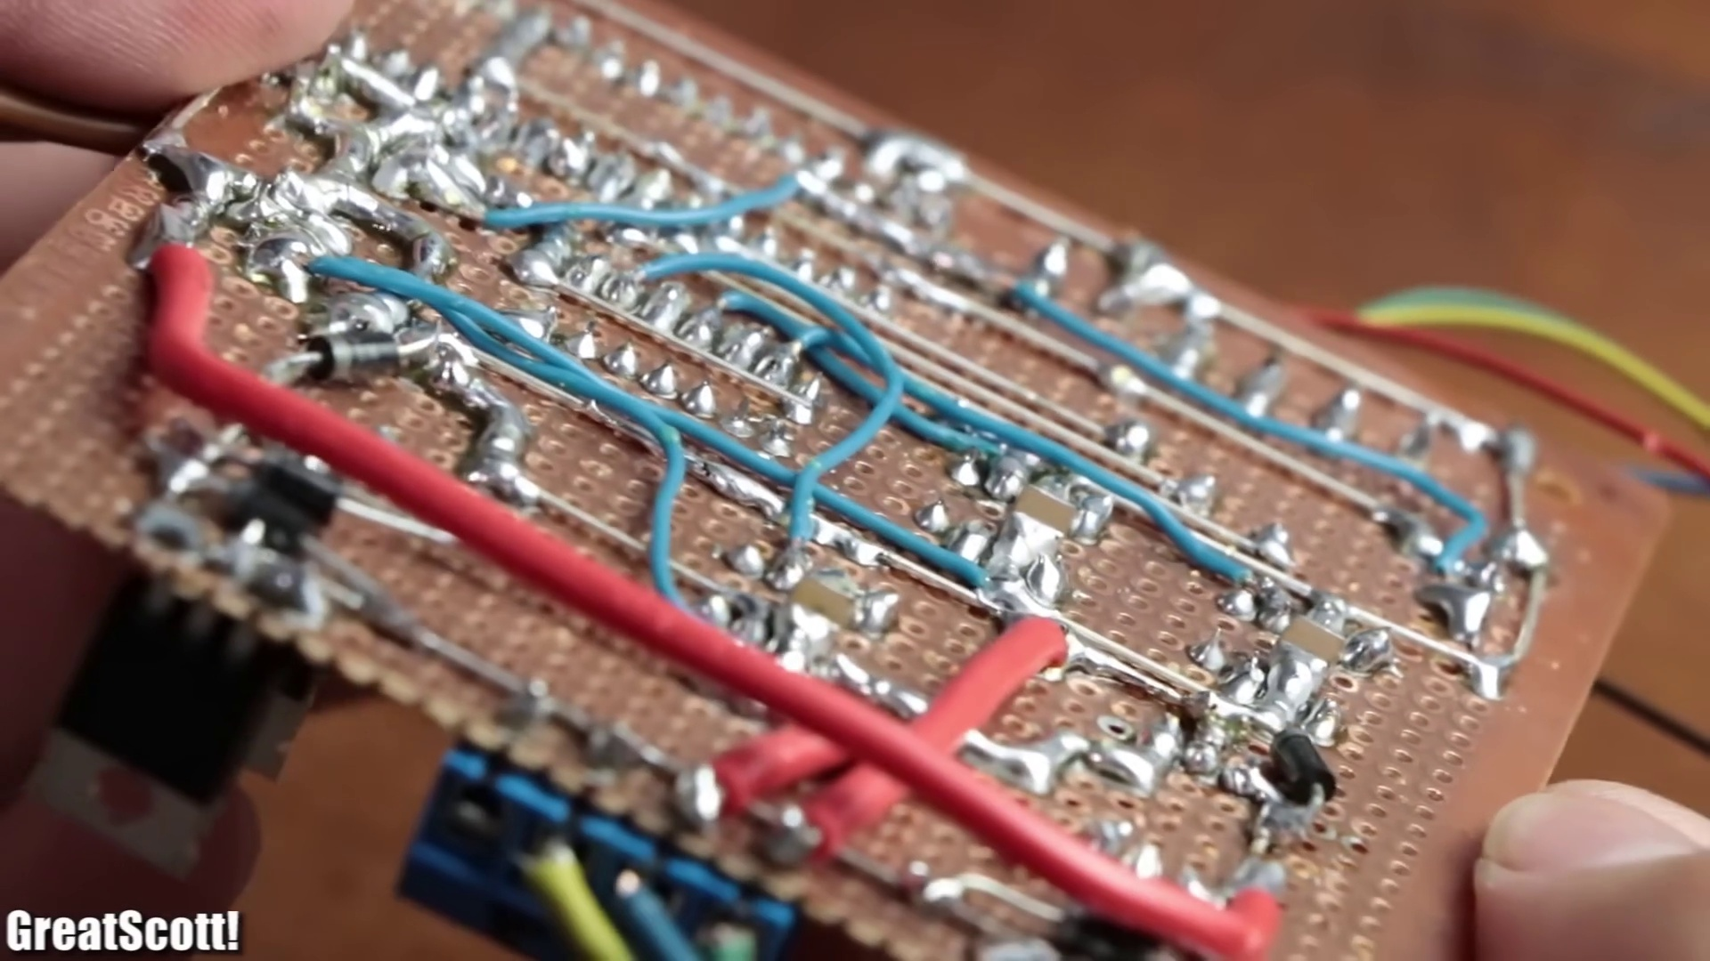 | 0:13   | 0:14  

Transcript
[0:09] But creating these solder traces takes up way too much time.

Section 0: Electronic Circuit Diagrams
Time: 0:15 - 0:20

Summary
The following images depict detailed diagrams of electrical circuits with various components labeled and connected. The layouts include wires connecting different components such as resistors, a battery, and a light bulb.

Representative Frames
0:15   | 0:16  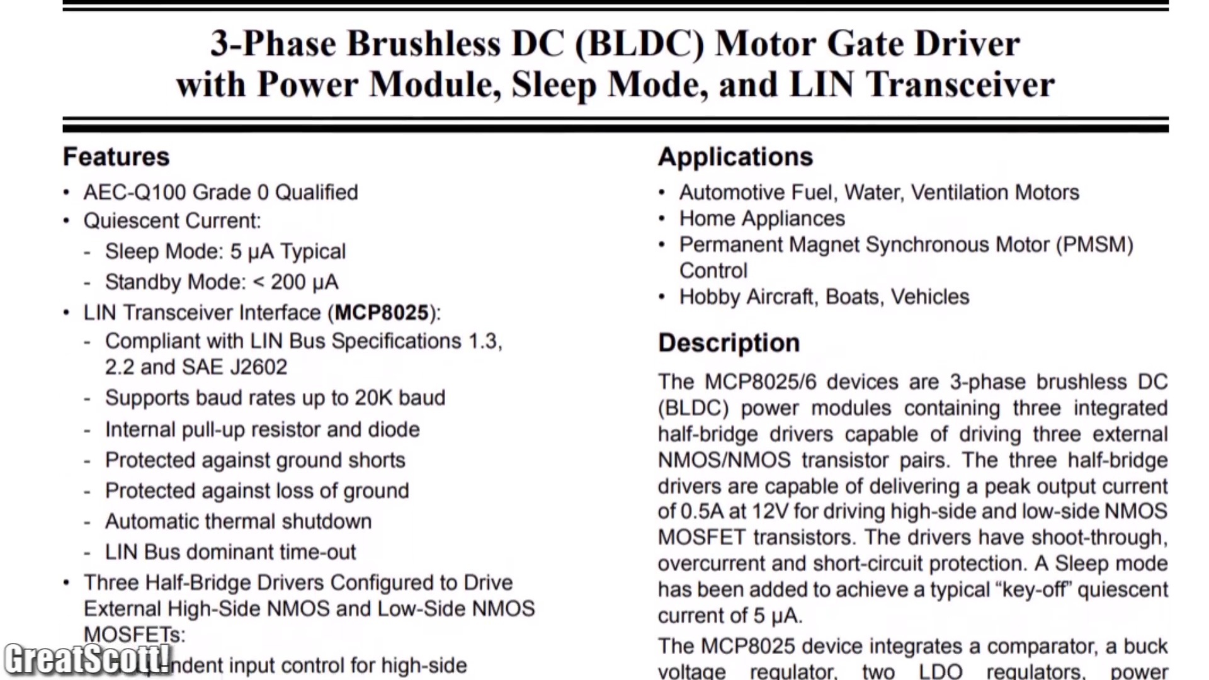 | 0:17   | 0:18   | 0:19  

Transcript
[0:14] Or you ogled a new awesome IC that would be perfect for your next project.

Section 0: PCB Layout Tools and Features
Time: 0:20 - 11:04

Summary
The last image shows a computer screen displaying a detailed diagram of an electrical circuit with various tools and features visible in the bottom left corner. The layout includes wires connecting different components such as resistors, a battery, and possibly other electronic parts.

Representative Frames
2:07  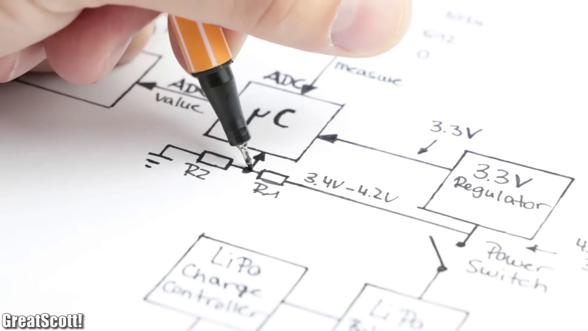 | 3:54  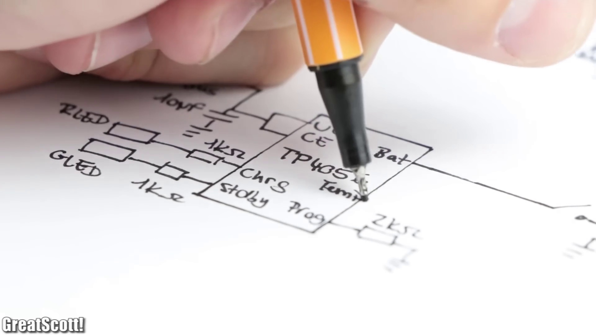 | 5:42  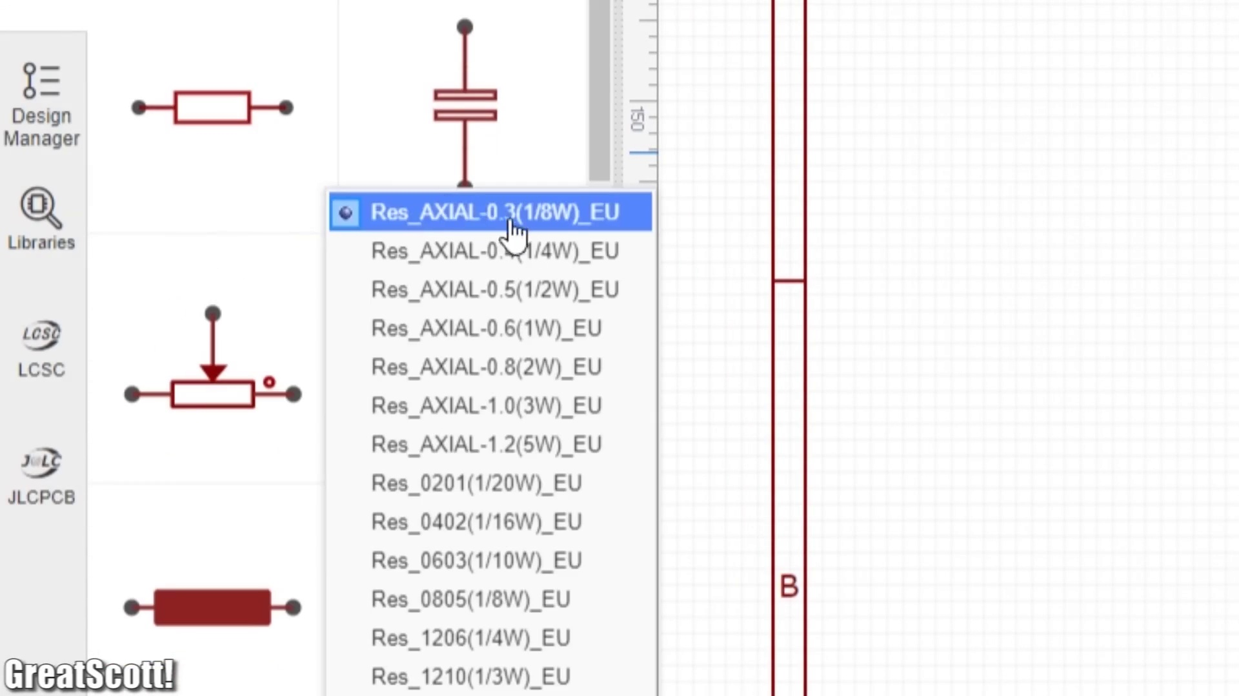 | 7:29  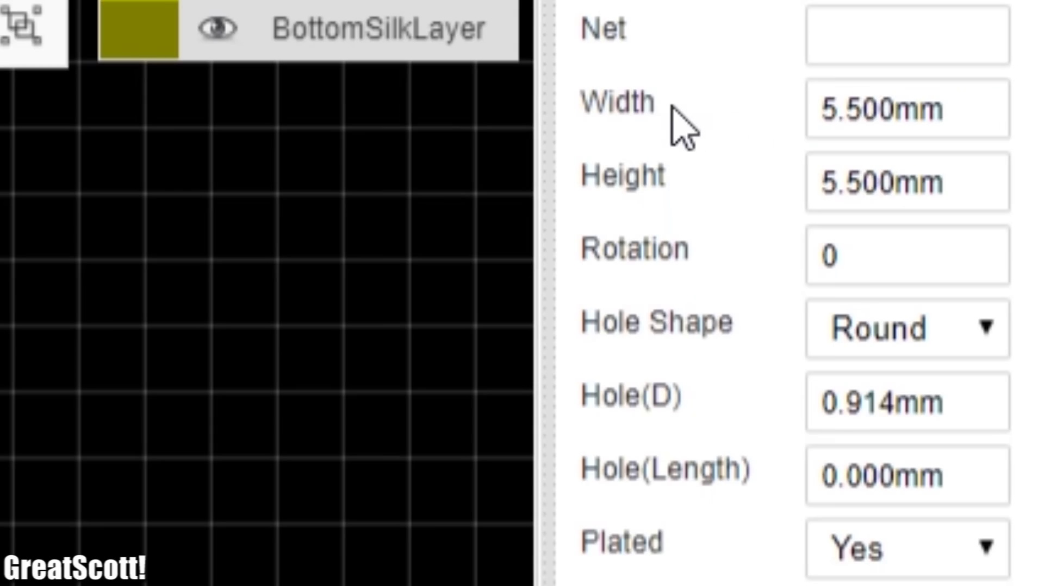 | 9:16  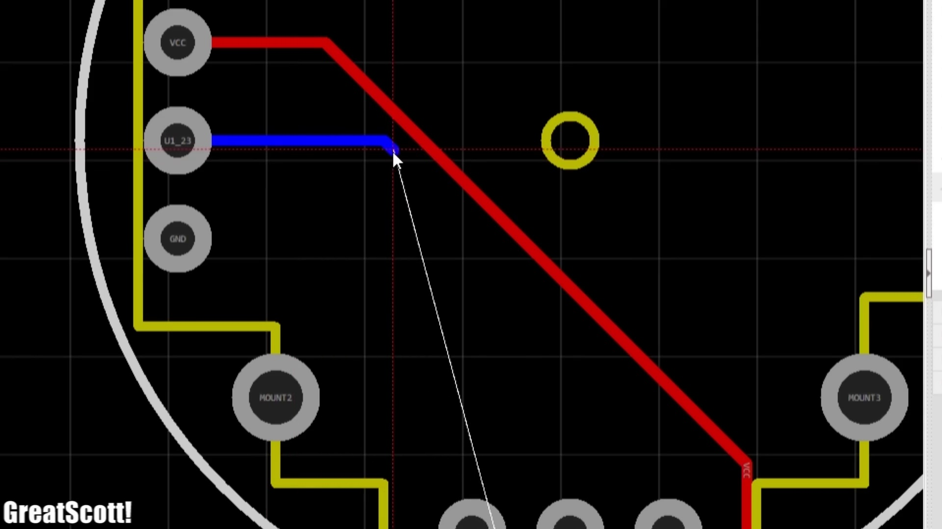

Transcript
[0:19] But sadly it does only exist as an SMD package, which makes perfboard soldering pretty hard to do.
[0:26] In both cases creating a proper PCB design and ordering it from a PCB manufacturing house is the way to go to save time and play around easily with SMD components.
[0:39] So in this video I will be showing you step by step what to look out for when creating the schematic of your project
[0:46] and how we can then turn it easily into a PCB design that we can order through a couple of simple clicks for quite a low price.
[0:55] Let's get started!
[1:09] As a practical example for this video I will be using this relatively simple double-sided PCB that I designed.
[1:18] Which brings me to the first step of this tutorial.
[1:21] Planning the function of the circuits.
[1:23] I knew that I wanted to create a microcontroller based circuit.
[1:28] That reads the position of a joystick and then sends the values through the RF band to receiver.
[1:35] Also I wanted to power the circuit through a LiPo battery.
[1:39] Which means I needed a LiPo charge controller IC, a micro USB port to deliver the power for charging.
[1:47] And a power switch to connect the battery voltage to a 3.3V regulator.
[1:52] Which converts the unregulated battery voltage into a suitable voltage for the microcontroller.
[1:58] Last but not least I wanted to monitor the battery voltage through a voltage divider with the microcontroller.
[2:05] So that when the battery voltage gets close to 3.4V the RF functionality shuts down and the yellow LED lights up.
[2:15] And with the function of the circuit planned out it was time for step 2.
[2:19] Which involves searching for suitable components and creating a paper schematic.
[2:25] For component sourcing I like to use LCSC.
[2:30] Because their selection is not only big.
[2:32] But also because we will be ordering the PCBs through JLCPCB later on.
[2:37] And we can combine that with the LCSC order and thus save shipping costs.
[2:43] But anyway once I decided on the main ICs.
[2:47] Which were the ATMEGA328 as a microcontroller.
[2:50] An NRF24 as the RF transmitter.
[2:54] A TP4056 as the charge controller.
[2:58] And a TPS76933dBVR as the voltage regulator.
[3:03] It was time to think about the packages.
[3:06] The package basically describes how the IC will physically look like.
[3:11] And determines whether it is a THT or SMD component.
[3:17] For example while the NRF24 is only available as a breakout board in THT.
[3:23] And the TP4056 is only available as an SMD version.
[3:28] We do have the choice between THT and SMD for the microcontroller.
[3:34] But since I wanted the circuit to be as small as possible.
[3:37] I went with the SMD version.
[3:39] Which I also set as the standard for the remaining complementary components.
[3:45] Next I planned out on a piece of paper.
[3:47] How to connect the main ICs to one another.
[3:51] And also what passive components are necessary to make them all work.
[3:55] To find that out.
[3:56] I had a closer look at all the data sheets of the ICs.
[4:00] And the recommended example circuits.
[4:03] And if everything fails you can always google your question.
[4:06] Which should give you a suitable answer in 99% of the cases.
[4:11] The last thing to do for the paper circuits was to add breakout points.
[4:15] So that I could later program the microcontroller.
[4:18] And also hook up the battery and LEDs to the circuits.
[4:22] Which will be mounted in a separate enclosure.
[4:24] Now for the passive component selection.
[4:28] I mainly went with 0603 as the package size.
[4:32] Which stands for 0.06 by 0.03 inches.
[4:36] Or 1.6 by 0.8 millimeters.
[4:40] There also exists a 0402 and a 0201 package.
[4:45] But I think 0603 is neither too big or too small.
[4:50] And can still be soldered with an iron with a bit of practice.
[4:54] And with the component selection and paper schematic being completed.
[4:58] It was time for step 3.
[5:00] Creating a proper schematic.
[5:03] For that I used the EasyEDA free online circuit creator.
[5:07] After logging in I created a new project.
[5:10] And there a new schematic.
[5:13] Then I simply used their online library.
[5:15] Which also includes pretty much all LCSC components.
[5:19] To search for my utilized components.
[5:22] And firstly imported them into the workspace.
[5:25] But make sure that you choose components.
[5:28] With the right package and correct footprint.
[5:31] Otherwise the PCB design will later not work out.
[5:34] Once all the main actors of the circuit were imported.
[5:39] I then used the left aligned resistors with the right package.
[5:43] And capacitors with the right package.
[5:45] As the complementary passive components.
[5:48] And of course we should not forget.
[5:50] To add male header connectors.
[5:52] For the breakout points.
[5:54] Now that we got all of our required components.
[5:57] In the editor.
[5:58] We can arrange them to logical blocks.
[6:01] Which in my case is the power parts.
[6:03] And the microcontroller parts.
[6:06] Once that was done.
[6:07] I utilized the wire function of the software.
[6:10] To connect all the components to one another.
[6:13] According to how I planned it out on paper.
[6:16] Last but not least.
[6:17] I then added the ground.
[6:19] VCC.
[6:20] And battery voltage supply flags to the schematic.
[6:23] Which not only completes it.
[6:25] But also ends the third step of this tutorial.
[6:28] That means it is time for the last step.
[6:31] Step 4.
[6:32] Which is PCB design and ordering.
[6:35] For that.
[6:36] We firstly have to click the convert to PCB button.
[6:39] Which automatically throws all the component footprints.
[6:42] Into the PCB editor.
[6:44] Shows how to connect them through the blue lines.
[6:47] And creates a PCB outline for us.
[6:51] The first thing I did though.
[6:52] Was removing the outline.
[6:54] Because as I mentioned earlier.
[6:56] I needed a specific PCB size.
[6:58] For the enclosure.
[7:00] To do that.
[7:01] I changed the measuring system to millimeters.
[7:04] Selected the board outline layer.
[7:06] And used the track tool.
[7:07] In combination with the given coordinates.
[7:10] In the down right corner.
[7:11] To create the correct size for the PCB.
[7:15] Then I moved the micro USB port.
[7:17] The main power switch.
[7:19] And the joystick.
[7:19] To the required position.
[7:21] According to the enclosure's cutouts.
[7:24] To later mount the PCB.
[7:26] I also added three pads.
[7:28] Whose size I enlarged.
[7:29] So that M3 screws would fit through them.
[7:33] And with that being done.
[7:34] I placed the rest of the components onto the PCB.
[7:38] Of course.
[7:39] You want to separate the power parts.
[7:41] And microcontroller part a bit.
[7:43] And also make sure.
[7:44] That the pins slash components.
[7:46] That need to get connected.
[7:47] To one another.
[7:49] Are physically close to one another.
[7:51] So that the copper trace length.
[7:53] Can be as short as possible.
[7:56] As soon as you think.
[7:57] Your layout looks logical.
[7:59] We could use the given auto router.
[8:01] To do the wiring for us.
[8:03] But as you might already have guessed.
[8:05] That is often not the best solution.
[8:08] So let's do it manually.
[8:10] By selecting the top layer.
[8:12] And using the track tool.
[8:13] To simply connect all the components.
[8:15] To one another.
[8:17] But before doing so.
[8:18] We have to talk about the width.
[8:20] Of the traces.
[8:21] Which is usually set to 0.254 millimeters.
[8:26] If we use an online trace width calculator.
[8:29] And set the ounce value to 1.
[8:31] Which is the standard value.
[8:33] For JLC PCBs.
[8:35] Then the trace could handle.
[8:36] Around 0.885 amps.
[8:39] Of current on outer layers.
[8:41] Which is enough.
[8:42] But I always like to work.
[8:44] With a width of 0.3 millimeters.
[8:47] Since that gives me.
[8:48] A maximum of 1 amp.
[8:50] And with that out of the way.
[8:52] I created all possible connections.
[8:54] On the top layer.
[8:55] While making sure.
[8:56] To not use 90 degree bends.
[8:58] Since that is bad practice.
[9:00] And everyone in the comment section.
[9:02] Will hate you.
[9:04] The only problem.
[9:05] With this top layer wiring.
[9:07] Was that after a short while.
[9:09] I was running out of space.
[9:11] And not all necessary connections.
[9:13] Were made yet.
[9:14] But don't worry.
[9:15] Since we can switch to the bottom layer.
[9:18] And do the rest wiring there.
[9:20] Which would be very simple to do.
[9:22] For THD components.
[9:23] Since the solder pads.
[9:24] Penetrate through all layers.
[9:27] But for SMD components.
[9:28] We have to create.
[9:29] A so called via.
[9:31] It is basically.
[9:32] A small tunnel.
[9:33] That connects the top.
[9:35] And bottom layer.
[9:36] And just like that.
[9:37] We can finish the wiring.
[9:39] Even for SMD components.
[9:40] On the bottom layer.
[9:42] Now here is my finished.
[9:43] PCB design.
[9:45] To which you would answer.
[9:46] It is not finished yet.
[9:47] Since all ground connections.
[9:49] Are not made.
[9:51] Well.
[9:51] For those.
[9:52] We can simply select.
[9:53] The top layer.
[9:54] And use the copper region tool.
[9:56] To encircle the whole PCB.
[9:59] And just like that.
[10:00] The traces got isolated.
[10:02] And the rest of the top layer space.
[10:04] Is used as a solid copper ground layer.
[10:08] Of course.
[10:08] If you want to.
[10:09] You could also repeat this process.
[10:11] For the bottom layer.
[10:13] At this point.
[10:14] The PCB design.
[10:15] Is basically complete.
[10:17] Which means.
[10:17] We can click.
[10:18] Generate Gerber files.
[10:20] In order to download them.
[10:21] Or.
[10:22] We can directly.
[10:23] Order our finished products.
[10:24] From JLC PCB.
[10:26] Which I did.
[10:28] And after waiting for a week.
[10:30] I was greeted.
[10:31] With 10 copies.
[10:32] Of my board.
[10:33] Which did not only look promising.
[10:35] Under the microscope.
[10:36] But also worked.
[10:37] Without any problems.
[10:39] Now.
[10:40] If you're curious.
[10:41] How to solder the components.
[10:42] To such a PCB.
[10:43] Then definitely.
[10:44] Make sure.
[10:45] To watch my soldering tutorial.
[10:46] About the subjects.
[10:49] As always.
[10:49] I hope you enjoyed.
[10:50] Watching this video.
[10:52] And learned a thing or two.
[10:53] About PCB design.
[10:55] If so.
[10:56] Don't forget to like.
[10:57] Share.
[10:58] And subscribe.
[10:59] Stay creative.
[11:01] And I will see you.
[11:02] Next time.

