Engagement Analysis: 3cFSNRG2xfA

Section 0: A person holding a Flysky remote control and working on a DIY quadcopter or drone.
Time: 0:00 - 0:01

Summary
The image shows a person holding a black Flysky remote control with red and silver buttons, adjusting the device. In their other hand, they are manipulating an object that appears to be a DIY quadcopter or drone, possibly assembling or reassembling it.

Representative Frames
0:00  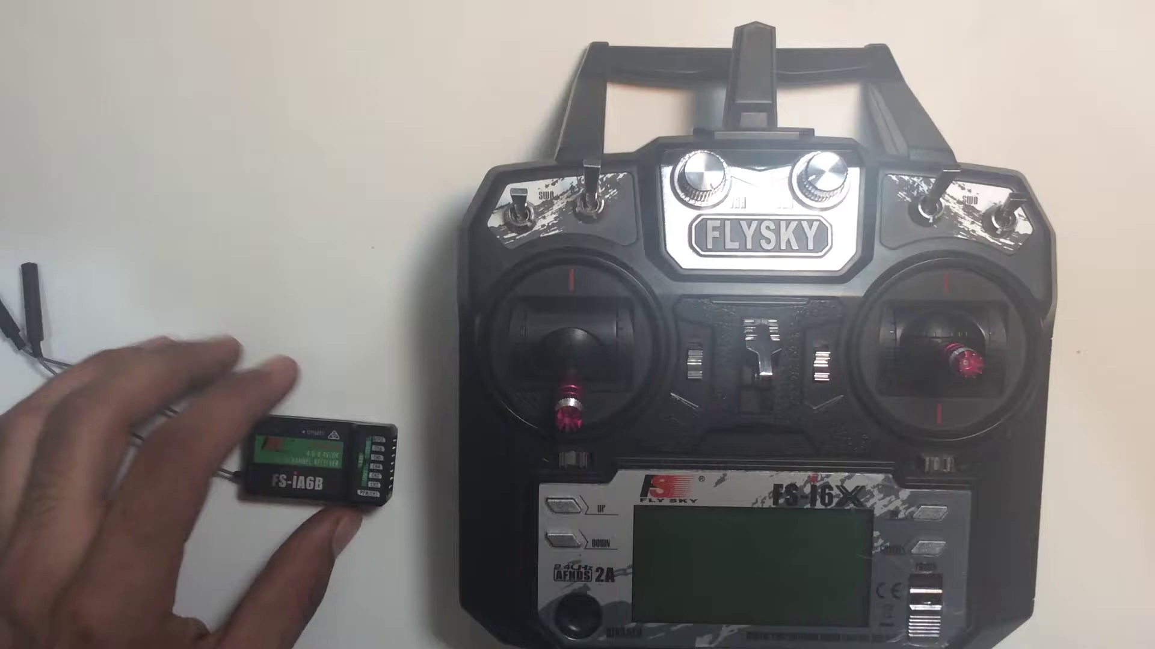 | 0:00   | 0:00   | 0:00   | 0:00  

Transcript
(No speech detected in this section)

Section 0: A person working on an electronic device.
Time: 0:01 - 0:02

Summary
The image shows two distinct scenes, one featuring an individual handling an electronic device, which appears to be a small quadcopter or drone. The device is connected to a circuit board with multiple electronic components, suggesting it's undergoing repairs or modification.

Representative Frames
0:01   | 0:01   | 0:01   | 0:01   | 0:01  

Transcript
(No speech detected in this section)

Section 0: A person holding a Flysky RC transmitter and working on a DIY quadcopter or drone.
Time: 0:02 - 0:03

Summary
The image shows two distinct scenes, one featuring an individual handling an electronic device, which appears to be a small quadcopter or drone. The device is connected to a circuit board with multiple electronic components, suggesting it's undergoing repairs or modification.

Representative Frames
0:02   | 0:02   | 0:02   | 0:02   | 0:02  

Transcript
(No speech detected in this section)

Section 0: A person holding a Flysky remote control and working on a DIY quadcopter or drone.
Time: 0:03 - 0:04

Summary
The image shows a person standing in front of a white surface, holding a black Flysky remote control with red and silver buttons. Their thumb is pressed on the red button, suggesting they may be setting up or adjusting the remote control.

Representative Frames
0:03   | 0:03  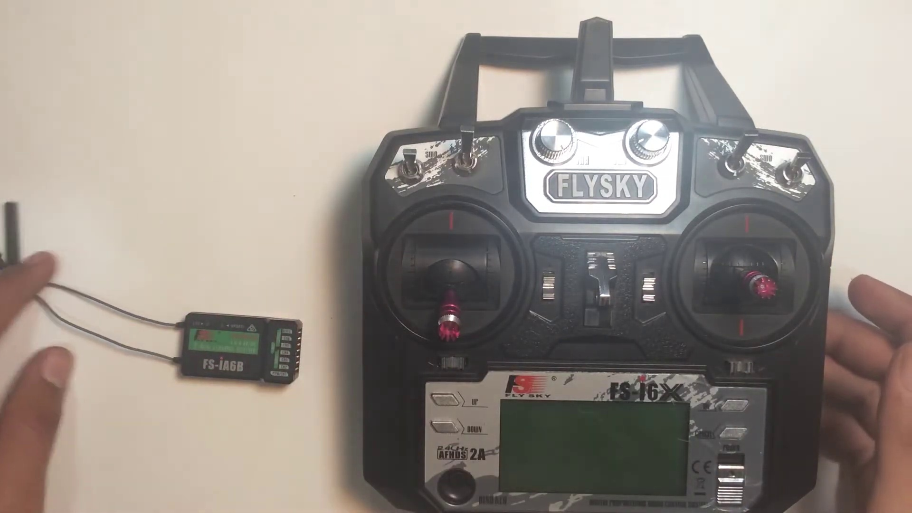 | 0:03   | 0:03   | 0:03  

Transcript
[0:00] Hello and welcome to the Saturday Shot Tip episode and in today's video we are going to

Section 0: A person assembling or repairing electronic devices.
Time: 0:04 - 0:05

Summary
The image shows a person holding an electronic device, which appears to be a Flysky radio control. The control, with its silver and black color scheme, features the Flysky logo and the word '4000'.

Representative Frames
0:04   | 0:04   | 0:04   | 0:04   | 0:04  

Transcript
(No speech detected in this section)

Section 0: A person working on a DIY quadcopter or drone.
Time: 0:05 - 0:06

Summary
The image shows two distinct scenes, one featuring an individual handling an electronic device, which appears to be a small quadcopter or drone. The device is connected to a circuit board with multiple electronic components, suggesting it's undergoing repairs or modification.

Representative Frames
0:05   | 0:05   | 0:05   | 0:05   | 0:05  

Transcript
(No speech detected in this section)

Section 0: A person holding a Flysky remote control and working on a DIY quadcopter or drone.
Time: 0:06 - 0:07

Summary
The image shows a person standing in front of a white surface, holding a black Flysky remote control with red and silver buttons. Their thumb is pressed on the red button, suggesting they may be setting up or adjusting the remote control.

Representative Frames
0:06   | 0:06   | 0:06   | 0:06  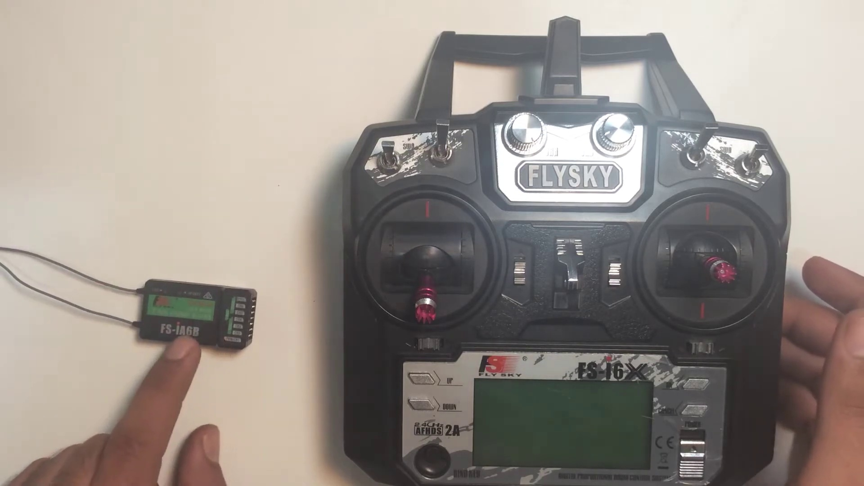 | 0:06  

Transcript
(No speech detected in this section)

Section 0: A person working on an electronic device.
Time: 0:07 - 0:08

Summary
The image shows a person holding an electronic device, which appears to be a Flysky radio control. The control, with its silver and black color scheme, features the Flysky logo and the word '4000'.

Representative Frames
0:07   | 0:07   | 0:07   | 0:07   | 0:07  

Transcript
(No speech detected in this section)

Section 0: A person working on a DIY quadcopter or drone.
Time: 0:08 - 0:09

Summary
The image shows two distinct scenes, one featuring an individual handling an electronic device, which appears to be a small quadcopter or drone. The device is connected to a circuit board with multiple electronic components, suggesting it's undergoing repairs or modification.

Representative Frames
0:08   | 0:08   | 0:08   | 0:08   | 0:08  

Transcript
(No speech detected in this section)

Section 0: A person holding a Flysky remote control and working on a DIY quadcopter or drone.
Time: 0:09 - 0:10

Summary
The image shows a person standing in front of a white surface, holding a black Flysky remote control with red and silver buttons. Their thumb is pressed on the red button, suggesting they may be setting up or adjusting the remote control.

Representative Frames
0:09   | 0:09   | 0:09   | 0:09   | 0:09  

Transcript
[0:05] bind this FSIA6B receiver to the transmitter. So for this purpose you need an ESC and a battery

Section 0: A person working on an electronic device.
Time: 0:10 - 0:11

Summary
The image shows a person holding an electronic device, which appears to be a Flysky radio control. The control, with its silver and black color scheme, features the Flysky logo and the word '4000'.

Representative Frames
0:10  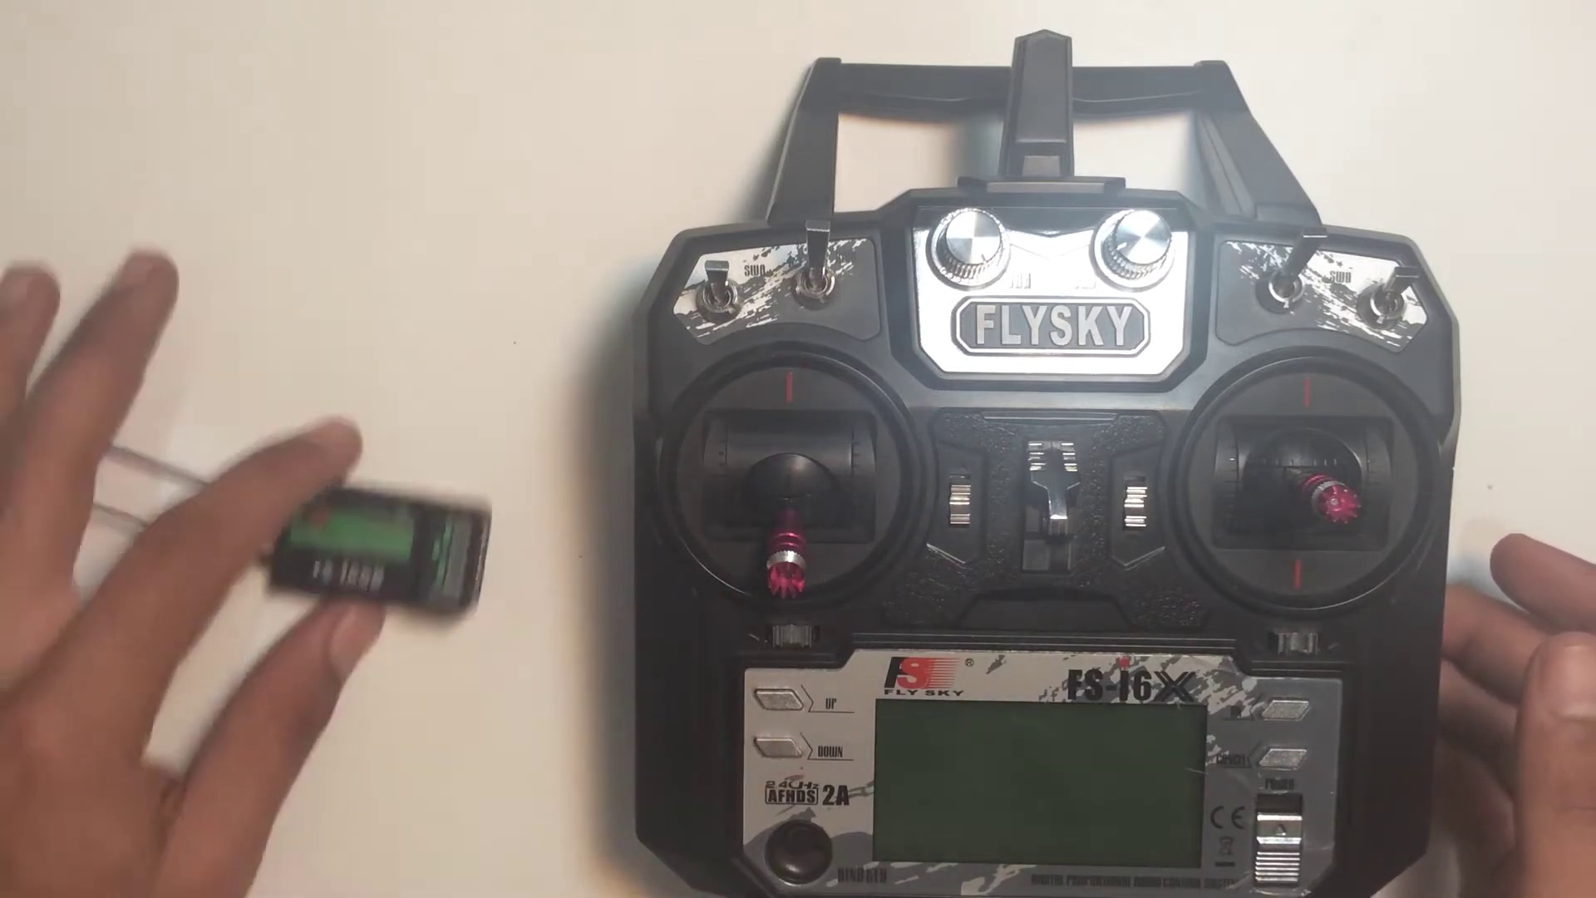 | 0:10   | 0:10   | 0:10   | 0:10  

Transcript
[0:05] bind this FSIA6B receiver to the transmitter. So for this purpose you need an ESC and a battery

Section 0: A person working on a DIY quadcopter or drone.
Time: 0:11 - 0:12

Summary
The image shows two distinct scenes, one featuring an individual handling an electronic device, which appears to be a small quadcopter or drone. The device is connected to a circuit board with multiple electronic components, suggesting it's undergoing repairs or modification.

Representative Frames
0:11   | 0:11   | 0:11   | 0:11   | 0:11  

Transcript
(No speech detected in this section)

Section 0: A person holding a Flysky remote control and working on a DIY quadcopter or drone.
Time: 0:12 - 0:13

Summary
The image shows a person standing in front of a white surface, holding a black Flysky remote control with red and silver buttons. Their thumb is pressed on the red button, suggesting they may be setting up or adjusting the remote control.

Representative Frames
0:12   | 0:12   | 0:12   | 0:12   | 0:12  

Transcript
(No speech detected in this section)

Section 0: A person working on an electronic device.
Time: 0:13 - 0:14

Summary
The image shows a person holding an electronic device, which appears to be a Flysky radio control. The control, with its silver and black color scheme, features the Flysky logo and the word '4000'.

Representative Frames
0:13   | 0:13  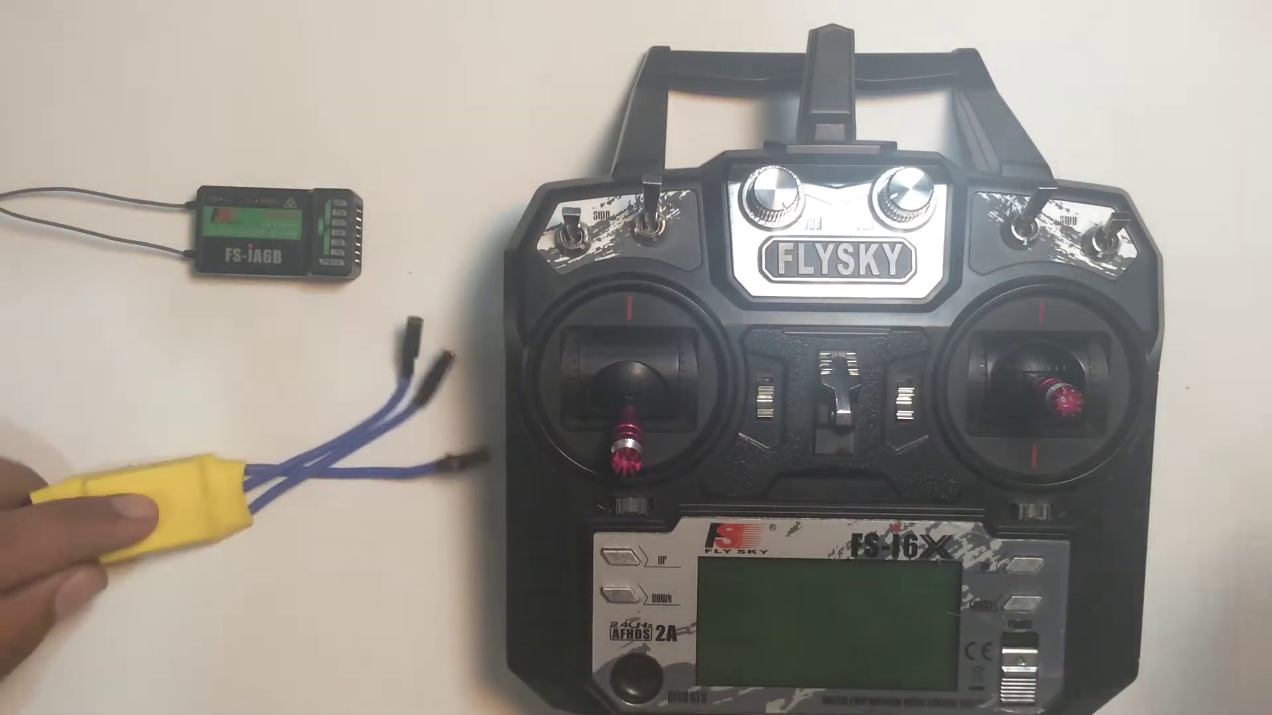 | 0:13   | 0:13   | 0:13  

Transcript
(No speech detected in this section)

Section 0: A person working on a DIY quadcopter or drone.
Time: 0:14 - 0:15

Summary
The image shows two distinct scenes, one featuring an individual handling an electronic device, which appears to be a small quadcopter or drone. The device is connected to a circuit board with multiple electronic components, suggesting it's undergoing repairs or modification.

Representative Frames
0:14   | 0:14   | 0:14   | 0:14   | 0:14  

Transcript
(No speech detected in this section)

Section 0: A person holding a Flysky remote control and working on a DIY quadcopter or drone.
Time: 0:15 - 0:16

Summary
The image shows a person standing in front of a white surface, holding a black Flysky remote control with red and silver buttons. Their thumb is pressed on the red button, suggesting they may be setting up or adjusting the remote control.

Representative Frames
0:15   | 0:15   | 0:15   | 0:15   | 0:15  

Transcript
(No speech detected in this section)

Section 0: A person working on an electronic device.
Time: 0:16 - 0:17

Summary
The image shows a person holding an electronic device, which appears to be a Flysky radio control. The control, with its silver and black color scheme, features the Flysky logo and the word '4000'.

Representative Frames
0:16   | 0:16   | 0:16   | 0:16  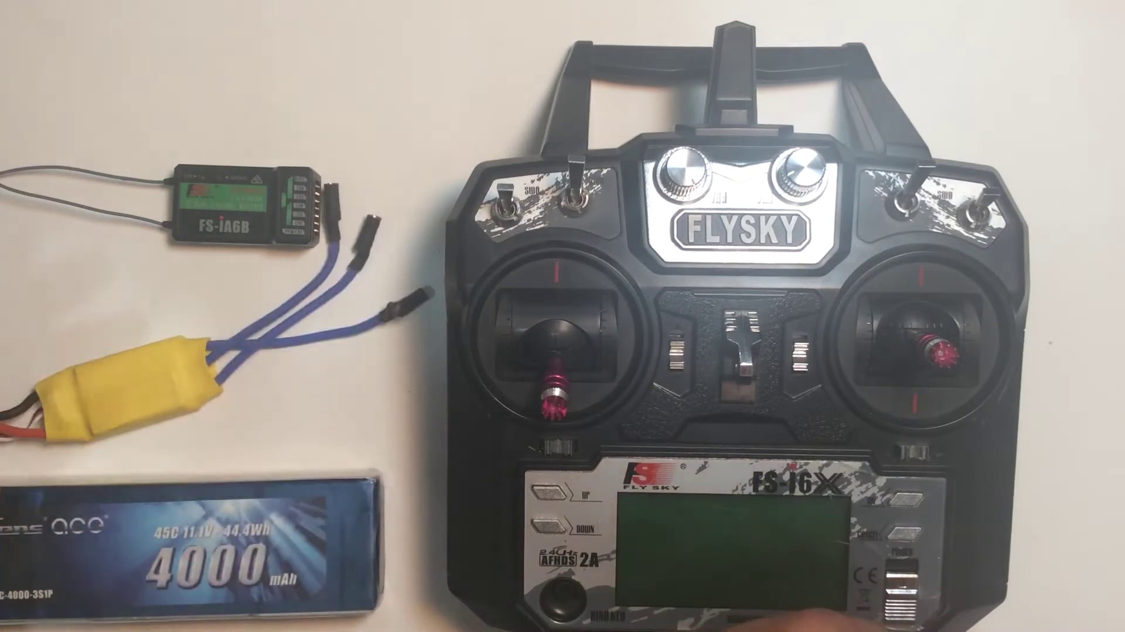 | 0:16  

Transcript
(No speech detected in this section)

Section 0: A person working on a DIY quadcopter or drone.
Time: 0:17 - 0:18

Summary
The image shows two distinct scenes, one featuring an individual handling an electronic device, which appears to be a small quadcopter or drone. The device is connected to a circuit board with multiple electronic components, suggesting it's undergoing repairs or modification.

Representative Frames
0:17   | 0:17   | 0:17   | 0:17   | 0:17  

Transcript
(No speech detected in this section)

Section 0: A person holding a Flysky remote control and working on a DIY quadcopter or drone.
Time: 0:18 - 0:19

Summary
The image shows a person standing in front of a white surface, holding a black Flysky remote control with red and silver buttons. Their thumb is pressed on the red button, suggesting they may be setting up or adjusting the remote control.

Representative Frames
0:18   | 0:18   | 0:18   | 0:18   | 0:18  

Transcript
[0:14] to power the receiver and a bind key. The bind key actually activates the bind state of the

Section 0: A person working on an electronic device.
Time: 0:19 - 0:20

Summary
The image shows a person holding an electronic device, which appears to be a Flysky radio control. The control, with its silver and black color scheme, features the Flysky logo and the word '4000'.

Representative Frames
0:19   | 0:19   | 0:19   | 0:19   | 0:19  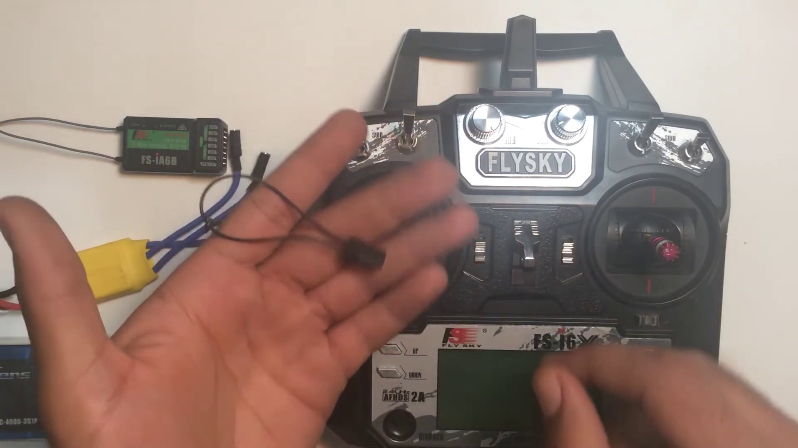

Transcript
(No speech detected in this section)

Section 0: A person working on a DIY quadcopter or drone.
Time: 0:20 - 0:21

Summary
The image shows two distinct scenes, one featuring an individual handling an electronic device, which appears to be a small quadcopter or drone. The device is connected to a circuit board with multiple electronic components, suggesting it's undergoing repairs or modification.

Representative Frames
0:20   | 0:20   | 0:20   | 0:20   | 0:20  

Transcript
(No speech detected in this section)

Section 0: A person holding a Flysky remote control and working on a DIY quadcopter or drone.
Time: 0:21 - 0:22

Summary
The image shows a person standing in front of a white surface, holding a black Flysky remote control with red and silver buttons. Their thumb is pressed on the red button, suggesting they may be setting up or adjusting the remote control.

Representative Frames
0:21   | 0:21   | 0:21   | 0:21   | 0:21  

Transcript
(No speech detected in this section)

Section 0: A person working on an electronic device.
Time: 0:22 - 0:23

Summary
The image shows a person holding an electronic device, which appears to be a Flysky radio control. The control, with its silver and black color scheme, features the Flysky logo and the word '4000'.

Representative Frames
0:22   | 0:22   | 0:22   | 0:22   | 0:22  

Transcript
(No speech detected in this section)

Section 0: A person working on a DIY quadcopter or drone.
Time: 0:23 - 0:24

Summary
The image shows two distinct scenes, one featuring an individual handling an electronic device, which appears to be a small quadcopter or drone. The device is connected to a circuit board with multiple electronic components, suggesting it's undergoing repairs or modification.

Representative Frames
0:23  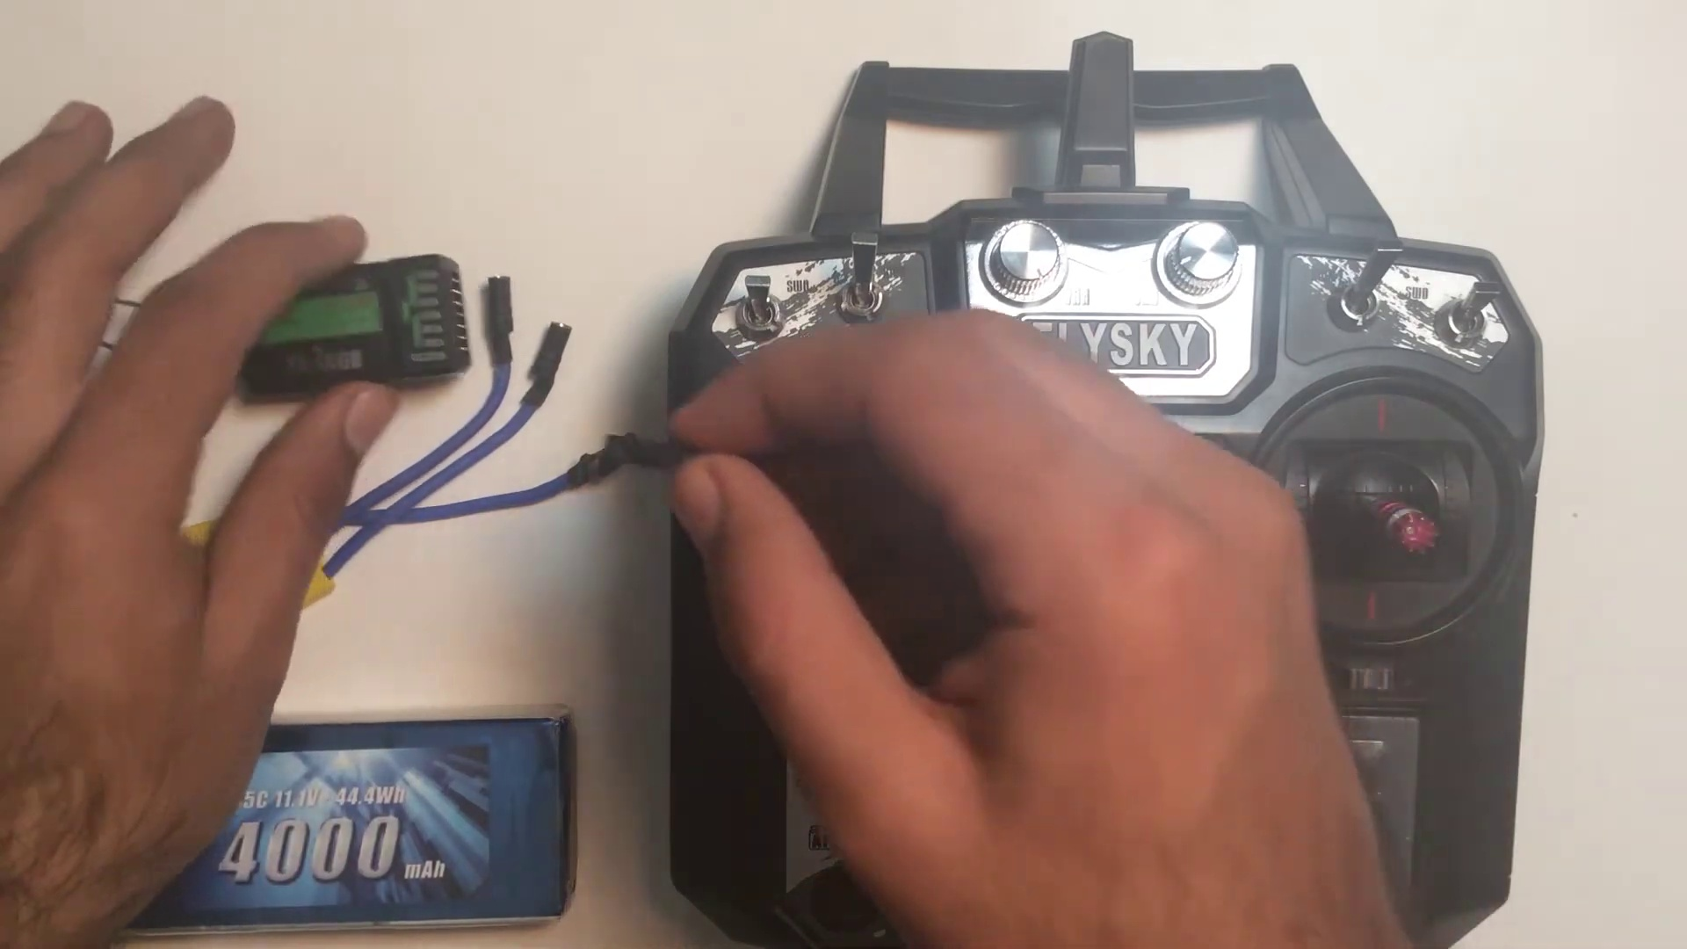 | 0:23   | 0:23   | 0:23   | 0:23  

Transcript
(No speech detected in this section)

Section 0: A person holding a Flysky remote control and working on a DIY quadcopter or drone.
Time: 0:24 - 0:25

Summary
The image shows a person standing in front of a white surface, holding a black Flysky remote control with red and silver buttons. Their thumb is pressed on the red button, suggesting they may be setting up or adjusting the remote control.

Representative Frames
0:24   | 0:24   | 0:24   | 0:24   | 0:24  

Transcript
(No speech detected in this section)

Section 0: A person working on an electronic device.
Time: 0:25 - 0:26

Summary
The image shows a person holding an electronic device, which appears to be a Flysky radio control. The control, with its silver and black color scheme, features the Flysky logo and the word '4000'.

Representative Frames
0:25   | 0:25   | 0:25   | 0:25   | 0:25  

Transcript
(No speech detected in this section)

Section 0: A person working on a DIY quadcopter or drone.
Time: 0:26 - 0:27

Summary
The image shows two distinct scenes, one featuring an individual handling an electronic device, which appears to be a small quadcopter or drone. The device is connected to a circuit board with multiple electronic components, suggesting it's undergoing repairs or modification.

Representative Frames
0:26   | 0:26   | 0:26  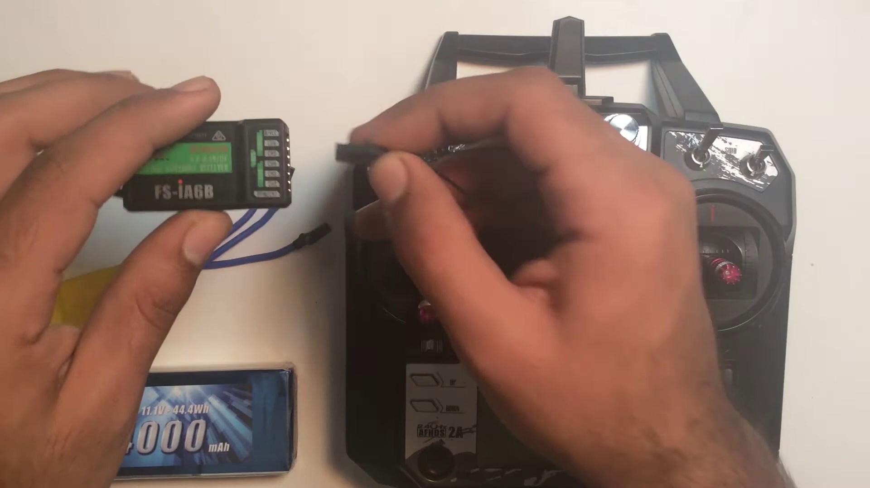 | 0:26   | 0:26  

Transcript
(No speech detected in this section)

Section 0: A person holding a Flysky remote control and working on a DIY quadcopter or drone.
Time: 0:27 - 0:28

Summary
The image shows a person standing in front of a white surface, holding a black Flysky remote control with red and silver buttons. Their thumb is pressed on the red button, suggesting they may be setting up or adjusting the remote control.

Representative Frames
0:27   | 0:27   | 0:27   | 0:27   | 0:27  

Transcript
(No speech detected in this section)

Section 0: A person working on an electronic device.
Time: 0:28 - 0:29

Summary
The image shows a person holding an electronic device, which appears to be a Flysky radio control. The control, with its silver and black color scheme, features the Flysky logo and the word '4000'.

Representative Frames
0:28   | 0:28   | 0:28   | 0:28   | 0:28  

Transcript
[0:22] receiver so you have to plug the bind key into the last port of the receiver that is actually B-VCC.

Section 0: A person working on a DIY quadcopter or drone.
Time: 0:29 - 0:30

Summary
The image shows two distinct scenes, one featuring an individual handling an electronic device, which appears to be a small quadcopter or drone. The device is connected to a circuit board with multiple electronic components, suggesting it's undergoing repairs or modification.

Representative Frames
0:29   | 0:29   | 0:29   | 0:29   | 0:29  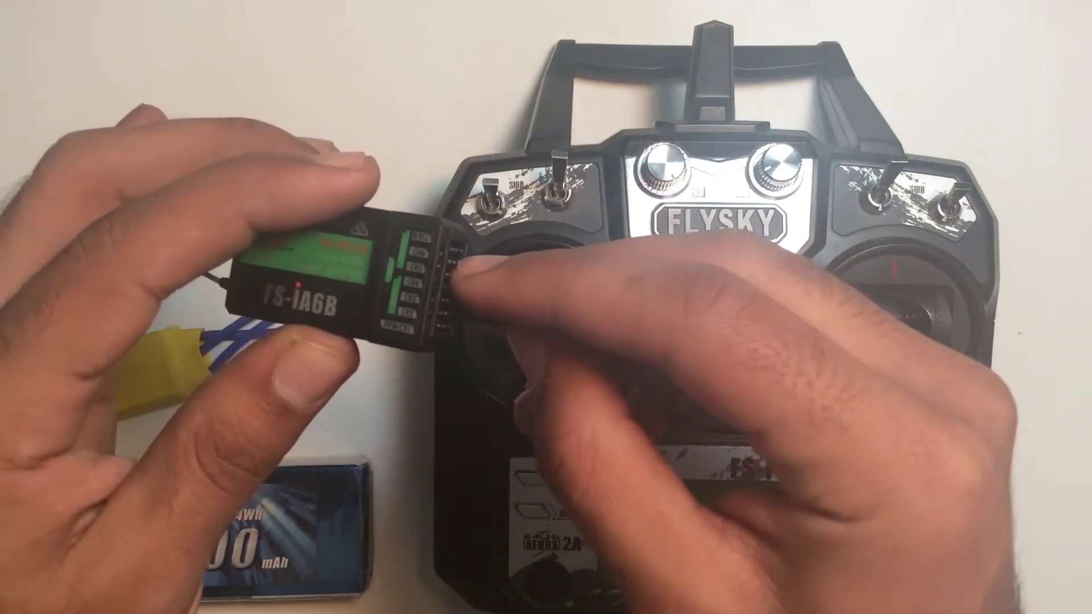

Transcript
(No speech detected in this section)

Section 0: A person holding a Flysky remote control and working on a DIY quadcopter or drone.
Time: 0:30 - 0:31

Summary
The image shows a person standing in front of a white surface, holding a black Flysky remote control with red and silver buttons. Their thumb is pressed on the red button, suggesting they may be setting up or adjusting the remote control.

Representative Frames
0:30   | 0:30   | 0:30   | 0:30   | 0:30  

Transcript
(No speech detected in this section)

Section 0: A person working on an electronic device.
Time: 0:31 - 0:32

Summary
The image shows a person holding an electronic device, which appears to be a Flysky radio control. The control, with its silver and black color scheme, features the Flysky logo and the word '4000'.

Representative Frames
0:31   | 0:31   | 0:31   | 0:31   | 0:31  

Transcript
(No speech detected in this section)

Section 0: A person working on a DIY quadcopter or drone.
Time: 0:32 - 0:33

Summary
The image shows two distinct scenes, one featuring an individual handling an electronic device, which appears to be a small quadcopter or drone. The device is connected to a circuit board with multiple electronic components, suggesting it's undergoing repairs or modification.

Representative Frames
0:32   | 0:32   | 0:32   | 0:32   | 0:32  

Transcript
(No speech detected in this section)

Section 0: A person holding a Flysky remote control and working on a DIY quadcopter or drone.
Time: 0:33 - 0:34

Summary
The image shows a person standing in front of a white surface, holding a black Flysky remote control with red and silver buttons. Their thumb is pressed on the red button, suggesting they may be setting up or adjusting the remote control.

Representative Frames
0:33  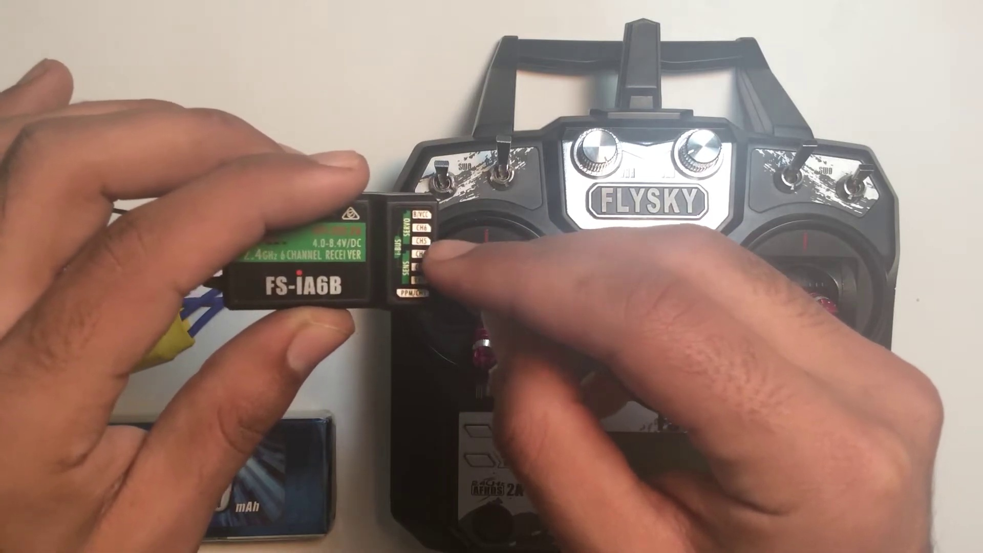 | 0:33   | 0:33   | 0:33   | 0:33  

Transcript
(No speech detected in this section)

Section 0: A person working on an electronic device.
Time: 0:34 - 0:35

Summary
The image shows a person holding an electronic device, which appears to be a Flysky radio control. The control, with its silver and black color scheme, features the Flysky logo and the word '4000'.

Representative Frames
0:34   | 0:34   | 0:34   | 0:34   | 0:34  

Transcript
(No speech detected in this section)

Section 0: A person working on a DIY quadcopter or drone.
Time: 0:35 - 0:36

Summary
The image shows two distinct scenes, one featuring an individual handling an electronic device, which appears to be a small quadcopter or drone. The device is connected to a circuit board with multiple electronic components, suggesting it's undergoing repairs or modification.

Representative Frames
0:35   | 0:35   | 0:35   | 0:35   | 0:35  

Transcript
(No speech detected in this section)

Section 0: A person holding a Flysky remote control and working on a DIY quadcopter or drone.
Time: 0:36 - 0:37

Summary
The image shows a person standing in front of a white surface, holding a black Flysky remote control with red and silver buttons. Their thumb is pressed on the red button, suggesting they may be setting up or adjusting the remote control.

Representative Frames
0:36   | 0:36   | 0:36  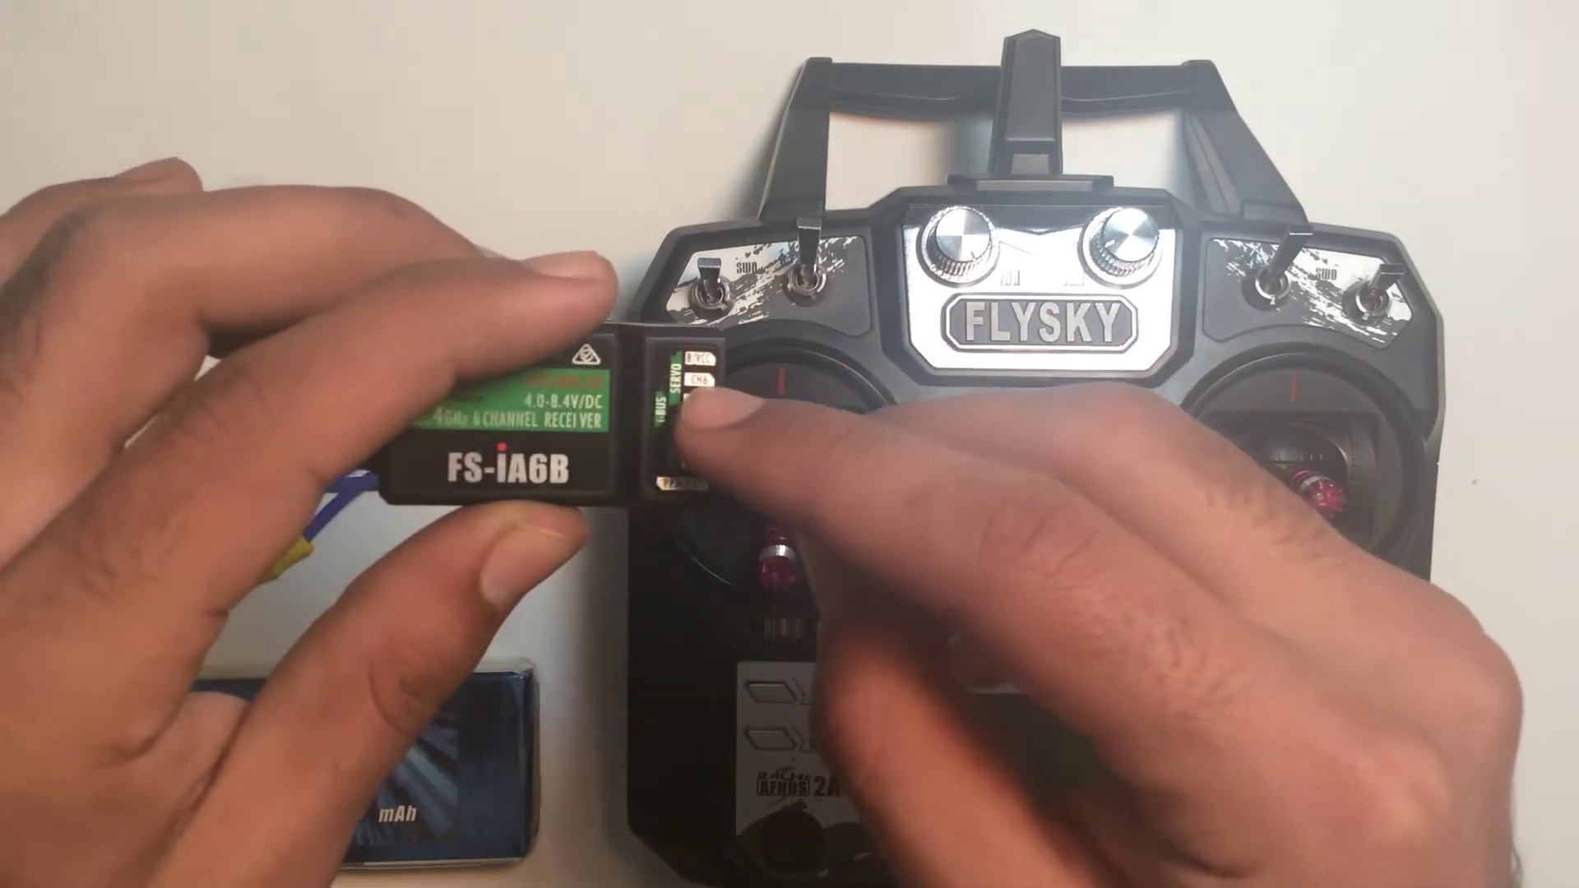 | 0:36   | 0:36  

Transcript
(No speech detected in this section)

Section 0: A person working on an electronic device.
Time: 0:37 - 0:38

Summary
The image shows a person holding an electronic device, which appears to be a Flysky radio control. The control, with its silver and black color scheme, features the Flysky logo and the word '4000'.

Representative Frames
0:37   | 0:37   | 0:37   | 0:37   | 0:37  

Transcript
[0:33] It is actually used for input power and binding. The B represents the bind so you have to plug this

Section 0: A person working on a DIY quadcopter or drone.
Time: 0:38 - 0:39

Summary
The image shows two distinct scenes, one featuring an individual handling an electronic device, which appears to be a small quadcopter or drone. The device is connected to a circuit board with multiple electronic components, suggesting it's undergoing repairs or modification.

Representative Frames
0:38   | 0:38   | 0:38   | 0:38   | 0:38  

Transcript
(No speech detected in this section)

Section 0: A person holding a Flysky remote control and working on a DIY quadcopter or drone.
Time: 0:39 - 0:40

Summary
The image shows a person standing in front of a white surface, holding a black Flysky remote control with red and silver buttons. Their thumb is pressed on the red button, suggesting they may be setting up or adjusting the remote control.

Representative Frames
0:39   | 0:39   | 0:39   | 0:39  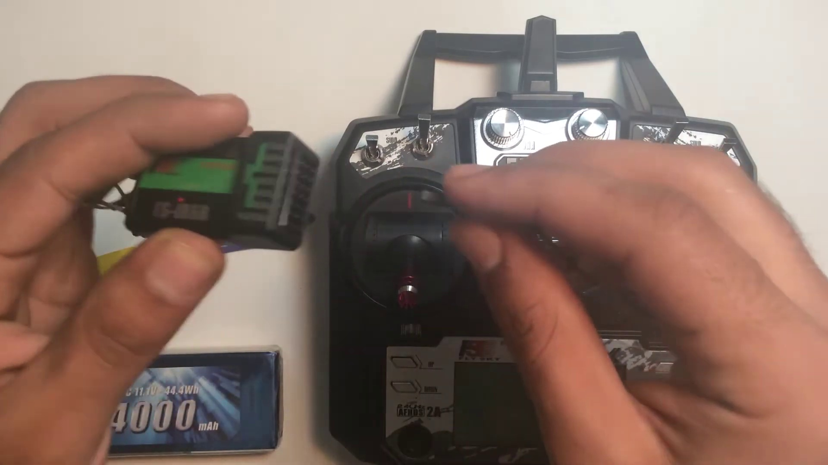 | 0:39  

Transcript
(No speech detected in this section)

Section 0: A person working on an electronic device.
Time: 0:40 - 0:41

Summary
The image shows a person holding an electronic device, which appears to be a Flysky radio control. The control, with its silver and black color scheme, features the Flysky logo and the word '4000'.

Representative Frames
0:40   | 0:40   | 0:40   | 0:40   | 0:40  

Transcript
(No speech detected in this section)

Section 0: A person working on a DIY quadcopter or drone.
Time: 0:41 - 0:42

Summary
The image shows two distinct scenes, one featuring an individual handling an electronic device, which appears to be a small quadcopter or drone. The device is connected to a circuit board with multiple electronic components, suggesting it's undergoing repairs or modification.

Representative Frames
0:41   | 0:41   | 0:41   | 0:41   | 0:41  

Transcript
(No speech detected in this section)

Section 0: A person holding a Flysky remote control and working on a DIY quadcopter or drone.
Time: 0:42 - 0:43

Summary
The image shows a person standing in front of a white surface, holding a black Flysky remote control with red and silver buttons. Their thumb is pressed on the red button, suggesting they may be setting up or adjusting the remote control.

Representative Frames
0:42   | 0:42   | 0:42   | 0:42   | 0:42  

Transcript
(No speech detected in this section)

Section 0: A person working on an electronic device.
Time: 0:43 - 0:44

Summary
The image shows a person holding an electronic device, which appears to be a Flysky radio control. The control, with its silver and black color scheme, features the Flysky logo and the word '4000'.

Representative Frames
0:43  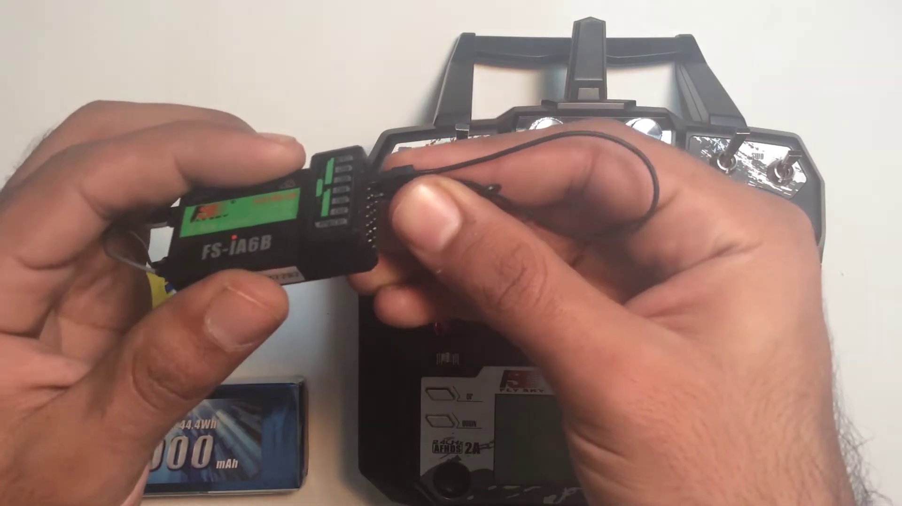 | 0:43   | 0:43   | 0:43   | 0:43  

Transcript
(No speech detected in this section)

Section 0: A person working on a DIY quadcopter or drone.
Time: 0:44 - 0:45

Summary
The image shows two distinct scenes, one featuring an individual handling an electronic device, which appears to be a small quadcopter or drone. The device is connected to a circuit board with multiple electronic components, suggesting it's undergoing repairs or modification.

Representative Frames
0:44   | 0:44   | 0:44   | 0:44   | 0:44  

Transcript
(No speech detected in this section)

Section 0: A person holding a Flysky remote control and working on a DIY quadcopter or drone.
Time: 0:45 - 0:46

Summary
The image shows a person standing in front of a white surface, holding a black Flysky remote control with red and silver buttons. Their thumb is pressed on the red button, suggesting they may be setting up or adjusting the remote control.

Representative Frames
0:45   | 0:45   | 0:45   | 0:45   | 0:45  

Transcript
(No speech detected in this section)

Section 0: A person working on an electronic device.
Time: 0:46 - 0:47

Summary
The image shows a person holding an electronic device, which appears to be a Flysky radio control. The control, with its silver and black color scheme, features the Flysky logo and the word '4000'.

Representative Frames
0:46   | 0:46  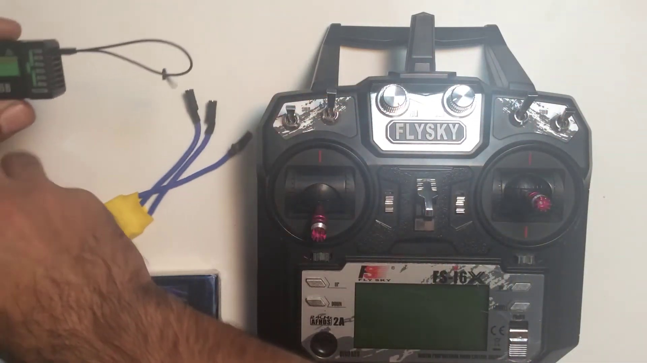 | 0:46   | 0:46   | 0:46  

Transcript
(No speech detected in this section)

Section 0: A person working on a DIY quadcopter or drone.
Time: 0:47 - 0:48

Summary
The image shows two distinct scenes, one featuring an individual handling an electronic device, which appears to be a small quadcopter or drone. The device is connected to a circuit board with multiple electronic components, suggesting it's undergoing repairs or modification.

Representative Frames
0:47   | 0:47   | 0:47   | 0:47   | 0:47  

Transcript
[0:42] key into the last port and then you just have to take the BEC wire of the ESC which is actually the

Section 0: A person holding a Flysky remote control and working on a DIY quadcopter or drone.
Time: 0:48 - 0:49

Summary
The image shows a person standing in front of a white surface, holding a black Flysky remote control with red and silver buttons. Their thumb is pressed on the red button, suggesting they may be setting up or adjusting the remote control.

Representative Frames
0:48   | 0:48   | 0:48   | 0:48   | 0:48  

Transcript
(No speech detected in this section)

Section 0: A person working on an electronic device.
Time: 0:49 - 0:50

Summary
The image shows a person holding an electronic device, which appears to be a Flysky radio control. The control, with its silver and black color scheme, features the Flysky logo and the word '4000'.

Representative Frames
0:49   | 0:49   | 0:49   | 0:49  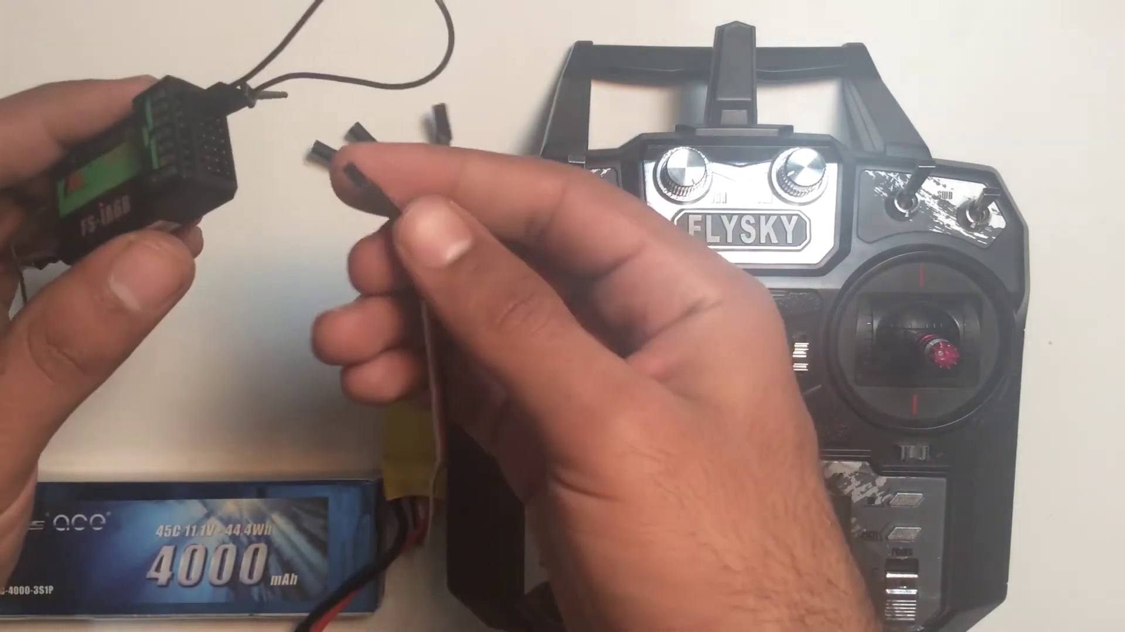 | 0:49  

Transcript
(No speech detected in this section)

Section 0: A person working on a DIY quadcopter or drone.
Time: 0:50 - 0:51

Summary
The image shows two distinct scenes, one featuring an individual handling an electronic device, which appears to be a small quadcopter or drone. The device is connected to a circuit board with multiple electronic components, suggesting it's undergoing repairs or modification.

Representative Frames
0:50   | 0:50   | 0:50   | 0:50   | 0:50  

Transcript
(No speech detected in this section)

Section 0: A person holding a Flysky remote control and working on a DIY quadcopter or drone.
Time: 0:51 - 0:52

Summary
The image shows a person standing in front of a white surface, holding a black Flysky remote control with red and silver buttons. Their thumb is pressed on the red button, suggesting they may be setting up or adjusting the remote control.

Representative Frames
0:51   | 0:51   | 0:51   | 0:51   | 0:51  

Transcript
(No speech detected in this section)

Section 0: A person working on an electronic device.
Time: 0:52 - 0:53

Summary
The image shows a person holding an electronic device, which appears to be a Flysky radio control. The control, with its silver and black color scheme, features the Flysky logo and the word '4000'.

Representative Frames
0:52   | 0:52   | 0:52   | 0:52   | 0:52  

Transcript
(No speech detected in this section)

Section 0: A person working on a DIY quadcopter or drone.
Time: 0:53 - 0:54

Summary
The image shows two distinct scenes, one featuring an individual handling an electronic device, which appears to be a small quadcopter or drone. The device is connected to a circuit board with multiple electronic components, suggesting it's undergoing repairs or modification.

Representative Frames
0:53  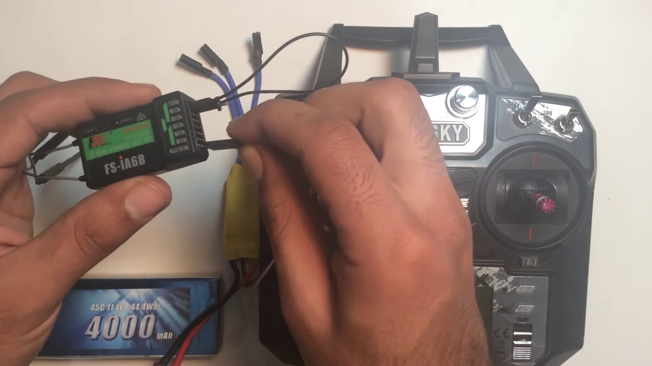 | 0:53   | 0:53   | 0:53   | 0:53  

Transcript
(No speech detected in this section)

Section 0: A person holding a Flysky remote control and working on a DIY quadcopter or drone.
Time: 0:54 - 0:55

Summary
The image shows a person standing in front of a white surface, holding a black Flysky remote control with red and silver buttons. Their thumb is pressed on the red button, suggesting they may be setting up or adjusting the remote control.

Representative Frames
0:54   | 0:54   | 0:54   | 0:54   | 0:54  

Transcript
(No speech detected in this section)

Section 0: A person working on an electronic device.
Time: 0:55 - 0:56

Summary
The image shows a person holding an electronic device, which appears to be a Flysky radio control. The control, with its silver and black color scheme, features the Flysky logo and the word '4000'.

Representative Frames
0:55   | 0:55   | 0:55   | 0:55   | 0:55  

Transcript
(No speech detected in this section)

Section 0: A person working on a DIY quadcopter or drone.
Time: 0:56 - 0:57

Summary
The image shows two distinct scenes, one featuring an individual handling an electronic device, which appears to be a small quadcopter or drone. The device is connected to a circuit board with multiple electronic components, suggesting it's undergoing repairs or modification.

Representative Frames
0:56  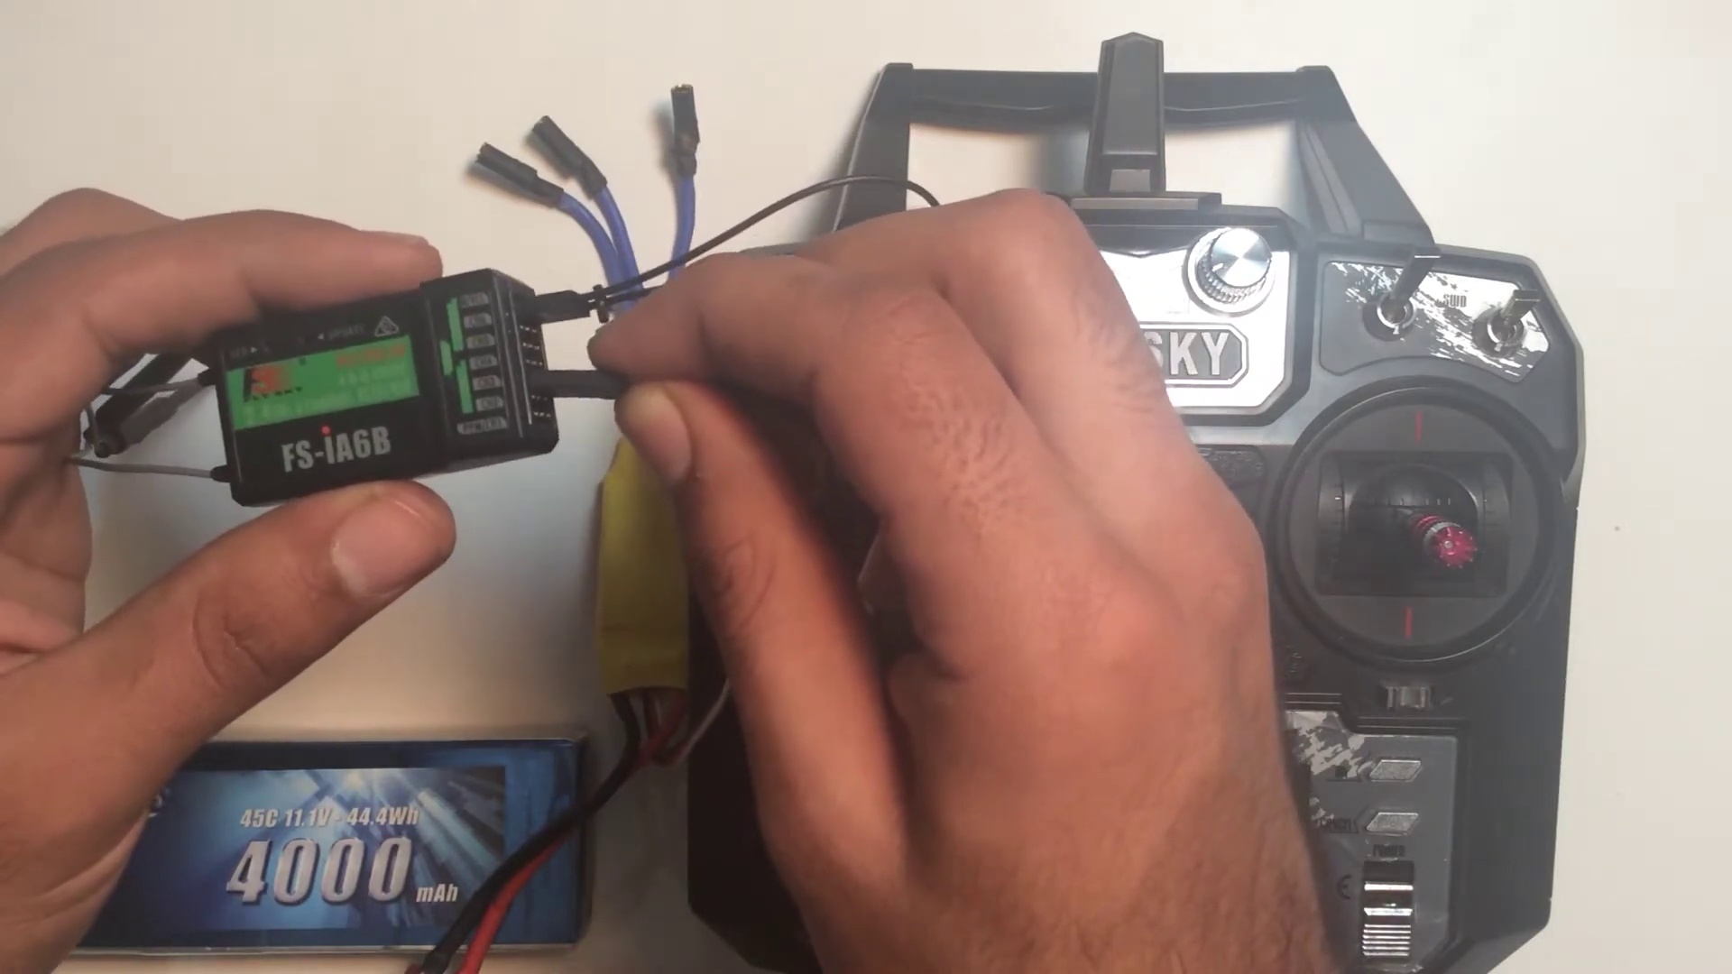 | 0:56   | 0:56   | 0:56   | 0:56  

Transcript
[0:52] to input power for to the receiver and plug it in any of the port of the receiver. Make sure that the

Section 0: A person holding a Flysky remote control and working on a DIY quadcopter or drone.
Time: 0:57 - 0:58

Summary
The image shows a person standing in front of a white surface, holding a black Flysky remote control with red and silver buttons. Their thumb is pressed on the red button, suggesting they may be setting up or adjusting the remote control.

Representative Frames
0:57   | 0:57   | 0:57   | 0:57   | 0:57  

Transcript
(No speech detected in this section)

Section 0: A person working on an electronic device.
Time: 0:58 - 0:59

Summary
The image shows a person holding an electronic device, which appears to be a Flysky radio control. The control, with its silver and black color scheme, features the Flysky logo and the word '4000'.

Representative Frames
0:58   | 0:58   | 0:58   | 0:58   | 0:58  

Transcript
(No speech detected in this section)

Section 0: A person working on a DIY quadcopter or drone.
Time: 0:59 - 1:00

Summary
The image shows two distinct scenes, one featuring an individual handling an electronic device, which appears to be a small quadcopter or drone. The device is connected to a circuit board with multiple electronic components, suggesting it's undergoing repairs or modification.

Representative Frames
0:59   | 0:59   | 0:59  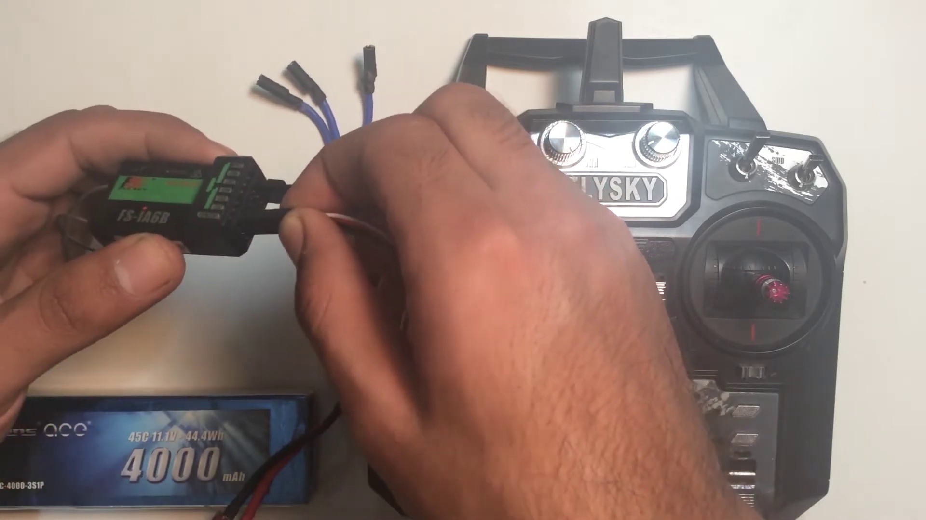 | 0:59   | 0:59  

Transcript
(No speech detected in this section)

Section 0: A person holding a Flysky remote control and working on a DIY quadcopter or drone.
Time: 1:00 - 1:01

Summary
The image shows a person standing in front of a white surface, holding a black Flysky remote control with red and silver buttons. Their thumb is pressed on the red button, suggesting they may be setting up or adjusting the remote control.

Representative Frames
1:00   | 1:00   | 1:00   | 1:00   | 1:00  

Transcript
(No speech detected in this section)

Section 0: A person working on an electronic device.
Time: 1:01 - 1:02

Summary
The image shows a person holding an electronic device, which appears to be a Flysky radio control. The control, with its silver and black color scheme, features the Flysky logo and the word '4000'.

Representative Frames
1:01   | 1:01   | 1:01   | 1:01   | 1:01  

Transcript
(No speech detected in this section)

Section 0: A person working on a DIY quadcopter or drone.
Time: 1:02 - 1:03

Summary
The image shows two distinct scenes, one featuring an individual handling an electronic device, which appears to be a small quadcopter or drone. The device is connected to a circuit board with multiple electronic components, suggesting it's undergoing repairs or modification.

Representative Frames
1:02   | 1:02   | 1:02   | 1:02   | 1:02  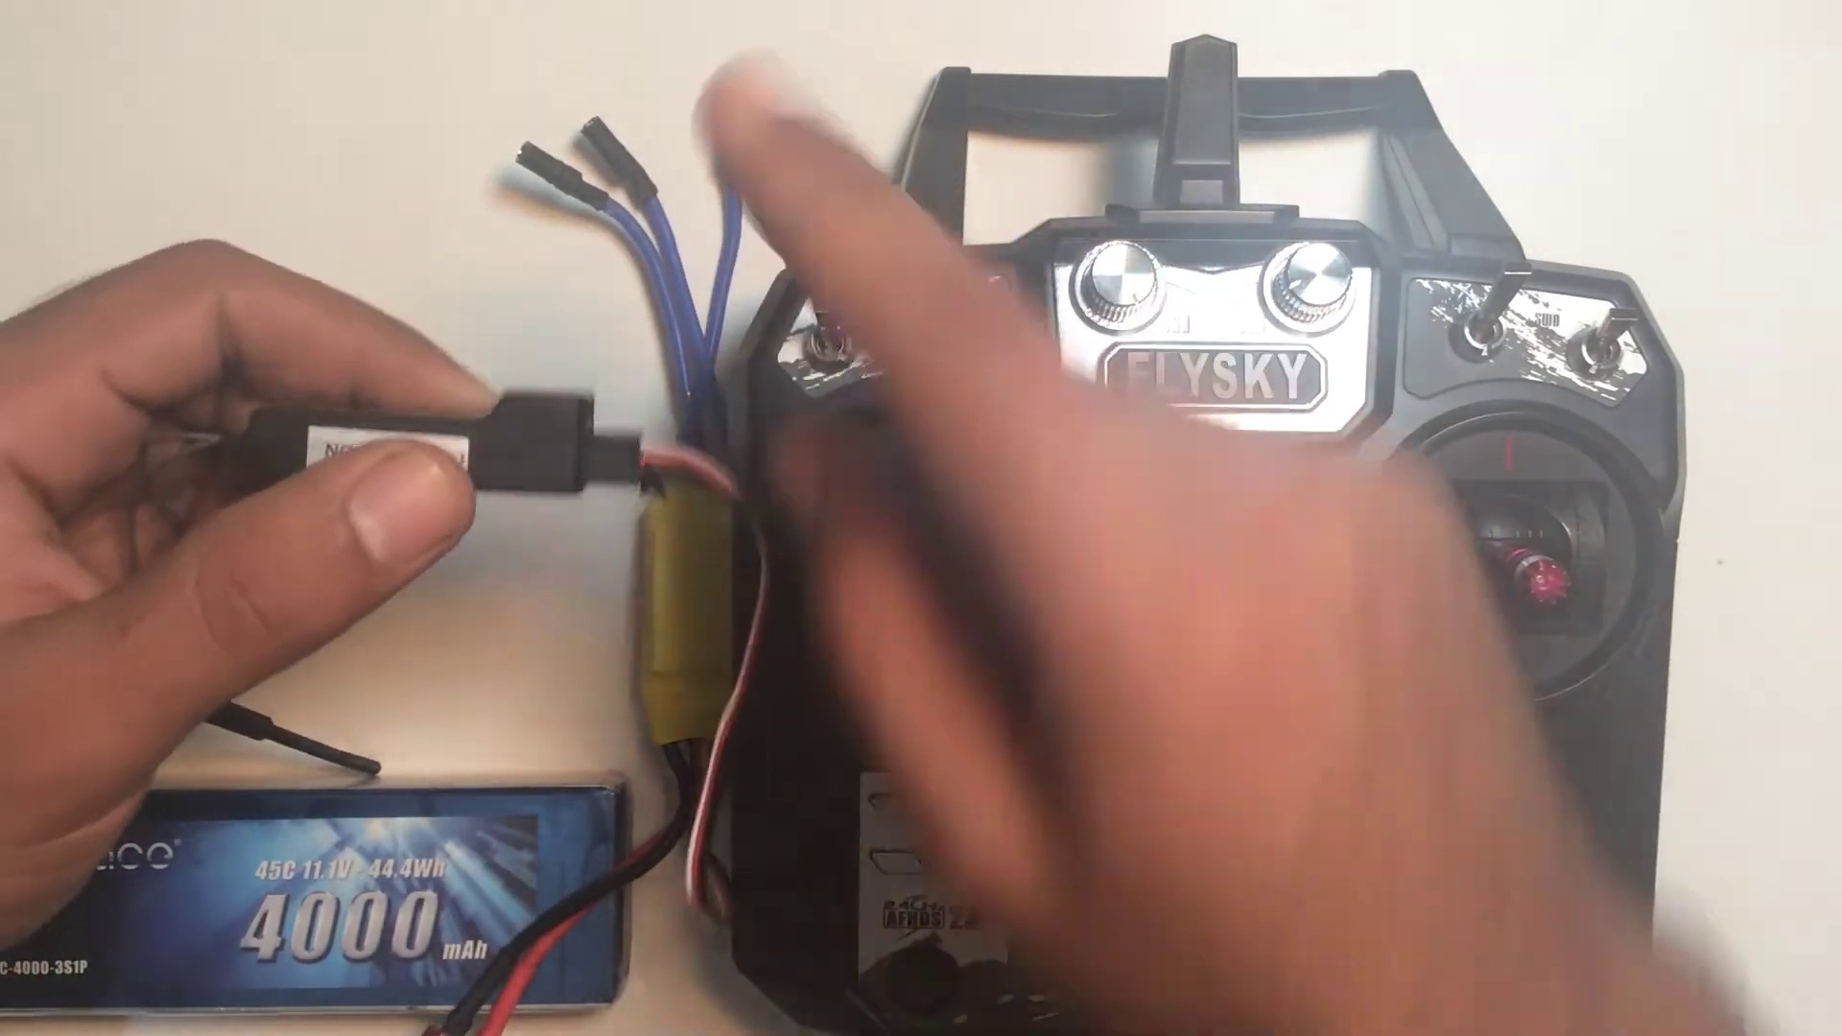

Transcript
(No speech detected in this section)

Section 0: A person holding a Flysky remote control and working on a DIY quadcopter or drone.
Time: 1:03 - 1:04

Summary
The image shows a person standing in front of a white surface, holding a black Flysky remote control with red and silver buttons. Their thumb is pressed on the red button, suggesting they may be setting up or adjusting the remote control.

Representative Frames
1:03   | 1:03   | 1:03   | 1:03   | 1:03  

Transcript
(No speech detected in this section)

Section 0: A person working on an electronic device.
Time: 1:04 - 1:05

Summary
The image shows a person holding an electronic device, which appears to be a Flysky radio control. The control, with its silver and black color scheme, features the Flysky logo and the word '4000'.

Representative Frames
1:04   | 1:04   | 1:04   | 1:04   | 1:04  

Transcript
[1:00] the signal wire the white wire is towards the facing upwards upwards toward towards you. So and then

Section 0: A person working on a DIY quadcopter or drone.
Time: 1:05 - 1:06

Summary
The image shows two distinct scenes, one featuring an individual handling an electronic device, which appears to be a small quadcopter or drone. The device is connected to a circuit board with multiple electronic components, suggesting it's undergoing repairs or modification.

Representative Frames
1:05   | 1:05   | 1:05   | 1:05   | 1:05  

Transcript
(No speech detected in this section)

Section 0: A person holding a Flysky remote control and working on a DIY quadcopter or drone.
Time: 1:06 - 1:07

Summary
The image shows a person standing in front of a white surface, holding a black Flysky remote control with red and silver buttons. Their thumb is pressed on the red button, suggesting they may be setting up or adjusting the remote control.

Representative Frames
1:06  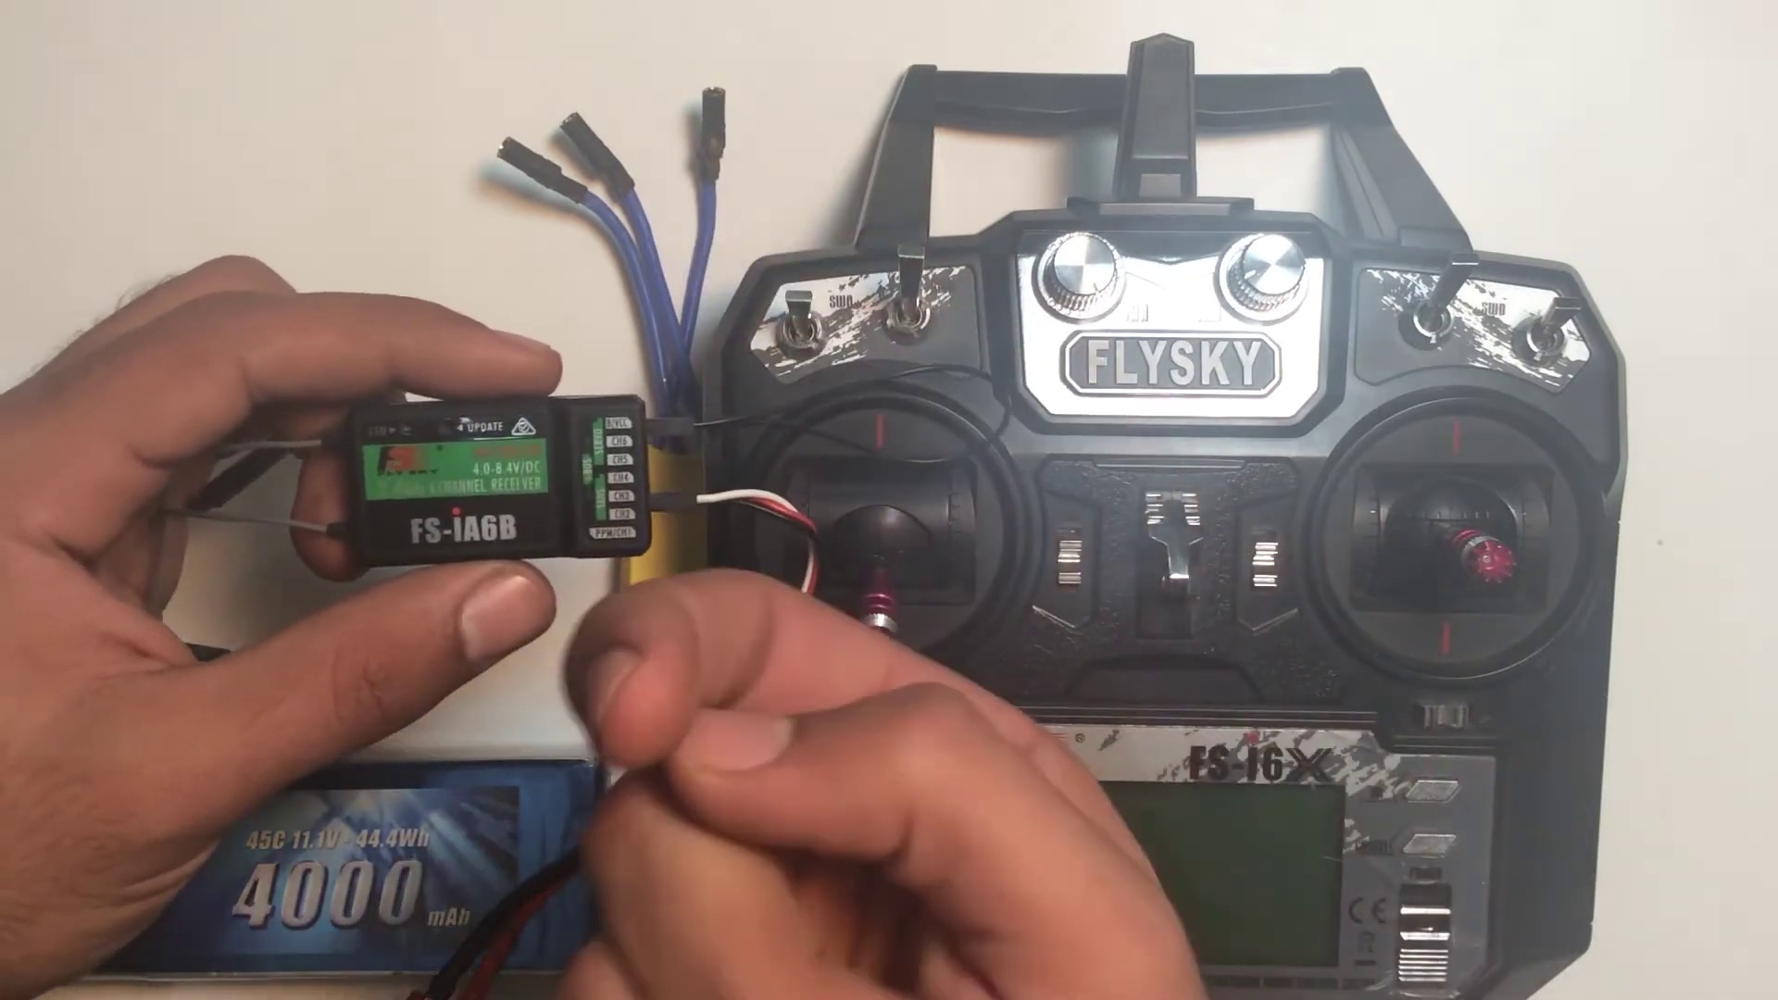 | 1:06   | 1:06   | 1:06   | 1:06  

Transcript
(No speech detected in this section)

Section 0: A person working on an electronic device.
Time: 1:07 - 1:08

Summary
The image shows a person holding an electronic device, which appears to be a Flysky radio control. The control, with its silver and black color scheme, features the Flysky logo and the word '4000'.

Representative Frames
1:07   | 1:07   | 1:07   | 1:07   | 1:07  

Transcript
(No speech detected in this section)

Section 0: A person working on a DIY quadcopter or drone.
Time: 1:08 - 1:09

Summary
The image shows two distinct scenes, one featuring an individual handling an electronic device, which appears to be a small quadcopter or drone. The device is connected to a circuit board with multiple electronic components, suggesting it's undergoing repairs or modification.

Representative Frames
1:08   | 1:08   | 1:08   | 1:08   | 1:08  

Transcript
(No speech detected in this section)

Section 0: A person holding a Flysky remote control and working on a DIY quadcopter or drone.
Time: 1:09 - 1:10

Summary
The image shows a person standing in front of a white surface, holding a black Flysky remote control with red and silver buttons. Their thumb is pressed on the red button, suggesting they may be setting up or adjusting the remote control.

Representative Frames
1:09   | 1:09   | 1:09  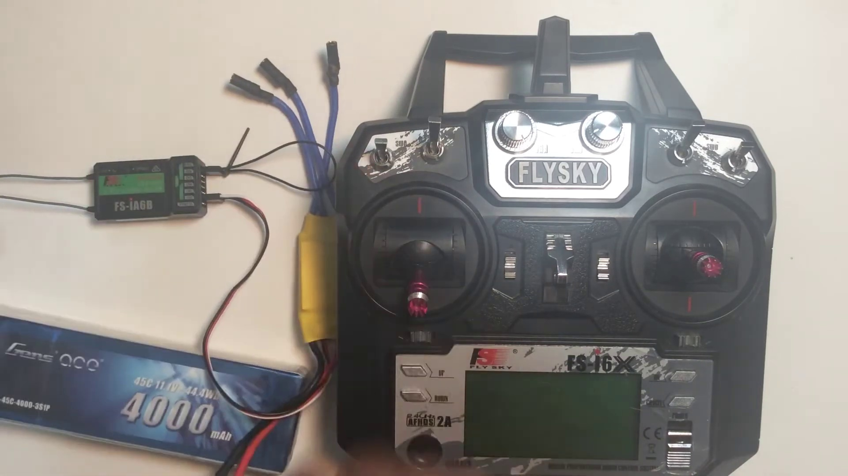 | 1:09   | 1:09  

Transcript
(No speech detected in this section)

Section 0: A person working on an electronic device.
Time: 1:10 - 1:11

Summary
The image shows a person holding an electronic device, which appears to be a Flysky radio control. The control, with its silver and black color scheme, features the Flysky logo and the word '4000'.

Representative Frames
1:10   | 1:10   | 1:10   | 1:10   | 1:10  

Transcript
(No speech detected in this section)

Section 0: A person working on a DIY quadcopter or drone.
Time: 1:11 - 1:12

Summary
The image shows two distinct scenes, one featuring an individual handling an electronic device, which appears to be a small quadcopter or drone. The device is connected to a circuit board with multiple electronic components, suggesting it's undergoing repairs or modification.

Representative Frames
1:11   | 1:11   | 1:11   | 1:11   | 1:11  

Transcript
(No speech detected in this section)

Section 0: A person holding a Flysky remote control and working on a DIY quadcopter or drone.
Time: 1:12 - 1:13

Summary
The image shows a person standing in front of a white surface, holding a black Flysky remote control with red and silver buttons. Their thumb is pressed on the red button, suggesting they may be setting up or adjusting the remote control.

Representative Frames
1:12   | 1:12   | 1:12   | 1:12   | 1:12  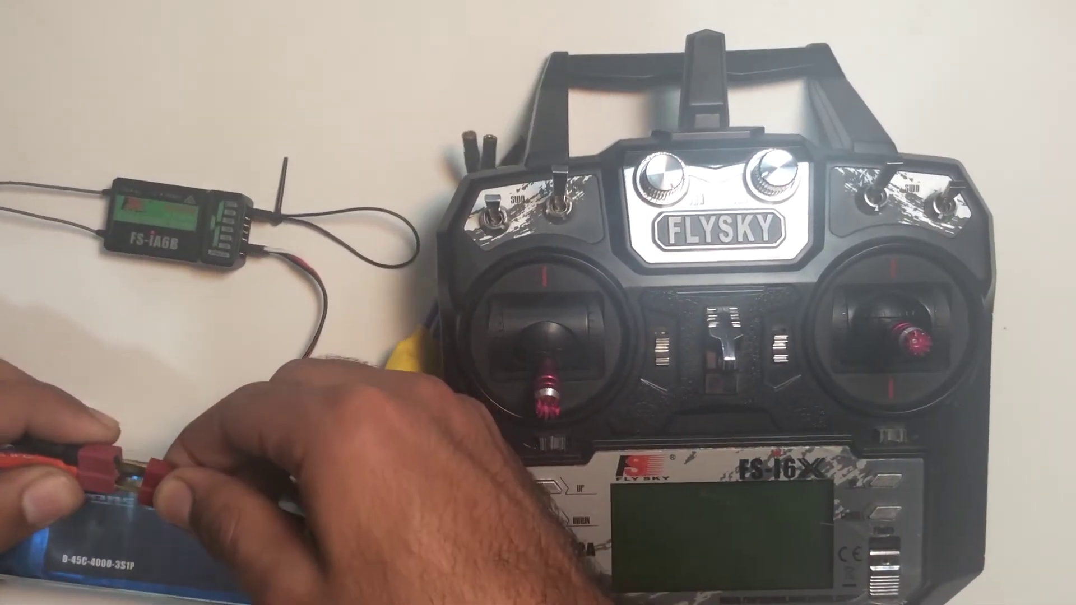

Transcript
(No speech detected in this section)

Section 0: A person working on an electronic device.
Time: 1:13 - 1:14

Summary
The image shows a person holding an electronic device, which appears to be a Flysky radio control. The control, with its silver and black color scheme, features the Flysky logo and the word '4000'.

Representative Frames
1:13   | 1:13   | 1:13   | 1:13   | 1:13  

Transcript
(No speech detected in this section)

Section 0: A person working on a DIY quadcopter or drone.
Time: 1:14 - 1:15

Summary
The image shows two distinct scenes, one featuring an individual handling an electronic device, which appears to be a small quadcopter or drone. The device is connected to a circuit board with multiple electronic components, suggesting it's undergoing repairs or modification.

Representative Frames
1:14   | 1:14   | 1:14   | 1:14   | 1:14  

Transcript
[1:09] lastly just plug the battery into the ESC. So the light in the receiver which will start blinking which

Section 0: A person holding a Flysky remote control and working on a DIY quadcopter or drone.
Time: 1:15 - 1:16

Summary
The image shows a person standing in front of a white surface, holding a black Flysky remote control with red and silver buttons. Their thumb is pressed on the red button, suggesting they may be setting up or adjusting the remote control.

Representative Frames
1:15   | 1:15   | 1:15   | 1:15   | 1:15  

Transcript
(No speech detected in this section)

Section 0: A person working on an electronic device.
Time: 1:16 - 1:17

Summary
The image shows a person holding an electronic device, which appears to be a Flysky radio control. The control, with its silver and black color scheme, features the Flysky logo and the word '4000'.

Representative Frames
1:16  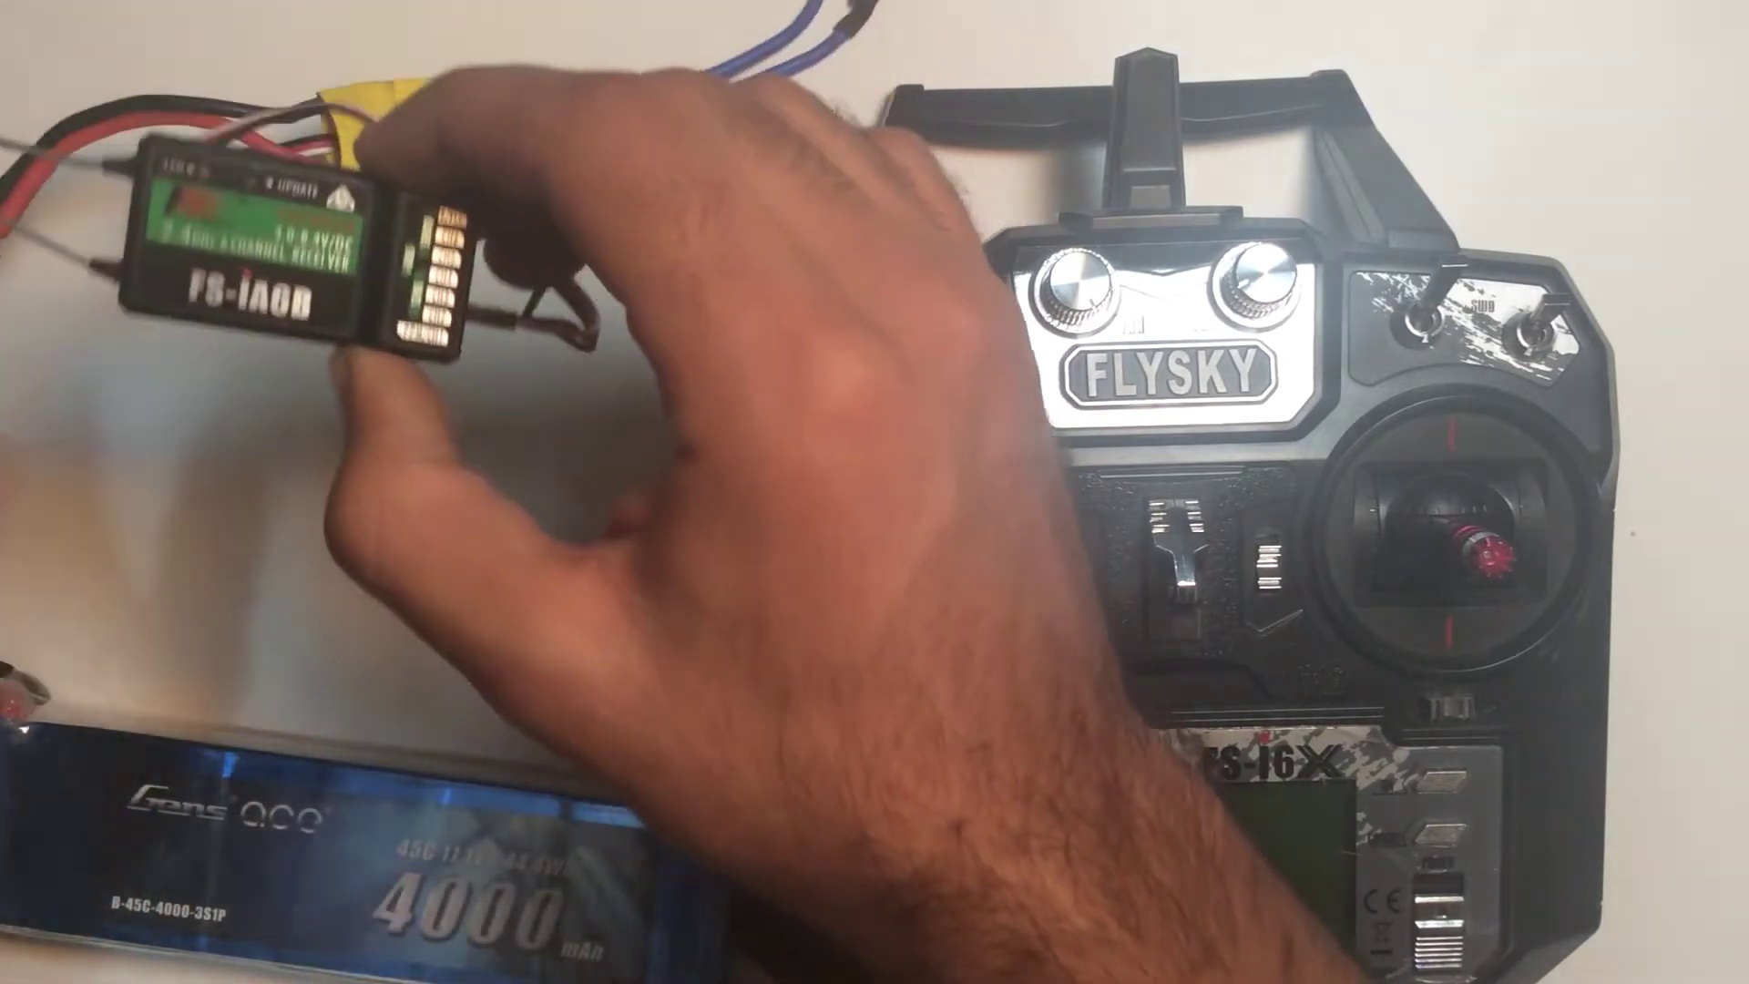 | 1:16   | 1:16   | 1:16   | 1:16  

Transcript
(No speech detected in this section)

Section 0: A person working on a DIY quadcopter or drone.
Time: 1:17 - 1:18

Summary
The image shows two distinct scenes, one featuring an individual handling an electronic device, which appears to be a small quadcopter or drone. The device is connected to a circuit board with multiple electronic components, suggesting it's undergoing repairs or modification.

Representative Frames
1:17   | 1:17   | 1:17   | 1:17   | 1:17  

Transcript
(No speech detected in this section)

Section 0: A person holding a Flysky remote control and working on a DIY quadcopter or drone.
Time: 1:18 - 1:19

Summary
The image shows a person standing in front of a white surface, holding a black Flysky remote control with red and silver buttons. Their thumb is pressed on the red button, suggesting they may be setting up or adjusting the remote control.

Representative Frames
1:18   | 1:18   | 1:18   | 1:18   | 1:18  

Transcript
(No speech detected in this section)

Section 0: A person working on an electronic device.
Time: 1:19 - 1:20

Summary
The image shows a person holding an electronic device, which appears to be a Flysky radio control. The control, with its silver and black color scheme, features the Flysky logo and the word '4000'.

Representative Frames
1:19   | 1:19  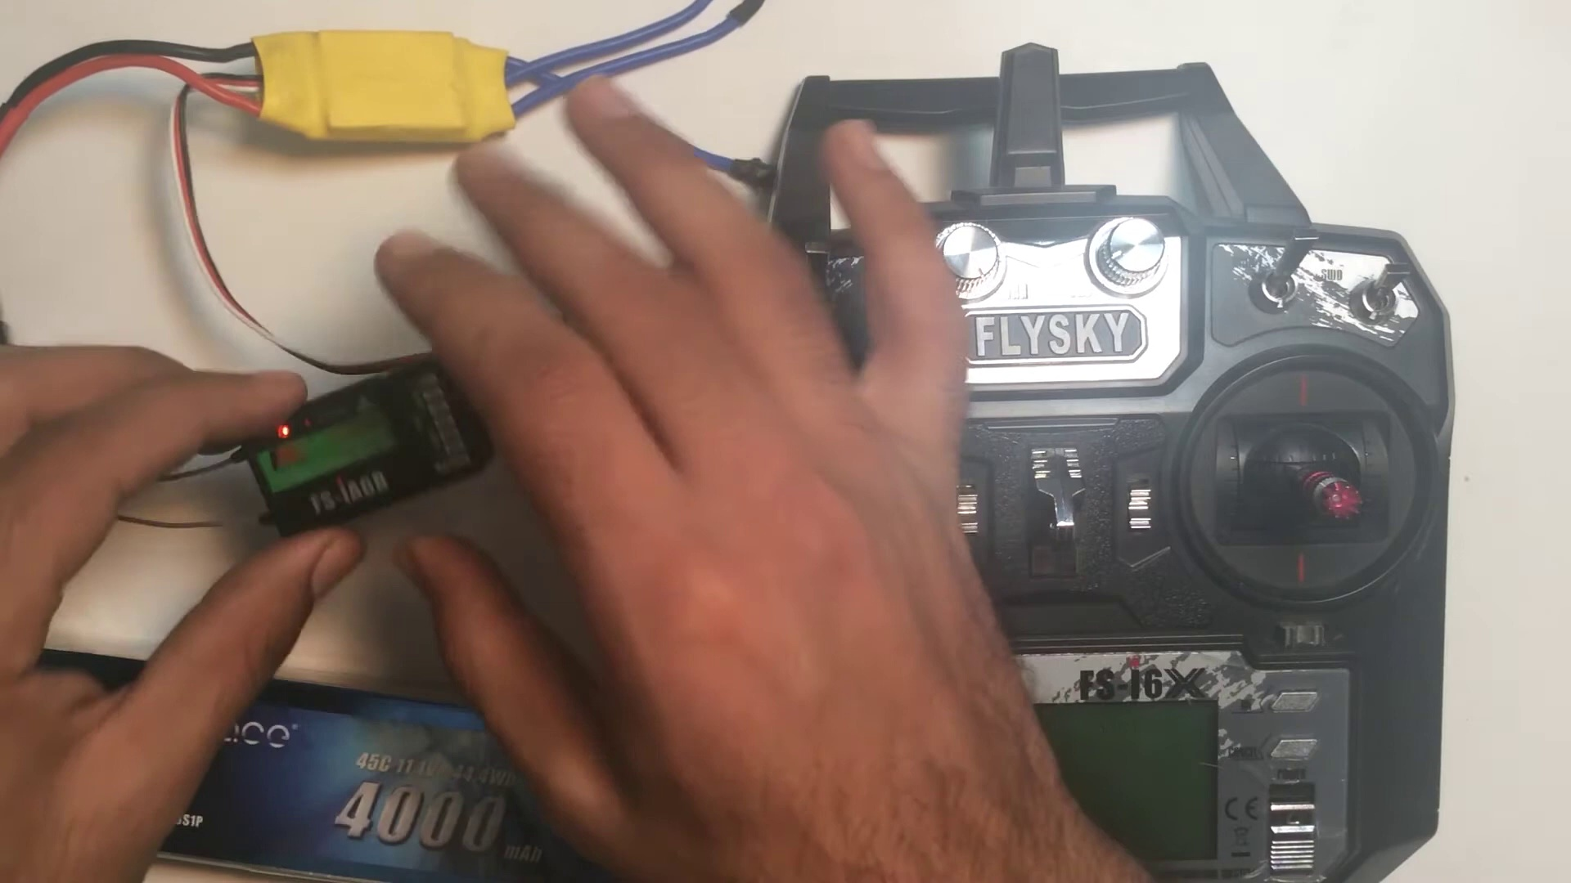 | 1:19   | 1:19   | 1:19  

Transcript
(No speech detected in this section)

Section 0: A person working on a DIY quadcopter or drone.
Time: 1:20 - 1:21

Summary
The image shows two distinct scenes, one featuring an individual handling an electronic device, which appears to be a small quadcopter or drone. The device is connected to a circuit board with multiple electronic components, suggesting it's undergoing repairs or modification.

Representative Frames
1:20   | 1:20   | 1:20   | 1:20   | 1:20  

Transcript
(No speech detected in this section)

Section 0: A person holding a Flysky remote control and working on a DIY quadcopter or drone.
Time: 1:21 - 1:22

Summary
The image shows a person standing in front of a white surface, holding a black Flysky remote control with red and silver buttons. Their thumb is pressed on the red button, suggesting they may be setting up or adjusting the remote control.

Representative Frames
1:21   | 1:21   | 1:21   | 1:21   | 1:21  

Transcript
(No speech detected in this section)

Section 0: A person working on an electronic device.
Time: 1:22 - 1:23

Summary
The image shows a person holding an electronic device, which appears to be a Flysky radio control. The control, with its silver and black color scheme, features the Flysky logo and the word '4000'.

Representative Frames
1:22   | 1:22   | 1:22   | 1:22  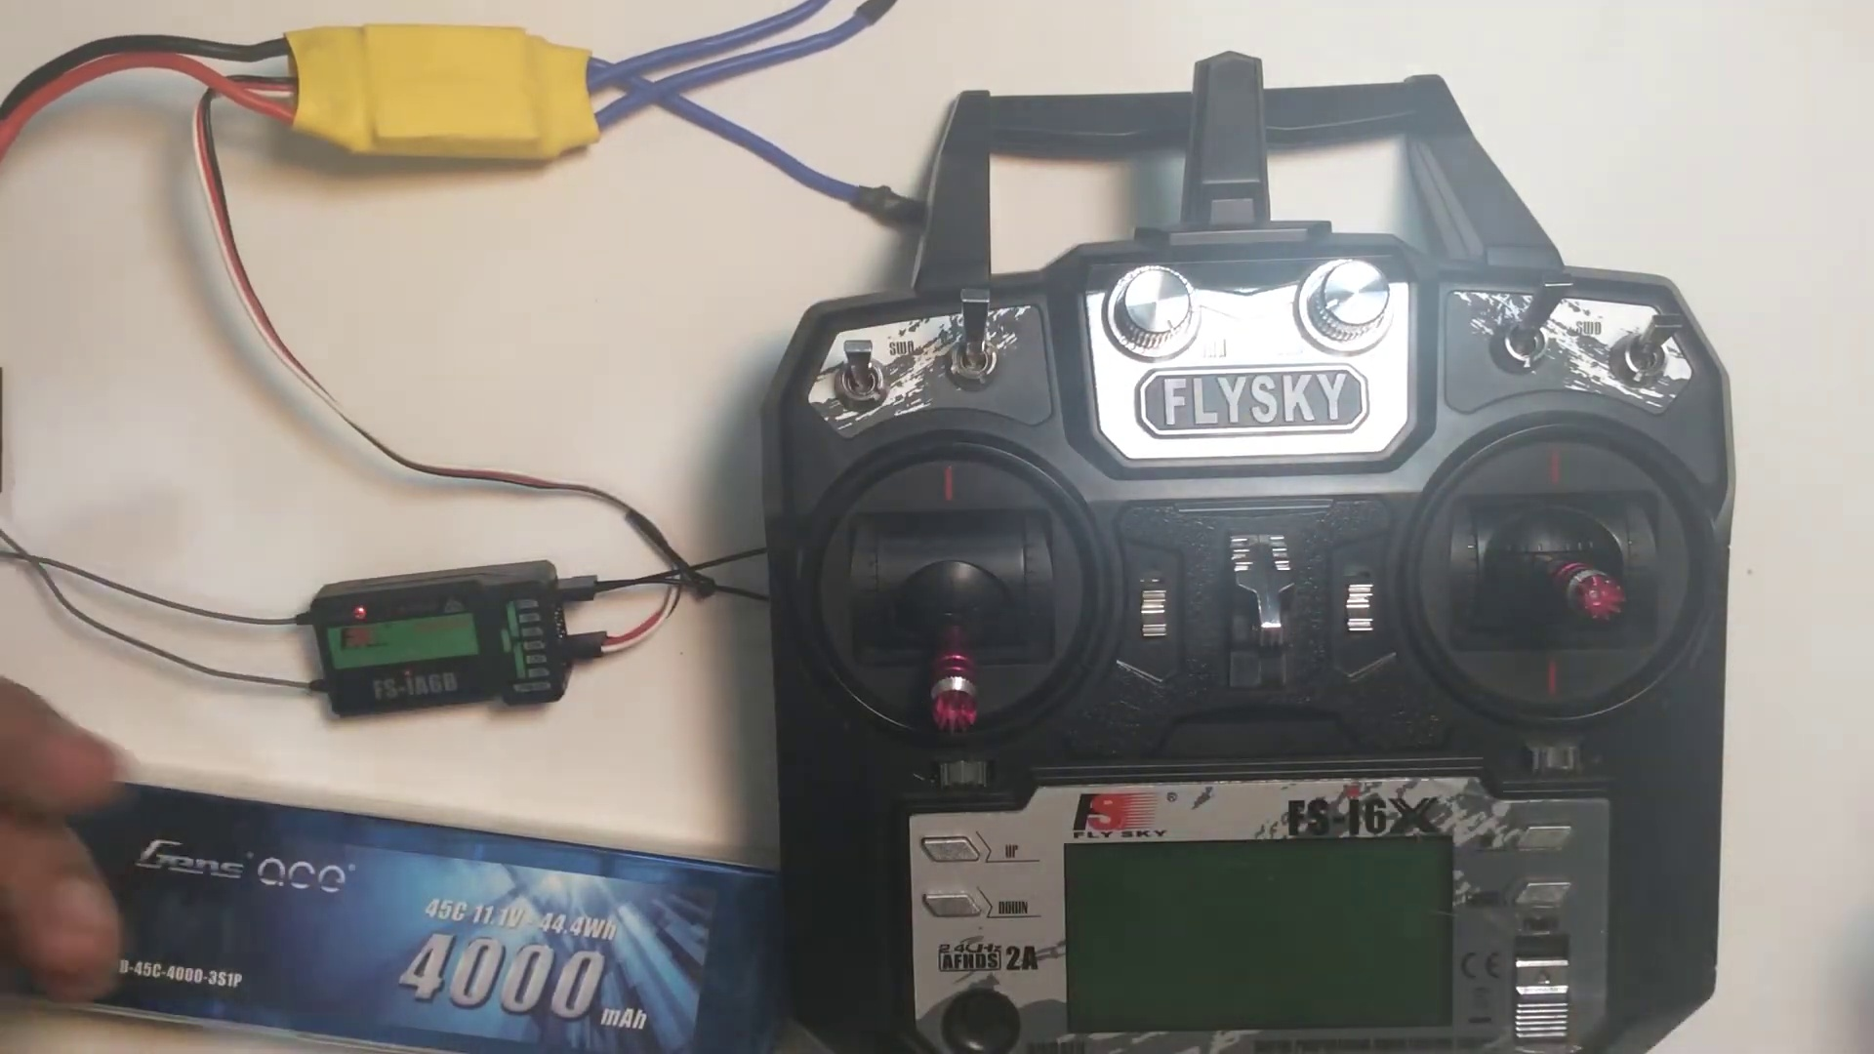 | 1:22  

Transcript
(No speech detected in this section)

Section 0: A person working on a DIY quadcopter or drone.
Time: 1:23 - 1:24

Summary
The image shows two distinct scenes, one featuring an individual handling an electronic device, which appears to be a small quadcopter or drone. The device is connected to a circuit board with multiple electronic components, suggesting it's undergoing repairs or modification.

Representative Frames
1:23   | 1:23   | 1:23   | 1:23   | 1:23  

Transcript
[1:19] actually represents that it is in bind mode. So now here come the turn of the transmitter and in

Section 0: A person holding a Flysky remote control and working on a DIY quadcopter or drone.
Time: 1:24 - 1:25

Summary
The image shows a person standing in front of a white surface, holding a black Flysky remote control with red and silver buttons. Their thumb is pressed on the red button, suggesting they may be setting up or adjusting the remote control.

Representative Frames
1:24   | 1:24   | 1:24   | 1:24   | 1:24  

Transcript
(No speech detected in this section)

Section 0: A person working on an electronic device.
Time: 1:25 - 1:26

Summary
The image shows a person holding an electronic device, which appears to be a Flysky radio control. The control, with its silver and black color scheme, features the Flysky logo and the word '4000'.

Representative Frames
1:25   | 1:25   | 1:25   | 1:25   | 1:25  

Transcript
(No speech detected in this section)

Section 0: A person working on a DIY quadcopter or drone.
Time: 1:26 - 1:27

Summary
The image shows two distinct scenes, one featuring an individual handling an electronic device, which appears to be a small quadcopter or drone. The device is connected to a circuit board with multiple electronic components, suggesting it's undergoing repairs or modification.

Representative Frames
1:26  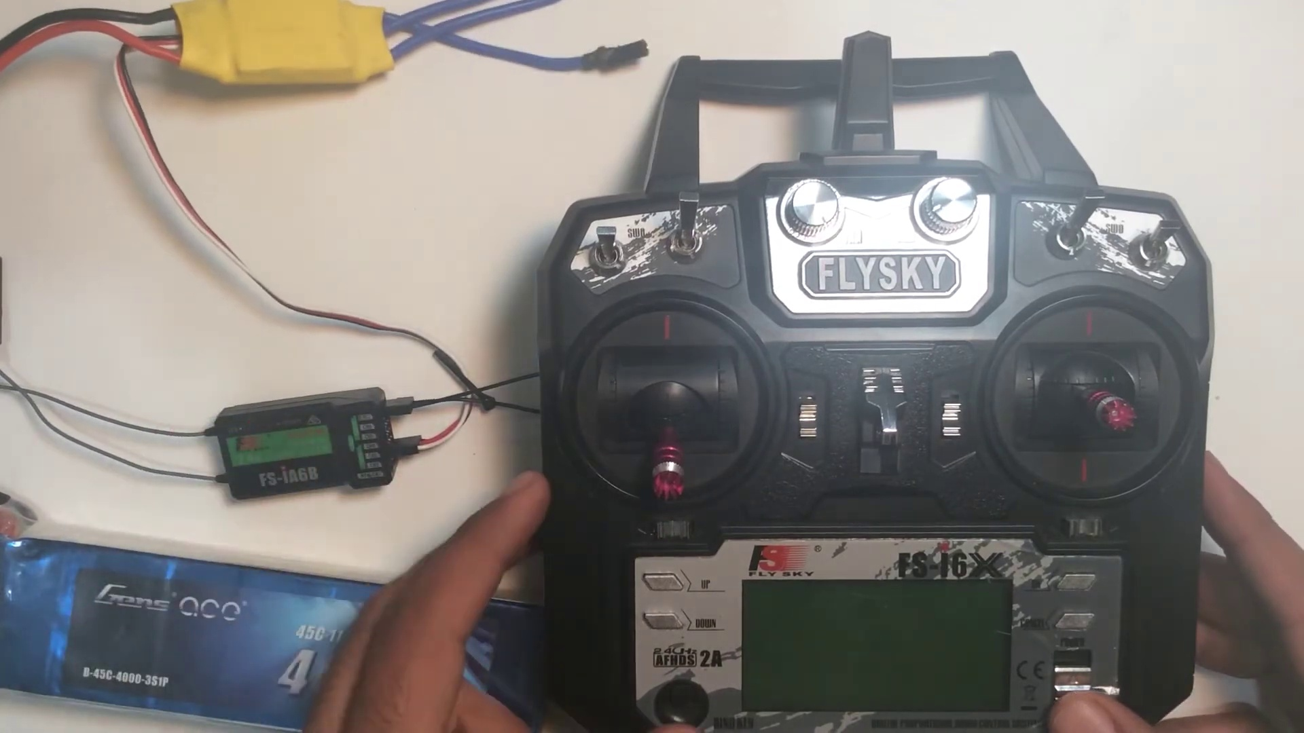 | 1:26   | 1:26   | 1:26   | 1:26  

Transcript
(No speech detected in this section)

Section 0: A person holding a Flysky remote control and working on a DIY quadcopter or drone.
Time: 1:27 - 1:28

Summary
The image shows a person standing in front of a white surface, holding a black Flysky remote control with red and silver buttons. Their thumb is pressed on the red button, suggesting they may be setting up or adjusting the remote control.

Representative Frames
1:27   | 1:27   | 1:27   | 1:27   | 1:27  

Transcript
(No speech detected in this section)

Section 0: A person working on an electronic device.
Time: 1:28 - 1:29

Summary
The image shows a person holding an electronic device, which appears to be a Flysky radio control. The control, with its silver and black color scheme, features the Flysky logo and the word '4000'.

Representative Frames
1:28   | 1:28   | 1:28   | 1:28   | 1:28  

Transcript
(No speech detected in this section)

Section 0: A person working on a DIY quadcopter or drone.
Time: 1:29 - 1:30

Summary
The image shows two distinct scenes, one featuring an individual handling an electronic device, which appears to be a small quadcopter or drone. The device is connected to a circuit board with multiple electronic components, suggesting it's undergoing repairs or modification.

Representative Frames
1:29   | 1:29  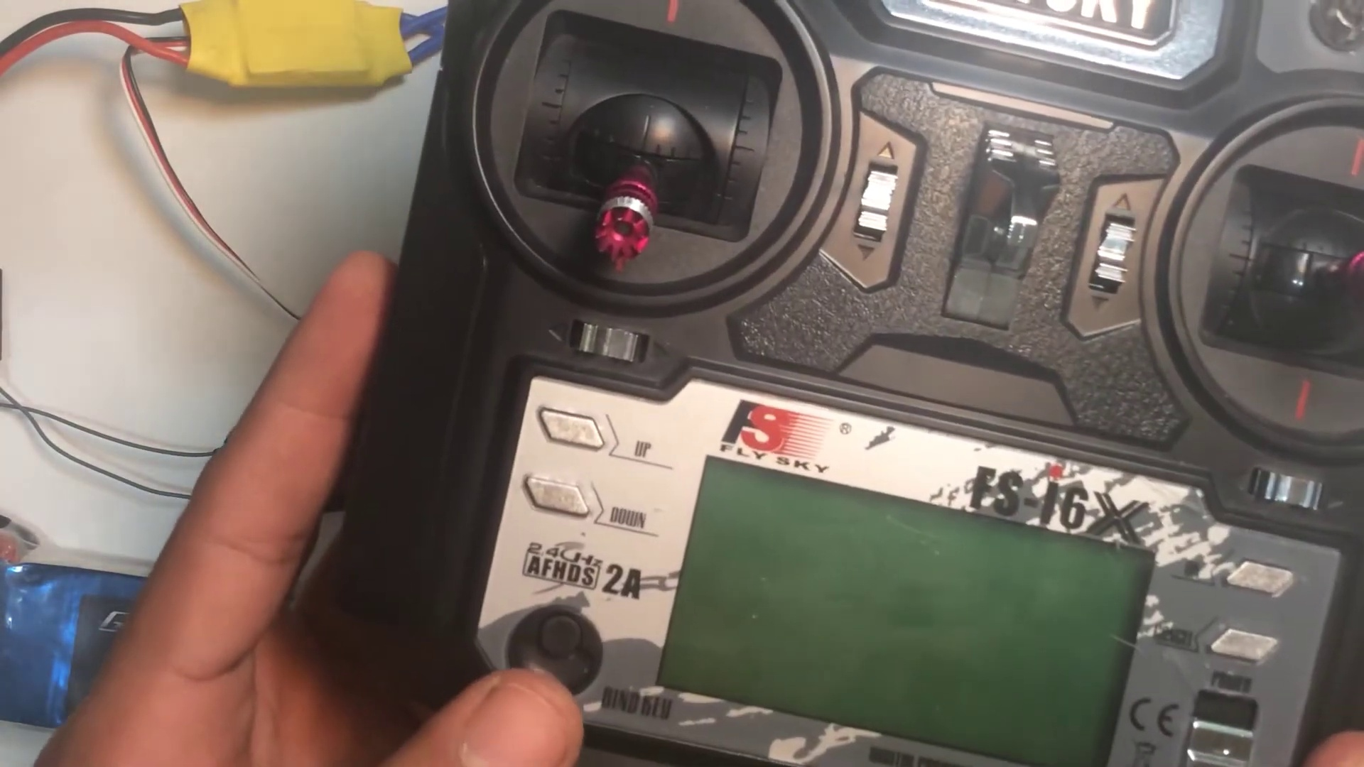 | 1:29   | 1:29   | 1:29  

Transcript
(No speech detected in this section)

Section 0: A person holding a Flysky remote control and working on a DIY quadcopter or drone.
Time: 1:30 - 1:31

Summary
The image shows a person standing in front of a white surface, holding a black Flysky remote control with red and silver buttons. Their thumb is pressed on the red button, suggesting they may be setting up or adjusting the remote control.

Representative Frames
1:30   | 1:30   | 1:30   | 1:30   | 1:30  

Transcript
(No speech detected in this section)

Section 0: A person working on an electronic device.
Time: 1:31 - 1:32

Summary
The image shows a person holding an electronic device, which appears to be a Flysky radio control. The control, with its silver and black color scheme, features the Flysky logo and the word '4000'.

Representative Frames
1:31   | 1:31   | 1:31   | 1:31   | 1:31  

Transcript
[1:28] transmitter you actually have got a bind key. Here it is written bind key. In some of the receiver for

Section 0: A person working on a DIY quadcopter or drone.
Time: 1:32 - 1:33

Summary
The image shows two distinct scenes, one featuring an individual handling an electronic device, which appears to be a small quadcopter or drone. The device is connected to a circuit board with multiple electronic components, suggesting it's undergoing repairs or modification.

Representative Frames
1:32   | 1:32   | 1:32  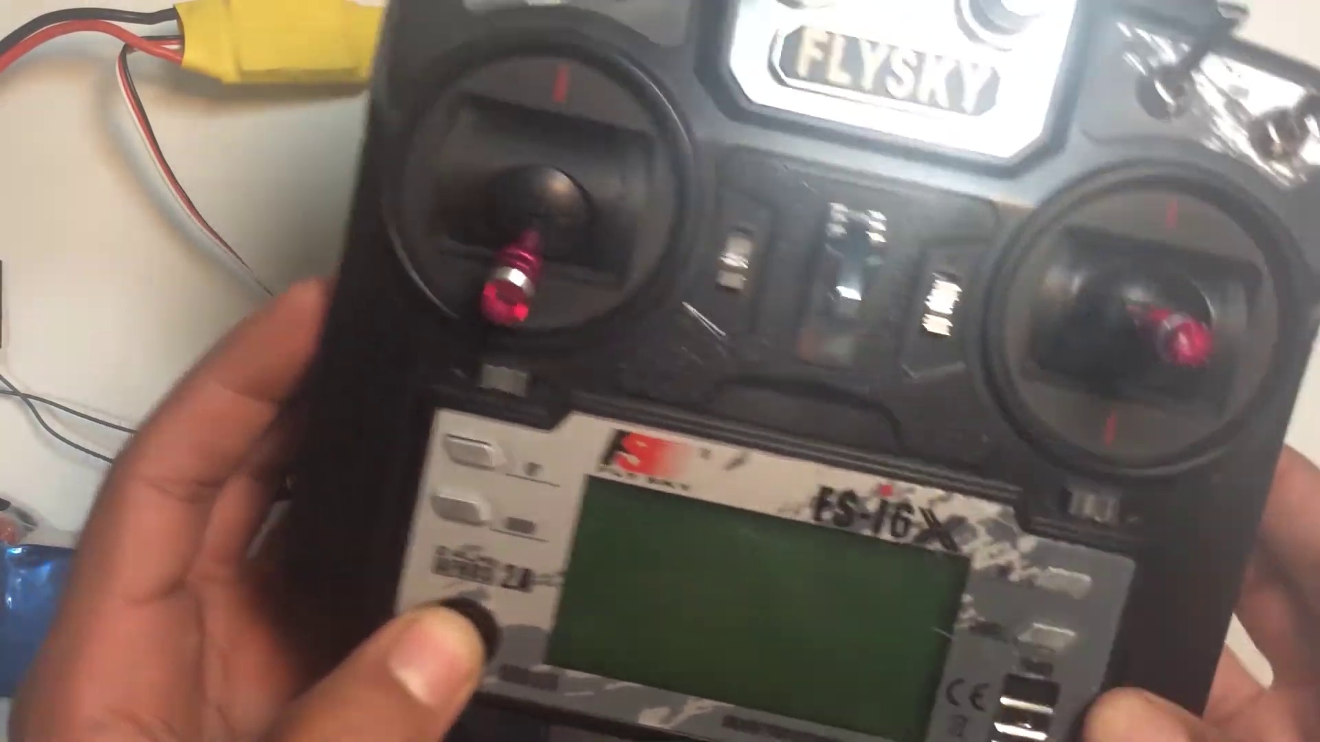 | 1:32   | 1:32  

Transcript
(No speech detected in this section)

Section 0: A person holding a Flysky remote control and working on a DIY quadcopter or drone.
Time: 1:33 - 1:34

Summary
The image shows a person standing in front of a white surface, holding a black Flysky remote control with red and silver buttons. Their thumb is pressed on the red button, suggesting they may be setting up or adjusting the remote control.

Representative Frames
1:33   | 1:33   | 1:33   | 1:33   | 1:33  

Transcript
(No speech detected in this section)

Section 0: A person working on an electronic device.
Time: 1:34 - 1:35

Summary
The image shows a person holding an electronic device, which appears to be a Flysky radio control. The control, with its silver and black color scheme, features the Flysky logo and the word '4000'.

Representative Frames
1:34   | 1:34   | 1:34   | 1:34   | 1:34  

Transcript
(No speech detected in this section)

Section 0: A person working on a DIY quadcopter or drone.
Time: 1:35 - 1:36

Summary
The image shows two distinct scenes, one featuring an individual handling an electronic device, which appears to be a small quadcopter or drone. The device is connected to a circuit board with multiple electronic components, suggesting it's undergoing repairs or modification.

Representative Frames
1:35   | 1:35   | 1:35   | 1:35   | 1:35  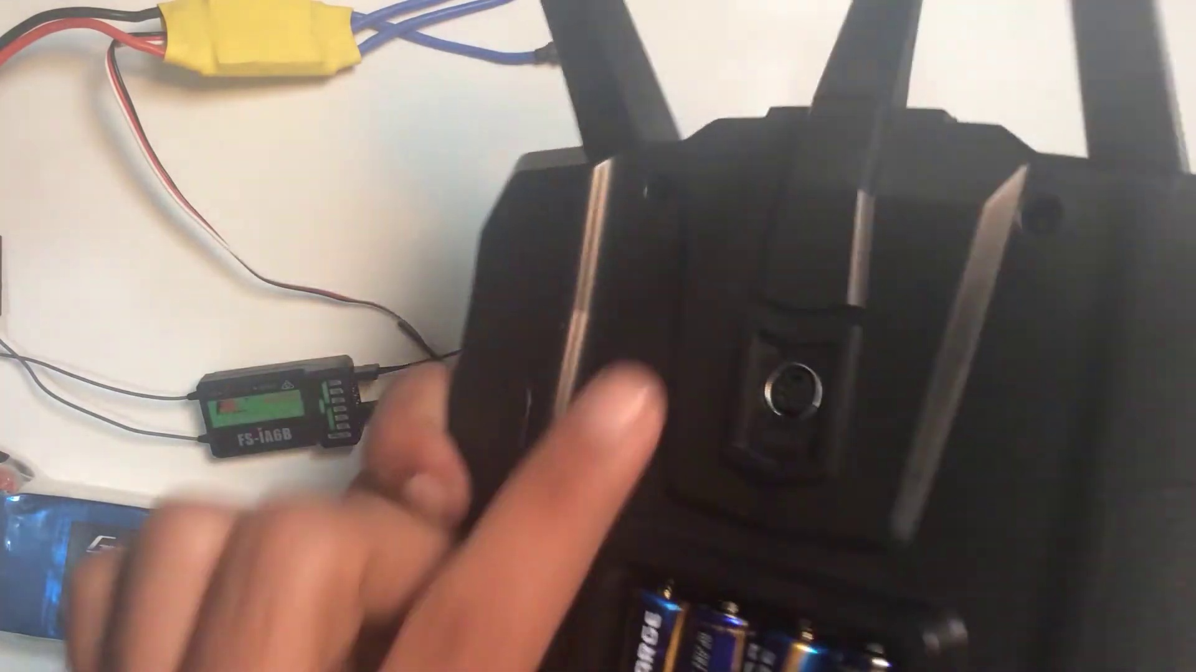

Transcript
(No speech detected in this section)

Section 0: A person holding a Flysky remote control and working on a DIY quadcopter or drone.
Time: 1:36 - 1:37

Summary
The image shows a person standing in front of a white surface, holding a black Flysky remote control with red and silver buttons. Their thumb is pressed on the red button, suggesting they may be setting up or adjusting the remote control.

Representative Frames
1:36   | 1:36   | 1:36   | 1:36   | 1:36  

Transcript
(No speech detected in this section)

Section 0: A person working on an electronic device.
Time: 1:37 - 1:38

Summary
The image shows a person holding an electronic device, which appears to be a Flysky radio control. The control, with its silver and black color scheme, features the Flysky logo and the word '4000'.

Representative Frames
1:37   | 1:37   | 1:37   | 1:37   | 1:37  

Transcript
(No speech detected in this section)

Section 0: A person working on a DIY quadcopter or drone.
Time: 1:38 - 1:39

Summary
The image shows two distinct scenes, one featuring an individual handling an electronic device, which appears to be a small quadcopter or drone. The device is connected to a circuit board with multiple electronic components, suggesting it's undergoing repairs or modification.

Representative Frames
1:38   | 1:38   | 1:38   | 1:38   | 1:38  

Transcript
(No speech detected in this section)

Section 0: A person holding a Flysky remote control and working on a DIY quadcopter or drone.
Time: 1:39 - 1:40

Summary
The image shows a person standing in front of a white surface, holding a black Flysky remote control with red and silver buttons. Their thumb is pressed on the red button, suggesting they may be setting up or adjusting the remote control.

Representative Frames
1:39  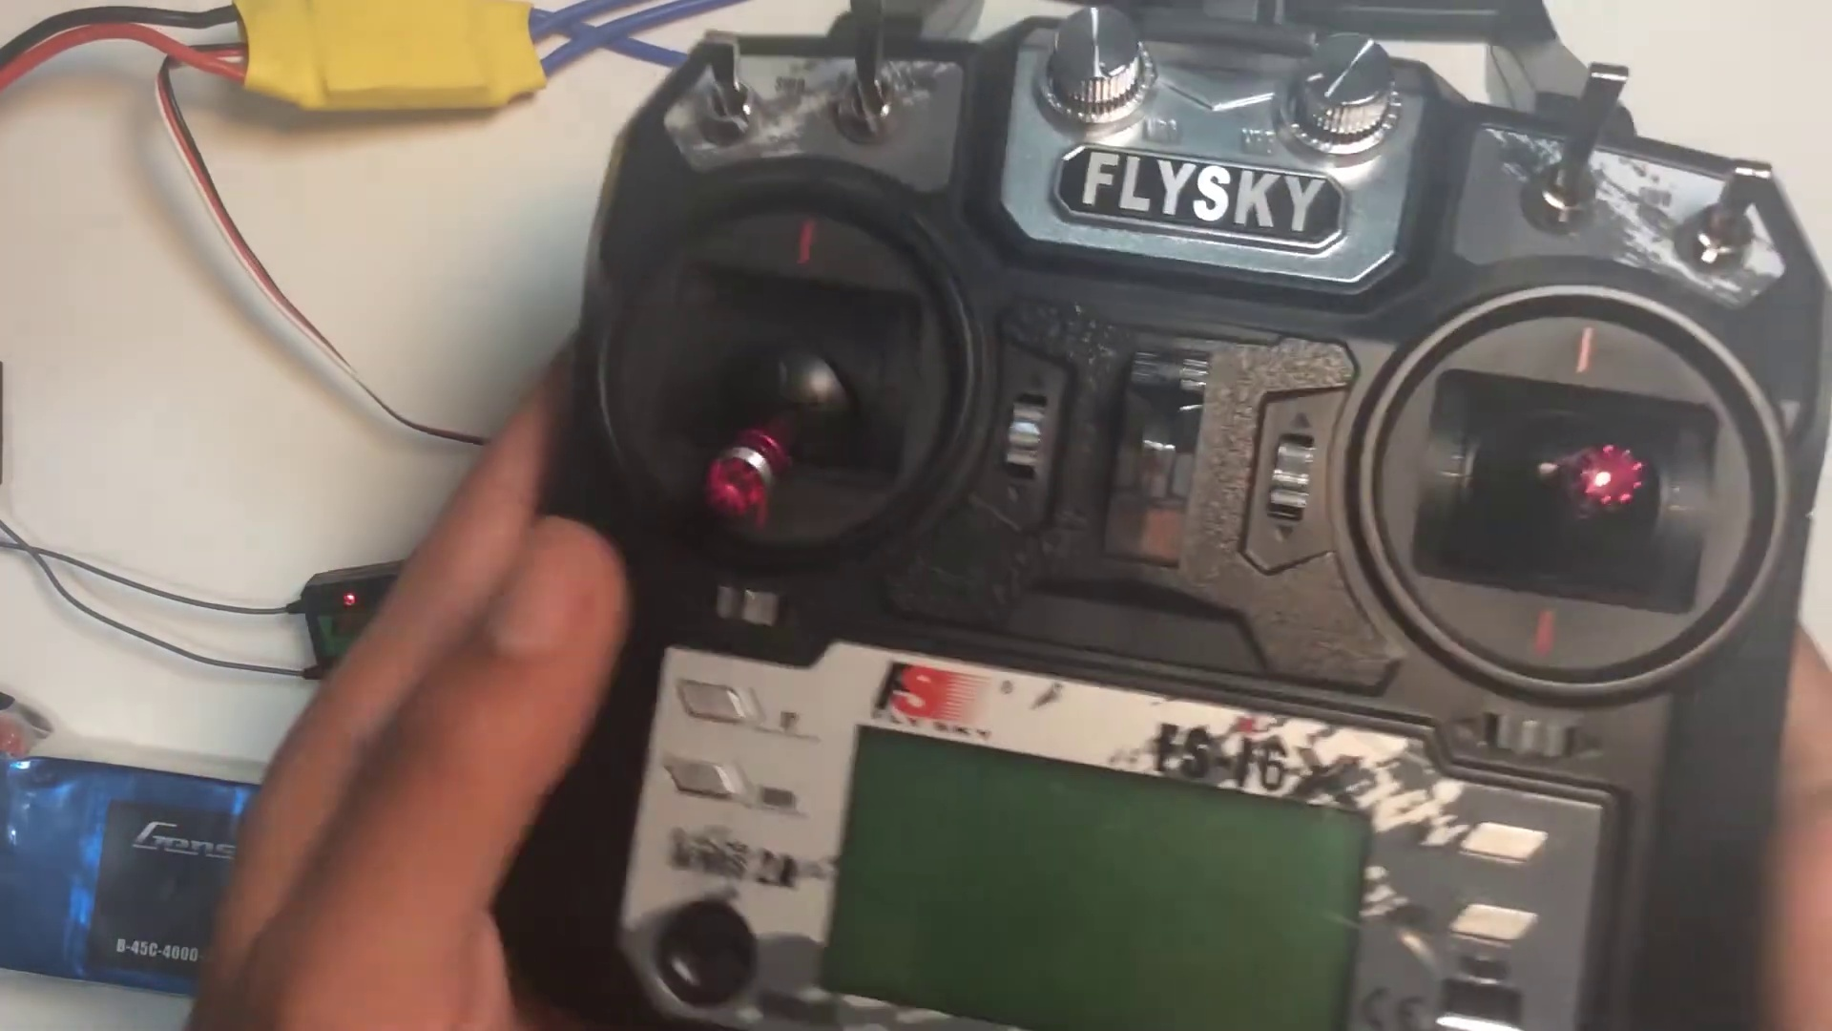 | 1:39   | 1:39   | 1:39   | 1:39  

Transcript
[1:34] example FST6 the bind key is just at the back side of the transmitter. So before turning on the transmitter

Section 0: A person working on an electronic device.
Time: 1:40 - 1:41

Summary
The image shows a person holding an electronic device, which appears to be a Flysky radio control. The control, with its silver and black color scheme, features the Flysky logo and the word '4000'.

Representative Frames
1:40   | 1:40   | 1:40   | 1:40   | 1:40  

Transcript
(No speech detected in this section)

Section 0: A person working on a DIY quadcopter or drone.
Time: 1:41 - 1:42

Summary
The image shows two distinct scenes, one featuring an individual handling an electronic device, which appears to be a small quadcopter or drone. The device is connected to a circuit board with multiple electronic components, suggesting it's undergoing repairs or modification.

Representative Frames
1:41   | 1:41   | 1:41   | 1:41   | 1:41  

Transcript
(No speech detected in this section)

Section 0: A person holding a Flysky remote control and working on a DIY quadcopter or drone.
Time: 1:42 - 1:43

Summary
The image shows a person standing in front of a white surface, holding a black Flysky remote control with red and silver buttons. Their thumb is pressed on the red button, suggesting they may be setting up or adjusting the remote control.

Representative Frames
1:42   | 1:42   | 1:42  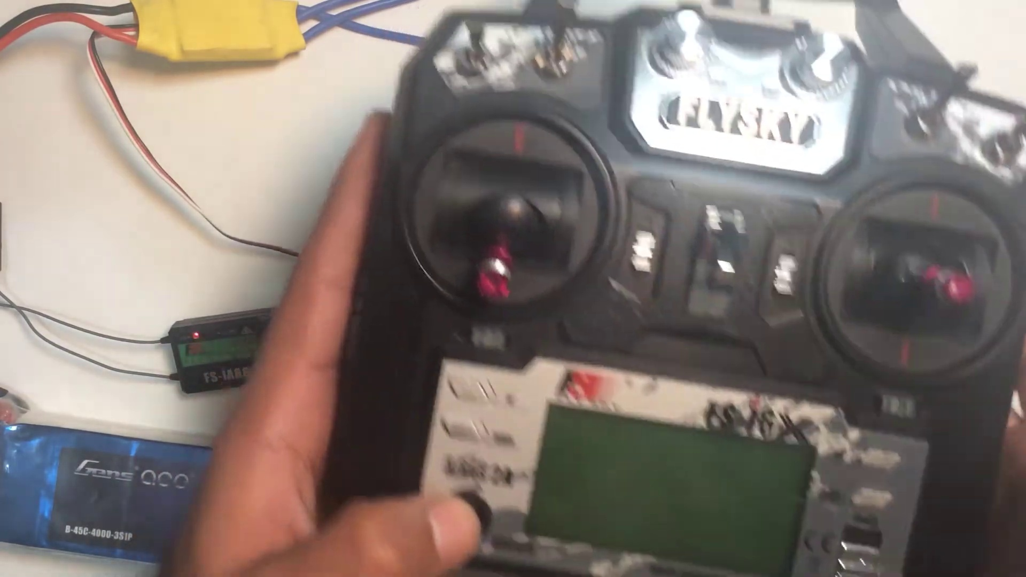 | 1:42   | 1:42  

Transcript
(No speech detected in this section)

Section 0: A person working on an electronic device.
Time: 1:43 - 1:44

Summary
The image shows a person holding an electronic device, which appears to be a Flysky radio control. The control, with its silver and black color scheme, features the Flysky logo and the word '4000'.

Representative Frames
1:43   | 1:43   | 1:43   | 1:43   | 1:43  

Transcript
(No speech detected in this section)

Section 0: A person working on a DIY quadcopter or drone.
Time: 1:44 - 1:45

Summary
The image shows two distinct scenes, one featuring an individual handling an electronic device, which appears to be a small quadcopter or drone. The device is connected to a circuit board with multiple electronic components, suggesting it's undergoing repairs or modification.

Representative Frames
1:44   | 1:44   | 1:44   | 1:44   | 1:44  

Transcript
(No speech detected in this section)

Section 0: A person holding a Flysky remote control and working on a DIY quadcopter or drone.
Time: 1:45 - 1:46

Summary
The image shows a person standing in front of a white surface, holding a black Flysky remote control with red and silver buttons. Their thumb is pressed on the red button, suggesting they may be setting up or adjusting the remote control.

Representative Frames
1:45   | 1:45   | 1:45   | 1:45   | 1:45  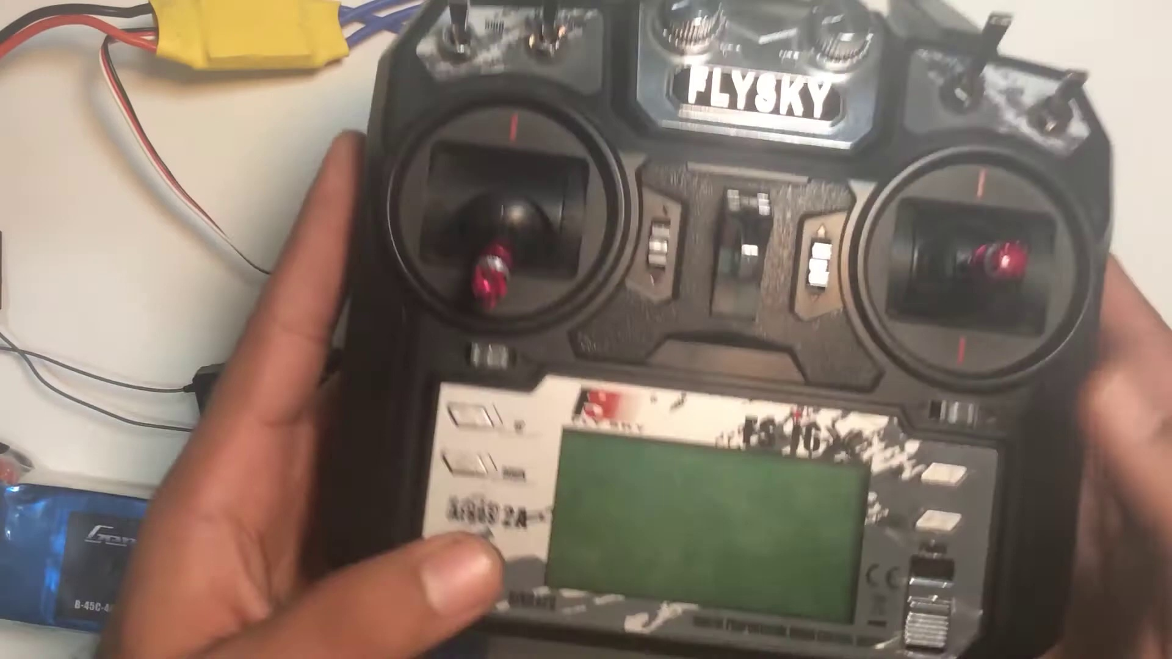

Transcript
(No speech detected in this section)

Section 0: A person working on an electronic device.
Time: 1:46 - 1:47

Summary
The image shows a person holding an electronic device, which appears to be a Flysky radio control. The control, with its silver and black color scheme, features the Flysky logo and the word '4000'.

Representative Frames
1:46   | 1:46   | 1:46   | 1:46   | 1:46  

Transcript
(No speech detected in this section)

Section 0: A person working on a DIY quadcopter or drone.
Time: 1:47 - 1:48

Summary
The image shows two distinct scenes, one featuring an individual handling an electronic device, which appears to be a small quadcopter or drone. The device is connected to a circuit board with multiple electronic components, suggesting it's undergoing repairs or modification.

Representative Frames
1:47   | 1:47   | 1:47   | 1:47   | 1:47  

Transcript
(No speech detected in this section)

Section 0: A person holding a Flysky remote control and working on a DIY quadcopter or drone.
Time: 1:48 - 1:49

Summary
The image shows a person standing in front of a white surface, holding a black Flysky remote control with red and silver buttons. Their thumb is pressed on the red button, suggesting they may be setting up or adjusting the remote control.

Representative Frames
1:48   | 1:48   | 1:48   | 1:48   | 1:48  

Transcript
[1:43] put all the switches up the throttle down and press the bind key and then turn on the transmitter. So it

Section 0: A person working on an electronic device.
Time: 1:49 - 1:50

Summary
The image shows a person holding an electronic device, which appears to be a Flysky radio control. The control, with its silver and black color scheme, features the Flysky logo and the word '4000'.

Representative Frames
1:49  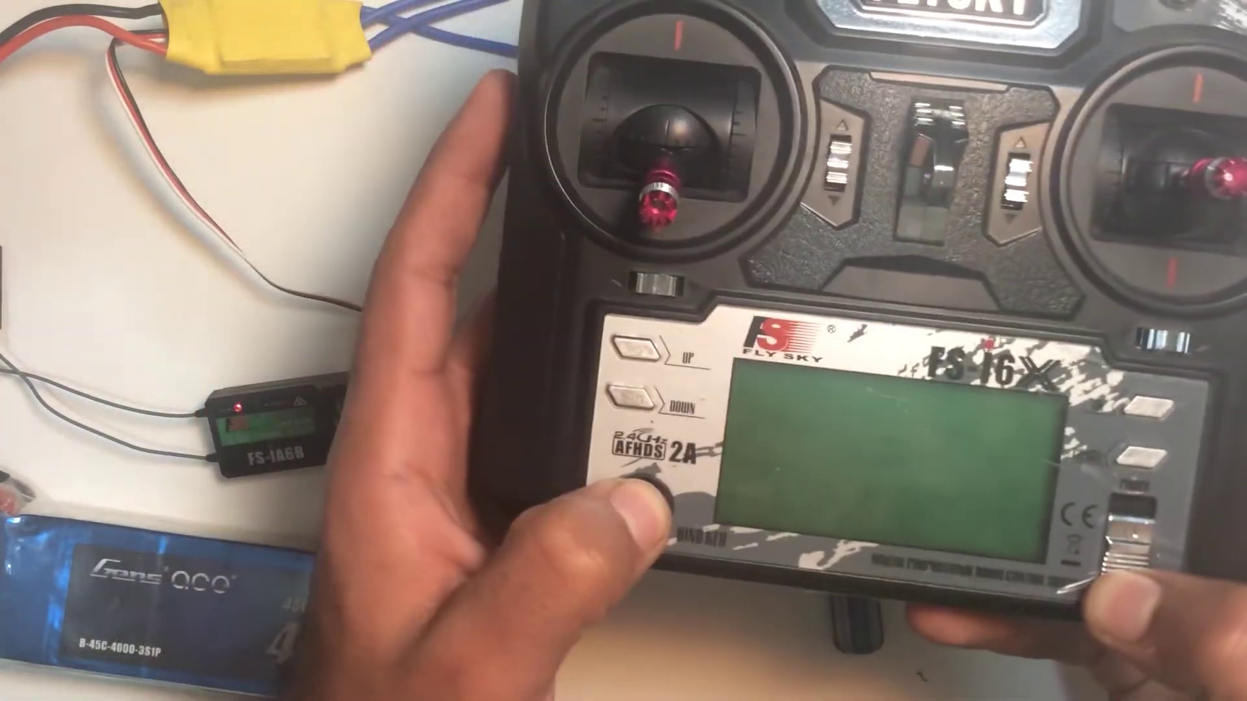 | 1:49   | 1:49   | 1:49   | 1:49  

Transcript
(No speech detected in this section)

Section 0: A person working on a DIY quadcopter or drone.
Time: 1:50 - 1:51

Summary
The image shows two distinct scenes, one featuring an individual handling an electronic device, which appears to be a small quadcopter or drone. The device is connected to a circuit board with multiple electronic components, suggesting it's undergoing repairs or modification.

Representative Frames
1:50   | 1:50   | 1:50   | 1:50   | 1:50  

Transcript
(No speech detected in this section)

Section 0: A person holding a Flysky remote control and working on a DIY quadcopter or drone.
Time: 1:51 - 1:52

Summary
The image shows a person standing in front of a white surface, holding a black Flysky remote control with red and silver buttons. Their thumb is pressed on the red button, suggesting they may be setting up or adjusting the remote control.

Representative Frames
1:51   | 1:51   | 1:51   | 1:51   | 1:51  

Transcript
(No speech detected in this section)

Section 0: A person working on an electronic device.
Time: 1:52 - 1:53

Summary
The image shows a person holding an electronic device, which appears to be a Flysky radio control. The control, with its silver and black color scheme, features the Flysky logo and the word '4000'.

Representative Frames
1:52   | 1:52  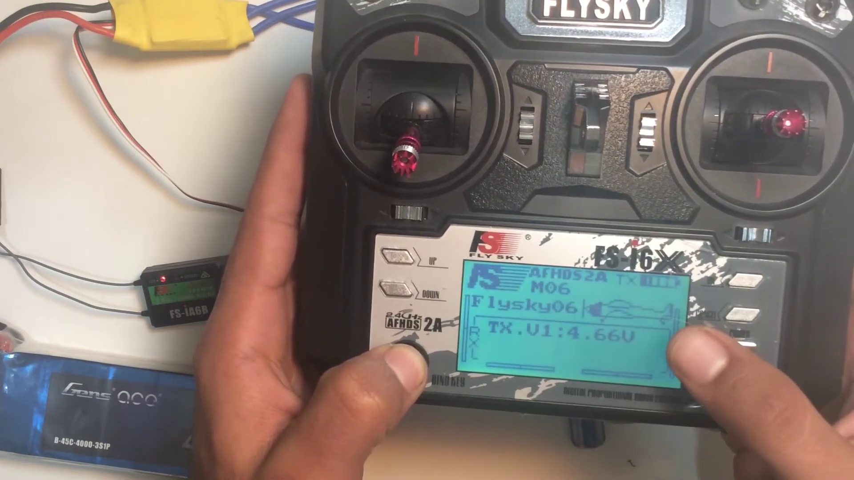 | 1:52   | 1:52   | 1:52  

Transcript
(No speech detected in this section)

Section 0: A person working on a DIY quadcopter or drone.
Time: 1:53 - 1:54

Summary
The image shows two distinct scenes, one featuring an individual handling an electronic device, which appears to be a small quadcopter or drone. The device is connected to a circuit board with multiple electronic components, suggesting it's undergoing repairs or modification.

Representative Frames
1:53   | 1:53   | 1:53   | 1:53   | 1:53  

Transcript
(No speech detected in this section)

Section 0: A person holding a Flysky remote control and working on a DIY quadcopter or drone.
Time: 1:54 - 1:55

Summary
The image shows a person standing in front of a white surface, holding a black Flysky remote control with red and silver buttons. Their thumb is pressed on the red button, suggesting they may be setting up or adjusting the remote control.

Representative Frames
1:54   | 1:54   | 1:54   | 1:54   | 1:54  

Transcript
(No speech detected in this section)

Section 0: A person working on an electronic device.
Time: 1:55 - 1:56

Summary
The image shows a person holding an electronic device, which appears to be a Flysky radio control. The control, with its silver and black color scheme, features the Flysky logo and the word '4000'.

Representative Frames
1:55   | 1:55   | 1:55   | 1:55  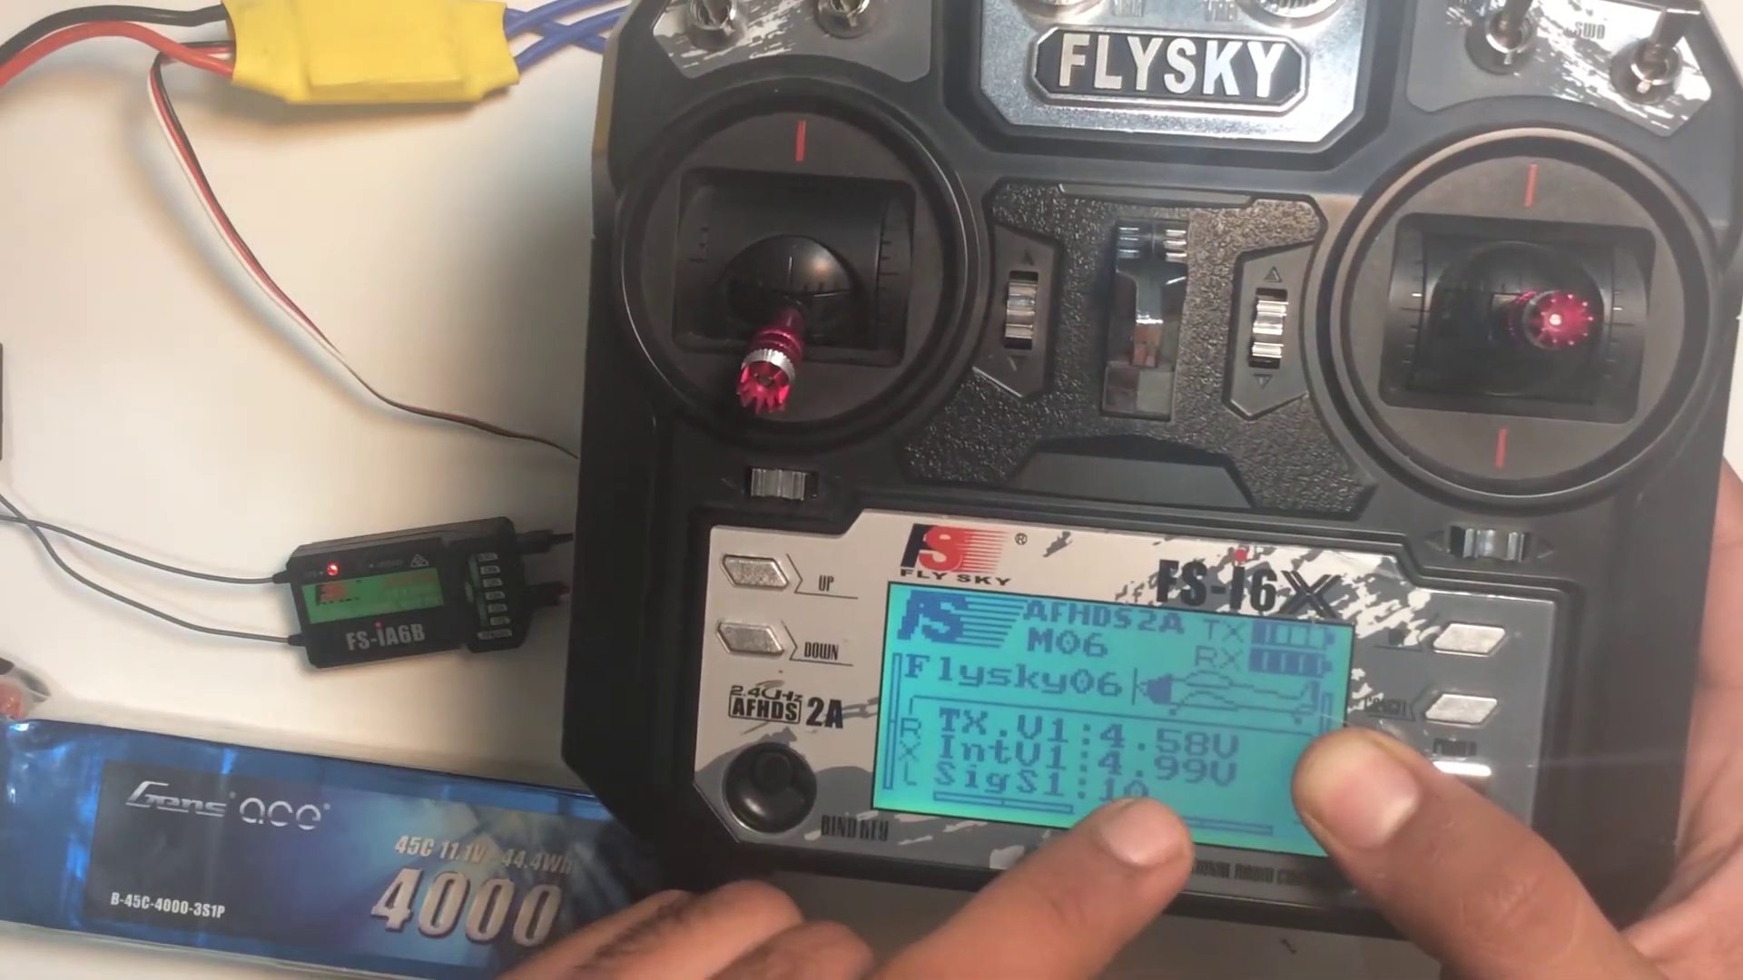 | 1:55  

Transcript
(No speech detected in this section)

Section 0: A person working on a DIY quadcopter or drone.
Time: 1:56 - 1:57

Summary
The image shows two distinct scenes, one featuring an individual handling an electronic device, which appears to be a small quadcopter or drone. The device is connected to a circuit board with multiple electronic components, suggesting it's undergoing repairs or modification.

Representative Frames
1:56   | 1:56   | 1:56   | 1:56   | 1:56  

Transcript
[1:52] will show binding rx and it is bound and here it will show the voltage of the receiver which is 4.9 volts

Section 0: A person holding a Flysky remote control and working on a DIY quadcopter or drone.
Time: 1:57 - 1:58

Summary
The image shows a person standing in front of a white surface, holding a black Flysky remote control with red and silver buttons. Their thumb is pressed on the red button, suggesting they may be setting up or adjusting the remote control.

Representative Frames
1:57   | 1:57   | 1:57   | 1:57   | 1:57  

Transcript
(No speech detected in this section)

Section 0: A person working on an electronic device.
Time: 1:58 - 1:59

Summary
The image shows a person holding an electronic device, which appears to be a Flysky radio control. The control, with its silver and black color scheme, features the Flysky logo and the word '4000'.

Representative Frames
1:58   | 1:58   | 1:58   | 1:58   | 1:58  

Transcript
(No speech detected in this section)

Section 0: A person working on a DIY quadcopter or drone.
Time: 1:59 - 2:00

Summary
The image shows two distinct scenes, one featuring an individual handling an electronic device, which appears to be a small quadcopter or drone. The device is connected to a circuit board with multiple electronic components, suggesting it's undergoing repairs or modification.

Representative Frames
1:59  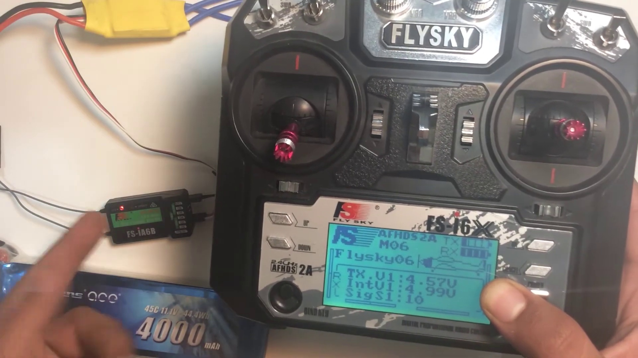 | 1:59   | 1:59   | 1:59   | 1:59  

Transcript
(No speech detected in this section)

Section 0: A person holding a Flysky remote control and working on a DIY quadcopter or drone.
Time: 2:00 - 2:01

Summary
The image shows a person standing in front of a white surface, holding a black Flysky remote control with red and silver buttons. Their thumb is pressed on the red button, suggesting they may be setting up or adjusting the remote control.

Representative Frames
2:00   | 2:00   | 2:00   | 2:00   | 2:00  

Transcript
(No speech detected in this section)

Section 0: A person working on an electronic device.
Time: 2:01 - 2:02

Summary
The image shows a person holding an electronic device, which appears to be a Flysky radio control. The control, with its silver and black color scheme, features the Flysky logo and the word '4000'.

Representative Frames
2:01   | 2:01   | 2:01   | 2:01   | 2:01  

Transcript
(No speech detected in this section)

Section 0: A person working on a DIY quadcopter or drone.
Time: 2:02 - 2:03

Summary
The image shows two distinct scenes, one featuring an individual handling an electronic device, which appears to be a small quadcopter or drone. The device is connected to a circuit board with multiple electronic components, suggesting it's undergoing repairs or modification.

Representative Frames
2:02   | 2:02  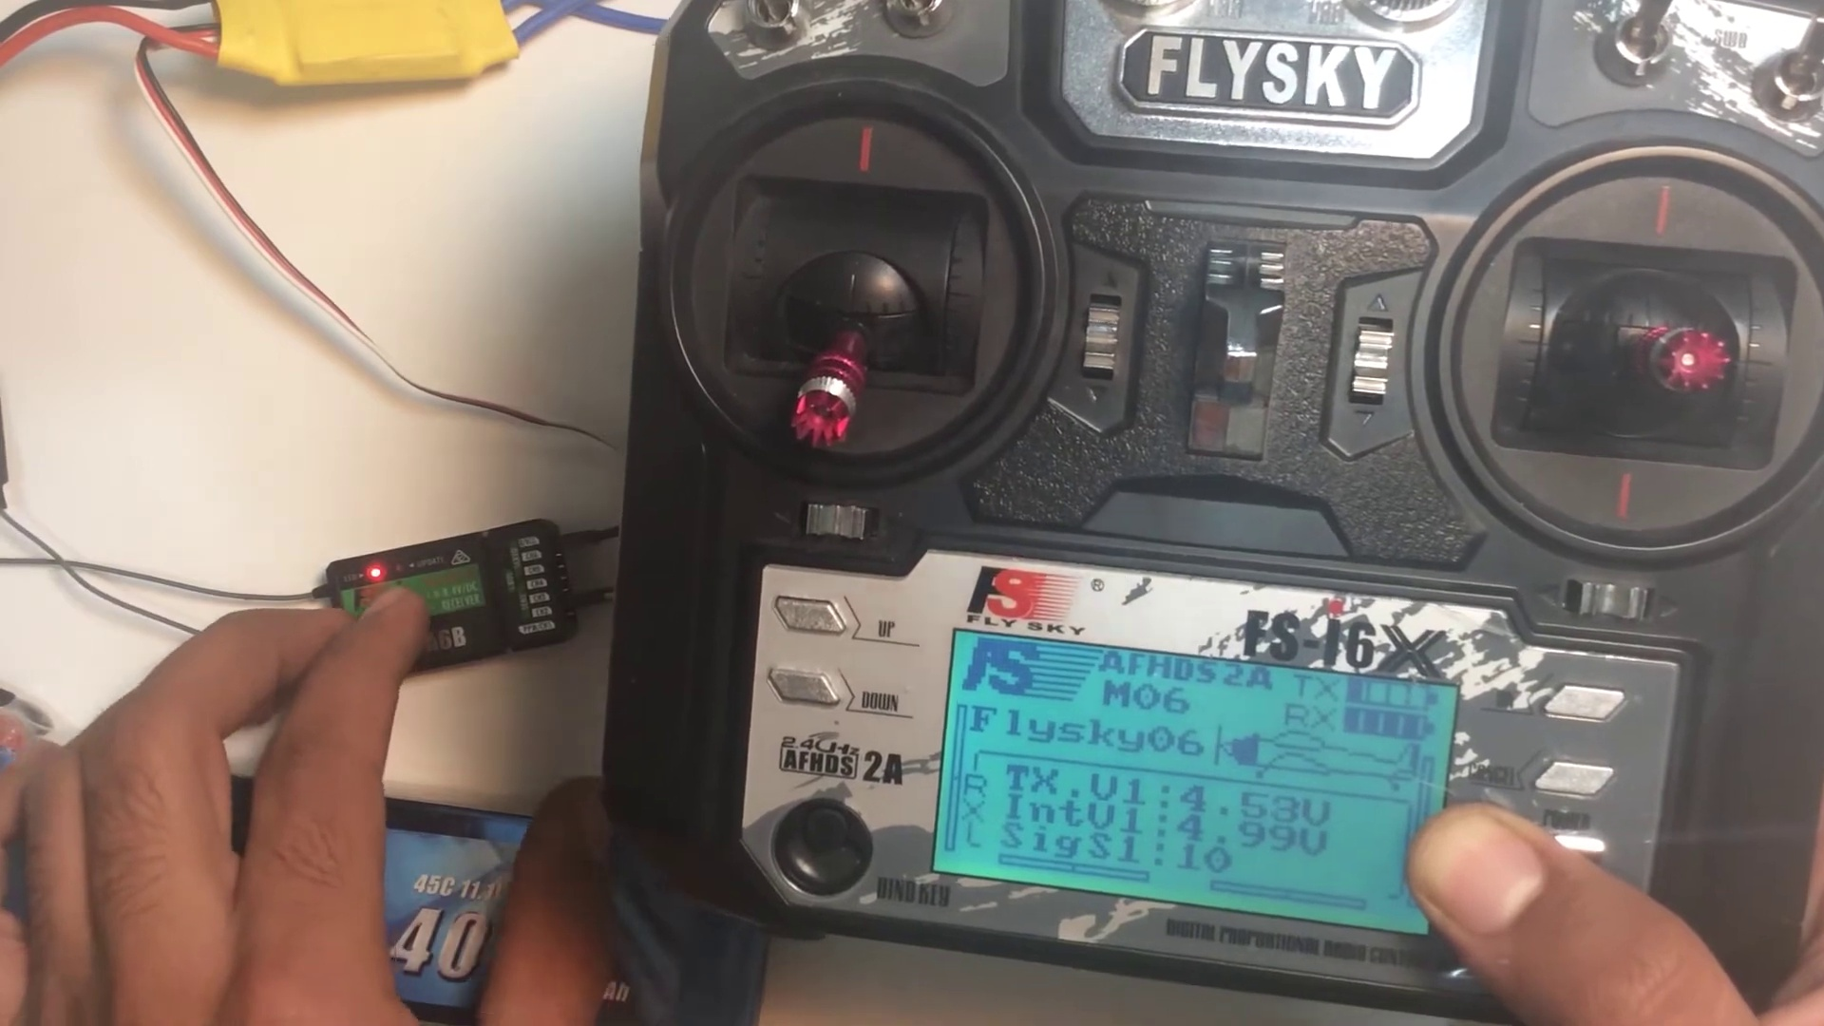 | 2:02   | 2:02   | 2:02  

Transcript
(No speech detected in this section)

Section 0: A person holding a Flysky remote control and working on a DIY quadcopter or drone.
Time: 2:03 - 2:04

Summary
The image shows a person standing in front of a white surface, holding a black Flysky remote control with red and silver buttons. Their thumb is pressed on the red button, suggesting they may be setting up or adjusting the remote control.

Representative Frames
2:03   | 2:03   | 2:03   | 2:03   | 2:03  

Transcript
[2:00] and the signal of the receiver and the light on the receiver will stop blinking which shows that the

Section 0: A person working on an electronic device.
Time: 2:04 - 2:05

Summary
The image shows a person holding an electronic device, which appears to be a Flysky radio control. The control, with its silver and black color scheme, features the Flysky logo and the word '4000'.

Representative Frames
2:04   | 2:04   | 2:04   | 2:04   | 2:04  

Transcript
(No speech detected in this section)

Section 0: A person working on a DIY quadcopter or drone.
Time: 2:05 - 2:06

Summary
The image shows two distinct scenes, one featuring an individual handling an electronic device, which appears to be a small quadcopter or drone. The device is connected to a circuit board with multiple electronic components, suggesting it's undergoing repairs or modification.

Representative Frames
2:05   | 2:05   | 2:05   | 2:05  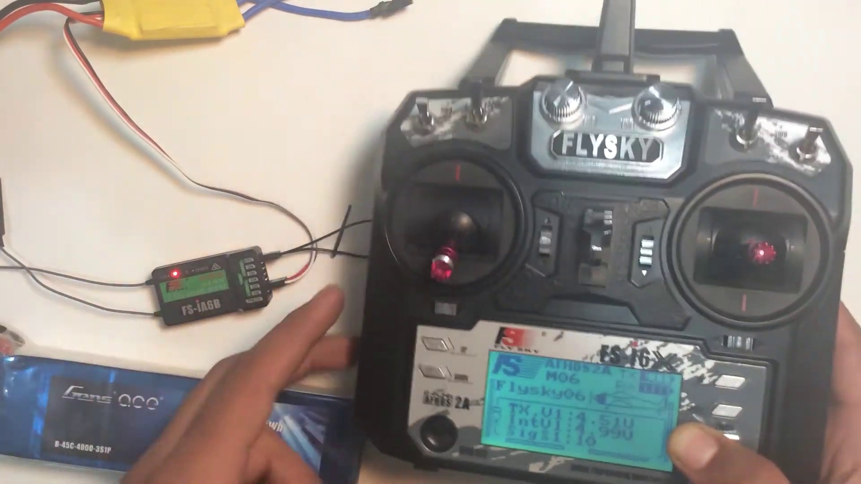 | 2:05  

Transcript
(No speech detected in this section)

Section 0: A person holding a Flysky remote control and working on a DIY quadcopter or drone.
Time: 2:06 - 2:07

Summary
The image shows a person standing in front of a white surface, holding a black Flysky remote control with red and silver buttons. Their thumb is pressed on the red button, suggesting they may be setting up or adjusting the remote control.

Representative Frames
2:06   | 2:06   | 2:06   | 2:06   | 2:06  

Transcript
(No speech detected in this section)

Section 0: A person working on an electronic device.
Time: 2:07 - 2:08

Summary
The image shows a person holding an electronic device, which appears to be a Flysky radio control. The control, with its silver and black color scheme, features the Flysky logo and the word '4000'.

Representative Frames
2:07   | 2:07   | 2:07   | 2:07   | 2:07  

Transcript
(No speech detected in this section)

Section 0: A person working on a DIY quadcopter or drone.
Time: 2:08 - 2:09

Summary
The image shows two distinct scenes, one featuring an individual handling an electronic device, which appears to be a small quadcopter or drone. The device is connected to a circuit board with multiple electronic components, suggesting it's undergoing repairs or modification.

Representative Frames
2:08   | 2:08   | 2:08   | 2:08   | 2:08  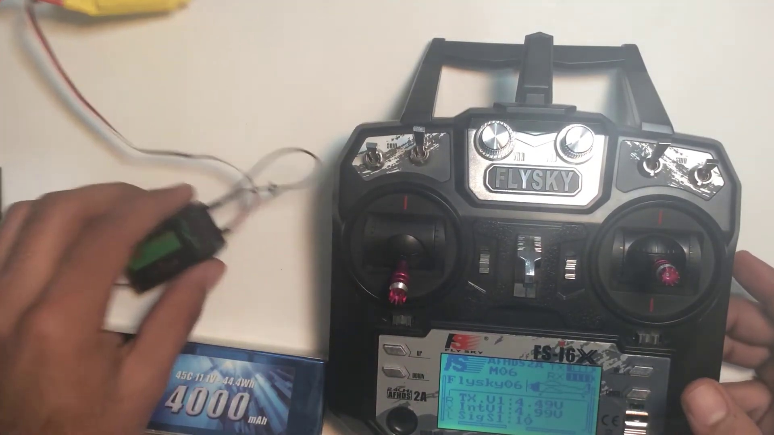

Transcript
(No speech detected in this section)

Section 0: A person holding a Flysky remote control and working on a DIY quadcopter or drone.
Time: 2:09 - 2:10

Summary
The image shows a person standing in front of a white surface, holding a black Flysky remote control with red and silver buttons. Their thumb is pressed on the red button, suggesting they may be setting up or adjusting the remote control.

Representative Frames
2:09   | 2:09   | 2:09   | 2:09   | 2:09  

Transcript
(No speech detected in this section)

Section 0: A person working on an electronic device.
Time: 2:10 - 2:11

Summary
The image shows a person holding an electronic device, which appears to be a Flysky radio control. The control, with its silver and black color scheme, features the Flysky logo and the word '4000'.

Representative Frames
2:10   | 2:10   | 2:10   | 2:10   | 2:10  

Transcript
[2:06] receiver is bound to the transmitter. About the bind key of the transmitter I actually carry my bind key in my

Section 0: A person working on a DIY quadcopter or drone.
Time: 2:11 - 2:12

Summary
The image shows two distinct scenes, one featuring an individual handling an electronic device, which appears to be a small quadcopter or drone. The device is connected to a circuit board with multiple electronic components, suggesting it's undergoing repairs or modification.

Representative Frames
2:11   | 2:11   | 2:11   | 2:11   | 2:11  

Transcript
(No speech detected in this section)

Section 0: A person holding a Flysky remote control and working on a DIY quadcopter or drone.
Time: 2:12 - 2:13

Summary
The image shows a person standing in front of a white surface, holding a black Flysky remote control with red and silver buttons. Their thumb is pressed on the red button, suggesting they may be setting up or adjusting the remote control.

Representative Frames
2:12  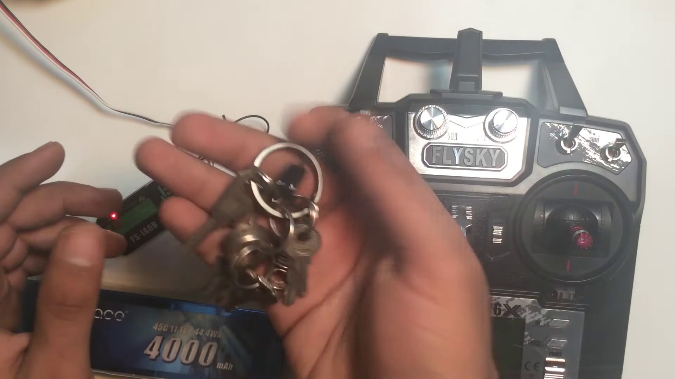 | 2:12   | 2:12   | 2:12   | 2:12  

Transcript
(No speech detected in this section)

Section 0: A person working on an electronic device.
Time: 2:13 - 2:14

Summary
The image shows a person holding an electronic device, which appears to be a Flysky radio control. The control, with its silver and black color scheme, features the Flysky logo and the word '4000'.

Representative Frames
2:13   | 2:13   | 2:13   | 2:13   | 2:13  

Transcript
(No speech detected in this section)

Section 0: A person working on a DIY quadcopter or drone.
Time: 2:14 - 2:15

Summary
The image shows two distinct scenes, one featuring an individual handling an electronic device, which appears to be a small quadcopter or drone. The device is connected to a circuit board with multiple electronic components, suggesting it's undergoing repairs or modification.

Representative Frames
2:14   | 2:14   | 2:14   | 2:14   | 2:14  

Transcript
(No speech detected in this section)

Section 0: A person holding a Flysky remote control and working on a DIY quadcopter or drone.
Time: 2:15 - 2:16

Summary
The image shows a person standing in front of a white surface, holding a black Flysky remote control with red and silver buttons. Their thumb is pressed on the red button, suggesting they may be setting up or adjusting the remote control.

Representative Frames
2:15   | 2:15   | 2:15  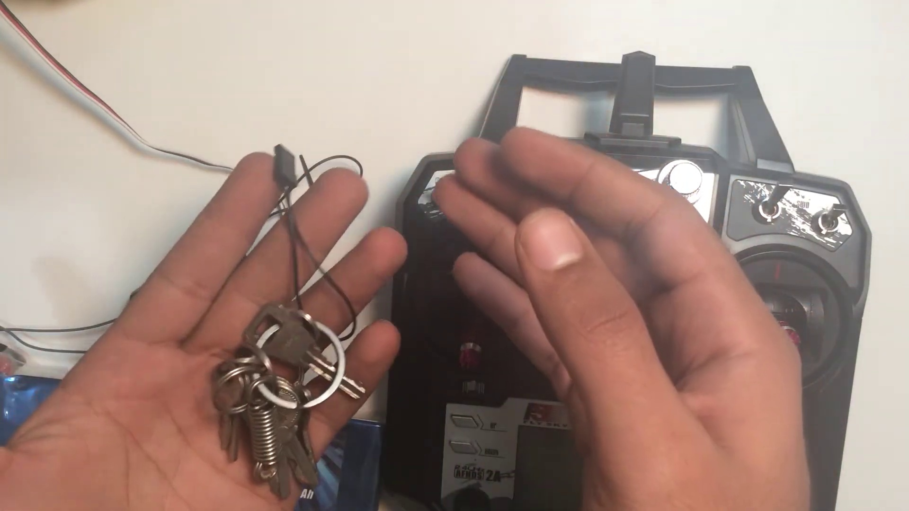 | 2:15   | 2:15  

Transcript
(No speech detected in this section)

Section 0: A person working on an electronic device.
Time: 2:16 - 2:17

Summary
The image shows a person holding an electronic device, which appears to be a Flysky radio control. The control, with its silver and black color scheme, features the Flysky logo and the word '4000'.

Representative Frames
2:16   | 2:16   | 2:16   | 2:16   | 2:16  

Transcript
(No speech detected in this section)

Section 0: A person working on a DIY quadcopter or drone.
Time: 2:17 - 2:18

Summary
The image shows two distinct scenes, one featuring an individual handling an electronic device, which appears to be a small quadcopter or drone. The device is connected to a circuit board with multiple electronic components, suggesting it's undergoing repairs or modification.

Representative Frames
2:17   | 2:17   | 2:17   | 2:17   | 2:17  

Transcript
(No speech detected in this section)

Section 0: A person holding a Flysky remote control and working on a DIY quadcopter or drone.
Time: 2:18 - 2:19

Summary
The image shows a person standing in front of a white surface, holding a black Flysky remote control with red and silver buttons. Their thumb is pressed on the red button, suggesting they may be setting up or adjusting the remote control.

Representative Frames
2:18   | 2:18   | 2:18   | 2:18   | 2:18  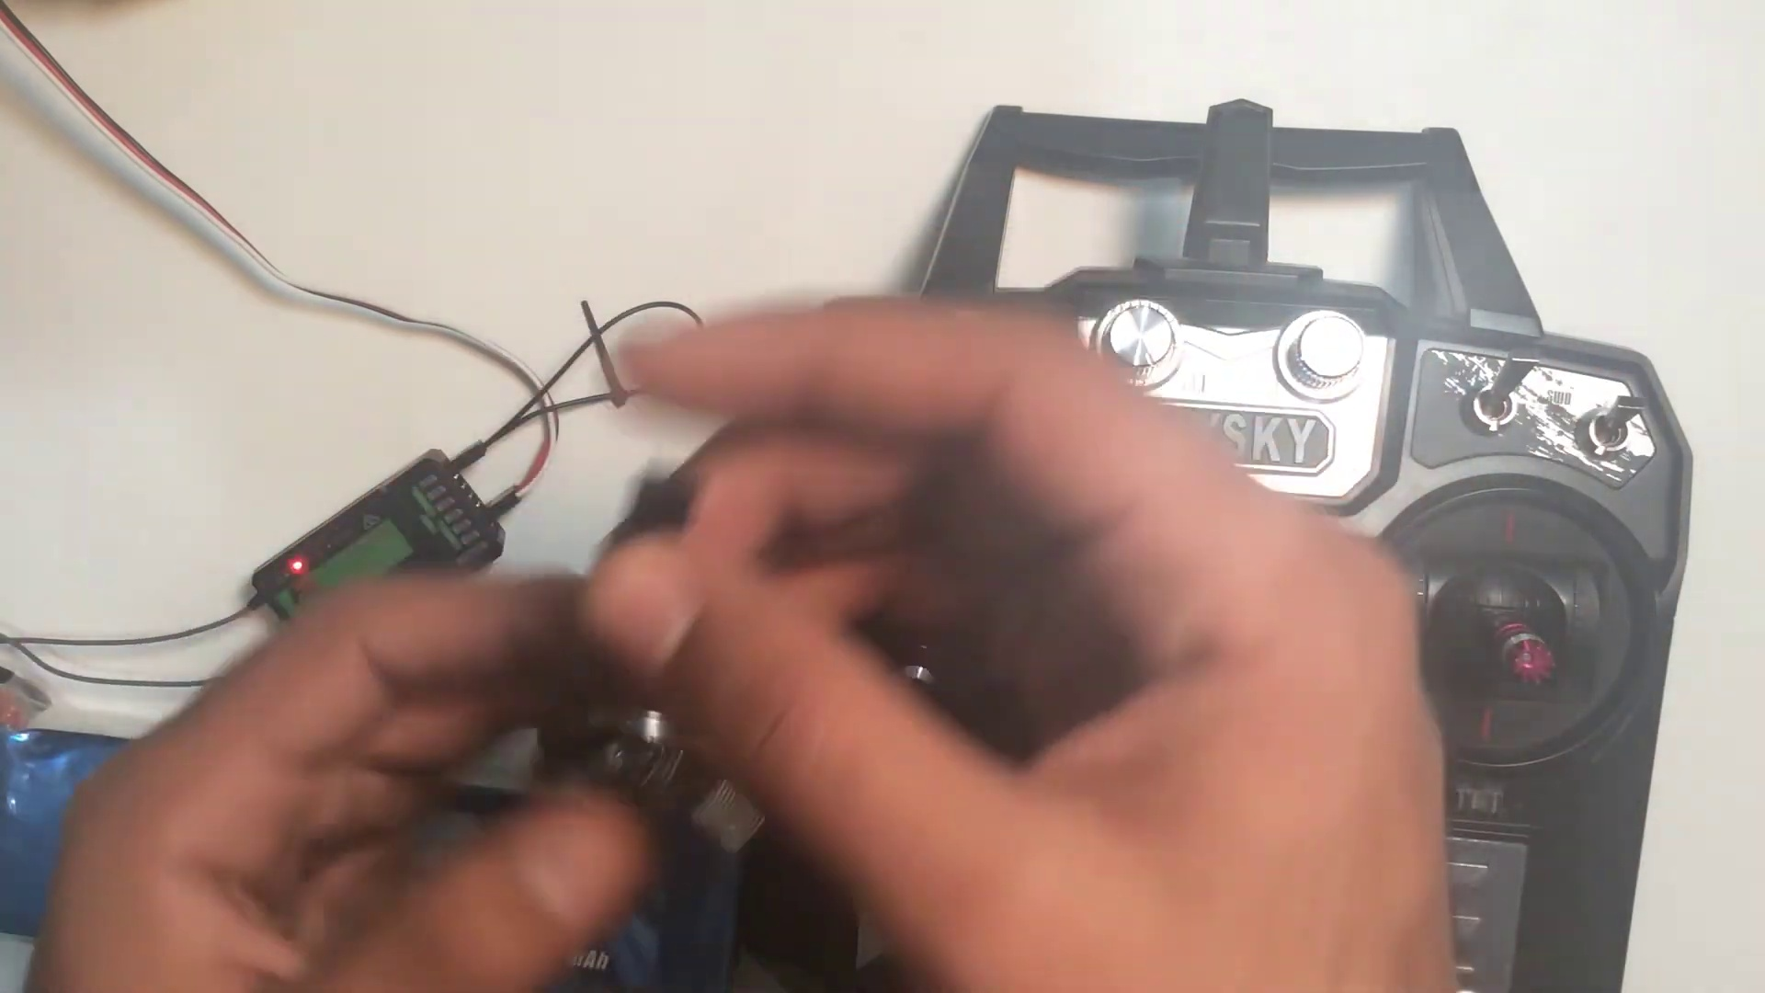

Transcript
(No speech detected in this section)

Section 0: A person working on an electronic device.
Time: 2:19 - 2:20

Summary
The image shows a person holding an electronic device, which appears to be a Flysky radio control. The control, with its silver and black color scheme, features the Flysky logo and the word '4000'.

Representative Frames
2:19   | 2:19   | 2:19   | 2:19   | 2:19  

Transcript
[2:13] keys. Actually I am mostly around the airplanes or receiver's binding so I keep it with me and my keys. You have these keys with your transmitter and

Section 0: A person working on a DIY quadcopter or drone.
Time: 2:20 - 2:21

Summary
The image shows two distinct scenes, one featuring an individual handling an electronic device, which appears to be a small quadcopter or drone. The device is connected to a circuit board with multiple electronic components, suggesting it's undergoing repairs or modification.

Representative Frames
2:20   | 2:20   | 2:20   | 2:20   | 2:20  

Transcript
(No speech detected in this section)

Section 0: A person holding a Flysky remote control and working on a DIY quadcopter or drone.
Time: 2:21 - 2:22

Summary
The image shows a person standing in front of a white surface, holding a black Flysky remote control with red and silver buttons. Their thumb is pressed on the red button, suggesting they may be setting up or adjusting the remote control.

Representative Frames
2:21   | 2:21   | 2:21   | 2:21   | 2:21  

Transcript
(No speech detected in this section)

Section 0: A person working on an electronic device.
Time: 2:22 - 2:23

Summary
The image shows a person holding an electronic device, which appears to be a Flysky radio control. The control, with its silver and black color scheme, features the Flysky logo and the word '4000'.

Representative Frames
2:22  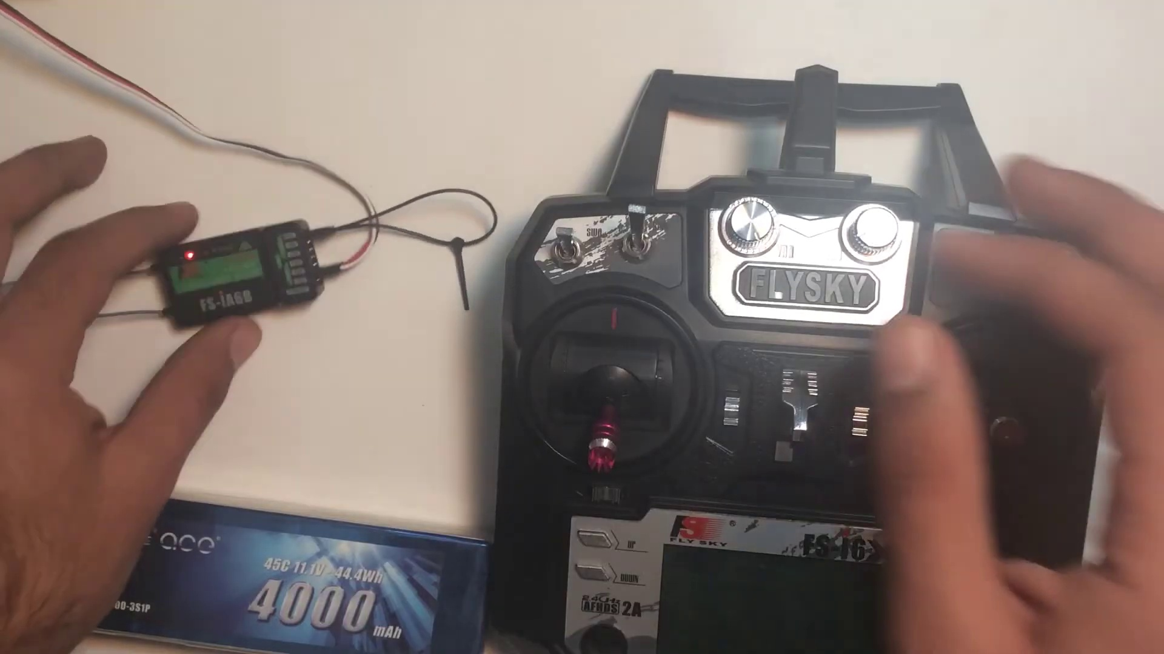 | 2:22   | 2:22   | 2:22   | 2:22  

Transcript
(No speech detected in this section)

Section 0: A person working on a DIY quadcopter or drone.
Time: 2:23 - 2:24

Summary
The image shows two distinct scenes, one featuring an individual handling an electronic device, which appears to be a small quadcopter or drone. The device is connected to a circuit board with multiple electronic components, suggesting it's undergoing repairs or modification.

Representative Frames
2:23   | 2:23   | 2:23   | 2:23   | 2:23  

Transcript
(No speech detected in this section)

Section 0: A person holding a Flysky remote control and working on a DIY quadcopter or drone.
Time: 2:24 - 2:25

Summary
The image shows a person standing in front of a white surface, holding a black Flysky remote control with red and silver buttons. Their thumb is pressed on the red button, suggesting they may be setting up or adjusting the remote control.

Representative Frames
2:24   | 2:24   | 2:24   | 2:24   | 2:24  

Transcript
(No speech detected in this section)

Section 0: A person working on an electronic device.
Time: 2:25 - 2:26

Summary
The image shows a person holding an electronic device, which appears to be a Flysky radio control. The control, with its silver and black color scheme, features the Flysky logo and the word '4000'.

Representative Frames
2:25   | 2:25   | 2:25  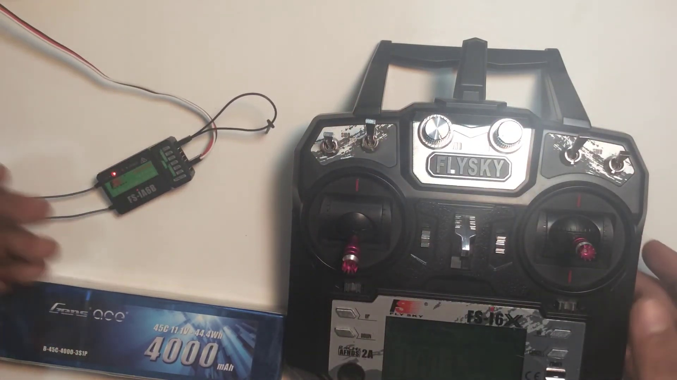 | 2:25   | 2:25  

Transcript
(No speech detected in this section)

Section 0: A person working on a DIY quadcopter or drone.
Time: 2:26 - 2:27

Summary
The image shows two distinct scenes, one featuring an individual handling an electronic device, which appears to be a small quadcopter or drone. The device is connected to a circuit board with multiple electronic components, suggesting it's undergoing repairs or modification.

Representative Frames
2:26   | 2:26   | 2:26   | 2:26   | 2:26  

Transcript
(No speech detected in this section)

Section 0: A person holding a Flysky remote control and working on a DIY quadcopter or drone.
Time: 2:27 - 2:28

Summary
The image shows a person standing in front of a white surface, holding a black Flysky remote control with red and silver buttons. Their thumb is pressed on the red button, suggesting they may be setting up or adjusting the remote control.

Representative Frames
2:27   | 2:27   | 2:27   | 2:27   | 2:27  

Transcript
(No speech detected in this section)

Section 0: A person working on an electronic device.
Time: 2:28 - 2:29

Summary
The image shows a person holding an electronic device, which appears to be a Flysky radio control. The control, with its silver and black color scheme, features the Flysky logo and the word '4000'.

Representative Frames
2:28   | 2:28   | 2:28   | 2:28  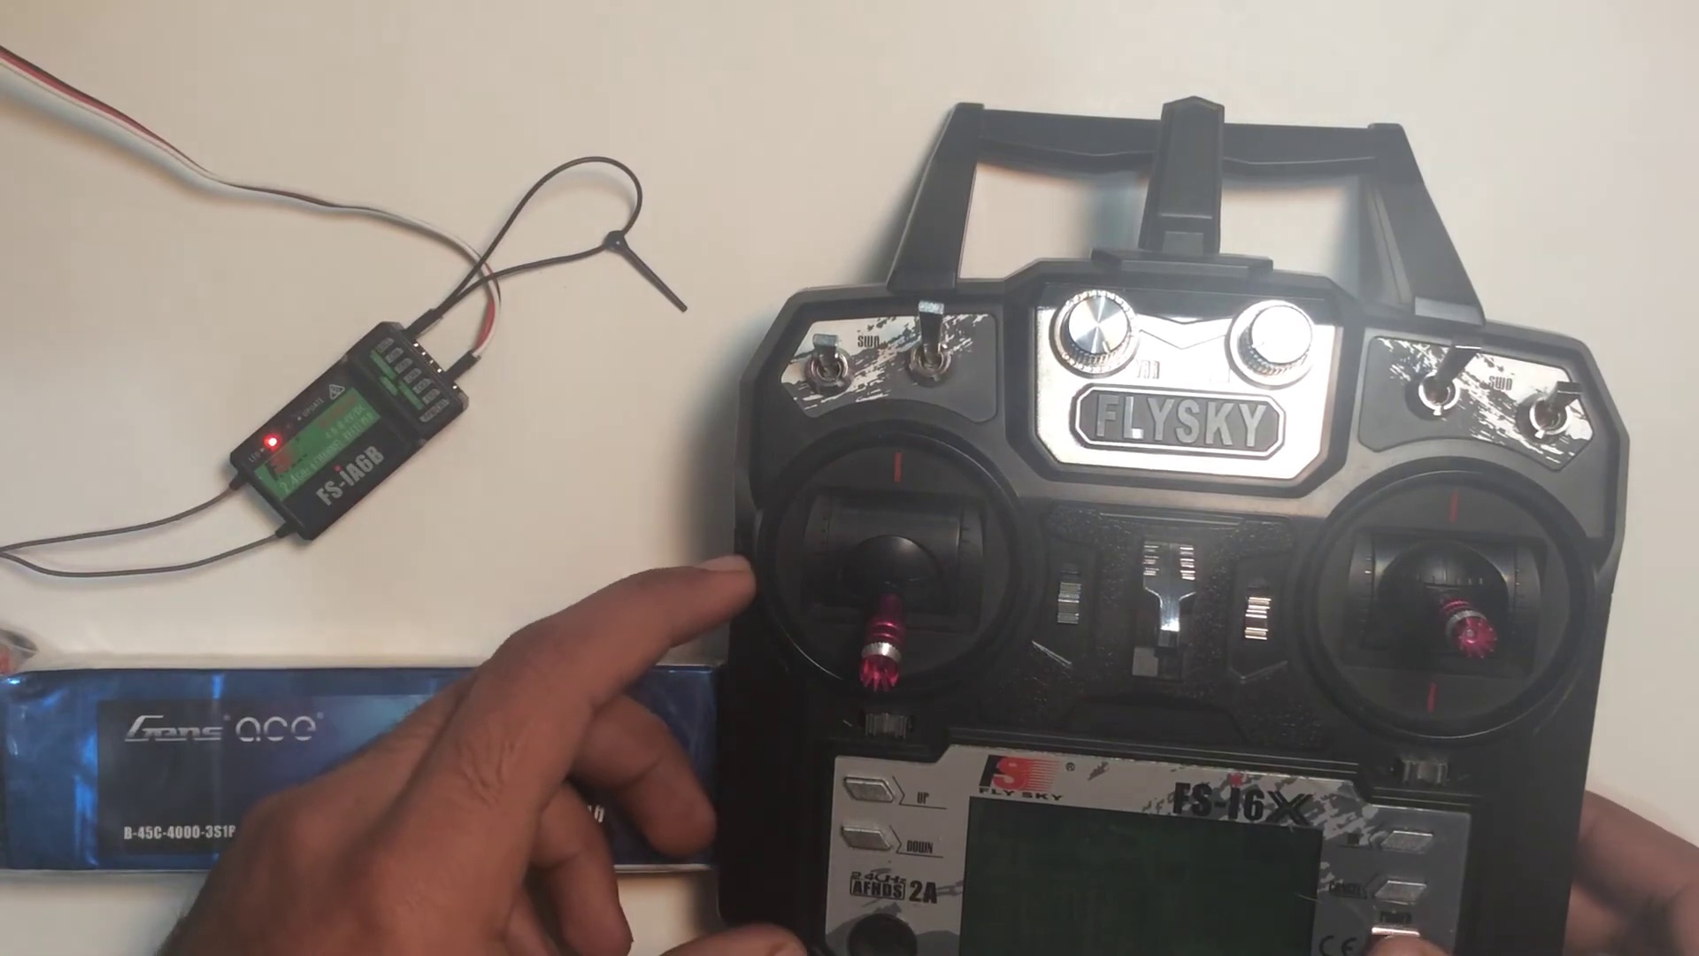 | 2:28  

Transcript
(No speech detected in this section)

Section 0: A person working on a DIY quadcopter or drone.
Time: 2:29 - 2:30

Summary
The image shows two distinct scenes, one featuring an individual handling an electronic device, which appears to be a small quadcopter or drone. The device is connected to a circuit board with multiple electronic components, suggesting it's undergoing repairs or modification.

Representative Frames
2:29   | 2:29   | 2:29   | 2:29   | 2:29  

Transcript
[2:26] it's your choice. So that's what that was all about today's video. Thank you and stay tuned.

Section 0: A person holding a Flysky remote control and working on a DIY quadcopter or drone.
Time: 2:30 - 2:31

Summary
The image shows a person standing in front of a white surface, holding a black Flysky remote control with red and silver buttons. Their thumb is pressed on the red button, suggesting they may be setting up or adjusting the remote control.

Representative Frames
2:30   | 2:30   | 2:30   | 2:30   | 2:30  

Transcript
(No speech detected in this section)

Section 0: A person working on an electronic device.
Time: 2:31 - 2:32

Summary
The image shows a person holding an electronic device, which appears to be a Flysky radio control. The control, with its silver and black color scheme, features the Flysky logo and the word '4000'.

Representative Frames
2:31   | 2:31   | 2:31   | 2:31   | 2:31  

Transcript
(No speech detected in this section)

Section 0: A person working on a DIY quadcopter or drone.
Time: 2:32 - 2:33

Summary
The image shows two distinct scenes, one featuring an individual handling an electronic device, which appears to be a small quadcopter or drone. The device is connected to a circuit board with multiple electronic components, suggesting it's undergoing repairs or modification.

Representative Frames
2:32   | 2:32   | 2:32   | 2:32   | 2:32  

Transcript
(No speech detected in this section)

Section 0: A person holding a Flysky remote control and working on a DIY quadcopter or drone.
Time: 2:33 - 2:34

Summary
The image shows a person standing in front of a white surface, holding a black Flysky remote control with red and silver buttons. Their thumb is pressed on the red button, suggesting they may be setting up or adjusting the remote control.

Representative Frames
2:33   | 2:33   | 2:33   | 2:33   | 2:33  

Transcript
(No speech detected in this section)

Section 0: A person working on an electronic device.
Time: 2:34 - 2:35

Summary
The image shows a person holding an electronic device, which appears to be a Flysky radio control. The control, with its silver and black color scheme, features the Flysky logo and the word '4000'.

Representative Frames
2:34   | 2:34   | 2:34   | 2:34   | 2:34  

Transcript
(No speech detected in this section)

Section 0: A person working on a DIY quadcopter or drone.
Time: 2:35 - 2:36

Summary
The image shows two distinct scenes, one featuring an individual handling an electronic device, which appears to be a small quadcopter or drone. The device is connected to a circuit board with multiple electronic components, suggesting it's undergoing repairs or modification.

Representative Frames
2:35   | 2:35  [No Frame] | 2:35  [No Frame] | 2:35  [No Frame] | 2:35  [No Frame]

Transcript
(No speech detected in this section)

Section 0: A person holding a Flysky remote control and working on a DIY quadcopter or drone.
Time: 2:36 - 2:37

Summary
The image shows a person standing in front of a white surface, holding a black Flysky remote control with red and silver buttons. Their thumb is pressed on the red button, suggesting they may be setting up or adjusting the remote control.

Representative Frames
2:36  [No Frame] | 2:36  [No Frame] | 2:36  [No Frame] | 2:36  [No Frame] | 2:36  [No Frame]

Transcript
(No speech detected in this section)

Section 0: A person working on an electronic device.
Time: 2:37 - 2:38

Summary
The image shows a person holding an electronic device, which appears to be a Flysky radio control. The control, with its silver and black color scheme, features the Flysky logo and the word '4000'.

Representative Frames
2:37  [No Frame] | 2:37  [No Frame] | 2:37  [No Frame] | 2:37  [No Frame] | 2:37  [No Frame]

Transcript
(No speech detected in this section)

Section 0: A person working on a DIY quadcopter or drone.
Time: 2:38 - 2:39

Summary
The image shows two distinct scenes, one featuring an individual handling an electronic device, which appears to be a small quadcopter or drone. The device is connected to a circuit board with multiple electronic components, suggesting it's undergoing repairs or modification.

Representative Frames
2:38  [No Frame] | 2:38  [No Frame] | 2:38  [No Frame] | 2:38  [No Frame] | 2:38  [No Frame]

Transcript
(No speech detected in this section)

Section 0: A person holding a Flysky remote control and working on a DIY quadcopter or drone.
Time: 2:39 - 2:40

Summary
The image shows a person standing in front of a white surface, holding a black Flysky remote control with red and silver buttons. Their thumb is pressed on the red button, suggesting they may be setting up or adjusting the remote control.

Representative Frames
2:39  [No Frame] | 2:39  [No Frame] | 2:39  [No Frame] | 2:39  [No Frame] | 2:39  [No Frame]

Transcript
(No speech detected in this section)

Section 0: A person working on an electronic device.
Time: 2:40 - 2:41

Summary
The image shows a person holding an electronic device, which appears to be a Flysky radio control. The control, with its silver and black color scheme, features the Flysky logo and the word '4000'.

Representative Frames
2:40  [No Frame] | 2:40  [No Frame] | 2:40  [No Frame] | 2:40  [No Frame] | 2:40  [No Frame]

Transcript
(No speech detected in this section)

Section 0: A person working on a DIY quadcopter or drone.
Time: 2:41 - 2:42

Summary
The image shows two distinct scenes, one featuring an individual handling an electronic device, which appears to be a small quadcopter or drone. The device is connected to a circuit board with multiple electronic components, suggesting it's undergoing repairs or modification.

Representative Frames
2:41  [No Frame] | 2:41  [No Frame] | 2:41  [No Frame] | 2:41  [No Frame] | 2:41  [No Frame]

Transcript
(No speech detected in this section)

Section 0: A person holding a Flysky remote control and working on a DIY quadcopter or drone.
Time: 2:42 - 2:43

Summary
The image shows a person standing in front of a white surface, holding a black Flysky remote control with red and silver buttons. Their thumb is pressed on the red button, suggesting they may be setting up or adjusting the remote control.

Representative Frames
2:42  [No Frame] | 2:42  [No Frame] | 2:42  [No Frame] | 2:42  [No Frame] | 2:42  [No Frame]

Transcript
(No speech detected in this section)

Section 0: A person working on an electronic device.
Time: 2:43 - 2:44

Summary
The image shows a person holding an electronic device, which appears to be a Flysky radio control. The control, with its silver and black color scheme, features the Flysky logo and the word '4000'.

Representative Frames
2:43  [No Frame] | 2:43  [No Frame] | 2:43  [No Frame] | 2:43  [No Frame] | 2:43  [No Frame]

Transcript
(No speech detected in this section)

Section 0: A person working on a DIY quadcopter or drone.
Time: 2:44 - 2:45

Summary
The image shows two distinct scenes, one featuring an individual handling an electronic device, which appears to be a small quadcopter or drone. The device is connected to a circuit board with multiple electronic components, suggesting it's undergoing repairs or modification.

Representative Frames
2:44  [No Frame] | 2:44  [No Frame] | 2:44  [No Frame] | 2:44  [No Frame] | 2:44  [No Frame]

Transcript
(No speech detected in this section)

Section 0: A person holding a Flysky remote control and working on a DIY quadcopter or drone.
Time: 2:45 - 2:46

Summary
The image shows a person standing in front of a white surface, holding a black Flysky remote control with red and silver buttons. Their thumb is pressed on the red button, suggesting they may be setting up or adjusting the remote control.

Representative Frames
2:45  [No Frame] | 2:45  [No Frame] | 2:45  [No Frame] | 2:45  [No Frame] | 2:45  [No Frame]

Transcript
(No speech detected in this section)

Section 0: A person working on an electronic device.
Time: 2:46 - 2:47

Summary
The image shows a person holding an electronic device, which appears to be a Flysky radio control. The control, with its silver and black color scheme, features the Flysky logo and the word '4000'.

Representative Frames
2:46  [No Frame] | 2:46  [No Frame] | 2:46  [No Frame] | 2:46  [No Frame] | 2:46  [No Frame]

Transcript
(No speech detected in this section)

Section 0: A person working on a DIY quadcopter or drone.
Time: 2:47 - 2:48

Summary
The image shows two distinct scenes, one featuring an individual handling an electronic device, which appears to be a small quadcopter or drone. The device is connected to a circuit board with multiple electronic components, suggesting it's undergoing repairs or modification.

Representative Frames
2:47  [No Frame] | 2:47  [No Frame] | 2:47  [No Frame] | 2:47  [No Frame] | 2:47  [No Frame]

Transcript
(No speech detected in this section)

Section 0: A person holding a Flysky remote control and working on a DIY quadcopter or drone.
Time: 2:48 - 2:49

Summary
The image shows a person standing in front of a white surface, holding a black Flysky remote control with red and silver buttons. Their thumb is pressed on the red button, suggesting they may be setting up or adjusting the remote control.

Representative Frames
2:48  [No Frame] | 2:48  [No Frame] | 2:48  [No Frame] | 2:48  [No Frame] | 2:48  [No Frame]

Transcript
(No speech detected in this section)

Section 0: A person working on an electronic device.
Time: 2:49 - 2:50

Summary
The image shows a person holding an electronic device, which appears to be a Flysky radio control. The control, with its silver and black color scheme, features the Flysky logo and the word '4000'.

Representative Frames
2:49  [No Frame] | 2:49  [No Frame] | 2:49  [No Frame] | 2:49  [No Frame] | 2:49  [No Frame]

Transcript
(No speech detected in this section)

Section 0: A person working on a DIY quadcopter or drone.
Time: 2:50 - 2:51

Summary
The image shows two distinct scenes, one featuring an individual handling an electronic device, which appears to be a small quadcopter or drone. The device is connected to a circuit board with multiple electronic components, suggesting it's undergoing repairs or modification.

Representative Frames
2:50  [No Frame] | 2:50  [No Frame] | 2:50  [No Frame] | 2:50  [No Frame] | 2:50  [No Frame]

Transcript
(No speech detected in this section)

Section 0: A person holding a Flysky remote control and working on a DIY quadcopter or drone.
Time: 2:51 - 2:52

Summary
The image shows a person standing in front of a white surface, holding a black Flysky remote control with red and silver buttons. Their thumb is pressed on the red button, suggesting they may be setting up or adjusting the remote control.

Representative Frames
2:51  [No Frame] | 2:51  [No Frame] | 2:51  [No Frame] | 2:51  [No Frame] | 2:51  [No Frame]

Transcript
(No speech detected in this section)

Section 0: A person working on an electronic device.
Time: 2:52 - 2:53

Summary
The image shows a person holding an electronic device, which appears to be a Flysky radio control. The control, with its silver and black color scheme, features the Flysky logo and the word '4000'.

Representative Frames
2:52  [No Frame] | 2:52  [No Frame] | 2:52  [No Frame] | 2:52  [No Frame] | 2:52  [No Frame]

Transcript
(No speech detected in this section)

Section 0: A person working on a DIY quadcopter or drone.
Time: 2:53 - 2:54

Summary
The image shows two distinct scenes, one featuring an individual handling an electronic device, which appears to be a small quadcopter or drone. The device is connected to a circuit board with multiple electronic components, suggesting it's undergoing repairs or modification.

Representative Frames
2:53  [No Frame] | 2:53  [No Frame] | 2:53  [No Frame] | 2:53  [No Frame] | 2:53  [No Frame]

Transcript
(No speech detected in this section)

Section 0: A person holding a Flysky remote control and working on a DIY quadcopter or drone.
Time: 2:54 - 2:55

Summary
The image shows a person standing in front of a white surface, holding a black Flysky remote control with red and silver buttons. Their thumb is pressed on the red button, suggesting they may be setting up or adjusting the remote control.

Representative Frames
2:54  [No Frame] | 2:54  [No Frame] | 2:54  [No Frame] | 2:54  [No Frame] | 2:54  [No Frame]

Transcript
(No speech detected in this section)

Section 0: A person working on an electronic device.
Time: 2:55 - 2:56

Summary
The image shows a person holding an electronic device, which appears to be a Flysky radio control. The control, with its silver and black color scheme, features the Flysky logo and the word '4000'.

Representative Frames
2:55  [No Frame] | 2:55  [No Frame] | 2:55  [No Frame] | 2:55  [No Frame] | 2:55  [No Frame]

Transcript
(No speech detected in this section)

Section 0: A person working on a DIY quadcopter or drone.
Time: 2:56 - 2:57

Summary
The image shows two distinct scenes, one featuring an individual handling an electronic device, which appears to be a small quadcopter or drone. The device is connected to a circuit board with multiple electronic components, suggesting it's undergoing repairs or modification.

Representative Frames
2:56  [No Frame] | 2:56  [No Frame] | 2:56  [No Frame] | 2:56  [No Frame] | 2:56  [No Frame]

Transcript
(No speech detected in this section)

Section 0: A person holding a Flysky remote control and working on a DIY quadcopter or drone.
Time: 2:57 - 2:58

Summary
The image shows a person standing in front of a white surface, holding a black Flysky remote control with red and silver buttons. Their thumb is pressed on the red button, suggesting they may be setting up or adjusting the remote control.

Representative Frames
2:57  [No Frame] | 2:57  [No Frame] | 2:57  [No Frame] | 2:57  [No Frame] | 2:57  [No Frame]

Transcript
(No speech detected in this section)

Section 0: A person working on an electronic device.
Time: 2:58 - 2:59

Summary
The image shows a person holding an electronic device, which appears to be a Flysky radio control. The control, with its silver and black color scheme, features the Flysky logo and the word '4000'.

Representative Frames
2:58  [No Frame] | 2:58  [No Frame] | 2:58  [No Frame] | 2:58  [No Frame] | 2:58  [No Frame]

Transcript
(No speech detected in this section)

Section 0: A person working on a DIY quadcopter or drone.
Time: 2:59 - 3:00

Summary
The image shows two distinct scenes, one featuring an individual handling an electronic device, which appears to be a small quadcopter or drone. The device is connected to a circuit board with multiple electronic components, suggesting it's undergoing repairs or modification.

Representative Frames
2:59  [No Frame] | 2:59  [No Frame] | 2:59  [No Frame] | 2:59  [No Frame] | 2:59  [No Frame]

Transcript
(No speech detected in this section)

Section 0: A person holding a Flysky remote control and working on a DIY quadcopter or drone.
Time: 3:00 - 3:01

Summary
The image shows a person standing in front of a white surface, holding a black Flysky remote control with red and silver buttons. Their thumb is pressed on the red button, suggesting they may be setting up or adjusting the remote control.

Representative Frames
3:00  [No Frame] | 3:00  [No Frame] | 3:00  [No Frame] | 3:00  [No Frame] | 3:00  [No Frame]

Transcript
(No speech detected in this section)

Section 0: A person working on an electronic device.
Time: 3:01 - 3:02

Summary
The image shows a person holding an electronic device, which appears to be a Flysky radio control. The control, with its silver and black color scheme, features the Flysky logo and the word '4000'.

Representative Frames
3:01  [No Frame] | 3:01  [No Frame] | 3:01  [No Frame] | 3:01  [No Frame] | 3:01  [No Frame]

Transcript
(No speech detected in this section)

Section 0: A person working on a DIY quadcopter or drone.
Time: 3:02 - 3:03

Summary
The image shows two distinct scenes, one featuring an individual handling an electronic device, which appears to be a small quadcopter or drone. The device is connected to a circuit board with multiple electronic components, suggesting it's undergoing repairs or modification.

Representative Frames
3:02  [No Frame] | 3:02  [No Frame] | 3:02  [No Frame] | 3:02  [No Frame] | 3:02  [No Frame]

Transcript
(No speech detected in this section)

Section 0: A person holding a Flysky remote control and working on a DIY quadcopter or drone.
Time: 3:03 - 3:04

Summary
The image shows a person standing in front of a white surface, holding a black Flysky remote control with red and silver buttons. Their thumb is pressed on the red button, suggesting they may be setting up or adjusting the remote control.

Representative Frames
3:03  [No Frame] | 3:03  [No Frame] | 3:03  [No Frame] | 3:03  [No Frame] | 3:03  [No Frame]

Transcript
(No speech detected in this section)

Section 0: A person working on an electronic device.
Time: 3:04 - 3:05

Summary
The image shows a person holding an electronic device, which appears to be a Flysky radio control. The control, with its silver and black color scheme, features the Flysky logo and the word '4000'.

Representative Frames
3:04  [No Frame] | 3:04  [No Frame] | 3:04  [No Frame] | 3:04  [No Frame] | 3:04  [No Frame]

Transcript
(No speech detected in this section)

Section 0: A person working on a DIY quadcopter or drone.
Time: 3:05 - 3:06

Summary
The image shows two distinct scenes, one featuring an individual handling an electronic device, which appears to be a small quadcopter or drone. The device is connected to a circuit board with multiple electronic components, suggesting it's undergoing repairs or modification.

Representative Frames
3:05  [No Frame] | 3:05  [No Frame] | 3:05  [No Frame] | 3:05  [No Frame] | 3:05  [No Frame]

Transcript
(No speech detected in this section)

Section 0: A person holding a Flysky remote control and working on a DIY quadcopter or drone.
Time: 3:06 - 3:07

Summary
The image shows a person standing in front of a white surface, holding a black Flysky remote control with red and silver buttons. Their thumb is pressed on the red button, suggesting they may be setting up or adjusting the remote control.

Representative Frames
3:06  [No Frame] | 3:06  [No Frame] | 3:06  [No Frame] | 3:06  [No Frame] | 3:06  [No Frame]

Transcript
(No speech detected in this section)

Section 0: A person working on an electronic device.
Time: 3:07 - 3:08

Summary
The image shows a person holding an electronic device, which appears to be a Flysky radio control. The control, with its silver and black color scheme, features the Flysky logo and the word '4000'.

Representative Frames
3:07  [No Frame] | 3:07  [No Frame] | 3:07  [No Frame] | 3:07  [No Frame] | 3:07  [No Frame]

Transcript
(No speech detected in this section)

Section 0: A person working on a DIY quadcopter or drone.
Time: 3:08 - 3:09

Summary
The image shows two distinct scenes, one featuring an individual handling an electronic device, which appears to be a small quadcopter or drone. The device is connected to a circuit board with multiple electronic components, suggesting it's undergoing repairs or modification.

Representative Frames
3:08  [No Frame] | 3:08  [No Frame] | 3:08  [No Frame] | 3:08  [No Frame] | 3:08  [No Frame]

Transcript
(No speech detected in this section)

Section 0: A person holding a Flysky remote control and working on a DIY quadcopter or drone.
Time: 3:09 - 3:10

Summary
The image shows a person standing in front of a white surface, holding a black Flysky remote control with red and silver buttons. Their thumb is pressed on the red button, suggesting they may be setting up or adjusting the remote control.

Representative Frames
3:09  [No Frame] | 3:09  [No Frame] | 3:09  [No Frame] | 3:09  [No Frame] | 3:09  [No Frame]

Transcript
(No speech detected in this section)

Section 0: A person working on an electronic device.
Time: 3:10 - 3:11

Summary
The image shows a person holding an electronic device, which appears to be a Flysky radio control. The control, with its silver and black color scheme, features the Flysky logo and the word '4000'.

Representative Frames
3:10  [No Frame] | 3:10  [No Frame] | 3:10  [No Frame] | 3:10  [No Frame] | 3:10  [No Frame]

Transcript
(No speech detected in this section)

Section 0: A person working on a DIY quadcopter or drone.
Time: 3:11 - 3:12

Summary
The image shows two distinct scenes, one featuring an individual handling an electronic device, which appears to be a small quadcopter or drone. The device is connected to a circuit board with multiple electronic components, suggesting it's undergoing repairs or modification.

Representative Frames
3:11  [No Frame] | 3:11  [No Frame] | 3:11  [No Frame] | 3:11  [No Frame] | 3:11  [No Frame]

Transcript
(No speech detected in this section)

Section 0: A person holding a Flysky remote control and working on a DIY quadcopter or drone.
Time: 3:12 - 3:13

Summary
The image shows a person standing in front of a white surface, holding a black Flysky remote control with red and silver buttons. Their thumb is pressed on the red button, suggesting they may be setting up or adjusting the remote control.

Representative Frames
3:12  [No Frame] | 3:12  [No Frame] | 3:12  [No Frame] | 3:12  [No Frame] | 3:12  [No Frame]

Transcript
(No speech detected in this section)

Section 0: A person working on an electronic device.
Time: 3:13 - 3:14

Summary
The image shows a person holding an electronic device, which appears to be a Flysky radio control. The control, with its silver and black color scheme, features the Flysky logo and the word '4000'.

Representative Frames
3:13  [No Frame] | 3:13  [No Frame] | 3:13  [No Frame] | 3:13  [No Frame] | 3:13  [No Frame]

Transcript
(No speech detected in this section)

Section 0: A person working on a DIY quadcopter or drone.
Time: 3:14 - 3:15

Summary
The image shows two distinct scenes, one featuring an individual handling an electronic device, which appears to be a small quadcopter or drone. The device is connected to a circuit board with multiple electronic components, suggesting it's undergoing repairs or modification.

Representative Frames
3:14  [No Frame] | 3:14  [No Frame] | 3:14  [No Frame] | 3:14  [No Frame] | 3:14  [No Frame]

Transcript
(No speech detected in this section)

Section 0: A person holding a Flysky remote control and working on a DIY quadcopter or drone.
Time: 3:15 - 3:16

Summary
The image shows a person standing in front of a white surface, holding a black Flysky remote control with red and silver buttons. Their thumb is pressed on the red button, suggesting they may be setting up or adjusting the remote control.

Representative Frames
3:15  [No Frame] | 3:15  [No Frame] | 3:15  [No Frame] | 3:15  [No Frame] | 3:15  [No Frame]

Transcript
(No speech detected in this section)

Section 0: A person working on an electronic device.
Time: 3:16 - 3:17

Summary
The image shows a person holding an electronic device, which appears to be a Flysky radio control. The control, with its silver and black color scheme, features the Flysky logo and the word '4000'.

Representative Frames
3:16  [No Frame] | 3:16  [No Frame] | 3:16  [No Frame] | 3:16  [No Frame] | 3:16  [No Frame]

Transcript
(No speech detected in this section)

Section 0: A person working on a DIY quadcopter or drone.
Time: 3:17 - 3:18

Summary
The image shows two distinct scenes, one featuring an individual handling an electronic device, which appears to be a small quadcopter or drone. The device is connected to a circuit board with multiple electronic components, suggesting it's undergoing repairs or modification.

Representative Frames
3:17  [No Frame] | 3:17  [No Frame] | 3:17  [No Frame] | 3:17  [No Frame] | 3:17  [No Frame]

Transcript
(No speech detected in this section)

Section 0: A person holding a Flysky remote control and working on a DIY quadcopter or drone.
Time: 3:18 - 3:19

Summary
The image shows a person standing in front of a white surface, holding a black Flysky remote control with red and silver buttons. Their thumb is pressed on the red button, suggesting they may be setting up or adjusting the remote control.

Representative Frames
3:18  [No Frame] | 3:18  [No Frame] | 3:18  [No Frame] | 3:18  [No Frame] | 3:18  [No Frame]

Transcript
(No speech detected in this section)

Section 0: A person working on an electronic device.
Time: 3:19 - 3:20

Summary
The image shows a person holding an electronic device, which appears to be a Flysky radio control. The control, with its silver and black color scheme, features the Flysky logo and the word '4000'.

Representative Frames
3:19  [No Frame] | 3:19  [No Frame] | 3:19  [No Frame] | 3:19  [No Frame] | 3:19  [No Frame]

Transcript
(No speech detected in this section)

Section 0: A person working on a DIY quadcopter or drone.
Time: 3:20 - 3:21

Summary
The image shows two distinct scenes, one featuring an individual handling an electronic device, which appears to be a small quadcopter or drone. The device is connected to a circuit board with multiple electronic components, suggesting it's undergoing repairs or modification.

Representative Frames
3:20  [No Frame] | 3:20  [No Frame] | 3:20  [No Frame] | 3:20  [No Frame] | 3:20  [No Frame]

Transcript
(No speech detected in this section)

Section 0: A person holding a Flysky remote control and working on a DIY quadcopter or drone.
Time: 3:21 - 3:22

Summary
The image shows a person standing in front of a white surface, holding a black Flysky remote control with red and silver buttons. Their thumb is pressed on the red button, suggesting they may be setting up or adjusting the remote control.

Representative Frames
3:21  [No Frame] | 3:21  [No Frame] | 3:21  [No Frame] | 3:21  [No Frame] | 3:21  [No Frame]

Transcript
(No speech detected in this section)

Section 0: A person working on an electronic device.
Time: 3:22 - 3:23

Summary
The image shows a person holding an electronic device, which appears to be a Flysky radio control. The control, with its silver and black color scheme, features the Flysky logo and the word '4000'.

Representative Frames
3:22  [No Frame] | 3:22  [No Frame] | 3:22  [No Frame] | 3:22  [No Frame] | 3:22  [No Frame]

Transcript
(No speech detected in this section)

Section 0: A person working on a DIY quadcopter or drone.
Time: 3:23 - 3:24

Summary
The image shows two distinct scenes, one featuring an individual handling an electronic device, which appears to be a small quadcopter or drone. The device is connected to a circuit board with multiple electronic components, suggesting it's undergoing repairs or modification.

Representative Frames
3:23  [No Frame] | 3:23  [No Frame] | 3:23  [No Frame] | 3:23  [No Frame] | 3:23  [No Frame]

Transcript
(No speech detected in this section)

Section 0: A person holding a Flysky remote control and working on a DIY quadcopter or drone.
Time: 3:24 - 3:25

Summary
The image shows a person standing in front of a white surface, holding a black Flysky remote control with red and silver buttons. Their thumb is pressed on the red button, suggesting they may be setting up or adjusting the remote control.

Representative Frames
3:24  [No Frame] | 3:24  [No Frame] | 3:24  [No Frame] | 3:24  [No Frame] | 3:24  [No Frame]

Transcript
(No speech detected in this section)

Section 0: A person working on an electronic device.
Time: 3:25 - 3:26

Summary
The image shows a person holding an electronic device, which appears to be a Flysky radio control. The control, with its silver and black color scheme, features the Flysky logo and the word '4000'.

Representative Frames
3:25  [No Frame] | 3:25  [No Frame] | 3:25  [No Frame] | 3:25  [No Frame] | 3:25  [No Frame]

Transcript
(No speech detected in this section)

Section 0: A person working on a DIY quadcopter or drone.
Time: 3:26 - 3:27

Summary
The image shows two distinct scenes, one featuring an individual handling an electronic device, which appears to be a small quadcopter or drone. The device is connected to a circuit board with multiple electronic components, suggesting it's undergoing repairs or modification.

Representative Frames
3:26  [No Frame] | 3:26  [No Frame] | 3:26  [No Frame] | 3:26  [No Frame] | 3:26  [No Frame]

Transcript
(No speech detected in this section)

Section 0: A person holding a Flysky remote control and working on a DIY quadcopter or drone.
Time: 3:27 - 3:28

Summary
The image shows a person standing in front of a white surface, holding a black Flysky remote control with red and silver buttons. Their thumb is pressed on the red button, suggesting they may be setting up or adjusting the remote control.

Representative Frames
3:27  [No Frame] | 3:27  [No Frame] | 3:27  [No Frame] | 3:27  [No Frame] | 3:27  [No Frame]

Transcript
(No speech detected in this section)

Section 0: A person working on an electronic device.
Time: 3:28 - 3:29

Summary
The image shows a person holding an electronic device, which appears to be a Flysky radio control. The control, with its silver and black color scheme, features the Flysky logo and the word '4000'.

Representative Frames
3:28  [No Frame] | 3:28  [No Frame] | 3:28  [No Frame] | 3:28  [No Frame] | 3:28  [No Frame]

Transcript
(No speech detected in this section)

Section 0: A person working on a DIY quadcopter or drone.
Time: 3:29 - 3:30

Summary
The image shows two distinct scenes, one featuring an individual handling an electronic device, which appears to be a small quadcopter or drone. The device is connected to a circuit board with multiple electronic components, suggesting it's undergoing repairs or modification.

Representative Frames
3:29  [No Frame] | 3:29  [No Frame] | 3:29  [No Frame] | 3:29  [No Frame] | 3:29  [No Frame]

Transcript
(No speech detected in this section)

Section 0: A person holding a Flysky remote control and working on a DIY quadcopter or drone.
Time: 3:30 - 3:31

Summary
The image shows a person standing in front of a white surface, holding a black Flysky remote control with red and silver buttons. Their thumb is pressed on the red button, suggesting they may be setting up or adjusting the remote control.

Representative Frames
3:30  [No Frame] | 3:30  [No Frame] | 3:30  [No Frame] | 3:30  [No Frame] | 3:30  [No Frame]

Transcript
(No speech detected in this section)

Section 0: A person working on an electronic device.
Time: 3:31 - 3:32

Summary
The image shows a person holding an electronic device, which appears to be a Flysky radio control. The control, with its silver and black color scheme, features the Flysky logo and the word '4000'.

Representative Frames
3:31  [No Frame] | 3:31  [No Frame] | 3:31  [No Frame] | 3:31  [No Frame] | 3:31  [No Frame]

Transcript
(No speech detected in this section)

Section 0: A person working on a DIY quadcopter or drone.
Time: 3:32 - 3:33

Summary
The image shows two distinct scenes, one featuring an individual handling an electronic device, which appears to be a small quadcopter or drone. The device is connected to a circuit board with multiple electronic components, suggesting it's undergoing repairs or modification.

Representative Frames
3:32  [No Frame] | 3:32  [No Frame] | 3:32  [No Frame] | 3:32  [No Frame] | 3:32  [No Frame]

Transcript
(No speech detected in this section)

Section 0: A person holding a Flysky remote control and working on a DIY quadcopter or drone.
Time: 3:33 - 3:34

Summary
The image shows a person standing in front of a white surface, holding a black Flysky remote control with red and silver buttons. Their thumb is pressed on the red button, suggesting they may be setting up or adjusting the remote control.

Representative Frames
3:33  [No Frame] | 3:33  [No Frame] | 3:33  [No Frame] | 3:33  [No Frame] | 3:33  [No Frame]

Transcript
(No speech detected in this section)

Section 0: A person working on an electronic device.
Time: 3:34 - 3:35

Summary
The image shows a person holding an electronic device, which appears to be a Flysky radio control. The control, with its silver and black color scheme, features the Flysky logo and the word '4000'.

Representative Frames
3:34  [No Frame] | 3:34  [No Frame] | 3:34  [No Frame] | 3:34  [No Frame] | 3:34  [No Frame]

Transcript
(No speech detected in this section)

Section 0: A person working on a DIY quadcopter or drone.
Time: 3:35 - 3:36

Summary
The image shows two distinct scenes, one featuring an individual handling an electronic device, which appears to be a small quadcopter or drone. The device is connected to a circuit board with multiple electronic components, suggesting it's undergoing repairs or modification.

Representative Frames
3:35  [No Frame] | 3:35  [No Frame] | 3:35  [No Frame] | 3:35  [No Frame] | 3:35  [No Frame]

Transcript
(No speech detected in this section)

Section 0: A person holding a Flysky remote control and working on a DIY quadcopter or drone.
Time: 3:36 - 3:37

Summary
The image shows a person standing in front of a white surface, holding a black Flysky remote control with red and silver buttons. Their thumb is pressed on the red button, suggesting they may be setting up or adjusting the remote control.

Representative Frames
3:36  [No Frame] | 3:36  [No Frame] | 3:36  [No Frame] | 3:36  [No Frame] | 3:36  [No Frame]

Transcript
(No speech detected in this section)

Section 0: A person working on an electronic device.
Time: 3:37 - 3:38

Summary
The image shows a person holding an electronic device, which appears to be a Flysky radio control. The control, with its silver and black color scheme, features the Flysky logo and the word '4000'.

Representative Frames
3:37  [No Frame] | 3:37  [No Frame] | 3:37  [No Frame] | 3:37  [No Frame] | 3:37  [No Frame]

Transcript
(No speech detected in this section)

Section 0: A person working on a DIY quadcopter or drone.
Time: 3:38 - 3:39

Summary
The image shows two distinct scenes, one featuring an individual handling an electronic device, which appears to be a small quadcopter or drone. The device is connected to a circuit board with multiple electronic components, suggesting it's undergoing repairs or modification.

Representative Frames
3:38  [No Frame] | 3:38  [No Frame] | 3:38  [No Frame] | 3:38  [No Frame] | 3:38  [No Frame]

Transcript
(No speech detected in this section)

Section 0: A person holding a Flysky remote control and working on a DIY quadcopter or drone.
Time: 3:39 - 3:40

Summary
The image shows a person standing in front of a white surface, holding a black Flysky remote control with red and silver buttons. Their thumb is pressed on the red button, suggesting they may be setting up or adjusting the remote control.

Representative Frames
3:39  [No Frame] | 3:39  [No Frame] | 3:39  [No Frame] | 3:39  [No Frame] | 3:39  [No Frame]

Transcript
(No speech detected in this section)

Section 0: A person working on an electronic device.
Time: 3:40 - 3:41

Summary
The image shows a person holding an electronic device, which appears to be a Flysky radio control. The control, with its silver and black color scheme, features the Flysky logo and the word '4000'.

Representative Frames
3:40  [No Frame] | 3:40  [No Frame] | 3:40  [No Frame] | 3:40  [No Frame] | 3:40  [No Frame]

Transcript
(No speech detected in this section)

Section 0: A person working on a DIY quadcopter or drone.
Time: 3:41 - 3:42

Summary
The image shows two distinct scenes, one featuring an individual handling an electronic device, which appears to be a small quadcopter or drone. The device is connected to a circuit board with multiple electronic components, suggesting it's undergoing repairs or modification.

Representative Frames
3:41  [No Frame] | 3:41  [No Frame] | 3:41  [No Frame] | 3:41  [No Frame] | 3:41  [No Frame]

Transcript
(No speech detected in this section)

Section 0: A person holding a Flysky remote control and working on a DIY quadcopter or drone.
Time: 3:42 - 3:43

Summary
The image shows a person standing in front of a white surface, holding a black Flysky remote control with red and silver buttons. Their thumb is pressed on the red button, suggesting they may be setting up or adjusting the remote control.

Representative Frames
3:42  [No Frame] | 3:42  [No Frame] | 3:42  [No Frame] | 3:42  [No Frame] | 3:42  [No Frame]

Transcript
(No speech detected in this section)

Section 0: A person working on an electronic device.
Time: 3:43 - 3:44

Summary
The image shows a person holding an electronic device, which appears to be a Flysky radio control. The control, with its silver and black color scheme, features the Flysky logo and the word '4000'.

Representative Frames
3:43  [No Frame] | 3:43  [No Frame] | 3:43  [No Frame] | 3:43  [No Frame] | 3:43  [No Frame]

Transcript
(No speech detected in this section)

Section 0: A person working on a DIY quadcopter or drone.
Time: 3:44 - 3:45

Summary
The image shows two distinct scenes, one featuring an individual handling an electronic device, which appears to be a small quadcopter or drone. The device is connected to a circuit board with multiple electronic components, suggesting it's undergoing repairs or modification.

Representative Frames
3:44  [No Frame] | 3:44  [No Frame] | 3:44  [No Frame] | 3:44  [No Frame] | 3:44  [No Frame]

Transcript
(No speech detected in this section)

Section 0: A person holding a Flysky remote control and working on a DIY quadcopter or drone.
Time: 3:45 - 3:46

Summary
The image shows a person standing in front of a white surface, holding a black Flysky remote control with red and silver buttons. Their thumb is pressed on the red button, suggesting they may be setting up or adjusting the remote control.

Representative Frames
3:45  [No Frame] | 3:45  [No Frame] | 3:45  [No Frame] | 3:45  [No Frame] | 3:45  [No Frame]

Transcript
(No speech detected in this section)

Section 0: A person working on an electronic device.
Time: 3:46 - 3:47

Summary
The image shows a person holding an electronic device, which appears to be a Flysky radio control. The control, with its silver and black color scheme, features the Flysky logo and the word '4000'.

Representative Frames
3:46  [No Frame] | 3:46  [No Frame] | 3:46  [No Frame] | 3:46  [No Frame] | 3:46  [No Frame]

Transcript
(No speech detected in this section)

Section 0: A person working on a DIY quadcopter or drone.
Time: 3:47 - 3:48

Summary
The image shows two distinct scenes, one featuring an individual handling an electronic device, which appears to be a small quadcopter or drone. The device is connected to a circuit board with multiple electronic components, suggesting it's undergoing repairs or modification.

Representative Frames
3:47  [No Frame] | 3:47  [No Frame] | 3:47  [No Frame] | 3:47  [No Frame] | 3:47  [No Frame]

Transcript
(No speech detected in this section)

Section 0: A person holding a Flysky remote control and working on a DIY quadcopter or drone.
Time: 3:48 - 3:49

Summary
The image shows a person standing in front of a white surface, holding a black Flysky remote control with red and silver buttons. Their thumb is pressed on the red button, suggesting they may be setting up or adjusting the remote control.

Representative Frames
3:48  [No Frame] | 3:48  [No Frame] | 3:48  [No Frame] | 3:48  [No Frame] | 3:48  [No Frame]

Transcript
(No speech detected in this section)

Section 0: A person working on an electronic device.
Time: 3:49 - 3:50

Summary
The image shows a person holding an electronic device, which appears to be a Flysky radio control. The control, with its silver and black color scheme, features the Flysky logo and the word '4000'.

Representative Frames
3:49  [No Frame] | 3:49  [No Frame] | 3:49  [No Frame] | 3:49  [No Frame] | 3:49  [No Frame]

Transcript
(No speech detected in this section)

Section 0: A person working on a DIY quadcopter or drone.
Time: 3:50 - 3:51

Summary
The image shows two distinct scenes, one featuring an individual handling an electronic device, which appears to be a small quadcopter or drone. The device is connected to a circuit board with multiple electronic components, suggesting it's undergoing repairs or modification.

Representative Frames
3:50  [No Frame] | 3:50  [No Frame] | 3:50  [No Frame] | 3:50  [No Frame] | 3:50  [No Frame]

Transcript
(No speech detected in this section)

Section 0: A person holding a Flysky remote control and working on a DIY quadcopter or drone.
Time: 3:51 - 3:52

Summary
The image shows a person standing in front of a white surface, holding a black Flysky remote control with red and silver buttons. Their thumb is pressed on the red button, suggesting they may be setting up or adjusting the remote control.

Representative Frames
3:51  [No Frame] | 3:51  [No Frame] | 3:51  [No Frame] | 3:51  [No Frame] | 3:51  [No Frame]

Transcript
(No speech detected in this section)

Section 0: A person working on an electronic device.
Time: 3:52 - 3:53

Summary
The image shows a person holding an electronic device, which appears to be a Flysky radio control. The control, with its silver and black color scheme, features the Flysky logo and the word '4000'.

Representative Frames
3:52  [No Frame] | 3:52  [No Frame] | 3:52  [No Frame] | 3:52  [No Frame] | 3:52  [No Frame]

Transcript
(No speech detected in this section)

Section 0: A person working on a DIY quadcopter or drone.
Time: 3:53 - 3:54

Summary
The image shows two distinct scenes, one featuring an individual handling an electronic device, which appears to be a small quadcopter or drone. The device is connected to a circuit board with multiple electronic components, suggesting it's undergoing repairs or modification.

Representative Frames
3:53  [No Frame] | 3:53  [No Frame] | 3:53  [No Frame] | 3:53  [No Frame] | 3:53  [No Frame]

Transcript
(No speech detected in this section)

Section 0: A person holding a Flysky remote control and working on a DIY quadcopter or drone.
Time: 3:54 - 3:55

Summary
The image shows a person standing in front of a white surface, holding a black Flysky remote control with red and silver buttons. Their thumb is pressed on the red button, suggesting they may be setting up or adjusting the remote control.

Representative Frames
3:54  [No Frame] | 3:54  [No Frame] | 3:54  [No Frame] | 3:54  [No Frame] | 3:54  [No Frame]

Transcript
(No speech detected in this section)

Section 0: A person working on an electronic device.
Time: 3:55 - 3:56

Summary
The image shows a person holding an electronic device, which appears to be a Flysky radio control. The control, with its silver and black color scheme, features the Flysky logo and the word '4000'.

Representative Frames
3:55  [No Frame] | 3:55  [No Frame] | 3:55  [No Frame] | 3:55  [No Frame] | 3:55  [No Frame]

Transcript
(No speech detected in this section)

Section 0: A person working on a DIY quadcopter or drone.
Time: 3:56 - 3:57

Summary
The image shows two distinct scenes, one featuring an individual handling an electronic device, which appears to be a small quadcopter or drone. The device is connected to a circuit board with multiple electronic components, suggesting it's undergoing repairs or modification.

Representative Frames
3:56  [No Frame] | 3:56  [No Frame] | 3:56  [No Frame] | 3:56  [No Frame] | 3:56  [No Frame]

Transcript
(No speech detected in this section)

Section 0: A person holding a Flysky remote control and working on a DIY quadcopter or drone.
Time: 3:57 - 3:58

Summary
The image shows a person standing in front of a white surface, holding a black Flysky remote control with red and silver buttons. Their thumb is pressed on the red button, suggesting they may be setting up or adjusting the remote control.

Representative Frames
3:57  [No Frame] | 3:57  [No Frame] | 3:57  [No Frame] | 3:57  [No Frame] | 3:57  [No Frame]

Transcript
(No speech detected in this section)

Section 0: A person working on an electronic device.
Time: 3:58 - 3:59

Summary
The image shows a person holding an electronic device, which appears to be a Flysky radio control. The control, with its silver and black color scheme, features the Flysky logo and the word '4000'.

Representative Frames
3:58  [No Frame] | 3:58  [No Frame] | 3:58  [No Frame] | 3:58  [No Frame] | 3:58  [No Frame]

Transcript
(No speech detected in this section)

Section 0: A person working on a DIY quadcopter or drone.
Time: 3:59 - 4:00

Summary
The image shows two distinct scenes, one featuring an individual handling an electronic device, which appears to be a small quadcopter or drone. The device is connected to a circuit board with multiple electronic components, suggesting it's undergoing repairs or modification.

Representative Frames
3:59  [No Frame] | 3:59  [No Frame] | 3:59  [No Frame] | 3:59  [No Frame] | 3:59  [No Frame]

Transcript
(No speech detected in this section)

Section 0: A person holding a Flysky remote control and working on a DIY quadcopter or drone.
Time: 4:00 - 4:01

Summary
The image shows a person standing in front of a white surface, holding a black Flysky remote control with red and silver buttons. Their thumb is pressed on the red button, suggesting they may be setting up or adjusting the remote control.

Representative Frames
4:00  [No Frame] | 4:00  [No Frame] | 4:00  [No Frame] | 4:00  [No Frame] | 4:00  [No Frame]

Transcript
(No speech detected in this section)

Section 0: A person working on an electronic device.
Time: 4:01 - 4:02

Summary
The image shows a person holding an electronic device, which appears to be a Flysky radio control. The control, with its silver and black color scheme, features the Flysky logo and the word '4000'.

Representative Frames
4:01  [No Frame] | 4:01  [No Frame] | 4:01  [No Frame] | 4:01  [No Frame] | 4:01  [No Frame]

Transcript
(No speech detected in this section)

Section 0: A person working on a DIY quadcopter or drone.
Time: 4:02 - 4:03

Summary
The image shows two distinct scenes, one featuring an individual handling an electronic device, which appears to be a small quadcopter or drone. The device is connected to a circuit board with multiple electronic components, suggesting it's undergoing repairs or modification.

Representative Frames
4:02  [No Frame] | 4:02  [No Frame] | 4:02  [No Frame] | 4:02  [No Frame] | 4:02  [No Frame]

Transcript
(No speech detected in this section)

Section 0: A person holding a Flysky remote control and working on a DIY quadcopter or drone.
Time: 4:03 - 4:04

Summary
The image shows a person standing in front of a white surface, holding a black Flysky remote control with red and silver buttons. Their thumb is pressed on the red button, suggesting they may be setting up or adjusting the remote control.

Representative Frames
4:03  [No Frame] | 4:03  [No Frame] | 4:03  [No Frame] | 4:03  [No Frame] | 4:03  [No Frame]

Transcript
(No speech detected in this section)

Section 0: A person working on an electronic device.
Time: 4:04 - 4:05

Summary
The image shows a person holding an electronic device, which appears to be a Flysky radio control. The control, with its silver and black color scheme, features the Flysky logo and the word '4000'.

Representative Frames
4:04  [No Frame] | 4:04  [No Frame] | 4:04  [No Frame] | 4:04  [No Frame] | 4:04  [No Frame]

Transcript
(No speech detected in this section)

Section 0: A person working on a DIY quadcopter or drone.
Time: 4:05 - 4:06

Summary
The image shows two distinct scenes, one featuring an individual handling an electronic device, which appears to be a small quadcopter or drone. The device is connected to a circuit board with multiple electronic components, suggesting it's undergoing repairs or modification.

Representative Frames
4:05  [No Frame] | 4:05  [No Frame] | 4:05  [No Frame] | 4:05  [No Frame] | 4:05  [No Frame]

Transcript
(No speech detected in this section)

Section 0: A person holding a Flysky remote control and working on a DIY quadcopter or drone.
Time: 4:06 - 4:07

Summary
The image shows a person standing in front of a white surface, holding a black Flysky remote control with red and silver buttons. Their thumb is pressed on the red button, suggesting they may be setting up or adjusting the remote control.

Representative Frames
4:06  [No Frame] | 4:06  [No Frame] | 4:06  [No Frame] | 4:06  [No Frame] | 4:06  [No Frame]

Transcript
(No speech detected in this section)

Section 0: A person working on an electronic device.
Time: 4:07 - 4:08

Summary
The image shows a person holding an electronic device, which appears to be a Flysky radio control. The control, with its silver and black color scheme, features the Flysky logo and the word '4000'.

Representative Frames
4:07  [No Frame] | 4:07  [No Frame] | 4:07  [No Frame] | 4:07  [No Frame] | 4:07  [No Frame]

Transcript
(No speech detected in this section)

Section 0: A person working on a DIY quadcopter or drone.
Time: 4:08 - 4:09

Summary
The image shows two distinct scenes, one featuring an individual handling an electronic device, which appears to be a small quadcopter or drone. The device is connected to a circuit board with multiple electronic components, suggesting it's undergoing repairs or modification.

Representative Frames
4:08  [No Frame] | 4:08  [No Frame] | 4:08  [No Frame] | 4:08  [No Frame] | 4:08  [No Frame]

Transcript
(No speech detected in this section)

Section 0: A person holding a Flysky remote control and working on a DIY quadcopter or drone.
Time: 4:09 - 4:10

Summary
The image shows a person standing in front of a white surface, holding a black Flysky remote control with red and silver buttons. Their thumb is pressed on the red button, suggesting they may be setting up or adjusting the remote control.

Representative Frames
4:09  [No Frame] | 4:09  [No Frame] | 4:09  [No Frame] | 4:09  [No Frame] | 4:09  [No Frame]

Transcript
(No speech detected in this section)

Section 0: A person working on an electronic device.
Time: 4:10 - 4:11

Summary
The image shows a person holding an electronic device, which appears to be a Flysky radio control. The control, with its silver and black color scheme, features the Flysky logo and the word '4000'.

Representative Frames
4:10  [No Frame] | 4:10  [No Frame] | 4:10  [No Frame] | 4:10  [No Frame] | 4:10  [No Frame]

Transcript
(No speech detected in this section)

Section 0: A person working on a DIY quadcopter or drone.
Time: 4:11 - 4:12

Summary
The image shows two distinct scenes, one featuring an individual handling an electronic device, which appears to be a small quadcopter or drone. The device is connected to a circuit board with multiple electronic components, suggesting it's undergoing repairs or modification.

Representative Frames
4:11  [No Frame] | 4:11  [No Frame] | 4:11  [No Frame] | 4:11  [No Frame] | 4:11  [No Frame]

Transcript
(No speech detected in this section)

Section 0: A person holding a Flysky remote control and working on a DIY quadcopter or drone.
Time: 4:12 - 4:13

Summary
The image shows a person standing in front of a white surface, holding a black Flysky remote control with red and silver buttons. Their thumb is pressed on the red button, suggesting they may be setting up or adjusting the remote control.

Representative Frames
4:12  [No Frame] | 4:12  [No Frame] | 4:12  [No Frame] | 4:12  [No Frame] | 4:12  [No Frame]

Transcript
(No speech detected in this section)

Section 0: A person working on an electronic device.
Time: 4:13 - 4:14

Summary
The image shows a person holding an electronic device, which appears to be a Flysky radio control. The control, with its silver and black color scheme, features the Flysky logo and the word '4000'.

Representative Frames
4:13  [No Frame] | 4:13  [No Frame] | 4:13  [No Frame] | 4:13  [No Frame] | 4:13  [No Frame]

Transcript
(No speech detected in this section)

Section 0: A person working on a DIY quadcopter or drone.
Time: 4:14 - 4:15

Summary
The image shows two distinct scenes, one featuring an individual handling an electronic device, which appears to be a small quadcopter or drone. The device is connected to a circuit board with multiple electronic components, suggesting it's undergoing repairs or modification.

Representative Frames
4:14  [No Frame] | 4:14  [No Frame] | 4:14  [No Frame] | 4:14  [No Frame] | 4:14  [No Frame]

Transcript
(No speech detected in this section)

Section 0: A person holding a Flysky remote control and working on a DIY quadcopter or drone.
Time: 4:15 - 4:16

Summary
The image shows a person standing in front of a white surface, holding a black Flysky remote control with red and silver buttons. Their thumb is pressed on the red button, suggesting they may be setting up or adjusting the remote control.

Representative Frames
4:15  [No Frame] | 4:15  [No Frame] | 4:15  [No Frame] | 4:15  [No Frame] | 4:15  [No Frame]

Transcript
(No speech detected in this section)

Section 0: A person working on an electronic device.
Time: 4:16 - 4:17

Summary
The image shows a person holding an electronic device, which appears to be a Flysky radio control. The control, with its silver and black color scheme, features the Flysky logo and the word '4000'.

Representative Frames
4:16  [No Frame] | 4:16  [No Frame] | 4:16  [No Frame] | 4:16  [No Frame] | 4:16  [No Frame]

Transcript
(No speech detected in this section)

Section 0: A person working on a DIY quadcopter or drone.
Time: 4:17 - 4:18

Summary
The image shows two distinct scenes, one featuring an individual handling an electronic device, which appears to be a small quadcopter or drone. The device is connected to a circuit board with multiple electronic components, suggesting it's undergoing repairs or modification.

Representative Frames
4:17  [No Frame] | 4:17  [No Frame] | 4:17  [No Frame] | 4:17  [No Frame] | 4:17  [No Frame]

Transcript
(No speech detected in this section)

Section 0: A person holding a Flysky remote control and working on a DIY quadcopter or drone.
Time: 4:18 - 4:19

Summary
The image shows a person standing in front of a white surface, holding a black Flysky remote control with red and silver buttons. Their thumb is pressed on the red button, suggesting they may be setting up or adjusting the remote control.

Representative Frames
4:18  [No Frame] | 4:18  [No Frame] | 4:18  [No Frame] | 4:18  [No Frame] | 4:18  [No Frame]

Transcript
(No speech detected in this section)

Section 0: A person working on an electronic device.
Time: 4:19 - 4:20

Summary
The image shows a person holding an electronic device, which appears to be a Flysky radio control. The control, with its silver and black color scheme, features the Flysky logo and the word '4000'.

Representative Frames
4:19  [No Frame] | 4:19  [No Frame] | 4:19  [No Frame] | 4:19  [No Frame] | 4:19  [No Frame]

Transcript
(No speech detected in this section)

Section 0: A person working on a DIY quadcopter or drone.
Time: 4:20 - 4:21

Summary
The image shows two distinct scenes, one featuring an individual handling an electronic device, which appears to be a small quadcopter or drone. The device is connected to a circuit board with multiple electronic components, suggesting it's undergoing repairs or modification.

Representative Frames
4:20  [No Frame] | 4:20  [No Frame] | 4:20  [No Frame] | 4:20  [No Frame] | 4:20  [No Frame]

Transcript
(No speech detected in this section)

Section 0: A person holding a Flysky remote control and working on a DIY quadcopter or drone.
Time: 4:21 - 4:22

Summary
The image shows a person standing in front of a white surface, holding a black Flysky remote control with red and silver buttons. Their thumb is pressed on the red button, suggesting they may be setting up or adjusting the remote control.

Representative Frames
4:21  [No Frame] | 4:21  [No Frame] | 4:21  [No Frame] | 4:21  [No Frame] | 4:21  [No Frame]

Transcript
(No speech detected in this section)

Section 0: A person working on an electronic device.
Time: 4:22 - 4:23

Summary
The image shows a person holding an electronic device, which appears to be a Flysky radio control. The control, with its silver and black color scheme, features the Flysky logo and the word '4000'.

Representative Frames
4:22  [No Frame] | 4:22  [No Frame] | 4:22  [No Frame] | 4:22  [No Frame] | 4:22  [No Frame]

Transcript
(No speech detected in this section)

Section 0: A person working on a DIY quadcopter or drone.
Time: 4:23 - 4:24

Summary
The image shows two distinct scenes, one featuring an individual handling an electronic device, which appears to be a small quadcopter or drone. The device is connected to a circuit board with multiple electronic components, suggesting it's undergoing repairs or modification.

Representative Frames
4:23  [No Frame] | 4:23  [No Frame] | 4:23  [No Frame] | 4:23  [No Frame] | 4:23  [No Frame]

Transcript
(No speech detected in this section)

Section 0: A person holding a Flysky remote control and working on a DIY quadcopter or drone.
Time: 4:24 - 4:25

Summary
The image shows a person standing in front of a white surface, holding a black Flysky remote control with red and silver buttons. Their thumb is pressed on the red button, suggesting they may be setting up or adjusting the remote control.

Representative Frames
4:24  [No Frame] | 4:24  [No Frame] | 4:24  [No Frame] | 4:24  [No Frame] | 4:24  [No Frame]

Transcript
(No speech detected in this section)

Section 0: A person working on an electronic device.
Time: 4:25 - 4:26

Summary
The image shows a person holding an electronic device, which appears to be a Flysky radio control. The control, with its silver and black color scheme, features the Flysky logo and the word '4000'.

Representative Frames
4:25  [No Frame] | 4:25  [No Frame] | 4:25  [No Frame] | 4:25  [No Frame] | 4:25  [No Frame]

Transcript
(No speech detected in this section)

Section 0: A person working on a DIY quadcopter or drone.
Time: 4:26 - 4:27

Summary
The image shows two distinct scenes, one featuring an individual handling an electronic device, which appears to be a small quadcopter or drone. The device is connected to a circuit board with multiple electronic components, suggesting it's undergoing repairs or modification.

Representative Frames
4:26  [No Frame] | 4:26  [No Frame] | 4:26  [No Frame] | 4:26  [No Frame] | 4:26  [No Frame]

Transcript
(No speech detected in this section)

Section 0: A person holding a Flysky remote control and working on a DIY quadcopter or drone.
Time: 4:27 - 4:28

Summary
The image shows a person standing in front of a white surface, holding a black Flysky remote control with red and silver buttons. Their thumb is pressed on the red button, suggesting they may be setting up or adjusting the remote control.

Representative Frames
4:27  [No Frame] | 4:27  [No Frame] | 4:27  [No Frame] | 4:27  [No Frame] | 4:27  [No Frame]

Transcript
(No speech detected in this section)

Section 0: A person working on an electronic device.
Time: 4:28 - 4:29

Summary
The image shows a person holding an electronic device, which appears to be a Flysky radio control. The control, with its silver and black color scheme, features the Flysky logo and the word '4000'.

Representative Frames
4:28  [No Frame] | 4:28  [No Frame] | 4:28  [No Frame] | 4:28  [No Frame] | 4:28  [No Frame]

Transcript
(No speech detected in this section)

Section 0: A person working on a DIY quadcopter or drone.
Time: 4:29 - 4:30

Summary
The image shows two distinct scenes, one featuring an individual handling an electronic device, which appears to be a small quadcopter or drone. The device is connected to a circuit board with multiple electronic components, suggesting it's undergoing repairs or modification.

Representative Frames
4:29  [No Frame] | 4:29  [No Frame] | 4:29  [No Frame] | 4:29  [No Frame] | 4:29  [No Frame]

Transcript
(No speech detected in this section)

Section 0: A person holding a Flysky remote control and working on a DIY quadcopter or drone.
Time: 4:30 - 4:31

Summary
The image shows a person standing in front of a white surface, holding a black Flysky remote control with red and silver buttons. Their thumb is pressed on the red button, suggesting they may be setting up or adjusting the remote control.

Representative Frames
4:30  [No Frame] | 4:30  [No Frame] | 4:30  [No Frame] | 4:30  [No Frame] | 4:30  [No Frame]

Transcript
(No speech detected in this section)

Section 0: A person working on an electronic device.
Time: 4:31 - 4:32

Summary
The image shows a person holding an electronic device, which appears to be a Flysky radio control. The control, with its silver and black color scheme, features the Flysky logo and the word '4000'.

Representative Frames
4:31  [No Frame] | 4:31  [No Frame] | 4:31  [No Frame] | 4:31  [No Frame] | 4:31  [No Frame]

Transcript
(No speech detected in this section)

Section 0: A person working on a DIY quadcopter or drone.
Time: 4:32 - 4:33

Summary
The image shows two distinct scenes, one featuring an individual handling an electronic device, which appears to be a small quadcopter or drone. The device is connected to a circuit board with multiple electronic components, suggesting it's undergoing repairs or modification.

Representative Frames
4:32  [No Frame] | 4:32  [No Frame] | 4:32  [No Frame] | 4:32  [No Frame] | 4:32  [No Frame]

Transcript
(No speech detected in this section)

Section 0: A person holding a Flysky remote control and working on a DIY quadcopter or drone.
Time: 4:33 - 4:34

Summary
The image shows a person standing in front of a white surface, holding a black Flysky remote control with red and silver buttons. Their thumb is pressed on the red button, suggesting they may be setting up or adjusting the remote control.

Representative Frames
4:33  [No Frame] | 4:33  [No Frame] | 4:33  [No Frame] | 4:33  [No Frame] | 4:33  [No Frame]

Transcript
(No speech detected in this section)

Section 0: A person working on an electronic device.
Time: 4:34 - 4:35

Summary
The image shows a person holding an electronic device, which appears to be a Flysky radio control. The control, with its silver and black color scheme, features the Flysky logo and the word '4000'.

Representative Frames
4:34  [No Frame] | 4:34  [No Frame] | 4:34  [No Frame] | 4:34  [No Frame] | 4:34  [No Frame]

Transcript
(No speech detected in this section)

Section 0: A person working on a DIY quadcopter or drone.
Time: 4:35 - 4:36

Summary
The image shows two distinct scenes, one featuring an individual handling an electronic device, which appears to be a small quadcopter or drone. The device is connected to a circuit board with multiple electronic components, suggesting it's undergoing repairs or modification.

Representative Frames
4:35  [No Frame] | 4:35  [No Frame] | 4:35  [No Frame] | 4:35  [No Frame] | 4:35  [No Frame]

Transcript
(No speech detected in this section)

Section 0: A person holding a Flysky remote control and working on a DIY quadcopter or drone.
Time: 4:36 - 4:37

Summary
The image shows a person standing in front of a white surface, holding a black Flysky remote control with red and silver buttons. Their thumb is pressed on the red button, suggesting they may be setting up or adjusting the remote control.

Representative Frames
4:36  [No Frame] | 4:36  [No Frame] | 4:36  [No Frame] | 4:36  [No Frame] | 4:36  [No Frame]

Transcript
(No speech detected in this section)

Section 0: A person working on an electronic device.
Time: 4:37 - 4:38

Summary
The image shows a person holding an electronic device, which appears to be a Flysky radio control. The control, with its silver and black color scheme, features the Flysky logo and the word '4000'.

Representative Frames
4:37  [No Frame] | 4:37  [No Frame] | 4:37  [No Frame] | 4:37  [No Frame] | 4:37  [No Frame]

Transcript
(No speech detected in this section)

Section 0: A person working on a DIY quadcopter or drone.
Time: 4:38 - 4:39

Summary
The image shows two distinct scenes, one featuring an individual handling an electronic device, which appears to be a small quadcopter or drone. The device is connected to a circuit board with multiple electronic components, suggesting it's undergoing repairs or modification.

Representative Frames
4:38  [No Frame] | 4:38  [No Frame] | 4:38  [No Frame] | 4:38  [No Frame] | 4:38  [No Frame]

Transcript
(No speech detected in this section)

Section 0: A person holding a Flysky remote control and working on a DIY quadcopter or drone.
Time: 4:39 - 4:40

Summary
The image shows a person standing in front of a white surface, holding a black Flysky remote control with red and silver buttons. Their thumb is pressed on the red button, suggesting they may be setting up or adjusting the remote control.

Representative Frames
4:39  [No Frame] | 4:39  [No Frame] | 4:39  [No Frame] | 4:39  [No Frame] | 4:39  [No Frame]

Transcript
(No speech detected in this section)

Section 0: A person working on an electronic device.
Time: 4:40 - 4:41

Summary
The image shows a person holding an electronic device, which appears to be a Flysky radio control. The control, with its silver and black color scheme, features the Flysky logo and the word '4000'.

Representative Frames
4:40  [No Frame] | 4:40  [No Frame] | 4:40  [No Frame] | 4:40  [No Frame] | 4:40  [No Frame]

Transcript
(No speech detected in this section)

Section 0: A person working on a DIY quadcopter or drone.
Time: 4:41 - 4:42

Summary
The image shows two distinct scenes, one featuring an individual handling an electronic device, which appears to be a small quadcopter or drone. The device is connected to a circuit board with multiple electronic components, suggesting it's undergoing repairs or modification.

Representative Frames
4:41  [No Frame] | 4:41  [No Frame] | 4:41  [No Frame] | 4:41  [No Frame] | 4:41  [No Frame]

Transcript
(No speech detected in this section)

Section 0: A person holding a Flysky remote control and working on a DIY quadcopter or drone.
Time: 4:42 - 4:43

Summary
The image shows a person standing in front of a white surface, holding a black Flysky remote control with red and silver buttons. Their thumb is pressed on the red button, suggesting they may be setting up or adjusting the remote control.

Representative Frames
4:42  [No Frame] | 4:42  [No Frame] | 4:42  [No Frame] | 4:42  [No Frame] | 4:42  [No Frame]

Transcript
(No speech detected in this section)

Section 0: A person working on an electronic device.
Time: 4:43 - 4:44

Summary
The image shows a person holding an electronic device, which appears to be a Flysky radio control. The control, with its silver and black color scheme, features the Flysky logo and the word '4000'.

Representative Frames
4:43  [No Frame] | 4:43  [No Frame] | 4:43  [No Frame] | 4:43  [No Frame] | 4:43  [No Frame]

Transcript
(No speech detected in this section)

Section 0: A person working on a DIY quadcopter or drone.
Time: 4:44 - 4:45

Summary
The image shows two distinct scenes, one featuring an individual handling an electronic device, which appears to be a small quadcopter or drone. The device is connected to a circuit board with multiple electronic components, suggesting it's undergoing repairs or modification.

Representative Frames
4:44  [No Frame] | 4:44  [No Frame] | 4:44  [No Frame] | 4:44  [No Frame] | 4:44  [No Frame]

Transcript
(No speech detected in this section)

Section 0: A person holding a Flysky remote control and working on a DIY quadcopter or drone.
Time: 4:45 - 4:46

Summary
The image shows a person standing in front of a white surface, holding a black Flysky remote control with red and silver buttons. Their thumb is pressed on the red button, suggesting they may be setting up or adjusting the remote control.

Representative Frames
4:45  [No Frame] | 4:45  [No Frame] | 4:45  [No Frame] | 4:45  [No Frame] | 4:45  [No Frame]

Transcript
(No speech detected in this section)

Section 0: A person working on an electronic device.
Time: 4:46 - 4:47

Summary
The image shows a person holding an electronic device, which appears to be a Flysky radio control. The control, with its silver and black color scheme, features the Flysky logo and the word '4000'.

Representative Frames
4:46  [No Frame] | 4:46  [No Frame] | 4:46  [No Frame] | 4:46  [No Frame] | 4:46  [No Frame]

Transcript
(No speech detected in this section)

Section 0: A person working on a DIY quadcopter or drone.
Time: 4:47 - 4:48

Summary
The image shows two distinct scenes, one featuring an individual handling an electronic device, which appears to be a small quadcopter or drone. The device is connected to a circuit board with multiple electronic components, suggesting it's undergoing repairs or modification.

Representative Frames
4:47  [No Frame] | 4:47  [No Frame] | 4:47  [No Frame] | 4:47  [No Frame] | 4:47  [No Frame]

Transcript
(No speech detected in this section)

Section 0: A person holding a Flysky remote control and working on a DIY quadcopter or drone.
Time: 4:48 - 4:49

Summary
The image shows a person standing in front of a white surface, holding a black Flysky remote control with red and silver buttons. Their thumb is pressed on the red button, suggesting they may be setting up or adjusting the remote control.

Representative Frames
4:48  [No Frame] | 4:48  [No Frame] | 4:48  [No Frame] | 4:48  [No Frame] | 4:48  [No Frame]

Transcript
(No speech detected in this section)

Section 0: A person working on an electronic device.
Time: 4:49 - 4:50

Summary
The image shows a person holding an electronic device, which appears to be a Flysky radio control. The control, with its silver and black color scheme, features the Flysky logo and the word '4000'.

Representative Frames
4:49  [No Frame] | 4:49  [No Frame] | 4:49  [No Frame] | 4:49  [No Frame] | 4:49  [No Frame]

Transcript
(No speech detected in this section)

Section 0: A person working on a DIY quadcopter or drone.
Time: 4:50 - 4:51

Summary
The image shows two distinct scenes, one featuring an individual handling an electronic device, which appears to be a small quadcopter or drone. The device is connected to a circuit board with multiple electronic components, suggesting it's undergoing repairs or modification.

Representative Frames
4:50  [No Frame] | 4:50  [No Frame] | 4:50  [No Frame] | 4:50  [No Frame] | 4:50  [No Frame]

Transcript
(No speech detected in this section)

Section 0: A person holding a Flysky remote control and working on a DIY quadcopter or drone.
Time: 4:51 - 4:52

Summary
The image shows a person standing in front of a white surface, holding a black Flysky remote control with red and silver buttons. Their thumb is pressed on the red button, suggesting they may be setting up or adjusting the remote control.

Representative Frames
4:51  [No Frame] | 4:51  [No Frame] | 4:51  [No Frame] | 4:51  [No Frame] | 4:51  [No Frame]

Transcript
(No speech detected in this section)

Section 0: A person working on an electronic device.
Time: 4:52 - 4:53

Summary
The image shows a person holding an electronic device, which appears to be a Flysky radio control. The control, with its silver and black color scheme, features the Flysky logo and the word '4000'.

Representative Frames
4:52  [No Frame] | 4:52  [No Frame] | 4:52  [No Frame] | 4:52  [No Frame] | 4:52  [No Frame]

Transcript
(No speech detected in this section)

Section 0: A person working on a DIY quadcopter or drone.
Time: 4:53 - 4:54

Summary
The image shows two distinct scenes, one featuring an individual handling an electronic device, which appears to be a small quadcopter or drone. The device is connected to a circuit board with multiple electronic components, suggesting it's undergoing repairs or modification.

Representative Frames
4:53  [No Frame] | 4:53  [No Frame] | 4:53  [No Frame] | 4:53  [No Frame] | 4:53  [No Frame]

Transcript
(No speech detected in this section)

Section 0: A person holding a Flysky remote control and working on a DIY quadcopter or drone.
Time: 4:54 - 4:55

Summary
The image shows a person standing in front of a white surface, holding a black Flysky remote control with red and silver buttons. Their thumb is pressed on the red button, suggesting they may be setting up or adjusting the remote control.

Representative Frames
4:54  [No Frame] | 4:54  [No Frame] | 4:54  [No Frame] | 4:54  [No Frame] | 4:54  [No Frame]

Transcript
(No speech detected in this section)

Section 0: A person working on an electronic device.
Time: 4:55 - 4:56

Summary
The image shows a person holding an electronic device, which appears to be a Flysky radio control. The control, with its silver and black color scheme, features the Flysky logo and the word '4000'.

Representative Frames
4:55  [No Frame] | 4:55  [No Frame] | 4:55  [No Frame] | 4:55  [No Frame] | 4:55  [No Frame]

Transcript
(No speech detected in this section)

Section 0: A person working on a DIY quadcopter or drone.
Time: 4:56 - 4:57

Summary
The image shows two distinct scenes, one featuring an individual handling an electronic device, which appears to be a small quadcopter or drone. The device is connected to a circuit board with multiple electronic components, suggesting it's undergoing repairs or modification.

Representative Frames
4:56  [No Frame] | 4:56  [No Frame] | 4:56  [No Frame] | 4:56  [No Frame] | 4:56  [No Frame]

Transcript
(No speech detected in this section)

Section 0: A person holding a Flysky remote control and working on a DIY quadcopter or drone.
Time: 4:57 - 4:58

Summary
The image shows a person standing in front of a white surface, holding a black Flysky remote control with red and silver buttons. Their thumb is pressed on the red button, suggesting they may be setting up or adjusting the remote control.

Representative Frames
4:57  [No Frame] | 4:57  [No Frame] | 4:57  [No Frame] | 4:57  [No Frame] | 4:57  [No Frame]

Transcript
(No speech detected in this section)

Section 0: A person working on an electronic device.
Time: 4:58 - 4:59

Summary
The image shows a person holding an electronic device, which appears to be a Flysky radio control. The control, with its silver and black color scheme, features the Flysky logo and the word '4000'.

Representative Frames
4:58  [No Frame] | 4:58  [No Frame] | 4:58  [No Frame] | 4:58  [No Frame] | 4:58  [No Frame]

Transcript
(No speech detected in this section)

Section 0: A person working on a DIY quadcopter or drone.
Time: 4:59 - 5:00

Summary
The image shows two distinct scenes, one featuring an individual handling an electronic device, which appears to be a small quadcopter or drone. The device is connected to a circuit board with multiple electronic components, suggesting it's undergoing repairs or modification.

Representative Frames
4:59  [No Frame] | 4:59  [No Frame] | 4:59  [No Frame] | 4:59  [No Frame] | 4:59  [No Frame]

Transcript
(No speech detected in this section)

Section 0: A person holding a Flysky remote control and working on a DIY quadcopter or drone.
Time: 5:00 - 2:31

Summary
The image shows a person standing in front of a white surface, holding a black Flysky remote control with red and silver buttons. Their thumb is pressed on the red button, suggesting they may be setting up or adjusting the remote control.

Representative Frames
4:35  [No Frame] | 4:10  [No Frame] | 3:45  [No Frame] | 3:21  [No Frame] | 2:56  [No Frame]

Transcript
(No speech detected in this section)

