Engagement Analysis: 3dQjIeYoIdM

Section 0: Introduction
Time: 0:00 - 0:07

Summary

Representative Frames
0:01   | 0:02   | 0:03   | 0:04  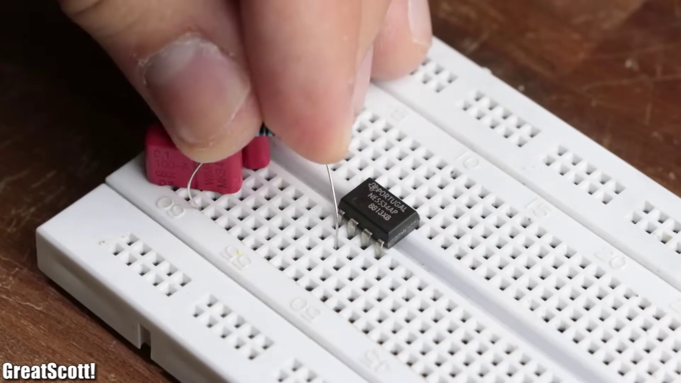 | 0:05  

Transcript
[0:01] In a previous video I showed you how to create a simple class AB audio amplifier

Section 0: Working with Electronic Components
Time: 0:07 - 0:14

Summary
A person is shown working on a project involving electronic components, including soldering and assembling devices.

Representative Frames
0:08   | 0:09  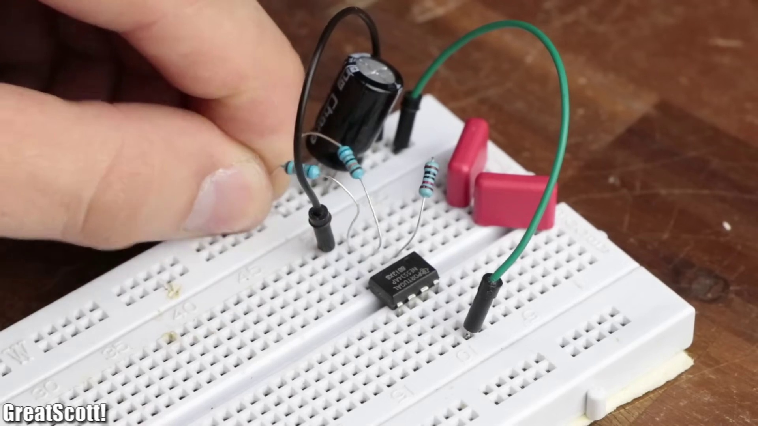 | 0:10   | 0:11   | 0:12  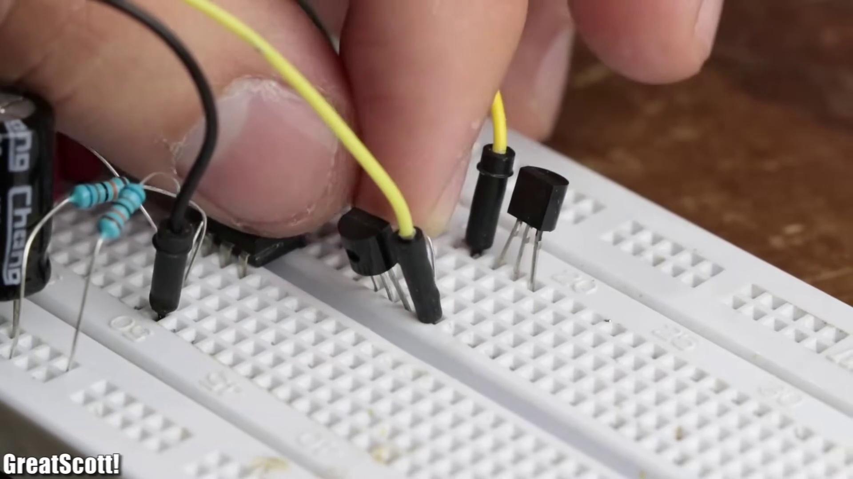

Transcript
[0:06] that consists of any 5534-bamp and a push-pull bipolar junction transistor output stage.

Section 0: Repairing Audio Devices
Time: 0:14 - 0:21

Summary
A person is repairing or modifying an audio device, with various tools and components scattered around the workbench.

Representative Frames
0:15   | 0:16   | 0:17  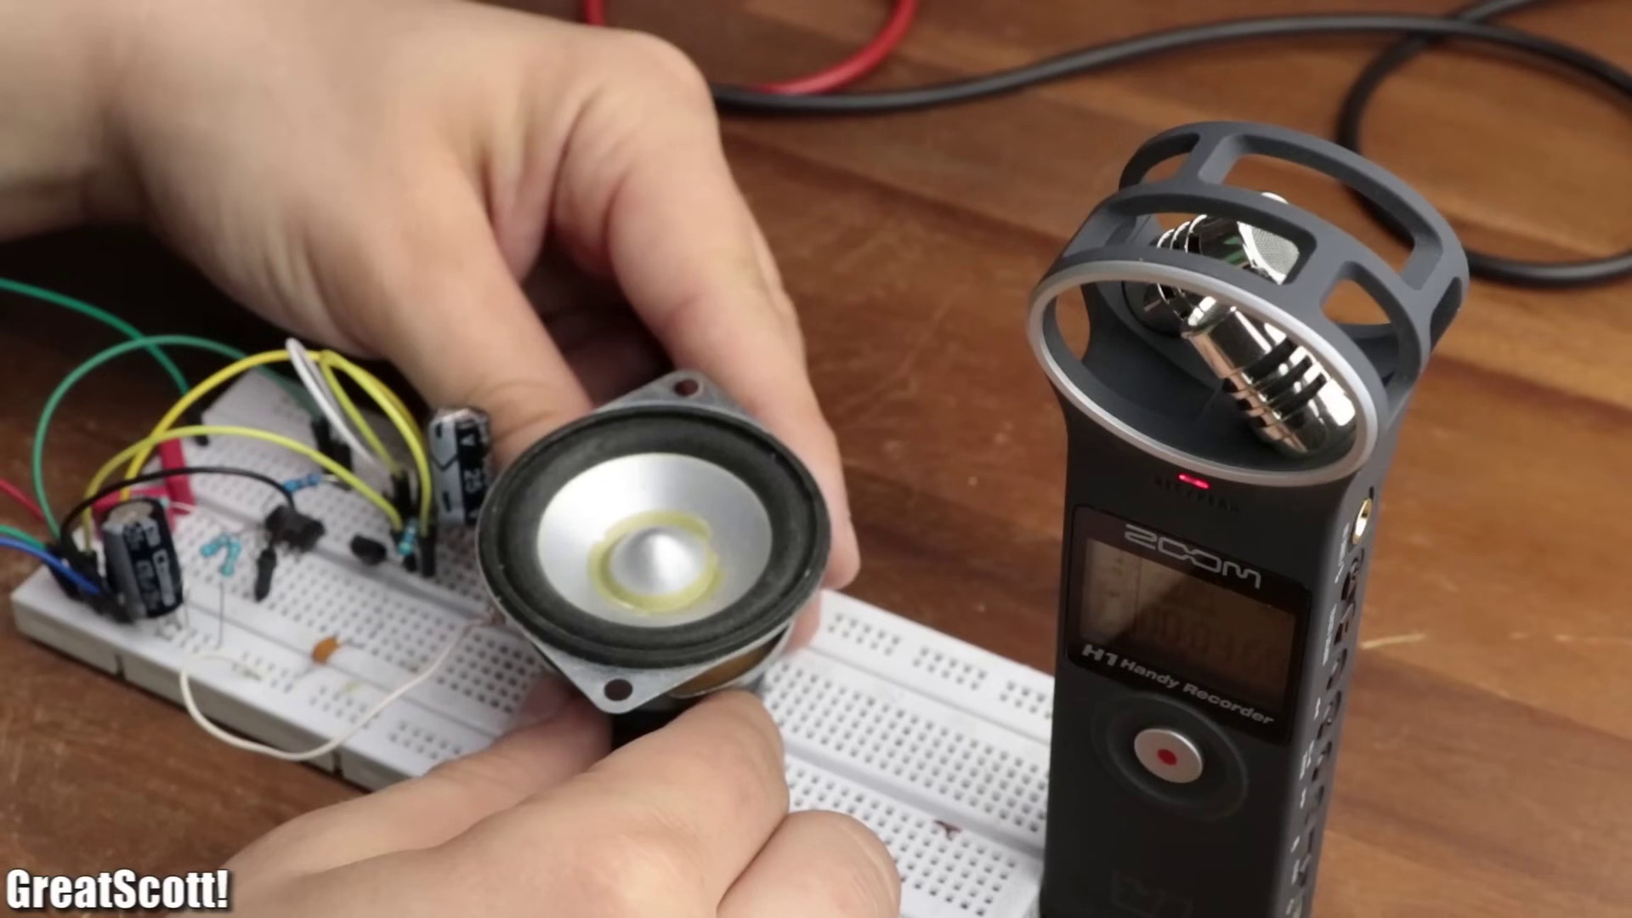 | 0:18   | 0:19  

Transcript
[0:13] Now, even though the circuit did work decently, there was one problem.
[0:19] It's power loss.

Section 0: Testing Speakers
Time: 0:21 - 7:58

Summary
A person is testing a speaker, with a close-up view of their hand pressing against the speaker's grille.

Representative Frames
1:37  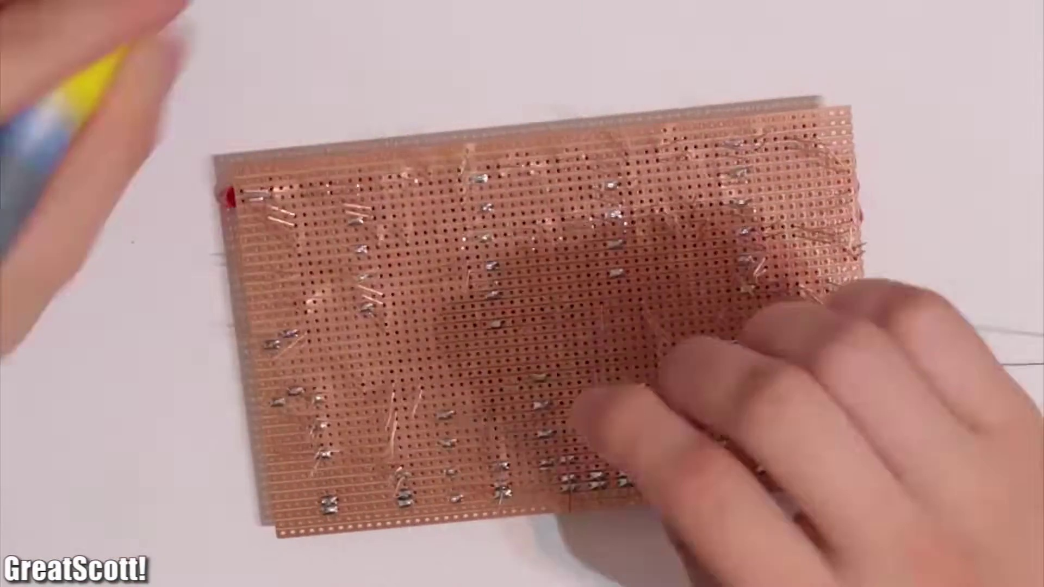 | 2:53  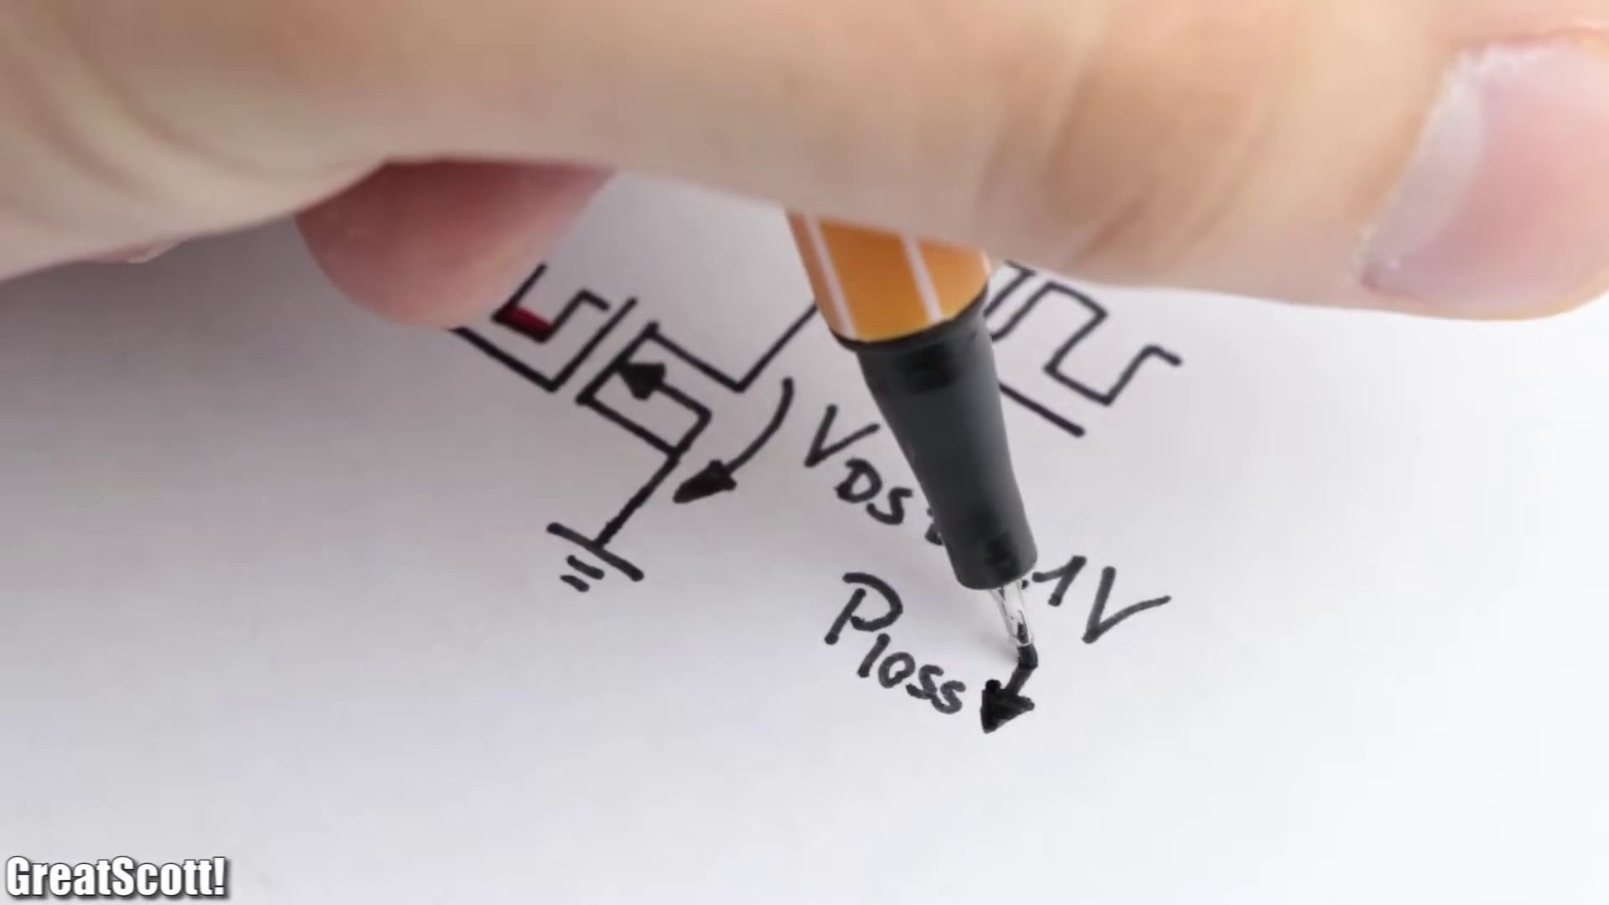 | 4:09  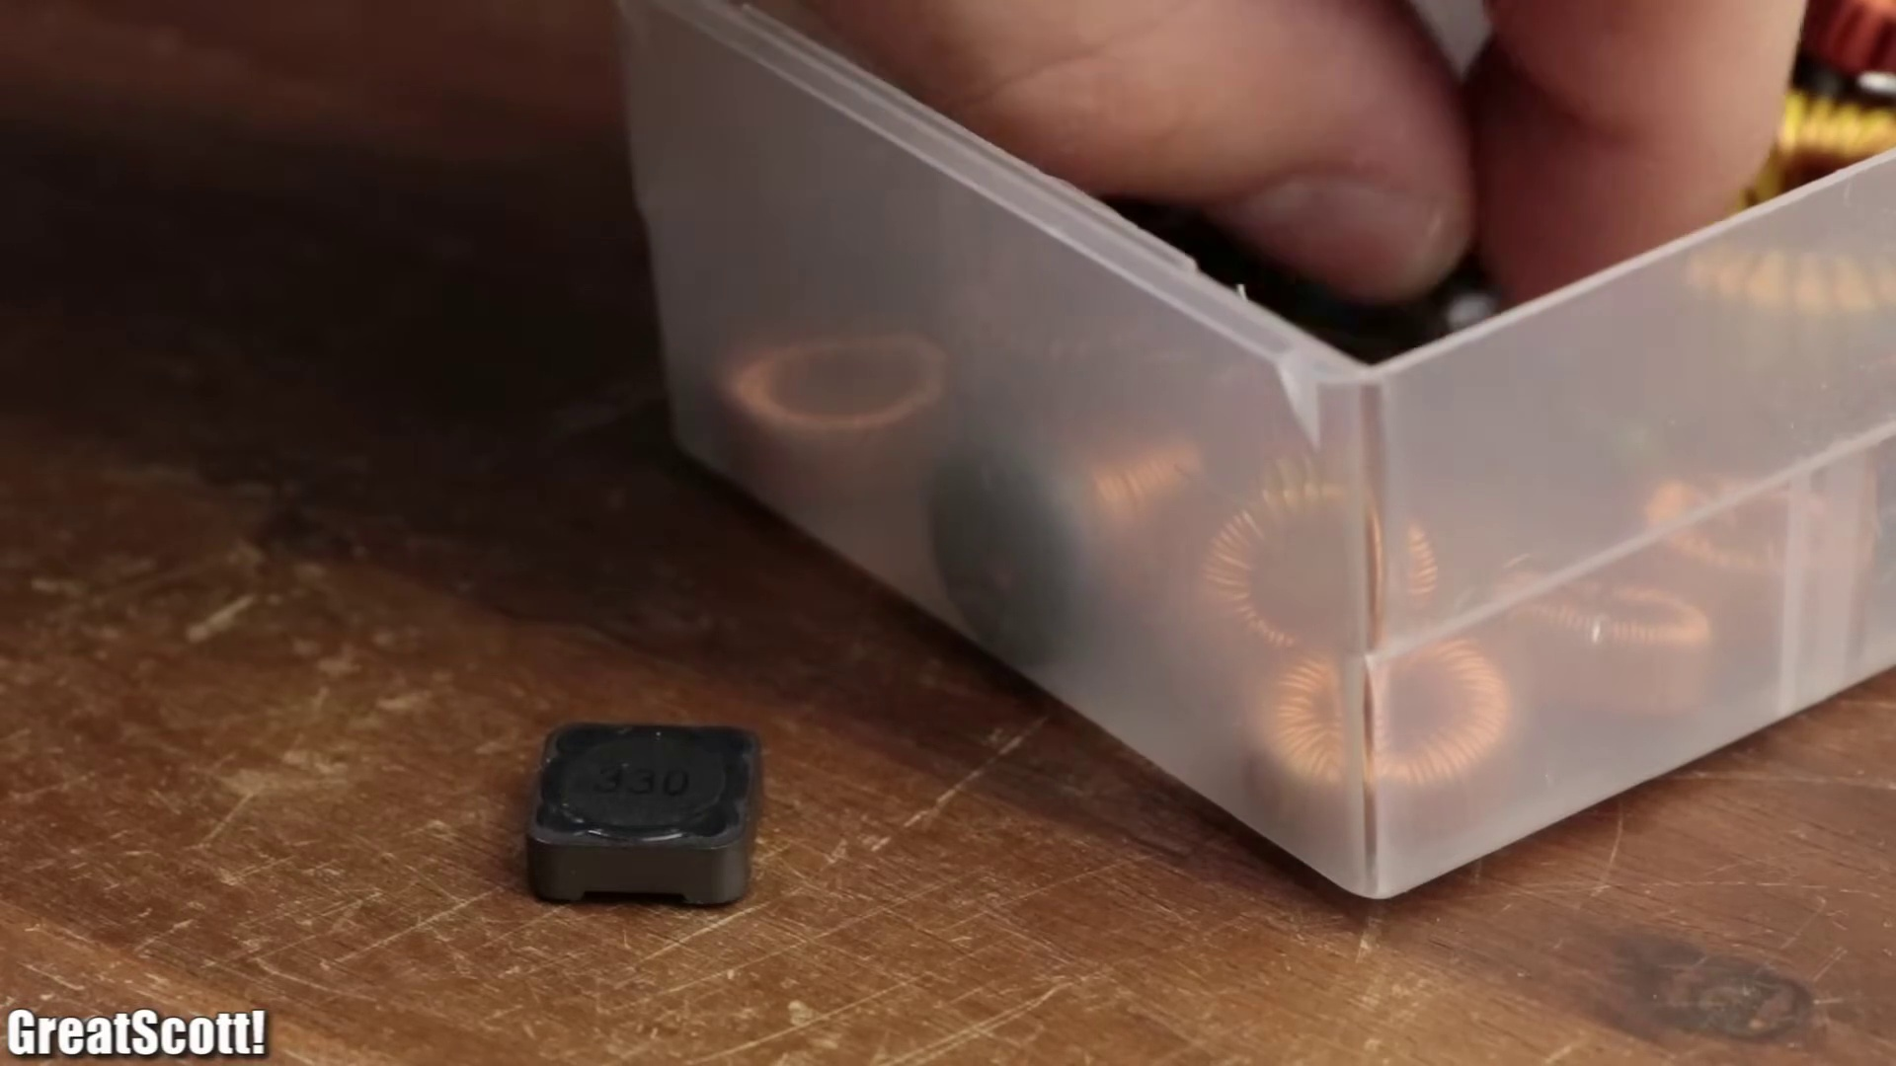 | 5:25  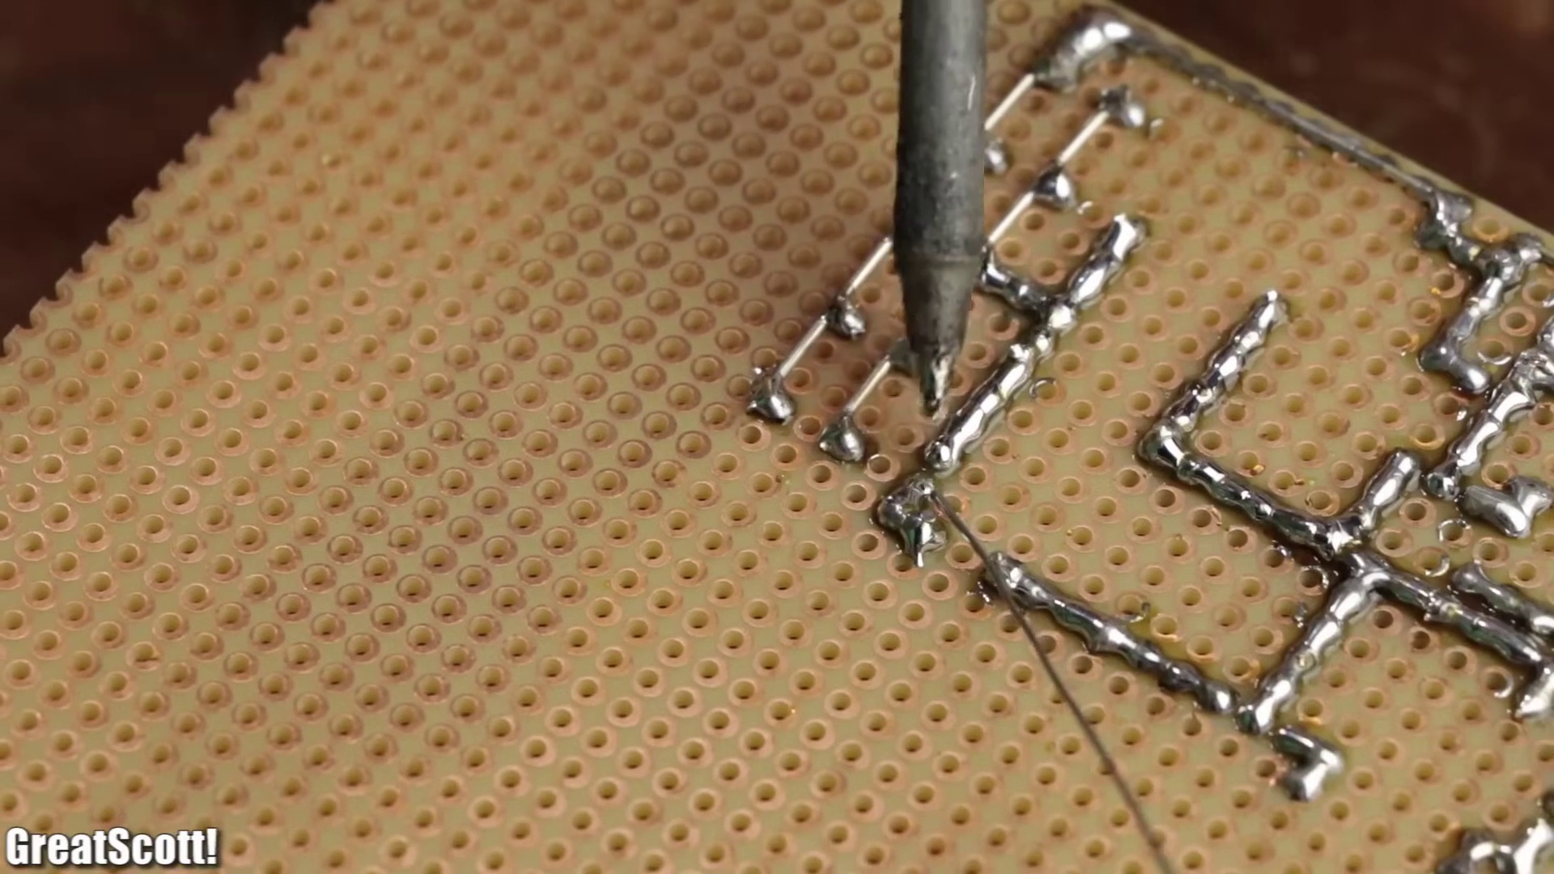 | 6:41  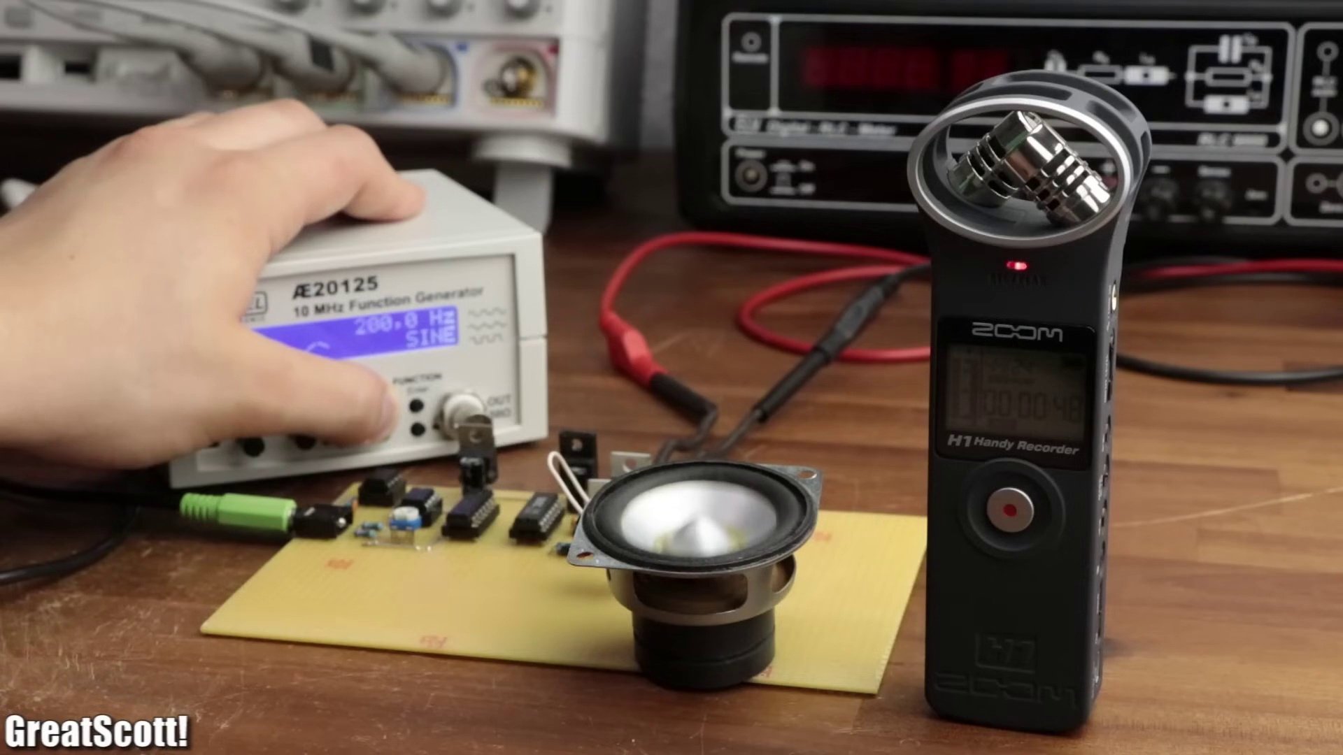

Transcript
[0:20] We can identify its cause by taking a look at the simplified functional block diagram.
[0:26] Firstly, our originally applied audio signal gets its voltage amplified by an op-amp.
[0:32] Since such op-amps can only supply very little power, the next part of the circuit is a BJT output stage
[0:39] that modulates a supply voltage of 12 volts to become the audio signal that is not only voltage amplified
[0:46] but can also supply sufficient current for the speaker.
[0:50] The only problem is that the transistors work in the active region,
[0:55] which means there exists a noticeable voltage drop across the collector emitter path
[1:00] and thus power loss is created, which leads to an overall efficiency of around 50 to 60%.
[1:08] To increase this efficiency though, we can utilize another audio amp kind,
[1:13] a class D amp to be precise, with an efficiency of up to 95%.
[1:19] So in this video, I will show you how such an audio amp works
[1:23] and how we can create our own DIY version, which consists of common components.
[1:29] Let's get started!
[1:31] First off, let's have a look at the simplified functional block diagram of a class D amp.
[1:49] On the left side, we got our audio signal, which is connected to the non-inverting input of a comparator.
[1:56] The inverting input however, gets connected to a triangle wave with a frequency of above 200 kilohertz.
[2:04] Now whenever the voltage of our audio signal is higher than the triangle voltage,
[2:09] the output of the comparator gets pulled high and vice versa.
[2:14] This way, we basically modulated our audio signal with maximum frequencies of around 20 kilohertz
[2:21] into a high-frequent square wave, which then connects to a MOSFET driver.
[2:26] The driver obviously turns on and off two MOSFETs.
[2:30] The high side one according to the high voltage levels,
[2:33] and the low side one according to the low voltage levels.
[2:37] This way, we get a powerful high-frequent square wave at the MOSFETs output,
[2:42] which since the MOSFETs were switched on and off in their ohmic region,
[2:46] with a low drain to source voltage drop, created very little power losses.
[2:52] Now we can recreate the original audio signal by adding an LC low-pass filter,
[2:58] which like the name implies, filters out all the high frequencies,
[3:02] and leaves us with our original, now amplified audio signal.
[3:06] As suitable components, we can use a 555 timer, a LM393, a 74HC04 to create an inverted signal of the high-frequent square wave,
[3:18] which is mandatory for the IR2113 MOSFET driver, and two IRLZ44N MOSFETs.
[3:26] Before we can solder a proper circuit though, I utilized the free EasyEDA circuit design software,
[3:33] to create an appropriate schematic.
[3:36] By utilizing the online component library, I imported all the required ICs and passive components,
[3:42] and afterwards connected them all to one another, according to the previously discussed functional block diagram.
[3:49] The only question left to answer, was what kind of values should be used for the LC filter.
[3:55] According to a commercial class D amp that I had lying around, inductances of 22μH should be suitable.
[4:04] The only inductors I had lying around though, were 33μH ones.
[4:09] So I connected two of them in parallel, in order to create a 16.5μH value,
[4:15] and wrote down the two formulas to calculate the inductance and capacity of a LC low-pass filter.
[4:22] If we rearrange the inductor formula, and insert the load impedance of 4Ω,
[4:28] according to the speaker properties, and the inductance of 16.5μH,
[4:33] we can calculate a cutoff frequency of around 40kHz,
[4:38] at which the original voltage amplitude will be lowered by 3dB, or 40% of the original amplitude.
[4:46] By inserting this frequency into the capacitor formula, we get a capacitance of around 1.03μF,
[4:54] which I created by connecting five 0.22μF capacitors in parallel.
[5:00] And now that the schematic was complete, I gathered all the required components,
[5:05] and started soldering them to a piece of perfboard.
[5:08] As always, I tried to utilize silvered copper wire for the most part,
[5:13] but still had to use a bit of hookup wire at the end.
[5:17] And of course, you can find reference pictures of my perfboard layout,
[5:21] as well as the schematic for this project, in the video description.
[5:25] After three hours of soldering, the circuit was complete,
[5:29] and it was time to insert all the ICs, connect a 15V power supply to the input,
[5:36] and a speaker to the output.
[5:38] As a first test, I hooked up my function generator,
[5:41] set to a sine wave with a frequency of only 1Hz to the audio input.
[5:47] Since the 555 timer creates a triangle voltage between around 1.3 and 2.3 of the supply voltage,
[5:54] we also have to use a potentiometer to add a DC offset to the sine wave,
[5:59] so that it is completely submerged inside the triangle wave.
[6:04] If we now take a look at the output of the comparator,
[6:07] we can see how the slowly changing 1Hz sine wave creates the modulated high-frequent square wave.
[6:14] And if we increase the frequency to a value that is closer to proper music,
[6:19] the output definitely looks crazy and confusing,
[6:23] but the theory pretty much stays the same.
[6:26] But by using lower frequencies, we can actually create a lot of visible vibrations of the speaker cone,
[6:33] which showcases that this class D-Amp is pretty damn powerful for its simplicity.
[6:39] And as you would have expected it, by increasing the frequency of the sine wave,
[6:44] we produce higher tones, which means that the amp works without a problem.
[6:49] So I replaced the function generator with my smartphone and tested the music playback capabilities of the amp.
[6:56] As you can hear, the music playback also worked like a charm, but the volume was a bit low.
[7:03] The reason for that was that the music signal only features a peak-to-peak voltage of around half a volt,
[7:10] while the function generator easily created peak-to-peak voltages of 4 volts.
[7:15] So as an afterthought, I added an LM386 op-amp in between the input audio signal and the comparator,
[7:23] which didn't even require complementary components.
[7:26] Afterwards, the audio signal consisted of a peak-to-peak voltage of 4 volts as well,
[7:32] which was suitable to create a much louder playback of the music through the class D-Amp.
[7:38] Now of course, this circuit is definitely not perfect.
[7:42] However, the audio quality is pretty decent.
[7:46] And more importantly, maybe you learned something new.
[7:49] If so, don't forget to like, share and subscribe.
[7:53] Stay creative and I will see you next time.
[7:57] See you next time.

