Engagement Analysis: 9fFjlxUUQZg

Section 0: Image of Iodine (I) Chemical Element
Time: 6:00 - 6:47

Summary
The image displays the chemical element Iodine, with its atomic number and properties described. It highlights iodine's applications in disinfection, photography, and human body functions.

Representative Frames
6:07  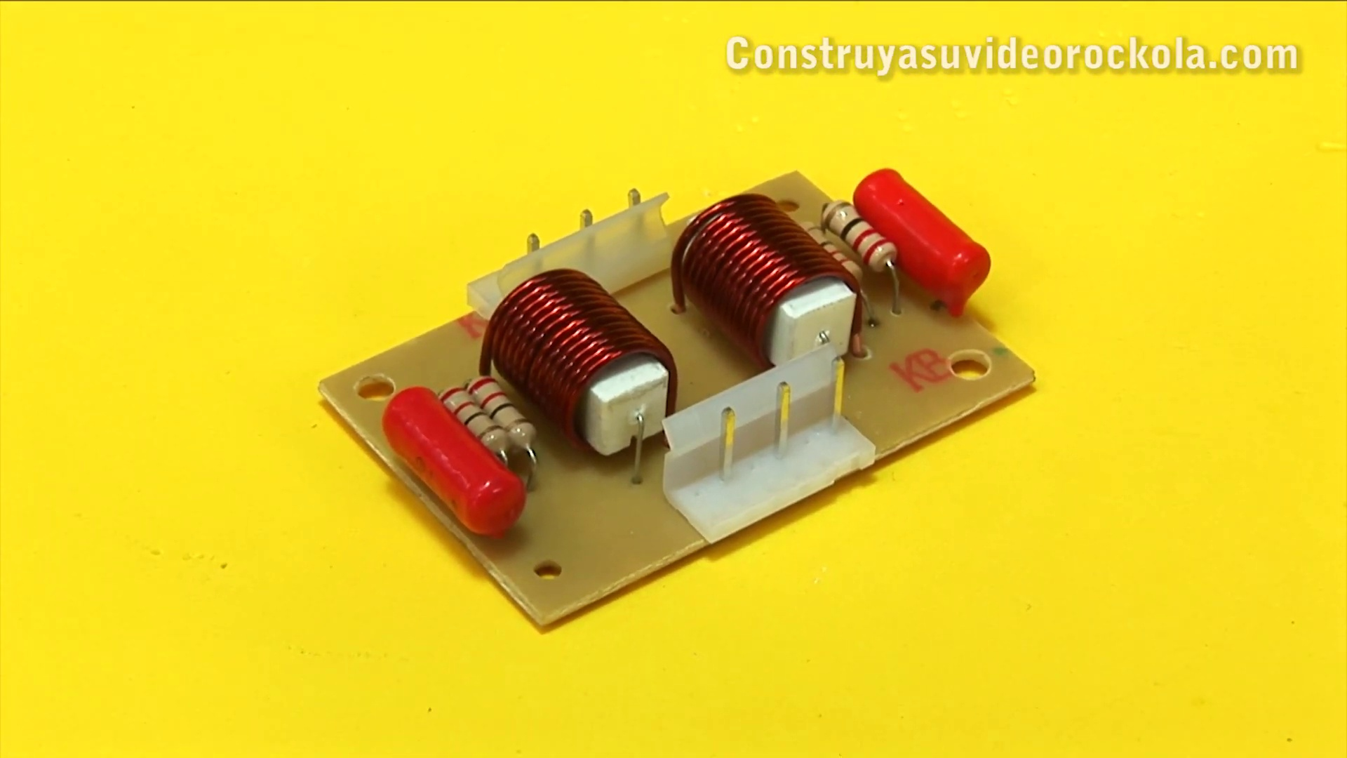 | 6:15  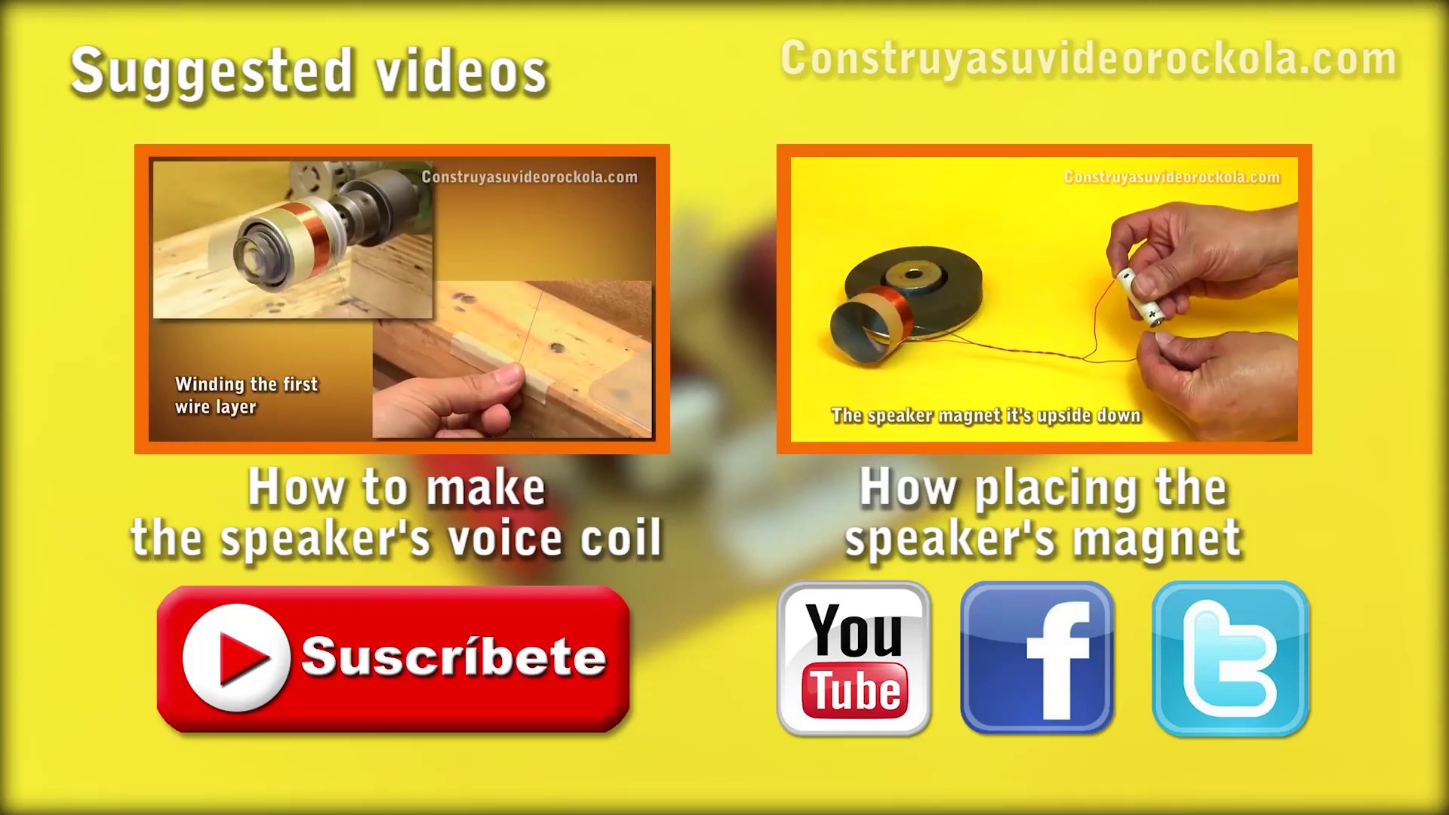 | 6:23  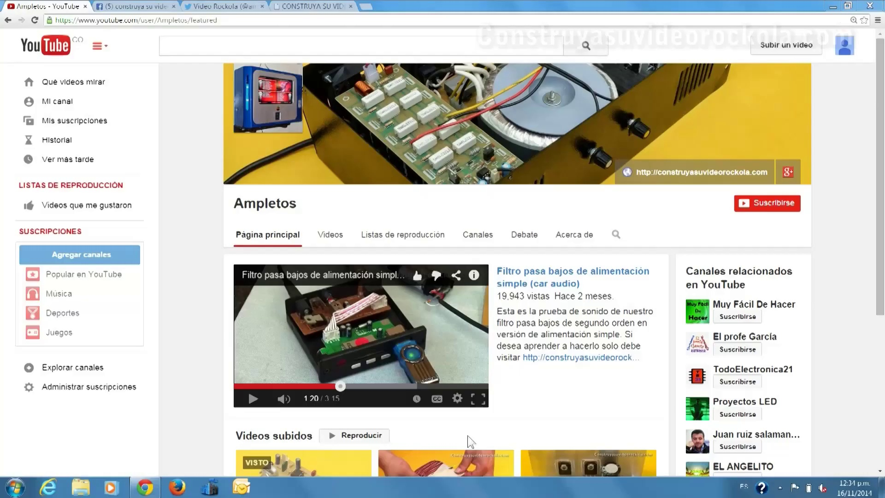 | 6:31  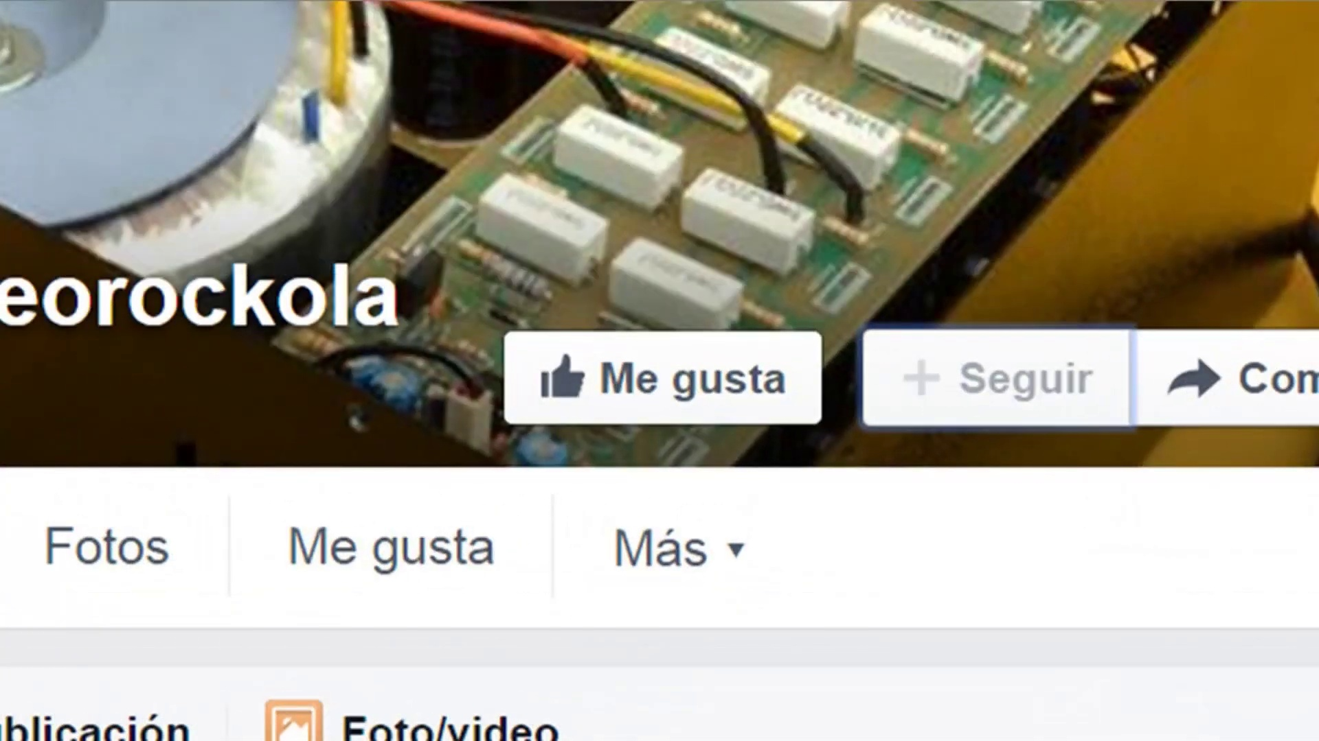 | 6:39  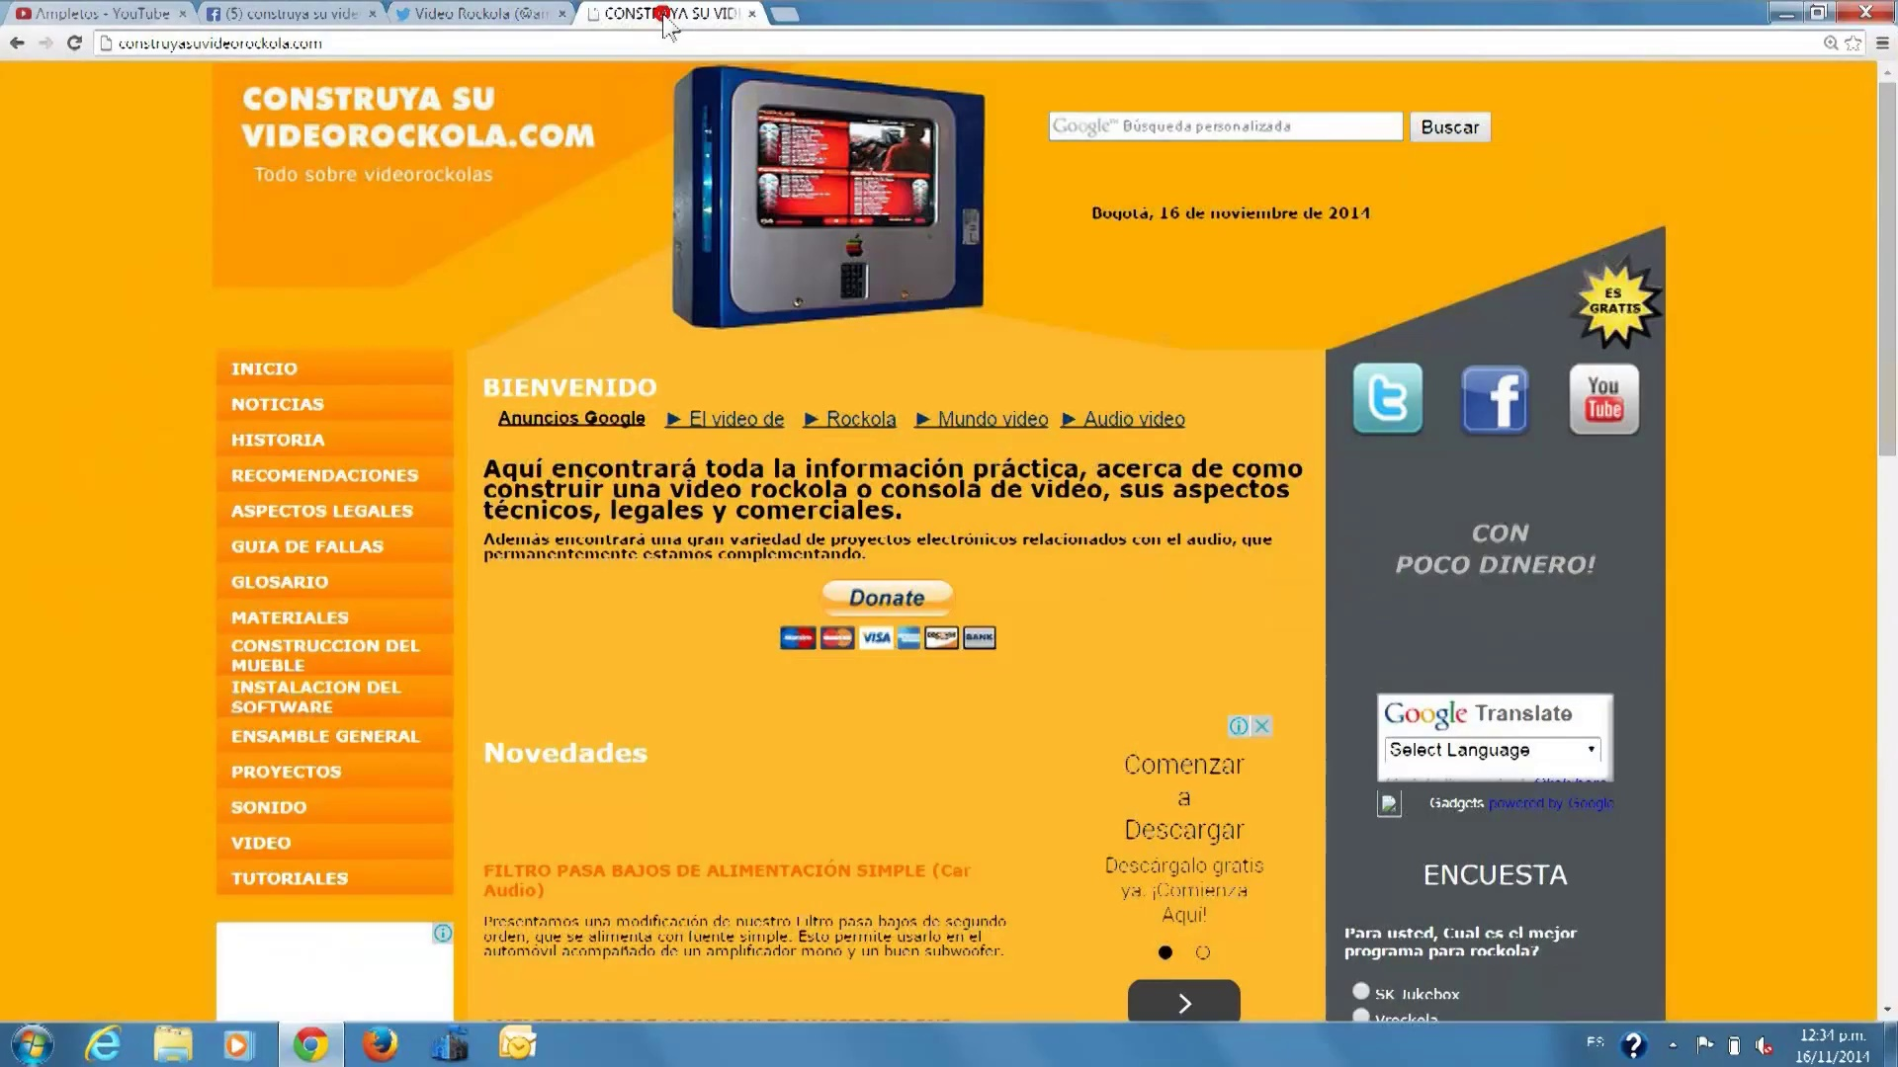

Transcript
[6:03] We have ready our Zobel network, which we can use with a great variety of amplifiers.
[6:08] Success!
[6:12] Watch our suggested videos.
[6:21] We invite you to subscribe to our YouTube channel.
[6:23] Go to the tall button, and check the box Send me updates.
[6:33] Join us on Facebook.
[6:37] And follow us on Twitter.
[6:40] Visit our website Construyasuvideoracola.com
[6:43] seeing your boobstworth WomenMER Connie
[6:44] on Facebook.

Section 0: Split-Screen Image of Construction Site and Text Overlay
Time: 6:47 - 6:51

Summary
The image features a split-screen format with a selfie on the left and a construction site or building under construction on the right. The text overlay provides information about 'CONSTRUYASUDO' and its website address.

Representative Frames
6:47   | 6:48  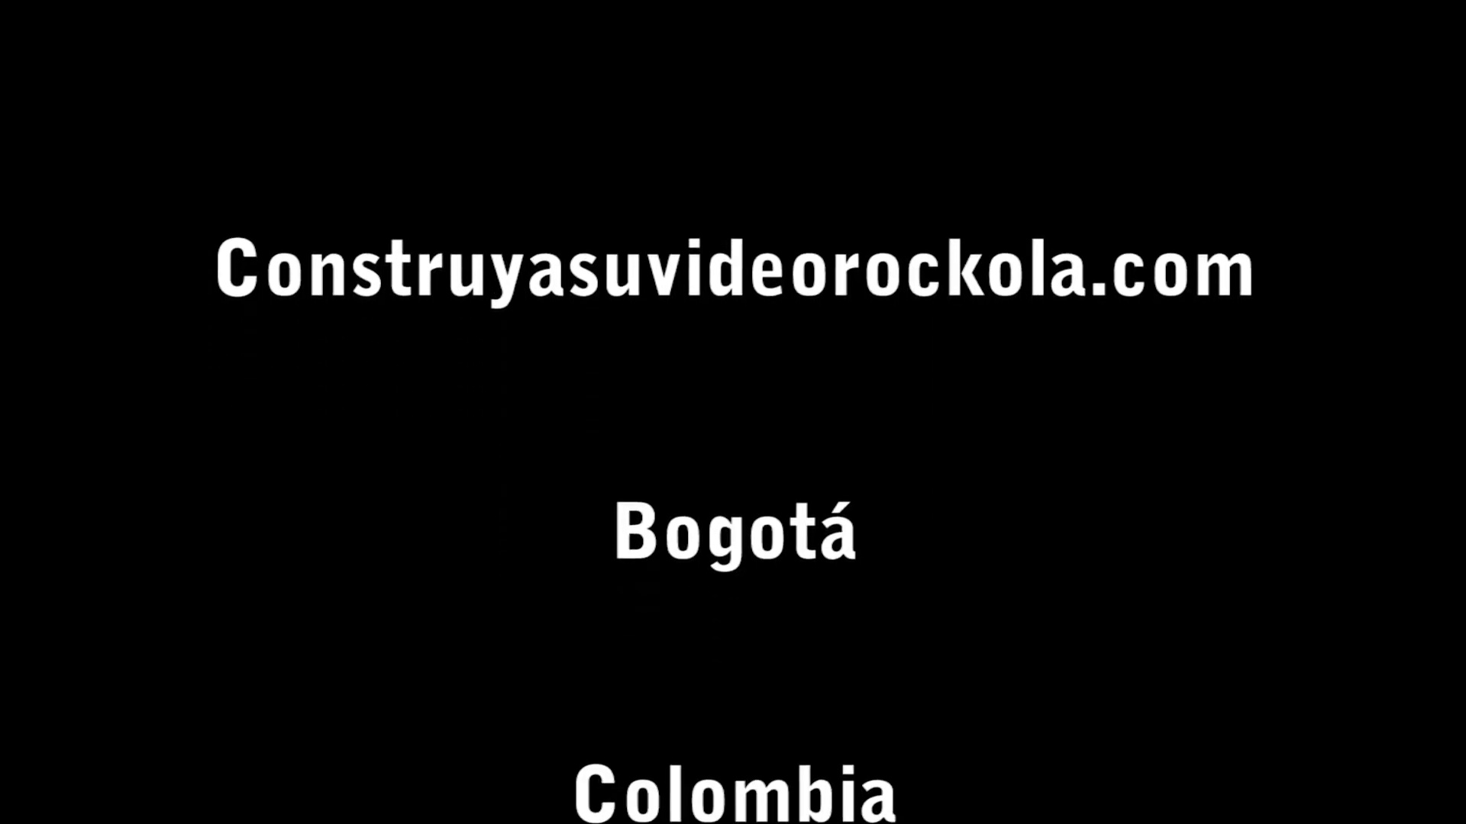 | 6:49   | 6:49   | 6:50  

Transcript
(No speech detected in this section)

Section 0: Prominent Display of Word 'COLOMBIA'
Time: 6:51 - 6:54

Summary
The image displays a striking visual display with the word 'COLOMBIA' prominently displayed in large white letters against a darker background. The title is accompanied by smaller text that reads '2016'.

Representative Frames
6:51   | 6:52   | 6:52   | 6:53   | 6:53  

Transcript
(No speech detected in this section)

Section 0: Low-Quality Image of Slide Content and Graphic
Time: 6:54 - 6:56

Summary
The image displays a slide with a dark background, some text, and a small graphic on the right side. However, due to poor image quality, it is difficult to discern any additional details.

Representative Frames
6:54   | 6:54   | 6:55   | 6:55   | 6:56  

Transcript
(No speech detected in this section)

