Engagement Analysis: 9fYzb1g8tzw

Section 0: Scene 1: Aerial View with Drone
Time: 10:00 - 10:04

Summary
The scene shows an aerial view of a landscape with clouds and hills. A drone is flying over the landscape, leaving a trail of smoke behind it.

Representative Frames
10:00  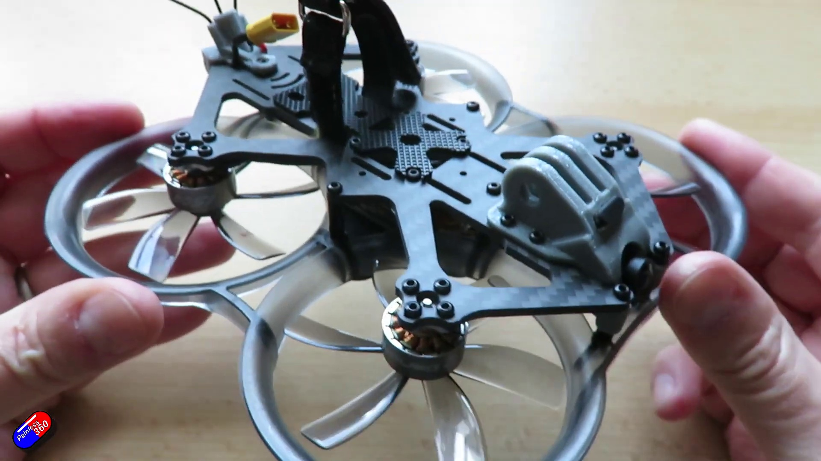 | 10:01   | 10:02   | 10:02   | 10:03  

Transcript
(No speech detected in this section)

Section 0: Scene 2: Panoramic View of Mountains
Time: 10:04 - 10:06

Summary
The scene shows a panoramic view of mountains from an aerial perspective. The sky above is clear blue with fluffy white clouds, and the mountains are covered in vegetation.

Representative Frames
10:04   | 10:04  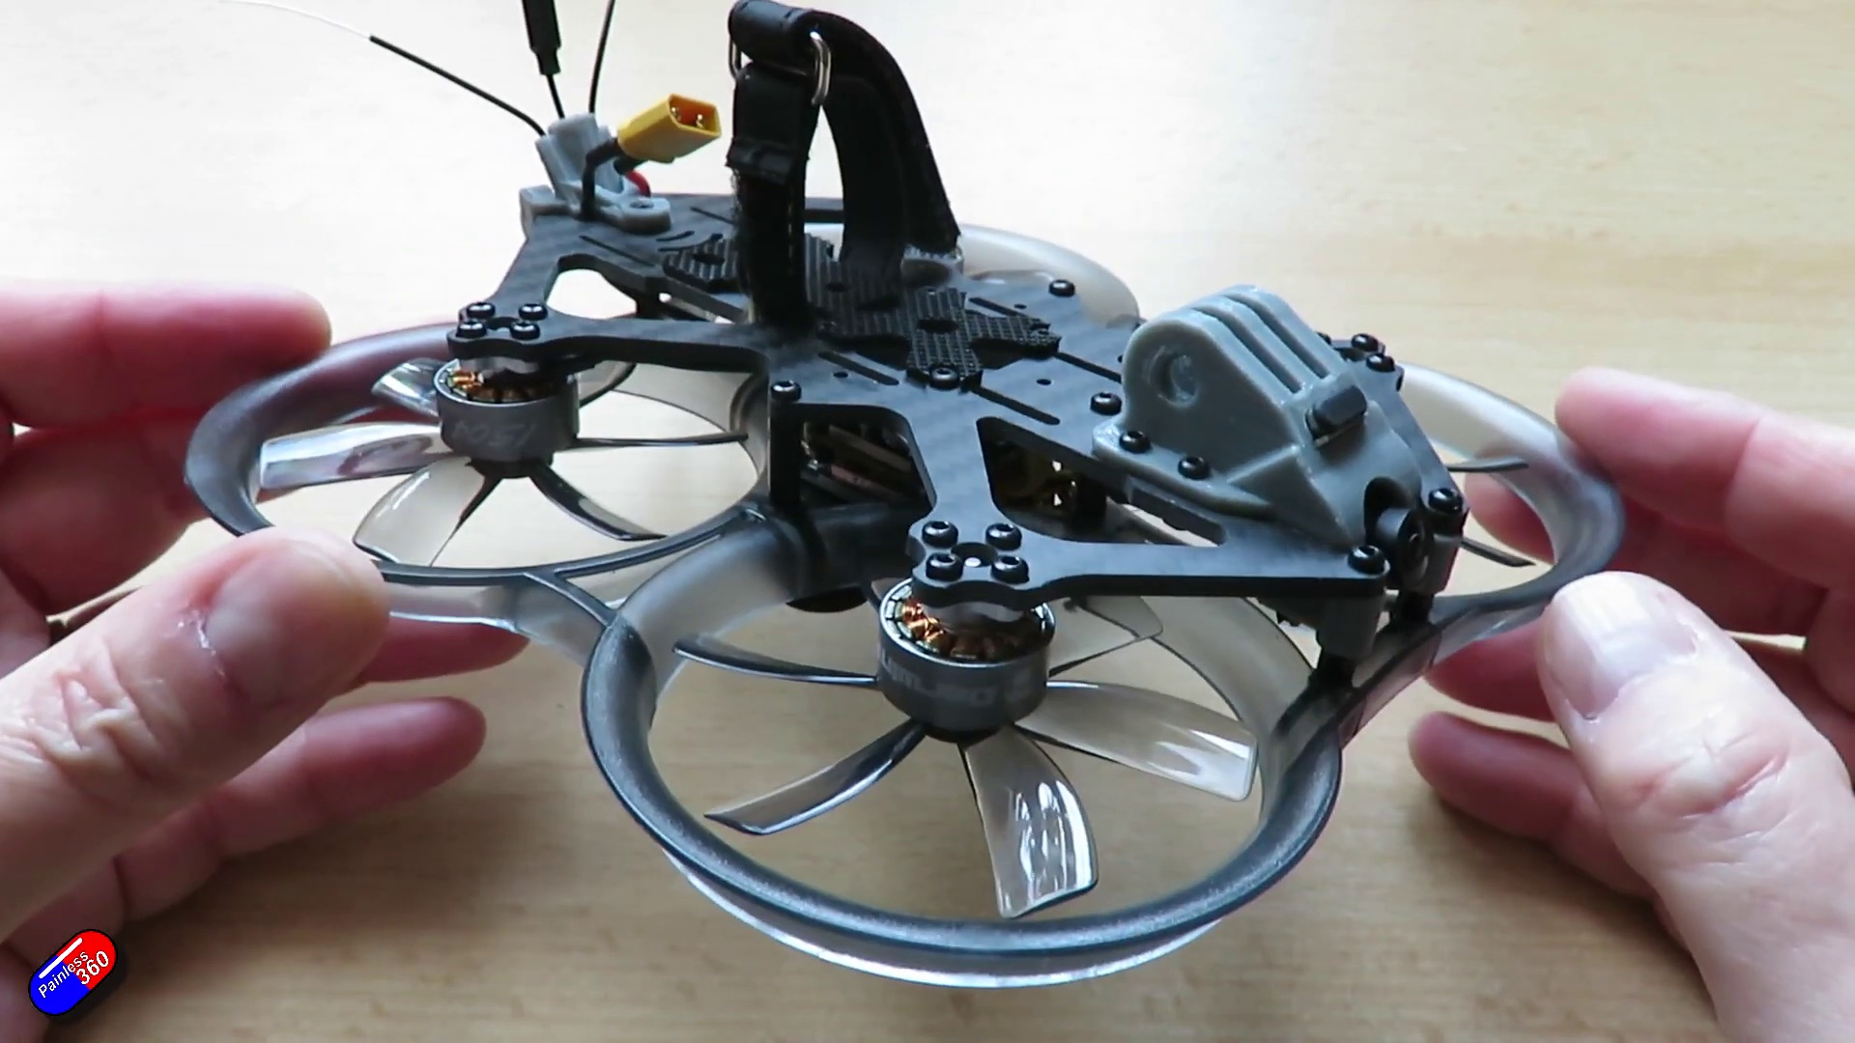 | 10:05   | 10:05   | 10:05  

Transcript
[10:01] within the range of most pilots because the price of the components going up the price of this stuff

Section 0: Scene 3: Video Call with Painless 360
Time: 10:06 - 10:08

Summary
The scene shows a video call with a person holding a smartphone displaying the video call interface. The background of the video call is an outdoor setting with rolling hills and a body of water.

Representative Frames
10:06   | 10:06   | 10:07   | 10:07   | 10:07  

Transcript
(No speech detected in this section)

Section 0: Scene 4: Grey Gradient Background
Time: 10:08 - 10:44

Summary
The scene shows a grey gradient background with a darker grey strip that appears to be a button. There is no visible content on this strip, and the overall style of the image is minimalistic.

Representative Frames
10:14  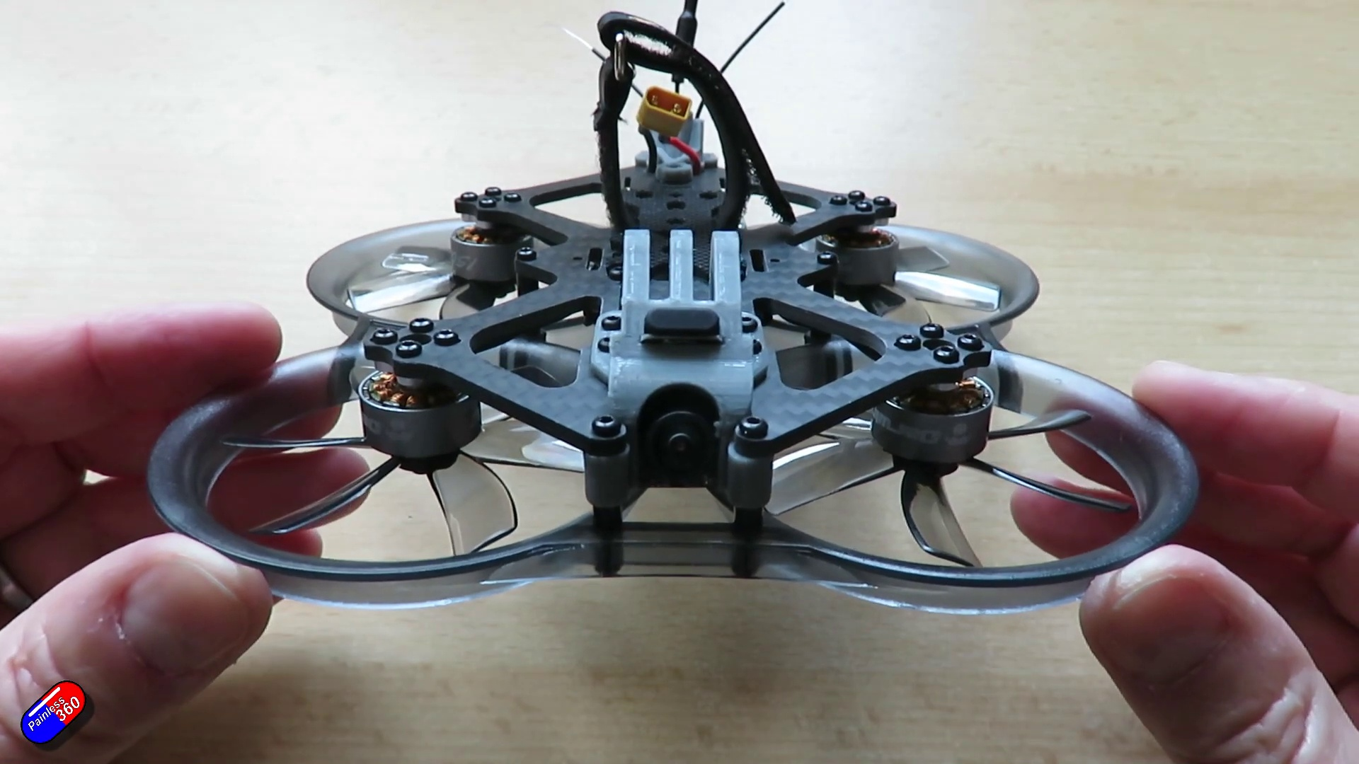 | 10:20  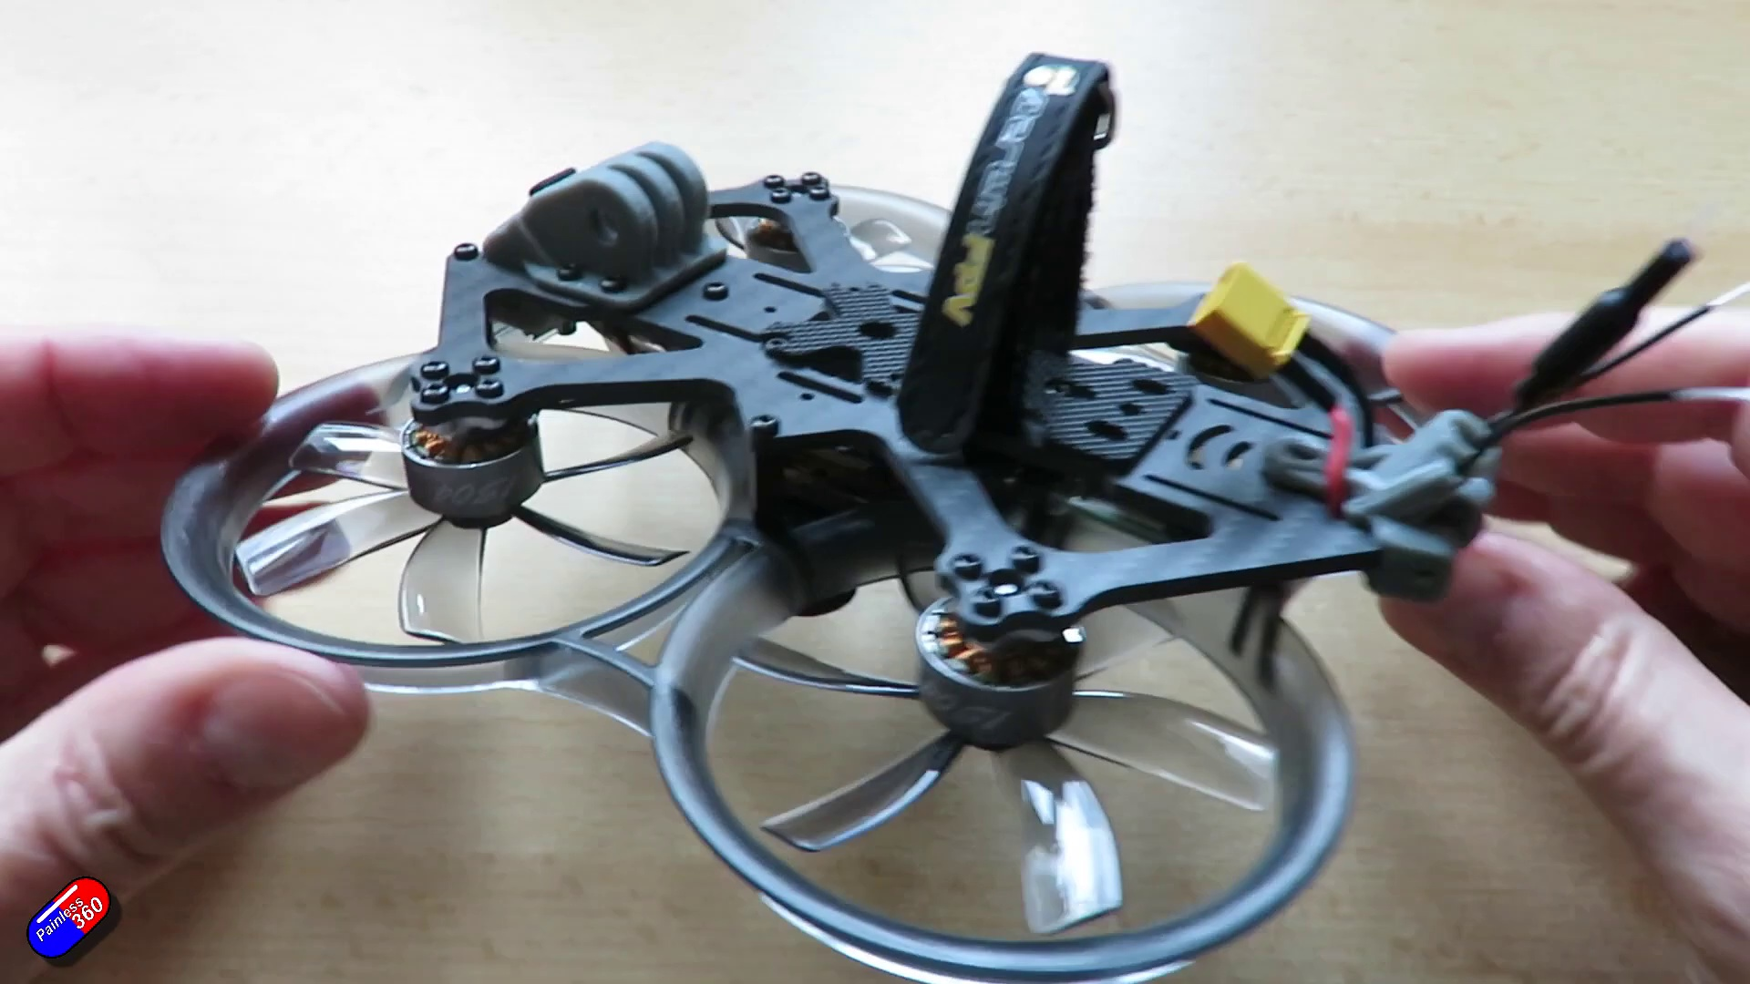 | 10:26   | 10:32  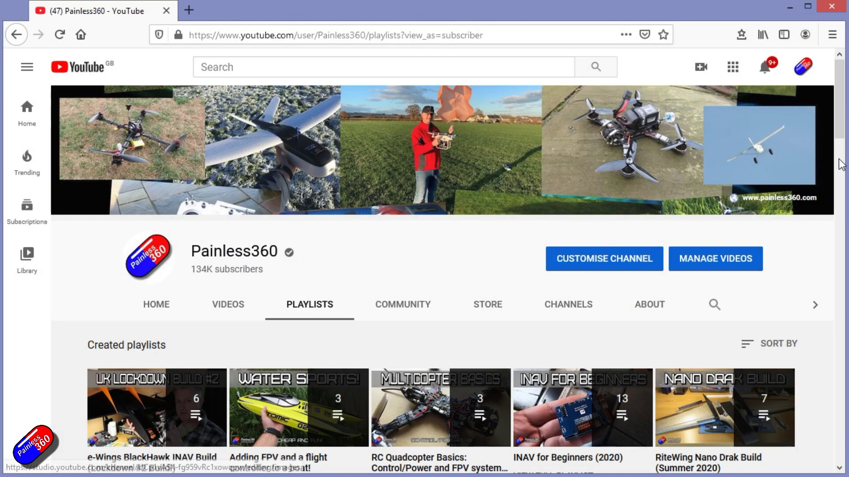 | 10:38  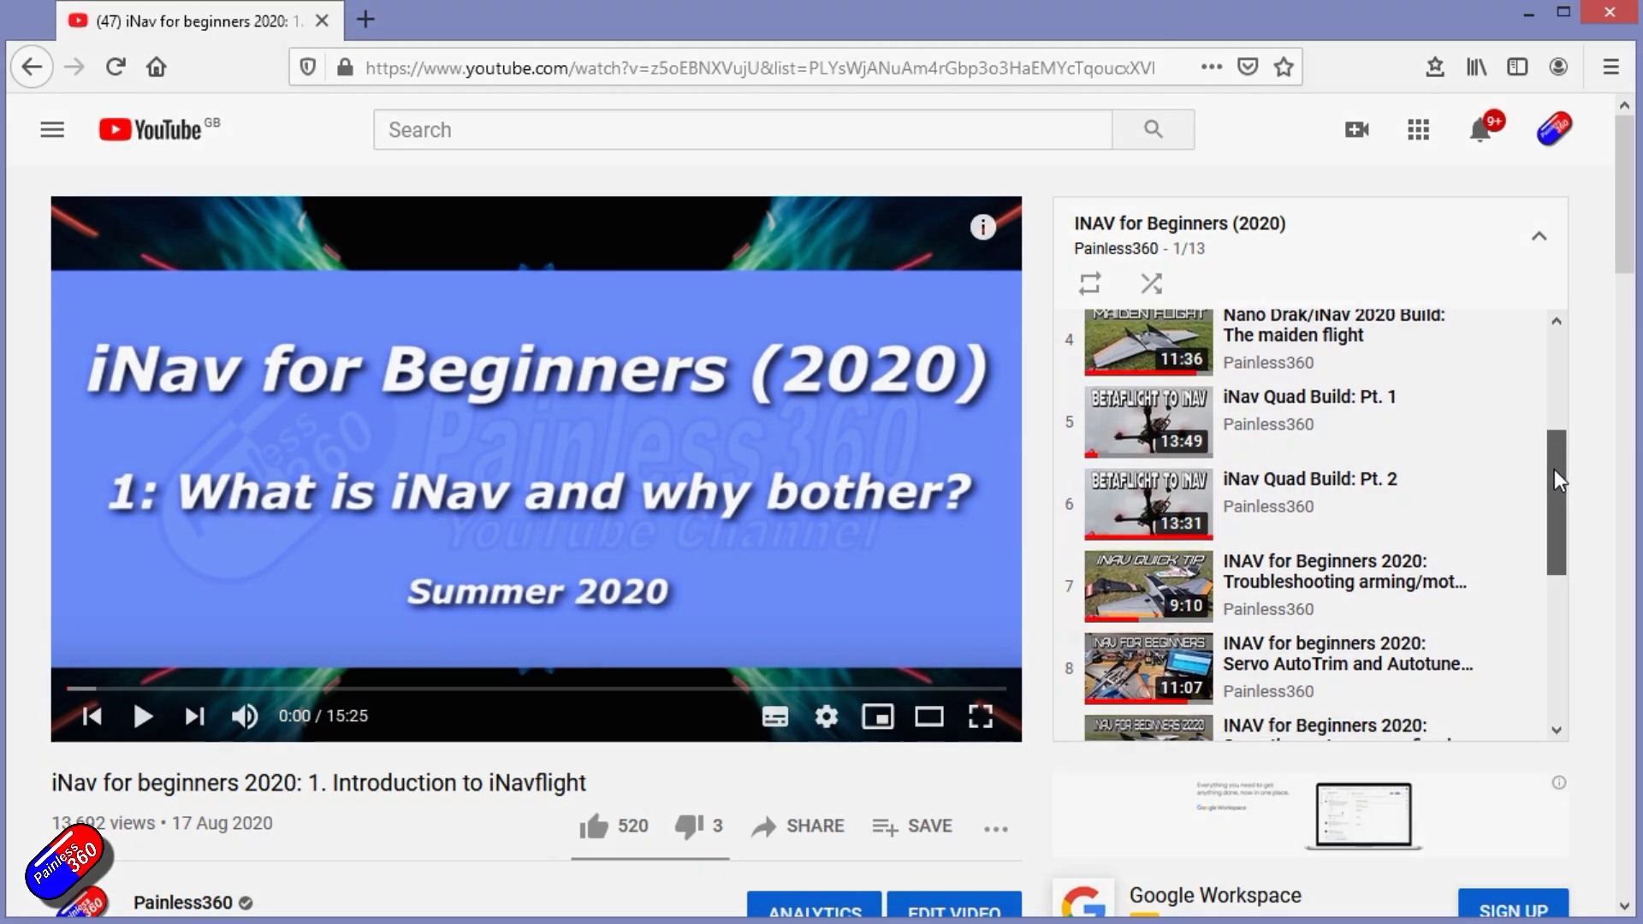

Transcript
[10:07] is as well. So in summary this is a very nice little quad. This is a great option if you want to have
[10:14] something that you can fly around outside, fly around indoors. The setup's really nice. The only
[10:18] thing that's letting this down is the performance of that FPV setup. Thank you for spending your time
[10:24] today watching that video. You can find me in all the usual places on social media and if you're trying
[10:29] to learn about a subject then check out the playlist. All of my videos are organized into easy to follow
[10:34] playlists that if you're trying to learn a topic will take you from the basics right the way through to
[10:39] some pretty advanced stuff.

Section 0: Scene 5: Panoramic View of Mountainous Landscape
Time: 10:44 - 10:50

Summary
The scene shows a panoramic view of a mountainous landscape from an aerial perspective. The sky above is clear blue, and the mountains are covered in vegetation.

Representative Frames
10:45  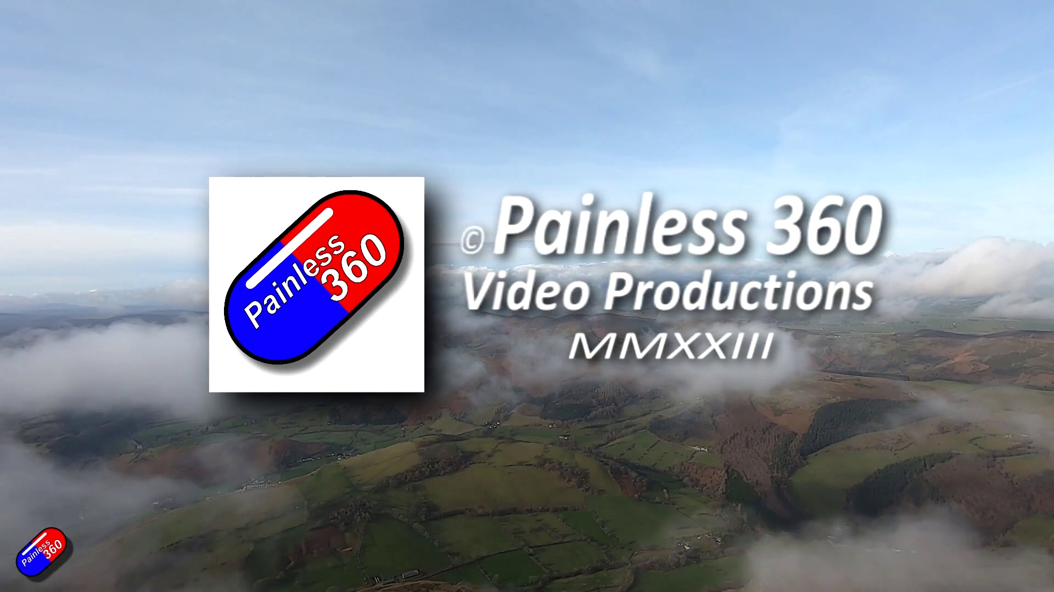 | 10:46   | 10:47   | 10:48   | 10:49  

Transcript
(No speech detected in this section)

