Engagement Analysis: CvMDlG_AF3Q

Section 0: Social Media Post with YouTube Video Screenshot
Time: 9:26 - 9:29

Summary
A social media post with a screenshot of a YouTube video page, featuring the creator's profile picture and a thumbnail image of a red heart-shaped object with a tool or device attached to it.

Representative Frames
9:26  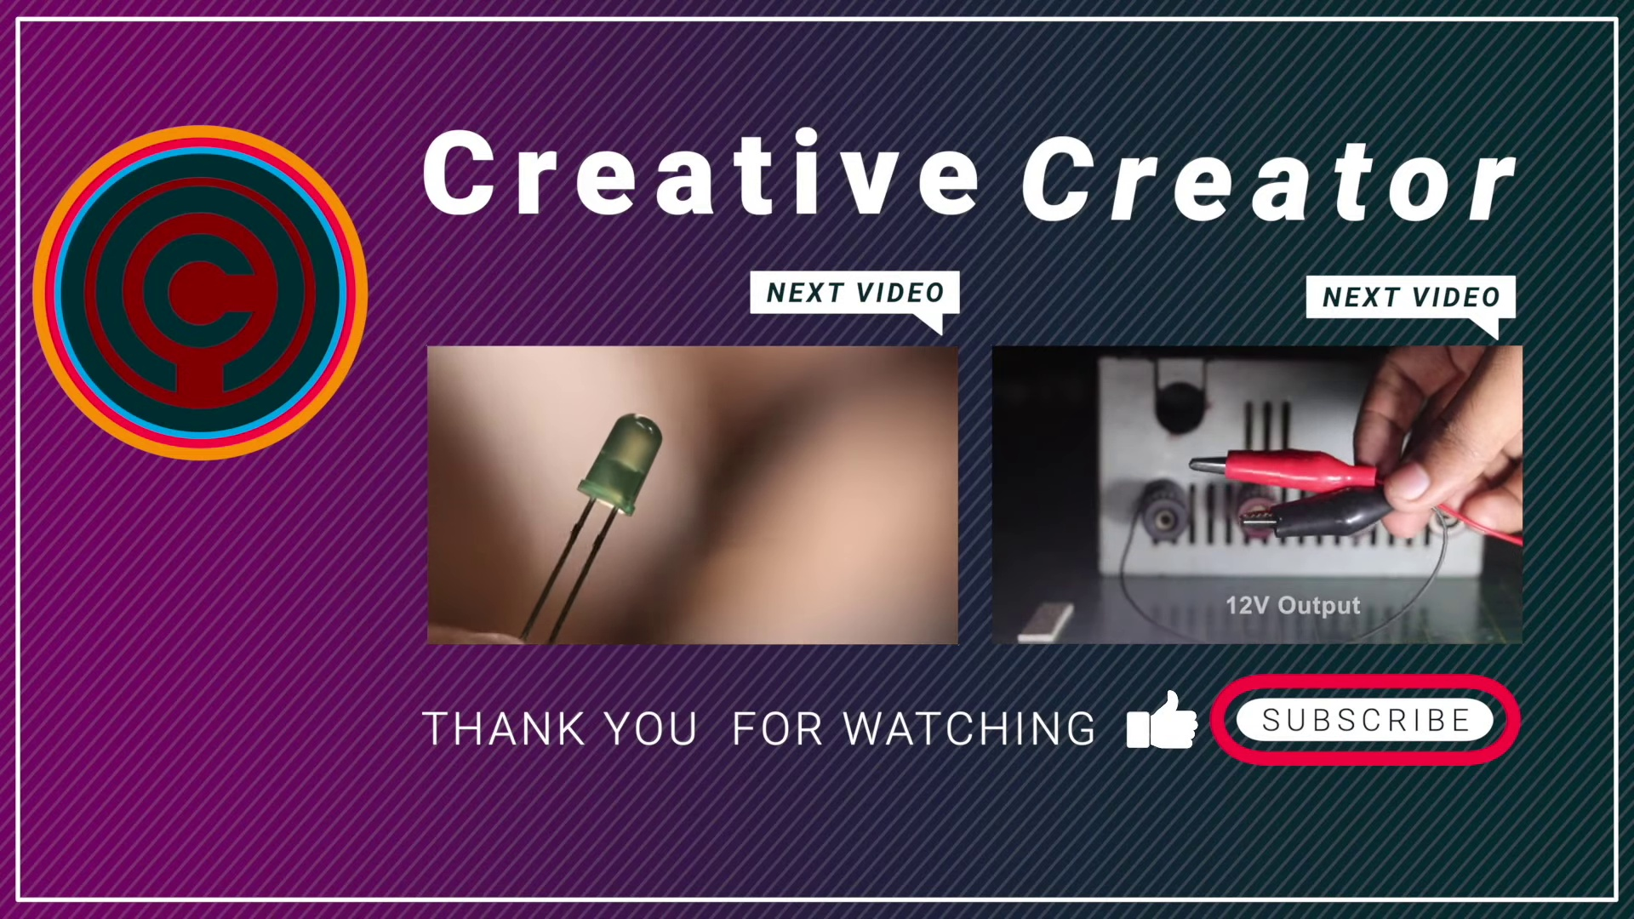 | 9:27   | 9:27   | 9:28   | 9:29  

Transcript
(No speech detected in this section)

