Engagement Analysis: DOWDNBu9DkU

Section 0: Introduction to Crunch Labs
Time: 0:00 - 0:05

Summary
The video begins with an introduction to Crunch Labs, a company that offers build boxes and creative resources for kids. The narrator explains that Crunch Labs is a place where kids can learn to create and build whatever they can dream up.

Representative Frames
0:00   | 0:01   | 0:02   | 0:03   | 0:04  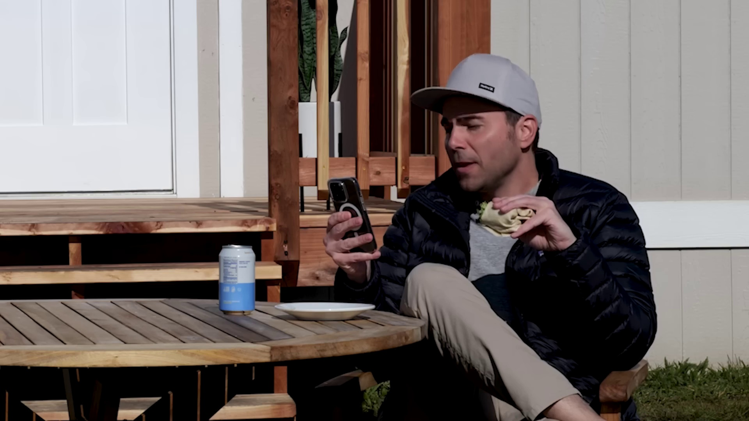

Transcript
[0:00] I cut my finger making lunch so I placed an order for some band-aids a couple minutes ago

Section 0: Tour of the Office
Time: 0:05 - 0:15

Summary
The video then takes us on a tour of the Crunch Labs office, showing us the various objects and toys available for kids to play with. We see a man standing behind a table, gesturing towards some papers in his hand.

Representative Frames
0:06   | 0:08  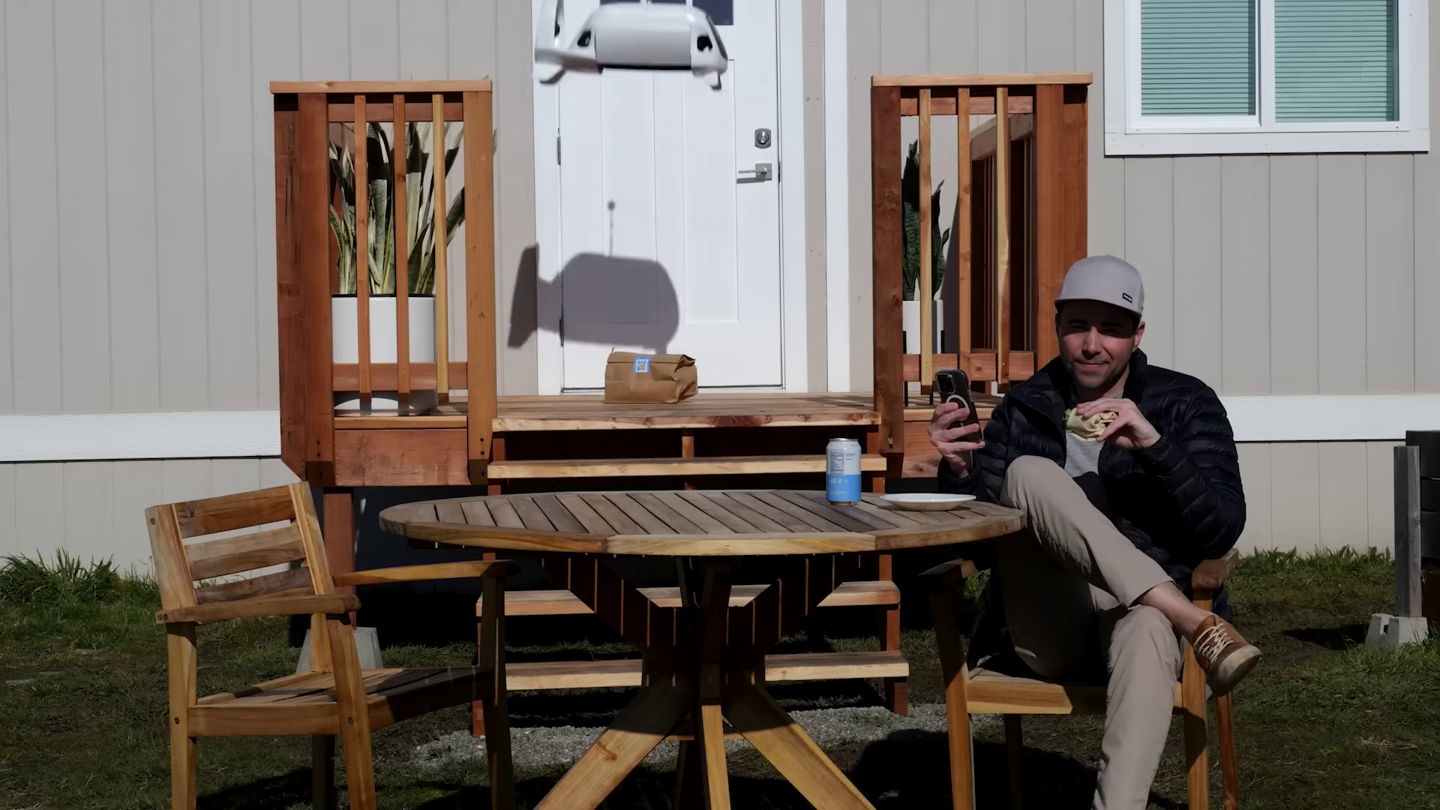 | 0:10   | 0:11   | 0:13  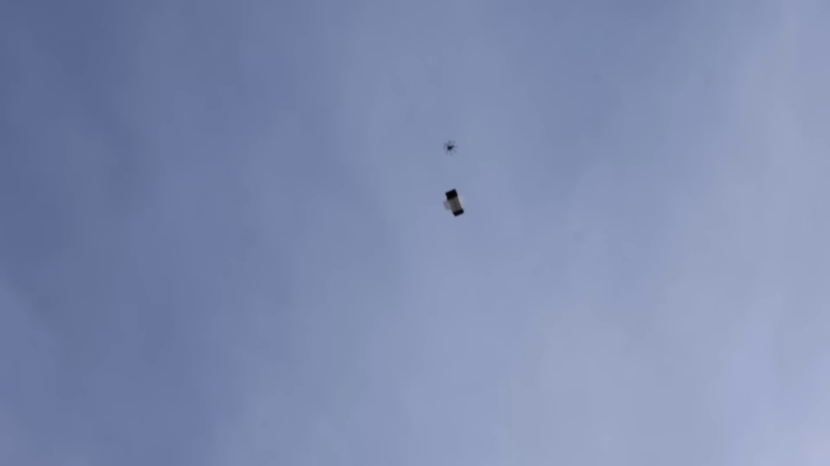

Transcript
[0:04] and now they're four seconds away.
[0:08] That is a nearly silent drone system that can deliver a package from the sky

Section 0: Build Box Subscription
Time: 0:15 - 0:25

Summary
The narrator explains that Crunch Labs offers a build box subscription service, where kids can receive regular shipments of creative resources and materials to build and create with. The man on screen holds up a microphone and invites viewers to order their build box subscription today.

Representative Frames
0:16  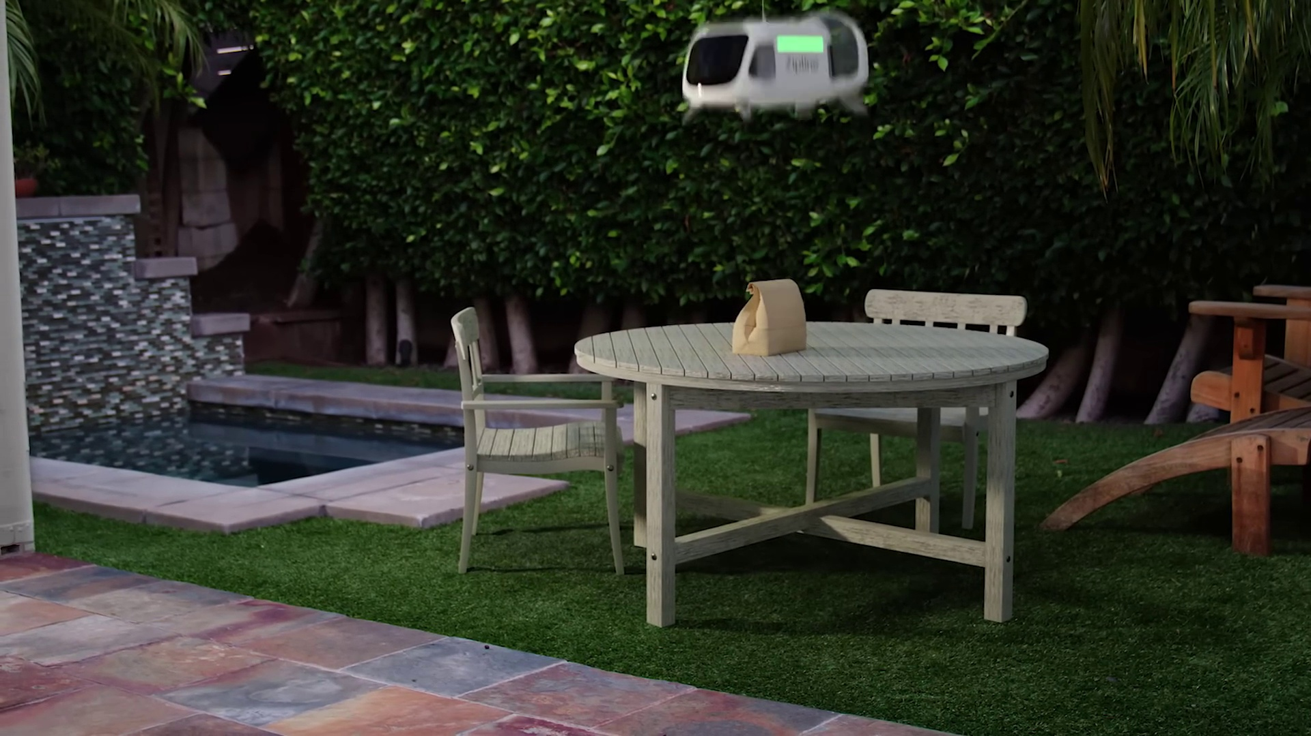 | 0:18   | 0:20   | 0:21   | 0:23  

Transcript
[0:13] right to my backyard in as little as two minutes with dinner plate accuracy.
[0:18] And as far as I'm concerned, that's basically teleportation.
[0:22] This is the very near future of package delivery from a company called Zipline.

Section 0: Crunch Labs Logo
Time: 0:25 - 0:30

Summary
We see the Crunch Labs logo, which features a distinctive blue color scheme and a bright red circle at its center. The narrator explains that Crunch Labs is a place where kids can learn to create and build whatever they can dream up.

Representative Frames
0:25  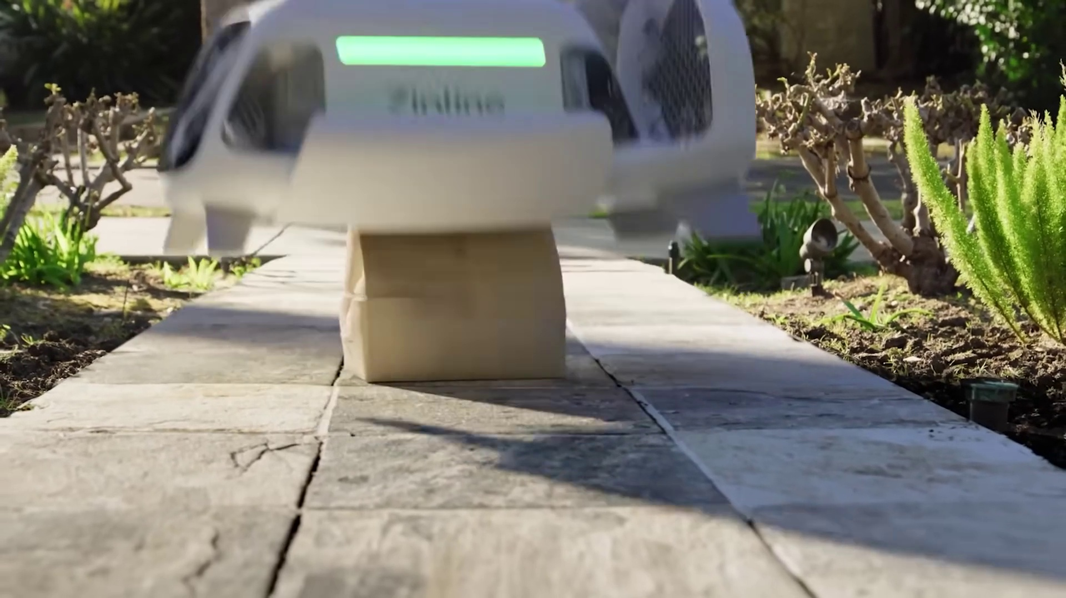 | 0:26   | 0:27   | 0:28   | 0:29  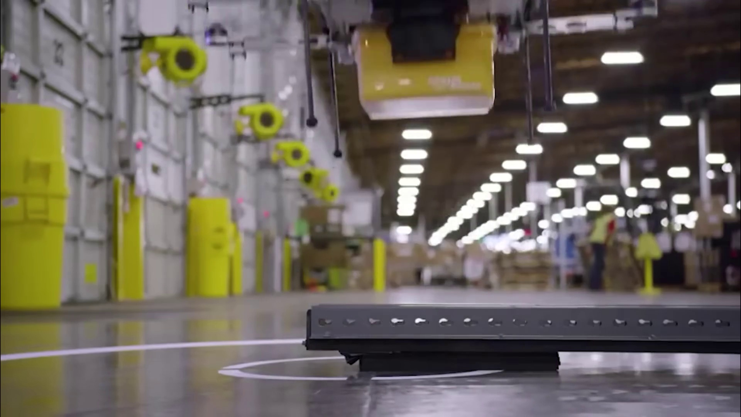

Transcript
[0:26] It's been over a decade since we were first promised drone delivery that looked like this

Section 0: Conclusion
Time: 0:30 - 21:29

Summary
The video concludes with a thank you from the narrator, inviting viewers to visit the Crunch Labs website or social media channels for more information. The final shot is of the Crunch Labs logo on screen.

Representative Frames
3:59  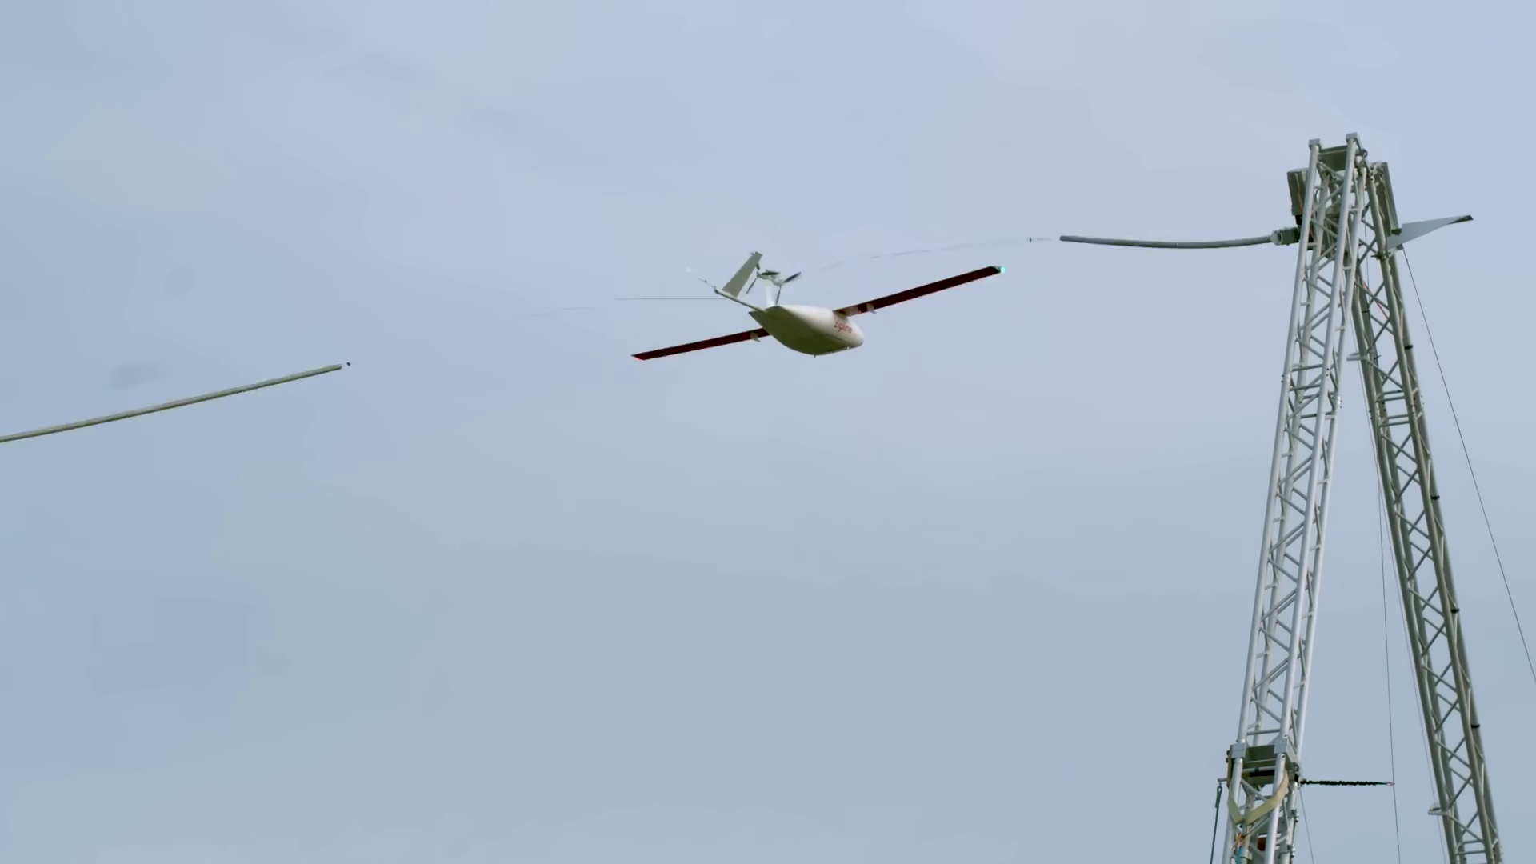 | 7:29  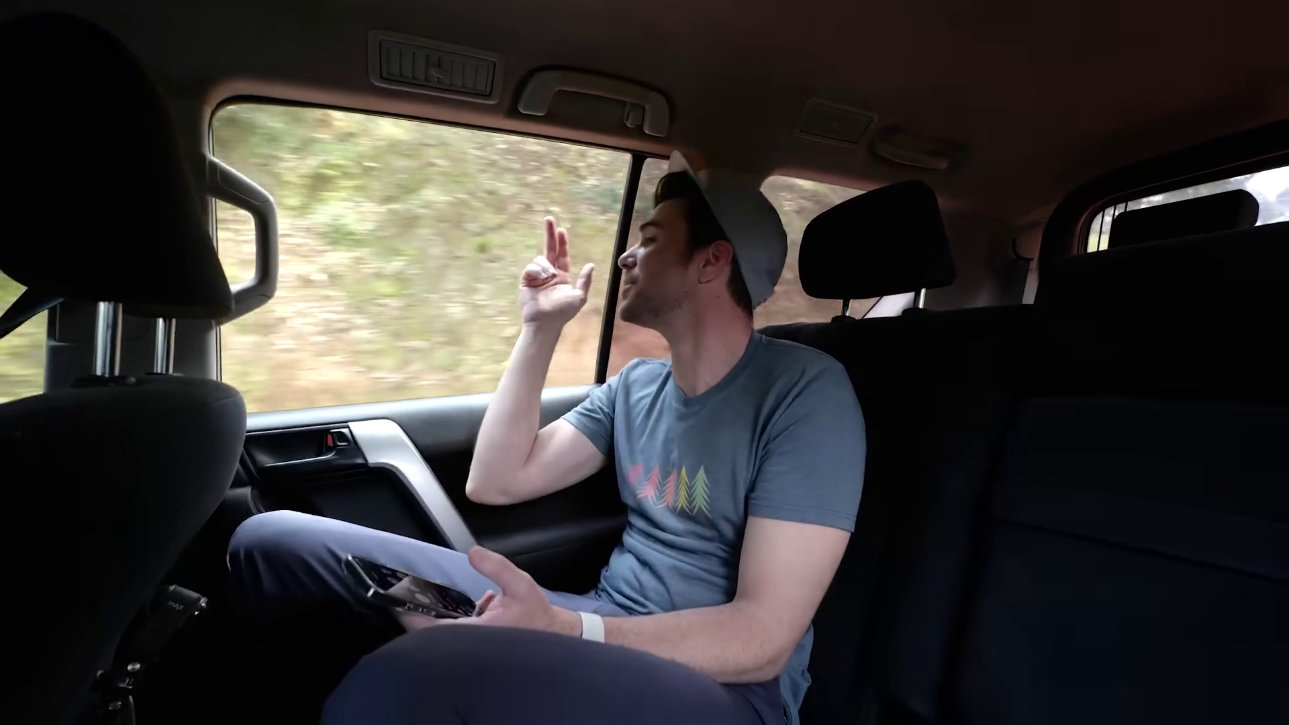 | 10:59   | 14:29  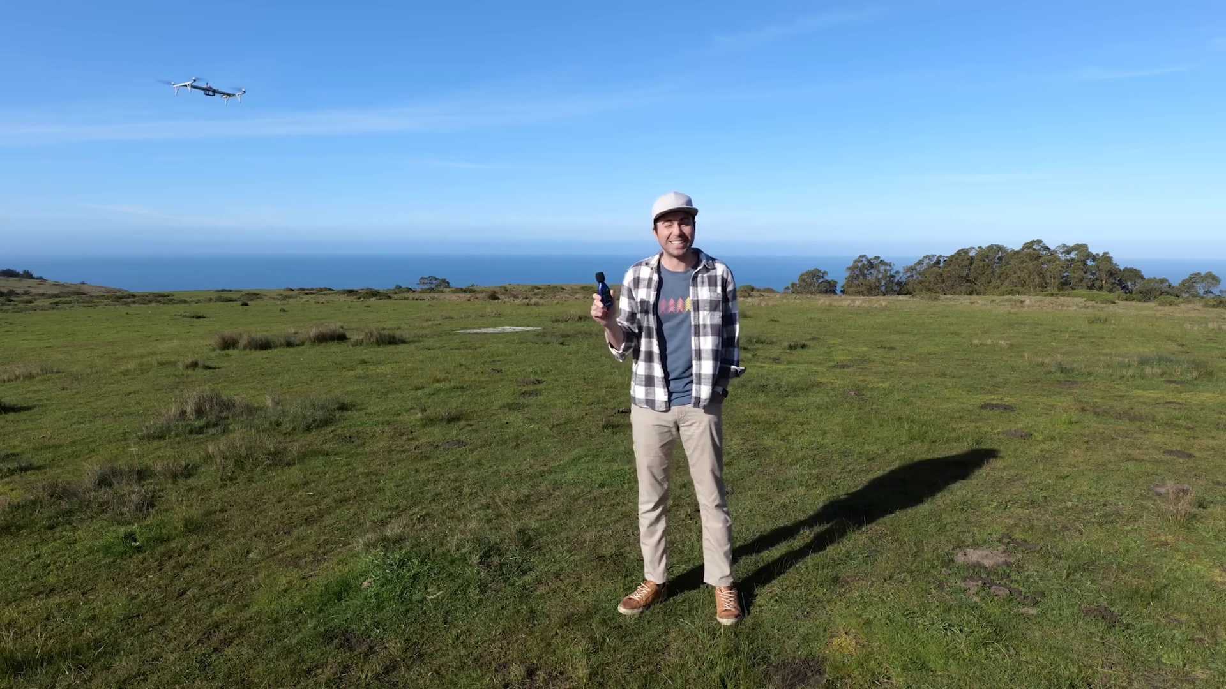 | 17:59  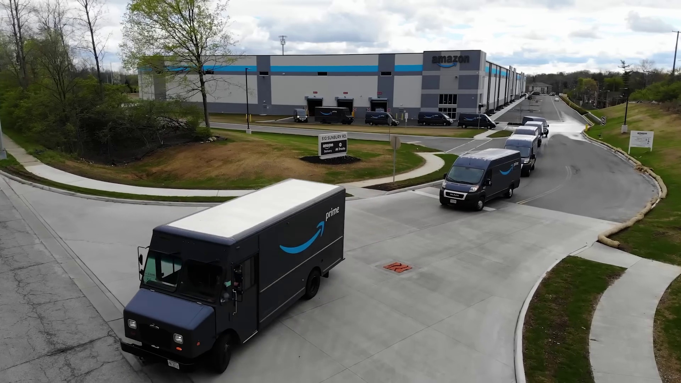

Transcript
[0:30] and to be honest, I was never that stoked about it
[0:33] because I couldn't imagine that anyone would actually want something that big and loud
[0:37] with dangerously fast spinning propellers landing anywhere near their house.
[0:41] And that was a bummer because with the explosion of people using Amazon
[0:44] or food delivery apps like DoorDash or Instacart,
[0:46] billions of doorstep deliveries are now happening every year.
[0:50] But when your lunch only weighs a few ounces,
[0:51] driving it to everyone with these two-ton gas-powered vehicles
[0:54] is wildly inefficient, bad for the whole planet,
[0:57] and not to mention just really slow.
[0:59] Drone delivery would not only take a lot of cars off the road,
[1:02] but it would be a lot faster than a car.
[1:04] It would be fully electric, fully autonomous,
[1:06] and it would cost pennies worth of energy per delivery.
[1:09] And with Zipline, because the droid that lowers the package
[1:12] can move laterally in any direction,
[1:14] it can make a dartboard-sized precision landing even in high winds,
[1:17] while the main drone can stay 400 feet up in the sky,
[1:20] making the whole thing whisper quiet...
[1:22] That is very quiet.
[1:25] Also due in part to the clever design of these really funky propellers.
[1:29] As you all know, I only make about 10 videos a year,
[1:32] and while most are just sort of ridiculous...
[1:35] I'd like to dedicate one video to showcase how clever people are using engineering
[1:43] to change the world for the better.
[1:45] And to be clear, the company I'm talking about today
[1:47] is not sponsoring this or paying me in any way.
[1:50] I'm just really impressed by the work that they're doing,
[1:52] and how they're doing it.
[1:53] So we'll circle back in a minute to exactly how they're going to pull off deliveries
[1:56] using these short-range drones in a city,
[1:59] but it begs the question.
[2:00] If they can make it work there,
[2:01] why not use gliding drones to cover longer distances
[2:04] to deliver critical medical supplies
[2:06] for countries with lots of remote villages?
[2:08] Well, as it turns out,
[2:10] catapulting life-saving blood through the skies
[2:12] is what they've already been doing for over six years,
[2:15] which is why we need to head out to Rwanda
[2:17] to understand where this all started.
[2:19] And immediately after showing up,
[2:21] we were right in the thick of it,
[2:22] as drones were taking off...
[2:24] Wow!
[2:26] ...and landing...
[2:28] That's another one lands!
[2:29] ...every 90 seconds.
[2:31] They're coming from everywhere.
[2:33] And as a newcomer, it felt a bit chaotic,
[2:35] but if you're going to rack up 40 million miles worth of drone flights...
[2:38] Your team needs to be operating with the efficiency of an F-1 pit crew,
[2:44] so here's a crash course on how it all works.
[2:46] It all starts with an order coming in from a doctor at a hospital,
[2:49] say, for example, for an emergency supply of blood.
[2:52] Then once it's all packed up,
[2:53] it gets passed out to be placed in the belly of the drone,
[2:56] and then the whole thing is placed on the launcher.
[2:58] At that point, they attach the wings,
[3:00] then secure the battery, followed by the nose cone.
[3:02] Then after some pre-flight safety checks,
[3:04] they launch the drone,
[3:05] all within 90 seconds of the order coming in.
[3:10] The catapult launcher takes the drone from 0 to 65 miles an hour
[3:13] in a third of a second,
[3:16] which is literally less time than it takes you to blink.
[3:19] And it's a pretty clever design, too,
[3:21] because it means the drone immediately starts at its cruising speed,
[3:24] where it takes much less energy to stay airborne.
[3:27] Then once it's in the air, cruising at 70 miles per hour,
[3:30] it navigates its way to the hospital,
[3:32] and upon arriving, opens the trap door to drop the package,
[3:35] which lands safely using a parachute.
[3:38] Having now completed the mission,
[3:39] it continues making all its own decisions
[3:41] to autonomously navigate back home
[3:43] from as far away as a 150 miles round trip.
[3:46] Then taking inspiration from an aircraft carrier,
[3:48] as the drone approaches,
[3:49] the military-grade GPS broadcasts its position within one centimeter,
[3:53] so these two poles know exactly when to swing up
[3:55] at the last possible moment,
[3:57] snagging a hook on the tail with the cable,
[4:00] which safely slows it down.
[4:02] Then once it's settled to a stop,
[4:04] the crew comes in to remove the battery and wings,
[4:07] and it all goes back into rotation.
[4:08] The whole thing is really impressive and incredibly robust,
[4:12] which means it works in pretty much any weather.
[4:14] And because there's no human steering it,
[4:16] it has no issues flying at night,
[4:17] so they run the operation 24 hours a day,
[4:20] which is how in six years,
[4:21] they've managed to make those half a million,
[4:23] often life-saving deliveries.
[4:25] That is the uppermost top of the iceberg tip
[4:29] of how they're doing what they're doing.
[4:31] But what you should know is six years ago,
[4:32] all the experts told them this was a hopeless cause
[4:35] and failure was a near certainty,
[4:37] and they kind of weren't wrong.
[4:38] Building an engineering product takes time,
[4:40] so you prototype, you build it,
[4:42] and then you fail, and then you try it again,
[4:44] and you fail, and you try it again
[4:45] until you have this shiny product that you want.
[4:47] This is a different type of aircraft.
[4:49] This is not what we had.
[4:50] The first one used to land on these inflated mattresses.
[4:54] The vehicle had a hook on the back,
[4:55] the tail.
[4:56] The tail would deploy like an aircraft carrier,
[4:58] and then the fishing pole would pull it,
[5:00] and it would land on the mattress.
[5:01] First of all, he's not saying that figuratively.
[5:03] They were scrappy in the early days,
[5:05] using actual fishing poles as you can see here.
[5:08] And secondly, this is Abdul,
[5:10] and what you should know about Abdul
[5:11] is he grew up in Rwanda,
[5:12] not far from where these drones are launching.
[5:15] And while he would eventually go on
[5:16] to do graduate work in robotics,
[5:17] attending both Stanford and Harvard,
[5:19] he got his start in engineering
[5:20] for much more simple means.
[5:22] I remember that I would make cars from milk boxes
[5:25] that, you know, was left over.
[5:27] You know, we would add tires there and use it as a car.
[5:29] Abdul was orphaned as a child
[5:31] when he lost both of his parents
[5:33] and all three of his siblings in the Rwandan genocide,
[5:36] narrowly escaping himself.
[5:38] But he didn't give up on his passion for engineering,
[5:40] and so as he got older,
[5:41] he would go around to all the local hospitals,
[5:43] fixing their MRI machines for free,
[5:45] using knowledge he gained from watching YouTube videos.
[5:48] Abdul was the very first Zipline employee in Rwanda,
[5:50] and he really helped to pioneer so many of the systems
[5:53] they have in place today
[5:54] that are now used all over the world.
[5:56] And so in an effort to test those very systems,
[5:59] I wanted to see if it was robust enough
[6:00] that even a total doob like me
[6:02] could send out an order.
[6:03] Oh, we got one.
[6:06] Panic!
[6:07] Don't worry.
[6:08] Don't worry, okay.
[6:09] Gloves, okay.
[6:10] Good enough.
[6:11] This is where the blood is, right?
[6:12] O positive.
[6:13] It's O positive.
[6:14] Yeah.
[6:14] I feel like I shouldn't be touching this.
[6:16] Stay calm.
[6:17] That's the number one rule.
[6:18] Now you scan.
[6:19] Scan it.
[6:20] Do six wraps.
[6:21] Like this?
[6:22] Two.
[6:23] Three.
[6:24] Two.
[6:25] Five.
[6:25] Okay.
[6:31] Just out here saving lives.
[6:33] And once I ring the bell,
[6:34] it's the drone team's problem.
[6:37] Okay.
[6:38] What do I do?
[6:39] Check this with no tango.
[6:40] And push it here.
[6:41] Out of my way.
[6:42] Coming through.
[6:43] The wings.
[6:44] How's that?
[6:44] Battery!
[6:45] We're trying to be picked.
[6:46] There's so many.
[6:49] So after a final check of the drone's condition.
[6:52] A little bit of a look to the right and cough.
[6:59] We had liftoff.
[7:01] I'm a hero.
[7:02] We did it.
[7:04] I just like saved a life basically.
[7:07] Wow.
[7:08] How do you guys do this all day long?
[7:11] So now that I had a pretty good feel for the launch site,
[7:13] we headed out to see where some of these drones were actually flying to.
[7:17] So we left the launch site like three and a half hours ago.
[7:19] We're driving to this remote hospital on these really windy roads.
[7:22] And as we've been driving,
[7:24] we've been tracking and seeing some of these zipline drones
[7:26] delivering blood and medical supplies to this hospital.
[7:29] So since we're about a half hour out,
[7:30] I thought it would be fun to place my own emergency order.
[7:33] Then it could meet us when we get there.
[7:34] Because when you need extra ointment,
[7:37] you just need extra ointment.
[7:39] And sure enough,
[7:40] a few minutes after arriving,
[7:41] I got a notification for an incoming package.
[7:44] This is wild because we're like four hours away on some really windy roads.
[7:50] I got it!
[7:55] Close!
[7:56] So close!
[7:57] And so after opening the package and checking their handiwork,
[8:00] I asked if I could speak to a few of the doctors.
[8:03] When's the last time you delivered a baby?
[8:05] In a few minutes ago.
[8:07] A few minutes ago?
[8:09] That's pretty fresh.
[8:11] For the doctors,
[8:12] it was like a miracle.
[8:14] With zipline,
[8:15] we are sure that in 15 to 20 minutes,
[8:17] we are going to get what we need.
[8:19] And you are sure that patient will be saved.
[8:21] But it wasn't just the doctors who were big on zipline.
[8:24] I also spoke with a handful of patients
[8:26] who for various different reasons
[8:27] are all alive today because of a zipline delivery.
[8:31] Every time when I see the drones around,
[8:33] I just think that someone's life is going to be saved.
[8:36] And that's kind of true
[8:37] because their drones have reduced
[8:39] in-hospital maternal mortality by 88%.
[8:42] Zipline has two launch sites
[8:44] that give them coverage for pretty much anywhere in Rwanda,
[8:46] but they also have operations running in all of these countries.
[8:49] And while they serve 3,000 hospitals globally today,
[8:52] that number will be 10,000 by the end of the year.
[8:55] All right, so we've covered their long-range country delivery drones,
[8:58] which means we've now got the context
[8:59] to talk about their short-range city delivery drones.
[9:02] But first, I just have to interject here
[9:04] and say I was blown away by Rwanda as a country.
[9:08] I mean, right out of the gate,
[9:09] their stoplights are really cool
[9:11] because they're just countdowns
[9:12] till the light turns green.
[9:13] They can balance and carry pretty much anything on their heads.
[9:17] And there's motorcycle taxis everywhere.
[9:19] And given that win in Rwanda,
[9:21] you do as the Rwandans do,
[9:22] whenever possible, that's how we got around ourselves.
[9:25] What a freaking lose.
[9:27] Everyone was also super friendly everywhere we went.
[9:30] Well, not everyone,
[9:32] because if you stop to play soccer with some random kids,
[9:34] Am I good? Am I good?
[9:37] just know they're not going to take it easy on you.
[9:39] What?
[9:40] Besides the fact that Messi seems to like it,
[9:43] before traveling there,
[9:44] the only real thing I knew about Rwanda
[9:46] was the Rwanda genocide that took place about 30 years ago.
[9:49] And while there are still plenty of battle scars,
[9:52] as horrific as that was,
[9:53] it sort of galvanized the country
[9:55] into a period of healing and solidarity
[9:57] as a single Rwandan people
[9:59] instead of divisive ethnic groups.
[10:01] For example, on the last Saturday of the month,
[10:03] literally everyone spends the day
[10:04] picking up trash
[10:05] and volunteering in their local communities.
[10:07] And that's one of the reasons
[10:08] you hardly see litter anywhere.
[10:10] The other one being 15 years ago,
[10:12] they were one of the first countries
[10:13] to ban all single-use plastics.
[10:15] There was just a pervasive optimism in the air.
[10:18] Everyone was moving with the purpose
[10:19] everywhere we went.
[10:21] Not just working hard,
[10:22] but working smart with their resources on hand.
[10:25] Yeah, buddy!
[10:26] Including their improvised soccer balls.
[10:29] For over a decade,
[10:30] attending school up to age 16
[10:31] has been both mandatory and free.
[10:33] And when you combine that
[10:34] with leapfrogging to new technologies
[10:36] like drone delivery,
[10:37] for the last decade,
[10:38] their economy has been growing
[10:40] at four times the rate of the U.S. economy,
[10:42] while their violent crime rate
[10:43] has been 15 times less than the U.S.
[10:45] And finally,
[10:46] the most unducing part of the whole trip
[10:48] was when I hiked to see
[10:49] an entire family of mountain gorillas
[10:51] up close in the wild,
[10:53] which was equal parts adorable and terrifying.
[10:56] I think he's looking at me.
[10:58] Mountain gorillas only exist
[10:59] in these two tiny red regions.
[11:01] And while there's only a thousand left in the world,
[11:03] I got to just chill with 20 of them.
[11:05] They're critically endangered,
[11:07] but thanks to Rwandan conservation efforts
[11:08] funded by people paying for brief visits like this,
[11:11] their numbers have climbed by 200
[11:13] over the past decade.
[11:14] All that's to say that besides,
[11:16] of course, my own country,
[11:17] Rwanda is my new second favorite country.
[11:19] We got this.
[11:20] And next time I go back,
[11:21] I'm bringing a bunch of soccer balls,
[11:23] Oh, yes!
[11:23] which I will give away to any kid
[11:25] who just promises not to embarrass me.
[11:29] Okay, so now let's talk a little bit more
[11:31] about these new short-range city drones.
[11:33] Because for the 4 billion doorstep deliveries
[11:35] that will happen this year in the U.S.,
[11:37] and that number doesn't even include Amazon, by the way,
[11:39] why not at least try and take
[11:41] some of those slow-moving traffic causing two-ton gas-guzzling cars off the road
[11:45] in exchange for a much faster delivery
[11:47] that's also electric, autonomous, really quiet, and zero emissions.
[11:51] And while there's a solution of dropping down a droid
[11:52] that could perfectly control its landing from super high up,
[11:55] seemed promising,
[11:56] and way better than something like this that had been proposed before,
[11:59] when they first told me about it,
[12:00] I had two main questions.
[12:02] One, how loud and disruptive are they?
[12:04] Because the last thing we want are annoying drones buzzing by our rooftops all day.
[12:08] And two, how safe are they?
[12:10] Because the other last thing we want is for those same annoying drones
[12:13] to start falling down on us from the sky.
[12:15] I also had a bonus third question
[12:16] around how a business is even supposed to load in their items for delivery.
[12:20] And so in a search for answers,
[12:22] I went right to their headquarters,
[12:23] not that far down the road from where I live.
[12:25] And the first thing you notice in the lobby
[12:26] is this really cool projection
[12:28] that not only shows the total number of flights they've flown,
[12:31] now at over half a million,
[12:32] but it also shows all the long-range drones they have in the air
[12:34] at that exact moment,
[12:36] delivering those critical medical supplies all around the world.
[12:39] And this isn't now just where they design and build all their drones.
[12:42] It's also where they do a lot of their testing.
[12:44] And they test pretty much everything in every way possible
[12:47] before getting it out to the field as quickly as possible.
[12:51] And according to their CEO, Keller,
[12:52] this is something they discovered early on.
[12:54] Our key insight was we were dumb
[12:57] and we basically always assumed we were dumb.
[12:59] And for that reason, when we designed things,
[13:01] we got them into the real world super fast
[13:03] and learned by serving real people.
[13:05] And you learn so much
[13:07] that you can't learn in a lab or in an ivory tower.
[13:10] And so before we actually hear just how quiet these things are,
[13:13] I just want to echo that all the best engineers I've ever known
[13:16] have had that same level of humility,
[13:18] knowing there's no better way to learn
[13:20] than to test and to break stuff.
[13:22] That's why I named the toy company I started
[13:24] that has the express goal of teaching kids
[13:25] to think like engineers Crunch Labs.
[13:27] It's because things are supposed to crunch
[13:29] and to break and to fail along the way.
[13:32] And so if I could get them to do more
[13:33] than just passively watch a video
[13:34] by building something alongside me
[13:37] while we talk about the physics of what's going on,
[13:39] then I know the principles will really sink in.
[13:41] So if you want to have a ton of fun
[13:43] while building up that resiliency in your brain like a muscle,
[13:47] just head to crunchlabs.com
[13:49] or use the link in the video description.
[13:51] All right, so to answer my first question on the noise level,
[13:53] I'll just show you my actual reaction
[13:56] to the first time I heard it.
[13:57] I mean, I hear something.
[14:01] I cannot believe that's airborne.
[14:03] Are you serious?
[14:05] And I just wish there was a better way
[14:06] to convey this on video,
[14:07] but here's my best attempt.
[14:08] You'll first hear a leaf blower,
[14:10] then a typical hobby drone that weighs one pound,
[14:12] then their drone that weighs 50 pounds.
[14:15] And of course, I've kept the audio levels
[14:16] completely untouched for all three.
[14:25] That is whisper quiet.
[14:26] That is very quiet.
[14:31] That cow is way louder than that drone.
[14:36] I bet the mic picked up that cow.
[14:39] And this test was incredibly surprising to me
[14:41] because I sort of just assumed the weight of a thing
[14:43] would exactly determine how loud the propellers
[14:46] will end up being to keep that thing in the air.
[14:49] But it turns out that's not actually true
[14:50] even if you just look at nature.
[14:52] Pigeons, for example, sound like this.
[14:54] But with owls, there's an evolutionary pressure
[14:58] to be as quiet as possible.
[14:59] And as a result, their flight sounds like this.
[15:04] For this reason, to crack the code,
[15:06] Zipline actually did turn to nature.
[15:07] I study the hummingbird a lot where you have...
[15:09] Oh, sure.
[15:10] They have the worst case.
[15:11] They're tiny and they're really quiet.
[15:12] They just like hover there.
[15:14] You barely hear it.
[15:14] By the way, that's Kenan.
[15:15] He's another Zipline co-founder.
[15:17] And for you robotics nerds,
[15:18] he's the dude who invented ROS,
[15:20] which is the open source software
[15:21] used by basically anyone
[15:22] who wants to build anything robotic.
[15:24] So in an effort to try and visualize
[15:26] the secret of their quiet propellers,
[15:27] in this graph, the area under the curve
[15:29] could represent the energy
[15:30] from one of those annoying,
[15:32] high-pitched hobby drones,
[15:33] where the closest of these spikes
[15:35] is the high frequency
[15:36] that's just sort of grating on your ears.
[15:38] So after studying the hummingbird
[15:39] and designing really wild-looking rotors like this,
[15:42] Zipline figured out how to take those spikes
[15:44] and flatten them all out.
[15:46] So while the extra weight means
[15:47] there's still more energy or area under the curve,
[15:49] getting rid of all the spikes
[15:50] means it's much more of a constant whooshing sound,
[15:53] more like white noise
[15:54] that your brain just sort of doesn't register.
[15:56] They use the same quiet propeller approach
[15:58] for their long-range drones.
[16:00] As you can tell from this doctor
[16:01] with an impeccable taste in YouTube content,
[16:03] who just wanted to say hi.
[16:04] You've seen my videos.
[16:05] Now you could be in one.
[16:07] Have you seen the planes fly over
[16:09] and deliver the supplies here?
[16:11] I have not yet seen one come
[16:13] and deposit something here.
[16:15] That's amazing.
[16:16] There was just 15 deliveries in the last hour.
[16:19] They're really quiet.
[16:20] If I would have heard it,
[16:22] I would have, you know, gone to see it.
[16:24] For my second question regarding safety,
[16:25] just like when sending something to Mars,
[16:27] all their critical systems have backups on board.
[16:29] In engineering, we call this redundancy,
[16:31] and they even demonstrated for us
[16:33] how if one propeller stops working,
[16:34] it could still fly due in part
[16:36] to the large back propeller that picks up the slack.
[16:38] And that back propeller is pretty clever, by the way,
[16:41] because it's what propels the drone forward
[16:42] as it moves across town,
[16:44] but then it turns down 90 degrees
[16:45] to help steer and create extra lift
[16:47] while it's stationary and dropping down the droid.
[16:50] In addition to the redundancy,
[16:51] a whole aircraft parachute is automatically deployed
[16:54] if there is a problem that's sensed
[16:56] or if the drone just loses power altogether.
[16:58] And because of their painstaking engineering efforts,
[17:01] it's worth noting in the six years
[17:02] they've been operating for those half a million flights,
[17:05] they've had exactly zero incidents causing any injury.
[17:08] As for my third bonus question
[17:10] around how the drones get loaded up,
[17:11] in the most simple case,
[17:12] something like a grocery store
[17:14] could reserve some parking spots as a loading zone.
[17:16] Or as one of the zipline engineers told me,
[17:18] you can take a window from your local pharmacy
[17:20] and turn it into this portal.
[17:22] So the droid would come down the chute,
[17:24] then some ASAP items like these would get loaded inside,
[17:27] then it goes back up the chute into the drone
[17:29] and off for delivery.
[17:31] For healthcare, if you were really sick
[17:32] and say on a 15 minute video call with your doctor,
[17:35] by the time the call was ending,
[17:36] your medications could be on your back porch
[17:38] so you don't have to leave your house.
[17:40] You could also imagine how this could work
[17:42] with a distribution center or a large retail store.
[17:44] More than 90% of people in the US
[17:46] live within 10 miles of a large retail store
[17:49] and zipline drones conveniently
[17:50] can make a 10 mile round trip
[17:52] while carrying up to eight pounds.
[17:53] An additional way for the planet here
[17:55] is you don't need to use all the cardboard to box it up
[17:57] because it doesn't have to survive
[17:59] being shipped out on a big truck.
[18:01] But this isn't just for big stores.
[18:02] Your favorite local shop or restaurant
[18:04] can now more easily afford to send a thing to your door,
[18:07] but at an ostensibly much lower cost
[18:09] than a person driving a 3,000 pound car to drop it off.
[18:13] And as soon as by the end of this year,
[18:14] customers such as Sweetgreen
[18:16] will start delivering salads straight to your backyard.
[18:19] And not having packages left on front porches
[18:21] is the worst news to hit the porch pirate community
[18:23] since the invention of the glitter bomb.
[18:25] Oh, you f***.
[18:29] All right, all right.
[18:29] We f***ing get it, okay.
[18:31] All right, so if your mind isn't already blown,
[18:33] let me try one final time by planting a seed
[18:36] for something we might see much further in the future.
[18:39] And to be clear, this is not at all from Zipline.
[18:41] It's just an idea that won't leave my head
[18:43] after seeing all this
[18:44] because it stands to reason
[18:46] if the system can work for packages,
[18:48] it should be able to work for humans, right?
[18:51] In other words, imagine a bigger drone.
[18:53] Let's say it's an ambulance
[18:54] with more powerful but equally quiet propellers
[18:57] parked so high up in the sky you can hardly see it.
[19:00] Then it lowers the entire cockpit like the droid,
[19:02] which could quietly touch down in your driveway.
[19:05] So you hop in or they put you in on the ground,
[19:08] then it reels you in
[19:09] so you can glide above roads and traffic
[19:12] straight to your destination
[19:13] only to be dropped off safely in the same manner.
[19:16] All right, so finally,
[19:17] I just want to wrap up with the coolest part
[19:19] of all of this by far.
[19:21] The whole time we were there,
[19:22] kids would be lined up at the fence
[19:24] to watch the drones be launched
[19:25] and captured over and over.
[19:27] In fact, one kid came up
[19:29] specifically wanting to show Abdul
[19:31] what he built completely on his own.
[19:33] And in that moment,
[19:34] it was impossible not to compare
[19:36] the complexity of this build
[19:37] to the simple milk carton version
[19:39] Abdul grew up making.
[19:41] Because here you have Abdul,
[19:43] who bears a scar on his head
[19:45] from the same machete that killed his entire family
[19:48] as a child,
[19:49] not only using his engineering knowledge
[19:51] to save the lives of his people,
[19:53] but more importantly,
[19:54] to inspire the next generation of problem solvers
[19:57] to dream even bigger.
[19:58] It's the type of thing
[19:59] that leaves you feeling a little bit
[20:01] of that contagious Rwandan optimism
[20:03] for the future
[20:04] and the incredible potential
[20:05] of us mere humans.
[20:07] In the future,
[20:12] your Crunch Labs box
[20:13] just might come from the sky.
[20:16] And the best part of Abdul's story
[20:17] is how using the superpower of engineering,
[20:20] they literally wield something into existence
[20:22] that is now saving lives.
[20:25] And as it says on the box,
[20:27] my goal with Crunch Labs
[20:29] is to help you think like an engineer.
[20:31] That means you know how to think critically
[20:33] and break a problem down into manageable steps.
[20:35] Thinking like an engineer
[20:37] makes you a better soccer player
[20:38] or piano practicer
[20:40] or math studier
[20:41] because you're resilient.
[20:42] And just like Abdul,
[20:43] you know the importance of failing a bunch
[20:45] before you finally get that breakthrough.
[20:48] So the way it works
[20:49] is every month,
[20:50] a really fun toy comes in a box like this.
[20:53] And when you open it,
[20:54] there's a link to a video
[20:55] where you not only build it alongside me,
[20:57] but I teach you all the juicy physics principles
[20:59] behind how the toy works.
[21:00] And the best part of all
[21:01] is each month,
[21:02] we randomly select one box
[21:04] to slip in a platinum ticket.
[21:05] And if it happens to be your box,
[21:06] Oh my gosh!
[21:07] Oh my gosh!
[21:09] Then you're coming out
[21:10] right here to Crunch Labs
[21:12] to design with me and my team for a day.
[21:13] So if you want to unlock the superpower
[21:15] of learning to create and build
[21:16] whatever you could dream up,
[21:18] use the link in the video description
[21:19] or go to crunchlabs.com
[21:21] and order your build box subscription today.
[21:23] Thanks for watching.

