Engagement Analysis: DQOt-m7rg80

Section 0: Using Simulation Software for Drone Operation and Testing
Time: 8:40 - 8:41

Summary
The user is shown using simulation software to operate and test drones, with notes and instructions provided.

Representative Frames
8:40  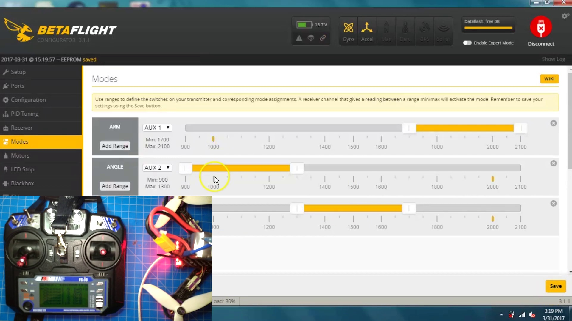 | 8:40   | 8:40   | 8:40   | 8:40  

Transcript
(No speech detected in this section)

Section 0: Remote Control Device and Project Assembly
Time: 8:41 - 8:45

Summary
A person assembles a remote control device, with the camera showing a live stream video of another device's screen.

Representative Frames
8:41   | 8:42  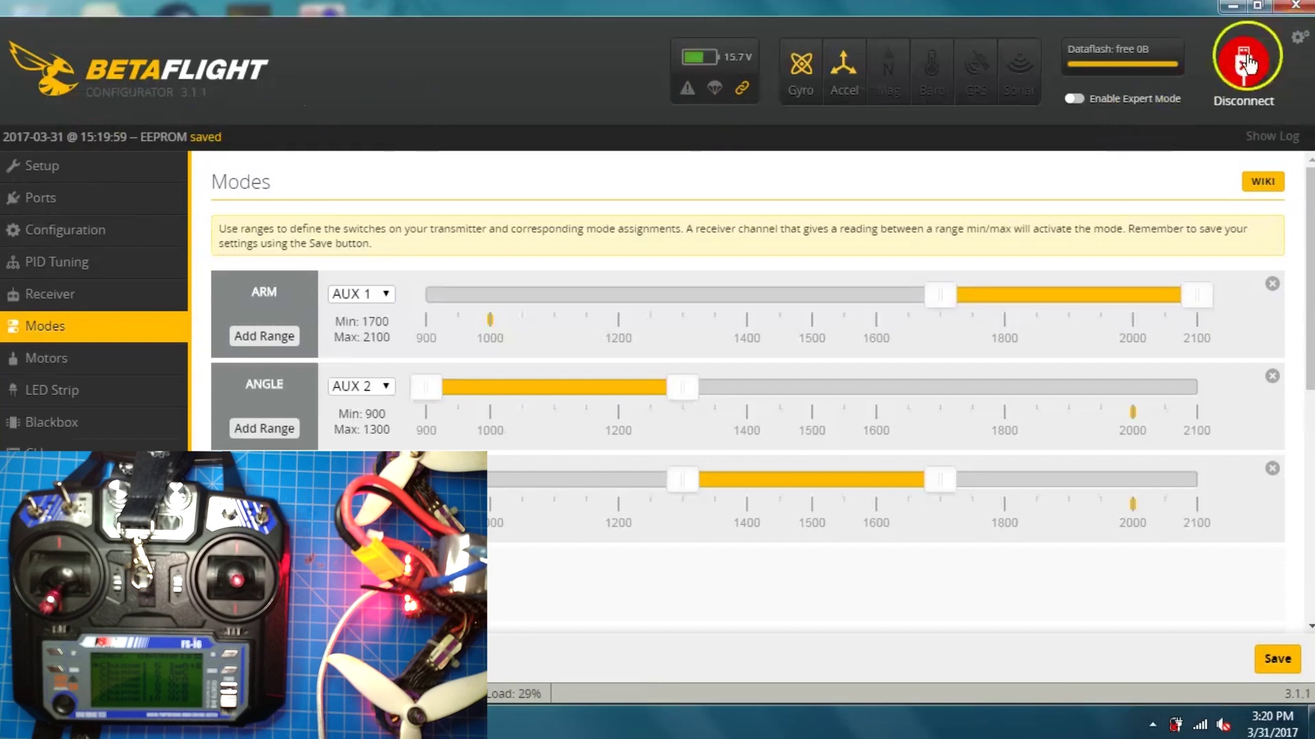 | 8:43   | 8:43   | 8:44  

Transcript
(No speech detected in this section)

Section 0: Flight Management Application and Testing Equipment
Time: 8:45 - 8:48

Summary
The user is shown using a flight management application to plan and analyze flights, with testing equipment visible in the background.

Representative Frames
8:45  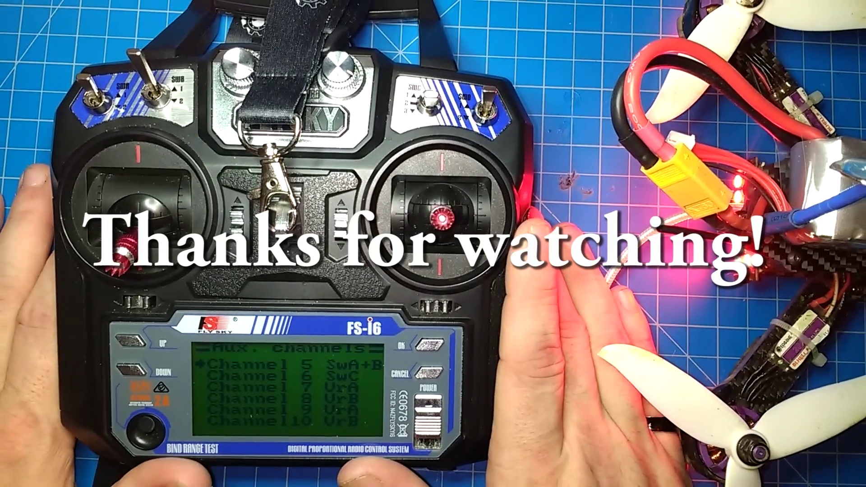 | 8:46   | 8:46   | 8:47   | 8:47  

Transcript
[8:40] easy that is anyways thanks for watching and I hope this uh taught you something that you didn't already

Section 0: Remote Control Device and Custom Modifications
Time: 8:48 - 8:50

Summary
A person holds a custom-modified remote control device next to a green drone, highlighting modifications made to the quadcopter.

Representative Frames
8:48   | 8:48  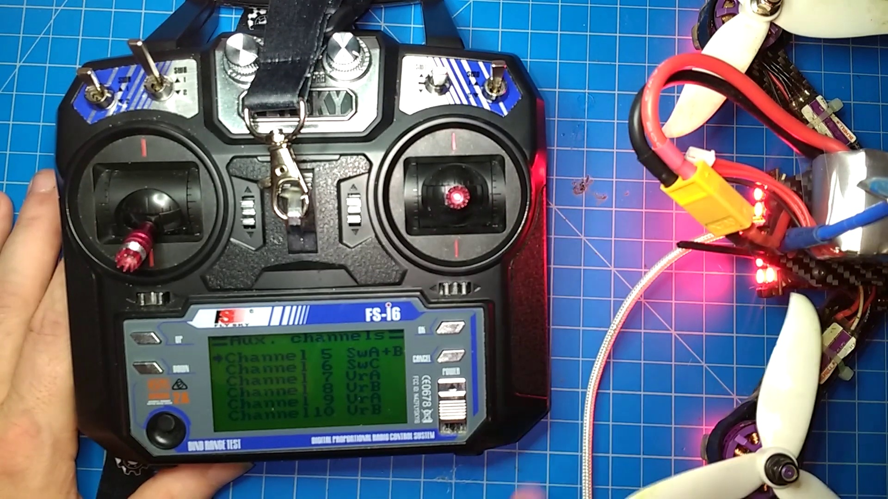 | 8:49   | 8:49   | 8:50  

Transcript
[8:49] know

