Engagement Analysis: DeSDjjicGWY

Section 0: Introduction
Time: 0:00 - 0:05

Summary
The video begins with an introduction to the creator and their content, inviting viewers to support them through Patreon.

Representative Frames
0:00  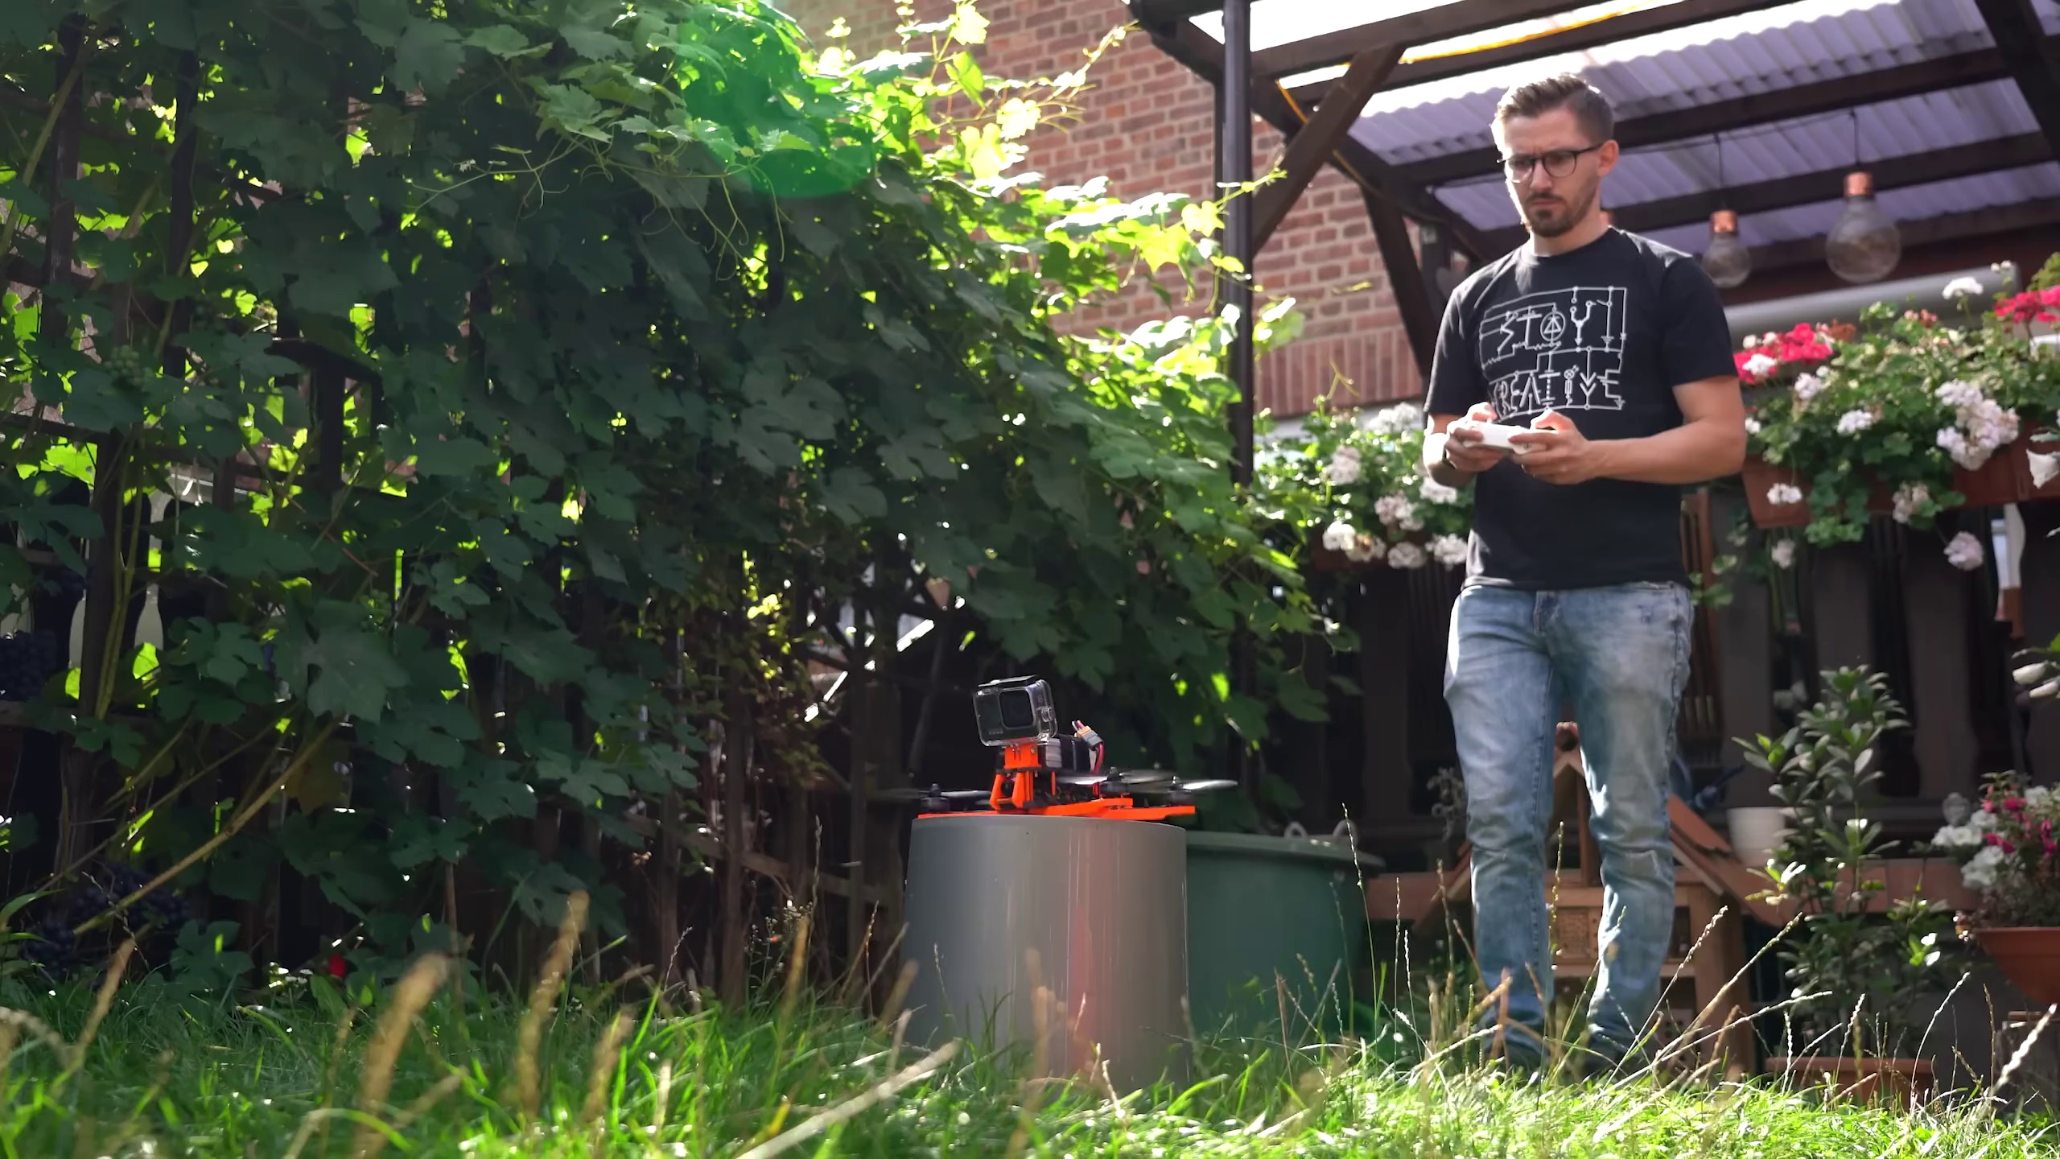 | 0:01   | 0:02  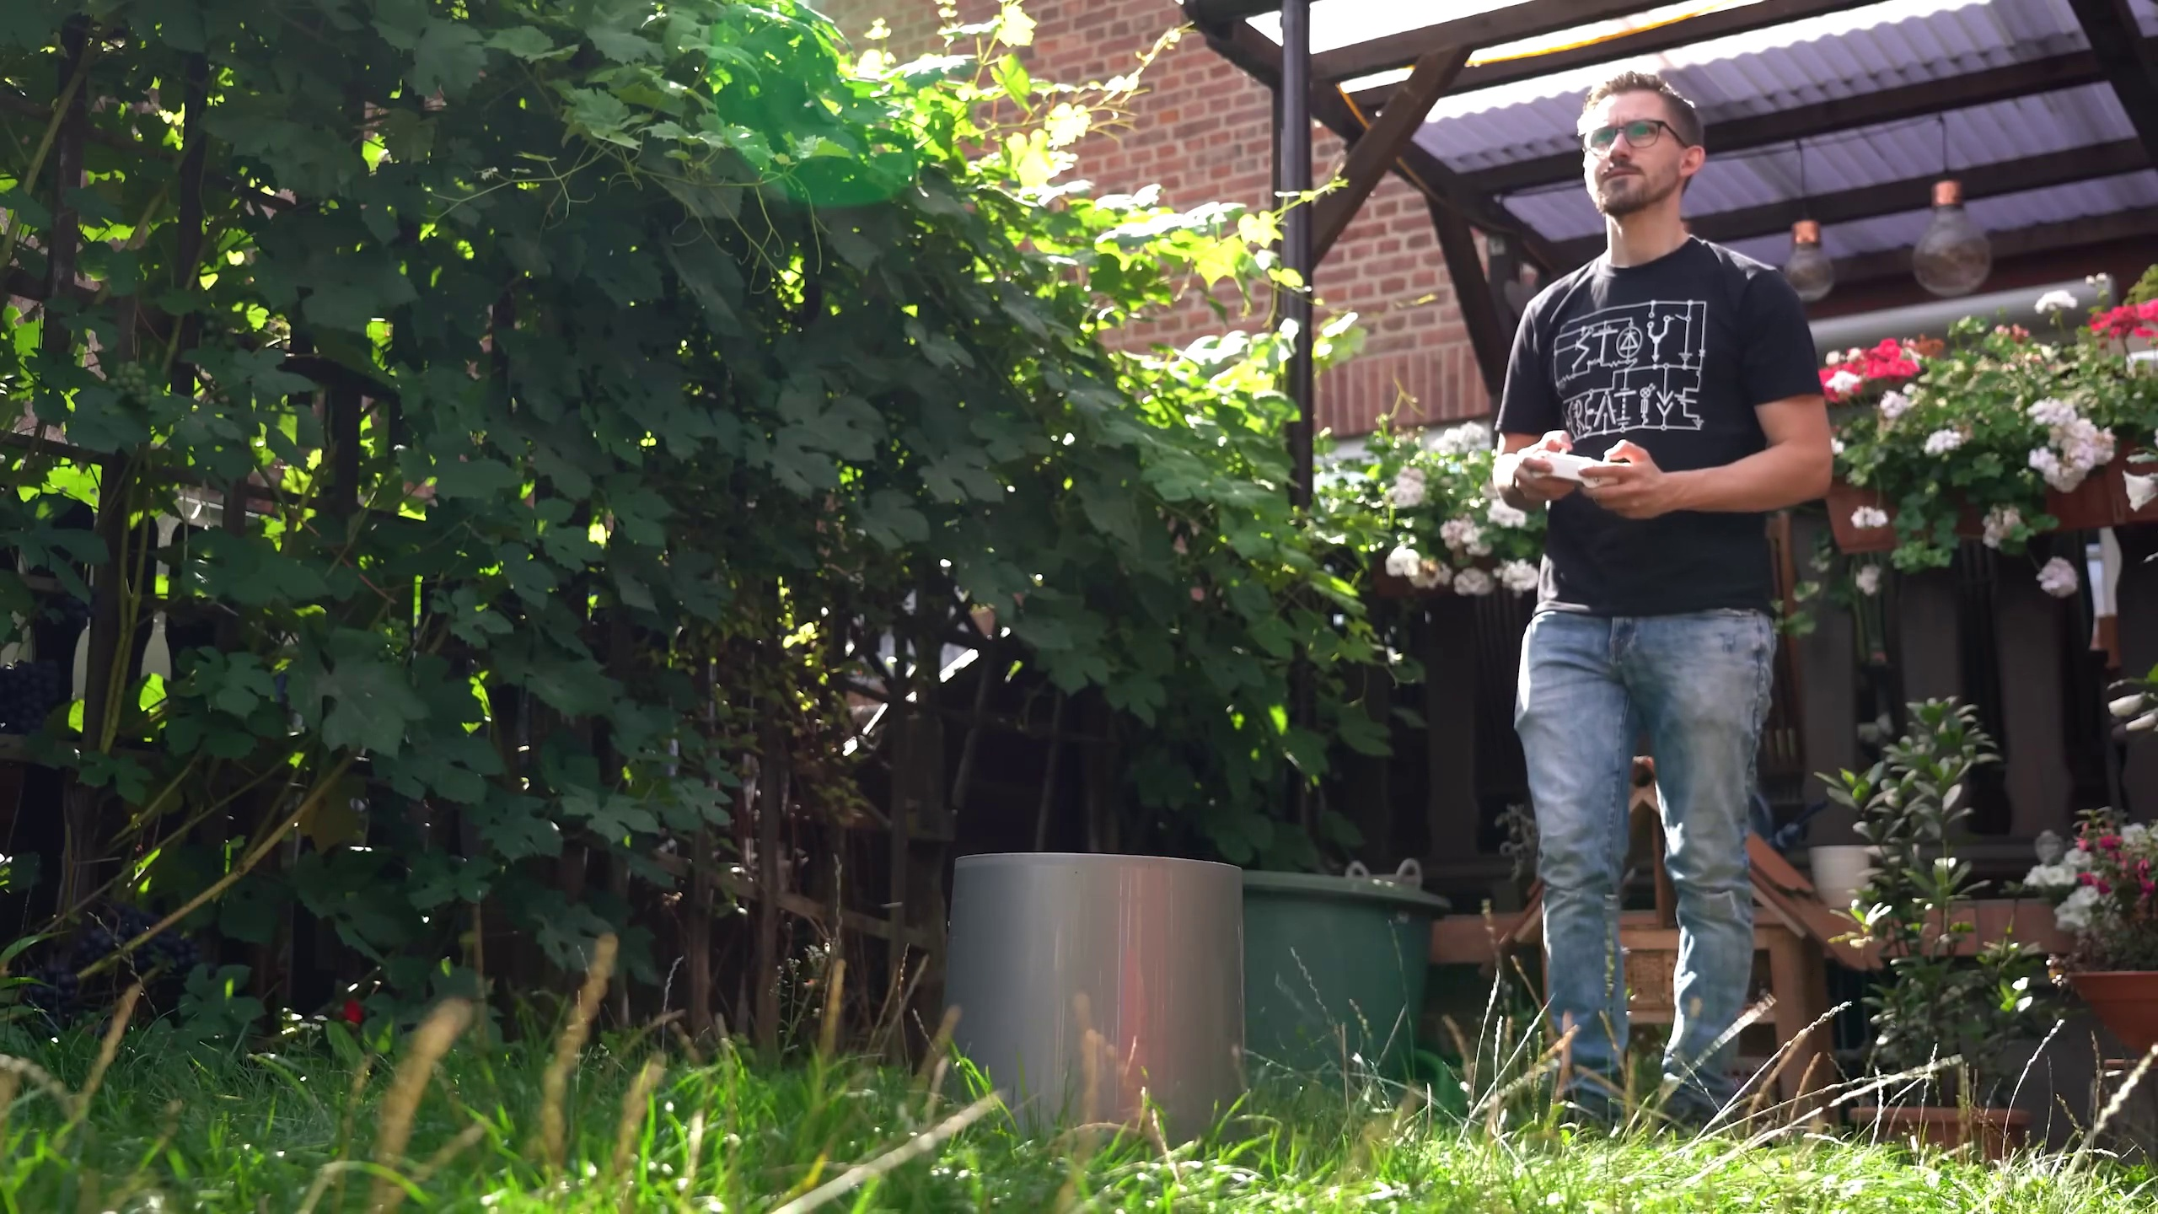 | 0:03   | 0:04  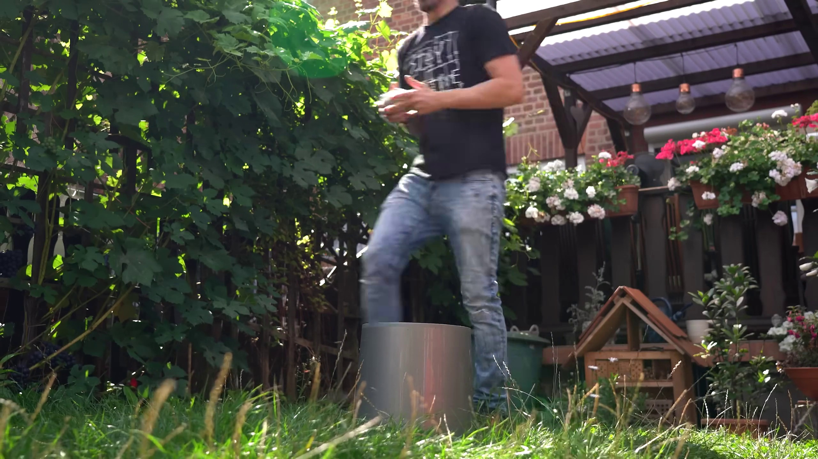

Transcript
(No speech detected in this section)

Section 0: Educational Context Absent in First Image
Time: 0:05 - 0:15

Summary
The first image shows a serene outdoor scene without any discernible text, diagrams, or other teaching context elements. The atmosphere is tranquil and inviting, but no educational content is present.

Representative Frames
0:06  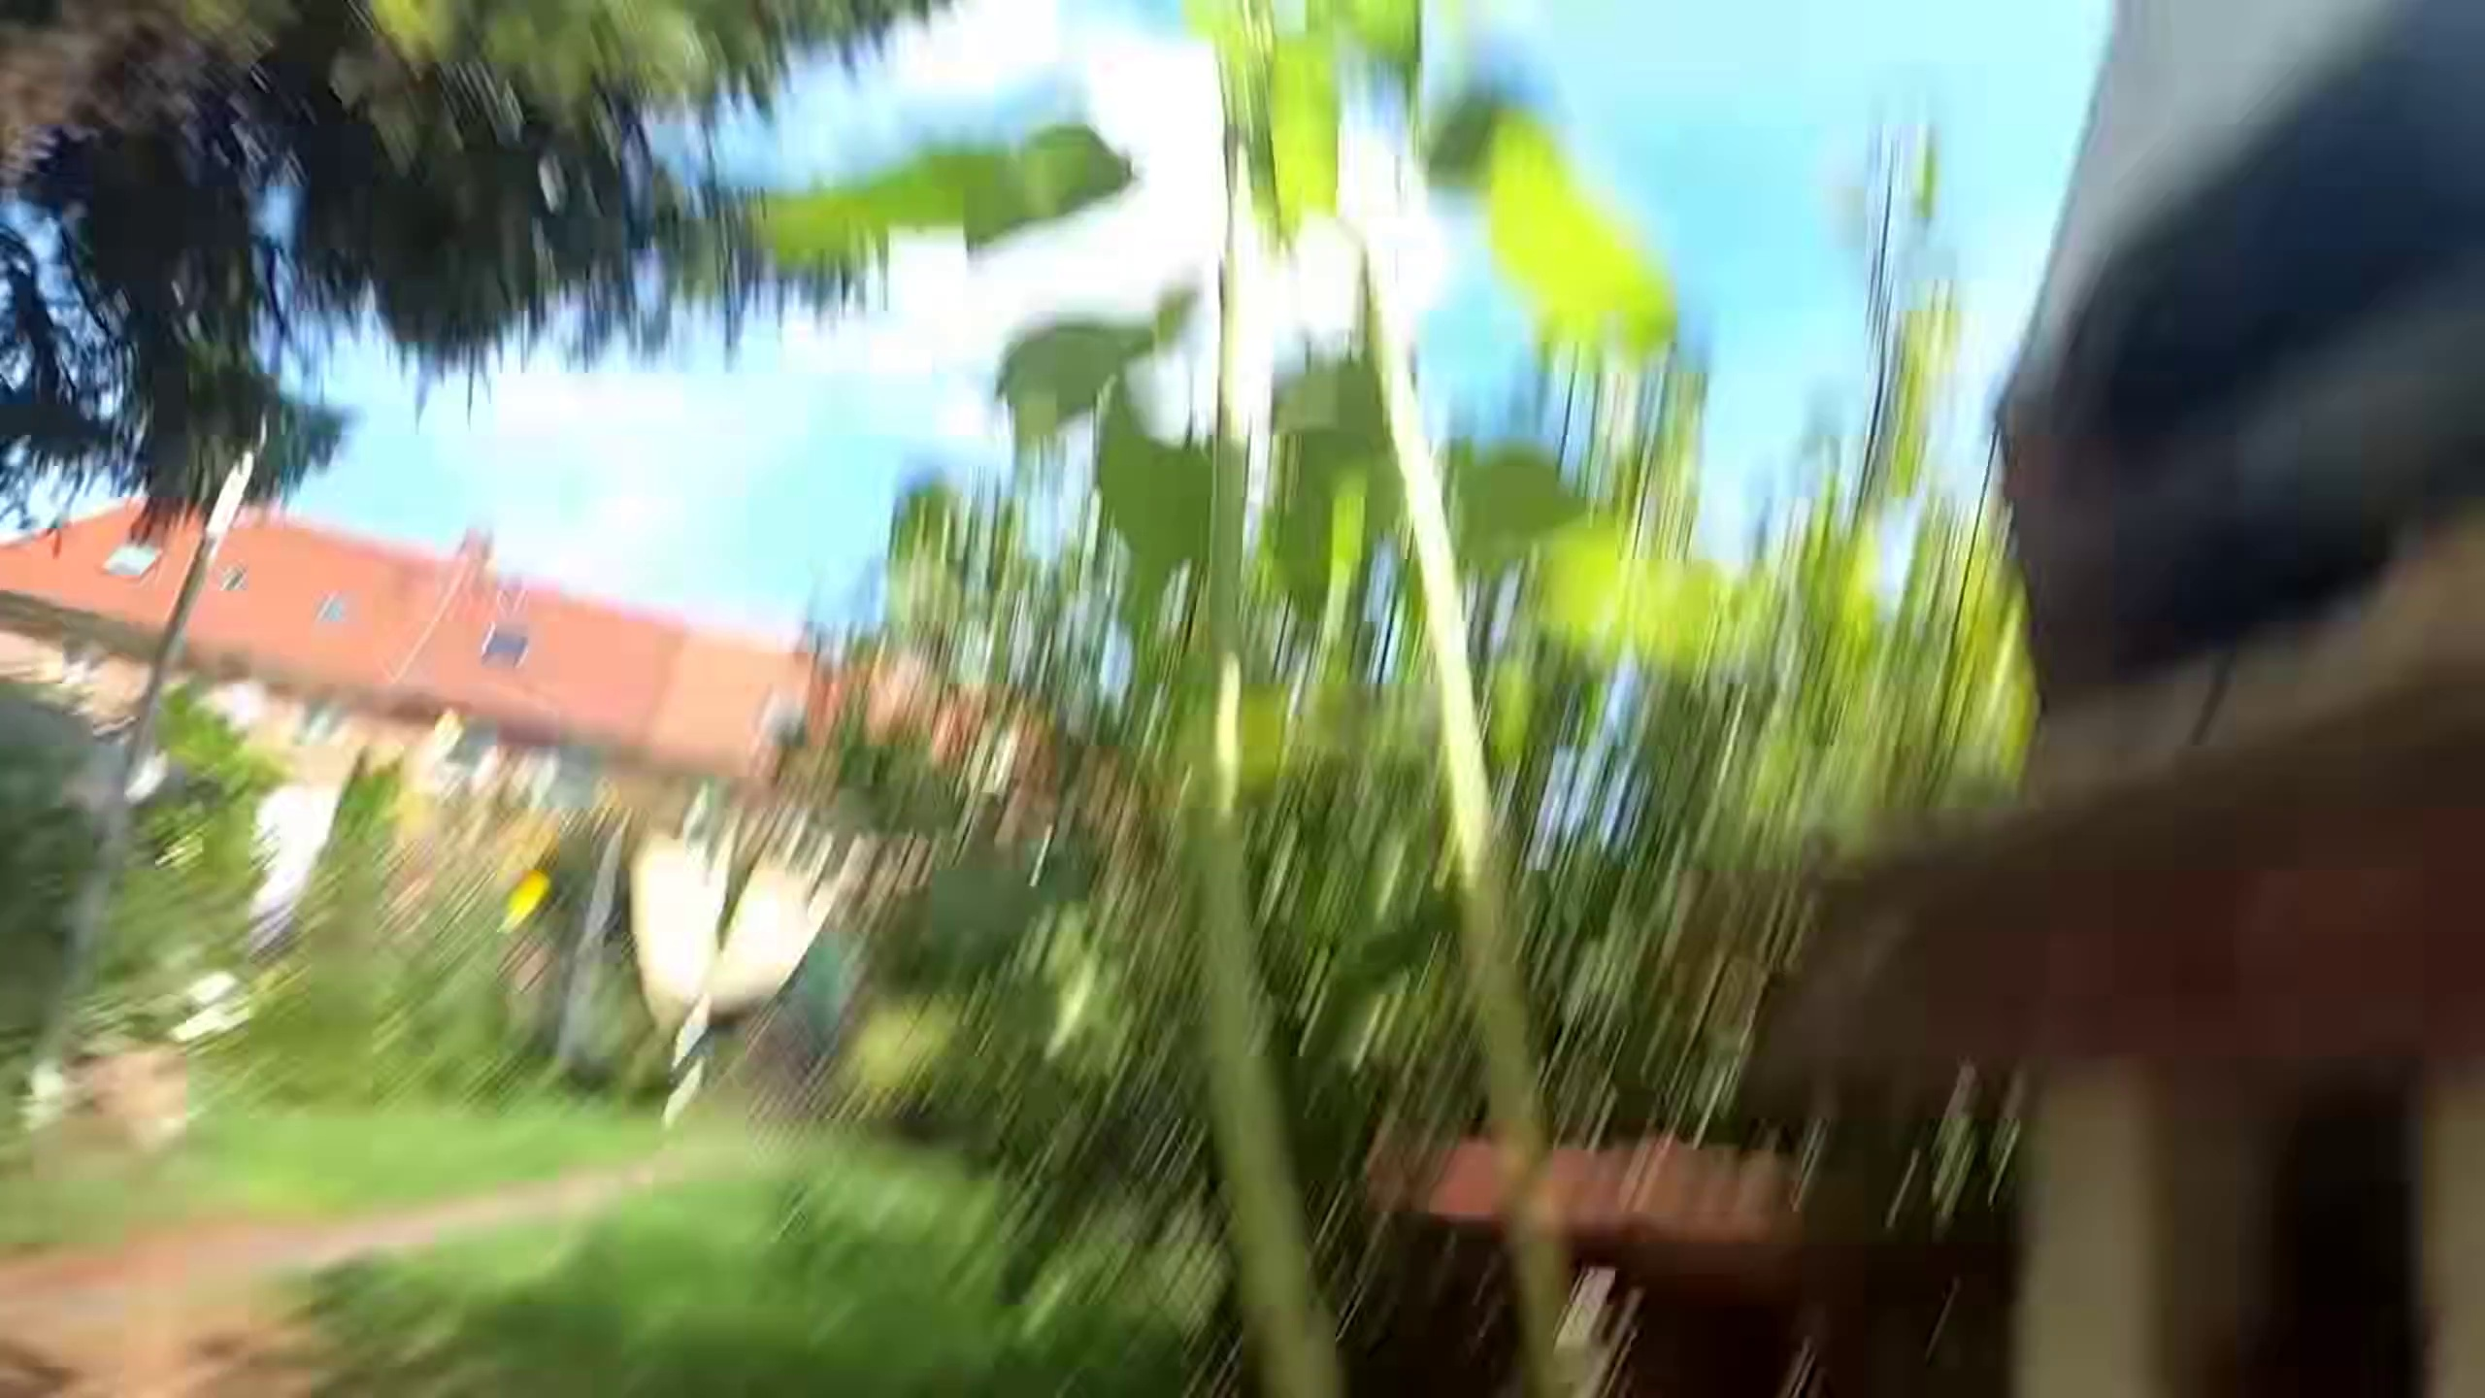 | 0:08   | 0:10  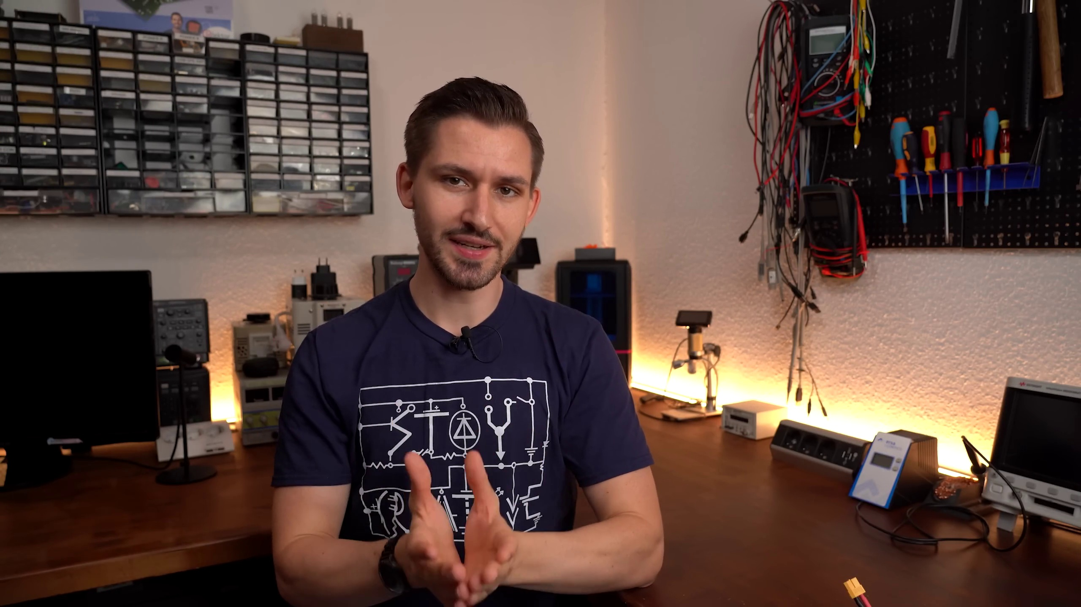 | 0:11   | 0:13  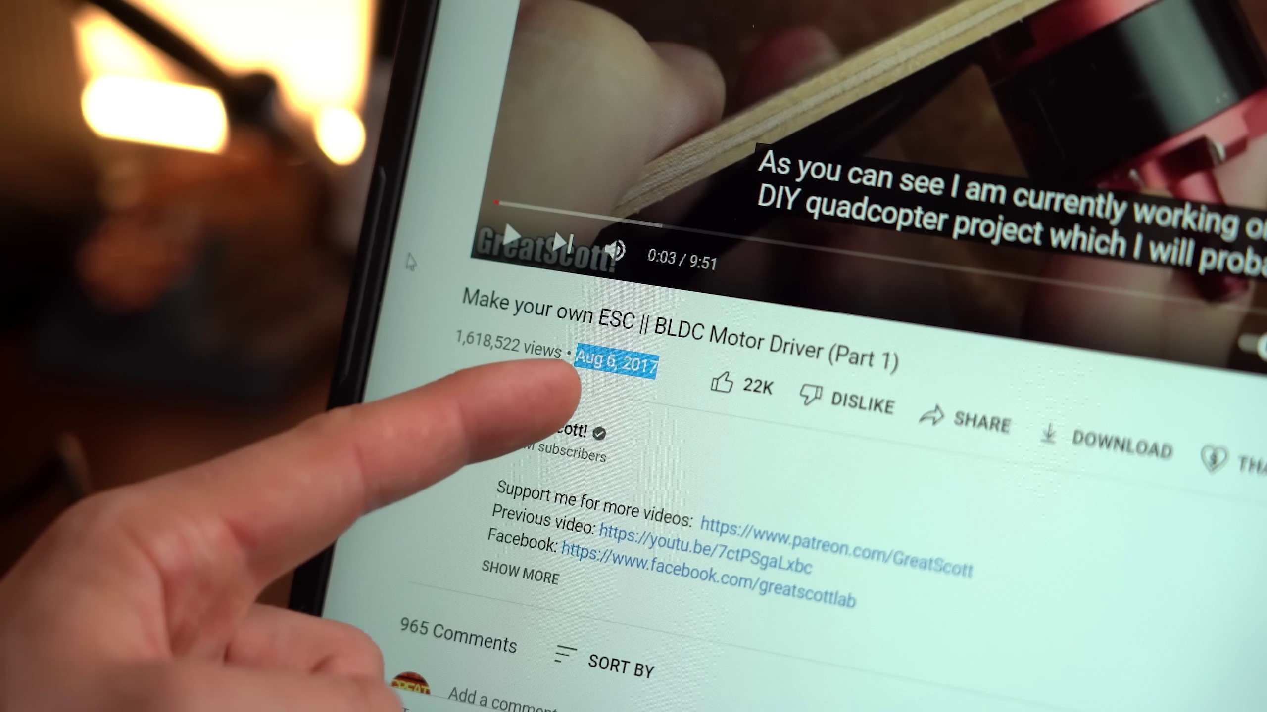

Transcript
[0:00] So, I finally did it. After stating in a video from 2017 that I would finish a DIY drone by 2022,

Section 0: Series of Images Show Tranquil Scenes
Time: 0:15 - 4:00

Summary
The next several images show a series of serene outdoor scenes, each with a unique perspective or composition. These images capture tranquil moments in nature without any educational content.

Representative Frames
0:52  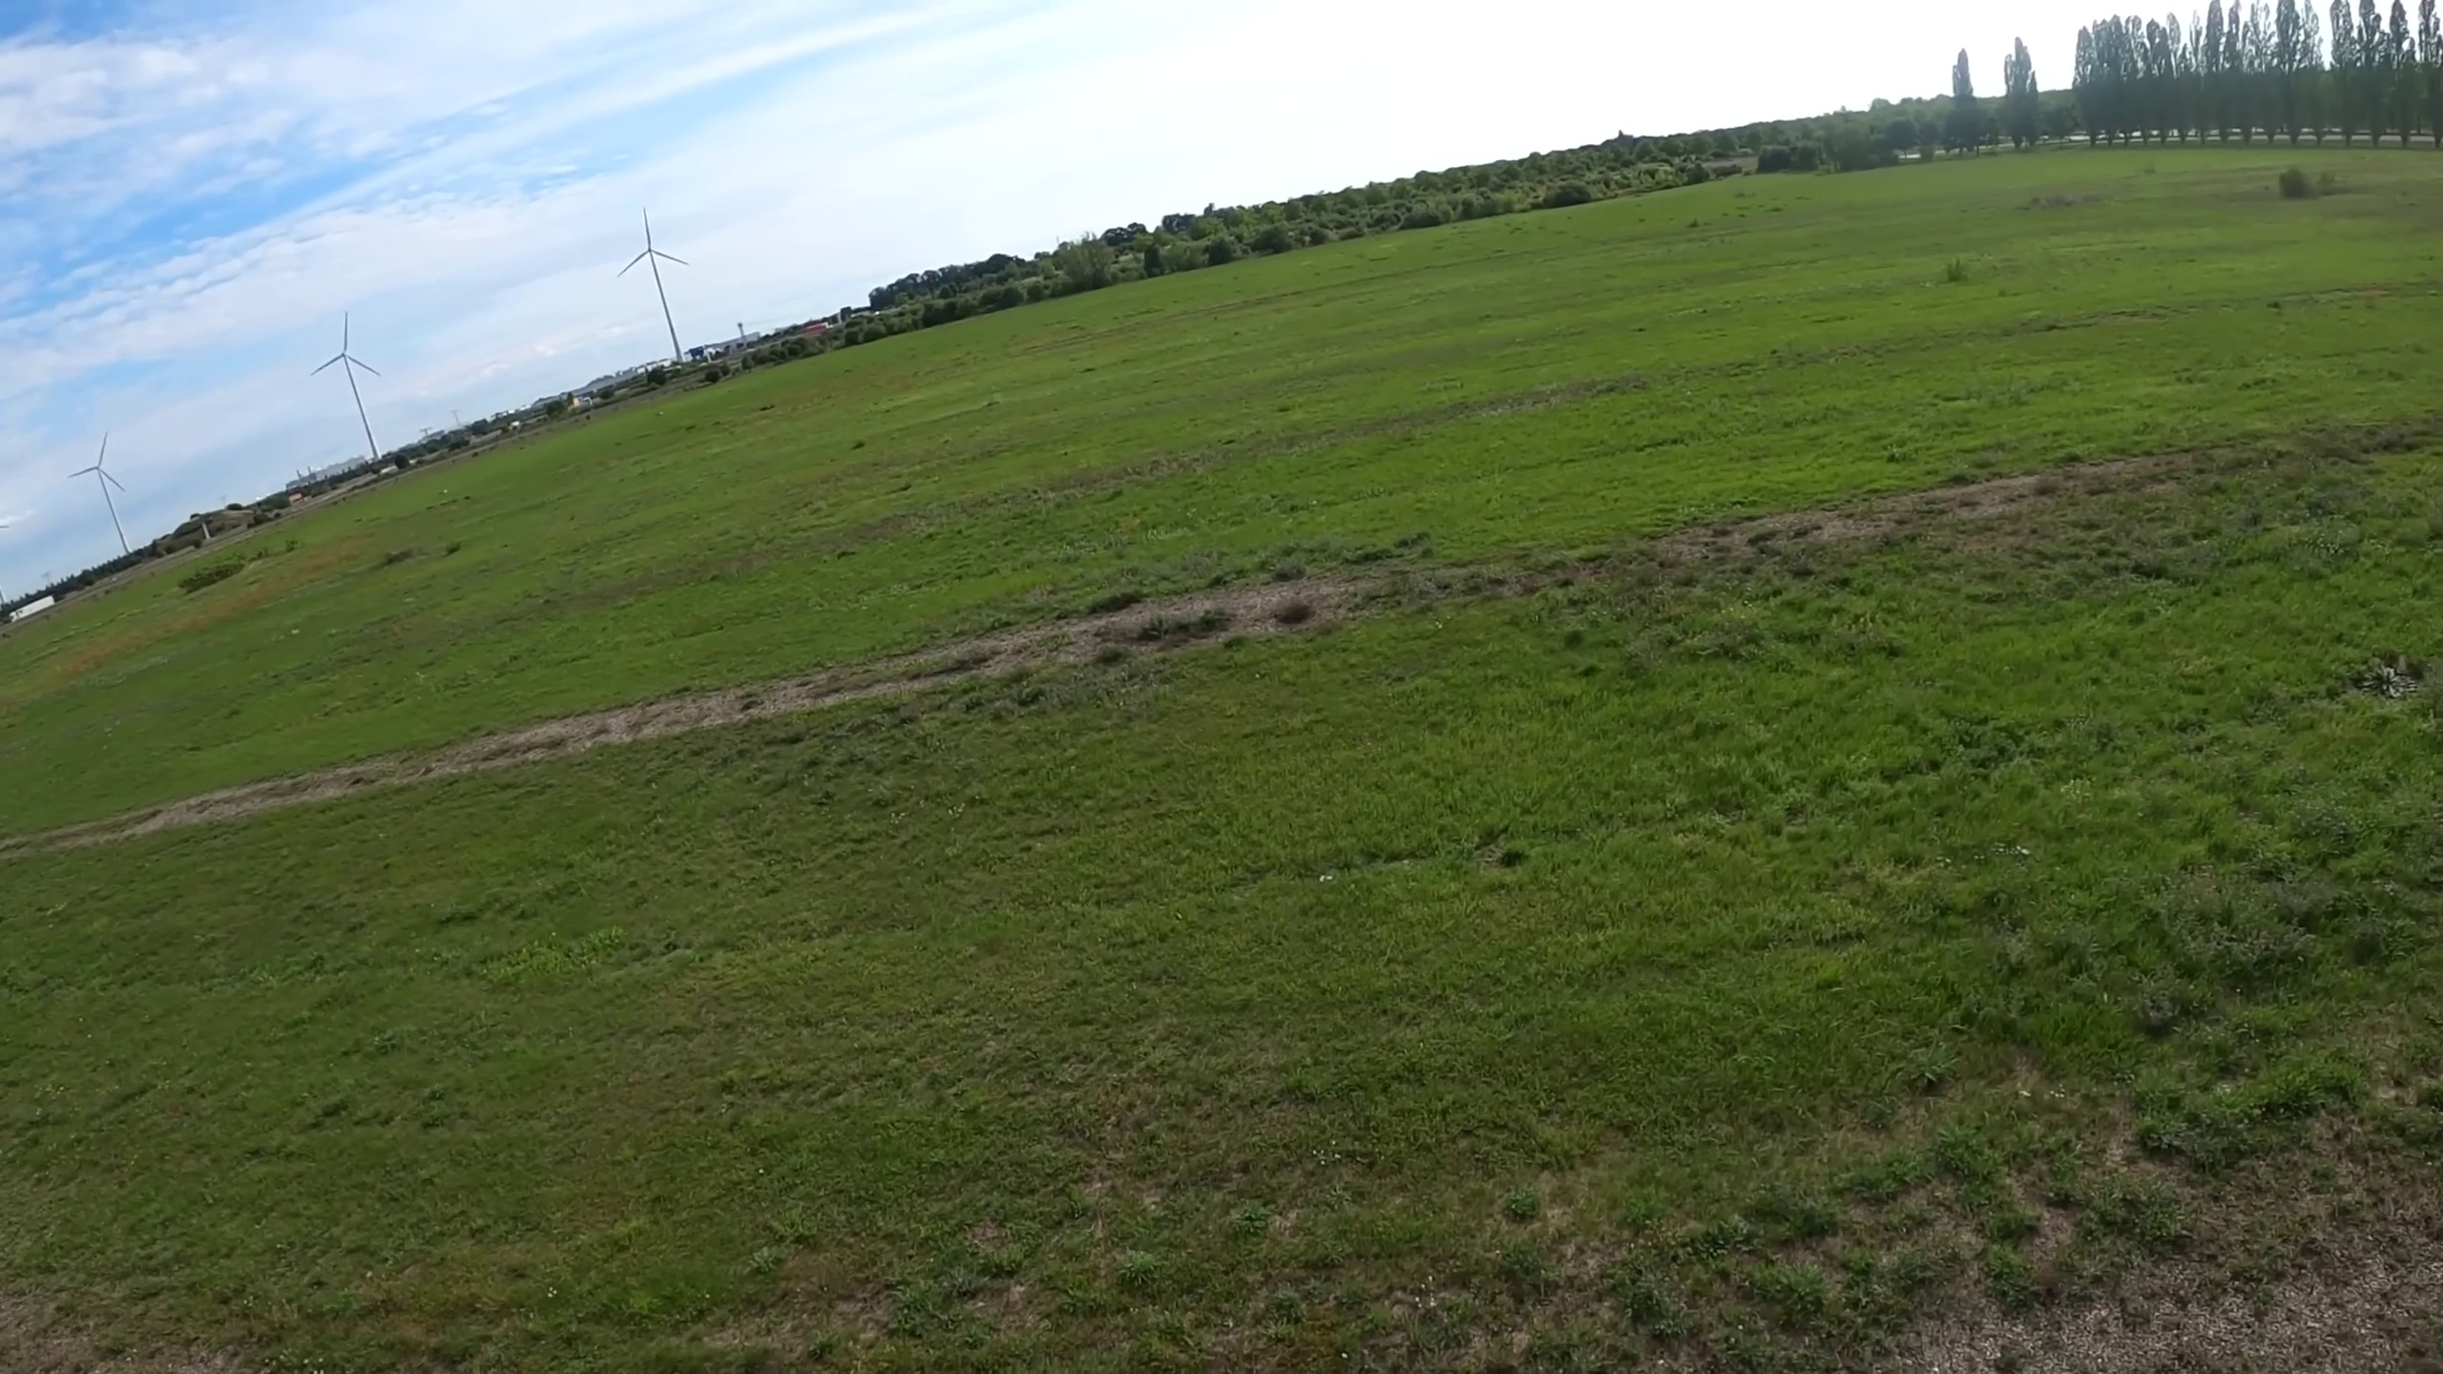 | 1:30  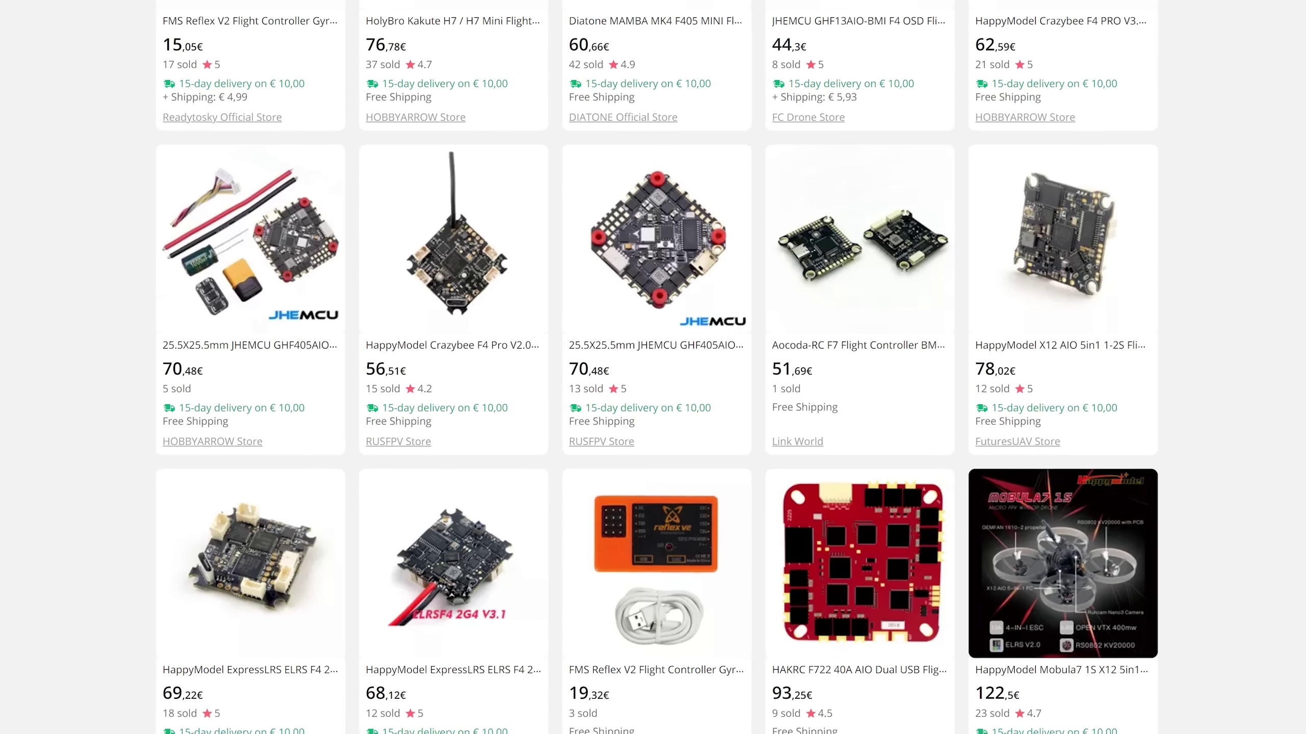 | 2:07   | 2:45  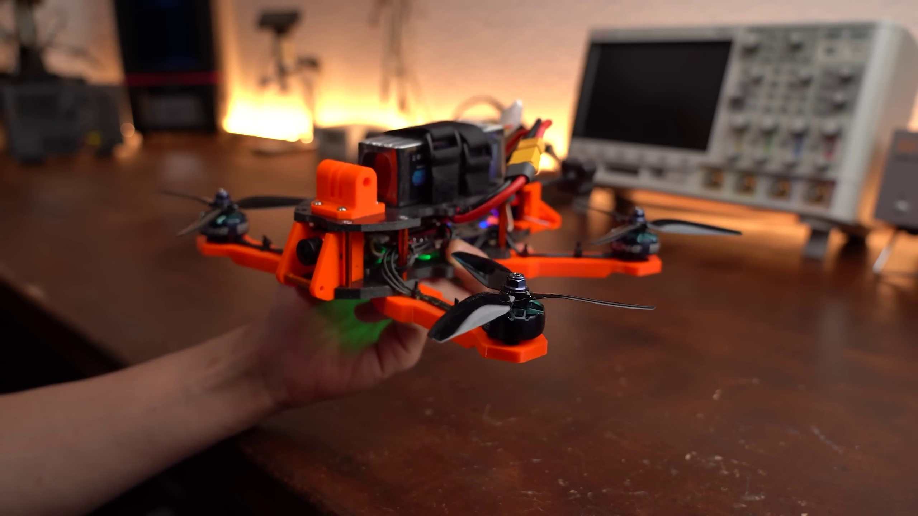 | 3:22  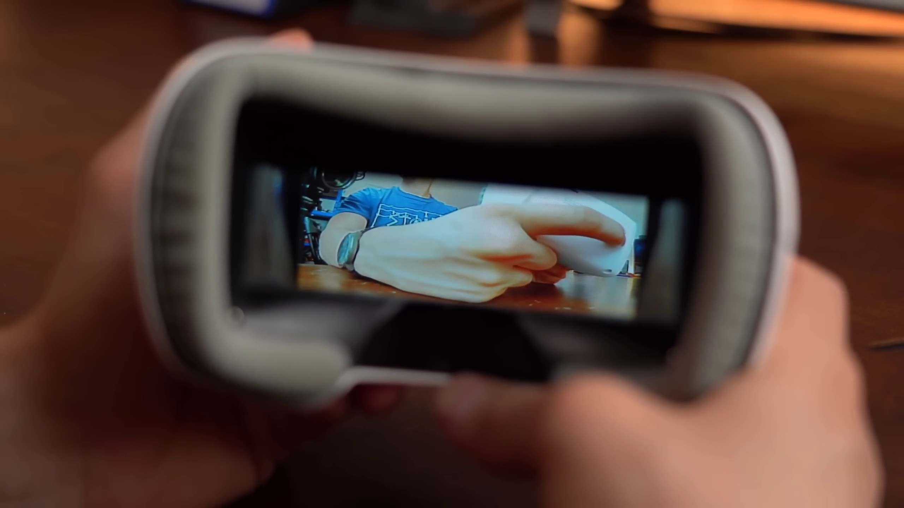

Transcript
[0:18] I am happy to say that I was finally able to put together this drone. Which can in fact fly but
[0:26] I am still a beginner when it comes to controlling it. Now you probably already noticed that this is
[0:32] not your standard drone like for example DJI mostly makes them which fly rather slow and controlled
[0:39] so that you can make beautiful recordings. No, this is an FPV or first person view drone meaning
[0:48] you can not only see what the drone sees while flying but it also moves way faster through the
[0:53] air and thus lets you capture some unique video footage with the help of a GoPro on top.
[1:01] And the reason why I built this was that months ago I got a beginners FPV drone kit that came with a tiny
[1:07] drone which works wonderfully but can easily get blown away by the wind. So, I wanted something a
[1:15] bit bigger and heavier and I feel like I went overboard here but you will see that later.
[1:21] Before that though let me show you my journey of building this thing which was not super easy to
[1:28] do because the drone market just overflows with different hardware, communication protocols and
[1:34] software. But luckily after this video you should have a good idea of what is going on and you should
[1:42] be able to build something similar. So, let's get started!
[1:55] This video is sponsored by Keysight who have a huge virtual event coming up called Keysight World Innovate.
[2:02] It is 4 days long and during that time industry leaders and experts will share their vision of future
[2:08] technology which involves 5G and 6G, electric and autonomous vehicle advances, quantum technology
[2:16] and much much more. If that sounds interesting to you then check out the link in the video description.
[2:24] Let's start off by exploring what parts we need for drone and let's use my completed one as an example.
[2:30] The first obvious part is of course a frame onto which all other components get mounted on.
[2:38] Next are the motors with propellers that create the upward thrust while spinning and of course we also
[2:45] need a battery to power it all. Then some kind of receiver that like the name implies receives a signal
[2:52] from a remote so that the drone knows what direction to follow. And since we are dealing with an FPV drone,
[2:59] we also need a camera and a VTX system with fitting antenna of which I honestly also never heard of before.
[3:08] It stands for Video Transmitter and it basically takes the camera video signal and sends it out as
[3:14] a 5.8GHz signal that the FPV goggles which we also need can then receive and play back.
[3:22] And the last things they are missing are the VC board and ESC board.
[3:26] Now FC stands for Flight Controller and it is basically the heart of the system.
[3:33] It for example comes with an accelerometer IC which the drone uses to find out how it is positioned in
[3:39] the air and through the help of an integrated PID control loop it can then tell each motor how fast
[3:46] to spin so that it can stand upright in the air without crashing. Of course it also manages to receive
[3:53] controller signal, camera signal, outputs the VTX signal and much much more.

Section 0: Conclusion and Call to Action
Time: 4:00 - 15:54

Summary
The video concludes with a call to action, encouraging viewers to like, share, subscribe, and hit the notification bell. The creator also mentions their Patreon page again.

Representative Frames
5:59  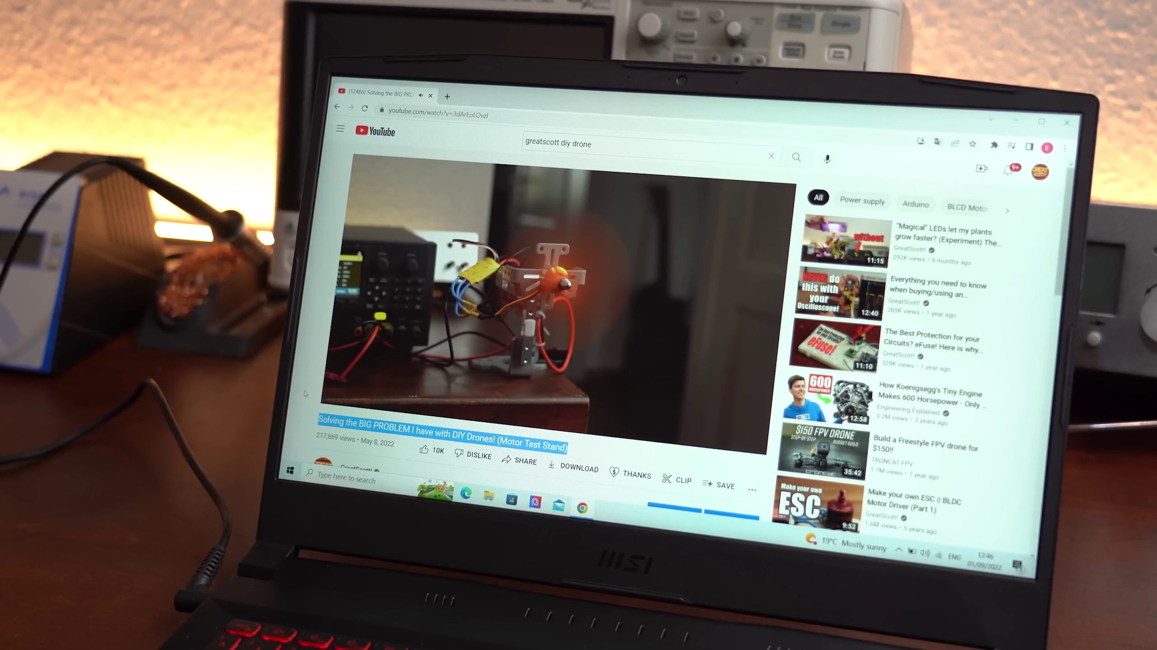 | 7:58  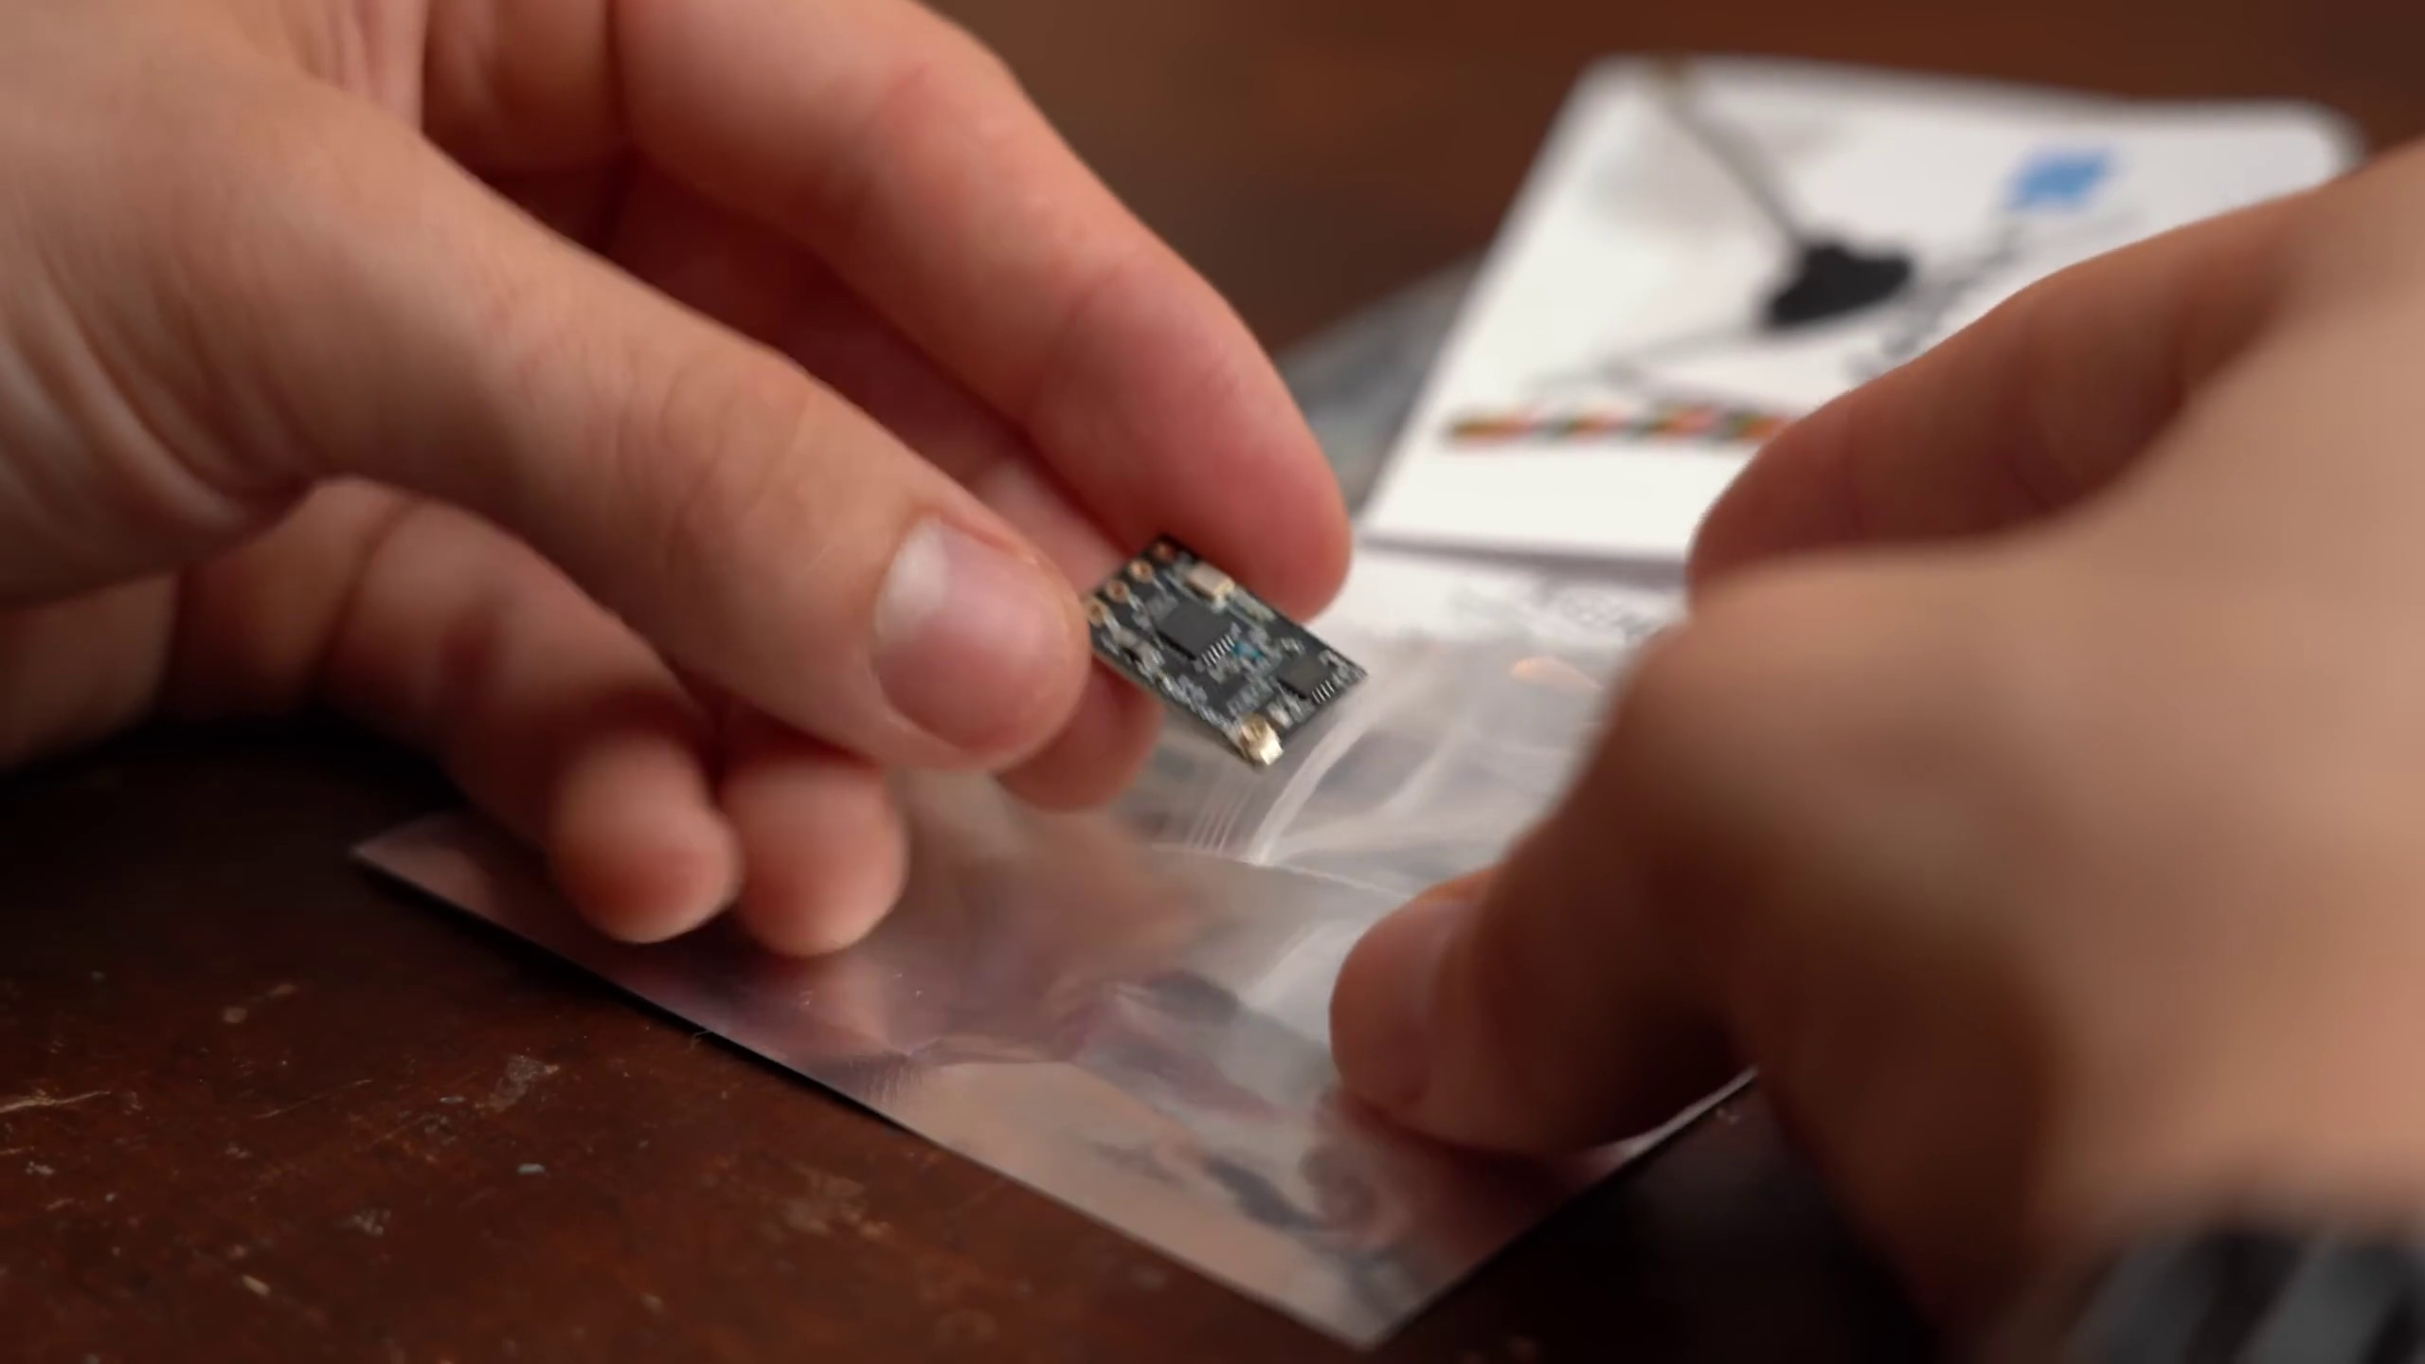 | 9:57  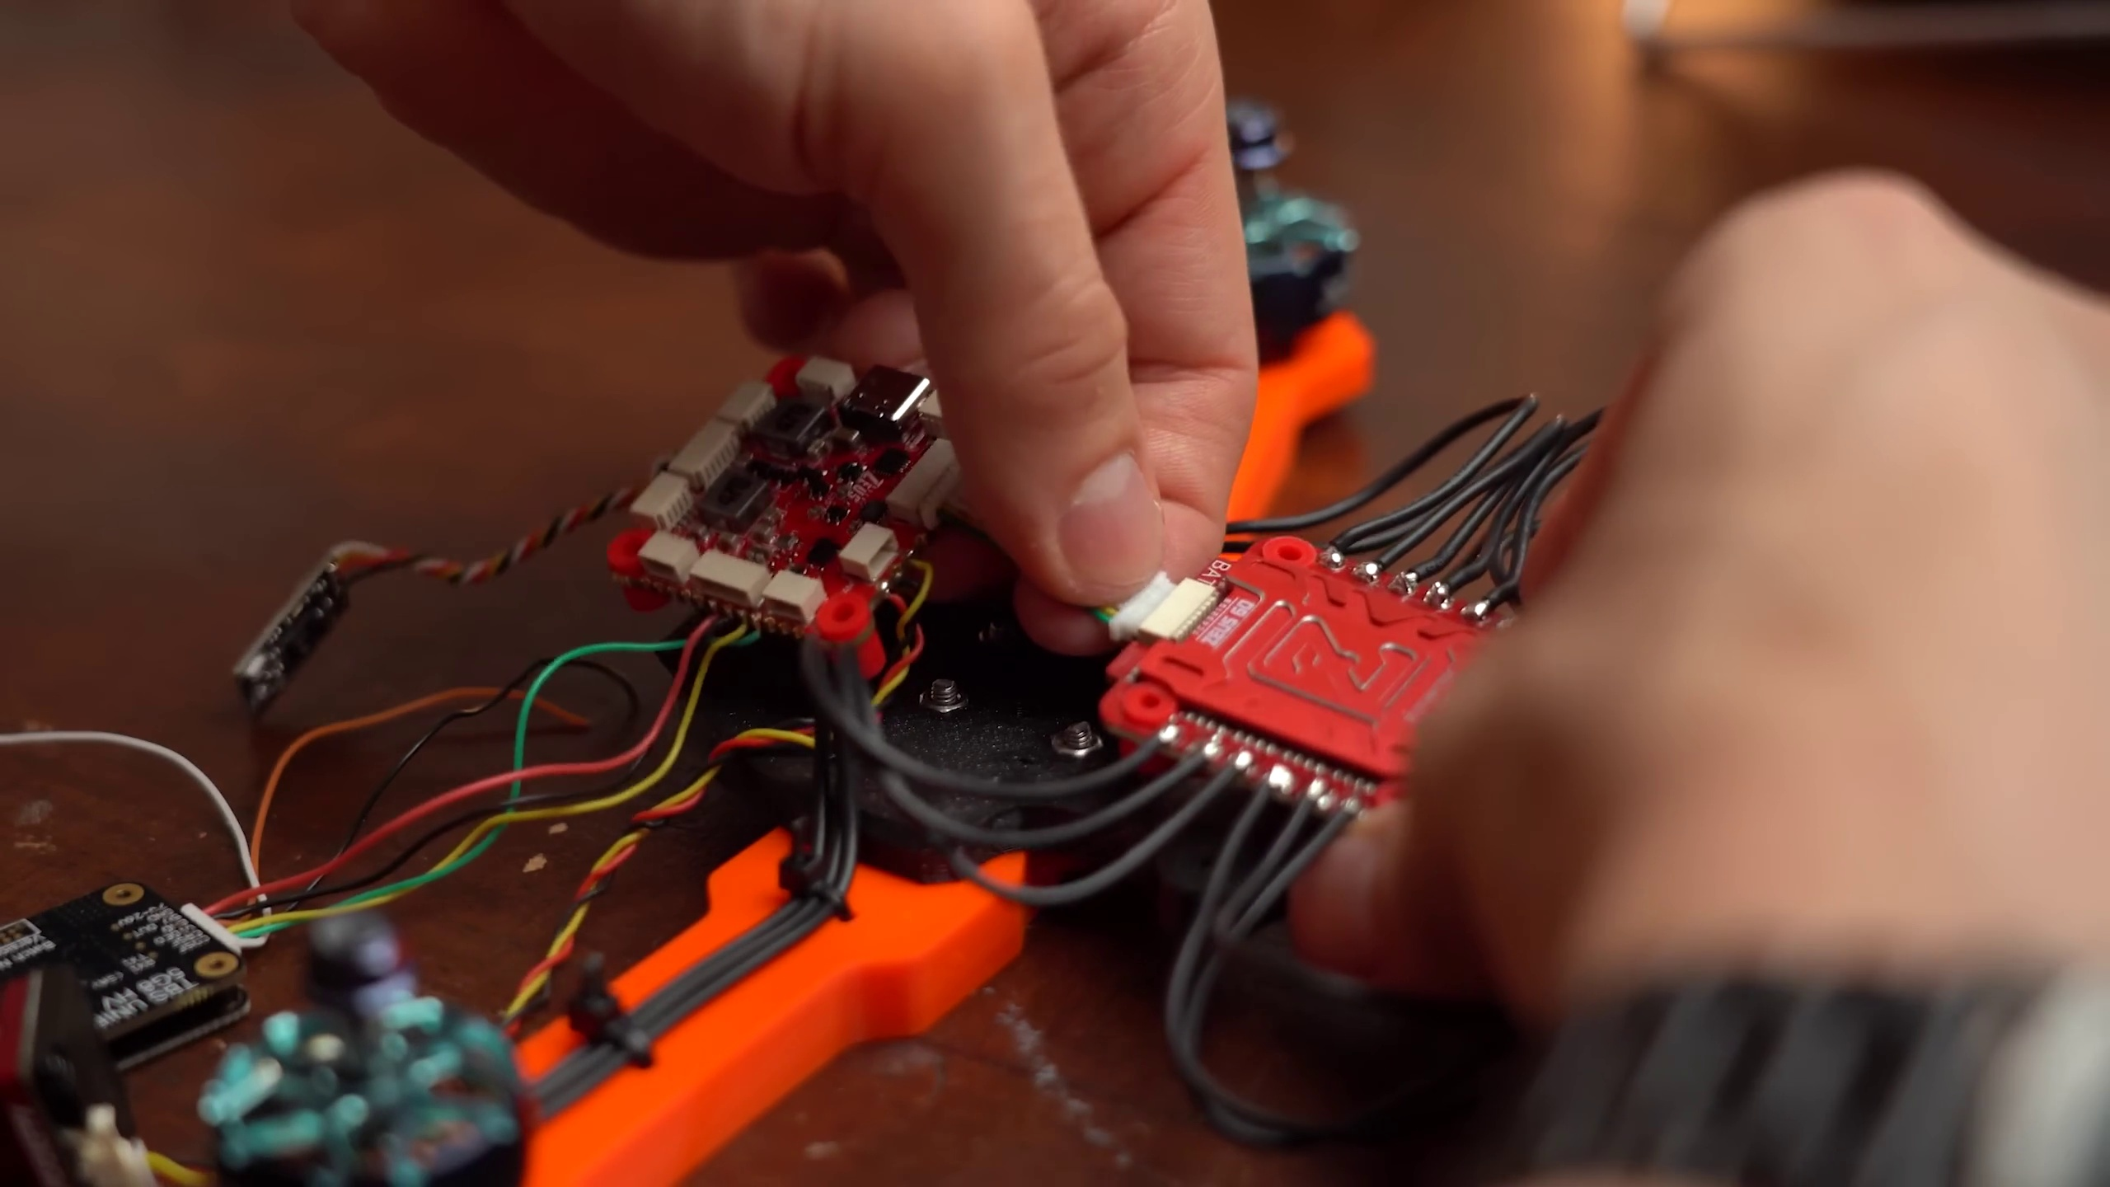 | 11:56  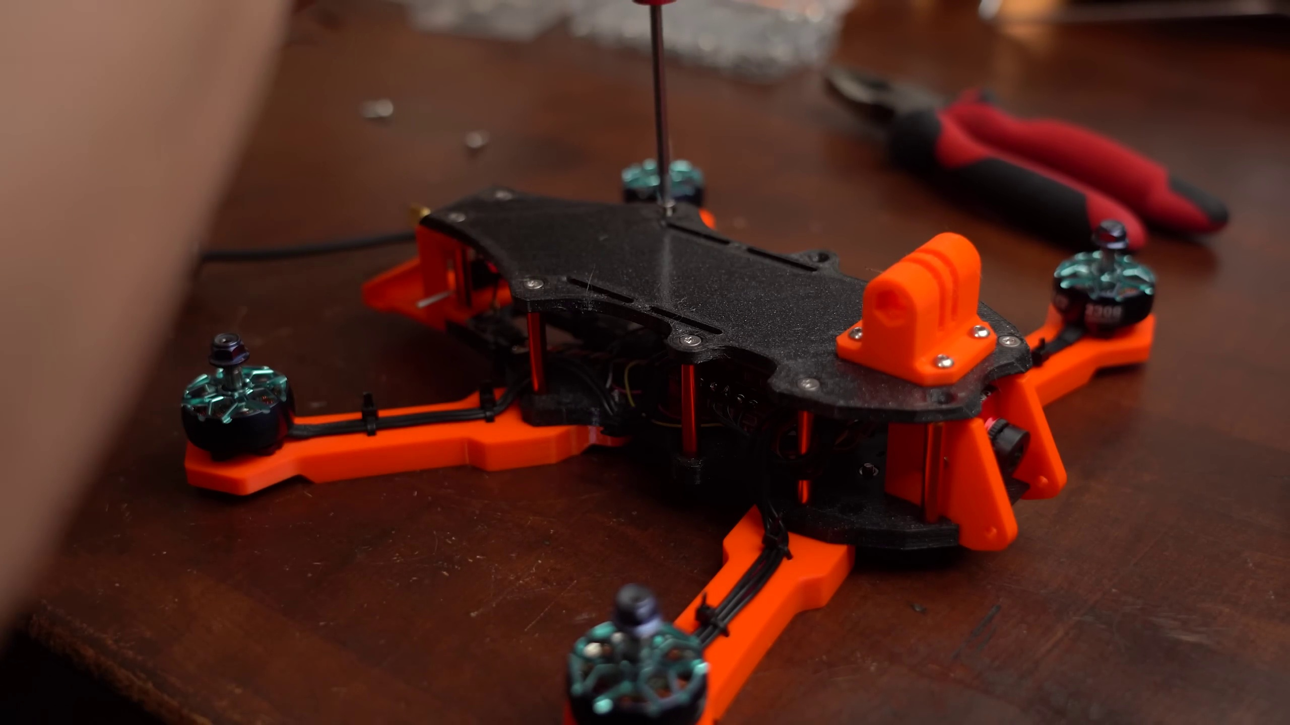 | 13:55  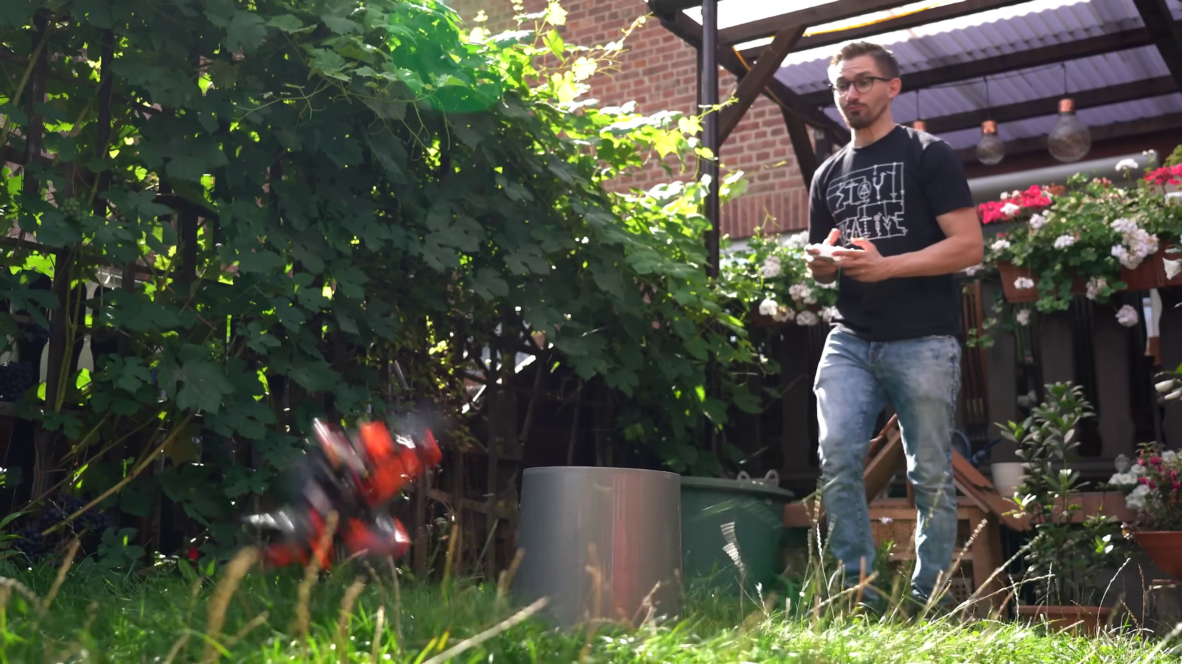

Transcript
[3:59] The only big thing it cannot do directly is driving the BLDC motors for which we got the ESC board
[4:06] aka electronic speed controller board that drives the motors at a specific speed depending on how the
[4:13] flight controller demands it. And those were all in all the basic components required for an FPV drone
[4:20] and I started my component hunt by firstly looking for a frame. The reason is that depending on whether
[4:28] you choose a small or big frame all the other components have to be smaller or bigger too.
[4:34] And honestly speaking I didn't feel like buying a pre-made frame because when 3D printing a frame
[4:40] you can always easily replace parts and by using PETG filament you also get reasonably strong parts
[4:47] which eventually though can also break. So I searched for suitable models on printables
[4:55] and eventually found this 6 inch one whose design I really liked. I asked his creator whether I can
[5:02] showcase it in the video and he agreed and even helped me a lot during the build so big thanks to him.
[5:10] And with the model selected I started 3D printing all parts
[5:14] and while that was going on I was looking for motors on Amazon which the model trader actually advised me
[5:21] not to use. The reason is that they often come with low quality bearings so he instead recommended this
[5:28] motor in combination with a 4S battery. With the given kV rating using a 4S battery should give me an
[5:37] average RPM of 37,814 which is above the RPM thrust graph I created in a previous video and thus it should
[5:47] easily lift 500g meaning 4 of them should be able to do 2kg which I thought was more than enough.
[5:56] And by the way I would highly recommend checking out the video I just mentioned because it shows you
[6:02] very well how battery, ESC, motor and propeller interplay with one another.
[6:09] But anyway the datasheet of the motor also stated that even with only 50% thrust it is capable of
[6:16] lifting 563g so I was pretty sure that those should work. Next for the propellers I was advised to get 6 inch
[6:26] ones but once I saw how close they get to the drone maybe turning it into drone goulash I instead went with generic 5 inch ones.
[6:37] For the battery like I said before I went with a 4S one with a capacity of 2.2Ah and most importantly a
[6:46] high C rating which basically says that it can output a high current and thus a high power which is more than
[6:54] enough to enjoy the maximum power of all 4 motors. Moving on, next was the receiver and remote part
[7:02] and for that I wanted to reuse the remote from my beginners drone kit. Luckily it apparently comes
[7:09] with the ELRS communication protocol that can be used for modern drones. As a comparison back in the old
[7:17] days all your drone remote inputs would alter one data channel at the receiver which is basically a standard
[7:24] servo signal. But since dealing with so many data channels is just confusing, modern remotes and
[7:32] receivers just talk to the flight controller through a receive and transmit line and thus we reduced for
[7:38] example 9 data wires to just 2. The bad news is though that there are a ton of different protocols from different
[7:46] manufacturers but like I said ELRS is apparently not only supported by my remote but also new and great
[7:55] and I could easily get a fitting 2.4GHz ELSR receiver for pretty cheap from the internet.
[8:02] So next I also wanted to reuse my old goggles which was also not a problem because all 5.8GHz
[8:10] transmitter systems should work with them so I simply got one that was currently available.
[8:17] And the camera was also a suggestion from the model trader which I didn't regret.
[8:23] Ok last but not least a flight controller and ESC and here I was told that pretty much anything would work
[8:31] as long as the ESC could handle the motor current, the flight controller comes with a standard size
[8:37] device and it uses Betaflight which is the software on the flight controller that basically handles everything
[8:45] and that probably most drone owners use. So I decided on this Zeus 60A one because it looked well made
[8:53] and came with a decent manual. And thus I finally got all the parts for the drone and if you want to
[9:00] build something similar you can of course find a complete parts list with example seller in the
[9:06] video description. There you can of course also find the additional parts like screws, standoffs,
[9:13] zip ties and everything else. And with that being said I started the actual drone build by firstly securing
[9:20] all the motors to the motor arms and then attaching those to the bottom piece of the frame with more screws.
[9:26] At this point I was happy to find out that the motor wires were long enough to reach the ESC.
[9:34] So I tied them to the arms with the help of zip ties before soldering the XT60 battery connector to the ESC
[9:42] along with all the motor wires. Next I soldered the camera wires, receiver wires and VTX wires to the solder pads
[9:50] of the flight controller like its manual told me to do so. And after connecting the ESC and FC with the
[9:58] help of the given wire it was already time for the first power test with my lab bench power supply
[10:04] which as you can hear and also see was a big success for me since nothing blew up.
[10:11] And best of all the camera system already worked without configuring anything which was pretty neat.
[10:17] What I still had to do though was binding the receiver with my controller and that was more or less a
[10:24] nightmare because no matter what I tried my remote didn't want it to do that.
[10:30] Eventually I found out that my remote is the FR Sky version which does not support ELRS and thus I had to
[10:39] get a new one which does support that but it was certainly not new. The story continues though because
[10:47] the binding with the bind button still didn't function. I actually had to not only flash a
[10:53] new firmware onto the remote but also a new firmware onto the receiver which was not hard to do but finding
[11:00] that out just took me way too long. And thus the remote and receiver finally bound correctly and it was
[11:08] time for me to assemble the rest of the frame to find out how I had to modify it so that it can hold my
[11:14] camera, GoPro mount and VTX antenna. The model creator also helped me a bit with that and since he uploaded
[11:23] the step files of his model I had no problem adjusting a couple of holes and cutouts as well
[11:29] and printing some parts again. And that means it was finally time to permanently mount the FC
[11:35] and ESC to the frame, secure the camera with small screws on the front as well as the antenna mount in
[11:42] the back, add standoffs all around the frame, use zip ties to keep all the wiring under control,
[11:49] attach the GoPro mount to the upper frame and finally attach that to the rest with the help of more screws.
[11:56] And just like that the drone was mostly done.
[11:59] And next I had to connect it to a computer and use the Betaflight configurator software to get all the
[12:06] settings right. To do that I first delayed the quads onto a flat surface to calibrate the accelerometer
[12:14] and afterwards I configured the receiver system, made sure that the board alignment was correct so that
[12:21] in this software the drone moves exactly like it does in real life. I had to alter two controller channels
[12:28] so that the quad moves with the controller inputs like you would expect it. I had to add modes to
[12:35] for example arm the quad and enter angle modes which is easier to fly and ultimately I checked the motor
[12:42] settings and spun up the motors to find out that they in fact all spun in the correct direction.
[12:49] And if you want more information about all of the Betaflight settings then I would highly recommend
[12:55] checking out the Joshua Boutwell channel who made a video series about this.
[13:01] But anyway with the configuration complete I added the propellers to the motors while making sure which
[13:08] ones are the clockwise and counter clockwise ones. And after then charging up the battery and securing it
[13:15] to the frame with velcro strips it was finally time for the first proper test in my hands to see whether
[13:22] the drone would follow the directions I pointed to with the controller which it did just fine.
[13:29] So I did a proper flying test next which wasn't as bad as I thought it would be but I should get used
[13:36] to disarm the drone to get it to land. And the last test I then did in the garden was with the GoPro on top
[13:44] which during the first run worked surprisingly well but during the second attempt the system oscillated
[13:56] a bit and got out of control. I think this is a good time to mention that I am using the standard PID
[14:03] values for my drone here which do work but are not perfect. So next I wanted to do a bigger test on
[14:11] an empty field which clearly showed me that I will have to practice quite a lot to get any decent
[14:17] results with my drone and worst of all as I was getting more comfortable with it it just stopped
[14:24] its motors at the highest point yet and crashed to the ground. Needless to say I had to replace a couple
[14:33] of 3D printed parts and I am not sure why the system abruptly stopped working. Maybe because I was only
[14:42] using half of the original copper wire or maybe because I forgot adding the ESC capacitor. Whatever
[14:50] it was this problem did not occur again after fixing those things and I was actually getting a bit more
[14:57] comfortable the second time on the fields. I got so confident that I finally tried out flying with
[15:06] the goggles on which made things easier and on top was an incredible experience. And with that being said
[15:14] you should now have a basic idea of how to make your own drone and always keep in mind that you can
[15:20] easily downgrade component parameters to not only save money but also make your drone lighter and
[15:27] less powerful because truth be told my one is a bit too big and powerful for my taste.
[15:35] But anyway if you enjoyed this video and maybe my other ones then consider supporting me through Patreon.
[15:42] As always don't forget to like, share, subscribe and hit the notification bell. Stay creative and I will see you next time!

