Engagement Analysis: DkbfBIMSdgo

Section 0: A close-up view of a breadboard with various electronic components connected to it.
Time: 0:06 - 0:09

Summary
The image shows a white plastic board with black lines running across it, acting as the connections for various components. On the left side of the breadboard, a jumper wire is connected to a transistor, suggesting that it might be an active component of the circuit.

Representative Frames
0:06  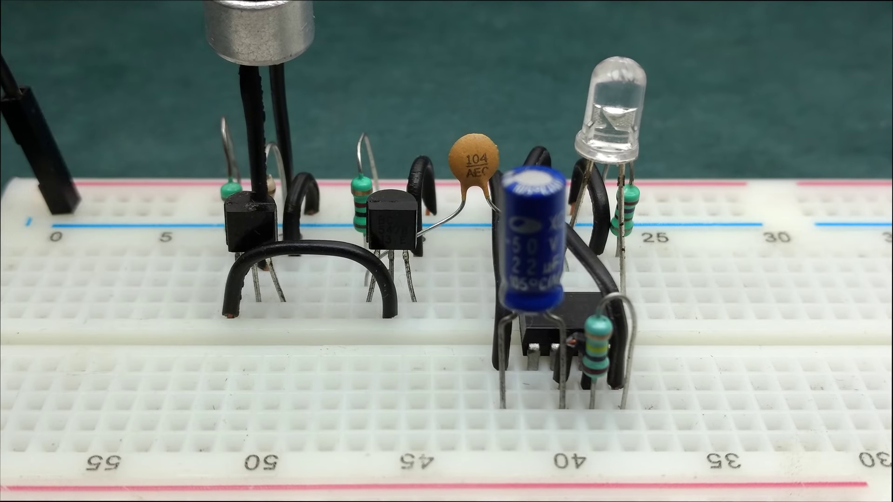 | 0:07   | 0:07   | 0:08  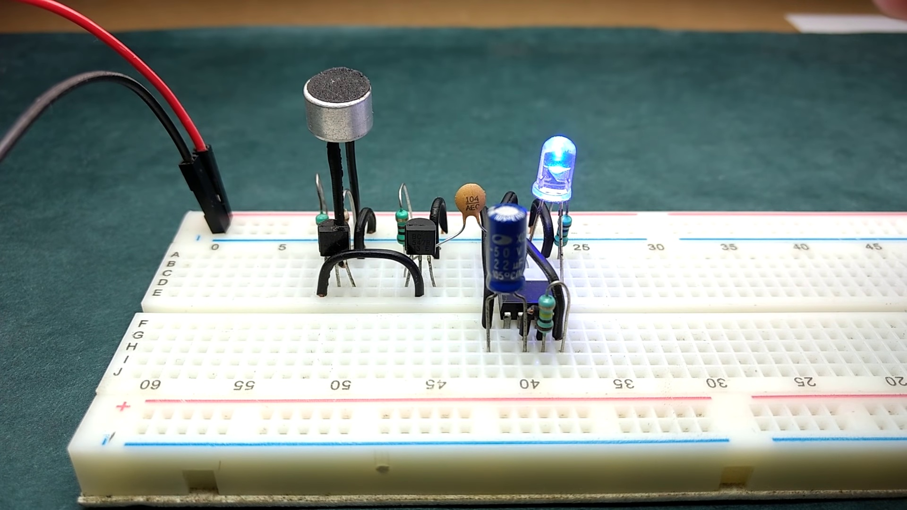 | 0:08  

Transcript
(No speech detected in this section)

Section 0: A person is setting up components on a breadboard or examining connections and measurements.
Time: 0:09 - 0:12

Summary
The image shows a close-up view of a breadboard with various electronic components connected to it. A multimeter, an LED connected in a circuit that includes resistors, a transistor (labeled "NPN"), another LED, and two additional components not clearly identifiable due to the resolution and angle of the photo are attached to the breadboard.

Representative Frames
0:09   | 0:10   | 0:10   | 0:11   | 0:11  

Transcript
(No speech detected in this section)

Section 0: A person is demonstrating an electronic circuit on a transparent breadboard.
Time: 0:12 - 0:16

Summary
The image shows an educational setup, likely for teaching electronics, robotics, or a related field. A transparent breadboard with various electronic components such as resistors, transistors, and a microcontroller board on it, along with a jumper wire and a 9V power adapter, appears to be demonstrating a basic electronic circuit.

Representative Frames
0:12  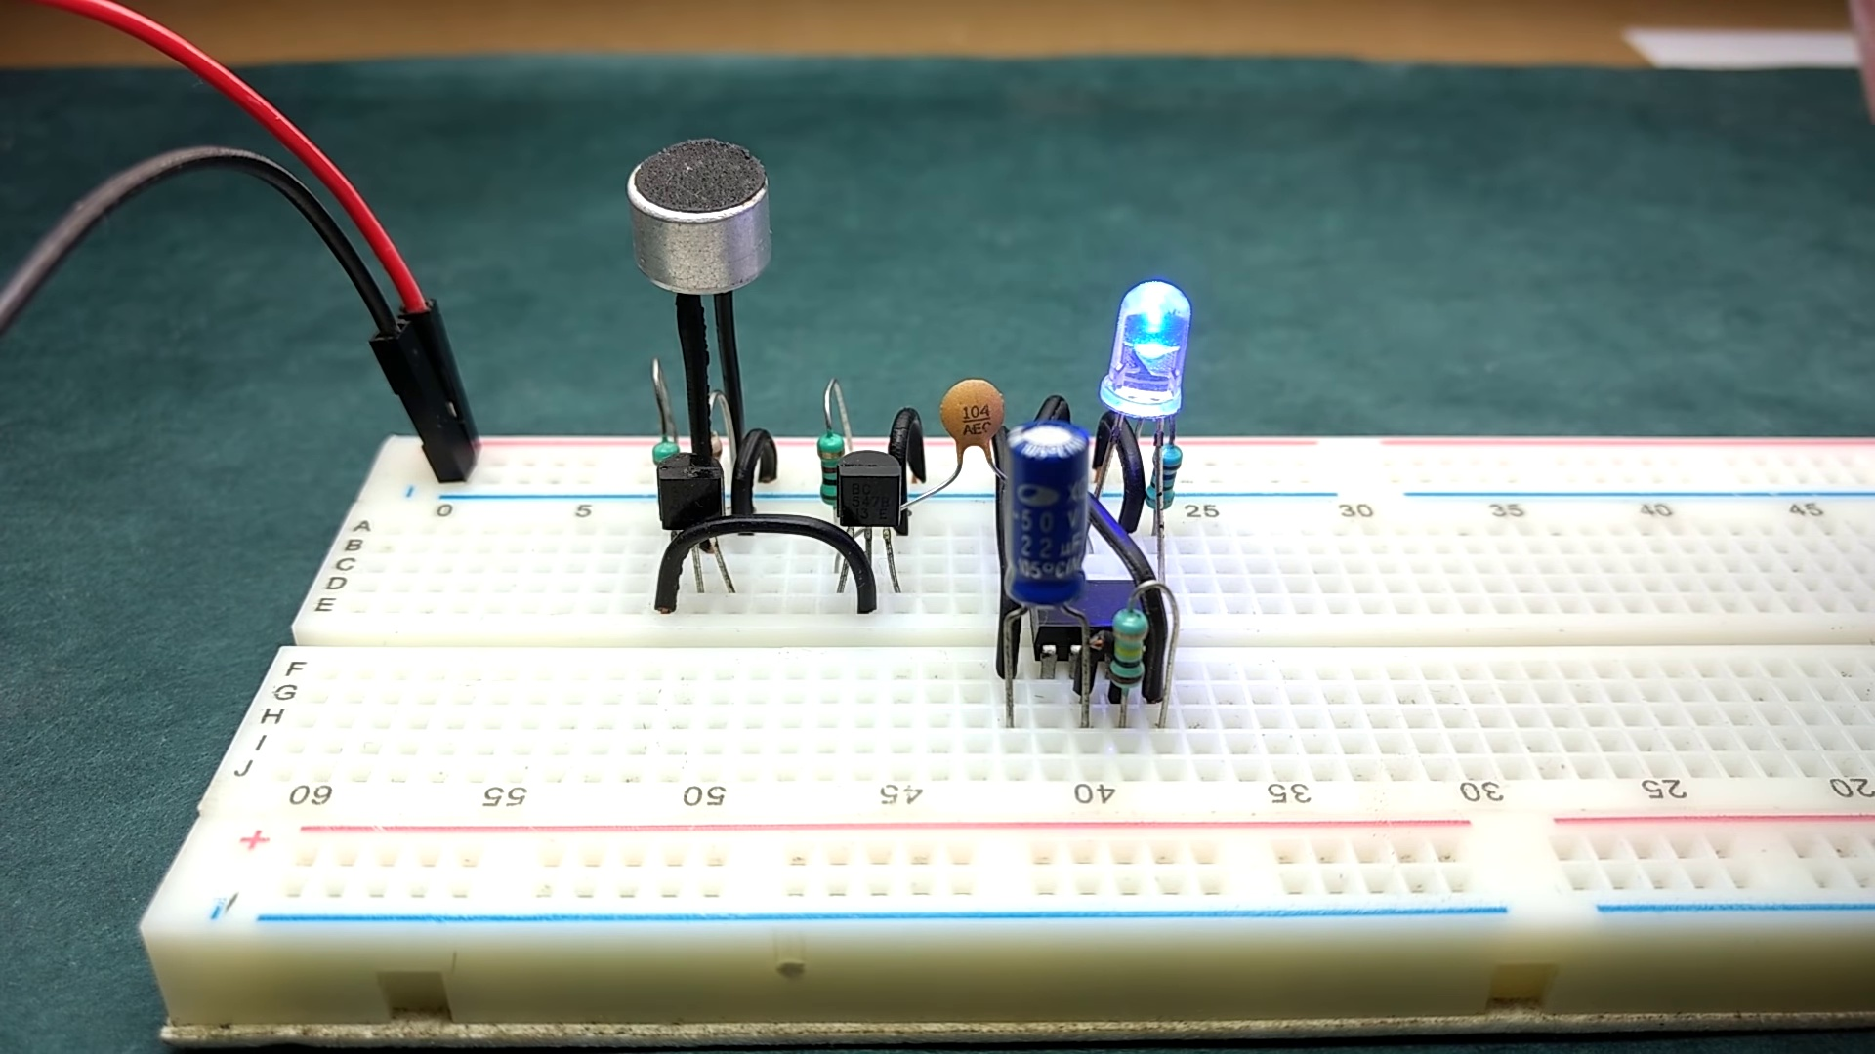 | 0:13   | 0:14   | 0:14   | 0:15  

Transcript
[0:08] learning how it works.

Section 0: A close-up view of a breadboard with various electronic components connected to it.
Time: 0:16 - 0:18

Summary
The image shows an educational setup, likely for teaching electronics, robotics, or a related field. A transparent breadboard with various electronic components such as resistors, transistors, and a microcontroller board on it, along with a jumper wire and a 9V power adapter, appears to be demonstrating a basic electronic circuit.

Representative Frames
0:16  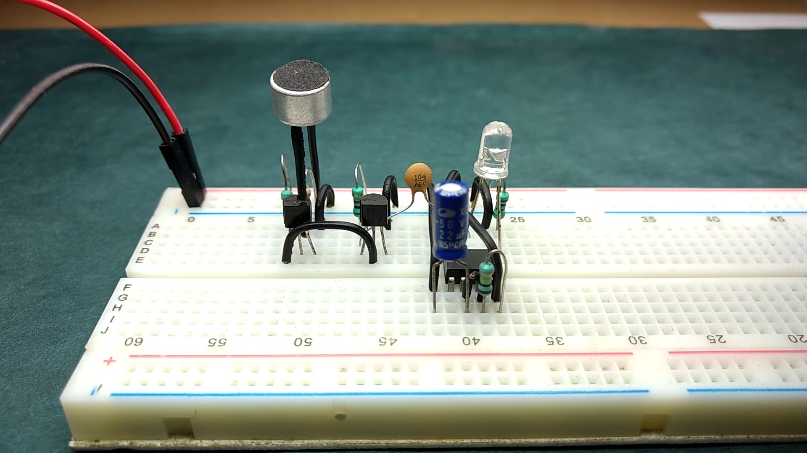 | 0:16   | 0:17   | 0:17   | 0:17  

Transcript
(No speech detected in this section)

Section 0: A person is holding a microcontroller board and explaining its use in controlling circuits or for interfacing with robots.
Time: 0:18 - 0:20

Summary
The image shows an educational setup, likely for teaching electronics, robotics, or a related field. A transparent breadboard with various electronic components such as resistors, transistors, and a microcontroller board on it, along with a jumper wire and a 9V power adapter, appears to be demonstrating a basic electronic circuit.

Representative Frames
0:18   | 0:18   | 0:19   | 0:19   | 0:19  

Transcript
(No speech detected in this section)

Section 0: The person says 'Thanks for your time, do subscribe and have fun'.
Time: 0:20 - 6:22

Summary
This is the end of the video, with the speaker thanking the viewer and encouraging them to subscribe.

Representative Frames
1:20  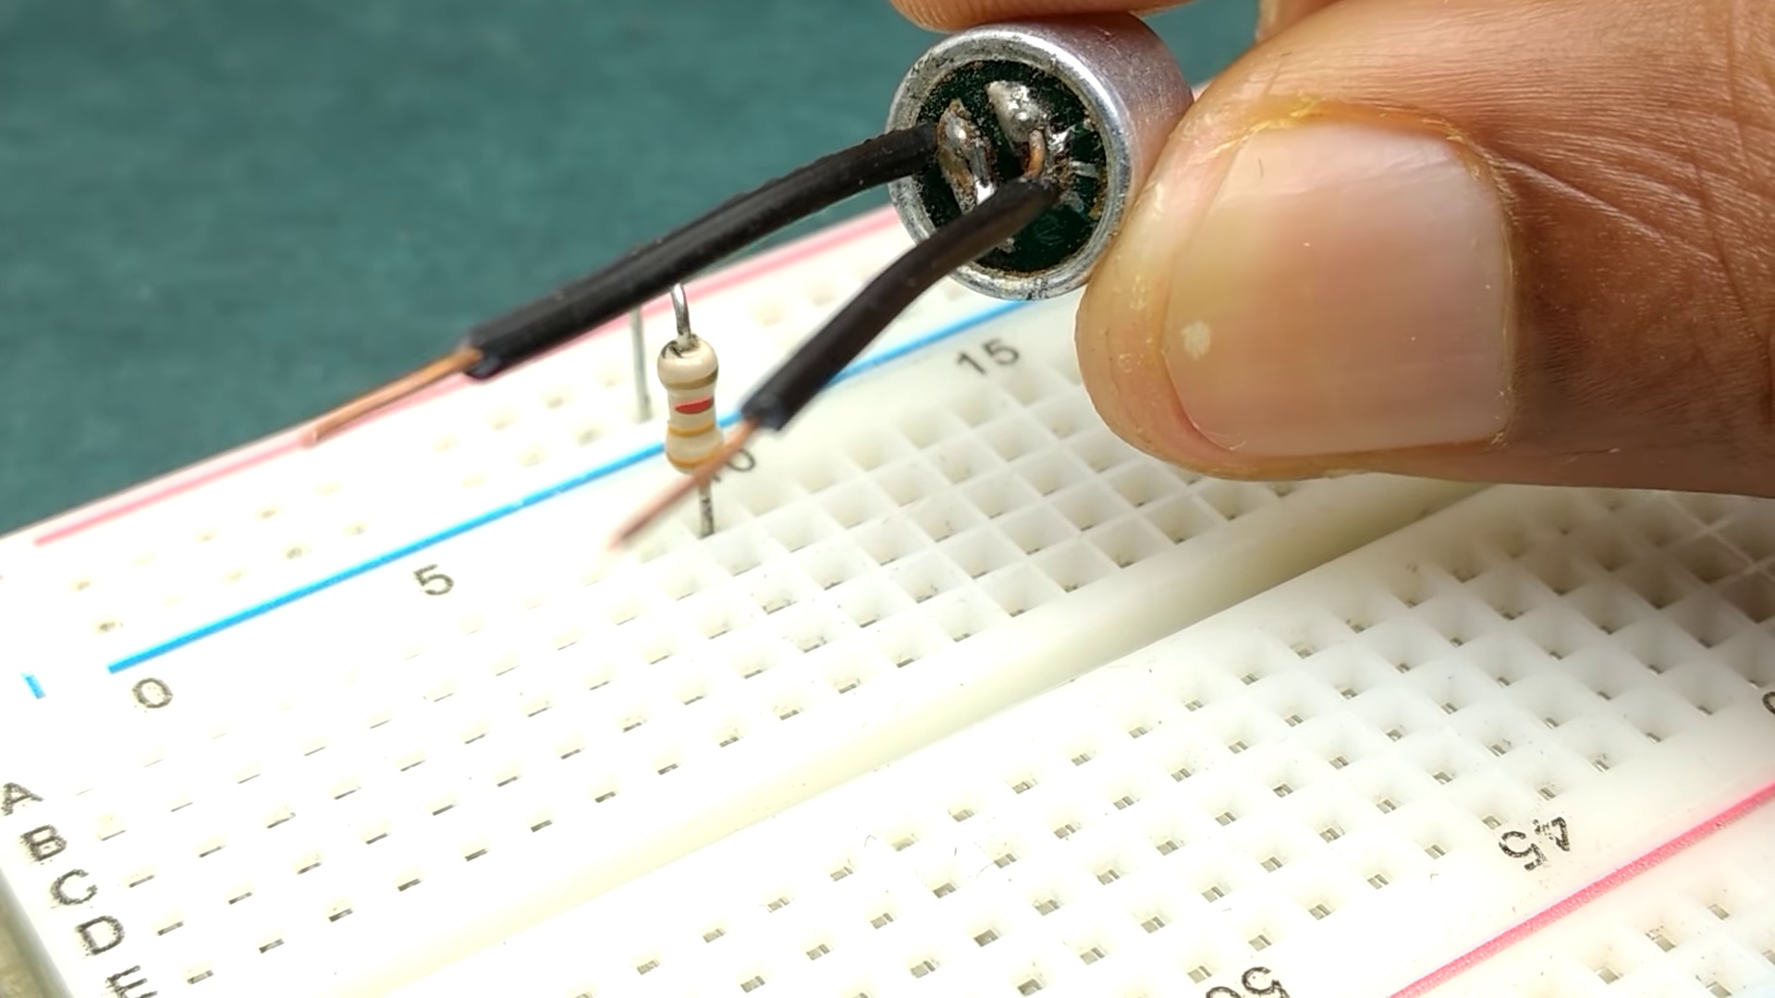 | 2:20  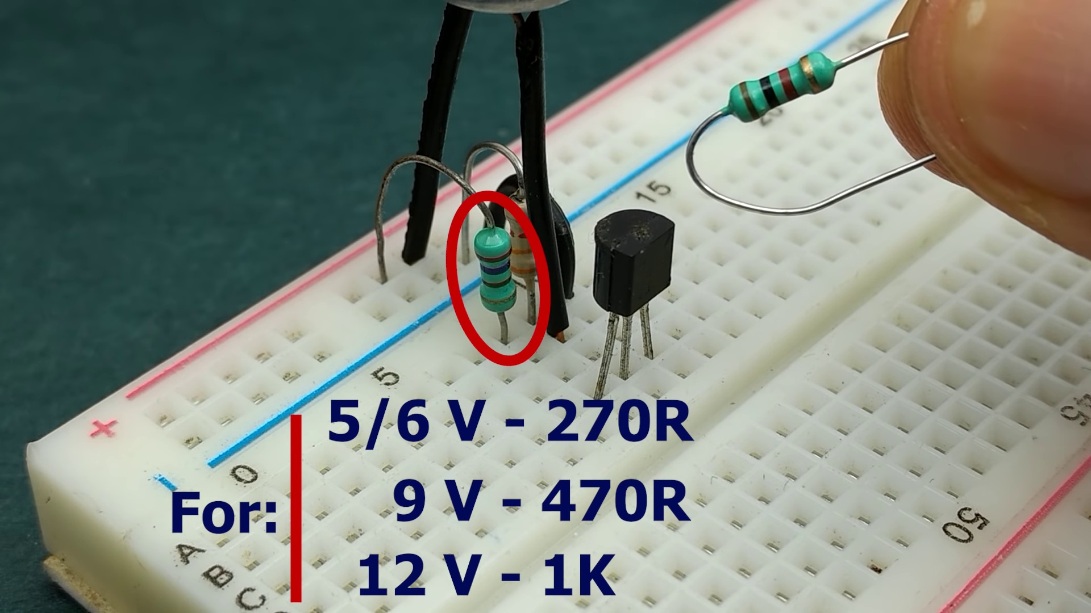 | 3:21  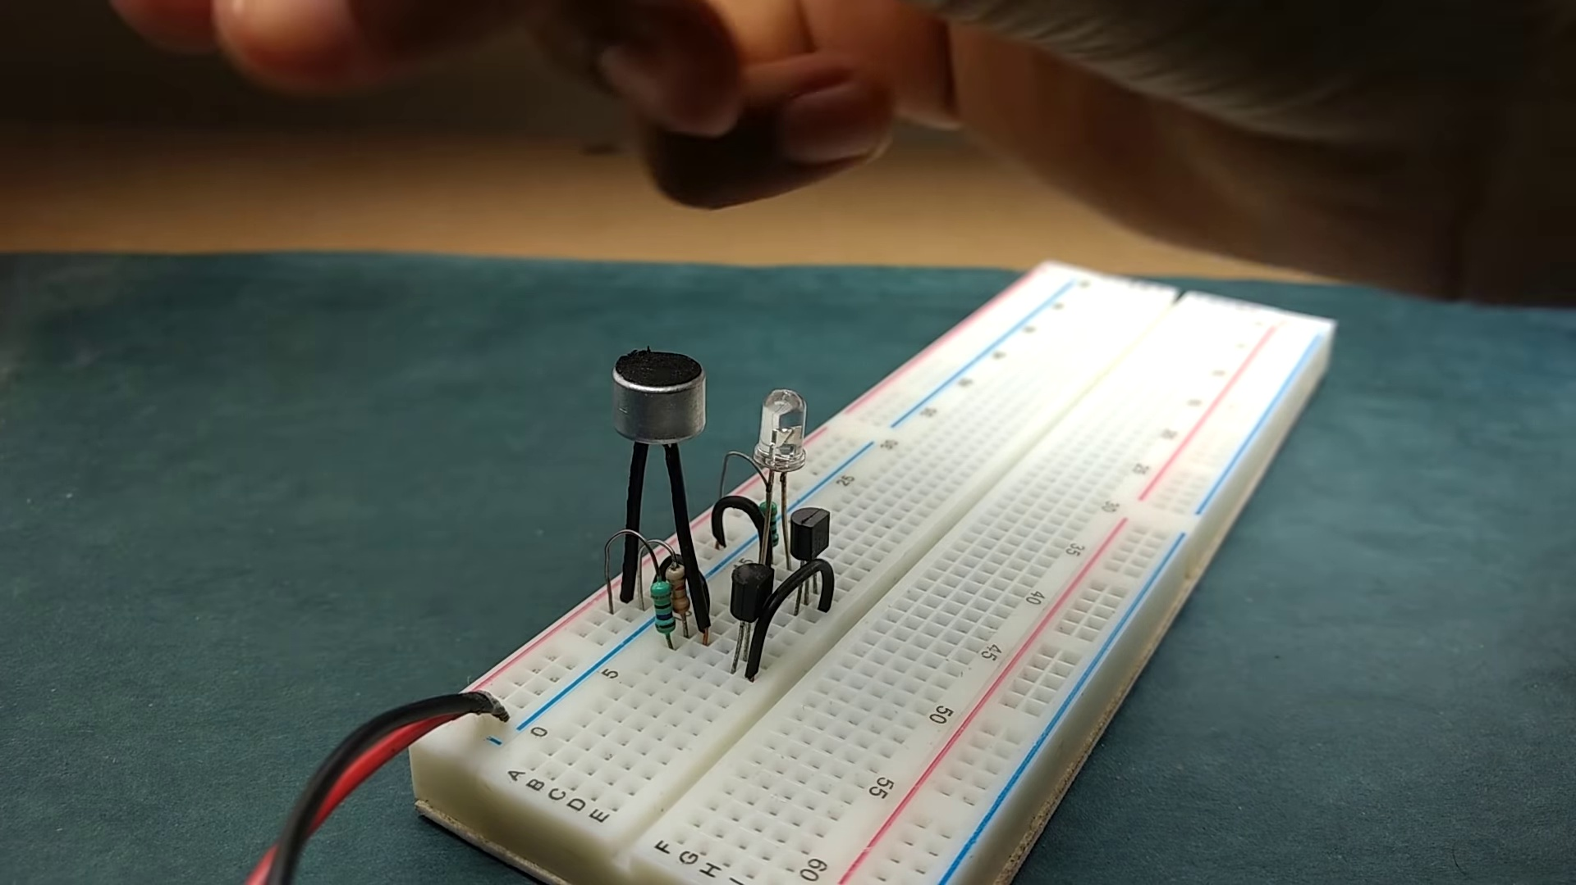 | 4:21  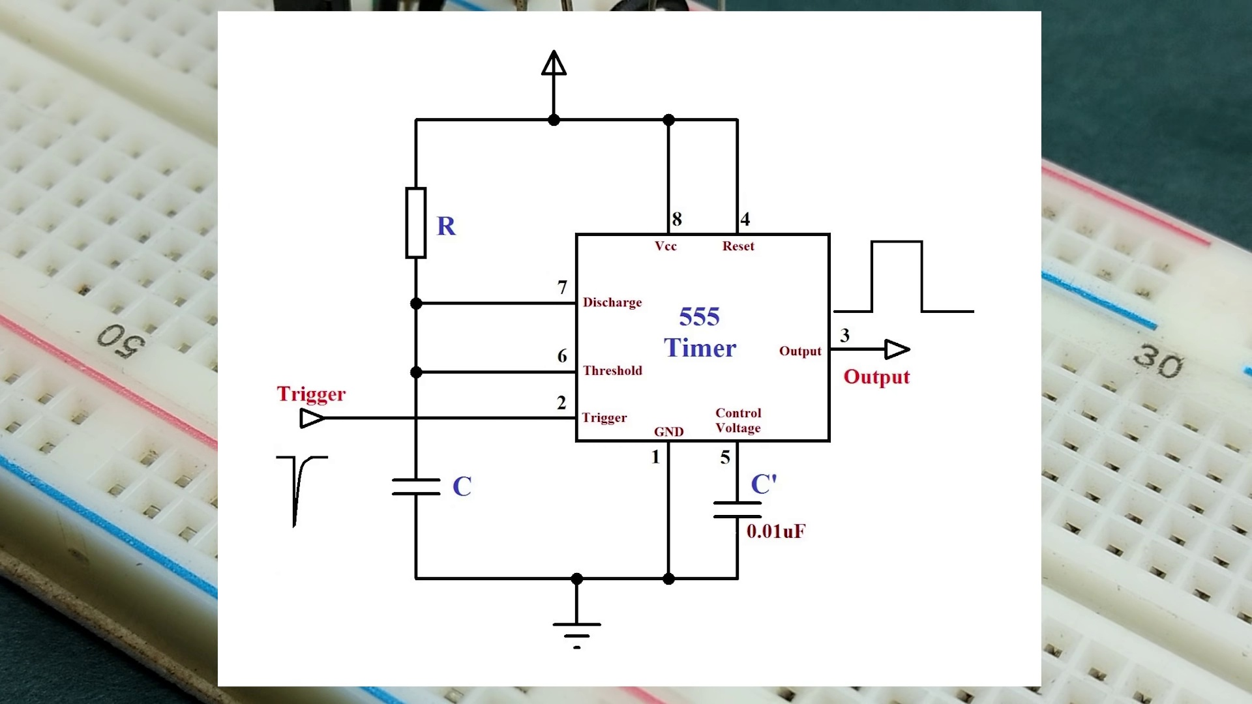 | 5:22  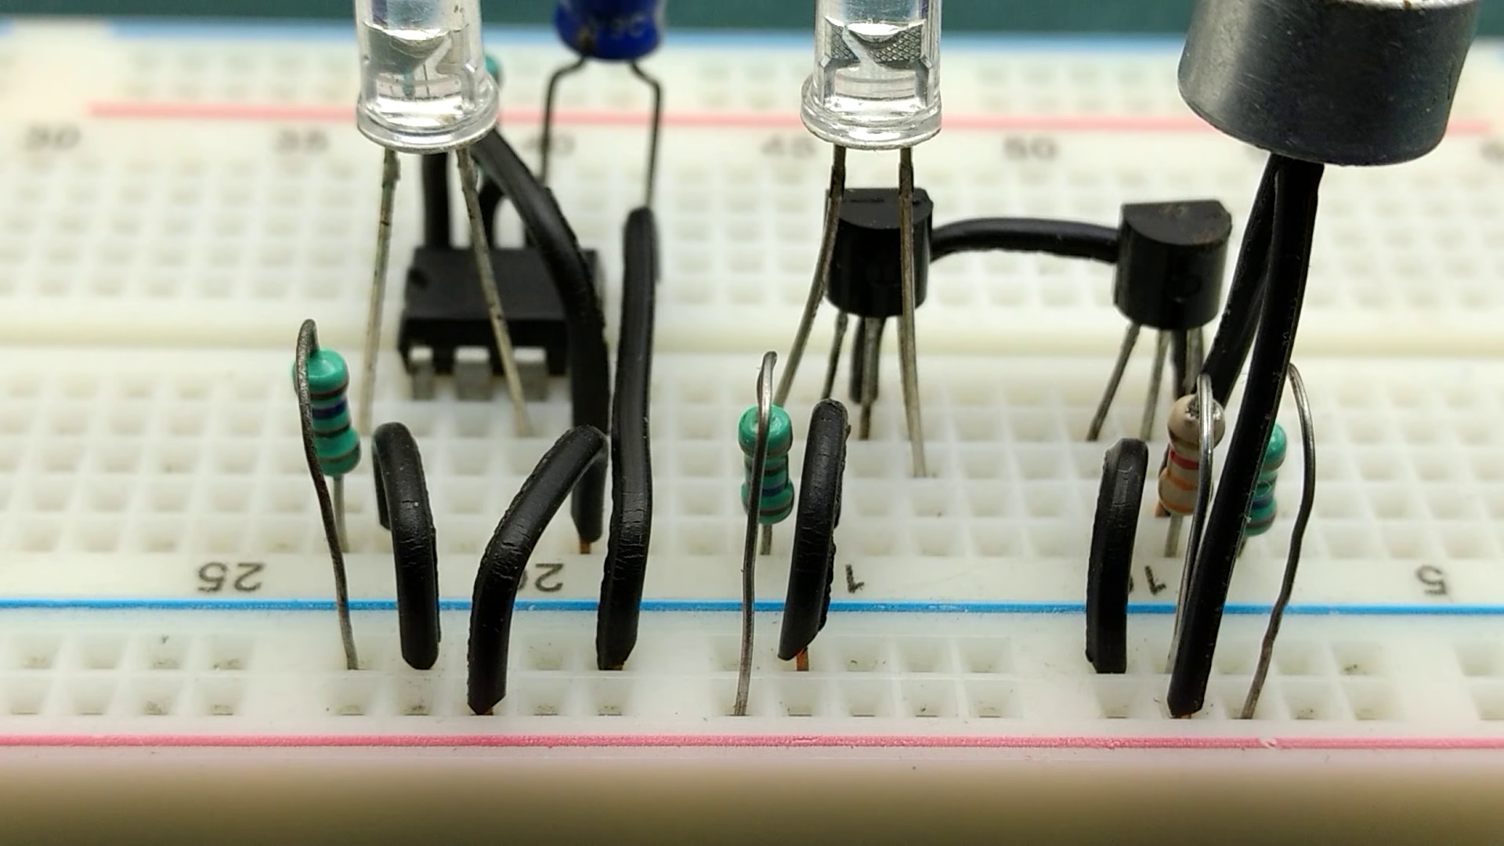

Transcript
[0:16] This circuit detected claps upto a distance of about 15 feet.
[0:30] And if you are near, the LED turns on even with finger snaps.
[0:37] You can also change the sensitivity so that it turns on the LED only when you clap near
[0:41] the circuit.
[0:49] We'll be using a condenser or elaterate microphone as the sensing element and its capacitance
[0:55] changes in response to ambient sound.
[0:58] So we'll start with the condenser microphone and a resistor in series so that the change
[1:03] in capacitance of the microphone is translated to change in voltage at this point.
[1:09] One terminal of the 3.3kohm resistor is connected to negative rail and the other terminal is
[1:15] connected to negative of condenser microphone which is the pin connected to outer casing.
[1:21] And the positive terminal of the microphone is connected to the positive rail.
[1:25] The voltage at this point is normally near positive voltage but it drops whenever there
[1:30] is a sudden loud sound around the microphone.
[1:32] We'll try to amplify this response by using BC547 and NPN transistor.
[1:39] So connect this point to the base of BC547 which is at pin 2 and the emitter which is at pin
[1:45] 3 should be connected to negative rail.
[1:49] Connect a resistor between positive rail and the collector of transistor.
[1:53] This resistor acts as a dummy load which keeps the collector base junction in reverse
[1:57] bias and that's required for making the transistor amplify the input signal.
[2:02] And because this resistance determines the voltage at the output, its value determines the sensitivity
[2:08] and is dependent on the supply voltage.
[2:10] So if you are using a 5 or 6 volts of power supply, use a 270 ohm resistor.
[2:15] 470 ohm for 9 volts and 1 kilo ohm for 12 volts of power supply.
[2:21] Increasing this resistance value reduces the sensitivity.
[2:25] Now this is not required but if you place an LED between the output and negative rail, the
[2:30] LED glows when you tap or blow air on the microphone.
[2:34] But the output is not high enough to detect claps.
[2:38] So we will use another NPN transistor and connect the output of the first transistor to the base
[2:43] of the second transistor BC547.
[2:46] Like you did for the first transistor, connect the emitter of the second transistor to negative
[2:50] rail and the collector to load.
[2:55] At this moment we will be using an LED as a load to test the circuit.
[2:59] So I have connected the collector of second transistor to negative terminal of the LED and
[3:03] the positive of LED connects to positive rail via a 270 ohm resistor.
[3:08] This resistor should be 470 ohms for 9 or 12 volts of power supply.
[3:13] Now turn on the power supply.
[3:14] Normally the LED should stay off and it should turn on when you clap or do finger snaps near
[3:19] the condenser microphone.
[3:22] Or even if you tap or blow air on it.
[3:25] Don't panic if the LED always stays on.
[3:28] All you need to do is increase the load resistance of the first transistor.
[3:33] For example if you are using a 270 ohm resistor, replace it with a higher one, say 330 ohm resistor
[3:38] and keep increasing until the LED just turns off.
[3:42] I advise you to purchase at least 3 resistors and start from the minimum.
[3:47] If the LED stays on, you will use the next resistor and so on.
[3:52] Coming back to the main circuit, even though it turns on LED with a clap, it stays on only
[3:57] for a moment and normally we would want to increase that duration.
[4:02] And obviously a 555 timer in mono stable mode is the best candidate for doing that.
[4:07] What this arrangement does is, whenever the trigger pin detects a drop in voltage, the
[4:13] 555 timer turns on the output for a duration determined by the value of capacitor and resistor.
[4:19] We will first build this mono stable circuit and then couple the trigger pin with the output
[4:24] of a primary circuit.
[4:27] So let's place the 555 timer IC on the breadboard.
[4:30] Connect the pins 6 and 7 and pins 4 and 8.
[4:34] Now connect a 100k ohm resistor between the pins 7 and 8.
[4:39] Next goes the capacitor with its positive terminal connected to pin 6 and its negative terminal
[4:44] connected to negative rail.
[4:47] You can choose the capacitor's value depending on the amount of time you require the LED to
[4:51] stay on.
[4:53] Now connect the output of 555 timer which is at pin 3 to the positive of the LED and the
[4:59] negative of the LED to negative rail via a 270 ohm resistor.
[5:03] Connect pin 1 to negative rail and pin 4 to positive rail.
[5:07] You can now test this mono stable circuit by applying 0V at the trigger pin.
[5:12] Now it's time to couple output of a primary circuit with the trigger pin of this mono stable circuit.
[5:22] As we don't require LED at the output of a primary circuit, I am removing it along with
[5:27] its series resistor.
[5:31] Place a 1k ohm resistor between the collector of second transistor and positive rail.
[5:37] This resistor acts as a load for the second transistor as well as keeps the output high when the
[5:42] transistor is not turned on.
[5:44] After this, use a 100nF capacitor to couple the output of the second transistor to the trigger
[5:50] pin of 555 timer ILC.
[5:53] The capacitor acts as a filter and prevents continuous loud sounds from triggering the monostable
[5:58] circuit.
[5:59] So normally the voltage at the trigger pin will be near to positive voltage and it drops whenever
[6:04] you clap which triggers the monostable circuit and so the LED should glow.
[6:09] Finally connect the power supply and here you go, the clap switch or sound triggered LED.
[6:18] Thanks for your time, do subscribe and have fun.

