Engagement Analysis: Gpm-TI21x9s

Section 0: A Man with Dark Hair and Glasses is Visible from the Chest Up, Possibly Speaking or Giving a Presentation on an Educational or Instructional Content
Time: 0:00 - 0:02

Summary
The image features a computer screen displaying a video on a YouTube-like platform. The man's upper body and part of his face are shown. He is possibly speaking or giving a presentation.

Representative Frames
0:00  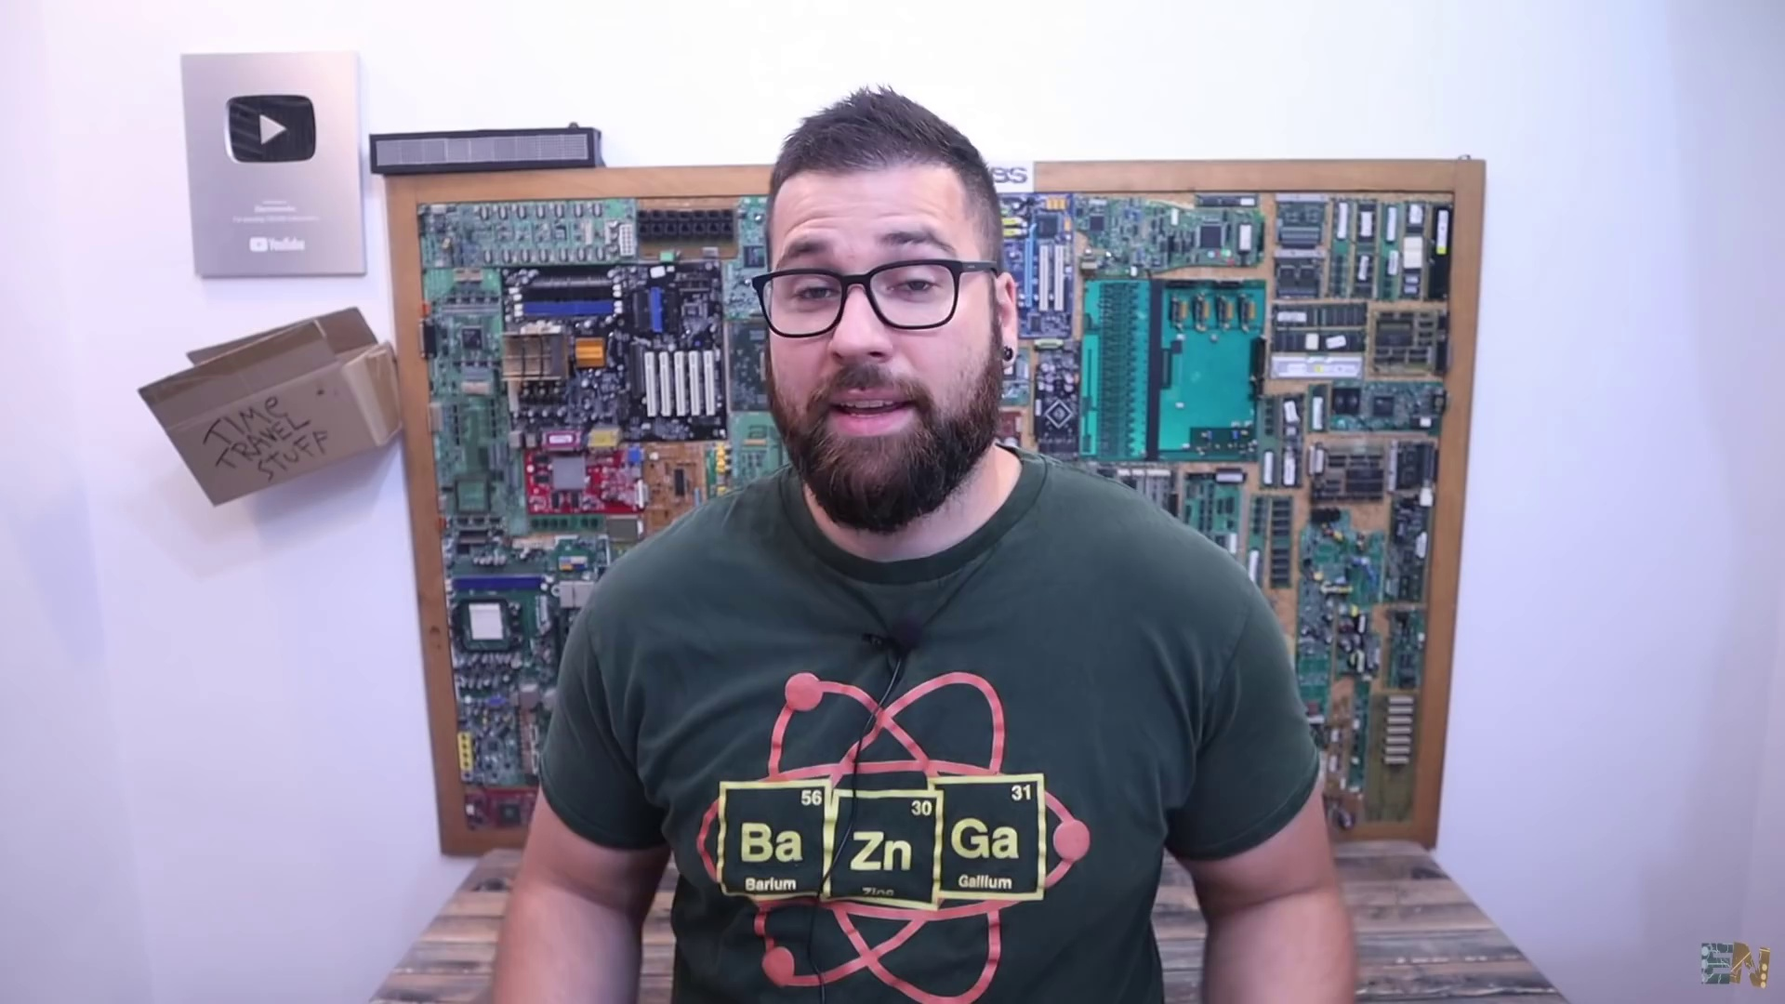 | 0:00   | 0:01   | 0:01   | 0:01  

Transcript
(No speech detected in this section)

Section 0: A Man with Glasses and a Beard Stands in Front of the Computer Screen, Holding a Black and White Camera
Time: 0:02 - 0:04

Summary
The man has his hands on his hips and wears a black shirt with a white graphic on the front. He is possibly involved in the tech or gaming industry.

Representative Frames
0:02   | 0:02   | 0:03   | 0:03   | 0:03  

Transcript
[0:00] Hey guys, so this is a balancing robot. And yes, yes, I know there are already a lot of balancing

Section 0: A Promotional Poster for YouTube Channel 'Ramon Marquez' with a Vibrant Green Background and White Text
Time: 0:04 - 0:06

Summary
The poster features the channel name, a picture of a man with glasses, and a list of other channels. It suggests an indoor setting, possibly a desk or workspace.

Representative Frames
0:04  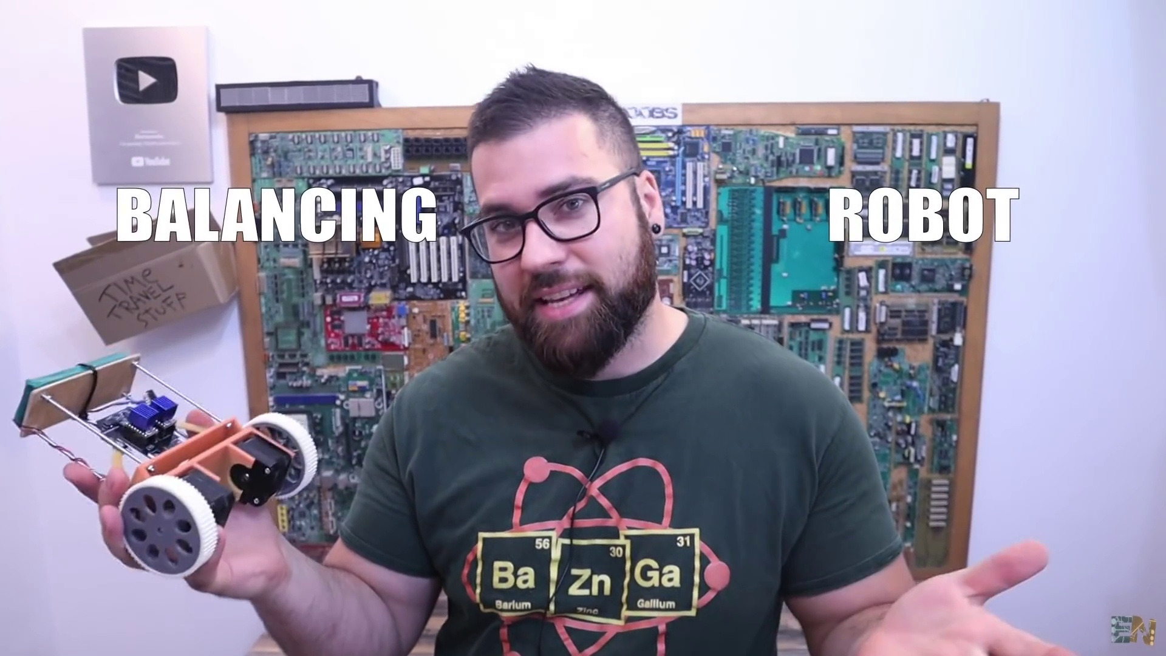 | 0:04   | 0:05   | 0:05   | 0:05  

Transcript
(No speech detected in this section)

Section 0: A Man Holding a White Smartphone in Front of a Green Background with a Pattern of Circuit Boards
Time: 0:06 - 17:40

Summary
The man's face is partially obscured by his phone. The background is striking green, featuring a subtle pattern of circuit boards scattered across it.

Representative Frames
3:01  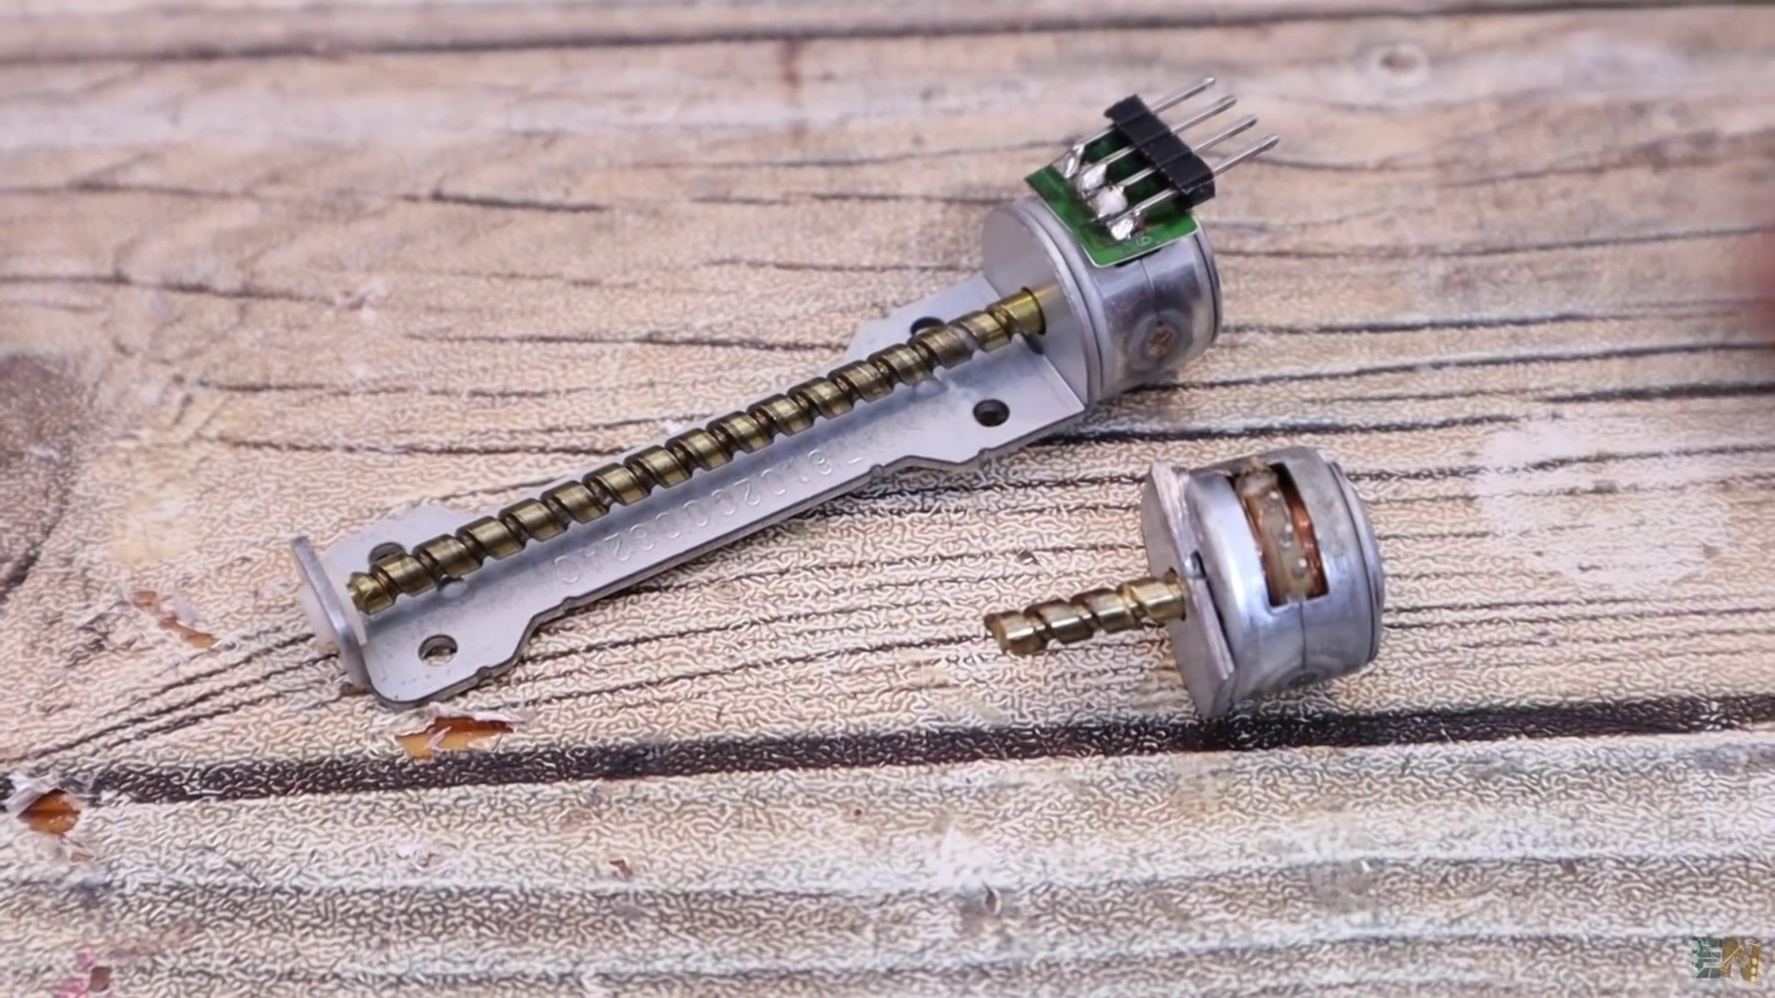 | 5:57  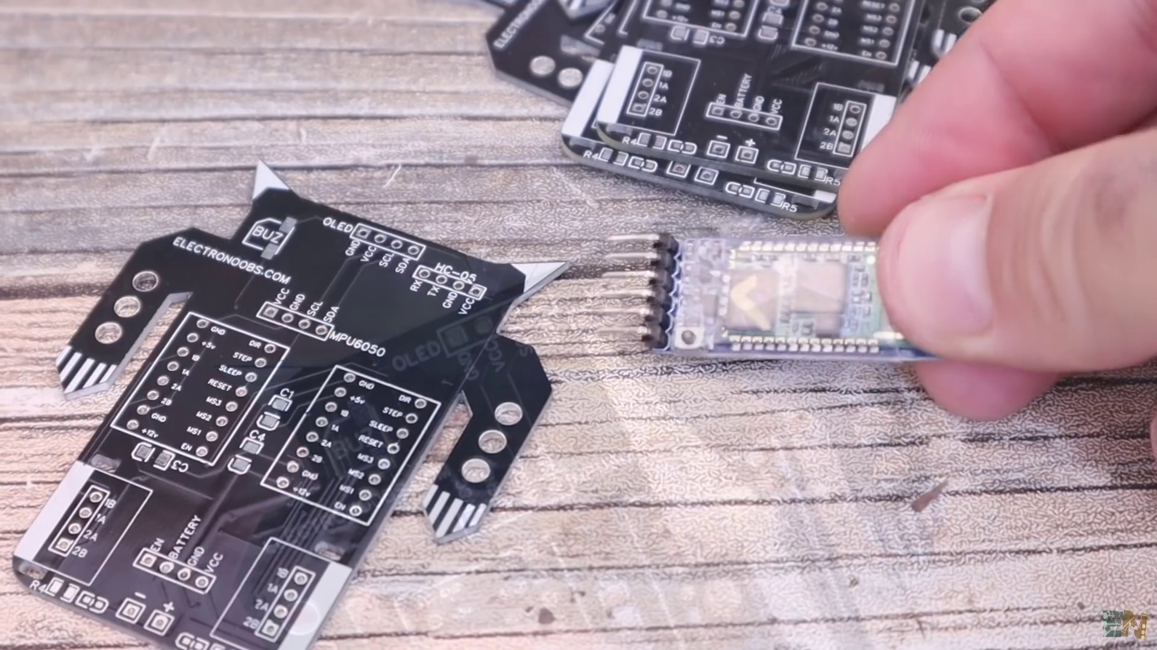 | 8:53  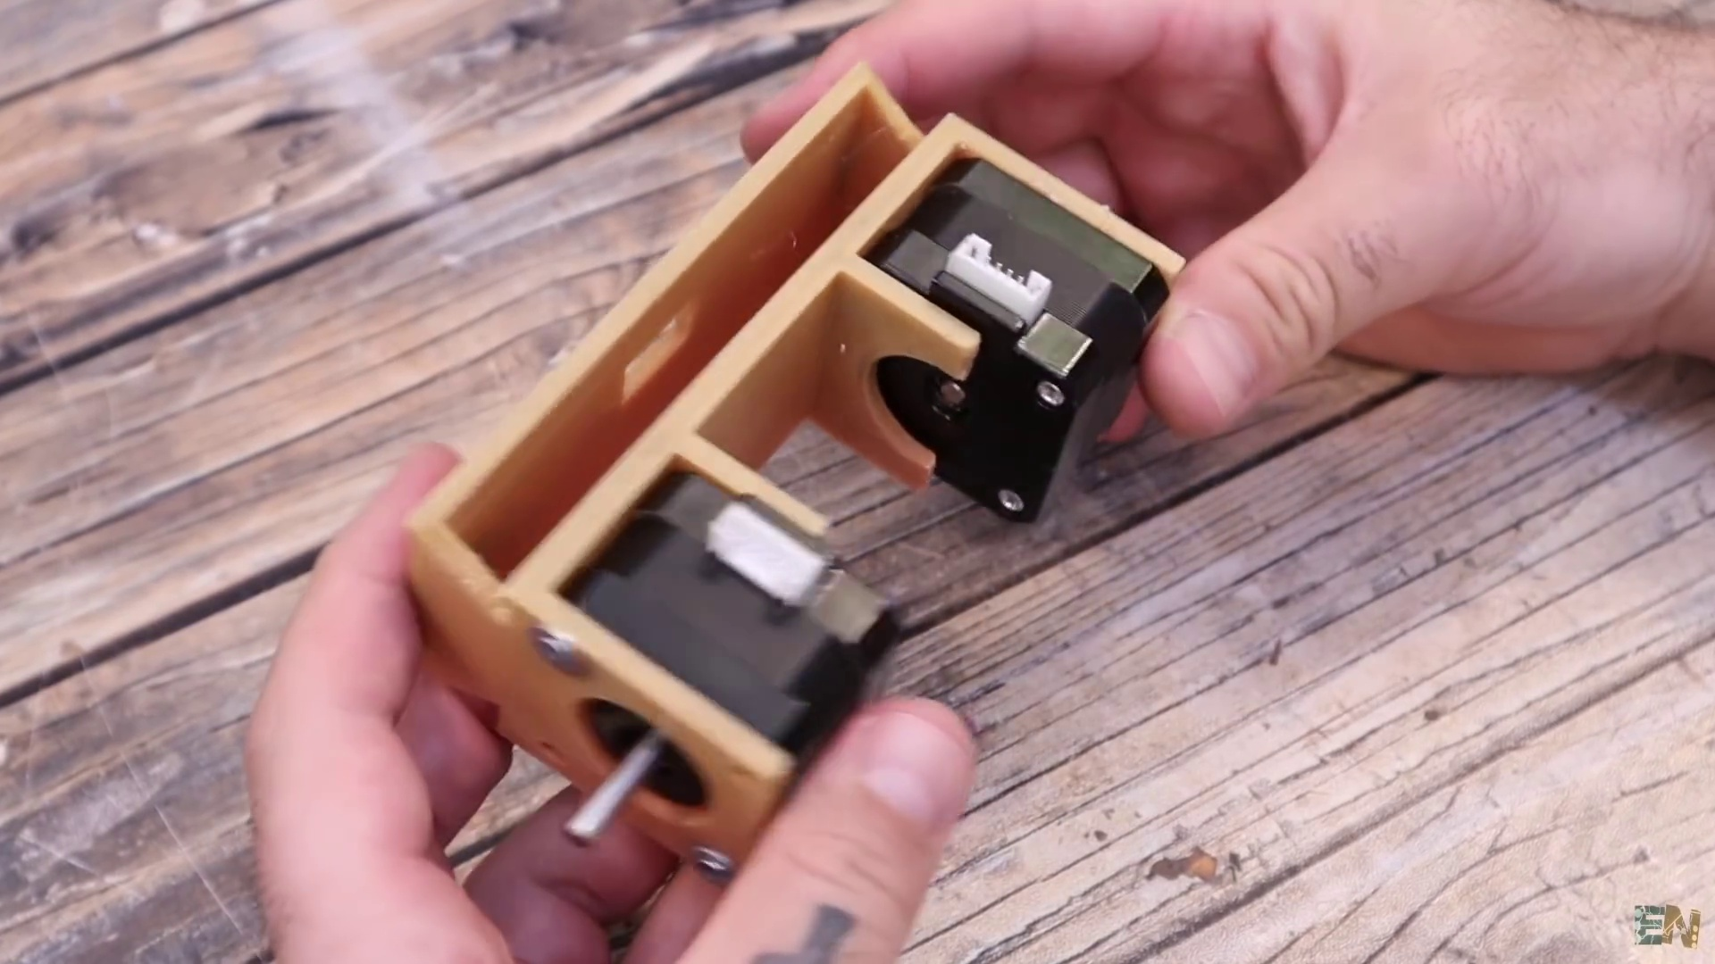 | 11:48  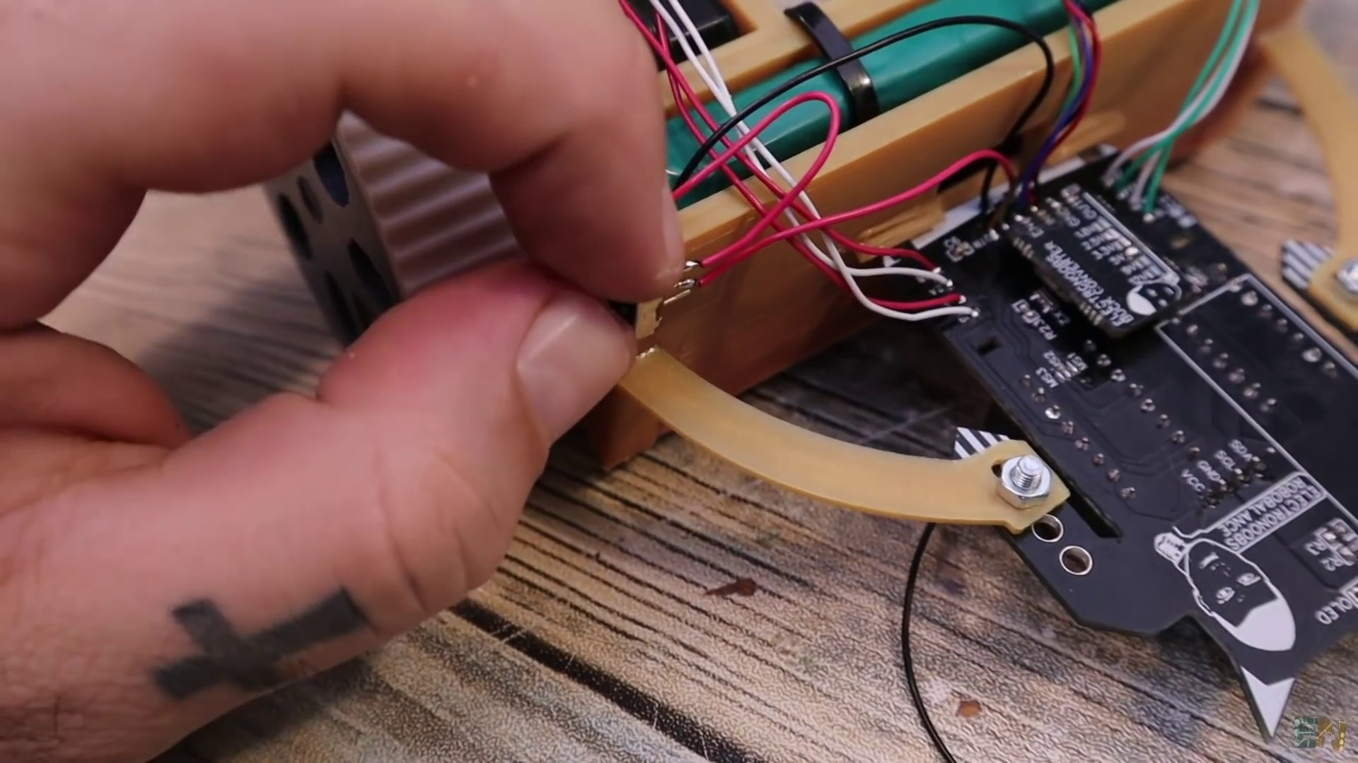 | 14:44  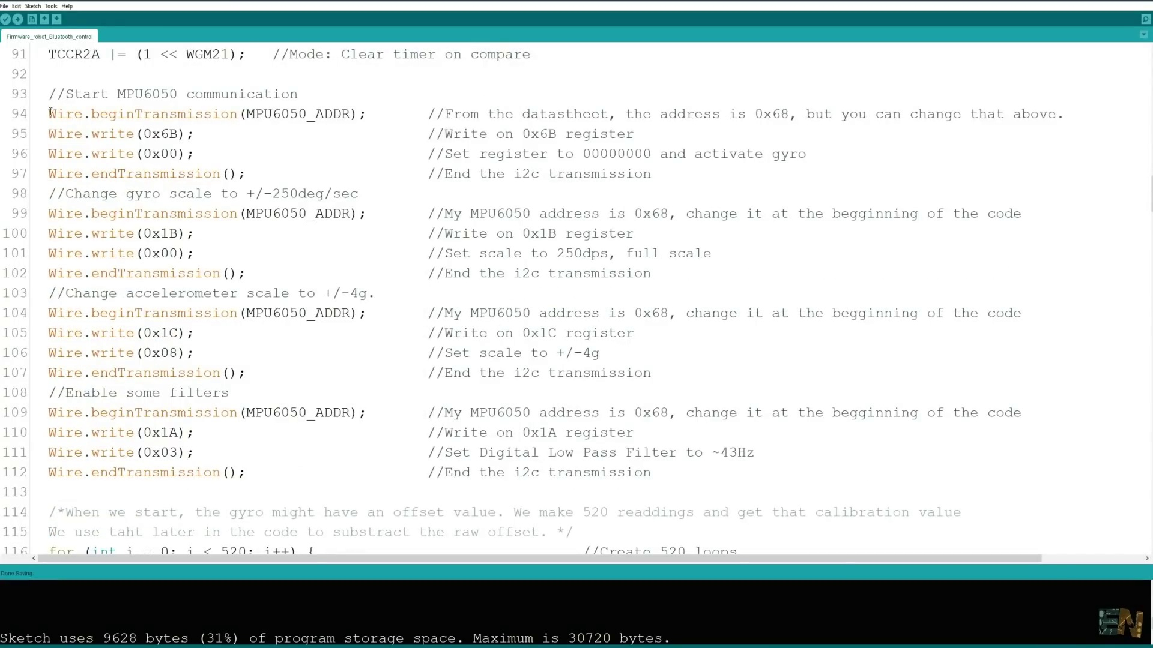

Transcript
[0:06] robots projects on the internet, but I wanted to make one for myself for a long time. And actually
[0:11] I wanted to make something special and make a mini balancing robot using this tiny PCB here.
[0:17] But I kind of failed with the stepper motors and I will explain that problem in the video,
[0:21] so stay tuned for that. So what I've done in the end is to use the same PCB that I've prepared for
[0:26] the mini balancing robot, design a small 3D printed body and use bigger stepper motors and like that
[0:32] be able to finish my idea. For now, this robot is pretty much stable even if you push it around.
[0:38] And I had a very hard time getting the good PID values so it would be more and more stable,
[0:42] but I'm not yet 100% happy with these results. Anyway, the robot should also get information
[0:48] from a homemade remote with a Bluetooth connection and like that we could move around. But internally,
[0:53] it should also get information from this IMU module here and calculate a PID value for the angle so it
[0:59] will never fall and always try to stay horizontal. That's pretty interesting and I think you will
[1:03] learn a lot with this video because I will explain step by step the circuit and also the code. So what
[1:09] do you think? Will this work? Stay tuned to find out. So guys, let's get started.
[1:23] These PCBs were manufactured by PCBWay and the finish quality is very good, especially with these gold
[1:34] plated pads. If you want to finish your product faster, you could also ask PCBWay to make a panelized
[1:41] order where you receive multiple PCBs on a single panel. Together with this, you can also order the
[1:47] SMD stencil from PCBWay and use it to add solder paste and solder all the components at once and by
[1:54] that you save time and effort. All the orders are high quality and you could select a lot of settings,
[2:00] such as the thickness, flexible PCBs, the color of the solder mask, the amount of layers, the material,
[2:07] the surface finish and more. So upload the Gerber files directly on PCBWay.com and make the order in just a couple of minutes.
[2:15] What's up my friends, welcome back. This here is the PCB that I've made for this project.
[2:23] And my plan was to use this PCB with this kind of stepper motors. I have this from some old DVD
[2:30] writers and I thought it would work great connected to this PCB. It's very easy to control them with some
[2:37] stepper drivers so that's not the problem. The problem was mechanical. You see these motors have
[2:44] the shaft connected to the magnets inside. This shaft is supported on both sides, here and here.
[2:53] So if I want to add a wheel to this shaft, I had to cut it smaller and in that way we have support only
[2:59] on one side. That's the problem. Without support on both sides, this shaft will move around and
[3:06] automatically break all the small coils and magnets inside. I've also tried gluing a bearing at the
[3:12] output but without success. Inside the shaft is kept in the center by a metal ball and once you move
[3:20] that, you can say goodbye to the whole motor. I've ordered these motors here which are smaller,
[3:27] but this time they are too small. They don't have enough torque and guess what? Their shaft is also
[3:33] weak and it will break very easy just as the other ones. So I had no other option but to use the NEMA 17
[3:39] motors. These are one of the smaller NEMA 17 steppers. On the side of that PCB I've also designed this support.
[3:50] And like this we can attach the motors below. The battery in the middle and the PCB will be kept
[3:55] in place with some plastic supports. So this is not a mini robot anymore but anyway, let's make this
[4:03] robot and you will definitely learn something new. So let's see what we have on the PCB.
[4:09] If you want the same PCB, you can get the Gerber files from below and go to PCBway.com. You click the
[4:15] Code Now button and select your settings such as the thickness, the amount of PCBs, the materials and the
[4:21] solar mask color. In my case I've selected the black one but you can select any other one as for example
[4:28] purple or the matte black which look amazing. On the next page you can upload the Gerber files
[4:35] and order the PCBs. I've received my ports to Spain in around 8 days so let's check them out.
[4:44] On the front part we have some spaces for two stepper motor drivers.
[4:47] On the front part you can use the basic A4988 drivers or even better you can use the TMC2225 drivers
[4:56] for better and silent movement. Below that we have these 4 pins which are used to connect a
[5:03] buck converter for 5V. Because I want to use a 2S or maybe a 3S battery and because the digital
[5:10] part will work at 5V, I will connect a buck converter here to these pins and have that voltage.
[5:18] On the bottom side we have the output for the 2 stepper motors. This is the place where I wanted
[5:23] to solder those tiny motors but unfortunately they break too easy. If you manage to use them,
[5:29] just solder the motor and use a zip tie like this one and keep them in place. It would be a lot cooler
[5:35] to have a mini robot but anyway. What more do we have on the PCB? These 4 pins here are for the IMU module
[5:43] and I will use the MPU 6050 as always. We use this module to measure the angle. On the top part we
[5:52] have 4 more pins for the Bluetooth module and I will use the HC05. On side of that we have these 4 more
[5:59] pins for the I2C for an OLED display. I might add this as well so we can draw faces for the robot and give it
[6:06] more personality. I've also placed an SMD buzzer here for some notifications. On the bottom of the
[6:14] PCB we have some LEDs to make the robot look cooler and also the input from the battery.
[6:21] So now let's take a look on the back of the PCB. Actually the Bluetooth module will go here
[6:27] because the other side will be full of components. Below here we have the Atmega 328 microcontroller
[6:35] and the needed components in order to work. It's very difficult to see but we have 3 pairs of pads
[6:41] for each stepper driver and by soldering this here we can select the microstepping amount.
[6:47] That's it for the PCB, that's all we need. The PCB, the stepper drivers as well, the back converter module
[6:55] for 5V, the HC05 Bluetooth module, the NPU6050 sensor and two NEMA17 stepper motors.
[7:05] If you want you can also add an OLED screen like this one. As for the tiny components we need the
[7:11] buzzer, also some SMD capacitors, some LEDs and resistors and yet mega cheap together with the 60MHz
[7:18] resonator. As for the battery, you can use a 3S LiPo battery like this one. But in my case,
[7:25] because I have a lot of batteries from cell phones, I want to connect 2 of these iPhone batteries in
[7:30] series and get 12V. These are very flat and will occupy less space. As for the body, just download
[7:39] the STL files from below and print them using PLA material. I've used a 0.2 mm layer height and a 0.4 mm
[7:46] nozzle with 3 perimeters and 20% infill. As for the wheels, the inner part is made out of PLA but the
[7:54] exterior is made out of flexible material and this must be printed at very low speeds. Like that we
[8:00] can have more grip. The wheels have this hole so we can pass a screwdriver and tie the screw here.
[8:08] So we have to add a screw nut inside and then insert the shaft on the motor and tie the screw.
[8:14] And like that it will stay in place. Once we tie the screw, we can add this rubber part on top.
[8:22] So these are all the parts that we need for this robot, more or less. You have the full part
[8:26] list below on electronoops.com. So let's assemble it. It should end up something like this, like this
[8:32] 3D design example. So I get the main 3D printed part and add the stepper motors. You just have to
[8:40] apply a little bit of force and it will snap into place. Then we add some screws and washers and tie the
[8:47] motor. Also make sure that the motor connector is on the back side of the robot. Now get the plastic
[8:56] wheels and add a small nut inside of this hole. We also add a screw. Now we can add a wheel to each
[9:04] motor. We tie that screw so it will stay tight on the motor shaft. Now this part was printed in flexible
[9:13] filament. So we can now add this part on top of the wheels. First I wanted the battery to go here above
[9:21] the motors but you will see later that I will change the position. Now let's assemble the PCB so download
[9:27] this schematic from below and have it in front of you. I first solder these SMD capacitors.
[9:36] And then we add some female pins for the drivers so we can remove it when we want.
[9:42] Now I get one of these small buck converters and solder the 5V connection on the back.
[9:46] I also connect it to 12V and test if the output is around 5V. Now we can solder this on the PCB but
[9:54] we will do that later. Now solder that buzzer here on top and the LEDs on the bottom of the PCB.
[10:03] On the other side we can solder the Atmega microcontroller, the crystal resonator and the
[10:08] small resistors and capacitors. Now at this point I connect my FTDI programmer and test the connection to
[10:15] make sure it works. If the chip works, on the front side I solder the MPU6050. On the back I also add
[10:25] some female pins for the Bluetooth module. Now that the Atmega chip is in place and it works, I can now
[10:32] solder the buck converter on top so we can supply the PCB with the battery. I might also add the OLED screen
[10:39] later when everything works. So please check this full schematic below for all the connection if you
[10:45] are trying to make the same project. Also remember to solder together the pads for the MS2 on the back
[10:51] in order to enable the quarter micro stepping. At this point you can download the code from below
[10:57] and upload it to the PCB using the FTDI programmer connected to the wired port. Now we have to connect
[11:04] the PCB to the motors and the battery. For the battery I've soldered together in series three of these
[11:10] iPhone batteries. Like that I will have around 12V and I can also have a very thin battery.
[11:18] Now get this plastic printed leg and screw it on one arm of the PCB. Do the same with the other side
[11:24] but don't tie the screws yet. Now place the PCB over the main body and we glue in place these small
[11:31] plastic arms. Now we can tie the screws and the PCB will be fixed in place. So solder the wires from
[11:39] the stepper motors to the PCB on these pins here. Between the battery and the PCB I add a switch so
[11:46] we can turn the robot on and off. But guys, before we go over the code, I have to say that with this
[11:52] shape, this robot won't be stable. Why is that? Well, because this type of balancing robot will need some
[11:59] weight on the upper part in order to have some inertia. But at this moment all the weight is on
[12:04] the bottom side of the robot as you can see and is very difficult to balance.
[12:12] This robot will work exactly the same as trying to balance a stick in your hand.
[12:17] If the stick is too short, it will be impossible.
[12:20] When the stick is large enough, you can move your hand in the same direction as the tilt and you can
[12:27] stabilize it. That's why I've placed some threaded rods on top of the robot. On top I have a plywood
[12:35] part and here I can place the battery. Like this we can have more inertia when moving. This is a crucial
[12:42] part for this project. With the same code before, I now got better results but as you can see the robot is
[12:49] still wobbling around. That's because we can still have to adjust the PID values in the code.
[12:55] And this was the longest part of this project. I had to manually go and change the PID values
[13:01] till I got better and better but even so I am not quite happy with the final results.
[13:06] So for example, if you start only with the P values and the I and the D are zero, you get this kind of
[13:12] oscillations where the wheels are rotating in the same direction as the tilt of the robot according to the
[13:17] angle. But then we add some D values and this will react to the speed of changing of the angle and it
[13:26] will try to stop the oscillations. But that's not enough, especially when the error is very small.
[13:33] So finally, to fine adjust the position, we can add the I and that will increase and decrease slowly
[13:39] when the error is very small. So after more than 30 tries, I got more or less good results and the
[13:45] robot is quite stable but I am not entirely happy yet. So at this point I've decided to make a second
[13:51] part for this project where I will show you how to tune the PID values. So till then I will try to get
[13:57] better results and in that video I will explore the mathematics and physics behind this kind of project,
[14:02] including the IMU position, the center of gravity, the inertia of the robot, the motor speed and the PID algorithm.
[14:14] Before I end this video, let's take a look at the code. These here are the variables that you could
[14:19] change in order to tune the PID controller. This is the same that we had for the brushless PID controller
[14:25] or the ping pong ball controller but this time we use stepper motors. To create the step pulses applied
[14:32] to the stepper drivers, we use a timer, timer 2 in this case. So by setting these registers, we can
[14:39] make that timer to click every 20 microseconds. Next, with these lines here in the code, we read the raw data
[14:46] from the gyro and the accelerometer. To overcome the gyro offset, we make around 500 reads from the IMU module
[14:53] and we save this data as an offset and subtract that later in the main loop. Then we calculate the
[14:59] angle each loop, which is said to be around 4000 microseconds. Using this gyro angle variable,
[15:05] we can calculate the PID values. As always, we first find the PID error which is the difference between
[15:11] the real angle of the robot and the desired angle, which in this case should be zero so the robot will
[15:16] stay horizontal. Finally, inside of the timer routine, depending on the PID output, we calculate the
[15:23] speed of the motors by creating more or less, faster or slower pulses applied to the stepper motors.
[15:30] And to make the code faster, instead of using a digital write function, we use register control,
[15:35] where this line here for example is the same as setting the digital pin D3 to high.
[15:40] And for more about this, you can take a look at my Arduino register control video and the links are
[15:45] below. So using this code, the robot should be able to stay horizontal. When I lift the code,
[15:52] it will detect the angle and starts the PID code. When it detects a tilt on the front side,
[15:58] it will accelerate the wheels so it will get horizontal once again and do the same process
[16:02] backwards if the tilt is on the other side. If you do this fast enough with the PID control,
[16:08] you get a stable horizontal robot. So this is not yet perfect. I will make it better in the second
[16:14] part of this project. Without a remote, we can control it. I will also add that in the second part.
[16:22] I want to use this Wii console nunchuck and get the movement from this joystick and we can send the
[16:27] data using a Bluetooth module. This actually has an accuracy communication so I might use that to read
[16:34] the values from the joystick. The schematic would be something like this with the battery and also a
[16:39] switch, the Arduino, the joystick analog outputs and the Bluetooth module. Stay tuned for more.
[16:47] So guys, that's how a balanced robot works and how you can make one. You have my PCB below for download,
[16:53] you also have the schematic for the robot and controller, the part list and the codes and everything
[16:58] is below in the description. If you have learned something new, consider giving me a like or comment
[17:03] below. Thanks again and see you later guys. Hey, so one more video that ends, I hope that you like it.
[17:09] Okay, so listen, if you want to buy my merch, my t-shirts, you have the links below for my shop
[17:14] and I promise that I will make more designs. Also, maybe you would comment below which one you like
[17:18] more and what more designs you would like to see because in that way I could start designing them
[17:22] and post my new t-shirts. So thank you for all the support and I'll see you in the next video.

