Engagement Analysis: GqCn94Ksdbo

Section 0: A group of people working on a project
Time: 0:00 - 0:03

Summary
The image shows a list of names and associated positions or roles, presented in a grid-like pattern on a black background. The names are written in a block font, with titles in a smaller, lighter grey font.

Representative Frames
0:00  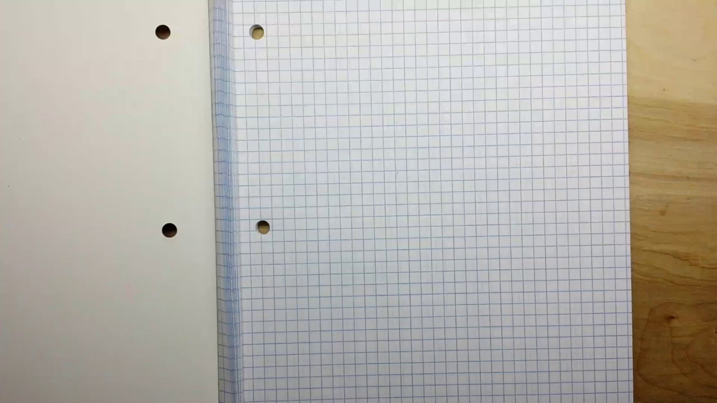 | 0:01   | 0:01   | 0:02   | 0:02  

Transcript
[0:00] Hey, what's happening guys?

Section 0: A presentation slide thanking patrons
Time: 0:03 - 0:08

Summary
The image is a combination of a screenshot from a presentation slide and a formal black and white photograph. The presentation slide has a dark background with yellow text, featuring a headline that reads "A BIG THANK YOU TO MY PATRONS."

Representative Frames
0:03  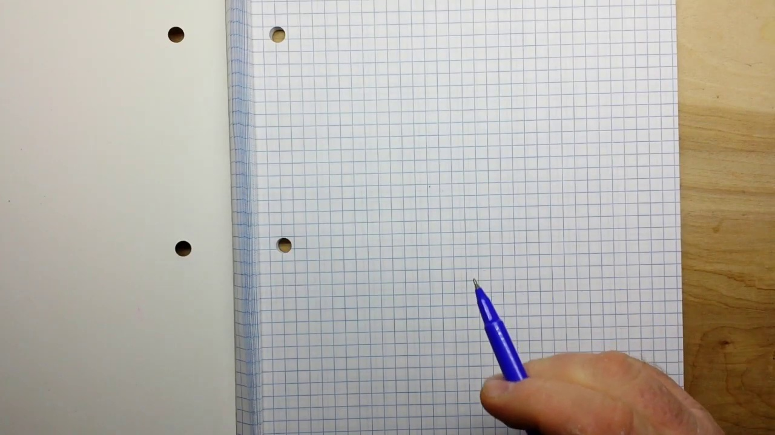 | 0:04   | 0:05   | 0:06   | 0:07  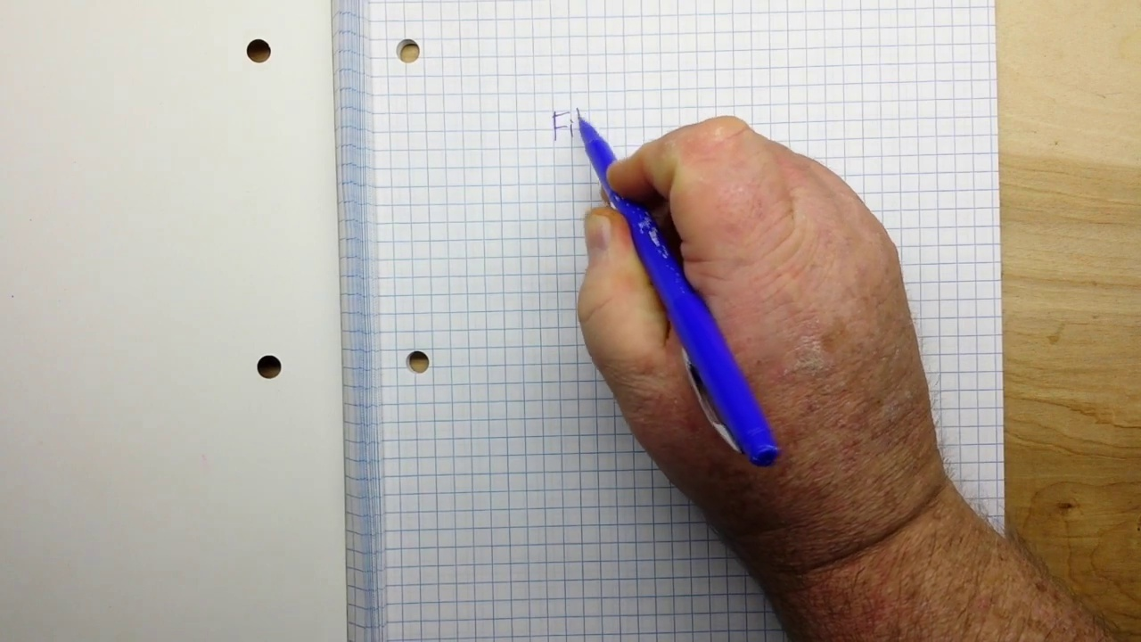

Transcript
[0:02] We're going to start another new series today, and this time it will be on filters.

Section 0: A poster thanking patrons
Time: 0:08 - 0:11

Summary
The image is a black and white poster with a large text that reads "A big thank you to your patrons" at the top, set against a white background. The central focus of the image is the title, which is in bold, yellow font.

Representative Frames
0:08   | 0:09   | 0:09   | 0:10   | 0:10  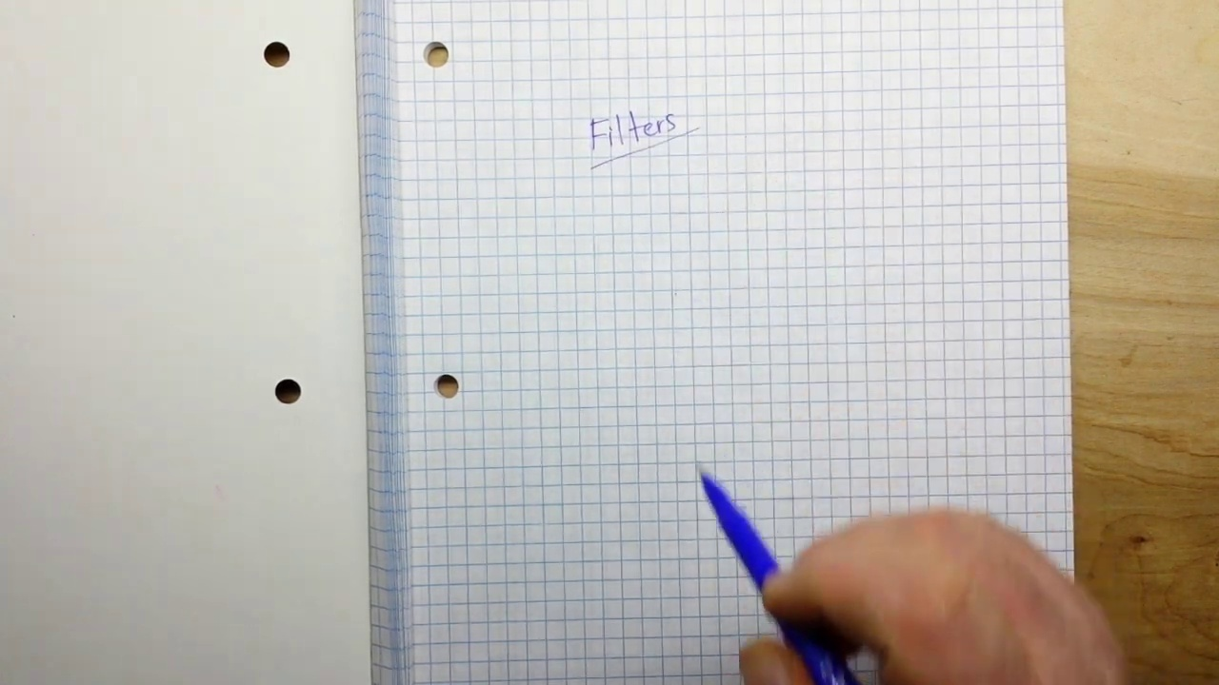

Transcript
(No speech detected in this section)

Section 0: People working on a project
Time: 0:11 - 10:02

Summary
The image shows a list of names and associated positions or roles, presented in a grid-like pattern on a black background. The names are written in a block font, with titles in a smaller, lighter grey font.

Representative Frames
1:49  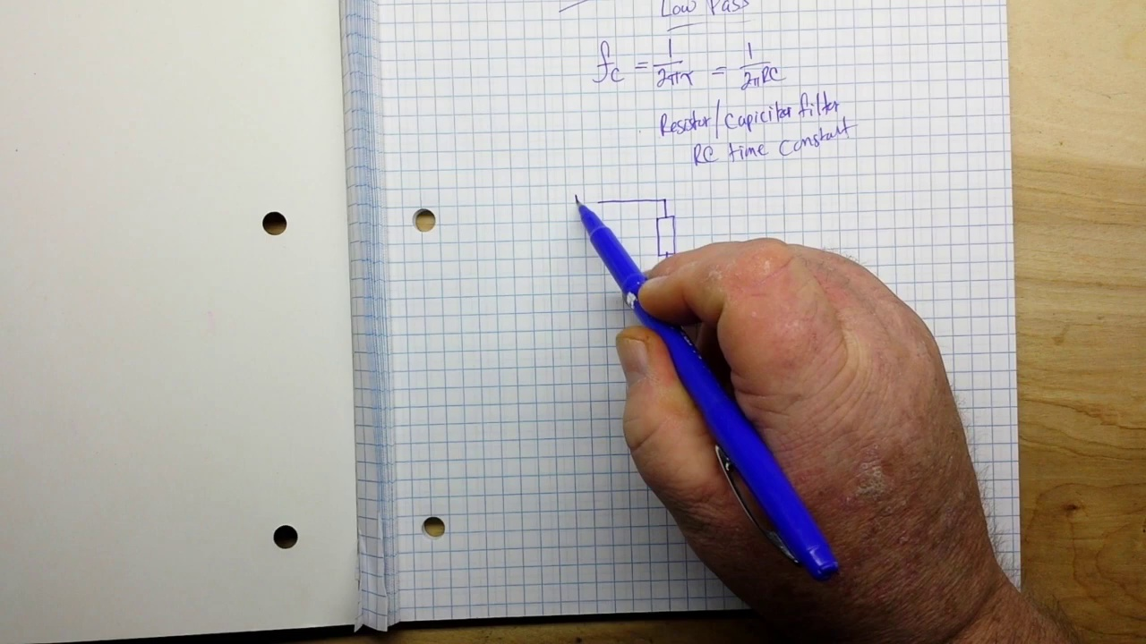 | 3:28  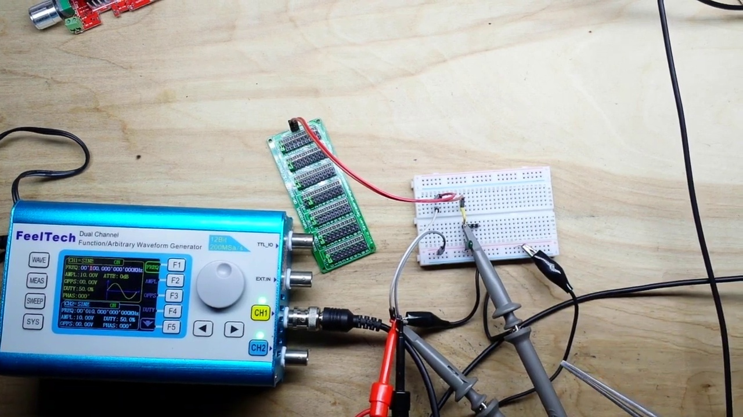 | 5:06  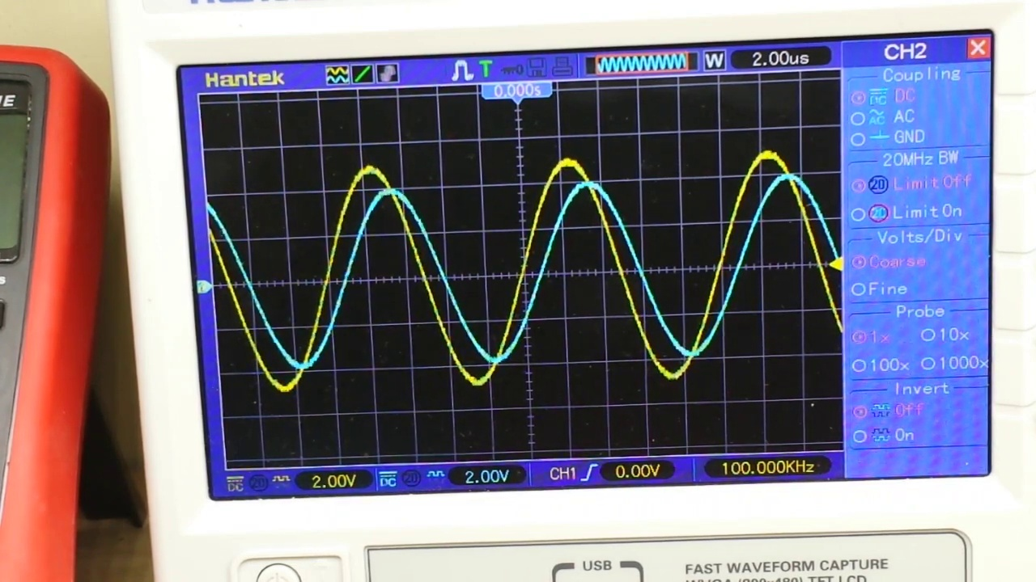 | 6:45  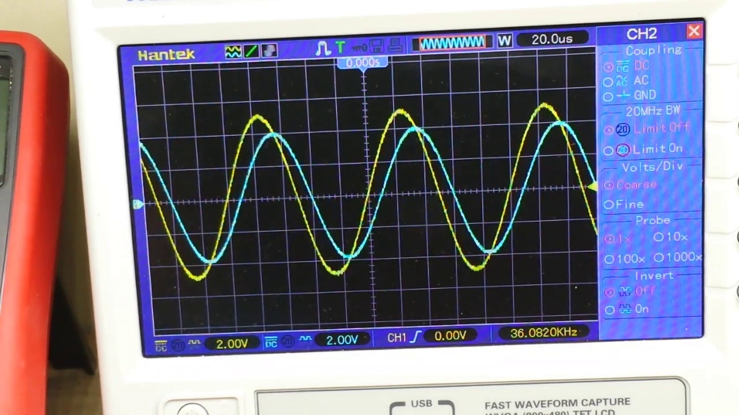 | 8:23  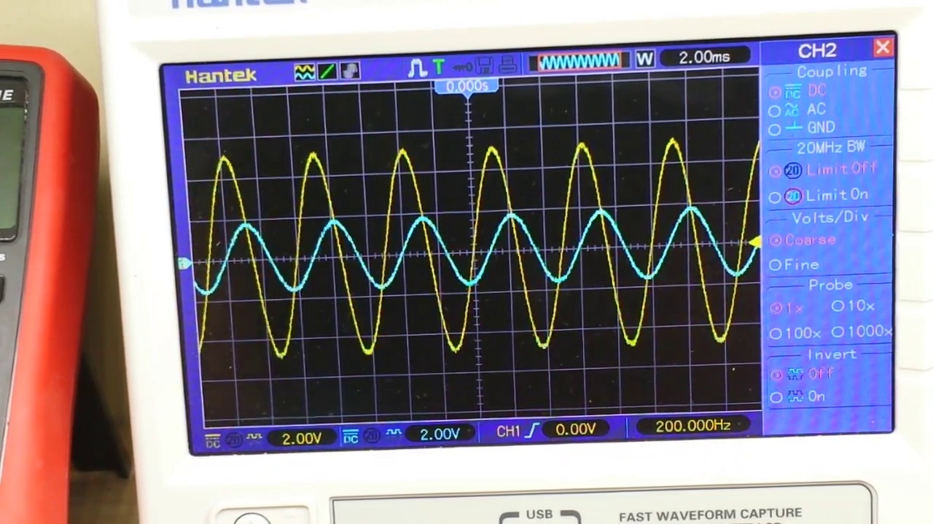

Transcript
[0:11] And today's filter will be the low pass filter.
[0:17] So what's a low pass filter?
[0:19] It's very simple.
[0:20] It's a filter that passes signals with a frequency lower than the set point of the
[0:25] filter.
[0:26] And how do we find that?
[0:28] Well, our formula for the cutoff frequency is 1 over 2 pi tau.
[0:41] Or 1 over 2 pi RC.
[0:47] So what's that tell you?
[0:48] That tells you that this is a resistor capacitor filter.
[1:01] We'll be using the RC time constant to determine our filter.
[1:12] So the next question is how do we set it up?
[1:14] Well, it's pretty simple.
[1:20] We start with a resistor.
[1:30] And then we have our V out.
[1:34] Then we have our capacitor going to ground.
[1:43] And here we have V in.
[1:47] So we bring in our signal here.
[1:58] It passes through the filter here.
[2:01] And comes out like that.
[2:05] Pretty simple, right?
[2:07] This particular RC filter is called a first order.
[2:18] low pass filter filter.
[2:20] How does it work?
[2:21] Well, it works like this.
[2:25] At low frequencies, so the frequencies that will pass, there is plenty of time for our
[2:33] capacitor to charge up almost to the input voltage.
[2:39] So the frequency we get in is very close to the frequency we get out with a slight phase shift.
[2:47] Now at higher frequencies, because we're oscillating faster, there's not enough time for this capacitor
[2:55] to charge up to the input frequency or the input voltage.
[2:59] And what we get out is severely attenuated.
[3:05] Let's take a look at building one of these practically on a breadboard.
[3:10] Alright, let's take a look at the setup.
[3:14] So we have our function generator over here putting out a hundred kilohertz sine wave, ten
[3:20] volts, peak to peak.
[3:23] And then we have our low pass filter set up here.
[3:26] Let me zoom in a bit.
[3:30] So our signal comes in on this white wire, feeds through our resistance, this is just
[3:36] a decade resistance box, and at the moment it is set on 1K.
[3:46] The signal then goes into this capacitor, which is a 1 nano.
[3:53] And at the divider point we're taking our output signal.
[3:58] So let's go now and take a look on the scope.
[4:02] Oh, I've got things blinking off here everywhere.
[4:06] Alright, let me get a good picture here for you guys.
[4:12] Alright, so here we have our input signal, channel 1.
[4:19] This is coming directly off the function generator.
[4:24] And you can see we are at 2 volts per division.
[4:28] Let's see, we're at 9.84 volts peak to peak, 50% duty cycle, blah, blah, blah.
[4:38] Now, let's bring in channel 2.
[4:43] Now if we take a look here, you see channel 2 also at 2 volts per division.
[4:50] It's just slightly attenuated there and slightly shifted out of phase.
[4:57] But watch what happens as we increase the frequency to our attenuation point, which in this case
[5:04] is about 160 kilohertz.
[5:08] We're at 100 now.
[5:09] Let's go up to 200.
[5:11] Boom.
[5:12] Now that signal is seriously attenuated by the low pass filter.
[5:18] And if we go higher, 300, 400, 500.
[5:24] You see as the frequency increases, less and less is passed of the signal.
[5:28] Alright, let me zoom back out.
[5:31] We're going to go back down to 100.
[5:33] Let's see if I can get this in the frame.
[5:37] Now, I'll just turn down here a little bit.
[5:42] And focus.
[5:43] So, what we're going to do now is we're going to take off our 1K and we're going to go to
[5:52] 10K.
[5:56] So now we have a 10K and a 1 nano, which remember our formulas, is going to make a serious difference.
[6:10] So look at that.
[6:10] There we are at 100 kilohertz.
[6:13] 10K at 1 nano almost completely attenuates that signal at 1 kilohertz.
[6:22] And let's go down at 50 kilohertz.
[6:32] You can see we're only slightly, oh I'm sorry, that's 10 kilohertz.
[6:35] We're only slightly attenuated.
[6:38] 20, 30, 40.
[6:41] Alright, let's go back.
[6:45] We're at 10 kilohertz now.
[6:49] And this time, instead of changing the resistor, we will change the capacitor.
[6:59] And as soon as I find out what to do with my capacitors, here we go.
[7:06] We'll swap out our capacitor.
[7:13] We'll swap out our capacitor.
[7:20] It's in the right spot, no.
[7:24] Got to get them right.
[7:26] Or they don't work.
[7:28] Shocking, I know.
[7:31] Okay.
[7:32] So now instead of 1 nano, I think this is like a 22 nano, it has almost completely attenuated
[7:46] the signal.
[7:47] So if we go down, there we are at 1 kilohertz.
[7:57] The signal is still attenuated.
[8:00] Let's take it down even more.
[8:04] 500 hertz.
[8:08] I'm sorry, 100 hertz.
[8:14] There's 200.
[8:20] So you can see the effect changing the capacitance and the resistance has.
[8:25] So let's go back up here.
[8:30] And we'll take out our 1k, or 10k rather.
[8:35] And if we put our 1k back in, boom, look at that.
[8:40] Almost no attenuation at all.
[8:43] 200 hertz, 300 hertz, 400, 500, 600.
[8:49] Okay, so somewhere around 500, 600, we start getting a slight bit of attenuation.
[8:57] And that's the way you design a low pass filter.
[9:02] So that is just about it.
[9:04] If you keep one thing in mind when you're thinking about filters and RC circuits, and that is
[9:10] a capacitor, whether it's, you know, one of these guys, or one of these guys, or whatever,
[9:20] is not an on and off device.
[9:22] A capacitor operates analog.
[9:26] It operates in between the two extremes of on and off.
[9:31] So there's that time going on there.
[9:33] There's time to charge, and there's time to discharge.
[9:36] And we take advantage of that to creating filters.
[9:39] All right?
[9:41] Next time, high pass filters.
[9:43] Hope you guys enjoyed this.
[9:44] If you did, give me a thumbs up.
[9:46] Feel free to comment, share, and don't forget to subscribe.
[9:50] That's it.
[9:51] I'm out.
[9:52] Peace.
[9:53] On the first day of Christmas, my true love gave to me a partridge in a pear tree.

