Engagement Analysis: HWMq1WjvgfE

Section 0: Intro to Electronics and Digital Art
Time: 0:00 - 1:20

Summary
The creator introduces their channel, focusing on electronics and digital art. They discuss the importance of supporting the channel through Patreon and provide a link to their shop.

Representative Frames
0:13  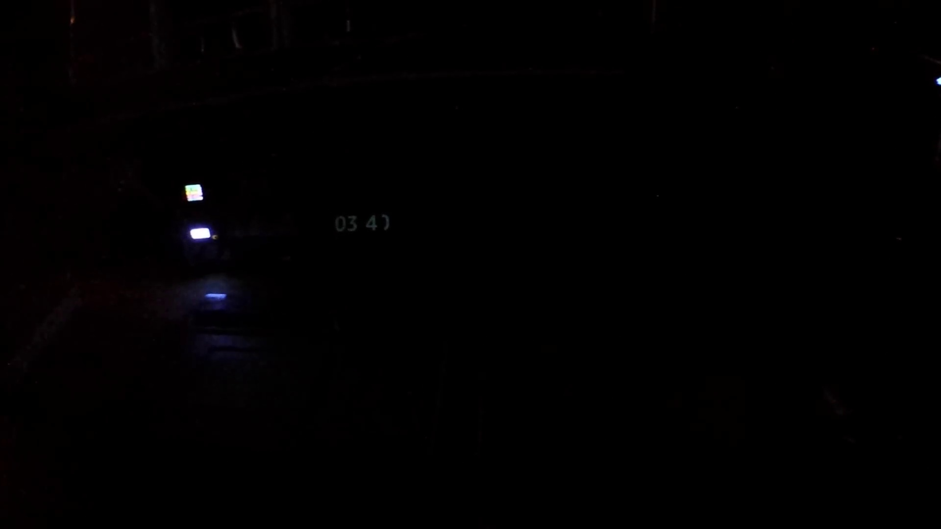 | 0:26  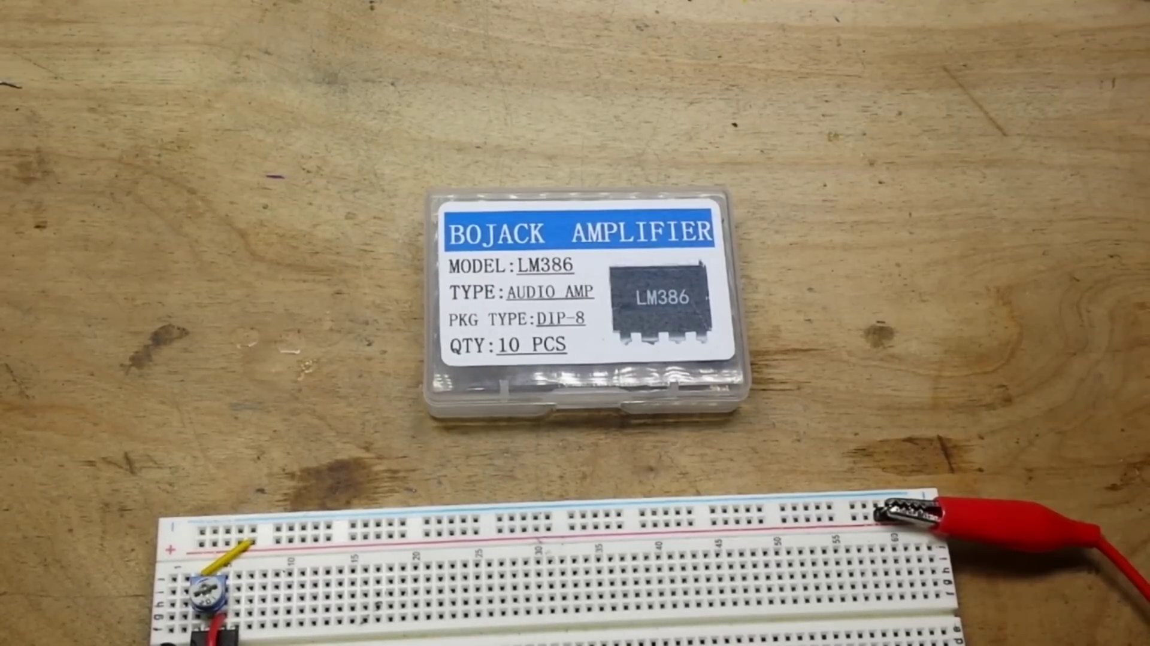 | 0:40  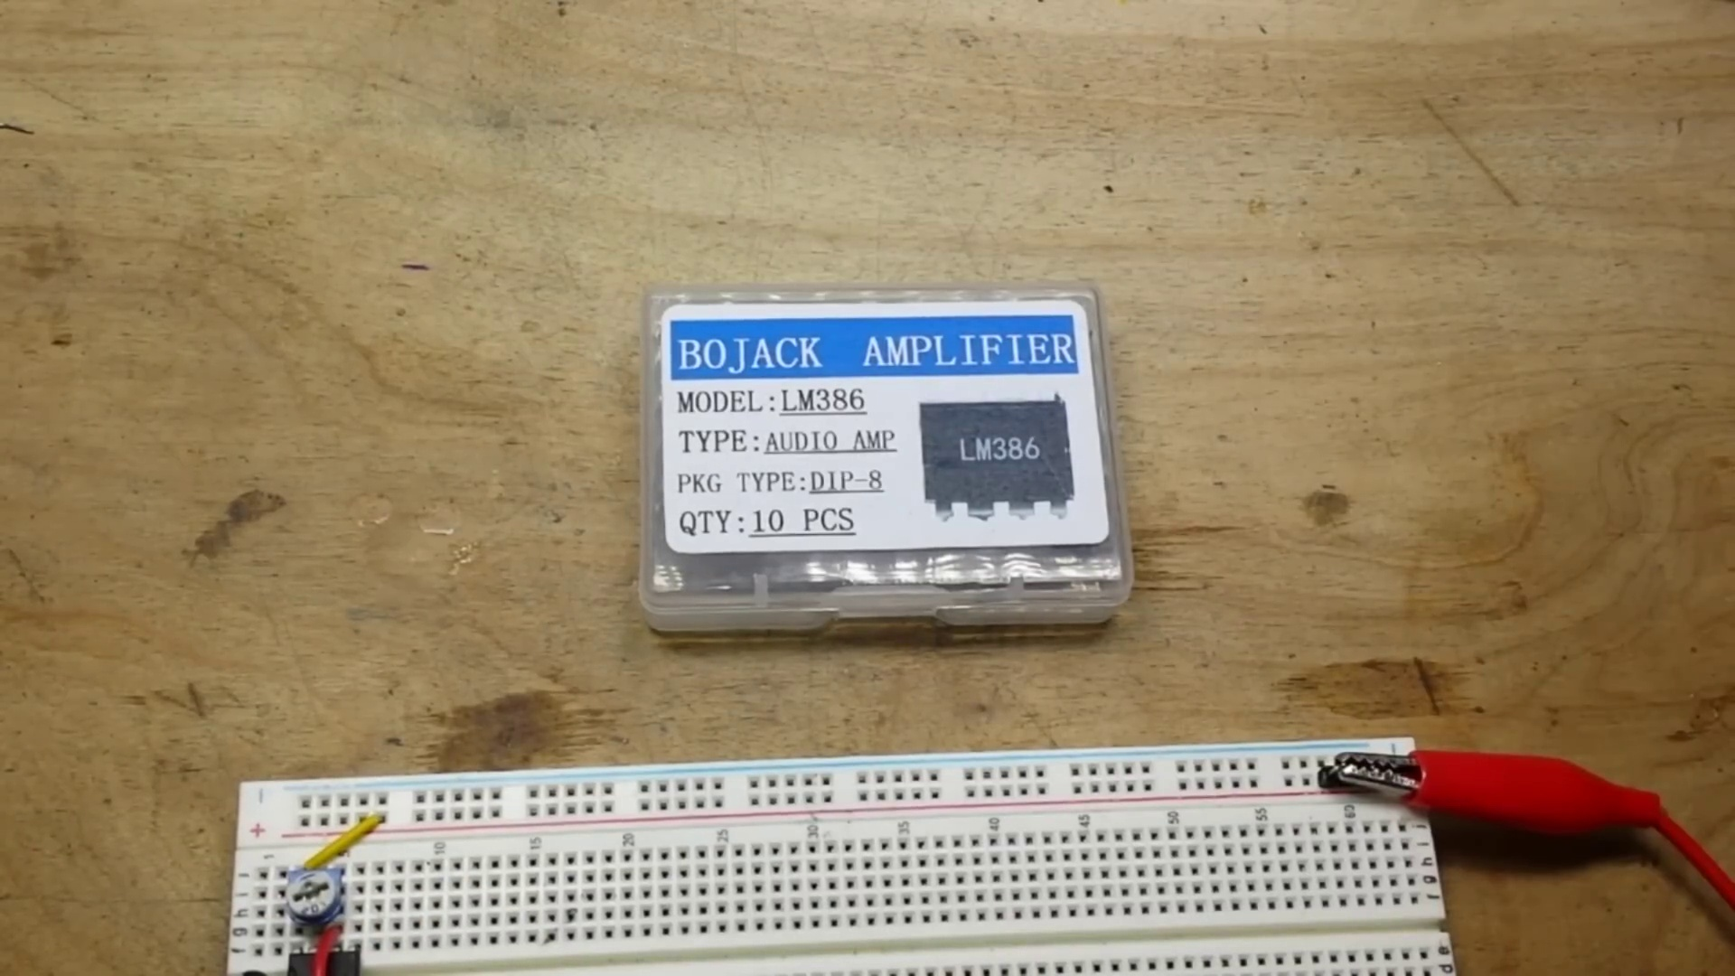 | 0:53  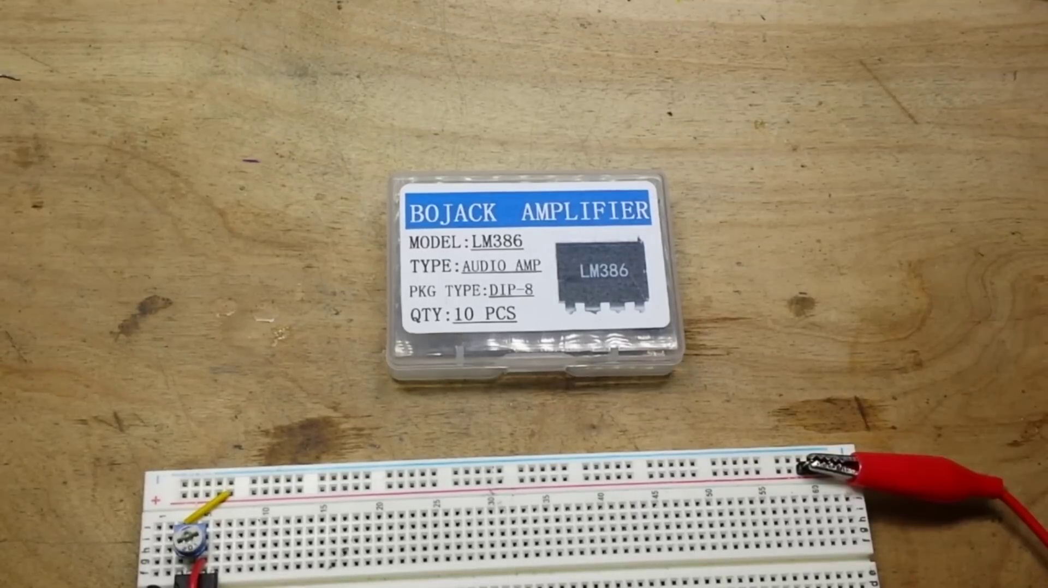 | 1:06  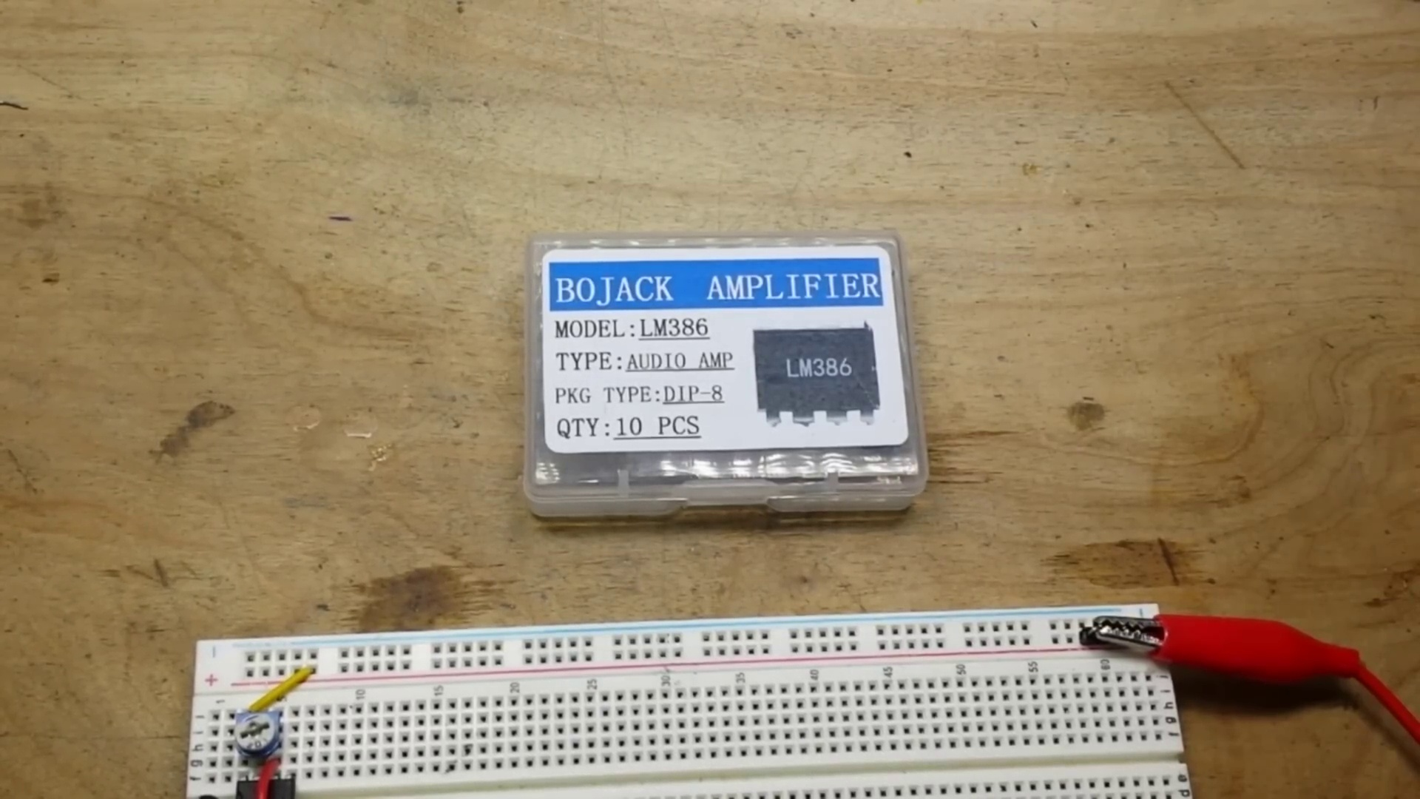

Transcript
[0:00] I swear I'll spend more time looking for the parts I need than actually building anything.
[0:18] Hey what's happening guys in our last video we used an op amp TLO72 as a gain stage in an
[0:28] oscillator. Today we're going to use a different op amp the LM386 as what it's intended for an audio
[0:37] amp. So I don't know if this exactly fits into the classic circuits you should know mold but we're
[0:45] going to show you how to set up an LM386 super easy using its internal gain to make yourself a basic
[0:52] little audio amplifier. So the first thing we need to do to do that is we need an audio source.
[1:00] I got all kinds of options for audio sources but I like to keep things simple and if you've been
[1:08] watching the channel for a while you know my favorite IC of all time is the 555 timer. So I have set up

Section 0: Introduction to Binary Digits
Time: 1:20 - 4:50

Summary
The creator explains binary digits (0s and 1s) and their representation in digital art. They show examples of binary patterns and how they relate to circuit boards and engineering concepts.

Representative Frames
1:55  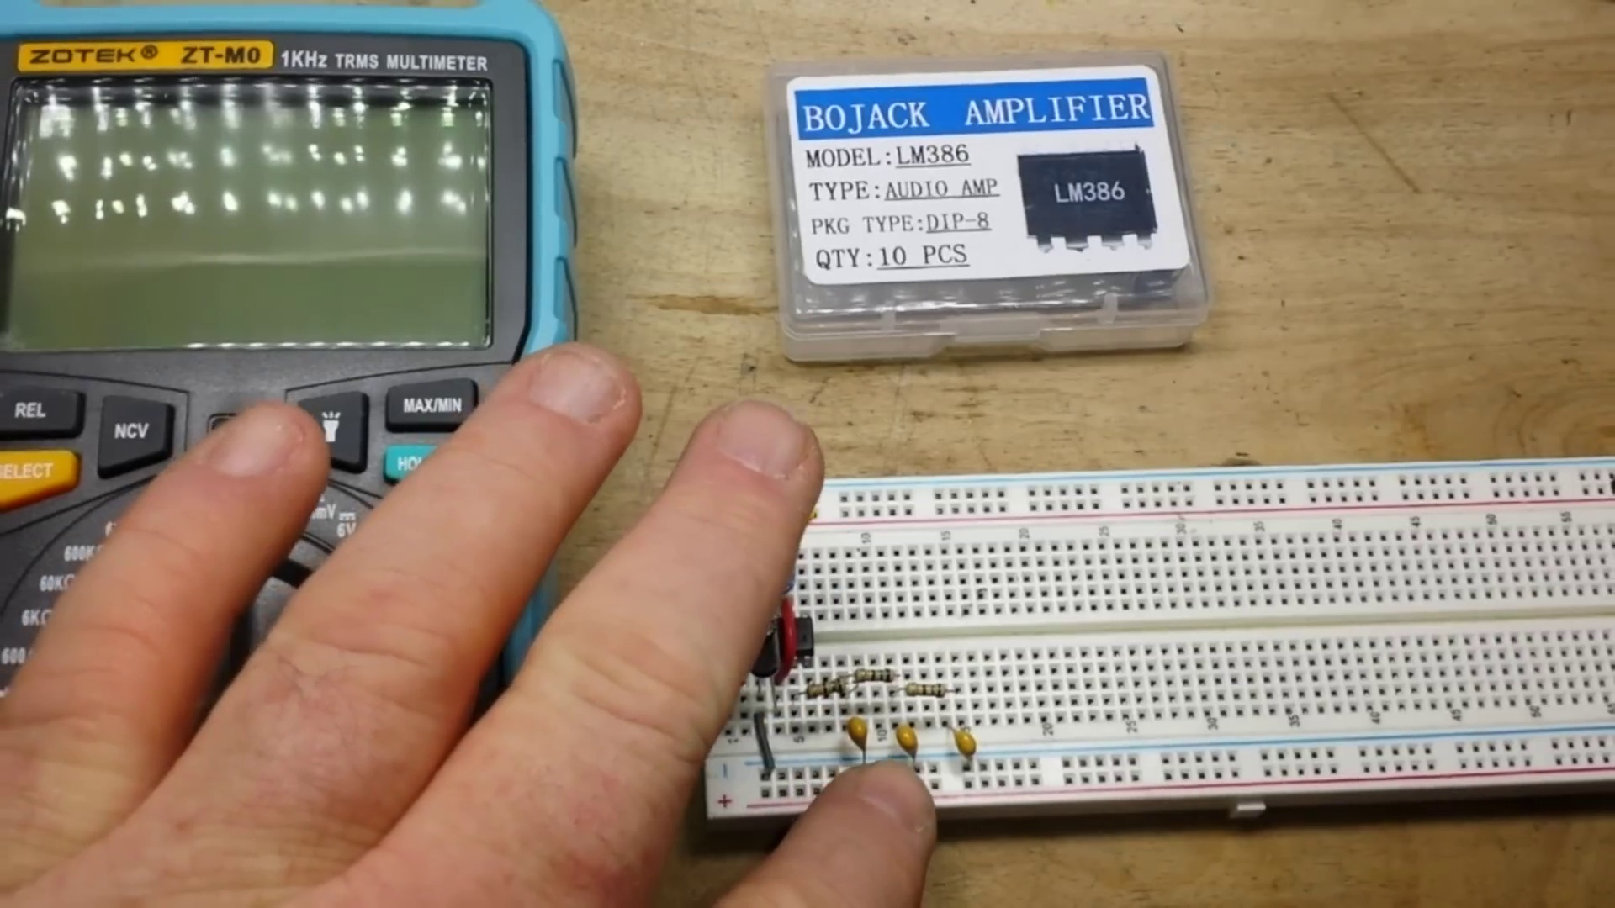 | 2:30  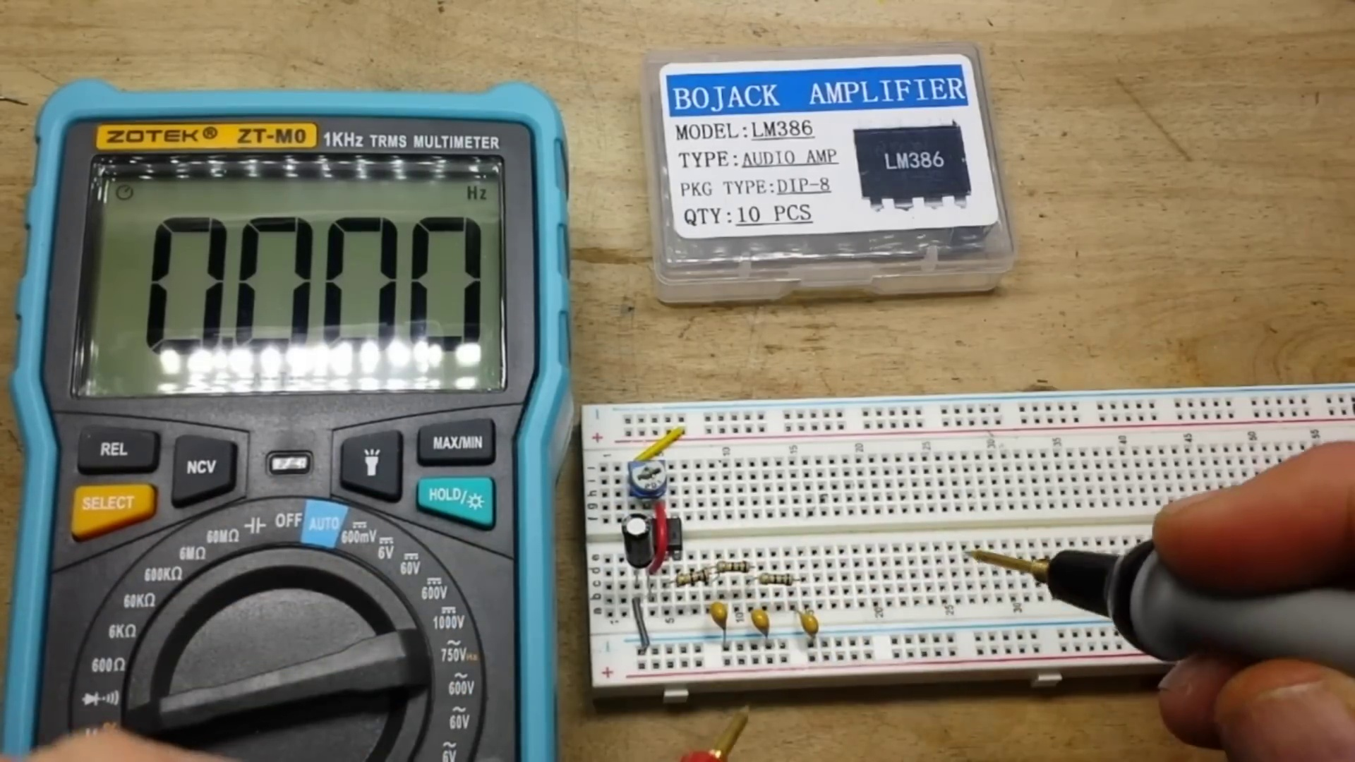 | 3:05  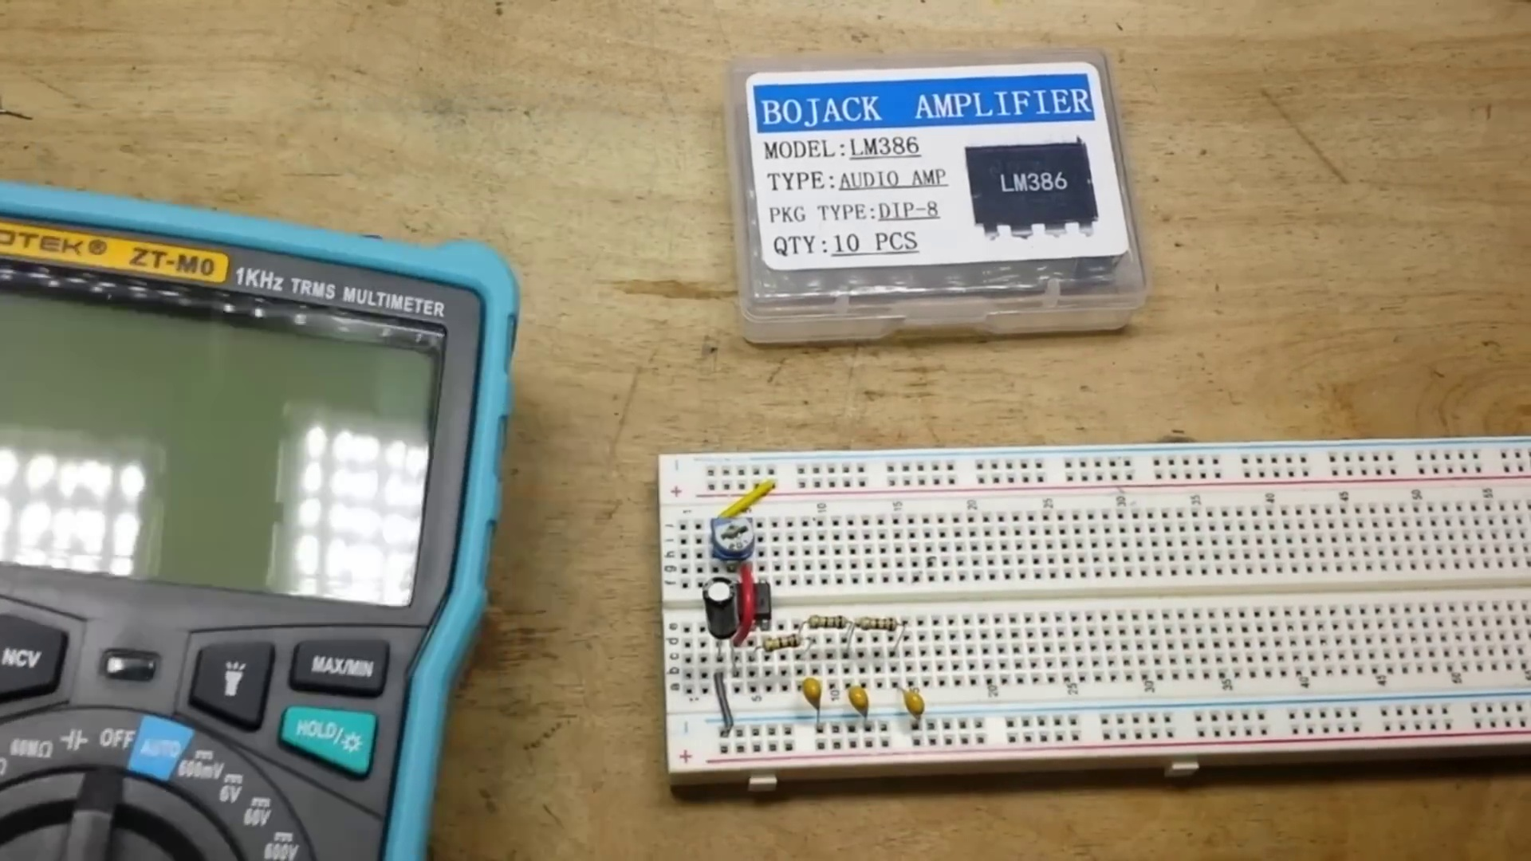 | 3:40  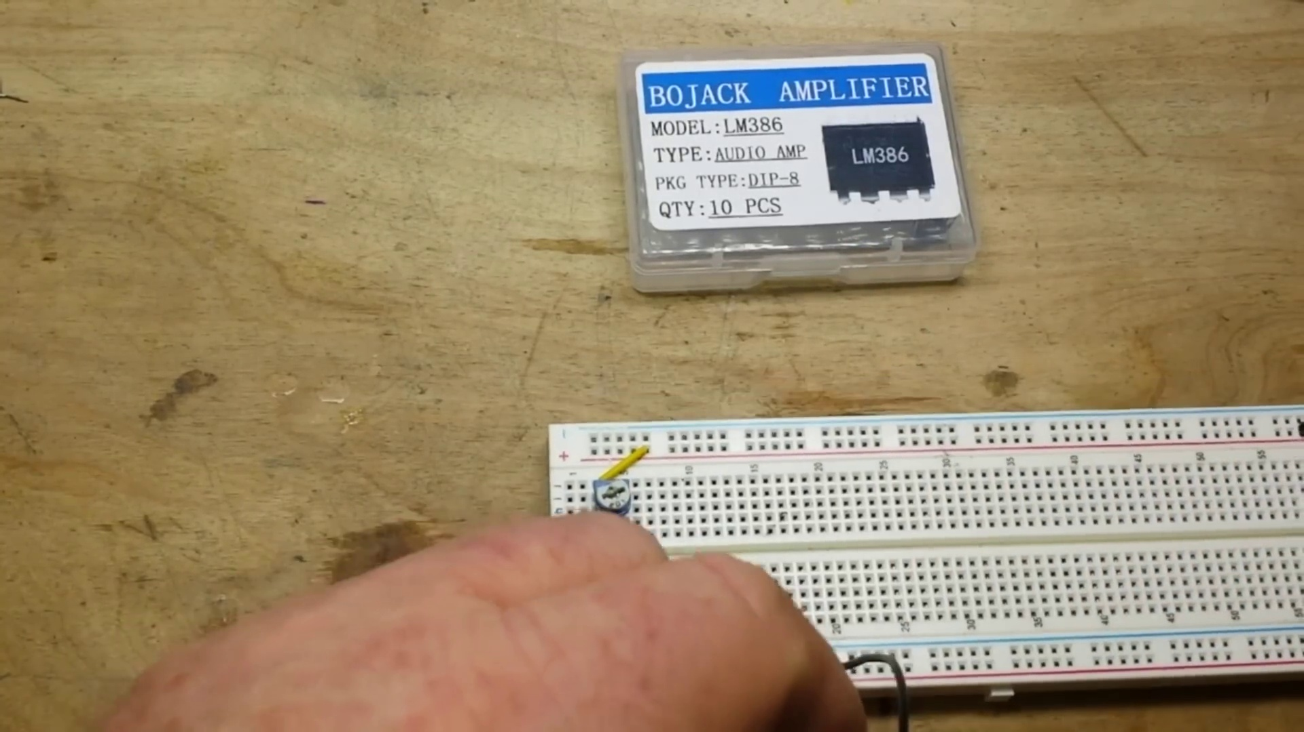 | 4:15  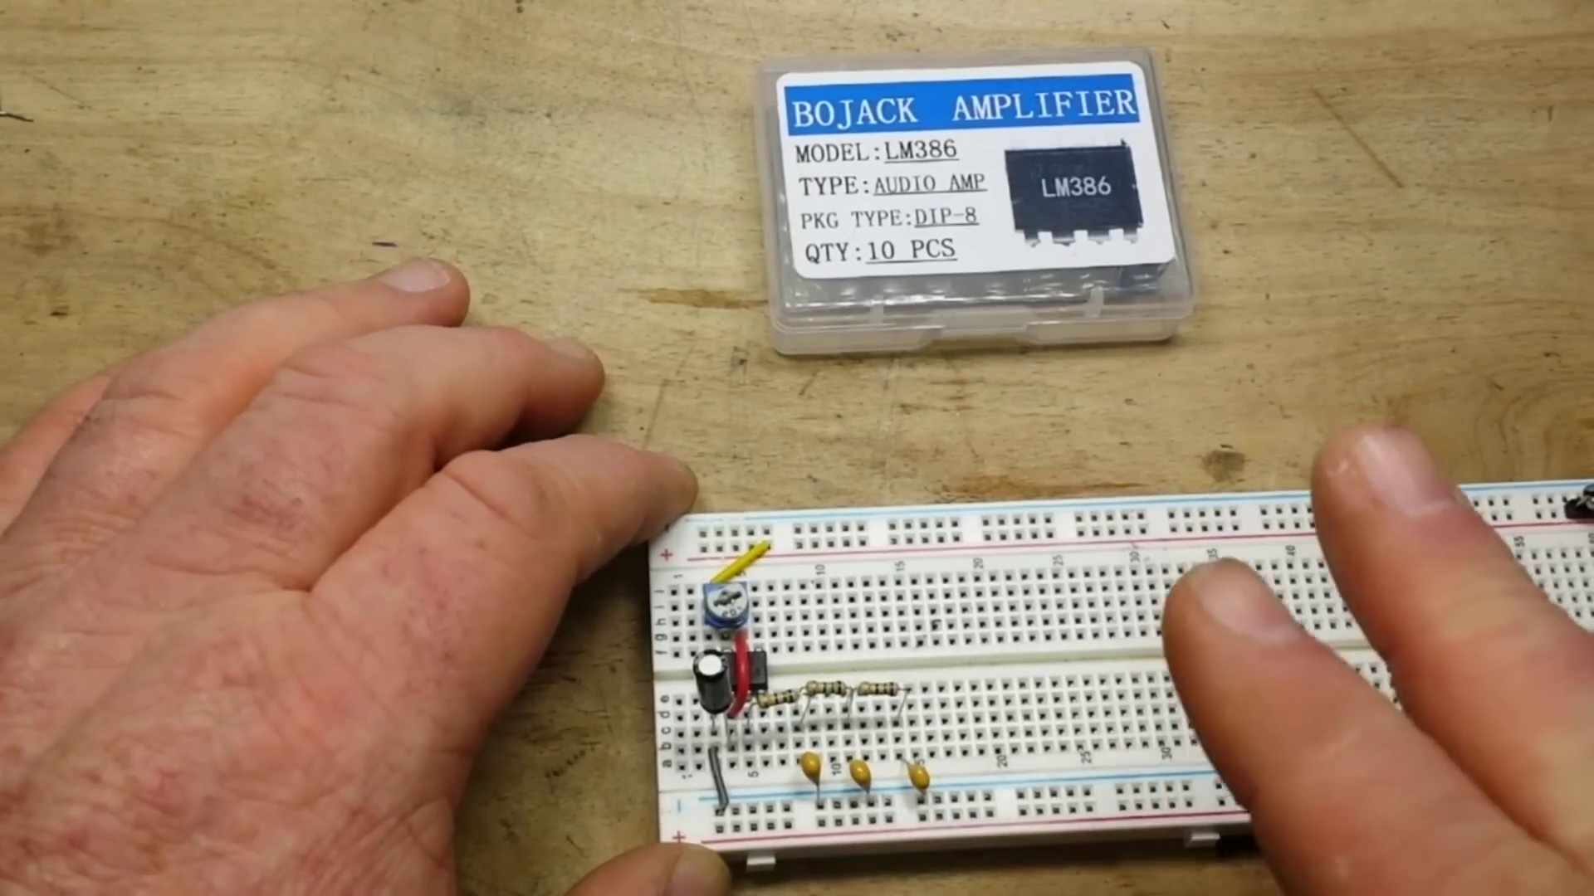

Transcript
[1:17] here a simple bi-stable 555 timer I'm sorry a stable 555 timer and it is oscillating at about a kilohertz
[1:29] which we can take a look at here. The 555 timer as you know outputs a square wave but square waves
[1:37] don't sound good you know frankly they're not good for speakers they're not really audio
[1:41] they're actually digital. But what I've done here is I simply set up a low pass filter these are 150
[1:52] ohm resistors one microfarad capacitors three stages should give us an approximation of a sine wave.
[2:00] No we're not going to look at it on the scope because you know what very few people actually have scopes
[2:04] and I want everybody to be to know that they can do these kinds of projects and experiments at home
[2:11] you don't have to have a scope there's other ways so we're going to use this cheap Zotec ZT-M0
[2:21] auto manual meter in frequency mode
[2:25] and if we come up here and we put her on pin three you see we get 1.075 kilohertz close enough to
[2:41] one kilohertz for government work and after our filter
[2:48] well that's showing 16 hertz but that's not true that's just because the voltage is so low
[2:52] so you're not getting anything there at all
[2:57] yeah don't worry we're still getting it and I'll show you that as well
[3:03] again without the use of a scope all we need is a speaker
[3:12] so we'll plug the negative lead of the speaker into our negative rail and we'll touch its pin three
[3:22] and you can hear the one kilohertz tone we'll touch it here after the first stage
[3:29] it's much quieter more of a sawtooth
[3:34] smoother it's a triangle wave there and now this is going to be extremely quiet
[3:40] I don't know if you're gonna be able to hear it or not but there is sound there
[3:43] so listen carefully and you should be able to barely hear the sine wave try and get this up
[3:54] as close to the camera as I can here we go
[4:00] there we go so that's our sine wave but the amplitude has been limited by our low pass filter
[4:14] so what we want to do is we want to amplify it we're going to use an lm386 audio amplifier let's
[4:21] be bop over to the computer and have a look at the data sheet
[4:24] all right so here is the data sheet for our lm386 low voltage audio power amplifier
[4:36] and we have it in the 8 pin dip package and there's some information tells you works on battery
[4:42] operation with minimum external parts and that's the truth and a supply voltage of 4 to 12 volts which is

Section 0: Digital Art Piece with Circles and Lines
Time: 4:50 - 8:10

Summary
The creator showcases a stunning digital art piece featuring circles, lines, and colors. They explain the technical elements in the image, including binary digits, circuit diagrams, and engineering concepts.

Representative Frames
5:23  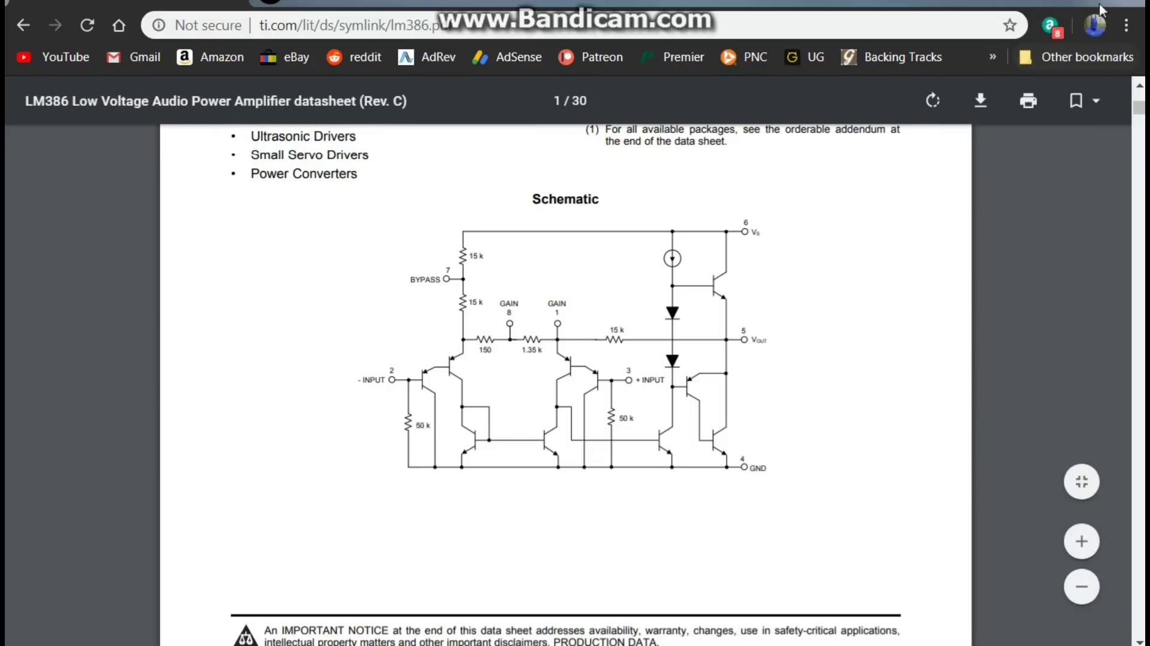 | 5:56  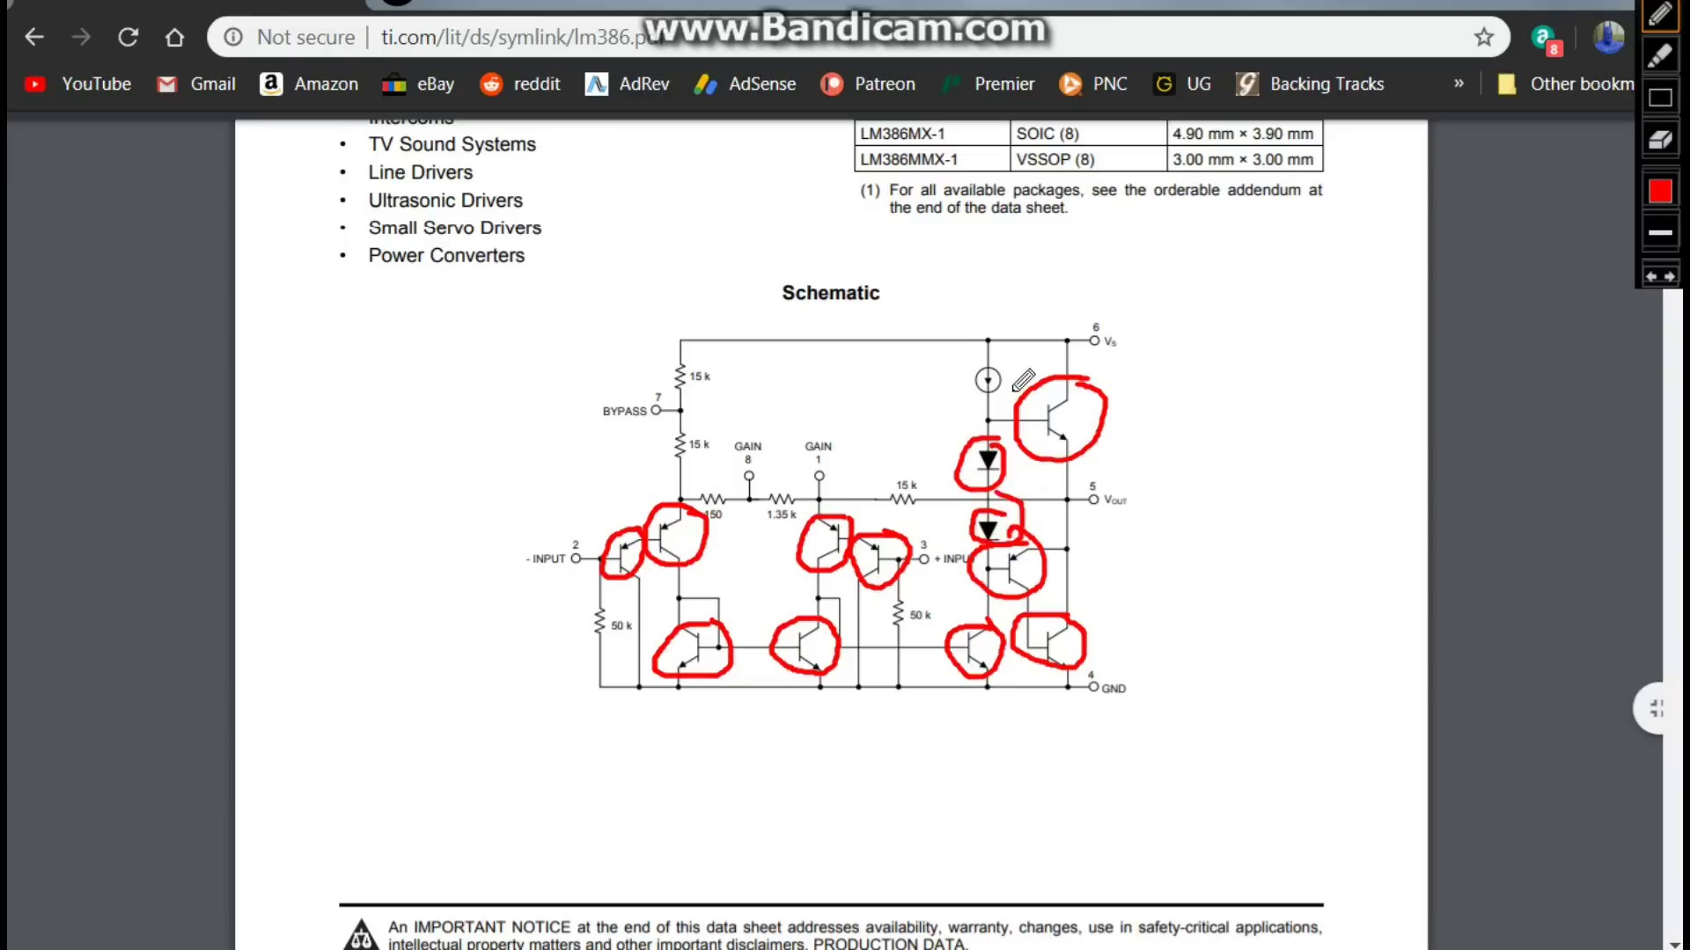 | 6:30  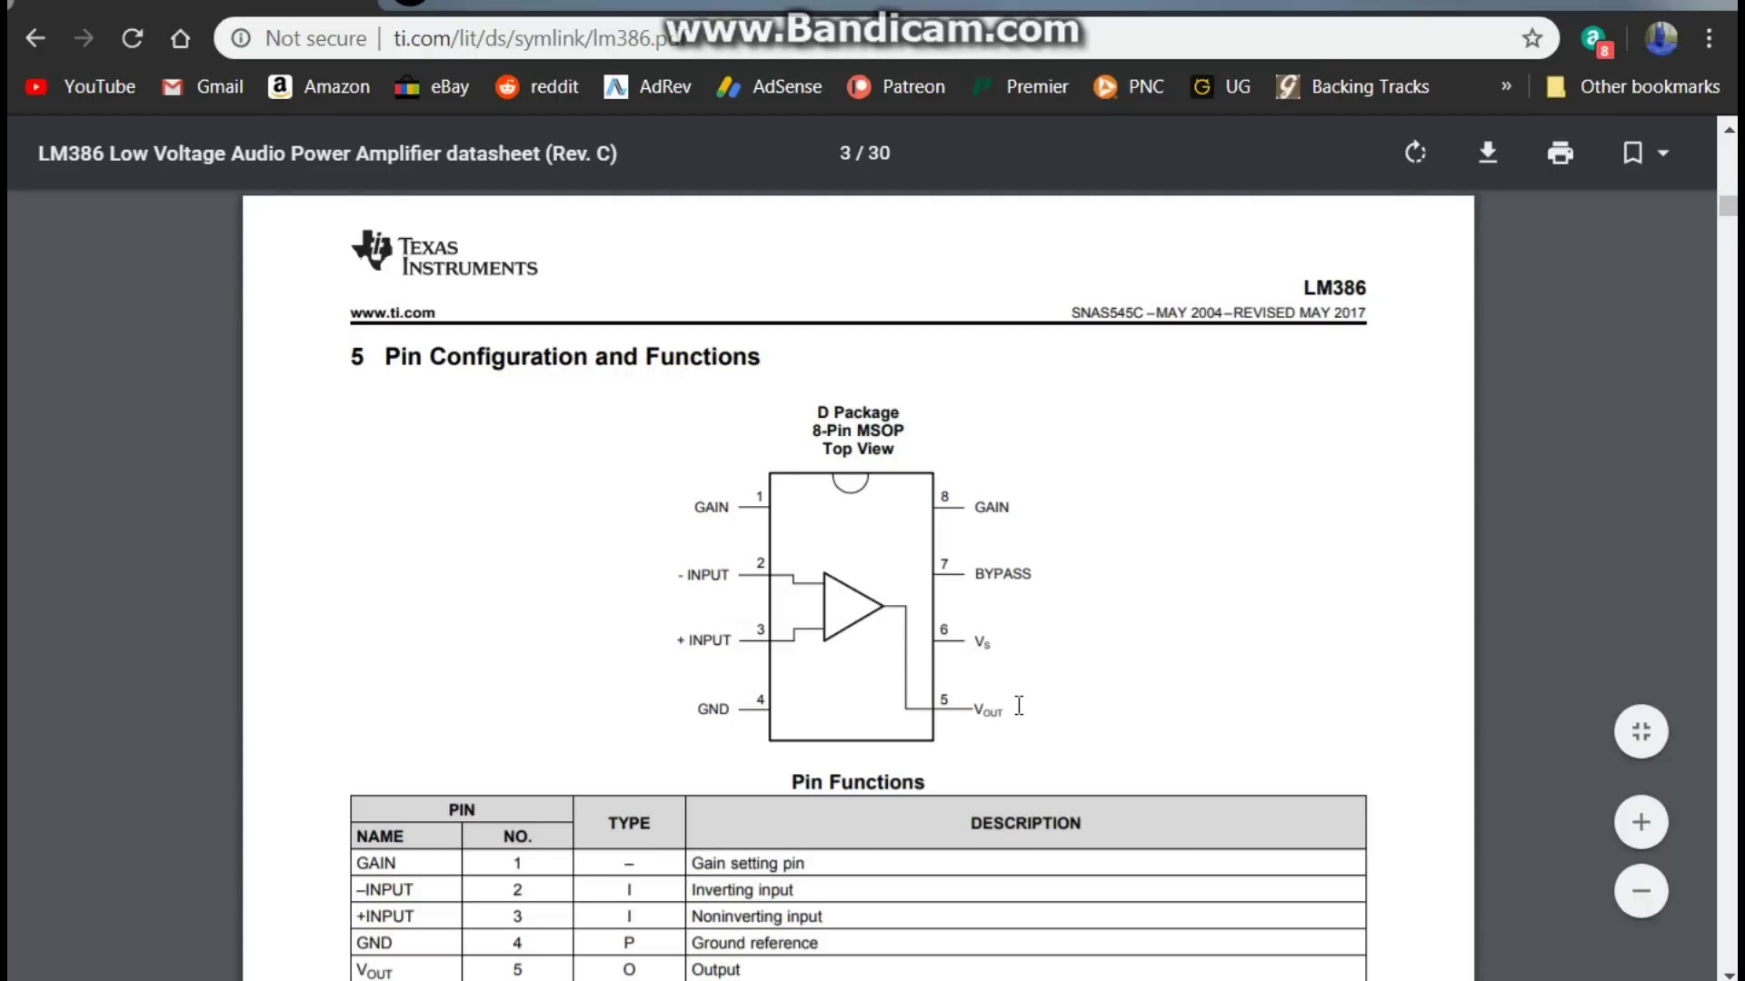 | 7:03  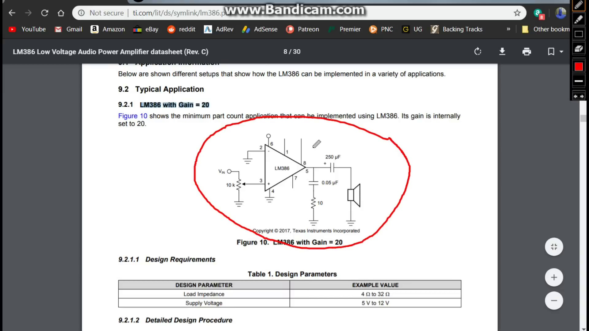 | 7:36  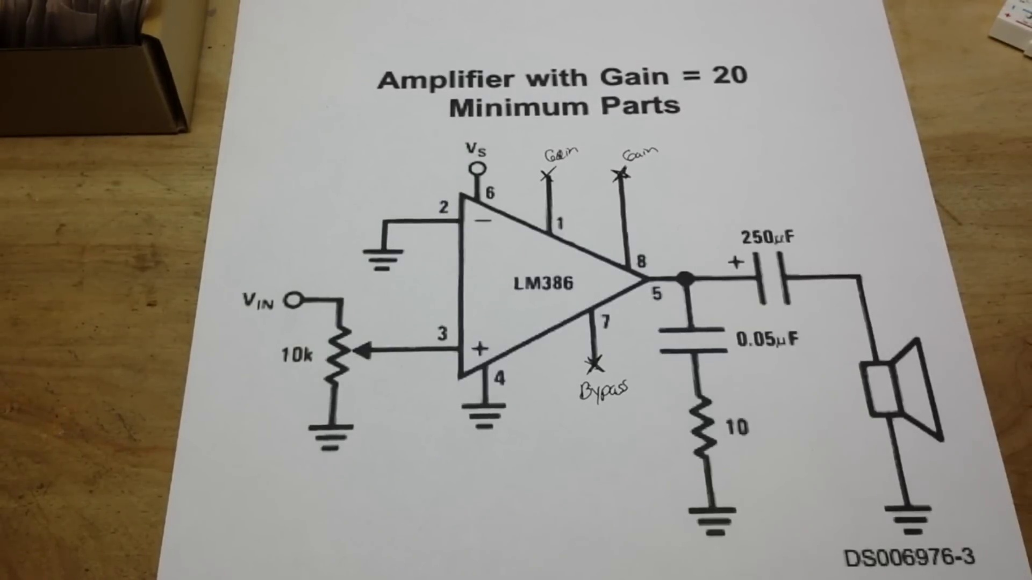

Transcript
[4:49] excellent we're going to be using that it has low quiescent current drain that means when it's not
[4:54] active that's your your gain now your voltage gain here from 20 to 200 ours is going to be 20 which is
[5:02] the built-in internal gain okay and then we have some applications here
[5:11] what's ours going to be portable tape tv sound line drivers yeah just a small audio amplifier i guess they
[5:18] don't list that here you can see the schematic of how it's built and if you take a look here
[5:28] i mean what is it made up of
[5:38] i know you're all yelling it's made up of transistors i know but check out how many transistors
[5:43] are in here if i get them all one two three four five six seven eight nine ten transistors
[5:54] one two possibly three diodes is that a diode that's strange one two three four five six seven resistors
[6:13] so i mean that's pretty cool there's a lot of stuff there
[6:21] come down here and you get your basic information there is our pin out
[6:27] input minus input plus ground bypass blah blah blah
[6:34] tells you what your pins are here inverting input non-inverting input
[6:39] absolute maximum but we're going to roll on down here
[6:44] to the application circuit typical application this is the lm 386 with an internal gain of 20
[6:52] and this is what we are going to set up here today just super simple we're going to put it together and
[7:00] we are going to make it work now you see this will be a non-inverting amplifier because the inverting pin
[7:09] is grounded we have a volume control here on the non-inverting pin
[7:14] other than that we have a nice big dc blocking capacitor going to our speaker a little filtering going
[7:24] on here and that's all she wrote let's do it
[7:30] okay i think we're ready to go and get started you can see we have our circuit diagram here and
[7:41] there are three pins we will not be connecting one eight and seven one and eight are where you can
[7:46] connect i believe it's a capacitor for uh external gain and then seven is a bypass that we're not going
[7:52] to be using either so we shall bring in our circuit
[8:02] and avail ourselves a lovely lm 386 who will it be who will be who wants to come out and play you okay

Section 0: Control Room or Interface
Time: 8:10 - 12:40

Summary
The creator presents a futuristic control room or interface with holographic displays and high-tech elements. They discuss the technical aspects of the image, including binary code and scientific data.

Representative Frames
8:55  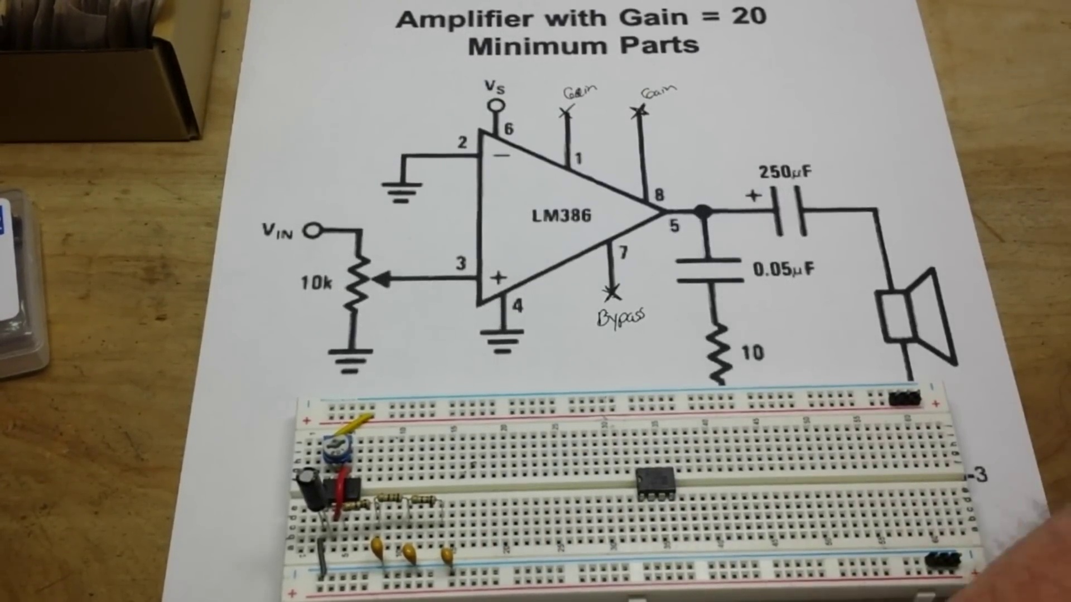 | 9:40  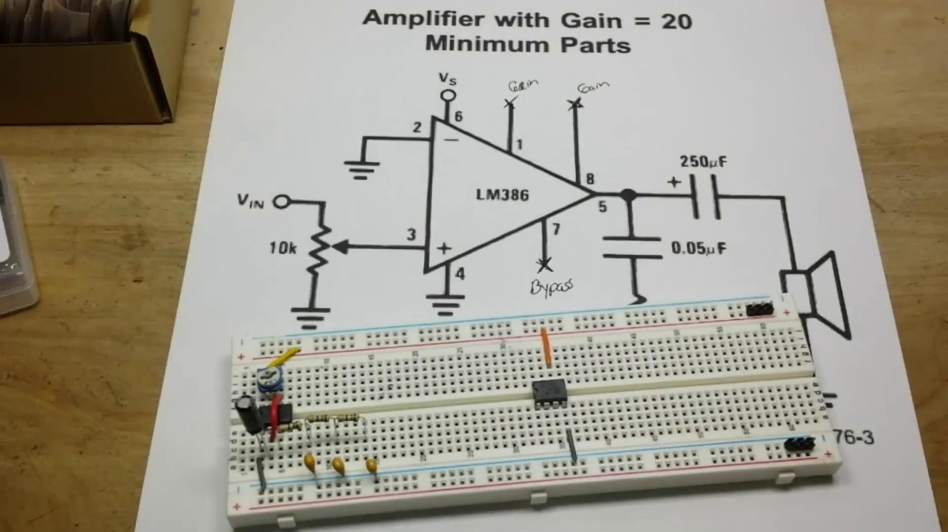 | 10:25  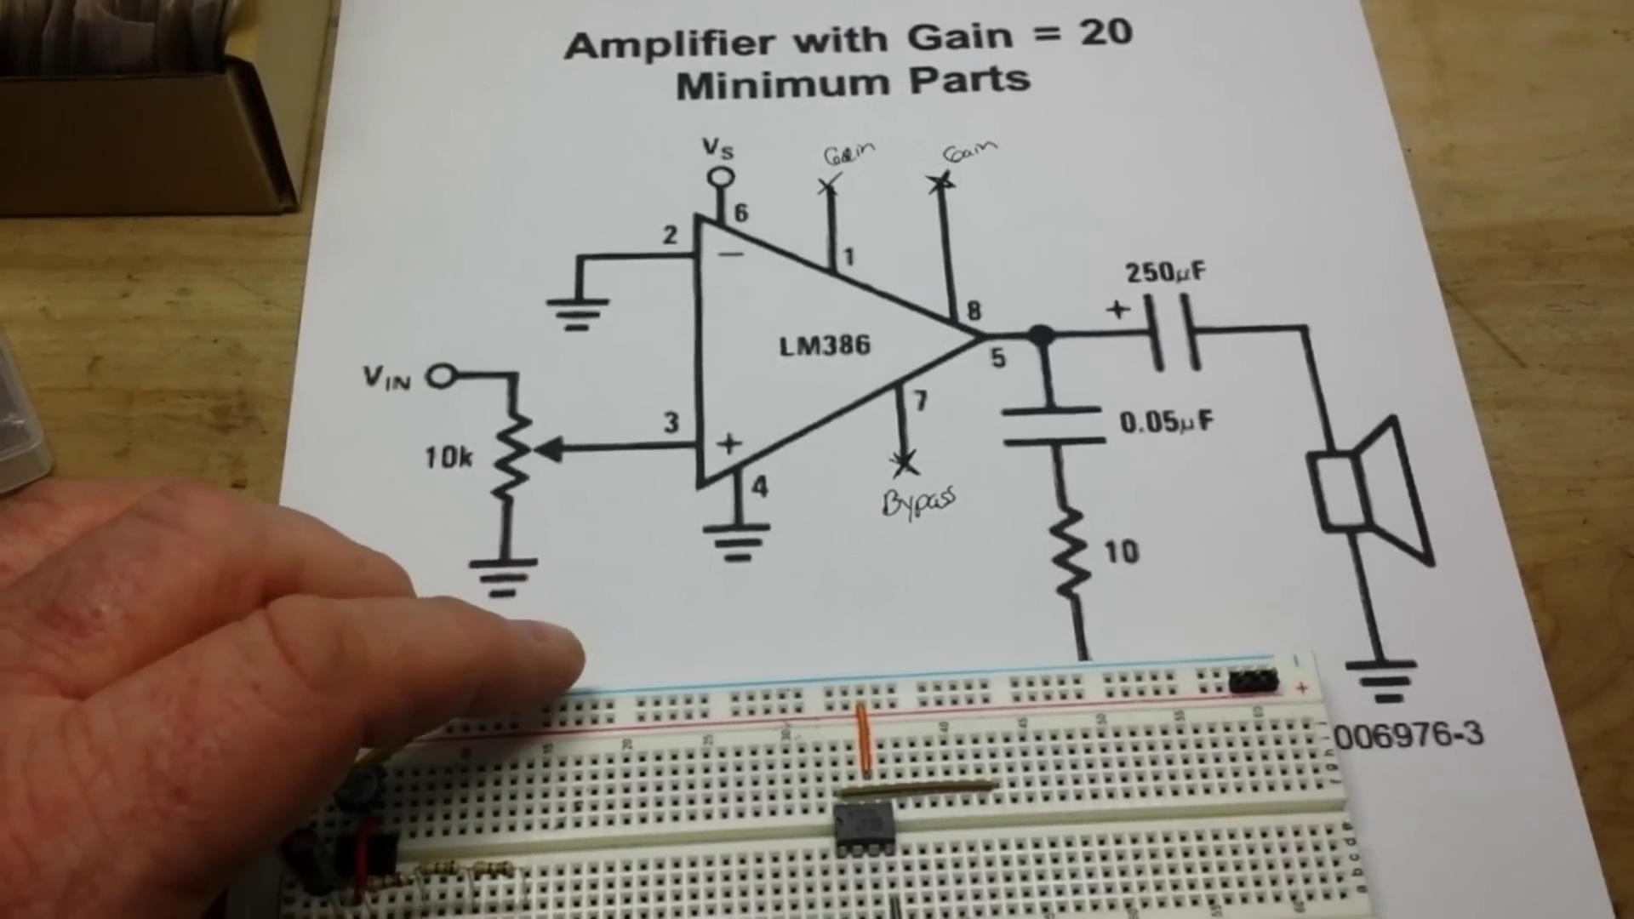 | 11:10  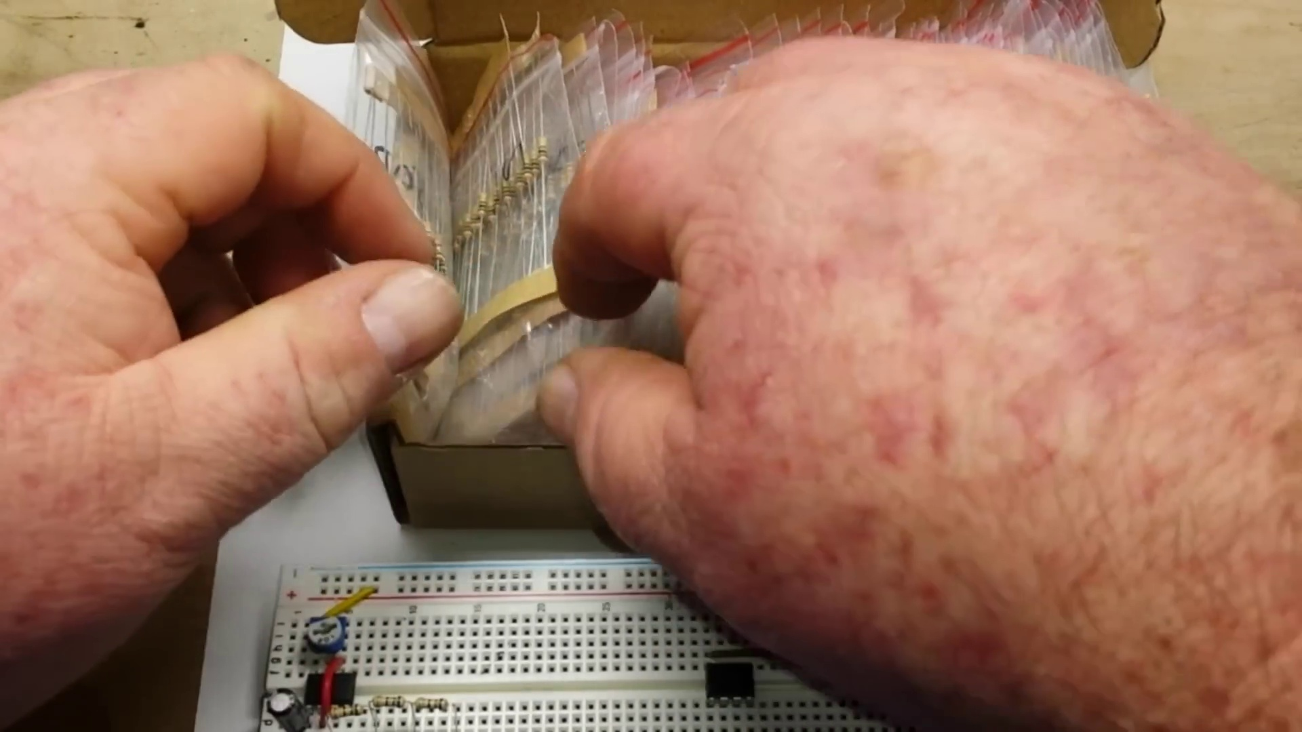 | 11:55  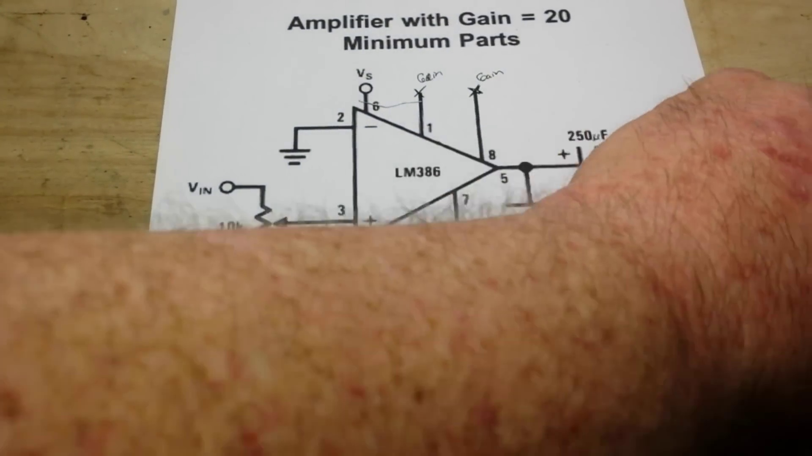

Transcript
[8:14] so you know ic's always have splayed legs
[8:16] they make tools for this but hey we don't like tools just put them on your bench give them a little
[8:25] bendy bendino and you're good
[8:30] we'll put him way over here
[8:34] all right so let's start by hooking up our power supply that's the pix that's the pittsburgh way to
[8:43] say power power like former steelers coach bill cower car we have some nice breadboard jumpers the reds are too
[8:54] long so we'll go with an orange
[9:02] and that's pin six one two three four five this is pin six right here so pin six goes to power
[9:13] the pin four is our ground
[9:27] we use gray for ground
[9:33] i just want to make sure that you're hooking your pins up correctly
[9:38] that's why an old guy like me has one of these doohickeys on his head
[9:47] okay so that's pin four that's that pin eight
[9:53] is our output so let's grab a longish
[9:59] connector
[10:00] and go from pin eight
[10:07] over to here
[10:10] then we need a 0.05 microfarad why would you say 0.05 microfarad why would you do that
[10:18] because now you got to make me do internal head math
[10:22] it's 50 nanofarads i think i'm sure somebody will correct me if i'm wrong i don't probably don't have
[10:28] 50 nanofarad but i probably have 47 nanofarad
[10:37] and you know what they say close enough for government work
[10:47] unless of course you work for nasa in which case you should probably use
[10:50] the specified value there's no reason
[10:52] that i'm going to this way you could go that way it'll be just fine and now it says we need a
[10:59] resistor to ground 10 10 what well since they put a k over here let's assume that's 10 ohms
[11:09] so let's see if we got a 10 ohm
[11:13] 15
[11:26] there's one we could twist 10 of them together if nothing else happens
[11:31] 100 10 r yeah
[11:35] enough for government work
[11:52] get that guy out of there
[11:53] one reason to have three foot long leads so we'll just trim them a little bit
[12:11] and there is our 10 ohm
[12:17] resistor to ground
[12:23] get in there come on all right 10 ohm resistor to ground next we need a large
[12:33] capacitor we're going to use an electrolytic 250

Section 0: Technical Context and Engineering Drawings
Time: 12:40 - 16:05

Summary
The creator shows a photo of hands holding blueprints or engineering drawings, providing context for the technical subject matter. They explain the importance of precision and order in digital art.

Representative Frames
13:14  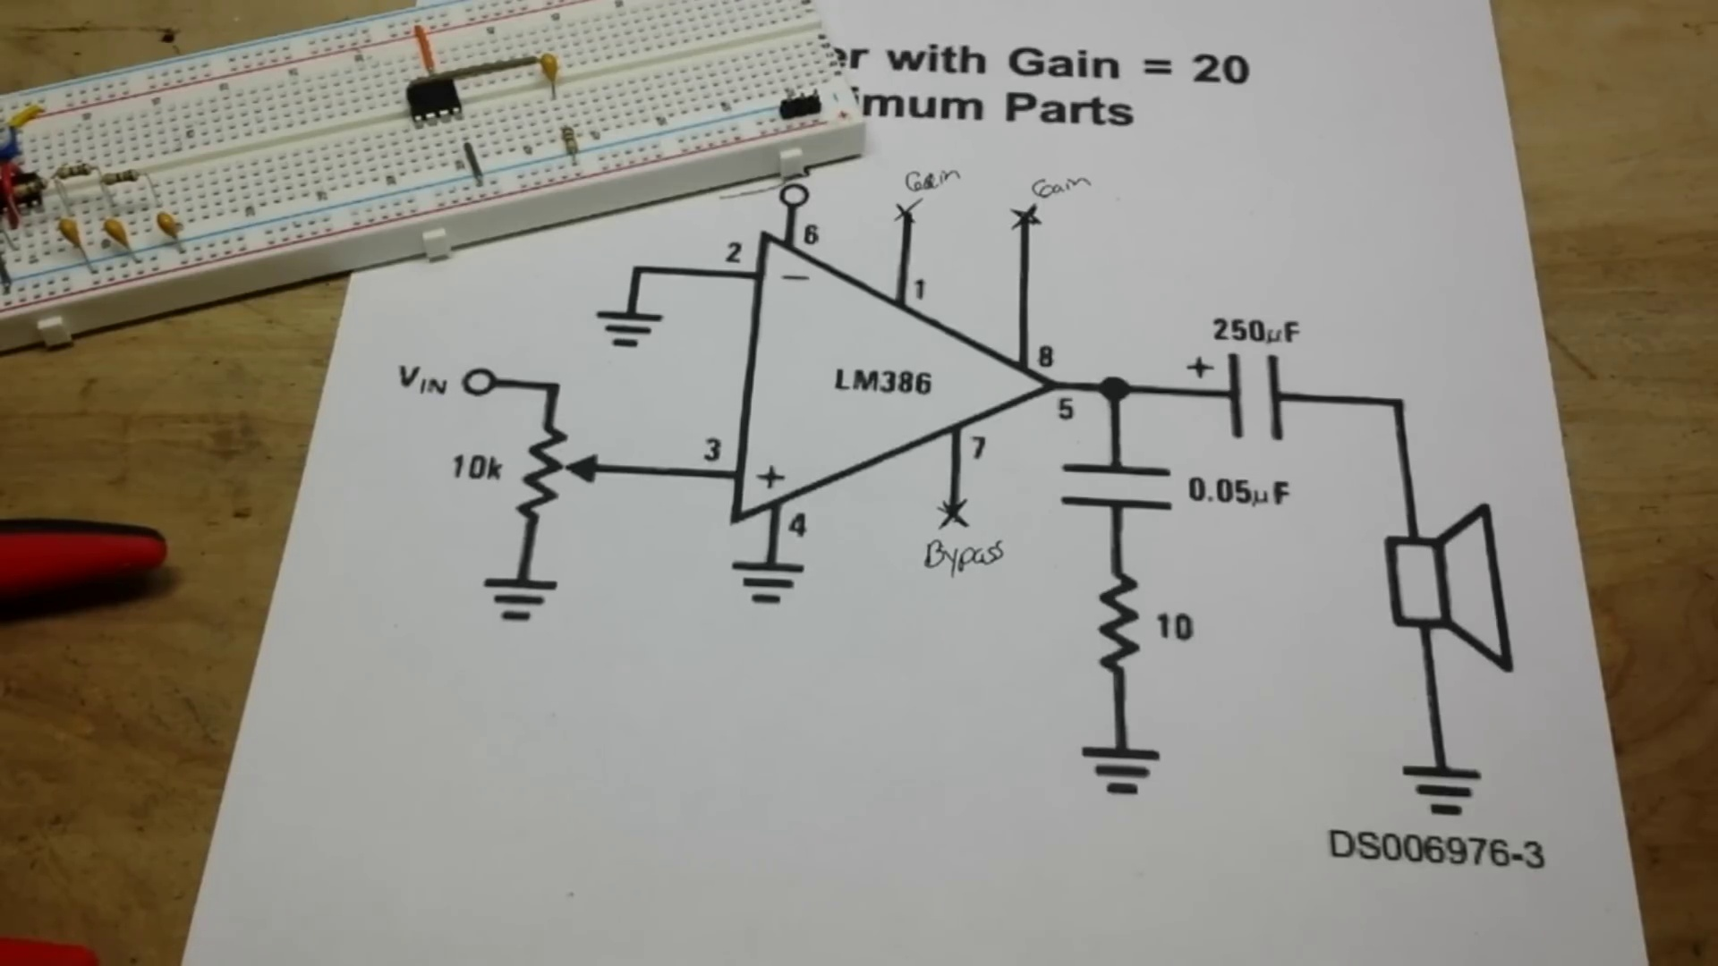 | 13:48  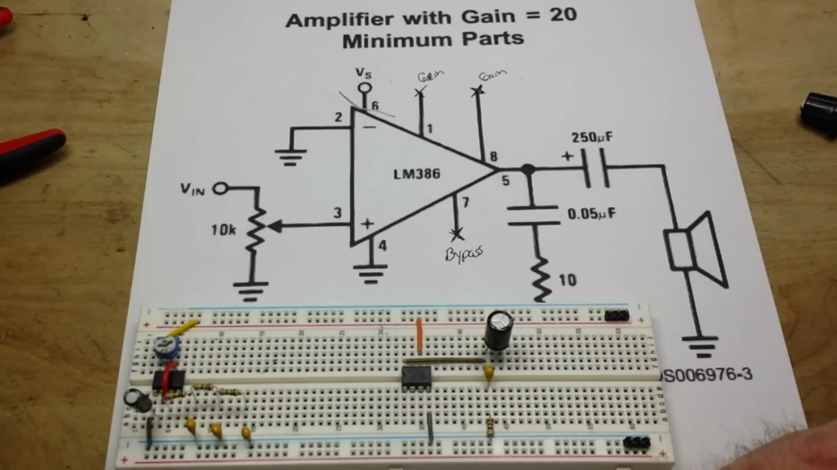 | 14:22  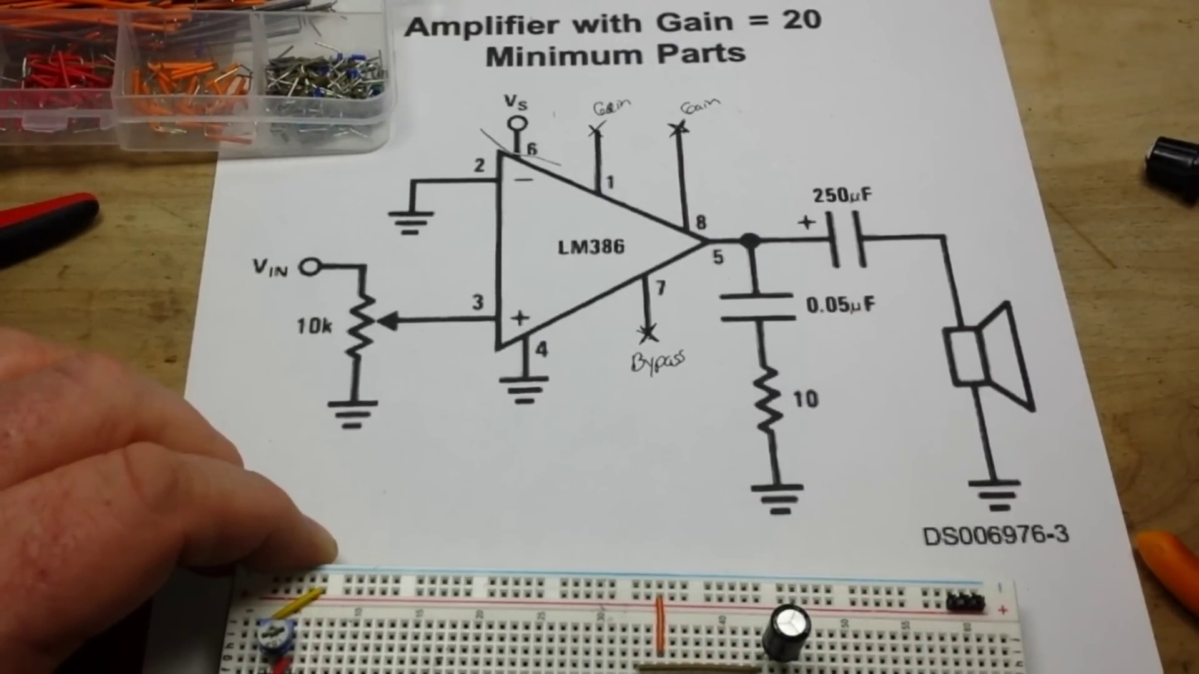 | 14:56  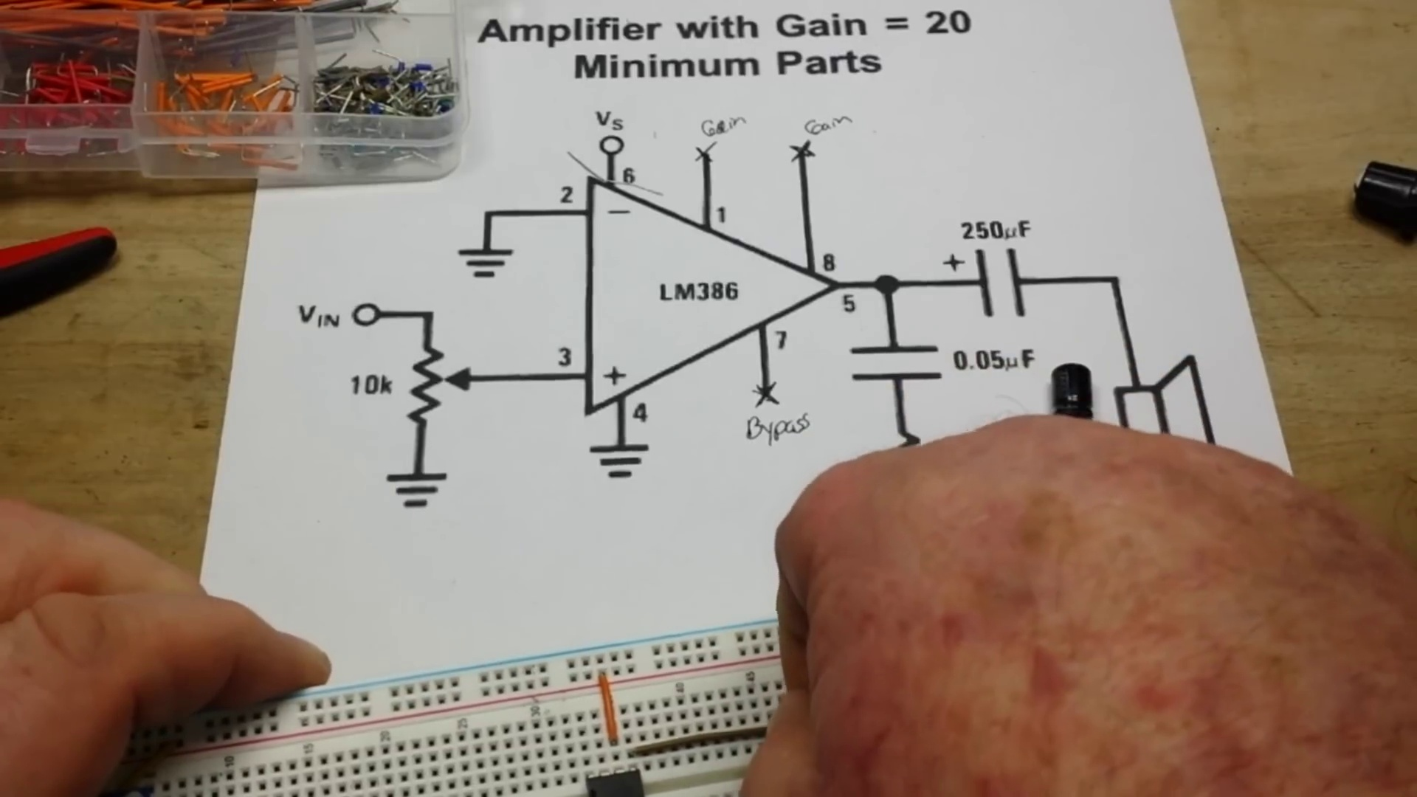 | 15:30  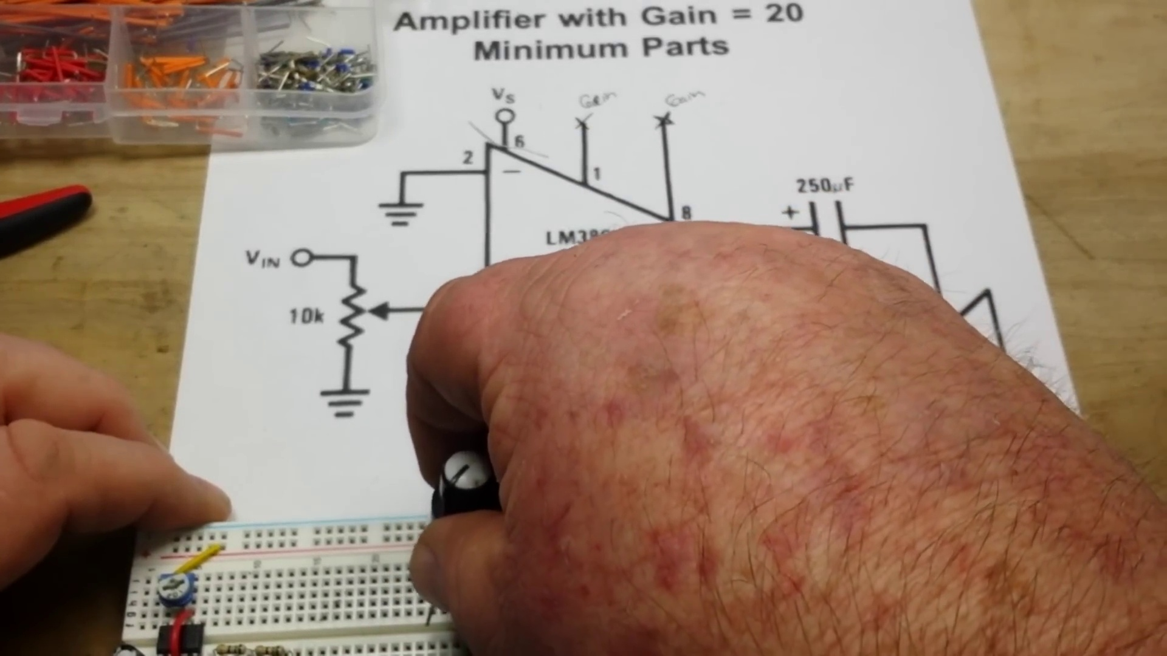

Transcript
[12:40] microfaradays
[12:43] i got 220
[12:44] 220 or 330
[12:50] let's go 330 when you're doing capacitors you should always err on the size
[12:58] caution 330
[13:04] capacitors of course long leg positive
[13:08] but i like to trim mine to the same length because that's how i roll
[13:14] the same length so i'm going to go
[13:18] and that guy
[13:20] go there like that
[13:25] yeah nice
[13:30] okay pin two
[13:34] which is our inverting input
[13:36] also needs to go to ground
[13:42] i'm looking for another
[13:46] gray one here
[13:50] come on
[13:53] my fingers are far too large
[13:56] to reach in there without some manner of assistance
[13:59] so pin two
[14:12] one two two and four
[14:16] four two both going to ground
[14:19] okay
[14:20] okay
[14:25] okay there's our first mistake that's pin eight our output is in fact pin five
[14:35] i know some of you guys are sitting there screaming at me
[14:40] you put it in the wrong hole
[14:41] not like i haven't heard that before
[14:53] only one golfing of course
[15:03] okay let's try this again here
[15:11] pin five that's much better
[15:18] and make sure yep going the right direction there
[15:22] so next we need a 10k pot i have a 10k pot right here
[15:27] get her to plug in nice and neat like
[15:43] yeah success
[15:48] that is
[15:48] okay that is fully on
[15:54] that's off
[15:57] hopefully we'll put it about
[16:01] halfway to start out with

Section 0: Call to Action and Support
Time: 16:05 - 28:18

Summary
The creator thanks their viewers and encourages them to support the channel through Patreon and Amazon shop purchases.

Representative Frames
18:07  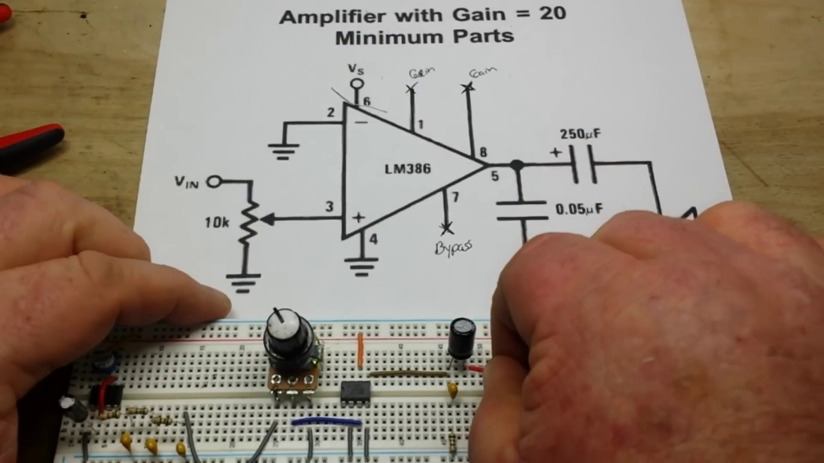 | 20:09  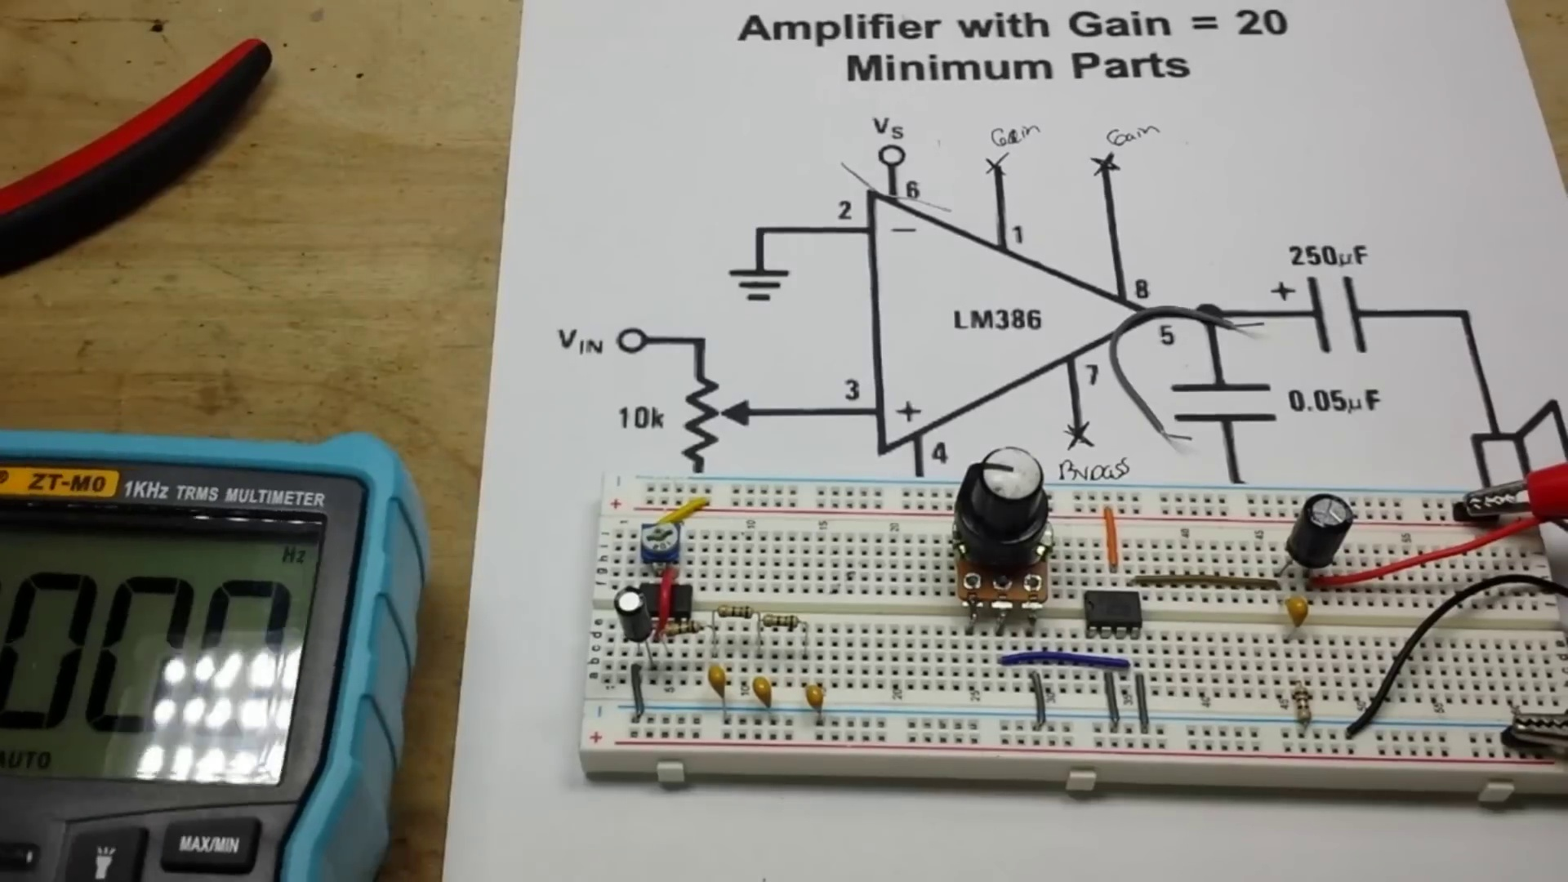 | 22:11  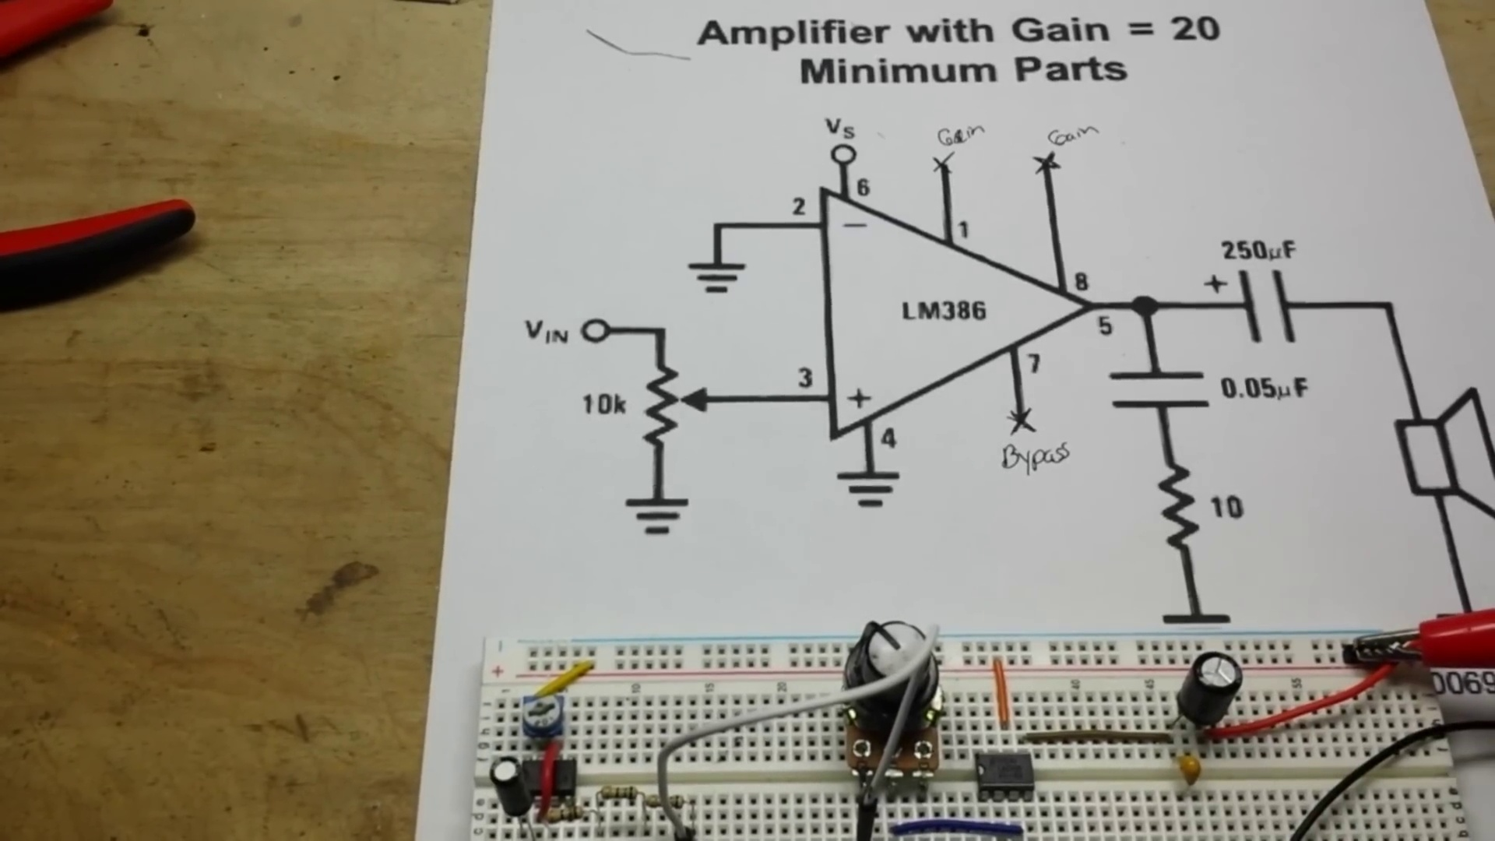 | 24:13  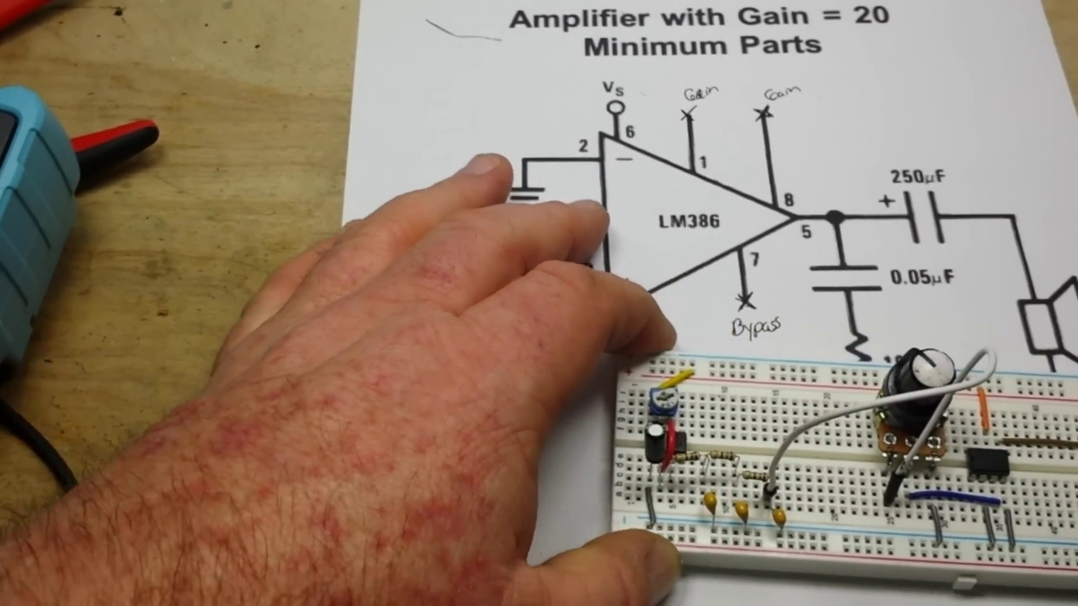 | 26:15  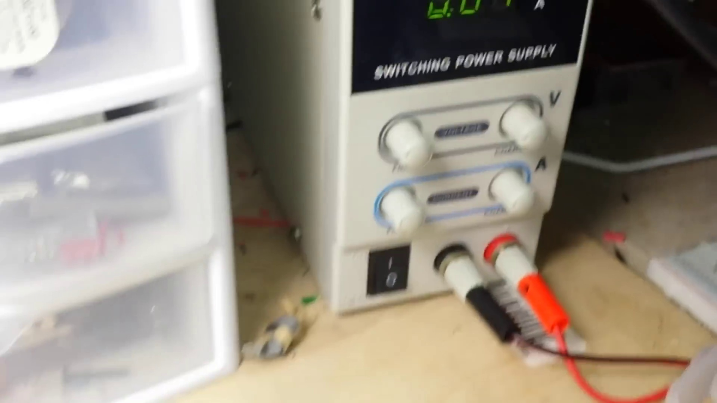

Transcript
[16:04] so the middle pin our wiper needs to go to pin tree
[16:16] one two three oh look at that
[16:18] i almost got it right
[16:25] story of my life
[16:28] okay
[16:31] and this one needs to go to ground
[16:34] hey caramba i gotta find another gray ground pin in here
[16:38] hey we got lucky
[16:39] these cheap bread boards sometimes just require a little
[16:51] massaging to get them to go in right
[16:54] definitely want to make sure you have them seated properly
[16:56] okay
[16:58] and then this one is our connection
[17:03] over
[17:08] so
[17:10] trying to see if i have
[17:13] something of the proper length
[17:15] not really
[17:22] not really
[17:25] what we'll do
[17:26] we'll take one of these
[17:32] longer gray ones here
[17:36] and we'll just give it the old bendaroonie
[17:41] just like that
[17:43] now
[17:45] assuming that i put everything together properly
[17:47] we should be good to go
[17:54] oh
[17:55] we must hook up our sprecker
[17:58] spreckens the electronics
[18:09] the negative
[18:21] positive
[18:26] and
[18:27] the power
[18:28] i'm putting about 5.5 volts in from my
[18:31] bench power supply what do you think
[18:33] will she make noise or will she go kablooey
[18:39] one way to find out
[18:41] okay seven eight and one are not connected
[18:44] everything else is connected
[18:54] and we have no sound
[19:04] hmm
[19:08] wiper pin three
[19:12] pin six is positive
[19:15] not getting warm
[19:16] like this there
[19:26] all right let's uh
[19:28] make sure we are still oscillating
[19:46] okay
[19:48] you know why is that showing me 50 hertz
[19:54] that hold on or something
[20:05] what is going on here
[20:07] well first problem was
[20:09] i had it on square wave out
[20:12] and not hertz in
[20:16] so yeah we are still getting
[20:24] our oscillation
[20:29] good
[20:33] but why
[20:35] are we not getting
[20:41] an output
[20:42] to the speaker
[20:59] what have we done wrong
[21:00] hmm
[21:13] all right i'm gonna shut off the power here
[21:17] shut that off
[21:20] all right let's have a think
[21:21] all right pin one
[21:28] not connected
[21:29] pin two
[21:31] connected to ground
[21:33] pin three to the wiper
[21:36] one two three
[21:39] pin four one two three four to ground
[21:44] pin five is our output
[21:46] which goes to our blocking cap
[21:50] and also
[21:52] to this filter
[21:55] pin six is our voltage supply
[22:02] seven is not connected
[22:05] eight is not connected
[22:06] all right turn the power back on
[22:17] i'm gonna put this guy over here
[22:21] set for six volts dc
[22:23] let's see
[22:28] we are getting at the pins
[22:33] five point two five point six two
[22:35] and our power supply is showing five point sixty so that's good
[22:40] all right let's look at six volts ac
[22:43] and see what we're getting out
[22:56] yeah we're getting oscillation out
[23:00] as you can see
[23:04] hard to do and not block the camera at the same time
[23:08] well we were getting it or we're not getting it now
[23:19] try and put it here
[23:23] and here
[23:26] no
[23:31] now let's just connect the speaker
[23:33] here
[23:41] now you see
[23:43] we're getting dc out
[23:45] this should actually be blocking dc so
[23:49] shouldn't get anything at all here
[23:58] we've got an offset here because this is actually
[24:03] the dc
[24:07] all right
[24:08] just for um s and g's
[24:12] let's take out
[24:14] our blocking capacitor
[24:21] yeah if it's blocking
[24:24] all of the dc we're not going to hear anything
[24:29] so let's see what we get now if we turn it on
[24:33] okay
[24:43] still nothing
[24:52] have a look here
[24:52] yeah i'm seeing two and a half
[25:07] hmm
[25:09] to the data sheet robin
[25:12] so unfortunately the data sheet didn't give me any clues
[25:14] i guess it's not on right now
[25:19] unless that pot's bad
[25:24] uh resistance resistance resistance
[25:28] 10k pots we'll put it on
[25:32] 60
[25:32] we'll be
[25:42] reading zero
[25:45] reading eight
[25:46] close enough for government work.
[25:59] Let's flip on the power supply again.
[26:02] I'm going to take you out of here so you can see.
[26:09] Oh.
[26:12] Did you hear that?
[26:15] Did you hear it?
[26:16] It appears to be working.
[26:22] Turn it up.
[26:42] Well, ain't that a miracle.
[26:43] All right, boys and girls.
[26:48] I have no explanation of why it didn't work before, but now it works.
[26:55] Anyway, the whole point of this was to show you how to set up the LM386 audio amplifier.
[27:05] We set it up as prescribed in the manual for the internal 20x gain.
[27:14] And after, I don't know, I just, I don't get it.
[27:27] I don't get it.
[27:29] I don't get it.
[27:29] But whatever.
[27:34] Sure works.
[27:36] I don't get it.
[27:36] I don't get it.
[27:37] I don't get it.
[27:37] I don't get it.
[27:38] I don't get it.
[27:39] I don't get it.
[27:40] I don't get it.
[27:42] give me a thumbs up give me two thumbs up sometimes life's just a mystery that's it I'm out
[27:48] peace I want to thank you all for watching and spending time with me today the community like
[27:56] this is something that we can all be very proud of so again thank you very much for all your
[28:02] support of learn electronics please feel free to check out the patreon page dollar month is all I
[28:07] ask and really helps keep the channel alive we also have an Amazon shop where you can buy most
[28:13] of the items that you see on here and there's a link to it down below

