Engagement Analysis: K4aI2t5T00c

Section 0: Person holding an electronic device
Time: 8:01 - 8:02

Summary
A person is shown holding an electronic device with multiple components attached to it. The background has a blurred area that suggests a natural setting.

Representative Frames
8:01  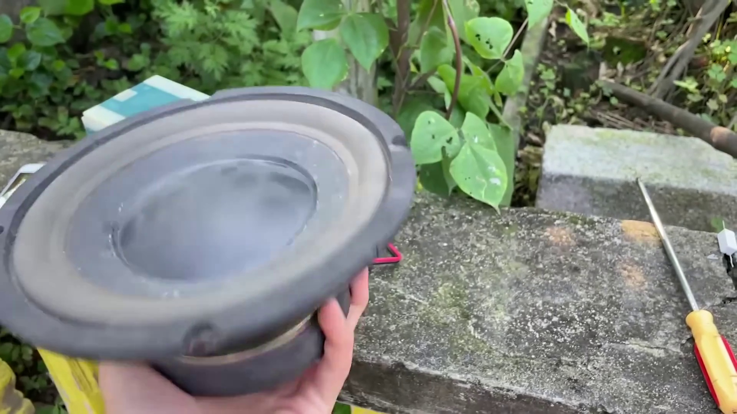 | 8:01   | 8:01  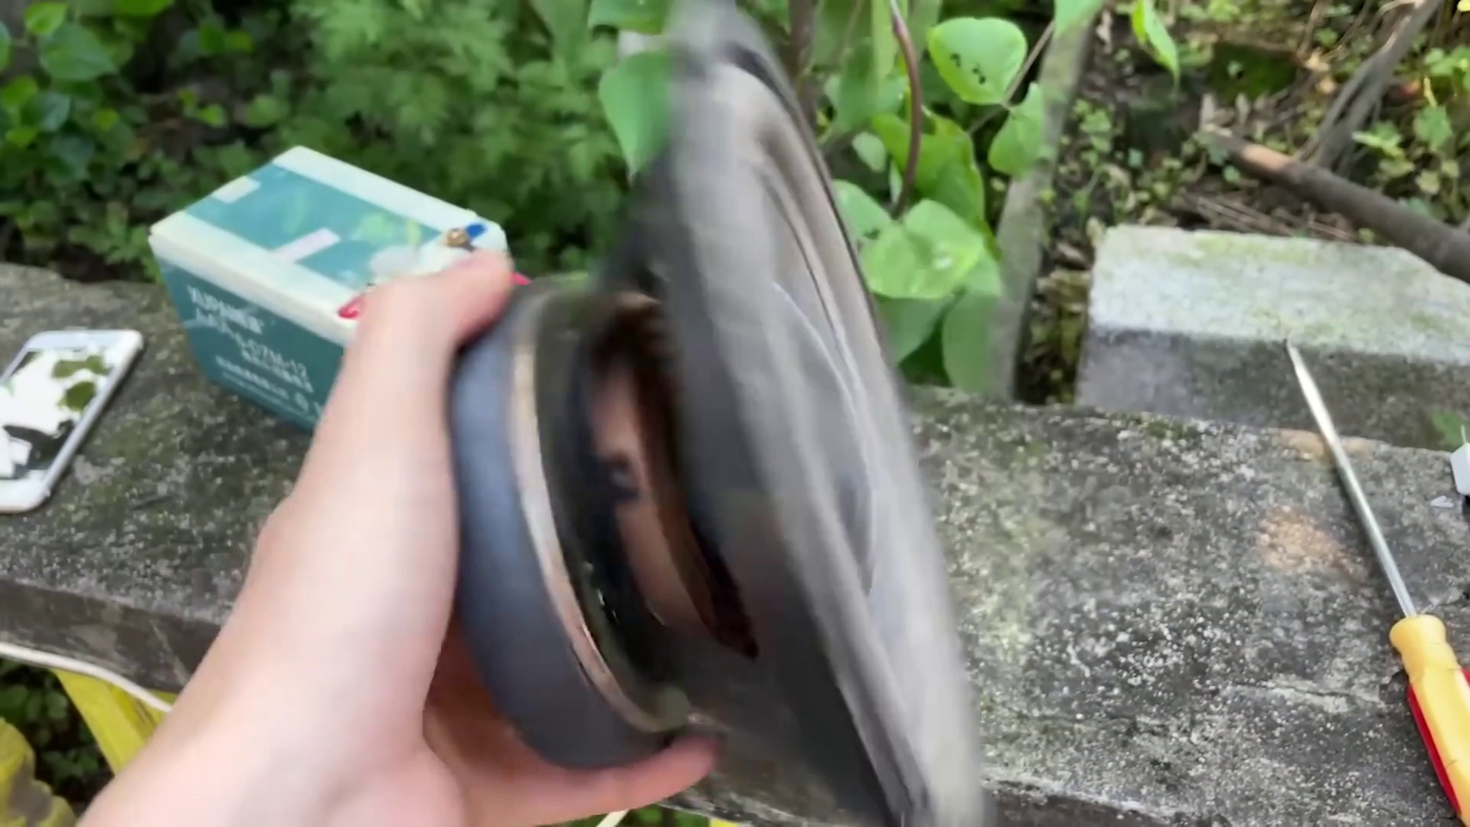 | 8:01   | 8:01  

Transcript
(No speech detected in this section)

Section 0: Hand holding a small box
Time: 8:02 - 8:03

Summary
A hand, adorned with a black leather glove, is seen holding a small, black box that appears to be a circuit board or component. The background has a green walled garden.

Representative Frames
8:02   | 8:02   | 8:02   | 8:02   | 8:02  

Transcript
(No speech detected in this section)

Section 0: Hand giving thumbs-up gesture
Time: 8:03 - 8:04

Summary
A hand gives a thumbs-up gesture while holding a smartphone in the background, suggesting that the photo was taken for social media or instructional purposes.

Representative Frames
8:03  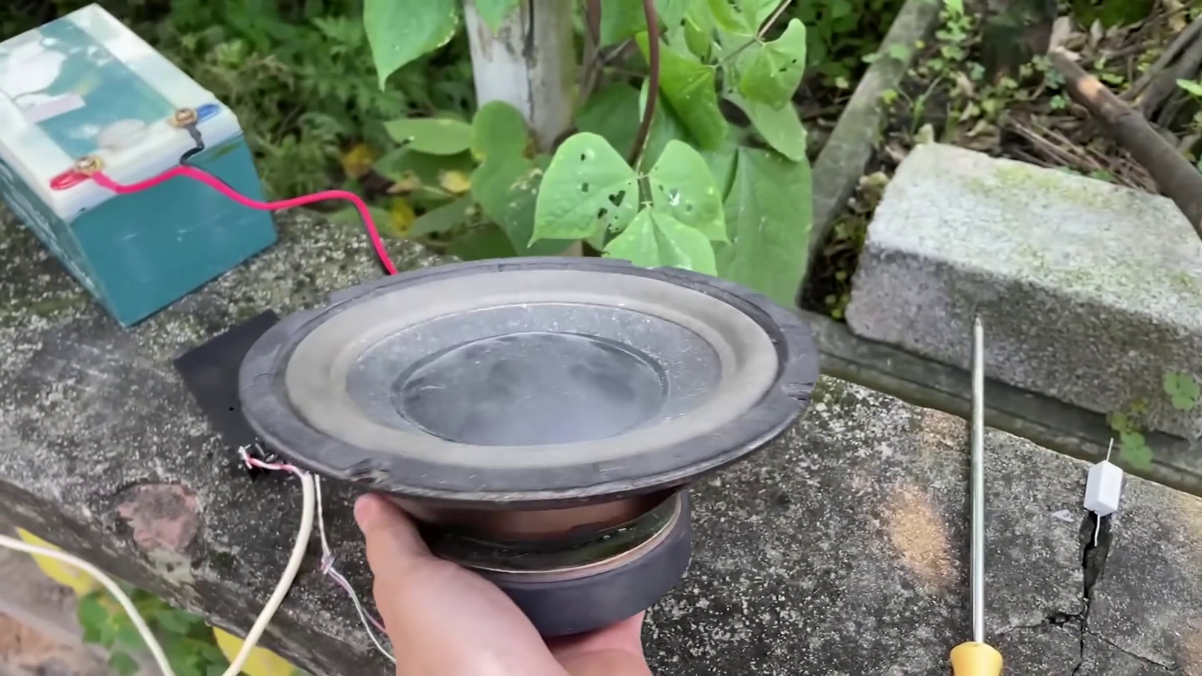 | 8:03   | 8:03   | 8:03   | 8:03  

Transcript
(No speech detected in this section)

Section 0: Close-up of a hand with electronic components
Time: 8:04 - 8:05

Summary
A close-up shot of a hand holding various electronic components, including a soldering iron and cables. The background has a blurred area that suggests an indoor or outdoor setting.

Representative Frames
8:04   | 8:04   | 8:04   | 8:04   | 8:04  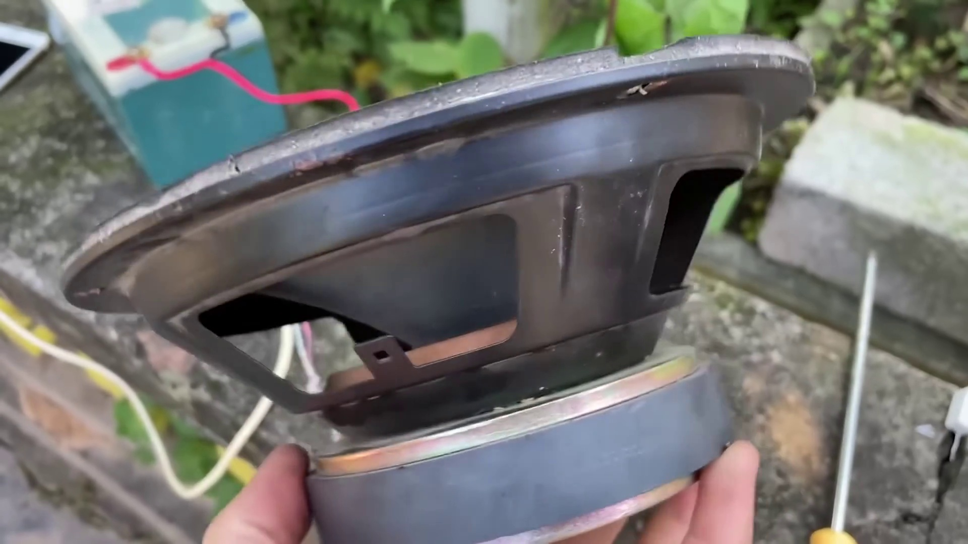

Transcript
(No speech detected in this section)

Section 0: Organized workshop with electronic equipment
Time: 8:05 - 8:26

Summary
A well-organized workshop is shown, featuring various electronic components and equipment, including battery packs, adapters, extension cords, and microphones. The background has a greenery and what appears to be a fence.

Representative Frames
8:08  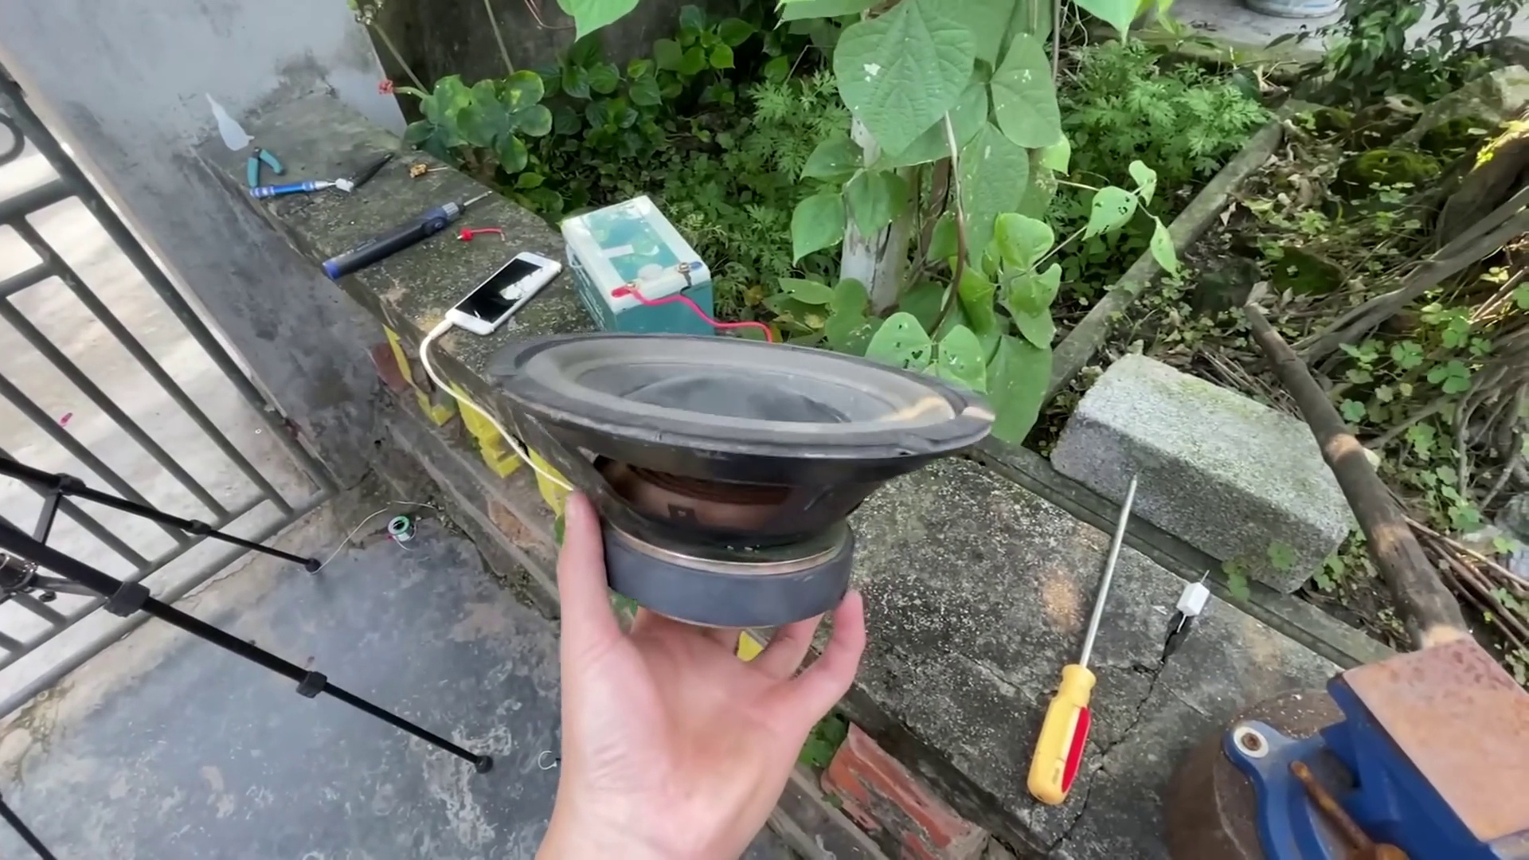 | 8:12  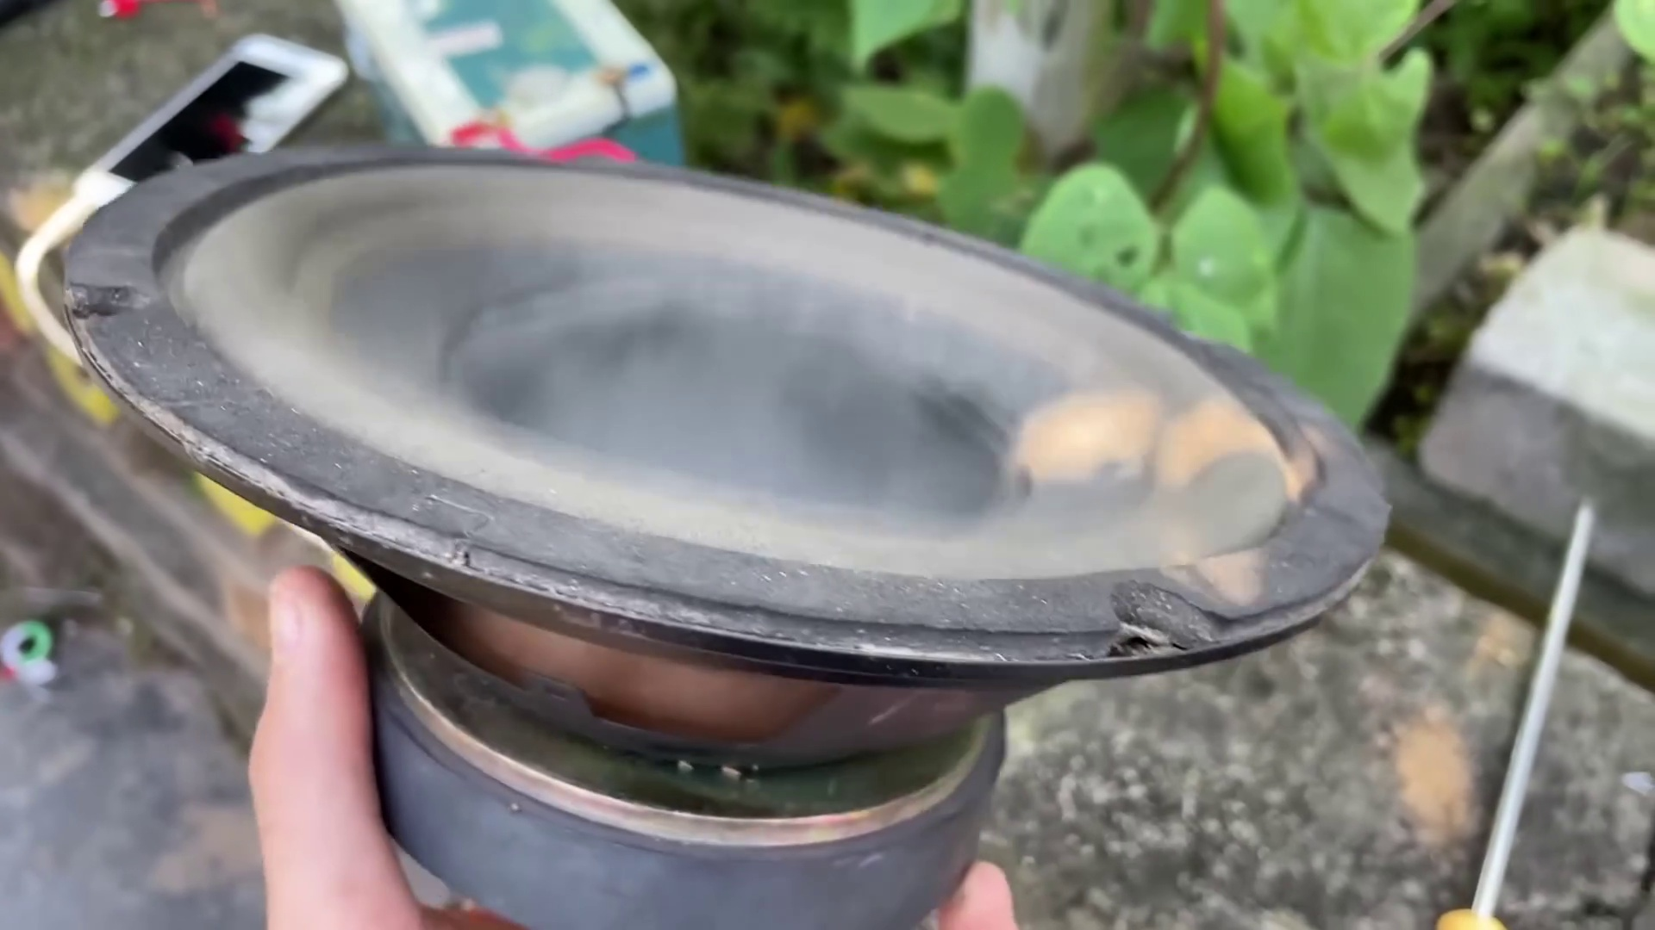 | 8:15  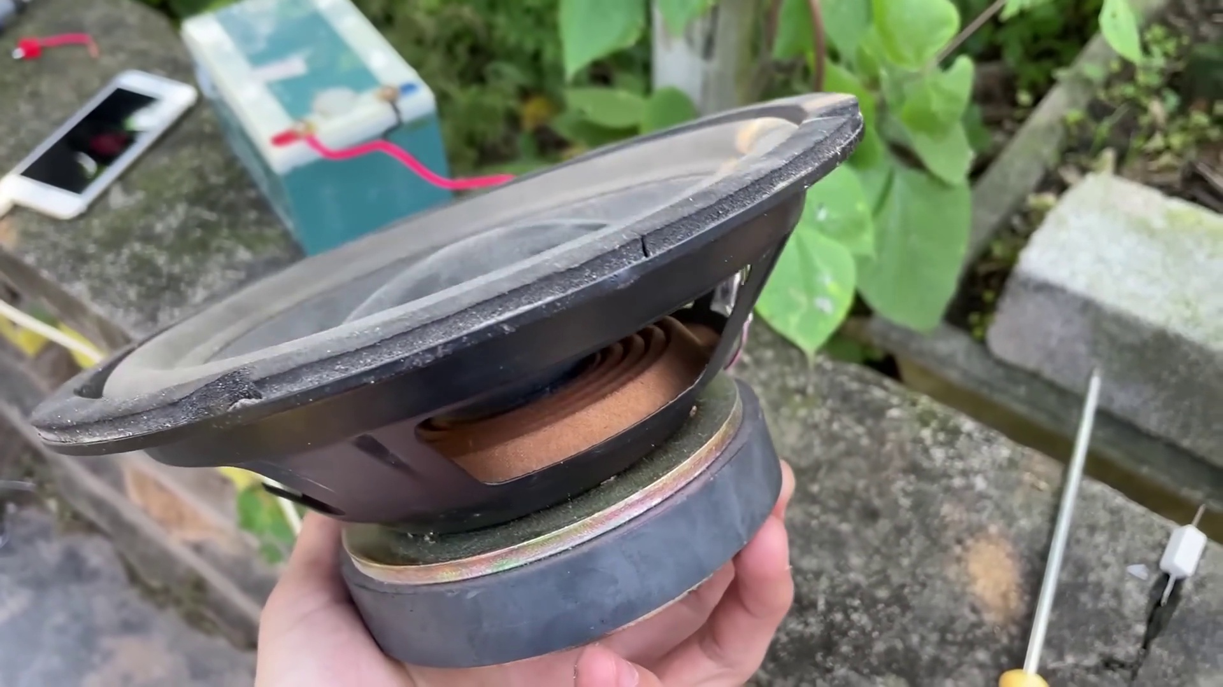 | 8:19  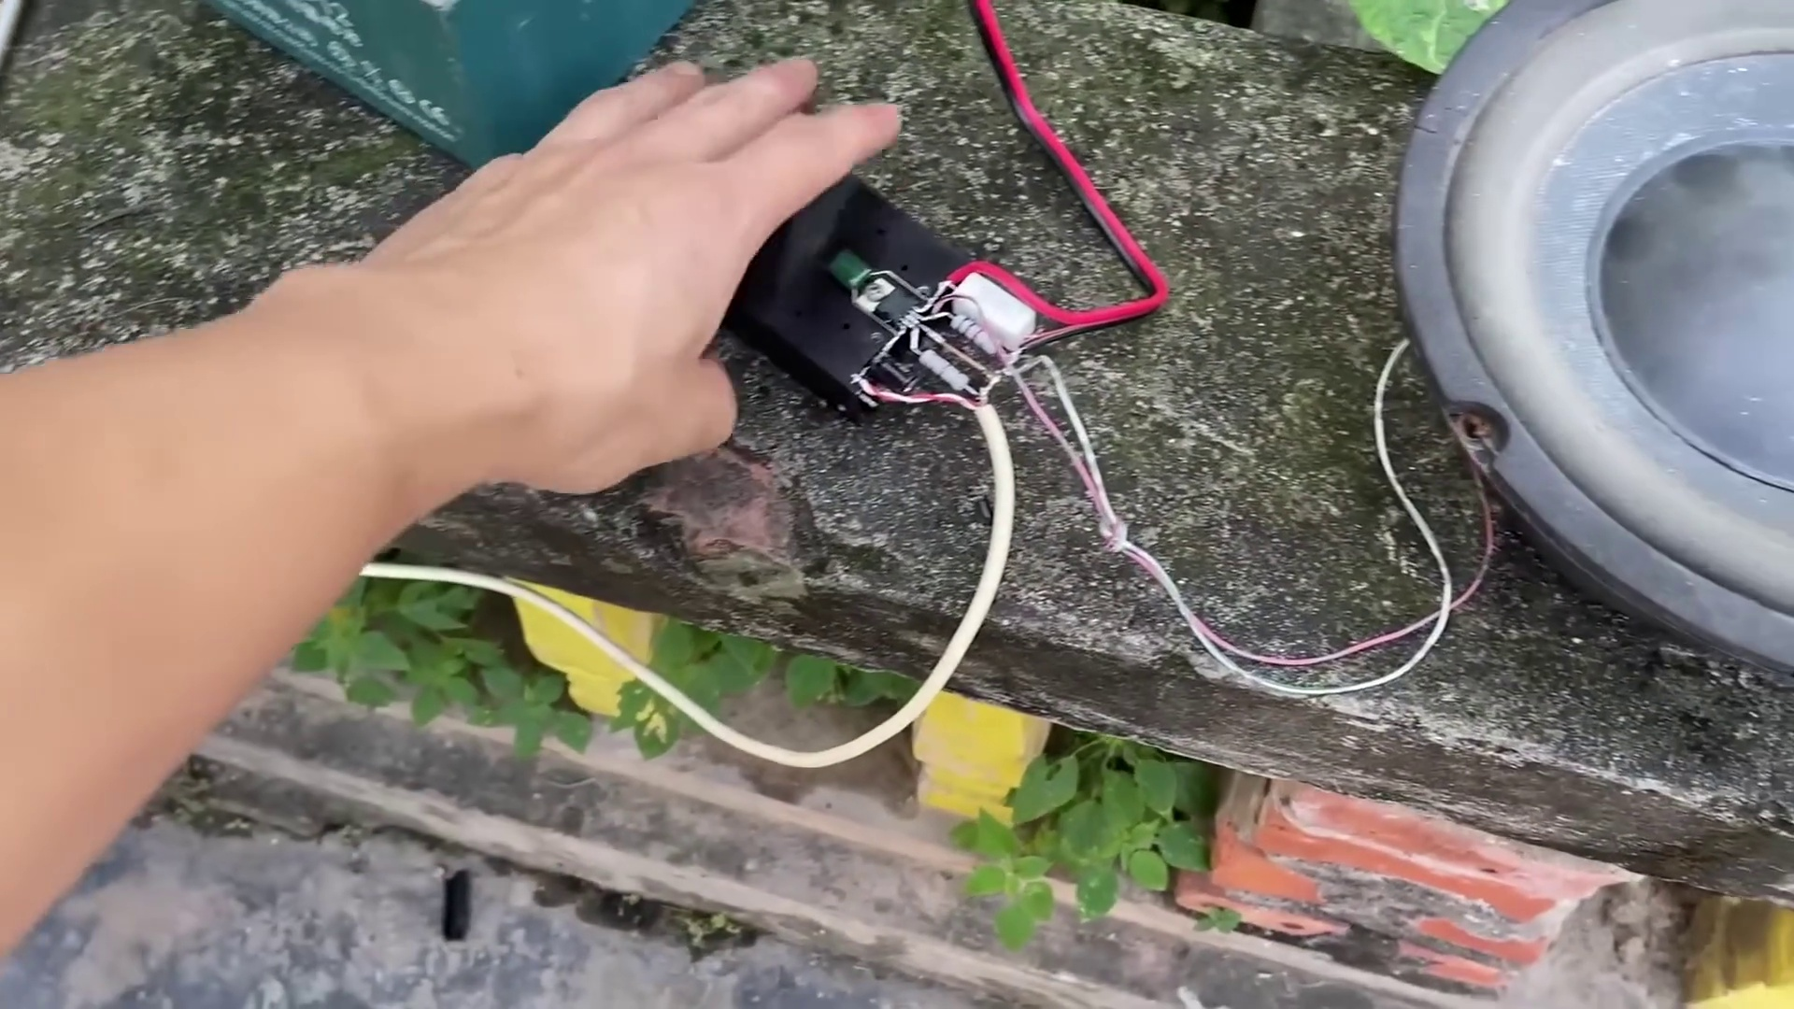 | 8:23  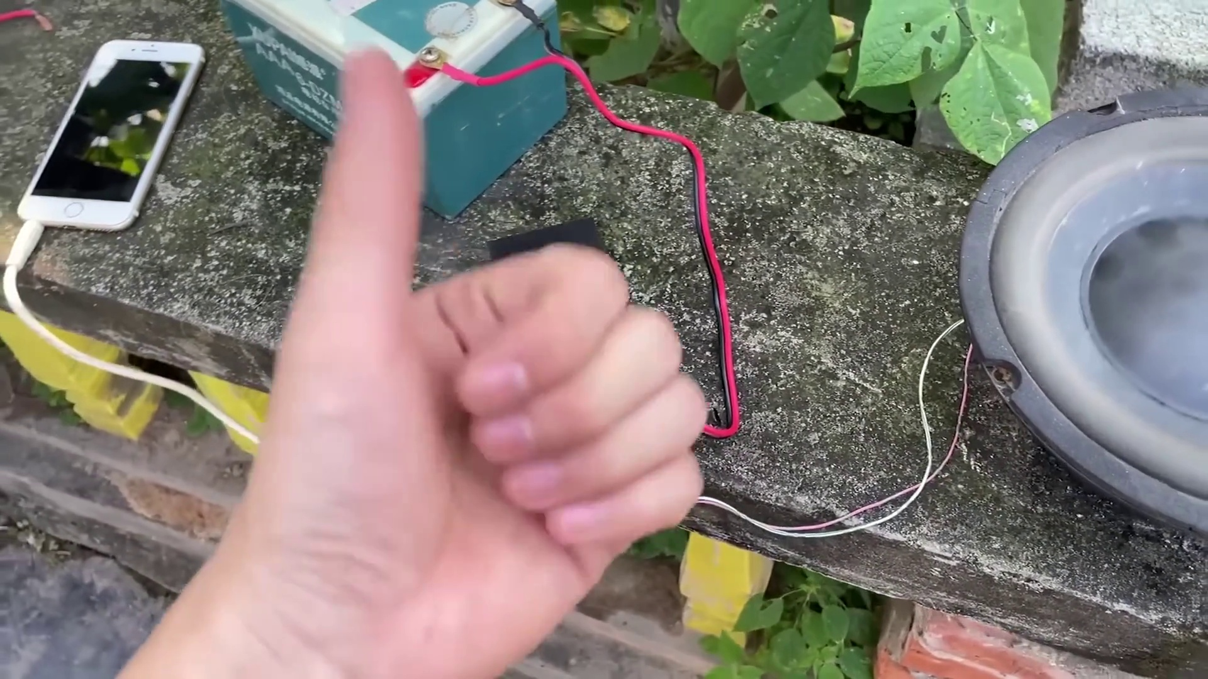

Transcript
[7:52] Let's go.
[8:22] Let's go.

