Engagement Analysis: KDwqqlqdYFQ

Section 0: Introduction to Electronics Project
Time: 0:00 - 0:05

Summary
The channel creator discusses various electronics projects, including circuit boards and devices.

Representative Frames
0:00  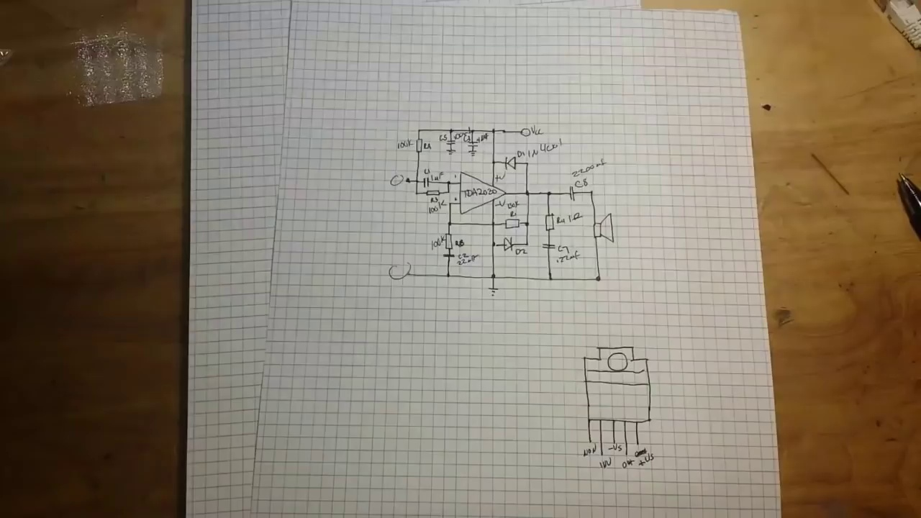 | 0:01   | 0:02   | 0:03  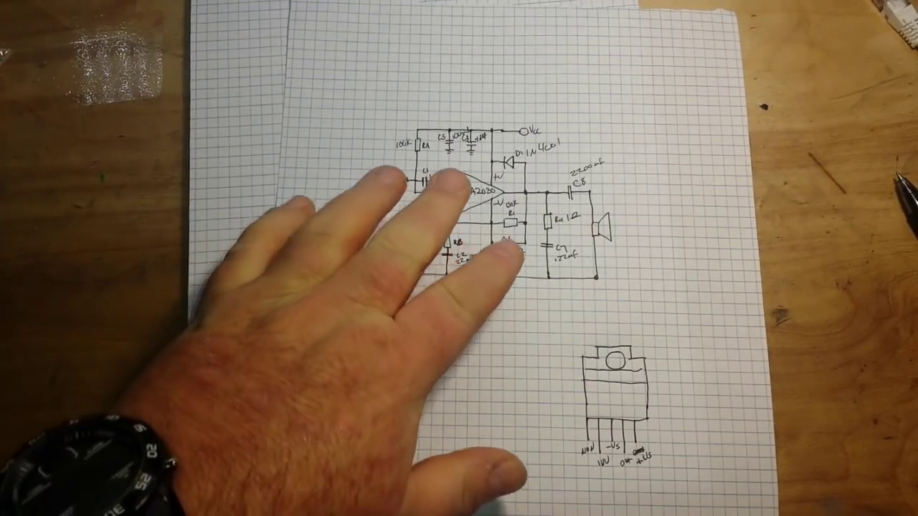 | 0:04  

Transcript
[0:00] Hey, what's happening guys? Yesterday we talked about this class AB amplifier with the TDA2030.

Section 0: Project Showcase
Time: 0:05 - 0:10

Summary
The creator showcases different electronic devices, explaining their purpose and functionality.

Representative Frames
0:05   | 0:06  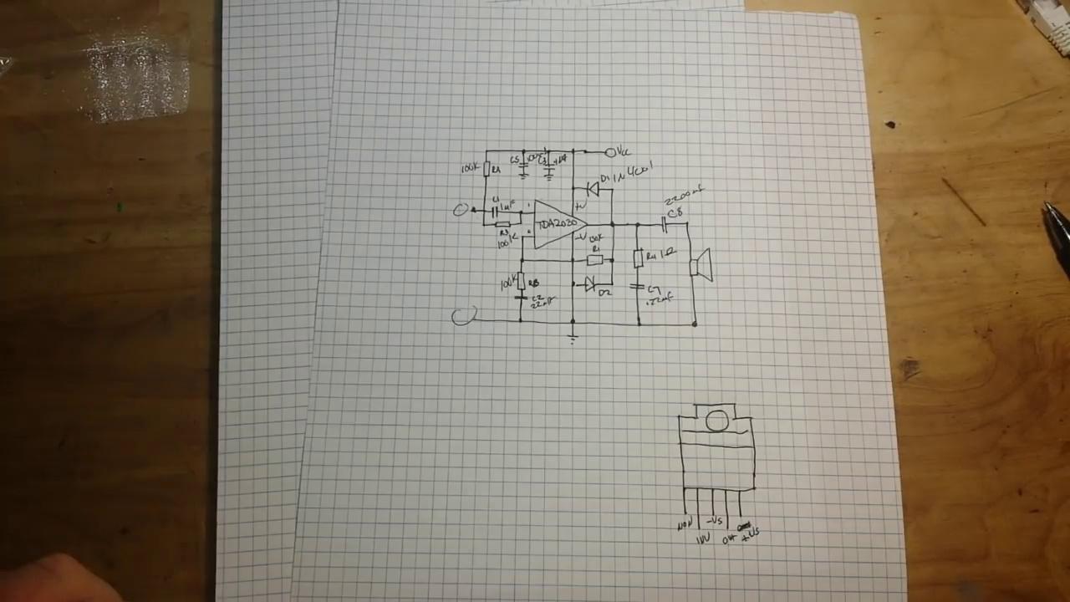 | 0:07   | 0:08   | 0:09  

Transcript
(No speech detected in this section)

Section 0: Component Explanation
Time: 0:10 - 0:15

Summary
The creator explains the components used in various electronics projects, including circuit boards and wires.

Representative Frames
0:10  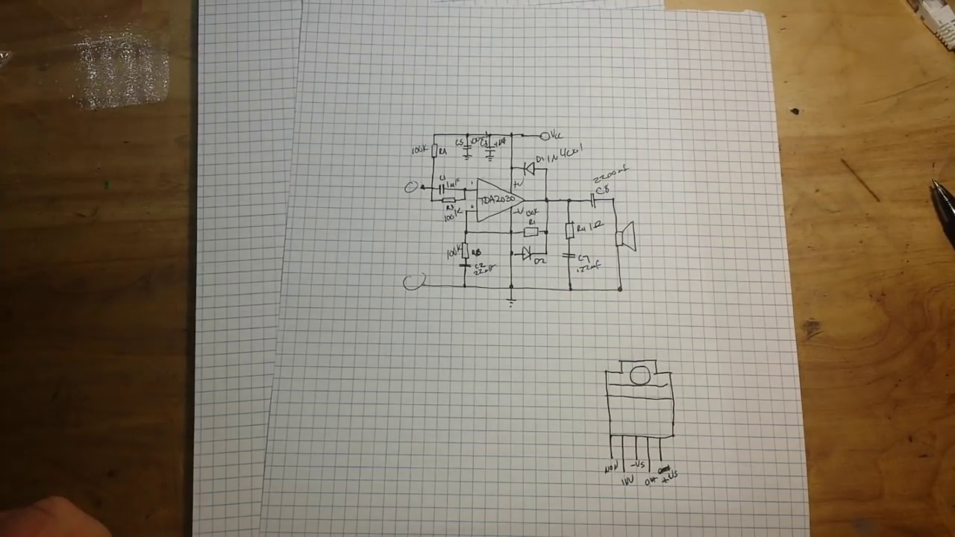 | 0:11   | 0:12   | 0:13  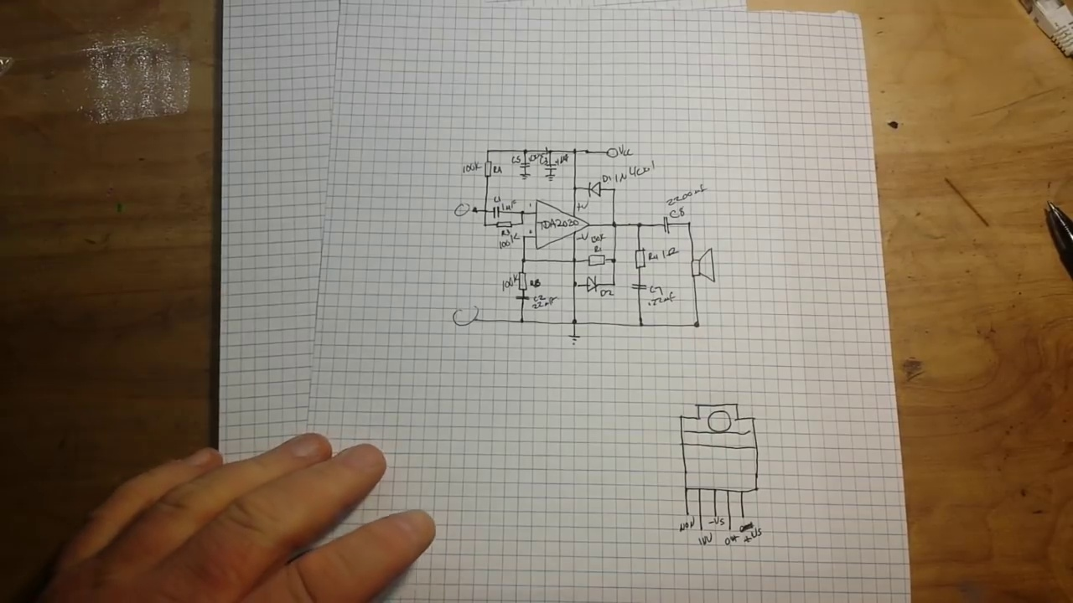 | 0:14  

Transcript
[0:08] And today, as promised, we're going to build that circuit.

Section 0: Assembly Process
Time: 0:15 - 0:20

Summary
The creator demonstrates the assembly process of electronic devices, highlighting attention to detail and expertise required.

Representative Frames
0:15   | 0:16  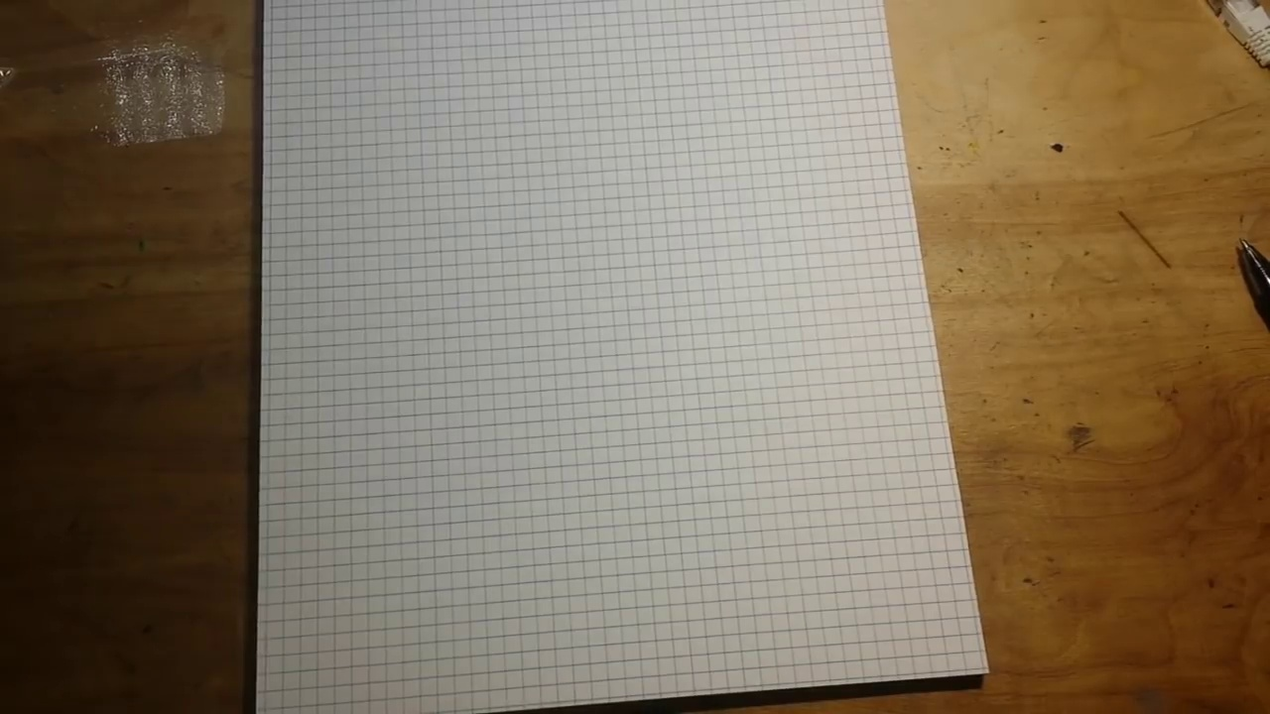 | 0:17   | 0:18   | 0:19  

Transcript
[0:17] So, I've had this kit on my wish list for a while.

Section 0: Thank You Message
Time: 0:20 - 9:40

Summary
The creator expresses gratitude to their patrons for supporting the channel through donations or subscriptions.

Representative Frames
1:53  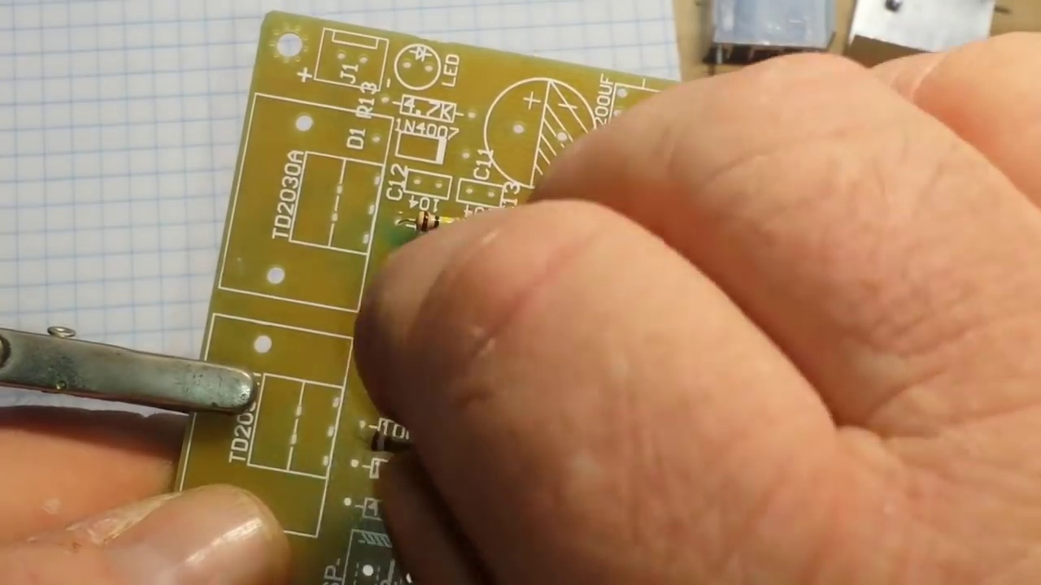 | 3:26  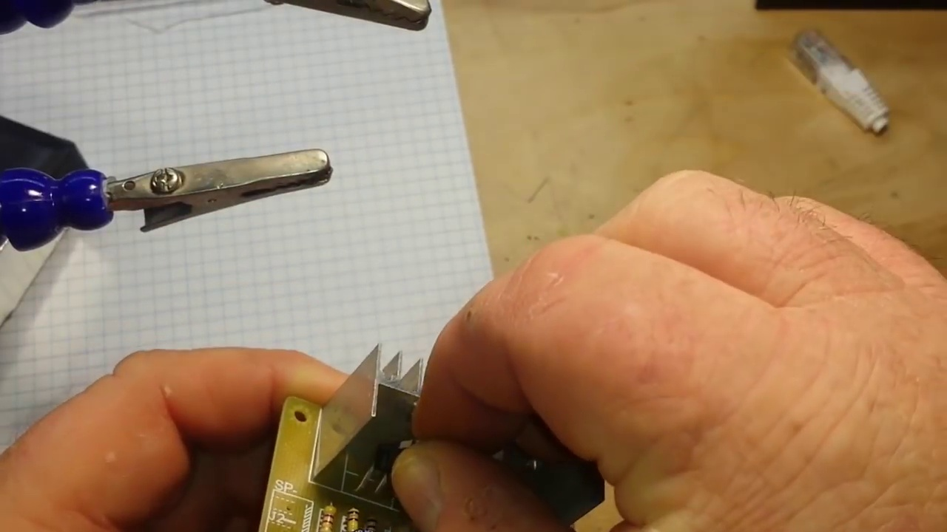 | 5:00  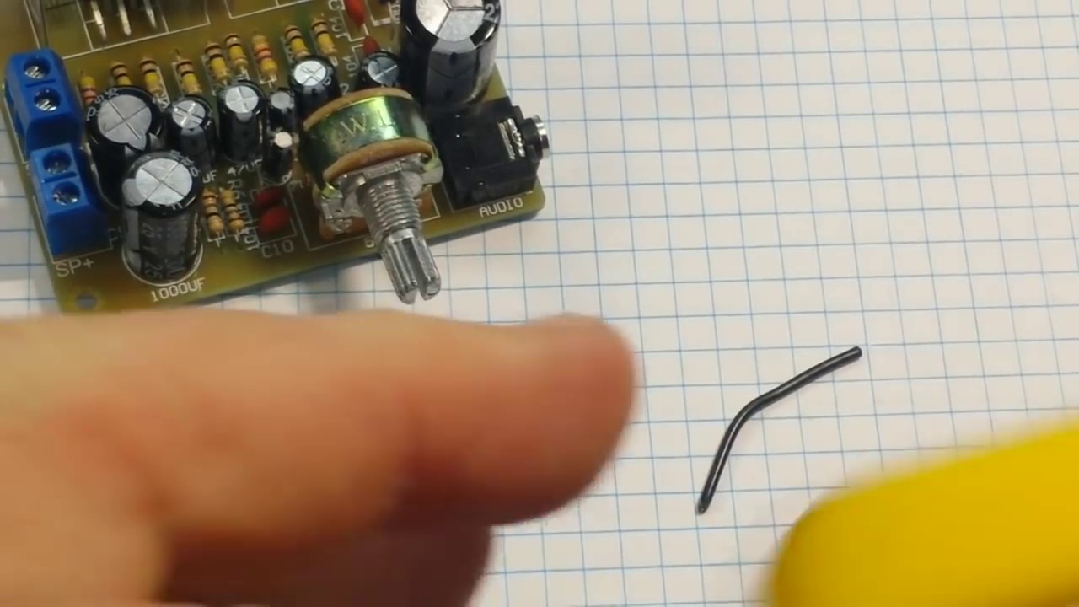 | 6:33  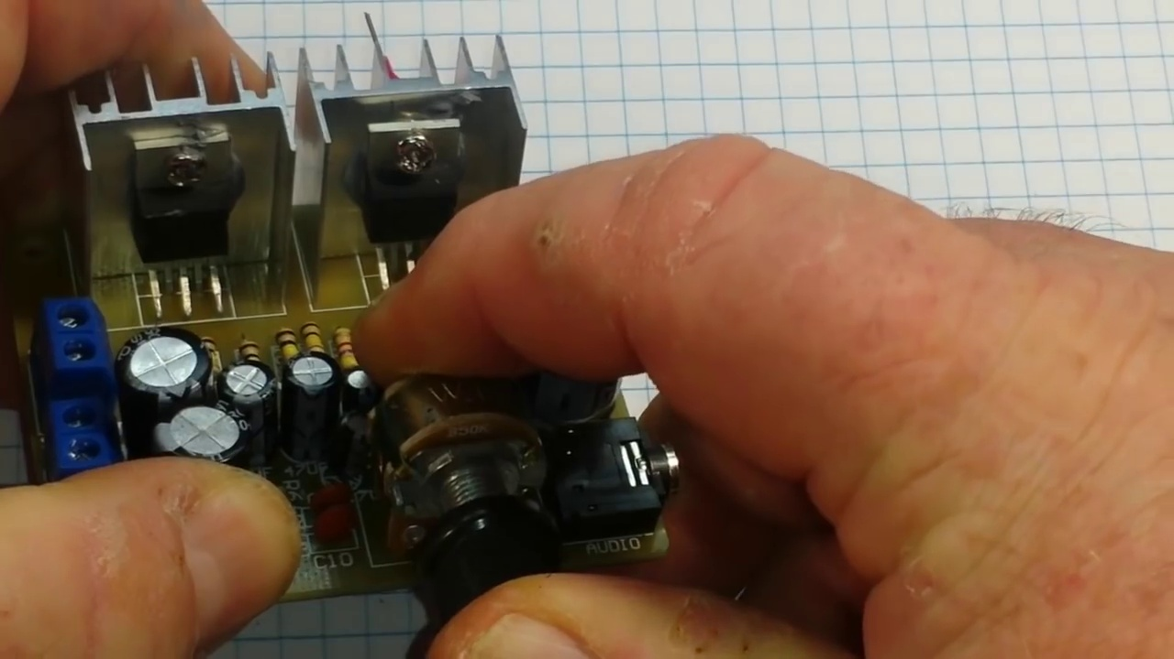 | 8:07  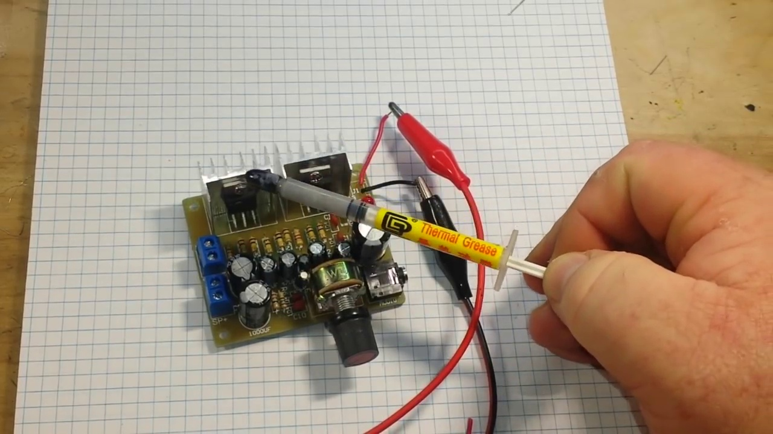

Transcript
[0:21] It's from ICStation.com and it's the TDA2030 amplifier kit.
[0:33] And I would like to thank Dave for sending it out to us.
[0:40] So, we're going to build it and have ourselves a nice TDA2030.
[0:46] If we take a look here at the circuit board, you can see there are a few changes from the circuit that I drew yesterday.
[0:58] They're using 1, 2, 3, 4, 5, 6, 7, 8, 9 capacitors.
[1:07] And my circuit had what?
[1:11] 8.
[1:12] Then there are also 4 ceramic capacitors.
[1:17] So, that's like 13 total capacitors here.
[1:24] Yeah.
[1:26] So, that's a little different.
[1:27] Also, only one diode.
[1:31] Which is a little strange.
[1:33] But, I think we'll make it work.
[1:37] Alright.
[1:39] Buckle up.
[1:39] We're going to do this fast mode.
[1:42] We're going to do this fast mode.
[2:09] Now, come on.
[2:14] Another time.
[2:16] But, let's check on.
[2:17] I don't care about Eolt.
[2:18] Okay.
[2:18] So, we want to do this fast mode.
[2:19] And we're going to do it fast pharmacist.
[2:20] Doing it fast.
[2:22] And we're going to use the cam.
[2:23] Today we're going to do it fast debate.
[2:24] And what's it mean?
[2:24] We're going to do this fast mode.
[2:25] I do not want a seat.
[2:25] Now, we know the about theünk Ho.
[2:26] When I look imbalpsy for some any piece,
[2:27] I want to aim for time at the gym.
[2:29] So, we will carry you over the profession.
[2:30] We're going to do this fast decibels.
[2:31] That's super lumico.
[2:33] We'll do it fast and see you guys.
[2:35] And, and download the Cristo from all across,
[2:36] and is the Fi.
[2:37] Thank you.
[3:07] Thank you.
[3:37] Thank you.
[4:07] Thank you.
[4:09] Thank you.
[4:11] Thank you.
[4:13] Thank you.
[4:15] Thank you.
[4:17] Thank you.
[4:19] Well, we're just about done.
[4:24] The only thing left is this little power jack.
[4:31] And, no.
[4:33] I don't want to use it.
[4:35] I don't like those jacks.
[4:40] I don't have anything to use it with.
[4:41] So, for our purposes today, I'm just going to cut some wire.
[4:51] And, strip it.
[5:01] And, we'll just hook it up with alligator clips.
[5:04] Now, one thing.
[5:07] I just realized.
[5:11] These speaker terminals here for bare wire.
[5:15] Oh, that's kind of ugly.
[5:17] Well, that needs fixed.
[5:19] Well, that needs fixed.
[5:20] Yeah.
[5:21] I don't have any speakers that hook up like that.
[5:26] So, before we can really test this out.
[5:29] Good.
[5:30] I need to get a hold of a couple of speakers of that ilk.
[5:40] I will grab some tomorrow.
[5:43] I think if I go up to my mom's house, there might be some old stereo speakers from when
[5:50] I was a boy.
[5:52] So, we can go check that out.
[6:00] Okay.
[6:01] Last soldering for this guy.
[6:04] It took me about an hour to put this together.
[6:08] Aren't you glad I condensed it?
[6:11] Alright.
[6:12] So, the piece de resistance.
[6:15] There we go.
[6:32] Nice.
[6:33] So, let's smoke test it.
[6:34] We'll hook it up to 12 volts.
[6:37] And hopefully, the only thing that lights up is the LED.
[6:44] I got that set for 6 volts.
[6:45] Let me get in here and change it.
[6:47] Voltage.
[6:48] Boom, boom.
[6:49] Zip.
[6:50] Boom, boom.
[6:51] Zip.
[6:52] Boom, boom.
[6:53] And I got that set for 6 volts.
[6:55] lights up is the LED. I got that set for 6 volts let me get in here and change it.
[7:11] Voltage boom boom zip and power. Okay so our LED is lit sniff testing
[7:28] nothing seems unreasonably hot
[7:42] yeah I guess I soldered everything in the right direction then power that down
[7:57] now I don't know if you could see it in the video because it went so fast but I
[8:04] put thermal grease in between those TDA 2030s and the heat sinks get these on
[8:12] eBay just put in thermal paste you get like 10 syringes for two dollars or
[8:20] something ridiculous like that. Alright so anyway there's our amplifier that's all
[8:29] we can do for tonight we will do the rest when I pick up a pair of speakers to test
[8:34] it with and instead of just shoving some audio through it I think what we might do
[8:49] is hook up this AD9833 digital synthesis chip and put some different frequencies through it
[9:10] you know we hook that up to the Arduino and we can sweep it through some different frequencies
[9:14] and we'll put it on a scope and look at the output. So if you guys want to see that
[9:19] give me the old thumbs up feel free to comment share and don't forget to subscribe.
[9:25] That's it I'm out peace except the Ravens
[9:30] you
[9:31] you

