Engagement Analysis: N5DbiWFjbh8

Section 0: Aerial view of a suburban neighborhood
Time: 0:17 - 0:18

Summary
The image shows an aerial view of a serene residential neighborhood during daylight. The scene presents a comprehensive view of the houses and their surroundings from a bird's eye perspective.

Representative Frames
0:17  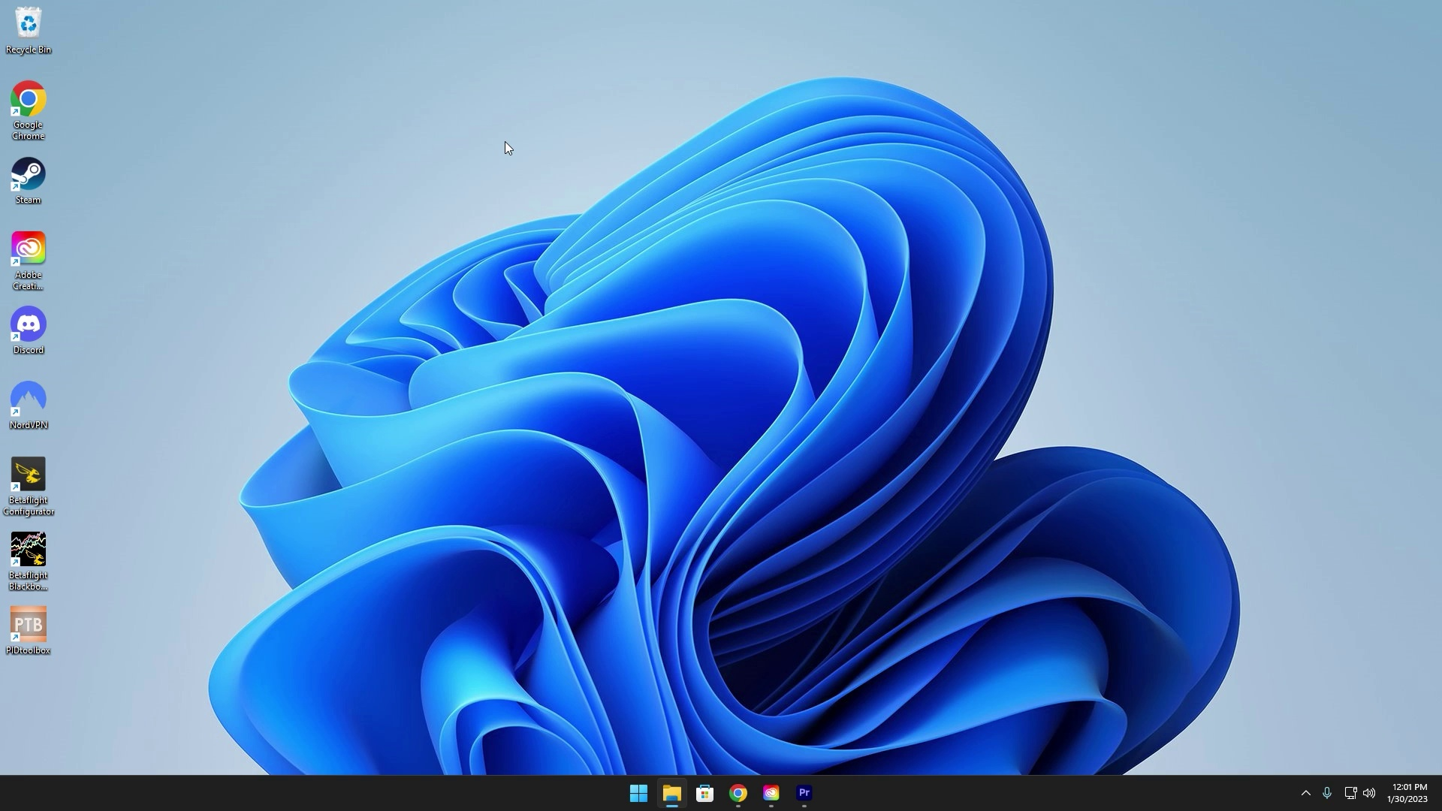 | 0:17   | 0:17   | 0:17   | 0:17  

Transcript
[0:15] of the assumption that you already have that all done and you're just looking to get that perfect

Section 0: Red car parked on the right side of the road
Time: 0:18 - 0:19

Summary
The image captures an aerial view of a suburban scene under a cloudy sky. A red car is parked on the right side of the road, while a white truck is visible on the left.

Representative Frames
0:18   | 0:18  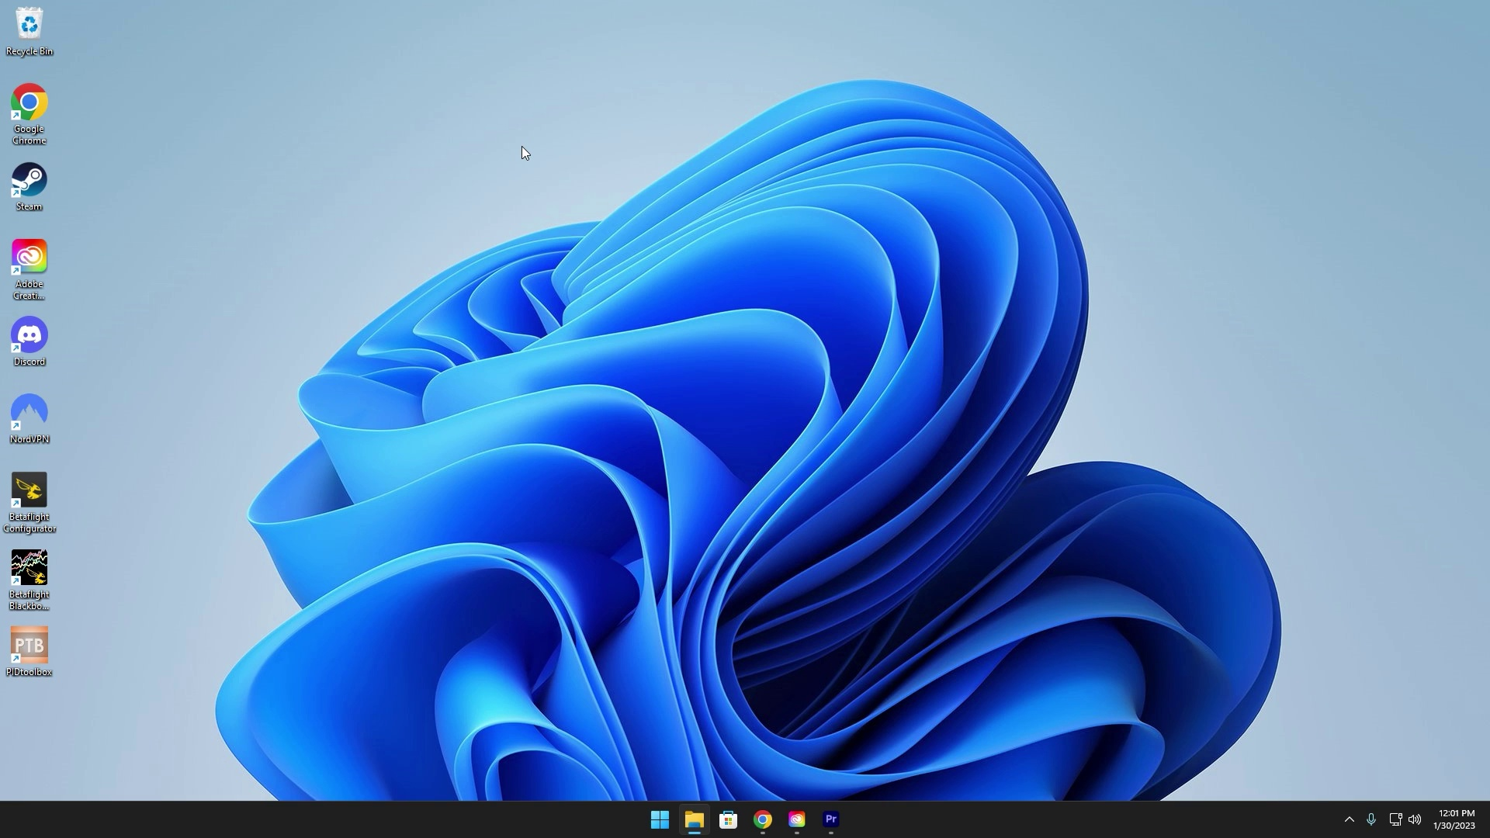 | 0:18   | 0:18   | 0:18  

Transcript
(No speech detected in this section)

Section 0: Serene residential neighborhood during daylight
Time: 0:19 - 0:20

Summary
The image shows an aerial view of a serene residential neighborhood during daylight. The scene presents a comprehensive view of the houses and their surroundings from a bird's eye perspective.

Representative Frames
0:19   | 0:19   | 0:19   | 0:19   | 0:19  

Transcript
(No speech detected in this section)

Section 0: Digital art piece with futuristic setting
Time: 0:20 - 18:02

Summary
The image shows a digital art piece featuring a blue background with a white text overlay. The text is surrounded by a white circle, and an overlay of a video call or presentation with a digital environment appears to represent a futuristic setting.

Representative Frames
3:17  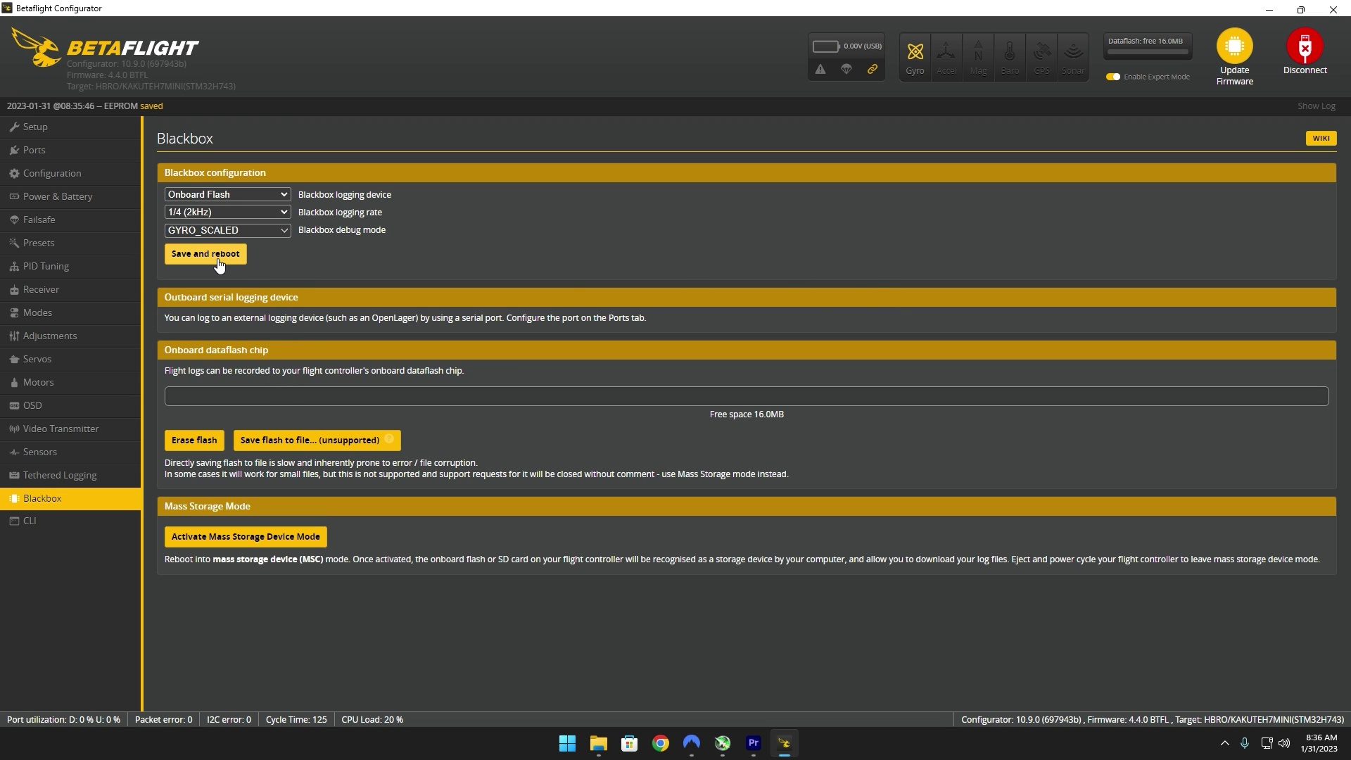 | 6:14  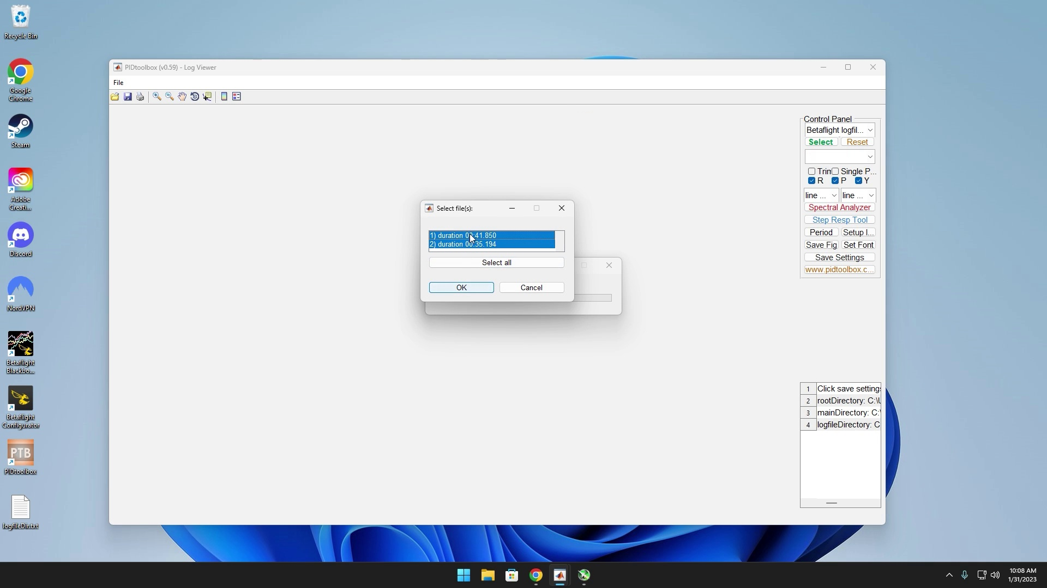 | 9:11  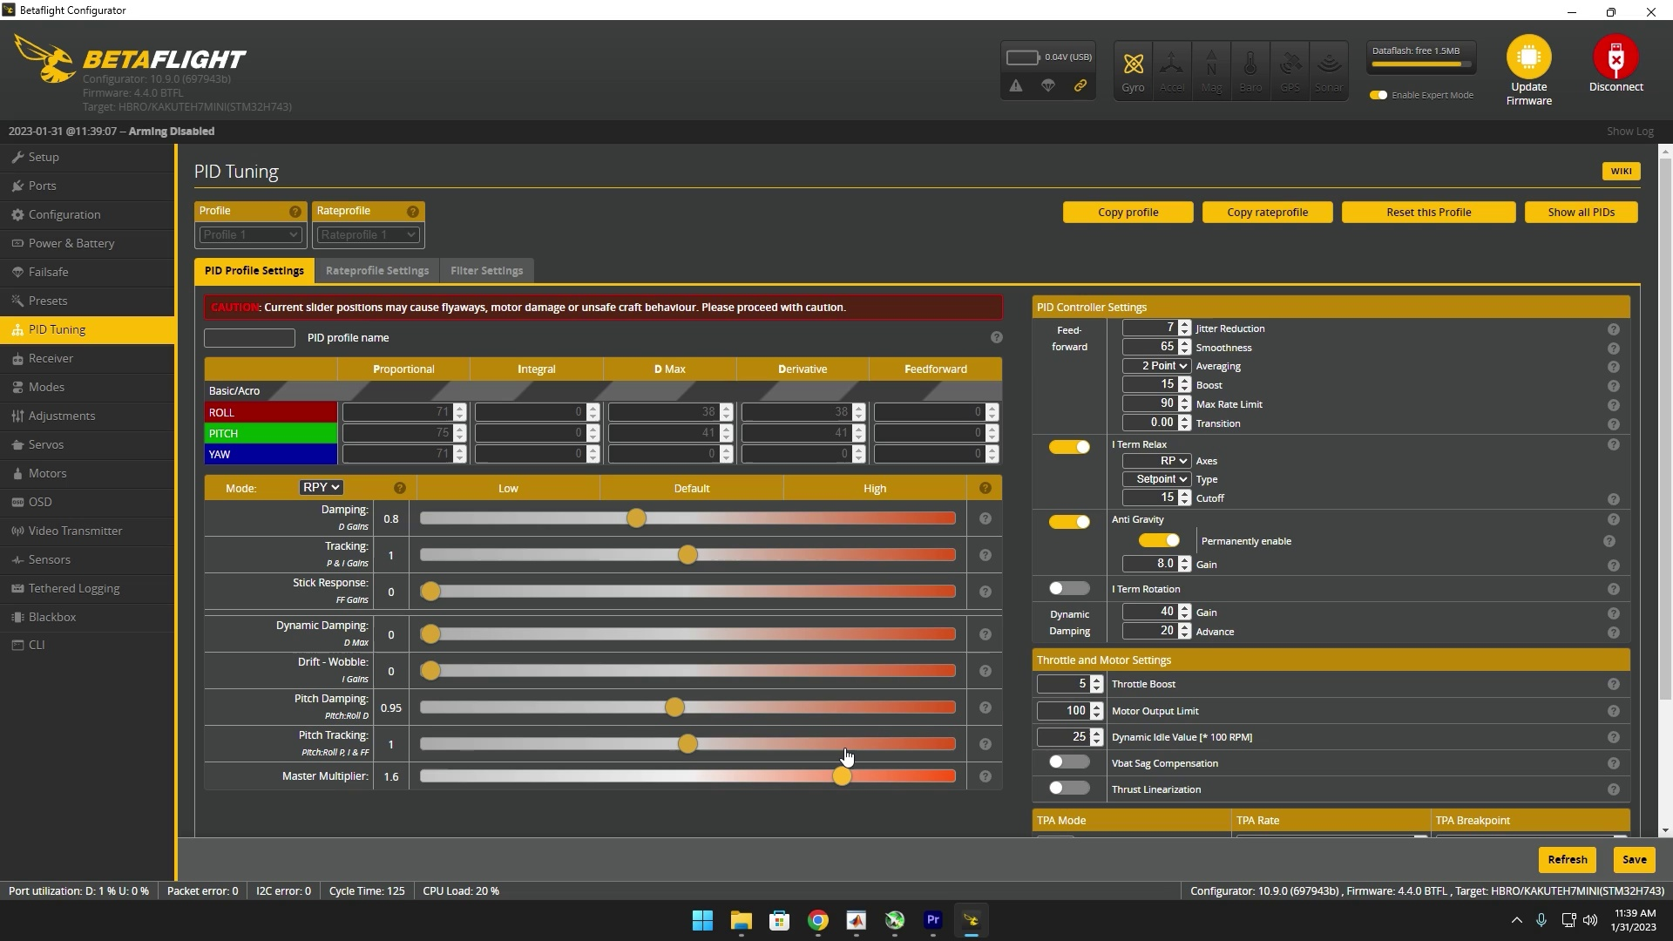 | 12:08  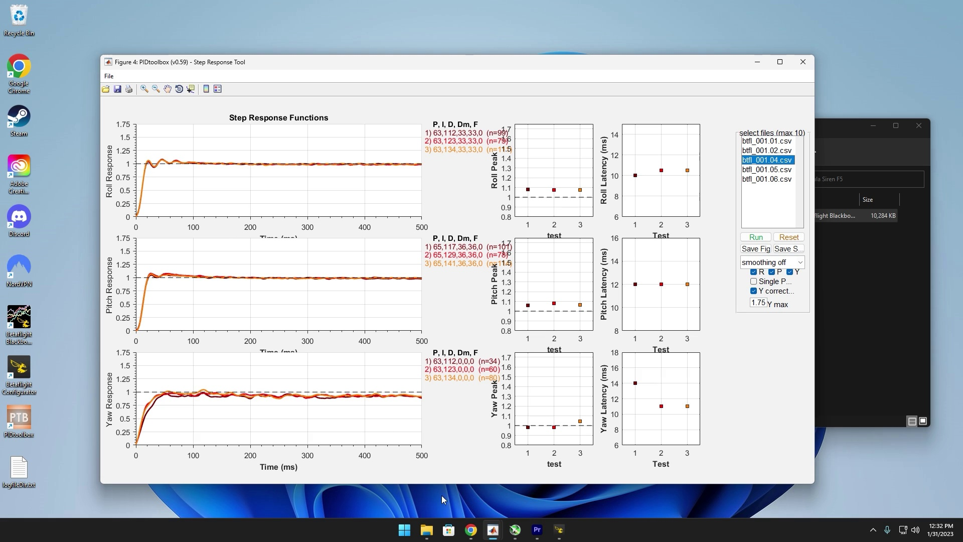 | 15:05  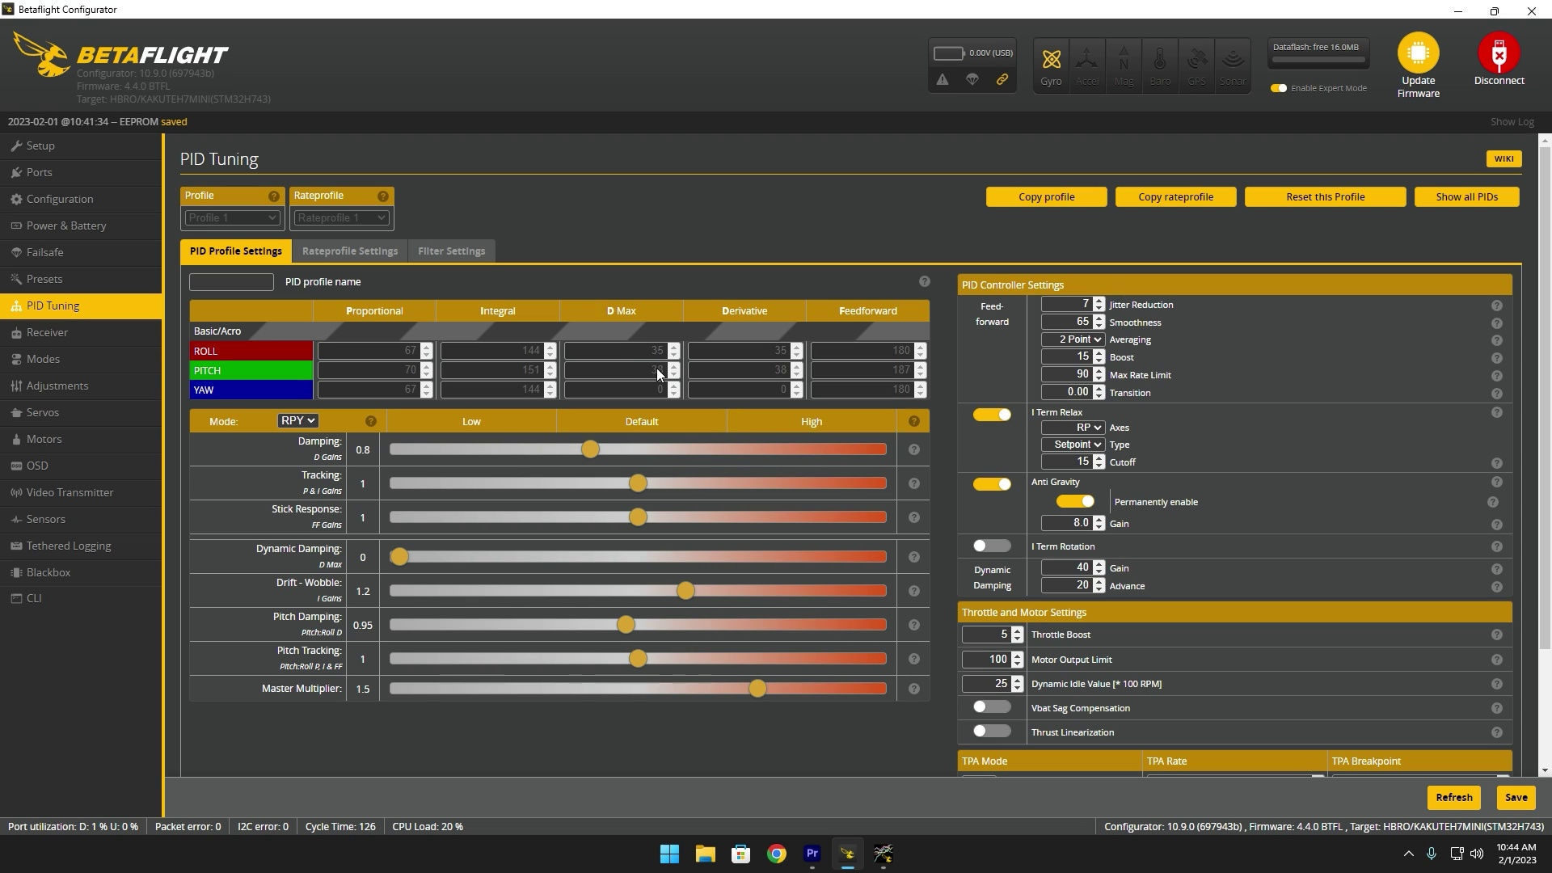

Transcript
[0:19] pid tune or improve your bid or you're just curious on how i tune my builds and another thing to
[0:23] mention is that every quad is different so they all require their own unique tune so please don't
[0:29] copy my end result and expect it to work flawlessly with your build so with that out of the way
[0:34] essentially you're gonna need three different softwares first being betaflight configurator
[0:37] obviously then black box explorer and then pid toolbox i'll have links to all these in the
[0:42] description but for the betaflight configurator make sure it's on the latest release at the time of this
[0:47] recording it's 10.9 essentially you're just going to scroll down to these download links um i have
[0:53] windows so i would just do win64 but i already have it downloaded so i'm not going to save it same thing
[0:58] for black box explorer you just scroll down click the download link and then for pid toolbox you're
[1:03] going to go over here under releases and then just scroll down and download it for years this uh pid
[1:10] toolbox software it can be kind of finicky to install it takes a minute it's got to install some other
[1:17] things but and sometimes if you create a shortcut on your desktop for example like this there's a chance
[1:23] that it won't load if the application isn't launching after you installed it what you want to do
[1:27] is right click open file location and then um open it from here and this should work if that happens
[1:38] now that you have all these softwares downloaded obviously open up betaflight assuming you already
[1:42] have updated your quad the latest release of betaflight 4.4 you probably can follow along if
[1:47] you're using 4.3 i would recommend updating the 4.4 they improved uh some dynamic notch filtering and
[1:53] anti-gravity they also supposedly improved that so heading over to the pid tuning um these numbers
[1:59] are going to be different from yours essentially i just applied the express lrs preset at 500 hertz so
[2:06] yeah after i applied that preset that's what changed these numbers so just make sure you already have your
[2:10] right control preset like i said in the beginning this is going off the assumption you already know how
[2:14] to work with betaflight you just want that perfect pit tune next i go to dynamic damping i actually
[2:20] change this value from 37 to 40. and then another thing dynamic idle i enable this and i like to set
[2:25] it to 25 that fits my props i run a 3.5 degree pitch if you have like a three degree pitch such as the
[2:32] ethics pb and j's or gempan 3s i would suggest maybe send that to 30 or if you have a steeply pitched prop
[2:38] like ethics p4s or like a four degree pitch then i would set this to 20. but for my case i'm going to
[2:45] have it set to 25 just click enter and as far as for the rest of these that's pretty much how i leave
[2:50] it for all my builds all right so with that out of the way go ahead and head over to the black box tab
[2:55] make sure you erase any remaining storage you have so with that being done make sure you just select
[3:00] the right settings for your specific setup usually it's just onboard flash for logging device to have
[3:05] it minimum two kilohertz and then for the debug i don't think you need it but i just like to set it to
[3:11] gyro underscore scale that could help with the filtering we're gonna have to view later but
[3:17] save and reboot so now that you have your black box settings in go ahead and head back over to the
[3:22] pit tuning tab first of all you're going to turn off feet forward then you're going to turn off dynamic
[3:27] damping and then you're going to turn off your eye gains essentially you're just going to be finding
[3:30] the pd balance and in order to do that you want to take your dampening slider and just bring it down to
[3:35] 0.6 and essentially you're going to fly your quad line of sight for about 30 seconds to a
[3:41] minute land it and then bring this value up to 0.8 do the same exact thing and just go up essentially
[3:46] in the increments of 0.2 so next would be one 1.2 and then even as high as 1.4 and what you're going
[3:52] to do while you're flying line of sight is you're going to be moving your pitch and roll axis
[3:56] essentially like in circles like if you just follow my mouse just move your stick like this or just up
[4:00] and down like crazy or left to right like crazy all for about 30 seconds to a minute like i said before
[4:06] another thing to mention probably self-explanatory but make sure your quad is uh set up exactly how you fly it
[4:11] like if you fly with a gopro make sure the gopro is on if you fly if you tend to crash a lot you might
[4:16] want to put on damage props these ones are somewhat damaged i don't know how well the gopro can pick it
[4:20] up but yeah essentially however you fly it out like in the field or at the bando set it up to exactly how
[4:27] how you black box it
[4:57] and that's how you know you do your answer to your hop now that you have all those tests completed
[5:05] go ahead and plug your quad back in head over to black box and then activate mass storage device mode
[5:13] and what you're going to do is save all these files except for this beta flight underscore all
[5:20] once that's completed go ahead and unplug your quad and plug it back in
[5:24] head back over to beta fleet go over to black box and erase flash and you might as well just go
[5:32] ahead and minimize beta flight so now we're going to be working with pid toolbox so go ahead and open
[5:37] that up now that pid toolbox is open simply select the select button right here and locate your black
[5:43] box files in my case it'd be in stuff drone black box siren of five and i have two files another thing too
[5:53] a lot of uh youtubers or other people attuned say to unplug the battery between each flight but i don't
[5:59] do that and it works perfectly fine i know probably going to start some controversy in the comments let
[6:04] me know how wrong i am but i mean it works for me at the end of the day so as you can see this first log
[6:13] had two flights on it so i'm just gonna select them both and then these were the other two logs i did
[6:20] and this one right here this is where i had too high of d gains so that's why it's only six seconds
[6:25] and there's no point of selecting that after this all loads what you want to do is come over here to
[6:31] the step response tool highlight all of these and then click y correction and as you can see this is
[6:39] the data from uh this these values right here represent 0.6 this represents 0.8 1 and then 1.2
[6:47] and based off of these lines it looks like 0.8 it is so now we head over we head back over into beta flight
[6:56] plug or quad in
[7:01] and 0.8 was my best result so put that there save all right so real quick i just wanted to explain how
[7:09] these lines should look ideally so right here is like a perfect example you want the line to slightly
[7:15] overshoot and then get back right on uh to this center point so this right here is actually perfect
[7:21] the lighter red value on the pitch axis though it's actually slightly under damped so with that being the
[7:27] case i'm actually going to head over to the pit to me and for pitch dampening i lowered it down to 0.95
[7:34] because it's just very subtle yeah like it's almost perfect just slightly under damped you want it to
[7:38] look like this light red line if i just click reset run that like this just right onto there maybe a
[7:46] little overshoot yes this is perfect this is almost perfect all right next step we're going to be
[7:52] messing with the master multiplier now this might also start up some controversy but just hear me out
[7:57] on this if you are running a fast controlling such as express rs ghost or tracer as in you're running a
[8:04] high packet rate uh basically that creates a noisy signal so when you have a noisy signal you need to
[8:11] filter it out more so what i'm getting at is that if you are running one of those fast control links
[8:16] your master multiplier is going to be lower than someone who's running a slower control link such as
[8:21] crossfire like the dji transmitter so i have been able to get my quads up to 1.4 but i like to play it on
[8:31] the safe side so i'm guessing it's going to get up to like 1.3 or 1.2 um hopefully this doesn't come
[8:38] across as confusing but if you have a fast control link i would go up in increments of 0.1 if you have
[8:44] a slower controlling i would go up in increments of 0.2 so you might be asking what's the limit that i
[8:50] should take this slider to and honestly after every time you land i would feel the motors and once they
[8:56] start feeling just a little bit uh too hot that's probably a good place to stop or if you start
[9:02] hearing flutter obviously or if you start hearing a raining noise that would be a good place to stop
[9:07] and usually about the 1.6 area and above that's when those uh instances will occur that just all
[9:14] depends on your control link and how well your quad is built now that we're done logging those files i
[9:34] actually went up to 1.5 on the master multiplier before things started going haywire okay so now
[9:40] you're going to notice that the line is starting to get a little more swiggly this is completely
[9:44] fine this is what happens when you turn up pids everything gets more precise and any little
[9:49] imperfections really start to show don't be too worried all right so now that all these black box
[9:55] logs are loaded this is one point or this is where the master multiplier is at 1.1 1.2 1.3 1.4 and 1.5
[10:03] over here is your latency your your pid latency and as you can see the more we moved up the master
[10:08] multiplier the less latency we had yours will probably vary usually it's like a curve that goes down
[10:15] steeply and then kind of levels out somewhere mine's still like a linear curve which is kind of ironic
[10:20] i've never seen that before but uh knowing based off of my experience i'm gonna leave the master multiplier
[10:28] at 1.4 so this green value right here let's just reset this and this is the one we're going to go with
[10:37] and now this is over damped but these values are actually looking good and i when we implement feet
[10:43] forward um and i term this should actually go back up so i'm not too worried all right so heading back
[10:51] over in the beta flight let's just move this down to 1.4 save now we're going to start implementing i term
[10:58] back again so i like to start this at 0.8 and just go up in increments of 0.1 so next would be 0.9 1 1.1
[11:08] and 1.2 usually one as the default has always worked but just to be on the safe side just start lower and
[11:16] increase oh so interesting we have what this means right here is oscillation so what that means most
[11:33] likely is that my master multiplier is too high so i'm actually going to decrease this from 1.4 down to 1.3
[11:40] save that okay so it's actually looking identical from 1 all the way up to 1.2 but honestly i'm just
[11:51] going to leave it at the default value the i term slider that should be good
[12:01] yeah the pitch looks absolutely beautiful um we just have some oscillations on the roll axis all right
[12:07] next we have feet forward now feet forward we're going to be tuning that not using pid toolbox but
[12:12] rather the black box explorer itself um i like to start this off at not dynamic david i like to start
[12:20] feet forward off at uh 0.6 and just go up in increments of 0.2 so 0.8 1 1.2 and 1.4 and another
[12:29] thing to mention about feet forward this is when you're gonna have to start doing flippy flops
[12:33] so if you've been flying in angle mode um you could do rapid stick movements that might be able to
[12:38] work but doing flips and rolls on both the pitch and roll access will be the best way to tune this
[12:53] all right now instead of opening up this file in pid toolbox we're just going to open it up in the
[13:06] regular black box explorer and if you don't have this chart what you want to do is go to graph setup
[13:12] and add in the access label gyro plus pid roll and then the access label gyro plus pid pitch you
[13:18] usually go here and then right here and right there so what we are looking for this is going to
[13:25] be the first log second log third fourth fifth let's go for one of these so essentially we're looking
[13:33] at this red line which is the p term we want this to be as flat as possible because we want the feet
[13:38] forward this purple line doing all the work so right here you can see the p term is actually pulling
[13:44] against uh the feet forward which is kind of surprising with the slider being so low i'll have
[13:50] to look at the other results but yes right here for example on the pitch you can see the p term is
[13:56] actually helping the feet forward that means that feet forward is too low so if we go to another example
[14:03] same here p term is helping like i said before you want this red line to be as flat as possible with
[14:09] this because feet forward needs to do all the work so it looks like in my case feet forward is best
[14:14] going to be left at one on the slider as you can see this is resisting or p term is resisting the
[14:21] feet forward but at the same time it actually catches up at the end i noticed on pitch this is actually as
[14:28] flat as i can get it other sliders were this is 1.2 and this is 1.4 on the feet forward slider
[14:34] these were like way too overdone um so yeah feet forward one it is
[14:42] now that we have feet forward out of the way the final step will be dynamic dampening and honestly
[14:46] i'm not too much of an expert on how to properly tune this but i basically just go off of how far
[14:53] i pushed the master multiplier for example i pushed it all the way up to 1.5 1.6 is where the quad started
[15:00] having issues and then i'll look at the d term here and be like all right this is 35 and 38
[15:06] bring this back down to 1.3 and then push this up until these values match 35 and 38. so in my case
[15:14] it would be 0.45 now this is the point where you're going to want to go fly a full pack um preferably
[15:21] with the goggles on as you would normally push your quad to the limits get the get all the prop wash out
[15:28] test the anti-gravity by giving it throttle blips and make sure your black box is good to go have
[15:33] it set to gyro scaled so you can view your filtering and yeah that's basically it we covered
[15:39] everything and for this specific build this is the tune we ended up with just before i showed the flight
[15:44] footage i thought i would show you guys um the pid toolbox results at the end as you can see our
[15:49] latency is extremely low now that everything's implemented and these lines are pretty much almost
[15:54] perfect we could somewhat tweak this to make it even better but i'm happy with these results
[16:00] another thing too these are the black box logs keep in mind this is a two minute flight so the
[16:06] longer you fly the more noisy these graphs are going to look i just wanted to show you guys this just to
[16:11] show like how good of a frame quad mullet is like there's especially for being a two minute flight
[16:17] there's just barely any noise on these graphs and then heading over to pitch we'll do frequency versus
[16:23] throttle and the reason i have a throttle cap set to 96 just at my motor kb at 1750 instead of 1850.
[16:30] so yeah i really appreciate you for sticking to the end if you have any feedback or criticism
[16:35] uh let me know in the comments i'm very open to it this is just specifically how i tune it could be
[16:39] right it could be wrong everyone tunes different but hopefully you learned a few things and again
[16:43] thank you for watching and here's the flight
[16:57] oh
[17:13] eh
[17:32] WOOOOOOO
[17:33] WOOOOOOO
[17:37] boarding
[17:40] AST
[17:43] if the
[17:51] funded
[17:53] has Mer欠
[17:58] that
[18:00] can

