Engagement Analysis: NQvVeLHzfSs

Section 0: An H Bridge Circuit with Four Transistors and a DC Motor
Time: 0:05 - 0:07

Summary
A schematic diagram of an electronic circuit featuring a four-transistor motor drive circuit, specifically a Basic 4-Transistor H Bridge configuration for converting AC to DC power.

Representative Frames
0:05  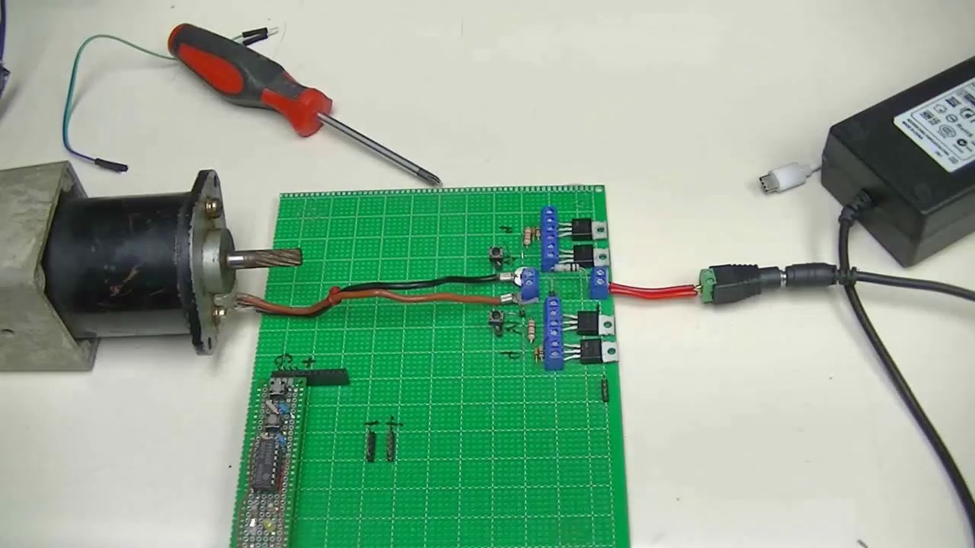 | 0:05   | 0:06   | 0:06   | 0:06  

Transcript
[0:00] All right here is a mock-up of an H-Bridge motor control. It is an improved version of one that I

Section 0: Complex Electronic Circuit Diagram with 24V Power Supply
Time: 0:07 - 0:10

Summary
A highly complex electronic circuit diagram showcasing an intricate network of components and connections, powered by a 24-volt DC power supply.

Representative Frames
0:07   | 0:08   | 0:08   | 0:09  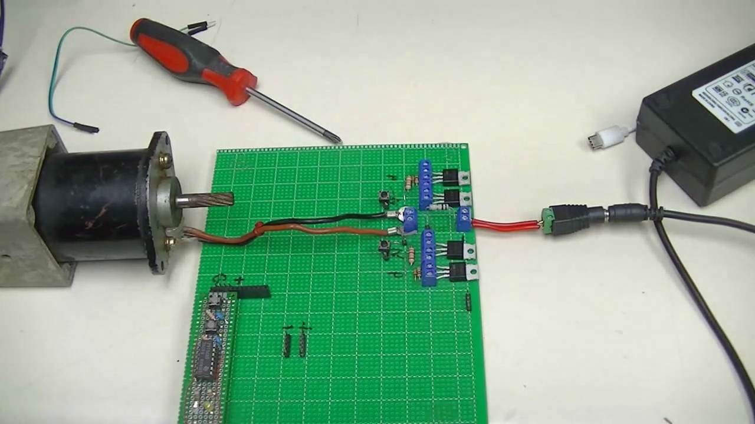 | 0:09  

Transcript
(No speech detected in this section)

Section 0: Technical Drawing or Schematic Related to Electronics or Electrical Engineering
Time: 0:10 - 0:13

Summary
A photograph of a technical drawing or schematic related to electronics or electrical engineering, featuring various electronic components and symbols representing switches and possibly relays.

Representative Frames
0:10   | 0:11   | 0:11   | 0:12   | 0:12  

Transcript
(No speech detected in this section)

Section 0: Student Studying the Inner Workings of a Miniature Circuit Board
Time: 0:13 - 0:16

Summary
A student is seen studying the inner workings of a miniature circuit board, surrounded by various electronics and equipment, with an open textbook on electrical engineering lying in front of them.

Representative Frames
0:13  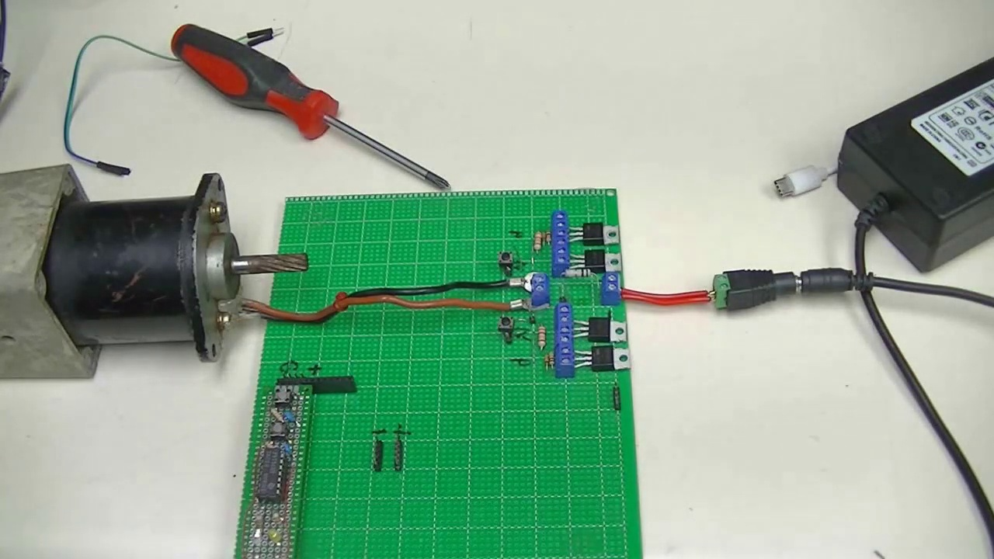 | 0:14   | 0:14   | 0:15   | 0:15  

Transcript
(No speech detected in this section)

Section 0: Four-Transistor Motor Drive Circuit Schematic Diagram
Time: 0:16 - 2:10

Summary
A schematic diagram of an electronic circuit featuring a four-transistor motor drive circuit, specifically a Basic 4-Transistor H Bridge configuration for converting AC to DC power.

Representative Frames
0:35  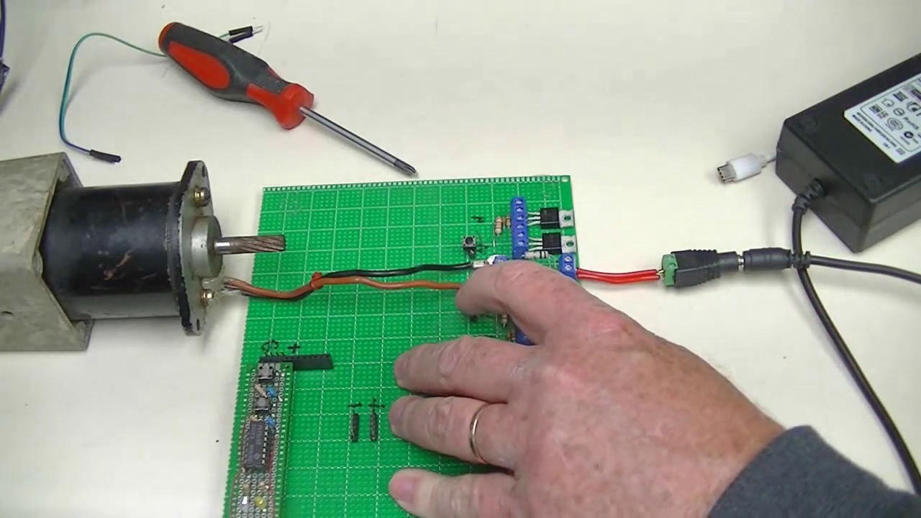 | 0:54  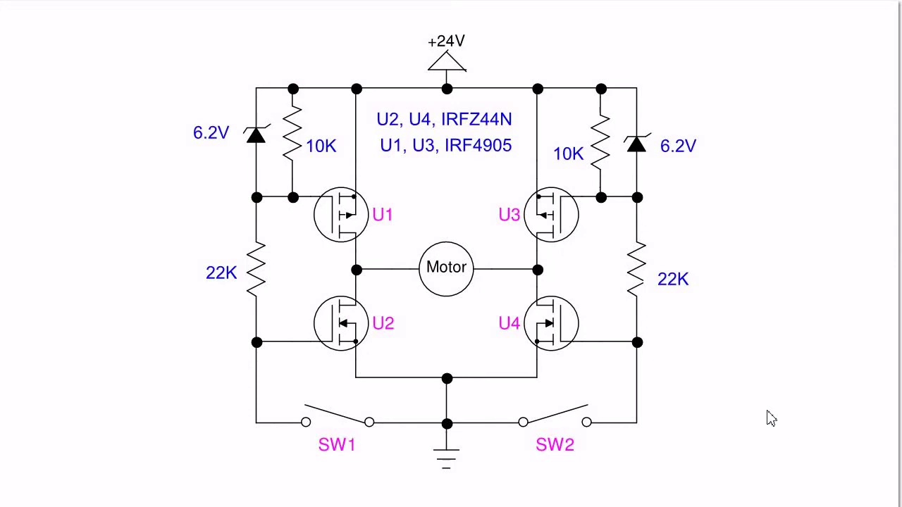 | 1:13  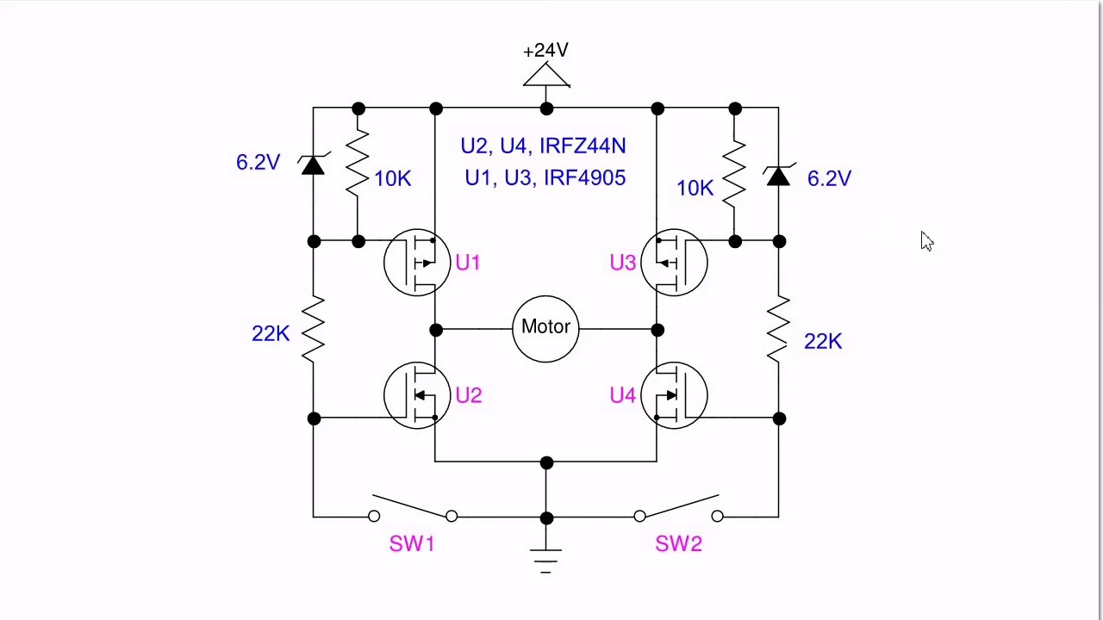 | 1:32  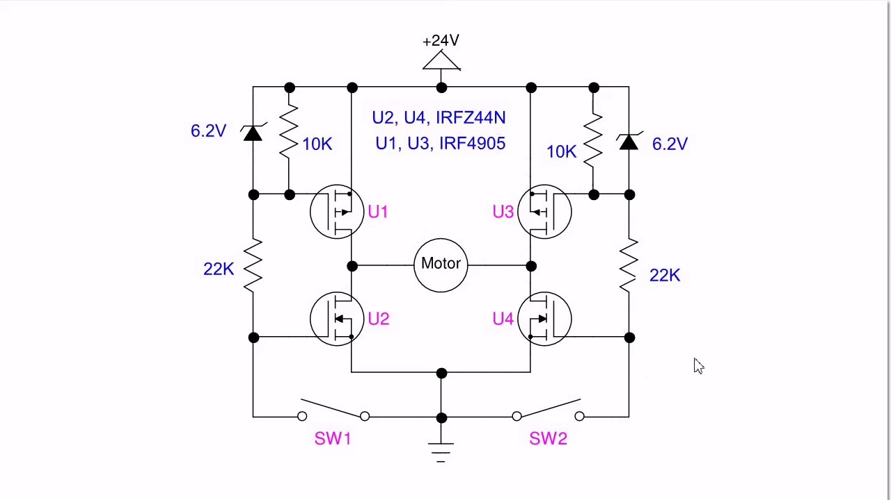 | 1:51  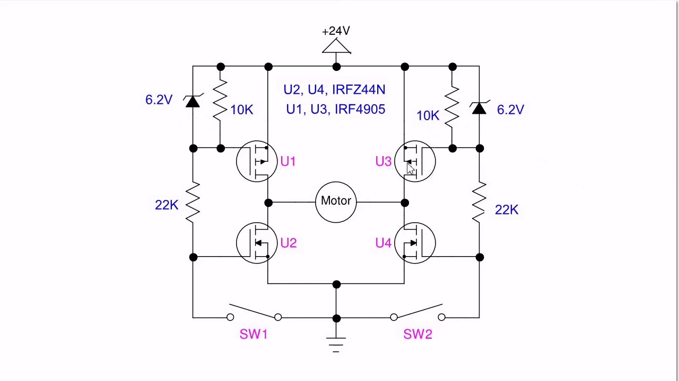

Transcript
[0:13] published nearly a decade ago. I'll discuss briefly what the improvements are and while I'm just using
[0:22] a set of tactile switches that is a 24 volt I think 3 amp motor on 24 volts and I'm controlling it with a pair of little low-power tactile switches.
[0:46] All right here's my schematic for the H-Bridge I demonstrated at the beginning of the video.
[0:56] Here's just the two little tactile switches. I have four MOSFETs, four resistors, and two Zener diodes. This
[1:07] has been tested to operate as is from 5 to 24 volts. U1 and U3 are P-channel MOSFETs I used at IRF4905.
[1:21] U2 and U4 are IRFC44N. These are sensitive gate MOSFETs unlike my original design that used some lower quality
[1:34] P-channel transistors that used to get hot. I ran that motor at a couple of amps and I didn't even heat
[1:42] sync the transistors. So this is going to be a starting point. By the way the 6.2 volt Zener's
[1:48] are to protect the gate circuit of U1 and U3 because I'm using more than 20 volts.
[1:57] All right and so this will be the basis of several more circuits that are up and coming.
[2:02] Be sure to visit my website at www.bristolwatch.com
[2:09] you

