Engagement Analysis: P4GsoMTv-SY

Section 0: Introduction to Digital Oscilloscope
Time: 19:00 - 19:04

Summary
The conversation starts with an introduction to digital oscilloscopes and their applications.

Representative Frames
19:00  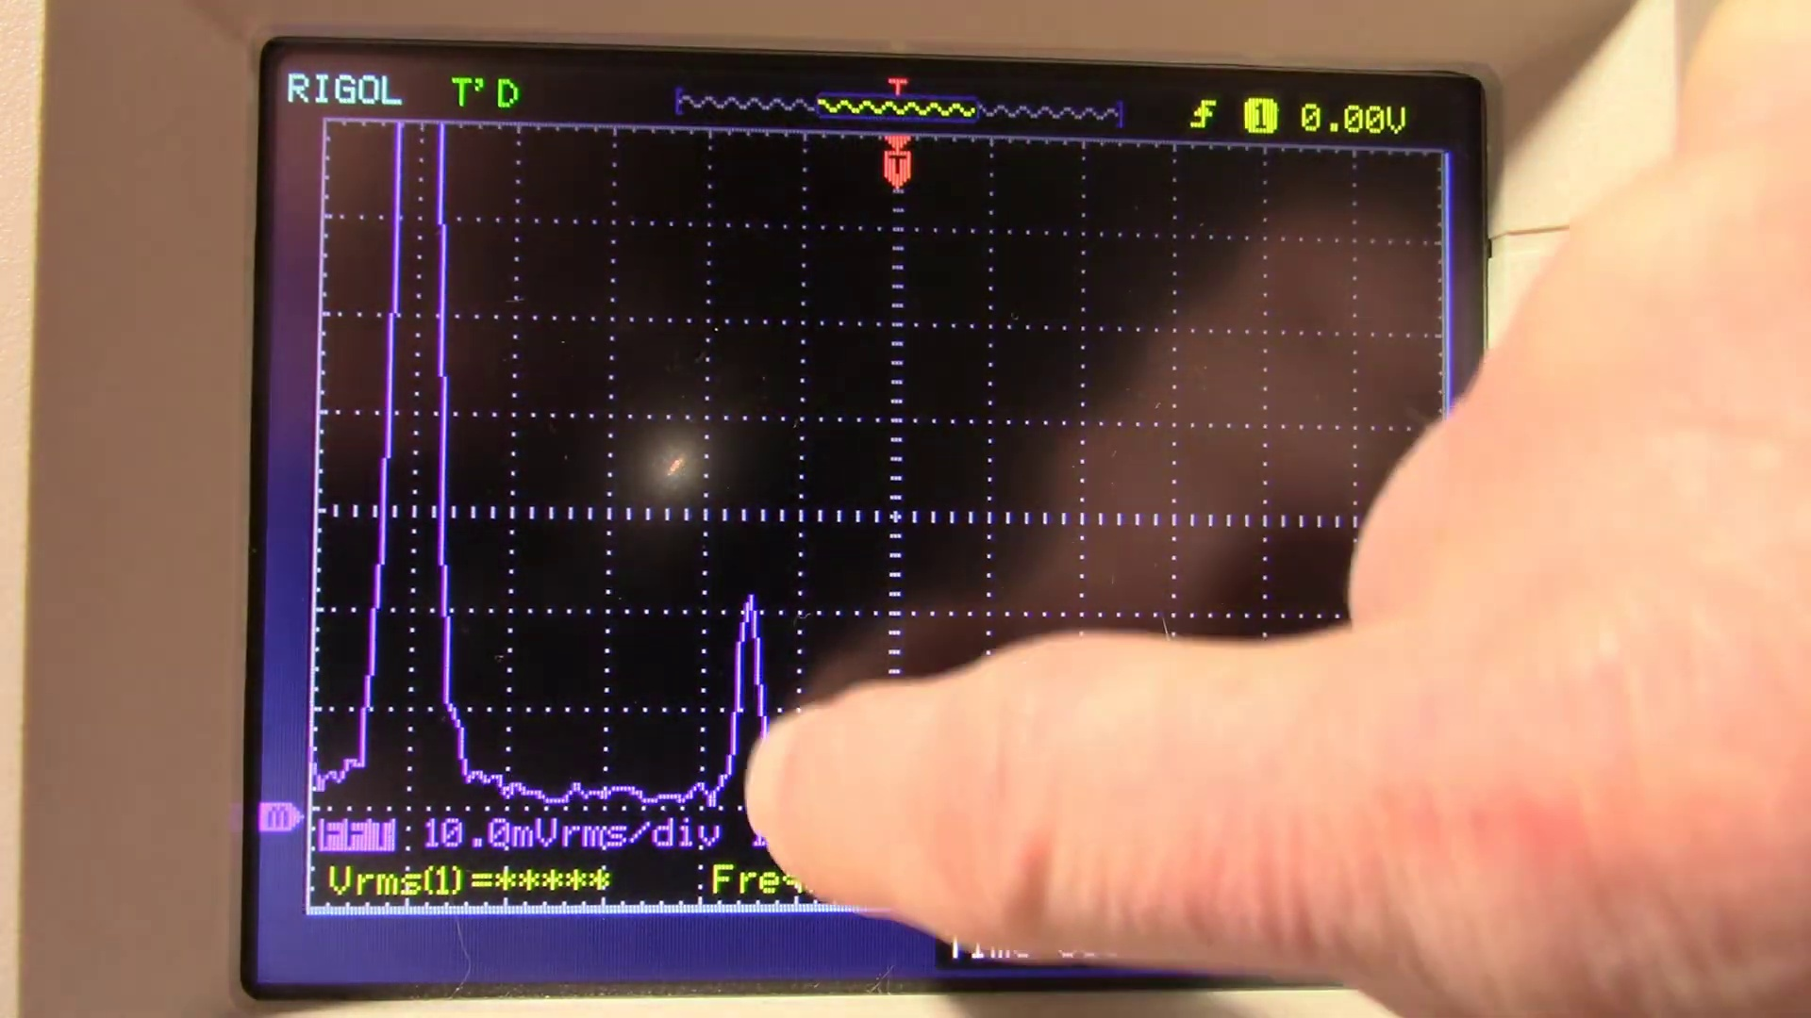 | 19:01   | 19:02   | 19:02  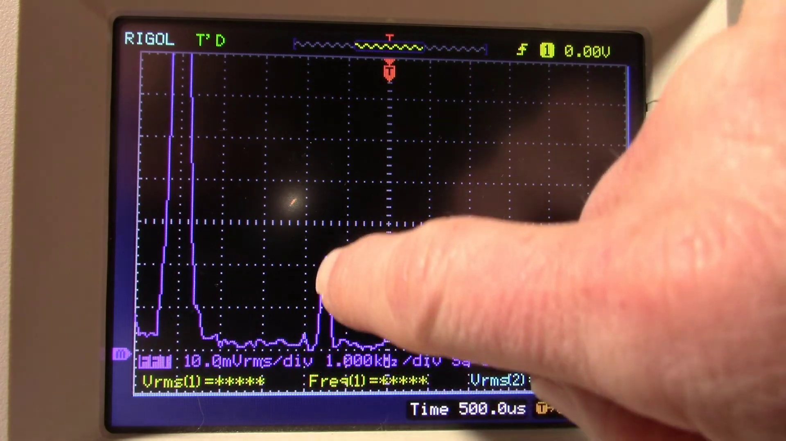 | 19:03  

Transcript
[18:57] one kilohertz fundamental this is the 4.5 kilohertz pilot signal which is at 1% of

Section 0: RIGOL T-D Oscilloscope
Time: 19:04 - 19:10

Summary
The speaker discusses the RIGOL T-D oscilloscope, its features, and how it is used for signal analysis.

Representative Frames
19:05   | 19:06  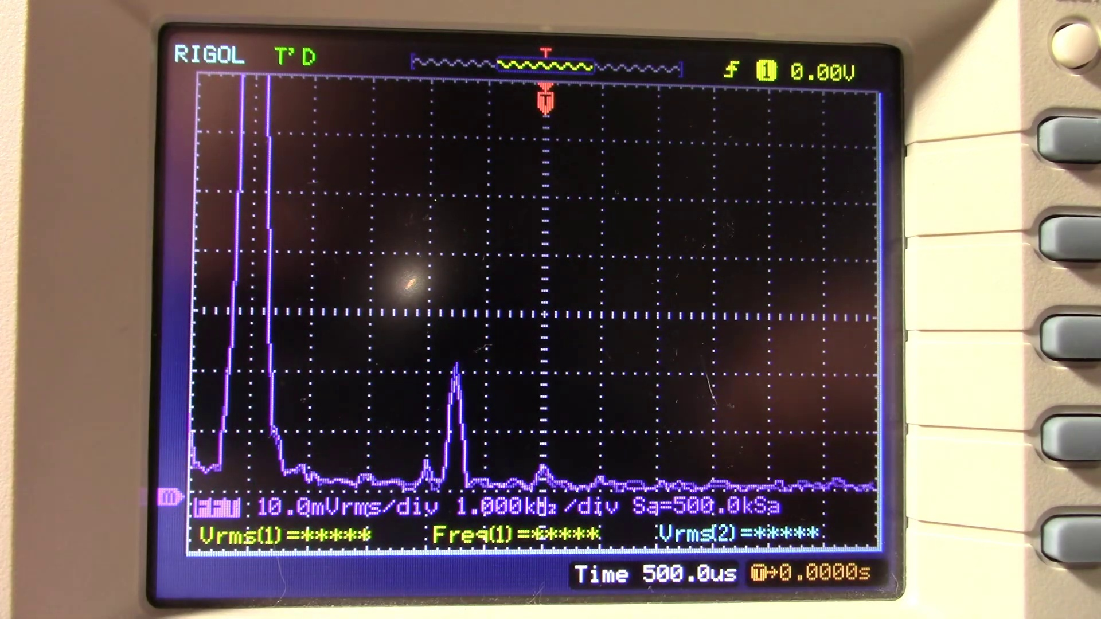 | 19:07   | 19:08   | 19:09  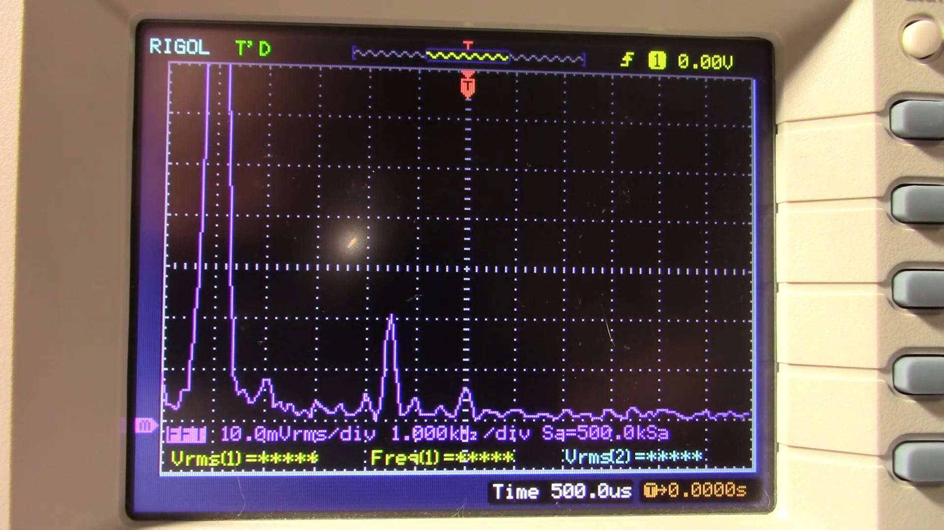

Transcript
[19:05] the fundamental adjust this amp okay that's clipping bring it out of clipping so

Section 0: Signal Analysis with Digital Oscilloscope
Time: 19:10 - 19:16

Summary
The speaker explains the process of analyzing signals using a digital oscilloscope, including setting up the equipment and interpreting the data.

Representative Frames
19:11   | 19:12   | 19:13  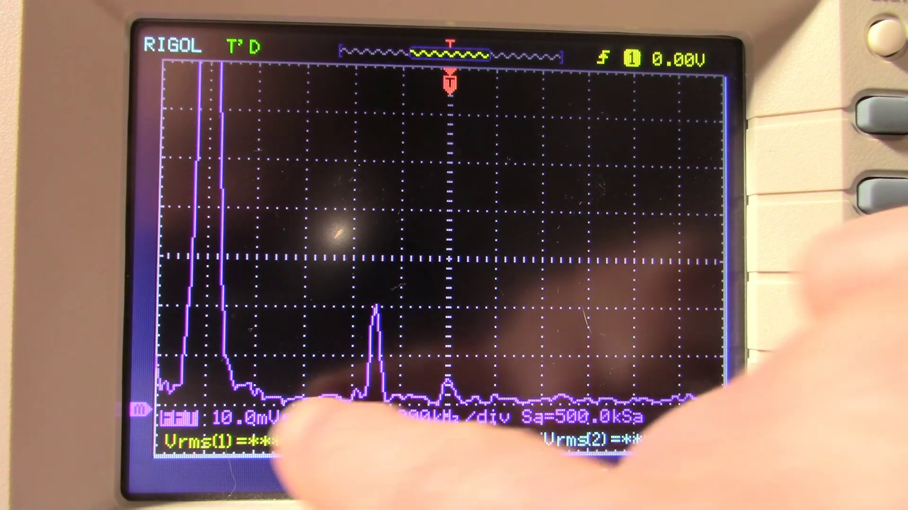 | 19:14   | 19:15  

Transcript
(No speech detected in this section)

Section 0: Circuit Board Assembly
Time: 19:16 - 19:22

Summary
A close-up view of a circuit board being assembled, with the speaker explaining the components and connections involved.

Representative Frames
19:17  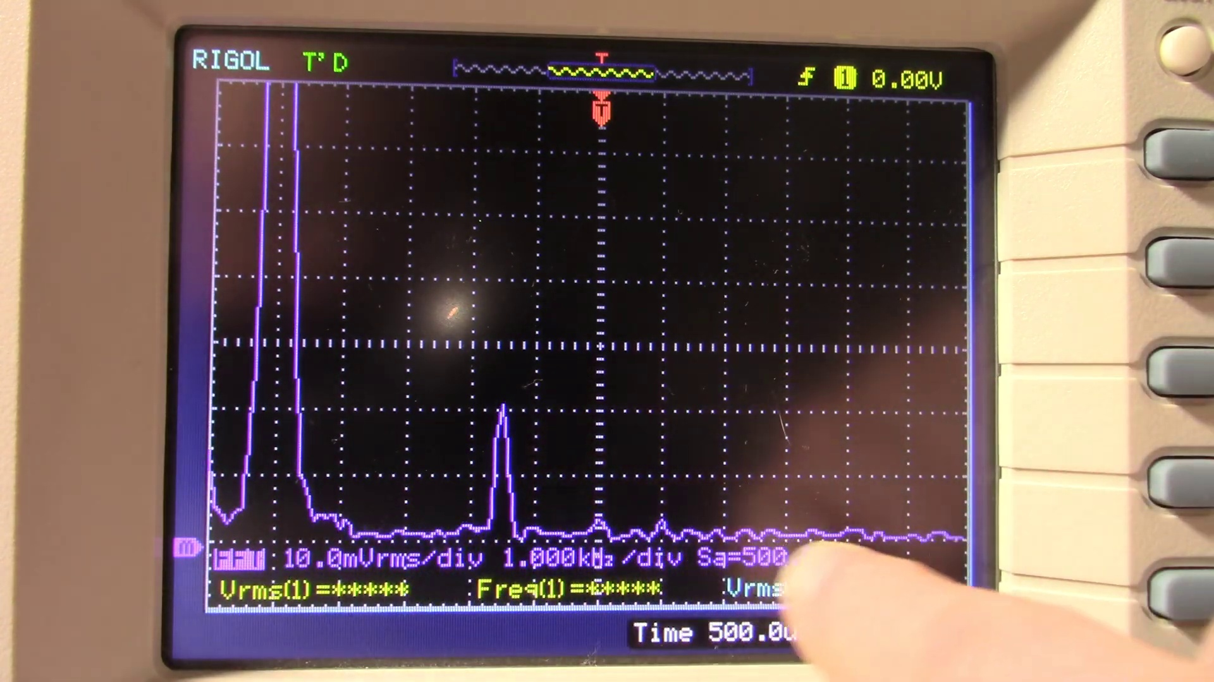 | 19:18   | 19:19   | 19:20  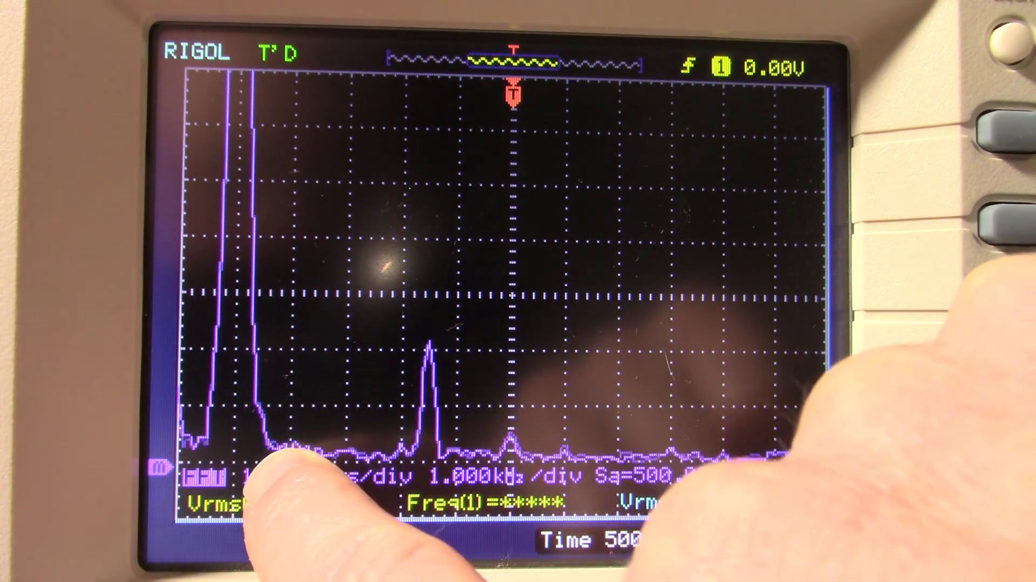 | 19:21  

Transcript
[19:12] we'll get a nice flat signal this is a pretty clean amplifier not seeing a second

Section 0: Simple Electronic Project
Time: 19:22 - 19:28

Summary
The speaker shows a simple electronic project using a circuit board and an LM386 board, explaining its function and performance.

Representative Frames
19:23  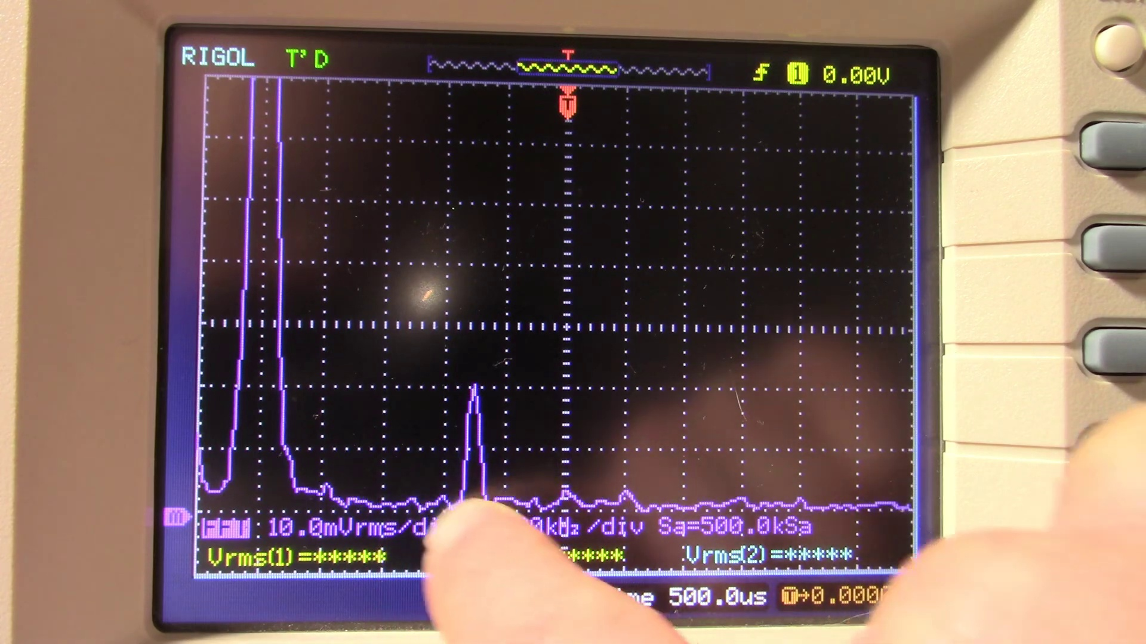 | 19:24   | 19:25   | 19:26  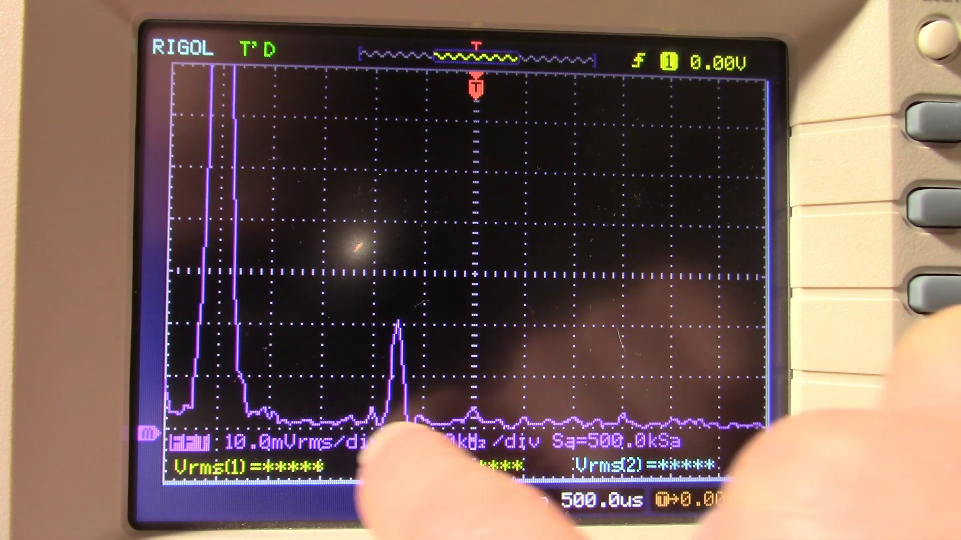 | 19:27  

Transcript
[19:20] harmonic a third maybe a little blip of a fourth and a fifth but yeah it's pretty

Section 0: Signal Analysis with Waveform
Time: 19:28 - 19:34

Summary
A waveform is displayed on the oscilloscope screen, with the speaker explaining how to interpret the data and adjust settings for optimal signal analysis.

Representative Frames
19:29   | 19:30  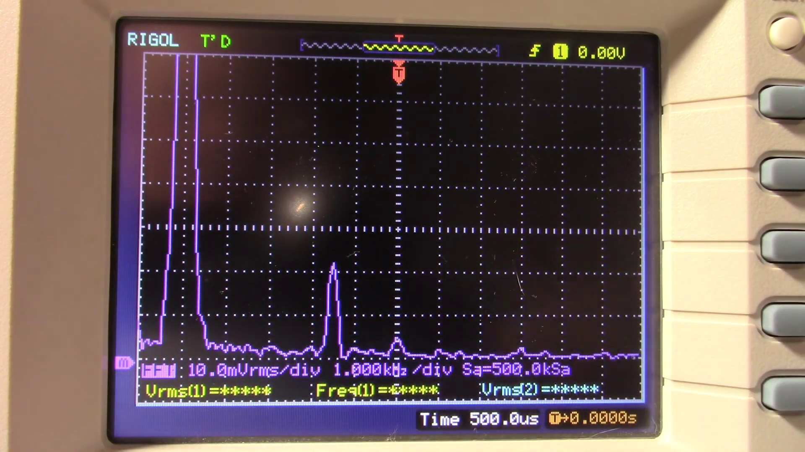 | 19:31   | 19:32   | 19:33  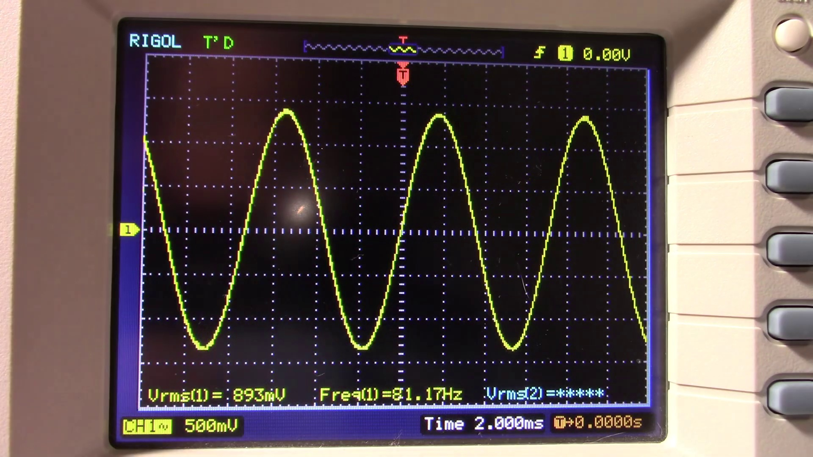

Transcript
(No speech detected in this section)

Section 0: Troubleshooting Signal Issues
Time: 19:34 - 19:40

Summary
The speaker discusses common issues that may arise during signal analysis and provides tips for troubleshooting and optimizing equipment performance.

Representative Frames
19:35   | 19:36  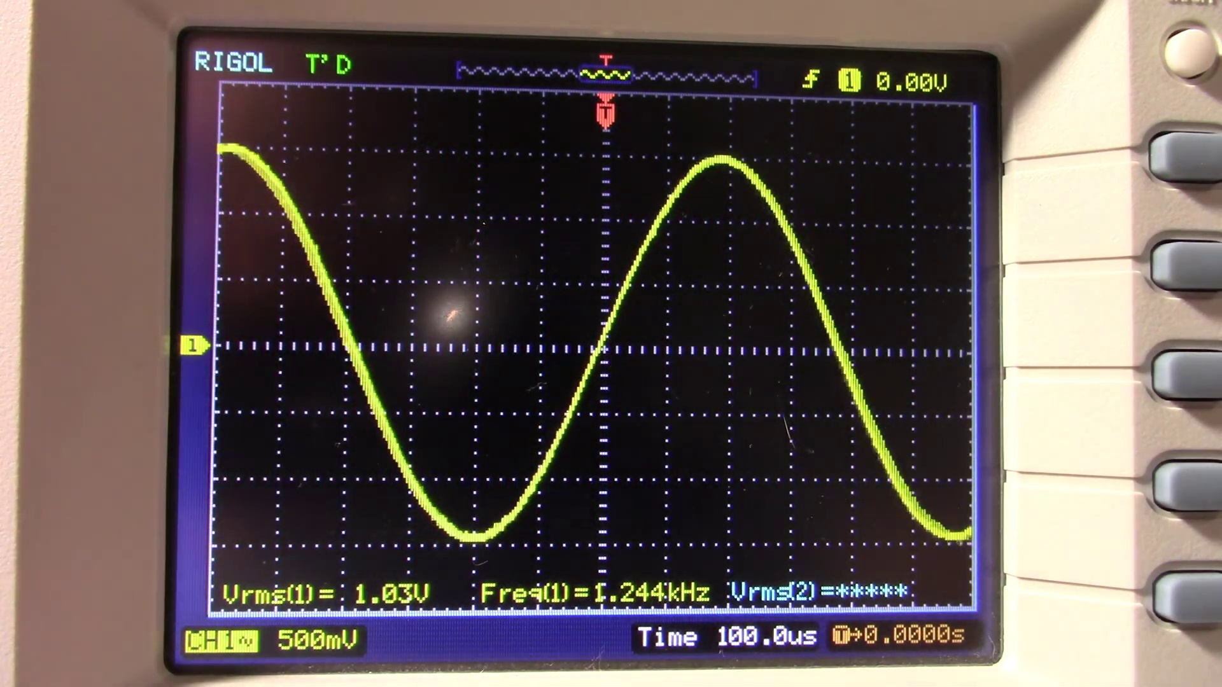 | 19:37   | 19:38   | 19:39  

Transcript
[19:30] clean little amplifier okay we'll do a frequency response sweep here

Section 0: Conclusion
Time: 19:40 - 20:14

Summary
The conversation concludes with a summary of the key points discussed, including the importance of digital oscilloscopes in signal analysis and their applications in various fields.

Representative Frames
19:45  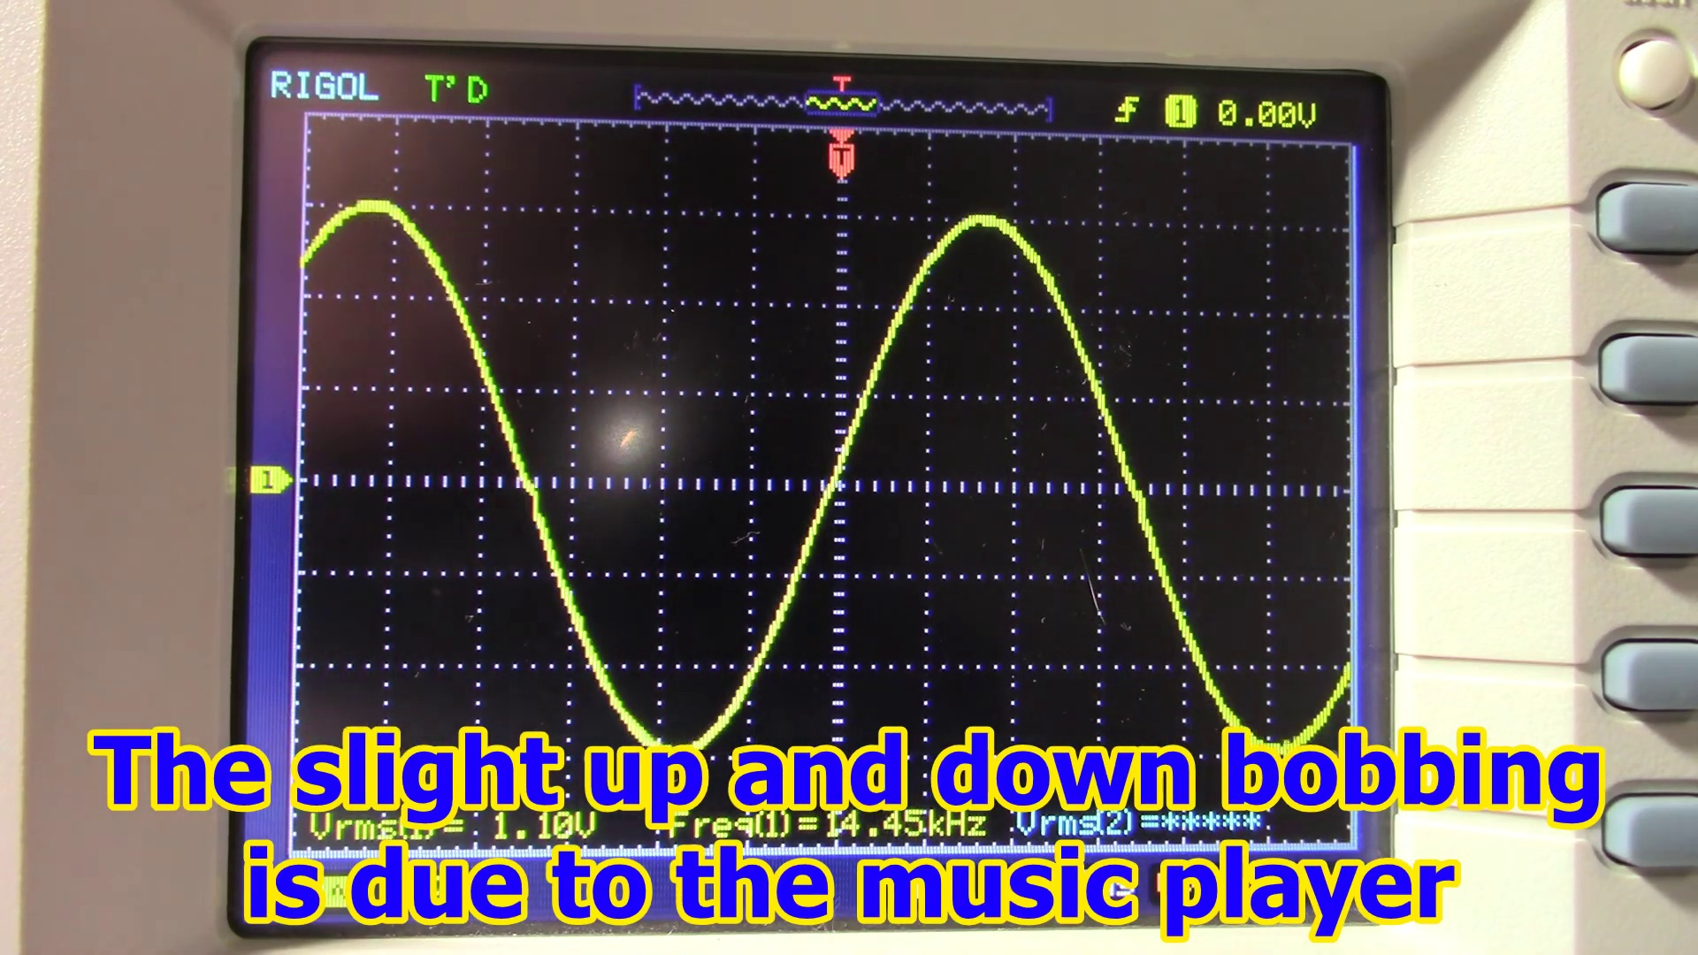 | 19:51  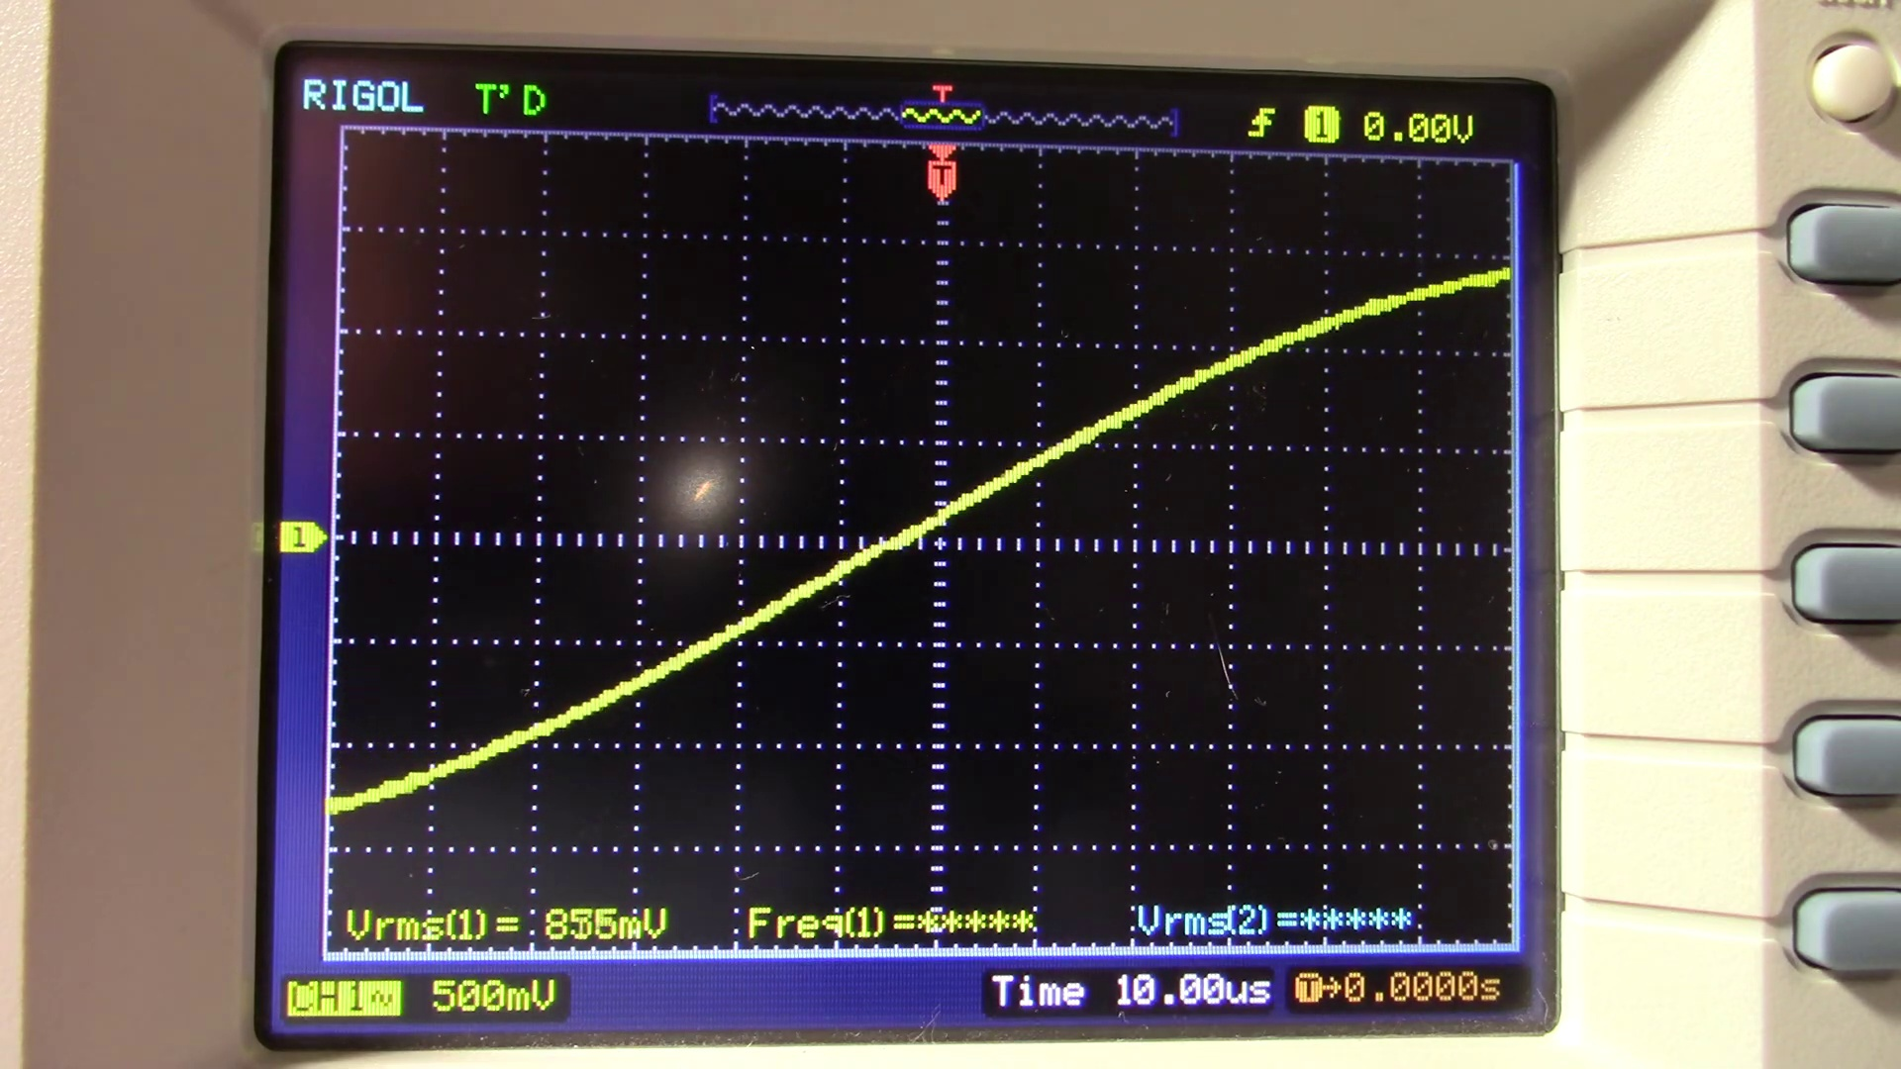 | 19:57  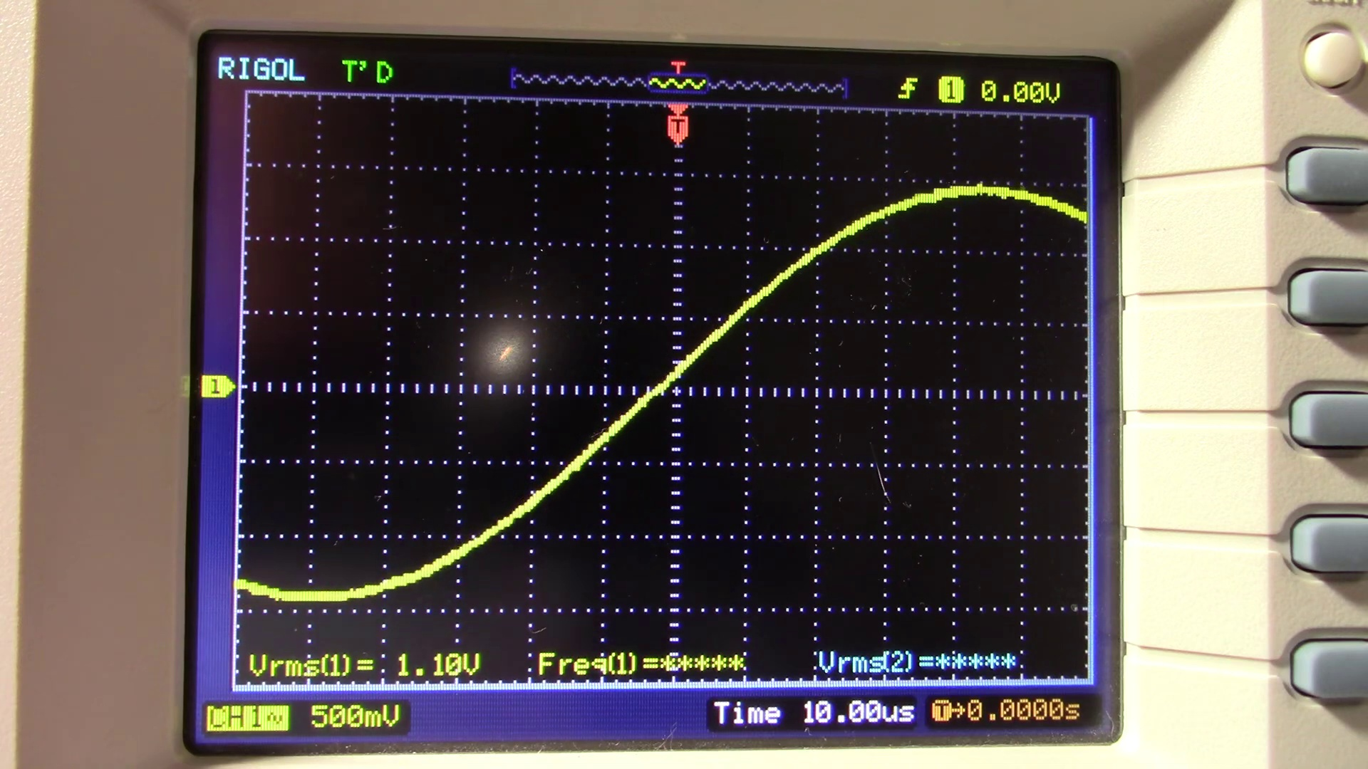 | 20:03  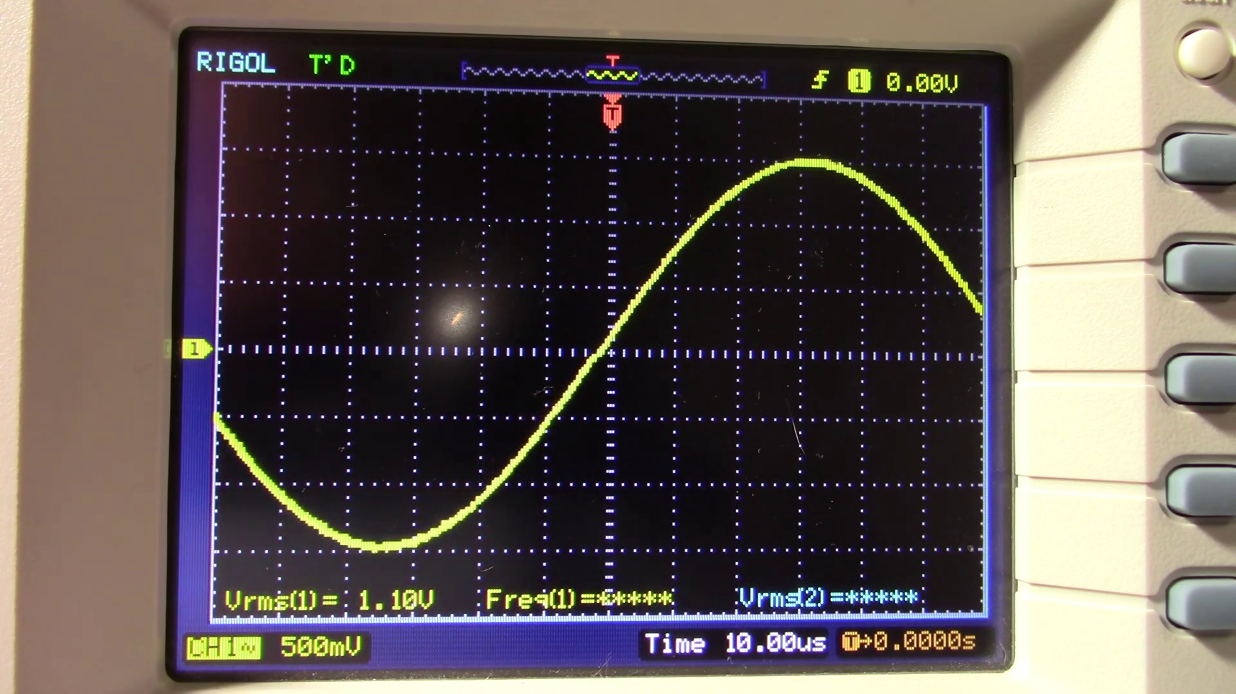 | 20:09  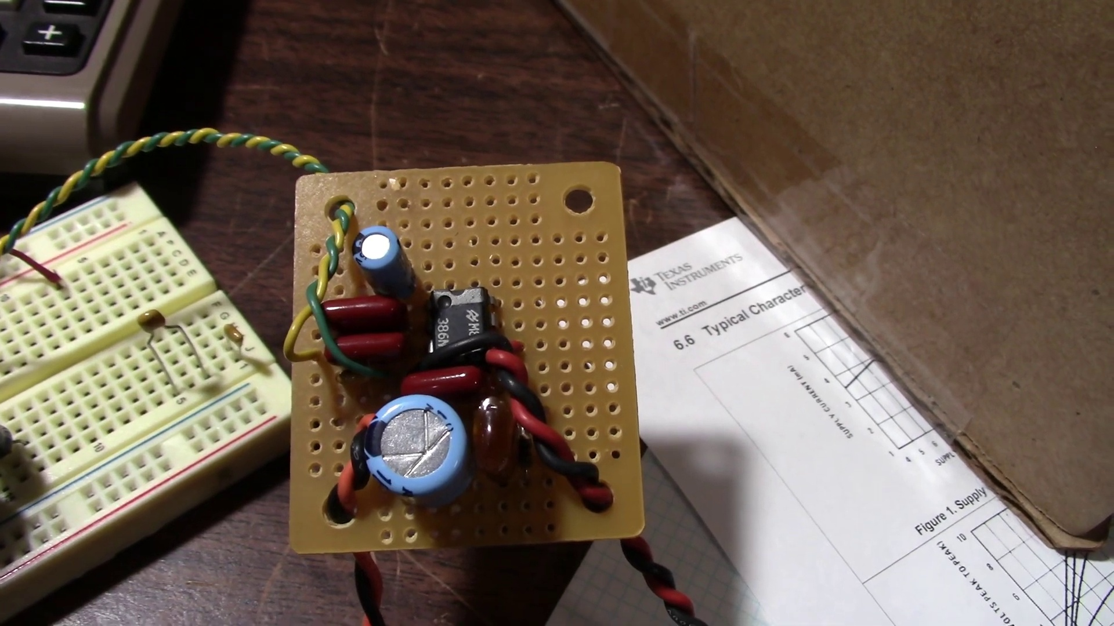

Transcript
[19:47] okay there you go that's uh of course the response is going to be pretty flat except that the lower end
[19:54] because of the output coupling cap that I'm using it's going to tend to roll it off at the very bottom of the
[20:03] frequency band so there you go a simple little LM 386 board you can make that performs pretty good for what it is
[20:12] well that's it thanks for watching

