Engagement Analysis: PWyqVEkZGWk

Section 0: BetiFlight Drone Control Software
Time: 14:24 - 14:28

Summary
The image captures a scene from BetiFlight drone control software, displaying a blue drone with its arm extended and graphs and charts monitoring the flight's performance.

Representative Frames
14:24  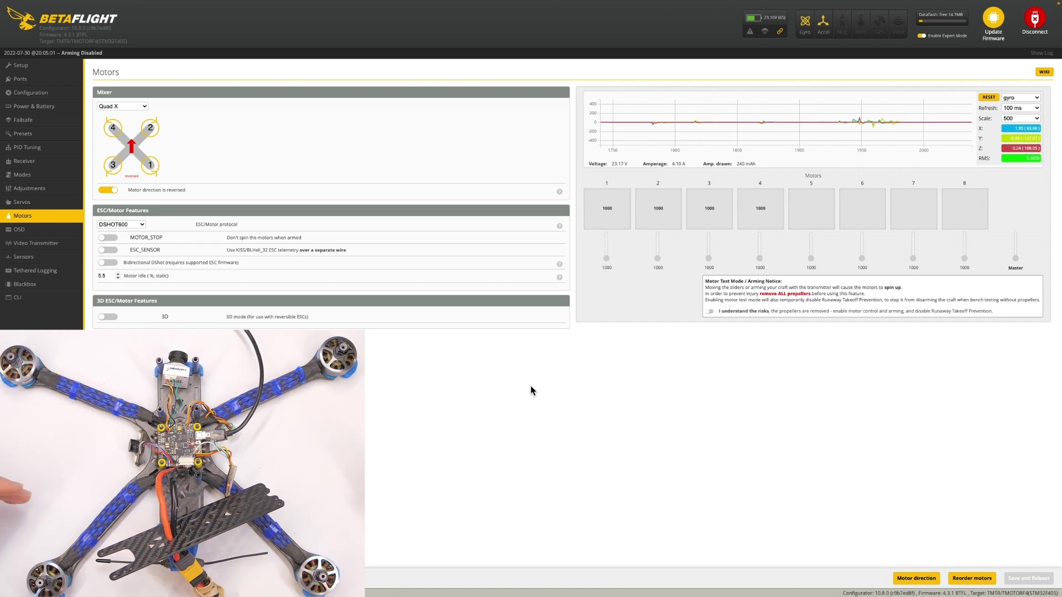 | 14:25  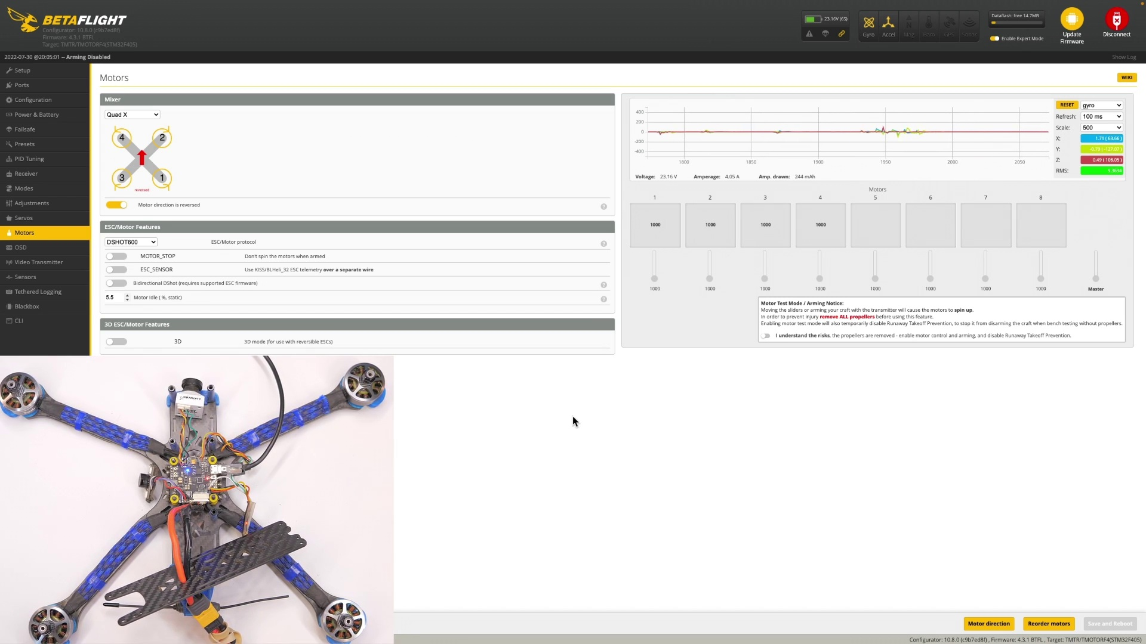 | 14:26   | 14:26   | 14:27  

Transcript
(No speech detected in this section)

Section 0: Drone Pre-Flight Preparation
Time: 14:28 - 14:31

Summary
The image appears to be a screenshot of a computer interface showing a drone with its landing gear extended, accompanied by control software and text that may relate to flight preparation or analysis.

Representative Frames
14:28  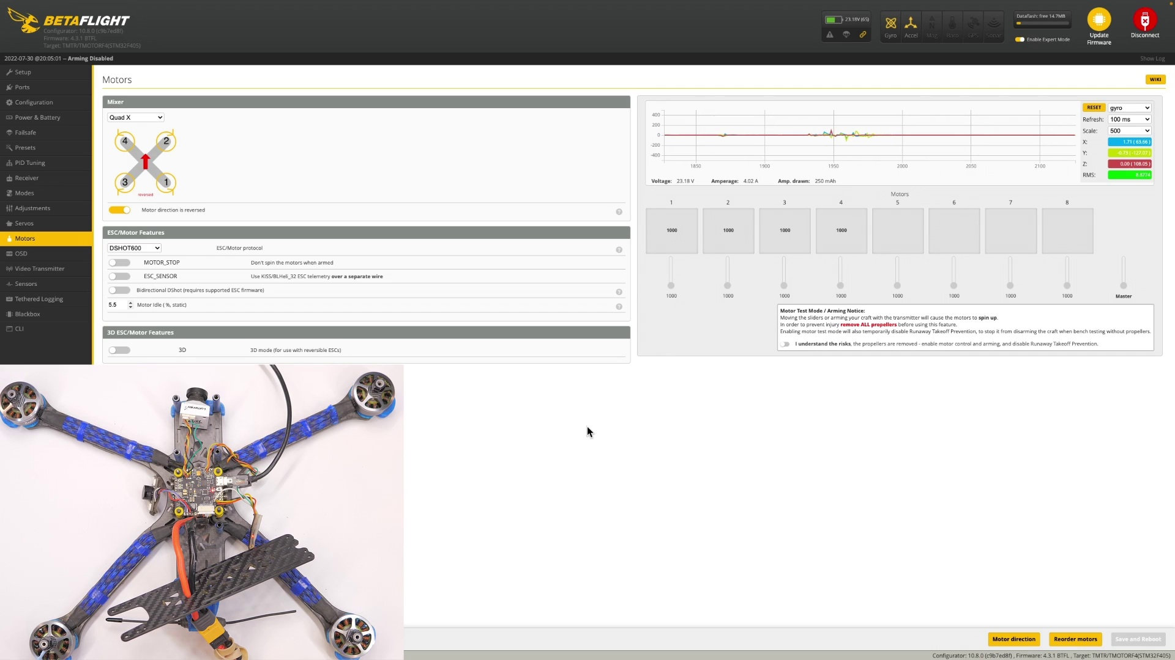 | 14:29   | 14:29   | 14:30   | 14:30  

Transcript
[14:24] I or someone else will be able to help you. Thanks for watching. Get out there and fly something and I'll see you next time.

Section 0: Logo Design - RC with ADAM
Time: 14:31 - 14:34

Summary
The image presents a stylized logo featuring a red and blue shield or crest with a focus on the text 'RCwithADAM.com' written in bold, white font.

Representative Frames
14:31  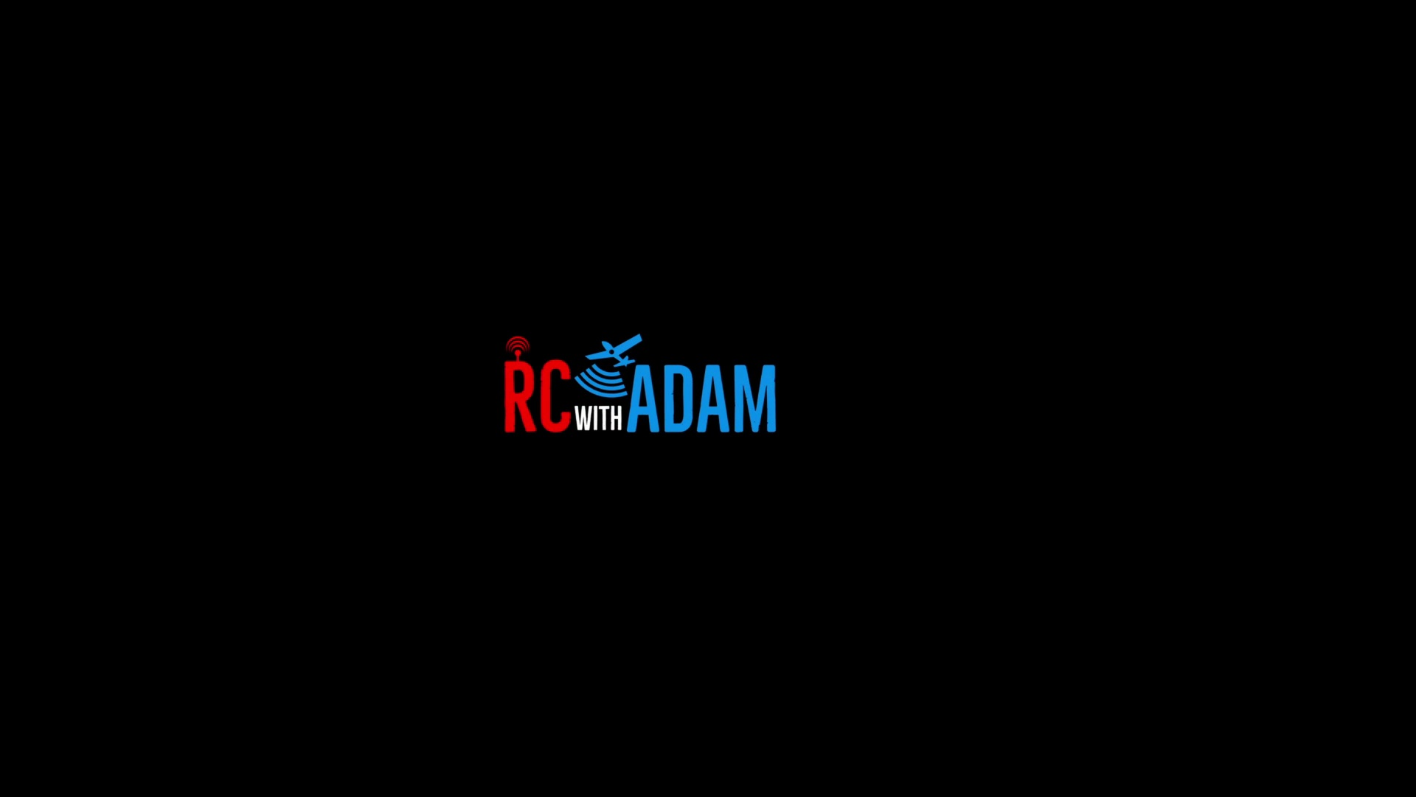 | 14:32   | 14:32   | 14:33   | 14:33  

Transcript
(No speech detected in this section)

Section 0: Minimalist Website Design
Time: 14:34 - 14:36

Summary
The image is a minimalist design featuring a black background with bold, white text reading 'RCwithADAM.com', focusing solely on the website's name and logo.

Representative Frames
14:34   | 14:34  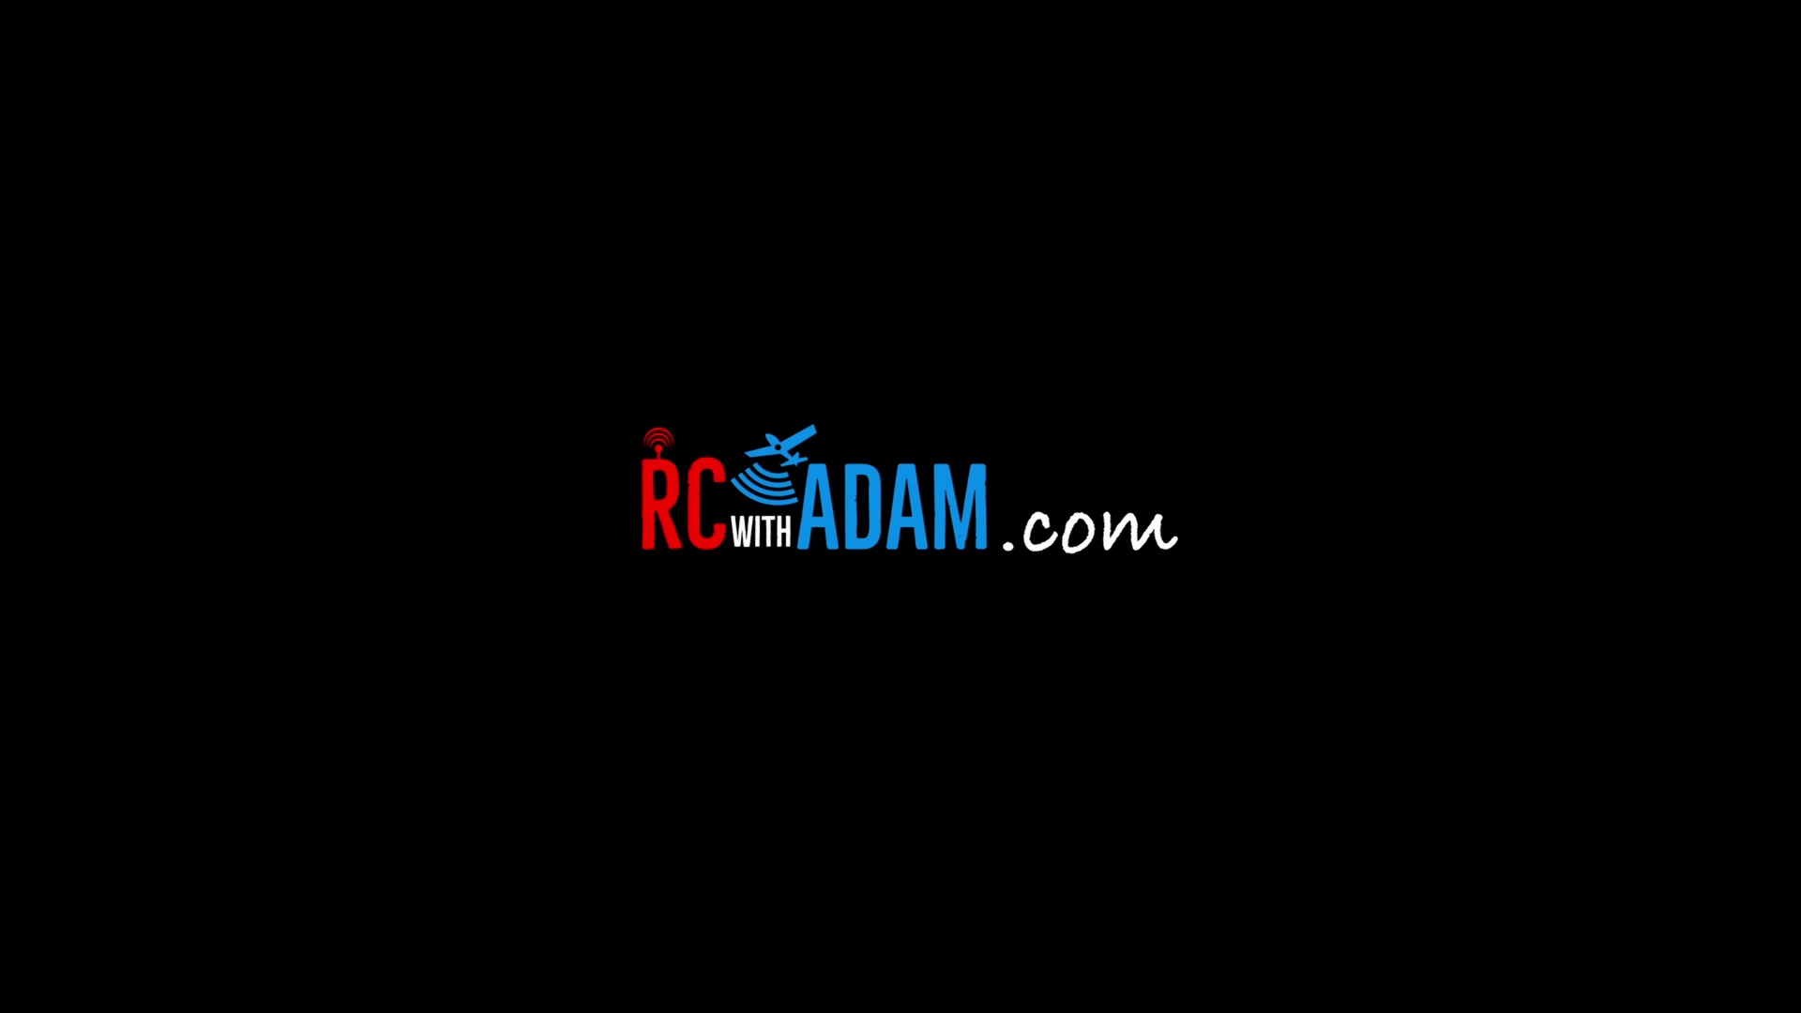 | 14:35   | 14:35   | 14:36  

Transcript
(No speech detected in this section)

