Engagement Analysis: R2UqeJbK2yc

Section 0: Electronics Workshop and DIY Projects
Time: 6:00 - 6:01

Summary
The section describes various scenes of electronics workshops, DIY projects, and individuals working with electronic devices. Images show tools, equipment, and components related to electronics repair, construction, and modification.

Representative Frames
6:00  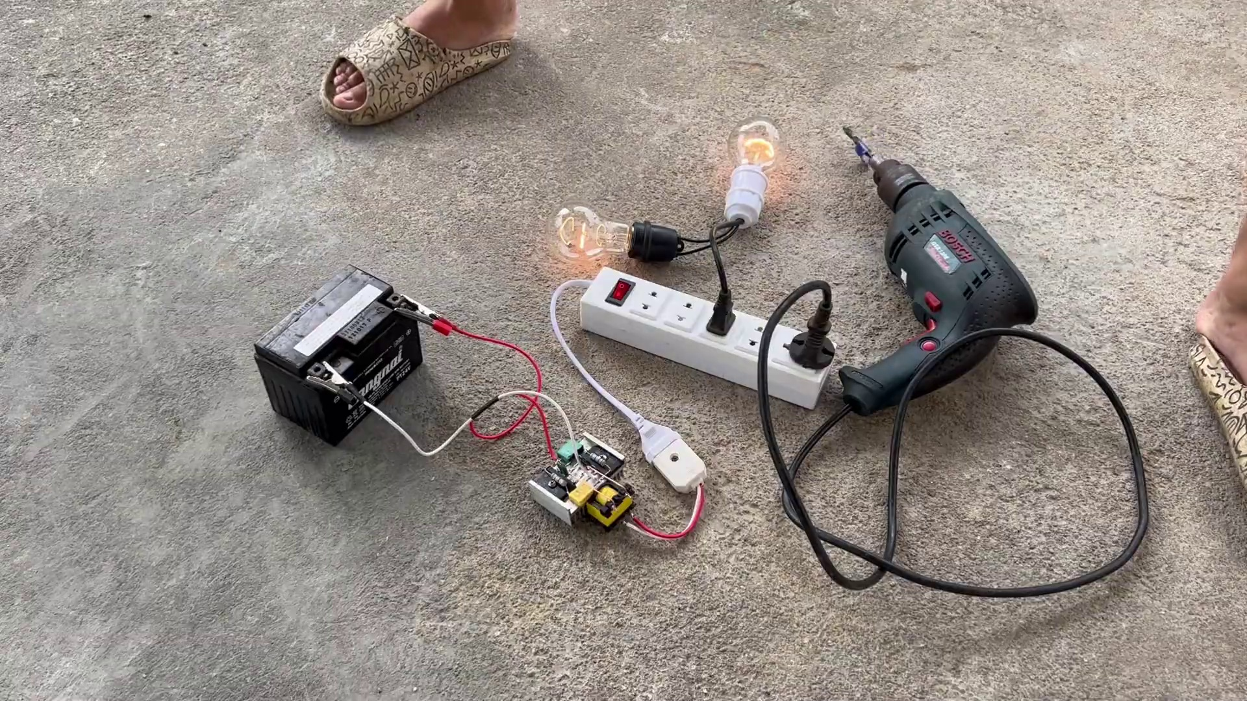 | 6:00   | 6:00   | 6:00   | 6:00  

Transcript
(No speech detected in this section)

Section 0: Multimeter and Power Tools
Time: 6:01 - 6:02

Summary
The image captures a scene of a workshop or workspace with an array of objects typically associated with electronics and DIY projects. Two power drills are seen lying side by side, suggesting they might be used for a task at hand.

Representative Frames
6:01   | 6:01   | 6:01  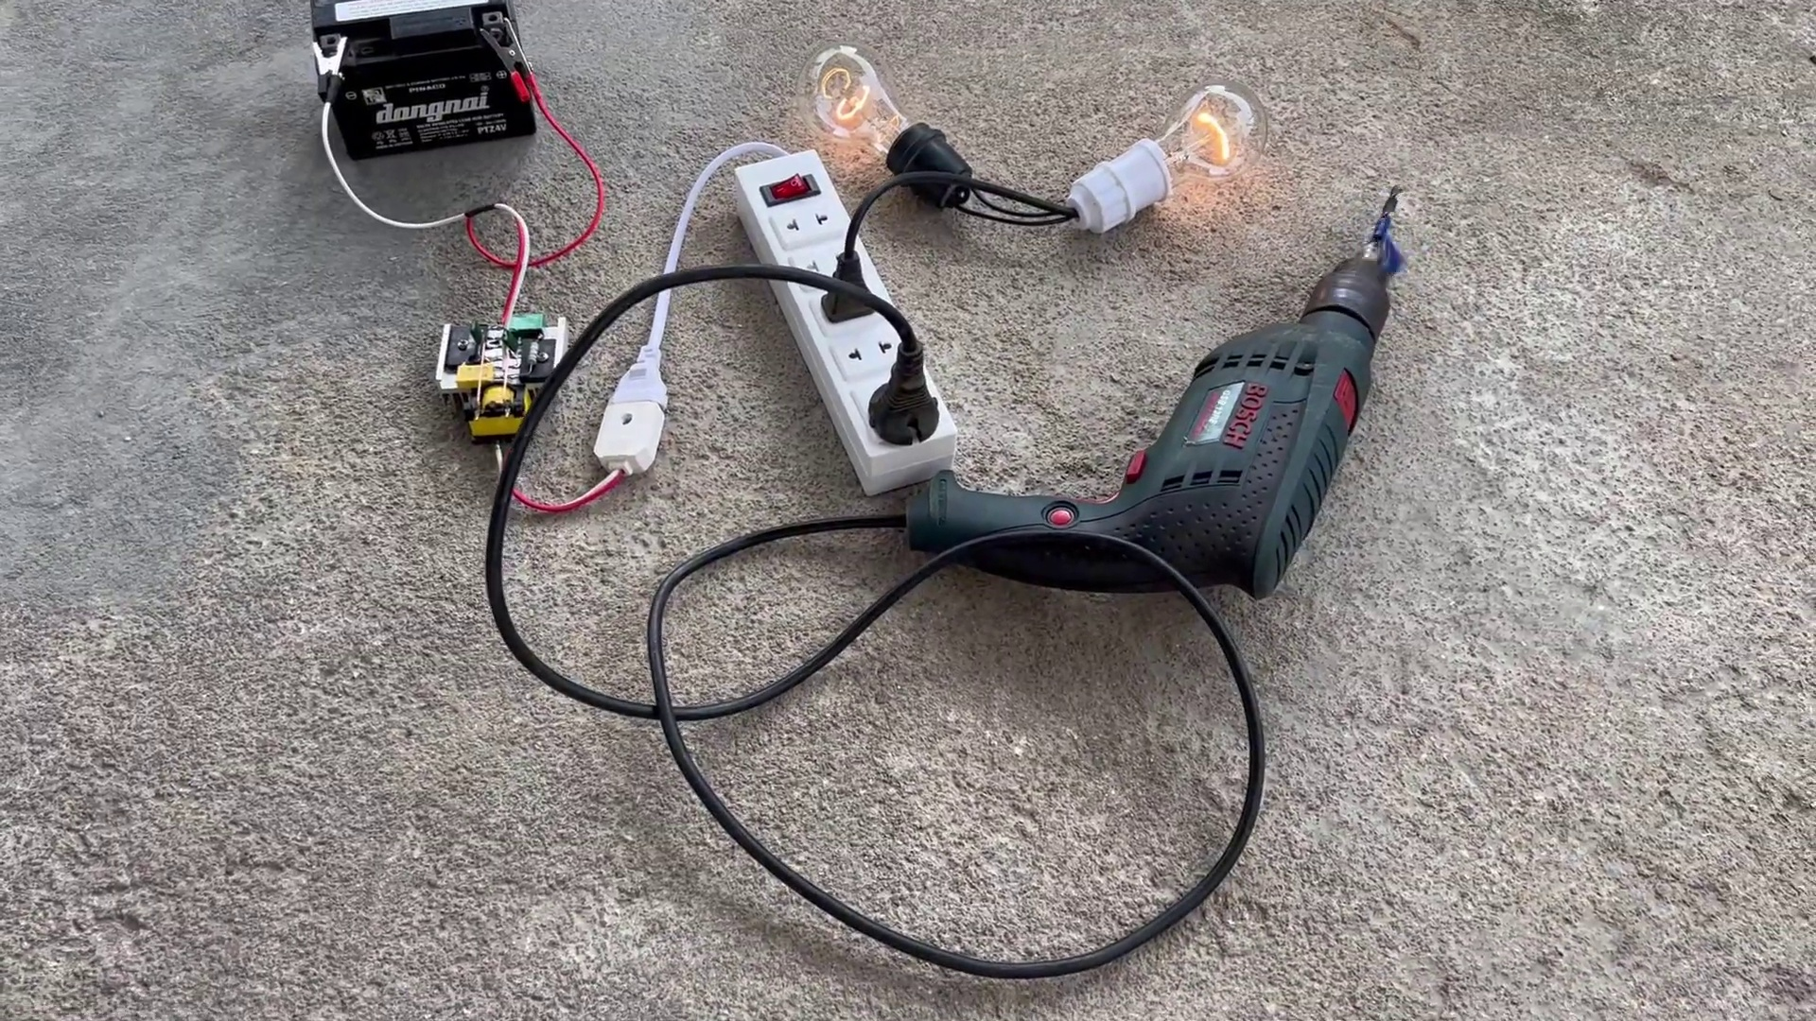 | 6:01   | 6:01  

Transcript
(No speech detected in this section)

Section 0: Electronic Components and Cables
Time: 6:02 - 6:03

Summary
The scene shows an assortment of electronic devices and tools laid out on a concrete floor. A black power drill is the focal point, with its silver cord tangled and twisted. Next to the power drill is a white socket, part of a larger circuit with red and white wires connected to a small black battery.

Representative Frames
6:02   | 6:02   | 6:02   | 6:02   | 6:02  

Transcript
(No speech detected in this section)

Section 0: Electronics Projects and Tools
Time: 6:03 - 6:04

Summary
The image shows an outdoor setting with a concrete floor, serving as the backdrop for a DIY project in progress. A person is engaged in electrical or mechanical work, surrounded by various tools and electronic equipment.

Representative Frames
6:03  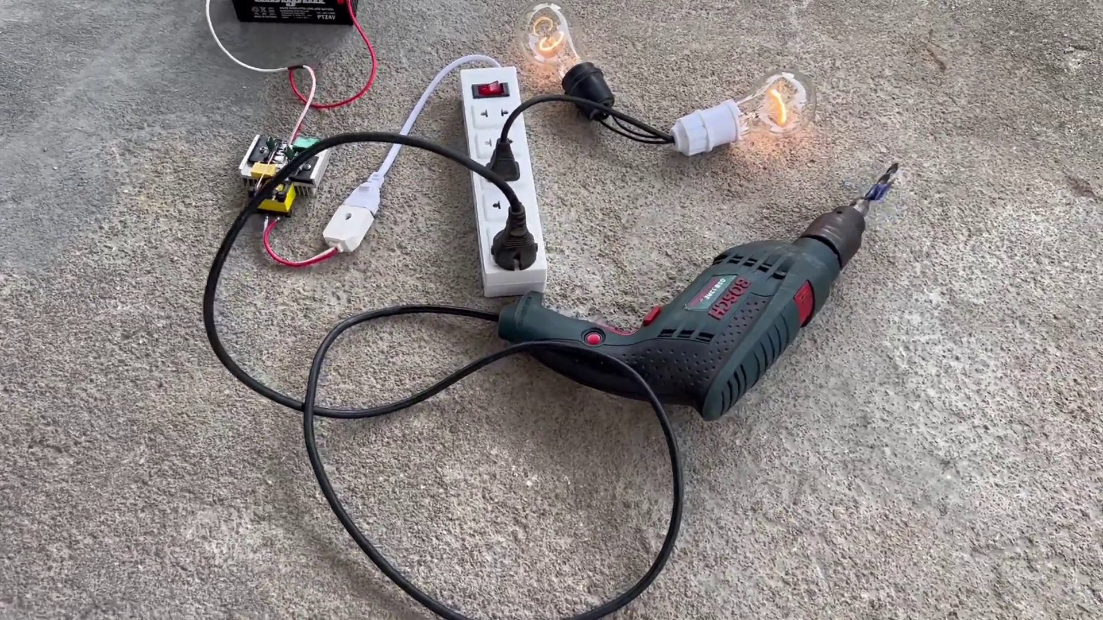 | 6:03   | 6:03   | 6:03   | 6:03  

Transcript
(No speech detected in this section)

Section 0: Workshop Scene with Power Tools and Equipment
Time: 6:04 - 6:05

Summary
The image captures a scene of a workshop or workspace. Dominating the scene is an array of objects typically associated with electronics and DIY projects. Two power drills are seen lying side by side, suggesting they might be used for a task at hand.

Representative Frames
6:04   | 6:04   | 6:04   | 6:04   | 6:04  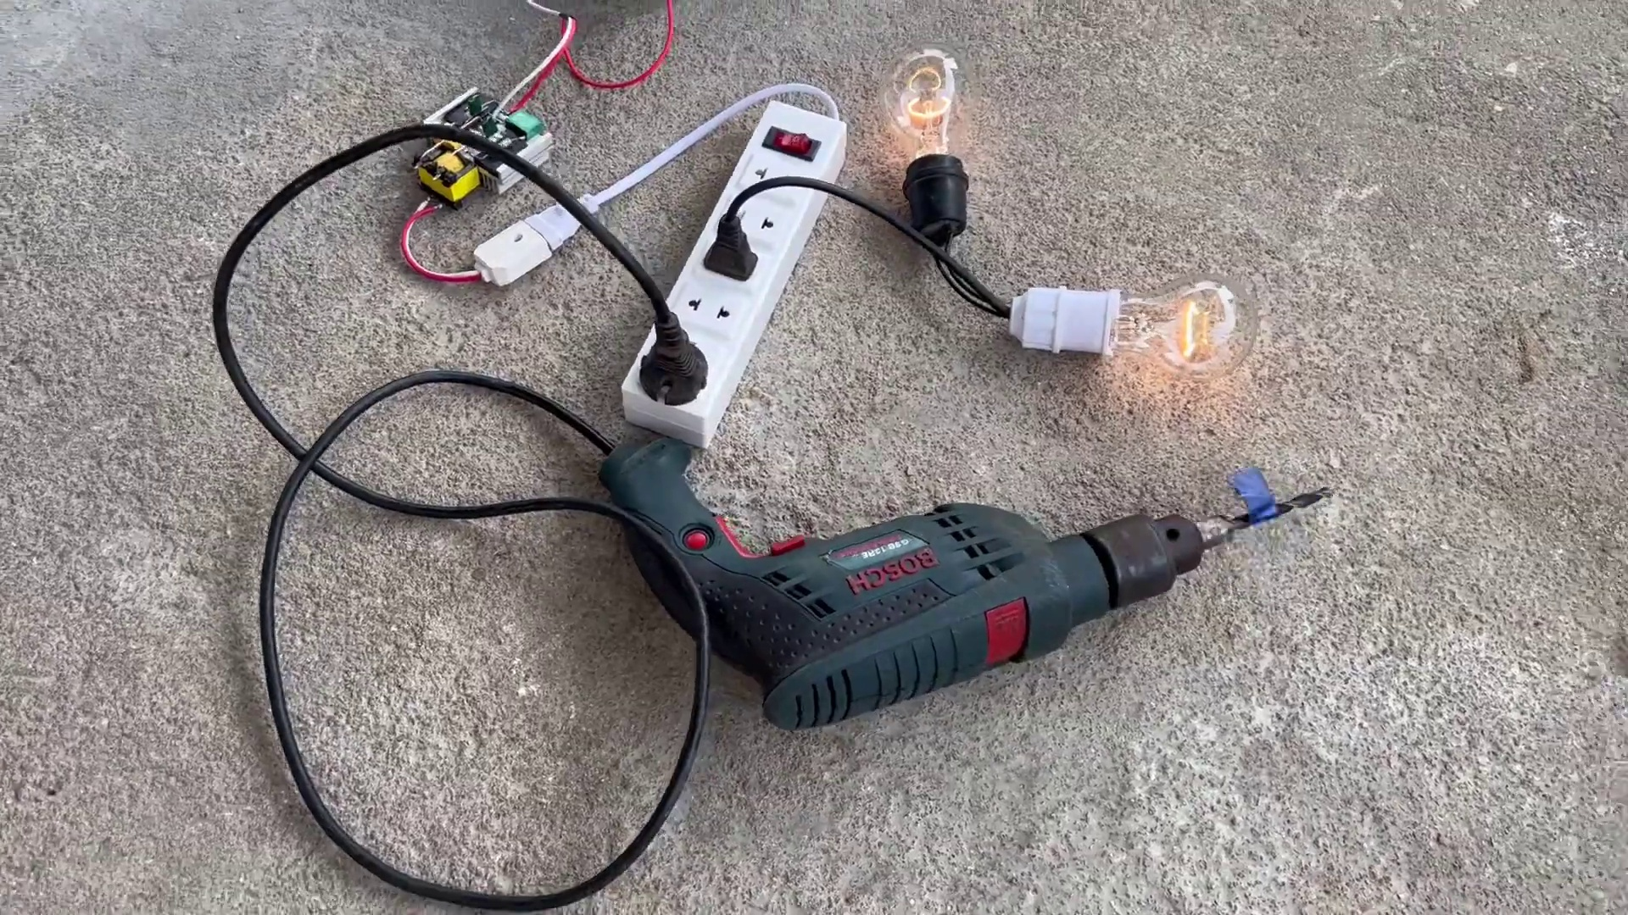

Transcript
(No speech detected in this section)

Section 0: Electronic Devices and Tools
Time: 6:05 - 6:59

Summary
The section continues to describe various scenes of electronics workshops, DIY projects, and individuals working with electronic devices. Images show tools, equipment, and components related to electronics repair, construction, and modification.

Representative Frames
6:14  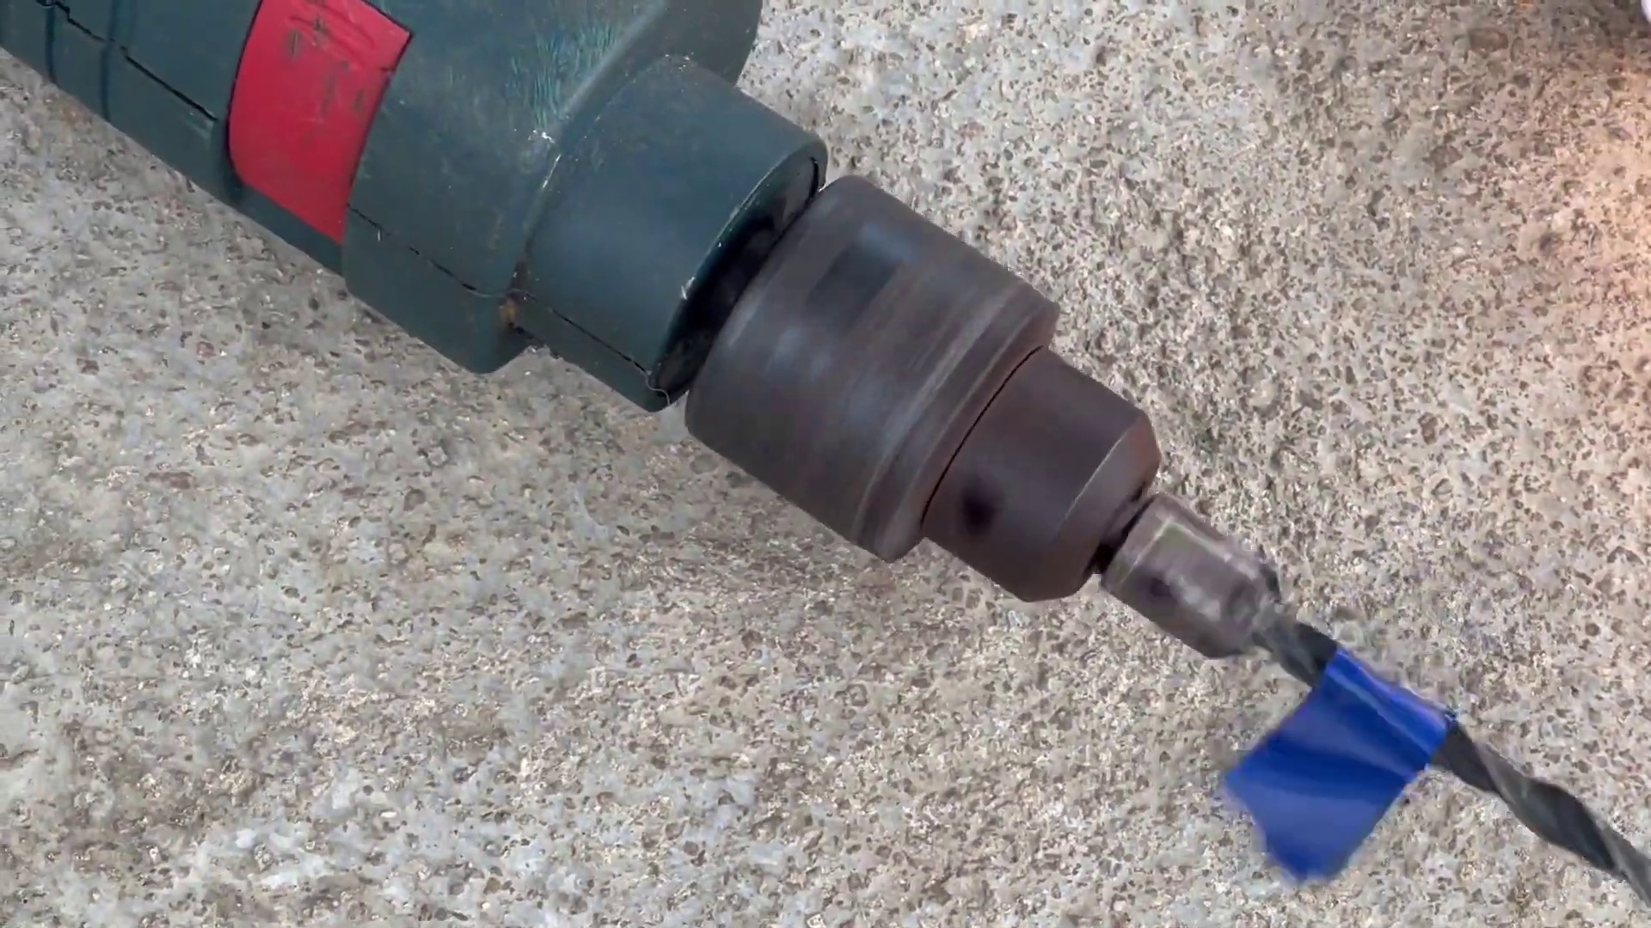 | 6:23  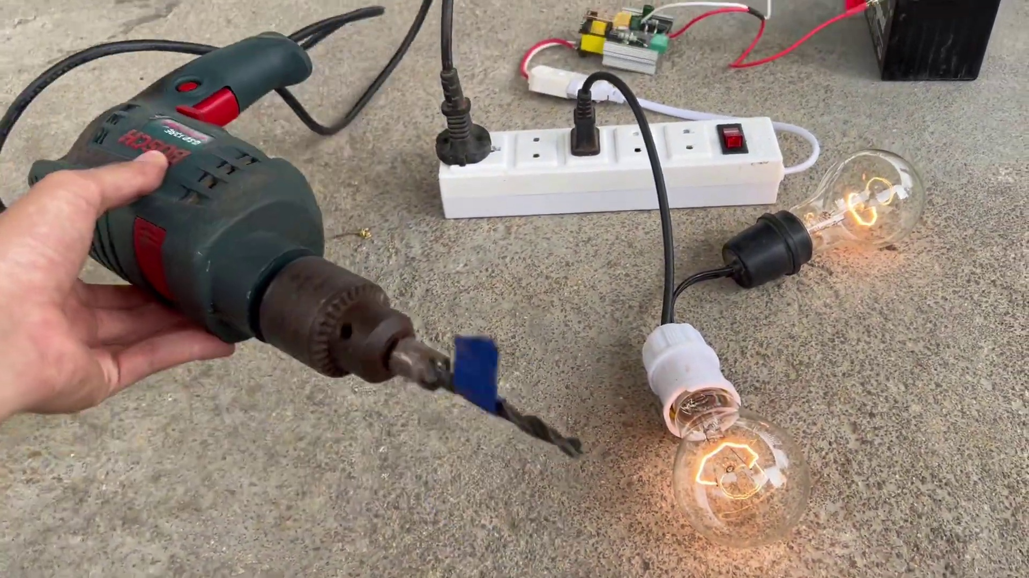 | 6:32  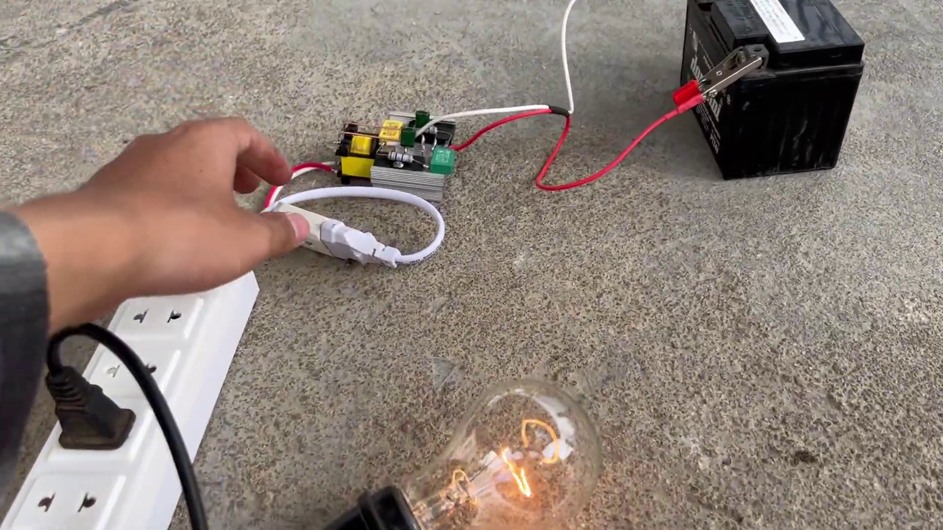 | 6:41  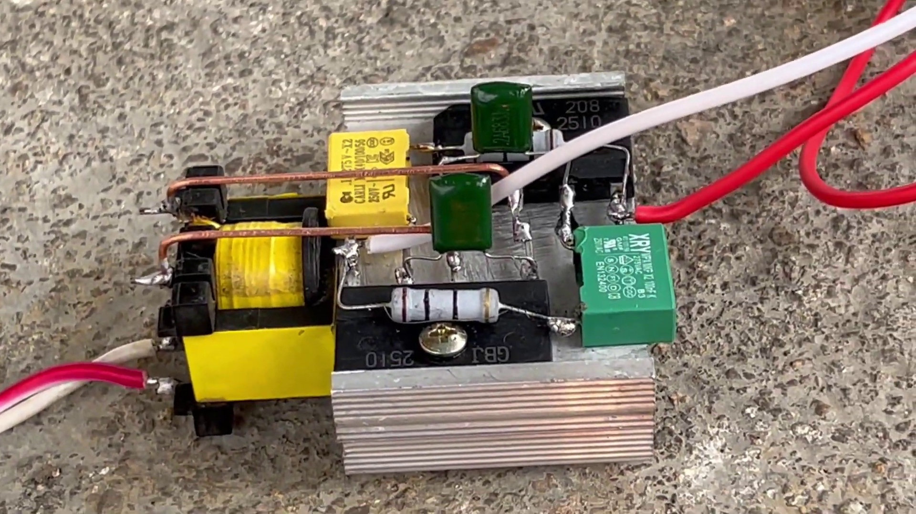 | 6:50  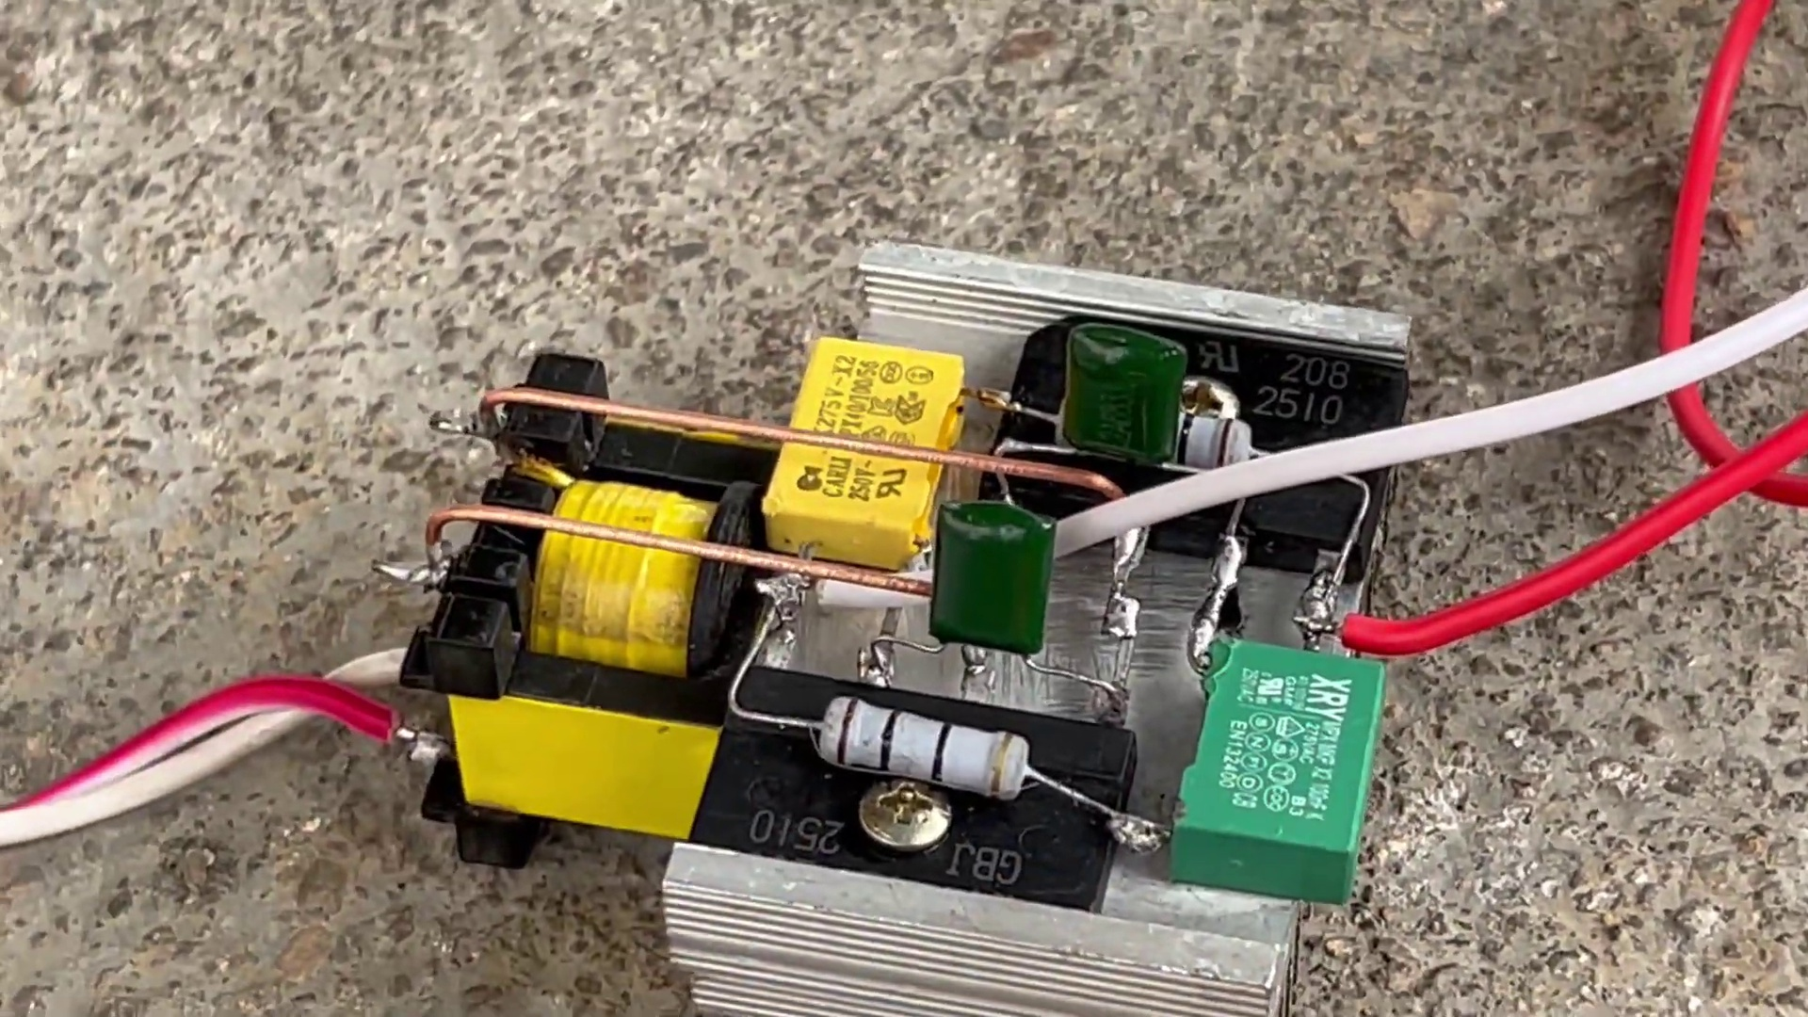

Transcript
[6:00] Thank you.
[6:30] Thank you.

Section 0: Informal DIY Session or Demonstration
Time: 6:59 - 7:00

Summary
The image shows an outdoor setting with a concrete floor, serving as the backdrop for a DIY project in progress. A person is engaged in electrical or mechanical work, surrounded by various tools and electronic equipment.

Representative Frames
6:59  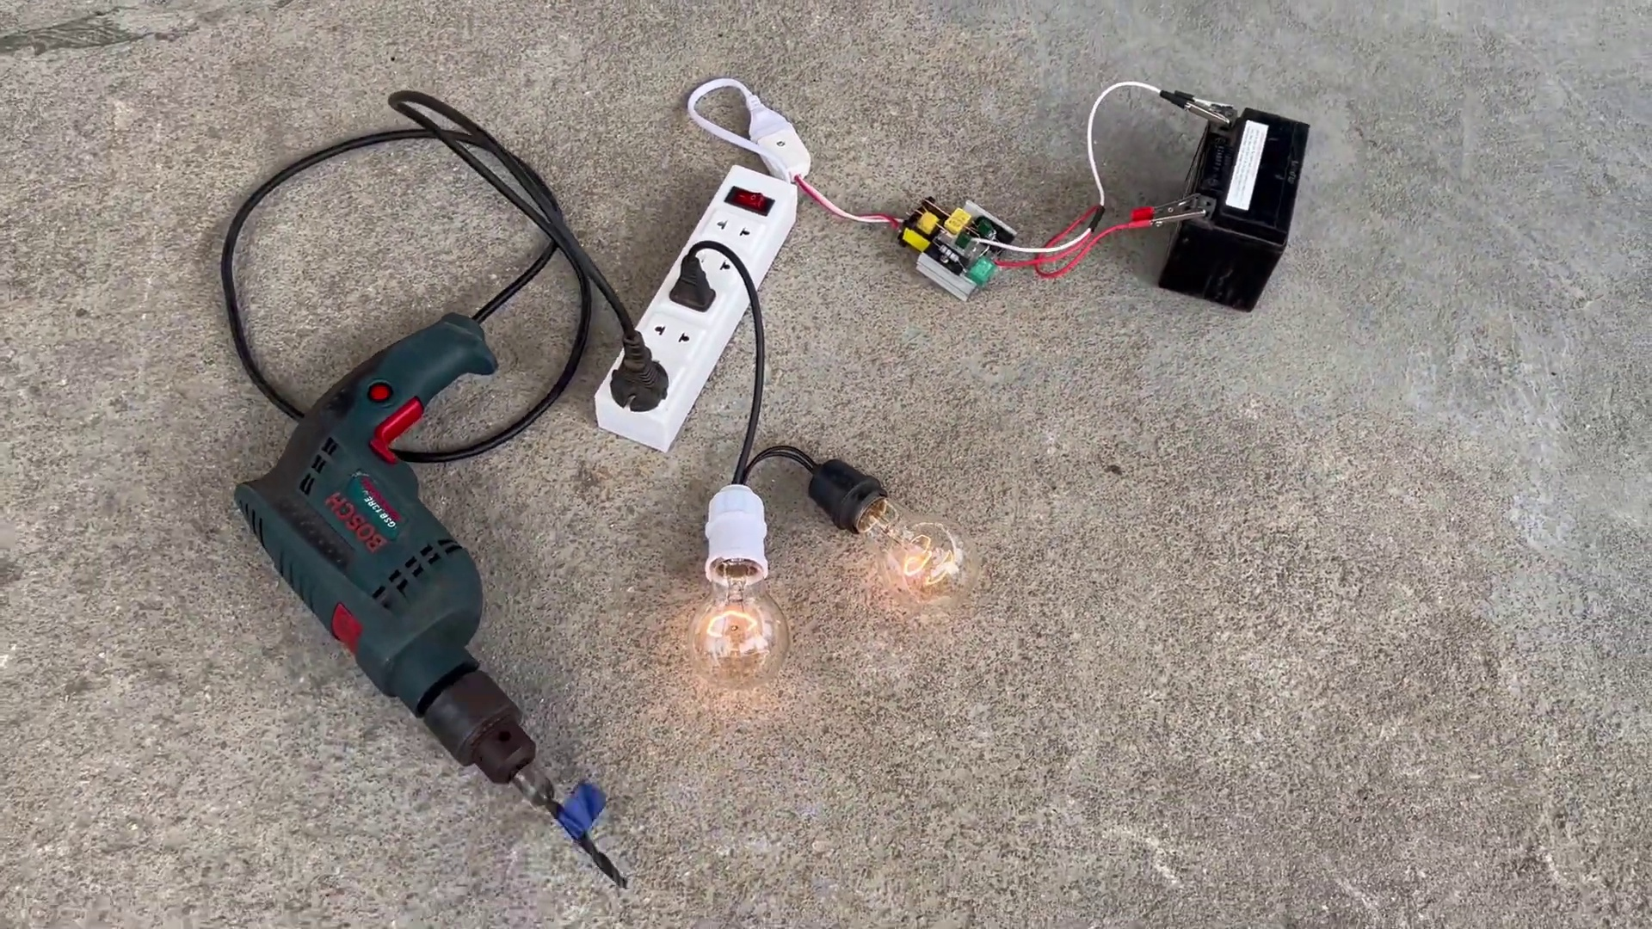 | 6:59   | 6:59   | 6:59   | 6:59  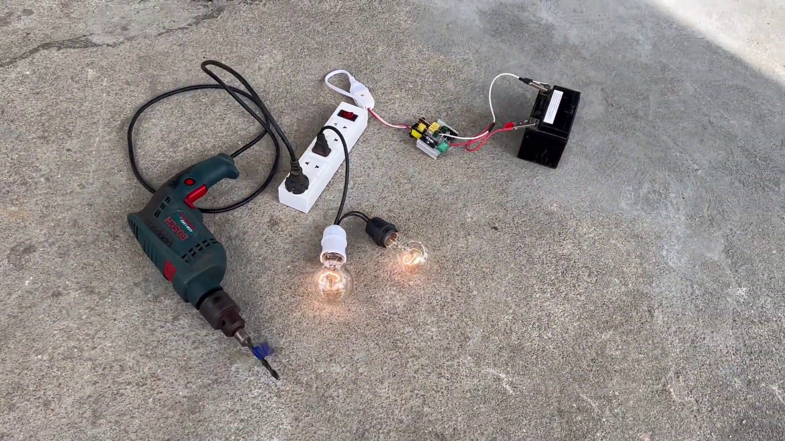

Transcript
(No speech detected in this section)

Section 0: Workshop Scene with Power Tools and Equipment
Time: 7:00 - 7:29

Summary
The image captures a scene of a workshop or workspace. Dominating the scene is an array of objects typically associated with electronics and DIY projects. Two power drills are seen lying side by side, suggesting they might be used for a task at hand.

Representative Frames
7:04  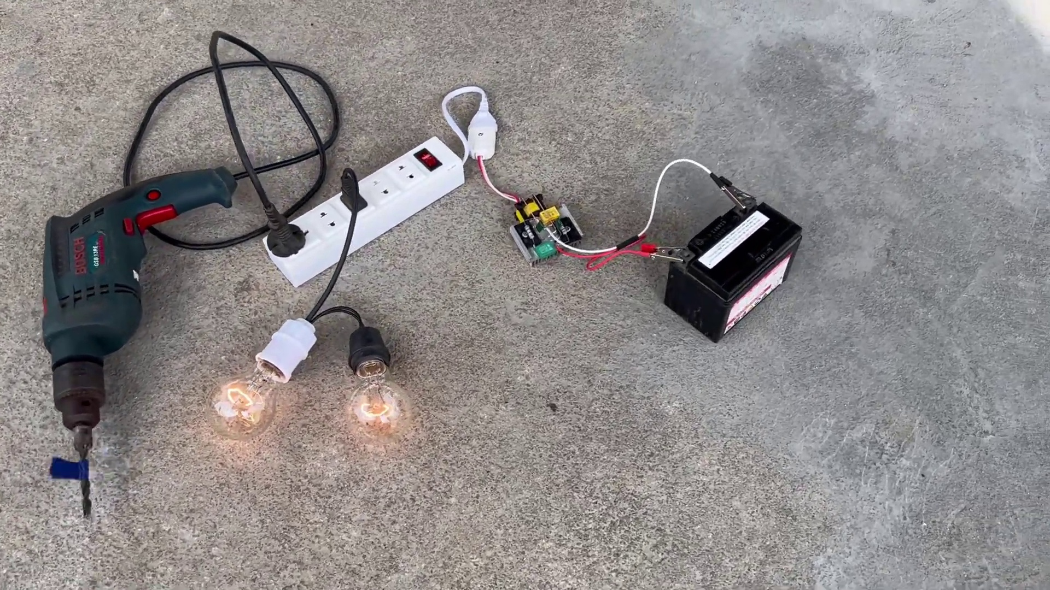 | 7:09  [No Frame] | 7:14  [No Frame] | 7:19  [No Frame] | 7:24  [No Frame]

Transcript
[7:00] Thank you.

