Engagement Analysis: S0j4xOuRzD4

Section 0: Electronic Equipment with Multisim 3000
Time: 0:01 - 0:04

Summary
A piece of electronic equipment, specifically the Multisim 3000, situated on a wooden table.

Representative Frames
0:01  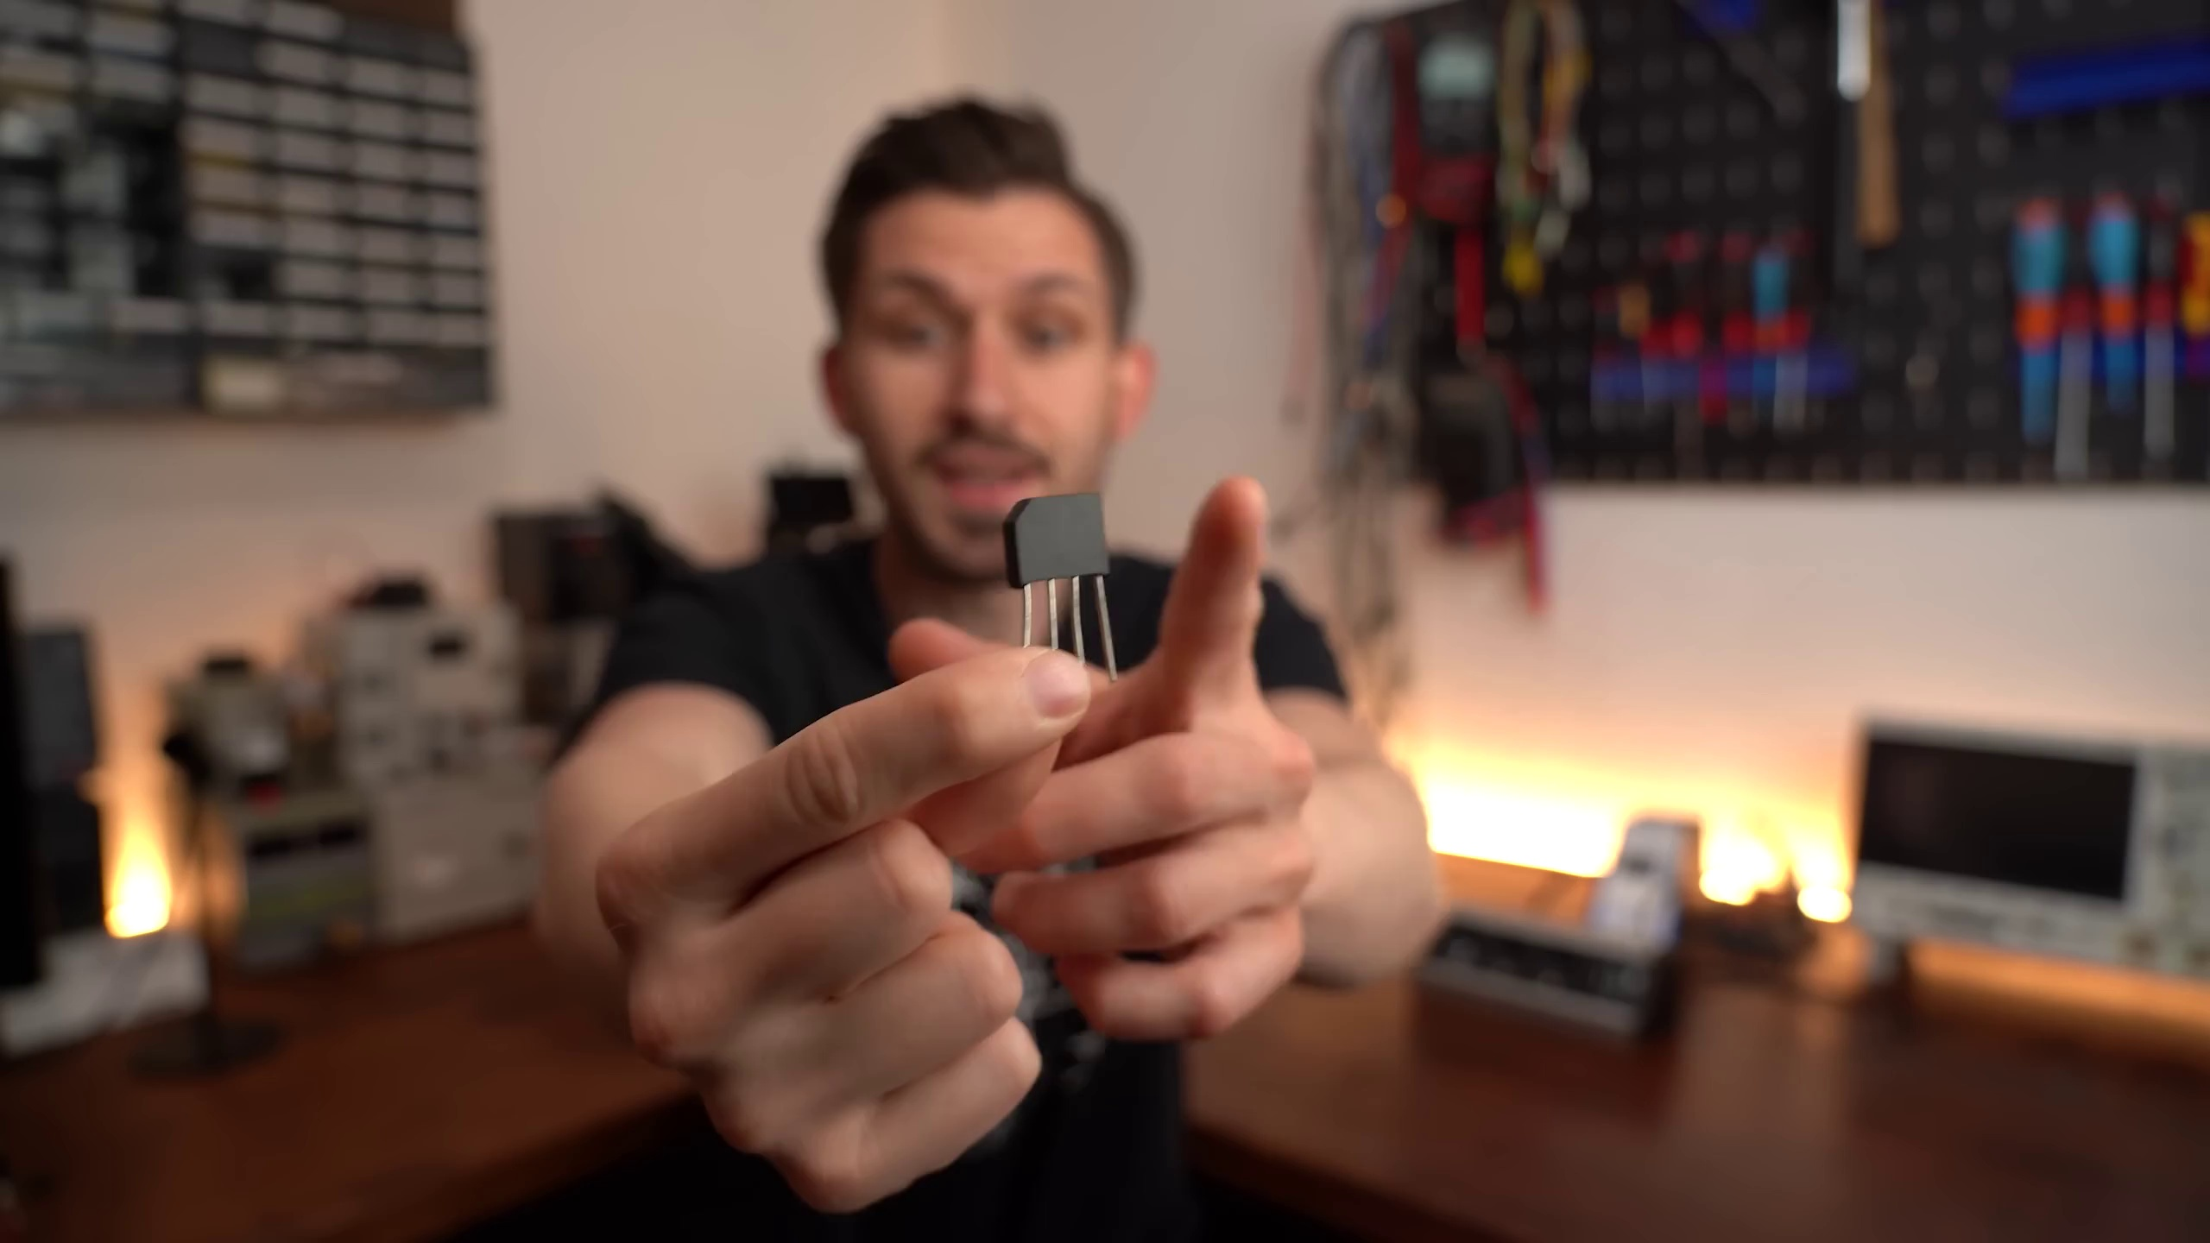 | 0:02   | 0:02   | 0:03   | 0:03  

Transcript
[0:00] This little component right here is a full bridge rectifier which converts our AC mains voltage we

Section 0: Multisim 3000 Displaying Analog Signal
Time: 0:04 - 0:06

Summary
The Multisim 3000 display shows a green waveform indicative of an analog signal captured in real-time.

Representative Frames
0:04  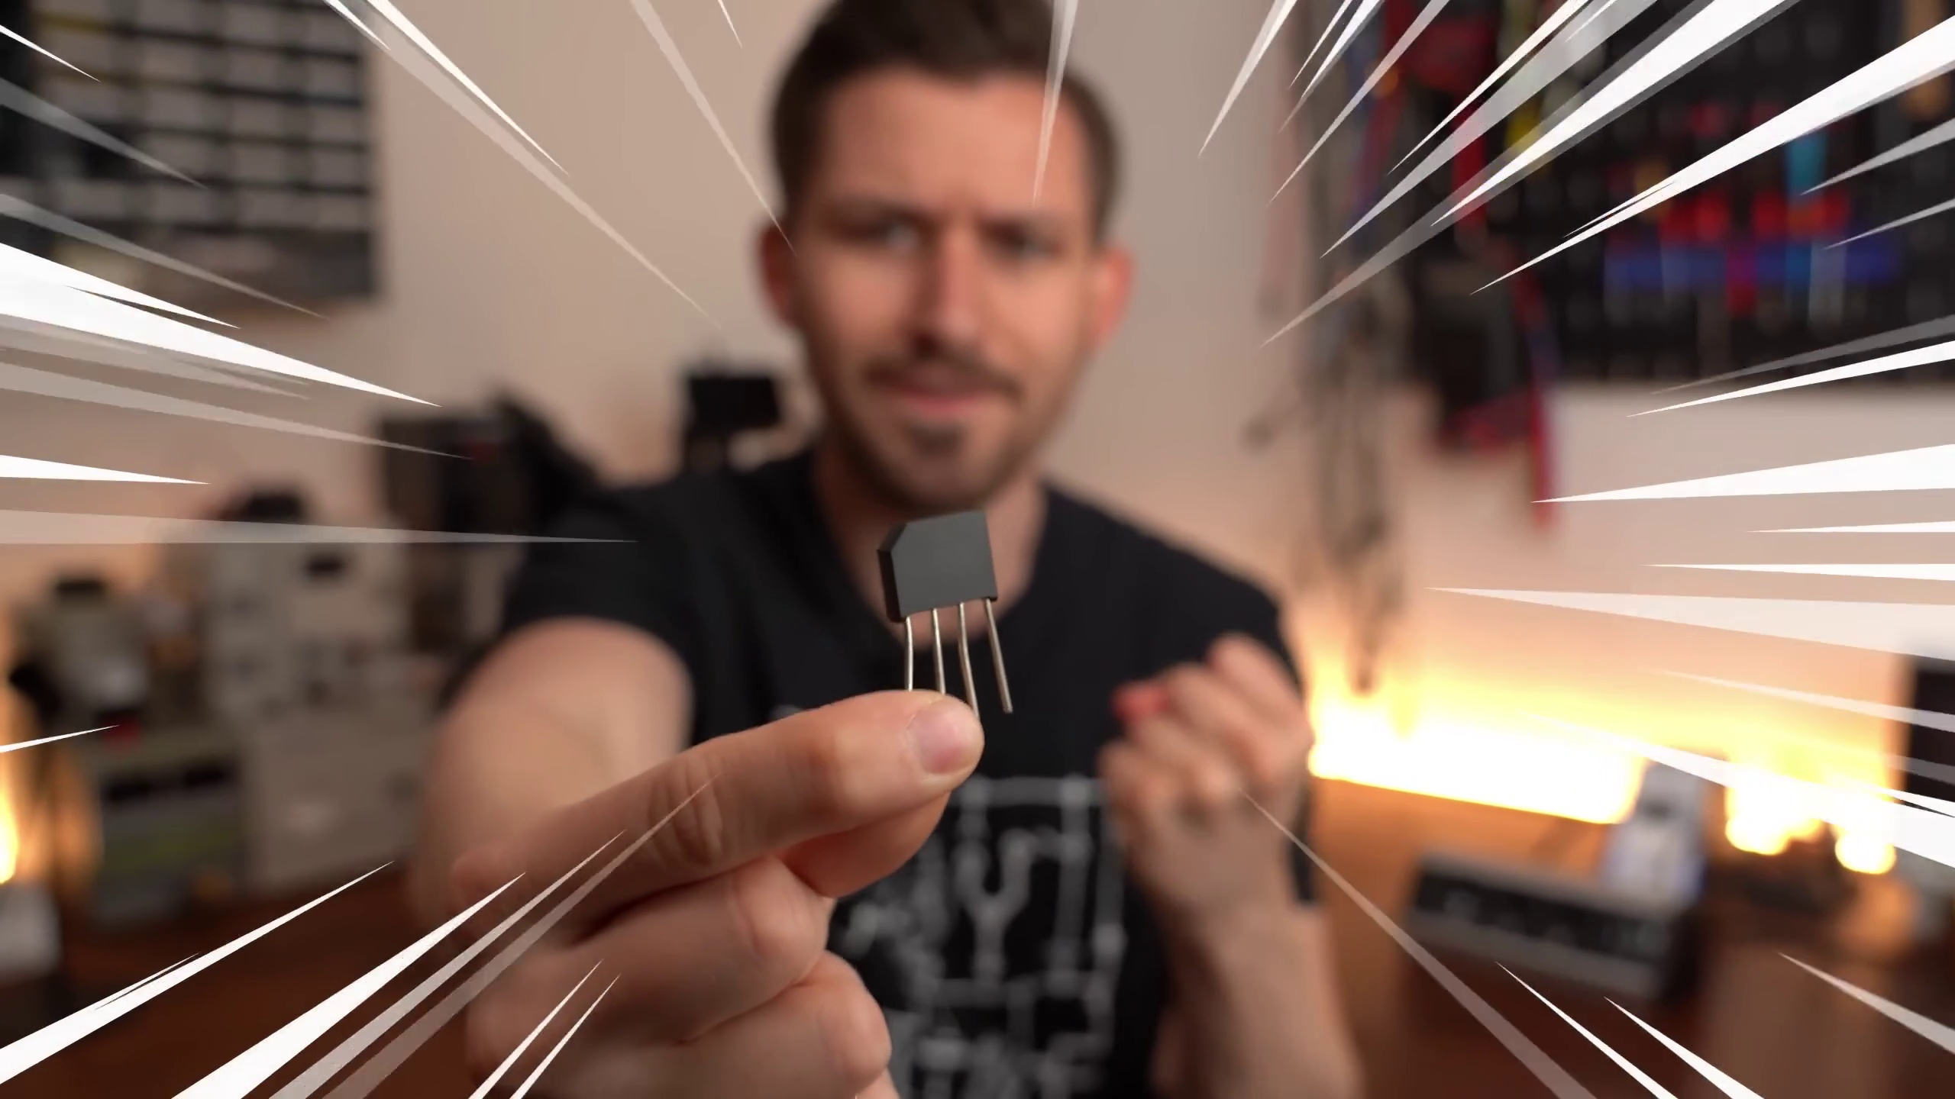 | 0:04   | 0:05   | 0:05   | 0:05  

Transcript
(No speech detected in this section)

Section 0: Oscilloscope with Digital Marker and Controls
Time: 0:06 - 0:09

Summary
An oscilloscope used mainly by electrical engineers and technicians, featuring a digital marker indicating a particular point on the graph.

Representative Frames
0:06   | 0:07   | 0:07   | 0:08  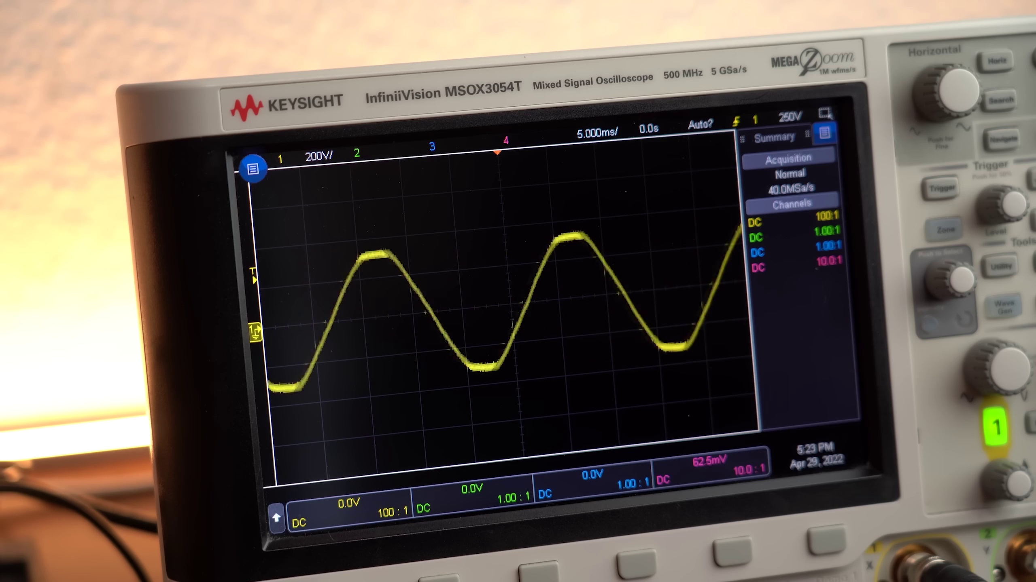 | 0:08  

Transcript
(No speech detected in this section)

Section 0: Digital Signal Analysis with Oscilloscope
Time: 0:09 - 10:57

Summary
A moment of digital signal analysis featuring an electronic device with a display screen and controls, likely used for communication signals or sensor measurement over time.

Representative Frames
1:57   | 3:45   | 5:33   | 7:21  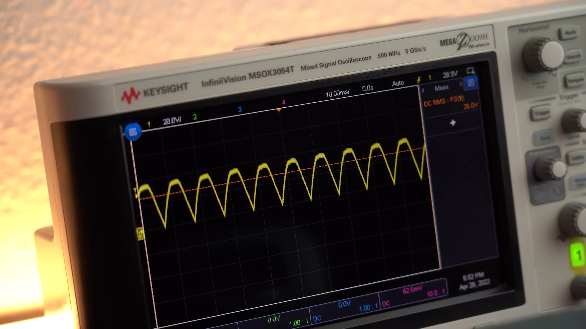 | 9:09  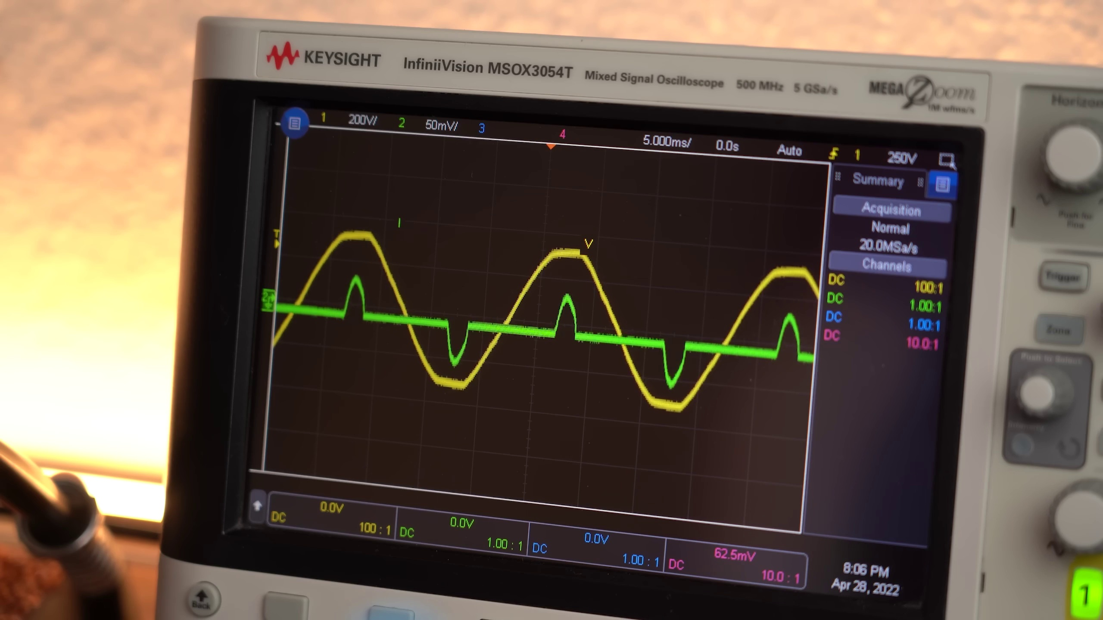

Transcript
[0:07] get from our outlets into a rather bumpy DC voltage. This might sound unspectacular but
[0:14] if we add a capacitor to the rectifier's output we get a smooth DC voltage that is basically
[0:20] required for every modern power supply to work. So yes, full bridge rectifiers are a big deal
[0:27] and make our modern electronics world possible. But that doesn't mean they are perfect. They in fact
[0:34] come with a noticeable voltage drop which multiplies with the flowing current equals the power loss that
[0:40] the rectifier dissipates in the form of heat. Needless to say we want to keep this power loss as small as
[0:47] possible to increase efficiency and that is why I was super excited to find this active rectifier board
[0:54] on the internet which apparently replaces the old school diodes of a full bridge rectifier
[1:00] with MOSFETs in order to decrease the voltage drop and thus power losses.
[1:06] So in this video we will not only put this pre-made active rectifier board to the test but also
[1:12] try to create our own DIY version in order to find out whether they are the future of rectification
[1:20] or whether we should stick with the old school solution instead. Let's get started!
[1:34] This video is sponsored by Altium. Now you might already be familiar with the Altium Designer for
[1:39] creating schematics and PCBs since I mentioned it once or twice before. But today I want to tell you about
[1:47] Altium 365 which is already integrated into the designer software and lets you easily share your
[1:54] designs not only with your colleagues but basically the entire world. This way you can get feedback
[2:00] easily and speed up your design process. So why not give it a try for free by clicking the link in the
[2:07] description. First off we need to understand how a traditional full bridge rectifier functions.
[2:14] As you can see in this schematic it only consists of 4 diodes positioned in a particular arrangement
[2:21] which I personally like to draw like this because this way it is easier to understand.
[2:27] And let's imagine we got a resistive load on the output across which we should later get the bumpy
[2:33] DC voltage we saw before and on the input we got the mains AC voltage. So how exactly do we go from
[2:41] this to this is the question? Well the answer lies in the behavior of a diode which lets current flow in
[2:49] only one direction and not the other. That means that when AC mains voltage is in the positive region
[2:56] we got a voltage potential here which lets current flow this way. And when the AC mains voltage is in
[3:02] the negative region we got the opposite voltage potential here which this time lets current flow this way.
[3:10] So in both cases a current flow through the load was possible and what is remarkable is that the current
[3:16] direction was always the same which basically means we folded over one half of the AC voltage and thus created DC.
[3:25] Pretty straightforward if you ask me but the bad news is that every diode comes with a certain voltage drop
[3:32] which causes the power loss I talked about at the beginning. The AC rectifier idea wants to change
[3:38] that by replacing the diodes with MOSFET switches that come with super low resistances and thus should
[3:46] decrease the power losses. Only problem is that MOSFETs are not exactly diodes even though they come with a
[3:53] body diode that also only allows one current path direction. But using the body diode is not the goal
[4:00] of the voltage voltage drop. Since its voltage drop is also rather high. No, we want to apply a DC voltage
[4:07] to the MOSFETs gate in order to properly turn it on. So for full bridge rectifier we would need some
[4:14] kind of circuitry that detects when the AC voltage is either positive or negative and depending on that
[4:21] only turns on the two MOSFETs diagonally to one another to mimic the functionality of a full bridge
[4:27] rectifier. Good timing is also key here because if just one additional MOSFET is on at any point
[4:35] we basically got a short circuit. And that is exactly why I was rather happy that I didn't have to design
[4:42] such a circuit myself because I found the TEA2206 and TEA2208IC on the internet. They are active bridge
[4:52] rectifier controllers and can do what I just described by utilizing their built in comparators and MOSFET
[4:59] drivers. So according to their typical application schematic there is not much I have to add to the
[5:05] ICs to create an active rectifier, just some MOSFETs and capacitors. And in case you are wondering the
[5:12] 2206 one only replaces the lower side diodes with MOSFETs while the 2208 one replaces them all which
[5:21] begs the question why I even got the 2206 version if it only does half the job of lowering the power
[5:28] losses. Well, the reason is that I got my hands on a development board around it which I can use to
[5:35] get my feet wet since it should be functional right? To safely try it out I utilized my small auto
[5:43] transformer to decrease the mains voltage to 25V ACRMS which I directly hooked up to the active rectifier.
[5:52] And as you can see on the oscilloscope it does seem to work just fine, awesome!
[5:58] That means it was time for the first efficiency tests slash comparisons which I performed by adding
[6:04] a capacitor bank to the rectifier's output as well as a constant load and then drawing varying constant
[6:11] current with it while measuring how much input power that required. Of course to get accurate values on
[6:18] the output side I also utilized my multimeter to precisely measure the current and my oscilloscope
[6:25] to get the RMS voltage value. After that was done I replaced the active rectifier with a normal full
[6:31] bridge rectifier and basically repeated this test in order to find out that the average efficiency was
[6:38] bumped up around 2 to 4% with the active version. Not bad!
[6:44] But of course next I wanted to replace all the diodes to increase the efficiency even more.
[6:50] To do that I soldered the TEA2208IC to a breakout board and afterwards to a perf board to which I
[6:58] then added the 4 MOSFETs and some capacitors pretty much like the typical application schematic recommended
[7:05] me to do. The result didn't look half bad but I was still very nervous while doing the first test with
[7:12] lowered mains voltage. But as you can see on the oscilloscope this active rectifier also seems to
[7:18] work just fine at least with resistive loads. Because while trying to charge up the capacitor bank for
[7:25] the power test there appeared to be some sort of short circuit problem with the rectifier.
[7:31] Not sure if my design with the low cost high resistance MOSFETs is the problem or whether the topology and IC can
[7:39] generally not handle capacitive loads because the datasheet also states that a boost type power
[7:45] factor circuit must follow the application which more or less prevents current surges from capacitors.
[7:53] The circuit does however work just fine with like I said resistive loads.
[7:58] But due to obvious safety concerns I really didn't want to include it in the next mains voltage power
[8:04] supply test in which I basically measured the efficiency of a common switch mode power supply
[8:10] before and after implementing an active rectifier. The only thing though that held me back once again
[8:17] was a familiar sentence in the TEA2206 datasheet that states that it is intended for applications followed by a PFC.
[8:27] And since such a power factor circuit got mentioned twice now, let me tell you that it basically
[8:33] prevents that mains current only gets drawn near the peak of the AC mains voltage.
[8:39] Instead it distributes the current draw evenly across the whole sinusoidal voltage but more about
[8:45] that topic in another video. The only problem was that pretty much all of my power supplies didn't
[8:51] come with this feature except of course one that I need to charge my newest laptop. And I decided to
[8:59] not sacrifice it for this video which is why I pushed my luck and tried it with this a bit nicer power
[9:06] supply that not only comes with less sharp current surges but also some filters on its inputs.
[9:13] So after doing the usual power measurement test with it, I desoldered its original full bridge rectifier
[9:19] and simply replaced it with the leads of the active rectifier boards.
[9:23] So I did not get the same thing as I did. And luckily nothing exploded after the power up and
[9:28] everything worked perfectly fine so that I could do all the measurements.
[9:33] Now the final results tell us that the active rectifier is once again more efficient but this time
[9:39] only with a difference of around 0.2 to a maximum of 0.9%. The reason is that due to the higher mains
[9:48] voltage level of 230V that gets transformed down, there is only a small current flowing through the
[9:55] rectifier which does not create that big of a power loss and thus is not that important for the efficiency.
[10:02] But if we got a low voltage high current system without transformation then a better rectifier
[10:08] is definitely recommended as we proved in test 1 of this video.
[10:13] So in conclusion the old school full bridge rectifier is definitely good enough for most of the mains
[10:20] voltage rectification because it is cheap, rigid and efficient enough for this task.
[10:26] With that being said I hope you learned something new through this video and now understand the
[10:31] advantages and disadvantages of active rectifiers. If so consider supporting me through Patreon.
[10:39] Don't forget to like, share, subscribe and hit the notification bell. Stay creative and I will see you next time!

