Engagement Analysis: YIAQ80evrFM

Section 0: A person is working on an electronic project with multiple speakers and earphones.
Time: 0:00 - 0:03

Summary
The person is assembling or testing some sort of electronic device, possibly a stereo or audio system.

Representative Frames
0:00  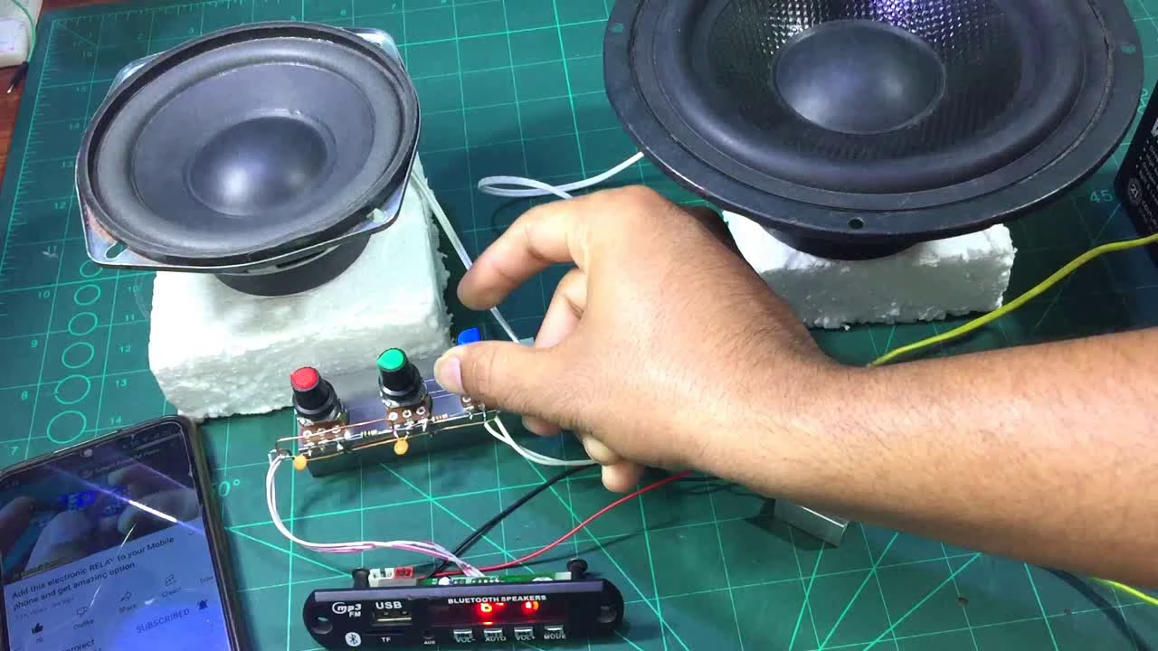 | 0:01   | 0:01   | 0:02   | 0:02  

Transcript
(No speech detected in this section)

Section 0: A person is interacting with various electronic devices that appear to be part of an audio system.
Time: 0:03 - 0:06

Summary
The setup includes speakers mounted on a wooden platform and connected to a small control box, as well as a smartphone or similar touchscreen device being used to adjust the setup.

Representative Frames
0:03  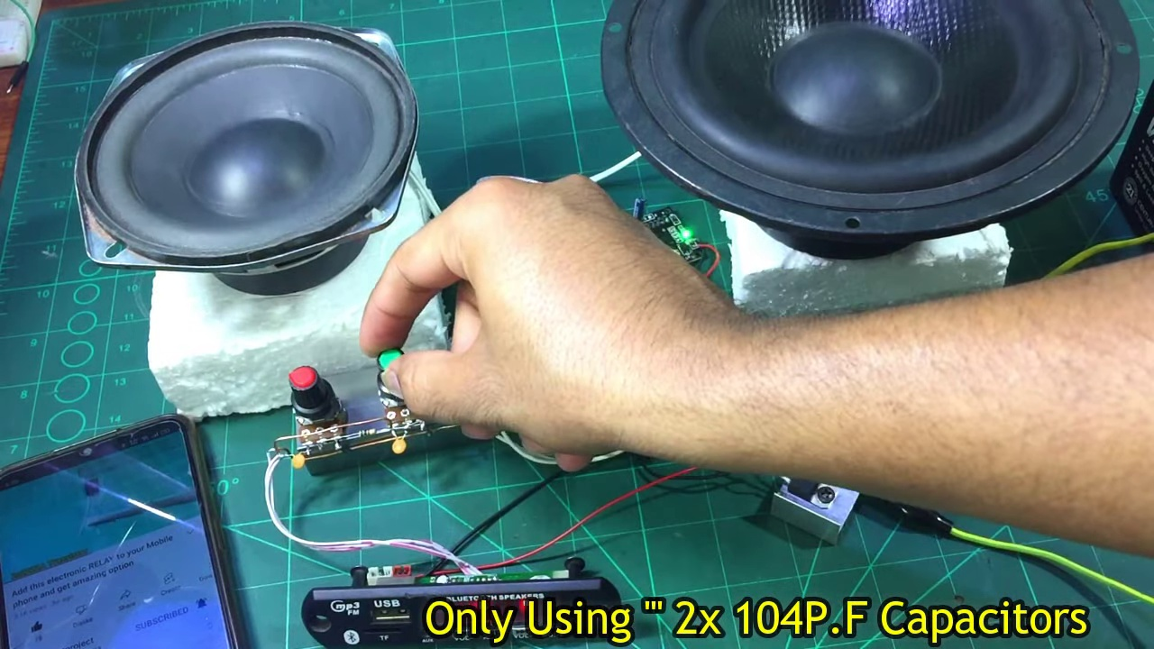 | 0:04   | 0:04   | 0:05   | 0:05  

Transcript
(No speech detected in this section)

Section 0: A person is working on a DIY electronics project with a pair of speakers and various electronic equipment.
Time: 0:06 - 0:09

Summary
The person appears focused on adjusting a device or looking at a diagram, and the overall scene suggests an ongoing process of experimentation and creation in the realm of electronics.

Representative Frames
0:06   | 0:07  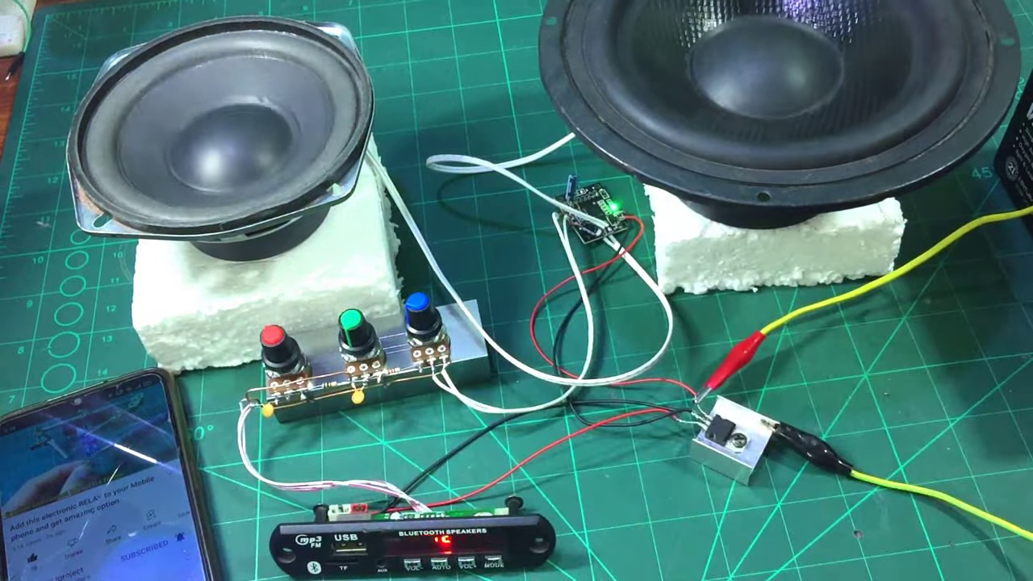 | 0:07   | 0:08   | 0:08  

Transcript
(No speech detected in this section)

Section 0: A presentation slide with a dark background and a single graphic logo.
Time: 0:09 - 0:12

Summary
The focus of the slide is solely on a message of gratitude to the viewer, with no other visible features or content beyond what is described.

Representative Frames
0:09   | 0:10  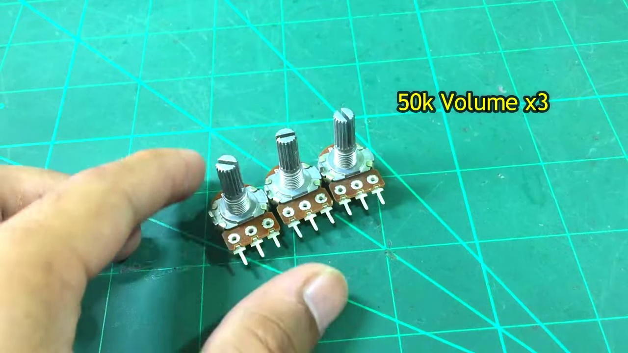 | 0:10   | 0:11   | 0:11  

Transcript
(No speech detected in this section)

Section 0: A person is working on an electronic project with multiple speakers and earphones.
Time: 0:12 - 0:15

Summary
The person is assembling or testing some sort of electronic device, possibly a stereo or audio system, and the overall scene suggests an ongoing process of experimentation and creation in the realm of electronics.

Representative Frames
0:12   | 0:13   | 0:13  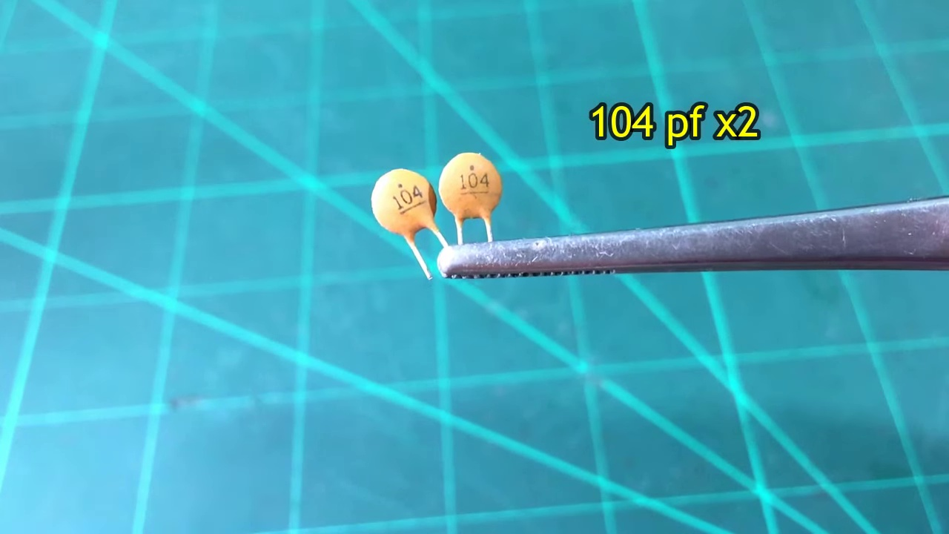 | 0:14   | 0:14  

Transcript
[0:00] O'er 지난 2 hours

Section 0: A presentation slide with a dark background and a single graphic logo.
Time: 0:15 - 0:18

Summary
The focus of the slide is solely on a message of gratitude to the viewer, with no other visible features or content beyond what is described.

Representative Frames
0:15   | 0:16   | 0:16   | 0:17  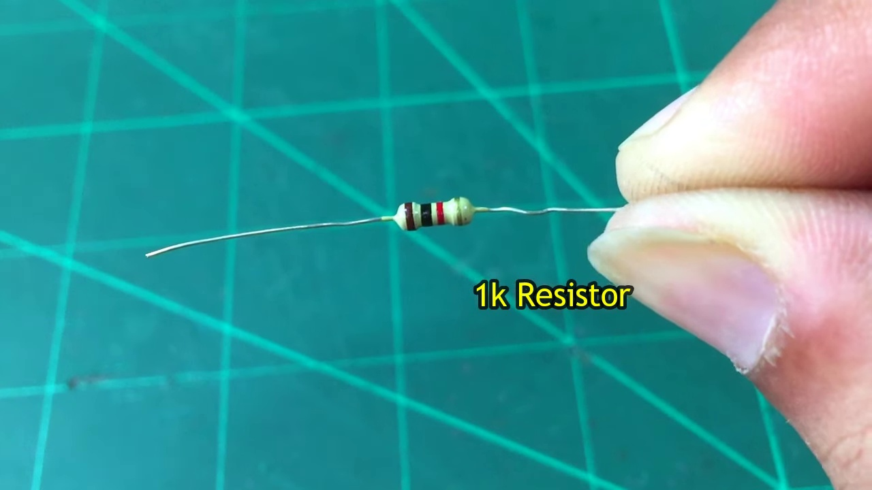 | 0:17  

Transcript
(No speech detected in this section)

Section 0: A person is interacting with various electronic devices that appear to be part of an audio system.
Time: 0:18 - 0:21

Summary
The setup includes speakers mounted on a wooden platform and connected to a small control box, as well as a smartphone or similar touchscreen device being used to adjust the setup.

Representative Frames
0:18   | 0:19   | 0:19   | 0:20  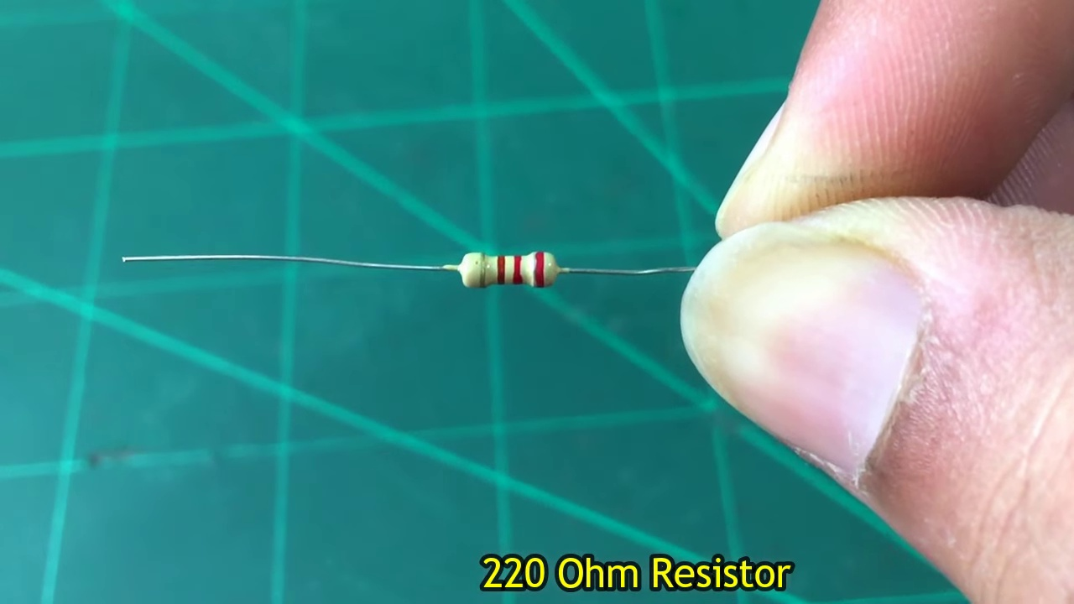 | 0:20  

Transcript
(No speech detected in this section)

Section 0: A person is working on a DIY electronics project with a pair of speakers and various electronic equipment.
Time: 0:21 - 0:24

Summary
The person appears focused on adjusting a device or looking at a diagram, and the overall scene suggests an ongoing process of experimentation and creation in the realm of electronics.

Representative Frames
0:21   | 0:22   | 0:22   | 0:23   | 0:23  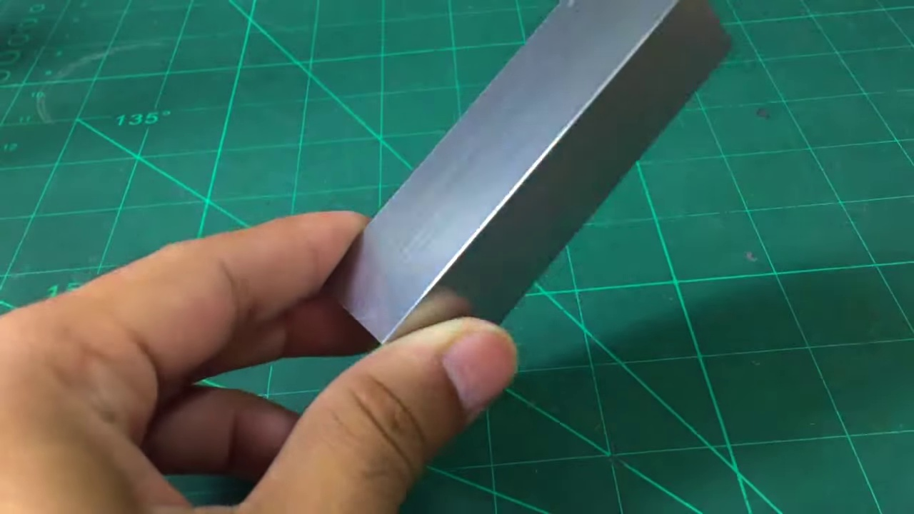

Transcript
(No speech detected in this section)

Section 0: A presentation slide with a dark background and a single graphic logo.
Time: 0:24 - 0:27

Summary
The focus of the slide is solely on a message of gratitude to the viewer, with no other visible features or content beyond what is described.

Representative Frames
0:24   | 0:25   | 0:25   | 0:26   | 0:26  

Transcript
(No speech detected in this section)

Section 0: A person is working on an electronic project with multiple speakers and earphones.
Time: 0:27 - 0:30

Summary
The person is assembling or testing some sort of electronic device, possibly a stereo or audio system, and the overall scene suggests an ongoing process of experimentation and creation in the realm of electronics.

Representative Frames
0:27  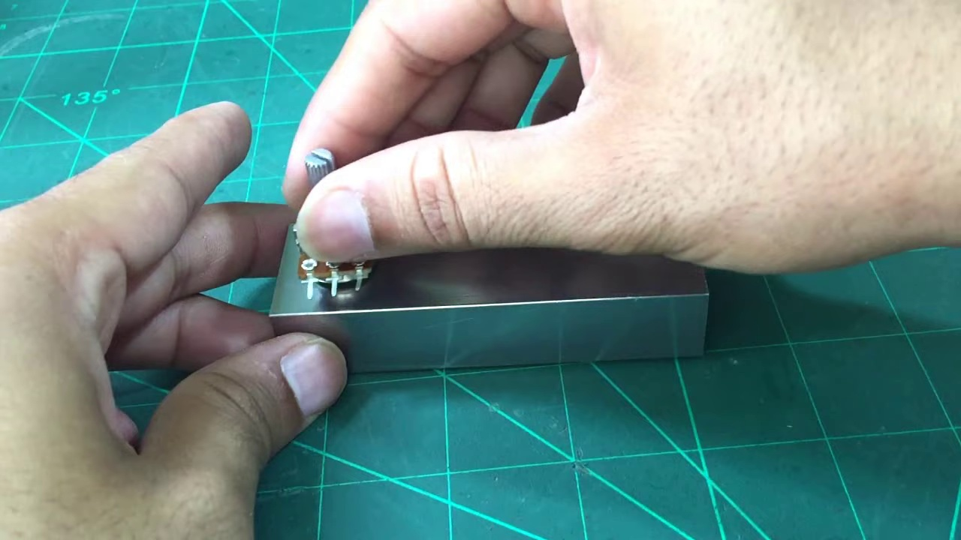 | 0:28   | 0:28   | 0:29   | 0:29  

Transcript
(No speech detected in this section)

Section 0: A presentation slide with a dark background and a single graphic logo.
Time: 0:30 - 4:59

Summary
The focus of the slide is solely on a message of gratitude to the viewer, with no other visible features or content beyond what is described.

Representative Frames
1:14  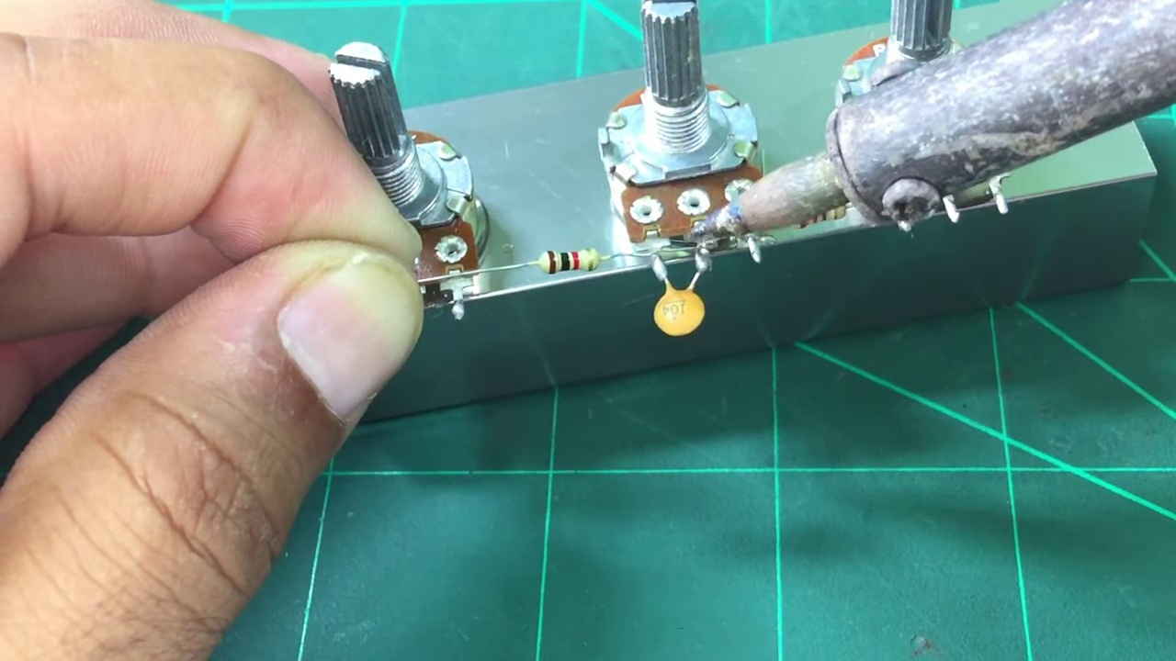 | 1:59  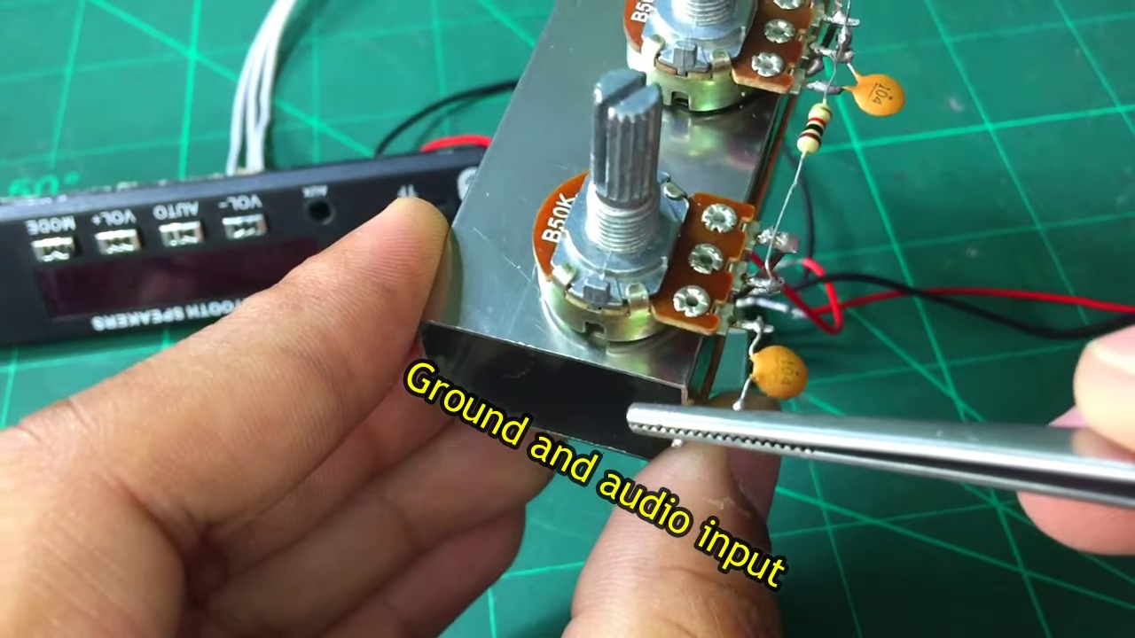 | 2:44  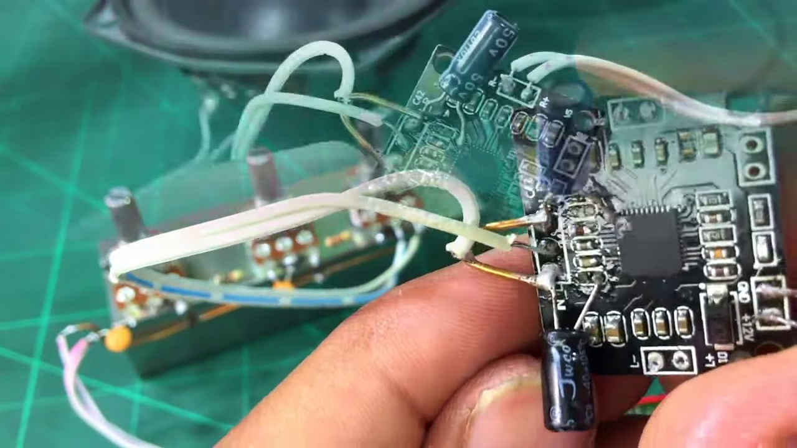 | 3:29  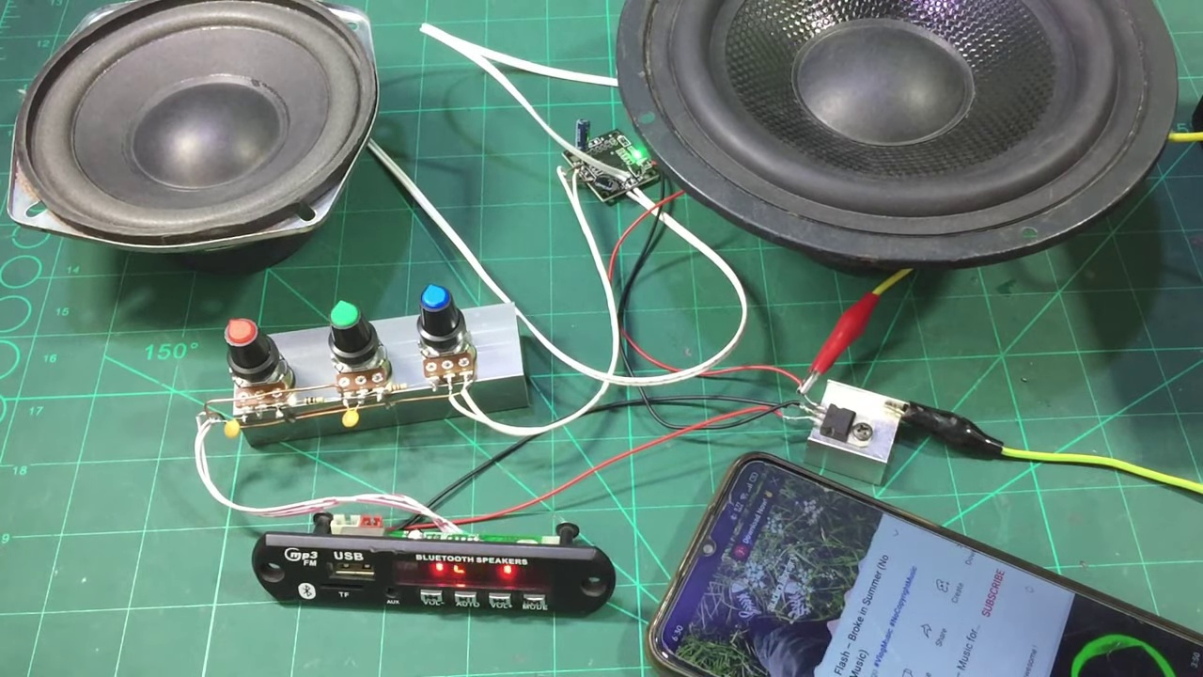 | 4:14  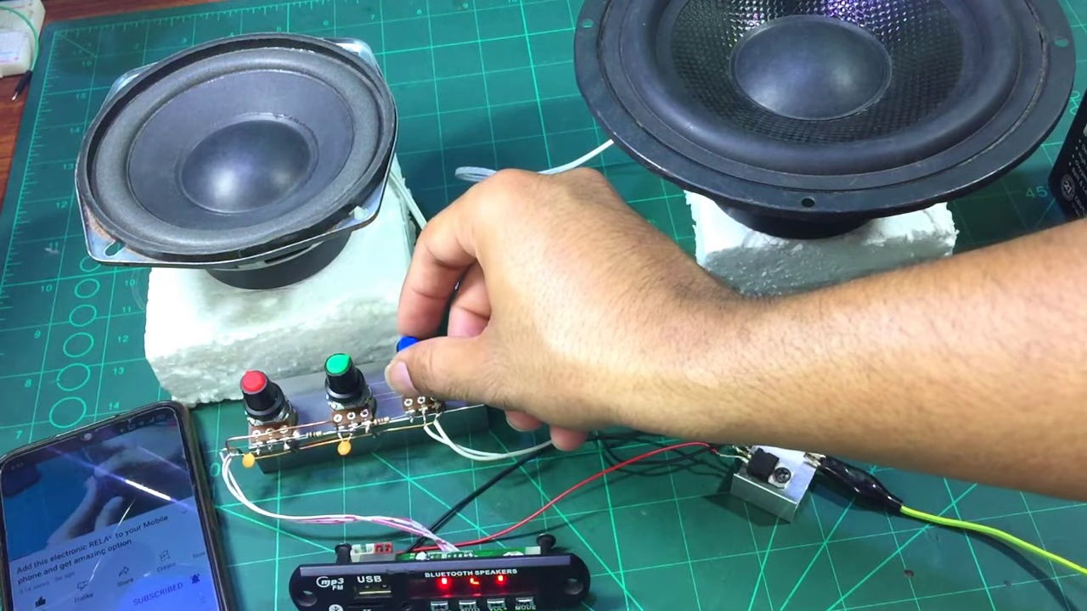

Transcript
[0:30] Let's go.
[1:00] Let's go.
[1:30] Let's go.
[2:00] Let's go.
[2:30] Let's go.
[3:00] Let's go.
[3:30] Let's go.
[4:00] Let's go.
[4:30] Let's go.

