Engagement Analysis: YQ8ZhHBraZg

Section 0: Introduction to Drone Flying Lessons
Time: 0:00 - 0:01

Summary
The video shows a promotional graphic for Horizon Hobby, with a logo and text overlay that highlights their training courses and services related to flying lessons for drones and helicopters.

Representative Frames
0:00   | 0:00   | 0:00   | 0:00   | 0:00  

Transcript
(No speech detected in this section)

Section 0: Drones in Stock
Time: 0:01 - 0:02

Summary
A digital advertisement shows a promotional graphic for Horizon Hobby, featuring a black circle-shaped logo with white text that reads 'Horizon HOBBY' in all capital letters. Below the logo, an overlaid text states '100+ drones in stock and ready to fly!' accompanied by an image of a drone.

Representative Frames
0:01   | 0:01   | 0:01   | 0:01   | 0:01  

Transcript
(No speech detected in this section)

Section 0: Blade Helis Logo
Time: 0:02 - 0:03

Summary
A graphic design combines photographic elements with overlaid text, featuring a large image of a red and white blade with the words 'Blade Helis' superimposed across it. The text within the graphic reads 'See Lots More', followed by three bullet points with different activities.

Representative Frames
0:02   | 0:02   | 0:02   | 0:02   | 0:02  

Transcript
(No speech detected in this section)

Section 0: Horizon Hobby Logo
Time: 0:03 - 0:04

Summary
A digital advertisement shows a promotional graphic for Horizon Hobby, featuring a circle-shaped logo with white text that reads 'Horizon HOBBY' in all capital letters. Below the logo, an overlaid text states 'See Lots More & Heli Flying Lessons'.

Representative Frames
0:03   | 0:03   | 0:03   | 0:03   | 0:03  

Transcript
(No speech detected in this section)

Section 0: Promotional Text
Time: 0:04 - 3:10

Summary
The video shows a promotional graphic for Horizon Hobby or Blade Helis, featuring overlaid text that highlights their training courses and services related to flying lessons for drones and helicopters.

Representative Frames
0:35  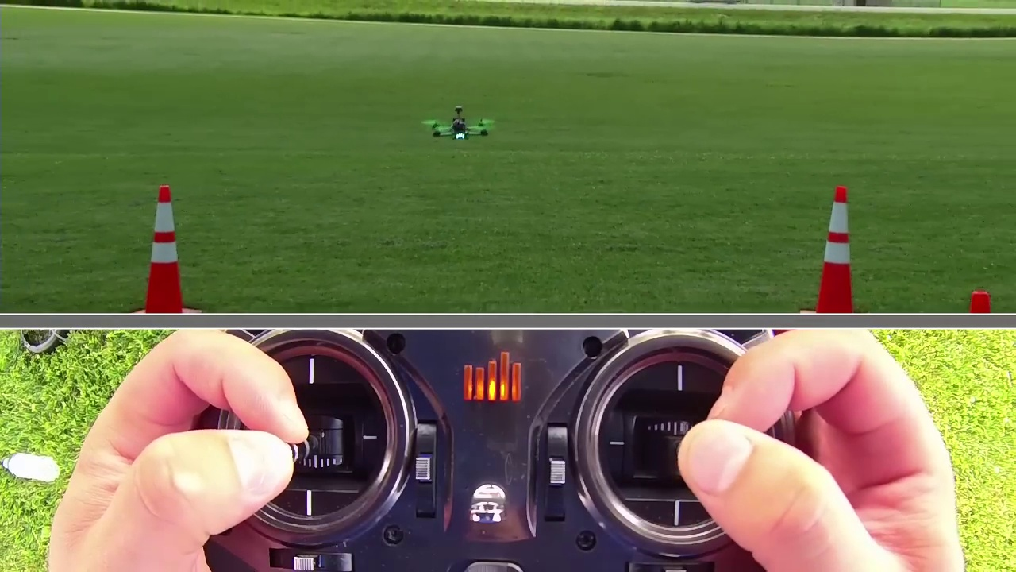 | 1:06  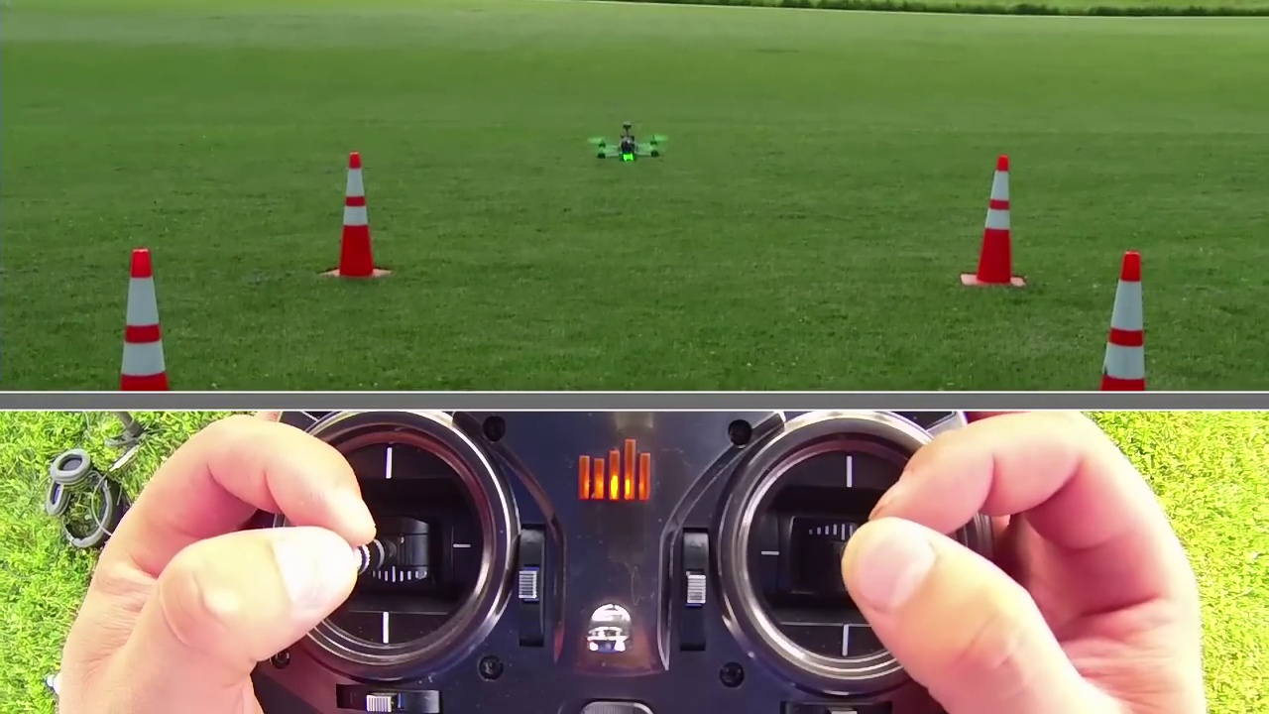 | 1:37  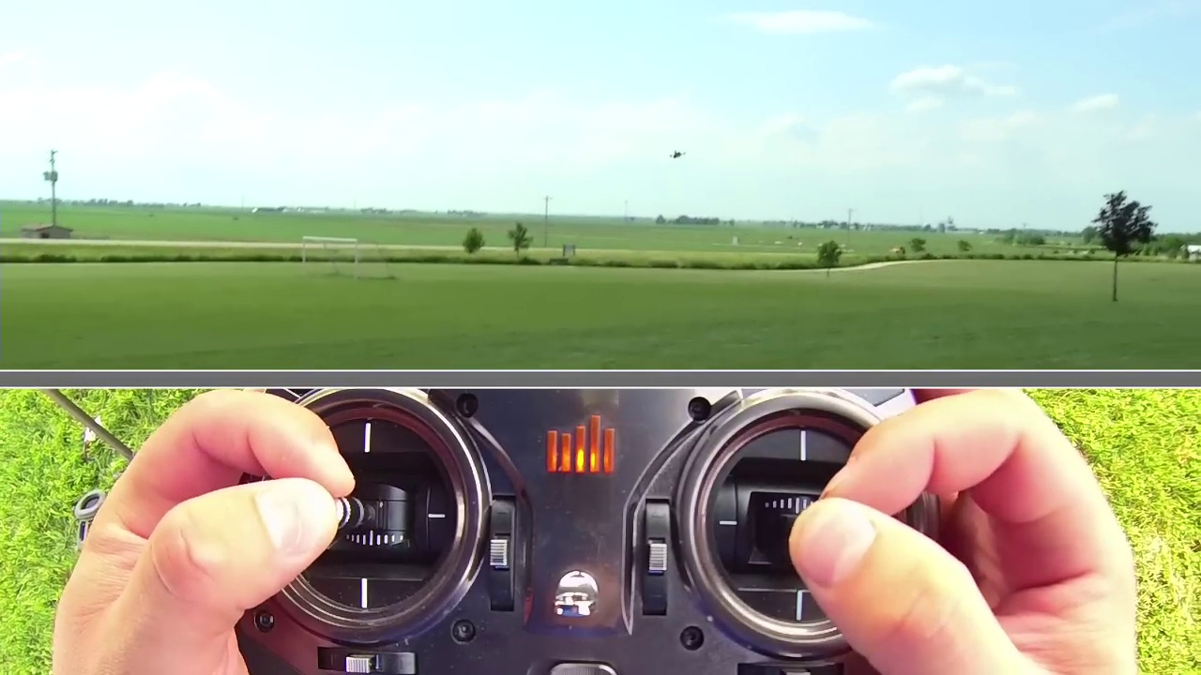 | 2:08  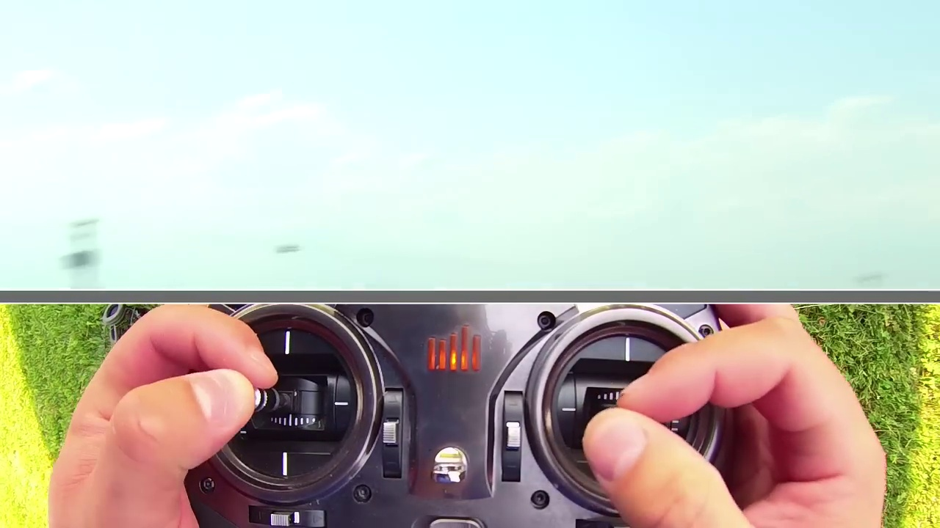 | 2:39  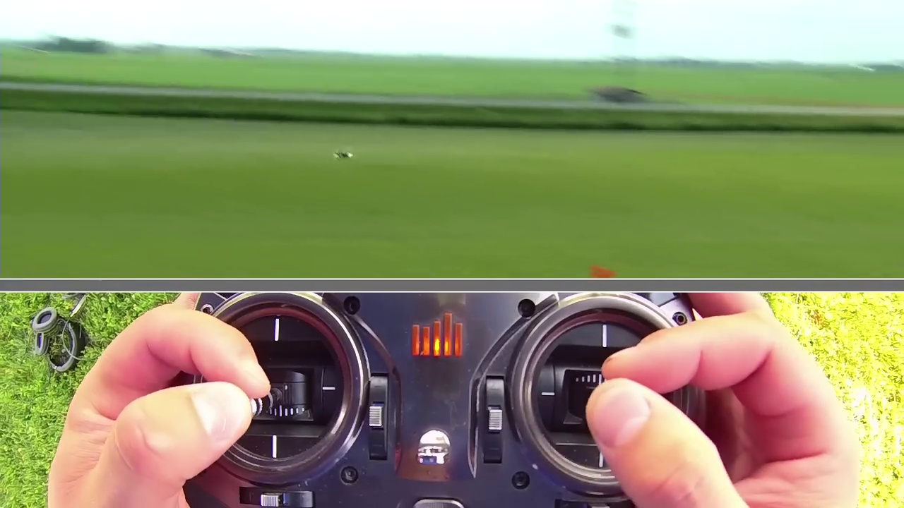

Transcript
[0:00] We're going to talk about basic aerobatics and more advanced aerobatics with a quadcopter.
[0:17] We'll go ahead and start and get in the air.
[0:20] And first thing we're going to do is talk about doing a right or left roll.
[0:24] So that's going to be this direction on the aileron stick.
[0:26] And what we're going to do is as we roll, we're going to add throttle, we're going to roll,
[0:32] and then we're going to lower throttle and then catch with more throttle.
[0:35] So what I mean by that is this, add throttle, roll, catch with throttle.
[0:39] So if I don't do that, I'll get more of a wider roll.
[0:42] If I keep throttling, you see how it's a little wider.
[0:44] But if I pull throttle out, three, two, one, it's more of a linear roll
[0:49] and I don't get a lot of sideways action.
[0:51] Once again, add throttle, reduce throttle, add throttle.
[0:54] Now if we want to do a front flip or back flip, it's roughly the same thing.
[0:58] We add throttle, we go forward, and then we add more throttle at the bottom.
[1:02] So here we go.
[1:03] Add throttle, flip, add throttle.
[1:05] And once we do that flip, all we're doing is pushing forward and then letting go of the stick
[1:09] and coming back to the level and catching it with the cyclic stick and then adding throttle.
[1:13] So to do a little bit more advanced stuff, let's go ahead and do a loop.
[1:17] Now that we know how to do flips and rolls, we're going to go out here to the side.
[1:20] And I'm going to come towards us and just pull a loop.
[1:23] I'm just going to do a little baby loop here for us.
[1:25] I'm going to come towards us, add throttle, and keep pulling back on that elevator stick.
[1:31] I'm going to try it one more time when we back up.
[1:33] So we're going to add throttle to get speed, add throttle, pull back, and then come out of the bottom.
[1:37] That was kind of a short loop, but again, you can kind of get the idea.
[1:40] That's how you do a basic loop.
[1:42] One more time, adding throttle, pulling elevator all the way through, and then stopping.
[1:46] So we'll come back here to center.
[1:48] And now we'll kind of go ahead and just string stuff together.
[1:50] I'm going to go out and fly out and just have a good time, and I'll kind of talk through
[1:53] some of it.
[1:54] Here we go.
[1:55] So I'm doing some stuff.
[1:57] Right rolls, left rolls, flips.
[2:01] Go ahead and do traversing flips, pirouetting stuff.
[2:08] Getting a little far out here, but we'll do it.
[2:12] This is kind of the real basic aerobatics, kind of some stall turns.
[2:19] The pirouet on the bottom.
[2:21] Again, you can kind of see what my hands are doing here.
[2:23] Just adding slight inputs at a time, catching it with throttle.
[2:27] Again, it's not a helicopter, so it doesn't float.
[2:31] But reducing throttle is probably the biggest importance in aerobatics with quads so that you
[2:35] don't carry through.
[2:36] What I mean by that is this.
[2:37] If I go ahead and roll and add throttle, you see how it's a very aggressive snap roll.
[2:42] I'll try it again the other way here.
[2:43] It's really aggressive.
[2:44] You can still make it look cool, but you just don't, the quad just tends to not like it.
[2:49] But that's it guys.
[2:50] Basic aerobatics.
[2:51] Try different things.
[2:52] Slips, loops, rolls, add pirouettes if you can, and you'll start to become a pro pilot.
[2:56] Thanks for watching guys.
[2:57] See ya.

