Engagement Analysis: YQeOmeMGpvE

Section 0: Image 1: Thank You Message
Time: 0:00 - 0:01

Summary
A computer screen with a thank you message from a content creator.

Representative Frames
0:00   | 0:00   | 0:00   | 0:00   | 0:00  

Transcript
(No speech detected in this section)

Section 0: Image 2: Digital Illustration
Time: 0:01 - 0:02

Summary
A digital illustration of a hand holding a black pen writing a subscription promotion message.

Representative Frames
0:01   | 0:01   | 0:01   | 0:01   | 0:01  

Transcript
(No speech detected in this section)

Section 0: Image 3: Streaming Context
Time: 0:02 - 0:03

Summary
A screenshot with elements suggesting a broadcast or stream context, including a watermark and a cartoon character.

Representative Frames
0:02   | 0:02   | 0:02   | 0:02   | 0:02  

Transcript
(No speech detected in this section)

Section 0: Image 4: Educational Video Series
Time: 0:03 - 13:19

Summary
A computer screen displaying a design part of an educational video series, with text encouraging viewers to subscribe and leave feedback.

Representative Frames
2:15  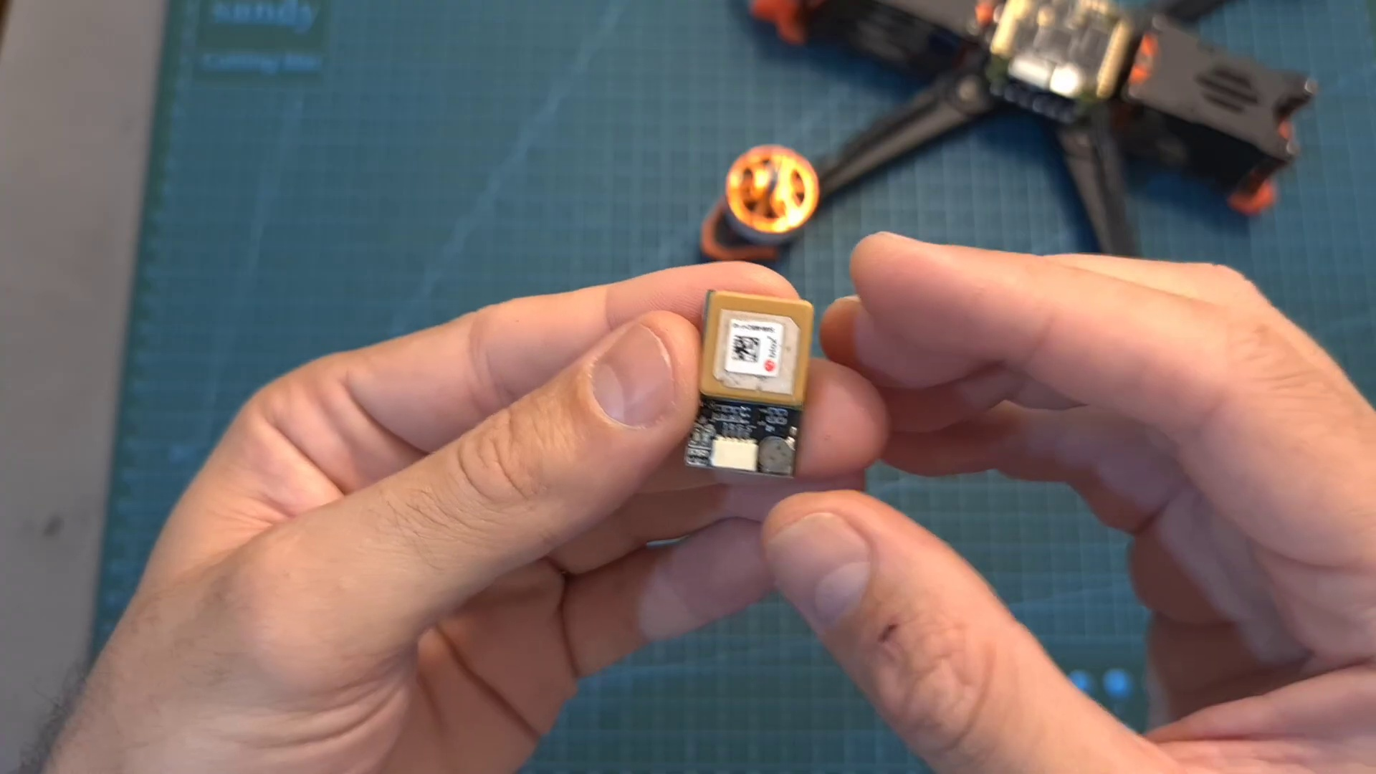 | 4:28  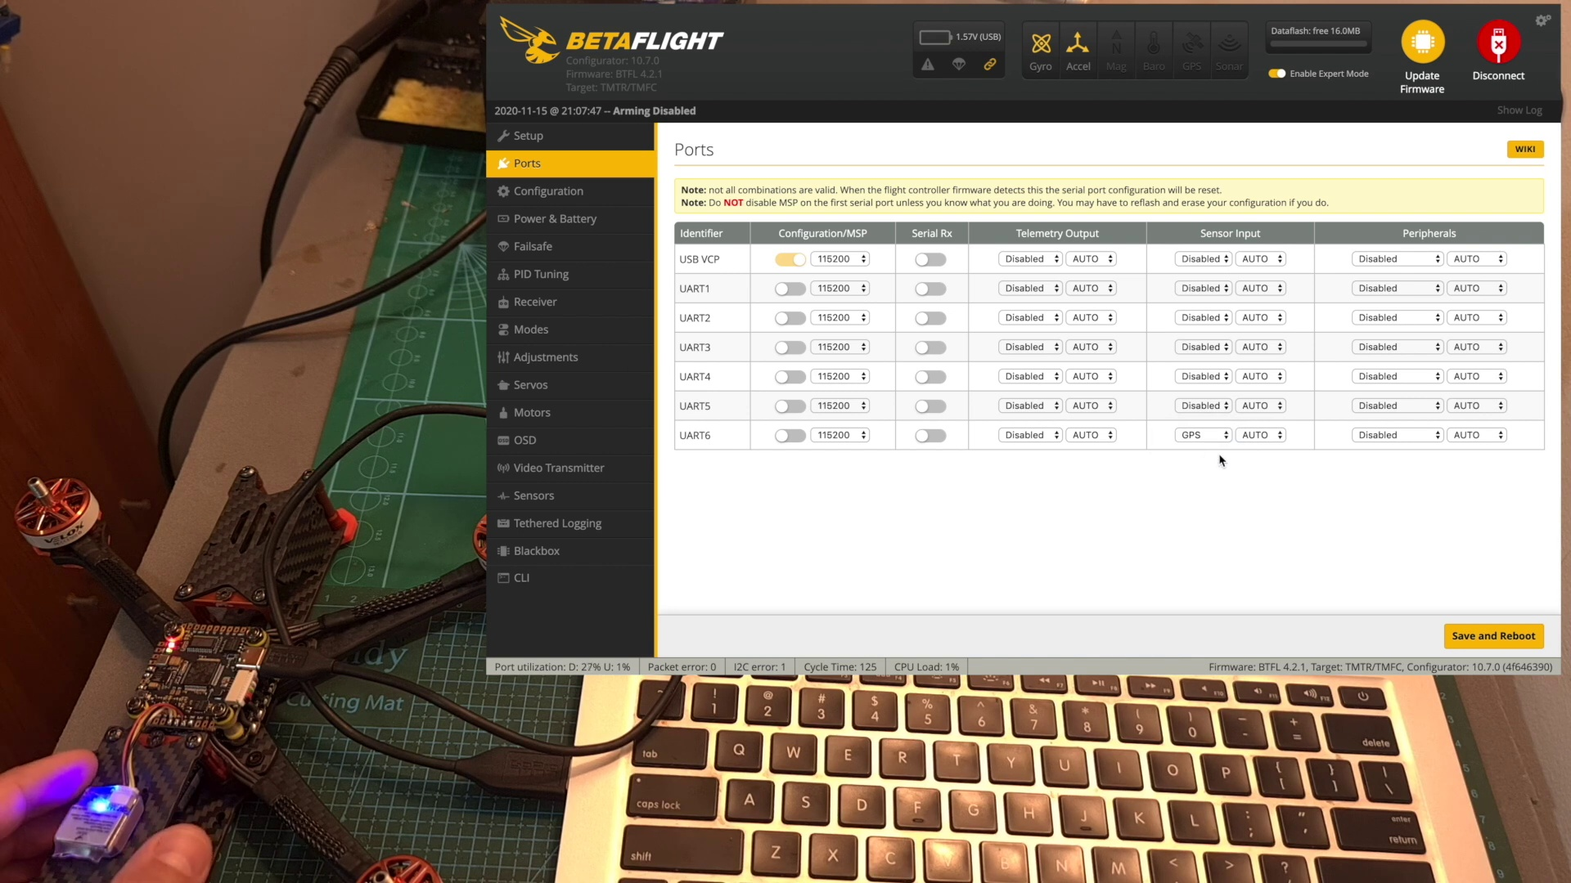 | 6:41  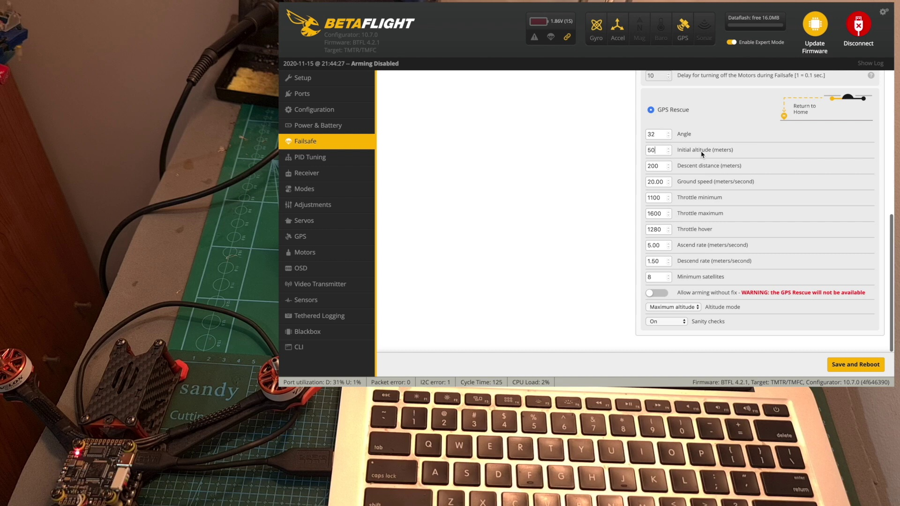 | 8:54  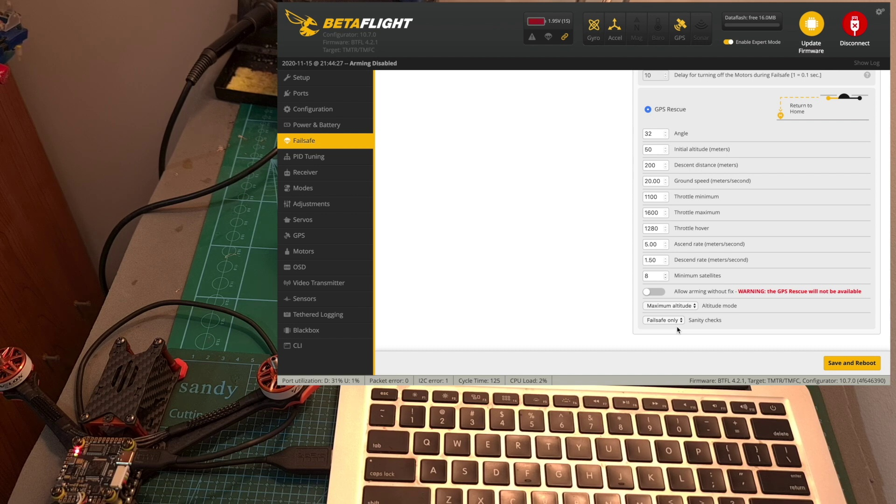 | 11:06  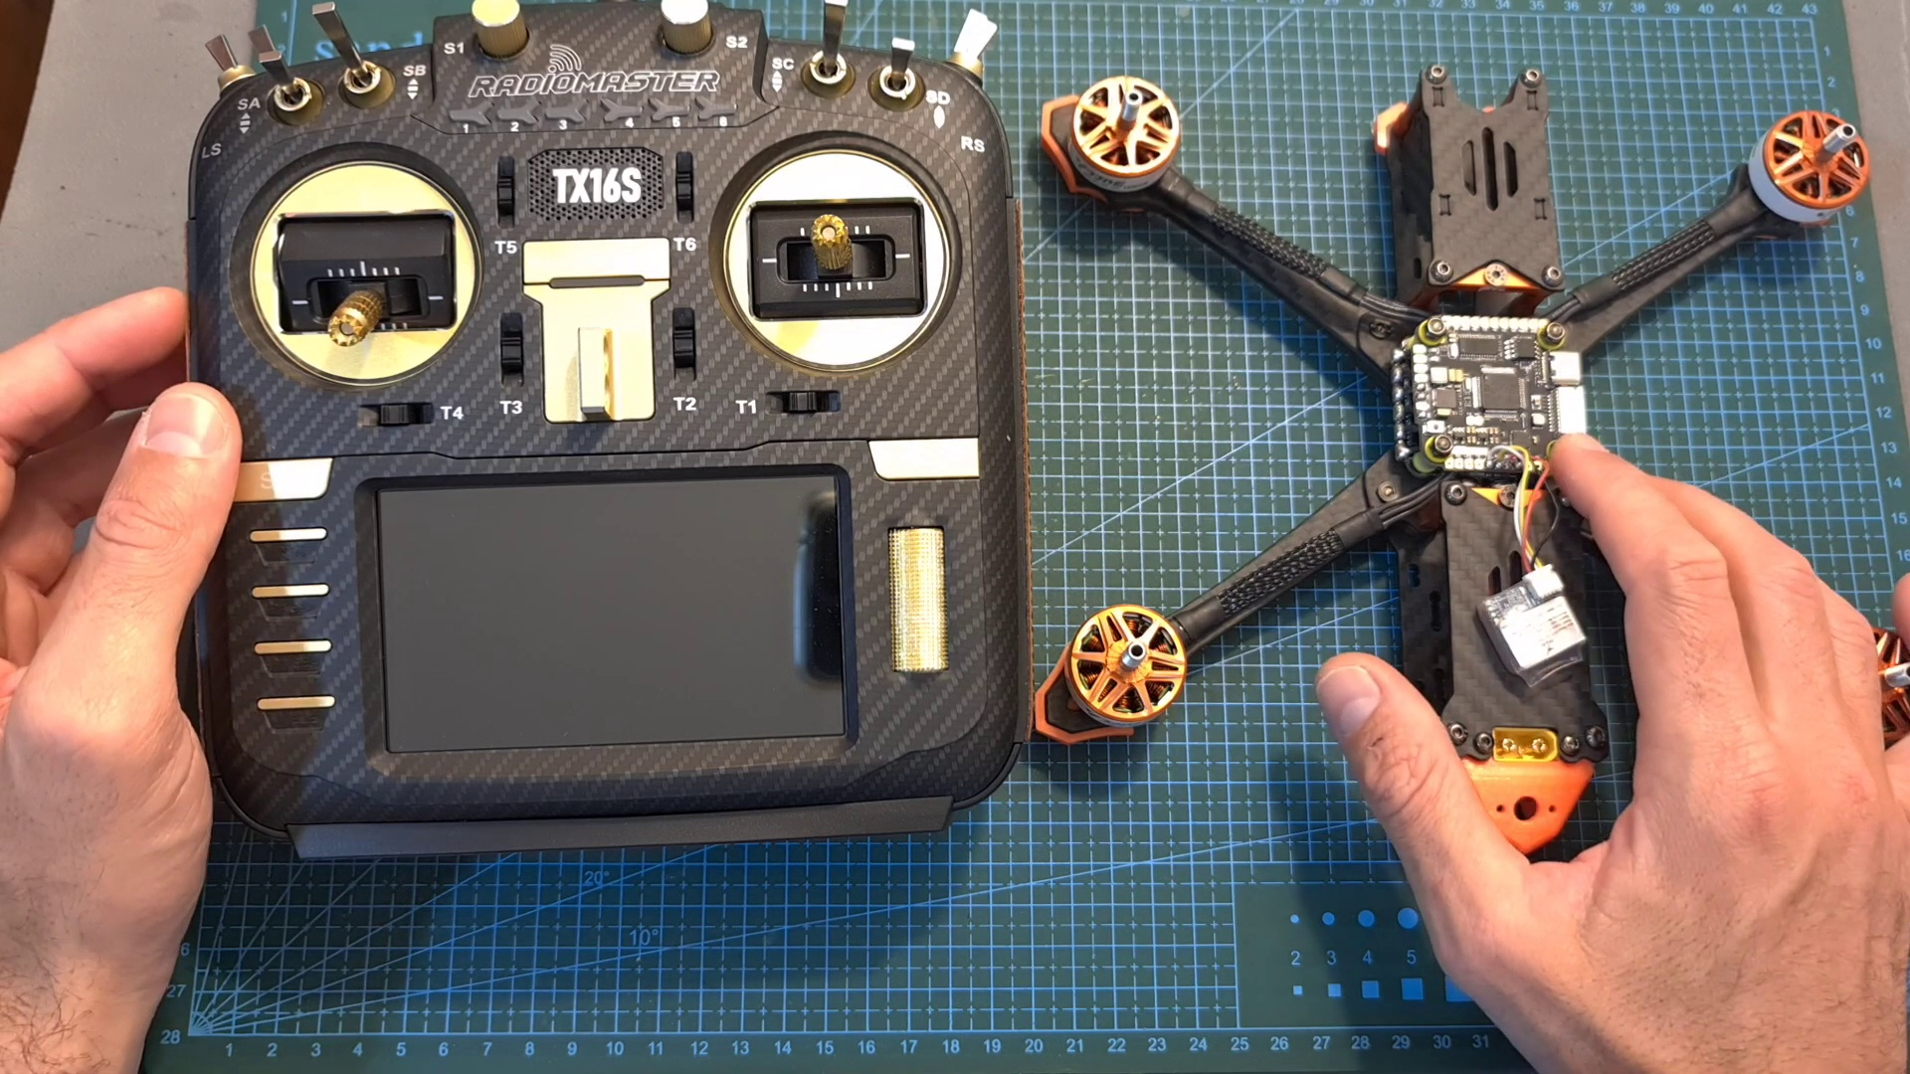

Transcript
[0:00] Hello guys and welcome back to my channel. Today in this video I'm going to show you how to connect
[0:10] a GPS unit to a flight controller, explain how to configure it using Bitaflight, and address
[0:15] common issues that you might encounter. First of all, this video is kindly sponsored by VONT,
[0:20] a company that manufactures and sells high-quality but yet budget-friendly LED headlamps.
[0:26] The VONT Spark LED headlamp comes inside a twin pack, so you are getting two LED headlamps for $14.
[0:33] The device is powered using three AAA batteries which are not included, and according to VONT,
[0:39] they can provide you with up to 90 hours of continuous use. In addition, the headlamp is
[0:44] waterproof, as far as I can tell the lamp is very powerful, and it features seven different light
[0:50] modes. Now after the sponsored part, let's get back to the main topic. The first question that you might
[0:57] ask yourself is why should you even better adding a GPS unit to your quadcopter? And for that question
[1:03] there are a couple of answers. For a long range system such as this one, using a GPS is very crucial,
[1:09] since it enables you to monitor the direction and distance to the home point where you took off,
[1:13] so for example, in case you lose orientation, you can use this data. It also enables you to see the
[1:19] GPS coordinates on the OSD and also on your radio controller in case it supports telemetry,
[1:25] so in case you lose the quadcopter, you can use these coordinates in order to retrieve the quadcopter,
[1:30] and finally, in case you lose connectivity with the radio controller or in case you lost orientation and
[1:36] you don't know where to go, you can enable the GPS rescue feature, and the quadcopter is going to
[1:41] return to the home point using the settings on Bitaflight, which I'm going to show you shortly.
[1:46] As for freestyle and racing drones, using a GPS unit will enable you to monitor the speed of the drone,
[1:52] which is something that you might want to know. Of course, you can still use it for the purposes that
[1:56] I mentioned before, but in case you're not going to get very far, it's not going to make a lot of sense.
[2:02] In order to set up the GPS rescue feature, you need to obtain a GPS unit. There are many available
[2:07] options in the market, and most if not all are going to be compatible with your flight controller.
[2:13] Out of my personal experience, I can tell you that so far the GPS that worked best for me,
[2:17] and I had zero issues with, is the Matic M8Q, however this is a very pricey GPS that costs about
[2:24] $32, so if you're looking for a more budget-friendly but yet reliable solution, I recommend to go with the
[2:30] AJRC M80, which costs only $11. You should note that some GPS units like the AJRC M81 feature a built-in
[2:38] compass, but this feature is not required for Bitaflight in order to use the GPS rescue feature.
[2:45] In addition, in case you're going to use a Batien GPS, which is a very popular and budget-friendly
[2:49] option, I recommend to power the unit using 3.3V, as it is going to reduce the generated heat
[2:55] and extend its lifespan. The next thing that we need to do is to wire the GPS to the flight
[3:01] controller, and even though most of the GPS units are using a 4-pins GST connector, their pinout is
[3:07] not necessarily identical, so I recommend to refer to the user manual of the product that you have,
[3:12] in order to avoid any potential mistake. The GPS unit is going to be connected to a 3U-out port on the
[3:18] flight controller, and most likely be powered using 5V, and even though the soft serial option is
[3:24] supported, I recommend to avoid it if possible due to the high data transfer rates.
[3:29] Now I've got the 4-pins GST connector soldered to the flight controller. Pay attention that the
[3:34] soldering pads are well separated, you are not mixing the ground and plus 5V pads, you are using
[3:40] the same U-out port on the flight controller, and the RX port on the GPS is wired to the TX pad on the
[3:47] flight controller and vice versa, as otherwise the GPS is not going to be able to communicate with the
[3:53] flight controller. Now you can go ahead and connect the GPS unit, and pay attention when installing it
[3:58] that the antenna is facing the top side and it is not being blocked by any of the carbon fiber parts.
[4:04] Now let's go over the configuration procedure in Betaflight and the relevant settings. First,
[4:09] connect the flight controller to your computer, open up Betaflight, and connect it to your flight
[4:14] controller. Under the port section, you need to configure the GPS under sensor inputs on the U-out that
[4:20] you connected. I'm using U-out 6, so I'm going to choose the GPS option, and in addition, since I'm
[4:27] using the older batch of the AGLRC M80 GPS, I also need to select this baud rate, as otherwise the GPS
[4:35] is not going to function properly. Now we need to hit save and reboot in order to save the options.
[4:41] Head over to the configuration tab, enable the GPS switch, and set its protocol.
[4:46] In case you're not sure which protocol your GPS unit is using, I recommend to start with U-blocks,
[4:52] and in case the GPS is going to be configured properly after hitting save and reboot, the GPS
[4:58] icon on the top is going to be highlighted. So in case it's not working for you, I would start by
[5:04] checking that the protocol is configured properly, and then I would double check that the port is
[5:09] configured properly, and also RX is wired to TX on the flight controller and vice versa.
[5:15] And of course, you also need to make sure that the GPS is turned on, as on some flight controllers,
[5:20] the GPS is going to be powered also when the flight controllers is connected via USB, and on some cases,
[5:27] you will need to power it using an external battery. Pay attention that in case the GPS unit is only going
[5:33] to be powered when connecting an external battery, that the propellers are off, and preferably disconnect
[5:38] the video transmitter, or at least set it to pit mode, in order to prevent it from overheating on the bench.
[5:44] Now let's go over the different Betaflight GPS-related options. First of all, in order to access the GPS
[5:50] and fail-safe tabs on Betaflight, enable Expert mode. Then under the GPS tab, you'll be able to monitor
[5:57] the status of the GPS and the acquired satellites, and under the fail-safe tab, configure the GPS rescue
[6:03] feature. The default fail-safe procedure when entering fail-safe mode, either when the quadcopter
[6:09] is going to lose connectivity with the radio controller, or by flipping an auxiliary switch which is assigned
[6:14] to the fail-safe mode, is dropped, so the quadcopter is just going to fall out of the sky. You can also
[6:20] set it to land, and then the quadcopter hopefully is going to land slowly, and the relevant option to this
[6:25] video is the GPS rescue option. The relevant values which you can configure are the angle of the drone
[6:32] when it is heading back to you, the initial attitude in meters, which is relative to the home point,
[6:38] so when GPS rescue is going to be enabled, your drone is going to first climb to this attitude
[6:43] before heading back to you. The next option is the descent distance in meters, so when the drone is going
[6:49] to reach this distance from the home point, it is going to start descending. Next you can adjust
[6:55] the ground speed in meters per second, adjust the throttle values, and in my experience the default
[7:01] settings work pretty well, set the ascend and descend rates in meters per second, adjust the number of
[7:08] minimum satellites which are required for the GPS rescue option to be enabled. Normally I would suggest
[7:14] leaving it on 8 in case you are not having any GPS issues, as the GPS is going to be more accurate,
[7:20] but in case you encounter difficulties and you don't have this amount of satellites during most of the
[7:26] flight, you can also reduce this number to 5, as it in my experience works well as well. The next
[7:32] related option is going to enable you to arm your drone, even when the minimum number of satellites
[7:37] requirement is not going to be met, but pay attention that in case you are going to take off without a GPS fix,
[7:44] the GPS rescue feature is not going to be available during your flight. The next option is attitude mode,
[7:51] in case you are going to set it to maximum attitude, your drone is going to climb to the maximum attitude
[7:56] that you reached during your flight, plus 15 meters. In case you are going to set it to fixed attitude,
[8:02] it's going to climb to the value that we previously set, and again it is relative to the home point, and in
[8:08] case you would like to maintain the current attitude of the drone when entering fail safe mode,
[8:12] set the option to current attitude. Finally, the GPS rescue sanity checks can be turned off,
[8:19] and then the GPS rescue feature is going to be enabled regardless of the minimum satellites,
[8:25] and even when you took off without a GPS fix, and pay attention that in case you are going to turn it off,
[8:32] and enter fail safe mode, you might lose your drone, as the GPS is not going to be accurate,
[8:38] and it is just going to fly away. You can also set this option to fail safe only, which is probably
[8:43] the recommended option, as the sanity checks are going to take place when entering fail safe mode,
[8:50] and they are only going to be overridden when triggering the GPS rescue feature using an auxiliary
[8:55] switch, which is good because otherwise, in case you are going to set the sanity checks to on,
[9:02] and trigger the GPS rescue feature using an auxiliary switch, the drone is just going to disarm itself,
[9:09] and fall out of the sky, in case one of the sanity checks requirement is not met.
[9:14] In addition, you should note that under stage 2 settings, you can adjust the amount of time that
[9:20] is going to pass when the signal loss is going to occur, so for example the default settings is far,
[9:26] so it means that after 0.4 seconds the fail safe procedure is going to take place, so in case you
[9:33] would like to make sure that the GPS rescue feature is going to be enabled right away, you can either
[9:38] set this value to 0, or adjust the channel fallback settings, which are the values that are going to be
[9:44] used during guard time, so that the GPS rescue feature is going to be triggered immediately.
[9:49] Now by the way, another thing that you should pay attention to, is that the accelerometer is turned on,
[9:55] and the gyro board is calibrated, and in case you would like the attitude values to be much more
[10:00] accurate, I recommend to use a flight controller with a built-in barometer. Finally, the last step
[10:06] is to configure the relevant OSD elements. The supported elements are the home distance, the home
[10:12] direction, the drone speed, the GPS coordinates, the attitude, and the number of satellites. The GPS
[10:20] coordinates are going to help you to find your drone in case of a crash,
[10:24] so you can use Google Maps in order to find it, and I also recommend that in case your radio
[10:30] receiver supports telemetry, to enable the telemetry option, and then your GPS coordinates can also be
[10:36] recorded on your radio transmitter. Your next step in order to make sure that everything is configured
[10:42] properly, is to head outdoors with your drone and radio controller. After getting a GPS fix, arm it,
[10:48] walk for 100 meters with the drone and radio controller in your hands, and by the way, 100 meters is the
[10:55] default minimum distance to home value, so in case a fail-safe is going to occur, or you are going to
[11:02] activate the GPS rescue feature when the drone is less than 100 meters from you, the drone is just going to
[11:08] disarm itself, and this value can be adjusted using the Betaflight CLI to 50 meters, but I recommend to
[11:15] leave it on the default value of 100 meters. After you reach 100 meters, just simply turn off your radio
[11:22] controller, and if everything is configured properly, the motors are going to start spinning faster,
[11:28] indicating that the drone is trying to return to the home point. After that, again, in order to make sure that
[11:34] everything is configured and working properly, I recommend to test the rescue feature using an
[11:40] auxiliary switch, and as you can see, after flipping it, the drone is starting to get back to the home
[11:45] point. Finally, before wrapping up this video, remember that the GPS rescue feature is not working
[11:53] like a DJI drone, so once you regain connectivity with your radio controller, or in case, for example,
[12:00] you lost video signal, and the drone is getting back to you, and you can see it, regain control, and land
[12:06] it safely. Now, by the way, you should note that when you are going to use the GPS unit for the first
[12:12] time, it might take a while until you are going to get a GPS lock, so if possible, power it using the 5V
[12:19] USB port, leave it outside for maybe 10-15 minutes, and next time that you are going to use the GPS unit,
[12:27] the GPS lock is going to be much quicker. Anyway, that's going to be it for my Betaflight GPS rescue
[12:34] guide, I hope it was informative enough, but of course, if you have any questions or issues that
[12:39] you encounter, let me know down below, and I will do my best to help you out. I would like to thank
[12:45] Vaunt for sponsoring this video, and I wish you all happy flying. See you on my next videos, and goodbye.
[12:58] K
[13:09] K
[13:14] ,
[13:19] .

