Engagement Analysis: ZOuZWE_tfgQ

Section 0: Introduction to Electronics Project
Time: 0:01 - 0:05

Summary
The video introduces an electronics project, showing a person's hands working with electronic components and devices.

Representative Frames
0:01   | 0:02   | 0:03   | 0:03   | 0:04  

Transcript
(No speech detected in this section)

Section 0: Breadboard Setup
Time: 0:05 - 0:11

Summary
The breadboard is surrounded by various wires and components, including resistors, capacitors, and possibly integrated circuits or other electronic parts.

Representative Frames
0:06   | 0:07  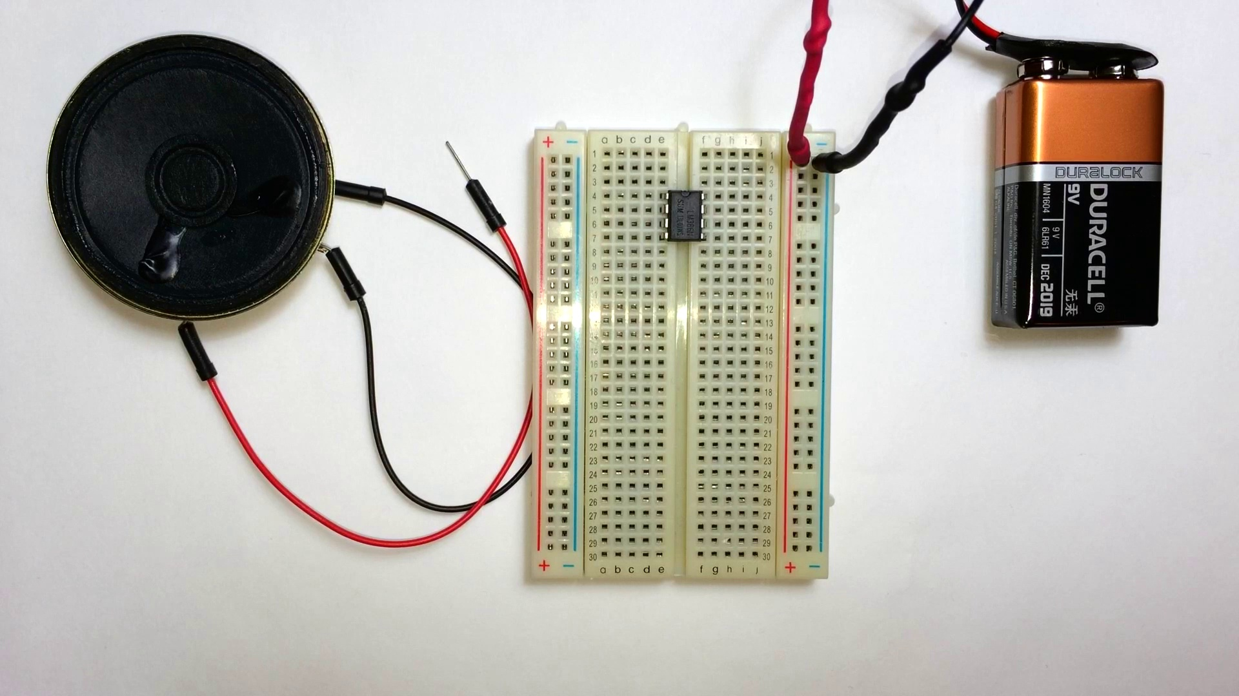 | 0:08   | 0:09   | 0:10  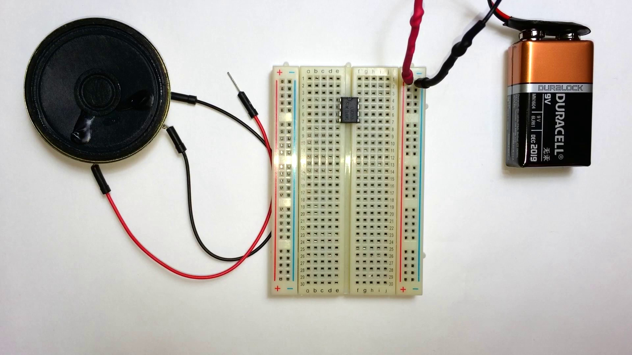

Transcript
[0:00] The LM386 is a really cool little IC. It's the heart of a lot of little audio amplifiers.

Section 0: Close-up of Circuit Board
Time: 0:11 - 0:16

Summary
A close-up view of a circuit board reveals a testament to the intricate world of electronics, with various components connected on the board.

Representative Frames
0:11   | 0:12   | 0:13  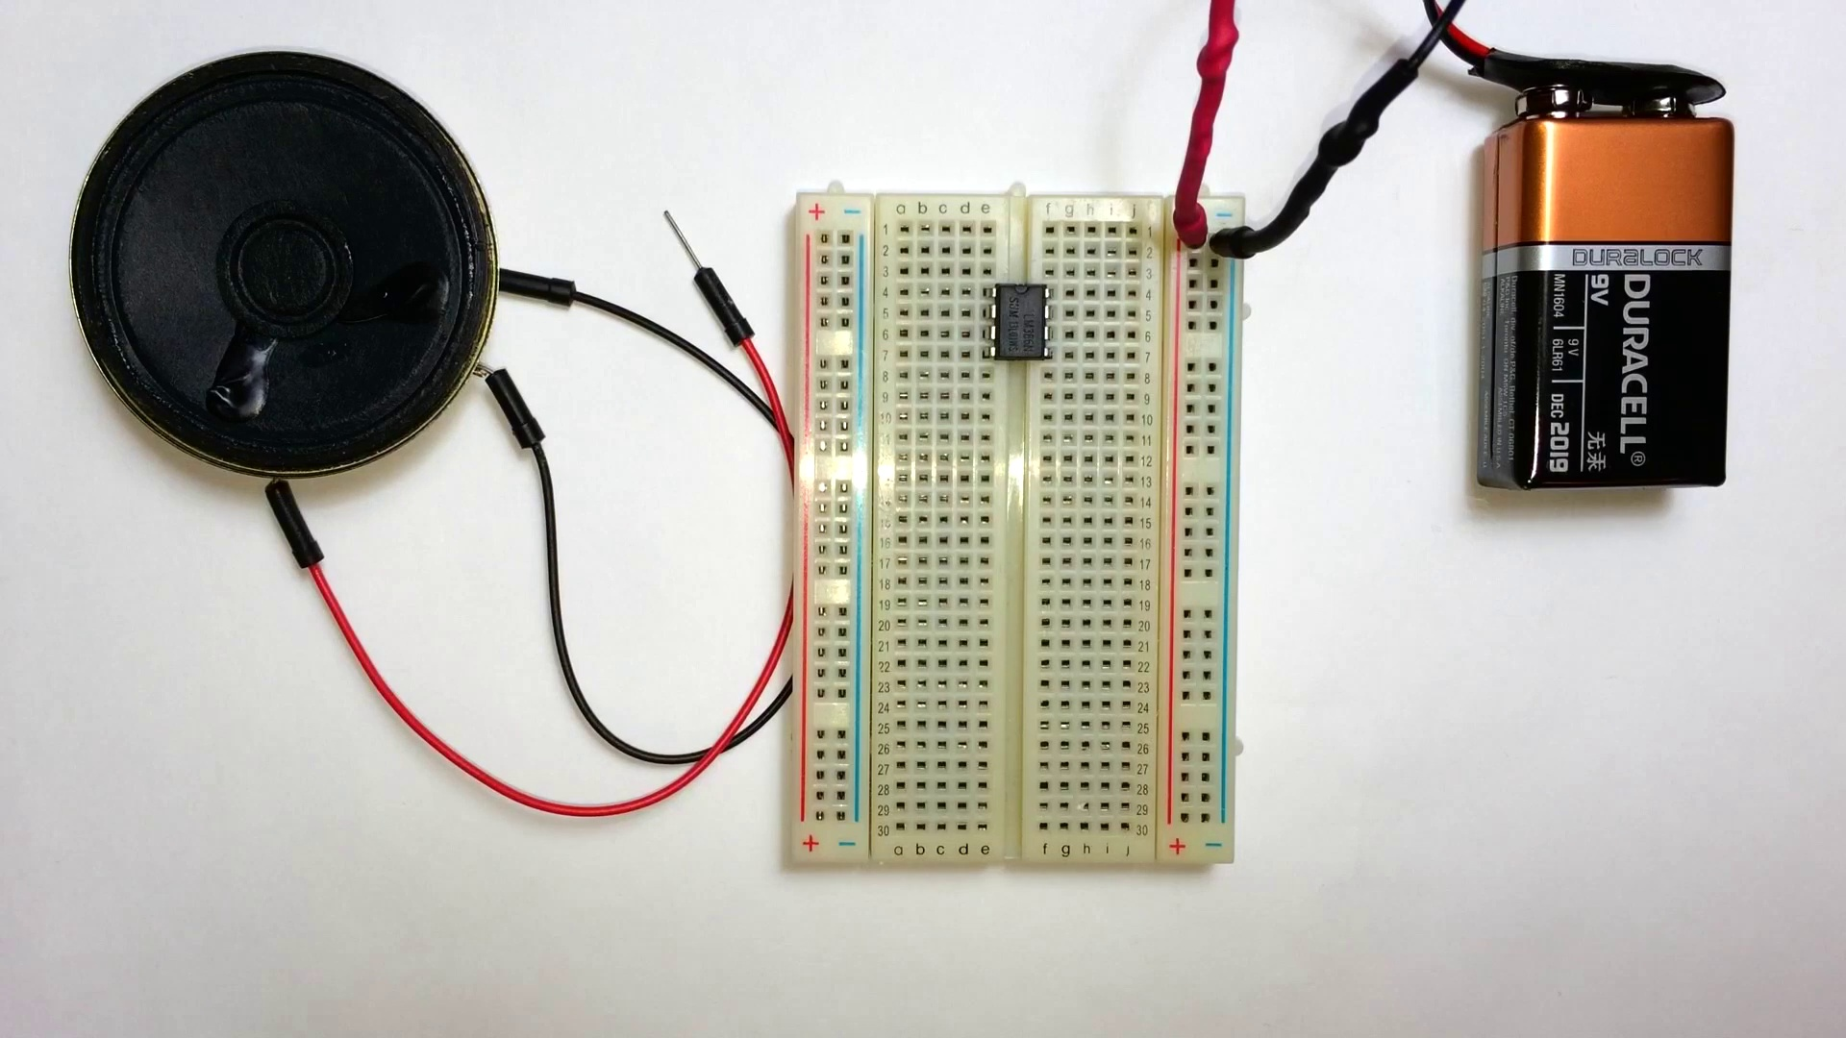 | 0:14   | 0:15  

Transcript
[0:13] And it's amazing because all you need is a couple of capacitors and a resistor, a speaker, and some power.

Section 0: Person Working with Components
Time: 0:16 - 0:23

Summary
The person is seen connecting wires and components on the breadboard, demonstrating active engagement with the circuit.

Representative Frames
0:17  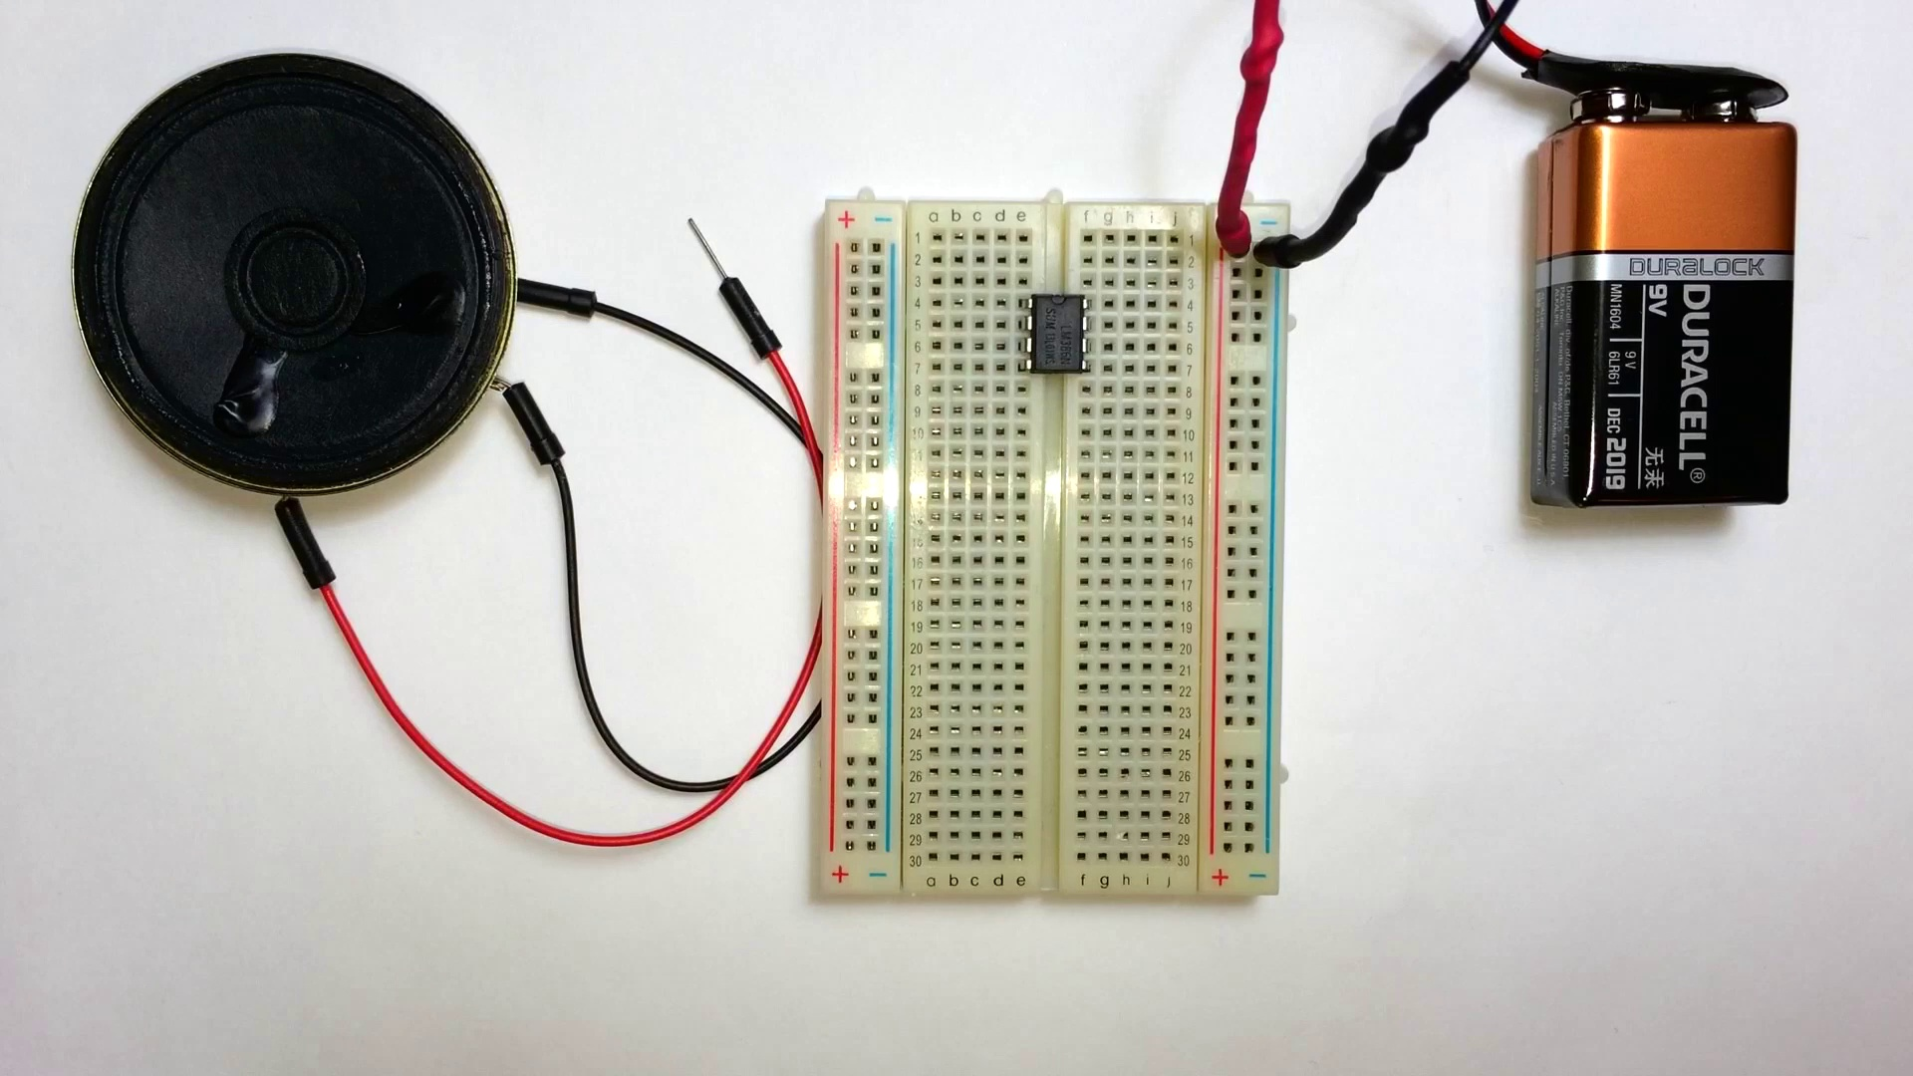 | 0:18   | 0:19   | 0:20  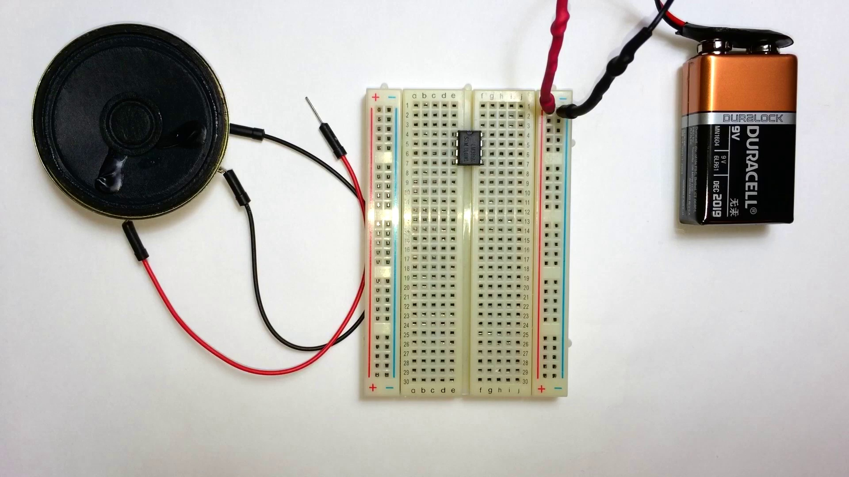 | 0:21  

Transcript
[0:13] And it's amazing because all you need is a couple of capacitors and a resistor, a speaker, and some power.
[0:19] And you're all set to make a really nice sounding audio amplifier.

Section 0: Discussion of Distortion and Amplification
Time: 0:23 - 0:28

Summary
The speaker discusses the possibility of creating a distortion or tube amplifier in the future.

Representative Frames
0:23  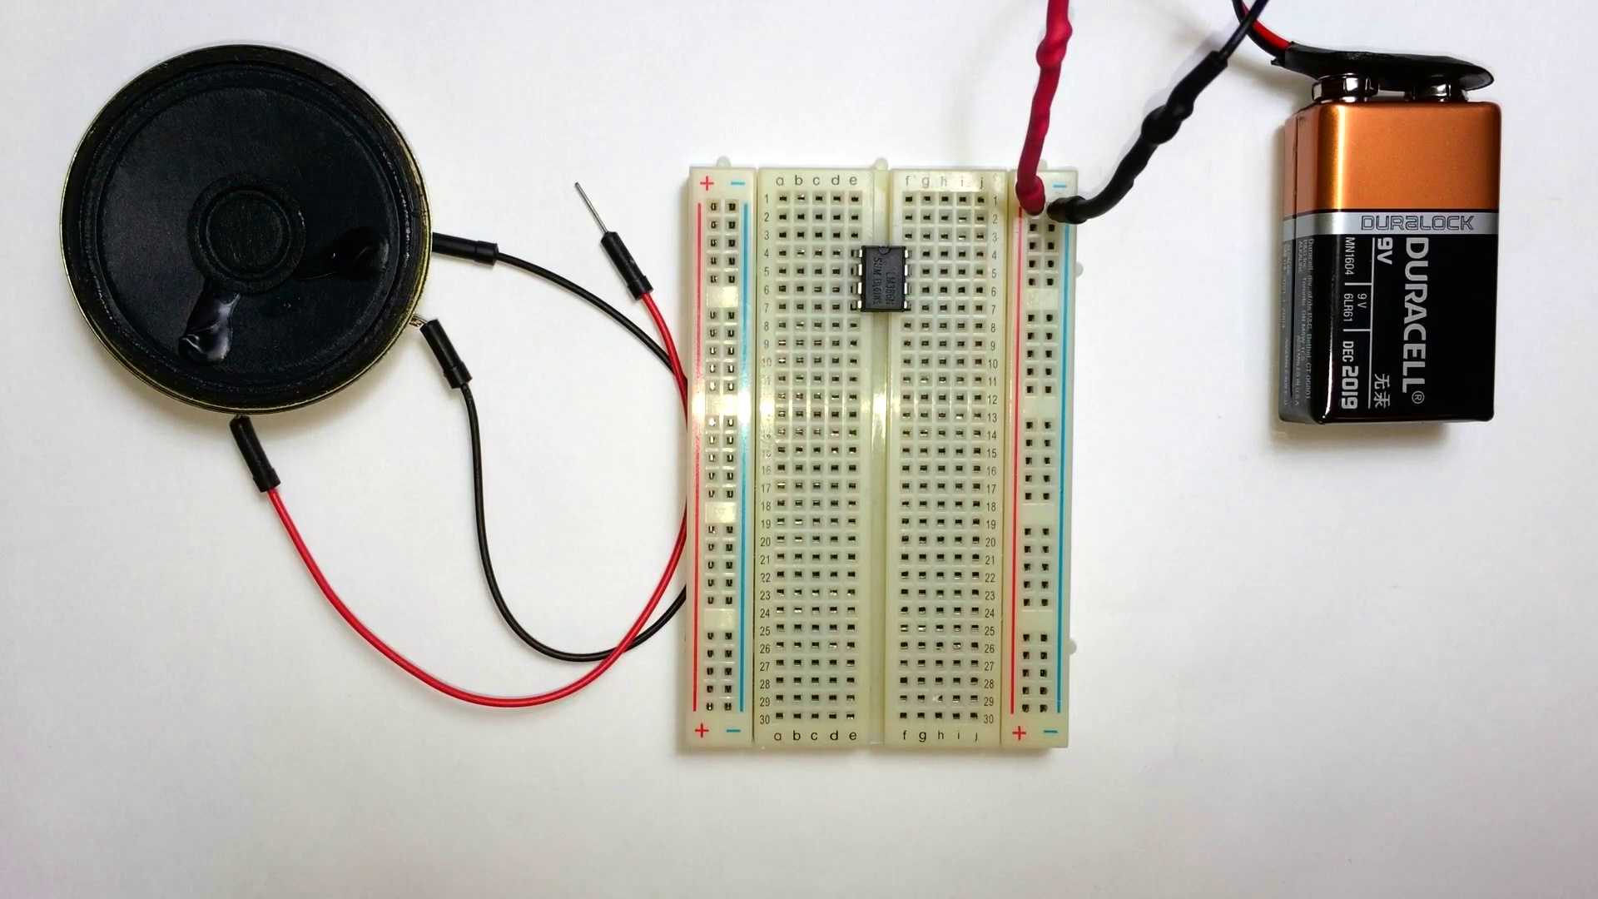 | 0:24   | 0:25   | 0:26   | 0:27  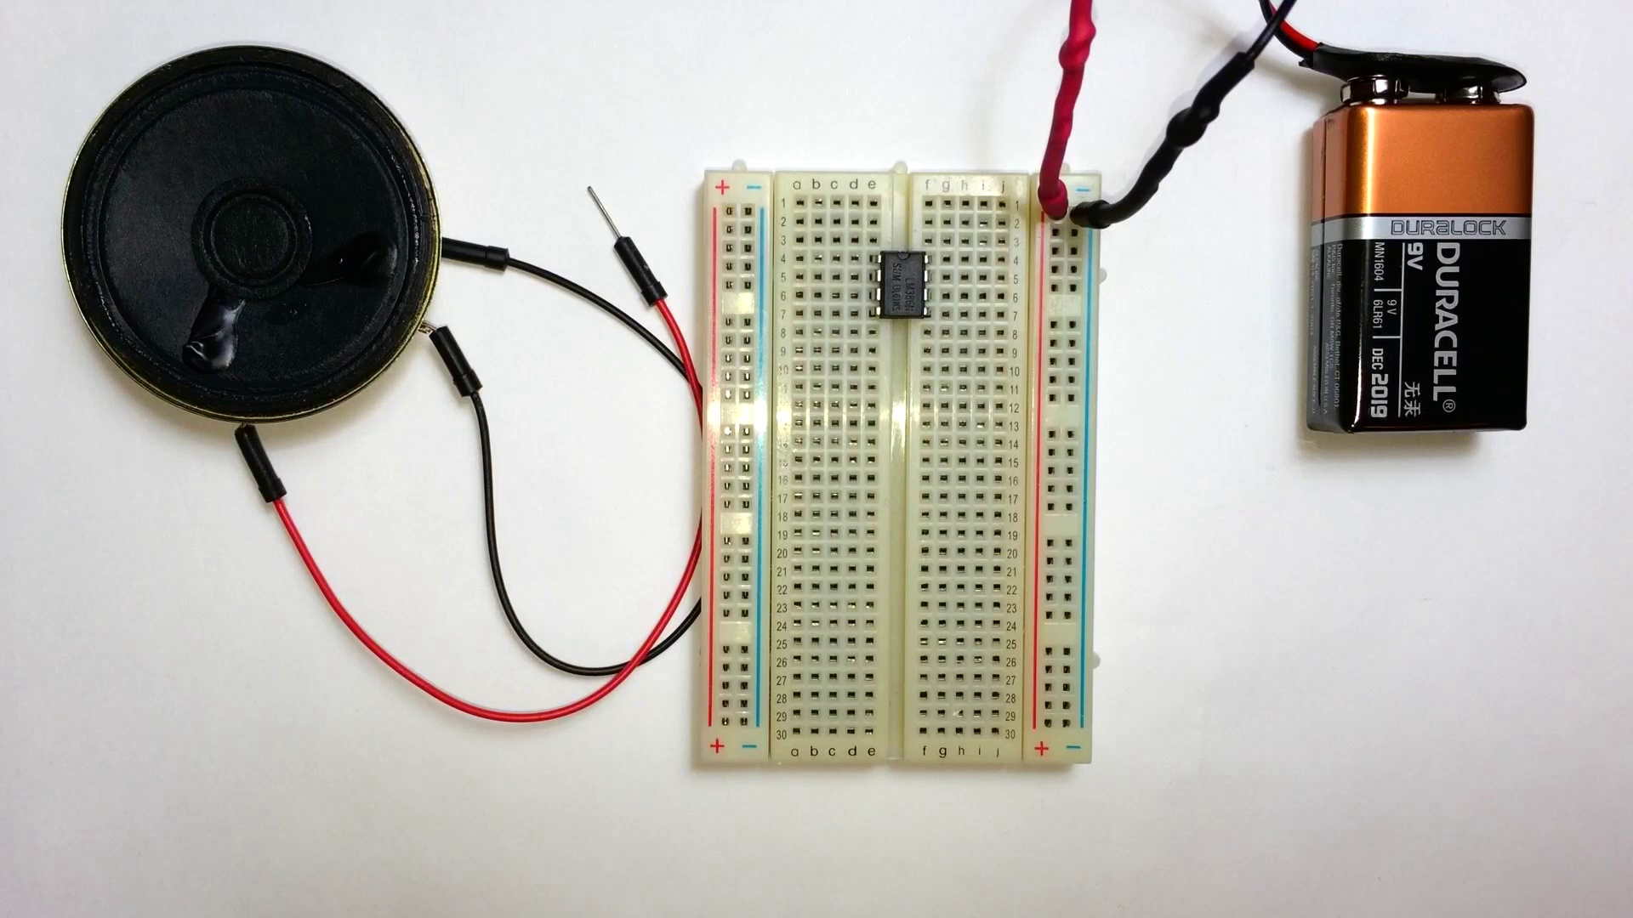

Transcript
[0:23] And in this tutorial I'm going to show you first of all how to build a really basic amplifier with the minimal parts, one resistor and two capacitors.

Section 0: Battery Power Source
Time: 0:28 - 16:19

Summary
A Duracell battery is visible, suggesting that this setup might be powered by batteries for the moment or demonstration purposes.

Representative Frames
3:06  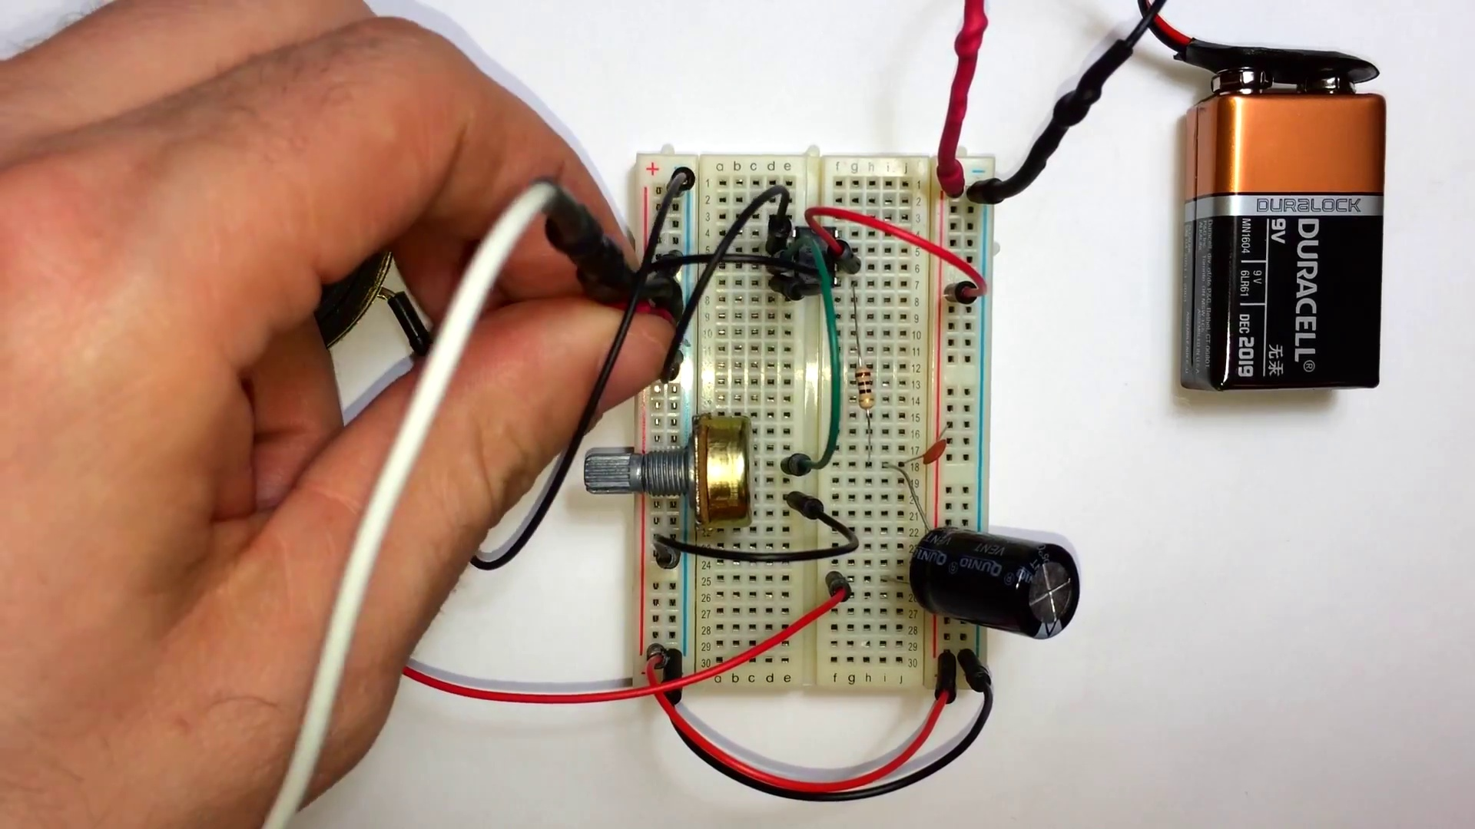 | 5:45  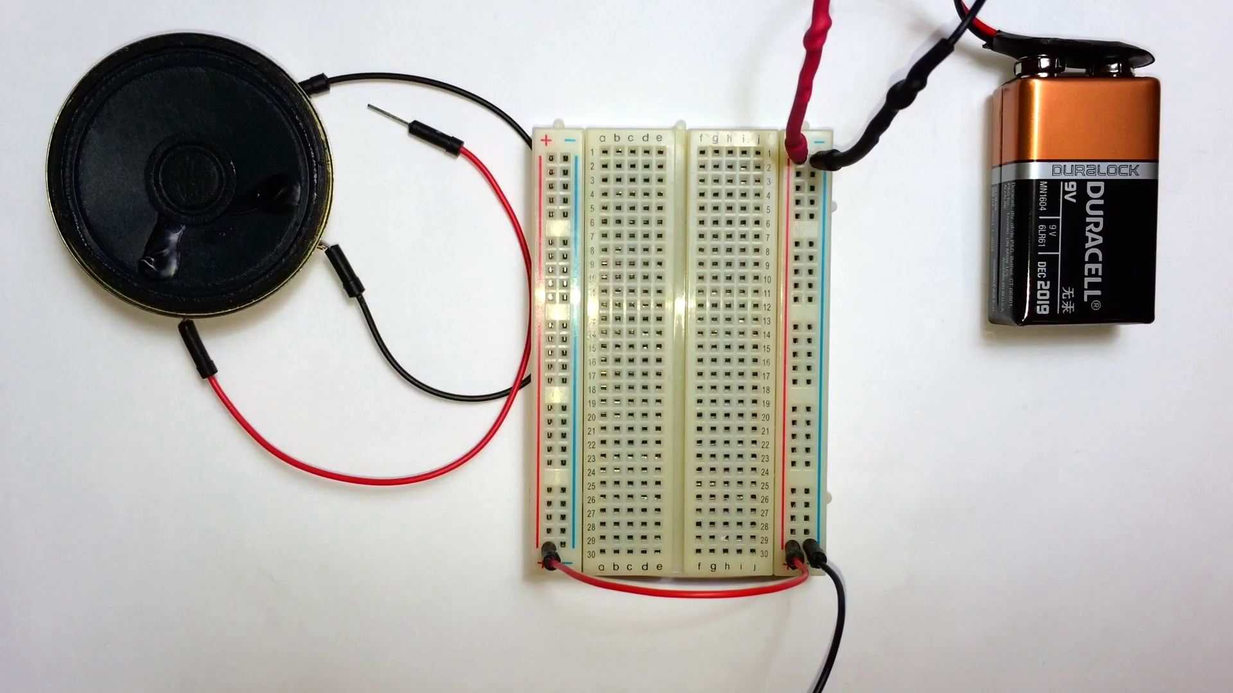 | 8:23  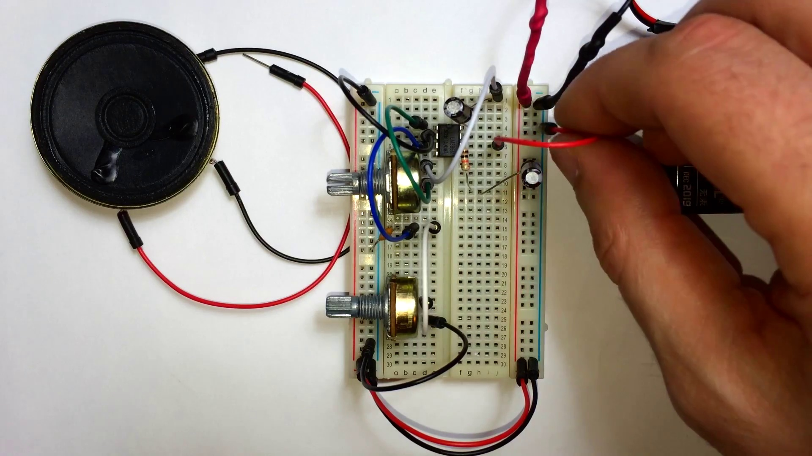 | 11:02  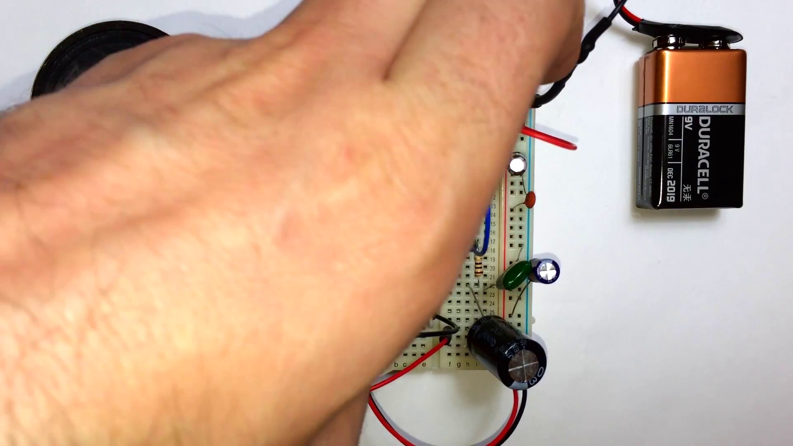 | 13:41  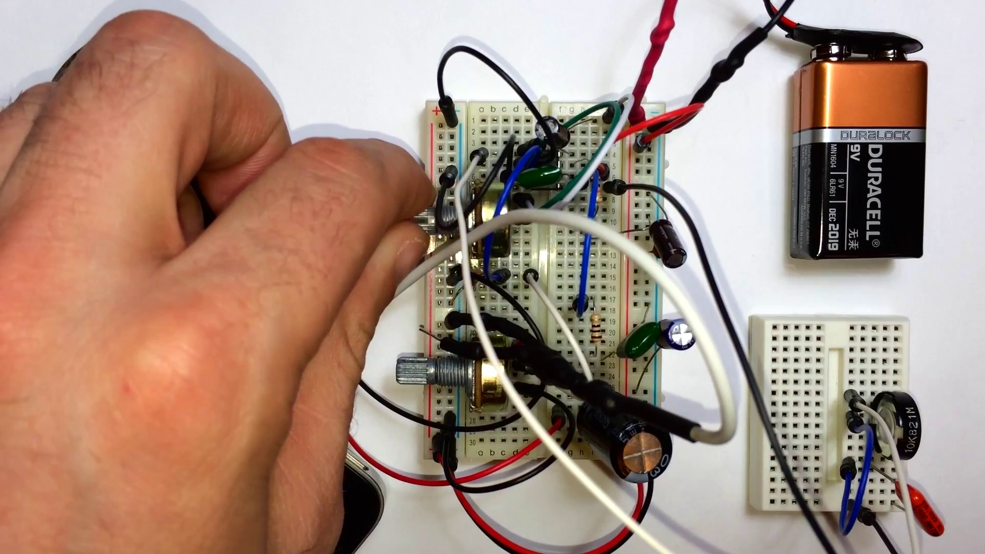

Transcript
[0:23] And in this tutorial I'm going to show you first of all how to build a really basic amplifier with the minimal parts, one resistor and two capacitors.
[0:33] Now I'm going to show you how to make a better sounding amplifier.
[0:36] And that's going to take some more capacitors but it's pretty easy.
[0:39] And we're also going to add a bass boost control. So follow along and we'll get going here.
[0:45] I've got the LM386 inserted into my breadboard with pin 1 in the upper left hand corner.
[0:50] Now I'm going to bridge the power rails. So connect the positive rails on both sides and the negative rails on both sides.
[1:07] Now take a jumper wire from pin 2 of the LM386 and connect it to ground.
[1:15] Now insert a 10K potentiometer somewhere into the breadboard.
[1:20] And connect the jumper wire from the middle pin of the potentiometer up to pin 3 of the LM386.
[1:33] Now connect pin 4 to ground.
[1:38] And one side of the potentiometer. Connect that to ground.
[1:45] Now we're going to put a 10 ohm resistor from pin 5 of the LM386. Bring that to another rail in the breadboard.
[2:00] And you want to put a 0.1 microfarad capacitor from that resistor into the positive rail.
[2:07] And then take the positive terminal of a 1000 microfarad electrolytic capacitor and insert it in between the resistor and the capacitor.
[2:16] Now you want to take the positive wire from your speaker and connect it to the negative terminal of that electrolytic capacitor.
[2:27] And then take the negative line of your speaker and connect it anywhere into the ground rail.
[2:42] Now we have to connect pin 6 of the LM386 to the positive rail.
[2:52] Alright now we're ready to connect the input for the amplifier circuit.
[2:58] I've cut into an old pair of headphones from my iPhone to use the 3.5mm audio jack.
[3:05] And I have another blog post about this on the website. Just look for it under the circuit section.
[3:12] So you want to connect the left or right audio channel into the third pin of the 10K potentiometer.
[3:21] And then the ground of the headphones into the ground rail of the circuit.
[3:28] And you can check my blog post on this tutorial. It'll have a better diagram.
[3:33] It's a lot easier to see what to do there.
[3:35] So now I'm going to connect this up to my iPhone.
[3:40] Play this little song I mixed up a while ago.
[3:47] And there's our volume control.
[3:52] And you can see it sounds pretty quiet.
[3:56] We don't have pin 1 or pin 8 bridged together in the circuit.
[4:02] So the gain with this setup is only 20.
[4:11] Now if we want to make it a little louder we can connect a wire between pin 1 and pin 8.
[4:18] And that'll make the gain 200.
[4:21] Now you can see it's a lot louder. It's a little too loud. It's got some distortion.
[4:38] There it is.
[4:40] That'll be a little bit more thousand.
[4:41] There you are.
[4:42] There use a hundred pounds.
[4:44] Do that many of the spots.
[4:46] Please take the zoom on.
[4:47] Yes.
[4:48] I'm not scrolling on.
[4:50] Now I'm scrolling on.
[4:51] Oh damn, raise your hand.
[4:54] I'm literally flying off the Trim.
[4:56] But there's mostly aint fres se.
[4:57] And I think more nails.
[4:59] However, fits the most of thekalif x type.
[5:07] Alright, well that does it for the really basic audio amplifier.
[5:19] Let's try making one that sounds a lot better.
[5:24] So I'm starting out with an empty breadboard here.
[5:26] I just have the power, the 9-volt battery, connected up to one side of the breadboard.
[5:32] So I'm going to bridge the two power rails and connect positive to positive and negative
[5:39] to negative.
[5:44] Now I'm going to insert the LM386 in there.
[5:53] I've got pin 1 in the upper left hand side.
[5:57] Now you want to connect pin 1 down to another rail somewhere in the breadboard.
[6:06] We're going to add our gain potentiometer to this.
[6:08] You want to connect that to the middle pin of the potentiometer.
[6:15] This is a 10K potentiometer.
[6:20] Now connect pin 2 of the LM386 to ground.
[6:30] Pin 3 goes to another rail in the breadboard.
[6:38] We're going to want to put a 740 pF capacitor from that rail into ground.
[6:47] This is a decoupling capacitor.
[6:48] You can read more about that on the blog post.
[6:52] Now you want to take that same rail and then bring it down to another rail on the breadboard.
[6:58] This is where our volume control is going to go.
[7:00] This is another 10K potentiometer.
[7:03] So connect that to the middle pin of the potentiometer.
[7:08] And then take one of the outside pins of the potentiometer and wire it to ground.
[7:18] Now completing our gain control, we want to insert a 10uF electrolytic capacitor from pin
[7:25] 8 of the LM386 up to another rail.
[7:29] And the negative side of the capacitor goes to the pin of the LM386.
[7:35] The positive side goes up to the other rail.
[7:38] Now take another jumper wire from that rail and connect it to one of the outside pins of
[7:47] your gain potentiometer.
[7:50] So now you want to insert a 10k ohm resistor from pin 7 of LM386 and bring that down to
[8:01] another rail of the breadboard.
[8:04] Now we want to insert another capacitor from the end of that resistor into ground with the
[8:11] negative side of the capacitor going to the ground side.
[8:15] The positive side going to the resistor side.
[8:18] Now we need to wire pin 6 of the LM386 to the positive rail.
[8:29] And then we need to insert a 0.1uF capacitor between pin 4 and pin 6.
[8:40] Kind of hard to get in here.
[8:42] With all these capacitors and wires it's best to get them as close to the chip as possible
[8:48] to minimize noise and interference from radios and other stuff.
[8:53] Now insert a jumper from pin 5 down to another rail of the breadboard.
[9:00] And then from there insert a 10 ohm resistor.
[9:14] Now insert a 0.1uF capacitor at the end of that resistor into ground.
[9:27] Now take a 1000uF capacitor and insert the positive side into that rail with the resistor and the
[9:33] other capacitor.
[9:35] And the negative side into another rail.
[9:37] Now we're going to add some decoupling capacitors for the power supply.
[9:42] So insert a 0.1uF capacitor between the positive and negative power rails.
[9:51] And then insert another capacitor.
[9:54] This one's 100uF in between the positive and negative power rails.
[9:59] And make sure the polarity is correct for these capacitors.
[10:02] I had a tantalum capacitor explode on me the other day.
[10:07] That was not fun.
[10:08] I might make another video about that.
[10:10] I actually inserted it backwards and the thing blew up between my fingers and I got burned
[10:16] kind of bad.
[10:17] So try to avoid that if possible.
[10:20] Now we want to insert a jumper wire from pin 4 into ground.
[10:25] Now we're ready to connect our speakers.
[10:33] So grab the positive wire of your speaker and insert it into that negative side of your
[10:41] 1000uF capacitor.
[10:43] And then take the negative wire and insert that anywhere into the ground rail.
[10:53] Now that we have that we're ready for the input.
[10:55] Now take either the left or right channel and wire it up to the remaining pin of your
[11:01] volume potentiometer.
[11:03] And then take the ground wire and connect it anywhere into the ground rail.
[11:23] Now we're ready to test it out.
[11:25] So I'll connect up my iPhone.
[11:41] And you can hear it's got a lot better sound than that first circuit we built.
[11:46] Plus we have a gain control and a volume control.
[11:48] I still have some distortion but we can balance it out with the gain and the volume.
[12:03] So I'll connect it to the bottom rail.
[12:04] Now let's add some bass control.
[12:10] I have another little mini breadboard over here with a 10k potentiometer inserted.
[12:30] So you want to connect a jumper wire from pin 1 of the LM386 up to an outer pin of the potentiometer.
[12:39] Now take the middle pin of the potentiometer and bring it down to another rail of the breadboard.
[12:46] And insert a 0.033 microfarad capacitor from the end of that connection down to another rail
[12:53] of the breadboard.
[12:55] And then connect the other end of that capacitor over to pin 5 of the LM386.
[13:05] So I'll connect the other end of that capacitor.
[13:17] And then connect the other end of that capacitor.
[13:22] So I'll connect the other end of that capacitor.
[13:27] So I'll connect the other end of that capacitor.
[13:37] So I will connect the other end of that capacitor.
[13:40] So I'll connect the other end of that capacitor.
[13:46] Really?
[13:48] Thank you.
[14:18] Thank you.
[14:48] Thank you.
[15:18] Thank you.
[15:48] Well, that's about it.
[15:50] I hope you enjoyed that.
[15:52] Don't forget to subscribe to keep updated on more videos coming out soon.
[15:56] Definitely going to be doing some more of these audio circuits.
[15:59] Might try a distortion, maybe like a tube amplifier sometime in the future.
[16:04] So keep updated with that.
[16:06] And have a good day.
[16:07] Bye-bye.
[16:18] Bye-bye.
[16:18] Bye-bye.

