Engagement Analysis: a3wDEcORRR4

Section 0: Introduction to PerfBoard and Building Prototypes
Time: 0:07 - 0:10

Summary
The host introduces the topic of building prototypes using PerfBoard, discussing its features and benefits.

Representative Frames
0:07  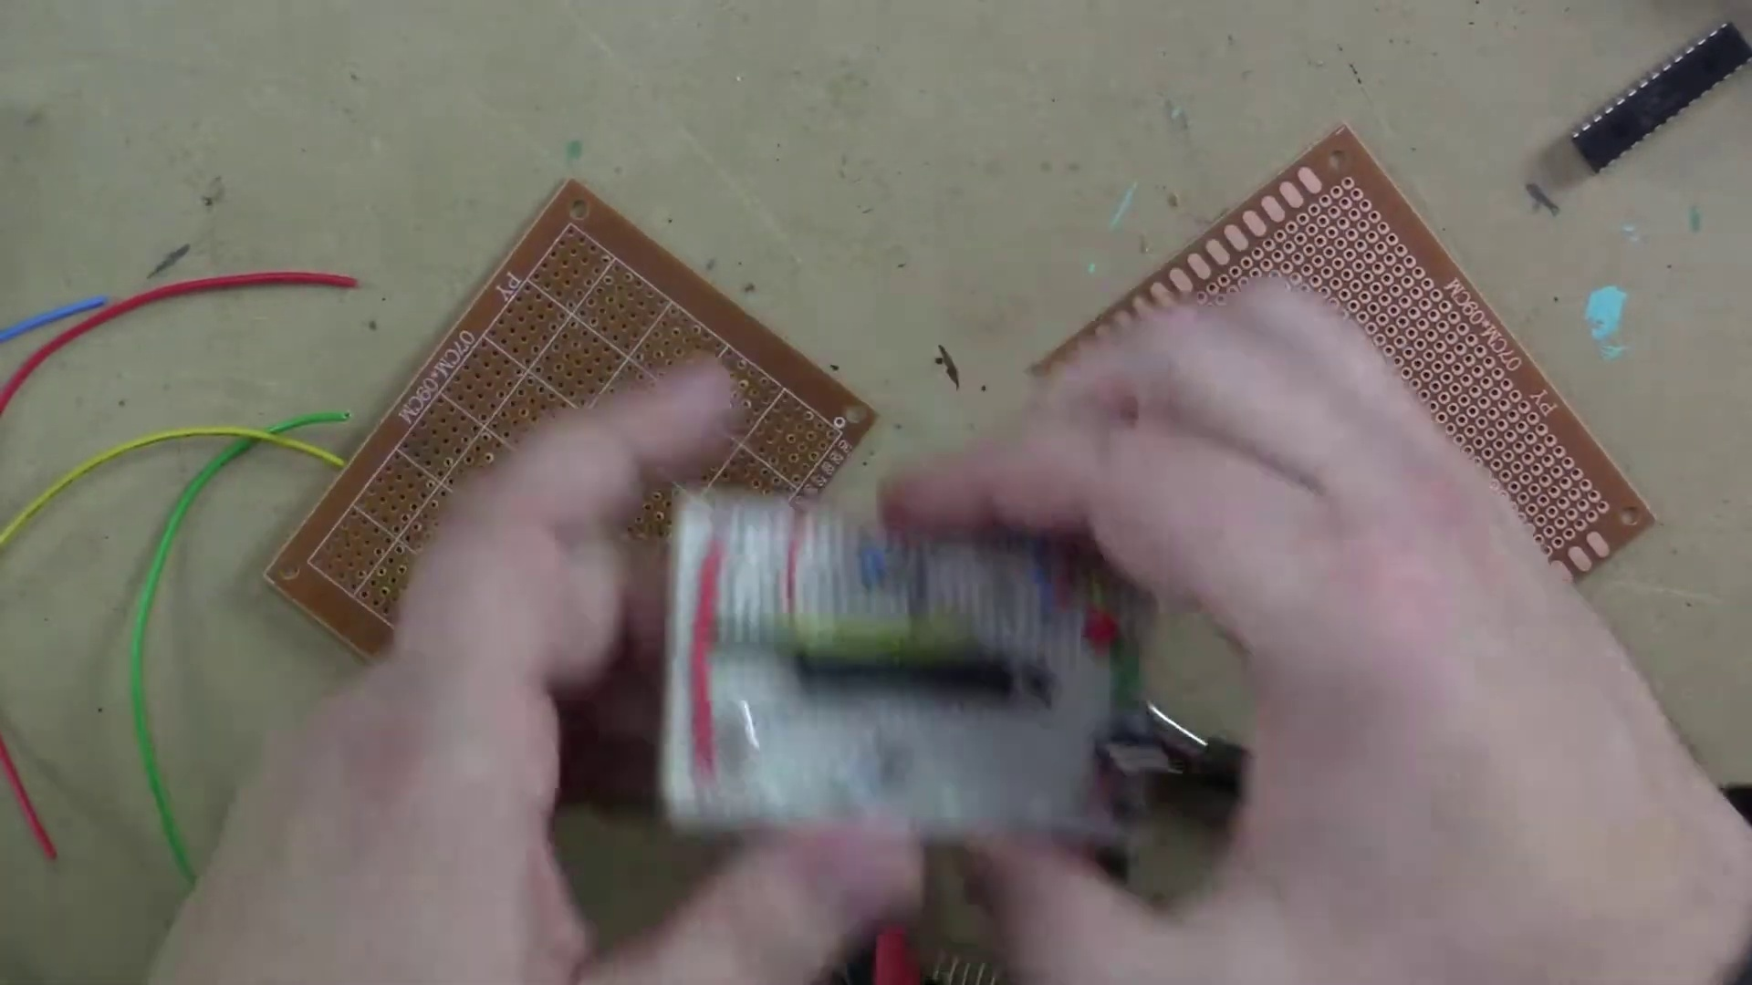 | 0:08   | 0:08   | 0:09   | 0:09  

Transcript
(No speech detected in this section)

Section 0: PerfBoard Components and Tools
Time: 0:10 - 0:14

Summary
The host shows various components and tools used for building on a PerfBoard, including electronic parts, cables, and tools like scissors and screwdrivers.

Representative Frames
0:10  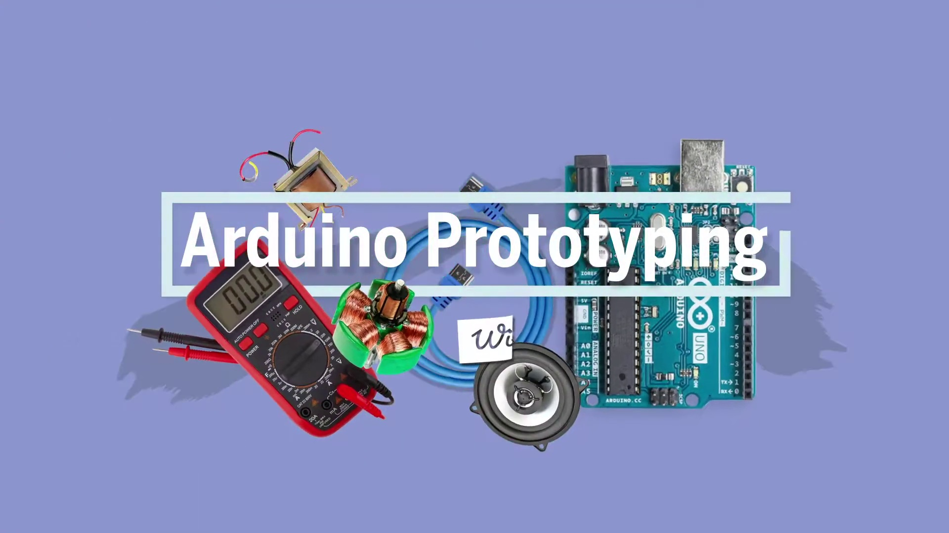 | 0:11   | 0:12   | 0:12   | 0:13  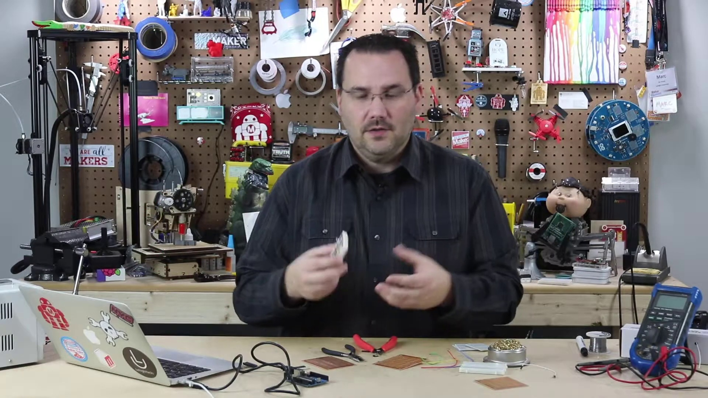

Transcript
[0:09] say, in a robot that's moving around or on your bicycle or in a car or an industrial application

Section 0: Step-by-Step Building Process on PerfBoard
Time: 0:14 - 0:22

Summary
The host guides the viewer through a step-by-step process of building a project using PerfBoard, highlighting key components and techniques.

Representative Frames
0:15   | 0:16  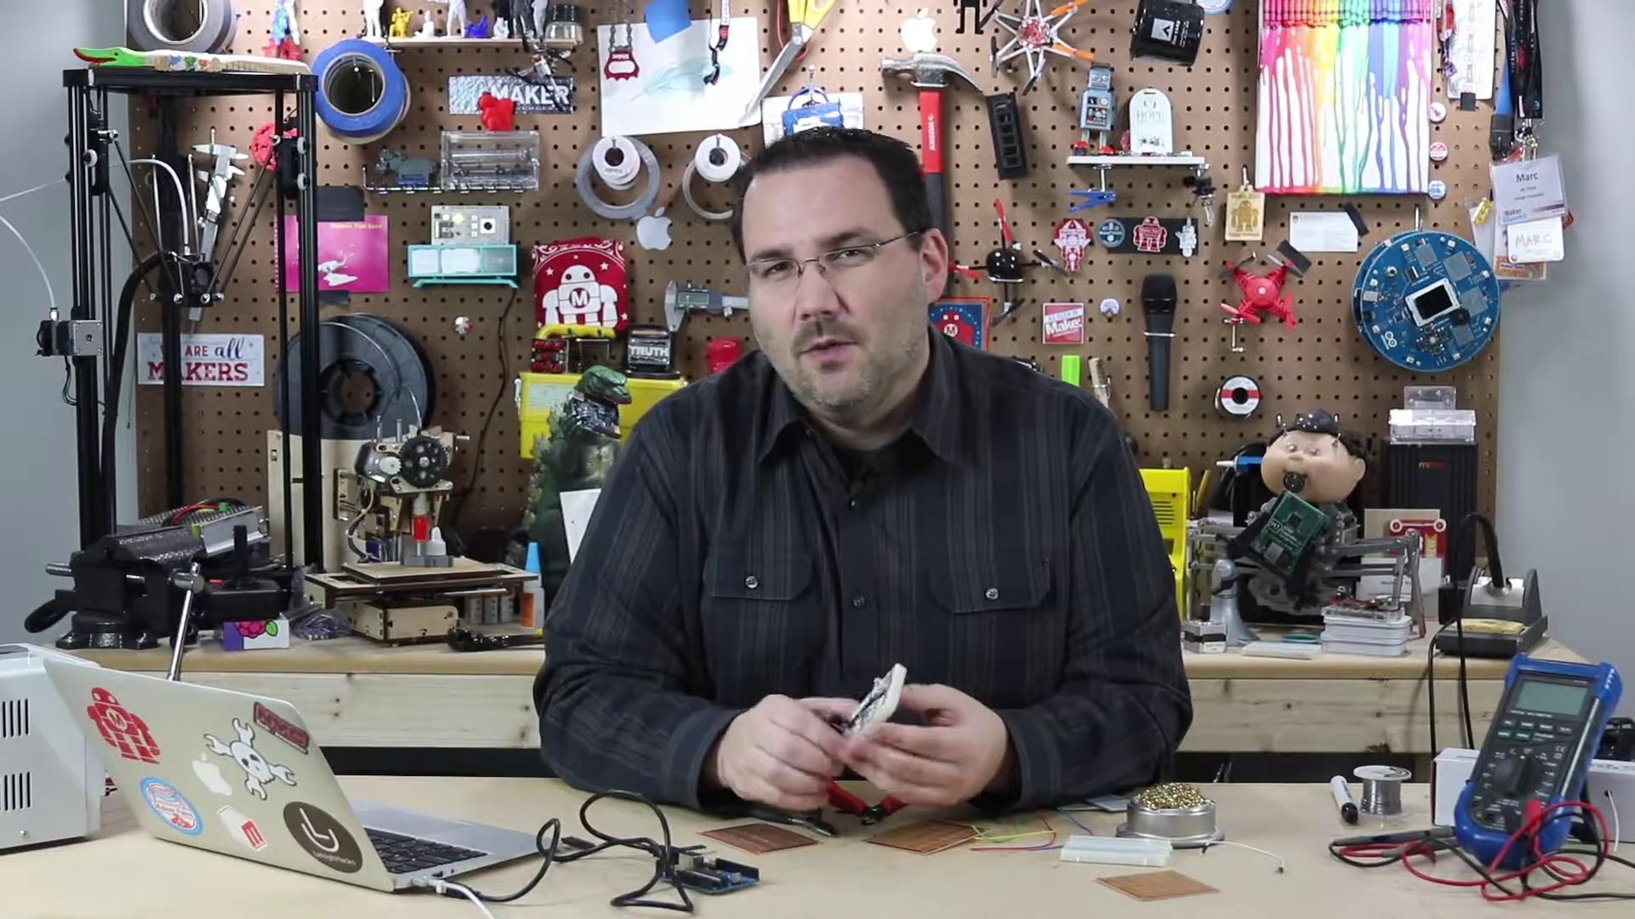 | 0:18   | 0:19   | 0:20  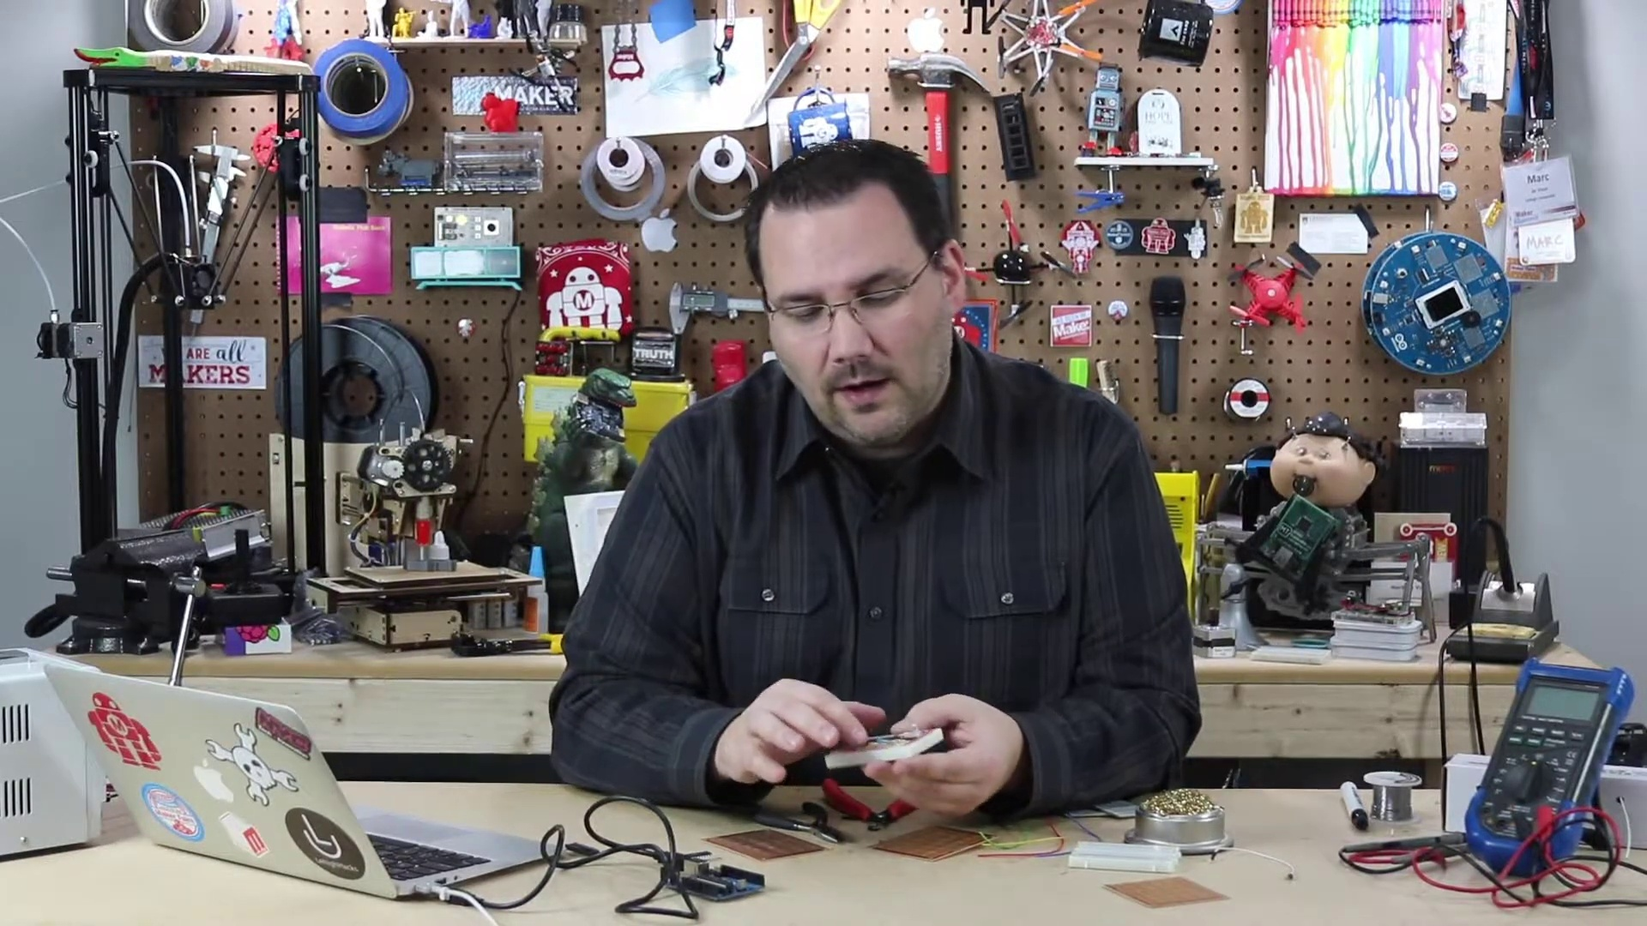

Transcript
[0:13] or something, or just the fact that you want to pass it around and let people play with this
[0:18] prototype, right? These wires can get loose eventually, they corrode, they make misconnections,

Section 0: Tips and Tricks for Building Prototypes with PerfBoard
Time: 0:22 - 0:30

Summary
The host shares tips and tricks for making the building process easier and faster on PerfBoard, including shortcuts and best practices.

Representative Frames
0:23  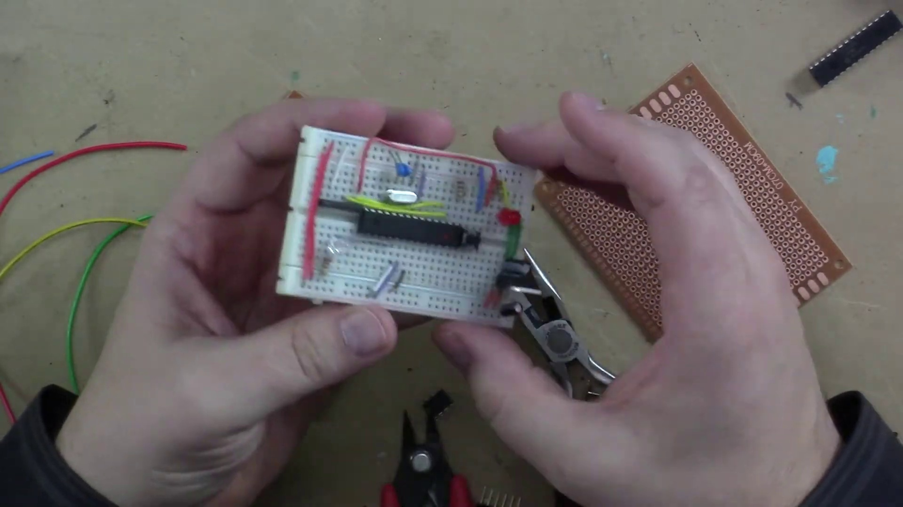 | 0:24   | 0:26   | 0:27  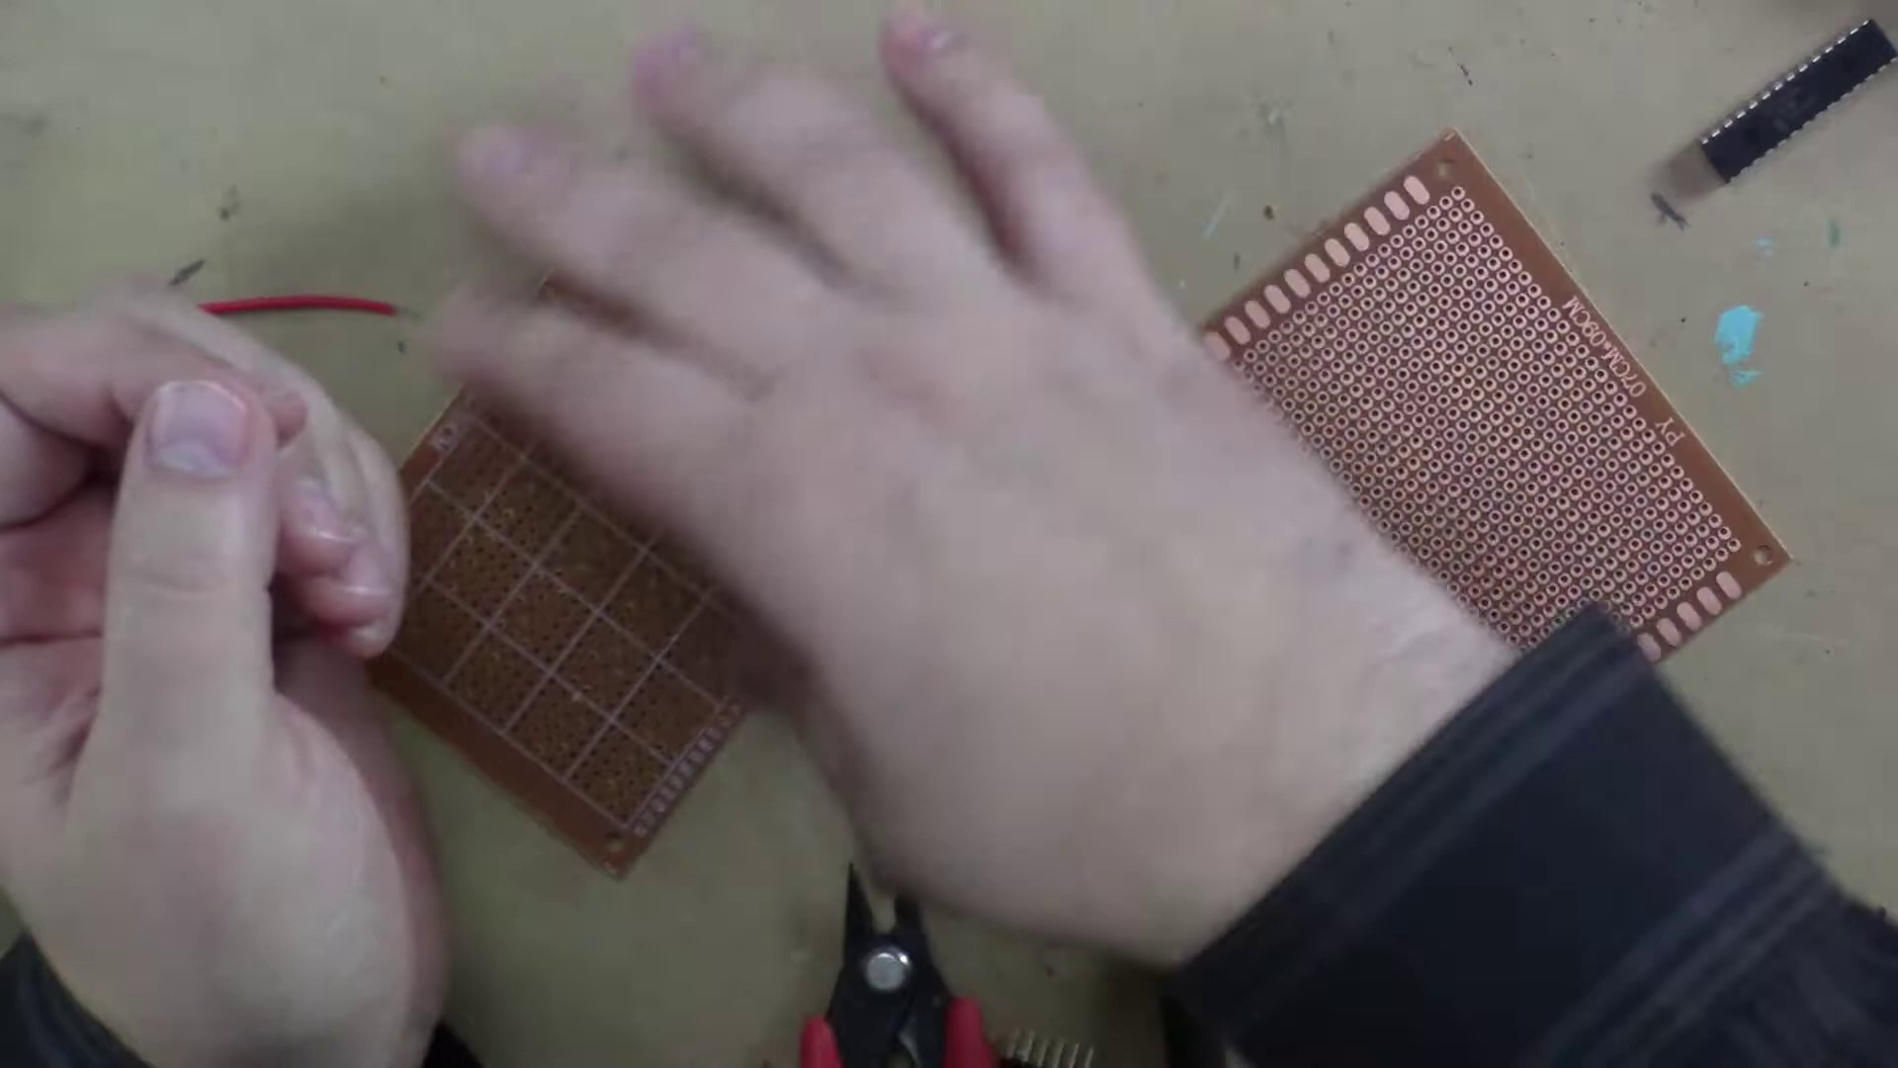 | 0:28  

Transcript
[0:23] it's just not the best long-term solution. So what we use is PerfBoard, and PerfBoard is perforated

Section 0: Conclusion and Final Thoughts
Time: 0:30 - 7:40

Summary
The host wraps up the tutorial, summarizing key points and encouraging viewers to apply what they've learned to their own projects.

Representative Frames
1:41  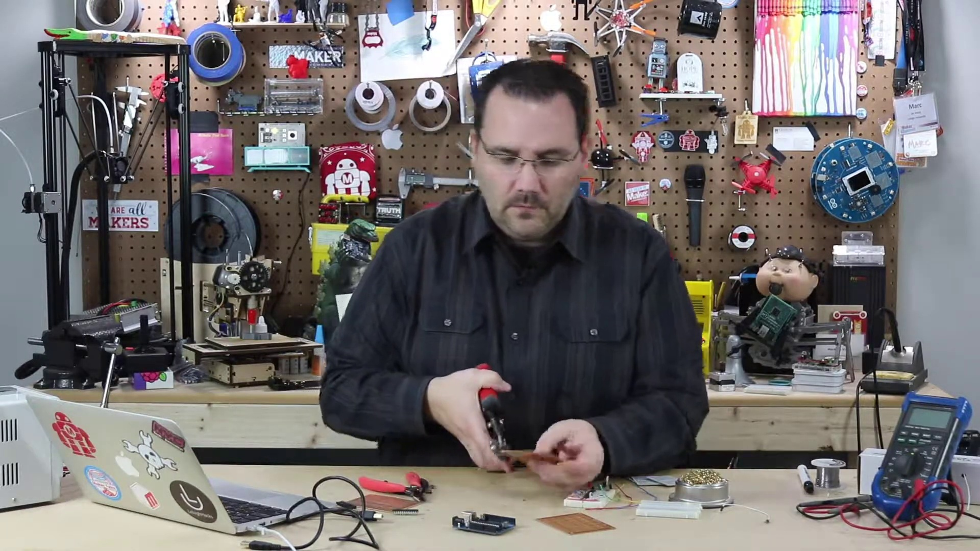 | 2:53  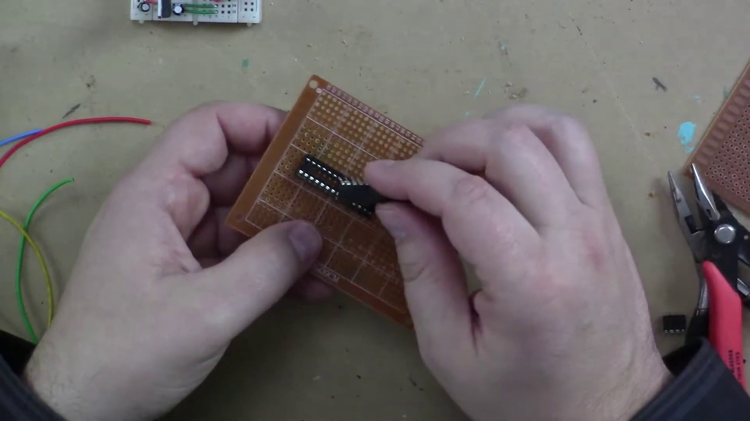 | 4:05  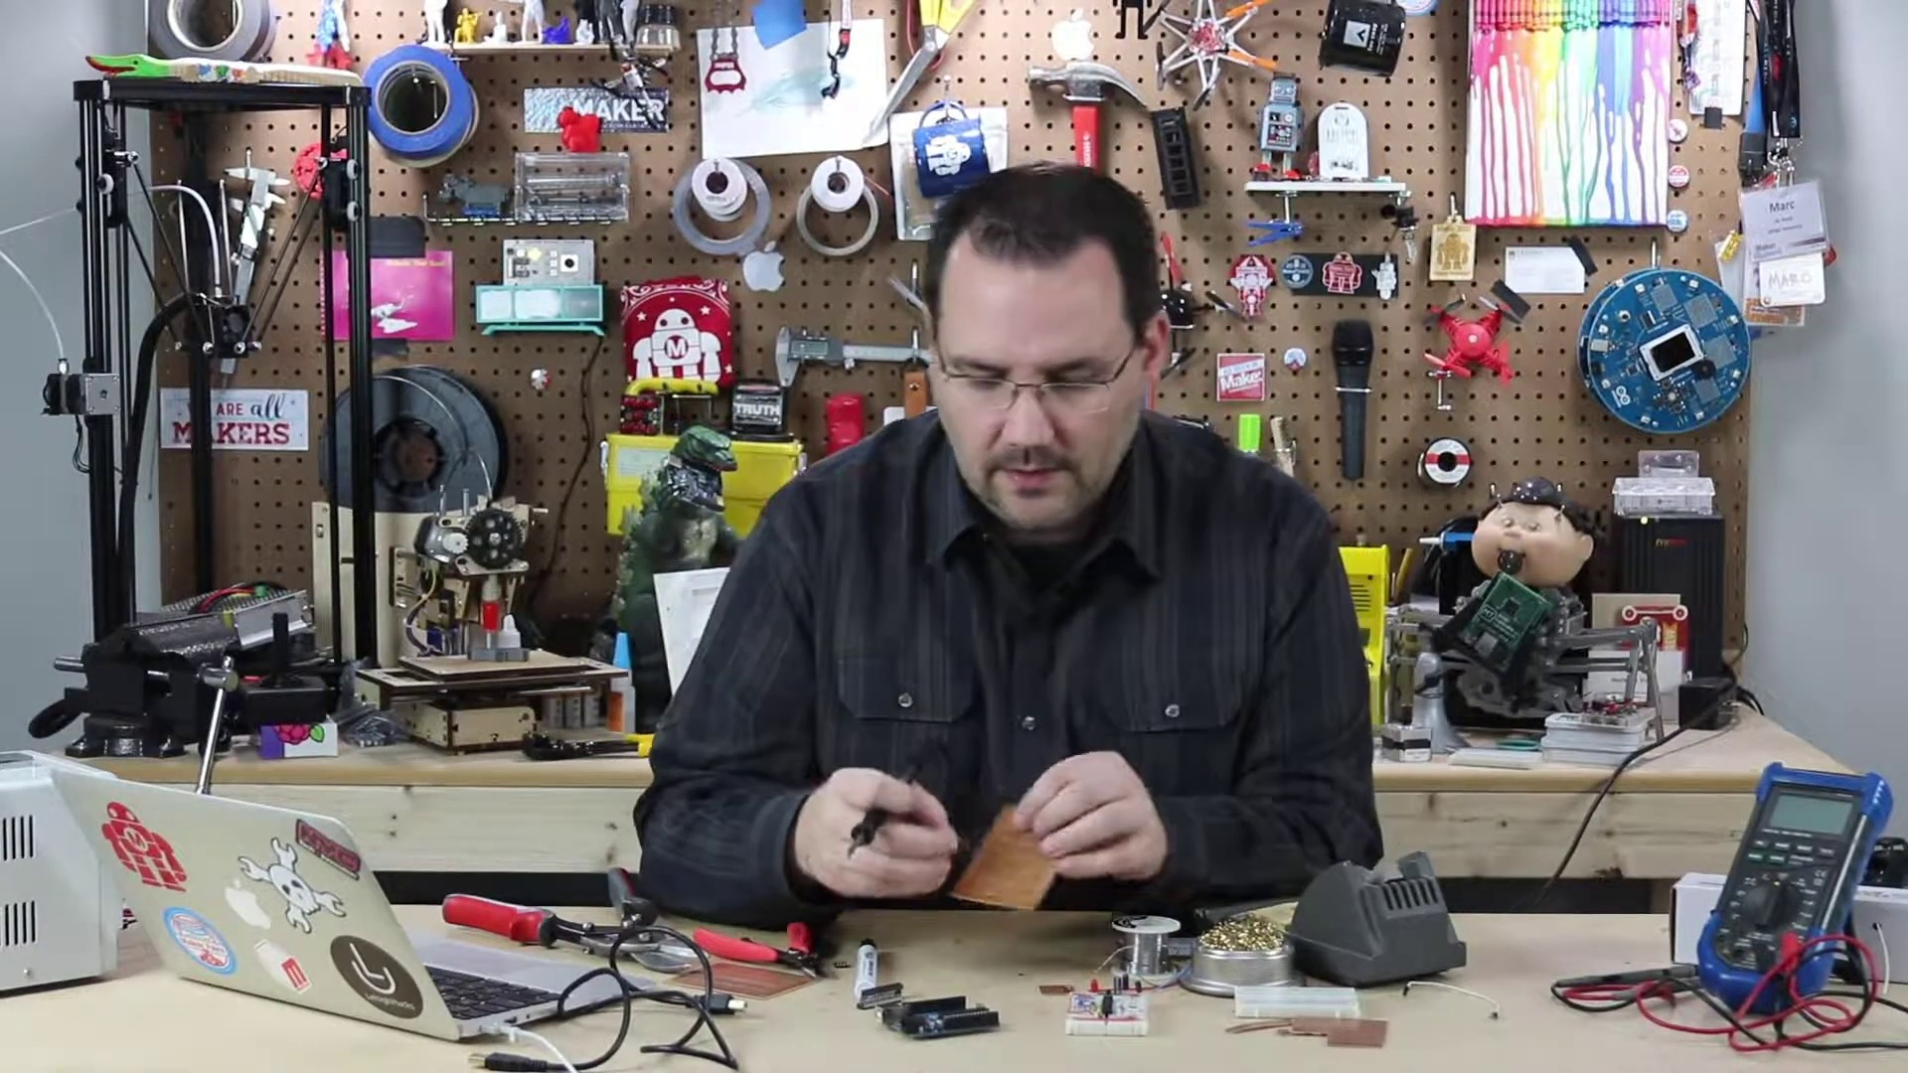 | 5:17  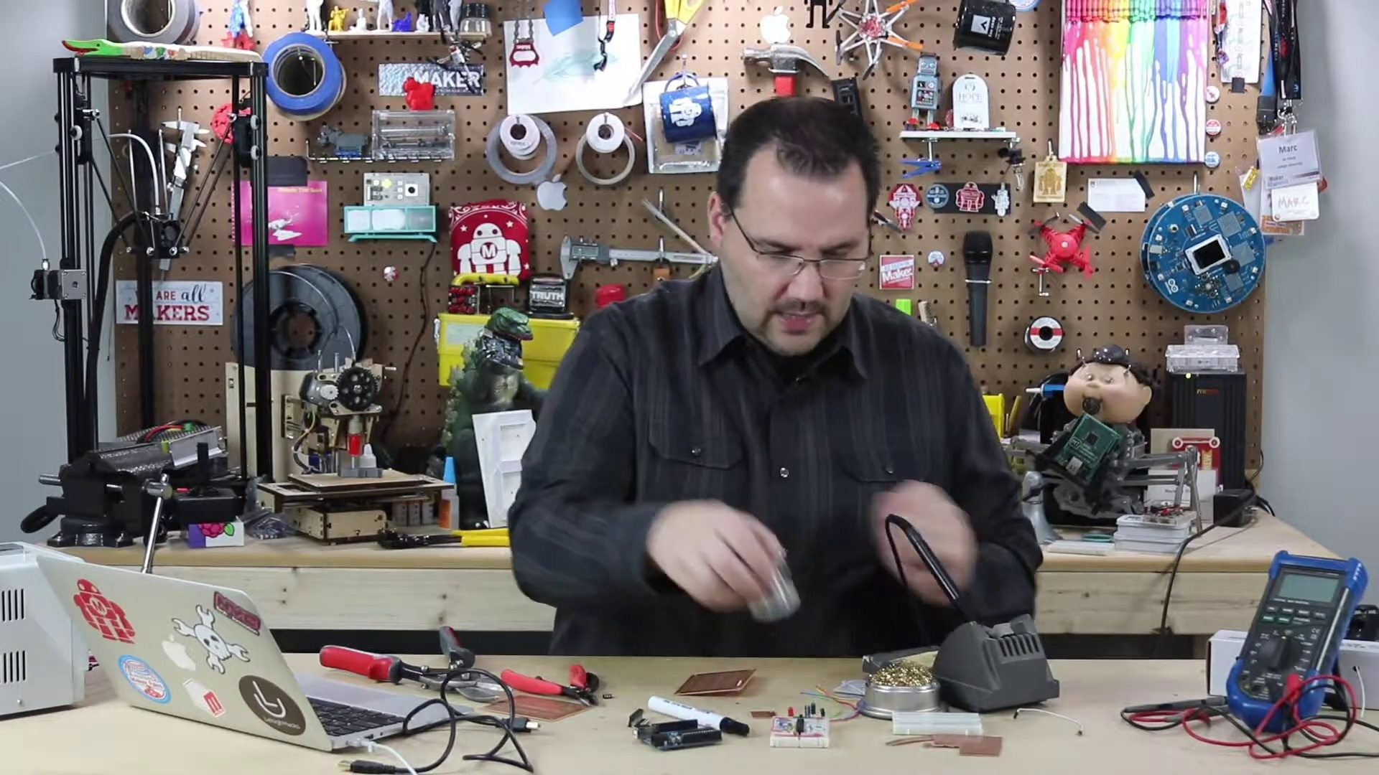 | 6:28  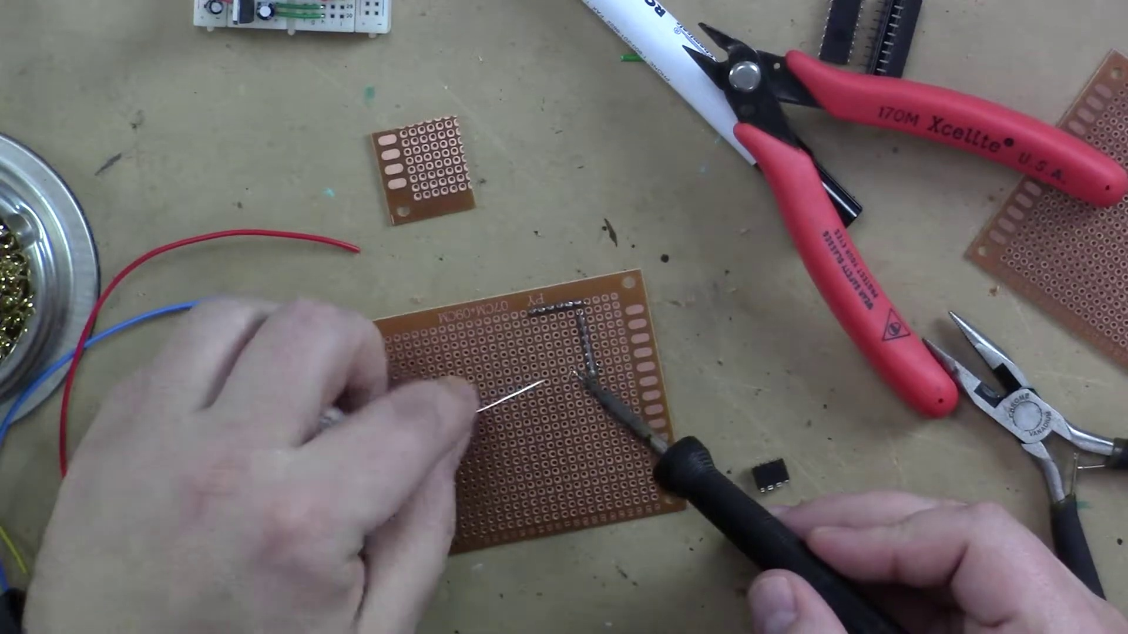

Transcript
[0:29] board that you cut to whatever size you want, and you hardwire solder all those connections in place.
[0:37] There's lots of different kind. This one is like a single point PerfBoard. Some of them have
[0:41] rows that are all connected, similar to like a breadboard and how that's connected.
[0:45] I like these, they're one-sided, and they have individual copper pads on each hole, and I'll show
[0:51] you briefly how I would use it. This video is more about some tips and techniques more than actually
[0:56] building something on a PerfBoard. It's fairly straightforward, but I've got some things that
[1:01] should help you build it. Number one, size. Don't necessarily want this size of a PerfBoard.
[1:08] I want something smaller. Maybe I'm creating a little board that breaks out all the analog pins
[1:13] here of my Arduino. It'd be just so much easier to have a PerfBoard that could plug into there,
[1:18] or have breakout header pins or something. So cutting it, cutting it. You can use little nippers,
[1:22] you can use some scissors. Don't bother. I see lots of people doing that. You get jagged edges.
[1:27] It's not the best way. Best thing you can do, go get some really cheap tin snips. Make sure you buy
[1:32] whether you buy a right-handed or left-handed version. But look at this. If I were to take
[1:36] this PerfBoard, or actually I have one here cut down already, and I were to just cut a row off of this,
[1:43] I mean it cuts so easily. It leaves a nice clean edge, very little sharp corners. I mean it's just,
[1:49] it's really nice. And if I wanted, say, a little breakout board from my Arduino, I can actually
[1:54] just cut the board like that. And look at that. I've got this great little breakout board that I
[1:59] could solder some header pins in and put it on my Arduino. Couldn't really be easier. So that's
[2:04] number one, cutting. Number two, soldering. So if you're going to put a integrated circuit into your
[2:12] board, you can solder it right to the PerfBoard, but trust me on this. And I've done it. Sadly,
[2:17] I've done it. I still actually remember one time I was making an Arduino many, many years ago. I want
[2:21] to say like close to 10 years ago. And I soldered my AT Mega, I don't remember, I think it was a 168
[2:28] microcontroller in there. And I fried it. And once I soldered it in, I go to unsolder it. It was a mess.
[2:35] It was horrible. Don't put your microcontrollers or integrated circuits, don't solder them directly to
[2:41] a board. Use something like a socket. And this is a socket. And what this allows you to do is put it
[2:46] into PerfBoard, solder this in from the backside. And then I can take my microcontroller and I can
[2:51] snap it into the socket. Something happens, I can pop it out. If I change my code, I can actually have
[2:56] on the side a couple of different microcontrollers with different codes. It's really great for demoing.
[3:01] It's great for having a backup. So that's one thing. Another thing to know is when soldering to
[3:07] the PerfBoard, and I'll grab my soldering iron real quick to show you. And you know what, I'm going to
[3:12] make a quick note about this soldering iron. This is my used industrial grade MetCal soldering iron.
[3:20] Why do I use this? This uses these RF tips. It's basically like a radio antenna, believe it or not,
[3:26] that from my understanding excites the tip of the soldering iron and heats it up extremely fast. I love
[3:34] this soldering iron. They're hundreds of dollars new, but you can go to eBay and buy them used for,
[3:40] I think I paid under a hundred bucks for this. And what I like about it is if I go to turn it on,
[3:45] I've just turned my soldering iron on.
[3:50] And let these little brass there, let's see. There you go. It's already up to temperature.
[3:56] I mean, what was that? A couple of seconds? Love it. It actually cools down just as fast.
[4:00] But what I wanted to show you is let's say we were going to solder this header pin in here.
[4:05] I push it through from this side.
[4:11] And I can get in here and get a nice little blob of solder on my soldering iron.
[4:16] I can tack it in place real quick.
[4:19] And now that's tacked in place, right? But this is what I wanted to get at.
[4:25] When working with PerfBoard, these are incredibly valuable.
[4:28] This is a rosin flux pen. And what this does is it cleans and is a facilitator for the solder to flow.
[4:37] So if I'm going to go in here, you can see the PerfBoards typically are a little,
[4:42] I don't want to say messy, but they're not exactly the cleanest of all things.
[4:46] And with a little flux pen, it makes soldering so much easier.
[4:51] Trust me on this one. You want a pen
[4:53] like this. This is a
[4:58] rosin flux pen by
[5:00] MG Chemicals. These are really
[5:03] handy to have. They're also really good when you're reworking solder joints.
[5:07] Paint over it with some of the flux
[5:09] and you will desolder much easier.
[5:12] So there's another tip. There I got my header pins in here.
[5:14] Last but not least, I want to also mention that
[5:17] if you are going to
[5:19] solder a bunch of things together,
[5:21] like let's say you needed a whole bunch of pins connected along a bar.
[5:27] I've mentioned earlier in videos, I saved these little
[5:30] clips from my LEDs and I'll usually have a few on hand.
[5:34] These can be very handy when soldering on a PerfBoard.
[5:37] Again, I can flux this
[5:39] and say I wanted to connect all these pins together.
[5:41] I can quickly take my
[5:46] little lead that I have here.
[5:54] I can temporarily put it right there
[5:56] and then I can bend it like that
[6:00] and I can actually go in and connect all these points.
[6:03] Sometimes you just need a lot of points connected together.
[6:05] See how quickly I can flood that?
[6:08] Look at that.
[6:10] Beautiful bar of solder.
[6:12] So, you know, imagine I had all different breakout wires
[6:14] that I want to connect on the other side.
[6:15] That's a really simple way of doing it.
[6:18] Wires are connected the same way.
[6:19] You know, I like to use these little
[6:21] flush cutters.
[6:24] I just put the wire in on the front.
[6:26] There's my wire on the back
[6:27] and I can easily just go in there
[6:29] and solder it
[6:31] right where it needs to be.
[6:34] Done.
[6:35] A little bit of a cold solder joint
[6:36] but don't worry about it.
[6:39] Another very useful thing
[6:41] is make sure you trim these leads down.
[6:42] Get them real nice and short
[6:44] and close to the board.
[6:45] So that's basically how you build
[6:46] on a PerfBoard.
[6:48] Now, there's all different kinds.
[6:49] Some of them have built-in rows.
[6:51] Some of them look just like breadboards
[6:52] and that's the last thing I want to show you.
[6:55] I'm a big fan of these.
[6:56] These are called the perma-proto boards.
[6:58] And what I like about these
[7:00] is if you look very carefully,
[7:01] each one of these holes is connected already
[7:04] just like it would be on a breadboard.
[7:07] And if you're building this circuit,
[7:08] I can buy a perma-proto board.
[7:11] That's a half-size breadboard.
[7:12] This happens to be a quarter size that I have here.
[7:15] But I can literally just hold this right here
[7:17] and build the same circuit,
[7:19] wire it up the same way as my breadboard,
[7:21] flip it over, solder it together,
[7:22] and it works perfectly.
[7:24] These are extremely handy.
[7:26] They're quite affordable.
[7:27] And to be quite honest with you,
[7:29] if you're building a prototype,
[7:30] they're really slick looking.
[7:32] So that's about it for building on a PerfBoard.
[7:35] I hope those tips and tricks help you a little bit
[7:38] and ease that learning curve.

