Engagement Analysis: cggDZE7gZNw

Section 0: A webpage with a video player interface and a notification bar overlaying it.
Time: 9:12 - 9:14

Summary
The image shows a screenshot of a webpage with a video player interface and a notification bar overlaying it, containing a message saying 'Thanks for watching' and two buttons labeled 'Subscribe' and 'Donate'.

Representative Frames
9:12  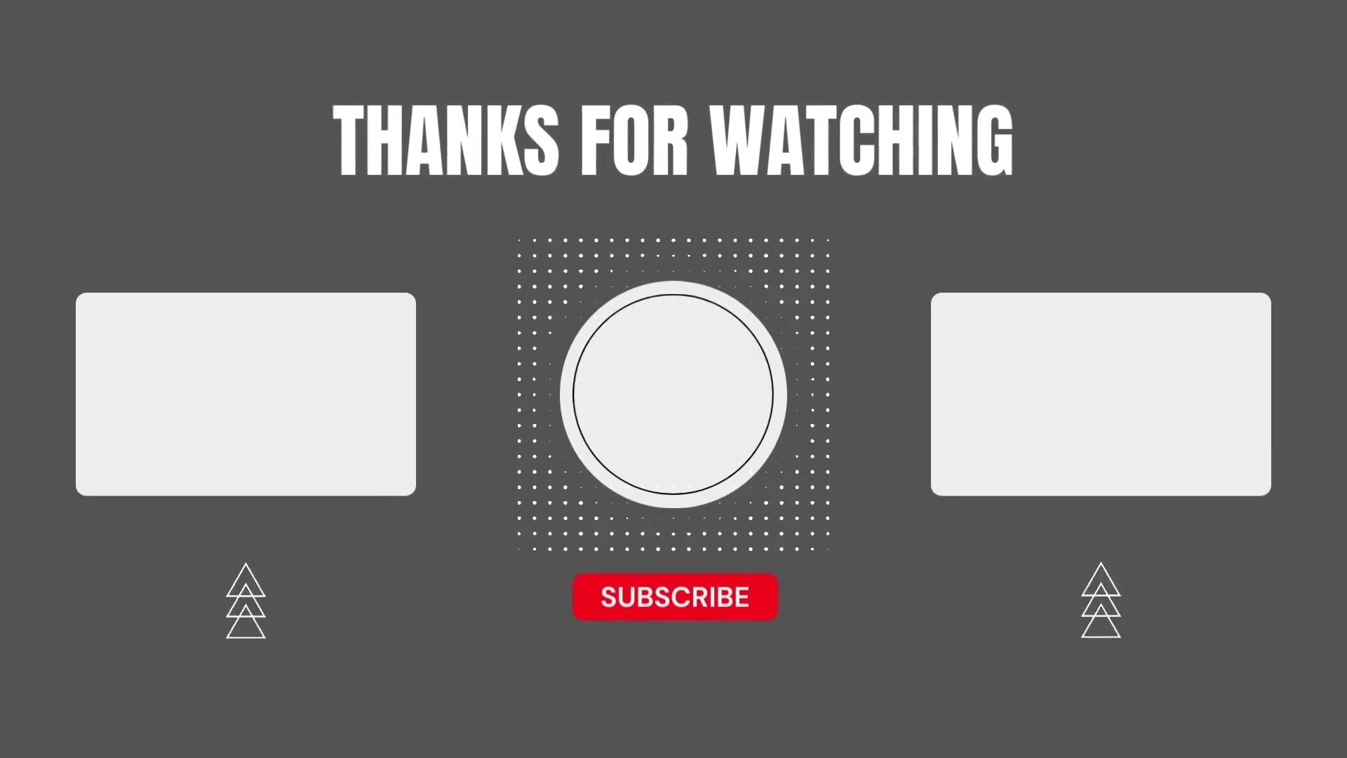 | 9:12   | 9:13   | 9:13   | 9:13  

Transcript
(No speech detected in this section)

Section 0: A minimalist digital interface dominated by a black background.
Time: 9:14 - 9:22

Summary
The image presents a minimalist digital interface with a white circle in the center of the screen, encircled by a red border, and several other UI elements such as the number of subscribers, video controls, and a chat window.

Representative Frames
9:15  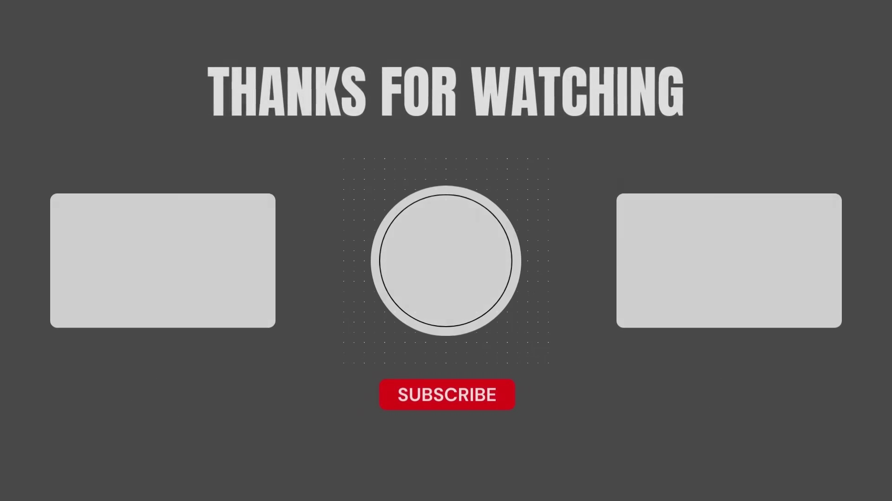 | 9:16   | 9:18   | 9:19   | 9:21  [No Frame]

Transcript
(No speech detected in this section)

