Engagement Analysis: dKB7uHYU-ow

Section 0: Image Analysis - Scene 1: Cityscape with Figure
Time: 0:04 - 0:06

Summary
A figure stands out against a dark night sky, conveying solitude and introspection.

Representative Frames
0:04  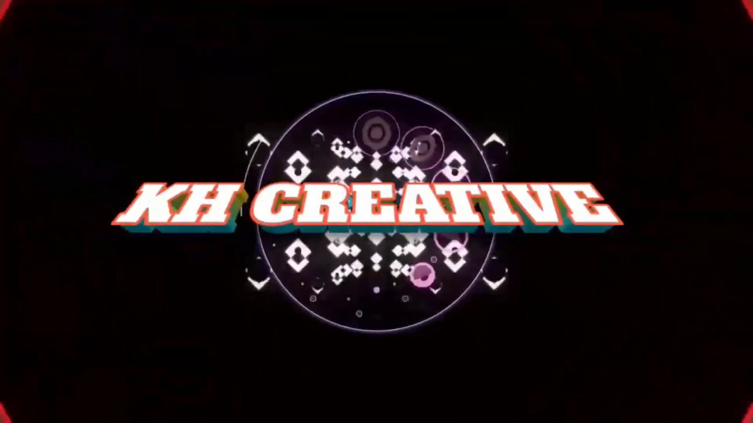 | 0:04   | 0:05   | 0:05   | 0:05  

Transcript
(No speech detected in this section)

Section 0: Image Analysis - Scene 2: Screen with Overlay Graphic
Time: 0:06 - 0:08

Summary
The image features a screen with a social media interface, including like and comment buttons.

Representative Frames
0:06   | 0:06  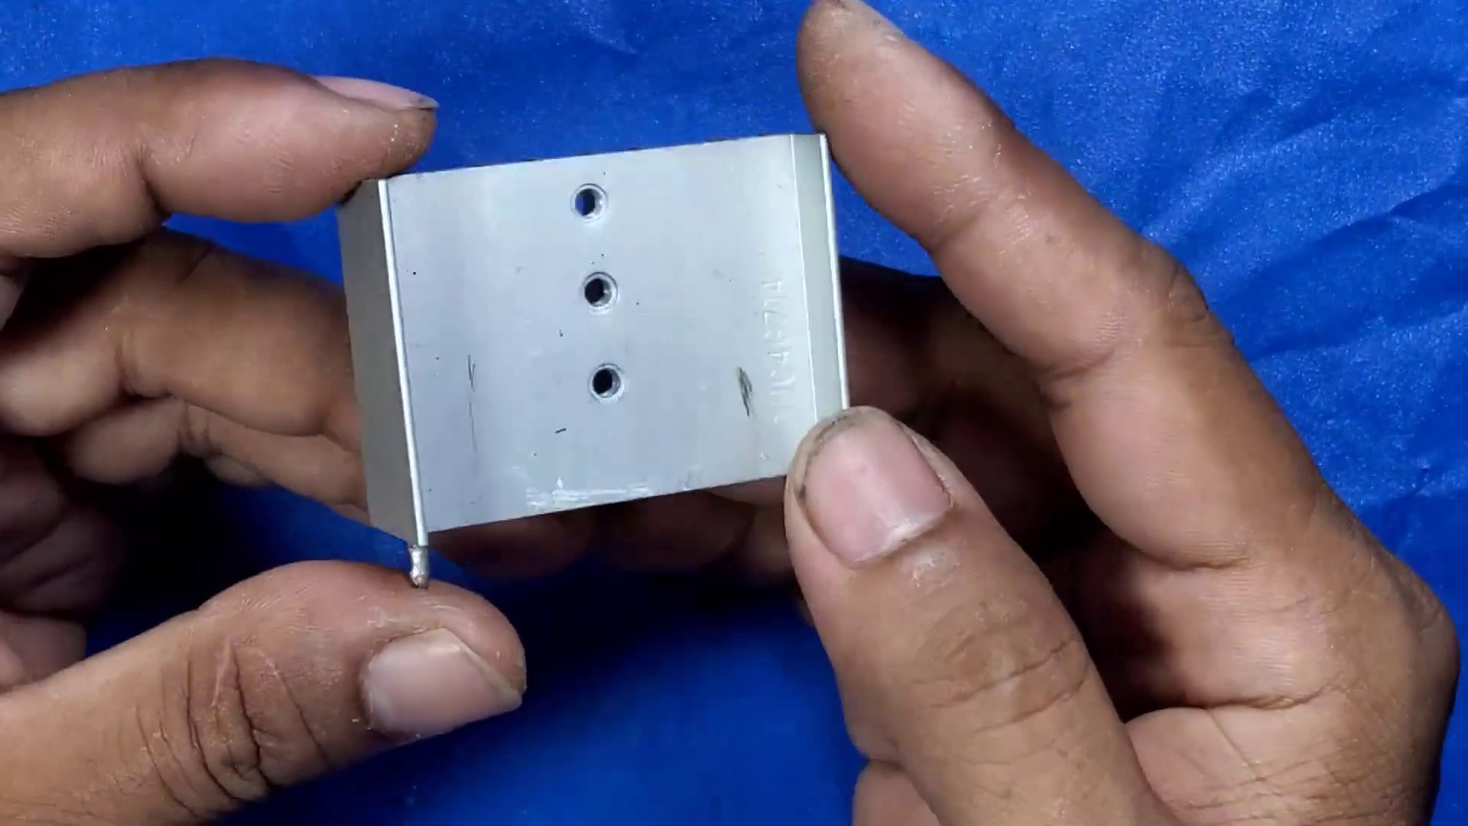 | 0:07   | 0:07   | 0:07  

Transcript
(No speech detected in this section)

Section 0: Image Analysis - Scene 3: Animated Sequence
Time: 0:08 - 0:10

Summary
A humanoid character with magical powers is depicted in an animated sequence with dynamic lighting effects.

Representative Frames
0:08   | 0:08   | 0:09   | 0:09   | 0:09  

Transcript
(No speech detected in this section)

Section 0: Image Analysis - Scene 4: Computer Screen with Subscription Menu
Time: 0:10 - 5:12

Summary
A still image from a video shows a computer screen with a subscription menu and interactive elements.

Representative Frames
1:00  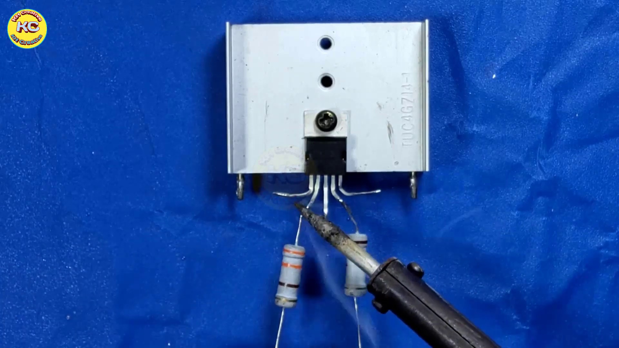 | 1:50  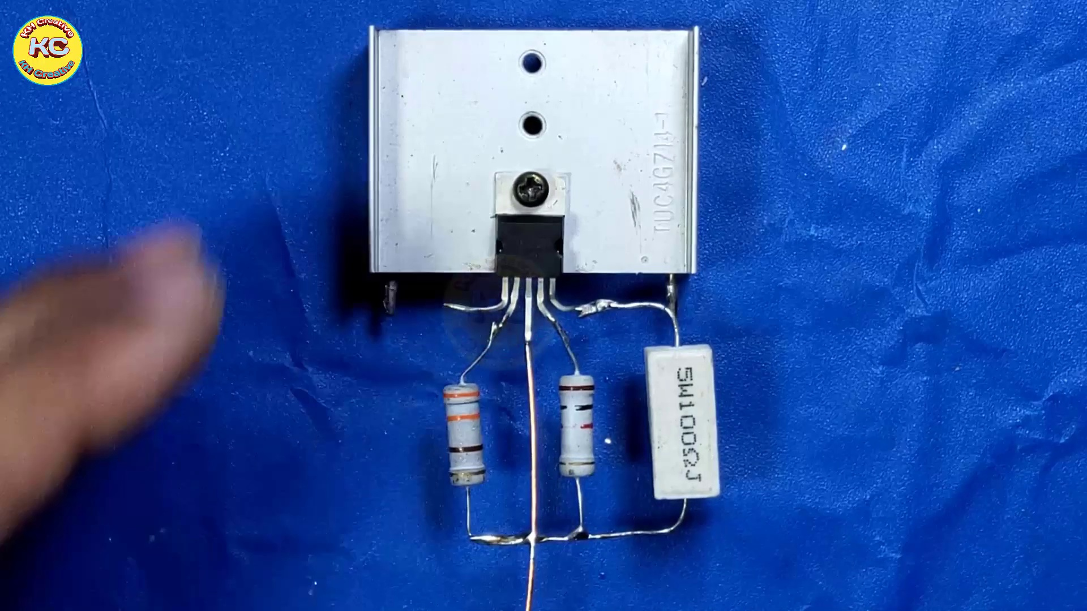 | 2:41  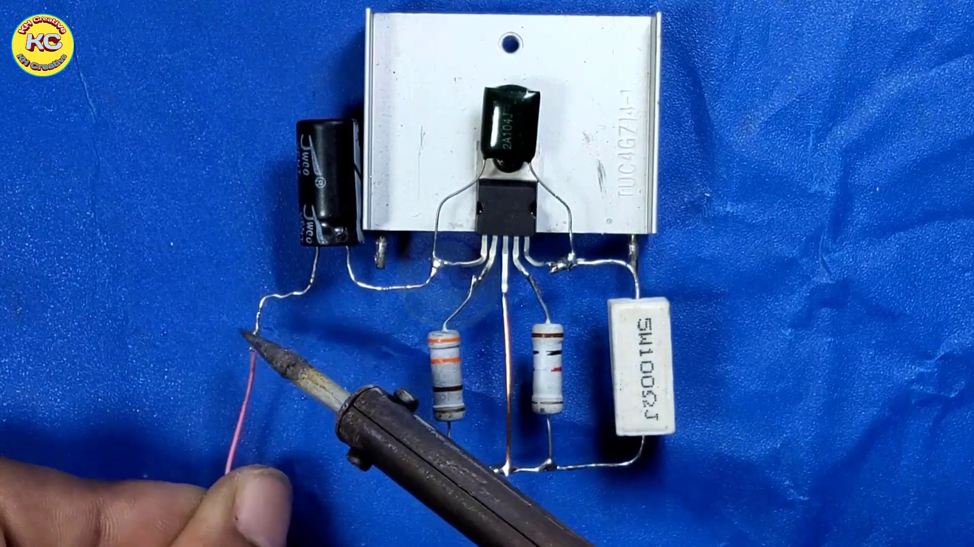 | 3:31  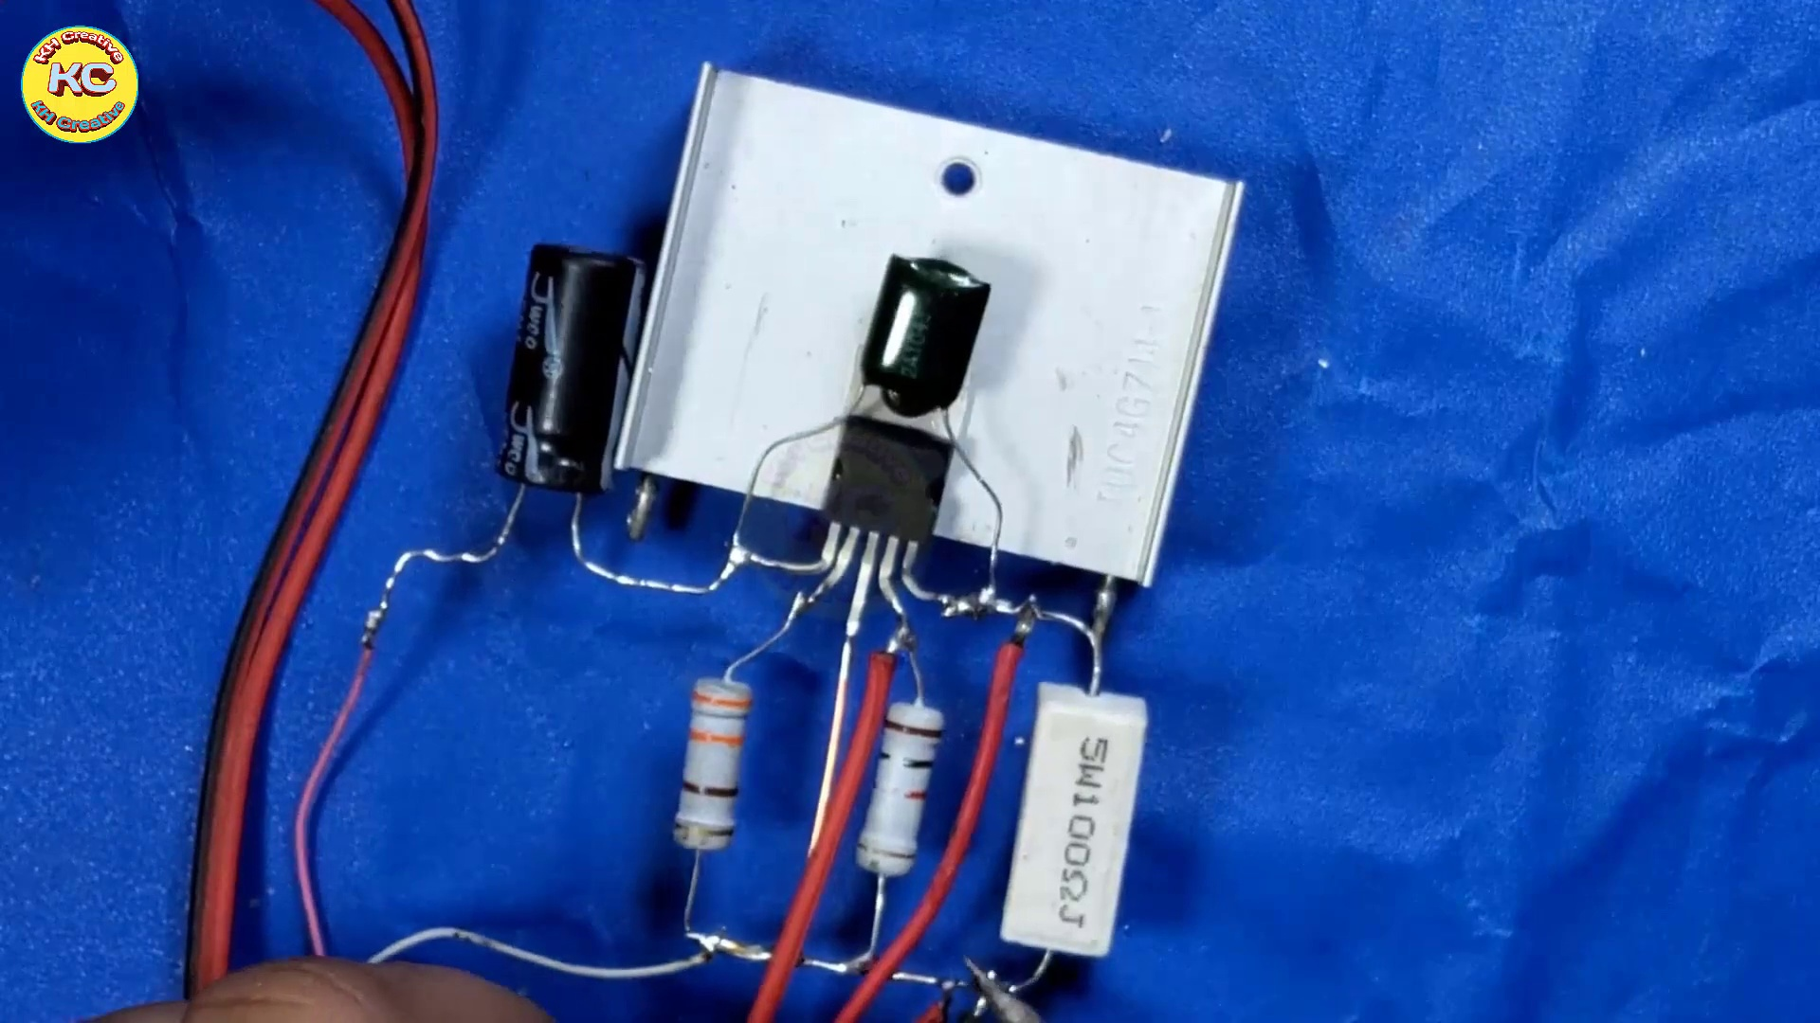 | 4:22  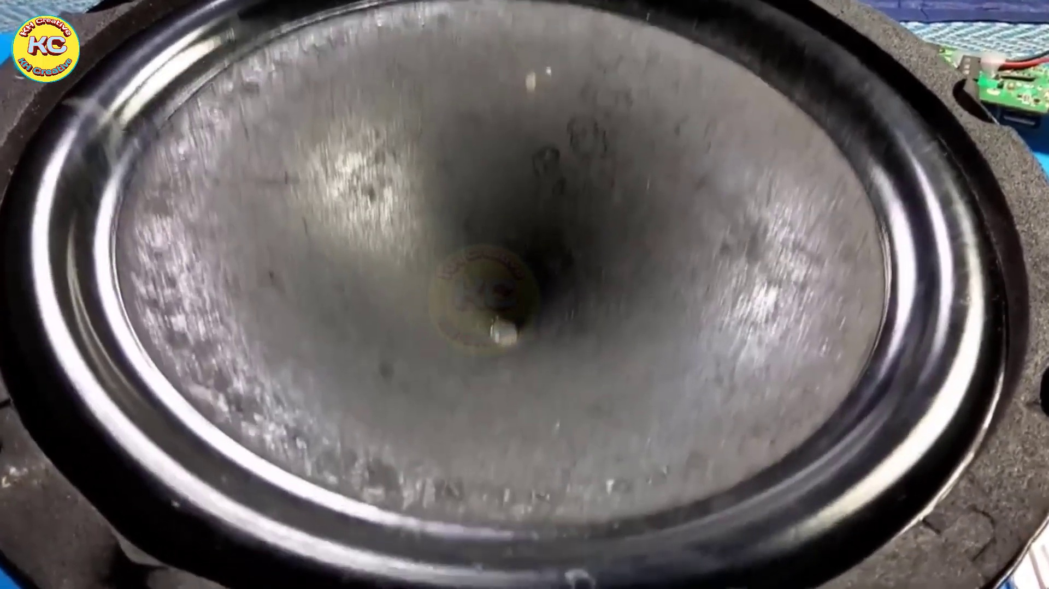

Transcript
[0:09] serving
[0:12] or
[0:17] sucking
[0:20] rope
[0:26] will
[0:28] Copets
[0:42] Filthy
[0:42] Thank you.
[1:12] Thank you.
[1:42] Thank you.
[2:12] Thank you.
[2:42] Thank you.
[3:12] Thank you.
[3:42] Thank you.
[4:12] Thank you.
[4:42] Thank you.

