Engagement Analysis: dV8rpGUoxns

Section 0: Person sitting at desk with computer equipment
Time: 0:00 - 0:02

Summary
The person is seated at a desk with multiple computer monitors and equipment in front of them, suggesting a workspace or office environment.

Representative Frames
0:00  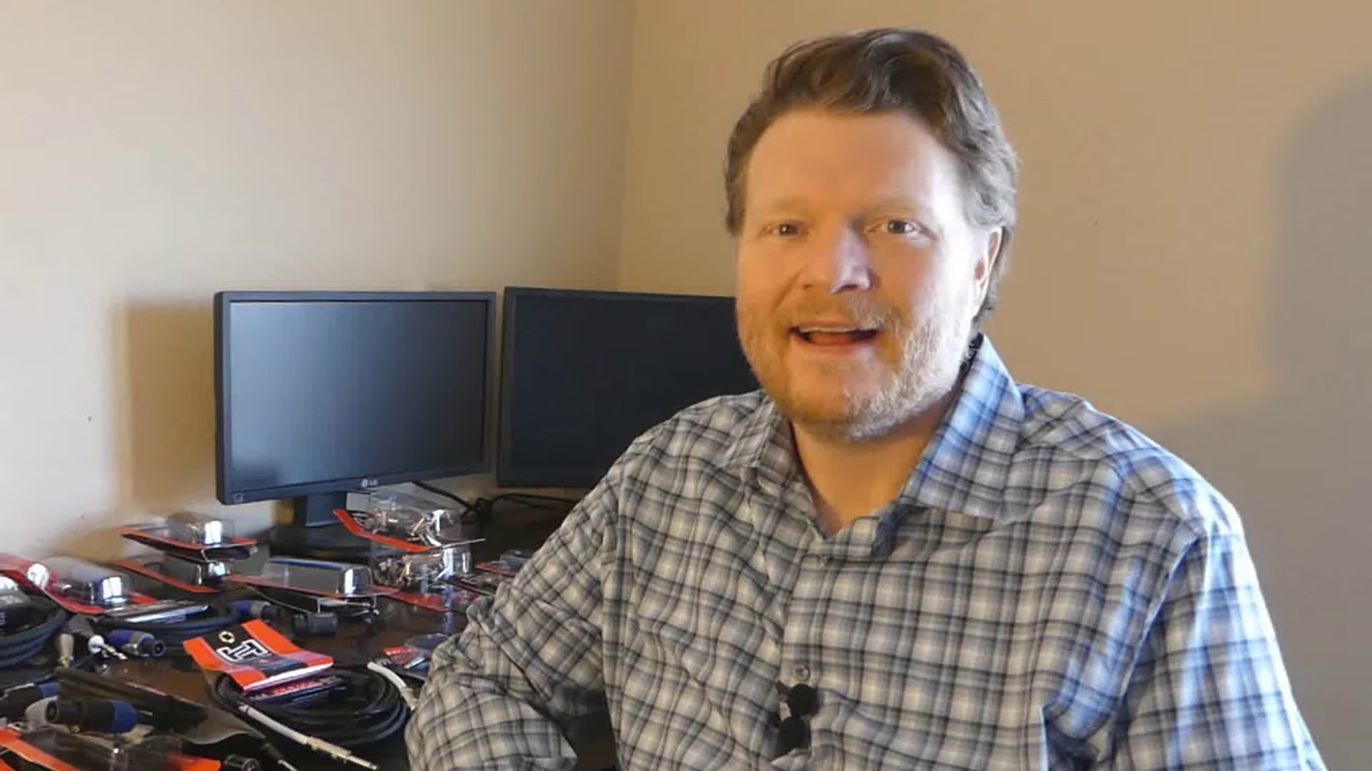 | 0:00   | 0:01   | 0:01   | 0:01  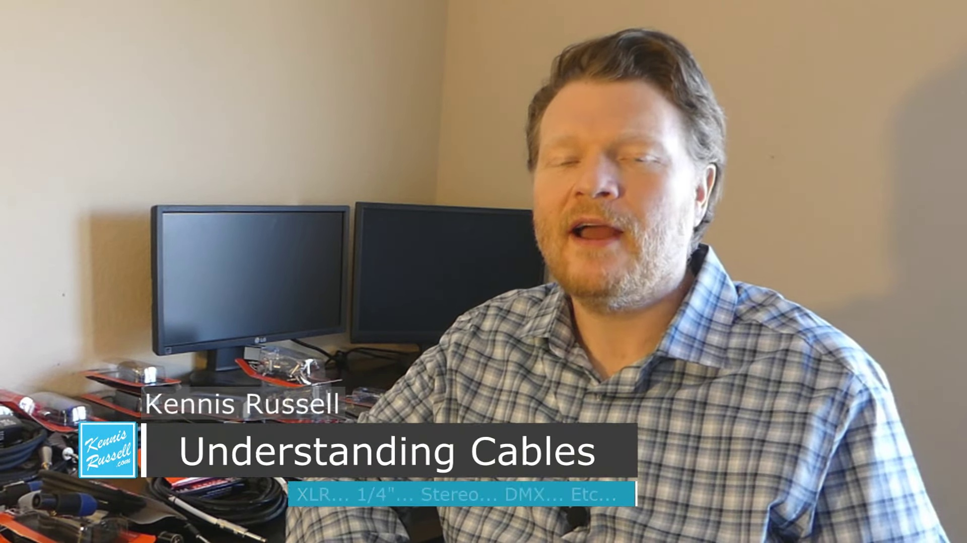

Transcript
(No speech detected in this section)

Section 0: Cables management
Time: 0:02 - 0:04

Summary
The person is discussing or demonstrating cable management techniques, as evidenced by the array of cables bundled together behind them.

Representative Frames
0:02   | 0:02   | 0:03   | 0:03  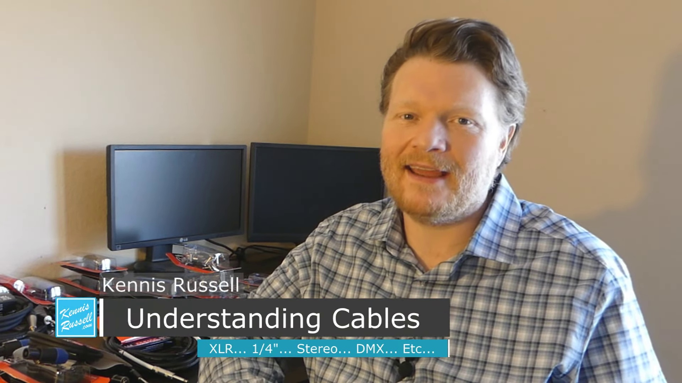 | 0:03  

Transcript
[0:00] Hey everybody, Kenneth Russell here. I hope you're doing great today. Today I'm talking about cables,

Section 0: Making videos for musicians
Time: 0:04 - 0:06

Summary
The person makes videos that help musicians become better musicians, as mentioned in the audio segment.

Representative Frames
0:04   | 0:04   | 0:05  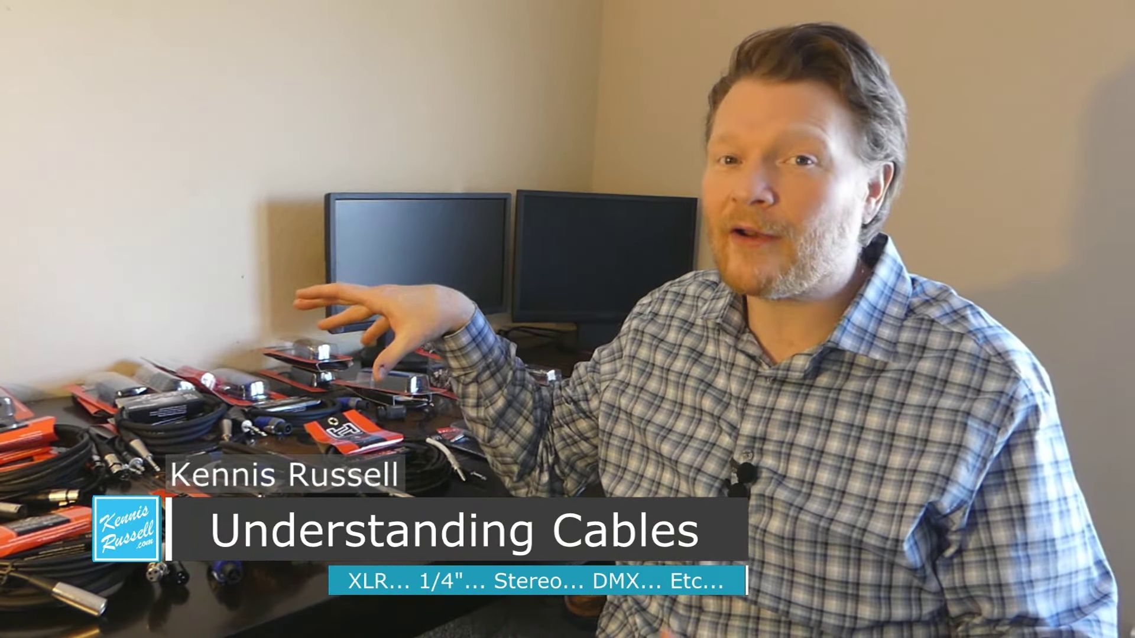 | 0:05   | 0:05  

Transcript
(No speech detected in this section)

Section 0: Descriptive title 5
Time: 0:06 - 0:08

Summary
The person is seated at a desk with multiple computer monitors and equipment in front of them, indicating a workspace or office environment.

Representative Frames
0:06   | 0:06  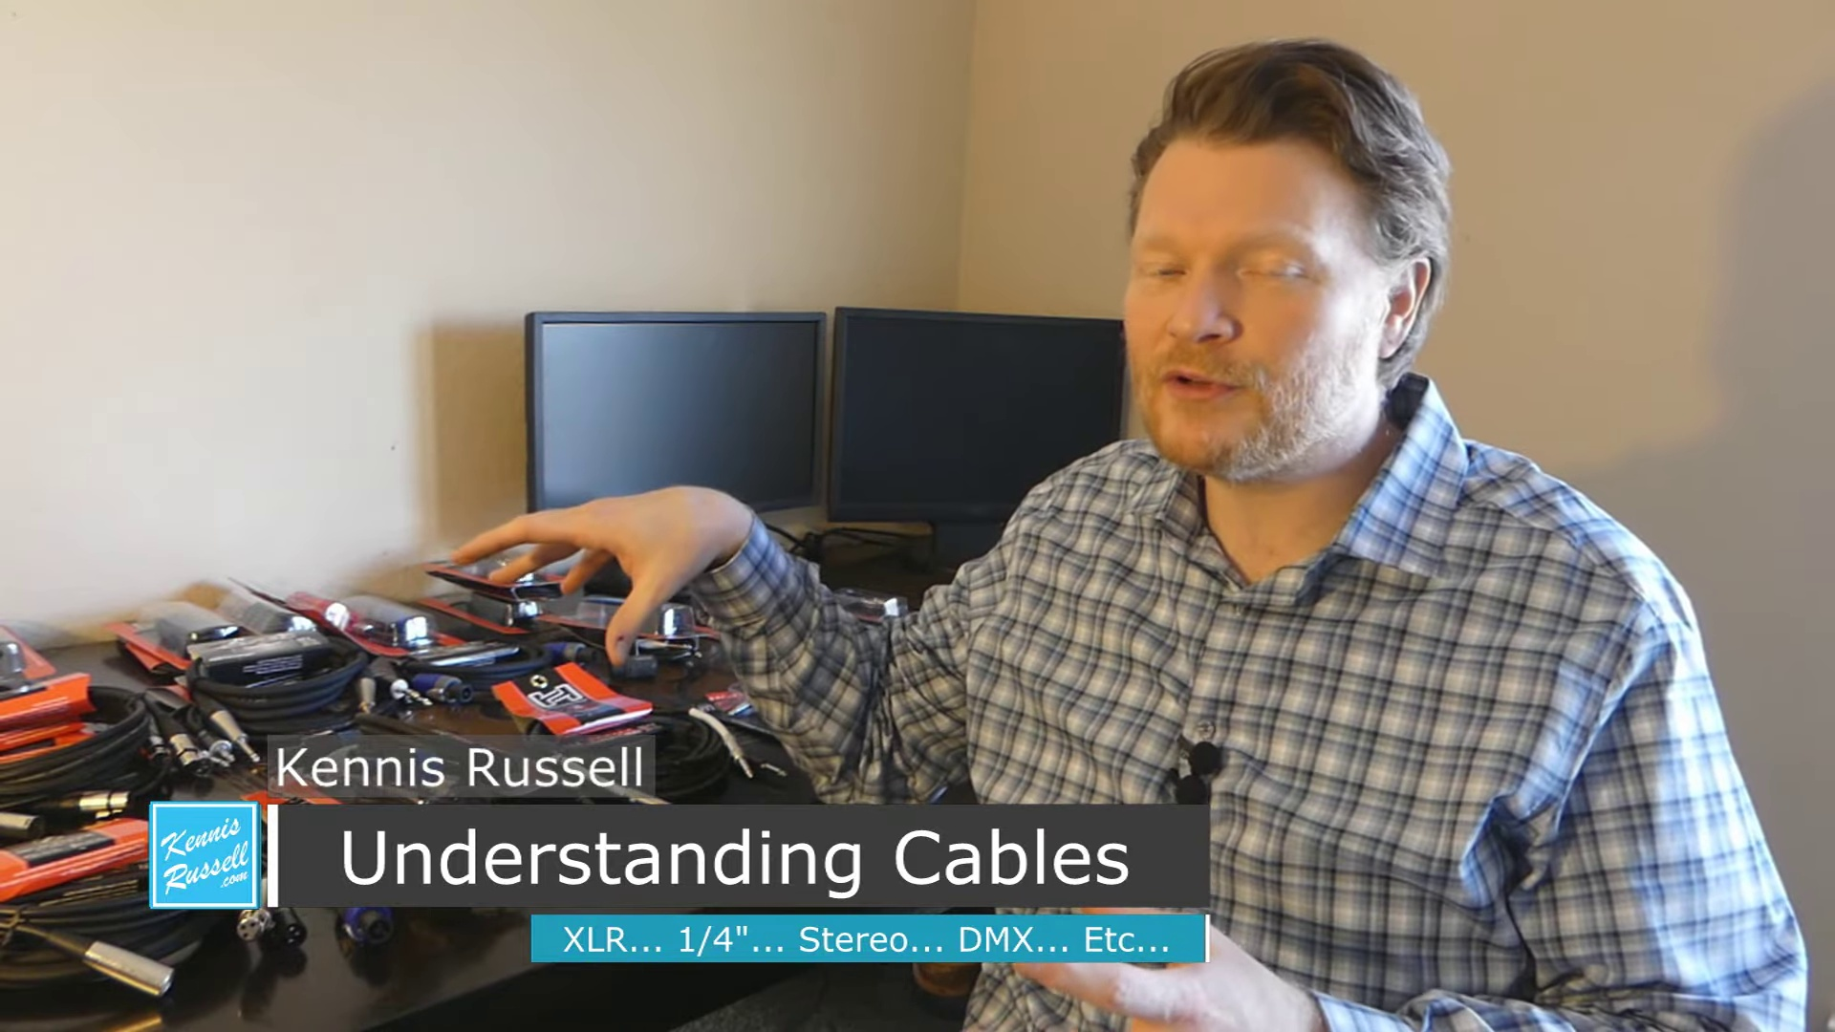 | 0:07   | 0:07   | 0:07  

Transcript
[0:04] how to understand cables and their connectors. Check it out.

Section 0: Electronics project or demonstration
Time: 0:08 - 17:00

Summary
The person may be involved in an electronics project or demonstration, as suggested by the collection of electronic components behind them.

Representative Frames
2:56  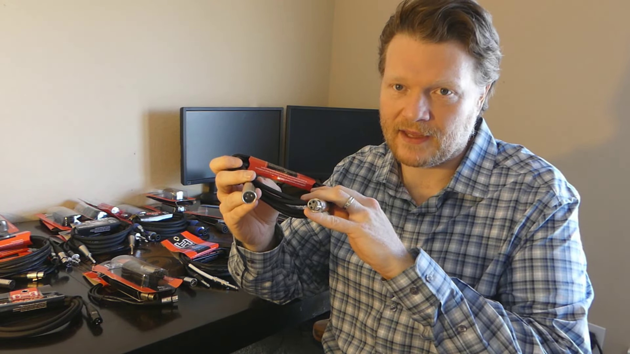 | 5:45  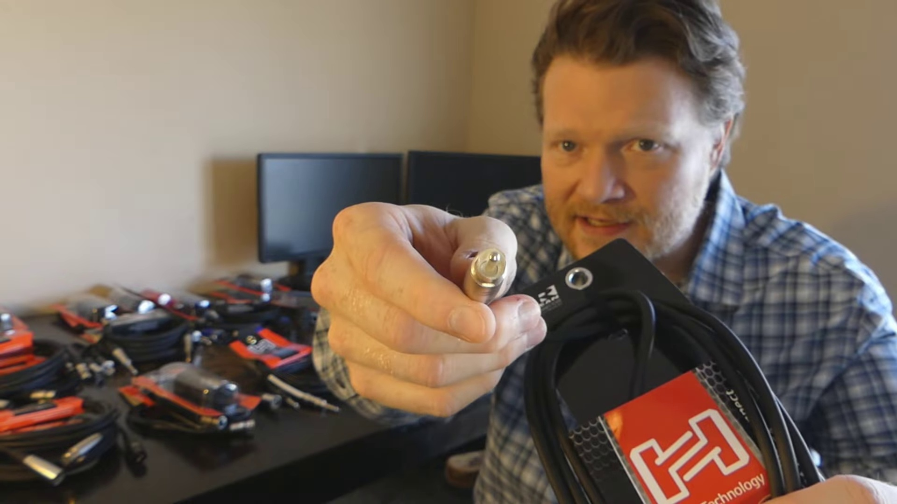 | 8:34  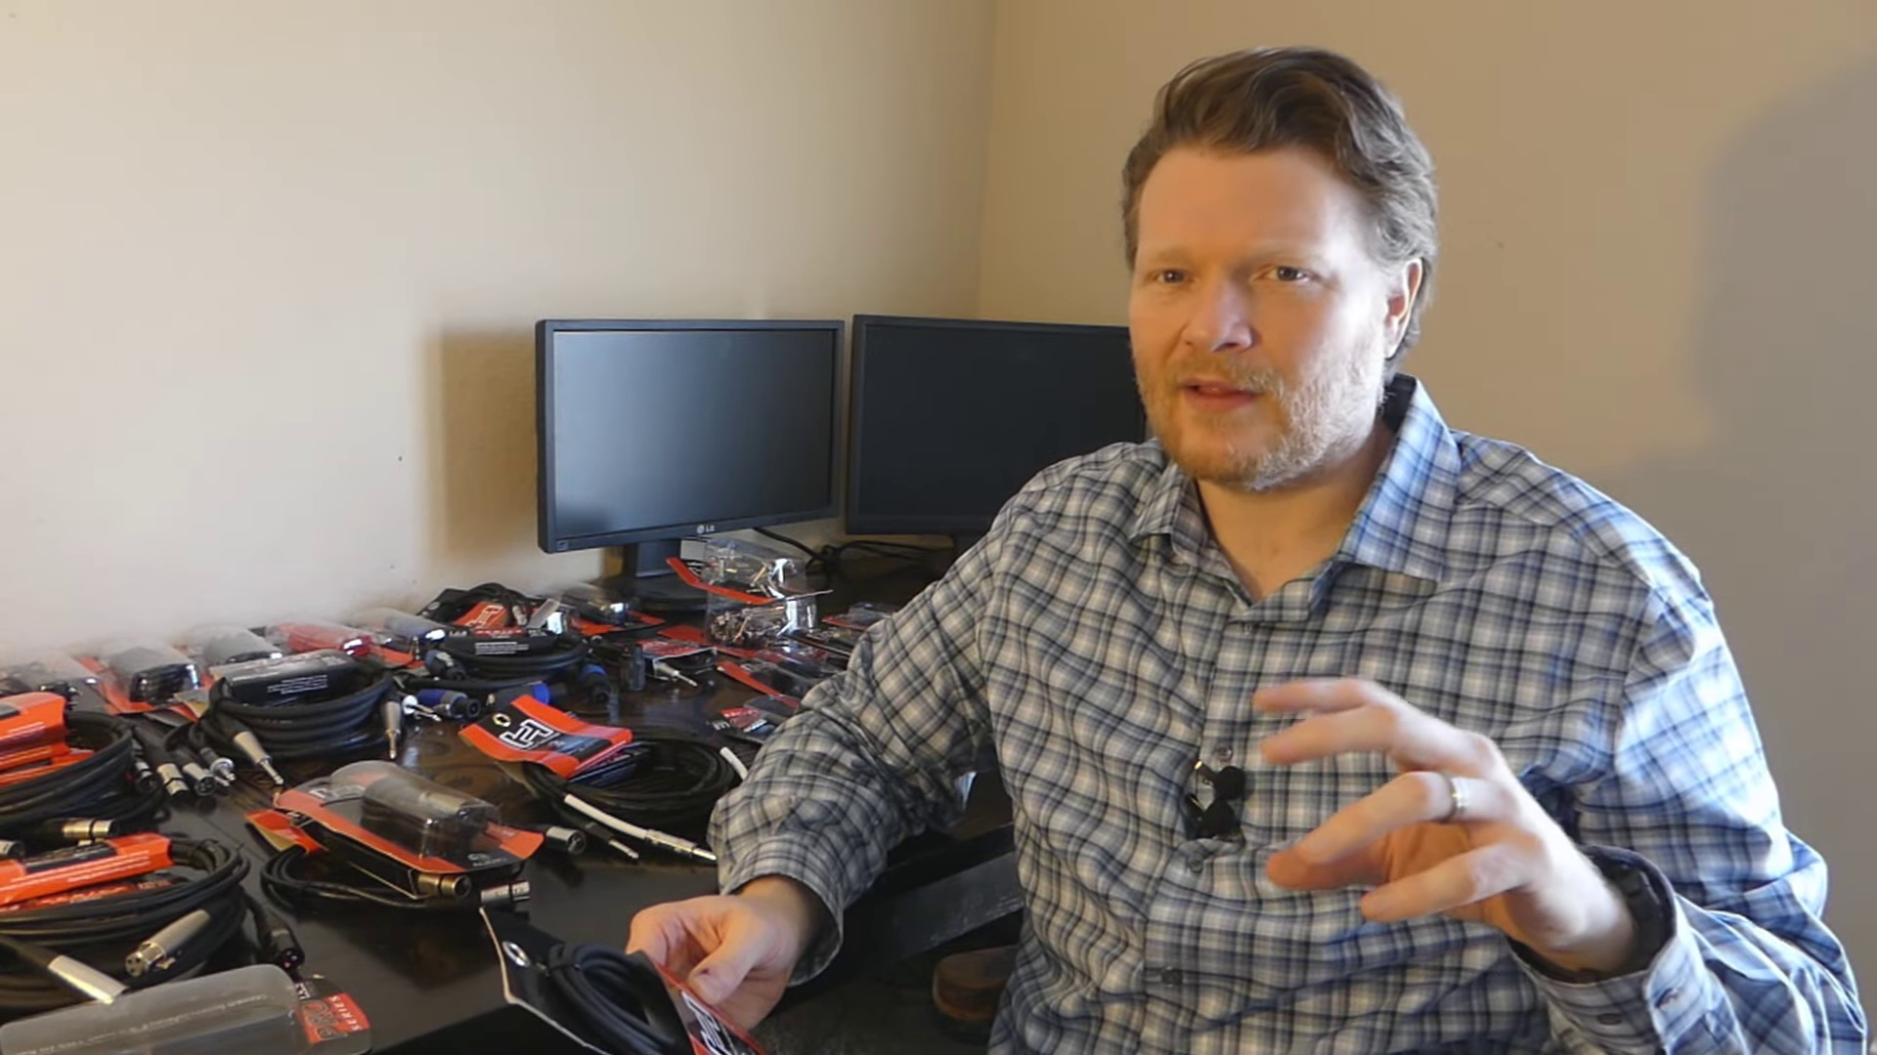 | 11:22  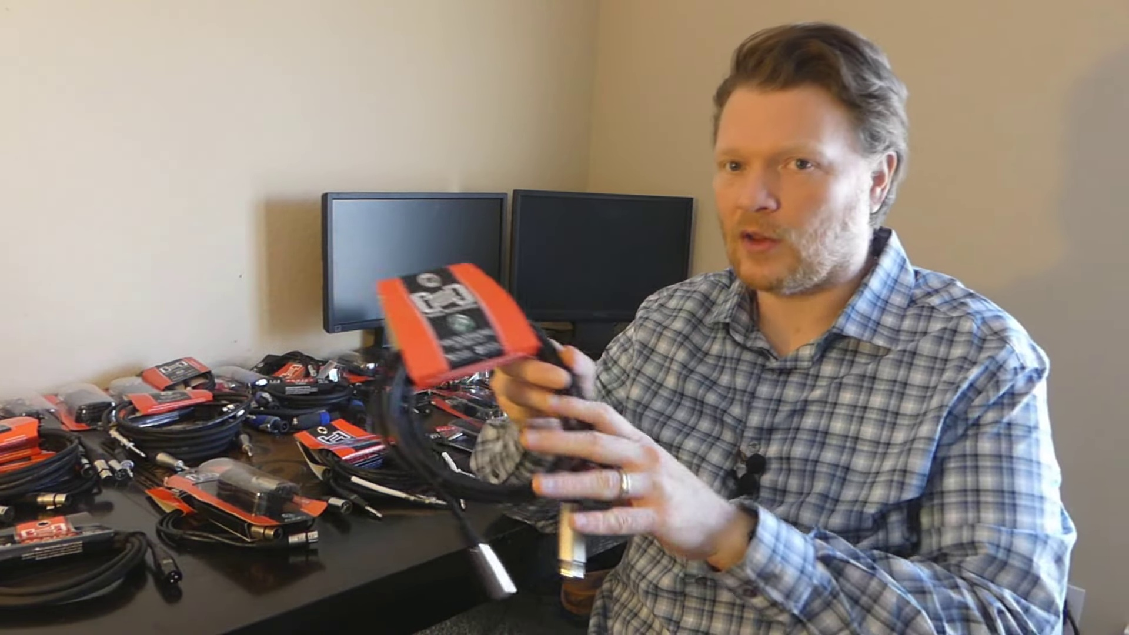 | 14:11  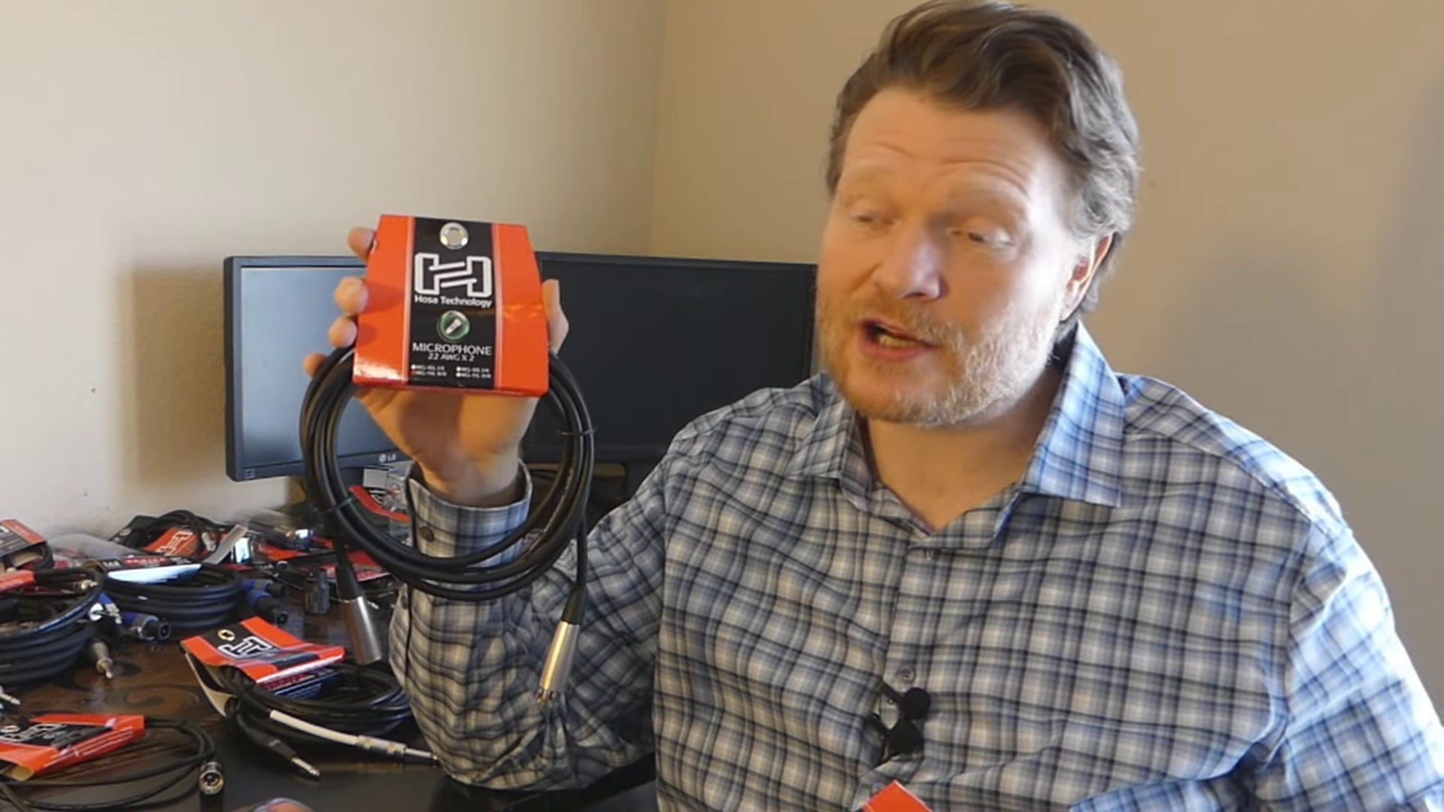

Transcript
[0:14] Well, if you're a musician or working in sound in any way, you're going to come across cables
[0:20] and all different types of cables. And sometimes it can be kind of daunting if you're just getting
[0:25] into it because there's all these different connectors. You don't know what they're called.
[0:28] So let's talk about the connectors in the first half of this video. And then we're going to talk
[0:33] about the cable itself in the second half of the video. By the way, a huge shout out to Hosea Cables
[0:39] for sending me all these cables. And they're just awesome cables. I've been buying Hosea Cables for
[0:45] years. If you're looking to buy an instrument cable for your guitar or microphone or whatever kind of
[0:50] cable you're looking for, don't look any further than Hosea. They really are awesome cables. They
[0:55] have different levels, good, better, best, and they're all very good actually. So let's talk
[1:00] about connectors. The first connector I want to talk about is the quarter inch connector.
[1:05] This would be also called an instrument cable or a guitar cable. Quarter inch, instrument,
[1:12] guitar cable. These are all synonymous with each other. So if someone says, hey, hand me that guitar
[1:16] cable or hand me that instrument cable. This is what they're talking about.
[1:20] So the quarter inch cable just has two ends like this usually. And this is the male connector.
[1:27] They're both male connectors. And we'll talk about that in a second. But they basically just one goes
[1:32] in your guitar, one goes in your pedal board or amp. There's a bunch of different applications for
[1:36] quarter inch cables. So this is what the quarter inch connector looks like. Now there is a male end and
[1:43] the female end to just about any cable really. And this is the male end. And I'll let you decide
[1:52] why it's called the male end. I'm not going to go into that, but let me see. Where was the
[1:56] other one I was looking at? Oh, and then this is the female end there. And it's just basically
[2:03] the male end goes into the female end. And so, you know, on your guitar, that's what this is going to be.
[2:10] This is the female quarter inch connector or the jack. A lot of times people just say jack. If it's
[2:16] attached to something, it's usually called a jack. Then you just plug it in like that. So in theory,
[2:21] I could have the end of this cable could be a female connector and I could keep on connecting them
[2:27] and just making a big long chain. So this is the quarter inch connectors, the male and female
[2:32] quarter inch connectors. The next kind of cable is the XLR cable. And that is this right here.
[2:39] Now, XLR technically is just the designation for the cable end itself. But usually when someone says
[2:48] XLR cable, they're meaning give me a microphone cable or an audio cable with these connectors at
[2:56] the end of it. So you can see here, this also has two ends to it. This is the female end because it's
[3:02] got three holes there. And this is the male end. It's got three stems there and they connect together.
[3:08] And you can make audio cables like this. Microphone cables connect together and loop like that,
[3:15] which there's no purpose in that other than storing it maybe. But you can connect them,
[3:19] daisy chaining them. And then on the back of your speaker or whatever, it's going to have one of these
[3:23] ends that's going to plug into or your microphone. There's a lot of different uses for this on a mixing
[3:29] desk. Most of the inputs are going to be XLR. If it's a pro mixing desk, sometimes you'll have quarter
[3:36] inch on the mixing desk as well. Usually those are your main connectors. Also, XLR cables can be
[3:42] data cables used for DMX lights. And we'll talk about that in just a minute. Right now, we're going
[3:48] to talk about just the connectors themselves. The next connector that is not known as much on the lower
[3:53] end stuff, but a lot higher end pro audio gear has speak on connectors. And this is a speak on
[4:00] connector right there. And this is, I think these are both the male ends right here. Now you'll see
[4:06] sometimes that there'll be a female end. This is what the female end looks like. And they click in
[4:13] like that. Now the great thing about speak on connectors is they lock into place until you pull
[4:19] this back and you undo it. So basically they just go in like this, you twist them, it locks into place,
[4:25] and then you've got a very, very secure cable until you pull this back. So these are speak on connectors.
[4:32] If you can use them for your speakers, these are great because you're not going to have anybody
[4:37] tripping over a cable and it unplugs. So if you're a DJ, maybe you're a mobile church setting up in a
[4:43] school where people are walking around a lot, it's not a permanent situation. If you have the choice for
[4:49] speak on, they're, they're very, very good. A lot of times too, you'll hear the word new tricks.
[4:55] Someone will say, Hey, give me a new tricks cable or that new tricks connector. It actually isn't a
[5:02] new tricks cable or new tricks connector. New tricks is a brand name. So it's kind of like Kleenex.
[5:07] So, you know, if someone says, give me a Kleenex, they really, they're just saying, give me a tissue,
[5:10] but Kleenex is synonymous with that. So sometimes if someone says, give me a new tricks connector,
[5:16] they really mean speak on. And a lot of times you'll have a quarter inch to speak on adapter used as
[5:23] well. If your speaker cabinet only has speak on connectors, but you only have quarter inch cables,
[5:29] the next kind of connector we're going to talk about is the RCA cable. Now this one has a lot
[5:34] of different applications that you will see, not just in pro audio, but in home audio as well.
[5:40] And this is what the, the RCA connector looks like there. And you know, you'll see this a lot of times
[5:46] the back of like a stereo system. There's just a lot of applications. The, the consumer world has
[5:52] really embraced the RCA connector. But it's also has a lot of purposes in pro audio and in sound.
[5:59] For example, a lot of times if you're doing anything stereo, if you're coming from a computer
[6:04] and you're hooking up into a mixing desk, a lot of times they'll have from your computer to a,
[6:11] like one cable coming out of that, which we'll talk about in a second.
[6:13] And then it's making a Y connection to the mixing desk left and right. A lot of times the other end
[6:19] of these will say, we'll have like a red and a yellow. These are also used in video as well.
[6:24] They're, they're pretty cool cable because they'll transmit a lot of different types of information,
[6:28] but this is the, the RCA connector right here. So the connector itself is called RCA.
[6:34] The next connector is a 3.5 millimeter connector or a eighth inch sometimes is what it's called.
[6:42] It actually 3.5 is, is more accurate, but let me open this up here. You're probably very familiar
[6:48] with this because this is the kind of connector that's going to be on your phone. So if you're,
[6:53] you're plugging this in from an iPod or an iPhone into something else, this is going to be the connector.
[7:00] So that, that little jack that's on everybody's phone, that is a, a 3.5 millimeter jack. Now I'm going to
[7:07] actually grab my headphones here. This is actually the headphones to my phone right here. And you can
[7:12] see on this one, there's actually three white lines there. That's because this has a microphone hooked up
[7:19] into this. There's actually three different signals happening left, right, and then the microphone.
[7:24] Usually though, in the, the pro audio world, you're going to see this connector right here, which is,
[7:30] it's got two lines here. This is a stereo connector, which means there's a left and a right. So this,
[7:37] this has a stereo connector. Now this is the same type of thing. You're going to see a male in like
[7:42] this and a female in. Also, before I move on too far, this is a quarter inch cable with a stereo
[7:50] connector there, a left and right. So this actually has two cables in here, two signals going through
[7:55] this cable as well. And we'll talk about that a little bit more in a second. The next cable we're
[8:00] going to talk about is MIDI. This is a MIDI cable here, and it's got two different ends like this
[8:07] that have five pins. They look similar to an XLR, but they have five pins. This is a data cable. It's
[8:15] going to transmit, uh, ones and zeros from a keyboard or an effects pedal, or there's a lot of applications.
[8:24] This is definitely a pro audio cable here. So a lot of times in the back of, of, uh, of keyboards,
[8:32] you'll see MIDI. Um, a lot of times keyboards are kind of moving away from MIDI and they're going to USB.
[8:38] So a lot of your older keyboards are going to see MIDI instead of the USB. If you're hooking it up
[8:43] like to a computer to record or something like that. So this is a MIDI cable and it produces or
[8:48] transmits data. So now that we've talked about the different types of connectors in cables, let's talk
[8:53] about the cable itself. So for example, let me compare a few different cables that I might have.
[8:59] This is a guitar cable and this is a speaker cable. Both of these have quarter inch jacks here,
[9:08] but they're made for two different reasons. Obviously this guitar cable, this generally when someone says
[9:14] quarter inch cable, they're talking about an instrument cable. They're talking about this. This is for
[9:19] instrument purposes, but this thicker cable here is for speaker purposes. Now here's the thing with this.
[9:27] Sometimes you can take a instrument cable and hook it up to a speaker and it'll work, but
[9:34] instrument cables are not made for speakers. Instrument cables are not rated. They're not made for
[9:40] sending loud to a loud speaker spending, sending the audio to a loud speaker. So even though sometimes if
[9:46] you hook up this cable to a speaker, it'll work, it's not going to be as good as audio and I think
[9:52] that you might be able to damage your equipment if it's kept on for a long, long time. If you're just
[9:57] testing something out, it'll be just fine. But if you're carrying a load on this, this cable is
[10:03] probably going to get kind of hot and I just wouldn't do it. Now the other way around, if you take a
[10:07] speaker cable and try to use this for guitar, it's not going to do anything bad and it's not going to do
[10:13] anything good either. It's not going to be able to transfer the signal. It literally just won't go
[10:18] through. So anyway, sometimes you'll see these two different connectors used for two different
[10:24] purposes. So how do you know if it's a connector or not? Like this one here, this one looks just like
[10:33] an instrument cable, but it's not. It's a speaker cable. So how do you know on the cable itself,
[10:39] see if you can read that there. It'll say speaker cable. And this one says speaker gauge,
[10:45] speaker cable, 16 gauge. And so on these, on the instrument cable, it's going to say
[10:51] either instrument or guitar cable. I don't know if you can see that there or not, but it'll say
[10:56] guitar cable on there. So, or instrument cable. So that's how you know. So whenever you, you,
[11:03] if you have a lot of cables, you might want to just label them. That's what I do. A lot of times,
[11:08] I'll just put a piece of tape on the end of it and I'll just put GTR or SPK or something like that.
[11:15] So I know if that's a speaker cable or if it is in fact a instrument cable. The next kind of connector
[11:21] is XLR. And these three can all be used for speaker. You can use a, a, a speak on XLR or quarter inch
[11:31] cable. And here's the thing. There's really not much of a difference between these cables. If you're
[11:36] hooking them up to a speaker, you're pretty much going to get the same audio. Matter of fact,
[11:40] a speak on cable and a quarter inch cable, these are the same cables with just different connectors
[11:47] at the end. Now the XLR cable is a balanced cable, but it's not really going to make a difference in
[11:54] the sound that you have. If you have a buzz in your system, perhaps you might want to try to use
[11:58] an XLR instead of another cable. But generally speaking, XLR, quarter inch, speak on,
[12:04] they're all going to work really well for speakers, but they're three different connectors.
[12:08] Just depending on the manufacturer, they may want to use only quarter inch or only XLR or only speak on.
[12:15] A lot of, a lot of backs of speaker cabinets have all three of them on it. So just it's the same basic
[12:22] thing. People ask sometimes, are you going to get a lesser quality audio if you use a adapter,
[12:29] like one of these going from a quarter inch to the speak on? No, you're not. All that the speak on is
[12:35] doing is just making that really secure connection. Now over time, probably it's going to wear better,
[12:41] the speak on connector is, than a quarter inch connector, but it's going to give you the same
[12:45] sound. Same thing with if you're converting anything. If you're, if you're having like,
[12:50] going from an eighth inch to a quarter inch, it's the same sound. It's just the connector
[12:55] transmitting the signal. If it's a quality connector, then it's going to have good sound coming to it.
[13:01] Now let's talk about XLR cables, both data and audio cables. Okay. So if it's a longer XLR audio cable,
[13:09] usually it's going to be labeled like this one, it says microphone cable. Sometimes you'll see them
[13:14] where they're labeled, uh, just XLR or they'll just say audio cable. Let's see this one here.
[13:20] This one just says balanced, uh, interconnected. This one is shorter. It says it's a five foot cable.
[13:29] It's a, it's just says audio. And the reason why that is, is because a five foot cable is not going
[13:33] to be very good for a microphone because you can't hold it for very long. You can't even stand and sing
[13:37] with it. So XLR cables are the connectors, but one is data and one is microphone. What does that mean?
[13:45] These have different homages. Basically they're going to produce different frequencies. And so
[13:51] they're going to transmit frequencies better for the different applications. So a lot of times you can
[13:57] actually take a XLR microphone cable and plug it into a DMX light, which is going to be a, it's
[14:05] transmitting data, uh, ones and zeros digital signal, and it'll actually transmit it, but it won't do it
[14:13] well, and it's going to have some interference and it's not going to be as reliable as a DMX cable.
[14:20] Basically the DMX cable is better at transmitting the digital information. So unless you're just in
[14:28] an absolute pinch, use a data cable to transmit DMX signals and don't use a microphone cable.
[14:35] Here's the thing, data cables, the DMX cable will not go the other way around. You cannot use a DMX cable
[14:41] for a microphone or any sort of audio. It just simply is incapable of transmitting that information.
[14:47] It's not made for that. It's a digital cable. It's not an analog cable for those purposes. So you can try
[14:54] to hook it up. It's just, you're never going to get sound out of it. It does, you can use the, the, the
[14:59] microphone cable for digital, even though it's not recommended, but it will not go the other way around.
[15:04] So therefore what I do is I always label my DMX cables. I just put a piece of tape on it and I
[15:10] write DMX on it just so that there's no way in the pinch. You know, the thing is whenever you need a
[15:15] new cable, you don't always have a lot of time. So you're just like grabbing a cable and you're trying
[15:19] to hook it up. So I always make sure that it's super, super obvious of DMX cables so that I don't
[15:25] accidentally grab the wrong one. Now, if you ever have any questions with it, it'll say on here, let's see,
[15:31] this one says DMX cable, 24 gauge, 120 ohm. If you look here, let me see if it'll focus on that.
[15:43] So it'll say DMX cable on the cable itself and on a microphone cable. It will either have nothing,
[15:50] which is usually they have it now though, because DMX is so popular or it'll say a microphone cable,
[15:57] or it might even say audio cable or instrument cable. But usually it says microphone if it is a
[16:02] microphone cable. So you want to make sure that it does say audio or microphone on the XLR if you're
[16:07] using it for an audio purpose. So with cables, as you can see, it's actually not super complicated.
[16:12] There's only really a handful of connectors. There's more connectors out there, but these are the ones
[16:17] that you're going to encounter most. If you're working in sound or you're working in as a musician,
[16:22] you're going to see these connectors all the time. It's important that as a musician, you're familiar
[16:27] with these because it's kind of the language that everyone is speaking. This is the information that
[16:31] you're going to need to know as a musician. And so hopefully this was helpful to you. If it was,
[16:37] please hit the thumbs up button, subscribe to my YouTube channel. If you didn't like this video,
[16:41] just go ahead and hit the thumbs down button. I won't be offended. I am kind of surprised you stuck
[16:45] around this long just to hit the thumbs down. But if you did, it's all good. Okay.
[16:49] I make videos that help make musicians better musicians. So hopefully this helped you.
[16:56] Anyway, Kinnis Russell out and I'll see you in another video.

