Engagement Analysis: gdJHi9I0V4w

Section 0: A series of images depicting various electronics projects and settings
Time: 0:00 - 0:03

Summary
The images show different outdoor settings with a focus on electronic equipment, components, and devices. They appear to be related to teaching or demonstrating electronics concepts, possibly as part of a project or experiment.

Representative Frames
0:00  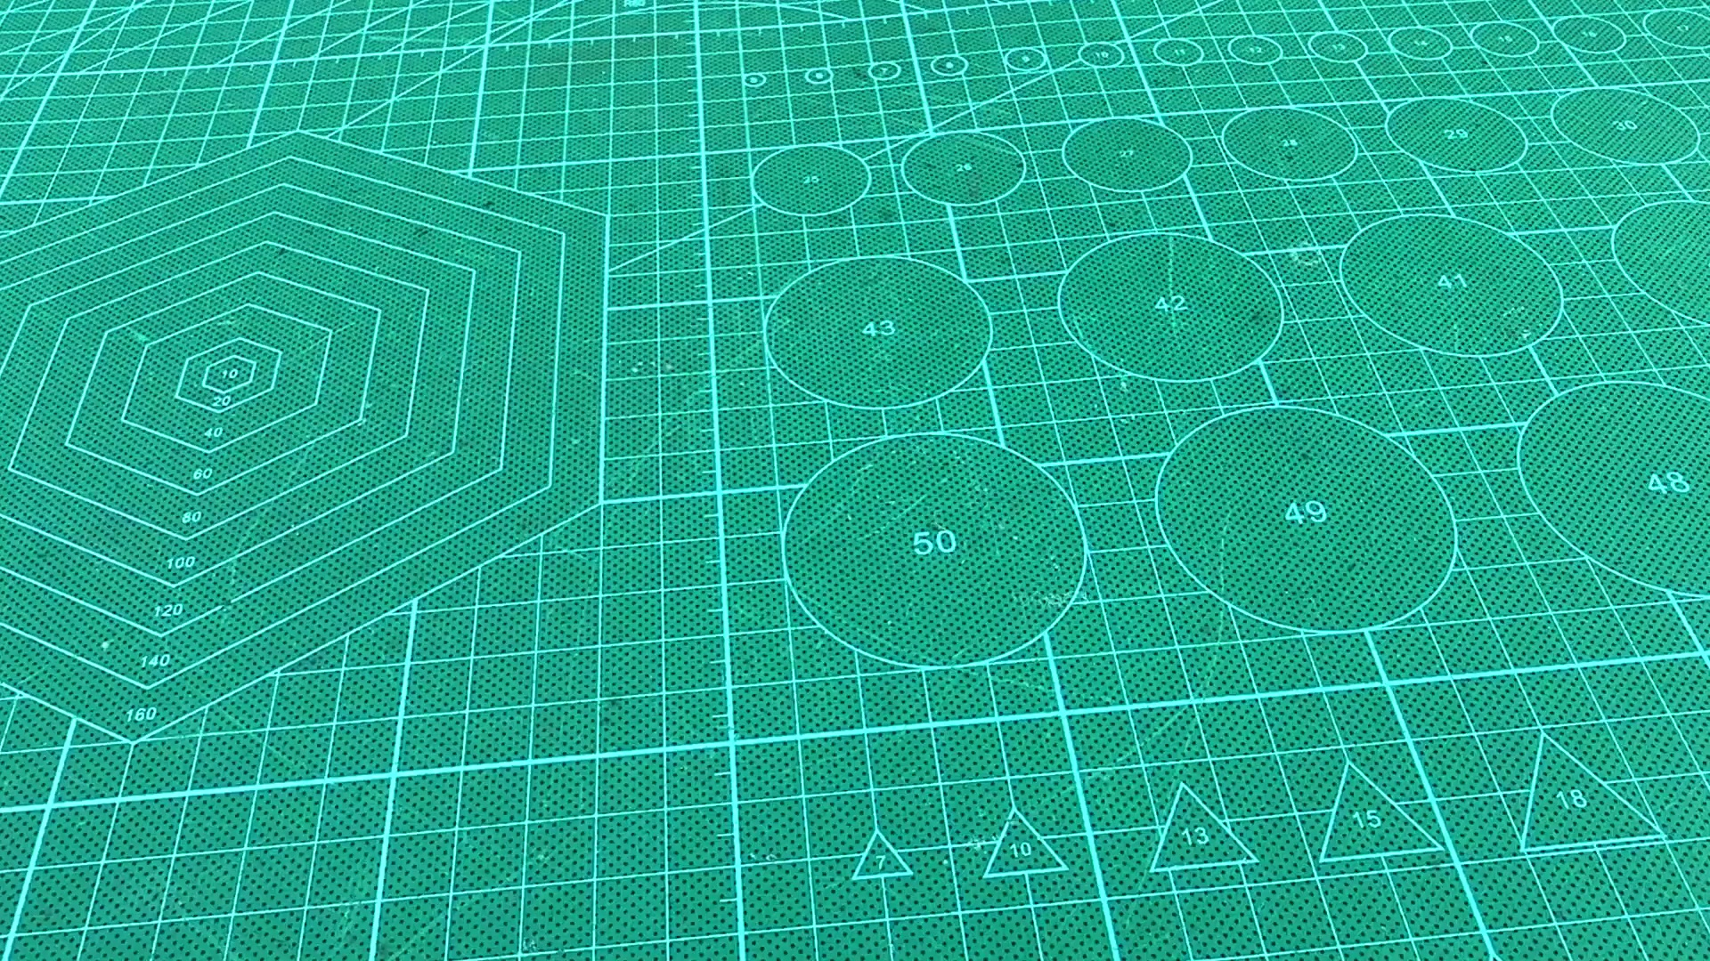 | 0:01   | 0:01   | 0:02  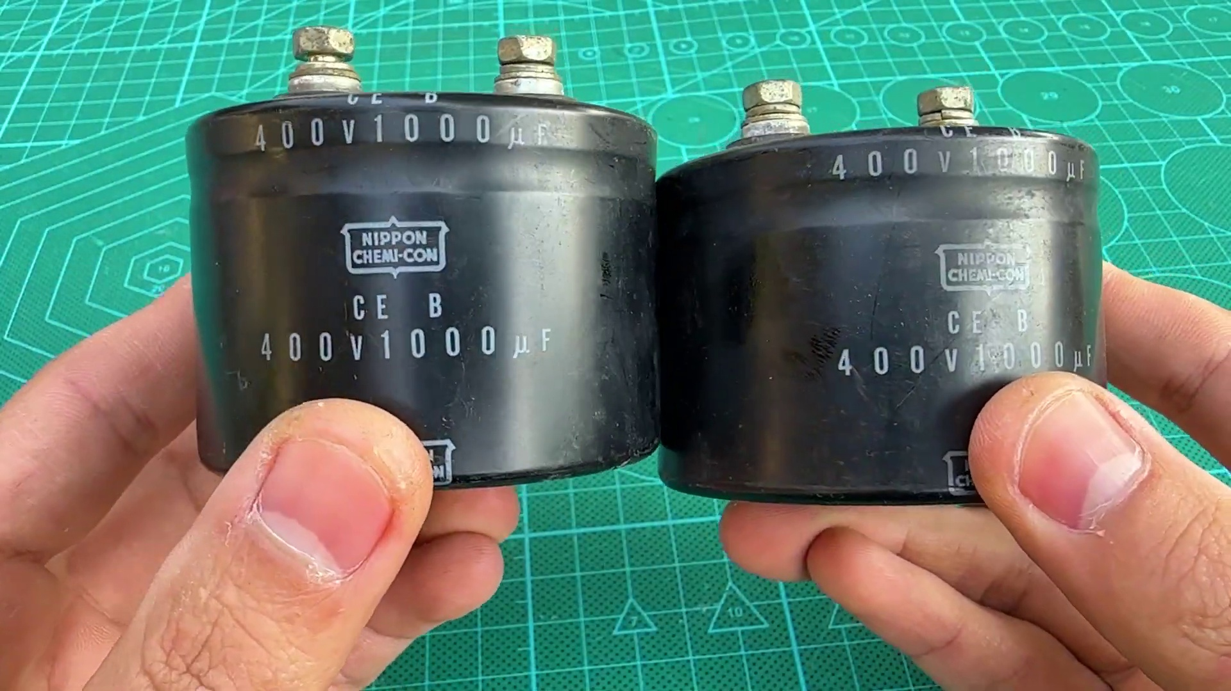 | 0:02  

Transcript
[0:00] saint

Section 0: Image 1: Speaker setup in an outdoor setting
Time: 0:03 - 0:05

Summary
A black speaker is displayed on a wooden table covered in a green cloth. A small electronic device with various components is mounted on the railing of a nearby fence.

Representative Frames
0:03  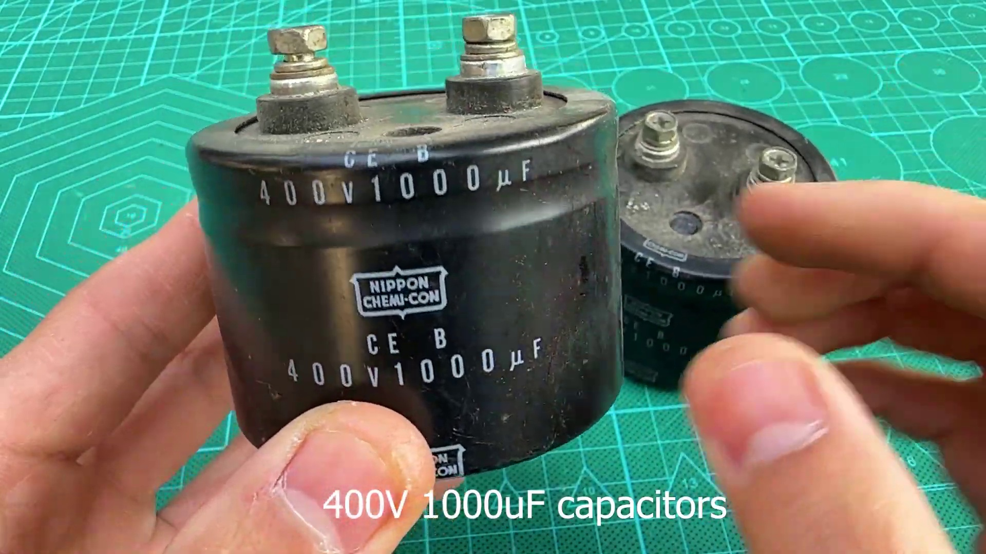 | 0:03   | 0:04   | 0:04   | 0:04  

Transcript
(No speech detected in this section)

Section 0: Image 2: Electronic components and equipment setup
Time: 0:05 - 0:07

Summary
A concrete railing is adorned with various electronic components, including a power supply box, speaker, and battery. A small wooden table features an electronic device connected to cables and a multimeter or signal tester.

Representative Frames
0:05  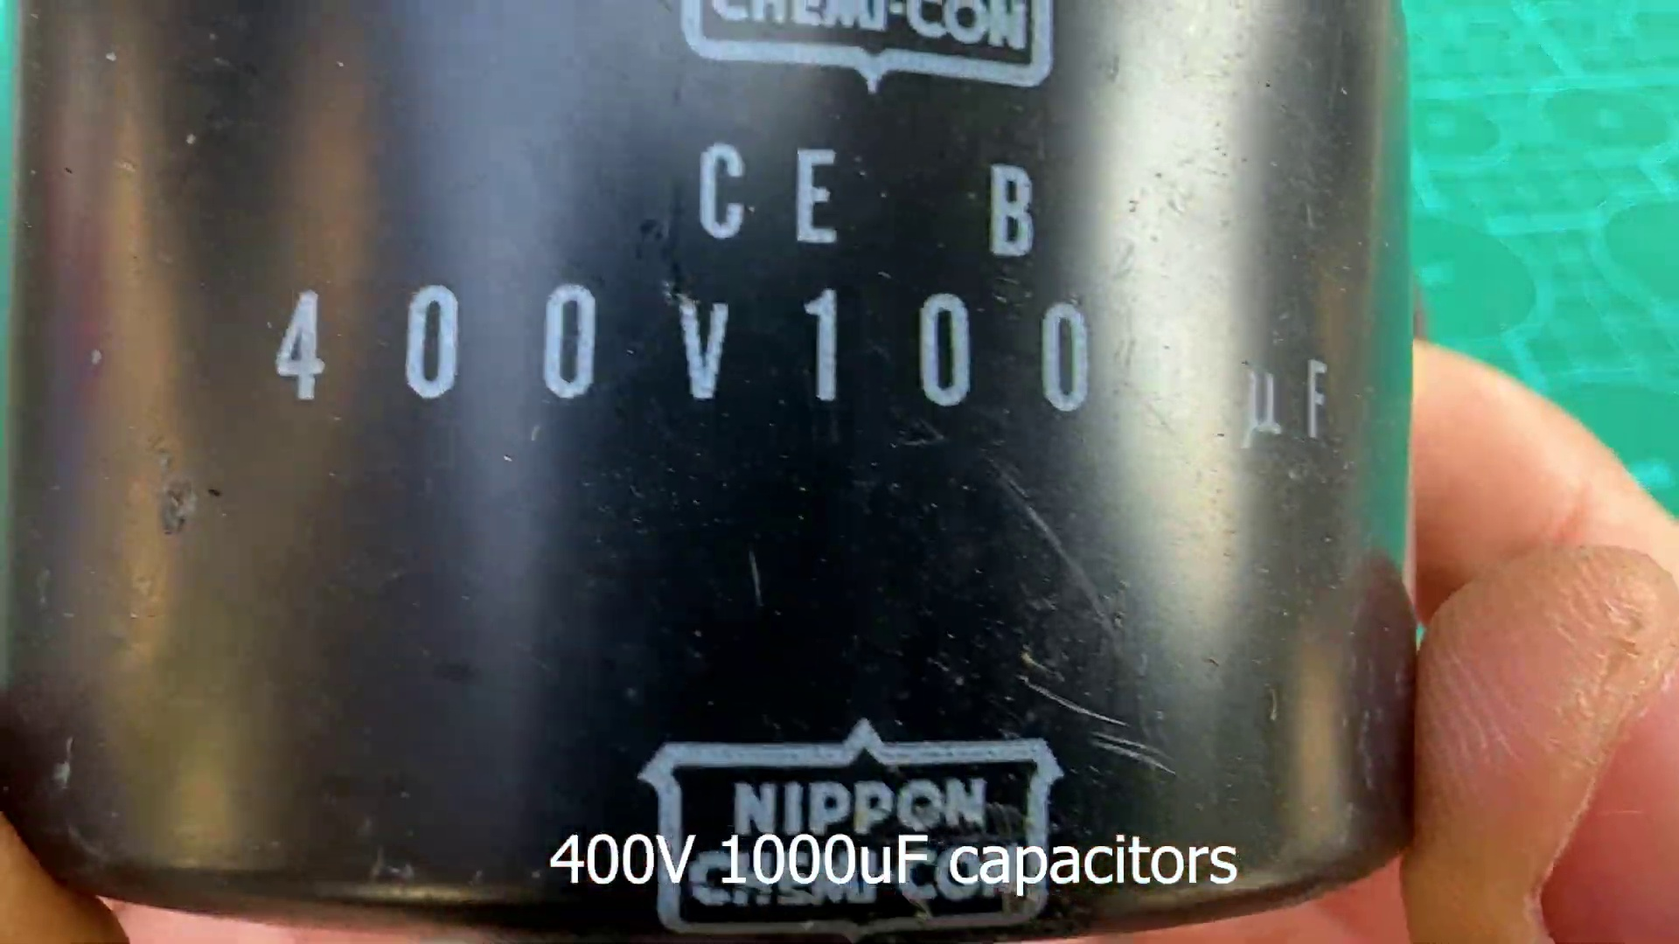 | 0:05   | 0:06   | 0:06   | 0:06  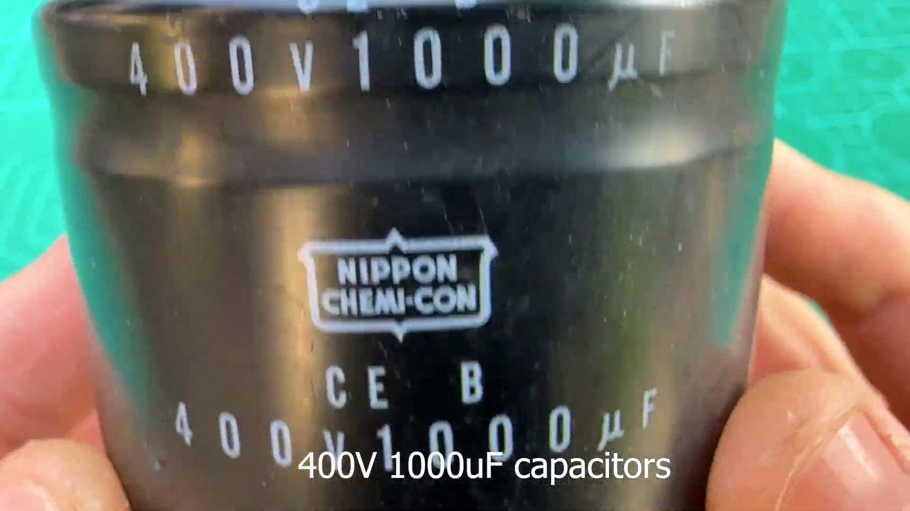

Transcript
[0:04] a

Section 0: Image 3: Person giving thumbs-up gesture towards an electronic device
Time: 0:07 - 0:09

Summary
A person is standing on a wooden ledge, giving a thumbs-up sign against a natural backdrop. A black and white power bank with a red logo is placed on a nearby table.

Representative Frames
0:07   | 0:07   | 0:08   | 0:08  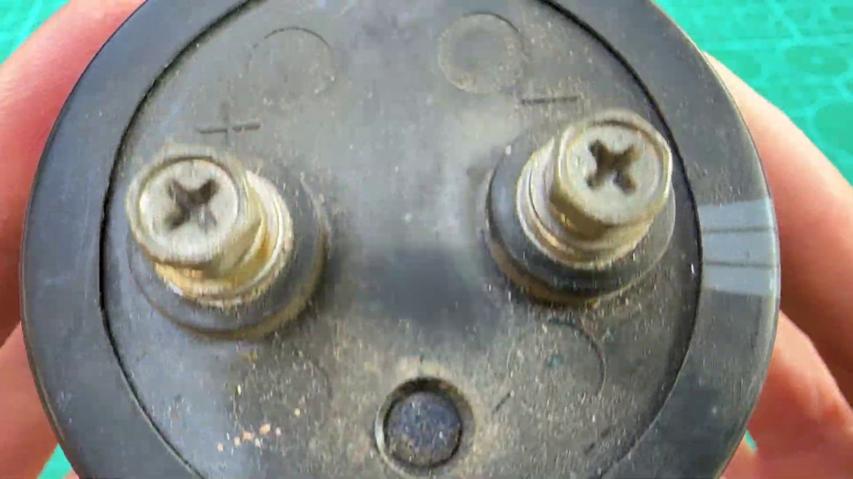 | 0:08  

Transcript
[0:07] christian

Section 0: Image 4: Overlay of Vision technology device
Time: 0:09 - 9:53

Summary
The image appears to be overlaid with another scene showing a person pointing at a piece of equipment labeled 'Vision'. Various components are visible, including a lens and possibly an internal structure.

Representative Frames
1:46  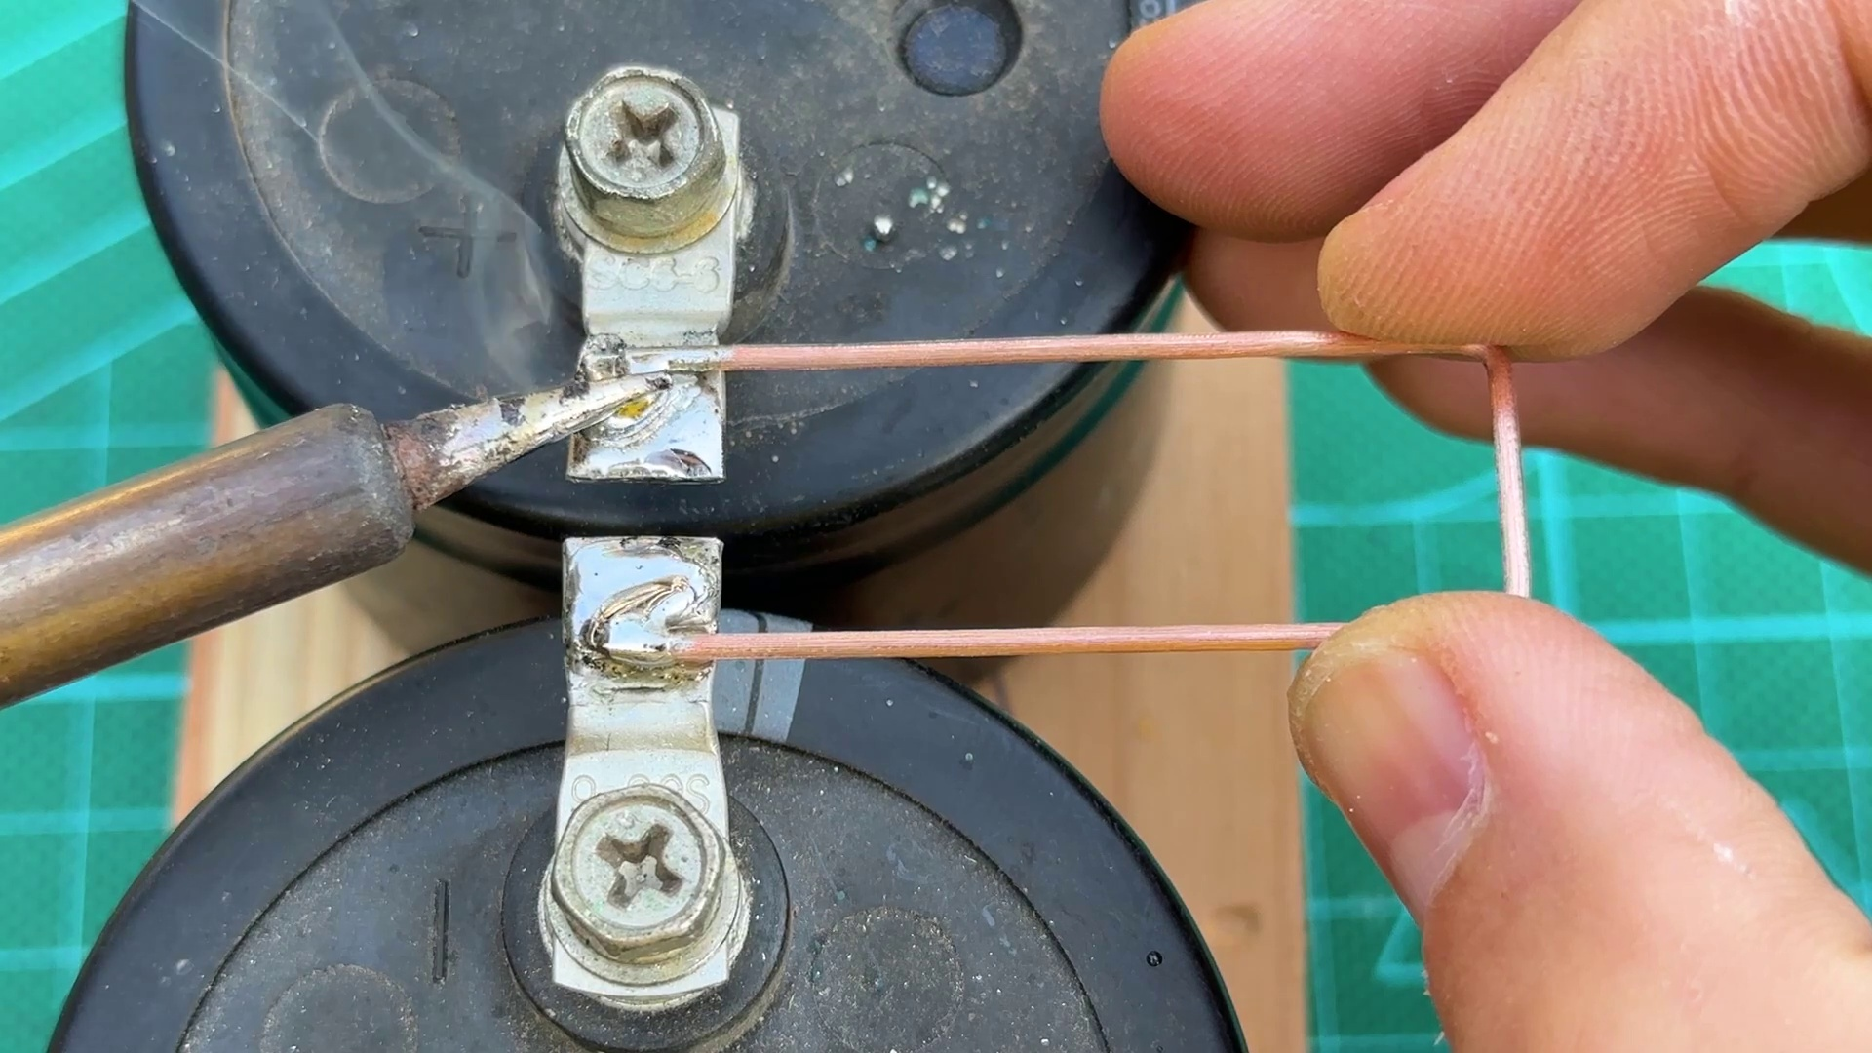 | 3:23  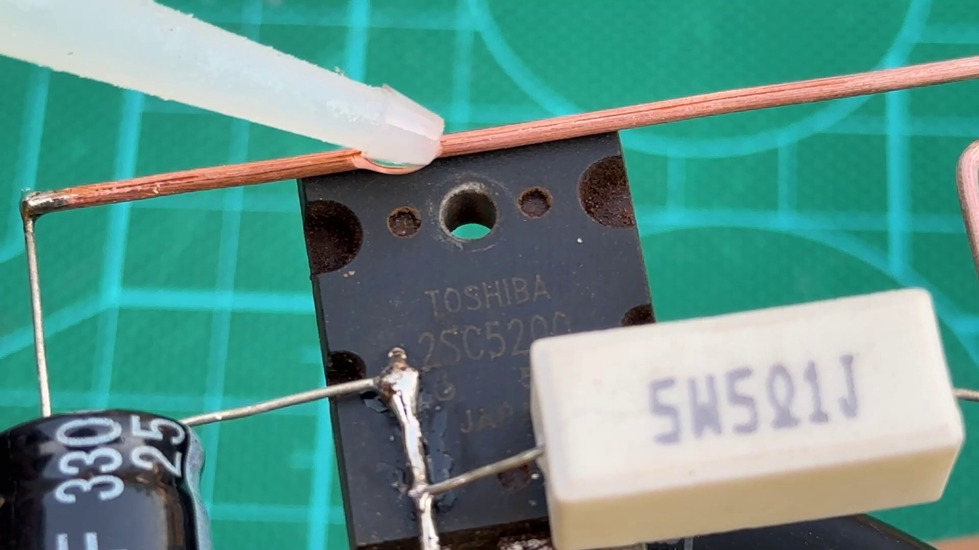 | 5:01  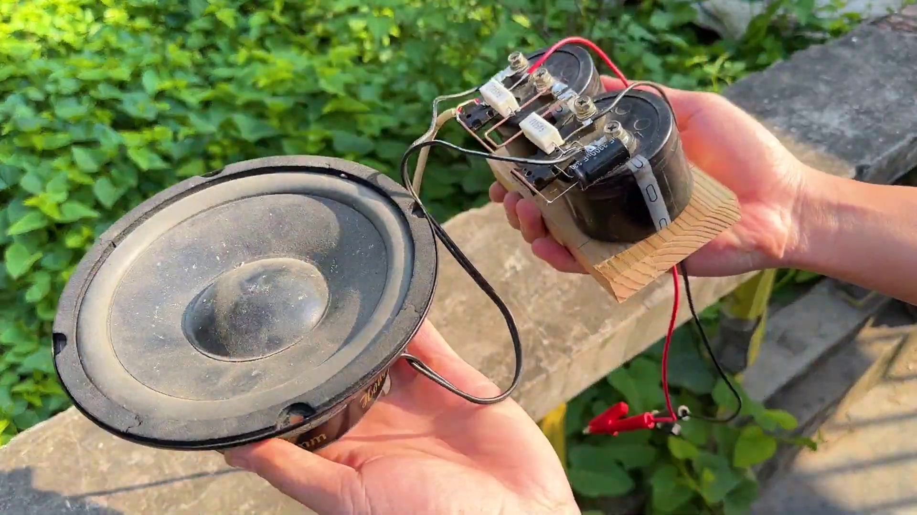 | 6:38  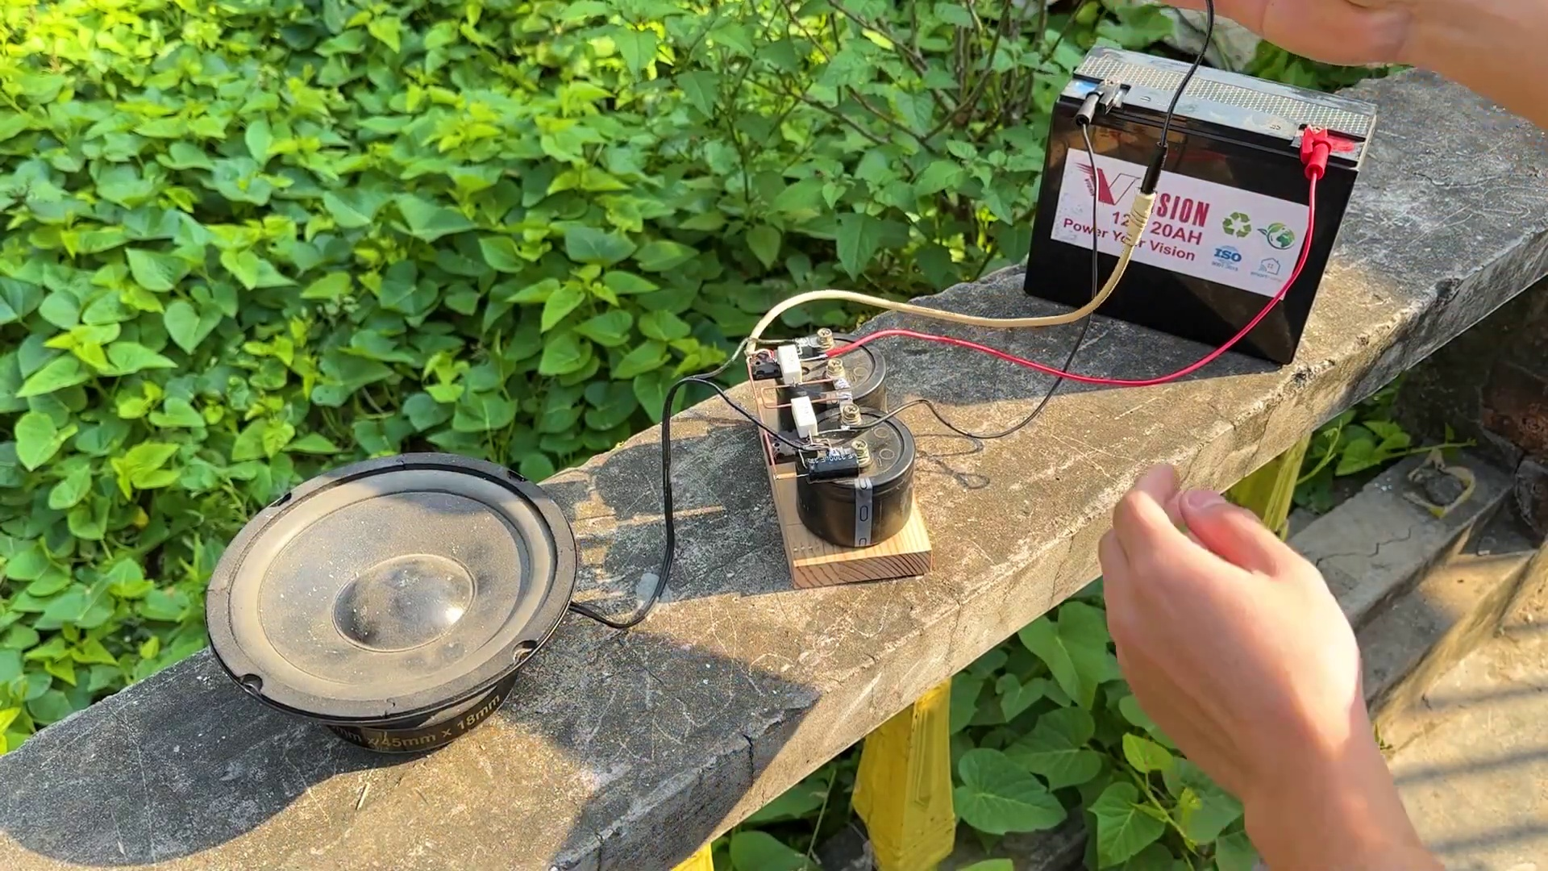 | 8:16  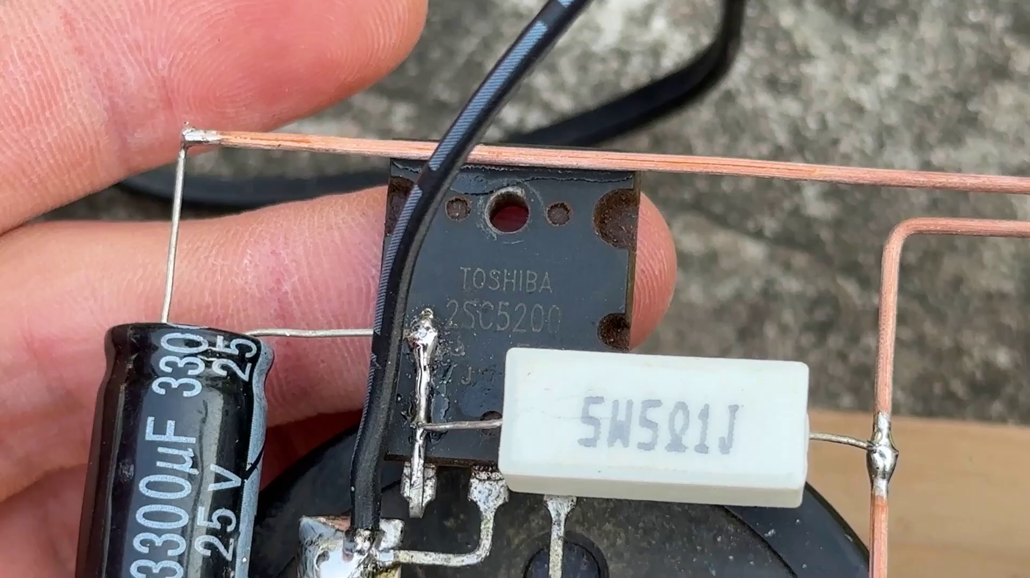

Transcript
[0:11] Alguns
[0:13] an
[0:16] old
[0:23] associated
[0:25] thank
[0:51] calculations
[0:53] and
[0:57] twist
[1:01] fout
[1:08] coisas
[1:14] WRITE
[1:18] EMц
[1:19] Let's go.
[1:49] NASA Jet Propulsion Laboratory, California Institute of Technology
[2:19] Schluss it up withragt stop
[2:23] Back in Mind
[2:53] We knew it was malaise, what this ad would have been thrown
[3:03] We lived in our four generations
[3:08] As ..."
[3:10] They could have gone 13% of our time
[3:14] They could have come a little bit
[3:19] To speak, so-called
[3:23] Thank you.
[3:53] Thank you.
[4:23] Thank you.
[4:53] Thank you.
[5:23] Thank you.
[5:53] Thank you.
[6:23] Thank you.
[6:53] Thank you.
[7:23] Thank you.
[7:53] Thank you.
[8:23] Thank you.
[8:53] Thank you.
[9:23] Thank you.

