Engagement Analysis: hnPi6i8Ua1M

Section 0: Introduction to DIY Electronics
Time: 0:01 - 0:03

Summary
The speaker introduces the topic of DIY electronics and invites viewers to participate in a hands-on project.

Representative Frames
0:01   | 0:01   | 0:02   | 0:02   | 0:02  

Transcript
(No speech detected in this section)

Section 0: Assembling an Electronic Device
Time: 0:03 - 0:05

Summary
The person's hands are shown meticulously assembling a small electronic device, combining a speaker and power supply.

Representative Frames
0:03  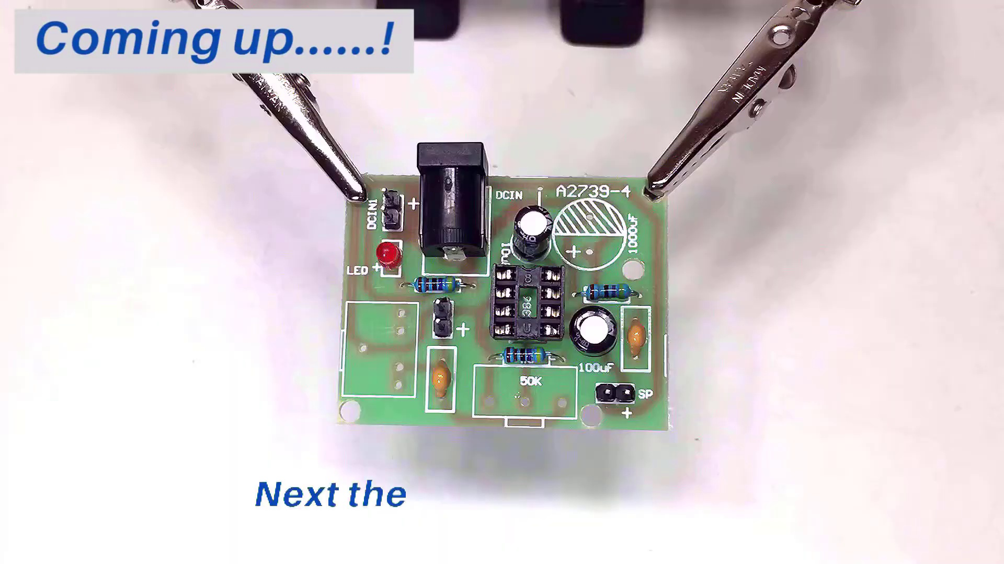 | 0:03   | 0:04   | 0:04   | 0:04  

Transcript
(No speech detected in this section)

Section 0: Examining a Circuit Board
Time: 0:05 - 0:07

Summary
The person's fingers delicately touch a small electronic circuit board with various components, possibly in the process of examining or adjusting its parts.

Representative Frames
0:05   | 0:05   | 0:06   | 0:06   | 0:06  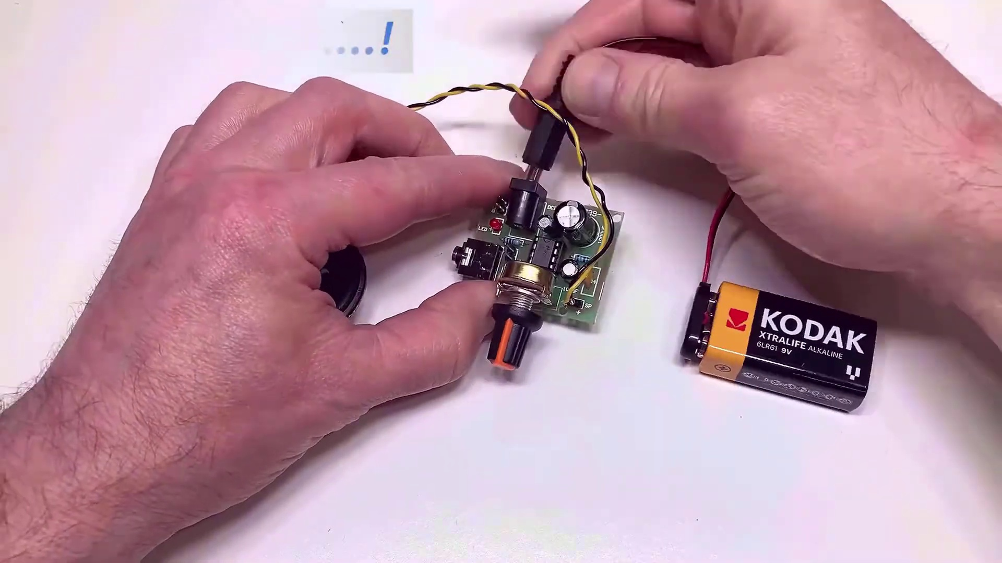

Transcript
(No speech detected in this section)

Section 0: Working with an Arduino Uno Board
Time: 0:07 - 0:09

Summary
The person's hands interact with an Arduino Uno board connected to a computer via USB cable and a breadboard with various components attached to it.

Representative Frames
0:07   | 0:07   | 0:08   | 0:08   | 0:08  

Transcript
(No speech detected in this section)

Section 0: Setting Up Electronic Circuits
Time: 0:09 - 6:05

Summary
Two electronic circuits are visible in the photo, one powered on with red LEDs, and another being assembled or tested on a breadboard setup.

Representative Frames
1:08  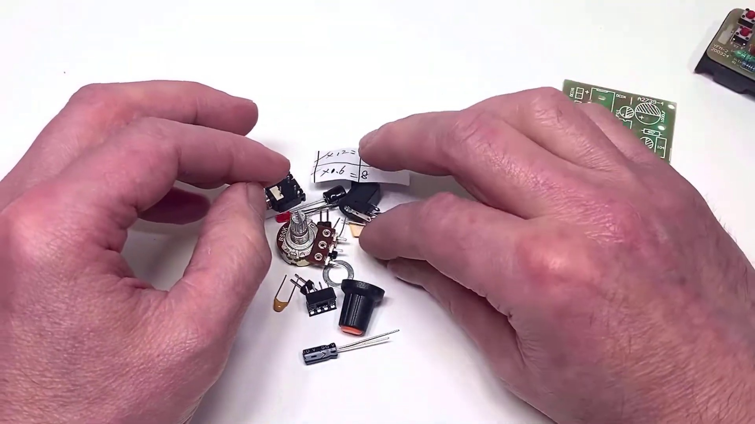 | 2:07  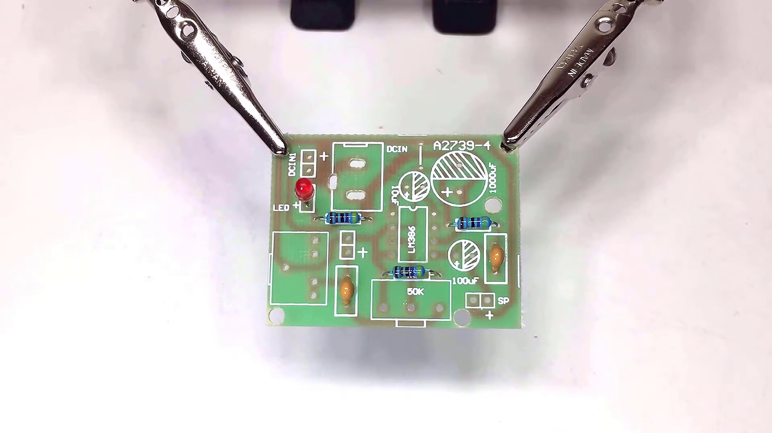 | 3:07  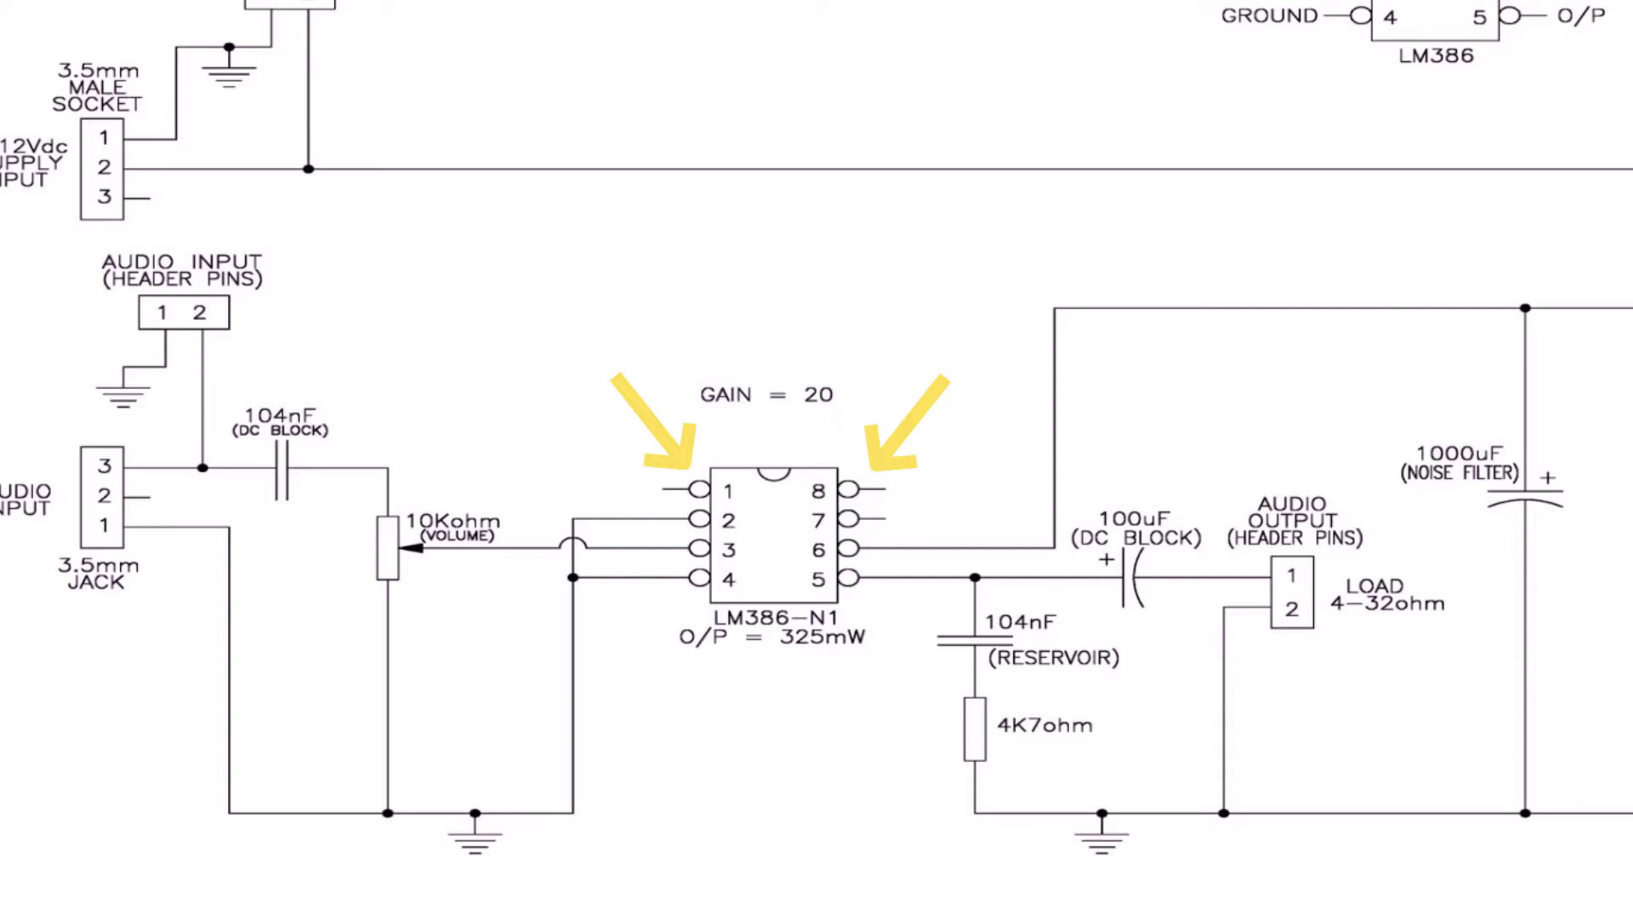 | 4:06  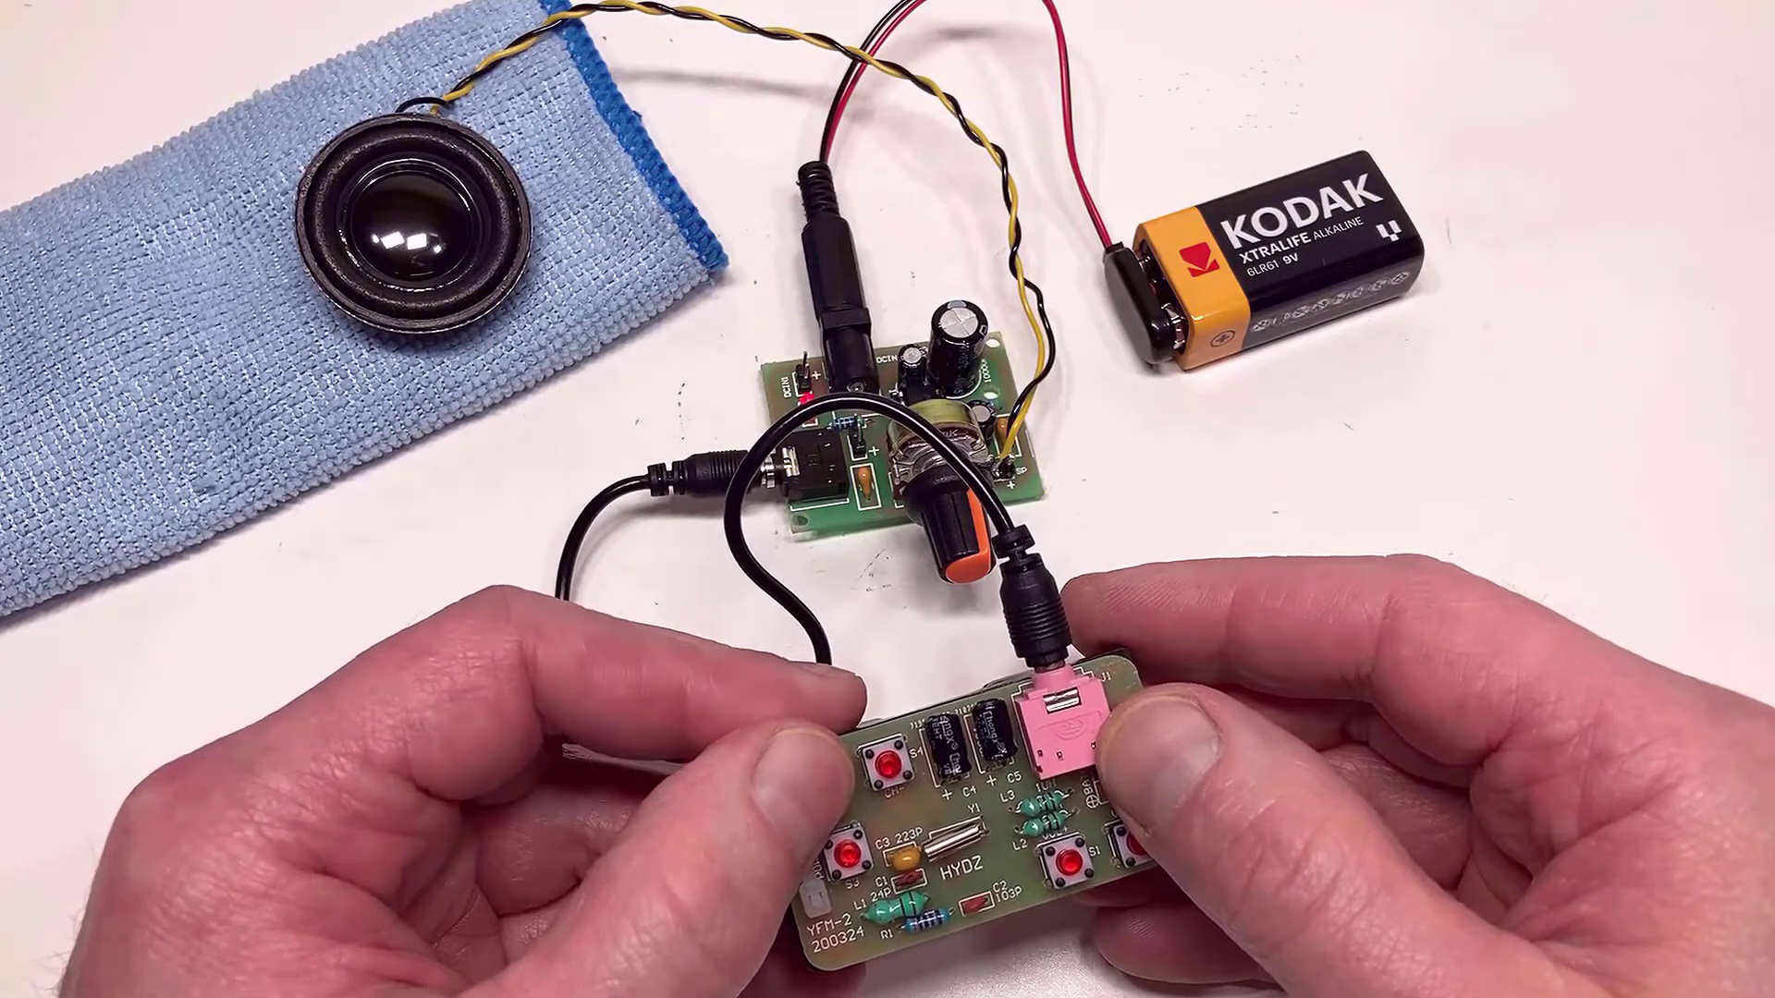 | 5:05  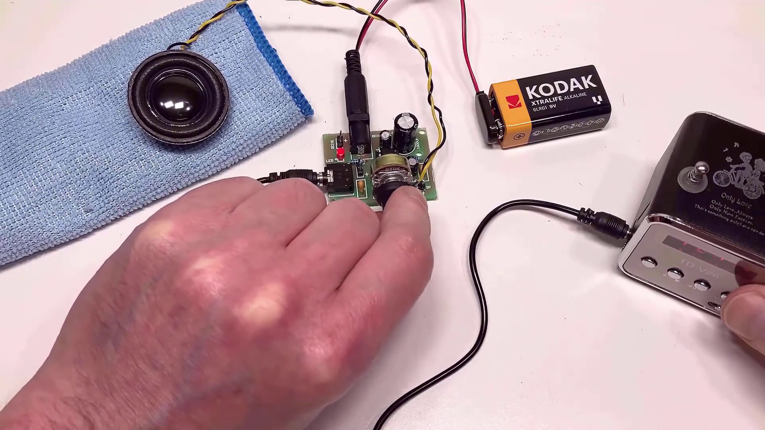

Transcript
[0:00] Hi everyone and welcome. I was looking on AliExpress recently and I came across this.
[0:21] This is a little audio amplifier kit and it's based on the LM386 audio amplifier and I thought
[0:27] this would be really good fun to try out with this. This is a little personal FM radio kit that I
[0:33] recently did a review on so if you're interested please pop across my channel. This only cost three
[0:37] dollars but obviously it's designed to just take a headphone or a connection there rather than a
[0:42] speaker. I thought this would be really good fun to see how it sounded through this little amplifier.
[0:46] So let's open this up and see what we've got. You get a little circuit diagram as you can see.
[0:57] there but to be honest the PC board itself actually comes with all the components identified on so
[1:03] hopefully construction shouldn't be too much of a problem. The LM386 itself this is the LM386 N1
[1:10] version and the N1 is good for around about 325 milliwatts so that's plenty to be honest just to
[1:15] drive a small speaker. Luckily it comes in an 8 pin DIL package that's really neat because a lot of the
[1:22] kits also provide sort of SMD sort of versions or surface mount versions and they're a real pain to
[1:28] solder. They even give you a little 8 pin sort of socket there for it which is a neat touch.
[1:32] Volume control that also is full size rather than a skeleton type and it will give you a little knob
[1:39] there just to sort of make life just a little bit easier. So even though this is budget they've
[1:44] actually put a little bit of thought into it. So what I'm going to do now I'm going to assemble it,
[1:48] I'll solder it all up and then we're going to see how she's sound so let's get on with the build.
[2:18] Okay so our little amplifier board now is fully populated. I'm also connected up a loud speaker,
[2:31] simply just connecting to the audio output pins there as you can see. I also made up a small power
[2:36] supply in the shape of a PP3 clip connected to a small female jack. Just remember to make the center
[2:42] pin there the positive. I'm just going to connect this up now to our little amplifier board. LED light
[2:48] comes on which is good. What I'm going to do is I'm going to pop up on the screen for you the schematic
[2:51] diagram for this little amplifier. The reason for doing this is this little LM386 chip has actually
[2:57] got a neat little party trick. It's as much as you can actually adjust the gain. If you look at pins 1
[3:02] and 8 then if there's nothing connected to them then the internal resistance sets the gain at 20.
[3:08] However if you connect a 10 microparad capacitor between pins 1 and 8 then the gain is increased to
[3:13] 200 and in fact that's what our little board has got. If you want something in between simply put a
[3:18] 1.2k resistor in series with that capacitor and the gain reduces to around about 50. Okay back to our
[3:25] little amplifier then. What I want to do is just connect up this little personal FM radio kit that I spoke
[3:31] about earlier in the video and just see as you perform. So I'm just going to simply just connect to
[3:35] the audio out and then connect to the audio in on the board. I'm going to put the speaker on the cloth
[3:44] because it can vibrate on this board a little bit. I'm going to turn it up.
[3:48] the volume works okay.
[4:18] That's actually not bad. What I'm going to do is just connect up a little mp3 player and just see
[4:26] how that performs. What I've got is this little TDV26. This is a useful little device to be honest.
[4:33] It's an FM radio come mp3 player. It's also got bluetooth. It's a brick on the back if you wish it.
[4:38] But it's only cost a few dollars and I've actually done a review on this if you want to pop a
[4:42] graph on channel and have a look at that. I'm simply just going to connect to the audio out on that.
[4:46] So I'm just going to pop a USB stick in there. Connect up to the audio out. Let's switch it on.
[5:16] That's actually not bad at all. I'm just going to switch that off.
[5:32] Okay so there you have it. It's a little LM386 audio amplifier kit. To be honest for the price it's an
[5:43] absolute bargain. You can keep yourself a few of these because perhaps you want to do some audio
[5:48] work or maybe repair radios and you just want a trusted amplifier just so you can look at the
[5:53] front end of your radios. There's all sorts of things you can do with this. So anyway appreciate
[5:57] you watching. Hopefully you found it useful. If you did give me that thumbs up. As always appreciate you
[6:01] watching and I'll catch up with you soon.

