Engagement Analysis: jLXW6qVdfq4

Section 0: A multimeter is being used to measure voltage.
Time: 0:03 - 0:06

Summary
The image shows a person holding a red and black electrical cable connected to a blue multimeter with a white display.

Representative Frames
0:03  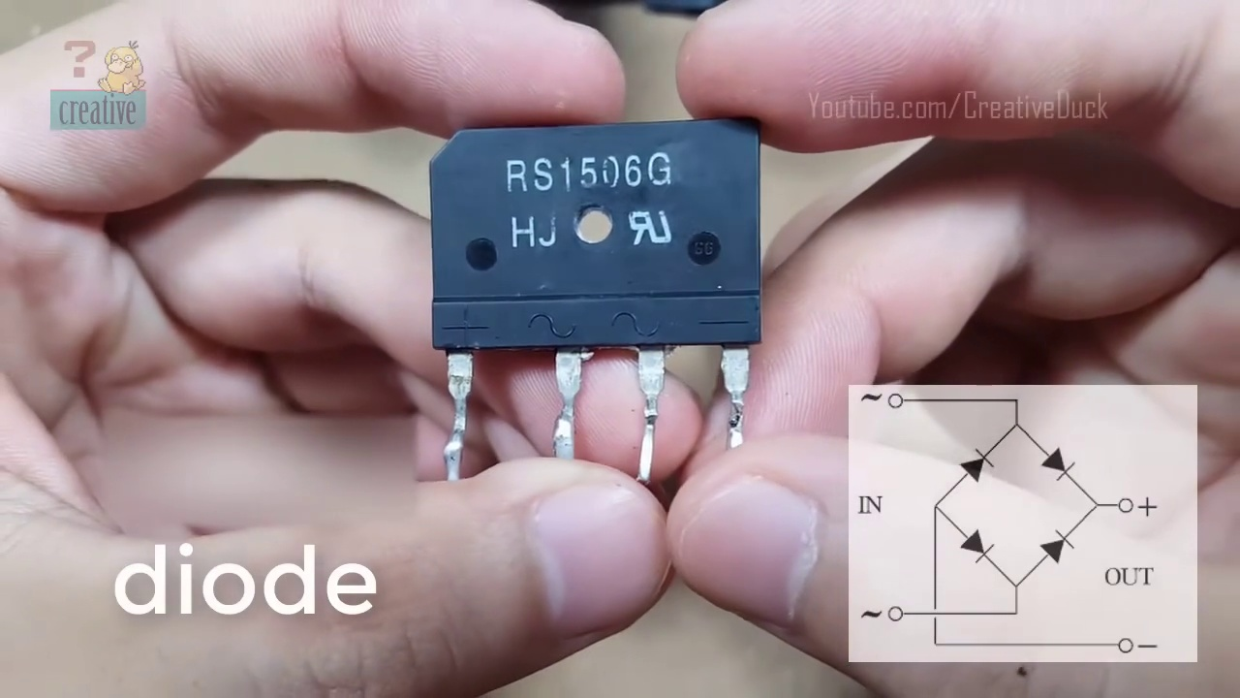 | 0:04   | 0:04   | 0:05   | 0:05  

Transcript
(No speech detected in this section)

Section 0: A breadboard setup for electronics experimentation.
Time: 0:06 - 0:09

Summary
The image captures a moment of setting up or adjusting components on the breadboard, which is connected to a digital device.

Representative Frames
0:06   | 0:07  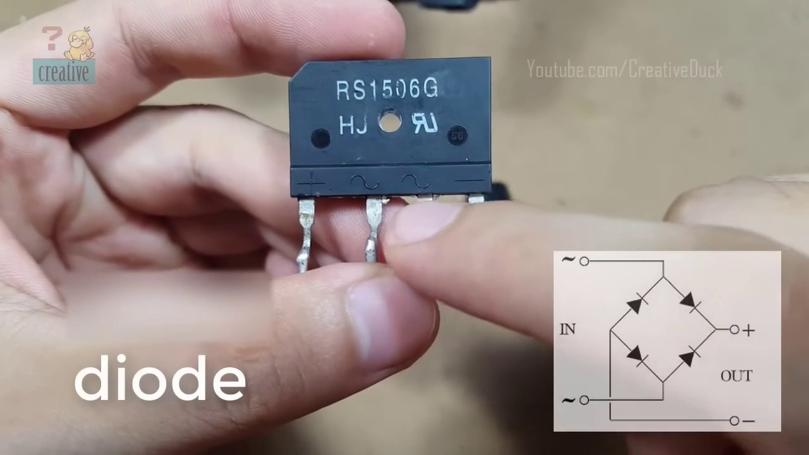 | 0:07   | 0:08   | 0:08  

Transcript
(No speech detected in this section)

Section 0: An oscilloscope and other electronic devices are shown in the background.
Time: 0:09 - 0:12

Summary
The image suggests an environment of electronics experimentation or development.

Representative Frames
0:09   | 0:10  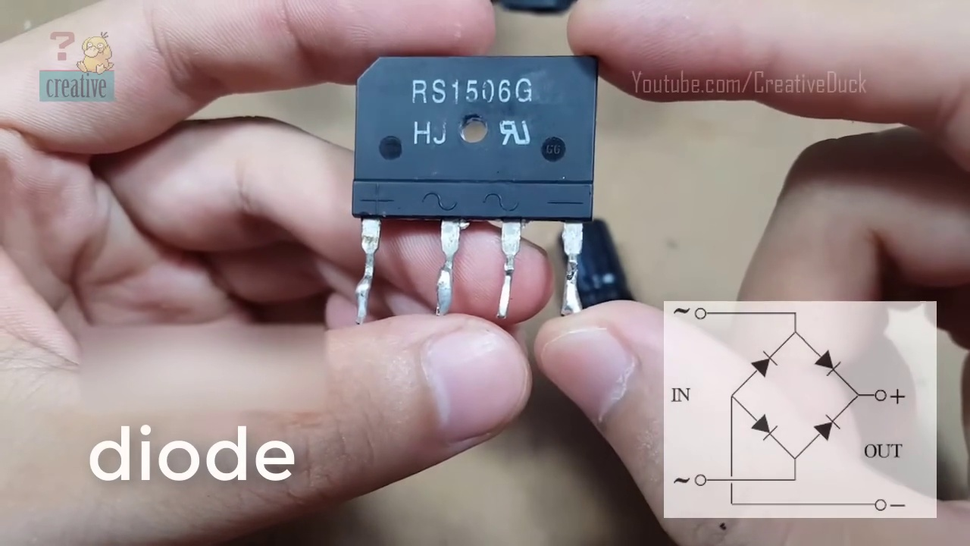 | 0:10   | 0:11   | 0:11  

Transcript
(No speech detected in this section)

Section 0: A screenshot of a digital interface with a subscription button.
Time: 0:12 - 0:15

Summary
The image appears to be from the TV series 'Subscribers' and features a dark-colored background with overlaid light-colored text that reads 'subscribe'.

Representative Frames
0:12   | 0:13   | 0:13  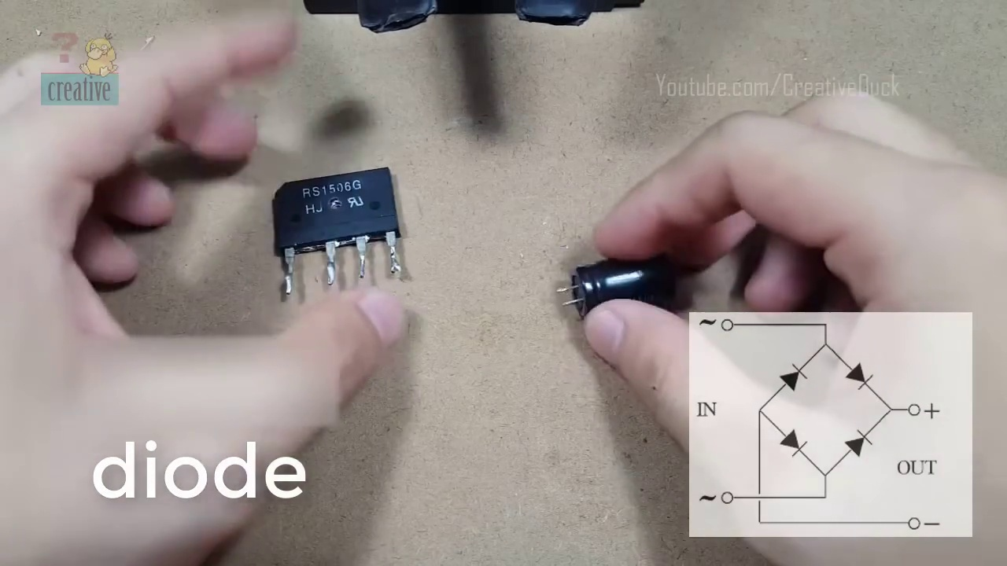 | 0:14   | 0:14  

Transcript
[0:00] do

Section 0: A minimalist design with a call to action to subscribe.
Time: 0:15 - 0:18

Summary
The image displays a striking minimalist design on a plain black background with the text 'subscribe' written in all capital letters.

Representative Frames
0:15   | 0:16   | 0:16   | 0:17  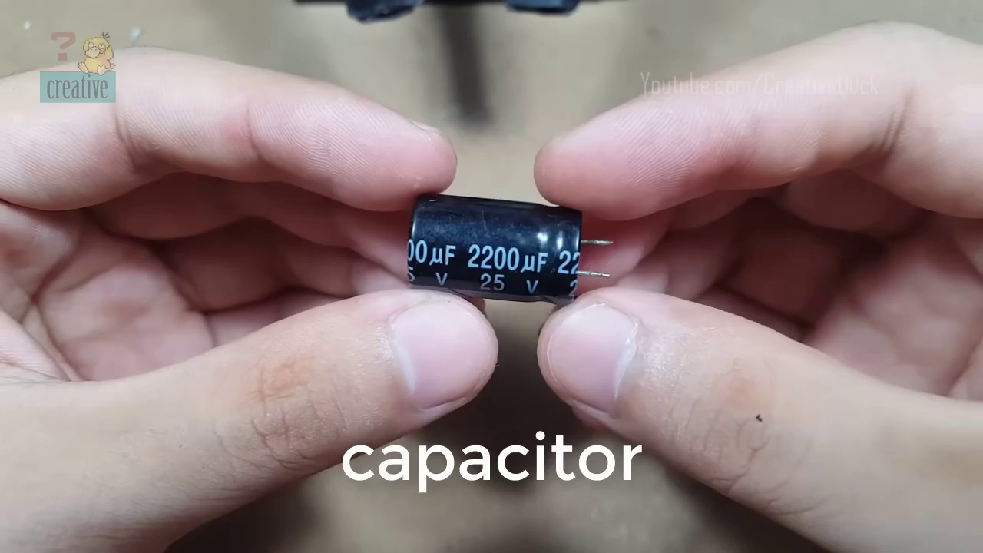 | 0:17  

Transcript
(No speech detected in this section)

Section 0: A video editing interface screenshot with a subscription URL.
Time: 0:18 - 3:59

Summary
The image appears to be from a YouTube video or presentation and features a timeline, markers, and an overview waveform on the left side of the screen.

Representative Frames
0:54  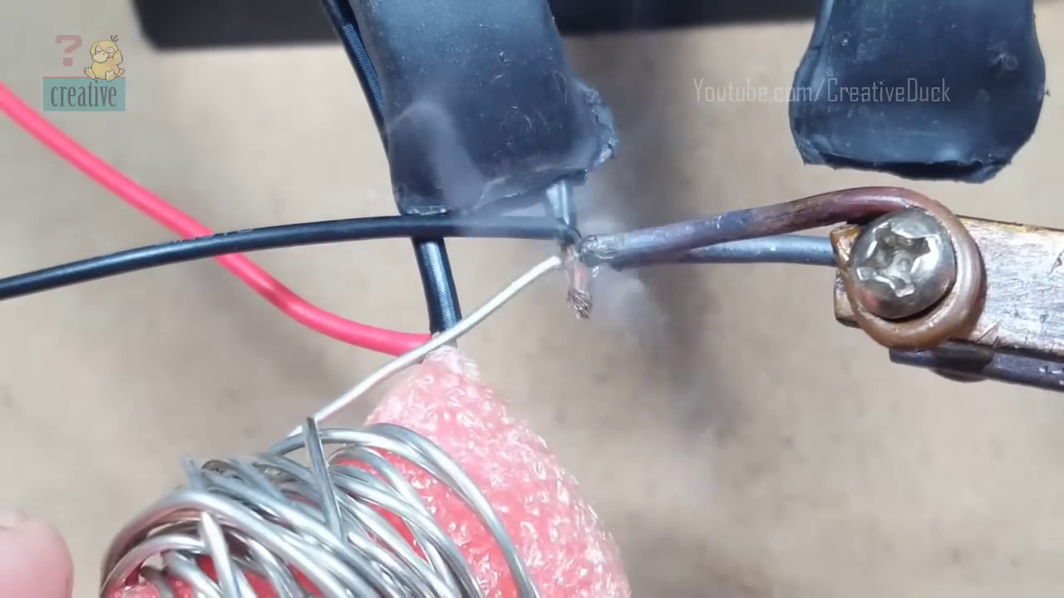 | 1:31  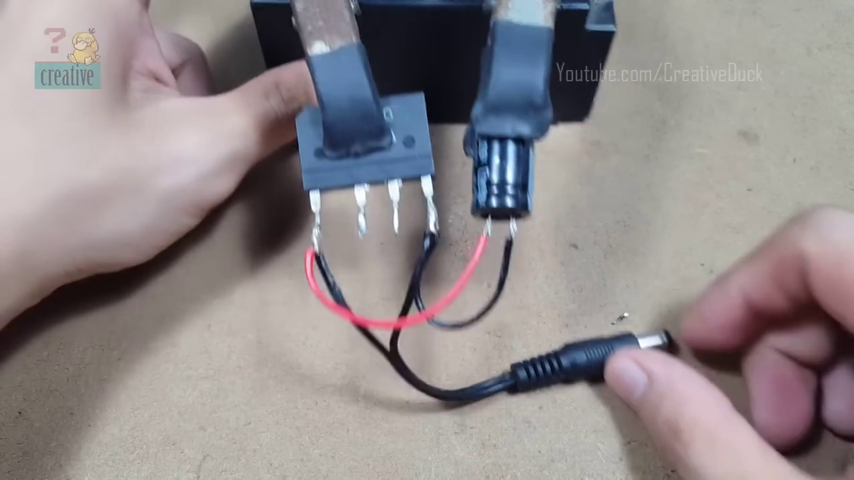 | 2:08  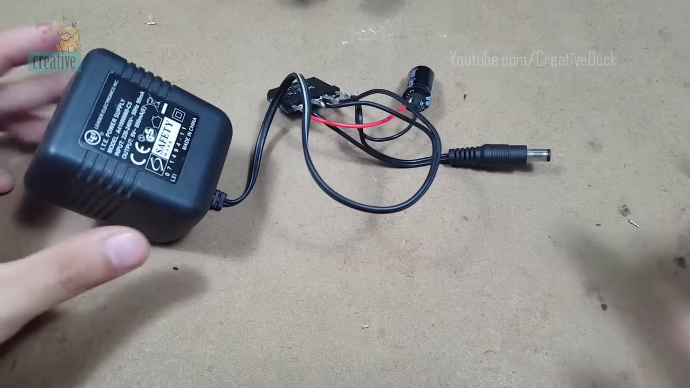 | 2:45  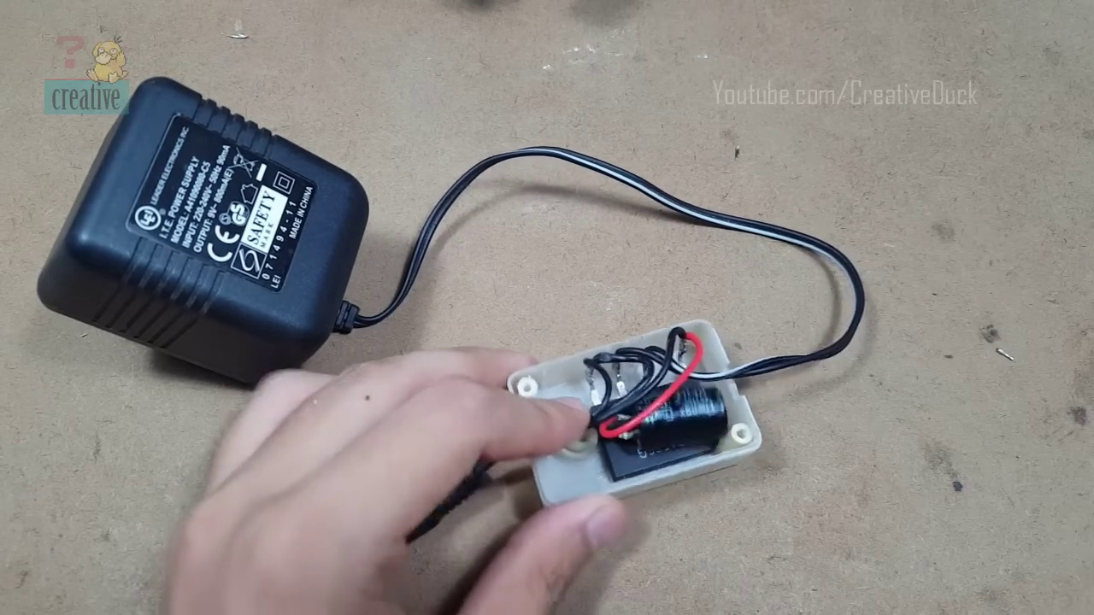 | 3:22  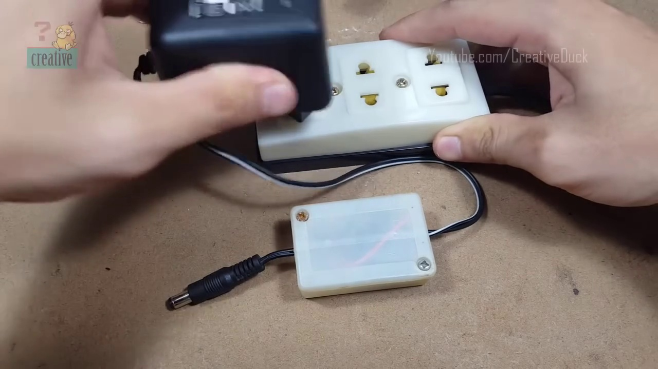

Transcript
[0:30] I'll see you next time.
[1:00] I'll see you next time.
[1:30] I'll see you next time.
[2:00] I'll see you next time.
[2:30] I'll see you next time.
[3:00] I'll see you next time.
[3:30] I'll see you next time.

