Engagement Analysis: lV6zevUF-v0

Section 0: Introduction to Constructo Su Videoroloca.com Website
Time: 0:00 - 0:03

Summary
The website appears to focus on providing video tutorials or related content.

Representative Frames
0:00   | 0:01   | 0:01   | 0:02   | 0:02  

Transcript
[0:00] Construya

Section 0: Video Presentation on Construyas Universo
Time: 0:03 - 0:06

Summary
An educational or informational video discussing the topic of constructing or organizing information or concepts.

Representative Frames
0:03   | 0:04   | 0:04   | 0:05   | 0:05  

Transcript
(No speech detected in this section)

Section 0: Movie Poster for Albe Canon Directed by Oscar Nunez
Time: 0:06 - 0:09

Summary
A black and white poster featuring the title and director's name in block-like fonts, accompanied by additional text in red.

Representative Frames
0:06   | 0:07   | 0:07   | 0:08   | 0:08  

Transcript
[0:05] Subideorockola

Section 0: Presentation Slide on Colombia Project
Time: 0:09 - 0:12

Summary
A presentation slide discussing the institution's involvement in Colombia in 2016, possibly related to a specific educational program or partnership.

Representative Frames
0:09   | 0:10   | 0:10   | 0:11   | 0:11  

Transcript
(No speech detected in this section)

Section 0: Simple Presentation Slide with Timestamp
Time: 0:12 - 13:47

Summary
A presentation slide with a black background and white text indicating the year 2016, coinciding with significant events in Wales.

Representative Frames
2:27  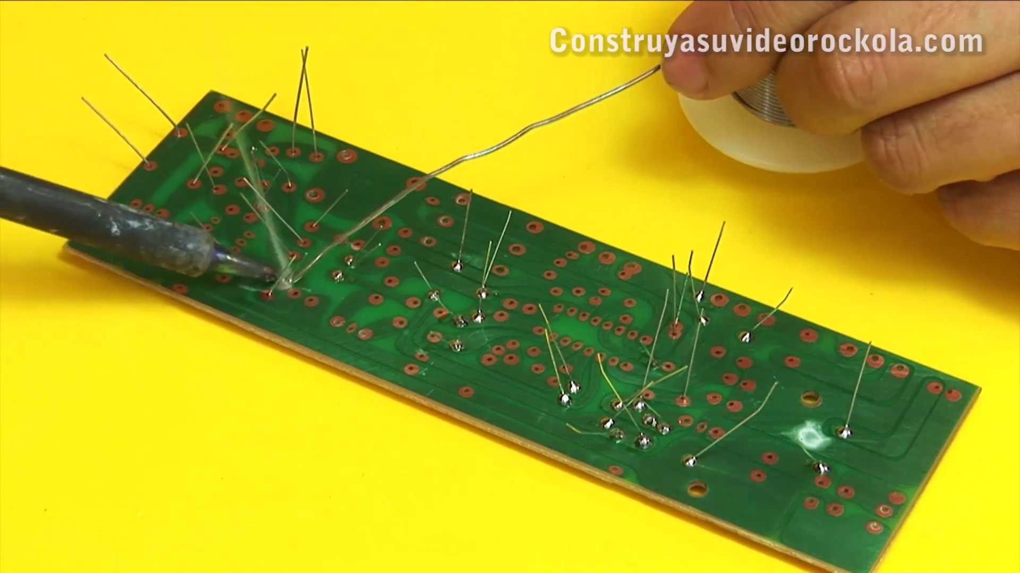 | 4:43  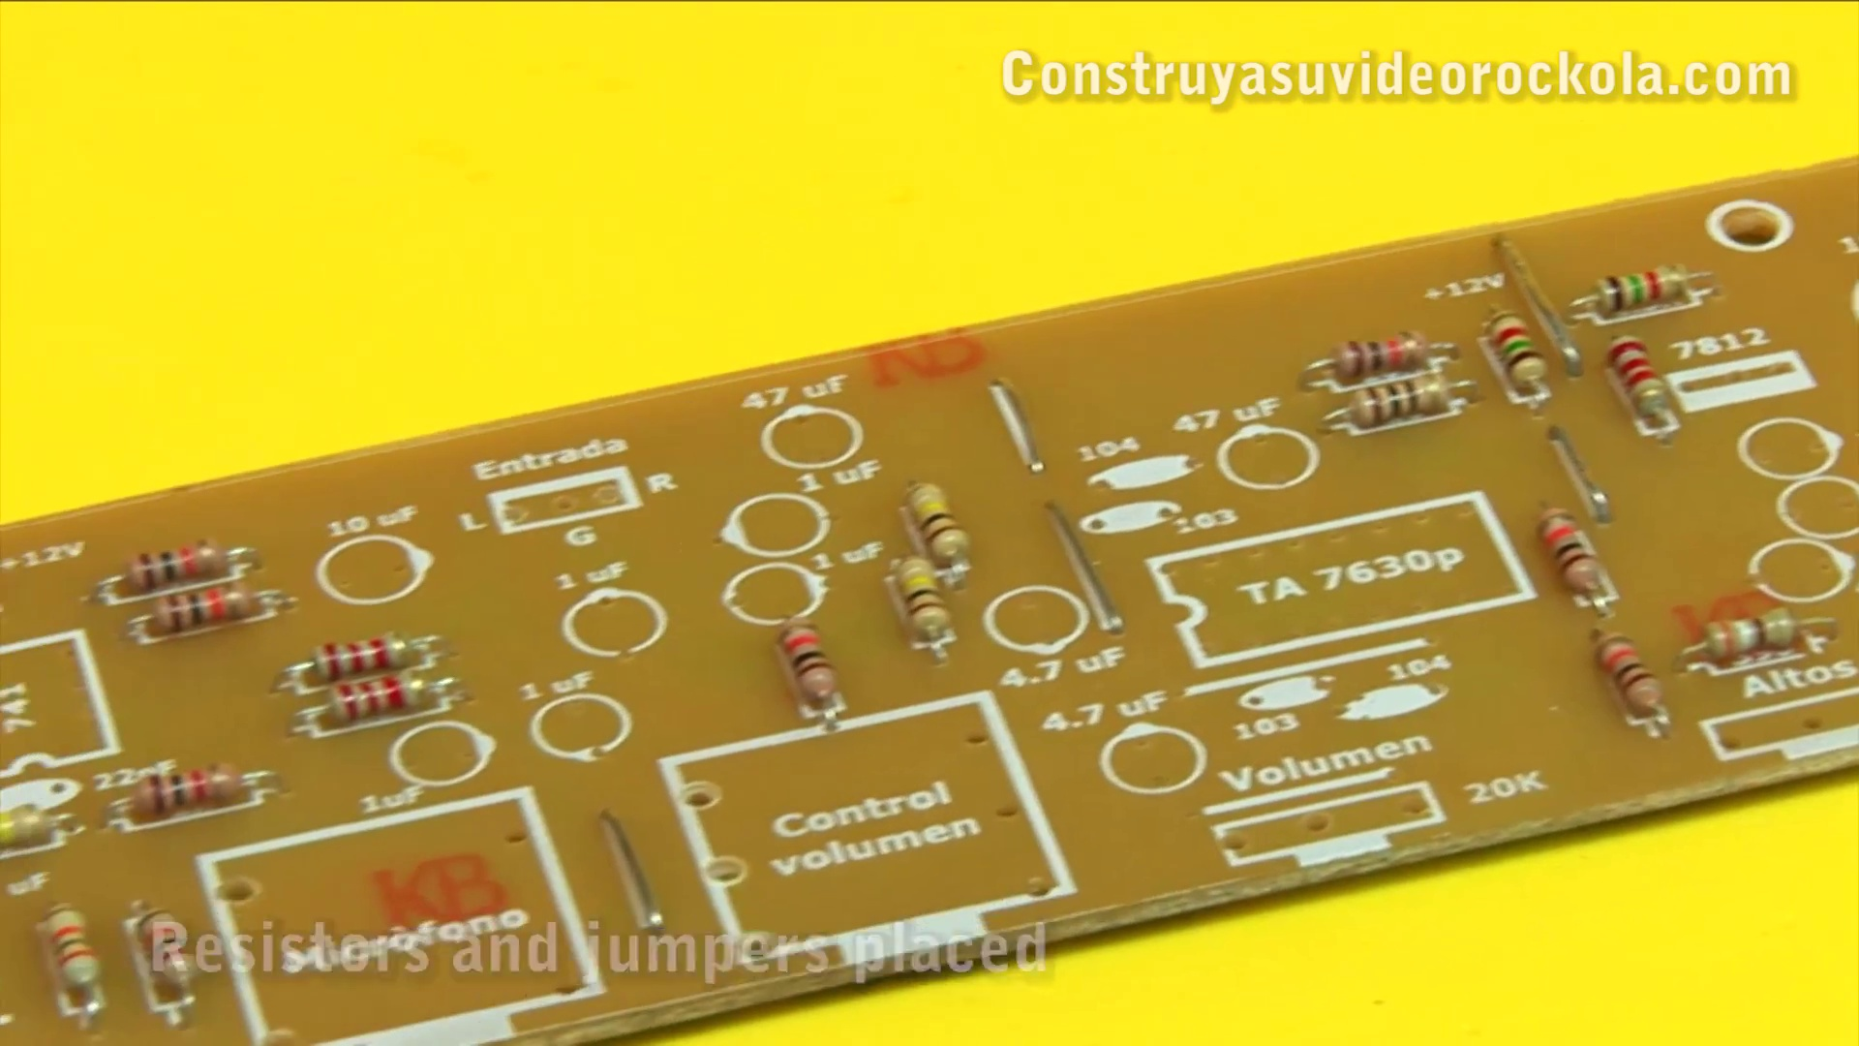 | 6:59  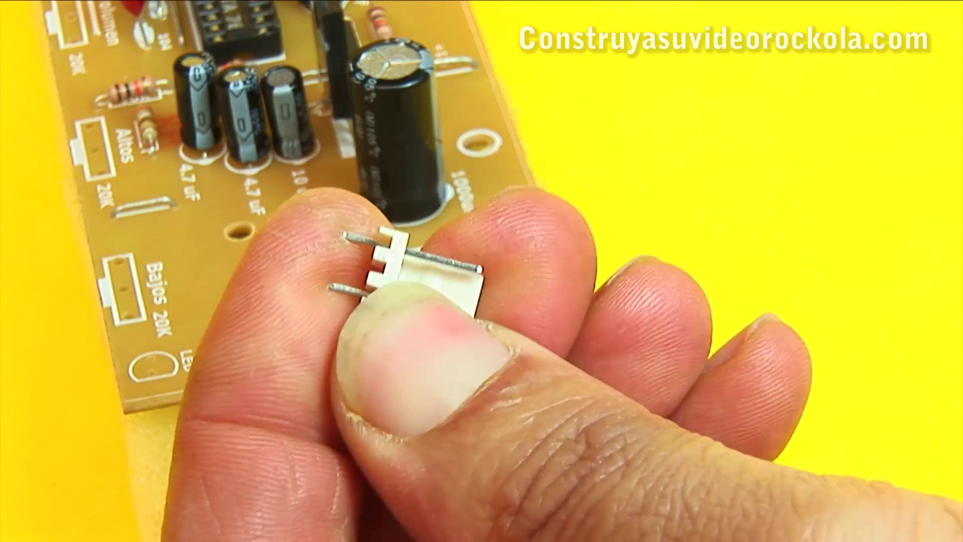 | 9:15  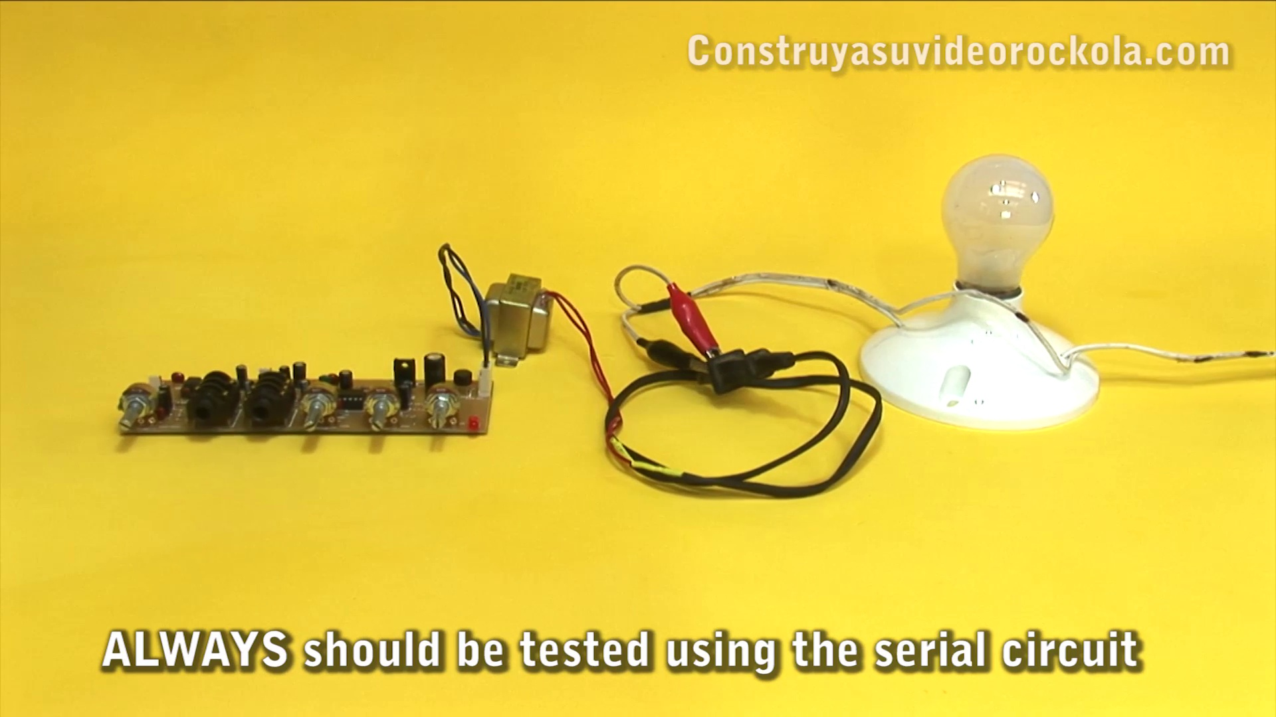 | 11:31  

Transcript
[0:12] Tone and volume control plus independent microphone pre-amplifier
[0:18] Next we teach to build a circuit, which very well complements your stereo amplifier, improving sound and performance.
[0:33] A great advantage of this circuit, is that we can place the volume control, up to 30 meters away from the amplifier, without any noise being introduced.
[0:42] This makes it ideal for video jukebox, making it easier to control them. Also, the microphone input, allows to convert your video jukebox, into a karaoke.
[0:54] Materials
[0:57] The materials for this project are pretty economical and easy to get.
[1:01] In the description of the video, you will find the link to the article, in which you can download a PDF file, with the PCB, electric diagram, bill of materials, and everything necessary to carry out this project.
[1:18] Construction
[1:20] We will begin by placing all the resistors.
[1:23] The resistor terminals, are banned with the help of a tweezers.
[1:28] They must remain straight, and of the same length.
[1:31] Then, the resistor is introduced into its corresponding place, taking care that it reaches the bottom, and is perfectly placed.
[1:40] With this same technique, we must place all other resistors.
[1:45] Remember to use the component mask as a guide.
[1:48] After verifying that all the resistors are in their correct place, they are well.
[2:13] Remember that the correct welding technique is done by joining, soldering iron, weld, and piece to be welded, at the same time.
[2:29] The welds should be round, and perfectly surround each terminal.
[2:32] Now we must cut all the leftovers of the resistor terminals.
[2:48] For this we can use a nail clipper.
[3:02] Leftovers are collected, as they will be recycled.
[3:10] These wires are stored, then used as jumpers.
[3:18] It is measured over the card, the length of the bridge to be made.
[3:22] Is bent one end of the wire.
[3:25] Is measured again.
[3:27] And bend the other end, at the exact distance, so that the jumper enters the holes in the cart.
[3:38] The jumper is placed in its respective place.
[3:43] In the same way, we build and place the other jumpers, which go in the printed circuit board.
[3:58] We proceed to weld all the jumpers.
[4:12] The excess are cut.
[4:13] The excess are cut.
[4:22] We weld two missing points for soldering.
[4:31] And we cut.
[4:34] We already have correctly placed all the resistors and jumpers.
[4:42] The polyester and ceramic capacitors have no polarity.
[4:54] We place the capacitors in their respective places.
[5:02] We place the polyester capacitors that are responsible for setting the frequencies, which
[5:07] operates the tone control.
[5:10] Doing this work, we realized that we were missing one of the jumpers.
[5:15] We will place it later.
[5:18] We weld the capacitors.
[5:21] Now, place the 8-pin socket in the correct position.
[5:29] And weld it to the PCB.
[5:37] Then place the 16-pin socket.
[5:40] Check the position in the component mask.
[5:48] And weld the socket.
[5:56] The electrolytic capacitors do have polarity.
[5:59] Check at the time of placing them, that the strip that determines the negative pole, match
[6:04] the drawing, in the component mask.
[6:11] And weld the capacitors.
[6:25] Now place the LM7812 regulator.
[6:36] See close attention to polarity.
[6:41] Place the molex connector of the signal input.
[6:47] And the signal output connector, which will go to the amplifier.
[6:51] To the power connector, is remove the middle pin.
[7:05] And put it in place.
[7:13] We place the diode bridge, leaving it slightly raised from the PCB.
[7:18] See close attention to polarity.
[7:21] Place the potentiometer that controls the microphone volume.
[7:25] The microphone jack.
[7:27] The jack for remote volume control.
[7:32] The volume potentiometer.
[7:35] The potentiometer that controls the high frequencies.
[7:38] The potentiometer that controls the low frequencies.
[7:42] And the power indicator LED.
[7:50] Now insert the 741 integrated circuit.
[7:54] Check the position on the component mask.
[7:58] In the same way, place the TA7630 integrated circuit.
[8:06] We already have our tone and volume control, with independent microphone preamplifier.
[8:14] Using a toothbrush and thinner, we proceed to wash the PCB very well, on the tracks side.
[8:20] The idea is to remove grease and all metal particles and solder, which can generate short circuits.
[8:29] With a piece of toilet paper, it dries very well the PCB.
[8:37] And finish cleaning with a dry brush.
[8:42] The PCB should be clean and shiny.
[8:46] Measurements.
[8:48] With the multimeter on the continuity scale, the AC power input is measured.
[8:54] There should be no impedance or continuity.
[8:58] Now, we feed the circuit with a transformer between 12 and 15 volts AC, and a minimum of 300 milliampperes.
[9:08] Always, the first time the preamplifier is turned on, the series circuit should be used, with a bulb of between 5 and 1 0 W.
[9:17] And then, connect to the public network.
[9:21] And if everything is correct, the LED turn on.
[9:26] Measure the voltage already rectified by the diode bridge and the 1000 microfarad capacitor.
[9:32] There should be approximately 18 volts DC.
[9:37] Now place the black tip on the bridge negative pole, and the red tip, on the pin 1 of the regulator.
[9:42] There should be the same 18 volts DC.
[9:46] Then, measure the regulator output, and there should be 12 volts approximately.
[9:55] To measure the voltage entering the 741 IC, place the black tip on pin 3, and the red tip on pin 7.
[10:03] Should measure 6 volts, which is half the regulator voltage.
[10:10] Now, with the black tip on pin 3, and the red tip on pin 4, is measured minus 6 volts DC.
[10:17] The voltage must be symmetrical.
[10:22] You can also check the total voltage, on the jumper marked with 12 volts.
[10:30] Connections.
[10:33] For signal input, we constructed a cable with a double female RCA connector, one piece of
[10:38] shielded stereo cable, and a 2.54 mm 3 pin molex female connector.
[10:46] The signal output cable, has in the same connector of 3 pins, 3 wires, left signal, ground, and
[10:52] right signal.
[10:57] And it connects to the amplifier, bifurcated, in independent connectors, to send each signal to
[11:02] each mono stage of the amplifier, thus keeping the stereo sound.
[11:08] Our tone control with microphone preamplifier is ready to be used.
[11:16] In the following videos, you can see how to do remote volume control for this project.
[11:21] And a 400 watts stereo amplifier, with which the sound test was performed.
[11:30] Now listen to the live sound test.
[11:34] ¿Qué tal amigos?
[11:35] Now listen to the sound of our control of tones
[11:39] control by tension
[11:41] with the additional microphone input.
[11:44] We will amplify it
[11:45] with our 400W stereo amplifier.
[11:49] Listen to it.
[11:52] The volume.
[11:56] Now let's see the bass.
[12:05] Now İndia's bass.
[12:09] Notice that small tune.
[12:19] And the score of both the bass.
[12:27] And now listen to audio
[12:36] quickly at insert recordings
[12:40] Hi there is the microphone
[12:42] It is interesting that you can dab the sound
[12:50] with the music
[12:57] We hope this project is of the best of all.
[13:04] You will find it on your website www.construyasuvideorockola.com
[13:08] Remember to give a thumbs up
[13:09] and if you like it, comment to keep improving.
[13:13] Bye everyone!
[13:27] And follow us on Twitter.
[13:30] Visit our website www.construyasuvideorockola.com

