Engagement Analysis: lWgYgef-hQ8

Section 0: Visual Description of Operating Systems and Video Creation
Time: 0:00 - 0:07

Summary
The description discusses various operating systems, including Windows, MacOS, and Linux, in relation to video creation.

Representative Frames
0:01   | 0:02   | 0:03  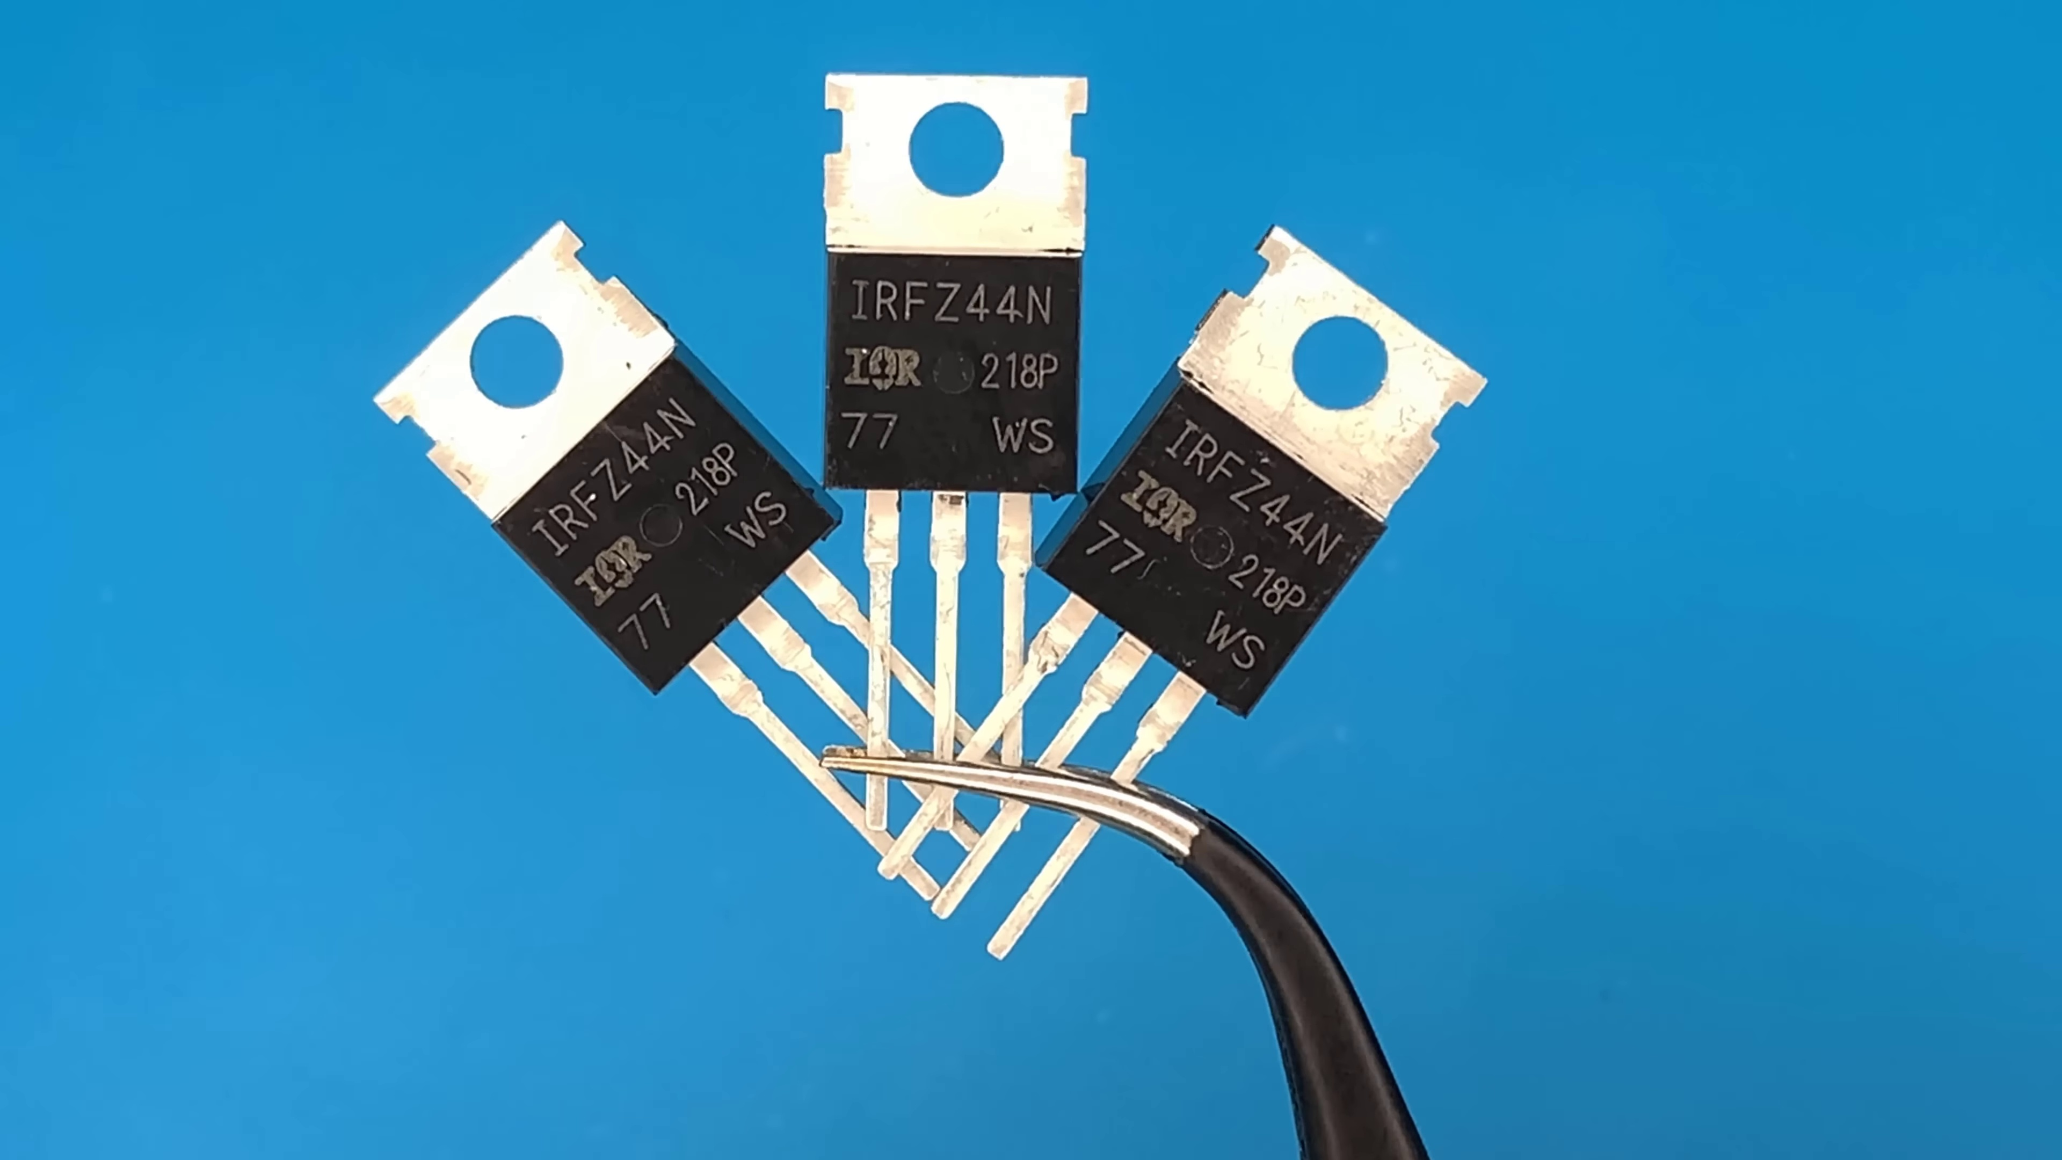 | 0:04   | 0:05  

Transcript
[0:00] musyl
[0:00] ítulo 1

Section 0: Cool Video OS and Subscription Invitation
Time: 0:07 - 0:12

Summary
The description features a logo for CoolVideo OS, inviting viewers to subscribe to the service or channel related to the content of the slide.

Representative Frames
0:07  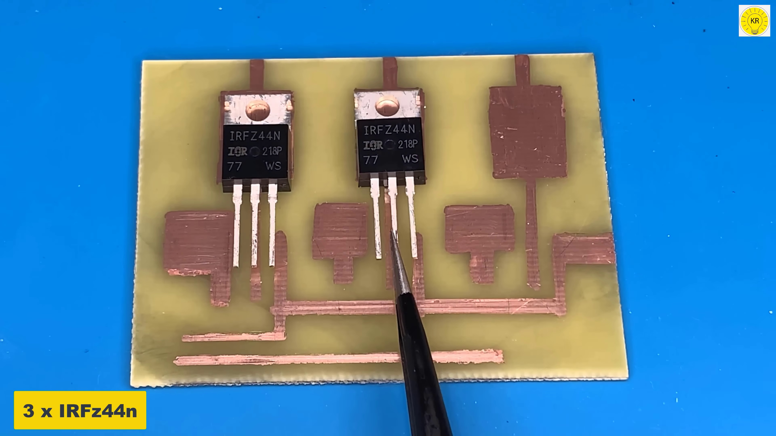 | 0:08   | 0:09   | 0:10  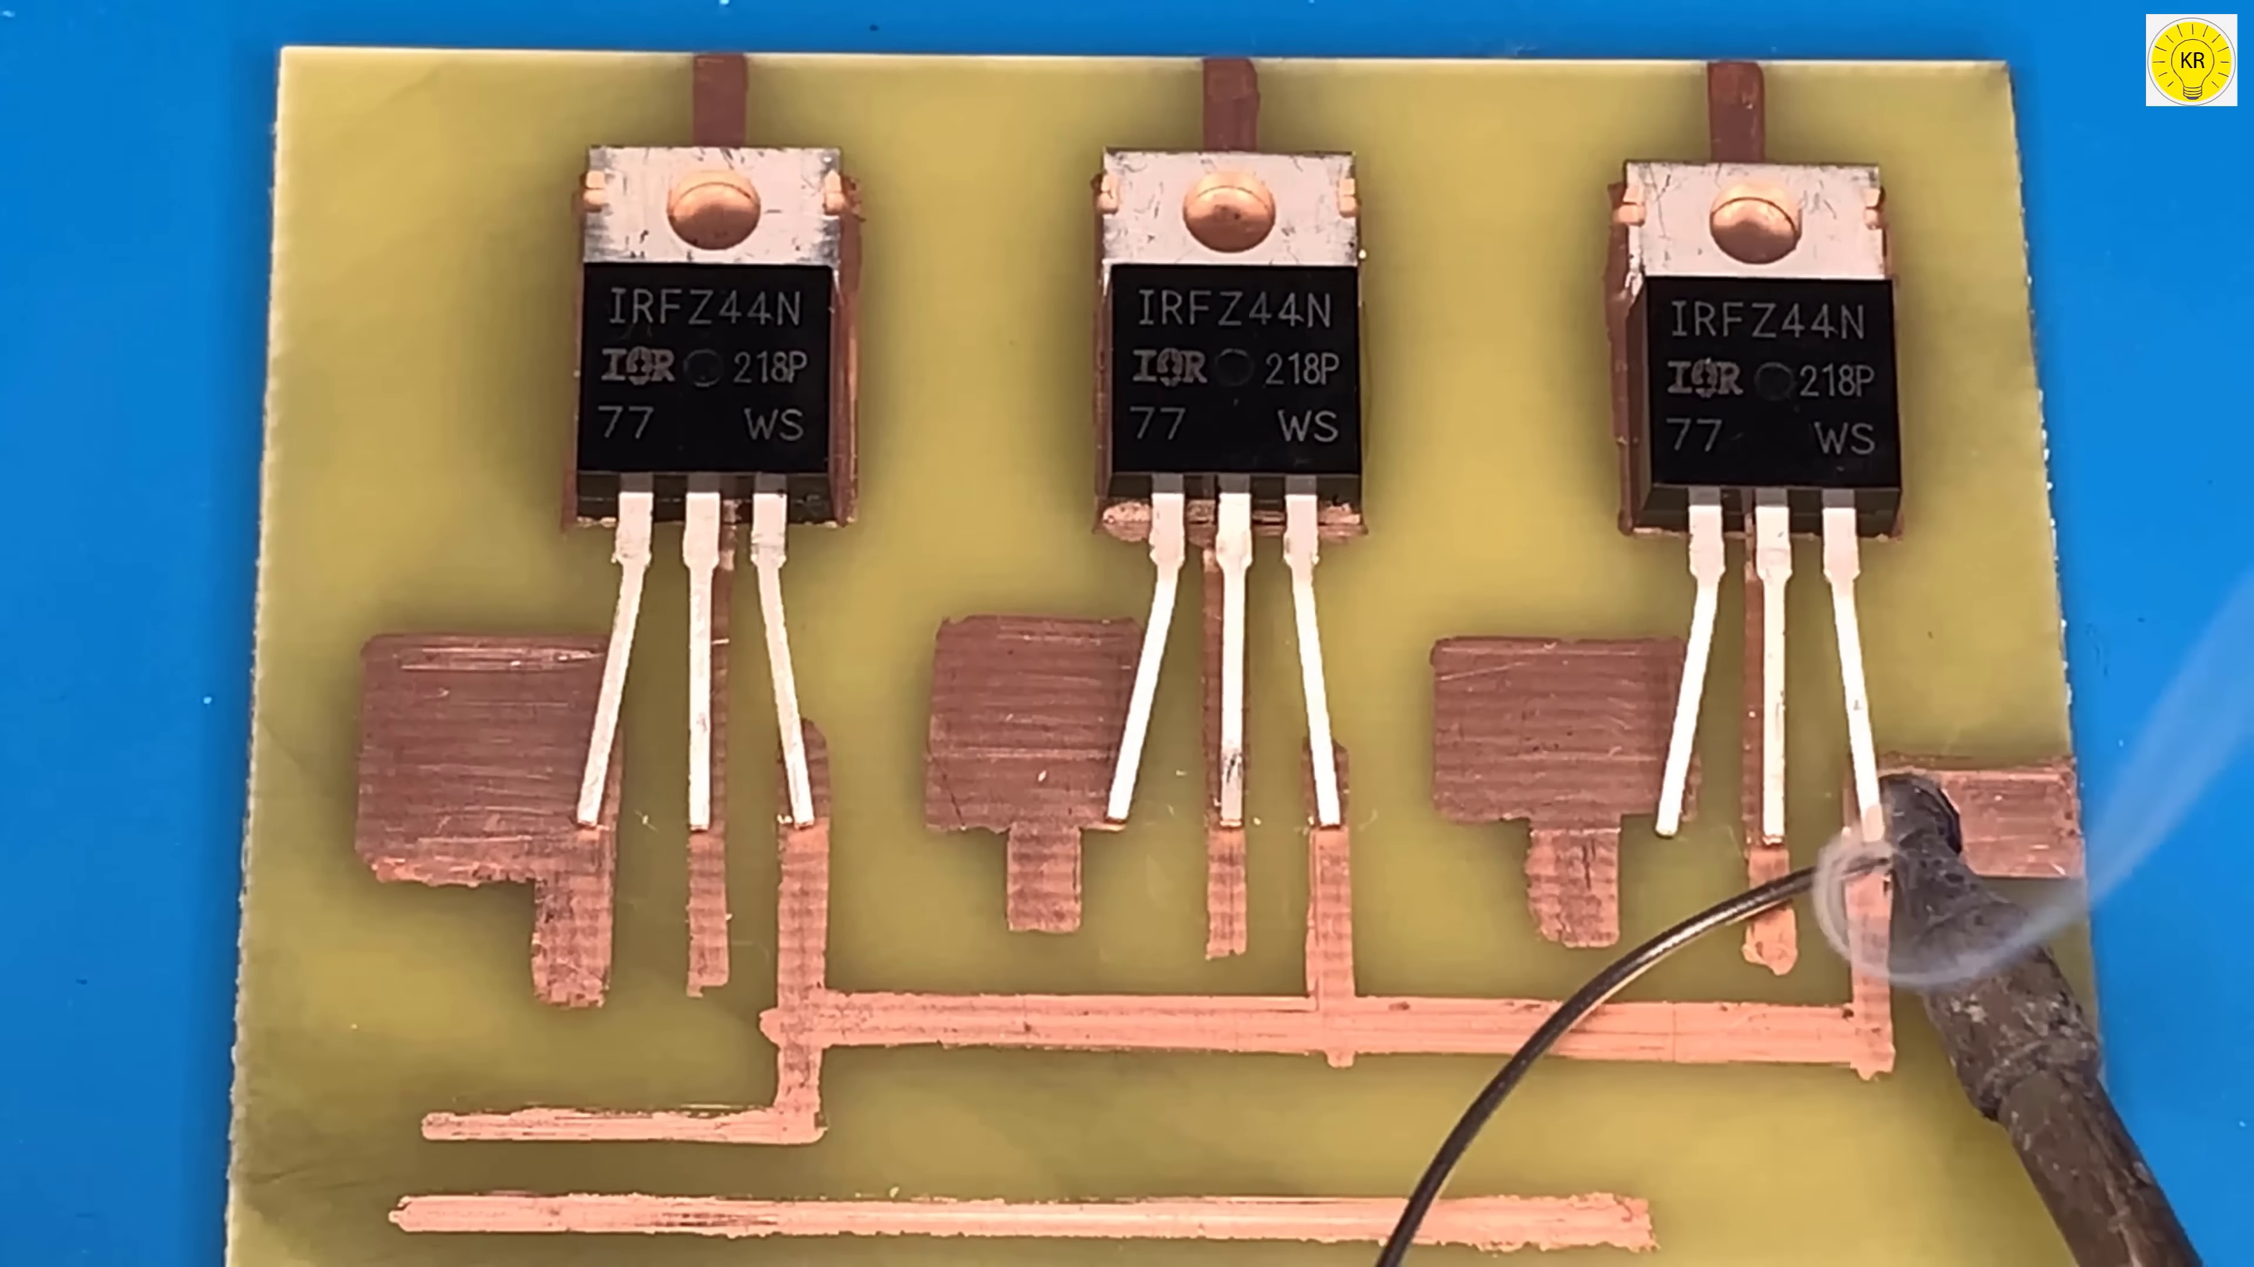 | 0:11  

Transcript
[0:09] 然後
[0:11] 竹童

Section 0: Call-to-Action Button with Subscribe Option
Time: 0:12 - 0:20

Summary
The description highlights a call-to-action button labeled 'Subscribe', encouraging viewers to join the community and engage with the content.

Representative Frames
0:13  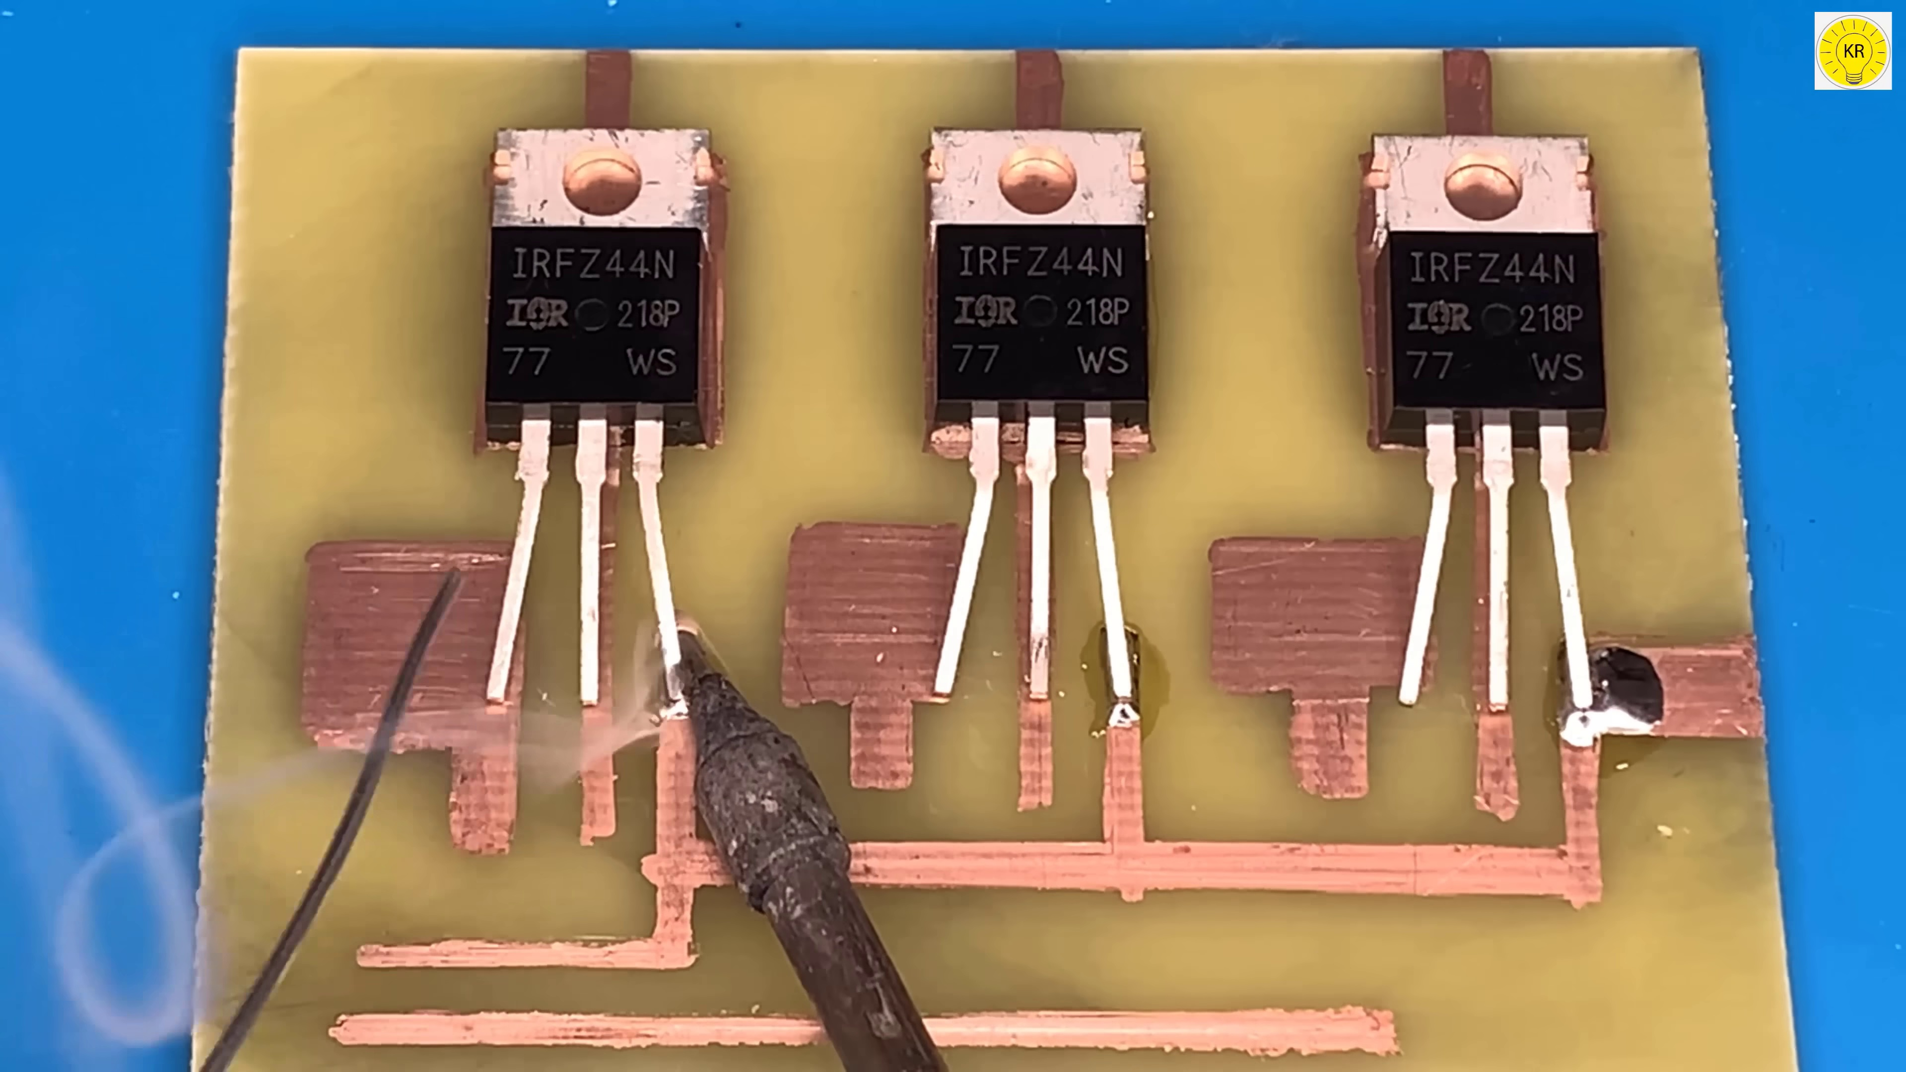 | 0:14   | 0:16   | 0:17  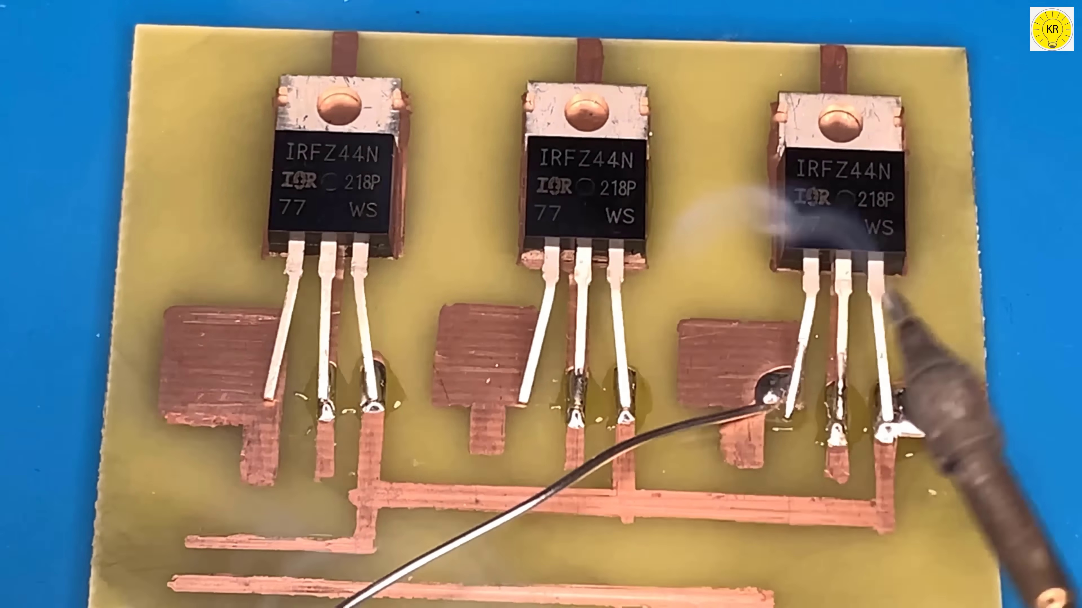 | 0:18  

Transcript
[0:12] 回答
[0:13] 回答
[0:14] 回答
[0:16] 回答
[0:16] 回答

Section 0: Interactive Video Creation Interface
Time: 0:20 - 0:28

Summary
The description depicts an interactive video creation interface, featuring icons or buttons representing options such as Cool Video Osc, Subscribe, and Video Creation Tips & Tricks.

Representative Frames
0:21  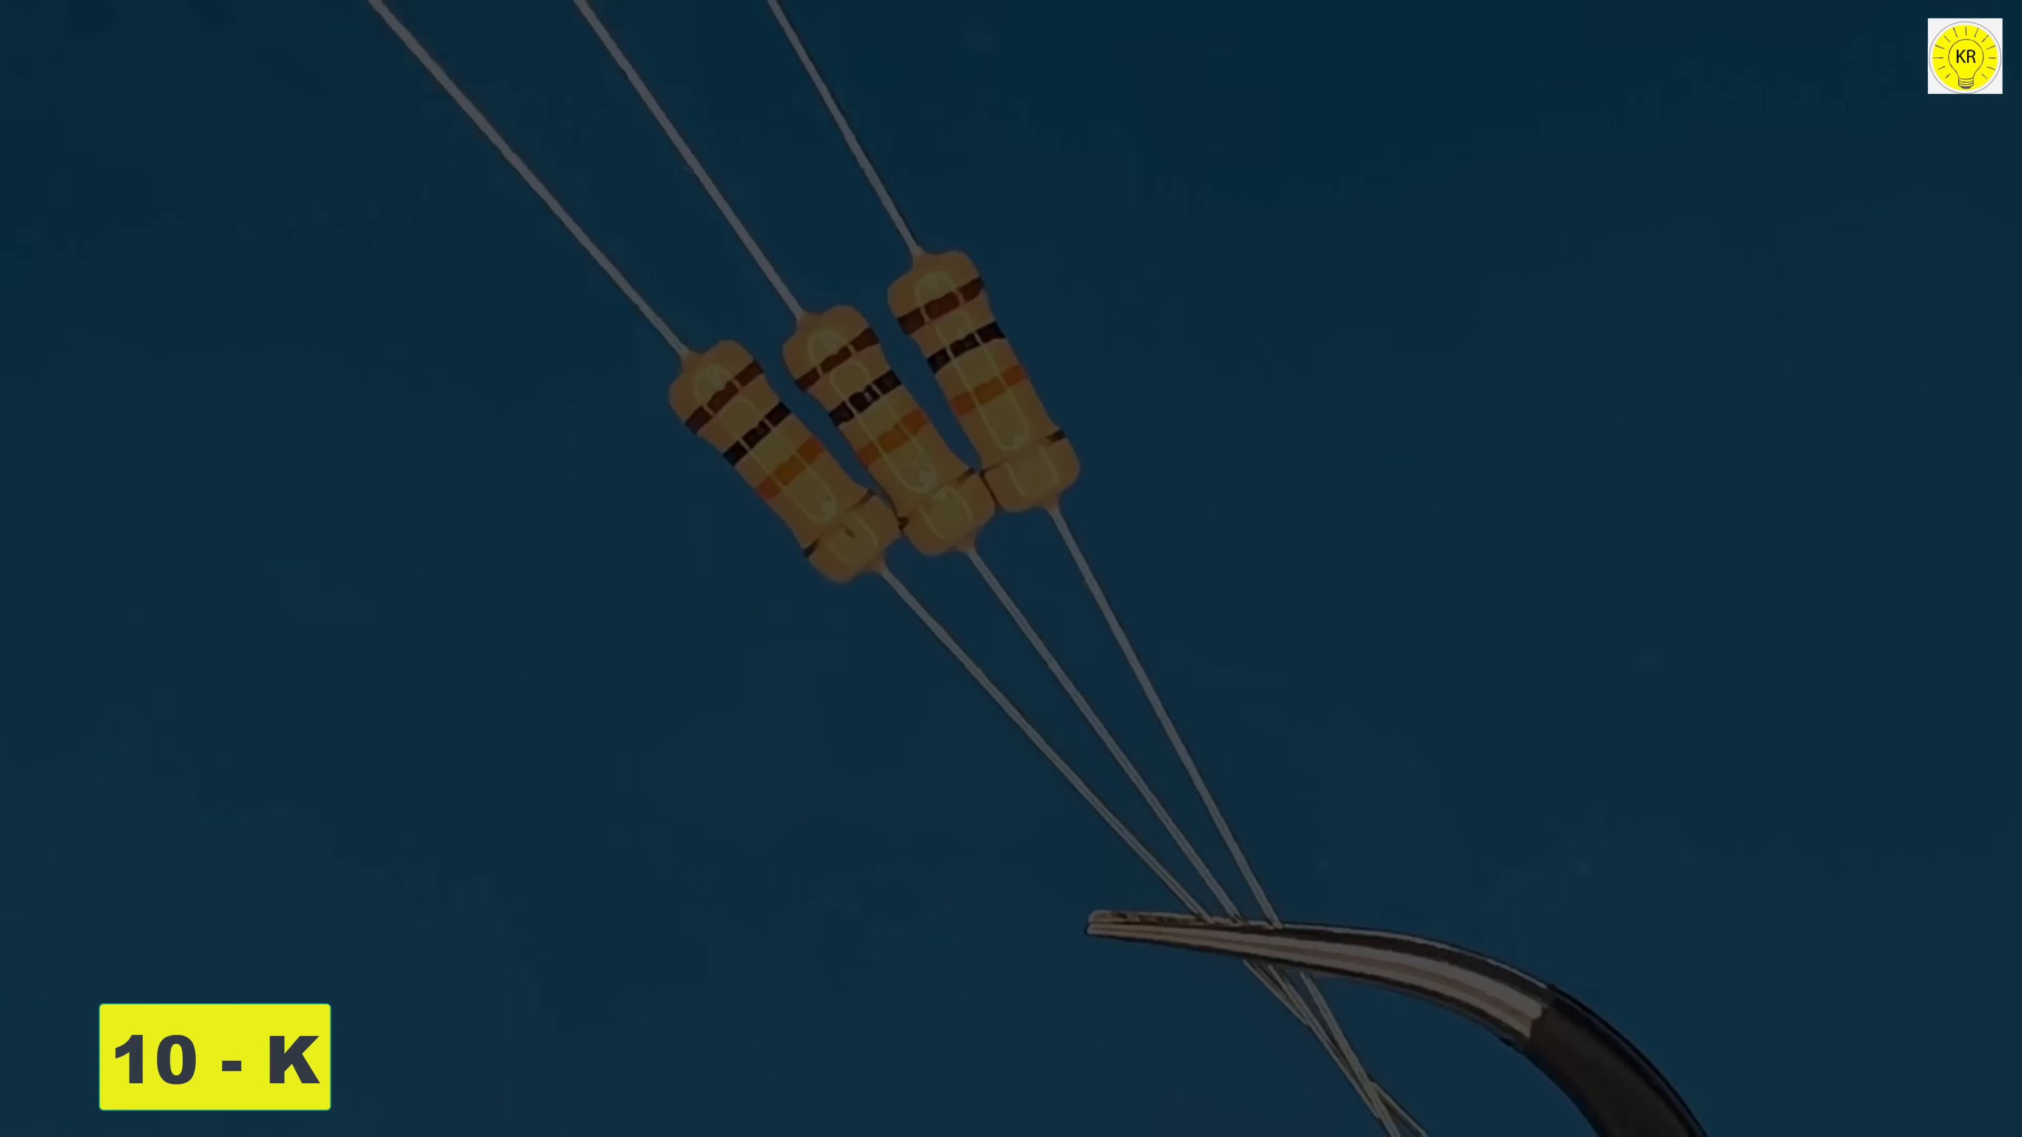 | 0:22   | 0:24  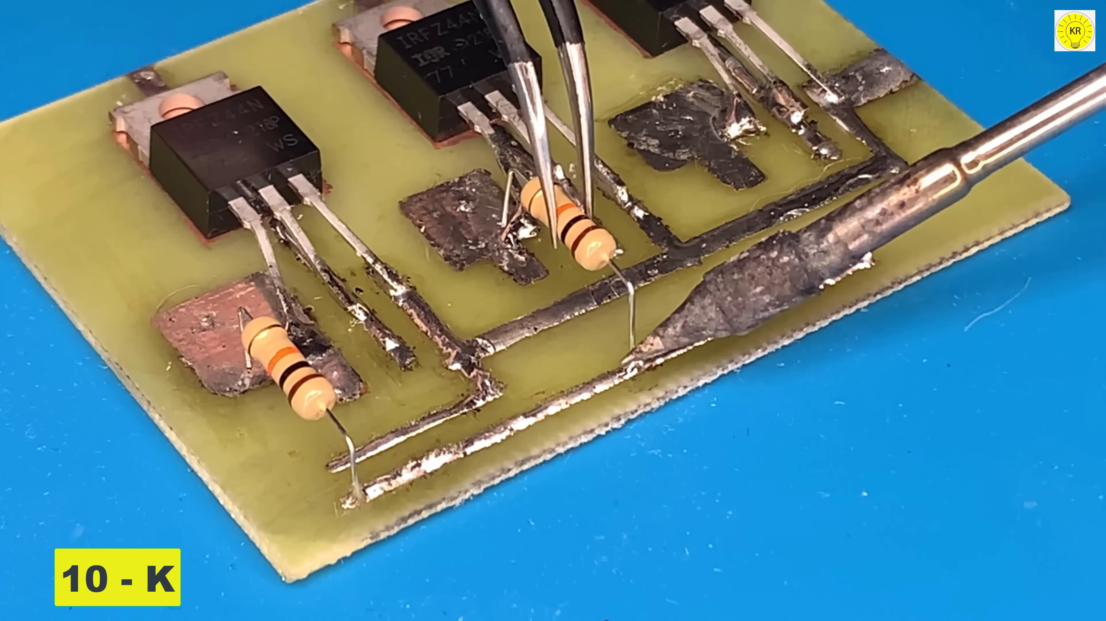 | 0:25   | 0:26  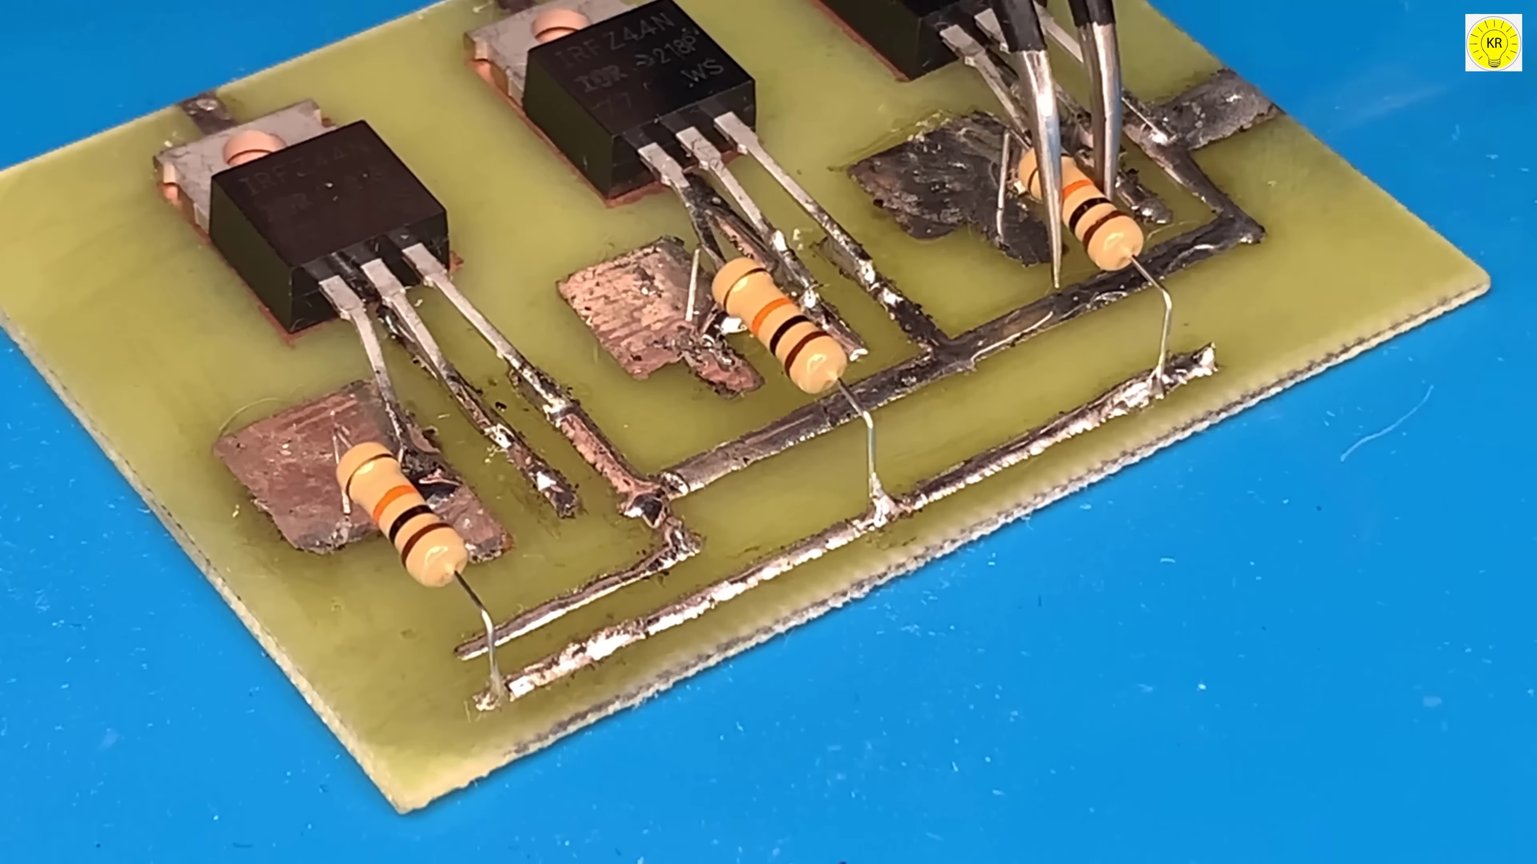

Transcript
[0:19] 回答
[0:21] 回答
[0:23] 回答
[0:26] 回答

Section 0: User-Friendly Interface with Text Box and Note Icon
Time: 0:28 - 8:34

Summary
The description describes a user-friendly interface designed for ease of use, featuring a text box where users can type in text and an icon representing the ability to add notes or write content.

Representative Frames
1:49  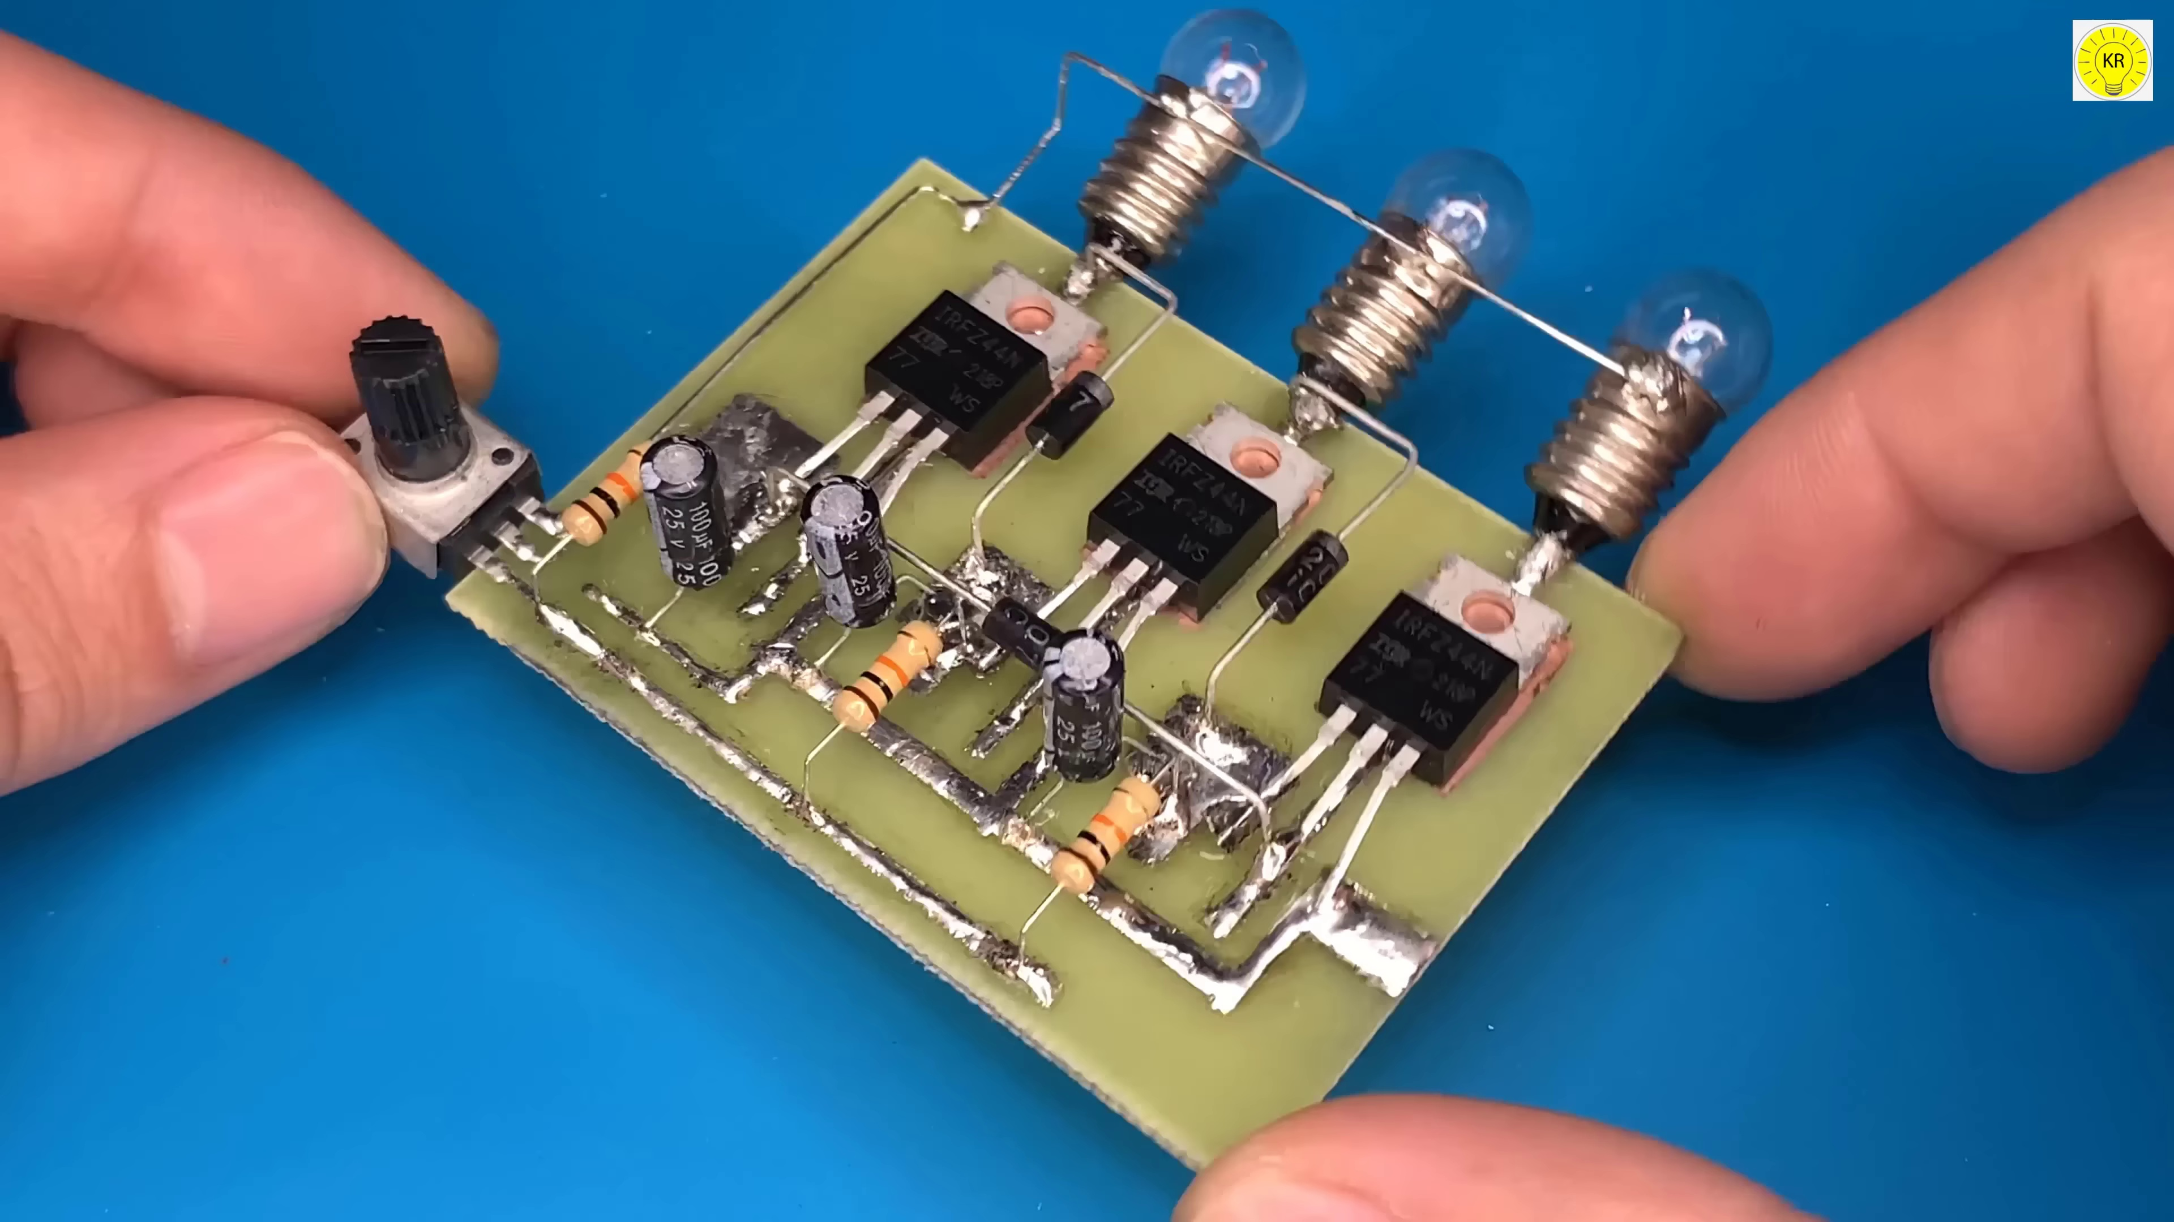 | 3:10  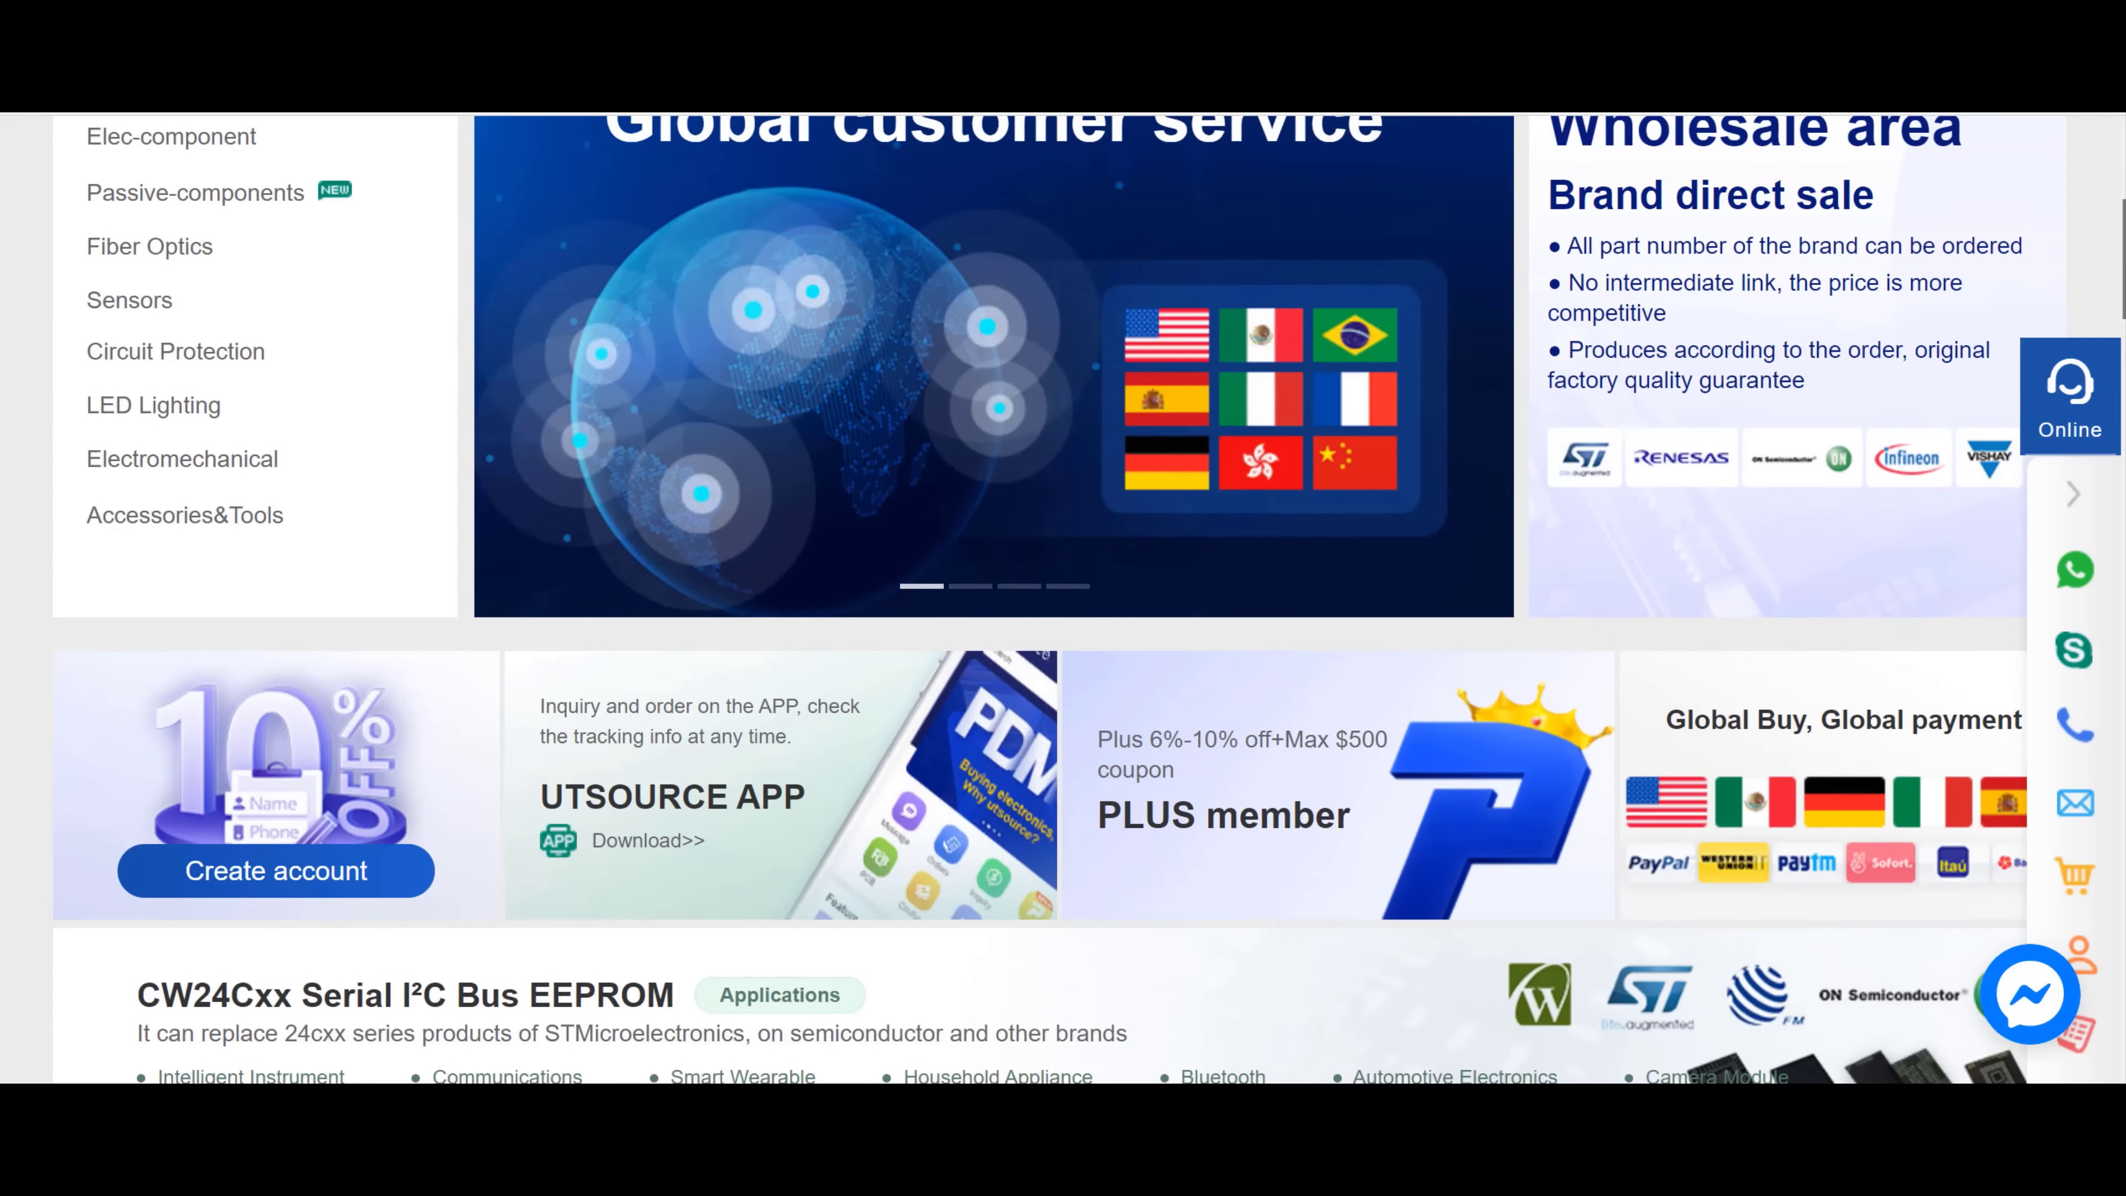 | 4:31  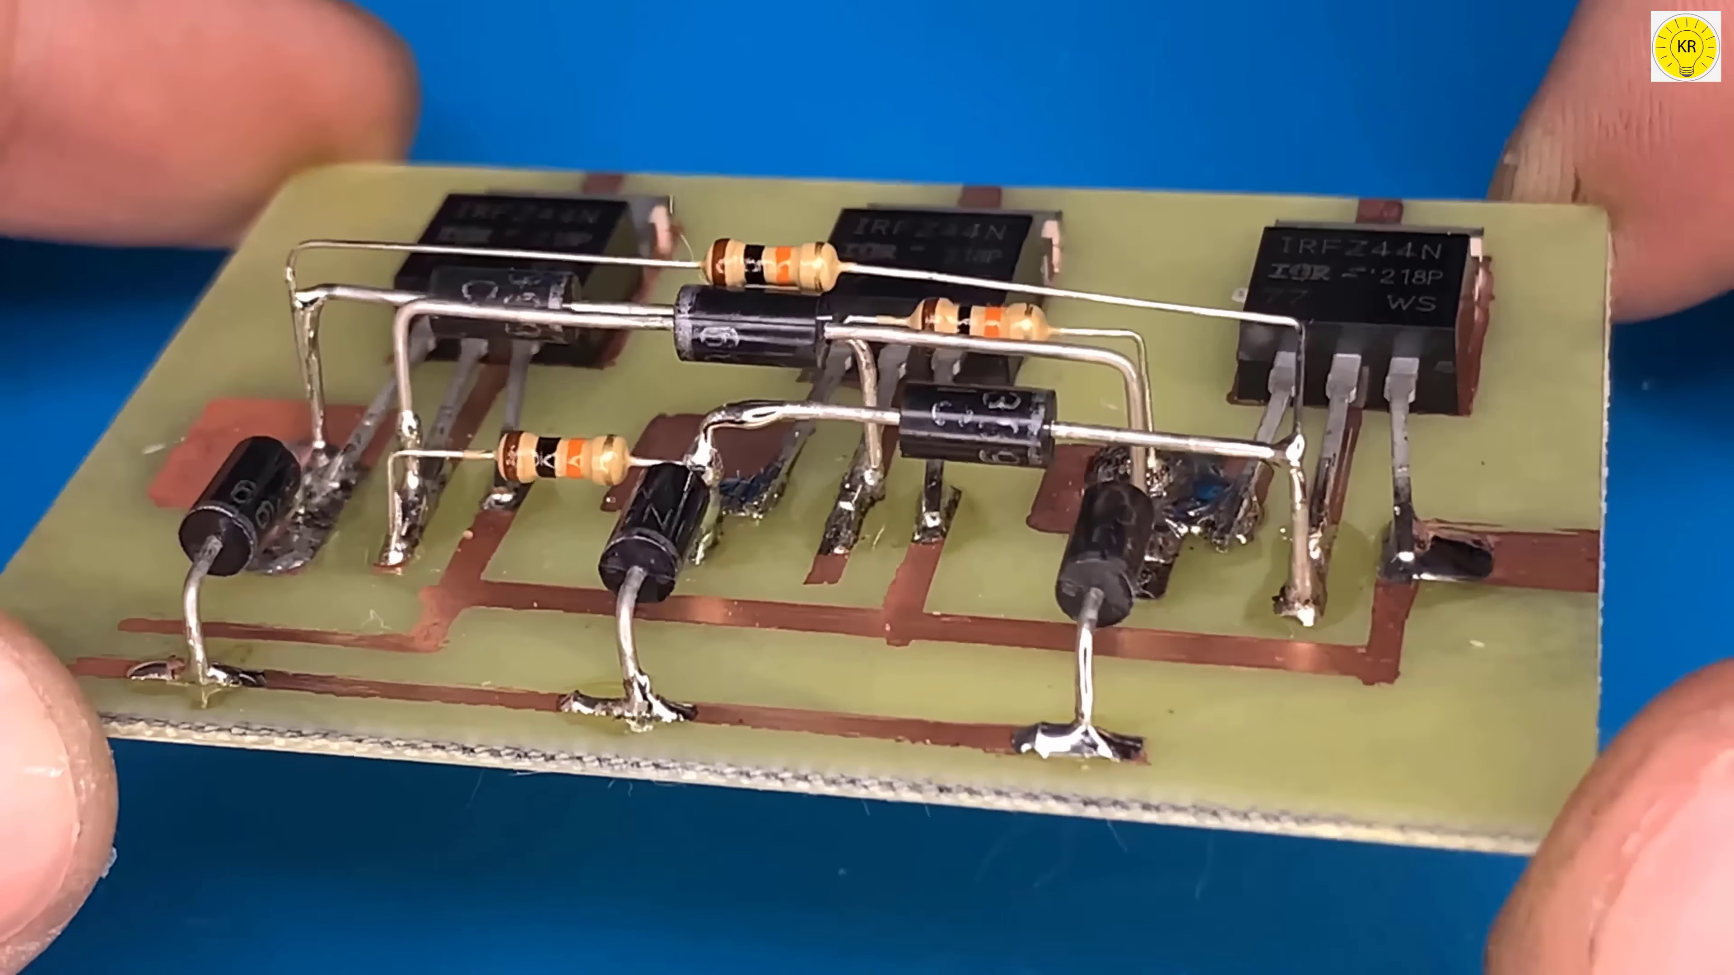 | 5:52  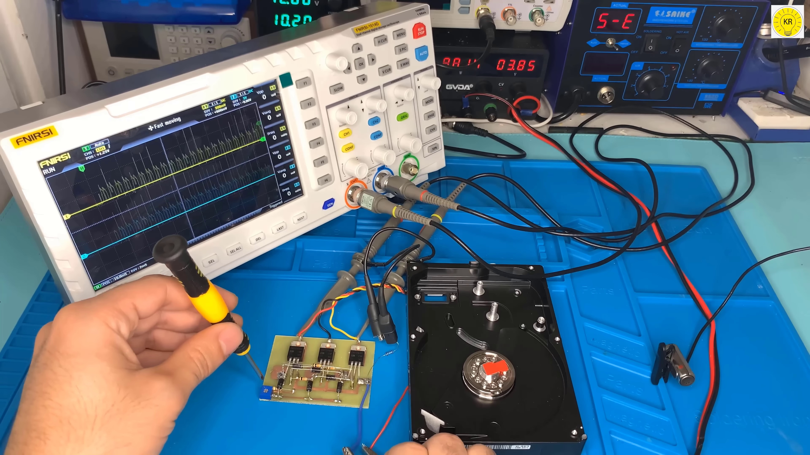 | 7:13  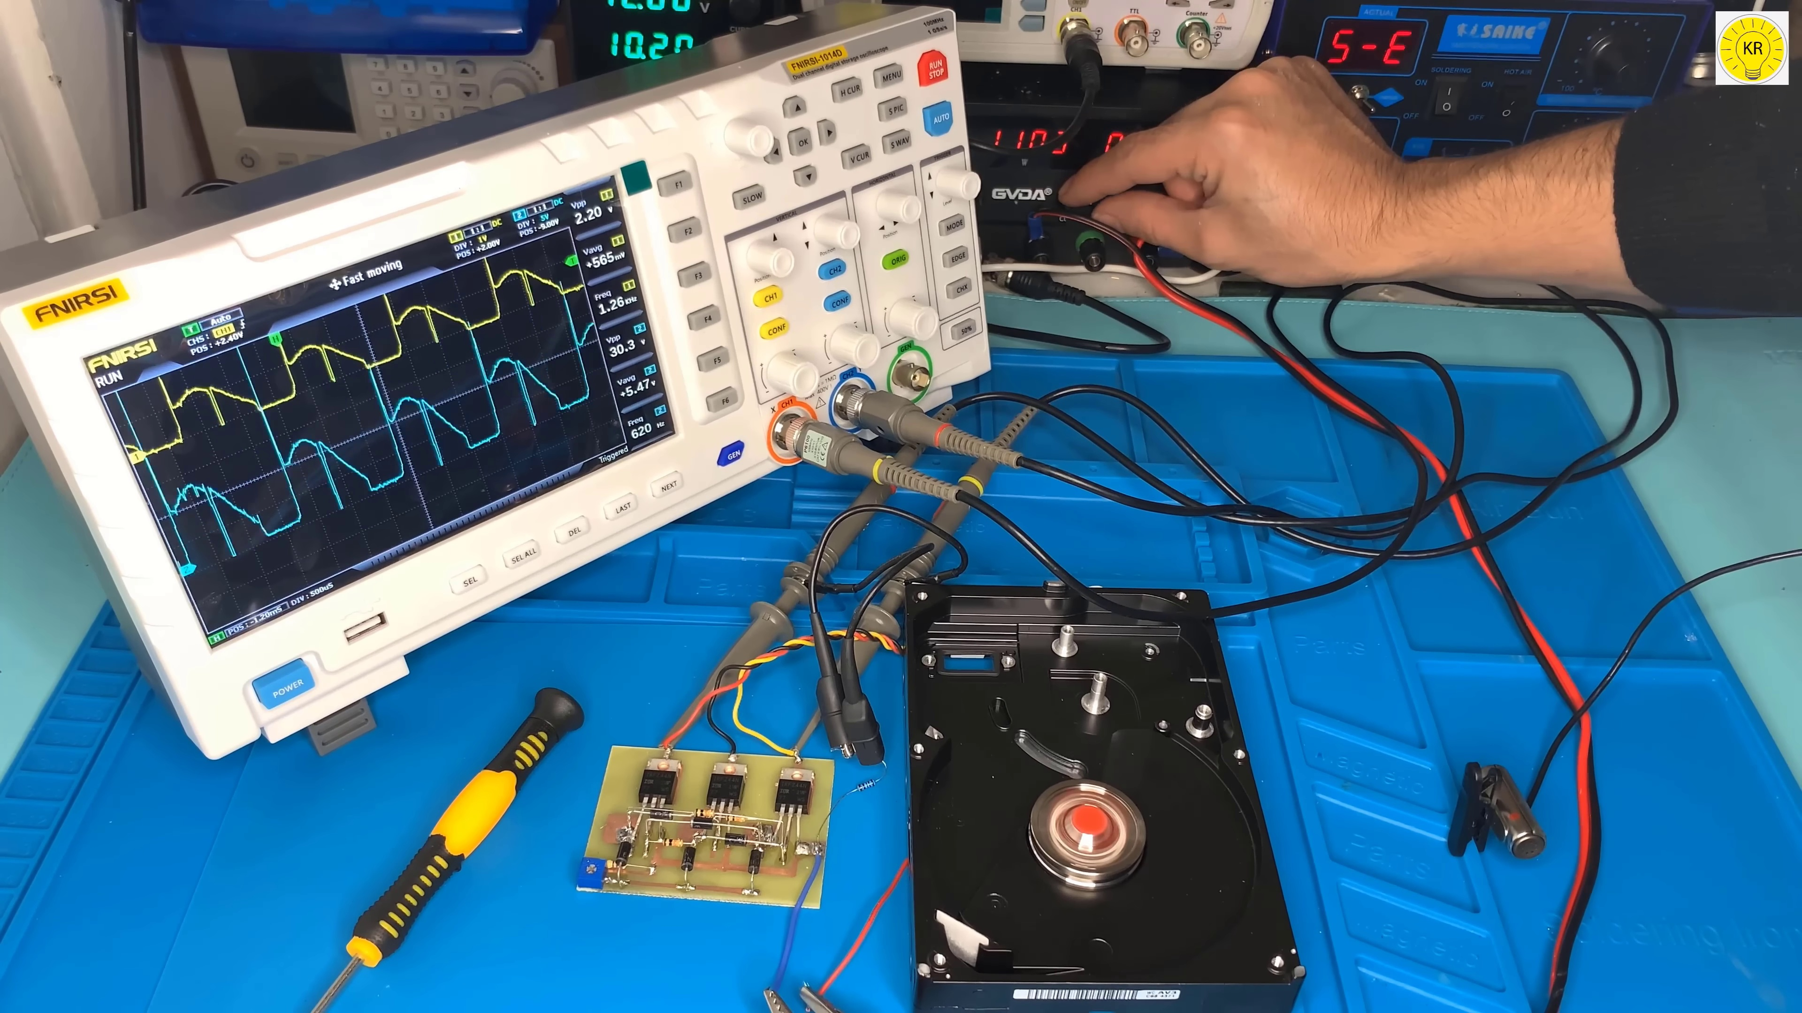

Transcript
[0:28] 回答
[0:29] Thank you.
[0:59] Thank you.
[1:29] Thank you.
[1:59] Thank you.
[2:29] Thank you.
[2:59] Thank you.
[3:29] Thank you.
[3:59] Thank you.
[4:29] Thank you.
[4:59] Thank you.
[5:29] Thank you.
[5:59] Thank you.
[6:29] Thank you.
[6:59] Thank you.
[7:29] Thank you.
[7:59] Thank you.
[8:29] Thank you.

